

Abortion is a Human Right and Health Issue: Disabled People’s Experiences of Abortion Services in Aotearoa

New Zealand

Executive Summary

Whakarāpopototaka Mātua / Executive Summary
This research explores the experiences of disabled people who have accessed the range of abortion-related services available in Aotearoa New Zealand (hereafter referred to as Aotearoa). The findings will help the government and healthcare providers to deliver more equitable and inclusive abortion services. They will also contribute to the government’s five-year review of the Abortion Legislation Act 2020, which decriminalised abortion in Aotearoa. The experiences of disabled people were collected through three questionnaires and seven interviews.

Key findings
- Positive experiences accessing abortion services
Disabled people’s experiences of abortion services after the legislation change were often positive, with participants describing warm and non-judgemental interactions with health professionals, receiving accessible information, in-depth positive discussions about contraception, positive engagement in abortion counselling, and helpful aftercare.
- Benefits of the legislation change
The legislation change has had some positive impacts. Participants' gestational duration were decreased (when compared to before the legislation change), indicating fewer barriers to services. Participants also benefited from the ability to self-refer to services and from the changes to counselling services, which are offered but optional.
- Barriers continue to impact the accessibility of services
Despite the aforementioned positive findings, some participants described barriers to access such as difficulty finding information in accessible formats, mental access barriers, not receiving accessible and appropriate communication from healthcare providers (including in NZSL), difficulties accessing their preferred form of aftercare, long waiting lists in rural areas and small towns, and challenges associated with travelling from rural areas.

- Experiences of ableism
Participants described experiencing ableism both prior to, and after, the legislation change. For example, some participants felt their disability was invisible within the process and that their access needs were not met or were responded to inappropriately. Some experiences of disablism were reported by participants who accessed abortion services prior to the legislation change.

Recommendations
- A principle-based approach
Throughout this research participants identified four interlinked principles that are integral to equitable and inclusive abortion services for disability communities.
Image description: Four overlapping circles. On the top of the circles, the text says ‘Principle-based approach’. The inner circle is orange and the text says ‘person-centred’, the second circle is tan and the text says ‘choice & control’, the third circle is light green and the text says ‘relational service provision’, and the outer circle is dark green and the text says ‘increased cultural safety & responsiveness’.
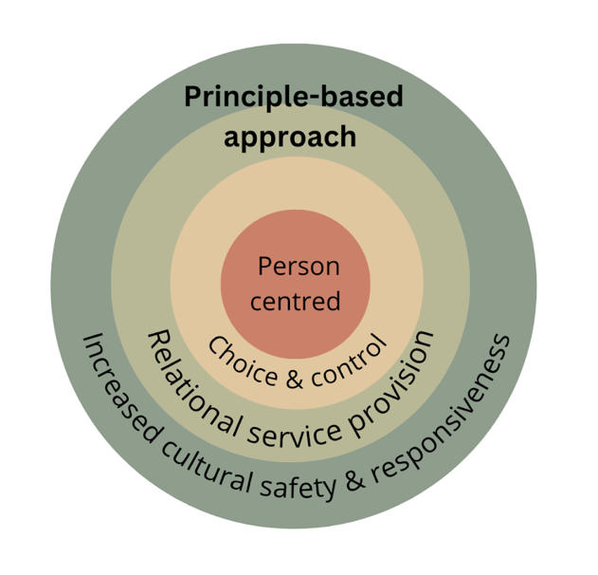

- A person-centred approach
Participants wanted services that were person-centred - that is, responsive to their needs and intersectional identities. This included asking people what their access needs are, providing a variety of options at each stage of the abortion pathway, and a range of ways they could access aftercare and post-abortion counselling.
- Prioritising choice and control
Participants valued having choice and control throughout the abortion pathway and wanted their autonomy respected when making critical decisions. In particular, participants wanted a variety of options available to them at different points, and for their decisions to be respected and actioned.
- A relational approach to service provision
Participants valued a relational approach within healthcare services, highlighting the importance of strong and respectful relationships, including with their general practitioner (GP). Participants spoke highly of health practitioners who provided warm and respectful interactions, and also valued continuity of care.
- Increased cultural safety and responsiveness
Individuals experienced trust and safe interactions with healthcare and abortion providers when their intersectional identities were respected.
Participants wanted an option to access culturally safe and responsive healthcare services both in regard to ethnic culture and disability culture.
- Education and training for healthcare providers
It is critical that healthcare providers receive disabled-led disability rights training that increases their ability to: be critical of the eugenics history of reproductive oppression; realise people’s legal capacity; communicate effectively; and provide culturally safe and responsive services in relation to both ethnicity and disability culture.
- Strategies for increasing the accessibility of services
Strategies for increasing the accessibility of services for disability communities include: the provision of abortion information in a variety of accessible formats including NZSL; resources that inform individuals of what will take place at each stage of the abortion pathway; the development of a transport service for travel to and from abortion providers; continued investment in and promotion of tele-health services; and the promotion of self-referral pathways.

Whakarakatira te tākata,
ahakoa ko wai, ahakoa nō hea.

Respect and treat all with dignity,
irrespective of who they are and
where they come from.

