

Abortion is a Human Right and Health Issue: Disabled People’s Experiences of Abortion Services in Aotearoa

New Zealand

Plain English Summary

Whakarāpopototaka Mātua / Executive Summary
This research is about the experiences of disabled people who have used different types of abortion services in Aotearoa New Zealand. These services include information about pregnancy, how to access an abortion and counselling for pregnant people. The findings from this research will help the government and healthcare providers (like doctors) to deliver more equitable (fair) and inclusive (includes everyone) abortion services. The findings will also help the government’s five-year review of the Abortion Legislation Act 2020, which decriminalised abortion (made abortion fully legal) in Aotearoa. The experiences of disabled people were collected through three questionnaires and seven interviews.

Key findings
- Positive experiences accessing abortion services
Disabled people’s experiences of abortion services after the change in the law were often positive. Participants (people who took part in this project) said that the healthcare professionals were warm and did not judge them. Most of the time, they had access to accessible information, in-depth positive discussions about contraception, positive experiences of abortion counselling, and helpful care after the abortion.
- Benefits of the legislation change
The law change had positive impacts. For example, participants had abortions earlier in their pregnancy. This might be because there were fewer barriers to accessing abortion services. Participants could make contact with abortion services without needing a referral from a healthcare professional (like a GP). Participants could also choose whether or not they wanted counselling, and when they did, it was often positive.
- Barriers continue to impact the accessibility of services
Even though there were a number of positive findings, some participants described access barriers like having a hard time finding information in accessible formats, mental access barriers (feeling stigma or shame about abortion, or having had negative experiences with the healthcare system before). Participants also said that communication with and from healthcare providers was not always accessible or appropriate, particularly for Deaf participants, and that they had difficulty accessing their preferred form of aftercare. Participants who lived in rural areas reported long waiting lists and challenges when they had to travel for abortion-related services.
- Experiences of ableism
Participants talked about experiencing ableism both before and after the law change. For example, some participants felt their disability was not acknowledged within the process and that their access needs were not met or were not responded to well. Some experiences of disablism (discrimination against disability) were reported by participants who accessed abortion services prior to the legislation change.

Recommendations
- A principle-based approach
During this research, participants identified four connected principles (ideas) that are important to equitable and inclusive abortion services for disability communities.
Image description: Four overlapping circles. The title says ‘Principle-based approach’. The inner circle is orange and the text says ‘person-centred’, the second circle is tan and the text says ‘choice & control’, the third circle is light green and the text says ‘relational service provision’, and the outer circle is dark green and the text says ‘increased cultural safety & responsiveness’.
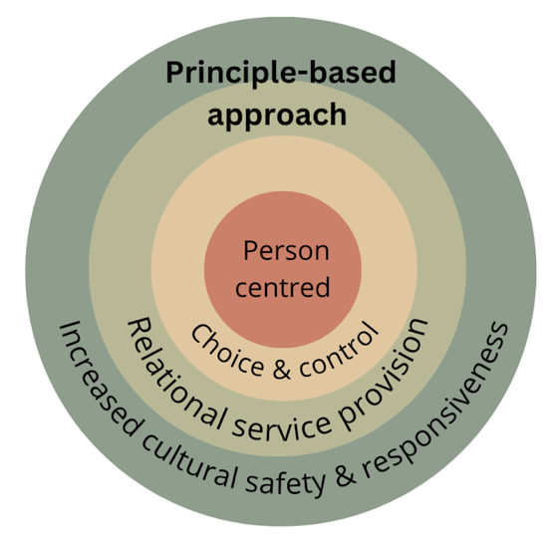

- A person-centred approach
Participants wanted services that were person-centred - that means services respond to people’s needs and intersectional identities (like their ethnicity, religion, gender, sexuality and age). Creating a person-centred approach is asking people what their access needs are, providing a variety of options at each part of the abortion pathway, and a range of ways they can access aftercare and post-abortion counselling.
- Prioritising choice and control
It was important to participants to have choice and control throughout the abortion pathway, and they wanted their autonomy (right to choose for themselves) respected when making important decisions. In particular, participants wanted a variety of options available to them at different points, and for their decisions to be respected and turned into actions.
- A relational approach to service provision
Participants said it is important to have a strong and respectful relationship with healthcare services, including with their doctor (GP). Participants spoke highly of health practitioners who provided warm and respectful interactions, and also valued long-lasting relationships with their healthcare providers.
- Increased cultural safety and responsiveness
Participants experienced trust and safe interactions with healthcare and abortion providers when all parts of themselves and their identities were respected. Participants wanted an option to access culturally safe and responsive healthcare services, both in regard to ethnic culture and disability culture.
- Education and training for healthcare providers
It is very important that healthcare providers (like doctors) receive disabled-led disability rights training that increases their ability to: be careful of the eugenics history of reproductive oppression (such as disabled people not being allowed to have children in the past); realise people’s legal capacity (support disabled people to make their own decisions); communicate effectively; and provide culturally safe and responsive services in relation to both ethnicity and disability culture (treat disabled people with respect and be respectful of their identity and culture).
- Ways to make abortion services more accessible
There are different ways to make abortion services more accessible for disability communities. These include: providing information about abortion in a variety of accessible formats including NZSL; information about what will take place at each stage of the abortion process; providing transport for people to travel to and from abortion providers; continue to put money and resources into tele-health services (being able to talk to your doctor or nurse over the phone, or through a video call); and making sure that people know they can refer themselves to abortion services (they don’t need a doctor’s permission to seek an abortion).

Whakarakatira te tākata,
ahakoa ko wai, ahakoa nō hea.

Respect and treat all with dignity,
irrespective of who they are and
where they come from.

