Models of Care for People Living with Long COVID: Evidence brief
Office of the Chief Science Advisor
Evidence, Research and Innovation – Te Pou Whakamārama

Disclaimer for this evidence brief publication
This document is an evidence brief and as such, the findings do not reflect government policy. It is intended as background material to support the work of health agencies.
Citation: Ministry of Health. 2025. Models of Care for People Living with Long COVID: Evidence brief. Wellington: Ministry of Health.
Published in May 2025 by the Ministry of Health
PO Box 5013, Wellington 6140, New Zealand
ISBN 978-1-991324-32-0 (online)
HP 9127

This document is available at health.govt.nz
 | This work is licensed under the Creative Commons Attribution 4.0 International licence. In essence, you are free to: share ie, copy and redistribute the material in any medium or format; adapt ie, remix, transform and build upon the material. You must give appropriate credit, provide a link to the licence and indicate if changes were made.

Executive summary
Long COVID presents a significant and ongoing health care challenge worldwide, with individuals experiencing prolonged symptoms often requiring comprehensive, multidisciplinary care. Aotearoa New Zealand currently lacks formalised, nationally coordinated care pathways for Long COVID. This evidence brief synthesises international literature and recent randomised controlled trials (RCTs) to inform the development of a locally relevant and equitable model of care.

Key insights from a major 2024 systematic review highlight the principles of existing Long COVID services internationally, including multidisciplinary expertise, patient-centred approaches, equitable access and evidence-based care pathways (1). Models of care should be tailored to the resources, geography, demographics and cultural needs of the population, with consideration of harder-to-reach rural communities, as well as under-served priority populations. Complementary evidence from high-quality RCTs demonstrates the efficacy of structured rehabilitation programmes in improving health-related quality of life, emphasising the need for integrated physical and psychosocial support.

Drawing on these findings, we propose four recommendations for New Zealand.
- Develop a cohesive national community of practice: Connect specialists and subject matter experts with community-based primary care.
- Develop a dedicated communication strategy: Develop clear pathways for dissemination of resources and up-to-date evidence, in a rapidly changing evidence landscape.
- Improve data collection, diagnostic code utilisation and/or formal registry: Employ standardised assessment tools, such as the Post-COVID-19 Functional Status (PCFS) scale, to diagnose and assess each individual’s level of functional impairment to inform the provision of care.
- Develop a national programme of interventions: Develop an iterative co-design process deployed at the local level to meet the specific needs, and address the specific constraints, of the populations they serve. The evidence does not support any definitive conclusions about which mode of delivery is superior: virtual or in-person or hybrid interventions.

By adapting international evidence to New Zealand’s unique health care landscape, these recommendations provide a roadmap for establishing a sustainable and effective Long COVID service that addresses the needs of all New Zealanders.

Contents
Executive summary iii
Background 1
International guidelines for Long COVID clinics or care centres 4
World Health Organization clinical management of COVID-19 4
Other jurisdictions and organisations 6
Methodology 10
Literature search 10
Identification, screening and inclusion/exclusion criteria 10
Data extraction, literature synthesis, and analysis 11
Results 12
Existing models of care described in the literature 12
Assessments of models of care 17
Individual studies on models of care that add new knowledge since Chou et al (2024) 19
Discussion 25
Limitations of this evidence review 27
Conclusions and recommendations 28
Leveraging international evidence for Long COVID services in New Zealand 28
Key recommendations for New Zealand 28
References 30
Appendix A: Inclusion and exclusion criteria for Chou et al (2024) 32
Appendix B: Characteristics of Long COVID models of care from Chou et al (2024) 33
Appendix C: 10 practice-based and 3 system-based representative Long COVID models of care 34
Appendix D: Post COVID-19 Functional Status (PCFS) scale 36
Appendix E: Literature search 37

List of Figures
Figure 1: Long COVID care pathway 1
Figure 2: Principles, core components, practice-based and system-based models of care for Chou et al (2024) 14
Figure 3: Inclusion and exclusion criteria for Chou et al (2024) 32
Figure 4: Characteristics of Long COVID models of care from Chou et al (2024) 33
Figure 5: 10 practice-based and 3 system-based representative Long COVID models of care 35
Figure 6: Post COVID-19 Functional Status (PCFS) scale (19) 36

List of Tables
Table 1: International guidelines for Long COVID models of care 7

Background
In December 2022, the Ministry of Health – Manatū Hauora published the Clinical Rehabilitation Guideline for People with Long COVID (Coronavirus Disease) in Aotearoa New Zealand. Those recommendations supported a three-tiered pathway.
Figure 1: Long COVID care pathway
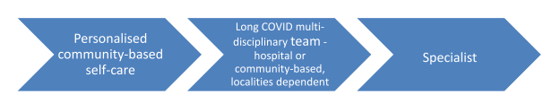
Personalised community-based self-care | Long-COVID multi-disciplinary team – hospital or community-based, localities dependent | Specialist
- Personalised management plan  - Access to resources that allow for people and whānau to learn to manage their symptoms with support and advice, eg, Health Navigator and Āwhina App  - Community-based face-to-face and non-face-to-face supports  - Virtual assistance, eg, apps  - Adaptation to peoples’ impairments | - Holistic assessment  - Personalised management plans  - Advice, rehabilitation and support for physical health, psychological health, mental wellbeing, and vocational improvement or recovery  - A nominated kaiārahi (guide) to support the management plan  - Adaptation to peoples’ impairments | - Referral for specific conditions according to health pathways  - A long-COVID multi-disciplinary team that continues while specialist care is undertaken  - Coordination between specialities  - Adaptation to peoples’ impairments
Recommendations | Grade
Acknowledge key elements of the care continuum, including:  - the use of specific symptom screening and assessment tools to systematically identify long-COVID condition symptoms and functional impairments  - pathways to determine patients’ rehabilitation trajectory and guide their transition between care settings  - customised, personalised, accessible management and education resources  - working with whānau and iwi to develop personalised management and education resources. | B

Since the publication of the guideline in 2022, many new studies have been published including on models of care. As part of a Long COVID evidence update (the last update from the Ministry being in September 2023), a review of the literature on models of care was performed and the results of that review are presented in this document.

New Zealand data on the numbers of people living with prolonged symptoms after infection with COVID-19 is limited. In 2022, Victoria University of Wellington published its report on the impacts of COVID-19 in Aotearoa New Zealand (2). The report was based on a survey of those who had been infected and included questions about prolonged symptoms. Of the survey participants, 22% (n=217) met the World Health Organization (WHO) criteria for Long COVID, including 33 tāngata whenua, four Pacific peoples and 181 non-Pacific tāngata Tiriti, all of whom self-reported at least one symptom lasting three months or more.

In 2024, the University of Auckland and Long COVID Support Aotearoa published a report on the lived experience of people with Long COVID in Aotearoa New Zealand and provided patient-generated suggestions for ways to address their ongoing health needs. The report was based on an online survey of individuals with self-reported symptoms after infection with COVID-19 (3). As of 31 March 2024, the survey included 1,348 individuals. The researchers concluded with a set of recommendations based on the survey results of those with lived experience. These recommendations were grouped into themes: Access, Belief, Support, Care, and Hope. Several recommendations within those themes addressed aspects of models of care. The report did not give specific details on how the recommendations were formed.

Regarding models of care, respondents recommended:
- validation of symptoms
- symptom mapping
- consistent and continuous medical assessment
- specialised Long COVID clinics
- clear support pathways to navigate their health care journey
- public health messaging and education
- home aid and mobility devices
- assurance of primary care access
- enhanced mental health support.

Experiences of those living with prolonged symptoms in New Zealand are reflected in studies based in other countries. A longitudinal qualitative study with 80 participants and 12 health care practitioners in the United Kingdom explored the health care experiences of those with Long COVID (4). Common reported barriers included problems entering and navigating health care systems; lack of awareness about integrated or specialised care for Long COVID due to the scarcity of accessible information and scarcity of practitioners; workforce shortages; and inadequate information for primary care practitioners.

Similar health system barriers were identified in studies of patients and health care professionals from Germany (5), Slovenia (6), other groups in the United Kingdom (7), Australia (8) and the United States (9). Medical practitioner comments in Fang’s study (4) reflect sentiments that individuals in Aotearoa have expressed:
the dilemmas between the needs of people living with Long COVID and the constraints of healthcare provision have reflected a ‘perfect storm’ in a healthcare system which has faced years of austerity, budget caps, increasing waiting times, pressurised services, backlogs, and workface shortages.

International guidelines for Long COVID clinics or care centres
Multiple guidelines exist in the international literature and grey literature on models of care. One of the most comprehensive guidelines was published by the World Health Organisation in 2023. Other guidelines from various countries are also presented in this section in table format.

World Health Organization clinical management of COVID-19 (10)
The WHO published a guideline for clinical management of both acute COVID-19 and post-COVID conditions in 2023. It references several systematic reviews on various topics related to models of care for Long COVID. The WHO notes that systematic scoping reviews for the model of rehabilitation care only identified papers that were based on expert evidence and no certainty of evidence assessment was applied using the Grading of Recommendations Assessment, Development and Evaluation (GRADE) approach. The recommendations are divided into six themes.
- Core components of rehabilitation services. These components are:
  - multidisciplinary rehabilitation teams
  - continuity and coordination of care
  - people-centred care and shared decision-making.
- Implementation of the core components. This involves:
  - standardised symptoms assessment and outcome measurement
  - a follow-up system
  - a referral system.
- Red flags for safe rehabilitation (strong recommendation)
  - Rule out and manage exertional desaturation and cardiac impairment following COVID-19 before considering physical exercise training.
  - While orthostatic intolerance and post-exertional symptom exacerbation (PESE) are amenable to rehabilitation, where they are diagnosed it will be necessary to modify interventions for rehabilitation to be safe.
- Referral principles (conditional recommendation)
  - The WHO suggests an early referral of adults with post COVID-19 condition to appropriate rehabilitation services when they are experiencing symptoms and impairments that may be managed effectively and that have an impact on everyday functioning, when red flags for safe rehabilitation have been considered.
  - It qualifies these recommendations with the following: ‘We do not yet have sufficient evidence of expected rehabilitation outcomes in people with post COVID-19 condition and subpopulations. However, maintenance or improvement of functioning is expected in patients who are referred using this recommendation based on the available indirect evidence for interventions for rehabilitation of selected impairments.’
- Service delivery
  - The WHO suggests using a hybrid approach of in-person and remote models that is integrated across all levels of health care.
  - It suggests that the length of a rehabilitation programme is based on patient needs, enabling re-engagement if new onset functional decline occurs.
- Workforce
  - A workforce for the rehabilitation of adults with post COVID-19 condition may include but is not limited to physiotherapists, occupational therapists, nurses, psychologists, speech and language therapists, physicians and social workers. Community health care workers may be required based on local needs.
  - A senior, experienced rehabilitation worker should be identified to comprehensively assess rehabilitation needs, and identify those occupational groups required for the rehabilitation care, support and guidance on self-management of individual patients and their family, and to coordinate step-down processes. This person needs to be familiar with locally available resources.
  - For low-resource settings in which an identified rehabilitation workforce is not available, the WHO values task sharing between health care workers who have undergone training on safe rehabilitation.

Other jurisdictions and organisations
Several other jurisdictions have produced guidelines for the care of people experiencing Long COVID. Guidelines are variable and demonstrate the lack of a gold standard model of care (Table 1).

Similarities across guidelines are their use of:
- a multidisciplinary approach
- escalation triggers or red flags (with the exception of the US Centers for Disease Control and Prevention).

Areas of variability are:
- their definition of Long COVID
- the extent to which they provide patient or provider education resources
- the specific ways in which they grade support from self-management to specialist assessment
- whether they use a uniform measure or a scale of symptoms
- whether they include telehealth.

Table 1: International guidelines for Long COVID models of care
 | Definition of Long COVID | Model | Referral/escalation principles | Multidisciplinary team | Patient education
New South Wales | WHO definition | Staged approach:  - Self-management  - GP care using Community Health Pathways  - Integrated care by Long COVID care coordinator  - Multidisciplinary Specialist care  Uses PCFS scale and C19-YRS to capture symptoms | Referral by GP at stage 2 or 3 according to specific escalation indicators | May include, but not limited to:  - pulmonary rehabilitation services  - cardiac rehabilitation  - gastroenterology  - endocrine  - mental health  - chronic and complex disease services  - community ‘restorative packages’  - drug and alcohol supports | Guidelines recommend using:  - Royal Australian College of General Practitioners (RACGP) patient resource: Managing post‑COVID‑19 symptoms: what to expect during recovery  - National Health Service (NHS) Your COVID Recovery  - WHO: Support for rehabilitation: self‑management after COVID‑19 illness
Australia | WHO definition | Recommends referral to rehabilitation or speciality services for those discharged after severe infection. Otherwise no specific model of care – refer to state or territory guidelines | Red flag symptoms:  - severe, new onset, or worsening breathlessness or hypoxia  - syncope  - unexplained chest pain, palpitations or arrhythmias  - new delirium, or focal neurological signs or symptoms | May include rehabilitation, exercise physiology, pulmonary rehabilitation, nutritional support, exercises, psychological assessment | Website has links to the same specific patient education resources as New South Wales
United States | National Academies of Science, Engineering, and Medicine definition | Promotes person-centred, multidisciplinary, coordinated models of care, including telehealth. Does not specify any model of care but maintains webpage with multiple resources | No specifics | Person-centred, multidisciplinary, coordinated models of care, including telehealth | Centers for Disease Control and Prevention (CDC) maintains a health care provider education webpage and partners with Project ECHO to support health care providers
United Kingdom | National Institute for Health and Care Excellence (NICE) definition | Tiered support:  - self management  - multidisciplinary rehabilitation  - additional support: care packages, advance care planning, support with ‘social isolation and loneliness’ | - Hypoxaemia, desaturation on exercise, cardiac chest pain, paediatric inflammatory multisystem syndrome  - Referral pathways up to local available services | Team ‘could include, but [is] not limited to’:  - occupational therapy, physiotherapy, clinical psychologist, psychiatry, rehabilitation medicine | NHS Inform website has resources for self-management
Alberta, Canada | Debilitating symptoms 12 weeks after COVID-19 diagnosis, which may last for many months’ | PCFS scale as screening tool for degree of functional impairment and rehabilitation service level required:  - universal rehabilitation  - targeted rehabilitation  - personalised rehabilitation | - Post-exertion symptom exacerbation  - Cardiac symptoms  - History of multisystem inflammatory syndrome in children  - Exertional desaturation  - Dysautonomia or orthostatic intolerance  - Coagulation dysfunction | Specific resources for community rehabilitation to be identified at ‘zone level’ | MyHealthAlberta self-management resources
Rehabilitation Medicine Society of Australia and New Zealand | WHO definition | Rehabilitation medicine physicians to assist primary care physicians if not responding to simple measures. Physicians to ‘lead and support’ allied health teams in delivery of self-management, or to deliver multidisciplinary rehabilitation | - Referral to multidisciplinary rehabilitation with:  - inability to mobilise independently  - weight loss  - dysphagia or dysphonia  - intercurrent illness  - critical illness myopathy or neuropathy  - persistent new cognitive impairment  - pain affecting function > 4 out of 10 visual analogue scale  - pre-existing disability  - request by single discipline therapist for additional therapy  - request by intensivist/acute care physician for rehabilitation assessment  - respiratory indicator: 7 or more days of invasive or non-invasive ventilation  - respiratory indicator: oxygen desaturation ≥3% on exertion eg, one-minute sit to stand test | Multidisciplinary rehabilitation (not otherwise specified) | Not specified

Methodology
The protocol for this scoping review was guided by these evidence questions.
- What are the different types or models of care that have been described in the literature and/or used in clinical practice for individuals with Long COVID?
- What have published studies reported on the effectiveness or evaluation of models of care for Long COVID?
- What guidelines exist for Long COVID clinics or care centres?

Literature search
A senior librarian at the Ministry of Health performed the literature search as detailed in Appendix E. In September 2024, databases were searched for studies from September 2023 onward as this was the end date of the last evidence update.

Identification, screening and inclusion/exclusion criteria
Inclusion criteria: Studies from September 2023 to September 2024, relating to humans, English, full text, peer reviewed, meeting WHO Long COVID definition, describing defined model of care.

Exclusion criteria: Studies of symptoms less than 3 months, and those not relevant to the evidence questions.

From this overarching search, we considered 123 records related to models of care were eligible for full-text review. Studies were excluded where they focused on specialist clinics addressing organ-specific sequelae of COVID infection with well-defined treatment pathways such as myocarditis/pericarditis, pulmonary fibrosis or other conditions. Of those, 47 studies met the inclusion criteria for extraction related to models of care.

Data extraction, literature synthesis, and analysis
A single reviewer extracted data using Covidence software. Systematic reviews were identified, and results extracted. Single studies published after the most comprehensive systematic review were also identified. Single studies were only considered if they were of moderate or high quality, and added new or relevant information to the themes or results of the previous systematic reviews. Given the diversity of the publications, the results from these studies have been summarised as a narrative review.

Results

Existing models of care described in the literature
The most comprehensive systematic review identified in the literature search was published by Chou et al in May 2024 (1). The review included studies published up to September 2023. It aimed to understand existing or proposed models of care, as well as to evaluate models of care. In total, 29 studies on models of care were included. Inclusion and exclusion criteria for that review were robust (see Appendix A).

Chou et al identified 31 Long COVID clinics or models of care described in the literature. Of these, 18 were in the United States. Key informants consulted by the authors provided an additional 18 US-based models of care, which made a total of 49 models of care. The panel of 18 key informants was involved in implementation of Long COVID care models in various geographic regions of the United States. Given the high number of US-based models, this systematic review provides a US-centric summary of evidence.

Among the models of care, five were proposed models of care, while all others were existing models. Chou et al also identified four overviews or surveys of Long COVID models of care (9) (11) (12) (13). This evidence brief relies heavily on this scoping review as most studies on models of care align with one or more of the models summarised by Chou et al, rather than adding new information. Those that do provide new information are discussed later in this section (see Individual studies on models of care that add new knowledge since Chou et al (2024)). The scoping review provides a good summary of the existing models but is not an evaluation of the models of care. Evaluation studies or randomised controlled trials (RCTs) of models of care are scant in the literature, but several found in the literature search are included later in this section (see section ‘Assessments of models of care’).

The populations served by the models were children and adolescents (1 study), children and adults (5 studies), adults only (4 studies), and populations where age was not specified but appeared to focus on adults (21 studies). Long COVID definitions used by the clinics or models varied.
The models varied in terms of setting, clinical lead, primary clinical department and other factors (see Appendix B). The following is a summary of their key features or characteristics.
- Models generally involved multiple specialties, with 31% of US-based Long COVID clinics reporting involvement of more than 10 specialties.
- Models generally were situated in large medical centres (both public and private) with access to multidisciplinary expertise.
- Model organisation ranged from a single specialty clinic with referrals to multiple specialties as needed, to co-location of multiple specialties within a single clinic.
- Details on care coordination methods were limited, although some models described personnel with care coordination responsibilities.
- All models described use of telehealth services. However, the extent of use varied from an option for initial or follow-up visits to entirely or almost entirely virtual models.
- Most US Long COVID clinics were newly created, with some evolving from pre-existing clinics.
- Models varied in their referral processes (for example, self-referral, physician referral or proactive follow-up of patients with acute COVID-19).
- Models varied in their intake methods (for example, use of standardised assessments, questionnaires or testing).
- Follow-up protocols and implementation of training and educational efforts varied across models, although some key informants viewed training of primary care clinicians as an important element.
- Key informants noted challenges related to clinic sustainability and funding, especially in serving uninsured and under-served populations.
- Non-US models that differed from US-based models included a Long COVID mobile outpatient clinic, a case manager–led multidisciplinary model, and systems-based ‘tiered care models’ in which patients underwent initial triage and were matched on the basis of symptom severity to different clinical care tiers with varying intensities of services.

Based on these characteristics, Chou et al summarised all the models according to five key principles, seven core components and thirteen models of care (ten practice-based and three systems-based).

Figure 2: Principles, core components, practice-based and system-based models of care for Chou et al (2024)
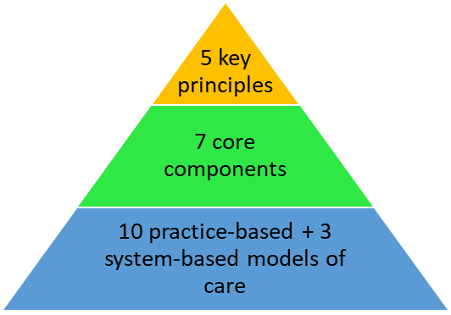

Five key principles
Based on the literature review and key informant interviews, the study identified five key principles for Long COVID models of care:
- a core ‘lead’ team with knowledge and expertise in Long COVID
- ready access to broad multidisciplinary expertise
- ready access to a broad range of evidence-based diagnostic and therapeutic services
- provision of patient-centred, individualised and equitable care
- capacity to meet high demand for Long COVID care in the population being served.

Seven key components
The study extracted seven key components that appeared useful for describing Long COVID models and distinguishing the variability in approaches to meeting the five key principles:
- home department or clinical setting
- clinical lead
- co-location of other specialties
- primary care role
- population served
- use of teleservices
- practice-based (implemented in an individual clinic or health system) versus systems-based (components across multiple levels of the health care system to provide care throughout a network or region).

Ten practice-based models of care and three systems-based models of care
Based on the seven key components, Chou et al described ten practice-based models of care and three systems-based models of care in their 2024 systematic review, along with examples of representative Long COVID care clinics (see Appendix C for more detail). Practice-based models of care are those models that describe the specifics of how individual clinics are set up. Systems-based models of care describe the larger health care system that supports the provision of Long COVID services more generally.

The following were the practice-based models of care.
- Single specialty-based Long COVID clinic. This commonly described model was located within a single specialty department and was led by a physician. These clinics leveraged existing specialty expertise and required systems to facilitate timely referrals to other specialties and services, which were not co-located. The robustness of such referral and coordination systems varied. This model was usually led by a physician from a specialty commonly involved in Long COVID care, such as physiatry, pulmonology or infectious diseases.
- Primary care-led Long COVID model. This model was based in a primary care setting with a primary care clinician lead. It has the potential advantage of preserving specialty capacity by referring patients to specialists only when needed. Although this model was primary care–led, its main purpose was to manage Long COVID, not to provide primary care. However, some primary care needs could be addressed. Similar to the specialty-based model, this model requires efficient systems for referrals and care coordination.
- Multidisciplinary Long COVID model. In this model, multiple specialties commonly involved in Long COVID care were co-located within a single clinic. Patients may need to be referred for specialties or services that are not available within the clinic. This model requires coordination of multiple specialties with dedicated time in the clinic and would likely be relatively resource-intensive and feasible primarily for larger health systems with extensive multidisciplinary expertise.
- Advanced practice provider-led model. In this variation on the three models listed above, an advanced practice provider (often an advance practice nurse) led the practice and a physician was readily available for consultation. A potential advantage is that it may be more resource-efficient and may help to increase capacity for management of Long COVID, although it would require support and training for advanced practice providers to perform optimally in this role.
- Primary care management of Long COVID model. This model integrated Long COVID management into existing primary care clinics rather than providing a designated Long COVID clinic. For this model to be successful, strategies to support primary care clinicians are critical, including education and training, implementation of evaluation and management algorithms, and care coordination support. On-site integration of specialty services could facilitate implementation. This model could substantially increase capacity in high-demand settings or those with limited specialty expertise.
- Virtual Long COVID clinic model. The defining characteristic of this model is that it was designed to be fully virtual. It could be applied to any of the models described above, each of which may use teleservices to some degree. This model may be more convenient, reduce burdens on patients and require fewer resources compared with an in-person clinic. On the other hand, some patients may prefer face-to-face interactions. In addition, it requires patients to have access to and be comfortable with technologies used to deliver virtual services, and some services or testing may require in-person visits.
- Mobile Long COVID clinic model. Designed for rural settings, this model used mobile units for initial evaluations and basic testing, followed by referral of patients to specialists as needed. It is likely to be limited in the services that can be provided, and its feasibility and suitability for ongoing management are unclear.
- Long COVID clinic and board model. In this model, an advanced practice provider led the clinic and consulted with a board of Long COVID specialists via telehealth. This model was intended for rural areas that lack specialty care.
- Long COVID or other complex conditions model. This model was similar to the multidisciplinary model but was designed to manage patients with Long COVID and other similar or complex conditions, such as myalgic encephalitis/chronic fatigue syndrome (ME/CFS), post-treatment Lyme disease syndrome or Ehlers–Danlos syndrome. It leverages expertise across these illnesses while potentially providing opportunities to elucidate how optimal management differs for each condition.
- ME/CFS in Long COVID model. This specialty-based model specifically focused on patients meeting criteria for both Long COVID and ME/CFS and leveraged expertise in managing ME/CFS. However, patients with Long COVID who did not meet criteria for ME/CFS were not included in this model and would need to be managed in another clinic.

The following were the three systems-based models of care.
- Hub and spoke model. This model consisted of clinics (spokes) that provide care for less complex patients and regional centres (hubs) that care for more complex patients and provide consultative services to the spokes. The spokes lack the extensive resources and expertise that are available at the hubs but are supported through integrated referrals and consultations. This model aims to increase access to Long COVID care outside of tertiary centres.
- Tiered care model. In this model, patients were triaged into different care tiers based on symptom severity, with each tier varying in its intensity of services. Lower tiers focused on education and self-management, whereas higher tiers involved multidisciplinary rehabilitation. Patients could move from one tier to another as their condition evolved. This model was designed to allocate limited resources more efficiently based on patient care needs.
- Centralised teleconsultation model. This model was designed as a safety net for areas lacking specialised Long COVID clinics. In it, clinicians with limited expertise in Long COVID who are managing Long COVID in primary care or other clinical settings consult with a centralised teleconsulting service that provides the necessary expertise.

Context of models of care
The Long COVID care models (based either in the United States or elsewhere), as described in Chou et al, have primarily been implemented in large health systems with access to multidisciplinary expertise. Most models managed adults separately from children given that these two age groups need different kinds of expertise. Key informants based in the United States noted growing interest in integrating Long COVID management into primary care settings.

Facilitators for primary care integration include:
- having existing networks for collaboration and coordination
- having Long COVID guidelines, algorithms and educational materials
- having support from health systems leadership
- implementing systems-based models like the hub and spoke model or the centralised teleconsultation model.

Barriers include:
- a lack of training for primary care clinicians
- resource constraints
- limited interest
- limited clinical time
- lack of access to specialty care.

Assessments of models of care
There are few evaluation or assessment studies of models of care for Long COVID. Three RCTs in the literature are described below.

German interdisciplinary facilitation programme RCT
A 2023 German RCT of an interdisciplinary facilitation programme studied 1,020 patients with Long COVID symptoms at least four weeks after onset of infection with COVID-19 (14). The study randomised patients into three groups: an intervention group (IG), an active control group (ACG) and an untreated comparison group (CompG). The intervention group received asynchronous digital interventions over six weeks that were tailored to their cognitive and physical capacities as determined by a three-day in-person assessment. The active control group received no assessment in the clinic, but received synchronous telephone contacts and asynchronous digital interventions based on their main symptoms (ie, fatigue, cognitive impairment or cardiorespiratory symptoms).

The first objective of the research was to test whether patients who received a health care facilitation programme, including medical internet support from human personal pilots and digital interventions (IG and ACG), would experience fewer symptoms and have a higher ability to work and participate socially than an untreated group (CompG). The second objective was to compare the impact of a diagnostic assessment and digital intervention tailored to patients’ personal capacity (IG) with that of only personal support and digital intervention targeting the main symptoms (ACG).

After 10–12 weeks, the study found no significant differences in any of the three outcome measures (symptoms severity, work ability and social interaction) between IG and ACG. However, there was statistically significant improvement in all three outcomes compared with the untreated control group. The study also found that a greater reduction in symptoms does not predict a higher reported work ability when controlling for age, sex, body mass index and previous health conditions, but does predict higher social participation (p=0.04).

This study has a robust design, when measured using the Joanna Briggs Institute (JBI) Critical Appraisal Checklist for Randomized Controlled trials (15), but it has some limitations. It lacks concealment and blinding, and relies on self-reported measures that may introduce bias. This study includes individuals with symptoms lasting four weeks or longer, which is not in line with the WHO definition, making comparison of its findings with those in other studies of Long COVID more challenging.

Taiwanese 12-week telerehabilitation training programme RCT
A 2024 Taiwanese RCT investigated the effectiveness of a 12-week telerehabilitation training programme (16). The intervention groups received 12 weeks of telerehabilitation training with weekly remote monitoring for exercise quality. Intervention participants used mobile phone apps with weekly remote reminders. They wore heart-rate sensing clothing and were instructed on how to use the app and set weekly exercise goals.

Among the sample of 182 adults experiencing Long COVID symptoms, the study found that the intervention group undertook more walking (p<0.001) and more physical activity overall (p=0.003), as well as having more exercise self-efficacy (p<0.001) and better sleep quality (p=0.012) compared with the control group. However, the two groups had no significant differences in any cardiorespiratory fitness parameters or health-related quality of life (HRQOL) at 12 weeks. The authors suggested that lack of improvement in HRQOL may have been due to high dropout rates from the telerehabilitation programme.

A JBI appraisal of this study finds that it has notable strengths in its design and implementation but challenges such as high dropout rates and non-adherence reduce the reliability of its findings. Overall, it demonstrated moderate methodological quality based on the checklist.

English and Welsh structured, online, supervised physical and mental health rehabilitation programme RCT
A 2024 RCT in England and Wales centred on a structured, online, supervised physical and mental health rehabilitation programme (17). It randomly divided 585 adults with ongoing symptoms three months after discharge from hospital for COVID-19 into two groups: the intervention group (Rehabilitation Exercise and psycholoGical support After COVID-19 InfectioN (REGAIN)) and the usual care group. Best-practice usual care was a single online session of advice and support with a trained practitioner. The REGAIN intervention was delivered online over eight weeks and consisted of weekly home-based, live, supervised, group exercise and psychological support sessions.

Compared with usual care, the REGAIN intervention led to improvements in health-related quality of life (p=0.02) at three months, driven predominantly by greater improvements in the patient-reported outcomes measurement information system subscores for depression (p=0.04), fatigue (p=0.001) and pain interference (p=0.01). Effects were sustained at 12 months (p=0.02). Very few adverse events were reported in the intervention arm, and only two of these events were definitively linked to the intervention (knee pain and anxiety). No instances of exacerbation of post-exertional symptoms were identified during weekly monitoring.

A quality appraisal of this study finds that it meets most of the criteria for a high-quality RCT under the JBI checklist. The primary limitation is the inability to blind participants and practitioners due to the nature of the intervention, but efforts to reduce the outcomes assessor bias were implemented effectively. Overall this study is considered to be of high quality.

Individual studies on models of care that add new knowledge since Chou et al (2024)
Several studies not included in the Chou et al (2024) scoping review have been published since September 2023. While none of them adds an entirely new model of care, several do add new information and/or inform the New Zealand context. We have included them in this section for that reason.

Implementation of a provincial Long COVID care pathway in Alberta, Canada
This study of a provincial Long COVID care pathway in Alberta, Canada (18) is included here because Alberta is a province that is similar in size and population to New Zealand, it has a public health care system (unlike the United States, where many of the models are based), and it has a large rural population similar to New Zealand. It also has an indigenous population that was considered in the implementation of the pathway.
- Alberta, Canada is a province of about 4.4 million people and has a single provincial health service. About 20% of Alberta’s population is classified as rural.
- Between 2020 and 2022, the study used a collaborative, provincial, consensus-based approach involving 129 multidisciplinary stakeholders to develop a novel care pathway for the screening, triage and management of Long COVID (the Post-COVID Rehabilitation Framework). This work culminated in the development of a post-COVID assessment tool, the Post-COVID-19 Functional Status (PCFS) scale (19) (see Appendix D).
- Care pathways are based on the PCFS score to align with the intensity of rehabilitation needs.
- The pathway provides self-management and educational resources for patients and providers.
- This model functions as an example of the tiered care model of systems-based models of care (mentioned above).
- The study found that the pathway faced three categories of barriers and facilitators: process perceptions; awareness of patient educational resources; and challenges of evolving knowledge.
- From an equity perspective, differences in the accessibility of well-versed clinicians across the province led to highly variable care.
- For services in similar contexts seeking to implement Long COVID rehabilitation care pathways involving multidisciplinary teams, the study recommends:
- having sites across the spectrum of care
- using standardised tools for Long COVID screening and assessment
- providing diverse educational resources for patients and providers
- having a dedicated communication strategy for disseminating the self-management resources, especially to primary care
- creating a communication pathway or community of practice between geographically disparate Long COVID teams to facilitate information sharing and interprofessional collaboration
- clarifying and updating Long COVID pathways to confirm the required standardised processes as compared with optional complementary functional screening and assessment tools.
- Since the introduction of the PCFS scale, its uptake and incorporation in the COVID-19 research community has been notable. The original study gained an Altmetrics score of 149 and has been cited more than 270 times. In addition, guidelines have recommended the scale, including the WHO’s guideline on clinical management of COVID-19 (20) and the guidelines produced by New South Wales, Australia.
- The PCFS scale is used in New Zealand by the Taranaki Long COVID Staff Clinic, which is a clinic set up to serve the needs of the staff at Taranaki Hospital with Long COVID. A survey of nine staff members who have used the support services found positive results, as reported by the Public Health Communication Centre Aotearoa. Eight of the nine respondents agreed that the Long COVID clinic for staff was meeting patient needs and all considered that patients had improved because of the service. The model of care used in the clinic is not published in the literature and the clinic does not have a public-facing website.

Ethnography of Long COVID clinics in the United Kingdom
The UK study on working knowledge, uncertainty and ontological politics (21) is included as it presents a novel approach to understanding how to tailor care delivery based on individuals’ needs and worldviews. This is relevant because, in an environment of uncertainty in terms of condition definition, treatment and prognosis, patients’ preferences and perspectives become even more important in supporting engagement with services and care.
- This study of 10 Long COVID clinics in the UK revealed how multidisciplinary teams built working knowledge by combining multiple kinds of formal and informal knowledge and harnessing uncertainty to open up dialogues with patients. The term ‘working knowledge’ is a way to describe how patients or health care workers frame the problem of Long COVID, or how they understand the problem of Long COVID and its potential treatments. The working knowledge in most teams was ‘rehabilitation’, supported by physiotherapists, psychologists and generalist clinicians. When patients showed little or no improvement, the team usually shifted to ‘microscopic damage’ working knowledge, which invariably featured the consultation of several specialist hospital doctors to justify extensive specialist investigations and pharmacological interventions.
- The uncertainty described above (relating to what Long COVID is) leads to uncertainty (as to how the condition should be researched and investigated), therapeutic uncertainty (as to how it should be treated), temporal uncertainty (as to how long it will last in any patient) and ethical uncertainty (as to what is the right decision in any given case). The authors concluded that in UK clinics, listening to which working knowledge any given patient adheres to offers the best chance of meeting that patient’s needs.
- The novel finding from this study was that relational knowledge of what was at stake for the patient was crucial to drawing out a unique trajectory narrative to inform management of Long COVID’s complex and varied manifestations. Without this kind of person-centred approach, the management journey was less clear.
- The working knowledge of ‘rehabilitation’ does not deny the existence of microscopic damage; it just focuses the work of the team on the whole person rather than the endothelium. The key clinical questions Greenhalgh asks are, ‘In which patients, and to what extent, does the clinical gaze need to shift to a more mechanistic, molecular level of explanation?’ and ‘In which patients does a rehabilitative explanation help better engage the patient?’

Co-designed model of care
This study on a co-designed model of care in the context of limited evidence (22) is included as it is a rare example in the literature of a co-designed model of care, which is a patient-centred method to design service delivery when there may be no prior existing model of care.

The 22nd International Conference on Integrated Care met in Denmark in May 2022 with the aim of co-designing a model of care to support recovery from COVID-19 infection in both the acute and post-acute phases. The DisCOVeRY model of care was explicitly designed for a practice context where evidence is limited, and patients hold the majority of expertise. The model of care was informed by 67 patients and 85 health care workers.

The result of the co-design process was a pathway starting with a comprehensive assessment using both standardised outcome measures and a co-designed, patient-rated outcome measure developed in the study. Then patients were placed into one of two streams of care, with the best option for each person determined via shared decision-making.
- The Supported Recovery stream provided intensive multidisciplinary rehabilitation (available face to face and via telerehabilitation) and a designated care coordinator to facilitate transition to longer-term primary care.
- The Self-Managed stream provided a navigator service (via hotline and email) that served as a single point of information and onward referral.

The model is also supported by patient-centred elements (peer support groups and a consumer-led steering committee) and evidence-informed components (community of practice and embedded research).

Journey mapping of Long COVID in Australia
This study of journey mapping Long COVID (23) is included because it considers the social context of care delivery and highlights ways to leverage individual agency in uncertain clinical environments.

The Australian study aimed to establish a journey map of 14 people suffering from Long COVID, capturing the personal agency and social support forces that can enable, or limit, individual empowerment. In this context, ‘agency’ refers to the individual’s ability to navigate an uncertain environment and a complex medical landscape with a range of symptoms and no known cure. ‘Social support’ refers to the social resources, guidance and assistance that health care providers, online groups, families and significant others provide to patients. These supporting resources explain the context and conditions within which people with Long COVID operate.

The analysis of these journey maps yielded a framework comprising four distinct clusters: high agency – high support network, low agency – high support network, high agency – low support network, and low agency – low support network. These clusters highlighted the significance of social support and patient agency, and their interaction, in influencing the experiential journey of those with Long COVID.

The health care system can leverage patient agency and social insights by designing screening tools to rapidly assess the clusters individuals are in and develop tailored support programmes and resources for each cluster, including patient education, self-care practices and peer support groups. These resources would focus on leveraging agency and social support where these forces are high, as well as on addressing the specific challenges of low agency and low social support by helping individuals transition to clusters with more agency and/or social support.

Learning health system for Long COVID care and research in British Columbia, Canada
This study focused on a learning health system (LHS) for Long COVID care and research in British Columbia (24). Given growing interest in and support for using an LHS approach to health care delivery and improvement, examples of using an LHS to develop Long COVID services can inform a similar process in New Zealand. This study is particularly relevant given British Columbia has a population size that similar to New Zealand’s, as well as a public health care system and a large rural population.

In British Columbia, the Post–COVID-19 Interdisciplinary Clinical Care Network (the network) was established in June 2020 as a partnership involving the Provincial Health Services Authority, British Columbia’s health authorities, patients and research organisations. The aim was to support patients throughout the province, which has a population of nearly 5.4 million spread over 945,000 square kilometres. The network was developed based on the learning health system model, which emphasises the integration of research into clinical care to foster discovery, innovation, rapid learning cycles and knowledge mobilisation.

The network’s clinical programme was anchored to Post–COVID-19 Recovery Clinics (PCRCs), which were staffed by an interdisciplinary team of nurses, allied health professionals and internal medicine physicians (general practitioners for adults only). In parallel, the network had a research team that used clinically ordered laboratory and patient-reported outcome measure data captured in its central Patient Records and Outcome Management Information System (PROMIS) database.

Over the first two years, the network adjusted strategies as its members learned more about Long COVID and faced administrative hurdles. The team used a variety of metrics to monitor trends and inform operational decisions. In the first two years, the network had 6,439 referrals to the programme. In total, there were 7,116 PCRC assessments, of which 59.6% were virtual. The network gradually increased the number of virtual group education sessions per month. Among the subset of the network’s patients who completed at least two patient-reported outcome measure questionnaires and either completed the group’s 18-month pathway or were discharged earlier by a physician, 40% had improved health-related quality of life, with scores beyond the minimum important difference.

The following were key takeaways from the study.
- An LHS model allowed synchronous support of clinical care, research, and knowledge dissemination on Long COVID throughout the province (which has five regional health authorities that typically function as independent health systems).
- Telemedicine enabled expansion of the LHS beyond academic health centres to reach Long COVID patients throughout the province.
- An interdisciplinary team of nurses and allied health professionals played an essential role in Long COVID care by running small- and large-group virtual education sessions to coach patients on self-management strategies.
- Efficient change management is essential to adapt to the evolving demands of the COVID-19 pandemic and the needs of Long COVID patients.
- The robust electronic medical record (PROMIS) served as the medical record, a data repository and a patient registry. Patients at all PCRCs completed a standardised panel of blood work and questionnaires containing patient-reported outcome measure instruments. The network’s data has been used to validate the instruments, investigate possible biomarkers and examine symptom patterns of patients. Additionally, the PCRCs were a platform to collect samples for biobanking. Research includes long-term follow-up with patients who were enrolled in trials while hospitalised for COVID-19 (eg, NCT04510623) and a recruitment platform for upcoming trials (eg, NCT05430152, NCT05513560).
- Hurdles to implementation were limited human resources, and difficulties with forecasting demand and with integrating technology and research.
- On the question of where to start in establishing a Long COVID LHS, the authors recommend expecting the need to adapt often, ensuring the right infrastructure is in place to build on and repurpose existing resources to fill gaps.

Discussion
A review of the literature on models of care for those suffering from Long COVID reveals a large number of studies have been published in recent years. However, most of them are descriptive; controlled trials, evaluation studies and patient outcome studies are scant. The systematic review that offers the most robust summary of existing models of care is the 2024 review by Chou et al. That study is informative in its distillation of existing models into categories that might be referenced by those looking to set up new models of care. The corresponding representative clinics or services are useful for selecting matching parameters of any health care setting interested in new Long COVID services (Appendix C).

The three RCTs of models of care that do exist support the conclusion that a dedicated Long COVID model of care is superior to usual care where it offers access to multidisciplinary services, is evidence informed and is flexible in the use of telehealth. All three studies are of moderate to high quality, and demonstrate that dedicated services lead to improved outcomes.

The studies published since Chou et al’s systematic review do not add significant new models of care. However, several selected for this review do highlight important ways of thinking about Long COVID care that can inform service delivery in New Zealand.

The Alberta pathway is an example of an approach in a jurisdiction where the demographics and geography are similar to New Zealand’s. Although not based on an evaluation study, the Alberta model of care was developed as a considered process involving over 100 stakeholders and people with lived experience. It culminated in a unique screening tool (PCFS scale) that has been adopted by other countries. The researchers’ comments about equity being a concern for those living in rural and remote areas, as well as for the indigenous population, are pertinent to the New Zealand context. For those looking to set up models of care, many of the study’s recommendations are relevant to the New Zealand context. Among them are the need for: continuity across the population; standardised tools; culturally appropriate educational material; treatment guidelines and communication pathways; community of practice between geographically disparate locations; access to centralised specialists; and dissemination of self-management resources, especially to primary care.

Greenhalgh’s study on working knowledge in multidisciplinary care teams is an innovative paradigm in which to consider the care of patients with Long COVID. It emphasises the importance of listening to the patient and formulating an approach to care that aligns with their preferred understanding of their condition, whether that involves a rehabilitation-type working knowledge or a microscopic damage-type working knowledge. In the case of a condition without universal definition, with no definitive diagnostic test and no definitive treatment, keeping the patient at the centre of their own recovery journey yields the best chance of success.

This concept of patient-centred care is taken one step further in Hitch’s study that came out of the 22nd International Conference on Integrated Care in Denmark. The conference produced a model of care that patients and health care providers co-designed. The process resulted in patient-designed outcome measures as well, which is an innovative approach to novel pathway development that resonates with kaupapa Māori approaches in the New Zealand context.

Figueiredo et al’s Australian study on individual agency and social support highlights the need for an approach to Long COVID care based on Te Whare Tapa Whā – one that considers social support, health literacy, and whānau in designing the multiple pathways that might be available to any one individual. It reminds the health sector that screening tools would benefit from assessing not just physical needs, but emotional, spiritual and social needs as well. The study findings reinforce those expressed in the Long COVID registry Aotearoa report, highlighting the experience of those suffering from a nebulous condition in a complex health care environment.

Finally, British Columbia’s experience with using a learning health system approach to developing Long COVID care is an innovative, systems-thinking approach that resulted in improved patient outcomes. Although the study had no control group, so that it was not possible to attribute causation, the process serves as a strong example of how research, evaluation, data, service provision and lived experience can participate in an iterative process that results in a model of care that is fit for purpose. British Columbia’s experience of setting up Long COVID services aligns well with the work that the Ministry’s Evidence, Research, and Innovation Directorate is currently doing to embed an LHS approach to system stewardship.

An ongoing three-year project funded by the Health Research Council aims to provide an evidence platform for delivering health services to manage Long COVID in New Zealand. The project proposes a multidisciplinary study, co-led in a Tiriti-based partnership, that integrates the disciplines of immunology, kaupapa Māori evaluation, co-design methodology, epidemiology and health services research with the clinical interface. The project outcomes proposed are:
- a set of bio-markers of immune dysfunction to contribute to the accurate diagnosis of Long COVID
- a template for evidence-based primary care service, co-designed with people with Long COVID
- recommendations for improving existing and developing future Long COVID services to further meet the needs of patients.

The work will be supported by Long COVID stakeholders, including people with lived experience of Long COVID, Māori health experts, health professionals, health service researchers and design experts.

Limitations of this evidence review
Limitations of this evidence review are similar to those in other evidence reviews involving Long COVID, including the first review in this series on prevalence of prolonged symptoms attributable to infection with COVID-19 and the Ministry’s 2022 Long COVID Guidelines. The model of care recommended in the Ministry’s Long COVID guidelines was given a level of evidence of grade B. This grade was defined as being supported by ‘fair’ evidence (based on studies that are mostly valid and not likely to be overturned by other evidence), but with some concerns about the volume, consistency, applicability and/or clinical relevance of the evidence that may cause some uncertainty.

Little has changed in the models of care literature landscape since then. That landscape continues to have no universal definition, no definitive biomarker or diagnostic test, and no definitive treatment, while the number of controlled trials of models of care also remains limited. In this context, there can be no gold standard model of care. The studies in this literature review used heterogenous definitions, used a combination of self-diagnosis and professional diagnosis (or did not mention method of diagnosis), and did not routinely address the issue of attributability of symptoms to prior infection.

The Long COVID care models described in the literature have been implemented primarily in large health systems with access to multidisciplinary expertise. The applicability of models outside these settings is uncertain. Only a few models implemented in the United States, or in provincial Canada or Australia, focused on providing care to medically under-served or rural populations. Applicability to New Zealand is therefore uncertain. There are, however, valuable lessons to be learned from international experiences of establishing Long COVID services that are pertinent to the New Zealand context and the unique needs of the population.

Conclusions and recommendations
The international literature on models of care for Long COVID provides critical insights that can guide the development of services in New Zealand, where formalised Long COVID care pathways remain underdeveloped. The evidence synthesised in Chou et al’s systematic review, alongside findings from robust randomised controlled trials (RCTs), highlights essential components of successful models of care that can inform the establishment of equitable and effective services in New Zealand.

Leveraging international evidence for Long COVID services in New Zealand
Chou et al identified five key principles for Long COVID care: the need for multidisciplinary expertise; patient-centred and individualised care; equitable access; evidence-based diagnostic and therapeutic services; and capacity to meet demand.

These principles align with the outcomes of high-quality RCTs, such as the REGAIN trial, which demonstrated significant improvements in health-related quality of life through a structured, multidisciplinary rehabilitation model. Furthermore, the Alberta tiered care model and British Columbia’s learning health system model of care development underscore the importance of having scalable and adaptive care pathways, integrating standardised assessment tools, and telehealth capabilities.

Key recommendations for New Zealand
- Develop a cohesive national community of practice: Connect specialists and subject matter experts with community-based primary care. The evidence supports a comprehensive national strategy to connect community primary care with centralised centres that have the specialisation and expertise necessary to inform personalised care.
- Develop a dedicated communication strategy: Develop clear pathways for dissemination of resources and up-to-date evidence, in a rapidly changing evidence landscape. Aetiology, biomarkers and therapeutics for Long COVID are an evolving space and clear lines of information dissemination are necessary to keep local practitioners up to date.
- Improve data collection, diagnostic code utilisation and/or formal registry: Employ standardised assessment tools, such as the PCFS scale, to diagnose and assess each individual’s level of functional impairment to inform the provision of care and facilitate data collection. The evidence supports utilising a standardised assessment tool, of which PCFS scale is only one. As new tools may be developed in a New Zealand context, use should be flexible to respond to new evidence as it emerges.
- Develop a national programme of interventions: Develop an iterative co-design process deployed at the local level to meet the specific needs, and address the specific constraints, of the populations served. Evidence supports the idea that both in-person and virtual programmes of multidisciplinary Long-COVID care can be effective, and both are better than usual care. The evidence does not support any definitive conclusions about which mode of delivery is superior. The co-design process will enable consideration of each individual’s cultural context, working knowledge, level of agency and level of social support – all of which evidence shows are crucial to successful interventions.

By combining insights from Chou’s systematic review, international RCTs, and successful case studies such as those in Alberta and British Columbia, New Zealand has an opportunity to develop a Long COVID service that is evidence-informed, culturally responsive, and equitable. These recommendations offer a practical roadmap for addressing the complex needs of individuals living with Long COVID, while building capacity and resilience within the health care system.

References
1. Chou R, Herman E, Ahmed A, et al. 2024. Long COVID definitions and models of care: a scoping review. Annals of Internal Medicine 177(7): 929–40.
2. Russell L, Jeffreys M, Churchward M, et al. 2023. Cohort profile: Ngā Kawekawe o Mate Korona | Impacts of COVID-19 in Aotearoa – a prospective, national cohort study of people with COVID-19 in New Zealand. BMJ Open 13(7): e071083.
3. Lorgelly P, Crossan J, Exeter DJ, et al. 2024. The Burden of Long COVID in Aotearoa New Zealand: Establishing a Registry. Final Report. Auckland: University of Auckland & Long Covid Support Aotearoa> URL: https://lcregistry.auckland.ac.nz/files/2024/06/report_to_MoH.pdf (accessed 26 April 2025).
4. Fang C, Baz SA, Sheard L, et al. 2024. ‘They seemed to be like cogs working in different directions’: a longitudinal qualitative study on Long COVID healthcare services in the United Kingdom from a person-centred lens. BMC Health Services Research 24(1).
5. Schmachtenberg T, Konigs G, Dragaqina A, et al. 2023. ‘There is no one who helps you with it’: experiences of people with long COVID regarding medical care, therapeutic measures, and barriers in the German healthcare system: results of a qualitative study with four focus groups. BMC Health Services Research 23(1): 1160.
6. Pavlic DR, Maksuti A, Mihevc M, et al. 2023. Long COVID as a never-ending puzzle: the experience of primary care physicians. A qualitative interview study. BJGP Open 7(4).
7. Turk F, Sweetman J, Chew-Graham CA, et al. 2024. Accessing care for Long Covid from the perspectives of patients and healthcare practitioners: a qualitative study. Health Expectations: An international journal of public participation in health care and health policy 27(2): e14008.
8. Luo S, Zheng Z, Bird SR, et al. 2023. An overview of Long COVID support services in Australia and international clinical guidelines, with a proposed care model in a global context. Public Health Reviews 44: 1606084.
9. Dundumalla S, Barshikar S, Niehaus WN, et al. 2022. A survey of dedicated PASC clinics: characteristics, barriers and spirit of collaboration. PM & R 14(3): 348–56.
10. World Health Organization. 2023. Clinical Management of COVID-19: Living guideline. Geneva: World Health Organization.
11. Décary S, De Groote W, Arienti C, et al. 2022. Scoping review of rehabilitation care models for post COVID-19 condition. Bulletin of the World Health Organization 100(11): 676–88.
12. Health Information and Quality Authority. 2022. International Review of Clinical Guidelines and Models of Care for Long COVID. Dublin: Health Information and Quality Authority. URL: www.hiqa.ie/sites/default/files/2022-12/Long-COVID-guidelines.pdf (accessed 26 April 2025).
13. Haas R, Walter M. 2023. Specialized clinics and health care professional resources for post-COVID-19 condition in Canada. Canadian Journal of Health Technologies 3(2).
14. Derksen C, Rinn R, Gao L, et al. 2023. Longitudinal evaluation of an integrated post-COVID-19/Long COVID management program consisting of digital interventions and personal support: randomized controlled trial. Journal of Medical Internet Research 25(1).
15. Barker TH, Stone JC, Sears K, et al. 2023. The revised JBI critical appraisal tool for the assessment of risk of bias for randomized controlled trials. JBI Evidence Synthesis 21(3): 494–506.
16. Lai C-Y, Lin C-H, Chao T-C, et al. 2024. Effectiveness of a 12-week telerehabilitation training in people with long COVID: a randomized controlled trial. Annals of Physical and Rehabilitation Medicine 67(5): 101853.
17. McGregor G, Sandhu H, Bruce J, et al. 2024. Clinical effectiveness of an online supervised group physical and mental health rehabilitation programme for adults with post-covid-19 condition (REGAIN study): multicentre randomised controlled trial. BMJ 384: e076506.
18. Manhas KP, Horlick S, Krysa J, et al. 2024. Implementation of a provincial Long COVID care pathway in Alberta, Canada: provider perceptions. Healthcare (Basel, Switzerland) 12(7): 730.
19. Klok FA, Boon GJAM, Barco S, et al. 2020. The Post-COVID-19 Functional Status scale: a tool to measure functional status over time after COVID-19. European Respiratory Journal 56(1): 2001494.
20. de Jong CMM, Le YNJ, Boon G, et al. 2023. Eight lessons from 2 years of use of the Post-COVID-19 Functional Status scale. European Respiratory Journal 61(5).
21. Greenhalgh T, Darbyshire J, Ladds E, et al. 2024. Working knowledge, uncertainty and ontological politics: an ethnography of UK long covid clinics. Sociology of Health & Illness 46(8): 1881–900.
22. Hitch D, Holton S, Garnys E, et al. 2022. DisCOVeRY: a co-designed and evidence informed model of care for people with Long Covid. International Journal of Integrated Care 22: art 392.
23. Figueiredo B, Sheahan J, Luo S, et al. 1982. Journey mapping long COVID: agency and social support for long-hauling. Social Science & Medicine. 340: 116485.
24. Naik H, Malbeuf M, Shao S, et al. 2023. A learning health system for Long Covid care and research in British Columbia. NEJM Catalyst Innovations in Care Delivery 4(9).

Appendix A: Inclusion and exclusion criteria for Chou et al (2024)
Figure 3: Inclusion and exclusion criteria for Chou et al (2024)
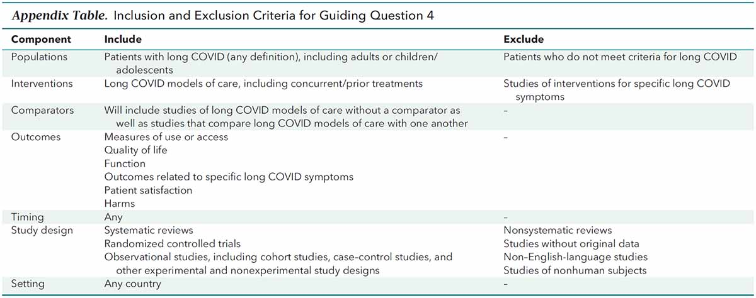

Appendix B: Characteristics of Long COVID models of care from Chou et al (2024)
Figure 4: Characteristics of Long COVID models of care from Chou et al (2024)
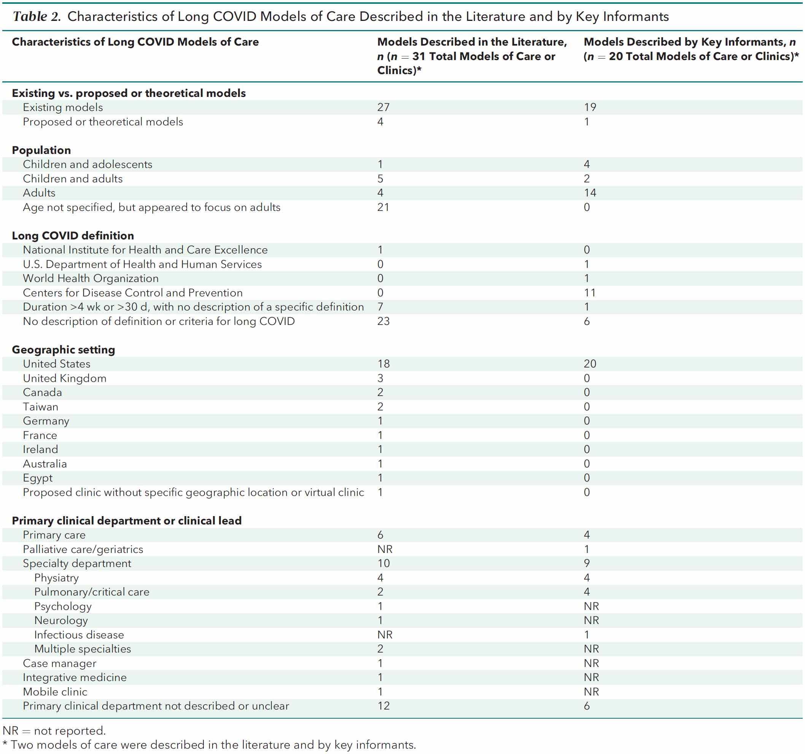

Appendix C: 10 practice-based and 3 system-based representative Long COVID models of care

Figure 5: 10 practice-based and 3 system-based representative Long COVID models of care
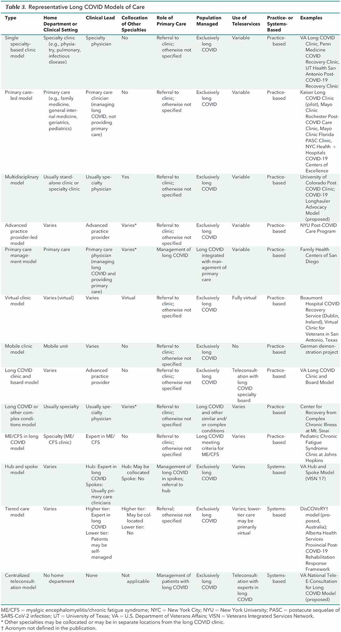

Appendix D: Post COVID-19 Functional Status (PCFS) scale
Figure 6: Post COVID-19 Functional Status (PCFS) scale (19)
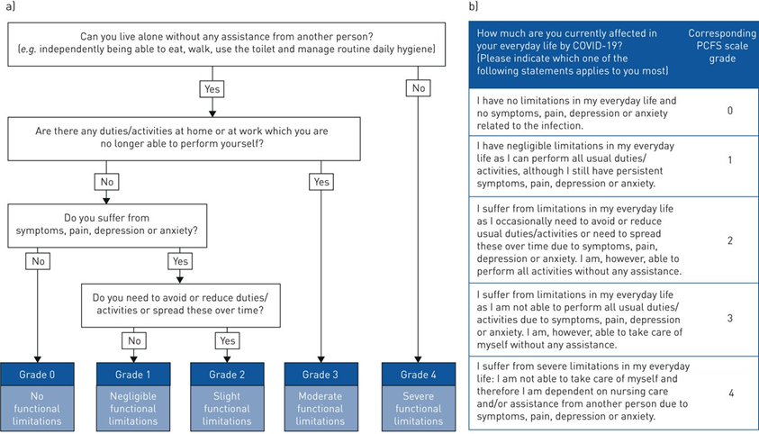

Appendix E: Literature search
Database: Ovid MEDLINE(R) and Epub Ahead of Print, In-Process, In-Data-Review & Other Non-Indexed Citations, Daily and Versions <1946 to September 25, 2024>, adapted for Scopus, Embase
Search Strategy:
1 (long-COVID or "long COVID" or longCOVID*).mp.
2 ("post-COVID condition*" or "postCOVID condition*").mp.
3 (("2019-ncov" or "ncov19" or "ncov-19" or "2019-novel CoV" or "sars-cov2" or "sars-cov-2" or "sarscov2" or "sarscov-2" or "Sars-cORonavirus2" or "Sars-cORonavirus-2" or "SARS-like cORonavirus*" or "cORonavirus-19" or "COVID19" or "COVID-19" or "COVID 2019" or "novel coronavirus" or COVID*) and (longhaul* or long-haul*)).mp.
4 *Post-Acute COVID-19 Syndrome/
5 "Post-Acute COVID-19 Syndrome".mp.
6 (("2019-ncov" or "ncov19" or "ncov-19" or "2019-novel CoV" or "sars-cov2" or "sars-cov-2" or "sarscov2" or "sarscov-2" or "Sars-cORonavirus2" or "Sars-cORonavirus-2" or "SARS-like cORonavirus*" or "cORonavirus-19" or "COVID19" or "COVID-19" or "COVID 2019" or "novel coronavirus" or COVID*) adj5 sequelae).mp.
7 1 or 2 or 3 or 4 or 5 or 6
8 (model* adj3 care).mp.
9 (care adj3 pathway*).mp.
10 "Delivery of Health Care"/
11 (supportive adj3 care).mp.
12 (care adj3 program*).mp.
13 (("2019-ncov" or "ncov19" or "ncov-19" or "2019-novel CoV" or "sars-cov2" or "sars-cov-2" or "sarscov2" or "sarscov-2" or "Sars-cORonavirus2" or "Sars-cORonavirus-2" or "SARS-like cORonavirus*" or "cORonavirus-19" or "COVID19" or "COVID-19" or "COVID 2019" or "novel coronavirus" or COVID*) and (long* or post*) and clinic*1).mp.
14 ((outpatient* adj3 rehab*) or (out-patient* adj3 rehab*)).mp.
15 ((model* or plan* or deliver* or framework* or multidisciplin* or interdisciplin* or network or pathway* or protocol*) adj3 (care or healthcare or service*)).mp.
16 Models, Organizational/
17 exp "Continuity of Patient Care"/
18 exp Patient Care Management/
19 8 or 9 or 10 or 11 or 12 or 13 or 14 or 15 or 16 or 17 or 18
20 7 and 19
21 (long* or post*).ti.
22 20 and 21
23 limit 22 to dt=20240701-20240927

See reference 19 and Appendix D.
URL: phcc.org.nz/briefing/long-covid-aotearoa-nz-risk-assessment-and-preventive-action-urgently-needed
URL: health.govt.nz/publications/clinical-rehabilitation-guideline-for-people-with-long-covid-coronavirus-disease-in-aotearoa-new
The GRADE approach (Grading of Recommendations Assessment, Development and Evaluation) is a method of assessing the certainty in evidence (also known as quality of evidence or confidence in effect estimates) and the strength of recommendations in health care.URL: www.gradeworkinggroup.org
URL: aci.health.nsw.gov.au/networks/rehabilitation/resources/covid (accessed 18 November 2024).
The continuation or development of new symptoms three months after the initial SARS-CoV-2 infection, and these symptoms last for at least two months with no other explanation. URL: www.who.int/europe/news-room/fact-sheets/item/post-COVID-19-condition (accessed 18 November 2024).
URL: www.ciap.health.nsw.gov.au/specialty-guides/nsw-healthpathways.html (accessed 19 November 2024).
Post COVID-19 Functional Status (PCFS) scale. URL: aci.health.nsw.gov.au/statewide-programs/prms/resources (accessed 28 May 2025). COVID-19 Yorkshire Rehabilitation Screen (C19-YRS). URL: c19-yrs.com/the-c19-yrs/ (accessed 27 May 2025).
URL: www.racgp.org.au/clinical-resources/covid-19-resources/clinical-care/covid-19-home-care-guidelines/background (accessed 17 December 2024).
URL: www.nhs.uk/conditions/covid-19/long-term-effects-of-covid-19-long-covid/ (accessed 17 December 2024).
URL: www.who.int/publications/m/item/support-for-rehabilitation-self-management-after-covid-19-related-illness (accessed 17 December 2024).
URL: www.racgp.org.au/clinical-resources/COVID-19-resources/clinical-care/caring-for-patients-with-post-COVID-19-conditions/introduction (accessed 18 November 2024).
URL: www.cdc.gov/COVID/long-term-effects/index.html (accessed 21 April 2025).
URL: nap.nationalacademies.org/catalog/27768/a-long-COVID-definition-a-chronic-systemic-disease-state-with (accessed 18 November 2024).
URL: www.cdc.gov/COVID/hcp/clinical-overview/?CDC_AAref_Val=https://www.cdc.gov/coronavirus/2019-ncov/hcp/clinical-care/post-COVID-conditions.html#cdc_clinical_overview_treat_pat-treatment-and-symptom-management (accessed 18 November 2024).
URL: www.cdc.gov/COVID/hcp/clinical-overview/?CDC_AAref_Val=https://www.cdc.gov/coronavirus/2019-ncov/hcp/clinical-care/post-COVID-conditions.html (accessed 18 November 2024).
URL: iecho.org/public/program/PRGM1699044218879IERCAXHJ8Y (accessed 18 November 2024).
URL: www.nice.org.uk/guidance/ng188/chapter/5-Management (accessed 18 November 2024).
NICE definition breaks prolonged symptoms down into two categories. - Ongoing symptomatic COVID-19 involves signs and symptoms of COVID-19 from 4 weeks up to 12 weeks. - Post-COVID-19 syndrome involves signs and symptoms that develop during or after an infection consistent with COVID-19, continue for more than 12 weeks and are not explained by an alternative diagnosis. It usually presents with clusters of symptoms, often overlapping, which can fluctuate and change over time and can affect any system in the body. Post-COVID-19 syndrome may be considered before 12 weeks while the possibility of an alternative underlying disease is also being assessed. In addition to the clinical case definitions, the term 'Long COVID' is commonly used to describe signs and symptoms that continue or develop after acute COVID-19. It includes both ongoing symptomatic COVID-19 (from 4 to 12 weeks) and post-COVID-19 syndrome (12 weeks or more).
URL: www.nhsinform.scot/long-term-effects-of-COVID-19-long-COVID/ (accessed 19 November 2024).
URL: www.albertahealthservices.ca/assets/info/ppih/if-ppih-COVID-19-post-COVID-rehab-response-framework-summary.pdf (accessed 18 November 2024).
URL: myhealth.alberta.ca/HealthTopics/After-COVID (accessed 19 November 2024).
URL: rmsanz.net/publications/ (accessed 19 November 2024).
The continuation or development of new symptoms three months after the initial SARS-CoV-2 infection, with these symptoms lasting for at least two months with no other explanation. URL: www.who.int/europe/news-room/fact-sheets/item/post-COVID-19-condition (accessed 22 April 2025).
Covidence systematic review software, Veritas Health Innovation, Melbourne, Australia. URL: www.covidence.org (accessed 22 April 2025).
Other countries included the United Kingdom (three studies), Canada (two studies), and Ireland, Australia, France, Taiwan, Germany and Egypt (one study each).
The key informants included people with experience in developing and implementing models of care, developing guidelines on evaluation and management of long COVID, implementing myalgic encephalomyelitis/chronic fatigue syndrome (ME/CFS) care models (given similarities to long COVID), the patient perspective, and developing long COVID policy. Key informants included researchers, clinicians, policymakers, patient advocates, and health care system representatives and were selected to provide multidisciplinary representation, including expertise in adult and child/adolescent COVID-19, various clinical disciplines, and primary care.
Definitions used included the NICE definition (see Table 1) (1 study), ‘duration >4 weeks or >30 days with no description of a specific definition’ (7), or ‘no description of definition or criteria for Long COVID’ (23 studies). For more on Long COVID definitions, see health.govt.nz/publications/prolonged-symptoms-attributable-to-infection-with-covid-19
Physiatry is a term more commonly used in the United States. Physiatry, also known as physical medicine and rehabilitation, is a medical specialty that focuses on improving the quality of life and functional ability of people with physical disabilities or impairments.
An Altmetric score is a tool used to identify how much and what type of attention a research output has received. Altmetric tracks and captures how much attention a range of online sources have paid to published research across social media, news outlets, and policy. URL: www.altmetric.com/about-us/our-data/donut-and-altmetric-attention-score/ (accessed 22 April 2025).
phcc.org.nz/briefing/long-covid-staff-clinic-caring-carers-taranaki#appx (accessed 16 December 2024).
The authors describe ‘rehabilitation’ working knowledge as ‘a set of interventions designed to optimise functioning and reduce disability in individuals with health conditions in interaction with their environment’.
The authors describe ‘microscopic damage’ working knowledge as knowledge ‘which is explicitly biomedical, based on mechanistic reasoning about molecular and cellular processes, and oriented around specialised tests requiring advanced technical knowledge to interpret’.
URL: health.govt.nz/strategies-initiatives/health-strategies/new-zealand-health-strategy (accessed 26 April 2025).
wgtn.ac.nz/health/centres/health-services-research-centre/recent-projects/evidence-based-management-of-long-covid
health.govt.nz/publications/prolonged-symptoms-attributable-to-infection-with-covid-19
health.govt.nz/publications/clinical-rehabilitation-guideline-for-people-with-long-covid-coronavirus-disease-in-aotearoa-new
Post-COVID-19 Functional Status scale. See reference 19 and Appendix D.

