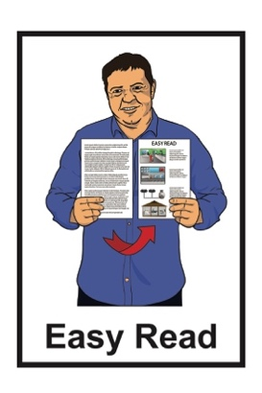
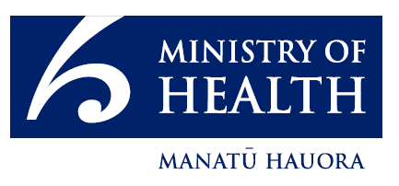

Summary – Aotearoa

New Zealand

Rare Disorders Strategy
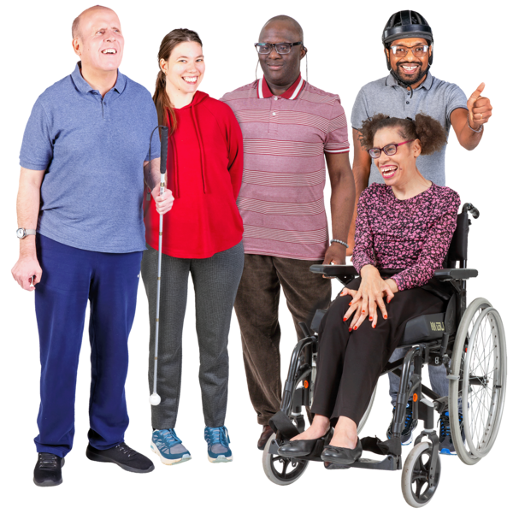
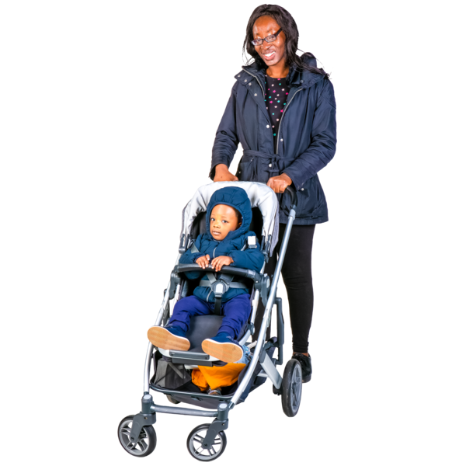

Published: March 2025

Before you start

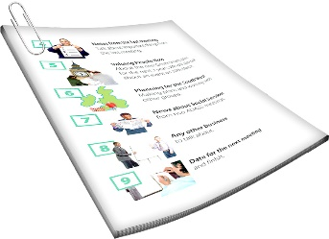
This is a long document.


It can be hard for some people to read a document this long.

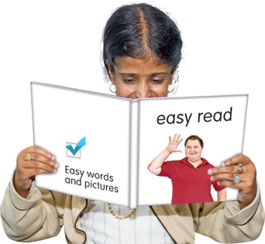
Some things you can do to make it easier are:
read it a few pages at a time
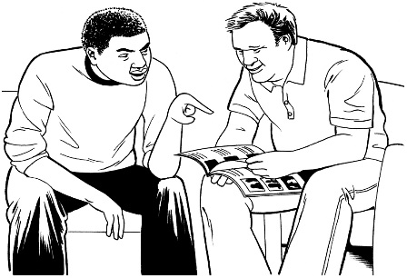
set aside some quiet time to look at it
have someone read it with you to support you to understand it.

What is in this document?

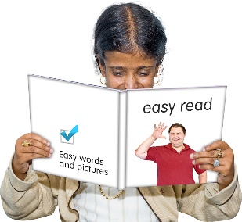
Page number:

About this document 4
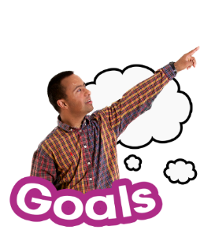

Our vision 7

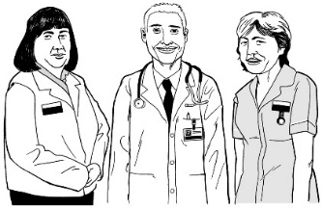
Why we need a
Rare Disorders Strategy 8

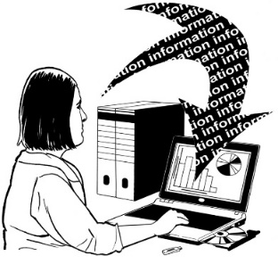
Priority 1 10

Priority 2 14
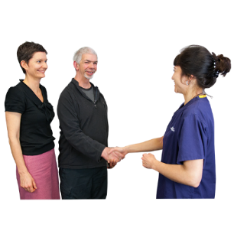

Priority 3 18

Page number:
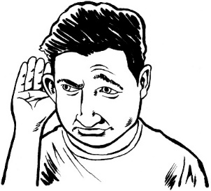

Priority 4 22

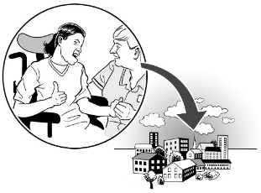
Priority 5 26

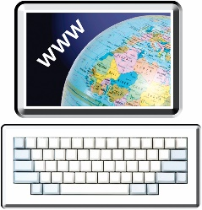
More information 31

About this document

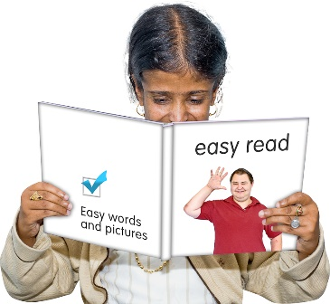
This document is a summary of a longer document called:

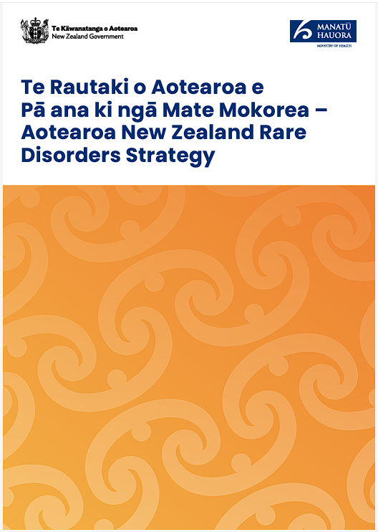
Aotearoa New Zealand Rare Disorders Strategy.

A summary is a shorter copy of a longer document.

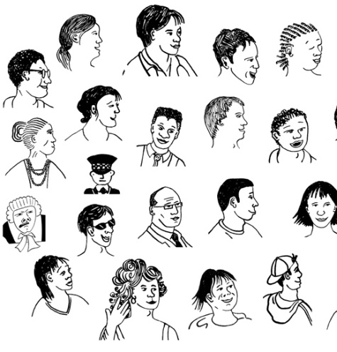
A rare disorder is a medical condition that only a few people in New Zealand have.

There are also ultra-rare disorders that even less people in New Zealand have.
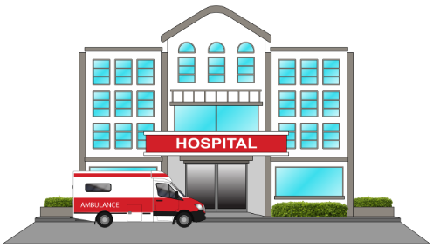
The Aotearoa New Zealand Rare Disorders Strategy is a document that says what the New Zealand health system plans to do for people with rare disorders.

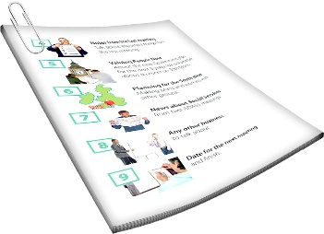
In this document we will call the Aotearoa Rare Disorders Strategy the Strategy.


There are 3 Easy Read documents that make up the summary:
Summary – Aotearoa New Zealand Rare Disorders Strategy
Rare voices and aspirations
Context and evidence.

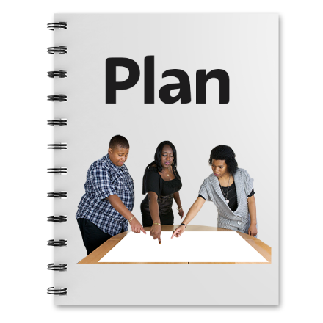
This Easy Read summary tells you about things we are going to do as part of the Rare Disorders Strategy.

Our vision

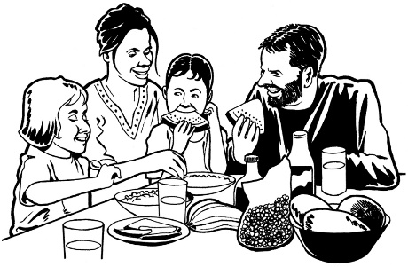
Our vision is for everyone with a rare disorder / their whānau /family to share in pae ora / healthy futures.


A vision is an idea about what you want the future / years ahead to look like.

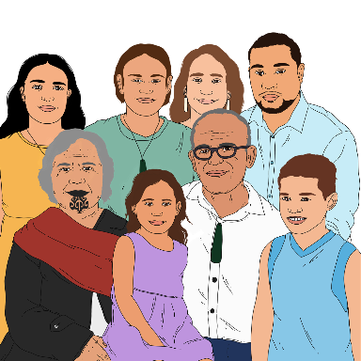
To do this we will need to work with:
people with rare disorders / their whānau / family

people who work as part of the health system
support people
communities.

Why we need a Rare Disorders Strategy

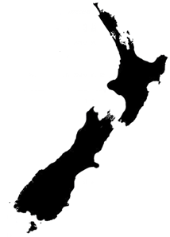
About 3 hundred thousand New Zealanders live with a rare disorder.

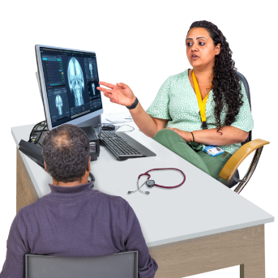
It can be hard for them to get support because of things like:
healthcare being hard to get
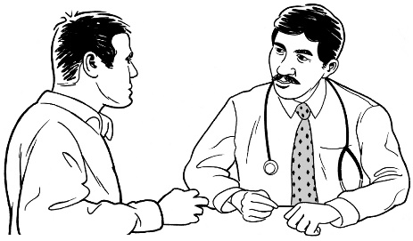
health practitioners like doctors not knowing enough about rare disorders.
?

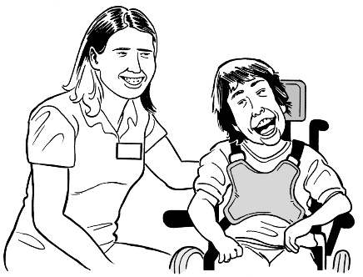
We need a rare disorders strategy so support can be given to the people who need it.

To do this we have created 5 priority areas.
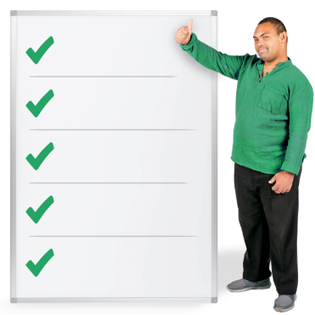
A priority area is a list of things that we need to do first.

Priority 1:
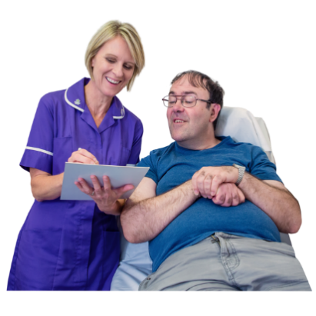

Priority 1 is about setting up the health system to care for people with rare disorders / their whānau / family.

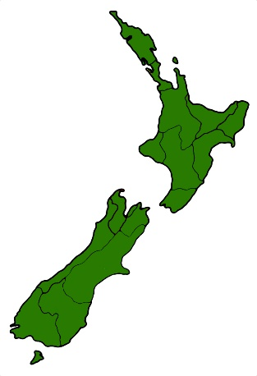
People with rare disorders / their whānau / family often need support from health services throughout New Zealand.

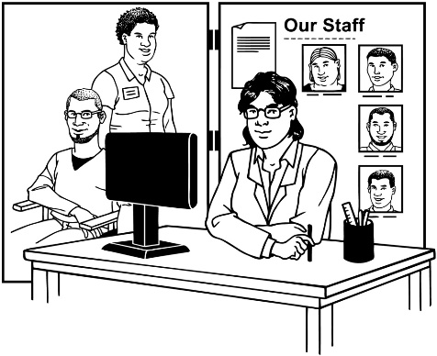
Health practitioners have told us that services need to work together better so that people can get better support.


We will have good leadership that can connect services so people can get better support.

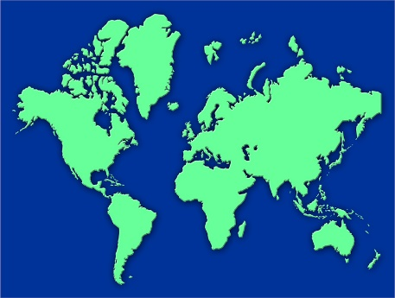
Leaders will also look at what is being done in other countries to see if what they are using could work well in New Zealand.

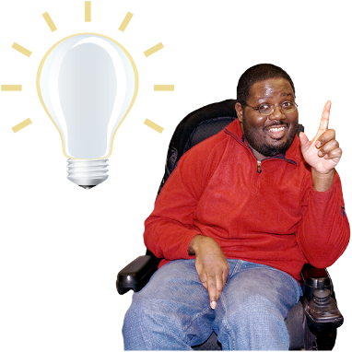
Having good leadership will support everyone in the health system to:
understand rare disorders better
connect services for rare disorders
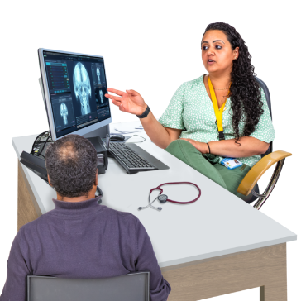
have better / faster ways of:
- diagnosing people which means working out what rare disorder someone has
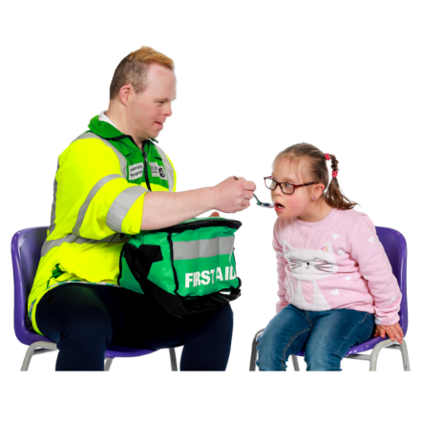
- referring people which means sending someone to another medical professional
- caring for people with rare disorders.
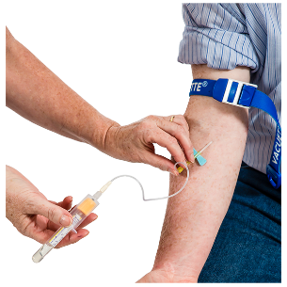
It will take time for us to get the things we need for:
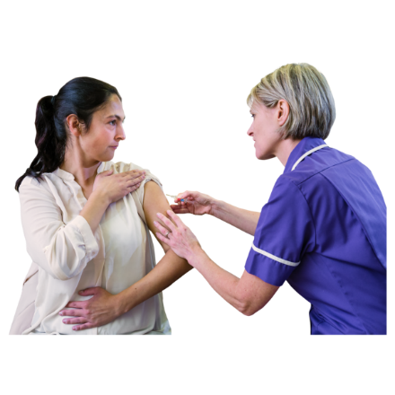
early testing for rare disorders
preventative care which is when we do things to try and stop something happening.

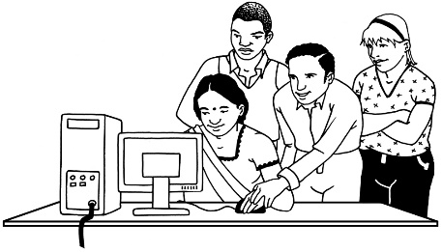
We will learn about new things that may work well in New Zealand.

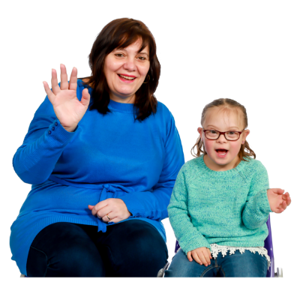
We will work with people with rare disorders / their whānau / family to make sure these new things are good for New Zealanders.

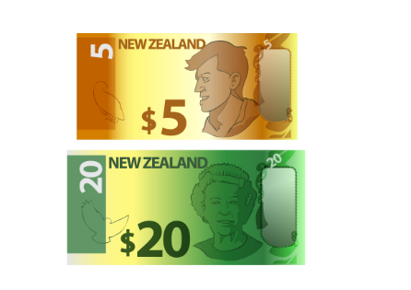
How we choose what to spend money on will look at what will work well for people with rare disorders / their whānau / family.
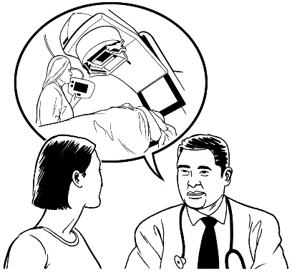
Some of the first things we will do will focus on better access to:
diagnosis
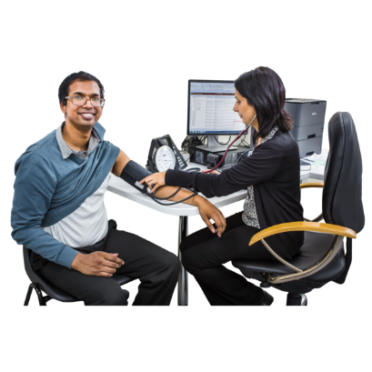
prevention
treatment.

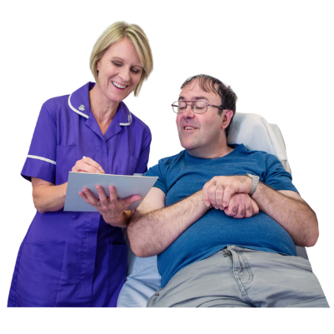
Over time we will also look at how what we do will make a difference to the care of people with rare disorders.

Priority 2
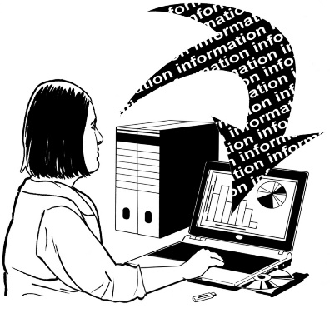

Priority 2 is about collecting information about rare disorders.

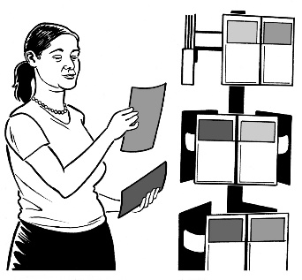
Priority 2 is also about using that information to:
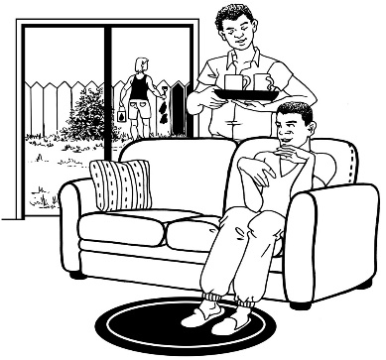
support people with rare disorders
find better ways of caring for people with rare disorders
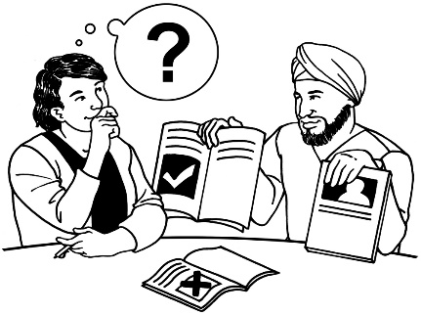
choose what we need to do next
do more research.

At the moment we do not collect much information about rare disorders in New Zealand.

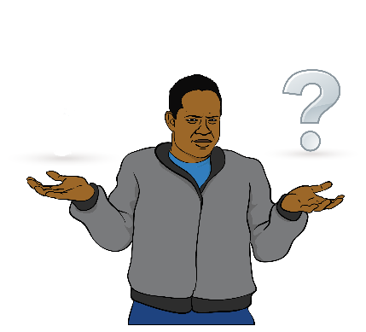
This means we do not know much about rare disorders in New Zealand.

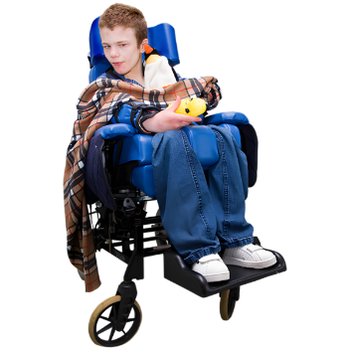
We will start collecting more information about:
rare disorders

illnesses that we do not have names for yet that might be rare disorders.



People with rare disorders / their whānau / family will be able to see:
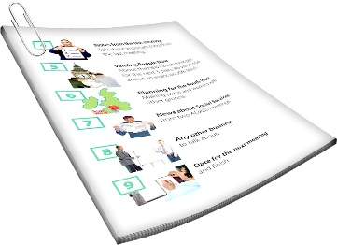
their information
information about rare disorders in Aotearoa New Zealand.
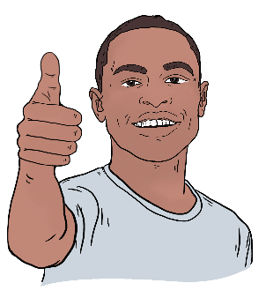

We will use this information to make services for rare disorders better.
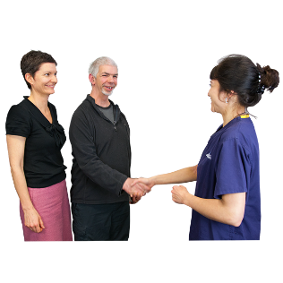
More people getting this information will make it easier to create a better system for people with rare disorders.


Any information we use to create a better system will be anonymous.


Anonymous means that no one can tell the information is about you.

When we choose what to spend money on we will put things that are good for rare disorder patients higher on our list of things to do.
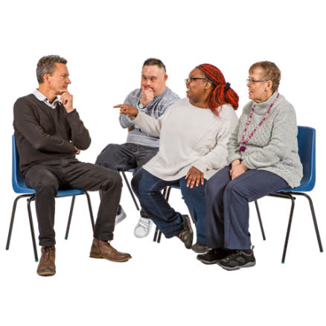

We will check these things work for people with rare disorders instead of just thinking that they do.

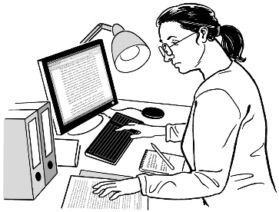
Research into rare disorders will be part of the research done by our health system by:
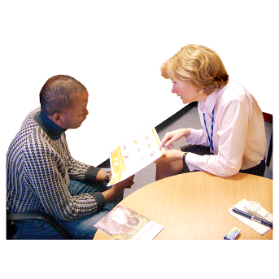
getting the things needed to test new treatments
creating ways to check:
- the cost of doing something
and

- what good things could happen if we do it.

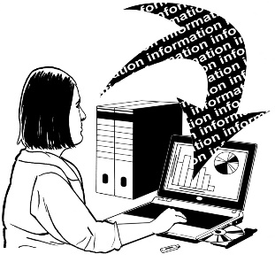
We will add the information we collect to other information we already have.

Priority 3

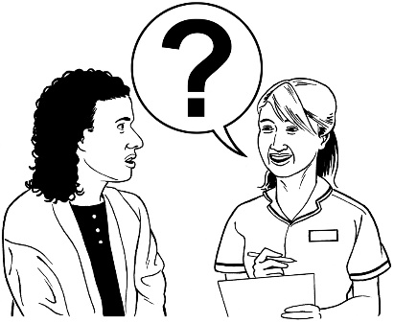
Priority 3 is about making sure our health workers:
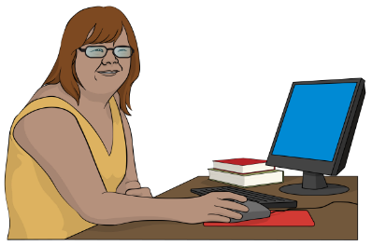
can support people with rare disorders well
learn about rare disorders when they are first studying.



A lot of people / their whānau / family have said:
getting a rare disorder diagnosis takes too long
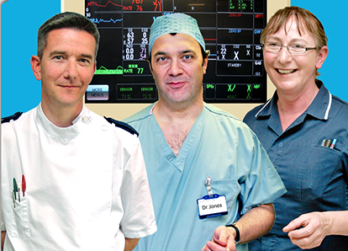
they have to go to a lot of different health practitioners to get a diagnosis.

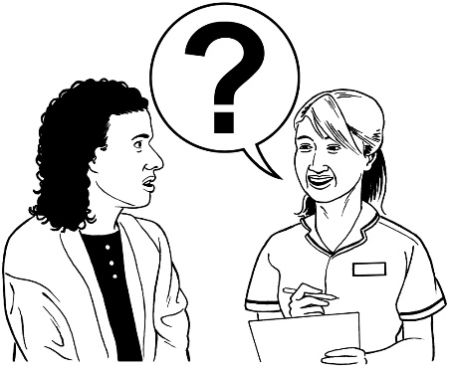
A lot of people with rare disorders / their whānau / family have also said:
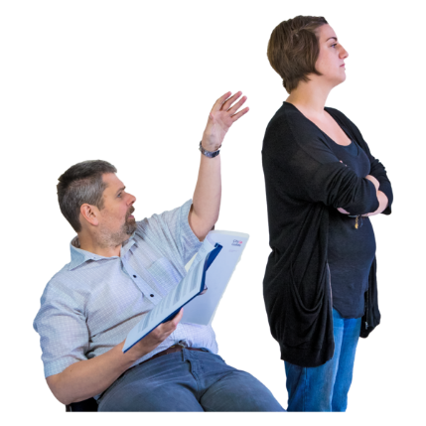
often health practitioners do not know enough about rare disorders
they feel they need to fight to:
- get support
- be heard.
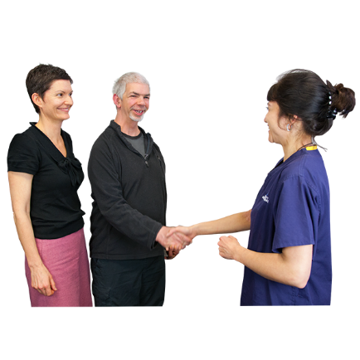

Health practitioners want to support people but often do not have the right:

medical things to do so like medicine
knowledge to do so.

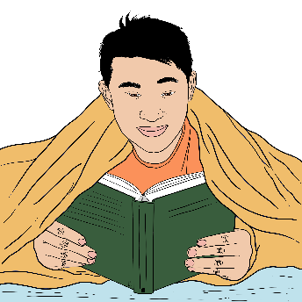
People studying health care at any level will be taught more about:
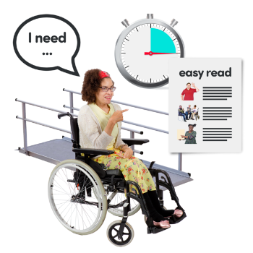
rare disorders
supporting people with different needs
how to find more information about rare disorders.
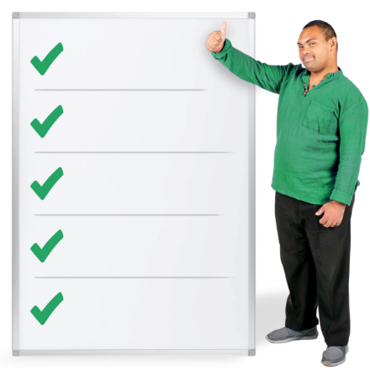

We will create guidelines to support practitioners to know how to best support people with rare disorders.


Guidelines are like instructions that tell practitioners what the next thing they should do is.

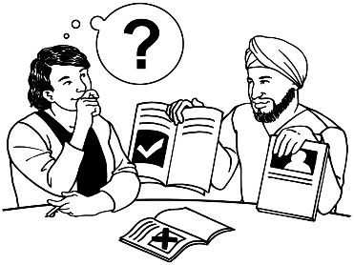
These guidelines will change as we learn more.
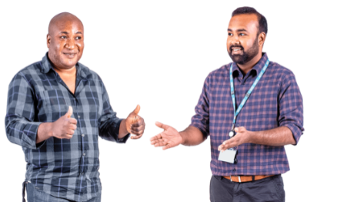
We will need more systems to teach / support practitioners:

in person
online.

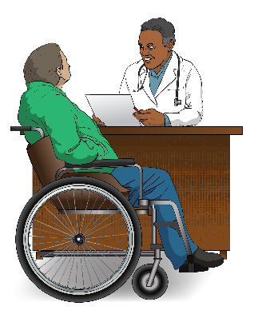
We might need experts to spend more of their time supporting other practitioners.

Priority 4

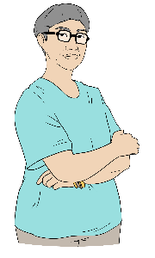
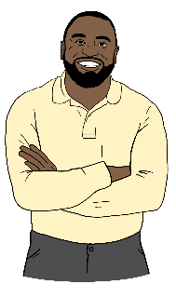
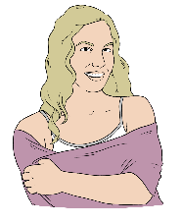
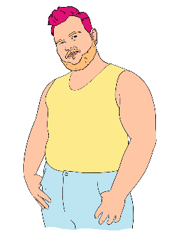
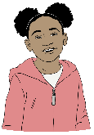
Priority 4 is about listening to people with rare disorders from lots of different communities.


People want people with rare disorders heard in the health system.

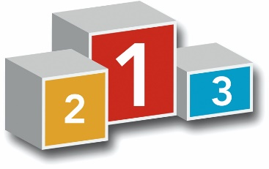
They want the people in charge to make choices that put people with rare disorders first.

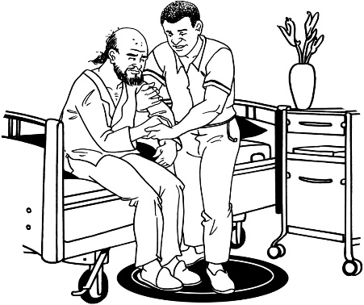
Rare disorder communities feel that the system takes care of people with more common conditions better.

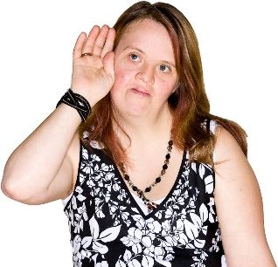
Listening to rare voices more would make their healthcare better.
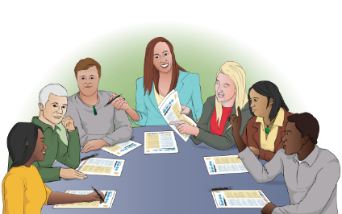
People with rare disorders / their whānau / family will join groups like committees to tell us what they think.

What they tell us will help us to plan what we do next in healthcare.

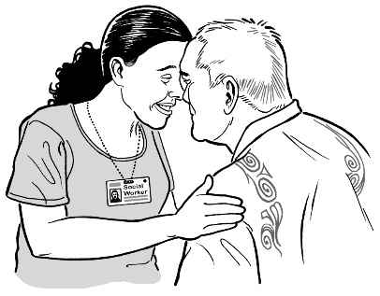
Māori with rare disorders will be treated with manaakitanga by health service providers.

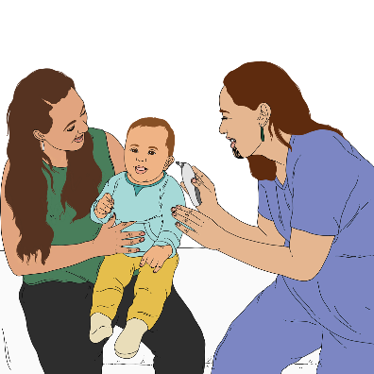
Manaakitanga means they will be treated better by being:
cared for
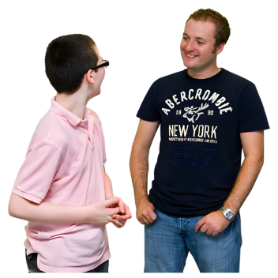
listened to
respected.

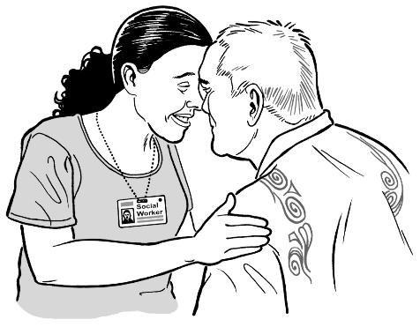
Providers will:
welcome tikanga / māori ways of doing things
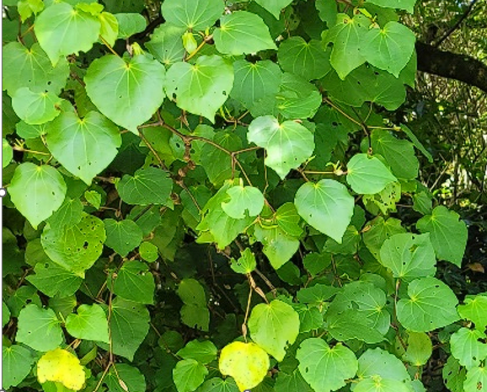
offer choices when possible
use:
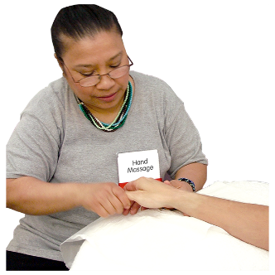
- rongoā Māori / Māori medicine
- mirimiri / massage.

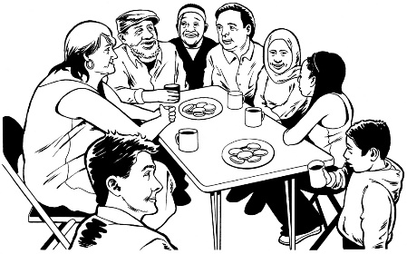
We will support people with rare disorders to be included in their communities.

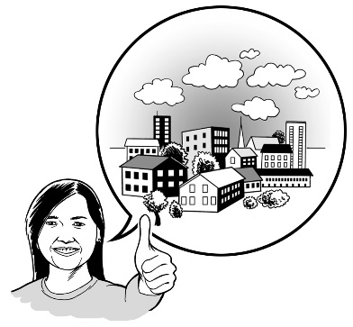
We will look at what the best ways to support these communities are.

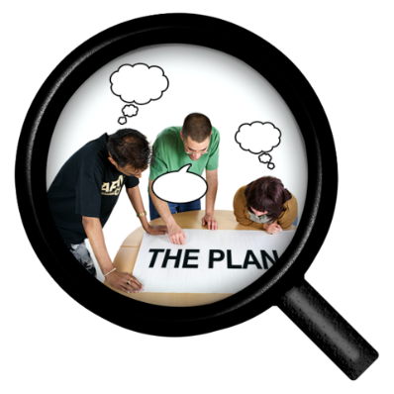
People who have experience of rare disorders will be part of working out what is needed in the community.

Priority 5

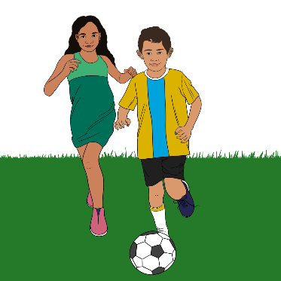
Priority 5 is about:
people with rare disorders being part of their communities
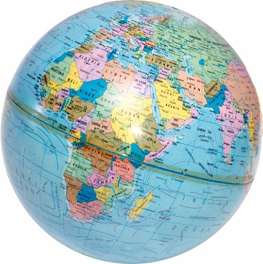
New Zealand working with other countries to learn more about rare disorders.

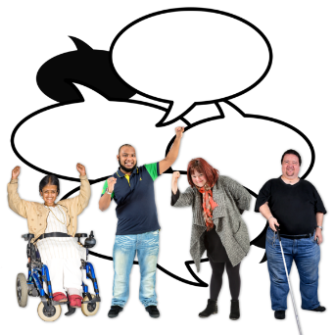
It is important for people with rare disorders to know other people with rare disorders:
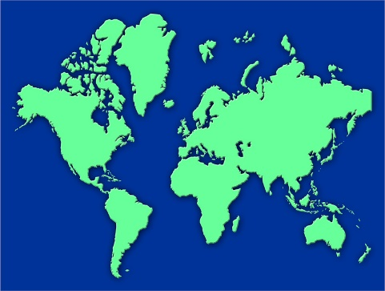
in New Zealand
in other countries.

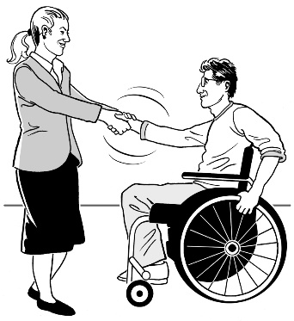
New Zealand will join / create partnerships with other countries around rare disorders to:
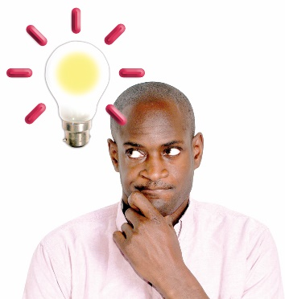
have better health outcomes for people with rare disorders
talk about ideas about rare disorders
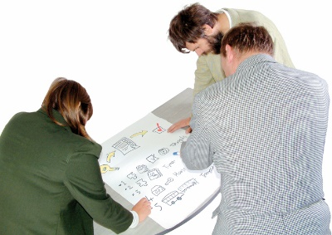
support other countries in their work around:
- new ways of diagnosing rare disorders
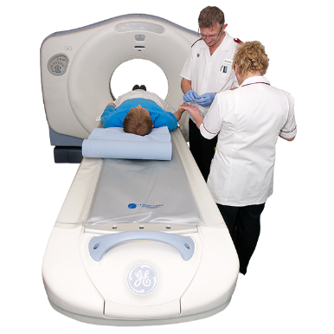
- making treatments / technologies more accessible.

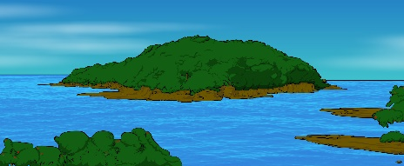
We will also support people with rare disorders in smaller countries like the Pacific islands.

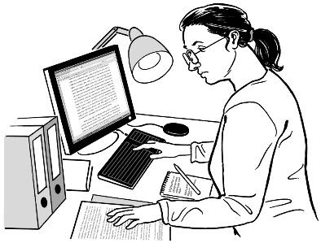
We will use things that other countries have researched in ways that work for New Zealand.
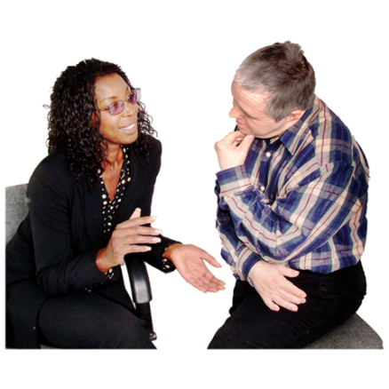

We will need to listen to rare disorder / community voices about what things we want to start using.


We will stay updated on what new things are working in other countries.

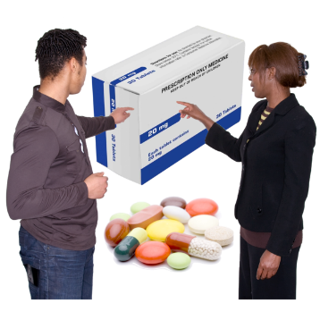
People with rare disorders will be able to join clinical trials in the future.

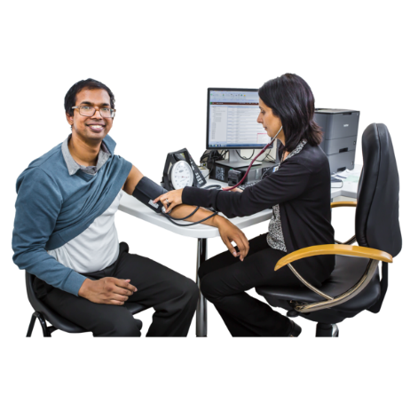
We need to build up the things New Zealand needs to join more clinical trials with other countries.

Clinicians will get support for their patients to be part of some trials.
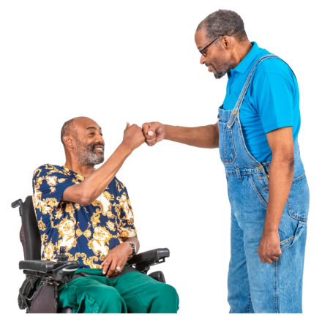
The changes we make will support rare disorder outcomes as well as possible.


We will have a group look at:
laws
ways we do things.

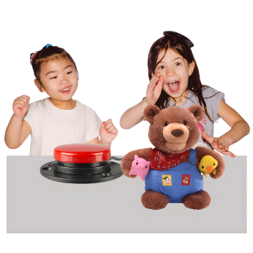
This is so we can make sure that our laws / the ways we do things also make the lives of people with rare disorders better.

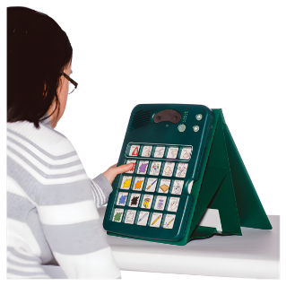
Rules will be needed for new things like:
technologies
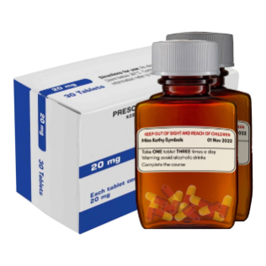
medicines
devices.
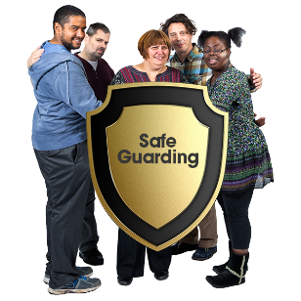
This will make sure access to these things is:
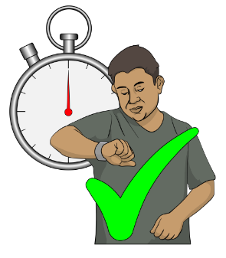
safe
fast.

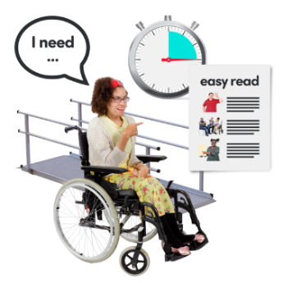
The health system will need to work for people with rare disorders.

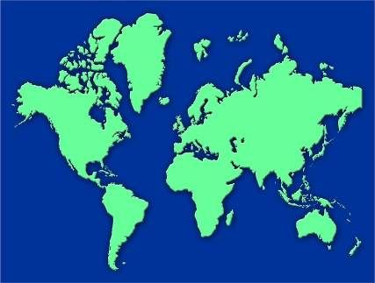
Working with other counties that think the same way will make diagnosis of people with rare disorders quicker.

More information

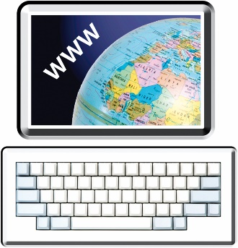
You can find the 3 full versions of the strategy documents on the Ministry of Health website at:

https://bit.ly/4h6LAK4

You can find Easy Read versions of the 3 summaries on the Ministry of Health website at:

https://tinyurl.com/ymevjz6k
This information has been written by the Ministry of Health Manatū Hauora.

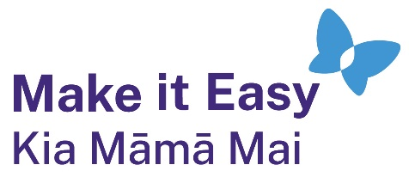
It has been translated into Easy Read by the Make it Easy Kia Māmā Mai service of People First New Zealand Ngā Tāngata Tuatahi.
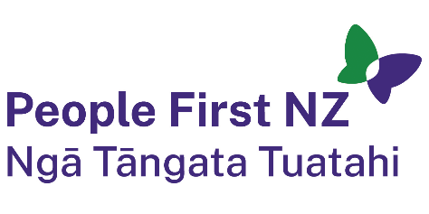
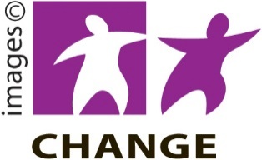
The ideas in this document are not the ideas of People First New Zealand Ngā Tāngata Tuatahi.

Make it Easy uses images from:


- Changepeople.org


            - Photosymbols.com

- SGC Image Works
- Huriana Kopeke-Te Aho
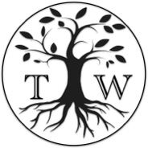
- T. Wood.

All images used in this Easy Read document are subject to copyright rules and cannot be used without permission.

