Office of the Director of Mental Health and Addiction Services

Regulatory Report   
1 July 2022 to 30 June 2023

Citation: Ministry of Health. 2025. *Office of the Director of Mental Health and Addiction Services: Regulatory Report 1 July 2022 to 30 June 2023*. Wellington: Ministry of Health.

Published in February 2025 by the Ministry of Health  
PO Box 5013, Wellington 6140, New Zealand

ISBN 978-1-991324-20-7 (online)  
HP 9113

This document is available at health.govt.nz

|  |  |
| --- | --- |
| **CCBY** | This work is licensed under the Creative Commons Attribution 4.0 International licence. In essence, you are free to: share ie, copy and redistribute the material in any medium or format; adapt ie, remix, transform and build upon the material. You must give appropriate credit, provide a link to the licence and indicate if changes were made. |

# Foreword

Welcome to our regulatory report for the financial year from 1 July 2022 to 30 June 2023. This report presents data about the use of compulsory assessment and treatment legislation in Aotearoa New Zealand under the Mental Health (Compulsory Assessment and Treatment) Act 1992 (the Mental Health Act), as well as related activities under the Intellectual Disability (Compulsory Care and Rehabilitation) Act 2003 (the Intellectual Disability Care Act) and the Misuse of Drugs Act 1975. For more information, see [Mental health and addiction](https://www.health.govt.nz/regulation-legislation/mental-health-and-addiction) on the Ministry of Health – Manatū Hauora website.

The mental health, intellectual disability and addiction workforce in Aotearoa New Zealand continues to demonstrate passion and care for people during times of significant vulnerability, and I truly thank everyone for this. As the demand for services continues to be high, the pressure on our workforce increases. We know there are always improvements to be made to reduce this pressure, and we are working closely with our colleagues in Health New Zealand – Te Whatu Ora to provide sustainable solutions.

As the Director of Mental Health and Addiction, I am responsible for the general administration of the relevant compulsory assessment, care and treatment legislation under the direction of the Minister of Health, the Director-General of Health and, following the establishment of the role in 2023, the Minister for Mental Health. My functions and powers under the Acts listed above, as well as under the Substance Addiction (Compulsory Assessment and Treatment) Act 2017 (the Substance Addiction Act), allow the Ministry of Health to provide guidance and oversight to mental health, addiction and intellectual disability services. It is my role to make sure that when people are under compulsory care or treatment in Aotearoa New Zealand, they are well cared for, their rights are upheld, and their care or treatment services follow all legislative requirements. When needed, I can intervene to ensure this is what people experience.

Since 2005, the Office of the Director of Mental Health and Addiction Services has been reporting each year on the activities we undertake. The main purpose of the report is to present information and statistics that serve as barometers of quality for our mental health, intellectual disability, and addiction services in the context of providing compulsory care. We monitor these services to assure ourselves and the public that people having compulsory assessment, care and treatment under the relevant legislation are receiving high-quality care.

This report shows use of compulsory assessment and treatment remains steady compared with previous years, in line with increases in both the population and service use. The number of people who have been secluded and the total hours people spend in seclusion have decreased, which are positive trends. We remain committed to working with Health New Zealand and Te Tāhū Hauora Health Quality & Safety Commission to reduce and eliminate seclusion, in line with their [Zero Seclusion: Safety and dignity for all](https://www.hqsc.govt.nz/our-work/mental-health-and-addiction-quality-improvement/projects/zero-seclusion-safety-and-dignity-for-all/) project*.* In April 2023, my office published the [*Guidelines for Reducing and Eliminating Seclusion and Restraint under the Mental Health Act*](https://www.health.govt.nz/publications/guidelines-for-reducing-and-eliminating-seclusion-and-restraint-under-the-mental-health-compulsory).[1] As this report covers up to only 30 June 2023, we do not yet have enough evidence to suggest that these guidelines have resulted in practice change. However, the sector has provided positive feedback on the implementation of the guidelines and the support for alternative approaches.

Work has continued on repealing and replacing the current Mental Health Act, as recommended in *He Ara Oranga: Report of the Government Inquiry into Mental Health and Addiction*.[2] The Minister for Mental Health introduced the Mental Health Bill to the House of Representatives in October 2024. For updates on this work, see [Repealing and replacing the Mental Health Act](https://www.health.govt.nz/regulation-legislation/mental-health-and-addiction/repealing-and-replacing-the-mental-health-act) on the Ministry’s website. My office will continue to be involved in the development of the Bill, and we are looking forward to supporting legislation that promotes a recovery and wellbeing approach to care.

We acknowledge that this report has been delayed. To provide more timely reports, we aim to use only data that services submit electronically through the Programme for the Integration of Mental Health Data (PRIMHD). However, because some services use manual data instead of PRIMHD, delays occur in the development of the report. We continue to work with Health New Zealand services to follow the PRIMHD standards more closely so data can be used to better inform services and practice.

To get a full picture of mental health and addiction services in Aotearoa New Zealand, including service use outside of compulsory legislation, I recommend you read this report in conjunction with updates on the Health New Zealand website, in particular the [Mental health and addiction monitoring, reporting and data](https://www.tewhatuora.govt.nz/for-the-health-sector/mental-health-and-addiction/mental-health-and-addiction-monitoring-reporting-and-data) page. The [Ministry of Health’s Annual Report](https://www.health.govt.nz/publications/ministry-of-health-annual-report-for-the-year-ended-30-june-2024) includes information on the use of the Substance Addiction Act, and Te Hiringa Mahara – Mental Health and Wellbeing Commission publishes monitoring reports on the mental health and addiction system, which are available on its [website](http://www.mhwc.govt.nz/).

This year’s report is the first to cover Health New Zealand districts, rather than district health boards. To maintain the ability to compare across years, we have separated the single district of Health New Zealand Capital, Coast and Hutt Valley into two services: Capital & Coast, and Hutt Valley. In this way, data on this district aligns with the previous district health board areas. Future reports will combine data on these services.

My office has close working relationships with Health New Zealand, Whaikaha – Ministry of Disabled People and more recently, due to wider sector changes, the Ministry of Social Development to ensure tāngata whaiora (people seeking health) and tāngata whaikaha (people with disabilities) are receiving a consistent level of high-quality care. While this report highlights areas where the sector has made improvements, sustained focus and efforts are needed to continue to improve the experiences of tāngata whaiora, tāngata whaikaha and their whānau.

Noho ora mai

Dr John Crawshaw

Director of Mental Health and Addiction

Contents

Foreword iii

Context 1

The Mental Health Act process 2

Court applications in 2022/23 2

Compulsory assessment and treatment in 2022/23 2

Compulsory treatment by age and gender 7

Use of the Mental Health Act 8

Compulsory assessment 9

Compulsory treatment orders 9

Length of time people are subject to compulsory treatment orders 12

Family and whānau consultation under the Mental Health Act 14

Indefinite compulsory treatment orders 16

Indefinite community treatment orders 16

Indefinite inpatient treatment orders 19

Seclusion 21

Seclusion in Aotearoa New Zealand mental health services 23

Use of seclusion by district 26

Seclusion and ethnicity 28

Seclusion in forensic units 31

People with intellectual disabilities cared for in an intellectual disability forensic service 32

Special and restricted patients 34

Extended forensic care special patients 35

Short-term forensic care special patients 35

Gender, age and ethnicity of special patients 37

Decisions about leave and change of legal status for special and restricted patients 39

Mental health and addiction adverse event reporting 41

Deaths reported to the Director of Mental Health 42

Section 95 inquiries and section 99 inspections 42

Electroconvulsive therapy 44

Number of people receiving ECT 44

ECT by region 45

Age and gender of people receiving ECT 47

Ethnicity of people treated with ECT 48

Consent to ECT treatment 48

Substance use treatment 50

Opioid substitution treatment 50

Substance Addiction (Compulsory Assessment and Treatment) Act 2017 55

Land Transport Act 1998 56

Drug-checking licensing scheme 56

Appendix 1: The Mental Health Act process 60

Compulsory assessment 60

Compulsory treatment 61

Appendix 2: Additional statistics – Ministry of Justice 62

Appendix 3: Additional seclusion statistics 64

Appendix 4: 2021/22 corrected ECT data 66

List of Figures

Figure 1: Applications and outcomes for compulsory treatment orders and extensions, 2008/09 to 2022/23 3

Figure 2: Number of granted compulsory treatment orders and extensions, community and inpatient, 2008/09 to 2022/23 4

Figure 3: Average number of people on a given day subject to a community treatment order (section 29) per 100,000 population, by district, 1 July 2022 to 30 June 2023 6

Figure 4: Average number of people on a given day subject to an inpatient treatment order (section 30) per 100,000 population, by district, 1 July 2022 to 30 June 2023 6

Figure 5: Number of people subject to compulsory treatment order applications (including extensions) per 100,000 population, by age group, 2008/09 to 2022/23 7

Figure 6: Number of people subject to compulsory treatment order applications (including extensions) per 100,000 population, by gender, 2008/09 to 2022/23 7

Figure 7: Rate ratio of Māori to non-Māori subject to a community treatment order (section 29) under the Mental Health Act per 100,000 population, by district, 1 July 2022 to 30 June 2023 10

Figure 8: Rate ratio of Māori to non-Māori subject to an inpatient treatment order (section 30) under the Mental Health Act per 100,000 population, by district, 1 July 2022 to 30 June 2023 11

Figure 9: Age-standardised rates of people subject to community (section 29) and inpatient (section 30) treatment orders under the Mental Health Act, by gender and ethnicity, 1 July 2022 to 30 June 2023 12

Figure 10: Total time spent subject to a community treatment order (section 29) under the Mental Health Act in the last three years, by ethnicity, for those with a current order in the year 1 July 2022 to 30 June 2023 13

Figure 11: Total time spent subject to an inpatient treatment order (section 30) under the Mental Health Act in the last three years, by ethnicity, for those with a current order in the year 1 July 2022 to 30 June 2023 13

Figure 12: Average percentage of family and whānau consultation for particular assessment or treatment events nationally, sections 10, 12, 14 and 76–78, 1 July 2022 to 30 June 2023 14

Figure 13: Average percentage of family and whānau consultation across all assessment and treatment events, by district, 1 July 2022 to 30 June 2023 15

Figure 14: Reasons for not consulting families and whānau, 1 July 2022 to 30 June 2023 15

Figure 15: Number of people subject to indefinite community treatment orders per 100,000 population, by district, at 30 June 2023 17

Figure 16: Rate ratio of Māori to non-Māori subject to indefinite community treatment orders per 100,000 population, by district, at 30 June 2023 18

Figure 17: Number of people subject to indefinite community treatment orders, by gender and ethnicity, at 30 June 2023 18

Figure 18: Number of people subject to indefinite inpatient treatment orders per 100,000 population, by district, at 30 June 2023 19

Figure 19: Rate ratio of Māori to non-Māori subject to indefinite inpatient treatment orders per 100,000 population, by district, at 30 June 2023 20

Figure 20: Number of people secluded in adult inpatient services nationally, 2007 to 2022/23 22

Figure 21: Number of seclusion hours in adult inpatient services nationally, 2007 to 2022/23 22

Figure 22: Number of people secluded across all inpatient services (adult, forensic, intellectual disability and youth), by age group, 1 July 2022 to 30 June 2023 24

Figure 23: Rate of people secluded across all inpatient services (adult, forensic, intellectual disability and youth) per 100,000 population, by age group, 1 July 2022 to 30 June 2023 24

Figure 24: Number of seclusion events across all inpatient services (adult, forensic, intellectual disability and youth), by length of event, 1 July 2022 to 30 June 2023 25

Figure 25: Number of seclusion events across all inpatient services (adult, forensic, intellectual disability and youth), by ethnicity and length of event, 1 July 2022 to 30 June 2023 25

Figure 26: Number of people secluded in adult inpatient services per 100,000 population, by district, 1 July 2022 to 30 June 2023 27

Figure 27: Number of seclusion events in adult inpatient services per 100,000 population, by district, 1 July 2022 to 30 June 2023 28

Figure 28: Number of people secluded in adult inpatient services, by ethnicity and year, from 1 July 2020 to 30 June 2023 29

Figure 29: Seclusion indicators for adult inpatient services, by ethnicity, 1 July 2022 to 30 June 2023 29

Figure 30: Percentage of people secluded in adult inpatient services, by ethnicity and gender, 1 July 2022 to 30 June 2023 30

Figure 31: Number of Māori and non-Māori secluded in adult inpatient services, 2007 to 2022/23 30

Figure 32: Seclusion indicators for forensic mental health services, by ethnicity, 1 July 2022 to 30 June 2023 32

Figure 33: Total number of special patients, by regional service, 1 July 2022 to 30 June 2023 35

Figure 34: Percentage of court orders given for extended and short-term forensic care, by regional service, 1 July 2022 to 30 June 2023 37

Figure 35: Number of special patients, by gender, 1 July 2022 to 30 June 2023 37

Figure 36: Total number of special patients, by age group, 1 July 2022 to 30 June 2023 38

Figure 37: Percentage (and number) of special patients, by ethnicity and special patient type, 1 July 2022 to 30 June 2023 38

Figure 38: Number of ECT patients per 100,000 population, 2005 to 2022/23 44

Figure 39: Number of people per 100,000 population treated with ECT, by district of domicile, 1 July 2022 to 30 June 2023 46

Figure 40: Number of ECT treatments per 100,000 population, by district of domicile, 1 July 2022 to 30 June 2023 46

Figure 41: Number of people treated with ECT per 100,000 population, by district of domicile, 1 July 2022 to 30 June 2023 47

Figure 42: Number of people treated with ECT, by age group and gender, 1 July 2022 to 30 June 2023 47

Figure 43: Percentage of people receiving opioid substitution therapy from specialist services and general practitioners, by district, 1 July 2022 to 30 June 2023 52

Figure 44: Number of people receiving opioid substitution therapy from a specialist service, general practitioner or prison service, 2007/08 to 2022/23 52

Figure 45: Number of people prescribed suboxone, 2007/08 to 2022/23 53

Figure 46: Number of opioid substitution treatment clients, by age group, 2007/08 to 2022/23 54

Figure 47: Percentage of exits from opioid substitution treatment programmes, by reason (voluntary, involuntary or death), 2008/09 to 2022/23 55

Figure 48: Number of samples tested and of individuals given harm reduction advice, nationally, 1 October 2022 to 30 June 2023 57

Figure 49: Drug types presented to drug-checking services, as presumed by client, nationally, 1 October 2022 to 30 June 2023 58

Figure 50: Percentage of presumed drug types consistent with the confirmed drug type results, 1 October 2022 to 30 June 2023 59

List of Tables

Table 1: Average number of people each month required to undergo assessment under section 11, 13 or 15 of the Mental Health Act per 100,000 population, by district, 1 July 2022 to 30 June 2023 5

Table 2: Average number of people on a given day subject to a compulsory treatment order under section 29, 30 or 31 of the Mental Health Act per 100,000 population, by district, 1 July 2022 to 30 June 2023 5

Table 3: Number and rate of people required to undergo assessment under section 11, 13 or 15 of the Mental Health Act, by ethnicity, 1 July 2022 to 30 June 2023 9

Table 4: Number and rate of people subject to a compulsory treatment order under section 29 or 30 of the Mental Health Act, by ethnicity, 1 July 2022 to 30 June 2023 9

Table 5: Age-standardised rates of people subject to community (section 29) and inpatient (section 30) treatment orders under the Mental Health Act, by gender and ethnicity, 1 July 2022 to 30 June 2023 11

Table 6: Rate ratio of Māori to non-Māori subject to indefinite community treatment orders per 100,000 population, by district, at 30 June 2023 17

Table 7: Rate ratio of Māori to non-Māori subject to indefinite inpatient treatment orders per 100,000 population, by district, at 30 June 2023 20

Table 8: Percentage of admissions to adult inpatient services with seclusion recorded during admission, by district, 1 July 2022 to 30 June 2023 26

Table 9: Seclusion indicators for forensic mental health services, by regional service, 1 July 2022 to 30 June 2023 31

Table 10: Seclusion indicators for people with intellectual disabilities, nationally, 1 July 2022 to 30 June 2023 33

Table 11: Length of seclusion for people with intellectual disabilities, nationally, 1 July 2022 to 30 June 2023 33

Table 12: Seclusion indicators for Māori and non-Māori with intellectual disabilities, nationally, 1 July 2022 to 30 June 2023 33

Table 13: Total number of special patients, by type and service, 1 July 2022 to 30 June 2023 36

Table 14: Number of applications for granting section 50A long leave, revoking that leave and reclassifying legal status that the Minister of Health received for special and restricted patients, 1 July 2022 to 30 June 2023 40

Table 15: Outcomes of reportable death notifications under section 132 of the Mental Health Act, 1 July 2022 to 30 June 2023 42

Table 16: Number of section 95 inquiries completed and section 99 inspections reports received or completed by the Director, 2012/13 to 2022/23 43

Table 17: ECT indicators, by region of domicile, 1 July 2022 to 30 June 2023 45

Table 18: Number of people treated with ECT and rate per 100,000 population, by ethnicity, 1 July 2022 to 30 June 2023 48

Table 19: ECT administered under second opinion without consent, by region of service, 1 July 2022 to 30 June 2023 49

Table A1: Applications for compulsory treatment orders or extensions, 2008/09 to 2022/23 62

Table A2: Types of compulsory treatment orders made on granted applications, 2008/09 to 2022/23 63

Table A3: Seclusion indicators including outlier data, 1 July 2022 to 30 June 2023 65

Table A4: Corrected ECT indicators, by district health board of domicile, 1 July 2021 to 30 June 2022 66

# Context

The following summarises the use of the Mental Health (Compulsory Assessment and Treatment) Act 1992 (Mental Health Act) in the financial year from 1 July 2022 to 30 June 2023. It provides a broad overview of how compulsory mental health legislation is operating in Aotearoa New Zealand.[3]

* 11,041 people (6.2% of specialist mental health and addiction service users) were subject to the Mental Health Act.[4]
* Out of all people using specialist mental health and addiction services, 93.8% engaged voluntarily rather than under compulsion.
* About 5,520 people were subject to either compulsory assessment or compulsory treatment under the Mental Health Act on the last day of the 2022/23 year.
* Males were more likely to be subject to the Mental Health Act than females.
* Across the different age groups, people aged 25–34 years were the most likely to be subject to compulsory treatment, and people aged 65 years and over were the least likely.
* Māori were more likely to be assessed or treated under the Mental Health Act than Pacific peoples and other ethnicities.[5]
* Most people subject to compulsory treatment are based in the community (approximately 85% in 2022/23).

# The Mental Health Act process

## Court applications in 2022/23

In the 2022/23 financial year, clinicians made 6,312 applications for compulsory treatment orders (CTOs) or extensions under the Mental Health Act. Of these applications, the courts granted 5,605 (88.8%). Appendix 1 describes the Mental Health Act process and Appendix 2 presents a time series of CTO application data.

A total of 1,359 applications were filed for a judge’s review of the patient’s condition, in line with section 16 of the Mental Health Act. Of these applications, judges issued an order to release a person from their CTO in 37 cases (2.7%) and confirmed that the order would continue in 713 applications (52.5%). The remaining applications were withdrawn.[6]

## Compulsory assessment and treatment in 2022/23

On the last day of the 2022/23 financial year, a total of 5,520 people were subject to either compulsory assessment or compulsory treatment under the Mental Health Act.[7]

On average[8] within each month, the assessment provisions of the Mental Health Act were applied as follows.

|  |  |  |
| --- | --- | --- |
| **Section 11** | 635 people were subject to an initial assessment | 12 people per 100,000 population |
| **Section 13** | 693 people were subject to a second period of assessment | 13 people per 100,000 population |
| **Section 15** | 514 people were subject to an application for a CTO | 10 people per 100,000 population |

Notes: In previous years, ‘Section 15’ was labelled ‘Section 14(4)’, a section that is no longer coded for in PRIMHD. The data presented here remains comparable with previous years. Section 15 includes subsections (1) and (2). These provisions describe similar circumstances in which a patient is waiting for a court decision on compulsory treatment.

Sources: PRIMHD data (extracted 28 February 2024) and manual data for Health New Zealand Waikato.

This data is relatively steady compared with the previous financial year.

In Aotearoa New Zealand, on an average day in the 2022/23 financial year, the treatment provisions of the Mental Health Act were applied as follows.

|  |  |  |
| --- | --- | --- |
| **Section 29** | 4,756 people were subject to a community treatment order | 91 people per 100,000 population |
| **Section 30** | 866 people were subject to an inpatient treatment order | 17 people per 100,000 population |
| **Section 31** | 245 people were on temporary leave from an inpatient unit | 5 people per 100,000 population |

Sources: PRIMHD data (extracted 28 February 2024) and manual data for Health New Zealand Counties Manukau, Tairāwhiti and Waikato.

Compared with the previous financial year, 2022/23 saw a slight increase in the rate of people subject to section 30 (15 per 100,000 population) and section 31 (3 per 100,000). Over the same time, the number of people subject to a community treatment order has decreased from 96 to 91 people per 100,000 people in the general population.

Figure 1 shows the number of CTOs and extensions that clinicians have applied for and courts have granted since 2008/09. It also shows the number of applications dismissed or withdrawn.

Figure 1: Applications and outcomes for compulsory treatment orders and extensions, 2008/09 to 2022/23

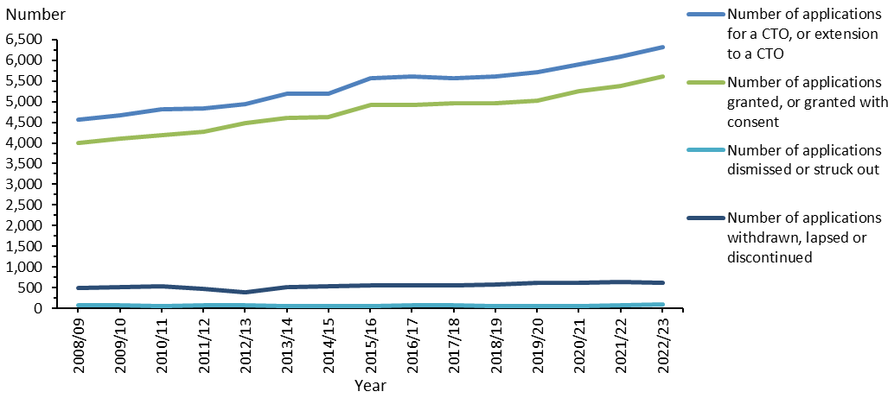

Notes: This figure is based on data entered into the Ministry of Justice’s case management system (CMS), which is a live operational database. Figures are subject to minor changes at any time.

Source: Ministry of Justice Integrated Sector Intelligence System data (extracted 6 March 2024).

Figure 2 shows the number of applications for community and inpatient treatment orders that courts have granted since 2008/09.

Figure 2: Number of granted compulsory treatment orders and extensions, community and inpatient, 2008/09 to 2022/23

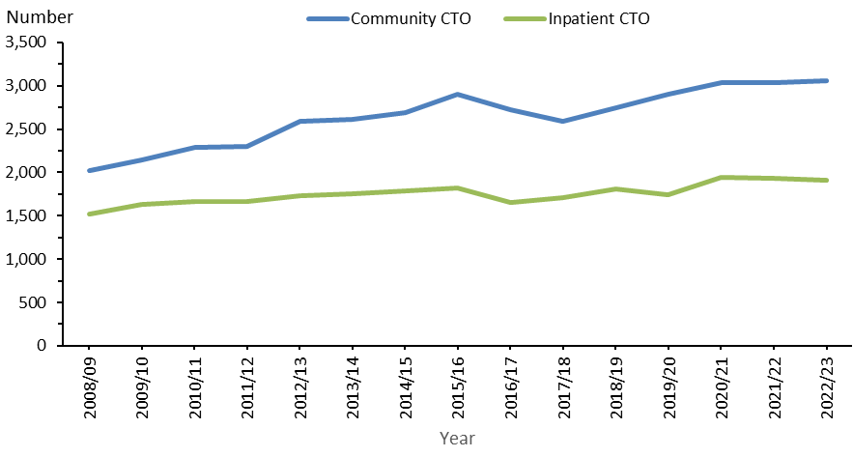

Notes: This figure is based on data entered into the CMS, which is a live operational database. Figures are subject to minor changes at any time.

Source: Ministry of Justice Integrated Sector Intelligence System data (extracted 6 March 2024).

Comparing compulsory assessment and treatment among districts Table 1 shows the average number of people per month in 2022/23 who were required to undergo assessment under the Mental Health Act in each district. Table 2 shows the average number of people subject to a CTO on a given day in the same period in each district. The following figures present the average number of people subject to a CTO on a given day, focusing specifically on either community treatment orders (Figure 3) or inpatient treatment orders (Figure 4).

Table 1: Average number of people each month required to undergo assessment under section 11, 13 or 15 of the Mental Health Act per 100,000 population, by district, 1 July 2022 to 30 June 2023

| **District** | **s 11** | **s 13** | **s 15** |  | **District** | **s 11** | **s 13** | **s 15** |
| --- | --- | --- | --- | --- | --- | --- | --- | --- |
| Auckland | 17 | 19 | 16 |  | Northland | 14 | 16 | 13 |
| Bay of Plenty | 14 | 13 | 6 |  | South Canterbury | 4 | 4 | 3 |
| Canterbury | 12 | 13 | 10 |  | Southern | 9 | 10 | 7 |
| Capital & Coast | 11 | 13 | 11 |  | Tairāwhiti | 16 | 13 | 5 |
| Counties Manukau | 9 | 12 | 9 |  | Taranaki | 14 | 13 | 7 |
| Hawke’s Bay | 12 | 10 | 7 |  | Waikato | 21 | 20 | 14 |
| Hutt Valley | 16 | 17 | 10 |  | Wairarapa | 5 | 1 | 6 |
| Lakes | 11 | 9 | 7 |  | Waitematā | 11 | 13 | 10 |
| MidCentral | 10 | 10 | 9 |  | West Coast | 6 | 6 | 4 |
| Nelson Marlborough | 11 | 12 | 10 |  | Whanganui | 12 | 12 | 6 |
|  |  |  |  |  | **National average** | **12** | **13** | **10** |

Notes: Section 15 includes PRIMHD records for its subsections (1) and (2). These section 15 provisions describe similar circumstances in which a patient is waiting for a court decision on compulsory treatment. As these figures are averages, some services may have higher volumes under section 13 than under section 11.

Sources: PRIMHD data (extracted 28 February 2024) and manual data for Health New Zealand Waikato.

Table 2: Average number of people on a given day subject to a compulsory treatment order under section 29, 30 or 31 of the Mental Health Act per 100,000 population, by district, 1 July 2022 to 30 June 2023

| **District** | **s 29** | **s 30** | **s 31** |  | **District** | **s 29** | **s 30** | **s 31** |
| --- | --- | --- | --- | --- | --- | --- | --- | --- |
| Auckland | 108 | 16 | 1 |  | Northland | 150 | 10 | 2 |
| Bay of Plenty | 56 | 16 | 5 |  | South Canterbury | 85 | 3 | 1 |
| Canterbury | 51 | 14 | 6 |  | Southern | 65 | 10 | 2 |
| Capital & Coast | 190 | 47 | 6 |  | Tairāwhiti | 55 | 4 | 6 |
| Counties Manukau | 69 | 16 | 1 |  | Taranaki | 97 | 4 | 1 |
| Hawke’s Bay | 198 | 26 | 19 |  | Waikato | 80 | 14 | 8 |
| Hutt Valley | 83 | 11 | 2 |  | Wairarapa | 88 | 7 | 2 |
| Lakes | 80 | 5 | 2 |  | Waitematā | 85 | 10 | 1 |
| MidCentral | 127 | 12 | 3 |  | West Coast | 80 | 4 | 1 |
| Nelson Marlborough | 71 | 6 | 0 |  | Whanganui | 128 | 28 | 3 |
|  |  |  |  |  | **National average** | **91** | **17** | **5** |

Note: ‘On a given day’ is the average of the last day of each month.

Sources: PRIMHD data (extracted 28 February 2024) and manual data for Health New Zealand Counties Manukau, Tairāwhiti and Waikato.

Figure 3: Average number of people on a given day subject to a community treatment order (section 29) per 100,000 population, by district, 1 July 2022 to 30 June 2023

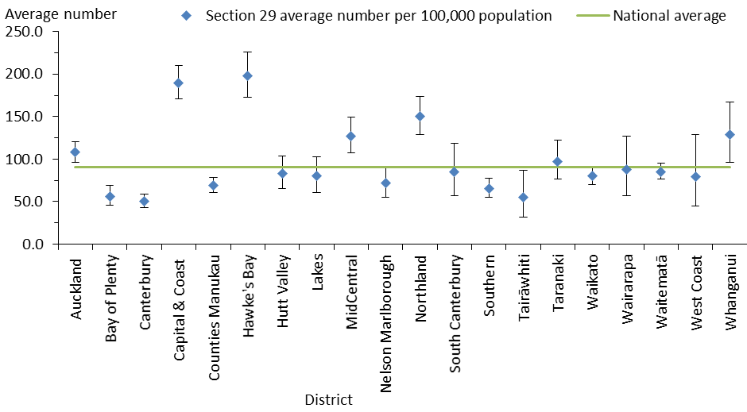

Notes: ‘On a given day’ is the average of the last day of each month. In this figure, the confidence intervals (for 99% confidence, shown as vertical lines through the blue diamond markers) can help with interpreting the data. Where a district’s confidence interval crosses the national average, that means its rate was not statistically different from the average.

Sources: PRIMHD data (extracted 28 February 2024) and manual data for Health New Zealand Counties Manukau, Tairāwhiti and Waikato.

Figure 4: Average number of people on a given day subject to an inpatient treatment order (section 30) per 100,000 population, by district, 1 July 2022 to 30 June 2023

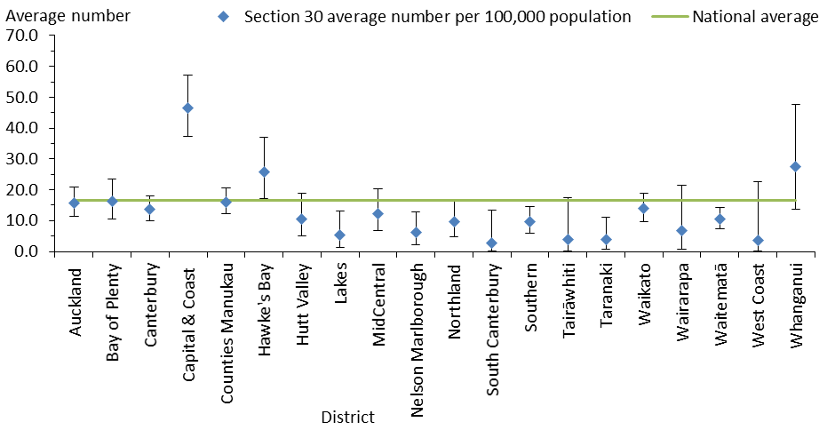

Notes: ‘On a given day’ is the average of the last day of each month. In this figure, the confidence intervals (for 99% confidence, shown as vertical lines through the blue diamond markers) can help with interpreting the data. Where a district’s confidence interval crosses the national average, that means its rate was not statistically different from the average.

Sources: PRIMHD data (extracted 28 February 2024) and manual data for Health New Zealand Counties Manukau, Tairāwhiti and Waikato.

## Compulsory treatment by age and gender

Among the age groups of people aged 15 years and over, those aged 25–34 years were the most likely to be subject to a CTO application (209.6 people per 100,000 population). People aged 65 years or over were the least likely (65.2 per 100,000) (Figure 5).

Figure 5: Number of people subject to compulsory treatment order applications (including extensions) per 100,000 population, by age group, 2008/09 to 2022/23

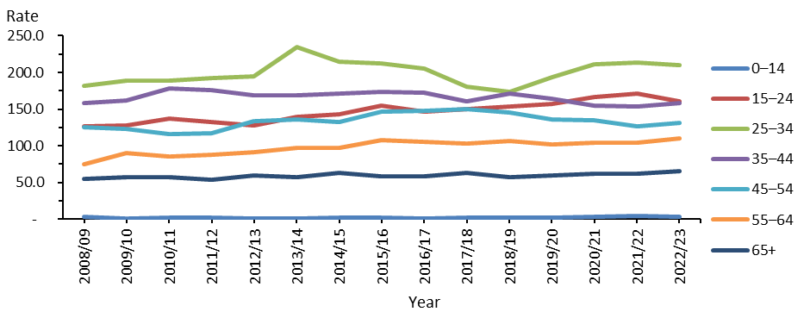

Notes: This figure is based on data entered into the CMS, which is a live operational database. Figures are subject to minor changes at any time.

Source: Ministry of Justice Integrated Sector Intelligence System data (extracted 6 March 2024).

Males were more likely to be subject to a CTO application (126 per 100,000 population) than females (87 per 100,000), as Figure 6 shows.

Figure 6: Number of people subject to compulsory treatment order applications (including extensions) per 100,000 population, by gender, 2008/09 to 2022/23

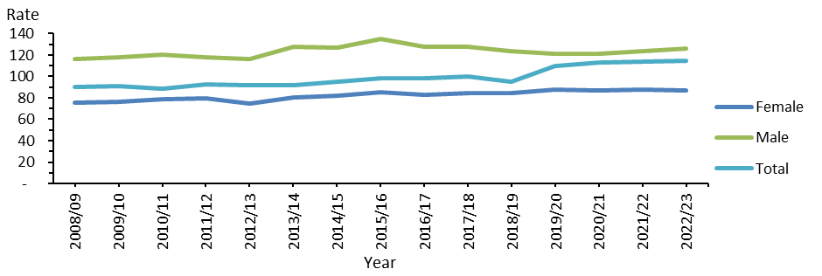

Notes: Due to the design of the system, this figure represents only two gender categories. The CMS includes an ‘other’ category; however, the size of this group is too small to appear here.

Source: Ministry of Justice Integrated Sector Intelligence System data (extracted 6 March 2024).

# Use of the Mental Health Act

This section presents statistics on people receiving care under the Mental Health Act. This information underlines the need for mental health services to take meaningful actions to address the disparity in outcomes for Māori and Pacific peoples in Aotearoa New Zealand.

The following summarises data on the use of the Mental Health Act from 1 July 2022 to 30 June 2023.[9]

* 5.8% of Māori accessed specialist mental health and addiction services, compared with 2.9% of non-Māori.
* Māori were 2.0 times more likely than Pacific peoples and 4.2 times more likely than other ethnicities to be subject to a community treatment order (section 29).[10]
* Māori were 1.7 times more likely than Pacific peoples and 4.2 times more likely than other ethnicities to be subject to an inpatient treatment order (section 30).
* Of all population groups, Māori men were the most likely to be subject to community and inpatient treatment orders.
* Districts varied in their ratio of Māori, Pacific peoples and other ethnicities subject to community and inpatient treatment orders.
* On average, Māori, Pacific peoples and other ethnicities remained on community and inpatient treatment orders for similar lengths of time.
* Māori were 2.7 times more likely to be subject to indefinite community treatment orders than non-Māori, and 3.8 times more likely to be subject to indefinite inpatient treatment orders than non-Māori.
* Māori made up about 17% of Aotearoa New Zealand’s population, yet they accounted for 29% of all mental health service users.
* Pacific peoples made up about 7% of Aotearoa New Zealand’s population and accounted for 6% of all mental health service users.
* Among service users, 28.9% of Māori, 27.2% of Pacific peoples and 27.5% of other ethnicities were aged under 20 years.
* Among people who were under a community treatment order, 47% of Māori and 50% of Pacific peoples were living in the most socioeconomically deprived areas (quintile 5), compared with 26% of non-Māori, non-Pacific peoples.[11]

## Compulsory assessment

In the 2022/23 financial year, Māori were more likely to undergo compulsory assessment than other ethnicities. Table 3 shows the number of people subject to compulsory mental health assessment on a national level by ethnicity and the rate per 100,000 people in the general population.

Table 3: Number and rate of people required to undergo assessment under section 11, 13 or 15 of the Mental Health Act, by ethnicity, 1 July 2022 to 30 June 2023

|  |  |  |  |  |  |  |
| --- | --- | --- | --- | --- | --- | --- |
|  | **Section 11** | | **Section 13** | | **Section 15** | |
| **Ethnicity** | **Number** | **Rate** | **Number** | **Rate** | **Number** | **Rate** |
| Māori | 2,245 | 248.7 | 1,988 | 220.2 | 1,456 | 161.3 |
| Pacific peoples | 359 | 97.8 | 366 | 99.8 | 305 | 83.1 |
| Other | 3,331 | 84.1 | 2,907 | 73.4 | 1,984 | 50.1 |
| **All** | **5,935** | **113.5** | **5,261** | **100.6** | **3,745** | **71.6** |

Notes: Section 15 data includes PRIMHD records for its subsections (1) and (2). These section 15 provisions describe similar circumstances in which a patient is waiting for a court decision on compulsory treatment.

Sources: PRIMHD data (extracted 28 February 2024) and manual data from Health New Zealand Waikato.

## Compulsory treatment orders

Table 4 shows that Māori were more likely to be subject to community and inpatient treatment orders than Pacific peoples and other ethnicities. These figures represent the number of people who were subject to a CTO during the 2022/23 financial year, rather than the number of CTOs issued for the year.

Table 4: Number and rate of people subject to a compulsory treatment order under section 29 or 30 of the Mental Health Act, by ethnicity, 1 July 2022 to 30 June 2023

|  |  |  |  |  |
| --- | --- | --- | --- | --- |
|  | **Section 29** | | **Section 30** | |
| **Ethnicity** | **Number** | **Rate** | **Number** | **Rate** |
| Māori | 2,763 | 306.1 | 928 | 102.8 |
| Pacific peoples | 618 | 168.4 | 232 | 63.2 |
| Other | 3,444 | 87.0 | 1,182 | 29.9 |
| **All** | **6,825** | **130.5** | **2,342** | **44.8** |

Sources: PRIMHD data (extracted 28 February 2024) and manual data from Health New Zealand Counties Manukau, Tairāwhiti and Waikato.

The following figures show the rate ratio of Māori to non-Māori subject to community treatment orders (Figure 7) and inpatient treatment orders (Figure 8) per 100,000 people in the general population for each district. Table 5 and Figure 9 then present the age-standardised ratio for both community and inpatient treatment orders by ethnicity and gender.

It is difficult to interpret the range of rates because the proportions of different ethnic groups within a population vary greatly across districts, so it is hard to define a standard rate ratio for a given population or district. However, to help with comparing rates, each figure includes a line of ‘no difference’ to indicate where Māori and non-Māori would be subject to CTOs at the same rate (ie, a 1:1 ratio). Therefore, the further a ratio is away from the ‘no difference’ line, the more disparity there is. The great variation between districts, as the figures show, emphasises the need for in-depth, area-specific knowledge to understand why these differences occur and how to address them at a local level.

Figure 7: Rate ratio of Māori to non-Māori subject to a community treatment order (section 29) under the Mental Health Act per 100,000 population, by district, 1 July 2022 to 30 June 2023

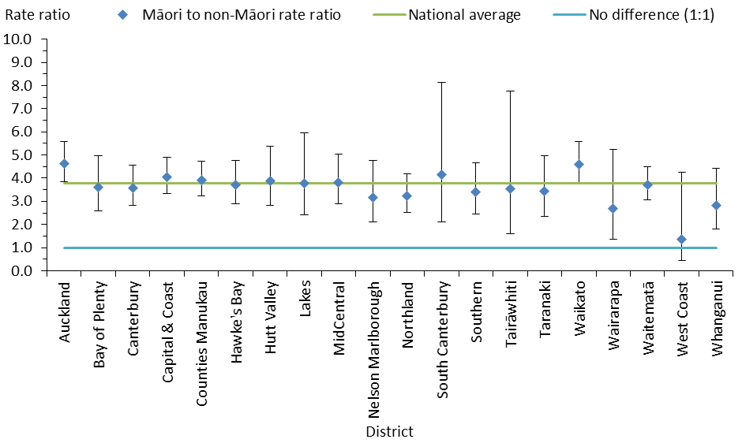

Notes: In this figure, confidence intervals (for 99% confidence, shown as vertical lines through the blue diamond markers) can help with interpreting the data. Where a district’s confidence interval crosses the national average, that means its rate per 100,000 is not statistically different from the average. These are age-standardised rates.

Source: PRIMHD data (extracted 28 February 2024).

Figure 8: Rate ratio of Māori to non-Māori subject to an inpatient treatment order (section 30) under the Mental Health Act per 100,000 population, by district, 1 July 2022 to 30 June 2023

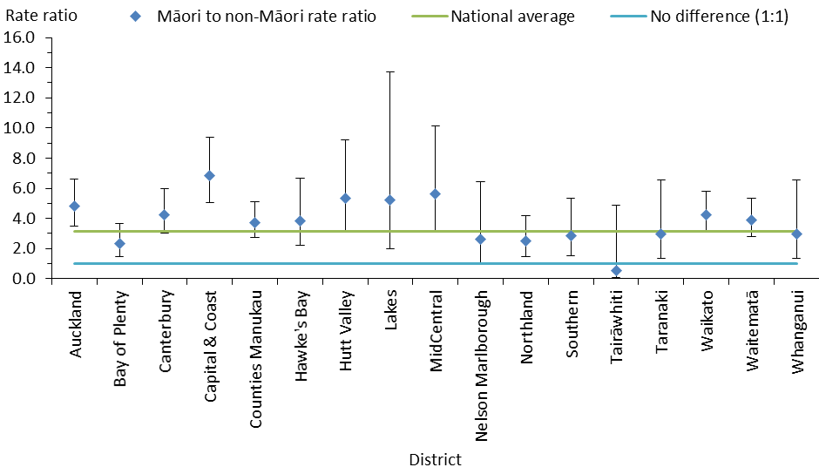

Notes: In this figure, the confidence intervals (for 99% confidence, shown as vertical lines through the blue diamond markers) can help with interpreting the data. If a district’s confidence interval crosses the national average, that means its rate per 100,000 is not statistically different from the average. These are age-standardised rates. As Health New Zealand South Canterbury and West Coast have small populations, their rates were very volatile and error bars of the resulting calculations were large. Health New Zealand Wairarapa has no inpatient service. This figure does not include the data for South Canterbury, Wairarapa and West Coast, to avoid skewing the overall results.

Source: PRIMHD data (extracted 28 February 2024).

Table 5: Age-standardised rates of people subject to community (section 29) and inpatient (section 30) treatment orders under the Mental Health Act, by gender and ethnicity, 1 July 2022 to 30 June 2023

|  |  |  |  |  |
| --- | --- | --- | --- | --- |
|  | **Community treatment orders** | | **Inpatient treatment orders** | |
| **Male** | **Female** | **Male** | **Female** |
| Māori per 100,000 population | 435.4 | 259.6 | 133.1 | 89.8 |
| Pacific peoples per 100,000 population | 237.9 | 112.9 | 85.7 | 45.6 |
| Other ethnicities per 100,000 population | 105.2 | 61.0 | 31.6 | 21.6 |
| Māori to Pacific peoples rate ratio | 1.8:1.0 | 2.3:1.0 | 1.6:1.0 | 2.0:1.0 |
| Pacific peoples to other ethnicities rate ratio | 2.3:1.0 | 1.9:1.0 | 2.7:1.0 | 2.1:1.0 |
| Māori to other ethnicities rate ratio | 4.1:1.0 | 4.3:1.0 | 4.2:1.0 | 4.2:1.0 |

Notes: Rates per 100,000 are age standardised. ‘Other ethnicities’ are all ethnicities excluding Māori and Pacific peoples.

Source: PRIMHD data (extracted 28 February 2024).

Figure 9: Age-standardised rates of people subject to community (section 29) and inpatient (section 30) treatment orders under the Mental Health Act, by gender and ethnicity, 1 July 2022 to 30 June 2023

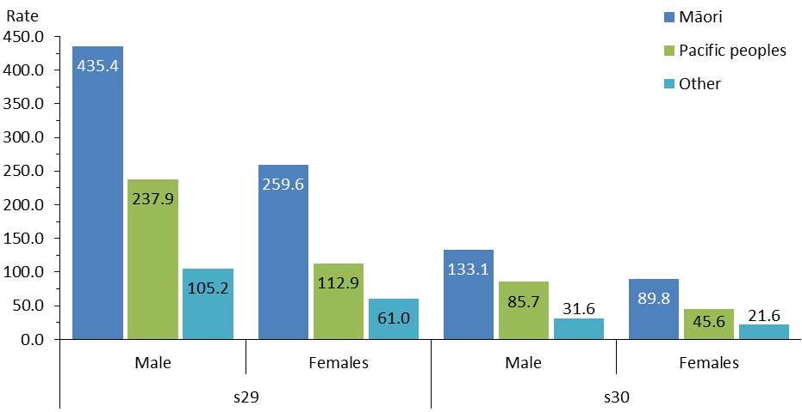

Note: Rates per 100,000 are age standardised.

Source: PRIMHD data (extracted 28 February 2024).

## Length of time people are subject to compulsory treatment orders

On average, Māori, Pacific peoples and other ethnicities remain on CTOs for a similar amount of time.

Among people with community treatment orders current at any time in the 2022/23 year, 31.6% of Māori, 35.9% of Pacific peoples and 32.0% of other ethnicities were subject to the order for less than a year (Figure 10).

Among people with inpatient treatment orders current at any time in the 2022/23 year, 70.6% of Māori, 69.8% of Pacific peoples and 77.1% of other ethnicities were subject to the order for less than a year (Figure 11).

Figure 10: Total time spent subject to a community treatment order (section 29) under the Mental Health Act in the last three years, by ethnicity, for those with a current order in the year 1 July 2022 to 30 June 2023

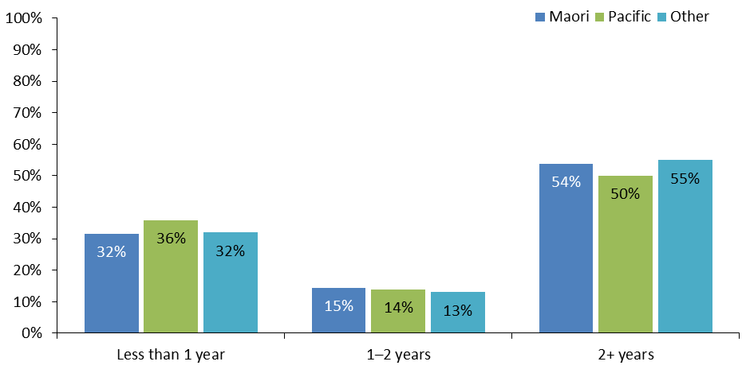

Notes: The data refers to people with treatment orders that were current at any point in 2022/23 and shows the total time they were subject to the order in the period from 1 July 2020 to 30 June 2023. Some orders current in this period will have started before 1 July 2020. For some people with orders starting in the most recent two years, the total time is not yet known as the orders are still current.

Source: PRIMHD data (extracted 28 February 2024).

Figure 11: Total time spent subject to an inpatient treatment order (section 30) under the Mental Health Act in the last three years, by ethnicity, for those with a current order in the year 1 July 2022 to 30 June 2023

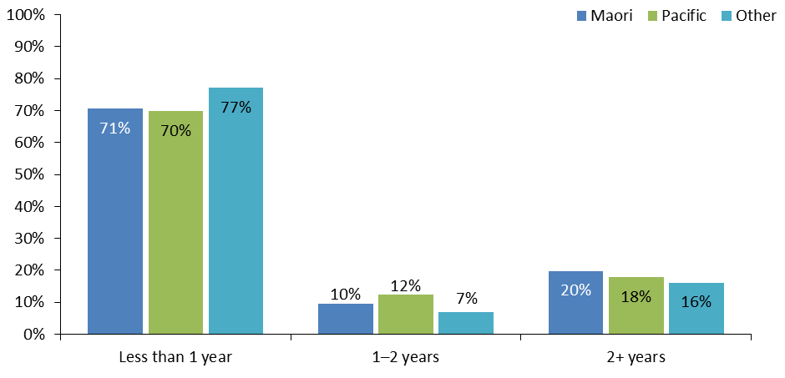

Notes: The data refers to people with treatment orders that were current at any point in 2022/23 and shows their total time subject to the order in the period from 1 July 2020 to 30 June 2023. Some orders current in this period will have started before 1 July 2020. For some people with orders starting in the most recent two years, the total time is not yet known as the orders are still current.

Source: PRIMHD data (28 February 2024).

## Family and whānau consultation under the Mental Health Act

Section 7A of the Mental Health Act requires clinicians to consult family and whānau of a person undergoing compulsory assessment or treatment, unless service providers and clinicians consider this consultation is not reasonably practicable or not in the interests of the person being assessed or receiving the treatment. Clinicians are encouraged to consider that the term ‘whānau’ could include any set of relationships a patient or proposed patient recognises as their closest connections, without limiting them to blood ties.

The following summarises the consultation data from 1 July 2022 to 30 June 2023.

* On average nationally, clinicians consulted families and whānau about Mental Health Act assessment or treatment events 72.1% of the time.
* Of all the steps in the Mental Health Act treatment process, clinicians were most likely to consult family and whānau at section 14, when a person is issued with a certificate of final assessment.
* Districts varied in the extent to which their clinicians consulted with families and whānau.
* The most common reason families and whānau were not consulted was that service providers and clinicians considered consultation was not reasonably practicable in the particular circumstance.

Figure 12 shows the percentage of cases in which consultation with families and whānau occurred at each of four points in the assessment and treatment process.

Figure 12: Average percentage of family and whānau consultation for particular assessment or treatment events nationally, sections 10, 12, 14 and 76–78, 1 July 2022 to 30 June 2023

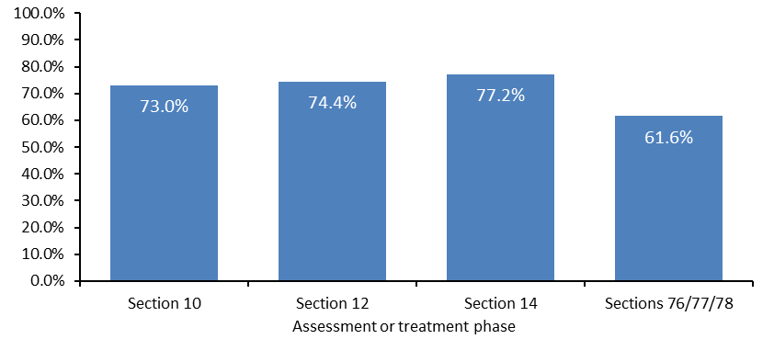

On average nationally during this financial year, 72.1% of cases included consultation with family and whānau across the assessment and treatment events. Hawke’s Bay had the highest rate of consultation at 93.6% and Northland had the lowest at 53.6% (Figure 13).

Where no consultation of families and whānau occurred, Figure 14 shows that by far the most common reason (in 86.4% of cases) was that service providers and clinicians considered consultation was not reasonably practicable in the particular circumstance. In 10.4% of cases consultation was considered to not be in the interests of the person being assessed or receiving the treatment.

Figure 13: Average percentage of family and whānau consultation across all assessment and treatment events, by district, 1 July 2022 to 30 June 2023

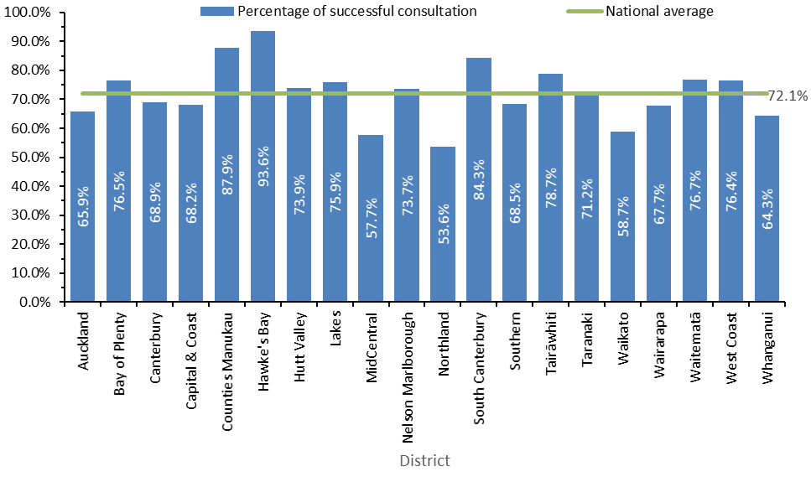

Note: Health New Zealand Whanganui only supplied data for quarter 1 of the financial year, and Wairarapa only supplied data for quarter 4.

Source: Office of the Director of Mental Health and Addiction Services records.

Figure 14: Reasons for not consulting families and whānau, 1 July 2022 to 30 June 2023

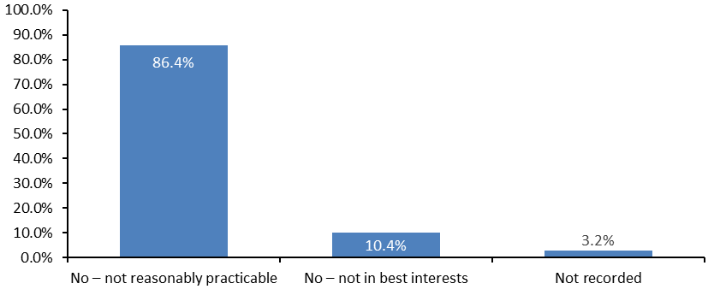

Source: Office of the Director of Mental Health and Addiction Services records.

# Indefinite compulsory treatment orders

A CTO lasts for an initial period of up to six months. A patient’s responsible clinician or the Mental Health Review Tribunal can end a CTO earlier. Alternatively, the responsible clinician can apply to the courts to have it extended for a further six months. During the period of this report, it was possible to extend an order ‘indefinitely’ after the first extension. Where people were subject to an indefinite CTO, their responsible clinician reviewed them every six months to decide whether compulsory treatment was still necessary.

More recently, however, as of 29 October 2023, indefinite CTOs have ceased to exist. The Mental Health (Compulsory Assessment and Treatment) Amendment Act 2021 abolished them and replaced them with 12-month extensions. As a result of this change, responsible clinicians need to reapply to the courts each year if they believe that a person continues to require compulsory treatment. This report will be the last to present this section on indefinite CTOs in this way.

These statistics summarise indefinite CTOs as at 30 June 2023.[12]

* 2,439 people were subject to indefinite CTOs.
* 2,280 people were subject to indefinite community treatment orders, which is 50% of all individuals on community treatment orders.
* 173 people were subject to indefinite inpatient treatment orders, which represents 24% of all individuals on inpatient treatment orders.
* The average period for which a person was subject to an indefinite community treatment order was 1,700 days (about four-and-a-half years). The longest period was 10,833 days (about 30 years).
* The average period for which a person was subject to an indefinite inpatient treatment order was 1,541 days (nearly four-and-a-quarter years). The longest period was 8,592 days (about 24 years).

## Indefinite community treatment orders

On 30 June 2023, 43.6 people per 100,000 people in the general population across Aotearoa New Zealand were subject to indefinite community treatment orders. Figure 15 shows the rates of indefinite community treatment orders in each district per 100,000.

Figure 15: Number of people subject to indefinite community treatment orders per 100,000 population, by district, at 30 June 2023

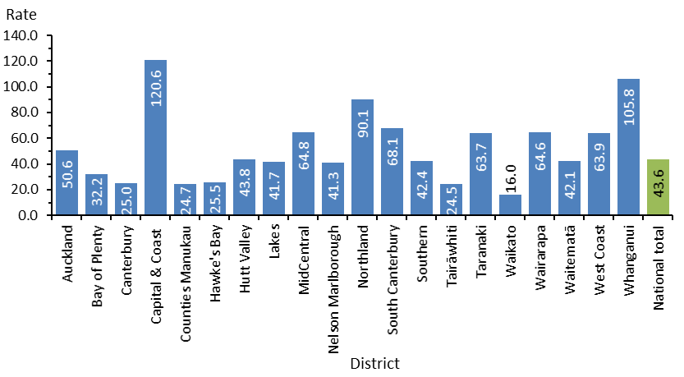

Sources: PRIMHD data (extracted 28 February 2024) and manual data from Health New Zealand Counties Manukau, Tairāwhiti, and Waikato.

Nationwide, Māori were 2.7 times more likely to be subject to an indefinite community treatment order than non-Māori. Table 6 and Figure 16 show the rate ratio of Māori to non-Māori in each district per 100,000 people in the general population.

Table 6: Rate ratio of Māori to non-Māori subject to indefinite community treatment orders per 100,000 population, by district, at 30 June 2023

|  |  |  |  |  |  |  |  |  |
| --- | --- | --- | --- | --- | --- | --- | --- | --- |
| **District** | **Māori** | **Non-Māori** | **Rate ratio Māori to non-Māori** |  | **District** | **Māori** | **Non-Māori** | **Rate ratio Māori to non-Māori** |
| Auckland | 172 | 40 | 4.3 |  | Northland | 162 | 49 | 3.3 |
| Bay of Plenty | 71 | 18 | 3.9 |  | South Canterbury | 129 | 61 | 2.1 |
| Canterbury | 57 | 21 | 2.6 |  | Southern | 93 | 36 | 2.6 |
| Capital & Coast | 249 | 102 | 2.4 |  | Tairāwhiti | 31 | 17 | 1.8 |
| Counties Manukau | 66 | 17 | 4.0 |  | Taranaki | 130 | 46 | 2.9 |
| Hawke’s Bay | 47 | 17 | 2.8 |  | Waikato | 36 | 9 | 3.8 |
| Hutt Valley | 107 | 29 | 3.7 |  | Wairarapa | 134 | 48 | 2.8 |
| Lakes | 67 | 26 | 2.6 |  | Waitematā | 102 | 35 | 2.9 |
| MidCentral | 137 | 45 | 3.1 |  | West Coast | 117 | 56 | 2.1 |
| Nelson Marlborough | 99 | 34 | 2.9 |  | Whanganui | 166 | 81 | 2.1 |
|  |  |  |  |  | **National** | **92** | **34** | **2.7** |

Sources: PRIMHD data (extracted 28 February 2024) and manual data from Health New Zealand Counties Manukau, Tairāwhiti and Waikato.

Figure 16: Rate ratio of Māori to non-Māori subject to indefinite community treatment orders per 100,000 population, by district, at 30 June 2023

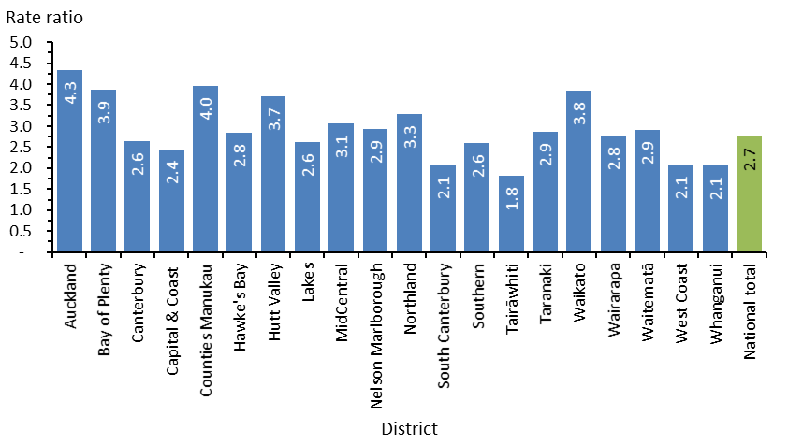

Sources: PRIMHD data (extracted 28 February 2024) and manual data from Health New Zealand Counties Manukau, Tairāwhiti and Waikato.

On 30 June 2023, 67.5% of people subject to indefinite community treatment orders were male (Figure 17). This trend is consistent with the higher rate of males subject to CTO applications.

Figure 17: Number of people subject to indefinite community treatment orders, by gender and ethnicity, at 30 June 2023

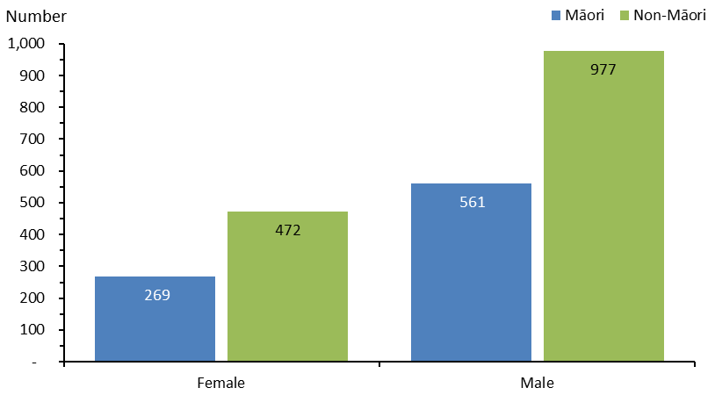

Sources: PRIMHD data (extracted 28 February 2024) and manual data from Health New Zealand Counties Manukau, Tairāwhiti and Waikato.

## Indefinite inpatient treatment orders

In Aotearoa New Zealand, 3.3 people per 100,000 people in the general population were subject to indefinite inpatient treatment orders. Figure 18 shows the rates of indefinite inpatient treatment orders in each district, per 100,000 people in the general population, on 30 June 2023.

Some services may have a higher rate of indefinite inpatient treatment orders because they care for more patients with forensic and intellectual disability needs but the nature of their presentation makes a Mental Health Act order appropriate for them. Some services such as those in Capital & Coast district have a national unit. Smaller services may be less likely to offer long-term inpatient care for people with complex needs. In 2022/23, Lakes, South Canterbury, Tairāwhiti, Wairarapa and West Coast districts had no individuals on indefinite inpatient treatment orders.

Figure 18: Number of people subject to indefinite inpatient treatment orders per 100,000 population, by district, at 30 June 2023

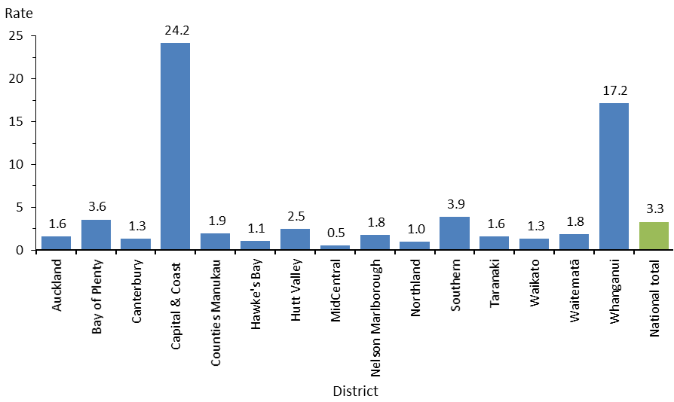

Note: Health New Zealand Wairarapa had no inpatient service, and Health New Zealand Lakes, South Canterbury, Tairāwhiti and West Coast had no indefinite inpatient treatment orders so they are not shown in this figure.

Sources: PRIMHD data (extracted 28 February 2024) and manual data from Health New Zealand Counties Manukau, Tairāwhiti and Waikato.

Nationwide during this time, Māori were 3.8 times more likely to be subject to an indefinite inpatient treatment order than non-Māori. Table 7 and Figure 19 show the rate ratio of Māori to non-Māori subject to indefinite inpatient treatment orders in each district per 100,000 people in the general population.

Table 7: Rate ratio of Māori to non-Māori subject to indefinite inpatient treatment orders per 100,000 population, by district, at 30 June 2023

|  |  |  |  |  |  |  |  |  |
| --- | --- | --- | --- | --- | --- | --- | --- | --- |
| **District** | **Māori** | **Non-Māori** | **Rate ratio Māori to non-Māori** |  | **District** | **Māori** | **Non-Māori** | **Rate ratio Māori to non-Māori** |
| Auckland | 5 | 1 | 3.8 |  | Nelson Marlborough | – | 2 | – |
| Bay of Plenty | 5 | 3 | 1.9 |  | Northland | 1 | 1 | 1.8 |
| Canterbury | 5 | 1 | 5.3 |  | Southern | 5 | 4 | 1.3 |
| Capital & Coast | 96 | 14 | 6.9 |  | Taranaki | 4 | 1 | 3.7 |
| Counties Manukau | 7 | 1 | 7.2 |  | Waikato | 3 | 1 | 3.1 |
| Hawke’s Bay | 2 | 1 | 2.5 |  | Waitematā | 9 | 1 | 8.4 |
| Hutt Valley | 3 | 2 | 1.4 |  | Whanganui | 29 | 12 | 2.4 |
| MidCentral | 2 | – | – |  | **National** | **9** | **2** | **3.8** |

Note: Health New Zealand Wairarapa had no inpatient service, and Health New Zealand Lakes, South Canterbury, Tairāwhiti and West Coast had no indefinite inpatient treatment orders, so they are not shown in this table.

Sources: PRIMHD data (extracted 28 February 2024) and manual data from Health New Zealand Counties Manukau, Tairāwhiti and Waikato.

Figure 19: Rate ratio of Māori to non-Māori subject to indefinite inpatient treatment orders per 100,000 population, by district, at 30 June 2023

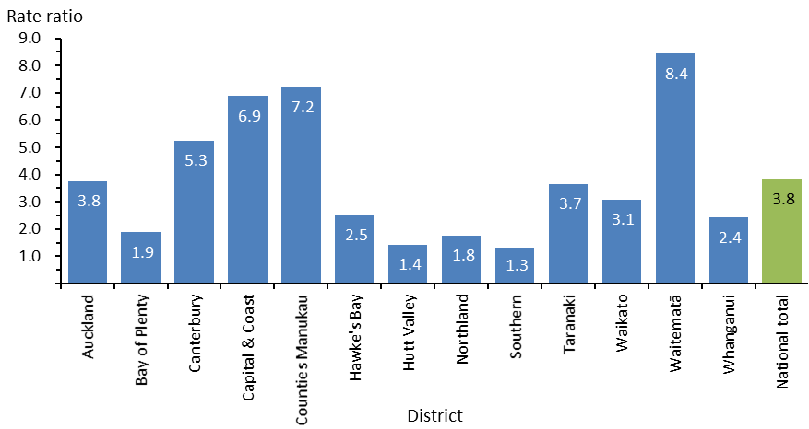

Notes: Health New Zealand Wairarapa had no inpatient service, and Health New Zealand Lakes, South Canterbury, Tairāwhiti and West Coast had no indefinite inpatient treatment orders, so they are not shown in this figure. Health New Zealand MidCentral and Nelson Marlborough had rate ratios of zero and so they are not included.

Sources: PRIMHD data (extracted 28 February 2024) and manual data from Health New Zealand Counties Manukau, Tairāwhiti and Waikato.

# Seclusion

In Aotearoa New Zealand, seclusion can only lawfully occur under the Mental Health Act or the Intellectual Disability (Compulsory Care and Rehabilitation) Act 2003 (the Intellectual Disability Care Act). While this section focuses mainly on people under the Mental Health Act in adult inpatient wards who have been secluded, it also covers people who have been secluded in intellectual disability facilities, under either the Mental Health Act or the Intellectual Disability Care Act.

Ngā Paerewa Health and Disability Services Standard defines ‘seclusion’ as a situation where a service user is ‘placed alone in a room or area, at any time and for any duration, from which they cannot freely exit’.[13] In April 2023, the Ministry of Health published updated guidelines with a focus on minimising and eventually eliminating the use of seclusion in services.

For the 2022/23 financial year, we have left out data from a number of outliers, where a high proportion of recorded seclusion hours related to seven patients. For more information about this outlier data, see Appendix 3: Additional seclusion statistics.

The following summarises adult inpatient services data[14] from 1 July 2022 to 30 June 2023.[15]

* The total number of people who experienced seclusion while receiving mental health treatment in an adult inpatient service decreased by 35% since 2009[16] (Figure 20) and by 11% compared with 2021/22.
* In contrast, the number of Māori who have been secluded has increased by 43% since 2009. However, it decreased by 3% compared with the previous year.
* Since 2009, the total number of hours spent in seclusion decreased by 65% (Figure 21). Compared with 2021/22, the total number of hours spent in seclusion decreased by 16.7%.
* Of all seclusion events, 65.5% lasted for less than 24 hours and 17% lasted for longer than 48 hours.
* Males were more than twice as likely as females to spend time in seclusion.
* People aged 20–29 years were more likely to spend time in seclusion than other age groups.
* Māori were more likely than non-Māori to have been secluded. They also had more seclusion events (as a rate per 100,000 population) and, on average, had longer periods of seclusion.
* Inpatients had an average of 5.5 seclusion events for every 1,000 bed nights they spent in adult inpatient units.
* Of the 10,124 admissions to adult inpatient units, 762 (7.5%) had seclusion recorded at some point during the stay.

Figure 20: Number of people secluded in adult inpatient services nationally, 2007 to 2022/23

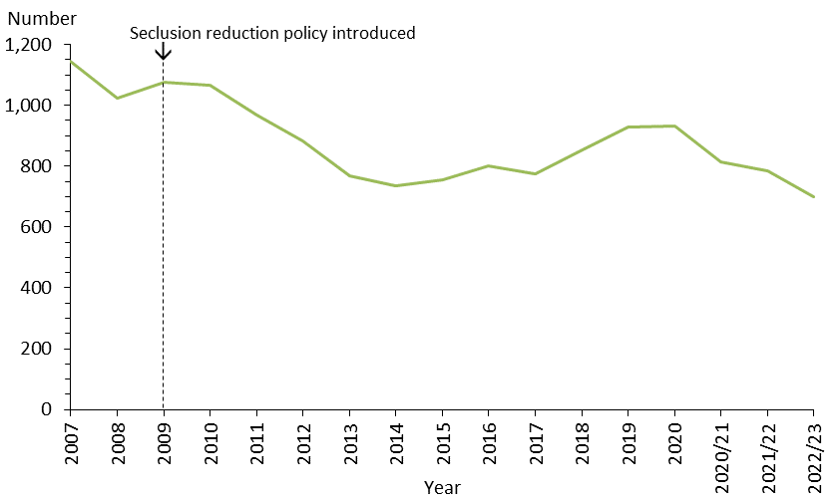

Notes: The data excludes forensic inpatient services and regional intellectual disability secure services. All years before 2020/21 are calendar years.

Sources: PRIMHD data (extracted 28 February 2024) and manual data from Health New Zealand South Canterbury, Tairāwhiti and Waitematā.

Figure 21: Number of seclusion hours in adult inpatient services nationally, 2007 to 2022/23

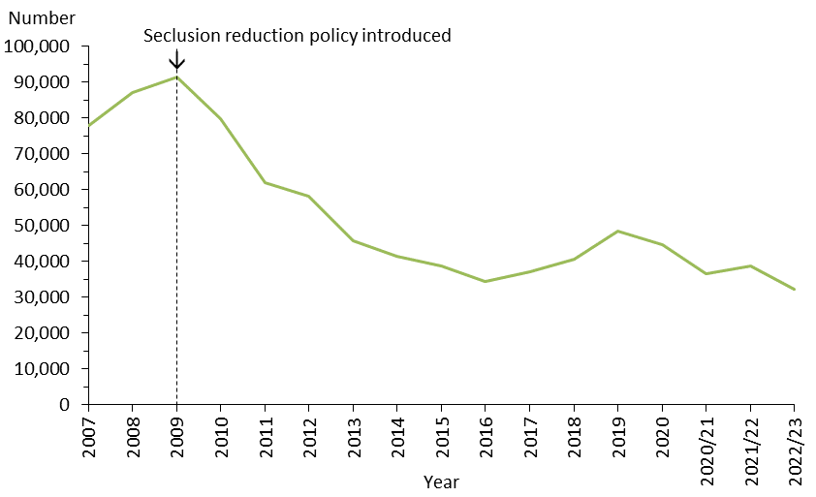

Notes: The data excludes forensic inpatient services and regional intellectual disability secure services. All years before 2020/21 are calendar years.

Sources: PRIMHD data (extracted 28 February 2024) and manual data from Health New Zealand South Canterbury, Tairāwhiti and Waitematā.

## Seclusion in Aotearoa New Zealand mental health services[17]

In the 2022/23 financial year, Aotearoa New Zealand adult mental health services (excluding forensic and other regional rehabilitation services) accommodated 7,866 people for a total of 215,233 bed nights. Of these, 699 people (8.9%) were secluded at some stage during the reporting period. Māori made up 55% of all adults secluded.

Many were secluded more than once (on average, 1.7 times). For this reason, the number of seclusion events in adult inpatient services (1,178) was higher than the number of people secluded. The seclusion reduction policy helps to explain this trend in that services are encouraged to support patients to exit seclusion rather than secluding them for a longer single session. If the period outside of seclusion is not yet successful, they may be secluded again, with the result that a patient could have several seclusion events.

There were 5.5 seclusion events per 1,000 bed nights in adult inpatient units. This means that nationally and on average, for every 1,000 bed nights a person spent in an inpatient unit, they would have 5.5 seclusion events.

Across all inpatient services, including forensic, intellectual disability and youth services, 942 people experienced at least one seclusion event. Of those people, 71.8% were male and 28% were female.

As Figure 22 shows, the most common age group for those secluded was 20–29 years. A total of 102 young people (aged 19 years and under) experienced 234 seclusion events across mental health and intellectual disability services during the year. Figure 23 presents the age group seclusion data as rates per 100,000 population to better demonstrate the differences between them.

Figures 24 and 25 present the number of seclusion events across all inpatient services by the length of event. 65.5% of events lasted for less than 24 hours.

Figure 22: Number of people secluded across all inpatient services (adult, forensic, intellectual disability and youth), by age group, 1 July 2022 to 30 June 2023

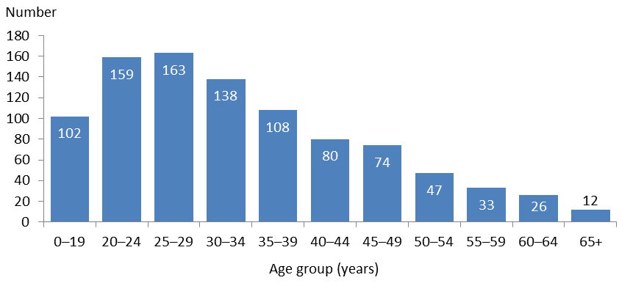

Note: The data includes patients treated in regional intellectual disability secure services.

Sources: PRIMHD data (extracted 28 February 2024) and manual data from Health New Zealand South Canterbury, Tairāwhiti and Waitematā.

Figure 23: Rate of people secluded across all inpatient services (adult, forensic, intellectual disability and youth) per 100,000 population, by age group, 1 July 2022 to 30 June 2023

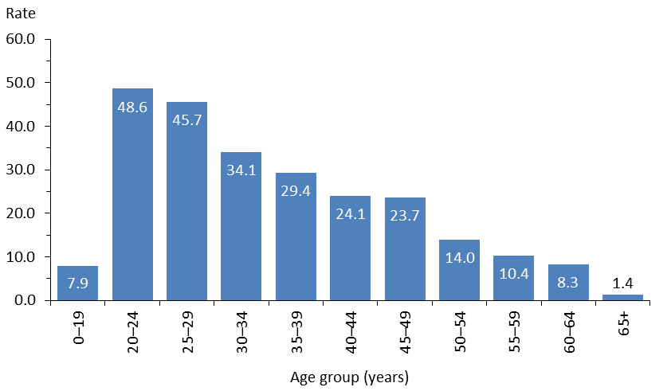

Note: The data includes patients treated in regional intellectual disability secure services.

Sources: PRIMHD data (extracted 28 February 2024) and manual data from Health New Zealand South Canterbury, Tairāwhiti and Waitematā.

Figure 24: Number of seclusion events across all inpatient services (adult, forensic, intellectual disability and youth), by length of event, 1 July 2022 to 30 June 2023

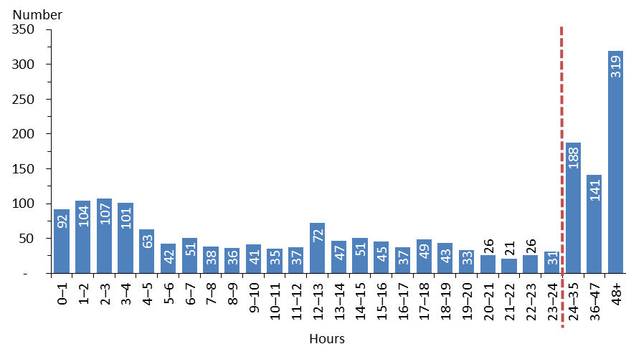

Notes: The data includes patients treated in regional intellectual disability secure services. .The 0-1 hours category includes any time up to 59 minutes, 1-2 includes any time from 1 hour to 1 hour 59 minutes etc. The dashed vertical line indicates the point at which the axis shifts from time spans covering a single hour to time spans covering multiple hours.

Sources: PRIMHD data (extracted 28 February 2024) and manual data from Health New Zealand South Canterbury, Tairāwhiti and Waitematā.

Figure 25: Number of seclusion events across all inpatient services (adult, forensic, intellectual disability and youth), by ethnicity and length of event, 1 July 2022 to 30 June 2023

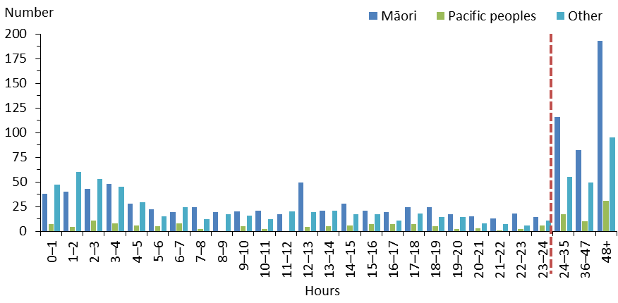

Notes: The data includes patients treated in regional intellectual disability secure services. The 0-1 hours category includes any time up to 59 minutes, 1-2 includes any time from 1 hour to 1 hour 59 minutes etc. The dotted vertical line indicates the point at which the axis shifts from time spans covering a single hour to time spans covering multiple hours.

Sources: PRIMHD data (extracted 28 February 2024) and manual data from Health New Zealand South Canterbury, Tairāwhiti and Waitematā.

## Use of seclusion by district

All Health New Zealand districts except for Wairarapa (which had no mental health inpatient service) used seclusion in the 2022/23 financial year.[18]

At the national level in 2022/23, the average number of people secluded in adult inpatient services was 22.8 per 100,000 people in the general population. Figure 26 shows how individual districts compare with this national average. Table 8Table 8 shows the seclusion rate for each district as a percentage of patients admitted to adult inpatient services who experienced seclusion during their admission.

Nationally, the average number of seclusion events was 38.4 per 100,000 people in the general population, down from 48.6 in the 2021/22 financial year.

Table 8: Percentage of admissions to adult inpatient services with seclusion recorded during admission, by district, 1 July 2022 to 30 June 2023

|  |  |  |  |  |
| --- | --- | --- | --- | --- |
| **District** | **Percentage** |  | **District** | **Percentage** |
| Auckland | 1.9% |  | Northland | 5.6% |
| Bay of Plenty | 8.7% |  | South Canterbury | 6.2% |
| Canterbury | 7.4% |  | Southern | 10.7% |
| Capital & Coast | 8.4% |  | Tairāwhiti | 8.7% |
| Counties Manukau | 6.9% |  | Taranaki | 7.8% |
| Hawke’s Bay | 10.4% |  | Waikato | 8.5% |
| Hutt Valley | 9.6% |  | Waitematā | 3.2% |
| Lakes | 8.2% |  | West Coast | 16.9% |
| MidCentral | 9.5% |  | Whanganui | 1.9% |
| Nelson Marlborough | 15.6% |  | **National average** | **7.5%** |

Notes: The data excludes forensic inpatient services, regional intellectual disability secure services, and Wairarapa as it had no inpatient service. Some services may have low admission rates, with the result that they have a higher percentage of admissions with seclusion recorded than other services.

Sources: PRIMHD data (extracted 28 February 2024) and manual data from Health New Zealand South Canterbury, Tairāwhiti and Waitematā.

Figure 27 breaks this rate down by Health New Zealand district. The average length of a seclusion event was 27.5 hours, an increase from 26.6 hours in the previous year.

Figure 26: Number of people secluded in adult inpatient services per 100,000 population, by district, 1 July 2022 to 30 June 2023

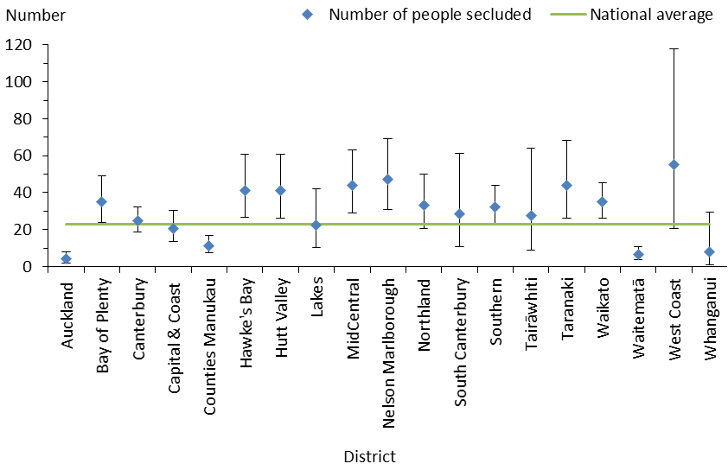

Notes: In this figure, the confidence intervals (for 99% confidence, shown as vertical lines through the blue diamond markers) can help with interpreting the data. Where a service’s confidence interval crosses the national average, that means its rate was not statistically significantly different from the average. The data excludes forensic inpatient services and regional intellectual disability secure services. Wairarapa had no inpatient unit, so is not shown in this figure.

Sources: PRIMHD data (extracted 28 February 2024) and manual data from Health New Zealand South Canterbury, Tairāwhiti, and Waitematā.

Figure 27: Number of seclusion events in adult inpatient services per 100,000 population, by district, 1 July 2022 to 30 June 2023

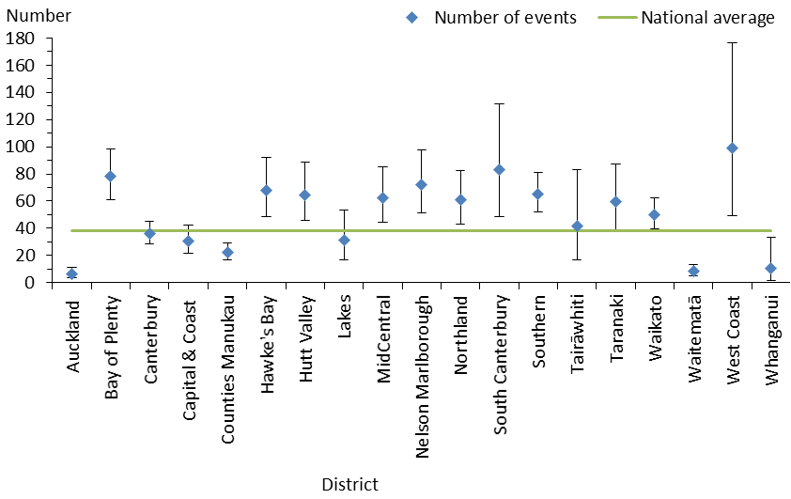

Notes: In this figure, the confidence intervals (for 99% confidence, shown as vertical lines through the blue diamond markers) can help with interpreting the data. Where a service’s confidence interval crosses the national average, that means its rate was not statistically significantly different from the average. The data excludes forensic inpatient services and regional intellectual disability secure services. Wairarapa had no inpatient unit, so is not shown in this figure.

Sources: PRIMHD data (extracted 28 February 2024) and manual data from Health New Zealand South Canterbury, Tairāwhiti and Waitematā.

## Seclusion and ethnicity

The rate of seclusion for Māori in adult inpatient services was 79.2 people per 100,000 people in the general population. Māori were 6.5 times more likely to be secluded than non-Māori, who had a rate of 12.2 people per 100,000.

Figure 28 shows the number of people secluded by ethnicity over three financial years: 2020/21, 2021/22 and 2022/23.

Figure 28: Number of people secluded in adult inpatient services, by ethnicity and year, from 1 July 2020 to 30 June 2023

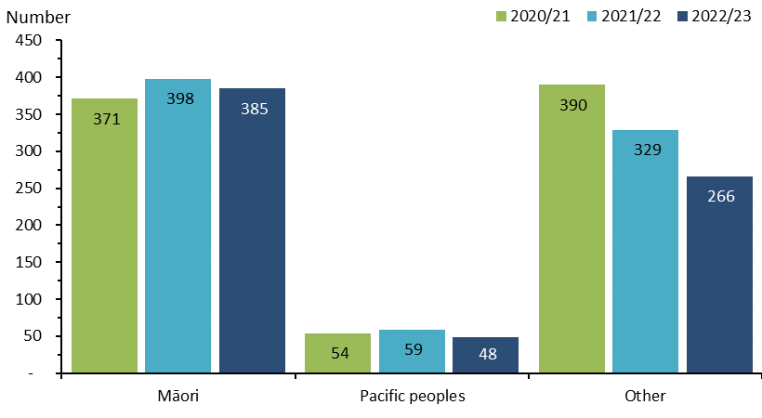

Notes: The data excludes forensic services and regional intellectual disability secure services.

Sources: PRIMHD data (extracted 28 February 2024) and manual data from Health New Zealand South Canterbury, Tairāwhiti and Waitematā.

Figure 29 shows seclusion rates for Māori, Pacific peoples and other ethnicities in 2022/23. Māori were secluded at a rate of 79.2 people per 100,000 people in the general population, Pacific peoples at a rate of 22.6 people per 100,000 and other ethnicities at a rate of 11.2 people per 100,000. Figure 30 shows the percentage of people secluded in adult inpatient services by ethnicity and gender.

Figure 29: Seclusion indicators for adult inpatient services, by ethnicity, 1 July 2022 to 30 June 2023

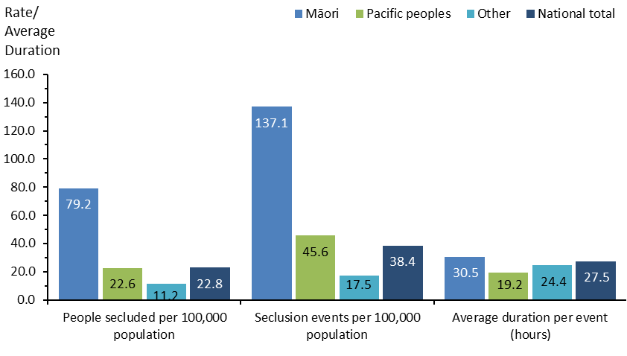

Note: The data excludes forensic services and regional intellectual disability secure services.

Sources: PRIMHD data (extracted 28 February 2024) and manual data for Health New Zealand South Canterbury, Tairāwhiti and Waitematā.

Figure 30: Percentage of people secluded in adult inpatient services, by ethnicity and gender, 1 July 2022 to 30 June 2023

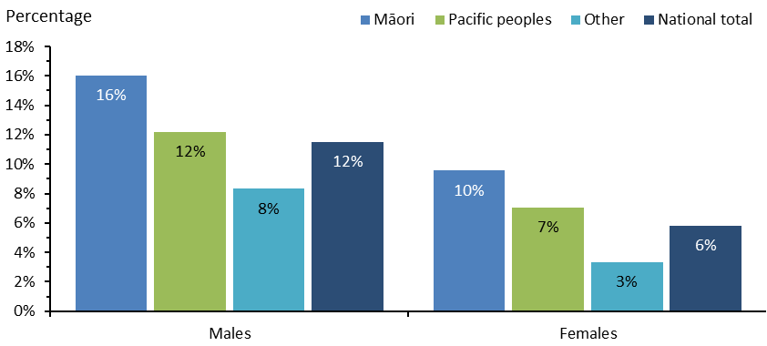

Note: The data excludes forensic services and regional intellectual disability secure services.

Sources: PRIMHD data (extracted 28 February 2024) and manual data for Health New Zealand South Canterbury, Tairāwhiti and Waitematā.

Figure 31 shows the number of Māori and non-Māori aged 20–64 years who were secluded in adult inpatient services from the 2007 calendar year to the 2022/23 financial year. Nationally since 2009 (when the seclusion reduction policies were introduced), the number of people secluded decreased by 35%. However the number of Māori secluded increased by 43% over the same period.

Figure 31: Number of Māori and non-Māori secluded in adult inpatient services, 2007 to 2022/23

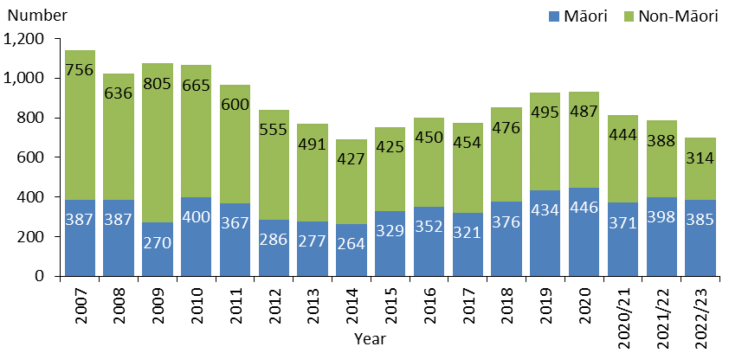

Notes: The data excludes forensic services and regional intellectual disability secure services. All years before 2020/21 are calendar years.

Sources: PRIMHD data (extracted 28 February 2024) and manual data for Health New Zealand South Canterbury, Tairāwhiti and Waitematā.

## Seclusion in forensic units

Five regional forensic mental health services provide specialist inpatient forensic care.

* Auckland Regional Forensic Psychiatry Service operates from Health New Zealand Waitematā and covers the Auckland, Counties Manukau, Northland and Waitematā districts.
* Midland Regional Forensic Psychiatric Service operates from Health New Zealand Waikato and covers the Bay of Plenty, Lakes, Tairāwhiti, Taranaki and Waikato districts.
* Central Regional Forensic Mental Health Service operates from Health New Zealand Capital, Coast and Hutt Valley and covers the Capital & Coast, Hawke’s Bay, Hutt Valley, MidCentral, Wairarapa and Whanganui districts.
* Canterbury Regional Forensic Mental Health Service operates from Health New Zealand Canterbury and covers the Canterbury, Nelson Marlborough, South Canterbury and West Coast districts.
* Southern Regional Forensic Mental Health Service operates from and covers the Southern district.

These services provide mental health treatment in a secure setting for prisoners with mental disorders and for people defined as a special or restricted patient. Some services have more beds than others, which may be a reason contributing to their higher levels of seclusion use.

Table 9 presents seclusion indicators for each regional service that provides forensic mental health services. With a focus on the national level, Figure 32 breaks down the number of people secluded and number of events by ethnicity. These indicators cannot be compared with adult inpatient service indicators because they have a different client base.

Table 9: Seclusion indicators for forensic mental health services, by regional service, 1 July 2022 to 30 June 2023

|  |  |  |  |  |
| --- | --- | --- | --- | --- |
| **Regional service** | **Number of people secluded** | **Number of events** | **Total hours** | **Average duration per event (hours)** |
| Auckland | 49 | 142 | 9,879 | 69.6 |
| Canterbury | 26 | 109 | 8,615 | 79.0 |
| Central | 8 | 11 | 655 | 59.5 |
| Midland | 27 | 75 | 2,654 | 35.4 |
| Southern | 9 | 18 | 1,916 | 106.4 |
| **Nationally** | **119** | **355** | **23,718** | **66.8** |

Notes: This data is for forensic mental health service users aged 20–64 years. It excludes one outlier.

Sources: PRIMHD data (extracted 28 February 2024) and manual data for Health New Zealand South Canterbury, Tairāwhiti and Waitematā.

Figure 32: Seclusion indicators for forensic mental health services, by ethnicity, 1 July 2022 to 30 June 2023

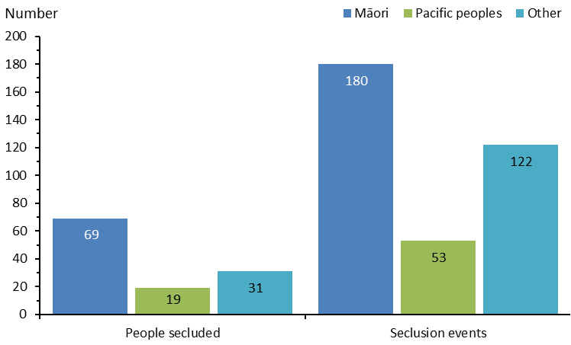

Notes: This data is for forensic mental health service users aged 20–64. It excludes one outlier.

Sources: PRIMHD data (extracted 28 February 2024) and manual data for Health New Zealand South Canterbury, Tairāwhiti and Waitematā.

## People with intellectual disabilities cared for in an intellectual disability forensic service

The five regional forensic mental health services listed in the section above also provide forensic intellectual disability services for people with an intellectual disability under the Intellectual Disability Care Act, as care recipients or special care recipients. Individuals become subject to the Intellectual Disability Care Act when convicted of criminal offending and compulsory care is ordered rather than a prison sentence. A small number of individuals in forensic intellectual disability services are under the Mental Health Act.

The seclusion data presented in Tables 10-12 for people with intellectual disabilities is for individuals with a legal status under the Intellectual Disability Care Act or the Mental Health Act. People receiving care under these Acts can be secluded only in hospital-level secure services that meet specific requirements.

Previous annual regulatory reports have presented this seclusion data by regional service. However, due to low numbers, this year we present the data on a national level to protect individuals’ privacy. Similarly, the seclusion indicators for Māori and non-Māori with intellectual disabilities are presented per 100,000 people in the general population (Table 12), rather than as raw figures.

Table 10: Seclusion indicators for people with intellectual disabilities, nationally, 1 July 2022 to 30 June 2023

|  |  |  |  |  |
| --- | --- | --- | --- | --- |
| **Act** | **Number of people secluded** | **Number of events** | **Median number of events** | **Average number of events per person** |
| Intellectual Disability Care Act | 18 | 66 | 2.0 | 3.7 |
| Mental Health Act | 6 | 29 | 4.0 | 4.8 |

Source: PRIMHD data (extracted 28 February 2024).

Table 11: Length of seclusion for people with intellectual disabilities, nationally, 1 July 2022 to 30 June 2023

|  |  |  |  |
| --- | --- | --- | --- |
| **Act** | **Total seclusion hours** | **Median length of seclusion events (hours: minutes)** | **Average length of seclusion events (hours: minutes)** |
| Intellectual Disability Care Act | 1,894.2 | 5:0 | 28:42 |
| Mental Health Act | 1,211.4 | 4:25 | 41:46 |

Source: PRIMHD data (extracted 28 February 2024).

Table 12: Seclusion indicators for Māori and non-Māori with intellectual disabilities, nationally, 1 July 2022 to 30 June 2023

|  |  |  |  |  |
| --- | --- | --- | --- | --- |
| **Act** | **Ethnicity** | **People secluded per 100,000 population** | **Seclusion events per 100,000 population** | **Average events per person** |
| Intellectual Disability Care Act | Māori | 0.8 | 1.4 | 1.9 |
| Non-Māori | 0.3 | 1.2 | 4.8 |
| Mental Health Act | Māori | 0.2 | 0.8 | 3.5 |
| Non-Māori | 0.1 | 0.5 | 5.5 |

Sources: PRIMHD data (extracted 28 February 2024).

# Special and restricted patients

Under Aotearoa New Zealand law, people who have been charged with committing crimes while severe mental illness was influencing their judgement may be treated in a secure mental health facility instead of going to prison. These people are given ‘special patient’ status.

Special patients include:

* people charged with, or convicted of, a criminal offence and remanded to a hospital for a psychiatric report
* remanded or sentenced prisoners transferred from prison to a hospital
* defendants found not guilty by reason of insanity or who have a finding of act proven but not criminally responsible on account of insanity
* defendants who are unfit to stand trial
* people who have been convicted of a criminal offence and are both sentenced to a term of imprisonment and placed under a CTO.

Restricted patients are people detained in forensic mental health services by court order because they pose a danger to others. They have not necessarily been charged with or convicted of a crime. They may have also been transferred from prison or previously had a special patient status that changed when their sentence ended.

Special and restricted patients can be detained in the five regional forensic mental health services (see the Seclusion in forensic units section).

Previous annual regulatory reports presented data on the forensic services under the name of their operating district. Here we present the data under the five regional forensic mental health services separately.

The national total of 461 special patients is lower than the sum of special patients by regional service. This is because some special patients may have transferred across services during the year.

Figure 33 presents the total number of special patients in the care of each regional forensic mental health service.

Special and restricted patients may be detained for either extended or short-term care. The following discussion details these variations.

Figure 33: Total number of special patients, by regional service, 1 July 2022 to 30 June 2023

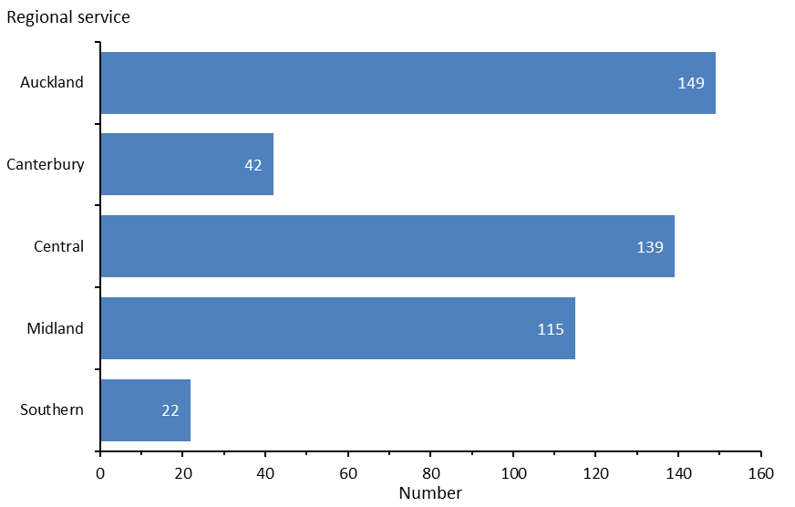

Source: PRIMHD data (extracted 28 February 2024).

## Extended forensic care special patients

Extended forensic care (EFC) patients include special patients who have been found not guilty by reason of insanity or unfit to stand trial under section 24(2)(a) of the Criminal Procedure (Mentally Impaired Persons) Act 2003. Restricted patients under section 55 of the Mental Health Act are also supported in extended forensic care facilities.

From 1 July 2022 to 30 June 2023, Aotearoa New Zealand had 175 EFC special patients.

Table 13 shows the number of these patients in the care of each regional forensic mental health service.

## Short-term forensic care special patients

Short-term forensic care (SFC) patients include people transferred from prison to a forensic mental health service. When a person has been sentenced to a term of imprisonment, any Mental Health Act status no longer applies. Remand prisoners may remain on a current CTO, but it is unlawful to enforce compulsory treatment in the prison environment. However, a court may make a ‘hybrid order’ under section 34(1)(a)(i) of the Criminal Procedure (Mentally Impaired Persons) Act 2003, sentencing an offender to a term of imprisonment while also ordering their detention in hospital as a special patient.

From 1 July 2022 to 30 June 2023, Aotearoa New Zealand had a total of 302 SFC special patients.

Table 13 shows the number of these patients in the care of each regional forensic mental health service. Figure 34 shows the percentage of court orders given for SFC and EFC legal status in each of these services.

Table 13: Total number of special patients, by type and service, 1 July 2022 to 30 June 2023

|  |  |  |  |
| --- | --- | --- | --- |
| **Regional service** | **EFC special patients** | **SFC special patients** | **Total special patients** |
| Auckland | 49 | 103 | 149 |
| Canterbury | 17 | 26 | 42 |
| Central | 64 | 80 | 139 |
| Midland | 40 | 81 | 115 |
| Southern | 9 | 14 | 22 |
| **Nationally** | **175** | **302** | **461** |

Notes: Special patients who receive treatment with more than one service are counted in each, which is why the sum of patients in the five services is higher than the national total. A patient may be represented under both the EFC and SFC categories in this table. Court orders for a small number of special patients directed them to receive treatment outside a regional forensic service. This data is excluded to protect patient confidentiality.

Source: PRIMHD data (extracted 28 February 2024).

Figure 34: Percentage of court orders given for extended and short-term forensic care, by regional service, 1 July 2022 to 30 June 2023

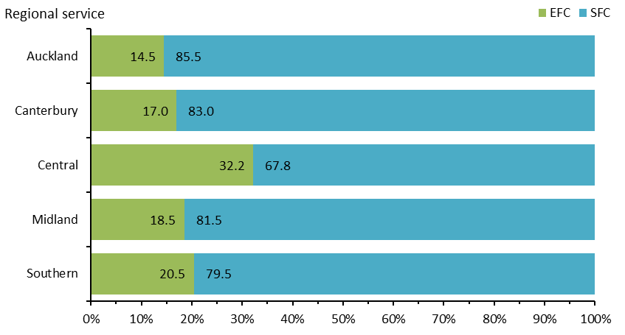

Notes: Unlike previous data in this section, this figure is based on a count of court orders rather than the number of special patients. A single special patient may have many court orders in the year, which could include both EFC and SFC, but each special patient’s legal status is counted in only one category at any one time. Please use caution when comparing the counts of court orders for legal status with the counts of people with either EFC or SFC legal status.

Source: PRIMHD data (extracted 28 February 2024).

## Gender, age and ethnicity of special patients

Special patients were over six times more likely to be male (86.6%) than female (13.4%) (Figure 35). The most common age groups for special patients in 2022/23 were 25–29 and 30–34 years (Figure 36).

Figure 35: Number of special patients, by gender, 1 July 2022 to 30 June 2023

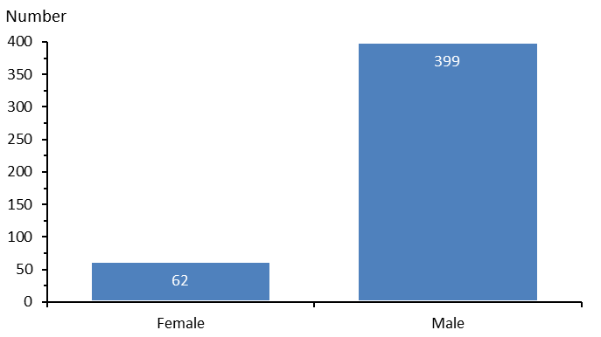

Source: PRIMHD data (extracted 28 February 2024).

Figure 36: Total number of special patients, by age group, 1 July 2022 to 30 June 2023

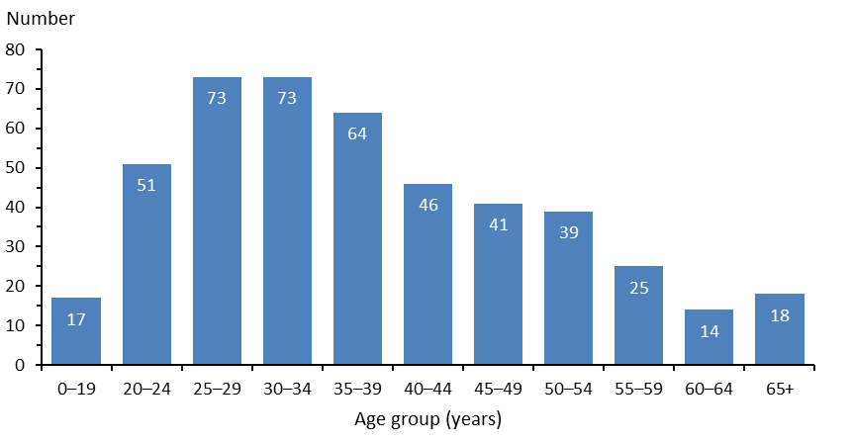

Source: PRIMHD data (extracted 28 February 2024).

Among people subject to a special patient order, most (53.4%) were Māori (Figure 37). Māori represented the highest proportion of both EFC (43.4%) and SFC (57.9%) special patients.

Figure 37: Percentage (and number) of special patients, by ethnicity and special patient type, 1 July 2022 to 30 June 2023

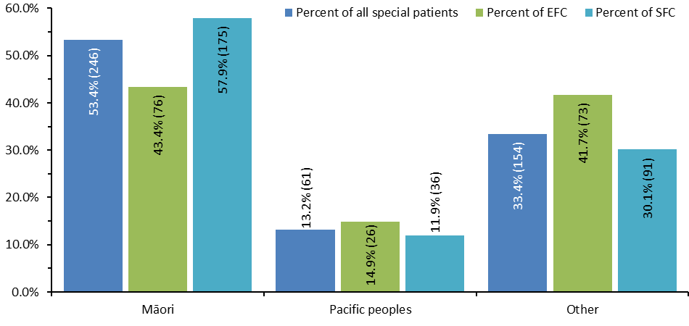

Notes: A single patient may be represented under both the EFC and SFC categories in this figure. Numbers in brackets are the number of special patients. In previous years, people of Asian ethnicity were included as a category; however, due to low numbers in 2022/23, they have been added to the ‘other’ category to avoid identification.

Source: PRIMHD data (extracted 28 February 2024).

## Decisions about leave and change of legal status for special and restricted patients

The Director of Mental Health (the Director) has a central role in managing special patients and restricted patients throughout the continuum of care. The Director must be notified when special and restricted patients are admitted, discharged or transferred, and when certain incidents involving these people occur (section 43 of the Mental Health Act). The Director may authorise the transfer of patients between districts under section 49 of the Mental Health Act or grant leave for any period no longer than seven days for certain special and restricted patients (section 52A).

Under section 50A of the Mental Health Act, the Minister of Health can grant periods of leave for longer than seven days to certain categories of special patients. The Director briefs the Minister of Health when requests for this type of leave are made. If the Minister grants the first application under section 50A, it is usually for a period of six months. Further applications for ministerial leave for a period of 12 months are possible.

Where a special patient has been aquitted by reason of of insanity, or the criminal act is proven but they are not criminally responsible on account of insanity,[19] they may be considered for a change of legal status if it is determined that their detention as a special patient is no longer necessary to safeguard their own or the public’s interests. This change in legal status will usually occur after the person has been living successfully in the community on ministerial long leave for several years. Forensic services apply to the Director for this change. After careful consideration, the Director makes a recommendation for the Minister of Health’s decision about a person’s legal status.

Table 14 shows the number of applications for granting section 50A long leave, revoking that leave and reclassifying a person’s legal status that the Office of the Director of Mental Health and Addiction Services processed through to the Minister of Health in 2022/23.

Table 14: Number of applications for granting section 50A long leave, revoking that leave and reclassifying legal status that the Minister of Health received for special and restricted patients, 1 July 2022 to 30 June 2023

|  |  |
| --- | --- |
| **Type of request** | **Number completed** |
| Initial ministerial section 50A leave applications approved | 10 |
| Initial ministerial section 50A leave applications not approved | 0 |
| Ministerial section 50A leave revocations (initial and further) | 1 |
| Further ministerial section 50A leave applications approved | 21 |
| Further ministerial section 50A applications not approved | 0 |
| Change of legal status applications approved | 4 |
| Change of legal status applications not approved | 1 |
| **Total applications completed** | **37** |

Notes: This table does not include applications that were withdrawn before the Minister of Health received them and applications for adjustments to be made to section 50 leave conditions for a special patient. The Rights for Victims of Insane Offenders Act 2021 has caused changes to the Mental Health Act, including by changing what were provisions under section 50 to become provisions under section 50A.

Source: Office of the Director of Mental Health and Addiction Services records.

# Mental health and addiction adverse event reporting

Aotearoa New Zealand has two major national reporting mechanisms for adverse events relating to mental health.[20]

1. Health New Zealand districts notify the Director of Mental Health of the death of any person or special patient under the Mental Health Act.
2. Districts report all adverse events rated Severity Assessment Code (SAC)[21] 1 or 2 to Te Tāhū Hauora Health Quality & Safety Commission (Te Tāhū Hauora) in line with the National Adverse Events Reporting Policy.[22] At the time the data reported here was collected, mental health services not funded by districts were encouraged but not required to report adverse events to Te Tāhū Hauora.

Public reporting of adverse events began in 2006. Since then, the number of reported adverse events has increased each year. .

To provide timely access to adverse events data on mental health and addiction services, Te Tāhū Hauora publishes the [national quarterly dashboard](https://reports.hqsc.govt.nz/AdverseEventsQuarterly/) online. In publishing providers’ reported adverse events, Te Tāhū Hauora aims to make harm visible and transparent.

Event totals displayed in the dashboards fluctuate because later reviews may change the SAC rating of some events to more accurately reflect their level of severity. That, in turn, changes a provider’s obligation to report or not.

Te Tāhū Hauora welcomes increases in reporting rates, because it believes they represent more thorough and consistent reporting of the events that have always been a part of the system, rather than that rates of adverse events are actually worsening. This stronger reporting culture can create real opportunities for improvement across the system.

## Deaths reported to the Director of Mental Health

Section 132 of the Mental Health Act requires services to notify the Director within 14 days of the death of any patient or special patient under the Mental Health Act. This includes identifying the apparent cause of death.

In Aotearoa New Zealand, a coroner determines a cause of death after completing their inquiry. Only deaths that the coroner decides are ‘intentionally self-inflicted’ will receive a final verdict of suicide. The coronial inquiry is unlikely to occur within a year of a death. When a death appears to be self-inflicted but the coroner has not yet made a ruling, it is called a ‘suspected suicide’. For more information and data, search for ‘suicide statistics’ on the [Ministry’s website](http://www.health.govt.nz).

In 2022/23, the Director received 62 death notifications relating to people under the Mental Health Act (Table 15). Of these, 14 related to people who were reported to have died by suspected suicide. The remaining 48 reportedly died by other means, including natural causes and illnesses unrelated to their mental health status.

Table 15: Outcomes of reportable death notifications under section 132 of the Mental Health Act, 1 July 2022 to 30 June 2023

|  |  |
| --- | --- |
| **Reportable death outcome** | **Number of deaths** |
| Suspected suicide | 14 |
| Other deaths | 48 |
| **All reportable deaths** | **62** |

Source: Office of the Director of Mental Health and Addiction Services records.

## Section 95 inquiries and section 99 inspections

The Director will occasionally require a district inspector to carry out an inquiry under section 95 of the Mental Health Act or undertake an inspection themselves under section 99. Inquiries and inspections generally focus on systemic issues across one or more mental health services. As a result of either an inquiry or an inspection, typically a district inspector or the Director makes specific recommendations about the mental health services and/or their system.

Following an inquiry under s95 of the Mental Health Act, the Director considers the recommendations and acts on any that have implications for the Ministry of Health or the wider mental health sector. The Director later audits the specific district’s implementation of the recommendations.

Following an inquiry under section 99 of the Mental Health Act, the Director will make specific recommendations to district mental health services and will monitor the implementation of these.

The inquiry process is complete when the Director considers that the district concerned and, if appropriate, the Ministry and all other districts have satisfactorily implemented the recommendations.

No section 95 inquiries or section 99 inspections were completed in the 2022/23 financial year. Table 16 shows the number of completed section 95 inquiry reports the Director received and the number of section 99 reports the Director received or completed between 1 July 2012 and 30 June 2023.

The Director initiated a section 99 inspection on 6 July 2022, following a serious incident in late June 2022 and in the context of concerns about the Canterbury adult inpatient service and associated mental health services. Due to delays in providing information that would support the Director in producing his report, this report is still in development. For more information, including the terms of reference, see [Section 99 inspection of Canterbury Mental Health Services](https://www.health.govt.nz/regulation-legislation/mental-health-and-addiction/section-99-inspection-of-canterbury-mental-health-services) on the Ministry’s website.

Table 16: Number of section 95 inquiries completed and section 99 inspections reports received or completed by the Director, 2012/13 to 2022/23

|  |  |  |  |  |  |  |  |  |  |  |
| --- | --- | --- | --- | --- | --- | --- | --- | --- | --- | --- |
| **2012/13** | **2013/14** | **2014/15** | **2015/16** | **2016/17** | **2017/18** | **2018/19** | **2019/20** | **2020/21** | **2021/22** | **2022/23** |
| 0 | 0 | 1 | 2 | 0 | 0 | 0 | 0 | 0 | 0 | 0 |

Source: Office of the Director of Mental Health and Addiction Services records.

# Electroconvulsive therapy

Electroconvulsive therapy (ECT) is a therapeutic procedure that delivers a brief pulse of electricity to a person’s brain to generate a seizure while they are under anaesthesia. ECT can be an effective treatment for depression, mania, catatonia and other serious neuropsychiatric conditions. It can happen only if the person receiving it consents or in carefully defined circumstances without their consent.

In last year’s regulatory report, some of the ECT data on MidCentral district was missing. Appendix 4: 2021/22 corrected ECT data presents the corrected data.

The following summarises ECT data from 1 July 2022 to 30 June 2023.[23]

* 264 people received ECT (5.0 people per 100,000 population).
* Services administered a total of 3,015 treatments of ECT.
* ECT patients received an average of 11.4 ECT treatments each over the year.
* Females (59.1%) were more likely to receive ECT than males (40.9%).
* Older people were more likely to receive ECT. Those aged over 50 years made up 62.5% of ECT patients.

## Number of people receiving ECT

Around 200 to 300 people receive ECT treatment each year. This number has remained relatively stable since 2006 (Figure 38).

Figure 38: Number of ECT patients per 100,000 population, 2005 to 2022/23

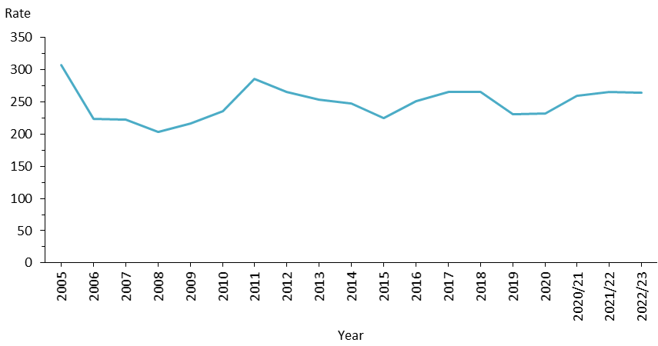

Sources: PRIMHD data (extracted 28 February 2024) and manual data for Health New Zealand MidCentral, Southern, Waikato and Waitematā. All years before 2020/21 are calendar years.

## ECT by region

The number and rate of ECT treatments vary regionally (Table 17 and Figure 39, Figure 40 and Figure 41). Several factors help to explain these variations.

* Districts with smaller populations are more vulnerable to variations between years (based on the needs of the population at any given time).
* People receiving ECT treatment to maintain the improvement in their mental health will typically receive more treatments in a year than those treated with an acute course.
* People in some districts have fewer barriers to accessing ECT services than those in other districts. Some districts have no ECT facilities.

It is important to keep these factors in mind when interpreting the following information.

In previous years, we reported ECT indicators by district health board, or districts. Because numbers in some districts were low in 2022/23, here we present this data regionally to protect the privacy of individuals. These regions are:

* Northern: covering Health New Zealand Northland, Waitematā, Auckland and Counties Manukau
* Midland: covering Health New Zealand Waikato, Bay of Plenty, Tairāwhiti, Lakes and Taranaki
* Central: covering Health New Zealand Whanganui, Hawke’s Bay, MidCentral, Wairarapa, and Capital, Coast and Hutt Valley
* South Island: covering Health New Zealand Nelson Marlborough, West Coast, Canterbury, South Canterbury and Southern.

Table 17: ECT indicators, by region of domicile, 1 July 2022 to 30 June 2023

|  |  |  |  |
| --- | --- | --- | --- |
| **Region of domicile** | **Number of people treated with ECT** | **Number of treatments** | **Mean number of treatments per person (range)** |
| Northern | 75 | 893 | 12 (1–52) |
| Midland | 74 | 863 | 12 (1–55) |
| Central | 62 | 637 | 10 (1–32) |
| South Island | 53 | 622 | 12 (1–35) |
| **Nationally** | **264** | **3,015** | **11 (1–55)** |

Note: In 2022/23, 18 people were treated outside of their district of domicile.

Sources: PRIMHD data (extracted 28 February 2024) and manual data from Health New Zealand MidCentral, Southern, Waikato and Waitematā.

Figure 39: Number of people per 100,000 population treated with ECT, by district of domicile, 1 July 2022 to 30 June 2023

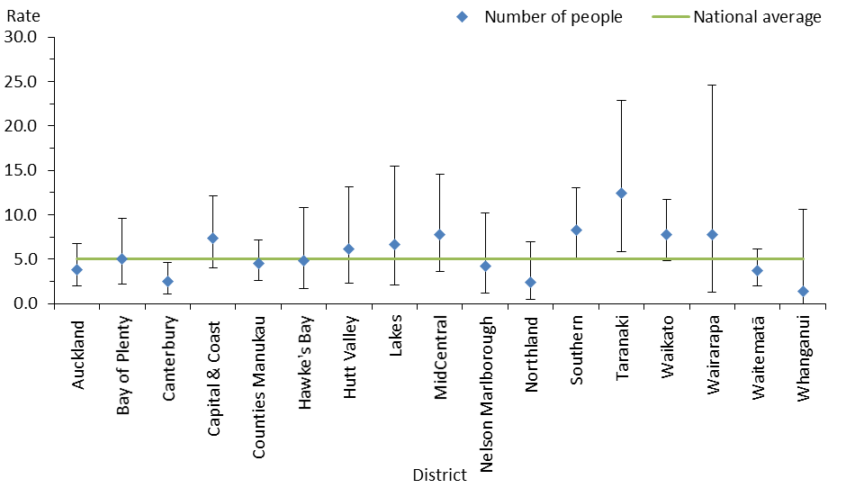

Note: In this figure, the confidence intervals (for 99% confidence, shown as vertical lines through the blue diamond markers) can help with interpreting the data. Where a service’s confidence interval crosses the national average, that means its rate was not statistically significantly different from the average. No one living in South Canterbury or Tairāwhiti received ECT treatment in the period, so these districts are not included in the figure.

Sources: PRIMHD data (extracted 28 February 2024) and manual data for Health New Zealand MidCentral, Southern, Waikato and Waitematā.

Figure 40: Number of ECT treatments per 100,000 population, by district of domicile, 1 July 2022 to 30 June 2023

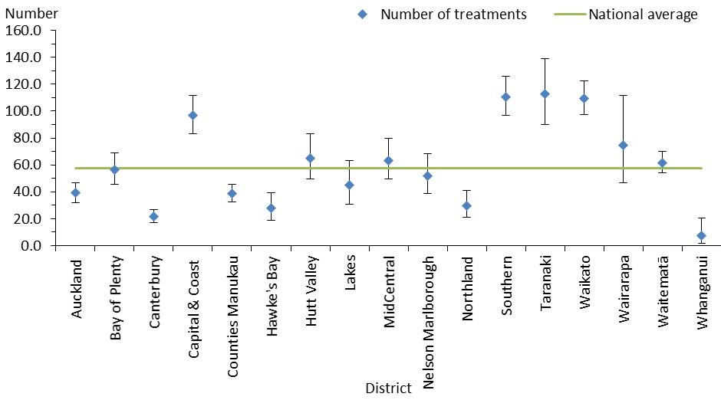

Note: In this figure, the confidence intervals (for 99% confidence, shown as vertical lines through the blue diamond markers) can help with interpreting the data. Where a service’s confidence interval crosses the national average, that means its rate was not statistically significantly different from the average. No one living in South Canterbury or Tairāwhiti received ECT treatment in the period, so these districts are not included in the figure.

Sources: PRIMHD data (extracted 28 February 2024) and manual data for Health New Zealand MidCentral, Southern, Waikato and Waitematā.

Figure 41: Number of people treated with ECT per 100,000 population, by district of domicile, 1 July 2022 to 30 June 2023

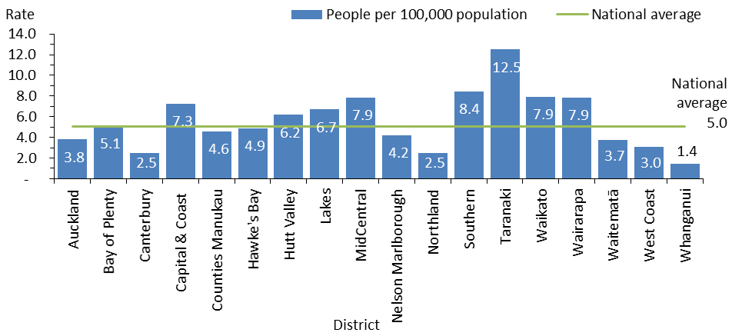

Note: No one living in South Canterbury or Tairāwhiti received ECT treatment in the period, so these districts are not included in the figure.

Sources: PRIMHD data (extracted 28 February 2024) and manual data for Health New Zealand MidCentral, Southern, Waikato and Waitematā.

## Age and gender of people receiving ECT

In the 2022/23 financial year, women were more likely to receive ECT than men. Older people were more likely to receive ECT, with those aged over 50 years making up 62.5% of ECT patients. Figure 42 breaks down the number of people treated with ECT by age group and gender.

Figure 42: Number of people treated with ECT, by age group and gender, 1 July 2022 to 30 June 2023

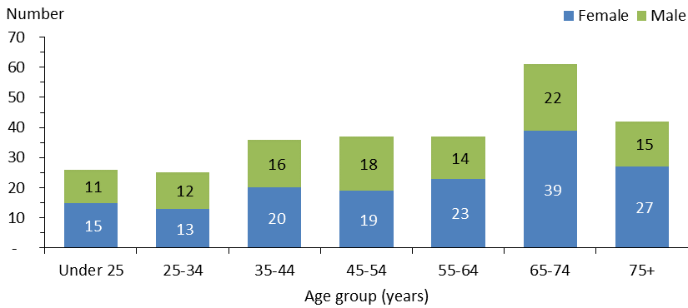

Note: No one aged under 15 or over 89 years received ECT.

Sources: PRIMHD data (extracted 28 February 2024) and manual data for Health New Zealand MidCentral, Southern, Waikato and Waitematā.

## Ethnicity of people treated with ECT

Table 18 indicates that Asian, Māori and Pacific peoples were less likely to receive ECT than people of other ethnicities, such as New Zealand Europeans. However, the numbers involved are so small that it is not statistically appropriate to compare the percentage of people receiving ECT in each ethnic group with that group’s proportion of the total population.

Table 18: Number of people treated with ECT and rate per 100,000 population, by ethnicity, 1 July 2022 to 30 June 2023

|  |  |  |
| --- | --- | --- |
| **Ethnicity** | **Number** | **Rate per 100,000** |
| Māori | 36 | 4.0 |
| Pacific peoples | 10 | 2.7 |
| Asian | 20 | 2.2 |
| Other | 198 | 6.5 |
| **All** | **264** | **5.0** |

Sources: PRIMHD data (extracted 28 February 2024) and manual data for Health New Zealand MidCentral, Southern, Waikato and Waitematā.

## Consent to ECT treatment

Under the Mental Health Act, a person can be treated with ECT if they consent in writing or if an independent psychiatrist appointed by the Mental Health Review Tribunal[24] considers this treatment to be in the person’s interests. An independent psychiatrist cannot be the patient’s responsible clinician or part of the patient’s clinical team.

In 2022/23, a total of 1,091 ECT treatments were administered to 113 people who did not have capacity to consent. In all of these cases, an independent psychiatrist provided a second opinion. No treatments were reported to be administered to people who had capacity but refused to consent Table 19 shows the number of treatments administered without consent during this period.

Table 19: ECT administered under second opinion without consent, by region of service, 1 July 2022 to 30 June 2023

|  |  |  |  |  |
| --- | --- | --- | --- | --- |
| **Region of service** | **Second opinion where patient did not have the capacity to consent** | | **Second opinion where patient had the capacity but refused to consent** | |
| **Number of people given ECT** | **Number of treatments administered** | **Number of people given ECT** | **Number of treatments administered** |
| Northern | 48 | 512 | 0 | 0 |
| Midland | 22 | 145 | 0 | 0 |
| Central | 18 | 141 | 0 | 0 |
| South Island | 25 | 293 | 0 | 0 |
| **Nationally** | **113** | **1,091** | **0** | **0** |

Notes: The data in this table cannot be reliably compared with the data in Table 17 as it relates to the Health New Zealand region of service rather than region of domicile.

Source: Manual data from districts.

# Substance use treatment

## Opioid substitution treatment

The Director, acting under delegated authority from the Minister of Health, designates specialist services and lead clinicians to provide treatment with controlled drugs to people who are dependent on them, under section 24A(7)(b) of the Misuse of Drugs Act 1975. These services are also subject to an audit every three years, using the *Specialist Opioid Substitution Treatment Service Audit and Review Tool.*[25]

Opioid dependence is a complex, relapsing condition requiring a model of treatment and care much like any other chronic health problem. Opioid substitution treatment (OST) helps people who have an opioid dependence to access treatment, including substitution therapy, which provides them with the opportunity to recover their health and wellbeing.

Specialist OST services are specified by the Minister of Health under section 24A of the Misuse of Drugs Act 1975 and notified in the *New Zealand Gazette*.

OST services in Aotearoa New Zealand are expected to provide a standardised approach that puts the person, family and whānau at the heart of treatment, recovery, wellbeing and citizenship. To help services take this approach, the *New Zealand Practice Guidelines for Opioid Substitution Treatment*[26] provide clinical and procedural guidance for specialist services and primary health care providers who deliver OST. The Ministry is working with the addictions sector to develop updated guidance for services and practitioners and will publish it once completed.

The following summarises OST data from 1 July 2022 to 30 June 2023.[27]

* 5,245 people received OST.
* 76.1% of these people were New Zealand European, 17.6% were Māori, 1.5% were Pacific peoples and 4.8% were of other ethnicities.
* 70.1% of clients receiving OST were over 45 years of age.
* 25.4% of people receiving OST were receiving treatment from a general practitioner in a shared-care arrangement.

### Service providers

Aotearoa New Zealand has three types of OST service providers.

**Specialist services:** Specialist OST services are the entry point for nearly all people needing treatment with controlled drugs. These services comprehensively assess the needs of clients, provide them with specialist interventions and stabilise them. This approach creates a pathway to plan for recovery, make referrals for co-existing health needs and social support, and eventually transfer treatment to a primary health provider or withdraw the client from treatment altogether.

In 2022/23, 73.6% of OST clients received treatment from specialist services.

**Primary health:** Specialist addiction services work alongside primary health care to share delivery of OST services. This approach allows specialist services to focus on clients who have the highest need and normalises the treatment process.

In 2022/23, 25.4% of OST clients received this treatment from their general practitioner (GP).

The Ministry’s target for service provision is to split it 50:50 between primary and specialist health care services.

**Ara Poutama – Department of Corrections** (Ara Poutama): When a person receiving OST goes to prison, Ara Poutama ensures that the person continues to receive OST services, including psychosocial support and treatment from specialist services.

In 2022/23, less than 1% of OST clients received this treatment from Ara Poutama. Service providers and Ara Poutama work together to initiate OST as appropriate for people who are imprisoned.

Figure 43 presents the percentage of people receiving OST from specialist services and GPs in each Health New Zealand district in 2022/23. Figure 44 shows the number of people receiving OST from these providers from 2007/08 to 2022/23, based on January to June six-monthly reports from OST providers.

Figure 43: Percentage of people receiving opioid substitution therapy from specialist services and general practitioners, by district, 1 July 2022 to 30 June 2023

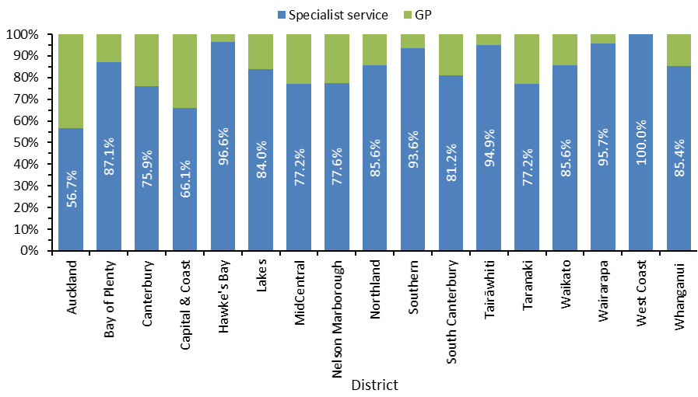

Notes: ‘Auckland’ includes Auckland, Counties Manukau and Waitematā districts. ‘Capital & Coast’ includes Capital & Coast and Hutt Valley districts. ‘Canterbury’ includes one GP service operating in Christchurch.

Source: Data provided by OST services in January to June six-monthly reports.

Figure 44: Number of people receiving opioid substitution therapy from a specialist service, general practitioner or prison service, 2007/08 to 2022/23

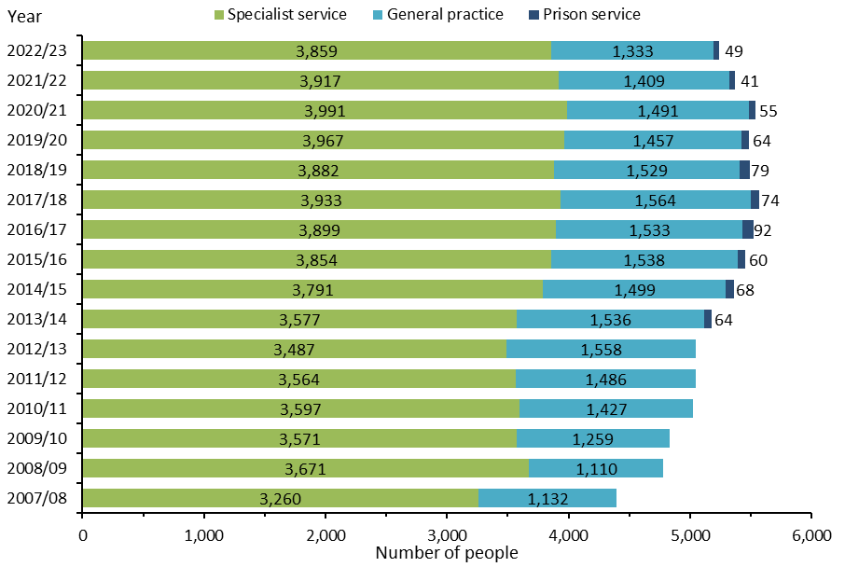

Note: Data for clients seen in prison collected from July 2013.

Source: Data provided by OST services in January to June six-monthly reports.

### Prescribing opioid treatments

A treatment that replaces addictive substances like opioids with prescribed drugs is called pharmacotherapy. The purpose of this treatment is to stabilise the opioid user’s health and reduce harms from drug use, such as the risk of overdose, blood-borne virus transmission and substance-related criminal activity.

The two types of pharmacotherapy are:

* maintenance therapy – using opioid substitutes to remain on a stable dose
* detox – using opioid substitutes to gradually withdraw from the substitute so the client can be free of all opioid substances.

Methadone has historically been the main OST available. Clients need a daily dose, which in turn makes it necessary to limit prescribing and dispensing.

In 2012, the Pharmaceutical Management Agency Ltd (Pharmac) began funding a buprenorphine-naloxone (suboxone) combination for OST. Suboxone can be administered in cumulative doses that last several days, which reduces the risk of drug diversion and offers clients more normality in their lives. Figure 45 presents the number of people prescribed suboxone from 2007/08 to 2022/23.

In 2022/23, 24.1% of OST clients were prescribed suboxone.

Figure 45: Number of people prescribed suboxone, 2007/08 to 2022/23

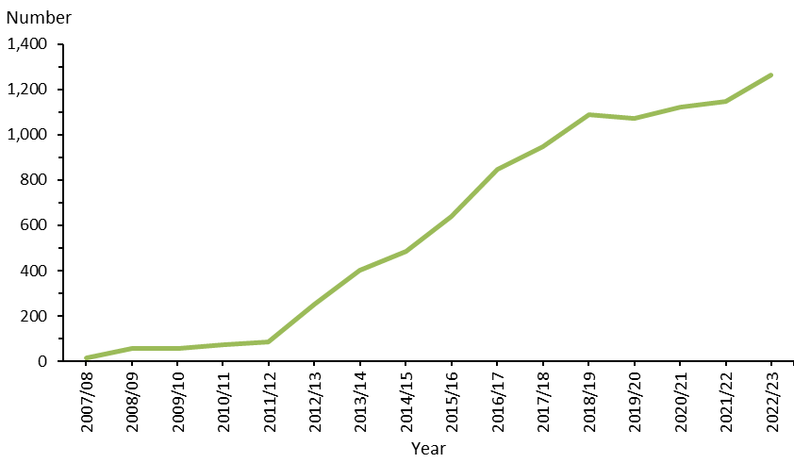

Source: Data provided by OST services in January to June six-monthly reports.

### The ageing population of OST clients

OST clients are an ageing population. Figure 46 shows how the number of clients in older age groups has been increasing from 2007/08. Those aged 45–59 years are the most likely age group to be receiving OST.

In 2022/23, the majority of clients (70.1%) were aged over 45 years. Treating an ageing population brings with it more health complications.

Figure 46: Number of opioid substitution treatment clients, by age group, 2007/08 to 2022/23

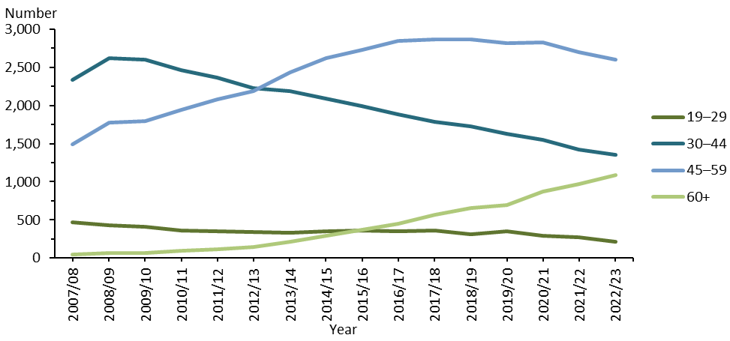

Source: Data provided by OST services in January to June six-monthly reports.

### Exit from OST

A total of 494 people receiving OST exited the service in 2022/23. The following summarises the OST exit data for this group of people.

* Of those who exited OST, 399 (81%) voluntarily withdrew.
* There were nine involuntary withdrawals (2% of all exits). Involuntary withdrawals can occur where a client’s behaviour puts their own safety or the safety of others at risk.
* Of the people who had been receiving OST and exited the service, 86 died. A small proportion of these people died of a suspected overdose. In these cases, the Ministry requires services to conduct an incident review and report it to the medical officer of health. The remaining deaths had a range of other causes, such as cancer and cardiovascular disease.

Figure 47 gives an overview of the reasons for exit from treatment (voluntary, involuntary or death) from 2008/09 to 2022/23.

Figure 47: Percentage of exits from opioid substitution treatment programmes, by reason (voluntary, involuntary or death), 2008/09 to 2022/23

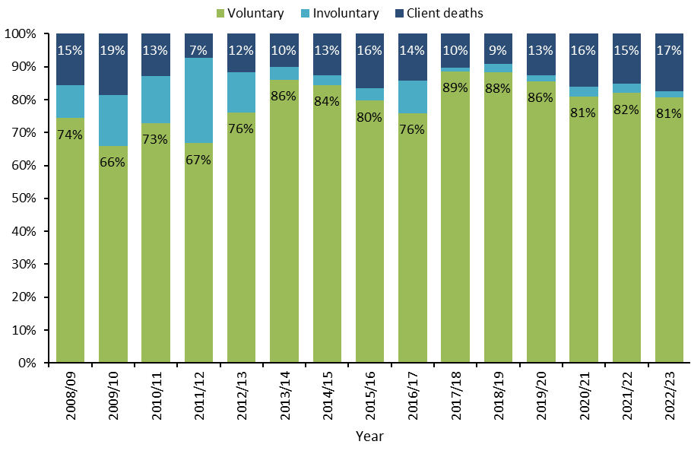

Source: Data provided by OST services in six-monthly reports.

## Substance Addiction (Compulsory Assessment and Treatment) Act 2017

In February 2018, the Substance Addiction (Compulsory Assessment and Treatment) Act 2017 (Substance Addiction Act) came into force, replacing the Alcoholism and Drug Addiction Act 1996. The Substance Addiction Act is designed to help people who have a severe substance addiction and impaired capacity to make decisions about engaging in treatment. This legislation is better equipped than the earlier Act to protect the human rights and cultural needs of patients and their families and whānau, and it places greater emphasis on enhancing mana and following a health-based approach.

Section 119 of the Substance Addiction Act requires the Ministry to publish certain information in its annual report, such as the number of people who received compulsory treatment. The 2022/23 annual report which includes the Substance Addiction Act data for the 2022/23 financial year, is available on the [Ministry’s website](https://www.health.govt.nz).

## Land Transport Act 1998

In 2022/23, the Office of the Director of Mental Health and Addiction Services continued to work with Waka Kotahi New Zealand Transport Agency (Waka Kotahi), the Ministry of Transport and the Drug and Alcohol Practitioners’ Association Aotearoa New Zealand to monitor the reinstatement of drivers disqualified for offences involving alcohol or drugs. It also worked with the agencies to approve assessment centres under section 65A of the Land Transport Act 1998.

Where people have committed repeat driving offences involving drugs or alcohol, section 65A requires them to be indefinitely disqualified from having a driver licence and to undergo assessment. To determine if a person can have their licence reinstated, an approved assessment centre considers their ability to manage their substance use or addictive behaviours. The assessment centre sends a copy of its report to Waka Kotahi, which decides whether to reinstate the person’s licence.

The Director-General of Health makes the decision on whether to approve an assessment centre. Establishments and individuals applying to be an approved assessment centre must demonstrate that they are competent in assessing alcohol and other drug problems and are a registered and experienced alcohol and drug practitioner or employ such practitioners.

## Drug-checking licensing scheme

Drug checking was legalised in Aotearoa New Zealand through amendments made to the Misuse of Drugs Act 1975 in November 2021. Drug checking is regulated under the Misuse of Drugs Act 1975, Psychoactive Substances Act 2013 and the Medicines Act 1981, along with the relevant regulations under those Acts. While several other countries offer drug checking services (eg, under research legislation or within legislative ‘grey areas’), Aotearoa New Zealand is the only country to have legal, licensed drug-checking services.

Drug checking services aim to reduce drug harm and risk by helping people make informed decisions about drug use. They do not promote illicit drug use or claim that illicit drug use is safe. Licensed drug checking providers conduct scientific tests on substances to indicate their likely identity and composition. They test unknown substances (which may be illicit drugs), interpret results, and provide mandatory harm reduction information to the person who provides the sample. In addition to reducing harm for individual clients, these frontline drug checking services have a crucial role in drug surveillance at a national level. Licensed providers can detect new substances in circulation often before a harm incident occurs, enabling a proactive response to reduce harm in communities.

Drug checking results also inform Aotearoa New Zealand’s early warning system, Drug Information Alert New Zealand (DIANZ). DIANZ, a business unit of the National Drug Intelligence Bureau (NDIB), is a joint operation between the Ministry of Health, Health New Zealand, New Zealand Customs Service and New Zealand Police. This system alerts health professionals and the public to especially dangerous drugs circulating in Aotearoa New Zealand. DIANZ works closely with licensed drug checking providers to share information and provide harm reduction messaging to the public through its early warning system, High Alert. Data from licensed drug checking services feeds directly into this early warning system. Drug checking services played a direct role in 50% (two of four) of the High Alert notifications released during the 2022/23 financial year.

During 2022/23, the drug-checking licensing scheme processed and granted approval to five entities to act as licensed providers. As the first provider was licensed in October 2022, the dataset used in this report is incomplete for the 2022/23 year. Data is available for three of the four quarters in this time period (ie, quarter 2, October to December 2022; quarter 3, January to March 2023; and quarter 4, April to June 2023). Future annual reports will publish data captured for a full year.

The Ministry of Health receives quarterly reporting from all licensed drug checking providers. A total of 208 drug checking events and clinics were held during 2022/23, including festivals and field events, static clinics, pop-up clinics and continuous services. At these drug-checking events and clinics, 6,209 samples were presented for drug checking.

Drug checking service providers must also provide harm reduction advice to anyone who receives test results for a particular drug. This harm reduction advice must include advice specific to the person, their circumstances and the drug identified. Under this scheme, 7,500 people received harm reduction advice over quarters 2 to 4 of 2022/23. This number differs according to the number of clients or samples that present at a given time (eg, one harm reduction client presenting three samples to test; or two clients presenting one sample and both receiving harm-reduction advice on the one sample tested). Figure 48 sets out the number of samples tested and the number of individuals given advice over this period.

Figure 48: Number of samples tested and of individuals given harm reduction advice, nationally, 1 October 2022 to 30 June 2023

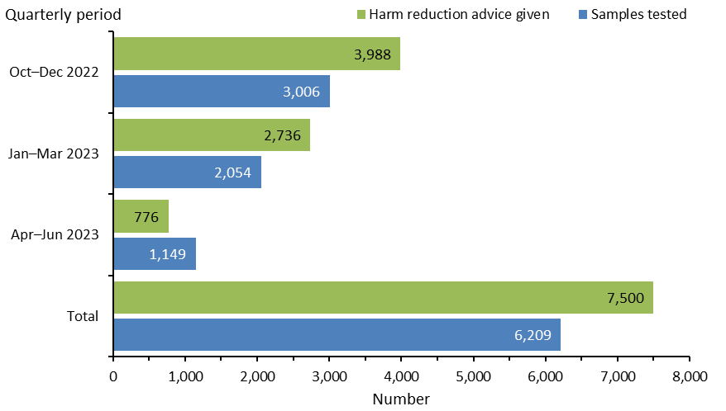

Source: Quarterly reporting by field-based, drug-checking providers to the Ministry of Health.

The data above excludes testing undertaken by the Institute of Environmental Science and Research (ESR), which is the approved laboratory for further testing and analysis of substances. In some cases, field drug checking may not be able to fully identify the substance, or may identify it as a novel (new) substance, or a substance linked to high-risk and/or harm events. In these cases, the substance can be sent for further analysis to ESR to determine its composition.

ESR tested 157 substances to further analyse drug checking samples during the 2022/23 period.

Drug checking providers also report to NDIB, which analyses drug-checking trends.

Figure 49 shows the types of drugs presented for testing, based on what the person presenting the drug believed (presumed) it to be, before testing. As per the data analysis done by NDIB ,the top five presumed drug types presented for testing, were MDMA[28] (60.4%), ketamine (7.7%), LSD[29] (6.2%), cocaine (4.7%) and methamphetamine (3.7%). These substances accounted for 82% of all drugs presented for drug checking.

Figure 49: Drug types presented to drug-checking services, as presumed by client, nationally, 1 October 2022 to 30 June 2023

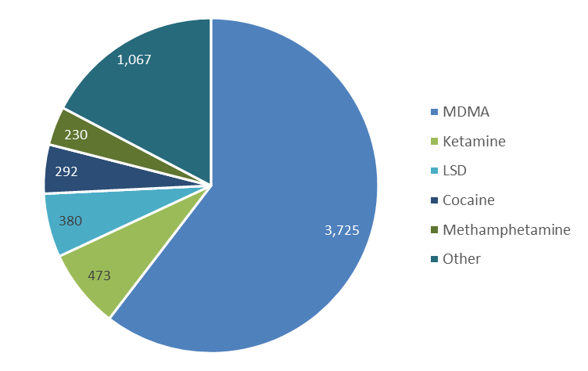

Source: Data submitted to NDIB in post-clinic reporting. Excludes data from ESR.

NDIB also reports it found that, of the top five substances presented for drug checking (Figure 49), 87.3% were consistent with what the client presumed (Figure 50).

Figure 50: Percentage of presumed drug types consistent with the confirmed drug type results, 1 October 2022 to 30 June 2023

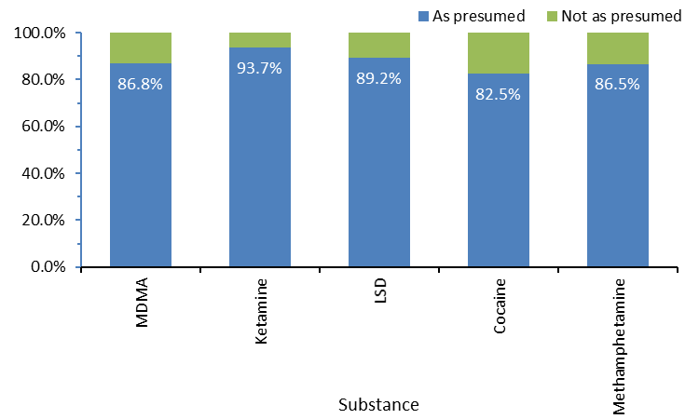

Source: Data submitted to NDIB in post-clinic reporting. Excludes data from ESR.

No matter whether or not drug-checking shows that the sample presented is the drug that the client presumed, drug checking providers have a harm reduction conversation with the client. The aim of this conversation is to inform the client of risks relating to the substance, allowing them to make more informed decisions about safety and risk associated with drug use.

This educational, health-based approach to reducing drug harm has seen an overall positive response from the sector and wider community. Providers often receive feedback from clients about the benefits of drug checking and how it enables people to make informed decisions about keeping themselves and others safe from drug-associated harm.

Moving forward, the Ministry of Health plans to liaise with rural communities and Te Tiriti o Waitangi partners to extend the reach of drug checking and increase equitable access across Aotearoa New Zealand. Future regulatory reports will publish information on the implementation and progress of these developments.

# Appendix 1: The Mental Health Act process

The compulsory assessment and treatment process begins with a referral and an initial assessment. If the health assessor believes a person fits the Mental Health Act’s criteria, the person will become subject to the Mental Health Act and receive further assessment from there.

## Compulsory assessment

Application for assessment (section 8A)

Compulsory assessment can take place in either a community or a hospital setting. There are two periods of compulsory assessment, during which a person’s clinician may release them from assessment at any time.

Second period of assessment (section 13, up to 14 days)

First period of assessment (section 11, up to 5 days)

During the assessment period, a person is obliged to receive treatment that their responsible clinician prescribes. The first period (section 11 of the Mental Health Act) lasts for up to 5 days. The second period (section 13 of the Mental Health Act) can last up to 14 days.

No CTO issued by courts

Community or inpatient treatment order made (section 29 or 30)

Application to the court for a CTO (section 14(4), within second period)

Following the first two assessment periods, a person’s responsible clinician can make an application to the courts under section 14(4) of the Mental Health Act to place the person under a compulsory treatment order (CTO).

At any time during the compulsory assessment process, the person (or someone on their behalf) can request a review of their condition by the courts to determine whether it is appropriate that they continue to be assessed. Based on information presented to them, a judge will decide whether the assessment should continue or not.

## 

## Compulsory treatment

There are two types of CTOs: community treatment orders (section 29 of the Mental Health Act) and inpatient treatment orders (section 30 of the Mental Health Act). A person’s responsible clinician can convert an inpatient treatment order to a community treatment order at any time. A responsible clinician can also grant leave in the community for up to three months to a person who is under an inpatient treatment order (section 31 of the Mental Health Act).

# Appendix 2: Additional statistics – Ministry of Justice

Table A1 presents data on applications for a CTO from 2008/09 to 2022/23. Table A2 shows the types of orders granted over the same period.

Table A1: Applications for compulsory treatment orders or extensions, 2008/09 to 2022/23

|  |  |  |  |  |  |
| --- | --- | --- | --- | --- | --- |
| **Financial year** | **Number of applications for a CTO, or extension to a CTO** | **Number of applications granted or granted with consent** | **Number of applications dismissed or struck out** | **Number of applications withdrawn, lapsed or discontinued** | **Number of applications transferred to the High Court** |
| 2008/09 | 4,570 | 4,003 | 76 | 496 | 0 |
| 2009/10 | 4,661 | 4,100 | 72 | 507 | 0 |
| 2010/11 | 4,807 | 4,198 | 63 | 542 | 1 |
| 2011/12 | 4,838 | 4,272 | 69 | 475 | 0 |
| 2012/13 | 4,950 | 4,480 | 75 | 397 | 0 |
| 2013/14 | 5,181 | 4,610 | 53 | 522 | 0 |
| 2014/15 | 5,184 | 4,629 | 55 | 526 | 0 |
| 2015/16 | 5,564 | 4,918 | 51 | 560 | 0 |
| 2016/17 | 5,607 | 4,927 | 73 | 563 | 0 |
| 2017/18 | 5,570 | 4,959 | 74 | 566 | 0 |
| 2018/19 | 5,619 | 4,972 | 64 | 571 | 0 |
| 2019/20 | 5,711 | 5,021 | 52 | 622 | 0 |
| 2020/21 | 5,899 | 5,244 | 62 | 626 | 0 |
| 2021/22 | 6,097 | 5,376 | 75 | 631 | 0 |
| 2022/23 | 6,312 | 5,605 | 105 | 620 | 0 |

Notes: The table presents applications that had been processed at the time of data extraction on 6 March 2024. The year is determined by the final outcome date. The CMS is a live operational database, which means figures are subject to minor changes at any time.

Source: Ministry of Justice Integrated Sector Intelligence System, which uses data entered into the CMS (extracted 6 March 2024).

Table A2: Types of compulsory treatment orders made on granted applications, 2008/09 to 2022/23

|  |  |  |  |  |  |
| --- | --- | --- | --- | --- | --- |
| **Financial year** | **Number of granted applications for orders** | **Number of community treatment orders (or extension)** | **Number of inpatient treatment orders (or extension)** | **Number of orders recorded as both community and inpatient treatment orders (or extension)** | **Number of applications where type of order was not recorded** |
| 2008/09 | 4,003 | 2,020 | 1,519 | 100 | 349 |
| 2009/10 | 4,100 | 2,147 | 1,628 | 116 | 203 |
| 2010/11 | 4,198 | 2,283 | 1,668 | 95 | 142 |
| 2011/12 | 4,272 | 2,297 | 1,663 | 98 | 206 |
| 2012/13 | 4,480 | 2,591 | 1,730 | 63 | 96 |
| 2013/14 | 4,610 | 2,616 | 1,756 | 88 | 148 |
| 2014/15 | 4,629 | 2,688 | 1,782 | 84 | 75 |
| 2015/16 | 4,918 | 2,896 | 1,821 | 60 | 137 |
| 2016/17 | 4,927 | 2,727 | 1,654 | 75 | 468 |
| 2017/18 | 4,959 | 2,594 | 1,709 | 49 | 603 |
| 2018/19 | 4,972 | 2,747 | 1,814 | 47 | 363 |
| 2019/20 | 5,021 | 2,896 | 1,744 | 67 | 314 |
| 2020/21 | 5,244 | 3,031 | 1,939 | 48 | 223 |
| 2021/22 | 5,376 | 3,030 | 1,934 | 87 | 323 |
| 2022/23 | 5,605 | 3,061 | 1,905 | 49 | 588 |

Notes: The table presents applications that had been processed at the time of data extraction on 6 March 2024. The year is determined by the date the application was granted. When more than one type of order is shown, it is likely to be because new orders are linked to a previous application in the CMS. The CMS is a live operational database, which means figures are subject to minor changes at any time.

Source: Ministry of Justice Integrated Sector Intelligence System, which uses data entered into the CMS (extracted 6 March 2024).

# Appendix 3: Additional seclusion statistics

In 2022/23, the volume of seclusion hours reported for seven people was so high that they were considered to be outliers compared with the average volume of hours across all people who were secluded.

The outliers consist of people receiving care in adult inpatient services (one person), forensic services (one person) and intellectual disability services (five people).

The outlier data has been excluded from the statistics presented in the main body of the report to avoid skewing the overall data and creating a different picture of mental health services. To highlight how much the outliers would affect the overall results, we present some of the data that includes the outlier data in Table A3.

Note that one person that was considered to be an outlier for their inpatient seclusion hours also experienced a small number of hours in seclusion in forensic services. Data for their forensic seclusion was included in the main body of the report, which is why the total number of people secluded across all services increases by six, not seven, to total 948 people when including outliers.

Table A3: Seclusion indicators including outlier data, 1 July 2022 to 30 June 2023

|  |  |  |
| --- | --- | --- |
| **Seclusion measure** | **Excluding outliers** | **Including outliers** |
| **Overall mental health inpatient services (adult, forensic, intellectual disability and youth)** | | |
| Number of people secluded in all services | 942 | 948 |
| Number of hours of seclusion in all services | 64,650 | 100,960 |
| Number of seclusion events in all services | 1,876 | 2,948 |
| Percentage of seclusion events lasting under 24 hours | 65% | 74% |
| Percentage of seclusion events lasting over 48 hours | 17% | 13% |
| **Adult inpatient services** | | |
| Number of people secluded | 699 | 700 |
| Number of hours of seclusion | 32,347 | 36,787 |
| Number of seclusion events | 1,178 | 1,535 |
| Number of seclusion events per person | 1.7 | 2.2 |
| Number of seclusion events per 1,000 bed nights | 5.5 | 7.1 |
| Number of people secluded per 100,000 population | 22.8 | 22.8 |
| Number of seclusion events per 100,000 population | 38.4 | 50.0 |
| Average duration per seclusion event | 27.5 hours | 24 hours |
| Decrease in people secluded since 2009 | 35% | 35% |
| Decrease in hours spent in seclusion since 2009 | 65% | 60% |
| Decrease in hours spent in seclusion since 2021/22 | 17% | 5% |
| **Forensic services** | | |
| Number of people secluded | 119 | 120 |
| Number of hours of seclusion | 23,718 | 28,477 |
| Number of seclusion events | 355 | 374 |
| **Intellectual disability services** | | |
| Number of people secluded | 24 | 29 |
| Number of hours of seclusion | 3,106 | 30,116 |
| Number of seclusion events | 95 | 791 |

Sources: PRIMHD data (extracted 28 February 2024) and manual data from Health New Zealand South Canterbury, Tairāwhiti and Waitematā.

# Appendix 4: 2021/22 corrected ECT data

When preparing the 2022/23 regulatory report, we discovered that some ECT data relating to MidCentral District Health Board (DHB) was missing from the published 2021/22 regulatory report. The 2021/22 regulatory report stated that 256 people received a total of 3,002 ECT treatments. This was incorrect. The report should have stated that 265 people received a total of 3,087 treatments.

Table A4 shows the difference between the corrected and previously reported data.

Table A4: Corrected ECT indicators, by district health board of domicile, 1 July 2021 to 30 June 2022

|  | **Corrected data** | | | **Previously reported** | | |
| --- | --- | --- | --- | --- | --- | --- |
| **DHB of domicile** | **Number of patients treated with ECT** | **Total number of treatments** | **Mean number of treatments per person (range)** | **Number of patients treated with ECT** | **Total number of treatments** | **Mean number of treatments per person (range)** |
| Auckland | 18 | 151 | 8 (1–18) | No difference | No difference | No difference |
| Bay of Plenty | 28 | 343 | 12 (2–57) | No difference | No difference | No difference |
| Canterbury | 13 | 97 | 7 (2–23) | No difference | No difference | No difference |
| Capital & Coast | 34 | 411 | 12 (2–28) | No difference | No difference | No difference |
| Counties Manukau | 22 | 366 | 17 (1–53) | No difference | No difference | No difference |
| Hawke’s Bay | 5 | 98 | 20 (4–36) | No difference | No difference | No difference |
| Hutt Valley | 9 | 70 | 8 (2–11) | No difference | No difference | No difference |
| Lakes | 9 | 55 | 6 (1–12) | No difference | No difference | No difference |
| MidCentral | 14 | 152 | 11 (2–27) | 5 | 67 | 13 (1–25) |
| Nelson Marlborough | 15 | 163 | 11 (2–33) | No difference | No difference | No difference |
| Northland | 7 | 108 | 15 (1–35) | No difference | No difference | No difference |
| South Canterbury | 0 | 0 | – | No difference | No difference | No difference |
| Southern | 17 | 163 | 9 (1–29) | No difference | No difference | No difference |
| Tairāwhiti | 0 | 0 | – | No difference | No difference | No difference |
| Taranaki | 12 | 178 | 15 (6–34) | No difference | No difference | No difference |
| Waikato | 30 | 347 | 12 (1–63) | No difference | No difference | No difference |
| Wairarapa | 3 | 31 | 10 (7–12) | No difference | No difference | No difference |
| Waitematā | 27 | 329 | 12 (1–38) | No difference | No difference | No difference |
| West Coast | 0 | 0 | – | No difference | No difference | No difference |
| Whanganui | 3 | 25 | 8 (2–21) | No difference | No difference | No difference |
| **Nationally** | **265** | **3087** | **12 (1–63)** | **256** | **3,002** | No difference |

Sources: PRIMHD data (extracted 16 May 2023) and manual data from Northland and MidCentral DHBs.

1. Ministry of Health. 2023. *Guidelines for Reducing and Eliminating Seclusion and Restraint Under the Mental Health (Compulsory Assessment and Treatment) Act 1992*. Wellington: Ministry of Health.
2. Government Inquiry into Mental Health and Addiction. 2018. *He Ara Oranga: Report of the* *Government Inquiry into Mental Health and Addiction.* URL: [mentalhealth.inquiry.govt.nz/inquiry-report/he-ara-oranga/](https://mentalhealth.inquiry.govt.nz/inquiry-report/he-ara-oranga/) (accessed 15 January 2025).
3. Source: Programme for the Integration of Mental Health Data (PRIMHD) data (extracted 28 February 2024).
4. Mental Health Act, sections 11, 13, 15(1), 15(2), 29, 30 and 31.
5. ‘Other ethnicities’ includes all ethnicities except for Māori and Pacific peoples.
6. Source: Ministry of Justice’s case management system (CMS) data (extracted 6 March 2024).
7. Sources: PRIMHD data (extracted 28 February 2024) and manual data for Health New Zealand Waikato.
8. ‘On an average day’ is the average of the last day of each month.
9. Source: PRIMHD data (extracted 28 February 2024).
10. These ratios are based on the age-standardised rates of the Māori, Pacific peoples and other populations. Source: PRIMHD data (extracted 28 February 2024).
11. Deprivation quintiles are ranked 1 to 5, where 1 represents areas with the least deprived scores and 5 the areas with the most deprived scores.
12. Sources: PRIMHD data (extracted 28 February 2024) and manual data from Health New Zealand Counties Manukau, Tairāwhiti and Waikato.
13. Standards New Zealand. 2021. *Ngā Paerewa* *Health and Disability Services Standard*. Wellington: Standards New Zealand.
14. ‘Adult inpatient service’ means an inpatient mental health service for those aged 18 years and older. It does not include those in older people’s mental health services.
15. Sources: PRIMHD data (extracted 28 February 2024) and manual data from Health New Zealand South Canterbury, Tairāwhiti and Waitematā.
16. We compare with 2009 because in that year seclusion reduction policies were introduced in Aotearoa New Zealand.
17. Data in this section excludes forensic, intellectual disability and youth services unless specified otherwise. Bed nights are measured by team types that use seclusion. This may differ from denominator figures used in other entities’ seclusion reporting. This data cannot be compared with years before 2017, when bed nights were measured by acute and sub-acute bed nights. Sources: PRIMHD data (extracted 28 February 2024) and manual data from Health New Zealand South Canterbury, Tairāwhiti and Waitematā.
18. If people in Wairarapa required admission to mental health inpatient services, they were transported to either Health New Zealand Hutt Valley or MidCentral. Any seclusion statistics for them are included in the service where they received treatment.
19. ‘Act proven but not criminally responsible on account of insanity’ is a new finding that was introduced by the Rights for Victims of Insane Offenders Act 2021 to replace ‘not guilty by reason of insanity’.
20. Te Tāhū Hauora defines an adverse event as an event that results in harm or has the potential to result in harm to a consumer.
21. A Severity Assessment Code is a numerical rating of how severe an adverse event is, which in turn indicates what level of reporting and investigation is needed for that event.
22. See the National Adverse Events Reporting Policy on the website for Te Tāhū Hauora at: [www.hqsc.govt.nz/our-programmes/adverse-events/national-adverse-events-policy/](http://www.hqsc.govt.nz/our-programmes/adverse-events/national-adverse-events-policy/).
23. Sources: PRIMHD data (extracted 28 February 2024) and manual data for Health New Zealand MidCentral, Southern, Waikato and Waitematā.
24. The Mental Health Review Tribunal is an independent body that the Minister of Health appoints under the Mental Health Act. For more information, see the Mental Health Review Tribunal webpage on the Ministry’s website at: [health.govt.nz/about-us/new-zealands-health-system/health-system-roles-and-organisations/health-committees-and-boards/mental-health-review-tribunal](https://www.health.govt.nz/about-us/new-zealands-health-system/health-system-roles-and-organisations/health-committees-and-boards/mental-health-review-tribunal) (accessed 12 December 2024).
25. For more information, see Ministry of Health. 2014. *Specialist Opioid Substitution Treatment (OST) Service Audit and Review Tool*. URL: [health.govt.nz/publications/specialist-opioid-substitution-treatment-ost-service-audit-and-review-tool](https://www.health.govt.nz/publications/specialist-opioid-substitution-treatment-ost-service-audit-and-review-tool) (accessed 8 December 2024).
26. Ministry of Health. 2014. *New Zealand Practice Guidelines for Opioid Substitution Treatment.* URL: [health.govt.nz/publications/new-zealand-practice-guidelines-for-opioid-substitution-treatment-2014](https://www.health.govt.nz/publications/new-zealand-practice-guidelines-for-opioid-substitution-treatment-2014) (accessed 8 December 2024).
27. Source: Data provided by OST services in six-monthly reports. These six-monthly reports do not collect data by National Health Index numbers. Instead, the national total is a sum of the district figures, so it may double-count people who received services from more than one district.
28. 3,4-methylenedioxymethamphetamine.
29. Lysergic acid diethylamide