Prolonged Symptoms Attributable to Infection with COVID-19
Office of the Chief Science Advisor
Evidence, Research, and Innovation –
Te Pou Whakamārama
2025

Citation: Ministry of Health. 2025. Prolonged Symptoms Attributable to Infection with COVID-19. Wellington: Ministry of Health.
Published in January 2025 by the Ministry of Health
PO Box 5013, Wellington 6140, New Zealand
ISBN 978-1-991324-12-2 (online)
HP 9105

This document is available at health.govt.nz
 | This work is licensed under the Creative Commons Attribution 4.0 International licence. In essence, you are free to: share ie, copy and redistribute the material in any medium or format; adapt ie, remix, transform and build upon the material. You must give appropriate credit, provide a link to the licence and indicate if changes were made.

Contents
Background 1
Methodology 2
Study selection 2
Data extraction and analysis 2
Results 3
Systematic reviews and meta-analyses 3
Larger single studies with non-COVID-19 controls 5
Smaller single studies with non-COVID-19 controls 6
Studies of children and adolescents with non-COVID-19 controls 7
Discussion 8
Conclusions 10
References 11
Appendices 16
Appendix A: Definitions 16
Appendix B: Link between definition and prevalence challenges 18
Appendix C: Study details 20
Appendix D: Search strategy 30

List of Figures
Figure A1: Venn diagrams of four Long COVID definitions 19
Figure A2: PHQ-15 scoring system example 25
Figure A3: Prevalence ratio of symptom severity among people with COVID-19 compared to those not diagnosed with COVID-19 as reported in Shen et al 26
Figure A4: Prevalence ratio of symptom severity: post-to-pre-COVID-19 longitudinal comparison as reported in Shen et al 27
Figure A5: Risk ratio by symptom and database as reported in Kostka et al 28
Figure A6: Age- and sex-adjusted odds ratios by symptom as reported in Hosozawa et al 29

List of Tables
Table A1: Long COVID symptoms at 3–6, 6–12 and >12 months as reported in Luo et al 21
Table A2: Long COVID symptoms as reported in Marjenberg et al 22
Table A3: Long COVID symptoms as reported in Azzam et al 24
Table A4: Long COVID symptoms in children as reported in Azzam et al 24

.

Background
During the initial stage of the global COVID-19 pandemic, attention was largely focused on the acute health impacts of SARS-CoV-2 infection (Leung et al 2020). Early observations suggested that most patients presented with and recovered from ‘mild’ infections within two weeks and from more serious disease within three weeks. As the pandemic progressed, accumulating evidence showed that some individuals may present with a prolonged and complicated hospital stay (National Institute for Health Research 2020). Over time, it has become clear that for some people COVID-19 can lead to persistent illness, with ongoing and often debilitating symptoms. Infection with SARS-CoV-2 can trigger health effects that can continue well after the resolution of the initial acute COVID-19 illness. These effects can manifest in most organ systems (Ito et al 2024; Kitsios et al 2024), and in some cases be disabling and have profound effects on quality of life. Most commonly referred to as long COVID, the constellation of symptoms after COVID-19 infection has multiple definitions with varied timeframes (Appendix A). This lack of a consensus definition of long COVID poses several problems, including achieving an accurate diagnosis, prevalence measurements and development of appropriate clinical guidelines (Appendix B). As such, the term ‘long COVID’ has been used sparingly in the brief.
International evidence to date provides a broad range of prevalence estimates for long COVID, ranging from 45 to 80% (Lopez-Leon et al 2021; O’Mahoney et al 2023). However, the accuracy of these estimates is limited given the lack of universal definition of long COVID, non-specificity of some of the reported long COVID symptoms, the impact of pre-existing health disorders and the wider psychosocial, socioeconomic effects of the pandemic (Amin-Chowdhury et al 2021).
Further, in the absence of robust prevalence studies in New Zealand and lack of a formal long COVID registry, the potential burden of long COVID in New Zealand remains unknown. This is particularly significant as New Zealand had a high vaccination rate at the time of community spread, and Omicron was the predominant variant among those infected.
Thus, the aim of this brief was to understand the overall prevalence of prolonged symptoms (three months and beyond) that may be attributable to COVID-19 infection.

Methodology
The literature search strategy initially encompassed 12 evidence questions, of which questions one and two, related to definition and prevalence, are addressed in this first evidence brief. Detailed methodology and PRISMA (Preferred Reporting Items for Systematic Reviews and Meta-Analyses) across the 12 questions is presented elsewhere.

Study selection
Studies that met the following criteria were included in the brief:
- published between September 2023 and August 2024
- involving human participants
- published in the English language and available in full text
- looking at symptoms from three months and longer.

Studies that met the following criteria were excluded from the brief:
- looking at symptoms less than three months
- beyond the scope of the evidence questions
- published in other languages
- conference proceedings
- abstracts only
- animal studies.
A total of 232 records were considered eligible for all 12 evidence questions. Of these,
14 studies were included in this brief to determine population prevalence where non-COVID-19 controls were used.

Data extraction and analysis
The Covidence online tool was used to extract all relevant data. Extraction was performed by a single reviewer. Findings presented are not a meta-analysis; rather, they are general themes presented in a systematic manner.

Results
The 14 studies included in this brief comprised three systematic reviews and meta-analyses, three case control studies, three cross-sectional studies, four cohort studies and one observational study.

Systematic reviews and
meta-analyses
Two of the three studies we looked at for this brief included symptoms reported less than three months after infection, but sub-analysis of symptoms greater than three months was possible. The studies were heterogeneous in their control groups and measure of prevalence. However, the overall findings were similar.
Luo et al’s meta-analysis included symptoms at any time interval after infection (not exclusively after three months) (Luo et al 2024). However, it was possible to extract the data for those symptoms at 3–6, 6–12 and >12 months. These results are presented as follows. In the time intervals of interest (3–6 months, 6–12 months and >12 months respectively, expressed as risk ratio (RR)), three symptoms were statistically significantly more prevalent in those individuals that had been infected with COVID-19: fatigue (2.6; 2.24–3.33), dyspnoea (2.78; 3.10–3.57), sore throat (1.76; 2.97–5.82) and loss of taste (ageusia) or smell (anosmia) (9.37; 5.10–39.99). In addition, depression and diarrhoea also appeared to be more prevalent at 3–6 months and 6–12 months, but not >12 months (see Luo et al study details in Appendix C).
Marjenberg et al’s systematic review and meta-analysis from 2023 also investigated symptoms in COVID-19-infected individuals compared to non-COVID-19 controls (Marjenberg et al 2023). This study included symptoms longer than four weeks, with sensitivity analysis of a subgroup of studies limited to symptoms after 12 weeks. This subgroup sensitivity analysis found similar relative risks compared with longer than four weeks. The review concluded that COVID-19 infection results in a significantly raised risk of fatigue (1.72-fold) and shortness of breath (2.60-fold) post infection when compared to a non-COVID-19 control group. There was also an increased risk of neurological symptoms found in this post-infection period; the risk of memory problems increased by 1.44-fold, and the risk of concentration problems increased by 2.53-fold (see Marjenberg et al study details in Appendix C).

The third systematic review and meta-analysis was authored by Azzam et al (2024). This study examined the prevalence of prolonged symptoms in both hospitalised and non-hospitalised groups, including non-COVID-19 controls. The first group focused on studies that compared the prevalence of symptoms in patients hospitalised with COVID-19 versus those hospitalised with other conditions. The second group compared non-hospitalised COVID-19 patients and healthy population controls. The study found that non-hospitalised patients with COVID-19 appeared to have a stronger association with certain symptoms compared to controls with no history of COVID-19. These included anosmia (loss of smell), ageusia (loss of taste), dyspnoea, fatigue and brain fog or confusion, all with pooled odds ratios greater than 1. Anosmia had the highest odds ratio (11.27), followed by ageusia (9.76). Some symptoms, such as chest pain, dizziness, skin conditions, myalgia/arthralgia and ear problems, showed slightly elevated odds ratios (1.9, 1.37, 1.42, 1.25, and 1.35 respectively (p<0.05)).
After adjusting for comorbidities, the pooled odds ratios for certain symptoms changed. Patients with COVID-19 were found to be at significantly higher odds of presenting with anosmia, ageusia, dyspnoea, fatigue and brain fog even after adjusting for comorbidities (4.91, 2.29, 2.2 and 2.91 respectively (p<0.05)). However, chest pain, skin conditions, myalgia/arthralgia and ear problems no longer showed a significant association (see Azzam et al study details in Appendix C). In a subgroup analysis of studies on children, when matched for comorbidities, anosmia and fatigue were found to be significantly associated with COVID-19 infection (see Azzam et al children study details in Appendix C). A subgroup of studies that focused on hospitalised COVID-19 patients compared to non-COVID-19 hospitalised controls did not find statistically significant differences in the prevalence of fatigue, brain fog, headache, anxiety or sleep disorders.

Larger single studies with
non-COVID-19 controls
Four large single studies were deemed eligible for inclusion in this evidence brief. The first is a cohort study from the United Kingdom that involved Scottish adults over 16 years of age, with polymerase chain reaction (PCR) test results, in the National Health Service Scotland Platform (Hastie et al 2023). In the study, 98,666 positive individuals were matched with 99,430 PCR-negative individuals. Although prevalence was not broken down by symptom, the overall prevalence of >1 symptom (out of 25) was 6.6%, 6.5% and 10.3% at 6, 12 and 18 months respectively.
The second study, Shen et al 2023, is a large cohort study of 64,888 individuals across Iceland, Sweden, Norway and Denmark. Of these individuals, 22,382 were COVID-19-positive. The study investigated the relationship between prolonged symptoms and symptom severity in infected and uninfected individuals. The researchers used the PHQ-15 scoring system (Kroenke et al 2002) to assess physical symptoms in both groups. It is important to note that loss of smell or taste is not one of the symptoms included in that system. Scoring was based on self-reported symptoms severity: ‘not bothered’, ‘bothered a little’ and ‘bothered a lot’. A score of 15 or higher out of 30 was considered ‘severe’. The authors found that the overall adjusted prevalence ratio (aPR) for a PHQ-15 score of >15 was 1.37. This was an aggregate measure of symptoms from 0–27 months from infection compared to those who reported no previous infection. When stratified by symptom, shortness of breath, headaches, chest pain, dizziness and low energy/fatigue were the only individual symptoms with a statistically significant aPR (see Shen et al study details
in Appendix C).
On sub-analysis at later time intervals (three months or longer), the results were broken down into two groups, depending on how many days the person had been bedridden, if at all, during infection. For those not bedridden at all, there was no significant difference in PHQ-15 score between infected and non-infected individuals. For those bedridden for 1–6 days, an aPR of 1.6, 1.4 and 1.2 for 3–5 months, 6–9 months and 10–27 months respectively was observed in the infected group compared to the non-infected group. For those bedridden for >7 days, aPR of 2.5, 2.6 and 2.4 at 3–5 months, 6–9 months and 10–27 months respectively was observed.
A subsequent prospective analysis of 398 individuals was undertaken to determine the PHQ-15 score before and after infection. Individuals with pre-COVID-19 symptoms were used as the control group. The authors reported a statistically significant increase in fatigue and headache over the period of 0–27 months (fatigue aPR 1.36 and headache aPR 2.03) (see Shen et al study details in Appendix C).
Kostka et al is another large study from 2023 that aimed to assess the burden of ‘post-acute COVID-19 symptoms’ in a cohort analysis of databases in the United Kingdom (Clinical Practice Research Datalink (CPRD)) and Spain (SIDIAP) (Kostka et al 2023). This study included 929,262 COVID-19-positive adult individuals and 4,800,280 negative controls. Participants were asked about the 25 symptoms chosen by World Health Organization (WHO) Delphi consensus to represent the most likely post-COVID-19 symptoms. Although symptoms were assessed at both 28 days and 90 days, the 3–6-month symptom data was extracted manually for the purposes of this report. The analysis showed that only loss of smell (anosmia), fatigue, and shortness of breath were statistically significantly more prevalent in those who had suffered from COVID-19 infection. Anosmia had an RR of 4.91 and 2.67 for the two different national databases. Fatigue had an RR of 1.06 (only the United Kingdom database was statistically significant). Shortness of breath had an RR of 1.12 (only the Spanish database was statistically significant) (see Kostka et al study details in Appendix C). Kostka’s study was also able to demonstrate that the unadjusted prevalence of all symptoms increased after re-infection, compared to first infection.
The last of the larger studies included in this review is a 2024 three-year long-term study of United States veterans investigating three-year outcomes of ‘post-acute sequelae’ of COVID-19 (Cai et al 2024). It studied 114,864 COVID-positive non-hospitalised veterans and 19,297 hospitalised veterans. There were 5,206,835 individuals in the non-infected veteran control group. Of 80 possible symptoms, researchers identified nine symptoms that were statistically significantly more prevalent in infected veterans compared to non-infected at three years: fatigue, dyspnoea, sleep disturbance, myalgia, joint pains, cough, change in smell, diarrhoea and abdominal pain. Headache was more prevalent at year two than year three.

Smaller single studies with
non-COVID-19 controls
Several smaller studies were reviewed for this report (Takamatsu et al 2024; de Bruijn et al 2024; Pagen et al 2023; Montoy et al 2023). In all four studies, shortness of breath and cognitive changes were more prevalent in positive individuals compared to negative controls at three or more months after infection. Fatigue and change in smell or taste were also more prevalent, but to varying degrees in the four studies.

Studies of children and adolescents with non-COVID-19 controls
Two controlled prevalence studies of children and adolescents were identified in the literature search. Hosozawa et al (2024) aimed to determine the prevalence and risk factors associated with post-COVID-19 symptoms among children and adolescents from ages 5 to 17 years in Japan. Of the 16 symptoms investigated, at three months or more after infection, they found only fatigue, decreased concentration, cough, headache and change in smell or taste were more prevalent compared to non-infected population matched controls (see Hosozawa et al study details in Appendix C).
The second controlled study of children and adolescents is a 2022 study of adolescents aged 11–17 years investigating physical and mental health three months after COVID infection in England (Stephenson et al 2022). The study used data from the CLoCK study in 2021 (Stephenson et al 2021). The analysis showed that 12 symptoms had a statistically significantly higher prevalence in COVID-19-positive adolescents compared with COVID-19-negative controls: fatigue, shortness of breath, cognitive difficulty, myalgia, headache, sore throat, chest pain, dizziness, loss of smell, skin complaint, gastrointestinal difficulty, earache, chills and eye pain. This study used latent class analysis to define two subgroups of clustering physical symptoms: class 1 was defined as ‘few symptoms’ (fewer than three symptoms) and class 2 was defined as ‘many symptoms’ (three or more). For those in class 1, COVID-19 positives had the same prevalence of symptoms as class 1 negatives. However, class 2 positives had a risk ratio of 1.53 compared to class 2 negatives. Latent class analysis helps us understand that on an individual basis, those with few symptoms are less likely to be able to attribute their symptoms to COVID-19 infection. Those that suffer from a multitude of symptoms may point to infection as the aetiology. This study also performed a qualitative assessment. The researchers used the Strength and Difficulties Questionnaire (SDQ)) to measure behavioural and emotional difficulties. They also used the Short Warwick-Edinburgh Mental Wellbeing Scale (SWEMWBS) score to measure mental wellbeing. A higher SDQ total difficulties score indicates more severe behavioural and emotional difficulties, and a higher SWEMWBS score indicates better mental wellbeing. Quality of life and functioning was measured using the EQ-5D-Y, and fatigue was measured by the 11-item Chalder Fatigue Questionnaire. SWEMWBS scores and SDQ scores were similar between the infected and control groups (mean 21.5 vs 21.4). Mean fatigue scores were similar (mean 13.3 vs 12.5). In terms of quality-of-life measures, EQ-5D-Y scores were higher for mobility problems, problems with usual activities and pain/discomfort in infected people compared to the control group. Regardless of test status, those with multiple physical symptoms at three months after the test reported concurrent poor mental health, reflecting the acknowledged close relationship between physical and mental health. Despite EQ-5D-Y scores being equivalent, the authors highlight that scores for worry/sadness/unhappiness were high in 40% of individuals in both groups, which is consistent with surveys of young people during the pandemic and is commonly attributed to lockdowns, school closures and social isolation.

Discussion
Fatigue, poor concentration/memory, shortness of breath and loss of taste or smell are the most prevalent symptoms following COVID-19 infection in adults when compared with non-COVID-19 infected controls (either population controls or those with infective symptoms but testing negative for COVID-19). Children and adolescents present with similar symptoms to adults, but may also include cough and headache. Given the heterogeneity of evidence to date, and in the absence of high-powered, robust studies, a meta-analysis could not be undertaken to accurately determine the overall prevalence of one or more of these symptoms three or more months after infection with COVID-19. While a precise measurement of symptom prevalence remains a challenge, the knowledge that a narrower subset of symptoms can be confidently attributed to infection with COVID-19 has important implications. In the absence of definitive diagnostic criteria, this subset can inform a refined, iterative definition of long COVID-19, both internationally and in New Zealand. The finding that four symptoms appear to be attributable to infection with COVID-19 will enable focused attention on these symptoms. This will facilitate accurate surveillance and targeted resourcing for clinical and wellbeing support where it is most needed.
The studies focusing on children and adolescents also highlight the link between physical and mental wellbeing. Hosozawa et al found that 20% of children and adolescents had experienced moderate disruption of their daily life, and 10% severe disruption. Given the qualitative analysis did not include non-COVID-19 controls, determining disruption compared to non-COVID-19 individuals is difficult and needs further investigation in larger, controlled studies. However, this is one of the largest studies focusing exclusively on children, and it highlights the need for controlled studies investigating the impacts of persistent symptoms on quality of life. Stephenson et al (2021 and 2022) also found a correlation between the pandemic and reduced mental wellbeing in all individuals (infected and non-infected).
It is important to note that the studies included in this brief have several overarching limitations: first, the heterogeneous population and challenges with comparability between groups; second, lack of uniformity of time interval used to measure duration of symptoms. Some subgroup analysis of those symptoms present at greater than three months was possible, but this was not universally so, and this limits our ability to accurately define prevalence. Third, there was variation in the measures used to determine and report prevalence, such as odds ratio, hazard ratio and risk ratio, among others. This limits comparability across studies and prevents accurate determination of prevalence. Fourth, all studies have a risk of recall bias, given the reliance on individual recollection of symptoms prior to the pandemic.

There are also specific limitations on studies included in this brief that should be noted. Two of the large single studies (Hastie et al 2023 ; Shen et al 2023) report difficulty in determining the correlation between severity of acute illness and prolonged symptoms. Hastie et al concluded that the crude prevalence of prolonged symptoms was higher following severe infection compared with mild infection. However, the study was unable to calculate adjusted attributable prevalence stratified by infection severity. Population attributable risk could also not be calculated by severity, because it is a detailed version of the exposure variable (test status), meaning that severity and test status are strongly correlated. The authors note that future work should explore other indicators of severity and alternative methods for understanding the correlation between illness and prolonged symptoms. Shen et al point out that those patients bedridden for more than seven days (which could act as a surrogate measure of illness severity) had a higher prevalence of prolonged symptoms compared with non-infected people; however, this study was limited by the inclusion of symptoms starting at zero months, up to 27 months, without the ability for subgroup analysis at later time intervals.
One of the largest single studies (Cai et al 2024) also had significant limitations. It was a very large study and was able to discern symptoms from a robust database, ensuring symptoms were not present prior to infection rather than depending on recall. Its limitations were significant, however. The aim of the study was to investigate ‘post-acute sequelae’ in the form of medical events and disability-adjusted life years (DALYs) categorised by organ system. So it is not possible to ascertain if certain symptoms were related to diagnosable non-COVID-19 medical conditions or otherwise medically unexplained and therefore likely attributable to post-COVID-19 condition. Another notable limitation is that the study population was roughly 90% male, older, and ethnically less diverse than the general American population, and therefore less generalisable. The two studies in this review focused on children and adolescents are limited by the low absolute numbers of individuals with symptoms; especially in the case of Hosazawa’s study, where several of the symptoms were only present in two or three individuals.

Conclusions
The symptoms most commonly attributable to prior COVID-19 infection in adults are fatigue, poor concentration/memory, shortness of breath and loss of taste or smell. In children and adolescents, the symptoms are similar but may also include cough and headache. While these are the symptoms most likely attributable to infection with
COVID-19, it is clear from the literature that a significant proportion of the population suffers from additional unexplained symptoms that they did not experience prior to the pandemic. Regardless of cause, these symptoms deserve acknowledgement, attention, and dedication of health care resources.

References
Al-Aly Z, Bowe B, Xie Y. 2022. Long COVID after breakthrough SARS-CoV-2 infection. Nature Medicine 28: 1461–7. URL: https://doi.org/10.1038/s41591-022-01840-0 (accessed 5 November 2024).
Amin-Chowdhury Z, Harris RJ, Aiano F, et al. 2021. Characterising post-COVID syndrome more than 6 months after acute infection in adults; prospective longitudinal cohort study, England. medRxiv. DOI: https://doi.org/10.1101/2021.03.18.21253633 (accessed 4 November 2024).
Azzam, A., Khaled, H., Refaey, et al. (2024). The burden of persistent symptoms after COVID-19 (long COVID): a meta-analysis of controlled studies in children and adults [Article]. Virology journal, 21(1), Article 16. URL: https://doi.org/10.1186/s12985-024-02284-3.
Cai M, Xie Y, Topol EJ, et al. 2024. Three-year outcomes of post-acute sequelae of COVID-19. Nature Medicine 30(6): 1564–73. URL: https://doi.org/10.1038/s41591-024-02987-8 (accessed 5 November 2024).
Caspersen IH, Magnus P, Trogstad L. 2022. Excess risk and clusters of symptoms after COVID-19 in a large Norwegian cohort. European Journal of Epidemiology 37(5): 539–48. URL: https://doi.org/10.1007/s10654-022-00847-8 (accessed 5 November 2024).
Castro VM, Rosand J, Giacino JT, et al. 2022. Case-control study of neuropsychiatric symptoms in electronic health records following COVID-19 hospitalization in 2 academic health systems. Molecular Psychiatry 27(9): 3898–3903. URL: https://doi.org/10.1038/s41380-022-01646-z (accessed 5 November 2024).
CDC. 2024. Clinical Overview of Long COVID. URL: https://web.archive.org/web/20240618112739/
https://www.cdc.gov/coronavirus/2019-ncov/hcp/clinical-care/post-covid-conditions.html (accessed 5 November 2024).
Chevinsky JR, Tao G, Lavery AM, et al. 2021. Late conditions diagnosed 1–4 months following an initial coronavirus disease 2019 (COVID-19) encounter: a matched-cohort study using inpatient and outpatient administrative data – United States, 1 March–30 June 2020. Clinical Infectious Diseases 73(Suppl 1): S5–S16. URL: https://doi.org/10.1093/cid/ciab338 (accessed 5 November 2024).
de Bruijn S, van Hoek AJ, Mutubuki EN, et al. 2024. Lower prevalence of post-Covid-19 condition following Omicron SARS-CoV-2 infection. Heliyon 10(7): e28941. URL: https://doi.org/https://dx.doi.org/10.1016/j.heliyon.2024.e28941 (accessed 5 November 2024).
Desgranges F, Tadini E, Munting A, et al. 2022. Post-COVID-19 syndrome in outpatients: a cohort study. Journal of General Internal Medicine 37(8): 1943–52. URL: https://doi.org/10.1007/s11606-021-07242-1 (accessed 5 November 2024).
Gorbalenya, A., Baker, S., Baric, R., et al. (2020). The species Severe acute respiratory syndrome-related coronavirus: classifying 2019-nCoV and naming it SARS-CoV-2. Nature Microbiology, 5(4), 536-544. URL: https://doi.org/10.1038/s41564-020-0695-z.
Grønkjær CS, Christensen RHB, Kondziella D, et al. 2023. Long-term neurological outcome after COVID-19 using all SARS-CoV-2 test results and hospitalisations in Denmark with 22-month follow-up. Nature Communications 14(1): 4235. URL: https://doi.org/10.1038/s41467-023-39973-6 (accessed 5 November 2024).
Hastie CE, Lowe DJ, McAuley A, et al. 2023. True prevalence of long-COVID in a nationwide, population cohort study. Nature Communications 14(1): 7892. URL: https://doi.org/https://dx.doi.org/10.1038/s41467-023-43661-w (accessed 4 November 2024).
Hosozawa M, Hori M, Hayama-Terada M, et al. 2024. Prevalence and risk factors of post-coronavirus disease 2019 condition among children and adolescents in Japan: A matched case-control study in the general population. International Journal of Infectious Diseases 143: 107008. URL: https://doi.org/https://dx.doi.org/10.1016/j.ijid.2024.107008 (accessed 5 November 2024).
Ito, F., Terai, H., Kondo, M., Takemura, R., et al. (2024). Cluster analysis of long COVID in Japan and association of its trajectory of symptoms and quality of life. BMJ open respiratory research, 11(1). URL: https://doi.org/https://dx.doi.org/10.1136/bmjresp-2023-002111.
Kitsios, G. D., Blacka, S., Jacobs, et al. (2024). Subphenotypes of self-reported symptoms and outcomes in long COVID: A prospective cohort study with latent class analysis [Article]. BMJ open, 14(3), Article e077869. URL: https://doi.org/10.1136/bmjopen-2023-077869.
Kostka K, Roel E, Trinh NTH, et al. 2023. The burden of post-acute COVID-19 symptoms in a multinational network cohort analysis. Nature Communications 14(1): 7449. URL: https://doi.org/https://dx.doi.org/10.1038/s41467-023-42726-0 (accessed 5 November 2024).
Kroenke, K., Spitzer, R., Williams, J. (2002). The PHQ-15: validity of a new measure for evaluating the severity of somatic symptoms. Psychosomatic medicine, 64(2), 258–266. URL: https://doi.org/10.1097/00006842-200203000-00008.
Krumholz HM. 2013. Post-hospital syndrome – an acquired, transient condition of generalized risk. New England Journal of Medicine 368(2): 100–2. URL: https://doi.org/10.1056/NEJMp1212324 (accessed 5 November 2024).
Kuodi P, Gorelik Y, Zayyad H, et al. 2022. Association between BNT162b2 vaccination and reported incidence of post-COVID-19 symptoms: cross-sectional study 2020-21, Israel. NPJ Vaccines 7(1): 101. URL: https://doi.org/10.1038/s41541-022-00526-5 (accessed 5 November 2024).

Leung TYM, Chan AYL, Chan EW, et al. 2020. Short- and potential long-term adverse health outcomes of COVID-19: a rapid review. Emerging Microbes & Infections 9(1): 2190–9. URL: https://www.ncbi.nlm.nih.gov/pmc/articles/PMC7586446/ (accessed 5 November 2024).
Liu YH, Chen Y, Wang QH, et al. 2022. One-year trajectory of cognitive changes in older survivors of COVID-19 in Wuhan, China: a longitudinal cohort study. JAMA Neurology 79(5): 509–17.
Lopez-Leon S, Wegman-Ostrosky T, Perelman C, et al. 2021. More than 50 long-term effects of COVID-19: a systematic review and meta-analysis. medRxiv. DOI: https://doi.org/10.1101/2021.01.27.21250617 (accessed 4 November 2024).
Luo D, Mei B, Wang P, et al. 2024. Prevalence and risk factors for persistent symptoms after COVID-19: a systematic review and meta-analysis. Clinical Microbiology and Infection 30(3): 328–35. URL: https://doi.org/https://dx.doi.org/10.1016/j.cmi.2023.10.016 (accessed 4 November 2024).
Marjenberg Z, Leng S, Tascini C, et al. 2023. Risk of long COVID main symptoms after SARS-CoV-2 infection: a systematic review and meta-analysis. Scientific Reports 13(1): 15332. URL: https://doi.org/10.1038/s41598-023-42321-9 (accessed 4 November 2024).
Ministry of Health. 2024. COVID-19. URL: www.health.govt.nz/strategies-initiatives/programmes-and-initiatives/covid-19#omicron (accessed 11 November 2024).
Montoy JCC, Ford J, Yu H, et al. 2023. Prevalence of symptoms ≤12 months after acute illness, by COVID-19 testing status among adults – United States, December 2020–March 2023. Morbidity and Mortality Weekly Report 72(32): 859–65. DOI: 10.15585/mmwr.mm7232a2. (accessed 5 November 2024).
National Academies of Sciences, Engineering and Medicine. 2024. A Long COVID Definition: A Chronic, Systemic Disease State with Profound Consequences. Washington, DC: National Academies Press. URL: https://nap.nationalacademies.org/catalog/27768/a-long-covid-definition-a-chronic-systemic-disease-state-with (accessed 5 November 2024).
National Institute for Health and Care Excellence. 2024. COVID-19 rapid guideline: managing the long-term effects of COVID-19. URL: www.nice.org.uk/guidance/ng188/chapter/1-Identification#case-definition (accessed 5 November 2024).
National Institute for Health Research. 2020. Living with COVID19. URL: https://evidence.nihr.ac.uk/themedreview/living-with-covid19/#Conclusions (accessed 4 November 2024).

Noviello D, Costantino A, Muscatello A, et al. 2022. Functional gastrointestinal and somatoform symptoms five months after SARS-CoV-2 infection: A controlled cohort study. Neurogastroenterology and Motility 34(2): e14187. URL: https://doi.org/10.1111/nmo.14187 (accessed 5 November 2024).
O'Mahoney LL, Routen A, Gillies C, et al. 2023. The prevalence and long-term health effects of Long COVID among hospitalised and non-hospitalised populations: a systematic review and meta-analysis. eClinicalMedicine 55: 101762. DOI: https://doi.org/10.1016/j.eclinm.2022.101762 (accessed 4 November 2024).
Pagen DME, van Bilsen CJA, Brinkhues S, et al. 2023. Prevalence of long-term symptoms varies when using different post-COVID-19 definitions in positively and negatively tested adults: the PRIME post-COVID study. Open Forum Infectious Diseases 10(10): ofad471. URL: https://doi.org/https://dx.doi.org/10.1093/ofid/ofad471 (accessed 5 November 2024).
Petersen EL, Goßling A, Adam G, et al. 2022. Multi-organ assessment in mainly non-hospitalized individuals after SARS-CoV-2 infection: The Hamburg City Health Study COVID programme. European Heart Journal 43(11): 1124–37. URL: https://doi.org/10.1093/eurheartj/ehab914 (accessed 5 November 2024).
Quinn KL, Stukel TA, Huang A, et al. 2023. Comparison of medical and mental health sequelae following hospitalization for COVID-19, influenza, and sepsis. JAMA Internal Medicine 183(8): 806–17. URL: https://doi.org/10.1001/jamainternmed.2023.2228 (accessed 5 November 2024).
Rawal G, Yadav S, Kumar R. 2017. Post-intensive care syndrome: an overview. Journal of Translational Internal Medicine 5(2): 90–2. URL: https://doi.org/10.1515/jtim-2016-0016 (accessed 5 November 2024).
Rivera-Izquierdo M, Láinez-Ramos-Bossini AJ, de Alba IG, et al. 2022. Long COVID 12 months after discharge: persistent symptoms in patients hospitalised due to COVID-19 and patients hospitalised due to other causes-a multicentre cohort study. BMC Medicine 20(1): 92. URL: https://doi.org/10.1186/s12916-022-02292-6 (accessed 5 November 2024).
Roessler M, Tesch F, Batram M, et al. 2021. Post COVID-19 in children, adolescents, and adults: results of a matched cohort study including more than 150,000 individuals with COVID-19. medRxiv. URL: https://doi.org/10.1101/2021.10.21.21265133 (accessed 5 November 2024).
Shen Q, Joyce EE, Ebrahimi OV, et al. 2023. COVID-19 illness severity and 2-year prevalence of physical symptoms: an observational study in Iceland, Sweden, Norway and Denmark. The Lancet Regional Health. Europe: 35: 100756. URL: https://doi.org/https://dx.doi.org/10.1016/j.lanepe.2023.100756 (accessed 4 November 2024).

Sørensen AIV, Spiliopoulos L, Bager P, et al. 2022. A nationwide questionnaire study of post-acute symptoms and health problems after SARS-CoV-2 infection in Denmark. Nature Communications 13(1): 4213. URL: https://doi.org/10.1038/s41467-022-31897-x (accessed 5 November 2024).
Stephenson T, Pinto Pereira SM, Shafran R, et al. 2022. Physical and mental health 3 months after SARS-CoV-2 infection (long COVID) among adolescents in England (CLoCk): a national matched cohort study. Lancet. Child & Adolescent Health 6(4): 230-–9. URL: https://doi.org/10.1016/S2352-4642(22)00022-0 (accessed 5 November 2024).
Stephenson T, Shafran R, De Stavola B, et al. 2021. Long COVID and the mental and physical health of children and young people: national matched cohort study protocol (the CLoCk study). BMJ Open 11(8): e052838. URL: https://doi.org/10.1136/bmjopen-2021-052838 (accessed 5 November 2024).
Takamatsu A, Honda H, Miwa T, et al. 2024. Prevalence and trends in persistent symptoms following COVID-19 in Japan: A nationwide cross-sectional survey. Journal of Infection and Chemotherapy 30(8): 725–33. URL: https://doi.org/https://dx.doi.org/10.1016/j.jiac.2024.02.008 (accessed 5 November 2024).
Wille, N., Badia, X., Bonsel, G., et al. (2010). Development of the EQ-5D-Y: a child-friendly version of the EQ-5D. Quality of life research : an international journal of quality of life aspects of treatment, care and rehabilitation, 19(6), 875–886. URL: https://doi.org/10.1007/s11136-010-9648-y.
World Health Organization. 2021. A clinical case definition of post COVID-19 condition by a Delphi consensus, 6 October 2021. URL: www.who.int/publications/i/item/WHO-2019-nCoV-Post_COVID-19_condition-Clinical_case_definition-2021.1 (accessed 5 November 2024).
Xie Y, Bowe B, Al-Aly Z. 2021. Burdens of post-acute sequelae of COVID-19 by severity of acute infection, demographics and health status. Nature Communications 12(1): 6571. URL: https://doi.org/10.1038/s41467-021-26513-3 (accessed 5 November 2024).

Appendices

Appendix A: Definitions
- Long COVID: WHO (International):
The continuation or development of new symptoms three months after the initial SARS-CoV-2 infection, with these symptoms lasting for at least two months with no other explanation (World Health Organization 2021). The WHO Delphi consensus on long COVID lists 24 symptoms spanning all organ systems.
- Long COVID: US Centers for Disease Control and Prevention (United States):
Long COVID, also known as ‘Post-COVID Conditions’, is an infection-associated chronic condition that can occur after SARS-CoV-2 infection, the virus that causes COVID-19, and is present for at least three months as a continuous, relapsing and remitting or progressive disease state that affects one or more organ systems (CDC 2024).
- Post-COVID-19 syndrome: National Institute for Health and Care Excellence
(United Kingdom):
Ongoing symptomatic COVID-19:
Signs and symptoms of COVID-19 from 4 weeks up to 12 weeks.
Post-COVID-19 syndrome
Signs and symptoms that develop during or after an infection consistent with
COVID-19, continue for more than 12 weeks and are not explained by an alternative diagnosis. It usually presents with clusters of symptoms, often overlapping, which can fluctuate and change over time and can affect any system in the body. Post-
COVID--19 syndrome may be considered before 12 weeks while the possibility of an alternative underlying disease is also being assessed.
In addition to the clinical case definitions, the term 'long COVID' is commonly used to describe signs and symptoms that continue or develop after acute COVID-19. It includes both ongoing symptomatic COVID-19 (from 4 to 12 weeks) and post-
COVID-19 syndrome (12 weeks or more) (National Institute for Health and Care Excellence 2024).

- Long COVID: National Academies of Sciences, Engineering and Medicine
(United States):
The National Academies has taken a lengthier approach to a definition of long COVID. The definition is as follows:
Long COVID is an infection-associated chronic condition (IACC) that occurs after
SARS-CoV-2 infection and is present for at least 3 months as a continuous, relapsing and remitting, or progressive disease state that affects one or more organ systems. Long COVID manifests in multiple ways. A complete enumeration of possible signs, symptoms, and diagnosable conditions of Long COVID would have hundreds of entries. Any organ system can be involved, and Long COVID patients can present with:
single or multiple symptoms, such as shortness of breath, cough, persistent fatigue, post-exertional malaise, difficulty concentrating, memory changes, recurring headache, lightheadedness, fast heart rate, sleep disturbance, problems with taste or smell, bloating, constipation, and diarrhea.
single or multiple diagnosable conditions, such as interstitial lung disease and hypoxemia, cardiovascular disease and arrhythmias, cognitive impairment, mood disorders, anxiety, migraine, stroke, blood clots, chronic kidney disease, postural orthostatic tachycardia syndrome (POTS) and other forms of dysautonomia, myalgic encephalomyelitis/chronic fatigue syndrome (ME/CFS), mast cell activation syndrome (MCAS), fibromyalgia, connective tissue diseases, hyperlipidemia, diabetes, and autoimmune disorders such as lupus, rheumatoid arthritis, and Sjogren’s syndrome (National Academies of Sciences, Engineering and Medicine 2024).
- SARS-Cov-2:
Strain of the species of severe-acute-respiratory-syndrome-related-coronavirus. (Gorbalenya, 2022).
- COVID-19:
Infectious disease caused by the SARS-CoV-2 virus
- Omicron variant:
Viral variant of SARS-CoV-2 first identified in mid-November 2021 and first detected in New Zealand on 10 December 2021 (Ministry of Health 2024).

Appendix B: Link between definition
and prevalence challenges
In Pagen’s 2023 study looking at prevalence of prolonged symptoms, the problem of inconsistency in long COVID definition is nicely illustrated (Pagen et al 2023). The researchers used six different definitions of long COVID to highlight the difference in prevalence depending on the definition used. Using definitions that do not include test negative controls, the researchers created Venn diagrams that show how inextricably linked definition and prevalence are. They also illustrate how important it is to define a core set of symptoms and use COVID-negative controls.

Figure A1: Venn diagrams of four Long COVID definitions
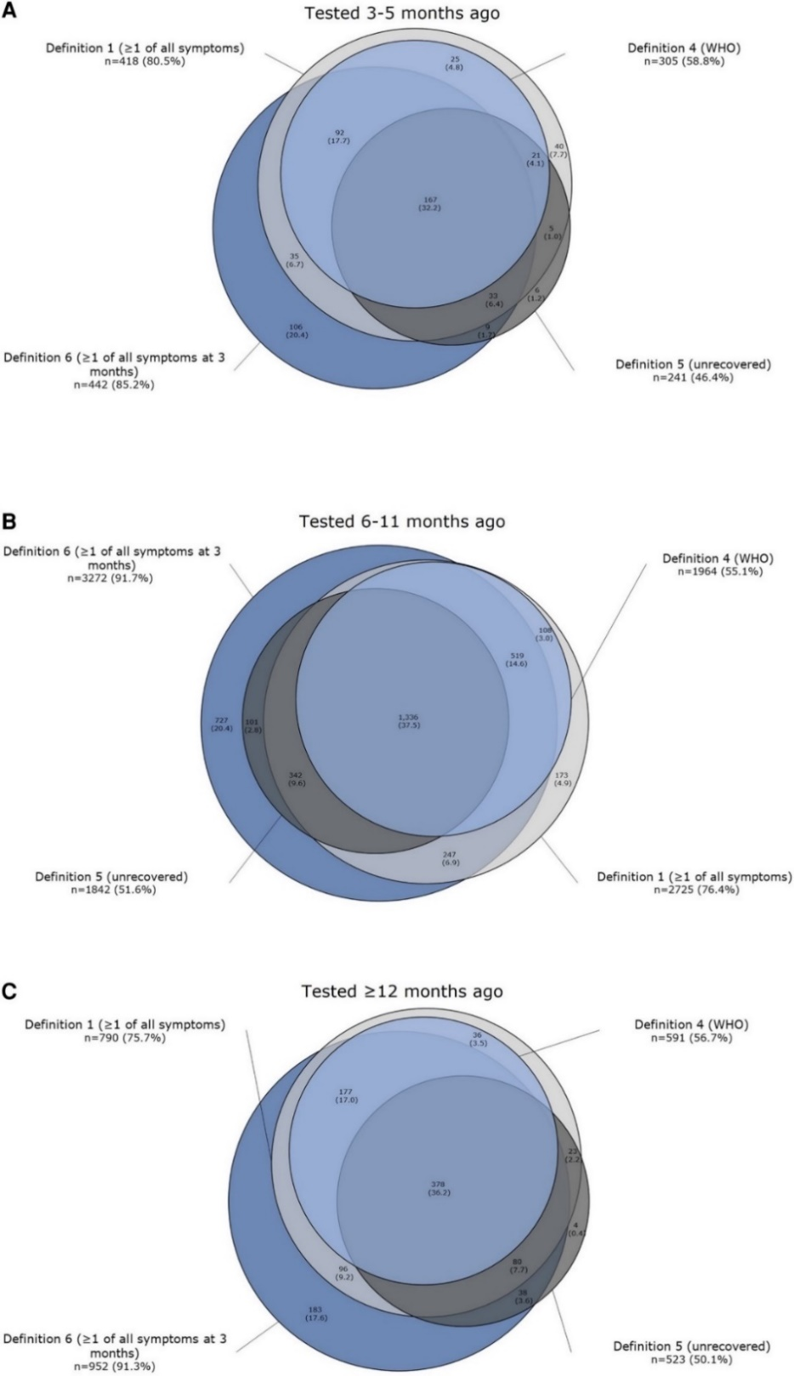
Venn diagrams of four long-term symptom definitions in positively tested participants, stratified for time since PCR test. A: tested 3–5 months ago. B: tested 6–11 months ago. C: Tested ≥12 months ago. Definition 1. Currently reporting ≥1 of the 44 prelisted symptoms. Definition 4. Meeting the WHO definition. Definition 5. Currently feeling unrecovered since PCR test. Definition 6. Reporting ≥1 of the 44 prelisted symptoms three months after testing. Percentages represent the proportion of participants meeting the definitions compared with all positives who met at least one of the definitions (n = 519 for participants tested 3–5 months ago, n = 3,567 for participants tested 6–11 months ago, and n = 1,043 for participants tested ≥12 months ago).

Appendix C: Study details

Luo et al study details
Luo et al included 28 studies that had non-COVID control groups and performed subgroup analysis of symptoms at 0–3 months, 3–6 months, 6–12 months and >12 months. It then performed a meta-analysis of the 25 symptoms that were reported by more than five studies.
Of the 28 studies, 17 were considered to be of high quality, having a Newcastle-Ottawa Score (NOS) of 7 or higher. The remaining 11 studies were of moderate quality, all of them scoring zero for comparability. The authors addressed this in the discussion section of the paper, noting that differences in the measurement tools used to define long COVID were very variable. This limitation was addressed by comparing the prevalence of individual symptoms rather than of long COVID as a definable condition. Luo’s meta-analysis included a total of 13,368,074 participants, comprising 3,474,987 COVID-19 patients and 9,893,087 non-COVID individuals. Non-COVID individuals had a negative COVID-19 PCR, including healthy controls, symptomatic hospitalised patients, matched influenza patients and matched individuals. The meta-analysis included symptoms at time interval 0–3 months, which is not a focus of this present scoping review. It was possible, however, to extract the data for those symptoms at only 3–6, 6–12 and >12 months. That data is as follows:

Table A1: Long COVID symptoms at 3–6, 6–12 and >12 months as reported in Luo et al
 | Duration (months) | COVID-19-positive (n=) | Controls (n=) | Risk ratio | 95% CI
Fatigue | 3–6 | 601,371 | 2,065,243 | 2.60 | 1.93–3.52
Fatigue | 6–12 | 256,847 | 4,498,463 | 2.24 | 1.41–3.58
Fatigue | >12 | 17,302 | 89,767 | 3.33 | 1.97–5.56
Dyspnoea | 3–6 | 600,023 | 2,063,359 | 2.78 | 1.80–4.30
Dyspnoea | 6–12 | 256,847 | 4,498,463 | 3.10 | 2.34–4.10
Dyspnoea | >12 | 16,080 | 88,640 | 3.57 | 1.24–10.27
Depression | 3–6 | 594,075 | 2,053,042 | 1.26 | 1.05–1.52
Depression | 6–12 | 181,384 | 4,397,509 | 1.82 | 1.77–1.88
Depression | >12 | N/A
Sore throat | 3–6 | 600,023 | 2,063,359 | 1.76 | 1.08–2.89
Sore throat | 6–12 | 1,022 | 24,888 | 2.97 | 1.90–4.66
Sore throat | >12 | 1,192 | 1,127 | 5.82 | 5.82–24.41
Loss of smell or taste | 3–6 | 489,214 | 1,948,319 | 9.37 | 4.29–20.51
Loss of smell or taste | 6–12 | 181,384 | 4,397,509 | 5.10 | 4.55–5.72
Loss of smell or taste | >12 | 16,075 | 16,361 | 39.99 | 8.57–18.6
Diarrhoea | 3–6 | 3,065 | 3,739 | 4.94 | 3.52–6.93
Diarrhoea | 6–12 | 182,406 | 4,422,397 | 1.89 | 1.10–3.22
Diarrhoea | >12 | N/A
CI= Confidence Interval

Marjenberg et al study details
Table A2: Long COVID symptoms as reported in Marjenberg et al
Symptom | COVID-19 positive (n=) | Control (n=) | OR, hazard ratio,  RR, or IRR* | 95% CI
Fatigue | Hospitalised
 | Al-Aly 2022: 3,667 | 4,983,491 | Hazard ratio 4.49 | 3.88–5.19
 | Castro 2022: 6,619 | 6,342 | OR 0.98 | 0.84–1.15
 | Chevinsky 2021: 44,489 | 44,489 | OR 1.1 | 0.90–1.4
 | Desgranges 2022: 418 | 89 | OR 2.14 | 1.04–4.41
 | Rivera-Izquierdo 2022: 453 | 453 | OR 0.57 | 0.36–0.90
 | Roessler 2021: 145,185 children,  11,950 adults | 3,106,010 children, 288,815 adults | IRR 1.97 children  IRR 2.28 adults | 1.89–2.06  1.71–3.06
 | All COVID-19
 | Al-Aly 2022: 33,940 | 4,983,491 | Hazard ratio 2.0 | 1.82–2.21
 | Amin-Chowdhury 2021: 140 | 1160 | OR 2.27 | 1.82–4.07
 | Kuodi 2022: 294 | 2,437 | RR 0.64 | 0.46–0.89
 | Caspersen 2022: 29 | 2,222 | RR 4.8 | 3.5–6.7
 | Noviello 2022: 164 | 183 | RR 2.24 | 1.48–3.37
 | Sorenson 2022: 61,000 | 91,878 | Risk difference 0.08 | 0.08–0.09
 | Xie 2021: 181,384 | 181,384 | Hazard ratio 1.75 | 1.68–1.81
 | Compared to flu
 | Al-Aly 2022: 33,940 | 5,785,273 | Hazard ratio 1.46 | 1.21–1.76
Dyspnoea | Hospitalised
 | Al-Aly 2022: 3,667 | 4,983,491 | Hazard ratio3.54 | 3.13–4.00
 | Rivera-Izquierdo 2022: 453 | 453 | OR 1.13 | 0.76–1.68
 | Desgranges 2022: 418 | 89 | OR 2.81 | 1.10–7.16
 | Roessler 2021: 145,184 | 3,106,010 | IRR 2.88 | 2.74–3.02
 | All COVID-19
 | Al-Aly 2022: 33,940 | 4,983,491 | Hazard ratio 2.08 | 1.95–2.21
 | Amin-Chowdhury 2021: 140 | 1,160 | OR 3.51 | 1.68–7.32
 | Caspersen 2022: 19 | 963 | RR 8.7 | 5.7–13.3
 | Kuodi 2022: 294 | 2,437 | RR 1.52 | 0.87–2.65
 | Petersen 2022: 443 | 1,328 | OR 1.10 | 0.68–1.79
 | Sorenson 2022: 61,002 | 91,878 | Risk difference 0.05 | 0.05–0.05
Cognitive  dysfunction | Hospitalised
 | Al-Aly 2022: 3,667 | 4,983,491 | Hazard ratio 3.06 | 2.47–3.79
 | Desgranges 2022: 418 | 89 | OR 5.71 | 1.53–21.3
 | Liu 2022: 1,178 | 438 | OR 9.10 | 5.61–14.75
 | Rivera-Izquiero 2022: 453 | 453 | OR 1.83 | 0.74–4.81
 | All COVID-19
 | Al-Aly 2022: 33,940 | 4,983,491 | Hazard ratio 1.7 | 1.54–1.88
 | Amin-Chowdhury 2021: 140 | 1,160 | OR 2.82 | 1.81–4.38
 | Kuodi 2022: 294 | 2,437 | RR 1.22 | 0.69–2.15
 | Sorenson 2022: 61,002 | 91,878 | risk difference 0.28 | 0.28–0.29
 | Compared to flu
 | Al-Aly 2022: 33,940 | 5,785,273 | Hazard ratio 1.35 | 1.15-1.87
* OR = odds ratio RR = risk ratio (RR) IRR = incident rate ratio

Azzam et al study details
Table A3 shows pooled odds ratio by symptom, matched for comorbidities.
Table A3: Long COVID symptoms as reported in Azzam et al
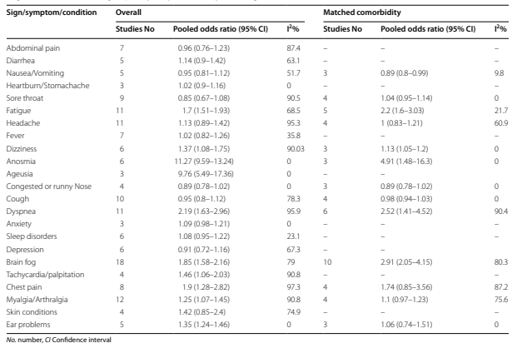

Azzam et al children study details
Table A4 shows pooled odds ratio by symptom for studies with subgroup analysis of children.
Table A4: Long COVID symptoms in children as reported in Azzam et al
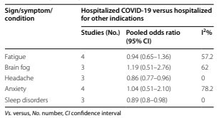

PHQ-15 scoring system
The following graphic, from Kroenke et al 2002, reproduces the questionnaire put to COVID-19 patients under the PHQ-15 scoring system.
Figure A2: PHQ-15 scoring system example
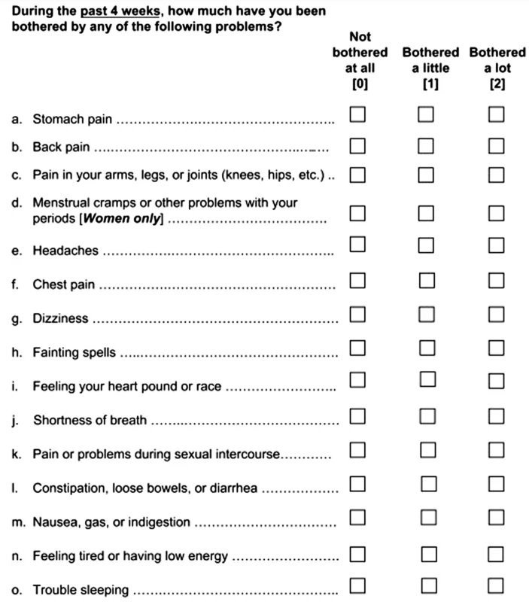

Shen et al study details
Figure A3 shows the prevalence ratio (95% confidence interval) of individual physical symptom severity among people with COVID-19 compared with those not diagnosed with COVID-19, by symptom. It presents a COVID-19-to-non-COVID-19 cross-sectional comparison (all cohorts).
Figure A3: Prevalence ratio of symptom severity among people with COVID-19 compared to those not diagnosed with COVID-19 as reported in Shen et al
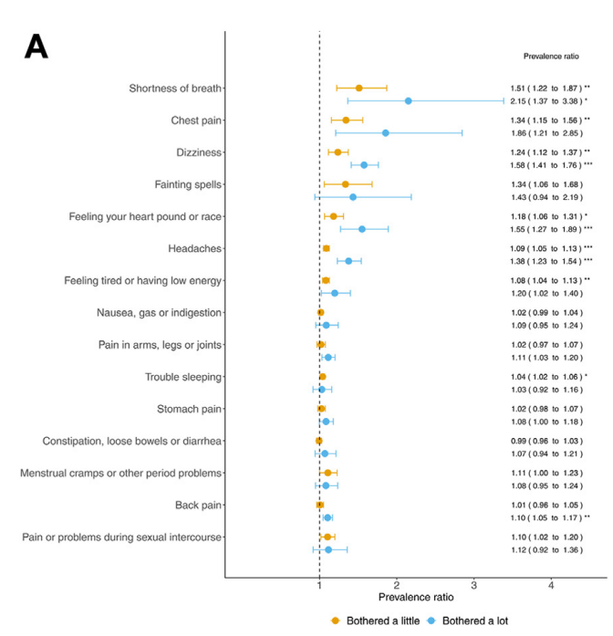

Figure A4 shows the prevalence ratio (95% confidence interval) of individual physical symptom severity, making a post-to-pre-COVID-19 longitudinal comparison (n = 398).
Figure A4: Prevalence ratio of symptom severity: post-to-pre-COVID-19 longitudinal comparison as reported in Shen et al
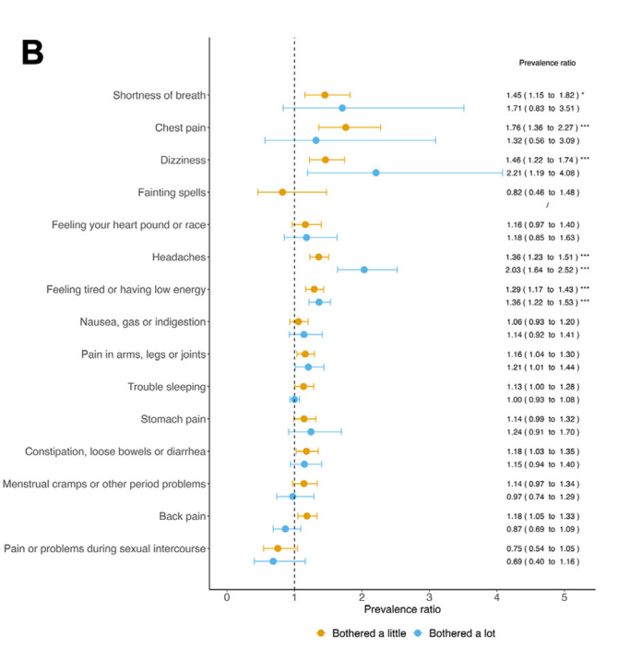

Kostka et al study details
Figure A5: Risk ratio by symptom and database as reported in Kostka et al
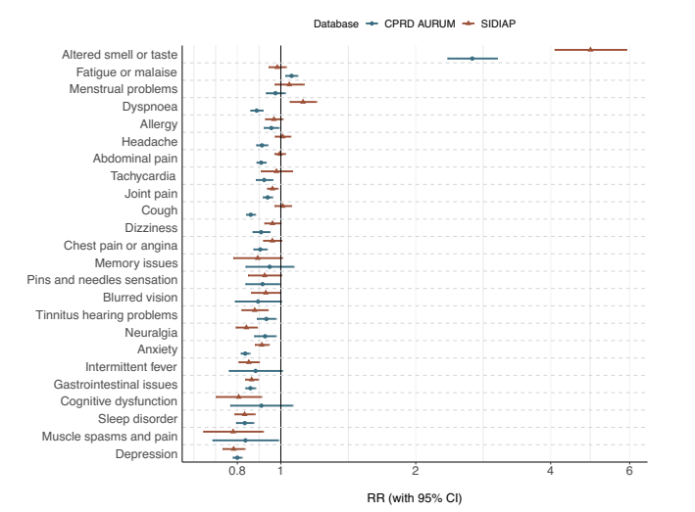

Hosozawa et al study details
Among 8,167 invited individuals, 3,141 (1,800 cases, mean age: 10.4 years, 46.1% females; 1,341 controls, mean age 10.5 years, 47.1% females) participated in Hosozawa et al’s study. Patients had elapsed an average of 273 (185-605) days from infection, and 1,708 (94.9%) experienced mild acute symptoms. Patients had higher odds of having persistent symptoms than did controls (6.3% vs 2.2%, adjusted odds ratio (aOR): 3.15, 95% confidence interval: 2.08–4.77). Age and sex-adjusted odds ratio by symptom expressed in figure below:
Figure A6: Age- and sex-adjusted odds ratios by symptom as reported in Hosozawa et al
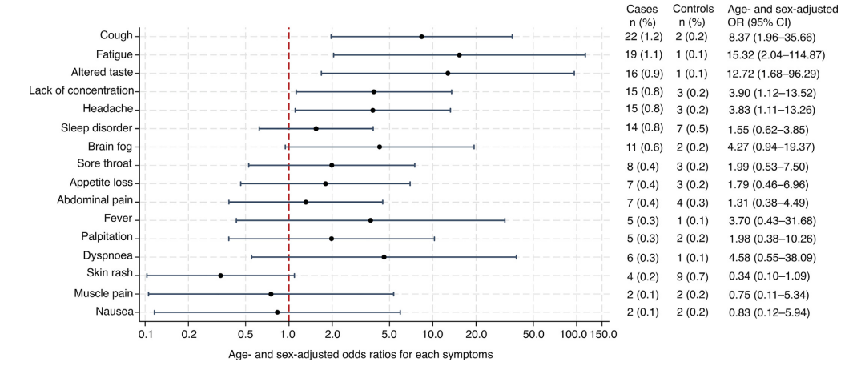

Appendix D: Search strategy
Database:
Ovid MEDLINE(R) and Epub Ahead of Print, In-Process, In-Data-Review & Other
Non-Indexed Citations, Daily and Versions <1946 to April 26, 2024>, adapted for Scopus, Embase, Cochrane
Search Strategy:
1 ("2019-ncov" or "ncov19" or "ncov-19" or "2019-novel CoV" or "sars-cov2" or "sars-cov-2" or "sarscov2" or "sarscov-2" or "Sars-cORonavirus2" or "Sars-cORonavirus-2" or "SARS-like cORonavirus*" or "cORonavirus-19" or "covid19" or "covid-19" or "covid 2019" or "novel coronavirus" or COVID*).mp.
2 (long-covid or "long covid" or longcovid* or long-haul* or longhaul* or sequelae).mp. [mp=title, book title, abstract, original title, name of substance word, subject heading word, floating sub-heading word, keyword heading word, organism supplementary concept word, protocol supplementary concept word, rare disease supplementary concept word, unique identifier, synonyms, population supplementary concept word, anatomy supplementary concept word]
3 1 and 2
4 Post-Acute COVID-19 Syndrome/
5 3 or 4
6 ((social or financ* or economic* or societal or society or psychosocial or psych* or "mental health") adj2 (impact* or challeng* or consequenc* or implication* or effect*)).mp.
7 (work or employment or "reduce* income*").m_titl.
8 6 or 7
9 5 and 8
10 ((prevent* or protect* or reduce or lessen or effective*) adj5 vaccin*).mp. [mp=title, book title, abstract, original title, name of substance word, subject heading word, floating sub-heading word, keyword heading word, organism supplementary concept word, protocol supplementary concept word, rare disease supplementary concept word, unique identifier, synonyms, population supplementary concept word, anatomy supplementary concept word]
11 5 and 10
12 ((variant* or "risk factor*") adj5 (long-covid or "long covid" or longcovid* or long-haul* or longhaul* or sequelae)).mp. [mp=title, book title, abstract, original title, name of substance word, subject heading word, floating sub-heading word, keyword heading word, organism supplementary concept word, protocol supplementary concept word, rare disease supplementary concept word, unique identifier, synonyms, population supplementary concept word, anatomy supplementary concept word]
13 5 and 12
14 ((long-covid or "long covid" or longcovid* or long-haul* or longhaul*) adj3 (Therapeutic* or treatment*)).mp.
15 ((long-term or longterm or post-intensive or postintensive or post-covid or postcovid or post-discharge or postdischarge or prolonged or persistent or long-lasting or permanent or lasting or pervasive or post-acute or postacute or aftereffect*) adj3 (Therapeutic* or treatment*)).mp.
16 14 or 15
17 5 and 16
18 (SNG001 or "interferon-beta1a" or "anti-histamin*" or "anti histamine*" or "dietary supplement*" or Paxlovid).mp.
19 5 and 18
20 ((supportive or model* or pathway*) adj3 care).mp. [mp=title, book title, abstract, original title, name of substance word, subject heading word, floating sub-heading word, keyword heading word, organism supplementary concept word, protocol supplementary concept word, rare disease supplementary concept word, unique identifier, synonyms, population supplementary concept word, anatomy supplementary concept word]
21 5 and 20
22 (guideline* or (policy adj3 response)).mp. or National Health Programs/ or health policy/ or public policy/ [mp=title, book title, abstract, original title, name of substance word, subject heading word, floating sub-heading word, keyword heading word, organism supplementary concept word, protocol supplementary concept word, rare disease supplementary concept word, unique identifier, synonyms, population supplementary concept word, anatomy supplementary concept word]
23 Practice Guideline/ or Guideline/
24 22 or 23
25 5 and 24
26 ((trajectory or recovery) adj5 (long-covid or "long covid" or longcovid* or long-haul* or longhaul* or postacute or post-acute)).mp. [mp=title, book title, abstract, original title, name of substance word, subject heading word, floating sub-heading word, keyword heading word, organism supplementary concept word, protocol supplementary concept word, rare disease supplementary concept word, unique identifier, synonyms, population supplementary concept word, anatomy supplementary concept word]
27 5 and 26
28 (definition* or (defin* adj3 (long-covid or "long covid" or longcovid* or long-haul* or longhaul or "post-acute covid syndrome" or "postacute covid syndrome"))).mp. [mp=title, book title, abstract, original title, name of substance word, subject heading word, floating sub-heading word, keyword heading word, organism supplementary concept word, protocol supplementary concept word, rare disease supplementary concept word, unique identifier, synonyms, population supplementary concept word, anatomy supplementary concept word]
29 5 and 28
30 Prevalence/
31 prevalence.ti.
32 5 and (30 or 31)
33 ((biomarker* or bio-marker* or pathophys* or patho-phys*) adj5 (long-covid or "long covid" or longcovid* or long-haul* or longhaul*)).mp. [mp=title, book title, abstract, original title, name of substance word, subject heading word, floating sub-heading word, keyword heading word, organism supplementary concept word, protocol supplementary concept word, rare disease supplementary concept word, unique identifier, synonyms, population supplementary concept word, anatomy supplementary concept word]
34 exp *Biomarkers/
35 33 or 34
36 5 and 35
37 (zealand or aotearoa or maori).mp. [mp=title, book title, abstract, original title, name of substance word, subject heading word, floating sub-heading word, keyword heading word, organism supplementary concept word, protocol supplementary concept word, rare disease supplementary concept word, unique identifier, synonyms, population supplementary concept word, anatomy supplementary concept word]
38 5 and 37
39 ((long term or longterm) adj5 ("health implications" or sequelae or "health complication*" or "health effect*" or "ongoing symptom*")).mp.
40 5 and 39
41 9 or 11 or 13 or 17 or 19 or 21 or 25 or 27 or 29 or 32 or 36 or 38 or 40
42 limit 41 to dt=20230801-20240426

Medline = 679 | Embase = 796 | Scopus = 650 | Cochrane =0
Total = 1,475
Total after duplicates and false drops removed = 651

Where the term long COVID has been used; it has been defined according to the World Health Organization’s definition of long COVID.
Cover letter detailing the 12 original evidence questions is found here: cover letter.
Covidence is an online tool designed to manage and streamline the writing of systematic reviews. https://www.covidence.org/
The studies used in this systematic review overlapped with several of the studies in Luo et al’s systematic review and several other larger studies.
Azzam’s meta-analysis included three studies in common with Luo et al and Marjenberg et al. Several of the studies excluded by Azzam but included in the other two meta-analyses were excluded because they did not stratify their results based on hospitalised versus non-hospitalised groups.
A list of 15 somatic complaints (see PHQ-15 in Appendix C).
Adjusted model controlling for age, gender, average monthly income, residency, relationship status, BMI, current smoking, habitual drinking, previous diagnosis of psychiatric disorder, pre-existing somatic comorbidity and response period.
Clinical Practice Research Datalink (CPRD) collects anonymised patient data from a network of general practices across the United Kingdom.
The Information System for Research in Primary Care (SIDIAP) is a database of population-wide primary care electronic health records.
EQ-5D-Y is a youth-adapted version of the commonly used EQ-5D. The EQ-5D is a widely used standardised generic measure of Health Related Quality of Life (HRQOL) (Willie et al, 2010).
As defined by the World Health Organisation. https://www.who.int/health-topics/coronavirus#tab=tab_1..
Newcastle Ottawa Scale (NOS) is a scale developed for assessing the quality of nonrandomized studies

