ANNUAL REPORT OF THE MENTAL HEALTH
REVIEW TRIBUNAL

1 JULY 2023 to 30 JUNE 2024

Contents

Contents i
Abbreviations used in this report ii
Introduction 1
About the Tribunal 3
Membership of the Tribunal 6
The review process 8
Applications at a glance 13
Applications received by Health New Zealand | Te Whatu Ora (former DHB) region 14
An overview of applications involving Māori patients 15
Timeliness 16
Publication of decisions 17
Section 75 Investigations 18
Appointments to give opinions pursuant to ss 59 and 60 of the Act 18
Relationship with the Director of Mental Health and the Ministry of Health 19
Secretariat 19
Professional Development 20
Website 20
What’s next for 2024-2025 21
Conclusion 21
Appendix A – Tribunal members 22
Appendix B – A breakdown of applications 26
Appendix C – A comparison over time (previous eight Annual Reports) 33

Abbreviations used
in this report

Application Application for Review
DAMHS Director of Area Mental Health Services
DHB District Health Board
Director Director of Mental Health for New Zealand
The Act Mental Health (Compulsory Assessment and Treatment) Act 1992
Tribunal Mental Health Review Tribunal

Introduction

Tēnā koutou katoa,
The Mental Health Review Tribunal (the Tribunal) is pleased to present its annual report for the year from 1 July 2023 to 30 June 2024.
The Tribunal helps to support and protect the rights and interests of patients subject to compulsory treatment under the Mental Health (Compulsory Assessment and Treatment) Act 1992. "Patient" is the word used in the Act. We recognise that characterisation focuses on only one aspect of their life.
The Tribunal's principal function is to hear applications for a review of the condition of a patient and to express its view regarding whether a patient ought to remain under the Act, as an ordinary, special, or restricted patient. In the case of ordinary patients, its opinion is determinative. In other cases, its opinion is advisory. It also approves clinicians to provide second opinions pursuant to sections 59 and 60 of the Act and investigates complaints when there is dissatisfaction with the outcome of a complaint investigation by a District Inspector of Mental Health.
The Tribunal reviews a small proportion of patients receiving compulsory treatment. In the period 1 July 2023 to 30 June 2024 the Tribunal received far fewer applications than recent years, receiving 81 applications. In the preceding five years from 2018 the number of applications varied from 115 to 157 per year.
The dramatic reduction coincides with the coming into effect of a law change abolishing indefinite compulsory treatment orders and replacing them with 12 month orders. This means longer term patients will have a Judicial review at meaningful intervals, reducing the need to apply to the Tribunal for an independent review.
Of the 81 applications received this period:
- 36 applications did not proceed because they were withdrawn, the patient was discharged from the Act by the responsible clinician or there was no jurisdiction for a review at the time of application

- 41 applications were determined. The Tribunal discharged 3 patients from ordinary compulsory treatment orders and recommended that 5 patients be discharged from special patient status

- 3 applications were set down for hearing and 1 application was awaiting further information before a hearing date could be set down.
Many health professionals within the mental health system work under pressure. We continue to focus on the need for good reports and supporting evidence from health professionals that address our guidelines and the matters we have to consider.
As a result of our work, we develop an insight into the care and treatment of patients throughout Aotearoa New Zealand. We continue to see the need in some instances for:
- better valuing and supporting a patient's ties with family and whānau

- better understanding the cultural and ethnic identity of patients and the implications of those for the provision of health care and treatment

- more community-based facilities and support.

We thank those who helped to ensure that the Tribunal functioned effectively, including patients, family and whānau, health professionals, lawyers, Ministry of Health | Manatū Hauora and the Secretariat of the Tribunal.

Ngā mihi nui,

James Wilding KC
(Convener)

Phyllis Tangitu
(Community member)

Dr Nick Judson
(Psychiatrist member)

About the Tribunal

The Tribunal was established by the Mental Health (Compulsory Assessment and Treatment) Act 1992. The Act enables the compulsory psychiatric assessment and treatment of people who have a mental disorder. It is intended to define and better protect patient rights than the preceding legislation.
The members of the Tribunal reflect the diverse nature of our society. We convene in Tribunals of three, comprising a lawyer, a psychiatrist and a community member, to hear cases throughout New Zealand, in the locality where the patient lives.
Some people welcome support under the Act. Others consider it to be a significant and unwanted intrusion into their lives. We consider the views put forward in reviews by patients, their family and whānau and health professionals, and strive to strike the balance required by the Act.
This continues to be a challenging task. We recognise that our functions and decisions directly affect the rights and interests of patients treated under the Act, and often impact their family, whānau and friends and the community.
The Act recognises the importance of the cultural and ethnic identity, the language, and the religious and ethical beliefs of patients who are subject to it, and their ties to family and whānau.
The Tribunal endeavours to discharge its statutory role in a manner which takes into account the articles of Te Tiriti o Waitangi.

The functions of the Tribunal
The functions of the Tribunal are to:
- on application or of its own motion, review the condition of patients who are subject to compulsory treatment orders, special patient orders and restricted patient orders, pursuant to ss79 to 81 of the Act. Reviews are for the purposes of assessing whether, in the Tribunal’s opinion, a patient ought to be released from compulsory treatment, or from special patient or restricted patient status.0F

- investigate complaints about breaches of specific patient rights. This occurs when a patient or complainant is not satisfied with the outcome of the investigation of a complaint by a District Inspector of Mental Health1F or an Official Visitor2F pursuant to s75 of the Act.

- report to the Director of Mental Health pursuant to s102 of the Act on any matter relating to the exercise or performance of its powers and functions.

- appoint psychiatrists who assess:
  - whether treatment is in the interests of a patient who does not consent to that treatment, pursuant to s59 of the Act;

  - whether electro-convulsive treatment is in the interests of a patient who does not consent to that treatment, pursuant to s60 of the Act; and

  - whether brain surgery is appropriate, if the Tribunal is first satisfied that the patient has given free and informed consent to surgery, pursuant to s61 of the Act. The Tribunal is not aware of this provision having been used.

Many patients accept compulsory treatment or the outcome of a District Inspector’s complaint investigation and neither they, nor others in their interests, make an application for review to the Tribunal. Consequently, the Tribunal reviews only a small proportion of patients receiving compulsory treatment. The issues on review are summarised below.
Ordinary Patients
For ordinary patients who are subject to compulsory treatment orders, the issue for the Tribunal is whether the patient is fit to be released from compulsory status. That requires that the patient no longer be “mentally disordered”.3F To be “mentally disordered” a patient must have a continuous or intermittent abnormal state of mind of such a degree that it poses a serious danger to the health or safety of the patient or others or seriously diminishes the capacity of the patient to self-care. If the Tribunal considers that the patient is no longer “mentally disordered”, they are released from compulsory treatment. If they remain “mentally disordered”, they remain subject to compulsion.
Special Patients
Some special patients receive compulsory treatment because they were found unfit to stand trial on criminal charges. The Tribunal must express an opinion on whether the patient remains unfit to stand trial and whether they should continue to be detained as a special patient. Depending on the outcome and whether the Attorney-General is the applicant, the opinion may be provided to the Attorney-General to enable a decision to be made for the purpose of s31 of the Criminal Procedure (Mentally Impaired Persons) Act 2003.
Other special patients receive compulsory treatment because they were acquitted on account of insanity. The Tribunal must express an opinion as to whether the patient’s condition still requires that they should be detained as a special patient. Depending on the outcome and whether the Minister of Health or the Minister of Mental Health is the applicant, the opinion may be provided to the Minister of Health or the Minister of Mental Health to enable a decision to be made for the purpose of s33 of the Criminal Procedure (Mentally Impaired Persons) Act 2003.
Restricted Patients
Restricted patients have been declared so because they present special difficulties due to the danger they pose to others. The Tribunal must express an opinion as to whether the patient is mentally disordered. If not, then the patient is released from compulsory treatment upon the direction of the Director of Mental Health. If the Tribunal considers the patient is mentally disordered but no longer needs to be a restricted patient, the matter is referred to the Minister of Health who, after consultation with the Attorney-General, will decide whether restricted patient status should continue.
Right of Appeal
Section 83 of the Act provides a right of appeal where the Tribunal considers that a patient is not fit to be released from compulsory status. This right is mainly to be exercised by the patient or certain classes of people acting in their interests.
The psychiatrist responsible for the patient’s care does not have a right of appeal. They can make a fresh assessment for the purpose of compulsory treatment if a patient who has been discharged later becomes sufficiently unwell.
Investigations
Under section 75 of the Act, the Tribunal can investigate complaints made to a District Inspector (or Official Visitor) if the complainant is not satisfied with the outcome.

The powers of the Tribunal
The Act confers on the Tribunal a range of powers to enable it to discharge its functions.
Pursuant to s104(3) of the Act, these include the powers and authority to summons witnesses and to receive evidence that are conferred on Commissions of Inquiry by the Commissions of Inquiry Act 1908.
The Tribunal prefers to operate in a cooperative manner without resorting to formal use of such powers.

Membership of the Tribunal

Every Tribunal review is heard by a Tribunal comprising three members, a lawyer, a psychiatrist and a community member. Additional members may be co-opted by the Tribunal for a particular hearing.
The Tribunal members are appointed by the Minister of Health. The membership is reviewed every three years.
The Tribunal seeks to ensure ethnic and gender diversity at review hearings, to ensure a fair allocation of work and to ensure all members undertake sufficient work to retain their expertise.
The members who held office during the report year are listed below. More information about members is contained in Appendix A.
Tribunal members | Deputy psychiatrist members
Mr A J F Wilding KC (Convener)  Dr N R Judson, psychiatrist  Ms P Tangitu, community member | Dr B Beaglehole  Dr C Dudek-Hodge  Dr H Elder  Dr M Honeyman  Dr J McMinn  Dr P Renison  Dr S Schmidt  Dr J Whiting
Deputy lawyer members | Deputy community members
Mr R A Newberry (Deputy Convener)  Mr T Clarke  Ms R Schmidt-McCleave*  Ms A McCarthy  Ms A Rakena | Mrs F Diver  Mr M Sukolski  Mr S Hanrahan  Ms L Pennington  Ms S Sidal  Ms S Sumita
*Ms R Schmidt-McCleave resigned from the Tribunal in October 2023 to take up a role as a Coroner.

Co-opted Members
Section 103 of the Act enables, and in some cases requires, if requested by the patient, the Tribunal to co-opt:
- any person whose specialised knowledge or expertise would be of assistance to the Tribunal in dealing with the case;

- any person whose ethnic identity is the same as the patient’s where no member of the Tribunal has that ethnic identity; or

- any person of the same gender as the patient, where no member of the Tribunal is of that gender.
During the reporting year, this power was exercised in two hearings for which a co-opted person of the same ethnicity as the patient was requested. The Tribunal is grateful to the co-opted members who made themselves available.
Co-opting is not necessary if a person with the requisite knowledge or expertise, or ethnic or gender identity, is already sitting on the Tribunal. There were several instances where that meant co-opting was not necessary. This reflected the diversity of the members of the Tribunal.
Interpreters
Section 6 of the Act enables, and in some cases requires, if requested by the patient, the Tribunal to provide the services of an interpreter, if:
- the first or preferred language of the person is a language other than English, Te Reo Māori or New Zealand Sign Language; or

- the person is unable, because of physical disability, to understand those languages; and

- it is practicable to provide the services of an interpreter.
During the reporting year, two patients requested an interpreter. The Tribunal is grateful to the interpreters who made themselves available.

The review process

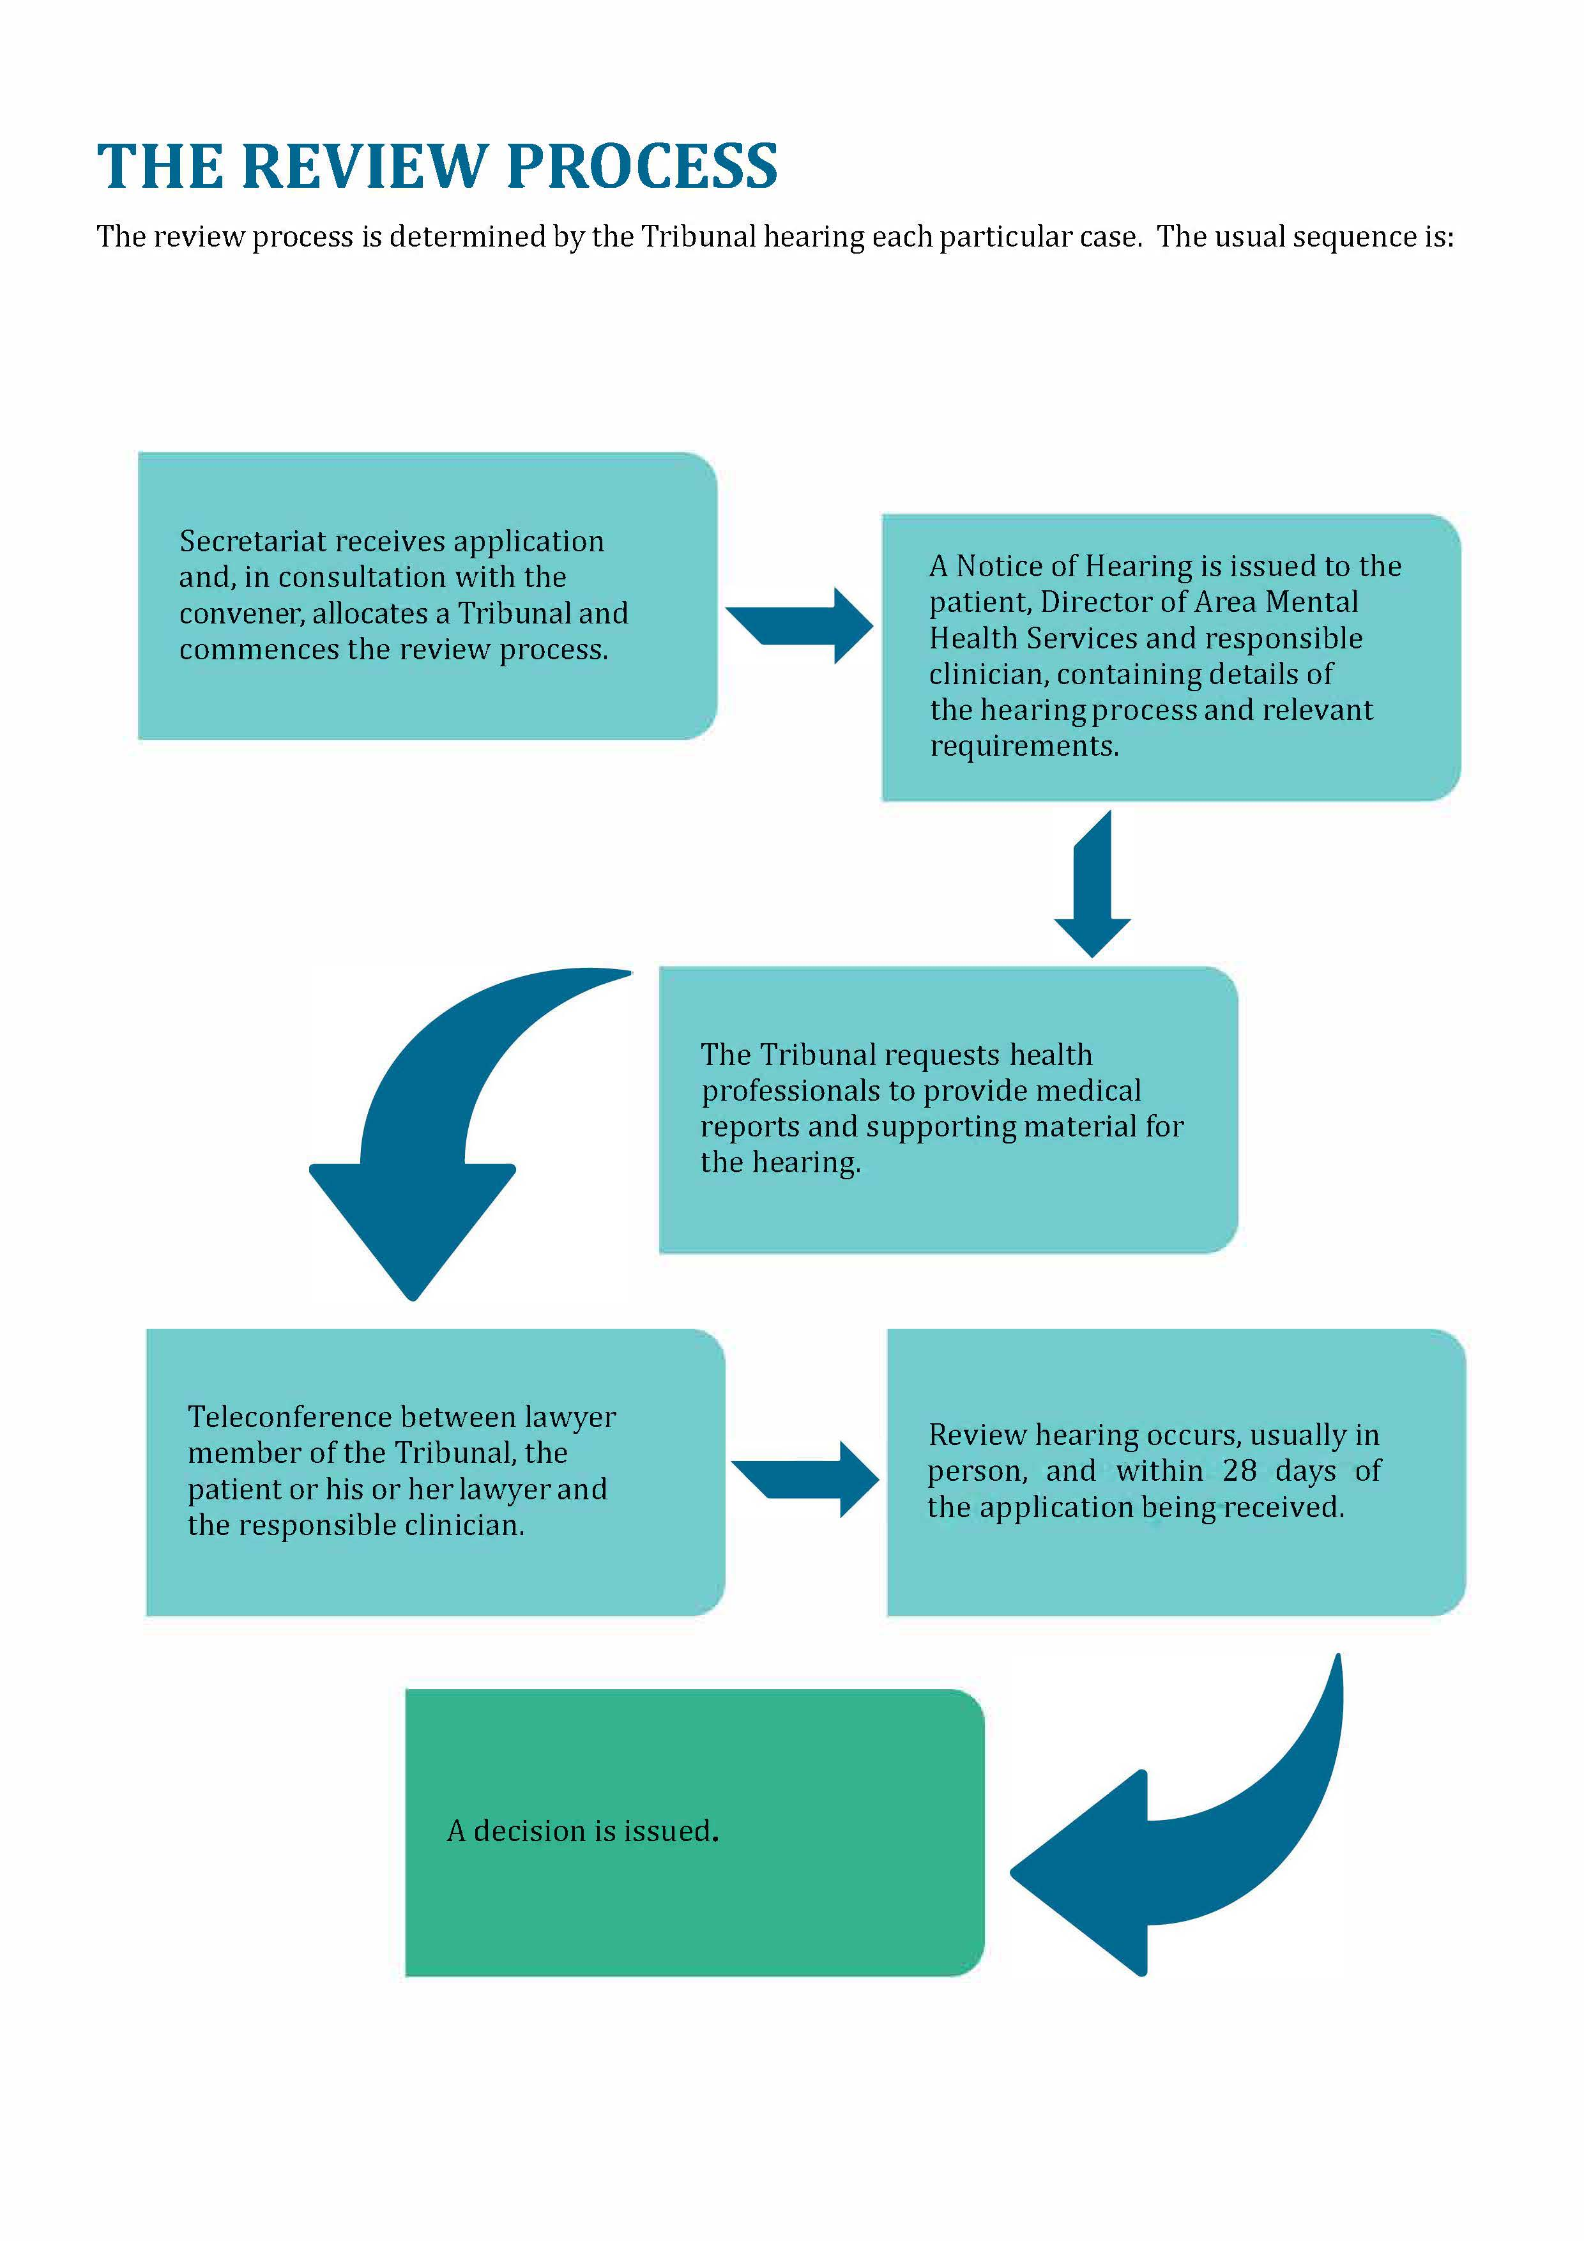
The review process is determined by the Tribunal hearing each particular case. The usual sequence is:

The approach taken by the Tribunal
The Tribunal tends to conduct hearings without undue formality. However, because the process is quasi-judicial and the determination affects important rights and interests, some formality is necessary.
Formality is inherent in the process outlined in Schedule 1 of the Act, which contains provisions regarding the conduct of reviews.
The process is partly inquisitorial. The Tribunal leads much of the questioning. It prefers to do so in a way that helps rather than undermines the therapeutic relationship between the patient and health professional, but not at the risk of relevant aspects not being addressed.
Parties to hearings may cross-examine. It is common for the patient or his or her lawyer to do so.
Tension is sometimes apparent in the hearings, reflective of the context. Health practitioners are contending that a patient ought to be subject to compulsory treatment, when the patient objects to current and future compulsory treatment.
The Tribunal benefits from patients giving candid accounts of often intensely personal matters, involving their background, family and whānau, health, current circumstances, and aspirations.
We seek to recognise the, often extraordinary, achievements of patients in their lives and in managing their health.
We may make recommendations or observations, focused on the care and treatment of the patient and on procedural and evidential issues.

The Tribunal may make broader observations, reflecting concerns about the patient's care. It sometimes does so with supporting evidence from health practitioners, who work within a constrained system. Health practitioners are to be commended for their frankness.

Who attends the hearings?
The hearings are not public. Those attending are usually:
- The applicant.
- The applicant’s lawyer.
- The responsible clinician, who is usually a psychiatrist.
- The keyworker, who tends to be a psychiatric nurse who has cared for the patient.
Others who might attend include:
- A support person or advocate for the patient.
- Family and whānau of the applicant.
- A social worker.
- A psychologist.
- An occupational therapist.
- A cultural advisor.
- Other medical and nursing staff.
- A District Inspector of Mental Health.
How hearings are conducted
The hearing format tends to be similar regardless of whether the patient is subject to a compulsory treatment order or is a special patient or a restricted patient.
In advance, the Tribunal receives written reports from the patient’s responsible clinician and the second health professional. Written material can be received from the applicant or their lawyer.
Prior to the hearing, the patient meets with a member of the Tribunal, usually the psychiatrist member, for a preliminary examination. The purpose is to ascertain whether the patient can participate in the hearing and to identify any issues that may need to be accommodated (such as a difficulty in communication).
Hearings may be opened or closed in a way which recognises and respects the cultural and ethnic beliefs of a patient, including by a karakia or other appropriate opening, if sought by the patient. This can be advised by a patient at an earlier stage in the review process, or on the day of a review hearing.
The hearing commences with the Tribunal introducing itself. It clarifies who is present and, when appropriate, whether there is any objection by the patient to any person being present.
An opening submission or statement is called for from the applicant or their lawyer. Following that, evidence is heard. Usually, the first witness is the patient, followed by the responsible clinician, being the clinician responsible for the care and treatment of the patient, and then a second health professional. Family and whānau are then usually invited to speak.
Evidence can be required on oath, but this would be unusual.
Each witness is usually questioned by the Tribunal. The applicant or lawyer for the applicant is then invited to ask questions of that witness. It is rare, but not unknown, for a responsible clinician to question other witnesses.
At the conclusion of the evidence, closing submissions are invited.
Those present are then asked to leave the room to enable the Tribunal to deliberate. If possible, a decision is given shortly after, on the same day.
Sometimes written submissions are sought or an adjournment is necessary, for example to enable further medical evidence to be obtained. The Tribunal may exercise its power in the First Schedule to the Act to call for its own medical, psychiatric, psychological or other report on the patient.
When further evidence is received, an opportunity to be heard is given, to the extent required by the rules of natural justice.
Following the hearing, the Tribunal issues a written decision, or written reasons for a decision if the decision was announced orally.

The attendance of family and whānau
Section 5 of the Act requires the Tribunal to exercise its powers with proper recognition of the importance and significance of the patient's ties with their family and whānau, hapu, iwi and family group.
Often, patients will seek to have one or a few members of their family and whānau present. This, and the understanding which results from that, is welcomed by the Tribunal. It is often of assistance to the patient, the Tribunal and health professionals.

Cultural and ethnic identity and language
Section 5 of the Act requires the Tribunal to exercise its powers with proper respect for the patient's cultural and ethnic identity, language, and religious or ethical beliefs.
When applying for reviews, applicants are asked whether they wish to have the Tribunal include a person of the same ethnic identity as the patient. If so, that is arranged, including by co-opting a member where necessary.
The Tribunal recognises that issues can arise where English is not the language or first language of the patient. It facilitates the attendance of an interpreter when needed.
The Tribunal composition reflects a mix of genders where possible.
It welcomes evidence from patients about their cultural and ethnic identity, and the relationship between those and diagnosis and treatment. It seeks evidence from health professionals about whether, and how, a patient's cultural and ethnic identity are recognised, understood and valued. Where there are shortcomings, it encourages understanding by treating teams and makes recommendations where appropriate.
The Tribunal recognises the role that inadequate knowledge of a patient's cultural and ethnic identity, and language barriers, can play in undermining a therapeutic relationship and the patient's sense of identity. They may lead to misdiagnosis.

Where do hearings take place?
If the applicant is being treated in hospital, the hearing usually takes place at the hospital. If the applicant lives in the community, the hearing usually takes place at the outpatient clinic which the applicant attends.
The Tribunal can seek for a hearing to occur in a setting that is reflective of a patient's cultural and ethnic identity. For example, when requested and practicable, a hearing may occur in a special setting within a service such as a wharenui, or in a marae in the community. Culturally appropriate processes are observed.

Applications received, by category of patient
81 applications were received during the reporting year. Of those:
- 52 were in respect of patients under a community treatment order
- 19 were in respect of patients under an inpatient treatment order
- 8 were in respect of special patients
- 2 were in respect of restricted patients.
Applications that proceeded, by category of patient
41 applications proceeded during the reporting year. Of those:
- 26 were in respect of patients under a community treatment order
- 9 were in respect of patients under an inpatient treatment order
- 5 were in respect of special patients
- 1 was in respect of a restricted patient.
Withdrawal of applications and ineligible applications
Often applications are withdrawn or there was no jurisdiction for a review at the time of application. There are a range of reasons for withdrawal, including because the health professionals and patient met and reached agreement on the type and nature of treatment, or leave, or whether treatment ought to be compulsory.
Ineligible applications tend to be those made within a month or two of a compulsory treatment order, without a clinical review pursuant to s76 of the Act having occurred. At that point a right to a Tribunal review has not arisen. An application can be filed later when the clinical review has occurred. There are a range of provisions affording the Tribunal discretion to consider applications outside of the usual timeframe.
During this reporting period, 36 applications were withdrawn prior to a hearing taking place, or not progressed because they were ineligible, being 44.44%. Over the past eight years, the average has been 50.36%.

Applications at a glance

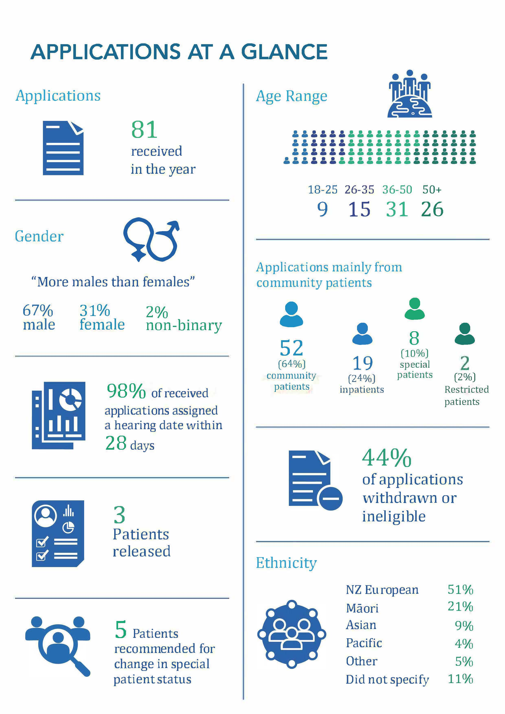
Figure 1: Overview of applications in 2023-24
(Total may not sum to 100% due to rounding)
Further detail illustrating the breakdown of applications is contained in Appendix B.
Applications received by Health New Zealand | Te Whatu Ora (former DHB region)

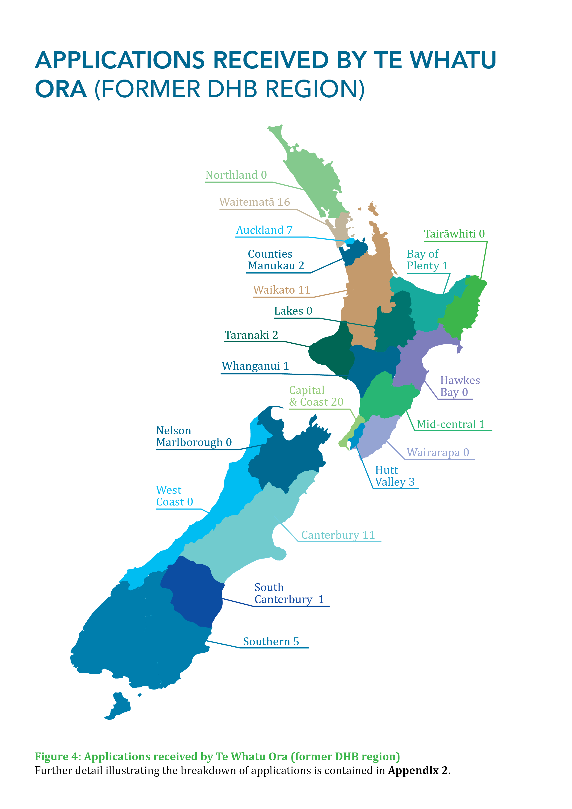
Figure 2: Applications received by Te Whatu Ora (former DHB region)
Further detail illustrating the breakdown of applications is contained in Appendix B.
An overview of applications involving Māori patients

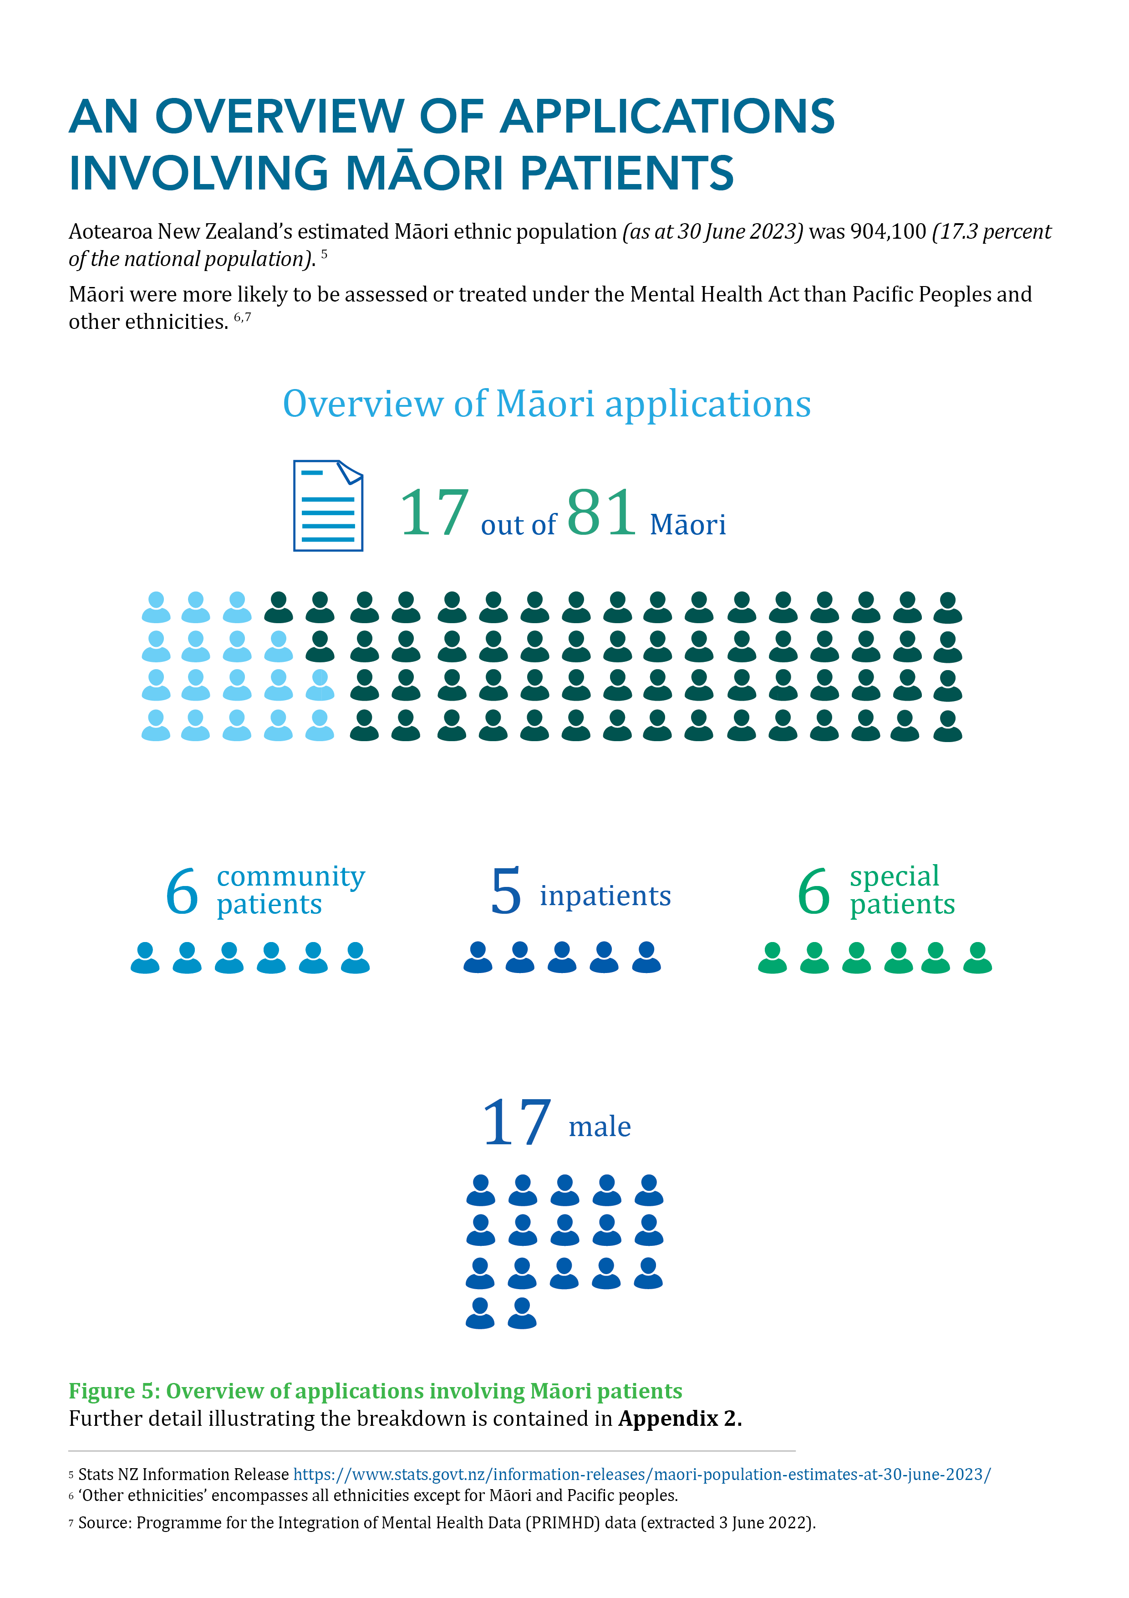
Aotearoa New Zealand’s estimated Māori population as of 30 June 2023 was 904,100 (17.3 percent of national population).4F Māori were more likely to be assessed or treated under the Mental Health Act than Pacific peoples and other ethnicities.5F, 6F
Figure 3: Overview of applications involving Māori patients
Further detail illustrating the breakdown of all ethnicities is contained in Appendix B.
Timeliness

The Tribunal allocates applications for review to commence within 21, or at most 28, days on receipt of an application.
There are instances where applications are heard outside of that timeframe. The reasons include:
- patients sometimes seek a later date to have a lawyer of their choice or to obtain a second opinion or a grant of legal aid

- responsible clinicians or lawyers being unavailable, for example being in another hearing, or family and whānau are not available, and the Tribunal and patient or his or her lawyer agree it is preferable that a hearing be delayed

- general scheduling difficulties. Difficulty is inherent in trying to coordinate dates suitable to patients, their lawyers, health professionals and the Tribunal. To ensure timeliness, the Tribunal may unilaterally set hearing dates and seek for professionals to make arrangements to ensure they are available

- travel factors, for example the limited availability of flights and cancellations due to poor weather conditions or circumstances outside of the Tribunal's control. Hearings tend to involve at least two if not three members travelling from different locations

- the interests of time giving way to the interest in having sufficient good quality information to enable the Tribunal to make a properly informed decision.
We have found those involved in scheduling and conducting hearings to be very cooperative. In some cases, there has been difficulty in scheduling telephone conferences and hearings, but that tends to be able to be resolved informally.
During the reporting year, five applications set down to be heard within 28 days were heard outside that timeframe or adjourned part-heard to a date outside that timeframe. In one case this was due to Tribunal error, with the case being set down for a hearing within 28 days but not all participants being notified in sufficient time to participate.

Publication of decisions

Clause 7 of Schedule 1 of the Act provides that Tribunal proceedings are not open to the public. Clause 8 allows for the publication of reports of proceedings with the leave of the Tribunal and in publications of a bona fide professional or technical nature.
Decisions of the Tribunal are rarely made public. This reflects the right of the patient, and often others, for example victims and family, to privacy. Decisions are highly fact specific and anonymisation may not prevent identification.
Those receiving compulsory treatment under the Act likely assume the usual privacy and confidentiality requirements attaching to medical matters will apply.
Patients, their families, and clinicians who provide private information during Tribunal hearings may be alarmed if decisions find their way onto the internet. Publishers of professional and technical journals now publish journals online.
Weighing against those factors is the public interest in being informed of the workings of the Tribunal.
In April 2010 the Tribunal and the Ministry agreed on guidelines intended to ensure that the relevant interests in privacy and making information public are balanced and that appropriate cases are identified for publication. The protection provided by these guidelines is essentially three-fold:
- only a selection of cases identified by the Tribunal is sent to publishers, by the Ministry;

- those cases will be anonymised, by the Tribunal and then the Ministry; and

- they will be sent only to three established professional and responsible publishers, namely Brookers (Thomson Reuters), LexisNexis and the New Zealand Legal Information Institute.
Reported cases can be found online on the New Zealand Legal Information Institute website: http://www.nzlii.org/nz/cases/NZMHRT/
The Tribunal is in the process of identifying a further suite of cases for publication.

Section 75 Investigations

Patients and others may complain to a District Inspector or Official Visitor of a breach of certain rights, pursuant to s75 of the Act. If the patient or complainant is not satisfied with the outcome, the complaint may be referred to the Tribunal for further investigation. Investigations tend to be time-consuming.

During the reporting year, two complaints were referred to the Tribunal for further investigation and are being considered. Another investigation was still being investigated as at the end of the reporting period. A further investigation was unable to be progressed, for reasons unrelated to the Tribunal.

Appointments to give opinions pursuant to s59 and s60 of the Act

The Tribunal is required to consider applications for the appointment of psychiatrists to assess:
- whether treatment is in the interests of a patient who does not consent to that treatment, pursuant to s59 of the Act;

- whether electro-convulsive treatment is in the interests of a patient who does not consent to that treatment, pursuant to s60 of the Act; and

- whether brain surgery is appropriate, if the Tribunal is first satisfied that the patient has given free and informed consent to surgery, pursuant to s61 of the Act.*

During this reporting period, 12 psychiatrists were appointed by the Tribunal to give opinions regarding whether the proposed treatment of patients without consent is in their interests. Two more applications were under consideration at the end of the reporting period.
*The Tribunal is not aware of this provision having been used before. No applications were received to give opinions regarding whether brain surgery is appropriate.

Relationship with the Director
of Mental Health and Ministry of Health | Manatū Hauora

The Tribunal is an independent statutory body. Decisions reflect its independent view.
Ministry of Health | Manatū Hauora administers the Act.
The Tribunal enjoys a constructive relationship with the Director of Mental Health, Dr John Crawshaw. That relationship involves support for the work of the Tribunal outside of the context of specific cases and consideration of issues which can adversely impact on the functioning of the Tribunal.
Rarely, the Tribunal invites the Director to be heard on an issue arising in a particular case. The Tribunal is grateful for the prompt and thoughtful consideration given by the Director and those in the Directorate when this occurs.
We extend our thanks to Dr Crawshaw and the team at Ministry of Health | Manatū Hauora for their support during the year.

Secretariat

Public policy firm Allen + Clarke is contracted by Ministry of Health | Manatū Hauora to provide the Tribunal with independent Secretariat services. It commenced that role in November 2018.
The Secretariat supports the work of the Tribunal by managing the flow of information between parties and the Tribunal, organising Tribunal pre-hearing teleconferences and hearings, supporting the Tribunal to give effect to its statutory requirements under the Act, and undertaking quarterly reporting to the Ministry of Health | Manatū Hauora on the Tribunal’s activities. The work is relentless and requires care.
The Tribunal is grateful for the hard work of the Allen + Clarke team.

Professional Development

The lawyer and psychiatrist members of the Tribunal are qualified in their respective professions. The community members of the Tribunal possess a diverse range of skills and experiences. All members have considerable experience in their respective areas of expertise prior to appointment.
Members maintain their own professional development. The Tribunal holds an annual plenary, most recently in November 2023. This was an opportunity for members of the Tribunal to discuss topical issues and to meet with the Director of Mental Health and those in the Directorate.

Website

The Tribunal website is hosted within the Ministry of Health | Manatū Hauora website:

https://www.health.govt.nz/about-us/new-zealands-health-system/health-system-roles-and-organisations/health-committees-and-boards/mental-health-review-tribunal

The website contains relevant information, including Policy and Practice notes and Guidelines.

What’s next for 2024-2025

Over the past few years, we have seen the restructuring of the health system, with more changes foreshadowed, including repealing and replacing the Act. We watch with interest.

The Mental Health (Compulsory Assessment and Treatment) Amendment Act 2021 came into force, eliminating indefinite compulsory treatment orders, and in our view leading to the dramatic reduction in the number of applications made to the Tribunal.

We will continue to focus on providing patients with meaningful reviews and, as part of that, support patients in proper recognition of their ties with family and whānau and respect for their cultural and ethnic identity, language and beliefs.

We take this opportunity to thank all of those who have supported our work over the past year.

Conclusion

The Tribunal is privileged to engage with issues that are intensely personal for patients and their families and whānau and supporters.
The competing arguments for why the significant step of compulsory treatment is or is not required are challenging. The Tribunal tries to apply the Act in a fair and balanced manner, and hopes that its work has helped to support:
- the right of those who are mentally disordered to be treated under the Act

- the right of those who are not mentally disordered to be discharged from the Act

- the interests that arise in the case of special and restricted patients.

Appendix A – Tribunal members

Mr A J F Wilding KC
(Tribunal Convener)
James is a barrister based in Christchurch. He was a District Inspector of Mental Health from 1999 to 2011 and is an appointed judge of the Court Martial Appeal Court. He has been Convener of the Tribunal since mid-2016.

Dr N R Judson
Nick is a psychiatrist based in Wellington. In the past he worked in Dunedin and then as Deputy Director of Mental Health. His interests are in forensic psychiatry and intellectual disability.

Ms P Tangitu
Phyllis hails from the Iwi of Ngati Pikiao, Ngati Ranginui and Ngati Awa. She has a background in education and health and has worked in the Mental Health and Addictions and Māori Health sector for 34 years. Phyllis has whānau members who have experienced mental ill-health and continues to advocate for recognition of Māori world views. Phyllis worked at Lakes DHB for 33 years and has recently joined Emerge Aotearoa as Mana Whakahaere (Group Director Equity and Māori) to lead and support the organisation in their Māori Health development.

Deputy Members
The Minister of Health also appoints deputy members of the Tribunal. During the report year, the deputy members of the Tribunal were:
Deputy lawyer members:
Mr R A Newberry
(Deputy Convener)
Robb is a barrister based in Wellington. Prior to becoming a deputy lawyer member of the Tribunal, he was a District Inspector of Mental Health from 1993 until 2008. He also practices in other jurisdictions, such as the Protection of Personal and Property Rights Act 1988 and Intellectual Disability (Compulsory Care and Rehabilitation) Act 2003.

Mr T Clarke
Tim is a lawyer, mediator and facilitator for Collaborative Solutions, based in Hamilton. He has 40 years of experience with mental health, legal and conflict issues. Tim values combining his legal and social experience with mediation and facilitation skills, to assist the rights of those who experience mental illness. Tim is celebrating having just completed his Masters in Peace and Conflict Studies with Otago University in 2023.

Ms A McCarthy
Alice is a partner of Manaia Legal, based in Hawke's Bay. She focuses on international and domestic human rights issues, te Tiriti o Waitangi and health and disability law. She is also a member of the Human Rights Review Tribunal and the health and disability ethics committee.

Mrs A Rakena
Annie is an Auckland family law barrister with over decade of litigation experience. Annie is of Samoan European heritage. Annie’s experience has seen her work closely with a diverse range of clients from different cultures and backgrounds. Her passion is helping families and individuals navigate the family court process. She has a close focus on mental health matters.

Ms R Schmidt-McCleave
Rachael has a Master of Arts and a Master of Laws (Hons) specialising in health law. She has acted for health regulatory authorities in medico-legal and disciplinary proceedings, and the Health and Disability Commissioner in relation to High Court proceedings. She has co-authored two Thomson Reuters textbooks on health and safety law and acted in inquests. Rachael has a sound knowledge of tikanga Māori and has acted in the Māori Land Court and in the Waitangi Tribunal. She left part-way through the period on being appointed a Coroner.

Deputy psychiatrist members:
Dr B Beaglehole
Ben is a Christchurch based psychiatrist. He is the clinical head of the Anxiety Disorders Service based at Hillmorton Hospital. Ben is also a Senior Lecturer for the University of Otago. He teaches medical students and researches compulsory treatment, mood disorders and mental health outcomes following disasters.

Dr C Dudek-Hodge
Christine trained as doctor in Germany and The Netherlands. She gained her PhD in Germany and went on to complete her vocational training as a psychiatrist at the Academic Medical Centre in Amsterdam, The Netherlands. Christine relocated with her family to Christchurch in 2012 and has since worked as a general adult psychiatrist for Te Whatu Ora, Waitaha.
Dr H Elder, MBChB, FRANZCP, PhD, MNZM
Ngāti Kurī, Te Aupōuri, Te Rarawa, Ngāi Takoto, Ngāpuhi. Hinemoa is a psychiatrist and works in a range of settings including Haumaru Ōrite (Child and Family Unit and Mother baby unit) Starship Hospital, and as a court report writer for the Youth Court and Kōti Rangtahi. She has a doctorate and post doctoral Fellowship in traumatic brain injury and is a researcher in TBI and dementia in the Māori community.

Dr M Honeyman, QSO
Margaret is a psychiatrist based in Auckland and is semi-retired. Her clinical work has been in adult psychiatry. A large part of her career has been in leadership and management roles, including as Clinical Director and DAMHS in DHB settings and as Chief Psychiatrist in South Australia. Margaret has thus been involved in the application of mental health legislation from a number of different perspectives.

Dr P Renison
Peri is a psychiatrist who works clinically in adult general psychiatry, currently in the area of adults with Intellectual Disability and Mental Illness. She was previously Chief of Psychiatry for the Canterbury DHB and Director of Area Mental Health Services for Canterbury. She has worked in both inpatient and community mental health services.

Dr S Schmidt
Sigi lives in Christchurch and is employed by Te Whatu Ora - Waitaha as Chief of Psychiatry and DAMHS. He is of German descent and grew up in South Africa. He moved to New Zealand in 1999 after completing his psychiatric training at the University of Cape Town. He has worked in a range of mental health services in Christchurch, including Adult General Psychiatric Services (in hospital and community settings), Rehabilitation, Early Intervention in Psychosis, Rural Psychiatric Services and working with Refugee and Migrant Services. He has also been a Clinical Director for a period of four years before commencing his current role in 2020.

Dr J McMinn MBBS FRANZCP (Cert. Forensic Psych.) FAChAM MAcadMEd
Jeremy is a forensic psychiatrist and an addiction specialist and was appointed to the Tribunal in 2021. He provides independent expert psychiatry and addiction opinions to a range of agencies and professional bodies. He is currently based in Wellington, and has worked in Whanganui, Rotorua and in the UK. He supervises junior doctors training in psychiatry, and consultants training in addiction.

Dr J Whiting
Jeremy is a consultant psychiatrist currently working at Mason Clinic and has worked in various clinical settings over the last twelve years. As part of his current role, he provides psychiatric reports for the court on matters such as fitness to stand trial, insanity defence, risk assessment and disposition, and forensic opinion for general mental health colleagues. In his day-to-day practice, he endeavours to work collaboratively with service users and families and whānau to assist patients in their recovery.

Deputy community members:
Mrs F Diver, QSM
Francis is a community member based in Central Otago. She is Ngai Tahu, Waitaha, Kāti Māmoe and works closely with the Māori community. She founded Uruuruwhenua Health Inc Māori health provider service and has held leadership roles with charities and local government initiatives. She has a close focus on mental health.

Mr S Hanrahan
Shannon is the Executive Chair of KŌ Kollective Trust in Opotiki that offers psycho-social support and wellbeing services to kaumātua, tamariki and adults. Shannon has relocated from the United Kingdom after running his own public health consultancy and public policy business for over a decade. He offers an international background and current experience working in rural New Zealand.

Ms L Pennington
Liz has a background in co-design work in collaboration and respectful partnership with communities in Bay of Plenty Te Tairawhiti and Hawkes Bay. She is passionate about the health, wellbeing, and social services sector and brings experience and commitment to working across cultures. Liz brings to her work significant experience working in mental health and trauma, private wellbeing practice and whānau lived experience.

Mr M Sukolski
Michael has worked in the mental health sector for over 30 years. His work as a peer advisor is informed by lived experience and its potential as an equal partner in decision-making negotiations. Michael has been a member of a number of NGO boards, including peer-led organisations. He is committed to the priority of Te Tiriti o Waitangi. He is a member of the LGBTQ+ community.

Ms S Sumita
Sumita provides mental health and addiction counselling and clinical supervision. She has previously worked as a drug and alcohol clinician for the Waikato District Health Board. Sumita is passionate about representation for immigrants including pacific nationals.

Mrs S Sidal
Shomilla is Chair of the Board for Pablo’s Art Studio, Property Development and Property, has a lead role at Wesley Community Action (supporting people in social housing), is a peer worker providing phone support for Emerge Aotearoa, and is self-employed as an external supervisor for social workers. She speaks fluent Hindi and English and understands basic Te Reo Māori.

Appendix B – A breakdown of applications

This section provides information on applications received from 1 July 2023–30 June 2024.
Figure B1: Applications received 1 July 2023 – 30 June 2024 by gender
Patients may identify their gender in their application. The number of applications received from those identifying as male was 54 and the number from those identifying as female was 25. Two applicants identified as non-binary.

Figure B2: Applications received 1 July 2023 – 30 June 2024 by age group
The majority of applications were received from individuals aged 36-50 (38.27%), followed by the over 50 (32.10%), 26-35 (18.52%), and 18-25 (11.11%). Over 70 percent of all applications received during 2023-2024 were from individuals aged 36 years or older.

Figure B3: Applications received 1 July 2023 – 30 June 2024 by Te Whatu Ora (former DHB Regions)
In July 2022, the health reforms resulted in all District Health Boards being merged into the national health system, Health New Zealand |Te Whatu Ora.
Most applications were received from the main centres across Aotearoa New Zealand. There were a high number of applications from the Auckland region which includes Auckland, Waitemata and Counties Manukau (25). The second highest number of applications were received from Capital and Coast (20).

Figure B4: Applications received 1 July 2023 – 30 June 2024 by order type
The largest number of applications received was from patients on community treatment orders. Of the 81 applications received, 52 (64.20%) were from patients on community treatment orders, 19 (23.46%) were from patients on inpatient treatment orders, 8 (9.88%) were from special patients and 2 (2.47%) were from restricted patients.

Figure B5: Applications received 1 July 2023 -30 June 2024 percentage withdrawn
Year | Applications | Applications ineligible or withdrawn by patient | Percentage
1 July 2023 – 30 June 2024 | 81 | 36 | 44.44%

Figure B6: Applications received 1 July 2023 – 30 June 2024 by hearing outcome
In most cases, the Tribunal decided that patients should remain under the Act. Three patients were released from the Act during the year. The Tribunal recommended that five special patients be released from special patient status.

Figure B7: Applications received 1 July 2023 – 30 June 2024 decision outcome by percentage
Of the 41 applications proceeding to hearing within the reporting period, four cases were yet to be determined at the end of the reporting period.
Number of cases determined: 41
Remained on order | % | Released from order | % | Recommendation for a change in special patient status / fit to stand trial | % | Adjourned Hearing Pending | %
32 | 78.05 | 3 | 9.76 | 5 | 12.2 | 1 | 2.44

Figure B8: Applications received 1 July 2023 – 30 June 2024 and percentage of hearings arranged to commence within 28 days
Quarter | Number of applications | Withdrawn | No jurisdiction | Number proceeding | Review arranged to commence within 28 days | %
1 July 2023 – 30 September 2023 | 25 | 9 | 1 | 15 | 15 | 100%
1 October 2023 – 31 December 2023 | 25 | 8 | 2 | 15 | 14 | 93%
1 January 2024 – 30 March 2024 | 12 | 2 | 3 | 7 | 7 | 100%
1 April 2024 – 30 June 2024 | 19 | 10 | 1 | 8 | 8 | 100%
Totals | 81 | 29 | 7 | 45 | 44 | 98%

Page 16, "Timeliness", contains more information about reviews that were arranged to commence within 28 days but which were not heard within that timeframe.
Figure B9: Applications received 1 July 2023 – 30 June 2024 by ethnicity
Ethnicity | Count | Percentage
Māori | 17 | 20.99%
Pacific Peoples | 3 | 3.70%
Asian | 7 | 8.64%
NZ European | 41 | 50.62%
Other | 4 | 4.94%
Unknown | 9 | 11.11%
Total | 81 | 100%

Figure B10: Applications received 1 July 2023 – 30 June 2024 by ethnicity
The largest self-identified ethnic group to apply to the Tribunal was New Zealand Europeans. The graph does not fully reflect the ethnicity of all applicants as they are not required to identify their ethnicity, and some did not do so.
*Prioritised ethnicity has been used to report on the data. Prioritised ethnicity involves each respondent being identified by a single ethnic group, in the prioritised order of Māori, Pacific, Asian, European, or Other. For example, if someone identified as being both Chinese and Māori, their prioritised ethnicity is Māori for the purpose of analysis. The prioritised ethnicity group European and Other effectively refers to non-Māori, non-Pacific, and non-Asian people.

Appendix C – A comparison over time

This section provides a comparison from the past eight annual reports, together with data from this reporting period.
Figure C1: Applications received by gender compared to the last eight annual reports
Since July 2014 the number of applications of all types stated as being from male patients was 792 and the number from female patients was 413. Some applications did not identify gender or, from the 2021 to 2022 year, stated non-binary. The 2015-2016 reporting data did not report on applications by gender. Total may not sum to 100% due to rounding.
Figure C2: Applications received by Te Whatu Ora (former DHB regions) compared to the last eight annual reports
The main centres continue to be the locations from where a large proportion of applications are received.

Figure C3: Application status compared to the last eight annual reports

Figure C4: Comparison of applications withdrawn or ineligible compared to the last eight annual reports
For this reporting period, of the number of applications received, the number of applications withdrawn or ineligible was under half. In some cases, withdrawal has occurred because, following making the application, there has been substantive discussion between the patient and responsible clinician resulting in the resolution of the issues of concern to the patient, and then the withdrawal of the application or the discharge of the patient by the responsible clinician.
Year | Number of applications | Withdrawn or Ineligible | Percentage
1 July 2014 – 30 June 2015 | 156 | 77 | 49%
1 July 2016 – 30 June 2017 | 139 | 70 | 50%
1 July 2017 – 30 June 2018 | 131 | 57 | 43%
1 July 2018 – 30 June 2019 | 147 | 80 | 54%
1 July 2019 – 30 June 2020 | 154 | 92 | 60%
1 July 2020 – 30 June 2021 | 157 | 75 | 48%
1 July 2021 – 30 June 2022 | 115 | 54 | 47%
1 July 2022 – 30 June 2023 | 138 | 70 | 51%
1 July 2023 – 30 June 2024 | 81 | 36 | 44%
Figure C5: Comparison of application outcomes compared to the last eight annual reports
At the time of reporting, there was one application that was adjourned for a subsequent hearing.

Figure C6: Decision outcomes compared with the last eight annual reports
This year saw a similar level in the number of patients who the Tribunal discharged from compulsory status, one more compared to last year.
There were five special patient hearings that occurred this year. The Tribunal recommended in all cases that the applicant be discharged from special patient status.

Year | # of cases determined | Remained on order | Released from order | Recommendation of discharge from special patient status | Application was abandoned by the applicant/ dismissed | Adjourned to be heard
1 July 2014 – 30 June 2015 | 62 | 57 | 5 | - | - | -
1 July 2016 – 30 June 2017 | 69 | 63 | 6 | - | - | -
1 July 2017 – 30 June 2018 | 63 | 58 | 5 | - | - | -
1 July 2018 – 30 June 2019 | 67 | 62 | 3 | 2 | - | -
1 July 2019 – 30 June 2020 | 62 | 47 | 11 | 4 | - | -
1 July 2020 – 30 June 2021 | 82 | 67 | 9 | 3 | 2 | 1
1 July 2021 – 30 June 2022 | 61 | 52 | 4 | 1 | 3 | 1
1 July 2022 – 30 June 2023 | 55 | 48 | 2 | 2 | 3 | -
1 July 2023 – 30 June 2024 | 41 | 32 | 3 | 5 | - | 1

Figure C7: Applications by ethnicity compared to the last eight annual reports
*Prioritised ethnicity has been used to report on the data. Prioritised ethnicity involves each respondent being identified by a single ethnic group, in the prioritised order of Māori, Pacific, Asian, European, or Other. For example, if someone identified as being both Chinese and Māori, their prioritised ethnicity is Māori for the purpose of analysis. The prioritised ethnicity group European and Other effectively refers to non-Māori, non-Pacific, and non-Asian people.

Figure C8: Number of applications received by ethnicity compared to the last eight annual reports
New Zealand European continues to be the largest self-identified ethnic group applying to the Tribunal. This has been consistent over the last eight annual reports.

Ethnicity | 1 July 2023– 30 June 2024 | 1 July 2022– 30 June 2023 | 1 July 2021– 30 June 2022 | 1 July 2020 – 30 June 2021 | 1 July 2019 – 30 June 2020 | 1 July 2018 – 30 June 2019 | 1 July 2017 – 30 June 2018 | 1 July 2016 – 30 June 2017 | 1 July 2014 – 30 June 2015
Māori | 17 | 37 | 24 | 22 | 33 | 25 | 18 | 26 | 31
Pacific Peoples | 3 | 8 | 8 | 4 | 10 | 8 | 7 | 8 | 5
Asian | 7 | 6 | 5 | 11 | 10 | 7 | 5 | 3 | 6
NZ European | 41 | 61 | 61 | 81 | 88 | 69 | 68 | 81 | 93
Other | 4 | 11 | 5 | 9 | 5 | 36 | 11 | 10 | 2
Unknown | 9 | 15 | 12 | 30 | 8 | 2 | 22 | 11 | 19
Total | 81 | 138 | 115 | 157 | 154 | 147 | 131 | 139 | 156



Decisions regarding the release of special and restricted patients are for the Minister of Health or Attorney-General, depending on the circumstances.
District Inspectors are lawyers who are appointed under the Act to help safeguard the rights of patients.
3 There are no Official Visitors in New Zealand.
Waitematā Health v the Attorney-General [2001] NZFLR 1122.
Stats NZ Information Release https://www.stats.govt.nz/information-releases/maori-population-estimates-at-30-june-2023/
‘Other ethnicities’ encompasses all ethnicities except for Māori and Pacific peoples.
Source: Programme for the Integration of Mental Health Data (PRIMHD) data (extracted 3 June 2022).

