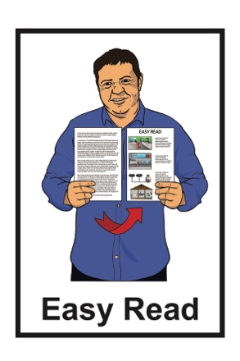



Smokefree Aotearoa:

Information about our plan to make Aotearoa New Zealand smokefree by 2025
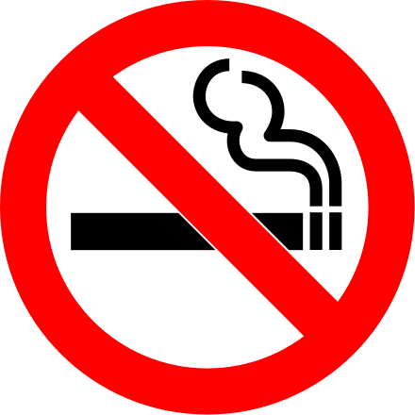
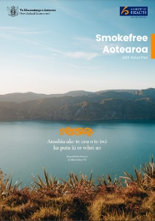

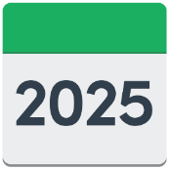

Published in Easy Read: February 2023

Before you start


This is a long document.

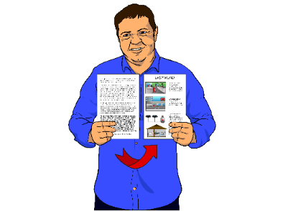
While it is written in Easy Read it can be hard for some people to read a document this long.

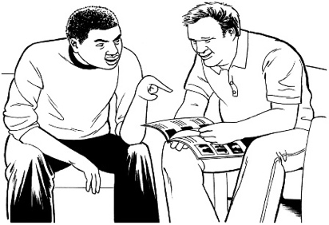
Some things you can do to make it easier are:

- read it a few pages at a time
- have someone support you to understand it.

What you will find in here

Page number:


What is this document
about? 5


Who we are 6

Smokefree Aotearoa
2025 Action Plan 9

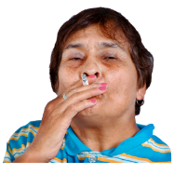
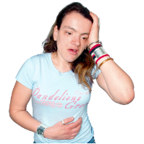
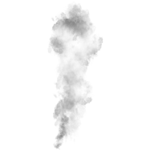
Smoking tobacco is a big
problem 13


Our vision 14
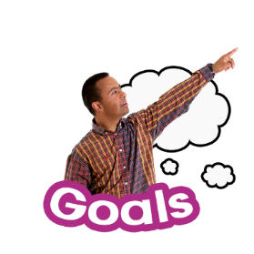

Our goal 16

Page number:


What are our outcomes? 18
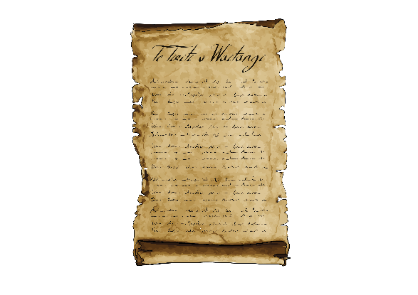
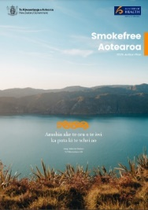

Principles of Te Tiriti o
Waitangi 22
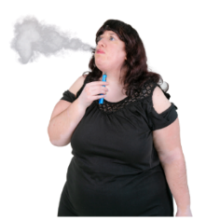
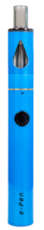

Vaping and the action plan 26



Achieving the outcomes 29


Monitoring and evaluating
the action plan 36

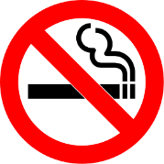

Support to stop smoking 38

Page number:
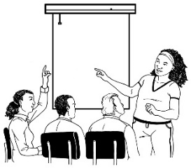
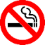

Extra supports 43

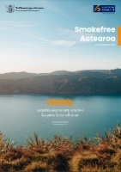
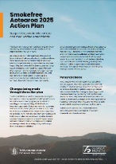
Where to find more
information 46

What is this document about?

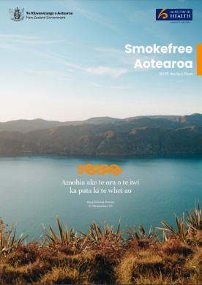
This Easy Read document is from the Ministry of Health Manatū Hauora about the Smokefree Aotearoa 2025 Action Plan.

This document is a summary of the full action plan.


A summary:
- is shorter than the full plan
- tells you the main ideas.


You can find more information about the full plan at the Ministry of Health website at:

https://bit.ly/3Yn840k

Who we are

The Ministry of Health Manatū Hauora is part of the New Zealand Government that looks after healthcare in Aotearoa New Zealand.


Healthcare is when people are given the supports / services they need to:

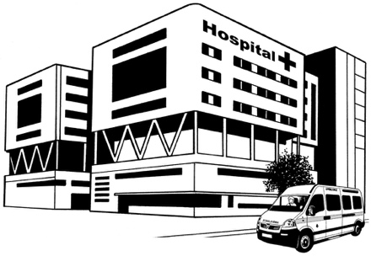
- stop them from getting sick
- get better if they get sick.

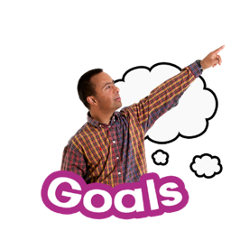
We want everyone in Aotearoa New Zealand to:

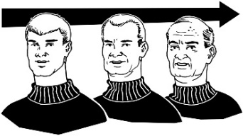
- live longer


- have good health

- have a good quality of life

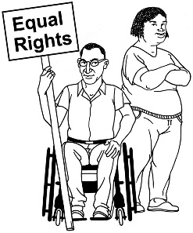
- be able to access good healthcare.


We work with the health sector to make sure people in Aotearoa New Zealand have good healthcare.


The health sector is made up of services / businesses that:

- provide medical treatment like:

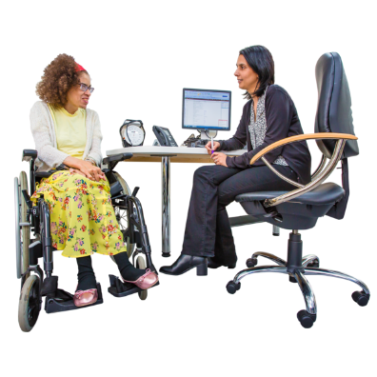
- hospitals

- doctors

- physiotherapists
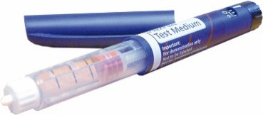
- design medical equipment
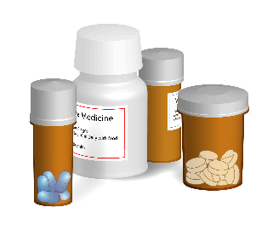
- build medical equipment

- make medicines.

Smokefree Aotearoa 2025 Action Plan

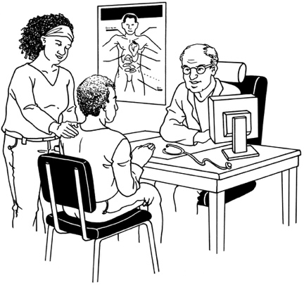
The New Zealand Government wants to do all it can to stop people being hurt by tobacco products.

Tobacco products are things that contain tobacco.

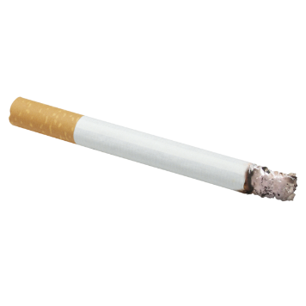
Tobacco products that can be smoked include:

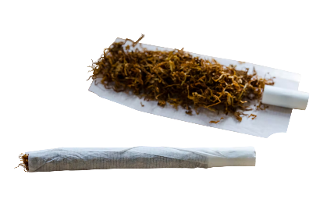
- cigarettes that you can buy already rolled
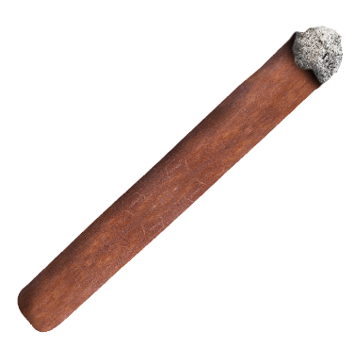
- cigarettes that you can roll yourself

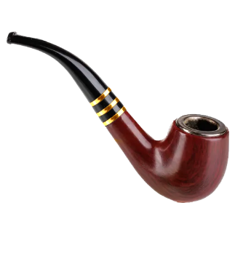
- cigars

- pipes.

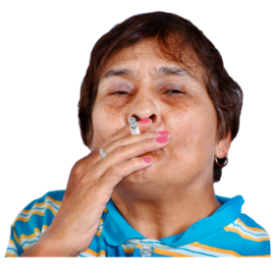
It is easy for people to get addicted to tobacco products.

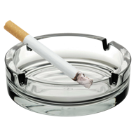

Addicted means you find it very hard to give up / stop doing something.


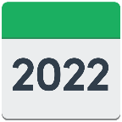
It has been 10 years since the Government promised to make New Zealand smokefree.

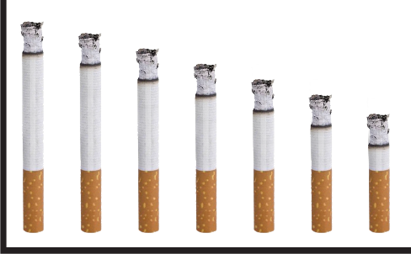
The plan to make New Zealand smokefree means:

- making the number of people in New Zealand who smoke much smaller

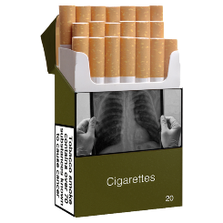

- making smoked tobacco products less available

- making tobacco products less addictive.

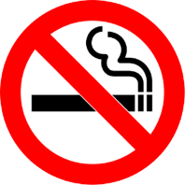
The Government wants to make New Zealand smokefree by 2025.


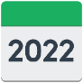
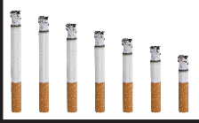
Over the last 10 years the number of people who smoke has kept going down

but
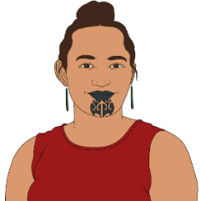
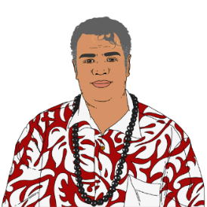
we need to do more work to make the number of people who smoke even smaller for people who are:
- Māori

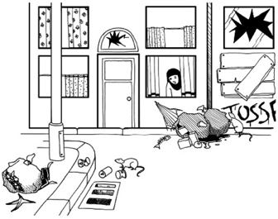
- Pacific peoples
- living in disadvantaged communities.

People in disadvantaged communities are people who find it hard to live a good life because of things like:

- not having a safe place to live

- not earning enough money

- not having good access to healthcare.
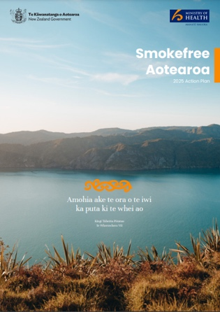

We have put together the Smokefree Aotearoa 2025 Action Plan so we can see how well our work is going.


You can watch a video about the Smokefree Aotearoa 2025 Action Plan on YouTube at:

https://youtu.be/Uhig2o45xsw

Smoking tobacco is a big problem
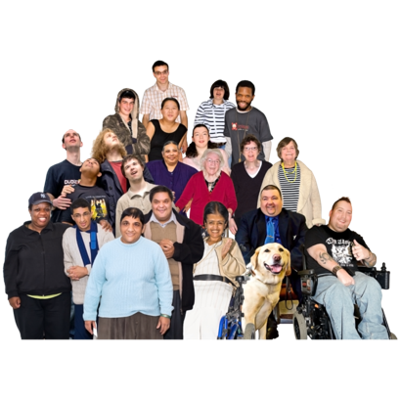

Smoking tobacco causes the deaths of around 5 thousand people in Aotearoa New Zealand every year.
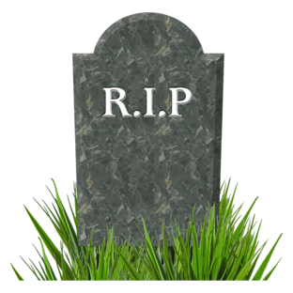

This means around 12 people die every day because of:

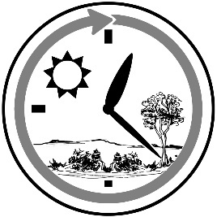
- smoking tobacco

- second-hand smoke.
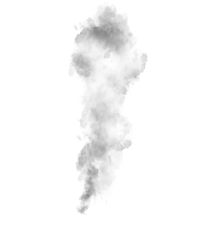
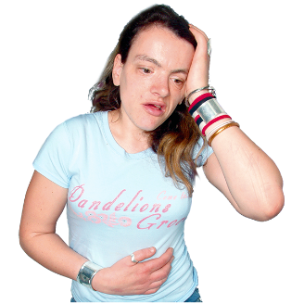
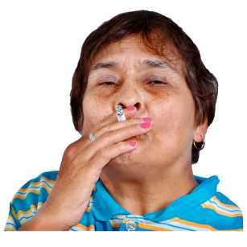
Second-hand smoke is when someone around the smoker breathes in tobacco smoke when they did not mean to.

Our vision


Our vision is what we want things to be like in the future.


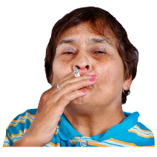
Smoking tobacco:
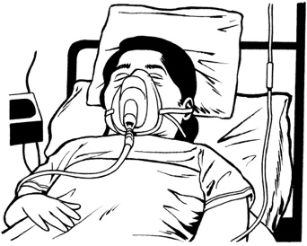
- is very dangerous
- can make you very sick
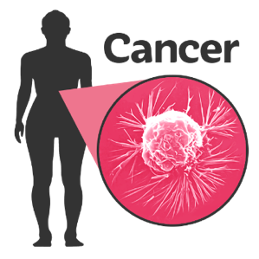
- can make you more likely to get a serious illness like:

- cancer
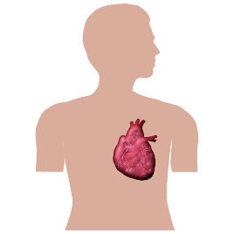
- heart disease

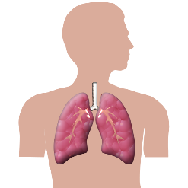
- stroke

- lung disease.


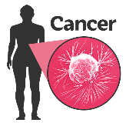
Our vision for the Smokefree Aotearoa 2025 Action Plan is to stop the harm that smoking causes to people.

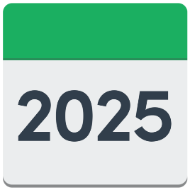
We will do this by making Aotearoa New Zealand smokefree by 2025.

Our goal
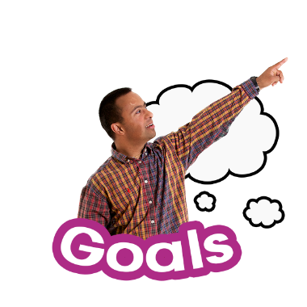

Our goal is what we are trying to make happen.

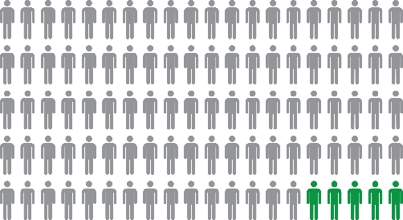
Our goal for the Smokefree Aotearoa 2025 Action Plan is that fewer than 5 people in every 1 hundred will smoke every day by 2025.

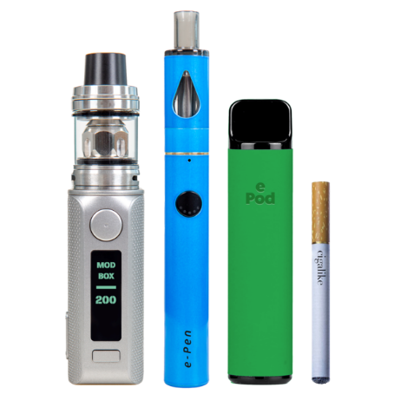
This goal does not include:

- e-cigarettes
- vapes

- smokeless tobacco products.

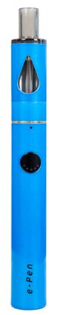
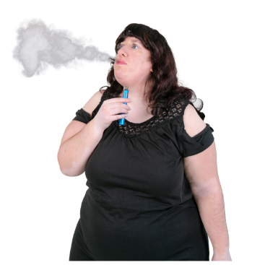
E-cigarettes / vapes:
- are powered by a small battery
- heat up liquid into a type of gas called vapor that you can breathe into your body.


Smokeless tobacco is a type of tobacco product that you do not smoke.

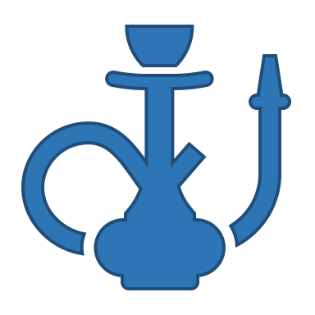
Some examples include:
- shisha which is when tobacco is heated and breathed in through a special pipe

- heated tobacco sticks.

What are our outcomes?


Outcomes are the results / changes that we want to see happen when we have reached our goals.

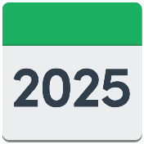
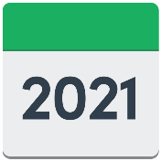
The action plan sets out our actions to reach the smokefree goal:
- between 2021 to 2025
- after 2025.

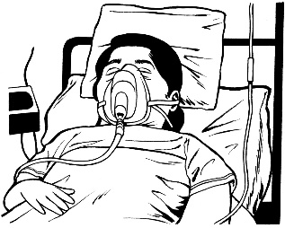

There are 3 main outcomes in the plan:

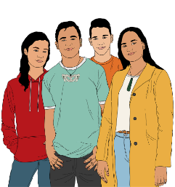
- stop inequities with smoking rates / illnesses linked to smoking

- create a smokefree generation to help children / young people stay smokefree
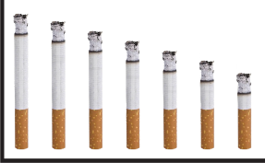
- make the number of people who quit smoking much bigger.
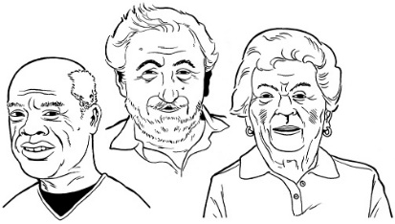
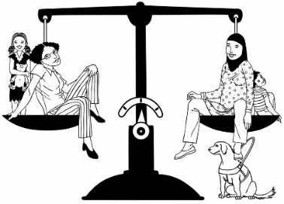
Inequities are when groups of people are not treated fairly / equally for reasons they cannot change like:
- being Māori
- being old.

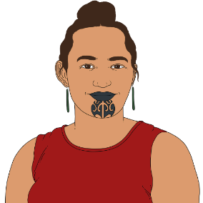
Outcome 1 means smoking is harming some people more than others such as:
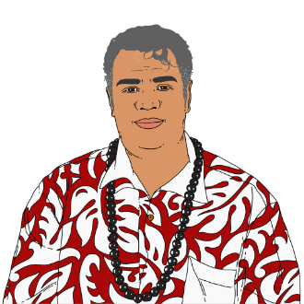
- Māori

- Pacific peoples
- people living in the poorest areas of Aotearoa New Zealand.


We need to change this so that these groups are not harmed by smoking.
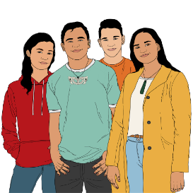
Outcome 2 means we need to stop young people from ever starting to smoke.

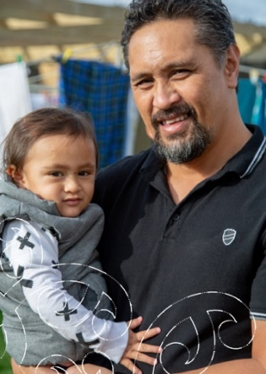
To do this we need to encourage the people that they look up to to quit smoking.

This means people like:

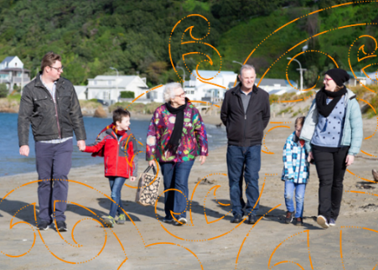
- their parents

- their family / whānau

- other adults they spend time with.


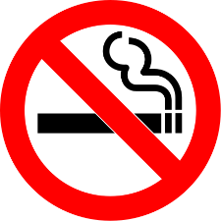
Outcome 3 means we need to make it easier for people to quit so that there are fewer people who smoke.


It is hard to quit smoking.


To make it easier for people to quit smoking we need to make positive changes to the way people live.

Principles of Te Tiriti o Waitangi

We aim for the Smokefree Aotearoa 2025 Action Plan to follow the principles of Te Tiriti o Waitangi / The Treaty of Waitangi.


Principles are rules that tell people how to act / behave.

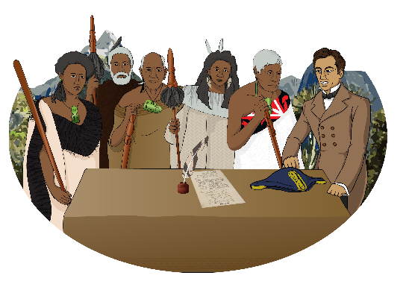
The Treaty of Waitangi / Te Tiriti o Waitangi is an important document that was signed in 1840.

It is about Māori and the New Zealand Government:

- making decisions together

- protecting things that are important to Māori.

Te Tiriti o Waitangi principles that apply to our work are:

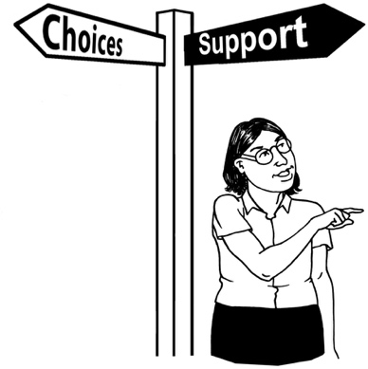
- Tino rangatiratanga

This means independence which is about people making decisions for themselves.

- Equity
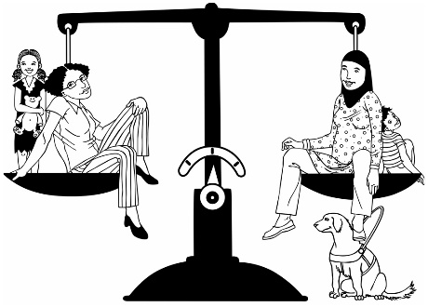

This means we want to be sure that the work we do is fair to Māori / thinks about how it affects Māori.


- Active protection

This means we take steps to protect the things that are important to Māori.

Other Te Tiriti o Waitangi principles that apply to our work are:

- Options

This means the choices we give to Māori are respectful of their:
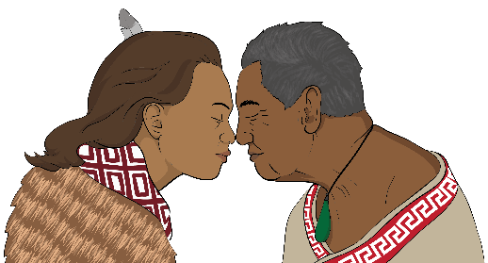
- cultural / spiritual needs

- physical needs.

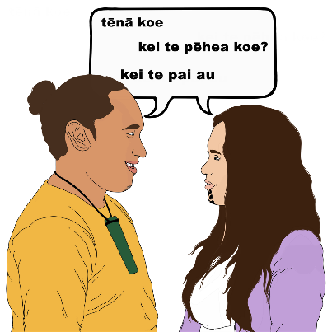
Cultural / spiritual needs are the things people need to live a good life like:

- the languages they speak

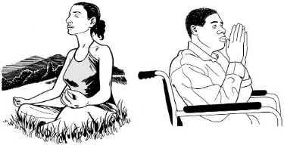
- their religious beliefs

- the values that are important to them.
Other Te Tiriti o Waitangi principles that apply to our work are:

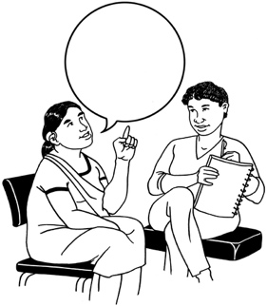
- Partnership

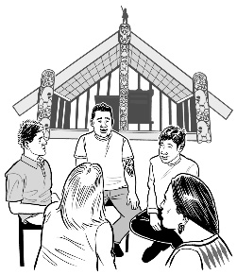
This means that Māori have a say about what happens in health and disability services when:

- the services are designed


- the services are in their community

- monitoring the services.


Monitoring the services is when services are looked at over an amount of time to see if they are
- working well
- have got better / worse.

Vaping and the action plan
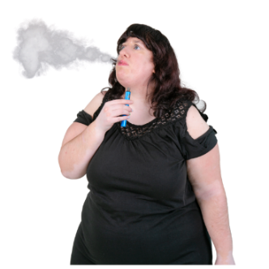
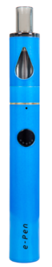

Vaping is when someone uses a vape / e-cigarette.


Vaping products have changed the smoking habits of people in Aotearoa New Zealand.
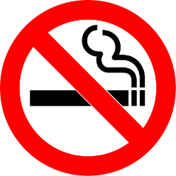
People can use a vape to help them quit smoking.

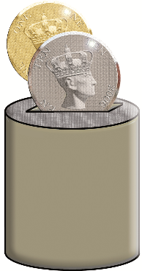
Vaping is:

- cheaper than smoking

- less harmful to your health than smoking.

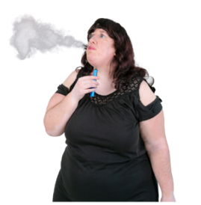
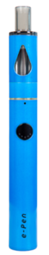
Vaping is seen as a better option for:

- people who are not ready to quit smoking

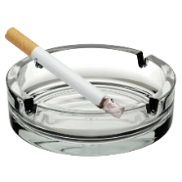
- people who cannot quit smoking.


Although vaping is less harmful than smoking tobacco it still has health risks.
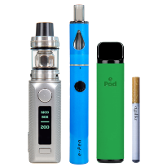


Vaping is not good for:
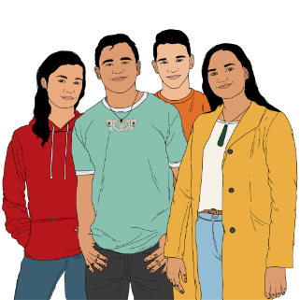
- young people

- people who do not smoke.

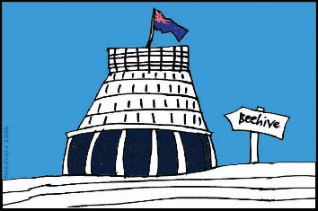
Vaping products are regulated under the Smokefree Environments and Regulated Products Act 1990.


Regulated is when the Government sets out rules that must be followed when using / selling certain items.

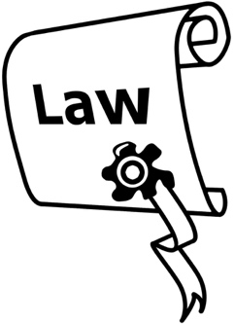
The Smokefree Environments and Regulated Products Act 1990 is the set of rules that people must follow when using / selling:
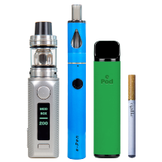
- tobacco products

- e-cigarettes / vapes.

Achieving the outcomes


There are 6 important areas we will look at to make sure we meet the outcomes of the plan.

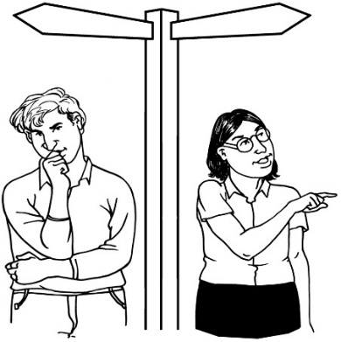
- Give Māori a bigger role in:

- being leaders
- making decisions.

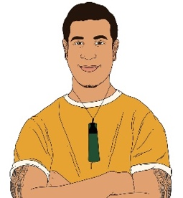
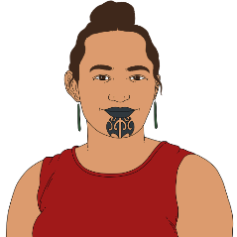
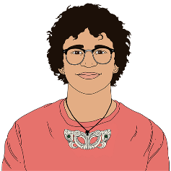
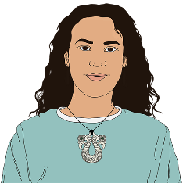
This means making sure that Māori are involved in the plan by:

- leading others

- making decisions on how to get things done.

It is important to make sure Māori are a part of making decisions so what we do is fair for everyone.


- Do more work to raise awareness about:

- good health
- supporting healthy communities.


This means we will support people to make changes to their life so they can stay smokefree.
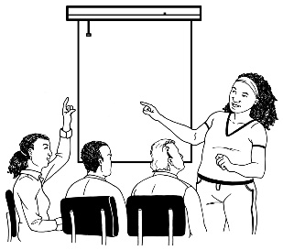
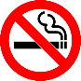

We will do this by:


- supporting people with ways to stay healthy

- working with the community to explain changes to the law.

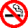
- Offer more evidence based services that support people to stop smoking.


Evidence based means we will:

- look at the types of services that work well to support people to stop smoking
- look at how / why these services have worked well so we can do the same things.

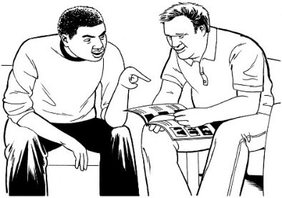
We will do this by:


- giving people the supports they need when they choose to stop smoking

- offering more evidence based services that support people to stop smoking.
We will also support people who support others to stop smoking by making sure they get the training they need.


The Government has set aside over 13 million dollars to pay for new services that support people to stop smoking.

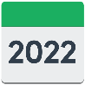
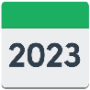
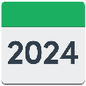
The money will be spent over 3 years starting from July 2022.

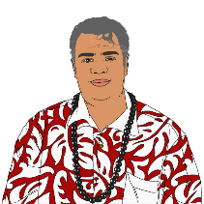
An extra 8 million dollars will be spent on support services to support Pacific peoples to stop smoking.

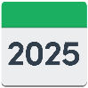
This money will be spent over 4 years.


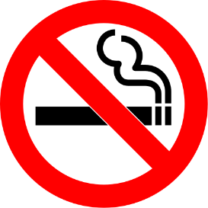
- We will make it:
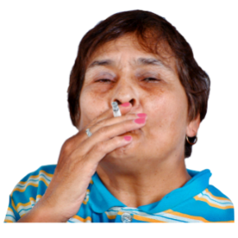
- easier to stop smoking

- harder to become addicted to smoking.

This means we will:
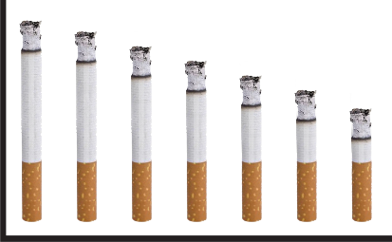
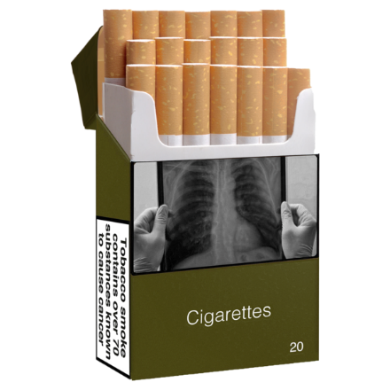
- make it less likely for people to get addicted to tobacco products by only selling products that have low levels of nicotine in them

- change the packaging of smoking products so that people know what we have changed about these products.

Nicotine is the substance in tobacco products that makes them addictive.


- Make smoked tobacco products less available.


We will do this by:

- making it so fewer shops can sell tobacco products

- making it so there are fewer tobacco shops in poorer communities.


We will also stop young people from ever starting smoking by making it against the law to sell smoked tobacco products to people born in / after 2009.
2009

Shops will also need to let us know if they sell vaping products.

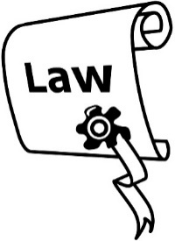

- Make sure everyone follows the rules set out in tobacco laws.

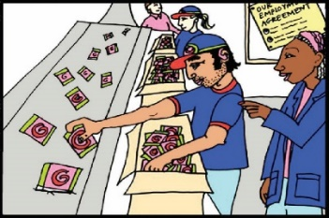
This means we will make sure the rules are followed by the companies / shops that:

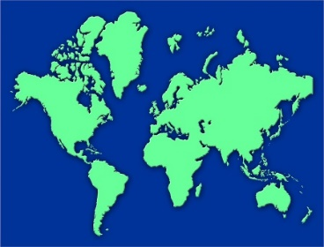
- make smoked tobacco products

- bring in tobacco products from overseas
$

- sell tobacco products.

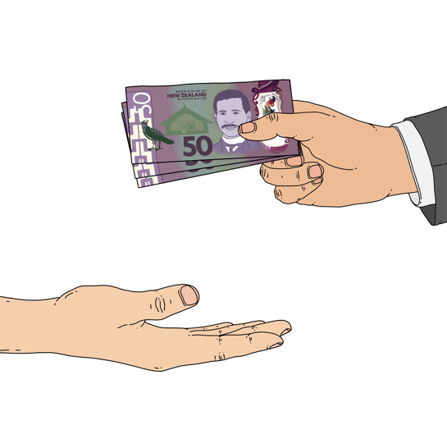
We will do this by making sure that anyone who does not follow the rules has to pay money called a fine.


We will work to find better ways of making sure everyone is following the rules.

Monitoring and evaluating the action plan

The plan to make Aotearoa New Zealand smokefree will be:


- monitored

- evaluated.

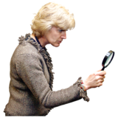
Evaluated means that we will:
- look at what we do to see if it is working

- check if we need to make any changes to what we do to make it better.

We will do this to make sure the plan is working how we need it to.

When we evaluate how the plan is going we will:

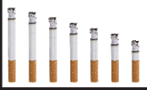
- look at the ways our work has lowered the number of people who smoke in Aotearoa New Zealand
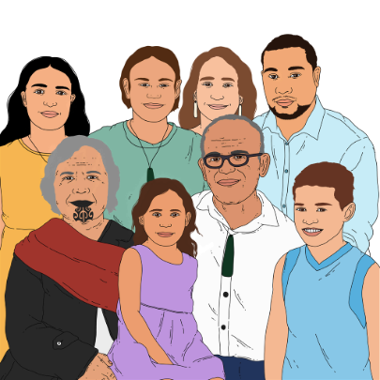
- make sure we think about how we support Māori

- make sure that Māori are:


- leading the work / research we do

- involved in monitoring / evaluating what we do
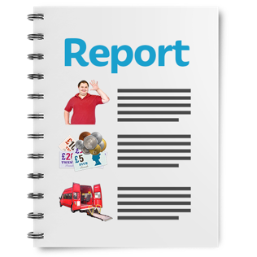
- write a report about what we have found out for everyone to read.

Support to stop smoking

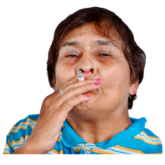
Smoking can hurt:
- the person who smokes

- their family / whānau

- their friends.


Finding good ways to support people to stop smoking must include everyone.

We can make sure young people in Aotearoa New Zealand have a better life free from the harmful effects of smoking.

Most people who smoke tobacco say that they:
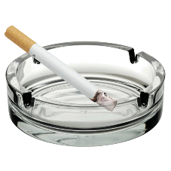
- wish they had never started

- find it hard to stop

- want us to make it easier for them to stop smoking.



There is support available for:

- people who want to stop smoking
- family / whānau of people who smoke who are supporting them to stop smoking.


Services that can support you to stop smoking will not cost you any money.

Services that can support you to stop smoking can:

- work with you to make a plan to stop smoking that is right for you
- give you free nicotine replacement therapy.

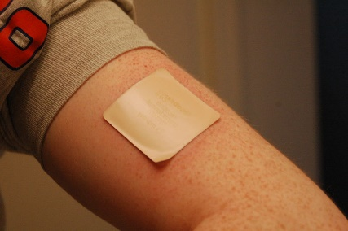
Nicotine replacement therapy supports people to stop smoking by giving them nicotine in other ways like:

- nicotine patches

- nicotine gum.


You can find out more about support to stop smoking in your local area at the Smokefree website at:

www.smokefree.org.nz/help-advice/stop-smoking-services

If you are a family member / friend of someone who is trying to stop smoking you can find information about the support you can give them at:

www.smokefree.org.nz/help-advice/helping-others-to-be-smokefree


Quitline is a free service that can support you to stop smoking.

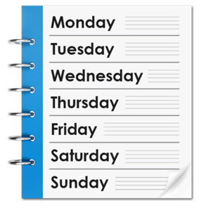
Quitline is open at all times of the day on every day of the week.


You can call Quitline on:

0800 778 778

You can also find Quitline online at:
- their website:
www.quit.org.nz


- their Facebook page:

www.facebook.com/quitlinenz

Extra supports

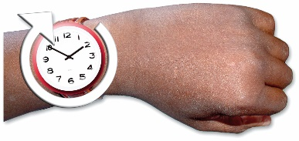
The changes in the action plan will not happen right away.

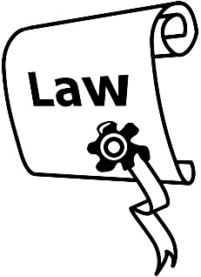
There will be a wait for some of the changes until new laws are put in place.

We are working with services that support people to stop smoking so there is support in place when someone is ready to stop.

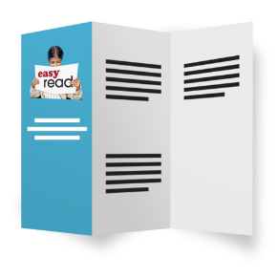
It is important that it is easy for everyone to get:

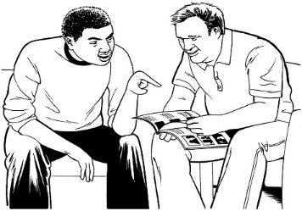
- the information they need

- access to support.

We will be giving more money to fund more services that support people to stop smoking including those that support Pacific peoples.

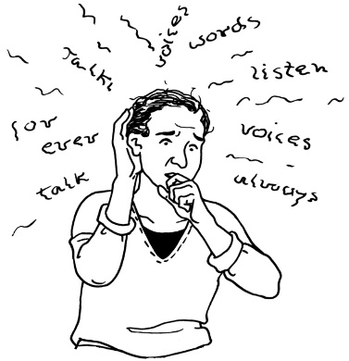
We will also work with services that look at things like:

- mental health issues

- addiction.


We will use the information we gather from this work to help us make better services that support people to stop smoking.

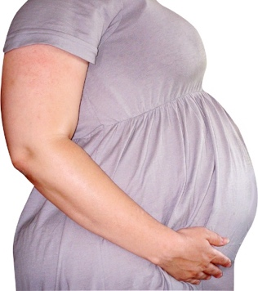
To support families / households to stop smoking we will also work with:

- Well Child / Tamariki Ora

- services that provide help to people who are pregnant.

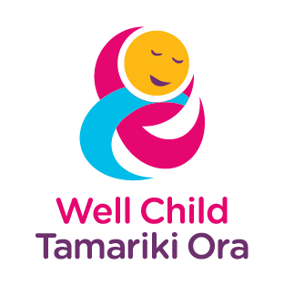
Well Child / Tamariki Ora is a free service that supports parents to protect the health of their child.

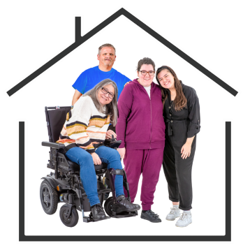
The service is provided by the Ministry of Health to all New Zealand children from when they are born to
5 years old.

Where to find more information

You can find out more information about the Smokefree Aotearoa 2025 Action Plan at the Ministry of Health website at:

www.health.govt.nz/smokefree2025
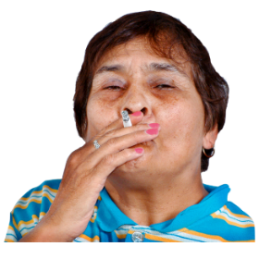

The website also includes information fact sheets for:


- people who smoke

- the family / whānau of people who smoke

- friends of people who smoke.


This information has been written by Ministry of Health Manatū Hauora.

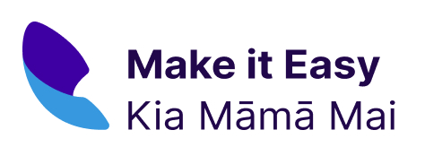
It has been translated into Easy Read by the Make it Easy Kia Māmā Mai service of People First New Zealand Ngā Tāngata Tuatahi.

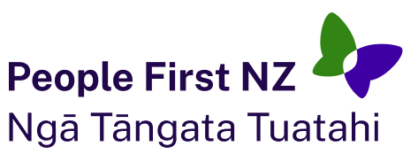
The ideas in this document are not the ideas of People First New Zealand Ngā Tāngata Tuatahi.
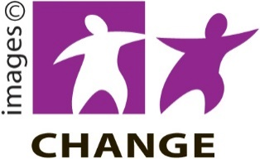
Make it Easy uses images from:

- Changepeople.org


- Photosymbols.com


- SGC Image Works

- Huriana Kopeke-Te Aho.


All images used in this Easy Read document are subject to copyright rules and cannot be used without permission.

