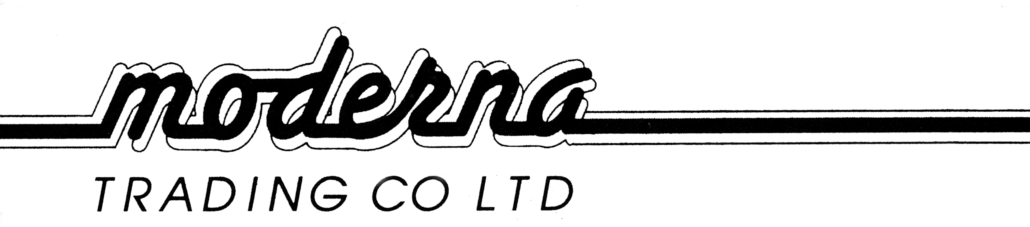

PH+644 568 4101
FAX+644 568 4102
2 Gough Street
P O Box 30 684
LOWER HUTT
TOBACCO RETURNS 1ST JAN 2018-31ST DEC 2018

SOLD WEIGHT RETAIL
PIPE TOBACCO

KOHLHASE 50 GM TINS 700TINS 35.0 KG $95.00
PETERSON 50 GM TINS 700TINS 35.0 KG $95.00

SNUFF

1584 TINS 1.90 KG $9.95

BLUNTS

JUICY/KINGPIN 25’S BOX 1750 BOXES 2.48 KG $3.95

SHISHA PIPE TOBACCO

AL-FAKHER 8350 PKT 1.25KG 16.95

