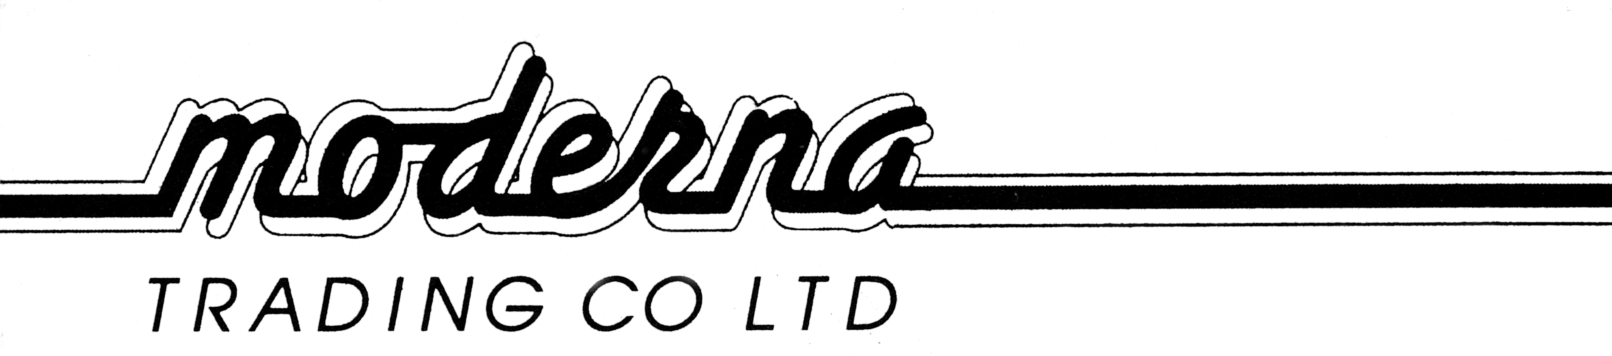

PH+644 568 4101
FAX+644 568 4102
2 Gough Street
P O Box 30 684
LOWER HUTT
TOBACCO RETURNS 1ST JAN 2017-31ST DEC 2017

SOLD WEIGHT RETAIL
PIPE TOBACCO

KOHLHASE 50 GM TINS 510 TINS 25.50KG $99.00
PETERSON 50 GM TINS 600 TINS 30.0 KG $99.00

CIGARS

BROWN BETTY 7’S TINS 168 TINS 2.60KG $27.50

SNUFF

1498 TINS 1.80KG $9.90

BLUNTS

JUICY/KINGPIN 25’S BOX 3800 BOXES 5.39KG $4.50

SHISHA PIPE TOBACCO

AL-FAKHER 14101 PKT 2.11KG 16.95

