ANNUAL REPORT OF THE MENTAL HEALTH
REVIEW TRIBUNAL

1 JULY 2022 to 30 JUNE 2023

Contents

Contents i
Abbreviations used in this report ii
Introduction 1
About the Tribunal 1
Membership of the Tribunal 6
The review process 9
An overview of applications 14
Applications received by Te Whatu Ora (former DHB region) 15
An overview of applications involving Māori patients 16
Timeliness 17
Publication of Decisions 18
s75 Investigations 19
Appointments to give opinions pursuant to ss 59 and 60 of the Act 19
Relationship with the Director of Mental Health and the Ministry of Health 20
Secretariat 20
Professional Development 21
Website 21
What’s next for 2023-2024 22
Conclusion 22
Appendix A – Tribunal members 23
Appendix B - A breakdown of applications 27
Appendix C – A comparison over time (previous seven Annual Reports) 34

Abbreviations used
in this report

Application Application for Review
CTO Compulsory Treatment Order
DAMHS Director of Area Mental Health Services
DHB District Health Board
DI District Inspector of Mental Health
Director Director of Mental Health (for New Zealand)
MOH Ministry of Health/Manatū Hauora
RC Responsible Clinician
The Act Mental Health (Compulsory Assessment and Treatment) Act 1992
Tribunal Mental Health Review Tribunal

Introduction

Tēnā koutou katoa,
The Mental Health Review Tribunal is pleased to present its annual report for the year from 1 July 2022 to 30 June 2023.
The Tribunal helps to support and protect the rights and interests of patients subject to compulsory treatment under the Mental Health (Compulsory Assessment and Treatment) Act 1992. "Patient" is the word used in the Act. We recognise that characterisation focuses on only one aspect of a person's life.
The Tribunal's principal function is to hear applications for a review of the condition of a patient and to express its view regarding whether a patient ought to remain under the Act, as an ordinary, special, or restricted patient. In the case of ordinary patients, its opinion is determinative. In most other cases, its opinion is advisory.
It approves clinicians to provide second opinions for the purpose of sections 59 and 60 of the Act and investigates complaints when there is dissatisfaction with the outcome of a complaint investigation by a District Inspector.
The Tribunal reviews a small proportion of patients receiving compulsory treatment. In the period from 1 July 2022 to 30 June 2023, it received 138 applications. Many did not proceed, because they were withdrawn, the patient was discharged by the responsible clinician or there was no jurisdiction. Over this period the Tribunal determined 55 applications, discharged two patients who were subject to ordinary compulsory treatment orders and recommended the discharge of two special patients from special patient status. A further 13 applications were set down to proceed.
Covid-19 continued to have an underlying impact on how we undertook our role, however with restrictions receding most reviews were able to place in person.
Health professionals, and others, within the mental health system continue to be working under pressure. It is important that the Tribunal receives good reports and supporting evidence from health professionals. The quality of reports and evidence from health professionals was generally excellent, with some exceptions.
The Tribunal has insight into how care is provided to patients by Te Whatu Ora, which leads and co-ordinates the delivery of health services in New Zealand. Te Whatu Ora has an important partnership with Te Aka Whai Ora, the Māori Health Authority, which has responsibility for driving improvement in Hauora Māori.

We continue to see the need for:
- greater emphasis on valuing and supporting a patient's ties with family and whānau.
- greater understanding of the gender, cultural and ethnic identity of patients and the implications of those for the provision of health care and treatment; and
- more, and more diverse, community-based facilities and support.
We thank all of those who have helped to ensure the Tribunal can function effectively, including patients, family and whānau, health professionals, lawyers, the Ministry of Health and the Secretariat.

Ngā mihi nui,

James Wilding KC
(Convener)

Phyllis Tangitu
(Community member)

Dr Nick Judson
(Psychiatrist member)

About the Tribunal

The Tribunal was established by the Mental Health (Compulsory Assessment and Treatment) Act 1992. The Act enables the compulsory psychiatric assessment and treatment of people who have a mental disorder. It is intended to define and better protect patient rights than the preceding legislation.
The members of the Tribunal reflect the diverse nature of our society. We convene in Tribunals of three, comprising a lawyer, a psychiatrist and a community member, to hear cases throughout New Zealand, in the locality where the patient lives.
Some people welcome support under the Act; others consider it to be a significant and unwanted intrusion into their lives. We consider the views put forward in reviews by patients, their family and whānau and health professionals, and strive to strike the balance required by the Act.
Achieving the right balance continues to be a challenging task. We recognise that our functions and decisions directly affect the rights and interests of patients treated under the Act, and often impact their family, whānau and friends and the community.
The Act recognises the importance of the cultural and ethnic identity, the language, and the religious and ethical beliefs of patients who are subject to it, and their ties to family and whānau.
The Tribunal endeavours to discharge its statutory role in a manner which takes into account the articles of Te Tiriti o Waitangi. We acknowledge Te Whatu Ora (Health NZ), Te Aka Whai Ora (the Māori Health Authority) and Whakamaua, the Māori Health Action Plan 2020 to 2025.

The functions of the Tribunal
The functions of the Tribunal are to:
- on application or of its own motion, review the condition of patients who are subject to compulsory treatment orders, special patient orders and restricted patient orders, pursuant to ss79 to 81 of the Act. Reviews are for the purposes of assessing whether, in the Tribunal’s opinion, a patient ought to be released from compulsory treatment, or from special patient or restricted patient status.

- to investigate complaints about breaches of specific patient rights. This occurs when a patient or complainant is not satisfied with the outcome of the investigation of a complaint by to a District Inspector of Mental Health or an Official Visitor pursuant to s75 of the Act.

- report to the Director pursuant to s102 of the Act on any matter relating to the exercise or performance of its powers and functions.

- appoint psychiatrists who assess:
  - whether treatment is in the interests of a patient who does not consent to that treatment, pursuant to s59 of the Act;

  - whether electro-convulsive treatment is in the interests of a patient who does not consent to that treatment, pursuant to s60 of the Act; and

  - whether brain surgery is appropriate, if the Tribunal is first satisfied that the patient has given free and informed consent to surgery, pursuant to s61 of the Act. The Tribunal is not aware of this provision having been used.

Many patients accept compulsory treatment or the outcome of a District Inspector’s complaint investigation and neither they, nor others in their interests, make an application for review to the Tribunal. Consequently, the Tribunal reviews only a small proportion of patients receiving compulsory treatment. The issues on review are summarised below.

Ordinary Patients
For ordinary patients who are subject to compulsory treatment orders, the issue for the Tribunal is whether the patient is fit to be released from compulsory status. That requires that the patient no longer be “mentally disordered”. To be “mentally disordered” a patient must have a continuous or intermittent abnormal state of mind of such a degree that it poses a serious danger to the health or safety of the patient or others or seriously diminishes the capacity of the patient to self-care. If the Tribunal considers that the patient is no longer “mentally disordered”, they are released from compulsory treatment. Otherwise, the patient remains subject to compulsion.

Special Patients
Some special patients receive compulsory treatment because they were found unfit to stand trial on criminal charges. The Tribunal must express an opinion on whether the patient remains unfit to stand trial and whether they should continue to be detained as a special patient. Depending on the outcome and whether the Attorney-General is the applicant, the opinion may be provided to the Attorney-General to enable a decision to be made for the purpose of s31 of the Criminal Procedure (Mentally Impaired Persons) Act 2003.
Other special patients receive compulsory treatment because they were acquitted on account of insanity. The Tribunal must express an opinion as to whether the patient’s condition still requires that they should be detained as a special patient. Depending on the outcome and whether the Minister of Health is the applicant, the opinion may be provided to the Minister of Health to enable a decision to be made for the purpose of s33 of the Criminal Procedure (Mentally Impaired Persons) Act 2003.

Restricted Patients
Restricted patients have been declared so because they present special difficulties due to the danger they pose to others. The Tribunal must express an opinion as to whether the patient is mentally disordered. If not, then the patient is released from compulsory treatment upon the direction of the Director of Mental Health. If the Tribunal considers the patient is mentally disordered but no longer needs to be a restricted patient, the matter is referred to the Minister of Health who, after consultation with the Attorney-General, will decide whether restricted patient status should continue.

Right of Appeal
Section 83 of the Act provides a right of appeal where the Tribunal considers that a patient is not fit to be released from compulsory status. This right is mainly to be exercised by the patient or certain classes of people acting in their interests.
The psychiatrist responsible for the patient’s care does not have a right of appeal. They can make a fresh assessment for the purpose of compulsory treatment if a patient who has been discharged later becomes sufficiently unwell.

Investigations
Under section 75 of the Act, the Tribunal can investigate complaints made to a District Inspector (or official visitor) if the complainant is not satisfied with the outcome.

The powers of the Tribunal
The Act confers on the Tribunal a range of powers in order to enable it to discharge its functions.
Pursuant to s104(3) of the Act, these include the powers and authority to summons witnesses and to receive evidence that are conferred on Commissions of Inquiry by the Commissions of Inquiry Act 1908.
The Tribunal prefers to operate in a cooperative manner without resorting to formal use of such powers.

Membership of the Tribunal

Every review is heard by a Tribunal comprising three members, a lawyer, a psychiatrist and a community member, although additional members may be co-opted by the Tribunal for a particular hearing.
The members are appointed by the Minister of Health. The membership is reviewed every three years. The outcome of the last review was on the 19 November 2021.
The Tribunal seeks to ensure ethnic and gender diversity at review hearings, to ensure a fair allocation of work and to ensure all members undertake sufficient work to retain their expertise.
The members who held office during the report year are listed below. More information about members is contained in Appendix A.
Tribunal members | Deputy lawyer members
Mr A J F Wilding KC (Convener)  Dr N R Judson, psychiatrist  Ms P Tangitu, community member | Mr R A Newberry (Deputy Convener)  Mr T Clarke  Ms A McCarthy  Ms A Rakena  Ms R Schmidt-McCleave
Deputy psychiatrist members | Deputy community members
Dr B Beaglehole  Dr C Dudek-Hodge  Dr H Elder  Dr M Honeyman  Dr J McMinn  Dr P Renison  Dr S Schmidt  Dr J Whiting | Mrs F Diver  Mr M Sukolski  Mr S Hanrahan  Ms L Pennington  Ms S Sidal  Ms S Sumita

Co-opted Members
Section 103 of the Act enables, and in some cases requires, if requested by the patient, the Tribunal to co-opt:
- any person whose specialised knowledge or expertise would be of assistance to the Tribunal in dealing with the case;

- any person whose ethnic identity is the same as the patient’s where no member of the Tribunal has that ethnic identity; or

- any person of the same gender as the patient, where no member of the Tribunal is of that gender.
Co-opting is not necessary if a person with the requisite knowledge or expertise, or ethnic or gender identity, is already sitting on the Tribunal. This power was not exercised during the reporting year, reflective of the diversity of the members of the Tribunal.

Interpreters
Section 6 of the Act enables, and in some cases requires, if requested by the patient, the Tribunal to provide the services of a competent interpreter, if:
- the first or preferred language of the person is a language other than English, Te Reo Māori or New Zealand Sign Language; or

- the person is unable, because of physical disability, to understand those languages; and

- it is practicable to provide the services of an interpreter.
The Tribunal must ensure, as far as reasonably practicable, that the interpreter provided is competent.
One applicant requested an interpreter.
The review process

The review process is determined by the Tribunal hearing each particular case. The usual sequence is:
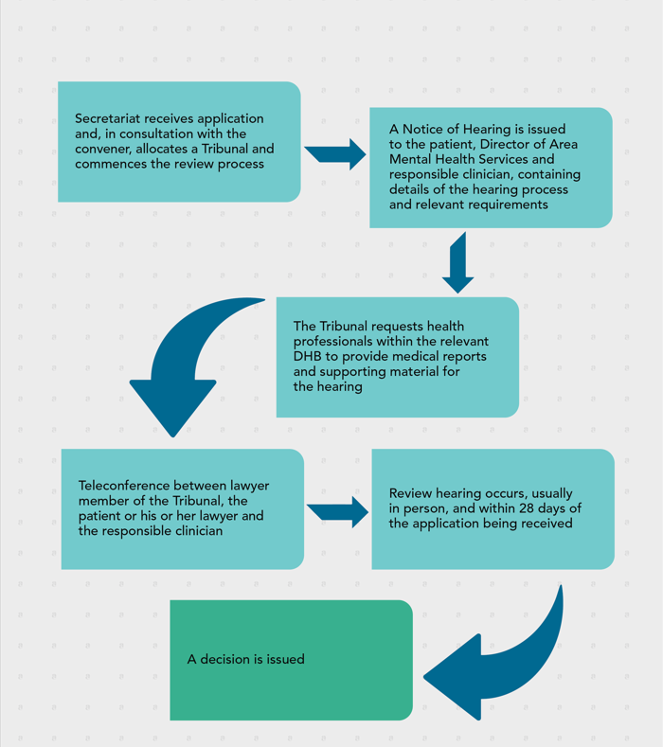

The approach taken by the Tribunal
The Tribunal tends to conduct hearings without undue formality. But because the process is quasi-judicial and the determination affects important rights and interests, a degree of formality is necessary.
Formality is inherent in the process outlined in Schedule 1 of the Act, which contains provisions regarding the conduct of reviews.
The process is partly inquisitorial. The Tribunal tends to lead much of the questioning. It prefers to do so in a way which helps rather than undermines the therapeutic relationship between the patient and health professional, but not at the risk of relevant aspects not being addressed.
Parties to hearings may cross-examine. It is common for the patient or his or her lawyer to do so, often in a manner which avoids or limits damage to therapeutic relationships.
Tension is sometimes apparent in the hearings, which is reflective of the context. Health practitioners are contending that a patient ought to be subject to compulsory treatment, when the patient objects to current and future compulsory treatment.
The Tribunal benefits from patients giving candid accounts of, at times, intensely personal matters, involving their background, family and whānau, health, current circumstances, and aspirations.
We seek to recognise the, often extraordinary, achievements of patients in their lives and in managing their health.
We may make recommendations or observations, focused on the care and treatment of the patient and on procedural and evidential issues.

The Tribunal sometimes makes broader observations, reflecting concerns about the patient's care. It sometimes does so with supporting evidence from health practitioners, who work within a constrained system. Health practitioners are to be commended for their frankness.

Who attends the hearings?
The hearings are not public. Those attending are usually:
- the applicant, who may be excused if need be.
- the applicant’s lawyer.
- the responsible clinician, who is usually a psychiatrist.
- the keyworker, who is usually a psychiatric nurse who is familiar with the patient
Others who might attend include:
- a support person or advocate for the patient.
- family and whānau of the applicant.
- a social worker.
- a psychologist.
- an occupational therapist.
- a cultural advisor.
- other medical and nursing staff.
- a District Inspector.

How hearings are conducted
The hearing format tends to be similar regardless of whether the patient is subject to a compulsory treatment order or is a special patient or a restricted patient.
In advance, the Tribunal receives written reports from health professionals, and sometimes written material from the applicant, or their lawyer or advocate.
Prior to the hearing, the patient meets with a member of the Tribunal, usually the psychiatrist member, for the purpose of a preliminary examination. The purpose is to ascertain whether the patient can participate in the hearing and to identify any issues that may need to be accommodated (such as a difficulty in communication).
Hearings may be opened or closed in a way which recognises and respects the cultural and ethnic beliefs of a patient, including by a karakia, a blessing or a waiata, or other appropriate opening, if sought by the patient. This can be advised by a patient at an earlier stage in the review process, or on the day of a review hearing.
The hearing commences with the Tribunal introducing itself. It clarifies who is present and, when appropriate, whether there is any objection by the patient to any person being present.
An opening submission or statement is called for from the applicant or their lawyer. Following that, evidence is heard. Usually, the first witness is the patient, followed by the responsible clinician, being the clinician responsible for the care and treatment of the patient, and then a second health professional. Family and whānau are then usually invited to speak.
Evidence can be required on oath, but this would be unusual.
Each witness is usually questioned by the Tribunal. The applicant or lawyer for the applicant is then invited to ask questions of that witness. It is rare, but not unknown, for a responsible clinician to question other witnesses.
At the conclusion of the evidence, closing submissions are invited.
Those present are then asked to leave the room to enable the Tribunal to deliberate. If possible, a decision is given shortly after, on the same day.
Sometimes written submissions are sought or an adjournment is necessary, for example to enable further medical evidence to be obtained. Where further evidence is received, an opportunity to be heard is given, reflecting the rules of natural justice.
Following the hearing, the Tribunal issues a written decision, or written reasons for a decision if the decision was announced orally.
The attendance of family and whānau
Section 5 of the Act requires the Tribunal to exercise its powers with proper recognition of the importance and significance of the patient's ties with their family and whānau.
Often, patients will seek to have one or a few members of their family and whānau present. This, and the understanding which results from that is welcomed by the Tribunal. It is often of assistance to the patient, the Tribunal and health professionals.

Ethnic and cultural identity and language
Section 5 of the Act requires the Tribunal to exercise its powers with proper respect for the patient's cultural and ethnic identity, language, and religious or ethical beliefs.
When applying for reviews, applicants are asked whether they wish to have the Tribunal include a person of the same ethnic identity as the patient. If so, that is arranged, including by co-opting a member where necessary.
The Tribunal recognises that issues can arise where English is not the language or first language of the patient. If an interpreter is sought or necessary, then it helps to facilitate that.
The Tribunal composition reflects a mix of genders where possible.
The Tribunal welcomes evidence from patients about their cultural and ethnic identity, and the relationship between those and diagnosis and treatment. It seeks evidence from health professionals about whether, and how, a patient's cultural and ethnic identity are recognised, understood and valued. Where there are shortcomings, it encourages understanding by treating teams and makes recommendations where appropriate.
In so doing, the Tribunal recognises the role that inadequate knowledge of a patient's cultural and ethnic identity, and language barriers, can play in undermining a therapeutic relationship, undermining a patient's sense of identity and, potentially, in misdiagnosis.

Where do hearings take place?
If the applicant is being treated in hospital the hearing usually takes place at the hospital. If the applicant lives in the community, the hearing usually takes place at the outpatient clinic which the applicant attends.
The Tribunal can seek for a hearing to occur in a setting that is reflective of a patient's cultural and ethnic identity. For example when requested and practicable, a hearing may occur in a special setting within a service such as a wharenui, or in a marae in the community. Culturally appropriate processes are observed.
A few hearings took place by video conference over this reporting period, due to Covid-19; the format described above was followed as much as possible in these instances.
Applications by category of patient
138 applications were received during the reporting year. Of those:
- 86 were in respect of patients under a community treatment order;
- 33 were in respect of patients under an inpatient treatment order;
- 17 were in respect of special patients; and
- 1 was from the United Kingdom and 1 was from an applicant who was not under the Act. Neither were eligible for review.

Proceeded applications by category of patient
68 applications proceeded during the reporting year. Of those:
- 46 were in respect of patients under a community treatment order;
- 16 were in respect of patients under an inpatient treatment order; and
- 6 were in respect of special patients.

Withdrawal of applications
Often applications are withdrawn or found to be ineligible. There are a range of reasons. They include the patient and health professionals having discussion and reaching an accommodation in the context of a review, for example regarding the type and nature of treatment and whether it ought to be compulsory. In the case of ineligible applications, this is often due to the treatment order commencing within the three months prior to the application being made.
During this reporting period, 70 applications were ineligible or withdrawn prior to a hearing taking place. This equates to 50.72%. Across the past seven years the average has been 50.33%.

Applications at a glance

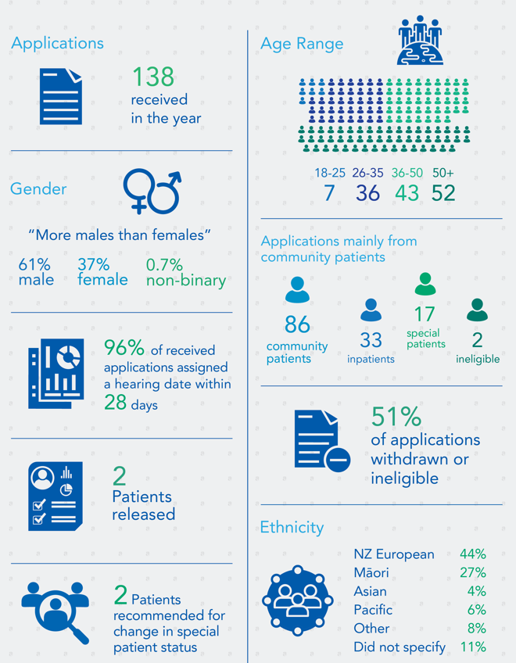
Figure 1: Overview of hearings in 2022-23
(Total may not sum to 100% due to rounding)
Further detail illustrating the breakdown of applications is contained in Appendix B.
Applications received by Te Whatu Ora (former DHB region)

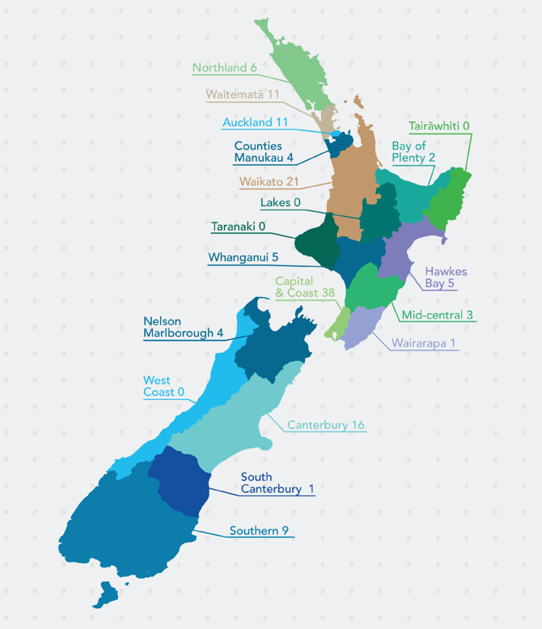
Figure 2: Applications received by Te Whatu Ora (former DHB region)
Further detail illustrating the breakdown of applications is contained in Appendix B.
An overview of applications involving Māori patients

Aotearoa New Zealand’s estimated Māori ethnic population (as at 30 June 2022) was 892,200 (17.4 percent of national population).
Māori were more likely to be assessed or treated under the Mental Health Act than Pacific peoples and other ethnicities.,
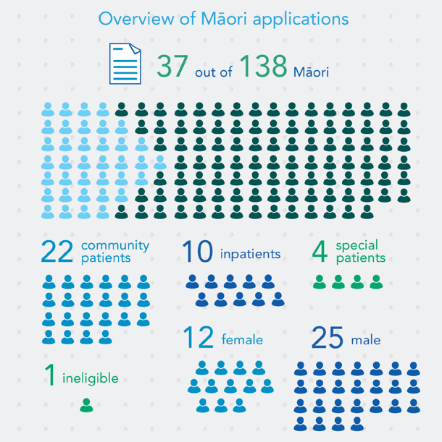
Figure 3: Overview of applications involving Māori patients
Further detail illustrating the breakdown is contained in Appendix B.
Timeliness

The Tribunal arranges for reviews to commence within 21, or at most 28, days of an application being received.
Sometimes those dates are not proceeded with. The reasons include:
- the applicant withdraws the application, or the responsible clinician discharges the patient from the Act;
- patients sometimes seek a later date to have a lawyer of their choice or to obtain a second opinion or a grant of legal aid. In some cases, applications are withdrawn until all information is to hand.
- responsible clinicians or lawyers being unavailable, for example being in another hearing, or family and whānau are not available, and the Tribunal and patient or his or her lawyer agree it is preferable that a hearing be delayed.
- scheduling difficulties. Difficulty is inherent in trying to coordinate dates suitable to patients, their lawyers, health professionals and the Tribunal. To ensure timeliness, the Tribunal can unilaterally set hearing dates and seek for professionals to make arrangements to ensure they are available.
- travel factors, for example the limited availability of flights and cancellations due to Covid-19 or poor weather conditions. Hearings tend to involve at least two if not three members travelling from different locations; and
- the interests of time giving way to the interest in having sufficient good quality information to enable the Tribunal to make a properly informed decision.
We have generally found those involved in scheduling and conducting hearings to be very cooperative. In some cases there has been difficulty in scheduling telephone conferences and hearings, but that tends to be able to be resolved informally.
Regrettably, in one region a lack of cooperation by staff administering the Act necessitated the Convener seeking the intervention of the Director of Mental Health, who swiftly addressed the problem. We were grateful for that assistance.
We had two hearings which occurred outside of the statutory timeframe, primarily due to the limited availability of counsel and responsible clinicians and the preference of the patient to have specific individuals attend. Such situations are understandable.
Three more hearings were adjourned beyond 28 days. One was when access to and use of the unit the patient was in was limited by Covid-19 isolation requirements and an in-person hearing was required. The other was due to the time taken in an independent psychiatrist report being provided. The third adjournment was sought at the pre-hearing teleconference, following a request from the applicant to have specific counsel available to attend. Again, such situations are understandable.
Publication of Decisions

Clause 7 of Schedule 1 of the Act provides that Tribunal proceedings are not open to the public. Clause 8 allows for the publication of reports of proceedings with the leave of the Tribunal and in publications of a bona fide professional or technical nature.
Decisions of the Tribunal are rarely made public. This reflects the right of the patient, and often others, for example victims and family, to privacy. Decisions are highly fact specific and anonymisation may not prevent identification.
Those receiving compulsory treatment under the Act likely assume that the usual privacy and confidentiality requirements attaching to medical matters will apply. They are vulnerable and may not be well placed to address issues of publication.
Patients, their families, and clinicians who provide private information during the course of Tribunal hearings may be alarmed if decisions find their way onto the internet. Publishers of professional and technical journals now publish journals online.
Weighing against those is the public interest in being informed of the workings of the Tribunal.
In April 2010 the Tribunal and the Ministry agreed on guidelines intended to ensure that the relevant interests in privacy and making information public are balanced and that appropriate cases are identified for publication. The protection provided by these guidelines is essentially three-fold:
- only a selection of cases identified by the Tribunal is sent to publishers, by the Ministry;
- those cases will be anonymised, by the Tribunal and then the Ministry; and
- they will be sent only to three established professional and responsible publishers, namely Brookers (Thomson Reuters), LexisNexis and the New Zealand Legal Information Institute.
Reported cases can be found online on the New Zealand Legal Information Institute website: http://www.nzlii.org/nz/cases/NZMHRT/.

s75 Investigations

Patients and others may make complaints to a district inspector or official visitor of a breach of certain rights, pursuant to s75 of the Mental Health (Compulsory Assessment and Treatment) Act 1992. If the patient or complainant is not satisfied with the outcome, the complaint may be referred to the Tribunal for further investigation.
In this reporting period the Tribunal concluded one s75 investigation. Three are in the process of investigation. These investigations generally require significant work over time.

Appointments to give opinions pursuant to ss59 and 60 of the Act

The Tribunal is required to consider applications for the appointment of psychiatrists to assess:
- whether treatment is in the interests of a patient who does not consent to that treatment, pursuant to s59 of the Act.

- whether electro-convulsive treatment is in the interests of a patient who does not consent to that treatment, pursuant to s60 of the Act; and

- whether brain surgery is appropriate, if the Tribunal is first satisfied that the patient has given free and informed consent to surgery, pursuant to s61 of the Act. *

In this reporting period, 11 psychiatrists were appointed by the Tribunal to give opinions regarding whether the proposed treatment of patients without consent is in their interests. Three more applications are under consideration.
* The Tribunal is not aware of this provision having been used before. No applications were received to give opinions regarding whether brain surgery is appropriate.

Relationship with the Director
Of Mental Health and Manatū Hauora|Ministry of Health

The Tribunal is an independent statutory body, supported by its own Secretariat. Decisions reflect its independent view.
The Tribunal enjoys a constructive relationship with the Director of Mental Health, Dr Crawshaw. That relationship involves support for the work of the Tribunal outside of the context of specific cases and consideration of issues which can adversely impact on the functioning of the Tribunal.
Rarely, the Tribunal will invite the Director to be heard on an issue arising in a particular case. The Tribunal is grateful for the prompt and thoughtful consideration given by the Director and those in the Directorate when this occurs.
Manatū Hauora | Ministry of Health administers the Act. The Tribunal enjoys a constructive relationship with it.
The Tribunal extends its thanks to Dr Crawshaw and the team at the Ministry for their support during the year.

Secretariat

Public policy firm Allen + Clarke is contracted by the Ministry to be the Tribunal’s Secretariat. It commenced that role in November 2018.
It supports the work of the Tribunal, which includes managing the flow of information between parties and the Tribunal, organising Tribunal pre-hearings and hearings, supporting the Tribunal to give effect to its statutory requirements under the Act, and undertaking quarterly reporting to the Ministry on Tribunal activities.
The work is relentless and requires care.
The Tribunal is grateful for the hard work of Allen + Clarke and the team of Mr Liu, Ms Brown, Ms Copeland and Ms Reeve.

Professional Development

The lawyer and psychiatrist members of the Tribunal are qualified in their respective professions. The community members possess a diverse range of skills and experiences. All members have considerable experience in their respective areas of expertise prior to appointment.
Members maintain their own professional development. The Tribunal holds an annual plenary, the most recent being in December 2022. This was an opportunity to welcome new members in person, following the relaxation of Covid-19 restrictions, as well as the usual discussion of topical issues.

Website

The Tribunal has a website, within the Ministry’s website:
http://www.health.govt.nz/new-zealand-health-system/key-health-sector-organisations-and-people/mental-health-review-tribunal.

The website contains relevant information, including Policy and Practice notes and Guidelines.

What’s next for 2023-2024

Substantive changes are afoot. Over the past few years we have seen restructuring of the health system.
The rights of victims are better recognised as a result of the Rights for Victims of Insane Offenders Act 2021.

When the Mental Health (Compulsory Assessment and Treatment) Amendment Act 2021 comes into force, indefinite compulsory treatment orders will be eliminated.

The Government has undertaken substantive work directed at repealing and replacing the Act.

We watch with interest, while continuing our focus on providing patients with meaningful reviews.

We take this opportunity to thank all of those who have supported our work over the past year.
Conclusion

The Tribunal engages with issues that are intensely personal for patients, their families and whānau and often others involved in their care and support.
The competing arguments for why the significant step of compulsory treatment is or is not required are challenging.
The Tribunal hopes that its work has helped to support, and in a changing health environment will continue to support:
- the rights of those who are mentally disordered to be treated under the Act;
- the rights of those who are not mentally disordered to be discharged from the Act; and
- the interests that arise in the case of special and restricted patients.
Thank you.

Appendix A – Tribunal members

Mr A J F Wilding KC
(Tribunal Convener)
James is a barrister based in Christchurch, undertaking family, civil and medico-legal work. He was a District Inspector of Mental Health from 1999 to 2011. He has been Convener of the Tribunal since mid-2016.

Dr N R Judson
Nick is a psychiatrist based for the last 25 years in Wellington. In the past he worked in Dunedin and then as Deputy Director of Mental Health. His interests are in forensic psychiatry and intellectual disability.

Ms P Tangitu
Phyllis hails from the Iwi of Ngati Pikiao, Ngati Ranginui and Ngati Awa. She has a background in education and health and has worked in the Mental Health and Addictions and Māori Health sector for 34 years. Phyllis has whānau members who have experienced mental ill-health and continues to advocate for recognition of Māori world views. Phyllis worked at Lakes DHB for 33 years and has recently joined Emerge Aotearoa as Mana Whakahaere (Group Director Equity and Māori) to lead and support the organisation in their Māori Health development.

Deputy Members
The Minister of Health also appoints deputy members of the Tribunal. During the report year, the deputy members of the Tribunal were:

Deputy lawyer members:
Mr R A Newberry
(Deputy Convener)
Robb is a barrister based in Wellington. Prior to becoming a deputy lawyer member of the Tribunal, he was a District Inspector of Mental Health from 1993 until 2008. He also practices in other jurisdictions, such as the Protection of Personal and Property Rights Act 1988 and Intellectual Disability (Compulsory Care and Rehabilitation) Act 2003.

Mr T Clarke
Tim is a lawyer, mediator and facilitator for Collaborative Solutions, based in Hamilton. He has 40 years of experience with mental health, legal and conflict issues. Tim values combining his legal and social experience with mediation and facilitation skills, to assist the rights of those who experience mental illness. Tim is celebrating having just completed his Masters in Peace and Conflict Studies with Otago University in (2023).

Ms A McCarthy
Alice is a partner of Manaia Legal. She is also a Counsel Assisting the Royal Commission into Abuse in Care, and a member of the Northern B Health and Disability Ethics Committee.

Mrs A Rakena
Annie is an Auckland family law barrister with over decade of litigation experience. Annie is of Samoan European heritage. Annie’s experience has seen her work closely with a diverse range of clients from different cultures and backgrounds. Her passion is helping families and individuals navigate the family court process. She has a close focus on mental health matters.

Ms R Schmidt-McCleave
Rachael has 26 years of experience as a barrister. She has a Master of Arts and a Master of Laws (Hons) specialising in health law. She has acted for health regulatory authorities in medico-legal and disciplinary proceedings, and the Health and Disability Commissioner in relation to High Court proceedings. She has co-authored two Thomson Reuters textbooks on health and safety law and acted in inquests for medical practitioners. Rachael has a sound knowledge of tikanga Māori and has acted in the Māori Land Court for Te Ohu Kai Moana New Zealand Limited, and in the Waitangi Tribunal for the Crown.

Deputy psychiatrist members:
Dr B Beaglehole
Ben is a Christchurch based psychiatrist. He is the clinical head of the Anxiety Disorders Service based at Hillmorton Hospital. Ben is also a Senior Lecturer for the University of Otago. He teaches medical students and researches compulsory treatment, mood disorders and mental health outcomes following disasters.

Dr C Dudek-Hodge
Christine trained as doctor in Germany and The Netherlands. She gained her PhD in Germany and went on to complete her vocational training as a psychiatrist at the Academic Medical Centre in Amsterdam, The Netherlands. Christine relocated with her family to Christchurch in 2012 and has since worked as a general adult psychiatrist for Te Whatu Ora, Waitaha.

Dr H Elder, MBChB, FRANZCP, PhD, MNZM
Ngāti Kurī, Te Aupōuri, Te Rarawa, Ngāpuhi. Hinemoa is a psychiatrist and works in a range of settings including Haumaru Ōrite (Child and Family Unit and Mother baby unit) Starship Hospital, and as a court report writer for the Family and District Courts and Kōti Rangtahi. She specialises in the neuropsychiatry of traumatic brain injury and is a researcher in that field and in the field of dementia.

Dr M Honeyman, QSO
Margaret is a psychiatrist based in Auckland and is semi-retired. Her clinical work has been in adult psychiatry. A large part of her career has been in leadership and management roles, including as Clinical Director and DAMHS in DHB settings and as Chief Psychiatrist in South Australia. Margaret has thus been involved in the application of mental health legislation from a number of different perspectives.

Dr P Renison
Peri is a psychiatrist who works clinically in adult general psychiatry, currently in the area of adults with Intellectual Disability and Mental Illness. She was previously Chief of Psychiatry for the Canterbury DHB and Director of Area Mental Health Services for Canterbury. She has worked in both inpatient and community mental health services.

Dr S Schmidt
Sigi lives in Christchurch and is employed by Te Whatu Ora - Waitaha as Chief of Psychiatry and DAMHS. He is of German descent and grew up in South Africa. He moved to New Zealand in 1999 after completing his psychiatric training at the University of Cape Town. He has worked in a range of mental health services in Christchurch, including Adult General Psychiatric Services (in hospital and community settings), Rehabilitation, Early Intervention in Psychosis, Rural Psychiatric Services and working with Refugee and Migrant Services. He has also been a Clinical Director for a period of four years before commencing his current role in 2020.
Dr J McMinn
Jeremy is a forensic psychiatrist and an addiction specialist and was appointed to the Tribunal in 2021. He provides independent expert psychiatry and addiction opinions to a range of agencies and professional bodies. He is currently based in Wellington, and has worked in Whanganui, Rotorua and in the UK. He supervises junior doctors training in psychiatry, and consultants training in addiction.

Dr J Whiting
Jeremy is a consultant psychiatrist currently working at Mason Clinic and has worked in various clinical settings over the last nine years. As part of his current role, he provides psychiatric reports for the court on matters such as fitness to stand trial, insanity defence, risk assessment and disposition, and forensic opinion for general mental health colleagues. In his day-to-day practice, he endeavours to work collaboratively with service users and families and whānau to assist patients in their recovery.

Deputy community members:
Mrs F Diver, QSM
Francis is a community member based in Central Otago. She is Ngai Tahu, Waitaha, Kāti Māmoe and works closely with the Māori community. She founded Uruuruwhenua Health Inc Māori health provider service and has held leadership roles with charities and local government initiatives. She has a close focus on mental health.
Mr S Hanrahan
Shannon is the Executive Chair of KŌ Kollective Trust in Opotiki that offers psycho-social support and wellbeing services to kaumātua, tamariki and adults. Shannon has relocated from the United Kingdom after running his own public health consultancy and public policy business for over a decade. He offers an international background and current experience working in rural New Zealand.

Ms L Pennington
Liz has a background in collaborative work and respectful partnership with communities in Bay of Plenty Te Tairawhiti and Hawkes Bay. She is passionate about the health, wellbeing, and social services sector and brings experience and commitment to working across cultures. Liz brings to her work significant experience working in mental health and trauma, private wellbeing practice and whānau lived experience.

Mr M Sukolski
Michael has worked in the mental health sector for over 30 years. His work as a peer advisor is informed by lived experience and its potential as an equal partner in decision-making negotiations. Michael has been a member of a number of NGO boards, including peer-led organisations. He is committed to the priority of Te Tiriti o Waitangi. He is a member of the LGBTQ+ community.

Ms S Sumita
Sumita is currently working for a private practice where she provides mental health and addiction counselling and clinical supervision. She has previously worked as a drug and alcohol clinician for the Waikato District Health Board. Sumita is passionate about representation for immigrants including pacific nationals.

Mrs S Sidal
Shomilla is Chair of the Board for Pablo’s Art Studio, Property Development and Property, has a lead role at Wesley Community Action (supporting people in social housing), is a peer worker providing phone support for Emerge Aotearoa, and is self-employed as an external supervisor for social workers. She speaks fluent Hindi and English and understands basic Te Reo Māori.

Appendix B - A breakdown of applications

This section provides information on applications received from 1 July 2022–30 June 2023.

Figure B1: Applications received 1 July 2022 – 30 June 2023 by gender
Patients may identify their gender on their application. The number of applications received from male patients was 85 and the number from female patients was 52. One application noted non-binary.

Figure B2: Applications received 1 July 2022 – 30 June 2023 by age range
The majority of the applications received were from people in age group of over 50 years (37.68% total). The next highest group was the 36-50 years age group with nine less applications (31.16%). The next highest group was the 26-35 years group (26.09%). The smallest age group was the 18-25 years group (5.07%).

Figure B3: Applications received 1 July 2022 – 30 June 2023 by Te Whatu Ora (former DHB Region)
In July 2022, the health reforms resulted in all DHBs being merged into the national health system, Te Whatu Ora/Health New Zealand. Most applications were received from the main city centres across Aotearoa New Zealand. There were a high number of applications from Capital & Coast (37), compared to other areas. The Auckland region (across Auckland, Waitemata and Counties Manukau) received the second highest number of applications (26).

Figure B4: Applications received 1 July 2022 – 30 June 2023 by type of order
The largest number of applications received was from patients on community treatment orders. Of the applications received, 86 (63.24%) were from patients on community treatment orders.

Figure B5: Applications received 1 July 2022 – 30 June 2023 by hearing status
Just over half of all applications received were withdrawn, or ineligible (50.72%). This is an increase compared to 2021/2022 reporting, when 46.96% of all applications were withdrawn or ineligible. A patient can withdraw an application at any stage.

Table B1: Applications received 1 July 2022 -30 June 2023 percentage withdrawn
Year | Applications | Applications ineligible or withdrawn by patient | Percentage
1 July 2022 – 30 June 2023 | 138 | 70 | 50.72%

Figure B6: Applications received 1 July 2022 – 30 June 2023 by decision outcome
In most cases, the Tribunal decided that patients should remain on their orders. Two patients were released from the Act during the year. The Tribunal recommended that two special patients be released from that status. One application was withdrawn at the hearing and two further applications were dismissed at the hearing due to non-attendance.

Table B2: Applications received 1 July 2022 – 30 June 2023 decision outcome by percentage
Number of cases determined: 55
Remained on order | % | Released from order | % | Recommendation for a change in special patient status | % | Application was abandoned by the applicant/ dismissed | % | Adjourned: Hearing Pending | %
48 | 87.27 | 2 | 3.64 | 2 | 3.64 | 3 | 5.45 | 0 | 0

Of the applications proceeding to hearing, 55 cases have been determined within the reporting period while 13 remain to be determined.

Table B3: Applications received 1 July 2022 – 30 June 2023 and percentage of applications whose review was arranged to commence within 28 days
Quarterly | Number of applications | Withdrawn | Number proceeding | Review arranged to commence within 28 days | % | Arranged to commence after 28 days | Adjourned before or after commencement
1 July 2022 – 30 September 2022 | 34 | 19 | 15 | 15 | 100% | N/A | 2
1 October 2022 – 31 December 2022 | 33 | 23 | 10 | 9 | 90% | 1 | N/A
1 January 2023 – 30 March 2023 | 33 | 15 | 18 | 17 | 94% | 1 | 1
1 April 2022 – 30 June 2022 | 38 | 13 | 25 | 25 | 100% | N/A | N/A
Totals | 138 | 70 | 68 | 66 | 96% | 2 | 3

All applications proceeding to hearing were set down for a hearing within the statutory timeframe. Of the 68 applications proceeding, three applications were adjourned, and two applications were heard outside of 28 days from the date of application.

Table B4: Applications received 1 July 2022 – 30 June 2023 by ethnicity
Ethnicity | Count | Percentage
Māori | 37 | 26.81%
Pacific Peoples | 8 | 5.80%
Asian | 6 | 4.35%
NZ European | 61 | 44.20%
Other | 11 | 7.97%
Unknown | 15 | 10.87%
Total | 138 | 100%

Figure B7: Applications received 1 July 2022 – 30 June 2023 by ethnicity
The largest self-identified ethnic group to apply to the Tribunal was New Zealand European. The graph does not fully reflect the ethnicity of all applicants because patients are not required to identify their ethnicity. Some did not do so.
*Prioritised ethnicity has been used to report on the data. Prioritised ethnicity involves each respondent being identified by a single ethnic group, in the prioritised order of Māori, Pacific, Asian, European, or Other. For example, if someone identified as being both Chinese and Māori, their prioritised ethnicity is Māori for the purpose of analysis. The prioritised ethnicity group European and Other effectively refers to non-Māori, non-Pacific, and non-Asian people.

Appendix C – A comparison over time (previous seven Annual Reports)

This section provides a comparison from the past seven annual reports, together with data from this reporting period.

Figure C1: Applications received by gender compared to the last seven annual reports
Since July 2014 the number of applications of all descriptions stated as being from male patients was 738 and the number from female patients was 388. Since 2014/2015, over 64% of the applications have been from males. Some applications did not identify gender or from 2021/22 stated non-binary.
(Total may not sum to 100% due to rounding)

Figure C2: Applications received by Te Whatu Ora (former DHB regions) compared to the last seven annual reports
The major cities continue to be the locations from where a large proportion of applications are received.

Figure C3: Application status compared to the last seven annual reports

Table C1: Comparison of applications withdrawn or ineligible compared to the last seven annual reports
Year | Number of applications | Withdrawn or Ineligible | Percentage
1 July 2014 – 30 June 2015 | 156 | 77 | 49%
1 July 2016 – 30 June 2017 | 139 | 70 | 50%
1 July 2017 – 30 June 2018 | 131 | 57 | 43%
1 July 2018 – 30 June 2019 | 147 | 80 | 54%
1 July 2019 – 30 June 2020 | 154 | 92 | 60%
1 July 2020 – 30 June 2021 | 157 | 75 | 48%
1 July 2021 – 30 June 2022 | 115 | 54 | 47%
1 July 2022 – 30 June 2023 | 138 | 70 | 51%

For this reporting period there was a minor increase in the number of withdrawn or ineligible applications compared to the previous year.
In some cases, withdrawal has occurred because, following making the application, there has been substantive discussion between the patient and responsible clinician resulting in the resolution of the issues of concern to the patient, and then the withdrawal of the application or the discharge of the patient by the responsible clinician.

Figure C3: Comparison of decision outcome compared to the last seven annual reports

Table C2: Decision outcomes over the last seven annual reports
Year | # of cases determined | Remained on order | Released from order | Recommendation of discharge from special patient status | Application was abandoned by the applicant/ dismissed | Discharged from order by responsible clinician
1 July 2014 – 30 June 2015 | 62 | 57 | 5 | - | - | -
1 July 2016 – 30 June 2017 | 69 | 63 | 6 | - | - | -
1 July 2017 – 30 June 2018 | 63 | 58 | 5 | - | - | -
1 July 2018 – 30 June 2019 | 67 | 62 | 3 | 2 | - | -
1 July 2019 – 30 June 2020 | 62 | 47 | 11 | 4 | - | -
1 July 2020 – 30 June 2021 | 82 | 67 | 9 | 3 | 2 | 1
1 July 2021 – 30 June 2022 | 61 | 52 | 4 | 1 | 3 | 1
1 July 2022 – 30 June 2023 | 55 | 48 | 2 | 2 | 3 | -

This year saw a similar level in the number of patients who the Tribunal discharged from compulsory status.
There were six special patient hearings this year. Two resulted in a recommendation that the patient be discharged from special patient status.
Three applications were abandoned by the applicant/dismissed at the hearing.

Figure C4: Applications by ethnicity compared to the last seven annual reports
*Prioritised ethnicity has been used to report on the data. Prioritised ethnicity involves each respondent being identified by a single ethnic group, in the prioritised order of Māori, Pacific, Asian, European, or Other. For example, if someone identified as being both Chinese and Māori, their prioritised ethnicity is Māori for the purpose of analysis. The prioritised ethnicity group European and Other effectively refers to non-Māori, non-Pacific, and non-Asian people.

Table C3: Number of applications received by ethnicity compared to the last seven annual reports
Ethnicity | 1 July 2022– 30 June 2023 | 1 July 2021– 30 June 2022 | 1 July 2020 – 30 June 2021 | 1 July 2019 – 30 June 2020 | 1 July 2018 – 30 June 2019 | 1 July 2017 – 30 June 2018 | 1 July 2016 – 30 June 2017 | 1 July 2014 – 30 June 2015
Māori | 37 | 24 | 22 | 33 | 25 | 18 | 26 | 31
Pacific Peoples | 8 | 8 | 4 | 10 | 8 | 7 | 8 | 5
Asian | 6 | 5 | 11 | 10 | 7 | 5 | 3 | 6
NZ European | 61 | 61 | 81 | 88 | 69 | 68 | 81 | 93
Other | 11 | 5 | 9 | 5 | 36 | 11 | 10 | 2
Unknown | 15 | 12 | 30 | 8 | 2 | 22 | 11 | 19
Total | 138 | 115 | 157 | 154 | 147 | 131 | 139 | 156

New Zealand European continues to be the largest ethnic group applying to the Tribunal. This has been consistent over the last seven annual reports.


Decisions regarding the release of special and restricted patients are generally for the Minister of Health or Attorney-General, depending on the circumstances.
District Inspectors are lawyers who are appointed under the Act to help safeguard the rights of patients.
3 There are no Official Visitors in New Zealand.
Waitemata Health v the Attorney-General [2001] NZFLR 1122.
Stats NZ Information Release https://www.stats.govt.nz/information-releases/maori-population-estimates-at-30-june-2022/
‘Other ethnicities’ encompasses all ethnicities except for Māori and Pacific peoples.
Source: Programme for the Integration of Mental Health Data (PRIMHD) data (extracted 3 June 2022).

