ANNUAL REPORT OF THE MENTAL HEALTH
REVIEW TRIBUNAL

1 JULY 2019 to 30 JUNE 2020

Contents

Contents i
Abbreviations used in this report ii
Message from the Convener 2
About the Tribunal 4
Membership of the Tribunal 7
Appointments to give opinions pursuant to ss 59 and 60 of the Act 9
The review process 10
An overview of applications at a glance 14
An overview of applications involving Māori patients 16
Timeliness 17
Publication of Decisions 19
Relationship with the Director of Mental Health and the Ministry of Health 20
Secretariat 20
Professional Development 21
Website 21
What’s next for 2020-2021 22
Conclusion 22
Appendix 1 – Tribunal members 24
Appendix 2 - A breakdown of applications 27
Appendix 3 – A comparison over time (previous four Annual Reports) 33

Abbreviations used
in this report

Application Application for Review
CTO Compulsory Treatment Order
DAMHS Director of Area Mental Health Services
DHB District Health Board
DI District Inspector of Mental Health
Director Director of Mental Health (for New Zealand)
MOH Ministry of Health
RC Responsible Clinician
The Act Mental Health (Compulsory Assessment and Treatment) Act 1992
Tribunal Mental Health Review Tribunal

Message from the
Convener

The Mental Health Review Tribunal is pleased to present its annual report for the year to 30 June 2020.
The Tribunal helps to support and protect the rights and interests engaged when people are treated compulsorily under the Mental Health (Compulsory Assessment and Treatment) Act 1992. It mainly does so in two ways.
First, by hearing applications for a review of whether a patient ought to remain subject to the Act. Secondly, by investigating complaints of breach of patient rights, if the patient is dissatisfied with the outcome of an investigation by a District Inspector. In this report we use the word "patient", because that is the word used in the Act. We recognise that characterising a person as a "patient" reflects only one aspect of their life.
Along the way, the Tribunal is in the special position of being able to observe how care is provided to particular patients by District Health Boards, hospitals and community based facilities, throughout New Zealand.
The year has seen a continued focus on the timeliness of hearing reviews and the importance of good reports and supporting evidence from health professionals to inform decisions.
The Tribunal determined 62 applications. It discharged 11 patients who were subject to ordinary compulsory treatment orders and recommended the release from special patient status of four special patients.
The hearing of four reviews commenced outside of the statutory timeframe, being less than 5% of the total number of applications. This reflects an ongoing and substantial focus on and improvement in timeliness over the past five years. The Secretariat, patients, lawyers and health professionals are to be commended for helping to achieve this.
Several reviews which occurred this year highlighted three concerns. First, the plight of some long term inpatients whose conditions of care and treatment, including the physical environment, are not well suited to long term care.
Secondly, the need for a greater focus by the mental health system on understanding and helping to support the cultural and ethnic identity of patients.
Thirdly, the need for the mental health system to address the challenges of helping to ensure that a patient's ties with family and whānau are properly valued and supported, particularly where an appropriate facility, often a forensic facility, is geographically distant from those family and whānau.
From late March 2020, COVID-19 and the Alert Levels set by Government and the Director of Health had a significant impact on how we undertook our role. Changes included a far greater focus on the conduct of hearings using audio-visual links (AVL). Legislative amendment occurred to support that.
We recognise the pressure and uncertainty COVID-19 placed and places on patients and others involved in the mental health system. Patients, health professionals and lawyers have been very accommodating of the disruption and of the limitations of hearings conducted by AVL. The Secretariat worked hard, often from home offices, to ensure hearings occurred. We are returning to in person hearings.
Following the Government releasing He Ara Oranga: Report of the Government Inquiry into Mental Health and Addiction, the Initial Mental Health and Wellbeing Commission was established. Two of the Commission priority areas include repealing and replacing the Mental Health (Compulsory Assessment and Treatment) Act 1992 and expanding access and choice.
We are yet to understand the implications for patients and their families and whānau. We consider that an independent Tribunal with effective powers is an essential component of a rights-based and wellbeing focused mental health system.
About the Tribunal

The members of the Tribunal reflect the diverse nature of our society. We convene in Tribunals of three, comprising a lawyer, a psychiatrist and a community member, to hear cases throughout New Zealand, in the locality where the patient lives.
The Tribunal was established by the Mental Health (Compulsory Assessment and Treatment) Act 1992. The Act enables the compulsory psychiatric assessment and treatment of people who have a mental disorder. It is intended to define and better protect their rights than the preceding legislation.
Some people welcome support under the Act. Others consider it to be a significant and unwanted intrusion into their lives. We endeavour to consider all of the views put forward in reviews, by patients, their family and whānau and health professionals, and to strike the balance required by the Act.
This remains a challenging task. We recognise that our functions and decisions directly affect the rights and interests of patients treated under the Act, and often impact on their friends, family and whānau and the community.
The Tribunal endeavours to discharge its statutory role in a manner which takes account of the principles of Te Tiriti o Waitangi.
It places significant weight on the importance of the cultural and ethnic identity, the language and the religious or ethical beliefs of patients who appear before it, and of their ties to family and whānau. These matters are affirmed by s5 of the Act. It is an area in which more work is required, by the Tribunal and by the mental health system.

The functions of the Tribunal
The functions of the Tribunal are to:
- on application or of its own motion, review the condition of patients who are subject to ordinary compulsory treatment orders, special patient orders and restricted patient orders, pursuant to ss79 to 81 of the Act. Reviews are for the purposes of assessing whether, in the Tribunal’s opinion, a patient ought to be released from compulsory treatment or from special patient or restricted patient status;
- to investigate complaints of breaches of specific patient rights. That occurs when a patient or complainant is not satisfied with the outcome of the investigation of a complaint by a District Inspector of Mental Health or an Official Visitor pursuant to s75 of the Act;
- report to the Director pursuant to s102 of the Act on any matter relating to the exercise or performance of its powers and functions; and
- appoint psychiatrists who assess:
  - whether treatment is in the interests of a patient who does not consent to that treatment, pursuant to s59 of the Act;

  - whether electro-convulsive treatment is in the interests of a patient who does not consent to that treatment, pursuant to s60 of the Act; and

  - whether brain surgery is appropriate, if the Tribunal is first satisfied that the patient has given free and informed consent to surgery, pursuant to s61 of the Act. The Tribunal is not aware of this provision having been used.

Many patients accept compulsory treatment or the outcome of a District Inspector’s complaint investigation and neither they, nor others in their interests, make an application for review to the Tribunal. Consequently, the Tribunal reviews only a small proportion of patients receiving compulsory treatment. The issues on review are summarised below.
Ordinary Patients
For ordinary patients who are subject to compulsory treatment orders the issue for the Tribunal is whether the patient is fit to be released from compulsory status. That requires that the patient no longer be ”mentally disordered”. To be “mentally disordered” a patient must have a continuous or intermittent abnormal state of mind of such a degree that it poses a serious danger to the health or safety of the patient or others or seriously diminishes the capacity of the patient to self-care. If the Tribunal considers the patient is no longer mentally disordered, he or she is released from compulsory treatment. Otherwise, the patient remains subject to compulsion.
Special Patients
Some special patients receive compulsory treatment because they were found unfit to stand trial on criminal charges. The Tribunal must express an opinion as to whether the patient remains unfit to stand trial and whether he or she should continue to be detained as a special patient. Depending on the outcome and whether the Attorney-General is the applicant, the opinion may be provided to the Attorney-General to enable a decision to be made for the purpose of s31 of the Criminal Procedure (Mentally Impaired Persons) Act 2003.
Other special patients receive compulsory treatment because they were acquitted on account of insanity. The Tribunal must express an opinion as to whether the patient’s condition still requires that he or she should be detained as a special patient. Depending on the outcome and whether the Minister of Health is the applicant, the opinion may be provided to the Minister of Health to enable a decision to be made for the purpose of s33 of the Criminal Procedure (Mentally Impaired Persons) Act 2003.
Restricted Patients
Restricted patients have been declared so because they present special difficulties due to the danger they pose to others. The Tribunal must express an opinion as to whether the patient is mentally disordered. If not, then the patient is released from compulsory treatment upon the direction of the Director of Mental Health. If the Tribunal considers the patient is mentally disordered but no longer needs to be a restricted patient, the matter is referred to the Minster of Health, who after consultation with the Attorney-General, will decide whether restricted patient status should continue.
Right of Appeal
Section 83 of the Act provides a right of appeal where the Tribunal considers that a patient is not fit to be released from compulsory status. It is mainly to be exercised by the patient or certain classes of people acting in his or her interests.
The psychiatrist responsible for the patient’s care does not have a right of appeal. In practice, he or she can make a fresh assessment for the purpose of compulsory treatment if a patient who has been discharged later becomes sufficiently unwell.

The powers of the Tribunal
The Act confers on the Tribunal a range of powers in order to enable it to discharge its functions.
Pursuant to s104(3) of the Act these include the same powers and authority to summons witnesses and to receive evidence conferred upon Commissions of Inquiry by the Commissions of Inquiry Act 1908. The provisions of that Act apply (except for sections 11 and 12 which relate to costs).
The Tribunal prefers to operate in a cooperative manner, without resorting to formal use of such powers.

Membership of the Tribunal

Every review is heard by a Tribunal comprising three members, a lawyer, a psychiatrist and a community member, although additional members may be co-opted by the Tribunal for a particular hearing.
The members are appointed by the Minister of Health. The membership is reviewed every three years. The appointment end date for current members is 26 September 2021, but their appointments continue until a successor is appointed.
The Tribunal seeks to ensure ethnic and gender diversity in the Tribunal hearing an application for review, to ensure a fair allocation of work and to ensure all members undertake sufficient work to retain their expertise.
The members who held office during the report year are listed below. Two deputy lawyer members resigned this year, consequent on their appointment as District Court Judges, for which we congratulate them. More full information about members is contained in Appendix 1.

Tribunal members | Deputy community members
Mr A J F Wilding QC (Convener) | Mrs F Diver
Dr N R Judson, psychiatrist | Ms A Lucas
Ms P Tangitu, community member | Mrs K Rose

Deputy psychiatrist members
Dr B Beaglehole  Dr J Cavney  Dr C Dudek-Hodge  Dr H Elder  Dr S Schmidt | Dr M Honeyman  Professor G Mellsop  Dr S Nightingale  Dr P Renison
Deputy lawyer members
Ms M J Duggan (resigned)  Mr M J Dunlop | Mr R A Newberry  Ms R F Von Keisenberg (resigned)

Co-opted Members
Section 103 of the Act enables, and in some cases requires, if requested by the patient, the Tribunal to co-opt:
- any person whose specialised knowledge or expertise would be of assistance to the Tribunal in dealing with the case;

- any person whose ethnic identity is the same as the patient’s where no member of the Tribunal has that ethnic identity; or

- any person of the same gender as the patient, where no member of the Tribunal is of that gender.
This power was exercised in several review hearings during the reporting year. The Tribunal is grateful to the co-opted members who made themselves available.

Appointments to give opinions pursuant to ss 59 and 60 of the Act

The Tribunal is required to consider applications for the appointment of psychiatrists who assess:
- whether treatment is in the interests of a patient who does not consent to that treatment, pursuant to s59 of the Act;

- whether electro-convulsive treatment is in the interests of a patient who does not consent to that treatment, pursuant to s60 of the Act; and

- whether brain surgery is appropriate, if the Tribunal is first satisfied that the patient has given free and informed consent to surgery, pursuant to s61 of the Act.

In this reporting period 13 psychiatrists were appointed by the Tribunal to give opinions regarding whether the proposed treatment of patients without consent (including electro-convulsive treatment) is in their interests.
No applications were received to give opinions regarding whether brain surgery is appropriate. The Tribunal is not aware of this provision having been used before.

The review process

The review process is determined by the Tribunal hearing each particular case. The sequence is:
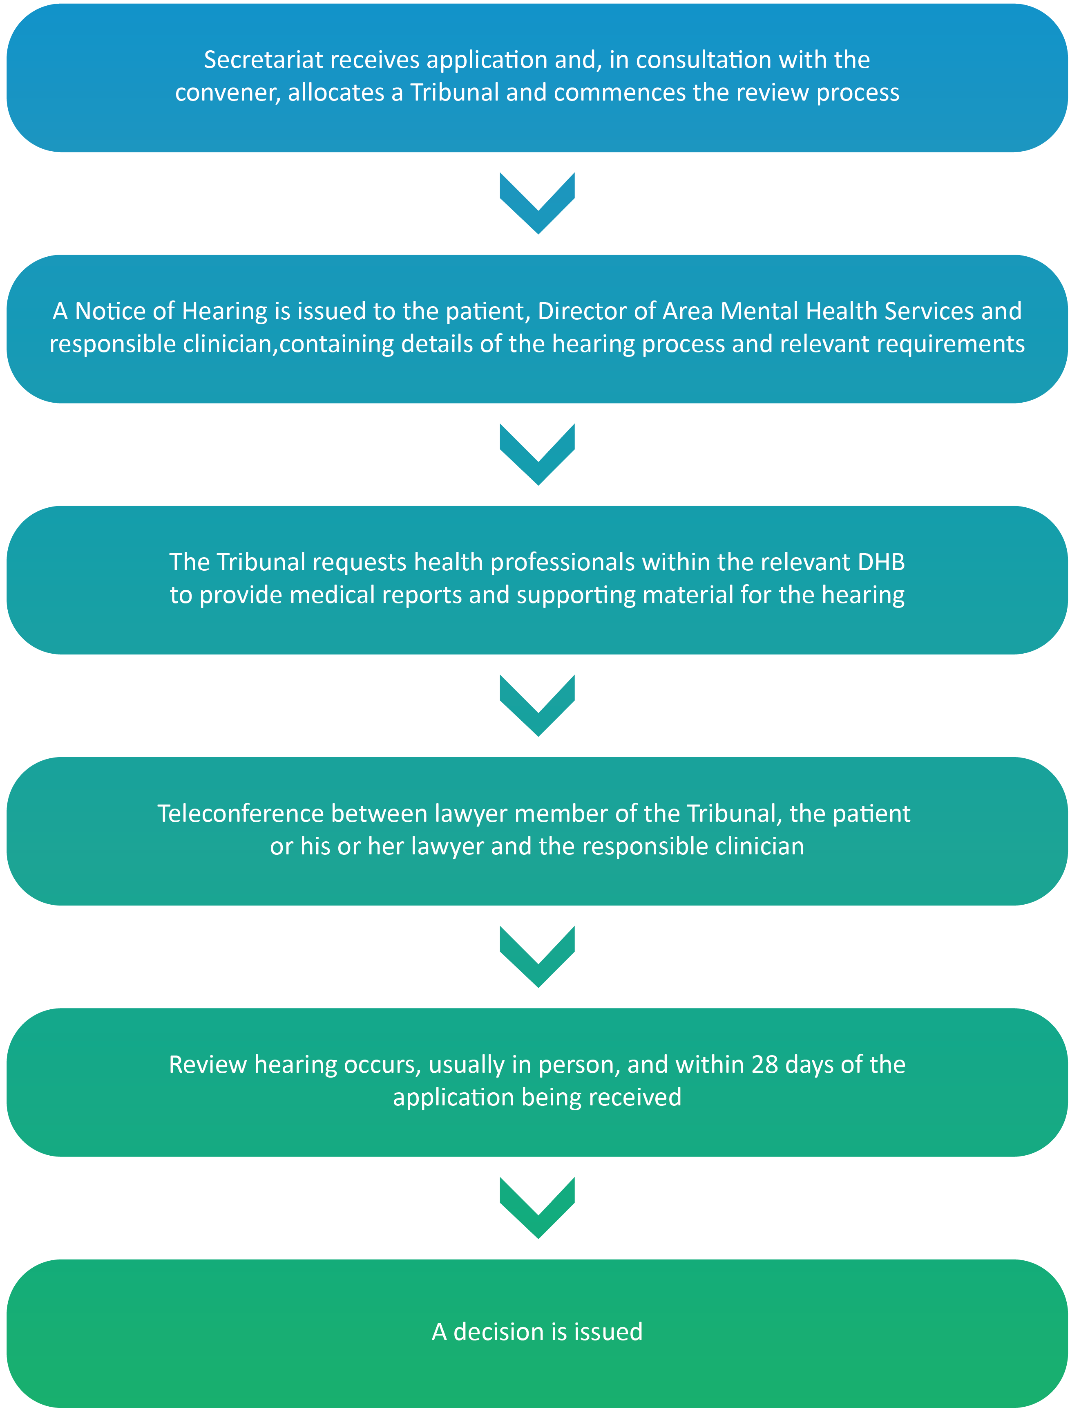
The approach taken by the Tribunal
The Tribunal tends to conduct hearings without undue formality. But because the process is quasi-judicial and the determination affects important rights and interests, a degree of formality is necessary.
Formality is also inherent in the process outlined in Schedule 1 of the Act, which contains provisions regarding the conduct of reviews.
The process is partly-inquisitorial. The Tribunal tends to lead much of the questioning. It prefers to do so in a way which helps rather than undermines the therapeutic relationship between the patient and health professional, but not at the risk of relevant aspects not being addressed.
Parties to hearings have the ability to cross-examine. It is common for the patient or his or her lawyer to do so, often in a manner which avoids or limits damage to therapeutic relationships.
Tension is sometimes apparent, reflective of the context. Health practitioners are contending that a patient ought to be subject to compulsory treatment, when the patient objects to current and future compulsory treatment.
An effort is made to provide applicants with constructive and positive comments.
The Tribunal sometimes makes recommendations or observations, focused on the care and treatment of the patient and also on procedural and evidential issues.

The Tribunal benefits from patients giving candid accounts of, at times, intensely personal matters, involving their background, family and whānau, health, current circumstances and aspirations.
The Tribunal sometimes makes broader observations, reflecting concerns about the patient's care. It sometimes does so with supporting evidence from health practitioners, who work within a constrained system. Health practitioners are to be commended for their frankness.

Who attends the hearings?
The hearings are not public.
Those attending are usually:
- the applicant, who may be excused if need be;
- the applicant’s lawyer;
- the responsible clinician, who is a psychiatrist; and
- the keyworker, who is usually a psychiatric nurse who is familiar with the patient.
Others who might attend include:
- a support person or advocate for the patient;
- family and whānau of the applicant;
- a social worker;
- a psychologist;
- an occupational therapist;
- a cultural advisor;
- other medical and nursing staff; and
- a district inspector.

How hearings are conducted
The hearing format tends to be similar regardless of whether the patient is an ordinary patient subject to a compulsory treatment order, a special patient or a restricted patient.
In advance, the Tribunal receives written reports from health professionals and sometimes written material from the applicant or his or her lawyer or advocate.
Prior to the hearing, the patient meets with a member of the Tribunal, usually the psychiatrist member, for the purpose of a preliminary examination. The purpose is to ascertain whether the patient is able to participate in the hearing and to identify any issues, for example a difficulty in communication, which may need to be accommodated.
The hearing commences with the Tribunal introducing itself. It clarifies who is present and, where appropriate, whether there is any objection by the patient to any particular person being present.
An opening submission or statement is called for from the applicant or his or her lawyer. Following that, evidence is heard.
Usually the first witness is the patient, followed by the responsible clinician, being the clinician responsible for the care and treatment of the patient, and then a second health professional. Family and whānau are then usually invited to speak.
Evidence can be required on oath, but this would be unusual.
Each witness is usually questioned by the Tribunal. The applicant or lawyer for the applicant is then invited to ask questions of that witness. It would be rare for a health professional to question other witnesses.
At the conclusion of the evidence, closing submissions are invited.
Those present are then asked to leave the room to enable the Tribunal to deliberate. If possible, a decision is given shortly after, on the same day.
Sometimes written submissions are sought or an adjournment is necessary, for example to enable further medical evidence to be obtained. Where fresh evidence is received, an opportunity to comment upon it is given to the extent consistent with natural justice.
Following the hearing the Tribunal issues a written decision, or written reasons for a decision if the decision was announced orally.

The attendance of family and whānau
Section 5 of the Act requires the Tribunal to exercise its powers with proper recognition of the importance and significance of the patient's ties with family and whānau.

Often, patients will seek to have one or a few members of their family and whānau present. This and the understanding which results from that is welcomed by the Tribunal. It is often of assistance to the patient, the Tribunal and health professionals.

Ethnic and cultural identity and language
Section 5 of the Act also requires the Tribunal to exercise its powers with proper respect for the patient's cultural and ethnic identity, language, and religious or ethical beliefs.
When applying for reviews applicants are asked whether they wish to have the Tribunal include a person of the same ethnic identity as the patient. If so that is arranged, including by co-opting a member where necessary.
The Tribunal recognises the issues which can arise where English is not the language or first language of the patient. If an interpreter is sought or necessary then it helps to facilitate that.
The Tribunal composition reflects a mix of genders where possible.
Hearings may be opened or closed by a karakia, blessing or waiata if a patient seeks that.
Where do hearings take place?
If the applicant is being treated in hospital the hearing usually takes place at the hospital. If the applicant lives in the community, the hearing usually takes place at the outpatient clinic which the applicant attends.
Some hearings take place by video conference. Where that occurs, the format described above is followed as much as possible. Whether videoconferencing is used is a matter of judgment, exercised consistently with natural justice and the Act.
Withdrawal of applications
Many applications are withdrawn in advance of a hearing. There are a range of reasons. They include the patient and health professionals having discussion and reaching an accommodation in the context of a review, for example regarding the type and nature of treatment and whether it ought to be compulsory.

Applications by category of patient
154 applications were received during the reporting year. Of those:
- 92 were in respect of patients under a community treatment order;
- 44 were in respect of patients under an inpatient treatment order; and
- 18 were in respect of special patients.
An overview of applications
at a glance

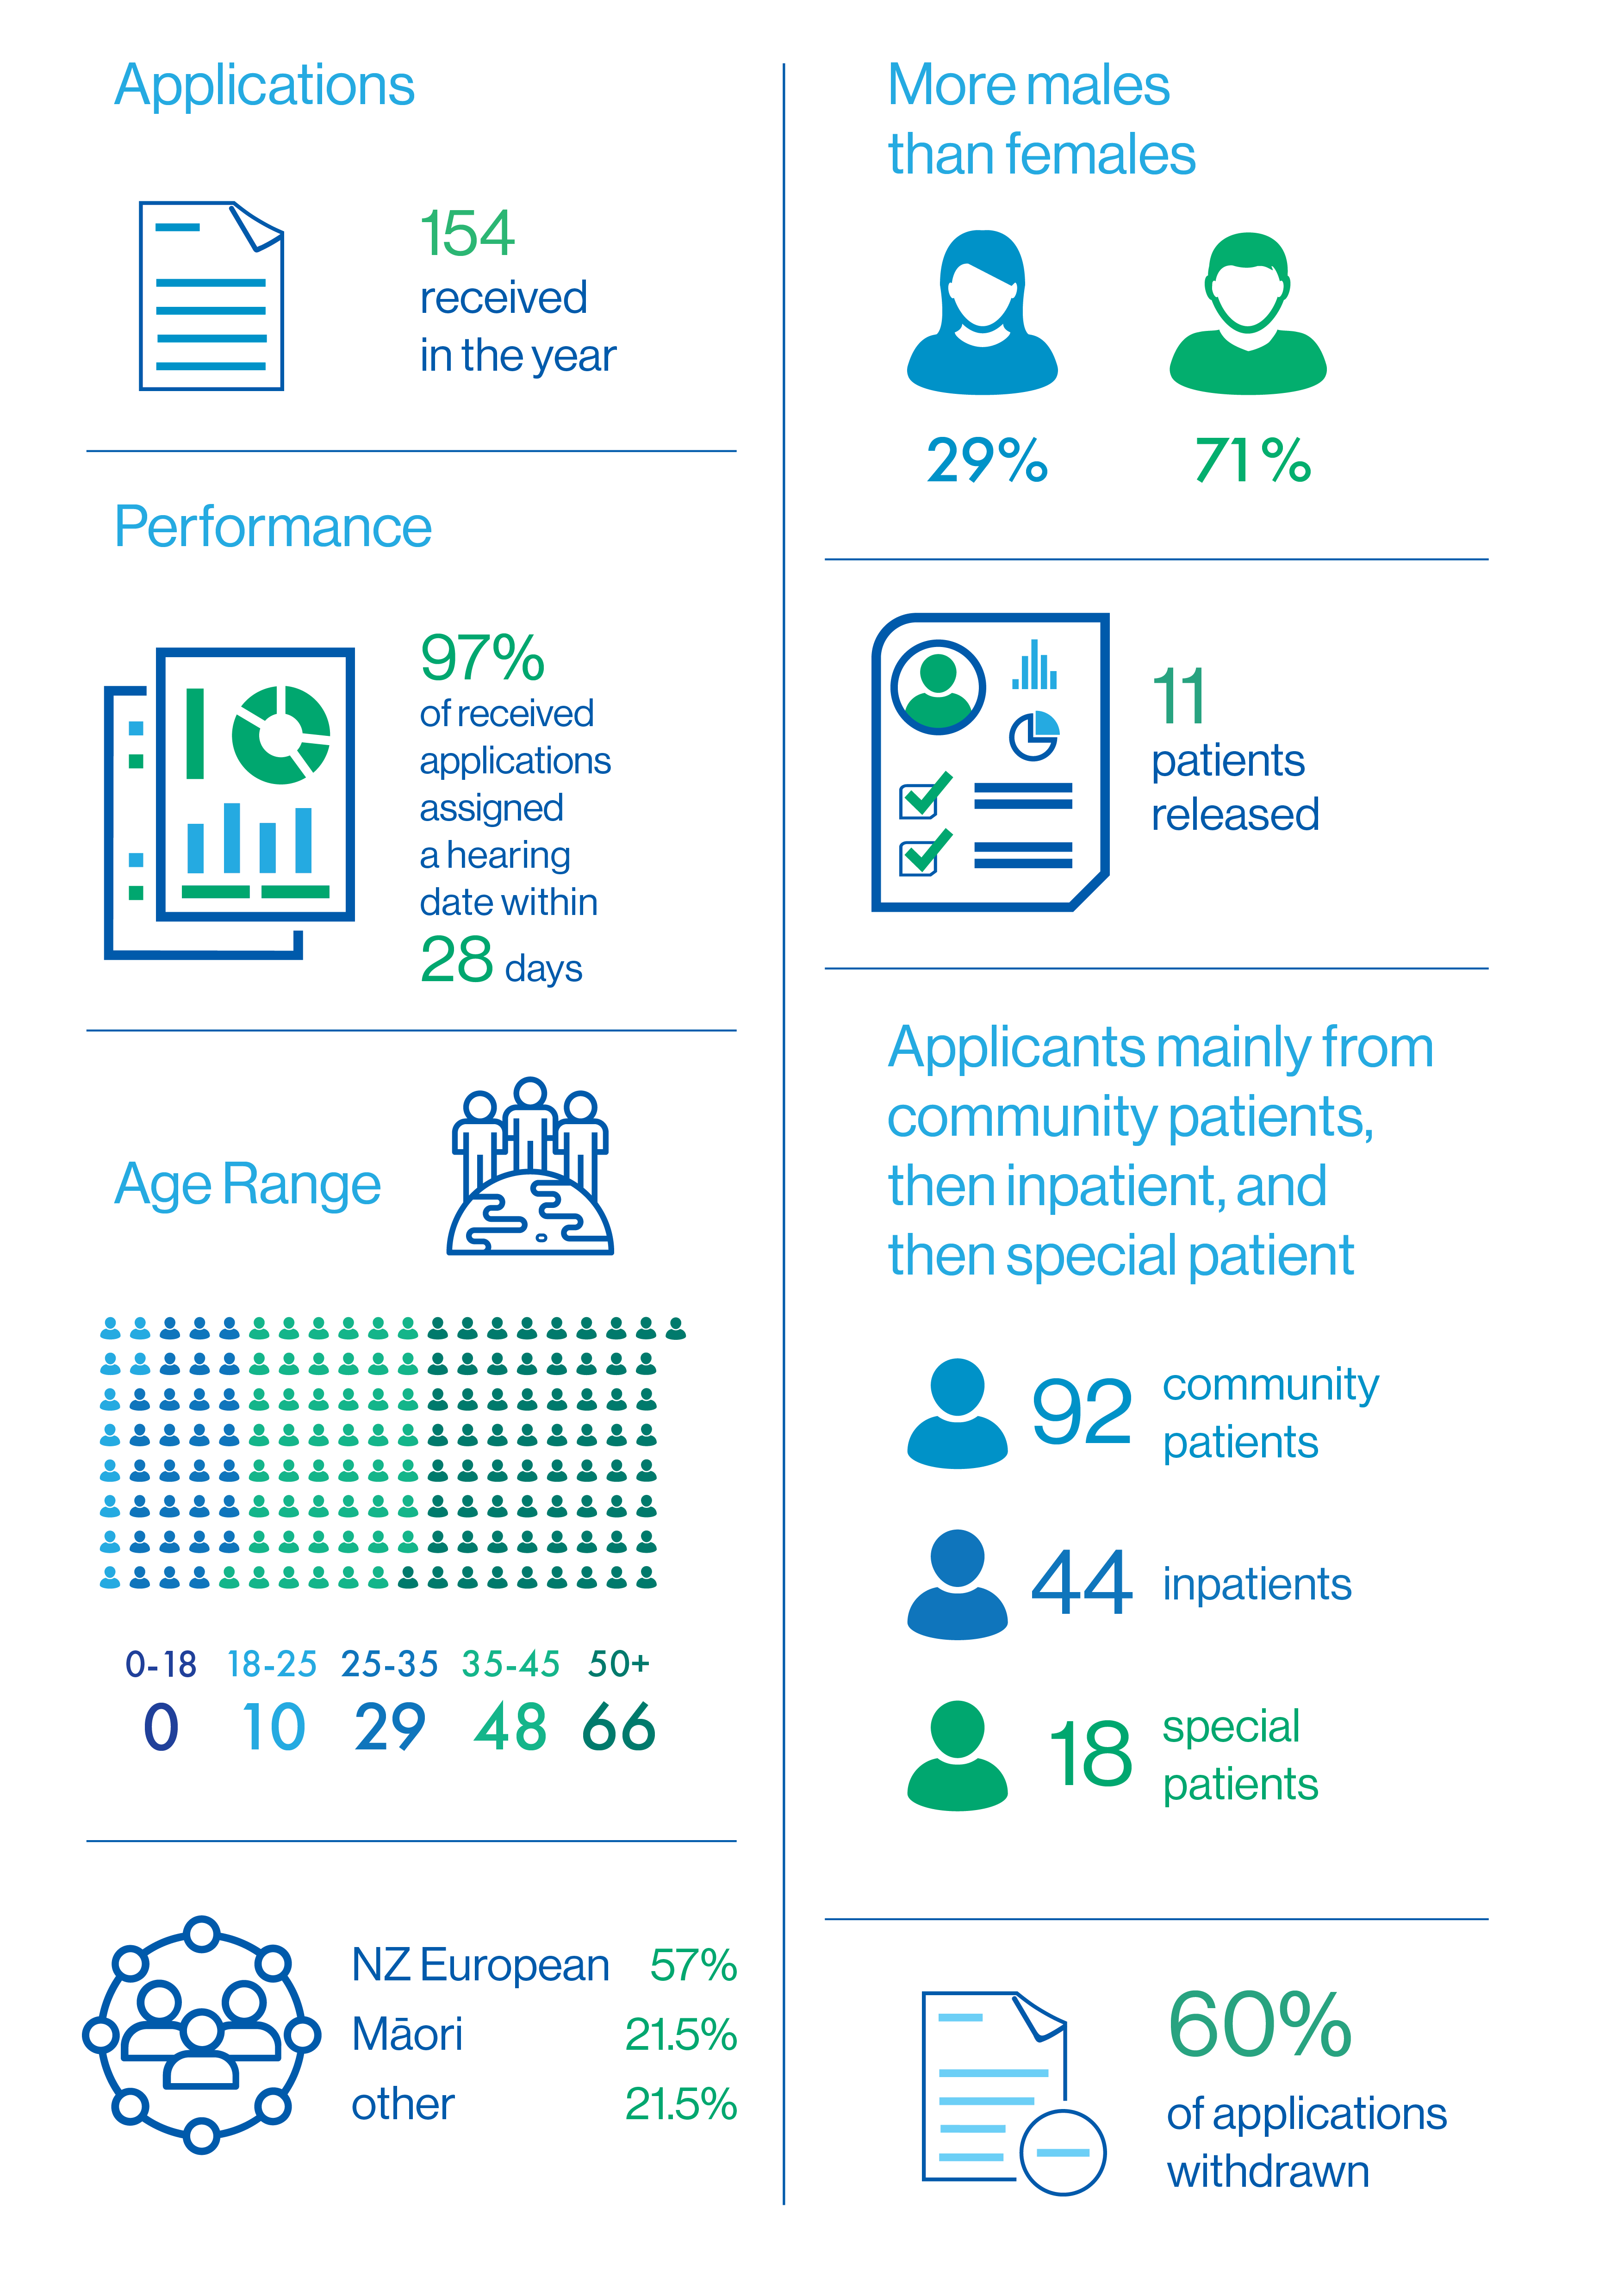
Further detail illustrating the breakdown of applications is contained in Appendix 2.
.Applications received by DHB

Further detail illustrating the breakdown of applications is contained in Appendix 2.
An overview of applications
involving Māori patients

Māori make up 15 percent of New Zealand population, yet account for 25 percent of all mental health service users. This uncomfortable disparity is reflected in the number of applications to the Tribunal by Maori.

Further detail illustrating the breakdown is contained in Appendix 2.
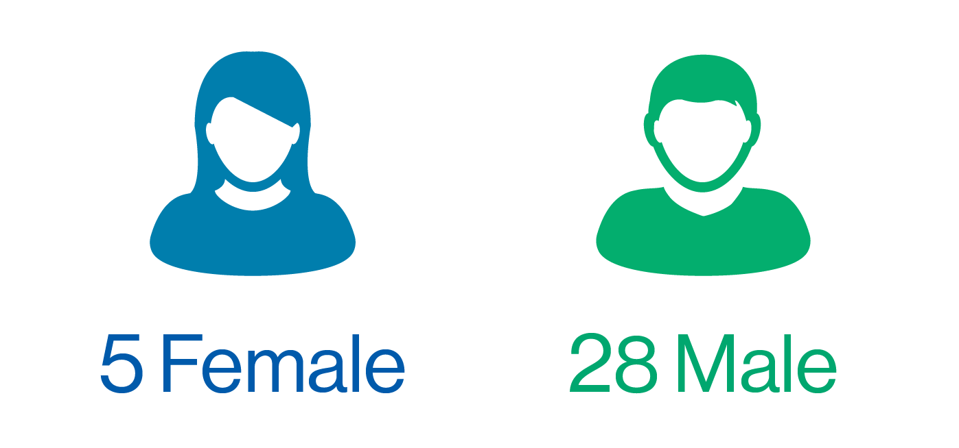
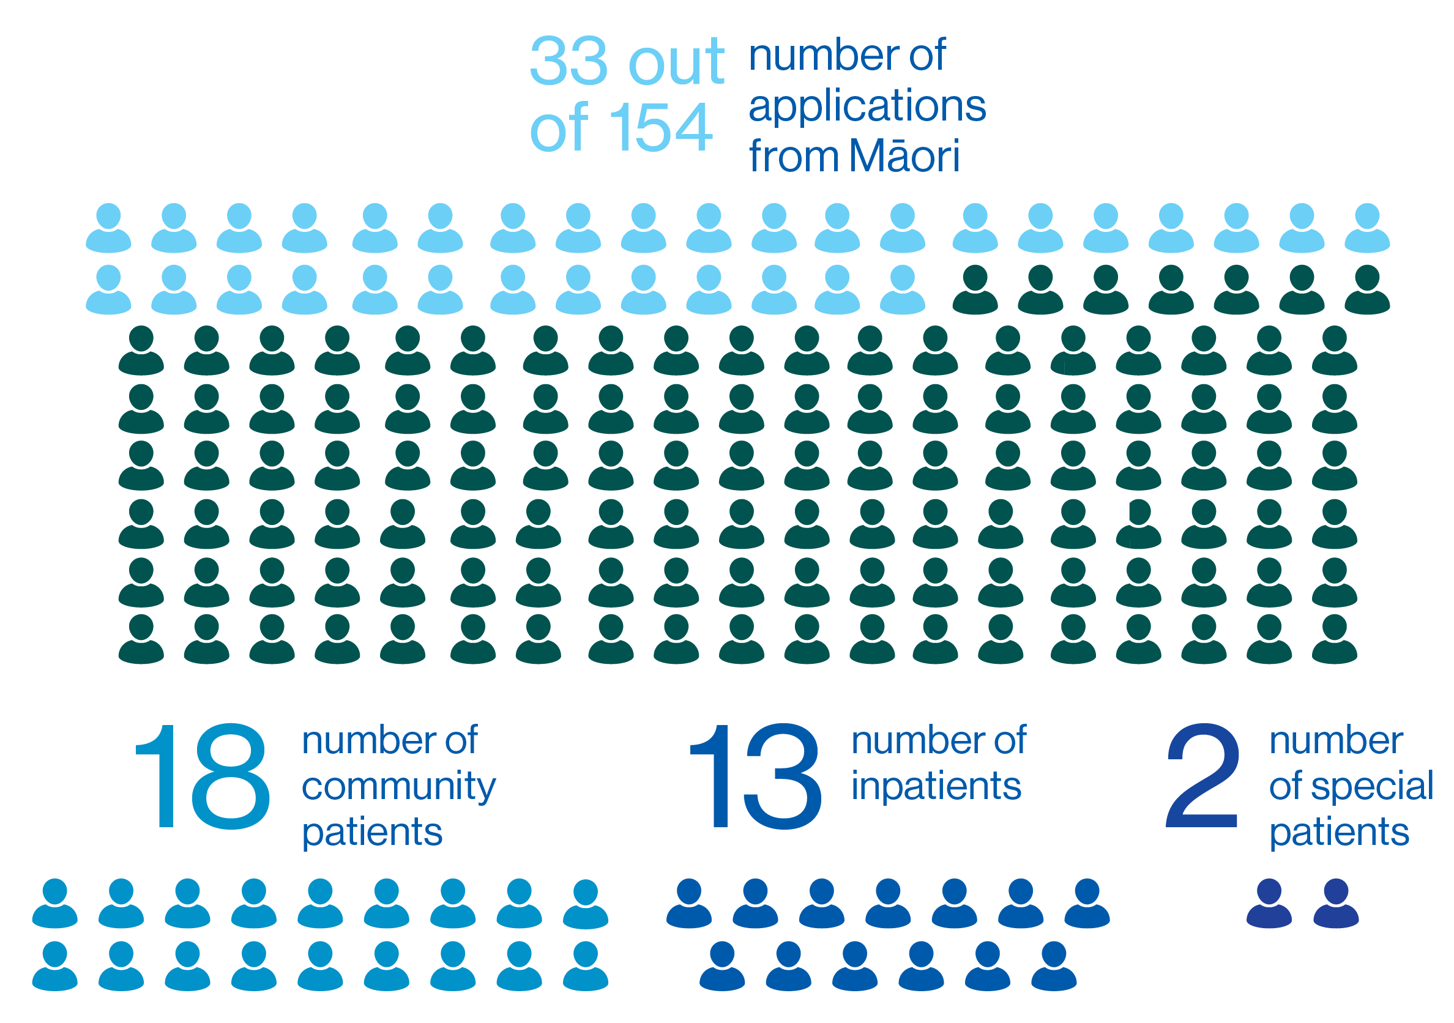
Timeliness

An ongoing focus for the Tribunal is the timely hearing of applications for review. By 2016 fewer than 30% of applications heard were heard within 28 days, being the statutory timeframe (inclusive of a 7 day extension). Addressing that became a focus.
The hearing of four reviews commenced outside of the statutory timeframe, being less than 5% of the total number of applications. This reflects an ongoing and substantial focus on and improvement in timeliness over the past five years.
This has been possible because of the efforts of the Secretariat and because of the generally excellent support and cooperation received from patients, lawyers and health professionals.
From 2019, the Tribunal commenced issuing notices regarding the hearing process and who has to do what, following applications being received.
This, in conjunction with revised guidelines issued in 2018 for responsible clinicians when writing reports, appears to have resulted in more timely and full reports from many clinicians, with the benefit that brings to the patient and Tribunal processes.
There are still circumstances in which the hearing of cases commenced outside of the statutory timeframe, and will continue to be, the reasons for which include:
- patients sometimes seeking deferral in order to have a lawyer of their choice or to obtain a second opinion or a grant of legal aid. In some cases, applications are being withdrawn until all information is to hand;
- responsible clinicians or lawyers being unavailable, for example overseas or in a hearing, and the Tribunal and patient or his or her lawyer agree it is preferable that a hearing be delayed;
- scheduling difficulties. Difficulty is inherent in trying to coordinate dates suitable to patients, their lawyers, health professionals and the Tribunal; and
- travel factors, being the availability of flights and cancellations due to poor weather conditions. Hearings tend to involve at least two if not three members travelling from different cities.
Sometimes the interests of time have had to give way to the interest in having sufficient good quality information to enable the Tribunal to make a properly informed decision.
The Tribunal has had several cases which have been part-adjourned or made more difficult because of deficiencies in the information provided by health professionals. Where necessary, the Tribunal will use its powers of compulsion to avoid the rights of the patient being undermined by such deficiencies.
It has drawn to the attention of the Director certain cases in which there have been problems. Where required, it can make a report pursuant to s102(2) of the Act.
It is hoped that with the issuing by the Ministry of Health of the revised Guidelines to the Mental Health (Compulsory Assessment and Treatment) Act 1992, and the section of that focusing on the Tribunal, that such issues will dissipate.

Publication of Decisions

Clause 7 of Schedule 1 of the Act provides that Tribunal proceedings are not open to the public. Clause 8 allows for the publication of reports of proceedings with the leave of the Tribunal and in publications of a bona fide professional or technical nature.
Decisions of the Tribunal are rarely made public. This reflects the right of the patient, and often others, for example victims and family, to privacy. Decisions are highly fact specific and anonymisation may not prevent identification.
Those receiving compulsory treatment under the Act likely assume that the usual privacy and confidentiality requirements attaching to medical matters will apply. They are vulnerable and may not be well placed to address issues of publication.
Patients, their families and clinicians who provide private information during the course of Tribunal hearings may be alarmed if decisions find their way on to the worldwide web. Publishers of professional and technical journals now publish journals online.
Weighing against those is the public interest in being informed of the workings of the Tribunal.
In April 2010 the Tribunal and the Ministry agreed on guidelines intended to ensure that the relevant interests in privacy and making information public are balanced and that appropriate cases are identified for publication. The protection provided by these guidelines is essentially three-fold:
- only a selection of cases identified by the Tribunal is sent to publishers, by the Ministry;
- those cases will be anonymised, by the Tribunal and then the Ministry; and
- they will be sent only to three established professional and responsible publishers, namely Brookers (Thomson Reuters), LexisNexis and the New Zealand Legal Information Institute.
As at the date of this report 49 cases can be found on line on the New Zealand Legal Information Institute website: http://www.nzlii.org/nz/cases/NZMHRT/.

Relationship with the Director of
Mental Health and the
Ministry of Health

The Tribunal is an independent statutory body, supported by its own Secretariat. Decisions reflect its independent view.
The Tribunal enjoys a constructive relationship with the Director of Mental Health, Dr Crawshaw. That relationship generally involves support for the work of the Tribunal outside of the context of specific cases and consideration of issues which can adversely impact on the functioning of the Tribunal.
Rarely, the Tribunal will invite the Director to be heard on an issue arising in a particular case. This is done formally.
The Ministry of Health administers the Act. The Tribunal enjoys a constructive relationship with it, in respect of training, administrative, personnel and funding issues.
The Tribunal extends its thanks to Dr Crawshaw and the team at the Ministry for their support during the year.

Secretariat

Public policy firm Allen + Clarke is contracted by the Ministry to be the Tribunal’s Secretariat. It commenced that role in November 2018.
It supports the work of the Tribunal, which includes managing the flow of information between parties and the Tribunal, organising Tribunal pre-hearings and hearings, supporting the Tribunal to give effect to its statutory requirements under the Act, and quarterly and six-monthly reporting to the Ministry on Tribunal activities.
The Tribunal is grateful for the hard work of Allen + Clarke and the team of Ms Harrison, Ms Slater, and Ms Tuifao.

Professional Development

The lawyer and psychiatrist members of the Tribunal are qualified in their respective professions. The community members possess a diverse range of skills and experiences. All members have considerable experience in their respective areas of expertise prior to appointment.
Members maintain their own professional development. The Tribunal usually holds a plenary once, and sometimes twice, a year.

Website

The Tribunal has a website, within the Ministry’s website: http://www.health.govt.nz/new-zealand-health-system/key-health-sector-organisations-and-people/mental-health-review-tribunal.

The website contains relevant information, including Policy and Practice notes and Guidelines.

What’s next for 2020-2021

The Tribunal will continue its focus on seeking to provide patients with meaningful and effective reviews within the statutory timeframe.
It will also:
- as part of its reviews, where appropriate seek to make constructive comment directed towards the care and treatment of patients and encourage patients and health professionals to try to further explore accord on certain aspects;
- reflect on the approach it takes to decisions, including whether a consistent and appropriate standard is being applied over time and between each of the variously composed Tribunals;
- reflect on its processes. COVID-19 has given the Tribunal an opportunity to trial AVL on a regular basis. There may be ongoing benefit in AVL hearings in some cases, but for most a return to in-person hearings is desirable;
- continue to address circumstances where there is avoidable delay which is not supported by the patient and, as part of that, draw circumstances to the attention of the Director in appropriate cases.

Conclusion

The work of the Tribunal involves intensely personal issues for patients, their families and whānau and those involved in their care and support.
The competing arguments for why the significant step of compulsory treatment is or is not required are challenging.
The Tribunal hopes that its work has helped to support:
- the rights of those who are mentally disordered to be treated under the Act;
- the rights of those who are not mentally disordered to be discharged from the Act; and
- the special interests that arise in the case of special and restricted patients.

_________________________
A.J.F. Wilding QC
(Convener)

_________________________
Ms P. Tangitu
(Community member)

_______________________
Dr N.R. Judson
(Psychiatrist member)
Appendix 1 – Tribunal members

Mr A J F Wilding QC
(Tribunal Convener)
James is a barrister based in Christchurch. His work includes family law and medico-legal issues. He was a District Inspector of Mental Health from 1999 until to 2011.
Dr N R Judson
Nick is a psychiatrist based for the last 20 years in Wellington. In the past he worked in Dunedin and then as Deputy Director of Mental Health. His interests are in forensic psychiatry and intellectual disability.
Ms P Tangitu
Phyllis hails from the Iwi of Ngati Pikiao, Ngati Ranginui and Ngati Awa. She has a background in education and health and has worked in the Mental Health and Addictions and Māori Health sector for 32 years. Phyllis has whānau members who have experienced mental ill-health and continues to advocate for recognition of Māori world views. She is employed by Lakes DHB as General Manager Māori Health, where she has worked for 30 years.

Deputy Members
The Minster of Health also appoints deputy members of the Tribunal. During the report year, the deputy members of the Tribunal were:

Deputy lawyer members:
Ms M J Duggan
Michelle is a lawyer based in Nelson who specialises in family law and mental health issues. She is the former chair of the Family Law Section of the New Zealand Law Society. In 2020 she left the Tribunal, consequent on appointment as a District Court Judge.
Mr N J Dunlop
Nigel is a Wellington based barrister and mediator. He has been a member of the Tribunal since 1992 and for many years was the convener. Additionally, Nigel conducts investigations, mediates, and sits on appeal and complaint bodies in the areas of censorship, retirement villages, physiotherapy, medicine and dentistry.
Mr R A Newberry
Robb is a barrister based in Wellington. Prior to becoming a deputy lawyer member of the Tribunal, he was a District Inspector of Mental Health from 1993 until 2008. He also practices in other jurisdictions, such as the Protection of Personal and Property Rights Act 1988 and Intellectual Disability (Compulsory Care and Rehabilitation) Act 2003.

Ms R F von Keisenberg
Robyn is a family law barrister with over 30 years’ experience in a broad range of areas including issues under Mental Health (Compulsory Assessment and Treatment) Act 1992 and the Protection of Personal and Property Rights Act 1988. Robyn is a senior counsel appointed in proceedings under that Act and in proceedings involving the care of children. She has served on and convened a number of Law Society committees. In 2020 she left the Tribunal, consequent on appointment as a District Court Judge.

Deputy psychiatrist members:
Dr Ben Beaglehole
Ben is a Christchurch based psychiatrist. He is the clinical head of the Anxiety Disorders Service based at Hillmorton Hospital. Ben is also a Senior Lecturer for the University of Otago. He teaches medical students and researches mood disorders and mental health outcomes following disasters.
Dr J Cavney
James is a forensic psychiatrist based in Auckland. He is a lead clinician, Kaupapa Māori and Pacific Services, Mason Clinic.
Dr C Dudek-Hodge
Christine Dudek trained as doctor in Germany and The Netherlands. She gained her PhD in Germany and went on to complete her vocational training as a psychiatrist at the Academic Medical Centre in Amsterdam, The Netherlands. Christine relocated with her family to Christchurch in 2012 and has since worked as a general adult psychiatrist for the CDHB.
Dr H Elder, MNZM
Ngāti Kurī, Te Aupouri, Te Rarawa, Ngāpuhi. Hinemoa is a psychiatrist, who works in a range of settings including CFU, Starship Hospital, and as a court report writer for the Family and District Courts and Kōti Rangtahi, and under the Intellectual Disability (Compulsory Care and Rehabilitation) Act 2003. She specialises in the neuropsychiatry of traumatic brain injury and is a researcher in that field and in the field of dementia. She is the Māori strategic leader at Brain Research NZ.
Dr M Honeyman, QSO
Margaret is a psychiatrist based in Auckland and who is semi-retired but still undertakes clinical work. She works mainly in adult psychiatry. A large part of her career has been in leadership and management roles, including as Clinical Director and DAMHS in DHB settings and as Chief Psychiatrist in South Australia. She has thus been involved in the application of mental health legislation from a number of different perspectives.
Professor G Mellsop, CNZM
Graham is a psychiatrist who has spent most of his working life contributing to adult mental health services, medical education, and research. He held Professorial positions for 37 yrs (1982-2019), sequentially at the Universities of Otago, Queensland, Melbourne and Auckland. Currently he works part time for the Waikato DHB, provides expert opinions to various NZ courts and is an Emeritus Professor at the University of Auckland.
Dr S Nightingale
Sue is a psychiatrist who has worked in Christchurch for many years. During the reporting year she was the Chief Medical Officer for the Canterbury District Health Board but was previously Chief of Psychiatry and DAMHS from 2010 to 2016. She has a strong interest in health law, completing a Masters in Bioethics and Health Law in addition to her medical qualifications.
Dr P Renison
Peri is a psychiatrist who works clinically in adult general psychiatry. She is Chief of Psychiatry for the Canterbury District Health Board and Director of Area Mental Health Services for Canterbury.
Dr S Schmidt
Sigi Schmidt moved to NZ in 1999 after completing his psychiatric training at the University of Cape Town in South Africa. He has worked in a range of services since that time. These include Adult General Psychiatric Services (both inpatient and outpatient settings), Reha-bilitation, Early Intervention in Psychosis and Rural Psychiatry. He is working for the CDHB as Clinical Director of Adult Community Psych-iatric Services in Christchurch.

Deputy community members:
Mrs F Diver, QSM
Francis is a community member based in Central Otago. She is Ngai Tahu, Waitaha, KatiMamoe and works closely with the Māori community. She founded the Te Ao Huri whānau group and has held leadership roles with charities and local government initiatives. She has a close focus on mental health.
Ms A Lucas
Albany is a PhD Candidate at the University of Otago, based at the Centre for Pacific Health. She has a law degree and a Master’s in Bioethics and Health Law. Albany is of Kiribati and Dutch descent.
Mrs K Rose
Kay has a background in nursing and has owned and operated a Nursing Bureau and a Recruitment Placement business. She was a Justice of the Peace from 1980 until 2012 having exercised jurisdiction in the District Courts in Auckland. She has an extensive background in commerce and voluntary services.

Appendix 2 - A breakdown of applications

This section provides information on applications received from 1 July 2019 – 30 June 2020.
Figure 1: Applications received 1 July 2019 – 30 June 2020 by gender

The number of applications received from male patients was 109 and the number from female patients was 45. There was an increase in applications from male patients from last year. The number of female applicants remained the same.

Figure 2: Applications received 1 July 2019 – 30 June 2020 by age range

The majority of the applications received were from people over the age of 36 years, with those aged over 50 years being the largest segment. This year we saw an increase in ages 26 - 35 years. 77 out of the 154 applications were from people aged 18 - 45 years.
*One applicant did not disclose their age and withdrew the application.

Figure 3: Applications received 1 July 2019 – 30 June 2020 by DHB location

The majority of applications were received from the main city centres across New Zealand. The Auckland region gave rise to the largest number of applications.

Figure 4: Applications received 1 July 2019 – 30 June 2020 by type of order

The largest number of applications received was from patients on community treatment orders. Of 154 applications, 92 were from patients on community treatment orders.

Figure 5: Applications received 1 July 2019 – 30 June 2020 by hearing status

Just over half of all applications received during the year were withdrawn. A patient can withdraw an application at any stage during the proceedings. Ten patients withdrew their application because they were released from the Act.

Table 1: Applications received 1 July 2019 -30 June 2020 percentage withdrawn
Year | Applications | Applications ineligible or withdrawn by patient | Percentage
1 July 2019 – 30 June 2020 | 154 | 92 | 60%

Figure 6: Applications received 1 July 2019 – 30 June 2020 by decision outcome

Most decisions that were received during the year resulted in patients remaining on their orders. Eleven patients were released from the Act during the year. The Tribunal recommended that four special patients be released from that status.

Table 2: Applications received 1 July 2019 - 30 June 2020 decision outcome by percentage
Year: 1 July 2019 – 30 June 2020
Number of cases determined: 62
Remained on order | % | Released from order | % | Recommendation for a change in special patient status | %
47 | 75% | 11 | 19% | 4 | 6%

Table 3: Applications received 1 July 2019 - 30 June 2020 percentage of applications heard within 28 days
Quarterly | Number of applications | Withdrawn | Number proceeding | Heard within 28 days | %
1 July 2019 – 30 September 2019 | 52 | 28 | 24 | 23 | 96%
1 October 2019 – 31 December 2019 | 32 | 19 | 13 | 13 | 100%
1 January 2020 – 30 March 2020 | 38 | 27 | 11 | 9 | 82%
1 April 2020 – 30 June 2020 | 32 | 18 | 14 | 13 | 96%

Figure 7: Applications received 1 July 2019 – 30 June 2020 by ethnicity

The largest ethnic group to apply to the Tribunal was New Zealand European. The graph does not fully reflect the ethnicity of all applicants because patients are not required to identify their ethnicity and some did not do so.

Table 5: Applications received 1 July 2019 - 30 June 2020 by ethnicity
Ethnicity | Number | Percentage
Asian | 10 | 7%
NZ European | 88 | 57%
Māori | 33 | 22%
Pacific Island | 10 | 7%
Other | 5 | 2%
Unknown | 8 | 5%
Total | 154 | 100%

Appendix 3 – A comparison over time (previous four Annual Reports)

This section provides a comparison from the last four annual reports.
Figure 8: Applications received by gender compared to the last four annual reports

The number of applications of all descriptions received from male patients was 109 and the number from female patients was 45. There was an increase in applications from male patients from last year, however the number of female patients remained the same. Since 2014, over 60% of the applications have been from males. There has been a decrease in the number of female applications since 2014.

Figure 9: Applications received by DHB compared to the last four annual reports

The major cities continue to be the locations where a large proportion of applications are received from. The Auckland region (including Auckland, Waitemata and Counties Manukau DHBs) continues to be the highest.

Figure 10: Application status compared to the last four annual reports

Table 6: Comparison of applications withdrawn or ineligible compared to the last four annual reports
Year | Number of applications | Withdrawn or Ineligible | Percentage
1 July 2014 – 30 June 2015 | 156 | 77 | 49%
1 July 2016 – 30 June 2017 | 139 | 70 | 50%
1 July 2017 – 30 June 2018 | 131 | 57 | 43%
1 July 2018 – 30 June 2019 | 147 | 80 | 54%
1 July 2019 – 30 June 2020 | 154 | 92 | 60%

During the year there was an increase in the number of applications withdrawn or ineligible.
In some cases withdrawal has occurred because, following making the application, there has been substantive discussion between the patient and responsible clinician resulting in the resolution of the issues of concern to the patient, and then the withdrawal of the application or the discharge of the patient by the responsible clinician.

Figure 11: Comparison of decision outcome compared to the last four annual reports

Table 7: Percentage of decisions over the last four annual reports
Year | # of cases determined | Remained on order | % | Released from order | % | Recommendation of discharge from special patient status | %
1 July 2014 – 30 June 2015 | 62 | 57 | 92% | 5 | 8% | - | -
1 July 2016 – 30 June 2017 | 69 | 63 | 91.3% | 6 | 8.7% | - | -
1 July 2017 – 30 June 2018 | 63 | 58 | 92% | 5 | 8% | - | -
1 July 2018 – 30 June 2019 | 67 | 62 | 93% | 3 | 4% | 2 | 3%
1 July 2019 – 30 June 2020 | 62 | 47 | 75% | 11 | 19% | 4 | 6%

This year saw an increase in the number of patients who the Tribunal discharged from compulsory status. That does not take into consideration 10 patients who were discharged by their responsible clinicians following an application being made, and in discussion with the patient.
There were 18 special patient hearings this year. Four resulted in recommendations that the patient be discharged from special patient status.

Figure 12: Applications by ethnicity compared to the last four annual reports

Table 8: Number of applications received by ethnicity compared to the last four annual reports
Ethnicity | 1 July 2019 – 30 June 2020 | 1 July 2018 – 30 June 2019 | 1 July 2017 – 30 June 2018 | 1 July 2016 – 30 June 2017 | 1 July 2014 – 30 June 2015
African | - | 2 | 6 | - | -
Asian | 10 | 7 | 5 | 3 | 6
NZ European | 88 | 69 | 68 | 81 | 93
Māori | 33 | 25 | 18 | 26 | 31
Pacific Island | 10 | 8 | 7 | 8 | 5
Other | 5 | 34 | 5 | 10 | 2
Unknown | 8 | 2 | 22 | 11 | 19
Total | 154 | 147 | 131 | 139 | 156

New Zealand European continues to be the largest ethnic group applying to the Tribunal. This has been consistent over the last four annual reports. This year saw an increase of applications for Māori.



Decisions regarding the release of special patients are generally for the Minster of Health or Attorney-General, depending on the circumstances.
District Inspectors are lawyers who are appointed under the Act to help safeguard the rights of patients.
3 There are no Official Visitors in New Zealand.
Waitemata Health v the Attorney-General [2001] NZFLR 1122.
Section 106 of the Act.

