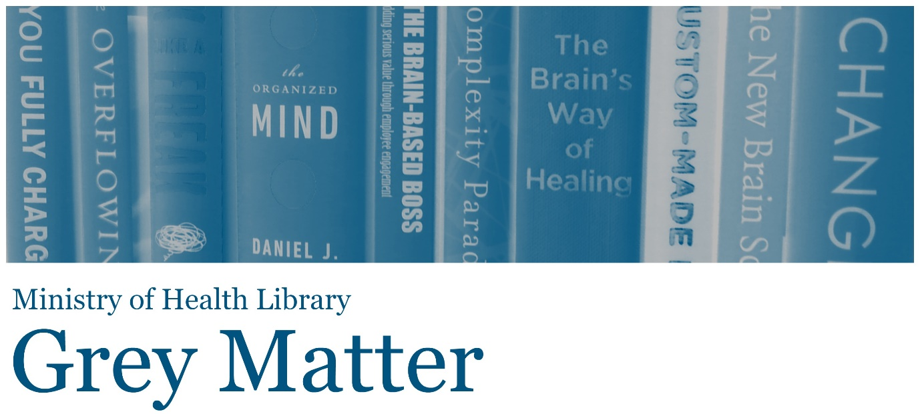

A Collection of Recent NGO, Think Tank, and International Government Reports
Issue 85, 2021, January
Welcome to Grey Matter, the Ministry of Health Library’s Grey Literature Bulletin. In each issue, we provide access to a selection of the most recent NGO, Think Tank, and International Government reports that are relevant to the health context. The goal of this newsletter is to facilitate access to material that may be more difficult to locate (in contrast to journal articles and the news media). Information is arranged by topic, allowing readers to quickly identify their key areas of interest. Email library@moh.govt.nz to subscribe.
Click on any of the bulleted points below to go to a section of interest.

Equity
Research & Technology
Child & Youth Health
Public Health
Health Systems, Costs, & Reforms
COVID-19
Mental Health & Wellbeing
Health of Older People

Equity

Income-related inequalities in affordability and access to primary care in eleven high-income countries
“To compare the health experiences of adults with a lower income during the pandemic and the effect of income-related disparities, the Commonwealth Fund surveyed adults across 11 high-income countries: Australia, Canada, France, Germany, the Netherlands, New Zealand, Norway, Sweden, Switzerland, the United Kingdom, and the United States. In nearly all countries, adults with a lower income were significantly more likely than those with a higher income to have multiple chronic health conditions.” Source: The Commonwealth Fund

Considering health inequality impact in decision making: what does it mean for policy makers?
“When making the decision about whether to fund a public health intervention, information on whether the intervention has different impacts on different population groups is important. However, economic evaluations that provide information on costs and health benefits in order to inform funding decisions do not tend to address whether impacts differ across population groups. This briefing showcases the value of capturing differences between socio-economic groups in the evaluation of how interventions impact on population overall health and health inequality.” Source: Centre for Health Economics

Opportunities to strengthen place-based systems approaches to consider and address associated health inequalities
“In July 2019 Public Health England (PHE) published the Whole Systems Approach (WSA) to obesity guide and supporting resources to support local areas to better understand and address the complex causes of obesity. The WSA guide articulates the importance of considering and addressing health inequalities associated with obesity through a whole systems approach.” Source: Public Health England

Unequal impact? Coronavirus and BAME people
“This report outlines the findings of an inquiry that aimed to explore the pre-existing inequalities facing people from ethnic minorities and how these inequalities have impacted on their vulnerability to the virus. It makes a series of recommendations to help mitigate the impacts of the pandemic on ethnic minority groups.” Source: House of Commons Women and Equalities Committee (UK)

One size does not fit all: moving towards delivering culturally competent services
“This report looks at the impact of coronavirus on local black, Asian and minority ethnic (BAME) communities across Enfield. A key lesson from this report is that specific community groups used different services in different ways, and as a result had different views about the support they need. It is also clear that the existing methods of cascade, with a strong reliance on online communication, do not work for everybody in BAME groups. A common issue is the lack of trust in the system, based on people’s previous experiences of giving feedback, only to see no action resulting from their efforts.” Source: Healthwatch Enfield (UK)

Understanding the Well-Being of LGBTQI+ Populations
“Understanding the Well-Being of LGBTQI+ Populations reviews the available evidence and identifies future research needs related to the well-being of SDG populations across the life course. This report focuses on eight domains of well-being; the effects of various laws and the legal system on SGD populations; the effects of various public policies and structural stigma; community and civic engagement; families and social relationships; education, including school climate and level of attainment; economic experiences (e.g., employment, compensation, and housing); physical and mental health; and health care access and gender-affirming interventions.” Source: National Academies Press
Back to top

Research & Technology

Digital technology and health inequalities: a scoping review
“This review seeks to…understand and offer advice on how equality can be promoted or risks mitigated in the design and use of digital technologies. We hope this scoping review will be of value to those seeking to better understand how the digital and health inequalities intersect, including leaders in national and local public sector organisations, and those involved in research and development of digital health technology.” Source: Public Health Wales

Heritable Human Genome Editing
From an international commission of the U.S. National Academy of Medicine, U.S. National Academy of Sciences, and the U.K.'s Royal Society, the report considers potential benefits, harms, and uncertainties associated with genome editing technologies and defines a translational pathway from rigorous preclinical research to initial clinical uses, should a country decide to permit such uses. The report specifies stringent preclinical and clinical requirements for establishing safety and efficacy, and for undertaking long-term monitoring of outcomes. Extensive national and international dialogue is needed before any country decides whether to permit clinical use of this technology, according to the report, which identifies essential elements of national and international scientific governance and oversight. Source: National Academies Press

A Framework for Assessing Mortality and Morbidity After Large-Scale Disasters
A Framework for Assessing Mortality and Morbidity After Large-Scale Disasters reviews and describes the current state of the field of disaster-related mortality and significant morbidity assessment. This report examines practices and methods for data collection, recording, sharing, and use across state, local, tribal, and territorial stakeholders; evaluates best practices; and identifies areas for future resource investment. Source: National Academies Press

Chatbots RESET: a framework for governing responsible use of conversational AI in healthcare
“Chatbots, or conversational artificial intelligence (AI) systems, are used increasingly by organizations to communicate with customers in a natural and easy-to-use way by embedding chatbots in websites, social network apps, smart home devices, etc. The COVID-19 pandemic has accelerated the adoption of chatbots in healthcare applications. As examples, both the World Health Organization and the Centers for Disease Control deployed chatbots for coronavirus information dissemination and symptom checking. So, too, did many governments and healthcare providers. Beyond the pandemic, the rate of adoption of chatbots in healthcare applications is likely to be sustained due to the access and cost benefits they enable.” Source: World Economic Forum
Back to top

Child & Youth Health

Youth19 Rangatahi Smart Survey Initial Findings: Sexual and Reproductive Health of New Zealand Secondary School Students
“This report highlights the sexual and reproductive health findings from the Youth19 Rangatahi Smart Survey (Youth19).” Source: Youth19 Research Group (New Zealand)

Children's Mental Health and the Life Course Model: A Virtual Workshop Series: Proceedings of a Workshop
“The Maternal and Child Health Life Course Intervention Research Network and the Forum for Children's Well-Being at the National Academies of Sciences, Engineering, and Medicine jointly organized a webinar series to explore how mental health disorders develop over the life course, with a special emphasis on prenatal, early, middle, and later childhood development. This series centered on identifying gaps in our knowledge, exploring possible new strategies for using existing data to enhance understanding of the developmental origins of mental disorders, reviewing potential approaches to prevention and optimization, and proposing new ways of framing how to understand, address, and prevent these disorders from a life course development perspective. This publication summarizes the presentations and discussions from the series.” Source: National Academies Press

School Success: An Opportunity for Population Health: Proceedings of a Workshop
“Education and health care significantly influence well-being and health outcomes, especially throughout adolescence. In fact, doctors note that performance in school is highly reflective of a child's current and future health. Despite knowledge of this connection, pediatricians are rarely aware of their patients' school performance and have a limited understanding of the education system. Fostering collaboration and aligning efforts within the health and education sectors is a critical step towards building stronger and healthier communities.” Source: National Academies Press

Improving health equity among young people: the role of social enterprise - final report
“Over the last two decades, public health and health promotion strategies have increasingly recognised the importance of redressing the social determinants of health (SDOH) inequities. This study investigates the ways in which work integration social enterprises (WISE) affect the SDOH equity for young people in Australia experiencing disadvantage.” Source: Centre for Social Impact

Unlimited potential: report of the Commission of Gender Stereotypes in Early Childhood
“Harmful gender stereotypes are significantly limiting children’s potential, warns a landmark report from the Commission on Gender Stereotypes in Early Childhood. The Commission was established by leading gender equality campaigning charity, the Fawcett Society, and calls for changes in education, parenting and the commercial sector.” Source: Fawcett Society (UK)

In Balance - Balancing Treatment and Prevention for Better Child and Youth Mental Health
“In the report In Balance, the New Brunswick Health Council has observed that communities that focus on achieving the right balance between the treatment of mental illnesses and the promotion of mental health show better outcomes for children and youth. This balance can be achieved by integrating assets from community partners and from publicly funded services.” Source: New Brunswick Health Council (Canada)
Back to top

Public Health

Improving the nation's health: the future of the public health system in England
“There is a risk that the immediate need to control the pandemic could lead to a deprioritisation of the very policies, systems and investment needed to keep people in good health. This briefing considers the challenges that lie ahead, and presents proposals for a new public health system.” Source: Health Foundation (UK)

Review of interventions to improve outdoor air quality and public health
“Public Health England published Review of interventions to improve outdoor air quality and public health in March 2019. The review provides local practitioners and policy-makers with an indication of the broad range of available interventions across 5 focal areas: vehicles and fuels, spatial planning, industry, agriculture, and people’s behaviour. It outlines principles for strategies and the future design and evaluation of interventions.” Source: Public Health England

Climate change and health: preparing for the next disaster
“This report shows how the health sector can better prepare for the effects of climate change, and how it should lead by reducing its own carbon and environmental footprint.” Source: Grattan Institute (Australia)

Technology-facilitated gender-based violence: an overview
“This paper serves as an introduction to technology-facilitated gender-based violence (TFGBV) and many of the concepts that will serve as the basis for a new research project. Relying on the research done to date on TFGBV, this paper reviews some of the more common forms of TFGBV, including harassment, image-based sexual abuse, publication of personal information, doxing, stalking, impersonation, threats and hate speech.” Source: Centre for International Governance Innovation

Children and technology-facilitated abuse in domestic and family violence situations
“This research explores the role technology plays in children's exposure to family and domestic violence. It shows the impacts of technology-facilitated abuse and highlights the range of strategies used for protection and intervention.” Source: Office of the eSafety Commissioner (Australia)
Back to top

Health Systems, Costs, & Reforms

Vertical integration of GP practices with acute hospitals in England and Wales: rapid evaluation
“The main impact of vertical integration was to sustain primary medical care delivery to local populations in the face of difficulties with recruiting and retaining staff, and in the context of rising demand for care. This was reported to enable continued patient access to local primary care and associated improvements in the management of patient demand.” Source: National Institute for Health Research (UK)

Towards a new model of prevention
“This policy briefing offers an overview of the discussion that took place, including recognising the value of prevention across the health sector, as well as ensuring the right funding and structures are in place to improve public health. The write-up also looks at how a data-driven approach to prevention could encourage more personalised care and tackle health inequalities.” Source: Reform (UK)
Back to top

COVID-19

The courage to be kind: reflecting on the role of kindness in the healthcare response to Covid-19
“This report draws on a series of reflective conversations, conducted between April and September 2020 with five medics working in different parts of NHS Scotland. The conversations reflected on what can be achieved when united by a common purpose, and when work is underpinned by relationships and collaboration. But alongside the opportunities presented by changes in practice and a renewed focus on wellbeing, there was concern that this may be lost amid a focus on remobilising and ‘getting back to normal’.” Source: Carnegie UK Trust

Build Back Fairer: The COVID-19 Marmot Review
“Build Back Better has become the mantra. Important, but we need to Build Back Fairer. The levels of social, environmental and economic inequality in society are damaging health and well-being. As the UK emerges from the pandemic it would be a tragic mistake to attempt to re-establish the status quo that existed before the pandemic – a status quo marked in England, over the past decade, by stagnation of health improvement that was the second worst in Europe and widening health inequalities.” Source: Institute of Health Equity

A guide to promoting health care workforce well-being during and after the Covid-19 pandemic
“This guide provides ideas and lessons learnt to improve the wellbeing of the health care workforce, including actions that individuals, leaders and organisations can take to support the health care workforce during the Covid-19 pandemic and beyond. It aims to support health care leaders at all levels with actionable tools for combating health care workforce burnout, fatigue and emotional distress.” Source: Institute for Healthcare Improvement

Changes in public sentiment in relation to data privacy during COVID-19
“This rapid research brief analyses whether COVID-19 had an impact on public sentiment in relation to privacy and the widespread use of data and technology by government in responding to the public health crisis, be it through tracing, compliance or enforcement.” Source: Office of the Chief Scientist (Australia)
Back to top

Mental Health & Wellbeing

Ending loneliness together in Australia
“This white paper aims to highlight the growing problem of loneliness in Australia and its significant impact on the social, health, and economic wellbeing of the Australian community. The paper outlines the impact of loneliness on key areas of focus, including health, children, adolescence and young adulthood, older adulthood, communities, workplaces and the economy, and delivers a series of recommendations across sectors to drive a coordinated national response to combat loneliness.” Source: Ending Loneliness Together (Australia)
Back to top

Health of Older People

Silver tsunami or silver lining? Why we should not fear an ageing population
“With people living longer than ever and the baby-boomer generation reaching retirement age, some people worry that we will run short of workers and taxpayers. Media reports and political discourse about population ageing or reduced population growth often adopt a tone of panic. Mitigating ageing is the main justification for successive governments’ policies of high population growth. Is this concern justified? In a wide reaching review of data and literature, this discussion paper untangles the facts from the myths.” Source: Sustainable Population Australia
Back to top
The information available on or through this newsletter does not represent Ministry of Health policy. It is intended to provide general information to the health sector and the public, and is not intended to address specific circumstances of any particular individual or entity.

