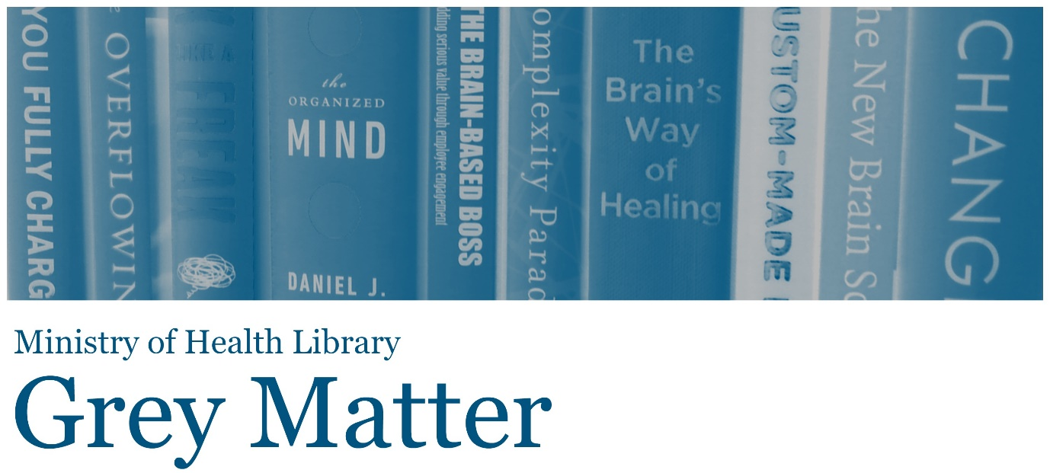

A Collection of Recent NGO, Think Tank, and International Government Reports
Issue 84, 2020, December
Welcome to Grey Matter, the Ministry of Health Library’s Grey Literature Bulletin. In each issue, we provide access to a selection of the most recent NGO, Think Tank, and International Government reports that are relevant to the health context. The goal of this newsletter is to facilitate access to material that may be more difficult to locate (in contrast to journal articles and the news media). Information is arranged by topic, allowing readers to quickly identify their key areas of interest. Email library@moh.govt.nz to subscribe.
Click on any of the bulleted points below to go to a section of interest.

Equity
Child & Youth Health
Health Systems, Costs, & Reforms
Health Technology
Mental Health & Wellbeing
Primary Care
COVID-19
Health of Older People

Equity

New report on cultural safety and health equity for Māori
“The Medical Council of New Zealand, in partnership with Te Ohu Rata O Aotearoa (Te ORA), has released an independent research report outlining findings on the current state of cultural safety and health equity delivered by doctors in Aotearoa New Zealand.” Source: Medical Council of New Zealand and Te Ohu Rata O Aotearoa

Rapid Review: What factors may help protect Indigenous peoples and communities in Canada and internationally from the COVID-19 pandemic and its impacts?
“This rapid review identifies, appraises, and summarizes emerging evidence to support decision making. It includes evidence available up to October 8, 2020, that addresses the following question: what factors may help protect Indigenous peoples and communities in Canada and internationally from the COVID-19 pandemic and its impacts?” Source: National Collaborating Centre for Indigenous Health (Canada)

Using economic development to improve health and reduce health inequalities
“Creating a society where everyone has an opportunity to live a healthy life requires action across government. While social protection measures – such as income replacement benefits, pensions, free school meals, social housing – are widely recognised as a core mechanism for reducing inequalities, the impact of structural inequalities in the economy itself has generally received less attention. This report contains case studies of economic development strategies which look beyond narrow financial outcomes as measures of success, and instead aim to enhance human welfare.” Source: Health Foundation (UK)

Health-Focused Public–Private Partnerships in the Urban Context
“To draw attention to health determinants and health inequities among populations that live in urban environments and to explore challenges faced in establishing urban population health, the Forum on Public-Private Partnerships for Global Health and Safety hosted a 1.5-day workshop on the role of health-focused public-private partnerships (PPPs) in the urban context. The workshop, held June 13-14, 2019, in Washington, DC, aimed to illuminate some of the intervention strategies that have been designed to attenuate these urban health issues and highlighted the importance of PPPs and urban-level governance in remediation efforts. By facilitating discussion among participants in both the public and private sectors, as well as among policy makers, the workshop served as a platform to share best practices on how to address health challenges through interventions that target healthier urban populations. This publication highlights the presentations and discussion of the workshop.” Source: National Academies Press
Back to top

Child & Youth Health

Now We Are Eight: Life in Middle Childhood
“Growing Up in New Zealand has released its Now We Are Eight: Life in Middle Childhood report which provides a unique insight into the lives and experiences of eight-year-old Kiwi children. New Zealand eight-year-olds are mostly living busy, healthy, happy lives in supportive families and developing a growing sense of their own identity and autonomy, but obesity, body image, mental wellbeing and screen time are emerging issues.” Source: Growing Up in New Zealand

Peer support models for children and young people with mental health problems
“The evidence, opportunities and issues relating to peer support models for children and young people with mental health problems.” Source: Centre for Mental Health (UK)

Mapping interventions for children and young people experiencing bereavement, loss and grief
“This overview seeks to descriptively outline both the types of interventions as well as the principles underpinning interventions for children and young people experiencing bereavement, loss, and grief.” Source: Mental Health Foundation (UK)
Back to top

Health Systems, Costs, & Reforms

A Framework for Integrating Family Caregivers into the Health Care Team
“The authors reviewed the literature on the role of family caregivers in the coordination of care and conducted key informant interviews with 13 experts from diverse stakeholder groups to better understand the barriers to integrating family caregivers into the patient's health care team and identify ways to mitigate these barriers. The authors identify promising policy directions and provide recommendations for next steps in assessing, developing, and implementing policies to improve the integration of family caregivers into care teams.” Source: RAND Corporation

Building on value-based health care: towards a health system perspective
“This policy brief calls for a shared understanding of value that embraces the health system in its entirety, including preventive services and other public health functions.” Source: European Observatory on Health Systems and Policies

From value for money to value-based health services: a twenty-first century shift
“WHO has developed a briefing note highlighting existing WHO work that contributes to Value Based Health Services. The policy brief explicitly looks at how to value health, and how to work through three levers to improve value in health care - setting a health benefits package, strategic purchasing and integrated people-centred health services.” Source: World Health Organisation

Enabling Person Centred, Team Based Care
“This paper outlines areas which require sectorwide attention to ensure that person-centred, team-based care is effectively implemented in Australia.” Source: Australian Healthcare and Hospitals Association

The economics of patient safety from analysis to action
“Across an entire health system, reducing harm is best approached using a framework of governance, resilience, culture and transparency. It also relies on better alignment of clinical, corporate, and professional risk, and a serious evaluation of the structures and institutions that dictate incentives and behaviour across a health system. The policy challenge is to apply the evidence to the local context to best deploy scarce resources across the range of available programs and interventions. Meanwhile, a degree of experimentation to find new ways of improving safety should be encouraged.” Source: OECD
Back to top

Health Technology

Building and enabling digital teams
“Digital teams are the cornerstone of building a digital organisation. Supported by effective governance, they are the muscles that enable [an] organisation to be responsive, open, efficient and agile, and to successfully deliver ever more transformational services.” Source: NHS Providers (UK)

The digital revolution: eight technologies that will change health and care
“In this explainer, [the authors] examine the technologies most likely to change health and care over the next few years. Some of the technologies we discuss are on the horizon; others are already in people’s pockets, their local surgeries, hospitals, homes and communities. But few are systematically deployed in the health and care system and none have reached their full potential. Each could represent an opportunity to achieve better outcomes or more efficient care and improve patient experience.” Source: King’s Fund
Back to top

Mental Health & Wellbeing

Kinship in the City: Urban Loneliness and the Built Environment
“Addressing loneliness is a complex effort that draws on expertise from many fields, from psychology and social science to public health and the third sector. The built environment industry is likewise cross-disciplinary, spanning architecture, urban design, construction, public policy, engineering, economics and more. A natural starting place for the Foundation’s research into urban loneliness was acknowledging the variety of professional spheres associated with this subject and including them in our discussion around it.” Source: Future Spaces Foundation

Caring for People with Mental Health and Substance Use Disorders in Primary Care Settings
“In an effort to understanding the challenges and opportunities of providing essential components of care for people with mental health and substance use disorders in primary care settings, the National Academies of Sciences, Engineering, and Medicine's Forum on Mental Health and Substance Use Disorders convened three webinars held on June 3, July 29, and August 26, 2020. The webinars addressed efforts to define essential components of care for people with mental health and substance use disorders in the primary care setting for depression, alcohol use disorders, and opioid use disorders; opportunities to build the health care workforce and delivery models that incorporate those essential components of care; and financial incentives and payment structures to support the implementation of those care models, including value-based payment strategies and practice-level incentives. This publication summarizes the presentations and discussion of the webinars.” Source: National Academies Press

Wellbeing and healing through connection and culture
“A number of key principles and practices fundamental to Indigenous knowledges of social and emotional wellbeing (SEWB), healing, and cultural responsiveness have been identified as central to effective suicide prevention. A strengths based approach, which empowers local healing capacity, is embedded in cultural understandings of healing and the life affirming principles of holistic relationality and respect which underpin SEWB is vital.” Source: Lifeline (Australia)

Taking Sleep Seriously: Sleep and our Mental Health (UK)
“Taking sleep seriously and understanding the many ways sleep interacts with our lives can help us harness its potential as a powerful way to promote and protect good mental health for all.” Source: Mental Health Foundation (UK)

Volunteer wellbeing: What works and who benefits?
“There is a growing body of research on the links between volunteering and wellbeing, and [this] review brought the most relevant studies together in one place. [It] focused on the experience of adult formal volunteers, and looked at the key factors involved in improving wellbeing through volunteering.” Source: What Works Wellbeing
Back to top

Primary Care

Early evidence of the development of primary care networks in England: a rapid evaluation study
“Over the past 20 years, many general practitioners (GPs) have been working more closely with other local practices to offer a wider range of services for patients. In July 2019, NHS England asked GP practices to join together into primary care networks and use new funding to offer extra services to improve the health and wellbeing of local communities. This research looked at how these networks were established, what they have achieved so far and what has helped or hindered progress. We were particularly interested in the experience of primary care networks in rural areas, and how networks fit in with other types of collaboration, including GP federations and super-partnerships.” Source: National Institute for Health Research
Back to top

COVID-19

The impact of COVID-19 on unemployment: A rapid review of the impact of COVID-19 on people with mental health issues across IIMHL countries
“This rapid review is a look at one key issue: how some IIMHL (International Initiative for Mental Health Leadership) countries are supporting people with mental health issues to stay at work and return to employment in the COVID-19 environment. As Individual Placement and Support (IPS) has the most evidence of success it will be highlighted across countries. This rapid review builds on the work of Lockett and colleagues in January 2020 which looked at IPS progress across countries.” Source: Te Pou (New Zealand)

Rapid Expert Consultation on Critical Issues in Diagnostic Testing for the COVID-19 Pandemic (November 9, 2020)
“Since the start of the pandemic, diagnostic testing has been critical to the medical care of those infected with COVID-19, the protection of health care and other essential workers, and the efforts to contain the spread of the disease. This rapid expert consultation draws attention to four critical areas in developing diagnostic testing and strategies to reduce the number of COVID-19 infections and deaths: (1) advantages and limitations of reverse transcription polymerase chain reaction (RT-PCR) testing for viral RNA; (2) the status of POC testing; (3) testing strategies, namely, considerations in the deployment of types and sequences of tests; and (4) next-generation testing that offers the prospect of high throughput, rapid, and less expensive testing.” Source: National Academies Press

Increasing adherence to COVID-19 preventative behaviours among young people
“This paper was commissioned by CO communications colleagues to focus on how messaging and other techniques can be used to promote adherence in young people.” Source: Scientific Advisory Group for Emergencies (UK)
Back to top

Health of Older People

An old age problem? How society shapes and reinforces negative attitudes to ageing
“Utilising a discourse analysis approach1, this report looks at the language used by national government, news and social media, advertising, ageing focused charities and health and social care organisations in relation to the topics of age, ageing and demographic change. This paper is based on research conducted by Savanta ComRes and Equally Ours. It is part of a wider programme of work at Ageing Better, in collaboration with Age-Friendly Manchester, to examine how ageing and demographic change are talked about in society, with the aim of shifting to a more positive and realistic narrative.” Source: Centre for Ageing Better (UK)

Supporting people with dementia and their families in rural Victoria: report of a community volunteer program
“This report outlines the rural volunteers for carers of people with dementia training program and evaluates its impact on carers, volunteers and health services staff. It discusses establishing and evaluating a training scheme for volunteers to support carers of people with dementia in two rural communities in Victoria, Australia (2018-19).” Source: Social Innovation Research Institute (Australia)
Back to top
The information available on or through this newsletter does not represent Ministry of Health policy. It is intended to provide general information to the health sector and the public, and is not intended to address specific circumstances of any particular individual or entity.

