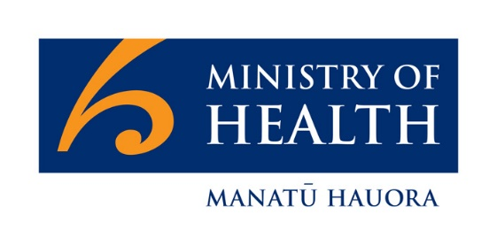
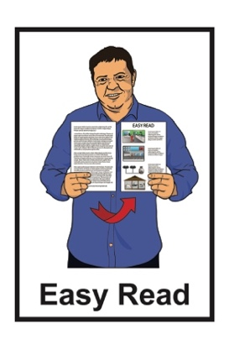

Summary of a plan for how Aotearoa New Zealand will manage COVID-19
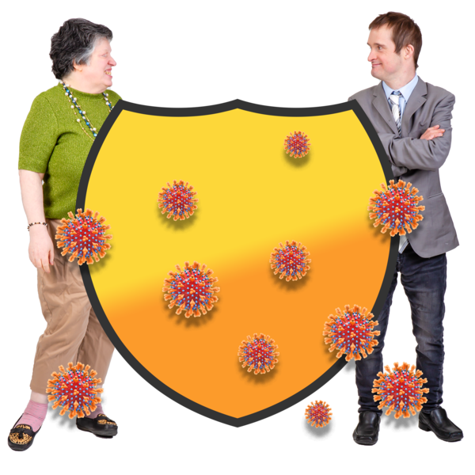

Published: February 2024

What this document is about

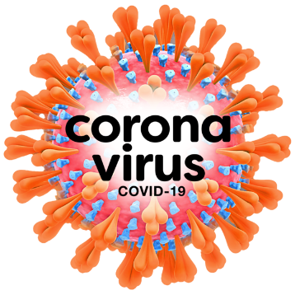
This Easy Read document is a summary of the Aotearoa New Zealand Strategic Framework for Managing COVID-19 from Manatū Hauora – Ministry of Health.

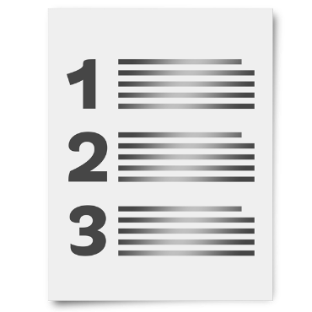
A summary is:
- shorter than the main report
- tells you the main ideas.

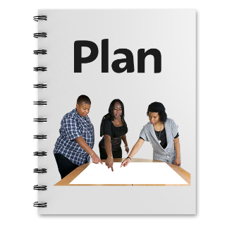
In this document the Aotearoa New Zealand Strategic Framework for Managing COVID-19 will be called the Strategic Framework.

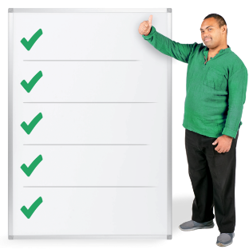
A Strategic Framework is the rules used to make a plan happen over a long time.

In this document we means Manatū Hauora – Ministry of Health.

What is the COVID-19 pandemic?

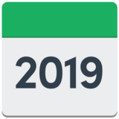
The COVID-19 pandemic started in 2019.

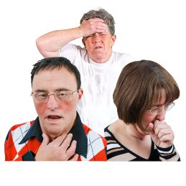
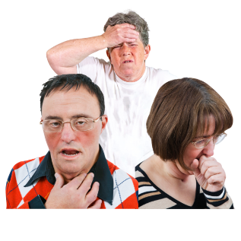
COVID-19 is a type of virus that makes people sick.

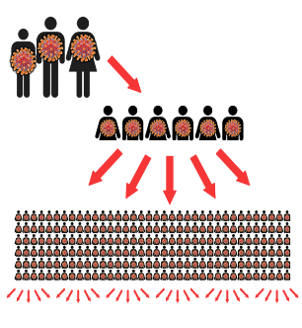
A pandemic is when many people around the world get the same sickness at the same time.


There is no cure for COVID-19 yet.

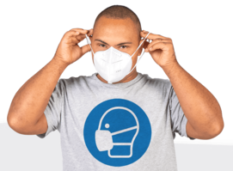
There were lots of rules to follow during the COVID-19 pandemic like:
- lockdown
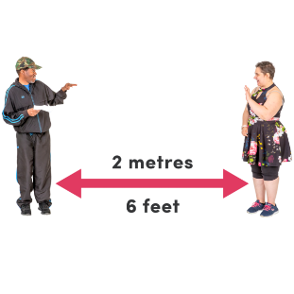
- wearing masks
- keeping a distance from people
- staying at home when sick
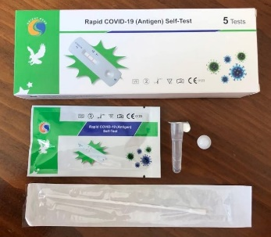
- taking tests
- getting the the COVID-19 vaccine.


Lockdown was when the Government asked everyone to stay at home so that they did not get COVID-19.

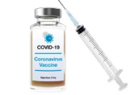
A vaccine is a medicine that can stop many people from getting very sick.

What is changing about COVID-19?

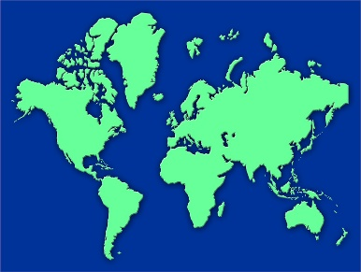
The COVID-19 pandemic has made big changes to life all around the world.

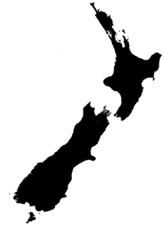
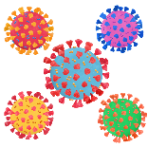
How we manage COVID-19 in Aotearoa New Zealand is changing.

We are not trying to stop COVID-19 coming into Aotearoa New Zealand.

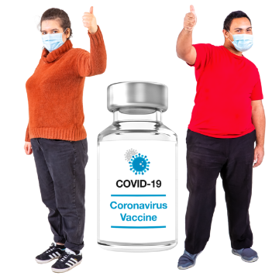
We now deal with COVID-19 by having:
- high levels of immunity
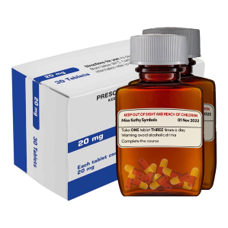
- better access to antivirals.

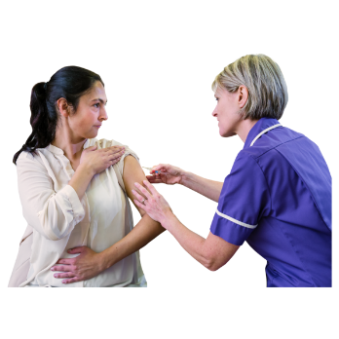
Immunity means:
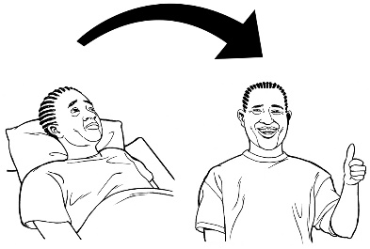
- once you have had COVID-19 you might not get it again
- getting vaccinated

This means:
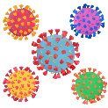

- you can avoid COVID-19 better
- your body can fight COVID-19 better if you get it.

Antivirals are a type of medicine that supports you getting better if you get COVID-19.

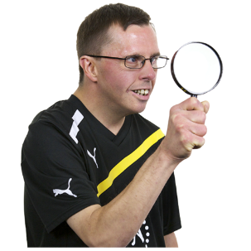

We also deal with COVID-19 with better ways to watch what is going on with the virus.


COVID-19 is hard to deal with because it is different to other viruses.

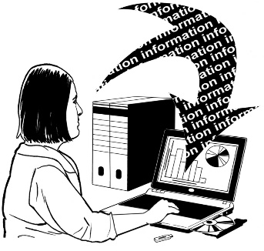
We will use what we now know about COVID-19 to be ready for other outbreaks.

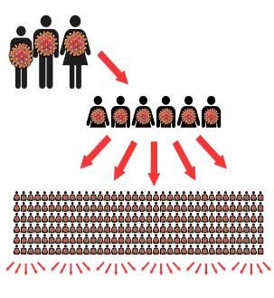
An outbreak is when a sickness happens again.

What will the Strategic Framework do?

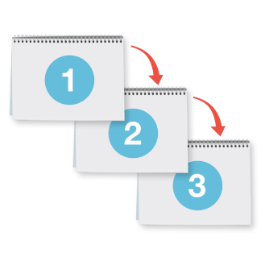
The Strategic Framework replaces other plans we have used to deal with COVID-19.

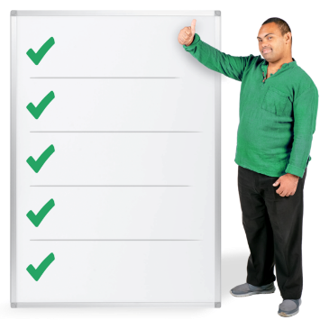
The Strategic Framework sets out:
- what we want to make happen
- the important things we will do for a long time.

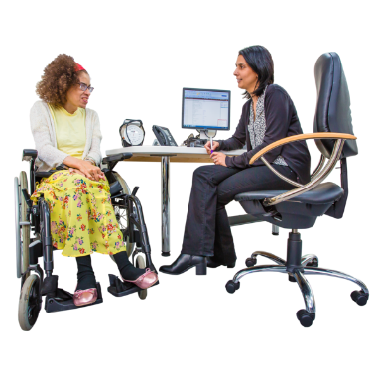
The Strategic Framework works on dealing with COVID-19 as an everyday part of our health system.

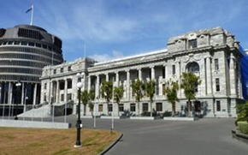
The Strategic Framework will:
- be the place the Government can get all its information from
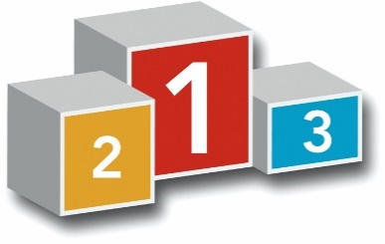
- show what is important for the government to do

- set up ways to deal with:
- COVID-19 outbreaks
- other pandemics that may happen.

Te Tiriti / The Treaty and COVID-19

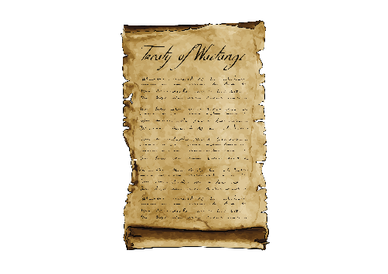
Te Tiriti o Waitangi / The Treaty of Waitangi is a big part of the Strategic Framework.

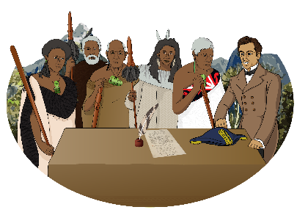
Te Tiriti o Waitangi / The Treaty of Waitangi is a legal document that was signed in 1840.

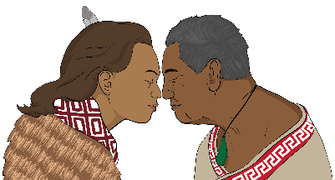
Te Tiriti / The Treaty is important to Aotearoa New Zealand.

It is about Māori and the New Zealand Government:
- making decisions together
- protecting things that are important to Māori.
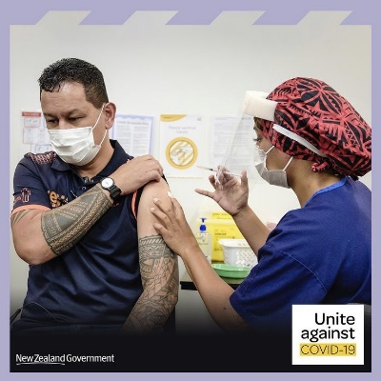
As part of the Strategic Framework the Government commits to working with Māori to:
- prepare for COVID-19
- manage COVID-19.

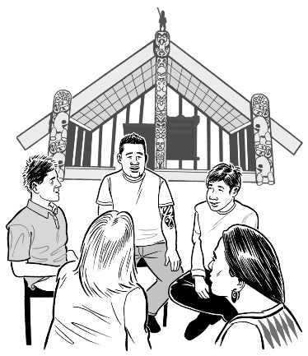
As part of the Strategic Framework the Government agrees to support tino rangatiratanga.

Tino rangatiratanga means decisions are made by Māori for Māori.
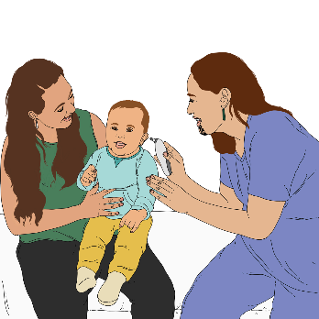

As part of the Strategic Framework the Government agrees to make health services that Māori need.

How we will make things fair
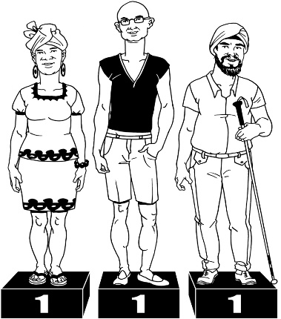
We will manage COVID-19 by using the ideas of:
- equity
and
- proportionality.

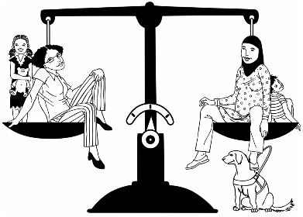
Equity means everyone gets what they need no matter who they are.

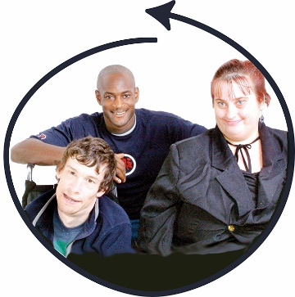
The Strategic Framework will make sure things are done in a fair way for people who are at a higher risk of getting COVID-19.

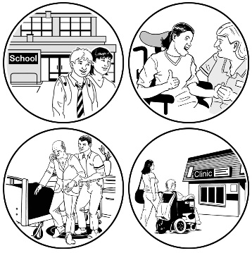
Proportionality means:
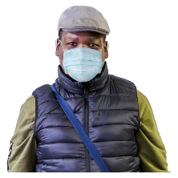
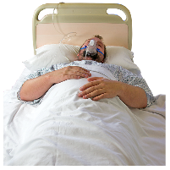
- the right amount of things are given to different groups of people depending on how many of them there are
and
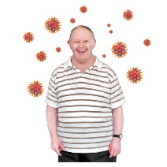
- the different problems they have with COVID-19.

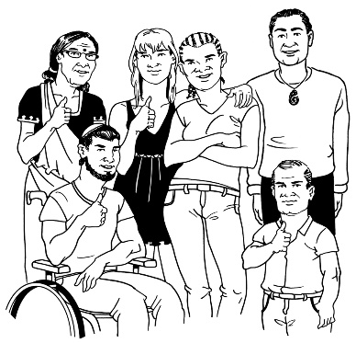
The Strategic Framework will make sure these different groups of people will get the right things they need all the time to deal with their COVID-19 problems.

What are the outcomes?
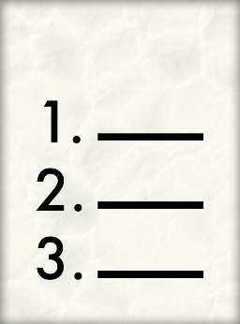

The Strategic Framework sets out 3 outcomes.

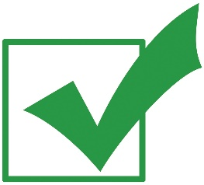
An outcome is a result you want to happen.

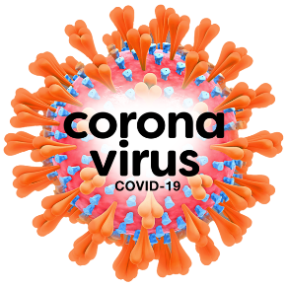
Outcome 1: Prepare

Outcome 1 is about being prepared for COVID-19 in the future.


The future is a time that is yet to happen.

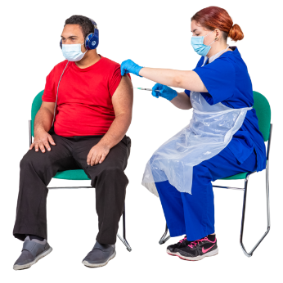
We want people to be vaccinated.

Being vaccinated:
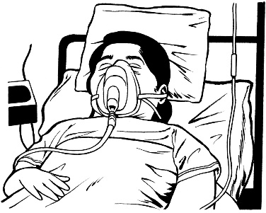
- protects you from being very sick
- slows down the spread of
COVID-19.

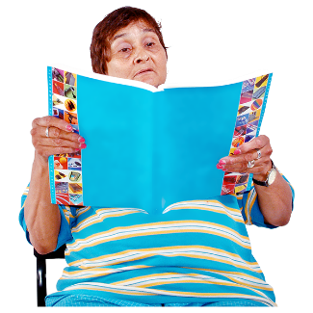
We want our experts to know:
- all about things about COVID-19 / the virus
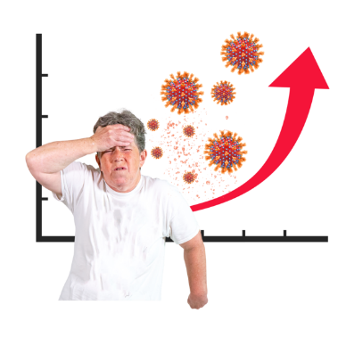
- what the virus is doing / how it is spreading
- how the virus is changing.

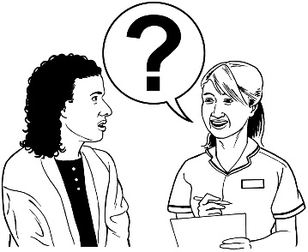
Understanding these things means we know:
- what happens when you get COVID-19
- how the Government deals with COVID-19 in our country.

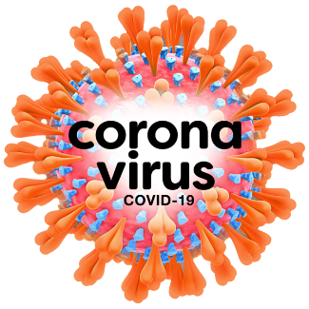
We want to have all the things ready to respond to COVID-19.

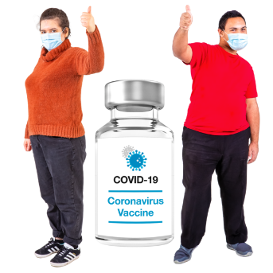
This can mean things like:
- vaccines
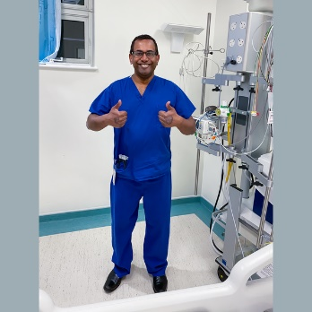
- medicines
- health care workers
- health care services.

This is so the Government can make changes:
- during outbreaks
- if a new COVID-19 variant happens.
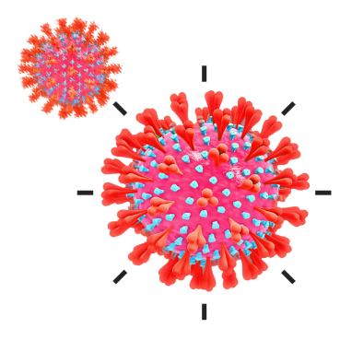

A variant is when a virus changes how it works.

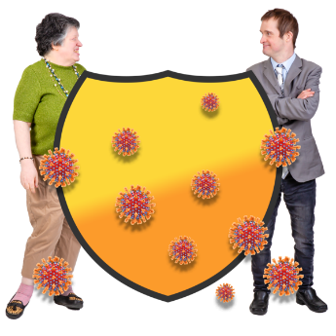
Outcome 2: Manage

Outcome 2 is about how we will manage the problems caused by COVID-19.

We want to manage the spread of COVID-19.

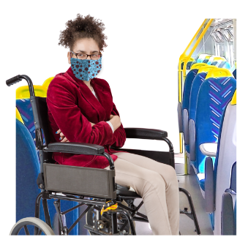
This is so people can still live their lives while keeping safe from
COVID-19.

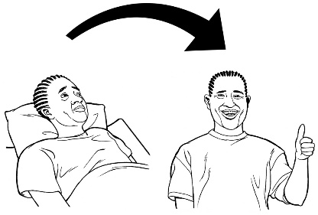
We want to manage treatment of COVID-19.

This is so people are looked after better when they are sick.

We want to manage the problems caused in our lives by COVID-19.

This is so:
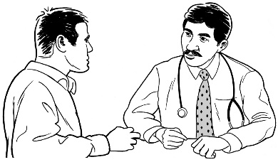
- people have their health taken care of
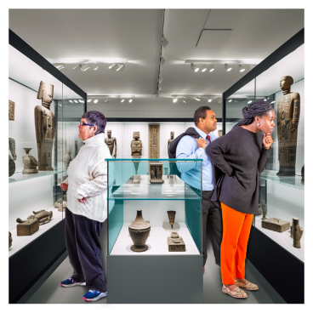
- we can do the things we like to do
- the economy can carry on as usual.

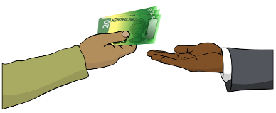
The economy is all the ways a country:
- makes money
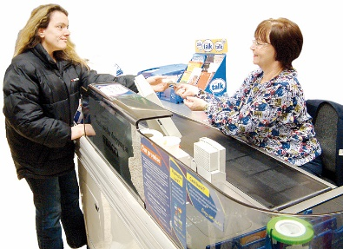
and
- spends money.

Outcome 3: Integrate
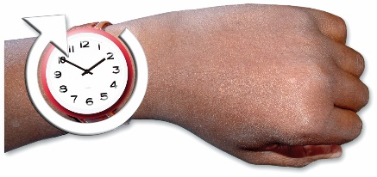
Outcome 3 is about managing COVID-19 for a long time.


All the things we learned during the COVID-19 emergency will be used to deal with:
- COVID-19 every day from now on
and
- other viruses.

We have all the rules ready in case things change again.

All the things we know about
COVID-19 will be used in our health system.

Keeping you informed about COVID-19

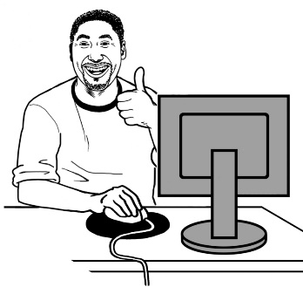
We will keep giving all the correct information to everyone about COVID-19.

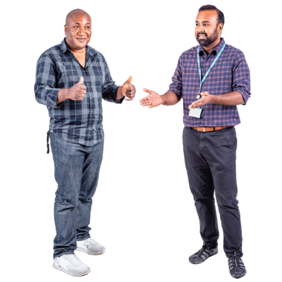
Having all the correct information means you can trust you are being looked after properly.

How we will check things

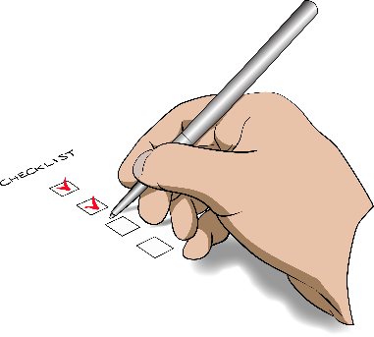
We have ways to keep checking we are doing the right things when dealing with COVID-19.


We will look at what:
- people are doing across the country to look after their health
- is happening at the places people enter or leave the country.

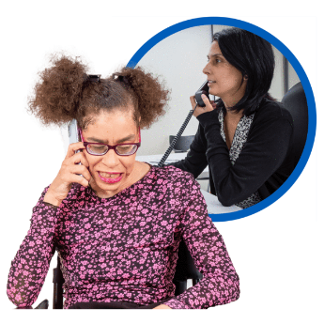
We can support people to look after their health.

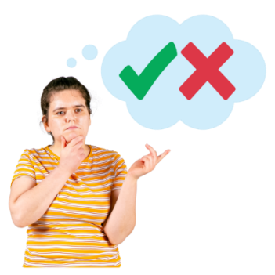
People who make big decisions can use the Strategic Framework to work out what is best for them to do.

Where to find more information

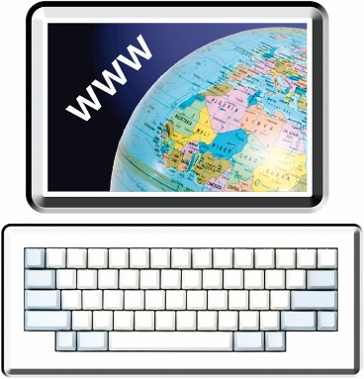
You can read the full Aotearoa New Zealand Strategic Framework for Managing COVID-19 at this website:

tinyurl.com/4jk24y8m

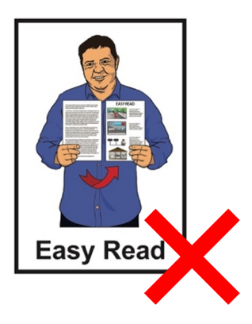
This website is not in Easy Read.

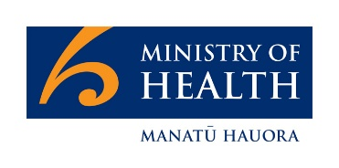
This information has been written by Manatū Hauora – Ministry of Health.

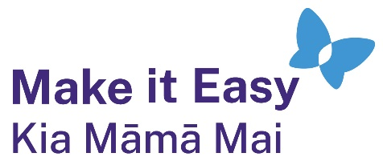
It has been translated into Easy Read by the Make it Easy Kia Māmā Mai service of People First New Zealand Ngā Tāngata Tuatahi.
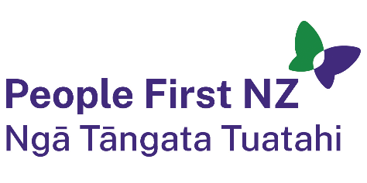
The ideas in this document are not the ideas of People First New Zealand Ngā Tāngata Tuatahi.
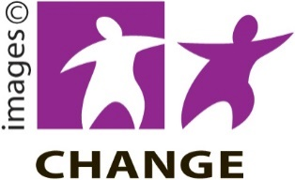
Make it Easy uses images from:

- Changepeople.org


            - Photosymbols.com


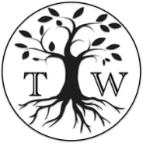
- SGC Image Works
- Huriana Kopeke-Te Aho
- T. Wood.
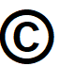
All images used in this Easy Read document are subject to copyright rules and cannot be used without permission.

