Greenhouse Gas Emissions Base Year Report and Inventory

2021

Revision history

|  |  |
| --- | --- |
| **Updated** | Details |
| December 2021 | *Greenhouse Gas Emissions Base Year Report and Inventory* published. |
| July 2023 | Miscalculation in our baseline inventory in Table 5 corrected. |

Citation: Ministry of Health. 2021. *Greenhouse Gas Emissions Base Year Report and Inventory*. Wellington: Ministry of Health.

Published in December 2021 by the Ministry of Health  
PO Box 5013, Wellington 6140, New Zealand

ISBN 978-1-99-110011-5 (online)  
HP 8013



This document is available at [health.govt.nz](http://www.health.govt.nz)

|  |  |
| --- | --- |
| **CCBY** | This work is licensed under the Creative Commons Attribution 4.0 International licence. In essence, you are free to: share ie, copy and redistribute the material in any medium or format; adapt ie, remix, transform and build upon the material. You must give appropriate credit, provide a link to the licence and indicate if changes were made. |

Contents

1 Introduction 1

2 Our commitment 1

3 Our statement of intent 2

4 Description of our organisation 3

5 Base-year selection 4

6 Ministry of Health organisational and operational boundaries included for this reporting period 5

7 Operational boundaries excluded from the Ministry of Health’s inventory 8

8 GHG emissions sources included in the Ministry of Health’s emissions inventory 10

9 Ministry of Health GHG emissions sources excluded from the emissions inventory 12

10 Data collection and uncertainties 14

11 Ministry of Health GHG emissions report summary 17

12 Calculations and results 18

13 Conclusion 19

Appendix 1: Ministry of Health GHG inventory – base year 20

List of Tables

Table 1: Brief description of the Ministry of Health’s operational boundaries 6

Table 2: Properties excluded from the Ministry of Health’s operational boundaries 9

Table 3: Summary of the Ministry of Health’s GHG emissions sources excluded from the emissions inventory 13

Table 4: Details of the Ministry of Health’s GHG emission sources included in the emissions inventory 15

Table 5: Ministry of Health GHG emissions summary 17

List of Figures

Figure 1: Ministry of Health organisational boundaries 5

Figure 2: Ministry of Health operational boundaries 6

Figure 3: Summary of the Ministry of Health’s GHG emissions sources included in the emissions inventory 11

Figure 4: Ministry of Health GHG emissions by scope 18

Figure 5: Ministry of Health GHG emissions by source 18

# Introduction

This document provides a base-year report and inventory for the greenhouse gas (GHG) emissions for Ministry of Health | Manatū Hauora (the Ministry). The inventory has been prepared in accordance with the requirements of:

* the Carbon Neutral Government Programme (CNGP)[1]
* the Greenhouse Gas Protocol (GHG Protocol)[2]
* International Standards ISO 14064-1:2018[3]

and with guidance from:

* Ministry for the Environment | Manatū mō te Taiao (MfE)
* Ministry of Business, Innovation and Employment | Hīkana Whakatutuki (MBIE).

# Our commitment

The GHG inventory forms part of the Ministry’s commitment to measuring and managing our emissions in support of the CNGP.

# Our statement of intent

We aim to:

* achieve carbon neutrality by 2025
* measure, manage, verify and report on our emissions annually
* reduce our GHG emissions and implement a reductions plan by end of 2022 with a 1.5°C target reduction pathway
* optimise our vehicle fleet to electric vehicles (EVs) or hybrids where practical[4]
* build or lease energy-efficient buildings with ratings at a minimum of four stars (or new builds of five stars) for our office requirements over 2,000 m2
* offset our remaining emissions where it is impractical to reduce them.

# Description of our organisation

The Ministry leads the health and disability system and has overall responsibility for the management and development of that system.

As kaitiaki of the health and disability system, the Ministry has a role and responsibility of stewardship to sustain, nurture, grow and develop the system. We steer improvements that help New Zealanders live longer, healthier and more independent lives.

The Ministry funds an array of national services (including disability support services and public health services) and provides clinical and sector leadership.

The Ministry ensures that the health and disability system is delivering on the Government’s priorities and that health sector organisations are well governed and soundly managed from a financial perspective. To do this, the Ministry:

* advises the Government
* funds, monitors and drives the performance improvements of health sector crown entities, including district health boards (DHBs)
* supports the planning and accountability functions of health sector crown entities, including DHBs
* regulates the sector and ensures legislative requirements are being met.

The Ministry is made up of directorates and business units, each with its own functions and areas of responsibility.

The property portfolio under the Ministry’s operational control operates across New Zealand, from Auckland through to Invercargill, in various property types.

# Base-year selection

In determining the base year for this report, the Ministry has consulted with MfE and other government agencies and agreed that, due to the variabilities presented by COVID-19, the base year should fall before March 2020. Thus, the base year for this GHG emissions report is set as 1 March 2019–29 February 2020.

Where data was impractical to source for the base-year period, we sourced an alternative time period of data (as close to the base year as possible) to best represent ‘business as usual’ for those specific emissions sources as noted in the inventory.

# Ministry of Health organisational and operational boundaries included for this reporting period

Organisation boundaries refer to the legal composition of an organisation and determine whether the Ministry has direct control over the sources of its emissions.

The organisational boundaries at the time of the base year (1 March 2019–29 February 2020) were set with reference to the methodology described in the GHG protocol standards.[5]

This protocol allows for two approaches to consolidate GHG emissions: the equity share (financial) approach and the control (operational) approach. For the purposes of the Ministry’s reporting, the control approach has been used to account for emissions.

Figure 1 describes the Ministry’s organisational boundaries, including excluded services and what would otherwise be assumed as being under the Ministry’s operational control.

Figure : Ministry of Health organisational boundaries

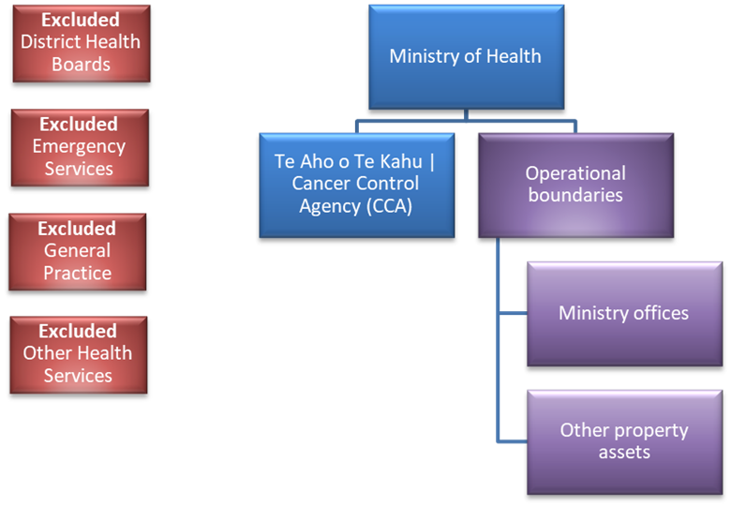

Figure 2 represents the structure of the operational boundaries defined in the GHG emissions inventory, which includes all owned and leased properties directly under the Ministry’s operational control or co-located premises where noted.

Figure : Ministry of Health operational boundaries

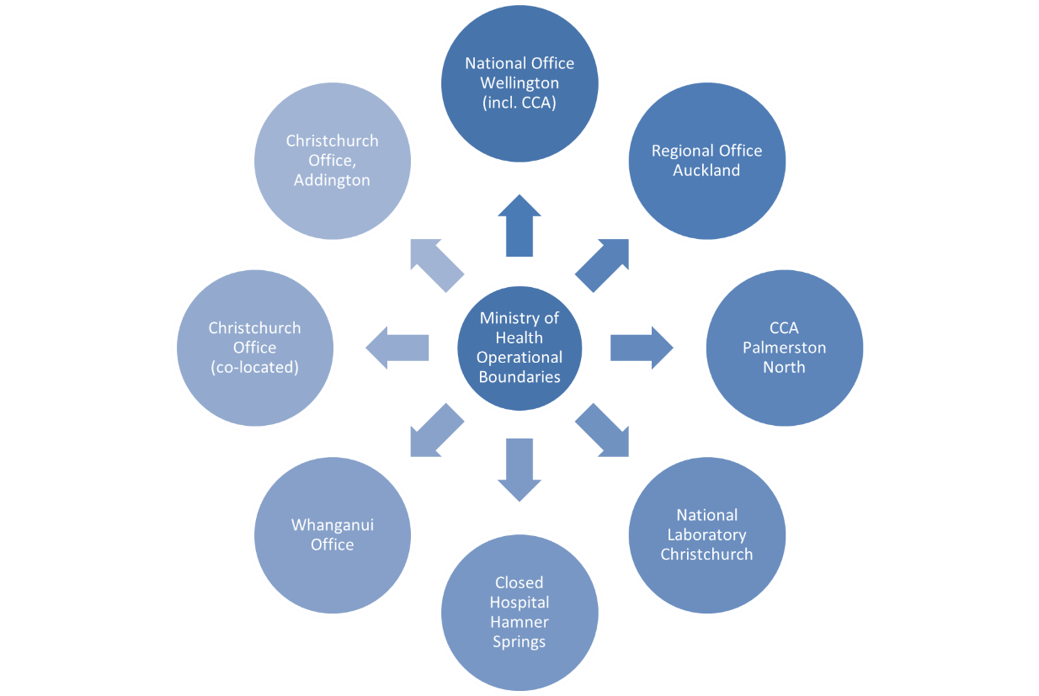

**Note**: Hospitals that have closed and are included in the Ministry’s operational boundaries are the result of a transfer of assets from the respective DHBs. Such hospitals are then reported under the Ministry’s operational control, form part of the emissions inventory and are excluded from DHB GHG reports.

Table : Brief description of the Ministry of Health’s operational boundaries

| **Property** | **Address** | **Description** |
| --- | --- | --- |
| Wellington Head Office | 133 Molesworth Street | Head office responsible for oversight and operational management of property portfolio. This site also accommodates Te Aho o Te Kahu | Cancer Control Agency (CCA) staff. CCA will be reporting their own inventory, however, the Ministry absorbs some of their sources. |
| Auckland Office | 650 Great South Road | Ministry office |
| Whanganui Office | 179 St Hill Street | Ministry office and call centre |
| Christchurch Office co‑location | 48 Hereford Street | Co-located office with the Ministry of Education as the lead agency |
| Christchurch Office Addington | 39 Moorehouse Avenue | Ministry office – energy bills only. The lease had expired however the Ministry continued to pay energy bills until August 2021. |
| Hamilton Fleet Vehicle | 87 Alexandra Street | Fleet vehicle on site to be reported only |
| Dunedin Office | 481 Moray Place | Ministry office |
| Hanmer Springs Closed Hospital | 28 Amuri Avenue | Closed hospital, minor maintenance conducted at this site |
| Whanganui Prescriptions Warehouse | 137 London Street | National prescriptions warehouse and storage |
| Christchurch National Laboratory | 108 Victoria Street | National laboratory and storage site |
| Wellington Office | 116 Lambton Quay | Ministry office |

# Operational boundaries excluded from the Ministry of Health’s inventory

Table 2 lists the properties that have recently been leased or where no emissions were produced (within the financial year 20/21). These properties are not relevant to the base year in which this report and GHG emissions inventory were consolidated. For transparency, this provides an overview of the current state of the Ministry’s property portfolio and potential for inclusion in future GHG reports and inventories.

Some properties do not sit under the Ministry’s operational control (for example, co‑located tenancies), however, if the emissions data can be sourced, future GHG emissions reports will note the relevant portion of their emissions outputs as per their associated scope. If this is not achievable, each lead agency shall report their emissions inclusive of their co-located tenants.

Note: The Ministry does not have operational control over DHBs, therefore their emissions are not included in this report. Each DHB will be required to produce their own GHG emissions inventories. Currently 7 of the 20 DHBs report on their emissions annually and are certified under the Toitū Envirocare programme.[6]

Table : Properties excluded from the Ministry of Health’s operational boundaries

|  |  |  |
| --- | --- | --- |
| **Property** | **Address** | **Description** |
| Hamilton | 16 Clarence Street | Te Aho o Te Kahu | Cancer Control Agency (CCA) – not under Ministry operational control, however, the agency agreement sits within the Ministry. Due to small staffing numbers (4–5 staff), this site has been excluded from this report. The emissions produced from this site will be reported separately via CCA’s GHG report. |
| Palmerston North | 619 Featherston Street | CCA – not under Ministry operational control, however, the agency agreement sits within the Ministry. Due to small staffing numbers (5–6 staff), this site has been excluded from this report. The emissions produced from this site will be reported separately via CCA’s GHG report. |
| Christchurch | 32 Oxford Street (The Loft) | CCA – not under Ministry operational control, and the Ministry has no influence over the operation of this building. Due to low staffing numbers (4–5 staff), this site has been excluded from the Ministry’s inventory. The emissions produced from this site will be reported separately via CCA’s GHG report. |
| Invercargill | 194 Dee Street | Closed hospital, minor maintenance conducted as required, however, no emissions were produced in the base year where data could practically be sourced, and there is no operational or energy use activity at this site. |
| Hamilton | 87 Alexandra Street | Small number of staff housed (approximately 8), which is assumed minor. Not under Ministry operational control as the lease agreement is per seat, and the Ministry has no influence over the operation of this building; part of the Waikato DHB. The Ministry’s fleet vehicle, however, is included in the Ministry’s inventory. |
| Wellington | 83 Molesworth Street | Secondary Ministry office housing approximately 160 staff. Leased in 2021, to be included in future inventories. The Ministry has some operational control over this property at the time of this report, however, given the date of leasing, this property is not relevant to the base year. |

# GHG emissions sources included in the Ministry of Health’s emissions inventory

The GHG emissions sources included in this inventory were identified following the methodology described in the GHG Protocol and ISO 14064-1:2018standard.

The emissions sources are also referenced in the MfE’s, *Measuring Emissions: A guide for organisations*,[7]which specifies the various types of emissions the organisation would typically report on, dependant on the type of organisation and its operational functions.

As adapted from the GHG Protocol, the emissions were classified under the categories of:

* **Direct GHG emissions (Scope 1):** emissions from sources that are owned or controlled by the agency
* **Indirect GHG emissions (Scope 2):** emissions from the generation of purchased electricity, heat and steam consumed by the agency
* **Indirect GHG emissions (Scope 3):** emissions that occur as a consequence of the agency’s activities but from sources not owned or controlled by the agency.

The emissions sources listed in Figure 3 have been identified and included in the GHG emissions inventory and are relevant to the Ministry’s operational boundaries.

Figure : Summary of the Ministry of Health’s GHG emissions sources included in the emissions inventory

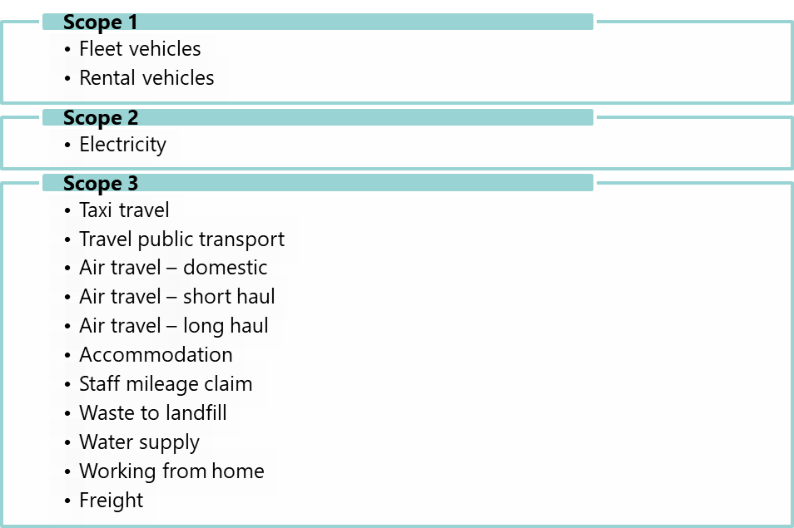

# Ministry of Health GHG emissions sources excluded from the emissions inventory

Due to the base year period (1 March 2019–29 February 2020), the emissions sources in Table 3 below have been excluded from the Ministry’s operational boundaries (as per Table 2). However, we can expect them to be included in future GHG emissions reports and added to the Ministry’s operational boundaries.

Properties deemed outside the Ministry’s operational control, for example, small co‑located tenancies as shown in table 1 of this report, will be reported as an exclusion.

Various factors can be involved in the decision to exclude an emissions source from the Ministry’s organisation boundaries for the base-year period. These include but are not limited to:

* the type of lease agreement in place
* the practicality of sourcing the emissions
* total occupied space
* the number of Ministry full-time-equivalent (FTE) staff working in the premises
* the emissions source being less than 1 percent of the total emissions within that source and not greater than 5 percent of the total emissions.

Table : Summary of the Ministry of Health’s GHG emissions sources excluded from the emissions inventory

|  |  |  |  |
| --- | --- | --- | --- |
| **Scope** | **Address** | **Reason** | **Source** |
| Scope 2 | 83 Molesworth Street, Wellington | Not relevant for base year. The Ministry leased this site in May 2021, and it will be included in future emissions reports. | Electricity used |
| Scope 2 | 87 Alexandra Street, Hamilton | Not relevant for base year, however, the data is impractical to source as it is not a sole-tenanted site/floor. This site is out of the Ministry’s operational control. It is part of the DHB and will be reported in their emissions. | Electricity used |
| Scope 2 | 16 Clarence Street, Hamilton  619 Featherston Street, Palmerston North  32 Oxford Street, Christchurch | CCA sites, which will be reported separately via CCA’s GHG report. As a result, these emissions are excluded from this inventory. | Electricity used |
| Scope 2 | 20 Buckleys Road, Christchurch | The data is impractical to source as the lease agreement is per seat leased. This site is out of the Ministry’s operational control. | Electricity used |
| Scope 2 | 194 Dee Street, Invercargill | No emissions have been produced and no operational activity has been conducted at this closed site. Potential future emissions will depend on the future use of this property. | All emissions |
| Scope 3 | All sites | During the reporting period, there was sufficient office space for staff to be accommodated within the existing office buildings. The Ministry’s flexible first policy[8] was adopted in 2020 post-COVID 19. | Working from home |
| Scope 3 | 116 Lambton Quay | Due to the nature of the reporting, the supplier was unable to provide accurate data and has only been able to provide data outside the base period. This site has since been handed over and is no longer under the Ministry’s operational control. | Waste |
| Scope 3 | All sites, excluding Wellington Head Office | See GHG inventory for details. All other sites are seen as being de minimis (or too insignificant to merit consideration) compared with the largest site – Head Office (133 Molesworth Street). | Water |

# Data collection and uncertainties

Table 4 provides an overview and an explanation of any uncertainties or assumptions. The calculation methodology has been used to quantify the emissions inventory, using emissions source activity data multiplied by the emissions factors. Further details around how the data was sourced are included in the GHG inventory (see Appendix 1: Ministry of Health GHG inventory – base year).

All emissions factors have been sourced from guidance provided by the MfE, specifically their *Measuring Emissions* guide.[9]

Table : Details of the Ministry of Health’s GHG emission sources included in the emissions inventory

| **Business unit** | **Activity** | **Scope** | **Data source** | **Data unit of measure** | **Uncertainty (description)** |
| --- | --- | --- | --- | --- | --- |
| All | Fleet | Scope 1 | Fleet summary | Kilometre (km) | It is assumed that the data collected about fleet utilisation is complete and accurate, however, due to the current manual processes in managing the Ministry’s fleet, there is potential for an element of human error. |
| All | Rental vehicle | Scope 1 | Rental vehicle report | km | It is assumed that the data sources represent a complete account of the travel activity. Emissions are reported per vehicle type and assume that the same or a similar type of vehicle was supplied across the class type. Specific engine size is sourced from the carsguide website at: carsguide.com.au and assumes we are using 2018-year vehicles, which is consistent across rental agencies. Factors used for vehicle post 2015. It is noted in the inventory where certain suppliers have reported that their data does not reflect these assumptions, for example, Hertz® reported VIN rather than emissions factors. |
| All | Electricity | Scope 2 | esmart.smartpower reporting tool | Kilowatt hours (kWh) | It is assumed that the report is complete and accurate. This excludes the sites not under the operational control as described in the operational boundary exclusions section of this report. |
| All | Air travel – domestic | Scope 3 | AIRNZ report (tandem travel) | Flight km | It is assumed that the report is complete and accurate. The unit of measurement is shown as KM due to the airline being unable to supply aircraft type or report as per the Ministry’s operational boundaries. |
| All | Air travel – short haul | Scope 3 | AIRNZ report (tandem travel) | Flight km | It is assumed that the report is complete and accurate. The unit of measurement is shown as KM due to the airline being unable to supply aircraft type or report as per the Ministry’s operational boundaries. |
| All | Air travel – long haul | Scope 3 | AIRNZ report (tandem travel) | Flight km | It is assumed that the report is complete and accurate. The unit of measurement is shown as KM due to the airline being unable to supply aircraft type or report as per the Ministry’s operational boundaries. |
| All | Hotel stay | Scope 3 | Accommodation report (tandem travel) | Per night | It is assumed that the report is complete and accurate. Emissions factors to be used are only provided in CO2-e. No other factors have been provided. Tarawa (Kiribati), Rarotonga (Cook Islands) and Niue did not supply emissions factors, so we have used the emissions factors for the closest country geographically to represent these three countries. |
| All | Taxi travel | Scope 3 | Cab charge report (tandem travel) | km | It is assumed that the report is complete and accurate. Litres could not be provided so km and default emissions factors were used for consistency across the inventory. |
| All | Waste | Scope 3 | Waste management report | Kilogram (kg) | It is assumed the report is complete. N2O and CO2 are excluded. Previous data representing base years could not be provided due to the inaccuracy of the reporting by the supplier, therefore the period 1 April 2020–31 March 2021 has been provided, which shows a higher level of confidence in the accuracy of the data.  We were unable to obtain data for sites outside the Ministry’s operational control. |
| All | Staff mileage | Scope 3 | Finance mileage report | km | Estimated assumption based on national vehicle ownership data to determine the split between petrol (91 percent) and diesel (9 percent) of light passenger vehicles. Default emissions factors were used. |
| All | Water supply | Scope 3 | Invoices | m3 | Invoices are charged in quarters, and the reporting period for this base year differs slightly at each end. The data is based on 1 February 2019–7 February 2020. There are seven extra days included in this data. Days have varied dependant on the days the meters were checked. The inventory is not based on invoice dates. An average calculation has been subtracted to remove the additional seven days. This relates to the largest site 15,537sqm. Every other respective site is considered de minimis, with the second largest site equating to less than 1 percent of total emissions. |
| All | Freight | Scope 3 | Freight mileage report | km | Using motor vehicle register: 79 percent of goods vans / trucks and utility vehicles are diesel, and therefore it is assumed that the figure used for the emissions factor is for diesel vehicles. |
| All | Working from home | Scope 3 | NA | Employee per day | During the reporting period, there was sufficient office space for staff to be accommodated within the existing office buildings. The Ministry’s flexible working policy[10] was adopted in 2020 post-COVID 19. |
| All | Travel public transport | Scope 3 | Expenses claim report | $ value | Public transport is reported from expense claims, where staff travelled for work purposes using methods of transport such as trains, busses, etc. This does not include taxi fares or rental vehicles – these are reported separately. |

# Ministry of Health GHG emissions report summary

Table 5 shows the Ministry’s total emissions for the period 1 March 2019–29 February 2020. The sums are expressed as kilograms of carbon dioxide equivalent (kg CO2e). A complete and quantified breakdown of this information can be found in the Ministry’s GHG inventory (Appendix 1: Ministry of Health GHG inventory – base year).

Table : Ministry of Health GHG emissions summary

|  |  |  |  |  |  |  |  |
| --- | --- | --- | --- | --- | --- | --- | --- |
| **Scope** | **Kg CO2** | **Kg CH4** | **Kg N2O** | **Kg HFCs** | **Kg PFCs** | **Kg SF6** | **Total tCO2e** |
| Scope 1 | 22,581 | 154 | 575 | 0 | 0 | 0 | 23.31 |
| Scope 2 | 141,618 | 5637 | 202 | 0 | 0 | 0 | 147.46 |
| Scope 3 | 1,642,718 | 109,394 | 21,109 | 0 | 0 | 0 | 1795.46 |
| **Total** | **1,806,918** | **115,185** | **21,886** |  |  |  | **1,966.23** |

Notes:

CO2 = carbon dioxide

CH4 = methane

N2O = nitrous oxide

HFCs = hydroflurocarbons

PFCs = perfluorinated chemicals

SF6 = sulfur hexafluoride

# Calculations and results

Figure 4 provides the totals of the Ministry’s emissions per scope. See section 8 of this report for the definition of each scope.

Figure : Ministry of Health GHG emissions by scope

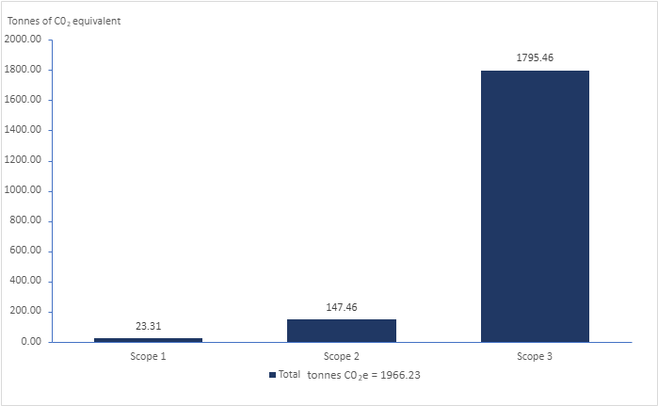

Figure 5 provides the totals of the Ministry’s emissions per source.

Figure : Ministry of Health GHG emissions by source

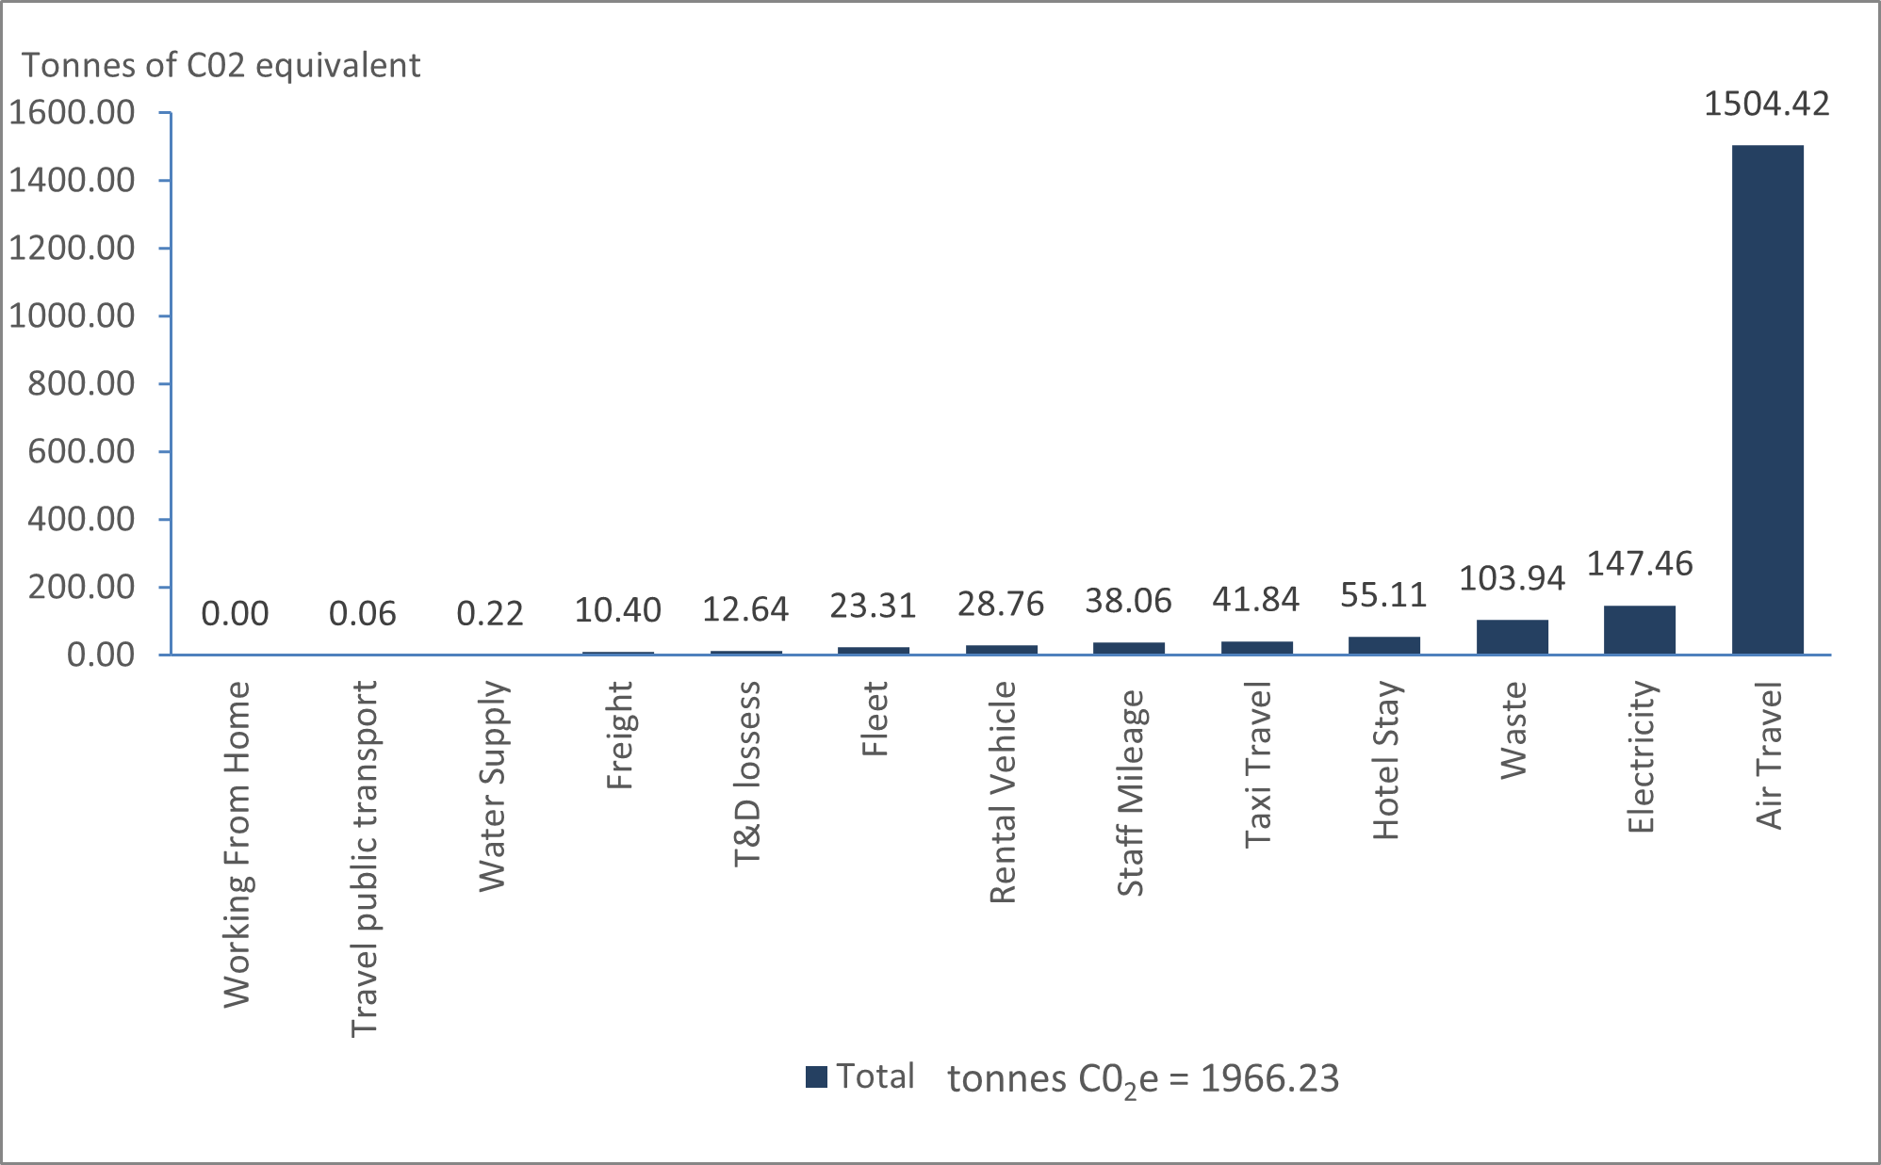

# Conclusion

For the base year (1 March 2019–29 February 2020), this report concludes that the Ministry’s highest emissions source was from air travel.

As indicated in section 5, the Ministry has chosen this period to reflect as close to business as usual (BAU) as possible, recognising that the COVID pandemic has influenced our largest emissions sources, and will continue to do for the financial years 20/21 and likely 21/22.

This report provides a framework for the Ministry to measure, verify and report on our emissions annually. Once the data has been verified, the Ministry will develop a reductions plan with a 1.5°C target reduction pathway.

# Appendix 1: Ministry of Health GHG inventory – base year

See attached.

1. New Zealand Government. 2020. Public sector to be carbon neutral by 2025. Releases. URL: [www.beehive.govt.nz/release/public-sector-be-carbon-neutral-2025](http://www.beehive.govt.nz/release/public-sector-be-carbon-neutral-2025) (accessed 30 November 2021).
2. Greenhouse Gas Protocol. About Us. URL: <https://ghgprotocol.org/about-us>.
3. ISO. 2018. ISO 14064-1:2018: *Greenhouse Gases – Part 1: Specification with guidance at the organization level for quantification and reporting of greenhouse gas emissions and removals*. Geneva: International Organization for Standardization (ISO). URL: [www.iso.org/standard/66453.html](http://www.iso.org/standard/66453.html) (accessed 30 November 2021).
4. In line with the government’s policy for reducing emissions – see the Reducing government fleet emissions webpage on the New Zealand Government Procurement website at: [www.procurement.govt.nz/broader-outcomes/reducing-emissions-and-waste/reducing-gqovernment-fleet-emissions](http://www.procurement.govt.nz/broader-outcomes/reducing-emissions-and-waste/reducing-gqovernment-fleet-emissions/).
5. Greenhouse Gas Protocol. nd. *The Public Sector GHG Accounting and Reporting Standard, Provisional draft.* URL: <https://ghgprotocol.org/sites/default/files/standards_supporting/provisional-draft.pdf> (accessed 7 December 2021).
6. See the Carbon Programmes & Certification webpage on the Toitū Envirocare website at: [www.toitu.co.nz/what-we-offer/carbon-management](http://www.toitu.co.nz/what-we-offer/carbon-management).
7. MfE. 2020. *Measuring Emissions: A guide for organisations, 2020 quick guide.* Wellington: Ministry for the Environment (MfE). URL: [https://environment.govt.nz/publications/measuring-emissions-2020-quick-guide](https://environment.govt.nz/publications/measuring-emissions-2020-quick-guide/) (accessed 7 December 2021).
8. The Ministry supports a balance between the requirements of work, personal and family/whānau commitments, as well as enabling staff to undertake volunteer activities outside work. Staff can discuss and agree with their managers ways of working that take into account their personal commitments and the business needs of the Ministry, including for example: working remotely, working reduced hours, working compressed hours, job sharing and using flexi-time.
9. MfE. 2020. *Measuring Emissions: A guide for organisations, 2020 quick guide.* Wellington: Ministry for the Environment (MfE). URL: [https://environment.govt.nz/publications/measuring-emissions-2020-quick-guide](https://environment.govt.nz/publications/measuring-emissions-2020-quick-guide/) (accessed 7 December 2021).
10. The Ministry supports a balance between the requirements of work, personal and family/whānau commitments, as well as enabling staff to undertake volunteer activities outside work. Staff can discuss and agree with their managers ways of working that take into account their personal commitments and the business needs of the Ministry, including for example: working remotely, working reduced hours, working compressed hours, job sharing and using flexi-time.