
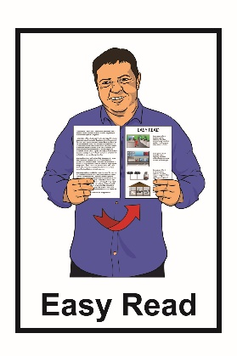

Changing the New Zealand mental health laws
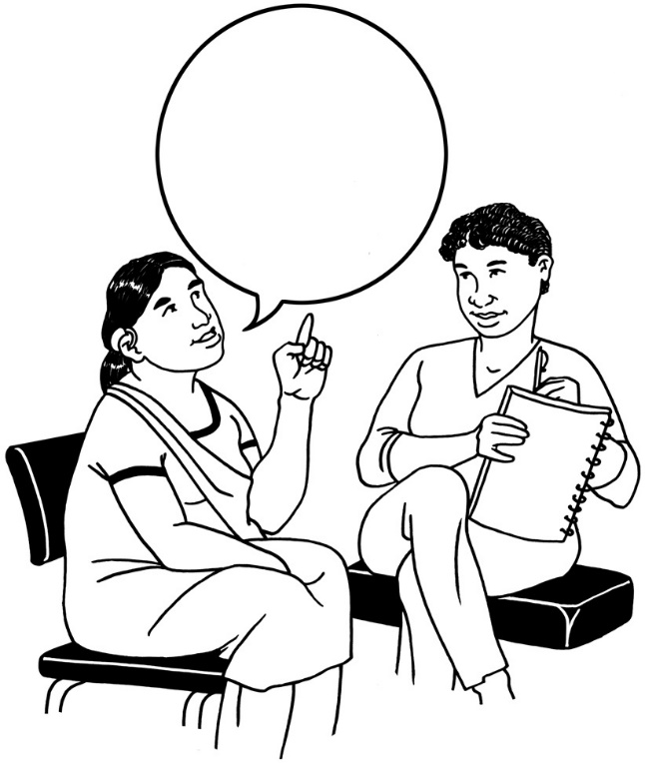


Have your say

December 2021
Before you read this document
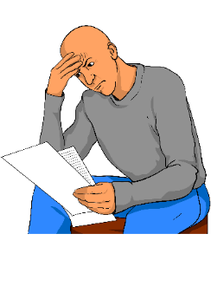

This is a long document.

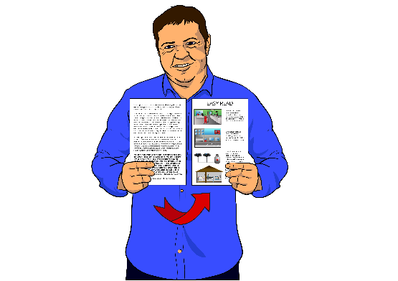
While it is written in Easy Read it can be hard for some people to read a document this long.

Some things you can do to make it easier are:
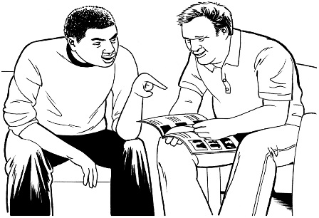
- read it a few pages at a time

- have someone help you to understand it.

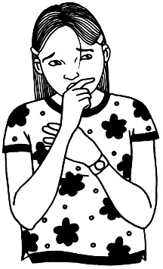
Some of the information in the document may upset people when they read it.

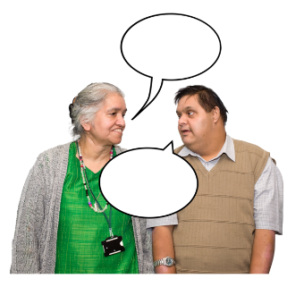
If you are worried after reading the document you can talk about it with someone you trust like:

- your family / whānau

- your friends
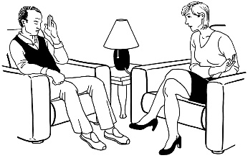
- your support workers

- a counsellor.


You can call Need to Talk if you want to talk to a counsellor about how you are feeling.

Need to Talk is a free phone or text counselling service in New Zealand.

You can contact Need to Talk by:

Phone: 1737
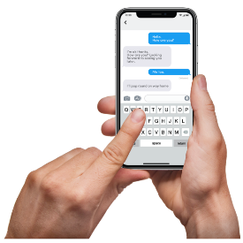

Text: 1737

If you are still worried and do not feel safe you can call the police:

- Phone: 111 if you need help straight away
- Phone: 105 if you need the police and you do not need help straight away.

What you will find in here

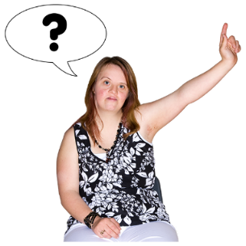
Page number:

Official Information Act………………8

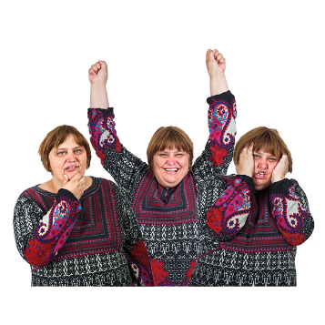
What is this document about?..........9

What is mental health?...................11
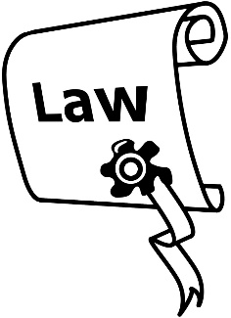

What is the Mental Health Act?......14

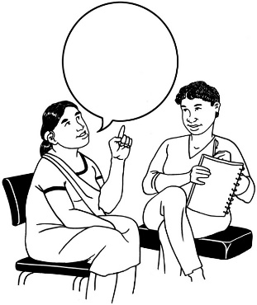

Changing the Mental Health Act….17

What we want to find out…………..20

Page number:
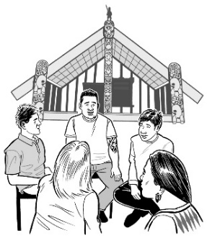

Māori being part of the law changes……………………………..22

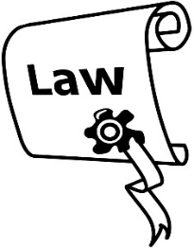
Why do we need mental health
laws?..............................................23


What we want to know about capacity……………………………...25

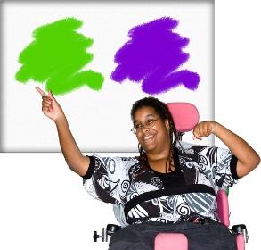
What we want to know about making choices……………………..27

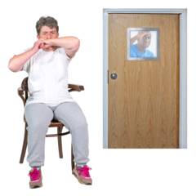
What we want to know about
using restrictive practices………….29

Page number:
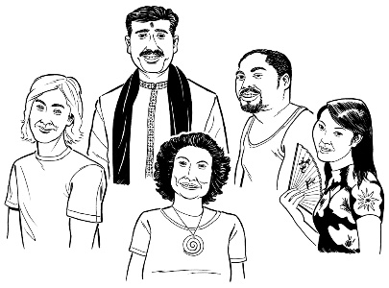

What we need to do differently
for people with cultural needs……..31
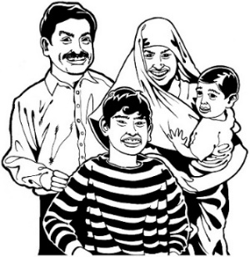

What we need to do differently for family / whānau…………………33

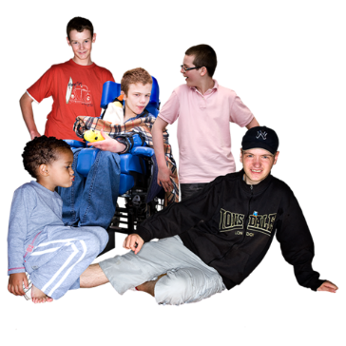
What we need to do differently for children and young people…….34


What we need to do differently for disabled people…………………35

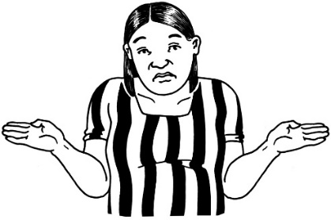
What we need to do differently for special patients…………………36

Page number:
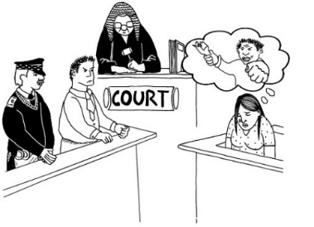

Protecting your rights in court……..39

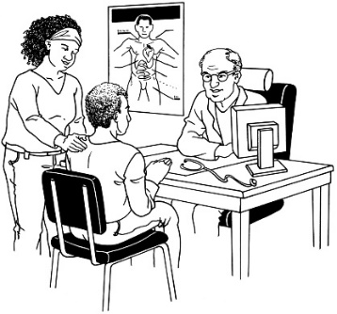
Protecting your rights with clinical decisions……………………42

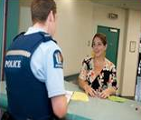
Protecting your rights with
the police…………………………….43

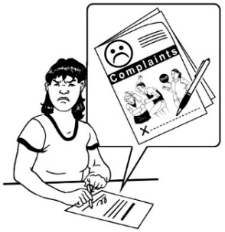
Protecting your rights when making a complaint………………...45


Where to find more information…...47
Official Information Act

Anyone can ask to see all the answers we get through the Official Information Act.

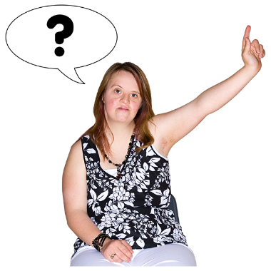
The Official Information Act is a law that lets anyone ask government to see information that the government holds.
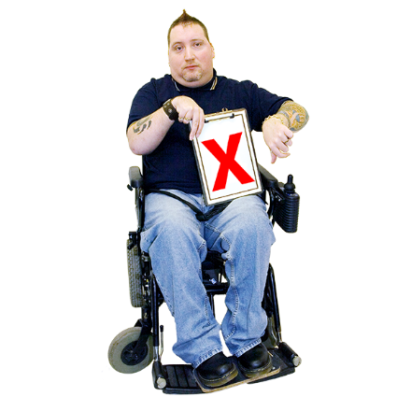

The government can say no if there is a good reason that people should not see the information.
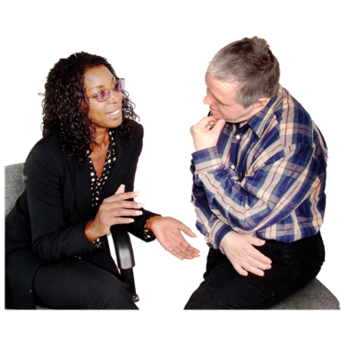

If you do not want your information to be seen by other people please let us know.

What is this document about?

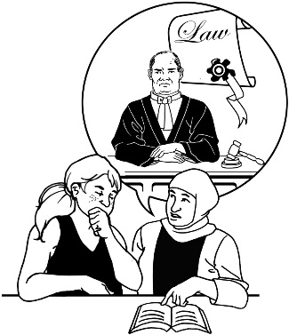
This Easy Read document is about changing mental health laws in New Zealand.

Mental health is how you:
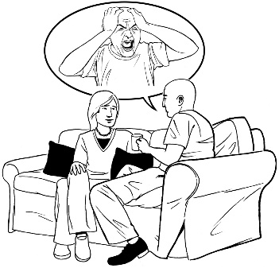
- think about things
- feel about things
- look after how you are feeling.
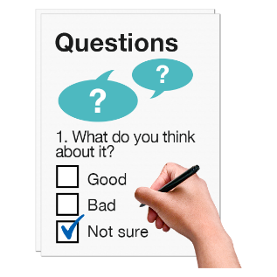
The Ministry of Health would like to ask you some questions about changing mental health laws in New Zealand.


You do not need to answer all the questions.

You can answer the questions online at our Health Consultation Hub at:
https://bit.ly/3kS9Owd

You can email your answers to us at:
mhactreview@health.govt.nz
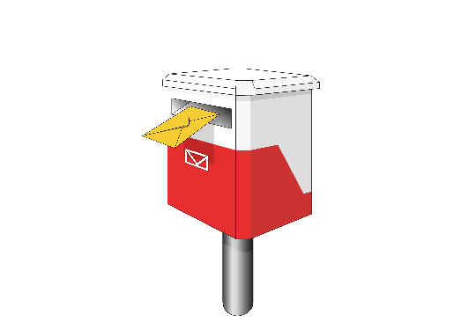
You can post your answers to:

Consultation: Transforming mental health law in Aotearoa New Zealand
Ministry of Health
PO Box 5013
Wellington 6140


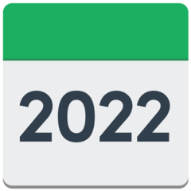
We need your answers by
28 January 2022.
What is mental health?

Mental health is how you:
- think about things
- feel about things
- look after how you are feeling.

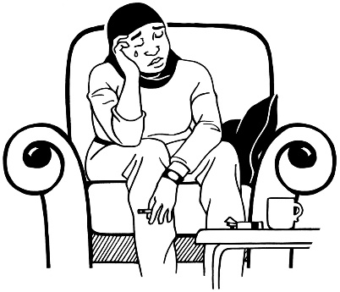
Your mental health can go up or down.

Sometimes people have good mental health. Sometimes people can be having a hard time.

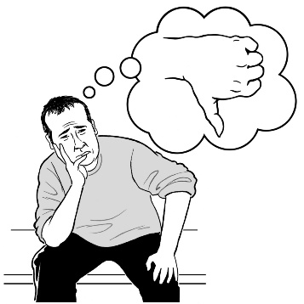
Sometimes people need support to manage their mental health.


Mental health can be managed by things like:
- getting exercise


- talking to family and friends

- going to a support group

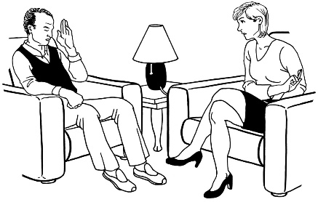
- taking medication
- talking to someone like a psychiatrist.


A psychiatrist is a doctor who:
- knows a lot about mental health
- supports people to have better mental health
- may give you medication to help you feel better.

What is the Mental Health Act?
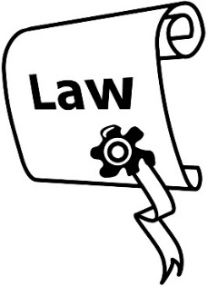

The Mental Health Act is a New Zealand law.

Sometimes mental health can be hard to manage.
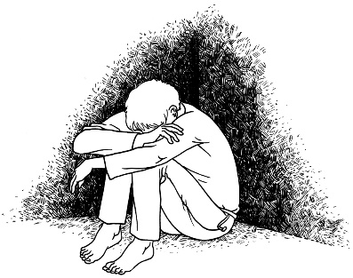
When someone has very bad mental health a doctor might call it an abnormal state of mind.


An abnormal state of mind means that they might:
- hurt someone

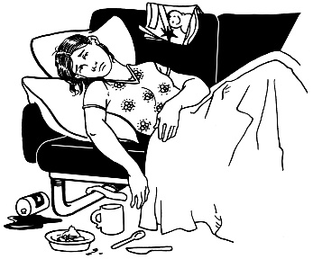
- hurt themselves

- not be able to take care of themselves.
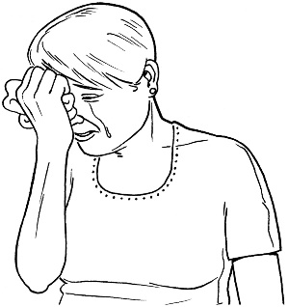
This will not happen to everyone who needs support with their mental health.

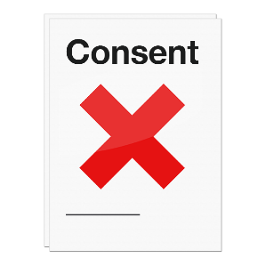
The Mental Health Act says that a person can be made to have mental health treatment without their consent.
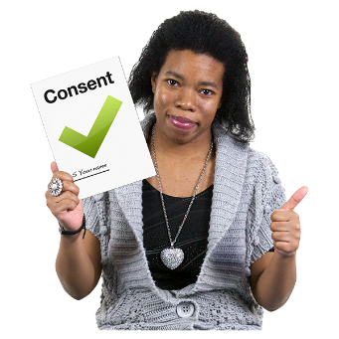
Consent means saying yes to something happening.

This means if a person is having a very hard time with their mental health a doctor can make them get treated even if they do not want to.

Being treated without your consent is called compulsory treatment.

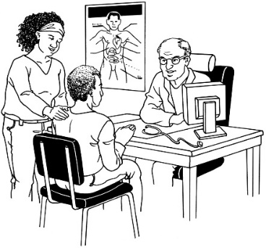
Many people go to a doctor for mental health support.

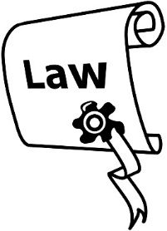
Not many people are put under the Mental Health Act.
Changing the Mental Health Act

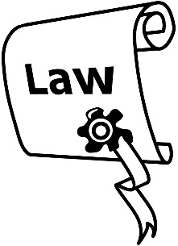
The Mental Health Act was made in 1992.

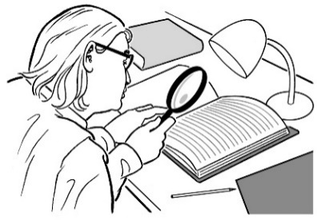
We have learnt a lot of new things about mental health since then.

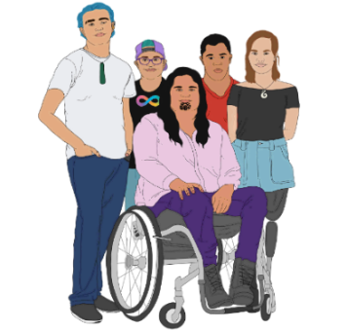
We have also learnt that the Mental Health Act is not fair to:
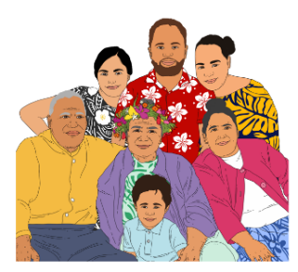
- Māori
- Pasifika
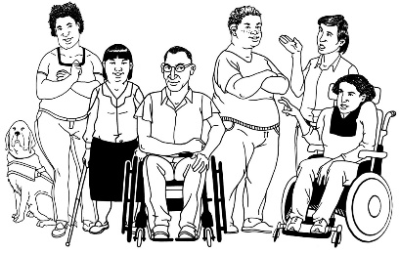
- disabled people.

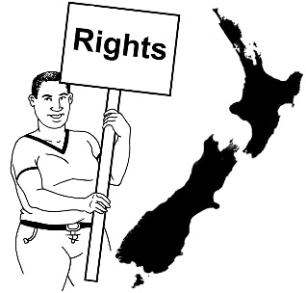
Some reasons we think the Mental Health Act needs to change are:
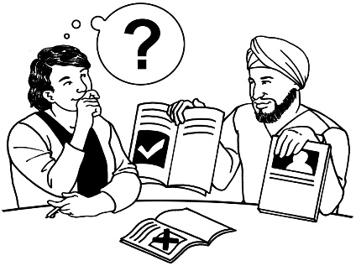
- the human rights of people need to be respected

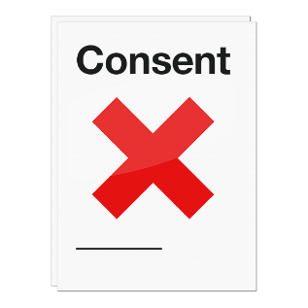
- people are sometimes not supported to make their own choices
- the way people can be made to have medical treatments without their consent may not be fair
- restrictive practices are used too often
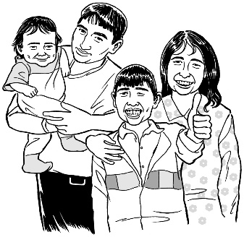
- we need to make it easier to include family / whānau in mental health support
- to make sure children are treated well.

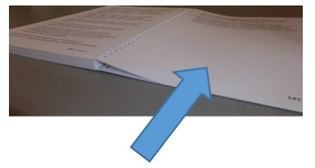
We take a look at what restrictive practices are on pages 28 to 29.
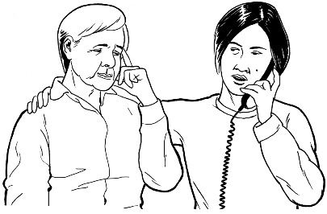
Some other reasons we think the Mental Health Act needs to change are:


- disabled people need better support
- so that courts know how to support people
- so that police know how to work with people having a hard time with their mental health
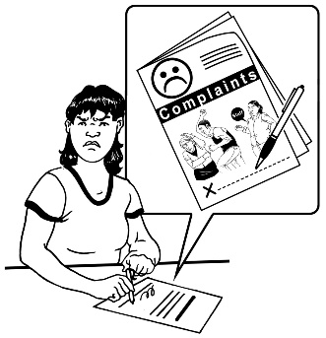
- to make it easier to make a complaint.

What we want to find out

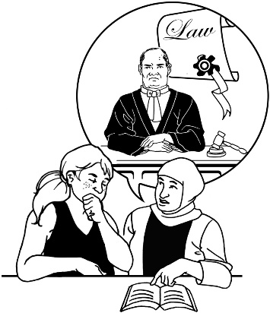
We want to find out what you think needs to change in the Mental Health Act.

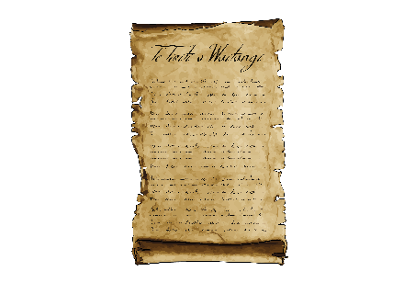
We want to ask questions about:

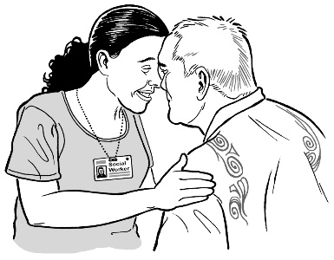
- Te Tiriti o Waitangi / the Treaty of Waitangi

- why we need to have mental health laws
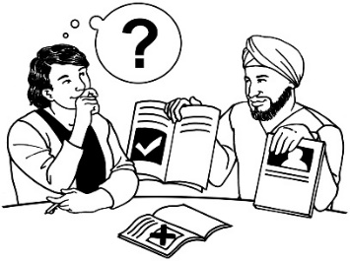
- Māori ideas on the law changes
- cultural needs
- people making their own choices
- restrictive practices.

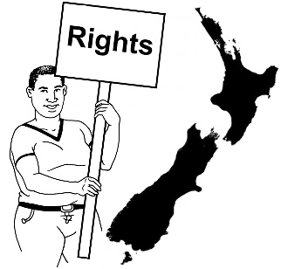
We also want to ask questions about how to:

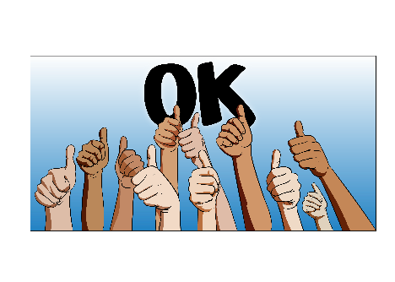
- protect human rights
- make sure everyone follows the new laws.

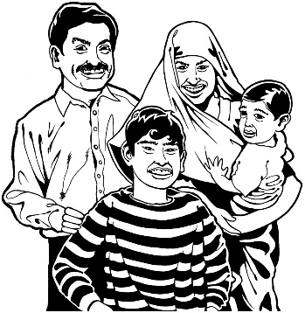
We also want to ask how we can do things better for:
- people with different cultural needs

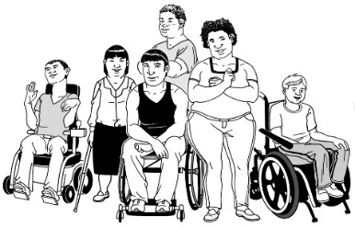
- family / whānau
- children
- young people
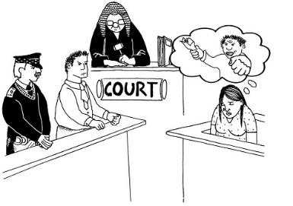
- disabled people

- people in the courts.

Māori being part of the law changes
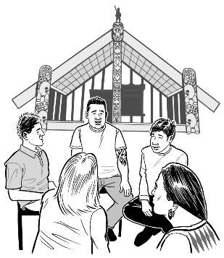

Māori ideas need to be part of the law changes.

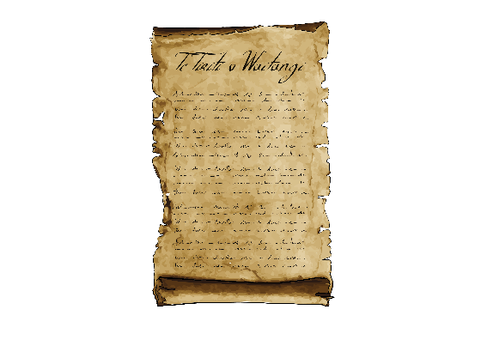
This means we also need to make the new laws fit with Te Tiriti o Waitangi / Treaty of Waitangi.

How can we:
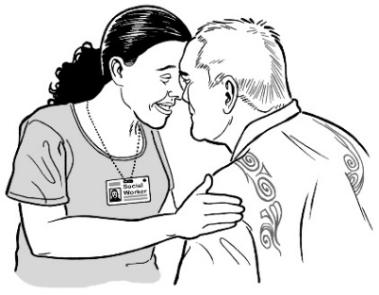
- make the new laws fit with Te Tiriti o Waitangi?

- have Māori ideas in the new laws?
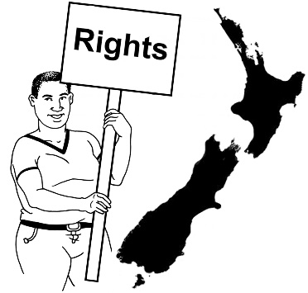
- make sure the new laws respect the rights of Māori?
- support the cultural needs of everyone?
Why do we need mental health laws?


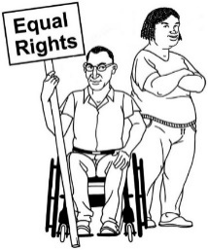
Human rights belong to every person in the world.

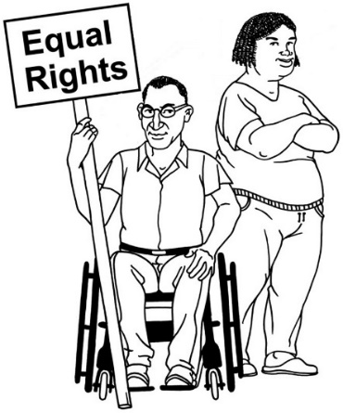
Human rights are rights to make sure everyone:
- is treated fairly
- has what they need to live a good life.


1 of these rights is the right to refuse medical treatment.

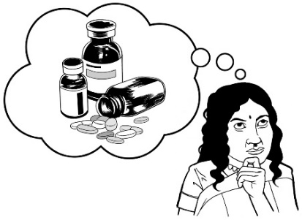
To refuse medical treatment means that you do not have to take any medicine or other treatment that a doctor says you should take.


Do you think the law should ever make people have compulsory treatment?

What we want to know about capacity

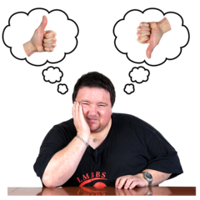
Capacity is a word used to say if a person can make their own decisions.

If a person does not have capacity the law lets someone else make decisions about them.
Sometimes having mental health issues can make it too hard for someone to have the capacity to make their own choices.
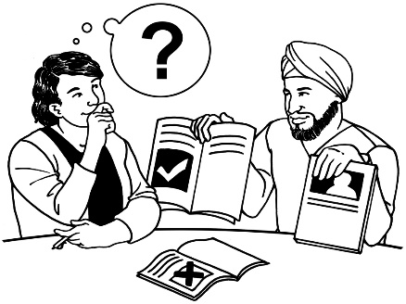
A lot of countries will only let someone else make the choices about your treatment if you cannot make the choices yourself.


What do you think NZ should do if someone is finding it hard to make their own decisions because of their mental health?

What we want to know about making choices
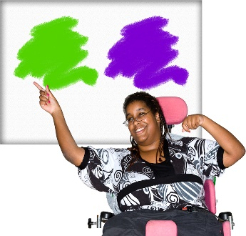

People have the right to make choices about their own life.

This includes having medical treatment.

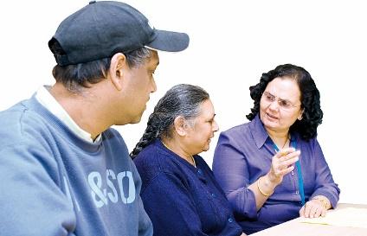
Sometimes people need support to make choices about what happens to them.

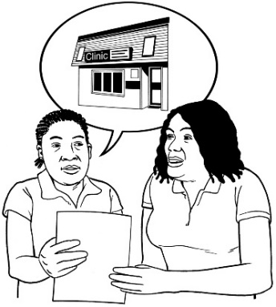
This is called supported decision making.

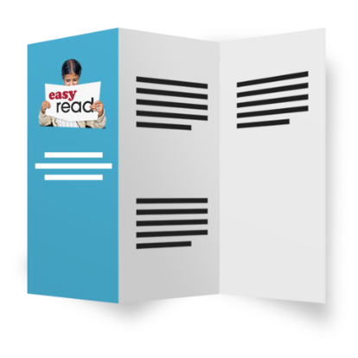
Supported decision making is when people have:

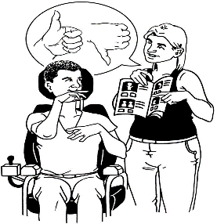
- all the information they need in a way they can understand to make a decision

- the support they need to make decisions like a support person.

How should people who do not have capacity be supported to make their own choices?

What we want to know about using
restrictive practices

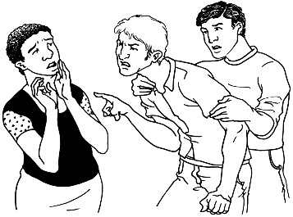
Restrictive practices are when health workers use things to stop a person moving like:
- seclusion
- restraint.
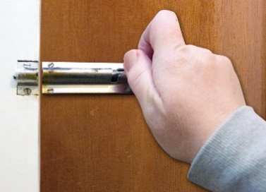
Seclusion is when a person is put alone in a locked room.

Restraint is when a person is stopped from moving around, even if they want to move.

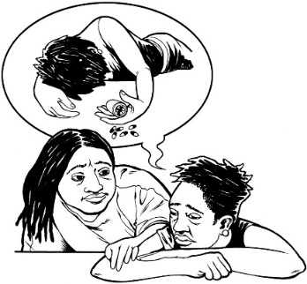
Restrictive practices are used when a health worker is worried a patient might hurt:

- themselves
- other people.

The Ministry of Health wants to stop using seclusion.

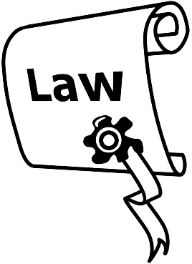
What do you think the new law should say about using:

- seclusion?

- restraint?


How can the new law make restrictive practices:

- safer?
- not used as much?
What we need to do differently for
people with cultural needs
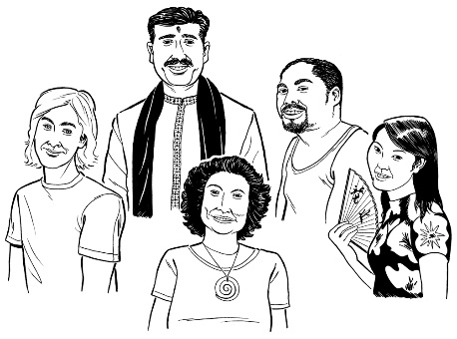

New Zealand is home to people from lots of different cultures.

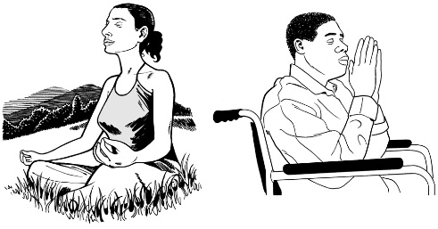
It is important that we look at the cultural needs of people when supporting them with their mental health.

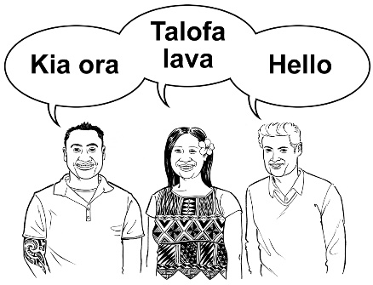
Cultural needs can be things like:

- language

- religious beliefs
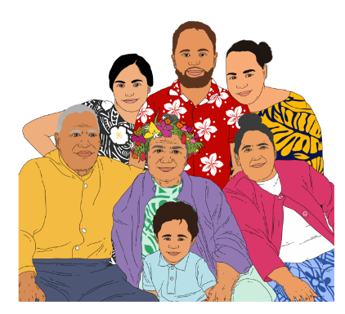
- traditional customs or ways of life

- family ways of life.
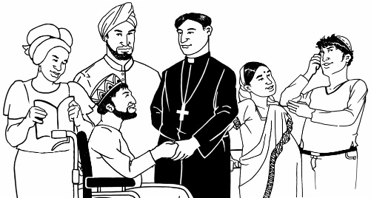
Do you think the law should say that people must be treated in ways that understand their culture?

What we need to do differently for
family / whānau
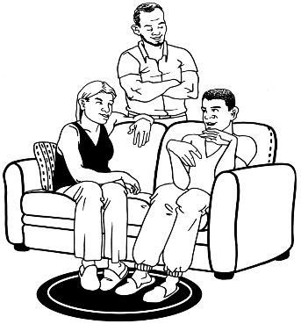

Family / whānau can be good support for people who are having a hard time with their mental health.

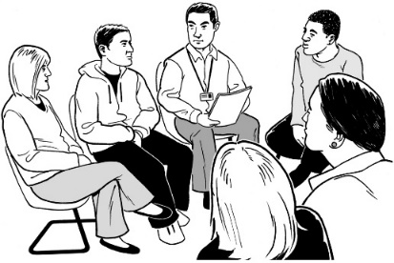
Sometimes the family / whānau may need more support as well.

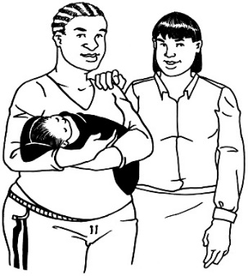
Do you think the law should say that the family / whānau of a person can be part of their care?

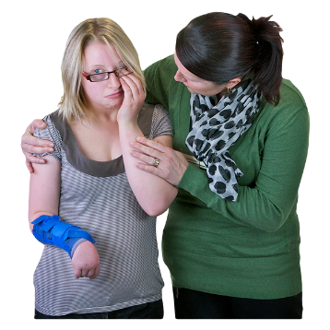
What should happen if someone does not want their family / whānau to be part of their care?

What we need to do differently for
children and young people

Sometimes compulsory treatment is used for:

- children

- young people.


We need to think about how compulsory treatment will work for them.

How do you think compulsory treatment should work for children and young people?
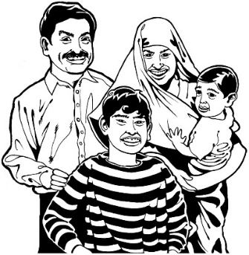

How would the family / whānau be a part of this care?

What we need to do differently for
disabled people


A person cannot be put under the Mental Health Act just for having a disability.


Disabled people can be put under the Mental Health Act if they are having a hard time with their mental health.

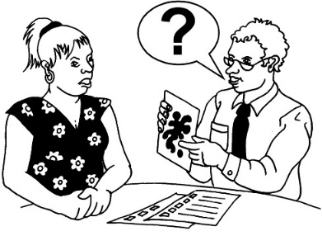
Disabled people can also have compulsory treatment if a psychiatrist says they must be put under the Mental Health Act.

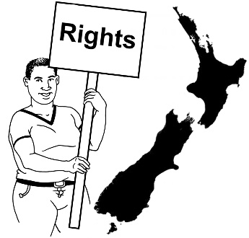
How do we need to change the laws to make sure the rights of disabled people are protected?
What we need to do differently for
special patients

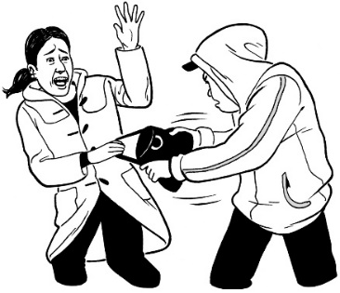
Special patients are people who:

- do not have good mental health

- have broken the law.


Breaking the law means doing something bad like:

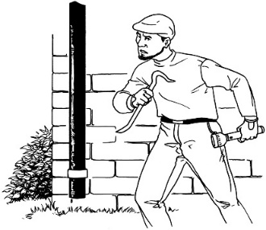
- hurting someone
- stealing.

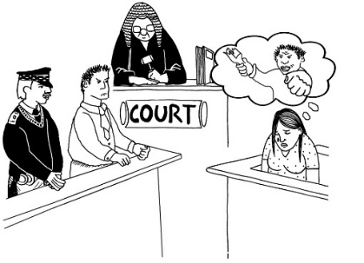
If someone is a special patient that means the court says they are unfit to stand trial.

Unfit to stand trial means that they cannot understand enough to be able to be part of a court case.


Sometimes a judge may say that they are not guilty by reason of insanity.

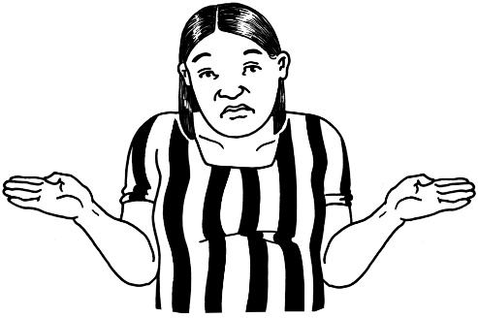
Not guilty by reason of insanity means that because of their mental health the person:
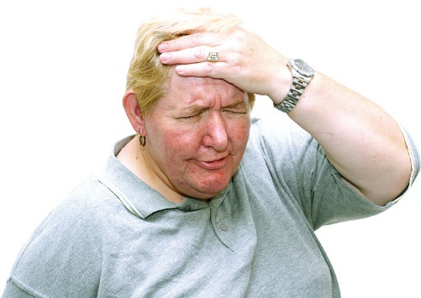
- did not know what they were doing
- did not understand that what they were doing was a crime.

People who are unfit to stand trial or not guilty by reason of insanity can be made special patients under the Mental Health Act.
All special patients can be given compulsory mental health treatment, even if they do not want treatment.

How can we make new laws about compulsory treatment safe for special patients?

Protecting your rights in court
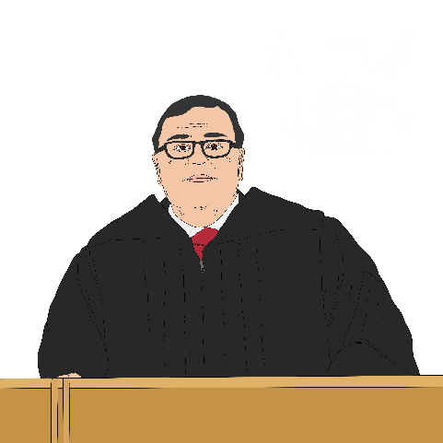

A judge from the family court decides if someone gets compulsory treatment.
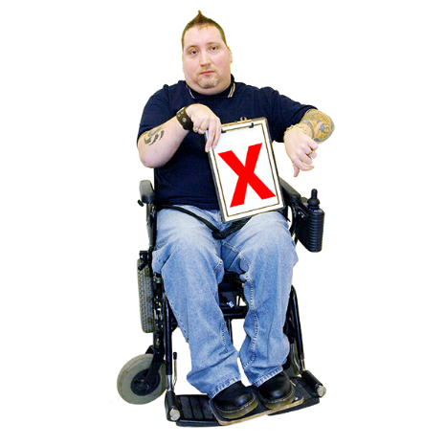

If someone does not agree with getting compulsory treatment then they can ask for the decision to be reviewed.

Getting a court decision reviewed means someone else will:
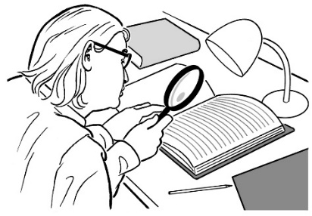
- look at the decision

- decide if it was the right decision.


The review is done by the Mental Health Review Tribunal.

The Mental Health Review Tribunal is a group of people who check if a person should be under the Mental Health Act.
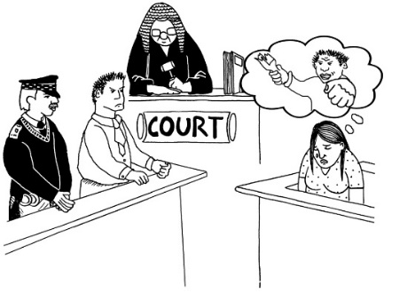

Some people have said that it is difficult to use:
- the Family Court
- the Mental Health Review Tribunal.

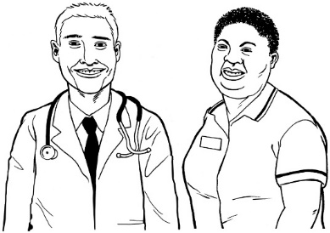
People also said that judges listen to doctors more than they listen to family / whānau.

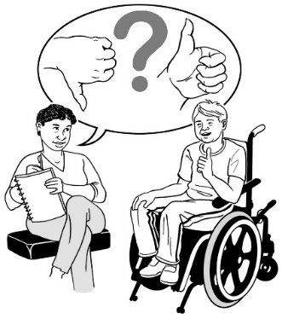
How can we make courts better for people who need support for their mental health?
Protecting your rights with clinical decisions

A clinical decision is when a medical professional says what treatment a person should get.
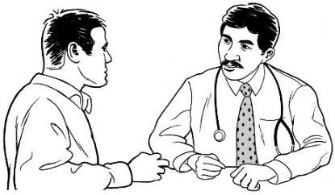

A medical professional is someone like:
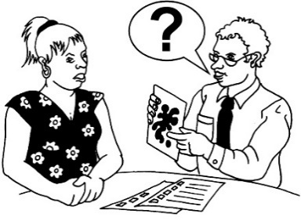
- a doctor
- a psychiatrist.
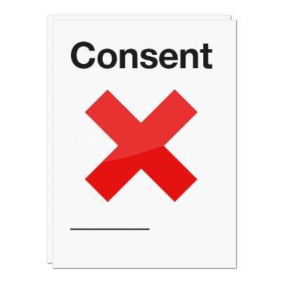

If someone is under the Mental Health Act they have to do what their medical professional says even if they do not want to.

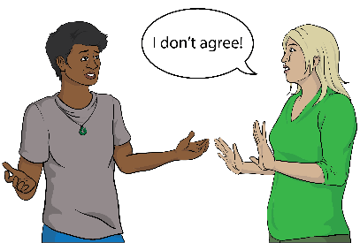
What do you think should happen when someone does not agree with a clinical decision?
Protecting your rights with the police

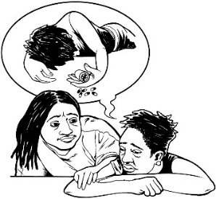
Sometimes police get called when someone is acting like they might hurt:

- themselves
- someone else.
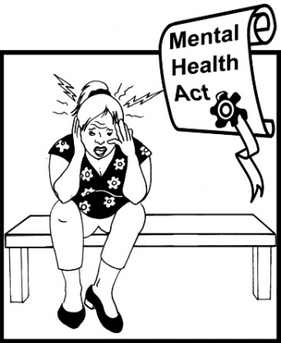
Police might think that person needs to be checked to see if they need mental health treatment.

This is called being assessed.
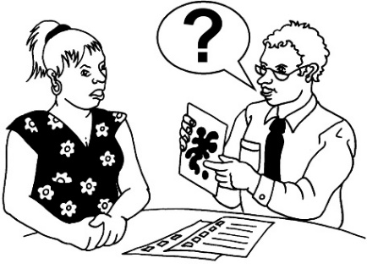

Police will get someone to do the assessment.
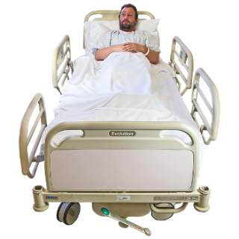
Police can keep a person in:
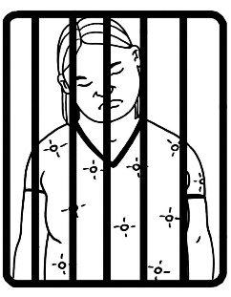
- hospital
- a police cell.

What role do you think police should have in new mental health laws?

Protecting your rights when
making a complaint


There are a lot of different people who check that the law is followed.

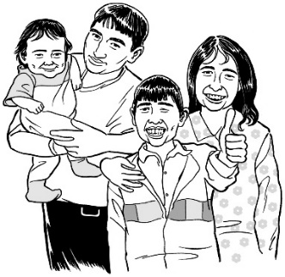
They also make sure people are treated well.

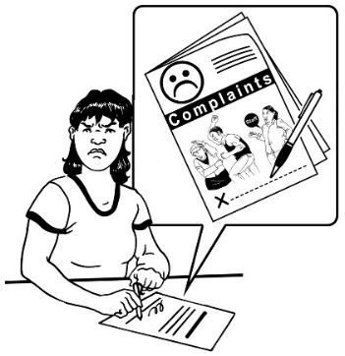
If you think the law is not being followed you can make a complaint.

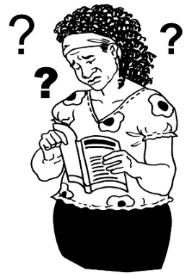
Some people have said that making a complaint is:
- confusing
- hard to do.

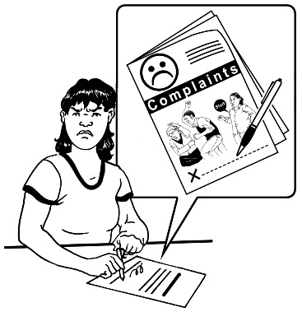
How should complaints be made?

What should happen once a complaint has been made?
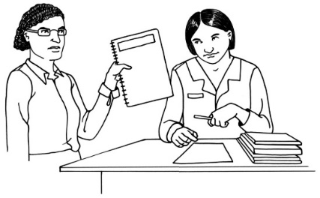

Who should complaints be made to?

Where to find more information


If you want to find out more you can contact the Ministry of Health.

Website:

www.health.govt.nz/our-work/mental-health-and-addiction/mental-health-legislation/repealing-and-replacing-mental-health-act

Phone: 0800 855 066

Email: mhactreview@health.govt.nz

This information has been written by the Ministry of Health.
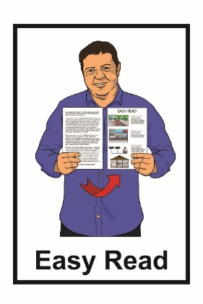

It has been translated into Easy Read in consultation with the Make It Easy service of People First New Zealand Inc. Ngā Tāngata Tuatahi.


The ideas in this document are not the ideas of People First New Zealand Inc. Ngā Tāngata Tuatahi.
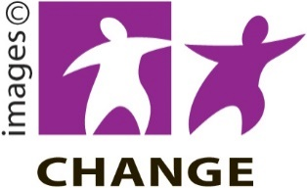
Make It Easy uses images from:

- Changepeople.org

- Photosymbols.com


- Sam Corliss

- Huriana Kopeke-Te Aho


All images used in this Easy Read document are subject to copyright rules and cannot be used without permission.

