Sexually Transmitted Infections

Findings from the  
2014/15 New Zealand Health Survey

2019

### Acknowledgements

The New Zealand Health Survey would not have been possible without the support and enthusiasm of many individuals, including the many thousands of New Zealanders who gave their time to participate in it and the interviewers who worked so diligently to collect the data. Thank you for your generosity.

This data brief was written by Nigel Dickson (University of Otago), Bridget Murphy (Ministry of Health), Jennie Connor (University of Otago), Antoinette Righarts (University of Otago) and Peter Saxton (University of Auckland). The data analysis was undertaken by Barry Gribben (CBG Health Research), Thomas Zhang (CBG Health Research) and James Stanley (University of Otago).

Citation: Ministry of Health. 2019. *Sexually Transmitted Infections: Findings from the 2014/15 New Zealand Heath Survey*. Wellington: Ministry of Health.

Published in November 2019 by the Ministry of Health  
PO Box 5013, Wellington 6140, New Zealand

ISBN 978-1-98-859746-1 (online)  
HP 7270



This document is available at health.govt.nz

|  |  |
| --- | --- |
| **CCBY** | This work is licensed under the Creative Commons Attribution 4.0 International licence. In essence, you are free to: share ie, copy and redistribute the material in any medium or format; adapt ie, remix, transform and build upon the material. You must give appropriate credit, provide a link to the licence and indicate if changes were made. |

Contents

Key findings v

Introduction 1

Lifetime sexually transmitted infection diagnoses 2

Sexually transmitted infection diagnoses in the last five years 5

Type of sexually transmitted infections diagnosed 9

Source of treatment for sexually transmitted infections 13

Interpretation notes 15

Overview of survey methodology 17

References 20

List of Tables

Table 1: Participation in the Sexual and Reproductive Health module of the New Zealand Health Survey, by ethnicity 18

List of Figures

Figure 1: Sexually transmitted infection diagnosis in lifetime (among those who had ever had sex), by age group and gender 3

Figure 2: Sexually transmitted infection diagnosis in lifetime (among those who had ever had sex), by ethnic group and gender 4

Figure 3: Sexually transmitted infection diagnosis in the five years preceding the survey (among those who had ever had sex), by age group and gender 6

Figure 4: Sexually transmitted infection diagnosis in the five years preceding the survey (among those who had ever had sex), by ethnic group and gender 8

Figure 5: Chlamydia, gonorrhoea, genital/anal warts, genital/anal herpes, trichomonas, syphilis and ‘another STI’ diagnosis in lifetime (total population), by gender 9

Figure 6: Chlamydia and genital/anal warts diagnosis in lifetime (total population), by age group and gender 10

Figure 7: Chlamydia, gonorrhoea, genital/anal warts and genital/anal herpes diagnosis in lifetime (total population), by ethnic group and gender 12

Figure 8: Where last treated for sexually transmitted infection: among those who had been diagnosed with an STI in the five years preceding the survey, by age group and gender 13

Figure 9: Where last treated for sexually transmitted infection: women (among those who had been diagnosed with an STI in the five years preceding the survey), by ethnic group 14

# Key findings

This report describes the burden of sexually transmitted infections (STIs) in New Zealand with regard to gender, age, ethnicity and neighbourhood deprivation patterns. Sexually transmitted infections can have serious long-term consequences, such as infertility.

The knowledge obtained from this survey will contribute to our understanding of the current burden of STIs in the New Zealand population, especially in terms of which sectors of the population are most affected, allowing a more nuanced approach to prevention and management of STIs (Haggerty et al 2010).

Key findings include the following.

* Approximately one in five women[1] and one in nine men (12 percent) who have had a sexual partner reported ever having been diagnosed with an STI.
* Women’s lifetime STI rate peaked at 20–24 years and dropped steeply after age 54 years. There was no age pattern for men.
* More Māori men and women had ever been diagnosed with an STI than non-Māori men and women.
* Chlamydia was the most commonly diagnosed STI in a person’s lifetime: 10 percent of women and 4.7 percent of men reported having ever been diagnosed with chlamydia.
* Genital warts were less frequently diagnosed in men and women under the age of 25, compared to those in older age groups.
* The commonest place to seek treatment for an STI in the past five years was a general practice for women and a general practice or a sexual health clinic for men.

# Introduction

Many STIs – particularly bacterial infections such as chlamydia – can affect women’s reproductive health, and a few can be life threatening (Price et al 2013).

Diagnoses of STIs at New Zealand sexual health clinics have risen substantially since the mid-1990s (Institute of Environmental Science and Research Ltd (ESR) 2001, 2011, 2014). In regions of New Zealand that have had laboratory monitoring of chlamydia since the early 2000s, rates showed an initial increase, a plateau after 2005 and a drop more recently. However, until recently, there had been no information on diagnosis rates of STIs in the whole population, and how these varied by age, ethnicity and level of deprivation.

To fill this gap, the Ministry of Health included questions about STIs in the Sexual and Reproductive Health module of the 2014/15 New Zealand Health Survey (the survey).

This report presents key findings about the population that reported that a doctor or other health professional had ever told them that they had an STI, by gender, age group, ethnicity and neighbourhood deprivation at the time of the survey interview.

You can find more information and results from the survey, including statistics on STIs by whether adults had had sex with someone of the same gender, in the data explorer, online at <https://www.health.govt.nz/publication/sexually-transmitted-infections-findings-2014-15-new-zealand-heath-survey>

# Lifetime sexually transmitted infection diagnoses

The survey asked respondents who had ever had sex with someone of a different gender or the same gender[2] if they had ever been told by a doctor or other health care professional that they had any of a list of common sexually transmitted infections – chlamydia, gonorrhoea, genital or anal warts, genital or anal herpes, trichomonas vaginalis (Trich, TV), syphilis or non-specific urethritis (NSU) – or had been told they had one of them but could not remember which. Multiple responses were possible.

The survey did not ask respondents about less common diseases that can be transmitted sexually (for example, HIV).

#### Women were more likely to have been diagnosed with an STI

* Overall, 12 percent of men and 20 percent of women aged 16–74 years who had had an opposite or same-gender sexual partner had ever been diagnosed with an STI.

#### Rates of lifetime-diagnosed STIs were higher for younger women

* For women, STI diagnoses most commonly occurred among those aged 25–34 years (26 percent) (Figure 1). In older age groups there was a progressive drop in rates of diagnoses, most marked after age 54 years, indicating a clear increase in lifetime STI diagnoses in younger generations of women.
* There was no clear trend in the equivalent figures for men. By age, the highest percentage was among those aged 45–54 years (14 percent), after which time there was a slight decrease.

Figure 1: Sexually transmitted infection diagnosis in lifetime (among those who had ever had sex), by age group and gender

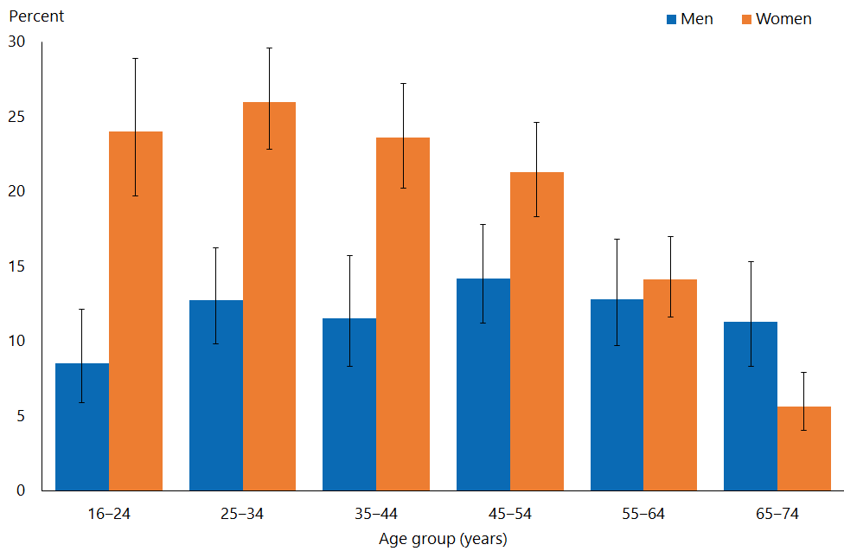

#### Māori men and women were more likely than non-Māori men and women to be ever have been diagnosed with a sexually transmitted infection, and Asian men and women less likely than non-Asian men and women

* Māori men and women who had had sexual partners were more likely than other ethnic groups to have ever had an STI diagnosed (26 percent). Asian men and women were the least likely to have ever had an STI diagnosed (5.2 percent) (Figure 2).
* After adjustment for age, Māori men and women who had had sexual partners were 1.6 and 1.7 times respectively as likely to have ever been diagnosed with an STI as non-Māori men and women. Asian men and women who had had sexual partners were 0.2 and 0.3 times respectively as likely to have ever been diagnosed with an STI as non-Asian men and women.
* There was a general trend for more women who had had sexual partners to have ever been diagnosed with an STI with increasing levels of deprivation. However, after adjustment for age and ethnic group, there was no statistically significant difference according to deprivation level.

Figure 2: Sexually transmitted infection diagnosis in lifetime (among those who had ever had sex), by ethnic group and gender

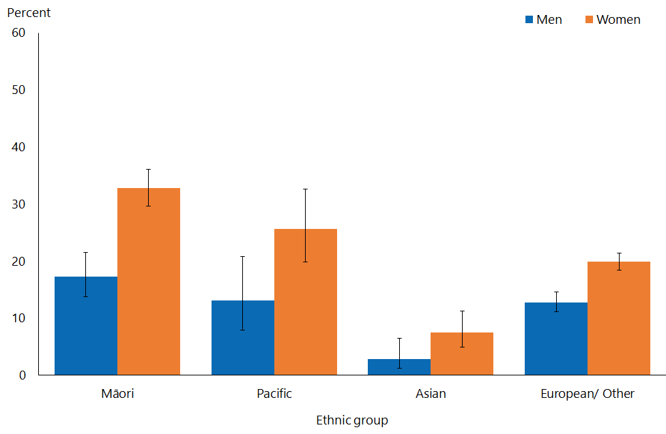

Note: Adults who reported more than one ethnic group are counted once in each group reported. This means that the total number of responses for all ethnic groups can be greater than the total number of adults who stated their ethnicities.

# Sexually transmitted infection diagnoses in the last five years

This section sets out people’s responses to a question about the timing of their last diagnosed ST, and shows STI rates for the five years preceding the survey. The denominator for this section is people who had had sex in the last five years with same-gender or opposite-gender sexual partners.

#### Women had more recently diagnosed sexually transmitted infections than men

* 2.9 percent of men and 5.6 percent of women aged 16–74 years who had had sex in the last five years had been diagnosed with one or more STIs during that time.

#### Sexually transmitted infection diagnoses in the last five years were commonest among women aged 16–24 years

* By age, women aged 16–24 years who had had sexual partners in the last five years had most commonly been diagnosed with an STI during that time (19 percent) (Figure 3).
* The percentage of men who had had a sexual partner in the last five years and had received an STI diagnosis during that time was highest for those under 35 years. The figures were similar for those aged 16–24 years (7.2 percent) and 25–34 years (6.2 percent). After age 35, the percentage dropped markedly.

Higher rates of testing in recent years will have contributed to higher rates of diagnosis among young women; testing for chlamydia (the commonest STI) is advocated for sexually active individuals under 25, and women are known to be tested more frequently than men (Low 2008; ESR 2014).

These survey findings will underestimate the risks for sexually active individuals in the youngest group (and possibly also some older groups), as some people would have become sexually active part way through the five-year period, and therefore not have been exposed to the risk of STIs for the whole period.

Figure 3: Sexually transmitted infection diagnosis in the five years preceding the survey (among those who had ever had sex), by age group and gender

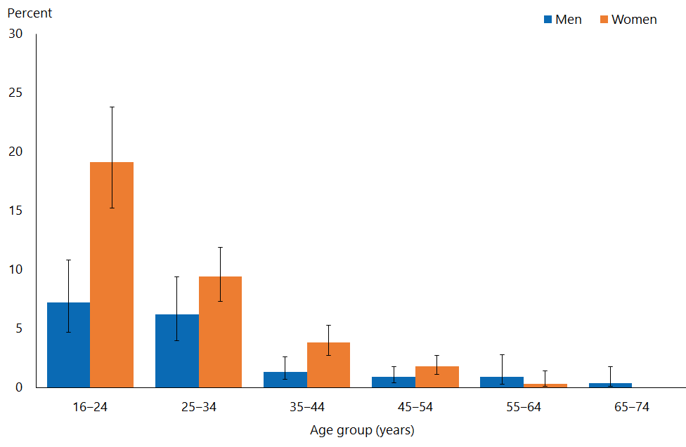

#### Māori men were more than twice as likely as non-Māori men to have been diagnosed with a sexually transmitted infection in the last five years

* After adjustment for age, Māori men who had had a sexual partner in the last five years were 2.5 times as likely as non-Māori men to have been diagnosed with an STI in the last five years.
* Māori and Pacific men who had had a sexual partner in the last five years were more likely than Asian men and those of European/Other ethnicity to have been diagnosed with an STI in the last five years (Figure 4).

#### Māori and Pacific women were more likely than non-Māori and non-Pacific women to have been diagnosed with a sexually transmitted infection in the last five years, and Asian women much less likely than non-Asian women

* Reflecting equivalent figures for men, Māori and Pacific women who had had a sexual partner in the last five years were more likely than Asian women and those of European/Other ethnicity to have been diagnosed with an STI in the last five years (Figure 4).
* After adjustment for age, Māori women who had had a sexual partner in the last five years were 1.8 times as likely as non-Māori to have been diagnosed with an STI in the last five years, and Pacific women 1.7 times as likely as non-Pacific women. Asian women were 0.2 times as likely as non-Asian women to have been diagnosed with an STI in the last five years.

Figure 4: Sexually transmitted infection diagnosis in the five years preceding the survey (among those who had ever had sex), by ethnic group and gender

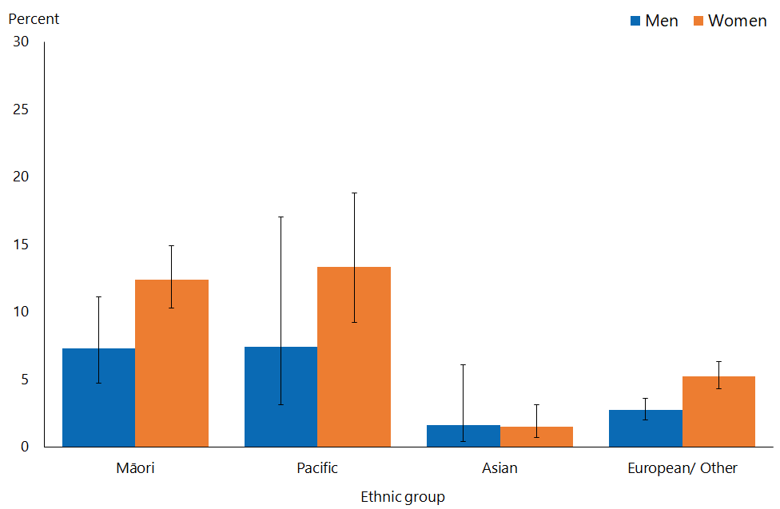

Note: Adults who reported more than one ethnic group are counted once in each group reported. This means that the total number of responses for all ethnic groups can be greater than the total number of adults who stated their ethnicities.

* After adjustment for age and ethnicity, there was no significant difference in percentages of men or women being diagnosed with an STI in the last five years between those living in the most and the least deprived neighbourhoods.

# Type of sexually transmitted infections diagnosed

The section reports the prevalence of a specific STI from the provided list.

#### Chlamydia and genital warts were the commonest sexually transmitted infections diagnosed

* Chlamydia and genital warts were the most commonly diagnosed STIs (Figure 5). More men than women reported having been diagnosed with “another STI”, which includes instances in which the respondent had not known the type of STI, or forgotten it.

Figure 5: Chlamydia, gonorrhoea, genital/anal warts, genital/anal herpes, trichomonas, syphilis and ‘another STI’ diagnosis in lifetime (total population), by gender

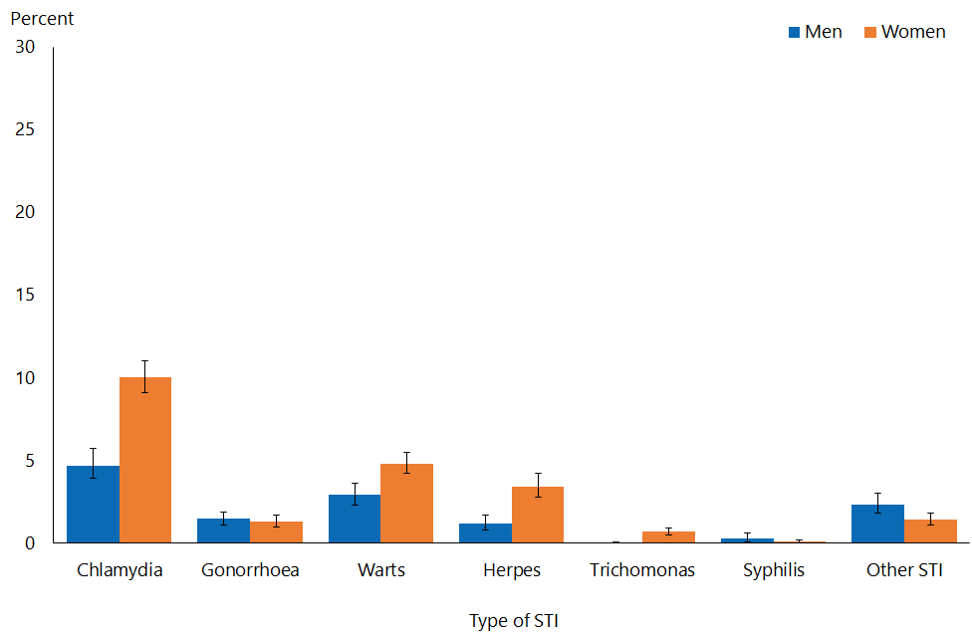

#### Chlamydia was the commonest sexually transmitted infection diagnosed in men and women aged under 45 years

* Chlamydia was the most commonly diagnosed STI for men younger than 35 years, and for women younger than 45 years (Figure 6); while this may be due more recent spread in the population, it could also reflect more frequent testing, and the use of more sensitive tests in recent years (ESR 2014).
* Genital warts were most frequently diagnosed STI in men and women aged  
  45–54 years. A diagnosis of warts was very much less common in men and women under 25 years than it was in people of other ages.

The reduction in the number of genital wart diagnoses may reflect the impact of the human papillomavirus (HPV) vaccine. The Ministry of Health introduced this in 2008 to prevent the types of HPV that cause cervical cancer; it is also effective against types that cause genital warts. Sexual health clinics have documented a decrease in diagnoses of genital warts among young people (Oliphant and Perkins 2011).

Figure 6: Chlamydia and genital/anal warts diagnosis in lifetime (total population), by age group and gender

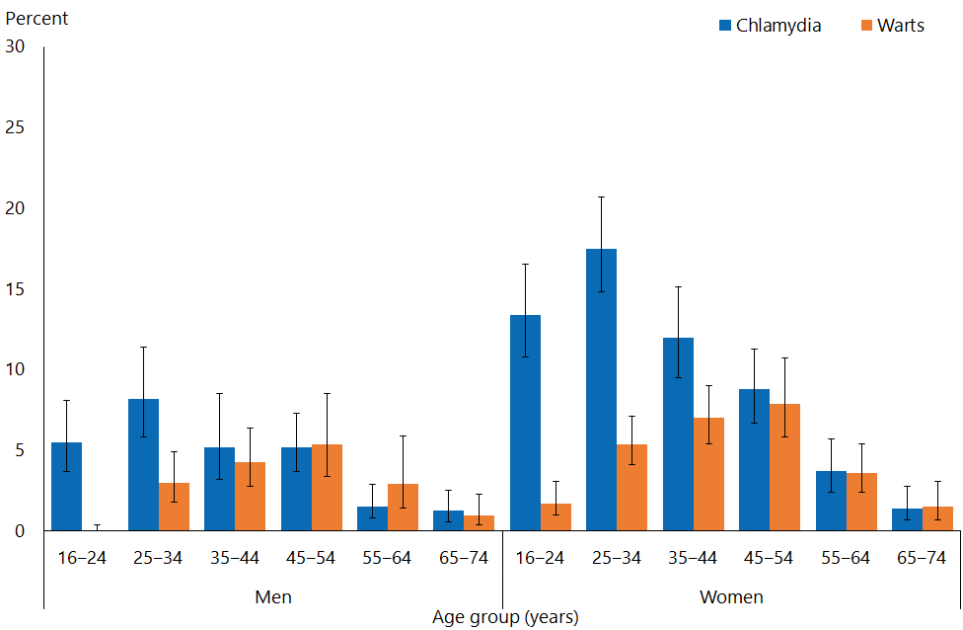

#### Chlamydia and gonorrhoea diagnoses were more common among Māori men than among non-Māori men

* For all ethnic groups and both sexes, chlamydia was the most commonly diagnosed STI, and a higher percentage of Māori and Pacific men and women had been diagnosed with chlamydia than men and women of other ethnic groups (Figure 7).
* Among men, by ethnicity, genital warts had been diagnosed most commonly among those of European/Other ethnicity; among women, the highest percentage diagnosed with genital warts were Māori and women of European/Other ethnicity. Gonorrhoea was diagnosed most commonly among Māori men and women, and genital herpes among women of European/Other ethnicity.
* After adjustment for age, Māori men were 2.3 times as likely to be diagnosed with chlamydia and 2.3 times as likely to be diagnosed with gonorrhoea as non-Māori men.

#### Māori women were more likely to have been diagnosed with chlamydia and less likely to have been diagnosed with genital herpes than non-Māori

* 23 percent of Māori women had been diagnosed with chlamydia. After adjustment for age, Māori women were 2.5 times as likely to have been diagnosed with chlamydia, 3.0 times as likely to have been diagnosed with gonorrhoea, 1.15 times as likely to have been diagnosed with genital warts, 0.5 times as likely to have been diagnosed with genital herpes and 2.5 times as likely to have been diagnosed with trichomonas (Figure 7) as non-Māori women.
* Pacific women were 1. 5 times as likely to have been diagnosed with gonorrhoea and 0.3 times as likely to have been diagnosed with genital herpes as non-Pacific women. Asian women were less likely than non-Asian to have been diagnosed with any of the specific STIs.

Figure 7: Chlamydia, gonorrhoea, genital/anal warts and genital/anal herpes diagnosis in lifetime (total population), by ethnic group and gender

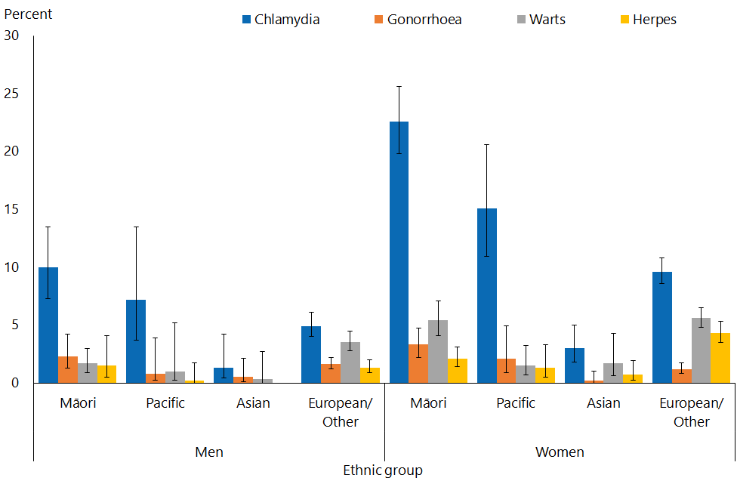

Note: Adults who reported more than one ethnic group are counted once in each group reported. This means that the total number of responses for all ethnic groups can be greater than the total number of adults who stated their ethnicities.

#### Chlamydia and gonorrhoea were more prevalent in women living in more deprived neighbourhoods

* There was a consistent trend among women for chlamydia and gonorrhoea to be more commonly diagnosed among those living in more deprived neighbourhoods, but no clear trend was seen for men or for the other STIs.
* After adjustment for age and ethnicity, women living in the most deprived neighbourhoods were more likely to have ever been diagnosed with chlamydia and gonorrhoea than those living in the least, and men in these neighbourhoods were more likely to have ever been diagnosed with gonorrhoea.

# Source of treatment for sexually transmitted infections

Respondents were asked where they had last been treated for an STI.

#### A medical centre/general practice was the commonest source for treatment for sexually transmitted infections experienced in the last five years; a greater percentage of men than women were treated at sexual health clinics

* A medical centre/general practice was the commonest place where men (45 percent) and women (62 percent) had sought treatment for STIs in the past five years; overall, a greater percentage of men (38 percent) than women (16 percent) sought treatment at sexual health clinics (Figure 8).

Figure 8: Where last treated for sexually transmitted infection: among those who had been diagnosed with an STI in the five years preceding the survey, by age group and gender

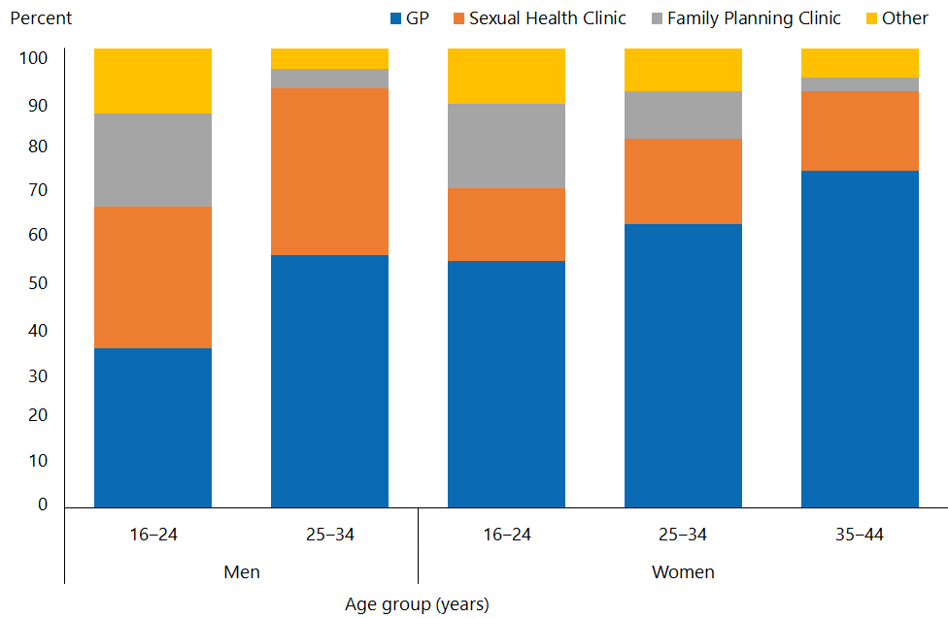

Note: Some age groups have been suppressed due to small numbers.

#### Māori women were less likely to seek treatment for a sexually transmitted infection at a general practice

* After adjustment for age, Māori women were 0.8 times as likely to have been treated for their last STI at a medical centre/general practice as non-Māori women. (Figure 9).

Figure 9: Where last treated for sexually transmitted infection: women (among those who had been diagnosed with an STI in the five years preceding the survey), by ethnic group

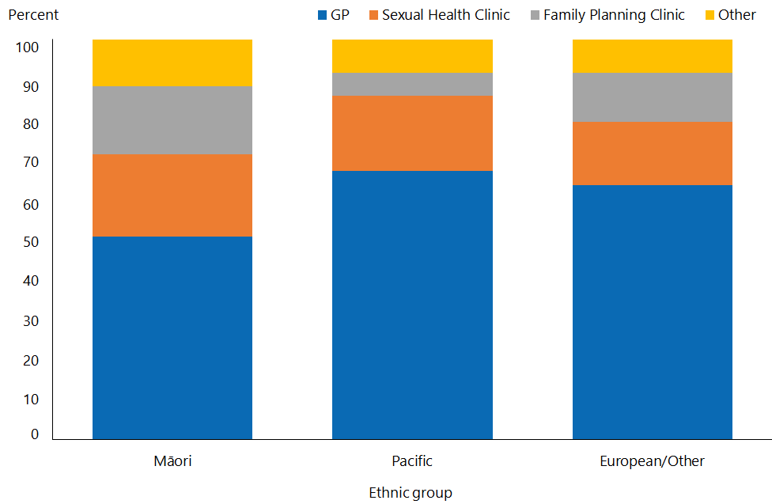

Note: Adults who reported more than one ethnic group are counted once in each group reported. This means that the total number of responses for all ethnic groups can be greater than the total number of adults who stated their ethnicities.

Note: The Asian ethnic group has been suppressed due to small numbers.

# Interpretation notes

This section provides some key points for interpreting the survey results presented in this report. For more details about the survey methodology, see the *Methodology Report 2014/15: New Zealand Health Survey* (Ministry of Health 2015b) and *Sexual and Reproductive Health Indicator Interpretation* *Guide 2014/15: New Zealand Health Survey* (Ministry of Health 2019).

### Statistical significance

Unless otherwise specified, the results discussed in this report only refer to differences that are statistically significant at the 5 percent level (ie, those with a p-value of less than 0.05). ‘Statistically significant’ means that the difference between the sample groups is likely to reflect real differences in the population groups, rather than being caused by chance. A statistically significant difference does not necessarily mean the difference between the population groups is meaningful.

### Confidence intervals

We use 95% confidence intervals to show the statistical precision of the estimates. Wider confidence intervals indicate less precise estimates than narrow intervals, caused by higher variation with a sample and/or smaller numbers in a sample. Confidence intervals generally agree with statistical significance. When confidence intervals for two estimates don't overlap, there is a statistically significant difference between the estimates. However, the opposite may not always be true.

### Comparing population subgroups

This report uses adjusted ratios to test if the prevalence of indicators is statistically significantly different between groups. We have adjusted these ratios for demographic factors that may be influencing the comparison, such as age, gender and ethnicity. The adjusted ratio indicates whether the results are less or more likely in the group of interest than the comparison group. A ratio of less than 1 indicates that the result is less likely and a ratio greater than 1 indicates that it is more likely.

The survey uses the New Zealand Index of Deprivation 2013 (NZDep2013) to measure neighbourhood deprivation. The survey groups neighbourhoods into five quintiles (the label ‘quintile 1’ applies to neighbourhoods with the lowest levels of deprivation, and ‘quintile 5’ to those with the highest). Indicators are reported for each quintile. The adjusted ratios for deprivation compare the highest and lowest deprivation areas, after adjusting for age, ethnic group, gender and the pattern across all five quintiles.

### Gender

Gender is self-defined by respondents in the survey. For some people, their gender is not the same as their biological sex at birth. Respondents were asked if they were male or female, and while what these options meant was open to the respondent’s interpretation, gender-diverse options (eg, ‘gender non-conforming’ or ‘other’) were not available. The Ministry of Health acknowledges the need to improve data collection in this area, and is considering implementing the statistical standard for gender identity in future surveys (Statistics New Zealand 2015).

### Non-sampling error

The survey results may underestimate or overestimate some indicators because the data is self-reported. The accuracy of a person’s memory may vary depending on many factors, including social norms, the importance of the event being recalled, the individual’s age at the time and the period of time that has passed since the event occurred.

# Overview of survey methodology

This section gives a brief overview of the survey methodology for the New Zealand Health Survey.

### How were people selected for the survey?

The 2014/15 results refer to the sample selected for the period July 2014–June 2015. The survey has a multi-stage sampling design that involves randomly selecting a sample of small geographic areas, households within the selected areas and individuals within the selected households. One adult aged 15 years or older and one child aged 14 years or younger (if there were any) were chosen at random from each selected household. Adults aged 16–74 years who had completed the 2014/15 survey were invited to participate in the Sexual and Reproductive Health module. Further details are available in *The New Zealand Health Survey: Sample design, years 1–3 (2011–2013)* (Ministry of Health 2011).

### How was data collected?

Professional surveyors from CBG Health Research Ltd collected data in respondents’ homes. For the core part of the survey, data was collected through a face-to-face interview. However, participants completed the Sexual and Reproductive Health module by themselves, directly entering responses into a program run on a tablet computer. Surveyors provided minimal assistance, and reiterated that they would not be able to see the answers. Respondents could answer ‘Don’t know’ or ‘Choose not to answer’ to any question. If they chose either of those options for the question about having ever had sex with someone of a different sex, then they were not asked to complete the rest of the survey module.

### How many people took part?

11,993 adults aged 16–74 years completed the core 2014/15 survey and were eligible for the Sexual and Reproductive Health module. This report is based on the responses from 10,198 adults (or 87 percent of eligible respondents). Some eligible respondents were not included in the final data set for the following reasons.

* 668 respondents (5.6 percent of those who were eligible) did not start the module, either because they refused or because of English language and/or cognitive difficulties.
* 991 respondents (6.5 percent of eligible respondents) started the module but stopped before the end of the module.
* 123 respondents (1.2 percent of eligible respondents) completed the module but their records were discarded because at least half of their responses were ‘Don’t know’ or ‘Choose not to answer’.

Of the people who completed the Sexual and Reproductive Health module, 4,358 gave their gender as male and 5,840 as female. The table below summarises the 10,198 survey respondents by ethnic group.

Table 1: Participation in the Sexual and Reproductive Health module of the New Zealand Health Survey, by ethnicity

|  |  |
| --- | --- |
| **Ethnic group** | **Number** |
| Māori | 2,460 |
| Pacific | 619 |
| Asian | 814 |
| European/Other | 7,542 |

Note: Adults who reported more than one ethnic group are counted once in each group reported. This means that the total number of responses for all ethnic groups can be greater than the total number of adults who stated their ethnicities.

### Survey weights

The Sexual and Reproductive Health data set was weighted so that the responding sample represented the New Zealand ‘usually resident’ population in that year, using external population benchmarks (age, sex, ethnicity and neighbourhood deprivation) and demographic and behavioural benchmarks (eg, educational level and hazardous drinking). After an initial selection weight was calculated, it was adjusted for those who did not complete the module (for any reason). This should have minimised the impact of any differences in the characteristics of people who did or did not participate in the Sexual and Reproductive Health module. For more detail about the survey methodology, refer to the *Methodology Report 2014/15* (Ministry of Health 2015b).

### Additional information

See also the following documents:

* *The New Zealand Health Survey: Sample design years 1–3 (2011–2013)* (Ministry of Health 2011). Note, despite the report title being 2011–13, this sample design was used for the 2014/15 Health Survey
* *Methodology Report 2014/15: New Zealand Health Survey* (Ministry of Health 2015b)
* *Content Guide 2014/15: New Zealand Health Survey* (Ministry of Health 2015a)
* Questionnaires for the New Zealand Health Survey 2014/15 (Ministry of Health 2016a; Ministry of Heath 2016b)
* *Sexual and Reproductive Health Indicator Interpretation* *Guide 2014/15: New Zealand Health Survey* (Ministry of Health 2019).

# References

ESR. 2001. *Sexually Transmitted Infections in New Zealand: Annual Surveillance Report 2001*. Porirua: Institute of Environmental Science and Research Ltd.

ESR. 2011. *Sexually Transmitted Infections in New Zealand: Annual Surveillance Report 2011*. Porirua: Institute of Environmental Science and Research Ltd.

ESR. 2014. *Sexually Transmitted Infections in New Zealand: Annual Surveillance Report 2014*. Porirua: Institute of Environmental Science and Research Ltd.

Haggerty CL, Gottlieb SL, Taylor BD, et al. 2010. Risk of sequelae after chlamydia trachomatis genital infection in women. *Journal of Infectious Diseases* 201(S2):  
S134–S155.

Low N. 2008. Caution: chlamydia surveillance data ahead. *Sexually Transmitted Infections* 84(2): 80–1.

Ministry of Health. 2011. *The New Zealand Health Survey: Sample design, years 1–3 (2011–2013)*. Wellington: Ministry of Health.

Ministry of Health. 2015a. *Content Guide 2014/15: New Zealand Health Survey*. Wellington: Ministry of Health.

Ministry of Health. 2015b. *Methodology Report 2014/15: New Zealand Health Survey*. Wellington: Ministry of Health.

Ministry of Health. 2016a. *Adult Sexual Reproductive Health Module (Year 4)*. Wellington: Ministry of Health.

Ministry of Health. 2016b. *New Zealand Health Survey Adult Questionnaire (Year 4)*. Wellington: Ministry of Health.

Ministry of Health. 2019. *Sexual and Reproductive Health Indicator Interpretation Guide 2014/15: New Zealand Health Survey*. Wellington: Ministry of Health.

New Zealand Sexual Health Society. 2017. *NZSHS STI Management Guidelines for use in primary care*. URL: www.nzshs.org/guidelines (accessed 27 August 2019).

Oliphant J, Perkins N. 2011. Impact of the human papillomavirus (HPV) vaccine on genital wart diagnoses at Auckland Sexual Health Services. *New Zealand Medical Journal* 124(1339).

Price MJ, Ades AE, Angelis DD, et al. 2013. Risk of pelvic inflammatory disease following *chlamydia trachomatis* infection: analysis of prospective studies with a multistate model. *American Journal of Epidemiology* 178: 484–92.

Statistics New Zealand. 2015. *Statistical Standard for Gender Identity*. Wellington: Statistics New Zealand.

1. “Sexual partner” includes opposite and same-gender sexual partners.
2. ‘Sex’ was defined as oral sex (or anal for men) or any other genital contact intended to achieve orgasm with someone of the same gender, and vaginal, oral or anal sex between a male and a female.