Health Impacts of PM10 from Unsealed Roads in Northland

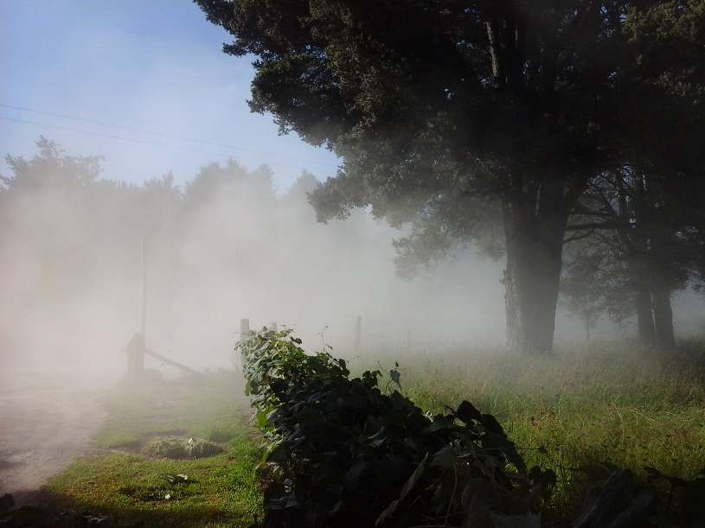Report date April 2019

Prepared for  
Ministry of Health

Health Impacts of PM10 from Unsealed Roads in Northland

Client: Ministry of Health

Prepared by:

Jayne Metcalfe & Louise Wickham

**Emission Impossible Ltd**

Suite 2-3, 93 Dominion Road, Mt Eden, Auckland 1024, New Zealand

www.emissionimpossible.co.nz

8 April 2019

Cover photo credit: Murray Armstrong

Revision History

|  |  |  |  |  |
| --- | --- | --- | --- | --- |
| **No.** | **Date** | **Author** | **Reviewer(s)** | **Details** |
| 1 | 31 Jan 2019 | **Jayne Metcalfe & Louise Wickham**  Directors & Senior Air Quality Specialists |  | First draft to client for review |
| 2 | 8 April 2019 |  | Dr Deborah Read | Report revised in response to peer review |
| 3 | 6 August 2019 |  |  | Update Table 9 with discrete labels to improve clarity |

This report has been prepared by Emission Impossible Ltd for the Ministry of Health in accordance with their specific instructions. It may be used in whole, or in part, as long with appropriate acknowledgement. No liability is accepted by Emission Impossible Ltd with respect to the use of this report by any other person.

# Executive Summary

Northland Regional Council and Far North District Council continuously monitored particulate matter less than 10 micrometres in diameter (**PM10**) near an unsealed road (Pipiwai Road) in Northland between 1 June 2017 and 31 May 2018. This monitoring enabled, for the first time, an assessment of the annual average PM10 exposure directly attributable to an unsealed road in New Zealand. This in turn, enabled an assessment of the health effects of this PM10 exposure.

The monitoring recorded:

* 27 exceedances of the 24-hour national environmental standard (**NES**) for PM10. One exceedance is permitted within any 12-month period;
* A maximum daily PM10 concentration of 164 µg/m3 and a second highest daily PM10 concentration of 127 µg/m3;
* Eight days of PM10 more than double the PM10 NES (i.e. more than 100 µg/m3 as a 24-hour average); and
* Exceedances of the PM10 NES occurred in all seasons except winter.

Rainfall measured during the monitoring period suggests that the Pipiwai dataset may not represent worst-case conditions for dust generation.

This study found the following empirical relationships between the PM10 NES and trucks (i.e. vehicles > 5.5 metres in length) on Pipiwai Road:

* Exceedances only occurred on days with more than 40 trucks;
* Most (88%) exceedances occurred on days with less than 1 mm of rain; and
* Exceedances occurred on 28% of days with more than 40 trucks and less than 1 mm of rain.

Overall, the monitoring at Pipiwai Road suggests that there is a significant risk of exceedance of the PM10 NES near unsealed roads with more than 40 trucks per day.[1]

Comparison of modelled and measured data showed the models significantly underpredicted *maximum* daily PM10 concentrations when compared with measurements from Pipiwai Road. A calibration factor was developed to provide a reasonable correlation between modelled and measured *average* dailyPM10 concentrations. However, maximum daily measured PM10 concentrations were still 1.5 – 5 times higher than modelled.

We also developed a calibration factor to provide a good correlation (within 10%) between modelled and measured *annual* PM10 concentrations. The correlations in this study may not be valid for unsealed roads in other locations. Recommendations for additional study are provided.

We then assessed chronic health impacts, and costs, of exposure to PM10 from unsealed roads in Northland.

The assessment utilised exposure-response relationships from Kuschel *el al.*, (2012) and included assessment of premature mortality, cardiovascular hospital admissions, respiratory hospital admissions and restricted activity days. This assessment was undertaken for all unsealed roads in Northland and estimated *inter alia* 0.6 (0.3 – 0.9) cases of premature mortality per year due to unsealed road dust. The total cost of all adverse effects assessed was $2.7 million ($1.2 – 3.8 million, $2017).

An illustrative assessment of acute effects was also undertaken using an exposure-response relationship from a recent Canadian study (Hong *et al*., 2016) that was specific to road dust. This suggested that the total estimated short-term effects of exposure to road dust (summed over a whole year) were approximately 52% of the estimated long-term effects at the same location over the same time period. It is important to note that the short-term effects on health effects are largely included in the long-term effects (they are not additional to the long-term effects).

Sensitivity analyses were undertaken for the key variables affecting PM10 emissions (silt fraction of road surface material), PM10 exposure (distance from road) and the assumed exposure-response relationships. These highlighted the uncertainties inherent in the assessment and supported recommendations for additional research.

# Acknowledgements

This assessment was only possible because of monitoring undertaken by Watercare Laboratory Services in service to Far North District Council and Northland Regional Council. We would like to thank both councils and Watercare Laboratory Services for providing such high-quality air quality and traffic monitoring data.

We would also like to acknowledge Dr Deborah Read for providing valuable peer review comments, as well as members of the National Dusty Roads Working Group under the Road Controlling Authorities Forum for providing technical comment.

**Contents**

**Executive Summary i**

*Acknowledgements iii*

**1. Introduction 1**

1.1 What is road dust? 1

1.2 Impacts of road dust 2

1.2.1 Health effects of road dust 2

1.2.2 Are the health effects of road dust different to the effects of other particulate? 2

1.3 Ambient air quality criteria 3

1.4 Background air quality in Northland 4

**2. Methodology for estimating health effects and costs 5**

2.1 Overall approach 5

2.2 Estimating PM10 exposure 6

2.2.1 Estimating a preliminary 24-hour emission factor 6

2.2.2 Modelling 24-hour PM10 close to an unsealed road 7

2.2.3 Calibrating the 24-hour PM10 emission factor 8

2.2.4 Estimating an annual average PM10 emission factor 8

2.2.5 Estimating annual average PM10 exposure 8

2.3 Estimating population exposed 9

2.4 Estimating chronic health impacts (Kuschel et al., 2012) 9

2.4.1 Estimating premature mortality cases 11

2.4.2 Estimating cardiovascular hospital admissions cases 12

2.4.3 Estimating respiratory hospital admissions cases 12

2.4.4 Estimating restricted activity days 13

2.5 Estimating costs of chronic PM10 exposure 13

**3. Air Quality Monitoring at Pipiwai Road: 1 June 2017 – 31 May 2018 15**

3.1 PM10 15

3.2 Meteorology 21

3.3 Traffic 25

**4. PM10 Exposure 28**

4.1 Traffic analysis 28

4.2 Modelling 24-hour PM10 close to an unsealed road using a preliminary emission factor 32

4.3 Calibrating the 24-hour PM10 emission factor 33

4.4 Estimating an annual PM10 emission factor 34

4.5 Comparison of modelled & measured annual PM10 (at one unsealed road) 35

Contents continued

**5. Health Impacts of Road Dust 36**

5.1 Estimated health impacts and costs of chronic exposure to PM10: all unsealed roads in Northland 36

5.2 Estimated health impacts and costs of acute exposure to road dust PM10 illustrative assessment 36

5.3 Sensitivity analyses 37

5.3.1 PM10 Exposure: distance from road 37

5.3.1 PM10 exposure: silt fraction 38

5.3.3 Exposure-response relationships (95% confidence limits) 39

5.3.4 Exposure-response relationships (sensitive populations) 40

**6. Conclusions 42**

6.1 Limitations 44

6.2 Recommendations 44

**References 46**

**Appendix A Ambient air quality monitoring data 49**

A1.1 Monitoring methods 49

A1.2 Quality assurance 50

A1.3 Valid data 50

A1.4 Monitoring site location 51

**Appendix B Acute effects assessment 56**

B1.1 Overall Methodology for Assessing Acute Effects 56

B1.2 Estimating acute PM10 exposure 57

B1.3 Estimating acute premature mortality cases (Hong *et al.*, 2017) 57

B1.4 Comparison acute and chronic health effects 59

B1.5 Results of the Acute Effects Assessment 59

Contents continued

**List of Tables**

Table 1 New Zealand Ambient PM10 Criteria

Table 2 Estimated costs of health impacts (per case per year)

Table 3 Summary 24-hour average PM10 Monitoring at Pipiwai Road, 1 June 2017 – 31 May 2018

Table 4 Exceedances of PM10 criteria measured at Pipiwai Road, 1 June 2017 – 31 May 2018

Table 5 Summary 1-hour average PM10 Monitoring at Pipiwai Road, 1 June 2017 – 31 May 2018

Table 6 Summary maximum (1-hour average) PM10 each day at Pipiwai Road, 1 June 2017 – 31 May 2018

Table 7 Traffic data measured at Pipiwai Road 1 June 17 – 31 May 18 [Source: FNDC]

Table 8 Pipiwai Road traffic data compared with Northland Unsealed Roads [Source: FNDC]

Table 9 Traffic and rainfall data groupings and sample size

Table 10 Modelled vs Measured Annual PM10

Table 11 Estimated annual health impacts and costs of PM10 from unsealed roads in Northland

Table 12 Estimated premature mortality and cost of PM10 at a single unsealed road (for assumed population of 40 people living within 80 m of the unsealed road)

Table 13 Sensitivity Analysis: Upper and lower bound average distance from unsealed road

Table 14 Sensitivity Analysis: Increased silt fraction of road surface material

Table 15 Sensitivity Analysis: Upper and lower bound exposure-response relationships

Table 16 Sensitivity Analysis: Māori-specific exposure response relationship

**List of Figures**

Figure 1 Size range of airborne dust [Source: WHO, 2006]

Figure 2 Daily PM10 measured 30 metres from Pipiwai Road, 1 June 2017 – 31 May 2018

Figure 3 1-hour average PM10 measured 30 metres from Pipiwai Road, 1 June 2017 – 31 May 2018

Figure 4 Maximum (daily) 1-hour average PM10 measured 30 metres from Pipiwai Road, 1 June 2017 – 31 May 2018

Figure 5 Seasonal rainfall measured at Pipiwai Road, 1 June 2016 – 31 May 2018 as compared with 40-year average in Kaikohe (1981 – 2010)

Figure 6 Monthly rainfall measured at Pipiwai Road, 1 June 2016 – 31 May 2018 as compared with 40-year average in Kaikohe (1981 – 2010)

Figure 7 Annual frequency of wind speed and wind direction measured at Pipiwai Road (1 June 2017 – 31 May 2018)

Figure 8 Winter frequency of wind speed and wind direction measured at Pipiwai Road (1 June 2017 – 31 August 2017)

Figure 9 Spring frequency of wind speed and wind direction measured at Pipiwai Road (1 September 2017 – 30 November 2017)

Figure 10 Summer frequency of wind speed and wind direction measured at Pipiwai Road (1 December 2017 – 28 February 2018)

Figure 11 Autumn frequency of wind speed and wind direction measured at Pipiwai Road (1 March – 31 May 2018)

Contents continued

**List of Figures continued**

Figure 12 Association between counts of trucks per day and average daily concentrations of PM10 measured 30 metres from Pipiwai Road, 1 June 2017 – 31 May 2018

Figure 13 Association between daily rainfall and average daily concentrations of PM10 measured 30 metres from Pipiwai Road, 1 June 2017 – 31 May 2018

Figure 14 Counts of trucks per day and exceedances of PM10 NES measured 30 metres from Pipiwai Road, 1 June 2017 – 31 May 2018.

Figure 15 Count of trucks per day and daily rainfall vs exceedances of PM10 NES measured 30 metres from Pipiwai Road, 1 June 2017 – 31 May 2018.

Figure 16 Comparison of modelled 24-hour PM10 with measured average and maximum 24-hour PM10 30 metres from Pipiwai Road as a function of all trucks on days with less than 1 mm of rain, 1 June 2017 – 31 May 2018

Figure 17 24-hour PM10 modelled with a calibration factor of 1.6 compared with measured average and maximum PM10 30 metres from Pipiwai Road as a function of all trucks on days with less than 1 mm of rainfall, 1 June 2017 – 31 May 2018

# Introduction

This report has three main objectives:

1. Summarise the findings of an ambient air quality monitoring study carried out in Northland near an unsealed road for the year ending 31 May 2018;
2. Investigate PM10 exposure from unsealed roads as a function of traffic and meteorology; and
3. Undertake an assessment, with sensitivity analysis, of the likely health impacts of PM10 from unsealed roads in Northland.

This report was prepared under contract to the Ministry of Health for submission to the National Dusty Roads Working Group under the Road Controlling Authorities Forum. It incorporates (in full) the findings of a previous report issued in draft form to the Working Group (EIL, 2018). It further updates the previous report (and calibrated emission factors) to include rainfall data collected at Pipiwai Road by Watercare that was not previously available.

Readers should note that this report does not investigate mitigation options for dust from unsealed roads, which have been the subject of NZTA research (refer Bluett *et al.*, 2016, Waters, 2009, Bartley Consultants, 1995).

## What is road dust?

Particulate matter (PM) is classified by aerodynamic properties because these determine transport and removal processes in the air and deposition sites and clearance pathways within the respiratory tract.

Airborne dust from unsealed roads is defined as dry, solid particles that can range in diameter from <1 micron to 100 microns (refer **Figure 1**).[2] The finer the particle, the longer it remains suspended in the air. At 1 micron any settling due to gravity is negligible, whereas particles above 50 microns tend to settle quickly.

Particles less than 10 microns in size (PM10) and particles less than 2.5 microns (PM2.5) can reach the alveolar region of the lungs where inhaled gases can be absorbed by the blood. Particles between 10 and 2.5 microns in size (PM10-2.5) are referred to as *coarse* particles, and particles smaller than 2.5 microns are referred to as *fine* particles. These fractions of airborne dust present the highest health risk because (WHO, 2006):

1. PM10 includes those inhalable particles that are sufficiently small to penetrate to the thoracic region; and
2. PM2.5 has a high probability of deposition in the smaller conducting airways and alveoli.

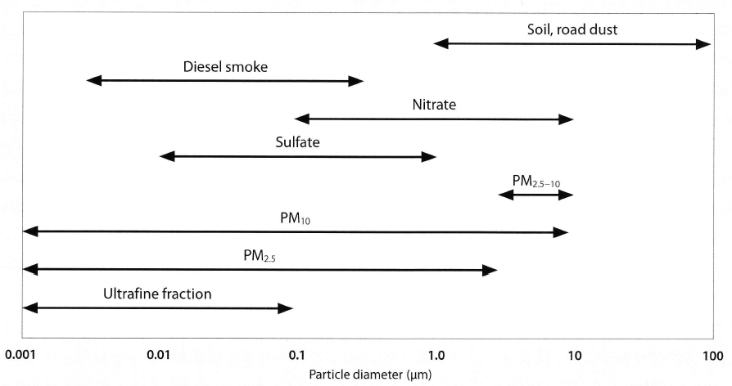

Figure 1 Size range of airborne dust [Source: WHO, 2006]

## Impacts of road dust

Dust from unsealed roads creates safety and health hazards for road users and those living or working nearby, as well as economic costs from reduced productivity of land, crops and livestock, and increased road and vehicle maintenance costs. Airborne dust from unsealed roads can depositon rooves contaminating drinking water, as well as deposit on gardens and houses causing nuisance and reducing amenity.

This report discusses the **adverse health effects** of exposure to airborne dust from unsealed roads.

### Health effects of road dust

Historically, airborne dust from unsealed roads was considered primarily a nuisance issue. It is only since the turn of this century that the full health impacts of suspended particles (dust in the air) began to be recognised in New Zealand (Ministry for the Environment, 2003).

There is now widespread, global scientific consensus that exposure to particulate pollution causes predominantly respiratory and cardiovascular effects, ranging from subclinical functional changes (e.g. reduced lung function) to symptoms (increased cough, exacerbated asthma) and impaired activities (e.g. school or work absenteeism) through to doctors’ or emergency room visits, hospital admissions and death (World Health Organisation, 2006). The effects, in terms of escalating severity, are described as increased visits to doctors for many individuals, hospital admission for some individuals and death for a few individuals. The exposure-response relationship is essentially linear and there is no ‘safe’ threshold; adverse effects on health are observed at all measured levels (World Health Organisation, 2013).

### Are the health effects of road dust different to the effects of other particulate?

There has been significant research to investigate whether different sources of PM are associated with different health outcomes (for example due to differences in chemical composition and particle size of PM from different sources). A comprehensive review of recent research suggests that there is no clear hierarchy of harmfulness for PM from different sources and that further research is required before changing the current public health protection approach of minimising exposure to total PM mass (Hime *et al*., 2018).

A World Health Organisation (WHO) scientific review in 2013 concluded that short-term exposure to coarse (PM10-2.5) particulate, including crustal material, is associated with adverse respiratory and cardiovascular effects on health including premature mortality (WHO, 2013). There is a growing body of evidence that the coarse fraction (PM10-2.5) may have independent health impacts. This is particularly important in some locations, such as those affected by road dust.

From a regulatory perspective, based on current evidence, WHO recommends that all PM should be treated the same. This approach has been adopted in New Zealand good practice for assessing and managing dust (MfE, 2016b).

## Ambient air quality criteria

Schedule 1 of the Resource Management (National Environmental Standards for Air Quality) Regulations 2004 (**NESAQ**) includes a health-based ambient air quality standard for PM10. This is 50 micrograms per cubic metre (µg/m3) as a 24-hour average with one permitted exceedance in any 12-month period.

The purpose of this standard is “*to provide a guaranteed level of health protection for all New Zealanders*” (MfE, 2016a). PM10 is a non-threshold contaminant, i.e. there is no known safe level of exposure, and thus the standard represents a tolerable level of risk.

The Ministry for the Environment national ambient air quality guidelines (**NAAQG**) also includes an annual average guideline of 20 µg/m3 for PM10. This guideline was set to “*provide the minimum requirements that outdoor air quality should meet to protect human health and the environment*” (MfE, 2016a).

The 24-hour average standard and annual guideline values for PM10 are numerically equivalent to global air quality guidelines published by the World Health Organisation (WHO, 2006). WHO notes “*The guidelines are written for worldwide use, and are intended to support actions aiming for the optimal achievable level of air quality in order to protect public health in different contexts*”.

In addition to the above, the Ministry for the Environment has published a suggested trigger threshold for managing PM10 from dusty sources (MfE, 2016b). The suggested trigger threshold is 150 µg/m3 as a 1-hour average. The purpose of this short-term threshold is to proactively manage dust sources (primarily on industrial sites) and to avoid exceedance of (longer time-average) health-based standards and guidelines in sensitive receiving environments (typically residential areas).

All New Zealand PM10 criteria are summarised in **Table 1**. In general, these apply outdoors where people may reasonably be exposed.

Table 1 New Zealand Ambient PM10 Criteria

|  |  |  |  |
| --- | --- | --- | --- |
| **Reference** | **Value**  **(µg/m3)** | **Time Average** | **Comments** |
| National environmental standard  (WHO global guideline) | 50 | 24-hours | 1 permissible exceedance in a 12-month period |
| National ambient air quality guideline  (WHO global guideline) | 20 | Annual |  |
| MfE suggested trigger threshold | 150 | 1-hour |  |

## Background air quality in Northland

The current national estimate of background levels of ambient PM10 in rural Northland is 9 µg/m3 as an annual average (Kuschel *et al.*, 2012).

This estimate was based on ambient PM10 monitoring data from rural New Zealand (Pongakawa) for the years 2006-2008. This value was assigned to rural areas and all very small towns in New Zealand with no appreciable urban or industrial discharges to air (i.e. primarily natural sources).

Given the lack of any other sources of discharges to air in rural Pipiwai, we consider a background concentration of 9 µg/m3 as an annual average is reasonable.

# Methodology for estimating health effects and costs

The continuous PM10 monitoring undertaken at Pipiwai Road for a full year enabled, for the first time, an assessment of the annual average PM10 exposure directly attributable to an unsealed road in New Zealand. This in turn, enabled an assessment of the health effects of this PM10 exposure.

We have estimated the chronic effects and costs of long-term exposure to PM10 near unsealed roads using published exposure-response relationships from the *Health and Air Pollution in New Zealand 2012 Update Study* (Kuschel *et al*., 2012). This approach estimates the health effects and costs for all unsealed roads in Northland. This method provides an estimate of premature mortality, cardiovascular hospital admissions, respiratory hospital admissions and restricted activity days.

The exposure-response relationships used to assess chronic health effects are not specific to road-dust. This is in accordance with current recommendations that all PM10 be treated as being equally harmful to health, irrespective of source (WHO, 2006). However, as noted by Bluett *et al*. (2016), the linear exposure-response model may not be applicable to the range and variation of particulate concentrations from road dust (in particular the very high levels of road dust that are measured). To investigate the likely significance of short-term exposure to road dust we undertook an indicative assessment of the acute effects of short-term exposure to PM10. The methodology for the assessment of acute effects is provided in Appendix B.

The following sections detail the methodologies employed to estimate chronic PM10 exposure, adverse health effects and costs.

## 2.1 Overall approach

The health effects of air pollution may be estimated as shown in Equation 1.

$${Health Effects}_{(Cases)} =Exposure× Relative Risk × Population Exposed$$

Equation 1

Where:

Health Effects(Cases) = the number of incidents of the health outcome being assessed (e.g. premature deaths).

Exposure* = exposure to ambient PM10 concentrations. Estimates of exposure need to take background concentrations into consideration if a true estimate of the contribution from one source (e.g. an unsealed road) is to be assessed.

Relative risk = exposure-response relationship developed from epidemiological studies. These quantify the relationship between exposure to the ambient pollutant concentration and the frequency of health effects.

Population Exposed = population under assessment.

*It should be noted that exposure is assumed to be constant over the population being assessed and does not address localised influences on personal exposure. This is acceptable for a population-based assessment because potential inaccuracies associated with higher or lower exposures are likely to balance out as they would have in the derivation of the exposure-response relationships.

The social costs of air pollution are then calculated from Equation 2 as follows:

$$Social Costs={Health Effects}_{(Cases)}×Cost per case$$

Equation 2

In simple terms, first we estimated the PM10 exposure and the number of people exposed. Then we applied exposure-response relationships to estimate adverse health effects. These were then combined with published health-cost data to estimate costs.

The following sections provide more detail.

## 2.2 Estimating PM10 exposure

We estimated PM10 exposure as follows:

* We estimated a preliminary 24-hour road dust PM10 emission factor with a USEPA model;
* We modelled the 24-hour concentration of PM10 close to Pipiwai Road using an NZTA screening tool model and the preliminary 24-hour PM10 emission factor;
* We compared the modelled 24-hour concentration of PM10 with measured 24-hour PM10 at Pipiwai Road. We used this to derive a calibrated 24-hour PM10 emission factor to provide a reasonable estimate of average daily PM10 concentrations close to Pipiwai Road;
* We then estimated an annual road dust PM10 emission factor from the calibrated 24-hour emission factor; and
* We compared the modelled annual concentration of PM10 with measured annual PM10 at Pipiwai Road. We then used this calibrated annual road dust PM10 emission factor to estimate the annual emissions, and exposure, attributable to unsealed roads in Northland.

### 2.2.1 Estimating a preliminary 24-hour emission factor

A preliminary estimate of the amount of daily PM10 created per truck travelling on an unsealed road per km was calculated using Equation 3 (USEPA, 2006):[3]

Equation 3 (USEPA)

Where:

EF = size-specific emission factor (pounds per vehicle mile travelled)

k, a and b are empirical constants (1.5, 0.9 and 0.45 respectively for PM10)

s = surface material silt content (%) = 2% [4]

W = mean vehicle weight (American tons)

= 25 (American) tons (assumed midpoint between full 44 and empty 11 tonne truck)

and 1 lb/VMT = 281.9 grams per vehicle kilometre travelled (g/VKT)

Thus:

EF = 1.5 x (2/12)0.9 x (25/3)0.45 x 281.9

**EF = 219 g per truck VKT**

### 2.2.2 Modelling 24-hour PM10 close to an unsealed road

We estimated the daily concentration of PM10 in ambient air due to emissions from an unsealed road using the NZTA screening dispersion model (Equation 4). This incorporates background concentrations of PM10 as follows:

$${Daily PM}_{10}=background { PM}_{10}+ 0.325\exp\left(-0.3d^{0.5}\right)×(\frac{vehicles per day }{24})×EF×0.5$$

Equation 4 (NZTA)

Where:

background PM10= background concentration of PM10.

This was assumed to be 9 µg/m3 (refer Section 1.4)

d = distance from road (m) = 30 m to monitor at Pipiwai Road

vehicles per day = measured daily count of all trucks (> 5.5 m long) at Pipiwai Road

EF = emission factor per vehicle km (219 g per truck VKT, estimated using Equation 3, USEPA)

### 2.2.3 Calibrating the 24-hour PM10 emission factor

The USEPA equation shown as Equation 3 is intended to estimate road dust PM10 emissions on days with no measurable rainfall (USEPA, 2006). To “calibrate” the emission factor for Pipiwai Road, we modelled the concentration of PM10 in ambient air using Equation 4 for a range of daily truck per day values. These modelled concentrations were compared with the average measured concentration for all days with less than 1 mm of rainfall and comparable trucks per day values. A calibrated emission factor was derived by resolving the average difference between modelled and measured values to zero.

### 2.2.4 Estimating an annual average PM10 emission factor

The USEPA (2006) provides the following equation to estimate annual average emissions from an unsealed road. This equation assumes that annual average emissions are inversely proportional to the number of days with measurable precipitation:

$$E_{ext} =EF × [(365 - P)/365)]$$

Equation 5 (USEPA)

Where:

Eext = annual emissions of PM10 from an unsealed road extrapolated for natural mitigation

EF = daily emission factor, in this case we used the calibrated 24-hour emission factor described above.

P = number of days in a year with measurable precipitation

### 2.2.5 Estimating annual average PM10 exposure

For each unsealed road in Northland the contribution of the road to annual average PM10 concentration was calculated using the NZTA dispersion screening model (less the background concentration) as shown in Equation 6:

$$Annual Road Dust{ PM}_{10}=0.325\exp\left(-0.3d^{0.5}\right)×(\frac{AADT of HCV }{24}) ×E_{ext}×0.5$$

Equation 6

Where:

d = distance from road (m) = 30 m (this was assumed to be a representative setback from the road to dwellings, as assumed in Bluett *et al*., 2016)

AADT of HCV = Annual Average Daily Traffic for heavy commercial vehicles on each unsealed road in Northland (Far North District Council, 2017)

Eext = calibrated annual emission factor (g per truck VKT) described above.

## 2.3 Estimating population exposed

For each road, the population exposed to the estimated annual average of PM10 (from road dust) was estimated based on the number of houses adjacent to the road as shown in Equation 7:

$$N=H×occupancy$$

Equation 7

Where:

N = Exposed population

H= number of houses adjacent to the unsealed road (Far North District Council, 2017). This includes all houses within 80 m of the roads in accordance with the recommendation of Bluett *et al.,* (2016).

Occupancy = average household occupancy rate in rural Northland, estimated from 2006 census data as 2.7 people per household.[5]

This means we are assuming that, on average, all people living in houses within 80 metres of the road are exposed to the annual average PM10 concentration estimated at a distance of 30 metres from the road. This is conservative, however, it ignores any houses further from the road than 80 metres (at which distance exposure to road dust will still be measurable and potentially significant).[6]

## 2.4 Estimating chronic health impacts (Kuschel et al., 2012)

This section describes our overall method for estimating all health effects (except restricted activity days; refer below).

Heath effects were assessed using the methodology described in the Kuschel *et al.,* (2012). For premature mortality, respiratory and cardiovascular hospital admissions the number of cases attributable to air pollution was calculated as follows:

$${Cases}_{Total}{=Cases}_{Base}+{Cases}_{AP}$$

Equation 8

Where:

CasesTotal is the total number of cases observed in the population of interest

CasesBase is the number of baseline cases that would have occurred without exposure to air pollution

CasesAP is the number of extra cases that arise due to exposure to air pollution

CasesAP was then calculated as follows:

$$Cases_{AP}=Cases_{Base}×(Relative Risk-1) ×Exposure$$

Equation 9

Where:

Relative Risk is the exposure-response relationship per unit of pollution (selected from epidemiological studies)

Exposure is the exposure for the population of interest (described in Section 2.2.2)

We have observational data for CasesTOTAL by census area[7] in the population from Kuschel *et al.,* (2012), so we combine the above equations to estimate CASESAP from CASESTOTAL as follows:

$$Cases_{Total}=\left(\frac{Cases_{AP}}{(Relative Risk-1)×Exposure}\right)+{Cases}_{AP}$$

Equation 10

Therefore:

$$Cases_{AP}=\frac{Cases_{Total}}{(1+\left(\frac{1}{(Relative Risk-1)×Exposure}\right))}$$

Equation 11

To estimate health effects for the population who are exposed to road dust, we need to estimate CasesTOTAL(NEAR ROAD) (i.e. the number of cases in the population within 80m of each unsealed road). These were pro-rated for each road from the total number of cases in Northland as follows:

$${Cases}_{TOTAL (NEAR ROAD)}={Cases}_{TOTAL (RURAL NORTHLAND)}×\frac{N}{Total population rural Northland}$$

Equation 12

Where:

Cases TOTAL (RURAL NORTHLAND) = Total number of cases for all census areas in Northland with a Rural classification (average for 2005-2007 from Kuschel *et al*., 2012)

N = number of people living within 80 m of each unsealed road (Far North District Council, 2017).

Total population = Total population of all census area units in Northland with rural classification = 61,347 (for 2006 from Kuschel *et al*., 2012)

This may underestimate the effects because we are pro-rating the estimate from the total population, most of whom do not have high PM10 exposure. It also assumes that the demographic characteristics of the rural population are representative of the population within 80 metres of each rural road.

### 2.4.1 Estimating premature mortality cases

As noted above, the first step to calculate air pollution cases is to estimate the total mortality for people in the affected area, **Cases TOTAL (NEAR ROAD)** (i.e. the total number of cases of non-external cause mortality in the population within 80 m of each unsealed road). These were pro-rated for each road from total mortality data for rural Northland (i.e. the actual total number of cases of non-external cause mortality observed in rural Northland) as shown in Equation 12:

$${Cases}_{TOTAL (NEAR ROAD)}={Cases}_{TOTAL (RURAL NORTHLAND)}×\frac{N}{Total population rural Northland}$$

Where:

Cases TOTAL (RURAL NORTHLAND) = Total annual mortality from all non-external causes for all census area units in Northland with Rural classification = 262 (average for 2005-2007 from Kuschel *et al*., 2012)

N = number of people living within 80 m of each unsealed road (Far North District Council, 2017).

Total population = Total population of all census area units in Northland with rural classification = 61,347 (for 2006 from Kuschel *et al*., 2012)

The cases attributed to air pollution were then calculated from Equation 11 as follows:

$${Cases}_{AP}=\frac{{Cases}_{TOTAL (NEAR ROAD)}}{(1+\left(\frac{1}{\left(Relative Risk-1\right)×Exposure}\right))}$$

Equation 13

Where:

Relative Risk = Premature mortality, adults over 30 for all non-external causes: exposure-response relationship = 1.07 (i.e. 7% (3% to 10%)) per 10 µg/m3 PM10 (from Kuschel *et al*., 2012)

Exposure = Annual PM10 concentration from road/10 (to give µg/m3 per 10 µg/m3)

So, annual cases due to air pollution for each road were calculated using Equation 13 as follows:

Where:

N = Exposed population which is the number of people living within 80 m of unsealed road, calculated from Equation 7

Exposure = Modelled annual PM10 concentration from each road/10 (to give µg/m3 per 10 µg/m3), calculated from Equation 6

### 2.4.2 Estimating cardiovascular hospital admissions cases

The overall approach is the same as for estimation of premature mortality cases with key assumptions as follows:

Cases BASE TOT**AL (RURAL NORTHLAND)** = total annual cardiovascular diseases hospital admissions (rural northland) = 571 (average 2005-2007 from Kuschel *et al*., 2012)

Relative Risk = Morbidity, exposure-response relationship, per 10 μg/ m3 PM10 for cardiovascular diseases hospital admissions, all ages, = 1.006 (i.e. 0.6% (0.3% to 0.9%), per 10 μg/m3 PM10 (from Kuschel *et al*., 2012)

So, cases due to air pollution for each road were calculated using Equation 13 as follows:

Where:

N = Exposed population which is the number of people living within 80 m of unsealed road, calculated from Equation 7

Exposure = Modelled annual PM10 concentration from each road/10 (to give µg/m3 per 10 µg/m3), calculated from Equation 6

### 2.4.3 Estimating respiratory hospital admissions cases

The overall approach is the same as for estimation of premature mortality cases with key assumptions as follows:

Cases BASE TOTAL (RURAL NORTHLAND) = total annual respiratory hospital admissions (rural Northland) = 485 (average for 2005-2007 from Kuschel *et al*., 2012)

Relative Risk = Morbidity, exposure-response relationship, per 10 μg/ m3 PM10 for respiratory hospital admissions, all ages, daily mean = 1.01 (i.e. 1% (0.6% to 1.7%), per 10 μg/m3 PM10 (from Kuschel *et al*., 2012)

So, cases due to air pollution for each road were calculated as follows:

$${Cases}_{AP}=\frac{485×(\frac{N}{61347})}{(1+\left(\frac{1}{\left(1.01-1\right)×Exposure}\right))}$$

Where:

N = Exposed population which is the number of people living within 80 m of unsealed road, calculated from Equation 7

Exposure = Modelled annual PM10 concentration from each road/10 (to give µg/m3 per 10 µg/m3), calculated from Equation 6

### 2.4.4 Estimating restricted activity days

Restricted activity days provide an indication of the broader impacts beyond premature mortality and hospital admissions. A restricted activity day includes days spend in bed, days missed from work and days when activities are partially restricted due to illness.

For restricted activity days the number of cases attributable to air pollution was calculated based on the methodology described in Kuschel *et al.,* (2012) as follows:

$$Cases_{RADs}=N×Risk Factor×Exposure$$

Equation 14

Where:

Risk Factor = 0.9 (0.5-1.7) days per person per year per 10 µg/m3 annual PM2.5 (from Kuschel *et al*., 2012).

N = population exposed, i.e. number of people living within 80 m of unsealed road, calculated from Equation 7

Exposure = Annual PM2.5 concentration from road/10 (to give µg/m3 per 10 µg/m3). We assumed that 10% of annual PM10 is PM2.5 based on USEPA 2006 factors for fugitive dust from unsealed roads (USEPA, 2006b).

And:

Annual PM10 = modelled annual PM10 concentration from each road/10 (to give µg/m3 per 10 µg/m3), calculated from Equation 6

Note: restricted activity days are not calculated relative to a baseline incidence; hence a risk factor (RF) of 0.9 was used (Kuschel *et al*., 2012).

## 2.5 Estimating costs of chronic PM10 exposure

Health costs were estimated for the modelled annual average PM10 concentration attributed to unsealed roads as follows:

$$Total Health Cost for annual average {PM}_{10} = Premature mortality costs + Cardiovascular hospital admission costs +Respiratory hospital admission costs + Restricted activity day costs$$

Equation 15

For Kuschel *et al.*, (2012) the cost per case for premature mortality was assumed to be the same as the New Zealand Transport Agency Value of Statistical Life published in 2010 = $3.56 M per case per year. Other health costs were estimated from Kuschel *et al.*, (2012) as follows:

* Cardiovascular hospital admission = $6,350 per case per year ($2008)
* Respiratory hospital admission = $4,535 per case per year ($2008)
* Restricted activity days = $62 per person per year ($2008)

The Value of Statistical Life is regularly updated by NZ Transport Agency. The most recently published value was $ 4.21 M (June 2017). To estimate costs for this study, we assumed that all health costs from exposure to PM10 have changed at the same rate as the Value of Statistical Life. Therefore, 2017 costs = 2010 costs x (4.21/3.56).

Costs assumed in this report are summarised in **Table 2**.

Table 2 Estimated costs of health impacts (per case per year)

|  |  |  |  |  |
| --- | --- | --- | --- | --- |
|  | **Cost per case per year (NZD)** | | | |
| **Date** | **Value of Statistical Life** | **Cardiovascular hospital admissions** | **Respiratory hospital admissions** | **Restricted activity days** |
| June 2010 (Kuschel *et al.*, 2012) | $3,560,000 | $6,350 | $4,535 | $62 |
| June 2017 (NZTA) | $4,210,000 | $7,509 | $5,363 | $73 |

# Air Quality Monitoring at Pipiwai Road: 1 June 2017 – 31 May 2018

In January 2017, Northland Regional Council (**NRC**) commissioned Watercare Laboratory Services Ltd (**Watercare**) to undertake ambient air quality monitoring near an unsealed road in Northland for a period of one year. Accordingly, between 1 June 2017 and 31 May 2018, Watercare undertook continuous monitoring near Pipiwai Road for five parameters:[8]

* Particulate matter less than 10 micrometres in diameter (**PM10**);
* Wind speed
* Wind direction
* Temperature
* Relative humidity
* Rainfall.

Funding and assistance in kind (provision of electricity connection and traffic data) was provided by Far North District Council (**FNDC**).

Details of the monitoring location, methods, quality assurance and data validation are in **Appendix A**.

## 3.1 PM10

Daily PM10 monitoring results are summarised in **Table 3** and presented graphically in **Figure 2**.

During the period of monitoring there were 27 exceedances of the 24-hour national environmental standard (**NES**) for PM10 of 50 µg/m3 (one exceedance is permitted in any 12-month period). The exceedances started in spring and continued through summer and autumn as shown in **Table 4**.

The maximum daily level recorded was very high; 164 µg/m3 which is more than three times the PM10 NES. Extremely elevated concentrations of PM10 (i.e. daily concentrations more than 100 µg/m3) occurred eight times throughout the year of monitoring. Despite January and February being wetter than usual (refer Section 3.2 for a discussion of meteorology), summer recorded the highest number of breaches of the PM10 NES.

Hourly PM10 monitoring results are summarised in **Table 5** and presented graphically in **Figure 3**. There were 124 exceedances of the Ministry for the Environment suggested trigger threshold for PM10 of 150 µg/m3 as a 1-hour average. These occurred on 39 separate days. The exceedances started in spring and continued through summer and autumn as shown in **Table 4**.

The maximum hourly level recorded was very high; 1,101 µg/m3 which is more than seven times the suggested trigger threshold for nuisance dust. The maximum 1-hour average PM10 concentrations measured each day are presented in presented in **Figure 4** and summarised in **Table 6**.

Table 3 Summary 24-hour average PM10 Monitoring at Pipiwai Road, 1 June 2017 – 31 May 2018

|  |  |
| --- | --- |
| **Summary 24-hour PM10**  **1 June 2017 – 31 May 2018** | **Concentration (µg/m3)** |
| Maximum | 164 |
| Second highest | 127 |
| Minimum | 3 |
| Mean (annual average) | 20 |
| Standard deviation | 22 |
| 95th percentile | 64 |
| 70th percentile | 19 |
| *Number of days > PM10 NES (50 µg/m3)* | *27 (7%)* |
| *Number of days > 100 µg/m3* | *8 (2%)* |

Table 4 Exceedances of PM10 criteria measured at Pipiwai Road, 1 June 2017 – 31 May 2018

|  |  |  |  |
| --- | --- | --- | --- |
| **Season** | **Month, Year** | **Number of Exceedances** | |
| **24-hour NES for PM10** | **Suggested 1-hour trigger threshold for nuisance dust** |
| Winter | June 2017 | 0 | 0 |
| July 2017 | 0 | 0 |
| August 2017 | 0 | 0 |
| Spring | September 2017 | 0 | 0 |
| October 2017 | 1 | 3 |
| November 2017 | 2 | 7 |
| Summer | December 2017 | 5 | 19 |
| January 2018 | 6 | 25 |
| February 2018 | 4 | 17 |
| Autumn | March 2018 | 1 | 5 |
| April 2018 | 8 | 46 |
| May 2018 | 0 | 2 |

Table 5 Summary 1-hour average PM10 Monitoring at Pipiwai Road, 1 June 2017 – 31 May 2018

|  |  |
| --- | --- |
| **Summary 1-hour average PM10**  **1 June 2017 – 31 May 2018** | **Concentration (µg/m3)** |
| Maximum | 1,101 |
| Minimum | 0 |
| Standard deviation | 44 |
| 99th percentile | 200 |
| 95th percentile | 69 |
| 70th percentile | 18 |
| *Number of hours > 150 µg/m3* | *124 (1.4%)* |

Table 6 Summary maximum (1-hour average) PM10 each day at Pipiwai Road, 1 June 2017 – 31 May 2018

|  |  |
| --- | --- |
| **Summary max 1-hour average PM10 each day**  **1 June 2017 – 31 May 2018** | **Concentration (µg/m3)** |
| Maximum | 1,101 |
| Minimum | 9 |
| Mean (1-hour max each day) | 79 |
| Standard deviation | 129 |
| 99th percentile | 674 |
| 95th percentile | 330 |
| 70th percentile | 57 |
| *Days with 1-hr max > 150 µg/m3* | *39 (11%)* |

Figure 2 Daily PM10 measured 30 metres from Pipiwai Road, 1 June 2017 – 31 May 2018

Figure 3 1-hour average PM10 measured 30 metres from Pipiwai Road, 1 June 2017 – 31 May 2018

Figure 4 Maximum (daily) 1-hour average PM10 measured 30 metres from Pipiwai Road, 1 June 2017 – 31 May 2018

## 3.2 Meteorology

The annual rainfall measured at Pipiwai Road was 1,333 mm for the year ended 31 May 2018. This appears typical, if slightly low, for the area compared with the forty-year average for Kaikohe of 1,532 mm (NIWA, 2013). Seasonal rainfall is presented in **Figure 5** and monthly rainfall in **Figure 6** along with the 40-year average (seasonal and monthly) rainfall measured in Kaikohe.

**Figure 6** shows that monthly rainfall for January and February measured at Pipiwai Road was significantly higher (around 30%) than the 40-year average rainfall for these months in Kaikohe. This was offset by a significantly dryer December such that the seasonal average comparison was not significantly affected (**Figure 5**).

Dust generation from unsealed roads is typically highest in summer, particularly January and February, when the weather is warmest, and moisture evaporates quickly. The unusually wet months of January and February were offset to some extent by the remaining seasons (winter, autumn and spring) being slightly dryer than usual as shown in **Figure 5**.[9] However, it suggests that the Pipiwai dataset may not represent a worst-case example, as there are likely to be years with dryer months during summer and correspondingly higher levels of PM10.

Annual and seasonal wind roses are presented in **Figure 7** (annual), **Figure 8** (winter), **Figure 9** (spring), **Figure 10** (summer) and **Figure 11** (autumn). Spring was both the windiest and driest period for the year of monitoring.

The high percentage of calm winds (32% annually) is most likely due to the reduced height of the meteorological mast[10] and the presence of tall trees within 50 metres of the monitoring site (refer **Appendix A**).

Pipiwai road runs from north-west to south-east. The meteorological monitoring indicates Pipiwai Road is influenced by winds from the north-west through to the south. Specifically, the wind roses show that winds from these directions (north-west to south) were predominant in all seasons, except summer, for the period monitored. These directions would direct dust generated from Pipiwai Road towards the PM10 monitor.

During summer the north-east and east-north easterly winds were more prevalent. These directions would direct dust generated from Pipiwai Road away from the PM10 monitor. As noted above, dust generation from unsealed roads is typically highest in summer. Whilst overall, the monitoring location was good relative to Pipiwai Road, it may not represent a worst-case example.

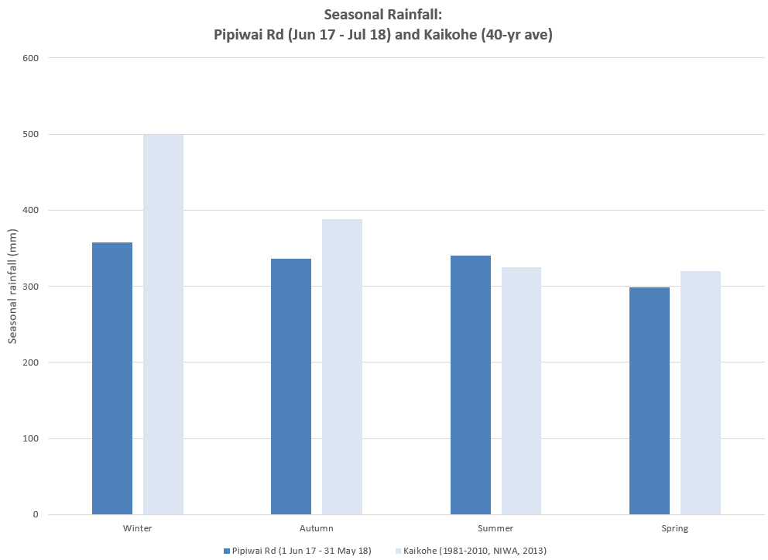

Figure 5 Seasonal rainfall measured at Pipiwai Road, 1 June 2016 – 31 May 2018 as compared with 40-year average in Kaikohe (1981 – 2010)

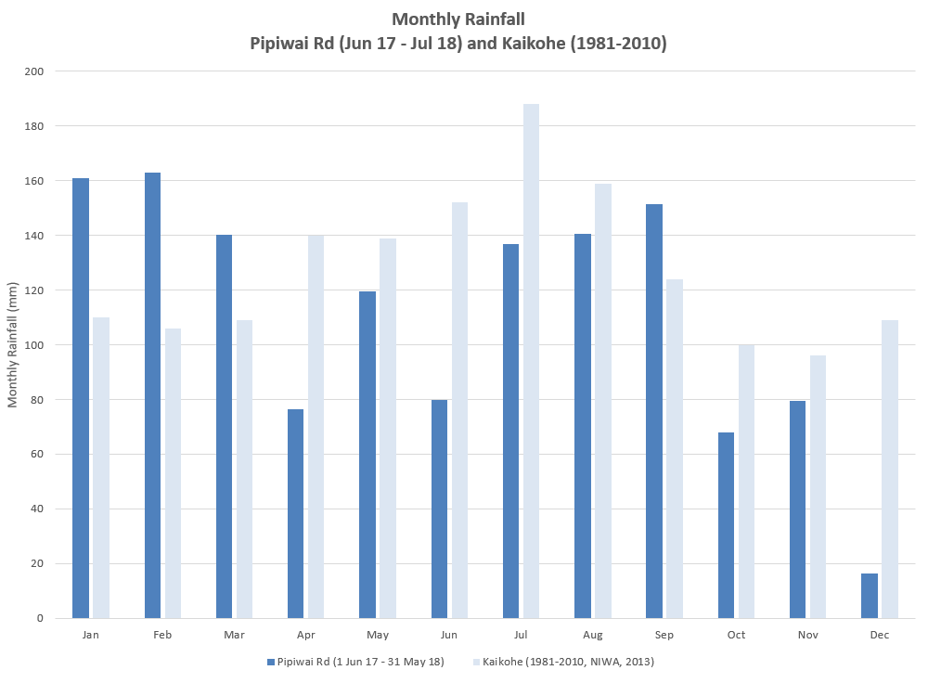

Figure 6 Monthly rainfall measured at Pipiwai Road, 1 June 2016 – 31 May 2018 as compared with 40-year average in Kaikohe (1981 – 2010)

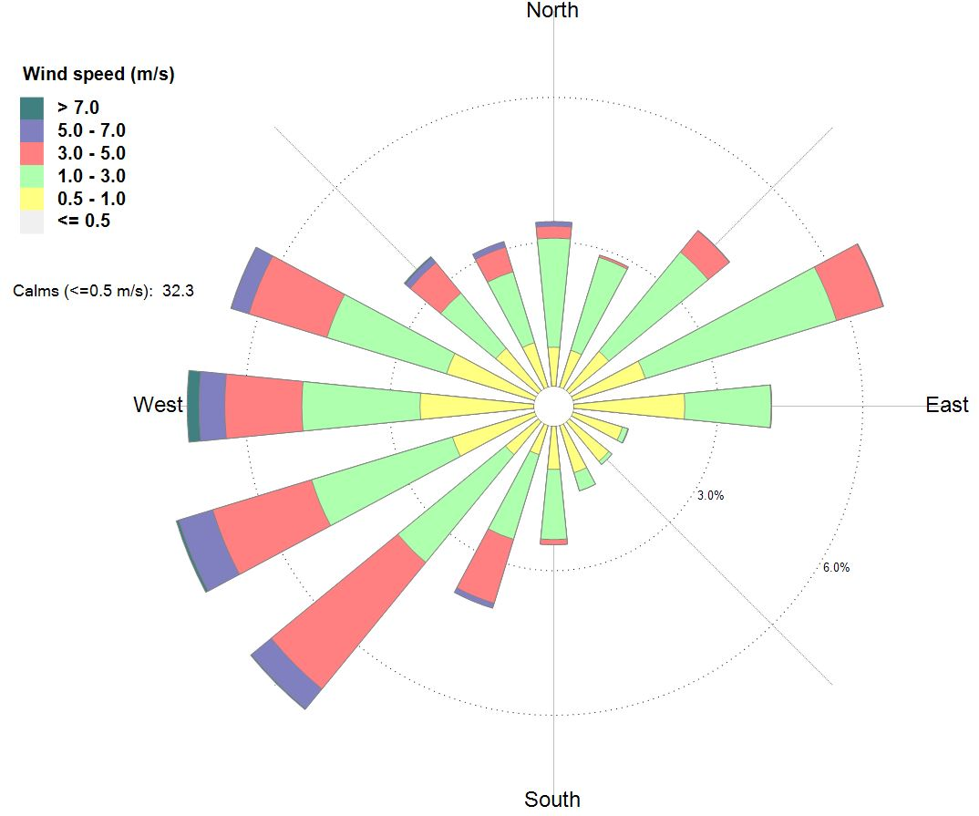

Figure 7 Annual frequency of wind speed and wind direction measured at Pipiwai Road (1 June 2017 – 31 May 2018)

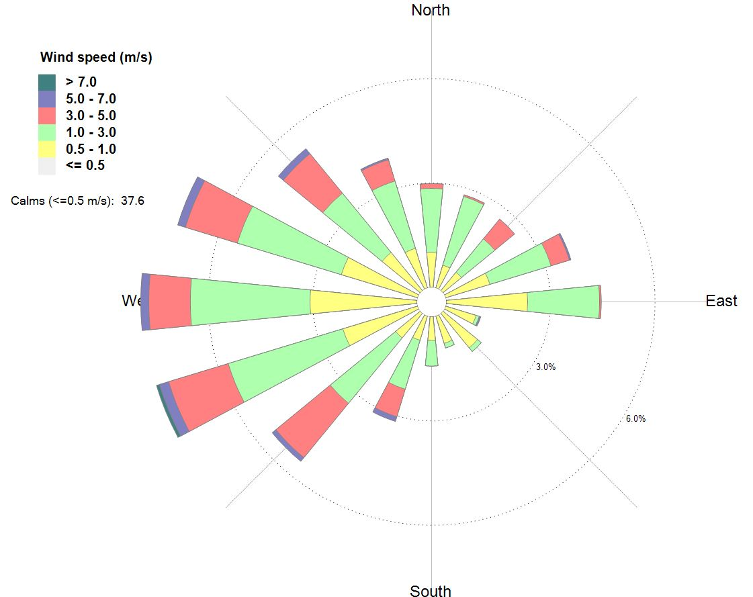

Figure 8 Winter frequency of wind speed and wind direction measured at Pipiwai Road (1 June 2017 – 31 August 2017)

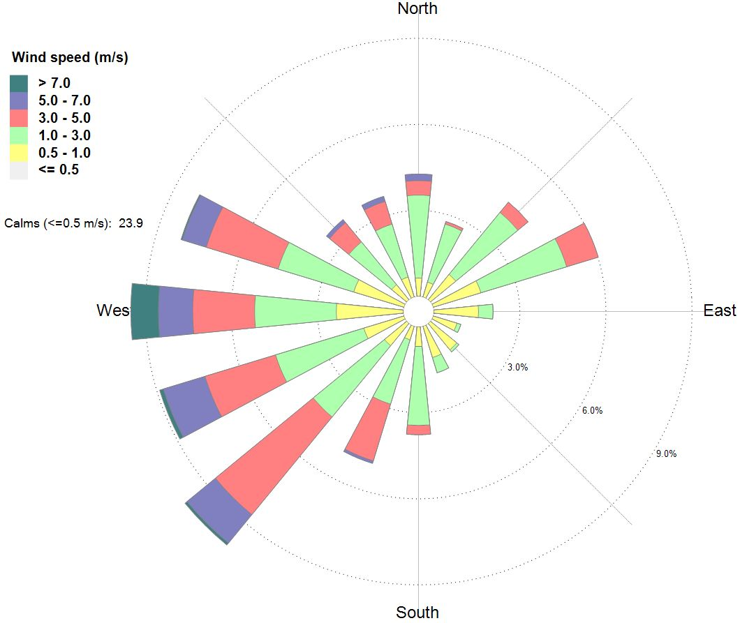

Figure 9 Spring frequency of wind speed and wind direction measured at Pipiwai Road (1 September 2017 – 30 November 2017)

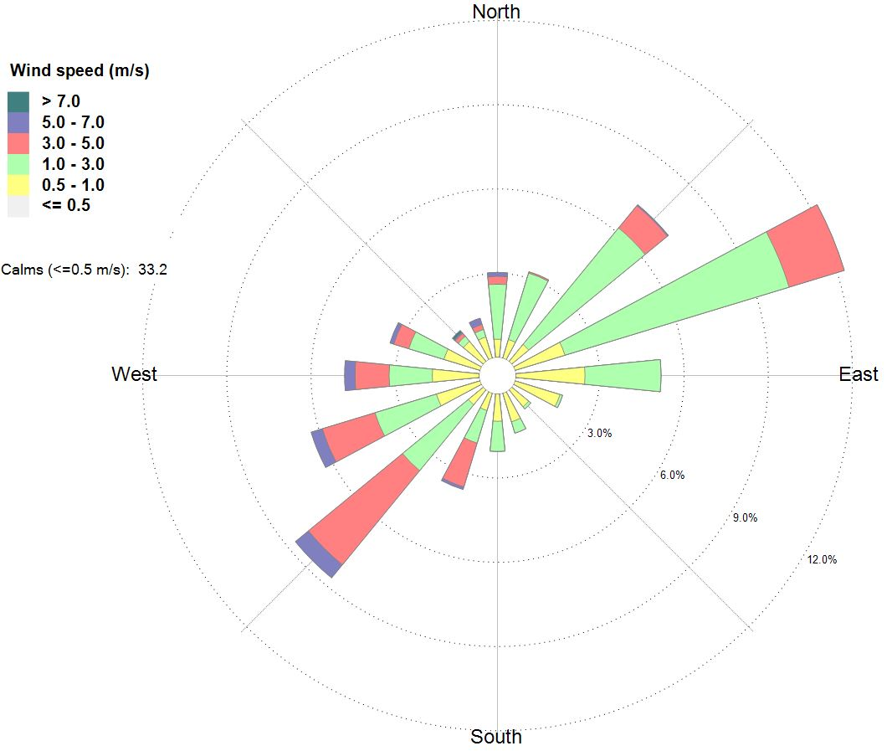

Figure 10 Summer frequency of wind speed and wind direction measured at Pipiwai Road (1 December 2017 – 28 February 2018)

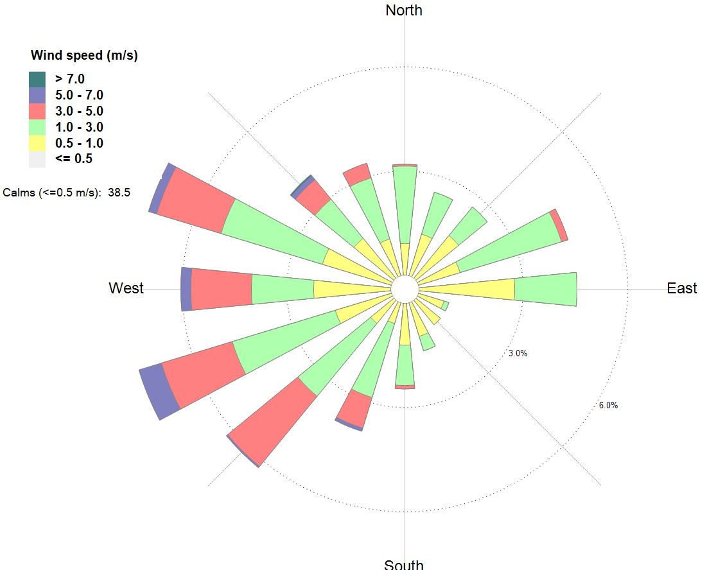

Figure 11 Autumn frequency of wind speed and wind direction measured at Pipiwai Road (1 March – 31 May 2018)

## 3.3 Traffic

Discharges of particulate matter to air from unsealed roads are influenced by factors including vehicle numbers, vehicle weight, vehicle speed, surface silt content and surface moisture (USEPA, 2006).

For this site, we had data on vehicle numbers as classified by vehicle length as shown in **Table 7**. There were 94% days of valid data for the year ended 31 May 2018.

There was no data for vehicle speed, vehicle weight or surface moisture so the influence of these factors was not investigated. Similarly, we did not have data to investigate the potential emission reductions that might be achieved with various mitigation strategies (such as speed limits).

**Table 8** compares the Pipiwai Road data with available regional data (FNDC, 2017) and shows that trucks (vehicles > 5.5 metres in length) made up 27% of all vehicles counted on Pipiwai Road. This is higher than the regional average (14%) for heavy commercial vehicles (**HCV**) on unsealed roads in Northland.

Very long trucks (vehicles > 17 m) comprised 14% of all vehicles counted on Pipiwai Road.

Very long trucks (vehicles > 17 m) comprised 52% of trucks (vehicles > 5.5 m) counted on Pipiwai Road.

Table 7 Traffic data measured at Pipiwai Road 1 June 17 – 31 May 18 [Source: FNDC]

|  |  |  |
| --- | --- | --- |
| Vehicle Class | | Count |
| Very short | < 2m | 1,032 |
| Short | 2 - 5.5m | 26,713 |
| Car Towing |  | 1,320 |
| Medium | 5.5 - 11m | 1,336 |
| 1,569 |
| 2,295 |
| Long 3 – 7 axle trucks | 11 - 17m | 747 |
| 306 |
| 19 |
| 1,097 |
| Very long trucks | >17m | 509 |
| 2,090 |
| 875 |
| Unclassified |  | 25 |
| Pipiwai Road Annual Total | | 39,933 |
| Count valid days | | 342 |
| % Valid data | | 94% |

Table 8 Pipiwai Road traffic data compared with Northland Unsealed Roads [Source: FNDC]

|  |  |  |  |  |  |
| --- | --- | --- | --- | --- | --- |
| Vehicle Class | 7-day Annual Average Daily Traffic (AADT) | Peak Daily Traffic | Annual Count | % Trucks1 | % All Vehicles2 |
| Pipiwai Rd, 1 June 1 – 31 May 18 | | | | | |
| Trucks (> 5.5 m) | 32 | 132 | 10,843 | 100% | 27% |
| Very long trucks (>17m) | 17 | 86 | 5,643 | 52% | 14% |
| All vehicles | 117 | 312 | 39,933 | - | 100% |
| All Northland Unsealed Roads3 | | | | | |
| HCV (>3,500 kg)4 | 15 | - | 1,242,391 | 100% | 14% |
| All vehicles | 104 | - | 8,692,840 | - | 100% |

**Notes**

1. Vehicle class as fraction of vehicles > 5.5 m (Pipiwai Road) or fraction of HCV (all Northland unsealed roads)
2. Vehicle class as fraction of all vehicles (Pipiwai Road and all Northland unsealed roads)
3. (FNDC, 2017) 7-day AADT for each vehicle class is average of 7-day AADT over all unsealed roads in Northland (i.e. regional average). NB: includes Pipiwai Road.
4. (FNDC, 2017) Daily volumes for HCV on all unsealed roads in Northland; 228/228 roads = 100% valid data

# PM10 Exposure

This section describes our analysis of traffic and PM10 data from Pipiwai Road and estimates annual exposure to PM10 attributable to road dust from Pipiwai Road. The methodologies are described in Section 2.

## Traffic analysis

We would expect to see higher daily concentrations of PM10 coinciding with higher numbers of vehicles; and particularly with higher numbers of trucks. We would also expect to see lower daily concentrations of PM10 coinciding with higher rainfall.

To investigate these factors, we grouped the traffic and rainfall data into defined ranges and then calculated the average concentrations of PM10 for all days in each range. We categorised trucks as including medium (5.5 – 11 m), long 3-7 axle trucks (11 – 17 m) and very long trucks (> 17 m). We removed any days missing any one parameter. There was a total of 320 days with data in all categories.

**Table 9** presents the sample numbers for the grouped traffic and rainfall data respectively.

Table 9 Traffic and rainfall data groupings and sample size

|  |  |  |  |
| --- | --- | --- | --- |
| **Trucks per day (all trucks)** | **Number of days** | **Daily rainfall (mm)** | **Number of days** |
| 0-9 | 89 | <1 | 209 |
| 10-19 | 21 | 1-1.9 | 15 |
| 20-29 | 62 | 2-4.9 | 29 |
| 30-39 | 47 | 5-9.9 | 17 |
| 40-49 | 23 | 10-19.9 | 31 |
| 50-59 | 27 | >20 | 19 |
| 60-69 | 16 | **Total days** | **320** |
| 70-79 | 13 |  |  |
| >80 | 22 |  |  |
| **Total days** | **320** |  |  |

**Figure 12** shows the results are as expected – with higher average concentrations of PM10 being measured on days with higher counts of trucks (i.e. vehicles > 5.5 m).

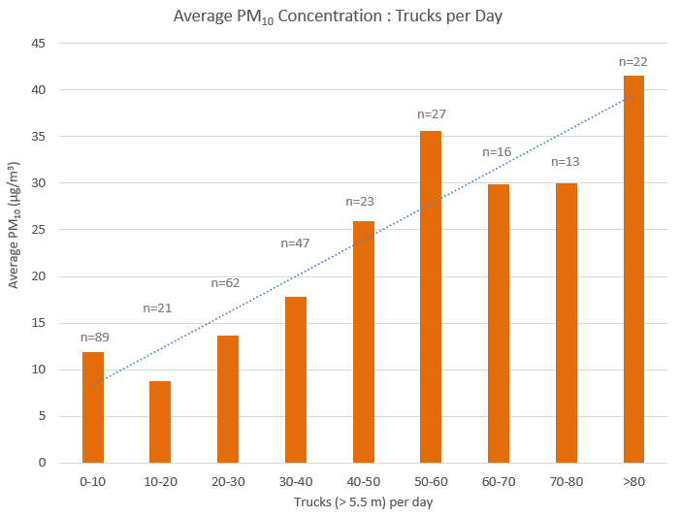

Figure 12 Association between counts of trucks per day and average concentrations of PM10 at Pipiwai Road, 1 June 2017 – 31 May 2018. n= number of days of counts of traffic within range. For example, there were 89 days with less than 10 trucks per day for which the average (3-month) PM10 concentration was 12 µg/m3.

**Figure 13** presents the (negative) association between rainfall and average PM10 concentrations. This shows that higher rainfall corresponds to lower PM10 concentrations.

When viewing these graphs, it is important to understand that PM10 concentrations are averaged over the number of days for which each range of traffic count or rainfall measurement corresponds. Thus, for example, in **Figure 12** the average PM10 concentration was 12 µg/m3 over the 89 days for which there were 0 – 10 trucks. By contrast, the average daily PM10 concentration measured on days with more than 80 trucks was 42 µg/m3, and this was averaged over 22 days.

This means that little weight should be placed on the value of the average PM10 concentration in the graphs, rather the focus should be on the overall trend.

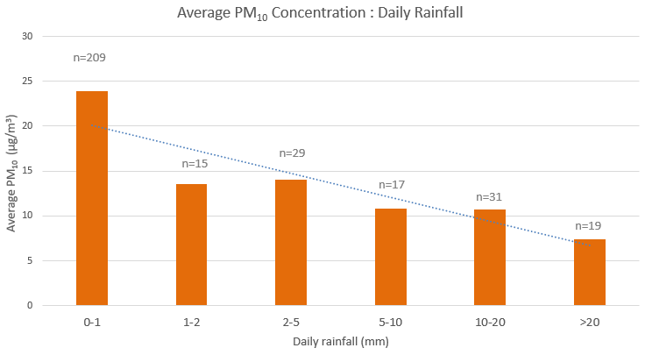

Figure 13 Association between daily rainfall and average concentrations of PM10 at Pipiwai Road, 1 June 2017 – 31 May 2018. n= number of days of counts of rainfall within range. For example, there were 209 days with 0-1 mm rain, during which the (209-day average) PM10 concentration was 24 µg/m3.

Similarly, caution is required, in interpreting the results. For example, **Figure 13** could be read to suggest that any rainfall greater than 1 mm reduces PM10 to approximately background concentrations. However, this is not always true – there was one day with 11 mm of rain that still exceeded the PM10 NES.[11] What **Figure 13** does clearly show is the overall trend that higher rainfall corresponds with lower PM10 concentrations – on average.

**Figure 14** presents the number of exceedances of the PM10 NES (positively) associated with the number of trucks per day. This shows that, at Pipiwai Road, exceedances of the PM10 NES only occurred on days with at least 40 trucks per day.

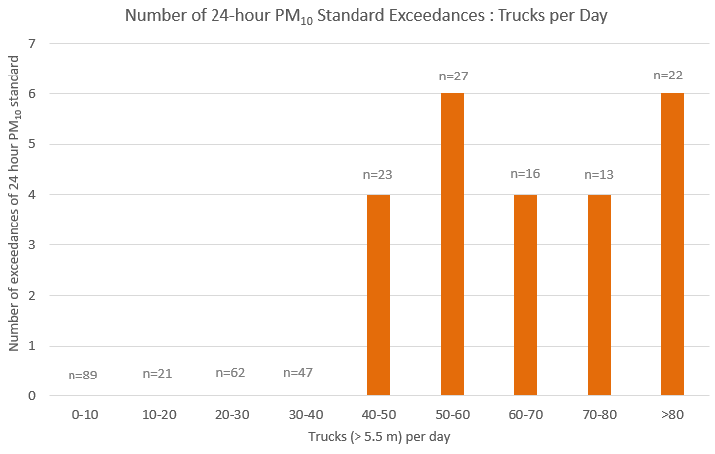

Figure 14 Count of trucks per day vs exceedances of PM10 NES at Pipiwai Road, 1 June 2017 – 31 May 2018. n= number of days of counts of traffic within range. For example, there were 6 exceedances of the PM10 NES out of n=22 days with more than 80 trucks per day.

NB: This report references the traffic counts provided by FNDC. As such each ‘truck’ represents one count of a truck on Pipiwai Road. This is more accurately described as one truck movement in transport terms.

**Figure 15** presents the number of exceedances of the PM10 NES as a function of the number of trucks per day for a specified daily rainfall. This shows that most exceedances (88%) occurred on days with less than 1 mm of daily rain. It also shows that, at Pipiwai Road, exceedances of the PM10 NES occurred 28% of the time when there were at least 40 trucks per day and less than 1 mm of daily rainfall.

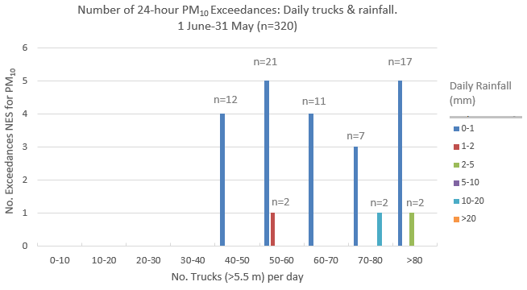

**Daily Rainfall**

**(mm)**

Figure 15 Count of trucks per day and daily rainfall vs exceedances of PM10 NES at Pipiwai Road, 1 June 2017 – 31 May 2018. n= number of days of counts of traffic within range for specified daily rainfall. For example, there were 4 exceedances of the PM10 NES out of n=12 days with 40-50 trucks and 0-1 mm rainfall per day.

## Modelling 24-hour PM10 close to an unsealed road using a preliminary emission factor

We modelled the concentration of PM10 in ambient air due to emissions from an unsealed road using the preliminary estimated emission factor (219 g per truck VKT) and the NZTA screening dispersion model as described in Section 2.2.1. We compared the estimate with:

* Maximum 24-hour PM10 concentration measured on days with truck counts within the corresponding range shown in **Table 9**.
* Average PM10 concentration measured on days with less than 1 mm of rain and truck counts within the corresponding range shown in **Table 9.**

As shown in **Figure 16** we found that the modelling predictions significantly underestimated average and maximum daily PM10 concentrations compared with PM10 concentrations measured at Pipiwai Road. Maximum daily measured PM10 concentrations were 2 – 7 times higher than modelled.

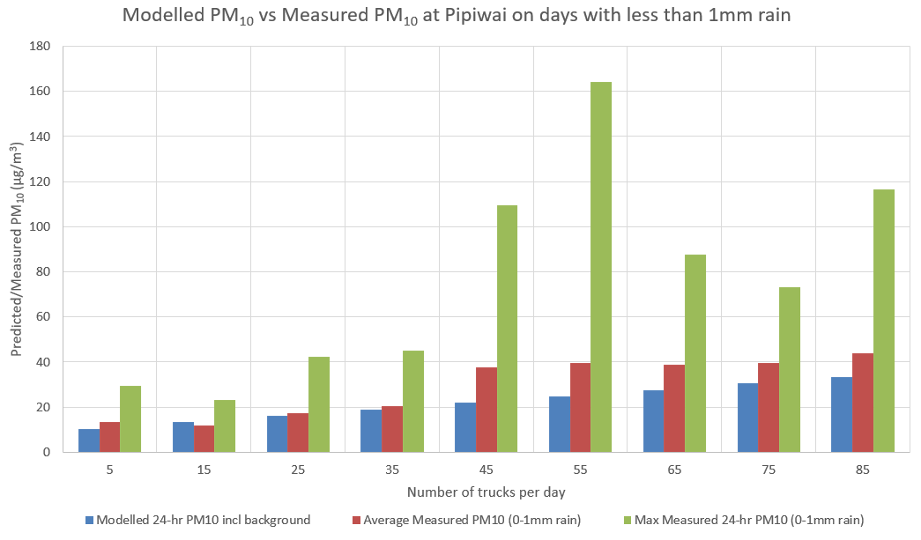

Figure 16 Comparison of modelled 24-hour PM10 with measured average and maximum 24-hour PM10 30 metres downwind of Pipiwai Road as a function of all trucks on days with less than 1 mm of rain, 1 June 2017 – 31 May 2018.

## Calibrating the 24-hour PM10 emission factor

To improve modelling predictions, we developed a calibration factor by resolving the average difference between modelled and (average) measured values to 0%. This yielded a calibration factor of 1.6 as follows:

$${EF}_{calibrated}=EF×1.6$$

Equation 16

Where:

EF **=** daily PM10 created per truck travelling on an unsealed road per km

= 219 g per truck VKT (from Equation 3 in Section 2.2.1)

Thus:

**EFcalibrated = 341 g per truck VKT**

This calibrated PM10 emission factor provides a reasonable estimate of the measured 24-hour PM10 averaged across days with less than 1 mm of rain, as shown in **Figure 17**. However, maximum daily PM10 concentrations were still significantly underestimated with measured concentrations being 1.5 – 4.4 times higher than modelled.

Figure 17 24-hour PM10 modelled with a calibration factor of 1.6 compared with measured average and maximum 24-hour PM10 30 metres downwind of Pipiwai Road as a function of all trucks on days with less than 1 mm of rainfall, 1 June 2017 – 31 May 2018.

## Estimating an annual PM10 emission factor

Given that the calibrated modelling approach provided a reasonable estimate of *average* PM10 concentrations across all days measured, the method is likely to be reasonable for estimating long-term average PM10 concentrations as a result of road dust.

We estimated an annual average emission factor using Equation 5, which is described in Section 2.2.1, as follows:

$$E_{ext} ={EF}_{calibrated} × [(365 - P)/365)]$$

In this case:

EFcalibrated = 341 g per truck VKT (estimated using Equation 18 in Section 4.3)

P = number of days in year with more than 1 mm of rain

= 111 out of 320 days (from **Table 9**)

= 127 (assuming that 111 out of 320 days was representative of the whole year)

Thus:

Eext = 341 x [(365-127)/365]

**Eext = 223 g per truck VKT**

## Comparison of modelled & measured annual PM10 (at one unsealed road)

We used the calibrated annual emission factor of 223 g per truck VKT and the modelling approach described in Section 2.2.1 to estimate *annual* average exposure to road dust based on the annual average daily traffic (AADT) at Pipiwai Road.

The (calibrated) modelling result for annual average PM10 compares reasonably well (within 10%) with measured annual average PM10 concentrations as shown in **Table 10**.

Table 10 Modelled vs Measured Annual PM10

|  |  |  |  |  |  |
| --- | --- | --- | --- | --- | --- |
| **Road** | **AADT (heavy)** | **(Calibrated) Modelled annual PM10** | **Background annual PM10** | **Modelled annual PM10 (including background)** | **Measured annual PM10 Pipiwai Road** |
| vehicles/day | (µg/m3) | | | |
| Pipiwai Road | 32 | 9 | 9 | 18 | 20  (measured) |

# Health Impacts of Road Dust

We have assessed **chronic** health effects attributable to PM10 from all unsealed roads in Northland. Health effects assessed are premature mortality, cardiac hospital admissions, respiratory hospital admissions and restricted activity days using exposure-response relationships from Kuschel *et al.*, (2012). A detailed description of the methodology is provided in Section 2.

We have also undertaken an illustrative assessment of **acute** premature mortality risk (only) from PM10 using exposure-response relationship specific to road dust from Hong *et al.*, (2017). A description of the methodology for illustrative assessment of acute effects is provided in Appendix B.

## 5.1 Estimated health impacts and costs of chronic exposure to PM10: all unsealed roads in Northland

Based on the methodologies outlined in Section 2 and using a calibrated annual emission factor of 223 g per truck VKT, we estimated the annual cost of health impacts from long-term exposure to PM10 near all unsealed roads in Northland as $2.7M ($2017).

The annual estimated number of cases of premature mortality, cardiovascular hospital admissions, respiratory hospital admissions and restricted activity days for Northland are shown in **Table 11**.

Table 11 Estimated annual health impacts and costs of PM10 from unsealed roads in Northland

|  |  |  |  |  |  |
| --- | --- | --- | --- | --- | --- |
|  | **Premature mortality** | **Cardiovascular hospital admissions** | **Respiratory hospital admissions** | **Restricted activity days** | **Total** |
| Number of cases | 0.6 | 0.1 | 0.2 | 205 |  |
| Annual Cost ($2017) | $2,723,468 | $950 | $957 | $15,006 | $2,740,382 |

## 5.2 Estimated health impacts and costs of acute exposure to road dust PM10 illustrative assessment

Based on the methodology described in Appendix B, we estimated premature mortality associated with short-term exposure to road dust. This was an illustrative assessment only based on monitoring results at one location and a hypothetical exposed population of 1,000 people. The number of cases (premature mortality) were calculated based on daily monitoring results at Pipiwai Road from 1 June 2017 to 31 May 2018 and the exposure-response relationship from Hong *et al.*, (2017).

For comparison the estimated premature mortality associated with long-term exposure to road dust assuming an exposed population of 1,000 people was also calculated. This was estimated based on the annual monitoring results at Pipiwai Road from 1 June 2017 to 31 May 2018 and utilises the exposure-response relationship in Kuschel *et al.*, (2012) for comparative purposes.

The results suggest that the estimated short-term effects of exposure to road dust PM10 are approximately 52% of the estimated long-term effects. It is important to note that the short-term effects on health effects are largely included in the long-term effects (they are not additional to the long-term effects).

## 5.3 Sensitivity analyses

As shown in Equation 1, health effects are estimated from:

1. Pollutant (PM10) concentrations attributable to road dust (exposure);
2. Exposure-response relationships (relative risk); and
3. The population exposed.

Our estimates of health effects are therefore directly proportional to these three variables.

We have assumed that the dwelling count is reasonably accurate (FNDC, 2017) and that the population data are robust, albeit slightly outdated being based on 2006 census data. These two parameters combine to give the third key variable.

The following analyses test the sensitivity of the effects estimates to the first two key variables.

### 5.3.1 PM10 Exposure: distance from road

We estimated the annual average PM10 concentration (exposure) using Equation 2 as described in Section 2.1.1:

$$Annual{ PM}_{10} \left({μg}/{m^{3}}\right)=0.325\exp\left(-0.3d^{0.5}\right)×(\frac{AADT of HCV }{24}) ×EF×0.5$$

The distance of receptors from the road (d) was assumed to be 30 m. This was selected because it was assumed to be a representative setback from the road to dwellings in Bluett *et al.,* 2016. Our assessment assumed that all houses within 80 m of the road are at an average distance of 30 metres. The average distance between the road and receptors could realistically be higher than the 30 m assumed.

**Table 13** shows the estimated effects when the assumed distance between the road and receptors was increased to 40 m and 60 m.

Table 13. Sensitivity Analysis: Upper and lower bound average distance from unsealed road

|  |  |  |  |  |  |
| --- | --- | --- | --- | --- | --- |
|  | **Number of cases** | | | | **Total**  **cost** |
| **Distance (d) between road and receptors** | **Premature mortality** | **Cardiovascular hospital admissions** | **Respiratory hospital admissions** | **Restricted activity days** |
| **30 m** (base case) | 0.6 | 0.1 | 0.2 | 205 | $2,740,382 |
| **40 m** (upper bound) | 0.5 | 0.1 | 0.1 | 159 | $2,148,535 |
| **60 m** (lower bound) | 0.3 | 0.06 | 0.1 | 104 | $1,421,583 |

The results show that:

* Increasing the assumed average distance between houses and unsealed roads to 40 metres decreased the impacts to approximately 78% of base case impacts.
* Increasing the assumed average distance between houses and unsealed roads to 60 metres decreased the impacts to approximately 52% of base case impacts.

### 5.3.1 PM10 exposure: silt fraction

We have estimated the annual average concentrations of PM10 attributable to each unsealed road in Northland using emissions and modelling estimates calibrated with monitoring data collected over one year for one road (Pipiwai Road). The actual annual PM10 concentration at each road could be higher or lower, and the effects estimate proportionately higher or lower.

Our estimate of road dust emissions from each road were calculated using Equation 3 (USEPA, 2006) and are directly proportional to the surface material silt content (particles smaller than 75 micrometres in diameter). USEPA, 2006 notes:

*It should be noted that the ranges of silt content vary over two orders of magnitude. Therefore, the use of data from this table can potentially introduce considerable error. Use of this data is strongly discouraged when it is feasible to obtain locally gathered data.*

We did measure silt fraction and our measurements of composite samples from Pipiwai, Omauri and Lovatt Roads yielded an average silt fraction of 2%. However, this silt content may not be representative of other unsealed roads in Northland. Default emission factors for the silt fraction on public gravel roads range from 0.5 – 25% with an average of 6.4% (USEPA, 2006).

Increasing the silt fraction to 6.4% increases the daily emission factor to 624 g/KVT. (This is an uncalibrated factor for sensitivity testing).

**Table 14** shows that increasing the silt fraction to a default average increases the impacts by approximately 260%.

Table 14. Sensitivity Analysis: Increased silt fraction of road surface material

|  |  |  |  |  |  |
| --- | --- | --- | --- | --- | --- |
|  | **Number of cases** | | | | **Total**  **cost** |
| **Silt fraction** | **Premature mortality** | **Cardiovascular hospital admissions** | **Respiratory hospital admissions** | **Restricted activity days** |
| **2 %** (base case) | 0.6 | 0.1 | 0.2 | 205 | $2,740,382 |
| **6.4 %** | 1.7 | 0.4 | 0.5 | 573 | $7,082,306 |

### 5.3.3 Exposure-response relationships (95% confidence limits)

The health effects estimates described in previous sections were based on best estimates for exposure-response relationships published in epidemiological studies. These studies include 95% confidence intervals for each exposure-response relationship that provide realistic upper and lower bounds for assessment purposes.

The exposure response relationships, with upper and lower 95% confidence limits shown in brackets, are summarised as follows:

**Premature mortality**, adults over 30 for all non-external causes: exposure-response relationship = 1.07 (i.e. 7% (**3% to 10%**)) per 10 μg/m3 PM10 (from Kuschel *et al*., 2012)

Morbidity, exposure-response relationship, per 10 μg/ m3 PM10 for **cardiac hospital admissions**, all ages, = 1.006 (i.e. 0.6% (**0.3% to 0.9%**), per 10 μg/m3 PM10 (from Kuschel *et al*., 2012)

Morbidity, exposure-response relationship, per 10 μg/ m3 PM10 for **respiratory hospital admissions**, all ages, daily mean = 1.01 (i.e. 1% (**0.6% to 1.7%**), per 10 μg/m3 PM10 (from Kuschel *et al*., 2012)

**Restricted activity days** = 0.9 (**0.5 - 1.7**) days per person per year per 10 µg/m3 annual PM2.5 (from Kuschel *et al*., 2012)

**Table 15** shows the sensitivity of the effects estimate to the exposure-response relationships:

* Using the highest likely values for the exposure-response relationships increases the impacts to approximately 140% of the base case impacts.
* Using the lowest likely values for the exposure-response relationships decreases the impacts to approximately 44% of the base case impacts.

Table 15. Sensitivity Analysis: Upper and lower bound exposure-response relationships

|  |  |  |  |  |  |
| --- | --- | --- | --- | --- | --- |
|  | **Number of cases** | | | | **Total cost** |
|  | **Premature mortality** | **Cardiovascular hospital admissions** | **Respiratory hospital admissions** | **Restricted activity days** |
| **Best estimate** exposure-response relationships (base case) | 0.6 | 0.1 | 0.2 | 205 | $2,740,382 |
| **Upper limit** exposure-response relationships (95% confidence interval) | 0.9 | 0.2 | 0.3 | 387 | $3,844,084 |
| **Lower limit** exposure-response relationships (95% confidence interval) | 0.3 | 0.06 | 0.1 | 114 | $1,210,228 |

### 5.3.4 Exposure-response relationships (sensitive populations)

It is well established that the burden of health effects from air pollution is not shared evenly in the general population. Susceptible groups include elderly people, children (including babies, infants and unborn babies) and people with pre-existing conditions (heart and lung disease, respiratory conditions including asthma).

New Zealand epidemiological research has shown that Māori are disproportionately affected by air pollution (Hales *et al.*, 2010):

**Premature mortality**, Māori adults over 30 for all non-external causes: exposure-response relationship = **1.2** (i.e. 20% (7% to 33%)) per 10 μg/m3 PM10

Rural Northland has a relatively high (22%) portion of the population that are Māori so it this is an important issue.

**Table 16** shows the sensitivity of the effects estimate to the inclusion of a Māori-specific exposure-response relationship. The impacts are significant – adopting a Māori-specific exposure-response relationship increases estimated health impacts to 154% of the base case.

Table 16. Sensitivity Analysis: Māori-specific exposure-response relationship

|  |  |  |  |  |
| --- | --- | --- | --- | --- |
|  | **Exposure Response Relationship** | | | |
|  | **Base Case** | **Māori adults** | **Non-Māori adults** | **All adults** |
| Cases premature mortality | 0.6 | 0.6 | 0.4 | 1.0 |
| Estimated Cost ($2017) | $2,723,468 | $2,394,674 | $1,813,339 | $4,208,013 |

# Conclusions

Northland Regional Council and Far North District Council continuously monitored PM10 near an unsealed road in Northland (Pipiwai Road) between 1 June 2017 and 31 May 2018. This monitoring enabled, for the first time, an assessment of the annual average PM10 exposure directly attributable to an unsealed road in New Zealand. This in turn, enabled an assessment of the health effects of this PM10 exposure.

**PM10 Exposure**

The monitoring recorded 27 exceedances of the 24-hour national environmental standard (**NES**) for PM10 (one exceedance is permitted within any 12-month period). The maximum daily PM10 concentration measured was 164 µg/m3 and the second highest daily PM10 concentration was 127 µg/m3.

The maximum hourly levels of PM10 were very high with a maximum hourly PM10 concentration of 1,101 µg/m3 which is more than seven times the Ministry for the Environment suggested trigger threshold for PM10 of 150 µg/m3 as a 1-hour average (MfE, 2016b). This suggested trigger threshold was exceeded 124 times, on 39 days.

Rainfall measured during the monitoring period suggests that the Pipiwai dataset may not represent worst-case conditions for dust generation.

This study found the following empirical relationships between the PM10 NES and trucks (i.e. vehicles > 5.5 metres in length) on Pipiwai Road:

* Exceedances only occurred on days with more than 40 trucks;
* Most (88%) exceedance occurred on days with less than 1 mm of rain; and
* Exceedances occurred on 28% of days with more than 40 trucks and less than 1 mm of rain.

Overall, the monitoring at Pipiwai Road suggests that there is a significant risk of exceedance of PM10 NES near unsealed roads with more than 40 trucks per day.[12]

It should be noted that this threshold is based on peak daily traffic, not annual average daily traffic. For example, over the monitoring period at Pipiwai Road, the annual average daily traffic for trucks was 32. However, over the same time period there were 101 days with more than 40 trucks per day and there were 27 exceedances of the PM10 NES.

The findings at Pipiwai are consistent with the results of previous monitoring of PM10 near unsealed roads in New Zealand, which has also revealed multiple exceedances of health-based air quality criteria (Northland Regional Council, 2013, Watercare Laboratory Services, 2016, Bluett *et al*., 2016).

**Modelled vs Measured**

Comparison of ambient daily PM10 concentrations predicted using a USEPA emissions model and an NZTA screening dispersion model showed the models significantly underpredicted concentrations when compared with measurements from Pipiwai Road.

We developed a calibration factor from measured data to derive an *average* daily PM10 emission factor of 341 g per truck VKT (for days with less than 1 mm of rain). This calibrated emission factor provides a reasonable correlation between modelled and measured *average* dailyPM10 concentrations at Pipiwai Road (averaged across days with less than 1 mm of rain). However, *maximum* measured daily PM10 concentrations were still 1.5 to 5 times higher than modelled using the calibrated emission factor.

We then developed a calibrated PM10 emission factor of 223 g per truck VKT for *annual* average emissions. Modelled annual average PM10 using the calibrated annual emission factor compared reasonably well (within 10%) with measured annual average PM10 at Pipiwai Road.

The correlations in this study may not be valid for unsealed roads in other locations.

**Health Effects of Road Dust in Northland**

We assessed chronic health impacts, and costs, of exposure to PM10 from unsealed roads in Northland.

The assessment utilised exposure-response relationships from Kuschel *el al.*, (2012) and included assessment of premature mortality, cardiac hospital admissions, respiratory hospital admissions and restricted activity days. This assessment was undertaken for all unsealed roads in Northland and estimated *inter alia* 0.6 (0.3 – 0.9) cases of premature mortality per year due to unsealed road dust. The total cost of all adverse effects assessed was $2.7 million ($1.2 – 3.8 million, $2017).

An illustrative assessment of acute effects was also undertaken using an exposure-response relationship from a recent Canadian study (Hong *et al*., 2016) that was specific to road dust. The results suggest that the total estimated short-term effects of exposure to road dust (summed over a whole year) were approximately 52% of the estimated long-term effects at the same location over the same time period. It is important to note that the short-term effects on health effects are largely included in the long-term effects (they are not additional to the long-term effects).

Sensitivity testing revealed the importance of key parameters as follows:

* Assumed distance from road – increasing the distance of houses from the road from 30 metres to 60 metres reduced chronic health impacts by nearly 50%.
* Silt fraction of road surface material – increasing the (measured) silt fraction to a default (emission factor) average increases chronic health impacts by approximately 260%.
* Sensitive populations – Māori are known to be disproportionately impacted by air pollution. Adoption of a Māori-specific exposure-response relationship increased chronic health impacts by 54%.

These highlight the uncertainties inherent in this assessment and support recommendations for additional research (detailed below).

## 6.1 Limitations

The associations and correlations in this study are based on measurements at one location and may not be valid for unsealed roads in other locations with different traffic and meteorological profiles. Similarly, the associations and correlations in this study may not be valid for unsealed roads in other locations with different roading materials.

As noted above, the study did not measure vehicle speed which is known to correlate linearly with particulate emissions from unsealed roads.

Also, the study did not measure the fine fraction of particulate (particulate matter less than 2.5 micrometres in diameter, **PM2.5**). Current research suggests different size fractions have different mechanisms and (adverse) health outcomes (WHO, 2013).

## 6.2 Recommendations

**Monitoring**

Considering the above limitations, we recommend at least one year of PM10 monitoring near unsealed roads in other locations. Monitoring should be undertaken on roads where the number of trucks per day regularly exceeds 40.

Ideally, this monitoring would be undertaken contemporaneously in several different regions and would measure:

* Vehicle counts (hourly, daily)
* Vehicle type
* Vehicle speed
* Silt content (<75 µm)
* Surface material moisture content (%)
* PM10
* PM2.5
* Wind speed, wind direction, rainfall

**Modelling**

The modelling presented in this report used emission factors derived from a USEPA equation and an NZTA screening dispersion model. The NZTA screening model is intended to provide a conservative (worst case) assessment of air quality. In this case, we found that the USEPA emission factor and the NZTA screening model significantly *underestimated* PM10 compared with measurements.

We developed a calibration factor to provide a reasonable comparison of model results with *average* daily measured PM10 concentrations. However, the modelling approach still significantly underestimated *maximum* daily PM10 concentrations. It should also be noted that the calibration factor was developed from data measured at Pipiwai Road during a year that may not be representative of worst case (due to slightly lower than average rainfall).

Further work is recommended to investigate whether the emission factors are too low, or the NZTA screening model is not sufficiently conservative to estimate peak 24-hour concentrations (or a combination of these).

**Assessment**

Currently 18% of New Zealand’s vehicle kilometres travelled (VKT) on unsealed roads occurs in the Northland region (NZTA, 2017).[13] Additional research is recommended to determine the national impacts of unsealed roads in New Zealand.

# References

APHEIS, (2004). *Health Impact Assessment of Air Pollution and Communication Strategy*, Third Year Report 2002 -2003.

Bartley Consultants, (1995). *Effect of dust palliatives on unsealed roads in New Zealand.* Transit New Zealand Research Report 38. 132 pp.

Bluett J., Gimson M., de Aguiar M., (2016) *Impacts of exposure to dust from unsealed roads*. New Zealand Transport Agency Research Report 590. August.

Emission Impossible Ltd, (2018). *PM10 and Unsealed Roads in Northland. Ambient PM10 at Pipiwai Road, 1 June 2017 – 31 May 2018*. Prepared for Ministry of Health. Auckland. 20 September.

FNDC, (2017). *Indicative Forestry Road Dust Prioritisation - Using NZTA General Circular 16/04 Matrix Assessment – 2017* (spreadsheet).

Hales S, Blakely T, Woodward A (2010). Air pollution and mortality in New Zealand: cohort study, *Journal of Epidemiology and Community Health*. doi:10.1136/jech.2010.112490.

Hime J., Marks G. and Cowie C., (2018). A comparison of the health effects of ambient particulate matter air pollution from five emission sources. *Int. J. Environ. Res. Public Health*. 2018:15.1206.

Hong Kris., King Gavin., Saraswat Arvind., Henderson Sarah. (2017). Seasonal ambient particulate matter and population health outcomes among communities impacted by road dust in British Columbia, Canada. *J Air & Waste Mgmt Assoc*. May. <https://doi.org/10.1080/10962247.2017.131534>

Kuschel G., Metcalfe J., Wilton E., Guria J., Hales S., Rolfe K., Woodward A., (2012). *Updated Health and Air Pollution in New Zealand Study*. Prepared for Health Research Council of New Zealand, Ministry of Transport, Ministry for the Environment and New Zealand Transport Agency. March. Available at: [www.hapinz.org.nz](http://www.hapinz.org.nz)

Ministry for the Environment (MfE), (2009). *Good Practice Guide for Air Quality Monitoring and Data Management*. Wellington. Available at www.mfe.govt.nz.

MfE, (2016a). *Good Practice Guide for Assessing Discharges to Air from Industry.* Wellington. November. Available at [www.mfe.govt.nz](http://www.mfe.govt.nz)

MfE, (2016b). *Good Practice Guide for Assessing and Managing Dust*. Wellington. November. Available at www.mfe.govt.nz

Mote, (2018). Letter from Mr Paul Baynham, Senior Scientist, Mote Ltd to Ms Louise Wickham, Director & Senior Air Quality Specialist, Emission Impossible Ltd *Re: Road Dust Analysis* dated 17 September 2018.

NIWA, (2013). *The Climate and Weather of Northland*. 3rd edition. P.R. Chappell. Available at: <https://www.niwa.co.nz/static/Northland%20ClimateWEB.pdf> Accessed 18 Sept 2018.

Northland Regional Council, (2013). *Ambient PM10 monitoring adjacent to four unsealed roads in Northland.* (Wright, Opouteke, Ngapipito and Pipiwai Roads – March/April 2013). Whangarei.

NZTA, (2017). “***Vehicle use, expressed as ‘vehicle kilometres travelled”*** within Road Controlling Authority areas, in each region and in NZ...over the last 10 years. Available at: http://www.nzta.govt.nz/assets/userfiles/transport-data/VKT.xls [Online: Retrieved 31 Jan 2018]

United States Environmental Protection Agency (USEPA), (2006). AP 42. *Compilation of Air Pollutant Emissions Factors*. Volume 1: Stationary Point and Area Sources. 13.2.2 Unpaved Roads. Fifth Edition. Available online at: <https://www3.epa.gov/ttn/chief/ap42/ch13/index.html>

United States Environmental Protection Agency (2006b). *Background document for revisions to fine fraction ratios used for AP-42 fugitive dust emission factors*. Midwest Research Institute project no 110397.

Watercare Laboratory Services, (2016). *Wright Road Continuous Ambient Air Quality Monitoring Summary Report 26 February to 12 March 2016.* Prepared for Whangarei District Council. Auckland. April.

Watercare Laboratory Services Ltd, (2017a). *Pipiwai Continuous Ambient Air Quality Monitoring Monthly Summary Report June 2017.* Prepared for Northland Regional Council by Watercare Laboratory Services. 7 July.

Watercare Laboratory Services Ltd, (2017b). *Pipiwai Continuous Ambient Air Quality Monitoring Monthly Summary Report July 2017.* Prepared for Northland Regional Council by Watercare Laboratory Services. 4 August.

Watercare Laboratory Services Ltd, (2017c). *Pipiwai Continuous Ambient Air Quality Monitoring Monthly Summary Report August 2017.* Prepared for Northland Regional Council by Watercare Laboratory Services. 6 September.

Watercare Laboratory Services Ltd, (2017d). *Pipiwai Continuous Ambient Air Quality Monitoring Monthly Summary Report September 2017.* Prepared for Northland Regional Council by Watercare Laboratory Services. 5 October.

Watercare Laboratory Services Ltd, (2017e). *Pipiwai Continuous Ambient Air Quality Monitoring Monthly Summary Report October 2017.* Prepared for Northland Regional Council by Watercare Laboratory Services. 8 November.

Watercare Laboratory Services Ltd, (2017f). *Pipiwai Continuous Ambient Air Quality Monitoring Monthly Summary Report November 2017.* Prepared for Northland Regional Council by Watercare Laboratory Services. 8 December.

Watercare Laboratory Services Ltd, (2018a). *Pipiwai Continuous Ambient Air Quality Monitoring Monthly Summary Report December 2017.* Prepared for Northland Regional Council by Watercare Laboratory Services. 8 January.

Watercare Laboratory Services Ltd, (2018b). *Pipiwai Continuous Ambient Air Quality Monitoring Monthly Summary Report January 2018.* Prepared for Northland Regional Council by Watercare Laboratory Services. 2 February.

Watercare Laboratory Services Ltd, (2018c). *Pipiwai Continuous Ambient Air Quality Monitoring Monthly Summary Report February 2018.* Prepared for Northland Regional Council by Watercare Laboratory Services. 2 March.

Watercare Laboratory Services Ltd, (2018d). *Pipiwai Continuous Ambient Air Quality Monitoring Monthly Summary Report March 2018.* Prepared for Northland Regional Council by Watercare Laboratory Services. 6 April.

Watercare Laboratory Services Ltd, (2018e). *Pipiwai Continuous Ambient Air Quality Monitoring Monthly Summary Report April 2018.* Prepared for Northland Regional Council by Watercare Laboratory Services. 3 May.

Watercare Laboratory Services Ltd, (2018f). *Pipiwai Continuous Ambient Air Quality Monitoring Monthly Summary Report May 2018.* Prepared for Northland Regional Council by Watercare Laboratory Services. 8 June.

Watercare Laboratory Services Ltd, (2018g). *Pipiwai Continuous Ambient Air Quality Monitoring Monthly Summary Report June 2018.* Prepared for Northland Regional Council by Watercare Laboratory Services. 5 July.

Waters J. C., (2009). *Long-term dust suppression using the Otta seal technique*. New Zealand Transport Agency Research Report 368. 51 pp.

World Health Organisation (WHO), (2006). *Air Quality Guidelines Global Update 2005, Particulate matter, ozone, nitrogen dioxide and sulfur dioxide.* Copenhagen: WHO Regional Office for Europe.

WHO, (2013). *Review of evidence on health aspects of air pollution – REVIHAAP Project.* Copenhagen: WHO Regional Office for Europe.

# Appendix A Ambient air quality monitoring data

In January 2017, Northland Regional Council (**NRC**) commissioned Watercare Laboratory Services Ltd (**Watercare**) to undertake ambient air quality monitoring near an unsealed road in Northland for a period of one year. Accordingly, between 1 June 2017 and 31 May 2018, Watercare undertook continuous monitoring near Pipiwai Road for five parameters:

* Particulate matter less than 10 micrometres in diameter (**PM10**);
* Wind speed
* Wind direction
* Temperature
* Relative humidity

Watercare provided 12 monthly reports with supporting data (in spreadsheet form) and a separate summary report to NRC (Watercare, 2017a-2018g).[14] We used these reports and the supporting data to prepare this report.

Funding and assistance in kind (provision of electricity connection and traffic data) was provided by Far North District Council (**FNDC**). Additional rainfall data was provided by NRC.

## A1.1 Monitoring methods

The following section details the methods reported by Watercare.

All monitoring was undertaken in accordance with the Ministry for the Environment *Good Practice Guide for Air Quality Monitoring and Data Management* (MfE, 2009). The instruments employed continuously measure each parameter permitting data to be analysed and reported from 10-minute data points to 1-hour and 24-hour averages.

Data was logged onsite and downloaded at regular intervals during the day via a cellular router for daily checking, validation and reporting. All data are stored and presented as time ending averages at New Zealand Standard time (NZST) (i.e. no daylight savings time).

PM10 was continuously monitored using a beta attenuation monitor (BAM) Thermo model FH62-C14. The BAM works by measuring the intensity of beta particles passing through a filter tape. As particulate mass deposited on the tape increases, the intensity of the beta particles decreases, and mass is calculated. The volume of air passing through the sample is also measured so that the concentration (mass per unit volume) of dust on the filter can be calculated.

At midnight each day the filter tap automatically turns over giving a clean filter tape for the next 24-hour period of sampling. Particulate matter concentrations were calculated to standard temperature (0°C) and pressure (1 atmosphere). The BAM operates with a full-scale measurement range of 0 - 10,000 micrograms per cubic metre (**µg/m3**).

Meteorological parameters were measured with reference to AS 3580.14 – 2014: Meteorological monitoring for ambient air quality monitoring applications and Watercare’s quality system. These were measured using a Vaisala model WXT520.

## A1.2 Quality assurance

**PM10**

Watercare is accredited by International Accreditation New Zealand to measure PM10 in accordance with AS 3580.9.11 – 2016: Determination of suspended particulate matter – PM10 beta attenuation monitors. Watercare reports this means that the BAM was installed, configured, calibrated, operated and maintained in accordance with the method’s requirements and the manufacturer’s instructions.

Maintenance checks, including operational parameter examinations, were conducted every three months, six months, and annually with calibrations performed every three months. In accordance with the manufacturer’s instructions, PM10 data was adjusted to remove 10-minute average concentrations below the detection limit (-9 µg/m3).

**Meteorological parameters**

The Vaisala model WXT520 met the performance specifications of AS 3580.9.11 – 2016 and was installed, configured, calibrated, operated and maintained in accordance with the method’s requirements and the manufacturer’s instruction. These included daily instrument performance and data checks, cable and system integrity checks as well as wind speed and direction sensor sensitivity checks.

## A1.3 Valid data

It is technically impossible to achieve 100% valid data capture for long-term continuous ambient air quality monitoring. This is because the monitors are required to undergo regular calibration and zero span checks which take them offline for short periods of time. In addition to this:

* standard requirements for regular instrument checks and maintenance (vital for data quality assurance) also necessitate short periods when the monitors are offline; and
* there will inevitably be periods of data loss due to unforeseen circumstances such as equipment failure, power outages, bias and drifts.

The Ministry for the Environment recommends the following targets:

* 95% data capture; and
* 75% valid data capture.

Where:

**Data capture** is the amount of valid data as a fraction of the total time the instrument was available to capture data; and

**Valid data** is the amount of valid data as a fraction of the total amount of data captured.

**Figure A-1** shows an example of a data capture rate and per cent valid data calculation.

Power cut = 1 hour (1 x 1-hour average)

Calibration = 2 hours (2 x 1-hour averages)

Valid data points = 21 hours (21 x 1-hour averages)

Figure A-1 Example data capture rate and valid data calculation

From **Figure A-1**, for a 24-average (24 x 1-hour averages):

* Per cent valid data for averaging = 21/24 = 88%
* Data capture rate = 21/(24-2) = 95%
* Data loss = 1/24 = 4%

Based on the per cent valid data in the ambient air quality monitoring data, site performance was:

* 91% PM10 (hourly)
* 95% PM10 (daily)
* 96% Wind speed/direction (hourly)

Data capture was not reported by Watercare (and cannot be estimated from the available data).

## A1.4 Monitoring site location

Pipiwai Road is 57 km long, connecting the village of Pipiwai with Kamo in Whangarei to the south west and the village of Matawai to the north east. Inland sections are unsealed beyond Pipiwai village, although there is some seal on intermittent sections in front of houses.

**Figure A-2** shows the general location of the monitoring site, around 36 km northwest of Whangarei and 7 km north-northwest of Pipiwai. The area is gently rolling, open grassland interspersed with forest and regenerating bush. **Figure A-3** provides a topographical map of the area around the monitoring site location.

**Figure A-4** shows the location of the monitoring site, which was 30 metres to the east of Pipiwai Road, and around 200 m north of the intersection with Lovatt Road. **Figure A-4** also shows the location of the temporary (road) seal in front of the house located near the monitor.

The field the monitor was located on is flat, but beyond the regenerating bush to the east, the land drops down to the Kaikau River. A few hundred metres to the south (beyond Lovatt Road), the land rises by around 100 m as shown in the site photo provided by Watercare (refer **Figure A-5**).

Photographs in **Figure A-6** (taken from Pipiwai Road facing south) and **Figure A-7** (taken from Pipiwai Road facing north) show the general surrounds of the monitoring site, including tall trees to the east of the monitoring location (masking the drop off to Kaikau River).

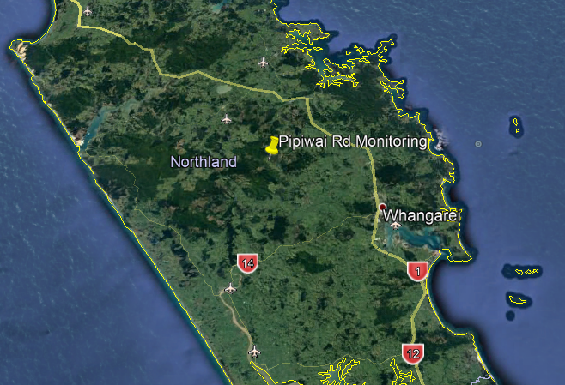

Figure A-2 General monitoring location

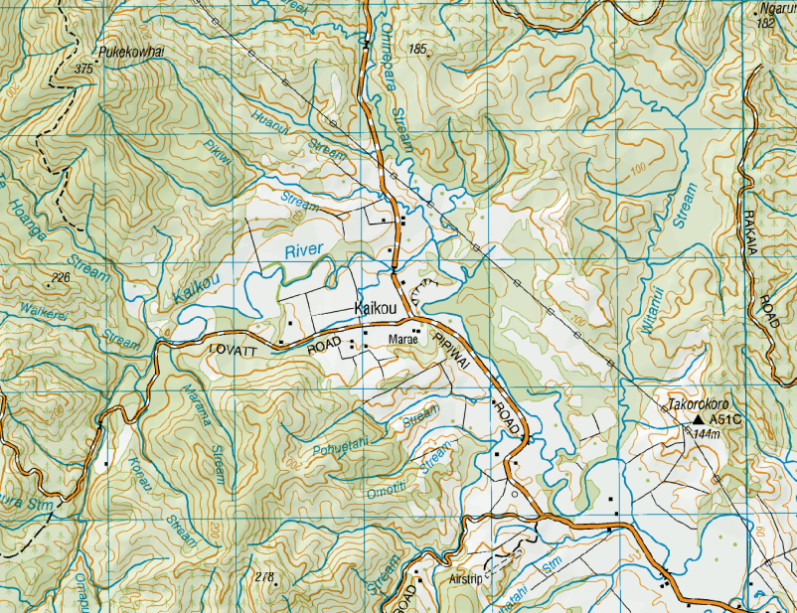

**Monitoring**

**location**

Figure A-3 Topographical map of general monitoring location

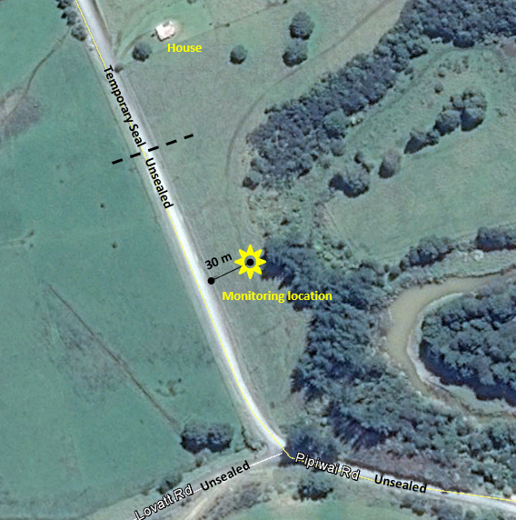

Figure A-4 Monitoring Location, 30 m from Pipiwai Road

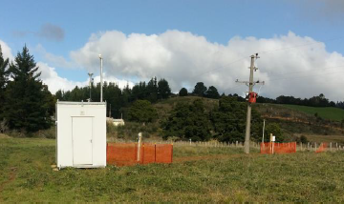

Figure A-5 Watercare site photo (facing south) of monitoring location (Pipiwai Road just beyond fence line)

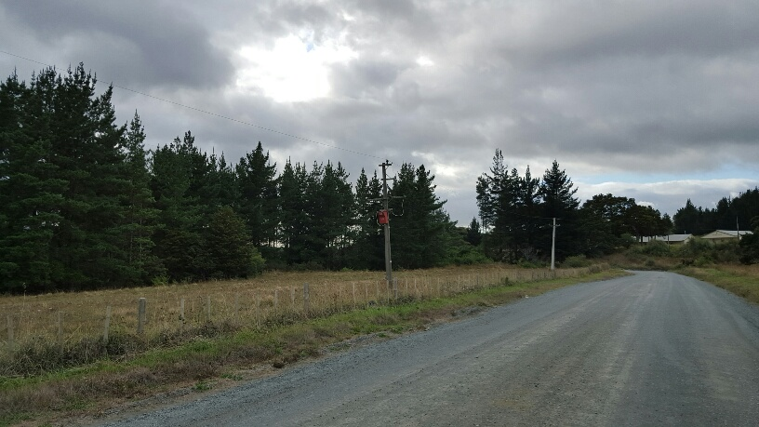

Figure A-6 Monitoring site location photo: Pipiwai Road facing south

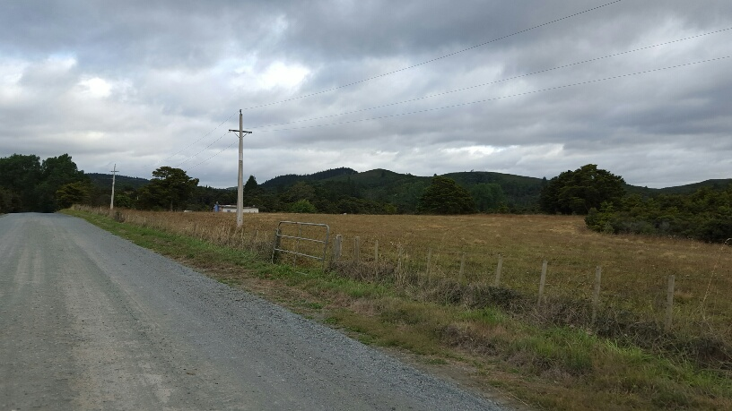

Figure A-7 Monitoring site location photo: Pipiwai Road facing north

# Appendix B Acute effects assessment

We have estimated the **acute** effects of short-term exposure to PM10 using a published exposure-response relationship from a Canadian assessment of road dust (Hong *et al*., 2017). This estimates the health effects based on monitoring results from **one unsealed road in Northland** (only). This method provides an estimate of premature mortality cases (only).

Short-term effects on mortality are largely included in the long-term effects. This means that the sum of the short-term effects is expected to be lower than the long-term effects over the same time period. Short-term effects are not additional to long-term effects.

The estimated acute effects from short-term exposure are included as an illustrative assessment for context and comparative purposes only. The Hong *et al.*, (2017) exposure-response relationship was selected because it is specific to road dust.

## B1.1 Overall Methodology for Assessing Acute Effects

The methodology in Section 2 estimates long-term (chronic) effects of exposure to PM10. Bluett *et al*., 2016, noted that this methodology is limited because it does not directly assess the acute effects of high levels of particulate exposure that are relevant to dusty roads.

A recent Canadian study specifically investigated the acute effects of exposure to high levels of road dust particulate matter (Hong *et al.*, 2016). The Canadian study found a strong association between non-external cause mortality and daily particulate matter concentrations during the road dust season. To investigate the potential acute (short-term) effects of road dust we have estimated premature mortality using the Canadian exposure-response relationship for road dust PM10. This estimate for a hypothetical exposed population of 1,000 people was based on measured daily PM10 concentrations at Pipiwai Road.

It should be noted that this acute assessment is indicative and included for context only. It is subject to the following limitations:

* The composition and characteristics of road dust in Canada may be different to New Zealand road dust;
* The exposure-response relationships are **not** intended to be accurate at the individual road level. Rather, they provide an indicative estimate at the population level. This is because they are based on epidemiology which requires a significant population to be statistically valid. For this report, **we have estimated effects for a hypothetical population of 1,000 people** **to provide an indicativeestimate of effects for illustrative purposes only.**

We also note that there are no source specific exposure-response factors for chronic effects of exposure to road dust. There is considerable uncertainty about the different effects of PM from different sources. However, it is well understood that the long-term effects of exposure to PM are significantly higher than the sum of all short-term effects over the same time period. This means that we would expect an estimate of acute effects to be lower than the chronic effects over the same time period.

The following sections describe the methodologies employed to assess acute health effects of PM10 exposure. The overall approach is identical to that employed for assessing chronic health effects. In simple terms, first we estimated the PM10 exposure and the number of people exposed. Then we applied exposure-response relationships to estimate adverse health effects. These were then combined with published health-cost data to estimate costs.

The following sections provide more detail.

## B1.2 Estimating acute PM10 exposure

The contribution of the unsealed road to daily PM10 exposure was estimated from Equation 17:

$$24 hour concentration of road dust {PM}_{10} =measured 24 hour {PM}_{10}-background {PM}_{10}$$

Equation 17

Where:

Background PM10 concentration is assumed to be 9 µg/m3 (as discussed in Section 1.4)

And:

The estimated concentration of road dust PM10 was assumed to be zero on days where the measured PM10 concentration was less than or equal to 9 µg/m3.

Finally, daily estimates were summed to give an estimate of annual premature mortality due to acute effects of exposure to PM10.

## B1.3 Estimating acute premature mortality cases (Hong *et al.*, 2017)

Premature mortality was calculated for each day using the same general approach described in Section 2. The number of cases of premature mortality attributed to road dust were calculated using Equation 13:

$${Cases}_{AP}=\frac{{Cases}_{TOTAL (NEAR ROAD)}}{(1+\left(\frac{1}{\left(RR-1\right)×Exposure}\right))}$$

In doing so, however, we estimated daily exposure for each day of the year based on the measured 24-hour concentration (at Pipiwai Road) for each day of the year. This differs from the chronic assessment which assesses annual average exposure (modelled using a calibrated annual emission factor, with road-specific traffic data). These daily estimates were then summed to give an estimate of annual premature mortality due to acute effects of exposure to PM10.

In order to estimate the daily number of cases of premature mortality attributed to road dust (daily CasesAP), we first need to calculate the total daily cases from all non-external causes in the exposed population (daily CasesTOTAL(NEAR ROAD)).

We did this by first calculating total annualcases of non-external cause mortality for the hypothetical population using Equation 12:

$${Cases}_{TOTAL (NEAR ROAD)}={Cases}_{TOTAL (RURAL NORTHLAND)}×\frac{N}{Total population rural Northland}$$

**Where:**

**Cases** **TOTAL (RURAL NORTHLAND)** = Total incidence rate annual average mortality from all non-external causes for all census area units in Northland with rural classification = 262 (for 2006 from Kuschel *et al*., 2012)[15]

N = Exposed population, i.e. number of people living within 80 m of unsealed road. This was assumed to be 1,000 for this hypothetical scenario.

Total population = Total population of all census area units in Northland with rural classification = 61,347 (for 2006 from Kuschel *et al*., 2012)

To estimate total daily cases of non-external cause mortality we assumed that daily cases = annual cases/365:

$${Daily Cases}_{TOTAL (NEAR ROAD)}=\frac{262}{365}×\frac{N}{61347}$$

The daily cases attributed to air pollution were then calculated in accordance with Equation 13 as follows:

$${Daily cases}_{AP}=\frac{(\frac{262}{365})×(\frac{N}{61347})}{(1+\left(\frac{1}{\left(Relative Risk-1\right)×Exposure}\right))}$$

Where:

Relative Risk = Non-accidental mortality: exposure-response relationship = 1.047 (i.e. 4.7% (2.2% to 7.2%), Hong *et al.* 2017) per 12 µg/m3 PM10 (daily concentration)

Exposure = 24-hour concentration of road dust PM10/12 (to give µg/m3 per 12 µg/m3)

So, cases due to air pollution for the hypothetical population were calculated as follows:

$${Daily cases}_{AP}=\frac{(\frac{262}{365})×(\frac{N}{61347})}{(1+\left(\frac{1}{\left(1.047-1\right)×Exposure}\right))}$$

Where:

N = number of people living within 80 m of Road. This was assumed to be a hypothetical population of 1,000 people.

Exposure = 24-hour concentration attributable to road dust PM10/12 (to give µg/m3 per 12 µg/m3) using daily PM10 data measured at Pipiwai Road from Equation 16.

### B1.3.1 Comparison acute and chronic health effects

We have estimated:

* annual premature mortality cases due to long-term exposure to PM10 (chronic adverse health effects) using the exposure-response exposure relationship in Kuschel *et al.*, 2012 for all unsealed roads in Northland; and
* annual premature mortality cases due to short-term exposure to PM10 (acute adverse health effects) using the exposure-response exposure relationship specific to road dust in Hong *et al.*, 2017 for one unsealed road in Northland.

To enable a comparison, we also estimated annual premature mortality cases due to long-term exposure to PM10 using the exposure-response exposure relationship in Kuschel *et al.*, 2012 and the annual monitoring results for Pipiwai Road.

The methodology was the same as that described in Section 2.2 except that the PM10 concentration was based on monitoring results (not modelling) as shown in Equation 18.

$$Annual average concentration of road dust{ PM}_{10}=measured annual average {PM}_{10}-background {PM}_{10}$$

Equation 18

Where:

Background PM10 concentration was assumed to be 9 µg/m3

Measured annual average PM10 concentration was the annual average from ambient monitoring undertaken at Pipiwai Road between 1 June 2017 to 31 May 2018.

The number of premature mortality cases was then calculated using Equation 13 and the exposure-response relationship in Kuschel *et al.*, 2017 for an assumed population of 1,000 people

## B1.4 Results of the Acute Effects Assessment

**Table B-1** shows the estimated premature mortality associated with short-term exposure to road dust assuming an exposed population of 1,000 people. This was calculated based on daily monitoring results at Pipiwai Road from 1 June 2017 to 31 May 2018 and the exposure-response relationship from Hong *et al.*, (2017). The total number of cases per year as shown in **Table B-1** is the sum of the estimated cases for every day of the year.

For comparison **Table B-1** also shows the estimated premature mortality associated with long-term exposure to road dust assuming an exposed population of 1,000 people. This was estimated based on the annual monitoring results at Pipiwai Road from 1 June 2017 to 31 May 2018 and utilises the exposure-response relationship in Kuschel *et al.*, (2012) for comparative purposes.

These estimates are **not** intended to be accurate at the individual road level. We have estimated short-term effects for a hypothetical population of 1,000 people only for illustrative purposes only.

The results in **Table B-1** suggest that the estimated short-term effects of exposure to road dust PM10 are approximately 52% of the estimated long-term effects.

Table B-1 Estimated premature mortality of PM10 for an assumed population of 1,000 people living within 80 m of unsealed roads.

|  |  |  |  |
| --- | --- | --- | --- |
|  | **Short-term effects: Premature mortality (Hong *et al.*, 2017)** | **Long-term effects: Premature mortality (Kuschel *et al*., 2012)** | **Short-term effects as a percentage of long-term effects** |
| Number of cases per year | 0.16 | 0.31 | 52% |

1. This study refers to truck counts, which are more accurately described as truck movements in transport terms.
2. Micron is the shortened name of micrometre (1 x 10-6 metres). For the purposes of comparison, a single sheet of paper is around 100 microns thick.
3. USEPA, 2006 also provides an equation for calculating emissions from public roads but this is only applicable for roads dominated by light duty vehicles (i.e. mean vehicle weight of 1.4 – 2.7 tonnes). This equation is not applicable to Pipiwai Road.
4. Average of composite samples from Pipiwai, Omauri and Lovatt Roads, Northland measured using USEPA, AP42 Appendix C2 titled “Procedures For Laboratory Analysis of Surface/Bulk Dust Loading Samples”. Mote, (2018).
5. Occupancy rate was based on 2006 census data because all health and population data was extracted from Kuschel *et al*., 2012 which is based on 2006 data. Census data indicates that the average household occupancy rate was similar in 2013 at approximately 2.5 people per household (total occupied dwellings = 60,189 and usually resident population = 151,689 for Northland in 2013).
6. For example, Bluet *et al.*, (2017) measured a (two-month) average of 16 µg/m3 at 80 metres from an unsealed road in rural Northland (where the annual average is typically 9 µg/m3).
7. It should be noted that the observational data (total number of cases observed in the population) from Kuschel *el al.*, (2012) are a three-year average for the years 2005 – 2007.
8. Watercare undertook an additional month of monitoring (for the period of June 2018) but this is not reported here or discussed further.
9. Readers should note that rainfall data for June 2017 is missing a week of data which depresses the seasonal average when compared with the 40-year average. The month of June still achieved 76% valid data, with 90% valid data for the winter average (good practice is to discard data with <75% valid data). These missing days occurred coincidentally with days of missing traffic data and fortunately do not unduly affect subsequent statistical analyses.
10. Standard height is 10 metres, the Pipiwai Road mast was at 6 metres above ground level.
11. 14 November 2017; daily PM10 54 µg/m3, total vehicle count 173, of which 70 vehicles were trucks (> 5.5m) and 49 vehicles were very long trucks (>17m).
12. This study refers to truck counts, which are more accurately described as truck movements in transport terms.
13. 97 million VKT Northland unsealed local roads vs 531 million VKT New Zealand unsealed local roads for year 2016/17.
14. Refer References.
15. NB: As noted above, the observational data (baseline health-outcome incidence rates) from Kuschel *el al.*, (2012) are a three-year average for the years 2005 – 2007.