Te Ao Auahatanga Hauora Māori
Māori Health Innovation Fund
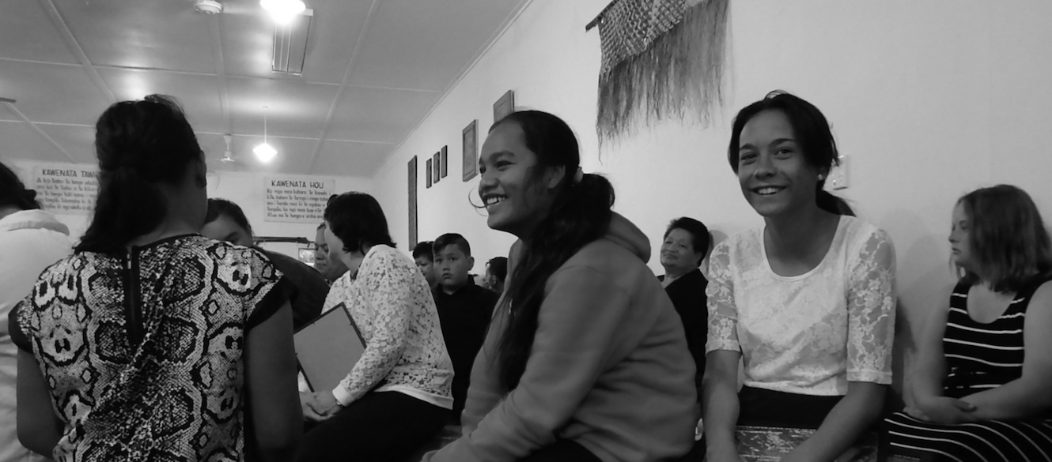


Analysis of Te Kākano:
Seeding Innovation
2013–2017

Report prepared for
the Ministry of Health
by Brown Research Ltd

November 2017

Table of Contents
Introduction 3
Te Kākano: Seeding innovation for new innovative models 4
Summary of Findings 6
Alignment with 2013–2017 Fund Priorities 10
Fund Priority - Tikanga a Tamariki Mokopuna 11
Outcomes - Tikanga a Tamariki Mokopuna 17
Alignment with the Fund objectives 24
OBJECTIVE 1: Advance Whānau Ora and affirm positive Māori approaches that improve Māori health outcomes 25
OBJECTIVE 2: Promote Māori service delivery systems that value health and social service collaboration and employ whānau-centred interventions 29
OBJECTIVE 3: Recognise service models that address the needs of whānau, hapū, iwi and Māori communities 34
OBJECTIVE 4: Enhance physical, spiritual, mental and emotional health, giving whānau control over their own destinies 38
Success for Māori Health Innovations 43
What were the common themes of success across Innovations? 43
What worked well to support success? 46
What were the challenges to success? 49
How might the trial of Māori Health Innovations be improved? 51
Conclusions 52
Appendices 52
Glossary of Māori terms 53
Programme Description Summary 55
Examples of Innovation Models 59
Examples of Programme Logic Models 62

Table of Figures
Figure 1: The Innovation Programmes 5
Figure 2: Overview of Tikanga a Tamariki Mokopuna 13
Figure 3: WOW Bus Healthy Food Learning Outcomes 17
Figure 4: WOW Bus Marae Learning Outcomes 17
Figure 5: Cultural identity Parent Outcomes 17
Figure 6: Ngā Kaitiaki Youth Confidence on Marae 19
Figure 7: Ngā Kaitiaki Youth Self-Esteem 19
Figure 8: iMOKO Interactions 21
Figure 9: iMOKO ARF and CRHD per 100,000 Population 21

Introduction

This report gives insight into a range of innovative models of service delivery (Innovations) trialled between 2013 and 2017 under the Te Ao Auahatanga Hauora Māori: Māori Health Innovation Fund. It draws upon the innovation stories and illustrates themes of success across the 22 initiatives and discusses alignment to the Fund objectives, its overall aim and priorities.
Established in 2009, the Te Ao Auahatanga Hauora Māori: Māori Health Innovation Fund supports Māori Health Providers for up to four years to scope design, develop implement and evaluate their vision of innovative initiatives that effectively meet the health needs of whānau, hapū, iwi and their wider communities.
The report focusses on the innovations trialled in the first stage of Māori innovation funding. The initial funding stage over a four year cycle is called the Te Kākano category or “the seeding of innovation” stage. The spreading and adaptation of Te Kākano programmes may occur after the initial trail period. However this is under a funding category referred to as Te Ruinga or Spreading Innovation and is not part of this report.
The Fund aligns to He Korowai Oranga (the Māori Health Strategy). Hence the overall aim of the Fund is to improve Māori health outcomes and achieve Whānau Ora through innovative service design, delivery and evaluation.

Whānau Ora is about Māori families supported to achieve their maximum health and wellbeing. It is an empowering concept which reorients our health sector towards a wellness and wholeness approach, placing whānau at the centre of services. Innovation is about recognising holistic and tikanga-based approaches to addressing health and disability issues for Māori and their wider communities.

A key priority for the 2013–17 funding round was Tikanga ā Tamariki Mokopuna – meaning Te Ao Māori approaches to whānau health and wellbeing through improved child health outcomes. In line with this, a number of the innovation programmes focused on improving the health and wellbeing of children (and their whānau).
Other priorities included utilisation of technology and collaborative or cross-discipline approaches that aim to reach and inform people by improving access to health and disability services and information.
The investment in Māori health through Te Kākano or seeding innovative models of service delivery:
- aims to advance whānau ora by affirming approaches that improve Māori health outcomes and the quality of services to Māori
- supports Māori Health Providers to improve Māori health by increasing Māori participation through whānau, hapū and iwi to create and determine their own solutions and destinies.

Te Kākano: Seeding innovation for new innovative models

“Whakatō te kākano, kia puāwai ngā whakaaro”
Plant the seed, so that ideas will blossom, develop, and grow

Te Kākano is the seed, the promise of something new
This category is about seeding innovation, encouraging new ideas and assisting successful Māori providers to trial new services, pilot new initiatives, progress the collaboration of health services and develop leadership throughout the sector.

Range of Te Kākano Innovations
Between 2013 and 2017 the Te Kākano innovations:
- were directed at serving the following populations: Māori whānau; hapū; iwi; kaumātua; kuia; vulnerable children; pregnant women; youth and people with addictions; at a local, regional or national level in both rural and urban communities

- covered a wide range of services, clients and approaches that spanned the country. This included innovations that are delivered locally, regionally and nationally including whānau-centred and marae-based. Some of the innovations have a service configuration component, whilst others involved integrative services or coordination and were developed based on the needs of a particular population group.

Figure 1: Innovation Programmes – shows the range of the innovation pilots.
INNOVATION NAME  (ALPHABETICAL ORDER) | INNOVATION TYPE | PROGRAMME FOCUS | DELIVERY SITE | MĀORI HEALTH PROVIDER
Aroha Ngā Mokopuna | Kaumātua led health promotion in schools | Rangatahi | Schools | Rauawaawa Charitable Trust
He Ara Toiora | e-learning nutrition and health programme | Tamariki and their whānau | Online, kohanga, kura, kainga, hāpori | Te Rau Matatini
iMOKO | Telemedicine in schools | Tamariki | Schools, ECEs | Navilluso Medical Ltd
Integrated Wellbeing & Learning PIlot | Integrated well-being support | Tamariki and their whānau | Provider Facility | The Positive Directions Trust
K2K or Kanohi ki te Kanohi | e-health applicaitons connecting whānau and primary care | Whānau with long-term conditions | App-based for smart devices | Raukura Hauora o Tainui
Ka Rewa | School-based resilience programme | Tamariki | Schools | Te Hauora Runanga o Wairarapa
Ka Tipu Te Whaihanga, e Hika, ki Ūawa | Parenting programme | Parents within the iwi | Marae | He Aitanga o Hauiti Hauora
Kia Tupu Ake Ai Whānau | Taitama mental health crisis support programme | Rangatahi/pakeke | In home | Ngāti Hine Health
Kiri ki te kiri | Breastfeeding for 1st time mothers | Antenatal and postnatal mothers | In home and Māori Hauora | Te Hauora o Turanganui a Kiwa
Ko te Marae te Matatiki | Marae-based health champions/health promotion | Whānau | Marae | Ngā Kairauhii Trust
Mana Tamariki, Mana Mokopuna, Mana Whānau | Young Māori mothers co-designing a health service delivery | Young Māori mothers | Māori Hauora | Poutini Waiora
Mokopuna Te Ao | Integrated antenatal and postnatal care model | Mums with pepe, tamariki | Māori Hauora | Turuki Health Care Charitable Trust
Ngā Kaitiaki | Marae-based youth programme | Rangatahi | Marae | Ngāti Kahu Social and Health Services Ltd
Ngā Kaupapa Mātauranga o Ngā Mahi o te Rā Project | Multimedia learning portal for intellectually disabled | Pākeke | Online from community hub | Te Rōpu Taurima o Manukau Trust
One Plan Project | Promote interagency collaboration for whānau | Whānau CYFS | Māori Hauora | Taumaraunui Community Kōkiri Trust
Shredathon - 4G | Weight loss and nutrition programme | Over weight whānau | Gym Facility | 4G Limited
Tamariki Mokopuna Ora | Marae-based parenting programme | Parents | Marae | Maraeroa Marae Health Clinic
Tāne Takitū Ake Programme | Men and their whānau - healthy lifestyle programme | Over weight tāne | Māori Hauora | Korowai Aroha
Te Kotuku ki te Rangi Whānau Respite Facility | Whānau respite facility for adults experiencing mental health problems | Adults and their whānau | Respite Facility | Te Kotuku ki te Rangi
Te Pauwai o te Ahi Kā | Marae-based health programme | Whānau | Marae | Te Oranganui Trust
Te Waka Tuatahi | Gym-based lifestyle programme | Whānau | Gym Facility | Hikoi Koutou Trust
WOW Bus | Mobile tamariki education service | Tamariki with their parents | Bus and schools | Te Kaha o te Rangatahi Trust
Figure 1: The Innovation Programmes

Summary of Findings
The report draws upon the 22 Te Kākano innovation stories and discusses alignment to the Fund objectives, its overall aim and priorities.
Analysis of the Innovations shows that all of the objectives of the Fund were met.
- Advance Whānau Ora and affirm positive Māori approaches that improve Māori health outcomes.
- Promote Māori service delivery systems that value health and social service collaboration and employ whānau centred interventions.
- Recognise service models that address the needs of whānau, hapū, iwi and Māori communities.
- Enhance physical, spiritual, mental and emotional health, giving whānau control over their own destinies.
1. Advancing Whānau Ora at the funder level involved the selection, funding, trial and evaluation of a wide range of innovations. All of the Innovations utilised a comprehensive Whānau Ora approach. In summary:
- the trialling allowed Māori Health Providers to build on existing capabilities and develop a wide range of new capabilities
- it provided formative evaluation input into programme development and ensured that Providers now have evidence of innovation successes; evidence that may be used to tell their stories and attract potential new funders and collaborators to further spread their innovations
- a strength of the Fund was the flexibility it allowed. The funder and providers were able to work together to adjust delivery expectations if required
- the funder, providers and others are able to use the evaluation findings to further advance Whānau Ora and affirm positive Māori approaches that demonstrate improved Māori health outcomes.
2. The Fund promoted the delivery of innovative whānau-centred collaborations. As expected, the type and extent of collaboration varied greatly from Innovation to Innovation. In summary:
- the Fund ensured that providers worked with a large number and variety of organisations in order to support whānau across the social, economic and cultural dimensions of health
- collaborations ranged from complex multi-organisation collectives or full partnerships to simple agreements to provide access to services
- typically providers connected with 20 or more agencies or services in order to meet the holistic needs of the whole whānau.
- whānau were well resourced with social and health services that were delivered in culturally appropriate ways
- for some Māori providers, the goal of collaboration was to help build cultural competency within mainstream provider organisations
- schools provided opportunities and challenges for collaborations; where schools were highly motivated, collaborations resulted in whānau-centred Innovations that provided significant outcomes for whānau

- collaborations between social service providers and clinical service providers generally utilised Māori kaimahi effectively at the interface with whānau
- advisory groups and health navigators were also particularly effective in opening pathways between collaborating organisations
- for many providers, receiving Te Kākano funding was a catalyst to forging collaborative relationships, some of which have the potential to endure well past the end of the funding period.
3. The service models were tailored to meet the needs of Māori. In summary:
- all Innovations had mechanisms for identifying the needs of Māori and working with whānau, hapū, iwi or other Māori communities to meet those needs
- a key to meeting Māori needs was delivering services that honoured Māori as Māori
- all Innovations shared distinctive Māori features: having foundations in Te Ao Māori; connecting as Māori through whakapapa, tikanga and whanaungatanga; and utilising Whānau Ora approaches that supported the whole whānau with services tailored to their needs
- Te Ao Māori focused Innovations helped facilitate engagement from Māori individuals and whānau
- providers were able in some cases to create and test entirely new service delivery models based in Te Ao Māori and tailored to the needs of whānau, hapū, iwi or other Māori communities
- the Innovations used a range of tools and processes to determine those needs and involved participants in addressing their own needs and a particular key to success in engaging whānau were the Māori kaimahi.

4. Providers aimed to enhance physical, spiritual, mental and emotional health of Māori, giving whānau control over their own destinies through their innovative approaches. In summary:
- the impacts on whānau health and wellbeing from these Innovations covered a wide range of outcomes across all the dimensions of health including:
  - significant improvements in physical health
  - increased health knowledge and health literacy
  - increased healthy behaviours and decreased risk taking
  - increased pro-social behaviours
  - improved whānau connections with hapū, iwi and other Māori communities
- whānau also experienced improved mental health, gaining confidence and self-esteem that was protective against suicide and was a requirement for taking control over their own lives and destinies.

Summary of Māori Health Innovation Success
Success was seen across the entire Te Kākano 2013-2017 funding category. In summary:
- Whānau Ora approaches resulted in a raft of positive outcomes for whānau, hapū, iwi and Māori communities
- providers built their connections with complementary services, so that whānau were supported across all the dimensions of health.

Factors common to the success of many of the Innovations included:
- comfortable, easy access pathways for whānau to engage with services
- Māori kaimahi skills, experience, knowledge, trustworthiness and warmth
- providers operating by Māori principles of whanaungatanga and manaakitanga
- whakapapa connections between providers and whānau, marae, hapū, iwi and other communities
- good interagency relationships
- the Innovation design was clear and achievable within the limitations of the Fund and provider capacity
- clearly articulating the Innovation to collaboration partners and participants
- length of funding allowed time to develop and review the Innovations
- flexibility of the Fund to allow necessary modifications to contracts.

Challenges to success included:
- unexpected capacity and capability challenges for Providers from trialling innovative approaches to service delivery
- workforce issues experienced by some providers including high staff turnover and difficulty engaging volunteers
- reliance on a key driver within an organisation resulted in slippage if that person left the organisation
- some Innovations experienced a fall off of clients during the later stages of implementation
- time and resources required to develop high quality Māori resources
- tight delivery timeframes and difficulties meeting target numbers
- data management and collection was generally burdensome
- time taken to build trust with other agencies
- lower commitment of time or resources from collaborating organisations slowed development
- sense of competition and patch protection from other service providers
- reluctance to operate from Whānau Ora principles from some collaborating organisations.

Suggested improvements to the trial of Māori Health Innovations included:
- extra time to develop complex Innovations
- support to develop appropriate databases
- facilitated networking across funded Innovations to share ideas and solutions to common challenges
- more consistency in evaluation.

Overall, Te Kākano 2013-2017 Innovations resulted in significant gains not just for whānau but also for hapū, iwi and other communities – gains that came from testing new models of service delivery, all of which were based in Te Ao Māōri and on Māori health models and Whānau Ora principles.
As a point of interest the Ministry of Health sought feedback in November 2017 on the status of the 22 Te Kākano pilots since the funding cycle ended in June 2017 and found that:
- thirteen (59%) of the Innovations have continued in part or whole
- four of those were successful under the Te Ruinga funding category (for the spreading, adoption or adaptation of Te Kākano Innovations) and nine are continuing, in part or in entirety, by either the Provider resourcing the Innovation themselves, or through adaptation into core business, or through collaboration with other local Providers or alternative funders
- of those pilots that were not successful in gaining alternative funding, two are actively seeking or awaiting funding decisions from alternative funders. Nevertheless, majority feedback indicates that principles, knowledge and learnings from these piloted Innovations have been incorporated into their health service delivery generally.

Alignment with 2013–2017 Fund Priorities

Overview
This section outlines the general alignment across the Innovations to the 2013–2017 fund priorities.
In 2013-2017 the Fund priority was:
”Tikanga a Tamariki Mokopuna” or Te Ao Māori ways of improving the health of children and their whānau and in this context using collaborative approaches with other organisations or agencies and technology to enhance service delivery and access to services.

Innovations that used distinctive Te Ao Māori approaches to improving the health of children and rangatahi are discussed, as are the ways in which technology was used to enhance service delivery. Collaborations are examined under Objective Two and are not further examined here.

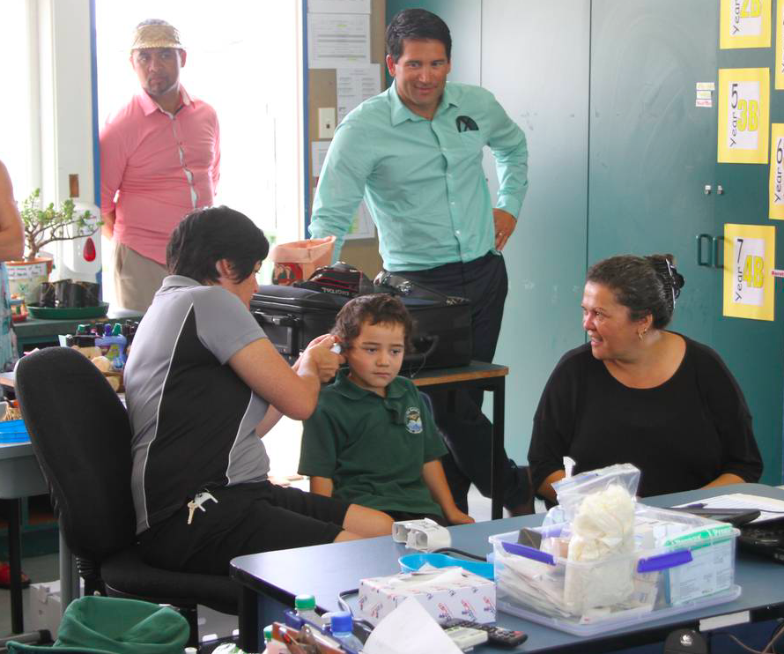

iMOKO Programme launch
Te Hapua School 2014

Photo/Petrina Hodgson

Fund Priority - Tikanga a Tamariki Mokopuna

Improving child and rangatahi health and wellbeing is an integral part of Whānau Ora. Many of the Innovations included goals related to, or having an impact on, child health and wellbeing. Fourteen Innovations (64%) had a specific focus on child health outcomes (pepe and rangatahi included). Eight (36%) were whānau focused with a specific component targeted to tamariki or rangatahi.

Overview of Te Kākano Innovations that primarily focused on Tikanga a Tamariki Mokopuna
The elements of Te Ao Māori integrated into the design and delivery of Innovations are summarised in Figure 2. A selection of Innovations are ranked by targeted age, from youngest to oldest with the shaded areas showing Innovations that work with tamariki – babies and young children through to rangatahi.
Figure 2 shows clear overlaps in the key Te Ao Māori features of the Innovations. The outcomes for participants and impacts for wider whānau and communities also show commonalities across the Innovations.

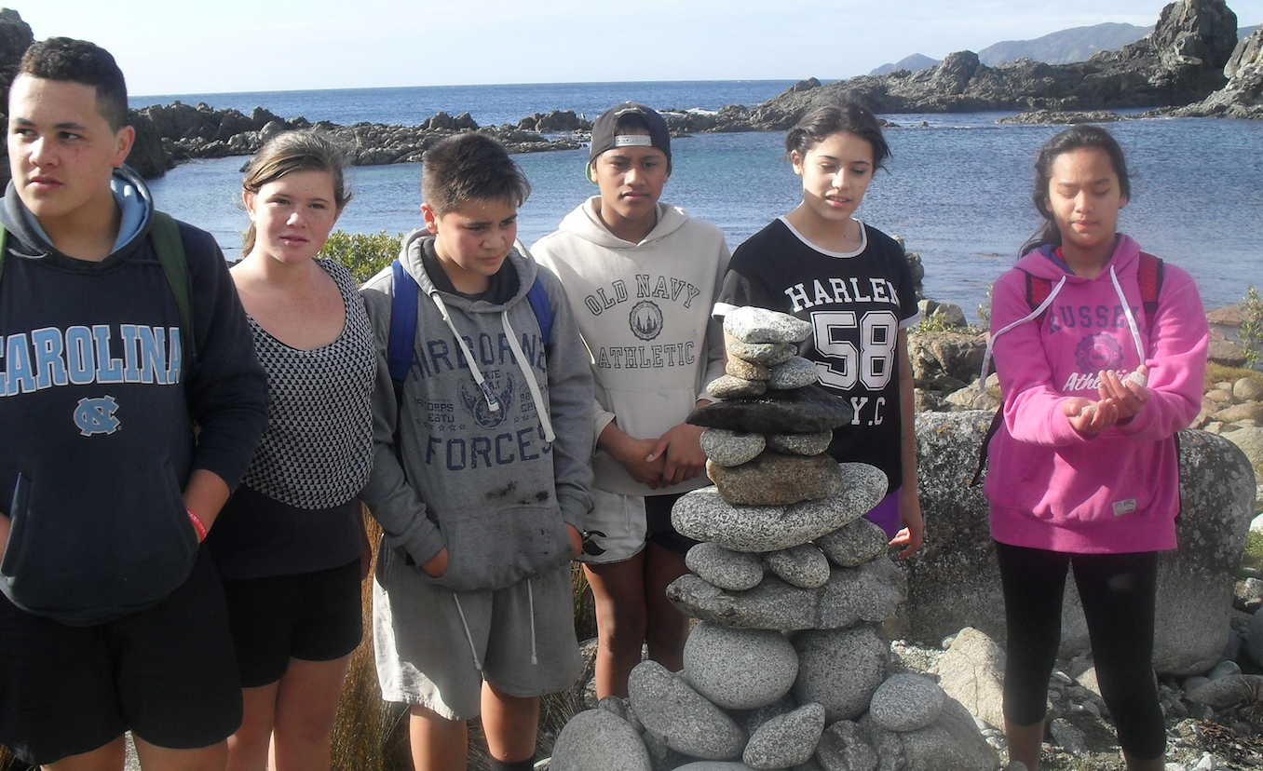
Youth at P.R.I.D.E Camp 2016
Ngā Kaitiaki Innovation
Figure 2: Overview of Tikanga a Tamariki Mokopuna Innovations
Innovations | Te Ao Māori | Outcomes for participants | Impacts for whānau and community
Parents and Babies
He Purapura Ora  (Ka Tipu Te Whaihanga, e Hika, ki Ūawa). Iwi parenting programme that supports the health and wellbeing of babies and young children | - iwi-based model  - kaimahi with whakapapa links to whānau  - reclamation of iwi knowledge on child birth and raising children  - oriori composed and learned to teach iwi tikanga on child rearing – dissemination through kapa haka rōpū  - iwi information books created. | - new parenting knowledge from Te Aitanga a Hauiti perspectives  - strengthened whakapapa connections for participating whānau  - improved sense of Māori identity  - better links with local Māori antenatal and postnatal services  - increased access and uptake of a range of social and health services. | - re-building and dissemination of Te Aitanga a Hauiti nurturing and parenting practises amongst Hauiti whānau  - development of a iwi kaimahi workforce  - strengthened connections for whānau, hapū and iwi.
Kiri ki te Kiri  Breastfeeding programme that support the health of babies | - based in Māori health frameworks  - Māori kaimahi with whakapapa connections to whānau  - teaching of traditional knowledge about parenting and breastfeeding practices  - making of ipu whenua. | - better knowledge of the reasons for breastfeeding  - increased parenting knowledge from Māori perspectives  - improved sense of Māori identity  - greater uptake of antenatal classes  - increased access and uptake of a range of social and health services. | - young parents better equipped to raise healthy babies  - teenage mothers attending teenage parenting centre to complete their high school education  - strengthened connections with Te Ao Māori for whānau.
Mana Tamariki, Mana Mokopuna, Mana Whānau  Mums co-designed hauora space and service delivery model – babies and tamariki benefited | - based in Māori health frameworks  - learning on marae  - parents learn cultural identity and pass on to pepe and tamariki – pepeha, tikanga, te reo Māori and mahi toi  - whānau friendly facility. | - 60 women involved across three health hubs  - 90% were in violent relationships  - supported to keep whānau safe  - improved sense of Māori identity  - improved health literacy  - increase in healthy behaviours  - increased access and uptake of a range of social and health services. | - safe one-stop shop for women to engage with health and social services  - whānau confidently engaging with services  - transformation of services to meet women’s needs.
Mokopuna Te Ao  Integrated antenatal and postnatal care – parents and babies, parenting training | - based in Māori health frameworks  - Māori values-based organisation  - Māori advisors with tikanga knowledge  - Māori kaimahi | - increased access and uptake of a range of social and health services  - improved sense of Māori identity  - improved health literacy  - increase in healthy behaviours. | - one-stop shop for whānau to engage with health and social services  - transformation of services to meet whānau needs.
Tamariki
Aroha Ngā Mokopuna  Kaumātua teach tamariki/rangatahi in schools | - kaumātua knowledge and mana  - based in Māori health frameworks  - programme includes cultural identity  - te reo and tikanga integral  - Māori kaimahi  - Māori teaching resources  - waiata, karakia, kōrero pūrakau. | - improved sense of Māori identity  - improved tikanga and te reo knowledge  - increased tamariki engagement in school  - increased confidence to be a leader  - improved health literacy  - increase in healthy behaviours | - accelerated adoption of health lifestyles by tamariki and their whānau  - strengthened engagement in school for tamariki and their whānau  - strengthened connections with kaumātua and Te Ao Māori for whānau.
iMOKO  Common childhood health conditions | - based in Māori health frameworks  - whānau kaitūao volunteers  - child-friendly Māori images in health promotion messages. | - improved access to assessment and treatment for targeted childhood health conditions  - improved health literacy  - increase in healthy behaviours  - increased access and uptake of a range of social and health services. | - improved health outcomes for tamariki  - tamariki and whānau more proactive in their own care and sharing their knowledge with others  - strengthened community engagement in school  - improved school absenteeism.
One Plan  Whānau with children at the interface with CYFS | - based in Māori health frameworks  - Māori kaimahi provide interface between whānau and CYFS  - based on Māori tikanga and values. | - increased confidence and trust in agencies  - increased access and uptake of a range of social and health services. | - safe one-stop shop for whānau to engage with health and social services  - whānau confidently engaging with services  - improved health & wellbeing for whānau.
He Ara Toiora  Children and youth e-learning about nutrition and physical exercise | - based in Māori health frameworks  - delivered to Māori medium schools  - use of te reo, tikanga and mātauranga Māori in resources. | - 100 tamariki at Kura Kaupapa Māori, 30 whānau and 30 tamariki at Kohanga Reo  - improved health literacy  - increase in healthy behaviours | - new health promotion resources in te reo Māori  - improved whānau collective capacity and strength to pursue their wellbeing aspirations.
Rangatahi
Ka Rewa  Resilience programme for youth | - based in Māori health frameworks  - kaimahi have cultural and community knowledge  - strong iwi networks support the programme  - distinct new Māori programme resources  - cultural advise sessions  - cultural learning – waka ama, whākapapa, kōrero purakau  - cultural trips. | - 122 rangatahi from 82 whānau  - improved sense of Māori identity  - improved tikanga and te reo knowledge  - improved health literacy  - increase in healthy behaviours  - increased access and uptake of a range of social and health services. | - school-based one-stop shop for whānau to engage with health and social services  - strengthened whānau engagement in the school  - strengthened community (iwi)  engagement in school  - strengthened connections with Te Ao Māori for whānau.
Kia Tupu Ake Ai Whānau  Youth in crisis and their whānau | - based in Māori health frameworks  - Whānau Ora – Whānau Rangatira strengths-based model  - kaimahi with whākapapa links to rangatahi and their whānau. | - increased hope in the future  - more tools to manage difficult whānau situations  - increased strength and sense of worth  - increased confidence and self-esteem. | - strengthened connections with Te Ao Māori for whānau  - improved whānau collective capacity and strength to pursue their wellbeing aspirations.
Ngā Kaitiaki  Youth and Marae ora | - iwi kaumatua knowledge utilised  - iwi marae delivery site  - tikanga and kawa central to learning  - kaimahi with whākapapa links to rangatahi  - whānau involvement. | - improved sense of Māori identity  - increased confidence and self-esteem  - improved health literacy  - increase in healthy behaviours  - decrease in risk taking  - strengthened whākapapa connections for participating tamariki | - strengthened connections with Te Ao Māori for whānau  - strengthened whākapapa connections for participating whānau  - strengthened connections for whānau, hapū and iwi.
Waka on Wheels (WOW) Bus  Health education and development services for teenage parents | - based in Māori health frameworks  - Māori kaimahi  - Māori learning resources  - cultural identity components – marae and ko wai au? | - 2,461 client engagements across 118 lessons  - improved access to health education and health promotion  - improved health literacy  - increase in healthy behaviours  - increased access and uptake of a range of social and health services. | - improved access to health and wellbeing information and services  - strengthened connections with Te Ao Māori for whānau  - improved whānau collective capacity and strength to pursue their wellbeing aspirations.
Whānau Innovations that include tamariki/rangatahi components
He Waka Tuatahi  Whānau Innovation including tamariki fitness and kapa haka | - based in Māori health frameworks  - whānau friendly facility  - whānau wānanga and cultural hikoi  - tamariki kapa haka, te reo Māori after-school  - rangatahi mau rakau classes. | - Improved health – weight loss and increased fitness  - improved sense of Māori identity  - increased confidence and self-esteem  - improved health literacy  - increase in healthy behaviours  - increased access and uptake of a range of social and health services  - improved social and economic outcomes – employment and training uptake. | - healthier whānau  - strengthened whānau relationships  - strengthened connections with Te Ao Māori for whānau  - improved whānau collective capacity and strength to pursue their wellbeing aspirations.
Ko te Marae te Matatiki  Marae working together for marae ora and whānau ora. Children’s health focus determined by each marae | - iwi marae-based model  - marae Health Champions  - Māori kaimahi and Marae Representatives  - whākapapa links between marae and kaimahi. | - 29 new health promotion initiatives to 1500+ participants  - whānau more active on marae  - strengthened whākapapa connections for participating whānau  - improved sense of Māori identity  - improved access to health education and health promotion  - improved health literacy  - increase in healthy behaviours  - increased access and uptake of a range of social and health services. | - improved access to health and wellbeing information and services  - strengthened connections with Te Ao Māori for whānau  - more whānau more active, more often on marae  - improved marae collective capacity and strength to pursue their wellbeing aspirations.
Ngā Kaupapa Mātauranga o Ngā Mahi o Te Rā  Multi-media learning portal for intellectually disabled - some rangatahi involved | - Advisory Group with knowledge in Te Ao and te reo Māori  - Māori kaimahi  - resources in te reo (and English and NZ sign language)  - Māori images in health promotion messages. | - Increased positive experience of tāngata with e-learning  - Increased tāngata knowledge on how to use e-learning resources  - improved health literacy  - increase in healthy behaviours | - new tri-lingual e-learning resources  - increased capability of the health and disability sector to work with tāngata to identify and address needs that will support their increased independence
Shredathon  Physical exercise and nutrition – some rangatahi involved | - based in Māori health frameworks  - Māori kaimahi  - whānau friendly facility. | - 65 participants and their whānau  - improved health – weight loss and increased fitness  - improved sense of Māori identity  - increased confidence and self-esteem  - improved health literacy  - increase in healthy behaviours  - increased access and uptake of a range of social and health services. | - healthier whānau  - strengthened whānau relationships  - strengthened connections with Te Ao Māori for whānau  - improved whānau collective capacity and strength to pursue their wellbeing aspirations.
Tāne Takitū Ake  Nutrition and exercise programme for adult men | - based in Māori health frameworks  - whānau friendly facility  - Māori kaimahi. | - 86 men completed the programme  - improved health – weight loss, lowered BMI, cholesterol, blood sugar levels  - improved sense of Māori identity  - increased confidence and self-esteem  - improved health literacy  - increase in healthy behaviours  - increased access and uptake of a range of social and health services  - improved social and economic outcomes – employment and training uptake. | - healthier men and their whānau  - strengthened whānau relationships  - strengthened connections with Te Ao Māori for whānau  - improved whānau collective capacity and strength to pursue their wellbeing aspirations.
Te Puawai o te Ahi Kaa  Marae-based whānau programme with child and youth health and parenting | - Marae Advisory Group included kaumātua  - designed from marae whānau survey  - kaimahi with whākapapa links to whānau  - Māori provider of clinical services  - teaching of traditional practices. | - 184 whānau members participated in the health survey  - whānau more active on marae  - strengthened whākapapa connections for participating whānau  - improved sense of Māori identity  - improved access to health education and health promotion  - improved health literacy  - increase in healthy behaviours  - increased access and uptake of a range of social and health services. | - strengthened whānau relationships  - strengthened connections with Te Ao Māori for whānau  - improved marae collective capacity and strength to pursue their wellbeing aspirations.
Figure 2: Overview of Tikanga a Tamariki Mokopuna

Outcomes - Tikanga a Tamariki Mokopuna


The majority of the Innovations analysed for this report have some degree of focus on the health and wellbeing of babies, children and youth. Three Innovations are included here as examples of the outcomes for children and youth from participation in the Innovation.

Example One
WOW Bus mobile education for youth
Waka on Wheels Innovation - Te Kaha o Rangatahi Trust
This Innovation delivered health promotion and health education to more than two thousand children between the ages of zero and eight years, with teen parents. ‘The programme was founded on Te Ao Māori principles through the infusion of Māori language, concepts, imagery and the use of stories and songs. Key topics central to the programme included oral health, healthy kai, self-identity and Māori cultural connectedness.’

Innovation outputs
- 2,000+ tamariki, 140 whānau spanning several generations and 320 teachers
- 118 lessons were delivered in community settings, mostly ECE facilities
- 66% self-identified as Māori
- 97% of participants agreed that the information was engaging and the teaching materials were of a high quality

Outcomes of the Innovation
Improved motivation to eat healthy:
- 97% said that giving their children healthy kai is now a higher priority
- 86% said they would eat and drink healthier kai as a result of the programme
- 95% would give their children water to drink everyday compared with just 22% prior to the programme.

Figure 3 shows the percentage of parents who learned new information about good nutrition for their tamariki.
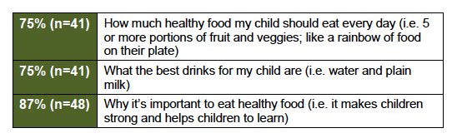

Figure 3: WOW Bus Healthy Food Learning Outcomes
Example One - Continued
Increased connection with culture: (Figure 4)
- 86% will support their child to have stronger connections with their culture
- 62% say they will learn more about their cultural identity with their child.
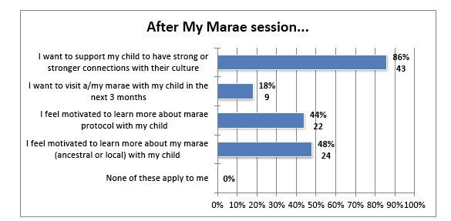

Figure 4: WOW Bus Marae Learning Outcomes

Increased understanding of the importance of knowing your identity: (Figure 5)
- 93% of parents learned why it is important to know their identity
- 79% were proud that their child knows who they are and where they are from.
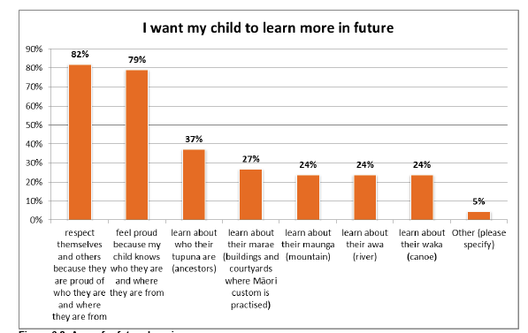

Figure 5: Cultural identity Parent Outcomes
Example Two
Tikanga-based resilience training in mainstream schools
Ka Rewa Innovation - Te Hauora Rūnanga o Wairarapa
This school-based tikanga Māori Innovation worked with 122 tamariki/rangatahi from 82 whānau, to build their cultural knowledge and resilience. The Ka Rewa Innovation had many challenges developing and embedding the programme in schools but the outcomes for tamariki and partnering schools were considerable.

Innovation Outputs
- the Innovation was fully delivered in one school and components were delivered in three additional schools
- 136 student and 100 whānau assessments were completed with 72 student referrals and 22 whānau referrals to other health and social services
- kaimahi provided 18 mentoring sessions and 73 cultural support sessions
- Innovation collaboration partners provided 62 cultural support sessions.

Innovation Outcomes
Tamariki outcomes included:
- 51% more students were confident to share ideas in class
- 42% more students were confident to share their pepeha
- 41% more students were confident to make plans
- 34% more students volunteer to lead
- 26% more students know how to cope when things don’t go well
- 24% more students were applying themselves to school studies
- 93% school attendance for Ka Rewa students compared with 90% for the rest of the school.
Impacts for the Provider included:
- improvement in community engagement
- developing a resilience toolkit (previously a resilience technological tool)
- developing the stakeholder partnership/collaboration model.
Impacts for the school included:
- increased whānau attending cultural and health activities
- increased kaumātua support along with iwi support for the school
- increased whānau voice through the whānau group and participation at noho marae
- impetus for the school to define and embed its cultural strategy
- consistency in tikanga within the school and various school wide programmes
- Ka Rewa youth actively demonstrating leadership skills and are being appointed to leadership positions in the school (e.g. prefects, academic role models).
- Tamariki/rangatahi becoming more service oriented and motivated, and generally showing improvement in their overall school goals.

Example Three
Ngāti Kahutanga marae-based youth mentoring
Ngā Kaitiaki Innovation - Ngāti Kahu Social and Health Services Ltd
This Te Ao Māori strengths-based, awards-based youth mentoring programme worked with youth (12–16 years) on local marae. The Innovation provided rangatahi with the learning and mentoring to gain the skills, knowledge, experience and confidence to make informed choices about healthy lifestyles and to become leaders in their spheres of influence.
- 100% increased their knowledge of marae tikanga and kawa
- 100% felt more confident on the marae
- 100% achieved goals and received awards.
Figure 6: Ngā Kaitiaki Youth Confidence on Marae

- 100% of youth in the programme for one year or more. increased their self-esteem and their confidence in the group
- youth that came to the programme through the courts did not reoffend.
Figure 7: Ngā Kaitiaki Youth Self-Esteem
Use of Technology
All Innovations used technology to improve access to health services. For some it was as simple as computers and smart phones for communicating, organising programmes and data collection and analysis. Most Innovations also utilised texting and social media such as Facebook pages for communications between kaimahi and whānau participants.
Up to a third of the Innovations used technology as a significant part of the Innovation. Uses included:
- health promotion and health education websites and Facebook pages
- facebook and other social media for communication and connection
- text alerts for quick response to emergencies
- text reminders of appointments, prescriptions etc
- e-learning materials
- virtual telemedicine platform for early detection of childhood diseases.

Innovative use of technology was particularly critical to the success of three Innovations. The development of online platforms and Māori e-learning resources was challenging, resource intensive, required specialist skills and was time-consuming. However, the outcomes from these Innovations were significant for participants and their whānau.
Example One
Trilingual e-learning for tāngata with intellectual disabilities
Ngā Kaupapa Mātauranga o Ngā Mahi o Te Rā Innovation - Te Rōpu Taurima o Manukau
This Innovation developed and piloted e-learning programmes to encourage tāngata to build their capacity and increase pro-social behaviours. This very unique resource took considerable time to develop, trial and modify. However the Innovation met all its short to medium term outcomes. There was also evidence that the Innovation was starting to meet the long-term outcome of tāngata being more independent and having increased pro-social skills.
Outcomes for the Innovation included:
- effective trilingual e-learning resources accessed regularly by tāngata (150 tāngata over three years)
- increased project engagement with the community
- improved e-learning resources based on tāngata feedback and provider feedback
- increased positive experience with e-learning for tāngata from trialling the resources
- increased provider knowledge on how to use trilingual e-learning resources effectively with tāngata
- increase in providers’ effective use of e-learning resources with tāngata
- increased use of e-learning resources by tāngata
- increased provider advocacy of trilingual e-learning resources.

Example Two
Telemedicine for early treatment of childhood health conditions
iMOKO Innovation - Navilluso Medical Ltd

An innovative telemedicine programme used trained volunteers to gather data on smart tablets for diagnosis and treatment of a range of common childhood health problems. iMOKO was delivered in schools, Kohanga Reo and early childhood education centres.

Outcomes from the Innovation included:
- improved health literacy
- improved access to assessment and treatment for targeted health conditions (see Figure 8 for increase in the number of interactions).

Wider impacts for whānau, schools and communities included:
- tamariki and whānau more proactive in their own care
- parents more knowledgeable so school absenteeism was more appropriate
- kaimahi became the ‘go to’ people for skin conditions and more
- key messages were being passed on to whānau and community, building the health literacy of the community
Figure 8: iMOKO Interactions
- schools that delivered with consistency found that the programme enhanced the whānau ora role of the school
- skin conditions per 100,000 aged 5-14 years showed a more marked decrease in the Innovation focus area compared with the rest of Northland
- iMOKO began throat swabbing in 2014 for detection and treatment of acute rheumatic fever (ARF) and chronic rheumatic heart disease (CRHD). Both fell to zero in 2015 and 2016 in the iMOKO focus area (Figure 9)
- The part the Innovation has played in the downward movement of these diseases is not clear but it is likely that it has contributed to it. These are encouraging sign that iMOKO and other initiatives to eliminate serious skin conditions and eradicate rheumatic fever in Northland tamariki are having an impact.
Figure 9: iMOKO ARF and CRHD per 100,000 Population

Example Three
e-learning encouragement for whānau to eat well and exercise
He Ara Toiora Innovation - Te Rau Matatini

This highly innovative and ambitious programme used te reo Māori e-learning resources to encourage whānau to eat healthy kai and be more physically active. The key activity of the Innovation during the first three years was the development of a full range of age appropriate resources in te reo Māori. These focused on learning about good nutrition and physical exercise within Te Ao Māori.
The website, resources and programme developed by Te Rau Matatini were very well received by tamariki and their whānau. Kaiako too considered the programme to be very distinctive – there is nothing else like it.
The Innovation was designed with five pathways to learning about healthy eating and exercise.
- Ara Toiora: 12 week interactive online e-learning resources.
- Ara Kohanga Reo:12 week e-learning resource for Kohanga Reo.
- Ara Kura Kaupapa Māori: 12 week e-learning resource for Kura Kaupapa Māori.
- Ara Kāinga: six month coached access He Ara Toiora for whānau to access resources in the home.
- Ara Hāpori: six month initiative that extended to community or marae to engage with the online resources.

In the year from 2016-2017 the Innovation worked with:
- 100+ tamariki registered for He Ara Kura Kaupapa Māori
- 30 registered for Kohanga Reo
- 30 whānau registered for He Ara Kāinga.
Whānau outcomes from participating included:
- improved health literacy and awareness of good nutrition and physical exercise
- adoption of simple, relevant physical activity options that were tailored to their whānau environment and lifestyle
- increased awareness of good nutrition
- increased ability to incorporate positive lifestyle factors into whānau daily routines
- beginning to change food purchasing behaviours, increasing the number of nutritious meals and physical activity levels.

Impacts for school and community included:
- kaiako were provided with coaching and were present at whānau sessions so they too were using resources and able to continue to pass learning on to tamariki and their whānau.

Alignment with the Fund objectives

This section of the report is a discussion of the general alignment across the Innovations for each of the Fund objectives. It highlights selected Innovations to give insight into how the objectives are aligned and achieved in an integrated way within programmes.
The four key objectives of the Fund are:
- Advance Whānau Ora and affirm positive Māori approaches that improve Māori health outcomes
- Promote Māori service delivery systems that value health and social service collaboration and employ whānau-centred interventions
- Recognise service models that address the needs of whānau, hapū, iwi and Māori communities
- Enhance physical, spiritual, mental and emotional health, giving whānau control over their own destinies.
While it is no small task to focus the various Innovations on these high level Whānau Ora aspirations, it is clear that all of the programmes utilised Whānau Ora approaches and overall they were very well aligned with the Fund objectives.

In summary all of the Innovations aligned closely with at least three of the four objectives, providing a very strong cumulative alignment across the Innovations for Te Kākano 2013-2017.

OBJECTIVE 1: Advance Whānau Ora and affirm positive Māori approaches that improve Māori health outcomes

Overview
Whānau Ora programmes are defined as having a ‘focus on support for the aspirations of whānau to become more self-managing, live healthy lifestyles and to take responsibility for their economic, social and cultural development.’ Furthermore they ‘provide support for whānau to be cohesive, resilient and nurturing’ and to ‘achieve their maximum health and wellbeing.’

Innovations are service models that endeavor to take new or flexible approaches to service delivery that meet the needs of the individual, whānau, hapū and iwi. The design and development of the Innovations included consultation or co-design with the target population and looked to bridge gaps to improve health and wellbeing through collaborations with other organisations or agencies.

Through a trialling process the Innovations programmes could be adapted to their environment and to the needs of the target group.

All Innovations aimed to achieve Whānau Ora and, while not expected to address outcomes across all of the socio-economic determinants of health, many Innovations have made progress towards improved Māori health outcomes in one or more significant areas. It is the impact of these positive outcomes that advances Whānau Ora.
Positive Māori Approaches
Overall the Innovations based in Te Ao Māori addressed a wide range of health issues through positive approaches that included:
- basing themselves at Marae in order to access and involve Māori community
- taking services into communities through attendance at gatherings
- adaptation to the needs of specific age groups
- kaumātua passing on their wisdom to rangatahi and rangatahi serving kaumātua and kuia in return
- tuakana/teina approaches to mentoring and learning
- creation of Māori spaces so that Māori feel safe
- encouraging a strong positive Māori identity and cultural connection to build confidence and self-esteem
- re-engaging with traditional knowledge to ground health and wellbeing in hapū and iwi practices
- building on whānau strengths to grow whānau resilience and self-determination.

The following three Innovation stories illustrate the impact on whānau and are examples of advancement in Whānau Ora.

Example One
Men are now positive role models for their whānau
Tāne Takitū Ake Innovation - Korowai Aroha Trust
By instilling pride and self-belief in their abilities, this Innovation successfully inspired obese tāne to change their behaviour, becoming positive role models for their whānau.
The Innovation ‘focused on building cultural competency, increasing health literacy and providing tools to manage and prevent long term health conditions that affect tāne.’
It was delivered over 10-weeks in stages moving from whakawhanaungatanga to goal setting, exercise and health education to poroporoaki at the end. Eighty-six tāne completed the programme. The Innovation was highly successful in providing men with the tools to change their lives. Tāne made gains physically, emotionally, culturally, spiritually and socially.
Tāne lost weight (9kg average weight loss) and reduced their BMI (64% of tāne). They also experienced a range of medical gains including lowering their blood pressure (69% of tāne), reducing their triglycerides (63% of tāne) and half reduced their blood sugar levels (HbA1c). Smoking and use of medications were also reduced. Tāne had improved health literacy, nutrition, increased exercise and self-confidence.
The programme has been life changing for me. I was in a really dark place and didn’t know how to get out of it. I was contemplating suicide. Now I have something to live for – myself, and my whānau … I want to get up in the morning now, I have a purpose. (Tāne participant)
Tāne engaged in Māori cultural activities and had better home life experiences and view of the future. The entire whānau benefited from these changes in their tāne. To help keep tāne active and develop leadership after completing the Tāne Takituū Ake programme, Korowai Aroha Trust successfully piloted the Kaiurungi programme.

Keys to Success
Highly skilled staff and reflective culture within He Korowai Aroha Trust; committed collaboration partners; and whānau-orientated programme. The Pātuwatawata, Whare Tapa Whā and Ngā Atua Māori conceptual and working models underpinned the strong cultural values and philosophy of the programme.

Challenges to Success
Attrition rate, need for a longer programme and regression post-programme completion.

Example Two
A Marae Ora–Whānau Ora partnership revitalises a marae
Te Puawai o te Ahi Kā Innovation – Te Oranganui Trust and Raetihi Pah

Raetihi Pah whānau increasingly became re-engaged with the marae as a living breathing space rather than only being used for special occasions such as tangihanga.
Whanganui based Te Oranganui Trust partnered with the Raetihi Pah to develop and deliver services to help revitalise the marae and restore whānau ora to families linked to the marae. As a result, Raetihi Pah, a ‘sacred and communal meeting place’ of Ngāti Uenuku and Ngāti Uenukumanawawiri of Ngāti Rangi was helped towards greater ahi kā.
Kaimahi connected by whakapapa to the Pah engaged whānau in health assessments and the design of health activities to improve access to health related knowledge and services. A key to the Innovation’s success was the early involvement of whānau. They were engaged in the powhiri for the programme launch and in completing a Health Needs Assessment survey that was used to inform the development of actions plans and programme activities.
The health survey, administered by kaimahi was a very significant intervention in its own right. Most whānau (90%) found that the health survey got them thinking about their own health as well as that of their whānau and how they could look after their health better. Most also believed the programme was giving them a voice on their own healthcare.
The collaboration was successful at assessing whānau needs and aligning actions with identified needs, increasing marae whānau awareness of how to prevent and manage identified health conditions, increasing whānau capability and opportunity to shape interventions and manage their own health.

Keys to Success
Partnership between Te Oranganui Trust and Raetihi Pah; whakapapa connections of kaimahi with marae community; cultural oversight by the advisory group; early engagement of whānau with the programme; connections with other hauora providers.
Challenges to Success
Rural location made travel difficult. Sustaining and growing the broad range of health and social gains is an issue. Kaimahi, who were the heart of the Innovation, did not retain their paid roles past the end of the trial.

Example Three
Kaumātua inputting into the lives of young ones
Aroha Ngā Mokopuna Innovation – Rauawaawa Charitable Trust

Kaumātua are recognised as taonga to whānau, hapū and iwi. In this programme they worked with tamariki in schools to build their mātauranga Māori, confidence and increase healthy behaviours.

Results of a survey completed by 112 students showed that tamariki improved their learning about their culture, themselves, the environment and increased their confidence and healthy behaviours. Almost all had more pride in their culture than before (91%) with most also knowing more about their cultural identity (83%). A strong majority (92%) knew more about how to care for the environment. Almost all tamariki had learned positive things about themselves (95%) and most felt better about themselves at school (87%).

Pre and post intervention surveys conducted with 60 tamariki showed statistically significant change in the following areas:
- increased proportion of students who felt proud of who they were
- increased proportion of students who felt confident to be a leader after the intervention
- increased proportion of students who had an idea about what jobs they would like to do when they left school
- increased proportion of students who brushed their teeth regularly after the intervention

As well as outcomes for participating tamariki, the Innovation also generated impacts for whānau, kaumātua and the school community. These included strengthened tamariki engagement with school and with Te Ao Māori, acceleration of whānau adopting health lifestyles and kaumātua connection with tamariki, their whānau and school communities that was likely to endure after the Innovation.

Keys to Success
The mana brought to the school, tamariki and their whānau from dedicated, caring and knowledgeable kaumātua; key driver on school staff who championed the Innovation roll out and ongoing development.

Challenges to Success
Time taken to develop teaching resources; school buy-in given that staff were often already at capacity; the limited number of available kaumātua given the other pressures on their time as the holders of hapū and iwi wisdom and expertise.

OBJECTIVE 2: Promote Māori service delivery systems that value health and social service collaboration and employ whānau-centred interventions

Overview
This section highlights the ways in which the Fund promoted delivery models that were whānau-centred collaborations.
Collaboration is defined as partnering with other organisations/agencies in a constructive approach to addressing health and social need. Whānau-centred approaches are service approaches that focus on whānau as a whole, build on whānau strengths and increase their capacity.
As expected, the type and extent of collaboration varied greatly from Innovation to Innovation. Looking across the 22 Innovations, the Fund ensured that providers worked with a large number and variety of organisations in order to support whānau across the social, economic and cultural dimensions of health.
Whānau-centred health and social service collaborations
Collaborations ranged from complex multi-organisation collectives, through to joint contract partnerships to simple verbal agreements between collaborators to provide access to one or more type of service.
Most providers had multi-layers of relationships with service providers. It was not uncommon for an Innovation to connect with 20 or more other services in order to meet the holistic needs of the whole whānau. As a result, whānau were provided with social services that supported them in matters relating to education, housing, police and their legal rights, custody visits, transport, clothing, harvesting traditional foods and much more.
Whānau also received help to become more financially secure by accessing services that helped with budgeting, debt repayment, employment, education and training, computer skills, income and business.
Services more directly related to physical health ranged from health education and health promotion, access to GP and dental services, through learning traditional sports to mental health support.
Where principle collaborators were unable to provide services needed by whānau, these were sourced from other providers. Importantly, Māori Health Providers worked with their collaborators to ensure that social and health services were whānau-centred and culturally appropriate for Māori whānau.
Overall, the social and health needs of the whole whānau were well served by these collaborative approaches to service delivery.

Examples of successful Māori whānau-centred collaborations included:
- marae-based collaborations bringing health and social services to whānau on their marae
- Māori language and mainstream school-based collaborations developing hubs for health and/or social service delivery in schools
- Māori Health Providers collaborating with other Māori Health Providers to ensure a full range of social and health services to whole whānau
- Māori Health Providers collaborating with mainstream social and/or health services and ensuring services were appropriate for Māori whānau
- Māori Health Providers establishing hauora centres and inviting other organisations to deliver within Māori spaces, operating by Māori values
- collaborations that utilised Whānau Ora navigators to broker relationships and advocate for services for whānau with a wide range of agencies and organisations
- Interagency Advisory Groups and Steering Committees that opened pathways to whānau across their agencies
- in-house re-alignment and integration of social and health services to better meet the needs of whole whānau.
Challenges to the success of collaborations included:
- new collaborations between Māori providers and mainstream agencies or organisations took time to develop sufficient trust to operate effectively to deliver services to whānau
- whānau were also slow to trust Māori providers when they partnered with an organisation they did not trust. As one kaimahi remarked, ‘Whānau see us all as just wanting to take the kids.’
- schools were, on the whole, very supportive of the concepts of the Innovations but limited capacity for teachers and other staff to commit time to initiatives, slowed the delivery of health related collaborations in some schools
- access to Kohanga Reo proved a challenge for some Innovations
- collaborations that relied on recruiting volunteer kaimahi to make connections between whānau and collaborating services often struggled to find suitable volunteers
- loss of a collaboration ‘champion’ or key driver within the provider organisation or any of their collaborating partners threatened the collaborations, often slowing or stopping service delivery to whānau.

The following three Innovation stories illustrate successful whānau-centred health and social service collaborations.

Example One
Integrated services provide better care to whānau
Ngā Mokopuna Te Ao Innovation – Turuki Health Care Charitable Trust

The team at Turuki Health moved away from a siloed approach to service delivery, reorganising to ensure the whole whānau was at the centre of their services. Integrating clinical and social services for the sake of pepe and their whānau required changes in staffing, leadership, communication and information sharing across an interdisciplinary team.
The integration promoted in-house collaboration at an entirely new level ensuring that whānau were able to access all of Turuki Health’s suite of services and a broad range of external services. The wrap around holistic support including health navigators and whānau planning tools to help whānau to determine and meet their health needs, taking more control over their own destinies.
Having spoken to the navigator gave me the kaha to talk to all these professionals on the phone if they could help me – before I couldn’t even ask people for help I was too stubborn. (Whānau participant)
The team used the Mokopuna te Ao Outcomes framework and a focus on the Takarangi cultural competencies to ensure that all staff were using the same whānau-centred approach and were culturally competent to work with whānau. Whānau felt supported and cared for and were more hopeful about their futures.
I felt they embraced me. They were strangers but I describe them as my angels rescuing me from a dark place. I became a better mother when I came here; they gave me that sense of hope… Honestly I don’t think I’d be where I am today if it wasn’t for the Turuki services, I know that for sure. (Whānau participant)
Whānau Ora navigators provided advocacy with social and health services, both internal and external, which worked well to support whānau health and wellbeing.
She’s been communicating with all the other services on our behalf with Strive, CYFS with Whirinaki [Mental Health] now … It takes a weight off my shoulder … because she can liaise with all the other services … I didn’t have to deal with that but she advocates for me and updates everybody on what’s going on. (Whānau participant)
Keys to success
Whole of whānau approach and one-stop shop for health and social services; navigators helping whānau to make plans and access services; Māori model of service delivery; and cultural competency of kaimahi.

Challenges to success
A major challenge for Turuki Health’s service integration was finding a suitable client information management system that worked for clinicians and social service providers.

Example Two
Young mums co-design their own hauora space
Mana Tamariki, Mana Mokopuna, Mana Whānau Innovation - Poutini Waiora

Co-designing services to meet their health and social needs helped young mothers in Te Tai O Poutini (the West Coast of the South Island) develop their knowledge, skills and confidence. The service co-designed with Poutini Waiora included a one-stop shop and a programme that featured one-on-one support sessions and focused group activities during which a range of other health and social services could be accessed.
It’s just like somewhere to come and socialise but also like, people help me out with my baby … I’m alone with her at home so I come here and she gets to be with other people. Um, and like all the health aspects too, like she sees the Tamariki Ora nurse here so it’s all good to have everything centralised. (Whānau participant)
More than 60 young mothers were involved in the Innovation. Most were living with family violence. The first priority was to ensure the safety of the women and their children. As a result of taking part in the Innovation, health services are now delivered to mothers in an environment with its own tikanga and kawa.
The women feel safe and together with their children and the staff, they engage in cultural activities such as karakia, waiata and wānanga. Trust has been built to the extent that the women are re-engaging with services that previously failed to meet their ‘emotional or cultural needs and therefore their physical needs (health).’ Another key success is that at least two whānau have retained their children when they would have gone into Child, Youth and Family Services (CYFS) care without the whānau-centred support they received through this Innovation.
The women are not only participated more in their own health and the health of their whānau, they ‘are intrinsically transforming current service and practice. Where women previously had to go and seek services, services are now seeking them. Where women had to go into a foreign and unsupported venue, health services are now being delivered in an environment deemed as safe and that is recognized as their own.’
Keys to success
Co-design process with young Māori mothers considered ‘hard to reach’ resulted in a comfortable Māori space operating on Māori values, tikanga and kawa; dedication of staff; perseverance to build trust of whānau and other providers.
Challenges to success
Time taken to build trust with whānau and with other providers especially brokering trust between whānau and CYFS.

Example Three
Better support for whānau engaged with Child, Youth and Family
One Plan Innovation - Taumarunui Community Kōkiri Trust (TCKT)

The One Plan collaboration was primarily between a Māori Health Provider and CYFS. The Innovation gave whānau the support of a non-government organization to advocate for them and build bridges between the family, CYFS and other agencies and services.
As the name suggests, the provider worked with whānau to create a single plan for their support and development. The plan involved coordination of all services to meet the immediate needs of whānau quickly, ensure their safety and help them to become more self-reliant and achieve their longer-term aspirations. For some whānau the collaboration meant they kept their children when they might otherwise have gone into CYFS care.
Prior to whānau engaging in the One Plan, CYFS initially recommended removal of two children from their mother. Following the intervention of the One Plan and a TCKT facilitated hui, an alternative solution was implemented which included the navigator supporting the whānau to access funding to relocate the mother and tamariki from an unsafe environment and be placed closer to other whānau in the South Island. (Kaimahi)
The One Plan Innovation proved to be a less imposing process for whānau to engage in than dealing directly with CYFS. Over time, whānau developed trust in the One Plan Innovation and CYFS developed trust in the provider and began to see the advantages of collaborating with the Trust.
We know that there is an agency out there to offer a one-stop shop. We can send a whānau to One Plan and we know that our [CYFS] requirements are being met and the whānau get their wants and needs addressed as well. (CYFS Manager)
Whānau Ora navigators were central to the success of the Innovation. They were able to build rapport with whānau, create plans with whānau and use their existing connections with other agencies to facilitate access to a wide range of social and health supports. Whānau were better able to determine their own futures, knowing that they had an advocate with CYFS and were supported to reach their goals.
Keys to success
Perseverance from the provider until trust was established with CYFS and with whānau; one-stop shop for whānau; existing connections and skills of the navigators.

Challenges to success
Time taken to build trust with CYFS; resistance from CYFS frontline staff to engage with One Plan; and trust with whānau because the provider was engaging with CYFS.

OBJECTIVE 3: Recognise service models that address the needs of whānau, hapū, iwi and Māori communities

Overview
This section summarises the ways in which Innovations were tailored to the specific needs of whānau within their wider communities. All Innovations had mechanisms for identifying the needs of Māori and working with whānau, hapū, iwi or other Māori communities to meet those needs.
A key to meeting Māori needs was delivering services that honoured Māori as Māori. Innovations whether targeted to whānau, marae or other hapū/iwi groupings, shared distinctive Māori features – features that clearly helped facilitate buy-in from whānau, made them feel safe and open to planning their own futures, accessing a wide range of supports to meet their needs and achieve their goals.

Māori kaimahi were invariably the lynch pins connecting whānau and services, helping to discern needs and address them. Their official roles within organisations varied – some were community volunteers, others highly trained technical or clinical staff, service managers, trustees, health navigators, mentors, trainers or other frontline staff. They operated from whānau ora values, making families feel welcome, comfortable and accepted. From that place of comfort and safety whānau were able to identify their needs and were open to exploring ways to meet those needs.

Service models tailored to the needs of Māori whānau and communities
Features of Māori models that address the needs of Māori whānau and their communities included:
- Māori kaimahi at the interface with whānau, putting them at ease
- services and their delivery founded in Te Ao Māori
- whānau, hapū, iwi driven, according to their aspirations
- reclamation of whānau, hapū and iwi knowledge to underpin services
- acknowledging the mana and knowledge of kaumātua and kuia
- recognition of the importance of whakapapa connections
- operating by Māori values such a manaaki, awhi, aroha, whanaungatanga and rangatiratanga
- services built on holistic Māori models of health e.g. Te Whare Tapa Wha
- normalised use of tikanga and te reo Māori
- taking services to Māori gatherings e.g. hui at marae
- use of spaces that are Māori such as marae or Kohanga Reo or the creation of spaces that are comfortable to Māori
- Whānau Ora approaches that supported the whole whānau
- inclusive service delivery with flexible timeframes
- reflexive practice of providers to continually review service models and adapt to better meet the needs of whānau, hapū, iwi and Māori communities
- needs assessment, health surveys and other processes that involved whānau, hapū, iwi and Māori communities in identifying their own needs.
The following three Innovation stories illustrate models that successfully met the needs of whānau, hapū, iwi or Māori communities.

Example One
Creating a community in a gym and saving lives, together
Te Waka Tuatahi Innovation – Hioki Koutou Trust
Te Waka Tuatahi was designed to address Māori loss and suffering by providing a community environment that supported whānau to improve their health behaviours. The Innovation, based out of the Hikoi-4-Life Gym in Hastings, provided a Māori community environment underpinned by Te Ao Māori.
This place has a feeling of Māori culture, even the approaches and staff, for us it relates more to home to us, to myself and husband and my daughter so it’s a sense of belonging first and foremost. (Whānau participant)
The target of the Innovation was to reduce the early loss of grandparents, parents, siblings and children to their whānau; losses that could never be recovered. This was personal affecting individuals, whānau, hapū and iwi.
Services were delivered through the community gym, where whānau were connected by hauora goals, Māori principles and often by whakapapa across generations of whānau, hapū and Ngāti Kahungunu iwi.
The Innovation was very successful in supporting whānau to set and achieve their goals. Almost all (97%) became more physically active, shaving an average of one minute off their run time for 1 km and increasing on other measures of physical ability. Average weight loss was almost 5 kg with many achieving significantly higher losses.
Other goals were also achieved such as exercising regularly together as a family and participating in sports and new events. Whānau were able to meet their wider social and clinical needs mainly through collaboration with Taiwhenua o Heretaunga.
Of course the weight loss is great, but as a result of our gym attendance our energy levels have increased and we are motivated to set goals and continue to improve. Our children are very aware of the life changes we have made – and are proud of our efforts. (Whānau participant)
The Innovation retained 83% of whānau in gym activities over two years (average retention of individuals for one year at other gyms is 66%).

Keys to success
Gym facility and kaimahi operating on Māori values of whanaungatanga, manaakitanga and kotahitanga.

Challenges to success
Database development, time taken to find the right partner to collaborate with for clinical and social services.

Example Two
Ngāti Kahungunu marae become a community resource again
Ko te Marae te Matatiki Innovation – Ngā Kairauhii Trust

‘Ko te tangata te kaupapa, ko ngā tikana te tuapapa, ko te marae te Matatiki.’
Based on this whakatauki Nga Kairauhii Trust achieved their goal to support marae to again become resource centres of the community, for the health and wellbeing of their whānau and hapū.
The Innovation supported six Ngāti Kahungunu marae located on the outskirts of Hastings. Marae Health Champions at each marae facilitated 29 new health promotion initiatives with more than 1500 attendees. The programmes and events varied from Health Expos, to a series of “Nannies Against P” hui, through to tree planting and Tā Moko wānanga. Each brought more life to participating marae.
[H]aving our maraes there is awesome because you’ve got people, you’ve got facilities and then you’ve got all the other wairua, our Māori dimensions that wrap around it. This has led to other things happening at maraes, like Omahu with their EIT cooking course, so we’ve had marae trade training, now it’s horticulture, so the marae’s alive ... It’s had other fruits that have come from Ko Te Marae Te Matatiki. (Kaimahi)
Some of the other fruits include a fantastic youth programme that supported rangatahi to determine their future and begin to work towards achieving the goals they set for themselves.
I developed a programme for them which covered knowing who they are, understanding who they are, why they make the decisions that they do, what were they wanting to do in life, and then at the end of the programme they developed their own life plan, they identified their strengths and their weaknesses, and I told them not to worry about their weaknesses, concentrate on their strengths, understand why they’re strong in those areas and basically throw those strengths into the jobs that they wanted to do. (Rangatahi Programme Coordinator)
As a whole, the programme provided the supports for marae to work together with each other and with a wide range of health and social service providers. It also allowed individual marae to determine their own needs and work towards meeting those needs. Marae, the traditional centres of hapū and iwi life, were once again the resource centres for meeting the health and wellbeing needs of their communities.
Keys to success
Building on existing whakapapa relationships; funding distributed through a central Trust; collaboration and information sharing; and the Marae Health Champion model.
Challenges to success
Volunteer status of Marae Health Champions and varied skills and abilities; time needed to clarify roles and functions at various levels of the innovation.

Example Three
Restoring hope to whānau in crisis
Kia Tupu Ake Ai Whānau Innovation - Ngāti Hine Health Trust

This highly successful Innovation restored hope to youth and young adults and their families in crisis, built confidence and self-esteem and gave whānau tools to manage what were often very difficult situations.
[W]ithout them, like I was saying before, I wouldn’t be here today. They surprised me with the work they do and did to actually make me think about life. That there’s always hope and there are people out there that can help. (Whānau participant)
The Innovation affirmed a Ngapuhitanga response to whānau crises. It was a response that ‘restored health and wellbeing to youth and their whānau affected by mental health issues and crisis situations - that was timely, innovative and intrinsically Māori.’

Over a 3-year period from November 2014 to October 2017, Ngati Hine Health Trust developed and piloted the Innovation utilising a strengths-based kaupapa Māori approach to restoring health and wellbeing. The Innovation used a staged approach to working with youth (13-24 years) and their whānau based on a ‘Poutama framework comprising nine steps that began with whakawhanaungatanga (making connections) and ended with whakawatea (celebration and exit)’ The Innovation gave whānau tools to help cope in a range of situations.
When I get really, really anxious and my anxiety starts to kick in … they helped me to realise it so I can tell my brain, ‘oh. I’m freaking out, I need to walk away.’ Yeah it helped realise the sign of when I’m starting to go down … and I’ll try and distract myself … I wouldn’t have figured that out if they weren’t there. If they were to drop off the end of the world today I would have those [coping mechanisms] in place. (Whānau participant)

The provider was reflexive and adapted their services to the needs of whānau. For example, in focusing on supporting mothers rather than on youth in crisis, whenever mothers were identified as the key to ensuring whānau wellbeing.

Keys to success
Time taken to customise the programme to the context of whānau dealing with complex needs; access and engagement; kaimahi roles, strengths and attributes; reflexive practice; and interagency relationships.
Challenges to success
Capacity of kaimahi to work effectively with whānau with complex needs within set timeframes; lack of, or inappropriate, essential services for whānau referral.

OBJECTIVE 4: Enhance physical, spiritual, mental and emotional health, giving whānau control over their own destinies

Overview
This section aligns closely with the previous section. There is considerable overlap between the service models used to ensure whānau, hapū and iwi needs are met and the approaches used by providers to enhance the holistic health of Māori giving whānau control over their own destinies. The key aspects of the former are not repeated here. Rather, approaches that particularly emphasize whānau control over their own destinies are summarized, followed by a selection of whānau stories that illustrate just how this worked in practice, for participants in three of the Innovations.

Enhancing physical, spiritual, mental and emotional health, giving whānau control over their own destinies
Approaches that enhanced holistic health and facilitated whānau controlling their futures included:
- one-stop shop and other approaches based on holistic Māori models of health, taking the whole person and their whānau context into consideration
- strengths-based approaches built on positives within whānau as a place to start planning for better futures
- facilitated whānau planning where whānau were guided through a planning process. Whānau often lacked knowledge of how to start planning for their future so navigators and other kaimahi provided planning tools and helped them use the tools
- PATH plans were particularly useful in this regard. The process was simple, enjoyable and created hope for a better future and actionable steps towards achieving that future for whānau
- co-design processes ensured whānau were gaining the skills and confidence to take control of their futures
- technology-based approaches that allowed whānau to access learning or services in their own time, in their own way.
The impacts on whānau health and wellbeing from Innovations that focused on enhancing their rangatiratanga, covered a wide range of outcomes across all the dimensions of health. They included significant improvements in physical health; increased health knowledge and health literacy; increased healthy behaviours and decreased risk taking; increased pro-social behaviours; and improved whānau connections with hapū, iwi and other Māori communities. Whānau also experienced improved mental health, gaining confidence and self-esteem that was protective against suicide and was a requirement for taking control over their own lives and destinies.
The following three whānau stories illustrate the success of the Innovations in enhancing physical, spiritual, mental and emotional health, giving whānau control over their own destinies.
Whānau Story One
Waiora’s story - from low self-esteem to confident public speaker
Tāne Takitū Ake Innovation - Korowai Aroha Trust
Waiora (not his real name) has lived in Rotorua for the past 12 years. Alcohol abuse was prevalent during his early years through to adulthood. Having spent time in prison recently, Waiora came out of prison feeling emotionally broken with low self-esteem and confidence.
Just getting out of the house and socialising with other people was an issue, I put on weight (after prison) from drinking. I wasn’t in a state to look after myself.
Waiora knew he had to do something for his own health and wellbeing and by chance was referred to Tāne Takitū Ake programme. Waiora thrived in the physical exercise environment resulting in current weight loss of 15kgs and a change in attitude and mental wellbeing. The physical and mental changes were noticeable and Waiora’s partner became interested in participating in the gym. Now there is a friendly but supportive competition between Waiora and his partner to attend the gym and make the biggest health gains.
Waiora also enjoyed the cultural elements of the programme particularly going out on the waka tētē on Lake Okareka.
Doing these cultural activities [like waka and taiaha] reminds us that we are Māori, and if you aren’t immersed in that stuff you forget.
Waiora’s dedication and commitment throughout the programme was rewarded by him being offering a free gym membership for a further 12 months. On completion of the programme, Waiora also participated in the Kaiurungi programme that aims to develop the leadership abilities of tāne.
The Kaiurungi programme forced us to practice being confident even if we are not!
For Waiora, the programme gave him confidence to speak in front of a crowd of people and the self-realisation that he could do it and was good at it.
I realised that people are interested in what I have to say. Before I thought who the hell would want to listen to me.
I also realised that it’s okay to make mistakes, even if you are speaking in front of others.
Waiora is feeling positive about the future.
He has applied to study Māori health and hopes within the next five years to be working in the Māori health space with other vulnerable people who have been in a similar predicament.

Whānau Story Two
Paula’s story – Turuki Health Care are my whānau
Ngā Mokopuna Te Ao Innovation – Turuki Health Care Charitable Trust

Paula is of Māori descent and her husband is Tongan. They have two children and Paula has been a client of Turuki for five years. This story highlights how a range of services provided to a young family can lift them from despair to a place where they are in control of their own destinies.
I started right from the bottom – me and my husband and our car and we were homeless for a bit, sleeping in garages. Then we found the lodge and then the sexual health clinic … and then we found Turuki … The nature of the relationships are like whānau. My midwife is like a second mum and my key worker is like a sister. Turuki has helped me to get up from the bottom and we’re still moving forward.
Paula was not expecting to get pregnant when she did and initially this was a surprise for her and her husband as young parents. At the time of their first child they had no home, were living on food parcels and her husband did not have a steady job.
We were stuck in this situation with no house and no money. My husband was a great support but it was worrying. ‘How were we going to get baby stuff?’
When Paula met the midwife at Turuki, it was a relief to find that she was easily able to relate.
She was down to earth and that’s what I wanted. I didn’t know much about anything … the services we were able to access resulted in stress-free births.
For Paula, the support of the kaimahi helped her out of depression and together with her husband they made plans for a better future and set about achieving it.
What helped was her understanding being a mum and talking about when she was a first time mum. I had a bit of post-natal depression. She took me to groups and it lifted my spirits up.
Progress according to the Mokopuna te Ao Outcomes framework:
✔ Mana Ora Success: Paula’s children have completed all their health checks, are living in a smoke-free household, in a safe home environment, enrolled with a GP service and love and nurture each other.
✔ Mana Motuhake Success: Paula’s PATH has been focused on supporting them to upskill and to work toward owning their own home. Her husband has permanent work and they have been on a whānau holiday.
✔ Mana Whānau Success: Paula’s children are happy and she and her partner are enjoying life and participate in a range of community activities.
✔ Mana Tangata Success: Paula’s husband is instilled in his Tongan culture and Paula wants to strengthen her ties to her tribal roots.
✔ Mana Rangatira Success: Paula’s children are enrolled in early childhood education. Paula intends to enrol in an Early Childhood training course.

Whānau Story Three
Tai’s story – off the streets and back home with whānau
Ngāti Kahu Social and Health Services Ltd

Tai (not his real name) started learning about tikanga and kawa in the safe environment of his local marae. Tai’s home situation was very difficult and so he was mostly living on the street, dealing drugs and committing burglaries prior to joining the Ngā Kaitiaki youth programme.

This story illustrates how a programme that connects youth with their culture and gives them pride in their identity can change their whole lives for the better. Tai readily admits that Innovation has saved him from his former life.
Yeah it’s actually took me off the streets actually. I always used to be on the streets before I came here, always used to deal drugs and other stuff, always used to fight but ever since I started this it changed, it’s been taking me off the streets, been giving me enough confidence to show who I am and where I come from.
Tai represents many of the youth on the programme who needed a safe place to be themselves, grow in confidence and learn how to relate to and trust other young people. It took him a year to trust the other youth on the programme.
I don’t really trust them cause I didn’t really know them and then about a year I started building, I started building up my knowledge and everything, my confidence and yeah I just suddenly, just trusted the group.
Once he trusted the group, Tai’s behaviour changed for the better and he began to learn new things and share what he learnt with others. He also learned to take responsibility for his own actions and to relate better to other adults.
It showed me that you can’t always just be mad at yourself or others. It shows you that anger isn’t an issue, violence and that.
Through the programme Tai has learned to respect others and his relationship with his parents and whānau has been repaired.
I always used to swear but I always say ‘sorry’ but now I respect them because they’re the top of us, because they know what they’re doing, they know the backgrounds of other people, and adults they’re like normally just the ones that’s taking care of you.
Tai now lives at home again, no longer deals drugs and has not reoffended. He has taken on leadership roles within Nga Kaitiaki, is teaching other youth and now sees a good future ahead for himself.

Success for Māori Health Innovations

This section provides answers to four key questions on Innovation success. The answers were drawn from across the Innovations by identifying commonalities and themes. Together these provide an overview on the success of the Innovations and Te Kākano 2013-2017 Fund.

What were the common themes of success across Innovations?
Success was seen across the entire Te Kākano 2013-2017 Fund in the range of whānau outcomes and in the positive impacts on wider whānau, hapū and iwi and on Innovation providers and their collaborators.

Whānau Outcomes
Whānau Ora approaches resulted in a raft of positive outcomes for whānau, hapū, iwi and Māori communities. Successes common to many Innovations included:
- improved health outcomes for tamariki and their whānau from Innovations tailored to their needs
- increased whānau health literacy
- increased whānau access to health and social services
- increase in healthy behaviours and decreased risk taking
- greater whānau resilience to overcome adversity
- whānau were better connected within Te Ao Māori
- whānau felt more confident on their marae
- whānau improved their knowledge of tikanga and te reo
- generations were working together
- improved individual and whānau self-esteem and confidence
- increased whānau rangatiratanga as they set goals and succeeded in meeting them.
Impacts on hapū, iwi and other communities
- Marae Ora - revitalised marae. Whānau attended a greater number of marae events and took on leadership roles. There was increased sharing of local hapū and iwi knowledge, tikanga and kawa and strengthened whakapapa relationships particularly across the generations
- reclamation of traditional hapū and iwi knowledges and practices regarding health and wellbeing
- new teaching resources based in Te Ao Māori made available to whānau, hapū, iwi and other Māori communities through songs, books, computer applications, websites, Facebook pages and e-learning portals
- increase in schools as health and social service hubs
- Māori Community Wellness Centres developed and/or strengthened in their ability to provide Whānau Ora services to their participating whānau
- whakapapa connected kaimahi contributing new skills, knowledge, and abilities to their whānau, hapū, iwi and other Māori communities.

Impacts on Māori Health Providers
- providers built their capacity and capability to deliver services appropriate to Māori
- providers built their credibility with whānau, offering integrated services and programmes that were flexible to meet their needs
- providers strengthened their foundations in Te Ao Māori
- providers expanded their reach to new whānau, communities and sites
- providers developed and/or strengthened relationships with many other service providers, increasing their circles of influence – including helping others to meet cultural competency standards to work with Māori
- providers and their collaboration partners learned how to work together for the good of whānau
- providers built their understanding of the requirements of joint funding
- new communication and information sharing systems were developed
- providers developed new teaching resources based in Te Ao Māori
- providers learned how to use social media and other technology more effectively to support whānau outcomes
- providers have evidence of outcomes in evaluation reports and other data collected to support the Innovation
- providers recruited new hauora kaimahi
- kaimahi increased their skills, knowledge and abilities.
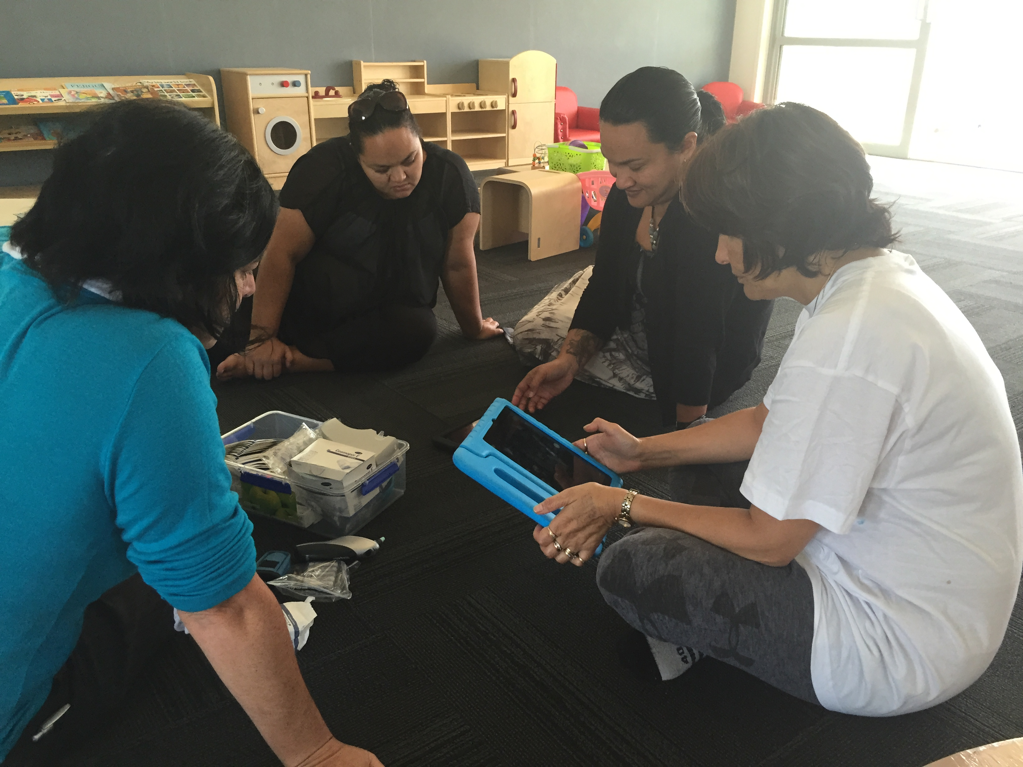
Kaitūao learning how to use software application
iMOKO Innovation

What worked well to support success?
Factors common to the success of many of the Innovations are outlined, followed by a summary of commonly experienced challenges to the success of the Innovations.

Whānau recruitment and engagement
Factors that supported successful whānau engagement included:
- access to the programme was straight forward and easy
- welcoming Māori environment and kaimahi
- whakapapa links with kaimahi provided an immediate point of connection and helped build trust and rapport quickly with whānau
- whānau had the benefits of engaging with the Innovation explained clearly.

Whānau interface with kaimahi
A range of kaimahi skills and attributes were identified as critical to success of the Innovations. Such as:
- kaimahi were the relatable Māori interface to services, critical to whānau buy-in and access to services
- kaimahi skills and experience inspired confidence and trust in whānau
- Māori kaimahi able to make whakapapa connections and understand whānau, hapū, iwi dynamics were important for whānau and helped other stakeholders to feel comfortable delivering services to Māori
- the ability to engage with whānau immersed in Māoritanga as well as those who were not
- kaimahi operating in non-judgemental, caring and empathetic ways put whānau at ease
- kaimahi worked in ways that were empowering to whānau, ensuring they retained control over decision-making about their lives and destinies
- kaimahi operated on principles that identified and build on whānau strengths
- kaimahi were role models to whānau, modelling healthy behaviours
- kaimahi opened their networks to whānau giving them greater access to resources and supports
- good whānau relationships with kaimahi relationship restored whānau faith in seeking help from other agencies.

Capability and capacity of providers
Innovation success relied on many factors related to provider capability and capacity to deliver the Innovation. These included:
- providers used whakawhanaungatanga engagement processes with whānau
- providers had good reputation/standing in the community
- effective databases and technology
- providers operated by Māori Values
- providers had existing networks to draw upon
- providers had whakapapa connections to whānau and other providers
- providers had all the skills, experience and knowledge to deliver the Innovation or the ability to quickly engage others with the required capabilities
- provider had the capacity to focus on the Innovation particularly in the development phase
- providers had high level of commitment to the success of the Innovation
- reflexive practice so that Innovation was reviewed and modified in an iterative process.

Interagency relationships
Good relationships with other providers were critical for the success of the Innovations. Factors that supported success included:
- professional relationships with clear roles and responsibilities
- trust between organisations, keeping each other’s ethical boundaries
- regular communication and information sharing
- willingness of all organisations to operate by Whānau Ora principles.

Innovation design and delivery
Many of the success factors related to design and delivery have already been described above. Other factors included:
- Innovation design underpinned by Māori health frameworks and principles
- individuals and whānau were engaged in co-designing aspects of innovations
- design was clear, appropriate and achievable within the Fund limitations
- Innovation could be clearly articulated to partners and participants
- timely access to mataraunga Māori and expertise in Te Ao Māori to develop the Innovations and the resources required
- sites of delivery were easily accessed and were welcoming to Māori.

Funding and resourcing
The Fund underpinned the success of Innovations in the following ways:
- the length of funding (four years for most Innovations) allowed time for Innovations to develop, deliver, review and make iterations
- flexibility of the funding allowed Innovations to be moulded to fit the needs of communities rather than external targets
- where relevant the funder varied Innovations contracts to accommodate adaptations to original design and testing of Innovations.

Formal evaluation
Evaluation provided positive impacts including:
- evaluators contributed formative input into programme development
- logic models were designed to guide evaluations and also helped providers to articulate the connections between their Innovations and the outcomes they hoped to achieve
- some providers were able to use interim impact reports to help secure funding from other sources prior to the end of the Fund
- evaluators built provider capability to self-evaluate
- evaluators were able to undertake quantitative data collection and analysis beyond the capabilities of most providers
- evaluators were able to provide qualitative data collection beyond the capacity of most providers
- evaluation Reports provide independent evidence of programme outcomes that can be used by providers to secure sustainable funding
- knowledge of challenges and successes were recorded and written, which allows learning for the provider, the funder and interested others.
Youth at P.R.I.D.E Camp 2016
Ngā Kaitiaki Innovation

What were the challenges to success?
Attaining success was not without its challenges. The commonly experienced challenges are summarised as they related to the Innovation providers and interagency collaborations.

Providers Challenges
Providers were the key to Innovation success. They also experienced the greatest number of challenges to success. These included:
- the innovative nature of the programmes created unexpected resourcing, capability and capacity challenges for providers
- loss of key drivers within an organisation resulted in loss of momentum for Innovations as new staff had to be recruited and brought up to speed with the Innovation
- the innovative nature of projects meant that new staff tended to need considerable orientation to their roles
- Innovations that relied on volunteers for the success of their programmes struggled to recruit and retain suitable volunteers. This was especially so in communities where the provider was known to have received significant funding to trial the Innovation
- developing unique resources was generally more time, expertise and funding intensive than expected. Projects that were both matauranga-based and required software development proved very challenging to develop, requiring collaborations between diverse organisations and individuals not ordinarily used to working together. Some took most of the funding period to develop new, unique and valuable resources but were left with little time for effective evaluation of the use of resources and their impact on whānau
- Innovations generally struggled to meet predicted delivery targets. Set before the Innovation began, delivery targets often proved unrealistic given the challenges of trialling new models of service delivery
- some organisations experienced a drop-off in clients in the later stages of implementation
- data collection for the evaluation proved time consuming and stretched the capabilities of some providers
- more challenging was creating databases for Innovations particularly where these were required to operate across organisations to share clinical and social information. The challenges associated with sharing clinical and social information via a joint database were not solved by most Innovations.

Inter-agency Challenges
Attaining the ideal of seamless interagency delivery of services to whānau was not without its challenges. Challenges included:
- the funded providers were often highly motivated to test their Innovation, and contractually obligated to work with others, but partnering with organizations with lower levels of commitment, motivation, resourcing or time was a prevailing challenge
- building effective relationships took time, especially with Innovations that required high levels of trust and respect for ethical boundaries between very difference organisations
- patch protection and a sense of competition provided challenges to interagency collaboration for a number of Innovations. These were not easily overcome, with some providers having to change agencies to obtain the services they wanted for their whānau
- not all organisations were ready to work within Te Ao Māori frameworks or by Whānau Ora principle. Modelling these approaches and advocating for them created challenges for providers when organizations were not ready or did not accept their need to learn from Māori providers.
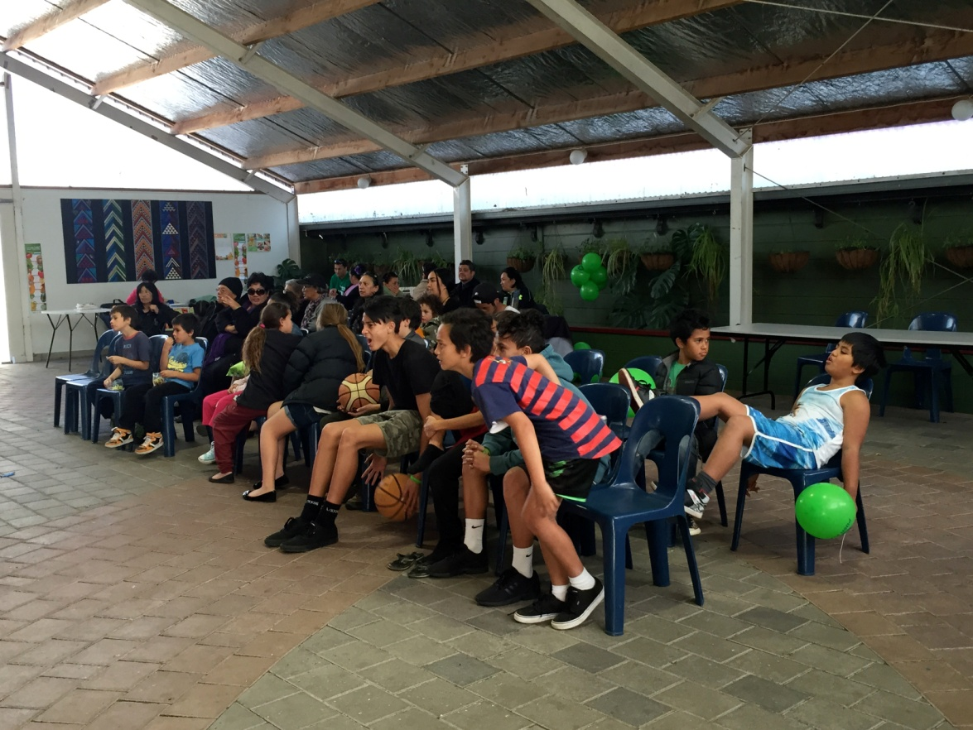
Tamariki at Health Expo Waimarama Marae
Ko te Marae te Matatiki Innovation

How might the trial of Māori Health Innovations be improved?
The challenges and successes seen across the Innovations provide some keys for better support of providers as they seek to test their Innovations.

Extra development time for complex Innovations
Complex Innovations including those that needed to develop resources in te reo Māori or from iwi or hapū knowledges or that were technology-based need more time in development and less pressure on delivery.
- Allowing this time and working with providers at the contracting stage to ensure that a significant proportion of the funded time be allocated to resource development would ensure that a range of innovative resources were thoroughly developed and tested
- Concentrating evaluation on process learning, rather than outcomes for participants and their whānau would produce learning that might be useful to others wanting to develop similar resources.

Extra support to providers to collect and share data
Innovations brought up new data collection challenges that providers were not generally equipped to deal with.
- The challenge to develop new suitable databases was common to almost all providers and is not an issue easily solved by individual organisations within the timeframe for Te Kākano funding.

Facilitated networking
Providers shared many of the same challenges. Some shared Innovations that targeted the same kinds of health conditions or target population.
- A facilitated information-sharing platform, that was voluntary for providers, might help providers to support each other and solve commonly experienced problems and issues.

Greater consistency across the evaluations
The evaluations lacked consistency and were of variable quality.
- More consistent evaluations would ensure providers received similar levels of formative support and evidence of effectiveness
- Quality evaluation across the suite of Innovations would provide the funder with a clear picture of successes and challenges and guidance on where to invest further funds to reap greater whānau ora.

Conclusions

Analysis and review of the evaluation reports from Te Kākano 2013–2017 Fund, show that all of the objectives of the Fund were met.
- Advance Whānau Ora and affirm positive Māori approaches that improve Māori health outcomes
- Promote Māori service delivery systems that value health and social service collaboration and employ whānau centred interventions
- Recognise service models that address the needs of whānau, hapū, iwi and Māori communities
- Enhance physical, spiritual, mental and emotional health, giving whānau control over their own destinies.

Furthermore the 2013-2017 priorities were in evidence across the suite of funded Innovations:
- Tikanga a Tamariki Mokopuna or Te Ao Māori ways of improving the health of children and their whānau
- ‘Collaboration,’ meaning the partnering with other organisations/agencies in a constructive approach to addressing health and social need
- The use of technology to enhance the service delivery and access to services.

Te Kākano 2013-2017 Innovations resulted in significant gains not just for whānau but also for hapū, iwi and other communities – gains that came from testing new models of service delivery, all of which were Whānau Ora models.
Providers built networks that supported whānau, as whānau, to meet immediate and pressing needs quickly and ensure they were guided, connected and resourced on their journeys towards achieving their longer-term aspirations.

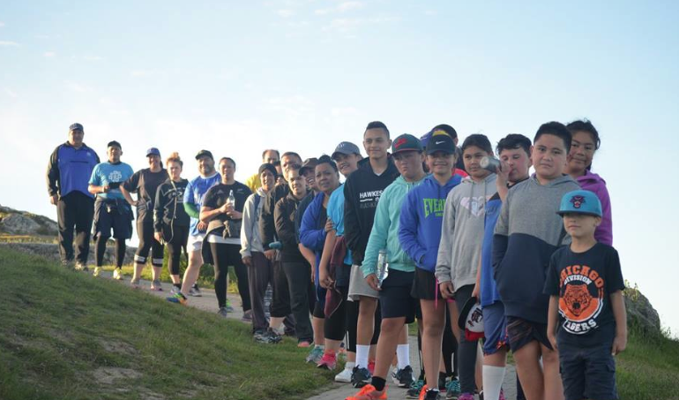

Appendices
Hikoi up Te Mata o Rongokaka
Te Waka Tuatahi Innovation

Glossary of Māori terms
Māori words and terms have much fuller meanings than the definitions given here. These brief definitions are indicative only.

Aroha love
Hauora health, holistic health
Hāpori community
Hapū sub-tribe, kinship group of mutiple whānau
He Korowai Oranga Māori Health Strategy
Hui meeting or gathering
Ipu whenua container to hold the placenta
Iwi tribe
Iwitanga tribal practices
Kai food
Kaiako teacher/tutor
Kaiārahi guide/coordinator
Kaimahi staff, volunteer, worker
Kainga home
Kaitūao kaimahi for iMOKO programme
Kapa Haka Māori cultural group
Karakia prayer
Kaumātua respected elder, male or female
Kawa customs and protocols
Ko wai au? who am I?
Koha contribution or gift
Kohanga Reo Māori medium preschool
Kōrero speak, talk
Kuia respected older woman
Kura school
Kura Kaupapa Māori Māori medium language school
Mahi work
Mahi toi making artworks
Mana prestige, integrity, spiritual force bestowed on people
Mana Motuhake self-identity, self-governance, autonomy
Mana whenua customary authority exercised by a tribe or sub-tribe
Manaaki care for, blessing
Manuhiri visitor, guest
Māori indigenous New Zealanders
Marae Māori gathering place
Mātauranga knowledge, wisdom, education
Mihimihi speech of greeting
Mokopuna grandchild, grandchildren
Ngāti prefix for a tribal group
Noho Marae overnight stay on a marae
Ora health, wellbeing
Oriori traditional lullaby
Pākehā people of European origin
Pakeke adult
Pepe/Pepi baby
Pepeha personal introduction
Poroporoaki farewell
Pūrākau traditional stories
Rangatahi youth
Rangatira leader
Rangatiratanga right to exercise authority
Rōpū group
Tamariki children
Taitamariki youth
Taoihi youth
Taonga treasure, highly prized
Tāne men
Tangata person
Tāngata people
Tāngata whenua people born of the land, local people
Tangihanga funeral
Tautoko support
Te Ao Māori the Māori world
Te Kākano the seed
Te reo Māori Māori language
Te Tiriti o Waitangi Māori version of the Treaty of Waitangi
Tikanga correct procedures, customs, manner
Turangawaewae place of origin (place to stand)
Waiata sing, song, chant
Wairua spirit, spiritual
Waka Ama outrigger canoe racing
Wānanga educational seminar/forum
Whākapapa line of descent from ancestors, layers of relationship
Whakataukī proverb, significant saying
Whakawhanaungatanga the process of establishing relationships, relating well to others
Whānau family
Whenua land

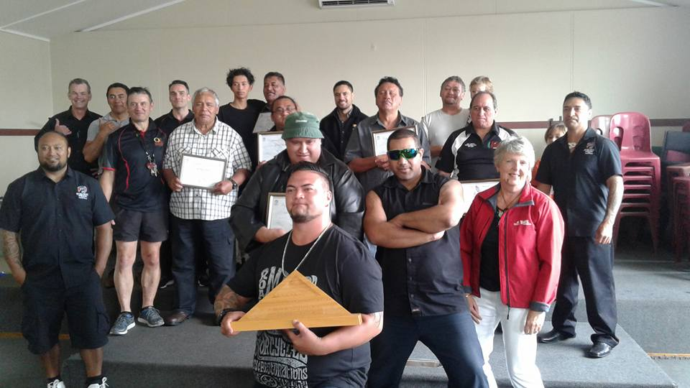
Te Reo Māori is an official language of Aotearoa New Zealand with equal status to English. It is therefore not subordinated with italicization.
Kaiurungi Programme Graduation
Follow-on from Tāne Takitū Ake Innovation

Innovation | Provider | Programme Description Summary
Aroha Nga Mokopuna  (48 months) | Rauawaawa Charitable Trust | Kaumātua led health promotion in schools - A unique kaumātua led health promotion programme in participating schools incorporating kaupapa Māori principles. The Innovation proposed to work in partnership with up to four local schools to promote cultural identity through (i) Mauriora, the environment people heritage (ii) Waiora, participation in society (iii) Te Oranga and Toiora, healthy lifestyles.  The overall aim was to address the health, wellbeing and cultural needs of tamariki in years 1-13 within a kaupapa Māori framework in collaboration with Midland Health for clinical referrals. Outcomes aimed for included: enhancement of the social and emotional wellbeing of tamariki/rangatahi, improved self-esteem, confidence and self-worth, improved knowledge, awareness and uptake of healthy lifestyle options by including food sustainability through traditional gardening activities and healthy cooking/food preparation, maintaining healthy weight and strengthened relationships between tamariki/rangatahi and their whānau, hapu, iwi and wider community.
He Ara Toiora  (48 months) | Te Rau Matatini | e-learning nutrition and health programme - The Innovation accessed tamariki at participating schools and aimed to involve their whānau to develop a co-designed health and wellbeing plan that builds on the strengths of whānau. The provider built resources to enable the tamariki (and their whānau) access to health information using interactive planning tools, Māori language e-learning tablets, and specialist smartphone applications specifically designed for each age group.  The e-tools were an aide to supporting tamariki/whānau to improve their physical health and wellbeing through improved nutrition and increased physical activity that is underpinned by the interactive use of technology. The outcomes aimed for included; reduction in Māori obesity through increased health literacy and awareness of nutrition and physical activity; changes in lifestyle that includes healthy food choices, good nutrition, physical activity; whānau having the collective capacity and strength to pursue their aspirations.
iMOKO  (48 months) | Navilluso Medical Limited | Telemedicine in schools - iMOKO (formerly vMOKO) is a virtual consulting, diagnosis and treatment programme that uses technology through a specially developed application (‘app’) installed in iPads and digital clinical equipment provided to schools. Volunteers are trained in schools to run the application and are given all medical resources for the program. Parental consent is gained at enrolment into the programme. Through photographs, observations and notes made by these school volunteers, Dr O’Sullivan and his clinicians can remotely diagnose from their medical centre in Kaitaia. Appropriate medication is then prescribed and relayed to the local pharmacy and advice is sent to the child’s family and GP. The main use of the application is assessing skin infections in children. Children either refer themselves, or are referred by the school. The main skin infections are impetigo, scabies, cellulitis, and infected eczema. A large number of the skin infections have been caused by insect bites, falling over, cuts and accidents at home. All medication prescribed by iMOKO is free and delivered via rural delivery or collected by the school or families.
Integrated Wellbeing & Learning Pilot  (12 months) | Positive Directions Trust | Integrated Wellbeing Support - A short-term pilot dovetailing off an existing education programme. The pilot was to scope, design, develop and test the implementation of an integrated model of service delivery to assist Māori tamariki/rangatahi (10–18 years) residing in the eastern suburbs of Christchurch who displayed health issues (poor nutrition, lack of exercise, mental health problems, low fitness levels) and behavioural and learning difficulties largely as a result of the effects of the recent earthquakes. The programme offered a tikanga Māori integrated approach using a combination of nutrition, traditional Māori fitness games and innovative teaching methods/pedagogy that would normally not be available to the tamariki and their whānau. The Innovation combined knowledge and practice from various disciplines to help youth overcome problems associated with a lack of opportunities and minimal access to mentoring and pastoral support.
K2K or Kanohi ki te Kanohi | Raukura Hauora o Tainui | e-health applications connecting whānau and primary care - The Innovation was conducted in tandem with Auckland University. Raukura Hauora o Tainui (Raukura) clients were engaged in using a health application suitable for their health condition. The University trained users to use the app while Raukura provided support to patients helping them to develop new skills in using the app, to assess and record health data, and introducing new apps as appropriate.
Ka Rewa  (48 months) | Te Hauora Runanga o Wairarapa | School-based resilience programme - The programme design envisaged two elements to the innovation (i) a school based resilience programme and (ii) a mental health and addictions prevention programme. The Innovation targets tamariki who are at risk of developing a mental health and addiction problem and/or self-harming. Ka Rewa is described as a Collaborative Approach to Building Resilience in the Māori Learner and supports tamariki who may be experiencing problems such as; violence, poverty, depression, bullying, drugs and alcohol issues, health issues, or are at risk of self-harm or suicide, to build their self-esteem and resilience for a better future.
Ka Tipu Te Whaihanga, e Hika, ki Ūawa  (48 months) | He Aitanga a Hauiti Hauora | A unique Iwi Parenting programme - The Innovation focused on enhancing local community, marae and whānau development through provision of a whānau parenting skills and support service model for the whānau of Te Aitanga a Hauiti. The initiative was targeted at improving health and wellbeing of babies and young children within a Te Ao Māori framework, through drawing on iwi traditional practises and adaptation of Plunket training for local Kaitiaki.  Iwi traditions and early childhood education were incorporated by the provider (supported by local kuia) into the standard Plunket training (workplace assessments/ supervision) in Tamariki Ora Modules undertaken by 5 local Hauiti Kaitiaki a-Whānau.
Kia Tupu Ake Ai Whānau  (36 months) | Ngāti Hine Health Trust | Taitama mental health crisis support programme - A kaupapa Māori whānau initiative providing expert support to rangatahi who are experiencing a health crisis that results in the diminishment of tapu, mana and mauri of the rangatahi, or that threatens the future health and wellbeing of the collective whānau group. The Innovation targeted rangatahi experiencing crisis but who did not meet the criteria for other youth services (e.g. child & adolescent mental health, Ministry for Vulnerable Children). The youth focused innovation supported youth to become leaders, and to build resilience through; self-awareness initiatives, skill and knowledge development, and learning more about their whakapapa and culture. The longer term aim was to also work with the whānau of the rangatahi using a family therapy/Whānau Ora approach.
Kiri ki te Kiri  (48 months) | Te Hauora o Turanganui a Kiwa Ltd [Turanga Health] | Breastfeeding for 1st time mothers - Use of local traditional knowledge and practices to focus on increasing breastfeeding rates at 6 weeks, 3 months and 6 months. Aimed at first-time Māori mothers within Turanganui a Kiwa, the objective was to increase breastfeeding rates in this cohort, and to achieve and maintain at least 80% of these women fully breastfeeding at each rate measure. ‘Kiri ki te Kiri’ translates to mean ‘skin to skin,’ a phrase attributed to traditional Māori practices starting from the initial birthing process enabling a birthing mother and her new pepi (baby) to stay skin to skin allowing for breastfeeding to occur naturally. The programme framework revolved around Māori cultural values of wairua, hinengaro, tīnana. Whānau. The Innovation further aimed to provide participants with relevant wrap-around services facilitated by the provider such as; access to GP, auahi kore, health promotion (nutrition/physical activity), immunisations, tamariki ora, sexual health, breast pumps, car seat initiative, drug and alcohol counselling, support for post-natal depression.
Ko te Marae te Matatiki  (36 months) | Nga Kairauhii Trust | Marae-based health champions/health promotion - Connecting whānau to their tūrangawaewae, marae, language and culture; and improving marae whānau health and wellbeing by raising awareness of health issues and how to address these through better health and lifestyle choices. Semi-rural / rural Māori communities in the Hawke's Bay region have been strong marae-centred communities in the past. Research has shown that many of the whānau now feel disenfranchised from the marae and their tūrangawaewae, which has impacted on their health and education. Marae health plans are developed for marae to address health needs. The Programme builds on existing relationships with whānau and stakeholders in these areas.
Mana Tamariki, Mana Mokopuna, Mana Whānau  (48 months) | Poutini Waiora | Young Māori mothers co-designing a health service delivery - The Innovation aimed to address the real needs of young mothers who live on the West Coast who may be rural, isolated and/or disempowered. The model aimed to; increase Health literacy, encourage healthy behaviours and re-engage young Māori women and their tamariki with critical health and social services. Collaboration and interface with health services and other agencies was also envisaged as ideally working towards a functional one-stop-shop. The Innovation involved the young mums participating in designing, developing and putting activities in place and supported the development of knowledge, skill and confidence in areas of health and wellbeing. A main feature is emerging leadership and support for young mums from their peers.
Mokopuna Te Ao | Turuki Health Care Charitable Trust | Integrated antenatal and postnatal care model - The Innovation targeted women who are hapū to be supported through antenatal and postnatal care services which meet their needs and those of their pepi and tamariki (“mokopuna”). The care starts with mokopuna from birth to their first day of school. The intention was to develop an Integrated Care Model bringing together staff, services and contracts into three work stream areas: maternity; parenting and education with the aim of enhancing whānau ora.
Nga Kaitiaki  (48 months) | Ngati Kahu Social & Health Services | Ngā Kaitiaki is a marae-based youth focused initiative supporting taitamariki from the far North to make positive choices for their future through building their life skills and leadership abilities. The Youth Mentoring programme supports tamariki/rangatahi to build self-esteem, sense of belonging, understanding and pride of who they are and where they come from. The Innovation assists youth to be aware of their own uniqueness, their talent and abilities and their contribution to healthy communities. The aim is to help local youth to build confidence and draws on the social values and principles of Te Ao Māori.
Ngā Kaupapa Mātauranga o Ngā Mahi o Te Rā Project  (30 months) | Te Roopu Taurima o Manukau Trust | Multimedia learning portal for intellectually disabled - An innovation to develop trilingual (English, Māori, sign language) kaupapa Māori learning and education resources for Māori who have an intellectual disability. The education sessions were developed from a current stock of education resources to be an online programme that the target group can access at home and at other day facilities they may attend. This is the first online education programme for people with an intellectual disability in trilingual form in the world.
One Plan Project  (18 months) | Taumarunui Community Kokiri Trust | Promote interagency collaboration for whānau - The One Plan Project is led by the Provider in collaboration with Child Youth and Family (Taumarunui). The aim of the collaborative Programme was to develop and consolidate a framework for a working model of locally focused service delivery that addresses common inconsistencies that arise when more than one service provider is working with individuals or whānau to address their health and social issues. The provider envisaged a future model of service delivery encompassing a shared kaupapa and joint-working relationship between the two organisations, enabling more effective utilisation of existing resources and more focused and cohesive responsiveness to clients and whānau. The overall goal of the Programme is to implement a collaborative working model whereby instead of a disjointed approach to addressing whānau health and wellbeing, a single Whānau Health and Social Services Plan is developed by and shared between the collaborating organisations.
Shredathon- 4G  (36 months) | 4G Limited | Weight loss and nutrition programme - Programme designed for rangatahi, pakeke, kaumātua and Māori who have a chronic health issue. It also aims to improve health and wellness to as many people as possible in Taumarunui. The programme offers enrolled participants advice on weight loss, nutritional education, cardio, yoga, and box-fit classes and mentoring through exercise in an unstructured format.
Tamariki Mokopuna | Maraeroa Marae Assoc. | Marae-based parenting programme - Facilitating better and informed access for Māori pregnant women to antenatal, maternity and child health support services from a local marae base in a low socio-economic part of Porirua. Targeting Māori pregnant women who for various and complex reasons do not have a lead maternity carer or support for their baby after birth.
Tâne Takitû Ake Programme  (48 months) | Korowai Aroha Trust | Men and their whānau - healthy lifestyle programme - Targets Māori men aged between 25-55 years residing in the Rotorua district with high social and health needs, providing tools and teaching skills to improve men’s health and wellbeing, and supporting them to become leaders in their home, good partners and fathers, for the overall benefit and wellbeing of themselves and their respective whānau. The target group is either obese, have a cardiovascular related disease, diabetes, or are at risk of developing a long term health condition and may be experiencing a range of social issues.
Te Kōtuku ki Te Rangi Whānau Respite Facility | Te Kōtuku ki Te Rangi | Whānau respite facility for adults experiencing mental health problems - The Whānau respite facility comprised two two-bedroom units specifically set up for adults, who are not in crisis, experiencing mental health problems and requiring short-term planned care who want to have their whānau at the facility with them. This was a kaupapa Māori model of care (Te Whare Tapa Whā) including Māori kaimahi to mentor and support the tāngata whaiora through a mental health episode. The facility supports whānau to stay together, but also ensures that tāngata whaiora receive the break they need from everyday stressors when experiencing mental health problems.
Te Puawai o Te Ahi Kā  (48 months) | Te Oranganui Trust | Marae-based health programme - The Innovation was designed to work with hapū and whānau who live on and around rural marae in the Whanganui region and was based on papakainga of Raetihi Marae. The Innovation focused on Whānau health checks and support for whānau to access health services; shared learning and education about hereditary whānau conditions often shared by hapū. The Innovation facilitated access to health promotion and other services such as; mobile dental care, Quit smoking, alcohol and drug counselling and support, and positive parenting.
Te Waka Tuatahi Innovation  (48 months) | Hikoi Koutou Trust | Gym-based lifestyle programme - Te Waka Tuatahi is a Māori centric Whānau Ora programme aiming to fight obesity and related health conditions. It is based out of the Hikoi-4-Life Gym in Hastings, drawing together sports, physical activities and healthy nutrition under the cloak of Te Ao Māori, taking whānau on a Virtual Hikoi tracing the ancestral journey from Hawaiiki to Aotearoa. Whānau were given free access to the wide range of activities available for all age groups, at the Hikoi-4-Life gym. Te Waka Tuatahi was designed to address Māori loss and suffering by providing a community environment that supports whānau to improve their health behaviours (be more physically active, quit smoking, eat well, lose weight etc.), have better access to quality health care and the social supports that might help them to turn around some of the factors implicated in poor Māori health outcomes.
WOW bus | Te Kaha o Te Rangatahi Trust | Mobile tamariki education service - The Innovation Waka Ora on Wheels (WOW) focused on the South Auckland region. The innovation included a mobile kaupapa Māori health promotion and education programme accessing and working with tamariki and their whānau face-to-face and providing parenting education and support to teenage and young parents. The innovation included promotion and prevention, customised clinical care and alliance with primary care.

Examples of Innovation Models
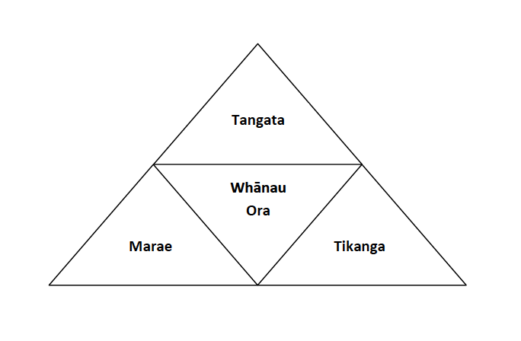
Ko te Marae te Matatiki – Nga Kairauhii Trust
The Ko te Marae te Matatiki Model of Health is based on the whakatauki:
Ko te tangata te kaupapa People are the reason
Ko ngā tikanga te tuapapa Our practices are the foundation
Ko te Marae te matatiki The marae is our resource
Tikanga is a foundation. This is the connection to deity through karakia, whenua through whakapapa, this is the link to Te Ao Māori through ancient practices passed down from mātua tūpuna, it is the link to the language. Te Reo Māori is the key to culture and practices. It is also the language that better aligns with the health outcomes this model supports. Our research identifies that many whānau today are not proficient with Te Reo and lack an understanding of tikanga but would love to learn it if the opportunity became available.
Whānau Ora is when physical, spiritual, mental and emotional health outcomes are driven and directed by the whānau themselves. It focuses on Wellness and preventative solutions to the ills that beset our communities. It draws on who Māori are (as outlined above) to improve one’s self esteem, to stand strong, to make good decisions that improve health and wellness outcomes.
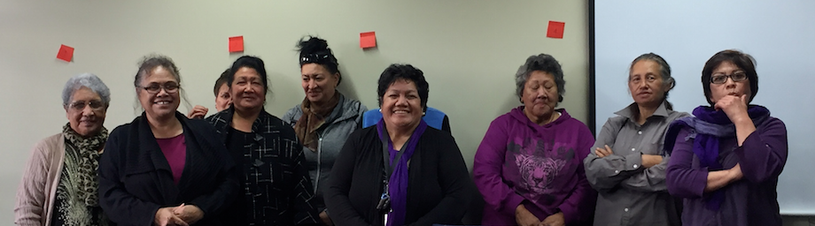
Marae Whānau Ora would use the above taonga tukuiho to improve the wellness of Māori communities. The research shows that there is a definite link between connecting the above elements to ones general wellbeing. Often we look too far beyond the mark, when what we actually need is right in front of us.
Tâne Takitû Ake Programme and Kaiurungi Programme Models
Marae Representatives and Marae Health Champions
Ko te Marae te Matatiki Innovation

Marae Representatives and Marae Health Champions
Ko te Marae te Matatiki Innovation

Stages of Tāne Takitū Ake Model | Purpose / focus | Activities/ components
Tāne Whakapiripiri (Stage 1) | (Two-week duration) – Tāne Whakapiripiri is the calling for people to come together (with a common interest), so that they can embrace the spirit of kotahitanga (unity) and discuss and plan ways to move toward a better future. | Stage one components include:  - Pre-program medical observations  - Pōwhiri/ Whakawhanaungatanga (Relationship building)  - Noho marae (Over-night stay)  - Waka tētē (Team building)  - Atuatanga (Tāne the role model)
Tāne Te Waiora  (Stage 2) | (Six-week duration) – Tāne the bringer of life. Participants gain knowledge around basic exercise techniques and programmes, building confidence and self-belief in their physical abilities so that they can continue exercising independently outside of a supervised session. | Stage two components include:  - 12x supervised gym activity (QE Health)  - Cancer society (Cancer awareness/prevention)  - Healthy families/Nutrition  - Native kai (Natural food resources)  - Aikido (Self-control and conflict resolution)  - Heart foundation (Heart care)  - Diabetes prevention (Korowai Aroha)  - Self-management of long-term conditions  - Sustaining change
Tāne Tokorangi (Stage 3) | (Two-week duration) – Tāne Tokorangi: Tāne took this name after separating the heavens and earth. The name means tāne who holds up the sky. It was akin to a rite of passage as it took everything he had to complete this task. At this point, participants in the programme would have demonstrated similar effort and determination through confidence and application of learnt behaviors. | Stage three components include:  - Noho marae (Review, goals)  - Haka (Pride, expression)  - Post program observations  - Leadership (Mentoring)  - Potaetanga (Graduation)  - Sustaining change

Stages of Kaiurungi Model | Purpose / focus | Activities/ components
Stage One:  Matakite (Vision) | Tāne focus on the vision for the future and what this looks like for them and their whānau. This stage looks at planning and goal setting.
Stage Two:  Matapono (Values) | Focusing on values helps tāne reflect on what matters most to them. Tāne must reflect first and then implement good values and standards which will contribute to them achieving their vision.
Stage Three:  Whakapuaki (Voice) | Tāne explore the importance of having a voice and speaking out when needed. Developing confidence to speak in various levels is essential for tāne to become good leaders in all environments.

Kiri ki te Kiri Programme Model

Kiri kit e Kiri translates to mean ‘skin to skin’ and is a phrase attributed to traditional Māori practices starting from the initial birthing process that enables a mother and her new pēpi (baby) to stay skin-to-skin allowing for breastfeeding to occur naturally.
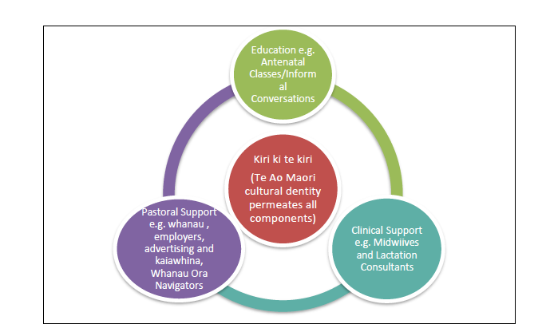
The programme designed by Tūranga Health has the goal to increase breastfeeding amongst Māori mothers when baby is 6 week, 3 months and 6 months. Four years on, four factors characterise a programme for first-time Māori mothers that enhances their success to breastfeed their baby to 6 months of age or older (see Figure).

- Education that includes formalised learning such as antenatal classes, informal learning opportunities for first-time mothers
- Clinical Support means consistent and practical help from health professionals such as midwives and lactation consultants when women require expertise.
- Pastoral Support is possibly the most important component for successful breastfeeding, because it assumes day-to-day positive affirmation and empathy from whānau, kaiawhina, employers, the community and the media.
- Cultural identity is a theme across all components. Not an add-on characteristic, but a inherent quality of an intervention, a service, a clinician, a kaimahi. Women recognize Māori cultural identity in the around them. They see, hear or feel an instant connection, because the connection is familiar and they feel ‘at home’ regardless of the actual social setting.

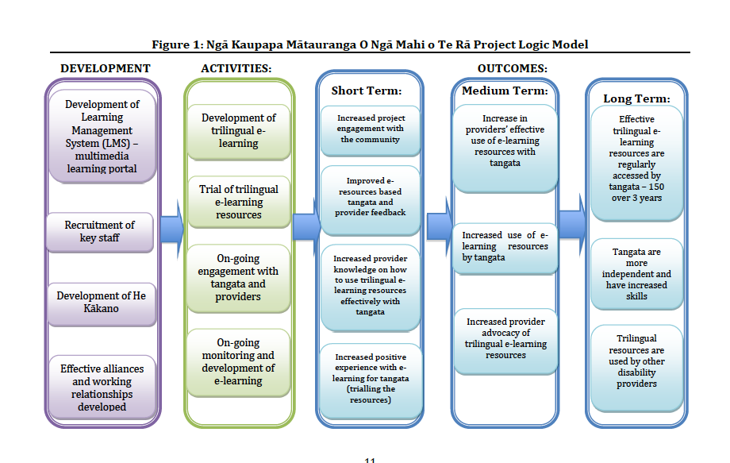
Examples of Programme Logic Models
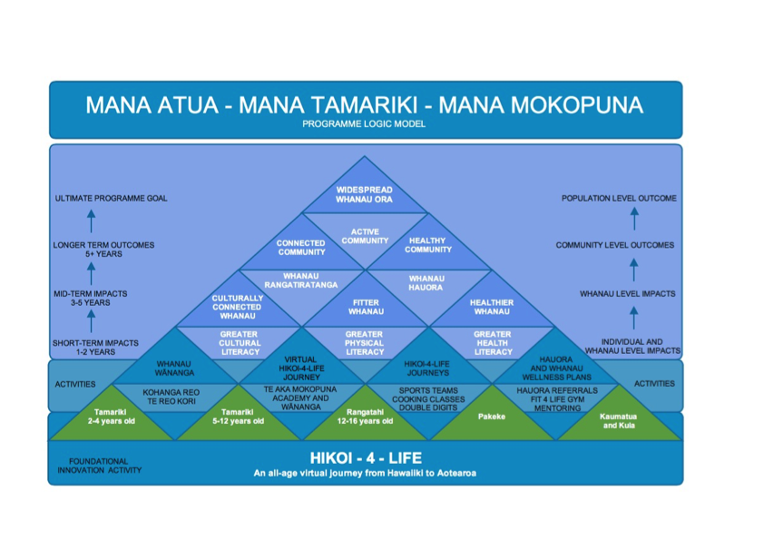
Te Waka Tuatahi
Programme Logic Model

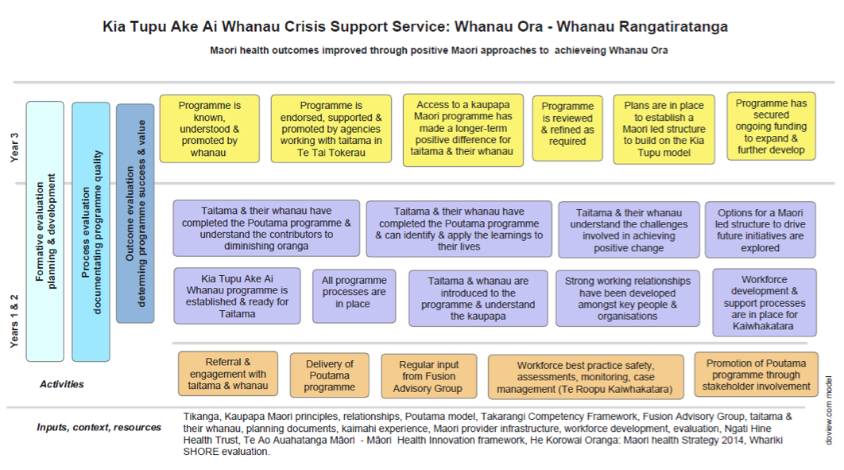

See Appendix One for a Glossary of Māori terms used in this report.
See Appendix Two for a description of the 22 initiatives funded under Te Kākano 2013-2017.
The providers may now also be eligible for Te Ruinga funding. The Fund provides for spreading or adoption of innovation under the Te Ruinga category.
iMOKO, Ka Rewa, Tāne Takitū Ake Programme and Te Waka Tuatahi were successful under Te Ruinga.
WOW Bus Evaluation Report. p.1
Ibid. p. 58
Determining exact alignment with the Fund objectives for individual Innovations is not attempted here as the Fund objectives are interwoven, precluding a clear-cut assessment on individual alignment per programme.
Ministry of Health, 2012. p.36
See Appendix Three for examples of Innovation Programme Models.
Tāne Takitū Ake Evaluation Report. p.3
Te Puawai o te Ahi Kā Evaluation Report. p.60
Aroha Ngā Mokopuna Evaluation Report.
Statistically significant change (z = 1.97, p < 0.05)
Statistically significant change (z = 2.03, p < 0.05)
Statistically significant change (z = 2.7, p < 0.05)
Statistically significant change (z = 2.74, p < 0.05)
Evaluation Report p.61
Ibid.
Child, Youth and Family (CYF) was renamed “The Ministry for Vulnerable Children, Oranga Tamariki” in April 2017.
The founder of the programme and Executive Director of Hikoi-4-Life community gym lost his own father in his 40s. He himself has battled obesity and is on his own journey to control his weight in order to live longer for the sake of his whānau.
Evaluation Report p. 29
Evaluation Report p.9
A more detailed summary of whānau outcomes and wider impacts is provided in the section following. However each evaluation was tailored to the Innovations and there is therefore no one standard for measuring outcomes across the Innovations.
PATH is an acronym for ‘Planning Alternative Tomorrows with Hope’.
Story adapted from Tane Takitū Ake Evaluaiton Report. p. 20-21
Story adapted from Turuki MPT Service Integration Evaluation Report. p. 38-40
Story adapted from Nga Kaitiaki Evaluation Report. p. 40-41.
See Appendix Three for sample Programme Logic Models.

