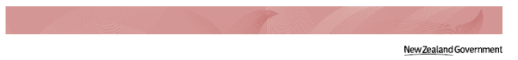

**Whāia Te Ao Mārama   
2018 – 2022:   
The Māori Disability Action Plan**

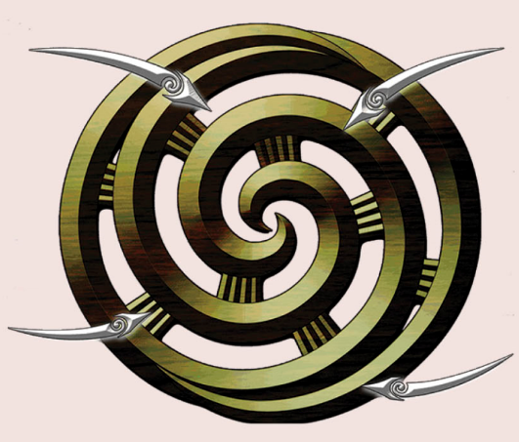

**Easy Read**

# Where things are in this book

Before you start 3

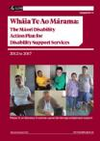Hard words 4

What has been done since 2012 5

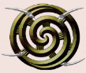A close up of a logo

Description generated with high confidence[About the symbol of   
Whāia Te Ao Marama 10](#_Toc508191640)

The 4 outcomes of Whāia Te Ao Mārama 2018-2022 155

A picture containing book, text

Description generated with very high confidenceAbout the next part of this book 17

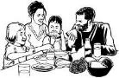Outcome 1: Te Rangatira 18

Outcome 2: Te Ao Māori 31

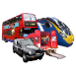

Outcome 3: Te Ao Hurihuri 38

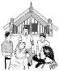

A close up of a clock

Description generated with high confidenceOutcome 4: Ngā Tūhonohono 45

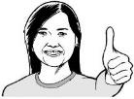List of hard words 544

People we would like to thank 62

# Before you start

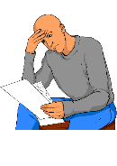

This is a long document.

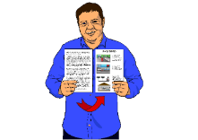

While it is written in Easy Read it can be hard for some people to read a document this big.

A picture containing text, book

Description generated with very high confidence

Some things you can do to make it easier are:

* read it a few pages at a time
* have someone to assist you to understand it.

# Hard words

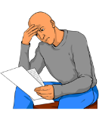There are some words in this book that might be hard or new to you.

These words may be hard to understand.

A close up of a sign

Description generated with very high confidence

These words will be in large print.

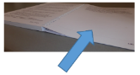If you want to know what these words mean you can go to the **List of hard words** in this book on **page 54**.

# What has been done since 2012

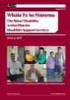

Whāia Te Ao Mārama 2012 – 2017 helped make some things better for:

* A picture containing text, book

  Description generated with very high confidencetāngata whaikaha

A drawing of a person

Description generated with high confidence

* the whānau of tāngata whaikaha.

A picture containing text, book

Description generated with very high confidence

When we use the words **tāngata** **whaikaha** we are using them to describe **2** **or more** **Māori people with a disability**.

**Tāngata** means 2 or more people.

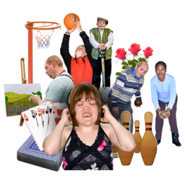

**Whaikaha** means:

* + to have skills

**or**

* + - * + to be able.



Making things better for tāngata whaikaha and their whānau in Aotearoa / New Zealand is important to the Ministry of Health.

A picture containing text, book

Description generated with very high confidenceThe **Ministry of Health** know Whāia Te Ao Mārama 2012 – 2017 has made some things better for tāngata whaikaha because more:

* Māori are using disability support services

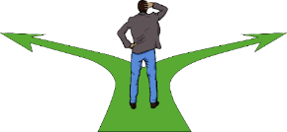

* Māori are using services that give them choice and control

A picture containing text, book, linedrawing

Description generated with high confidence

* tāngata whaikaha choose to live in the community with support
* A group of people posing for the camera

  Description generated with very high confidencetāngata whaikaha choose how they are supported
* tāngata whaikaha choose who they get support from.

The **Ministry of Health** also know Whāia Te Ao Mārama 2012 – 2017 has made some things better for tāngata whaikaha because more:

A close up of a logo

Description generated with high confidence

* Māori that use services said they are happy with the service.

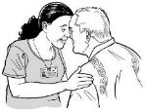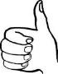

Some work has been done to make disability support services better for Māori.

A picture containing book, text

Description generated with high confidence

Checks are done now to make sure disability support services work well with Māori culture.

A picture containing text, book

Description generated with very high confidenceMāori carers can get new training to help them give good support to tāngata whaikaha.

A drawing of a person

Description generated with high confidence

Some carers who are Māori joined the carer matching service.

A picture containing text

Description generated with very high confidence

Most staff working in the Ministry of Health’s Disability Support Services have done a course to learn how to work with Māori.

# About the symbol of

# Whāia Te Ao Mārama

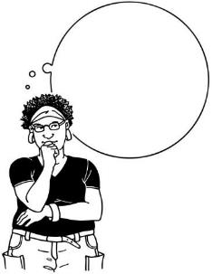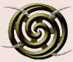

Whāia Te Ao Mārama has a symbol.

A symbol is something that means something.

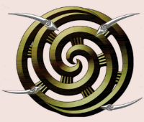Whāia Te Ao Mārama uses this torino as its symbol.

The torino is a double spiral.

****The torino is a shape that is important in Te Ao Māori.

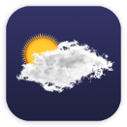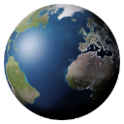

The torino shows the world of light that was made when Ranginui and Papatūānuku were separated.

A drawing of a person

Description generated with high confidence

It can be seen:

* 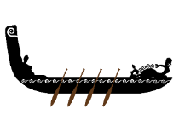above the doorway of wharenui
* on some carved waka.



Each part of the torino means something about Whāia Te Ao Mārama.

****The middle part of the torino is called Te Rangatira.

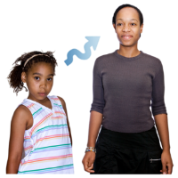

Te Rangatira is about tāngata whaikaha having choices during their whole lives.

A person posing for the camera

Description generated with very high confidence

Te Rangatira is also about tāngata whaikaha being leaders in:

* + - * + their own lives
        + other people’s lives.



The white space in between the two 2 spirals of the torino is Te Ao Māori.

Te Ao Māori is the Māori world.

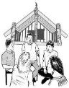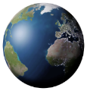



The spiral on the outside of the torino is Te Ao Hurihuri.

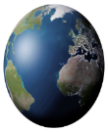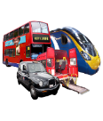

Te Ao Hurihuri is the modern world.

The modern world is the world we live in today.



The bits that join the two spirals are about joining the other parts of the torino together.

This is called Ngā Tūhonohono

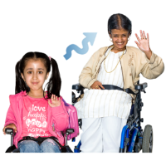Joining the parts of the torino help a person:

* + - * + 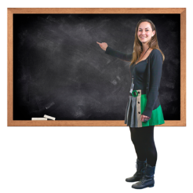grow
        + learn
        + have balance in their life.

A picture containing text, book

Description generated with very high confidence

This plan has been made to support tāngata whaikaha.

# The 4 outcomes of Whāia Te Ao Mārama 2018-2022

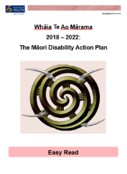

There are **4 outcomes** in Whāia Te Ao Mārama 2018-2022.

An **outcome** is how we want something to turn out.



The torino shape shows the 4 things we hope will happen if we follow this plan.

The **4 outcomes** are:

1. **Te Rangatira**
   * For more information about this outcome turn to **page 18**



1. **Te Ao Māori**
   * For more information about this outcome turn to **page 31**



1. **Te Ao Hurihuri**
   * For more information about this outcome turn to **page 38**
2. **Ngā Tūnonohono**
   * For more information about this outcome turn to **page 45**

# About the next part of this book



The next part of this book will talk about the outcomes of the plan.

We will also talk about:



* the goals for each outcome
* what the Ministry of Health will do to make the goals real

A drawing of a person

Description generated with high confidence

* what **whānau** can do to make the goals real
* 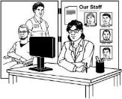what **disability provide**rs can do to make the goals real
* what **other organisations** can do to make the goals real.

# Outcome 1: Te Rangatira

A picture containing book, text

Description generated with very high confidence

If we follow the plan **tāngata** **whaikaha** will:

* have information

A person standing posing for the camera

Description generated with very high confidence

* be able do something about their different choices
* make decisions for themselves.

This outcome has 2 goals.

2

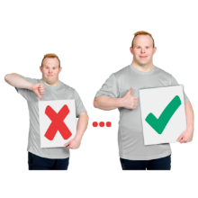

1. That tāngata whaikaha will be able to join in to make health and disability services better

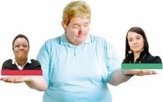

1. That tāngata whaikaha will be in control of the disability support they get.

To make these **2 goals** real the **Ministry of Health** will try to make sure:

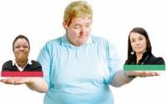

* tāngata whaikaha can get the disability supports they choose

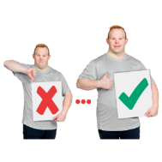

* tāngata whaikaha and their whānau can make services better by:
  + asking them to help make new services

A drawing of a person

Description generated with high confidence

* + asking them to help make those new services real for others.

To make the **goals** real the **Ministry of Health** will also try to make sure:



* tāngata whaikaha and their whānau can make services better by:

A picture containing book, text

Description generated with high confidence

* + asking them to say if disability support is doing a good job or not
  + 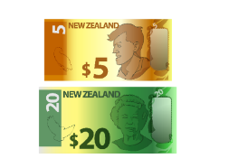making sure tāngata whaikaha can get self directed funding for their disability supports
  + making sure more **tāngata whaikaha** can get the disability supports they **choose**.

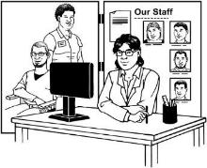To make the **goals** real the **Ministry of Health** will also make sure that tāngata whaikaha are involved by working with:

* + disability support providers

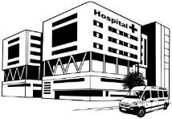

* + district heath boards.

A picture containing text, book

Description generated with very high confidenceTo help make the **goals** real **tāngata whaikaha** can:

* talk with whānau and disability providers about self directed funding options like:
  + individualised funding
  + flexible respite budgets
  + choice in community living

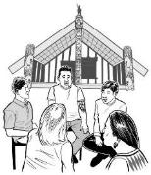

* register with the **Tāngata Whaikaha Whānau National Peer Support Network**

A picture containing book, text

Description generated with very high confidence

* think about joining organisations led by disabled people.

A picture containing text, book

Description generated with very high confidenceTo help make the **goals** real **tāngata whaikaha** and **whānau** can:

* find ways to have their say about services

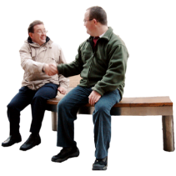

* meet with other tāngata whaikaha and whānau



* keep up to date with how disability support is changing from the **Office for Disability Issues**.

A close up of a computer

Description generated with high confidence

**You can find more information at this website:**

www.odi.govt.nz/nz-disability-strategy/other-initiatives/transforming-the-disability-system/

A picture containing text, book

Description generated with very high confidenceTo help make the **goals** real **tāngata whaikaha** and **whānau can** also find ways to help:

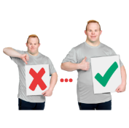

* + make services better
  + make policies.

A close up of a sign

Description generated with very high confidence

Policies are like rules.

A picture containing text, book

Description generated with very high confidenceTo help make the **goal**s real **whānau** can also talk about different choices for disability support funding with:

* + tāngata whaikaha

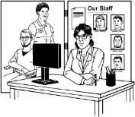

* + disability providers

A drawing of a person

Description generated with high confidence

* + other whānau.

To help make the **goals** real **Disability Providers** can:

* make sure their services give tāngata whaikaha:



* + more control of their supports
  + more choice of supports

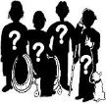

* take away the things that stop tāngata whaikaha from getting information for themselves
* A close up of a sign

  Description generated with very high confidencemake sure they have rules that mean tāngata whaikaha can join in with making services better.

To help make the **goals** real **Disability Providers** can also:

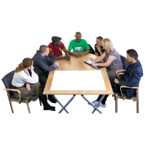

* make sure tāngata whaikaha have places on boards that make decisions



* help make sure people know about the **Tāngata Whaikaha Whānau National support Network**.

To help make the **goals** real **Disability Providers** can also:

* give jobs to tāngata whaikaha to help make:

A close up of a sign

Description generated with very high confidence

* + policies  
      
    policies are like rules
  + procedures  
      
    procedures are the ways rules are made real.

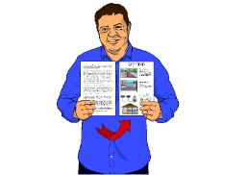

* make information about how well their service is doing easy fortāngata whaikaha to read and understand.

To make the **goals** real **other** **organisations** **can**:

* get rid of things that stop tāngata whaikaha from getting services

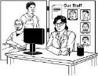

* get rid of the things that stop tāngata whaikaha from getting information for themselves.

# Outcome 2: Te Ao Māori

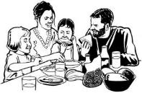If we follow this plan tāngata whaikaha will be an **active** part of:

* whānau
* A drawing of a person

  Description generated with high confidencehapū
* iwi.

A close up of a logo

Description generated with very high confidence**Active** means tāngata whaikaha will join in in things like:

* hui

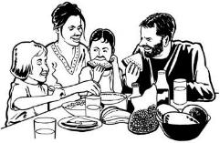A drawing of a person

Description generated with high confidence

* making future plans for:
  + whānau
  + hapū
  + iwi.

The **goal** of **Te Ao Māori** is for tāngata whaikaha to be **part of Te Ao Māori.**



To make this **goal** real the **Ministry of Health** will make disability support systems that make sure tāngata whaikaha can be part of Te Ao Māori.

A picture containing text, book

Description generated with very high confidenceTo make this **goal** real **tāngata whaikaha** can do things like:

* join in Te Ao Māori



* register with iwi rūnanga to get information about the things they are doing

A drawing of a person

Description generated with high confidence

* help tell **iwi rūnanga** about tāngata whaikaha
* help at things run by:

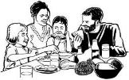

* + whānau

A drawing of a person

Description generated with high confidence

* + hapū
  + iwi.

A picture containing text, book

Description generated with very high confidenceTo make this **goal** real **tāngata whaikaha** can do things like become committee members of their:

* + A drawing of a person

    Description generated with high confidencemarae
  + Māori freehold land trust.

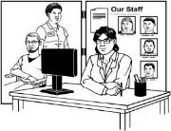To make this **goal** real **whānau** and **other organisations** can:

* A close up of a logo

  Description generated with very high confidencemake sure tāngata whaikaha have chances to join in with things like:
  + Matariki

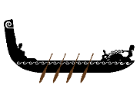

* + kapa haka

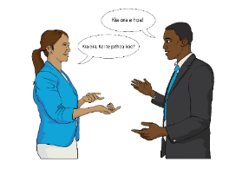

* + sports like waka ama
  + Te Reo Māori courses

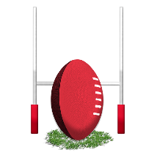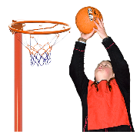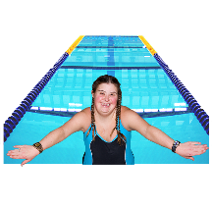

* + iwi sports
  + 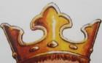Koroneihana

To help make this **goal** real **whānau** and **other organisations** can:

A close up of a logo

Description generated with very high confidence

* support tāngata whaikaha to join in things around Aotearoa / New Zealand

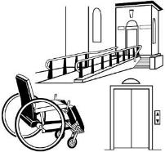

* make sure places are accessible for tāngata whaikaha.

**A close up of a computer

Description generated with high confidenceFor more information about making places accessible you can go to this website:**

www.odi.govt.nz/guidance-and-resources/how-to-make-an-accessible-built-enviroment

# Outcome 3: Te Ao Hurihuri

A close up of a logo

Description generated with very high confidence

If we follow this plan tāngata whaikaha will join in with their communities.

The **goal** of **Te Ao Hurihuri** is for tāngata whaikaha to join in with their communities.

A drawing of a person

Description generated with high confidence

Tāngata whaikaha will have more chances to get jobs.

To make this **goal** real the **Ministry** **of** **Health** will:

* make sure tāngata whaikaha can get training to help them get jobs
* work with other government departments to find opportunities for tāngata whaikaha.

A picture containing text, book

Description generated with very high confidenceTo make this **goal** real **tāngata** **whaikaha** can:

* take chances for training

A close up of a logo

Description generated with very high confidence

* look for chances to join communities
* sign up as a volunteer.

A picture containing text

Description generated with very high confidenceTo make this **goal** real **whānau** can:

* support tāngata whaikaha to take the chances they have for training

A close up of a logo

Description generated with very high confidence

* look for chances for tāngata whaikaha to join in with their communities.

A drawing of a person

Description generated with high confidenceTo make this **goal** real **disability providers** can:

* support Māori staff to get disability support training

A close up of a logo

Description generated with very high confidence

* support tāngata whaikaha to join in with their communities.

To make this **goal** real **other organisations can:**

* support tāngata whaikaha to take part in disability support training

A drawing of a person

Description generated with high confidence

* support whānau to take part in disability support training
* support tāngata whaikaha to get training in things like:
  + leadership
  + 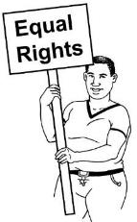self advocacy.

Self advocacy is standing up for yourself to make sure you have a good life.

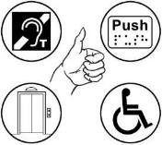Other organisations can also get rid of the things that stop tāngata whaikaha from getting the services they need.



For example:

A picture containing text, linedrawing

Description generated with high confidenceDistrict Health Boards could make sure tāngata whaikaha can get the information they need in ways that are easy to:

* read

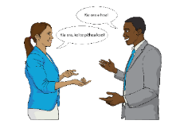

* understand.

# Outcome 4: Ngā Tūhonohono

If we follow this plan **tāngata whaikaha** should be able to be part of:

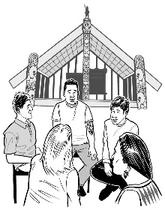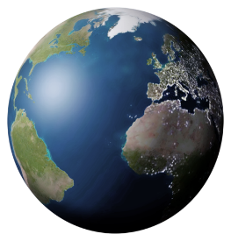

* Te Ao Māori

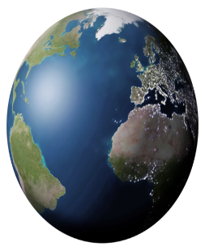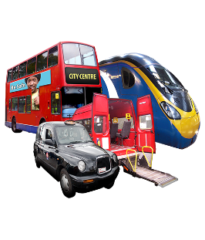

**and**

* Te Ao Hurihuri.

A picture containing text, book

Description generated with very high confidence

When tāngata whaikaha can do this their mana will be safe.

This **outcome** has **2 goals**.

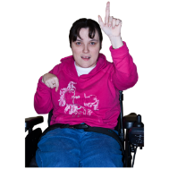

The **1st goal** is for tāngata whaikaha to have **disability support services** that:

* know about tāngata whaikaha

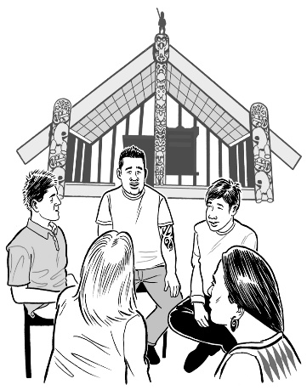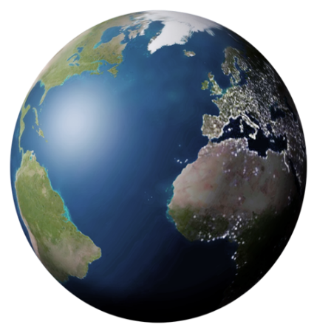

* can do the things that tāngata whaikaha need
* support tāngata whaikaha to be part of Te Ao Māori.

The **2nd** **goal** is for communities of tāngata whaikaha to know about disability issues.



These communities will include:

* + whānau

A drawing of a person

Description generated with high confidence

* + hapū

* + iwi.

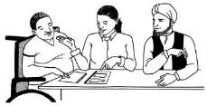

These communities will get information about disability issues from things that have been made together with tāngata whaikaha.

To make these **goals** real the **Ministry** **of** **Health** will:

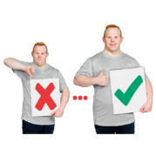

* make services better by using information they have about services
* work with tāngata whaikaha to make services that will help tāngata whaikaha to have good lives

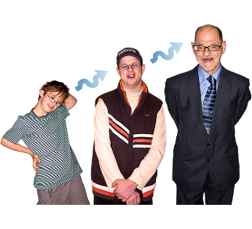

A drawing of a person

Description generated with high confidence

* make sure there are more Māori in the Ministry of Health Disability Support group

A drawing of a person

Description generated with high confidence

* A drawing of a person

  Description generated with high confidence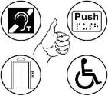make sure that more people in the Ministry of Health Disability Support group can do what Māori need.

To make these **goals** real The **Ministry** **of** **Health** will also:

* A picture containing book, text

  Description generated with very high confidencework with Māori leaders to:
  + make information about disability support services
  + 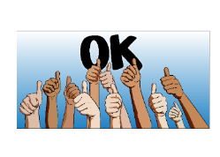get information out to people
* make things for Māori communities that will help them to understand disability.

A drawing of a person

Description generated with high confidenceTo make these **goals** real **tāngata whaikaha** and **whānau** can:

* help train people
* A picture containing book, text

  Description generated with very high confidencegive their time to hand out information about tāngata whaikaha in their communities
* take information about tāngata whaikaha to whānau events

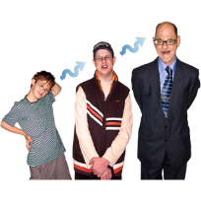

* share their lived experience

Lived experience means the things people have:

* + done in their lives
  + had done to them.

A drawing of a person

Description generated with high confidenceTo make these **goals** real **disability providers** can:

* work with Māori to help with the services they give to tāngata whaikaha

A drawing of a person

Description generated with high confidence

* make sure people have training so they understand what tāngata whaikaha need

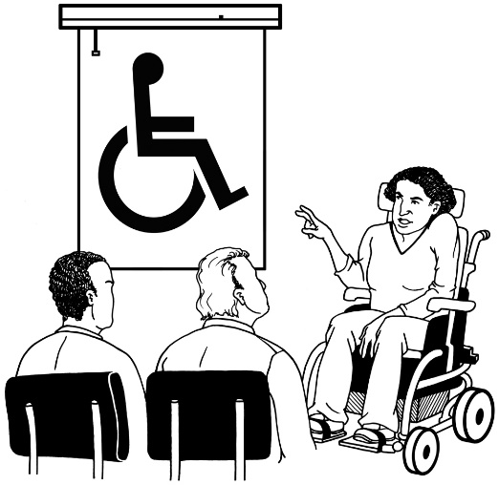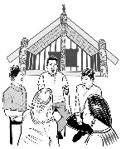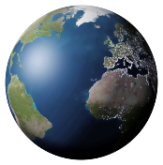

* make sure tāngata whaikaha are part of giving training about Te Ao Māori
* make sure staff have training to understand things Māori.

A drawing of a person

Description generated with high confidenceTo make these **goals** real **disability providers** can also:

* make sure people see tāngata whaikaha as experts of their own lives

A picture containing book, text

Description generated with very high confidence

* have their staff give information to communities

A picture containing book, text

Description generated with high confidence

* organise groups to give feedback about their services.

To make these **goals** real **other organisations** can:

* A picture containing text, book

  Description generated with very high confidencehave training to understand things Māori
* tell people about disability support services

A picture containing book, text

Description generated with very high confidence

* make sure to hand out information about disability support services.

# List of hard words

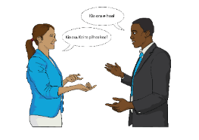

There are some **Te Reo Māori** words used in this book.

These might be hard or new to you.

A close up of a clock

Description generated with high confidence

This list says what these words mean.

**A close up of a mans face

Description generated with very high confidenceAotearoa**

* This is the Te Reo Māori name for New Zealand.  
    
  Aotearoa means land of the long white cloud.

**Iwi runanga**

* This is like a council for an iwi.

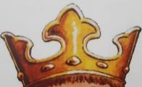

**Koroneihana**

* This is a big event that happens every year.

It celebrates King Tuheitia being made the Māori King after his mother Te Arikinui Dame Te Ataairangikaahu died.

A close up of a computer

Description generated with high confidence  
  
**For more information about this you can go to this website:**

https://koroneihana.com/

A picture containing text, book

Description generated with very high confidence**Mana**

* This is a person’s power and control.

A drawing of a person

Description generated with high confidence  
If you want to know more about mana you could talk to your:

* + whānau
  + hapū
  + iwi.

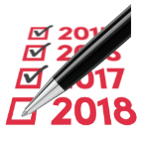

**Matariki**

* Matariki is the Māori new year.

**Ngā Tūhonohono**

* **Tūhonohono** means to join.

We use the words Ngā Tūhonohono to talk about how to join the modern world with the Māori world.

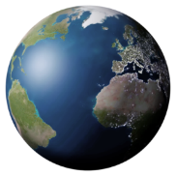

**Papatūanuku**

* Papatūanuku is the Earth Mother.

She is the wife of Ranginui.



**Ranginui**

* Ranginui is the Sky Father.

He is the husband of Papatūānuku.

**Tāngata** **whaikaha**

A picture containing text, book

Description generated with very high confidence

* When we use the words **tāngata** **whaikaha** we are using them to describe **2** **or more** **Māori people with a disability**.

**Tāngata** means 2 or more people.



**Whaikaha** means:

* + to have skills

**or**

* + - * + to be able.

**Te Ao Hurihuri**

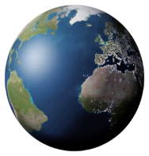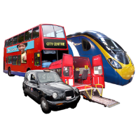

* + - * + The modern world.  
            
          The modern world is the world we live in now.

**Te Ao Māori**

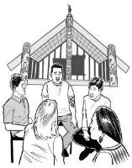

* The Māori World

**Te Tiriti o Waitangi**

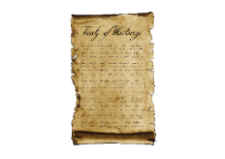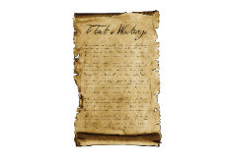

* The Treaty of Waitangi.

**Torino**

* This is a double spiral shape.  
    
  In Te Ao Māori the torino is about the light that was created when Ranginui and Papatūānuku were separated.

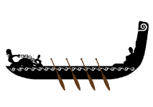

**Waka**

1. A waka is a Māori canoe.



**Whāia Te Ao Mārama**

* The Māori Disability Action Plan.

**Whānau**

* Whānau means family.  
    
    
  Whānau is also a word that can mean other people in a person’s family like:

A picture containing book, text

Description generated with very high confidence

* + aunties
  + uncles
  + nieces
  + A drawing of a person

    Description generated with high confidencenephews
  + grandchildren
  + grandparents.

**Wharenui**

* A wharenui is a meeting house.

# People we would like to thank

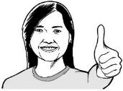

A lot of people have helped to make this new plan.

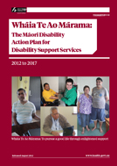

Many Māori helped to make the first plan which was called Whāia Te Ao Mārama 2012 -2017.



This new plan uses the work that was done by the people who helped to make the first plan.

To make this plan the Ministry of Health had help from:



* Kāpō Māori Aotearoa
* Te Ao Mārama: The Māori Disability Advisory Group.

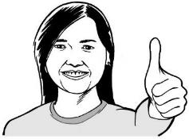We want to thank everyone who helped to make the 2012-2017 plan.

We also want to thank everyone who helped make this new plan.

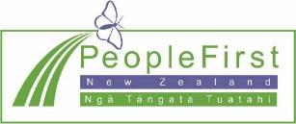

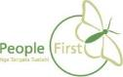**This information has been translated into Easy Read**

**by People First New Zealand Inc. Ngā Tāngata Tuatahi**

