Indicators for the Well Child / Tamariki Ora Quality Improvement Framework

March 2016

Citation: Ministry of Health. 2016. *Indicators for the Well Child / Tamariki Ora Quality Improvement Framework: March 2016*. Wellington: Ministry of Health.

Published in August 2016  
by the Ministry of Health  
PO Box 5013, Wellington 6140, New Zealand

ISBN 978-0-947515-40-9 (online)  
HP 6455

This document is available at health.govt.nz



 This work is licensed under the Creative Commons Attribution 4.0 International licence. In essence, you are free to: share ie, copy and redistribute the material in any medium or format; adapt ie, remix, transform and build upon the material. You must give appropriate credit, provide a link to the licence and indicate if changes were made.

# Foreword from the Expert Advisory Group

The Well Child / Tamariki Ora (WCTO) Quality Improvement Framework Expert Advisory Group (EAG) welcomes this fifth report on the indicators for the Quality Improvement Framework. We wish to acknowledge the WCTO sector’s commitment to improving services for children and their families and whānau. We hope that this report is used to close the quality improvement loop by helping service providers to identify, at a local level, what is and is not working. We see the WCTO Quality Improvement Framework as a tool to support each level of the sector to achieve family-centred, high-quality, equitable and effective child health services that deliver the best possible health outcomes for all New Zealand children and their families and whānau.

In the September 2015 report, we wrote about revising the WCTO quality indicators set. It was hoped that a new set of indicators would be available in time for this, the March 2016 report. However, the EAG wanted to ensure that a new set of indicators reflected the future of the sector, and so the revision of the indicators was postponed until the release of the refreshed New Zealand Health Strategy in April 2016. The sector will be informed of any changes that will be made to the indicators.

Achievement against many indicators have not improved since our last report – neither in total population figures nor in the reduction of inequities for high-deprivation, Māori or Pacific people’s communities. As we know, our hardest to reach populations are normally those that most need our health services. For this reason, it is imperative that community organisations, PHOs, DHBs and other health services work together and continue to listen to those communities to ensure services are fit for purpose and reaching all families.

We thank you for being part of the journey so far, and hope that you continue to travel forward with us.

# Summary of national results

| **Quality indicator** | **September 2015** | | | | **March 2016** | | | |
| --- | --- | --- | --- | --- | --- | --- | --- | --- |
| **Total** | **High dep** | **Māori** | **Pacific** | **Total** | **High dep** | **Māori** | **Pacific** |
| 1. Newborns are enrolled with a general practice by three months* | 74% | N/A | 78% | 73% | 67% | N/A | 72% | 65% |
| 2. Families and whānau are referred from their LMC to a WCTO provider | 98% | 98% | 97% | 98% | 98% | 98% | 97% | 98% |
| 3. Infants receive all WCTO core contacts due in their first year | 68% | 55% | 52% | 53% | 72% | 64% | 57% | 59% |
| 4. Four-year-olds receive a B4SC | 94% | 90% | 87% | 93% | 92% | 90% | 86% | 90% |
| 5. Children are enrolled with child oral health services | 77% | N/A | 68% | 78% | 76% | N/A | 64% | 75% |
| 6. Immunisations are up to date by eight months | 93% | 91% | 90% | 95% | 94% | 91% | 91% | 96% |
| 7. Children participate in ECE | 96% | 100% | 94% | 91% | 96% | N/A | 94% | 92% |
| 8. Children under six years have access to free primary care | 100% | 100% | 100% | 100% | 100% | 100% | 100% | 100% |
| 9. Children under six years have access to free after-hours primary care | 99% | N/A | N/A | N/A | 98% | N/A | N/A | N/A |
| 10. Children are seen promptly by specialist services | 100% | N/A | N/A | N/A | 100% | N/A | N/A | N/A |
| 11. Infants are exclusively or fully breastfed at two weeks | 78% | 74% | 76% | 72% | 78% | 75% | 76% | 74% |
| 12. Infants are exclusively or fully breastfed at discharge from LMC | 66% | 59% | 62% | 57% | 74% | 69% | 68% | 70% |
| 13. Infants are exclusively or fully breastfed at three months | 55% | 45% | 45% | 47% | 55% | 46% | 43% | 46% |
| 14. Infants are receiving breast milk at six months | 66% | 56% | 54% | 59% | 66% | 57% | 53% | 62% |
| 15. Children are a healthy weight at four years | 75% | 68% | 72% | 60% | 70% | 62% | 63% | 53% |
| 16. Children are caries free at five years | 59% | N/A | 40% | 36% | 59% | N/A | 40% | 35% |
| 17. The burden of dental decay is minimised (average dmft) | 4.41 | N/A | 4.98 | 5.07 | 4.42 | N/A | 4.91 | 5.09 |
| 18. Child mental health is supported (normal SDQ-P score) | 96% | 94% | 94% | 95% | 96% | 93% | 94% | 94% |
| 19. Mothers are smokefree at two weeks postnatal | 87% | 78% | 66% | 92% | 88% | 78% | 68% | 92% |
| 20. Children live in a smokefree home (age four years) | 98% | 97% | 97% | 97% | 98% | 96% | 97% | 91% |
| 21. B4SCs are started before children are 4½ years | 85% | 84% | 81% | 84% | 86% | 84% | 82% | 85% |
| 22. Children with an abnormal SDQ-P score are referred** | 100% | 100% | 100% | 100% | 100% | 100% | 100% | 100% |
| 23. Children with a PEDS Pathway A are referred** | 98% | 99% | 98% | 98% | 98% | 99% | 99% | 99% |
| 24. Children with a Lift the Lip (oral health) score of 2–6 are referred | 100% | 100% | 100% | 100% | 100% | 100% | 100% | 100% |
| 25. Children with an untreated vision problem are referred | 100% | 100% | 100% | 100% | 100% | 100% | 100% | 100% |
| 26. Children with an untreated hearing problem are referred | 100% | 100% | 100% | 100% | 100% | 100% | 100% | 100% |
| 27. Children with a BMI > 98th percentile are referred*** | n/a | n/a | n/a | n/a | 31% | 36% | 29% | 39% |

Note: B4SC = B4 School Check; BMI = body mass index; dmft = count of decayed, missing or filled deciduous teeth; ECE = early childhood education; High dep = the population living in areas of high socioeconomic deprivation; LMC = lead maternity carer; N/A = not available; PEDS = Parental Evaluation of Developmental Status; SDQ-P = Strengths and Difficulties Questionnaire (Parent); WCTO = Well Child / Tamariki Ora.

* Data to monitor this indicator is not yet available. Primary health organisation (PHO) enrolment at three months will be used as a de facto indicator in the interim.

** Includes ‘advice given’; all other referrals exclude ‘advice given’. See full analysis for more information.

*** Previous indicator was ‘Children with a BMI > 99.4th percentile are referred’. Indicator has been changed to >98th percentile to fit with the Obesity Health Target in B4SC.

Contents

Foreword from the Expert Advisory Group iii

Summary of national results iv

Introduction 1

Background 1

Development of the quality indicators 1

Quality indicator targets 2

How to use this document 2

Indicators 1–10: Access 3

Summary of results for this period 3

WCTO Quality Improvement Framework Indicator 1 5

WCTO Quality Improvement Framework Indicator 2 7

WCTO Quality Improvement Framework Indicator 3 9

WCTO Quality Improvement Framework Indicator 4 11

WCTO Quality Improvement Framework Indicator 5 13

WCTO Quality Improvement Framework Indicator 6 14

WCTO Quality Improvement Framework Indicator 7 16

WCTO Quality Improvement Framework Indicator 8 18

WCTO Quality Improvement Framework Indicator 9 20

WCTO Quality Improvement Framework Indicator 10 21

Indicators 11–20: Outcomes 22

Summary of results for this period 22

WCTO Quality Improvement Framework Indicator 11 24

WCTO Quality Improvement Framework Indicator 12 26

WCTO Quality Improvement Framework Indicator 13 28

WCTO Quality Improvement Framework Indicator 14 30

WCTO Quality Improvement Framework Indicator 15 32

WCTO Quality Improvement Framework Indicator 16 34

WCTO Quality Improvement Framework Indicator 17 35

WCTO Quality Improvement Framework Indicator 18 36

WCTO Quality Improvement Framework Indicator 19 39

WCTO Quality Improvement Framework Indicator 20 41

Indicators 21–27: Quality 43

Summary of results for this period 43

WCTO Quality Improvement Framework Indicator 21 45

WCTO Quality Improvement Framework Indicator 22 47

WCTO Quality Improvement Framework Indicator 23 50

WCTO Quality Improvement Framework Indicator 24 53

WCTO Quality Improvement Framework Indicator 25 56

WCTO Quality Improvement Framework Indicator 26 59

WCTO Quality Improvement Framework Indicator 27 62

Appendix 1: Targets for the quality indicators 65

Appendix 2: Membership of the Expert Advisory Group 66

List of Figures

Figure 1: Newborns enrolled with a primary health organisation by three months, total New Zealand 5

Figure 2: Newborns enrolled with a primary health organisation by three months, Māori 6

Figure 3: Newborns enrolled with a primary health organisation by three months, Pacific peoples 6

Figure 4: Referral from lead maternity carer to Well Child / Tamariki Ora, total New Zealand 7

Figure 5: Referral from lead maternity carer to Well Child / Tamariki Ora, high deprivation population 7

Figure 6: Referral from lead maternity carer to Well Child / Tamariki Ora, Māori 8

Figure 7: Referral from lead maternity carer to Well Child / Tamariki Ora, Pacific peoples 8

Figure 8: Core Well Child / Tamariki Ora contacts 1–5 received, total New Zealand 9

Figure 9: Core Well Child / Tamariki Ora contacts 1–5 received, high deprivation population 9

Figure 10: Core Well Child / Tamariki Ora contacts 1–5 received, Māori 10

Figure 11: Core Well Child / Tamariki Ora contacts 1–5 received, Pacific peoples 10

Figure 12: B4 School Check received, total New Zealand 11

Figure 13: B4 School Check received, high deprivation population 11

Figure 14: B4 School Check received, Māori 12

Figure 15: B4 School Check received, Pacific peoples 12

Figure 16: Infants fully immunised by eight months, total New Zealand 14

Figure 17: Infants fully immunised by eight months, high deprivation population 14

Figure 18: Infants fully immunised by eight months, Māori 15

Figure 19: Infants fully immunised by eight months, Pacific peoples 15

Figure 20: Participation in early childhood education, total New Zealand 16

Figure 21: Participation in early childhood education, high deprivation population 16

Figure 22: Participation in early childhood education, Māori 17

Figure 23: Participation in early childhood education, Pacific peoples 17

Figure 24: Under-six access to free primary care, total New Zealand 18

Figure 25: Under-six access to free primary care, high deprivation population 18

Figure 26: Under-six access to free primary care, Māori 19

Figure 27: Under-six access to free primary care, Pacific peoples 19

Figure 28: Under-six access to free after-hours primary care, total New Zealand 20

Figure 29: First specialist appointment for paediatric medicine received within four months, total New Zealand 21

Figure 30: Infants exclusively or fully breastfed at two weeks, total New Zealand 24

Figure 31: Infants exclusively or fully breastfed at two weeks, high deprivation population 24

Figure 32: Infants exclusively or fully breastfed at two weeks, Māori 25

Figure 33: Infants exclusively or fully breastfed at two weeks, Pacific peoples 25

Figure 34: Infants exclusively or fully breastfed at LMC discharge, total New Zealand 26

Figure 35: Infants exclusively or fully breastfed at LMC discharge, high deprivation population 26

Figure 36: Infants exclusively or fully breastfed at LMC discharge, Māori 27

Figure 37: Infants exclusively or fully breastfed at LMC discharge, Pacific peoples 27

Figure 38: Infants exclusively or fully breastfed at three months, total New Zealand 28

Figure 39: Infants exclusively or fully breastfed at three months, high deprivation population 28

Figure 40: Infants exclusively or fully breastfed at three months, Māori 29

Figure 41: Infants exclusively or fully breastfed at three months, Pacific peoples 29

Figure 42: Infants receiving breast milk at six months, total New Zealand 30

Figure 43: Infants receiving breast milk at six months, high deprivation population 30

Figure 44: Infants receiving breast milk at six months, Māori 31

Figure 45: Infants receiving breast milk at six months, Pacific peoples 31

Figure 46: Children are a healthy weight at age four years, total New Zealand 32

Figure 47: Children are a healthy weight at age four years, high deprivation population 32

Figure 48: Children are a healthy weight at age four years, Māori 33

Figure 49: Children are a healthy weight at age four years, Pacific peoples 33

Figure 50: Children with a normal SDQ-P score at four years, total New Zealand 36

Figure 51: Children with a normal SDQ-P score at four years, high deprivation population 37

Figure 52: Children with a normal SDQ-P score at four years, Māori 37

Figure 53: Children with a normal SDQ-P score at four years, Pacific peoples 37

Figure 54: Mothers smokefree at two weeks postnatal, total New Zealand 39

Figure 55: Mothers smokefree at two weeks postnatal, high deprivation population 39

Figure 56: Mothers smokefree at two weeks postnatal, Māori 40

Figure 57: Mothers smokefree at two weeks postnatal, Pacific peoples 40

Figure 58: Children living in a smokefree home (age four years), total New Zealand 41

Figure 59: Children living in a smokefree home (age four years), high deprivation population 41

Figure 60: Children living in a smokefree home (age four years), Māori 42

Figure 61: Children living in a smokefree home (age four years), Pacific peoples 42

Figure 62: B4 School Checks started before age 4½ years, total New Zealand 45

Figure 63: B4 School Checks started before age 4½ years, high deprivation population 45

Figure 64: B4 School Checks started before age 4½ years, Māori 46

Figure 65: B4 School Checks started before age 4½ years, Pacific peoples 46

Figure 66: Children with abnormal SDQ-P referred, total New Zealand 47

Figure 67: Children with abnormal SDQ-P referred, high deprivation population 48

Figure 68: Children with abnormal SDQ-P referred, Māori 48

Figure 69: Children with abnormal SDQ-P referred, Pacific peoples 48

Figure 70: Children with PEDS Pathway A referred, total New Zealand 50

Figure 71: Children with PEDS Pathway A referred, high deprivation population 51

Figure 72: Children with PEDS Pathway A referred, Māori 51

Figure 73: Children with PEDS Pathway A referred, Pacific peoples 51

Figure 74: Children with Lift the Lip score of 2–6 referred, total New Zealand 53

Figure 75: Children with Lift the Lip score of 2–6 referred, high deprivation population 54

Figure 76: Children with Lift the Lip score of 2–6 referred, Māori 54

Figure 77: Children with Lift the Lip score of 2–6 referred, Pacific peoples 54

Figure 78: Children with an untreated vision problem referred, total New Zealand 56

Figure 79: Children with an untreated vision problem referred, high deprivation population 57

Figure 80: Children with an untreated vision problem referred, Māori 57

Figure 81: Children with an untreated vision problem referred, Pacific peoples 57

Figure 82: Children with an untreated hearing problem referred, total New Zealand 59

Figure 83: Children with an untreated hearing problem referred, high deprivation population 60

Figure 84: Children with an untreated hearing problem referred, Māori 60

Figure 85: Children with an untreated hearing problem referred, Pacific peoples 60

Figure 86: Children with body mass index > 98th percentile referred, total New Zealand 62

Figure 87: Children with body mass index > 98th percentile referred, high deprivation population 63

Figure 88: Children with body mass index > 98th percentile referred, Māori 63

Figure 89: Children with body mass index > 98th percentile referred, Pacific peoples 63

# Introduction

## Background

Well Child / Tamariki Ora (WCTO) is a free health service offered to all New Zealand children from birth to five years. Its aim is to support families and whānau to maximise their child’s developmental potential and health status, thereby establishing a strong foundation for ongoing healthy development.

The 2007/08 review and the 2012 quality reviews of the WCTO programme identified variable clinical practice, service quality and health outcomes. They all recommended that an evidence-based quality framework be developed to ensure the programme consistently achieves its aims.

In response, the Ministry of Health, in partnership with sector expert advisors, developed the WCTO Quality Improvement Framework, drawing on New Zealand and international research. The Framework has three high-level aims, which focus on the WCTO experience of families and whānau, population health, and best value for the health system’s resources. The Framework also sets quality indicators to monitor health system performance.

The Framework and quality indicators provide a mechanism to drive improvement in the delivery of WCTO services. Ultimately, they aim to support the WCTO programme to ensure all children and their families and whānau achieve their health and wellbeing potential.

The data used in this report for Indicator 3 on WCTO core contacts, and the breastfeeding indicators (11–14) now includes data from the whole WCTO sector. Previous reports used Plunket data only. This represents a seminal step for the sector and the report.

## Development of the quality indicators

The aim of the quality indicators is to monitor and promote quality improvement across WCTO providers without creating an additional reporting burden. They comprise a subset of potential measures drawn from existing data collections and reporting mechanisms.

The quality indicators are broadly grouped under the categories of:

* universal access (access)
* equitable outcomes (outcomes)
* continuous quality improvement (quality).

The Ministry of Health reports on all quality indicators by region, ethnicity and deprivation quintile, where possible, and the results are published six-monthly. This is the fifth report.

As information collection improves and the WCTO programme evolves, indicators may be added or changed. The Ministry of Health will review the quality indicators at least every three years.

## Quality indicator targets

Targets for the quality indicators reflect national targets set by other monitoring frameworks and processes, including health targets, district health board (DHB) non-financial performance monitoring and the Government’s ‘Better Public Service’ key result areas.

Where there is no existing target, the EAG has agreed on new three-year targets to best reflect the objectives of the Framework. It has staged new targets in recognition that the sector will achieve improvements over time. Interim targets to be achieved by December 2014 were largely set at 90 percent of the three-year targets.

To promote equity, the target for each quality indicator is the same across all ethnic groups, deprivation quintiles and DHB regions.

## How to use this document

Regular monitoring is an essential part of quality improvement. The quality indicators presented here enable WCTO providers, DHBs and other stakeholders to review local performance, identify quality improvement priorities, and monitor progress in improving the uptake, timeliness and quality of WCTO and related child health services over time. To assist, information from the previous report (March 2015) is presented for each indicator for comparative purposes.

The quality indicators do not stand alone. They are part of a whole-system approach to quality improvement that includes:

* standards (the WCTO Quality Improvement Framework)
* monitoring (quality indicator reports)
* support for collaboration and planning quality improvement priorities (local WCTO quality improvement programmes led by DHBs and regional programmes led by WCTO Quality Improvement Project Managers)
* support for learning and sharing best practice (via the Child and Youth Compass and other tools and resources, including regional WCTO Quality Improvement Project Managers).

# Indicators 1–10: Access

Aim 1 of the WCTO Quality Improvement Framework is the **improved safety and quality of WCTO experience for the child and their family and whānau**. We can measure this, to some degree, by families’ and whānau’s uptake of and continued engagement with services: they will be more likely to access and remain involved with acceptable, high-quality services that are simple to access. The Ministry of Health expects that, in addition to these indicators, DHBs and WCTO providers will consider other ways to monitor quality of experience, such as through the use of consumer surveys or parent focus groups.

Indicators 1–10 measure access rates, with or without consideration of timeliness, across a range of universal and specialist services that contribute to improved outcomes for children. The inclusion of this broad range of services as indicators reflects the role of WCTO in assessing and supporting the health and developmental needs of a growing family. The core roles of the access indicators are to:

* facilitate and support a family/whānau’s timely engagement with health services such as primary care, immunisation and oral health
* support referral to specialist services
* support child development through participation in high-quality ECE.

## Summary of results for this period

### National

Newborn enrolment with primary care continued to fluctuate between the March and September reporting. This report showed that the total percentage enrolled had dropped by 7 percentage points since September, despite having risen 9 percentage points in the previous period. However, if we look at the figures for March 2015 and March 2014, newborn enrolment is steadily climbing (now at 67 percent at a population level, up from 65 percent in March 2015 and 63 percent in March 2014). There is still considerable work to be done to reach the 98 percent target. Providers should be actively working with their local PHOs to increase newborn enrolments in all areas.

From the September 2015 report Indicator 3: ‘Infants receive all WCTO core contacts due in their first year’ has included data from Tamariki Ora providers, where previously it only showed Plunket figures. An increase of 4 percentage points at a population level is significant and could be the outcome of increased engagement between DHBs and all WCTO providers. Although there were increases in Māori, Pacific and high-deprivation communities, there is still a significant equity gap that requires continued work.

The rates of completed B4 School Checks (B4SCs) dropped slightly in the last six months: 2 percentage points to 92 percent. However, this figure is still above the target, and is also the case for both Pacific and high-deprivation communities. Māori are slightly less likely to complete a B4SC at 86 percent. However, with the rates of completion remaining steadily high across all groups, it is recommended focus be transferred into the timeliness of completed checks (see Indicator 21).

Eight-month immunisation coverage remained steady over the six months September–March, picking up the single percentage point it dropped in the last reporting period to return to its highest ever rate of 94 percent.

There is no new data for Indicator 5 (oral health services) for this report.

### By region

There continued to be significant variation by DHB for Indicators 1, 3 and 5(newborn enrolment, WCTO core contacts and enrolment in oral health services), with variation of over 20 percentage points. However, DHBs often have similar rates to their neighbouring DHBs. With new born enrolments for example, the three Auckland DHBs (Waitemata, Auckland and Counties Manukau) all have similar rates, as do the five South Island DHBs. This may suggest that the problems reaching the target are similar and collaboration to find new innovation across regions may have an impact.

District health boards need to focus on areas where their populations are not accessing the services offered.

### By deprivation level

Of the indicators where data is currently available by New Zealand Deprivation Index (NZDep) quintile, only one of the access indicators show significant gaps between population level access and that of high-deprivation communities. For Indicator 3 (infants receiving all WCTO core contacts) the rates for high-deprivation communities rose by 9 percentage points to 64 percent. Total population access for this indicator is at 72 percent. This indicates that there is still some progress to be made in closing that equity gap, but ground is being gained.

For indicators 2, 4, 6, 7 and 8 (LMC referral to WCTO, four-year olds receiving a B4SC, immunisations are up to date at eight months, participation in ECE and access to free primary care for under 6s) there is only a small gap between high-deprivation communities and total population levels. This is significant as high-quality care needs to be accessible to all of our children, but in particular our most vulnerable. Work still needs to be done in individual DHBs, however, to ensure this is the case for their particular populations.

### By ethnicity

As mentioned previously, newborn enrolment with primary care fluctuates between the March and September reporting. However, if we look at the figures for March 2015 and March 2014, newborn enrolment in Māori and Pacific communities is increasing. Māori continued to have the highest rates for newborn enrolment: 72 percent at March 2016 (up from 70 percent at the same time last year). Pacific rates have dropped slightly since March 2015: down 2 percentage points to 60 percent. Providers should be actively working with their local PHOs to increase newborn enrolments in all areas. All ethnicities, deprivation quintiles and DHBs remain below the June 2016 target of 96 percent.

Although the rates of WCTO core contacts have risen from September, Indicator 3 again shows significant inequities. In March, only 57 percent of Māori and 59 percent of Pacific children were receiving all their WCTO core contacts in their first year, compared with 72 percent of the total population.

For a sixth straight report, Pacific children continued to have the highest rate for Indicator 6: Immunisations are up to date by eight months. They remain the only population group meeting the Better Public Service target of 95 percent.

## WCTO Quality Improvement Framework Indicator 1

|  |  |
| --- | --- |
| **Standard** | All children and families/whānau have access to primary care, WCTO services (including the B4 School Check) and early childhood education. |
| **Indicator** | Newborns are enrolled with a primary health organisation (PHO) by three months.[1] |
| **Target by December 2014** | 88 percent |
| **Target by June 2016** | 98 percent |

|  |  |  |  |  |
| --- | --- | --- | --- | --- |
|  | **Total New Zealand** | **High deprivation** | **Māori** | **Pacific peoples** |
| March 2016 mean (range) | 67% (61–81) | N/A | 72% (52–115) | 65% (59–85) |
| September 2015 mean (range) | 74% (62–87) | N/A | 78% (54–180) | 73% (53–94) |

Figure 1: Newborns enrolled with a primary health organisation by three months, total New Zealand

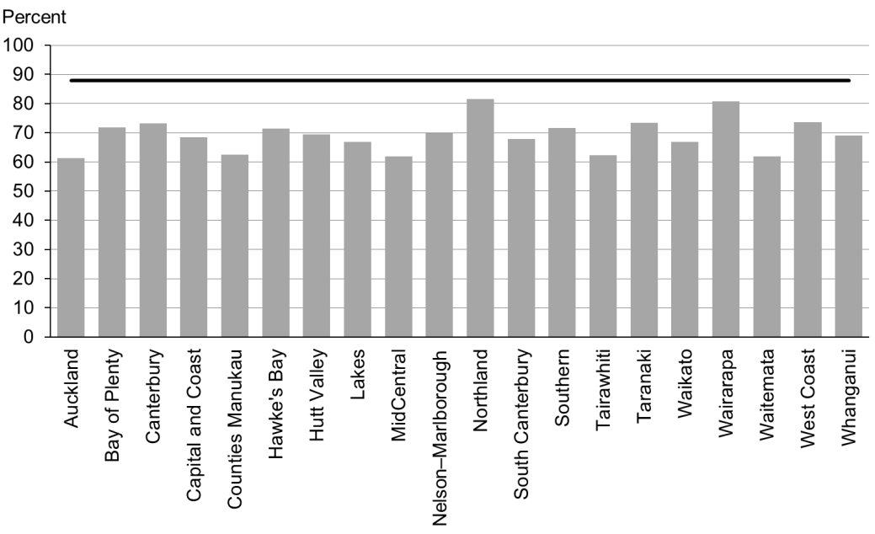

Figure 2: Newborns enrolled with a primary health organisation by three months, Māori

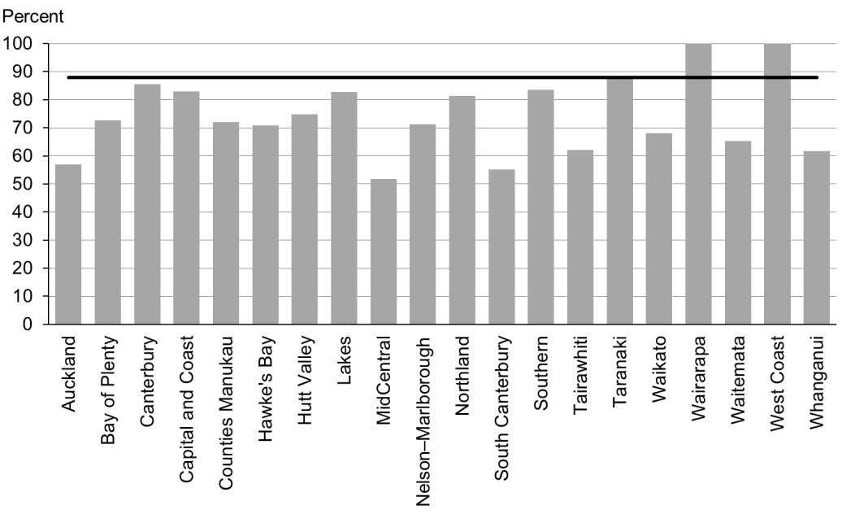

Figure 3: Newborns enrolled with a primary health organisation by three months, Pacific peoples

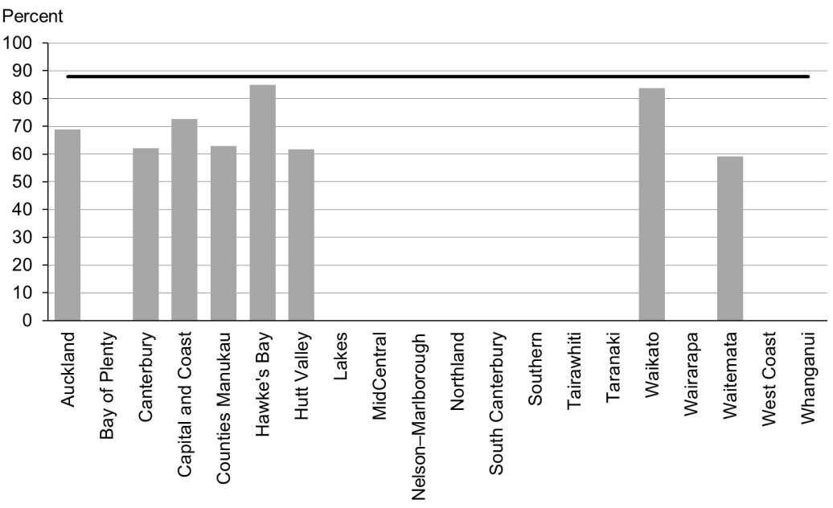

### Data notes

* No bar on graph = fewer than 20 infants in that population.
* Data is not available by deprivation quintile.
* Time period: births between 20 August 2015 and 19 November 2015.
* The data excludes overseas DHB and undefined DHB.
* Numerator: enrolments of infants under three months with a PHO.
* Denominator: births reported to the National Immunisation Register.
* Rates of greater than 100 percent for ethnic subgroups is likely due to variation in ethnicity reporting in different systems.

## WCTO Quality Improvement Framework Indicator 2

|  |  |
| --- | --- |
| **Standard** | All children and families/whānau have access to primary care, WCTO services (including the B4 School Check) and early childhood education. |
| **Indicator** | Families and whānau are referred from their lead maternity carer (LMC) to a WCTO provider. |
| **Target by December 2014** | 88 percent |
| **Target by June 2016** | 98 percent |

|  |  |  |  |  |
| --- | --- | --- | --- | --- |
|  | **Total New Zealand** | **High deprivation** | **Māori** | **Pacific peoples** |
| March 2016 mean (range) | 98% (95–100) | 98% (93–100) | 97% (93–100) | 98% (93–100) |
| September 2015 mean (range) | 98% (95–100) | 98% (93–100) | 97% (92–100) | 98% (93–100) |

Figure 4: Referral from lead maternity carer to Well Child / Tamariki Ora, total New Zealand

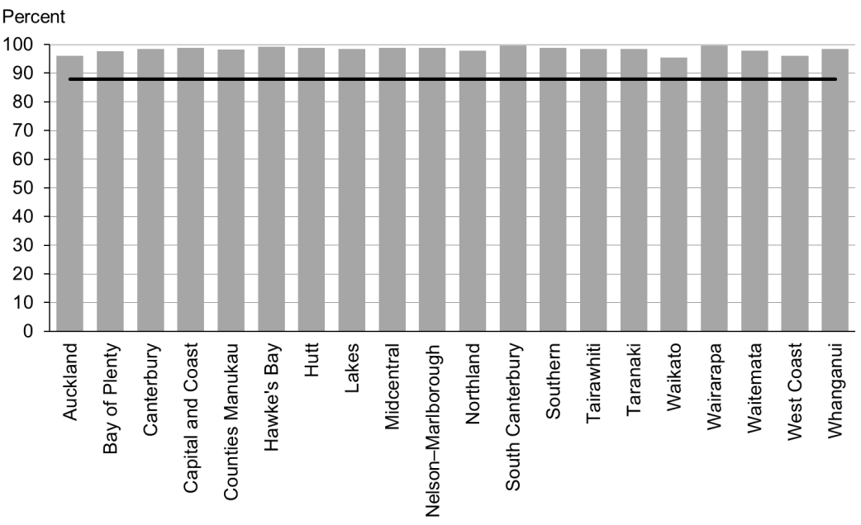

Figure 5: Referral from lead maternity carer to Well Child / Tamariki Ora, high deprivation population

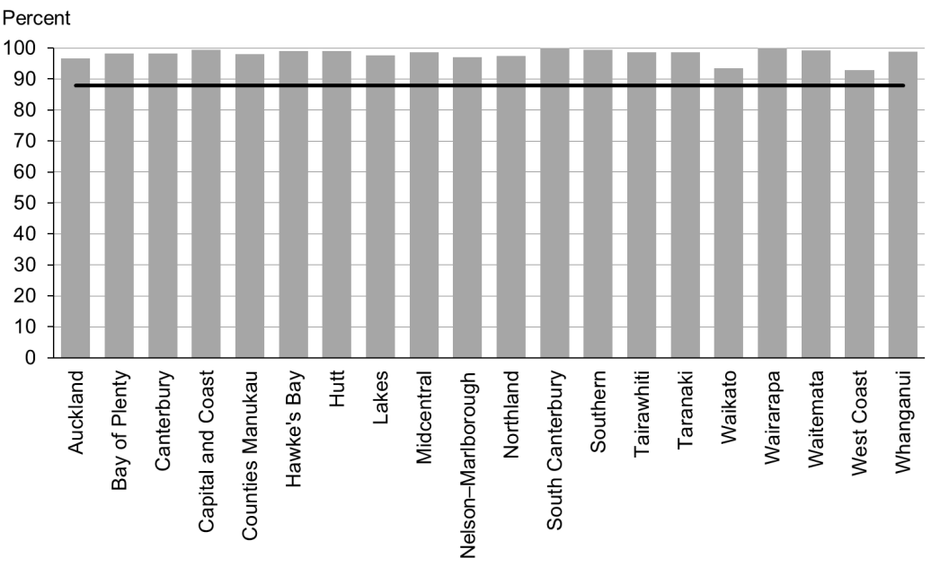

Figure 6: Referral from lead maternity carer to Well Child / Tamariki Ora, Māori

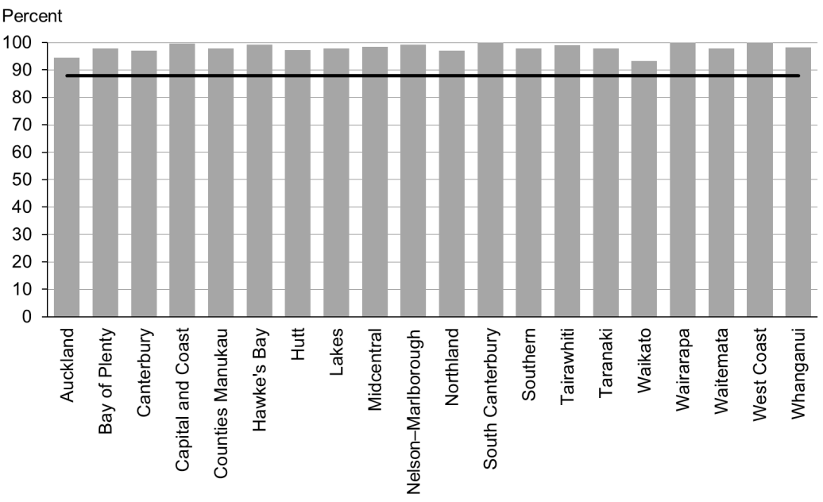

Figure 7: Referral from lead maternity carer to Well Child / Tamariki Ora, Pacific peoples

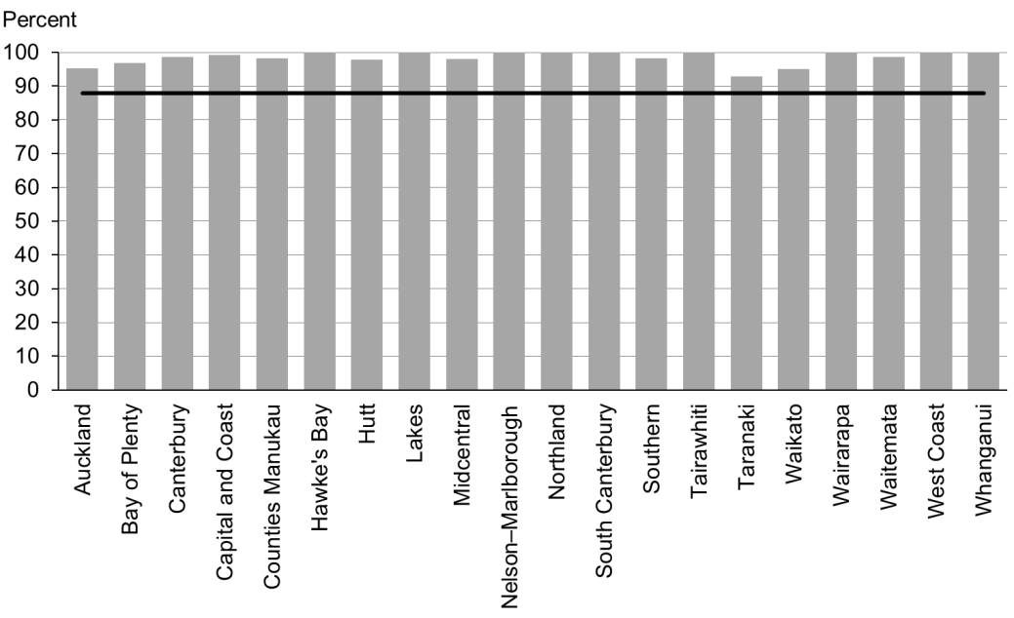

### Data notes

* Time period: births between 1 January 2015 and 31 July 2015.
* The data excludes overseas DHB and undefined DHB.
* Numerator: LMC referral to WCTO = Yes (source: National Maternity Collection [MAT]).
* Denominator: LMC referral to WCTO = Yes or No (source: MAT).

## WCTO Quality Improvement Framework Indicator 3

|  |  |
| --- | --- |
| **Standard** | All children and families/whānau have access to primary care, WCTO services (including the B4 School Check) and early childhood education. |
| **Indicator** | Infants receive all WCTO core contacts due in their first year. |
| **Target by December 2014** | 86 percent |
| **Target by June 2016** | 95 percent |

|  |  |  |  |  |
| --- | --- | --- | --- | --- |
|  | **Total New Zealand** | **High deprivation** | **Māori** | **Pacific peoples** |
| March 2016 mean (range) | 72% (55–80) | 64% (53–80) | 57% (53­–80) | 59% (39–69) |
| September 2015 mean (range) | 68% (48–77) | 55% (37–71) | 52% (26–62) | 53% (41–70) |

Figure 8: Core Well Child / Tamariki Ora contacts 1–5 received, total New Zealand

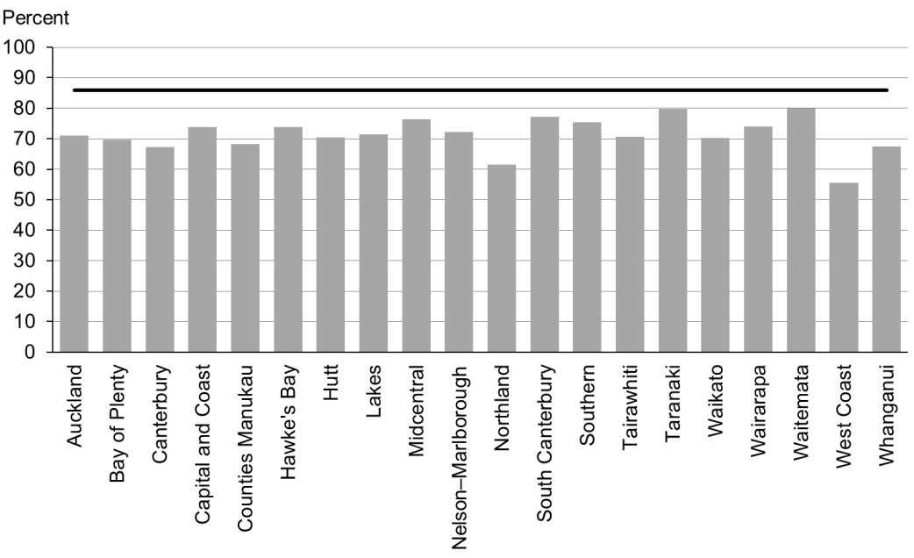

Figure 9: Core Well Child / Tamariki Ora contacts 1–5 received, high deprivation population

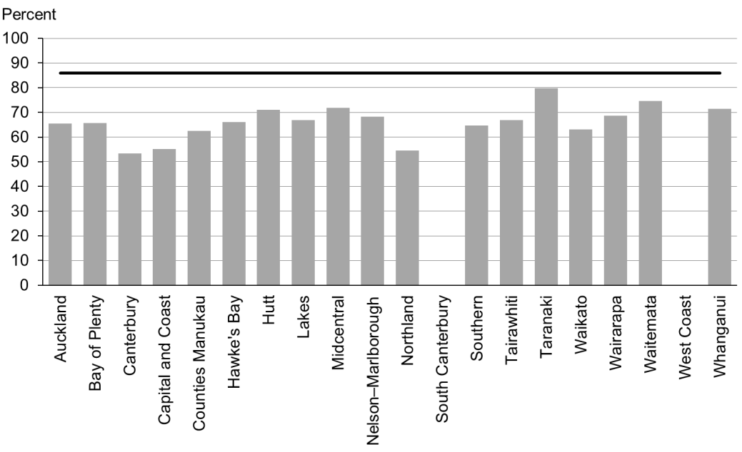

Figure 10: Core Well Child / Tamariki Ora contacts 1–5 received, Māori

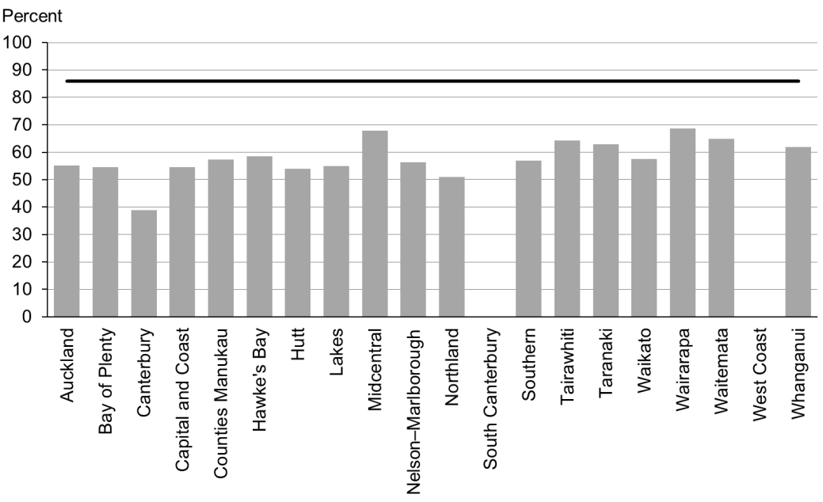

Figure 11: Core Well Child / Tamariki Ora contacts 1–5 received, Pacific peoples

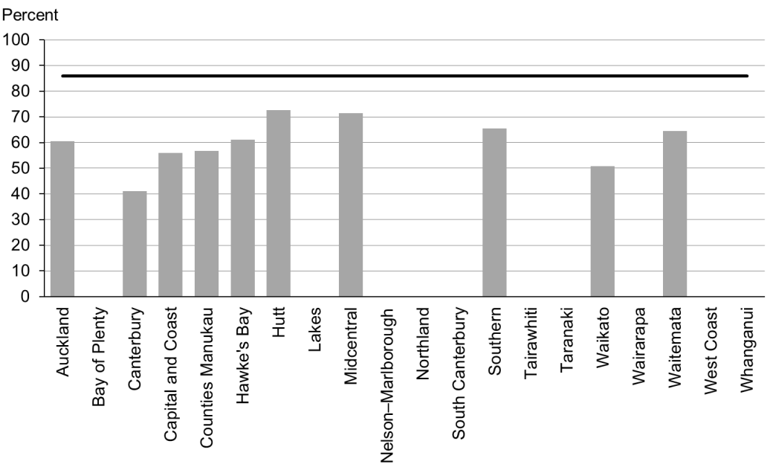

### Data notes

* No bar on graph = fewer than 20 children in that population.
* Time period: children reaching the age band for core contact 6 between July 2015 and December 2015.
* From this report onwards, the data source for indicator 3 includes reporting from all WCTO providers. Prior to this report, data presented for these two indicators was sourced from Plunket alone. This means results for indicators 3 for the period January–June 2015 are not directly comparable with results from earlier periods. The data excludes overseas DHB and undefined DHB.
* Numerator: number of infants where contact was able to be made by six weeks and who received all five contacts (source: WCTO NHI dataset).
* Denominator: number of infants where contact was able to be made by six weeks, who reached the age band for core contact 6 (13 months, 4 weeks, 1 day) (source: WCTO NHI data set).

## WCTO Quality Improvement Framework Indicator 4

|  |  |
| --- | --- |
| **Standard** | All children and families/whānau have access to primary care, WCTO services (including the B4 School Check) and early childhood education. |
| **Indicator** | Four-year-olds receive a B4 School Check. |
| **Target by December 2014** | 90 percent |
| **Target by June 2016** | 90 percent |

|  |  |  |  |  |
| --- | --- | --- | --- | --- |
|  | **Total New Zealand** | **High deprivation** | **Māori** | **Pacific peoples** |
| March 2016 mean (range) | 92% (53–100) | 90% (50–100) | 86% (46–100) | 90% (33–100) |
| September 2015 mean (range) | 94% (87–113) | 90% (73–115) | 87% (68–150) | 93% (63–250) |

Figure 12: B4 School Check received, total New Zealand

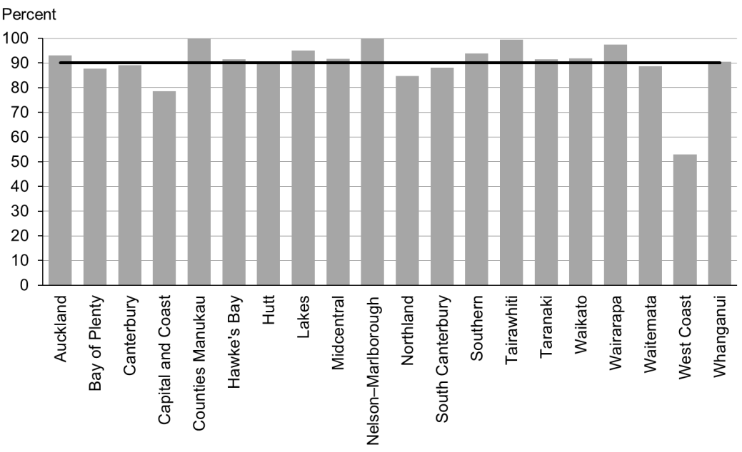

Figure 13: B4 School Check received, high deprivation population

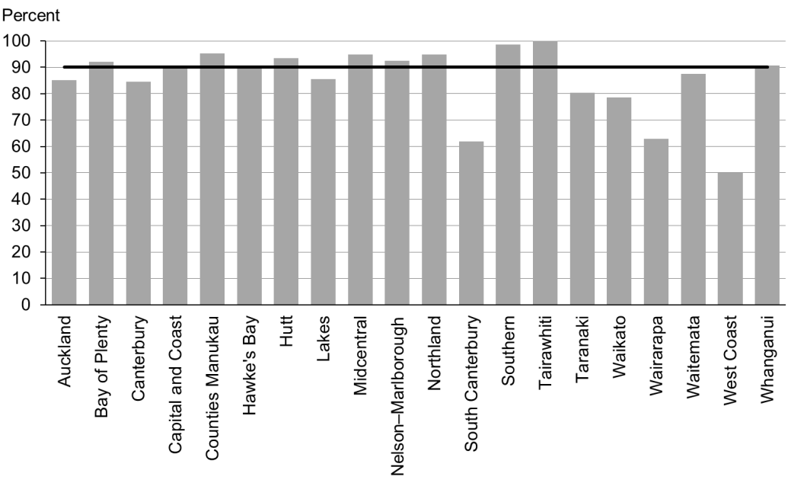

Figure 14: B4 School Check received, Māori

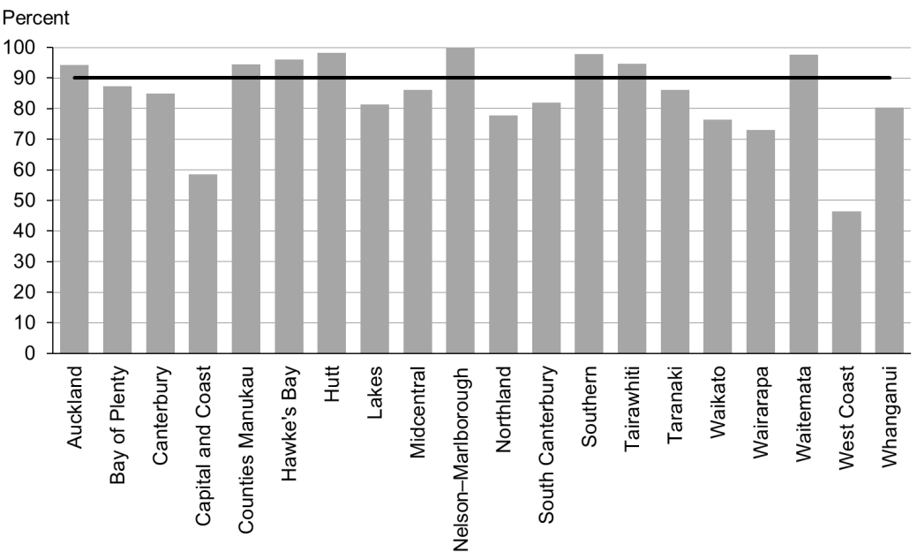

Figure 15: B4 School Check received, Pacific peoples

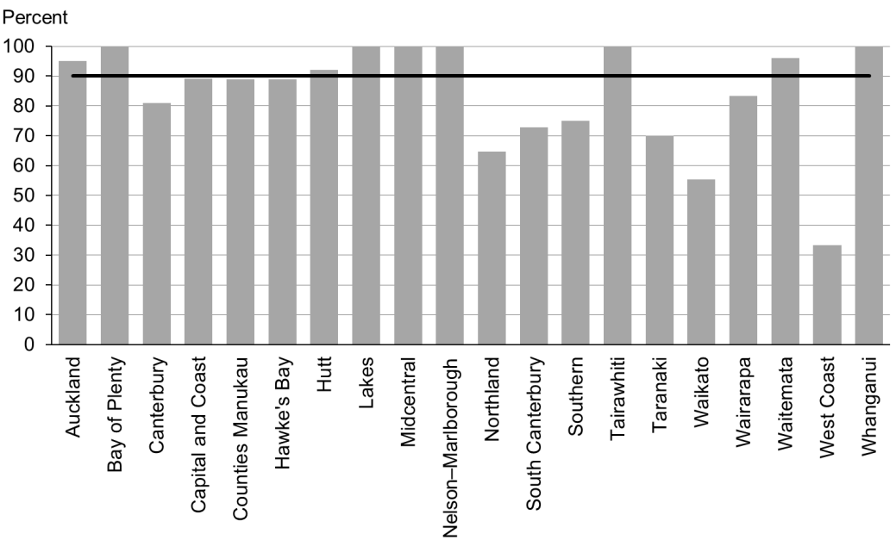

### Data notes

* Time period: checks between July 2015 and December 2015.
* DHB is DHB of service.
* Numerator: number of completed B4 School Checks (source: B4 School Checks).
* Denominator: number of children eligible for a B4 School Check (source: PHO).
* Rates of greater than 100 percent for ethnic subgroups is likely due to variation in ethnicity reporting in different systems.

## WCTO Quality Improvement Framework Indicator 5

|  |  |
| --- | --- |
| **Standard** | All children and families/whānau have access to primary care, WCTO services (including the B4 School Check) and early childhood education. |
| **Indicator** | Preschool children are enrolled with child oral health services. |
| **Target by December 2014** | 86 percent |
| **Target by June 2016** | 95 percent |

|  |  |  |  |  |  |
| --- | --- | --- | --- | --- | --- |
|  | **Total New Zealand** | **High deprivation** | **Māori** | | **Pacific peoples** |
| March 2016 mean (range) | No new data | | | | |
| September 2015 mean (range) | 76% (55–100) | N/A | | 61% (20–92) | 75% (39–92) |

### Data notes

* No new data is available for this period. Please see the previous report for the latest data available.
* Numerator: number of children aged under five years enrolled with oral health services (source: community oral health services).
* Denominator: number of children aged under five years (source: PHO).

## WCTO Quality Improvement Framework Indicator 6

|  |  |
| --- | --- |
| **Standard** | All children and families/whānau have access to primary care, WCTO services (including the B4 School Check) and early childhood education. |
| **Indicator** | Immunisations are up to date by eight months. |
| **Target by December 2014** | 95 percent |
| **Target by June 2016** | 95 percent |

|  |  |  |  |  |
| --- | --- | --- | --- | --- |
|  | **Total New Zealand** | **High deprivation** | **Māori** | **Pacific peoples** |
| March 2016 mean (range) | 94% (81–96) | 91% (46–96) | 91% (83–96) | 96% (92–100) |
| September 2015 mean (range) | 93% (85–96) | 91% (61–97) | 90% (80–96) | 95% (50–100) |

Figure 16: Infants fully immunised by eight months, total New Zealand

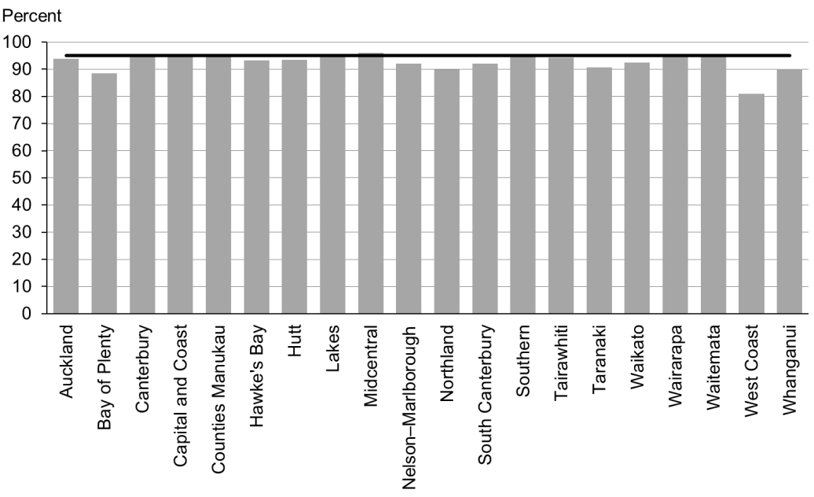

Figure 17: Infants fully immunised by eight months, high deprivation population

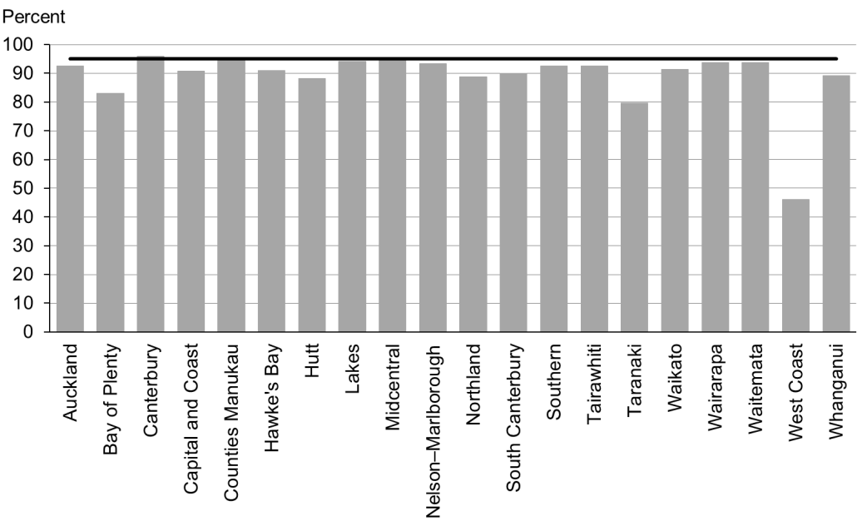

Figure 18: Infants fully immunised by eight months, Māori

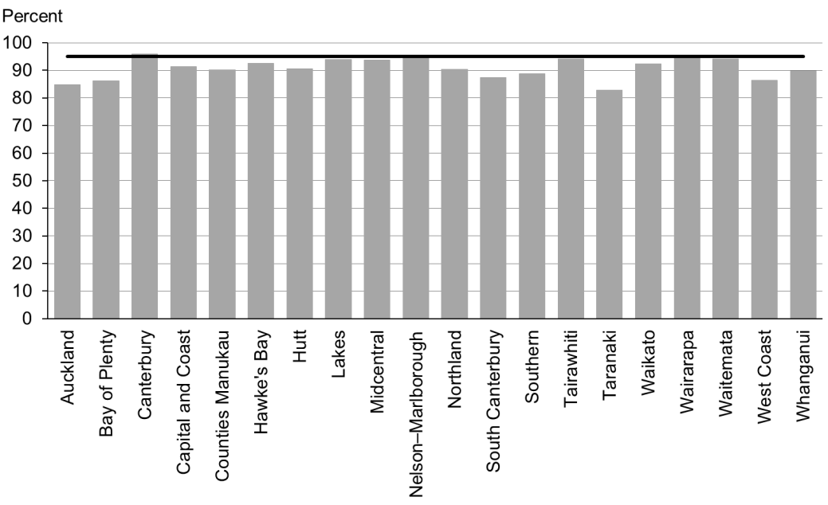

Figure 19: Infants fully immunised by eight months, Pacific peoples

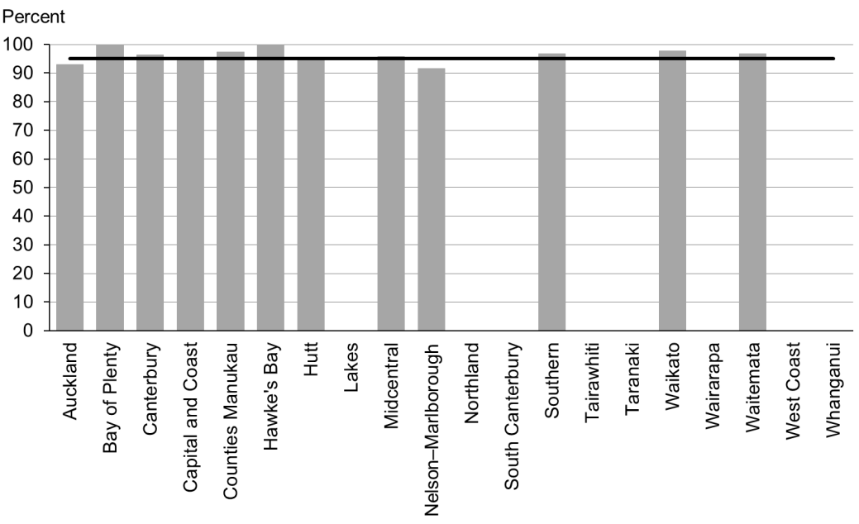

### Data notes

* Time period: three-month period ending December 2015.
* The data excludes overseas DHB and undefined DHB.
* Numerator: number of eight-month-old infants up to date with immunisations for age (source: National Immunisation Register).
* Denominator: number of eight-month-old infants (source: National Immunisation Register).

## WCTO Quality Improvement Framework Indicator 7

|  |  |
| --- | --- |
| **Standard** | All children and families/whānau have access to primary care, WCTO services (including the B4 School Check) and early childhood education. |
| **Indicator** | Children participate in early childhood education (ECE). |
| **Target by December 2014** | 98 percent |
| **Target by June 2016** | 98 percent |

|  |  |  |  |  |
| --- | --- | --- | --- | --- |
|  | **Total New Zealand** | **High deprivation** | **Māori** | **Pacific peoples** |
| March 2016 mean (range) | 96% (93–98) | 99% (94–100) | 94% (90–99) | 92% (87–100) |
| September 2015 mean (range) | 96% (92–99) | 100% (97–100) | 94% (88–98) | 91% (85–100) |

Figure 20: Participation in early childhood education, total New Zealand

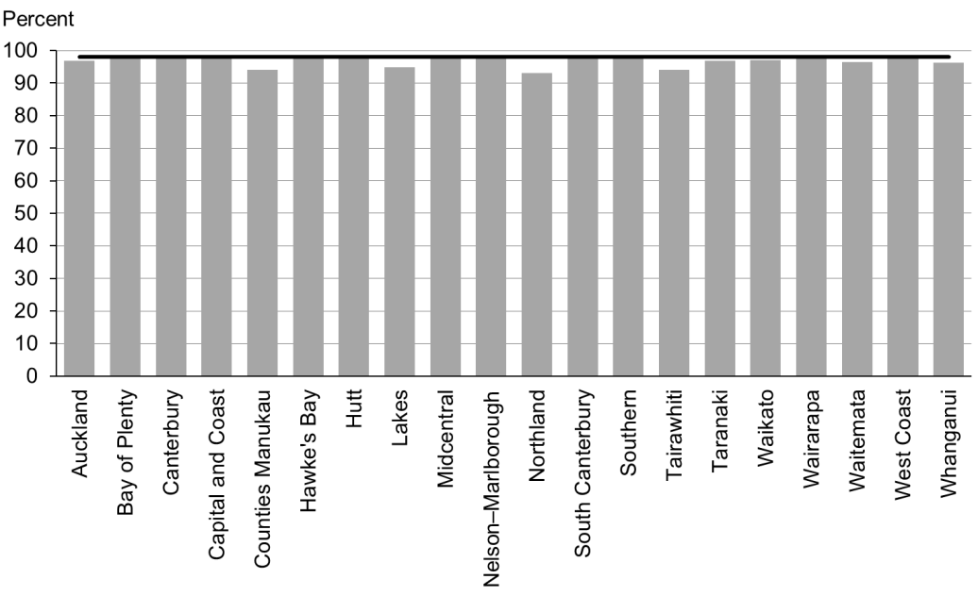

Figure 21: Participation in early childhood education, high deprivation population

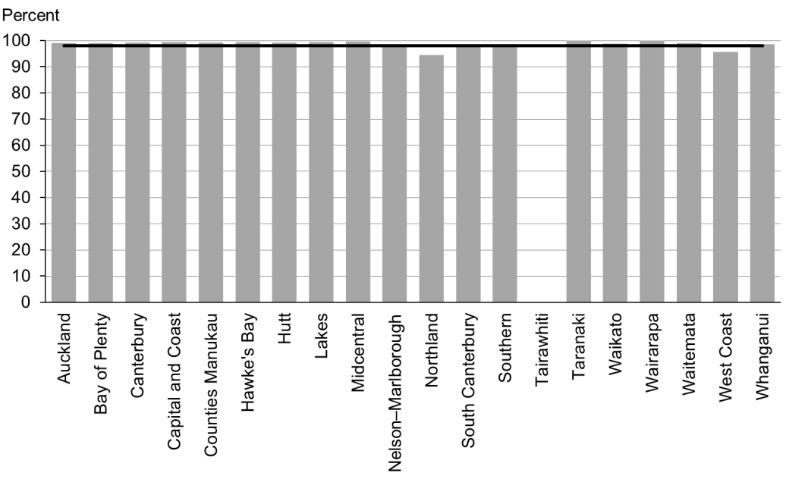

Figure 22: Participation in early childhood education, Māori

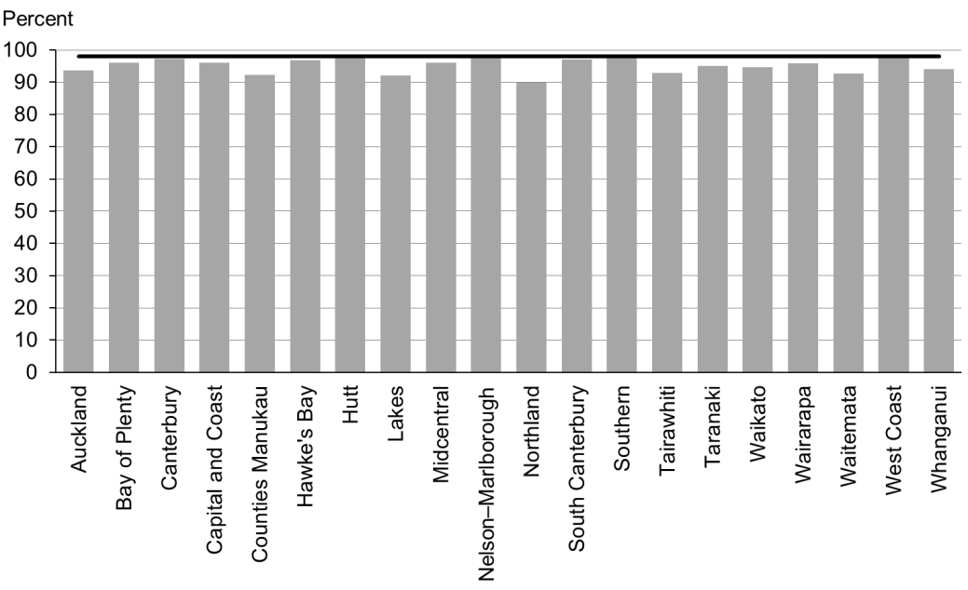

Figure 23: Participation in early childhood education, Pacific peoples

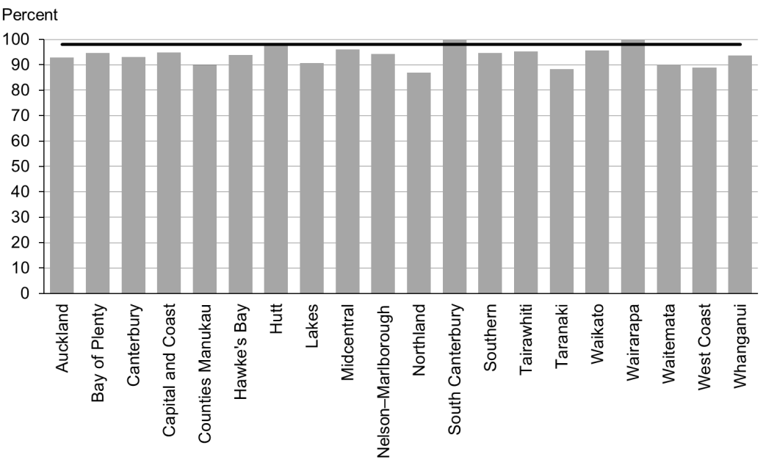

### Data notes

* Where no bar appears on the graph, there was no date provided.
* Data for this indicator was collected for children starting school during the 12 months to December 2015.
* Children counted within the ‘high deprivation’ population were those attending a Ministry of Education-defined decile 1 or 2 school.
* The numerator is children starting school who had participated in ECE (source: ENROL).
* The denominator is children starting school (source: ENROL).

## WCTO Quality Improvement Framework Indicator 8

|  |  |
| --- | --- |
| **Standard** | All children and families/whānau have access to primary care, WCTO services (including the B4 School Check) and early childhood education. |
| **Indicator** | Children under six years have access to free primary care. |
| **Target by December 2014** | 98 percent |
| **Target by June 2016** | 100 percent |

|  |  |  |  |  |
| --- | --- | --- | --- | --- |
|  | **Total New Zealand** | **High deprivation** | **Māori** | **Pacific peoples** |
| March 2016 mean (range) | 100% (98–100) | 100% (99–100) | 100% (99–100) | 100% (100–100) |
| September 2015 mean (range) | 100% (98–100) | 100% (99–100) | 100% (99–100) | 100% (100–100) |

Figure 24: Under-six access to free primary care, total New Zealand

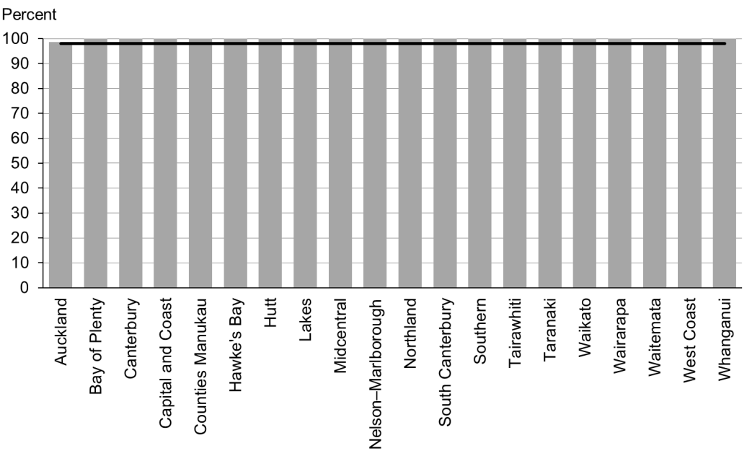

Figure 25: Under-six access to free primary care, high deprivation population

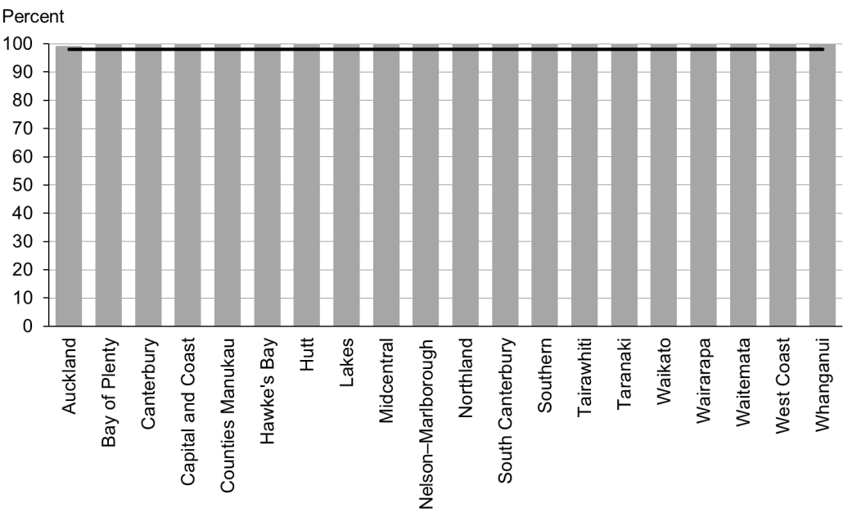

Figure 26: Under-six access to free primary care, Māori

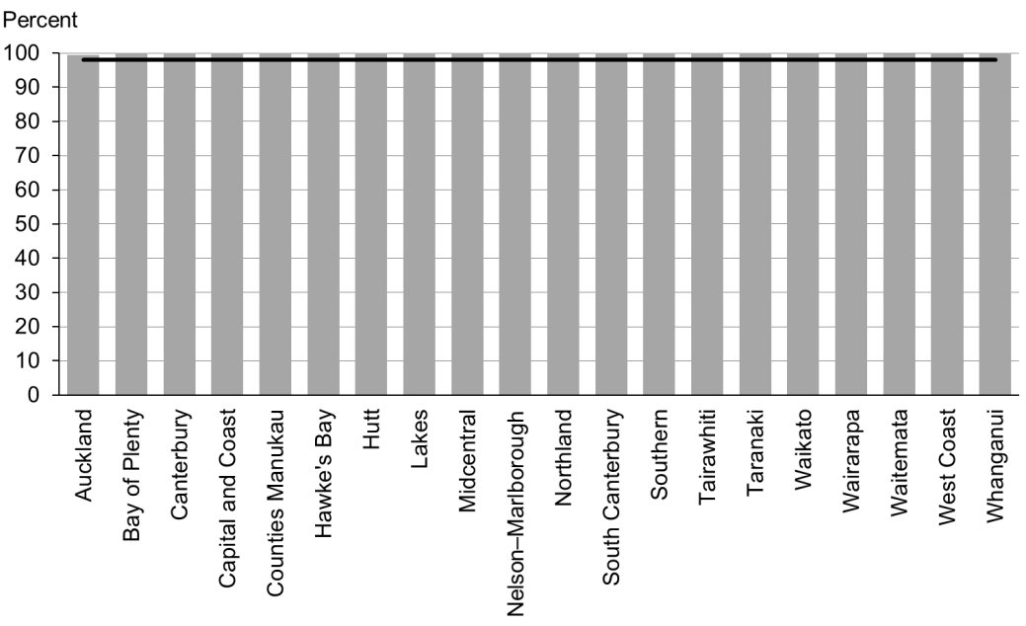

Figure 27: Under-six access to free primary care, Pacific peoples

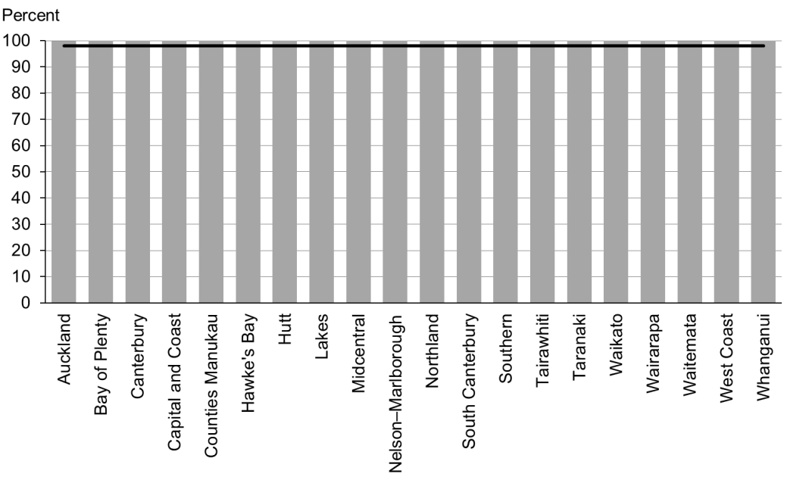

### Data notes

* Time period: snapshot as at 1 January 2016.
* Numerator: number of children aged under six years enrolled with a PHO that delivers free primary care for under-sixes (source: PHO).
* Denominator: number of children aged under six years enrolled with a PHO (source: PHO).

## WCTO Quality Improvement Framework Indicator 9

|  |  |
| --- | --- |
| **Standard** | All children and families/whānau have access to primary care, WCTO services (including the B4 School Check) and early childhood education. |
| **Indicator** | Children under six years have access to free after-hours primary care. |
| **Target by December 2014** | 98 percent |
| **Target by June 2016** | 100 percent |

|  |  |  |  |  |
| --- | --- | --- | --- | --- |
|  | **Total New Zealand** | **High deprivation** | **Māori** | **Pacific peoples** |
| March 2016 mean (range) | 98% (86–100) | N/A | N/A | N/A |
| September 2015 mean (range) | 99% (95–100) | N/A | N/A | N/A |

Figure 28: Under-six access to free after-hours primary care, total New Zealand

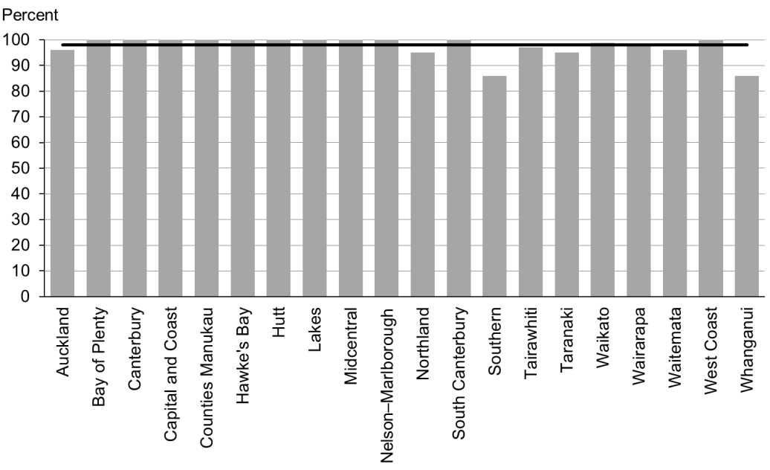

### Data notes

* Time period: snapshot as at January 2016.
* Data is not available by ethnicity or deprivation quintile.
* Numerator: number of children aged under six years who are enrolled with a PHO that delivers free after-hours primary care for under sixes (source: PHO).
* Denominator: number of children aged under six years who are enrolled with a PHO (source: PHO).

## WCTO Quality Improvement Framework Indicator 10

|  |  |
| --- | --- |
| **Standard** | All children and families/whānau have access to specialist and other referred services, where required, in a timely manner. |
| **Indicator** | Children are seen promptly following referral to specialist services. |
| **Target by December 2014** | 100 percent within five months of referral |
| **Target by June 2016** | 100 percent within four months of referral |

|  |  |  |  |  |
| --- | --- | --- | --- | --- |
|  | **Total New Zealand** | **High deprivation** | **Māori** | **Pacific peoples** |
| March 2016 mean (range) | 100% (96–100) | N/A | N/A | N/A |
| September 2015 mean (range) | 100% (89–100) | N/A | N/A | N/A |

Figure 29: First specialist appointment for paediatric medicine received within four months, total New Zealand

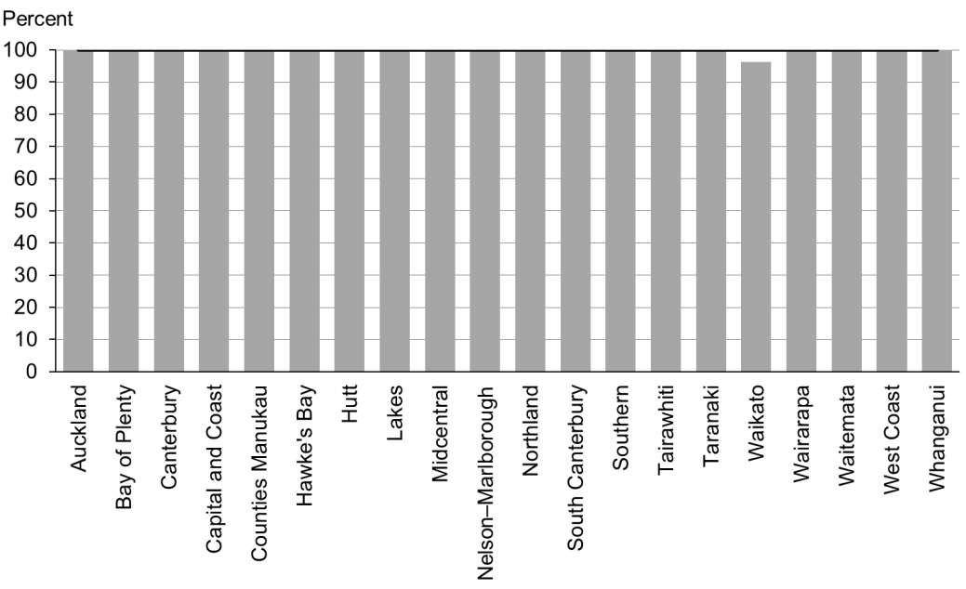

### Data notes

* Time period: snapshot for January 2015.
* DHB is DHB of service.
* Data is not available by ethnicity or deprivation quintile.
* The data presented is for includes any referral to DHB paediatric medicine (at any age).
* Numerator: number waiting longer than four months (source: DHB Elective Services Patient Flow Indicators reporting).
* Denominator: total number waiting at end of month (source: DHB Elective Services Patient Flow Indicators reporting).

# Indicators 11–20: Outcomes

Aim 2 of the WCTO Quality Improvement Framework is **improved health and equity for all populations**. We will know we have achieved this when we see improved health and wellbeing outcomes for children, families and whānau. The Ministry of Health expects that, in addition to these indicators, DHBs and WCTO providers will consider monitoring other measures of family and whānau health and wellbeing that through national or local data sources.

Indicators 11–20 measure health outcomes across a range of domains representing infant and child physical health (by measurements of nutrition and healthy weight and oral health), infant and child mental health (through the strengths and difficulties questionnaire) and family health (by tracking rates of smoking status). The Ministry expects to add further measures of health and wellbeing outcomes as new data becomes available. A number of performance- and outcome-monitoring documents, including Māori Health Plans and the New Zealand Maternity Clinical Indicators, have adopted these indicators.

These indicators reflect the core roles of WCTO in promoting and supporting physical health, mental wellbeing, healthy families and whānau, and healthy home environments. Achieving improvements in these indicators will require a cross-sector response and a multi-faceted approach, and may not happen in the short term. However, we must continue to monitor the health and wellbeing outcomes these indicators represent, because they show us where WCTO services are working well, in their own capacities and together with the wider health sector.

## Summary of results for this period

### National

Figures in this set of indicators remain static. In particular, there have been very few statistically significant changes in the breastfeeding outcomes since the indicators were first reported in September 2013. This is despite efforts in DHBs to increase these figures. Only results against Indicator 12: ‘Infants are exclusively or fully breastfed at discharge from LMC’ significantly changed between the September and March reports (an 8 percentage point increase at a total population level). This was the inverse of the last period (to September 2015), where there was an 8 percentage point decrease for this indicator. MAT data (used for this indicator) can take up to two years to show all events, which may explain the deviation between reports.

Indicator 15: ‘Children are a healthy weight at four years’ will be a focus over the coming years. DHBs should all currently be implementing the Minister’s childhood obesity health package. The plan has three focus areas made up of 22 initiatives, which are either new or an expansion of existing initiatives. (See [the Ministry of Health website](http://www.health.govt.nz/our-work/diseases-and-conditions/obesity/childhood-obesity-plan) for detailed information.) Hopefully this will lead to a growing number of healthy children having the best start as they enter their school years.

There is no new data for Indicators 16 and 17 (caries free at five years and dmft minimised) for this report.

Also of note is that MAT data (used for Indicator 19: ‘Mothers are smokefree at two weeks postnatal’) can take up to two years to show all events, which may explain why there is some variation between the data shown in these reports and data available within DHBs.

### By region

Achievement against the breastfeeding indicators (11–14) remained variable across the DHBs in the March results – 16 DHBs are meeting or are within 2 percentage points of meeting the June 2016 target of 80 percent. Eight DHBs are also meeting the June 2016 target of 80 percent (another two were within 2 percentage points. However, only four DHBs were hitting the June 2016 target for Indicator 13 (‘Infants are exclusively or fully breastfed at three months’). Some of the DHBs were hitting the target for both early-life breastfeeding indicators but were failing to sustain the numbers of women breastfeeding to three months. Sustained work on ensuring women continue to breastfeed past the very early stages of an infant’s life remains important for all DHBs.

There was a 14-percentage-point difference between the DHBs’ achievement rates against Indicator 15: ‘Children are a healthy weight at four years’, and this increased across high-deprivation areas (19 percentage points), Māori (15 percentage points) and Pacific peoples (34 percentage points).

### By deprivation level

Looking at achievement against all four breastfeeding indicators, it generally remains the case that fewer infants living in areas of high deprivation are exclusively or fully breastfed, and fewer infants are receiving some breast milk at six months, relative to the total population. In the March results, for the fourth reporting period in a row, there was no significant increase in rates for any of the four breastfeeding indicators for infants living in areas of high deprivation. Indicator 12: ‘Infants are exclusively or fully breastfed at discharge from LMC’, having dropped 12 percentage points in the last period, increased 10 percentage points in this period. This was consistent with the total population figures.

Breastfeeding is free and helps lay the foundations for a healthy life – both emotionally and physically. Supporting families who are living in areas of high deprivation to establish and maintain breastfeeding should be a focus for all DHBs.

### By ethnicity

Outcomes for Māori and Pacific families are generally significantly poorer across most indicators in this group.

Pacific children are significantly less likely to be a healthy weight at four years of age than children within the total population (53 percent at a healthy weight as compared with 70 percent of total population). This should be a focus for all DHBs: the Minister’s childhood obesity package provides tools and ideas to improve the number of Pacific children who are a healthy weight.

In the September results, breastfeeding rates remained lower among Māori and Pacific communities at later ages (three and six months).

Despite the limitation in data for Indicator 19 (as described above); Māori still have significantly higher rates of smoking than the general population. This is confirmed in the *Report on Maternity, 2014* (available on the Ministry of Health website).

## WCTO Quality Improvement Framework Indicator 11

|  |  |
| --- | --- |
| **Standard** | WCTO providers use evidence-based interventions and education to promote child, family and whānau health and wellbeing. |
| **Indicator** | Infants are exclusively or fully breastfed at two weeks. |
| **Target by December 2014** | 72 percent |
| **Target by June 2016** | 80 percent |

|  |  |  |  |  |
| --- | --- | --- | --- | --- |
|  | **Total New Zealand** | **High deprivation** | **Māori** | **Pacific peoples** |
| March 2016 mean (range) | 78% (74–85) | 75% (67–86) | 76% (67–100) | 74% (50–100) |
| September 2015 mean (range) | 78% (72–85) | 74% (60–87) | 76% (58–82) | 72% (60–100) |

Figure 30: Infants exclusively or fully breastfed at two weeks, total New Zealand

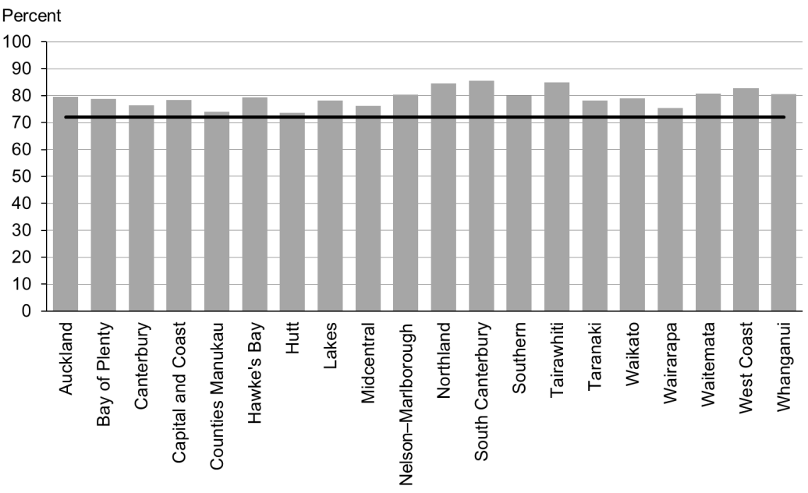

Figure 31: Infants exclusively or fully breastfed at two weeks, high deprivation population

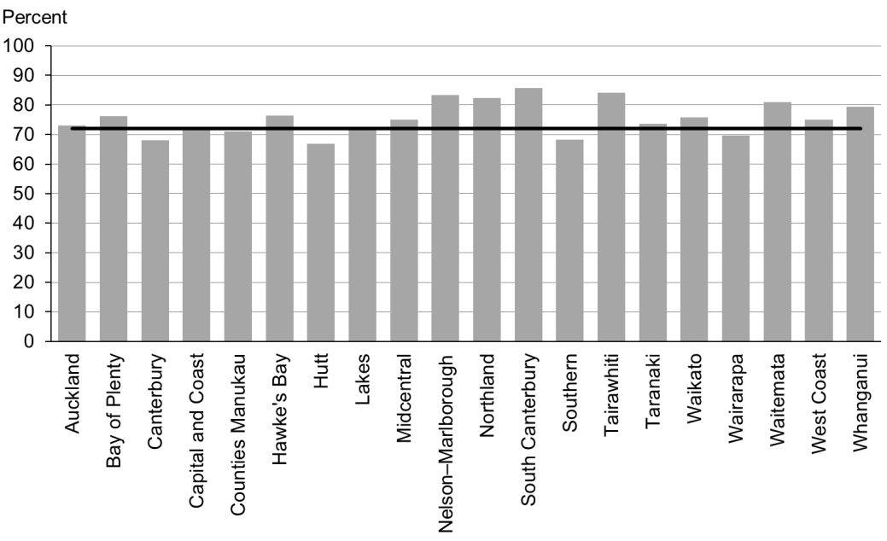

Figure 32: Infants exclusively or fully breastfed at two weeks, Māori

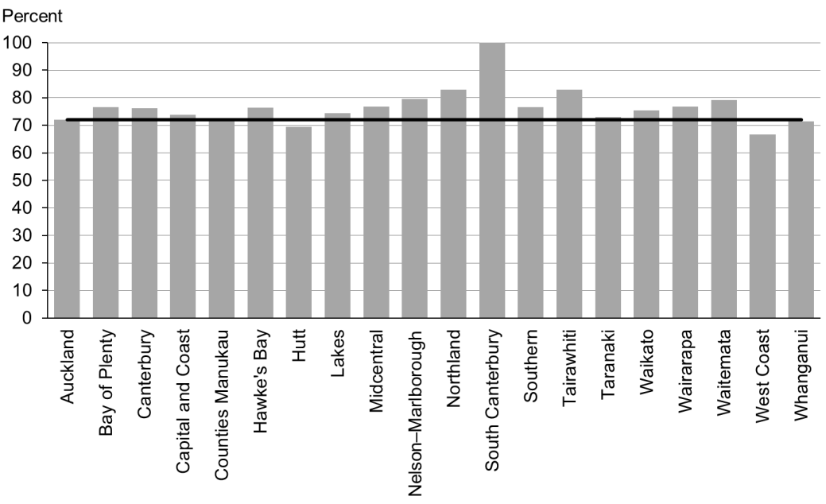

Figure 33: Infants exclusively or fully breastfed at two weeks, Pacific peoples

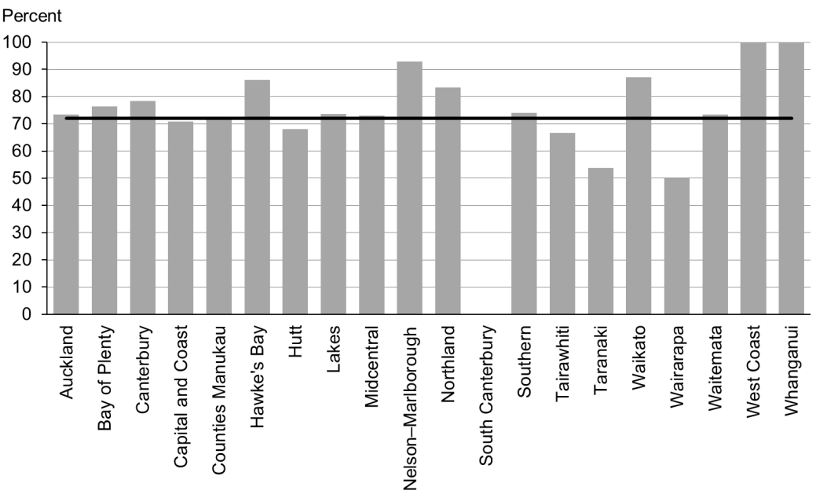

### Data notes

* Time period: babies born between 1 January 2015 and 31 July 2015.
* Excludes overseas DHB and undefined DHB.
* Numerator: breastfeeding at two weeks = exclusive or fully (source: MAT).
* Denominator: breastfeeding at two weeks = not null (source: MAT).

## WCTO Quality Improvement Framework Indicator 12

|  |  |
| --- | --- |
| **Standard** | WCTO providers use evidence-based interventions and education to promote child, family and whānau health and wellbeing. |
| **Indicator** | Infants are exclusively or fully breastfed at discharge from lead maternity carer (LMC) |
| **Target by December 2014** | 68 percent |
| **Target by June 2016** | 75 percent |

|  |  |  |  |  |
| --- | --- | --- | --- | --- |
|  | **Total New Zealand** | **High deprivation** | **Māori** | **Pacific peoples** |
| March 2016 mean (range) | 74% (68–79) | 69% (60–86) | 68% (58–81) | 70% (50–100) |
| September 2015 mean (range) | 66% (40–73) | 59% (0–73) | 62% (41–71) | 57% (49–80) |

Figure 34: Infants exclusively or fully breastfed at LMC discharge, total New Zealand

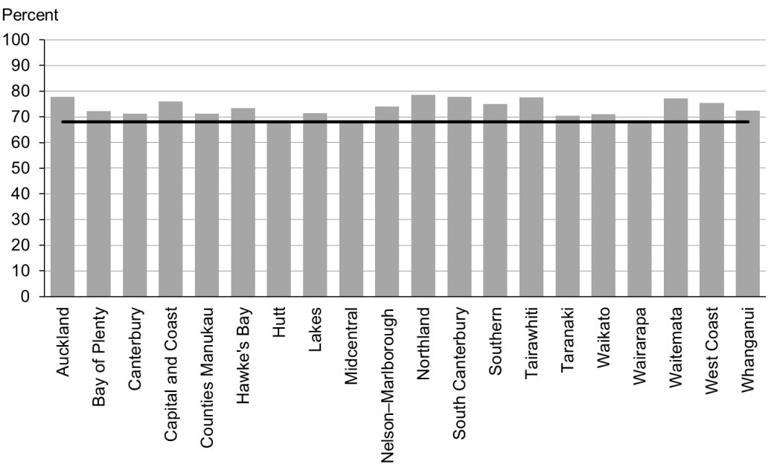

Figure 35: Infants exclusively or fully breastfed at LMC discharge, high deprivation population

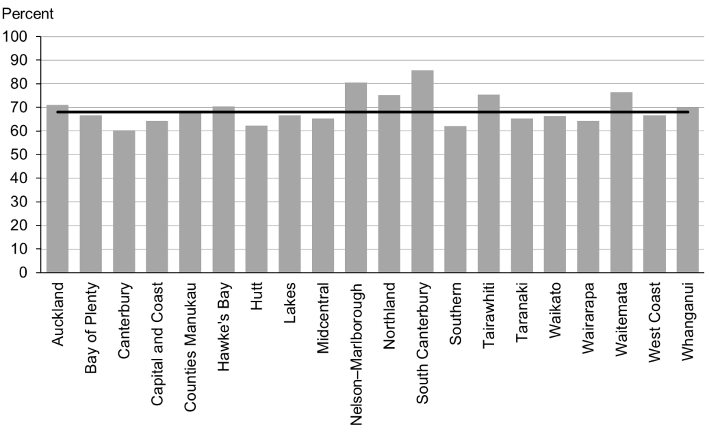

Figure 36: Infants exclusively or fully breastfed at LMC discharge, Māori

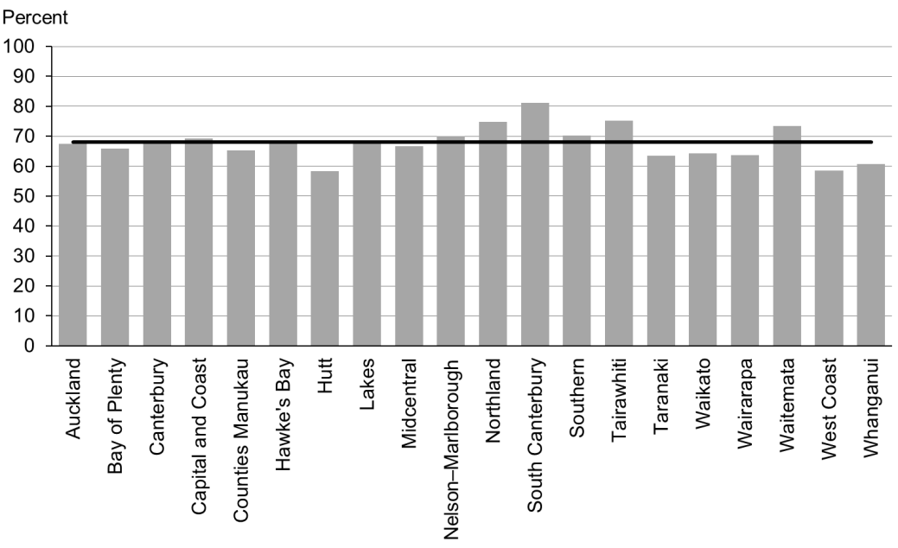

Figure 37: Infants exclusively or fully breastfed at LMC discharge, Pacific peoples

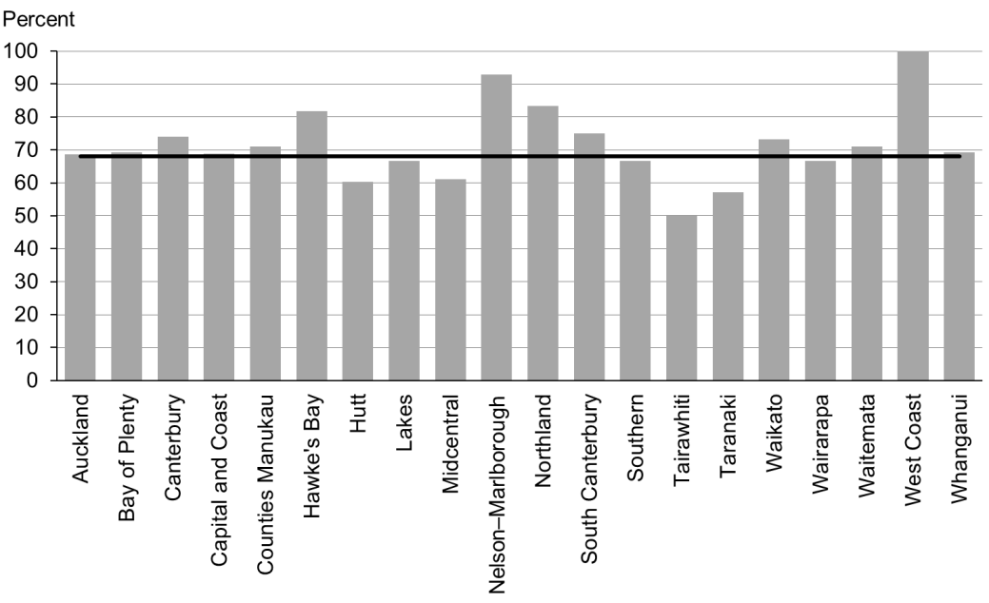

### Data notes

* Time period: babies born between 1 January 2015 and 30 June 2015.
* MAT Data (used for this indicator) can take up to two years to show all events. Therefore graphs may not illustrate a complete picture.
* Excludes overseas DHB and undefined DHB.
* Numerator: breastfeeding at discharge = exclusive or fully (source: MAT).
* Denominator: breastfeeding at discharge = not null (source: MAT).

## WCTO Quality Improvement Framework Indicator 13

|  |  |
| --- | --- |
| **Standard** | WCTO providers use evidence-based interventions and education to promote child, family and whānau health and wellbeing. |
| **Indicator** | Infants are exclusively or fully breastfed at three months. |
| **Target by December 2014** | 54 percent |
| **Target by June 2016** | 60 percent |

|  |  |  |  |  |
| --- | --- | --- | --- | --- |
|  | **Total New Zealand** | **High deprivation** | **Māori** | **Pacific peoples** |
| March 2016 mean (range) | 55% (46–63) | 46% (41–68) | 43% (36–55) | 46% (39–67) |
| September 2015 mean (range) | 55% (46–63) | 45% (38–64) | 45% (38–57) | 47% (35–62) |

Figure 38: Infants exclusively or fully breastfed at three months, total New Zealand

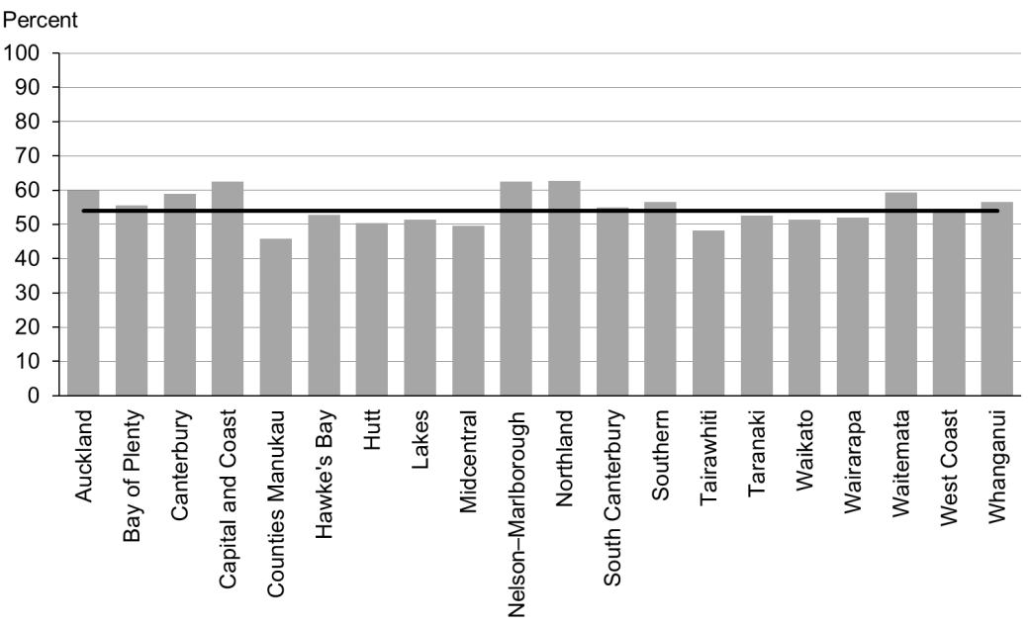

Figure 39: Infants exclusively or fully breastfed at three months, high deprivation population

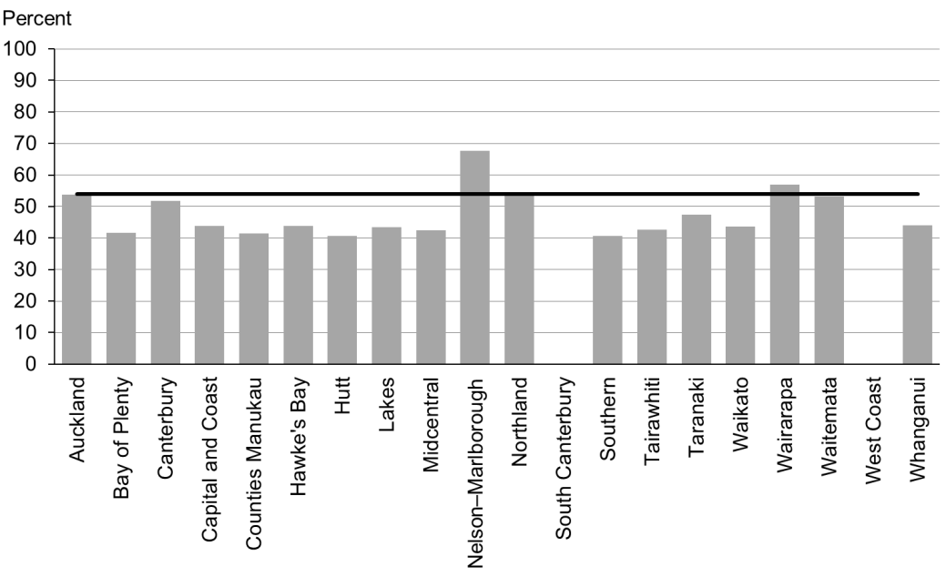

Figure 40: Infants exclusively or fully breastfed at three months, Māori

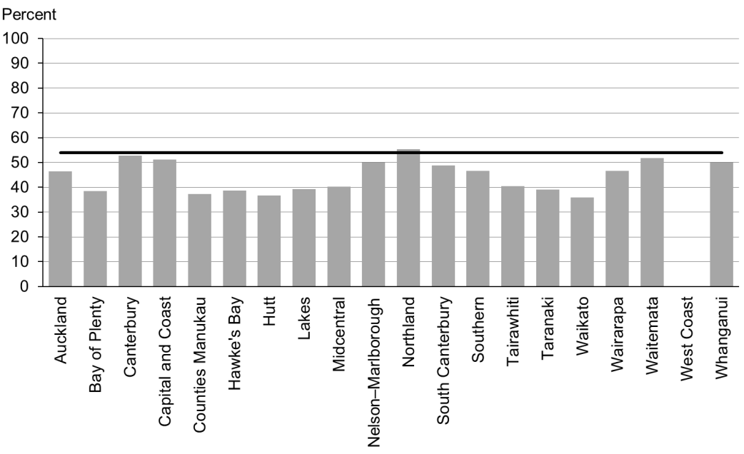

Figure 41: Infants exclusively or fully breastfed at three months, Pacific peoples

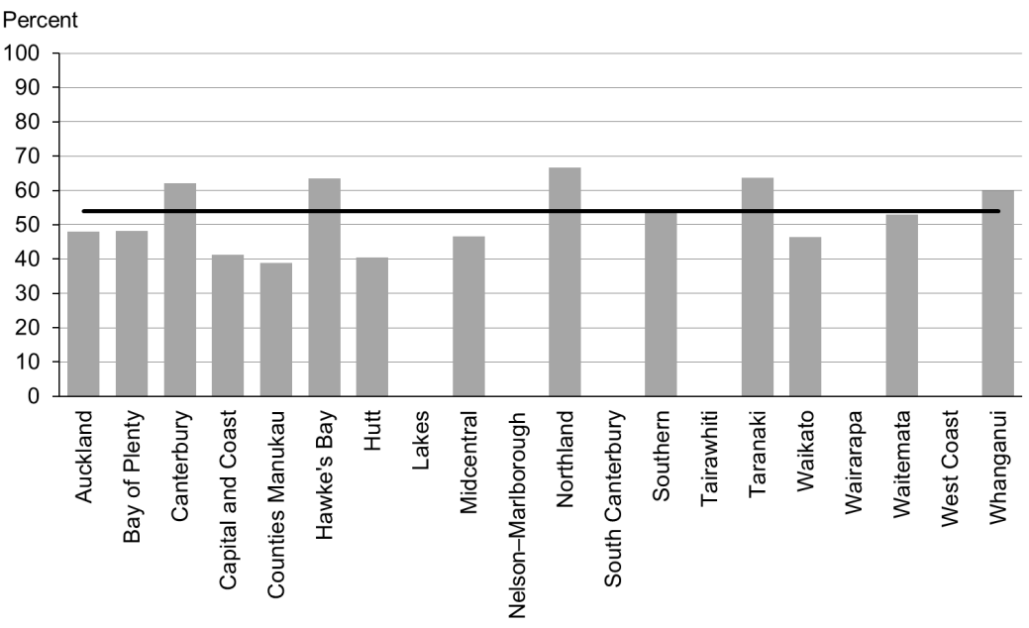

### Data notes

* No bar on graph = fewer than 20 infants in this category.
* Time period: infants aged three months between 1 July and 31 December 2015.
* The data excludes overseas DHB and undefined DHB.
* Numerator: breastfeeding at three months = exclusive or fully (source: WCTO NHI dataset).
* Denominator: breastfeeding at three months = not null (source: WCTO NHI dataset).

## WCTO Quality Improvement Framework Indicator 14

|  |  |
| --- | --- |
| **Standard** | WCTO providers use evidence-based interventions and education to promote child, family and whānau health and wellbeing. |
| **Indicator** | Infants are receiving breast milk at six months (exclusively, fully or partially). |
| **Target by December 2014** | 59 percent |
| **Target by June 2016** | 65 percent |

|  |  |  |  |  |
| --- | --- | --- | --- | --- |
|  | **Total New Zealand** | **High deprivation** | **Māori** | **Pacific peoples** |
| March 2016 mean (range) | 66% (58–75) | 57% (45–70) | 53% (45–65) | 62% (57–77) |
| September 2015 mean (range) | 66% (56–75) | 56% (44–69) | 54% (46–65) | 59% (47–70) |

Figure 42: Infants receiving breast milk at six months, total New Zealand

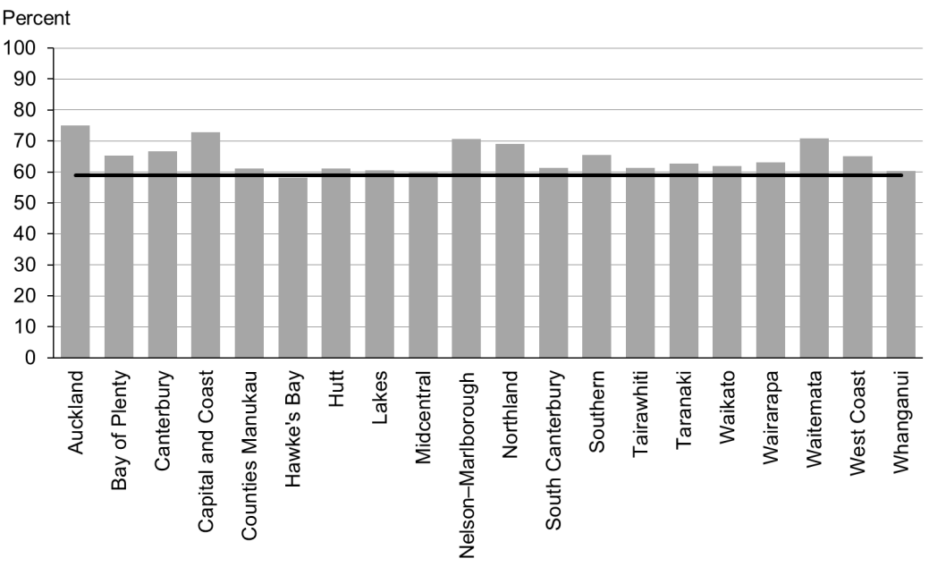

Figure 43: Infants receiving breast milk at six months, high deprivation population

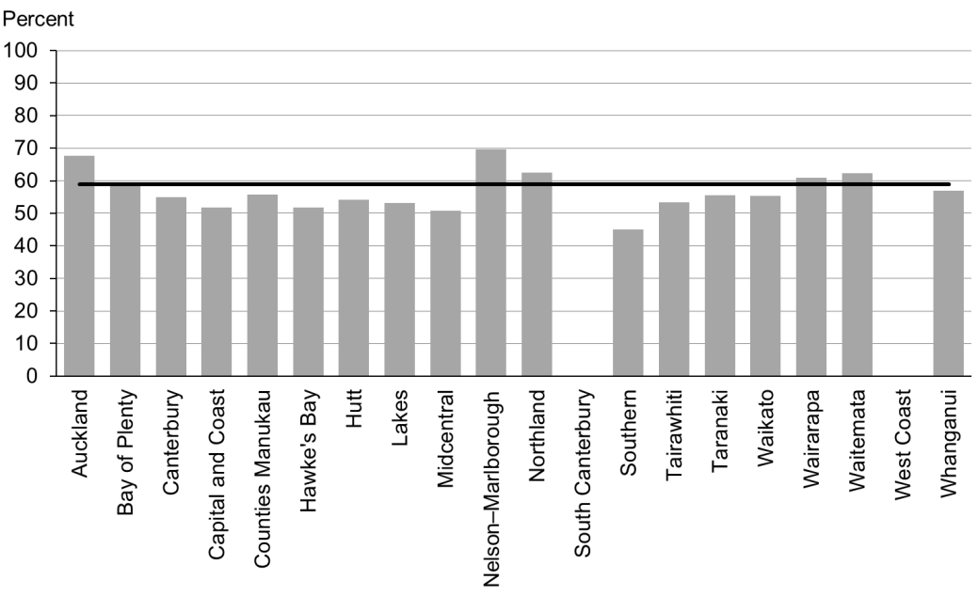

Figure 44: Infants receiving breast milk at six months, Māori

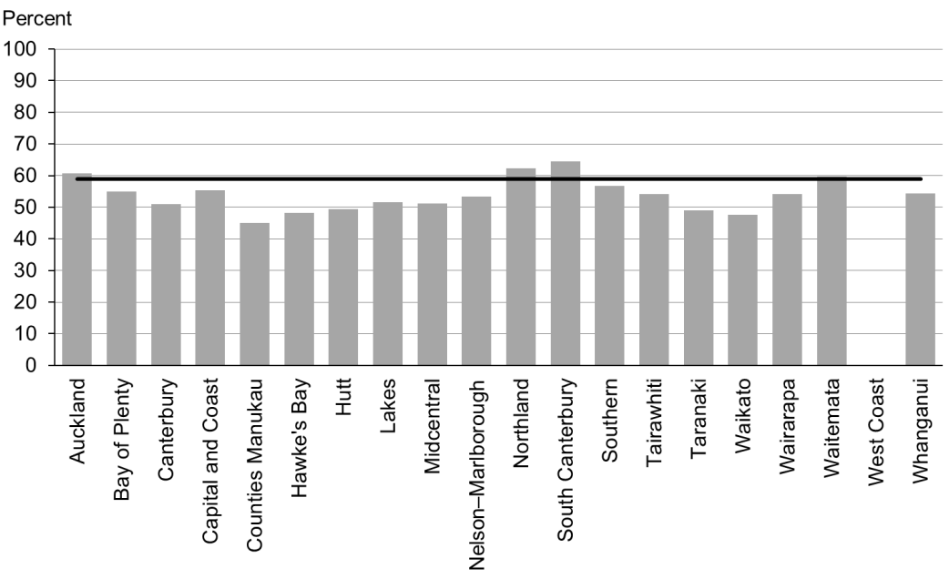

Figure 45: Infants receiving breast milk at six months, Pacific peoples

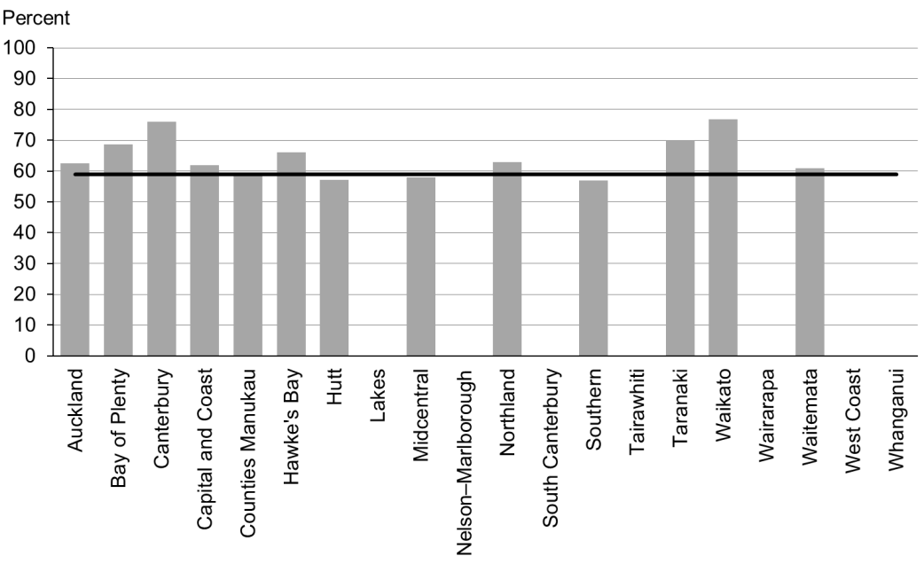

### Data notes

* No bar on graph = fewer than 20 infants in this category.
* Time period: infants aged six months between 1 July and 31 December 2015.
* The data excludes overseas DHB and undefined DHB.
* Numerator: breastfeeding at six months = exclusive, full or partial (source: WCTO NHI dataset).
* Denominator: breastfeeding at six months = not null (source: WCTO NHI dataset).

## WCTO Quality Improvement Framework Indicator 15

|  |  |
| --- | --- |
| **Standard** | WCTO providers use evidence-based interventions and education to promote child, family and whānau health and wellbeing. |
| **Indicator** | Children are a healthy weight at four years. |
| **Target by December 2014** | 68 percent |
| **Target by June 2016** | 75 percent |

|  |  |  |  |  |
| --- | --- | --- | --- | --- |
|  | **Total New Zealand** | **High deprivation** | **Māori** | **Pacific peoples** |
| March 2016 mean (range) | 70% (60–74) | 62% (54–73) | 63% (54–69) | 53% (38–72) |
| September 2015 mean (range) | 75% (69–80) | 68% (56–75) | 72% (60–80) | 60% (48–75) |

Figure 46: Children are a healthy weight at age four years, total New Zealand

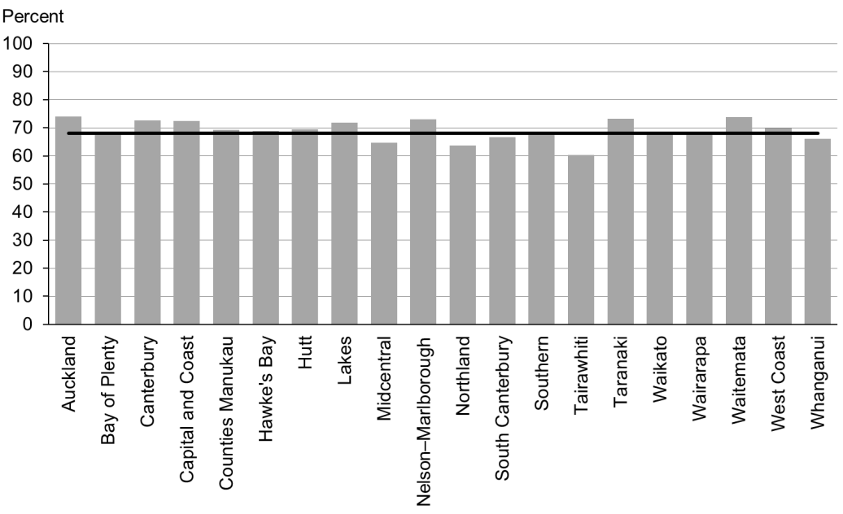

Figure 47: Children are a healthy weight at age four years, high deprivation population

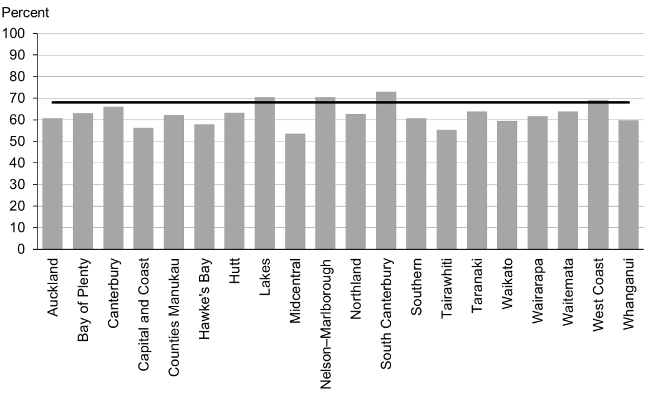

Figure 48: Children are a healthy weight at age four years, Māori

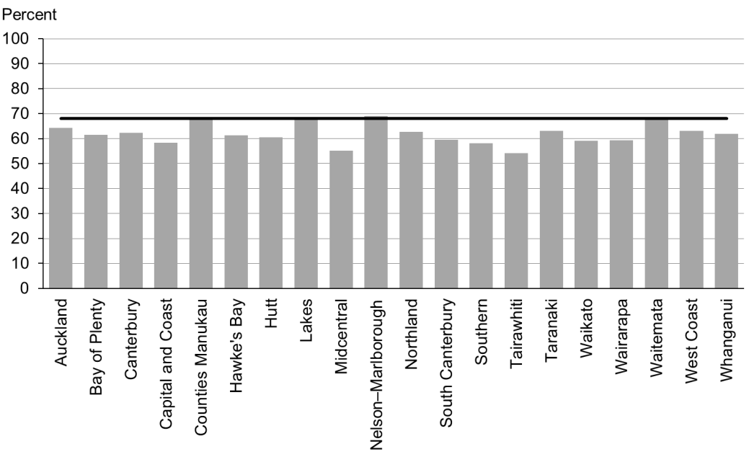

Figure 49: Children are a healthy weight at age four years, Pacific peoples

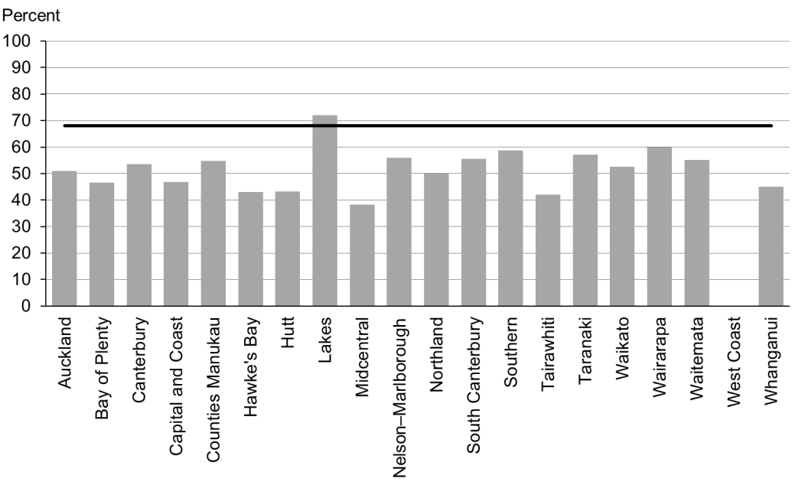

### Data notes

* No bar on graph = fewer than 20 children in this category.
* Time period: children receiving a B4 School Check between 1 July and 31 December 2015.
* DHB is DHB of service.
* Numerator: children with a BMI between the 5th and 84th percentile at B4 School Check (source: B4 School Check).
* Denominator: children with a BMI recorded at B4 School Check (source: B4 School Check).

## WCTO Quality Improvement Framework Indicator 16

|  |  |
| --- | --- |
| **Standard** | WCTO providers use evidence-based interventions and education to promote child, family and whānau health and wellbeing. |
| **Indicator** | Children are caries free at five years. |
| **Target by December 2014** | 65 percent |
| **Target by June 2016** | 65 percent |

|  |  |  |  |  |  |
| --- | --- | --- | --- | --- | --- |
|  | **Total New Zealand** | **High deprivation** | **Māori** | | **Pacific peoples** |
| March 2016 mean (range) | No new data | | | | |
| September 2015 mean (range) | 59% (34–68) | N/A | | 40% (25–56) | 36% (22–65) |

### Data notes

* No new data is available for this period. Please see the previous report for the latest data available.
* Numerator: number of five-year-old children caries free (source: community oral health services).
* Denominator: number of five-year-old children enrolled with oral health services (source: community oral health services).

## WCTO Quality Improvement Framework Indicator 17

|  |  |
| --- | --- |
| **Standard** | WCTO providers use evidence-based interventions and education to promote child, family and whānau health and wellbeing. |
| **Indicator** | The burden of dental decay among children with one or more decayed, missing or filled (dmft) deciduous (baby) teeth is minimised. |
| **Target by December 2014** | 4.4 average dmft |
| **Target by June 2016** | 4 average dmft |

|  |  |  |  |  |
| --- | --- | --- | --- | --- |
|  | **Total New Zealand** | **High deprivation** | **Māori** | **Pacific peoples** |
| March 2016 mean (range) | No new data | | | |
| September 2015 mean (range) | 4.42 (3.3–5.2) | N/A | 4.91 (4.0–5.9) | 5.10 (3.11–8.0) |

### Data notes

* No new data is available for this period. Please see the previous report for the latest data available.
* Numerator: sum of dmft scores at five years old (source: community oral health services).
* Denominator: number of five-year-olds with a dmft score greater than zero (source: community oral health services).

## WCTO Quality Improvement Framework Indicator 18

|  |  |
| --- | --- |
| **Standard** | WCTO providers use evidence-based interventions and education to promote child, family and whānau health and wellbeing. |
| **Indicator** | Child mental health is supported (children’s SDQ-P scores are within the normal range at the B4 School Check).[2] |
| **Target by December 2014** | 86 percent |
| **Target by June 2016** | 95 percent |

|  |  |  |  |  |
| --- | --- | --- | --- | --- |
|  | **Total New Zealand** | **High deprivation** | **Māori** | **Pacific peoples** |
| March 2016 mean (range) | 96% (93–98) | 93% (89–100) | 94% (90–98) | 94% (78–100) |
| September 2015 mean (range) | 96% (93–98) | 94% (91–97) | 94% (87–97) | 95% (71–100) |

Figure 50: Children with a normal SDQ-P score at four years, total New Zealand

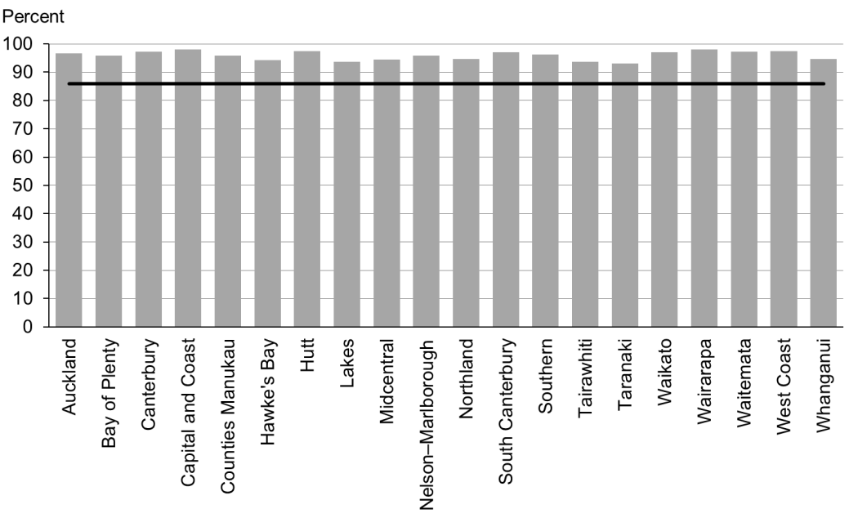

Figure 51: Children with a normal SDQ-P score at four years, high deprivation population

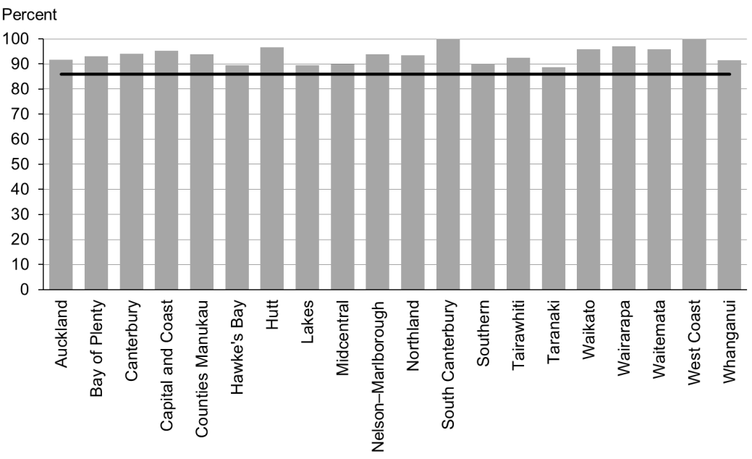

Figure 52: Children with a normal SDQ-P score at four years, Māori

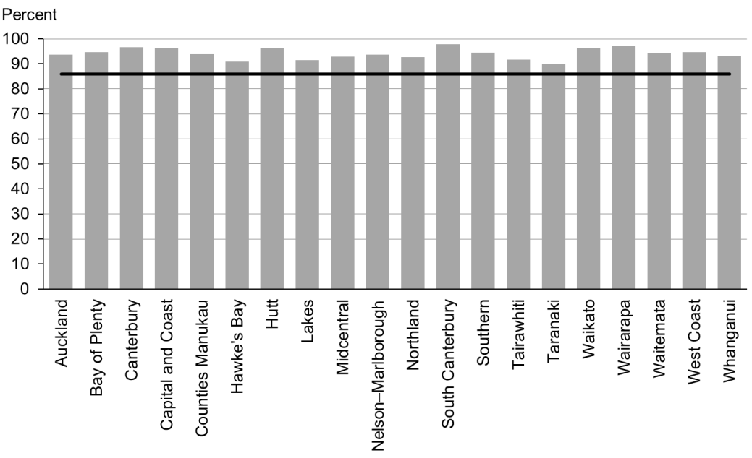

Figure 53: Children with a normal SDQ-P score at four years, Pacific peoples

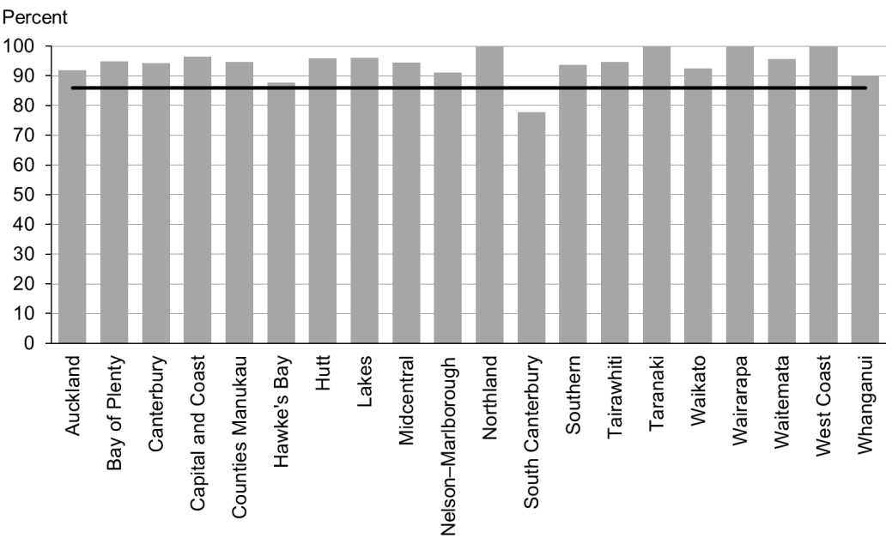

### Data notes

* Time period: children receiving a B4 School Check between 1 July and 31 December 2015.
* DHB is DHB of service.
* Numerator: children with an SDQ-P score that is within the normal range (source: B4 School Check).
* Denominator: children with an SDQ-P score recorded at the B4 School Check (source: B4 School Check).

## WCTO Quality Improvement Framework Indicator 19

|  |  |
| --- | --- |
| **Standard** | WCTO providers use evidence-based interventions and education to promote child, family and whānau health and wellbeing. |
| **Indicator** | Mothers are smokefree at two weeks postnatal. |
| **Target by December 2014** | 86 percent |
| **Target by June 2016** | 95 percent |

|  |  |  |  |  |
| --- | --- | --- | --- | --- |
|  | **Total New Zealand** | **High deprivation** | **Māori** | **Pacific peoples** |
| March 2016 mean (range) | 78% (70–97) | 74% (62–95) | 62% (54–84) | 91% (50–100) |
| September 2015 mean (range) | 87% (72–98) | 78% (61–95) | 66% (58–89) | 92% (67–100) |

Figure 54: Mothers smokefree at two weeks postnatal, total New Zealand

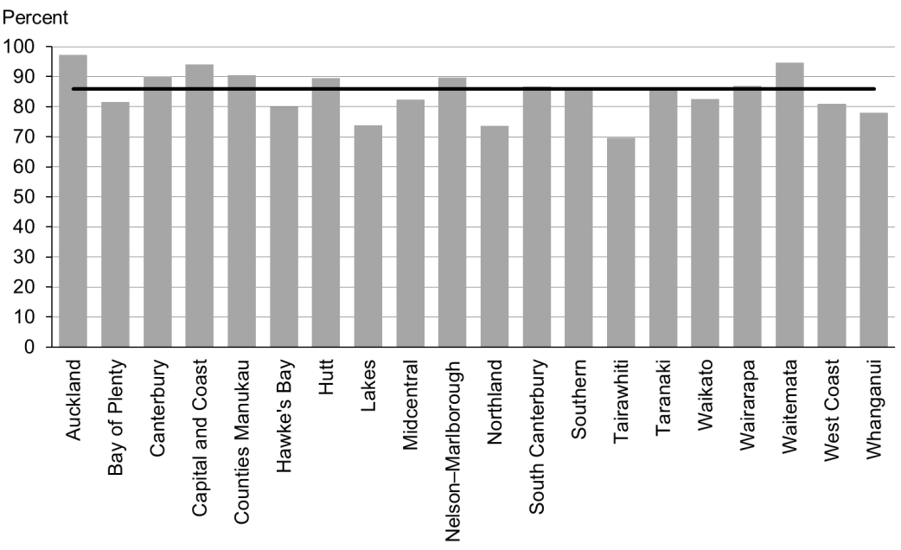

Figure 55: Mothers smokefree at two weeks postnatal, high deprivation population

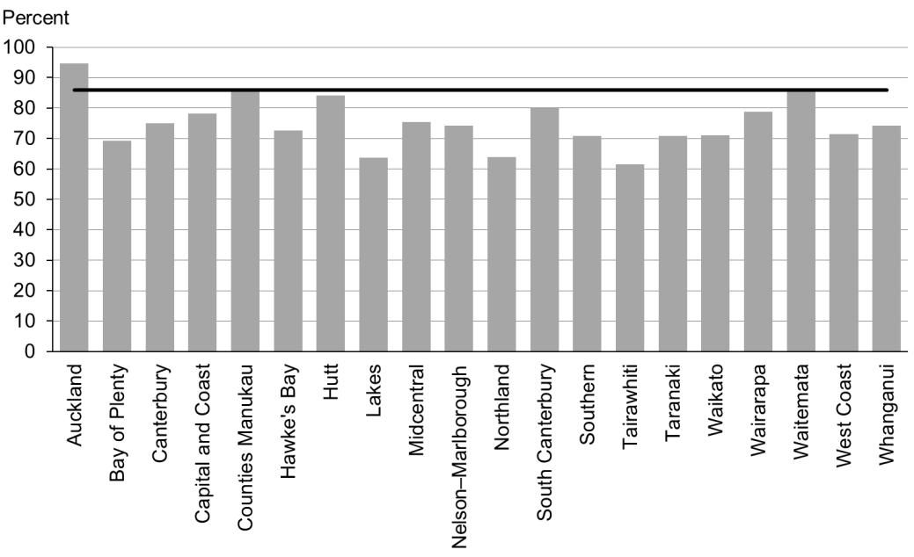

Figure 56: Mothers smokefree at two weeks postnatal, Māori

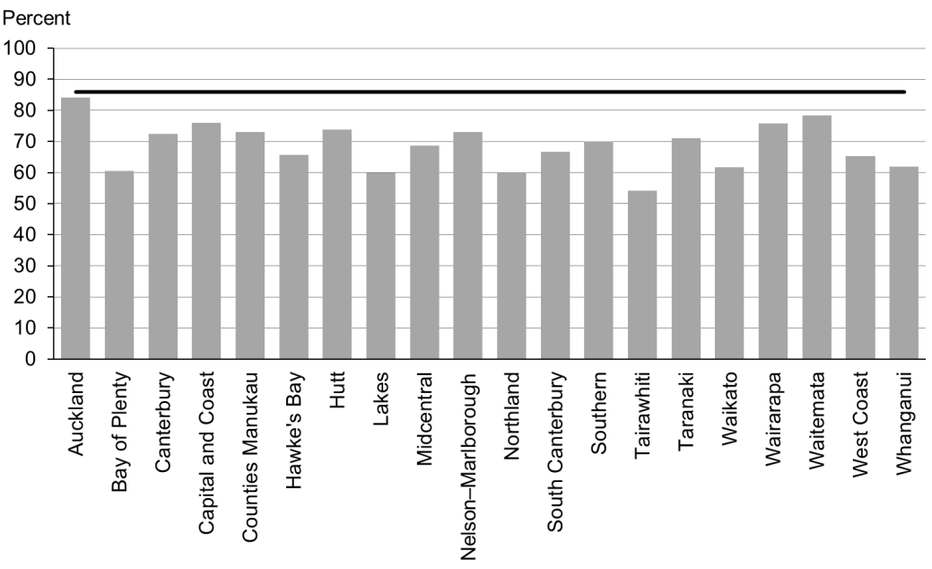

Figure 57: Mothers smokefree at two weeks postnatal, Pacific peoples

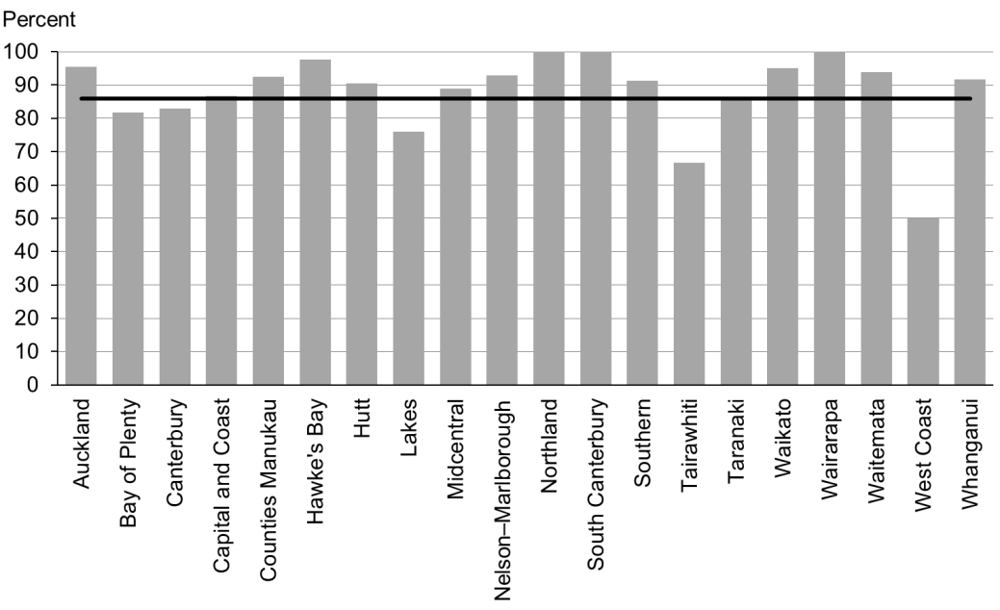

### Data notes

* Time period: births between 1 January and 30 June 2015.
* The data excludes overseas DHB and undefined DHB.
* MAT Data (used for this indicator) can take up to two years to show all events. Therefore graphs may not illustrate a complete picture.
* Numerator: maternal tobacco use (two weeks) = Yes (source: MAT).
* Denominator: maternal tobacco use (two weeks) = Yes or No (source: MAT).

## WCTO Quality Improvement Framework Indicator 20

|  |  |
| --- | --- |
| **Standard** | WCTO providers use evidence-based interventions and education to promote child, family and whānau health and wellbeing. |
| **Indicator** | Children live in a smokefree home (age four years).[3] |
| **Target by December 2014** | 90 percent |
| **Target by June 2016** | 100 percent |

|  |  |  |  |  |
| --- | --- | --- | --- | --- |
|  | **Total New Zealand** | **High deprivation** | **Māori** | **Pacific peoples** |
| March 2016 mean (range) | 98% (28–100) | 96% (23–100) | 97% (29–100) | 91% (15–100) |
| September 2015 mean (range) | 98% (74–100) | 97% (91–100) | 97% (92–100) | 97% (0–100) |

Figure 58: Children living in a smokefree home (age four years), total New Zealand

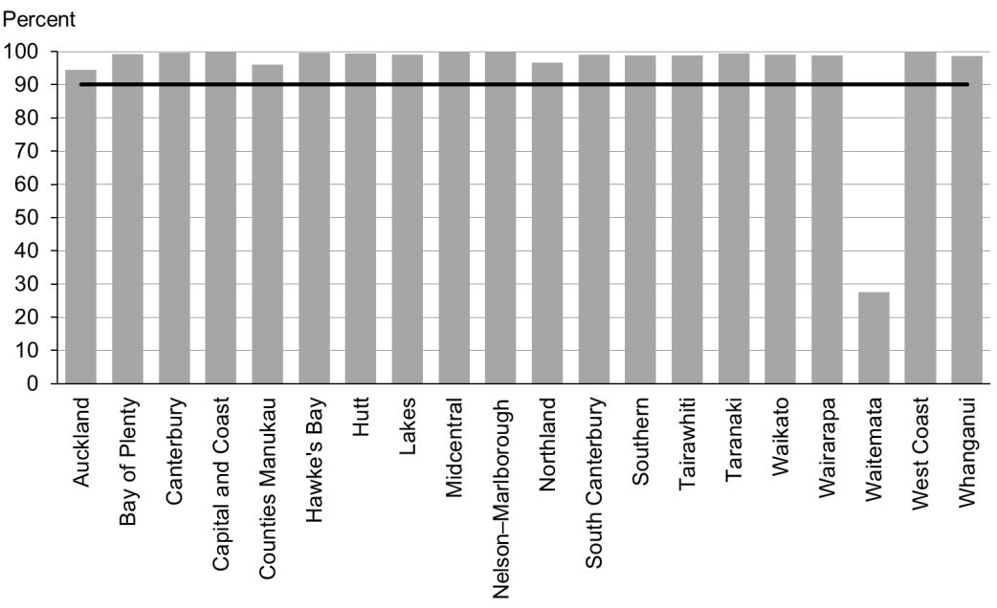

Figure 59: Children living in a smokefree home (age four years), high deprivation population

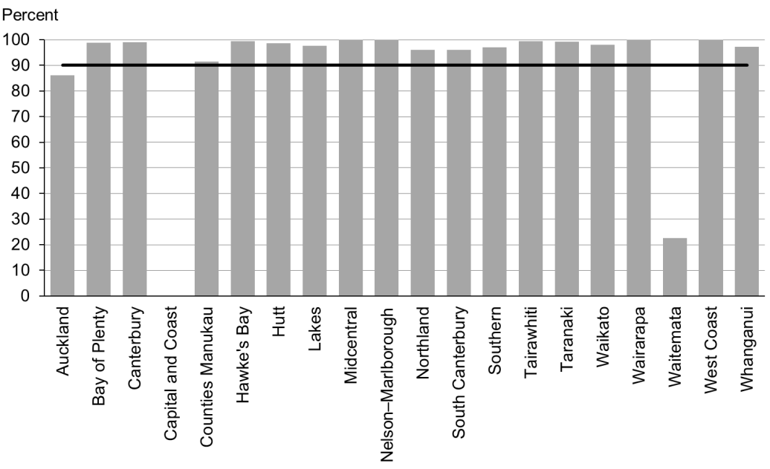

Figure 60: Children living in a smokefree home (age four years), Māori

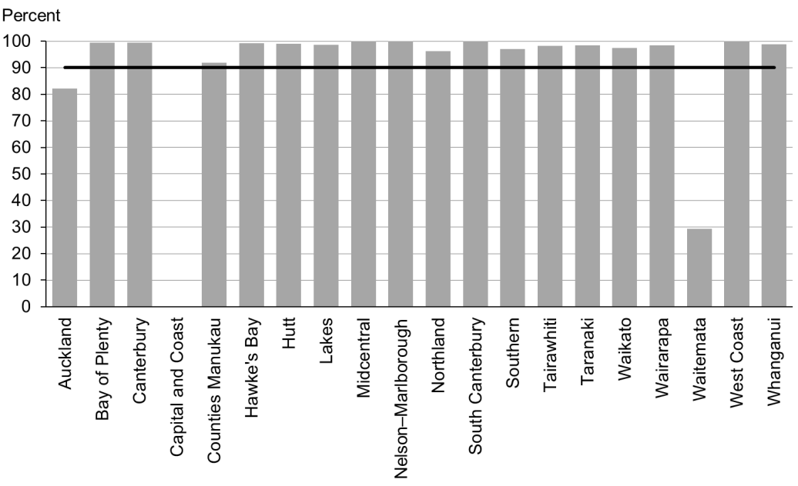

Figure 61: Children living in a smokefree home (age four years), Pacific peoples

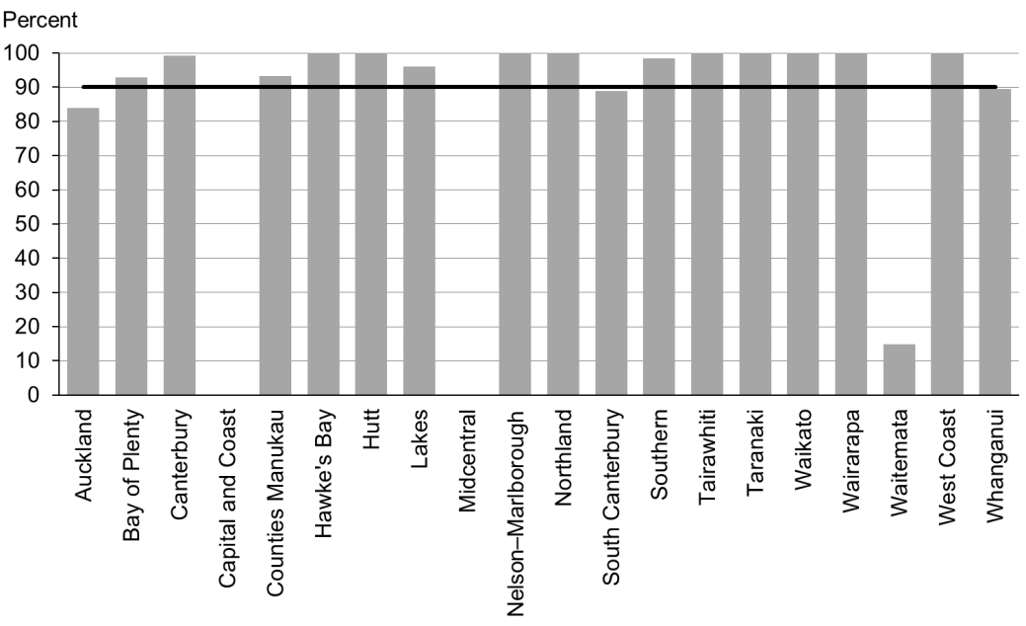

### Data notes

* No bar on graph = the smokefree at-home status is not reported.
* Time period: children receiving a B4 School Check between 1 July and 31 December 2015.
* DHB is DHB of service.
* Numerator: children with smokefree home = Yes (source: B4 School Check).
* Denominator: children with smokefree home = Yes or No (source: B4 School Check).

# Indicators 21–27: Quality

Aim 3 of the WCTO Quality Improvement Framework is **best value for health system resource**. To achieve this aim, providers must base advice, screening and interventions on the best available evidence, and deliver them to a consistently high quality. Providers can achieve the best value for money by:

* identifying health and development problems accurately (reducing downstream costs related to poor sensitivity, and wastage due to poor specificity)
* treating health and development issues early (reducing the intensity of the intervention required) through interventions that have the best evidence of success (maximising health gain for investment).

Indicators 21–27 measure the quality of service delivery within the WCTO programme; in other words, adherence to best practice (either in terms of the timing of the intervention or adherence to screening protocol). The current indicators within this section focus exclusively on the B4SC, due to the limited availability of data for other parts of the WCTO programme. The Ministry of Health expects to add other indicators over time.

## Summary of results for this period

### National

Indicator 27 (referrals based on BMI) has changed definition to match the reporting for the upcoming Health Target. This report shows referrals made for those children identified at B4SC as having a BMI over the 98th percentile (in previous reports the data showed referrals for children with a BMI over the 99.4th percentile). DHBs should take note of this data in preparation for the Health Target, which starts being measured from 1 July 2016.

Nationally, providers most consistently meet targets for Indicators 21−26, out of all the indicators in the set. Additionally, providers consistently achieve the most equitable results (in terms of regions, ethnicities and deprivation areas) for this group of indicators. Providers have achieved the December 2014 targets for six of the seven indicators (that is, if ‘advice given’ is included within Indicators 22 and 23 – referral rates for abnormal SDQ-P scores and PEDS Pathway A, respectively). For the purposes of these indicators, ‘referral’ applies to a primary care provider arranging for a child to see a specialist service; ‘advice’ is the primary care provider advising the child or their family/whānau on the issue themselves.

Quality improvement efforts and the commitment of B4SC providers, vision and hearing technicians and specialist audiology and optometry/ophthalmology services has meant that since March 2014, consistently, 100 percent of children with an identified issue are being referred to specialist services, across all regions, deprivation quintiles and ethnic groups.

### By region

A large variation for DHBs was the difference when an indicator showed referrals being made and advice being given – particularly in the case of Indicators 22 and 23 (referral rates for abnormal SDQ-P and PEDS Pathway A, respectively). Some DHBs refer very few of their children, preferring instead to provide advice within primary care – other DHBs take the exact opposite approach. The Ministry does not recommend one single ‘right way’, but expects that, whichever option DHBs and B4SC providers choose, their choice is thoroughly researched and they support the establishment of appropriate local pathways and build the local capacity of specialist services.

### By deprivation level

Unlike for other indicators in this report, performance against these seven quality-related indicators does not seem to be lower for children living in areas of high deprivation. The exception is Indicator 21, ‘B4 School Checks are started before children are 4½ years’, achievement against which remained at a slightly lower rate in high deprivation areas in this reporting period (stable at 2 percentage points lower than the total population).

### By ethnicity

In the case of Māori and Pacific children, achievement against all seven quality indicators showed improvement or remained at 100 percent between the September and March reports. Similar increases and stability was evident in the previous report.

Because Indicator 27 has been amended to match the Health Target going forward (children identified at the B4SC as having a BMI over the 98th percentile are referred), DHBs have previously been unaware of how they compare with the rest of the nation for this indicator. Therefore, it is not surprising to see incredible variation across all DHBs in all population groups. Over time, we expect to see that variation reduce dramatically – but that will take concerted effort from all DHBs.

## WCTO Quality Improvement Framework Indicator 21

|  |  |
| --- | --- |
| **Standard** | WCTO services are delivered at the right time. |
| **Indicator** | B4 School Checks are started before children are 4½ years. |
| **Target by December 2014** | 81 percent |
| **Target by June 2016** | 90 percent |

|  |  |  |  |  |
| --- | --- | --- | --- | --- |
|  | **Total New Zealand** | **High deprivation** | **Māori** | **Pacific peoples** |
| March 2016 mean (range) | 86% (35–99) | 84% (38–100) | 82% (37–100) | 85% (43–100) |
| September 2015 mean (range) | 85% (34–96) | 84% (34–97) | 81% (36–95) | 84% (52–94) |

Figure 62: B4 School Checks started before age 4½ years, total New Zealand

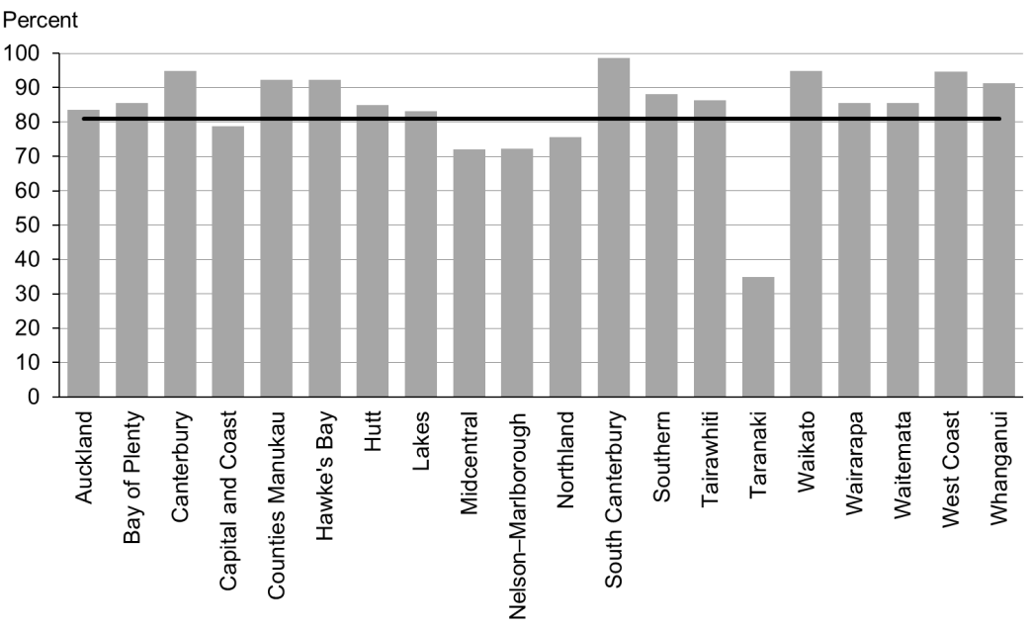

Figure 63: B4 School Checks started before age 4½ years, high deprivation population

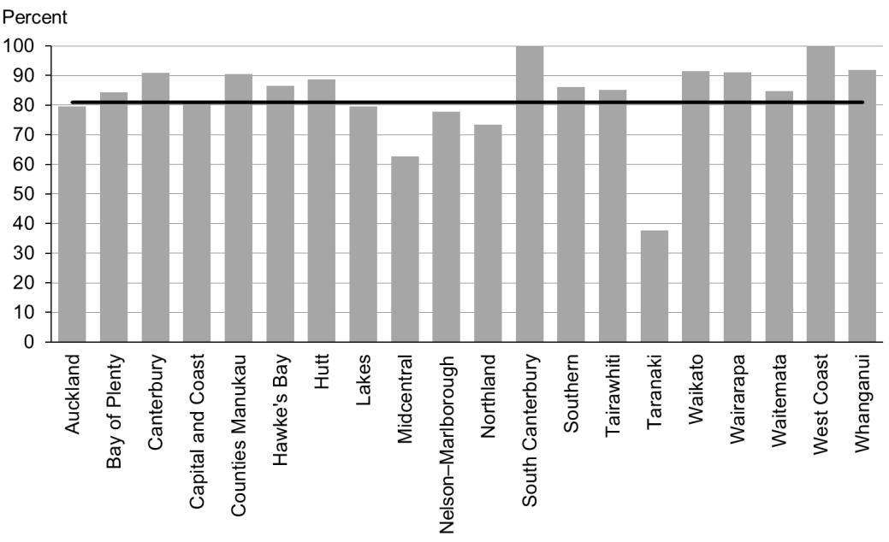

Figure 64: B4 School Checks started before age 4½ years, Māori

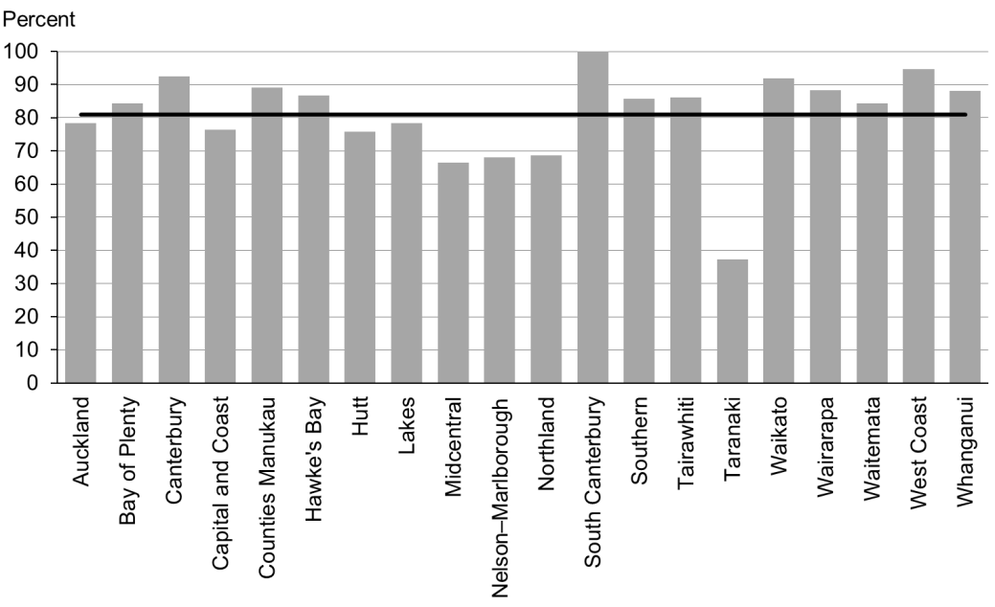

Figure 65: B4 School Checks started before age 4½ years, Pacific peoples

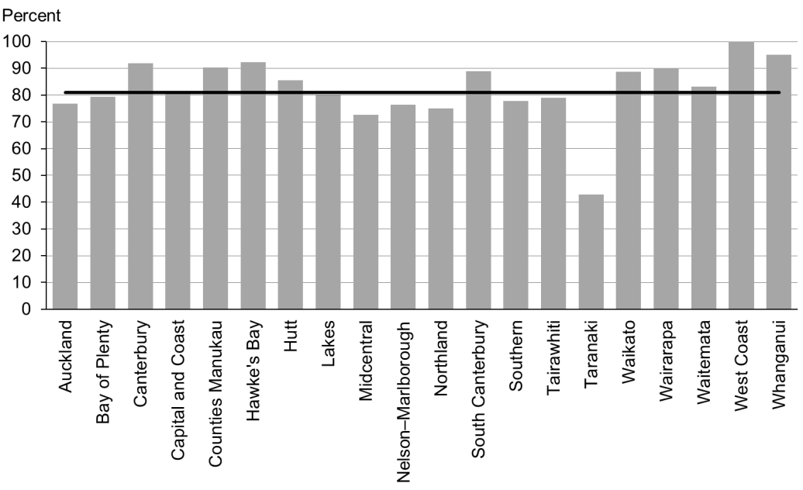

### Data notes

* Time period: children receiving a B4 School Check between 1 July and 31 December 2015.
* DHB is DHB of service.
* Numerator: number of children receiving a B4 School Check who started the check at younger than 4½ years (source: B4 School Check).
* Denominator: number of children receiving a B4 School Check (source: B4 School Check).

## WCTO Quality Improvement Framework Indicator 22

|  |  |
| --- | --- |
| **Standard** | WCTO providers deliver services in accordance with best practice (inappropriate variation is reduced). |
| **Indicator** | Children with an abnormal SDQ-P at the B4 School Check are referred to specialist services. |
| **Target by December 2014** | 86 percent |
| **Target by June 2016** | 95 percent |

|  |  |  |  |  |
| --- | --- | --- | --- | --- |
|  | **Total New Zealand** | **High deprivation** | **Māori** | **Pacific peoples** |
| March 2016 mean – advice or referral | 100% | 100% | 100% | 100% |
| March 2016 mean (range) – referral only | 45% (6–69) | 42% (0–76) | 44% (0–88) | 38% (0–75) |
| September 2015 mean – advice or referral | 100% | 100% | 100% | 100% |
| September 2015 mean (range) – referral only | 44% (13–74) | 44% (0–100) | 48% (0–100) | 30% (0–67) |

Figure 66: Children with abnormal SDQ-P referred, total New Zealand

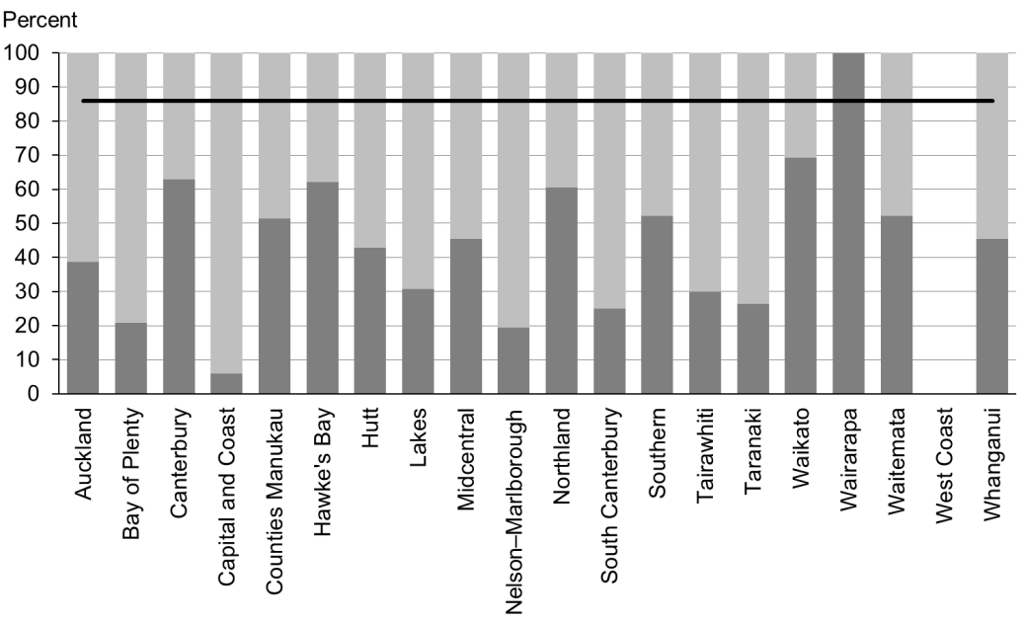

Figure 67: Children with abnormal SDQ-P referred, high deprivation population

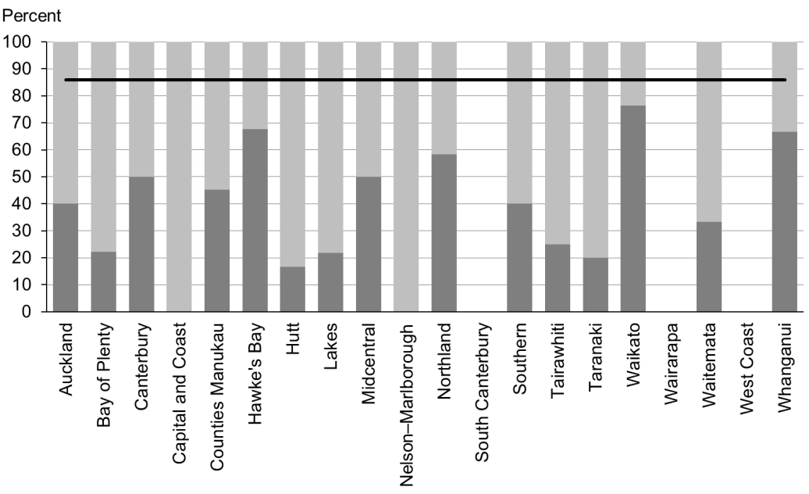

Figure 68: Children with abnormal SDQ-P referred, Māori

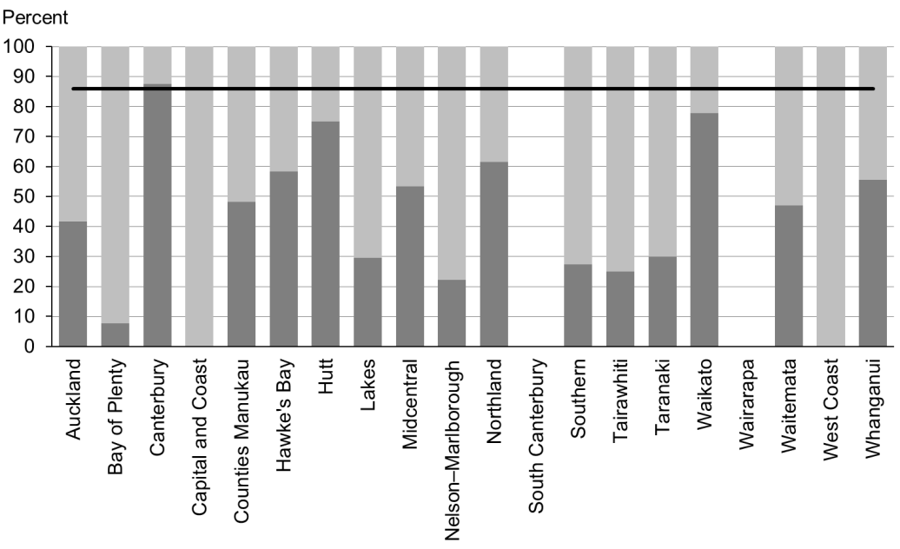

Figure 69: Children with abnormal SDQ-P referred, Pacific peoples

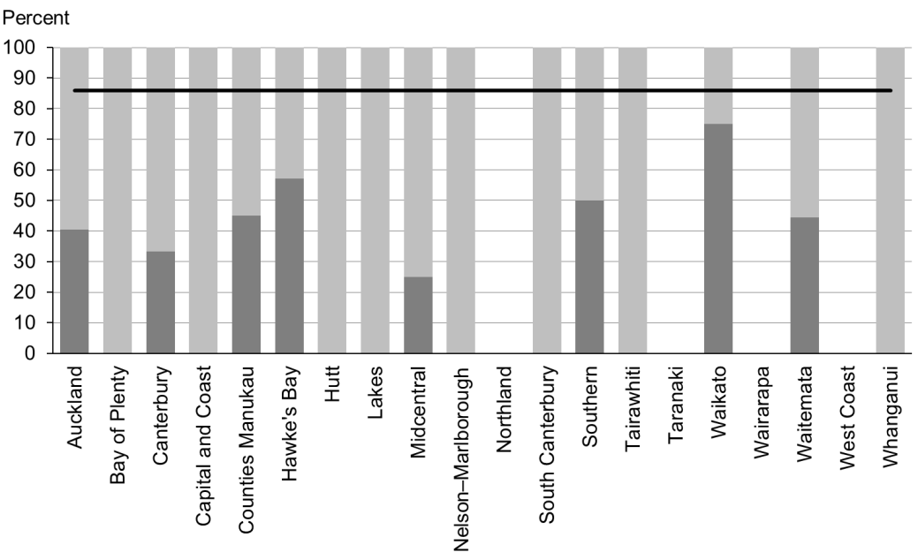

### Data notes

* The stacked bar shows rate of referral excluding ‘advice given’ (dark grey section) and rate of referral including ‘advice given’ (dark grey plus light grey sections).
* No bar on graph = no children with abnormal SDQ-P for that population.
* Time period: children receiving a B4 School Check between 1 July and 31 December 2015.
* DHB is DHB of service.
* Numerator: number of children with an abnormal SDQ-P referred (source: B4 School Check).
* Denominator: number of children with an abnormal SDQ-P (excluding those already under care) (source: B4 School Check).

## WCTO Quality Improvement Framework Indicator 23

|  |  |
| --- | --- |
| **Standard** | WCTO providers deliver services in accordance with best practice (inappropriate variation is reduced). |
| **Indicator** | Children with a Parental Evaluation of Developmental Status (PEDS) Pathway A at the B4 School Check are referred to specialist services. |
| **Target by December 2014** | 86 percent |
| **Target by June 2016** | 95 percent |

|  |  |  |  |  |
| --- | --- | --- | --- | --- |
|  | **Total New Zealand** | **High deprivation** | **Māori** | **Pacific peoples** |
| March 2016 mean – advice or referral | 98% (91–100) | 99% (95–100) | 99% (85–100) | 100% |
| March 2016 mean (range) – referral only | 64% (23–89) | 67% (32–100) | 66% (25–100) | 72% (0–100) |
| September 2015 mean – advice or referral | 98% (80–100) | 99% (92–100) | 98% (88–100) | 98% (0–100) |
| September 2015 mean (range) – referral only | 58% (25–88) | 69% (0–100) | 61% (0–100) | 64% (0–100) |

Figure 70: Children with PEDS Pathway A referred, total New Zealand

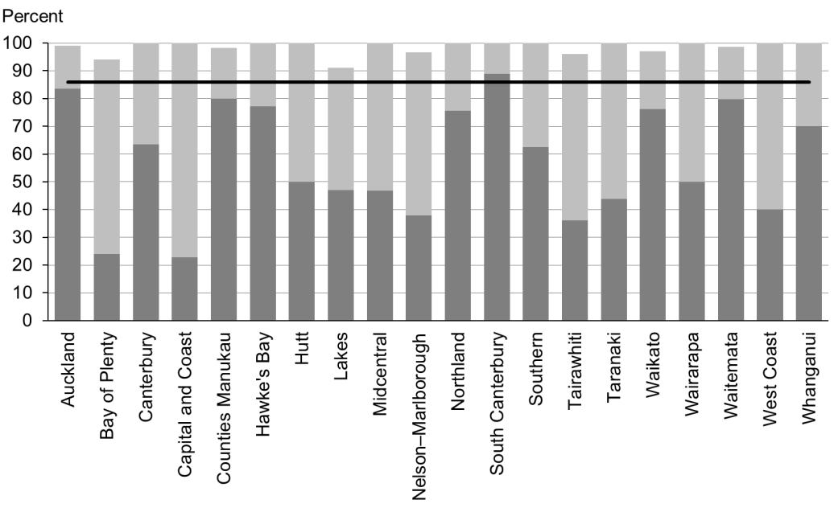

Figure 71: Children with PEDS Pathway A referred, high deprivation population

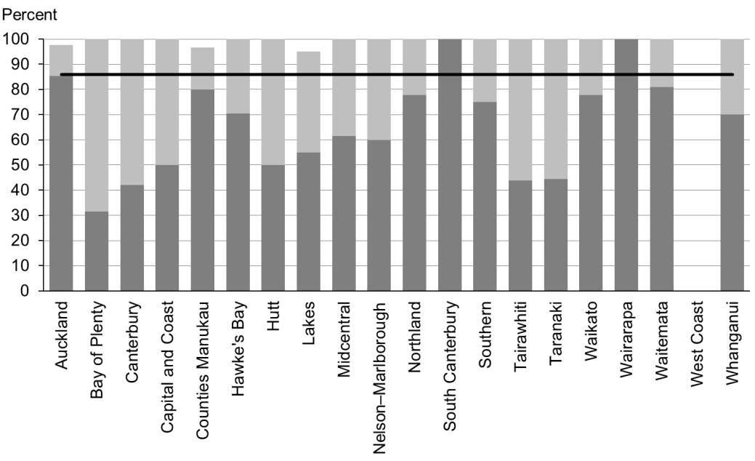

Figure 72: Children with PEDS Pathway A referred, Māori

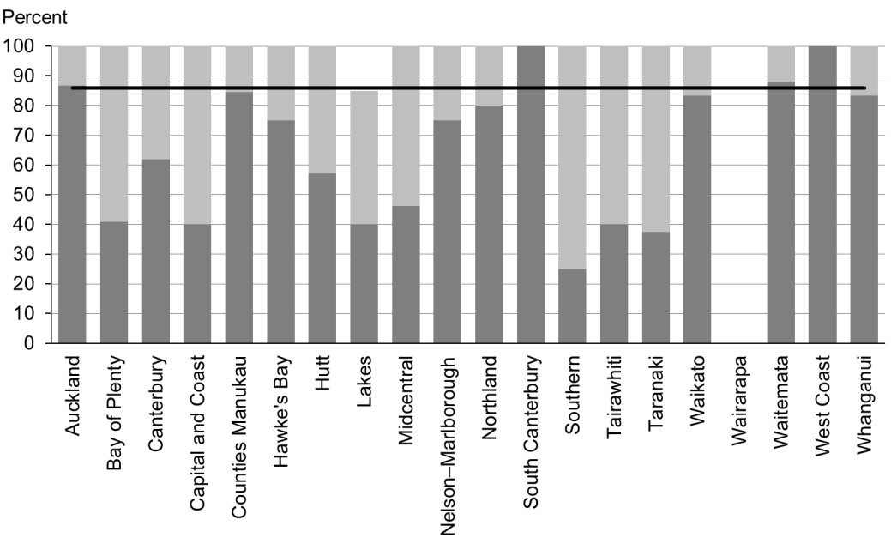

Figure 73: Children with PEDS Pathway A referred, Pacific peoples

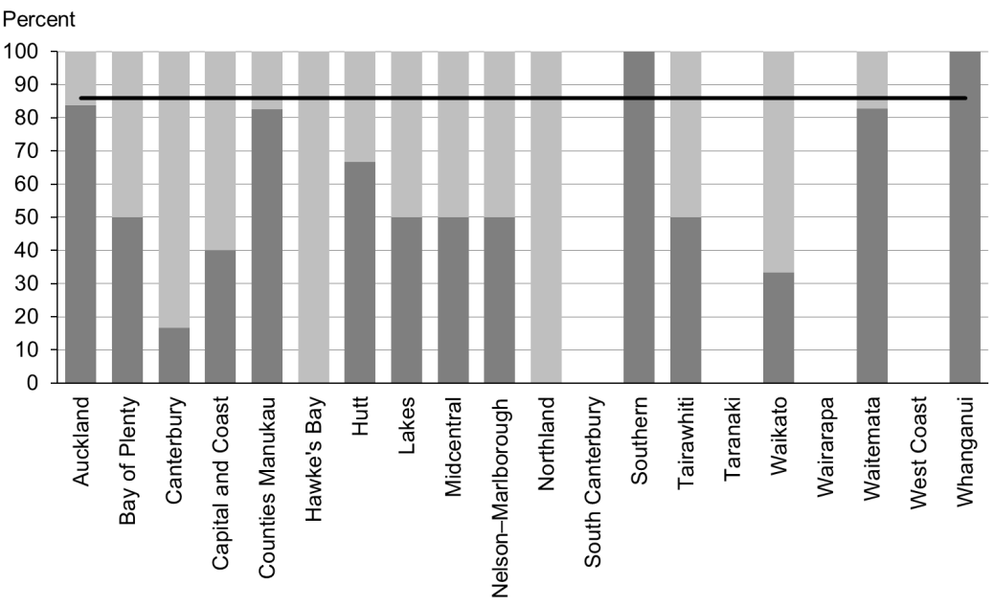

### Data notes

* The stacked bar shows rate of referral excluding ‘advice given’ (dark grey section) and rate of referral including ‘advice given’ (dark grey plus light grey sections).
* No bar on graph = no children with PEDS Pathway A for that population.
* Time period: children receiving a B4 School Check between 1 July and 31 December 2015.
* DHB is DHB of service.
* Numerator: number of children assessed as PEDS Pathway A referred (source: B4 School Check).
* Denominator: number of children assessed as PEDS Pathway A (excluding those already under care) (source: B4 School Check).

## WCTO Quality Improvement Framework Indicator 24

|  |  |
| --- | --- |
| **Standard** | WCTO providers deliver services in accordance with best practice (inappropriate variation is reduced). |
| **Indicator** | Children with a Lift the Lip (oral health) score of 2–6 at the B4 School Check are referred to specialist services. |
| **Target by December 2014** | 86 percent |
| **Target by June 2016** | 95 percent |

|  |  |  |  |  |
| --- | --- | --- | --- | --- |
|  | **Total New Zealand** | **High deprivation** | **Māori** | **Pacific peoples** |
| March 2016 mean – advice or referral | 100% | 100% | 100% | 100% |
| March 2016 mean (range) – referral only | 100% | 100% | 100% | 100% |
| September 2015 mean – advice or referral | 100% | 100% | 100% | 100% |
| September 2015 mean (range) – referral only | 100% | 100% | 100% | 100% |

Figure 74: Children with Lift the Lip score of 2–6 referred, total New Zealand

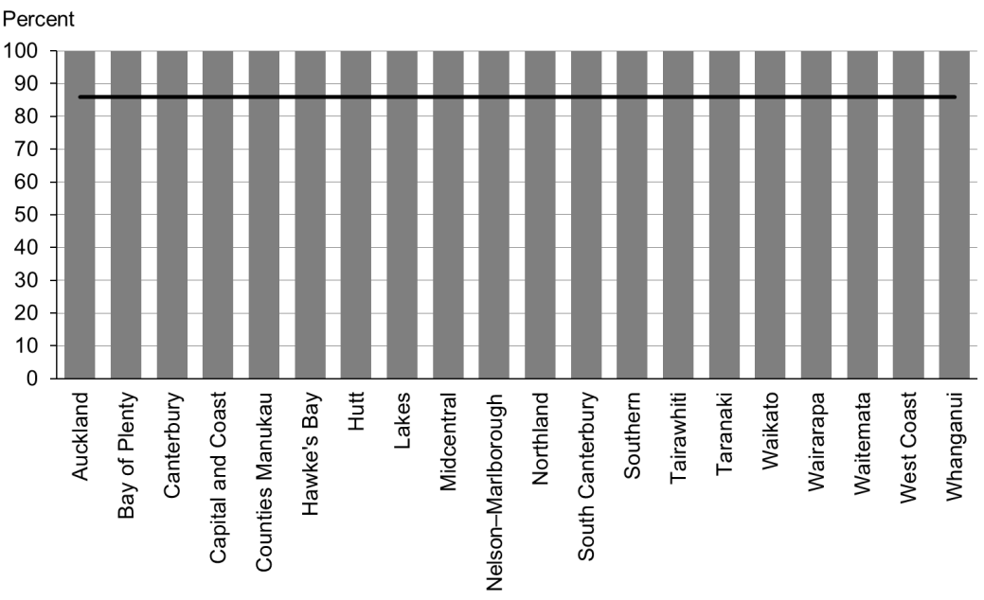

Figure 75: Children with Lift the Lip score of 2–6 referred, high deprivation population

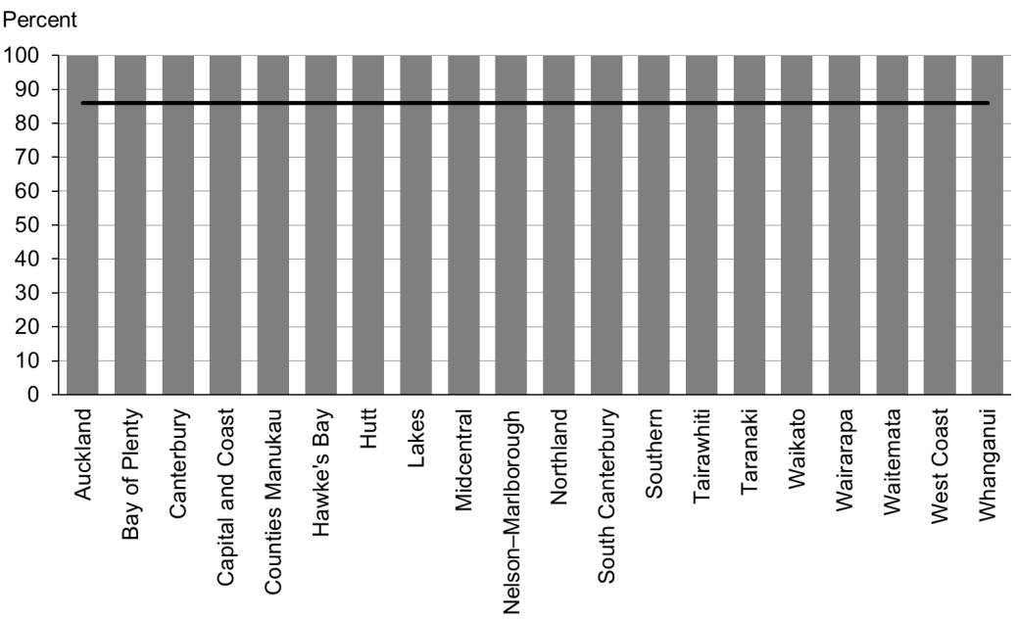

Figure 76: Children with Lift the Lip score of 2–6 referred, Māori



Figure 77: Children with Lift the Lip score of 2–6 referred, Pacific peoples

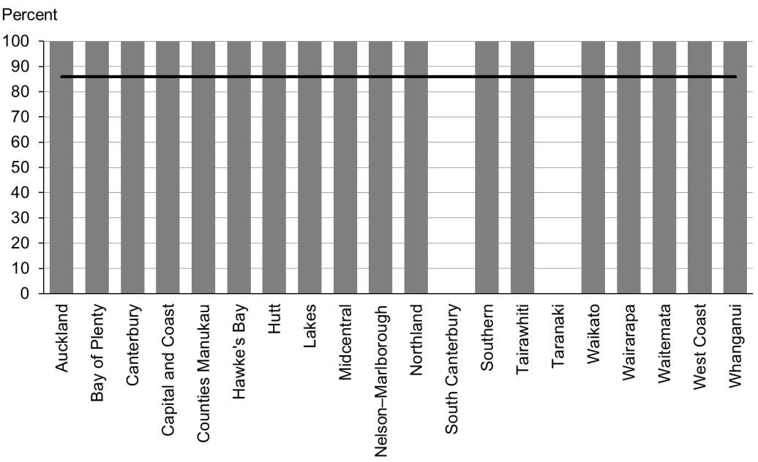

### Data notes

* The stacked bar shows rate of referral excluding ‘advice given’ (dark grey section) and rate of referral including ‘advice given’ (dark grey plus light grey sections).
* No bar on graph = no children with LTL score 2–6 for that population.
* Time period: children receiving a B4 School Check between 1 July and 31 December 2015.
* DHB is DHB of service.
* Numerator: number of children with LTL score of 2–6 referred (B4 School Check).
* Denominator: number of children with LTL score of 2–6 (excluding those already under care) (B4 School Check).

## WCTO Quality Improvement Framework Indicator 25

|  |  |
| --- | --- |
| **Standard** | WCTO providers deliver services in accordance with best practice (inappropriate variation is reduced). |
| **Indicator** | Children with an untreated vision problem at the B4 School Check are referred to specialist services. |
| **Target by December 2014** | 86 percent |
| **Target by June 2016** | 95 percent |

|  |  |  |  |  |
| --- | --- | --- | --- | --- |
|  | **Total New Zealand** | **High deprivation** | **Māori** | **Pacific peoples** |
| March 2016 mean – referrals only | 100% | 100% | 100% | 100% |
| September 2015 mean – referrals | 100% | 100% | 100% | 100% |

Figure 78: Children with an untreated vision problem referred, total New Zealand

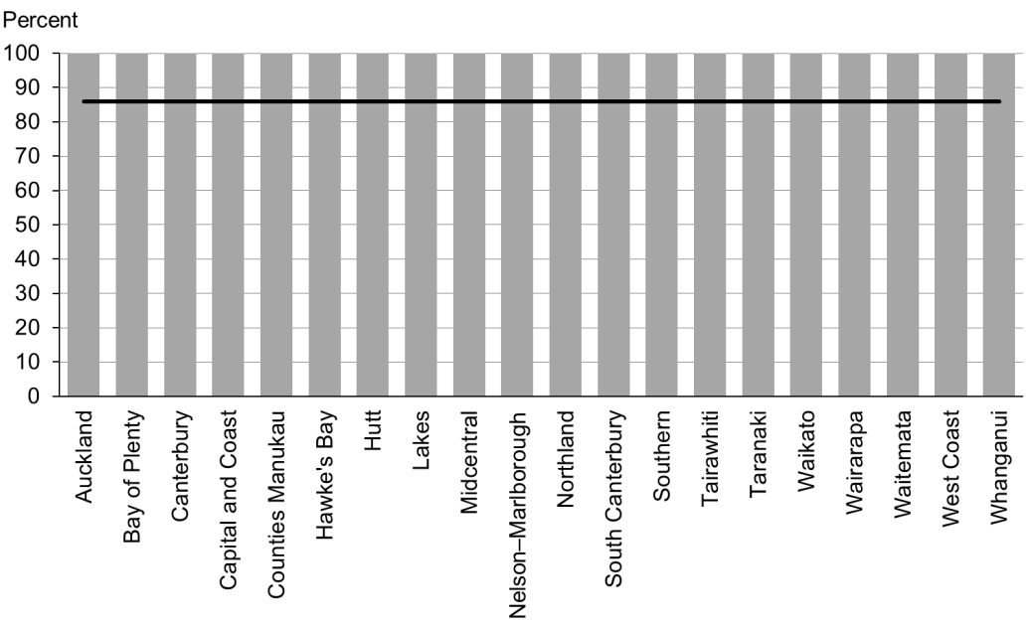

Figure 79: Children with an untreated vision problem referred, high deprivation population

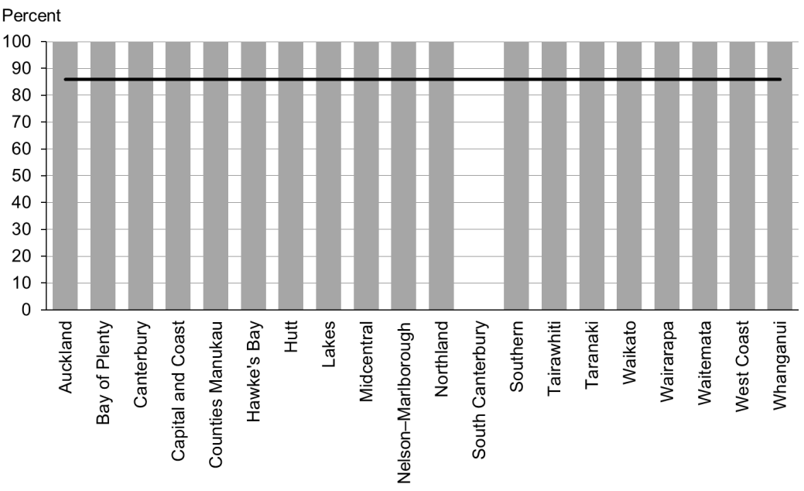

Figure 80: Children with an untreated vision problem referred, Māori

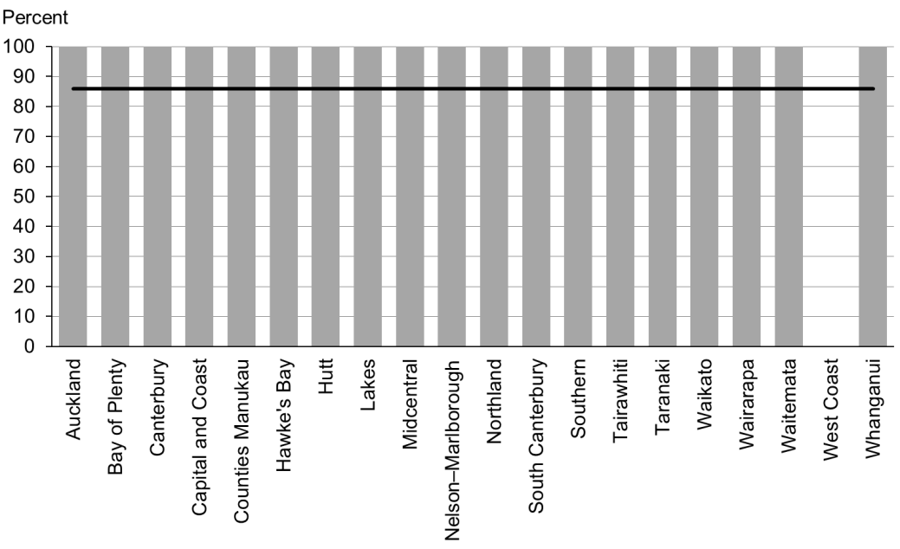

Figure 81: Children with an untreated vision problem referred, Pacific peoples

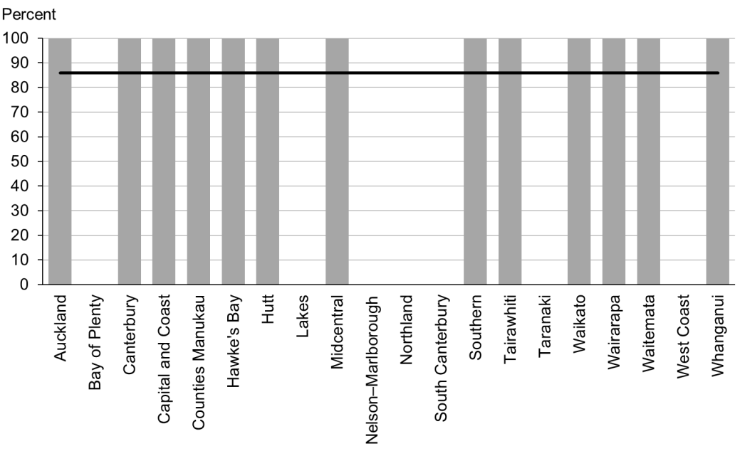

### Data notes

* No bar on graph = no children with untreated vision problem for that population.
* Time period: children receiving a B4 School Check between 1 July and 31 December 2015.
* DHB is DHB of service.
* Numerator: number of children with a vision problem referred (excluding advice given) (source: B4 School Check).
* Denominator: number of children with a vision problem (excluding those already under care) (source: B4 School Check).

## WCTO Quality Improvement Framework Indicator 26

|  |  |
| --- | --- |
| **Standard** | WCTO providers deliver services in accordance with best practice (inappropriate variation is reduced). |
| **Indicator** | Children with an untreated hearing problem at the B4 School Check are referred to specialist services. |
| **Target by December 2014** | 86 percent |
| **Target by June 2016** | 95 percent |

|  |  |  |  |  |
| --- | --- | --- | --- | --- |
|  | **Total New Zealand** | **High deprivation** | **Māori** | **Pacific peoples** |
| March 2016 mean – referrals only | 100% | 100% | 100% | 100% |
| September 2015 mean – referrals only | 100% | 100% | 99% | 100% |

Figure 82: Children with an untreated hearing problem referred, total New Zealand



Figure 83: Children with an untreated hearing problem referred, high deprivation population



Figure 84: Children with an untreated hearing problem referred, Māori

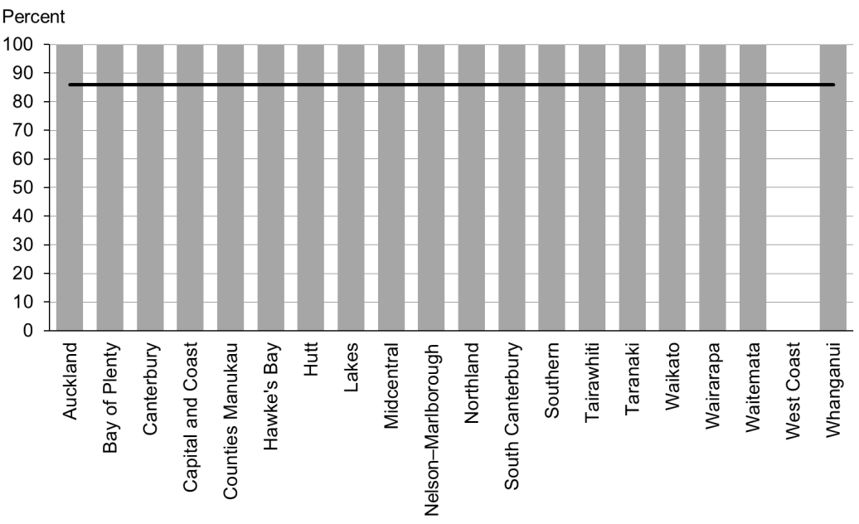

Figure 85: Children with an untreated hearing problem referred, Pacific peoples

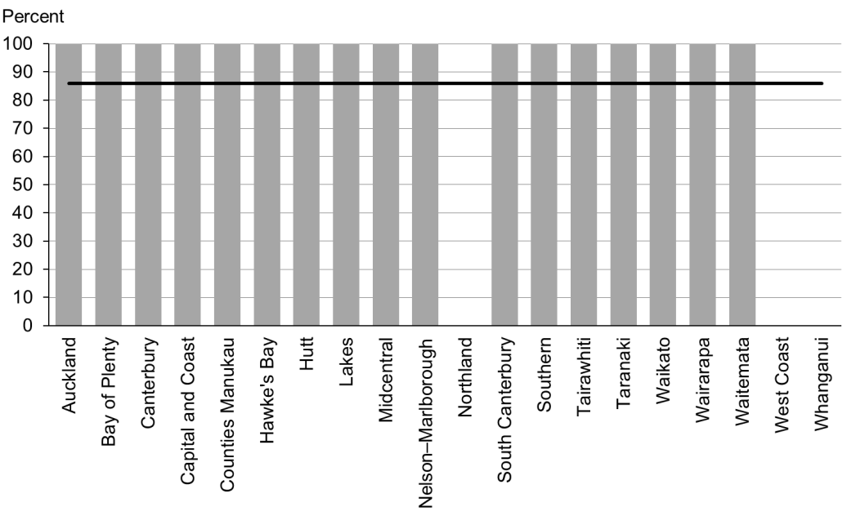

### Data notes

* No bar on graph = no children with untreated hearing problem for that population.
* Time period: children receiving a B4 School Check between 1 July and 31 December 2015.
* DHB is DHB of service.
* Numerator: number of children with a hearing problem referred (excluding advice given) (B4 School Check).
* Denominator: number of children with a hearing problem (excluding those already under care) (B4 School Check).

## WCTO Quality Improvement Framework Indicator 27

|  |  |
| --- | --- |
| **Standard** | WCTO providers deliver services in accordance with best practice (inappropriate variation is reduced). |
| **Indicator** | Children with a body mass index (BMI) greater than the 98th percentile at the B4 School Check are referred to a general practitioner or specialist services. |
| **Target by December 2014** | Not applicable – indicator has changed from >99.4th percentile to >98th percentile |
| **Target by June 2016** | Not applicable – indicator has changed from >99.4th percentile to >98th percentile |

|  |  |  |  |  |
| --- | --- | --- | --- | --- |
|  | **Total New Zealand** | **High deprivation** | **Māori** | **Pacific peoples** |
| March 2016 mean – advice or referral | 55% (0–60) | 57% (6–51) | 58% (0–100) | 54% (33–100) |
| March 2016 mean (range) – referral only | 31% (10–60) | 36% (0–60) | 29% (6–51) | 39% (0–100) |
| September 2015 mean – advice or referral | Not applicable – indicator has changed from >99.4th percentile to >98th percentile | | | |

Figure 86: Children with body mass index > 98th percentile referred, total New Zealand

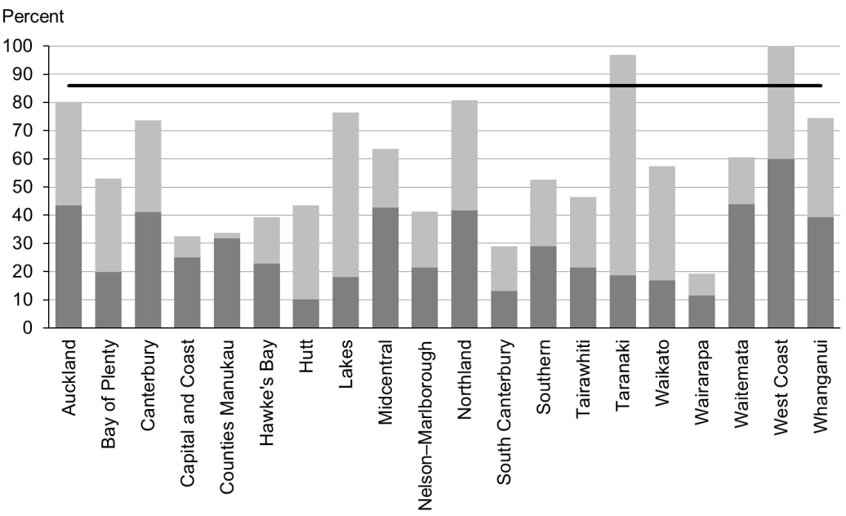

Figure 87: Children with body mass index > 98th percentile referred, high deprivation population

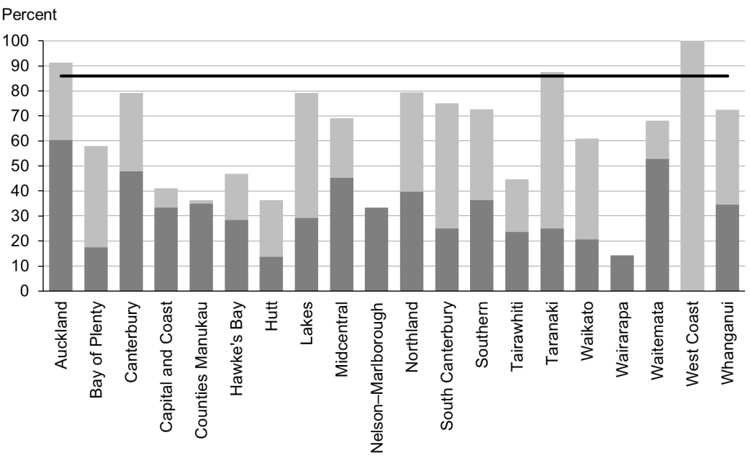

Figure 88: Children with body mass index > 98th percentile referred, Māori

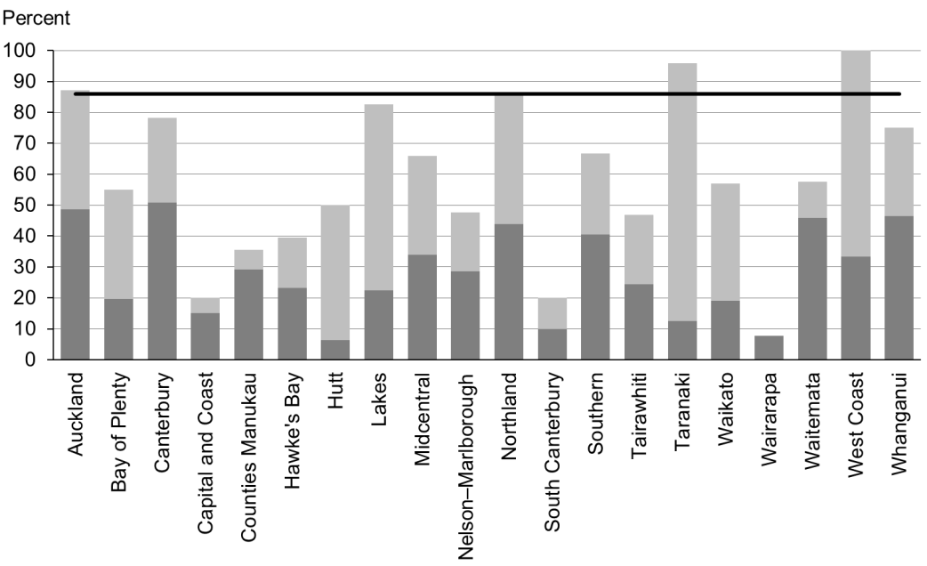

Figure 89: Children with body mass index > 98th percentile referred, Pacific peoples

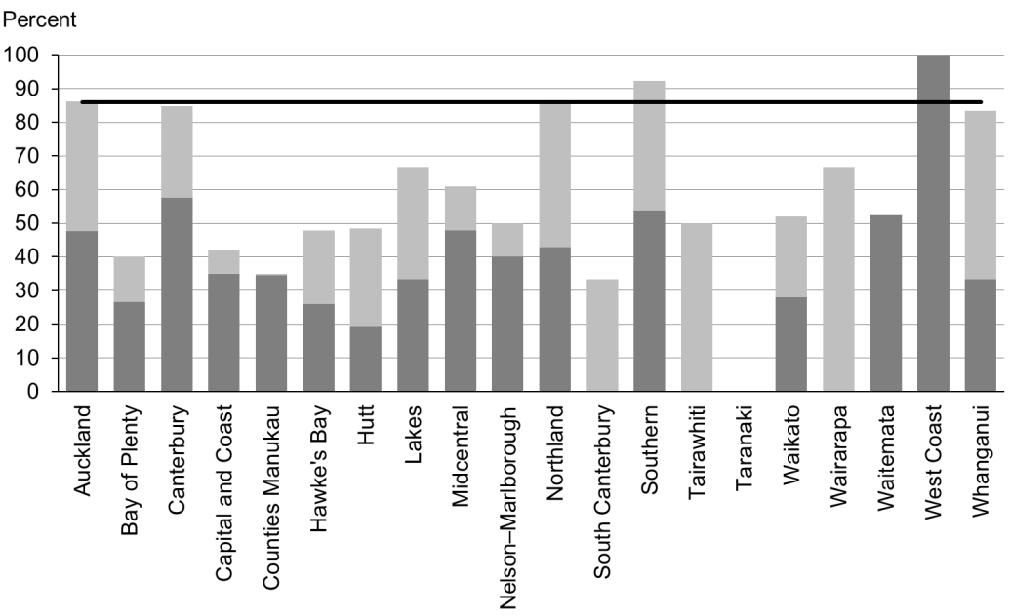

### Data notes

* The stacked bar shows rate of referral excluding ‘advice given’ (dark grey section) and rate of referral including ‘advice given’ (dark grey plus light grey sections).
* No bar on graph = no data provided.
* Time period: children receiving a B4 School Check between 1 July and 31 December 2015.
* DHB is DHB of service.
* Numerator: number of children with a BMI greater than the 98th percentile referred (source: B4 School Check).
* Denominator: number of children with a BMI greater than the 98th percentile (excluding those already under care) (source: B4 School Check).

# Appendix 1: Targets for the quality indicators

|  |  |  |  |  |
| --- | --- | --- | --- | --- |
|  |  | **Indicator** | **December 2014 target** | **June 2016 target** |
| Access | 1 | Newborns are enrolled with a general practice by two weeks * | 88% | 98% |
| 2 | Families and whānau are referred from their LMC to a WCTO provider | 88% | 98% |
| 3 | Infants receive all WCTO core contacts due in their first year | 86% | 95% |
| 4 | Four-year-olds receive a B4 School Check | 90% | 90% |
| 5 | Preschool children are enrolled with child oral health services | 86% | 95% |
| 6 | Immunisations are up to date by eight months | 95% | 95% |
| 7 | Children participate in early childhood education | 98% | 98% |
| 8 | Children under six years have access to free primary care | 98% | 100% |
| 9 | Children under six years have access to free after-hours primary care | 98% | 100% |
| 10 | Children are seen promptly by specialist services | 100% in 5 months | 100% in 4 months |
| Outcomes | 11 | Infants are exclusively or fully breastfed at two weeks | 72% | 80% |
| 12 | Infants are exclusively or fully breastfed at discharge from LMC | 68% | 75% |
| 13 | Infants are exclusively or fully breastfed at three months | 54% | 60% |
| 14 | Infants are receiving breast milk at six months (exclusively, fully or partially) | 59% | 65% |
| 15 | Children are a healthy weight at four years | 68% | 75% |
| 16 | Children are caries free at five years | 65% | 65% |
| 17 | The burden of dental decay among children with one or more decayed, missing or filled (dmft) deciduous (baby) teeth is minimised (average dmft) | 4.4 | 4 |
| 18 | Child mental health is supported (normal SDQ-P score) | 86% | 95% |
| 19 | Mothers are smokefree at two weeks postnatal | 86% | 95% |
| 20 | Children live in a smokefree home (age four years) | 90% | 100% |
| Quality | 21 | B4 School Checks are started before children are 4½ years | 81% | 90% |
| 22 | Children with an abnormal SDQ-P score are referred to specialist services | 86% | 95% |
| 23 | Children with a PEDS Pathway A are referred to specialist services | 86% | 95% |
| 24 | Children with a Lift the Lip (oral health) score of 2–6 are referred to specialist services | 86% | 95% |
| 25 | Children with an untreated vision problem are referred to specialist services | 86% | 95% |
| 26 | Children with an untreated hearing problem are referred to specialist services | 86% | 95% |
| 27 | Children with a BMI > 98th percentile are referred to a general practice or specialist services [4] | n/a | n/a |

Notes

* Data to monitor this indicator is not yet available. Primary health organisation enrolment at three months will be used as a de facto indicator in the interim.

# Appendix 2: Membership of the Expert Advisory Group

|  |  |  |
| --- | --- | --- |
| **Name** | **Role(s)** | **Representing** |
| Helen Connors | WCTO nurse and clinical advisor | Royal New Zealand Plunket Society |
| Dave Graham | Paediatrician – Waikato DHB, chair of Midland Child Health Action Group and member of the Paediatric Society of New Zealand | Paediatric Society of New Zealand |
| Christine Griffiths | Lead maternity carer, lecturer Otago Polytechnic and expert advisor to the New Zealand College of Midwives | New Zealand College of Midwives |
| Tui Makoare-Iefata | WCTO nurse/team leader – Ngāti Whātua o Orakei and Tamariki Ora provider national representative | Tamariki Ora providers |
| Gail Tihore | Vision and hearing technician – Hutt Valley DHB | Vision Hearing Technicians Society |
| Pat Tuohy | Paediatrician – Hutt Valley DHB and chief advisor child and youth health | Ministry of Health |
| Nikki Turner | General practitioner, associate professor Auckland University and director of Conectus and the Immunisation Advisory Centre | New Zealand College of General Practitioners |
| Russell Wills | Paediatrician – Hawke’s Bay DHB and children’s commissioner | Office of the Children’s Commissioner |
| Mollie Wilson | WCTO nurse and CEO of the Paediatric Society of New Zealand | Paediatric Society of New Zealand |

Note: This list presents membership as at March 2016. The Ministry would like to thank previous members of the EAG for their work.

1. Indicator 1 was designed to measure enrolment with a general practice by two weeks of age. This data was not available at the time of writing, and so enrolment with a PHO by three months of age has been used as an interim measure.
2. SDQ stands for ‘strengths and difficulties questionnaire’. It refers to a questionnaire used within the B4SC to assess a child’s social and emotional development. There are two versions: one for parents (SDQ-P) and one for teachers (SDQ-T).
3. A ‘smokefree home’ for the purposes of the indicator is defined as one in which parents do not smoke indoors.
4. In previous reports, Indicator 27 was ‘Children with a BMI >99.4th percentile are referred’. It has been changed to >98th percentile to align with the new Health Target.