

Completing
Private Hospitals
Discharge Form
(ADF96)

CLASSIFICATION & TERMINOLOGY
NATIONAL COLLECTIONS & REPORTING, CLIENT INSIGHTS & ANALYTICS

November 2017

Introduction 3
When to use ADF96 forms 3
Filling in the form 3
Sending completed forms 3-4
Other information 4
Some definitions 4-5
Patient identification 6
Patient National Health Index number (NHI) (mandatory field) 6
Family name (mandatory field) 6
First given name (mandatory field) 6
Second given name 6
Third given name 6
Patient information 7
Date of birth (mandatory field) 7
Sex (M or F) (mandatory field) 7
NZ resident (mandatory field) 7
Ethnicity (mandatory field) 7-8
Patient’s usual residential address 8
Event information 9
Health facility name (mandatory field) 9
HAF code (mandatory field) 9
Admission date (mandatory field) 9
Discharge date (mandatory field) 9
Admission type (mandatory field) 9
Discharge type (mandatory field) 9
Principal purchaser (mandatory field) 9-10
Infants born at the facility 11

Birth weight (mandatory field) 11
Gestation in weeks (mandatory field) 11
Mother's NHI (mandatory field) 11
Mother's age (mandatory field) 11

Postnatal/neonatal admissions…………...................... 11

(Weight on admission) (mandatory field)
Diagnosis and procedure data 12
Principal diagnosis description (mandatory field) 12
Other diagnosis, procedure or external cause (provide if applicable) 12-13

Introduction

This guide will assist private hospitals, privately owned healthcare facilities, hospices, and those providing maternity services. The purpose is to provide accurate hospital discharge data to the National Collections & Reporting Group within the Ministry of Health.

The hospital discharge data that is provided forms part of the national dataset of hospitalisation data in the National Minimum Data Set (NMDS).

http://www.health.govt.nz/publication/national-minimum-dataset-hospital-events-data-mart-data-dictionary

- It follows a step-by-step method.
- It includes all relevant information and instructions.
- It will be useful as a training tool.
- It will be useful as a reference guide.

When to use ADF96 forms

A form needs to be filled in when the patient is discharged, or transferred, or has died.
Please do not send in ADF96 forms for residents in rest home beds.

ADF96 forms must be filled in for
- inpatients – patients who remain in hospital overnight
- day patients – patients who attend for more than three hours and do not remain overnight
- a patient – a patient who dies while in hospital.
- Maternity patients – maternity events where there is an outcome of delivery

Filling in the form

The ADF96 form must be filled in to provide National Collections & Reporting, with the minimum of useful information. We cannot emphasise enough the importance of making sure that all writing is legible and in capital letters where appropriate. The form provided on the website can be typed into then printed off.
The mandatory fields are marked in this guide.

Sending completed forms

ADF96 forms can be used by the hospital as part of the Register requirements if desired. Batches of completed forms are to be sent monthly to ensure an even workflow and up-to-date information. A monthly batch is to contain all discharge forms from the previous month. Forms are to be sent in batches of no more than 200 for security reasons.

ADF96 forms can be sent in quarterly batches if a hospital generates fewer than 10 discharge forms per month on average. In all instances, all ADF96 forms for any calendar quarter (e.g. January-February-March) must arrive within 28 days from the end of that quarter.

Please also consider the option of sending discharge data electronically through a secure channel to our FTP server. You can contact us on the phone number below for further information.

You can send completed forms to:

Postal address: Private Hospitals
National Collections & Reporting
Ministry of Health
PO Box 5013
Wellington 6145

Telephone: (04) 816 2872 Team Leader
(04) 816 2875 Administrator
Fax: (04) 816 2897

Other information

Assigning the correct National Health Index (NHI) number, patient identification, patient information and diagnosis and procedure information provided to us is to be accurate and complete as possible.

Private Hospitals provides the Ministry of Health and the District Health Boards the data gathered from the ADF96 discharge form. The importance of accurate data that is provided helps to guarantee the integrity and accuracy of the data in the National Minimum Data Set.

Some definitions

ADF96: Private hospital discharge form was first used in 1996. A copy can be found on Ministry of Health, Publications, Private Hospitals Discharge Form-for supply of statistical information by hospitals (ADF96) web site at www.health.govt.nz/publication/completing-adf96-private-hospital-discharge-forms

Dates: All dates on the ADF96 forms are to be filled in as DDMMYYYY.
DD refers to the day, MM to the month, and YYYY to the year.

Examples: • the third of September 2001 is to be reported as
03/09/2001
• the fourteenth of October 2001 is to be reported as
14/10/2001

DHB: District Health Board.

HAF: Health agency facility. This is the healthcare facility (hospital or hospice) where the patient is treated. Each healthcare facility has been allocated a code number by the Ministry for reporting purposes.

HCU: Healthcare User Number

MOH: Ministry of Health (the Ministry)

NHI: The National Health Index is an alphanumeric index that uniquely identifies health care users who access New Zealand public health services. It contains only information related to the identification of patients.

NMDS: National Minimum Dataset is a national collection of public and private hospital discharge information.

Patient identification

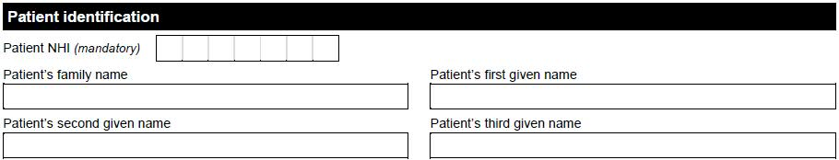

Patient National Health Index number (NHI) (mandatory field)
Please enter the patient’s NHI number.
Leave this blank only if the NHI number is not known. Private Hospitals will assign it, based on the patient information that is provided.
This is also known as the Healthcare User (HCU) number.

Family name (mandatory field)

The patient’s surname.

First given name (mandatory field)
The patient’s first given name.

Second given name

The patient’s second given name. Please provide this if available.

Third given name
The patient’s third given name. Please provide this if available.

Patient information

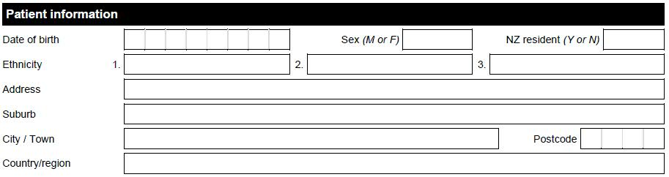

Date of birth (mandatory field)
The patient’s date of birth (entered as DDMMYYYY).

Sex (mandatory field)
The patient’s gender (sex) – ‘M’ (male) or ‘F’ (female).

NZ resident (mandatory field)
Is the patient a resident of New Zealand? – ‘Y’ (yes) or ‘N’ (no).
A person is judged to be a resident of New Zealand for reporting purposes if they are a New Zealand citizen or classified as ‘ordinarily resident in New Zealand.’

Ethnicity (mandatory field)
The patient’s ethnicity. A two-digit code from the list below or a description in the empty space to the right of the Ethnicity group fields.
The patient may identify the ethnic groups they feel they belong to. Up to three ethnic groups may be reported on the ADF96 form.

10 | European not further defined
11 | NZ European
12 | Other European (stated ethnicity not listed)
21 | NZ Maori
30 | Pacific Island not further defined
31 | Samoan
32 | Cook Island Maori
33 | Tongan
34 | Niuean
35 | Tokelauan
36 | Fijian
37 | Other Pacific Island (stated ethnicity not listed)
40 | Asian not further defined
41 | South East Asian
42 | Chinese
43 | Indian
44 | Other Asian (stated ethnicity not listed)
51 | Middle Eastern
52 | Latin American / Hispanic
53 | African
99 | Not stated

Patient’s usual residential address
The patient’s address where they have been, or plan to be, living for three months or more. Provide the address as completely as possible.

Event information

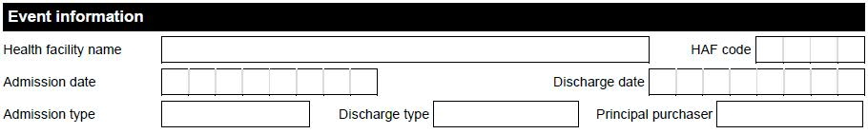

Health facility name (mandatory field)
Report the name of the hospital or healthcare facility where the patient is being treated.

HAF code (mandatory field)
The four-digit code unique to your hospital.
Please contact the Data Administrator for Private Hospitals, if this code is not known.

Admission date (mandatory field)
The date the patient was admitted to your hospital or healthcare facility.
This is sometimes known as the ‘Event Start Date’.

Discharge date (mandatory field)
The date the patient was discharged or transferred from your hospital or healthcare facility, or the date the patient died whilst still in care.

This is sometimes known as the ‘Event End Date’.

Admission type (mandatory field)
A single-digit code from the list below describing whether the patient’s admission was routine or a transfer from another hospital or healthcare facility.

R | Routine
T | Transfer from another hospital or healthcare facility

Discharge type (mandatory field)
A two-digit code from the list below describing the type of discharge from your hospital or healthcare facility. DD, DR, and DT are the most common.
This is sometimes known as the ‘Event End Type’.

DR | Ended routinely
DT | Discharge of patient to another healthcare facility (transferred)
DD | Died
DI | Self-discharge from hospital (indemnity signed)
DS | Self-discharge from hospital (no indemnity)

Principal purchaser (mandatory field)
A two-digit code from the list below identifying the organisation or body which purchased the healthcare service provided. The purchaser who paid the most should be selected in cases that have more than one purchaser, unless the MOH (previously HFA) or DHB have been involved in funding (subsidy, top-up, partial, or full). In this case, in the Principal purchaser field use code 34 when the health care service is MOH Funded or code 35 when the health care service is DHB-Funded.
____________________________________________________________

06 Privately funded NZ citizens
34 MOH-funded purchase
35 DHB-funded purchase
98 Other / Mixed Funding
A0 ACC – direct purchasing
____________________________________________________________

Infants born at the facility

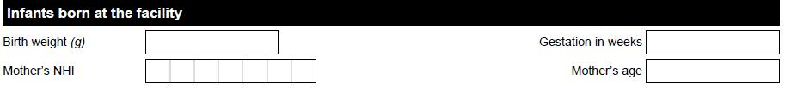

Only the hospital in which a birth takes place should provide the following information. No ADF96 form is to be sent for stillborn neonates, as this information will be available to Classification and Terminology through the death registration process.

Birth weight (g) (mandatory field)
A four-digit value giving the infants weight in grams at birth.
The acceptable range is 0001 to 9999 grams.

Gestation in weeks (mandatory field)
The number of completed weeks since the mother’s last menstrual period.

Mother’s NHI (mandatory field)
Mother’s NHI (so that baby can be linked to mother in case forms get separated)

Mother’s age (mandatory field)
The age of the mother in complete years at the time of birth.

Postnatal/neonatal admissions (aged less than 29 days)

For mothers and babies where only postpartum/postnatal care was provided at the hospital

Weight on admission
The weight, in grams, of any infant patient.
Infants are those who are under 29 days of age. Acceptable values are between 0001 and 9999 grams.

Diagnosis and procedure data

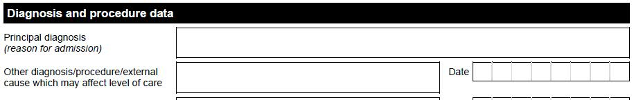

Please enter only the most final diagnosis available. Provisional diagnoses should not be entered when it is possible to enter more complete information. Do not mention on this form any operation that is expected to be performed.
The following guidelines will help full and accurate information to be entered on the form. They are by no means exhaustive.

If in doubt, write it down. The more information the better.

- If diagnoses such as CVA (stroke) or fracture are mentioned, for instance, then you should also state whether acute care is being given or whether that time has passed and care is needed now because of residual effects. The nature of any residual effects (such as hemiparesis, aphasia, or non-union, in the case of a fracture) should also be entered as separate diagnoses.

- The nature (traumatic or pathological) and site of a fracture is also required.

- Where malignancy is mentioned, please indicate for each site
whether primary or secondary
whether removed without mention of recurrence (history of) or still present.

- When the admission is to give relief to the usual carer(s) (respite care) then please enter this as the principal diagnosis. The conditions affecting the patient should be entered as secondary diagnoses.

Principal diagnosis description (mandatory field)
Description of the principal diagnosis. The principal diagnosis is the condition or disease which is established, after study, to be chiefly responsible for the patients hospitalisation.
Diagnosis description that are unacceptable: general decline, old age, frailty.

Other diagnosis, procedure or external cause (provide if applicable)
Circle ‘Diagnosis’, ‘Procedure’, or ‘External cause’ to indicate the type for each of these entries.

Other diagnosis:
Provide a description. No date information is required.
‘Other diagnoses’ refers to secondary diagnoses.

Procedure:
Provide description of each procedure and the date on which each procedure was performed.
All significant procedures should be documented. One or more of the following conditions means that the procedure is significant:
- it is surgical in nature
- it carries a procedural risk
- it carries an anaesthetic risk
- it requires special facilities or equipment or specialised training.

External cause:
Enter the date of the external cause and a description.
External cause descriptions and dates must immediately follow the diagnoses resulting from them. Describe the external cause (accident, assault, poisoning, etc) where this is responsible for the patient’s condition.

