Indicators for the Well Child /  
Tamariki Ora  
Quality Improvement Framework: September 2015

Citation: Ministry of Health. 2016. *Indicators for the Well Child / Tamariki Ora Quality Improvement Framework: September 2015*. Wellington: Ministry of Health.

Published in February 2016  
by the Ministry of Health  
PO Box 5013, Wellington 6145, New Zealand

ISBN: 978-0-947491-63-5 (online)  
HP 6348

This document is available at health.govt.nz



### CCBY This work is licensed under the Creative Commons Attribution 4.0 International licence. In essence, you are free to: share ie, copy and redistribute the material in any medium or format; adapt ie, remix, transform and build upon the material. You must give appropriate credit, provide a link to the licence and indicate if changes were made.

# Foreword from the Expert Advisory Group

The Well Child / Tamariki Ora (WCTO) Quality Improvement Framework Expert Advisory Group (EAG) welcomes this fifth report on the indicators for the Quality Improvement Framework. We wish to acknowledge the WCTO sector’s commitment to improving services for children and their families and whānau. We hope that this report is used to close the quality improvement loop by helping service providers to identify what is working and what is not in terms locally. We see the WCTO Quality Improvement Framework as a tool to support each level of the sector to achieve family-centred, high-quality, equitable and effective child health services that deliver the best possible health outcomes for all New Zealand children and their families and whānau.

The EAG met in December 2015 to review the WCTO quality indicators set, to ensure it reflects the sector’s current priorities. The discussion focussed on the benefits of replacing targets that are routinely being achieved with one that better addresses gaps in access, outcomes or quality. Additionally, we have access to different data sets now than we did when we first developed the indicators; this may also influence the revised set. Before the next report (March 2016) is released, we will inform the sector of any changes that will be made.

In the second indicators report (September 2013) we quoted Nelson Mandela, who said ‘[t]here can be no keener revelation of a society’s soul than the way in which it treats its children’. We, the EAG, will keep that in mind in our review of the indicators. How can we to build a system that treats our children as taonga and ensures we work in partnership with families to help them grow strong, healthy and resilient? In the next report, we will put that question to you: how can YOU help build such a system?

For now, we would like to take the opportunity to thank the sector for the work they have put into achieving these current indicators – it is impressive that 8 of the 27 indicators are at least 98 percent achieved across all groups. Achievement against other indicators is tracking at about the December 2014 targets, or has already reached June 2016 targets. This assures us that children are getting most of the services they require.

There is still significant work to be done. For example, targets linked to childhood obesity will be a focus for the sector going forward. Dr Jonathan Coleman, Minister of Health, announced in October 2015 a package of 22 initiatives to help reduce childhood obesity, including a health target that ‘by December 2017, 95 percent of obese children identified in the Before School Check (B4SC) programme will be offered a referral to a health professional for clinical assessment and family based nutrition, activity and lifestyle interventions.’ The context of the target is the B4SC because of its focus on early intervention to ensure positive, sustained effects on health. The government is planning increased support for families with overweight children and other initiatives such as public health campaigns and proactive work with the food industry, alongside the target.

Achievement against many indicators has not improved since our last report – neither in total population figures nor in the reduction of inequities for high-deprivation, Māori or Pacific people’s communities. We hope a revitalised set of indicators will help the sector push forward with the next generation of children.

We thank you for being part of the journey so far, and hope that you continue to travel forward with us.

# Summary of national results

| **Quality indicator** | **March 2015** | | | | **September 2015** | | | |
| --- | --- | --- | --- | --- | --- | --- | --- | --- |
| **Total** | **High dep** | **Māori** | **Pacific** | **Total** | **High dep** | **Māori** | **Pacific** |
| 1. Newborns are enrolled with a general practice by three months* | 65% | N/A | 70% | 60% | 74% | N/A | 78% | 73% |
| 2. Families and whānau are referred from their LMC to a WCTO provider | 97% | 97% | 96% | 98% | 98% | 98% | 97% | 98% |
| 3. Infants receive all WCTO core contacts due in their first year | 76% | 68% | 67% | 63% | 68% | 55% | 52% | 53% |
| 4. Four-year-olds receive a B4SC | 93% | 86% | 85% | 83% | 94% | 90% | 87% | 93% |
| 5. Children are enrolled with child oral health services | 73% | N/A | 59% | 68% | 77% | N/A | 68% | 78% |
| 6. Immunisations are up to date by eight months | 94% | 93% | 92% | 96% | 93% | 91% | 90% | 95% |
| 7. Children participate in ECE | 96% | 89% | 94% | 91% | 96% | 100% | 94% | 91% |
| 8. Children under six years have access to free primary care | 99% | 100% | 100% | 100% | 100% | 100% | 100% | 100% |
| 9. Children under six years have access to free after-hours primary care | 98% | N/A | N/A | N/A | 99% | N/A | N/A | N/A |
| 10. Children are seen promptly by specialist services | 99% | N/A | N/A | N/A | 100% | N/A | N/A | N/A |
| 11. Infants are exclusively or fully breastfed at two weeks | 79% | 76% | 77% | 74% | 78% | 74% | 76% | 72% |
| 12. Infants are exclusively or fully breastfed at discharge from LMC | 74% | 71% | 69% | 72% | 66% | 59% | 62% | 57% |
| 13. Infants are exclusively or fully breastfed at three months | 55% | 44% | 45% | 46% | 55% | 45% | 45% | 47% |
| 14. Infants are receiving breast milk at six months | 66% | 56% | 55% | 59% | 66% | 56% | 54% | 59% |
| 15. Children are a healthy weight at four years | 75% | 69% | 71% | 61% | 75% | 68% | 72% | 60% |
| 16. Children are caries free at five years | 57% | N/A | 37% | 36% | 59% | N/A | 40% | 36% |
| 17. The burden of dental decay is minimised (average dmft) | 4.4 | N/A | 5.0 | 5.1 | 4.41 | N/A | 4.98 | 5.07 |
| 18. Child mental health is supported (normal SDQ-P score) | 96% | 93% | 94% | 95% | 96% | 94% | 94% | 95% |
| 19. Mothers are smokefree at two weeks postnatal | 87% | 76% | 65% | 91% | 87% | 78% | 66% | 92% |
| 20. Children live in a smokefree home (age four years) | 98% | 97% | 97% | 97% | 98% | 97% | 97% | 97% |
| 21. B4SCs are started before children are 4½ years | 85% | 82% | 80% | 82% | 85% | 84% | 81% | 84% |
| 22. Children with an abnormal SDQ-P score are referred** | 100% | 100% | 100% | 100% | 100% | 100% | 100% | 100% |
| 23. Children with a PEDS Pathway A are referred** | 97% | 99% | 98% | 99% | 98% | 99% | 98% | 98% |
| 24. Children with a Lift the Lip (oral health) score of 2–6 are referred | 99% | 99% | 97% | 99% | 100% | 100% | 100% | 100% |
| 25. Children with an untreated vision problem are referred | 100% | 100% | 100% | 100% | 100% | 100% | 100% | 100% |
| 26. Children with an untreated hearing problem are referred | 100% | 100% | 100% | 100% | 100% | 100% | 100% | 100% |
| 27. Children with a BMI > 99.4th percentile are referred | 86% | 86% | 75% | 99% | 83% | 87% | 79% | 92% |

Note: B4SC = B4 School Check; BMI = body mass index; dmft = count of decayed, missing or filled deciduous teeth; ECE = early childhood education; High dep = the population living in areas of high socioeconomic deprivation; LMC = lead maternity carer; N/A = not available; PEDS = Parental Evaluation of Developmental Status; SDQ-P = Strengths and Difficulties Questionnaire (Parent); WCTO = Well Child / Tamariki Ora.

* Data to monitor this indicator is not yet available. Primary health organisation (PHO) enrolment at three months will be used as a de facto indicator in the interim.

** Includes ‘advice given’; all other referrals exclude ‘advice given’. See full analysis for more information.

Contents

Foreword from the Expert Advisory Group iii

Summary of national results iv

Introduction 1

Background 1

Development of the quality indicators 1

Quality indicator targets 2

How to use this document 2

Indicators 1–10: Access 3

Summary of results for this period 3

WCTO Quality Improvement Framework Indicator 1 5

WCTO Quality Improvement Framework Indicator 2 7

WCTO Quality Improvement Framework Indicator 3 9

WCTO Quality Improvement Framework Indicator 4 11

WCTO Quality Improvement Framework Indicator 5 13

WCTO Quality Improvement Framework Indicator 6 15

WCTO Quality Improvement Framework Indicator 7 17

WCTO Quality Improvement Framework Indicator 8 19

WCTO Quality Improvement Framework Indicator 9 21

WCTO Quality Improvement Framework Indicator 10 22

Indicators 11–20: Outcomes 23

Summary of results for this period 23

WCTO Quality Improvement Framework Indicator 11 26

WCTO Quality Improvement Framework Indicator 12 28

WCTO Quality Improvement Framework Indicator 13 30

WCTO Quality Improvement Framework Indicator 14 32

WCTO Quality Improvement Framework Indicator 15 34

WCTO Quality Improvement Framework Indicator 16 36

WCTO Quality Improvement Framework Indicator 17 38

WCTO Quality Improvement Framework Indicator 18 40

WCTO Quality Improvement Framework Indicator 19 42

WCTO Quality Improvement Framework Indicator 20 44

Indicators 21–27: Quality 46

Summary of results for this period 46

WCTO Quality Improvement Framework Indicator 21 48

WCTO Quality Improvement Framework Indicator 22 50

WCTO Quality Improvement Framework Indicator 23 52

WCTO Quality Improvement Framework Indicator 24 54

WCTO Quality Improvement Framework Indicator 25 56

WCTO Quality Improvement Framework Indicator 26 58

WCTO Quality Improvement Framework Indicator 27 60

Appendix 1: Targets for the quality indicators 62

Appendix 2: Membership of the Expert Advisory Group 63

List of Figures

Figure 1: Newborns enrolled with a primary health organisation by three months, total New Zealand 5

Figure 2: Newborns enrolled with a primary health organisation by three months, Māori 6

Figure 3: Newborns enrolled with a primary health organisation by three months, Pacific peoples 6

Figure 4: Referral from lead maternity carer to Well Child / Tamariki Ora, total New Zealand 7

Figure 5: Referral from lead maternity carer to Well Child / Tamariki Ora, high deprivation population 7

Figure 6: Referral from lead maternity carer to Well Child / Tamariki Ora, Māori 8

Figure 7: Referral from lead maternity carer to Well Child / Tamariki Ora, Pacific peoples 8

Figure 8: Core Well Child / Tamariki Ora contacts 1–5 received, total New Zealand 9

Figure 9: Core Well Child / Tamariki Ora contacts 1–5 received, high deprivation population 9

Figure 10: Core Well Child / Tamariki Ora contacts 1–5 received, Māori 10

Figure 11: Core Well Child / Tamariki Ora contacts 1–5 received, Pacific peoples 10

Figure 12: B4 School Check received, total New Zealand 11

Figure 13: B4 School Check received, high deprivation population 11

Figure 14: B4 School Check received, Māori 12

Figure 15: B4 School Check received, Pacific peoples 12

Figure 16: Preschool children enrolled with child oral health services, total New Zealand 13

Figure 17: Preschool children enrolled with child oral health services, Māori 13

Figure 18: Preschool children enrolled with child oral health services, Pacific peoples 14

Figure 19: Infants fully immunised by eight months, total New Zealand 15

Figure 20: Infants fully immunised by eight months, high deprivation population 15

Figure 21: Infants fully immunised by eight months, Māori 16

Figure 22: Infants fully immunised by eight months, Pacific peoples 16

Figure 23: Participation in early childhood education, total New Zealand 17

Figure 24: Participation in early childhood education, high deprivation population 17

Figure 25: Participation in early childhood education, Māori 18

Figure 26: Participation in early childhood education, Pacific peoples 18

Figure 27: Under-six access to free primary care, total New Zealand 19

Figure 28: Under-six access to free primary care, high deprivation population 19

Figure 29: Under-six access to free primary care, Māori 20

Figure 30: Under-six access to free primary care, Pacific peoples 20

Figure 31: Under-six access to free after-hours primary care, total New Zealand 21

Figure 32: First specialist appointment for paediatric medicine received within four months, total New Zealand 22

Figure 33: Infants exclusively or fully breastfed at two weeks, total New Zealand 26

Figure 34: Infants exclusively or fully breastfed at two weeks, high deprivation population 26

Figure 35: Infants exclusively or fully breastfed at two weeks, Māori 27

Figure 36: Infants exclusively or fully breastfed at two weeks, Pacific peoples 27

Figure 37: Infants exclusively or fully breastfed at LMC discharge, total New Zealand 28

Figure 38: Infants exclusively or fully breastfed at LMC discharge, high deprivation population 28

Figure 39: Infants exclusively or fully breastfed at LMC discharge, Māori 29

Figure 40: Infants exclusively or fully breastfed at LMC discharge, Pacific peoples 29

Figure 41: Infants exclusively or fully breastfed at three months, total New Zealand 30

Figure 42: Infants exclusively or fully breastfed at three months, high deprivation population 30

Figure 43: Infants exclusively or fully breastfed at three months, Māori 31

Figure 44: Infants exclusively or fully breastfed at three months, Pacific peoples 31

Figure 45: Infants receiving breast milk at six months, total New Zealand 32

Figure 46: Infants receiving breast milk at six months, high deprivation population 32

Figure 47: Infants receiving breast milk at six months, Māori 33

Figure 48: Infants receiving breast milk at six months, Pacific peoples 33

Figure 49: Children are a healthy weight at age four years, total New Zealand 34

Figure 50: Children are a healthy weight at age four years, high deprivation population 34

Figure 51: Children are a healthy weight at age four years, Māori 35

Figure 52: Children are a healthy weight at age four years, Pacific peoples 35

Figure 53: Children are caries free at five years, total New Zealand 36

Figure 54: Children are caries free at five years, Māori 36

Figure 55: Children are caries free at five years, Pacific peoples 37

Figure 56: Burden of dental decay among children, total New Zealand 38

Figure 57: Burden of dental decay among children, total New Zealand, Māori 38

Figure 58: Burden of dental decay among children, total New Zealand, Pacific peoples 39

Figure 59: Children with a normal SDQ-P score at four years, total New Zealand 40

Figure 60: Children with a normal SDQ-P score at four years, high deprivation population 40

Figure 61: Children with a normal SDQ-P score at four years, Māori 41

Figure 62: Children with a normal SDQ-P score at four years, Pacific peoples 41

Figure 63: Mothers smokefree at two weeks postnatal, total New Zealand 42

Figure 64: Mothers smokefree at two weeks postnatal, high deprivation population 42

Figure 65: Mothers smokefree at two weeks postnatal, Māori 43

Figure 66: Mothers smokefree at two weeks postnatal, Pacific peoples 43

Figure 67: Children living in a smokefree home (age four years), total New Zealand 44

Figure 68: Children living in a smokefree home (age four years), high deprivation population 44

Figure 69: Children living in a smokefree home (age four years), Māori 45

Figure 70: Children living in a smokefree home (age four years), Pacific peoples 45

Figure 71: B4 School Checks started before age 4½ years, total New Zealand 48

Figure 72: B4 School Checks started before age 4½ years, high deprivation population 48

Figure 73: B4 School Checks started before age 4½ years, Māori 49

Figure 74: B4 School Checks started before age 4½ years, Pacific peoples 49

Figure 75: Children with abnormal SDQ-P referred, total New Zealand 50

Figure 76: Children with abnormal SDQ-P referred, high deprivation population 50

Figure 77: Children with abnormal SDQ-P referred, Māori 51

Figure 78: Children with abnormal SDQ-P referred, Pacific peoples 51

Figure 79: Children with PEDS Pathway A referred, total New Zealand 52

Figure 80: Children with PEDS Pathway A referred, high deprivation population 52

Figure 81: Children with PEDS Pathway A referred, Māori 53

Figure 82: Children with PEDS Pathway A referred, Pacific peoples 53

Figure 83: Children with Lift the Lip score of 2–6 referred, total New Zealand 54

Figure 84: Children with Lift the Lip score of 2–6 referred, high deprivation population 54

Figure 85: Children with Lift the Lip score of 2–6 referred, Māori 55

Figure 86: Children with Lift the Lip score of 2–6 referred, Pacific peoples 55

Figure 87: Children with an untreated vision problem referred, total New Zealand 56

Figure 88: Children with an untreated vision problem referred, high deprivation population 56

Figure 89: Children with an untreated vision problem referred, Māori 57

Figure 90: Children with an untreated vision problem referred, Pacific peoples 57

Figure 91: Children with an untreated hearing problem referred, total New Zealand 58

Figure 92: Children with an untreated hearing problem referred, high deprivation population 58

Figure 93: Children with an untreated hearing problem referred, Māori 59

Figure 94: Children with an untreated hearing problem referred, Pacific peoples 59

Figure 95: Children with body mass index > 99.4th percentile referred, total New Zealand 60

Figure 96: Children with body mass index > 99.4th percentile referred, high deprivation population 60

Figure 97: Children with body mass index > 99.4th percentile referred, Māori 61

Figure 98: Children with body mass index > 99.4th percentile referred, Pacific peoples 61

# Introduction

## Background

Well Child / Tamariki Ora (WCTO) is a free health service offered to all New Zealand children from birth to five years. Its aim is to support families and whānau to maximise their child’s developmental potential and health status, thereby establishing a strong foundation for ongoing healthy development.

The 2007/08 review and the 2012 quality reviews of the WCTO programme identified variable clinical practice, service quality and health outcomes. They all recommended that an evidence-based quality framework be developed to ensure the programme consistently achieves its aims.

In response, the Ministry of Health, in partnership with sector expert advisors, developed the WCTO Quality Improvement Framework, drawing on New Zealand and international research. The Framework has three high-level aims, which focus on the WCTO experience of families and whānau, population health, and best value for the health system’s resources. The Framework also sets quality indicators to monitor health system performance.

The Framework and quality indicators provide a mechanism to drive improvement in the delivery of WCTO services. Ultimately, they aim to support the WCTO programme to ensure all children and their families and whānau achieve their health and wellbeing potential.

The data used in this report for Indicator 3 on WCTO core contacts, and the breastfeeding indicators (11–14) now includes data from the whole WCTO sector. Previous reports used Plunket data only. This represents a seminal step for the sector and the report.

## Development of the quality indicators

The aim of the quality indicators is to monitor and promote quality improvement across WCTO providers without creating an additional reporting burden. They comprise a subset of potential measures drawn from existing data collections and reporting mechanisms.

The quality indicators are broadly grouped under the categories of:

* universal access (access)
* equitable outcomes (outcomes)
* continuous quality improvement (quality).

The Ministry of Health reports on all quality indicators by region, ethnicity and deprivation quintile, where possible, and the results are published six-monthly. This is the fifth report.

As information collection improves and the WCTO programme evolves, indicators may be added or changed. The Ministry of Health will review the quality indicators at least every three years.

## Quality indicator targets

Targets for the quality indicators reflect national targets set by other monitoring frameworks and processes, including health targets, district health board (DHB) non-financial performance monitoring and the Government’s ‘Better Public Service’ key result areas.

Where there is no existing target, the EAG has agreed on new three-year targets to best reflect the objectives of the Framework. It has staged new targets in recognition that the sector will achieve improvements over time. Interim targets to be achieved by December 2014 were largely set at 90 percent of the three-year targets.

To promote equity, the target for each quality indicator is the same across all ethnic groups, deprivation quintiles and DHB regions.

## How to use this document

Regular monitoring is an essential part of quality improvement. The quality indicators presented here enable WCTO providers, DHBs and other stakeholders to review local performance, identify quality improvement priorities, and monitor progress in improving the uptake, timeliness and quality of WCTO and related child health services over time. To assist, information from the previous report (March 2015) is presented for each indicator for comparative purposes.

The quality indicators do not stand alone. They are part of a whole-system approach to quality improvement that includes:

* standards (the WCTO Quality Improvement Framework)
* monitoring (quality indicator reports)
* support for collaboration and planning quality improvement priorities (local WCTO quality improvement programmes led by DHBs and regional programmes led by WCTO Quality Improvement Project Managers)
* support for learning and sharing best practice (via the Child and Youth Compass and other tools and resources, including regional WCTO Quality Improvement Project Managers).

# Indicators 1–10: Access

Aim 1 of the WCTO Quality Improvement Framework is the **improved safety and quality of WCTO experience for the child and their family and whānau**. We can measure this, to some degree, by families’ and whānau’s uptake of and continued engagement with services: they will be more likely to access and remain involved with acceptable, high-quality services that are simple to access. The Ministry of Health expects that, in addition to these indicators, DHBs and WCTO providers will consider other ways to monitor quality of experience, such as through the use of consumer surveys or parent focus groups.

Indicators 1–10 measure access rates, with or without consideration of timeliness, across a range of universal and specialist services that contribute to improved outcomes for children. The inclusion of this broad range of services as indicators reflects the role of WCTO in assessing and supporting the health and developmental needs of a growing family. The core roles of the access indicators are to:

* facilitate and support a family/whānau’s timely engagement with health services such as primary care, immunisation and oral health
* support referral to specialist services
* support child development through participation in high-quality ECE.

## Summary of results for this period

### National

The March 2015 report on the indicators recorded the highest ever rates of completed B4SCs. These rates remained steady. Coverage in September was at 94 percent nationwide: an increase of a percentage point over the last six months. It is outstanding of the wider WCTO sector to have continued to achieve this outcome despite having already reached the 90 percent target.

Eight-month immunisation coverage remained steady over the six months March–September, dropping only a single percentage point off the March rate, which was the highest ever at 94 percent.

Newborn enrolment with primary care continued to fluctuate between the March and September reporting. The March report found that it had dropped significantly (six percentage points to 65 percent), but figures rose again to 74 percent in the subsequent six months.

Indicator 3: ‘Infants receive all WCTO core contacts due in their first year’ now includes data from Tamariki Ora providers, where previously it only showed Plunket figures. There appears to have been a drop of 8 percentage points between March and September across the total population. This is not the result of lower performance; instead, it reflects the more accurate picture of performance the data now allows. Currently we are only reaching two-thirds of all infants and only around half of our Maori, Pacific and children living in high deprivation communities. DHBs and all WCTO providers are to actively collaborate to increase coverage, in particular for our higher needs populations.

The rate of children enrolled with an oral health service rose to 77 percent between March and September: a rise of 4 percentage points.

### By region

There continued to be significant variation by DHB for some of the access indicators. Of particular concern are Indicators 1, 3 and 5(newborn enrolment, WCTO core contacts and enrolment in oral health services), where variation between DHBs covered over 20 percentage points. Rates for some indicators, such as Indicators 7 and 8 (participation in ECE and free access to primary care for under sixes) were much more evenly balanced across the DHBs.

District health boards need to focus on areas in which where their populations are not accessing the services offered.

### By deprivation level

Of the indicators currently available by New Zealand Deprivation Index (NZDep) quintile, indicator 4 (four-year olds receiving a B4SC) increased by 4 percentage points to 90 percent, coming closer to the figure of 94 percent for the total New Zealand population. Some DHBs are reaching 100 percent of children in high-deprivation communities for this indicator.

There appeared to be a drop in the September rates of the number of children receiving WCTO core contacts in high-deprivation areas. Only 55 percent of children in these areas were receiving WCTO core contacts, compared to 68 percent of children in the same areas in the last reporting period (and 68 percent of the total population). This is likely due to the inclusion of Tamariki Ora data during for reporting period. Tamariki Ora providers report lower rates of completion of core checks, and a higher proportion of enrolled children from high-deprivation areas. Comparison between the rate in this report and the next report will provide a true indication of any change.

Among other access indicators, figures for high-deprivation areas remained relatively static, meaning there is still work to be done to close equity gaps across the board. We need to place urgent priority on ensuring equity of access to universal services for all families and whānau, to mitigate the health inequalities experienced by children due to material deprivation.

### By ethnicity

The largest gain in this set was in rates between March and September for Indicator 1: the percentage of Pacific newborns enrolled with a PHO increased by 13 percentage points, to 73 percent. That figure is almost on par with the total population at 74 percent. Māori continued to have the highest rates for newborn enrolment: 78 percent at September 2015. However, all these figures remained well below the December 2014 target of 88 percent; we need to increase focus on raising enrolment rates in all communities.

Between March and September, Indicators 3 and 5 (WCTO core contacts and enrolment in oral health services) continued to reveal significant inequities. In September, only 52 percent of Māori and 53 percent of Pacific children were receiving all their WCTO core contacts in their first year, compared with 68 percent of the total population. Additionally, Māori children were far less likely to be enrolled in oral health services compared to the total population (61 percent of Māori children compared to 76 percent of the total population). Of particular concern were several low-performing DHBs in which less than one-third of Māori children were enrolled in oral health services.

In September, Pacific children continued to have the highest rate for Indicator 6: Immunisations are up to date by eight months, meaning that, nationally, they were the only population group meeting the Better Public Service target of 95 percent.

## WCTO Quality Improvement Framework Indicator 1

|  |  |
| --- | --- |
| **Standard** | All children and families/whānau have access to primary care, WCTO services (including the B4School Check) and early childhood education. |
| **Indicator** | Newborns are enrolled with a primary health organisation (PHO) by three months.[1] |
| **Target by December 2014** | 88 percent |
| **Target by June 2016** | 98 percent |

|  |  |  |  |  |
| --- | --- | --- | --- | --- |
|  | **Total New Zealand** | **High deprivation** | **Māori** | **Pacific peoples** |
| September 2015 mean (range) | 74% (62–87) | N/A | 78% (54–180) | 73% (53–94) |
| March 2015 mean (range) | 65% (57–85) | N/A | 70% (55–117) | 60% (54–85) |

Figure 1: Newborns enrolled with a primary health organisation by three months, total New Zealand

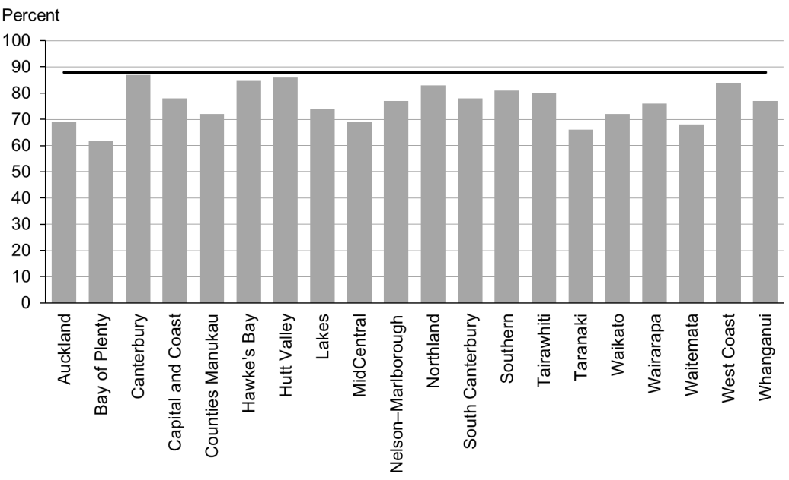

Figure 2: Newborns enrolled with a primary health organisation by three months, Māori

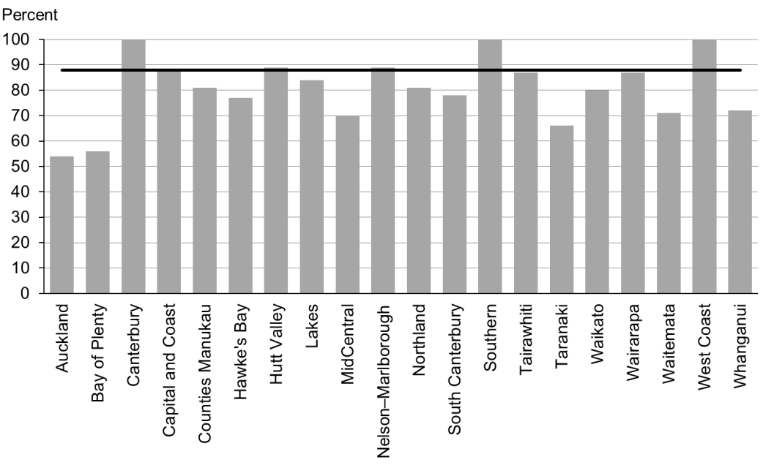

Figure 3: Newborns enrolled with a primary health organisation by three months, Pacific peoples

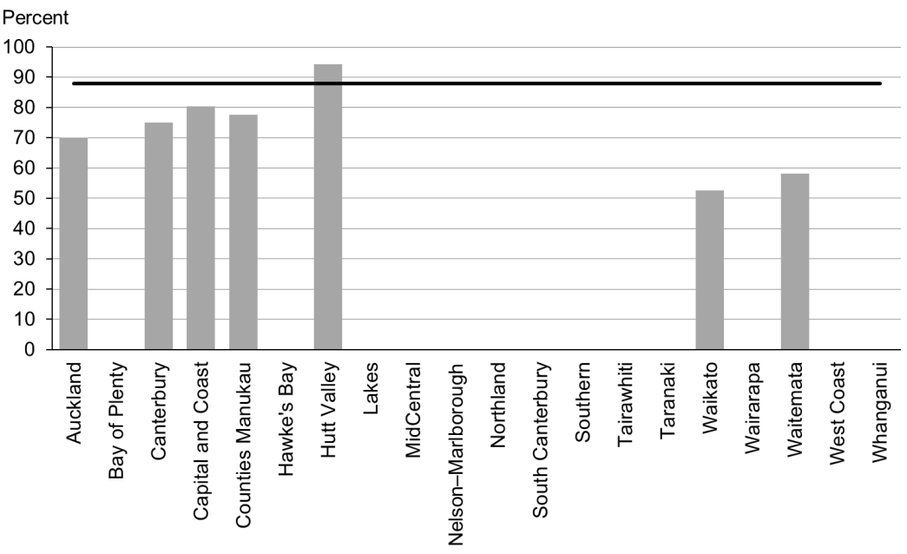

### Data notes

* No bar on graph = fewer than 20 infants in that population.
* Data is not available by deprivation quintile.
* Time period: births between 20 February 2015 and 19 May 2015.
* The data excludes overseas DHB and undefined DHB.
* Numerator: enrolments of infants under three months with a PHO.
* Denominator: births reported to the National Immunisation Register.
* Rates of greater than 100% for ethnic subgroups is likely due to variation in ethnicity reporting in different systems

## WCTO Quality Improvement Framework Indicator 2

|  |  |
| --- | --- |
| **Standard** | All children and families/whānau have access to primary care, WCTO services (including the B4School Check) and early childhood education. |
| **Indicator** | Families and whānau are referred from their lead maternity carer (LMC) to a WCTO provider. |
| **Target by December 2014** | 88 percent |
| **Target by June 2016** | 98 percent |

|  |  |  |  |  |
| --- | --- | --- | --- | --- |
|  | **Total New Zealand** | **High deprivation** | **Māori** | **Pacific peoples** |
| September 2015 mean (range) | 98% (95–100) | 98% (93–100) | 97% (92–100) | 98% (93–100) |
| March 2015 mean (range) | 97% (94–99) | 97% (90–100) | 96% (92–100) | 98% (93–100) |

Figure 4: Referral from lead maternity carer to Well Child / Tamariki Ora, total New Zealand

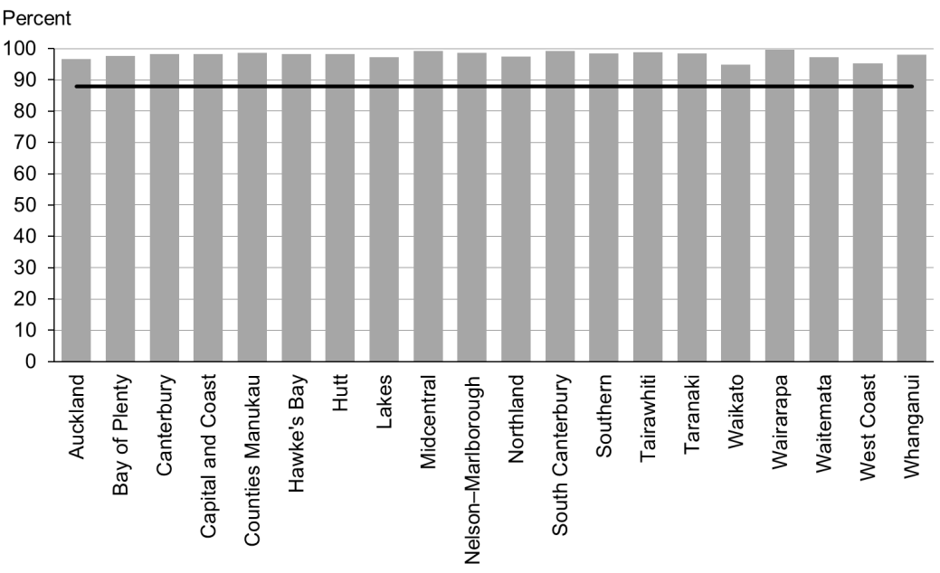

Figure 5: Referral from lead maternity carer to Well Child / Tamariki Ora, high deprivation population

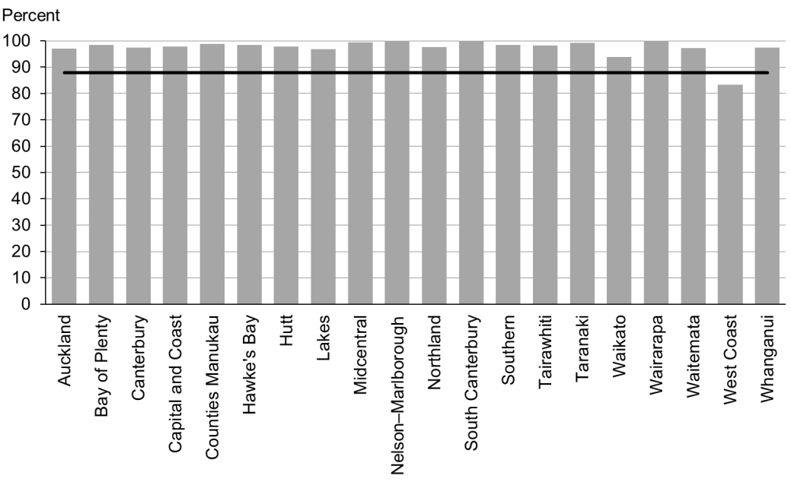

Figure 6: Referral from lead maternity carer to Well Child / Tamariki Ora, Māori

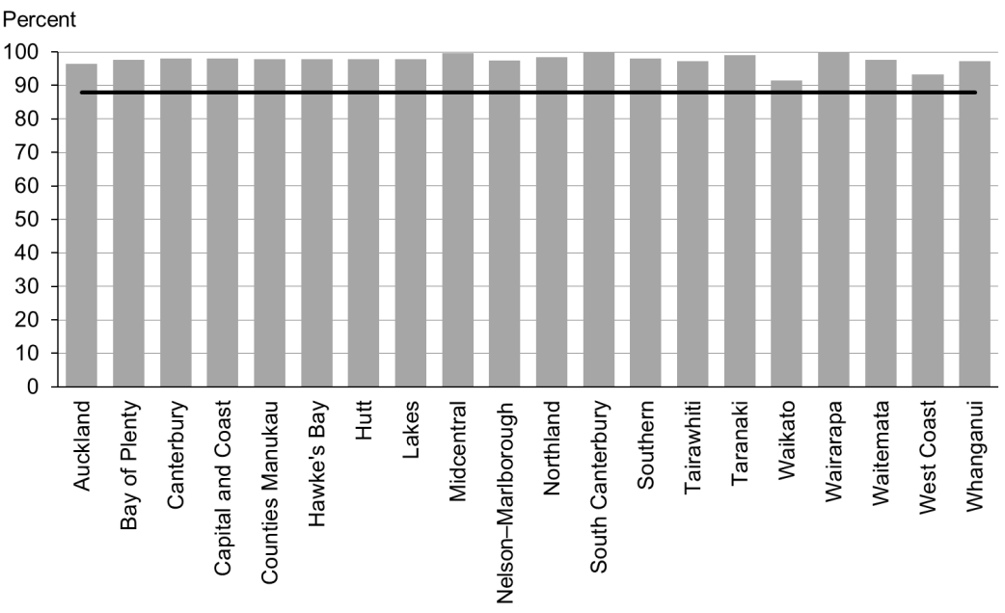

Figure 7: Referral from lead maternity carer to Well Child / Tamariki Ora, Pacific peoples

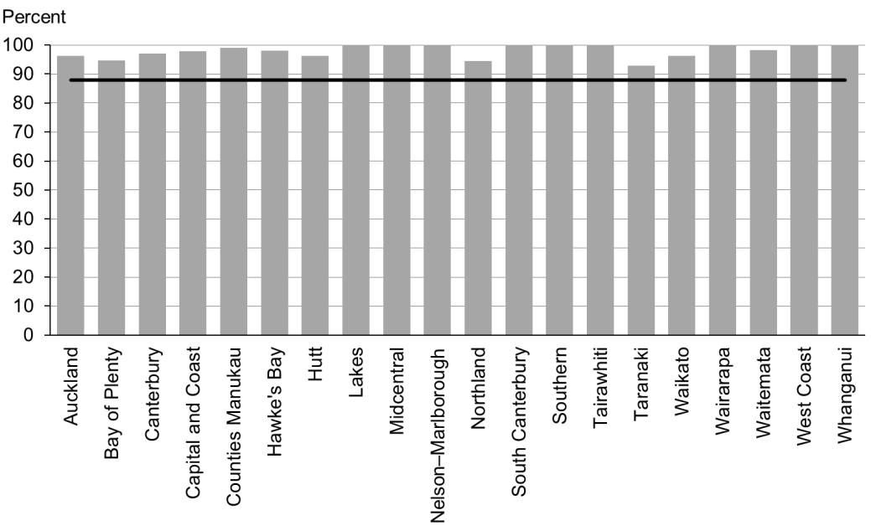

### Data notes

* Time period: births between 1 July 2014 and 31 December 2014.
* The data excludes overseas DHB and undefined DHB.
* Numerator: LMC referral to WCTO = Yes (source: National Maternity Collection [MAT]).
* Denominator: LMC referral to WCTO = Yes or No (source: MAT).

## WCTO Quality Improvement Framework Indicator 3

|  |  |
| --- | --- |
| **Standard** | All children and families/whānau have access to primary care, WCTO services (including the B4School Check) and early childhood education. |
| **Indicator** | Infants receive all WCTO core contacts due in their first year. |
| **Target by December 2014** | 86 percent |
| **Target by June 2016** | 95 percent |

|  |  |  |  |  |
| --- | --- | --- | --- | --- |
|  | **Total New Zealand** | **High deprivation** | **Māori** | **Pacific peoples** |
| September 2015 mean (range) | 68% (48–77) | 55% (37–71) | 52% (26–62) | 53% (41–70) |
| March 2015 mean (range) | 76% (64–85) | 68% (51–81) | 67% (55–79) | 63% (55–77) |

Figure 8: Core Well Child / Tamariki Ora contacts 1–5 received, total New Zealand

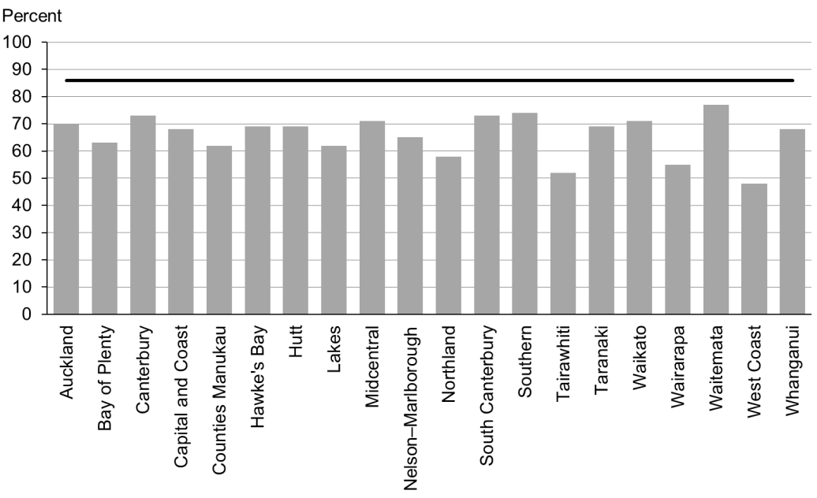

Figure 9: Core Well Child / Tamariki Ora contacts 1–5 received, high deprivation population

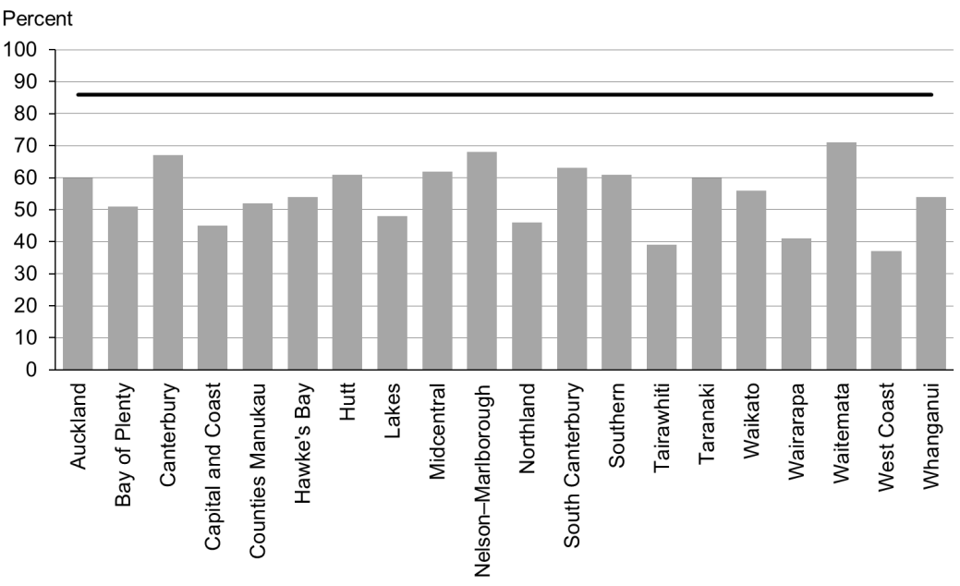

Figure 10: Core Well Child / Tamariki Ora contacts 1–5 received, Māori

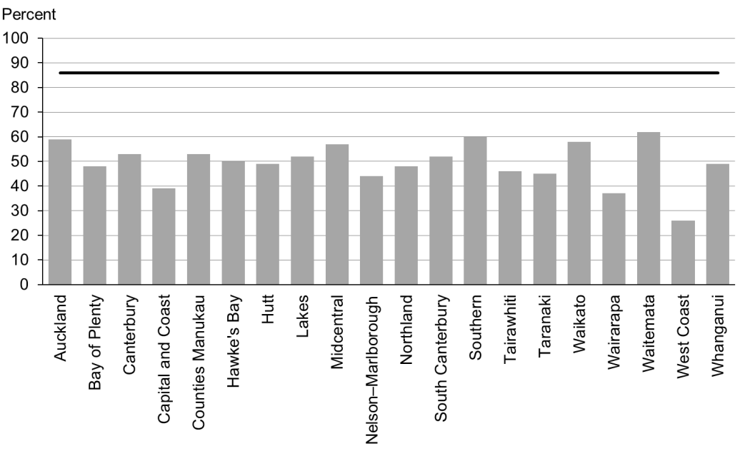

Figure 11: Core Well Child / Tamariki Ora contacts 1–5 received, Pacific peoples

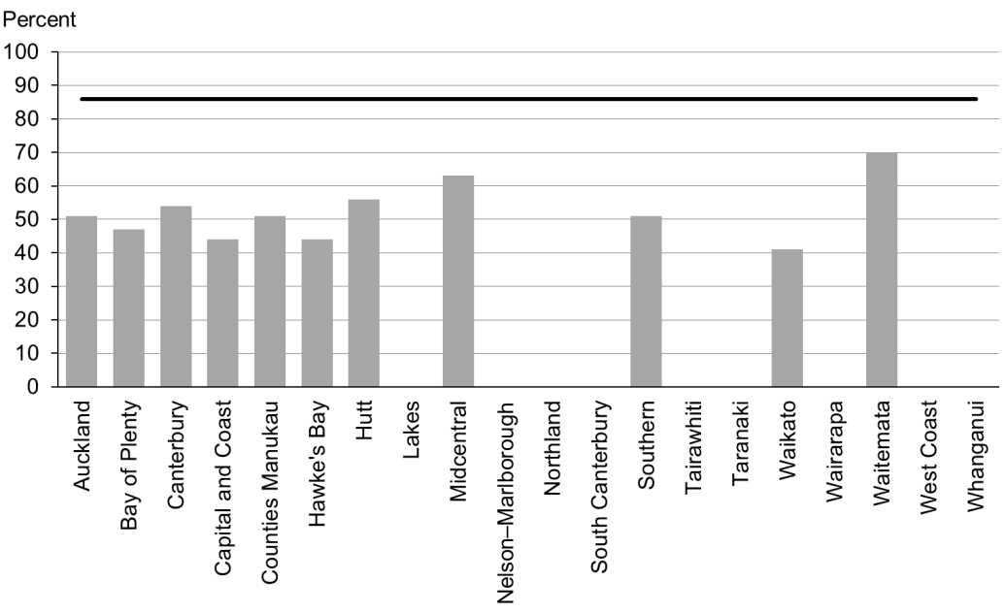

### Data notes

* No bar on graph = fewer than 20 children in that population.
* Time period: children reaching the age band for core contact 6 between January 2015 and June 2015.
* From this report onwards, the data source for indicator 3 includes reporting from all WCTO providers. Prior to this report, data presented for these two indicators was sourced from Plunket alone. This means results for indicators 3 for the period January–June 2015 are not directly comparable with results from earlier periods. The data excludes overseas DHB and undefined DHB.
* Numerator: number of infants where contact was able to be made by six weeks and who received all five contacts (source: WCTO NHI dataset).
* Denominator: number of infants where contact was able to be made by six weeks, who reached the age band for core contact 6 (13 months, 4 weeks, 1 day) (source: WCTO NHI data set).

## WCTO Quality Improvement Framework Indicator 4

|  |  |
| --- | --- |
| **Standard** | All children and families/whānau have access to primary care, WCTO services (including the B4School Check) and early childhood education. |
| **Indicator** | Four-year-olds receive a B4 School Check. |
| **Target by December 2014** | 90 percent |
| **Target by June 2016** | 90 percent |

|  |  |  |  |  |
| --- | --- | --- | --- | --- |
|  | **Total New Zealand** | **High deprivation** | **Māori** | **Pacific peoples** |
| September 2015 mean (range) | 94% (87–113) | 90% (73–115) | 87% (68–150) | 93% (63–250) |
| March 2015 mean (range) | 93% (78–110) | 86% (68–123) | 85% (71–111) | 83% (64–156) |

Figure 12: B4 School Check received, total New Zealand

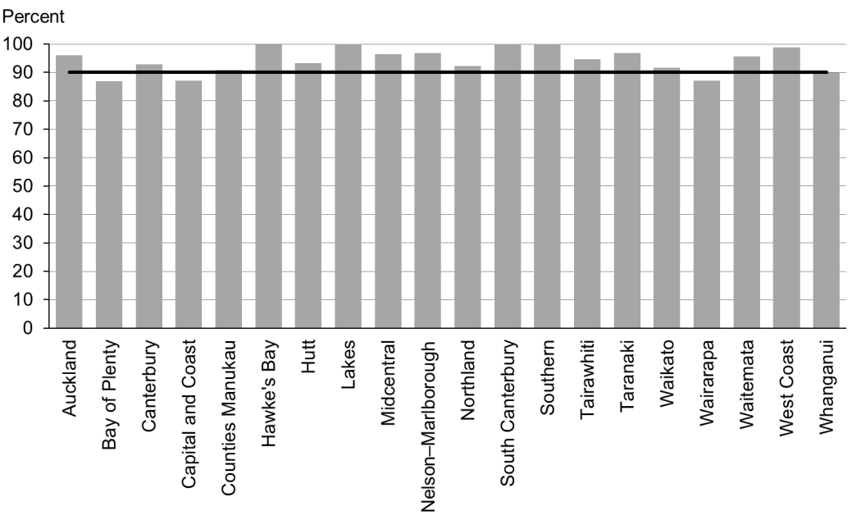

Figure 13: B4 School Check received, high deprivation population

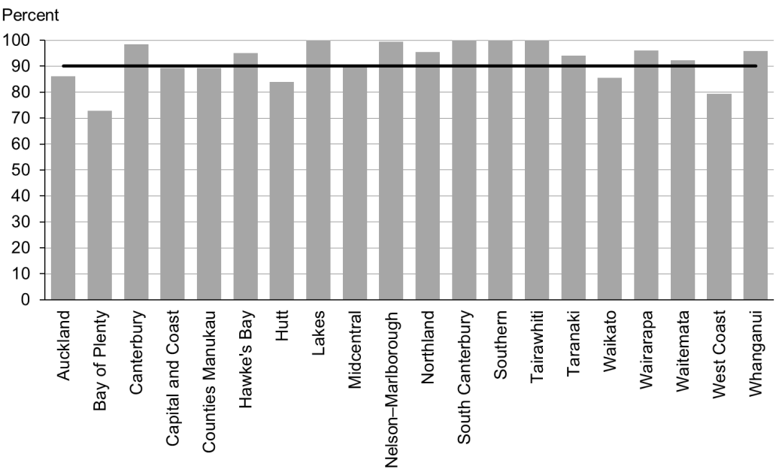

Figure 14: B4 School Check received, Māori

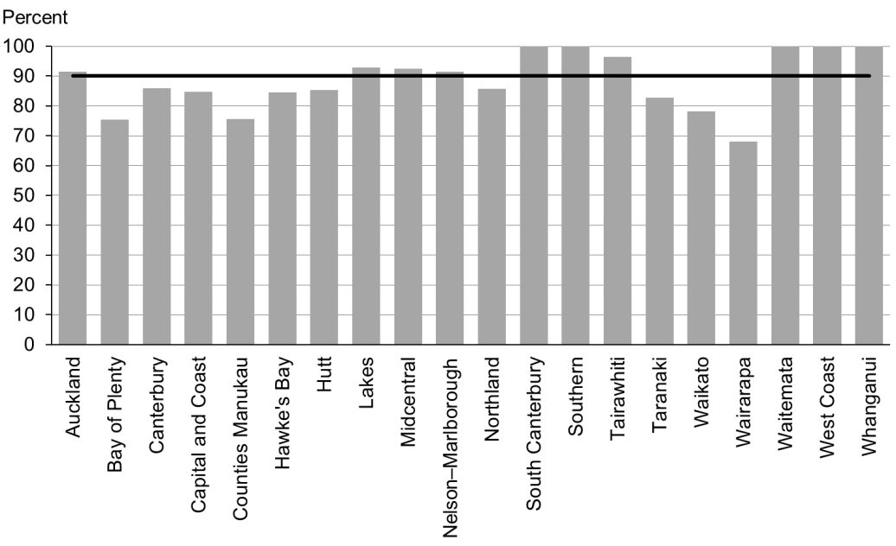

Figure 15: B4 School Check received, Pacific peoples

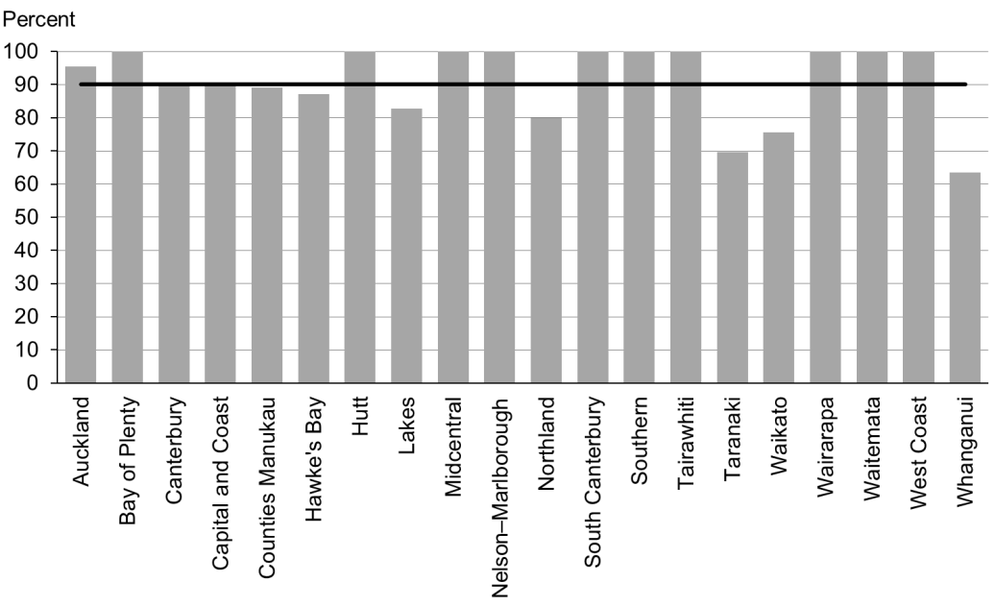

### Data notes

* Time period: checks between January 2015 to June 2015.
* DHB is DHB of service.
* Numerator: number of completed B4 School Checks (source: B4 School Checks).
* Denominator: number of children eligible for a B4 School Check (source: PHO).
* Rates of greater than 100% for ethnic subgroups is likely due to variation in ethnicity reporting in different systems

## WCTO Quality Improvement Framework Indicator 5

|  |  |
| --- | --- |
| **Standard** | All children and families/whānau have access to primary care, WCTO services (including the B4School Check) and early childhood education. |
| **Indicator** | Preschool children are enrolled with child oral health services. |
| **Target by December 2014** | 86 percent |
| **Target by June 2016** | 95 percent |

|  |  |  |  |  |  |
| --- | --- | --- | --- | --- | --- |
|  | **Total New Zealand** | **High deprivation** | **Māori** | | **Pacific peoples** |
| September 2015 mean (range) | 76% (55–100) | N/A | | 61% (20–92) | 75% (39–92) |
| March 2015 mean (range) | no data | | | | |

Figure 16: Preschool children enrolled with child oral health services, total New Zealand

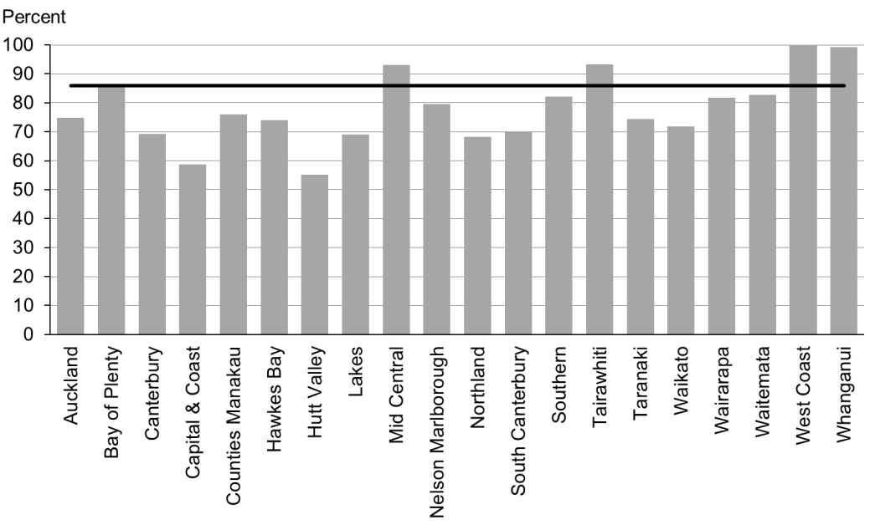

Figure 17: Preschool children enrolled with child oral health services, Māori

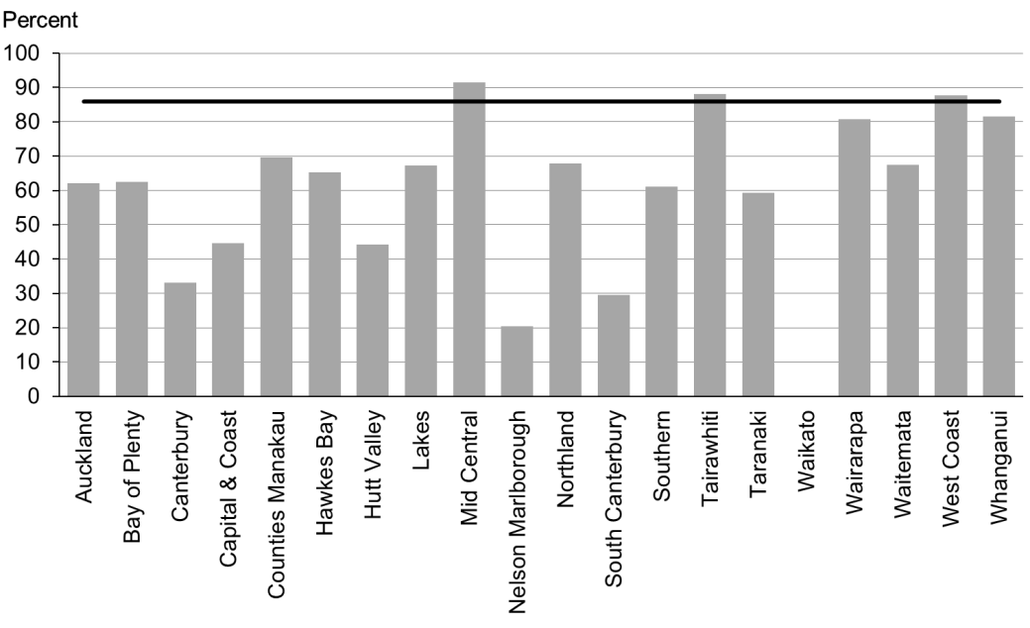

Figure 18: Preschool children enrolled with child oral health services, Pacific peoples

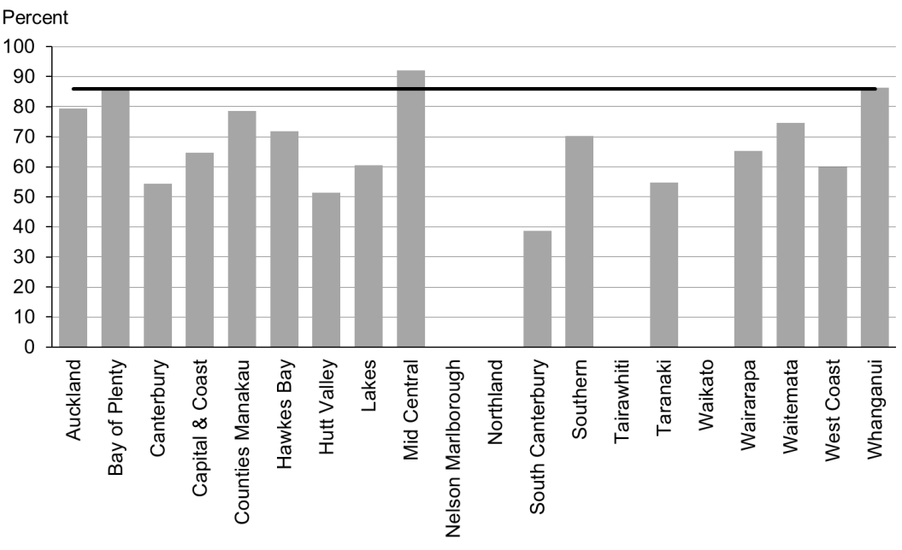

### Data notes

* Time period: 2014
* Data is not available by deprivation quintile.
* Numerator: number of children aged under five years enrolled with oral health services (source: community oral health services).
* Denominator: number of children aged under five years (source: PHO).

## WCTO Quality Improvement Framework Indicator 6

|  |  |
| --- | --- |
| **Standard** | All children and families/whānau have access to primary care, WCTO services (including the B4School Check) and early childhood education. |
| **Indicator** | Immunisations are up to date by eight months. |
| **Target by December 2014** | 95 percent |
| **Target by June 2016** | 95 percent |

|  |  |  |  |  |
| --- | --- | --- | --- | --- |
|  | **Total New Zealand** | **High deprivation** | **Māori** | **Pacific peoples** |
| September 2015 mean (range) | 93% (85–96) | 91% (61–97) | 90% (80–96) | 95% (50–100) |
| March 2015 mean (range) | 94% (82–96) | 93% (41–100) | 92% (89–100) | 96% (88–100) |

Figure 19: Infants fully immunised by eight months, total New Zealand

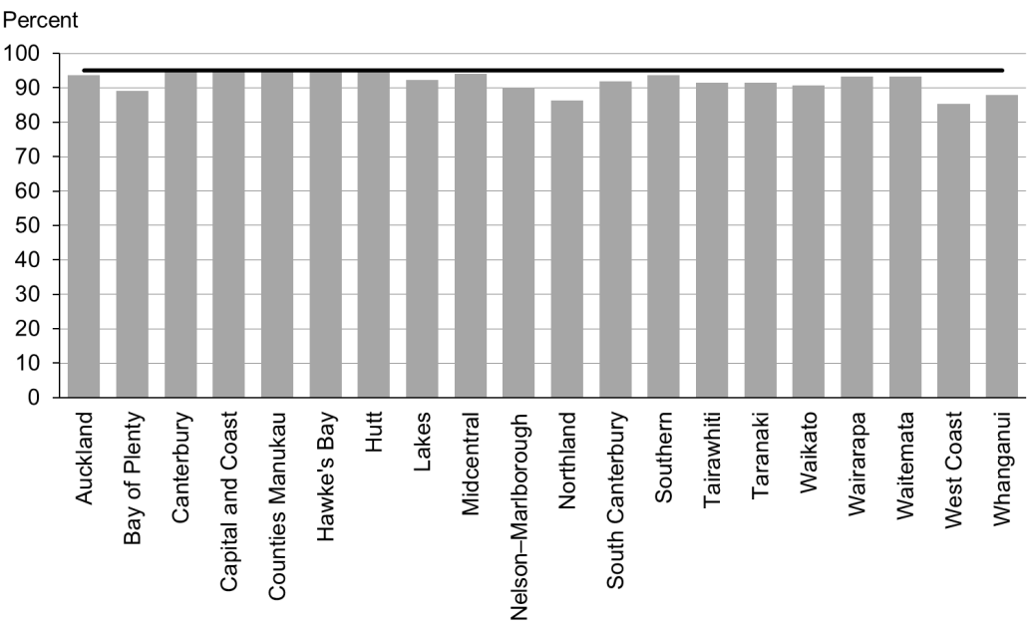

Figure 20: Infants fully immunised by eight months, high deprivation population

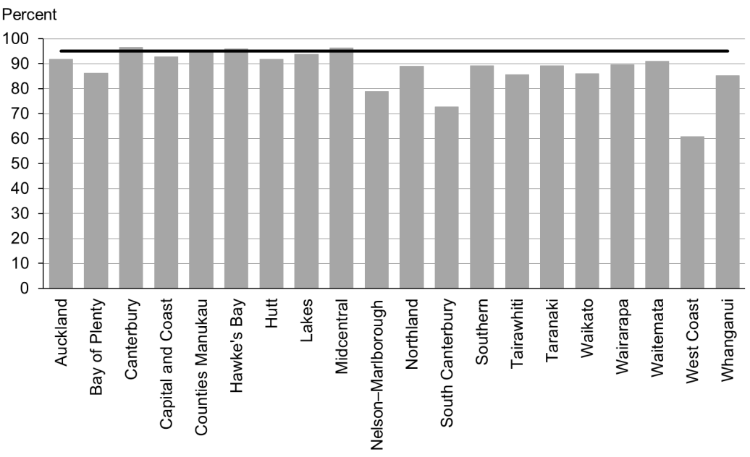

Figure 21: Infants fully immunised by eight months, Māori

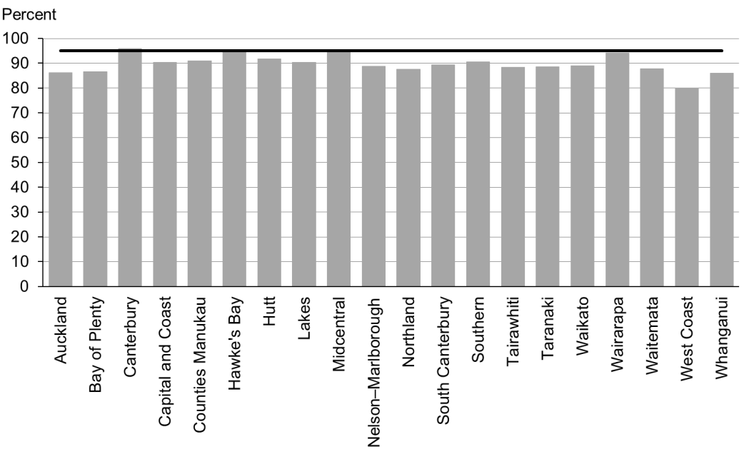

Figure 22: Infants fully immunised by eight months, Pacific peoples

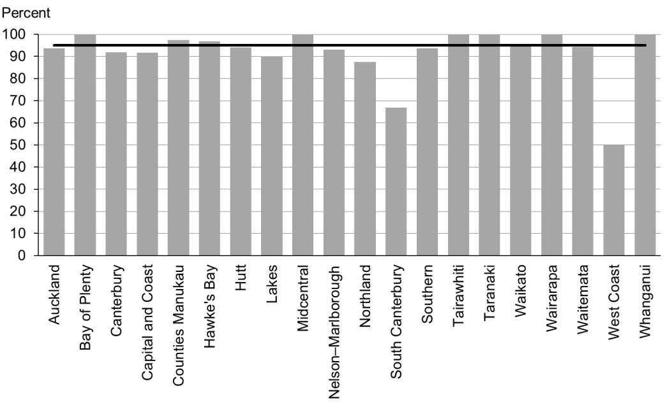

### Data notes

* Time period: April 2015 to June 2015.
* The data excludes overseas DHB and undefined DHB.
* Numerator: number of eight-month-old infants up to date with immunisations for age (source: National Immunisation Register).
* Denominator: number of eight-month-old infants (source: National Immunisation Register).

## WCTO Quality Improvement Framework Indicator 7

|  |  |
| --- | --- |
| **Standard** | All children and families/whānau have access to primary care, WCTO services (including the B4School Check) and early childhood education. |
| **Indicator** | Children participate in early childhood education (ECE). |
| **Target by December 2014** | 98 percent |
| **Target by June 2016** | 98 percent |

|  |  |  |  |  |
| --- | --- | --- | --- | --- |
|  | **Total New Zealand** | **High deprivation** | **Māori** | **Pacific peoples** |
| September 2015 mean (range) | 96% (92–99) | 100% (97–100) | 94% (88–98) | 91% (85–100) |
| March 2015 mean (range) | 96% (92–99) | 89% (87–100) | 94% (55–98) | 91% (88–100) |

Figure 23: Participation in early childhood education, total New Zealand

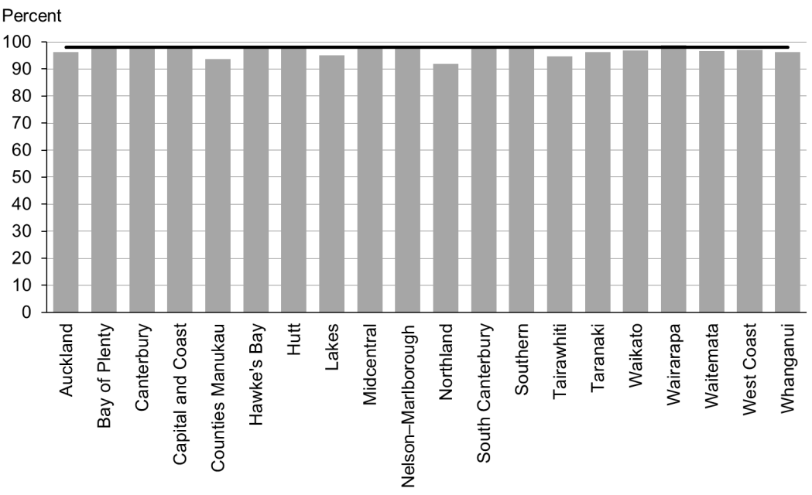

Figure 24: Participation in early childhood education, high deprivation population

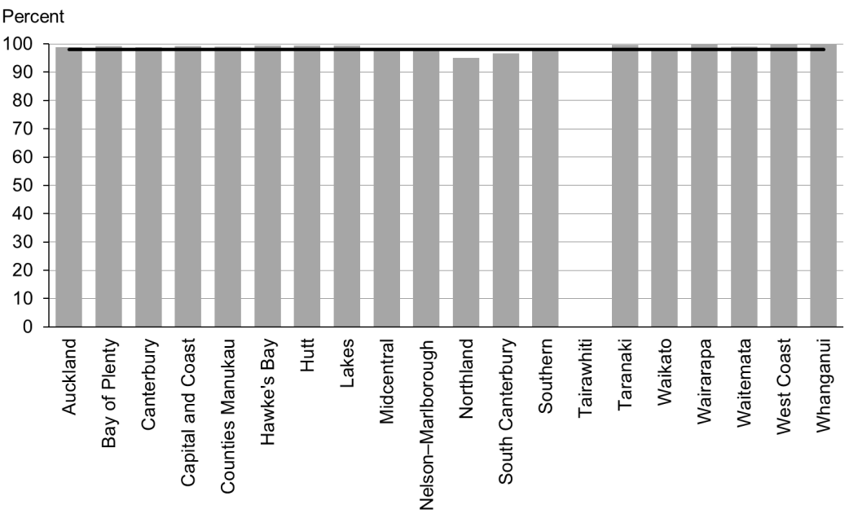

Figure 25: Participation in early childhood education, Māori

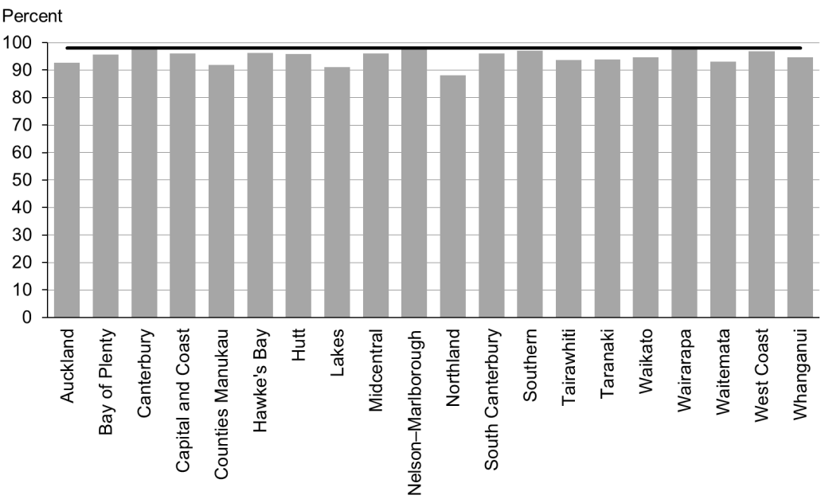

Figure 26: Participation in early childhood education, Pacific peoples

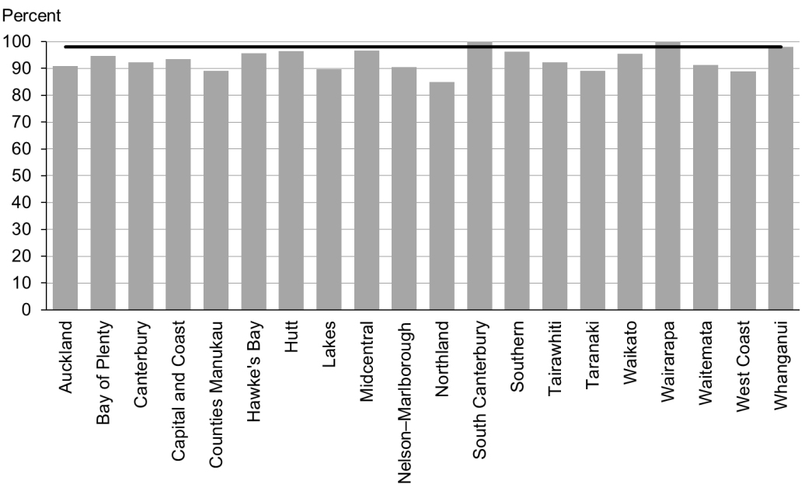

### Data notes

* Where no bar appears on the graph, there was no date provided.
* Data for this indicator was collected for children starting school during the 12 months to 30 June 2015.
* Children counted within the ‘high deprivation’ population were those attending a Ministry of Education-defined decile 1 or 2 school.
* The numerator is children starting school who had participated in ECE (source: ENROL).
* The denominator is children starting school (source: ENROL).

## WCTO Quality Improvement Framework Indicator 8

|  |  |
| --- | --- |
| **Standard** | All children and families/whānau have access to primary care, WCTO services (including the B4School Check) and early childhood education. |
| **Indicator** | Children under six years have access to free primary care. |
| **Target by December 2014** | 98 percent |
| **Target by June 2016** | 100 percent |

|  |  |  |  |  |
| --- | --- | --- | --- | --- |
|  | **Total New Zealand** | **High deprivation** | **Māori** | **Pacific peoples** |
| September 2015 mean (range) | 100% (98–100) | 100% (99–100) | 100% (99–100) | 100% (100–100) |
| March 2015 mean (range) | 99% (96–100) | 100% (98–100) | 100% (98–100) | 100% (99–100) |

Figure 27: Under-six access to free primary care, total New Zealand

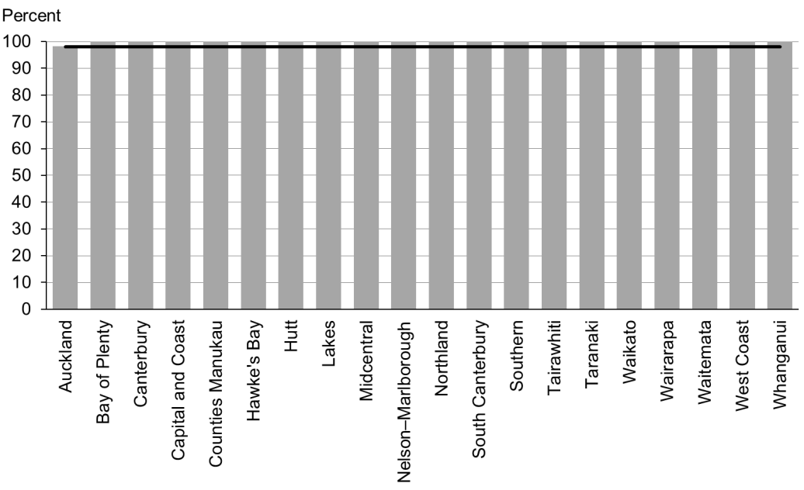

Figure 28: Under-six access to free primary care, high deprivation population

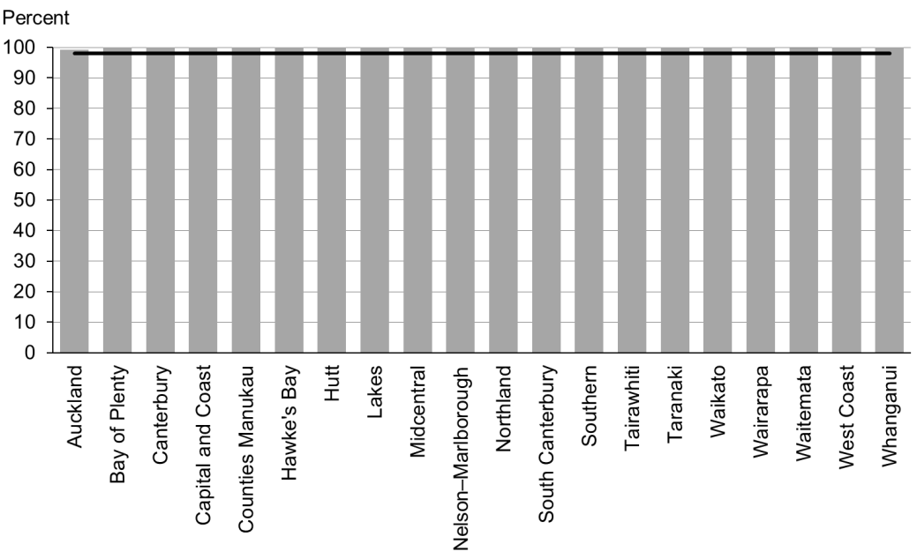

Figure 29: Under-six access to free primary care, Māori

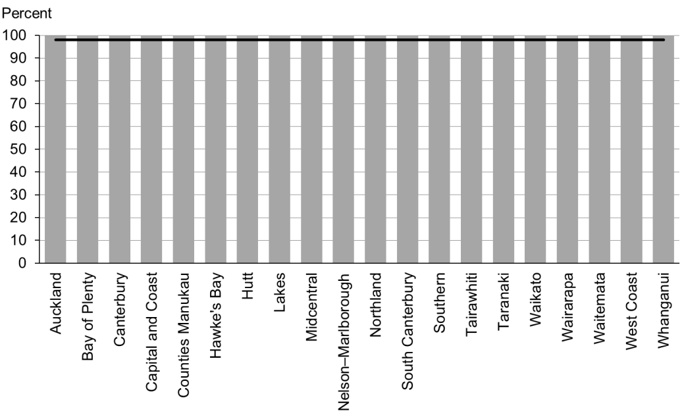

Figure 30: Under-six access to free primary care, Pacific peoples

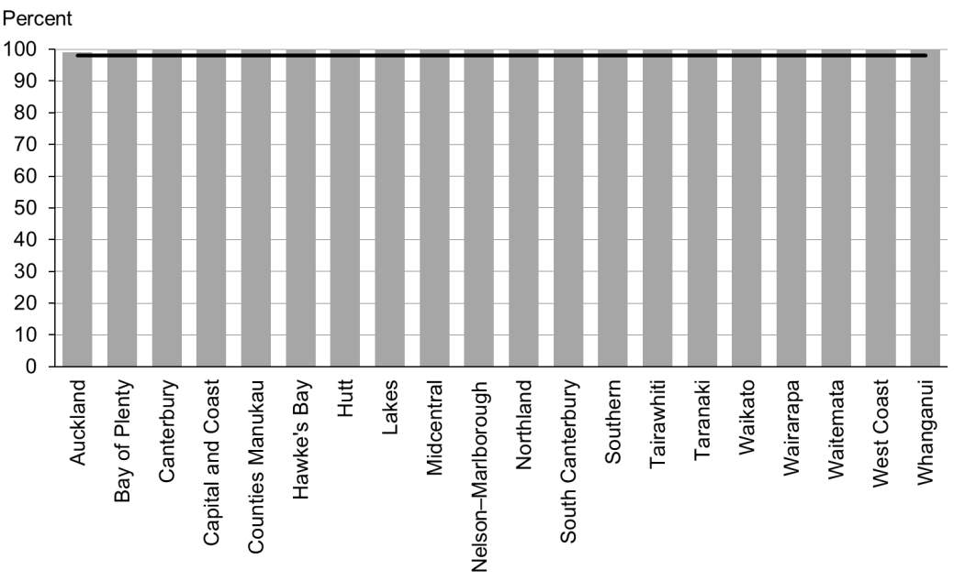

### Data notes

* Time period: snapshot as at 1 July 2015.
* Numerator: number of children aged under six years enrolled with a PHO that delivers free primary care for under-sixes (source: PHO).
* Denominator: number of children aged under six years enrolled with a PHO (source: PHO).

## WCTO Quality Improvement Framework Indicator 9

|  |  |
| --- | --- |
| **Standard** | All children and families/whānau have access to primary care, WCTO services (including the B4School Check) and early childhood education. |
| **Indicator** | Children under six years have access to free after-hours primary care. |
| **Target by December 2014** | 98 percent |
| **Target by June 2016** | 100 percent |

|  |  |  |  |  |
| --- | --- | --- | --- | --- |
|  | **Total New Zealand** | **High deprivation** | **Māori** | **Pacific peoples** |
| September 2015 mean (range) | 99% (95–100) | N/A | N/A | N/A |
| March 2015 mean (range) | 98% (83–100) | N/A | N/A | N/A |

Figure 31: Under-six access to free after-hours primary care, total New Zealand

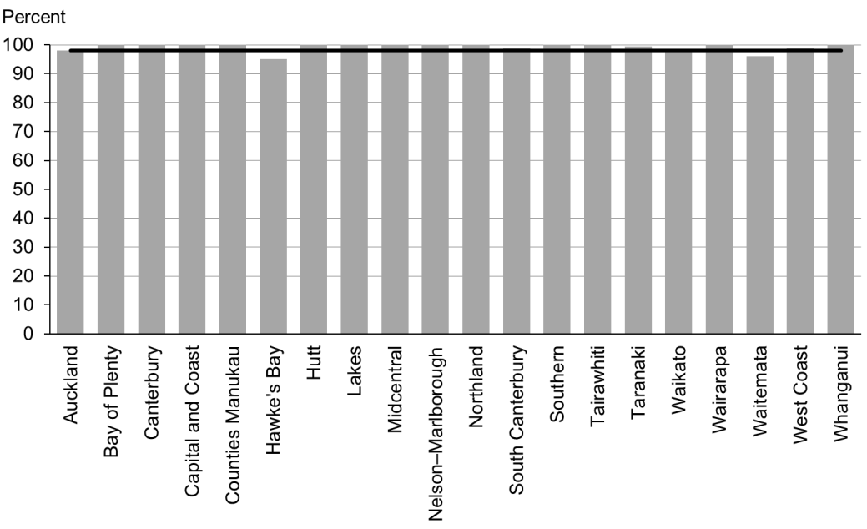

### Data notes

* Time period: snapshot as at 1 May 2015.
* Data is not available by ethnicity or deprivation quintile.
* Numerator: number of children aged under six years who are enrolled with a PHO that delivers free after-hours primary care for under sixes (source: PHO).
* Denominator: number of children aged under six years who are enrolled with a PHO (source: PHO).

## WCTO Quality Improvement Framework Indicator 10

|  |  |
| --- | --- |
| **Standard** | All children and families/whānau have access to specialist and other referred services, where required, in a timely manner. |
| **Indicator** | Children are seen promptly following referral to specialist services. |
| **Target by December 2014** | 100 percent within five months of referral |
| **Target by June 2016** | 100 percent within four months of referral |

|  |  |  |  |  |
| --- | --- | --- | --- | --- |
|  | **Total New Zealand** | **High deprivation** | **Māori** | **Pacific peoples** |
| September 2015 mean (range) | 100% (89–100) | N/A | N/A | N/A |
| March 2015 mean (range) | 99% (91–100) | N/A | N/A | N/A |

Figure 32: First specialist appointment for paediatric medicine received within four months, total New Zealand

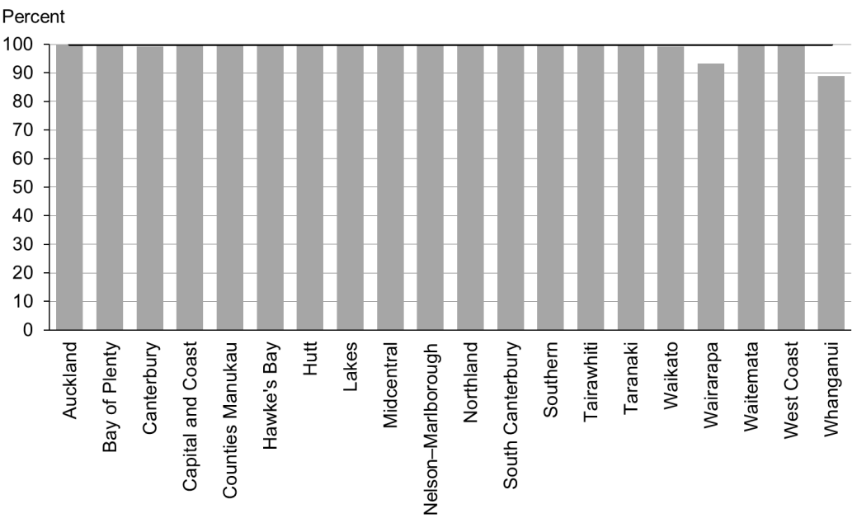

### Data notes

* Time period: snapshot for July 2015.
* DHB is DHB of service.
* Data is not available by ethnicity or deprivation quintile.
* The data presented is for includes any referral to DHB paediatric medicine (at any age).
* Numerator: number waiting longer than four months (source: DHB Elective Services Patient Flow Indicators reporting).
* Denominator: total number waiting at end of month (source: DHB Elective Services Patient Flow Indicators reporting).

# Indicators 11–20: Outcomes

Aim 2 of the WCTO Quality Improvement Framework is **improved health and equity for all populations**. We will know we have achieved this when we see improved health and wellbeing outcomes for children, families and whānau. The Ministry of Health expects that, in addition to these indicators, DHBs and WCTO providers will consider monitoring other measures of family and whānau health and wellbeing that through national or local data sources.

Indicators 11–20 measure health outcomes across a range of domains representing infant and child physical health (by measurements of nutrition and healthy weight and oral health), infant and child mental health (through the strengths and difficulties questionnaire) and family health (by tracking rates of smoking status). The Ministry expects to add further measures of health and wellbeing outcomes as new data becomes available. A number of performance- and outcome-monitoring documents, including Māori Health Plans and the New Zealand Maternity Clinical Indicators, have adopted these indicators.

These indicators reflect the core roles of WCTO in promoting and supporting physical health, mental wellbeing, healthy families and whānau, and healthy home environments. Achieving improvements in these indicators will require a cross-sector response and a multi-faceted approach, and may not happen in the short term. However, we must continue to monitor the health and wellbeing outcomes these indicators represent, because they show us where WCTO services are working well, in their own capacities and together with the wider health sector.

## Summary of results for this period

### National

Figures in this set of indicators remained the steadiest of all the three indicator groups. At a population level, providers were either reaching the targets for most indicators in this group, or were very close to reaching them. In particular, there have been very few statistically significant changes in the breastfeeding outcomes since the indicators were first reported on in September 2013. Only results against Indicator 12: ‘Infants are exclusively or fully breastfed at discharge from LMC’ significantly changed between the March and September reports (an 8 percentage point decrease at a total population level).

Achievement against Indicator 15: ‘Children are a healthy weight at four years’ remained stable at 75 percent between the March and September reports. Reducing childhood obesity is currently a significant focus of the Minister of Health; the Ministry of Health released a package of actions towards reducing the number of obese children in October 2015. The plan has three focus areas made up of 22 initiatives which are either new or an expansion of existing initiatives. (See [the Ministry of Health website](http://www.health.govt.nz/our-work/diseases-and-conditions/obesity/childhood-obesity-plan) for detailed information.)

Achievement against Indicators 16 and 17 (‘Children are caries free at five years’ and ‘The burden of dental decay is minimised’) remained static between the September 2014 report and this one. We need to do significant work to achieve the oral health targets we have set, and better outcomes for our children.

We also need to focus on the smokefree indicators (Indicator 19: ‘Mothers are smokefree at two weeks postnatal’ and Indicator 20: ‘Children live in smokefree homes’), if the June 2016 targets are to be achieved.

### By region

Achievement against the breastfeeding indicators (11–14) remained highly variable across the DHBs in the September results – although in the case of Indicator 11: ‘Infants are exclusively or fully breastfed at two weeks’ all DHBs met the December 2014 target of 72 percent. Around half of DHBs met, or were close to meeting, the December 2014 target for Indicator 12: ‘Infants are exclusively or fully breastfed at discharge from LMC’. Those DHBs that had lower achievement against Indicator 12 also had lower achievement against Indicators 13 and 14 (‘Infants are exclusively or fully breastfed at three months’ and ‘Infants are receiving breast milk at six months’), suggesting that they need to work on ensuring women continue to breastfeed past the very early stages of an infant’s life.

There was an 11 percentage point difference between the DHBs’ achievement rates against Indicator 15: ‘Children are a healthy weight at four years’, and this increased across high-deprivation areas (19 percentage points), Māori (20 percentage points) and Pacific peoples (27 percentage points). There were similar issues across DHBs in terms of achievement against Indicators 16 and 17 (‘Children are caries free at five years’ and ‘The burden of dental decay is minimised’). District health boards should focus on multi-pronged initiatives to improve their performance these indicators – there is no silver bullet to ensure better outcomes.

Rates of mothers who were smokefree at two weeks postnatal (Indicator 19) varied significantly by DHB, reflecting the population make-up of each region. District health boards should focus on differences that are persistent when analysed by ethnicity or deprivation.

### By deprivation level

Looking at achievement against all four breastfeeding indicators, it generally remains the case that fewer infants living in areas of high deprivation are exclusively or fully breastfed, and fewer infants are receiving some breast milk at six months, relative to the total population. In the September results, for the third reporting period in a row, there was no significant increase in rates for any of the four breastfeeding indicators for infants living in areas of high deprivation. Indicator 12: ‘Infants are exclusively or fully breastfed at discharge from LMC’ dropped 12 percentage points, but this was consistent with the total population figures.

Breastfeeding is free and helps lay the foundations for a healthy life – both emotionally and physically. Supporting families living in areas of high deprivation to establish and maintain breastfeeding should be a focus for all DHBs.

Looking at the September results for the other indicators in this group, children living in areas of high deprivation were less likely to be a healthy weight at four years old (68 percent of those living in high deprivation areas, compared with 75 percent of the total population), and mothers living in areas of high deprivation were less likely to be smokefree at two weeks postnatal (78 percent of those living in high deprivation areas, compared with 87 percent of the total population).

Data was not collected on deprivation level for the oral health indicators (16 and 17).

### By ethnicity

Outcomes for Māori and Pacific families are generally significantly poorer across a range of indicators. This particularly applies to the oral health indicators (16 and 17) – in the September results, only 40 percent of Māori and 36 percent of Pacific children were caries free at age five, compared to 59 percent of children nationwide. Even more concerning are the DHBs in which less than one-third of the Māori and Pacific children were caries free. Oral health is often an indicator for other issues within a family – poverty, for example. Therefore, to improve these indicators, and the health of their region’s children, DHBs need to focus on wider services for families.

Pacific children are significantly less likely to be a healthy weight at four years of age than children within the total population. Although the gap decreased by two percentage points between the March and September reports, there has been no further improvement in this reporting period. The Minister’s childhood obesity package will provide DHBs with some tools and ideas to improve the number of Pacific children who are a healthy weight.

In the September results, breastfeeding rates remained lower among Māori and Pacific communities at later ages (three and six months).

Rates of maternal tobacco use remained significantly higher among Māori than among the total population. September rates showed that only 66 percent of Māori mothers were smokefree at two weeks postnatal, compared to 87 percent of mothers in the total population.

## WCTO Quality Improvement Framework Indicator 11

|  |  |
| --- | --- |
| **Standard** | WCTO providers use evidence-based interventions and education to promote child, family and whānau health and wellbeing. |
| **Indicator** | Infants are exclusively or fully breastfed at two weeks. |
| **Target by December 2014** | 72 percent |
| **Target by June 2016** | 80 percent |

|  |  |  |  |  |
| --- | --- | --- | --- | --- |
|  | **Total New Zealand** | **High deprivation** | **Māori** | **Pacific peoples** |
| September 2015 mean (range) | 78% (72–85) | 74% (60–87) | 76% (58–82) | 72% (60–100) |
| March 2015 mean (range) | 79% (71–90) | 76% (68–90) | 77% (69–94) | 74% (44–90) |

Figure 33: Infants exclusively or fully breastfed at two weeks, total New Zealand

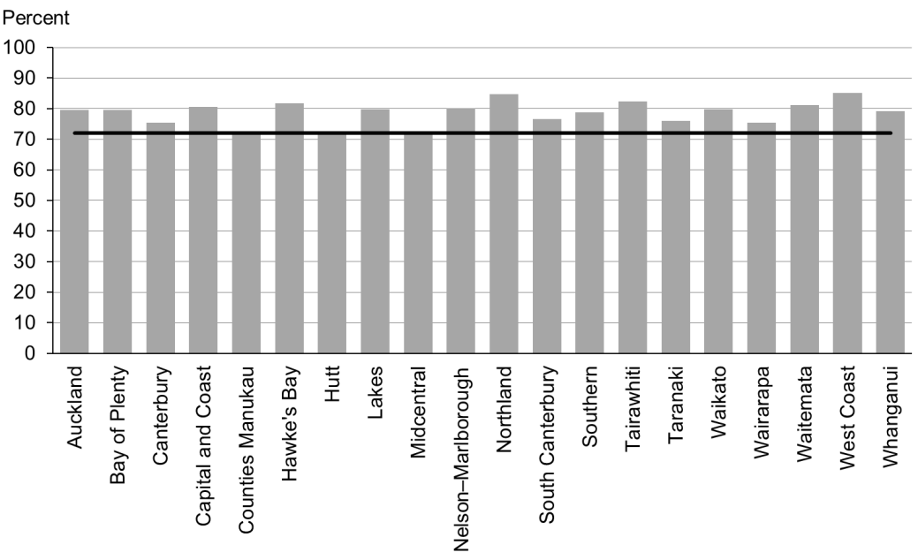

Figure 34: Infants exclusively or fully breastfed at two weeks, high deprivation population

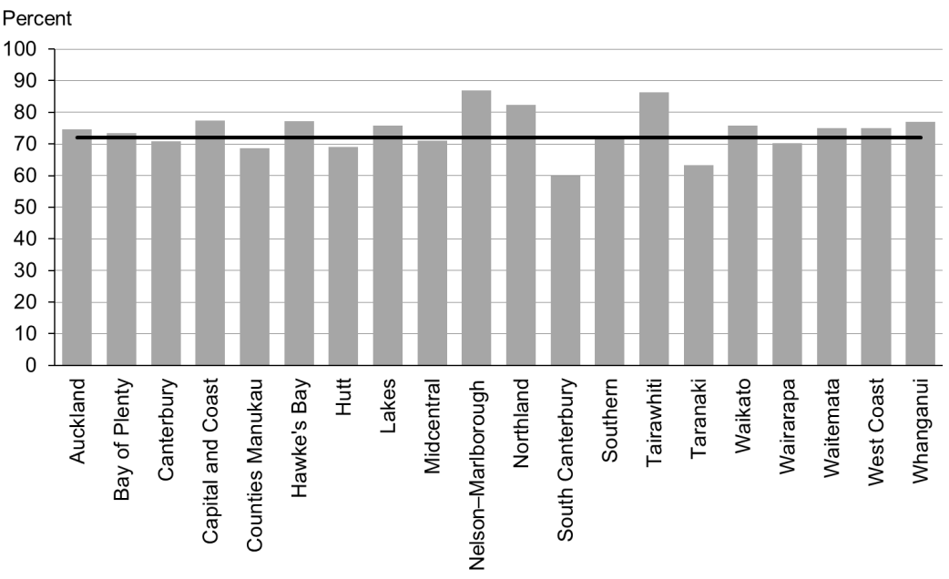

Figure 35: Infants exclusively or fully breastfed at two weeks, Māori

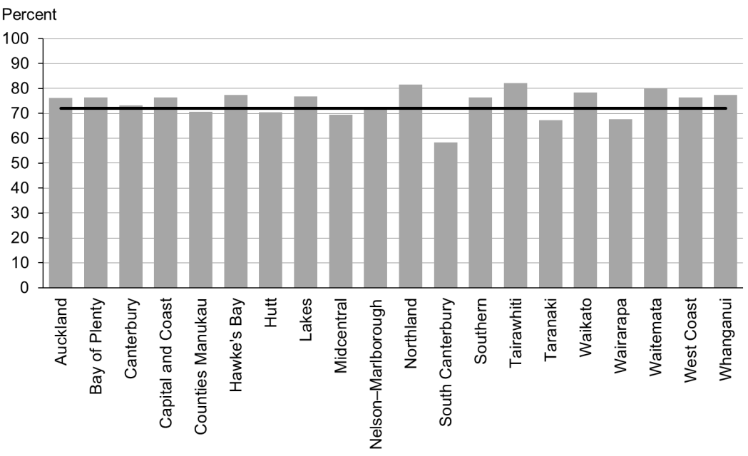

Figure 36: Infants exclusively or fully breastfed at two weeks, Pacific peoples

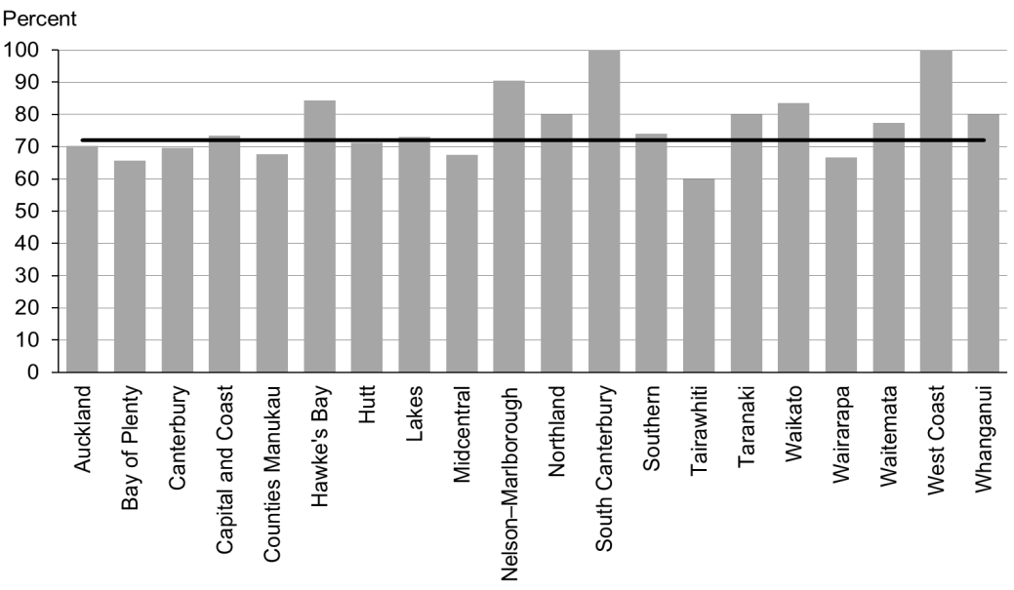

### Data notes

* Time period: babies born between 1 July 2014 and 31 December 2014.
* Excludes overseas DHB and undefined DHB.
* Numerator: breastfeeding at two weeks = exclusive or fully (source: MAT).
* Denominator: breastfeeding at two weeks = not null (source: MAT).

## WCTO Quality Improvement Framework Indicator 12

|  |  |
| --- | --- |
| **Standard** | WCTO providers use evidence-based interventions and education to promote child, family and whānau health and wellbeing. |
| **Indicator** | Infants are exclusively or fully breastfed at discharge from lead maternity carer (LMC) |
| **Target by December 2014** | 68 percent |
| **Target by June 2016** | 75 percent |

|  |  |  |  |  |
| --- | --- | --- | --- | --- |
|  | **Total New Zealand** | **High deprivation** | **Māori** | **Pacific peoples** |
| September 2015 mean (range) | 66% (40–73) | 59% (0–73) | 62% (41–71) | 57% (49–80) |
| March 2015 mean (range) | 74% (65–85) | 71% (61–83) | 69% (55–94) | 72% (44–86) |

Figure 37: Infants exclusively or fully breastfed at LMC discharge, total New Zealand

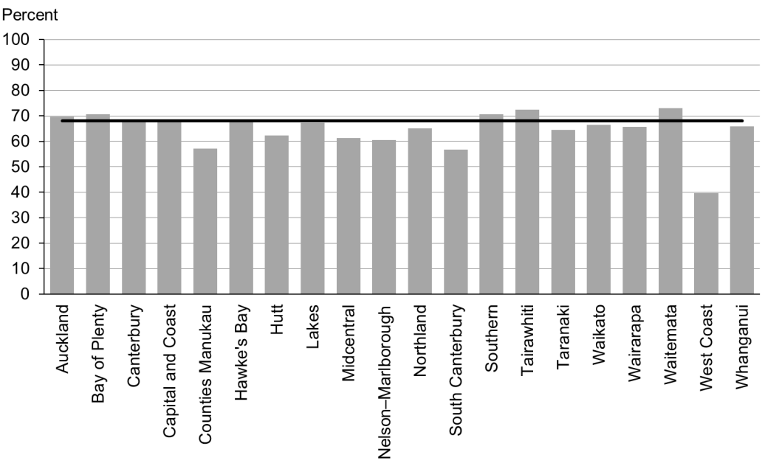

Figure 38: Infants exclusively or fully breastfed at LMC discharge, high deprivation population

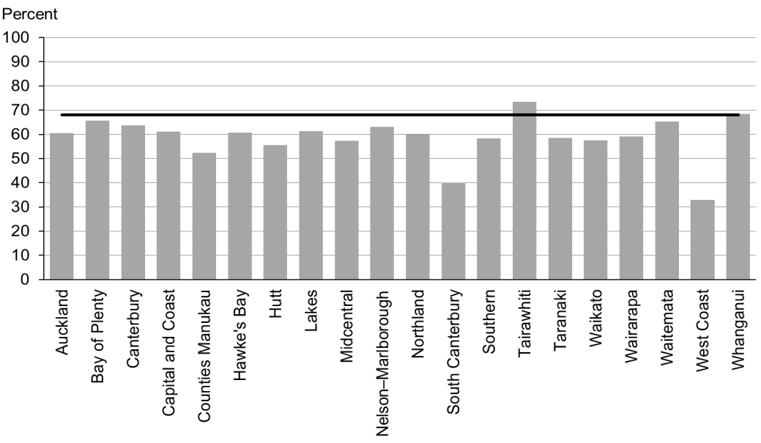

Figure 39: Infants exclusively or fully breastfed at LMC discharge, Māori

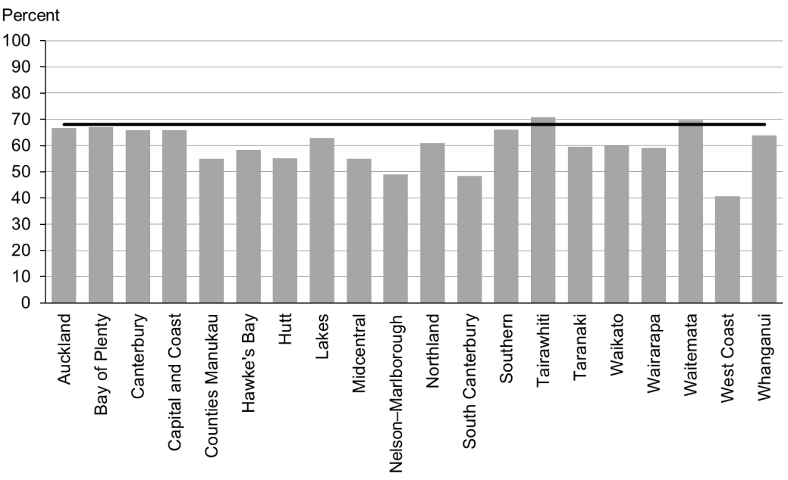

Figure 40: Infants exclusively or fully breastfed at LMC discharge, Pacific peoples

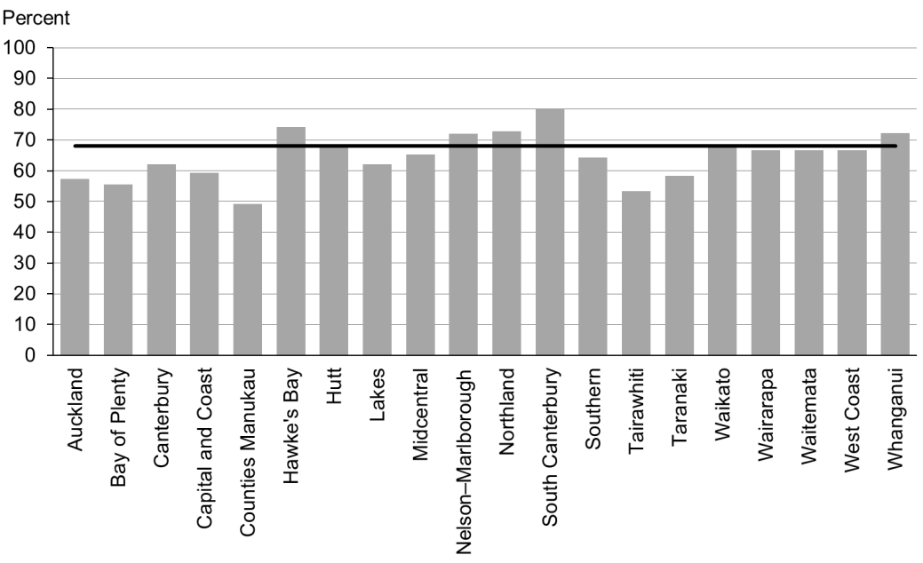

### Data notes

* Time period: babies born between 1 July 2014 and 31 December 2014.
* Excludes overseas DHB and undefined DHB.
* Numerator: breastfeeding at discharge = exclusive or fully (source: MAT).
* Denominator: breastfeeding at discharge = not null (source: MAT).

## WCTO Quality Improvement Framework Indicator 13

|  |  |
| --- | --- |
| **Standard** | WCTO providers use evidence-based interventions and education to promote child, family and whānau health and wellbeing. |
| **Indicator** | Infants are exclusively or fully breastfed at three months. |
| **Target by December 2014** | 54 percent |
| **Target by June 2016** | 60 percent |

|  |  |  |  |  |
| --- | --- | --- | --- | --- |
|  | **Total New Zealand** | **High deprivation** | **Māori** | **Pacific peoples** |
| September 2015 mean (range) | 55% (46–63) | 45% (38–64) | 45% (38–57) | 47% (35–62) |
| March 2015 mean (range) | 55% (46–61) | 44% (31–56) | 45% (33–58) | 45% (37–57) |

Figure 41: Infants exclusively or fully breastfed at three months, total New Zealand

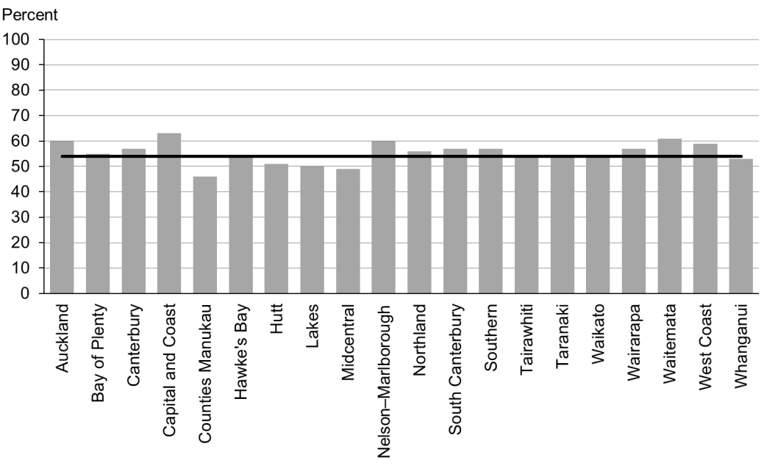

Figure 42: Infants exclusively or fully breastfed at three months, high deprivation population

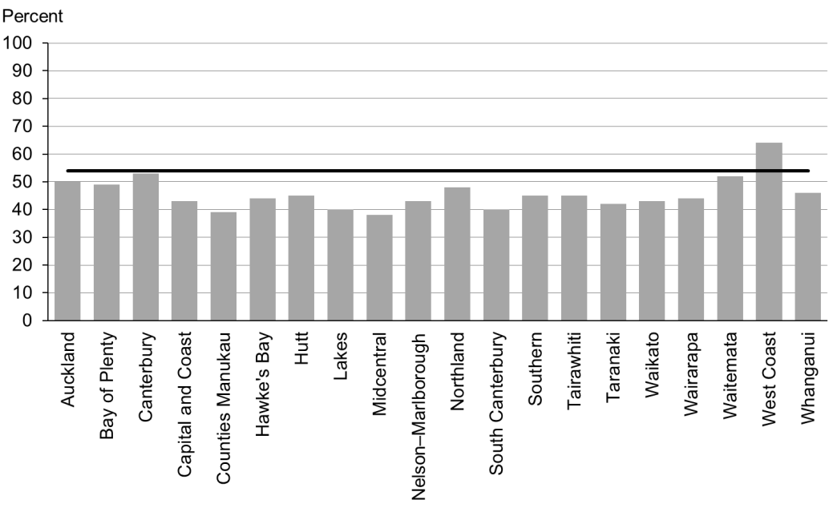

Figure 43: Infants exclusively or fully breastfed at three months, Māori

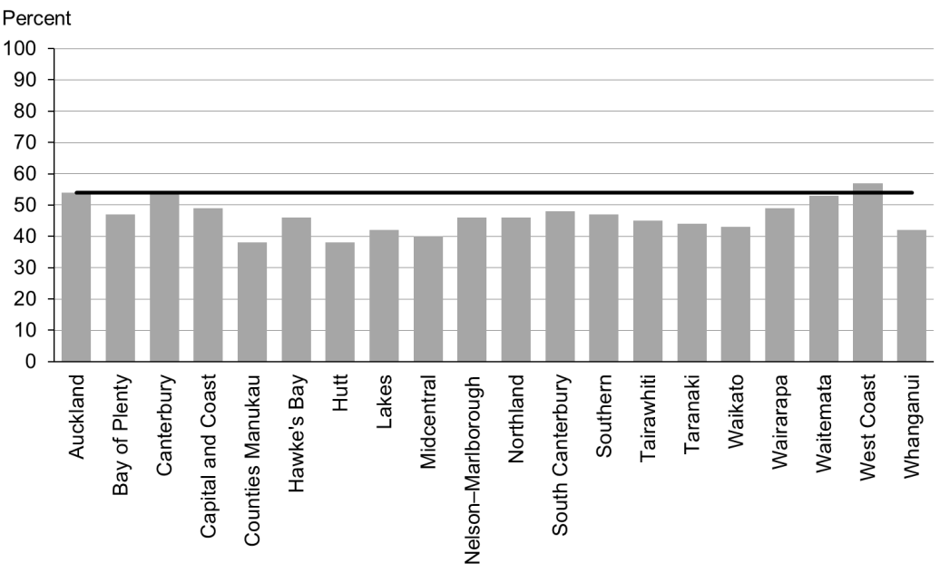

Figure 44: Infants exclusively or fully breastfed at three months, Pacific peoples

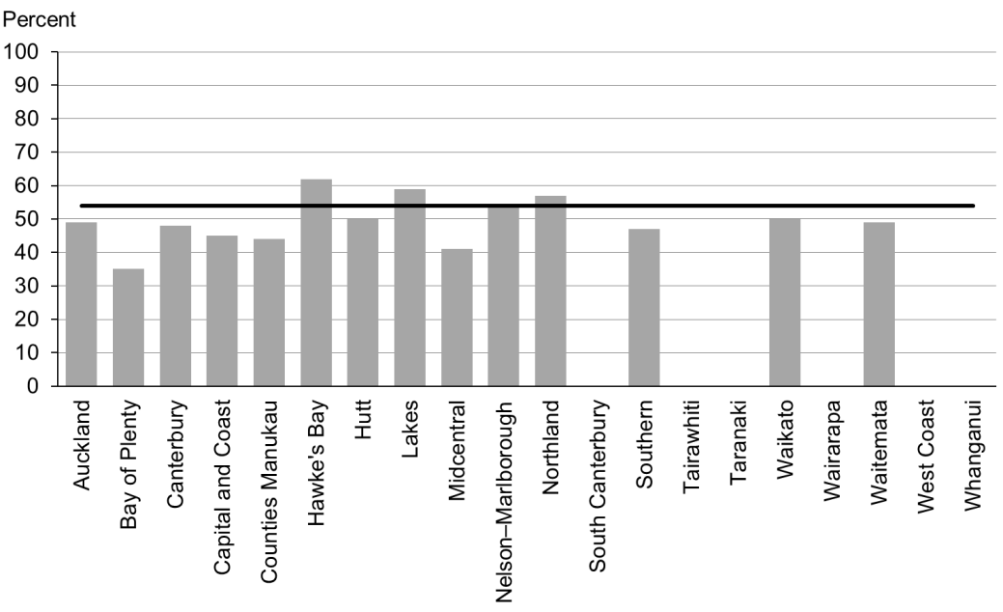

### Data notes

* No bar on graph = fewer than 20 infants in this category.
* Time period: infants aged three months between 1 January 2015 t0 30 June 2015.
* As explained in the Introduction, results for Indicator 13 for this period are not directly comparable with results from earlier periods, because of the inclusion of data from Tamariki Ora providers in addition to Plunket data.
* The data excludes overseas DHB and undefined DHB.
* Numerator: breastfeeding at three months = exclusive or fully (source: WCTO NHI dataset).
* Denominator: breastfeeding at three months = not null (source: WCTO NHI dataset).

## WCTO Quality Improvement Framework Indicator 14

|  |  |
| --- | --- |
| **Standard** | WCTO providers use evidence-based interventions and education to promote child, family and whānau health and wellbeing. |
| **Indicator** | Infants are receiving breast milk at six months (exclusively, fully or partially). |
| **Target by December 2014** | 59 percent |
| **Target by June 2016** | 65 percent |

|  |  |  |  |  |
| --- | --- | --- | --- | --- |
|  | **Total New Zealand** | **High deprivation** | **Māori** | **Pacific peoples** |
| September 2015 mean (range) | 66% (56–75) | 56% (44–69) | 54% (46–65) | 59% (47–70) |
| March 2015 mean (range) | 66% (57–76) | 56% (40–68) | 55% (47–69) | 59% (45–71) |

Figure 45: Infants receiving breast milk at six months, total New Zealand

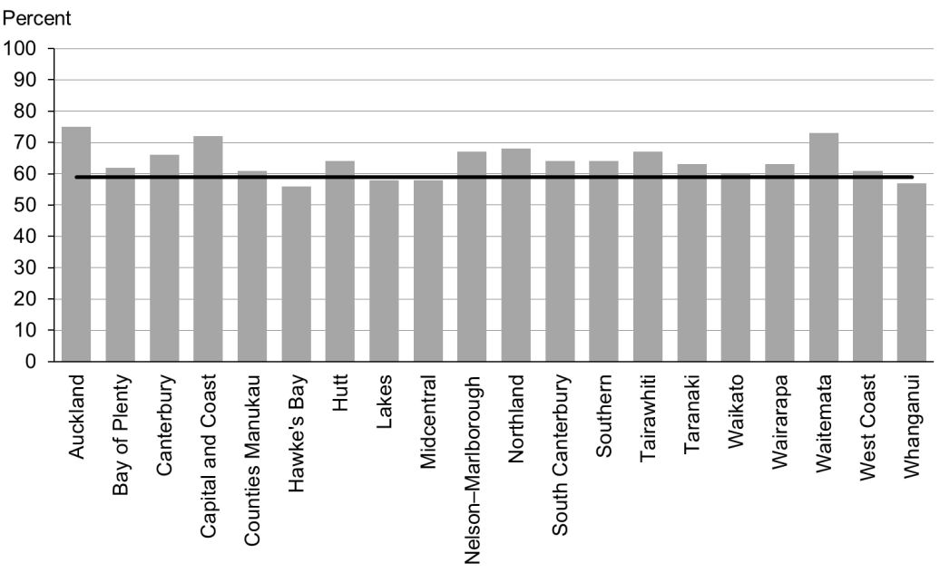

Figure 46: Infants receiving breast milk at six months, high deprivation population

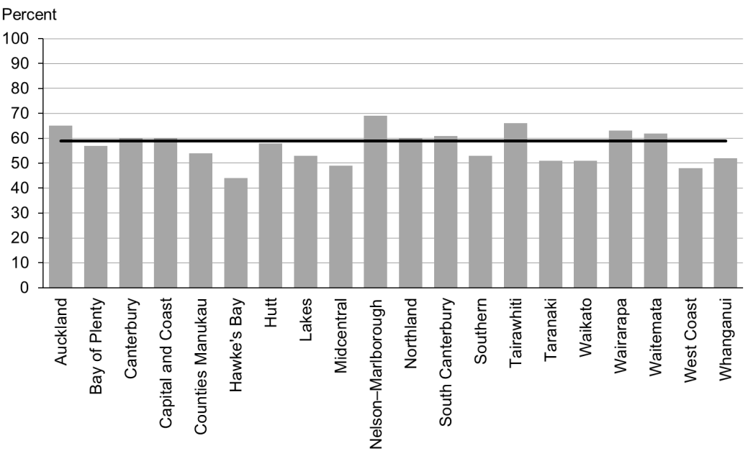

Figure 47: Infants receiving breast milk at six months, Māori

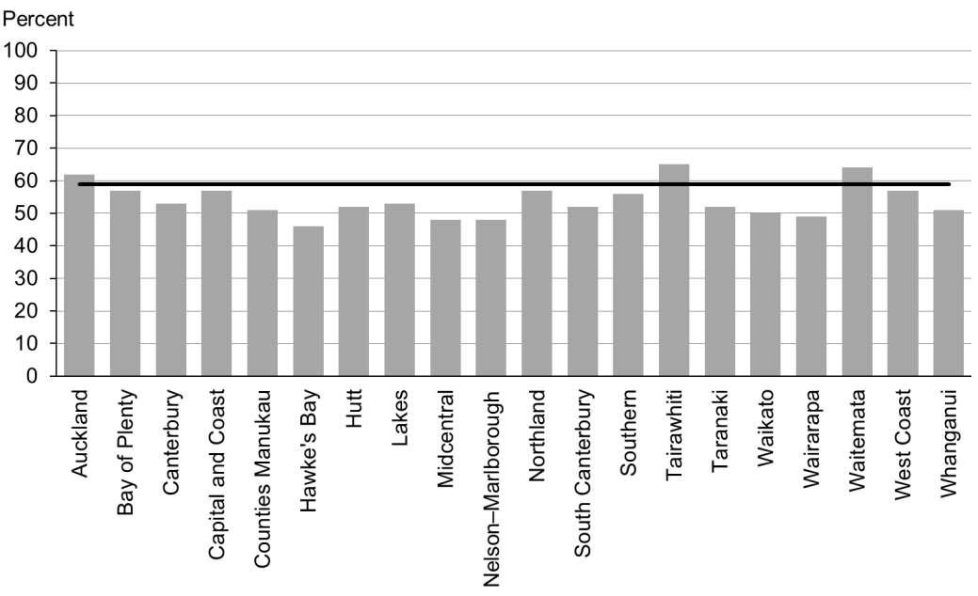

Figure 48: Infants receiving breast milk at six months, Pacific peoples

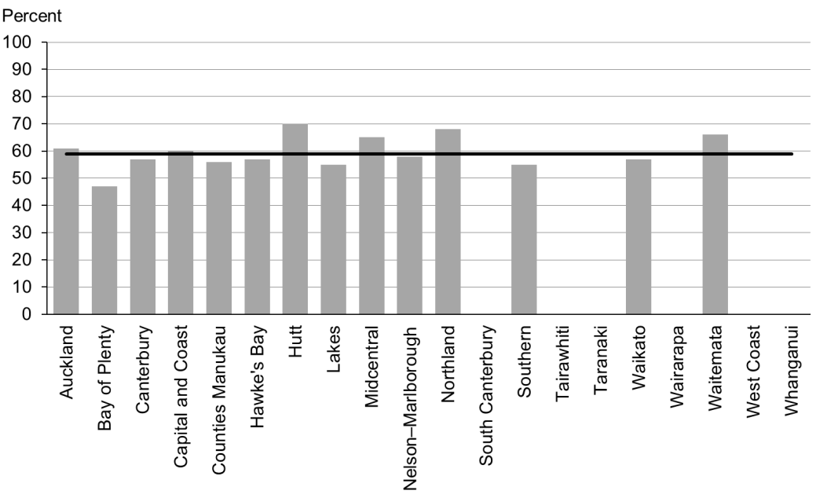

### Data notes

* No bar on graph = fewer than 20 infants in this category.
* Time period: infants aged six months between 1 January 2015 to 30 June 2015.
* As explained in the Introduction, results for Indicator 14 for this period are not directly comparable with results from earlier periods, because of the inclusion of data from Tamariki Ora providers in addition to Plunket data.
* The data excludes overseas DHB and undefined DHB.
* Numerator: breastfeeding at six months = exclusive, full or partial (source: WCTO NHI dataset).
* Denominator: breastfeeding at six months = not null (source: WCTO NHI dataset).

## WCTO Quality Improvement Framework Indicator 15

|  |  |
| --- | --- |
| **Standard** | WCTO providers use evidence-based interventions and education to promote child, family and whānau health and wellbeing. |
| **Indicator** | Children are a healthy weight at four years. |
| **Target by December 2014** | 68 percent |
| **Target by June 2016** | 75 percent |

|  |  |  |  |  |
| --- | --- | --- | --- | --- |
|  | **Total New Zealand** | **High deprivation** | **Māori** | **Pacific peoples** |
| September 2015 mean (range) | 75% (69–80) | 68% (56–75) | 72% (60–80) | 60% (48–75) |
| March 2015 mean (range) | 75% (70–81) | 69% (63–80) | 71% (58–79) | 61% (42–94) |

Figure 49: Children are a healthy weight at age four years, total New Zealand

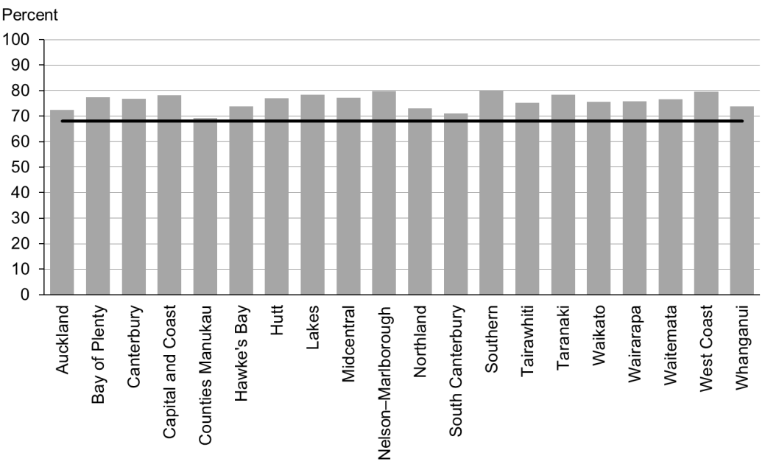

Figure 50: Children are a healthy weight at age four years, high deprivation population

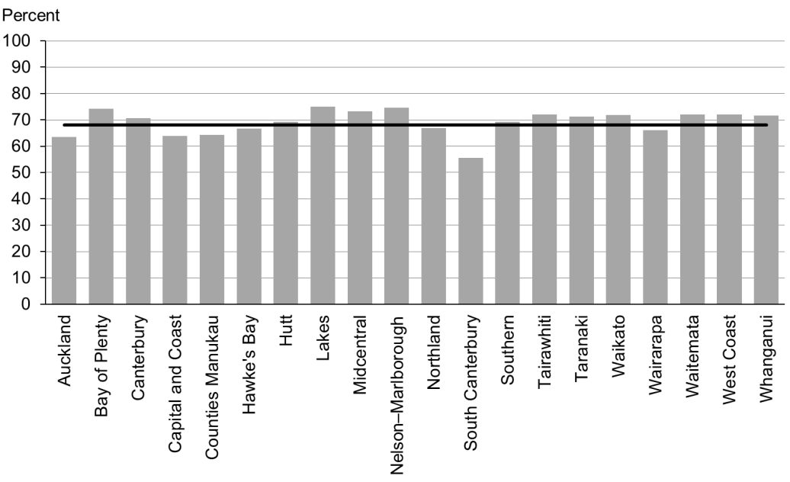

Figure 51: Children are a healthy weight at age four years, Māori

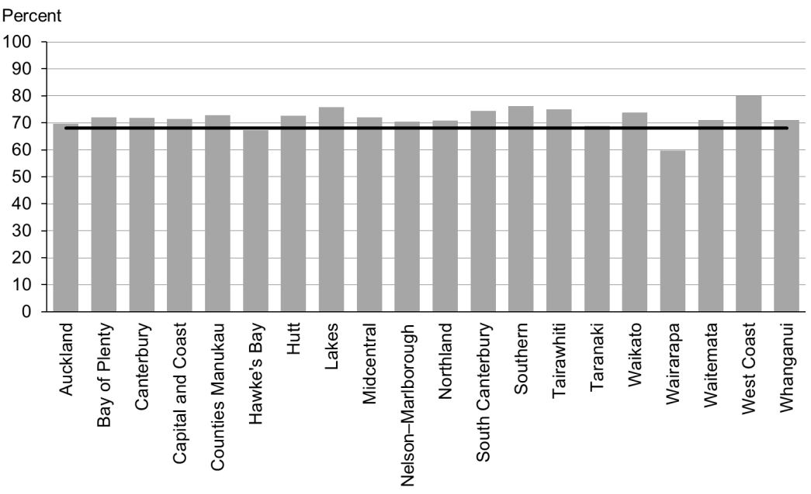

Figure 52: Children are a healthy weight at age four years, Pacific peoples

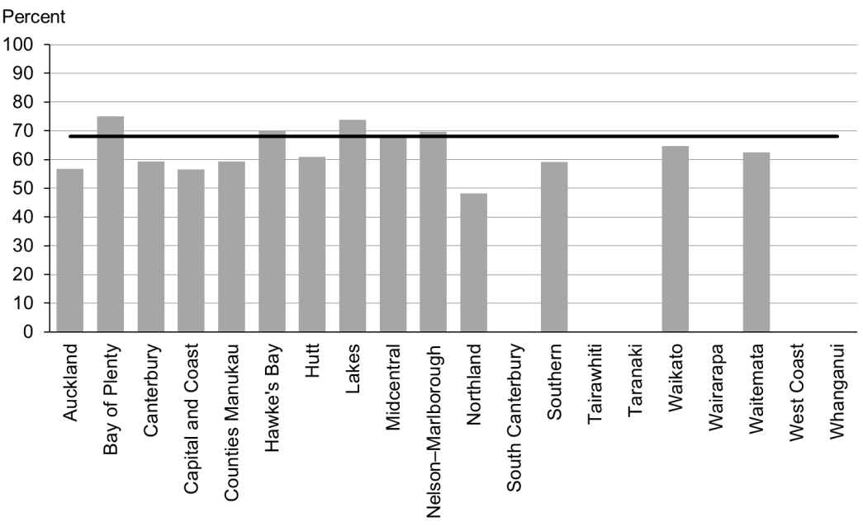

### Data notes

* No bar on graph = fewer than 20 children in this category.
* Time period: children receiving a B4 School Check between 1 January 2015 and 30 June 2015.
* DHB is DHB of service.
* Numerator: children with a BMI between the 5th and 84th percentile at B4 School Check (source: B4 School Check).
* Denominator: children with a BMI recorded at B4 School Check (source: B4 School Check).

## WCTO Quality Improvement Framework Indicator 16

|  |  |
| --- | --- |
| **Standard** | WCTO providers use evidence-based interventions and education to promote child, family and whānau health and wellbeing. |
| **Indicator** | Children are caries free at five years. |
| **Target by December 2014** | 65 percent |
| **Target by June 2016** | 65 percent |

|  |  |  |  |  |  |
| --- | --- | --- | --- | --- | --- |
|  | **Total New Zealand** | **High deprivation** | **Māori** | | **Pacific peoples** |
| September 2015 mean (range) | 59% (34–68) | N/A | | 40% (25–56) | 36% (22–65) |
| September 2014 mean (range) | 57% (34–68) | N/A | | 37% (23–53) | 36% (10–86) |

Figure 53: Children are caries free at five years, total New Zealand

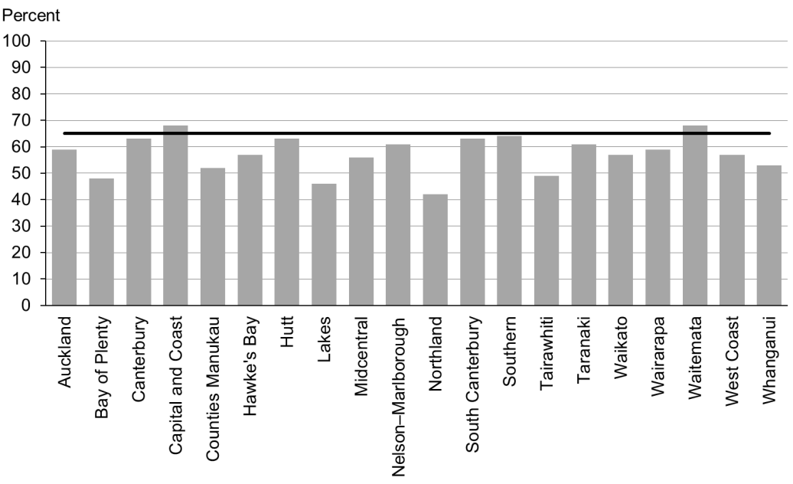

Figure 54: Children are caries free at five years, Māori

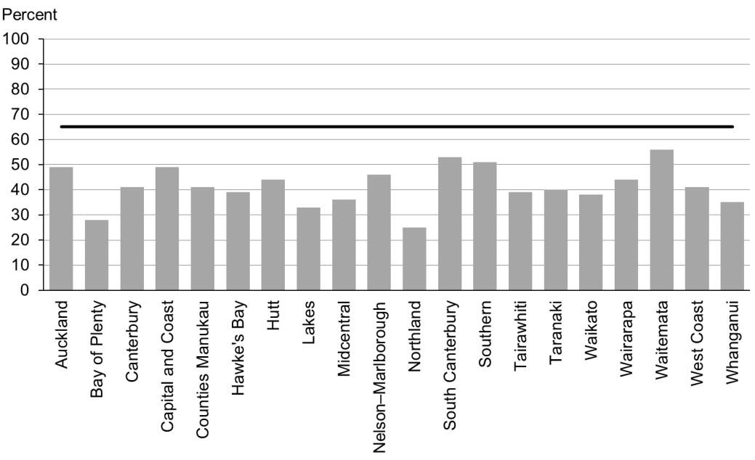

Figure 55: Children are caries free at five years, Pacific peoples

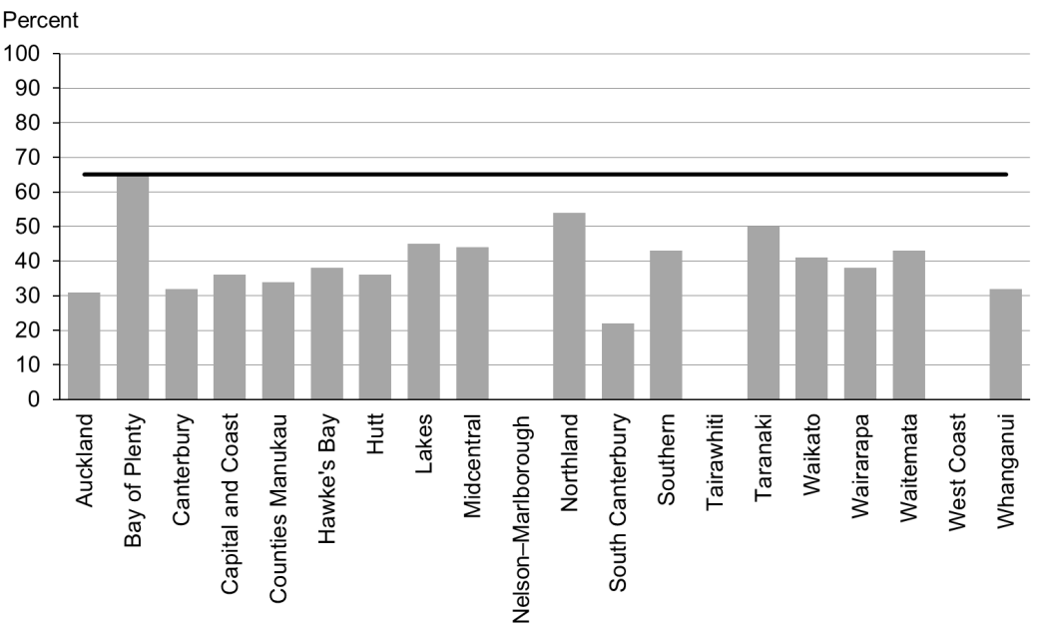

### Data notes

* No bar on graph = no children in this category.
* Time period: children turning five years between 1 January 2014 and 31 December 2014.
* Excludes overseas DHB and undefined DHB.
* Data is not available by deprivation quintile.
* Numerator: number of five-year-old children caries free (source: community oral health services).
* Denominator: number of five-year-old children enrolled with oral health services (source: community oral health services).

## WCTO Quality Improvement Framework Indicator 17

|  |  |
| --- | --- |
| **Standard** | WCTO providers use evidence-based interventions and education to promote child, family and whānau health and wellbeing. |
| **Indicator** | The burden of dental decay among children with one or more decayed, missing or filled (dmft) deciduous (baby) teeth is minimised. |
| **Target by December 2014** | 4.4 average dmft |
| **Target by June 2016** | 4 average dmft |

|  |  |  |  |  |  |  |
| --- | --- | --- | --- | --- | --- | --- |
|  | **Total New Zealand** | | **High deprivation** | | **Māori** | **Pacific peoples** |
| September 2015 mean (range) | 4.42 (3.3–5.2) | N/A | | 4.91 (4.0–5.9) | | 5.10 (3.11–8.0) |
| September 2014 mean (range) | 4.4 (3.6–5.5) | N/A | | 5.0 (3.9–6.2) | | 5.1 (4.0–7.8) |

Figure 56: Burden of dental decay among children, total New Zealand

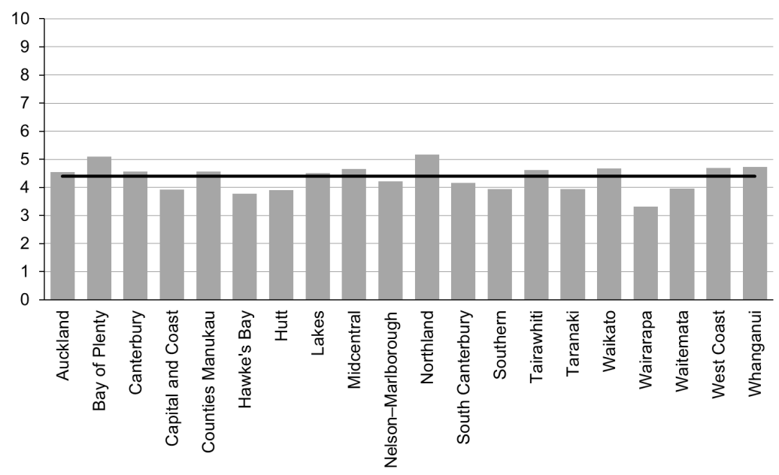

Figure 57: Burden of dental decay among children, total New Zealand, Māori

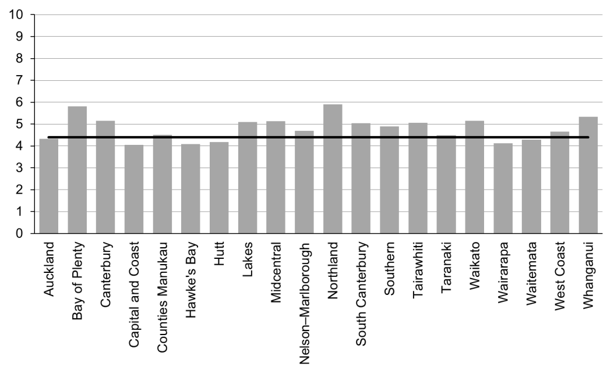

Figure 58: Burden of dental decay among children, total New Zealand, Pacific peoples

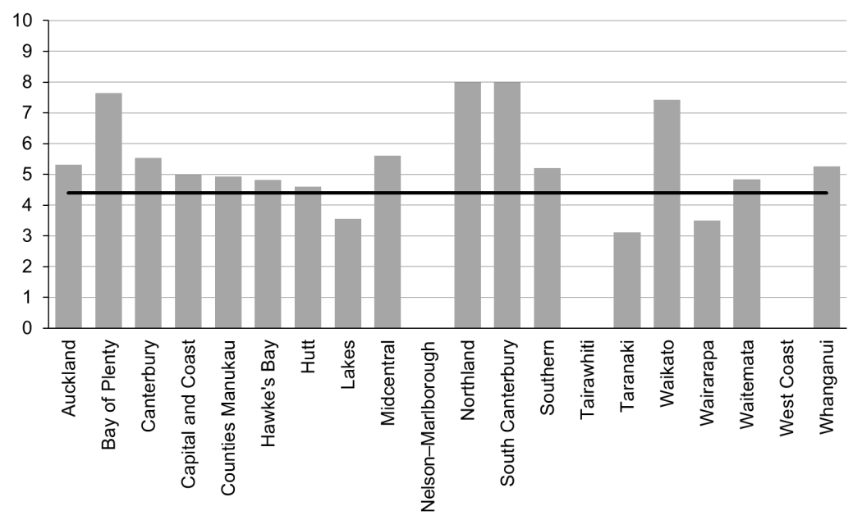

### Data notes

* No bar on graph = no children in this category.
* Time period: children turning five years old between 1 January 2014 and 31 December 2014.
* Excludes overseas DHB and undefined DHB.
* Data is not available by deprivation quintile.
* Numerator: sum of dmft scores at five years old (source: community oral health services).
* Denominator: number of five-year-olds with a dmft score greater than zero (source: community oral health services).

## WCTO Quality Improvement Framework Indicator 18

|  |  |
| --- | --- |
| **Standard** | WCTO providers use evidence-based interventions and education to promote child, family and whānau health and wellbeing. |
| **Indicator** | Child mental health is supported (children’s SDQ-P scores are within the normal range at the B4 School Check).[2] |
| **Target by December 2014** | 86 percent |
| **Target by June 2016** | 95 percent |

|  |  |  |  |  |
| --- | --- | --- | --- | --- |
|  | **Total New Zealand** | **High deprivation** | **Māori** | **Pacific peoples** |
| September 2015 mean (range) | 96% (93–98) | 94% (91–97) | 94% (87–97) | 95% (71–100) |
| March 2015 mean (range) | 96% (91–99) | 93% (84–100) | 94% (88–100) | 95% (84–100) |

Figure 59: Children with a normal SDQ-P score at four years, total New Zealand

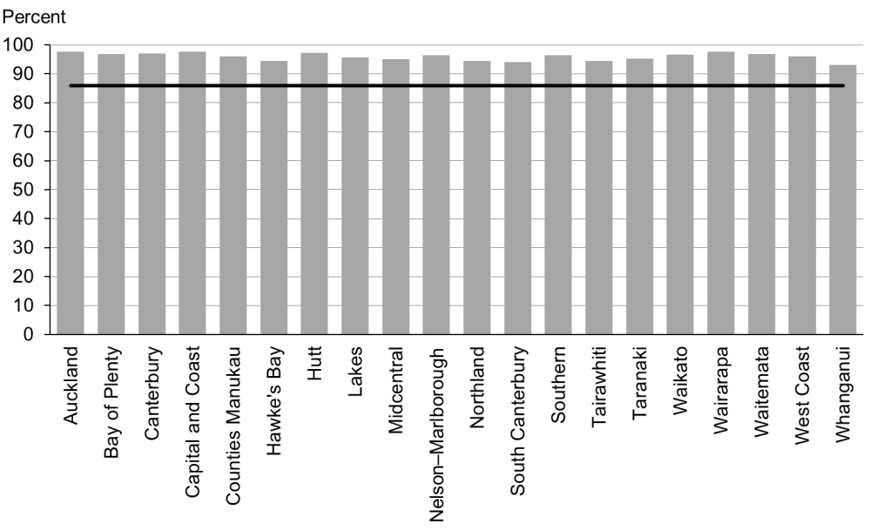

Figure 60: Children with a normal SDQ-P score at four years, high deprivation population

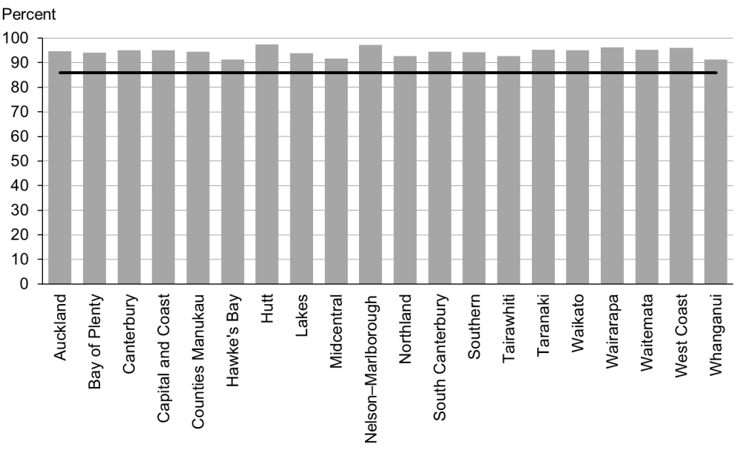

Figure 61: Children with a normal SDQ-P score at four years, Māori

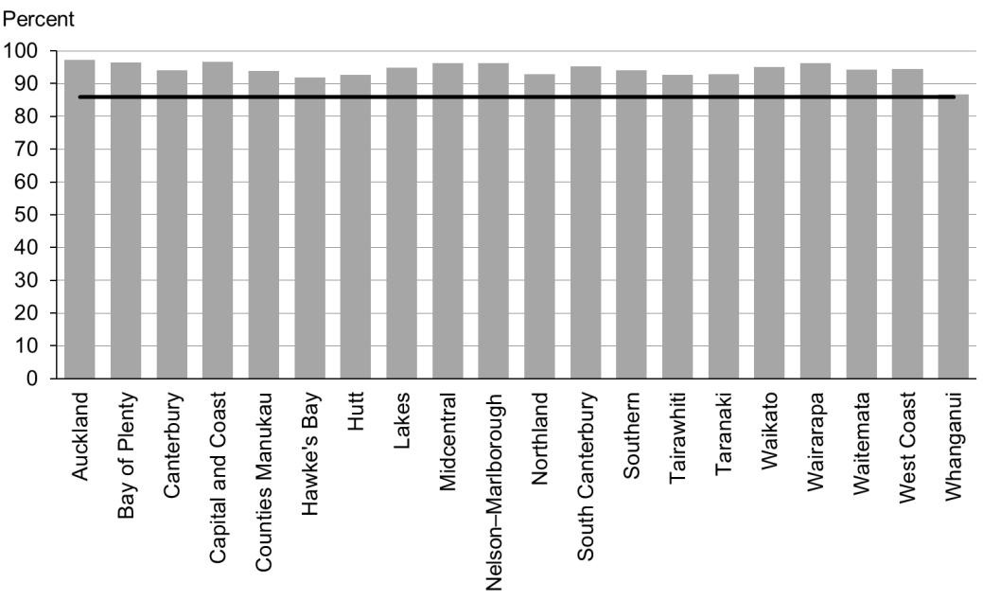

Figure 62: Children with a normal SDQ-P score at four years, Pacific peoples

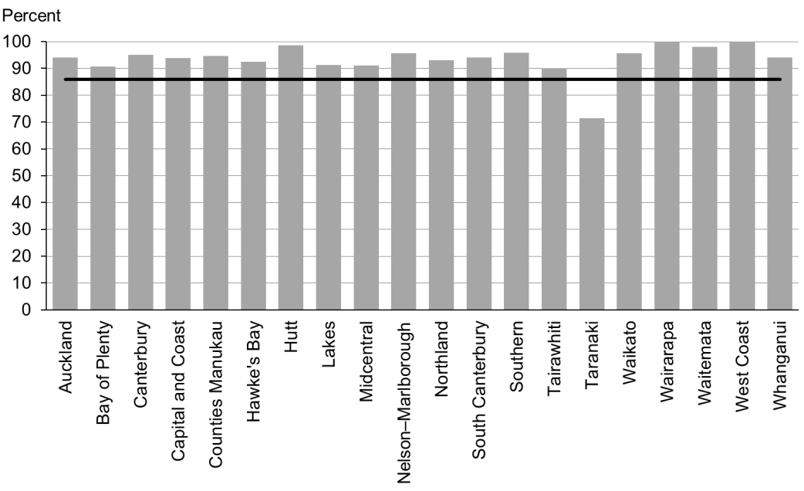

### Data notes

* Time period: children receiving a B4 School Check between 1 January 2015 and 30 June 2015.
* DHB is DHB of service.
* Numerator: children with an SDQ-P score that is within the normal range (source: B4 School Check).
* Denominator: children with an SDQ-P score recorded at the B4 School Check (source: B4 School Check).

## WCTO Quality Improvement Framework Indicator 19

|  |  |
| --- | --- |
| **Standard** | WCTO providers use evidence-based interventions and education to promote child, family and whānau health and wellbeing. |
| **Indicator** | Mothers are smokefree at two weeks postnatal. |
| **Target by December 2014** | 86 percent |
| **Target by June 2016** | 95 percent |

|  |  |  |  |  |
| --- | --- | --- | --- | --- |
|  | **Total New Zealand** | **High deprivation** | **Māori** | **Pacific peoples** |
| September 2015 mean (range) | 87% (72–98) | 78% (61–95) | 66% (58–89) | 92% (67–100) |
| March 2015 mean (range) | 87% (72–96) | 76% (61–94) | 65% (56–83) | 91% (71–100) |

Figure 63: Mothers smokefree at two weeks postnatal, total New Zealand

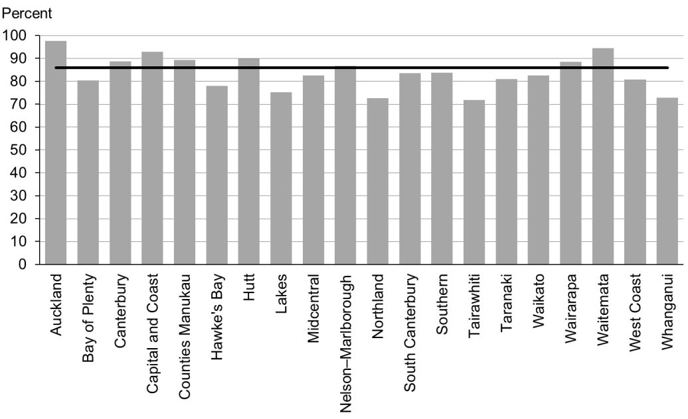

Figure 64: Mothers smokefree at two weeks postnatal, high deprivation population

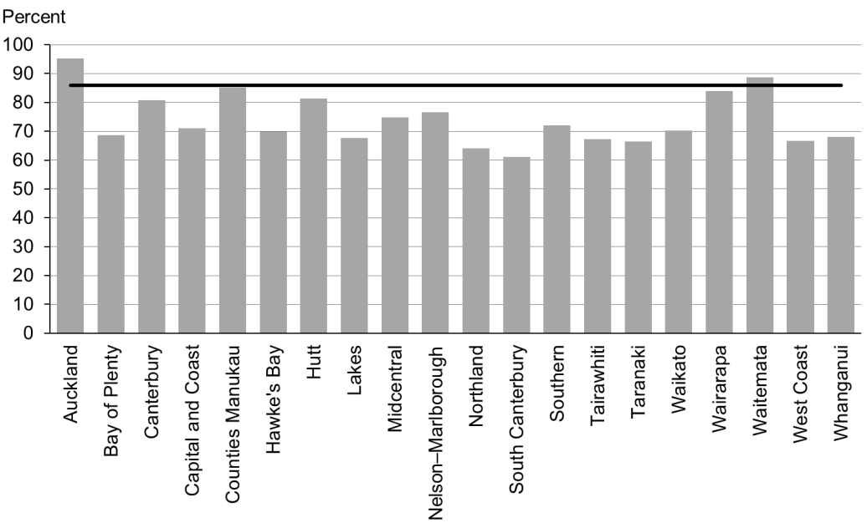

Figure 65: Mothers smokefree at two weeks postnatal, Māori

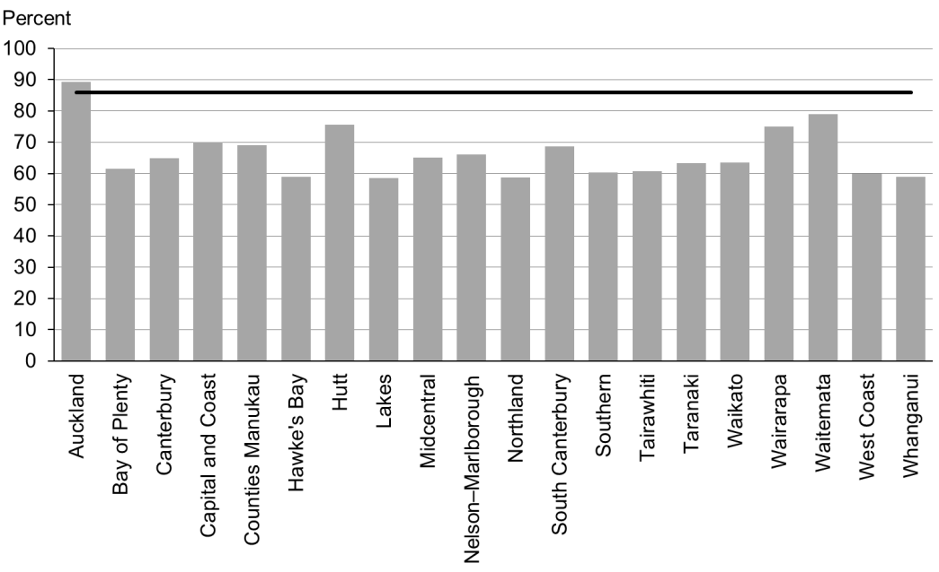

Figure 66: Mothers smokefree at two weeks postnatal, Pacific peoples

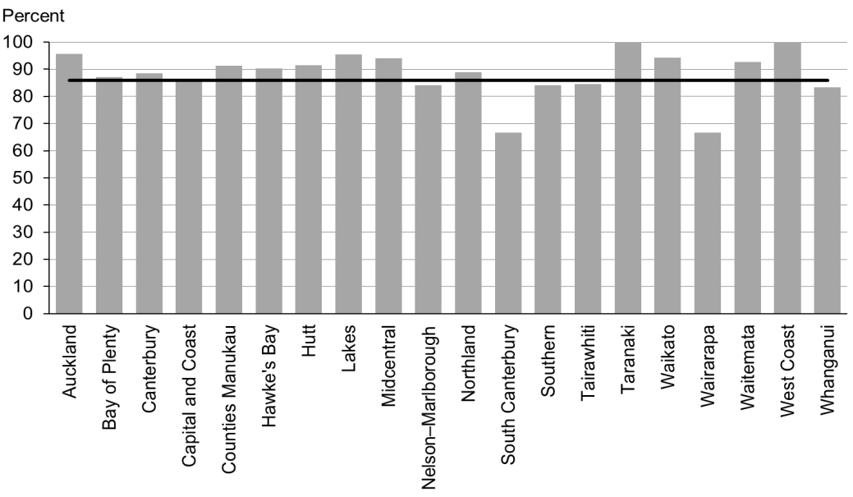

### Data notes

* Time period: births between 1 July 2014 and 31 December 2014.
* The data excludes overseas DHB and undefined DHB.
* Numerator: maternal tobacco use (two weeks) = Yes (source: MAT).
* Denominator: maternal tobacco use (two weeks) = Yes or No (source: MAT).

## WCTO Quality Improvement Framework Indicator 20

|  |  |
| --- | --- |
| **Standard** | WCTO providers use evidence-based interventions and education to promote child, family and whānau health and wellbeing. |
| **Indicator** | Children live in a smokefree home (age four years).[3] |
| **Target by December 2014** | 90 percent |
| **Target by June 2016** | 100 percent |

|  |  |  |  |  |
| --- | --- | --- | --- | --- |
|  | **Total New Zealand** | **High deprivation** | **Māori** | **Pacific peoples** |
| September 2015 mean (range) | 98% (74–100) | 97% (91–100) | 97% (92–100) | 97% (0–100) |
| March 2015 mean (range) | 98% (94–100) | 97% (91–100) | 97% (86–100) | 97% (86–100) |

Figure 67: Children living in a smokefree home (age four years), total New Zealand

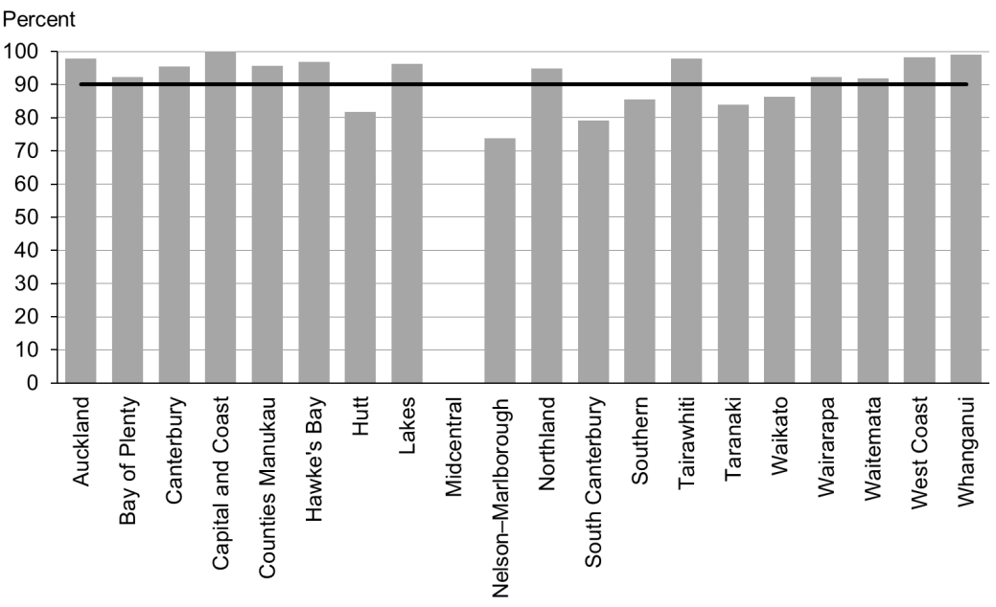

Figure 68: Children living in a smokefree home (age four years), high deprivation population

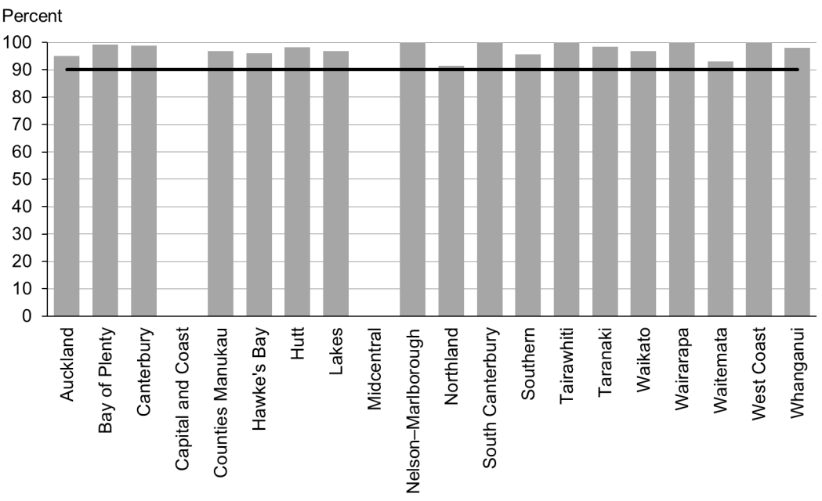

Figure 69: Children living in a smokefree home (age four years), Māori

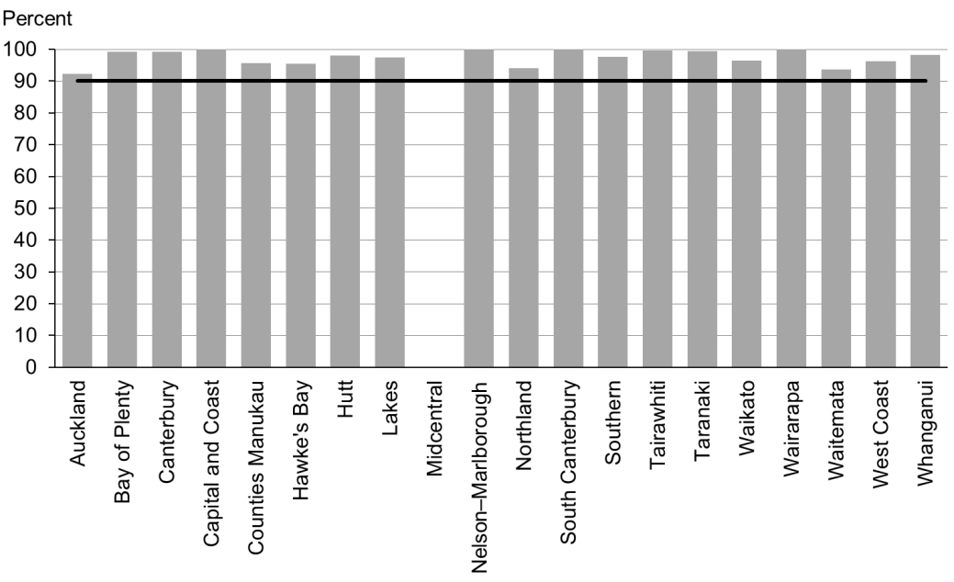

Figure 70: Children living in a smokefree home (age four years), Pacific peoples

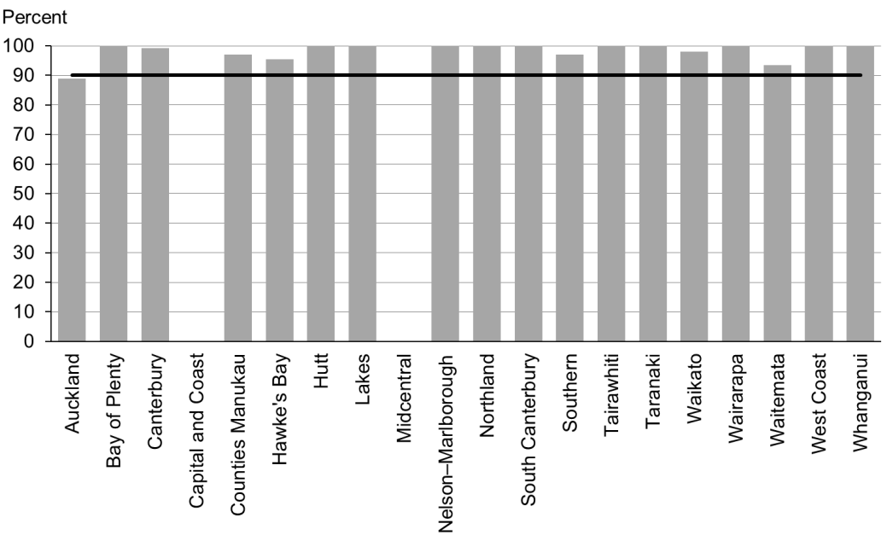

### Data notes

* No bar on graph = the smokefree at-home status is not reported
* Time period: children receiving a B4 School Check between 1 January 2014 and 30 June 2014.
* DHB is DHB of service.
* Numerator: children with smokefree home = Yes (source: B4 School Check).
* Denominator: children with smokefree home = Yes or No (source: B4 School Check).

# Indicators 21–27: Quality

Aim 3 of the WCTO Quality Improvement Framework is **best value for health system resource**. To achieve this aim, providers must base advice, screening and interventions on the best available evidence, and deliver them to a consistently high quality. Providers can achieve the best value for money by:

* identifying health and development problems accurately (reducing downstream costs related to poor sensitivity, and wastage due to poor specificity)
* treating health and development issues early (reducing the intensity of the intervention required) through interventions that have the best evidence of success (maximising health gain for investment).

Indicators 21–27 measure the quality of service delivery within the WCTO programme; in other words, adherence to best practice (either in terms of the timing of the intervention or adherence to screening protocol). The current indicators within this section focus exclusively on the B4SC, due to the limited availability of data for other parts of the WCTO programme. The Ministry of Health expects to add other indicators over time.

## Summary of results for this period

### National

Nationally, providers most consistently meet targets for Indicators 21−27, out of all the indicators in the set. Additionally, providers consistently achieve the most equitable results (in terms of regions, ethnicities and deprivation areas) for this group of indicators. Providers have achieved the December 2014 targets for all of the seven indicators (that is, if ‘advice given’ is included within Indicators 22 and 23 – referral rates for abnormal SDQ-P scores and PEDS Pathway A, respectively). For the purposes of these indicators, ‘referral’ applies to a primary care provider arranging for a child to see a specialist service; ‘advice’ is the primary care provider advising the child or their family/whānau on the issue themselves.

The overall referral rate for children with extreme obesity (a BMI greater than the 99.4th percentile) dropped slightly between the March and September reports, from 86 percent to 83 percent. Given the small number of children in this category, a small drop is not concerning.

Quality improvement efforts and the commitment of B4SC providers, vision and hearing technicians and specialist audiology and optometry/ophthalmology services has meant that since March 2014, consistently, 100 percent of children with an identified issue are being referred to specialist services, across all regions, deprivation quintiles and ethnic groups.

Achievement against Indicator 24: ‘Children with a Lift the Lip (oral health) score of 2–6 are referred’ was also at 100 percent in September for every group – this represents a significant increase of 30 percentage points (within the total population) from the September 2014 report.

### By region

Nationally, although the September results indicated that 85 percent of B4SC were started before the age of 4½ years (Indicator 21), there was still significant variation by region (the range was 34–96 percent). In this case, Taranaki DHB was the significant outlier, achieving only 34 percent, but five other DHBs failed to reach the December 2014 target of 81 percent. Conversely, other DHBs were already meeting the June 2016 target of 90 percent. There was also a large variety across the DHBs when it came to Māori and Pacific children starting B4SCs before 4½ years.

The only other variation between DHBs for this group of indicators was the difference in achievement against the indicator when looked at in terms of referrals being made and advice being given – particularly in the case of Indicators 22 and 23 (referral rates for abnormal SDQ-P and PEDs Pathway A, respectively). Some DHBs refer very few of their children, preferring instead to provide advice within primary care – other DHBs take the exact opposite approach. The Ministry of Health does not recommend one single ‘right way’, but expects that, whichever option DHBs and B4SC providers choose, their choice is thoroughly researched, and they support the establishment of appropriate local pathways and build the local capacity of specialist services.

### By deprivation level

Unlike for other indicators in this report, performance against these seven quality-related indicators does not seem to be lower for children living in areas of high deprivation. The exception is Indicator 21, ‘B4SC are started before children are 4½ years’, achievement against which remained at a slightly lower rate in high deprivation areas in this reporting period (stable at 3 percentage points lower than the total population).

### By ethnicity

In the case of Māori and Pacific children, achievement against all seven quality indicators showed improvement or remained at 100 percent between the March and September reports. Similar increases and stability was evident in the previous report.

The gap between referral rates for Māori and non-Māori children with extreme obesity closed between the March and September reports (from 9 percentage points in March to 4 percentage points in September 2015). Pacific children with extreme obesity had the highest rates of referral (excluding advice given) in September, at 92 percent.

## WCTO Quality Improvement Framework Indicator 21

|  |  |
| --- | --- |
| **Standard** | WCTO services are delivered at the right time. |
| **Indicator** | B4SCs are started before children are 4½ years. |
| **Target by December 2014** | 81 percent |
| **Target by June 2016** | 90 percent |

|  |  |  |  |  |
| --- | --- | --- | --- | --- |
|  | **Total New Zealand** | **High deprivation** | **Māori** | **Pacific peoples** |
| September 2015 mean (range) | 85% (34–96) | 84% (34–97) | 81% (36–95) | 84% (52–94) |
| March 2015 mean (range) | 85% (27–97) | 82% (34–96) | 80% (35–96) | 82% (11–100) |

Figure 71: B4 School Checks started before age 4½ years, total New Zealand

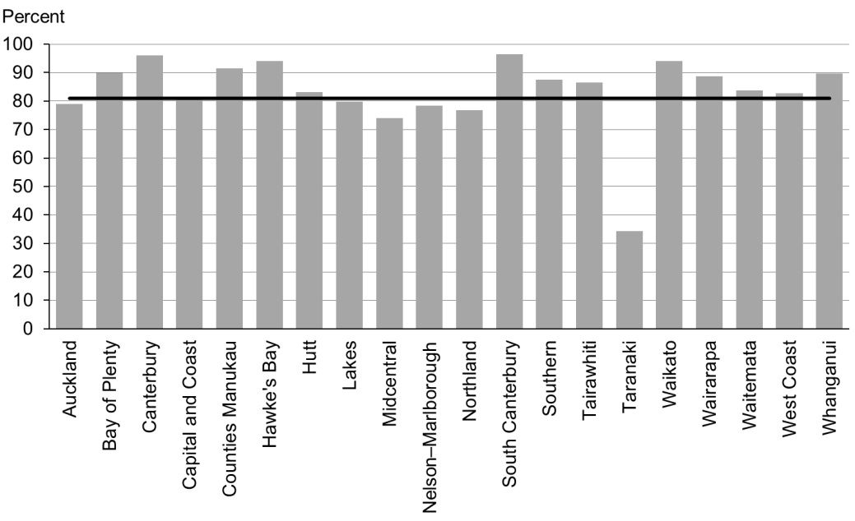

Figure 72: B4 School Checks started before age 4½ years, high deprivation population

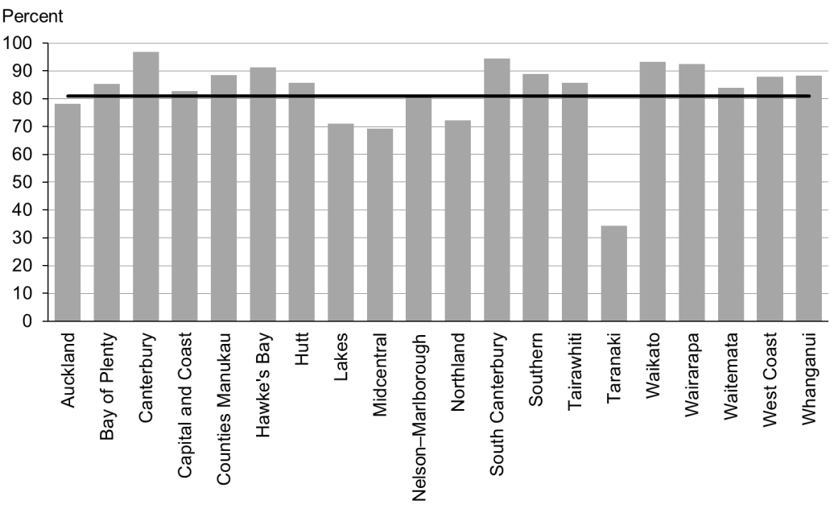

Figure 73: B4 School Checks started before age 4½ years, Māori

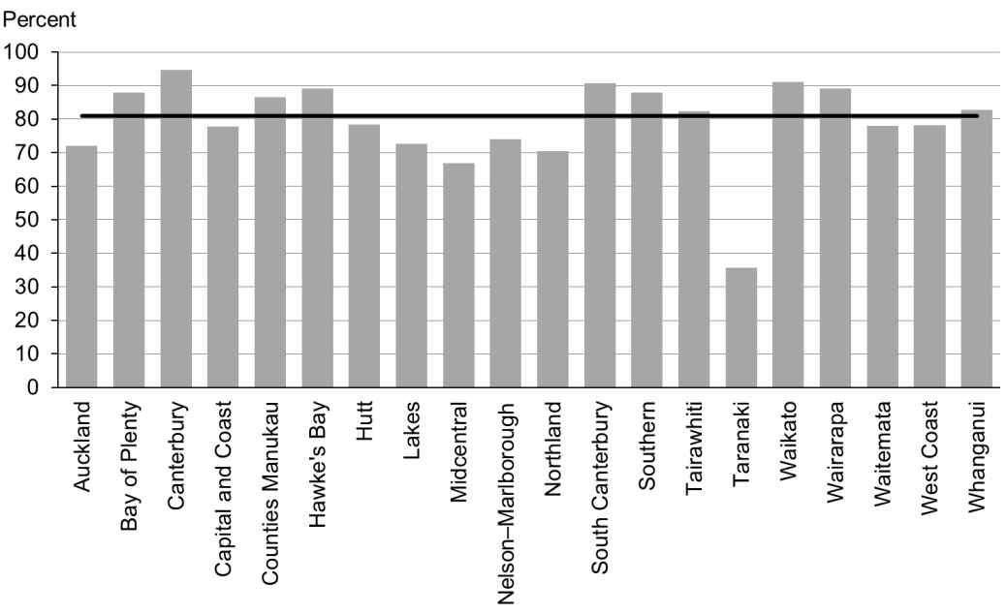

Figure 74: B4 School Checks started before age 4½ years, Pacific peoples

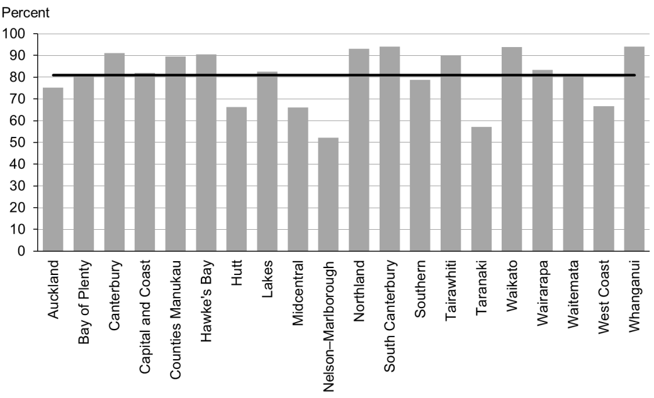

### Data notes

* Time period: children receiving a B4 School Check between 1 January 2015 and 30 June 2015.
* DHB is DHB of service.
* Numerator: number of children receiving a B4 School Check who started the check at younger than 4½ years (source: B4 School Check).
* Denominator: number of children receiving a B4 School Check (source: B4 School Check).

## WCTO Quality Improvement Framework Indicator 22

|  |  |
| --- | --- |
| **Standard** | WCTO providers deliver services in accordance with best practice (inappropriate variation is reduced). |
| **Indicator** | Children with an abnormal SDQ-P at the B4 School Check are referred to specialist services. |
| **Target by December 2014** | 86 percent |
| **Target by June 2016** | 95 percent |

|  |  |  |  |  |
| --- | --- | --- | --- | --- |
|  | **Total New Zealand** | **High deprivation** | **Māori** | **Pacific peoples** |
| September 2015 mean – advice or referral | 100% | 100% | 100% | 100% |
| September 2015 mean (range) – referral only | 44% (13–74) | 44% (0–100) | 48% (0–100) | 30% (0–67) |
| March 2015 mean – advice or referral | 100% | 100% | 100% | 100% |
| March 2015 mean (range) – referral only | 47% (0–100) | 50% (0–100) | 48% (0–100) | 45% (0–100) |

Figure 75: Children with abnormal SDQ-P referred, total New Zealand

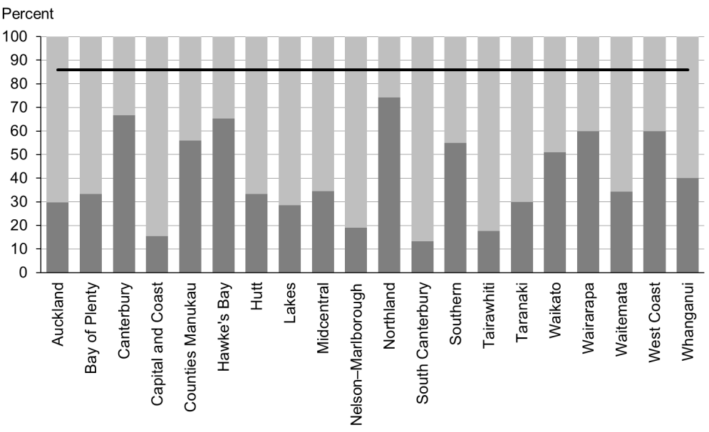

Figure 76: Children with abnormal SDQ-P referred, high deprivation population

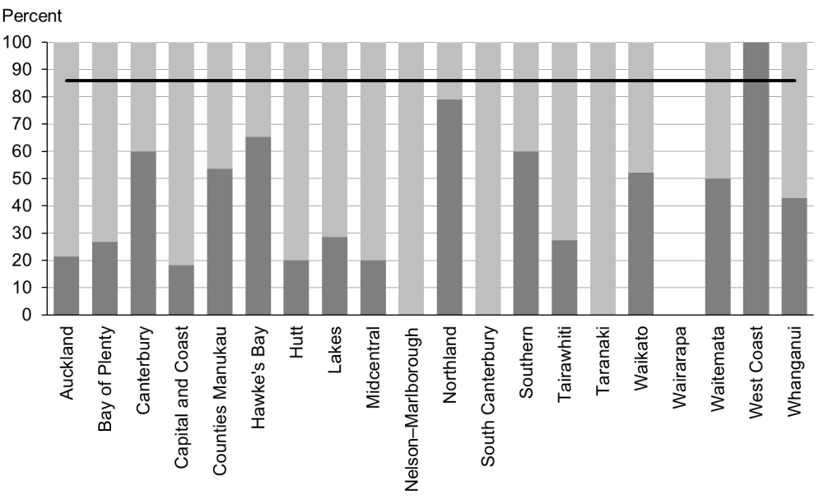

Figure 77: Children with abnormal SDQ-P referred, Māori

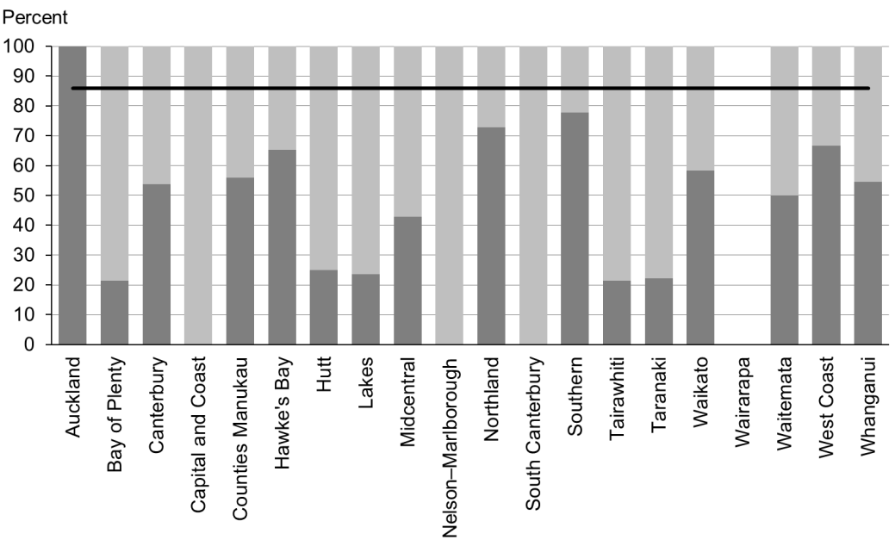

Figure 78: Children with abnormal SDQ-P referred, Pacific peoples

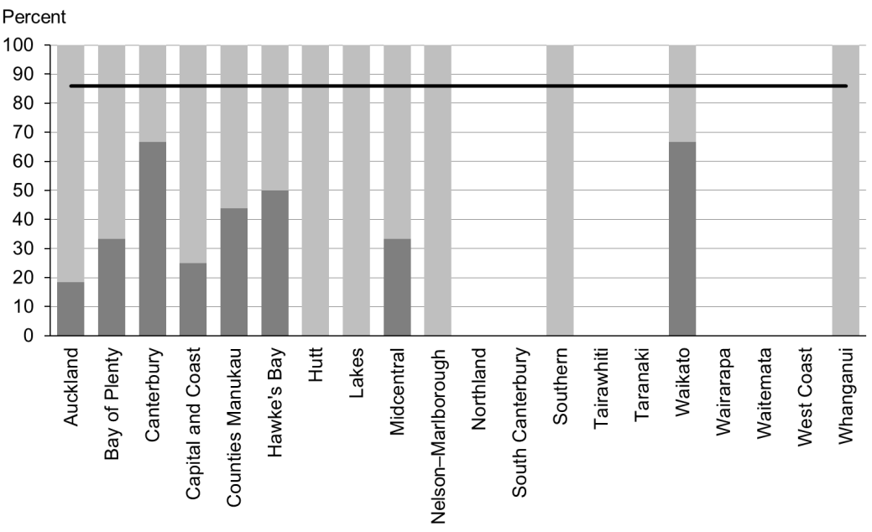

### Data notes

* The stacked bar shows rate of referral excluding ‘advice given’ (dark grey section) and rate of referral including ‘advice given’ (dark grey plus light grey sections).
* No bar on graph = no children with abnormal SDQ-P for that population.
* Time period: children receiving a B4 School Check between 1 January 2015 and 30 June 2015.
* DHB is DHB of service.
* Numerator: number of children with an abnormal SDQ-P referred (source: B4 School Check).
* Denominator: number of children with an abnormal SDQ-P (excluding those already under care) (source: B4 School Check).

## WCTO Quality Improvement Framework Indicator 23

|  |  |
| --- | --- |
| **Standard** | WCTO providers deliver services in accordance with best practice (inappropriate variation is reduced). |
| **Indicator** | Children with a Parental Evaluation of Developmental Status (PEDS) Pathway A at the B4 School Check are referred to specialist services. |
| **Target by December 2014** | 86 percent |
| **Target by June 2016** | 95 percent |

|  |  |  |  |  |
| --- | --- | --- | --- | --- |
|  | **Total New Zealand** | **High deprivation** | **Māori** | **Pacific peoples** |
| September 2015 mean – advice or referral | 98% (80–100) | 99% (92–100) | 98% (88–100) | 98% (0–100) |
| September 2015 mean (range) – referral only | 58% (25–88) | 69% (0–100) | 61% (0–100) | 64% (0–100) |
| March 2015 mean – advice or referral | 97% (50–100) | 99% (93–100) | 98% (0–100) | 99% (75–100) |
| March 2015 mean (range) – referral only | 55% (22–90) | 66% (0–100) | 61% (0–88) | 68% (14–100) |

Figure 79: Children with PEDS Pathway A referred, total New Zealand

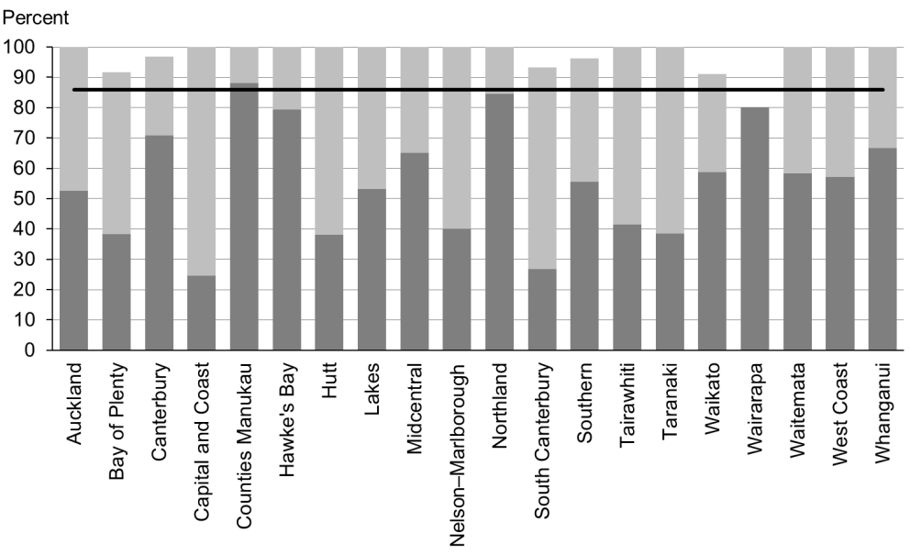

Figure 80: Children with PEDS Pathway A referred, high deprivation population

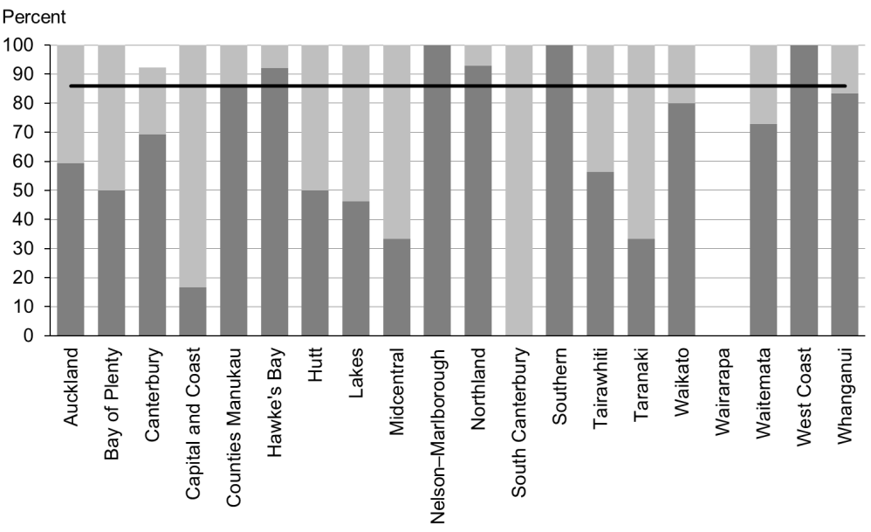

Figure 81: Children with PEDS Pathway A referred, Māori

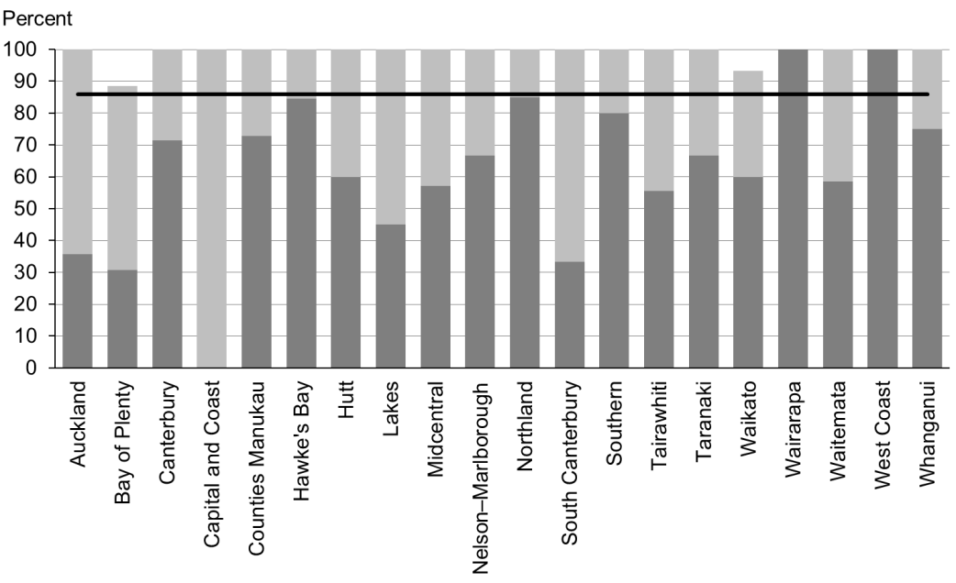

Figure 82: Children with PEDS Pathway A referred, Pacific peoples

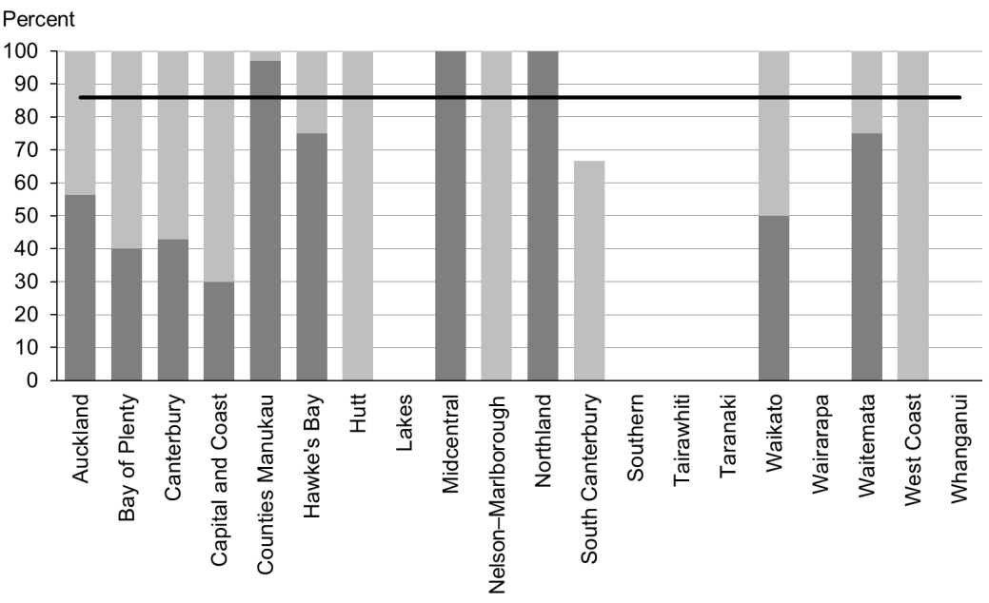

### Data notes

* The stacked bar shows rate of referral excluding ‘advice given’ (dark grey section) and rate of referral including ‘advice given’ (dark grey plus light grey sections).
* No bar on graph = no children with PEDS Pathway A for that population.
* Time period: children receiving a B4 School Check between 1 January 2015 and 30 June 2015.
* DHB is DHB of service.
* Numerator: number of children assessed as PEDS Pathway A referred (source: B4 School Check).
* Denominator: number of children assessed as PEDS Pathway A (excluding those already under care) (source: B4 School Check).

## WCTO Quality Improvement Framework Indicator 24

|  |  |
| --- | --- |
| **Standard** | WCTO providers deliver services in accordance with best practice (inappropriate variation is reduced). |
| **Indicator** | Children with a Lift the Lip (oral health) score of 2–6 at the B4 School Check are referred to specialist services. |
| **Target by December 2014** | 86 percent |
| **Target by June 2016** | 95 percent |

|  |  |  |  |  |
| --- | --- | --- | --- | --- |
|  | **Total New Zealand** | **High deprivation** | **Māori** | **Pacific peoples** |
| September 2015 mean – advice or referral | 100% | 100% | 100% | 100% |
| September 2015 mean (range) – referral only | 100% | 100% | 100% | 100% |
| March 2015 mean – advice or referral | 99% (89–100) | 99% (90–100) | 97% (89–100) | 99% (99–100) |
| March 2015 mean (range) – referral only | 99% (89–100) | 99% (95–100) | 99% (89–100) | 99% (99–100) |

Figure 83: Children with Lift the Lip score of 2–6 referred, total New Zealand

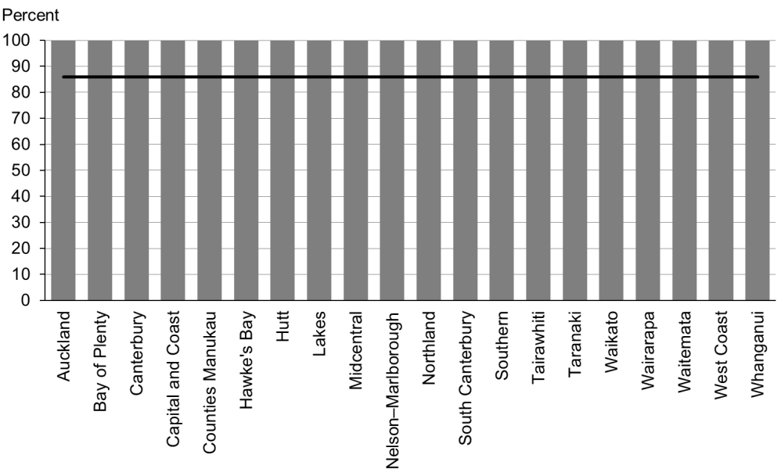

Figure 84: Children with Lift the Lip score of 2–6 referred, high deprivation population

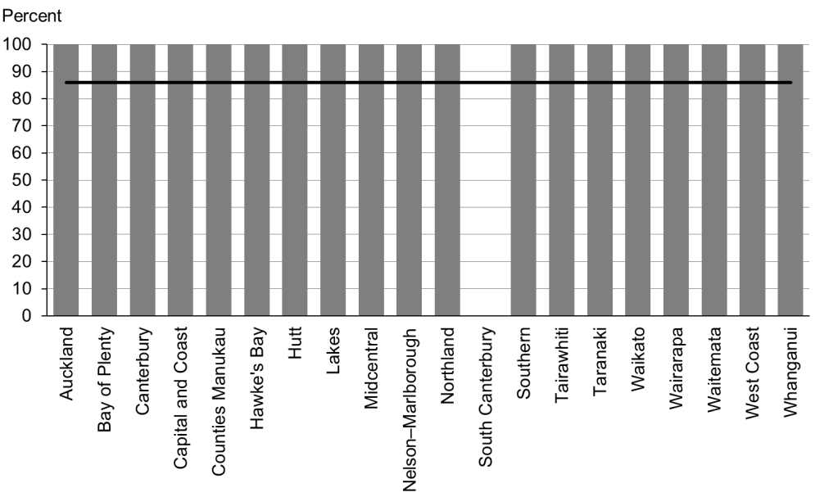

Figure 85: Children with Lift the Lip score of 2–6 referred, Māori

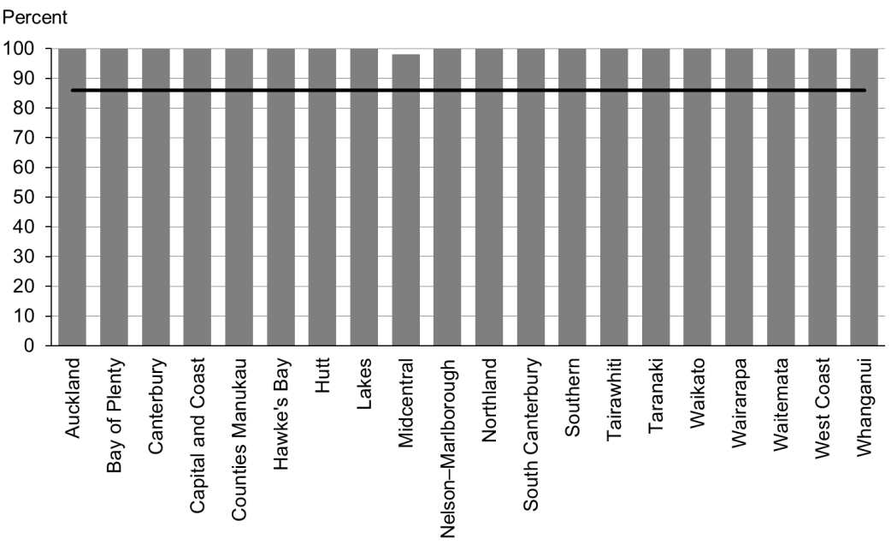

Figure 86: Children with Lift the Lip score of 2–6 referred, Pacific peoples

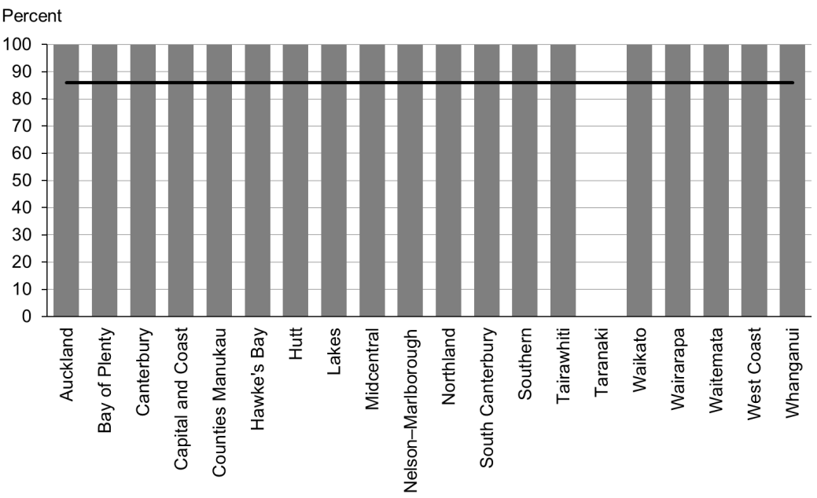

### Data notes

* The stacked bar shows rate of referral excluding ‘advice given’ (dark grey section) and rate of referral including ‘advice given’ (dark grey plus light grey sections).
* No bar on graph = no children with LTL score 2–6 for that population.
* Time period: children receiving a B4 School Check between 1 January 2015 and 30 June 2015.
* DHB is DHB of service.
* Numerator: number of children with LTL score of 2–6 referred (B4 School Check).
* Denominator: number of children with LTL score of 2–6 (excluding those already under care) (B4 School Check).

## WCTO Quality Improvement Framework Indicator 25

|  |  |
| --- | --- |
| **Standard** | WCTO providers deliver services in accordance with best practice (inappropriate variation is reduced). |
| **Indicator** | Children with an untreated vision problem at the B4 School Check are referred to specialist services. |
| **Target by December 2014** | 86 percent |
| **Target by June 2016** | 95 percent |

|  |  |  |  |  |
| --- | --- | --- | --- | --- |
|  | **Total New Zealand** | **High deprivation** | **Māori** | **Pacific peoples** |
| September 2015 mean –  referrals only | 100% | 100% | 100% | 100% |
| March 2015 mean –  referrals | 100% | 100% | 100% | 100% |

Figure 87: Children with an untreated vision problem referred, total New Zealand

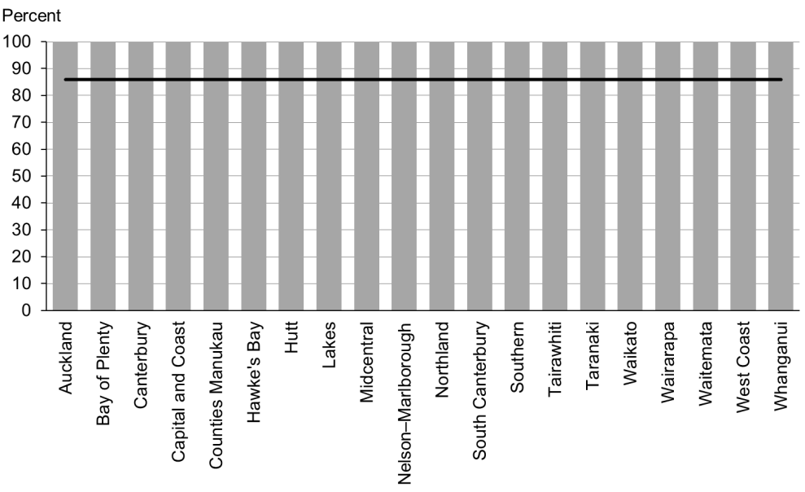

Figure 88: Children with an untreated vision problem referred, high deprivation population

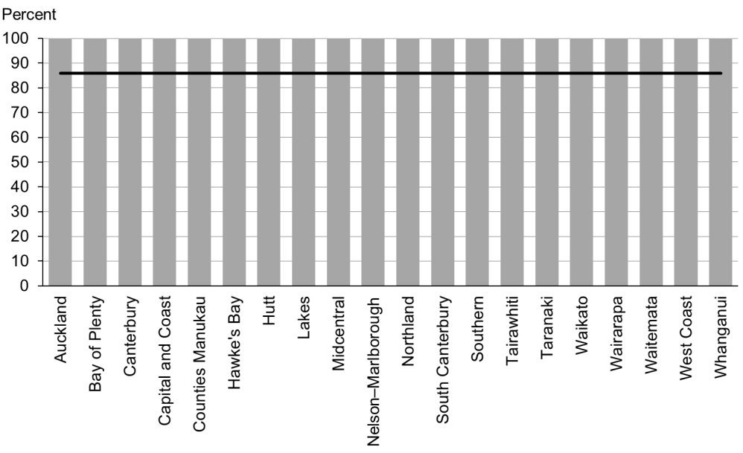

Figure 89: Children with an untreated vision problem referred, Māori

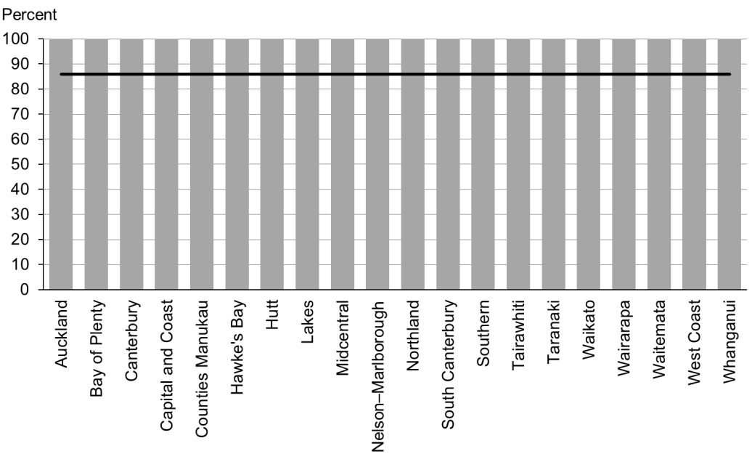

Figure 90: Children with an untreated vision problem referred, Pacific peoples

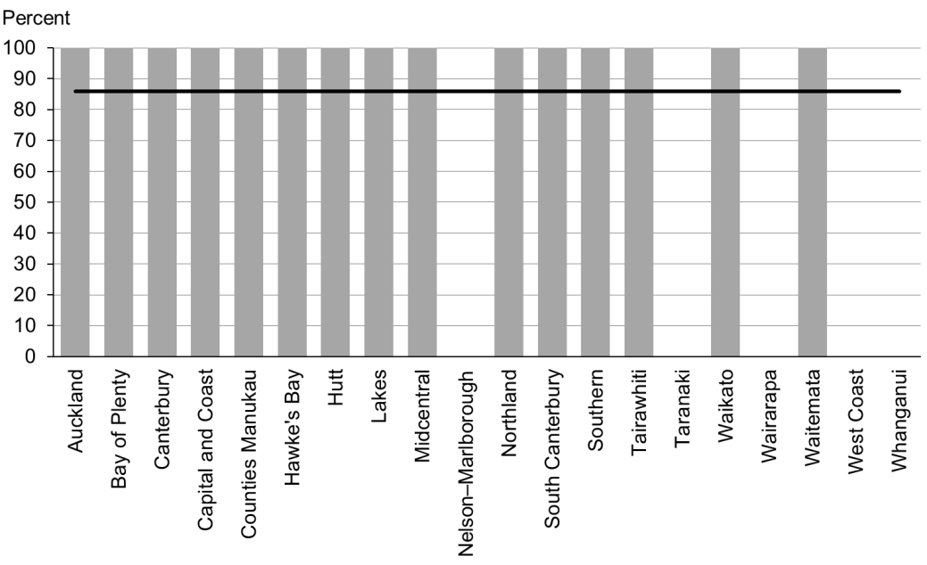

### Data notes

* No bar on graph = no children with untreated vision problem for that population.
* Time period: children receiving a B4 School Check between 1 January 2015 and 30 June 2015.
* DHB is DHB of service.
* Numerator: number of children with a vision problem referred (excluding advice given) (source: B4 School Check).
* Denominator: number of children with a vision problem (excluding those already under care) (source: B4 School Check).

## WCTO Quality Improvement Framework Indicator 26

|  |  |
| --- | --- |
| **Standard** | WCTO providers deliver services in accordance with best practice (inappropriate variation is reduced). |
| **Indicator** | Children with an untreated hearing problem at the B4School Check are referred to specialist services. |
| **Target by December 2014** | 86 percent |
| **Target by June 2016** | 95 percent |

|  |  |  |  |  |
| --- | --- | --- | --- | --- |
|  | **Total New Zealand** | **High deprivation** | **Māori** | **Pacific peoples** |
| September 2015 mean –  referrals only | 100% | 100% | 100% | 100% |
| March 2015 mean –  referrals only | 100% | 100% | 99% | 100% |

Figure 91: Children with an untreated hearing problem referred, total New Zealand

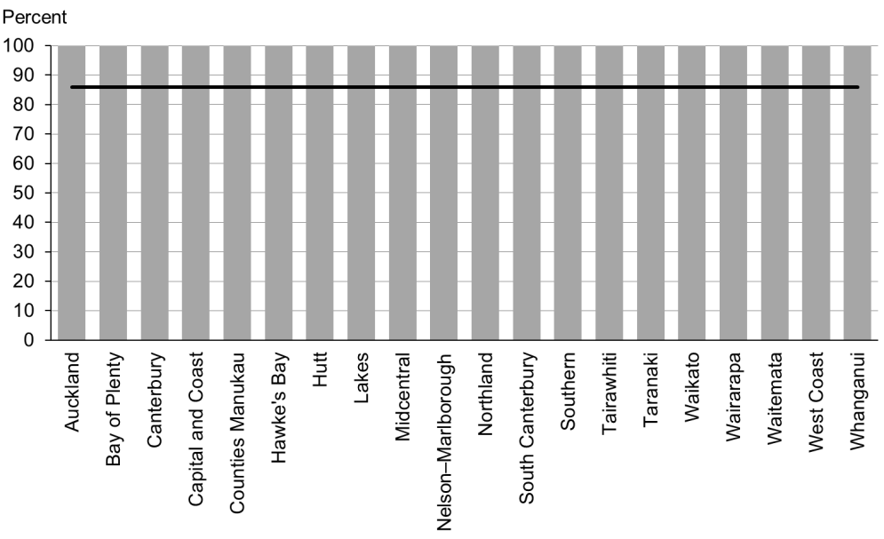

Figure 92: Children with an untreated hearing problem referred, high deprivation population

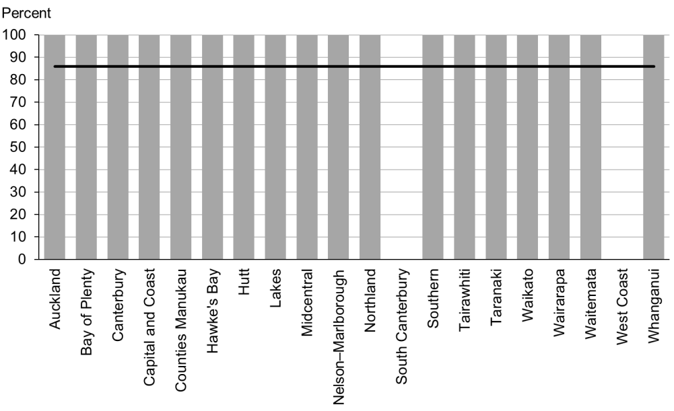

Figure 93: Children with an untreated hearing problem referred, Māori

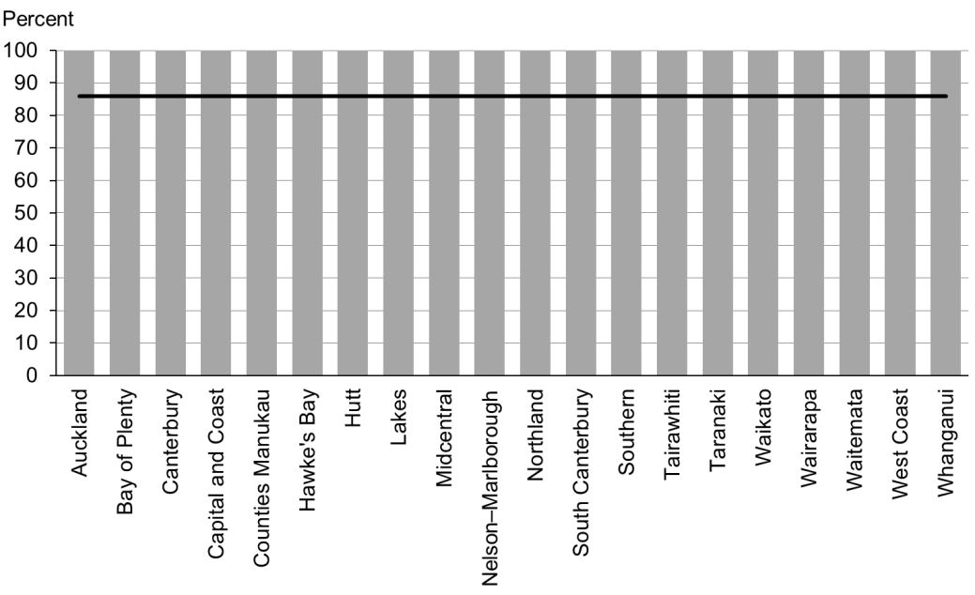

Figure 94: Children with an untreated hearing problem referred, Pacific peoples

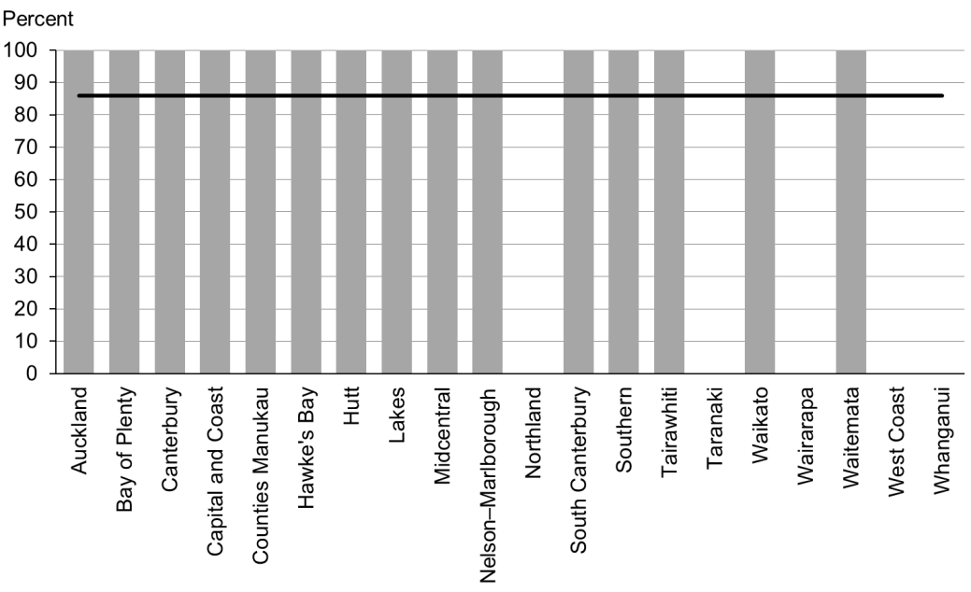

### Data notes

* No bar on graph = no children with untreated hearing problem for that population.
* Time period: children receiving a B4 School Check between 1 January 2015 and 30 June 2015.
* DHB is DHB of service.
* Numerator: number of children with a hearing problem referred (excluding advice given) (B4 School Check).
* Denominator: number of children with a hearing problem (excluding those already under care) (B4 School Check).

## WCTO Quality Improvement Framework Indicator 27

|  |  |
| --- | --- |
| **Standard** | WCTO providers deliver services in accordance with best practice (inappropriate variation is reduced). |
| **Indicator** | Children with a body mass index (BMI) greater than the 99.4th percentile at the B4 School Check are referred to a general practitioner or specialist services. |
| **Target by December 2014** | 86 percent |
| **Target by June 2016** | 95 percent |

|  |  |  |  |  |
| --- | --- | --- | --- | --- |
|  | **Total New Zealand** | **High deprivation** | **Māori** | **Pacific peoples** |
| September 2015 mean – advice or referral | 100% | 100% | 100% | 100% |
| September 2015 mean (range) – referral only | 83% (0–100) | 87% (0–100) | 79% (0–100) | 92% (0–100) |
| March 2015 mean – advice or referral | 100% | 100% | 100% | 100% |
| March 2015 mean (range) – referral only | 86% (0–100) | 86% (0–100) | 75% (0–100) | 99% (83–100) |

Figure 95: Children with body mass index > 99.4th percentile referred, total New Zealand

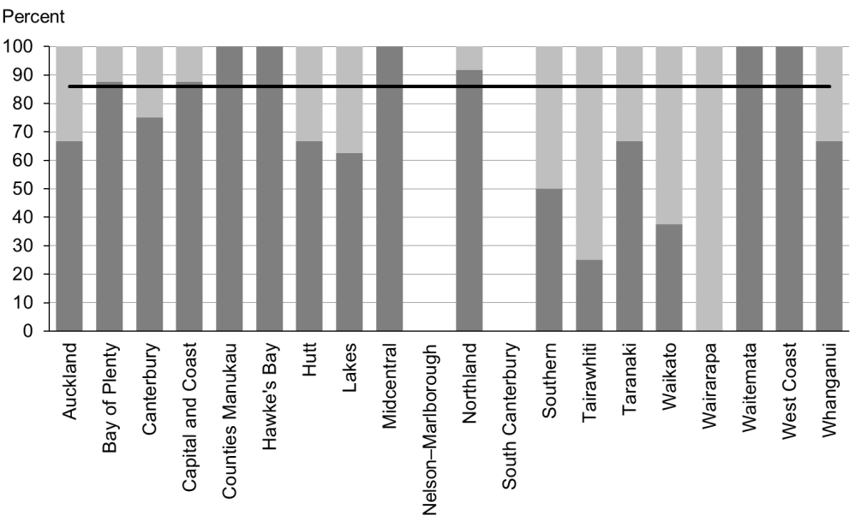

Figure 96: Children with body mass index > 99.4th percentile referred, high deprivation population

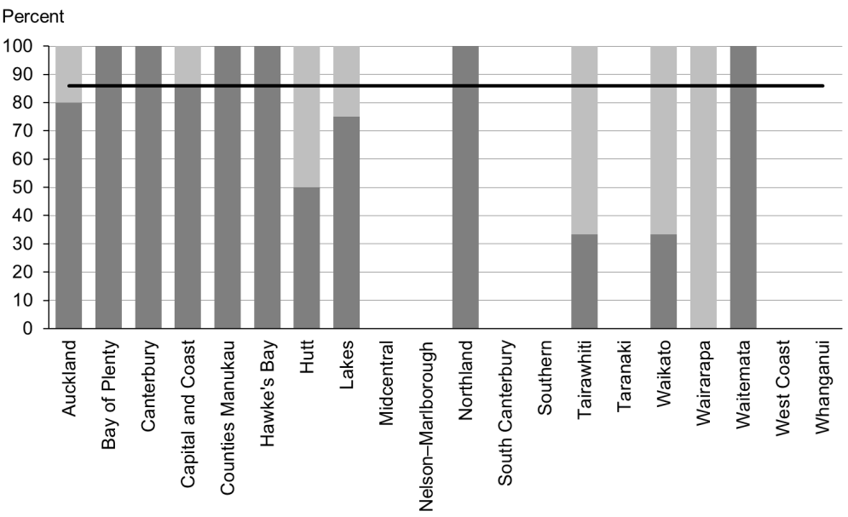

Figure 97: Children with body mass index > 99.4th percentile referred, Māori

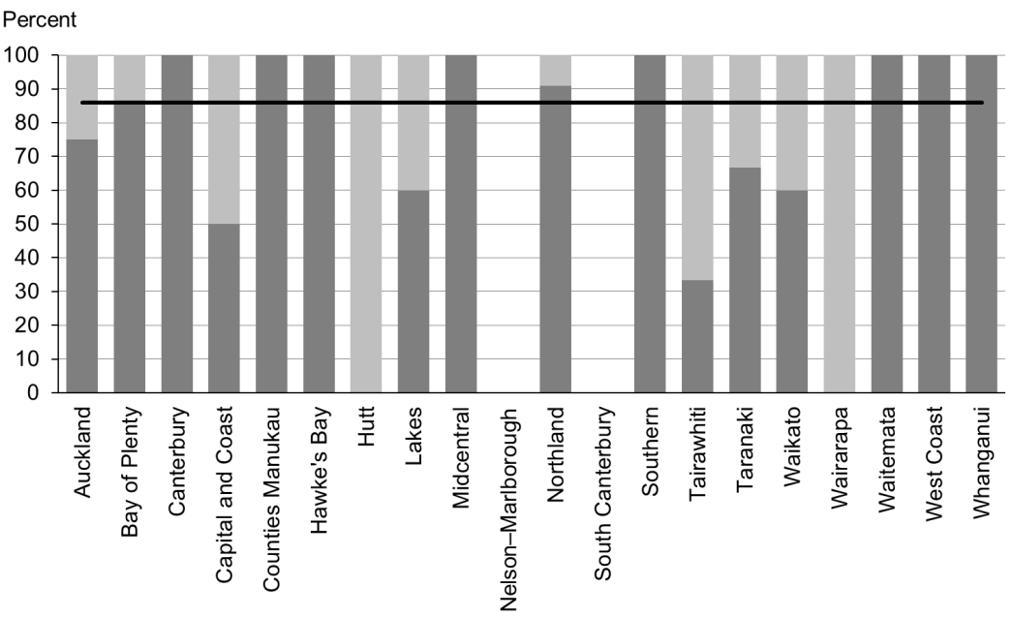

Figure 98: Children with body mass index > 99.4th percentile referred, Pacific peoples

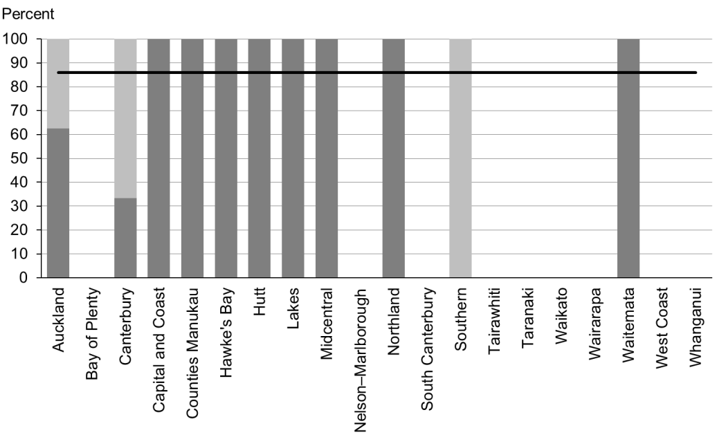

### Data notes

* The stacked bar shows rate of referral excluding ‘advice given’ (dark grey section) and rate of referral including ‘advice given’ (dark grey plus light grey sections).
* No bar on graph = no children with BMI > 99.4th percentile for that population.
* Time period: children receiving a B4 School Check between 1 January 2015 and 30 June 2015.
* DHB is DHB of service.
* Numerator: number of children with a BMI greater than the 99.4th percentile referred (source: B4 School Check).
* Denominator: number of children with a BMI greater than the 99.4th percentile (excluding those already under care) (source: B4 School Check).

# Appendix 1: Targets for the quality indicators

|  |  |  |  |  |
| --- | --- | --- | --- | --- |
|  |  | **Indicator** | **December 2014 target** | **June 2016 target** |
| Access | 1 | Newborns are enrolled with a general practice by two weeks * | 88% | 98% |
| 2 | Families and whānau are referred from their LMC to a WCTO provider | 88% | 98% |
| 3 | Infants receive all WCTO core contacts due in their first year | 86% | 95% |
| 4 | Four-year-olds receive a B4 School Check | 90% | 90% |
| 5 | Children are enrolled with child oral health services | 86% | 95% |
| 6 | Immunisations are up to date by eight months | 95% | 95% |
| 7 | Children participate in early childhood education | 98% | 98% |
| 8 | Children under six years have access to free primary care | 98% | 100% |
| 9 | Children under six years have access to free after-hours primary care | 98% | 100% |
| 10 | Children are seen promptly by specialist services | 100% in 5 months | 100% in 4 months |
| Outcomes | 11 | Infants are exclusively or fully breastfed at two weeks | 72% | 80% |
| 12 | Infants are exclusively or fully breastfed at discharge from LMC | 68% | 75% |
| 13 | Infants are exclusively or fully breastfed at three months | 54% | 60% |
| 14 | Infants are receiving breast milk at six months (exclusively, fully or partially) | 59% | 65% |
| 15 | Children are a healthy weight at four years | 68% | 75% |
| 16 | Children are caries free at five years | 65% | 65% |
| 17 | The burden of dental decay among children with one or more decayed, missing and filled teeth (dmft) is minimised (average dmft) | 4.4 | 4 |
| 18 | Child mental health is supported (normal SDQ-P score) | 86% | 95% |
| 19 | Mothers are smokefree at two weeks postnatal | 86% | 95% |
| 20 | Children live in a smokefree home (age four years) | 90% | 100% |
| Quality | 21 | B4School Checks are started before children are 4½ years | 81% | 90% |
| 22 | Children with an abnormal SDQ-P score are referred | 86% | 95% |
| 23 | Children with a PEDS Pathway A are referred | 86% | 95% |
| 24 | Children with a Lift the Lip (oral health) score of 2–6 are referred | 86% | 95% |
| 25 | Children with an untreated vision problem are referred | 86% | 95% |
| 26 | Children with an untreated hearing problem are referred | 86% | 95% |
| 27 | Children with a BMI > 99.4th percentile are referred | 86% | 95% |

Notes

* Data to monitor this indicator is not yet available. Primary health organisation enrolment at three months will be used as a de facto indicator in the interim.

# Appendix 2: Membership of the Expert Advisory Group

|  |  |  |
| --- | --- | --- |
| **Name** | **Role(s)** | **Representing** |
| Helen Connors | WCTO nurse and clinical advisor | Royal New Zealand Plunket Society |
| Dave Graham | Paediatrician – Waikato DHB, chair of Midland Child Health Action Group and member of the Paediatric Society of New Zealand | Paediatric Society of New Zealand |
| Christine Griffiths | Lead maternity carer, lecturer Otago Polytechnic and expert advisor to the New Zealand College of Midwives | New Zealand College of Midwives |
| Tui Makoare-Iefata | WCTO nurse/team leader – Ngāti Whātua o Orakei and Tamariki Ora provider national representative | Tamariki Ora providers |
| Gail Tihore | Vision and hearing technician – Hutt Valley DHB | Vision Hearing Technicians Society |
| Pat Tuohy | Paediatrician – Hutt Valley DHB and chief advisor child and youth health | Ministry of Health |
| Nikki Turner | General practitioner, associate professor Auckland University and director of Conectus and the Immunisation Advisory Centre | New Zealand College of General Practitioners |
| Russell Wills | Paediatrician – Hawke’s Bay DHB and children’s commissioner | Office of the Children’s Commissioner |
| Mollie Wilson | WCTO nurse and CEO of the Paediatric Society of New Zealand | Paediatric Society of New Zealand |

Note: This list presents membership as at September 2015. The Ministry would like to thank previous members of the EAG for their work.

1. Indicator 1 was designed to measure enrolment with a general practice by two weeks of age. This data was not available at the time of writing, and so enrolment with a PHO by three months of age has been used as an interim measure.
2. SDQ stands for ‘strengths and difficulties questionnaire’. It refers to a questionnaire used within the B4SC to assess a child’s social and emotional development. There are two versions: one for parents (SDQ-P) and one for teachers (SDQ-T).
3. A ‘smokefree home’ for the purposes of the indicator is defined as one in which parents do not smoke indoors.