Indicators for the Well Child /  
Tamariki Ora  
Quality Improvement Framework

March 2015

Citation: Ministry of Health. 2015. *Indicators for the Well Child / Tamariki Ora Quality Improvement Framework – March 2015*. Wellington: Ministry of Health.

Published in June 2015  
by the Ministry of Health  
PO Box 5013, Wellington 6145, New Zealand

ISBN: 978-0-478-44819-1 (online)  
HP 6193

This document is available at www.health.govt.nz



### CCBY This work is licensed under the Creative Commons Attribution 4.0 International licence. In essence, you are free to: share ie, copy and redistribute the material in any medium or format; adapt ie, remix, transform and build upon the material. You must give appropriate credit, provide a link to the licence and indicate if changes were made.

# Foreword from the EAG

The Well Child / Tamariki Ora Quality Improvement Framework Expert Advisory Group welcomes this fourth report on the indicators for the Quality Improvement Framework. We wish to acknowledge the Well Child / Tamariki Ora (WCTO) sector’s commitment to improving services for children and their families and whānau. We hope that this report is used to ‘close the quality improvement loop’ by helping to identify what is working and what is not in terms of local improvement initiatives. We see the WCTO Quality Improvement Framework as a tool to support each level of the sector to achieve family-centred, high-quality, equitable and effective child health services that deliver the best possible health outcomes for all New Zealand children, and their families and whānau.

As a Better Public Service target, the rate of children fully immunised at eight months old was a significant priority for district health boards and communities in the second half of 2014. As at 31 December 2014 the national immunisation rate for eight-month-old infants was 93.5 percent, with eight district health boards having achieved or exceeded 95 percent and seven more at 93 or 94 percent. This is the highest rate ever achieved for this age group, and the Expert Advisory Group congratulates everyone for all the effort and innovation that has gone on around the country to improve the health of not only our children but our communities.

Among the other gains since the last report is the continuing improvement of the number of children completing B4 School Checks before the age of 4½, although the drop in timely access among children living in high deprivation is concerning. There were also significant increases in referral rates for children with a Lift the Lip Score of 2–6, from 70 to 99 percent, and referral rates for children with a body mass index (BMI) greater than the 99.4th percentile, from 69 to 86 percent. These substantial increases were not just in the total population figures, but across high deprivation areas and Māori and Pacific communities. These are significant increases and show how hard work across the sector has a positive impact on children’s lives.

The Expert Advisory Group was, however, disappointed to see that newborn enrolment with primary care by three months of age decreased six percentage points (from 71 percent in September 2014 down to 65 percent in March 2015). Māori and Pacific enrolments also dropped, by 4 and 13 percentage points respectively. This is hugely disappointing given the effort that went in to increasing those figures in the recent past. What it shows is that we cannot afford to be complacent when numbers are rising, and that it still takes work to improve and sustain the gains made.

You will see that a number of indicators continue to meet or exceed their targets. We have deliberately chosen to continue to report these to demonstrate the commitment and achievements the WCTO sector makes every day, while not losing sight of the areas for improvement.

Over the next 12 months the Expert Advisory Group will lead a review of the WCTO quality indicators to ensure, as a sector, we continue to strive towards a system that works in partnership with families and whānau and achieves world-leading health outcomes for all New Zealand children. We thank you for joining us on this journey.

# Summary of national results

| **Quality indicator** | **September 2014** | | | | **March 2015** | | | | | |
| --- | --- | --- | --- | --- | --- | --- | --- | --- | --- | --- |
| **Total** | **High dep** | **Māori** | **Pacific** | **Total** | **High dep** | **Māori** | | **Pacific** | |
| 1. Newborns are enrolled with a general practice by three months* | 71% | N/A | 74% | 73% | 65% | N/A | 70% | | 60% | |
| 2. Families and whānau are referred from their lead maternity carer to a WCTO provider | 98% | 97% | 97% | 98% | 97% | 97% | 96% | | 98% | |
| 3. Infants receive all WCTO core contacts due in their first year | 76% | 67% | 67% | 61% | 76% | 68% | 67% | | 63% | |
| 4. Four-year-olds receive a B4 School Check | 91% | 90% | 83% | 80% | 93% | 86% | 85% | | 83% | |
| 5. Children are enrolled with child oral health services | 73% | N/A | 59% | 68% | No new data | | | | | |
| 6. Immunisations are up to date by eight months | 92% | 89% | 88% | 95% | 94% | 93% | 92% | | 96% | |
| 7. Children participate in early childhood education | 96% | 90% | 93% | 90% | 96% | 89% | 94% | | 91% | |
| 8. Children under six years have access to free primary care | 98% | 99% | 100% | 100% | 99% | 100% | 100% | | 100% | |
| 9. Children under six years have access to free after-hours primary care | 98% | N/A | N/A | N/A | 98% | N/A | N/A | | N/A | |
| 10. Children are seen promptly by specialist services | 100% | N/A | N/A | N/A | 99% | N/A | N/A | | N/A | |
| 11. Infants are exclusively or fully breastfed at two weeks | 79% | 77% | 77% | 74% | 79% | 76% | 77% | | 74% | |
| 12. Infants are exclusively or fully breastfed at six weeks | 75% | 73% | 71% | 73% | 74% | 71% | 69% | | 72% | |
| 13. Infants are exclusively or fully breastfed at three months | 55% | 43% | 44% | 45% | 55% | 44% | 45% | | 46% | |
| 14. Infants are receiving breast milk at six months | 66% | 55% | 54% | 59% | 66% | 56% | 55% | | 59% | |
| 15. Children are a healthy weight at four years | 75% | 69% | 71% | 59% | 75% | 69% | 71% | | 61% | |
| 16. Children are caries free at five years | 57% | N/A | 37% | 36% | No new data | | | | | |
| 17. The burden of dental decay is minimised (average dmft) | 4.4 dmft | N/A | 5.0 dmft | 5.1 dmft | No new data | | | | | |
| 18. Child mental health is supported (normal SDQ-P score) | 96% | 93% | 93% | 95% | 96% | 93% | | 94% | | 95% |
| 19. Mothers are smoke-free at two weeks postnatal | 87% | 77% | 65% | 91% | 87% | 76% | | 65% | | 91% |
| 20. Children live in smoke-free homes (age four years) | 98% | 97% | 97% | 96% | 98% | 97% | | 97% | | 97% |
| 21. B4 School Checks are started before children are 4½ years | 83% | 82% | 80% | 81% | 85% | 82% | | 80% | | 82% |
| 22. Children with an abnormal SDQ-P score are referred** | 100% | 100% | 100% | 100% | 100% | 100% | | 100% | | 100% |
| 23. Children with a PEDS Pathway A are referred** | 98% | 99% | 99% | 98% | 97% | 99% | | 98% | | 99% |
| 24. Children with a Lift the Lip (oral health) score of 2–6 are referred | 70% | 66% | 71% | 81% | 99% | 99% | | 97% | | 99% |
| 25. Children with an untreated vision problem are referred | 100% | 100% | 100% | 100% | 100% | 100% | | 100% | | 100% |
| 26. Children with an untreated hearing problem are referred | 100% | 100% | 99% | 100% | 100% | 100% | | 100% | | 100% |
| 27. Children with a body mass index > 99.4th percentile are referred | 69% | 73% | 66% | 78% | 86% | 86% | | 75% | | 99% |

Note: dmft = count of decayed, missing or filled deciduous teeth; High dep = high socioeconomic deprivation; N/A = not available; PEDS = Parental Evaluation of Developmental Status; SDQ-P = Strengths and Difficulties Questionnaire (Parent); WCTO = Well Child / Tamariki Ora.

* Data to monitor this indicator is not yet available. PHO enrolment at three months will be used as a *de facto* indicator in the interim.

** Includes ‘advice given’; all other referrals exclude ‘advice given’. See full analysis for more information.

Contents

Foreword from the EAG iii

Summary of national results iv

Introduction 1

Background 1

Development of the quality indicators 1

Quality indicator targets 2

How to use this document 2

Indicators 1–10: Access 3

Summary of results for this period 3

WCTO Quality Improvement Framework Indicator 1 5

WCTO Quality Improvement Framework Indicator 2 7

WCTO Quality Improvement Framework Indicator 3 9

WCTO Quality Improvement Framework Indicator 4 11

WCTO Quality Improvement Framework Indicator 5 13

WCTO Quality Improvement Framework Indicator 6 14

WCTO Quality Improvement Framework Indicator 7 16

WCTO Quality Improvement Framework Indicator 8 18

WCTO Quality Improvement Framework Indicator 9 20

WCTO Quality Improvement Framework Indicator 10 21

Indicators 11–20: Outcomes 22

Summary of results for this period 22

WCTO Quality Improvement Framework Indicator 11 24

WCTO Quality Improvement Framework Indicator 12 26

WCTO Quality Improvement Framework Indicator 13 28

WCTO Quality Improvement Framework Indicator 14 30

WCTO Quality Improvement Framework Indicator 15 32

WCTO Quality Improvement Framework Indicator 16 34

WCTO Quality Improvement Framework Indicator 17 35

WCTO Quality Improvement Framework Indicator 18 36

WCTO Quality Improvement Framework Indicator 19 38

WCTO Quality Improvement Framework Indicator 20 40

Indicators 21–27: Quality 42

Summary of results for this period 42

WCTO Quality Improvement Framework Indicator 21 44

WCTO Quality Improvement Framework Indicator 22 46

WCTO Quality Improvement Framework Indicator 23 48

WCTO Quality Improvement Framework Indicator 24 50

WCTO Quality Improvement Framework Indicator 25 52

WCTO Quality Improvement Framework Indicator 26 54

WCTO Quality Improvement Framework Indicator 27 56

Appendices

Appendix 1: Summary of the WCTO quality indicators 58

Appendix 2: Membership of the WCTO Quality Improvement Framework Expert Advisory Group 59

List of Figures

Figure 1: Newborns enrolled with a PHO by three months, total New Zealand 5

Figure 2: Newborns enrolled with a PHO by three months, Māori 6

Figure 3: Newborns enrolled with a PHO by three months, Pacific peoples 6

Figure 4: Referral from LMC to WCTO, total New Zealand 7

Figure 5: Referral from LMC to WCTO, high deprivation 7

Figure 6: Referral from LMC to WCTO, Māori 8

Figure 7: Referral from LMC to WCTO, Pacific peoples 8

Figure 8: Core WCTO contacts 1–5 received, total New Zealand 9

Figure 9: Core WCTO contacts 1–5 received, high deprivation 9

Figure 10: Core WCTO contacts 1–5 received, Māori 10

Figure 11: Core WCTO contacts 1–5 received, Pacific peoples 10

Figure 12: Children receive a B4 School Check, total New Zealand 11

Figure 13: Children receive a B4 School Check, high deprivation 11

Figure 14: Children receive a B4 School Check, Māori 12

Figure 15: Children receive a B4 School Check, Pacific peoples 12

Figure 16: Fully immunised by eight months, total New Zealand 14

Figure 17: Fully immunised by eight months, high deprivation 14

Figure 18: Fully immunised by eight months, Māori 15

Figure 19: Fully immunised by eight months, Pacific peoples 15

Figure 20: Prior participation in ECE, total New Zealand 16

Figure 21: Prior participation in ECE, high deprivation 16

Figure 22: Prior participation in ECE, Māori 17

Figure 23: Prior participation in ECE, Pacific peoples 17

Figure 24: Under-six access to free primary care, total New Zealand 18

Figure 25: Under-six access to free primary care, high deprivation 18

Figure 26: Under-six access to free primary care, Māori 19

Figure 27: Under-six access to free primary care, Pacific peoples 19

Figure 28: Under-six access to free after-hours primary care, total New Zealand 20

Figure 29: First specialist appointment for paediatric medicine received within five months, total New Zealand 21

Figure 30: Exclusively or fully breastfed at two weeks, total New Zealand 24

Figure 31: Exclusively or fully breastfed at two weeks, high deprivation 24

Figure 32: Exclusively or fully breastfed at two weeks, Māori 25

Figure 33: Exclusively or fully breastfed at two weeks, Pacific peoples 25

Figure 34: Exclusively or fully breastfed at LMC discharge, total New Zealand 26

Figure 35: Exclusively or fully breastfed at LMC discharge, high deprivation 26

Figure 36: Exclusively or fully breastfed at LMC discharge, Māori 27

Figure 37: Exclusively or fully breastfed at LMC discharge, Pacific peoples 27

Figure 38: Exclusively or fully breastfed at three months, total New Zealand 28

Figure 39: Exclusively or fully breastfed at three months, high deprivation 28

Figure 40: Exclusively or fully breastfed at three months, Māori 29

Figure 41: Exclusively or fully breastfed at three months, Pacific peoples 29

Figure 42: Infants receive breast milk at six months, total New Zealand 30

Figure 43: Infants receive breast milk at six months, high deprivation 30

Figure 44: Infants receive breast milk at six months, Māori 31

Figure 45: Infants receive breast milk at six months, Pacific peoples 31

Figure 46: Children are a healthy weight at age four years, total New Zealand 32

Figure 47: Children are a healthy weight at age four years, high deprivation 32

Figure 48: Children are a healthy weight at age four years, Māori 33

Figure 49: Children are a healthy weight at age four years, Pacific peoples 33

Figure 50: Children have a normal SDQ-P score at four years, total New Zealand 36

Figure 51: Children have a normal SDQ-P score at four years, high deprivation 36

Figure 52: Children have a normal SDQ-P score at four years, Māori 37

Figure 53: Children have a normal SDQ-P score at four years, Pacific peoples 37

Figure 54: Mother smokefree at two weeks postnatal, total New Zealand 38

Figure 55: Mother smokefree at two weeks postnatal, high deprivation 38

Figure 56: Mother smokefree at two weeks postnatal, Māori 39

Figure 57: Mother smokefree at two weeks postnatal, Pacific peoples 39

Figure 58: Children live in a smokefree home (age four years), total New Zealand 40

Figure 59: Children live in a smokefree home (age four years), high deprivation 40

Figure 60: Children live in a smokefree home (age four years), Māori 41

Figure 61: Children live in a smokefree home (age four years), Pacific peoples 41

Figure 62: B4 School Checks started before age 4½ years, total New Zealand 44

Figure 63: B4 School Checks started before age 4½ years, high deprivation 44

Figure 64: B4 School Checks started before age 4½ years, Māori 45

Figure 65: B4 School Checks started before age 4½ years, Pacific peoples 45

Figure 66: Abnormal SDQ-P referred, total New Zealand 46

Figure 67: Abnormal SDQ-P referred, high deprivation 46

Figure 68: Abnormal SDQ-P referred, Māori 47

Figure 69: Abnormal SDQ-P referred, Pacific peoples 47

Figure 70: PEDS Pathway A referred, total New Zealand 48

Figure 71: PEDS Pathway A referred, high deprivation 48

Figure 72: PEDS Pathway A referred, Māori 49

Figure 73: PEDS Pathway A referred, Pacific peoples 49

Figure 74: Children with LTL score > 1 referred, total New Zealand 50

Figure 75: Children with LTL score > 1 referred, high deprivation 50

Figure 76: Children with LTL score > 1 referred, Māori 51

Figure 77: Children with LTL score > 1 referred, Pacific peoples 51

Figure 78: Vision problem referred, total New Zealand 52

Figure 79: Vision problem referred, high deprivation 52

Figure 80: Vision problem referred, Māori 53

Figure 81: Vision problem referred, Pacific peoples 53

Figure 82: Hearing problem referred, total New Zealand 54

Figure 83: Hearing problem referred, high deprivation 54

Figure 84: Hearing problem referred, Māori 55

Figure 85: Hearing problem referred, Pacific peoples 55

Figure 86: Children with BMI > 99.4th percentile referred, total New Zealand 56

Figure 87: Children with BMI > 99.4th percentile referred, high deprivation 56

Figure 88: Children with BMI > 99.4th percentile referred, Māori 57

Figure 89: Children with BMI > 99.4th percentile referred, Pacific peoples 57

# Introduction

## Background

Well Child / Tamariki Ora (WCTO) is a free health service offered to all New Zealand children from birth to five years. Its aim is to support families and whānau to maximise their child’s developmental potential and health status, thereby establishing a strong foundation for ongoing healthy development.

The 2007/08 review and the 2012 quality reviews of the WCTO programme identified variable clinical practice, service quality and health outcomes. They all recommended that an evidence-based quality framework be developed to ensure the programme consistently achieves its aims.

In response, the Ministry of Health, in partnership with sector expert advisors, developed the WCTO Quality Improvement Framework, drawing on New Zealand and international research. The Framework has three high-level aims, which focus on the WCTO experience of families and whānau, population health, and best value for the health system’s resources. The Framework also sets quality indicators to monitor health system performance.

The Framework and quality indicators provide a mechanism to drive improvement in the delivery of WCTO services. Ultimately, they aim to support the WCTO programme to ensure all children and their families and whānau achieve their health and wellbeing potential.

## Development of the quality indicators

The aim of the quality indicators is to monitor and promote quality improvement across WCTO providers without creating an additional reporting burden. As such, the quality indicators are a subset of potential measures drawn from existing data collections and reporting mechanisms.

The quality indicators are broadly grouped under the categories of:

* universal access (access)
* equitable outcomes (outcomes)
* continuous quality improvement (quality).

All quality indicators are reported on by region, ethnicity and deprivation quintile, where possible, and the results will be published six-monthly. This is the fourth report on the quality indicators.

As information collection improves and the WCTO programme evolves, indicators may be added or changed. The Ministry of Health will review the quality indicators at least every three years.

## Quality indicator targets

Targets for the quality indicators reflect national targets set by other monitoring frameworks and processes, including health targets, district health board (DHB) non-financial performance monitoring and Better Public Service key result areas.

Where there is no existing target, the Expert Advisory Group has agreed on new three-year targets to best reflect the objectives of the Framework. New targets are staged in recognition that improvements will be realised over time. Interim targets to be achieved by December 2014 are set at 90 percent of the three-year targets.

To promote equity, the target for each quality indicator is the same across all ethnic groups, deprivation quintiles and DHB regions.

## How to use this document

Regular monitoring is an essential part of quality improvement. The quality indicators presented here enable WCTO providers, DHBs and other stakeholders to review local performance, identify quality improvement priorities, and monitor progress in improving the uptake, timeliness and quality of WCTO and related child health services over time.

The quality indicators do not stand alone. They are part of a whole-system approach to quality improvement that includes:

* standards (the WCTO Quality Improvement Framework)
* monitoring (quality indicator reports)
* support for collaboration and planning quality improvement priorities (DHB-led local WCTO quality improvement programmes and regional WCTO Quality Improvement Project Managers)
* support for learning and sharing best practice (via the Child and Youth Compass and other tools and resources, including regional WCTO Quality Improvement Project Managers).

# Indicators 1–10: Access

Aim 1 of the WCTO Quality Improvement Framework is **improved safety and quality of WCTO experience for the child and their family and whānau**. This can be measured, to some degree, by the uptake of and continued engagement with services, as families and whānau will be more likely to access and remain involved with acceptable, high-quality services that address barriers to access for families and whānau. It is expected that, in addition to these indicators, DHBs and WCTO providers will consider other ways to monitor quality of experience, such as through the use of consumer surveys or parent focus groups.

Indicators 1–10 measure access rates, with or without consideration of timeliness, across a range of universal and specialist services that contribute to improved outcomes for children. The inclusion of this broad range of services as indicators reflects the role of WCTO in assessing and supporting the health and developmental needs of a growing family. The core roles of WCTO in supporting the access indicators are to:

* facilitate and support a family’s timely engagement with health services, such as primary care, immunisation and oral health
* support referral to specialist services, where required
* support child development by discussing the importance of children participating in high-quality early childhood education.

## Summary of results for this period

### National

The highlights for this period include the highest rate of completed B4 School Checks and the highest rates of immunisation among eight-month-olds that New Zealand has recorded. The proportion of four-year-olds receiving B4 School Checks continued to increase despite having already reached the target of 90 percent in the last reporting period. Coverage is now at 93 percent nationwide, an increase of two percentage points in the last six months. Eight-month immunisation coverage increased to reach its highest rate of 94 percent. Both indicators reflect the outstanding work of the wider WCTO sector to achieve these outcomes.

Newborn enrolment with primary care dropped significantly in this reporting period after showing improvement in the last report. Total population figures dropped by six percentage points to 65 percent, and rates for Pacific infants decreased by 13 percentage points. Early enrolment with primary care is an important driver of timely immunisation. Timely access to primary care can also reduce demand on emergency departments and secondary care. WCTO (including maternity services) has an important role in this area, and improving engagement with primary care will have a positive impact on a number of other indicators across the Framework.

No new data was available for *Indicator 5: Children are enrolled with child oral health services*, so this is not being reported on for this period.

### By region

There is significant variation by DHB in most of the indicators in this area. This is of particular concern in *Indicators 1, 3 and 4* (newborn enrolment, WCTO core contacts and B4 School Checks), in which the variation between DHBs is over 20 percentage points. Of these, only *Indicator 4* (B4 School Checks) has DHBs reaching the target for December 2014. This means there is work to do in all DHBs for those indicators, but some DHBs need to focus extra attention to improve service access for their populations.

### By deprivation

Of the indicators currently available by New Zealand Deprivation Index (NZDep) quintile, two show improvement since the last report (*Indicators 6 and 8*). Immunisation for eight-month-olds in high deprivation areas rose to 93 percent (against a total population figure of 94 percent), and 100 percent of children under six living in areas of high deprivation have access to free primary care.

There was a significant drop in the rate of children receiving their B4 School Checks in high deprivation areas. Only 86 percent of children in these areas are receiving B4 School Checks, compared to 90 percent of children in the last reporting period. This is despite total population figures increasing from 91 to 93 percent. *Indicator 3: Infants receive all WCTO core contacts in their first year* again increased by one percentage point, but at 68 percent among children living in areas of high deprivation still lags significantly behind the national rate of 76 percent.

Among other access indicators, figures for high deprivation areas remained relatively static, meaning there is still work to be done to close the equity gaps across the board. It is an urgent priority to ensure equity of access to universal services for all families and whānau to help mitigate the health inequalities experienced by children due to material deprivation.

### By ethnicity

Results for *Indicator 4: Four-year-olds receive a B4 School Check* were at 85 percent for Māori and 83 percent for Pacific children. These are gains since the last report, but they remain significantly lower than the rate for the total population rate (93 percent). This is partly due to lower overall B4 School Check coverage for a number of regions that have large Māori and Pacific populations, but providers should consider strategies to ensure equitable access to the B4 School Check. More Māori infants were enrolled with primary care by three months of age than any other group. However, this figure dropped in the last reporting period by four percentage points to 70 percent, which means that nearly one-third of Māori infants are not enrolled with primary care by three months.

Pacific children continue to have the highest rate for *Indicator 6: Immunisations are up to date by eight months*, meaning that, nationally, they are the only population group meeting the 95 percent Better Public Service target. However, Pacific children have lower rates than other population groups for *Indicators 3 and 4* (WCTO core contacts and B4 School Checks). Regions with large Pacific populations should focus on reviewing access rates to WCTO services and the B4 School Check and prioritise improvements that support access for Pacific families.

## WCTO Quality Improvement Framework Indicator 1

|  |  |
| --- | --- |
| **Standard:** | All children and families have access to primary care, WCTO services (including the B4 School Check) and early childhood education. |
| **Indicator:** | Newborns are enrolled with a primary health organisation (PHO) by three months of age.[1] |
| **Target by December 2014:** | 88 percent |
| **Target by June 2016:** | 98 percent |

|  |  |  |  |  |
| --- | --- | --- | --- | --- |
|  | **Total New Zealand** | **High deprivation** | **Māori** | **Pacific peoples** |
| March 2015 mean (range) | 65% (57–85) | N/A | 70% (55–117) | 60% (54–85) |

Figure 1: Newborns enrolled with a PHO by three months, total New Zealand

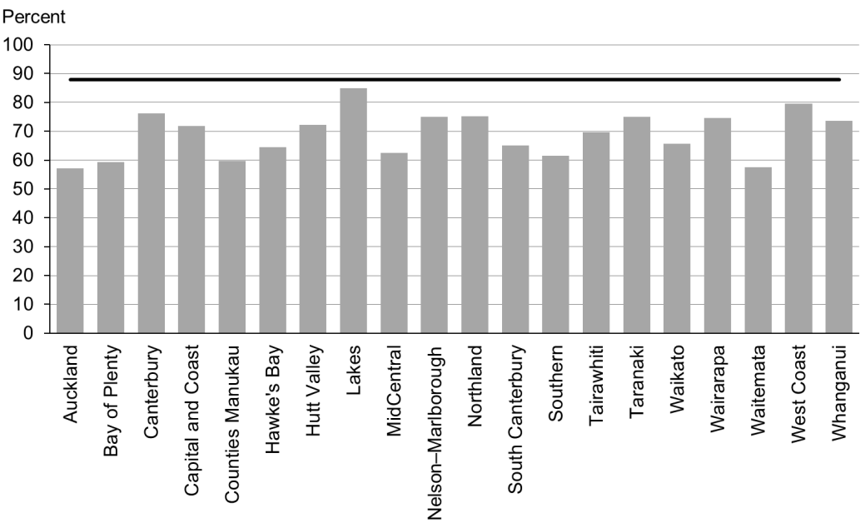

Figure 2: Newborns enrolled with a PHO by three months, Māori

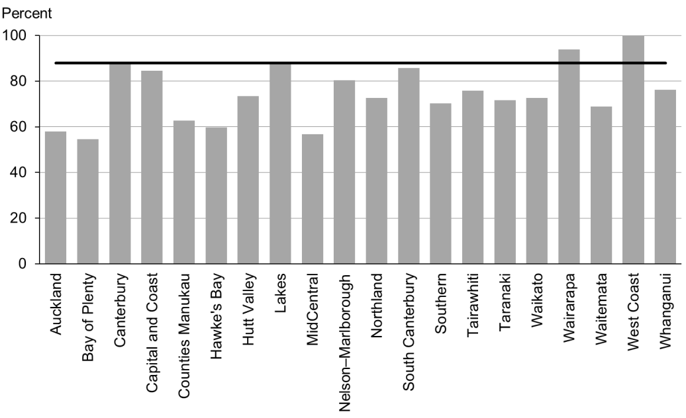

Figure 3: Newborns enrolled with a PHO by three months, Pacific peoples

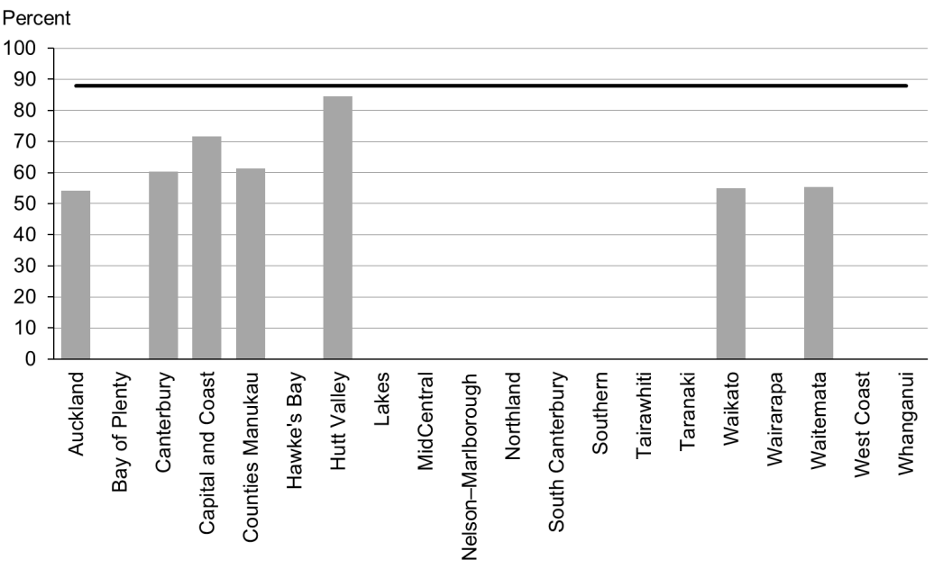

### Data notes

* No bar on graph = fewer than 20 infants in that population.
* Data on enrolment with a general practice by two weeks of age was not available at the time of writing. Enrolment with a PHO by three months of age has been used as an interim measure.
* Data is not currently available by deprivation quintile.
* Time period: births between 20 August 2014 and 19 November 2014.
* The data excludes overseas DHB and undefined DHB.
* Numerator: enrolments of infants under three months with a PHO.
* Denominator: births reported to the National Immunisation Register.
* Rates of greater than 100% for ethnic subgroups is likely due to variation in ethnicity reporting in different systems

## WCTO Quality Improvement Framework Indicator 2

|  |  |
| --- | --- |
| **Standard:** | All children and families have access to primary care, WCTO services (including the B4 School Check) and early childhood education. |
| **Indicator:** | Families and whānau are referred from their lead maternity carer (LMC) to a WCTO provider. |
| **Target by December 2014:** | 88 percent |
| **Target by June 2016:** | 98 percent |

|  |  |  |  |  |
| --- | --- | --- | --- | --- |
|  | **Total New Zealand** | **High deprivation** | **Māori** | **Pacific peoples** |
| March 2015 mean (range) | 97% (94–99) | 97% (90–100) | 96% (92–100) | 98% (93–100) |

Figure 4: Referral from LMC to WCTO, total New Zealand

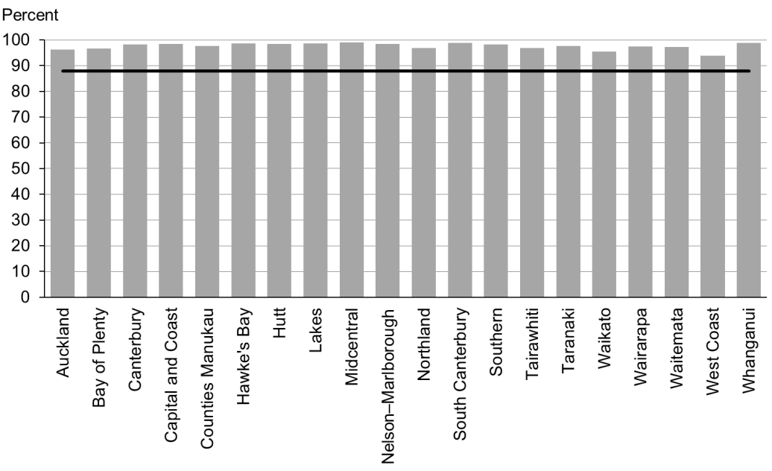

Figure 5: Referral from LMC to WCTO, high deprivation

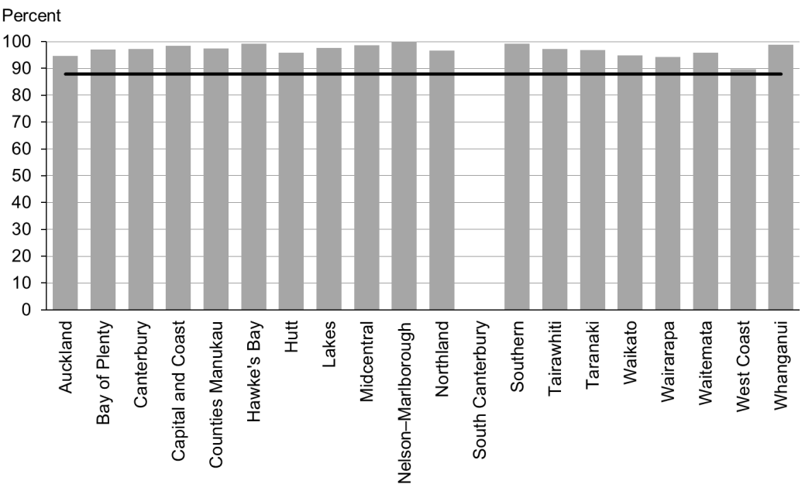

Figure 6: Referral from LMC to WCTO, Māori

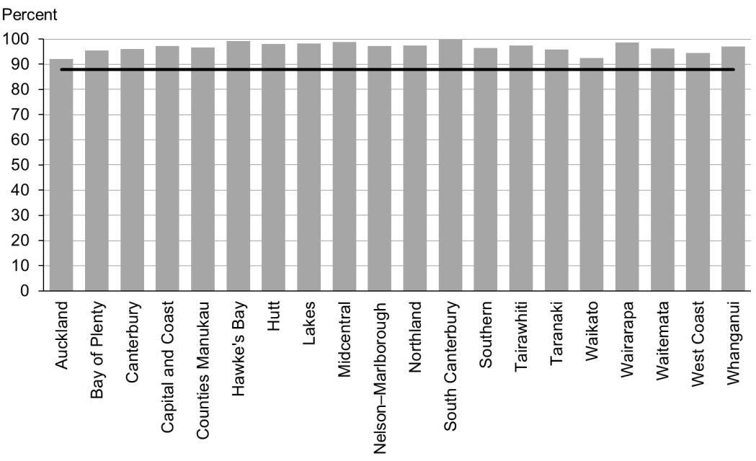

Figure 7: Referral from LMC to WCTO, Pacific peoples

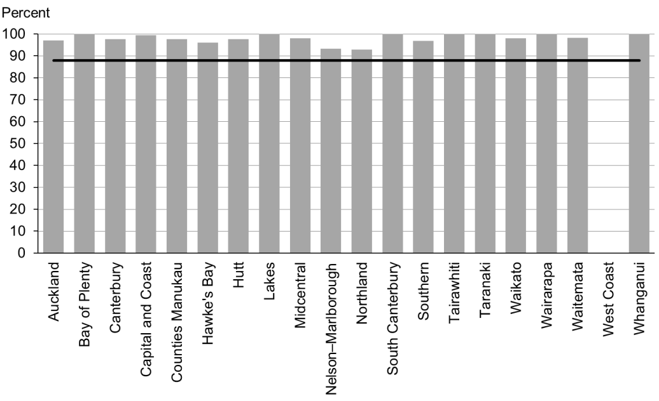

### Data notes

* No bar on graph = no infants in this category.
* Time period: births between 1 January 2014 and 30 June 2014.
* The data excludes overseas DHB and undefined DHB.
* Numerator: LMC referral to WCTO = Yes (source: National Maternity Collection [MAT]).
* Denominator: LMC referral to WCTO = Yes or No (source: MAT).

## WCTO Quality Improvement Framework Indicator 3

|  |  |
| --- | --- |
| **Standard:** | All children and families have access to primary care, WCTO services (including the B4 School Check) and early childhood education. |
| **Indicator:** | Infants receive all WCTO core contacts due in their first year. |
| **Target by December 2014:** | 86 percent |
| **Target by June 2016:** | 95 percent |

|  |  |  |  |  |
| --- | --- | --- | --- | --- |
|  | **Total New Zealand** | **High deprivation** | **Māori** | **Pacific peoples** |
| March 2015 mean (range) | 76% (64–85) | 68% (51–81) | 67% (55–79) | 63% (55–77) |

Figure 8: Core WCTO contacts 1–5 received, total New Zealand

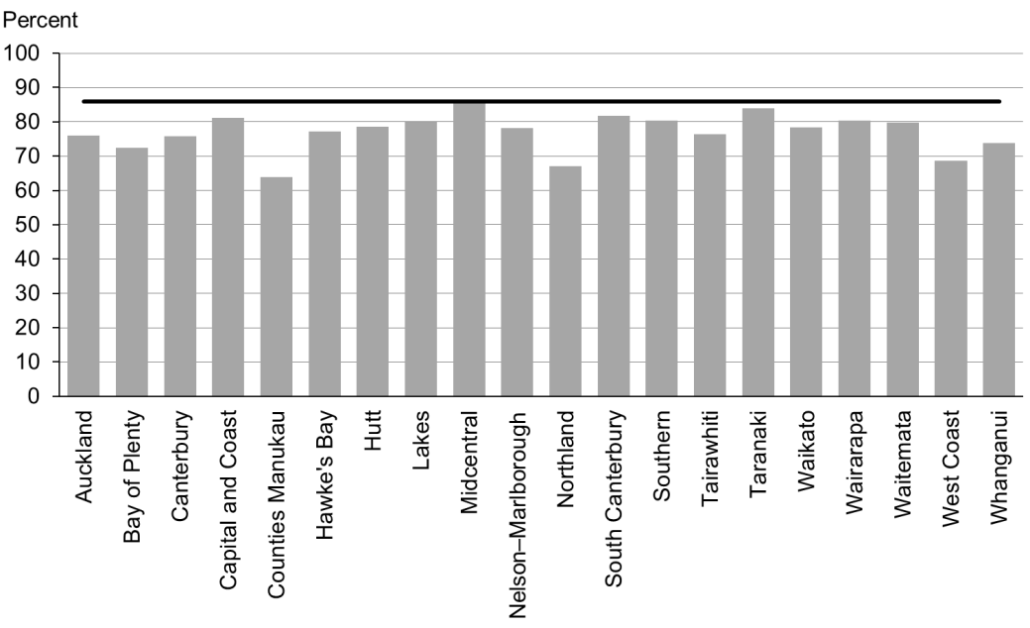

Figure 9: Core WCTO contacts 1–5 received, high deprivation

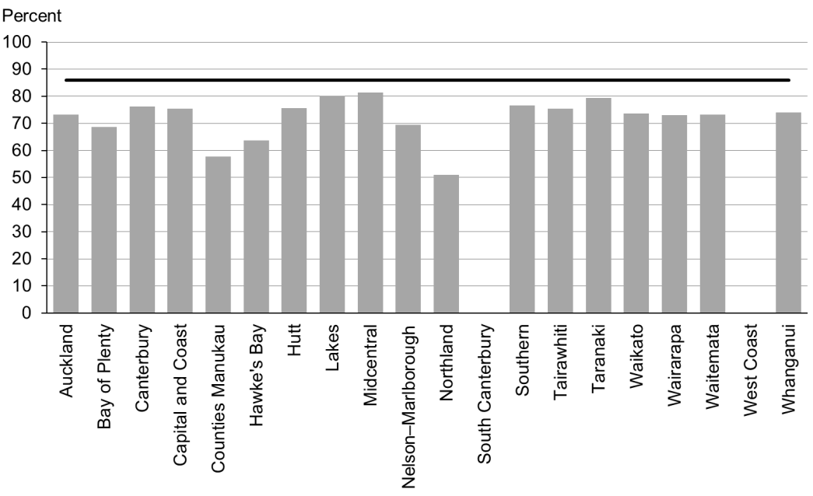

Figure 10: Core WCTO contacts 1–5 received, Māori

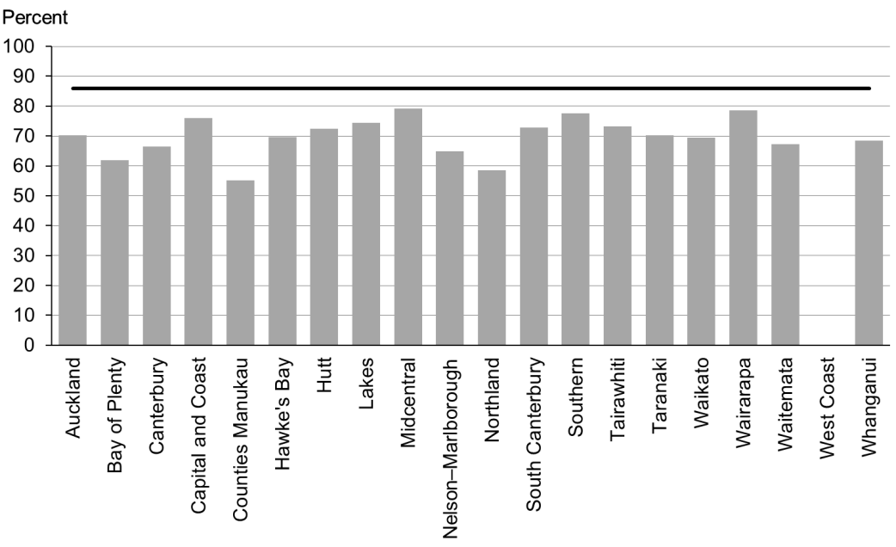

Figure 11: Core WCTO contacts 1–5 received, Pacific peoples

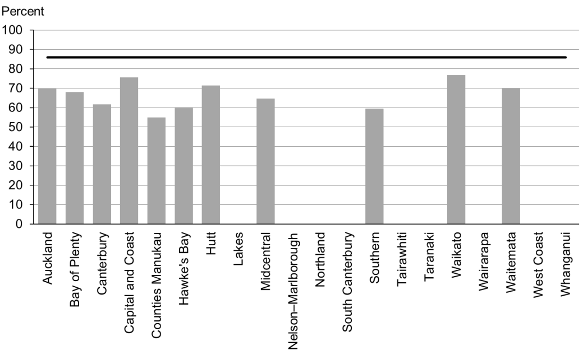

### Data notes

* No bar on graph = fewer than 20 children in that population.
* Time period: children reaching the age band for core contact 6 between July and December 2014.
* The data excludes overseas DHB and undefined DHB.
* Numerator: number of infants where contact was able to be made by six weeks and who received all five contacts (source: Plunket).
* Denominator: number of infants where contact was able to be made by six weeks, who reached the age band for core contact 6 (13 months, 4 weeks, 1 day) (source: Plunket).

## WCTO Quality Improvement Framework Indicator 4

|  |  |
| --- | --- |
| **Standard:** | All children and families have access to primary care, WCTO services (including the B4 School Check) and early childhood education. |
| **Indicator:** | Four-year-olds receive a B4 School Check. |
| **Target by December 2014:** | 90 percent |
| **Target by June 2016:** | 90 percent |

|  |  |  |  |  |
| --- | --- | --- | --- | --- |
|  | **Total New Zealand** | **High deprivation** | **Māori** | **Pacific peoples** |
| March 2015 mean (range) | 93% (78–110) | 86% (68–123) | 85% (71–111) | 83% (64–156) |

Figure 12: Children receive a B4 School Check, total New Zealand

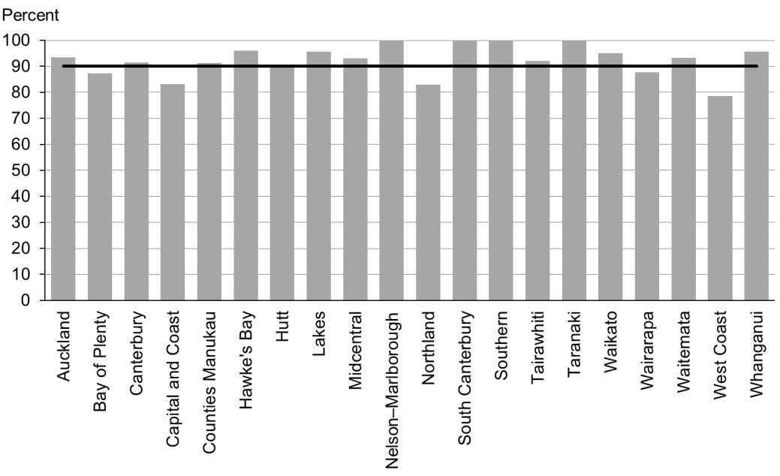

Figure 13: Children receive a B4 School Check, high deprivation

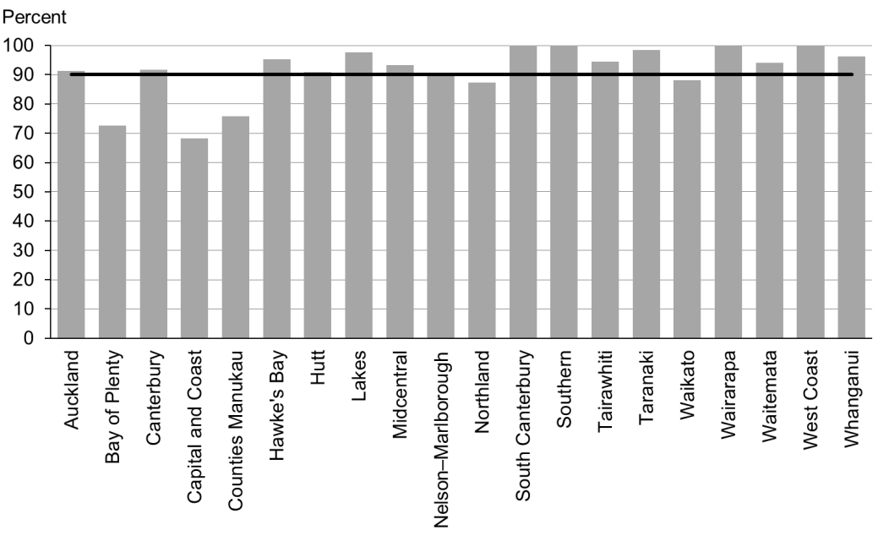

Figure 14: Children receive a B4 School Check, Māori

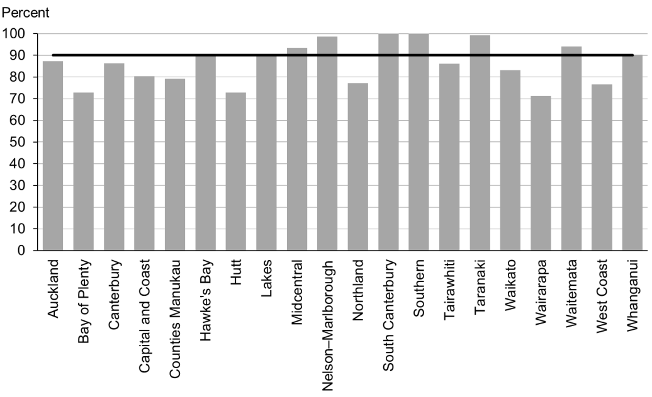

Figure 15: Children receive a B4 School Check, Pacific peoples

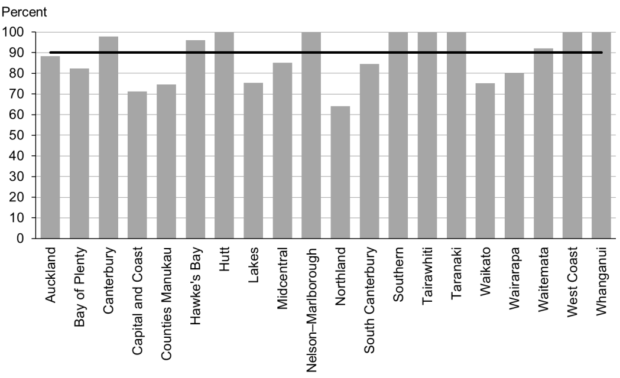

### Data notes

* Time period: checks between July 2014 and January 2015.
* DHB is DHB of service.
* Numerator: number of completed B4 School Checks (source: B4 School Checks).
* Denominator: number of children eligible for a B4 School Check (source: PHO).
* Rates of greater than 100% for ethnic subgroups is likely due to variation in ethnicity reporting in different systems

## WCTO Quality Improvement Framework Indicator 5

|  |  |
| --- | --- |
| **Standard:** | All children and families have access to primary care, WCTO services (including the B4 School Check) and early childhood education. |
| **Indicator:** | Children are enrolled with child oral health services. |
| **Target by December 2014:** | 86 percent |
| **Target by June 2016:** | 95 percent |

|  |  |  |  |  |
| --- | --- | --- | --- | --- |
|  | **Total New Zealand** | **High deprivation** | **Māori** | **Pacific peoples** |
| March 2015 mean (range) | No new data | | | |

### Data notes

* No new data is available for this period. Please see the previous report for the latest data available.
* Numerator: number of children aged under five years enrolled with oral health services (source: community oral health services).
* Denominator: number of children aged under five years (source: PHO).

## WCTO Quality Improvement Framework Indicator 6

|  |  |
| --- | --- |
| **Standard:** | All children and families have access to primary care, WCTO services (including the B4 School Check) and early childhood education. |
| **Indicator:** | Immunisations are up to date by eight months. |
| **Target by December 2014:** | 95 percent |
| **Target by June 2016:** | 95 percent |

|  |  |  |  |  |
| --- | --- | --- | --- | --- |
|  | **Total New Zealand** | **High deprivation** | **Māori** | **Pacific peoples** |
| March 2015 mean (range) | 94% (82–96) | 93% (41–100) | 92% (89–100) | 96% (88–100) |

Figure 16: Fully immunised by eight months, total New Zealand

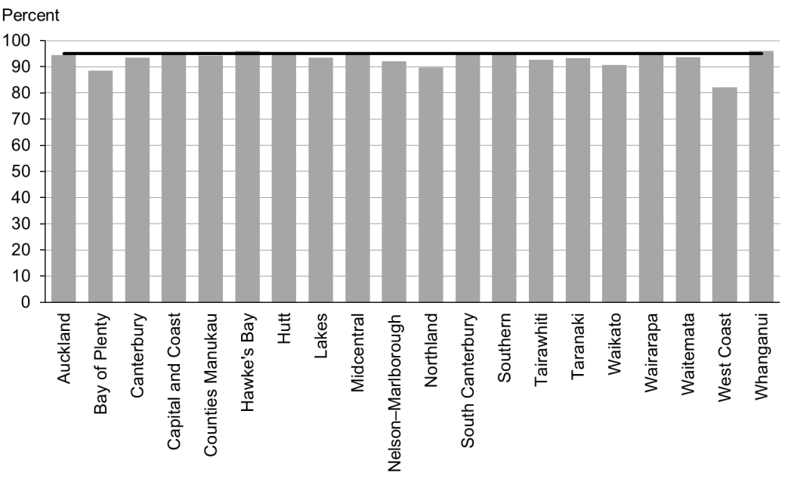

Figure 17: Fully immunised by eight months, high deprivation

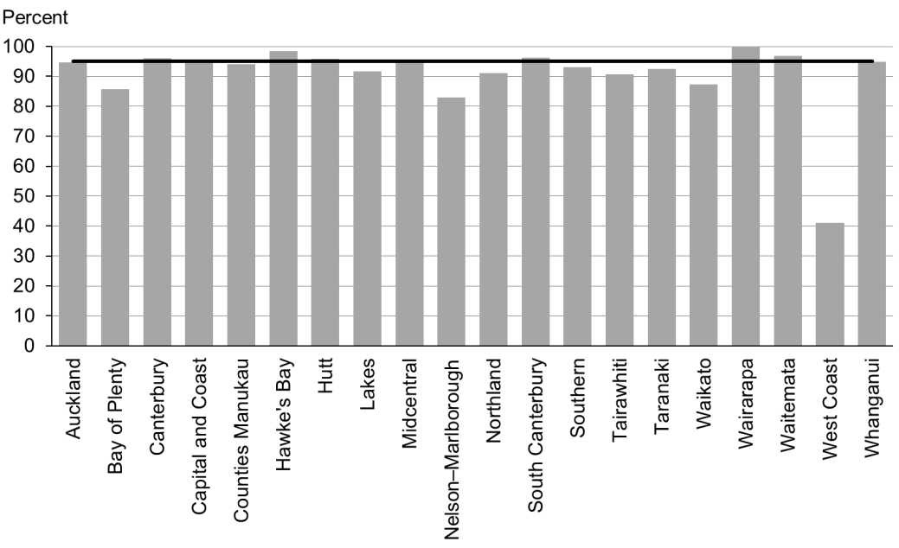

Figure 18: Fully immunised by eight months, Māori

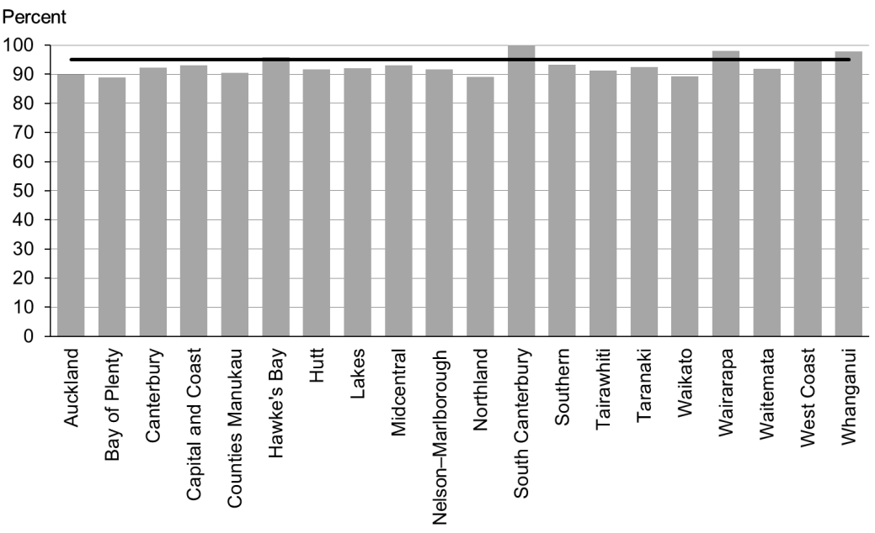

Figure 19: Fully immunised by eight months, Pacific peoples

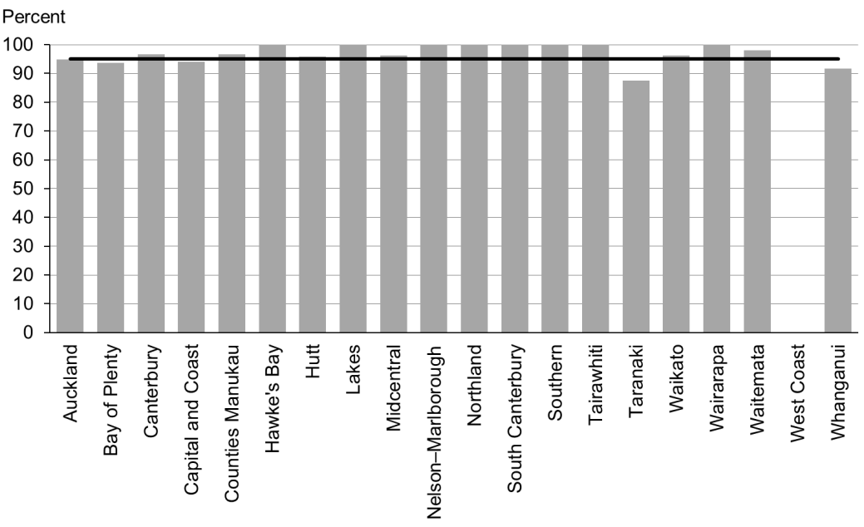

### Data notes

* Time period: October 2014 to December 2014.
* The data excludes overseas DHB and undefined DHB.
* Numerator: number of eight-month-old infants up to date with immunisations for age (source: National Immunisation Register).
* Denominator: number of eight-month-old infants (source: National Immunisation Register).

## WCTO Quality Improvement Framework Indicator 7

|  |  |
| --- | --- |
| **Standard:** | All children and families have access to primary care, WCTO services (including the B4 School Check) and early childhood education. |
| **Indicator:** | Children participate in early childhood education (ECE). |
| **Target by December 2014:** | 98 percent |
| **Target by June 2016:** | 98 percent |

|  |  |  |  |  |
| --- | --- | --- | --- | --- |
|  | **Total New Zealand** | **High deprivation** | **Māori** | **Pacific peoples** |
| March 2015 mean (range) | 96% (92–99) | 89% (87–100) | 94% (55–98) | 91% (88–100) |

Figure 20: Prior participation in ECE, total New Zealand

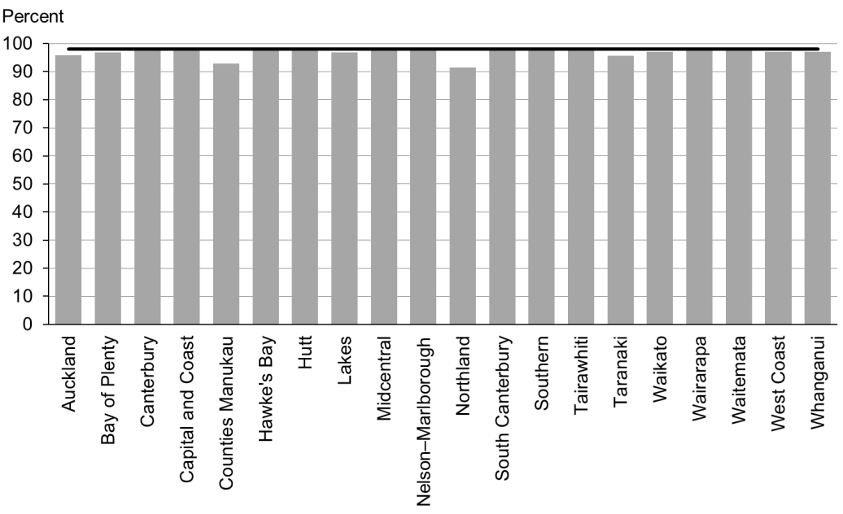

Figure 21: Prior participation in ECE, high deprivation

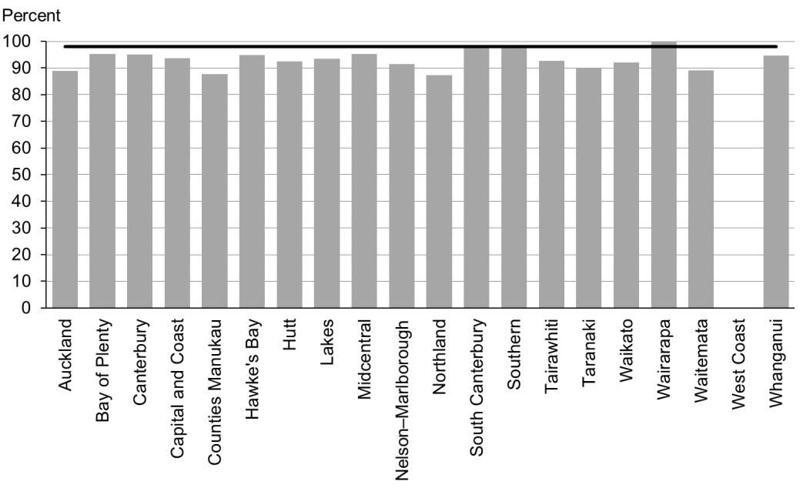

Figure 22: Prior participation in ECE, Māori

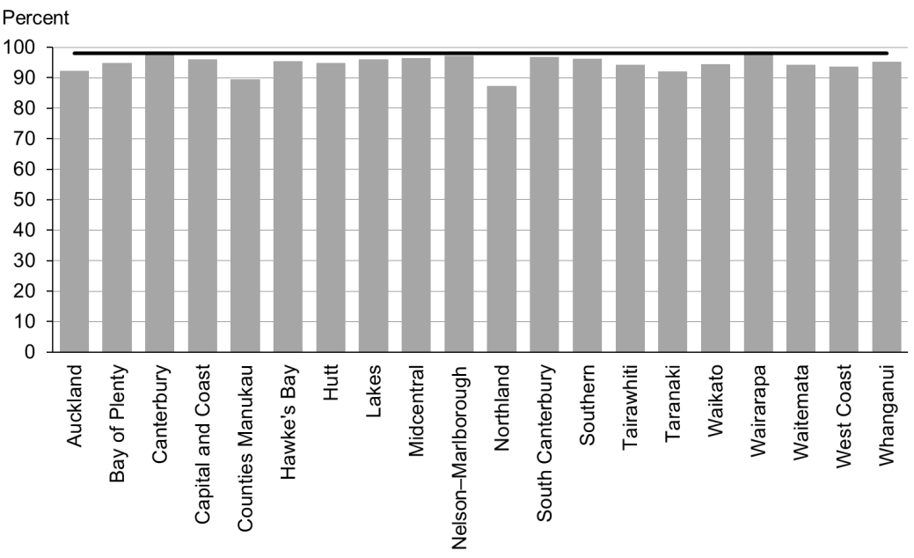

Figure 23: Prior participation in ECE, Pacific peoples

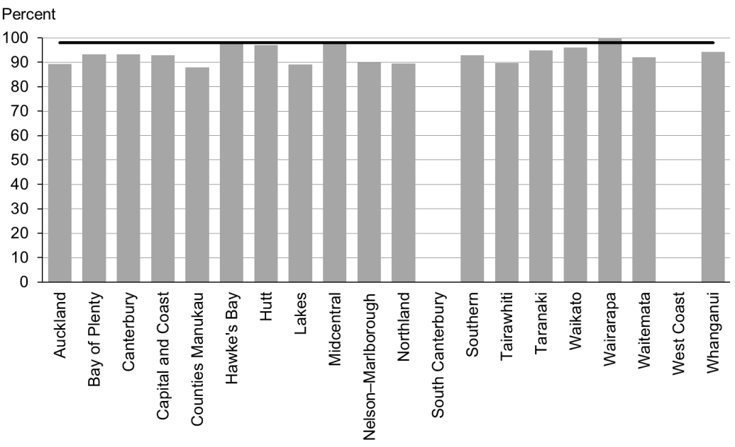

### Data notes

* No bar on graph = no children in this category.
* Time period: children starting school during the 12 months to 31 December 2014.
* High deprivation: children attending a Ministry of Education decile 1 or 2 school.
* Numerator: number of children starting school who have participated in ECE (source: ENROL).
* Denominator: number of children starting school (source: ENROL).

## WCTO Quality Improvement Framework Indicator 8

|  |  |
| --- | --- |
| **Standard:** | All children and families have access to primary care, WCTO services (including the B4 School Check) and early childhood education. |
| **Indicator:** | Children under six years have access to free primary care. |
| **Target by December 2014:** | 98 percent |
| **Target by June 2016:** | 100 percent |

|  |  |  |  |  |
| --- | --- | --- | --- | --- |
|  | **Total New Zealand** | **High deprivation** | **Māori** | **Pacific peoples** |
| March 2015 mean (range) | 99% (96–100) | 100% (98–100) | 100% (98–100) | 100% (99–100) |

Figure 24: Under-six access to free primary care, total New Zealand

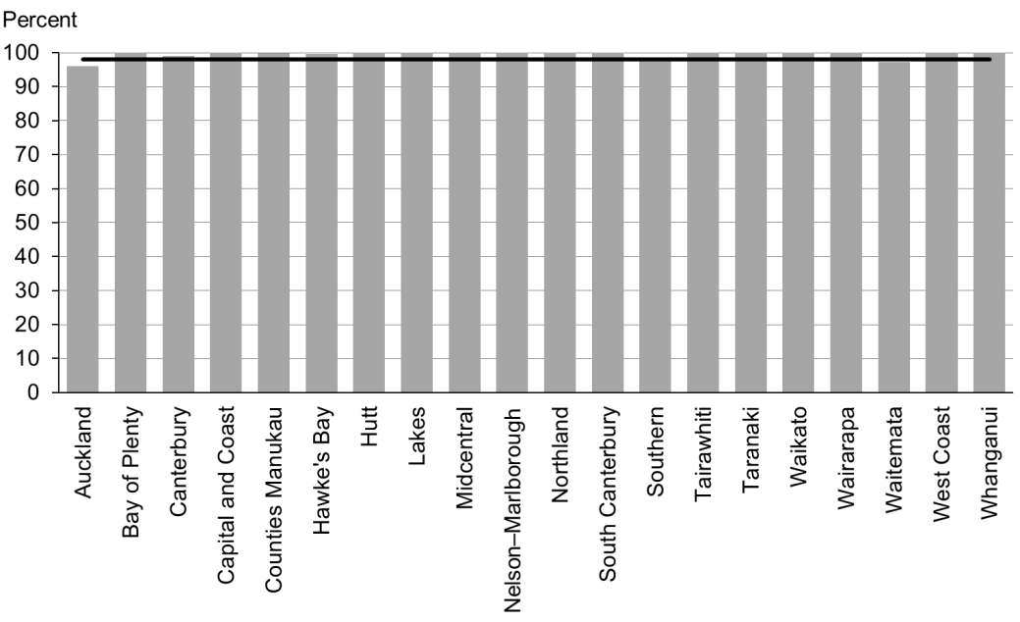

Figure 25: Under-six access to free primary care, high deprivation

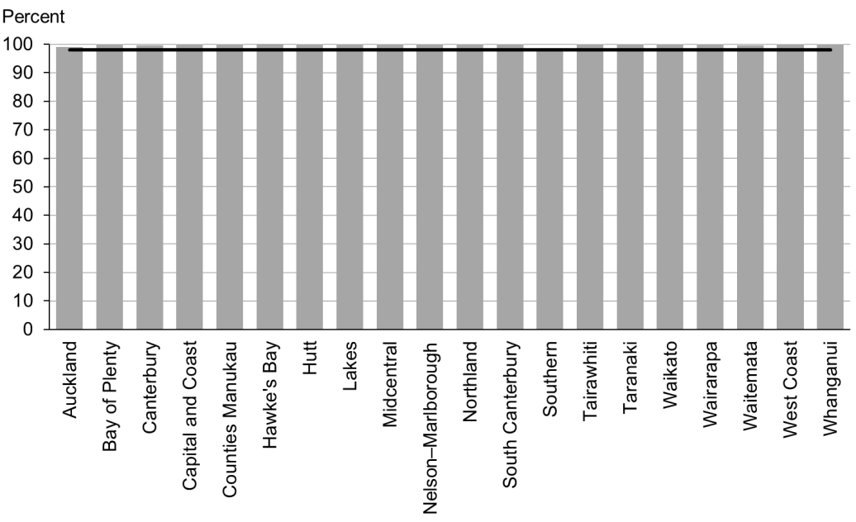

Figure 26: Under-six access to free primary care, Māori

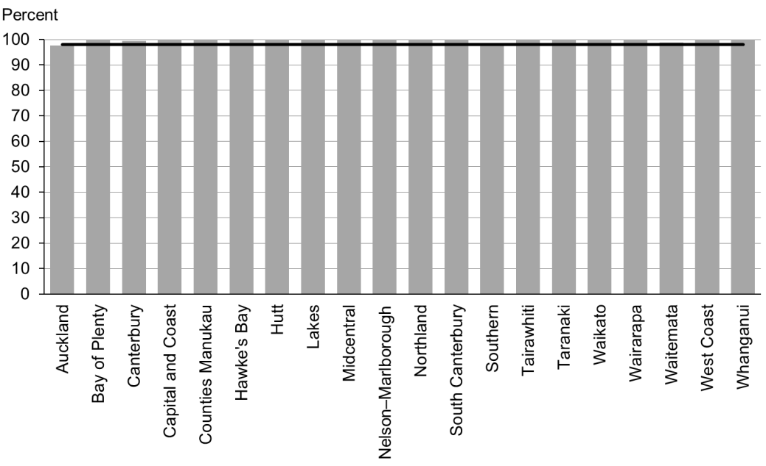

Figure 27: Under-six access to free primary care, Pacific peoples

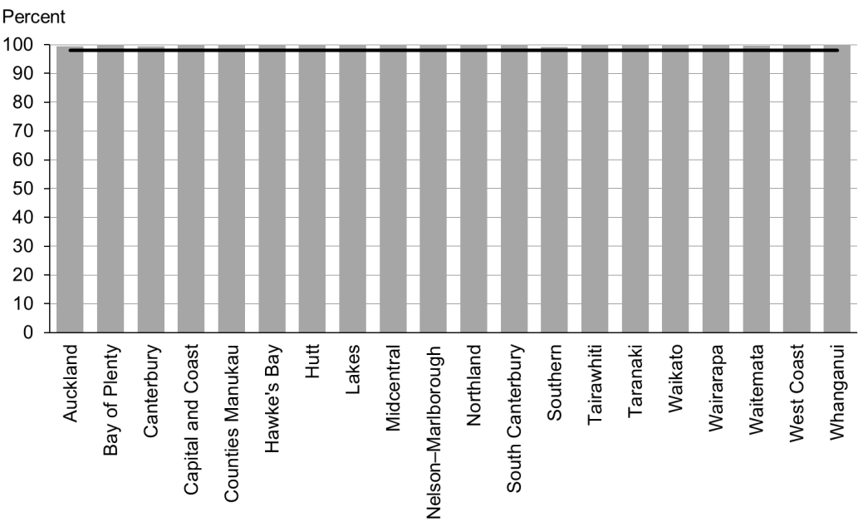

### Data notes

* Time period: snapshot as at 1 January 2015.
* Numerator: number of children aged under six years enrolled with a PHO that delivers free primary care for under-sixes (source: PHO).
* Denominator: number of children aged under six years enrolled with a PHO (source: PHO).

## WCTO Quality Improvement Framework Indicator 9

|  |  |
| --- | --- |
| **Standard:** | All children and families have access to primary care, WCTO services (including the B4 School Check) and early childhood education. |
| **Indicator:** | Children under six years have access to free after-hours primary care. |
| **Target by December 2014:** | 98 percent |
| **Target by June 2016:** | 100 percent |

|  |  |  |  |  |
| --- | --- | --- | --- | --- |
|  | **Total New Zealand** | **High deprivation** | **Māori** | **Pacific peoples** |
| March 2015 mean (range) | 98% (83–100) | N/A | N/A | N/A |

Figure 28: Under-six access to free after-hours primary care, total New Zealand

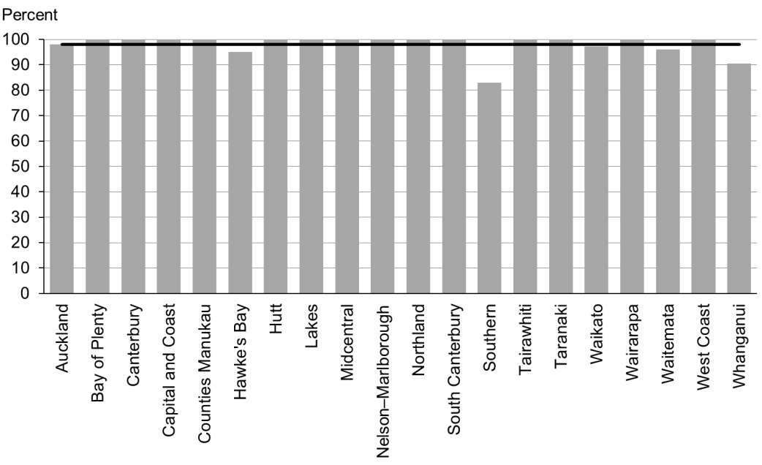

### Data notes

* Time period: snapshot as at 1 January 2015.
* Data is not available by ethnicity or deprivation quintile.
* Numerator: number of children aged under six years who are enrolled with a PHO that delivers free after-hours primary care for under sixes (source: PHO).
* Denominator: number of children aged under six years who are enrolled with a PHO (source: PHO).

## WCTO Quality Improvement Framework Indicator 10

|  |  |
| --- | --- |
| **Standard:** | All children and families have access to specialist and other referred services, where required, in a timely manner. |
| **Indicator:** | Children are seen promptly following referral to specialist services. |
| **Target by December 2014:** | 100 percent within five months of referral |
| **Target by June 2016:** | 100 percent within four months of referral |

|  |  |  |  |  |
| --- | --- | --- | --- | --- |
|  | **Total New Zealand** | **High deprivation** | **Māori** | **Pacific peoples** |
| March 2015 mean (range) | 99% (91–100) | N/A | N/A | N/A |

Figure 29: First specialist appointment for paediatric medicine received within five months, total New Zealand

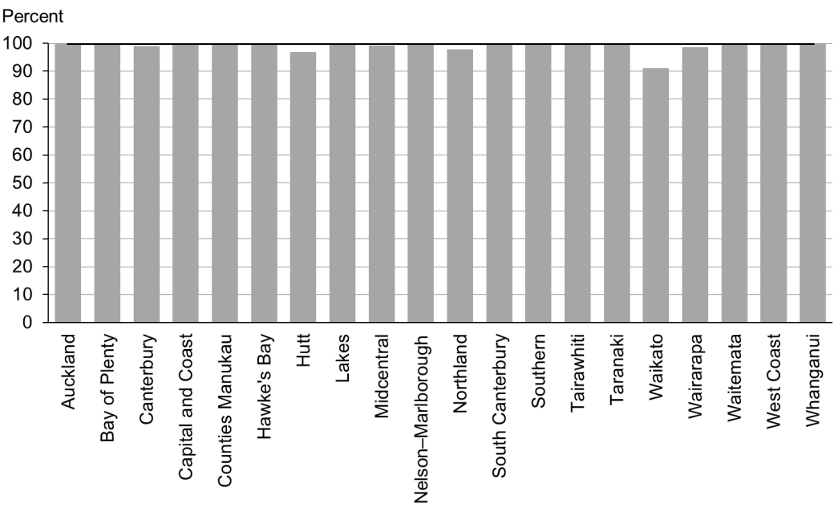

### Data notes

* Time period: snapshot for January 2015.
* DHB is DHB of service.
* Data is not available by ethnicity or deprivation quintile.
* The data presented is for any referral to DHB paediatric medicine (any age).
* Numerator: number waiting longer than five months (source: DHB Elective Services Patient Flow Indicators reporting).
* Denominator: total number waiting at end of month (source: DHB Elective Services Patient Flow Indicators reporting).

# Indicators 11–20: Outcomes

Aim 2 of the WCTO Quality Improvement Framework is **improved health and equity for all populations**. This can be measured by improved health and wellbeing outcomes for children, families and whānau. It is expected that, in addition to these indicators, DHBs and WCTO providers will consider other measures of family and whānau health and wellbeing that can be monitored through national or local data sources.

Indicators 11–20 measure health outcomes across a range of domains. This set is not exhaustive, but instead aims to measure a range of outcomes related to infant and child physical health (nutrition and healthy weight, oral health), infant and child mental health (strengths and difficulties questionnaire) and family health (smoking status). It is expected that additional measures of health and wellbeing outcomes will be added as new data becomes available. A number of these indicators have been adopted in other performance and outcome monitoring documents, including Māori Health Plans, the New Zealand Maternity Clinical Indicator, and Integrated Performance and Incentive Framework Contributory Measures.

These indicators reflect the core roles of WCTO in promoting and supporting physical health, mental wellbeing, healthy families and whanau, and healthy home environments. Achieving improvements in these indicators will require a cross-sector response and a multi-faceted approach, and improvements may not be seen in the short term. However, monitoring health and wellbeing outcomes is important because it shows where WCTO services are working well and where they are working together with the wider health sector to achieve the best outcomes for families and whānau.

## Summary of results for this period

### National

Figures in this set of indicators are the steadiest of all the three indicator groups. Only two indicators (*12: Infants are exclusively or fully breastfed at discharge from LMC* and *15: Children are a healthy weight at four years*) show a change of plus or minus two percentage points or greater in any area. While the breastfeeding indicators (11–14) have remained relatively static since the last report, they are all still on track to achieve the June 2016 targets. The smokefree indicators (*19: Mothers are smokefree at two weeks postnatal* and *20: Children live in smokefree homes*) still need focus if the June 2016 targets are to be reached.

There was no new data for Indicators 16 and 17 (*Children are caries free at five years* and *The burden of dental decay is minimised*).

### By region

Across this set of indicators, variance between DHBs is noticeable in most areas but especially in breastfeeding rates. At all four age points − two weeks, discharge with an LMC (normally around six weeks), three months and six months − variance between DHBs is around 20 percentage points, and although the DHBs who have the lowest rates are consistent across all age groups, the highest-performing DHBs are variable for each age group. This suggests that some have focused on early breastfeeding rates, while others are trying to ensure women continue to breastfeed as the baby gets older. Rates of women smokefree at two weeks postnatal (*Indicator 19*) vary significantly by DHB, reflecting the population make up of each region. DHBs should focus on differences that are persistent when analysed by ethnicity or deprivation. Reported rates for children in smokefree homes continue to remain high, although it should be noted that this data only represents approximately one-third of the population because providers do not consistently report this data.

### By deprivation

In all four breastfeeding indicators fewer infants living in areas of high deprivation are exclusively or fully breastfed, and fewer infants receive some breast milk at six months relative to the total population. Again, for the second report in a row there has been no increase in rates for any of the four breastfeeding indicators for infants living in areas of high deprivation. Breastfeeding is free and helps lay the foundations for a healthy life.. Supporting families living in areas of high deprivation to establish and maintain breastfeeding should be a focus for all DHBs.

Of the other indicators in the group, children in areas of high deprivation are less likely to be a healthy weight at four years old (69 percent of those living in high deprivation versus 75 percent of the total population) and women are less likely to be smokefree at two weeks postnatal (74 percent of those living in high deprivation versus 87 percent of the total population).

### By ethnicity

Outcomes for Māori and Pacific families are significantly poorer across a range of indicators. For Māori, maternal tobacco use is significantly higher than for the total population, with only 65 percent of women smoke free at two weeks postnatal, compared to 87 percent of the total population. Pacific children are significantly less likely to be a healthy weight at four years of age than the total population, although the gap has decreased by two percentage points since the last report, which is encouraging (61 percent, versus 75 percent nationally).

Nationally, breastfeeding rates for Māori and Pacific infants start at a similar (although slightly lower) rate as the total population, but drop off more quickly than the total population at the three- and six-month time points. This is recommended as an area of focus because there is significant room for improvement, and breastfeeding has wide-reaching benefits and potentially results in a reduced cost for families.

## WCTO Quality Improvement Framework Indicator 11

|  |  |
| --- | --- |
| **Standard:** | WCTO providers use evidence-based interventions and education to promote child, family and whānau health and wellbeing. |
| **Indicator:** | Infants are exclusively or fully breastfed at two weeks. |
| **Target by December 2014:** | 72 percent |
| **Target by June 2016:** | 80 percent |

|  |  |  |  |  |
| --- | --- | --- | --- | --- |
|  | **Total New Zealand** | **High deprivation** | **Māori** | **Pacific peoples** |
| March 2015 mean (range) | 79% (71–90) | 76% (68–90) | 77% (69–94) | 74% (44–90) |

Figure 30: Exclusively or fully breastfed at two weeks, total New Zealand

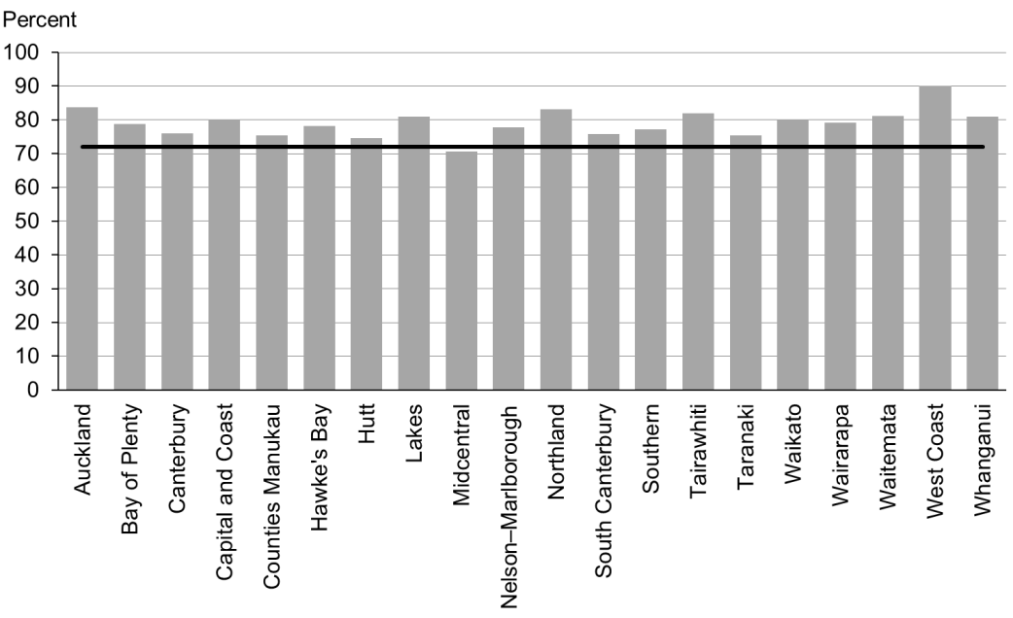

Figure 31: Exclusively or fully breastfed at two weeks, high deprivation

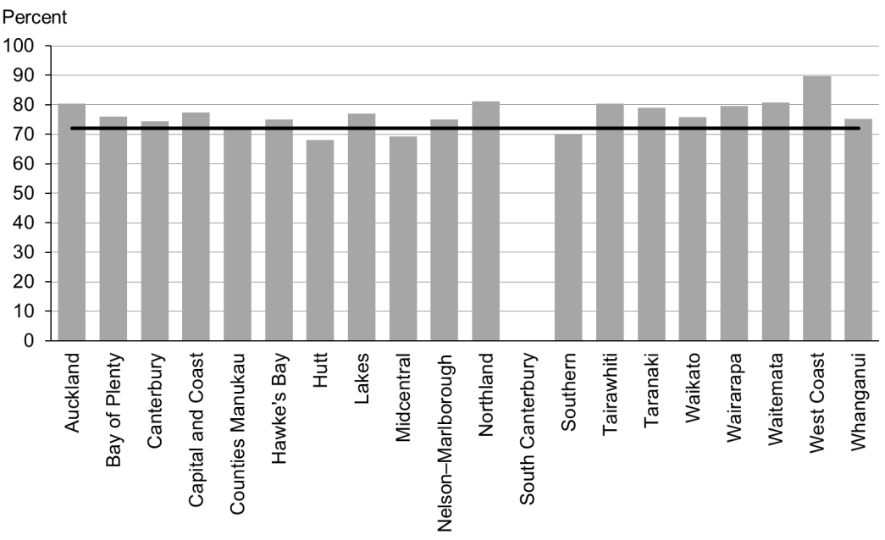

Figure 32: Exclusively or fully breastfed at two weeks, Māori

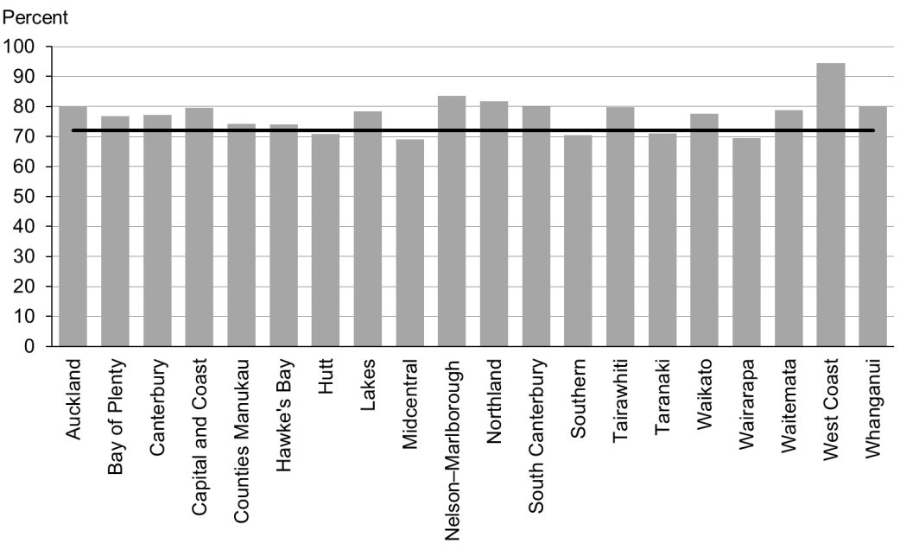

Figure 33: Exclusively or fully breastfed at two weeks, Pacific peoples

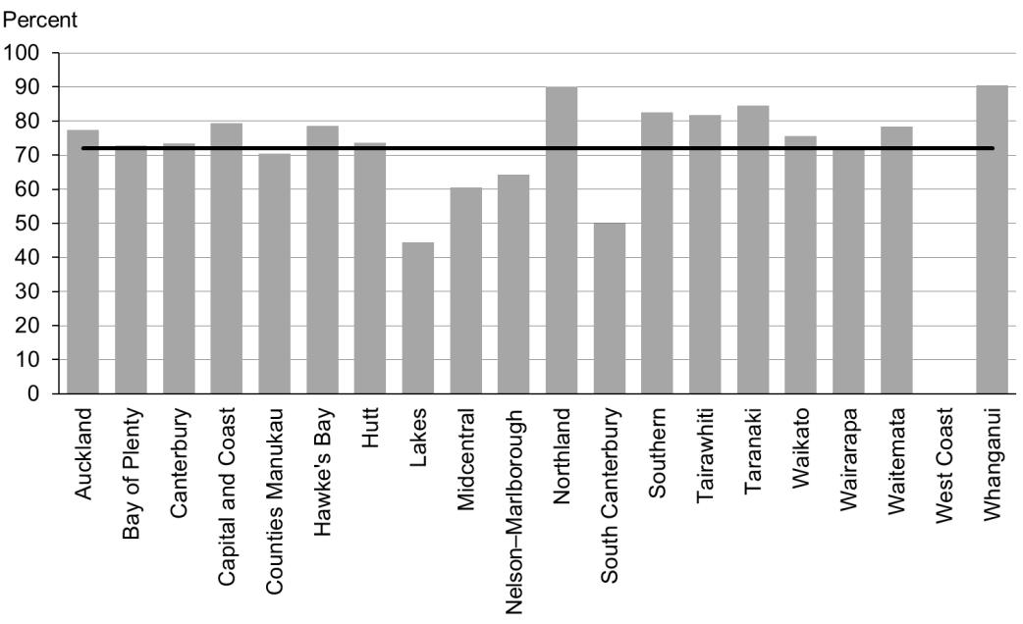

### Data notes

* No bar on graph = no infants in this category.
* Time period: babies born between 1 January 2014 and 30 June 2014.
* Excludes overseas DHB and undefined DHB.
* Numerator: breastfeeding at two weeks = exclusive or fully (source: MAT).
* Denominator: breastfeeding at two weeks = not null (source: MAT).

## WCTO Quality Improvement Framework Indicator 12

|  |  |
| --- | --- |
| **Standard:** | WCTO providers use evidence-based interventions and education to promote child, family and whānau health and wellbeing. |
| **Indicator:** | Infants are exclusively or fully breastfed on discharge from lead maternity carer (LMC) care. |
| **Target by December 2014:** | 68 percent |
| **Target by June 2016:** | 75 percent |

|  |  |  |  |  |
| --- | --- | --- | --- | --- |
|  | **Total New Zealand** | **High deprivation** | **Māori** | **Pacific peoples** |
| March 2015 mean (range) | 74% (65–85) | 71% (61–83) | 69% (55–94) | 72% (44–86) |

Figure 34: Exclusively or fully breastfed at LMC discharge, total New Zealand

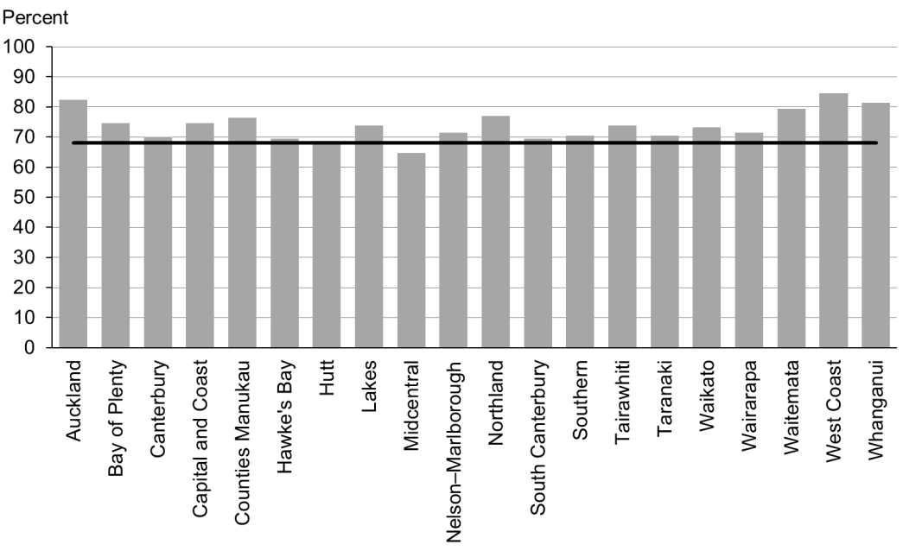

Figure 35: Exclusively or fully breastfed at LMC discharge, high deprivation

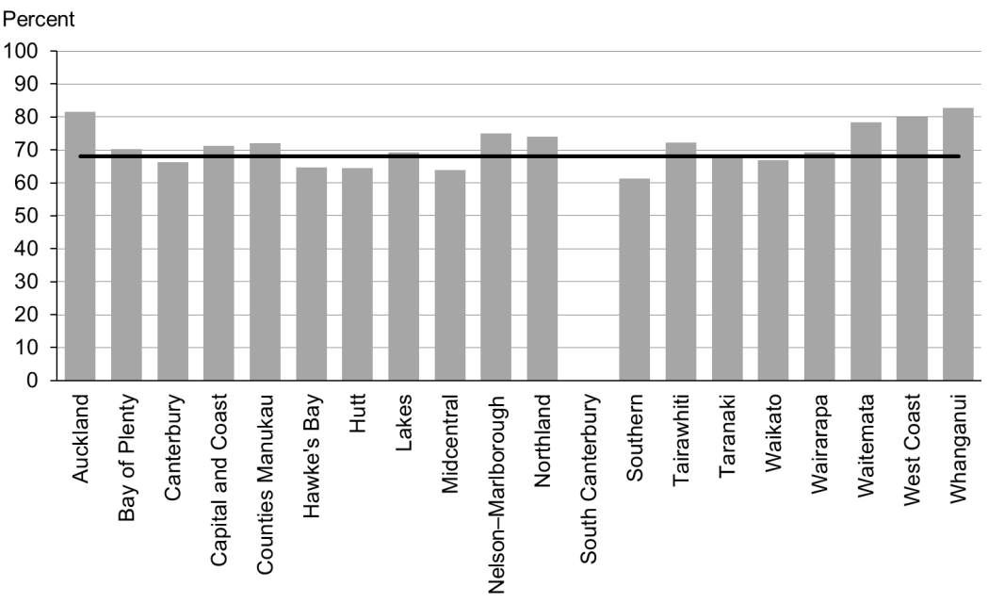

Figure 36: Exclusively or fully breastfed at LMC discharge, Māori

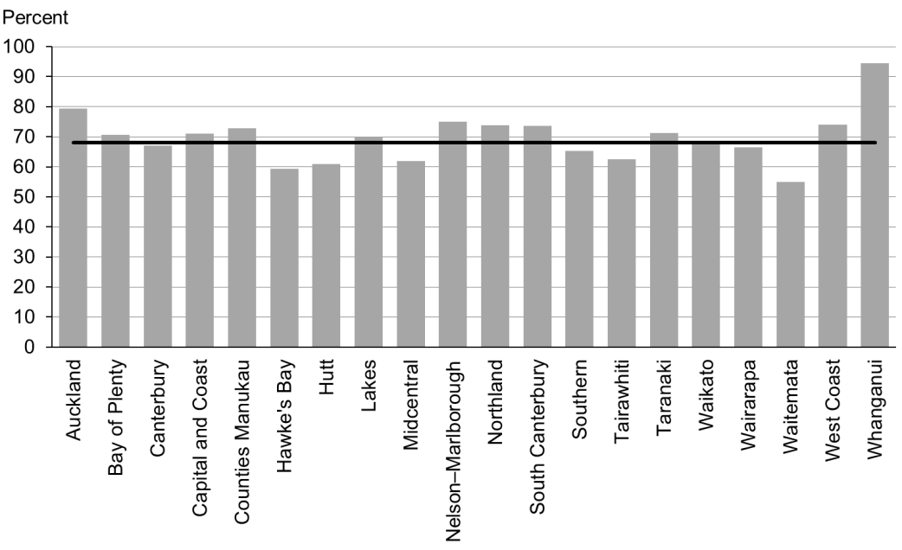

Figure 37: Exclusively or fully breastfed at LMC discharge, Pacific peoples

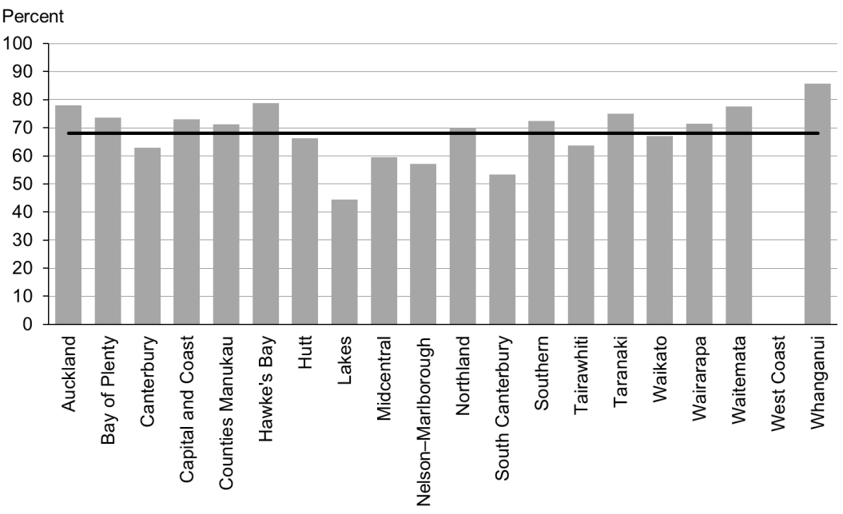

### Data notes

* No bar on graph = no infants in this category.
* Time period: babies born between 1 January 2014 and 30 June 2014.
* Excludes overseas DHB and undefined DHB.
* Numerator: breastfeeding at discharge = exclusive or fully (source: MAT).
* Denominator: breastfeeding at discharge = not null (source: MAT).

## WCTO Quality Improvement Framework Indicator 13

|  |  |
| --- | --- |
| **Standard:** | WCTO providers use evidence-based interventions and education to promote child, family and whānau health and wellbeing. |
| **Indicator:** | Infants are exclusively or fully breastfed at three months of age. |
| **Target by December 2014:** | 54 percent |
| **Target by June 2016:** | 60 percent |

|  |  |  |  |  |
| --- | --- | --- | --- | --- |
|  | **Total New Zealand** | **High deprivation** | **Māori** | **Pacific peoples** |
| March 2015 mean (range) | 55% (46–61) | 44% (31–56) | 45% (33–58) | 45% (37–57) |

Figure 38: Exclusively or fully breastfed at three months, total New Zealand

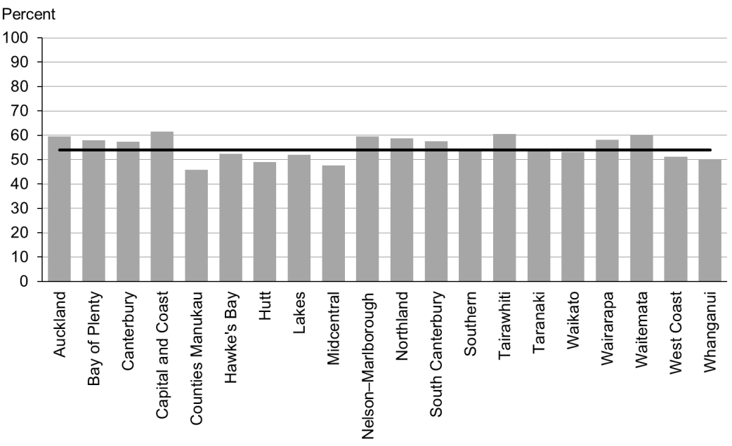

Figure 39: Exclusively or fully breastfed at three months, high deprivation

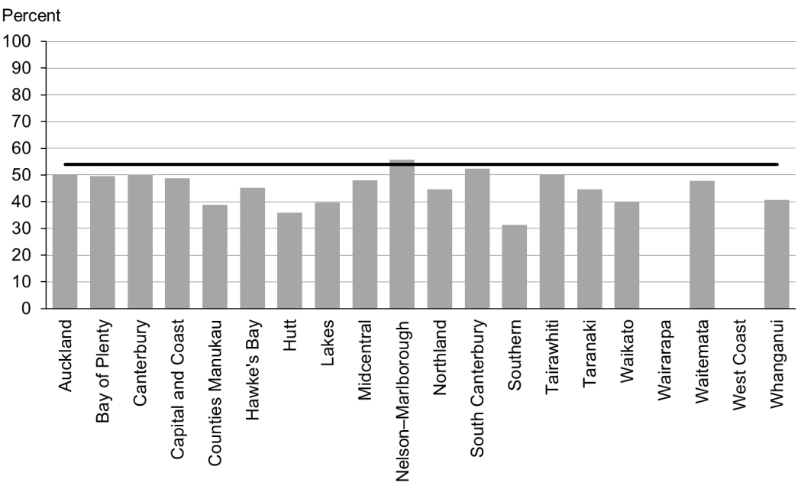

Figure 40: Exclusively or fully breastfed at three months, Māori

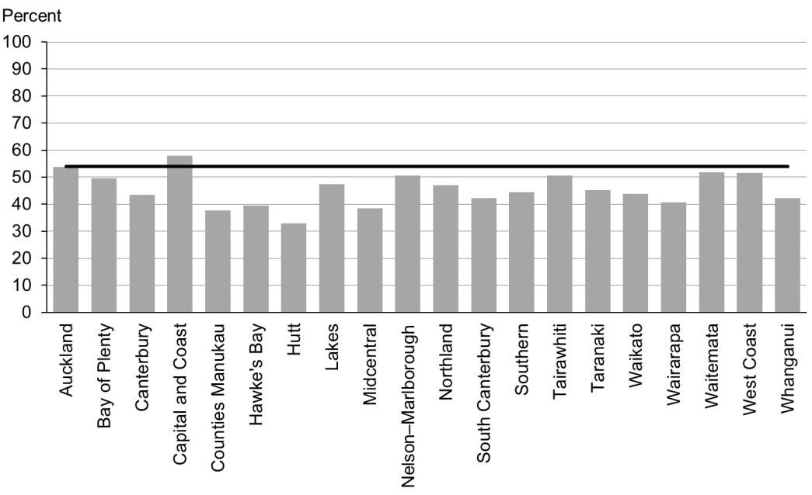

Figure 41: Exclusively or fully breastfed at three months, Pacific peoples

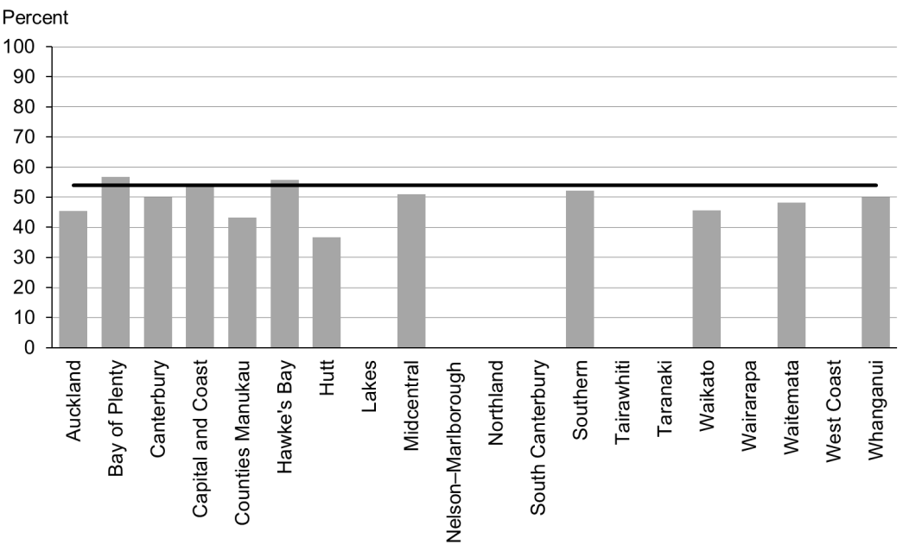

### Data notes

* No bar on graph = fewer than 20 infants in this category.
* Time period: infants aged three months between July 2014 and December 2014.
* The data excludes overseas DHB and undefined DHB.
* Numerator: breastfeeding at three months = exclusive or fully (source: Plunket).
* Denominator: breastfeeding at three months = not null (source: Plunket).

## WCTO Quality Improvement Framework Indicator 14

|  |  |
| --- | --- |
| **Standard:** | WCTO providers use evidence-based interventions and education to promote child, family and whānau health and wellbeing. |
| **Indicator:** | Infants are receiving breast milk at six months of age (exclusively, fully or partially breastfed). |
| **Target by December 2014:** | 59 percent |
| **Target by June 2016:** | 65 percent |

|  |  |  |  |  |
| --- | --- | --- | --- | --- |
|  | **Total New Zealand** | **High deprivation** | **Māori** | **Pacific peoples** |
| March 2015 mean (range) | 66% (57–76) | 56% (40–68) | 55% (47–69) | 59% (45–71) |

Figure 42: Infants receive breast milk at six months, total New Zealand

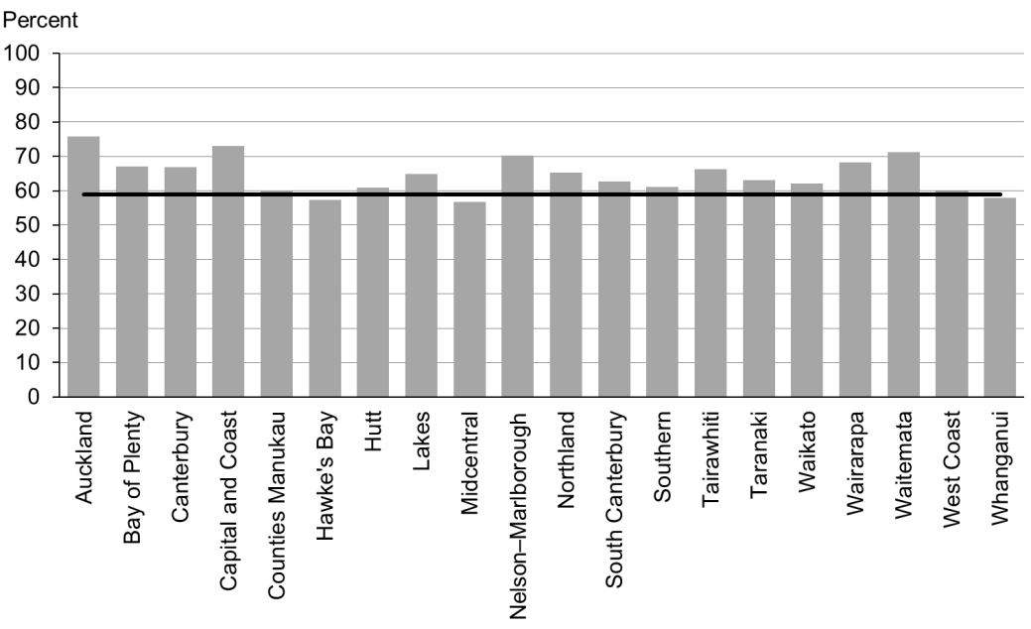

Figure 43: Infants receive breast milk at six months, high deprivation

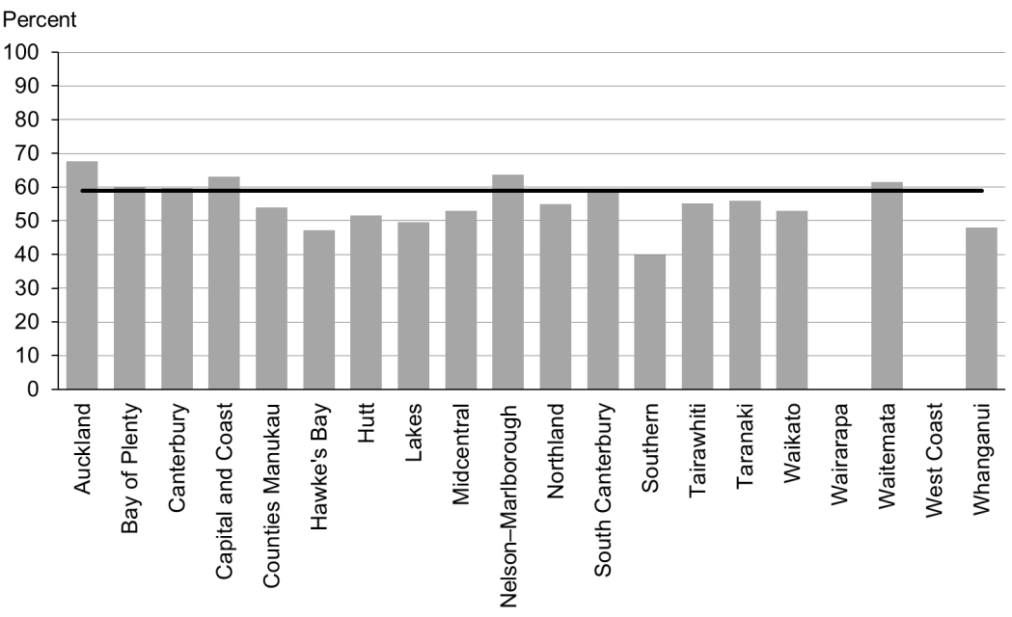

Figure 44: Infants receive breast milk at six months, Māori

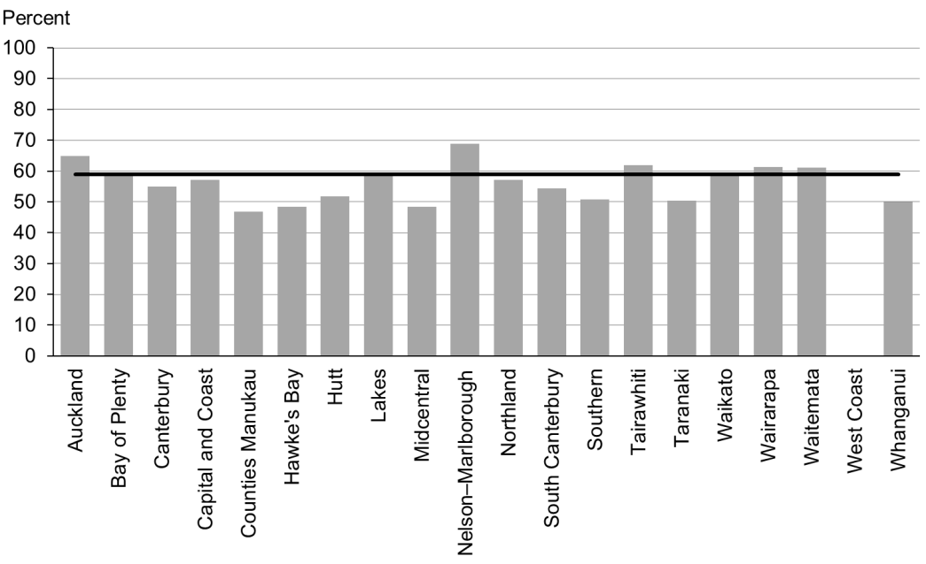

Figure 45: Infants receive breast milk at six months, Pacific peoples

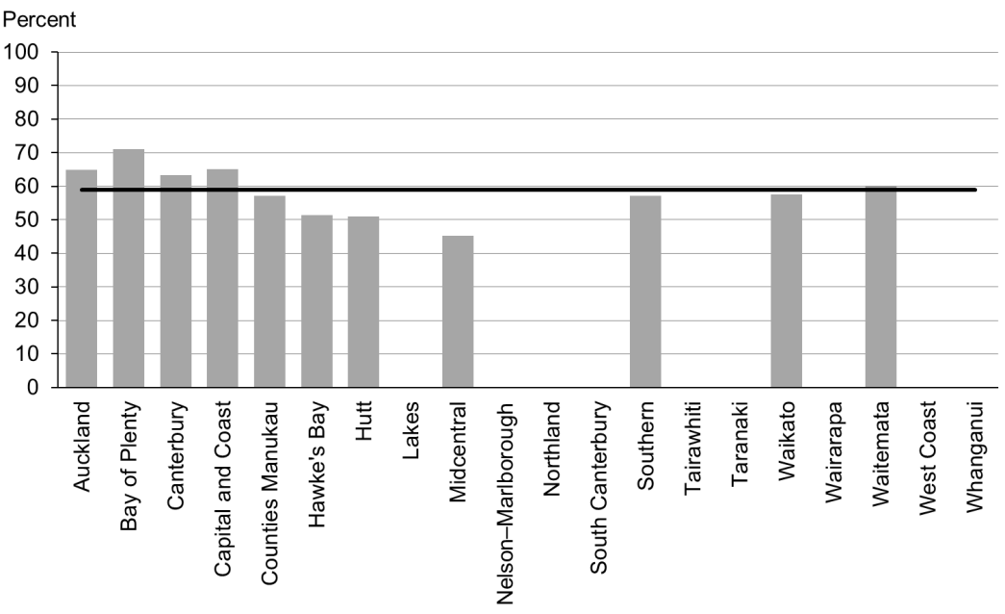

### Data notes

* No bar on graph = fewer than 20 infants in this category.
* Time period: infants aged six months between July and December 2014.
* The data excludes overseas DHB and undefined DHB.
* Numerator: breastfeeding at six months = exclusive, full or partial (source: Plunket).
* Denominator: breastfeeding at six months = not null (source: Plunket).

## WCTO Quality Improvement Framework Indicator 15

|  |  |
| --- | --- |
| **Standard:** | WCTO providers use evidence-based interventions and education to promote child, family and whānau health and wellbeing. |
| **Indicator:** | Children are a healthy weight at four years. |
| **Target by December 2014:** | 68 percent |
| **Target by June 2016:** | 75 percent |

|  |  |  |  |  |
| --- | --- | --- | --- | --- |
|  | **Total New Zealand** | **High deprivation** | **Māori** | **Pacific peoples** |
| March 2015 mean (range) | 75% (70–81) | 69% (63–80) | 71% (58–79) | 61% (42–94) |

Figure 46: Children are a healthy weight at age four years, total New Zealand

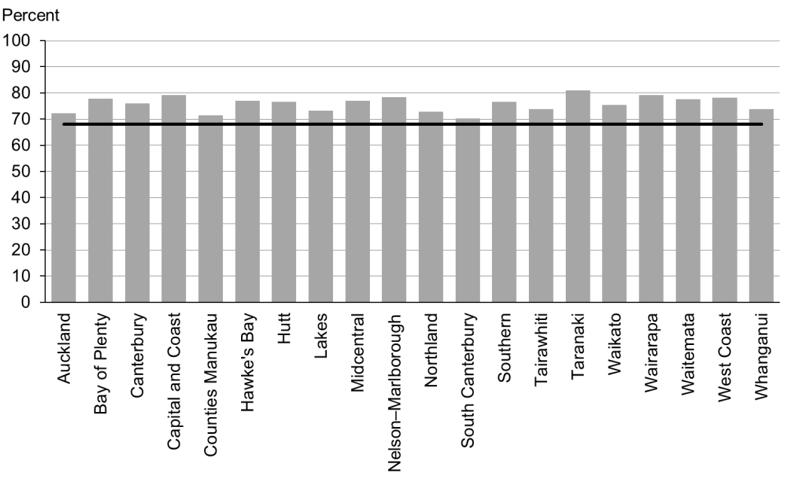

Figure 47: Children are a healthy weight at age four years, high deprivation

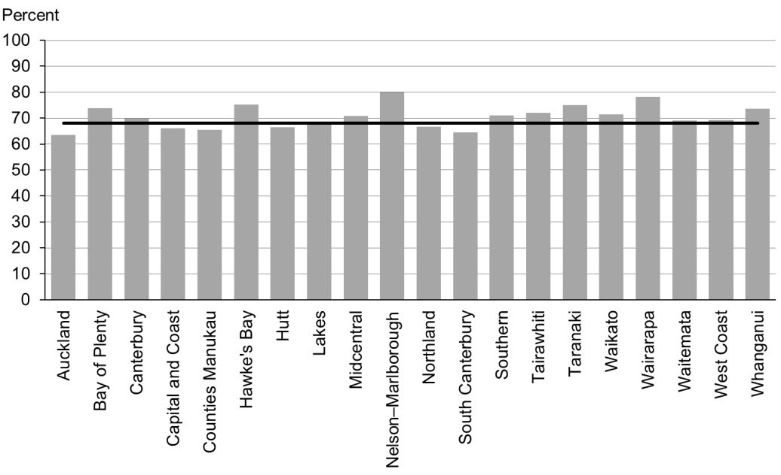

Figure 48: Children are a healthy weight at age four years, Māori

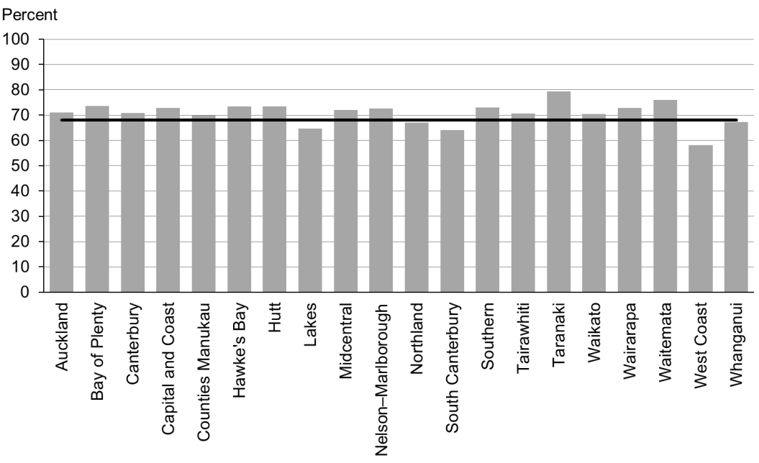

Figure 49: Children are a healthy weight at age four years, Pacific peoples

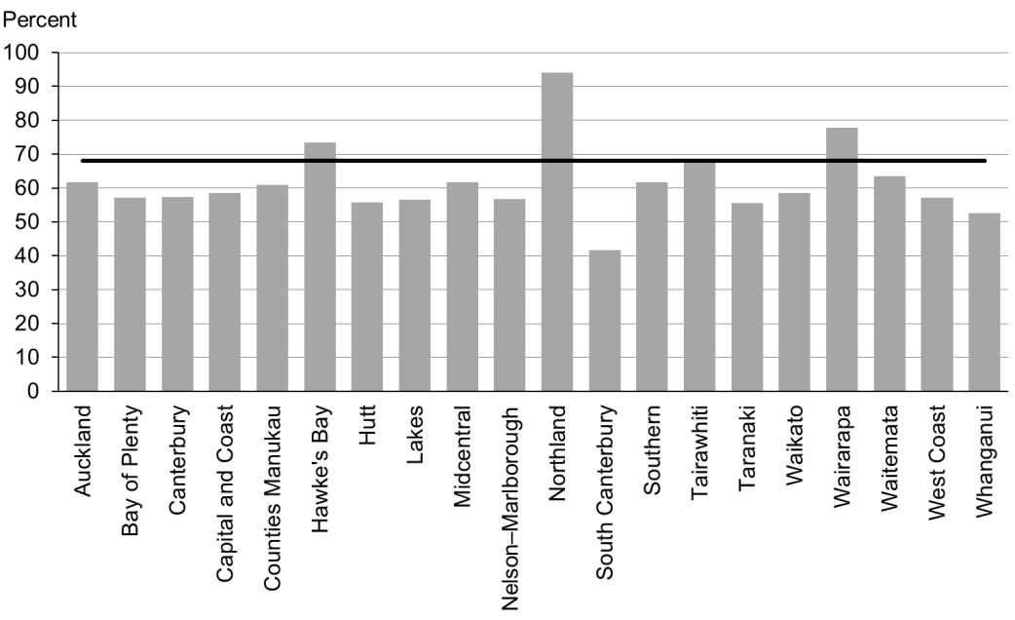

### Data notes

* Time period: children receiving a B4 School Check between 1 July and 31 December 2014.
* DHB is DHB of service.
* Numerator: children with a BMI between the 5th and 84th percentile at B4 School Check (source: B4 School Check).
* Denominator: children with a BMI recorded at B4 School Check (source: B4 School Check).

## WCTO Quality Improvement Framework Indicator 16

|  |  |
| --- | --- |
| **Standard:** | WCTO providers use evidence-based interventions and education to promote child, family and whānau health and wellbeing. |
| **Indicator:** | Children are caries free at five years. |
| **Target by December 2014:** | 65 percent |
| **Target by June 2016:** | 65 percent |

|  |  |  |  |  |
| --- | --- | --- | --- | --- |
|  | **Total New Zealand** | **High deprivation** | **Māori** | **Pacific peoples** |
| March 2015 mean (range) | No new data | | | |

### Data notes

* No new data is available for this period. Please see the previous report for the latest data available.

## WCTO Quality Improvement Framework Indicator 17

|  |  |
| --- | --- |
| **Standard:** | WCTO providers use evidence-based interventions and education to promote child, family and whānau health and wellbeing. |
| **Indicator:** | The burden of dental decay among children with one or more decayed, missing and filled teeth (dmft) is minimised. |
| **Target by December 2014:** | 4.4 dmft |
| **Target by June 2016:** | 4 dmft |

|  |  |  |  |  |
| --- | --- | --- | --- | --- |
|  | **Total New Zealand** | **High deprivation** | **Māori** | **Pacific peoples** |
| March 2015 mean (range) | No new data | | | |

### Data notes

* There is no new data available for this period. Please see the previous report for the latest data available.

## WCTO Quality Improvement Framework Indicator 18

|  |  |
| --- | --- |
| **Standard:** | WCTO providers use evidence-based interventions and education to promote child, family and whānau health and wellbeing. |
| **Indicator:** | Child mental health is supported (children’s SDQ-P scores are within the normal range at the B4 School Check).[2] |
| **Target by December 2014:** | 86 percent |
| **Target by June 2016:** | 95 percent |

|  |  |  |  |  |
| --- | --- | --- | --- | --- |
|  | **Total New Zealand** | **High deprivation** | **Māori** | **Pacific peoples** |
| March 2015 mean (range) | 96% (91–99) | 93% (84–100) | 94% (88–100) | 95% (84–100) |

Figure 50: Children have a normal SDQ-P score at four years, total New Zealand

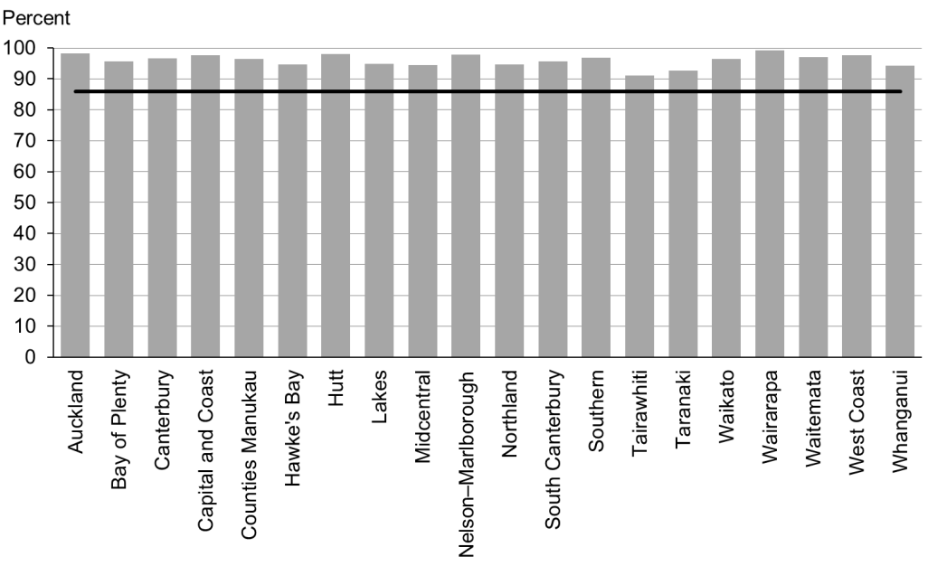

Figure 51: Children have a normal SDQ-P score at four years, high deprivation

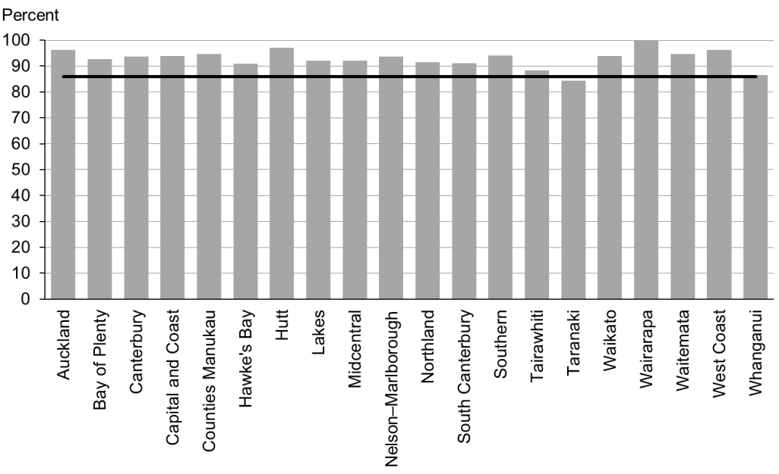

Figure 52: Children have a normal SDQ-P score at four years, Māori

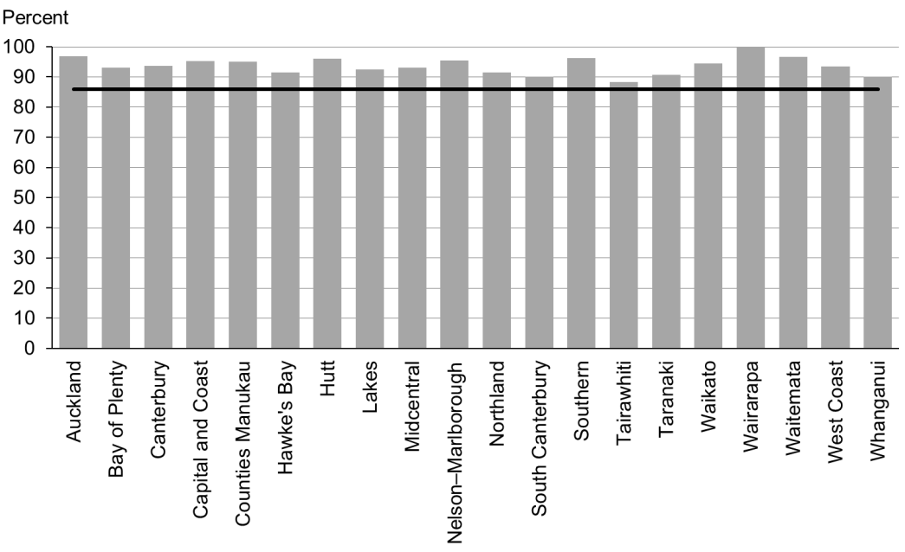

Figure 53: Children have a normal SDQ-P score at four years, Pacific peoples

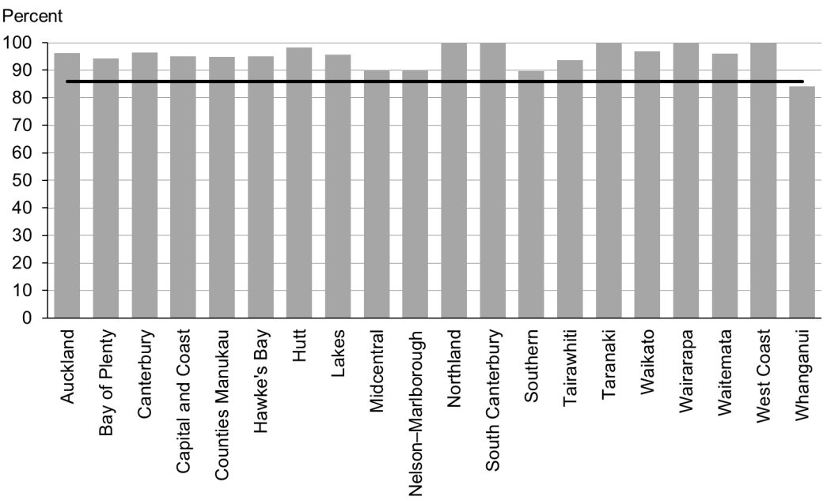

### Data notes

* Time period: children receiving a B4 School Check between 1 July and 31 December 2014.
* DHB is DHB of service.
* Numerator: children with an SDQ-P score that is within the normal range (source: B4 School Check).
* Denominator: children with an SDQ-P score recorded at the B4 School Check (source: B4 School Check).

## WCTO Quality Improvement Framework Indicator 19

|  |  |
| --- | --- |
| **Standard:** | WCTO providers use evidence-based interventions and education to promote child, family and whānau health and wellbeing. |
| **Indicator:** | Mothers are smokefree at two weeks postnatal. |
| **Target by December 2014:** | 86 percent |
| **Target by June 2016:** | 95 percent |

|  |  |  |  |  |
| --- | --- | --- | --- | --- |
|  | **Total New Zealand** | **High deprivation** | **Māori** | **Pacific peoples** |
| March 2015 mean (range) | 87% (72–96) | 76% (61–94) | 65% (56–83) | 91% (71–100) |

Figure 54: Mother smokefree at two weeks postnatal, total New Zealand

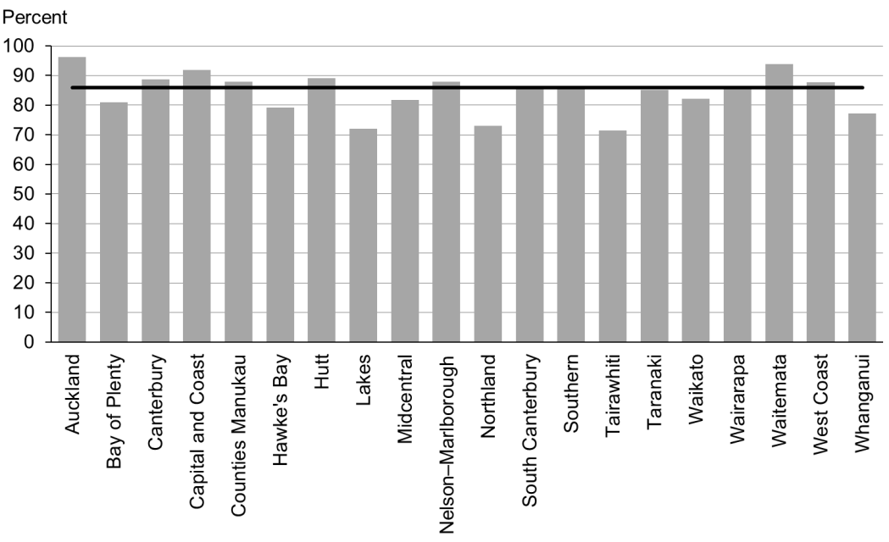

Figure 55: Mother smokefree at two weeks postnatal, high deprivation

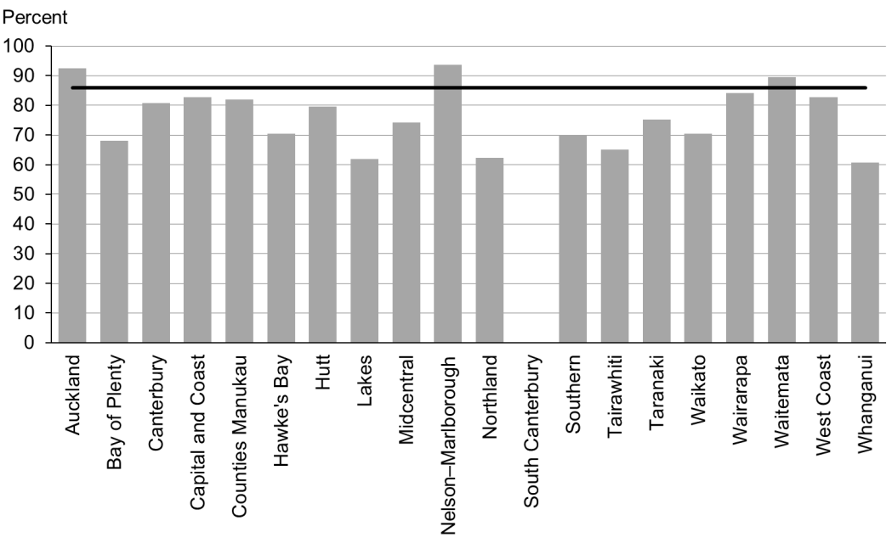

Figure 56: Mother smokefree at two weeks postnatal, Māori

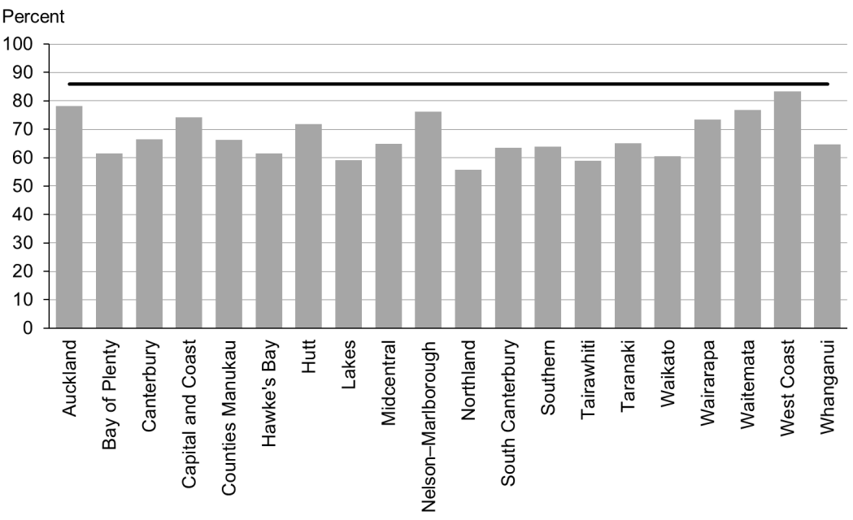

Figure 57: Mother smokefree at two weeks postnatal, Pacific peoples

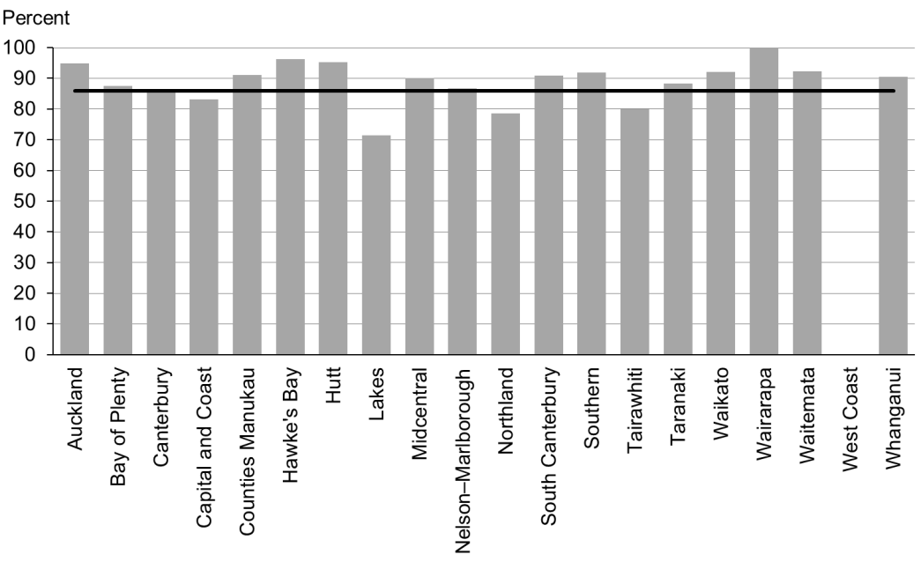

### Data notes

* Time period: births between 1 January and 30 June 2014.
* The data excludes overseas DHB and undefined DHB.
* Numerator: maternal tobacco use (two weeks) = Yes (source: MAT).
* Denominator: maternal tobacco use (two weeks) = Yes or No (source: MAT).

## WCTO Quality Improvement Framework Indicator 20

|  |  |
| --- | --- |
| **Standard:** | WCTO providers use evidence-based interventions and education to promote child, family and whānau health and wellbeing. |
| **Indicator:** | Children live in a smokefree home (age four years). |
| **Target by December 2014:** | 90 percent |
| **Target by June 2016:** | 100 percent |

|  |  |  |  |  |
| --- | --- | --- | --- | --- |
|  | **Total New Zealand** | **High deprivation** | **Māori** | **Pacific peoples** |
| March 2015 mean (range) | 98% (94–100) | 97% (91–100) | 97% (86–100) | 97% (86–100) |

Figure 58: Children live in a smokefree home (age four years), total New Zealand

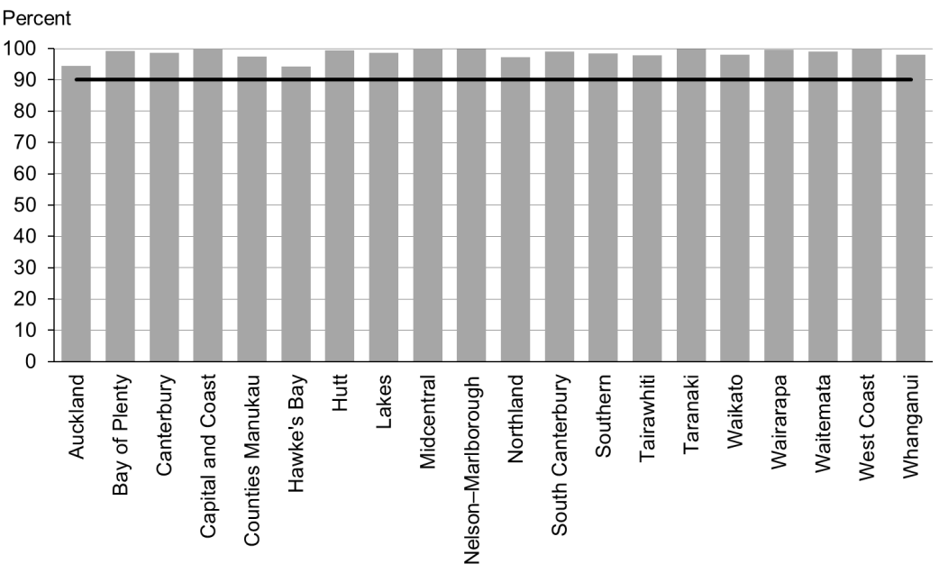

Figure 59: Children live in a smokefree home (age four years), high deprivation

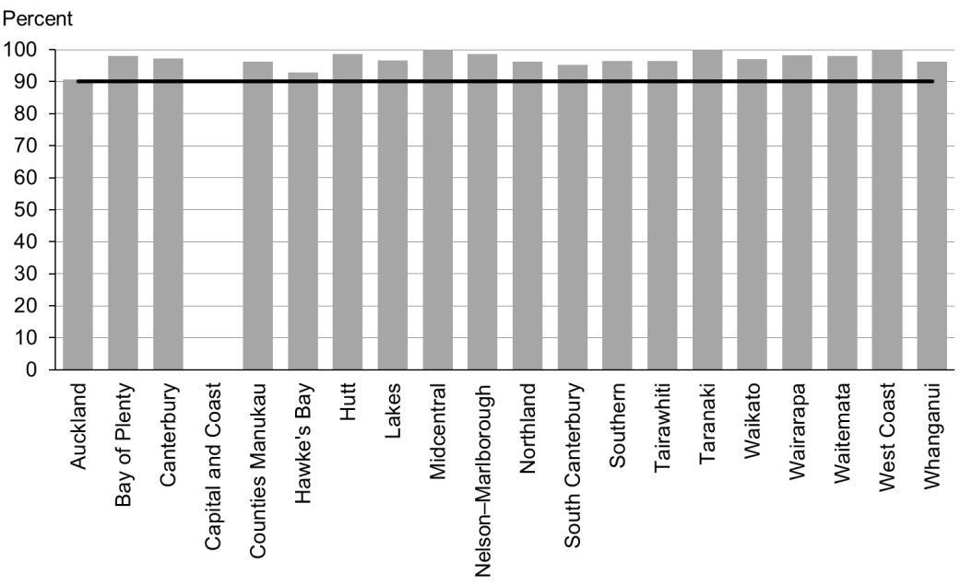

Figure 60: Children live in a smokefree home (age four years), Māori

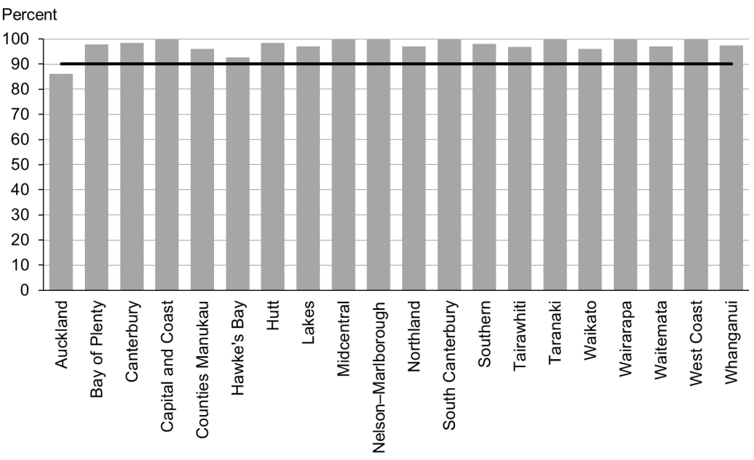

Figure 61: Children live in a smokefree home (age four years), Pacific peoples

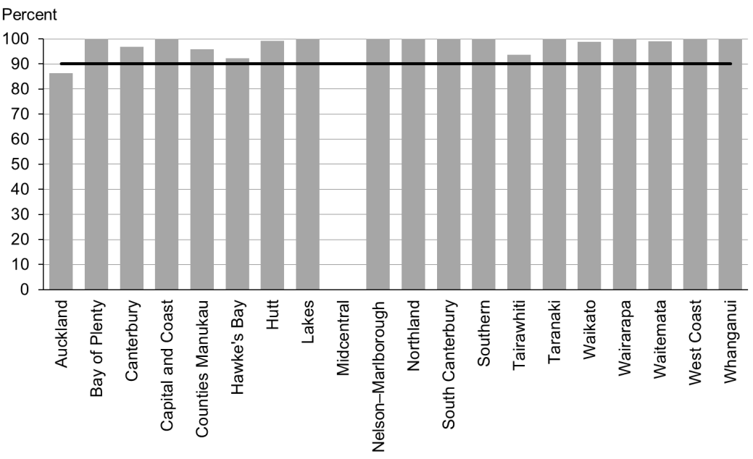

### Data notes

* This indicator relates to parental smoking indoors at home.
* No bar on graph = the smokefree at-home status is not reported.
* Time period: children receiving a B4 School Check between 1 July and 31 December 2014.
* DHB is DHB of service.
* Numerator: children with smokefree home = Yes (source: B4 School Check).
* Denominator: children with smokefree home = Yes or No (source: B4 School Check).

# Indicators 21–27: Quality

Aim 3 of the WCTO Quality Improvement Framework seeks **best value for health system resource**. To achieve this aim, advice, screening and interventions must be based on the best available evidence and delivered to a consistently high quality. This approach ensures best value for money, because health or development issues are:

* identified accurately (reducing downstream costs related to poor sensitivity, and wastage due to poor specificity)
* treated early (reducing the intensity of the intervention required) through interventions that have the best evidence of success (maximising health gain for investment).

Indicators 21–27 measure the quality of service delivery; in other words, adherence to best practice (either in the timing of the intervention or adherence to screening protocol) in delivering components of the WCTO programme. The current indicators focus exclusively on the B4 School Check due to the limited availability of data for other parts of the WCTO programme. It is expected that other indicators to monitor the quality of WCTO service delivery will be added over time.

## Summary of results for this period

### National

Nationally, *Indicators 21−27* are both the most successful at meeting targets and the most equitable across regions, ethnicities and high deprivation areas. Five of the seven indicators are on track to reach their December 2014 targets. *Indicators 22* and *23* (referral rates for abnormal SDQ-P scores and PEDS Pathway A, respectively) are not yet reaching the targets when ‘advice given’ is excluded. However, giving advice at the time of the WCTO check is sometimes the most pragmatic approach to meeting an identified need, and so the national rates are not necessarily concerning in themselves. What is of concern is that referral rates still show marked variability across the DHBs, meaning children receive different care for the same issue or concern, apparently based on geography alone.

The greatest changes in the group were increases in referral rates for oral health concerns and extreme obesity (*Indicators 24* and *27*, respectively). Referrals for children with Lift the Lip scores of between 2 and 6 increased by at least 18 percentage points across all groups and the equity gap narrowed substantially. Total referrals among children with identified oral health need at the B4 School Check across New Zealand have now reached 99 percent.

The overall rate of 86 percent for referrals for extreme obesity (a BMI greater than the 99.4th percentile) marks a significant increase since the last report. Total referrals have increased by 17 percentage points, to 86 percent, and high deprivation, Māori and Pacific referrals have increased to 86 percent, 75 percent and 99 percent, respectively. While this is a significant improvement, the figures can change dramatically given the small denominator so it is important that providers and referred services work to maintain this performance.

*Indicators 25* and *26* measure referral to specialist services where a hearing or vision problem is identified. Following previous quality improvement efforts and commitment by B4 School Check providers, along with vision and hearing technicians and specialist audiology and optometry/ophthalmology services, 100 percent of children with an identified issue are referred – across all regions, deprivation quintiles and ethnic groups. This significant achievement has now been maintained since March 2014.

### By region

Nationally, although 85 percent of B4 School Checks are started before the age of 4½ years, there is still significant variation by region (*Indicator 21*, range = 27–97 percent). In this case, Taranaki DHB is the significant outlier at 27 percent, but there are still a number of DHBs that are failing to reach the 81 percent December 2014 target. Canterbury, South Canterbury and Waikato have already exceeded the June 2016 target of 90 percent.

Since the last report the variation by DHB of referral for oral health concerns (*Indicator 24*, range = 43–91 percent, excluding ‘advice given’) has significantly decreased, with all DHBs showing high rates of referrals across all groups. While the overall rate of referrals for extreme obesity (*Indicator 27*, range = 0–100 percent, excluding ‘advice given’) has significantly increased, there is still significant variation across the DHBs. DHBs and B4 School Check providers in regions with low referrals rates should investigate the protocol and referral options in place in regions with high rates of referral to support the establishment of appropriate local pathways and build local capacity of specialist services.

### By deprivation

Unlike for other indicators in this report, performance against these seven quality-related indicators does not seem to be lower for children living in areas of high deprivation. The exception is B4 School Checks being started before 4½ years (*Indicator 21*), which has a slightly lower rate in high deprivation areas in this reporting period (3 percentage points lower).

### By ethnicity

Quality of service delivery (adherence to protocol) within the indicators presented here does not, on the whole, seem to differ significantly for different ethnic groups. Among Māori children, all seven indicators showed improvement or remained at 100 percent since the last report. This follows similar increases or stability in the previous report. Notable improvements are referral rates for oral health concerns (*Indicator 24*), which increased from 71 to 97 percent for Māori, and referrals for extreme obesity (*Indicator 27*), which increased from 66 to 75 percent for Māori. These increases are in line with similar increases across all groups in those particular indicators.

Among Pacific children, all indicators showed improvement or maintained a rate of 100 percent since the last report.

The gap between referral rates for Māori and non-Māori children with extreme obesity appeared to be closing in the last report, but has since increased to an 11 percent gap (75 percent for Māori versus 86 percent nationally). Providers should ensure that consistent, evidence-based protocols are applied across all services and service providers so that all families and whānau have access to high-quality services.

## WCTO Quality Improvement Framework Indicator 21

|  |  |
| --- | --- |
| **Standard:** | WCTO services are delivered at the right time. |
| **Indicator:** | B4 School Checks are started before children are 4½ years. |
| **Target by December 2014:** | 81 percent |
| **Target by June 2016:** | 90 percent |

|  |  |  |  |  |
| --- | --- | --- | --- | --- |
|  | **Total New Zealand** | **High deprivation** | **Māori** | **Pacific peoples** |
| March 2015 mean (range) | 85% (27–97) | 82% (34–96) | 80% (35–96) | 82% (11–100) |

Figure 62: B4 School Checks started before age 4½ years, total New Zealand

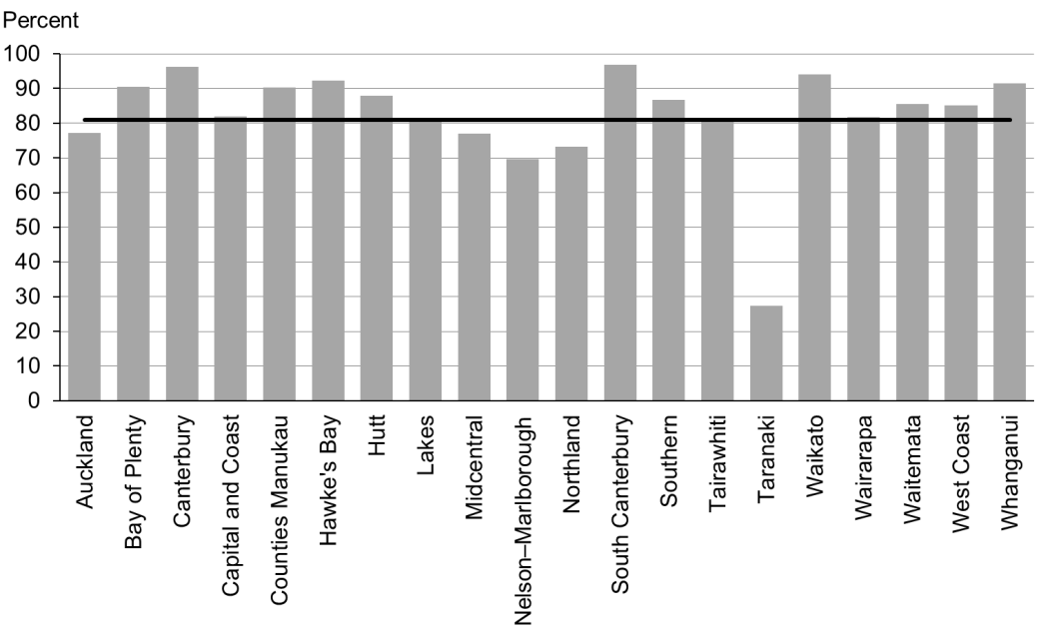

Figure 63: B4 School Checks started before age 4½ years, high deprivation

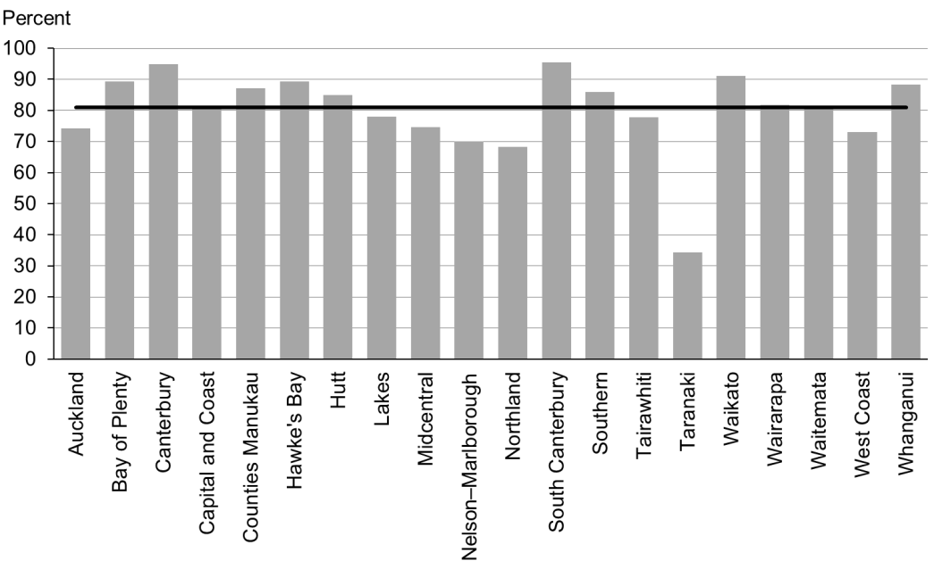

Figure 64: B4 School Checks started before age 4½ years, Māori

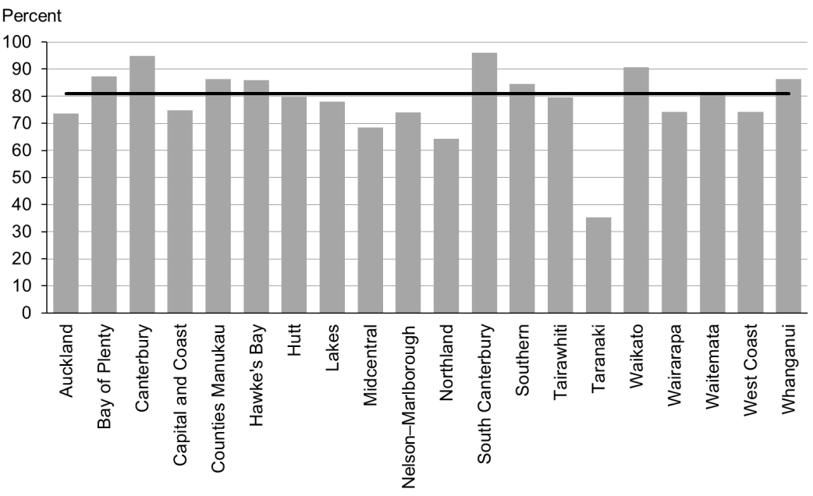

Figure 65: B4 School Checks started before age 4½ years, Pacific peoples

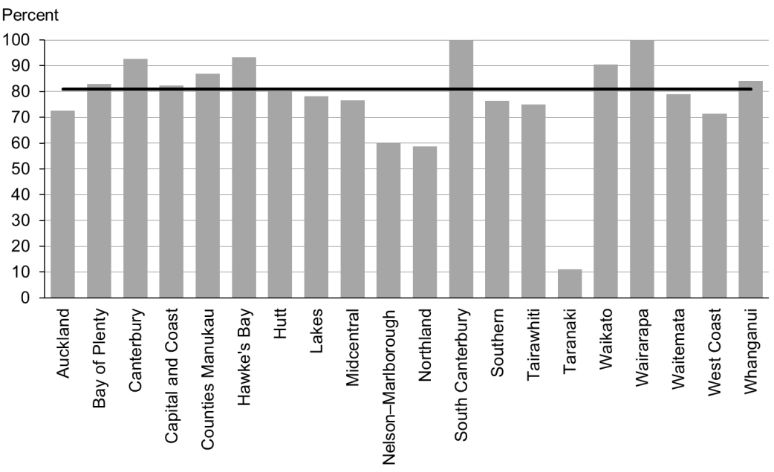

### Data notes

* Time period: children receiving a B4 School Check between 1 July and 31 December 2014.
* DHB is DHB of service.
* Numerator: number of children receiving a B4 School Check who started the check at younger than 4½ years (source: B4 School Check).
* Denominator: number of children receiving a B4 School Check (source: B4 School Check).

## WCTO Quality Improvement Framework Indicator 22

|  |  |
| --- | --- |
| **Standard:** | WCTO providers deliver services in accordance with best practice (inappropriate variation is reduced). |
| **Indicator:** | Children with an abnormal SDQ-P at the B4 School Check are referred to specialist services. |
| **Target by December 2014:** | 86 percent |
| **Target by June 2016:** | 95 percent |

|  |  |  |  |  |
| --- | --- | --- | --- | --- |
|  | **Total New Zealand** | **High deprivation** | **Māori** | **Pacific peoples** |
| March 2015 mean – including advice given | 100% | 100% | 100% | 100% |
| March 2015 mean (range) – excluding advice given | 47% (0–100) | 50% (0–100) | 48% (0–100) | 45% (0–100) |

Figure 66: Abnormal SDQ-P referred, total New Zealand

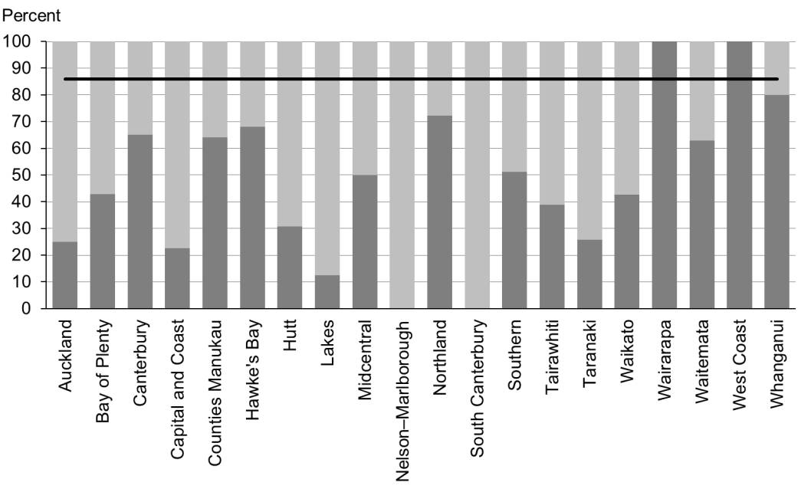

Figure 67: Abnormal SDQ-P referred, high deprivation

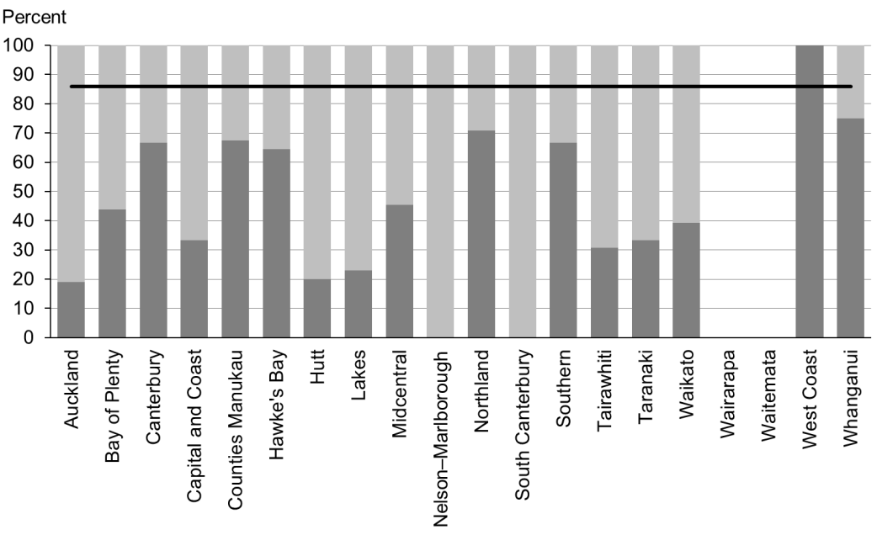

Figure 68: Abnormal SDQ-P referred, Māori

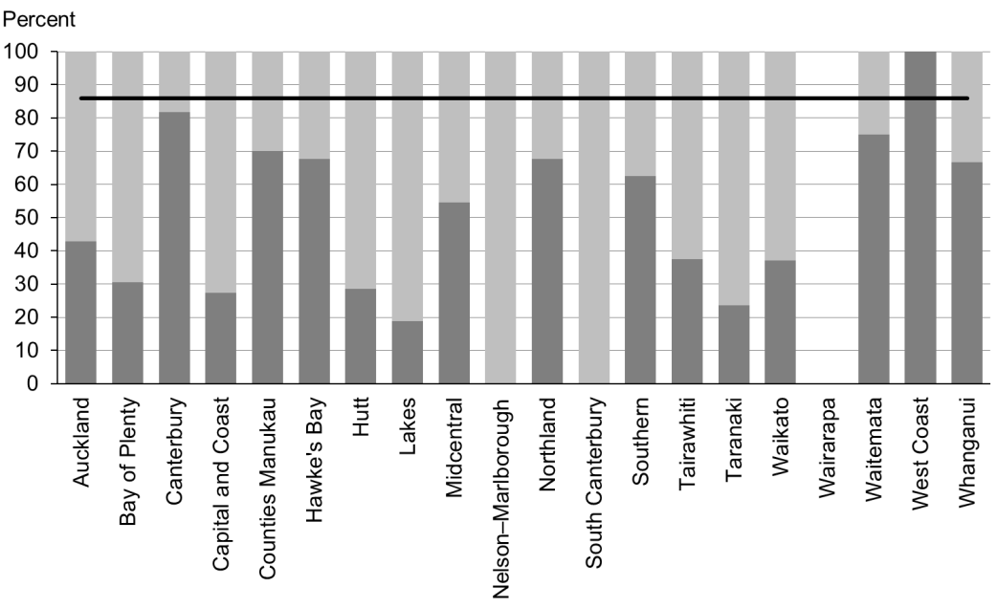

Figure 69: Abnormal SDQ-P referred, Pacific peoples

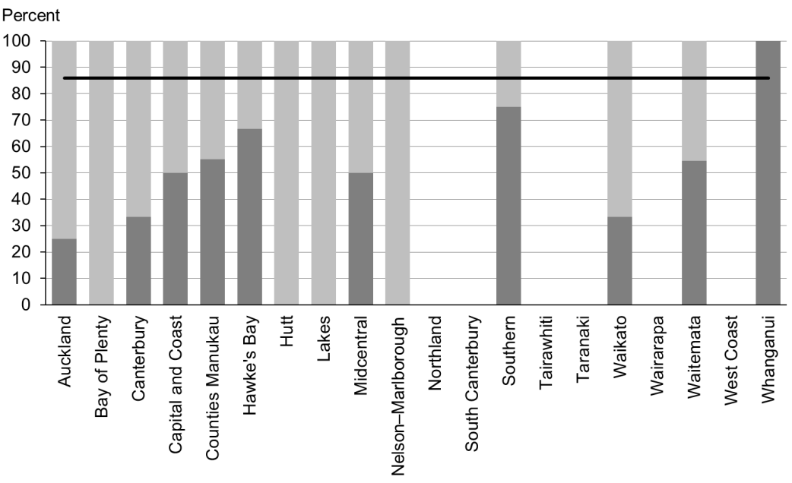

### Data notes

* The stacked bar shows rate of referral excluding ‘advice given’ (dark grey section) and rate of referral including ‘advice given’ (dark grey plus light grey sections).
* No bar on graph = no children with abnormal SDQ-P for that population.
* Time period: children receiving a B4 School Check between 1 July and 31 December 2014.
* DHB is DHB of service.
* Numerator: number of children with an abnormal SDQ-P referred (source: B4 School Check).
* Denominator: number of children with an abnormal SDQ-P (excluding those already under care) (source: B4 School Check).

## WCTO Quality Improvement Framework Indicator 23

|  |  |
| --- | --- |
| **Standard:** | WCTO providers deliver services in accordance with best practice (inappropriate variation is reduced). |
| **Indicator:** | Children with a Parental Evaluation of Developmental Status (PEDS) Pathway A at the B4 School Check are referred to specialist services. |
| **Target by December 2014:** | 86 percent |
| **Target by June 2016:** | 95 percent |

|  |  |  |  |  |
| --- | --- | --- | --- | --- |
|  | **Total New Zealand** | **High deprivation** | **Māori** | **Pacific peoples** |
| March 2015 mean (range) – including advice given | 97% (50–100) | 99% (93–100) | 98% (0–100) | 99% (75–100) |
| March 2015 mean (range) – excluding advice given | 55% (22–90) | 66% (0–100) | 61% (0–88) | 68% (14–100) |

Figure 70: PEDS Pathway A referred, total New Zealand

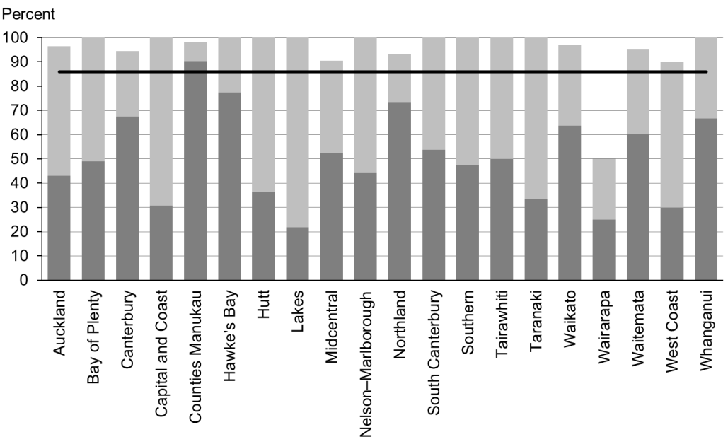

Figure 71: PEDS Pathway A referred, high deprivation

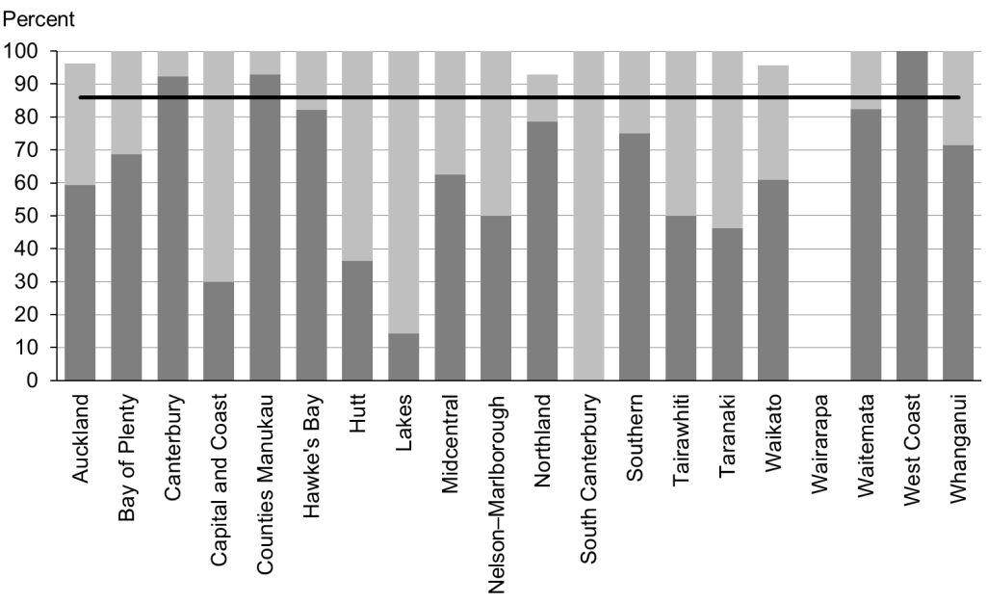

Figure 72: PEDS Pathway A referred, Māori

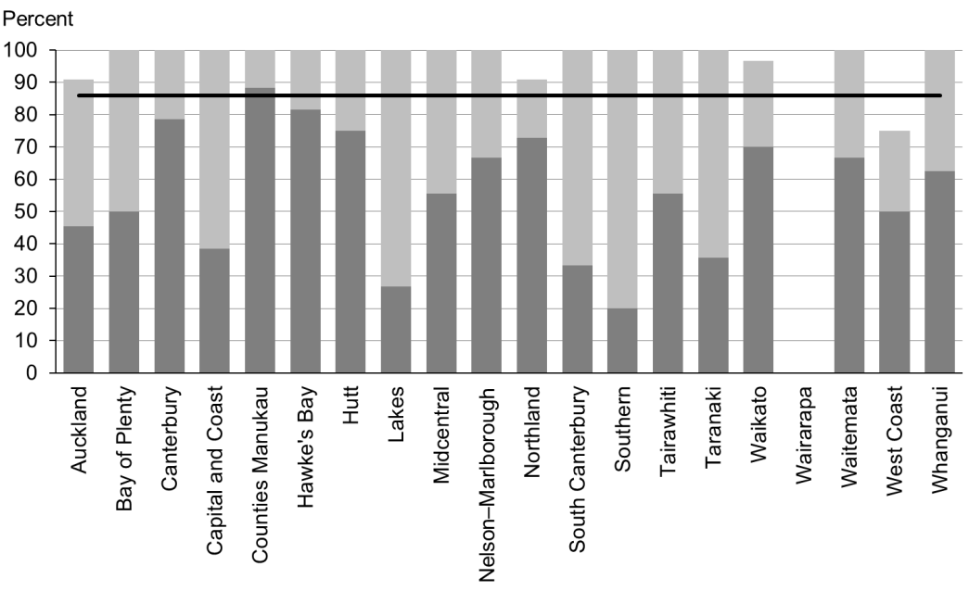

Figure 73: PEDS Pathway A referred, Pacific peoples

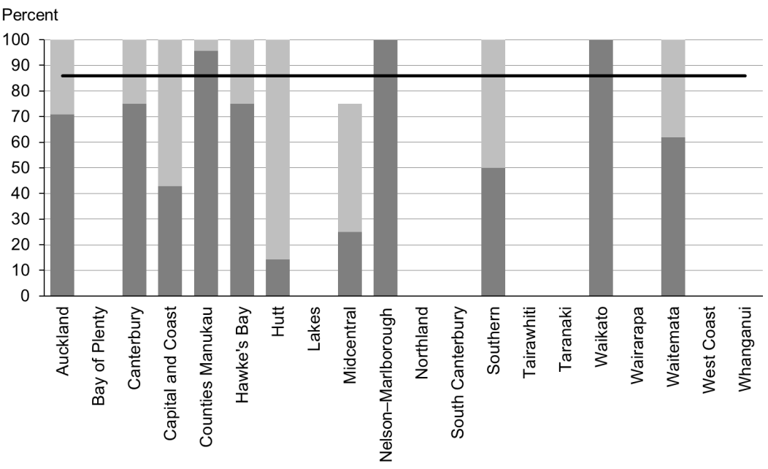

### Data notes

* The stacked bar shows rate of referral excluding ‘advice given’ (dark grey section) and rate of referral including ‘advice given’ (dark grey plus light grey sections).
* No bar on graph = no children with PEDS Pathway A for that population.
* Time period: children receiving a B4 School Check between 1 July and 31 December 2014.
* DHB is DHB of service.
* Numerator: number of children assessed as PEDS Pathway A referred (source: B4 School Check).
* Denominator: number of children assessed as PEDS Pathway A (excluding those already under care) (source: B4 School Check).

## WCTO Quality Improvement Framework Indicator 24

|  |  |
| --- | --- |
| **Standard:** | WCTO providers deliver services in accordance with best practice (inappropriate variation is reduced). |
| **Indicator:** | Children with a Lift the Lip (LTL) score of 2–6 at the B4 School Check are referred to specialist services. |
| **Target by December 2014:** | 86 percent |
| **Target by June 2016:** | 95 percent |

|  |  |  |  |  |
| --- | --- | --- | --- | --- |
|  | **Total New Zealand** | **High deprivation** | **Māori** | **Pacific peoples** |
| March 2015 mean (range) –including advice given | 99% (89–100) | 99% (90–100) | 97% (89–100) | 99% (99–100) |
| March 2015 mean (range) –excluding advice given | 99% (89–100) | 99% (95–100) | 99% (89–100) | 99% (99–100) |

Figure 74: Children with LTL score > 1 referred, total New Zealand

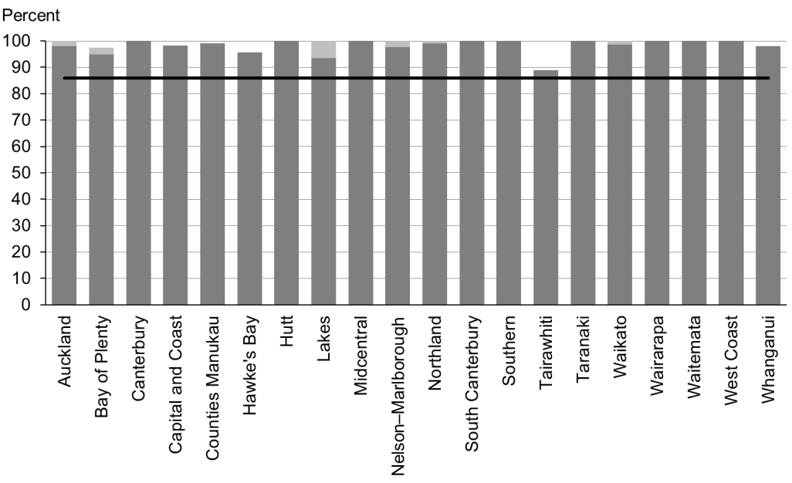

Figure 75: Children with LTL score > 1 referred, high deprivation

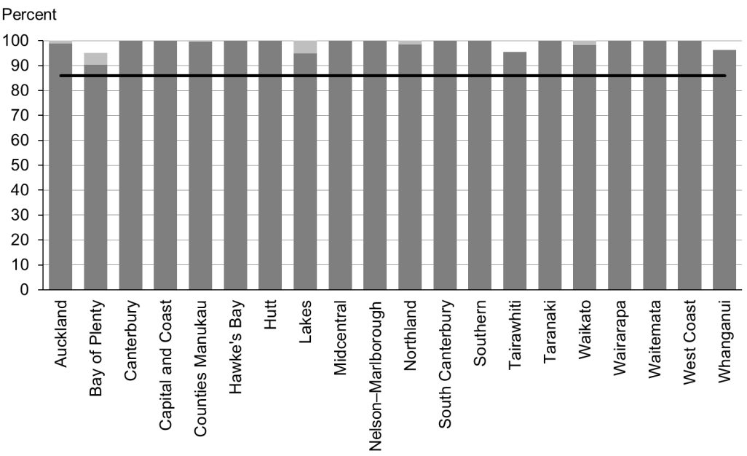

Figure 76: Children with LTL score > 1 referred, Māori

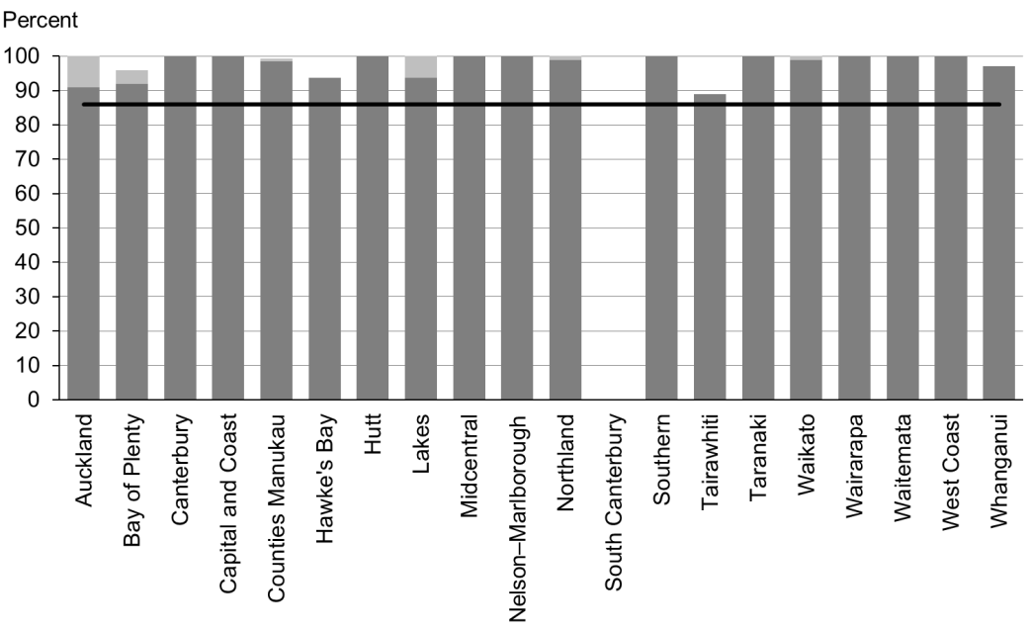

Figure 77: Children with LTL score > 1 referred, Pacific peoples

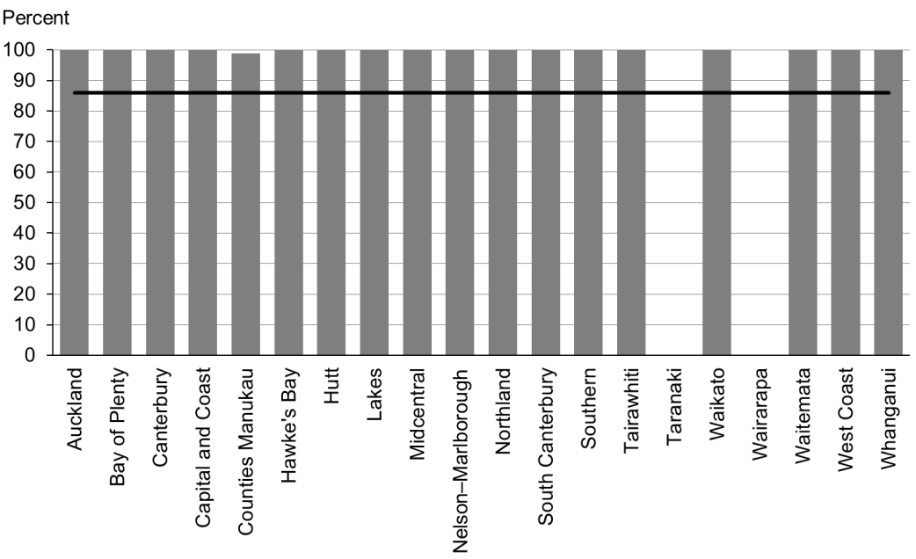

### Data notes

* The stacked bar shows rate of referral excluding ‘advice given’ (dark grey section) and rate of referral including ‘advice given’ (dark grey plus light grey sections).
* No bar on graph = no children with LTL score 2–6 for that population.
* Time period: children receiving a B4 School Check between 1 July and 31 December 2014.
* DHB is DHB of service.
* Numerator: number of children with LTL score of 2–6 referred (B4 School Check).
* Denominator: number of children with LTL score of 2–6 (excluding those already under care) (B4 School Check).

## WCTO Quality Improvement Framework Indicator 25

|  |  |
| --- | --- |
| **Standard:** | WCTO providers deliver services in accordance with best practice (inappropriate variation is reduced). |
| **Indicator:** | Children with an untreated vision problem at the B4 School Check are referred to specialist services. |
| **Target by December 2014:** | 86 percent |
| **Target by June 2016:** | 95 percent |

|  |  |  |  |  |
| --- | --- | --- | --- | --- |
|  | **Total New Zealand** | **High deprivation** | **Māori** | **Pacific peoples** |
| March 2015 mean – excluding advice given | 100% | 100% | 100% | 100% |

Figure 78: Vision problem referred, total New Zealand

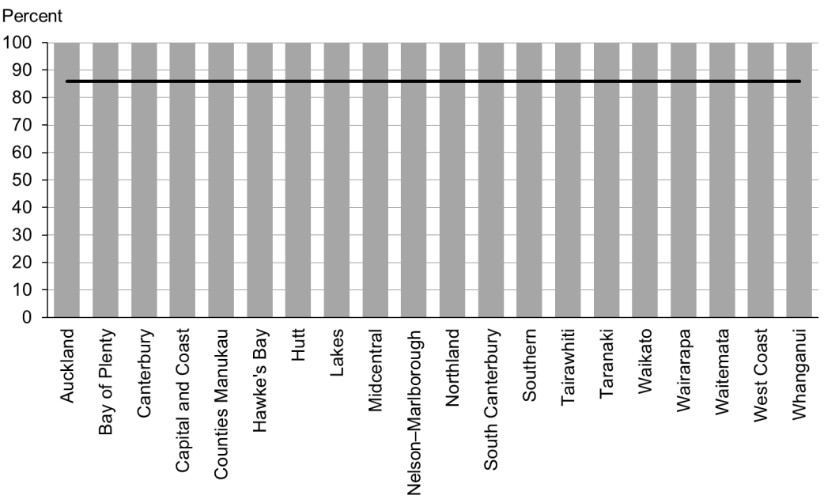

Figure 79: Vision problem referred, high deprivation

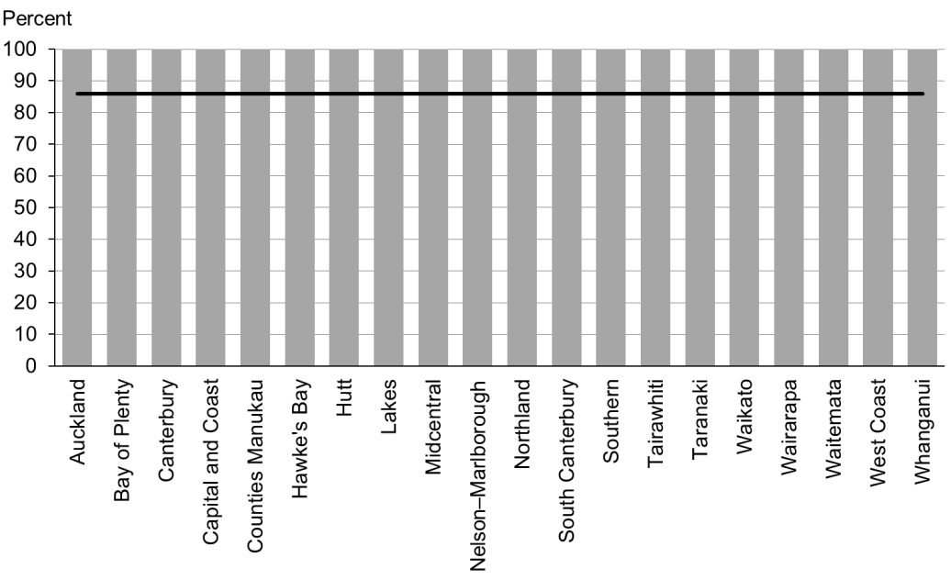

Figure 80: Vision problem referred, Māori

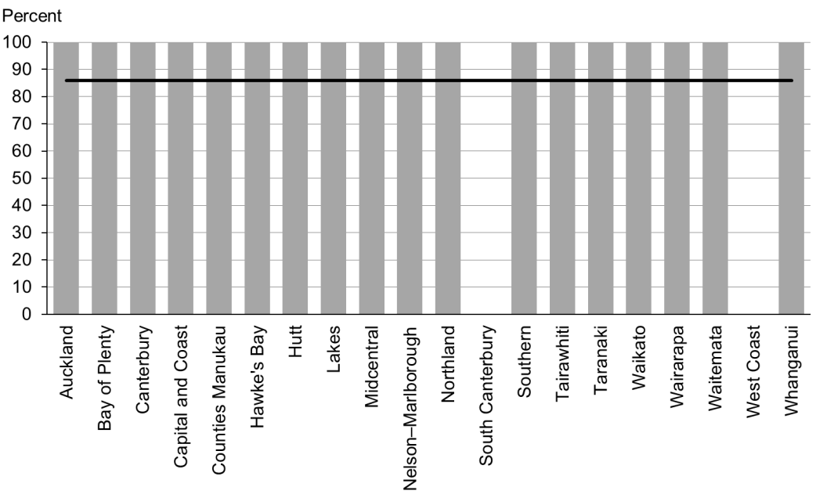

Figure 81: Vision problem referred, Pacific peoples

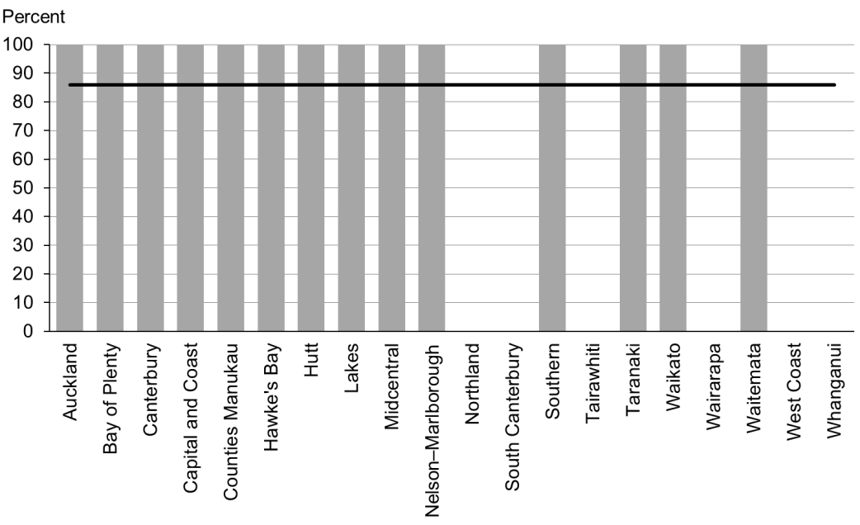

### Data notes

* No bar on graph = no children with vision problem for that population.
* Time period: children receiving a B4 School Check between 1 July and 31 December 2014.
* DHB is DHB of service.
* Numerator: number of children with a vision problem referred (excluding advice given) (source: B4 School Check).
* Denominator: number of children with a vision problem (excluding those already under care) (source: B4 School Check).

## WCTO Quality Improvement Framework Indicator 26

|  |  |
| --- | --- |
| **Standard:** | WCTO providers deliver services in accordance with best practice (inappropriate variation is reduced). |
| **Indicator:** | Children with an untreated hearing problem at the B4 School Check are referred to specialist services. |
| **Target by December 2014:** | 86 percent |
| **Target by June 2016:** | 95 percent |

|  |  |  |  |  |
| --- | --- | --- | --- | --- |
|  | **Total New Zealand** | **High deprivation** | **Māori** | **Pacific peoples** |
| March 2015 mean – excluding advice given | 100% | 100% | 99% | 100% |

Figure 82: Hearing problem referred, total New Zealand

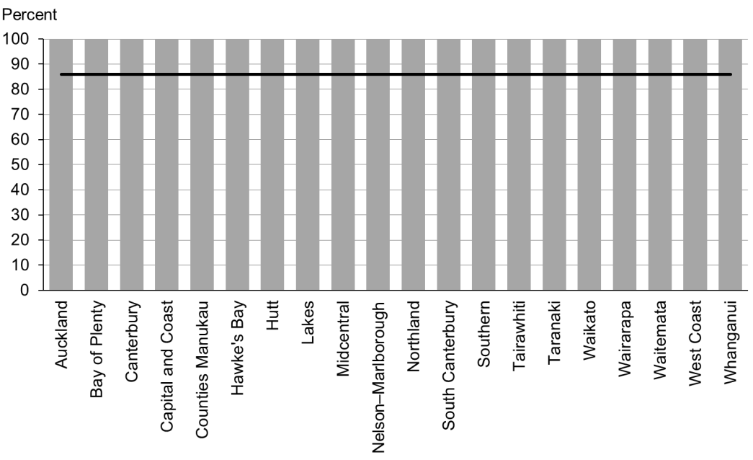

Figure 83: Hearing problem referred, high deprivation

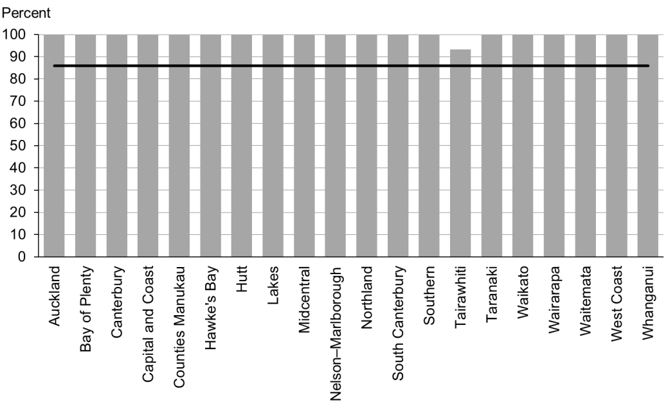

Figure 84: Hearing problem referred, Māori

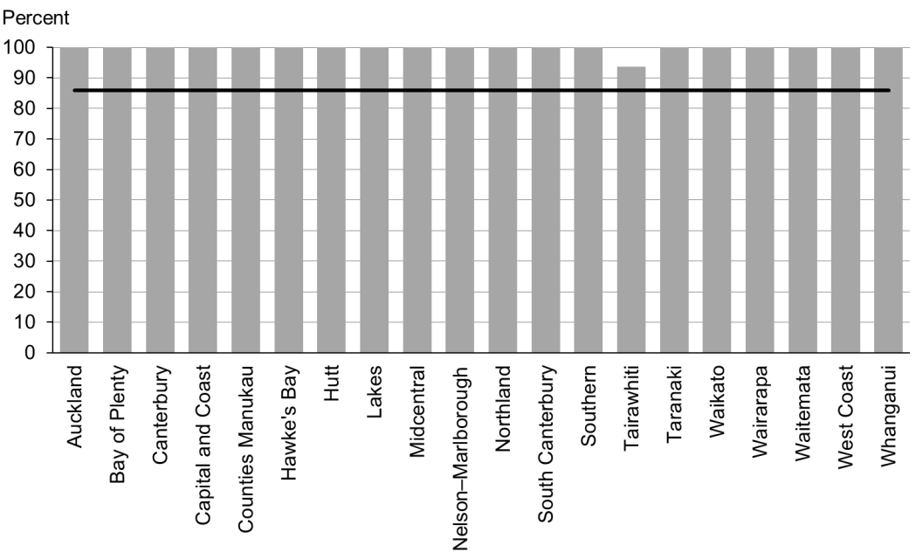

Figure 85: Hearing problem referred, Pacific peoples

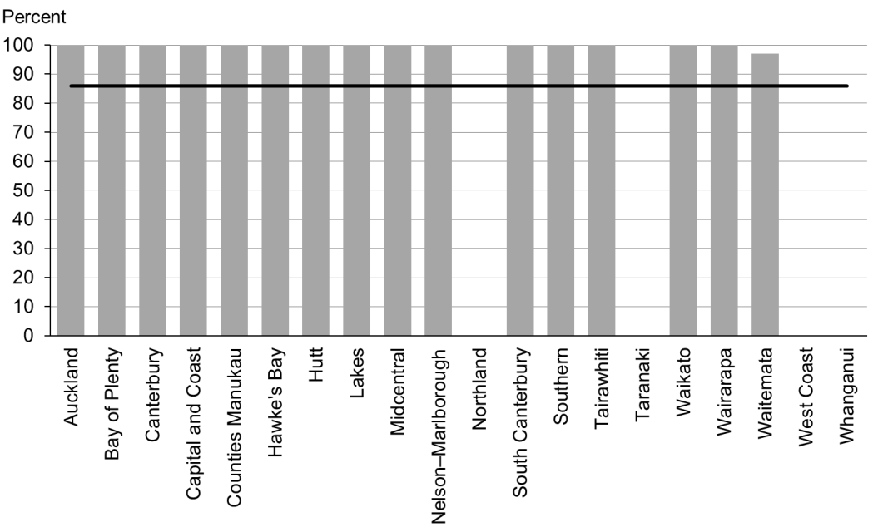

### Data notes

* No bar on graph = no children with hearing problem for that population.
* Time period: children receiving a B4 School Check between 1 July and 31 December 2014.
* DHB is DHB of service.
* Numerator: number of children with a hearing problem referred (excluding advice given) (B4 School Check).
* Denominator: number of children with a hearing problem (excluding those already under care) (B4 School Check).

## WCTO Quality Improvement Framework Indicator 27

|  |  |
| --- | --- |
| **Standard:** | WCTO providers deliver services in accordance with best practice (inappropriate variation is reduced). |
| **Indicator:** | Children with a BMI greater than the 99.4th percentile at the B4 School Check are referred to a general practitioner or specialist services. |
| **Target by December 2014:** | 86 percent |
| **Target by June 2016:** | 95 percent |

|  |  |  |  |  |
| --- | --- | --- | --- | --- |
|  | **Total New Zealand** | **High deprivation** | **Māori** | **Pacific peoples** |
| March 2015 mean – including advice given | 100% | 100% | 100% | 100% |
| March 2015 mean (range) – excluding advice given | 86% (0–100) | 86% (0–100) | 75% (0–100) | 99% (83–100) |

Figure 86: Children with BMI > 99.4th percentile referred, total New Zealand

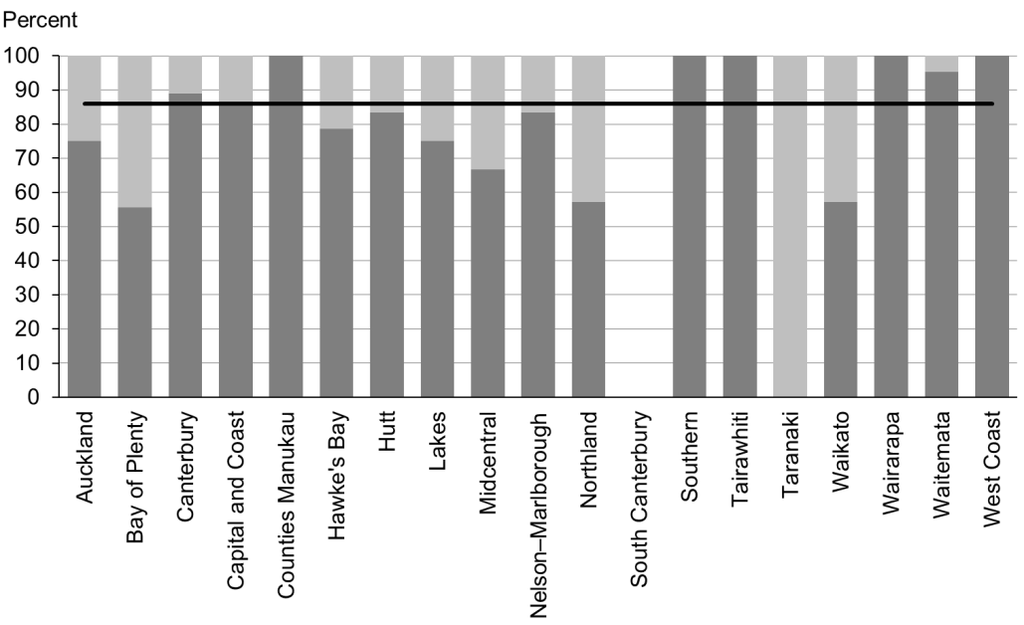

Figure 87: Children with BMI > 99.4th percentile referred, high deprivation

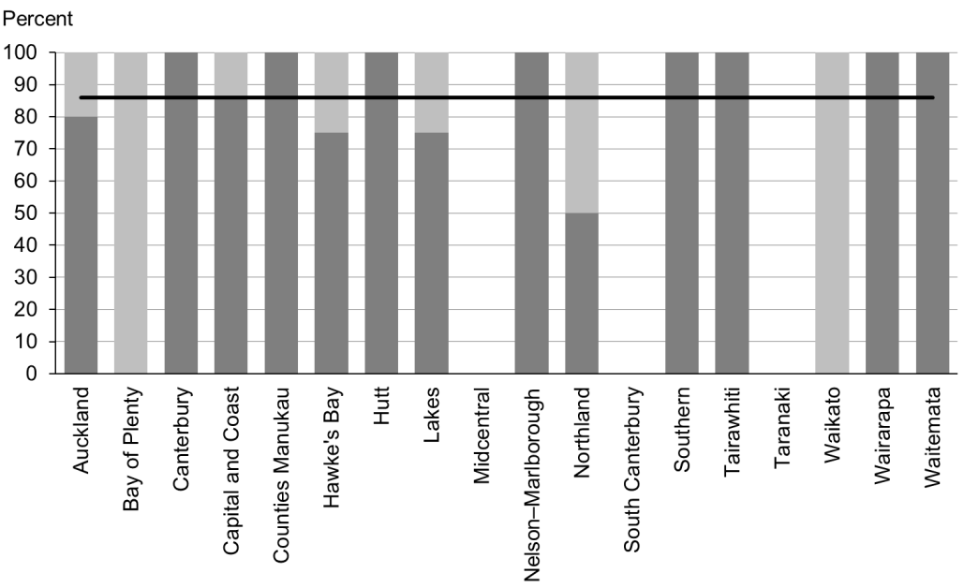

Figure 88: Children with BMI > 99.4th percentile referred, Māori

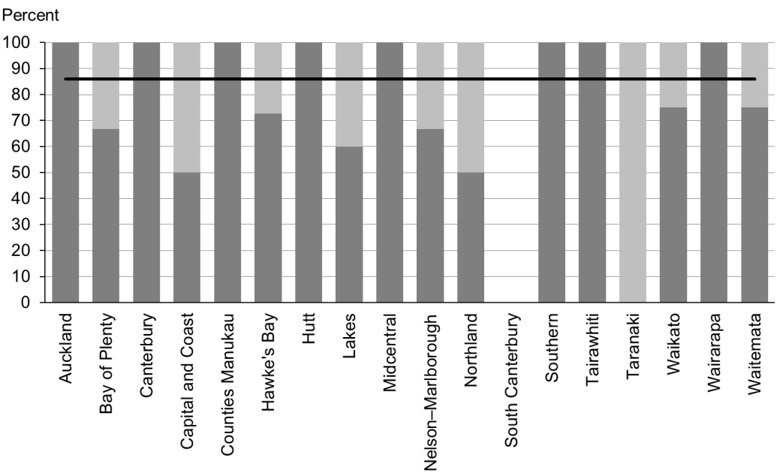

Figure 89: Children with BMI > 99.4th percentile referred, Pacific peoples

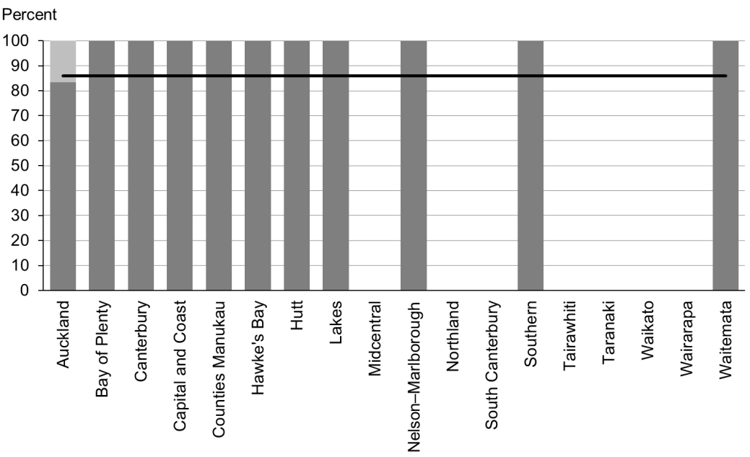

### Data notes

* The stacked bar shows rate of referral excluding ‘advice given’ (dark grey section) and rate of referral including ‘advice given’ (dark grey plus light grey sections).
* No bar on graph = no children with BMI > 99.4th percentile for that population.
* Time period: children receiving a B4 School Check between 1 July and 31 December 2014.
* DHB is DHB of service.
* Numerator: number of children with a BMI greater than the 99.4th percentile referred (source: B4 School Check).
* Denominator: number of children with a BMI greater than the 99.4th percentile (excluding those already under care) (source: B4 School Check).

# Appendix 1: Summary of the WCTO quality indicators

|  |  |  |  |  |
| --- | --- | --- | --- | --- |
|  |  | **Indicator** | **December 2014 target** | **June 2016 target** |
| Access | 1 | Newborns are enrolled with a general practice by two weeks of age* | 88% | 98% |
| 2 | Families and whānau are referred from their LMC to a WCTO provider | 88% | 98% |
| 3 | Infants receive all WCTO core contacts due in their first year** | 86% | 95% |
| 4 | Four-year-olds receive a B4 School Check | 90% | 90% |
| 5 | Children are enrolled with child oral health services | 86% | 95% |
| 6 | Immunisations are up to date by eight months | 95% | 95% |
| 7 | Children participate in early childhood education | 98% | 98% |
| 8 | Children under six years have access to free primary care | 98% | 100% |
| 9 | Children under six years have access to free after-hours primary care | 98% | 100% |
| 10 | Children are seen promptly following referral to specialist services | 100% in 5 months | 100% in 4 months |
| Outcomes | 11 | Infants are exclusively or fully breastfed at two weeks | 72% | 80% |
| 12 | Infants are exclusively or fully breastfed at six weeks (discharge from LMC) | 68% | 75% |
| 13 | Infants are exclusively or fully breastfed at three months of age | 54% | 60% |
| 14 | Infants are receiving breast milk at six months (exclusively, fully or partially breastfed) | 59% | 65% |
| 15 | Children are a healthy weight at four years | 68% | 75% |
| 16 | Children are caries free at five years | 65% | 65% |
| 17 | The burden of dental decay among children with one or more decayed, missing and filled teeth (dmft) is minimised | 4.4 dmft | 4 dmft |
| 18 | Child mental health is supported (children’s SDQ-P scores are within the normal range at the B4 School Check) | 86% | 95% |
| 19 | Mothers are smokefree at two weeks postnatal | 86% | 95% |
| 20 | Children live in smokefree homes (age four years) | 90% | 100% |
| Quality | 21 | B4 School Checks are started before children are 4½ years | 81% | 90% |
| 22 | Children with an abnormal SDQ-P score at the B4 School Check are referred to specialist services | 86% | 95% |
| 23 | Children with a PEDS Pathway A at the B4 School Check are referred to specialist services | 86% | 95% |
| 24 | Children with an LTL score of 2–6 at the B4 School Check are referred to specialist services | 86% | 95% |
| 25 | Children with an untreated vision problem at the B4 School Check are referred to specialist services | 86% | 95% |
| 26 | Children with an untreated hearing problem at the B4 School Check are referred to specialist services | 86% | 95% |
| 27 | Children with a BMI greater than the 99.4th percentile at the B4 School Check are referred to a general practitioner or specialist services | 86% | 95% |

Notes

* Data to monitor this indicator is not yet available. PHO enrolment at three months will be used as a de facto indicator in the interim.

** Data for all WCTO providers is not yet available, and so data from Plunket has been used in the interim for quality indicators 3, 11 and 12.

# Appendix 2: Membership of the WCTO Quality Improvement Framework Expert Advisory Group

|  |  |  |
| --- | --- | --- |
| **Name** | **Role(s)** | **Representing** |
| Helen Connors | WCTO Nurse and Clinical Advisor – Plunket | Royal New Zealand Plunket Society |
| Dave Graham | Paediatrician – Waikato DHB, Chair of Midland Child Health Action Group and Member of the Paediatric Society of New Zealand | Paediatric Society of New Zealand |
| Christine Griffiths | Lead Maternity Carer, Lecturer Otago Polytechnic and Expert Advisor to the New Zealand College of Midwives | New Zealand College of Midwives |
| Victoria Bryant | Charge Nurse Manager, Otago Public Health Nursing, Well Child Health | College of Primary Care Nurses, New Zealand Nurses Organisation |
| Tui Makoare-Iefata | WCTO Nurse/Team Leader – Ngati Whatua o Orakei and Tamariki Ora provider national representative | Tamariki Ora providers |
| Gail Tihore | Vision and Hearing Technician – Hutt Valley DHB | VHT Society |
| Pat Tuohy | Paediatrician – Hutt Valley DHB and Chief Advisor Child and Youth Health | Ministry of Health |
| Nikki Turner | General Practitioner, Associate Professor Auckland University and Director of CONECTUS and the Immunisation Advisory Centre | New Zealand College of General Practitioners |
| Russell Wills | Paediatrician – Hawke’s Bay DHB and Children’s Commissioner | Office of the Children’s Commissioner |
| Mollie Wilson | WCTO Nurse and CEO of the Paediatric Society of New Zealand | Paediatric Society of New Zealand |

Note: Membership as at March 2015. The Ministry would like to thank previous members of the EAG for their work.

1. Indicator 1 was designed to measure enrolment with a general practice by two weeks of age. This data was not available at the time of writing, and so enrolment with a PHO by three months of age has been used as an interim measure.
2. The SDQ is used to assess a child’s social and emotional development. There are two versions of the questionnaire: one for parents (SDQ-P) and the other for teachers (SDQ-T).