Primary Care for Pacific People: A Pacific and Health Systems approach
Report to the Health Research Council and the Ministry of Health

Margaret Southwick, Timothy Kenealy, Debbie Ryan
June 2012

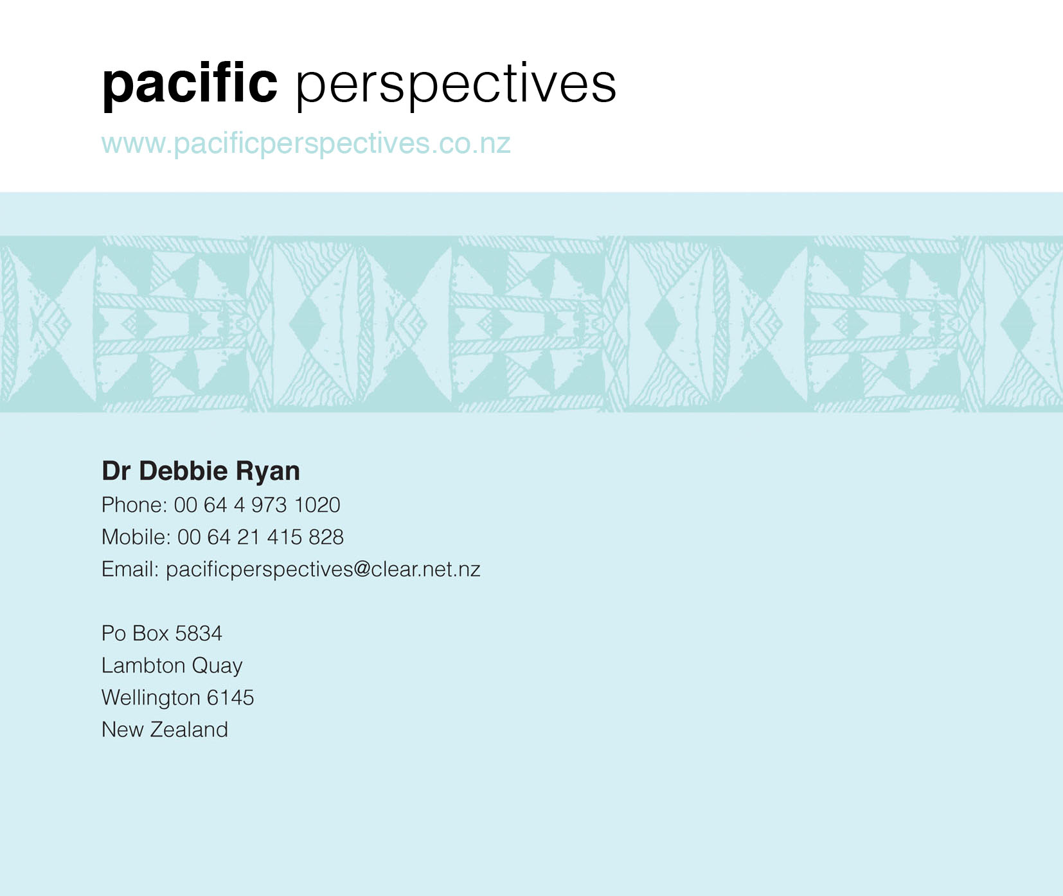


Acknowledgements
This report was prepared by:
Dr Margaret Southwick QSM  Director Pacific Health Research Centre  Dean of Health Faculty  Whitireia Community Polytechnic  Chair New Zealand Nursing Council | Dr Timothy Kenealy  Associate Professor of Integrated Care  University of Auckland
Dr Debbie Ryan
Principal
Pacific Perspectives

We would like to acknowledge the contribution of the Project Advisory Group and the Pacific Expert Advisory Group. Thanks to Tara Ross and Gerardine Cliffford-Lidstone for their editing and formatting skills and Lita Foliaki and Gerardine Clifford-Lidstone for their contribution to explaining the Talatalaga a Aiga methodology and Talanoa process.
Thanks also to Chris Lewis from the Ministry of Health and Rosie Whittington at Counties Manukau DHB for advice on interpreting data from their respective organisations.
As always, the primary authors are responsible for any omissions or errors of interpretation.

Advisory group members
Professor Ross Lawrenson (Chair), Head of Waikato Clinical School, Auckland University
Dr Wing Cheuk Chan, Public Health Physician, Counties Manukau District Health Board
Hilda Fa’asalele, General Manager Pacific Health, Auckland District Health Board
Ron Hooten, CEO, ProCare
Cathy O’Malley, CEO, Compass Health
Dr Jim Primrose, Chief Advisor, Primary Care, Ministry of Health
Dr Nicolette Sheridan, Associate Professor, School of Nursing, University of Auckland
Dr Api Talemaitoga, Chief Advisor, Community Service Improvement, Ministry of Health
Dr Lynley Cook, Population Health Specialist, Pegasus Health

Pacific Expert Group members
Dr Margaret Southwick, Tuvaluan
Fuimaono Karl Pulotu-Endemann, Samoan
Lita Foliaki, Tongan
Jean Mitaera, Cook Islands
Anne Allan-Moetaua, Cook Islands

Secretariat for Advisory and Pacific Expert Groups
Dr Debbie Ryan, Pacific Perspectives
Brenden Mischewski, Pacific Perspectives

Research associates
Faith Mahony, Auckland University
Contents

Executive Summary 8
Introduction 8
Pacific View 8
Methods 8
Results 8
Health Services View 9
Interview Methods 9
Interview Results 10
Quantitative Methods 13
Quantitative Results 13
Summary 14
Recommendations 14
Background 19
Literature Review 20
Domain One Findings 20
Domain Two Findings 22
Pacific View 24
Methods 24
Cultural Methodologies and Frameworks 24
Maintaining Cultural Integrity 24
Christchurch Focus groups 28-29 October – the trial 26
Focus Group Meeting Venues and Catering 27
Research assistants’ role in recruitment and meeting facilitation 28
Overarching cultural methodology 30
Talatalaga a Aiga using Talanoa 30
The Call to Talanoa in the Extended Family Context 31
Translating the call to Talanoa 31
Talatala 32
Talatala using Talanoa in the Extended Family Context 33
A Tongan Perspective 33
Talatala in action 34
Toelalaga 34
Toelalaga in action 35
Uluulumatafolau 35
Fa‘aleleiga 36
Fakahounga – Showing Appreciation 36
Pau’u/Paupau’u – Playfulness 36
Ethnic specific differences 37
Transcription and Translation 37
What does “health” look like for you? 38
Issues in seeking help 46
Health Services View 52
Interviews 52
Methods 52
Analysis 53
Results 53
Appointments in primary care 54
Initial greeting 57
The waiting room as a Pacific meeting place 58
Transport 59
Getting people back 59
Health Literacy, language and interpreters 66
Data collection and performance management 71
The cost of primary care 73
Access / availability (providers and service) 78
Workforce Capacity (numbers) 79
Workforce capability (training, professional development) 81
Access /accessibility 82
Effective services 82
Community responsiveness 85
The business and policy environment, the model of health care delivery 85
Health services within a wider social context 86
Quantitative data 87
Methods 87
Factors behind upward trends in data 89
Describing people in the master ethnicity file 90
Results 92
PHO data 92
Outpatient data 95
Emergency Department 101
Laboratory data 101
Pharmaceutical data 103
Emergency Department data 106
General Medical Services data 108
Counties Manukau Chronic Care Management Programme (CCM) 113
Chronic Obstructive Pulmonary Disease (COPD) 113
Congestive Heart Failure (CHF) 114
Depression 115
Cardiovascular disease 115
Diabetes 115
Primary Care data 116
Summary 119
References 120
Appendix 1: Ethics approvals 122
Appendix 2. Pacific View: Consumer focus group organisation and participants 126
Appendix 3. Research assistants involved in community focus groups 127
Appendix 4. Pacific View: Pacific interview protocol training sheet for research assistants 128
Appendix 5. Pacific View: Pacific interview information sheet and consent form for participants, with translations 130
Appendix 6. Health Services View: People interviewed 144
Appendix 7. Health Services View: Interview guides 146
Guide for interviews with Health System Experts - Operational / management / policy / funding and planning 146
Interview guide. Service delivery / front line staff 146
Appendix 8. Schematic of matching with minor variations 149
Appendix 9. ADHB appointment-making process 150
Appendix 10. Ethnicities from Master ever-Pacific file to which all other files were matched. 151

Table of Figures
Figure 1. Schematic diagram of relationships between ‘ever-Pacific’ master file and the national, DBH and PHO data matched to this file 87
Figure 2. PHO Registrations by age group, data from above tables 93
Figure 3. Outpatient visits by financial year. This is what the raw data shows, but the figures are misleading in that much of the increase is due to coding changes and progressive capture of new data 96
Figure 4. Outpatient visits (diabetes and renal) for DHBs 98
Figure 5. Outpatient visits (diabetes and renal) for DHBs 98
Figure 6. Outpatient visits attended (diabetes and renal) for DHBs 99
Figure 7. Outpatient visits DNA (diabetes and renal) for DHBs 99
Figure 8. Outpatient FIRST service type for Renal and Diabetes 100
Figure 9. Outpatient Follow-up service type for Renal and Diabetes 100
Figure 10. Laboratory Claims by year 102
Figure 11. Laboratory claims by ethnicity and year 103
Figure 12. Pharmaceuticals dispensed per year, red line numbers in data, blue line adjusted for percentage NHI present by year 104
Figure 13. Count of patients by year 105
Figure 14. Count of scripts per patient 106
Figure 15. ED attendances by financial year 107
Figure 16. ED visits by ethnicity and financial year 108
Figure 17. GMS visits by year 109
Figure 18. Total GMS visits by ethnicity and year 111
Figure 19. Predicted probability of Flu vaccine given within 1 year of each visit, by year and ethnicity 114
Figure 20. Predicted probability of being on an ACE inhibitor (or ARB) and beta blocker, by year and ethnicity 114
Figure 21. Predicted HbA1c by months completed in diabetes programme, Pacific ethnicity only. 116
Figure 22. Consultation rates for Pacific vs non Pacific 118
Figure 23. Consultation rates for Pacific ethnicities 118

Table of Tables
Table 1 Summary of differences in world views 14
Table 2. Pacific Expert Advisory Group Members 24
Table 3. PEAG Focus Group planning by region and ethnic communities to be recruited 25
Table 4. Summary of Christchurch Focus Groups 30 September – 1 October 2011. 26
Table 5. Research staff involved in Whitireia Polytechnic Community Focus Groups 10 October 2011 29
Table 6. Concepts included in Talatala 32
Table 7. Professional roles and numbers participating in this research project 53
Table 8. Percentage of valid NHI recording on claims for payment for laboratory and pharmaceutical goods and services, by year. 88
Table 9. Pacific population growth, total response count for any Pacific ethnicity. 90
Table 10. Population growth, total response count by specific Pacific ethnicities 90
Table 11. Total response count by Pacific ethnicity, where one person can have more than one ethnicity 91
Table 12. Current ethnicity (main categories, total response count) of the 103,572 individuals with no current Pacific ethnicity 91
Table 13. Current gender 91
Table 14. Current age 92
Table 15. Total Pacific numbers in PHO registers, by age category, at 1 January of each year 92
Table 16. Outpatient Events by financial year 95
Table 17. Number of Outpatient events coded DOM101, by financial year 95
Table 18. Outpatient events by numbers Attended, Did Not Attend and Did not Wait 95
Table 19. Attended, Outpatient events, by financial year and ethnicity 96
Table 20. Table, Did Not Attend, Outpatient events by financial year and ethnicity 96
Table 21. Diabetes and renal Outpatient services (first and follow up) by DHB and financial year. 97
Table 22. Diabetes and renal Outpatient servies by DHB and financial year 97
Table 23. Ethnicity for Counties Manukau Outpatients Renal and Diabetes 100
Table 24. Attend, Did Not Attend (DNA), Did Not Wait (DNW) 101
Table 25. Laboratory Claims by year 101
Table 26. Laboratory claims by ethnicity and year 102
Table 27. Count of scripts dispensed by year, adjusted for low NHI rate on prescriptions in earlier years 104
Table 28. Count of scripts dispensed and count of patients by year 105
Table 29. ED attendances by financial year 106
Table 30. ED visits by ethnicity and financial year 107
Table 31. ED event attendance type by financial year 108
Table 32. Unique patients per year and Total number of visits per year 109
Table 33. Unique patients by ethnicty and year 110
Table 34. Total visits by ethnicity and year 110
Table 35. GMS visits by age-MOH category 111
Table 36. GMS visits by gender 112
Table 37. GMS visits by NZ resident 112
Table 38. Number and percentage of individuals attending COPD programme in each year, by Pacific and non-Pacific ethnicity. 113
Table 39. Number and percentage of individuals attending CHF programme in each year, by Pacific and non-Pacific ethnicity. 114
Table 40. Number and percentage of individuals attending depression programme in each year, by Pacific and non-Pacific ethnicity. 115
Table 41. Number and percentage of individuals attending CVD programme in each year, by Pacific and non-Pacific ethnicity. 115
Table 42. Number and percentage of individuals attending diabetes programme in each year, by Pacific and non-Pacific ethnicity. 115

Executive Summary

Introduction
This report presents evidence to support improvements in primary care delivery to Pacific peoples. It arises from a 2010 Request for Proposal (RFP), Improving Pacific Health Outcomes: Research on the delivery of primary care to Pacific Peoples in New Zealand, which was jointly funded by the Ministry of Health (MoH) and the Health Research Council of New Zealand (HRC).
The joint initiative sought to improve knowledge about the most effective ways to improve both Pacific peoples’ access to and use of primary care and, ultimately, Pacific health outcomes.

Pacific View

Methods
The research team developed cultural methodologies and frameworks appropriate for diverse Pacific communities to involve, engage and capture the views of Pacific peoples. A Pacific Expert Advisory Group (PEAG) oversaw development of the narrative methodology and data collection fono, and considered results against ethnic-specific cultural frameworks to ensure cultural integrity was maintained.
PEAG members recruited research assistants and focus group participants from their ethnic communities around the country. Eighteen research assistants recognised for their roles as effective community networkers were engaged to recruit participants and facilitate meetings in Pacific ethnic languages. There were 36 focus groups in total, held in Auckland, Hamilton, Wellington and Christchurch between 30 September and 10 October 2011. Eight groups were held in English; the remaining 28 were held in Samoan, Tongan, Cook Islands Maori, Niuean, Tuvaluan, Kiribati or Tokelauan.
The research project was guided by the Talatalaga a Aiga methodology and talanoa, which underpinned information gathering. Both methodologies are embedded in on-going relationships or va (sacred space) between communities, families and individuals. The invitation to talanoa and acceptance by participants was part of on-going reciprocal interactions between senior members of the Pacific health sector and communities. As part of this on-going reciprocity, researchers provided food and a small financial contribution to show appreciation, and promised to return and share their research results.

Results
- Participants’ views of ‘health’ traversed a continuum from being taken-for-granted by young adolescent men to being understood as wellness and living a ‘balanced life’. In many cases, it was understood as being underpinned by spirituality or family relationships. They talked at length about healthy diet, the need for exercise, rest and sleep, and the recognition that good hygiene and good housing was important aspects of maintaining healthy lifestyles. Underpinning this was a strong narrative of poverty and limited resources. Discussion illustrated strongly that it was not a lack of knowledge that led to unhealthy lifestyles, but a lack of economic resources and, thus, ability to make better choices.
- A strong theme was the connection made between high levels of stress, particularly among mothers, and poor health. Participants spoke of stress in relation to complex family dynamics (for example, the balancing of obligations to immediate and extended family through the practice of fa’alavelave), not being able to provide for their families, and the effects of having to manage very difficult life circumstances. Participants managed stress through family and cultural practices, spirituality, faith in God, alcohol, kava and eating. The concept of spirituality was a significant aspect of the understanding shared among many of the groups’ that health is more than a physical thing.
- Barriers to seeking help included transport problems, the cost of healthcare, and a degree of frustration and disappointment at the gap between participants’ expectations and actual experience of health services. Many participants described difficulties making appointments to see their GP, especially the same GP. Participants also spoke of their anxiety and lack of confidence in communicating with doctors, especially among older Pacific patients. Language barriers and a lack of interpreter resources was partly the problem – some people, for example, prioritised the language ability of a doctor over a health service’s more convenient location. Communication problems were also partly attributed to health workers’ culturally insensitive and, often, racist behaviour.
- Significantly, Pacific people judged the quality of their health care by their sense of whether or not the va was being respected. Consultations are more than just a commercial transaction in which doctors provide a service and patients pay; when the relationship between patient and health professional respects the va, then, to the Pacific person, there is a completely different quality to the relationship.

Health Services View
There appear to be many innovative and effective services already being provided for Pacific people. They are not ‘built into’ the health system and therefore depend on the energy and goodwill of individuals. As such they may not be sustainable, and they are not sufficiently widespread.
We were impressed with what Pacific people contribute from their roles within the health services, both within Pacific provider organisations and mainstream. Pacific people in frontline services offer obvious language and cultural skills. Perhaps less obvious is the role of Pacific people at every level of the system who are able to observe and articulate a combined understanding of both the realities of the health services and the reality of living as a Pacific person.

Interview Methods
We sought the perspectives of both Pacific and mainstream primary care providers located in the Greater Auckland region, Wellington and Christchurch, as well as the perspectives of those involved in policy and/or funding and planning in PHOs, DHBs and the Ministry of Health. The views of Pacific and non-Pacific respondents from a mix of roles were sought and we interviewed fifty people from mainstream and Pacific providers, including 21 who are themselves Pacific. We covered all intended respondent groups apart from Accident and Medical clinics. All interviews, each lasting 20-30 minutes, were conducted in person and digitally recorded.

Data were imported into NVivo and initially coded as responses to the questions in the interview guides. Coding after that proceeded inductively and in repeated discussions between Mahony, Kenealy and Ryan, best described as qualitative description, a process that remains naturalistic and close to the data, and that tends to use terms and concepts from within the data that would be readily recognised by the interviewees. Data from frontline operational management and at policy levels were analysed separately as their roles and expertise covered broadly different areas; commonalities and differences are noted in reporting.

Interview Results
The results for this section of the research project focussed on the following themes:
- Frontline staff concerns and expertise centred on practical issues of appointment systems, contacting people and payments.
- Staff think their clinical care is better if appointments are scheduled, though accept that people have genuine difficulty keeping appointments. Fifteen-minute appointment slots can be an unsatisfactory way to arrange a meeting between practice staff and Pacific people, perhaps more so than for other patient groups.
- There is no one system that suits everyone, but staff suggested a number of strategies they had used to successfully balance the needs of appointment and walk-in patients, such as having one doctor see only walk-ins and another see only appointments, having an appointment system with a good number of walk in slots, having the doctor see the patient briefly before handing over to a nurse, and ringing patients who have not yet arrived to see if they will make an appointment time.
- Some clinics open extended hours to cater for families where both parents are working and cannot attend during weekdays, and for people who travel a long distance to see their preferred practice. Such clinics are typically busy. Having multiple services available on one site can make specialist services more accessible to people. Clinics suggested a number of strategies that work for transport, such as using St John’s shuttle or a community health worker to collect patients.
- The initial greeting is important for setting the tone of the relationship and trust with patients. Similarly, the waiting room can be an important Pacific meeting place if it is culturally welcoming.
- Practices were concerned about the number of Pacific people who did not come for regular care or follow up when needed, and used a variety of recall processes in an attempt to address this, mostly led by practice nurses, chronic care nurses or clerical people (recall assistants), and sometimes by doctors. Although phone calls are probably the most effective, even a Pacific health worker may have to ring several times before patients will engage in conversation. Texting is commonly used as an alternative or preliminary to phone calls, partly because young people in particular may not answer a call from someone whose number they do not recognise, and the cost of cell phones means people are unlikely to pick up voice mail messages and limit the number of calls they make themselves.
- Preventive care and screening is best done opportunistically when patients visit for another reason. This can be successful at a practice population level with systematic use of a tool such as the ProCare MedTech Dashboard. Practices use a variety of methods to make initial contact, to maintain contact, or to re-establish contact. The best is option is to do as much as possible when people do attend. Much preventive care is now considered a task for nurses, some of whom said the CarePlus written plan did not work well. Some misunderstandings, especially with medicines, can only be sorted face to face, not over the phone.
- Practices identify individuals or families who may be at high medical or social risk. These processes are not systematic and the task is potentially limitless.
- Staff debate amongst themselves about whether they are or should be paternalistic. Doctors may directly contact patients about whom they have some medical or diagnostic concern. Issues of overdue medications, appointment failure, lifestyle issues and self-management are left to nurses or clerical recall assistants. Social problems are common and important. Persistent contact and an unusual degree of practical support may be necessary before sufficient trust is established to allow people to disclose sensitive and relevant information.
- Lack of transport was the most frequently cited reason for failure to attend primary care. Lack of a phone was also mentioned. ‘Health’ is only one of many competing commitments the person or their transport supporter is coping with, and these commitments often need to take precedence. Sometimes not attending points to people choosing not to address a health issue, or reflects what several people referred to as “Pacific time”. One strategy is to double-book appointments for patients with a DNA history. That means when they do attend they may receive a briefer service, which conflicts with statements about maximising opportunistic care. It also risks a hurried appointment, which may discourage people from returning. Explaining in a Pacific language may help.
- DNA rates at outpatient clinics vary markedly. Rates quoted by interviewees ranged from 2% at an endocrinology clinic to 25% at a diabetes clinic. Overall, Pacific people DNA at a higher rate than do non-Pacific people. Many reasons were suggested for outpatient DNAs, including being in an unfamiliar place, not knowing the people, needing support, bad weather, not understanding the purpose of multiple appointments, not understanding the length of time needed to attend the appointment, difficulties finding parks and the cost of parking. Poor communication by health professionals about what will occur and the purpose of the appointment are also a factor – people can be scared and confused before an appointment, and perceive no benefit after. Long delays getting an appointment can exacerbate DNA. Specialist outreach nurses who follow up clinic patients have resulted in marked improvement in understanding, treatment concordance and outcomes. Notably, the need for DHBs to report on Maori DNA increases managerial focus on the situation; perhaps the same is needed for Pacific. Outpatient clinics often have limited hours. Otherwise the only clinics operating into the evening are private clinics run in public facilities.
- Apparent mis-understanding in relation to health issues was interpreted as being due to limited patient understanding of their bodies, the difficulty of communication between English and a Pacific language, people choosing to ignore out of a desire to not change lifestyle or from being afraid, and having priorities higher than health issues. People are prepared to act, such as take their medicines, when they understand the reasons. There is a need for Pacific dieticians, and alternative ways of imparting information, for example as with the Pacific radio station show hosted in Wellington by a clinical pharmacist (although, there appears to be no funding to continue this service).
- Patient level data was collected in a range of clinical audits, but there was no suggestion that this was widespread, systematic or routine. Some, but not many, practices used patient surveys; one had translated the survey into a Pacific language. One DHB service had used translators to present a survey orally; no primary care service mentioned this. Several comments stated Pacific people prefer discussion to written feedback. The commonest complaints at practice level are waiting for appointment times, difficulty getting through on the telephone, and car parking.
- Management and policy people wanted more data and more information. Current PHO performance programme targets include immunisation, access, service usage, diabetes annual reviews, CVD risk, and smoking status. Pacific immunisation rates are seen as a good example of Pacific success; contracts with an ethnic focus and targets can produce results. Targets appropriate for Pacific may be different from those for other ethnic groups, especially for clinical targets and processes such as age of CVD screening. There should be more data sharing between PHOs and DHBs, and data needs to be shared between health and social services to measure effectiveness, as many diseases, like rheumatic fever, have social determinants. Current politics may be out of line with evidence of effective interventions for Pacific, despite some information clearly suggesting that targets focus managerial attention and improve results at least on that target
- Most, but not all, respondents saw cost as an important problem. Managing the issue of costs takes many forms, including undercharging, accepting non-payment or reduced payments, writing off bills, keeping downstream costs low, joining capitation or other schemes that generate higher subsidies, and seeking alternative payers such as ACC, access funding or Care Plus. For many frontline staff, discussions about money are the worst part of the job; clinical staff often simply avoid such conversations. Staff are aware people may choose to pay for other goods and services before paying for health care, and are aware of the obligations on many Pacific people from church tithing. There is a level of genuine understanding that money is an issue for many people. Practices have a range of processes, some escalating in planned steps, some ad hoc, to approach people over unpaid accounts, but are clear they never turn away anyone on the basis on money if they have an urgent medical problem. Their concern is more that people don’t come at all or delay coming for non-urgent problems, especially delaying medication for long-term conditions.
- Physical and financial access is not enough; access has many components and we will not be effective if we address only some of those.
- Senior people interviewed assumed the need for Pacific people in the workforce as a given. Examples were given of the value of being Pacific (and the additional burdens this imposed on the health service workers). All were concerned about current low numbers of Pacific nurses and critically low numbers of Pacific doctors. The problem is most acute in regions with relatively low numbers of Pacific people – all regions except Auckland. Solutions are not obvious, but there are clear suggestions that the current workforce is becoming overloaded and burnt out.
- Changing work roles, especially developing nurse roles to take over some tasks from doctors, is seen as one partial solution in which both DHBs and PHOs are investing. However, there remain many uncertainties about the mechanisms to achieve and sustain such changes, and the effectiveness of such changes. In addition to not having enough nurses, doctors and other health service workers, there is a need to develop the capabilities of those already present. Importantly, this also applies to primary care management staff.
- Transport is seen as a big problem in terms of access. Solutions include appointment flexibility, attitudinal acceptance by service staff, taking care to peoples’ venue such as church or other community centre, and buses provided by the service. Limited hours of opening are a perennial area of conflict between patients wanting longer hours than staff want to or are able to offer. Many patients need flexible appointment times, along with flexible attitudes from staff.

Quantitative Methods
We sought data from primary and secondary care. Although our aim was to describe Pacific peoples’ use of primary care, we considered that use of emergency departments, hospital admissions and outpatient service can be complementary to, and sometimes an alternative to, primary care. We sought data that would describe use looking back 10 years where possible.
The Ministry of Health constructed an anonymous list of people who were ‘ever-Pacific’ in key national databases. Data on people included in the ever-Pacific list were then extracted from the national data collections on PHOs, outpatients and emergency departments, hospital admissions, pharmaceuticals, laboratory tests and General Medical Services. This master list was also used to identify the same ever-Pacific people in data collected from PHOs and practices, and from Counties Manukau DHB.
The national data is analysed only as Pacific data. The DHB and primary care data include non-Pacific people and a limited number of comparisons are made.

Quantitative Results
- There were 596,903 people on the ‘ever-Pacific’ list. Of these, 17.4% are not currently identified as Pacific.
- Data from national data sets was readily available. Interpretation of some newer collections is remains difficult due to coding changes and variation in coding practices between DHBs. Data from PHOs and primary care practices was not readily available. Arrangements for access to the data varied between and within organisations. Data from primary care is still coming in.
- Most of the national data we examine shows apparently large upward trends in Pacific peoples’ use of health services. While in some instances this is clearly the case, there are several data issues which contribute to the apparent rises. Although we present this data in the report, we do so partly to warn readers and others who use this data that it is open to misinterpretation. Factors causing apparent increase in utilisation include:
- The data matching process we used, which depends on presence of NHIs in any data set being matched to our ever-Pacific.
- Coding changes in data collections
- Population growth amongst Pacific peoples
- Genuine growth in numbers.

- The Chronic Care Management programme in Counties Manukau DHB is an example of when systematic care can work as well for Pacific as it does for non Pacific. For example Pacific people in the diabetes programme attended a higher number of appointments and received the same number of prescriptions. However this is yet to demonstrate improved outcomes. While glucose control overall is not good, it does result in a delay of more than 6 years in the natural history of glucose increase. On the other hand we note relatively low enrolment of Pacific people in the depression programme.
- The number of GMS claims has gone down markedly since the advent of capitation. Nevertheless there were still about 66,000 patients in 160,000 visits in 2010. These claims are made when the patient receives no capitation subsidy and therefore pays a relatively high cost for attending primary care – currently this means attending a practice with which they are not registered, or newly registered, or attending an after-hours clinic.
- The number of Emergency Department visits has risen by 15% in the last four financial years. The percentage of people who did not wait but has risen from 1.2% to 2.7% over the same period, being about 2800 people in 2010-11.
- Pacific people cluster strongly to a limited number of primary care providers.

Summary

The research findings identified the differences between the hopes, expectations and aspirations of Pacific peoples in accessing and utilising primary care services and the aims, understandings and services delivered by primary care staff and systems. These are summarised in Table 1 below.
Table 1 Summary of differences in world views
Worldview and issues that shape Pacific Peoples interactions with primary care services | Worldview and issues that shape Primary Care interactions with Pacific Peoples
Spirituality | Biomedical
Relationships | Transactional
Family | Individual
Poverty | Business
Language | Language
Health literacy | Pacific literacy
Health needs | Health needs
Frustrated hopes | Frustrated caring

Recommendations

- Require public funded primary care organisations to provide appropriately anonymous data for quality improvement, accountability and achievement of Better Sooner More Convenient Care (BSMC) health services for Pacific people.
“Inequity is built into health systems...” (Starfield, 2011) and equity is achieved only by good policy and managing to that policy (Sheridan, 2011). Such management is only possible with good data. For this research, providers often cited the privacy regulations as a reason for not providing data. The research team believe there is a need for strong and clear messages from the Privacy Commissioner, the Health and Disability Commissioner and the Ministry of Health to clarify the obligations of providers to supply anonymised data to support quality improvement at a policy and practice level, and to monitor progress towards achieving the goals of BSMC. The requirement to make data available should be reflected in contracting from the Ministry to DHBs, and DHBs to PHOs and providers.
The research team is concerned that the delays in accessing data, and the variability in the nature and quality of data supplied for this project stems from systemic policy and practice shortfalls within the health system. This can prevent health equity and prevents evidence informed action at all levels of health services for Pacific peoples.
It is proposed that in receiving public funding providers accept an obligation of public accountability. In relation to data, that obligation needs to be strengthened at national, DHB, PHO and practice level if the potential for quality improvement and performance improvement is to be realised. If patients and providers do not want to make appropriately anonymous data available they should be free to opt out of receiving public funding for health services.
- Improve consistency in the application of capitation funding at PHO and practice level so as to achieve a population health approach which includes targeting enrolled patients with high health needs and service delivery models based on a primary acre team approach. Many practices are still operating a fee for service regime internally.
The objectives of capitation funding include equitable funding, targeting high health needs and ensuring a primary care team approach. Capitation funding and a population health approach intends to encourage a more proactive approach to managing the health of the population. This project has identified that the use of capitation funding at practice level is inconsistent, and in many instances, a fee for service regime still applies. Where this occurs, the objectives of capitation funding are not met. Monitoring functions need to ensure that contractual expectations and requirements flow through from the Ministry of Health to District Health Board’s, to PHO’s and to practices and that they meet the required standard. Improved health services for Pacific populations require a population health approach which includes concern for equity, community participation, team work and attention to the determinants of health (Neuwelt et al, 2009).

- Improve the use of ethnicity data. Despite near universal collection of data, there is very little analysis or use of this information to improve quality of health services and to determine who is not accessing services. Mandatory reporting of service provision and outcomes by ethnicity would be one mechanism to address health equity.
While collection of ethnicity data is now near universal, the research team found limited and inconsistent use of ethnicity data. Analysing and acting on ethnicity data is vital to address system improvement for Pacific peoples. The current focus on understanding the characteristics and behaviours of those who are accessing services needs to be enhanced by understanding of the characteristics, including ethnicity, of those who are not accessing services.

- In locating primary care provision, the availability of public and/or private transport is a key factor to enable Pacific peoples to access to primary care.
Pacific people repeatedly identified problems with the availability of transport as a major barrier to accessing primary care. Health workers confirmed this view. Transportation issues were most notable in the Auckland region where 67% of the Pacific population live. Consideration needs to be given to public transport design taking in to consideration access to healthcare facilities and secondary care services. The location of community health services should also consider proximity to public transport issues routes. The research team identified health providers who were providing transport to enable access. This had a positive impact and should be recognised in capitation funding contracts.

- Require improved appointment system approaches in order to deliver Better Sooner More Convenient Care to Pacific peoples. This will generally mean practices actively managing a balance between consultations with and without pre-arranged appointments, and flexible length of consultation and appointment times.
Appointment systems were found to be problematic both in primary care and in community services in secondary care. Patients experienced difficulties and inflexibility in gaining timely appointments and appointments outside of work hours. Health workers expressed concerns at high DNA rates leading to underutilisation and inefficiencies with resultant impacts on other parts of the system.
The project found that in primary care, many practices used a combination of appointment system processes. Where there are high concentrations of Pacific people, for example in the Auckland region, a common approach is to operate a walk in system in combination with an appointment system. Whilst this would appear to be a flexible and accommodating approach, patients tended to experience long waiting times which were frustrating for both staff and patients. Practices that had good management oversight of appointment systems did not experience the same level of delay when accessing services. Central to the success of these approaches was active management, flexibility and responsive action.
In considering solutions, health managers should be considering the model of care and adequate use of the general practice team including nurses and allied health staff for triage, chronic disease management and routine care. In monitoring health services, health service funders should consider the efficiency and effectiveness of delivery of health services including whether the ratios of clinical staff to enrolled patient numbers within a practice facilitates Better, Sooner, More Convenient Care. This is particularly important for vulnerable populations who underutilise patient feedback and complaint systems.

- Implement strategies that derive advantage from the clustering of Pacific peoples by area of residence and by practices they choose to attend. This clustering can facilitate delivery of local solutions within these clusters to target high needs groups requiring chronic care management.
The Chronic Care Management (CCM) programme in Counties Manukau DHB indicates that Pacific people are clustered within a limited number of preferred practices. Of note, of the 9,717 Pacific people with diabetes on the CCM programme register, 97 percent are enrolled in 3 (of 11) PHOs. Additionally 46% of these patients access two practices and 81% go to 10 (of 125) practices. A targeted intervention with these PHOs and providers could make a significant and immediate impact on Pacific health. Furthermore the opportunities to try innovative approaches with a critical mass of Pacific peoples could be used to inform wider system changes.

- Support cultural competence across the health services workforce and training for health professionals in family based approaches in health and well being.
All staff from the receptionist through to clinical and management personnel have an impact on the engagement experience of Pacific peoples. The qualitative data indicates that while language may be a barrier, it does not prevent Pacific people from picking up negative nuance and innuendo. Cultural competence of the health workforce is a recognised component of health service quality. A greater appreciation of diversity and the differences between patient’s and providers worldviews and lived reality, will lead to improved communication, diagnosis and adherence to treatment regimes. Better, Sooner, More Convenient Care requires providers to accommodate collective as well as individual approaches to patient care. For Pacific people, where the unit of care is a family experiencing multiple and complex health and social challenges, providers require the skills to coordinate responses at a family, community, social services and health systems level. Such an approach requires leadership at all levels of the system and we suggest consideration of leadership development for a senior nursing generalist role (nurse practitioner) in the primary care team.

- Pacific health workers make a significant contribution to Pacific health improvement, in frontline roles offering language and cultural skills and at every level of the health system providing insights in to the realities of the health system and of Pacific world views. Pacific workforce and provider development has been a key resource for supporting Pacific workforce participation at all levels of the health system. This support should be continued.
The policy and rationale for Pacific provider and workforce development was first developed in the 1990s as a response to the needs of a largely migrant population requiring assistance with language and “settlement”. However by 2012 the majority of Pacific people have been born in New Zealand. Pacific workforce and provider development is still an important resource that supports and enables a very small Pacific health workforce, who face multiple demands on their time, high expectations of representation of a Pacific perspective from health systems, and a health systems perspective from communities; to contribute to health service improvement and bring an understanding of the reality of health services from a Pacific perspective. The past decade of Pacific workforce and provider development has resulted in established community focused services led by Pacific health professionals and Pacific leadership at all levels of the health system. Support for this needs to continue to ensure there is a strong voice requiring a commitment to health equity for Pacific peoples in policy, resource allocation and service provision.

- Development of policy for translation services and approaches to support effective communication between Pacific peoples and health care providers is required to address this complex topic.
This research identified many instances where language was an important barrier to effective communication between a Pacific person and a health care provider when either party did not have English as their first language. Currently translation is being undertaken in multiple ways – frequently by ‘informal translators’, family members who are well meaning but may not have a strong grasp of health issues themselves. There is a need for a larger number of ‘formal’, qualified translators. We are aware that some qualified translators have an inadequate knowledge of health terms and issues. Providers need training in how to best work with both informal and formal translators. There was a strong sense of providers not recognising, and perhaps not wanting to recognise, the extent of the problem. There is a strong sense that there are multiple considerations in choosing when to use formal or informal translation options, hence the need for further policy development, management process development and educational approaches.

- Further investment in the development of ethnic specific research methodologies to promote intercultural understanding and enhance the richness and knowledge of diverse populations within the New Zealand context.
This research looked at the Talatalaga a Aiga model and the process of Talanoa as representations of Samoan and Tongan worldviews as a methodological solution to promote inter-cultural insight and understanding. We would strongly argue that further investment in developing these research methodologies and promoting the application of this methodological approach to other Pacific language groups would result in enhanced richness and knowledge of the diverse populations within the New Zealand context. There is a plethora of ethnic specific information that would help inform and fine-tune approaches with the diverse range of ethnicities and cultures that make up Pacific communities in New Zealand.

Background
Compared to the total New Zealand population, Pacific peoples have poorer health status across a wide variety of measures and appear to have gained least advantage from changes to delivery in primary care in the last decade, compared with other major ethnic groups. This report presents evidence to support improvements in primary care delivery to Pacific peoples. It arises from a 2010 Request for Proposal (RFP), Improving Pacific Health Outcomes: Research on the delivery of primary care to Pacific Peoples in New Zealand, which was jointly funded by the Ministry of Health (MoH) and the Health Research Council of New Zealand (HRC).

The joint initiative sought to improve knowledge about the most effective ways to improve both Pacific peoples’ access to and use of primary care and, ultimately, Pacific health outcomes. The RFP called for an exploration of trends in Pacific peoples’ use of primary care since the 2001/2 National Medical Care Survey (NatMedCa), a comparison of mainstream primary health care providers and Pacific providers, Pacific peoples’ views of primary care, and the identification of barriers and enablers for both Pacific peoples’ access to primary care and improved health outcomes. The resulting contract, which specified a start date of 1 March, 2011, and a final report date of 30 June, 2012, set the following objectives.
- Undertake literature review.
- Interview health system persons and Pacific peoples and undertake qualitative analysis.
- Collect and analyse quantitative health data.
- Synthesise data, prepare report and incorporate review feedback.

This project, which began with a literature review that has been reported separately (Pacific Perspectives, 2011) and is described in more detail below, was organised around two domains and work streams – a Pacific view and a health systems view of Pacific peoples’ use of primary care. For the Pacific view, we aimed to interview Pacific consumers individually and in groups to understand Pacific peoples’ worldviews and their perceptions of and attitudes towards primary care to identify how these impact on their access to primary care. We also aimed to understand notions of self-care, understanding and expectations of the health care system, and use of alternatives to traditional (general practice) primary care, and to address the question: ‘what makes some providers hard to reach?’ For the health systems view, researchers aimed to interview health services personnel and collate quantitative data from national sources, District Health Boards (DHBs), and Primary Health Organisations (PHOs), including some with detailed practice-level data. Ethics permission was given by the Multi-region Ethics Committee, reference MEC/11/EXP/062. This is attached as appendix one.
Across both research domains, we aimed to compare Pacific peoples’ use of mainstream providers with use of Pacific providers; consider variation by patient gender, Pacific ethnicity and deprivation level; report barriers and enablers to Pacific peoples’ use of primary care; identify successful or promising practice and policy; identify measures of quality of primary care that are relevant to Pacific peoples; and seek the presence and voices of under-served, disengaged and ‘informal’ (non-resident and ineligible) Pacific peoples. The main aims of the project were to provide:
- cross sectional and trend reports on Pacific use of primary care to establish current reference points for on-going reporting at the Ministry, DHB and PHO levels,
- insights into Pacific worldviews, especially as they offer an understanding of mismatch between what the health system offers and what Pacific peoples want, need, and have a right to,
- and a synthesis of the data to make evidence-based recommendations for practice and policy at the national, DHB, PHO, and practice levels.
This report details the methods used, the difficulties that arose and how we addressed these. It presents initial results and analysis, which will be further developed for dissemination in other forums, as responses to a series of questions for which answers are offered from both Pacific and health services’ perspectives, drawing on both qualitative and quantitative findings as relevant. The report finishes with a series of policy recommendations.

Literature Review
Our literature review (Pacific Perspectives, 2011) was divided into two domains to reflect two perspectives: domain one reviewed the literature on primary health for Pacific peoples from a health systems view, while domain two dealt with the literature on Pacific peoples’ views and understandings, and how we might better understand health issues from their point of view. The findings from both domains are summarised here.

Domain One Findings
This health systems view of Pacific peoples’ primary health care use was based on an overview of the health status of Pacific peoples (which applies health systems performance measures for Pacific people), health needs analysis and District Health Boards (DHBs) reports, and an overview of barriers to and facilitators of health service delivery. It attempted to identify successful practices that engaged Pacific peoples.
As well as providing trends on Pacific health and primary care use, the health data reviewed for this project also gave some insight into a health systems view of Pacific peoples. The focus on health indicators in much of the literature results in a long list of Pacific peoples’ poor health outcomes. The picture is that of a “Pacific problem”, which, we suggest, potentially impedes health providers’ self-examination of problems with their own services, cultural assumptions, and culturally framed delivery.
Recent attempts to provide an overview of Pacific health and/or primary healthcare have identified poorer health status, greater exposure to risk factors for poor health, and access barriers to health care for Pacific people, and a Pacific population that is experiencing unmet health needs and variations in the quality of primary care. The first national study of primary care which included Pacific analysis, NatMedCa, provided valuable overviews, but too small a sampling of the Pacific population. The grouping of all Pacific peoples as one ethnicity further limited its usefulness.
However, NatMedCa and more recent studies included in our review do highlight a potential disconnect between primary health care providers and Pacific patients: General Practitioners (GPs) were less likely to record high levels of rapport with Pacific patients, and Pacific patients had low uptake of subsidised care, high use of Accident & Medical (A & M) clinics, and lower levels of satisfaction with their experiences of primary health care.
Across key priority health areas for Pacific people – child and youth health, reducing prevalence of risk factors, and preventing and managing chronic conditions – significant inequalities persist compared to the total New Zealand population. They include:
- higher rates of Pacific hospitalisations for close contact infectious diseases and respiratory conditions, including asthma
- high rates of avoidable Ambulatory Sensitive Hospital Admissions (ASH), including high child ASH rates for respiratory infections, asthma and skin infections
- higher rates of severe asthma symptoms, yet lower prevalence of diagnosed asthma and use of preventer medications (suggesting poor management of asthma among Pacific children)
- a higher burden of mental illness, yet poor uptake of mental health services
- higher rates of diabetes and diabetes mortality and complications, yet little or no attempt to change the “usual care” mainstream approach to tailor healthcare to Pacific people’s greater health needs
- higher rates of stroke and stroke mortality, and greater dependence after stroke
- higher cancer mortality, despite lower cancer incidence.
A desktop review of seven DHB annual reports for the year ending June 2010 found that Counties Manukau DHB was the only DHB to have completed a detailed Pacific health needs analysis, including a breakdown by specific Pacific ethnic groups. It also found that Pacific people are concentrated in a few DHBs, and mostly registered with a select few Primary Health Organisations (PHOs). Although the reports demonstrate some gains in primary care, such as improved screening and immunisation rates, indicators of unmet need and less effective primary care remain, such as increased Pacific attendance at emergency care for less urgent issues, high ASH admission rates, and the failure of programmes to engage effectively with high needs populations, including Pacific peoples.
The top three barriers to primary health care for Pacific peoples are identified as cost, transport and language. Other barriers include family commitments, difficulty in meeting appointment times, difficulty in understanding the nature/necessity of an appointment, lack of access to after hours services, communication barriers, inflexible employment, and feeling cultural discomfort when discussing health issues with non-Pacific practitioners. Structural problems associated with long waiting times, lack of discussion time with the doctor, crowded clinics, and the bringing and minding of other children have also been reported as barriers.
Measures that have been suggested and/or proven to improve Pacific health outcomes include:
- providing culturally appropriate health education in an appropriate language
- providing language-specific resources to overcome language barriers and improve communication
- focusing on family, that is, involving family members, especially family carers
- supporting culturally competent care and/or Pacific health providers, many of whom have demonstrated success with integrated services, single sites or “one-stop-shop” premises, and church-based delivery
- supporting new/alternative modes of health care delivery, such as mobile services, transportation for patients, workplace-based healthcare, church-based initiatives, culturally competent and “embracing” school-based nursing practices, community health workers, and opportunistic services such as opportunistic immunisation in hospital
- flexible provision, for example, flexible appointment scheduling
- nurse-led programmes
- collaborative efforts such as between providers and communities
- personal engagement, that is, knowing participants and having a personal rapport with them
- role modelling
- effective recording and tracking systems, and improved monitoring of outcomes.
Although health is strongly linked to socio-economic status in New Zealand – and Pacific people are over-represented in the lower social groups – New Zealand evidence suggests that socio-economic explanations do not account for all of the disparities in Pacific health outcomes. There is a joint effect of socio-economic status and ethnicity through multiple complex pathways, emphasising the need to urgently target improvements in primary care services for Pacific people.

Domain Two Findings
The second part of this research project focuses on Pacific peoples’ perceptions and understandings of health, illness and primary health care systems in order to provide insights into the best ways to improve health outcomes. There is relatively little written in this area. As a result, our literature review focused on broader key areas that underscored the need to focus on Pacific people’s own views of primary healthcare and suggested how we might better understand what those views might be.

The first area of focus was on the demographic status of Pacific peoples in Aotearoa/New Zealand. The most recent and authoritative data shows that the Pacific population is now one of considerable size and social significance, and, unlike the general New Zealand population, one that is characterised by its youthfulness, rapid growth and high level of urbanisation. The Pacific population is also characterised by social networking and transnational mobility. Significantly, the data also reveals key differences within the Pacific population, particularly between ethnic groups, suggesting a ‘one-size-fits-all’ approach to Pacific health care is possibly not the best approach.

The second key focus was on the low socio-economic status of Pacific peoples in relation to their comparative poor health status. According to the National Health Committee (1998), the most significant determinants of health are people’s income levels, employment rates, education achievement, and housing experiences – and Pacific peoples as a whole fare poorly in each of these categories. Subsequent reports have shown that the Pacific population’s socio-economic situation has barely changed and Pacific people are still over-represented among the unemployed, lower skilled and low income earners, and economic disparities between Pacific people and the wider New Zealand population remain.

However, while broader socio-economic determinants play a significant part in the health inequalities experienced by Pacific peoples, various health reports state that health equity is not reducible to socio-economic determinants alone. Equity of access to health services and equity of use with regard to need are also important – and there is evidence that improving access and quality of care does make a difference. Tellingly, the Ministry of Health’s ‘Ala Mo’ui report notes that Pacific peoples want not just high-quality but also culturally competent health care services, which suggests that the cultural perspectives and assumptions underpinning health care delivery are crucial.

The third key focus was on the ethnic diversity of the Pacific population in New Zealand, which must be understood by health providers if they are to improve their services to Pacific peoples. The Pacific population comprises diverse ethnic groups that differ subtly in language, religion and, potentially, their health beliefs and expectations of health services. Indeed, the literature demonstrates differences between Pacific groups in various health data. The literature makes clear, too, that Pacific identities are fluid, multiple (the proportion of Pacific peoples with more than one ethnicity is increasing) and contested. This presents challenges not only for this research, but also for health care providers who want simple remedies for complex Pacific health issues.

Finally, we explored the issue of health literacy. As a concept and goal, improved health literacy, according to the literature, must be empowering, must recognise the voice of the patient/consumer, and must better align with patients’ own world views and levels of knowledge. As such, we adopted Nutbeam’s (2008) concept of health literacy, which is patient-centred and usefully problematises health providers’ views. It provided an organising framework for this research that is more open to the potential disconnects between health providers and Pacific patients/consumers.

Pacific View

Methods
This part of the work was led by Dr Southwick. She worked closely with a Pacific Expert Advisory Group (PEAG) and Dr Debbie Ryan as project manager to develop the methodology for interviewing Pacific peoples using cultural methodologies and frameworks that are appropriate for diverse Pacific communities.

Cultural Methodologies and Frameworks
This section of the report describes how the research team used cultural methodologies and frameworks to involve, engage and capture the views of the Pacific peoples who participated in this research project. It is important, because navigating genealogy, culture and language is a complex task within diverse Pacific communities. Without researchers who have the competence to navigate this terrain the relevance of recruitment and accuracy of data collection and interpretation can be undermined. Furthermore, Pacific participants behave differently depending on the age, ethnicity, gender, cultural rank or community standing of the researcher, which can significantly affect results (Vaioleti, 2006).

Maintaining Cultural Integrity
One of the main aims of this research is to provide insights into Pacific worldviews on primary healthcare. The research team recognised that it was important to acknowledge the ethnic-specific needs of each participating population group. A Pacific Expert Advisory Group (PEAG) was therefore established at the outset of the project to ensure a high level of cultural integrity was maintained and that the worldviews of participants were not ‘lost in translation’.
The members of the PEAG were selected because of their expertise in the health sector and their community connectedness and cultural expertise. Each led an ethnic-specific approach that looked at how to ensure the voices of the under-served, disengaged, young and informal Pacific peoples were included. The members of the PEAG were as follows:
Table 2. Pacific Expert Advisory Group Members
Dr Margaret Southwick (Chair) | Tuvaluan
Fuimaono Karl Pulotu-Endemann | Samoan
Jean Mitaera | Cook Islands
Lita Foliaki | Tongan
Anne-Allan Moetaua | Cook Islands

The group met eight times over the duration of the project, and undertook to:
- define and develop the narrative methodology used in the data collection fono
- identify ethnic-specific approaches and protocols required for each fono
- identify recruitment processes for fono participants from each Pacific ethnic group
- assist with organising logistics for fono in seven main centres – Christchurch, Porirua, Wellington Central, Hamilton, and South, West and Central Auckland
- consider the results against ethnic-specific cultural frameworks and assess for areas of cultural commonality
- articulate the cultural methodologies and approaches adopted to ensure cultural integrity was maintained throughout the research project.
There were 36 focus groups in total, held in Auckland, Hamilton, Wellington and Christchurch between 30 September and 10 October 2011.
The language used was principally Samoan for seven groups, Tongan for eight groups, Cook Islands Maori for seven groups, Niuean for two groups, Tuvaluan for two groups, Kiribati for one group and Tokelauan for one group. Eight groups were held in English. Appendix 2 gives further details on the focus groups and participants.
Members of PEAG were tasked with recruiting research assistants and focus group participants from their ethnic communities around the country. Based on the distribution of ethnic communities in the main regions covered by the research, PEAG determined that groups would be held in locations summarised in Table 2.
Table 3. PEAG Focus Group planning by region and ethnic communities to be recruited
Region | Cook Islands | Fijian | Niuean | Kiribati | Samoan | Tongan | Tuvaluan | Youth
Christchurch
Porirua
Wellington Central
West Auckland
South Auckland
Central Auckland
Hamilton- including Tokoroa

As the process developed, Fuimaono Karl Pulotu-Endemann, a leader in nursing and mental health with extensive networks across all ethnic groups, took the lead in working with other PEAG members to organise the focus groups in the different regions. Fuimaono Karl had a key role in providing continuity across all focus groups and attended 34 out of the 36 groups held.

Christchurch Focus groups 28-29 October – the trial
The first community meetings and focus groups were held in Christchurch, as a test of the methodology, on 28 and 29 October 2011. Fuimaono Karl was asked to lead the planning of the Christchurch meetings as he has worked extensively in Christchurch, including, as recently as early 2011, working in a leadership role to coordinate a Pacific health service response for the Ministry of Health after the Christchurch earthquakes.
Three separate meetings for the Samoan, Tongan and Fijian communities were held over two days at St Bernadette’s Church Hall in Hei Hei Road, Hornby. A separate meeting had been planned for young people of different ethnic groups, but a change was made on the day to combine this group with the Samoan community group meeting. Participants opted to be divided into smaller focus groups based on age, ethnicity and gender. A summary of the nine focus groups is included in Table 3.
Table 4. Summary of Christchurch Focus Groups 30 September – 1 October 2011.
 | Young People  Mixed ethnicity | Samoan Community | Tongan Community | Fijian  Community
Date and time | 30 September 2011  1-4 pm | 30 September 2011  1-4 pm | 1 October 2011  10-1 pm | 1 October 2011  2-5 pm
Subgroups | 2 subgroups  Young men (10)  Young women (10) | 1 large group (20) | 3 subgroups  Older men (5)  Older women (10)  Youth (10) | 3 subgroups  Older men (5)  Older women (10)  Youth (10)
Researchers involved in facilitation | Lita Foliaki  (Young men)  Edna Soli  (Young women) | Co facilitated by Fuimaono Karl Pulotu-Endemann and  Toleafoa Malu | Lita Foliaki (Older women)  Ratu Lolohea (Older men)  Fuimaono Karl (Youth, mixed male and female) | Fuimaono Karl Pulotu-Endemann (Older men)  Maureen Moala and Debbie Ryan (Mixed older and younger Women’s group)  Lita Foliaki (Youth group, mainly male)

The use of cultural protocols to show appreciation (as described on page 25) underpinned the planning and running of the Christchurch focus group meetings. This included, where possible, the use of community venues that were appropriately reimbursed, the provision of meaalofa or koha to Church Ministers and local leaders involved in the meetings for providing a blessing or welcome, and paying the communities involved in the research for providing catering. This was an important way of demonstrating to communities that the research team were sharing with participating communities, if only in a small way, the resources available to the project.
PEAG determined that these cultural protocols would be used for the rollout of focus groups in other areas. However, as described in the next section, the methods used for subsequent groups varied according to the advice provided by the research assistants recruited to work with PEAG members and advise on the arrangements for recruiting and running focus groups in their communities.

Focus Group Meeting Venues and Catering
Church venues and a similar meeting process to that used in Christchurch were used for the focus groups held in Wellington on 15 October 2011, at the Wesley Methodist Church in Taranaki St for Tongan and Fijian communities; on 27 October 2011 in West Auckland with the Tongan community; and in Hamilton at the Presbyterian Church Hall, 11 Kings St, Frankton on 4 November 2011 for Cook Islands communities from Hamilton and Tokoroa. These focus groups started with a combined group welcome session followed by smaller focus group discussions and ended with a meal catered by the local community groups.
The meetings in West Auckland on 25 October 2011 for the Samoan and Tuvaluan communities were held at health providers’ premises. The Samoan meetings were held at West Fono clinic (a Pacific health provider), led by research assistant David Lui, a long-serving leader in the Samoan community and board member of West Fono. The Tuvaluan community meeting was held at Health West, a Maori provider employing a number of Tuvaluan staff. These meetings followed a similar format to that described above except that the catering was provided by the research team and consisted of a modest meal, similar to that which would normally be provided as part of health provider or DHB consultation meetings.
Hilda Faasalele, General Manager Pacific at Auckland District Health Board and a member of the project Advisory Group, led coordination of the meetings in Central Auckland on 26 October 2011. Hilda’s Pacific team at ADHB used their networks to recruit people from the Samoan, Tongan and Cook Islands communities, as well as a large group of young people. The focus groups were held in the evening using offices in the ADHB’s Greenlane premises, and a professional caterer provided a meal at the end of the focus groups (about 8 pm). This provided an opportunity for all the participants to come together in what was almost a festive atmosphere with much laughter and re-establishment of community connections.
A similar format was used for the South Auckland meetings held at the Pacific Business Trust site in Otahuhu on 27 October 2011. The focus groups held in South Auckland included two Cook Islands groups, one Samoan adult group, and a youth group.
Recruitment and facilitation of the focus groups for the Niuean community were led by Niuean community health worker and respected leader Maliana Erick. Two groups were held, one on the morning of 26 October 2012 at the Pacific Business Trust premises and the second later that evening as part of the ADHB focus group meetings. As described above, the catering and protocols for meetings held at offices and business sites tended to follow established health provider protocols with a modest morning tea or a meal if the meeting coincided with meal times.
The meetings in Porirua on 10 October 2011 were held at Whitireia Community Polytechnic. Nine groups were run concurrently using the classroom and lecture theatre facilities at the main campus on Wineera Drive, Porirua. The groups included two Cook Islands community groups, two Tongan groups, one each of Samoan, Tokelauan, Niuean, Kiribati and Tuvaluan, and a youth group. The ethnic group meetings at Whitireia were all held separately and a simple afternoon tea of biscuits and hot drinks was provided to each group.
The difference in the protocols used for showing appreciation for the meetings held at Whitireia reflected the longstanding and on-going linkages that Whitireia Polytechnic has with its local Pacific communities, based on the community networks of both Pacific staff employed by Whitireia and students. The research team was able to draw on these relationships and networks using research assistants from different ethnic groups to lead focus groups in different Pacific ethnic languages. This is discussed in more detail in the next section of this report, including the list of research assistants and their roles at Whitireia Polytechnic in Table 4 below.
The protocols used for these focus group meetings were the same as those used by Whitireia Pacific staff in their other research programmes.

Research assistants’ role in recruitment and meeting facilitation
In total, 18 research assistants were engaged to work with the research team in recruiting participants and facilitating meetings in Pacific ethnic languages. PEAG members identified that research assistants required networking skills and standing in the local communities from which focus group participants were selected. Although a number of research assistants were health professionals or community or social service workers, the main criteria for the selection of research assistants was their recognised role as effective community networkers. The list of research assistants involved in the project is included in Appendix 3.
The Whitireia Polytechnic meetings provided an example of how the research team was able to leverage the relationships and networks of staff and students at Whitireia Polytechnic with their ethnic communities to recruit participants and facilitate the focus groups.
The staff involved in the Whitireia meetings and their roles with the polytechnic are included in Table 4.
Table 5. Research staff involved in Whitireia Polytechnic Community Focus Groups 10 October 2011
Name | Role at Whitireia or Porirua | Role with research | Ethnicity
Jean Mitaera | Senior lecturer | PEAG member, led research assistant training and Cook Island Focus groups  Coordination of Whitireia staff | Cook Islands
Anne Allan-Moetaua | Chair, establishment board for the Bachelor Nursing Pacific course | PEAG  Cook Islands focus groups’ recruitment and facilitation | Cook Islands
Kitiona Tauira | Community health worker with Pacific Health Service Porirua, a Pacific health provider, and wife of Cook Islands Church Minister Rev Tauira | Research assistant for recruitment and facilitation of Cook Islands focus groups | Cook islands
Sipaia Kupa | Senior lecturer Nursing programme | Led recruitment and facilitation of Tokelauan focus groups | Tokelauan
‘Ungatea Havea Tuitupou | Senior lecturer Nursing programme | Led recruitment and facilitation of Tokelauan focus groups | Tongan
Paula Strickland- Laumemea | Youth worker in Porirua, former student | Led recruitment and facilitation of youth group | Samoan
Margaret Shutz | Whitireia nursing student | Led recruitment and facilitation of Kiribati group | Kiribati
Alisa Kokea Logo | Whitireia nursing student | Led recruitment and facilitation of Tuvaluan group | Tuvaluan
Fuimaono Karl Pulotu-Endemann | Whitireia nursing lecturer | Led and participated in focus groups overall | Samoan
Leaupepe Anthony Leaupepe | Health promoter | Led recruitment and facilitation of Samoan focus group | Samoan

A session to provide research assistants with training on the methodology was held either the day before the focus groups (Christchurch) or prior to the start of the meetings. The training protocol for research assistants is included in Appendix 4.
Dr Margaret Southwick, Jean Mitaera, Fuimaono Karl Pulotu-Endemann or Lita Foliaki led the training for all research assistants prior to the start of the focus groups. Training included the need to discuss with groups informed consent, the purposes for which the information would be used, anonymity and confidentiality, and the research team’s commitment to share the findings of the research with the communities who had contributed.

Overarching cultural methodology
The Talatalaga a Aiga methodology provided the overarching framework for this research project, while the process of talanoa underpinned the information gathering. These methodologies are detailed below. These are not mutually exclusive and were interwoven throughout the entire engagement phase. What is more, they do not start or end with the research project; Pacific relational boundaries are far more enduring than that. The concept of talanoa is embedded in the context of on-going relationships or va (sacred space) between communities, families and individuals. These relationships precede a particular talanoa and continue after the talanoa.

Talatalaga a Aiga using Talanoa
Talatalaga a Aiga simply means talking with families. The model was developed in 1999 by (Masoe & So’o) as a way of engaging primarily Samoan and Tongan families and communities in the process of talatalaga or talanoa.
The concept of talanoa is central to the Talatalaga a Aiga model. The word talanoa according to Halapua (2002) consists of ‘tala’, meaning talking or telling stories, and ‘noa’, meaning zero or without concealment. He reconstructs the word talanoa to mean “engaging in dialogue with or telling stories to each other absent concealment of the inner feelings and experiences that resonate in our hearts and mind” (Halapua, 2002).
Prescott (2007) asserts that talanoa should not be taken as simply a particular style of interview. However, there are similarities between unstructured interviews and the process of talanoa. Fontana and Frey (2005, cited in Prescott, 2007) suggest that the latest trends in interviewing have reached a point where the interview is treated more as a “negotiated text”. Spradley (1979, cited in Prescott, 2007) argues that
It is the very essence of unstructured interviewing – the establishment of a human to human relation with the respondent and the desire to understand rather than explain, ‘we talk to the respondent and attend to the meaning of the stories they weave while interjecting our own perspective.
Deidman (1991, cited in Prescott, 2007) views the interview as “a relationship based on mutual sharing of ideas and perspectives to the extent that each party no longer regards the role of interviewer and respondent as being separate but one”.
What differentiates talanoa is its embeddedness in on-going relationships between communities, families and individuals. Prescott (2007:13) states that:
Maintaining these relationships pre-empts the conduct of participants during talanoa. Respect for elders, family members, society and tradition encourages participants to consider the wider context of their existence and not just their individual point of view.

The Call to Talanoa in the Extended Family Context
Talanoa can be both formal and informal. Formal talanoa, in its most fundamental form, takes place within the extended family (kainga) and in that context it has a structure that includes:
- the decision to call together extended family to talanoa, and a decision about who calls family members together and how this is communicated
- the starting of the talanoa
- the participants in the talanoa
- the closing of talanoa (refer to toelalaga below).
In the extended family context, formal talanoa usually occurs when the family has a fatongia to carry out. Fatongia can be translated as a duty that is willingly accepted by individuals as essential to maintaining and enhancing the va that exists between families, communities or groups.
In the family context, the calling of members together is done by the senior member of the family or ‘ulumotu’a (in the Tongan context). The ‘ulumotu’a need not speak to each individual family member; their message is conveyed to the eldest sibling of the nuclear families that make up the extended family who may then pass on the message from the ‘ulumotu’a.

Translating the call to Talanoa
In this project, the invitation to participate in talanoa was conveyed not by family members of the talanoa participants but by people regarded in the Pacific community as senior members of the Pacific health sector. Seniority in this context was defined by participants as Pacific people who had served in the health sector for a long period of time, as part of the formal health sector and in the community and, most importantly, in the interface between the community and the palagi bureaucracy of health and education. There was a perception that these people had been involved in the health and education sector not only for their own benefit but for that of Pacific people and communities as well. In this way, in both the family and research contexts, seniority is seen in terms of long-term service to the extended family and the community.
Those that invited the talanoa participants had established relationships either with those they invited or those that conveyed the invitation. There was a va or sacred space/relationship that existed between them, which had been established and nurtured by reciprocal exchanges over many years, and the invitation to talanoa and acceptance of that by the participants was part of these on-going reciprocal interactions.
There are key differences, however, in the way that talanoa is conducted in the research as opposed to the family context. For this project, those who conveyed the invitation to meet and talanoa and those who conducted the talanoa were not necessarily the same as the talanoa was conducted in ethnic/language specific groups and young people’s groups. When the invitation to talanoa was issued some participants asked who would conduct the talanoa with them, so they could know whether they had a connection with that person and whether they could trust that person to talanoa without concealment.
Lita Foliaki, lead Tongan researcher comments on how the call to Talanoa was applied to the recruitment of Tongan focus groups participants:
So you might assume that as the lead Tongan researcher, I was responsible for organising the Tongan groups. Of the eight Tongan groups, I made the call to talanoa for one. So who called the Tongan people to come together to Talanoa? In Christchurch it was a Samoan, Fuimaono Karl Pulotu-Endemann. In Porirua, it was connections with the Tongan community developed by Whitireia Polytechnic. In Auckland, it was relationships that have been established through the District Health Board programme ‘Healthy Village Action Zones’. In West Auckland, I called the group together because I have worked intimately in that community.
So I challenge the assumption that in the New Zealand context that a Tongan person will always gather people together more effectively. This is not what we have demonstrated. The context in Tonga and the context in New Zealand are different. What is exactly the same is that people were gathered through relationships.

Talatala
The first step in the Talatalaga a Aiga process is called talatala, which is best translated as untangle. The word talatala is used to describe the untangling of strands of an old fala or mat when it needs to be repaired or when parts of the mat have become worn. Careful talatala allows a skilled weaver to salvage the good strands of the mat, while discarding what is no longer useful. This process equates to that of establishing kinship with research participants to help them develop a sense of mutual association and affinity. In Pacific research, talatala starts at the immediate point of contact with participants and includes the following concepts:

Table 6. Concepts included in Talatala
Samoan
Fa’amasani | Building a relationship with participants  - Identifying kinship, village and familial ties both in NZ and the islands  - Gaining an understanding of the migratory journey/history  - Identifying the family members and their respective roles and responsibilities  - Identifying the powerbase and power structure within the family unit
Ia maua se mafutaga vavalalata | Establishing Trust  - Helping them understand your role as a researcher  - Being honest whilst treating with respect
Va fealoai | Keeping relational boundaries, respecting participants  - Respecting the sacred space between people
Ia mataalia | Keeping the process lively and motivational  - Being inclusive  - Allowing people to contribute  - Using imagery, allegory and stories

Talatala using Talanoa in the Extended Family Context

A Tongan Perspective
In the traditional context, even though family members are known to each other, greetings and salutations are still expressed, though not as formally as would be done at a village meeting. In the Tongan context, the greeting can be “malo ho’omou lava mai”, meaning “thank you for making it here”, which is part of preparing people for the discussion or talanoa that is about to take place. Informal talanoa starts right away as people arrive. It may be related to the topic of the formal talanoa or it may be catching up on village gossip, while still heeding the rules of faka’apa’apa (respect that restricts topics of conversation between brothers/sisters and male/female cousins). The formal part of the talanoa will not start until senior and key members of the extended family are present. The meeting will not wait for junior members of the family to arrive. When the senior members are present, the ‘ulumotu’a will formally start the talanoa with a formal greeting thanking all for making the meeting and an opening prayer. The ‘ulumotu’a will then put forward the issue for talanoa, typically a fatongia the extended family must meet. Most often, extended family members will already know the reason for the talanoa.
In the Tongan context there is an order as to who speaks first in response to the ‘ulumotu’a and the order is based on seniority. Junior members of the family most often do not speak and if they do it is to ask for clarification (the motivation for asking is not to challenge the elders, but to ensure that he/she understands correctly the contributions that need to be made to fulfil the fatongia). Consensus emerges from the talanoa, because it is actively sought, as the deepening of relationships between family members is equally important as meeting the fatongia of the family to other groups in the village or church or fonua. When this consensus is reached, the ‘ulumotu’a will aofangatuku, that is, summarise the key points of the talanoa and state the agreement that has been reached. The ‘ulumoutu’a will then thank family members for their on-going ‘ofa (love), acknowledge the many fatongia that they have met in the past despite their on-going struggle to meet their daily needs, and then close the meeting with prayer. The younger members of the extended family may then serve food that has been pre-prepared.
In this particular research context, some participants were known to all of the research team and some were not, so introductions were made, then informal talanoa started. For people who knew each other, opportunity was given to catch up, and for those who did not know each other, and especially those who did not know the research team, the opportunity was provided to find or establish connections. Although talanoa about the research did not occur at this point, this introductory time is a very important part of the talatala process leading up to the formal part of the talanoa. Prescott (2007: 21) states
Tongans prefer to interact in the broader social context with people they know and feel comfortable with. Tongan people are more likely to talanoa with a researcher they feel is likely to understand their opinions and differences.

The start of the formal talanoa in the focus groups was done differently in different places, and was determined by the physical set up of the sites where talanoa took place. In some places, a common introduction was done for all participants before ethnic/language specific groupings were formed. When this was done, the person who issued the invitation to participants made the formal speech to begin the meeting and invited a church minster to open the meeting with prayer. Greetings and salutations were conveyed to the participants, as well as gratitude for accepting the invitation and thereby foregoing other responsibilities and obligations that they may have had. As Prescott (2007: 18) says, “the salutations made at the beginning of the talanoa aim to establish the va or the relationships between the participants” and also between the research team and the participants. After greetings were conveyed, a background to the research was given, highlighting achievements that have been made in the health of Pacific people, such as high immunisation rates, and also problems that seem to be entrenched and getting worse, such as diabetes. At this point, the importance of what they may share in the talanoa was emphasised as a source of possible solutions to these problems.
Participants then went to ethnic groups or youth groups and each had a facilitator. Introductions were made in the ethnic groups, and participants said their names, the village in Tonga, Samoa, Niue or the Cook Islands they originated from, the village where their husband came from (in women-only groups), and the church that they are members of. The facilitator would introduce herself/himself similarly.

Talatala in action
Lita Foliaki, lead Tongan researcher, describes her experience of the Christchurch focus groups:
The Samoan parish priest spent time talking with the participants of the Samoan and Tongan groups prior to the start of the meetings. He welcomed them to the parish and stayed around for a least an hour.
Some young people attended because they were told they had to attend by their parents. They were initially very factual with their responses and did not elaborate. It was clear that they were operating from a cultural paradigm and they would not speak unless spoken to.
It was a huge benefit that I was a Tongan woman talking to Samoan young men. Because I was not known to their parents, they were a lot less concerned about confidentiality and were very open while maintaining a high level of respect.

Toelalaga
The next step in the process is toelalaga, which translates as reweave. This step is not typically done in a palagi research setting, but it is an important step when dealing with Pacific peoples. The process of talatala or untangling can leave research participants feeling raw and vulnerable. Most often, this is driven by ma asiasi or loss of face. This can invoke a feeling or worry that you have disclosed too much information or have said something thoughtless and, in doing so, sullied the family name (and therefore your ancestors and heritage). It can lead to a number of emotions such as anger, crying, frustration and fear. These emotions may not always be visible, but an experienced Pacific researcher will be cognisant they may be just beneath the surface.
For Pacific research participants, it is important that researchers reweave the strands that were untangled so participants are left in a secure position. This may mean that at the end of an interview, the researcher spends another hour with participants continuing to talanoa and identify kinship links. It may mean the researcher shares a prayer or sings a song. It may mean sharing a meal or taking time to meet family members who drift in to collect participants.
This toelalaga process is just as important for the interviewer as it provides an opportunity to reflect on the richness of discussion and any areas of enjoyment and/or discomposure.

Toelalaga in action
The research team reflections included:
There was a conversation about prostate cancer. I sensed some unease amongst the men during discussions about testing. I made sure to put extra emphasis at the end of the talanoa on confidentiality and that they will never be identified. Male Researcher
I needed to put some effort into addressing the non-verbal body language, which underlined her talanoa. As she shared her story I instinctively knew she carried a deep sense of shame about doctors questioning her about her weight. After the talanoa I spent time with her one on one to debrief. Our discussion confirmed my assessment of the non-verbals and I was glad I could put some support around her. Female Researcher

Uluulumatafolau
Uluulumatafolau is a Samoan term meaning to enter house after house or to go from heart to heart. This goes hand in hand with toelalaga or reweaving, because it describes a usually implicit process whereby the researcher will investigate opportunities to reciprocate the gift of knowledge imparted by participants. To a bystander, this could pass by unnoticed.
She said her doctor prescribes pills to control her blood pressure and that she didn’t take them because she felt too unwell. I spent time afterwards to make sure she totally understood what the pills were for. She laughed and said next time we met she would be feeling better. Female Researcher
During the youth discussions it transpired that many didn’t know a local health service provided free GP care for those under 18 years. I gave them the details for the clinic. Female Researcher
While sharing her story this older lady said ‘e leai se isi e fia oti’ - ‘no one wants to die’. Her comment was laden with emotion and I took time after the focus group to spend time with her. Our one on one talanoa was therapeutic for both of us. Male Researcher
This reciprocal process should be motivated by the knowledge that, if performed with the best possible motives, it will be reciprocated in time and in kind (Tamasese, 2009).

Fa‘aleleiga
Fa’aleleiga is the final step in the Talatalaga A Aiga process and means to make good. This process relates to bringing the entire process to a close, and it is done by the ‘ulumotu’a. For this research project, this was done by the talanoa facilitator. A judgement was made by the talanoa facilitator that all the talatala, toelalaga and uluulumatafolau processes had been completed. He/she then repeated the appreciation conveyed at the beginning of the talanoa, about people giving up their time to participate in this attempt to improve the health of Pacific people despite leading very busy lives in New Zealand and needing to make a living. The facilitator went on to explain the process that would continue after the talanoa, saying that the research team would come back to them to share the learning’s from all of the talanoa. In some instances, participants expressed appreciation to the facilitator for the on-going advocacy work that he/she carried out on behalf of themselves and Pacific people.

Fakahounga – Showing Appreciation
In the traditional context, when an extended family receives food or mats/tapa cloth from another family they have made their fatongia to, this is distributed amongst the senior members of the extended family. In this research context, the promise to return and share the results of the research was part of showing appreciation. Showing appreciation was also conveyed through a small monetary contribution and provision of a generous amount of food.

Pau’u/Paupau’u – Playfulness
One of the groups consisted of Tongan men and a talanoa facilitator who was a Tongan woman. In giving out the envelopes with the small monetary gift, the language used by the facilitator took the traditional form when giving a gift to anyone: “’ikai ke ‘iai ha me’a ‘e ma’u”, meaning “I was not able to get anything”. With this introduction, the facilitator went on to say “ko ho’omou ki’i ‘utu pe ena”, meaning “this is just a little petrol money”.
In giving anything to anyone, one always says that what one gives is less than what one received. It conveys that one continues to “owe” the other party/person and implies that the relationship will continue and is on-going. The usual response from the other person/party is, “fakahela, ‘oku mau fiefia ke tokoni ki he ngaue mahu’inga ‘oku fai”, meaning “you should not have bothered, we are happy to help with the important work that you are doing”.
With this particular focus group, one man responded on behalf of the group, saying “[facilitator’s name] I’m sure that you have noticed that we live in a very mountainous city and it takes a lot of petrol to travel around”, to which the facilitator responded, “that (meaning the money in the envelope) will keep you travelling through the mountains for months”.
This is not the usual exchange, but it reflects a state of relationship that allows the men to pau’u or responds in a playful manner to the facilitator and allows the facilitator to pau’u back. At the beginning of the talanoa, the facilitator and the group did not know each other and there was some formality to the talanoa, but by the end of the Talatalaga A Aiga process, the relationship had reached a stage of informality that allowed this particular exchange to happen.
Pau’u is an element of talanoa adds to the enjoyment of the talanoa. It also generates energy during the talanoa that can be sustained after it, and harnessed to address the issues that are identified during the talanoa.

Ethnic specific differences
Our description of the overarching cultural methodology (the Talatalaga A Aiga model and talanoa processes) has been contextualised in the preceding section of this report using Samoan and Tongan cultural concepts and language examples. We have not done this for Cook Islands, Niuean, Tokelauan, Tuvaluan, and Kiribati focus groups. Our approach for these groups was to apply the methodology and processes as described, but to lead the discussion through research assistants chosen for their status in these communities and their fluency in the languages of these communities. Attached as Appendix 5 is the Pacific interview sheets and consent forms in the various Pacific languages.
The research team acknowledges that literature on talanoa and how it is applied to ethnic groups other than Samoan and Tongan groups is still in development; our approach will contribute to its further development in the future.
A comment made at the Whitireia Polytechnic Cook Islands focus group endorses the approach we took, and may indicate the challenges of capturing the perspectives of specific ethnic groups when research methodologies apply a pan-Pacific approach. The coordination of the Whitireia Polytechnic community focus groups was led by Jean Mitaera, our lead Cook Islands researcher. Cook Islands participants commented approvingly of Jean’s leading role, noting only partly in jest, that they were pleased for once not to be attending a health project led by Tongans or Samoans.
A participant in the Fijian focus group in Christchurch responded similarly to the presentation of pan-Pacific health statistics in the introductory comments of the facilitator (who was using them to explain the purpose of the research), by asking the question: “But is this also true for Fijians?”

Transcription and Translation
Focus group discussions were digitally recorded. The Niuean, Kiribati, Tokelauan and Tuvaluan recordings were transcribed and translated by the research assistants who led these groups. Research assistants were asked to ensure quality peer review of their work by submitting a part of the recording and the English translation to another expert language speaker for review.
The Samoan, Cook Islands and Tongan focus groups were transcribed in their languages. The transcriptions were analysed initially by the relevant PEAG lead researcher in their own languages, and a quality review of the concepts and themes was undertaken with other language experts before the material was translated.
Dr Margaret Southwick undertook her analysis of the English translations.
Results
As stated above, the focus group interviews did not use a structured interview approach; instead, the researchers identified four overarching themes that provided an organising scaffold for the focus group discussions and a basis for comparison between the different narratives that emerged from each of the focus groups. These themes invited the participants to talk about what they understood the concept of “health” to mean to them and, the flip side of this, the notion of “illness”. A second area participants were asked to explore was their decision-making process for deciding when it was time to seek help if they were managing an illness for themselves or others, and who they went to for this help. The third area invited participants to talk about their experiences of what worked for them and what made seeking help difficult. Included in this narrative was an evaluation from their perspective on the quality of the services they accessed.

What does “health” look like for you?
Participants shared a broad range of responses that traversed a continuum from inarticulate circularity to thoughtful and sophisticated descriptions of their concept of health. The participants who found it hardest to articulate their understanding of “health” were, perhaps not surprisingly, young adolescent men. Reading the transcripts of these discussions invokes cringing sympathy for the facilitators’ every effort to draw out the participants’ views – efforts that were rewarded with the ubiquitous monosyllabic grunts of adolescent young men. Even expanded responses were limited and often framed as a question. Responses to the question “what does being healthy mean for you?” typically elicited statements such as:
Ummmmmm – balanced diet and all that?
Looking after yourself?
Like – staying healthy, being fit.
Like routine and all that. Like looking after yourself.

While these responses do not appear at first glance to be particularly informative, when placed in the context in which they were shared a different meaning can be elicited. These young men turned up to participate in a focus group that was held on a Saturday afternoon in the middle of the Rugby World Cup. The significance of their contribution is not to be read (necessarily) in the quality of their statements, but rather in the fact that they chose to participate at the expense of their collective commitment to a favourite sporting activity. The second point to draw from their comments is that they are probably not unrepresentative of the views of most young men. At the peak of their own physical fitness, their state of health is taken for granted and not challenged by a well-developed understanding of illness. Indeed, as one participant stated in response to the question, “So when have you gone to the Doctor?”: “When my mother tells me I am sick”.

At the other end of the continuum, participants shared with each other their own definitions of what it meant to be healthy. Many of these contributions identified that, for them, being healthy was an indication that one was leading a ‘balanced life’.
Have a balanced life. Not too much on materialistic side, but should also have a good spiritual life. It should be balanced.
...if you have a happy soul and mind then you find wellness.

In all the focus groups, participants used the terms health and wellness interchangeably and as synonyms. The participants helped develop their descriptions of what health and wellness meant to them by building on and contributing to the words of others in their group, as the following interchange demonstrates:
[Q: What do you understand by the term wellness?]
It means a healthy life.
My understanding of sickness is when you are ill and wellness is when you are healthy, your body is completely well and healthy.
Complete. Includes how you feel, feeling well and having a healthy mind. Holistic.
Spiritual. Feeling good.
Health is like being well. By eating the right food.
Spiritual.
You know that you feel well, you know when your mind is clear and you are happy.
You don’t think about other rubbish, because it makes you stress and sick, but if you are healthy, you are happy most of the time and you feel good and well.
In another example, the participants related their definitions of health to a state of contentment or a fullness of life.
My answer is wellbeing, is having full health. I feel good in body and mentally.
Full strength. That is what you call healthy, you are 100% well. And this comes from yourself having a good diet, exercising to get fit, to know when to go to sleep, your mind is not stressed out.
In all of the groups, there appeared to be an understanding of health and wellness that was more than the mere absence of disease. In some cases, there was explicit reference to a spiritual element and in other cases there was strong reference to the significance of relationships as a critical element of how one understands health.

A functional sense of health
Being healthy is when “I’m feeling good and can do anything everyday”. A dialectic notion of health is evident when participants used ‘illness’ as the binary opposite, and the level of functionality is used as the distinguishing characteristic, perhaps best illustrated in the following comments:
Being well and healthy is when I’m feeling good and not sick... this is when I can go cruise around town doing stuff without feeling any discomfort. This is when I know I am well and healthy. Despite that, I can feel well and healthy, but really there is an on-going sickness inside me that I could not feel due to no symptoms or it could be a sleeping disease. So I just thought I am well without knowing that I could be sick.
Illness does not have a definition in my language and I don’t know where the word illness comes from, but I know that sick is not feeling well, and feeling well is when you don’t feel sick. I know when I’m sick because I can’t get up in the morning; feeling weak and exhausted and unable to do my everyday normal routine. When I stay in bed without any movement the family know that I am not feeling well and when I am up and smart the family know I am well. Staying in bed because of illness or getting up smart and feeling healthy is pretty much what illness is; what’s happening inside tells you how you feel every day and that feeling allows you to judge whether you are sick or well.
Moving beyond the exercise of trying to define health as opposed to illness, all of the participants across all of the groups had a consistent sense of the elements that contributed to both a sense of what was needed to be healthy and a well-grounded understanding of what caused them to be ill.

Healthy
In every interview, participants talked at length about healthy diet, the need for exercise, rest and sleep, and the recognition that good hygiene and good housing was important aspects of maintaining healthy lifestyles. In many interviews, participants talked explicitly of the role they believed God played in their health, while others spoke more generically about their belief that ‘spirituality’ was a significant dimension of their concepts of health. Another strong theme in the interviews was the importance and significance positive family and family relational dynamics played in their sense of wellbeing and health.
The subtext that underpinned their understanding of what choices they made in relation to each of these elements or dimensions of health/illness, and how, was the narrative of poverty and limited resources.

Diet
In almost all of the transcripts of the interviews, invariably the first response to the question “what makes us healthy?” is the answer, healthy diet and exercise. Sometimes there is explicit reference to salads and vegetables, but more generally the discussion is couched in terms of recognising that the options chosen for themselves and their families may not be the best. For example, one participant says:
Wanting to have quality food in order to be well is not an option for us as we are living in poverty and do not have enough money to buy quality food or nutritious food as money is an issue.
In another case, a participant shares his situation in which he acknowledges that having to feed his children ‘chicken backs ‘ more often than he would like is simply a question of having to prioritise. With limited income, his priorities are first paying the rent and the power bill. With six kids with medical conditions, he prioritises the phone bill next, and only what is left over pays the food bill. In his view:
I am grateful, we are thankful because it’s what we can afford, even though the kids have a hard time with the chicken backs. I know it’s not enough but it’s what I have to do at the time.
Another participant in the same focus group comments:
You know we live in poverty. When you look at what income we get and trying to manage and I do know I take my boys, 3 boys at home with myself that we don’t always have or we can’t always afford good food all the time, but we have to make the most of what we do have.
From another participant:
Most Pacific families are low income earners which forces people to buy cheap food which is full of fats and leads to unhealthy lifestyle.

This theme of the relationship between health and financial resources came through strongly in their understanding that healthy lifestyles are dependent on the adequacy of resources they have at their disposal. Their discussions illustrate strongly that it is not a lack of knowledge that results in unhealthy lifestyles, but rather the lack of economic resources with which to make better choices. This is best summed up by the participant who stated:
For me, it is about lifestyle and having no money to pay decent accommodation. It all comes down to money.... If you got money, you can go to the doctor, you can pay your bills, buy good food and pay for a roof over your head.

The relationship between food and exercise nicely illustrates the different perspectives of the world view of Pacific youth compared to those participants who were born in the Pacific nations and migrated. For youth, eating well and exercising were excepted elements of what they understood as ‘being healthy’. Exercise was invariably defined as being part of their lives, either through gyms or sporting activities. They engaged in these activities partly because they experienced intrinsic joy or because it was an antidote to boredom, “something to do”. As young men and women, these participants were also motivated to eat well and exercise because they understood this was part of their youth culture of “looking good”. Alternative narrations were provided by older and/or migrant participants.
If I think how we lived in the Islands, we ate well with food from the sea, and we worked hard. We used to walk to the plantations, regardless how far it was. Once we come to New Zealand, we just sit in front of the TV, we only get up to go to the Chinese Takeaway
This view was picked up by another participant.
It’s true we used coconut cream for our food, but we walked from one village to another and worked off all that coconut cream. In NZ we eat the coconut cream then sit in front of the TV not doing any exercise.
There is never any lack of humour in these conversations. One participant suggested, “there should be a programme by the Ministry of Health to cook healthy burgers for pacific People”.

Hygiene
A number of participants made reference to the fact that hygiene played an important part in people’s health or that the absence of ‘good hygiene’ was a significant causative factor in people’s illness or sickness.
Some of the things you need to look at for the wellbeing of your family is the cleanliness of your home and how you prepare your food.
Even though we live in NZ, some of our houses are not the best; we should live in clean houses.
Hygiene at home causes sickness to the individual and to the family , both in relation to hand washing if someone has a cold and in general the hygiene handling of food.

Housing
The relationship between poverty, poor housing and poor health is clearly understood as a significant barrier to Pacific families experiencing optimum health. In one of the focus groups the father of a young child talked about his family’s experience of moving into a damp house and realising over a period that “maybe we [himself, his wife and child] were getting sick because of the house we are living in”. A consultation with the GP confirmed their illness could well be related to the dampness of the house they were living in. Despite their knowledge that the house was causing sickness for himself and his family, and despite his GP’s support, he said it took another ten months before they could move somewhere else, “because we needed to save some money” in order to move.
This participant was responding to the question, “what are the reasons that might make you sick?” He prefaced his explanation about his family’s experience with poor housing with the comment that it was a really hard question to answer, because there were many causes and for him to answer the question he had to look at the whole scenario. He said, “It was one thing connected to another and connected to another. I know we became sick physically because of that [damp house] and we moved.” The damp house causing physical illness did not sufficiently convey everything he felt he and his family experienced in this incident. It did not convey his sense of the emotional anxiety they experienced for almost two years, from the time they began experiencing poor health, through identifying the pattern of poor health was related to their housing situation, saving enough money to be able to afford better accommodation, to then moving.
Other participants make references to poor housing as a reason for increased illness among Pacific people. In some cases poor housing is understood to be poor quality houses (as is the case in the example above). In other cases though, poor housing is understood as having too many people in the house, in other words overcrowding is the issue.
…. some of it has to do with overcrowding. I know with my family, they are all living in one house and they have been sick. I think part of it is to do with cost of living, affordability.

Stress
One of the strong themes that emerged from all of the focus groups was the relationship participants made between high levels of stress and poor health. Sometimes the stress was identified as a result of not being able to provide the things they felt family needed such as healthy diets and adequate housing. In other cases, stress was the result of complex family dynamics, or simply the effects felt from people having to manage very difficult life circumstances. On the other hand a number of participants talked about things in their lives that helped ameliorate stress, and often they were the same things that others identified as stressors, such as family and cultural practices. Spirituality, a faith in God, alcohol, kava and eating were all identified by some as ways people used to manage their stress. To the question “what makes us sick?’ came these kinds of responses:
My personal experience as a working person and a member of a family, the number one illness is stress.
For me, I think it’s being under a lot of stress, being a boy in the family; they’re all depending on me to pick up the family and do everything.
Worry can make a person upset and make the person unwell. When a person is unwell it affects their daily routines.

While the concept of stress comes through all of the narratives, the strongest stories came from the women, particularly the mothers. Several spoke not so much about their stress as they did about the burden they felt at having to be responsible for everyone else, sometimes at the cost of their own health.
As a mother and a family provider, you know, if you can’t get paid its stressful. It’s the stress on your job, you know, being overworked … you can be sick but you don’t have the time off … yeah, it’s stressful as a mother.
Her comment was supported by another participant in the group who said:
It’s not easy to be mothers. We are forced to go to work regardless of whether we’re sick, sometimes until we actually die, near death!
There are many comments in a similar vein.
We don’t think about our health, even when we are sick we have to carry on. There’s that luxury we don’t have as Pacific.
For me, being sick means you’re unwell … I guess I look at my role in my family – I’m the mum and usually when mums are sick it’s like the family falls apart.
The person the family usually looks for direction is not at their full potential to serve as the mum. So, for me, being sick as a mother not only puts you at risk, but it affects the whole family.

One participant shared that she and her husband had switched roles; he is a ‘stay at home dad’ while she goes out to work. Yet, even in this situation, she does not feel relieved of the burden of responsibility to her family if she becomes sick.
… So the question is again what does it mean for me to be sick? It’s something I can’t really or choose not to think about cause when I am feeling sick, or when I am sick I try and disguise or hide it because of the general fact that if the family see that I am sick then the family would fall apart.

The women’s stories about the burden and responsibility they feel to support their families are balanced to some degree by this contribution from a man’s perspective on how men feel stressed and pressured by the environmental demands on them.
I know it happens in our workplace and most other workplaces. Once they are short of shift workers they will look for a Samoan. It is only a Samoan who would say yes to overtime and can work for 16 or 17 hours. If you look at the palagi, they won’t. If they ask a palagi to work overtime, he will say no. When he’s finished for the day, that’s it. So what I am trying to say is that it’s hard for us to solve the problem about an unbalanced life because we need the overtime to fund our fa’alavelave because we have families in Samoa…. When we come to New Zealand it does not mean that we look after just me, the wife and the kids, but we also think of the family in Samoa and send some money to support them. That’s why I’m saying it’s hard to address the problem especially for us people. Perhaps it’s the same with the Tongans and Fijians.

This extensive contribution about the significance of family provides a good illustration of this perspective.
Family plays an important role in everyone’s wellbeing. It starts off with the individual’s partner, a partner in a relationship is crucial. In life, a happy marriage reflects your wellbeing, because supporting each other helps you carry on in your life and has a good outcome in healthiness. Less stress and pressure to encounter when partners are always there to support each other.
There is a strong flavour through all of the interviews that families are a blessing and a strength; it is central to how Pacific people describe their situations. This is expressed in the view that if all is well with the family, then all will be well.
The children are next to affect our wellbeing. Communicating well with children and working together contributes largely on health. Feeling great everyday without any family issue will give good health overall. On the other hand, if your partner is not supportive and children not cooperating well, this is likely to cause pressure and stress. This will affect us mentally and physically. Inadequate income and lack of rest also contributes to illness, because if I don’t meet my family’s needs, I will start worrying, which contributes to lack of rest and stressful tasks. Overall, being healthy is when I have all of the above needs: good partner, good relationship with children, community, workplace, and having sufficient money to support the family and meet their wants and needs.

Nevertheless there is another view that sometimes it is the family or family dynamics which are a major stressor for some Pacific people – one participant says quite bluntly, “the other cause of stress is families”. For some, the stressors relate to not just the immediate family, but also extended families and the particular tension that sometimes exists between married couples and their respective in-laws. Some of these issues are couched in terms of people’s views about social obligations and issues of reciprocity. This is particularly true of the Samoan participants who commented on the fact that the practice of fa’alavelave leaves people having to choose between their obligations to their extended family and their responsibilities for their immediate family.
…once you are told about a family fa’alavelave, you should contribute even if it’s only a dollar. Some families give priority to fa’alavelave. So I should really look after my health but should not allow myself to be stressed out with fa’alavelave like some people. I believe that’s how some people get a stroke.
To which another person replied:
Let me share a story about my mum who was quite well, but it was stress over cultural obligations that led her to her early death. So I’ve learned from my mother’s experience , I don’t take much notice except for intimate family fa’alavelave, then I would be obliged to contribute.

Balancing the stress caused by the social pressure to conform to such cultural obligations is the sense that spirituality and a belief in God helps people achieve balance in their lives – something frequently cited as a measure of a healthy life. In response to several comments about the way meeting family obligations can create stress, a participant commented:
This is where spiritual life comes in, it helps in situations like these, if you have spiritual leanings then you will find peace of mind.
To which someone added:
That’s what one of our elderly mothers said, not to go away from God because the devil creates friction in relationships.
The concept of spirituality is a significant aspect of the understanding shared among many of the groups’ that health is more than a physical thing; it also includes a sense of mental and emotional wellbeing, which can be achieved through a sense of spirituality or a belief in God in people’s lives.

A few participants believed that their mental wellbeing was just as much about being able to maintain their cultural and social obligations and networks. One youth talked about participating in the church choir whenever he felt stressed – and in the response from one of his contemporaries, when he was asked if he was a minister’s son, one gets a glimpse of how humour is often used to dispel anxiety and stress.
The youth groups responded to questions about stress in terms of mental health, particularly depression, as something they either experienced or used as the reason for some of their behaviour. For example, there was a long discussion in one of the youth groups about the relative merits of drinking kava as opposed to alcohol use. Kava relaxes you, you chill out and don’t get into fights the same way as when alcohol is used. Some youths described their alcohol use as a way to deal with stress, but it does not seem to be a widespread behaviour. One young woman, in response to the question ‘is drinking an issue’, replied:
I think it is personal preference. Like I drink but I don’t have a problem. I can drink at the weekend. I don’t think drinking is bad, I think the way we handle it is. It’s not the drinking, it’s how we’re drinking.
For others, working out at the gym or physical activity (which included a couple of references to arguing or fighting with siblings) were good ways of relieving their stress.

Issues in seeking help
Participants were asked to discuss their experiences of seeking medical help, including what they found to work well and what created barriers. For a few participants, transport certainly plays a part in determining how easy or difficult it is to access services. For example, one participant said bluntly that their greatest difficulty was the distance they had to travel. For others, the reliance they have on the availability of family members with cars is the issue: “If I’ve got no car to take my son (to the health service) then I can’t do much about it”.
Another participant felt there were “too many, many barriers”:
The cost, going for a long time to see the doctor, transport. (You) don’t feel confident to talk to the doctor or wait and see if the sickness will improve…. Then we thought maybe it is better for me to go back and drink the noni juice.
Another participant explained:
Lack of money is a barrier, I have a debt with the mainstream and I am paying it off. How can I go again to the mainstream when I haven’t paid off my previous debt?

The cost of health care is certainly an issue for some participants and in their talk you can hear them trying to find ways of minimising the cost of their care. This participant offers their view that:
As you get older you get sick a lot and you don’t have enough money. You want to have or make two things to make it worthwhile to see the doctor.
For others, there is sense that if you go to the doctor repeatedly for the same condition, that should incur lower fees than if you were going about something different. Several participants argued that this is a reason why people delay seeking early medical assistance – if you have to pay for return visits, you might as well wait until your condition resolves itself or the treatment is obvious and can be dealt with “properly” at the first consultation. This can best be described as a “wait and see” approach.

In discussing the barrier that costs create for some people, there is also a recognition within the groups that they have some responsibilities as well. One person, for example, shared that:
This old lady said when she have her money she always put away some money just in case something happen and she does not want to rely on others…. She does not rely on her family, because she knows they don’t always have the money. She has to look after herself to make sure she has the money to look after her health as her GP would not book it. Some people they go and say, “I will pay you next week”, and the GP trust you. A lot of people, they don’t pay their bill, they run away and the GP don’t trust them.

From participant’s stories, there does appear to be heightened expectations from Pacific peoples about just what they believe they go to the doctor for. When their expectations are not met (in their eyes) there is frustration and disappointment in the services they experience. Several examples of this include:
My doctor prescribes pills to control my blood pressure but personally I don’t take them because I do feel well. I don’t see the use of taking them as I can’t feel any symptoms that will slow me down. I believe taking the medications will make me feel more sick.
They (doctors) like play games…. If we take the medication for a week and then (stop it) for a week to see if your health improve…. Then you don’t go back to the GP about the medication you move on to another one for the same thing.
Not only that I would struggle to explain my sickness to the doctor, but I would also struggle to understand what the doctor is trying to tell me. Especially when the doctor talks at a fast pace, then I just say “yeah, yeah”, then the doctor gives me a prescription and I pick up my medication and take it home and try to understand writings on the label. Just as well the numbers are telling me the strength of the medication and not the doctor telling me how many, days I’ve got left before I die!
Sometimes the medications I got don’t work. There are medication that, despite taking faithfully, they did not work and I think the reason could be miscommunication because of the language or I had been given the wrong medicine.

Managing the consultations
There are two subthemes to participants’ stories that pertain to their experiences around their consultation with a health professional. These are making appointments and the quality of the communications.

Many participants described the difficulties they have at times making an appointment to see their GP.
I decided to ring to make an appointment to see my family doctor…. The receptionist told me there are no appointment available that day and it is fully booked till the end of the week, which means my daughter will not see the doctor for another 2 or 3 days.
If I am told there are not appointments available I will wait a few days and then forget to follow up on the doctor’s availability.
When I ring up to make an appointment, it (the practice) is always full booked and that’s the only day I have free.

Several participants referred to the fact they found it difficult when, every time they went to their doctor, they saw a different person.
We get seen by different doctors that may not result in better treatment for the patient.
When the doctors get mixed around. It’s confusing when you see different doctors all the time, cause, yeah, you got to find a good doctor… and next time she or he is not there.

But this point of view is balanced by another perspective that sees having consultations with different doctors is not always a negative thing.
There are times when you see a different doctor, you find the service provided much better than what you are used to. It depends on the doctor… they don’t all provide the same service.

The issue of who the participants see when they go to the doctor to some extent overlaps with the quality of communication they feel they are able to establish, particularly, for the older Pacific patients, their lack of confidence in their ability to communicate their health concerns to the doctor. These stories are told by both the elders themselves and also by family members who often have to accompany their elders to provide translations. To a lesser extent this anxiety is also found in parents’ stories of seeking medical assistance for their children.

Having access to doctors who speak their language is something people will prioritise over more convenient or closer access. As the following extracts indicate, communities use their own networks very efficiently to disseminate news of desirable doctors.
Sometimes it’s like word of mouth. Like sometimes for Samoans they say, “There’s a good Samoan doctor in Mangere so go there”. Dad’s really pleased to hear that, so I take him along and as soon as I get to the door Dad closes it, leaving me outside. Then we go to a palagi doctor and Dad will go, “Hey what are you doing? Come in”, and I’m thinking, ‘Oh, okay, you want me now’. They (parents) seem to be more at ease when its someone they can relate to in their own language.
There was that language barrier that our parents aren’t comfortable with and that’s why we go to these certain places and it’s much easier for me.
My big problem is when I go to see the doctor, I try to think of what to say, how to explain my illness.
If my son is sick I would say to him before we go…, “Son when we get to the doctor, I want you to explain exactly what’s wrong with you”. The reason why I would say this is because in my mind there is no way I can communicate my son’s health problem to the doctor because my English is very limited…. If I communicate with the doctor and convey the wrong message then the doctor would arrive at the wrong conclusion. There are times I get asked (things) by the doctor and I sit there not knowing what to say. So language is my problem.

The language barrier and the lack of interpreter resources was something that many of the participants referred to in their stories. However, some of the participants had a slightly different view:
For me, my English is poor, but when I come and see Dr X, I pour out all the things I have bottled up inside me because she can understand my language. I can’t do that with a palagi doctor, but, on the other hand, any doctor is great to have when you are sick, and if it is a palagi doctor then I will have to depend on my sign language to complement my limited English.
For me, they are all the same, whether they are Samoan, palagi or Indian. They’re all the same.

It is also true to say that many of the participants were not uncritical of what they saw as poor communication on the part of health professionals.
Some don’t take much notice of what you are trying to tell them. They don’t listen. All of a sudden they would push a prescription towards you, but never appear to have heard what you have said.
Like, my mum doesn’t speak English, so I go along with her and it really frustrates me when the GP doesn’t look at her, they look at me. It’s just decent courtesy to look at the patient when you are talking.
Probably of greater concern were the stories from participants who interpreted the behaviour of some health workers as frankly racist.
I rang the clinic to find out more about swine flu injections and the answer I got back was that I cannot afford to inject my family because I had too many children.[Q. How did you feel when you were told that?] I didn’t like it because they just judge me because they look on my records and see I have eight children. To me, I feel as if they are being racist, because they are not giving us opportunities to discuss things and if I try to ask them about a booking they just tell me to call back. They don’t help us or give us time to meet.… That’s why I moved to another practice.
A family member of mine moved to another Health Service because they felt people where being racist. [Q. What do you mean by racist?] This family member said he was trying to tell the receptionist that he had paid his previous visit, but there was no explanation from the receptionist. She does not have any patience. I don’t think it is fair that we have to pay what is needed and they don’t have to make us feel comfortable.
The customer service from the receptionist and how doctors and nurses communicates to us, especially the tone of voice and the use of words can also be offensive.
It’s a cultural thing. The tone of voice and the way they talk to us can be culturally offensive and rude and it just puts us off…. Cultural differences influences whether we go and see the doctor or not.
Even the way the receptionist greets us sometimes puts us off.
The first thing I look for is her outlook, her facial expression, whether she makes me feel welcome.

While not always claiming the behaviour is racist, other participants took issue with the fact that sometimes health professionals demonstrate scant awareness of the cultural needs of their clients. In the following extract a participant describes how the doctor ignored the usual formalities of “meeting and greeting” and immediately launched into comments about the person’s weight.
You go in there and straight away ... he (the doctor) says, “you need to lose weight”. You know you are big and yet you are not there for that. I mean, that can come after…. You are there because you are sick and need treatment. I find it very annoying and intimidating.
To which someone else responded, “Doctors have a way of speaking to you and I find it can be intimidating”.
I have to take my dad to the doctor and I get frustrated at the doctor, because he thinks he (the dad) is dumb because he doesn’t speak English.
Another participant adds his story.
I can relate to how you said they thought your dad was dumb because my grandpa was here (and the doctor was) talking to my grandpa about his condition and just the tone and how he was explaining things was a bit degrading, but then my grandpa took the mask off and said, ‘I’m a doctor as well so you can speak to me properly now’, and he totally changed how he was talking to my grandpa.

Discussing how they sometimes feel that they are being ignored when they are waiting for long periods in the waiting room, a participant provided an example of how these issues could be better managed.
I feel it is the person behind the desk who has not been considerate about the patient who is still waiting. They could say ... “Look, I’m sorry, can I get you to wait? This person is very sick and I need to put him ahead of you. I haven’t forgotten you ... and your turn will come”.
In a similar vein another participant commented:
This is respecting you.... It’s when they look as if they are just ignoring you, that feels disrespectful. What you like from your GP is the respect, and the practice nurse to acknowledge you.

A number of participants did talk about the positive experiences they had with their primary health care provider.
I have a very good doctor and the nurses say hello and call us ‘mum’ and ‘dad’. That’s why I am happy to go by myself to the doctors and not feel I have to ask one of my kids to go with me.
Several contributions talk about the moral support and encouragement they feel they get from their doctors and nurses: “I like the confirmation that what I am doing is right”. What is inferred in these comments is explicitly referred to elsewhere by some of the participants as “building a relationship of trust” with their GP or Practice Nurse.

Given the discussion on Talanoa and the centrality of the concept of the “Va” to Pacific worldviews (refer pages 31 to 37) of reciprocity and obligations in interpersonal relations, the degree to which Pacific people judge the quality of health care they experience is measured by their sense of whether or not they think the Va is being respected. Going to the doctor is not merely a commercial transaction in which the doctor provides a service and the patient pays. The wry comment by one participant that, “you can seek out professional medical advice but it doesn’t change the condition or the environment” might indicate that there is a healthy level of scepticism held by some Pacific people in relation to the claims of western medicine and who gains from these services.

Where the relationship between the patient and the health professional is respectful of the Va, then to the Pacific person there is a completely different quality to the relationship.
I build a relationship (with my doctor). My own story is that we had a great family doctor ... and the thing is, I chose him because he had the same religious beliefs with me and my values were respected. His way of delivering services to me, I always get the sense he had time for me to listen and explain ... you know the whole package.
And from a participant in one of the youth groups:
It’s a matter of building a relationship with your GP and it has to be both ways, so obviously your GP has to build that trust or that atmosphere where you can trust them no matter what.

Health Services View
This work was led by Dr Timothy Kenealy. The interviews and initial analysis were done by Faith Mahony, initial analysis of the national data collections and Compass primary care data were done by Jayden McRae and his team at Compass Health. Further work on both the qualitative and quantitative analyses was done by Dr Kenealy with input and advice from others, particularly Dr Debbie Ryan and members of the Advisory Group.
The data collection from primary care concentrates on general practice and equivalent services, as specified by the RFP and contract. We are aware that primary care and primary health care include a wider range of services and professions. The contract specified that, where possible, we comment on Pacific providers and contrast as relevant with mainstream providers.

Interviews

Methods

Selection criteria
We sought the perspectives of both Pacific and mainstream primary care providers located in the Greater Auckland region, Wellington and Christchurch. Also sought were the perspectives of those involved in policy and/or funding and planning in PHOs, DHBs and the Ministry of Health. The views of Pacific and non-Pacific respondents from a mix of roles were sought. Appendix 6 provides a list of the names, roles and ethnicities of those interviewed.

Selection process
The expertise and network experience of the investigators and Project Advisory Group was used in the first instance to create a list of potential interviewees, who also provided names of people from within their organisation and area of expertise. A list of primary care practice enrolments by Pacific percentage for the Greater Auckland region was used to identify and invite front line staff from practices serving high-Pacific populations. People were contacted via email and phone and provided with information about the study before being interviewed. We covered all intended respondent groups apart from Accident and Medical clinics.

The Interviews
The purpose of interviews was to understand how health services view Pacific peoples’ use of primary care, how services have adapted in response to these views and what problems and solutions they see. The interview schedules were reviewed by Project Advisory Group members who requested the inclusion of prompts about workforce and team roles, and whether the interviewee believed they were making a difference to Pacific populations and why. The interview guides are shown in Appendix 7.
The interview process started with clarifying the purpose and process of the interview. Written informed consent was obtained, and all interviews were digitally recorded. Brief field notes were also taken. Interviews lasted from 20-30 minutes and all were conducted in person. Most were one-to-one, but several were conducted at least partially as joint interviews with others in the same workplace. Most interviews were conducted in the workplace; a small number were conducted at other venues of the interviewee’s choosing. In one instance, a person chose only to give email input. Each interview was transcribed word for word. Interviewees were offered their transcripts for review, but none wished to do so. Nurses were offered their transcripts for professional portfolio purposes.

Analysis
Data were imported into NVivo and were initially coded as responses to the questions in the interview guides. Coding after that proceeded inductively and in repeated discussions between Mahony, Kenealy and Ryan. The analysis is best described as qualitative description (see Sandelowski 2000 & 2010). This process is within the wide ambit of content analysis, remains naturalistic and close to the data, and tends to use terms and concepts from within the data that would be readily recognised by the interviewees, rather than making high-level abstractions. Data from frontline operational management and at policy levels were analysed separately as their roles and expertise covered broadly different areas; commonalities and differences are noted in reporting.

Results
Frontline staff concerns and expertise centred on practical issues of appointment systems, contacting people and payments. Reporting categories fell naturally from this data. The concerns and expertise of policy and management people were mostly at a more abstract level. We have broadly grouped the findings from their interviews under a framework proposed by Campbell et al (2000). This framework recognises two main components of quality of care for individual patients: access and effectiveness. Access requires each of availability, affordability, accessibility and acceptability of care. (This list and variations of it are widely used. See, for example, Walley et al, 2008.) Effectiveness includes effective clinical care and effective inter-personal care. Quality care for populations needs additional criteria of equity and efficiency. We also found it useful to report on quality of care at practice-population level and at a wider population level.

We interviewed 50 people from mainstream and Pacific providers, including 21 who are themselves Pacific. The following table gives an overview of their professional roles. As previously mentioned more detailed information can be found in Appendix 7.

Table 7. Professional roles and numbers participating in this research project
CEO | 4
Dietician | 1
Health Promoter | 1
Mental Health Team | 2
Midwife | 3
Nurse | 13
Pharmacist | 1
Practice Manager | 3
Receptionists | 3
Doctors | 6
Operational Management | 6
Policy level | 7
Total | 50

Quotes are identified as coming from a person who is Pacific or not, whose role is frontline, management or policy. As is strongly argued by Betancourt et al. (2003), Pacific people within the health services can offer unique voices and insights and are able to see things from ‘both sides’.

Appointments in primary care
The appointment system is central to organising the meeting between patients and health care professionals. Appointment systems vary between clinics. The challenge, from the provider’s point of view, is to manage their staff time and resources efficiently while being available for patients on request. Patients who arrive without an appointment are generally referred to as “walk-ins”. Some clinics have fixed appointments, usually 15 or 20 minutes in the clinics we spoke to. Some have no appointments. Some clinics planned for “walk-ins” by scheduling “appointment” and “walk-in” times into their appointment template. Some clinics attempted to meet the needs of “walk ins” on an ad-hoc basis. Another variation was clinics that scheduled appointments for nurses not doctors, or vice versa.

Staff think their clinical care is better if appointments are scheduled:
We’re generally on an appointment system; …. It just means we can spend a proper amount of time per person, instead of trying to cram a whole lot of people in, because they’ve all turned up, wanting to see them all sort of thing. [Pacific, frontline, Pacific provider]
Though, staff accept that people have genuine difficulty keeping appointments:
I mean these people are very hard working, busy people and what I find helps is not keeping them waiting too long as much as I can, although that’s difficult. And flexibility – some don’t turn up, some turn up late – and accommodating them when they can turn up late, because I know that the reason is usually, well is always substantial. [non-Pacific, frontline, Pacific provider]

Fifteen-minute appointment slots can be an unsatisfactory way to arrange a meeting between practice staff and Pacific people, perhaps more so than for other patient groups.
We have 15 minute appointments in all of our three clinics, but we have probably more issues with those appointments than in other clinics that are not dominated by Pacific Island people. [Pacific, frontline, Pacific provider]
Fifteen minutes may be too short as “it doesn’t respect their family issues or their needs…. whereas with a system of no appointments “each one gets as long as they need” [non-Pacific, frontline, mainstream].

Even clinics with fixed-appointments expect to accommodate “walk-ins” out of necessity, though they note that pressure can be eased when some people who make appointments do not come.

Overall it’s just a juggling act to try and keep everyone happy [Pacific, frontline, Pacific provider].

Even clinics with a “pure” appointment system are clear that they see walk-in patients due to medical priority, especially children:
…we never ever turn a child away, no matter what [non-Pacific, frontline, Pacific provider].
A few clinics with large Pacific populations have opted for a no-appointment system.
It’s a walk-in clinic. And I think that’s a big thing. Pacific Islanders don’t keep appointments; they just roll on in, keep island-time and they do that here as well. [non-Pacific, frontline, mainstream]

Staff can find it stressful to have many people waiting.
to be honest, the anxiety about that sort of thing is my problem, because I put my palagi ways of ‘I must keep on time....” [non-Pacific, frontline, mainstream].

It is not always clear whether people don’t mind waiting or choose to come early or “walk-in” due to lack of other choices.
People will come early for appointments, like today I had a lady who was here an hour before her appointment, not because she was particularly sick, but she just showed up. Maybe transport had been an issue. [Pacific, frontline, Pacific provider]
… people often don’t have phones, or if they have phones, they have a cell phone, so walking in to make an appointment would be the norm for some people. [non-Pacific, frontline, Pacific provider]
It is clear that the wait is too long for some people.
We do get a little bit of aggro every now and again, but that’s to be expected of them to sit and wait for four hours for a doctor, but these folks do it. [non-Pacific, frontline, mainstream]
Most people are very patient and happy, and we hear a lot of chatting and laughing going on, but obviously it is annoying for some people to wait, because they do have deadlines. [Pacific, frontline, Pacific provider]

There is no one system that suits everyone.
...we had a survey because lots of people were complaining about the waiting time, so, as I say, its 50-50; some prefer appointment, some prefer walk-in. [Pacific, frontline, Pacific provider]
And staff wonder if providing walk-in clinics becomes self-perpetuating.
I sort of feel a bit torn with that sometimes, because I think if we always fit people in, that’s what they’ll always do, and there will be a time when they’ll walk in, expecting to be fitted in, and we’ll be genuinely too busy to get them in, and then that will be a bit of a problem in terms of getting them to come back, but equally, I’m wanting access to be as good as possible, and I think it is a difficult balance to get.... [non-Pacific, frontline, Pacific provider]

Staff suggested a number of strategies they had used to successfully balance the needs of appointment and walk-in patients:
- Having one doctor see only walk-ins and another see only appointments
- Having an appointment system where “a good number of their slots in the day are labelled as walk-ins, so that the walk-in people don’t wait too long either” [Pacific, frontline, Pacific provider]
- Having the doctor see the patient briefly then hand over to a nurse: “patients are very happy with the nurses’ care so if they see my face and I do a couple things then overall they’re pretty happy with that. It’s not perfect, but it helps” [non-Pacific, frontline, Pacific provider]
- Ringing patients who have not yet arrived to see if they will make an appointment time: “if they say, ‘ah we forgot that’, then I can put that [walk-in] person in” [Pacific, frontline, Pacific provider]
- One person suggested that when there are many Pacific patients waiting at the same time she can let them sort the order in which they will be seen:
It happened to me today at my clinic. I had appointments in there for 10 o’clock - 1:30, of which six people all turned up at 10 o’clock. ... I went out and I said, ‘Look, everyone is here and that’s fab. Let’s get you seen. But, actually, one or two of you will probably need to get out of here quickly because you’ve got other family or work commitments. Who of you needs to go first?’ And it’s lovely; they just sorted it between themselves. ‘I don’t need to go to work...’ and that’s exactly what happened today. [non-Pacific, frontline, mainstream]

Hours of opening are part of the appointment system. Some clinics open extended hours, such as 8am to 8pm and often a Saturday morning walk-in clinic. This caters for families where both parents are working and cannot come themselves or cannot bring their children during weekdays. It also caters for people who travel a long distance to see their preferred practice. Such clinics are typically busy.
We usually get more people than we can deal with…. So for Saturday mornings with walk-ins we don’t do things like immigration medicals, it’s just basic emergency medicine. [non-Pacific, management, Pacific provider]
… so depending how full the waiting room is then we can get a gauge on what time to close the doors, but we say to everyone come in as soon as you can. So it’s a good flow, … if you don’t mind waiting. [Pacific, frontline, Pacific provider]
This morning we opened up the doors and we had probably a good 20 people on at 8:30. We cleared them up about 11:30. They sit and wait. Some of them will go away and come back again. If they’ve been into the clinic, they’ve put their name down, I don’t care if they go away, they can come back.… And I don’t care when you come back, just as long as you come back before we close. [non-Pacific, frontline, mainstream]

Home visits may be available (but not encouraged) and may even be in the personal time of workers.
We do home visits for people who can’t come in and they are mainly for regular patients who are just bed-bound who are cared for at home. [Pacific, frontline, Pacific provider]
[having an] outreach [nurse] is fortunate, because they don’t have the money to call the house call all the time. I do work out of my time on my way home. I visit people and even some people can call me after hours; I go to them. [Pacific, frontline, Pacific provider]

Having multiple services available on the one site can be a valued service that makes specialist services more accessible to people. Examples included hosting visits from specialist diabetes and asthma clinics, podiatry, midwifery, physiotherapy, family planning and pharmacy.

Initial greeting
The initial greeting is important to set the tone of the relationship and trust:
Yes, as soon as they walk in,’ oh hi, so and so’, and they’re like, ‘you remember my name’, and it’s like ‘yup’. We try to at front desk, it just makes them feel welcomed, not forgotten. [Pacific, frontline, Pacific provider]
… sometimes it takes them a wee while for them to get to know, but once they do, they really warm to you, you know. They’re quite shy people, but they really respond to a smile, I’ve decided. You know, ‘cause they’re not outgoing people initially I’ve discovered, but once you get through just that little barrier, they’re just lovely ... you really need that familiar person on the desk I think. [non-Pacific, frontline, mainstream]
If the people are not connected they won’t come back.... It’s the attitude, it’s the facial expressions, it’s the way they communicate. With our island people, although I don’t know your face, I first look at your face. That tells me that you are either friendly or stressed or you are angry and then I keep a distance. If I see that you are smiling, for any Pacific person, ‘I’m gonna go to that nurse, she’s smiling at me’. That’s the first impact, no matter what sort of service you are going to, it’s the impact from the people’s ways of communication. That’s very important.... where I used to work, the diabetic clinic is right at the back; just a long corridor and the room. And how I know what face is the nurses at the front, the receptions, the doctors, is from the people that comes in.... and that’s the first message they share, ‘is something wrong with doctor so and so’, ‘what’s wrong with nurse dadada today, you know she goes like this to me and she’s very harsh calling my name, that’s the first time she did that’. So it’s the way that we communicate. It’s the communication, yeah, so it’s a breakdown communication that creates barriers between us, the professionals and the people. And for Pacific, I know that if I go out there and I say, ‘oh good morning’, although I don’t know I just say that, they will think, ‘oh she’s nice, I better open up to her’. Yeah, it’s that way for us to develop that good relationship with people with the need – I don’t call people with long term problems, I call them people with long term needs because problem is a negative word. [Pacific, frontline, Pacific provider]

The waiting room as a Pacific meeting place
The waiting room is not only a place to wait for the nurse or doctor, it is a place where people can meet each other.
Some people will see someone they haven’t seen for a long time…. so they’ll be able to chat to each other.... so even if their appointment is finished, they’ll still be there catching up with the other patients. I suppose it’s just a safe place to chat. [Pacific, frontline, Pacific provider]
We did have one doctor, one Tuvalu doctor, when it was his night, we called it Tuvalu night, because even if you weren’t seeing the doctor you’d just still come anyway, and then it’ll be like, not a village meeting, but it would, it’s got that village feel I suppose, yeah. So that would be a good time when we’d have cervical smear clinics that we’d try and get everyone at the same time. Get in as much as we can. [Pacific, frontline, Pacific provider]
A lot of our elderly will come in and just have a sit and chat with people for ages just before they all go home sort of thing.... They will come two hours early and just hang around and chat. And at the end, they’ll sit around and chat for ages before they go home.… It’s not just a waiting room, it’s a meeting place, and people see it as that. [Pacific, frontline, Pacific provider]
Yes, it’s very important the atmosphere and the people [that] are here, should be cultural ... welcoming, so they can feel safe. They are safe in other places, but they feel like home when they welcome here. If they feel relaxed, ‘Oh, they are Pacific Island, I feel good’. _[Pacific, frontline, Pacific provider]
It’s really nice, some ... especially the old people, that’s the only chance for them to come and sit there and talk, you know, they talk to each other, in their language ... people I recognise they always come, they just come to meet people, to meet their friends and then that’s the only, as I said, the only work time that they speak Tongan. Probably at home, you know the children they talk in English. [Pacific, frontline, Pacific provider]

Being with family or friends in the waiting room is especially important for people who feel apprehensive.
Most of the time I see they are very in tension, eh. Unless they know someone then you can see they start talking or they are coming with their family members then you see that they are talking among themselves but maybe you can just see that tension. There is almost like you know ... dreading to go into the doctor to confirm my belief that I’m gonna die or I’m very sick. [Pacific, frontline, Pacific provider]
Contrast that with an observation from a non-Pacific practice:
It’s funny sometimes. You’ll get them come in, and the husband will sit on one side of the room, and wife will sit totally on the other side of the room, and they don’t have any interaction at all. It’s quite amazing ... the Samoan families ... in particular, they quite often just sit quietly in their own little space. [non-Pacific, frontline, mainstream]

Transport
Strategies that work for transport:
- A community health worker picks up people and brings them to the practice, arranged via a receptionist and then community health worker.
- St John’s shuttle takes older patients or mothers with children to hospital. The service costs a gold coin donation and must be booked the day before.
- Patients with a “gold card” (age 65 and over) can use the public bus system free in the Auckland region. This requires mobility and confidence.

Getting people back
Practices were concerned about the number of Pacific people who did not come for regular care or follow up when it was needed. They used a variety of recall processes in an attempt to bring these people to see them. The work was done mostly by practice nurses, chronic care nurses or clerical people (recall assistants), and sometimes by doctors.
I think one thing that we do see fairly frequently are people coming in a bit later than they should. So, obviously for most of these conditions, they’re going to have a 3-month prescription, because that’s what we can prescribe, and it’s not unusual for it to be 4, 5, or 6 or sometimes even more months since they’ve been in. [non-Pacific, frontline, Pacific provider]
I guess our biggest problem here is trying to get hold of people, isn’t it? Contacting people. [non-Pacific, frontline, mainstream]
We’re doing recalls sort of all the time. We have a recall assistant. I don’t know how she copes to be honest, so I think we need another one. And we struggle at times, we really do, because if you’re doing recall by phone things like smears, cervical smears, it takes a lot of explanation often, and if you do it by letter, things in writing does not hold the power or the usefulness among people in the Tongan community as verbal. So we usually get better results from talking to people than giving them letters, we think. [Pacific, frontline, Pacific provider]

Although phone calls are probably the most effective, even a Pacific health worker may have to ring several times before patients will engage in a conversation.
So when you call, you also need to be almost like strategic with the way you make the phone call, you know, because what I’ve found out, first when I call and say, ‘Talofa lava, my name is Sulita and I’m from Westfono’. The moment you say Westfono, sometimes click, they hang up on you. And I’m like, ok ... I’m not gonna ring you now but I’ll wait 5 minutes or 10 minutes and I’ll ring again. The second time, you hear them, ‘what do you want’, you know, and I say, ‘well, the reason why I’m ringing is I’m just introducing myself, I’m working with people with chronic disease and I just want to know if maybe there is somewhere we can talk’, and they say ‘oh I don’t want to, I’m very busy’. So, initially, when I first started here, that’s what I was getting. [Pacific, frontline, Pacific provider]

Texting is commonly used as an alternative or preliminary to phone calls. This is partly because young people in particular may not answer a phone call from someone whose number they do not recognise or they have no desire or perceived need to talk to. The cost of cell phones means that people are unlikely to pick up voice mail messages and limit the number of calls they make themselves.
They’ve all given us cell phone numbers and, of course, if you call them on that you never get anywhere, ‘cause there’s never any credit. So we find, though, if we text now we get better results, and the community health workers are really good, too. [non-Pacific, frontline, mainstream]
One practice made use of a computer-based texting system called ‘text to remind’, whereas others used mobile phones that could be their personal phones.

Some practices use their reminder system to prompt them to contact selected patients before they are due to run out of medication.
… and say, ‘your pills are going to be due, why don’t you make a time now so we got that under....’ Sometimes they don’t come in despite making that ... but that’s a start. [non-Pacific, frontline, mainstream]
Processes to contact patients include phone calls, text messages, letters, home visits by practice staff or outreach nurses, and taking advantage of opportunities as they arise on meeting either at the practice or in the community.
We have quite a lot of patients now who don’t have landlines. So they only have a cell phone, and I would imagine that they’re doing the $10 text thing or whatever, so that they’re not using it for phone calls, they’re using it mainly for texting amongst their families, and it’s a very efficient way of having that communication, but we don’t have ... we did talk about trying to have sort of texting, but it was in the too hard basket given the volume of people we’d be dealing with. [non-Pacific, frontline, Pacific provider]
Of course, if it’s something like they’ve moved house … we can’t contact them, ignoring our letters, phone calls … then our community will flick off a referral to our community team up here and then they could just home visit and see if that family is still there, just check if they’re there, just see their needs. Good, too, that we’ve got a social worker, so we’re like, ‘oh lovely’, so everything’s got a nice flow, so everyone helps each other. [Pacific, frontline, Pacific provider]
... I would have to sometimes go around to their home if they didn’t have a phone or they weren’t answering their cell phones whatever. So, I would make direct contact and I tended to find that there were no no-shows after that ... but it takes effort, you know, so a lot of people aren’t prepared to do that. [Pacific, frontline, mainstream]
... with some of the Pacific Island people, we might intensively manage them and then we try to put them back into the usual care and it’s not gone that great for them, so then they’ve bounced back to us and we’re more case managing really.... It’s sort of phone calls and catching up with them in clinic and ringing to make sure that they were okay with their medicines, they’ve had their blood tests and if there’s anything else that they need, and if we’re in the area then we might pop in. So it’s keeping track of them. [non-Pacific, frontline, mainstream]

Another difficulty identified by interviewees is that people share their phones.
And we do find this a lot with non-European patients … they actually share the phone, so you’re ringing because that number is attached to Patient A. When you ring them, it’s actually Patient A’s uncle or... they lend the phone to Patient A when they came in previously. There are all those little quirks that we work with. [Pacific, management, mainstream]

Preventive care
Preventive care and screening is best done opportunistically when patients visit for another reason. This can be successful at a practice population level with systematic use of a tool such as the ProCare MedTech Dashboard. Practices use a variety of methods to make initial contact, to maintain contact, or to re-establish contact. The best is option is to do as much as possible when people do attend.
You have to, you have to be opportunistic about the whole thing. Yeah, you do, ‘cause otherwise you might not see them, particularly with kiddies, yeah, definitely. [non-Pacific, management, mainstream]

Much preventive care is now considered a task for nurses, some of whom said the CarePlus written plan did not work well.
One of the things that didn’t work very well was the CarePlus booklet, the written thing.… When it first came out we tried to use it and I don’t know, but it seemed to me the majority of people wouldn’t bring it back the next time. I still struggle with Care Plus. I think it’s a good idea, ... but the idea of Care Plus is to try and get the person to take responsibility for their own health basically and to share in decisions, setting goals. We were doing that anyway. [Pacific, frontline, Pacific provider]

Some misunderstandings, especially with medicines, can only be sorted face to face, not over the phone.
I think with the older ones, I think there’s still problems and, you know, it’s small things like, diabetic, you need to up their meds and you can’t just ring up and say,’ ok, take this packet out, and it’s got this written on it, this is what you’re going to double, you can’t do that’. You have to physically bring them in with the packets, and then you do it. [non-Pacific, frontline, mainstream].
Although men can be difficult at any venue.
With the men, a lot of the men at that church were well supported by their wives and their wives were standing behind them and were like ‘Tell him, yes, tell him that he has to go to the GP, he has to go to the doctor’. Yeah, so when I called them the following week it was sad that the wives weren’t able to encourage their husbands to go to the GP so it’s really just a guy thing that they don’t want to. [Pacific, frontline, mainstream]
And just referring women for breast screening may not be enough.
A lot of the breast screening [isn’t occurring]. When I’ve referred them back to the GPs and then just followed up with the patients, I don’t know whether it’s waiting for an appointment, but they still haven’t been screened. [Pacific, frontline, mainstream]

Identifying people for more intensive follow up
Practices identify individuals or families who may be at high medical or social risk. These processes are not systematic and the task is potentially limitless.
You could follow up everybody actually because there’s so much to do, but I pick out certain people that I’m worried about. [non-Pacific, frontline, Pacific provider].
I feel that we should be a lot stricter about that – that we ring and do that follow up. Having said that, we have that recall, it’s not on possibly everybody, and it needs to be maintained by everybody. [non-Pacific, frontline, mainstream]
Such a list may be held in one person’s head or it may be committed to display, paper or computer, and may be variously shared with the practice team.
We have a little watch list of families that are at risk or crisis, sort of struggling ... that’s on the board for everybody to see so we all are conscious of them. [non-Pacific, frontline, mainstream]

Staff debate amongst themselves about whether they are or should be paternalistic.
We were, I suppose, having a bit of debate, myself and another nurse, the other day and ‘are we being paternalistic or are we being supportive?’ in terms of the work that we do to try and get people to come in to get their prescriptions on time. I felt that it was quite a supportive role that we could play in reminding people early, building up a rapport by doing that. I think we were emphasising the importance of their healthcare and the importance of their medication and not letting it be quite chaotic. I feel that we should be a lot stricter about that, that we ring and do that follow up. [non-Pacific, frontline, mainstream]

Doctors may directly contact patients about whom they have some medical or diagnostic concern. Issues of overdue medications, appointment failure, lifestyle issues and self-management are left to the nurses or clerical recall assistants. Social problems are common and important. Persistent contact and an unusual degree of practical support may be necessary before sufficient trust is established to allow people to disclose sensitive and relevant information.
I followed up a woman who had high blood pressure from a screening and she had an appointment at Greenlane Hospital. Anyway, I only went with her just to support her and try to build a relationship with her and so I took her to her appointments and she was actually clear, so she didn’t have to go back to Greenlane and then when we were sitting in the car on the way home she disclosed that her son was physically abusive. [Pacific, frontline, mainstream]

Did Not Attend
The data collected refers to people who Did Not Attend (DNA) at both general practice and outpatient clinics. The reasons largely overlap and people who do not attend outpatient clinics may add diagnostic and management load to primary care. A recurrent theme is summed up by changing the label, as suggested by one nurse, to “Can Not Attend” (CAN) rather than DNA.
DNAs or not turning up for appointments is a problem…. We still have issues with not turning up for appointments. We deal as best as we can. [Pacific, frontline, Pacific provider]
Lack of transport was the most frequently cited reason.
… particularly with the older people. They are dependent on younger relatives getting time off and driving them here quite often, so that could be an issue. [Pacific, frontline, Pacific provider]
Ah, first thing is transport. Some people they have no one to bring them.… Sometimes, money, and no petrol ... that’s why ... and some other people that they working, you know, their working comes first in their life. [Pacific, frontline, Pacific provider]
Lack of a phone was also mentioned.

I think quite often it’s lack of phone, to be honest. [non-Pacific, frontline, mainstream]

‘Health’ is only one of many competing commitments the person or their transport supporter is coping with and these commitments often need to take precedence.
…if you’ve got a number of children and actually relying on a relative to collect you, and that relative has also got other commitments. [non-Pacific, frontline, mainstream]
First off, they have to maintain a job – it’s usually the women that are working – their families, and their health, so health is certainly a number of steps down the line before they will do.... [non-Pacific, frontline, mainstream]
Sometimes not attending points to people choosing not to address a health issue at present.
No, they don’t come back, you say’ oh come next week, in a fortnight or in a month’, but they’ll come back when they think they’re ready to come back, that’s what I’ve found. [non-Pacific, frontline, mainstream]
Several people referred to “Pacific time”.
But I do think, from my many years of experience, that the significance of keeping an appointment doesn’t have the same feel or importance than it would for say a very time-orientated European group who much more think ‘this is an appointment, I must keep it’. I think there is a more relaxed attitude, which is nice in some ways. It does mean that if they do wait they tend not to complain as much, but we do have complaints about waiting. [Pacific, frontline, Pacific provider]

One nurse – at a clinic that has a problem with people going elsewhere for immunisations – told a story of directly confronting a patient:.
I asked her quietly, “do you love your child?”. “Yes.” I said – I was blunt – “this is how you do it, why can’t you bring”. “Oh, I forget.” “How can you forget if you love your child; it’s this protection, you have to do something, you have to make a time”. Yeah, I am very blunt with the patient. [non-Pacific, frontline, mainstream]
One strategy is to double-book appointments for patients with a DNA history. That means when these patients do attend they may receive a briefer service, which conflicts with prior statements about maximising opportunistic care. It also risks a hurried appointment, which may discourage people from returning.
…there’s several people who have alerts on their notes saying double-book this, because this person DNAs. Of course, it’s inevitable, that time you do double-book they’ll turn up. [non-Pacific, frontline, Pacific provider]
Explaining in a Pacific language can help.
Obviously, the language thing is helpful, being able to explain to them, ‘this is your appointment time. If you come later than that, we’ll try and fit you in, but we may not be able to see you at all.’ The communication is a big part of that, but obviously there are issues there, things that we can’t deal with. [Pacific, frontline, Pacific provider]

DNA rates at outpatient clinics vary markedly. Rates quoted by interviewees ranged from 2% at an endocrinology clinic to 25% at a diabetes clinic. Overall, Pacific people DNA at a higher rate than do non-Pacific people. Many reasons were suggested for outpatient DNAs. In addition to the reasons suggested for primary care, these included being in an unfamiliar place, not knowing the people, needing support, bad weather, not understanding the purpose of multiple appointments, not understanding the length of time needed to attend the appointment, difficulties finding parks and the cost of parking. Poor communication by health professionals about what will occur and the purpose of the clinic appointment adds to reasons people may not attend clinics. People can be scared and confused before an appointment, and perceive no benefit after.
And all these big procedures that they have to go to Middlemore what have you, that it’s gonna go down here and they are gonna look at here – nothing is explained until they front up there and so the poor mother or elderly person is panicking and anxious and afraid. All they want to do is to go home. So it’s the explanation of procedures, the communication; it’s all to do with communication. That’s the key, the bridging of the people, the communication with – from the health team to the people with the health need – needs to be enhanced, and also utilising, to me, I’m still talking about it, is bridging the people with using the care plan. They need to have some sort of care plan so they know when to come back, what sort of things they need to do, it’s all in that documentation. [Pacific, frontline, mainstream]
The major learning’s are – people have been saying to me when I ask the questions like, ‘why aren’t you attending your [appointment] when the letter comes … to attend specialist appointments’. The answers that I get from them are, ‘there is nothing in there about you; it is all about nurses and doctors’. Yes, that’s their key, because every time we go there, this is their remarks: ‘we get to sit here, sit there, sit here, go see the doctor’. There is very limited communication with staff members, right from the front desk all the way to the doctors and nurses. There are a few nurses that will spend time with the patients or plans but majority of the health professional team do not spend time with them. Even though they come with huge and urgent health issues that need to be dealt with: ‘Oh please’, ‘Ah the time is up, can you come back tomorrow or come back another day’. And that’s when they say ‘no, we are not going to go there, we would rather stay in the community or any of the emergency hospitals’. So that’s the general comment right across, I get from them, ‘there is nothing there about us, it’s all about doctors and nurses’. [Pacific, frontline, mainstream]
But a lot of them when we first started we found that the clinic was of no benefit to them. They did not know why they were coming, they had to wait when they came, they got given prescriptions, they had to pay for parking and it was all very confusing and no benefit. [non-Pacific, frontline, mainstream]
Long delays getting an appointment can exacerbate DNA because the person may never have understood or no longer recalls why the appointment was activated in the first place and how the appointment system works.

Even if a patient can be reached by phone, the person doesn’t want to offend by saying they can’t attend.
Some patients, we have found out, this applies to our Maori and Pacific Island population, is they will confirm, say yes, then really have no intention of coming because they are just trying to be nice. I think it’s a cultural thing, they don’t want to offend: ‘If you are calling me, you sound so pleasant on the phone, so I’m going to say ‘okay’ and hang up’, but not intending. They don’t intend or they just forget, and forget to pass on. [Pacific, management, mainstream]
Specialist outreach nurses who follow up clinic patients have resulted in marked improvement in understanding, treatment concordance and outcomes. Notably, the need for DHBs to report on Maori DNA increases managerial focus on the situation; perhaps the same is needed for Pacific.
I think because I have had a look at some of the Maori [data]... We had to put scheme in place specifically for the Maori population, that’s why I’m aware there is a higher DNA. I have also heard there is a high in the Pacific Island, but I haven’t really had to look at the data myself. [Pacific, management, mainstream]
ADHBs process for improving attendance includes sending letters out to all clinic attendees requiring them to confirm attendance by phone. They employ seven Patient Liaison Administrators who attempt to follow up non-responders. The intended appointment-making process in shown in Appendix 9. It is not clear to us whether the complexity represents many checks and balances or many chances for patients to fall through the net. Outpatient clinics in general open from 8am to 5pm, but some finish much earlier depending on availability of medical specialists. We are aware of one urology clinic that opens at 7am. Otherwise the only clinics operating into the evening are private clinics run in public facilities.

Health Literacy, language and interpreters
Apparent mis-understanding in relation to health issues was interpreted as being due to limited patient understanding of their bodies, the difficulty of communication between English and a Pacific language, people choosing to ignore out of a desire to not change lifestyle or from being afraid, and having priorities higher than health issues. People are prepared to act, such as take their medicines, when they understand the reasons.
The usual question that we have as an opening when we go out to them is, ‘Do you know why you’re [at the kidney] clinic?’ and ‘What can you tell me about your kidney disease?’, and … they don’t actually have much knowledge about why they’re attending clinic and what actually is the main issue. So that has been really good, and when they can see results of the medicines in terms of the blood pressure coming down and that’s going to translate to keeping them off the machine, they’re really happy to do that. But until they can see any benefit, they’re not prepared to make the changes, and also particularly Pacific Islanders get very stressed and worried about their disease, yeah. [non-Pacific, frontline, mainstream]
... before, we keep contacting them to come and see doctor about your blood result, about your ... and they decline, you know, they didn’t come. But once they understand it, it make them come regular for check-up and all.[Pacific, frontline, Pacific provider]
Unfortunately, realisation often comes (too) late.
… with the diabetes, some people they leave it until too late, then they start to change. [Pacific, frontline, Pacific provider]
Because I think it’s brought about by, they don’t understand and somebody says they’ve got kidney problems and then, yeah, they get very worried. [non-Pacific, frontline, mainstream]
Their families, I think, get a really raw health service otherwise. Because 1) they don’t know what it is that’s available out there and 2) no one is prepared to help them find what suits them. [non-Pacific, frontline, mainstream]
Not understanding the health system is a major source of anxiety and stress and confusion
you will receive an appointment from the super clinic, I don’t know why I’m going to the super clinic, there was no explanation that the person you’re gonna see doesn’t work here and this is what he is gonna do. You know referring, they don’t know about that system so when they front up at the clinics and it’s a mainstream person, they are confused, “why am I coming to see this doctor when I’m seeing my doctor and my nurse and the dietician and why am I seeing him”. Yea that’s a big confusion with our people, there was no explanation there in the first instance. [Pacific, frontline, mainstream]
and not understanding the reason for a specific treatment is a source of anxiety and poor adherence to treatments
But until they can see any benefit, they’re not prepared to make the changes and also particularly Pacific Islanders get very stressed and worried ..about their disease, yeah… Because I think it’s brought about by they don’t understand, and somebody says they’ve got kidney problems and then, yeah, they get very worried. [non-Pacific, frontline, mainstream]

Language is a central issue. Even those with good English skills have difficulty with medical jargon.
[if] the doctor uses medical words more then they’re lost. [Pacific, frontline, mainstream]

Translating between languages is not sufficient. One needs to translate concepts and world-views.
I became really aware that we didn’t even have a language for talking about mental distress with people of the Pacific culture that was, that I could connect with them, that I could get a conversation going comfortably. I still struggle at it, I think I’ve made a connection and then, they don’t come back. [non-Pacific, frontline, mainstream]
They believe you go to the Doctors, you get well, not to stay well. [non-Pacific, frontline, mainstream]
even though she has the English, she doesn’t have the context to understand it. So it will be even more difficult for a person whose got limited use of English, as well as not having much information about health. [Pacific, frontline, Pacific provider]

So that even translated printed material may be inadequate
Health literacy, we try and provide a lot of our information in Tongan or we’ve translated things into Tongan. We explain a lot of it in Tongan, and then we will give them things in English if we feel that they can get family to help them with. But, we’ve sourced as many Tongan pamphlets as we can for issues that we deal with a lot and we tend to use as much as we can in language that we know they will understand. Or, we will write things out for them in Tongan, instructions on how to.... And having medications in blister packs is very helpful as well. We work around it. [Pacific, frontline, Pacific provider]
when I read stuff that’s been translated into Samoan sometimes, you know that intellectual stuff is translated in the language and it doesn’t make sense so the project that I’m working on for [organisation] is a talking resource where we are translating things/information around depression and anxiety and alcoholism and violence into Pacific languages for people to hear’ [Pacific, frontline, mainstream]

For patients, sickness presumes impaired function, while for medical people a diagnosis may imply increased risk without current impaired function. This can lead to fear of diagnoses and misunderstanding of the implications of diagnoses.
You know they already depended on, most people they come here they say, ’you know I got diabetes, so I told my doctors, you know I wanna go on a benefit’. And I say, ‘no, you’re not sick’.[Pacific, frontline, Pacific provider]
If Pacific people believe or assume you go to the doctor only when you are ill, this can have major implications for not managing risk conditions or risk markers on a regular, preventive basis.
They believe you go to the doctors, you get well, not to stay well. [non-Pacific, frontline, mainstream]
People with a limited medical understanding of their bodies struggle with understanding health communications.
For those who are coming from the islands … we’re talking taboo, most women don’t know the background of, you know, their bodies…. They can see physically but understanding the inside, its difficult. [non-Pacific, frontline, Pacific provider]
When there is limited understanding it is easy to get incorrect messages from partial information from family and social sources.
I put her on Metformin and she did [well] ... So she came in and said that, ‘I’m not taking Metformin’ and I asked her why, ‘we have a church group, my friend she told me Metformin is very bad, her kidney shut down after she took Metformin’. [non-Pacific, frontline, mainstream]
Or they don’t want to take insulin because ‘my cousin have insulin and die after’. Even family and friends, because everyone got sickly members, and they talk about this one. Some people need to be on insulin, they are scared of it, because they had a bad experience from a family member. [Pacific, frontline, Pacific provider]
One interviewee explained in great detail the difficulties of finding an appropriate Pacific diet while having gestational diabetes. The necessary knowledge was highly specific and the information was generally not available. This speaks to the need for Pacific dieticians. Many Wellington-based interviewees reflected positively on the impact of a radio show on a Pacific radio station by a clinical pharmacist. There appears to be no funding to continue this service.

Health providers speak English, and a small number also speak a Pacific language, usually as their own first language. Many patients, especially older patients and those born in the Islands, speak a Pacific language and may speak English. Their English varies from minimal to fluent. Some patients, again mainly those who are elderly and both in the Islands, may not read or write in either English or a Pacific language. In principle, translators are available free for clinical consultations, either in person or on the phone. Clearly language is a major attraction of Pacific providers. And there is more to it than just the words, there is a cultural connection.
Definitely people come here because of the language, particularly all the ones that are new from Tonga or are older and don’t have good English, they like to come for the language. And also, the Tongan doctors or people like me who’ve worked in Tonga for years, we know the kind of humour, we know the feel for the situation and I think that helps. And I do occasionally need a bit of translation help if they’ve a story attached to the illness and the stories are using a lot of words or vocab that I haven’t learnt. So occasionally I get the nurse in. [Pacific, frontline, Pacific provider]
Providers acknowledge that language differences between themselves and patients can be a major problem that needs to be addressed. Patients clearly recognise this as an issue and commonly bring a family member or friend with them.
Some of them are, yea, some of the elders always have a family member with them, because some of them don’t speak good English. So they always have somebody make the appointment for them, and they just stand there and smile at you, and you know, there’s a couple in particular that's just what they do, they just smile at you. And how much interaction they have with the doctor I’m not quite sure, but I’d say that their English is very limited. They just stand there and smile. [non-Pacific, frontline, mainstream]
I haven’t [used interpreter service] so far because there’s always younger family members that are there. [non-Pacific, management, mainstream]
But family members are not always sufficiently skilled in the language and concepts to interpret well.
with the people born here or came here when they are little, they bi-language, they don’t really... Maybe they understand, but they can’t interpret properly to the second person what the first one say, they just do it in their way of thinking. [Pacific, frontline, Pacific provider]
Providers seem to make do or improvise …
Look I’ve never used it [interpreter service]. … If we haven’t got someone in the clinic, we’ll fish around and we’ll find someone, but mostly, as I say people bring their own entourage in. So someone who comes, you never have an elderly person who doesn’t bring a husband, or wife, or child. I mean goodness me, I can’t think of the last day that I saw one patient. Very rare. [non-Pacific, frontline, Pacific provider]

Official interpreters seem seldom used.
from what I hear you’re getting the feeling that Primary Care is not actually using the interpreter’s services, the phone interpreter services, if the people are missing the communication... Well, I don’t and there’s two reasons. One is that it’s very expensive … (even if it is free to the patient) somebody’s still paying for it, and it’s expensive. The second reason, is that its time consuming so you know, you’re extending the time that you’ve got to see somebody and that means you see fewer people, and when I see somebody, I need about half an hour, I can’t do anything in less than that. [non-Pacific, frontline, mainstream]
Some providers stated that the official interpreters were easy to access, while more stated them to be difficult to obtain in practice.
Some providers minimise the issue of language
It wasn’t the language, it was an approach and I don’t think it was the language because we don’t really have language difficulties. I mean that’s never been a complaint. I mean we don’t have a Samoan speaking doctor at the moment because she left a month ago and we want to have a Samoan speaking doctor, but in the meantime we don’t suffer from that. [non-Pacific, frontline, Pacific provider]

Including one who suggested the difficulties were often more with different understandings of health and wellbeing, and the role of the medical system (health literacy) more than language per se.
Language barrier is a big problem, although I’ve actually just done clinics in Samoa and I’ve now realised that most people actually do speak English. 15 years it’s driven me nuts. It’s just that they feel well and that’s the problem, they don’t understand the nature no matter how much you explain them, because they feel well, they think they are well. [non-Pacific, frontline, mainstream]

Many providers think they manage, when perhaps they don’t.
The non-Tongan speaking doctors ought to be using translation, but I think they sometimes think they can get away without it, but I just had a case today of a man who didn’t know that he had to take the pill twice a day, even though it was written two times a day on the bottle and he said he wasn’t told that. And it may be that he was told in English and that the doctor didn’t have time or couldn’t be bothered bringing in the nurse for translation. It certainly adds a lot to the time when you have to have a translator. [Pacific, frontline, Pacific provider]
Furthermore, many providers are not skilled at using formal or informal interpreters. More than once people mentioned that providers tend to look at the interpreter rather than the patient.
the lady yesterday she come, she’s Tonga, she’s talking to have interpreter so between always what I do, you need to consider with the Pacific Island and this message I want to give it to the Nurses, all the people working with patients speak English as second language, don’t ignore the patient and talk to interpreter. Please focus on the patient because it’s, I’ll put it on myself because I'm like on one stage, doesn’t speak English and people need to talk to my husband and he want, why, I'm here, talk to me, can be somebody translate to me. [non-Pacific, frontline, mainstream]

Clearly language is a major attraction of Pacific providers. And there is more to it than just the words, there is a cultural connection.
Definitely people come here because of the language, particularly all the ones that are new from Tonga or are older and don’t have good English, they like to come for the language. And also, the Tongan doctors or people like me who’ve worked in Tonga for years, we know the kind of humour, we know the feel for the situation and I think that helps. And I do occasionally need a bit of translation help if they’ve a story attached to the illness and the stories are using a lot of words or vocab that I haven’t learnt. So occasionally I get the nurse in. [Pacific, frontline, Pacific provider]
Bilingual providers have the advantage of being able to switch between languages in response to the patient.
No, but if somebody who would rather talk in English and we speak Tongan to them, but if he start talking in Tongan and starts mixing it with English, then we will start to talk in English. But we don’t go and start talking in English. [Pacific, frontline, mainstream]
Using an interpreters, official or unofficial, makes some people worry about the confidentiality of their information. One provider advises patients to choose their interpreter carefully.
So you can ring any friend but ring a trusted/responsible friend because you don’t want your problems to be heard by the whole village or the whole area [Pacific, frontline, mainstream]

Data collection and performance management
Data is collected at patient level, GP level, practice level, PHO level and DHB level, as well as for national programmes. Patient level data was collected in a range of clinical audits (blood pressure and glucose levels and the like). This was not discussed in detail, but there was no suggestion that this was widespread, systematic or routine.
The GP level data was from patient satisfaction surveys used for college accreditation. Use of this data was not discussed. Practice level data came from patient surveys, talanoa (focus groups), suggestion boxes, “exit interviews” and complaints management processes. It seemed that some, but not many, practices used patient surveys. One practice had translated the survey into a Pacific language. One DHB service had used translators to present a survey orally. No primary care service mentioned this.
One DHB service manager routinely contacts clients who choose to exit the service or change carers within a service, finding them generally willing to explain their reasons. One service with a mixed ethnicity population uses anonymous patient surveys, but does not collect ethnicity so cannot analyse or target responses to any ethnic group. Several comments stated that Pacific people prefer discussion over written feedback.
They have the feedback form there, but I don’t think.... Culturally, it’s not something that our people do. They are much happier to just tell you if they are unhappy or they will ring up to say if they are not happy about something. [Pacific, frontline, Pacific provider]
But I think having a talanoa session [focus group] with the patients, it can get a whole lot more than filling in a piece of paper. [Pacific, management, Pacific provider]
Oh they’ll let you know.... They’ll let you know or they’ll tell a family member who may tell one of the community members that may come back to us and they’ll be like ‘Oh snap, ok right let’s try and....’ [Pacific, frontline, Pacific provider]

The commonest complaints at practice level are waiting for appointment times, difficulty getting through on the telephone, and car parking. One practice had tried several different combinations of opening hours in an attempt to respond to survey results. People mentioning car parks and telephone difficulties appeared to regard these as unsolvable. It is interesting to note the complaints about waiting times in the context of the earlier comments over managing appointments. The central organising principle of the general practice workplace is the appointment schedule, and the conflict between fixed appointments, walk ins and not keeping people waiting seems perennial.
The PHO performance programme provides measures that were a good basis for management. One manager suggested this currently leaves plenty for PHOs to work on; another suggested there would be value for more detailed targets. Current PHO targets include immunisation; cervix and breast screening; asthma, diabetes and thyroid management; laboratory testing. Payments are made to PHOs (not the practices). For some PHOs this forms a substantial part of their income.
For data collection and management to be effective, the frontline staff must “buy in”.
The general practice network has owned the issue [immunisation rates]. They own it, and the practice nurses particularly.… [now] we’ve got to get general practice to own Pacific health improvement. [non-Pacific, management, mainstream]

Pacific immunisation rates are seen as a good example of Pacific success. Even people who doubt the overall model of contractual relationships in the health sector consider that contracts with an ethnic focus and targets can produce results.
… when we put the ethnic targets around the HPV immunisations and really drove it, we were able to give a signal to the DHBs and a lever to the Pacific workers within the DHB to say, ‘hey, we can actually get the Pacific numbers up if you resource us to do things’.... now first, second and third jabs, Pacific is leading the way, all the time. [Pacific, policy, mainstream]
It may be that targets appropriate for Pacific may be different from those appropriate for other ethnic groups, especially for clinical targets and processes such as age of CVD screening.

Management and policy people wanted more data and more information. Some wanted qualitative information to understand and improve their processes. Some wanted quantitative data to set targets and manage processes. Some wanted more analysis of data already collected.
Always one of the challenges around some of those programmes it that, yes, we can quantify the clinical data they measure it through, but there is a whole lot of other work that goes around that...it’s the qualitative stuff that we have to quantify. [Pacific, management, Pacific provider]
I think there’s a very big difference between how it would be really great to measure it, and how we do. [non-Pacific, management, mainstream]
We would like to have a more structured approach to measuring effectiveness within our services and that is a step forward for us, now that we are with Cornerstone, and doing Cornerstone stuff. [Pacific, management, Pacific provider]
There are certain areas that we need a lot of improvement on like cervical screening, breast screening for women; it’s a relatively difficult area for us to address. But we try to invest in propping up those services and making them more friendlier for our people. [Pacific, management, Pacific provider]
… measuring success, it’s something that is new and it is something that we are continuing to work on with our PHO now. Now we are working a lot more on developing tools, advanced tools that the clinicians can use and therefore we can get reports in the end of the day and it tells us stuff that we didn’t have before. [Pacific, management, Pacific provider]

One respondent wanted practice data to be publicly available.
Even through to PHO performance programme and how that measures some basic things as far as performance in the primary sector, and that is visible to the New Zealand public at a PHO level, it’s not visible at a practice level and you’d have to say why. It would be a good thing if it was. [non-Pacific, policy, mainstream]
Measuring effectiveness requires sharing data between health and social services, because many diseases have social determinants. Rheumatic fever is offered as one example. There should be more data sharing between PHOs and DHBs.
The … DHB system shares with us … numbers of people who go to ED, how they are triaged, what their conversion rate is. Whole lot of data we can share with the DHB.[non-Pacific, management, mainstream]
[it is very important] that we [DHB] get some key results and data … and that’s a bit problematic in that some of the PHOs think they own the information and so [not] releasing that information. [non-Pacific, management, mainstream]

Current politics may be out of line with the evidence of effective interventions for Pacific – the Minister is very focused on health targets … [but] may not favour ethnic targets [Pacific, policy, mainstream] – despite some information clearly suggesting that targets focus managerial attention and improve results at least on that target (see earlier comment on Maori DNA rates).

The cost of primary care
Some respondents saw cost as a major problem; others did not see as an issue or saw it as a managed issue. Managing the issue of costs takes many forms, including: undercharging in the first place; accepting non-payment; writing off bills; accepting non-payment in specific circumstances; accepting current non-payment if debt is managed; accepting reduced payments, especially if one is on a salary; keeping downstream costs low, such as for prescriptions or dressings; joining capitation or other schemes that generate higher subsidies; and seeking alternative payers such as ACC, access funding or Care Plus.
The following is from a staff member of a low cost practice whose sense is that cost is not a big issue, compared with other issues. Most, but not all, other interviewees ranked cost as a more important issue.
When I compare to what I hear other people are charging, I think cost is not a huge problem here. Our 65 and above are seen for free if they are registered, and 18 and below. There is only a small group that are having to pay, and they are only paying $10-15 per consult.... And we do a lot of things we don’t charge them for, so I don’t think cost is a big issue. [Pacific, frontline, Pacific provider]

Here is an extended conversation from one non-Pacific practice that gives a good sense of how many primary care practices manage issues of money, combining a series of attitudes and strategies:
I mean our fees are generally very low. The chronic care stuff is all free, even if they come in, in between visits, if it’s to do with their diabetes, it’s all free. I mean they only fund us for one visit every three months, that’s funded, but say somebody’s badly controlled, and [the nurse] needs to see them for half an hour, well that’s free, and that sort of stuff. So that’s alright, and then short consults, we only charge $5.… [non-Pacific, frontline, mainstream]
We don’t have bills that run up. They’re quite good, I mean most of them are fairly honest, and they’ll come in and, ‘oh I don’t have money today, I’ll come back and pay’, and if we’ve known them for years, we’ll say that’s fine. But we never let them have more than one bill, and that seems to work quite well. I think it’s when you keep charging them for little things, for a fee each time, that puts them off, because then they think well I only went in to talk about something and now I’ve got another bill, I’m not going back. We don’t do that you see, and that kind of gets a little bit of trust going both ways.… [non-Pacific, frontline, mainstream]
I don’t feel right charging them if they come in and ask me what was their blood test result and that sort of thing, you know? We just have to let it go, I mean, it only takes 2 minutes anyway to sort out, so, no, I wouldn’t say we’ve got big issues with cost at all. [non-Pacific, frontline, mainstream]

Practices may undercharge in the first place.
Yes, run up bills. Some doctors, in fact, most of them probably wouldn’t charge the full amount if they knew the situation for family. I know we see some families who, have done for ages, with very little charging being made. We don’t always charge if we are putting through a prescription, because we know that’s needed and they are going to come in and see the doctor, so we wouldn’t put a cost on that. [non-Pacific, frontline, mainstream]

Practices attempt to find alternative payers and join schemes, such as high subsidy capitation that allow them keep direct costs to patient low.
We would probably try and have Care Plus or any of those income providers onside if that was appropriate, so that we could support them. [non-Pacific, frontline, mainstream]
Use a lot of access, I always run out of access. I encourage people to have a disability allowance, but that is another challenge in itself because that means approaching WINZ [Work and Income NZ] and the potential language barriers there as well. And, yeah, I try to negotiate with people to say, you know, I think this is really, really important. So for instance, if I’ve got someone who really wants to come back for a follow up, I might say, look, okay, it’s normal consultation charges today, but we’ll bring you back for no charge, and we use access or something else or nothing. [non-Pacific, frontline, Pacific provider]

Practices also need to be conscious of costs subsequent to visits, such as providing medications from their own stock or prescribing low cost medications. The blister pack example here is probably outside the terms of the pharmacy contract, but is not uncommon. At best, it is an example of providers colluding to advantage patients.
We’ll try and give them as much subsidised medications that’s going to cost them least when they pick up at the pharmacy.... We do blister packing, but we deal with one of the chemists who will do it for free if they pick it up every week. We try and do it as much as possible to fit in with their finances. It is still an issue in some cases. but for our registered patients, I don’t think cost is the biggest issue. [Pacific, frontline, Pacific provider]
But we tend to refer to district nurses a bit more to get around the dressing situation, even if it is someone who is mobile and able to come to the clinic. We haven’t had any complaints from the district nurses yet, but it might happen. [Pacific, frontline, Pacific provider]

Some staff accept reduced payments, especially if it does not affect their personal income: “it’s not my own business…. If I ran the practice then I might be a bit stricter” [non-Pacific, frontline, Pacific provider]. Most staff combine attitudes to accepting and processes to manage debt.
Yeah, sometimes if cost is an issue then they will ask to come in on their benefit day. Yeah, so we would have probably more people coming in on a Wednesday/Thursday/Friday rather than a Monday/Tuesday. So, yeah, and I think that’s just a reality of life I guess. [Pacific, frontline, mainstream]
We have them [unpaid bills]. We only charge $15, so we’re cheap as it is. As time’s gone on, they’ve got much better at paying, but we still have three, four, some people five hundred dollars outstanding. Are we ever going to get that money? No. You just live with it. We’ve got a new practice manager who is quite aggressive in chasing the money, which causes big rifts. As far as [the doctor] is concerned, it’s just if they can’t pay, they can’t pay. [non-Pacific, frontline, mainstream]

Automatic payments are a good option for some patients.
But you know, if people’s bills are racking up, we do have the facility here for people to, say, pay by direct debit, say $5 a week. It depends on how often they’re coming in, and that works really really well for a lot of people, because it means that sometimes they’re in credit, sometimes they’re in debit, but they’re not scared to come in. They’re not thinking, ‘oh I can’t come in because I can’t pay or am I going to get turned away’ or anything like that, you know, so that works really really well. [non-Pacific, frontline, Pacific provider]
Generally, the reception team will phone me and I’ll go downstairs and I’ll say ‘Look, what about two dollars a week automatic payments?’. It’s time consuming and it’s not really cost effective, but we feel that people appreciate something more if they can pay something towards it. So we’re trying that. [non-Pacific, management, Pacific provider]

Work and Income NZ may help with payments, though these are generally deducted from benefits in another form of automatic payment. Any part payment may be acceptable
Even if you pay bit by bit ... they honour, yeah, they do. [Pacific, frontline, Pacific provider]
The Tongan Health Society offers an insurance type payment, although this is being phased out.
Our fee is $15 but there is a membership called Tongan Health Society, which you pay $100 to become a member and for consultations it is only $10. But the benefit of that membership is when you have got family from overseas, you can put them under that membership and there will be less fee. [Pacific, frontline, Pacific provider]
One practice requires pre-payment for new patients or casual patients. Some practices write off debt, although not as a first option.
… the reception staff are always reminding people that this is the amount they owe. Some of the bills go back 10-odd years, so we’re slowly going in and just wiping those. _[non-Pacific, frontline, mainstream]

For many frontline staff, discussions about money are the worst part of the job. Clinical staff often simply avoid such conversations, ignoring computer reminders about debt, but administrative staff cannot.
… cost is a big thing. It’s horrible. It’s the worst part of my job, I hate it. I have to say, that’s the only part of my job I absolutely detest, because cost is a big issue for them, and we have a certain amount of pressure put on us to retrieve the money, and it’s difficult for them. [non-Pacific, frontline, mainstream]

Staff are aware that people may choose to pay for other goods and services before paying for health care.
But of course you wouldn’t go to Pak N Save and not pay for your groceries, so.... [Pacific, frontline, Pacific provider]
… there are a lot of bad debts. However, we’ve just been talking about that this morning with our two [Pacific] managers. We believe, I mean I’m European so I shouldn’t say we believe, but the royal we, that there is a culture in the Pacific that you don’t necessarily pay to see a doctor. That’s their view, and there are people that don’t have a lot to come and go on, so this is discretionary spending or they’ll spend it on their family rather than here and you just miss out. They just say ‘I’m sorry, we’re not paying you we’re paying someone else’. [non-Pacific, frontline, Pacific provider]
Blood glucose monitor you give them free of charge, ‘I went to island, and I left it there, can I have another one?’ I said, ‘no, you can’t because it costs the government money, you have to buy now on your own’. ‘Oh, please?’ They’ve got the money to fly for weekend, and they don’t have money to buy machine. I mean, sometimes you have to be honest.... [non-Pacific, frontline, mainstream]
… we’re still loose over here. We’re not strictly stop people … If they go and see a palagi clinic, they will pay you. … [here] they will get away with what they are doing [not paying]. [Pacific, frontline, Pacific provider]

Staff are also aware of the obligations on many Pacific people from church tithing.

… a lot of the churches tithe, and they set up a system whereby if you don’t give in the environment as much as somebody else who might be able to afford, you lose face, and so a lot of these people are having money taken away from them that they can’t afford and it is a big problem. [non-Pacific, frontline, mainstream]

There is a level of genuine understanding that money is an issue for many people.
I think a lot, I think not just for Pacific, but for a lot of our patients here, cost is a huge, huge issue, even with the disability allowance, even with access money, and things like that, Care Plus – it’s still a huge, huge issue. I think that there are lots of people that are, you know, literally living from week to week, and sometimes not even that, and so finding money for a consultation is difficult. [non-Pacific, frontline, Pacific provider]
Of course, [if a person is really sick] we don’t worry about the bill. That’s a no-brainer. We have had that happen to us, so we’ve just got the nurses, I mean, a couple of dollars isn’t that important, life is more important than money. [Pacific, frontline, Pacific provider]
Well, it’s really hard and it’s sad, very sad, ay? Yeah, but we just do it by our heart. If they come, yes, we can put down, you know, we can send you your account, but if you got no money today you can go, come back next time and pay.... We’d rather see them, sort out what’s happening and then talk with them; you can go, come back next time and pay. [Pacific, frontline, Pacific provider]
We probably have the real needy that are coming through here, and there’s one part where you will know that you will ask them to pay, but they will be missing out on other areas or they’re neglecting other areas, so there has to be a fine line that we need to... [Pacific, management, Pacific provider]
Pacific PHOs and Pacific-led practices have in the past shown a strong commitment to maintaining low fees. Pacific-led practices have historically charged very low fees well before the Primary Healthcare Strategy was introduced (CBG Research, cited in Lalaga p7).

Practices have a range of processes, some escalating in planned steps, some ad hoc, to approach people over unpaid accounts.
We can use our text to remind them, just flick out a quick text to, ‘you’ve got an outstanding account here, please pay the soonest’ or we could flick out a letter. [Pacific, frontline, Pacific provider]
Sometimes, people, we will really know that they have no money, but we always – we face that every day – but we make sure that it is not more than $50.... Well, once they call, if people call, we have their name and I say, ‘Look you have quite a few bills in here’. I ask if they will be able to afford what the payment for the consultation for the day and part payment. It is just some way we can talk to them and if they say, ‘Oh, I only have $20’, I say, ‘That’s fine, as long as you can pay for today’s’, and then I will be happy to book them in. [Pacific, frontline, Pacific provider]
When somebody has an unpaid bill and they ring for an appointment, the reception gently reminds them and say, ‘When you come it today, will you bring some money to go towards your account?’ Sometimes that works, but we do have people being unable to keep up.... We definitely have a process. We text them if they leave without paying, just drive off – and it’s surprising, everybody seems to have a mobile phone these days – and we send out letters. We do all the obvious things, but the one that works the most is being reminded on the phone, but of course we still see them. [non-Pacific, management, Pacific provider]
But we do, we’re gentle with them. We start off, we give them lots of options: they can pay off by, some of them have computers, some of them don’t obviously, but they can come in at $2 a week if they want to. We give them lots of gentle options, but some of them just make no attempt whatsoever. You know, we give them accounts to take to Work and Income, so that Work and Income often will give them a [chit] to come and pay. [non-Pacific, frontline, mainstream]
But trying to get the repeat offenders to... we’ve left those to [practice manager] to try and tackle them around. [Pacific, frontline, Pacific provider]

Practices are clear that they never turn away anyone on the basis on money if they have an urgent medical problem. Their concern is more that people don’t come at all or delay coming for non-urgent problems, especially delaying medication for long term conditions.
No one is turned away because they haven’t got any money. [non-Pacific, frontline, mainstream]
I think sometimes money might be a bit of an issue for the people that say, you know, ‘if I can make the medicines last a bit longer, then it’s less in terms of prescription charges, and medical charges’. [non-Pacific, frontline, Pacific provider]
Yeah, it is an issue. They don’t come back ... they just decide that they can live without it and so they don’t come back in to get the medication. [non-Pacific, frontline, mainstream]

The preceding discussion has focussed on regular patients. Casual or non-registered patients, or patients who are not New Zealand residents, are a different problem.
Our casual patients, the ones who are not non-residents and so forth, obviously they pay $50 and that’s a big thing for them. [Pacific, frontline, Pacific provider]

Access / availability (providers and service)
Note that physical and financial access is not enough; access has many components and we will not be effective if we address only some of those.
You can have mainstream organisations trying to capture this population, because they’re well-funded, and quarantine them into a low-cost practice that is still quite mainstream, and although you may get access, you may not necessarily get proactive quality capacity building care. [non-Pacific, policy, mainstream]
We’ve got some really good literature about what the access barriers are, but we’re focused on maybe two or three. So we’ve got a bit of, a huge focus and system on the cost of access, but the other dimensions don’t get a lot of attention, you know, language. [Pacific, policy, mainstream]

Workforce Capacity (numbers)
Senior people interviewed assumed the need for Pacific people in the workforce as a given. Examples were given of the value of being Pacific (and the additional burdens this imposed on the health service workers).
One of the things that I’ve been supporting a lot of my staff around is that we are health professionals, but also Pacific. Our role is to find out that va, the space between the two, be able to navigate, because once we get that right, we are able to support our families to be able to navigate through the health system as a Pacific person. [Pacific, management, Pacific provider]
All were concerned about current low numbers of Pacific nurses and critically low numbers of Pacific doctors.
… what’s the point when you’re not getting enough nurses coming through. [Pacific, policy, mainstream]
The problem is most acute in regions with relatively low numbers of Pacific people – basically all regions except Auckland.
The Pacific ones down here have stumbled along. There’s been an ambivalent attitude towards them from others. They’ve never really had the workforce. They have a constantly changing workforce … Quite unlike Auckland where you’ve got people like South Seas that have got a critical mass. You’ve got the Tongan service. You know, Wellington struggles …. [non-Pacific, policy, mainstream]
Solutions are not obvious. There are ethical issues about enticing doctors to New Zealand from Pacific islands where they are also needed. Current medical school intake policy is to reflect current population proportions rather than to enrol extra Pacific students to address the imbalance in current or projected workforce (an individual rights approach rather than a community need approach).
If you only have, you know, less than a hundred kids a year qualifying for medical, health degrees in year one, you know, there’s something going on with the supply chain. But the, you know, it’s overwhelming the size of the gap to be honest, and it’s a long term investment, you know. [Pacific, policy, mainstream]
There is some hope in a new cohort of graduates. This quote is from a teaching practice that sees the benefit of teaching in that they get a chance to identify promising new students:
What we’ve recently realised is that there are good Pacific graduates that are coming soon. [Pacific, management, Pacific provider]
But there are clear suggestions that the current workforce is becoming overloaded and burnt out.
I think Pacific services, when you look at them, you see them, they try so hard, but they just get done over and burnt out, so sustainability is obviously hard. [non-Pacific, policy, mainstream]
There are also suggestions of different work attitudes between Pacific-born and New Zealand-born nurses.
The Pacific-born nurses, I find, tend to be very focused and very hard-working, and probably achieved really well whereas NZ-born nurses, I understand language is not a barrier, yet I think sometimes it tends to be a sort of high level of complacency and taking advantage-of, [Pacific, policy, mainstream]
From other discussions we wonder if this observation is simply unusual or if it reflects Island-born nurses not feeling they can challenge the system, whereas NZ born nurses feel they can …?
Services that were already under financial pressure struggled with the high cost of buying in (scarce) Pacific providers, especially in the context of servicing a population who did not or would not pay. The cost of hiring Pacific doctors when there are few around adds further financial strain to an already underfunded service.
I would like to have more doctors available to see the patients, but to do that we need funding. It’s a bit of a vicious circle and the patients are unable or unwilling to pay, which makes it harder. Doctors are expensive, too. [non-Pacific, management, Pacific provider]
The Pacific doctors are a very small workforce, and so it’s a big market for them. So their asking price is quite high and they move around a lot. [non-Pacific, policy, mainstream]

Pacific doctors make up 1.3% of the medical workforce, and of this number only twenty eight worked in general practice (New Zealand Medical Council, 2010). The majority of Pacific doctors working in general practice are employed by Pacific providers or own their own practices and are more likely to work in areas of socioeconomic deprivation. The small number working as locums are likely to be recent graduates. Economic drivers are a significant consideration influencing decisions about career choice for new graduates, particularly given the costs of training, and the marked difference in income and the similarity in the training required for some specialist work compared to general practice.

Changing work roles, especially developing nurse roles to take over some tasks from doctors, is seen as one partial solution in which both DHBs and PHOs are investing.
There’s an awful lot of focus on growing the medical workforce and also on growing perhaps the unregulated workforce, but in some sense the most valuable to the medical workforce is the nursing workforce and not eclipsing, but actually enhancing and working as a team, but actually having them work at the top of their scope. [Pacific, policy, mainstream]
We’ve co-invested in initiatives to build Pacific nursing capacity in the primary care sector. [Pacific, policy, mainstream]
RN scope is quite permissive and the changes going on to the omnibus bill around the barrier to innovation, which would unleash quite a lot of stuff that was formerly the work of doctors to others, but also the changes to the medicines act that will make perhaps for the provision of perhaps an RN prescriber in the future. [non-Pacific, policy, mainstream]
However, there remain many uncertainties about that the mechanisms to achieve and sustain such changes, and the effectiveness of such changes.
If nurses are to be the future of primary healthcare or a key component (and that’s an assumption), what is the evidence that their clinical intervention makes any difference to clinical outcomes? …and there’s a whole lot of other things that Pacific nurses are doing by nature of the fact that they’re Pacific and they’re working in their communities that may well be able to be done by someone else or may not. [non-Pacific, policy, mainstream]
We’re really interested in how do we first know what is the activity that will lead to good outcomes, what is the role that is needing to be created, and then how do we make sure that role is safeguarded. [non-Pacific, policy, mainstream]

Workforce capability (training, professional development)
In addition to not having enough nurses, doctors and other health service workers, there is a need to develop the capabilities of those already present.
We’ve got about a hundred and forty Pacific nurses in our district and when I first started none of them were connected to the professional development recognition programme. [Pacific, policy, mainstream]
Importantly, this also applies to primary care management staff
And the funding environment has been as much a reason as the services, but it’s also suffered from poor management…. [non-Pacific, policy, mainstream]
It’s a real challenge to help them run sustainable businesses – first you need to systemise things…. For example, something we’ve done was actually put our accountant into [PHO] for a few hours a week to help them sort themselves out, with a view to actually training some of their staff to do the job when he is not there. And that’s because I’ve lost my [rag] and said, ‘Unless you get your act together, I will withdraw your contract. You need to systematise your processes. You can’t not pay your bills for 6 months, it’s not acceptable.’ [non-Pacific, policy, mainstream]

Reporting requirements in contracts with the Ministry of Health or DHBs cause considerable workload, and it is not always clear that this is effective use of staff time or that they have the capability to benefit from the information gathered in the process. Some organisations may need support to improve, particularly from DHBs.
If I think about the PHO’s six monthly report that takes a long time to pull together. You need a good few days to pull everything together for that. Most of the time it’s in, but at the moment we’re behind because we’re just so busy. And what we need, it’s a system thing for us is actually how do we get that just a little bit better, because some of that might be our problem too and we need to meet with the DHB and say ‘hey could we change this’, [non-Pacific, management, mainstream]

Access /accessibility
Transport is seen as a big problem
One of the biggest gaps we see ... our people are still experiencing problems with transport, which is a major. That is a major. People are missing important appointments, because there is no transport for them to get there. Some families have only one car and the person who works takes the car and the mother who sits at home sickly can’t get to appointments and stuff like that. And that is something that needs to be addressed; it is a huge gap. It’s not necessarily what we would call a core service, but if you can’t get people to the core service what use is it if you can’t get people to it? [Pacific, management, Pacific provider]
Although one interviewee suggested that transport as an issue is over-rated.
… but it’s [transport] overemphasised, because it again locates the problem with the patient. Most people will herd their entire community onto a bus if there’s something good to go for. [non-Pacific, policy, mainstream]
Solutions include appointment flexibility, attitudinal acceptance by service staff, taking care to peoples’ venue such as church or other community centre, and buses provided by the service.

Limited hours of opening are a perennial area of conflict between patients wanting longer hours than staff want to or are able to offer.
The hours that we offer at the moment are not so flexible, I have to say. Primarily, because, from the majority of our team, because they work basically an 8-4:30.... [non-Pacific, management, mainstream]
Flexible appointment times are needed by many patients, along with flexible attitudes by staff.
The inability to change appointments or, you know, they might have booked in at 12 o’clock to come in [but] all of a sudden the cousin who’s using the car cannot make it. So there’s no phone in the house, so they just turn up at 1 o’clock when you’re fully booked and some doctors just say, ‘sorry we can’t see them’. And that understanding of why they’re there, because they weren’t able to change, but the effort they made to drive half way across town to get there. [Pacific, policy, mainstream]
The ability to drop in without an appointment, because having to phone and be organised and have it all running like clockwork down to ten minutes appointment doesn’t work for lots of people. [non-Pacific, policy, mainstream]

Effective services
Attitudes required of staff include – flexibility, service, accepting, understanding, and seeing patients as an opportunity not a hassle.
Feeling welcome, flexibility in the staff. So if you walk in and you’ve made an appointment for one person, but you’ve got a child who became unwell that day or you’ve got a possibility of doing an immunisation, you’ve just got to have staff who see that as an opportunity not as a hassle. [non-Pacific, policy, mainstream]
Relationships outside the consultation and over a long period of time are important to relationships within a consultation in ways that are not the case for palagi. This is problematic when most doctors and nurses are palagi, where both providers and consumers move relatively often. It is also a problem when the business model is for short consultations.
… it’s all around relationship that, as a clinician, if you know that person well enough, then you will understand what’s appropriate for them, but even that, because western concept of relationship is so different to Pasifika. We are talking here, a relationship that’s been there for years,... And in kiwi culture we are like that, first impressions...you’ve got 30 seconds to make a good first impression, you need to have a person assessed in the first 7 minutes... It’s sort of like, ‘Oh my goodness!’ Next year in April, I would have been in this community 20 years, and I’m still new to this community. ...I’m still earning my stripes in this community, so when you compare that to a consultation of 10-15 minutes... [Pacific, management, mainstream].
Providers must be culturally competent to be effective
I believe it is through clinical cultural competency that will be the most effective for our Pacific that we work with. ....And if they are not competent, then they are not going to be very effective. [Pacific, management, Pacific provider]
It’s about, an example is, I knew of a church minister that worked in the community. He is young, great leader, has huge respect in his community. ... And he was doing everything that my team was doing for his church family. So all I’ve done was hire him, give him money, pay him for what he is doing, but provided him with the resources and the tools and the information that he is getting from … to be able to give the families that information that they need. They are getting it from somebody that they trust, someone competent that had worked with them and things like that. He’s proved to be extremely successful. [Pacific, management, Pacific provider]
But the thing is that, because of the competency of the staff, it’s not only they are competent or clinical in the area but in their own community. [Pacific, management, Pacific provider]
When I was a health promoter, we had a pandemic outbreak down here and so, as part of my role, I ended up going out with all the Health Protection Officers, because that’s their role. So these are Pakeha/Palagi Health Protection Officers and we were going to Pasifika families. What we had to do is give out the Tamiflu, but we also had to show them how to dispense it for children, to give it to the kids. It did amaze me, so we get to a house, there is a big line of shoes outside the door, and they just walk in with shoes. The families are sitting on the floor and they stand their talking to them... These are things that I sort of think are really basic sort of things that you would think people know, but they don’t, obviously. When it came to showing them how to give the Tamiflu to the kids, they are going, ‘So, when you are dispensing this medication, you need to...’ I’m thinking, ‘Oh my goodness, what are you talking about?’ So, what we had to show them was you open up the pill and you give half in a spoon of jam to help the kids to take it. So I just said to the kids, because the kids were sitting there, they spoke English and the parents has English as their second language, and I said to them, ‘You go get me a big spoon and you go get me a little spoon,’ so they brought it. Basically, I broke it open and I showed them how they could put a blob of the jam in the big spoon, you open this up, this is how much to put in, then you stir it up, and then you give it to the kids. But I sort of thought, surely..., but again, I suppose I’m assuming a whole lot of stuff. [Pacific, management, mainstream]
But Pacific people, vitally needed as health professionals, can struggle with value conflicts working within the health care system.
when I first did my training, I had gone in, I had learnt, very ambitious, wanting to learn about the whole health, all that kind of stuff. But then, as I was learning, it really conflicted with a lot of my morals and values that I had learnt as a child from my family, from my parents and my extended family. I kind of thought, ‘Man, my parents have got it so wrong.’ That was my thoughts when I had come through that. And then, I continued and I had to really learn to separate who I was at home and then who I was as a professional. For me, they were completely two different hats; I couldn’t merge the two, because they conflicted so much. [Pacific, management, Pacific provider]
Cultural competence also includes appropriate venues
I think where we deliver services is not meeting the needs of Pacific communities. ... I think that we need to develop cultural competency around creating, (this is health promotion,) creating supportive environments ... [Pacific, management, mainstream]
These venues must make Pacific people feel ‘at home’
Your physical activity environment is also relevant. So, when they walk into an environment, for me as a Pacific person, I do walk into an environment and look for tapa and look for something in there that says, to me as a Pacific person, ‘Hey, first of all, this is your place. Secondly, you are welcome.’ .... But for our clients, it’s a new environment and it’s human nature, just like you, when you walk in a room, we scan the room, we try and work out, like when we go to training, who am I going to sit next to that I’ll get along with? [Pacific, management, mainstream]
And when people are at home, the discussion flows. They are not inhibited; they are not being polite; they are not on their best behaviour; they are not saying what you want them to say... so they are confident; they are honest... [Pacific, management, mainstream]
It doesn’t have to be Pacific, but it does have to be Pacific friendly. [non-Pacific, policy, mainstream]
you have to take the services to the people...[Pacific, management, Pacific provider]
Flexibility to work in Pacific ways can be clinically effective.
Pacific can demonstrate remarkable achievements and I think meningococcal is a prime example, but that was a really thoughtful implementation approach that actually used, as I understand it, existing networks and existing peer groups and social connectedness and so I’d have thought there must be some lessons from that about how you could generalise that approach. [non-Pacific, policy, mainstream]

Community responsiveness
Not all services aspire to community involvement and know how to do it
I mean if you look at the real Alma Ata stuff, community participation doesn’t just mean some minister on a board. It actually means working with the most at risk in your community and recognising their capability and involving them in the design of your health service. [non-Pacific, policy, mainstream]
my sense is consumer and community engagement in real health service delivery is largely tokenistic [non-Pacific, policy, mainstream]
It takes on-going commitment from funders to support such participation. It is not clear that funders are willing to keep doing this.
I think we’ve got huge gap in maybe Pacific provider development, we’ve grown, we’ve taken a very strong community participation focus to the way that we’ve supported organisations, I’m not sure that’s sustainable anymore as services get more complex and we expect more integration, level of technology that providers need to be experiencing is I.T or other types of technology, I think the small community developed, community-based organisations are not sustainable and, so I think there’s a gap in the, I suppose, the spirit of entrepreneurial leadership but sound management leadership in those Pacific providers that A) helps sustain them and gets good nuts and bolts practice in there, but also engages clinical leadership in a way that they’re contributing, and so I think that’s a gap . [Pacific, policy, mainstream]
Furthermore it is demanding on the individual community participants, who themselves may burn out.
I notice with all of them is that they tend towards, you know over time, they tend towards the mainstream. You get a mainstreaming because people get burnt out, people get tired. [non-Pacific, policy, mainstream]

The business and policy environment, the model of health care delivery
Opportunities and need for innovation, including probably some funds for extra services but they tend to get spent of providing more of the same. The other gap is that we are still institutionalising health care, it has to be on a particular site, a doctor sits in a nice office and has a door here, where the problem is out there...[Pacific, management, Pacific provider]
And what I’ve observed in terms of how the funding or the services have been delivered, I don’t know if it’s actually encouraged any innovation....I don’t know if people have considered, well, I just wonder how much effort has actually been put in, in terms of thinking that this is extra funding, and what can we do that is different to what we do already? It’s sort of just tagged on to what they’re already doing, you know. There are definitely some surgeries that are a fantastic example of being innovative, and they’ve committed specific resources to it, but other have just tagged it on to what they usually do. [Pacific, management, mainstream]
it’s about the culture of the health services and I think a lot of that heart has been lost in the contractualism. [non-Pacific, policy, mainstream]
I think Pacific services, when you look at them, you see them, they try so hard but they just get done over and burnt out, so sustainability is obviously hard. [non-Pacific, policy, mainstream]
I think the tough question particularly for a Ministry is balancing the settings from equable national policy settings and expectations that everyone should be able to access with the targeting interventions for high need people. Rheumatic fever is a classic example. Not everyone’s at risk of rheumatic fever but you know, there are particular pockets, and so that takes quite a bit of negotiating to say ‘Minister it’s ok to put extra money in here, even though they’re brown, even though they’re poor because actually the evidence says this is where the need is. [Pacific, policy, mainstream]
always asking that the NZ health system is responsive to the needs of Pacific people so we can continue to ensure that the systems with health in place, the programmes, the screening and all of that ensures that we have better health outcomes. [Pacific, policy, mainstream]

Health services within a wider social context
There was universal acknowledgement that Pacific health is affected by many social and political and economic factors outside of the health system
I do recognise that it’s employment and education are both health interventions, and in the Pacific community has very low average wages... Some of that social stuff is incredible. [non-Pacific, management, mainstream]
A proportion of our population [issues] are actually housing, there’s no doubt about that; parents are losing jobs. So, there’s a nutritional issues around there, there are housing issues around there that causes some of this kids sickness and all that. [Pacific, management, Pacific provider]

Quantitative data

Methods
We sought data from primary and secondary care. Although our aim was to describe Pacific peoples’ use of primary care, we considered that use of emergency departments, hospital admissions and outpatient service can be complementary to, and sometimes an alternative to, primary care. We sought data that would describe use looking back 10 years where possible. We sought data first from national data collections, going to Primary Health Organisations (PHOs) and District Health Boards (DHBs) only for data that were not available nationally. We planned not to repeat analyses that we had already identified in the course of the literature review and that were publicly available.
Central to the analysis was a master list of every person who had ever been assigned a Pacific ethnicity in one of the following national datasets: hospital admissions, outpatient’s events and deaths and the master NHI file. Each person was uniquely anonymously identified by their encrypted National Health Index (NHI). This list included 596,093 persons. It included people who had since died and people who were non-residents but who had been assigned an NHI. Each other file from the national data collection was linked to this master file, so that they are all sub-sets of this one master file in terms of the people included in the analyses. Our data included the current ethnicities (up to three) recorded in the national master NHI file. Although all these people had been designated Pacific at one time, some were no longer currently designated Pacific.
For national data, we extracted data only for individuals within the ever Pacific list. For PHO and DHB data, we extracted data for everyone, but used the national anonymous ever-Pacific list to identify people as Pacific. This provided a reference population to consistently identify the same people as Pacific across all the data sets used. This avoids problems with possible poor or inconsistent ethnicity coding of the PHO or DHB data. All linking was anonymous and handled by the Analytical Services section of the Ministry of Health. For the PHO and DHB data, each agency and the researchers handled only anonymous data. This matching, with minor variations, was handled by the process shown schematically in Appendix 8.
Figure 1. Schematic diagram of relationships between ‘ever-Pacific’ master file and the national, DBH and PHO data matched to this file
Ever
Pacific
List

National data – inpatients, outpatients, PHO, pharmaceuticals, laboratory, GMS
Extracted only records for people in the ever-Pacific list

Chronic care management (primary care / DHB), Primary care use and clinical data (practices / PHOs)
Extracted data on all people, identified Pacific ethnicity from matching with the ever-Pacific list

A natural consequence of this process was that all matches are limited by the rate and quality of NHI recording in the datasets. As rates of NHI recoding improved, this caused an increase in matching with the ever-Pacific list and hence an apparent increase in Pacific use of services. This applies particularly to the pharmaceutical and laboratory data.
Table 8. Percentage of valid NHI recording on claims for payment for laboratory and pharmaceutical goods and services, by year.
 | Laboratory payment claim data | Pharmaceutical payment claim data
2000 | 58.4% | 0.0%
2001 | 66.7% | 0.0%
2002 | 73.5% | 25.6%
2003 | 82.0% | 43.7%
2004 | 87.9% | 63.9%
2005 | 90.8% | 86.5%
2006 | 92.1% | 92.2%
2007 | 93.8% | 94.3%
2008 | 95.5% | 95.4%
2009 | 96.9% | 96.2%
2010 | 98.0% | 96.9%

Most of the analyses were conducted only on Pacific populations. Some comparisons are made with the whole population. Our master ever-Pacific list is essentially a Pacific-prioritised population list, so that any person not on this list could only be properly designated as never-Pacific, rather than positively ascribed a specific, non-Pacific identity, and was thus a group of indeterminate ethnicity. When such comparisons are made, both populations are age standardised, within limits explained in Appendix 10.
Where results are framed for DHBs and service providers, we have counted individual persons, identifying them simply as ‘Pacific’. Any reports by specific Pacific ethnicities provide a “total response” count in which a person who is both Samoan and Tongan, for example, will be counted under both ethnicities. This mode is preferred by Statistics New Zealand and we think it is more relevant to the Pacific community.
We have provided both graph reports and table reports. Graphs give the overall impression. These can be deceptive if the numbers of one group are very large compared with others on the same graph, as often happens. Tables give the detailed numbers underlying the graphs and can be easier to interpret correctly. We have also provided absolute and percentage changes over time when relevant.
We have reported some data as percentages of the whole population in the whole Pacific community, or in a specific Pacific community. To do this we have used estimates of the total number of Pacific people, and of specific Pacific ethnicities, by age and year. This was required using estimates based on data from Statistics New Zealand, described in Appendix x.
National data sets we used were:
- The National Minimum Dataset (NMDS), which holds information on hospital discharges, including diagnoses and procedures.
- The National Non-Admitted Patient Collection (NNPAC), which holds data on all outpatient and Emergency Department attendances. NNPAC holds data from 1 July 2006, but data is considered to be reliable from financial year 2007/2008. Data for earlier years are held at DHB level but we did not seek this data. These data hold information on specialty of service provided, but not a specific diagnosis. Our data are for financial years 2007/2008 to 2010/2011.
- The Pharmaceutical data contains information collected to manage payments for medication dispensing. Data includes medication details. Date includes medication details from 1 Jan 2002 to 30 June 2011.
- The Laboratory data contains information collected to manage payments for community laboratory tests. Data includes tests performed, but not their results, from 1 Jan 2000 to 30 June 2011.
- The PHO Enrolment Dataset is built from PHO registers collected every 3 months. These identify which PHO each person is enrolled with for that 3 months and is used to calculate capitation payments to PHOs. Data cover Quarter 3, 2004 to Quarter 3, 2011.
- The General Medical Services subsidy collection. Historically, the GMS Subsidy Collection recorded GMS payments to general practices and was near-complete data in terms of coverage of primary care visits. Since the advent of capitation, this data records only ‘casual’ GP visits, i.e. to after-hours clinics or practices at which a patient is not registered. Data cover 1 Jan 2002 to 30 June 2011.
In addition, we collected data from:
- The Chronic Care Management Database in Counties Manukau. It contains details of clinical measures and management of people in their programmes for diabetes, congestive heart failure, chronic obstructive respiratory disease, cardiovascular disease and depression.
- Data from Compass PHO are reported below. Data from other PHOs is still being collected.

Factors behind upward trends in data
Most of the national data we examined shows apparently large upward trends in Pacific peoples’ use of health services. While in some instances this is clearly the case, there are several data issues which contribute to the apparent rises. Some issues can be quantified and therefore allowed for, and others acknowledged but not measured. Thus although we present this data here, we do so partly to warn readers and others who use this data that it is open to misinterpretation.
Factors include:
- the data matching process we used, which depends on presence of NHIs in any data set being matched to our ever-Pacific. Without NHIs there was no other marker for ethnicity.
- genuine growth in numbers. There were 42 million pharmaceutical items dispensed in 2005, and 63 million in 2010. Laboratory total numbers have been more constant.
- coding changes in data collections, examples given later include capture of District Nursing activities within the Outpatients data, and claims for pharmaceutical dispensed as ‘close control’
- population growth amongst Pacific peoples, see following tables.
Table 9. Pacific population growth, total response count for any Pacific ethnicity.
Age | 2001 | 2002 | 2003 | 2004 | 2005 | 2006 | 2007 | 2008 | 2009 | 2010 | 2011
Total | 261,800 | 269,760 | 277,720 | 285,680 | 293,640 | 301,600 | 310,280 | 318,960 | 327,640 | 336,320 | 345,000
0-14 | 100,000 | 102,060 | 104,120 | 106,180 | 108,240 | 110,300 | 113,460 | 116,620 | 119,780 | 122,940 | 126,100
15-39 | 105,900 | 108,760 | 111,620 | 114,480 | 117,340 | 120,200 | 122,820 | 125,440 | 128,060 | 130,680 | 133,300
40-64 | 46,900 | 49,440 | 51,980 | 54,520 | 57,060 | 59,600 | 61,860 | 64,120 | 66,380 | 68,640 | 70,900
65+ | 8,900 | 9,420 | 9,940 | 10,460 | 10,980 | 11,500 | 12,140 | 12,780 | 13,420 | 14,060 | 14,700

Table 10. Population growth, total response count by specific Pacific ethnicities
 | 2001 | 2002 | 2003 | 2004 | 2005 | 2006 | 2007 | 2008 | 2009 | 2010 | 2011
Samoan | 115,017 | 118,234 | 121,451 | 124,669 | 127,886 | 131,103 | 134,320 | 137,538 | 140,755 | 143,972 | 147,189
Cook | 52,569 | 53,657 | 54,745 | 55,832 | 56,920 | 58,008 | 59,096 | 60,184 | 61,271 | 62,359 | 63,447
Tongan | 40,719 | 42,671 | 44,624 | 46,576 | 48,529 | 50,481 | 52,433 | 54,386 | 56,338 | 58,291 | 60,243
Nuiean | 20,148 | 20,614 | 21,079 | 21,545 | 22,010 | 22,476 | 22,942 | 23,407 | 23,873 | 24,338 | 24,804
Tokelauan | 6,204 | 6,327 | 6,450 | 6,573 | 6,696 | 6,819 | 6,942 | 7,065 | 7,188 | 7,311 | 7,434
Fijian | 7,041 | 7,606 | 8,170 | 8,735 | 9,299 | 9,864 | 10,429 | 10,993 | 11,558 | 12,122 | 12,687
Tuvaluan | 1,965 | 2,098 | 2,230 | 2,363 | 2,495 | 2,628 | 2,761 | 2,893 | 3,026 | 3,158 | 3,291

Describing people in the master ethnicity file
The master ethnicity file contains encrypted NHIs for 596,903 individuals who have ever been recorded as Pacific. Each person can have up to 3 ethnicities recorded. Every person has at least one ethnicity recorded, which may include Don’t Know (code 94), Refused to Answer (code 95), Response Unidentifiable (code 97) or Not Stated (code 99). A second code, apart from codes 94-99, was recorded for 86,942 and a third code for 14,278 individuals. Of the 596,903 ever-Pacific individuals, 103,572 (17.4%) are not Pacific on the current national master NHI list.
Data will be presented in two main ways. The first is a total Pacific count, which counts each ever-Pacific person once. This is most useful to indicate the volume of health services delivered or used. The second is a total response count, which counts every Samoan person, regardless of their other ethnicities, and each Tongan person regardless of their other ethnicities, and so on. This is most useful to indicate the impact of health service need and use on the Samoan community, and the Tongan community, and so on.
Table 11. Total response count by Pacific ethnicity, where one person can have more than one ethnicity
 | Number | Percentage of 596,903  (adds to 103%)
Samoan | 227,649 | 38.1
Cook | 72,011 | 12.1
Tongan | 92,881 | 15.6
Niuean | 25,524 | 4.3
Tokelauan | 8,638 | 1.5
Fijian | 41,551 | 7.0
Pacific – other specific | 29,563 | 5.0
Pacific – not further defined | 11,985 | 2.0
No current Pacific ethnicity | 103,572 | 17.4
Total response count | 613,374

Table 12. Current ethnicity (main categories, total response count) of the 103,572 individuals with no current Pacific ethnicity
NZ European | 25,655
Maori | 24,496
Indian | 19,604
Response unidentifiable | 14,024
Not stated | 14,992
Total | 98,771

Table 13. Current gender
Gender | Freq | Percentage
Female | 298377 | 49.99
Indeterminate | 2 | 0
Male | 298287 | 49.97
Unknown | 237 | 0.04
Total | 596903 | 100

Table 14. Current age
Age for individuals, total Pacific count (Age is calculated at 1 Jan 2012)
Age Category | Freq | Percentage
0-4 | 50464 | 8.45
05-19 | 164274 | 27.52
20-64 | 329704 | 55.24
65+ | 52461 | 8.79
Total | 596903 | 100

Results

PHO data
People can register with a general practice and each practice belongs within a Primary Health Organisation. Every three months the PHOs report numbers of registered patients to the Ministry of Health. These figures form the basis of capitation payments to PHOs and practices. People who are registered at a practice pay less for their care at that practice, as their care is subsidised by capitation payments. People who are registered should also receive better continuity of care and better preventive care than those who are not registered.
Table 15. Total Pacific numbers in PHO registers, by age category, at 1 January of each year
Year | 0-4 | 5-19 | 20-64 | 65+ | Total
2005 | 37,324 | 97,969 | 155,273 | 14,135 | 304,701
2006 | 38,116 | 104,922 | 163,060 | 15,021 | 321,119
2007 | 39,279 | 108,071 | 170,251 | 15,814 | 333,415
2008 | 40,378 | 111,172 | 177,888 | 16,649 | 346,087
2009 | 41,852 | 114,026 | 186,065 | 17,289 | 359,232
2010 | 43,301 | 117,068 | 194,695 | 18,152 | 373,216
2011 | 44,824 | 118,620 | 200,599 | 19,065 | 383,108
Increase 2005 to 2011
absolute | 7,500 | 20,651 | 45,326 | 4,930 | 78,407
% | 20.1 | 21.1 | 29.2 | 34.9 | 25.7

Figure 2. PHO Registrations by age group, data from above tables
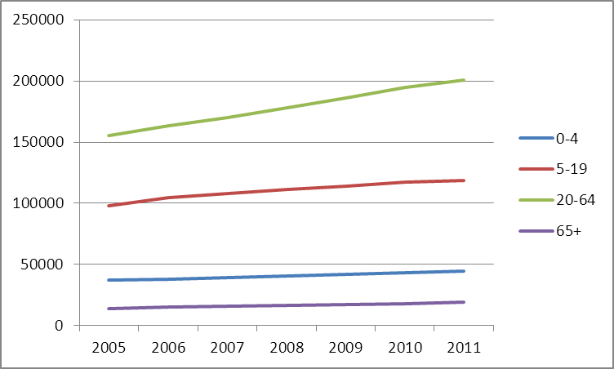

Map 1. Count of total Pacific resident population in 2006 census (not from Pacific-ever cohort) mapped to census area units 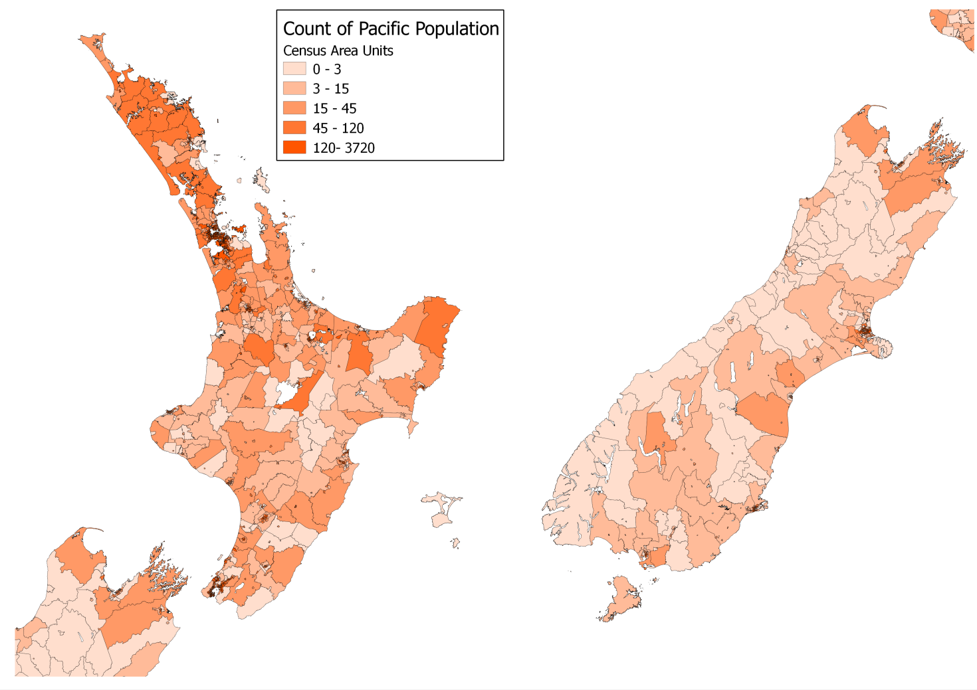
Map 2. Pacific population registered in PHOs, in Quarter 4, 2006 (using ever-Pacific cohort)
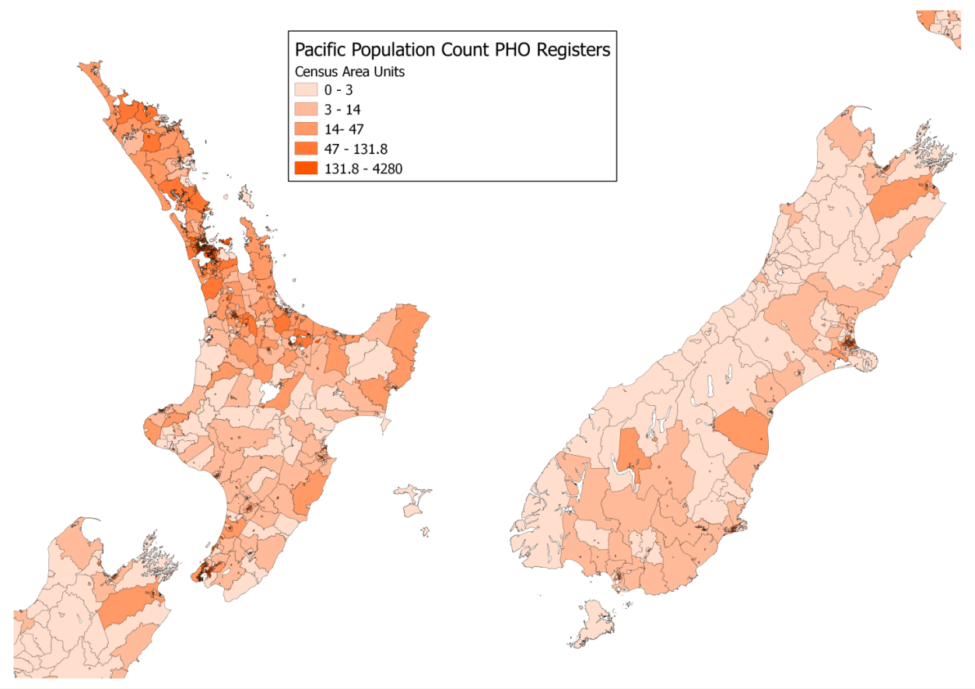
Map 3. Difference between Pacific population registered with PHO and Pacific population in census.
Negative numbers and lighter colours mean more Pacific people registered with PHOs than Census counts as resident within census area units. Positive numbers and darker colours mean that fewer Pacific people are registered with PHOs than the Census counts as resident within census area units.
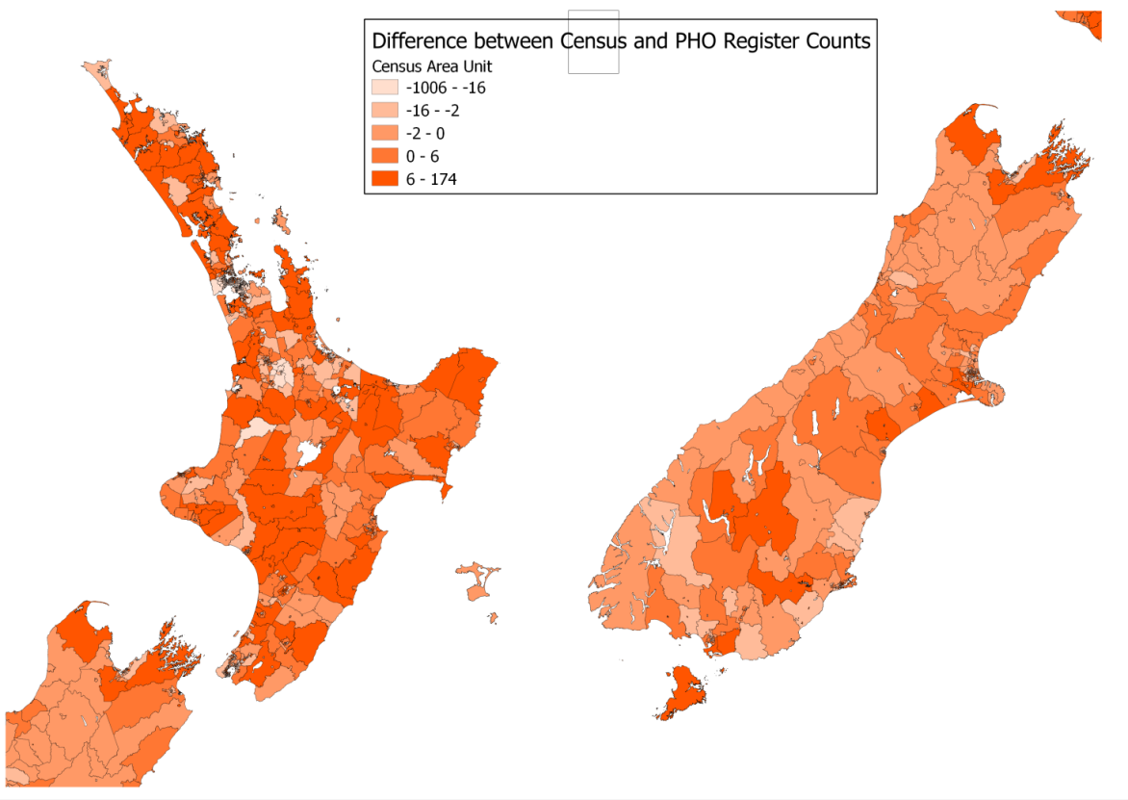

Outpatient data
The National Non-Admitted Patients Collection data includes a complex mix of services and we were advised that for some items coding was not consistent between DHBs and over time.
At first appearance the data shows an increase in Outpatient services of 94% over 3 financial years, which is misleading. In particular, community services by District Nurses and others (purchase unit code DOM101) have been progressively added to OP data when they were not present in this data previously.
Table 16. Outpatient Events by financial year
Financial Year | Number
2007-08 | 256,845
2008-09 | 392,492
2009-10 | 490,381
2010-11 | 497,051
Total | 1,636,769
Absolute Increase | 240,206
Ratio | 1.9

These data are misleading, however, in that coding changes and additional data capture in later years inflate the numbers. The largest such change is the progressive addition of Purchase Unit Code DOM101 “community services …”, District Nursing services
Table 17. Number of Outpatient events coded DOM101, by financial year
Financial year | Number
2007-08 | 4,531
2008-09 | 38,429
2009-10 | 54,075
2010-11 | 61,084

Table 18. Outpatient events by numbers Attended, Did Not Attend and Did not Wait
Financial Year | Attended | Did Not Attend | Did Not Wait
2007-08 | 234,741 | 22,077 | 27
2008-09 | 356,632 | 35,805 | 55
2009-10 | 448,724 | 41,604 | 53
2010-11 | 453,421 | 43,579 | 51
Total | 1,493,518 | 143,065 | 186

Table 19. Attended, Outpatient events, by financial year and ethnicity
Financial Year | Cook Islands Maori | Fijian | Niuean | Other Ethnicity | Other Pacific Peoples | Pacific Peoples nfd | Samoan | Tokelauan | Tongan
2007-08 | 37,932 | 13,719 | 15,077 | 37,077 | 5,416 | 2,186 | 87,526 | 4,279 | 37,979
2008-09 | 57,022 | 21,429 | 22,055 | 52,515 | 8,795 | 3,459 | 140,694 | 7,450 | 54,025
2009-10 | 71,994 | 27,904 | 23,852 | 71,227 | 12,135 | 4,445 | 171,731 | 11,062 | 67,455
2010-11 | 73,699 | 28,210 | 24,082 | 71,307 | 13,541 | 5,147 | 170,615 | 9,906 | 70,059
Total | 240,647 | 91,262 | 85,066 | 232,126 | 39,887 | 15,237 | 570,566 | 32,697 | 229,518

Table 20. Table, Did Not Attend, Outpatient events by financial year and ethnicity
Financial Year | Cook Islands Maori | Fijian | Niuean | Other Ethnicity | Other Pacific Peoples | Pacific Peoples nfd | Samoan | Tokelauan | Tongan
2007-08 | 3,154 | 998 | 780 | 3,538 | 660 | 317 | 9,939 | 512 | 2,896
2008-09 | 5,196 | 1,551 | 1,371 | 5,259 | 1,063 | 433 | 16,252 | 980 | 4,938
2009-10 | 6,259 | 1,987 | 1,365 | 6,329 | 1,196 | 476 | 18,297 | 1,283 | 5,758
2010-11 | 6,713 | 2,213 | 1,561 | 6,580 | 1,332 | 589 | 18,605 | 1,461 | 6,077
Total | 21,322 | 6,749 | 5,077 | 21,706 | 4,251 | 1,815 | 63,093 | 4,236 | 19,669

Figure 3. Outpatient visits by financial year. This is what the raw data shows, but the figures are misleading in that much of the increase is due to coding changes and progressive capture of new data
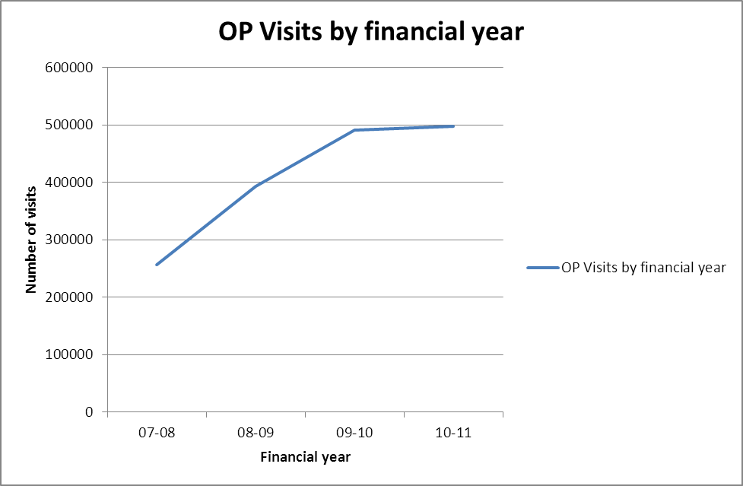

Rather than report all Outpatient services, we have selected first and followup Outpatient visits for diabetes and renal services because they are important services with known longstanding consistent coding. These are shown in the next table for the seven DHBs considered to be of particular interest for Pacific peoples. The following table shows equivalent numbers for other agencies.
Table 21. Diabetes and renal Outpatient services (first and follow up) by DHB and financial year.
Agency | 2007-08 | 2008-09 | 2009-10 | 2010-11
Counties Manukau District Health Board | 33,551 | 32,952 | 33,630 | 35,561
Auckland District Health Board | 25,610 | 28,439 | 31,110 | 31,047
Canterbury District Health Board | 834 | 860 | 1,140 | 954
Waitemata District Health Board | 513 | 556 | 949 | 5,935
Capital and Coast District Health Board | 479 | 6,800 | 8,498 | 10,234
Hutt Valley District Health Board | 262 | 354 | 382 | 391
Mid Central District Health Board | 212 | 389 | 787 | 791
Total | 61,461 | 70,350 | 76,496 | 84,913

Table 22. Diabetes and renal Outpatient servies by DHB and financial year
OP visits diabetes+renal
 |  | Financial Year
DHB Name | 07-08 | 08-09 | 09-10 | 10-11
Waikato District Health Board | 1576 | 1576 | 2807 | 3035
Northland District Health Board | 1312 | 283 | 1882 | 1487
Hawke's Bay District Health Board | 426 | 614 | 1063 | 1738
Lakes District Health Board | 383 | 345 | 798 | 995
Bay of Plenty District Health Board | 339 | 566 | 669 | 516
Otago District Health Board | 312 | 295 | 358 | 362
Nelson Marlborough District Health Board | 236 | 124 | 94 | 81
Whanganui District Health Board | 84 | 64 | 26 | 91
Tairawhiti District Health Board | 61 | 29 | 85 | 53
Taranaki District Health Board | 45 | 147 | 138 | 147
Southland District Health Board | 38 | 148 | 107 | 150
Wairarapa District Health Board | 6 | 5 | 30 | 50
South Canterbury District Health Board | 3 | 13 | 74 | 47
West Coast District Health Board | 1 | 2 | 93 | 95
Clutha Health First | 0 | 0 | 3 | 4
Dunstan Charitable Trust | 0 | 0 | 0 | 2
Gore Health Centre | 0 | 0 | 0 | 2
Oamaru Charitable Trust | 0 | 0 | 54 | 58
Total | 4822 | 4211 | 8281 | 8913

Figure 4. Outpatient visits (diabetes and renal) for DHBs
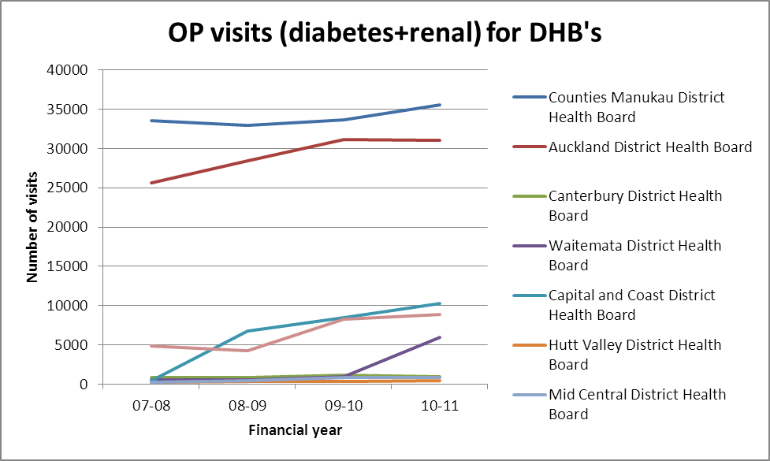
Figure 5. Outpatient visits (diabetes and renal) for DHBs
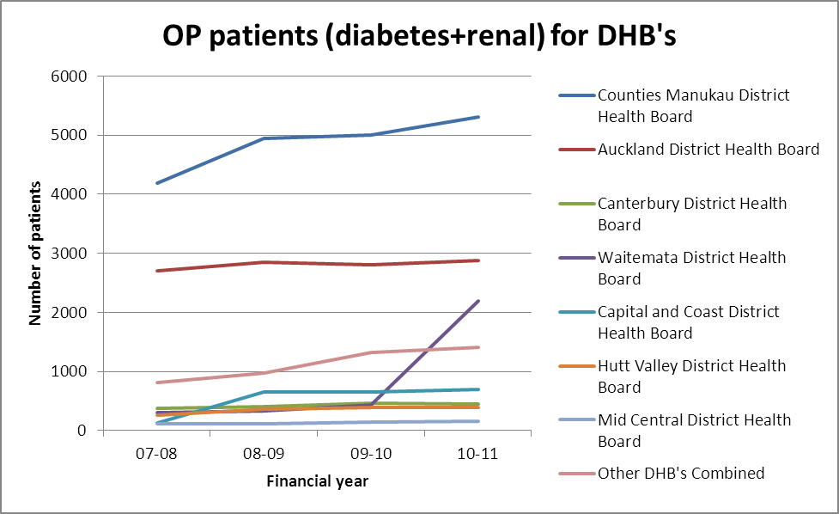

Figure 6. Outpatient visits attended (diabetes and renal) for DHBs
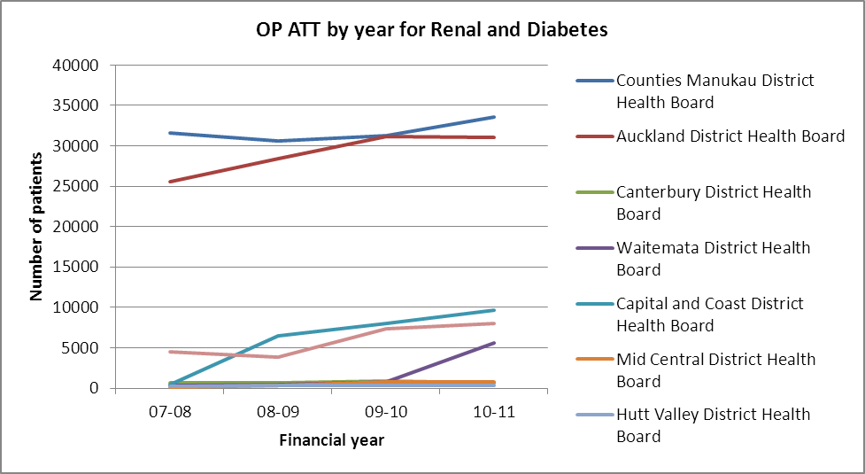
Figure 7. Outpatient visits DNA (diabetes and renal) for DHBs
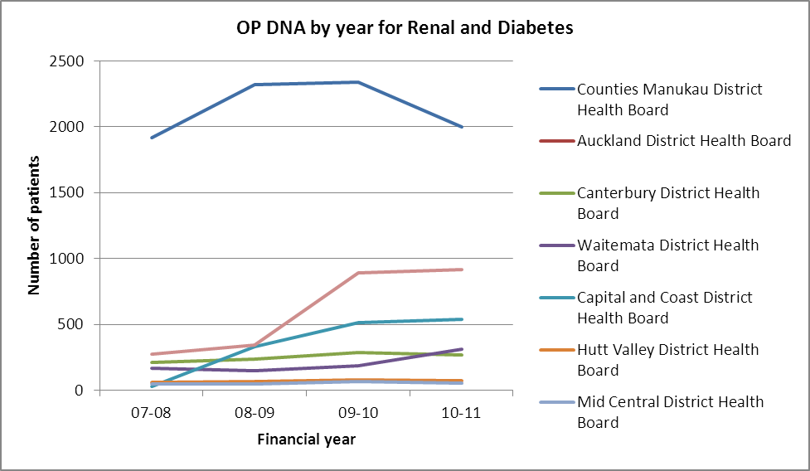

Figure 8. Outpatient FIRST service type for Renal and Diabetes
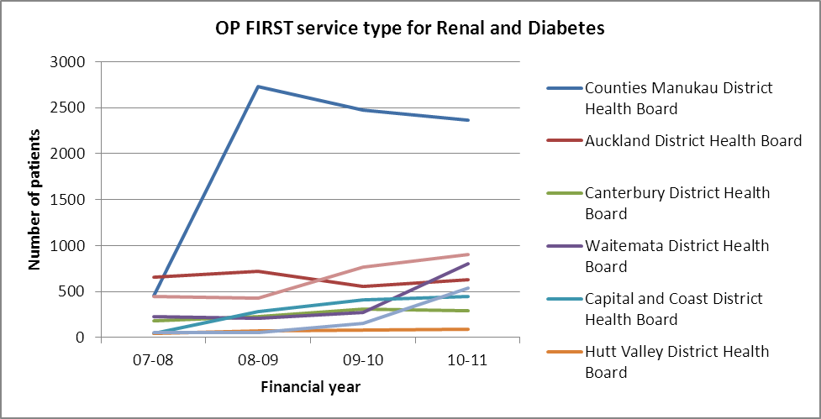
Figure 9. Outpatient Follow-up service type for Renal and Diabetes
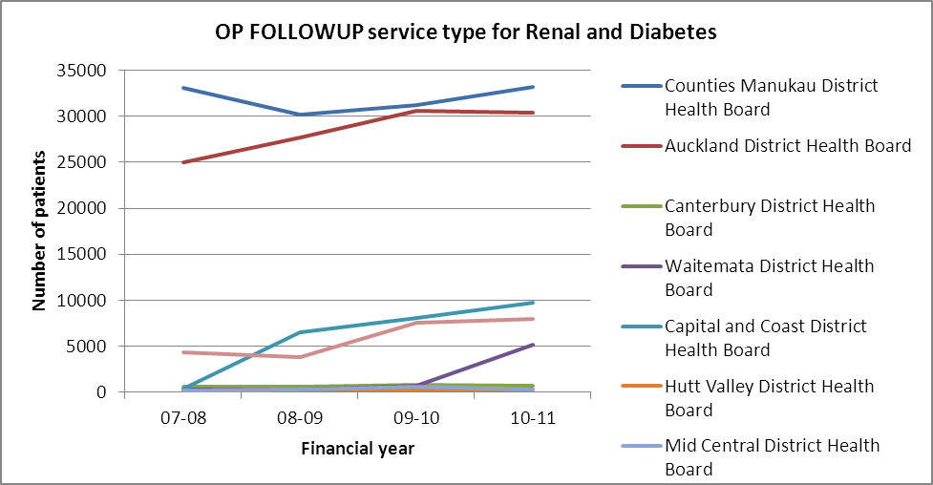
Table 23. Ethnicity for Counties Manukau Outpatients Renal and Diabetes
Year | Cook Islands Maori | Fijian | Niuean | Other Ethnicity | Other Pacific Peoples | Pacific Peoples nfd | Samoan | Tokelauan | Tongan
07-08 | 7740 | 1487 | 9-Jul | 24-Oct | 7-May | 31-Jul | 12429 | 43 | 7102
08-09 | 6576 | 1631 | 2673 | 2040 | 627 | 230 | 12893 | 47 | 6834
09-10 | 6991 | 1404 | 2538 | 2220 | 672 | 207 | 12450 | 32 | 7806
10-11 | 7824 | 1703 | 2628 | 2672 | 747 | 335 | 13094 | 34 | 7374

Emergency Department

Table 24. Attend, Did Not Attend (DNA), Did Not Wait (DNW)
 | Attend | DNA | DNW
Community Referred Diagnostics | 22,405 | 1,036 | 0
% | 95.6 | 4.4 | 0
Emergency Dept | 391,638 | 0 | 6,876
% | 98.3 | 0.0 | 1.7
Outpatient | 1,493,518 | 143,065 | 186
% | 91.3 | 8.7 | 0.01

Laboratory data
The laboratory data finishes in 2008.
Table 25. Laboratory Claims by year
Year | Number
2000 | 547,880
2001 | 709,590
2002 | 864,430
2003 | 1,051,183
2004 | 1,223,560
2005 | 1,347,670
2006 | 1,387,506
2007 | 1,469,036
2008 | 1,592,841

Figure 10. Laboratory Claims by year
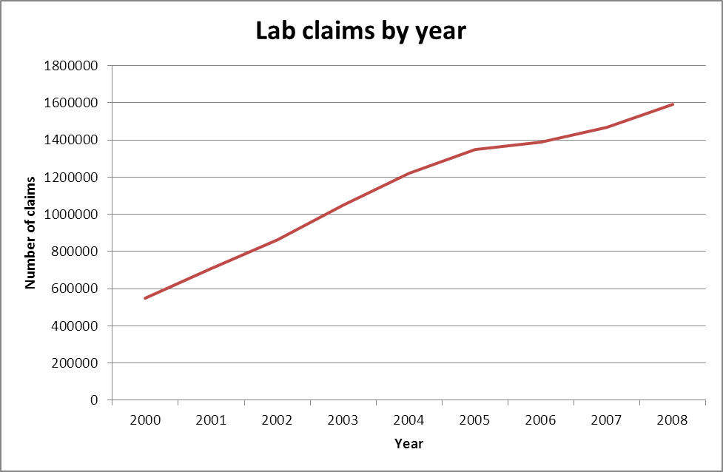
Table 26. Laboratory claims by ethnicity and year
Year | Cook Islands Maori | Fijian | Niuean | Other Ethnicity | Other Pacific Peoples | Pacific Peoples nfd | Samoan | Tokelauan | Tongan
2000 | 84,939 | 32,090 | 34,821 | 114,725 | 12,973 | 5,491 | 195,315 | 6,964 | 70,623
2001 | 110,866 | 43,347 | 43,169 | 149,297 | 17,536 | 7,505 | 252,065 | 8,895 | 89,214
2002 | 131,033 | 55,737 | 51,342 | 184,946 | 22,411 | 9,809 | 306,194 | 10,847 | 107,734
2003 | 157,245 | 73,151 | 60,648 | 225,006 | 26,222 | 11,289 | 368,522 | 13,607 | 133,423
2004 | 176,919 | 85,891 | 69,078 | 270,187 | 31,362 | 14,000 | 423,206 | 15,269 | 157,988
2005 | 188,833 | 101,570 | 73,438 | 301,609 | 36,893 | 14,939 | 460,775 | 16,485 | 176,267
2006 | 192,533 | 106,514 | 74,169 | 307,856 | 35,790 | 15,403 | 474,657 | 16,930 | 188,007
2007 | 201,786 | 118,622 | 77,811 | 320,584 | 39,400 | 16,393 | 504,471 | 16,536 | 198,630
2008 | 215,620 | 131,597 | 84,963 | 341,837 | 45,046 | 18,725 | 548,858 | 18,822 | 216,985

Figure 11. Laboratory claims by ethnicity and year
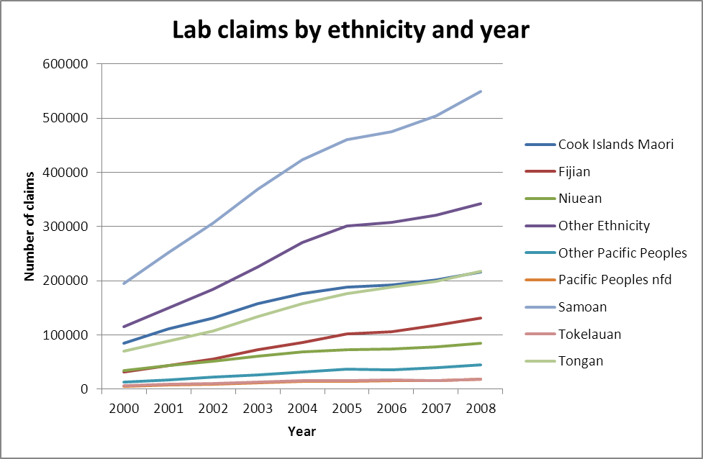

Pharmaceutical data
Pharmaceutical data is collected in the process of reimbursement claims from community pharmacists. Adding an NHI to such claims is encouraged but has not been obligatory for a valid claim until the new pharmacy contract starting 1 July 2012. Some of the uptrends from years 2002 to about 2006 is therefore be due to increasing inclusion of NHI on claims rather than a reflection of a real increase in prescriptions and patients. In this respect the data are relatively stable from about 2007. It is not clear why the number of scripts per patient should have risen, although this may relate in part to increased use of ‘close control’ prescribing.

Table 27. Count of scripts dispensed by year, adjusted for low NHI rate on prescriptions in earlier years
Year | Number | NHI Coverage | Ratio | Adjusted Number
2002 | 518,445 | 25.6% | 3.90625 | 2,025,176
2003 | 969,272 | 43.7% | 2.28833 | 2,218,014
2004 | 1,540,312 | 63.9% | 1.564945 | 2,410,504
2005 | 2,301,526 | 86.5% | 1.156069 | 2,660,724
2006 | 2,735,351 | 92.2% | 1.084599 | 2,966,758
2007 | 3,124,143 | 94.3% | 1.060445 | 3,312,983
2008 | 3,519,659 | 95.4% | 1.048218 | 3,689,370
2009 | 4,000,832 | 96.2% | 1.039501 | 4,158,869
2010 | 4,444,728 | 96.9% | 1.031992 | 4,586,923

Figure 12. Pharmaceuticals dispensed per year, red line numbers in data, blue line adjusted for percentage NHI present by year
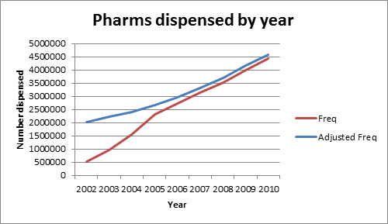

Table 28. Count of scripts dispensed and count of patients by year
Year | Patients | Scripts | Scripts/Patient
2002 | 60,640 | 518,445 | 8.55
2003 | 97,978 | 969,272 | 9.89
2004 | 162,357 | 1,540,312 | 9.49
2005 | 206,131 | 2,301,526 | 11.17
2006 | 226,461 | 2,735,351 | 12.08
2007 | 245,716 | 3,124,143 | 12.71
2008 | 261,821 | 3,519,659 | 13.44
2009 | 279,669 | 4,000,832 | 14.31
2010 | 289,132 | 4,444,728 | 15.37
2011* | 235,510 | 2,337,054 | 9.92
*6 months data

Figure 13. Count of patients by year
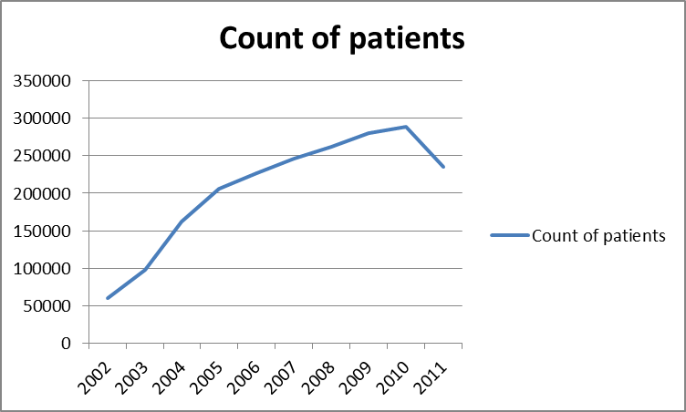

Figure 14. Count of scripts per patient
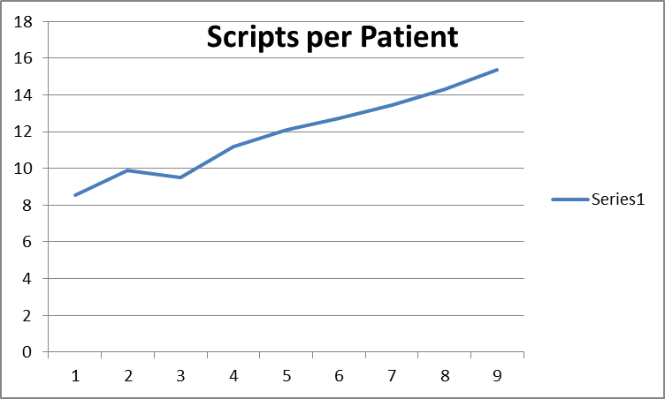

If we follow only individuals present in ever-Pacific list in 2002, and count the number of items dispensed to each of them per year, we find an increase from a median of about 3.5 to about 5. This increase (polypharmacy), together with the increase in the number of patients appearing in the data sets in later years (from more complete NHI recording on prescriptions) and an increase in ‘close control’ prescriptions, appears to account for the rise in pharmacy claims.

Emergency Department data

Table 29. ED attendances by financial year
Financial Year | Number
2007-08 | 90,383
2008-09 | 98,273
2009-10 | 103,020
2010-11 | 106,838
Increase absolute | 16,455
Increase % | 15.4

Figure 15. ED attendances by financial year
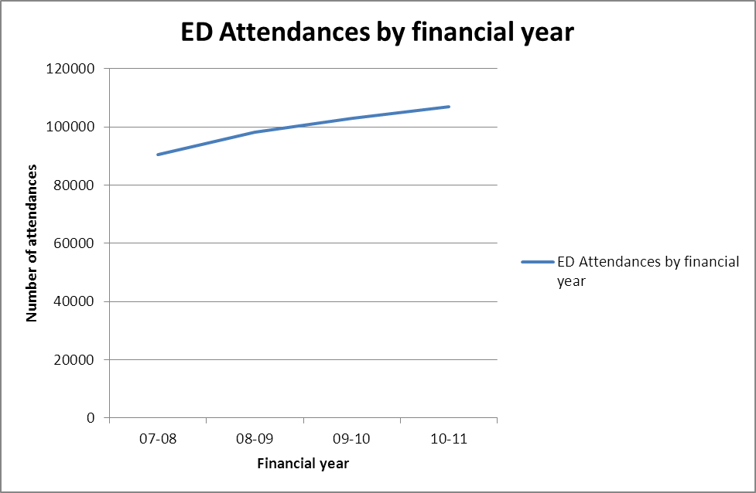

Table 30. ED visits by ethnicity and financial year
Financial Year | Cook Islands Maori | Fijian | Niuean | Other Ethnicity | Other Pacific Peoples | Pacific Peoples nfd | Samoan | Tokelauan | Tongan
07-08 | 12,489 | 4,943 | 4,150 | 15,272 | 2,571 | 1,032 | 37,579 | 1,500 | 14,757
08-09 | 13,483 | 5,810 | 4,833 | 16,222 | 2,891 | 1,207 | 40,736 | 1,682 | 16,056
09-10 | 14,205 | 6,553 | 4,850 | 17,003 | 3,155 | 1,218 | 42,139 | 1,821 | 16,979
10-11 | 14,272 | 7,025 | 5,168 | 17,488 | 3,473 | 1,302 | 43,805 | 1,901 | 17,607
Increase absolute | 1,783 | 2,082 | 1,018 | 2,216 | 902 | 270 | 6,226 | 401 | 2,850
Increase % | 12.5 | 29.6 | 19.7 | 12.7 | 26.0 | 20.7 | 14.2 | 21.1 | 16.2

Figure 16. ED visits by ethnicity and financial year
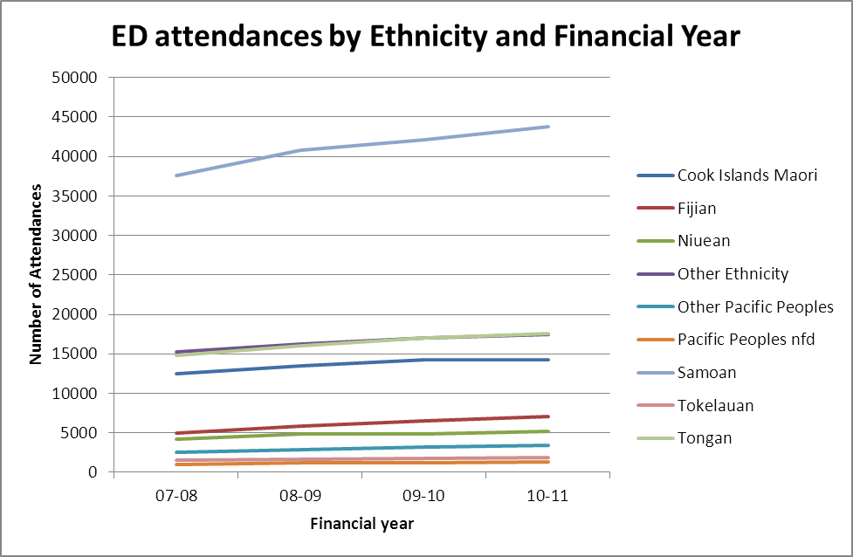
Table 31. ED event attendance type by financial year
Financial Year | Attended | Did Not Wait
07-08 | 89,264 | 1,119 (1.2%)
08-09 | 96,888 | 1,385 (1.4%)
09-10 | 101,507 | 1,513 (1.5%)
10-11 | 103,979 | 2,859 (2.7%)
Increase absolute | 14,715 | 1,740
Increase % | 16.5% | 1.5%

General Medical Services data
General Medical Services (GMS) data collects all the fee-for-service subsidy claims from general practitioners. The number of such claims has reduced dramatically since the introduction of capitation from 2000 onwards. Since capitation, a GMS entry reflects a patient who has attended a practice or after-hours clinic at which he or she is not enrolled.

Table 32. Unique patients per year and Total number of visits per year
Year | Patients | Visits
2002 | 113,328 | 456,010
2003 | 112,371 | 369,703
2004 | 88,776 | 264,090
2005 | 57,474 | 123,073
2006 | 73,681 | 205,380
2007 | 72,196 | 192,961
2008 | 70,529 | 183,330
2009 | 70,017 | 178,143
2010 | 65,927 | 164,250
2011* 6 months | 39,247 | 76,208

Figure 17. GMS visits by year
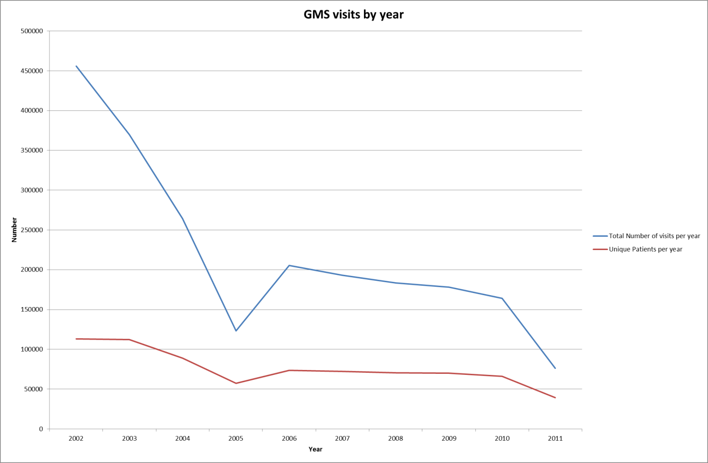
Table 33. Unique patients by ethnicty and year
Year | Cook Islands Maori | Fijian | Niuean | Other Ethnicity | Other Pacific Peoples | Pacific Peoples nfd | Samoan | Tokelauan | Tongan
2002 | 15,961 | 4,730 | 7,162 | 22,723 | 2,962 | 1,548 | 43,979 | 1,497 | 17,063
2003 | 15,944 | 4,946 | 6,409 | 23,144 | 3,034 | 1,542 | 43,142 | 1,704 | 16,796
2004 | 11,936 | 3,984 | 4,699 | 18,427 | 2,365 | 1,128 | 34,021 | 1,373 | 14,461
2005 | 7,516 | 2,704 | 3,110 | 11,639 | 1,417 | 648 | 22,408 | 742 | 9,823
2006 | 9,628 | 3,605 | 3,805 | 14,772 | 1,963 | 947 | 29,091 | 1,079 | 12,250
2007 | 9,445 | 3,742 | 3,685 | 13,940 | 2,061 | 939 | 28,728 | 1,136 | 11,971
2008 | 9,233 | 3,922 | 3,654 | 13,076 | 2,046 | 909 | 28,261 | 1,081 | 11,882
2009 | 9,339 | 4,147 | 3,651 | 12,306 | 2,024 | 892 | 28,065 | 1,136 | 12,153
2010 | 8,702 | 3,902 | 3,467 | 11,645 | 2,153 | 887 | 26,110 | 1,092 | 11,614
2011* | 5,137 | 2,265 | 1,983 | 6,393 | 1,122 | 548 | 15,976 | 621 | 7,435
*6 months data

Table 34. Total visits by ethnicity and year
Year | Cook Islands Maori | Fijian | Niuean | Other Ethnicity | Other Pacific Peoples | Pacific Peoples nfd | Samoan | Tokelauan | Tongan
2002 | 65,323 | 19,481 | 34,440 | 83,168 | 10,546 | 4,724 | 181,161 | 4,911 | 71,482
2003 | 52,697 | 16,018 | 23,063 | 75,489 | 8,845 | 4,193 | 143,386 | 5,042 | 56,432
2004 | 36,103 | 11,336 | 15,144 | 54,073 | 6,125 | 2,838 | 102,517 | 3,281 | 44,304
2005 | 16,111 | 5,375 | 7,313 | 24,114 | 2,693 | 1,140 | 49,217 | 1,307 | 21,678
2006 | 26,689 | 9,223 | 12,147 | 38,972 | 4,588 | 2,130 | 83,907 | 2,526 | 36,224
2007 | 25,226 | 9,169 | 11,224 | 35,100 | 4,742 | 2,124 | 79,787 | 2,611 | 33,758
2008 | 24,228 | 9,464 | 10,862 | 31,591 | 4,667 | 2,113 | 76,513 | 2,430 | 32,325
2009 | 23,735 | 9,599 | 10,399 | 29,001 | 4,589 | 2,049 | 74,346 | 2,630 | 32,880
2010 | 21,676 | 9,032 | 9,610 | 26,577 | 5,028 | 2,019 | 67,840 | 2,439 | 30,633
2011* | 9,931 | 4,245 | 4,222 | 11,618 | 2,034 | 1,028 | 31,668 | 1,109 | 14,888
*6 months data

Figure 18. Total GMS visits by ethnicity and year
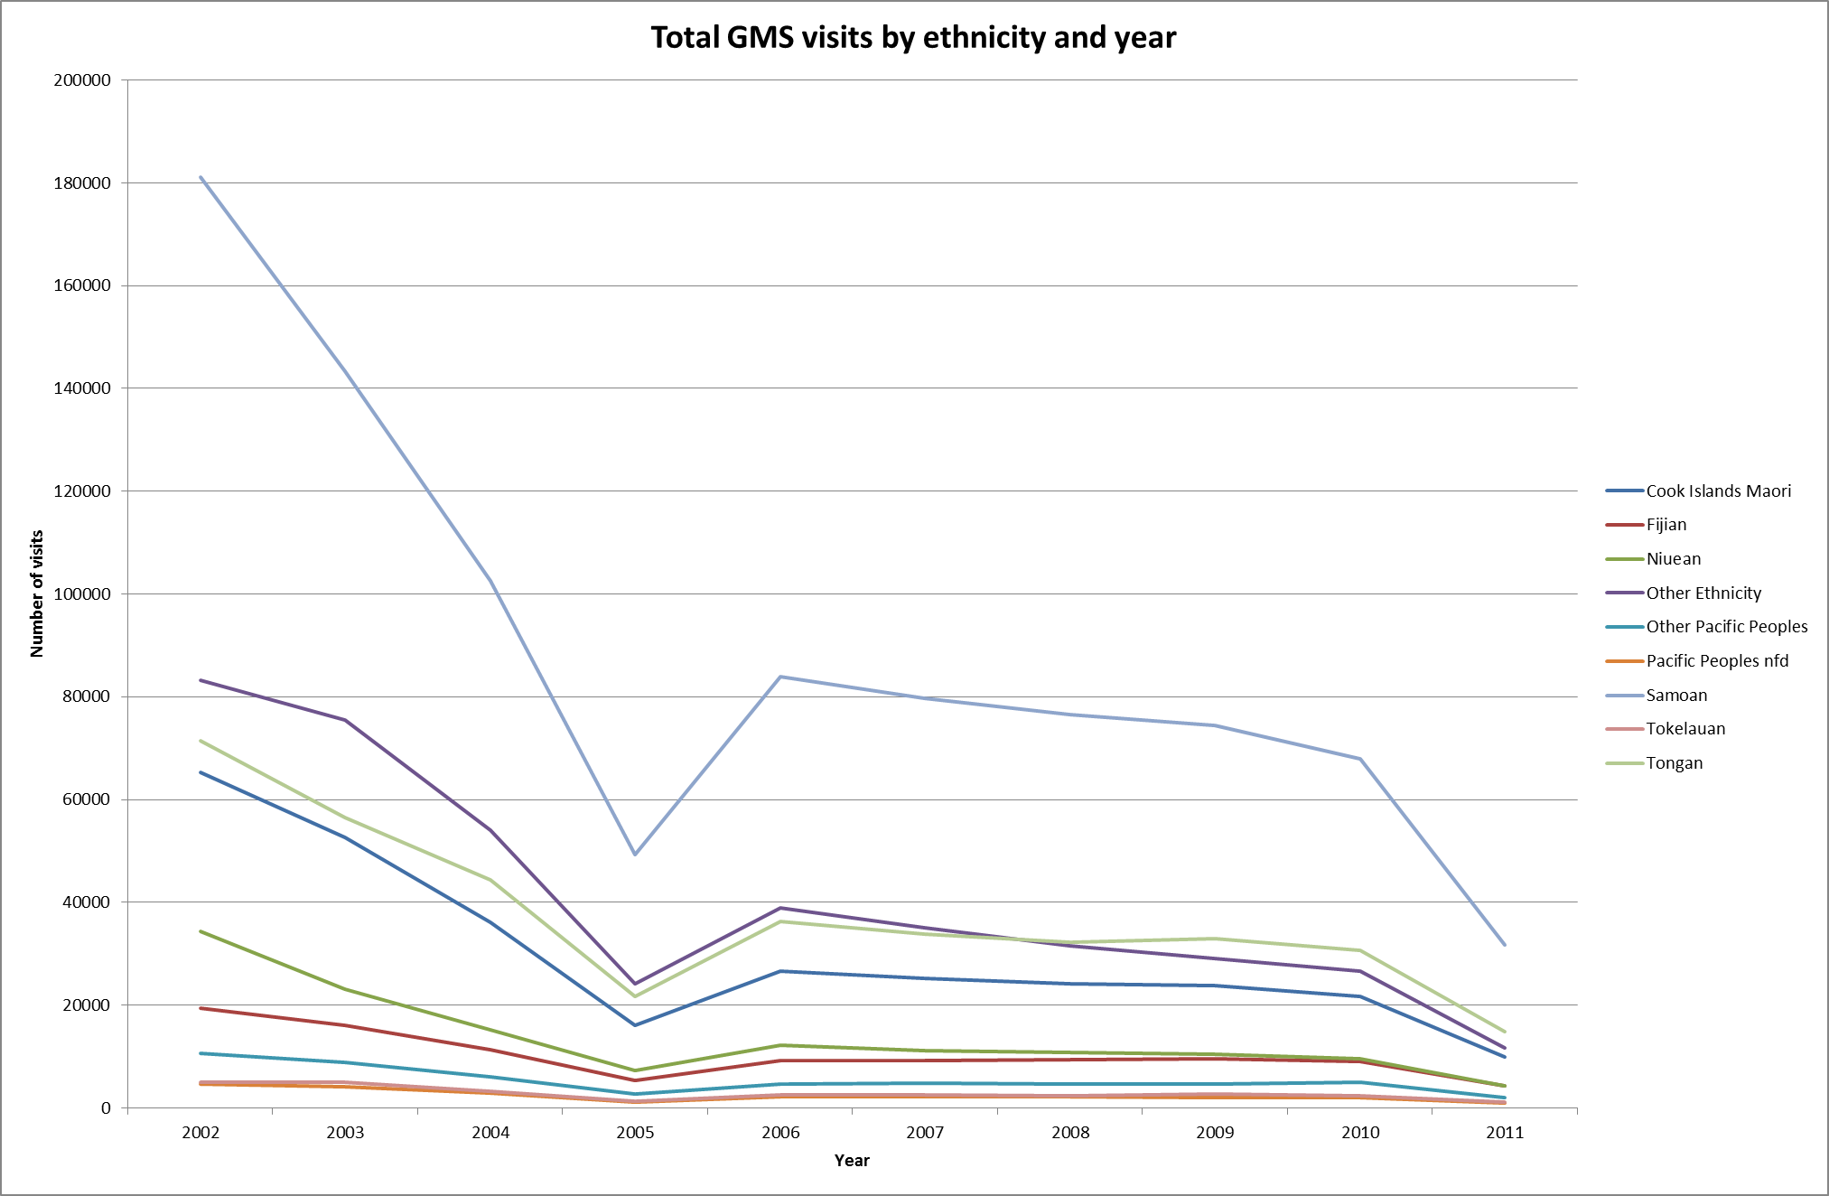
Table 35. GMS visits by age-MOH category
Year | 0-4 | 05-19 | 20-64 | 65+
2002 | 177,937 | 103,686 | 135,521 | 38,866
2003 | 155,464 | 84,057 | 102,753 | 27,429
2004 | 124,951 | 61,489 | 63,670 | 13,980
2005 | 60,817 | 32,107 | 24,530 | 5,619
2006 | 111,703 | 49,070 | 36,026 | 8,581
2007 | 106,643 | 47,256 | 31,410 | 7,652
2008 | 104,146 | 44,267 | 27,709 | 7,208
2009 | 101,123 | 43,241 | 26,035 | 7,744
2010 | 96,900 | 39,225 | 22,042 | 6,083
2011 | 42,791 | 19,985 | 10,404 | 3,028

Table 36. GMS visits by gender
Year | Female | Male
2002 | 250,567 | 205,436
2003 | 198,832 | 170,852
2004 | 136,774 | 127,307
2005 | 62,755 | 60,317
2006 | 104,369 | 101,011
2007 | 97,138 | 95,823
2008 | 92,041 | 91,285
2009 | 89,195 | 88,948
2010 | 80,901 | 83,346
2011 *6 months | 37,473 | 38,734

Table 37. GMS visits by NZ resident
Year | Not Resident | Resident
2002 | 18,086 | 437,924
2003 | 14,790 | 354,913
2004 | 10,477 | 253,613
2005 | 5,330 | 117,743
2006 | 9,765 | 195,615
2007 | 11,016 | 181,945
2008 | 12,724 | 170,606
2009 | 15,489 | 162,654
2010 | 15,799 | 148,451
2011 *6 months | 8,521 | 67,687

Counties Manukau Chronic Care Management Programme (CCM)

This programme started in 2001 and runs only in Counties Manukau DHB area primary care practices. It funds up to four patient visits per year for structured care of diabetes, chronic obstructive pulmonary disease (COPD), congestive heart failure (CHF), cardiovascular disease (CVD) and, more recently, depression. Entry criteria for each condition generally mean that people with ‘mild’ conditions do not qualify. The programme provides computer templates to use within a consultation; data are collected automatically by the DHB and automated specialist advice is returned to the practitioner automatically. The programme has been reported and evaluated on several occasions, the last being in 2007 (Kenealy, T. et al, 2007). The time series analyses reported below have not been undertaken or presented previously. Ethnicities in this data are from the primary care data, which includes only one ethnicity field. At this stage the data set has not been linked to the national ever-Pacific list. We report here on numbers of people and one or more measure of quality within each programme. Analysis used mixed effects linear regressions, without confidence intervals, with post-estimation contrasts between ethnic groups, unless otherwise stated. Data were extracted in August 2011, so the 2011 data do not represent a full year.
The Counties Manukau DHB area comprises the territorial authorities of Manukau City, Papakura District and Franklin District. The ethnic composition of the area as of the 2006 Census included 98,570 Pacific people or 20.25% of the usual resident population. (www.stats.govt.nz/Census/2006CensusHomePage/QuickStats/AboutAPlace.aspx)
This database shows how Pacific people tend to cluster strongly within a limited number of preferred practices. In the Diabetes programme there are 28,983 people in 11 PHOs and 125 practices. There are 9717 Pacific people, of whom 45% are in one PHO, and 97% are in just 3 PHOs. Similarly, 46% of Pacific people are in just two practices, and 81% are in just 10 practices.

Chronic Obstructive Pulmonary Disease (COPD)
Since 2002, 322 Pacific people have entered this programme. The proportion of Pacific people appears lower than the population proportion in some early years of the programme, but looks broadly appropriate now. The number of people with COPD in Counties Manukau is unknown, either overall or by ethnicity. The proportion of Pacific people with a flu vaccine is not statistically significantly different from the proportion for European.
Table 38. Number and percentage of individuals attending COPD programme in each year, by Pacific and non-Pacific ethnicity.
 | 2002 | 2003 | 2004 | 2005 | 2006 | 2007 | 2008 | 2009 | 2010 | 2011
Pacific | 1 | 7 | 14 | 24 | 37 | 93 | 140 | 226 | 213 | 201
% | 25.0 | 16.7 | 16.9 | 10.5 | 9.7 | 15.6 | 17.5 | 23.0 | 20.8 | 20.5
Non Pacific | 3 | 35 | 69 | 204 | 343 | 505 | 661 | 755 | 809 | 778
% | 75.0 | 83.3 | 83.1 | 89.5 | 90.3 | 84.5 | 82.5 | 77.0 | 79.2 | 79.5

Figure 19. Predicted probability of Flu vaccine given within 1 year of each visit, by year and ethnicity

Congestive Heart Failure (CHF)
Since 2002, 307 Pacific people have entered this programme. The proportion of Pacific people is higher than their population proportion. The numbers of people with CHF in Counties Manukau is unknown, either overall or by ethnicity. Current guidelines advise that most people with CHF should be taking, amongst other medications, both an ACE inhibitor (or an ARB) and a beta-blocker. The proportion of people on both these medications is not statistically significantly different by ethnicity. (There are only 14 patients of ‘Other’ ethnicity in the data set.)
Table 39. Number and percentage of individuals attending CHF programme in each year, by Pacific and non-Pacific ethnicity.
 | 2002 | 2003 | 2004 | 2005 | 2006 | 2007 | 2008 | 2009 | 2010 | 2011
Pacific | 0 | 9 | 21 | 42 | 72 | 143 | 162 | 177 | 181 | 157
% | 0.0 | 18.0 | 19.8 | 26.3 | 24.6 | 30.8 | 30.9 | 30.7 | 33.1 | 32.7
Non Pacific | 1 | 41 | 85 | 118 | 221 | 322 | 362 | 399 | 366 | 323
% | 100.0 | 82.0 | 80.2 | 73.8 | 75.4 | 69.3 | 69.1 | 69.3 | 66.9 | 67.3

Figure 20. Predicted probability of being on an ACE inhibitor (or ARB) and beta blocker, by year and ethnicity

Depression
Since the programme started in 2005, 1049 Pacific people have entered it. The proportion of Pacific people is well short of their population proportion. This programme is intended to provide a limited number of visits, then discharge patients. The median number of visits per Pacific person is 2 (interquartile range 1 to 5), significantly fewer than European (median 3, interquartile range 2 to 6).
Table 40. Number and percentage of individuals attending depression programme in each year, by Pacific and non-Pacific ethnicity.
 | 2005 | 2006 | 2007 | 2008 | 2009 | 2010 | 2011
Pacific | 1 | 35 | 110 | 141 | 286 | 525 | 436
% | 3.1 | 10.0 | 6.1 | 4.6 | 6.9 | 9.7 | 10.6
Non Pacific | 31 | 314 | 1,684 | 2,921 | 3,878 | 4,871 | 3,668
% | 96.9 | 90.0 | 93.9 | 95.4 | 93.1 | 90.3 | 89.4

Cardiovascular disease
This programme was initially designed to support systematic care for one year after a person had a heart attack, at which time people were discharged from the programme. The programme was later allowed to carry on beyond one year, but it is not thought to be widely used long term. The proportion of Pacific people each year is somewhat variable. The median number of visits per Pacific person is 2 (interquartile range 1 to 4), significantly fewer than European (median 2, interquartile range 1 to 5).
Table 41. Number and percentage of individuals attending CVD programme in each year, by Pacific and non-Pacific ethnicity.
 | 2003 | 2004 | 2005 | 2006 | 2007 | 2008 | 2009 | 2010 | 2011
Pacific | 4 | 27 | 61 | 98 | 140 | 181 | 382 | 324 | 214
% | 36.4 | 22.3 | 19.9 | 14.8 | 15.4 | 14.3 | 21.7 | 17.1 | 18.1
Non Pacific | 7 | 94 | 245 | 563 | 769 | 1,089 | 1,376 | 1,568 | 966
% | 63.6 | 77.7 | 80.1 | 85.2 | 84.6 | 85.8 | 78.3 | 82.9 | 81.9

Diabetes
Diabetes is the largest CCM programme and includes 9717 Pacific people. Pacific people are well represented as a proportion of individuals seen each year. Changes to enrolment criteria and funding limited the growth in numbers in recent years. The number of visits per Pacific person per year mean 2.4 (SD 1.2) is significantly more than for European mean 2.1 (SD 1.2).
Table 42. Number and percentage of individuals attending diabetes programme in each year, by Pacific and non-Pacific ethnicity.
 | 2001 | 2002 | 2003 | 2004 | 2005 | 2006 | 2007 | 2008 | 2009 | 2010 | 2011
Pacific | 234 | 1,254 | 1,633 | 2,107 | 2,868 | 3,329 | 5,016 | 5,620 | 5,885 | 6,178 | 5,573
% | 66.5 | 62.1 | 50.2 | 43.7 | 41.7 | 38.2 | 35.6 | 35.2 | 40.7 | 41.2 | 42.3
Non Pacific | 118 | 767 | 1,622 | 2,720 | 4,006 | 5,397 | 9,077 | 10,370 | 8,577 | 8,823 | 7,591
% | 33.5 | 38.0 | 49.8 | 56.4 | 58.3 | 61.9 | 64.4 | 64.9 | 59.3 | 58.8 | 57.7

Mean glucose control is worse for Pacific than for other ethnic groups. At CCM entry, mean HbA1c is 8.9% (SD 2.1). Ideal HbA1c for most people is between 6.5% and 7%; 8.9% is considered ‘poor control’. For people in the programme, HbA1c initially drops then it rises steadily, a pattern seen across other ethnic groups and consistent with the ‘natural history’ of diabetes if not aggressively managed by both health professionals and patients. The baseline HbA1c is significantly higher than subsequent readings until more than 6 years later. This suggests that the CCM programme delays a rising HbA1c by at least 6 years. The following Figure 22 shows predictions from a regression model; the variation between individuals is wider than might appear from this graph and no adjustments have been made for potential confounders such as age, weight or treatment.
Figure 21. Predicted HbA1c by months completed in diabetes programme, Pacific ethnicity only.

Primary Care data
This section reports on data collected from primary care, either via PHOs or directly from the practices.
A key part of our proposal was the inclusion of PHO data for analysis. At the commencement of the project, agreement in principle to support the project by supplying data for analysis was received in writing from all the major PHOs with significant Pacific populations. This included Alliance Health Plus, Compass Health, East Tamaki Healthcare, ProCare and Pegasus (Partnership PHO). WellHealth PHO and Ora Toa were added during the project.
Our approach was to develop a detailed quantitative data analysis plan which was provided to the chairs of PHO Boards and each chief executive. Engagement between senior management staff of PHOs and the research team was on-going and responsive to any issues raised and it has continued until this draft report’s submission. Discussions with delegated senior staff resulted in refinements specific to each PHO reflecting what data they had available, their relationships with their practices and what they were prepared to release.
In addition, the Advisory Group providing oversight for the project included the chief executives of ProCare and Compass Health, the chair of Alliance Health Plus and a nominee of Partnership Health PHO. This was designed to facilitate PHO understanding of the project and its importance, and to provide a feedback mechanism for the project.
The complexity of individual governance arrangements, organisational interpretations of privacy and confidentiality requirements and varied interpretations of what constitutes commercially sensitive information were significant challenges and added to the work and time required of the project team. Policy changes driving the merger of PHOs occurred during the course of the project and the resulting senior management, governance and system changes required on-going and frequent interaction and relitigation of earlier agreements.
We entered into a series of arrangements for data extraction from the PHOs, matching with the national ever-Pacific list, and analysis of the data. Our original intention was to pool the data and analyse it together, so that no analysis would start before all the data were collated. In practice we needed to come to separate arrangements for data extraction with each PHO. Where these have involved third parties this has added considerable delay and in some instances is still incomplete. Matching data to the national ever-Pacific list has also proven to take longer than anticipated due to leave taken by essential parties and to dealing with multiple individuals at PHOs as well as third parties, many of whom were unfamiliar with the processes. As it became clear there were delays at each stage we entered agreements with Compass Health and CBG Research to analyse part of the data in an attempt to speed up availability of partial results. Each of these steps has added time and cost to the project.
We have included in this report the data that are available to us at the time of writing. We are very grateful to those PHOs and people who have provided data, time and expertise to date. We have every expectation that further data will be coming from other PHOs and commit to reporting on this in due course.

The following figure comes from a PHO with between 13,000 (2007) and 17,000 (2012) Pacific people enrolled, as matched with the national ever-Pacific list. It shows that the average of numbers of consultations, by Quarter, for Pacific people compared with non-Pacific people. These data have not been adjusted for age.

Figure 22. Consultation rates for Pacific vs non Pacific
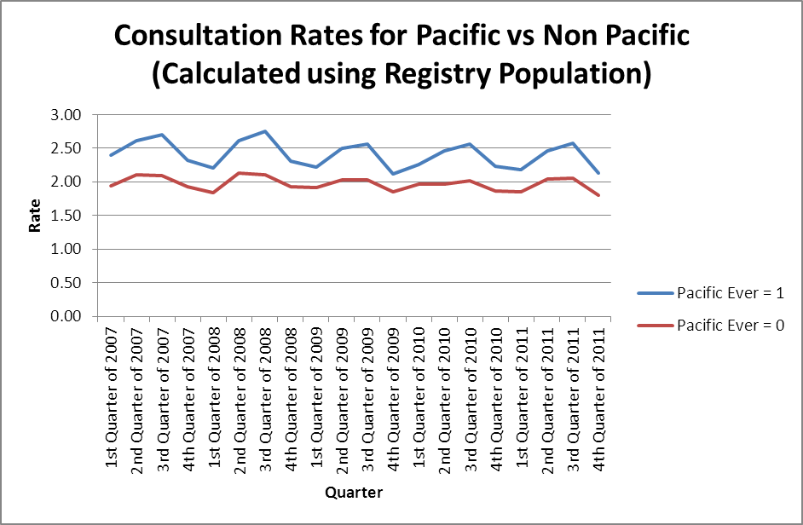
The consultation for Pacific ethnicities, derived from PHO data on a total-response count is shown in the figure below. The rates appear to vary be Pacific ethnicity, with Niuean having a higher rate over much of this time. The data have not been adjusted for age.
Figure 23. Consultation rates for Pacific ethnicities
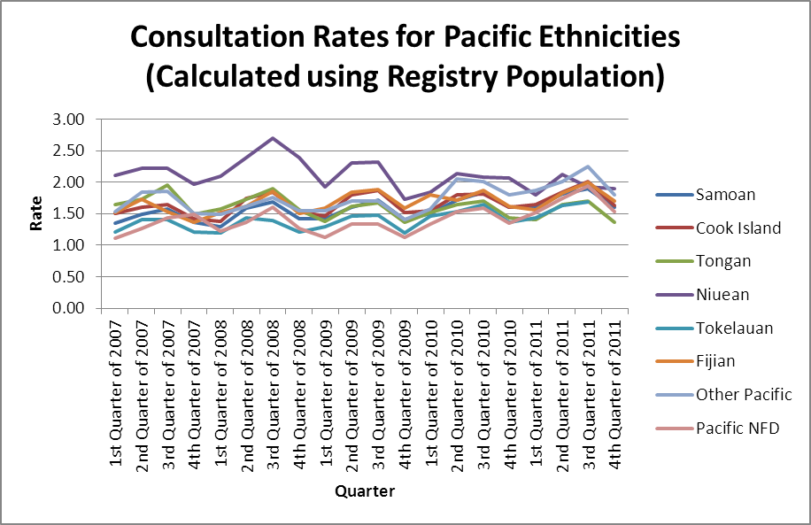

Summary
Our findings and recommendations are based on our literature review, and both Pacific and health service perspectives, drawn from both qualitative and quantitative data. Pacific consumer views were gathered from thirty six focus groups (involving nearly three hundred Pacific people), held in Auckland, Hamilton, Wellington and Christchurch. Eight groups were held in English; the remaining twenty eight were held in Samoan, Tongan, Cook Islands Maori, Niuean, Tuvaluan, Kiribati or Tokelauan. Health service perspectives were gathered from fifty interviews, twenty one with Pacific and twenty nine with non-Pacific health workers. Their roles included frontline primary care, and management, and policy at provider organisations, PHOs, DHBs and the Ministry of Health. Quantitative data were analysed from national data collections, covering the whole country, and DHBs, PHOs and primary care practices covering more than two thirds of all the Pacific people in the country.
We note some convergence between the views of consumers and health workers on the shortfalls of health services and the solutions required for Pacific peoples. We believe such convergence reflects a valuable contribution by the increased number of Pacific people in the health workforce.
Our qualitative and quantitative data support our findings from the literature, while adding strength and richness. The research process was conducted within a Pacific framework of relationships and reciprocity in which we have committed to return our findings to the Pacific community and continue to advocate for their needs. We have presented some important characteristics of Pacific world views which underpin their decisions about when to use health services, which services to use and how to judge the acceptability and effectiveness of these services. In particular, Pacific people view health as functional well-being, in a holistic sense, and illness as an interruption to such function. Health services are for fixing illness, not for maintaining function or even preventing illness. A key finding was that it is not lack of knowledge which leads to unhealthy lifestyles, or delayed or non-attendance for treatment, but the lack of economic resources, system barriers and people making the best of difficult circumstances.
We also note that health services staff showed widespread recognition of both the importance of addressing health issues for Pacific people and the practical difficulties that staff face working in the current systems of health funding and the models of care. There are also many examples of excellent and effective practice. There is clearly some good policy in place such as capitation funding for primary care, but the picture which emerges is that of mixed messages in policy and funding, incomplete implementation and management to existing policy through DHBs, PHOs and practices, and some providers innovating or providing flexible health services despite or over-and-above existing policy and funding. A key finding is that absence of knowledge both at the community level and at the frontline is not the problem.
System change will require managing to equity policies at Ministry, DHB, PHO and practice level. Effective management relies on data to measure current state against intended state. A key finding from our research is a paucity of relevant data; limited energy and willingness to collaborate across provider boundaries in the interest of system improvement; and a failure of the system as a whole to enable, support and require this.

References
Betancourt, J.R., Green, A.R., Carrillo, J.E., Ananeh-Firempong II, O. (2003) Defining cultural competence: a practical framework for addressing racial/ethnic disparities in health and health care. Public Health Reports 118(4): 293-302.
Campbell, S.M., Roland, M.O., Buetow, S.A. (2000) Defining quality of care. Social Science & Medicine 51(11): 1611-25.
Fontana, A., Frey, J.H. (2005). The Interview: From Neutral Stance to Political Involvement. In N. K. Denzin & Y.S Lincoln (Eds.), The Sage Handbook of Qualitative Research (3rd ed., pp 695 – 728). Thousands Oaks: Sage
Halapua, S. (2002) Talanoa Process: The Case of Fiji. East-West Centre, Honolulu Hawaii.
Kenealy T., Carswell P., Clinton J., Mahony, F. (2007) Report of the evaluation of Chronic Care Management in Counties Manukau: Phase One. Auckland: Uniservices, University of Auckland.
Masoe, P., So'o, I. (2011) The Talatalaga A Aiga Model. Interviewed by G.Clifford-Lidstone, Tory Street Wellington 30 June 2011.
National Primary Care Research and Development Centre. (2005) Care outside hospitals: a discussion paper in the role of primary care within the NHS. Manchester: National Primary Care Research and Development Centre.
Nutbeam, D. (2008) The Evolving Concept of Health Literacy. Social Science and Medicine 67(12): 2072-2078.
Pacific Perspectives (2011) Primary Care for Pacific People: A Pacific and Health Systems View. Wellington: Pacific Perspectives.
Prescott S.M., Hooper, K. (2007). Incorporating the tradition of ‘talanoa’ in Pacific accounting research. Auckland University of Technology.
Sandelowski, M. (2000) Whatever Happened to Qualitative Description? Research in Nursing & Health 23: 334-40.
Sandelowski, M. (2010) What's in a name? Qualitative description revisited. Research in Nursing & Health 33(1): 77-84.
Sheridan NF, Kenealy TW, Connolly MJ, Mahony F, Barber PA, Boyd MA, et al. Health equity in the New Zealand health care system: a national survey. International Journal for Equity in Health. 2011; 10.)
Spradley, J.P. (1979) The Ethnographic Interview. Fort Worth Texas: Harcourt Brace Jovanovich.
Starfield, B. (1998) Primary care: balancing health needs, services and technology. New York: Oxford University Press.
Starfield B. (2011) The hidden inequity in health care. International Journal for Equity in Health. 2011; 10: 15+
Ryan, D., Beckford, N., & Fitzsimons, M. (unpublished, 2010) Lalaga: Pacific providers making a difference. Wellington: Ministry of Health
Tamasese, T. (November, 2009) Speech presented at the New Zealand Families Commission Pasifika Families Fono, Telstra Clear Pacific Events Centre, Manukau City, New Zealand.
Vaioleti, T. (2006) Talanoa Research Methodology: A developing position on Pacific research. Waikato Journal of Education 12: 21-34.
Walley, J., Lawn, J.E., Tinker, A., de Francisco, A., Chopra, M., et al. (2008) Alma-Ata: Rebirth and Revision 8: Primary health care: making Alma-Ata a reality. Lancet 372(9642): 1001-07.

Appendix 1: Ethics approvals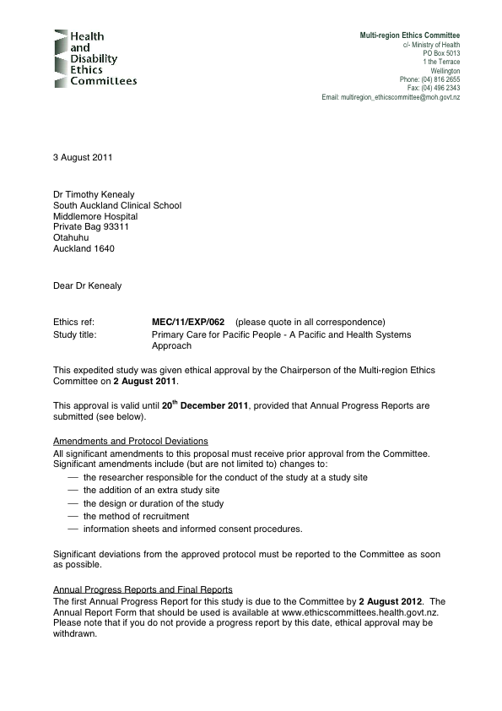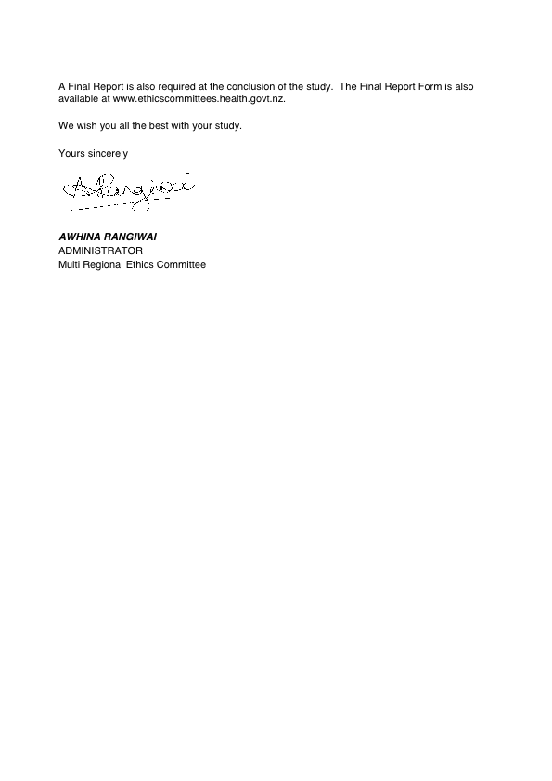

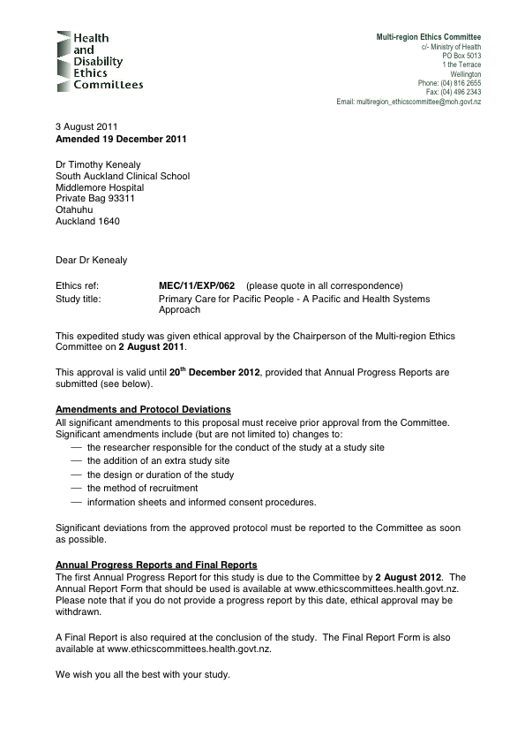



Appendix 2. Pacific View: Consumer focus group organisation and participants

 | Youth/NZ Born | Cook Island | Fijian | Niuean | Samoan | Tokelauan | Tongan | Tuvalu | Kiribati | Total  (n)
South Auckland |  | 27 October  1 group  (3 ) people |  | 27 October  1 group  (3) | 27 October  2 groups  (6 ) and (5) |  |  |  |  | 14
Auckland Central | 26 October  1 group  (16) | 26 October  1 group  (8) |  | 26 October  2 groups  (9) and (7) | 26 October  1 group  (7) |  | 26 October  1 group  (7) |  |  | 54
West Auckland |  | 27 October  1 group  (5) |  |  | 25 October  2 groups  (5) and (11) |  | 27 October  1 group  (11) | 25 October  1 group  (4) |  | 36
Hamilton combined groups from Tokoroa and Hamilton |  | 4 November 2 groups (10) and (10) |  |  |  |  |  |  |  | 20
Porirua (Whitireia) | 10 October  1 group  (8) | 10 October  2 groups  (8 ) and (7) |  |  | 10 October  1 group  (7) | 10 October  1 group(6) | 10 October  2 groups  (8) and (7) | 10 October  1 group  (10) | 10 October  1 group  (8) | 63
Wellington |  |  | 15 October  1 group  (13) |  |  |  | 15 October  2 groups  (6 ) and (8) |  |  | 27
Christchurch | 30 Sept  (25)  1 October  Tongan  (10) |  | 1 October  1 group  (29) |  | 30 September  1 group  (15) |  | 1 October  2 groups  (4) and (10) |  |  | 93
TOTAL | 49 | 51 | 42 | 16 | 51 | 6 | 61 | 14 | 8

Appendix 3. Research assistants involved in community focus groups
Name | Ethnicity | Occupation | Organisation | Focus Groups involved in
Lana Afu | Tongan | Community health worker | Pacific Trust Canterbury | Tongan, Christchurch
Karopaerangi Crawford | Cook Islands | Student | Waikato University | Cook Islands, youth group, Hamilton
Maliana Erick | Niuean | Clinical advisor | The Werry Centre for Child and Adolescent Mental Health, University of  Auckland | Niuean, Central and South Auckland
David Lui | Samoan | Manager | West Fono (Pacific provider) | Samoan, West Auckland
Leaupepe Anthony Fiu | Samoan | Health consultant | self-employed | Samoan, Whitireia Polytechnic
Hilda Faasalele | Samoan | General Manager Pacific | Auckland District Health Board | Samoan, Central Auckland
Karolina Lolohea | Tongan | Community support worker | Pacific Trust Canterbury | Tongan, Christchurch
Ratu Lolohea | Tongan | Teacher | Tongan Community Leader | Tongan, Christchurch
Alisa Logo | Kiribati | Nursing student | Whitireia Polytechnic | Kiribati, Whitireia Polytechnic
Tina McNicholas | Fijian | Health consultant | Self-employed | Fijian, Central Wellington
Maureen Moala | Fijian | Community mental health worker | Pacific Trust Canterbury | Fijian, Christchurch
Margaret Schutz | Tuvaluan | Nursing student | Whitireia Polytechnic | Tuvaluan, Whitireia Polytechnic
Edna Soli | Samoan | Community health worker | Pacific Trust Canterbury | Youth, Christchurch
Laine Stevens | Tuvaluan | Community health worker | Health West | Tuvaluan, West Auckland
Kitiona Tauira | Cook Islands | Community health worker | Pacific Health Service Porirua | Cook Islands, Whitireia Polytechnic
‘Ungatea Havea Tupou | Tongan | Lecturer in nursing | Whitireia Polytechnic | Tongan, Whitireia Polytechnic, central Wellington,  West, Central and South Auckland
Toleafoa Malu Tulia | Samoan | Community support worker | Pacific Trust Canterbury | Samoan, Christchurch
Helen Wong | Cook Islands | Health promoter | Counties Manukau DHB | Cooks Islands, West, Central and South Auckland  Hamilton

Appendix 4. Pacific View: Pacific interview protocol training sheet for research assistants
Pacific Primary Health Project
21 September 2011
Interview Protocols
Welcome and greet participants.
Begin session in a manner culturally appropriate for the group.
Handout Project Information Sheets for Participants.
- Go through the information with participants.
Key points to cover
- Who is involved (that is who is the research team – note our contact details)
- What the research is all about.
- What we asking people to do and why.
- What will happen with the information

- Go through the Consent Process
Key points to cover
- Consent must be an informed decision
- Participants can withdraw at anytime
- Participants information will be anonymous and confidential
- If participants are happy to be contacted by the research team can they add their name and contact details on the consent form.
Give people time to read and fill out the form.
Collect all consent forms before starting next step.

Start the story telling process
Use these questions as a guide rather than a questionnaire. Some groups may be slower than others to get going. Other groups you will have to make sure everyone has a chance to tell a story.
Don’t interrupt a compelling story; on the other hand don’t let one or two dominate the space.
- How well do you think the health care services take care of you and/or your family?

- Where do you go for this care usually?
- How well are you treated be the staff when you go?
- What stops you seeking help when you think you need it?
- Do you have examples of when you received really good care. What made the difference?
- How do you know when to seek help?
- How do you know where to go?

- Have you ever gone to the Doctor and then not done what they said you needed to do? Eg, they told you to lose weight and you didn’t. Or they gave you a prescription and you either did not pick it up or you didn’t take the medicine.

Try and tease out why people do what they say they do. What did they want the Doctor to say or do – why did they seek help in the first place and not follow the advice. - different expectations?
-Just looking for reassurance?
-Did not think the Doctor listened to them properly?
- How easy or hard is it for you to tell the doctor/nurse what is wrong with you?

- How well do you understand what they tell you?

- Do you sometimes get the feeling your Dr/Nurse doesn’t believe you, doesn’t believe your story?

- What things make you sick/unwell. How do you try to stop this happening?

- What is the difference between being unwell and being healthy?

- Do you use traditional healing – what/when/why?

- Are there ways your family have for dealing with sickness? – what/when/why?

- Why do you think Pacific people are so sick in this country?

Finish the session by thanking everyone for their stories.
If you are taping the session-
    - Check the batteries, tapes before you start
    - Keep an eye on the tape – be ready to change tapes
    - Label the tape – Date/ number 1,2, 3 etc/ Venue /Group
If you are taking notes –
- Number the pages
- Date/ venue/ group each page.

Appendix 5. Pacific View: Pacific interview information sheet and consent form for participants, with translations

Primary Care for Pacific People: A Pacific and Health Systems Approach

Information Sheet for Community Focus Groups

Information about this project:
Over the past fifteen years, a lot of effort and resources have gone into providing Primary Health Care for Pacific people, but despite this, National Health statistics show that there has been little or no improvement in the overall health of Pacific people. This project has been designed to explore the question – why?

The project has three major parts.

One part is to look at the information that is currently collected at National, DHB and PHO levels to see the patterns of use Pacific people make of current services and to understand from a provider point of view what works well and what might be causing barriers to improved health outcomes for Pacific peoples.

A second part of the project is being set up to explore Pacific peoples’ experiences of accessing health care – what works and how things could be improved from a Pacific point of view. This part of the project will involve individual interviews and focus group discussions with Pacific people. A key question we want to explore with Pacific people is whether the health care system is able to respond appropriately to how Pacific people themselves think of health and what they expect a health care system can provide. We want to hear Pacific peoples’ stories.

A third important part of the project is to take both sets of stories – that is, from the health providers on one hand and from Pacific peoples on the other, and see if we can identify both the strengths but also, identify how a better understanding of both points of view may result in being able to provide health care services that really make a difference.

The ultimate goal of this project is to improve the effectiveness of Primary Health Care services for Pacific peoples in order for them to achieve their maximum health and well being.

What would be expected of you if you chose to participate in this project?

You can choose to participate in an individual interview or to be part of a focus group or to be a part of both. An individual interview could be 2 – 3 hours long and a focus group 3 – 4 hours long to make sure everyone has an opportunity to have their say.

The individual interviews will be conducted by Pacific researchers who self identify with the ethnicity of the participants. This is to ensure that participants can tell their stories in their own language or in English or as often happens, a combination of both. The same would apply with the focus group sessions. These conversations will be held in places/ spaces that are accessible and at times that are convenient for the participants.

Budget constraints have meant that interviews can only be undertaken in Auckland, Wellington, Christchurch and Gisborne.

Participant Recruitment

Consultation meetings will be held in Auckland, Wellington, Christchurch and Gisborne to inform specific Pacific ethnic communities about the project. Invitations and details about date/time and venue will communicated through Community radio and newspaper notices.

From these sessions we will be asking for people who would like to participate in the small focus group sessions to contact us. We will be aiming to set up the following groups to undertake Part 2 of this project:

Auckland: 2 Samoan Groups
1 Tongan Group
1 Mixed Pacific Group (Open to any person who self identifies as Pacific)

Wellington: 1 Samoan Group
1 Cook Islands Group
1 Mixed Group (Open to any person who self identifies as Pacific)
Christchurch: 1 Samoan Group
1 Tongan Group

Gisborne/Napier: 1 Tongan Group
1 Samoan group
1 Cook Islands group

People who wish to be interviewed individually can indicate their preference on the consent form. You will be contacted by the researcher to set up a time and date that is convenient for you.

Who is in the research team?

The overall Project is under the Management Leadership of Dr Debbie Ryan (Samoan) of Pacific Perspectives Limited.
Her contact details are:
email:pacificperspectives@clear.net.nz. Phone: 049731020. Mobile: 021415828.

The Co-Primary Investigators are:
Dr Margaret Southwick (Tuvalu/Pakeha), Dean of Faculty. Whitireia Community Polytechnic. Private Bag 50910 Porirua.
Contact details:
email Margaret.Southwick@whitireia.ac.nz. Phone: DDI 04 2386234.

Assoc. Professor Dr Timothy Kenealy. (NZ European). School of Population Health. University of Auckland.
Contact Details:
Email: t.kenealy@auckland.ac.nz. Phone: 09 2760044 ext 8415. Mobile 0274 905 914.

The Pacific Expert Advisory group members are

Lita Foliaki (Tongan).
Contact details: email: Lita.Foliaki@waitematadhb.govt.nz.

Fuimaono Karl Pulotu-Endemann (Samoan).
Contact details:
Email: Fonofale@xtra.co.nz

Jean Mitaera. (Cook Islands).
Contact details:
Email: Jean.Mitaera@whitireia.ac.nz. Phone: 04 2373103.

Please feel free to contact us at any time if you have questions about the project or wish to discuss any aspects of it.
This project is co-funded by the Health Research Council of New Zealand and the Ministry of Health.

SAMOAN TRANSLATION

Uluai Siaki ma Togafitiga mo le Soifua Maloloina o Tagata Pasefika:
O se Alafua mo le galulue faatasi o Tagata Pasefika ma Auaunaga Faasoifua maloloina.

Faamatalaga o le Suesuega.

I le 15 tausaga ua mavae, sa tele taumafaiga ma alaga’oa a le matagaluega na faaalu aua siaki ma togafitiga o le soifua maloloina o tatou tagata Pasefika. E ui i lenei taumafaiga, peitai, e tusa ai ma faamaumauga a le matagaluega, o loo tumau pea le maualalo ma le faaletonu o le soifua manuia o tatou tagata. Ua ae ai nei se tofa ina ia faia se suesuega sei saili pe “Aisea” ua mafua ai lea tulaga.

E tolu ni vaega autu o lenei Suesuega.

Vaega muamua, o le vaavaai lea i faamatalaga ma faamaumauga o loo aoina e le Matagaluega o le Soifua Maloloina i ona ofisa tutotonu(National), faaitumalo (DDHB), aemaise ofisa tumaoti (PHO) o loo avea ma paaga. O nei faamaumauga ma faamatalaga o le a maua ai se ata manino i le tulaga i le asiasi ma faaoga e tagata Pasefika o falemai tutotonu ma isi auaunaga faalesoifua maloloina. O le a mafai foi na maua se malamalamaaga mai le matagaluega ma ana auaunaga pe aisea e faigata ai ona agai atu o tatou tagata ma faaoga mo siaki ma togafitiga. E le gata i lea a ia malamalama le matagaluega i ni auala e faaleleia ai le auaunaga.

Vaega lona lua, o le aoina mai lea o faamatalaga mai i o tatou tagata Pasefika e tusa ai foi ma lo latou asiasi atu i nei auaunaga, poo a ni itu lelei ao a foi ni faafitauli o feagai ma i latou ae pe faapefea ona faaleleia atili lea tulaga. O le a faia ni faatalatalanoaga taitoatasi poo ni vaega foi mo le soalaupuleina o lenei mataupu. O le auga poo mafai ona faamalieina manaoga o tagata Pasefika i auaunaga a le Soifua Maloloina ae faapefea foi ona faatinoina nei auaunaga i ni auala talafeagai ma manaoga o tatou tagata. E moomia lava faamatalaga e uiga i lagona ma manatu o tatou tagata Pasefika.

Ma le vaega lona tolu, o le tuufaatasia lea o faamatalaga mai le Matagaluega ma ana auaunaga ma faamatalaga mai o tatou tagata Pasefika. E fia iloaina ni tulaga lelei e laugatasia ai itu e lua ao a foi ni tulaga e faitau eseese ai, ina ia mautinoa ia faamalieina tagata Pasefika faapea foi le matagaluega pe a sao le faatinoina o ana auaunaga.

O a mea moomia pe afai o le a e filifili e te auai i lenei suesuega.

E te filifili lava e oe poo a faatalatalanoaga e te fia auai ai pe taitoatasi pe talanoa toatele poo le auai uma i vaega e lua. O faatalatalanoaga taitoatasi e 2-3 itula ao le faatalatalanoaga toatele e tusa ma le 3-4 itula le umi. E moomia le tofu avanoa uma o tagata auai e faaali o latou finagalo.

O faatalatalanoaga uma o le a faatautaia i lau lava gagana e ou lava tagata nuu o loo faatinoina le suesuega. O le a faia foi i ni nofoaga ma taimi talafeagai ma faigofie ona auai o tatou tagata.

Talu ai le utiuti o le tulaga tautupe ua filifilia ai na o Auckland, Wellington, Christchurch ma Gisbourne mo lenei suesuega.

O le faamoemoe autu lava o lenei suesuega, ia lelei atoatoa le faatinoga o nei auaunaga mo siaki ma togafitiga aua le soifua manuia ma le maloloina o tatou tagata.

Filifiliaina o tagata e auai mouesuega.

O le a faia ni fonotaga i Auckland, Wellington, Christchurch ma Gisbourne e faailoa ai i tagata Pasefika lenei suesuega. O le a tufaina tusi valaau e faailoa ai aso ma taimi. Nofoaga e faatino ai o le a faalauiloa i nusipepa ma leitio.

O le a faamanino ai foi tagata Pasefika e fia auai i le faatalatalanoaga ma faailoa iai e mafai ona latou toe auai i le vaega lona lua o lenei suesuega.

Auckland:
2 Vaega o tagata Samoa
1 Vaega o tagata Fiti
1 Vaega o tagata fefiloi(Tagata pito Pasefika ma isi atunuu)

Wellington:
1 Vaega o tagata Samoa
1 Vaega o tagata Cook Island
1 Vaega o tagata fefiloi(Tagata pito Pasefika ma isi atunuu)
Christchurch:
1 Vaega tagata Samoa
1 Vaega tagata Tonga

Gisborne/Napier:
1 Vaega tagata Tonga
1 Vaega tagata Samoa
1 Vaega o tagata Cook Islands

Mo i latou uma e fia auai i faatalatalanoaga taitoatasi e moomia lou faatumuina ma sainia se pepa e faailoa mai ai lau faatagana. O le a fesootai atu se tagata tralafeagai ma oe mo sau faatalatalanoaga i se aso ma se taimi e talafeagi ma oe.

O suafa o lo o i lalo o latou ia o lo o faauluulu i ai lenei suesuega

The overall Project is under the Management Leadership of Dr Debbie Ryan (Samoan) of Pacific Perspectives Limited.
Her contact details are:
email:pacificperspectives@clear.net.nz. Phone: 049731020. Mobile: 021415828.

The Co-Primary Investigators are:
Dr Margaret Southwick (Tuvalu/Pakeha), Dean of Faculty. Whitireia Community Polytechnic. Private Bag 50910 Porirua.
Contact details:
email Margaret.Southwick@whitireia.ac.nz. Phone: DDI 04 2386234.

Assoc. Professor Dr Timothy Kenealy. (NZ European). School of Population Health. University of Auckland.
Contact Details:
Email: t.kenealy@auckland.ac.nz. Phone: 09 2760044 ext 8415. Mobile 0274 905 914.

The Pacific Expert Advisory group are:

Lita Foliaka (Tongan).
Contact details: email: Lita.Foliaki@waitematadhb.govt.nz.

Fuimaono Karl Pulotu-Endemann (Samoan).
Contact details:
Email: Fonofale@xtra.co.nz

Jean Mitaera. (Cook Islands).
Contact details:
Email: Jean.Mitaera@whitireia.ac.nz. Phone: 04 2373103.

Faamolemole faafesootai mai i soo se taimi mo ni fesili po nisi mataupu e uiga i lenei suesuega.

O lenei suesuega o lo o faatupeina e le Vaega Suesue o le Soifua Manuia ma le Matagaluega o le Soifua Maloloina a Niu Sila.

Title of the study: Primary Care for Pacific Peoples: A Pacific and Health Systems approach.

Participant Consent Form for Pacific Focus Groups
(This consent form will be held for a period of five (5) years)

Please circle the box at the end of each statement that best describes your understanding.

I have read the Information Sheet explaining this project and have had the opportunity to have my questions about the project explained to me. My questions have been answered to my satisfaction and I know I can ask for more information at any time.
yes
No

I agree to participate in a community focus group and understand that this will involve a meeting of 3-4 hours. I understand that I am free to withdraw from the focus group at any time.
yes
No

I understand that focus group sessions may be recorded for the purpose of gathering information for the research and these records will be held by the researchers for 10 years.
yes
No

I understand that because of the nature of focus groups, my anonymity can not be assured by the researchers – but that confidentiality of the information shared will be retained within the group.
yes
No

I understand that I may choose to ask for an individual interview with the researcher. I also understand that in this case, my identity or any identifying features of the information will be removed by the researcher to maintain anonymity and confidentiality.
yes
No

Signature:_______________________________ Date:_______________

Full Name:_______________________________________
Please Print

SAMOAN TRANSLATION

Ulutala o le suesuega
Primary Care for Pacific Peoples: A Pacific and Health Systems approach.

O le pepa lenei mo i latou ua taliaina le auai ma faamatuu mai faamatalaga mo lenei suesuega.
(O le a teuina lenei pepa mo se vaitaimi e sefulu (10) tausaga)

Faamolemole lio le pusa o lo o i autafa e faamatala mai ai lou malamalama lelei pe leai i lea faamatalaga.

Sa ou faitauina le pepa o faamatalaga, o lo o faamatala mai ai lenei suesuega, sa i ai le avanoa na ou fesili ai e uiga i lenei suesuega. Sa faamalieina au i tali o au fesili, ua ou iloa foi e mafai ona ou toe fesili mo nisi faamatalaga i soo se taimi.
Ioe
leaio

Ua ou malie ma taliaina lou auai i totonu o lenei vaega, ua ou malamalama foi e i ai se fonotaga pe a ma le 3-4 itula le umi e tatau ona ou auai. O lo o i ai le saolotoga e mafai ona ou faamaamulu mai ai i soo se taimi mai lea vaega pe a ou manao ai.
Ioe
leaio

Ua ou malamalama o faatalatalanoaga a lenei suesuega e faaono
Ioe
pueina mo le faamoemoe e tuufaatasia nei faamatalaga mo
suesuega. O le a tuufaatasia ma teu e i latou o loo faauluulu i le
leaio
lenei faamoemoe, seia oo ina maea ma faia le latou ripoti faaiu.

Ua ou malamalama, talu ai ona o le tulaga o lenei suesuega i
Ioe
faatalatalanoaga, e le mafai ai i e o taitai ona taofiofi malu
i le faailoa atu o lou tagata i isi, ae mo le malu puipuia o
leaio
faamatalaga ma talatalanoaga e faasoa, e nao totonu lava o
lenei vaega.

Ua faailoa mai ma ou malamalama e ono filifilia au e se o taitai
Ioe
o lenei faamoemoe mo se faatalatalanoaga taitoatasi. Ua ou
malamalama foi o nei faatalatalanoaga o le a le mafai lea ona
leaio
faailoa atu i soo se isi ma o le a malu puipuia le faailoa atu o
lou tagata.

Saini:_______________________________
Aso:_______________

Igoa Atoa:_______________________________________
Faamolemole lolomi
TONGAN TRANSLATION
Kaveinga ‘o e Fakatotolo ni:

Founga honoTokanga’I moTauhi e Mo’ui ‘a e Kakai Pasifiki.

Foomu Fakangofua Ke ke Kau ki he Fakatotolo
(Koe foomu ko ‘eni ‘e tauhi ia ‘i he ta’u ‘e nima)

Kataki ‘o siakale’i ‘a e puha e taha ‘i he tafa’aki to’omata’u ‘oku ke pehe ko ho’o tali ia.
Oku ou ‘osi lau ‘a e fakamatala ‘i he tohi ni ‘o fekau‘aki mo e ngaue koeni. Na’e ‘osi fakamatala’i ‘a engaahi fehu’i koia kiate au. ‘Oku ou fiemalie ki he ngaahi tali ‘o ‘eku fehu’i pea ‘oku ou mahino’i teu lava ‘o kole ha toe fakamatala ‘i ha fa’ahinga taimi pe. | ‘Io  ‘Io | ‘Ikai
Oku ou loto lelei mo tau’ataina keu kau ‘i he kulupu ko ‘eni, pea ‘oku mahino kiate au ‘e fai ‘a e fakataha houa ‘e 3 ki he 4 ‘o fekau’aki mo e fakatotolo ni. ‘Oku mahino kiate au teu lava lelei ‘o nofo pe fakafisi mei he kulupu ni ‘i ha fa’ahinga taimi pe. | ‘Io | ‘Ikai
Oku ou loto lelei ke hiki ‘a e ngaahi faka’eke’eke ‘oku ou kau kiai, pea ‘oku mahino kiate au he’ikai toe ngaue’aki ‘a engaahi faka’eke’eke ko eni kiha to e ngaue kehe; pea ko e ngaahi lekooti ‘o e ngaahi faka’eke’eke ‘e tauhi ia he’ekau fakatotolo kae‘oua kuo ‘osi maau ‘a e lipooti faka’osi. | ‘Io | ‘Ikai
‘Oku mahino kiate au ko e natula ‘o e ngaue ko eni ‘oku faingata’a ki he kau fakatotolo kenau tauhi hoku hingoa ke malu. Ka ko e ngaahi fakamatala pe faka’eke’eke fekau’aki mo au, ‘e tauhi pe ia ‘i loto ‘i he kulupu. | ‘Io | Ikai
‘Oku ou loto tau’ataina keu kau ki ha faka’eke’eke taau taha mo e toko taha fakatotolo. ‘Oku mahino kiate au ko ha fa’ahinga fakamatala ‘e lava ke ‘ilo’i ai au pe ko hoku hingoa, e to’o ‘ia he’e tokotaha faifakatotolo ke malu’i au. | ‘Io | ‘Ikai

Fakamo’oni:__________________________________________________________ ‘Aho:___________________

Hingoa Kakato:___________________________________________
(Kataki ‘o Tohi Fakamata’itohi)

Appendix 6. Health Services View: People interviewed

Name | Organisation | Role | Interview category | Ethnicity
Adrienne Bell | ADHB | Midwife | Frontline, mainstream
Ady Priday | Independent midwife | Midwife | Frontline, mainstream
Ann Hutching | General Practice | Practice Nurse | Frontline, mainstream
Api Talemaitoga | Ministry of Health | Clinical Director Pacific Health | Policy, mainstream | Fijian
Caran Barratt Boyes | CMDHB | Team leader Diabetes team | Management, mainstream | Maori
Christina Ualika | ADHB's HVAZ | Parish Nurse | Frontline, mainstream | Samoan
Corina Malopito | ADHB | Team Leader - Patient Administration | Management, mainstream | Samoan
Daksha Mistry | General Practice | Practice Nurse | Frontline, mainstream
Dorothy Kennach | Well Health | Health Promoter | Frontline, Pacific provider
Elena Asekona | Westfono | Receptionist | Frontline, Pacific provider | Niuean
Elham Hajje | CMDHB | Diabetes Nurse Specialist | Frontline, mainstream
Emma Mold | Ministry of Health | Nurse advisor | Frontline, mainstream
Genevieve Togiaso | Pacific Trust Canterbury | Service Manager Primary Health team | Management, Pacific provider | Samoan
Glennis Mafi | Langimalie | GP | Frontline, Pacific provider | Tongan
Hilda Fa'asalele | ADHB | GM Pacific | Policy, mainstream | Samoan
Irene Burke | Lynwood Medical Centre | Practice manager | Management, mainstream
Jane Cartwright | Partnership Health | CEO | Management, mainstream
Jane O'Malley | Ministry of Health | Chief nurse | Policy, mainstream
Jill Gilmore | Lynwood Medical centre | Receptionist | Frontline, mainstream
Jim Primrose | Ministry of Health | Primary Care Advisor | Policy, mainstream
John Dunlop | Well Health | Specialist community pharmacist | Frontline, mainstream
John Kennelly | Westfono | GP | Frontline, Pacific provider
Julia Carr | Te Puni Kokiri | Senior Policy Analyst | Policy, mainstream
Justine Thorpe | Well Health | CEO | Management, mainstream
Kara Okesene-Gafa * | CMDHB | Obstetrician | Frontline, mainstream
Karen Gilchrist | Lynwood Medical centre | Practice Nurse | Frontline, mainstream
Karen Upton | ADHB | Charge Midwife | Management, mainstream
Karla Magan | General Practice | GP | Frontline, mainstream
Liana Williams | General Practice | Practice Nurse | Frontline, mainstream
Lu'isa Fonua | Langimalie | GP | Frontline, Pacific provider | Tongan
Lynley Cook | Pegasus | Population Health Specialist | Management, mainstream
Mafi Funaki-Tahifote | Pacific Heartbeat | Dietician | Frontline, Pacific provider | Tongan
Margaret Donald | Well Health | Mental Health counsellor | Frontline, mainstream
Margie Apa | Ministry of Health | DDG Directorate with Pacific Policy | Policy, mainstream | Samoan
Maria Pasene | Pegasus | Pacific Manager | Management, mainstream | Niuean/ Samoan
Marie Burke | Lynwood Medical centre | GP | Frontline, Pacific provider
Marlene Brooks | Westfono | Practice manager | Management, Pacific provider
Miriama Tolo | Well Health | Mental Health counsellor | Frontline, mainstream | Pacific
Paul Lavulo | Tongan Health Society | CEO | Management, Pacific provider | Tongan
Pula Fatupaito | ADHB's HVAZ | SME expert nurse | Frontline, mainstream | Samoan
Sandy Speedy | DHB Renal | Specialist Nurse | Frontline, mainstream
Soana 'Ali | Langimalie | Receptionist | Frontline, Pacific provider | Tongan
Stephen Lavery | Pegasus | Health Services Manager | Management, mainstream
Sulita Smith | Westfono | Chronic disease nurse | Frontline, Pacific provider | Samoan
Tagaloa Taima Fagaloa | CCDHB | Director, Pacific Health Directorate | Policy, mainstream | Samoan
Tevita Funaki | Westfono | CEO | Management, Pacific provider | Tongan
Toakase Latis | Langimalie | Practice Nurse | Frontline, Pacific provider | Tongan
Vaiola Ha'unga | ADHB's HVAZ | Parish Nurse | Frontline | Tongan
ViaMoana Manukia | Westfono | Outreach nurse | Frontline, Pacific provider | Tongan
Viliami Toafa | Tongan Health Society | Practice manager | Management, Pacific provider | Tongan
* emailed response

Appendix 7. Health Services View: Interview guides

Guide for interviews with Health System Experts - Operational / management / policy / funding and planning
Thank participant and introduce yourself
Check that information on the evaluation has been received and understood
Check that consent has been given and that the participant is aware they can withdraw or not
Answer questions if they wish
Ask if there are any questions before starting the recorder and the interview

1. Background
a. What trends are you noticing in utilisation of primary care by Pacific people?
b. Do you notice any sub-group differences?
c. How coordinated is the care this group of people receives?

2. How is your organisation working to improve access to primary health care for Pacific peoples?
a. What do you take into consideration when planning services?
b. What future plans?
c. How responsive are Pacific clients to the offered services?

3. What measures are you using to judge the effectiveness of primary care services for Pacific? a. How effective have these approaches been in practice?
b. Why do you think particular strategies succeed?
c. Why do you think other strategies encountered problems?

4. Are there any gaps in current service provision?
a. What improvements are needed now?

5. Do you have any interactions with Pacific health providers or Pacific community services?
a. Comment on experiences in working with Pacific providers/services

6. Do you know of any unpublished data/ reports that can be accessed to add to the overall completeness of data for this project?

7. Any other comments

Interview guide. Service delivery / front line staff
Thank participant and introduce yourself
Check that information on the evaluation has been received and understood
Check that consent has been given and that the participant is aware they can withdraw or not
Answer questions if they wish
Ask if there are any questions before starting the recorder and the interview

1. Please tell me briefly who you are, what your role is and how long you have been doing this role?

2. Please briefly describe the Pacific population who attend your clinic /service in terms of age, gender, what they come for and their Pacific ethnic group?
Probe:
• How does this differ from other ethnic groups?
• Who are they likely to interact with during their time at the clinic / service?
• Does your practice include non-clinical support staff (e.g.) community health workers? Please describe roles?
• Are any of the health professionals or support staff Pacific?
• What is the usual process by which people make an appointment / attend the clinic / service?

3. Are there any problems your clinic / service have in dealing with Pacific peoples? Do these differ from other ethnic groups?
Probe:
• DNAs
• Language
• Health literacy
• Acute vs preventative
• Cost / Outstanding bills (primary care)
• Bringing additional people into the consultation
• Other...
• Can you give some examples?

Probe:
What have you done about any of these problems or what do you think might work?
• Interpreters
• Ambience
• Spirituality
• Opening hours
• Transportation
• Community venue
• Do you have any processes to aid follow-up?
• What have you tried that you no longer use? (Why?)

4. Are there any problems you think Pacific peoples have in dealing with your clinic / service? Do these differ from other ethnic groups?
Probe:
• DNAs
• Language
• Health literacy
• Acute vs preventative
• Cost / Outstanding bills (primary care)
• Bringing additional people into the consultation
• Requests for assistance with accessing benefits, appropriate health subsidies e.g. disability allowance, applications for housing etc.
• Other...
• Can you give some examples?

Probe:
What have you done about any of these problems or what do you think might work?
• Interpreters
• Ambience
• Spirituality
• Opening hours
• Transportation
• Community venue
• Do you have any processes to aid follow-up?
• What have you tried that you no longer use? (Why?)

5. What examples do you have of your Pacific patients/ clients bringing others to your clinic/ service?
Probe:
• Why do you think they brought, encouraged, referred these people to your service?

6. What processes does your service have for eliciting patient feedback and or complaints?
Probe
• What is the pattern for Pacific people?

7. Do other people or organisations in the health care system cause you difficulties in dealing with Pacific peoples? Please explain.

8. Please share an example of a successful interaction or process you are using with Pacific patients.

9. Is there anything else you think could help increase the engagement of Pacific people in their health care?

Appendix 8. Schematic of matching with minor variations

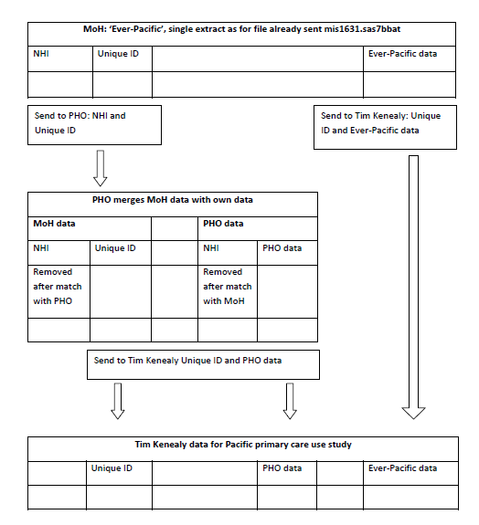

Appendix 9. ADHB appointment-making process
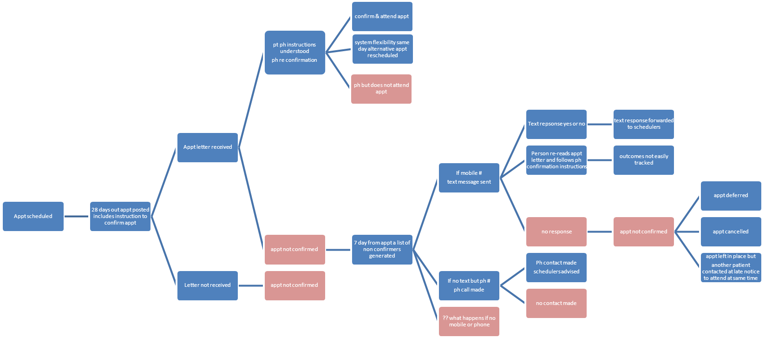

Appendix 10. Ethnicities from Master ever-Pacific file to which all other files were matched.

Ethnicity of people with one ethnic code
Ethnicity code | Description | Number | Percent
10 | European nfd | 1,102 | 0.18
11 | New Zealand European | 37,553 | 6.29
12 | Other European | 3,264 | 0.55
21 | Māori | 44,330 | 7.43
30 | Pacific Peoples nfd | 10,118 | 1.7
31 | Samoan | 207,183 | 34.71
32 | Cook Islands Maori | 61,386 | 10.28
33 | Tongan | 84,929 | 14.23
34 | Niuean | 19,661 | 3.29
35 | Tokelauan | 6,847 | 1.15
36 | Fijian | 35,959 | 6.02
37 | Other Pacific Peoples | 27,293 | 4.57
40 | Asian nfd | 672 | 0.11
41 | Southeast Asian | 946 | 0.16
42 | Chinese | 1,248 | 0.21
43 | Indian | 23,048 | 3.86
44 | Other Asian | 1,499 | 0.25
51 | Middle Eastern | 194 | 0.03
52 | Latin American | 136 | 0.02
53 | African | 274 | 0.05
54 |  | 14 | 0
61 | Other Ethnicity | 187 | 0.03
94 | Don't Know | 26 | 0
95 | Refused to Answer | 17 | 0
97 | Response Unidentifiable | 14,012 | 2.35
99 | Not Stated | 15,005 | 2.51
Total |  | 596,903 | 100

Ethnicity combinations of people with 2 ethnicities
 | IsPacificNFD | Samoan | Cook Island Maori | Tongan | Niuean | Tokelauan | Fijian | Other Pacific | Not Pacific
IsPacificNFD | 11985 | 511 | 155 | 169 | 71 | 50 | 52 | 133 | 0
Samoan |  | 227649 | 2858 | 3004 | 2273 | 1418 | 451 | 759 | 0
Cook Island Maori |  |  | 72011 | 1004 | 1247 | 164 | 126 | 394 | 0
Tongan |  |  |  | 92881 | 1084 | 189 | 278 | 227 | 0
Niuean |  |  |  |  | 25524 | 51 | 102 | 125 | 0
Tokelauan |  |  |  |  |  | 8638 | 51 | 93 | 0
Fijian |  |  |  |  |  |  | 41551 | 111 | 0
Other Pacific |  |  |  |  |  |  |  | 29563 | 0
Not Pacific |  |  |  |  |  |  |  |  | 103572

Ethnicity combinations of people with 3 ethnicities. For 1 read “Yes, this ethnicity applies”, for 0 read “No, this ethnicity does not apply”. Total number of individual people = 2037.
IsSamoan | IsCook Island Maori | IsTongan | IsNiuean | IsTokelauan | IsFijian | IsOther Pacific | IsPacific NFD | IsNot Pacific | Number of people
1 | 0 | 1 | 1 | 0 | 0 | 0 | 0 | 0 | 387
1 | 1 | 0 | 1 | 0 | 0 | 0 | 0 | 0 | 384
1 | 1 | 1 | 0 | 0 | 0 | 0 | 0 | 0 | 264
0 | 1 | 1 | 1 | 0 | 0 | 0 | 0 | 0 | 144
1 | 0 | 1 | 0 | 1 | 0 | 0 | 0 | 0 | 117
1 | 1 | 0 | 0 | 1 | 0 | 0 | 0 | 0 | 72
1 | 0 | 1 | 0 | 0 | 1 | 0 | 0 | 0 | 63
1 | 1 | 0 | 0 | 0 | 0 | 1 | 0 | 0 | 57
1 | 0 | 0 | 1 | 1 | 0 | 0 | 0 | 0 | 54
0 | 0 | 1 | 1 | 0 | 1 | 0 | 0 | 0 | 48
1 | 0 | 1 | 0 | 0 | 0 | 1 | 0 | 0 | 39
1 | 0 | 0 | 0 | 1 | 0 | 1 | 0 | 0 | 36
1 | 0 | 0 | 0 | 1 | 1 | 0 | 0 | 0 | 27
1 | 0 | 0 | 1 | 0 | 0 | 1 | 0 | 0 | 27
1 | 0 | 0 | 1 | 0 | 1 | 0 | 0 | 0 | 24
0 | 1 | 1 | 0 | 0 | 0 | 1 | 0 | 0 | 21
1 | 0 | 0 | 0 | 0 | 1 | 1 | 0 | 0 | 21
1 | 1 | 0 | 0 | 0 | 0 | 0 | 1 | 0 | 21
0 | 1 | 0 | 1 | 0 | 0 | 1 | 0 | 0 | 18
1 | 0 | 0 | 0 | 1 | 0 | 0 | 1 | 0 | 18
0 | 0 | 1 | 1 | 0 | 0 | 1 | 0 | 0 | 15
0 | 0 | 1 | 1 | 1 | 0 | 0 | 0 | 0 | 15
1 | 0 | 0 | 0 | 0 | 0 | 1 | 1 | 0 | 15
0 | 1 | 0 | 0 | 0 | 0 | 1 | 1 | 0 | 12
0 | 1 | 0 | 1 | 0 | 0 | 0 | 1 | 0 | 12
0 | 1 | 1 | 0 | 0 | 0 | 0 | 1 | 0 | 12
0 | 1 | 1 | 0 | 0 | 1 | 0 | 0 | 0 | 12
1 | 0 | 0 | 0 | 0 | 1 | 0 | 1 | 0 | 12
1 | 0 | 1 | 0 | 0 | 0 | 0 | 1 | 0 | 12
1 | 1 | 0 | 0 | 0 | 1 | 0 | 0 | 0 | 12
0 | 0 | 0 | 0 | 1 | 0 | 1 | 1 | 0 | 6
0 | 0 | 0 | 1 | 0 | 1 | 1 | 0 | 0 | 6
0 | 0 | 0 | 1 | 1 | 0 | 0 | 1 | 0 | 6
0 | 1 | 0 | 1 | 0 | 1 | 0 | 0 | 0 | 6
0 | 0 | 0 | 0 | 0 | 1 | 1 | 1 | 0 | 3
0 | 0 | 0 | 1 | 1 | 0 | 1 | 0 | 0 | 3
0 | 0 | 0 | 1 | 1 | 1 | 0 | 0 | 0 | 3
0 | 0 | 1 | 0 | 0 | 0 | 1 | 1 | 0 | 3
0 | 0 | 1 | 0 | 0 | 1 | 1 | 0 | 0 | 3
0 | 0 | 1 | 0 | 1 | 0 | 0 | 1 | 0 | 3
0 | 0 | 1 | 0 | 1 | 1 | 0 | 0 | 0 | 3
0 | 0 | 1 | 1 | 0 | 0 | 0 | 1 | 0 | 3
0 | 1 | 0 | 0 | 0 | 1 | 0 | 1 | 0 | 3
0 | 1 | 0 | 0 | 1 | 0 | 0 | 1 | 0 | 3
0 | 1 | 0 | 0 | 1 | 0 | 1 | 0 | 0 | 3
0 | 1 | 0 | 0 | 1 | 1 | 0 | 0 | 0 | 3
0 | 1 | 1 | 0 | 1 | 0 | 0 | 0 | 0 | 3
1 | 0 | 0 | 1 | 0 | 0 | 0 | 1 | 0 | 3
 |  |  |  |  |  |  |  | Total | 2037

Informal is defined as non-New Zealand resident and ineligible.
The reason for this change was that the young people could only attend in the morning as they wanted to watch the Manu Samoa Rugby World Cup Game scheduled later that day.
Research assistants were tasked with working with their communities to provide the catering for a meal at the end of each community meeting. The cost of this catering was set at $25 per head, and $500 was paid to each of the groups to manage the provision of food and tidy up after the sessions.
All participants received a koha of $20 cash, given in an envelope.
Estimated usual resident counts, from Statistics New Zealand. Years 2001, 2006 are official Census estimates; 2011 is an official estimate; intervening years are extrapolations.
. Years 2001, 2006 are official Census estimates; other years are extrapolations.

