Guidance for implementing high-quality multidisciplinary meetings
Achieving best practice
cancer care
Citation: Ministry of Health. 2012. Guidance for Implementing High-Quality Multidisciplinary Meetings: Achieving best practice cancer care.
Wellington: Ministry of Health.
Published in October 2012 by the
Ministry of Health
PO Box 5013, Wellington 6145, New Zealand
ISBN 978-0-478-39375-0 (online)
HP 5535
This document is available at www.health.govt.nz


 This work is licensed under the Creative Commons Attribution 4.0 International licence. In essence, you are free to: share ie, copy and redistribute the material in any medium or format; adapt ie, remix, transform and build upon the material. You must give appropriate credit, provide a link to the licence and indicate if changes were made.
Contents
Introduction 1
What is the purpose of this guidance? 1
Key definitions 2
Multidisciplinary meetings 2
Multidisciplinary team 2
Framework for high-quality MDMs 3
1 The team 4
2 Meeting organisation 5
3 Infrastructure for meetings 6
4 Data collection and monitoring 7
5 Patient-centred care 7
MDM checklist 9
Meeting arrangements 9
Equipment 9
Meeting purpose 10
Membership and attendance 10
Meeting organisation 11
Organisation 12
Communication 13
Meeting outputs 13
Toolkit for implementing high-quality MDMs 14
Example of MDM Terms of Reference 14
Example of MDM data form 18
Example of role description for an MDM coordinator 19
Example of an MDM patient information sheet 21

Introduction
International evidence shows that multidisciplinary care is a key part of providing best-practice treatment and care for patients with cancer. Multidisciplinary care involves a team approach to planning treatment and providing care for cancer patients as they move along the pathway of services they need.

Cancer multidisciplinary meetings (MDMs) are part of the philosophy of multidisciplinary care. Effective MDMs have positive outcomes for patients receiving the care and for the health professionals involved in providing the care and health services. Some of the benefits are that:
- treatment planning is improved because health professionals consider the full range of therapeutic options, which improves outcomes
- improved equality of outcomes for patients with cancer
- more patients are offered the opportunity to take part in relevant clinical trials
- there is greater continuity of care and less duplication of services
- services are better coordinated
- communication between care providers improves, as clear lines of responsibility are developed between members of the multidisciplinary meeting
- time and resources are used more efficiently.

What is the purpose of this guidance?
This guidance document provides a framework and toolkit to support district health boards (DHBs) in establishing and implementing high-quality MDMs.

It does not propose a ‘one size fits all’ approach to MDMs. Instead, it recognises the need for a structured approach in which MDMs match the mix of services and the nature of service delivery and access particular to each region in New Zealand.

DHBs are encouraged to consider solutions that include establishing regional MDMs across the tumour types. Smaller DHBs can then participate in the regional MDMs, whose broad selection of members will have sufficient time and expertise across the core disciplines involved. DHBs are encouraged to work with their regional cancer centre DHB and regional cancer network to determine which MDMs to hold locally, regionally and supra-regionally.

If MDMs are to be of high quality, DHBs need to recognise the participation of health professionals in MDMs as part of job sizing, position descriptions and position reviews.

This guidance document was developed with input from the four regional cancer networks. It will be reviewed annually.

Key definitions
The following are key terms used in this guidance document.

Multidisciplinary meetings
MDMs are deliberate, regular meetings either face-to-face or via videoconference at which health professionals with expertise in a range of different specialities discuss the options for patients’ treatment and care prospectively. Prospective treatment and care planning involves making recommendations in real time, with an initial focus on the patient’s primary treatment. MDMs facilitate a holistic approach to the treatment and care of the patient.

In some cases, the disease stage or symptoms make it necessary to begin treatment before a patient’s case is presented at an MDM. Instead, a multidisciplinary discussion for ongoing planning is held at the earliest possible time.

If treatment plans need to be reviewed, presentation at subsequent MDMs may be warranted.

Multidisciplinary team
A multidisciplinary team involves a range of health professionals, from one or more organisations, working together to deliver comprehensive patient care.

Framework for high-quality MDMs
High-quality, effective MDMs have the following characteristics. These characteristics also form the framework needed to implement high-quality MDMs.

1 The team
1.1 Meeting protocol
1.2 Clinical leadership
1.3 Membership
1.4 Attendance

2 Meeting organisation
2.1 Referral pathways
2.2 Case presentation
2.3 Meeting coordination and administration
2.4 Documenting meeting outcomes

3 Infrastructure for meetings
3.1 Physical meeting environment
3.2 Technological equipment

4 Data collection and monitoring
4.1 Data collection
4.2 Monitoring of meetings

5 Patient-centred care
5.1 Patient information
5.2 Communication

This section outlines each of these aspects in turn.

1 The team

1.1 Meeting protocols
Agreed Terms of Reference are established to govern the MDMs. The toolkit provides an example of MDM Terms of Reference.

Written protocols describe the organisation and content of the meeting.

1.2 Clinical leadership
The chair is appointed in line with the Terms of Reference for the MDMs. The chair ensures that:
- members adhere to the clinical protocols
- all issues relevant to each patient’s future management are presented and discussed
- all members participate in the meeting as appropriate to their speciality.

Other roles of the chair are to summarise the discussion and formulate an agreed recommendation. The recommendation is documented by the MDM coordinator during the meeting.

1.3 Membership
MDM members include:
- a radiologist
- a pathologist
- radiation and medical oncologists
- a general surgeon or physician
- a specialist surgeon, or other surgical representative (when appropriate)
- a palliative care clinician
- a nurse – for example, a clinical nurse specialist or cancer nurse
- one or more allied health or psychosocial professionals (as appropriate).

Radiologists and pathologists participating in MDMs are provided time as part of their job sizing and position description to prepare as necessary for an MDM.

The MDM coordinator is a core member of the MDM where there is a dedicated MDM coordinator role.

A patient’s general practitioner attends the MDM where their participation is agreed and provided for in the MDM Terms of Reference.

1.4 Attendance
Core members are present for the discussion of all cases where their input is needed. The chair decides whether there is adequate representation at a single meeting to make safe recommendations about any or all patients. The chair will decide on the necessary action if there is inadequate representation at a single meeting. A record of who attends each MDM is kept.

2 Meeting organisation

2.1 Referral pathways
Locally agreed referral pathways are established with clear information as to who can refer, how to refer and the timeframes within which referrals are expected (including locally agreed processes for late referrals). Locally agreed referral pathways are aligned with any nationally agreed referral pathways.

Each MDM has agreed criteria for the patients that should be discussed. If the MDM Terms of Reference allow for referring but not formally presenting some patients, there are clear criteria for such cases. These patients are still registered via the MDM process so that relevant data are captured.

Each MDM has agreed criteria for discussion of private patients.

Case presentation
Patients with cancer are presented at MDMs for prospective discussion and recommendations for treatment and care planning. No case is discussed in the absence of the lead clinician for that case or their delegate (who is briefed). The needs and views of patients are presented as part of the multidisciplinary discussion where practical.

The standard treatment protocols used will align with current evidence-based care and/or best practice. Supportive care and palliative care needs are also discussed.

MDM attendees confirm concordance between the clinical, imaging, and pathology information for each case.

2.3 Meeting coordination and administration
A single point of coordination for MDMs is recommended to support the clinicians participating in them. It improves communication, maintains MDM standards and ensures MDMs are timely. In larger metropolitan hospitals, an MDM coordination team may be required. The toolkit provides an example of a role description for an MDM coordinator. The MDM coordinator:
- receives referrals and ensures they are complete
- ensures all clinical information required is documented on the proforma and/or is available for discussion
- ensures prior radiology and pathology information is available
- prepares the clinical MDM agenda in advance and makes it available at the meeting
- records the outcomes of the MDM discussions and informs the treating clinician and/or the patient’s general practitioner
- enters the data set into the MDM database for clinical audit and reporting.

Where data collected locally also contribute to national data sets or reporting, they are aligned with the nationally mandated data definitions and codes.

2.4 Documenting meeting outcomes
The treatment recommendations agreed by the MDM participants are documented during the MDM and recorded in each patient’s electronic and/or hard copy medical record.

The meeting recommendations are not prescriptive. Each patient, in consultation with members of the treating team, will be involved in the final decisions about the treatment and care plan.

3 Infrastructure for meetings

3.1 Physical meeting environment
A regular meeting time is set, preferably in a dedicated room that is of an appropriate size and layout.

The room should be easy to access for all participants as significant travel is a deterrent to attending MDMs. Conferencing technology should be available for hosting or participating in regional and supra-regional MDMs.

3.2 Technological equipment
Audiovisual and videoconferencing equipment is available to help specialist MDMs be effective and efficient. Appropriate equipment includes:
- audiovisual equipment so that participants at tertiary centres can review pathology, radiology and proformas or other content adequately and simultaneously
- conferencing equipment so that clinicians can share pathology, radiology and other multimedia (such as proformas and clinical reports) with participants from other sites.

The standards for videoconferencing interoperability are met by all DHBs. DHBs ensure that the provider of their information systems and technology comply with the Connected Health Network Connectivity Standards (2010). DHBs are required to create routing that supports videoconferencing connections through the connected health network.

MDMs have access to a database or proformas so that recommendations can be documented in real time.

4 Data collection and monitoring

4.1 Data collection
Core data specific to tumour type are collected before and during the MDM. These data are used to monitor and audit patient pathways locally, regionally and nationally.

4.2 Monitoring of meetings
Data sets are consistently and routinely captured so that they can be used in clinical audit and pathway monitoring for ongoing quality improvement. This activity reflects the level of clinical involvement in MDM decision-making.

MDMs are reviewed annually for their effectiveness and performance.

5 Patient-centred care

5.1 Patient information
Patients are informed. Patients may be provided with written information about MDMs. The toolkit provides an example of a patient information sheet.

Patients are informed about the recommendations from the MDM. In consultation with members of the treating team, they make final decisions about their treatment and care plan.

Patients are routinely offered verbal and written information about all aspects of their treatment choices, including supportive care.

5.2 Communication
Processes are established to communicate outcomes in a timely way (eg, expected within one working day) to:
- the patient’s general practitioner
- clinical teams
- other referrers.

The confidentiality of information that identifies the patient is respected.

Processes are in place to communicate recommendations to patients, general practitioners and clinical teams within locally agreed timeframes. The lead clinical team member who will discuss the meeting’s recommendations with the patient is identified.

MDM checklist
This MDM checklist aligns with the characteristics of a high-quality MDM. It provides a framework for reviewing and auditing MDMs.

Meeting arrangements
Meeting title | What name is the meeting generally known by?
Venue | What is the usual venue for the meeting and what type of room is used (for example, seminar room)?
Room arrangements | What is the room layout; for example, lecture style with parallel seating, or seating around a table?
Time and duration | What time of day is the meeting held and how long does the meeting run?
Frequency | How often is the meeting held?
Parties involved | Which hospitals and organisations are involved?
Others involved | Can any additional individuals not aligned with an organisation attend (for example, general practitioners)? If so, please list.
Videoconferencing | Are the meetings videoconferenced and, if so, who is involved (for example, which disciplines and health services)?
Refreshments | Are refreshments provided and, if so, by whom (for example, sponsor or hospital)?

Equipment
Equipment | What equipment is used in the meeting?
Equipment arrangements | Is the equipment static or brought in from elsewhere (imported)? If imported, what are the arrangements for transporting the equipment?

Meeting purpose
Meeting purpose | What is the purpose of the meeting, and is the purpose documented or agreed in principle or does neither of these apply?
Stage in pathway | At what stage in the patient pathway is the case discussion intended (before beginning treatment, pre-surgery, immediately post-surgery, on completion of treatment or other)?
Prospectively | Are patients reviewed prospectively (the management plan under discussion has yet to be implemented) or retrospectively (the management plan has already commenced and is presented for review) or a mixture of prospectively and retrospectively (if so, what are the proportions of prospective and retrospective)?
Educative component | Is there an educative component to the meeting? If so, is this in the form of an explicit education session (speaker, paper presentation etc) or is the meeting considered educational in itself?

Membership and attendance
Disciplines attending | Which disciplines regularly attend the meeting? How many people from each discipline attend?
Notification of meeting | By what process are team members notified of the meeting?
Recording of attendance | Is attendance at the meeting recorded? If yes, how and by whom?
Use of attendance record | How is the attendance record used?
Number attending | What is the approximate number of people attending the meeting on a regular basis?
Attendance by treating clinician required | Does the lead treating clinician or delegate have to attend before the case can be discussed?
Other disciplines required | Which other disciplines must be present before the case can be discussed?

Meeting organisation
Coordinator | Is there a recognised person who coordinates the meeting? If so, who?
Meeting organisation | What is involved in organising the meeting; for example:  - sourcing radiology films or images  - sourcing medical records  - making pathology, slides and other investigation results available  - notifying team members  - communicating with presenting clinicians  - communicating with pathologist/s  - communicating with radiologist/s  - communicating with general practitioner/s  - preparing meeting agenda or data form  - booking room and organising equipment?
Reports required | What physical documents, films, reports etc are actually required at the meeting?
Time taken to organise | What is the estimated time taken to organise each meeting?
Protocols for meeting | Is the process for organising the meeting documented (in full, in part or not at all)?

Organisation
Written agenda | Is there a written agenda? If so, who creates it?
Process for placing patients/ cases on the agenda | What is the process for placing a case for discussion on the agenda?
Criteria for inclusion in discussion | Are there explicit criteria for including a case in the meeting?
Consent process | Is the patient’s consent deliberately sought (verbally or in writing) before their case is included in the meeting?
Percentage of total patients put on the agenda | What percentage of new cancer cases are placed on the agenda? Is this figure actual or estimated?
The proportion of patients put on the agenda that are discussed | Of those cases placed on the agenda, what percentage are actually discussed in the meeting?
The number of cases discussed per meeting | Approximately how many cases are discussed in each meeting?
The number of times a case is discussed | How many times is a case normally brought to the team for discussion?
The features of cases presented on more than one occasion | Where a case is presented on more than one occasion for the same episode, what are the features that lead to this recurring presentation?
Meeting format | Is there a structured format for running the meeting? If yes, describe the format and state whether it is documented.
Chair and determination of chair | Is there a recognised chair? How is the chair appointed?
Discussion drawn from guidelines | Does the discussion clearly draw from an evidence base and/or guidelines? If yes, provide some examples.
Other MDMs at facility | Are there other multidisciplinary activities at this facility? If so, what are they (for example, multidisciplinary cancer clinic)?

Communication
Communication within the meeting | What sort of communication occurs within the team? (Please specify.)  - Is there an equal contribution from all team members?  - Do a few team members dominate the discussion?  - Do team members have to be invited to speak?  - Does each team member have the opportunity to be heard?  - Is the opportunity for open discussion limited?  - Are some individuals reluctant to contribute to the discussion?  - Is the meeting environment intimidating?  - Is feedback offered and graciously received?  - Is feedback sought and constructively received?

Meeting outputs
Clearly articulated | Is the management plan for each patient clearly articulated before moving on to the management plan for the next case? If so, by whom?
Documentary evidence | Is documentation made during the meeting? If so, by whom and what type?
The agenda | How is the agenda used during the meeting and what happens to the agenda at the conclusion of the meeting?
Strategy for informing patient | Is there a strategy for informing the patient about the recommendations arising from the meeting? If so, what is it?
Communications arising | What communication deliberately arises from the meeting (eg, letters to/from other clinicians; notification to absent team members)?
Process for checking meeting treatment recommendations are carried out | Is there a process for checking whether recommendations are carried out? If so, what is it and is it documented?

Toolkit for implementing high-quality MDMs
This toolkit for implementing high-quality MDMs provides useful examples of the documentation for MDM:
- Terms of Reference
- data form
- coordinator role description
- patient information sheet.

Example of MDM Terms of Reference
- The overall aim of the multidisciplinary [insert tumour type or scope of the group] cancer meeting is to function as a formal mechanism for multidisciplinary input into treatment planning and ongoing management and care of patients with cancer.

The objectives of the meeting are to:
- provide an opportunity for multidisciplinary discussion of new cases of [insert tumour type] cancer presenting to the surgical and/or oncology team
- ensure new patients presenting with a malignancy have their case discussed by a multidisciplinary team with access to all available information about that case
- determine, in the light of all available information and evidence, the most appropriate treatment and care plan for each individual patient
- confirm concordance between the clinical, imaging and pathology information for each case
- provide education to senior and junior medical, nursing and allied health staff.

Membership
- Membership of the multidisciplinary [insert tumour type] cancer meeting comprises medical staff, nursing staff and allied health professionals providing clinical services in relation to [insert tumour type/s] cancer within [insert name/s] DHB: [list the disciplines and trainees represented]. A list of regular attendees including medical specialists, nursing and allied health professionals can be accessed by contacting [insert title].

Attendance
- Those who will attend the [insert DHB] multidisciplinary [insert tumour type] cancer meeting are:
- the members of the meeting
- other health professionals invited by the presenting clinician or chair of the meeting
- any support staff who may be required to assist meeting implementation. [insert title] will keep a record of attendance of meetings.

Time of meetings
- Meetings will be held on [insert the day of the week], unless otherwise notified, and will begin promptly at [insert time].

Meeting venues
- The meeting venue, unless otherwise notified, will be [insert hospital name and address].

- Any change in venue must be notified in writing. This information must be circulated to members of the meeting [insert number of days if appropriate] before the meeting day.

Chair of meetings
- Each meeting will be chaired by a member of the meeting who will be nominated [insert how and when].

- Where the nominated chair is unable to attend, he or she will organise for a proxy to chair the meeting.

- The role of the chair is to facilitate and summarise the MDM discussion to be recorded by the MDM coordinator during the MDM.

Notification of meetings
- All members of the meeting will receive notification of:
- the meeting dates and venue at the beginning of the year
- cases for presentation at least [insert number] days prior to the meeting.

Meeting agenda
- Newly diagnosed cases of [specify tumour type/s] cancer will be placed on the agenda, along with other cases for multidisciplinary discussion.

- In instances where not all patients within [specify tumour type/s] are discussed, team protocols outline those patients who will be presented at meetings.

- Clinicians will place cases for presentation onto the meeting agenda by informing the [insert title of person to receive notification of cases] of the relevant case details at least [insert number] days before the meeting.

- Late inclusions to the agenda are acceptable. In such cases, the presenting clinician is responsible for making all appropriate clinical results available to the meeting.

Results
- Requests on behalf of the presenting clinician for investigation/diagnostic results will be made to the respective diagnostic services by the [insert title of person] at least [insert number] working days before the meeting. The request for results will include: the requesting doctor’s name; the patient’s full name, date of birth and NHI number; the test procedure and date; and any other information required by the individual service.

Invitation to non-core team members
- To enable full presentation of relevant medical and psychosocial factors, the chair (or their delegate) will inform other key health professionals as specified by the presenting clinician, and/or request their attendance at the meeting.

Case discussion
- No patient will be discussed in the absence of the consulting clinician or his or her delegate.

- All applicable patient information must be available before the case discussion can proceed.

- Case discussion should incorporate the patient’s age, clinical condition and any psychosocial aspects impacting on clinical management.

- The chair should articulate a summary of the recommendations arising from the discussion of a case before proceeding to the next case.

Confidentiality
- Attendance of medical and other health professionals and the meeting details will remain confidential to the meeting. Clinicians provide information presented in this meeting in confidence. Any clinicians who keep a copy of the agenda are responsible for maintaining the confidentiality of the document. The team can keep a copy of the agenda in an agreed secure manner for audit purposes.

Meeting documentation
- Treatment and care recommendations from the meeting discussion will be documented in the medical record by completing the [insert title] form or [insert details of other mechanism].

- The general practitioner will be notified of the meeting’s recommendations through a standardised letter to be completed by the chair, or through another agreed communication mechanism or process.

Communication with patients and families
- An identified member of the multidisciplinary team will effectively convey the recommendations of the meeting to the patient and their family. Their aim will be to assist the patient and family to participate in decision-making about ongoing treatment and care.

Review
- These Terms of Reference and protocols will be reviewed annually or as specified. Indications for early review will include:
- legislative change
- change to government or hospital policy
- an absence of key speciality groups from the meeting over at least three consecutive meetings
- less than 60 percent of meeting members attending over at least three consecutive meetings.

Example of MDM data form
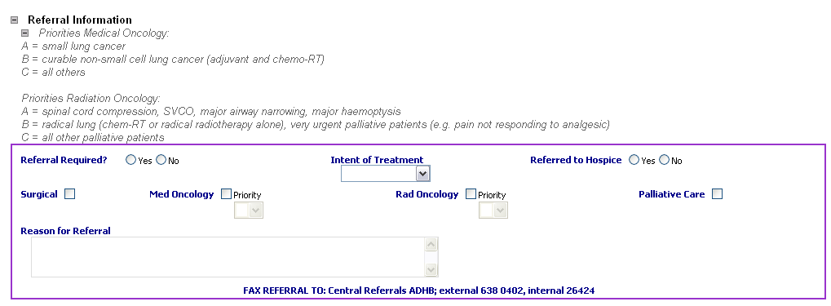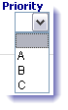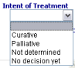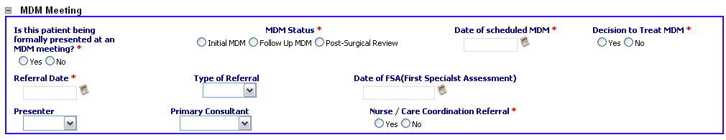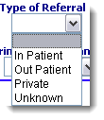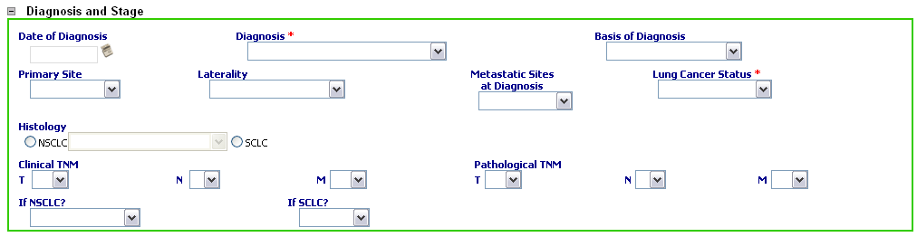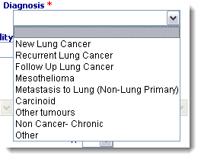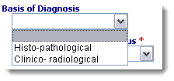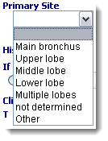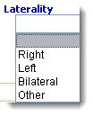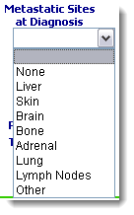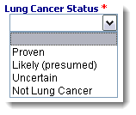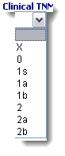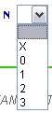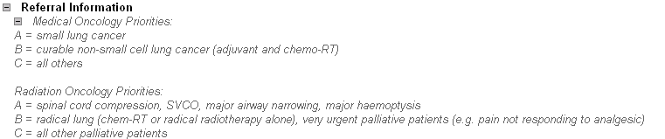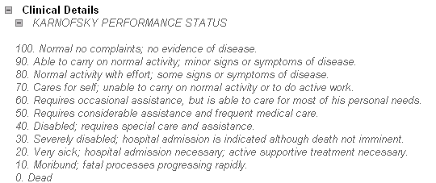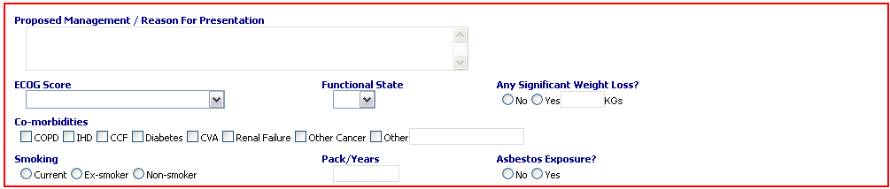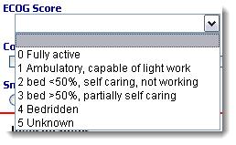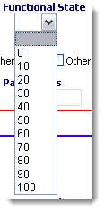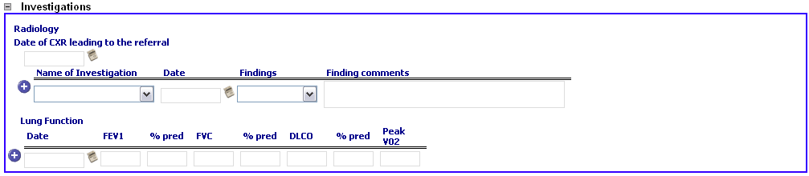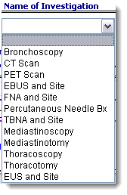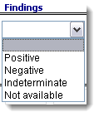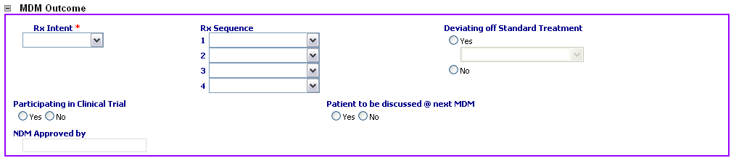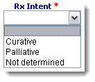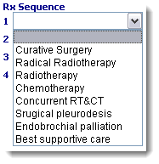

Example of role description for an MDM coordinator

Job summary
This position is part of a team specifically supporting cancer services. The main purpose of the role is to support and coordinate the cancer multidisciplinary meetings (MDMs). This includes collecting cancer data from various sources and ensuring all results of tests, including scans, are available at each MDM. The role includes a high level of liaison with different departments and other district health boards (DHBs). Attention to detail, and good organisational and communication skills are key components to the role.

Duties and responsibilities
- Arrange and coordinate all cancer MDMs and check they are run in accordance with the MDM Terms of Reference, which align with the document, Guidance for implementing quality multidisciplinary meetings: achieving best practice cancer care.
- Receive and process all MDM referrals.
- Collect cancer data in accordance with local and national clinical data sets and mandated requirements. Ensure data are kept confidential and secure in accordance with local policy.
- Input accurate and timely data into DHB cancer databases to facilitate upload of data to meet national targets for cancer waiting times and to meet requirements for national clinical data sets.
- Support multidisciplinary teams to undertake ongoing audit and evaluation.
- Liaise closely with the MDM chair, clinicians and their secretaries, clinical nurse specialists, the pathology and radiology departments and clinicians from hospitals referring patients to MDMs, to identify which patients are to be discussed.
- Collate and distribute agendas to all relevant parties. Ensure relevant case notes, results, radiology and previous MDM proformas are available for each MDM.
- Ensure that a MDM proforma outlining the recommendations for each patient’s treatment is completed and filed within the patient’s medical record (electronic or hard copy).
- Develop and maintain effective working relationships with other departments and other DHBs. Ensure all referrals that result from the MDM are actioned in accordance with MDM Terms of Reference and protocols.
- Ensure that all information on cancer waiting times and clinical information required for tracking, discussion and treatment of patients is made available to other DHBs as required.
- Attend MDMs, keeping comprehensive records of attendance and outcomes of the meeting, and distributing to relevant team members.
- Ensure that the necessary proformas are completed and entered into the relevant MDM database, electronic systems and the patient’s medical notes.
- Confer with the chair to establish that all the information is correct and complete and can be added to the patient’s records.

Example of an MDM patient information sheet

What does a multidisciplinary approach mean for me?
The purpose of this form is to help you understand multidisciplinary care.

Multidisciplinary care is a team approach to health care. Doctors, nurses and other health professionals with skills in diagnosing and managing cancer will meet to discuss options about both your cancer treatment and ongoing care, developing an individual treatment plan for you. This plan will be discussed with you.

Research shows that it is beneficial to involve a range of professionals in deciding the best care for you. For example:
- Each member brings a different area of expertise
- each member of a multidisciplinary team member has a different perspective so the team as a whole can consider a wider variety of social, cultural and emotional needs
- a multidisciplinary meeting makes it easier to plan treatment, streamlines referrals and prevents unnecessary tests, saving time and resources
- when adults with cancer have information about treatment options, their mental health and wellbeing can improve.

What is a multidisciplinary team?
[Insert hospital name] has a team of health professionals involved in the care of patients with cancer. Each team member brings different skills that are important to managing your care. Team members may include:
- a radiologist
- a pathologist
- radiation and medical oncologists
- a general surgeon or physician
- a specialist surgeon
- a palliative care clinician
- a nurse – for example, a clinical nurse specialist or cancer nurse
- allied health professionals – for example, a dietician, physiotherapist or social worker.

To make sure you are receiving the best possible care, the team will meet to review your case and decide on the most appropriate treatments for you. The team is responsible for:
- working out your treatment plan
- deciding on further tests
- making appropriate referrals to specialist services
- collecting information and keeping good records.

There may be some people at the meeting who are not involved in your case.

What happens at a multidisciplinary meeting?
During the meeting the team will review your medical history and your test results. Personal or other health information that you have disclosed to any member of the team, including your general practitioner, may be shared at the meeting if relevant to your treatment, unless you request otherwise. Everyone at the meeting is bound to keep the information confidential, just as they would in a face-to-face consultation with you.

Do I have to be discussed at one of these meetings?
It is important for you to realise that you and your cancer may be discussed at a meeting with professionals that you have not met. If you do not want the team to discuss your case you must advise [insert name of person who is giving this information].

Can I attend one of these meetings?
You will not be invited to attend the meeting, as the team will discuss several other patients at the same meeting and need to keep their information confidential as well.

What happens after the meeting?
After the meeting, the person managing your care will tell you what course of action the team recommends. You will have the opportunity to ask questions and indicate any preferences you have for treatment. The final decision about your care plan is made in consultation with you.

What if I have a question?
[Insert appropriate team member] is the link between you and the team. Your consultant will write letters to your general practitioner to keep them informed too. If you have any questions about your team, or about the meeting at which your case will be discussed, please contact [insert appropriate team member and their contact details], who is managing your care.

What if I have concerns?
If you have any concerns about your treatment, contact the Customer Complaints Coordinator at [insert DHB] in the first instance.

A tumour board rather than a multidisciplinary meeting is referred to in the Management of Early Colorectal Cancer (Ministry of Health, 2001). A tumour board is a treatment planning approach in which doctors who are experts in different specialities or disciplines review and discuss the medical condition and treatment options for a patient. It does not usually include a range of health professionals and has a narrower scope than MDMs.
A proforma is an electronic or paper-based template consisting of the required data fields for the MDM. The proforma is completed prior to the meeting.
Available at: www.ithealthboard.health.nz/connected-health-network-connectivity-standards.

