Pacific CULTURAL COMPETENCIES
A literature review

Acknowledgements
The author Jemaima Tiatia wishes to acknowledge the contributions of and thank those who provided advice and peer review: Metua Faasisila, Dr Peggy Fairbairn-Dunlop, Dr Monique Faleafa, Lita Foliaki, Dr Siale Foliaki, Nite Fuamatu, Pefi Kingi, Dr Jean Mitaera and the Ministry of Health’s Pacific Innovations and Capability and Pacific Policy and Strategy teams.
Citation: Tiatia J. 2008. Pacific Cultural Competencies: A literature review.
Wellington: Ministry of Health.
Published in February 2008
by the Ministry of Health
PO Box 5013, Wellington, New Zealand
ISBN 978-0-478-31702-2 (Print)
ISBN 978-0-478-31703-9 (Online)
HP 4542
This document is available on the Ministry of Health’s website:
http://www.moh.govt.nz


Foreword
Talofa lava, Malo e lelei, Kia Orana, Taloha Ni, Fakalofa Lahi Atu, Ni Sa Bula Vinaka, Talofa, Kia Ora, Greetings

Recent Ministry of Health sponsored research about the contribution of health care to health gains is showing that, in contrast to other population groups, Pacific peoples have benefited least. This clearly suggests that concerns about inequalities in access and exposure to health services (including health promotion and disease prevention programmes) are well founded and that health services need to be more responsive.

In Aotearoa / New Zealand there is a growing awareness that cultural competence is a key tool to making health services more responsive to Pacific peoples, Māori and other groups. Some organisations (including District Health Boards and other regulatory bodies) have already begun thinking about what Pacific cultural competence means. Likewise many Pacific health services have for many years already interpreted and implemented culturally competent Pacific practice in their work places.

This report Pacific Cultural Competencies: A Literature Review was undertaken by Dr Jemaima Tiatia (Hibiscus Research Ltd) and includes the input of leading Pacific cultural competence experts. The report contributes to the exciting and evolving thinking in the area of Pacific cultural competence, by providing an overview of the literature to date. It also provides practical recommendations for taking Pacific cultural competence forward.

Increasing cultural competency is a shared responsibility that requires partnerships across a wide range of sectors – including health, social services, education, justice and research – using systematic and sustainable approaches.

Towards this end, I hope that you will find this report valuable in your own journey towards achieving culturally competent Pacific health care.

Dr Debbie Ryan
Chief Advisor, Pacific Health
Ministry of Health

‘I consider New Zealand a Pacific nation. We are of the Pacific – the vast ocean binds and connects us all.’
Luamanuvao Winnie Laban
‘The ocean is our sea of islands. One thing we all have in common is the ocean, the same sea washes the shores of all islands and also the coastline of Australia and New Zealand.’
Epeli Hauofa

Contents
Acknowledgements ii
Foreword iii
Executive Summary vii
1 Overview 1
Background 1
Objectives 1
Methods 2
Review limitations 2
2 Definitions 3
Culture and cultural competency 3
Other related terms 4
3 Why the Need for Pacific Cultural Competencies? 6
New Zealand’s Pacific population in brief 6
Pacific peoples’ health status in brief 7
The need for Pacific cultural competencies 8
Some Pacific initiatives 9
4 Conceptualising Cultural Competency 13
Conceptualising Pacific cultural competency 14
Traditional healing 18
Acculturation 18
Individual and organisational cultural competence 19
Individual cultural competence 19
Organisational cultural competence 21
5 Cultural Competence Measures and Mechanisms for Achievement 22
6 The Role of Pacific Cultural Competence in Service Quality 30
7 Recommendations 32
Organisations and services 32
Content of cultural competence programmes 32
Measures of cultural competence 32
Research/investigations needed 33
Other considerations 33
References 34

Tables
Table 1: Key themes of the Waitemata DHB Pacific Cultural Competency Project 17
Table 2: Individual Pacific cultural competence constructs 20
Table 3: Mason’s five progressive steps for measuring cultural competence 23
Table 4: Core elements of the BESAFE model 24
Table 5: Summary of culturally competent services 26
Table 6: Measures of organisational Pacific competency 28

Figures
Figure 1: Mason’s continuum of cultural competence 23
Figure 2: Leininger’s Sunrise Model 25

Executive Summary
As part of Goal 2 of the Pacific Health and Disability Workforce Development Plan, objective 2.1 is to ‘define and develop cultural competence’. This objective notes the importance of cultural competence in the delivery of health and disability services to Pacific peoples by Pacific, mainstream and other (Māori) providers.

This report provides an overview of the literature on Pacific cultural competence in health care, focusing on the following key areas:
- relevant definitions of Pacific cultural competence, cultural competence and other related concepts
- studies that provide a rationale for, and outline the benefits of, different Pacific cultural competence approaches
- studies relating to individual and organisational cultural competence
- competence measures and mechanisms for achievement
- the role of Pacific cultural competence in service quality
- analysis and recommendations from the literature review on actions to take in the New Zealand setting to address Pacific cultural competence issues for the health and disability sector.

Cultural competence is the capacity of a health system to improve health and wellbeing by integrating cultural practices and concepts into health service delivery. Generally it is considered a behavioural approach and functions on the principle that behavioural changes can only be achieved first and foremost by changes in attitude. The capacity to affect attitudes and behaviours is influenced by many factors, including leadership in the field, access to information, goodwill, informed decision-making, a learning environment, best-quality practices, and organisational processes and procedures.

Although there is no universally accepted single definition of cultural competence, most definitions have a common element, which requires an adjustment or acknowledgement of one’s own culture in order to understand the culture of clients, patients, working colleagues or communities. This is achieved by recognising and respecting the culture of the person, family, community and/or organisation being served.

Pacific cultural competence is a relatively recent concept with very little development, resulting in few clear definitions and limited buy-in. There are, however, working definitions, including the ability to understand and appropriately apply cultural values and practices that underpin Pacific peoples’ world views and perspectives on health. A pertinent definition also includes the ability to integrate or acknowledge Pacific values, principles, structures, attitudes and practices in the care and delivery of service to Pacific clients, their families and communities.

Seeking clear definitions for Pacific peoples alone is rather complex, for within Pacific communities themselves, there are diversities. For instance, Pacific peoples occupy different social positions, hold various places of status and encompass a range of backgrounds and experiences. Cultural competence should include all these diverse dimensions.

Culturally competent attitudes and aptitudes are critical for all marginalised sub-groups, whether gender groups (male, female, trans-gender, fa’afafine); age groups (elderly, adolescent, children); sexual-preference groups (gay, heterosexual, lesbian, bisexual); place of birth (island-born or raised, New Zealand-born or raised, and multi-ethnic); people with disabilities; or religious groups.

There is substantial evidence to suggest that cultural competence is imperative. However, there is little evidence on which approaches and techniques are effective and how and when to implement them appropriately. In addition, the development of suitable cultural competence measures is hampered by a lack of clarity on the meaning of cultural competence in the first instance. So although there is no universal understanding of what culturally competent care is, the challenge lies in identifying ways of measuring or evaluating appropriate care and cultural competence training, defining successful programmes, and creating innovative methods for assessing a construct that is continually evolving at multiple levels within a service community.

An important issue for Pacific peoples is that cultural competencies lack rigorous evaluation. As a result, it is uncertain what actually works to improve outcomes. It must also be said that criteria for what a culturally appropriate service entails need to be established and must be clearly defined in order to develop cultural competencies or best practices within the context of continuous quality (Kirk et al 2002).

Cultural competence is achievable within health care if leadership and workforce development are supported. At present, in health care there are community assessments, mechanisms for community and client feedback, and implementation of systems for ethnic and language preference data collection. There are also quality measures developed for diverse client populations; culturally and linguistically appropriate health education resources, materials and health promotion activities; and appropriate secondary interventions. It is important to acknowledge recent initiatives that could complement and further contribute to cultural competence developments.

Pacific cultural competence should be considered integral to the definition of quality of care if we are to move towards quality outcomes. It could be included in accreditation tools, regulatory criteria and national surveys. Quality indicators are required to identify, define, track, evaluate and improve culturally competent practices and services. The implication seems to be that little is known about the feasibility and efficacy of Pacific cultural competencies. For Pacific peoples, the issue is that cultural competencies lack rigorous evaluation, which means the most effective approaches for improving outcomes are uncertain. Increased research and study are recommended for achieving sound outcomes in cultural competence.

Increasing cultural competency is a shared responsibility, requiring partnerships across a wide range of sectors – including health, social services, education, justice and research – using systematic and sustainable approaches. Pacific cultural competencies are fundamental to the delivery of health and disability services for Pacific peoples by Pacific, mainstream and other (Māori) providers. Pacific communities should be encouraged and supported to develop more effective and innovative models of health care delivery and service to appropriately meet their health needs.

Cultural competence is a subset of individualised care, in the sense that it is the ability to provide individualised care that accounts for the influences and benefits of the client’s culture. An organisation that gains skills in cultural competence increases its ability to serve all diversity.

1 Overview

Background
The Ministry of Health administers a Pacific Provider Development Fund (PPDF) (Ministry of Health 2005). One area of focus for the PPDF is national projects to implement the Pacific Health and Disability Workforce Development Plan (Ministry of Health 2004a). This Plan was published in November 2004 and sets out the following four goals, which are designed to contribute to a competent and qualified Pacific health and disability workforce to meet Pacific peoples’ needs by:
- increasing the capacity and capability of the Pacific health and disability workforce
- promoting Pacific models of care and cultural competence
- advancing opportunities in the Pacific health and disability workforce
- improving information about the Pacific health and disability workforce.

These four goals were broken down into a number of objectives and related action points for the Ministry of Health’s Pacific Health Branch, various Ministry directorates, District Health Boards (DHBs) and external agencies.

As part of Goal 2 of the Pacific Health and Disability Workforce Development Plan, objective 2.1 is to ‘define and develop cultural competence’ (Ministry of Health 2004a). This objective notes the importance of cultural competence in the delivery of health and disability services to Pacific peoples by Pacific, mainstream and other (Māori) providers.

The Pacific Health Branch monitored implementation of the Plan and identified that a literature review on Pacific cultural competence in health care delivery is needed. It agreed to fund this literature review, ensuring that progress is maintained under the ‘Promote models of care and Pacific cultural competence’ goal.

In addition, the Pacific Health Branch has undertaken a stocktake of Pacific cultural competence activity within the health sector.

Objectives
This report provides an overview of the literature on Pacific cultural competence in health care and focuses on the following key areas:
- relevant definitions of Pacific cultural competence, cultural competence and other related concepts
- studies that provide a rationale for, and outline the benefits of, different Pacific cultural competence approaches
- studies relating to individual and organisational cultural competence
- competence measures and mechanisms for achievement
- the role of Pacific cultural competence in service quality
- analysis and recommendations from the literature review on actions to take in the New Zealand setting to address Pacific cultural competence issues for the health and disability sector.

Methods
The following databases were searched for relevant peer-reviewed studies on Pacific cultural competence: Looksmart Find Articles, PLoS Medicine, HealthSTAR, Healthline, Ovid MEDLINE(R), PsycINFO, PubMed, ScienceDirect and CINAHL. Search terms used in various combinations were: Pacific cultural competencies, benefits of cultural competency, competency and health care, minorities and cultural competency, minorities in healthcare, culturally competent practice, and Pacific health. Internet searches using subject guides of popular search engines included Google, Netscape, Lycos and Yahoo, and these proved worthwhile because they identified the more ‘grey’ and esoteric literature.

A number of Internet sites that are linked to government agencies, professional organisations and universities were also explored. Unpublished works were also accessed through the author’s academic and professional relationships.

Feedback on drafts was sought from peer reviewers, which were identified by both the Ministry of Health and the author, and included those based in government departments, universities and non-government organisations.

Review limitations
There is a plethora of cultural competence literature available, both nationally and abroad. However, this current review was limited by funding and time constraints. Another major limitation was the lack of specific Pacific cultural competency literature on the monitoring and evaluation of organisations implementing Pacific cultural competency policies.

2 Definitions
There are a number of terms that need to be defined in the context of this literature review. These are discussed in further detail throughout the report. Various concepts are used in the literature, but for the purposes of this review the following terms have been chosen. It is also important to note that for this review, the terms ‘competence’ and ‘competency’ are used interchangeably.

Culture and cultural competency

Culture
There are two types of culture: material elements that people create and assign meaning to; and non-material elements that include language, beliefs, ideas, rules, customs, myths and skills (Macpherson and Macpherson 1990). The non-material elements of culture are the focus of this review.

Culture influences an individual’s and family’s health beliefs, practices, behaviours, and even the outcomes of interventions. Health behaviour depends on how one understands the cause of illness (Minnesota Department of Human Services 2004).

Culture has an effect on how we see, understand and respond to physical and social phenomena (Macpherson and Macpherson 1990; New Zealand Nurses Organisation 1995). It extends beyond language and ethnicity: factors such as age and generational issues, gender, sexual orientation, geographic location, religion and socioeconomic status may have as much – or more – cultural significance for an individual or community (Bennett et al 2005).

Culture is a process, and is not fixed or predetermined. It is formed by individuals, and expresses the interaction between individual subjectivities and collective objectivities (Airini 1997). Culture, therefore, is dynamic and fluid by nature.

Competency
Competency has been broadly defined as the ability to do something well or effectively (Makins 1994). A high degree of competency that constitutes effective performance in a defined role is marked by knowledge, attitudes and skills (Ministry of Health National Screening Unit 2004).

Competency, therefore, in the health and disability sector may be described as the ability to effectively produce knowledge and skill to a required standard in order to produce excellence in quality health care, with the ability to transfer this knowledge and skill to new and differing contexts (Ministry of Health National Screening Unit 2004).

Cultural competency
Cultural competence can be defined as a set of academic, experiential and interpersonal skills that allow individuals and systems to increase their understanding and appreciation of cultural differences and similarities within, among and between groups (Counties Manukau DHB 2001; Jansen and Sorrensen 2002).

Therefore, becoming culturally competent requires the ability to draw on the values, traditions and customs of other cultural groups, to work with knowledgeable persons from other cultures, and shape service delivery to meet patients’ social, cultural and linguistic needs by developing targeted interventions and other supports (Betancourt et al 2002; Counties Manukau DHB 2001).
Cultural competency is not merely a skill set to be taught, as argued by Rhymes and Brown (2005); it also involves a fundamental shift in the way one perceives the world. It is a path on which to travel, as opposed to an end to be achieved (Rhymes and Brown 2005).

Pacific cultural competence
Pacific cultural competence is a relatively new concept, and there are no clear definitions. There are, however, working definitions which include the ability to understand and appropriately apply cultural values and practices that underpin Pacific peoples’ world views and perspectives on health (Tiatia and Foliaki 2005). It also involves acknowledgement of the various facets of culture, particularly in terms of understanding cultural differences between Pacific clients and their families (Suaalii-Sauni and Samu 2005). Pacific cultural competence has also been defined as the ability to integrate Pacific values, principles, structures, attitudes and practices into the care and delivery of service to Pacific clients, their families and communities (Counties Manukau DHB 2001).

Major complications arise due to lack of agreement on definitions and approaches to cultural competence. For instance, Pacific people occupy different social positions, hold various places of status and encompass a range of backgrounds and experiences. Cultural competence should include all of these diverse dimensions. Culturally competent attitudes and aptitudes are crucial for all marginalised sub-groups, whether based on gender (male, female, trans-gender, fa’afafine); age (elderly, adolescent); sexual preference (gay, heterosexual, lesbian, bisexual); place of birth (island-born or raised, New Zealand-born or raised, or multi-ethnic); disability; or religion.

Individual and organisational cultural competency
Individual cultural competence is the state of being capable of functioning effectively in the context of cultural differences (Finger Lakes Health Systems Agency 2003).

The most commonly used definition for organisational competence is a set of matching behaviours, attitudes, practices, policies and structures that come together in a system, agency or among professionals, enabling that system, agency or those professionals to work effectively in culturally diverse situations (Cross et al 1989).

Other related terms

Cultural safety
The concept of cultural safety is a political idea promoted by Māori nurses, which arose from the colonial context of New Zealand society in response to the poor health status of Māori and the demands for changes in service delivery (Papps and Ramsden 1996).

Cultural safety attempts to transform health professionals’ attitudes with regard to the power relationships they have with their patients (National Aboriginal Health Organization 2006). It has been described as interactions that recognise, respect and nurture the unique cultural identity of each person to safely meet their needs, expectations and rights, and involves showing respect and sensitivity to people, and taking into account their spiritual, emotional, social and physical needs (Paediatric Special Interest Group 1998). In other words, it is an approach that asserts, respects and fosters the cultural expression of the client. This usually requires health professionals to have undertaken a process of contemplation of their own cultural identity, and to have learned to practise in a way that asserts the culture of clients and health professionals (Papps and Ramsden, 1996).

Cultural sensitivity
Cultural sensitivity is defined as a state in which the health professional has regard for a client’s beliefs, values and practices within a cultural context, and shows awareness of how their own cultural background may be influencing professional practice (Lister 1999). It also includes the extent to which ethnic/cultural characteristics, experiences, values, behavioural patterns and beliefs of a target population, as well as relevant historical, environmental and social factors, are integrated in the design, delivery and evaluation of targeted health materials and programmes (Resnicow et al 1999).

Culturally safe practice
Culturally safe practice has been described as recognising negative attitudes and the stereotyping of individuals on the basis of their ethnicity, and acting accordingly. Like cultural safety and cultural sensitivity, it involves actions that respect and nurture the unique cultural identity of people and safely meet their needs, expectations and rights. It is believed that a key element of culturally safe practice is establishing a trusting relationship with the patient. It is seen to empower people by emphasising the notion that each person’s knowledge and reality are important and valid.

Culturally safe practice facilitates open communication and allows patients to voice their concerns about practices that they may deem unsafe (Nurses Working with First Nations Professional Practice Group et al 2005).

Unsafe cultural practice occurs when the patient is disempowered, humiliated and alienated on the basis of their cultural identity, and is therefore directly or indirectly discouraged from accessing necessary health care (National Aboriginal Health Organization 2006; New Zealand Nurses Organisation 1995).

Acculturation
Acculturation is the process of acquiring, adapting to or adopting a second culture, whereby two distinct cultural groups have continuous first-hand contact, resulting in subsequent changes in the original cultural patterns of either or both groups (Administration of Aging 2004; Strickland and Gale 2001).

3 Why the Need for Pacific Cultural Competencies?

New Zealand’s Pacific population in brief
Pacific peoples have been in New Zealand for more than a century and have contributed significantly to the political, social and cultural fabric of this society. Pacific peoples influence, and will continue to influence, the demographic pattern, socio-cultural features and overall health and wellbeing of New Zealand in the future as the population increases and ages (Finau and Tukuitonga 2000).

According to the 2006 Census, 265,974 people identified with the Pacific peoples ethnic group, representing 6.9 percent of the total New Zealand population. Geographically, over 9 in 10 Pacific people (93.4 percent) live in the North Island and two-thirds (66.9 percent) live in the Auckland region. The Pacific population is significantly younger than the total population and has the highest proportion of children (0 to 14 years) of all of the major ethnic groups at 37.7 percent (Statistics New Zealand 2007a).

The Pacific population is projected to reach 414,000 in 2021 (Statistics New Zealand 2004). This is an increase of 152,000, or 58 percent, over the estimated resident population of Pacific ethnicity of 262,000 at 30 June 2001. Furthermore, the Pacific share of the total population is projected to rise to 9 percent in 2021 (Statistics New Zealand 2004).

The seven largest Pacific ethnic groups in New Zealand are Samoan, Cook Islands, Tongan, Niuean, Fijian, Tokelauan and Tuvaluan (Statistics New Zealand 2007a). Although most groups have similarities, each has their own cultural beliefs, values, traditions, language, social structure and history. Moreover, within each group there are also sub-groups; for example, differentiating between those born or raised in New Zealand, those born or raised overseas and those who identify with multiple ethnicities (Tukuitonga and Finau 1997).

Migration has provided the opportunity for a wide array of people to engage in dialogue about what it means to be a Pacific person. Given that Pacific people occupy different social positions and encompass a range of backgrounds and experiences, there are unavoidably a range of views about what it is to be a Pacific person (Macpherson 2001). For instance:
There is no generic ‘Pacific community’ but rather Pacific peoples who align themselves variously, and at different times along ethnic, geographic, church, family, school, age/ gender, island-born/New Zealand born, occupational lines or a mix of these (Anae et al 2001).

The term ‘New Zealand-born’ (NZ-born) recognises both Pacific descent and local upbringing and is an identity shared with many other Pacific young people. The social and material experiences of Pacific NZ-born or -raised people are diverging in terms of the significant differences in the ways they perceive themselves and the importance placed on their Pacific identity (Macpherson 2001). This is an important consideration, given that 60 percent of Pacific people were born in New Zealand (Statistics New Zealand 2003).

It is also important to recognise that some Pacific people may identify with more than one ethnic group. For example, findings from the Youth2000 National Secondary School Youth Health Survey (2003) indicated that 11.7 percent of Pacific secondary school students identified with Pacific and one or more other ethnic groups (Adolescent Health Research Group 2003). In addition, it is projected that intermarriages among Pacific populations will also increase (Callister et al 2005). Such diversities are a vital consideration when addressing Pacific cultural competency issues for the health and disability sector.

Pacific peoples’ health status in brief
The New Zealand Health Strategy (NZHS) and the New Zealand Disability Strategy set out goals and objectives for the health sector. Ensuring accessible and appropriate services for Pacific peoples is one of three priority objectives for the NZHS, which aims to reduce inequalities in health and independence outcomes between ethnic groups (Ministry of Health 2005). In order to enhance positive health outcomes for Pacific peoples in New Zealand there need to be Pacific cultural competencies.

Compared to the total New Zealand population, Pacific peoples have poorer health status, are more exposed to risk factors for poor health, and experience barriers to accessing health services (Ministry of Health 2004b). The Pacific Health Chart Book 2004 (Ministry of Health 2004) suggests that interrelated risk factors and socioeconomic determinants of health contribute to the poor health status of Pacific peoples in New Zealand: in particular, lifestyle and cultural factors such as beliefs, values and preferences that influence how Pacific peoples view health care; underutilisation of primary and preventive health care services by Pacific peoples; and lower rates of selected secondary care interventions (Ministry of Health 2004b).

The Chart Book notes that Pacific people die younger and have higher rates of chronic disease such as cardiovascular disease (coronary heart disease and stroke), obesity, diabetes and respiratory diseases (chronic bronchitis/emphysema and asthma) in comparison to other New Zealanders. It also suggests that Pacific men have higher rates of lung cancer and primary liver cancer, and Pacific women have higher rates of breast and cervical cancer than other New Zealand women. Infectious disease rates are also higher among Pacific peoples in comparison to other New Zealanders. Pacific young people have higher pregnancy and birth rates than the New Zealand average, and have higher rates of chlamydia and gonorrhoea than the national youth average (among clinic attendees) (Ministry of Health 2004b).

Government health funding has sought to improve access to health services for Pacific peoples by supporting the development of Pacific health providers and the Pacific health workforce. This is designed to increase the scope and quality of services available to Pacific peoples through Pacific providers. The services are intended to enhance mainstream services, that have proven less effective in responding to the health needs of Pacific peoples compared with other New Zealanders.

Developing the Pacific provider sector and increasing the number of Pacific people working as health practitioners and health professionals will benefit both mainstream and targeted providers. It will ensure that Pacific providers are well placed to utilise their better understanding of the needs of Pacific communities, and to provide a comfortable provider environment consistent with the cultural values of Pacific health consumers (Ministry of Health 2005).

The increase in the number of Pacific health professionals and health practitioners will also promote better communication with Pacific health consumers, which in turn will contribute to improved health outcomes (Ministry of Health 2005).

The need for Pacific cultural competencies
The New Zealand Health Practitioners Competence Assurance Act 2004 (HPCA Act) came into effect in September 2004, and covers all health professionals. Its function is to protect the health and safety of New Zealanders by providing mechanisms to ensure health professionals are competent, registered and subject to regulation. The HPCA Act requires that professional registration bodies set standards of clinical competence, cultural competence and ethical conduct, and ensure these are observed by health practitioners in their profession. In achieving the goal for all health professionals of being familiar with the concept of cultural competence, it is also critical that they be able to demonstrate it. It follows that teaching programmes and registering bodies need to develop and support competency standards as the first step (Bacal et al 2006). Bacal et al maintain that it is both logical and crucial that the HPCA Act pay special attention to the ways in which the health care system can become more effective in addressing the health of Māori and special needs groups. This includes Pacific peoples.

Southwick (2001) has explored Pacific women’s experiences of nursing and their first year of practice post-registration within the New Zealand setting. Southwick acknowledges that the nursing profession requires all nurses to be ‘culturally safe’. However, Southwick’s argument is that this is compromised by the reality that only one culture has the power to determine what ‘safety’ really means. Therefore, the criteria for shaping successful knowledge and skill acquisition, and the standards and competency measures for what constitutes ‘good practice’, are all derived from a mainstream world view. Southwick does not suggest that the mainstream nursing profession deliberately sets out to dominate or oppress other groups, or that Pacific nurses are victims. Rather, this argument reinforces the notion that cultural safety and competence can only be achieved if the nursing profession reflects the evolving, pluralistic and diverse nature of New Zealand society and responds appropriately to the needs of Pacific peoples (Southwick 2001).

The following statement, taken from a study by Kirk et al (2002), is one of many scenarios highlighting the type of misunderstandings that occur in the health and disability sector in relation to access to, and the delivery of, health care for Pacific communities:
... there are a lot of high risk families. There are a lot of families who are not accessible by going to a clinic because their English is bad, they’ve got immigration issues, they’ve got money issues, they’ve got family issues around people that are working all day and half the night their grandparents are looking after the kids during the day. There are all these sorts of things that have impacted, and add to this whole issue around barriers and when they get to the doctors and they don’t understand what the person is asking them to do at the beginning – they turn around and say well we’re gonna go back home and say don’t worry about it. (Kirk et al 2002)

Although this excerpt focuses on barriers to access, it has implications for developing policies that recognise social disadvantage and inequalities in the health and disability sector for Pacific peoples. It also validates why Pacific cultural competencies are crucial to achieving better health outcomes for the Pacific population.

Consequently, the failure to recognise Pacific cultures and their contribution to health care will result in inadequate care, which, Rhymes and Brown (2005) argue:
... includes poor health outcomes, underutilisation of services, inequities, increased burdens from morbidity and mortality. As a result, cultural competence must be integrated into public health policy, program and services. This includes having culturally competent health care providers. (Rhymes and Brown 2005)

It is generally recognised that not all health care professionals understand the health-related and health-system-related beliefs and attitudes of other ethnic or social class groups, as well as lacking awareness of (usually covert) biases they themselves bring to the processes of patient care (Horner et al 2004). Promoting cultural competence among health care professionals will help to address barriers such as mistrust of the medical community, little or no access to quality health care, and/or cultural stereotyping of patients (McNeil et al 2002).

It is well documented that culturally competent care adds value to the health care delivery system by demonstrating improvements in the quality of care, such as better outcomes, greater client satisfaction, increased access, greater provider satisfaction, and other aspects of enhanced value (Beach et al 2004; Counties Manukau DHB 2001). In general, it is believed that barriers among patients, providers and the health care system that affect quality and ethnic disparities in care include:
- lack of diversity in health care’s leadership and workforce
- systems of care being poorly designed to cater to the needs of diverse patient populations
- lack of communication between providers and patients of different ethnic and cultural backgrounds (Betancourt et al 2002).

Some Pacific initiatives

The Counties Manukau DHB’s Plan for Chronic Care Management in Counties Manukau 2001–06
The Plan for Chronic Care Management in Counties Manukau 2001–06 (Counties Manukau DHB 2001) argues that Pacific cultural competencies are needed in order to:
- respond to current and projected demographic changes
- eliminate long-standing disparities in the health status of Pacific peoples
- improve the quality of services and health outcomes
- meet Crown objectives.

As further outlined in this plan, Pacific cultural competencies are essential because:
- there is a need for consistent collection of ethnicity data in an approved manner to underpin the delivery of culturally competent health care to individuals and communities
- concepts such as family, community, wellness, disease and illness are different for various cultures, and the meanings of these are contained within the language and customs of each culture
- culture influences help-seeking behaviours and attitudes towards health care providers
- individual preferences affect traditional and non-traditional approaches to health care
- providers need to be both culturally and clinically competent to be effective
- Pacific cultural competence requires a commitment to ongoing improvements through continuing education, review and feedback, in the same way that clinical competence does
- health care providers themselves are culturally diverse
- cultural competence requires culturally competent methods for satisfaction surveys, complaints processes, and other non-clinical communications (Counties Manukau DHB 2001).

This plan also illustrates the need for developing cultural competence at a provider–patient level to ensure Pacific cultural competence in service quality. It argues that communication and understanding lead to improved diagnoses and treatment plans, and that improved patient satisfaction leads to greater compliance with these plans. In addition, cultural competence:
- allows the provider to obtain more specific and complete information to make an appropriate diagnosis
- facilitates the development of treatment plans that are followed by the patient and supported by the family
- reduces delays in seeking care, and allows for improved use of health services
- enhances overall communication and the clinical interaction between the patient and provider, leading to improved satisfaction for both the patient and the provider
- enhances the compatibility between Western and traditional cultural health practices
- goes hand in hand with building healthy communities through community development programmes.

Practitioner Competencies for Pacific Alcohol and Drug Workers Working with Pacific Clients in Aotearoa–New Zealand
In 2001, consultation with Pacific alcohol and other drug (AoD) workers in New Zealand’s main centres resulted in unanimous support for developing workplace competencies specifically for Pacific AoD workers dealing with Pacific communities (Pacific Competencies Working Party 2002). The Practitioner Competencies for Pacific Alcohol and Drug Workers Working with Pacific Clients in Aotearoa–New Zealand was developed for Pacific workers in the AoD field and is the first of its kind.

This document identified a lack of accurate information on Pacific models of practice, and consequently an absence of evidence-based Pacific conceptual frameworks that could inform the further development of Pacific AoD practitioner competencies. It was also suggested that there is a need for more forums in which Pacific AoD workers can share, develop and amass Pacific models of good practice (Pacific Competencies Working Party 2002).

These Pacific AoD practitioner competencies were based on the beliefs, knowledge and skills used by Pacific AoD workers dealing with Pacific clients, with a focus on generic and common understandings across Pacific cultures. They were written in broad terms to allow for the diversity of Pacific models of practice. It was noted that although the term ‘Pacific’ was used to describe ‘pan-Pacific’ attributes, the competencies can be interpreted and applied by individual AoD workers within their own ethnic contexts (Pacific Competencies Working Party 2002).

Waitemata District Health Board: Health promotion and draft cultural competency standards for Pacific mental health workers
In recent years, within the Pacific health sector there has been a focused investment of Pacific health resources towards merging and developing key areas of Pacific health provider growth, such as infrastructure, workforce, governance, information technology, research and knowledge in health promotion (Foliaki 2002). Foliaki argues that national health promotion models (as characterised by strategies in the Ottawa Charter, the links to the Alma Ata Declaration and subsequent Pacific Declarations on health) have yet to be developed for Pacific families in New Zealand. Foliaki adds that in developing this area of work there is a need to build and increase the number of multi-skilled Pacific researchers, policy writers and health promoters.

The notion of a national cultural best practice framework emerged from the understanding that culture, language and history significantly influence how Pacific peoples perceive, access and continue to use health services in New Zealand (Foliaki 2002). Foliaki maintains that the development of national cultural best practice and the gathering of indigenous knowledge and concepts to inform this are essential foundations to planning and delivering health promotion services to Pacific families.

As part of this development towards national cultural best practice and the gathering of indigenous knowledge and concepts, Isalei, a Waitemata DHB Pacific mental health service, has attempted to identify and document perceptions Pacific peoples have about mental health. This led to the development of draft cultural competency standards for Pacific mental health staff. These standards identify a knowledge base that can be linked to a set of skills that assist Pacific mental health staff to integrate traditional and bio-medical interventions in the recovery of Pacific mental health consumers (Foliaki 2002).

In 2002 Waitemata DHB facilitated a workshop at the Sixth Conference for Health Promotion Forum, giving the opportunity for Pacific peoples to comment on these draft cultural competency standards for Pacific mental health. Key issues raised in this workshop included recognition of the importance of:
- quality in service planning and delivery
- accurate cultural knowledge and evidence to support this when developing health promotion and other health services for Pacific families
- communication between Pacific health providers, the Ministry of Health and Pacific families to ensure that information and service delivery are co-ordinated, relevant to the diversity of Pacific populations and appropriate to the cultures of these populations.

A key recommendation from the workshop was to identify and address developing needs for a Pacific health promotion workforce and appropriate models (Foliaki 2002).

It is clear that Pacific cultural competence is fundamental to the delivery of health and disability services to Pacific peoples by Pacific, mainstream and other (Māori) providers. It is therefore imperative that the health care sector adapt to positively acknowledge the beliefs and practices of the diverse Pacific populations in New Zealand and Pacific communities, and are encouraged and supported to develop more effective and innovative models of health care delivery and service to appropriately meet their health needs (Finau and Tukuitonga 2000).

A fundamental part of providing effective health care for Pacific peoples is a well-trained, competent and capable workforce. Such a workforce needs to be directed and supported by the development of Pacific cultural competencies and best practice guidelines (Tiatia and Foliaki 2005). In addition, overseas practitioners play an increasing role in the New Zealand workforce, and Pacific cultural competence among these practitioners also needs to be emphasised (Ministry of Health 2004a).

4 Conceptualising Cultural Competency
Cultural competence is the capacity of a health system to improve health and wellbeing by integrating cultural practices and concepts into health service delivery (Australian Government National Health and Medical Research Council 2005). Generally it is considered a behavioural approach and functions on the principle that behavioural changes can only be achieved by changes in attitude (Bennett 2006). The capacity to affect attitudes and behaviours is influenced by many factors, including leadership in the field, access to information, goodwill, informed decision-making, a learning environment, best-quality practices, and organisational processes and procedures.

Although there is no universally accepted single definition of cultural competence, most definitions have a common element, which requires an adjustment or acknowledgement of one’s own culture in order to understand the culture of clients, patients, working colleagues or communities. This is achieved by recognising and respecting the culture of the person, family, community and/or organisation being served (Bureau of Health Professions n.d; Campinha-Bacote 2002; Williams 2001). However, the implication is that this lack of agreement on definitions and approaches affects how best to provide the necessary knowledge, skills, experience and attitudes to effectively serve diverse populations (Bureau of Health Professions n.d; Rhymes and Brown 2005).

Cross et al (1989) have outlined five essential elements that contribute to a system’s, institution’s or agency’s ability to become more culturally competent:
- valuing diversity
- having the capacity for cultural self-assessment
- being conscious of the dynamics inherent when cultures interact
- having institutionalised culture knowledge
- having developed adaptations to service delivery reflecting an understanding of cultural diversity.

It was recommended that these five elements manifest themselves at every level of an organisation including policy making, administration and practice – and should be reflected in the attitudes, structures, policies and services of the organisation (Cross et al 1989).

In 2001 the US Department of Health and Human Services Office of Minority Health conducted a literature review conceptualising cultural competence. The project team found that Cross et al’s (1989) elements, among other conceptual literature discussed in their report, needed to be broadened to cover a wider range of areas. As a result, nine areas were identified and considered important to the development of a measurement profile for cultural competence in health care.

These areas are referred to as domains, and include: values and attitudes; cultural sensitivity; communication; policies and procedures; training and staff development; facility characteristics, capacity and infrastructure (with a focus on access and the availability of care and the environment in which it is provided, such as the location); intervention and treatment model features; family and community participation; and monitoring, evaluation and research (US Department of Health and Human Services Office of Minority Health 2001a).

Cultural competence does not suggest treating all members of a cultural group in the same way. Rather, it presumes that difference and diversity between and within groups are valued, and acknowledges a positive integration of diversity, difference and multiculturalism within a system of care. Universals and normative standards that reference ‘the average person’ are avoided. Failure to do so will mask differences that significantly influence access, utilisation and quality (Chin 2006).
According to the US Department of Health and Human Services Office of Minority Health (2001b), culturally competent care includes:
- striving to overcome cultural, language and communications barriers
- providing an environment in which clients from diverse cultural backgrounds feel comfortable discussing their cultural health beliefs and practices in the context of negotiating treatment options
- using community workers as a check on the effectiveness of communication and care
- encouraging clients to express their spiritual beliefs and cultural practices
- being familiar with and respectful of various traditional healing systems and beliefs and, where appropriate, integrating these approaches into treatment plans.

These factors are all pertinent for Pacific peoples.

Conceptualising Pacific cultural competency
The Practitioner Competencies for Pacific Alcohol and Drug Workers Working with Pacific Clients in Aotearoa–New Zealand (Pacific Competencies Working Party 2002) notes that Pacific providers offer a service that acknowledges the ‘whole’ person and is a crucial consideration for effective service delivery to Pacific communities. For example, in most cases the Pacific world view does not separate aspects of life, but rather sees life as an integrated whole (Pacific Competencies Working Party 2002). As recommended, Pacific AoD workers must meet this holistic approach by bringing the ‘whole self’ to the client relationship. It was also stipulated that there needs to be an awareness among AoD workers of their own personal limitations and a recognition of the impact of a holistic approach and how it is applied, as this will also differ between Pacific groups (Pacific Competencies Working Party 2002). The following competencies were documented in this report.
(a) Generic Pacific competencies:
- establishing and maintaining relationships with Pacific clients
- setting and managing Pacific cultural and professional boundaries and expectations
(b) Pacific vocational competencies:
- assessing, matching and referring Pacific clients
- service provision, following up and reviewing services for Pacific clients.

Each of these competencies incorporates the following components as core objectives: Pacific beliefs, Pacific knowledge and Pacific skills. They focus on aspects of Pacific AoD workers’ practice that are considered important and integral to Pacific cultural and traditional understandings in relation to health care and appropriate service quality (Pacific Competencies Working Party 2002).

Counties Manukau DHB’s (2001) Plan for Chronic Care Management in Counties Manukau 2001–06 suggests that any need required by Pacific peoples that lies beyond the scope of mainstream general practice should be facilitated by linking them to further specialist advice and clinical services, thus ensuring effective and appropriate care is maintained. This is consistent with the recommendation made in the Minnesota Department of Human Services guidelines (2004), whereby an organisation that lacks knowledge and skills in a client’s culture should refer the client to someone who has this expertise. It is important, then, that health care providers equip themselves not only with the knowledge and skills of culturally competent care and new clinical skills, but also with the ability to identify and access appropriate support systems for Pacific peoples, as needed (Counties Manukau DHB 2001).

The Plan for Chronic Care Management in Counties Manukau 2001–06 outlines the following culturally competent health care practices when working with Pacific peoples. Health care practices should:
- be grounded in Pacific peoples’ values of respect, love, responsibility, honesty, commitment or passion, and spirituality
- acknowledge that the Pacific patient is a member of an extended family and community – family members and community (eg, village and church) are often involved with decisions on health care plans and management, and assist in the care giving, so knowledge of the relationships between caregivers and patients will enable staff to understand, adopt and practise appropriate behaviours and protocols
- provide information in the Pacific patient’s first language to enable them to communicate clearly with staff – this requires access to qualified, professional interpreting and translation services to ensure that Pacific patients and their families are well informed and are able to participate in their care
- acknowledge that there may be differences between health professionals’ views of health, wellbeing, healing and quality of life and those of Pacific patients and their families, which may lead to staff working alongside church ministers and traditional healers with the aim of improved health outcomes for Pacific patients
- seek to improve the quality of services and strategies for working with Pacific peoples
- recognise traditions and protocols in palliative and bereavement care.

Such practices are parallel to those highlighted by the National Aboriginal Health Organization (NAHO) and the New Zealand Nurses Health Organisation, whereby trust with the patient must be assured, where Pacific peoples’ knowledge and realities are considered valid and significant, where open communication is promoted, and where humiliation, alienation and barriers to access are avoided.

Foliaki’s (2003) Pacific Cultural Screening Competencies draft report under the umbrella of the Cancer Screening Workforce Development Project recognises that attaining cultural knowledge increases cultural awareness and eventually leads to a greater understanding of Pacific peoples and an appreciation of cultural differences without assigning values of ‘better or worse, right or wrong’.

Foliaki provides fundamental knowledge components of Pacific cultural awareness training, which are worthy of consideration for Pacific cultural competence and effective service delivery for Pacific peoples. These are:
- knowledge of one’s own beliefs and values, specifically in relation to health and ill health
- the historical, demographic, socioeconomic and cultural context of Pacific communities in New Zealand
- Pacific values, beliefs and practices specifically in relation to health and ill health
- Pacific family structure and family decision-making processes
- Pacific community structures.

Foliaki also maintains that the key to successful interpersonal engagement between Pacific peoples and cross-cultural engagement between Pacific and non-Pacific peoples is respect. In a one-on-one interaction with a client, respect is expressed through:
- appropriate greetings, including saying the name of the person/s correctly
- introducing yourself, your function and the function of other people that are present in the meeting
- establishing a connection between yourself and the patient/family, sharing something personal of yourself (humanising yourself, taking yourself out of your professional role before tackling the business at hand)
- explaining/demonstrating what you expect to happen during your meeting
- asking the person/family what they want/expect to happen in the meeting
- reassuring them that they have your full attention by not engaging in other activities while talking with them.

When interacting with a group, Foliaki reiterates that respect should continue to be regarded with the utmost importance and demonstrated by:
- knowing the structure of the group and acknowledging the key people in the right order
- expressing appreciation for the opportunity to meet
- acknowledging past interactions
- sharing some personal information about oneself that may have some connection with the group or with the purpose of the meeting
- addressing the business at hand only after an emotional/spiritual connection has been made.

As discussed earlier, in 2002 Waitemata DHB commissioned a Pacific cultural competency project. Its aim was to explore, from the ground up, Pacific workers’ understanding of cultural competencies, and to provide baseline information on which to develop culturally appropriate practices, particularly those relevant to working with Pacific mental health clients (Suaalii-Sauni and Samu 2005). This work provided a rationale for the inclusion of Pacific cultural competencies in the health sector from the ethnic-specific perspectives of Samoan, Tongan, Niuean, Cook Islands and Fijian communities in New Zealand. The impetus for this study was the desire to generate debate and identify effective ways of continuing to provide appropriate services for Pacific peoples. It was born of the need for cultural competency frameworks that promote the needs of clients and remind health workers of the importance of culture and cultural differences in the politics of service delivery (Suaalii-Sauni and Samu 2005).

As mentioned, the project formally began at a 2002 conference which involved discussions among Pacific mental health practitioners from across New Zealand that were documented in conference proceedings. Discussions suggested that more detail of ethnic-specific perspectives was required. In response, in 2004 five ethnic-specific workshops (Samoan, Tongan, Niuean, Cook Islands, Fijian) were held to explore in more depth the findings from the 2002 conference. Suaalii-Sauni and Samu (2005) provided a synopsis of the key themes and issues that arose from these workshops. Their report is divided into five main discussion areas: language, family, tapu and Christian relations, cultural knowledge and skills, and policy considerations. These are summarised in the following table.

Table 1: Key themes of the Waitemata DHB Pacific Cultural Competency Project
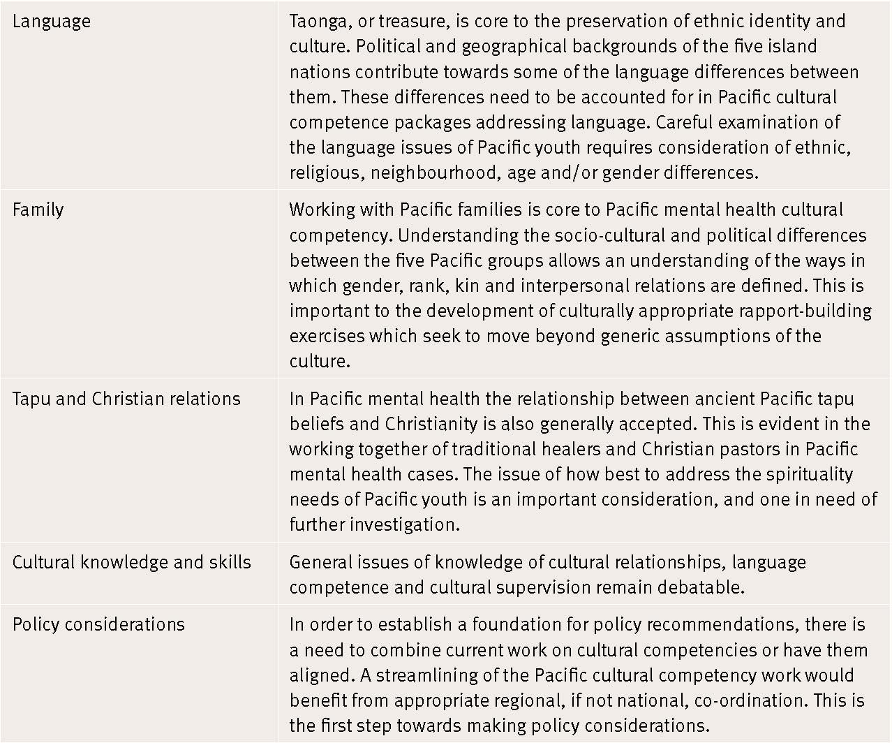

There is an awareness that services provided by Pacific peoples, for Pacific peoples, cannot meet the needs of the entire community. It is therefore important that mainstream and other (Māori) providers are also supported and encouraged to offer their services in an affable Pacific manner (Tukuitonga 1999).

Pacific Mental Health Services and Workforce: Moving on the Blueprint (Mental Health Commission 2001 includes work developed by Dr Siale Foliaki with the guidance of the Commission’s Pacific People’s Advisory Committee (1997–2001). This work sought to heighten awareness and understanding of key Pacific mental health service and workforce capacity-building issues. It reinforced that Pacific views on health must be fully understood and fundamentally bound to the holistic view of health if the needs of Pacific peoples are to be better met by mental health services in New Zealand. It argued that part of this holistic view is recognising the importance of traditional healing and its inclusion in the development of Pacific cultural competencies (Mental Health Commission 2001).

Traditional healing
The Mental Health Commission (2001) has noted that it is unknown how many Pacific people choose to access traditional healers for their mental health needs, although anecdotally the percentage is large. It points out that Pacific communities are in fact signalling to mainstream services that meaningful options between different types and combinations of mental health services are needed, which Pacific providers, mainstream and other (Māori) health services and traditional healers should be more than capable of providing. Thus, mainstream mental health services must recognise the significant role of traditional healers in Pacific communities (Mental Health Commission 2001).

Examples of successful partnerships between Pacific mental health services and a Pacific traditional healer include the following:
- Pacificare, a non-government organisation, has a traditional healer employed or contracted to provide services to service users within Pacificare who request it
- Lotofale Pacific Nations Mental Health Services (Auckland DHB) facilitate community support workers to assist Pacific service users to access traditional healers
- Faleola Services (Counties Manukau DHB) and Isalei Pacific Mental Health services (Waitemata DHB) support and monitor Pacific service users who wish to access traditional healers.

Exploring notions of Pacific cultural competency and the examination of traditional health processes or remedies could also include how traditional healing beliefs interrelate with the Western medical model (Health Resources and Services Administration 2001; Suaalii-Sauni and Samu 2005). The co-existence of traditional and Western methods needs to be successfully co-ordinated to ensure continuity of care for the patient. This would also increase the likelihood that the patient will agree with and adhere to treatment (Rhymes and Brown 2005).

The implications of the use of traditional healers and the relationship of traditional healing to the mainstream mental health sector have yet to be addressed. There has been a call for acceptance, more funding for creditable traditional healers, and ongoing support (Mental Health Commission 2001).

Acculturation
A further consideration in the conceptualisation of cultural competence is acculturation (Blakely and Dew 2004). The degree to which acculturation takes place is influenced directly by both cultural and individual-level differences (Administration of Aging 2004). For Pacific peoples there are varying levels of acculturation. For instance, as mentioned earlier, NZ-born or -raised, Island-born or -raised and multi-ethnic marriages have contributed to further diversity in Pacific communities.

A study by Paterson et al (2003), which examined pregnancy planning by Pacific mothers, reinforced that acknowledging acculturation in health care is just as important as the need for appropriate advice and services. For example, the study found that higher education, being NZ-born or -raised and residing longer in New Zealand (indicators of increasing cultural capital) are all indicative of a planned rather than unplanned pregnancy (Paterson et al 2003). Findings also suggested that there are various generational perceptions of sexuality and reproduction, whereby younger Samoan males believe contraception is part of God’s way of teaching them to plan, but for older Samoan males the suggestion that they could not provide for a large family is an insult to their masculinity. These findings confirm that there are dissimilar beliefs, knowledge and understandings within Pacific ethnic groups.
Southwick (2001) argues that if there is a tendency by non-Pacific peoples to stereotype all Pacific peoples as the same, then it is equally important to recognise that within Pacific cultural groups there is a tendency to generalise that which makes one ‘Pacific’, particularly in comparison to non-Pacific peoples and even further, to those of mixed ethnicity. It is imperative that health professionals assess the level of acculturation of a Pacific patient. This is an area in need of further investigation.

Individual and organisational cultural competence
The interpersonal relationship between the health professional and the client is believed to be the determining factor for whether services are appropriate (Minnesota Department of Human Services 2004). The culturally skilled professional is one who is in the process of actively developing and practising strategies and skills at working with culturally diverse clients. An individual professional cannot be culturally competent alone: organisational commitment is also required. Therefore, management forms the service delivery structure and environment whereby cultural competence is achievable (Minnesota Department of Human Services 2004).

Individual cultural competence
At the personal level it is argued (Campinha-Bacote 2003; Olavarria et al 2005) that three main components are required to become culturally competent:
- a sensitivity and understanding of one’s own cultural identity
- having knowledge of other cultures’ beliefs, values and practices
- having the skills to co-operate effectively with diverse cultures.

Campinha-Bacote’s (2002) model, The Process of Cultural Competence in the Delivery of Healthcare Services, posits five constructs of cultural competence for an individual: cultural awareness, cultural knowledge, cultural skill, cultural encounters and cultural desire. Table 2 is based on this model yet relevant for Pacific peoples, whereby the individual experiencing the development of cultural competency should seek to have in place the following attributes.

Table 2: Individual Pacific cultural competence constructs
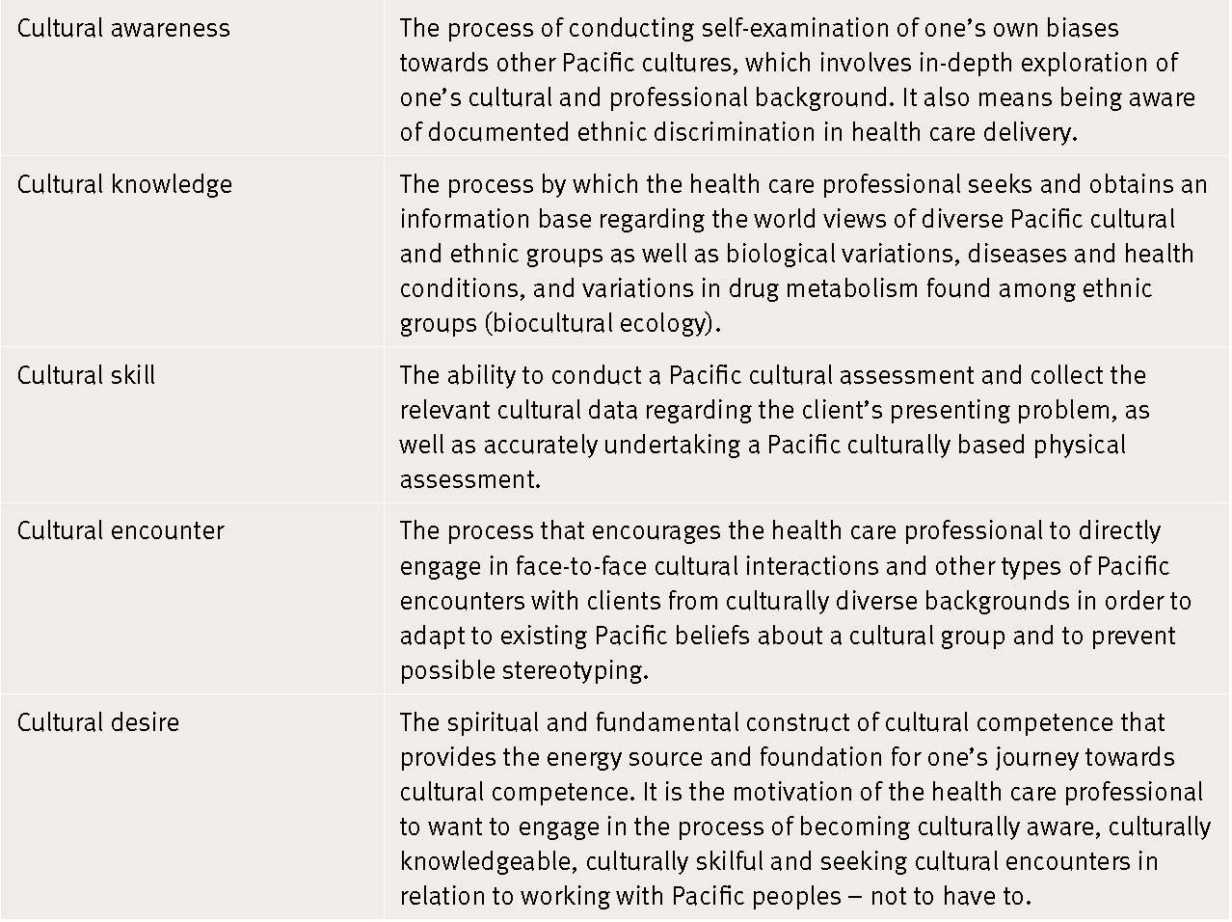

The key for the individual is to have the capacity to critically apply these competencies in the delivery of quality care for Pacific peoples (Health Workforce Advisory Committee n.d). It is acknowledged that a health professional may not attain the level of ‘cultural skill’ (see Table 2), yet this is necessary in the encounter with a Pacific client because it is the application of the other four constructs and components that will make the clinical encounter effective. For instance, Pacific cultural skill is attained by an organisation through employing culturally skilled Pacific persons.

There is the view that establishing cultural competency standards may run the risk of reducing complex cultural processes into simplistic formulas, which may underestimate and ritualise culture (Southwick 2001). In other words, standards imply normative behaviours within a defined group, but it must be understood that individual behaviours vary widely from these norms. Thus, individual health workers require a sensitivity to the possibilities of beliefs, meaning, behaviours and needs that may be discernible by any Pacific person (Foliaki 2003). Standards, coupled with training, should enable the health worker to identify the specific cultural needs of Pacific people, and the health provider organisation must then have the capacity to respond to these needs (Foliaki 2003).

To reiterate, for the individual, knowledge, attitudes and behaviours defining culturally competent behaviour are maximised and made more effective by existing within a supportive health organisation and wider health system. Individual health professionals should feel supported to work with Pacific communities to develop relevant, appropriate and sustainable health programmes (Foliaki 2002).

Organisational cultural competence
As we have seen, it has been argued that in order for an individual to be competent, an organisational infrastructure must be in place to enable this. Opportunities for training, performance appraisal systems and sufficient funding must be established at the management level of an organisation to enable individual knowledge, skills and attitude competencies to be gained and upheld (Ministry of Health National Screening Unit 2004).

Waitemata DHB’s Pacific Cultural Competencies Framework for District Health Boards (Draft 4) by Tiatia and Foliaki (2005), as well as the National Screening Unit’s Draft Generic Cultural Competences (2004) documents specify that a Pacific culturally competent organisation will seek to have the capacity to:
- equip health care providers with knowledge, tools and skills to better understand and manage socio-cultural issues in the clinical encounter
- communicate to its clients in their language of preference
- have systems and processes that facilitate understanding of and respect for values, beliefs and practices
- incorporate these values, beliefs and practices in its service delivery
- deliver its service in the context of its clients’ socioeconomic reality
- correctly identify Pacific clients in its demographic, epidemiological and clinical outcome data base
- document the organisation’s progress towards becoming culturally competent.

It is crucial for managers and others in health care institutions to be reminded that responsiveness is not simply an attitude or skill to be possessed by individual health professionals, but should run through the whole health care institution (Bischoff 2003). Cultural competence is a subset of individualised care, in the sense that it is the ability to provide individualised care that accounts for the influences and benefits of the client’s culture. Thus, an organisation that gains the skills in cultural competence, subsequently increases its ability to serve all diversity (Minnesota Department of Human Services 2004).

To some extent there is some overlap between individual and organisational cultural competence, in that cultural competence must be systematically included at every level of the organisation including policy making, administrative practice and patient, family and community levels (Counties Manukau DHB 2001). However, the distinction between personal and organisational cultural competence is equally important, because organisational cultural competence includes both personal and institutional-level cultural competence. Therefore, a self-assessment of an organisation’s cultural competence would not only evaluate the cultural competence of its staff but also that of the organisation overall (Olavarria et al 2005).

5 Cultural Competence Measures and Mechanisms for Achievement
Brach and Fraser (2000) argue that although there is substantial evidence to suggest that cultural competence is imperative, there is little evidence for which approaches and techniques are effective, and how and when to implement them appropriately. Furthermore, the development of suitable cultural competence measures is hampered by a lack of clarity around the meaning of cultural competence in the first instance (Davis 2003). So although there is no universal understanding of what culturally competent care is, the challenge lies in identifying ways of measuring or evaluating appropriate care and cultural competence training, defining successful programmes, and creating innovative methods for assessing a construct that is continually evolving at multiple levels within a service community (Davis 2003; Zambrana et al 2004).

There are several reasons for this lack in universal understanding of what cultural competence is. For instance:
- there are no established standards to define competent care
- the costs of providing appropriate care (eg, interpreter services) are often not reimbursed many public officials, health care facilities and providers are unaware of their obligations or unwilling to provide linguistic and culturally appropriate health care to their patients
- institutional practices often tend to disregard the health care needs of those who are unable to pay, have insurance, or are unable to negotiate the system due to low education and literacy skills and/or access constraints (Zambrana et al 2004).

It is evident that cultural competence involves a dynamic interplay among socioeconomic status, ethnicity and language – an interplay that definitions and interpretations of the term do not always acknowledge (Zambrana et al 2004).

Chin (2000) has addressed cultural competence training from a business and organisational perspective and suggests that in order to assess attitudes, policies, structures and practices, there needs to be monitoring, planning and implementation of cultural competence within organisations. Chin maintains that the focus of cultural competence initiatives have been on the provider-patient relationship, with little attention given to whether the systems of care in which they operate are culturally competent. Moreover, the author argues that measurable evidence of the cultural competence of an organisation includes patterns of use and disparities in health status, and there is a need to create quality indicators for organisational cultural competence and accountability (Chin 2000).

Similarly, Betancourt et al (2002) claim that in order to achieve systematic cultural competence, it is crucial to address such initiatives as undertaking community assessments, developing mechanisms for community and patient feedback, implementing systems for ethnic and language preference data collection, developing quality measures for diverse patient populations, and ensuring culturally and linguistically appropriate health education materials and health promotion and disease prevention interventions. As has been emphasised throughout this report, Betancourt et al also recommend that to achieve organisational cultural competence within health care, leadership and workforce development are vital.

Many models have been used to describe a continuum of cultural competency. One example is Mason’s Model (1993) (see Figure 1), which describes the characteristics of cultural destructiveness at one end and advanced competence at the other. Mason’s continuum measures competence for individuals and organisations and is based on five progressive steps (Mason 1993).
Figure 1: Mason’s continuum of cultural competence

Table 3: Mason’s five progressive steps for measuring cultural competence
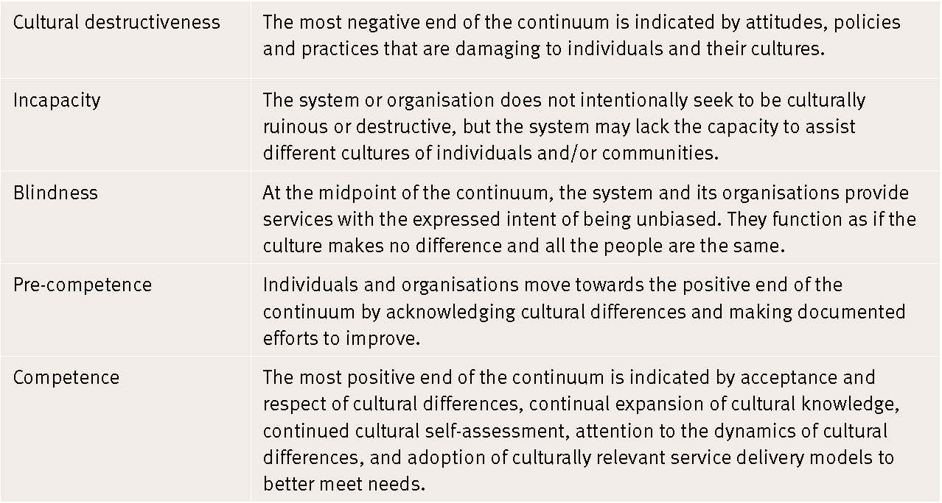

The benefit of Mason’s continuum is that, with honest self-appraisal, individuals and organisations can determine their present state and measure their change towards cultural competence over time.

The National Minority AIDS Education and Training Center (NMAETC) in the United States acknowledges that HIV/AIDS increasingly and disproportionately affects ‘people of colour’, particularly African Americans, and recognises that there is a need for cultural competence among health care professionals who treat minority patients with HIV/AIDS. In addressing the importance of cultural competence in HIV/AIDS education and training to health care professionals who treat minority patients, NMAETC has developed a model for clinical practice – the ‘BESAFE model’.

The mnemonic BESAFE is a framework that uses culturally pluralistic content and perspectives based on six core elements: barriers, ethics, sensitivity of the provider, assessment, facts and encounters. Each of these core elements provides health care professionals with a culturally relevant framework while providing primary health care services for those infected with HIV/AIDS (McNeil et al 2002).

These six core elements are described as follows:

Table 4: Core elements of the BESAFE model
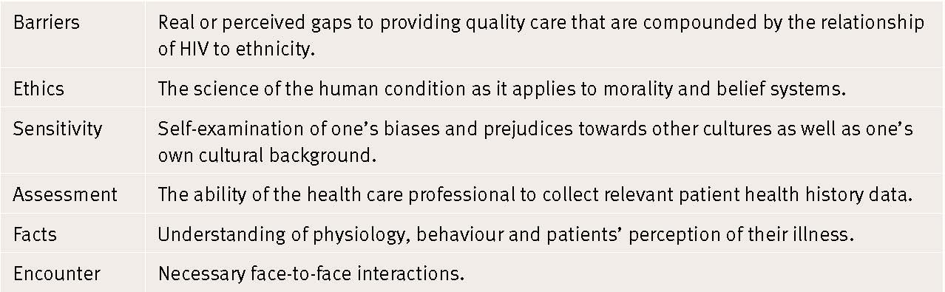

McNeil et al (2002) argue that the BESAFE model offers health care professionals caring for African Americans with HIV/AIDS an important practice model to enhance their level of cultural competency. This model suggests that health care professionals begin their journey towards becoming culturally competent by:
1 addressing overt and covert barriers to care
2 assessing their level of awareness and sensitivity toward African-American patients with HIV/AIDS
3 conducting a cultural assessment
4 obtaining knowledge about this cultural group
5 maintaining effective clinical encounters (McNeil et al 2002).

NMAETC acknowledges that although a cure has yet to be discovered for HIV/AIDS, it is vital to understand a person’s culture and its influence on health care beliefs and practices, which in turn will pave the way for culturally responsive approaches to health care delivery. NMAETC also believes that cultural competence is a journey, not a destination, a process not an event, and a process of ‘becoming’ competent, not ‘being’ culturally competent (McNeil et al 2002). This model may be useful for Pacific communities.

A model that may also be of relevance to Pacific communities is Leininger’s Sunrise Model (1991) (see Figure 2), which provides a method for assessing patients in order to provide comprehensive and culturally appropriate care. Leininger’s Sunrise Model was developed on the basis that the Western medical model had failed to explore cultural patterns of illness (Leininger 1991). The model implies that the world view and social structure of the client are important areas to investigate and can be explored using seven dimensions: cultural values and lifeways; religious, philosophical and spiritual beliefs; economic factors; educational factors; technological factors; kinship and social ties; and political and legal factors (Leininger 1991). In addition to these factors, traditional healing methods should also be taken into account, as was discussed earlier (Cuttilli 2006).

According to the Sunrise Model, providers should base their selection of a treatment approach, or amalgamation of strategies, on information gathered from the assessment. Leininger suggests that this guidance could occur in a variety of ways: cultural care preservation and/or maintenance; cultural care accommodation and/or negotiation; and cultural care re-patterning and/or restructuring.

Culture care preservation and maintenance imply that existing behaviour and lifestyles that are beneficial to health should remain unchanged (Leininger 1991). For instance, health professionals should promote cultural practices such as mutual support for the sick members of the extended family, and include such practices in care plans.

Figure 2: Leininger’s Sunrise Model
Source: Cuttilli 2006

Cultural Competence Works (2001), produced by the Health Resources and Services Administration (HRSA) in the United States, provides best practices for cultural competence undertaken mainly in managed care settings and may be worthy of consideration for Pacific peoples. The HRSA sponsored a Cultural Competence Works competition and conducted a national search to recognise and expose programmes that provide culturally competent care for diverse populations. The HRSA report found that, overall, those who provided culturally competent services most successfully tended to do the following (see Table 5).

Table 5: Summary of culturally competent services
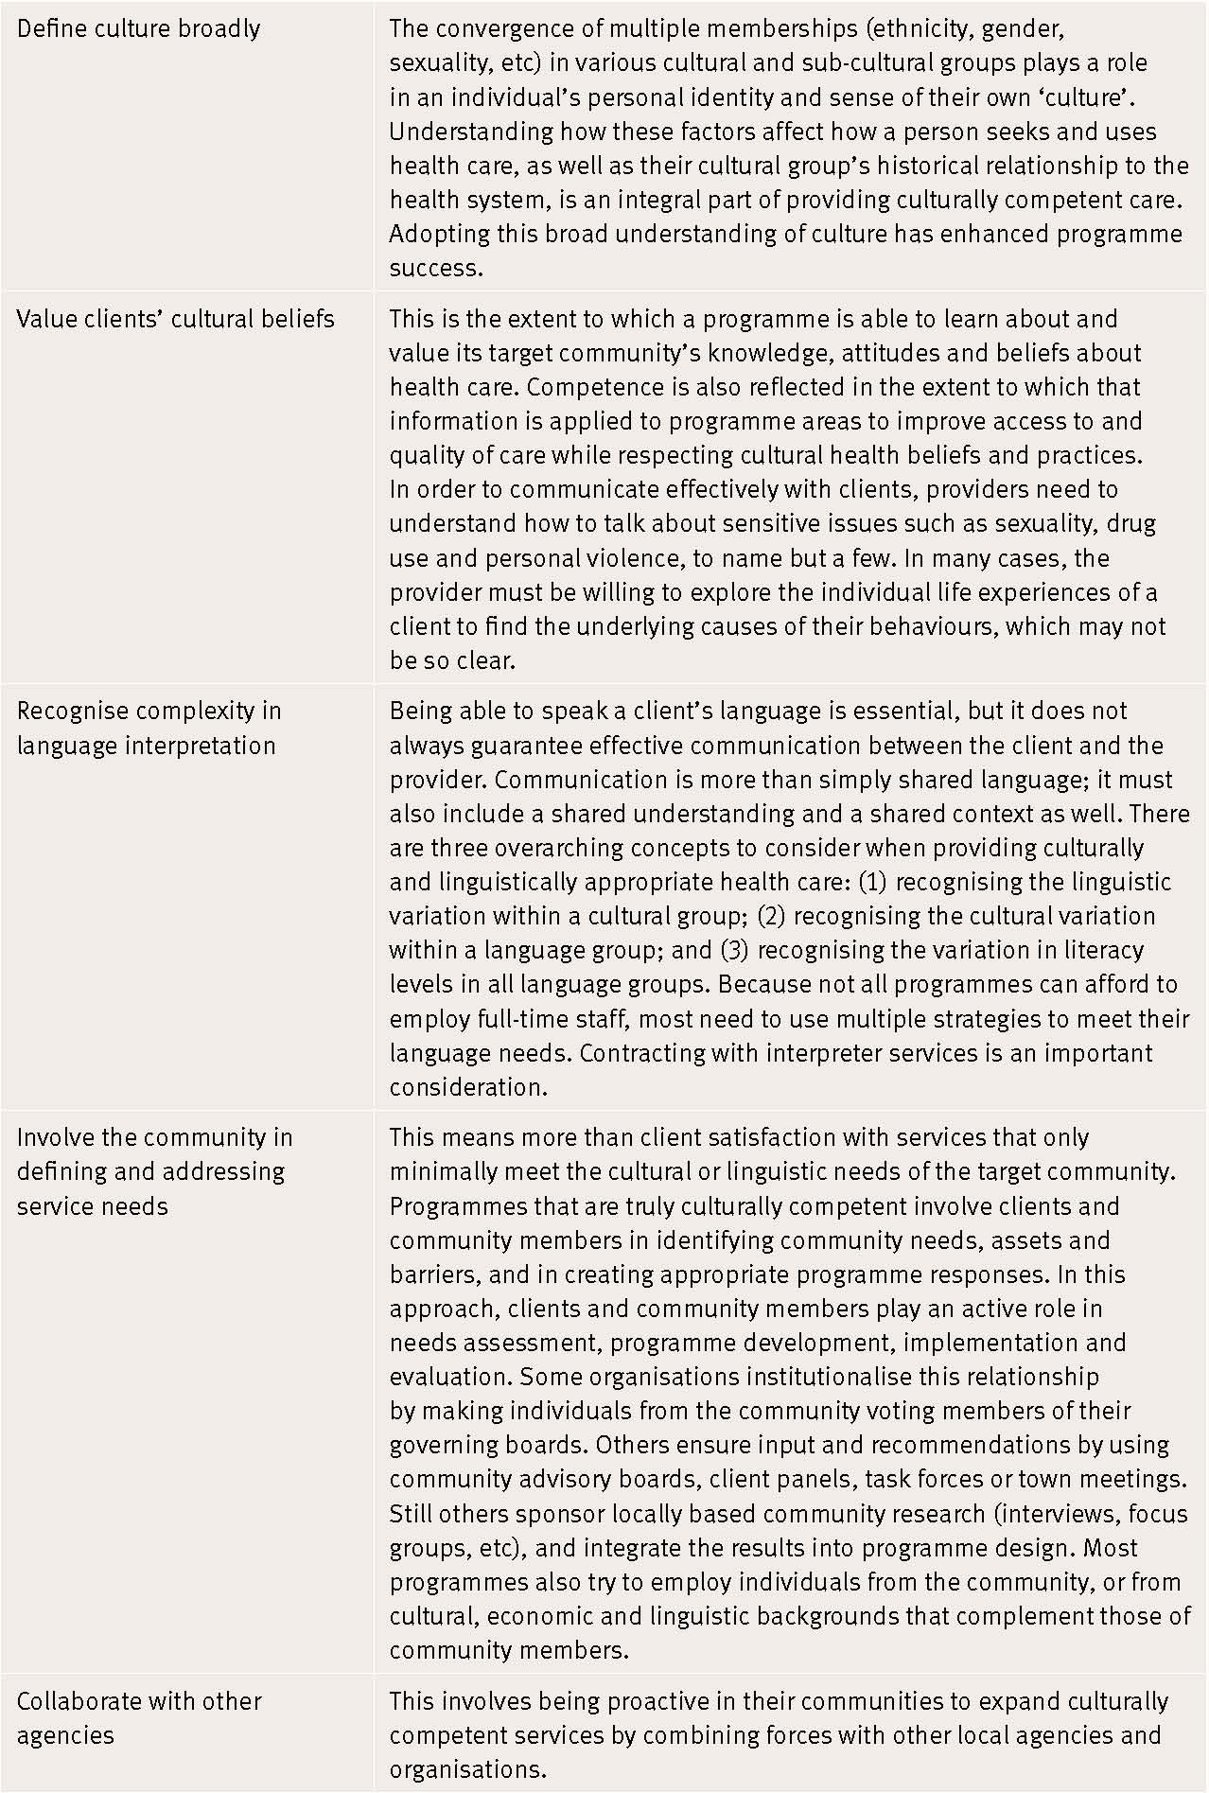
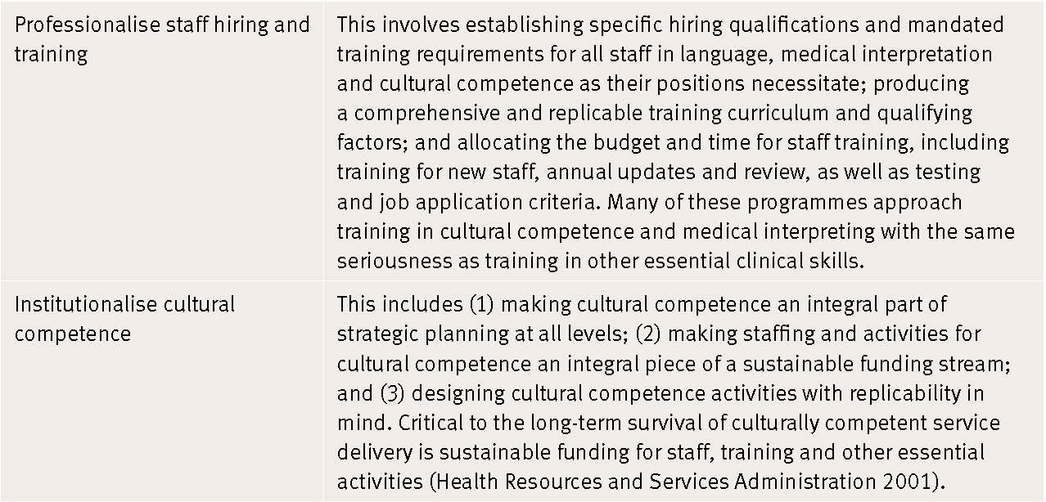

A study by Robinson et al (2006), which explored Pacific health care workers and their treatment interventions for Pacific clients with AoD problems in New Zealand, found that clinical concepts of assessment, treatment and outcome measures were not well understood by Pacific health care workers. Findings indicated that the most effective assessments were those conducted by skilled Pacific staff with sound knowledge, not only in their field of expertise, but in Pacific cultures and processes, and in the ability to combine mainstream and Pacific knowledge to benefit the client (Robinson et al 2006).

This study concluded that there was a need for clearly defined performance and outcome measures that accurately reflect Pacific processes and interventions. For instance, it was argued that:
- assessment is the first phase of assisting in treatment intervention, and needs to be recognised as such
- the establishment of rapport is crucial to the development of ongoing engagement with the client, and makes the initial stage more than simply completing an assessment form
- clients should be encouraged to inform workers about the significance of interventions
- there should be alternatives to written questionnaires given to Pacific clients, because questionnaires do not always reflect ‘honest’ opinions even when translated into Pacific languages
- client progress can be measured at different stages of the client’s journey, particularly at the beginning (assessment stage) and at the end of treatment (after the follow-up period)
- client-based outcomes should take into account social and environmental factors by recording verbal feedback from the client, families, referrers and any relevant others involved with the client.

The findings also reinforced the notion that when working with Pacific clients, it is not enough to simply be ‘Pacific’; it is equally, if not more, crucial to have formal training and skills development (Robinson et al 2006). This study is relevant because it contributes to understandings and supports current intervention practices for Pacific peoples, not only in the field of AoD but in all health sectors.

It seems appropriate in the context of this discussion to address the Pacific Cultural Competencies Framework for District Health Boards (Draft 4) developed by Tiatia and Foliaki (2005). This document argues for the need for DHBs to be culturally competent when working with Pacific peoples, and also addresses outcomes being sought for DHBs to ‘becoming’ culturally competent. The authors provide the following measures for organisational Pacific competency (see Table 6), which include primary domains, the rationale for their inclusion, and measures/indicators of organisational Pacific cultural competence.

Table 6: Measures of organisational Pacific competency
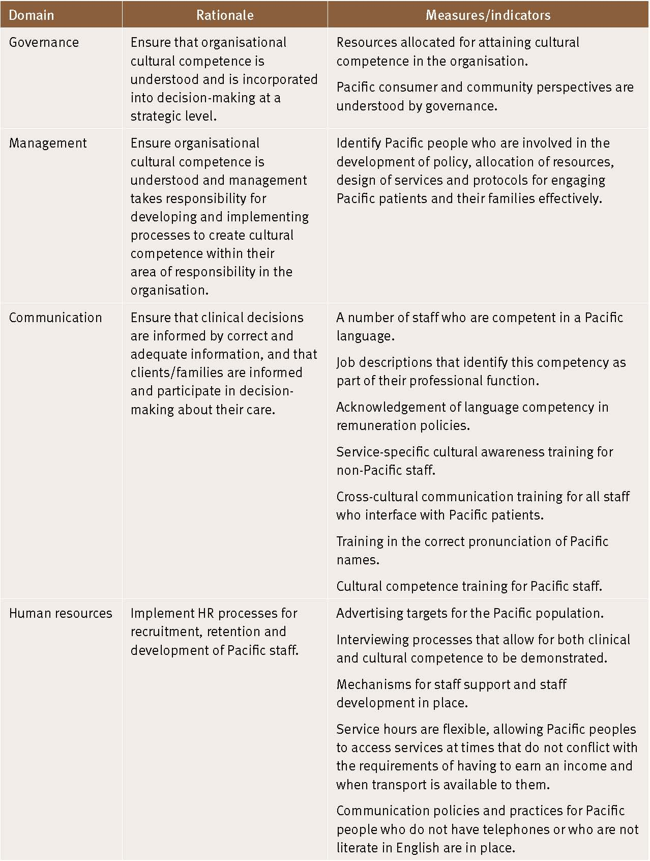
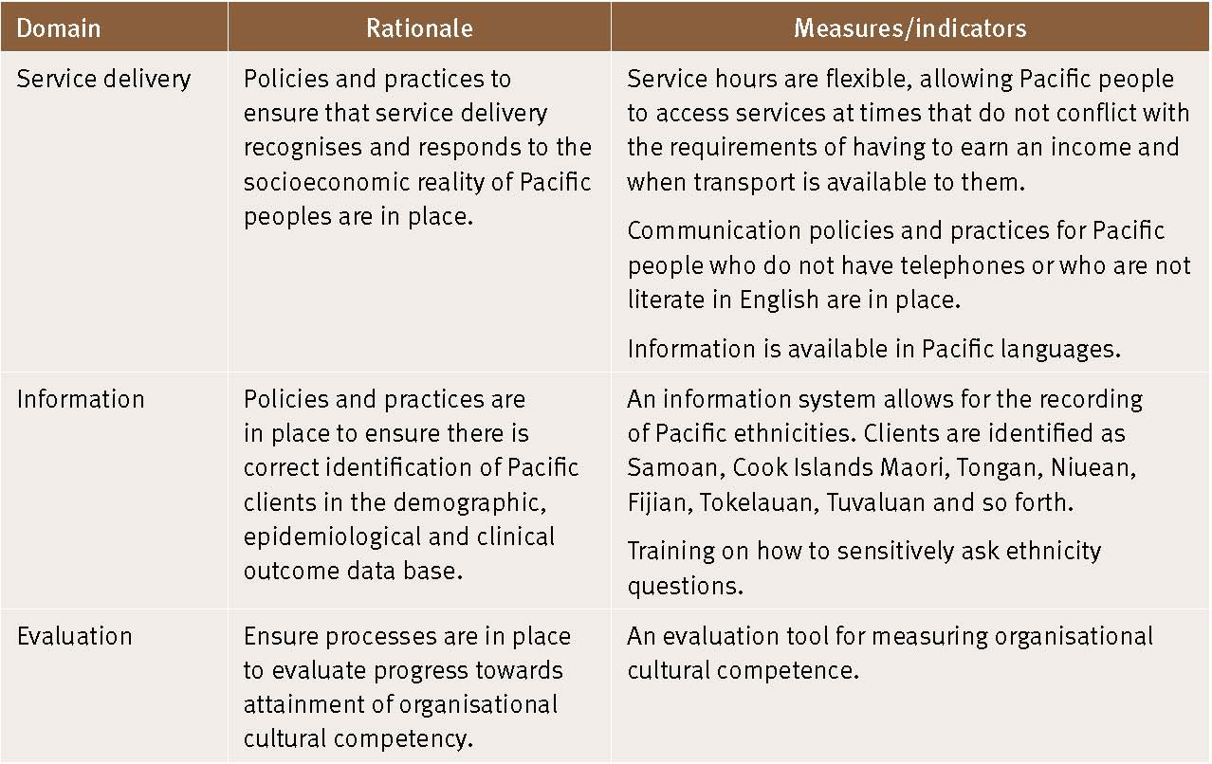

It is important that careful examination of language issues, particularly for Pacific youth, is also considered, which, as mentioned earlier, requires consideration of their ethnic, religious, sexual preference, neighbourhood and/or gender differences (see Table 1).

Assessment of cultural competence should include all stakeholders (ie, provider, care delivery system, purchaser, payer and consumer) and the different world views they bring to the system of care. It is the amalgam of all stakeholders and perspectives that results in culturally competent systems of care (Chin 2006).

6 The Role of Pacific Cultural Competence in Service Quality
Based on the premise that the Treaty of Waitangi is New Zealand’s founding document, New Zealand has a responsibility in health care to provide culturally competent services as a requirement of the Treaty and this is deemed crucial for any organisation focused on quality (Counties Manukau DHB 2001; Suaalii-Sauni and Samu 2005). Moreover, according to the 2006 Census, 7 percent of Māori also identify with Pacific ancestry (Statistics New Zealand 2007b). Inevitably this will increase, and will be an important consideration in the future development of Pacific cultural competencies.

An evaluation of the Pegasus Global Budget Contract undertaken by Kirk et al (2002) found that non-Pacific general practitioners were not expected to have in-depth knowledge of cultural knowledge, customs and traditions of their Pacific clients. It was argued that while such knowledge would have been beneficial to improving communication, it is only one aspect of a Pacific culturally competent service. Study participants (patients, doctors) believed that cultural sensitivity was of the utmost importance. For instance, participants agreed that the ability to build rapport and express empathy and respect should take precedence in quality general practice consultations and service delivery (Kirk et al 2002).

Foliaki (2003) has argued that in the delivery of quality services to Pacific communities, health care professionals should be expected to progressively attain a degree of cultural awareness and cultural sensitivity to Pacific peoples which would then allow successful engagement with Pacific clients and communities and ensure cultural safety (Foliaki 2003).

Currently, language and interpreter services have been the primary criteria for defining cultural responsiveness and competence. Such a confining definition must be broadened to include the integration of culture into the delivery of quality care and ongoing training and staff development for working with diverse populations (Rhymes and Brown 2005).

The Agency for Healthcare Research and Quality (AHRQ) conducted a review of an array of strategies to improve both the cultural competence of health care providers and the quality of health care received by ‘minority’ populations in the United States. After examining over 3500 papers (of which 91 were suitable for full evaluation), investigators found that cultural competency training improves the knowledge, attitudes and skills of health care providers as well as improving patient satisfaction and adherence to care (Beach et al 2004). However, it is important to note that training in cultural competence cannot be achieved in a ‘one-off’ course or workshop, but rather necessitates a lifelong process (Bacal et al 2006). This is an important consideration for Pacific cultural competency training.

As has been emphasised throughout this review, there is a need for some educational training that encapsulates the essential components of working with cultural and generational diversity, in and within Pacific communities, being mindful of course that any such expectation does not necessarily contribute to better primary health care service quality and delivery. In fact, it is vital to ensure that the development of cross-cultural education and training is not makeshift. Such training should be designed to promote holistic approaches to primary health care that are informed by Pacific models (Kirk et al 2002).

Pacific cultural competencies are an under-researched area. Many services are culture-based, but have rarely been analysed in detail, so the impact of culture-based components are not well understood. For example, Pacific interventions may be more acceptable and salient among Pacific adults and older peoples, but less so among Pacific youth. A major implication is that little is known about the feasibility and efficacy of Pacific cultural competencies. As we have seen, the issue for Pacific peoples is that cultural competencies lack rigorous evaluation, which means it is unclear what actually works to improve outcomes.

The AHRQ study identified gaps that may be of benefit for the future of Pacific-focused cultural competence research. It found that research requires:
- curricular objectives to be measurable and linked to measured outcomes
- outcomes to be measured objectively
- standardised, reliable and valid instruments to measure aspects of cultural competence
- studies evaluating the effect of cultural competence training to have a pre-and post-intervention evaluation and/or comparison group, and more randomised trials
- studies to measure the effect of curricular interventions on the health care process and patient outcomes, including health status
- researchers to comprehensively describe the curricular interventions
- studies to include comprehensive information about the resources needed and the cost of cultural competence training
- updated evidence assessments as the literature grows
- more funding for this research.

In the shift towards quality service outcomes, cultural competence should be considered integral to the definition of quality of care and included in accreditation tools, regulatory criteria and national surveys. Quality indicators to identify, define, track, evaluate and improve culturally competent practices and services are needed (Chin 2006).

In conclusion, increasing cultural competency is a shared responsibility, requiring partnerships across health, social services, education, justice and the research sectors, using systematic and sustainable approaches (Australian Government National Health and Medical Research Council 2005).

7 Recommendations
All recommendations in this area are inevitably based largely on argument by analogy with parallel areas of work undertaken overseas and exploratory Pacific components that have yet to be evaluated. For these reasons, the following recommendations are provisional and in need of empirical evaluation before being implemented.

Organisations and services
- Pacific cultural competency must be a core institutional value.
- Increasing cultural competency is a shared responsibility, requiring partnerships across health, social services, education, justice and research sectors, using systematic and sustainable approaches. A concerted intersectoral approach is needed.
- Health providers should not only be equipped with the knowledge and skills of culturally competent care and new clinical skills, but should also be capable of identifying and accessing appropriate support systems.
- The co-existence of traditional and Western methods needs to be successfully co-ordinated to ensure continuity of care for the patient.

Content of cultural competence programmes
- Successful programmes of cultural competence address the following: a broadened definition of culture; valuing clients’ cultural beliefs; recognising complexity in language interpretation; involving the community in defining and addressing service needs; collaboration with other agencies; professionalised staff hiring and training; and institutionalised cultural competence.
- Programmes with the highest potential for increasing cultural competence among health professionals are: cultural competence education before, during and after training; ongoing monitoring and evaluation of processes of care; certification and accreditation requirements; use of culturally diverse governing boards for health care practices; and promotion of workforce diversity.
- Training in cultural competence cannot be achieved in a one-off course or workshop, but necessitates a lifelong process. This is an important consideration for Pacific cultural competency training.
- Quality indicators to identify, define, track, evaluate and improve culturally competent practices and services are needed.

Measures of cultural competence
- Measurable evidence of the cultural competence of an organisation includes patterns of use and disparities in health status. Thus, there is a need to create quality indicators for organisational cultural competence and accountability relevant to Pacific communities.
- To achieve systematic cultural competence, it is crucial to address such initiatives as undertaking community assessments, developing mechanisms for community and patient feedback, implementing systems for ethnic and language preference data collection, and ensuring culturally and linguistically appropriate health education materials and health promotion and disease prevention interventions.
- Assessments of cultural competence should include all stakeholders (ie, provider, care delivery system, purchaser, payer, and consumer) and the different world views they bring to the system of care. It is the amalgam of all stakeholders and perspectives that results in culturally competent systems of care.

Research/investigations needed
- There is still a dearth of information on Pacific models of practice and therefore an absence of evidence-based Pacific conceptual frameworks to inform further development of Pacific health care competencies.
- An evidence base needs to be built on culturally competent Pacific research that can inform policy, planning, education and capacity building, and evaluation.
- A major implication for Pacific peoples is that cultural competencies lack rigorous evaluation, which means it is uncertain what actually works to improve outcomes.
- Acculturation is an important component in Pacific cultural competence. For instance, NZ-born or -raised, Island-born or -raised and multi-ethnic marriages have contributed to further diversity in Pacific communities. Therefore, it is important that health professionals assess the level of acculturation. This is an area in need of further investigation.
- There need to be more forums in which Pacific peoples develop and amass Pacific models of good practice.
- There needs to be ongoing monitoring and modifying of existing programmes on Pacific cultural competencies.

Other considerations
- Cultural competence includes other ‘marginalised’ groups such as women, older people, children, young people, gay and lesbian people, people with disabilities and religious minorities.
- Cultural competence presumes that difference and diversity between and within groups are valued and acknowledged. Failure to do so will mask differences that significantly influence access, utilisation and quality; for instance, Pacific NZ-born or -raised, those who identify with more than one ethnic group, and projected increases in intermarriages.
- In order to establish a foundation for policy recommendations, there is a need to combine current work streams on cultural competencies or have them aligned. A streamlining of the Pacific cultural competency work would benefit from appropriate regional, if not national, co-ordination. This is the first step towards making policy considerations.

References
Administration of Aging. 2004. Achieving Cultural Competence: A guidebook for providers of services to older Americans and their families. URL: http://www.aoa.gov/prof/adddiv/cultural/CC-guidebook.pdf.
Adolescent Health Research Group. 2003. New Zealand Youth: A profile of their health and wellbeing. Auckland: University of Auckland.
Airini. 1997. Dreams of woken souls: the relationship between culture and curriculum. PhD thesis, University of British Columbia.
Anae M, Coxon E, Mara D, et al. 2001. Pasifika Education Research Guidelines: Report to the Ministry of Education. Wellington: Auckland Uniservices Limited.
Australian Government National Health and Medical Research Council. 2005. Cultural Competency in Health: A guide for policy, partnerships and participation. Canberra: Australian Government National Health and Medical Research Council.
Bacal K, Jansen P, Smith K. 2006. Developing cultural competency in accordance with the Health Practitioners Competence Assurance Act. Māori and Pacific Island Health 33(5).
Beach MC, Cooper LA, Robinson KA, et al. 2004. Strategies for Improving Monitoring Healthcare Quality. Baltimore: US Department of Health and Human Services.
Bedford R, Didham R. 2001. Who are the ‘Pacific peoples’? Ethnic identification and the New Zealand Census. In: C Macpherson, P Spoonley, M Anae (eds). Tangata o te Moana Nui: The Evolving Identities of Pacific Peoples in Aotearoa/New Zealand. Palmerston North: Dunmore Press.
Bennett DL, Chown P, Kang M. 2005. Cultural diversity in adolescent health care. Medical Journal of Australia 183(8): 436–8.
Bennett J. 2006. Achieving race equality through training: a review of approaches in the UK. Journal of Mental Health Workforce Development 1(1): 2–8.
Betancourt JR, Green AR, Carrillo E. 2002. Cultural Competence in Health Care: Emerging frameworks and practical approaches. New York: The Commonwealth Fund.
Bischoff A. 2003. Caring for Migrant and Minority Patients in European Hospitals: A review of effective interventions. Vienna: Ludwig Boltzmann Institute for the Sociology of Health and Medicine.
Blakely T, Dew K. 2004. Ethnicity, acculturation and health: who’s to judge? New Zealand Medical Journal 117(1188): 1–3. URL: http://www.wnmeds.ac.nz/acade-mic/dph/research/nzcms/ BlakeDewNZMJEdJan2004.pdf. Accessed July 2006.
Brach C, Fraser I. 2000. Can cultural competency reduce racial and ethnic health disparities? A review and conceptual model. Medical Care Research and Review 57(Suppl 1): 181–217.
Bureau of Health Professions. [n.d]. Other Definitions of Cultural Competence. US Department of Health and Human Services Office of Minority Health. URL: http://bhpr.hrsa.gov/diversity/ cultcomp.htm. Accessed August 2006.
Callister P, Didham R, Potter D. 2005. Ethnic intermarriage in New Zealand. Statistics New Zealand. URL: http://www.stats.govt.nz/NR/rdonlyres/14E5BF11-60CF-4F97-BB3B-CD76BAEAC6CE/0/ EthnicIntermarriageinNZ.pdf. Accessed May 2007.
Campinha-Bacote J. 2002. The Process of Cultural Competence in the Delivery Healthcare Services: A culturally competent model of care. Transcultural C.A.R.E Associates. URL: http://www.transculturalcare.net/Cultural Competence Model.htm. Accessed March 2004.
Campinha-Bacote J. 2003. Many faces: addressing diversity in health care. Online Journal of Issues in Nursing. URL: http://nursingworld.org/ojin/topic20/tpc20_2.htm. Accessed March 2004.
Chin J. 2000. Culturally competent health care. Public Heath Reports 115: 25–33.
Chin J. 2006. Assessment of cultural competence in mental health systems of care for Asian Americans. In: K Kurasaki, S Okazaki, S Sue (eds). Asian American Mental Health: Assessment methods and theories. Netherlands: Kluwer Academic Publishers.
Counties Manukau DHB. 2001. Plan for Chronic Care Management in Counties Manukau 2001–06. Auckland: Counties Manukau District Health Board.
Cross T, Bazron B, Dennis K. 1989. Towards a Culturally Competent System of Care (Vol. I). Washington: Georgetown University Child Development Center, CASSP Technical Assistance Center.
Cuttilli CC. 2006. Do your patients understand? Providing culturally congruent patient education. Orthopaedic Nursing 25(3): 218–24.
Davis TS. 2003. Viability of concept mapping for assessing cultural competence in children’s mental health systems of care: a comparison of theoretical and community conceptualisations. PhD thesis, University of Texas at Austin, Texas.
Finau S, Tukuitonga C. 2000. Pacific peoples in New Zealand. In: P Davis, K Dew (eds). Health and Society in Aotearoa/New Zealand. Melbourne: Oxford University Press.
Finger Lakes Health Systems Agency. 2003. What’s Goin’ On: Report of the African American Health Status Task Force. FLHSA African American Status Task Force Report. URL: http://www.flhsa.org/ currentprojects.htm. Accessed July 2006.
Foliaki L. 2002. Waitemata District Health Board: draft cultural competency standards for Pacific mental health workers. Paper presented at the Sixth Conference of the Health Promotion Forum of New Zealand, Christchurch, 2002.
Foliaki L. 2003. Cancer Screening Workforce Development Project: Pacific screening workforce (Draft 1). Wellington: National Screening Unit.
Health Resources and Services Administration. 2001. Cultural Competence Works: Using cultural competence to improve the quality of health care for diverse populations and add value to managed care arrangements. Merryfield: Health Resources and Services Administration, US Department of Health and Human Services.
Health Workforce Advisory Committee [n.d]. Building Pacific healthworkforce capacity. New Zealand Health Workforce discussion document. URL: www.hwac.govt.nz/publications/ discussiondocument/5BuildingPacificHealthWorkforce Capacity. Accessed March 2004.
Horner RD, Salazar W, Geiger J, et al. 2004. Changing healthcare professionals’ behaviours to eliminate disparities in healthcare: what do we know? How might we proceed? American Journal of Managed Care 10: 12–19.
Jansen P, Sorrensen D. 2002. Culturally competent health care. New Zealand Family Physician 29(5): 306–11.
Kirk R, Barnett P, Clayden C, et al. 2002. Evaluation of the Pegasus Health Global Budget Contract. Christchurch: New Zealand Health Technology Assessment.
Leininger MM. 1991. Culture, Care, Diversity and Universality: Theory of nursing. New York: National League for Nursing Press.
Lister P. 1999. A Taxonomy for developing cultural competence. Nurse Education Today 19(4): 313–18.
Macpherson C. 2001. One trunk sends out many branches: Pacific cultures and cultural identities. In: C Macpherson, P Spoonley, M Anae (eds). Tangata o te Moana Nui: The Evolving Identities of Pacific Peoples in Aotearoa/New Zealand. Palmerston North: Dunmore Press.
Macpherson C, Macpherson L. 1990. Samoan Medical Belief and Practice. Auckland: Auckland University Press.
Makins M (ed.). 1994. Collins Compact English Dictionary. Glasgow: Harper Collins Publishers.
Mason JL. 1993. Cultural Competence Self-assessment Questionnaire. Portland, Oregon: Portland State University.
McNeil J, Campinha-Bacote J, Tapscott E, et al. 2002. BESAFE: NMAETC Cultural Competency Model. Washington: National Minority AIDS Education and Training Center.
Mental Health Commission. 2001. Pacific Mental Health Services and Workforce: Moving on the Blueprint. Mental Health Commission. URL: www.mhc.govt.nz/publications/2001/Pacific%20work force%20paper.doc. Accessed August 2006.
Ministry of Health. 2003. National Pacific Cultural Competencies Framework Project Discussion Document. Unpublished report.
Ministry of Health. 2004a. Pacific Health and Disability Workforce Development Plan. Wellington: Ministry of Health.
Ministry of Health. 2004b. Tupu Ola Moui: Pacific Health Chart Book 2004. Wellington: Ministry of Health.
Ministry of Health. 2005. Pacific Provider Development Fund Purchasing Strategy 2005/06 to 2007/08. Wellington: Ministry of Health.
Ministry of Health National Screening Unit. 2004. Generic Competencies in Screening Programmes [draft]. Wellington: National Screening Unit.
Minnesota Department of Human Services. 2004. Guidelines for Culturally Competent Organizations. 2nd ed. Minnesota: Minnesota Department of Human Services.
National Aboriginal Health Organization. 2006. Fact Sheet: Cultural safety. National Aboriginal Health Organization. URL: http://www.naho.ca/english/documents/Culturalsafetyfactsheet. pdf#search=%22%22culturally%20safe%20practice%22%22. Accessed August 2006.
New Zealand Nurses Organisation. 1995. Cultural safety in nursing education. In: Policy and Standards on Nursing Education. Wellington: New Zealand Nurses Organisation.
Nurses Working with First Nations Professional Practice Group, Aboriginal Health Improvement Committee of the Thomspon/Cariboo/Shuswap Health Service Delivery Area (Interior Health), First Nations and Inuit Health Branch Transfer Unit and Registered Nurses Association of British Columbia. 2005. Performance Appraisal Tool: For Registered Nurses Working in Aboriginal Communities in the Thompson Cariboo Shuswap Health Service Delivery Area, July, 2006. URL: http://www.interiorhealth.ca/NR/rdonlyres/52AF7D85-3ED9-4F59-8189-3F2342D3345E/2660/ PerformanceAppraisalCHN.pdf#search=%22%22culturally%20safe%20practice%22%20%22
Olavarria M, Beaulac J, Belanger A, et al. 2005. Organizational Cultural Competence: Self-assessment tools for community health and social service organizations. Ottawa: Centretown Community Health Centre.
Pacific Competencies Working Party. 2002. Practitioner Competencies for Pacific Alcohol and Drug Workers Working with Pacific Clients in Aotearoa – New Zealand. Wellington: Alcohol Advisory Council of New Zealand.
Paediatric Special Interest Group. 1998. Standards and Guidelines for Physiotherapy Practice in Paediatrics in New Zealand. New Zealand Society of Physiotherapists Inc. http://www.myson. co.nz/PSIG%20Standards%20and%20Guidelines%20April%202003.pdf#search=%22%22phys iotherapy%20board%20of%20new%20zealand%22%20guidelines%20for%20cultural%22%22. Accessed August 2006.
Papps E, Ramsden I. 1996. Cultural safety in nursing: the New Zealand experience. International Journal for Quality in Health Care 8(5): 491–7.
Paterson J, Cowley E, Percival T, et al. 2003. Pregnancy planning by mothers of Pacific infants recently delivered at Middlemore Hospital. New Zealand Medical Journal 117(1188): 1–6. URL: http://www.nzma.org.nz/journal/117-1188/744/. Accessed July 2006.
Resnicow K, Baranowski T, Ahluwalia JS, et al. 1999. Cultural sensitivity in public health: defined and demystified. Ethnicity and Disease 9(1): 10–21.
Rhymes J, Brown DC. 2005. Summary Report Cultural Competence in Primary Health Care: Perspectives, tools and resources. Nova Scotia: Capital Health.
Robinson G, Warren H, Samu K, et al. 2006. Pacific healthcare workers and their treatment interventions for Pacific clients with alcohol and drug issues in New Zealand. New Zealand Medical Journal. URL: http://www.nzma.org.nz/journal/119-1228/1809/. Accessed July 2007.
Southwick MS. 2001. Pacific women’s stories of becoming a nurse in New Zealand: a radical hermeneutic reconstruction of marginality. PhD thesis, Victoria University, Wellington.
Statistics New Zealand. 2003. 2001 Census of Population and Dwellings: Pacific Islands people. Wellington: Statistics New Zealand.
Statistics New Zealand. 2004. Ethnic Population Projections: Issues and trends. Statistics New Zealand. URL: http://www.stats.govt.nz/NR/rdonlyres/9C60DFB7-713E-4A1F-84C09E2AE98FE32F/ 0/EthPopProj.pdf. Accessed May 2007.
Statistics New Zealand. 2007a. QuickStats about Culture and Identity 2006 Census. Statistics New Zealand. URL: http://www.stats.govt.nz/census/2006-census-data/quickstats-about-cultureidentity/quickstats-about-culture-and-identity.htm?page=para016Master. Accessed May 2007.
Statistics New Zealand. 2007b. QuickStats about Māori. Statistics New Zealand. URL: http://www.stats.govt.nz/NR/rdonlyres/095030F8-BD62-4745-836D-0EF185619C37/0/ 2006censusquickstatsaboutmaorirevised.pdf. Accessed May 2007.
Strickland B, Gale T. 2001. Acculturation. eNotes.com. URL: http://soc.enotes.com/galepsychology-encyclopedia/acculturation. Accessed September 2006.
Suaalii-Sauni T, Samu K. 2005. Cultural Competency: An exploratory study of cultural competency in Pacific mental health. Auckland: Waitemata District Health Board.
Tiatia J, Foliaki L. 2005. Pacific Cultural Competency Framework for DHBs (Draft 4). Unpublished report.
Tukuitonga C. 1999. Primary Healthcare for Pacific People in New Zealand: Discussion paper for the National Health Committee. Auckland: Faculty of Medicine and Health Science, University of Auckland.
Tukuitonga C, Finau S. 1997. The health of Pacific peoples in New Zealand up to the early 1990s. Pacific Health Dialog 4(2): 59–67.
US Department of Health and Human Services Office of Minority Health. 2001a. National Standards for Culturally and Linguistically Appropriate Services in Health Care. Washington, DC: US Department of Health and Human Services Office of Minority Health.
US Department of Health and Human Services Office of Minority Health. 2001b. Resources and Services Administration Study on Measuring Cultural Competence in Health Care Delivery. Washington, DC: US Department of Health and Human Services, Health Resources and Services Administration. URL: http://ww.hrsa.gov/culturalcompetence/measures/sectionii.htm. Accessed 8 June 2006.
Williams B. 2001. Accomplishing cross cultural competence in youth development programs. Journal of Extension. URL: http://www.joe.org/joe/2001december/iw1.html. Accessed 17 May 2006.
Zambrana RE, Molnar C, Munoz HB, et al. 2004. Cultural competency as it intersects with racial/ethnic, linguistic and class disparities in managed healthcare organizations. American Journal of Managed Care 10: 37–44.

The label ‘Pacific peoples’ includes groups with a range of ethnic affiliations, and includes many people with more than one ethnicity (Bedford and Didham 2001). The term ‘Pacific peoples’ in this report primarily refers to the New Zealand population with South Pacific ethnic origin.
Authorities appointed under the Act include the Chiropractic Board, Dental Council of New Zealand, Dieticians Board, Medical Council of New Zealand, Medical Laboratory Science Board, Medical Radiation Technologists Board, Midwifery Council, Nursing Council of New Zealand, Occupational Therapy Board, Optometrists and Dispensing Opticians Board, Osteopathic Council, Pharmacy Council, Podiatrists Board, Physiotherapy Board of New Zealand, and Psychologists Board.
‘Alcohol and drug’ is used in the Pacific Competencies Working Party 2002 report, but ‘alcohol and other drugs’ (AoD) is the most current and commonly used term.

