
People with Intellectual Disability in New Zealand and their health - Easy read version

This report looks at how well people with an intellectual disability are. It also looks at how much they use publicly funded health care services.

There has been little information in New Zealand about this up till now.
The report studied 31,847 people who have an intellectual disability and 4,261,600 people who do not.

Some stats:
0.7% of the study group had intellectual disability.
Many were children, teenagers or people aged 85 and over.
People with intellectual disability often live in poorer parts of New Zealand.

Overall results
- People with intellectual disability were worse off, in terms of their health and life expectancy, compared to people without intellectual disability.
- They had higher rates of health problems.
- They used health services more (apart from preventive screening services).
- These results are similar to overseas studies.

Life expectancy of people with intellectual disability
Average life expectancy of 59.7 years. More than 18 years LESS than other New Zealand males (78.4 years)
Average life expectancy of 59.5 years. Almost 23 years LESS than other New Zealand females (82.4 years).
How much more likely are people with intellectual disability to need care and treatment compared to people without?
Condition | People with intellectual disability
Cancer | 1.5 times more likely
Breathing difficulties | 1.5 times more likely
Chronic health problems | 1.5 times more likely
Heart disease | 2 times more likely
Diabetes | 2 times more likely
Obesity | 4 times more likely
Injury | 2 times more likely
Epilepsy | 30 times more likely
Dental | 15 times more likely
Mental health | 3 times more likely
Depression and anxiety | 2 times more likely
Psychotic disorder | 17 times more likely
Dementia | 10 times more likely
Go to GP | 1.5 times more likely
Breast screening | Less likely
Cervical screening | Less than half as likely
Medications | 2 times more likely
Elective hospital treatment | 2 times more likely
Acute hospital treatment | 3 times more likely
Hospital admission | 4 times more likely
Use emergency department | 2.5 times more likely





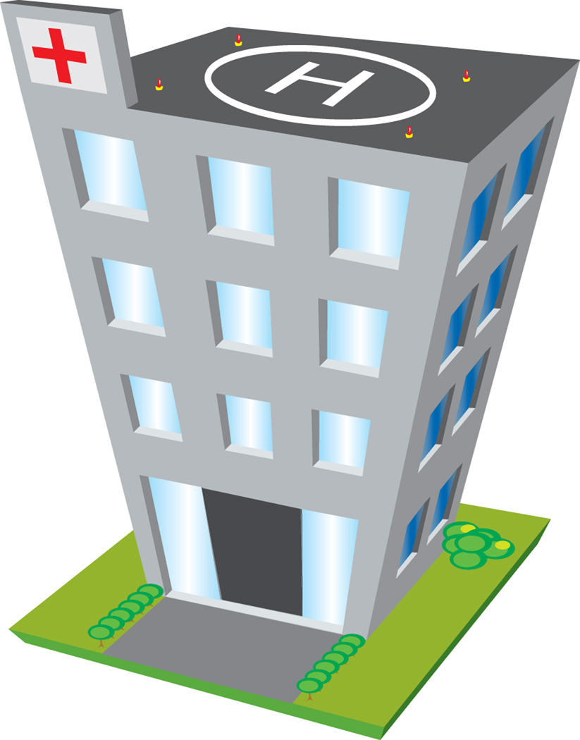

Costs of public funded health care per year
In 2008, public funded health care for people with intellectual disability cost $3,001 per person.
For people without intellectual disability this was $1,028.

Published by the Ministry of Health, New Zealand, August 2011
HP5388

