Women’s Health Strategy 2023

Citation: Minister of Health. 2023. Women’s Health Strategy. Wellington: Ministry of Health.
Published in July 2023 by the Ministry of Health
PO Box 5013, Wellington 6140, New Zealand
ISBN 978-1-991075-45-1 (online)
HP 8810
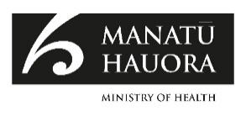
This document is available at health.govt.nz
This work is licensed under the Creative Commons Attribution 4.0 International licence. In essence, you are free to: share ie, copy and redistribute the material in any medium or format; adapt ie, remix, transform and build upon the material. You must give appropriate credit, provide a link to the licence and indicate if changes were made.

Ministers’ foreword
As Minister and Associate Minister of Health, we are proud to present the Women’s Health Strategy, the first New Zealand strategy dedicated to women’s health and wellbeing.

The Women’s Health Strategy sets an ambition to achieve pae ora | healthy futures, for all women. We will achieve this by better prioritising women’s health and wellbeing needs, and by supporting women to live longer in better health, in healthy families and healthy environments.

We thank and acknowledge the women, whānau, organisations, and sector groups that shared or gathered insights, experiences, and aspirations for women’s health through the engagement on the pae ora strategies.

Women are more likely to be carers, to be sole parents, and to have a low income, all of which can contribute to poorer health outcomes. Inequities and challenges are bigger for many groups of women, including wāhine Māori, Pacific women, rural women, and disabled women. To improve women’s health, we need a system that will address these inequities and prioritise women’s realities.

The Women’s Health Strategy reflects kōrero that we have had with a range of women, their whānau and communities, and members of the health and wellbeing sector, across the country. It also sets the direction for addressing key challenges identified for women and whānau and builds on work that is already happening to address issues that disproportionately affect women, including the Budget 2022 investment in community- based specialist infant and maternal mental health services and care.

Key challenges include inequities in health outcomes, with women spending more of their lives in poor health. Women have shared experiences of not being heard or prioritised when they seek care for their health and the health of their whānau.

The strategy identifies priority areas and sets the direction for change that will guide health sector entities and organisations to prioritise and improve women’s health and wellbeing in a coordinated way. We know that embedding these priorities in our core health system accountability documents, including the Government Policy Statement on Health, and Te Pae Tata | New Zealand Health Plan, will be central to our success.

We acknowledge all women in Aotearoa New Zealand for their diverse strengths and contributions, from those who work in the healthcare system, to those who advocated for the development of a women’s health strategy, as well as all who continue to advocate for healthier futures for women in Aotearoa New Zealand.

Many women are using their voices to create change, including those who contributed to the 2019 report, Hearing and Responding to the Stories of Survivors of Surgical Mesh.
This follows a long legacy of women leading change to support better outcomes for current and future generations.

Women’s advocacy has contributed towards important legislative changes, such as enabling leave for domestic violence, miscarriage and stillbirth. Paid parental leave is being extended and payments are being increased. There have been changes to reduce pay equity gaps for nurses, 88% of whom are women.

We know there is more to do to honour women’s voices, and to achieve pae ora, | healthy futures, for women and their whānau. The Women’s Health Strategy will guide us as we realise this vision.

Hon Dr Ayesha Verrall Hon Willow-Jean Prime
Minister of Health Associate Minister of Health

Contents
Ministers’ foreword iii
Executive summary 1
The purpose of this document 3
Introduction 5
The structure of this document 6
Part 1: Our vision for women’s health 7
Our vision 7
Our goals 7
Our commitment to Te Tiriti o Waitangi | The Treaty of Waitangi 8
Part 2: Where are we now? 10
What we heard 10
Diversity 11
Wāhine Māori 13
Medium to long-term trends 14
Women’s health and health system performance 14
Access to health care for issues specific to women 18
Inequities in perinatal outcomes and health care access 20
Determinants of poor health and wellbeing for women 21
Part 3: Priority areas for women’s health and wellbeing action 24
Priority 1: A health system that works for women 25
Priority 2: Improving health care for issues specific to women 29
Priority 3: Better outcomes for mothers, whānau, and future generations 33
Priority 4: Living well and ageing well 37
Part 4: Delivering our commitment to change 42
Turning strategies into action 42
Monitoring outcomes 43
Ongoing evaluation 44
References 45

List of Figures
Figure 1: Some of the women’s voices that informed the Strategy 3
Figure 2: Women’s Health Strategy on a page 4
Figure 3: Population statistics on New Zealand women 12
Figure 4: Healthy life expectancy and years in poor health by sex at birth, from 1990 to 2019 15
Figure 5: Projected life expectancy, by ethnic group and sex, 2019-2043 15
Figure 6: Top five burdens of disease for women at different ages (based on Disability Adjusted Life Years). Global Burden of Disease statistics, 2019 16
Figure 7: Selected causes of years lived with disability by sex. Global Burden of Disease statistics, 2019 16
Figure 8: System architecture 43

Executive summary
The Women’s Health Strategy sets the direction for improving the health and wellbeing of women over the next 10 years. It sets long-term priorities which will guide health system progress towards equity and healthy futures for women.

Our vision is pae ora | healthy futures for women. All women will live longer in good health, have improved wellbeing and quality of life, and be part of healthy and resilient whānau and communities within healthy environments that sustain their health and wellbeing.

There will be equitable health outcomes for wāhine Māori, which is a commitment under Te Tiriti o Waitangi | The Treaty of Waitangi.

There will also be equity of health outcomes between men and women, and between all groups of women.

The Women’s Health Strategy is informed by women and our evidence. The strategy focuses on health needs and experiences that are different for, or specific to women. This strategy sits alongside the other pae ora strategies: New Zealand Health Strategy, Pae Tū — Hauora Māori Strategy, Te Mana Ola —
the Pacific Health Strategy, the Rural Health Strategy, and the Health of Disabled People Strategy. All pae ora strategies set the direction for the health system that will make improvements for populations of women.

A common theme we heard in our engagement was that gender bias is affecting women’s health and wellbeing and their experiences in the health system. Women, the health sector, and organisations that support women, told us that women are often not heard or understood when they access health care, and there is a lack of knowledge and understanding and support in many areas of women’s health.

We also heard that racism is a root cause of health inequity and a routine experience for wāhine Māori, and that addressing structural racism and meeting commitments under Te Tiriti of Waitangi | The Treaty of Waitangi must happen to improve the health outcomes of wāhine Māori.

We heard from women and their communities about the many roles and responsibilities that women hold, including community work and caring roles. Work is needed to ensure that health services are accessible and effective for women and their whānau.

The Women’s Health Strategy sets out the following goals to guide health entities in their work to achieve the vision for women’s health and wellbeing.
- The government and health system protect the indigenous rights of wāhine Māori, who are able to exercise tino rangatiratanga | self-determination and mana motuhake over their health and wellbeing. Kaupapa Māori services are accessible to all wāhine Māori who wish to access them.
- Women are leaders within the health system, including wāhine Māori and diverse groups of women.
- The health system recognises and meets the needs and aspirations of all women and their whānau who will experience equitable health outcomes. All women and their whānau will:
- feel welcomed and valued by the health system
- not experience gender bias, racism, or other discrimination within health care
- be empowered to have ownership over their health
- receive high quality, evidence-based care and support that is appropriate to their gender, culture, context, age, and life stage
- have more options, including access to kaupapa Māori services for wāhine Māori.

Four strategic priority areas set a clear direction on the changes needed in the next 10 years to move towards achieving the goals and ensuring our health system is fairer, stronger, more sustainable, and responsive to women.

The priorities set out in the Women’s Health Strategy and the other pae ora strategies will inform the Government Policy Statement on Health and Te Pae Tata | New Zealand Health Plan. Together these documents will guide the health sector in better prioritising and responding to women’s health needs and experiences.
- A health system that works for women is our overarching priority which sets out our ambitions for system change. Achieving a health system that works for all women requires us to address gender bias, racism, and other forms of discrimination and bias, including how these influence the design and operation of the health system and women’s experience within it. These are the necessary enablers to achieving the ambitions in priority areas 2, 3 and 4, which focus on specific issues women face within the health system.
- Improving health care for issues specific to women. Women told us about how barriers like stigma and gaps in service availability and information make it hard to access some forms of health care. Priority area 2 includes a focus on sexual and reproductive health, pelvic and menstrual health. Priority area 2 also includes women’s gynaecological cancers.
- Better outcomes for mothers, whānau and future generations. We also heard that pregnant women and people are not always able to access pregnancy care that meets their needs. This includes lack of access to early and ongoing support and a lack of continuity between pregnancy and early years care. Inequities in access and perinatal outcomes have been shown to be worse for some groups of women, including wāhine Māori and Pacific women. This informed priority area 3, which focuses on what needs to change to improve the health and wellbeing of mothers and young children and ensure the health of future generations.
- Living well and ageing well. Women also told us that they want to live longer in good health, in environments that support good health, and with better support for conditions and life stages that affect women’s health. Priority area 4 focuses on prevention and early intervention to better manage conditions and life stages, like menopause, as well as how the health system can better respond to the determinants of women’s health.

The purpose of this document
The Women’s Health Strategy sets the direction for improving the health of women over the next 10 years. It sets long-term priorities which will guide health entities progress towards equity and healthy futures for all groups of women.

Figure 1: Some of the women’s voices that informed the Strategy
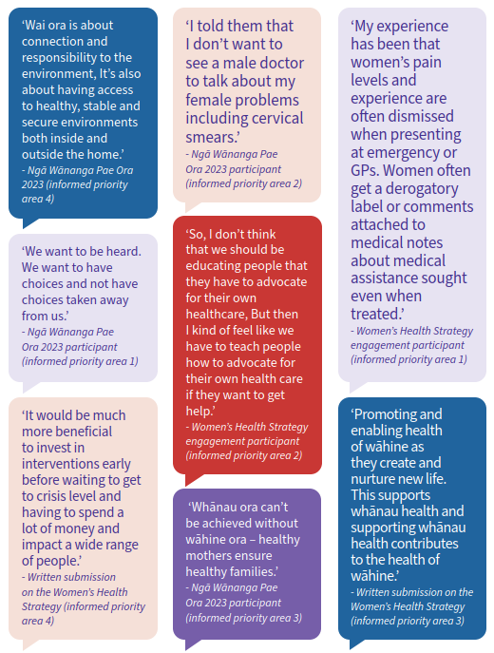

Purpose
The Women’s Health Strategy sets the direction for improving the health and wellbeing of women over the next 10 years.

Figure 2: Women’s Health Strategy on a page
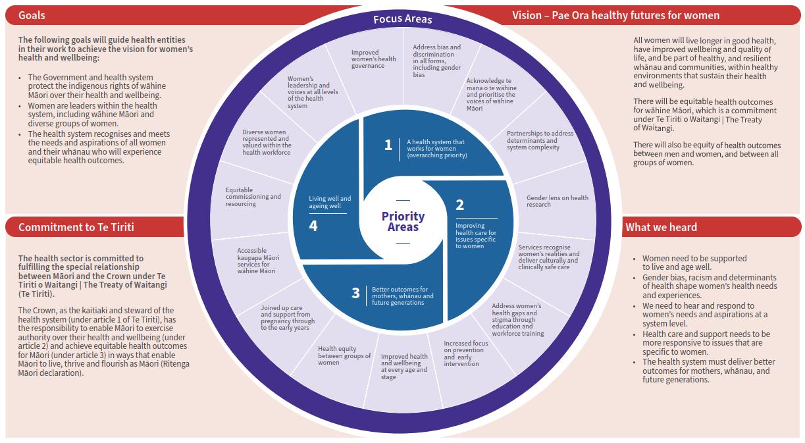

Introduction
This is the first New Zealand Women’s Health Strategy, and is a response to significant advocacy from women. The strategy is an acknowledgment that we need to do better for women to support them to live well, age well and experience equitable health outcomes.

The strategy recognises our commitment to wāhine Māori under Te Tiriti o Waitangi | The Treaty of Waitangi — to provide for tino rangatiratanga, equitable health outcomes, active protection, options, and working in partnership. There are significant shifts needed to meet the Crown’s obligations to wāhine Māori under Te Tiriti o Waitangi | The Treaty of Waitangi and we must acknowledge mana wāhine, the strengths and special role of wāhine Māori.

We have listened to what is most important to women for their health and wellbeing and these voices sit at the heart of the strategy. New Zealand’s health system, like many others, has not been designed well for women or for people who identify outside of the male/female gender binary. This results in a system-wide ‘gender bias’, which is when ideas, policies and practices favour people of one gender over those of other genders. Gender bias can happen at an interpersonal level, for example in interactions between an individual or whānau and a health professional, and at the systematic level, for example in how the health system is designed, funded and operated.

Gender bias in the health system, means that the health system often does not respond well to women’s health and wellbeing needs. Gender bias can result in gaps in research on women’s health, lack of information and a lack of services for health conditions that only affect women or are more common in women. It can also result in delays in diagnosis, and access barriers to health services and support that disproportionately affect women.

In addition to gender bias which affects all women, some groups of women also experience other forms of bias and discrimination, including racism, both within the health system and in wider society. Racism is a root cause of health inequity. It operates at multiple levels with various pathways to health. Bias and racism have resulted in the unequal distribution of power and resources, and differential access and exposure to the broader determinants of health. As a result, wāhine Māori and Pacific women are more likely to experience disproportionate rates of health risk, poor health outcomes, and shorter life and health expectancy. It also presents as cultural bias within the health system, experienced by Māori, Pacific, Asian and other ethnic women.

Other groups of women experience various forms of bias. This includes disabled women experiencing ableism and rainbow communities experiencing transphobia and homophobia.

The Women’s Health Strategy is one of the six health strategies required under the Pae Ora Act (2022) that are being published in 2023, as part of making effect of the health reforms. Together the suite of health strategies guide collective efforts to achieve the goals of equity and pae ora. This direction will inform future decisions on Government objectives and health and wellbeing approaches, and in turn guide service priorities and the performance of health entities.

Prioritising women as a population group sets the direction for a whole-of-system shift where women and their whānau are supported to thrive. Women need to receive equitable consideration and resourcing within the health system. This requires the health system to review and then prioritise addressing areas of women’s health and wellbeing where there are significant knowledge and service gaps. The strategy is a call for action across the system broadly and in key areas of women’s health where gaps are resulting in preventable disease and death for our women and future generations.

Specific actions and decisions on investment will be made as part of confirming the Government Policy Statement on Health and Te Pae Tata | New Zealand Health Plan, that come into effect from July 2024. In addition, planning and design of local services will also be guided by locality plans and Iwi-Māori Partnership Boards.

It is recognised that not everyone who experiences the health issues covered in the strategy are women. The health needs discussed in this strategy can be experienced by people with diverse gender identities and expressions and sex characteristics. This includes those with variations of sex characteristics or intersex people, transgender men, non-binary people, takatāpui and MVPFAFF+.

While the term ‘women’ is used throughout the strategy, priorities in this health strategy will be relevant to wider groups of people. It is intended that the development and design of specific actions flowing from this strategy will be inclusive of rainbow voices and work to drive services and approaches that respond to rainbow needs and aspirations. We also recognise that not all women will experience some of the health issues that are referred to as ‘women-specific’ throughout the strategy.

The Women’s Health Strategy recognises the special relationship between New Zealand and countries of the Realm in the Pacific — the territory of Tokelau, and the self-governing states of the Cook Islands and Niue. In recognition of New Zealand’s obligations to Realm countries and as citizens of New Zealand, the strategy includes these Pacific people when in New Zealand.

The structure of this document
Part 1 describes a long-term vision for women’s health and goals which guide our progress towards this vision.

Part 2 provides an assessment of the current state of women’s health and wellbeing, and health system performance for women, as well as key themes from engagement.

Part 3 identifies the priority areas and the changes needed in these areas to achieve our 10-year vision for women’s health and wellbeing.

Part 4 describes the next steps for how these changes can be delivered, including how the strategic direction will inform actions for health entities.

Part 1: Our vision for women’s health

Our vision
Our vision is pae ora | healthy futures for women. All women will live more years in good health, have improved wellbeing and quality of life, and be part of healthy, and resilient whānau and communities, within healthy environments that sustain their health and wellbeing.

There will be equitable health outcomes for wāhine Māori, which is a commitment under Te Tiriti o Waitangi | The Treaty of Waitangi.

There will also be equity of health outcomes between men and women, and between all groups of women.

Our goals
The following goals will guide health entities in their work to achieve the vision for women’s health.
- The government and health system protect the indigenous rights of wāhine Māori to exercise tino rangatiratanga | self- determination and mana motuhake over their health and wellbeing. Kaupapa Māori services are accessible to all wāhine Māori who wish to access them.
- Women are leaders within the health system, including wāhine Māori and diverse groups of women.
- The health system recognises and meets the needs and aspirations of all women and their whānau who will experience equitable health outcomes. All women and their whānau will:
- feel welcomed and valued by the health system
- not experience gender bias, racism, or other discrimination within health care
- be empowered to have ownership over their health
- receive high quality, evidence-based care and support that is appropriate to their gender, culture, context, age, and life stage
- have more options, including access to kaupapa Māori services for wāhine Māori.

Our commitment to Te Tiriti o Waitangi | The Treaty of Waitangi
The health sector is committed to fulfilling the special relationship between Māori and the Crown under Te Tiriti of Waitangi | The Treaty of Waitangi (Te Tiriti). Regarding the text of Te Tiriti and declarations made during its signing — the Crown, as the kaitiaki and steward of the health system (under article 1 of Te Tiriti), has the responsibility to enable Māori to exercise authority over their health and wellbeing (under article 2) and achieve equitable health outcomes for Māori (under article 3) in ways that enable Māori to live, thrive and flourish as Māori (Ritenga Māori declaration).

The Crown’s approach to meeting its obligations under Te Tiriti is outlined in section 6 of the Pae Ora (Healthy Futures) Act 2022. The legislation contains specific provisions intended to give effect to the Crown’s obligations.

In particular, the health sector principles in section 7 of the Act guide the Minister of Health, Manatū Hauora | Ministry of Health and health entities in how they carry out their functions. The health sector principles incorporate key outcomes and behaviours derived from the principles of Te Tiriti, as articulated by the courts and the Waitangi Tribunal, including:
- Tino rangatiratanga: providing for Māori self-determination and mana motuhake in the design, delivery and monitoring of health and disability services
- Equity: being committed to achieving equitable health outcomes for Māori
- Active protection: acting to the fullest extent practicable to achieve equitable health outcomes for Māori. This includes ensuring that the Crown, its agents, and its Treaty partner under Te Tiriti are well informed on the extent and nature of both Māori health outcomes and efforts to achieve Māori health equity
- Options: providing for and properly resourcing kaupapa Māori health services. Furthermore, the Crown is obliged to ensure that all health services are provided in a culturally safe way that recognises and supports the expression of hauora Māori models of care
- Partnership: working in partnership with Māori in the governance, design, delivery and monitoring of health and disability services — Māori and the Crown must be co-designers of the primary health system for Māori.

These principles are central to achieving our vision of pae ora | healthy futures for Māori. The interconnected elements of pae ora acknowledge the importance of mauri ora, whānau ora and wai ora to Māori health and wellbeing and the need to work collectively and in collaboration with the communities our system serves. This involves working with iwi, hapū and Māori communities, and with the organisations that contribute to the health and wellbeing of whānau.

Our commitment to Te Tiriti o Waitangi | The Treaty of Waitangi is described in greater detail in Pae Tū, published in parallel with this document.

Pae Tū and Whakamaua: Māori Health Action Plan 2020–2025 (Ministry of Health 2020a) provide guiding outcomes and priorities for the health sector so that all Māori, whoever they are and wherever they are from, can flourish and thrive.

Part 2: Where are we now?

What we heard
This list draws out the overarching themes in health system performance for women, and many of the key insights on women’s health from engagement on the pae ora strategies.

Women need to be supported to live and age well.
- Improving women’s health will also lead to better health outcomes for their whānau.
- There is a need for a greater focus on prevention, screening, and early intervention.
- Women want better information about key life stages, including menopause and ageing, and information about how to live well at every stage.
- Good mental wellbeing is integral to women’s overall health and wellbeing, and it is affected by their concerns about whānau and friends, and women’s environments.
- Women want the health system to prioritise issues that cause poor health in women, including issues that are more common in women.

Gender bias, racism and determinants of health shape women’s health needs and experiences.
- Women tend to put their own health last, prioritising the needs of their whānau first.
- Women experience barriers to health service access, including cost, transport, and access to childcare. Health service design tends not to consider women within their broader whānau and environmental context.
- Bias and discrimination, including gender bias, racism, ableism, transphobia, and homophobia are present in the health system. These affect access and quality of care, have compounding effects for many women and drive inequities in health outcomes.
- Wāhine Māori have shared experiences of racism and bias in the health system and don’t feel they can trust it. These experiences included members of the workforce dismissing or ignoring health symptoms.
- Asian and other ethnic women experience racism and cultural barriers to accessing health care, including language barriers and a lack of health translation services.
- Determinants of health, including income level, exposure to family violence/sexual violence and access to healthy food, contribute to health outcome inequities between men and women, as well as inequities between groups of women.
- Many women do not feel heard, validated, or taken seriously by health care workers regarding their symptoms, including pain. This affects the timeliness of diagnosis and treatment, particularly for conditions that mostly affect women.

We need to hear and respond to women’s needs and aspirations at a system level.
- The health and social systems need to empower women and their whānau to make decisions to support pae ora | healthy futures.
- Wāhine Māori need to be in decision-making roles and heard when advocating for the health and wellbeing of themselves and their whānau.
- Women want to be treated as a whole person, rather than as a single issue, and to be considered within their broader social and cultural context.
- Women are an essential component of the health workforce. There is a need to support women, particularly wāhine Māori, Pacific women, and other key groups of women including disabled women to train in health professions, and to better recognise and value women working the health system.

Health care and support needs to be more responsive to issues that are specific to women.
- There is a lack of understanding, support and treatment options for conditions or experiences that specifically affect women, such as endometriosis and menopause, and conditions that look different between genders, like heart disease.
- Stigma, whakamā and lack of accessible women’s health education affect women’s openness about health conditions, as well as their access to support for issues with menstruation, sexual health, and mental health and wellbeing.
- While the amount of information available about women’s health is improving, women want their daughters and the next generation to have access to more information, including on menstrual, pelvic, and sexual health.

The health system must deliver better outcomes for mothers, whānau, and future generations.
- Wāhine Māori are the holders of whakapapa with deep connection to te taiao, land, iwi and communities. Health services and programmes, including those for pregnancy and early years, need to recognise and uphold mana wāhine.
- Access to health care and support in the period of pregnancy through to the early years is not equitable, leading to poorer perinatal outcomes for some groups of women and their whānau.
- All groups of women and their whānau want to see a better health system and better health and wellbeing for the next generation.

Diversity
Women make up just over 50% of the total adult population of New Zealand. Women identify with many different population groups, identities and cultures. Women are diverse, and have their own unique contexts, strengths, worldviews, experiences, identities, preferences, and choices. Some population statistics about the women of New Zealand are described below.
Figure 3: Population statistics on New Zealand women
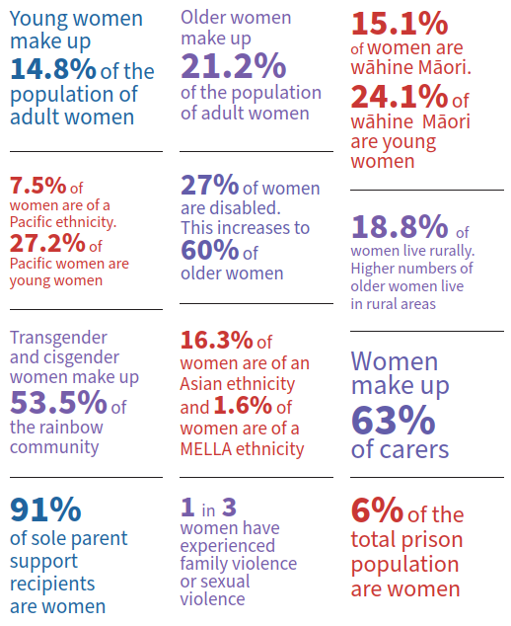

Sources: Stats NZ 2022, Stats NZ 2014, Stats NZ 2021, Ministry of Social Development 2019, Department of Corrections 2021, Ministry of Justice 2018, and Manatū Wāhine 2022.

Wāhine Māori
‘Me aro koe ki te hā o Hineahuone. Mai te tīmatanga, ko Papatūānuku, te whaea whenua, ko Hineahuone te ira tangata tuatahi, he wāhine. Tihei Mauri ora!

Pay the heed to the dignity of Māori women. From the beginning of time was Papatūānuku, the Earth Mother, then Hineahuone the first human created a woman. I sneezed and therefore I live!’

Te mana o te wāhine is embedded within a Māori worldview and celebrated within Māori creation narratives. In a traditional Māori worldview, there is balance between the intrinsic value of men and women, both reliant on each other for survival, and both contributing to the collective wellbeing of whānau, hapū and iwi. Wāhine Māori hold special status as ‘whare tangata’ house of the people, which recognises their role as central to continuing whakapapa.

During engagement in early 2023, wāhine Māori shared their aspirations for pae ora | healthy futures. Wāhine Māori told us that for them, pae ora involves:
- mauri ora | being content, balanced, protected, strong, special, and positive
- whānau ora | healthy women ensure healthy families and communities
- wai ora | connection to nature and having access to a healthy and safe environment.

To develop a health system that works for wāhine Māori, the indigenous rights of Māori and tino rangatiratanga need to be recognised, with mana wāhine and mātauranga Māori at the centre. While there have been some improvements for wāhine Māori in recent times, including rising life expectancy, decreasing rates of cervical cancer and smoking, there are still significant health inequities driven by the structural and social determinants of health.

For example, Wāhine Māori experience higher levels of poverty and socioeconomic disadvantage than non-Māori men and women, and Māori men. Wai 2700 — the Mana Wāhine Kaupapa Inquiry includes claims related to the impact of Crown policies and actions on the health and wellbeing of wāhine Māori and their whānau (Walker 2020).

Health and health system performance for wāhine Māori is discussed in more detail in the section, ‘Women’s health and health system performance’. Achieving pae ora for wāhine Māori requires an ecosystem of change that redistributes power, privilege, resources, and opportunities to create an equitable health system that ensures all wāhine Māori, whoever they are and wherever they are from, can thrive and flourish.

Pae Tū and Whakamaua: Māori Health Action Plan 2020–2025 provides guiding outcomes, priorities and actions for the health system, so that:
- wāhine Māori can exercise their authority to improve their health and wellbeing
- the health system is fair and sustainable, and delivers more equitable outcomes for wāhine Māori
- the health system addresses racism and discrimination for wāhine Māori
- the health system includes and protects mātauranga Māori.
The Women’s Health Strategy sits alongside the other pae ora strategies in setting direction for system change to address inequity for wāhine Māori.

Medium to long-term trends
Our population of women is becoming increasingly diverse. In 20 years, the populations of women aged 65 and over are projected to more than double for Māori, Pacific, and Asian ethnicities, with European women aged 65 and over increasing by 40% (Stats NZ 2022). Whilst life expectancy for women is expected to increase, so is the time women spend living in poor health.

A more diverse and ageing population of women living longer in poor health has a range of implications for the future health system. This includes implications for the workforce and system sustainability.

We are seeing more public health emergencies including disease outbreaks, as well as natural disasters caused by climate change. These emergencies disproportionately affect women. For example, women were more impacted by the COVID-19 job losses due to greater numbers of women working in tourism- characteristic industries, such as accommodation, passenger transport, travel agencies, sightseeing operators, and cafés and restaurants (Stats NZ 2020).

Women’s health and health system performance

Women’s life expectancy and time spent in good health
Health-adjusted life expectancy (health expectancy) represents the number of years people live in good health. While men have a shorter life and health expectancy than women, women spend more time living in poor health (Ministry of Health 2020b).

In 2019, women spent 13.4 years living in poor health, with men spending 11 years living in poor health. Since 2010, health- adjusted life expectancy has only increased slightly for women (from 70 to 70.3 years) while years spent in poor health has had a greater increase (12.8 to 13.4 years).

There are stark inequities — life expectancy for wāhine Māori and Pacific women (77.3 years and 79.3 years) is lower than for European or Asian men (81.3 years and 85 years).
Figure 4: Healthy life expectancy and years in poor health by sex at birth, from 1990 to 2019
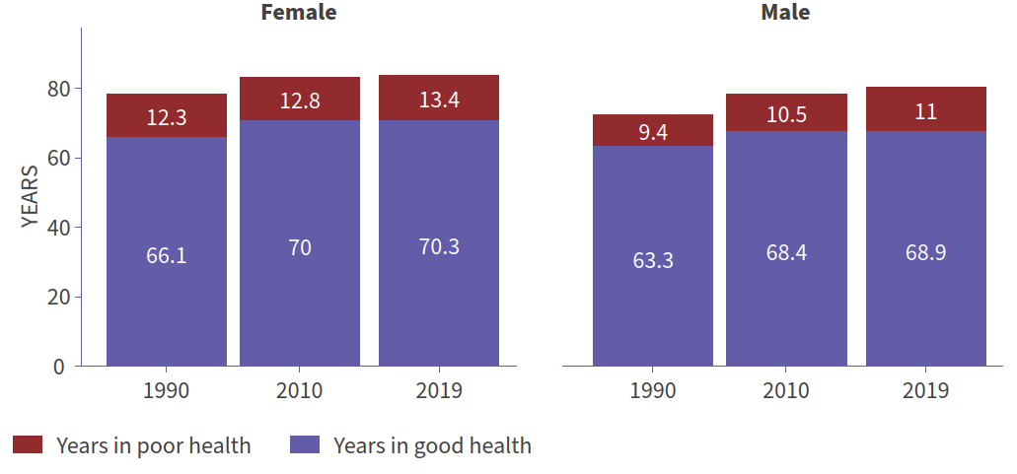
Source: Institute for Health Metrics and Evaluation (2020).

Figure 5: Projected life expectancy, by ethnic group and sex, 2019-2043
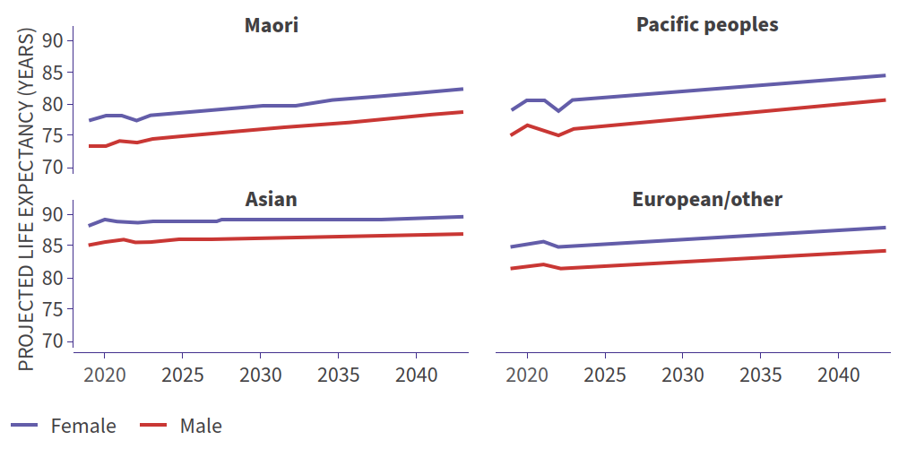
Source: Stats NZ 2022.

Major causes of poor health for women
The top five causes of disease burden for females of all ages (based on Disability Adjusted Life Years) are ischaemic heart disease, low back pain, chronic obstructive pulmonary disease, stroke, and falls (Institute for Health Metrics and Evaluation 2020b).

For women aged 15-49 years gynaecological diseases, low back pain, anxiety and depressive disorders and headache disorders are the top disease burdens. For women aged 50 to 69 years low back pain, breast and lung cancers, chronic obstructive pulmonary disease and osteoarthritis are the top disease burdens. For women 70 years and older, ischaemic heart disease, Alzheimer’s disease, and other dementias, as well as stroke, chronic obstructive pulmonary disease, and falls are the top disease burdens.

Figure 6: Top five burdens of disease for women at different ages (based on Disability Adjusted Life Years). Global Burden of Disease statistics, 2019
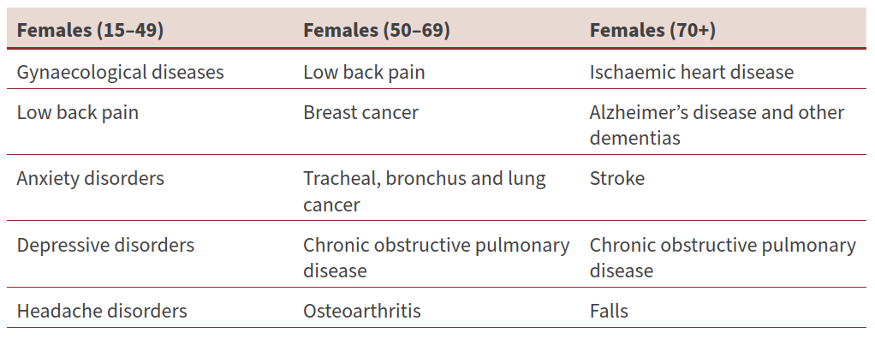
Source: Institute for Health Metrics and Evaluation (2020).

Figure 7: Selected causes of years lived with disability by sex. Global Burden of Disease statistics, 2019
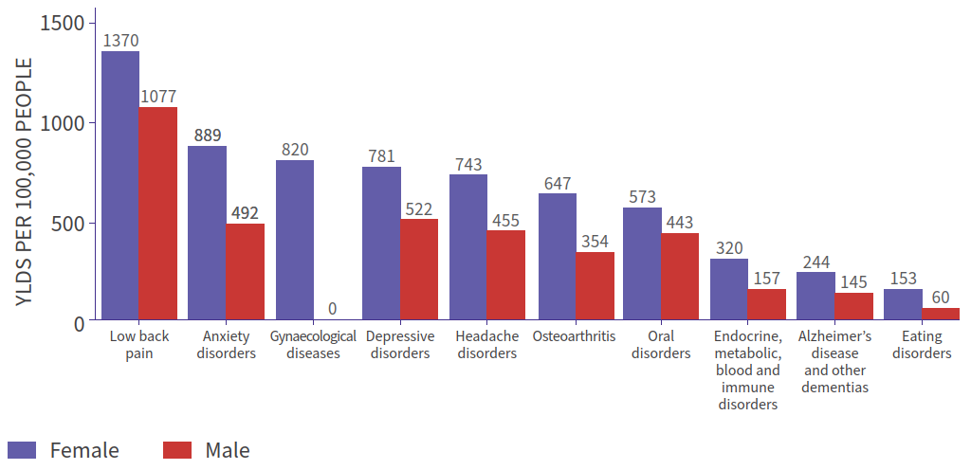
Source: Institute for Health Metrics and Evaluation (2020).

The top burdens of disease for women vary between ethnic and social groups
Lung cancer makes the greatest contribution to the gap in life expectancy between Māori and non-Māori non-Pacific women. Ischaemic heart disease is the second largest cause for the gap in life expectancy for Māori women, and the second leading cause of healthy life years lost. Other non-communicable diseases, including diabetes, chronic lung disease, and stroke are also leading contributors to the gap in life expectancy between Māori and non-Māori non-Pacific women (Walsh and Grey 2019). Major causes of death for Pacific women include diseases of the circulatory system, cancer, and endocrine, nutritional, and metabolic diseases (Te Whatu Ora 2022a).

Time spent in good health for rainbow women and gender-diverse people may differ to that of non-rainbow women. For example, the Counting Ourselves survey found that five out of every seven trans and non-binary participants aged 15 and older (71%) reported high or very high psychological distress, compared with only 8% of the general population in Aotearoa New Zealand (Counting Ourselves 2022).

Women’s mental health and wellbeing
Women’s mental health and wellbeing is influenced by a range of social, cultural, environmental, and economic conditions. Women disproportionately report depressive and anxiety symptoms and are more likely to be diagnosed with anxiety, depression, or other mood disorders (Ministry of Health 2021). In comparison, men experience different symptoms that may not be as well captured by mental health surveys, accounting for some of the difference between diagnosis rates for women and men. Evidence also suggests that autism spectrum disorder assessment tools may be less sensitive for girls and women, and that training for clinicians needs to include autism presentation in girls and women (van der Meer and Evans 2021).

Mental health and wellbeing outcomes can vary between groups of women, with younger women and young wāhine Māori experiencing higher rates of psychological distress (Ministry of Health 2022). People in rainbow communities are more than twice as likely as non-rainbow people to experience daily feelings of depression. Rainbow young people, including cis-gender women and transgender people, report high rates of self-harm and attempted suicide (Fenaughty et al 2022).

Health conditions and issues that are more common in women
There are several health conditions that are more likely to affect women compared to men. This includes osteoporosis, autoimmune diseases, urinary incontinence, headache disorders and certain cancers.

Osteoporosis is experienced by over half of postmenopausal women over 60 years old, compared to just one in three men over 60 years (Healthify 2022a). Osteoporosis leads to increased risk of hip fractures in postmenopausal women, with women having a one in three lifetime risk of osteoporotic fractures.

Autoimmune conditions that are more common in women include lupus and rheumatoid arthritis. Some submitters on the strategy reported low numbers of rheumatologists (autoimmune condition specialists), in some regions, impacting women’s access to these services.

There are also health conditions that are more common in women because of women’s longer life expectancies, including dementia. The number of women in New Zealand living with dementia is 20-30% higher than the number of men (Alzheimers NZ 2019).

Access to health care for issues specific to women
Stigma is a known issue in women’s sexual and reproductive health (Hussein and Ferguson 2019). Women told us they can feel embarrassed about accessing health services for sexual health and gynaecological concerns due to stigma. This can stop women from talking with others about gynaecological health, which limits understanding of what is normal and when health advice is required. Stigma, in the form of shaming, can be worse for groups of women due to cultural beliefs or other biases. A survey of disabled people, that included disabled Māori and rainbow people, about their experiences of accessing sexual and reproductive health care in New Zealand identified the presence of shaming and a need for further research and practitioner training (Pretious and Temple 2022).

Pelvic health conditions
Through engagement we heard that many women are living with pelvic pain or heavy bleeding that impacts their lives. Even when women have a diagnosis, there are often barriers to treatment for pelvic health conditions, including cost barriers and long waiting times.

Endometriosis is an example of how the health system performs in relation to women’s pelvic health, and how this affects women’s health and wellbeing. Endometriosis affects up to 10% of girls and women of reproductive age (Healthify 2022b). A New Zealand chronic pain survey found endometriosis accounted for 19% of all chronic pain (Moore and Davies 2018). The health system takes an average of eight years to diagnose endometriosis, which affects women’s quality of life, including through negative effects on their schooling, employment, relationships, and mental wellbeing (Tewhaiti-Smith et al 2022).

Women’s cancers
Women’s cancers are those that only affect women or people assigned female at birth, such as gynaecological cancers (ovarian, cervical, and endometrial cancer), or that disproportionately affect women, such as breast cancer. Wāhine Māori experience higher rates and mortality across all women’s cancers (Te Aho o Te Kahu | Cancer Control Agency 2021). Breast cancer is the most common cancer affecting women and causes the most cancer deaths in women under 65 years (Te Whatu Ora 2022b).

It is estimated that 30 to 50% of all cancers are preventable, with the main modifiable cancer risk factors being tobacco, poor nutrition, inadequate physical activity, excess body weight, alcohol, exposure to UV radiation, workplace carcinogens, and chronic infections (Te Aho o Te Kahu | Cancer Control Agency 2021).

Compared to men, women in New Zealand have more opportunities for prevention of some cancers. For example, human papillomavirus (HPV) vaccination is fully funded in New Zealand for those aged nine to 26 years and prevents 90% of cervical cancers. There are also cervical and breast screening programmes available for women.

From July 2023, HPV testing will become the primary cervical screening test, and women will have the choice to self-test. The National Cervical Screening Programme and Breast Screening Aotearoa are working with wāhine Māori and Pacific women to
co-design screening programmes that will address the screening equity gap that exists. There are also innovative early cancer detection programmes, including a programme for Pacific women that aims to detect endometrial cancer earlier.

Access to contraception
Access to effective contraception is important for the health and wellbeing of women of reproductive age. Barriers to contraceptive access can lead to unintended pregnancies and sexually transmitted infections. One area where women want change
is in access to long-acting reversible contraceptives (LARC).

Whilst LARC are highly effective contraceptives, some forms of LARC are also used as treatment for menstrual conditions, including pain and heavy menstrual bleeding (Family Planning 2023), as well as menopause symptoms. Whilst there has been additional funding for LARC in recent years, access criteria to funded LARC has been inconsistent across the country and access to trained LARC providers varies. This has resulted in a lack of equitable access to LARC and cost barriers (McGinn et al 2021).

Menopause
Menopause is a normal life stage that women in New Zealand typically experience between the ages of 45 and 55 years old. Around 70% of women have significant symptoms associated with menopause and 40% will see a doctor for menopause symptoms (Healthify 2022c).

We heard that many women feel that they did not receive good care when they sought support for perimenopause and menopause symptoms. Women told us they felt there was a lack of general practitioner (GP) education around menopause.

Menopause hormone treatment is now included in treatment pathways, and many GPs have upskilled in perimenopause and menopause. However, there is a lack of publicly funded clinics in New Zealand. This means that for women that require specialist support for their menopause symptoms, this care is only available for those able to pay.

Inequities in perinatal outcomes and health care access
Key findings of the Mortality Review Committee identified that ethnic, deprivation, and age inequities persist. This included the finding that Māori, Pacific peoples, Indian populations, those aged under 20 years, and those living in areas of high deprivation all experience worse perinatal outcomes than those of New Zealand European ethnicity (PMMRC 2022).

We know that there are significant issues with access to early pregnancy care in New Zealand. Not only is there a shortage of around 1,000 midwives across the country, but there is also limited availability of kaupapa Māori and Pacific services. Primary maternity care data shows that of women giving birth in 2020, only 55.9% of wāhine Māori and 40.8% of Pacific women registered with a lead maternity carer (LMC) in the first trimester of pregnancy (Te Whatu Ora 2022c). Disabled women also face significant challenges when accessing pregnancy care, including experiencing judgement from health providers for choosing to have a baby (Donald Beasley Institute 2022).

Rural women are disproportionately affected by maternity workforce shortages. Midwifery Council registration data analysed by rural/urban classification shows that just 11% of registered midwives work in rural areas, whilst 18% of children aged between 0 and 4 years live in rural communities.

There has been a lack of wider support services available for women and pregnant people during pregnancy and the early years. For example, support with existing physical and mental health conditions, alcohol and substance use, as well as conditions that develop during pregnancy and birthing, such as gestational diabetes, back and pelvic injury, and perinatal distress. Lack of access to wider support services means that the LMC can become the sole support for women, causing extra pressure and stress on the LMC workforce.

Perinatal mental health
In New Zealand, between 10 and 20% of birthing parents experience perinatal distress to a level requiring mental health support. Wāhine Māori are disproportionately affected by poor perinatal mental health. Focusing on mental wellbeing before pregnancy, during pregnancy, and into the first few years of a child’s life has been identified as the most effective way to break cycles of intergenerational disadvantage and improve perinatal outcomes (The Helen Clark Foundation 2022).

Work under way
Work towards improving pregnancy and early years outcomes is under way. Kahu Taurima is the joint Te Aka Whai Ora and Te Whatu Ora approach to pregnancy and early years care (the first 2,000 days) for all whānau in New Zealand. Kahu Taurima is reconfiguring pregnancy and early years services to support well-connected, easy-to-navigate, and culturally affirming health services for all women and families, and specifically for wāhine Māori and whānau (Te Whatu Ora 2022d). Budget 2022 invested in improving access to community-based specialist infant and maternal mental health services, including kaupapa Māori services (NZ Government 2023b).

Determinants of poor health and wellbeing for women
Multiple factors (determinants of health) combine to affect the health and wellbeing of women and their whānau. These include genetics, environment, and circumstances such as relationships, societal attitudes and available choices, income, and caring responsibilities.

As highlighted throughout this strategy, gender bias is a key of determinant of health for women and influences their experience within the health system. Gender bias interacts with a range of other determinants, including but not limited to the following factors.

Racism is a root cause of health inequity, operating within and outside the health system. It results in unequal distribution of power and resources, and differential access and exposure to the broader determinants of health. Within Aotearoa New Zealand, extensive research has produced clear evidence of the presence of racism in the health system and its impact on health outcomes (Ministry of Health 2019). Racial health inequity affects Māori, Pacific, Asian and ethnic communities, with Māori and Pacific peoples the two groups most historically affected in Aotearoa.

Racism has resulted in wāhine Māori experiencing poorer health outcomes, including lower life expectancy, trauma, mental distress, substance use, maternal suicide, and cancer. For example, whānau Māori report that bias contributes to delayed diagnostic testing when presenting with cancer symptoms.

Manatū Hauora is undertaking work to support the way the health system understands, reacts, and responds to racism in health. This includes identifying and shifting the conditions that hold unfair and unjust health outcomes in place (Ministry of Health 2023a).

Family violence and sexual violence harms women’s physical, mental, and spiritual health and can result in trauma. Women are twice as likely than men to experience intimate partner violence and almost three times more likely to experience sexual
violence at some point during their lives (Ministry of Justice 2018). Disabled women are more likely to experience intimate partner violence compared to other women and disabled men (Fanslow et al 2021). We also know rainbow communities report higher levels of sexual violence (Counting Ourselves 2022).

Housing and homelessness. Women are less likely than men to be homeowners, with Pacific women having the lowest rates of home ownership (Stats NZ 2023). A New Zealand-based study identified that most women who were homeless, including living in overcrowded and emergency housing were younger (between 25 and 44 years), indigenous Māori (79%) and had children (81%) (Fraser et al 2021).

Socioeconomic deprivation and financial stability. Women overall are more likely to have a low income than men. Wāhine Māori experience higher levels of hardship than non-Māori men and women and Māori men, across a range of measures, including low income, unemployment, and access to motor vehicles. Pacific, ethnic, and disabled women have the lowest median weekly incomes out of the total New Zealand population. Lower incomes mean that women are disproportionately affected by health care costs such as primary care fees, dental costs, and prescription charges (Ministry of Health 2023b).

Many women enter retirement with significantly lower savings than men due to lower wages and more time spent outside of paid employment over the course of their lives (Retirement Commission 2022).

Unpaid carers are people who care for friends, family, whānau, and aiga members with a disability, health condition or illness who need help with everyday living. Women make up 63% of unpaid carers, with older women as the largest group. Unpaid carers are less likely to be partnered and more likely to be sole parents. Younger carers are more likely to be Māori and Pacific. Caring is associated with reduced health and wellbeing and has an economic cost, including loss of income and lost opportunities to participate in education (Ministry of Social Development 2019).

Substance and gambling-related harm. Many women in New Zealand experience substance-related harm, with wāhine Māori and Pacific women experiencing high rates of drug and alcohol harm which significantly affects their mental health (Manatū Wāhine 2018). For women who are pregnant there are significant risks of harm to the developing baby, including risk of fetal alcohol spectrum disorder (Rankine et al 2013). Māori, Pacific, and Asian women experience higher levels of gambling-related harm than Pākehā women (Te Hiringa Hauora 2022).

Women in prison are a vulnerable population who typically have high and complex health requirements. Sixty-eight percent of women in prison have been the victim of family violence and sexual violence (including in State settings). Fifty-two percent have suffered post-traumatic stress disorder, 75% have a diagnosed mental health condition and 62% have both mental health and substance disorders. Wāhine Māori make up 66% of women in prison (Department of Corrections 2021).

Unhealthy environments. Environments, including availability of nutritious food, access to green space, clean air and fresh water are fundamental to physical, mental, emotional and spiritual health and wellbeing. A key theme in engagement with wāhine Māori was that their connection to taiao | the natural environment, is crucial for their wellbeing. Women and girls are more likely to feel unsafe in public spaces, and non- Pākehā women are more likely to feel unsafe due to experiencing both gendered and racialised harassment.

Prevention of poor health and wellbeing in women
Addressing determinants of health can prevent and reduce health inequities experienced by women, including between groups of women. Risk factors for the longterm conditions contributing to the life expectancy gap between wāhine Māori and non-Māori women include exposure to unhealthy environments, substance use including tobacco and alcohol use, and poor nutrition. These risk factors are rooted in structural racism and influenced by related factors including poverty, family violence and sexual violence (Walsh and Grey 2019).

Women told us that their communities play a significant role in keeping them healthy and active. We know that isolation can cause vulnerability for older people, including women, who experience higher levels of social isolation (women living alone and not volunteering or helping whānau). Reducing barriers and supporting women to engage in physical activity to keep them moving improves their quality of life, reduces the risk of injuries such as hip fracture, and has the potential for significant cost savings for the health system.

Part 3: Priority areas for women’s health and wellbeing action
The health reforms are an opportunity to redesign the health system so that it better reflects the needs of the people it serves. Part 2 of this strategy highlighted that although women make up over half of New Zealand’s population, our health system is not delivering for women. Achieving pae ora for women requires changes across the health system and wider sectors.

There are four priority areas for realising our vision for women’s health. Achieving our vision and making progress towards our goals for women’s health requires system level shifts and focus on key areas of women’s health and wellbeing. Our four interconnected priority areas are:

Priority area 1. A health system that works for women

Priority area 2. Improving care for issues specific to women

Priority area 3. Better outcomes for mothers, whānau and future generations

Priority area 4. Living well and ageing well.

Priority area 1, a health system that works for women, sets out the system-level shifts and enablers to drive change within the health system and help us to achieve these goals. Priority area 1 is overarching across the other priorities.

Priority areas 2, 3 and 4 highlight areas of specific focus within the broader system. These focus areas were developed by what we heard from women, groups and organisations that support women, and those working in the health sector about key challenges and opportunities in women’s health.

Priority 1: A health system that works for women

What we heard
‘Ngā wāhine e ngaro ana.’ (Wāhine missing/not heard by system.)
- Ngā Wānanga Pae Ora 2023 participant.
‘I want to feel heard, not rushed. Take the time to read the notes about me and my history, come to an appointment with understanding and empathy. I am not a robot, and neither are you’
- Women’s Health Strategy engagement participant.
‘My ideal system would be one in which it was safe for people of all identities to be openly, authentically themselves; it would provide professionals who are well- trained and willing to listen and to learn and to work in partnership; and it would give time and space for patients to share their experience and be believed when they do.’
- Written submission on the Women’s Health Strategy.

Why this is a priority
Women’s needs and experiences are not equitably considered in the design and operation of the health system or prioritised in health research. There is clear evidence of bias in the health system and such bias effects health system performance for women, particularly wāhine Māori. There is also evidence that cost barriers in the health system disproportionately affect women.

Many women also do not feel that their voices are heard and responded to, both in their interactions with health care providers, and at the system and service level. For women to trust the health system, all women need to be confident that they will receive high quality care that is in keeping with the Code of Health and Disability Services Consumers’ Rights and meets their needs and aspirations.

The health system needs to meet Te Tiriti obligations to address health inequities for wāhine Māori. Through engagement, wāhine Māori told us that they want to see action and accountability for this. We must support self-determination for wāhine Māori over their health and wellbeing, partner with wāhine Māori, and hear and respond to their voices and choices in the design and delivery of health care for women. Wāhine Māori told us that this includes having wāhine Māori in decision-making roles in the health system and being involved in the design and delivery of health care services and programmes.

Addressing the different manifestations of racism requires a systems-change approach, strong collaboration, and a commitment to shifting the conditions that create, maintain, and perpetuate Māori health inequity at multiple levels. We need continue work that has been started to address racism and cultural bias within the health system to address health inequities experienced by wāhine Māori, Pacific, Asian and other ethnic women.

It is also important that we hear from women from all stages of life, as young women will set the course of our future health system, and older women represent the life experience and needs of our growing older population.

Lack of consideration of women’s needs, experiences and aspirations causes women to face inequities in access to health information, accessing health care, getting timely diagnoses, and receiving the appropriate treatment. It also means that the health care does not respond to differences in needs and experiences of women, which leads to health inequities across New Zealand and between groups of women. This includes major health inequities for wāhine Māori.

Our priority is to achieve system change for women’s health so that all women have access to health information and services that are culturally and clinically safe for women and informed by evidence and the voices of women. There is a need to ensure that health care for women is better coordinated across health care services and programmes, as well as across New Zealand.

Priority area 1 sets out the system changes needed across all areas of the health system to achieve pae ora for women. These are necessary enablers to achieving the ambitions in priority areas 2, 3 and 4, which outline specific focus areas within the broader system.

What it will look like in the future
There will be improved equity of health service access and outcomes for all women and between groups of women.

Te mana o te wāhine is acknowledged and the voices of wāhine Māori are prioritised with recognition of their indigenous rights. Wāhine Māori are able to exercise self determination over their health and wellbeing. Mātauranga Māori is respectfully included and protected in the health system, in commissioning and service delivery, and kaupapa Māori models of care are available for wāhine Māori.

Women’s health leadership and the voices of diverse women will be present at all levels of the system, including in governance, service design, delivery, and system monitoring. Consumer engagement will be aligned with the code of expectations for engagement with consumers and whānau, as required by the Pae Ora Act. There will be equitable prioritisation and resourcing of women’s health services, health and wellbeing support services and women’s health research.

Clear governance mechanisms will support joined-up, safer services for women with a focus on system-level quality improvement, innovation, and sustainability across all health entities and inclusive of localities.
Health data makes women and their realities visible, and a gender lens is applied to health research to ensure there are no significant research gaps in women’s health. Women’s health services, pathways and treatments will be based on evidence of effectiveness for women. Women’s health service design will see women within a whānau context and consider their realities. For example, services will better support women caring for children or others to access health care.

The health workforce will be representative of all groups of women and will value women in the workforce, including their clinical, cultural, and lived experience skillsets. There is more health education and investment in keeping women well (disease prevention), as well as improved access to primary care to support early intervention. The health workforce will be more responsive to women’s health needs, including in areas of health where women present differently or experience different outcomes to men.

Partnerships across the system, with communities and cross-government, are increased in number and strengthened. Partnerships contribute to healthier communities and address wider determinants of health for women, contributing to improved health outcomes and social and economic outcomes.

What needs to change
Health entities need to:
- actively address bias and discrimination in all forms, including gender bias, racism and cultural bias, as root causes of health inequity. Stigma must also be actively challenged, through public health, education, training, and accountability mechanisms
- ensure there are proactive and accessible pathways for wāhine Māori to be in leadership and decision-making roles within the health system. We also need to ensure accessible pathways to health leadership positions for all women across the health system, with an active focus on supporting a diversity of female leaders
- prioritise services and programmes by Māori for Māori, recognise te mana o te wāhine, and regional commissioning aligned with locality plans agreed by Iwi-Māori Partnership Boards. This includes recognising and respectfully including mātauranga Māori, and recognising kaupapa Māori approaches, of rongoā Māori, and whānau centred health care for wāhine Māori.
- listen to the voices of women of all ages. This requires action from policy makers, service commissioners, service coordinators, health professionals and education and training providers
- ensure that health policy and commissioning include equitable prioritisation and resourcing of women’s health services and support, with a focus on prevention, early intervention, and areas of unmet need.
- health services and programmes are designed to be accessible for all groups of women. This includes reduced cost barriers, offering flexible opening hours, disability accessible services, and services that are welcoming of rainbow people, young women, and diverse groups of women. This includes culturally responsive services for Pacific, Asian and other ethnic women
- improve coordination and governance structures within and across women’s health to support more joined-up health services, continuous quality improvement, and better mechanisms and pathways for women and whānau to hold the system accountable
- address data and research gaps on women’s health and wellbeing, including through supporting increased participation of women in clinical trials, and ensuring data makes health system performance for all groups of women more visible. This evidence needs to inform improved health policy, service and programme commissioning, pathways, and treatments
- ensure that health workforce recruitment and retention strategies support diverse women to enter and thrive in the health workforce. Workforce policies and procedures need to recognise women’s health and wellbeing requirements and make health a safer and more attractive place to work for women
- ensure the health workforce has access to information and training that promote skills and capabilities in managing and supporting women’s health needs, including sex and gender differences across all areas of health, women’s life stages, the impacts of conscious and unconscious bias and discrimination, and determinants of health.

Links to other pae ora strategy priorities
Priority area 1 is for overarching system-level change and links across all other pae ora strategy priorities. This includes priorities across the strategies related to:
- voice, autonomy, and self determination
- access to and redesign of health care
- health workforce
- a learning culture and accountable system
- partnering for health and wellbeing.

Priority 2: Improving health care for issues specific to women

What we heard
‘When I started talking about my ovarian cancer diagnosis publicly my family initially responded negatively. I was told that it was something private that shouldn’t be discussed with other people. Now they are my biggest champions (…) but the societal and cultural barriers to talking about it still exist.’
- Written submission on the Women’s Health Strategy.
‘I have had my reproductive care minimised and ignored, because health care professionals can’t imagine a disabled person being a parent as an option.’
- Commenter on Tātou, the online discussion platform for the pae ora strategies.
‘Gynaecological care, including recognition and management of impactful conditions that inflict pain, fatigue and other symptoms that are sometimes minimised is a current gap.’
- Written submission on the Women’s Health Strategy.
‘The basic tests were coming back “normal” or they “didn’t know what was wrong” so therefore I “must have been fine” and there was “nothing more to be done” (...) I believe this shows a lack of insight and training around Endometriosis, at no fault of their own because whilst Endometriosis affects 1 in 10 women in New Zealand it is rarely spoken about nor trained for(….)’
- Written submission on the Women’s Health Strategy.

Why this is a priority
There are a range of issues that are specific to women and people assigned female at birth. This includes aspects of sexual health and reproductive health, including access to some contraceptive options, diagnosis and treatment of gynaecological conditions, and gynaecological cancers. Through engagement, we heard from many women and groups representing women about these issues.

A range of barriers prevent women and people from seeking health care for these issues and having conversations about these aspects of their health. This includes stigma and lack of access to information about these health conditions.

Stigma and discrimination can be real or perceived and has important implications, including the delivery of sexual and reproductive health care. Women also face challenges with accessibility and availability of care, with information gaps, lack of treatment pathways and lack of prioritisation of issues, which can result in significant unmet need for women.
We heard that women with endometriosis are affected by a lack of available information around menstrual health, as well as being unfairly affected by a lack of management and treatment guidance for health practitioners, and limited availability of specialist treatments.

We heard how wāhine Māori and their whānau feel that bias can result in a lack of timely diagnostic testing for conditions, including cancer when they present with symptoms. We also know that wāhine Māori and Pacific women have lower rates of cervical screening and are more likely to die from women’s cancers than other groups of women.

We also know that current services for issues specific to women and people assigned female at birth are not sufficiently accessible for disabled women. Promotion and delivery of services are often not inclusive of rainbow communities.

Inequities for groups of women highlight the need for health information and women’s health care that is culturally safe and informed by mātauranga Māori, Pacific, Asian and ethnic cultural knowledge.

System change in these areas of women’s health requires us to proactively address stigma, alongside the system changes outlined in priority area 1, to support improved access to high- quality women’s health services and equitable health outcomes for all groups of women.

What it will look like in the future
Women and whānau feel safe and confident to discuss women-specific health needs, supported by non-judgemental environments. All women, including young women, have accessible, non-stigmatising information about menstruation and sexual and reproductive health. This includes advice on healthy sexual relationships and their rights, with a focus on prevention of family violence and sexual violence including
female genital mutilation. This allows women to feel confident seeking help for women-specific health issues when they need to.

Women have timely access to services and programmes that are responsive to their sexual and reproductive health needs, including pelvic health conditions. All women can access sexual and reproductive health care closer to home, including choice of contraceptive options. Inequities in access to screening and treatment are reduced.

There are equitable levels of screening for cervical cancer and equitable outcomes for women’s cancers. There is equity for wāhine Māori and Pacific women across women’s cancers.

When women seek help for women-specific issues, they receive culturally safe care, timely diagnosis, and treatment. This includes services and programmes that are welcoming of and responsive to rainbow communities, young women, and disabled women. When needed, women have access to the support and specialist services that they need, and effective management and treatments. This includes equitable access to support from allied health workforces and specialist gynaecological care. It also includes culturally appropriate support for women experiencing family violence and sexual violence.

What needs to change
Health entities need to:
- ensure that women have accessible, culturally safe information and education on women-specific health issues to reduce stigma and enable more women to access health advice. Health entities should partner with women, communities, and education providers to design and promote this
- prioritise health research on women-specific issues across prevention, screening, and treatment
- support the health workforce to improve their knowledge of women-specific issues and follow best practice pathways of care to support timely screening, diagnosis, treatment, and management of issues including pelvic health conditions and gynaecological cancers
- prioritise commissioning of accessible sexual and reproductive health care, which addresses access barriers including cost and distance, with efficient and culturally safe women’s pathways of care across the country, including in rural areas
- ensure that there are high-quality programmes and services relating to women specific issues designed with diverse women and people to be culturally appropriate and accessible for all women and tailored to local communities. For example, cervical screening programmes for Pacific women, gender affirming care for transgender people, and disability accessible sexual and reproductive health information and services
- enable the primary and community health care workforce to access evidence-based health education and training on women-specific issues. This includes training on LARC insertion and removal and early medical abortion
- ensure that all treatment and support for health issues specific to women is carried out with their informed consent. This is supported by investment in providing clear, accessible evidence-based advice on options and treatments, and supported decision making and language translation for women who need this.

Example: Listening to women and responding to surgical mesh injury
In response to the pain and distress caused to women who have experienced complications because of pelvic mesh surgery, Manatū Hauora co-designed a model of care with women and whānau affected by surgical mesh injury and those from the health sector. Te Whatu Ora implemented the national surgical mesh injury service in early 2023 (Te Whatu Ora 2023). This service supports and cares for women who experience complications from surgical mesh inserted as part of treatment for stress urinary incontinence or pelvic organ prolapse.
Women are referred to the service via their GP or specialist and a health navigator is assigned to work with each woman to develop an individual treatment and care plan.
The multidisciplinary team includes health navigators, physiotherapists, social workers, psychology services, credentialled surgeons, pharmacists, sexual health therapists, specialist pain medicine doctors, occupational therapists, dietitians, and nurses. Care and support options include continence care, pain management, physiotherapy, psychology, surgery, cultural, spiritual, and language support.
Telehealth consults are an option for some appointments and accommodation expenses may be covered for the woman and a support person.
Although this service has only been operating since April 2023, it highlights an example of how listening to women can result in a model of multidisciplinary care that seeks to be responsive to the different needs of women.
There are opportunities for similar approaches to be applied in other areas of women’s health.

Links to other pae ora strategy priorities
- New Zealand Health Strategy Priority area 2: Flexible, appropriate care
- Pae Tū Priority area 4: Enabling culturally safe, whānau centred and preventive primary health care
- Te Mana Ola: The Pacific Health Strategy Priority area 4: Haitiaaga moui malolo (Access)
- Te Mana Ola: The Pacific Health Strategy Priority area 2: Te pāruru`anga, te apii`anga, e te akateretere`anga no te ora’anga meitaki (disease prevention, health promotion and management for good health)
- Health of Disabled People Strategy Priority area 2: Ensure that the health system is designed by and accessible for disabled people and their whānau, and provides models of care that suit their needs
- Rural Health Strategy Priority area 3: Services are closer to home for rural communities.

Priority 3: Better outcomes for mothers, whānau, and future generations

What we heard
‘Knowing my future is safe ... My mokopuna, my whānau [brings me happiness].’
- Ngā Wānanga Pae Ora 2023 participant
‘Whakapapa continues through me. Ma te wāhine ka ora ai te iwi.’
- Ngā Wānanga Pae Ora 2023 participant
‘[Good health and wellbeing looks like being] protected and respected — as a teen mum I am often judged and made to feel like I have done something wrong…’
- Engagement participant, Women’s Health Strategy
‘Models of care need to reflect how women want to be cared for. Should incorporate Pacific cultural values. There are successful examples of holistic models…’
- Engagement on Te Mana Ola — the Pacific Health Strategy.
‘Failing to provide prevention and early intervention assessment and recovery services to women at-risk or experiencing peri-natal depression has a far greater cost to New Zealand than the cost of providing it.’
- Written submission on the Women’s Health Strategy

Why this is a priority
A healthy mother and whānau is particularly important during pregnancy and the early years of a child’s life. These early stages of life lay the foundations for the child’s future as well as future generations. Many of those who engaged on the Women’s Health Strategy called for improvements in health care and support during this critical period. The message ‘healthy mothers are needed for healthy whānau’ was consistent across all groups of women we engaged.

Investment in health care and support during this critical period builds trust and supports better health outcomes for women and their whānau. For wāhine Māori and their whānau, this care needs to include recognition of the status and care requirements of hapū māmā and pēpi from a mātauranga Māori worldview. Approaches to support whānau at the earliest opportunity have the greatest potential to improve health and wellbeing.

Many women and their whānau miss out on this important care and support. This can be due to workforce shortages, a lack of cultural diversity in the workforce, a lack of culturally safe care, fragmented services, and other access barriers to pregnancy and early years services and supports. This includes access to a range of supports, including perinatal mental health support, management of gestational diabetes and pelvic floor physiotherapy.

The effects of access barriers, on top of determinants that cause stress during pregnancy through to the early years, can lead to life-long inequities for some within our population. This includes significant inequities in perinatal outcomes for wāhine Māori, Pacific women, Indian women, young women, women living in high deprivation areas, and their whānau.

What it will look like in the future
The vital role and contribution of mothers to the health of future generations is recognised through investment in women’s health and the health of their whānau during the period of pregnancy through to the early years of a child’s life.

Wāhine Māori will have access to kaupapa Māori pregnancy and early years care and access to whānau orientated interventions providing intensive support during the early years of their child’s life that seeks to address and minimise stress for wāhine Māori and whānau.

The health system will support maternal mental wellbeing and empower parents and whānau to self-determine, building their capacity and confidence, strengthening informal support networks, and cultural connection.

All women and pregnant people will experience high-quality, consistent care from a trusted care provider throughout their pregnancy and birthing into the early years of their children’s lives to support healthy and safe family environments. This includes disabled women, transgender people and rainbow women, and women of all cultures and ethnicities.

There will be engagement from the first trimester of pregnancy with a key person who builds a strong, trusting relationship with the woman and her whānau. There will also be early screening for a range of factors, including mental wellbeing, family violence and sexual violence, alcohol and substance use, smoking, pelvic health, and gestational diabetes, to support timely access to specialist services and practical support following positive screening.

Women and their whānau report positive experiences of care during this period including their wellbeing being supported and flexible care that responds to what matters to them. Perinatal, maternal, and early years health outcomes are equitable and improved for all, setting up women and future generations to experience better health and wellbeing throughout their lives.

What needs to change
Health entities need to:
- continue work to join up care and create pregnancy and early years care pathways to improve quality, safety, and equity of outcomes for all pregnant women and people and their whānau into the first few years of their children’s lives. To support this, programmes and services need to engage diverse groups, including wāhine Māori, Pacific women, Asian and other ethnic women, rainbow communities, and disabled women to ensure that they provide culturally safe, accessible and gender affirming care.
- ensure accessible, quality and culturally safe antenatal and birthing care, including wrap-around support, for wāhine hapū, and for wāhine Māori and whānau during the early years of a child’s life. This will include options for kaupapa Māori pregnancy and early years care and support. Commissioning of pregnancy and early years services will be informed by wāhine Māori, and locality plans approved by Iwi- Māori Partnership Boards
- ensure that commissioning and delivery of pregnancy and early years services deliver sustainable, high-quality integrated care across hospital, primary and community settings
- invest in pregnancy and early years programmes and services that support nurturing, safe, health-promoting environments and address key determinants of health that influence children’s early development
- ensure that communities are resourced and incentivised to deliver intergenerational wellbeing solutions to improve equitable outcomes for wāhine Māori and whānau and other women and families
- ensure that the pregnancy and early years workforce is developed and retained. This requires recruitment of and support for a representative and culturally safe workforce
- prioritise post-partum care and support for women and people who have given birth. This includes access to timely, pelvic floor physiotherapy and mental health and addiction services.

Example: Healthy Mother Healthy Future (HMHF) Asian Perinatal Wellbeing Project
The HMHF project offers support for Asian mothers during the time of pregnancy and after their babies are born. The project aims to address poor perinatal outcomes in Asian women by offering accessible support and letting women know it is ok to ask for help.
This includes:
- delivering resources and online workshops in multiple languages
- providing practical support to connect women to their communities
- providing food, formula, and nappies when these are required
(Asian Health Services 2022)

Links to other pae ora strategy priorities
- New Zealand Health Strategy Priority area 2: Flexible, appropriate care
- New Zealand Health Strategy Priority area 6: Partnerships for health and wellbeing
- Pae Tū Priority area 2: Strengthening whole-of- government commitment to Māori health
- Te Mana Ola: The Pacific Health Strategy Priority area 2: Te pāruru`anga, te apii`anga, e te akateretere`anga no te ora’anga meitaki (disease prevention, health promotion and management for good health)
- Health of Disabled People Strategy Priority area 2: Ensure that the health system is designed by and accessible for disabled people and their whānau, and provides models of care that suit their needs
- Rural Health Strategy Priority area 5: A valued and flexible rural health workforce.

Priority 4: Living well and ageing well

What we heard
‘[A good and fair system looks and feels like] equal outcomes — equity is the mechanism to achieve this.’
- Ngā Wānanga Pae Ora participant
‘There is not enough understanding, communication or education around perimenopause and menopause. I feel like I am going through the emotional rollercoaster of puberty again yet having to hold down a job and family while feeling brain dead and crazy — NOBODY talks about this stuff.’
- Women’s Health Strategy engagement participant
‘When ethnic women are well, they are empowered, and this makes other ethnic women happy to see...’
- Pae Ora strategies ethnic communities engagement participant
‘As you get older things start coming up. I’d like to talk to someone in a group, not take drugs. I’m on those for depression.’
- Pae Ora strategies engagement with older people
‘For me healthy futures is not this fragmented systemic failure, it’s something quite holistic that really understands the needs of carers.’
- Women’s Health Strategy engagement participant

Why this is a priority
Too many women are living with illness, disability and long-term health conditions that could have been prevented or the impacts minimised. Poor health and wellbeing affect women’s ability to enjoy and fully participate in life. This includes affecting their ability to participate in paid employment and unpaid caring responsibilities, and to connect with and contribute to their whānau and their communities.

We need to support women to live and age well, at every stage of life. To achieve this, we need to address conditions and issues that are more common in women, and are top causes of health loss for women.

We also need to address causes of inequities between groups of women, and determinants that affect women’s health and wellbeing. Submissions on the Women’s Health Strategy reinforced the importance of living and ageing well for women and supporting women to live full and productive lives.

Living and ageing well can look different for women depending on their experiences. We also know that some groups of women, including wāhine Māori and Pacific women, experience significant inequities in both life and health expectancy. For example, inequitable rates of chronic lung disease contribute to the life expectancy gap between wāhine Māori and non-Māori women.

There are several conditions that are more likely to affect women, including breast cancer, autoimmune diseases, and osteoporosis. There are also health issues and conditions, like isolation and dementia, that are more common in women because overall they are living longer than men. There are also health conditions that can present differently in women, such as mental health conditions and autism, and issues that affect women differently, including gambling-related harm.

The health system needs to recognise differences in how women present with disease and how women respond to treatments. There is evidence of challenges in access, availability of information, and treatment and management pathways across these issues.

What women need to live and age well can vary depending on life stage and experience of determinants of health, including access to healthy environments. Key life stages for girls and women include puberty, pregnancy for some, and menopause. However, as outlined in part 2, many girls and women are not receiving the information, advice and support they need to live well at every life stage.

Determinants that affect women’s ability to live and age well include access to good nutrition, use of alcohol and other drugs, access to a warm, dry home, and exposure to family violence and sexual violence, including elder abuse. Access to healthy environments, including connection to communities and safe relationships are important at every stage of life to reduce the risk of issues like isolation and gendered violence. Wāhine Māori told us that wai ora and connection to taiao | the natural environment is essential for pae ora for them and their whānau.

What it will look like in the future
Women experience improved health and wellbeing at every age and stage, and inequity of health outcomes between groups of women are reduced throughout the life course. This is supported by women being enabled to live in safe and healthy environments alongside their whānau and communities.

System complexity is reduced for women who are caring and navigating different services on behalf of whānau with complex needs. For carers, this looks like receiving better, more coordinated support from the health and social systems, as well as feeling less stressed and more connected to their communities.

Women’s life stages are recognised as key opportunities to promote good health and wellbeing. This is enabled by accessible, culturally safe health information, access to screening, and health services and support. These are available for conditions that are more common in or differently experienced by women, and for key life stages, like puberty, menopause, and healthy ageing.
There is more support for women with long-term mental and physical health conditions. As a result, all women, including women with conditions that are more common among or present differently in women, experience high-quality, equitable care, and improved health outcomes.

Technology and innovation support accessible remote health care options for women, including digital health services and mobile service options for improved health and wellbeing.

What needs to change
Health entities need to:
- support women to live well through the prioritisation of prevention, screening and early intervention programmes and models of care that address determinants and whole- of-life issues for women
- ensure that women have access to culturally appropriate, non-judgemental information about women’s key life stages, healthy life choices, and health issues that are more common in women, or differently experienced by women
- provide health professionals with information about women’s health and wellbeing, enabled by education, training, and research. This includes information on:
- supporting women through key life stages, such as puberty, perimenopause and menopause, including available treatments and support
- supporting women experiencing issues and conditions that are more common in women, including available treatments and supports
- how illness, disability and health conditions present in women differently, and effective treatments and support
- embracing cultural safety, with health care professionals and organisations engaging in ongoing self-reflection and self-awareness and being held accountable for providing culturally safe care to wāhine Māori.
- prioritise pathways, treatments, and services to manage health conditions that only affect, or more commonly affect women, such as menopause and autoimmune disease.
- partner across the health system, government agencies, and with communities to address determinants of health and improve access to healthy environments to support healthy behaviours. This includes investing in accessible and timely alcohol and drug services and support.
- partner with Ara Poutama Aotearoa | Department of Corrections to better address women’s health needs within prisons and as they transition out of prison
- provide better support for carers, including improving accessibility of respite care. Partner with other agencies, including ACC, Whaikaha | the Ministry of Disabled People, and the Ministry of Social Development to make it easier for carers to navigate on behalf of those they care for
- prioritise safe and effective models of care that support women to live well for longer with greater independence. This includes minimising the effects, or delaying the onset, of health conditions more common in older women, including frailty and dementia
- support women to remain connected to their communities, especially as they age, to reduce social isolation and poor mental wellbeing
- improve utilisation of health technology and innovation to support system access and health monitoring for women.

Example: Young wāhine smoking cessation project: a health equity challenge
The 2016 NZ Health Survey showed that self-reported daily smoking for wāhine aged between 18 and 24 was 42.7% compared with 8.6% of non-Māori women of the same age. Reducing smoking rates has the potential to significantly improve wāhine and their whānau outcomes across a range of health indicators, including lung cancers.
The Manatū Hauora funded a project to understand and address the high smoking rates of young wāhine Māori. The study identified barriers to wāhine Māori stopping smoking related to their environments. Wāhine Māori knew smoking was bad for their health but continued to smoke as a coping mechanism due to stress (Ministry of Health 2020c).
Several prototypes were launched, led by Māori health providers. Success factors were found to include:
- taking a broad wellbeing approach — looking to address whole-of-life issues facing young wāhine Māori and addressing smoking cessation within this context
- reframing quitting in the context of living well — using goal setting and planning processes to identify and prioritise personal and whānau wellbeing goals that are important to wāhine Māori
- being responsive to the needs of women with priorities set by the women themselves — employing a ‘whatever it takes’ mentality when responding to engagement issues and supporting wāhine Māori to lead their own development and set their own priorities
- making non-smoking more attractive than smoking — creating positive, social and supportive environments for wāhine Māori by facilitating connections with their peers
- using culture as a connector and enabler — using tikanga (Māori cultural practices and principles) to connect wāhine Māori to each other and their cultural roots, and to affirm their identity as Māori.
Approaches that consider women’s realities, such as described in the young wāhine Māori smoking cessation study have the potential to be applied across a range of areas of health and wellbeing, with a range of different groups of women. Such approaches have the potential to reduce inequities between groups of women and support all women live and age well.

Links to other pae ora strategy priorities
- New Zealand Health Strategy Priority area 2: Flexible, appropriate care
- New Zealand Health Strategy Priority area 5: A resilient and sustainable system
- New Zealand Health Strategy Priority area 6: Partnerships for health and wellbeing
- Pae Tū Priority area 4: Enabling culturally safe, whānau centred and preventive primary health care
- Pae Tū Priority area 2: Strengthening whole-of- government commitment to Māori health
- Te Mana Ola Priority area 1: Vaqaqacotaka na yavutu ni tiko bulabula (Population health)
- Health of Disabled People Strategy Priority area 3: Ensure that the health system is part of a coherent cross-government system that addresses broader drivers of poor health and wellbeing
- Rural Health Strategy Priority area 2: Prevention: Paving the path to a healthier future.

Part 4: Delivering our commitment to change

Turning strategies into action
One of the objectives of the health system reforms is to better align and integrate the accountability arrangements that set direction and priorities for health agencies. The reforms put in place a new approach that aims to ensure clarity and coherence, from long-term strategic objectives to shorter-term priorities and expectations.

This new approach provides clear roles for key documents, underpinned by statutory requirements in the Pae Ora (Healthy Futures) Act.

Health strategies are intended to set a long-term (five to ten years) direction for improving health and identify priorities and opportunities for the health system. The strategies provide a vision and indicate the types of change necessary over the medium and long term. Strategies do not make commitments to particular actions or require health entities to undertake specific activities — instead, they describe potential choices and issues to be considered, to inform the decisions that the Government will make on what actions are taken forward, and when. Health entities must take the strategies into account in carrying out their responsibilities.

The Government Policy Statement on Health (GPS) sets out the specific priorities and expectations for the health system over a three-year period. It is the key document for government to set its priorities, confirm actions for entities and funding for the health system, and detail how success will be measured. The GPS will reflect the long-term direction of the strategies and include more detailed actions for health entities in the short term that work towards the strategy aims. The GPS is agreed by Ministers, and health entities must give effect to it.

Te Pae Tata | New Zealand Health Plan (NZHP) is a three-year national service plan that specifies the service priorities and areas for improvement that will achieve Government’s expectations in the GPS. The NZHP includes more detailed plans for health services, programmes and enablers that show how the health entities will meet priorities within the funding available. The NZHP is developed by health entities and approved by ministers.

These documents work together to set a consistent direction for the health system, which is then developed into more specific actions and costed service plans that span a multi-year period, as illustrated in the diagram below.

Figure 8: System architecture
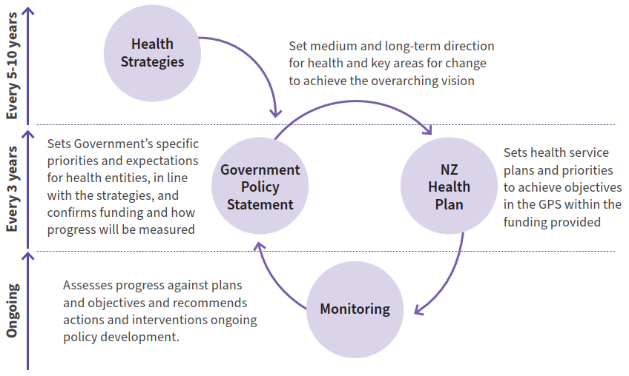

This new approach provides a clear pathway for translating strategies into action and monitoring the impact of strategies and the performance of agencies. The role of health strategies is critical to providing the long-term vision and priority areas that inform decisions on the other documents.

As the Government determines the first three-year GPS for 2024–2027, and in subsequent cycles, the strategies will be turned into clear expectations and actions that will provide the opportunity to achieve the changes set out.

Monitoring outcomes
The health strategies set a direction towards achieving pae ora | healthy futures for all New Zealanders and include goals to eliminate health inequities and improve outcomes. Monitoring progress towards this vision requires a long-term approach to measuring key health outcomes.

The GPS will set requirements for measures and indicators that will be used to monitor and assess the progress of the health system and of individual entities in achieving these goals.

These measures will combine more enduring and long-term outcomes that are closely linked to the strategies, as well as more specific measures that reflect three-year priorities and help drive action in certain areas. They will support Manatū Hauora in its stewardship role to track delivery of the strategies and report on impacts over time.

Ensuring high-quality data will be essential to monitoring outcomes. This is particularly the case for monitoring inequities between population groups, which require a breakdown of data to make comparisons and develop insights. The current health data sets contain numerous gaps, both for certain groups (eg, Pacific, rainbow, and rural communities) and services (eg, primary and community care), that will need to be addressed through purposeful, targeted data and analytics plans to ensure that the intended impact of the strategies can be appropriately monitored for all groups.

Ongoing evaluation
In addition to monitoring the intended outcomes of the strategies to account for the success of their delivery, it is also important to ensure ongoing evaluation of the strategy direction itself to ensure that this remains appropriate.

Over the coming years as the strategies are developed into firm actions in the GPS and NZ Health Plan and then implemented, it will be necessary to invest in ongoing research and evaluation to continue to build our understanding of the direction and evolve it where needed. This may include:
- evaluating the impact of the Pae Ora (Healthy Futures) Act, the effectiveness of its implementation and lessons for the system structure
- evaluating the new accountability approach, the roles of strategies, the GPS and NZ Health Plan, and the effectiveness of their delivery and alignment in achieving system goals
- evaluating the process undertaken to develop the health strategies, to draw insights on the benefits of different engagement approaches, analysis, and development
- continuing to work with women in monitoring and evaluating progress within the health system towards the goals and vision set out in the Women’s Health Strategy.

These areas for evaluation will be developed further to support a refreshed approach to research across the health system.

References
Alzheimer’s New Zealand. 2019. Reflections on International Women’s Day. URL: alzheimers.org.nz/blogs/reflections-on-international-womensday/?highlight=women%20 (accessed 10 July 2023).
Asian Health Services. 2022. Healthy Mother Healthy Future. URL: asianhealthservices.co.nz/News-Events/News-Updates/healthy-mother-healthyfuture-hmhf-asian-perinatal-wellbeing-project-2022#%3A~%3Atext%3DWaitemat%C4%81%20DHB%20would%20like%20to%2Cimproving%20their%20accessibility%20to%20relevant (accessed 10 July 2023).
Counting Ourselves. 2022. Aotearoa New Zealand Trans and Non-Binary Health Survey. URL: countingourselves.nz (accessed 10 July 2023).
Department of Corrections. 2021. Wahine: E Rere Ana Ki te Pae Hou Women’s Strategy 2021-2015. URL: corrections.govt.nz/resources/strategic_reports/wahine_e_rere_ana_ki_te_pae_hou_womens_strategy (accessed 10 July 2023).
Donald Beasley Institute. 2022. My Experiences, My Rights: A monitoring report on disabled people’s experiences of health and wellbeing in Aotearoa New Zealand [Monitoring Long Report]. New Zealand Disabled People’s Organisation Coalition.
Family Planning. 2023. Abnormal Periods. URL: familyplanning.org.nz/advice/periods/abnormal-periods (accessed 10 July 2023).
Fanslow JL, Malihi ZA, Hashemi L, et al. 2021. Lifetime prevalence of intimate partner violence and disability: Results from a population-based study in New Zealand. American Journal of Preventative Medicine 61(3): 320–28.
Fenaughty J, Ker A, Alansari M, et al. 2022. Identify survey: Community and advocacy report. URL: https://www.identifysurvey.nz/s/community_advocacy_report.pdf (accessed 10 July 2023).
Fraser B, White M, Cook H, et al. 2021. Service usage of a cohort of formerly homeless women in Aotearoa New Zealand. SSM – Population Health 13. URL: https://doi.org/10.1016/j.ssmph. 2021.100842 (accessed 10 July 2023).
Healthify. 2022a. Osteoporosis | Kōiwi ngoikore. URL: healthify.nz/health-az/o/osteoporosis (accessed 10 July 2023).
Healthify. 2022b. Endometriosis. URL: healthify.nz/health-a-z/e/endometriosis (accessed 10 July 2023).
Healthify. 2022c. Menopause. URL: healthify.nz/hauora-wellbeing/m/menopause (accessed 10 July 2023).
Hussein J, Ferguson L. 2019. Eliminating stigma and discrimination in sexual and reproductive health care: a public health imperative. Sexual and Reproductive Health Matters, 27:3, 1-5. URL: tandfonline.com/doi/full/10.1080/26410397.2019.1697103 (accessed 10 July 2023).
Institute for Health Metrics and Evaluation. 2020a. Global Burden of Disease (GBD). URL: vizhub.healthdata.org/gbd-results (accessed 10 July 2023).
Institute for Health Metrics and Evaluation. 2020b. Global Burden of Disease Study 2019 (GBD 2019 Life Tables 1950-2019). URL: ghdx.healthdata.org/record/ihme-data/gbd-2019-life-tables-1950-2019 (accessed 10 July 2023).
Manatū Wāhine | Ministry for Women. 2018. Ministry for Women’s input into the inquiry into mental health and addiction URL: https://women.govt.nz/sites/default/files/2021- 08/Ministry%20for%20Womens%20input%20into%20the%20inquiry%20into%20mental%20health%20and%20addiction.pdf (accessed 10 July 2023).
Manatū Wāhine | Ministry for Women. 2022. Te Pūrongo-ā-Tau Mō te tau i mutu i te 30 o ngā rā o Pipiri 2022 | Annual Report for the year ended 20 June 2022. URL: https://www.women.govt.nz/sites/default/files/2023-01/Ministry-for-Women-Annual-Report-2022_0.PDF (accessed 10 July 2023).
McGinn O, Mount V, Fulcher H. 2021. Increasing access to contraception in New Zealand: assessing the impact of a new funding initiative. The New Zealand Medical Journal 134(1528): 88–95.URL: journal.nzma.org.nz/journal-articles/increasingaccess-to-contraception-in-new-zealand-assessing-the-impact-of-a-new-funding-initiative (accessed 10 July 2023).
Ministry of Business, Innovation and Employment | Hīkina Whakatutuki. n.d. Extending paid parental leave. URL: mbie.govt.nz/business-and-employment/employmentand-skills/employment-legislation-reviews/extending-paid-parental-leave (accessed 10 July 2023).
Ministry of Health. 2019. Achieving Equity in Health Outcomes: Summary of a discovery process. Wellington: Ministry of Health.
Ministry of Health. 2020a. Whakamaua: Māori Health Action Plan 2020–2025. Wellington: Ministry of Health.
Ministry of Health. 2020b. Longer, Healthier Lives: New Zealand’s Health 1990–2017. Wellington: Ministry of Health.
Ministry of Health. 2021. Annual Data Explorer 2020/21: New Zealand Health Survey [Data File]. URL: https://minhealthnz.shinyapps.io/nz-health-survey-2021-22-annual-data-explorer/_w_18d68b66/#!/home (accessed 10 July 2023).
Ministry of Health. 2022. Annual Update of Key Results 2021/22: New Zealand Health Survey. URL: health.govt.nz/publication/ annual-update-key-results-2021-22-newzealand-health-survey (accessed 10 July 2023).
Ministry of Health. 2023a. Ao Mai te Rā | The Anti-Racism Kaupapa. URL: health.govt.nz/our-work/populations/maori-health/ao-mai-te-ra-anti-racism-kaupapa (accessed 10 July 2023).
Ministry of Health. 2023b. Health and Independence Report 2023: The Director-General of Health’s annual report on the state of public health. Wellington: Ministry of Health.
Ministry of Justice. 2018. The New Zealand Crime and Victims Survey Key Findings 2018. Wellington: Ministry of Justice.
Ministry of Social Development. 2019. Mahi Aroha Carers’ Strategy Action Plan. URL: msd.govt.nz/about-msd-and-our-work/work-programmes/policydevelopment/carers-strategy/#:~:text=that%20affects%20them.-,Mahi%20Aroha%20%2D%20Carers’%20Strategy%20Action%20Plan%202019%2D2023,health%20condition%2C%20il-lness%20or%20injury (accessed 10 July 2023).
Moore D, Davies P. 2018. The Problem of Chronic Pain and Scope for Improvements in Patient Outcomes. Report to the Faculty of Pain Medicine Sapere Group. URL: https://www.srgexpert.com/wp-content/uploads/2019/03/The-problem-of-chronic-pain-and-scope-for-improvements-in-patient-outcomes.pdf(accessed 10 July 2023).
Perinatal and Maternal Mortality Review Committee. 2022. Fifteenth Annual Report of the Perinatal and Maternal Mortality Review Committee | Te Pūrongo ā-Tau Tekau mā Rima o te Komiti Arotake Mate Pēpi, Mate Whaea Hoki: Reporting Mortality and Morbidity 2020 | Te Tuku Pūrongo mō te Mate me te Whakamate 2020. Wellington: Health Quality & Safety Commission.
Pretious H, Temple V. 2022. NZCSRH feedback for practitioner training project: Experiences of disabled clients accessing sexual and reproductive healthcare in Aotearoa. [unpublished].
Rankine J, et al. 2013. Women and Alcohol in Aotearoa/New Zealand | Te waipiro me ngā wāhine. Policy Briefing Paper. URL: http://www.ahw.org.nz/Portals/5/Resources/Briefing%20papers/2013/WomenAndAlcoholBriefingPolicy_final%20Nov%202013.pdf (accessed 10 July 2023)
Stats NZ. 2014. Disability Survey: 2013. URL: stats.govt.nz/information-releases/disability-survey-2013 (accessed 10 July 2023).
Stats NZ. 2020. COVID-19’s impact on women and work. URL: stats.govt.nz/news/covid-19s-impact-on-women-and-work (accessed 10 July 2023).
Stats NZ. 2021. LGBT+ population of Aotearoa: Year ended June 2021. URL: stats.govt.nz/information-releases/lgbt-plus- population-of-aotearoa-year-ended-june-2021 (accessed 10 July 2023).
Stats NZ. 2022. National ethnic population projections, projection assumptions. 2018(base)-2043 update. URL: nzdotstat.stats.govt.nz/wbos/Index.aspx?DataSetCode=TABLECODE8615 (accessed 10 July 2023).
Stats NZ. 2023. Pacific housing: People, place, and wellbeing in Aotearoa New Zealand, in January 2023. URL: stats.govt.nz/ infographics/pacific-housing (accessed 10 July 2023).
Te Aho o Te Kahu | Cancer Control Agency. 2021. The State of Cancer in New Zealand 2020. URL: teaho.govt.nz/reports/cancer-state (accessed 10 July 2023).

Te Ara Ahunga Ora | Retirement Commission. 2022. New data reveals for the first time largest breakdown of KiwiSaver balances across all ages and genders. URL: retirement.govt.nz/news/latest-news/new-data-reveals-for-the-first-timelargest- breakdown-of-kiwisaver-balances-across-all-ages-and-genders (accessed 10 July 2023).
Te Hiringa Hauora 2022. Kupe | Data Explorer Gambling Harm. Te Hiringa hauora | Health Promotion Agency 2020 Health and Lifestyles Survey. URL: kupe.hpa.org.nz/#!/gambling (accessed 10 July 2023).
Te Kāwanatanga o Aotearoa | New Zealand Government. 2023a. Cheaper Childcare: 20 hours free ECE extended to two-year-olds. URL: beehive.govt.nz/release/cheaper-childcare-20-hours- free-ece-extended-two-year-olds (accessed 10 July 2023).
Te Kāwanatanga o Aotearoa | New Zealand Government. 2023b. Hundreds to benefit from additional maternal health support. URL: beehive.govt.nz/release/hundredsbenefit-additional- maternal-healthsupport#:~:text=The%20Government’s%20Budget%202022%20investment,expectant%20mothers%20 around%20the%20country (accessed 10 July 2023).
Te Puna Aonui. 2021. Te Aorerekura: The National Strategy to Eliminate Family Violence and Sexual Violence. URL: tepunaaonui.govt.nz/nationalstrategy/#:~:text=Addressing%20family%20 violence%20and%20sexual%20violence%20will%20significantly,communities%20to%20eliminate%20family%20violence%20and%20sexual%20violence (accessed 10 July 2023).
Te Whatu Ora. 2022a. Mortality web tool. URL: tewhatuora.govt. nz/our-healthsystem/data-and-statistics/mortality-web-tool (accessed 10 July 2023).
Te Whatu Ora. 2022b. Historical Cancer data. URL: tewhatuora.govt.nz/our-healthsystem/data-and-statistics/historical-cancer (accessed 10 July 2023).
Te Whatu Ora. 2022c. Report on the maternity web tool. URL: tewhatuora.govt.nz/our-health-system/data-and-statistics/report-on-maternity-web-tool (accessed 10 July 2023).
Te Whatu Ora. 2022d. Te Pae Tata Interim New Zealand Health Plan 2022. URL: tewhatuora.govt.nz/publications/te-pae-tata-interim-new-zealand-health-plan-2022 (accessed 10 July 2023).
Tewhaiti-Smith J, Semprini A, Bush D, et al. 2022. An Aotearoa New Zealand survey of the impact and diagnostic delay for endometriosis and chronic pelvic pain. Sci Rep (12) 4415. URL: https://doi.org/10.1038/s41598-022-08464-x (accessed 10 July 2023).
The Helen Clarke Foundation. 2022. Āhurutia Te Rito | It takes a village. URL: helenclark.foundation/publications-and-medias/ahurutia-te-rito-it-takes-a-village (accessed 10 July 2023).
ThinkPlace. 2020. Young Māori Women Smoking Cessation: Designing out inequity case study. URL: tewhatuora.govt. nz/for-the-health-sector/health-sectorguidance/vaping- and-smokeless-tobacco-products/insights-into-maori-womensmoking (accessed 10 July 2023).
van der Meer L, Evans K. 2021. The autism diagnostic process in New Zealand. URL: https://www.autismcrc.com.au/sites/default/files/reports/1-058_NZ-Diagnostic-Practices_Final-Report_2021.pdf (accessed 10 July 2023).
Wailling J, Marshall C, Wilkinson J. 2019. Hearing and responding to the stories of survivors of surgical mesh. URL: health.govt.nz/publication/hearing-andresponding-stories-survivors- surgical-mesh (accessed 10 July 2023).
Walker K. 2020. The Chief Historian’s Pre-Casebook Discussion Paper for the Mana Wāhine Inquiry. URL: https://forms.justice.govt.nz/search/Documents/WT/wt_DOC_162348807/Wai%202700%2C%206.2.1.pdf (accessed 10 July 2023).
Walsh M, Grey C. 2019. The contribution of avoidable mortality to the life expectancy gap in Māori and Pacific populations in New Zealand — a decomposition analysis. New Zealand Medical Journal 132(1492): 46–60. URL: https://assets-global.website-files.com/5e332a62c703f653182faf47/5e332a62c703f6a6e92fc416_Walsh%20FINAL.pdf (accessed 10 July 2023).

Te Whatu Ora I Health New Zealand Health workforce data 2022 (personal communication)
Based on Stats NZ projected life expectancy by ethnic group and sex 2019

