Tracking the Obesity Epidemic:
New Zealand 1977–2003

Public Health Intelligence
Occasional Bulletin No 24

Citation: Ministry of Health. 2004. Tracking the Obesity Epidemic: New Zealand 1977–2003. Wellington: Ministry of Health.
Published in December 2004 by the
Ministry of Health
PO Box 5013, Wellington, New Zealand
ISBN 0-478-25760-0 (Book)
ISBN 0-478-25761-9 (Internet)
HP 4010
This document is available on the Ministry of Health’s website:
http://www.moh.govt.nz/phi


Foreword
Obesity has long been recognised by the Ministry of Health as a major public health issue. ‘Improving nutrition’ and ‘reducing obesity’ are priority objectives in the New Zealand Health Strategy, launched by the Minister of Health in December 2000. In a study carried out jointly by the Ministry and the University of Auckland, higher than optimal body mass index (BMI, weight adjusted for height) was estimated to contribute to approximately 3200 deaths per year in New Zealand, mostly through type 2 diabetes, ischaemic heart disease and stroke.

This burden is growing, as mean BMI and the prevalence of obesity continue to increase in New Zealand, the latter doubling over the past quarter century in both males and females. Until now we have lacked a description of the shifts over time in the full BMI distribution. Such a description is the purpose of the present study. Using data from four national health and nutrition surveys, we have applied graphical techniques to visualise trends in the BMI distribution among adults, for the total New Zealand population from 1977 to 2003, and for Mäori from 1989 to 2003. The results not only provide a richer and more comprehensive picture of the ‘obesity epidemic’ than previously available, but also give some cause for cautious optimism that the epidemic can be contained and even reversed. This report provides the first indication that the rate of growth of the epidemic – while still positive – may be slowing among some population groups. However, there is no reason for complacency and the possibility that the apparent slowing may be at least partly artefactual cannot be excluded. The BMI data from the next round of health and nutrition surveys (scheduled for 2005–07) are therefore awaited with keen interest.

In the interim, this report on Tracking the Obesity Epidemic: New Zealand 1977–2003 provides detailed information that will be useful in further developing and evaluating the Ministry’s Healthy Eating – Healthy Action strategy, launched by the Minister of Health in March 2003, and the strategy’s Implementation Plan, launched by the Minister in June 2004. In fact, this report may well represent the most thorough and comprehensive description of a national ‘obesity epidemic’ yet produced for any country. In particular, its focus on the full BMI distribution and its use of innovative graphical techniques to visualise and quantify shifts in this distribution provide a solid evidence base for policy and planning. While the report is national in scope, District Health Boards and primary health organisations (PHOs) may find this information of value in framing their own response to the epidemic. Indeed, as the setting in which population health meets personal health care, PHOs in particular have a critical role to play in bringing the epidemic under control and minimising its harm.

We invite readers to comment on the content, relevance and direction of this report. Please direct any comments to Public Health Intelligence, Ministry of Health, PO Box 5013, Wellington.

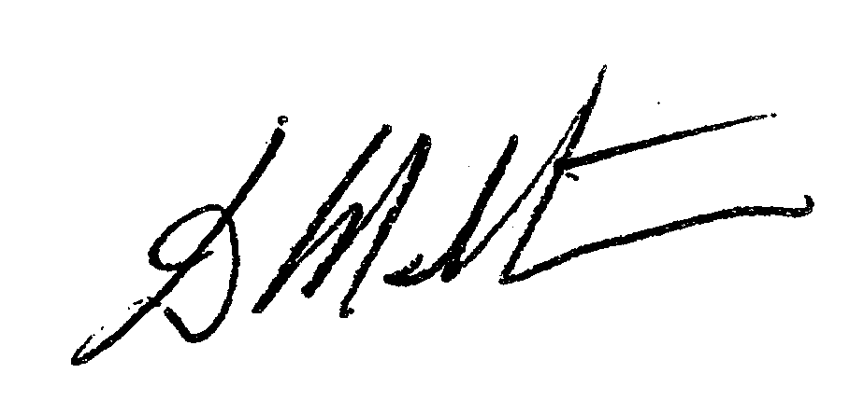

Don Matheson
Deputy Director-General, Public Health Directorate

Acknowledgements
The authors of this report were Martin Tobias, Sue Paul and Maria Turley of the Public Health Intelligence Group of the Ministry of Health. The authors are grateful to Matthew Cronin (Public Health Intelligence) for statistical assistance, and to the Ministry of Health peer reviewers.

The authors also acknowledge the following people for peer reviewing this report and providing useful feedback: Professor Boyd Swinburn (Deakin University), Professor Jim Mann (Otago University), Dr Noela Wilson (Otago University), and Dr Cliona Ni Mhurchu (Auckland University).

Contents
Foreword iii
Executive Summary viii
Introduction 1
Objective 1
Background 1
Body mass index 1
Describing BMI distributions 2
Data Sources and Methods 8
The surveys 8
Methods 9
Presentation of results 10
Results – Total Population 13
BMI distributions 13
Overview of BMI distributional shifting, 1977–2003 47
Results – Mäori Population 53
BMI distributions 53
Overview of BMI distributional shifting among Mäori, 1989–2003 60
Socioeconomic Position and BMI 62
Household income and BMI 63
Neighbourhood deprivation and BMI 65
Smoking and BMI 67
Mean BMI and smoking 67
Obesity and smoking 68
Trends in Extreme Obesity 70
Trends in mean BMI of the obese 70
Trends in the prevalence of extreme obesity 71
Trends in Stature 74
Discussion 76
Shifts in the BMI distribution, 1977–2003 76
Shifts in the BMI distribution, 1997–2003 77
Policy implications 79
Monitoring implications 80
Summary of key policy and monitoring implications 81
References 83
Statistical Annexe 85
Total population 86
Mäori population 95

List of Tables
Table 1: Classification of overweight and obesity according to BMI (kg/m²) 2
Table 2: Nationally representative surveys with measured BMI 8
Table 3: Selected sample statistics, ages pooled, 1977–2003 14
Table 4: Selected sample statistics, by 10-year age group (males), 1977–1989 24
Table 5: Selected sample statistics, by 10-year age group (females), 1977–1989 25
Table 6: Selected sample statistics, by 10-year age group (males), 1989–1997 35
Table 7: Selected sample statistics, by 10–year age group (females), 1989–1997 35
Table 8: Selected sample statistics, by 10-year age group (males), 1997–2003 45
Table 9: Selected sample statistics, by 10-year age group (females), 1997–2003 45
Table 10: Selected Mäori sample statistics, ages pooled, 1989–2003 54
Table 11: Selected Mäori sample statistics, ages pooled, 1989–1997 57
Table 12: Selected Mäori sample statistics, ages pooled, 1997–2003 59
Table 13: Prevalence of extreme obesity, crude and age standardised,* total population 72
Table 14: Prevalence of extreme obesity, crude and age standardised,* Mäori population 72
Table 15: Mean height (cm), by age group and sex, 2003 74
Table 16: BMI cut-offs for overweight and obesity 85
Table 17: Mean BMI (kg/m²) and 95% confidence intervals, total population 86
Table 18: Prevalence (%) of overweight and 95% confidence intervals, total population 87
Table 19: Prevalence (%) of obesity and 95% confidence intervals, total population 88
Table 20: Prevalence (%) of extreme obesity and 95% confidence intervals, total population 89
Table 21: 10th percentile of BMI and 95% confidence intervals, total population 90
Table 22: 25th percentile of BMI and 95% confidence intervals, total population 91
Table 23: 50th percentile of BMI and 95% confidence intervals, total population 92
Table 24: 75th percentile of BMI and 95% confidence intervals, total population 93
Table 25: 90th percentile of BMI and 95% confidence intervals, total population 94
Table 26: Mean BMI and 95% confidence intervals, Mäori population 95
Table 27: Prevalence (%) of overweight and 95% confidence intervals, Mäori population 95
Table 28: Prevalence (%) of obese and 95% confidence intervals, Mäori population 95
Table 29: Prevalence (%) of extreme obesity and 95% confidence intervals, Mäori population 95
Table 30: 10th percentile of BMI and 95% confidence intervals, Mäori population 95
Table 31: 25th percentile of BMI and 95% confidence intervals, Mäori population 96
Table 32: 50th percentile of BMI and 95% confidence intervals, Mäori population 96
Table 33: 75th percentile of BMI and 95% confidence intervals, Mäori population 96
Table 34: 90th percentile of BMI and 95% confidence intervals, Mäori population 96

List of Figures
Figure 1: Changes in the BMI distribution, total population, ages pooled, 1977–2003 viii
Figure 2: Prevalence of overweight and obesity, total population, ages pooled, 1977–2003 ix
Figure 3: Changes in the BMI distribution, Mäori population, ages pooled, 1989–2003 ix
Figure 4: Prevalence of overweight and obesity, Mäori population, ages pooled, 1989–2003 ix
Figure 5: BMI distribution (kernel densities) 3
Figure 6: Cumulative BMI distribution 3
Figure 7: Tukey mean–difference plot (single percentile only shown) 4
Figure 8: Uniform upward shift (the universal model) 5
Figure 9: Increased skewness (the high-risk subgroup model) 6
Figure 10: Upward shift with increased skewness (the mixed population model) 7
Figure 11: Changes in BMI distribution, ages pooled, 1977–2003 13
Figure 12: Prevalence of overweight and obesity, ages pooled, 1977–2003 14
Figure 13: Kernel densities of BMI, 1977–1989 17
Figure 14: Cumulative distribution functions, 1977–1989 19
Figure 15: Tukey mean–difference plots, 1977–1989 21
Figure 16: Prevalence of overweight and obesity, 1977–1989 23
Figure 17: Kernel densities of BMI, 1989–1997 27
Figure 18: Cumulative distribution functions, 1989–1997 29
Figure 19: Tukey mean difference plots, 1989–1997 31
Figure 20: Age-specific prevalence of overweight and obesity, 1989–1997 33
Figure 21: Kernel densities of BMI, 1997–2003 37
Figure 22: Cumulative distribution functions, 1997–2003 39
Figure 23: Tukey mean difference plots 1997–2003 41
Figure 24: Prevalence of overweight and obesity, 1997–2003 43
Figure 25: Prevalence of overweight and obesity, 1977–2003 47
Figure 26: Trends in BMI (mean, median and 90th percentile), 1977–2003 49
Figure 27: AAPC in obesity prevalence, total population, by period and gender 51
Figure 28: Changes in BMI distribution of Mäori population, ages pooled, 1989–2003 53
Figure 29: Prevalence of overweight and obesity (Mäori population), ages pooled, 1989–2003 54
Figure 30: Changes in BMI distribution (Mäori), ages pooled, 1989–1997 56
Figure 31: Prevalence of overweight and obesity (Mäori), ages pooled, 1989–1997 57
Figure 32: Changes in BMI distribution of Mäori population, ages pooled, 1997–2003 58
Figure 33: Prevalence of overweight and obesity (Mäori), ages pooled, 1997–2003 59
Figure 34: AAPC in obesity prevalence, Mäori population, by period and gender 60
Figure 35: Mean BMI, by income, 1989, 1997 and 2003 63
Figure 36: Obesity prevalence, by income, 1989, 1997 and 2003 64
Figure 37: Mean BMI, by NZDep category, 1997 and 2003 65
Figure 38: Prevalence of obesity, by NZDep category, 1997 and 2003 66
Figure 39: Mean BMI, by smoking status, 2003 68
Figure 40: Prevalence of overweight and obesity, by smoking status, 2003 69
Figure 41: Mean BMI of the obese subpopulation, by gender, total population, 1977–2003 70
Figure 42: Mean BMI of the obese subpopulation, by gender, Mäori population, 1989–2003 71
Figure 43: Prevalence of extreme obesity, by gender, total population, 1977–2003 71
Figure 44: Prevalence of extreme obesity, by gender, Mäori population, 1989–2003 72
Figure 45: Trends in mean stature of males 75
Figure 46: Trends in mean stature of females 75

Executive Summary
Graphical methods have been applied to visualise trends in the body mass index (BMI) distribution of the New Zealand adult population from 1977 to 2003 by age, gender, ethnicity and socioeconomic position.

The BMI data are derived from measured weight and height from nationally representative samples of New Zealanders examined in four serial cross-sectional prevalence surveys: the 1977 National Diet Survey (n = 1761), the 1989 Life in New Zealand Survey (n = 2924), the 1997 National Nutrition Survey (n = 4100) and the 2003 New Zealand Health Survey (n = 10,813). For Mäori, there were insufficient respondents in the earliest (1977) survey, so analysis is restricted to the 1989 to 2003 period.

BMI distributions are described using frequency histograms after kernel smoothing (kernel density plots), cumulative distribution functions, and Tukey mean–difference plots. Trends in the prevalence of ‘overweight’ (BMI 25.0–29.9 for European/Other and 26.0–31.9 for Mäori and Pacific ethnic groups), ‘obesity’ (BMI ≥ 30.0 and 32.0, respectively) and ‘extreme obesity’ (BMI ≥ 40.0 for all ethnic groups) are also described.

Three patterns of BMI distributional shift are theoretically possible: uniform right shift of the whole distribution (universal pattern), increased skewness (high-risk subgroup pattern), or both combined (mixed pattern).

Pooling all adult ages and time periods, the overall visualisation of the ‘obesity epidemic’ from 1977 to 2003 (total population) and from 1989 to 2003 (Mäori population) is shown below (Figures 1–4). There were too few Pacific or Asian respondents in any but the most recent survey (ie, 2003) to allow separate analysis of BMI distributional shifts for these ethnic groups.

Figure 1: Changes in the BMI distribution, total population, ages pooled, 1977–2003
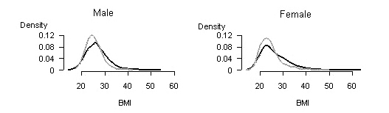
Key: 1977 distribution 2003 distribution

Figure 2: Prevalence of overweight and obesity, total population, ages pooled, 1977–2003
Males | Females
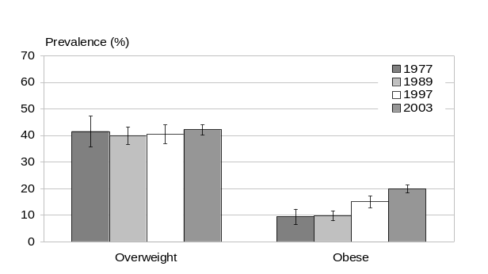 | 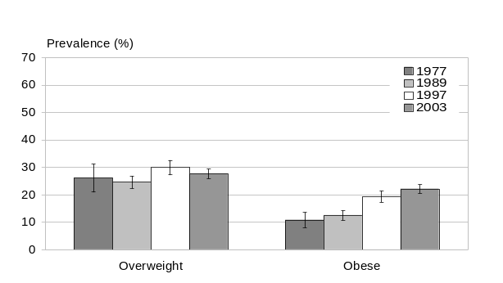

Figure 3: Changes in the BMI distribution, Mäori population, ages pooled, 1989–2003
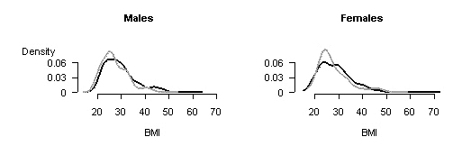
Key: 1989 distribution 2003 distribution

Figure 4: Prevalence of overweight and obesity, Mäori population, ages pooled, 1989–2003
Males | Females
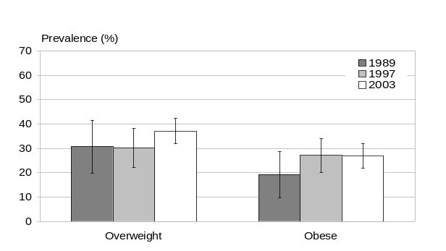 | 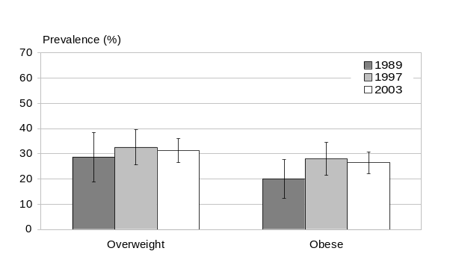

Examination of the pattern of BMI distributional shifting over time shows – despite some variation across ethnic groups, age groups and periods – a mixed pattern with little change at the lower percentiles of the BMI distribution and most of the increase in BMI being concentrated at the higher percentiles (ie, increasing skewness). This is compatible with differential susceptibility when individuals are exposured to an increasingly ‘obesogenic’ environment (Swinburn et al 1999).

This pattern of distributional shifting is reflected in increasing median (or mean) BMI, with much greater increase at higher percentiles (eg, the 90th percentile). It is also mirrored in the dramatic rise in obesity prevalence seen over the quarter century: from 9 percent (males) and 11 percent (females) in 1977 to 20 percent and 22 percent, respectively, in 2003, accompanied by near-stable overweight prevalence (42 percent for males and 28 percent for females).

Although differing in detail, the overall pattern is similar for Mäori over the 1989–2003 period. Median and mean BMI increased, yet the relative increase was greater at higher percentiles of the BMI distribution. In keeping with this pattern of distributional shifting, obesity prevalence increased from approximately 20 to 27 percent (both genders), while overweight prevalence remained almost steady at approximately 30 percent for females and increased from 31 to 37 percent in males.

A socioeconomic gradient in the BMI distribution (with lower socioeconomic groups having more right-shifted distributions) was evident among females since (at least) 1989, yet was only just beginning to emerge among males in 2003.

This overall picture disguises significant differences between age groups, genders and time periods within both the total population and the Mäori population. More detailed analysis shows that the ‘epidemic’ grew relatively slowly in the 1970s and early to mid-1980s (especially among non-Mäori and among males), then accelerated rapidly in the late 1980s to mid-1990s, only to slow once again in the late 1990s to early 2000s among Mäori, as well as among non-Mäori females (but not non-Mäori males). Yet the epidemic continues to grow, and the apparent slowing in the growth rate of the epidemic among some population subgroups could be due to differences in survey design. Therefore, this finding cannot be confirmed until data from the next round of health and nutrition surveys (scheduled for 2005–2007) are available.

Key policy and monitoring implications arising from this detailed analysis of shifts in the population’s BMI distribution over the past quarter century include the following.
- Mean BMI and obesity prevalence are continuing to increase, although possibly less rapidly now than in the 1990s, at least among non-Mäori females and Mäori of both genders. This apparent slowing could reflect technical differences between the surveys, especially for Mäori (for whom sample sizes were small).
- The apparent slowing in the growth rate of the ‘epidemic’ in some population groups needs to be confirmed in future surveys, but even if true, gives no reason for complacency. Rather, this finding should invigorate intersectoral control efforts and encourage the setting of more ambitious targets.
- The pattern of shifting of the BMI distribution is compatible with a mixed rather than a universal pattern – suggesting that strategies aimed at reducing the obesogenicity of the environment could usefully be complemented with targeted strategies aimed at high-risk groups.
- BMI distributional shifting began earliest and has advanced furthest among middle-aged women, but now involves both sexes, Māori and non-Māori, and has spread to younger and older age groups.
- Increased efforts to monitor and control childhood obesity are critical for the health of future generations of adults as results of the 2002 National Children’s Nutrition Survey suggest that 10 percent of school age children are now obese. Thus any slowing in the growth rate of the epidemic among adults could be temporary and may reverse as the current generation of children reach adulthood.
- Socioeconomic inequality in the distribution of BMI is marked among females and is beginning to emerge among males. Strategies tailored to the needs of lower socioeconomic groups are needed to reverse this trend.
- Monitoring of BMI distributional shifting provides a basis for the projection of future BMI-related burden. This information can also be used to assess the effectiveness of intervention strategies and to model the potential impact of different policy options.
- Such information may not only be of use at the national policy level, but may also assist District Health Boards and primary health organisations in achieving their obesity-related objectives.

Introduction

Objective
The objective of this work is to apply graphical methods to monitor changes in the body mass index (BMI) distribution of New Zealand adults from 1977 to 2003 by age, gender, ethnicity and socioeconomic position, using measured BMI from serial nationally representative cross-sectional prevalence surveys.

Background
Excess body weight is one of the most important modifiable risk factors for a number of important diseases, including type 2 diabetes mellitus, ischaemic heart disease (IHD), ischaemic stroke and several common cancers (WHO 2000). The impact of excess body weight on these diseases operates, at least in part, through its effects on insulin resistance, blood glucose, blood lipids and blood pressure.

Energy intake is determined by food and beverage consumption. Energy expenditure has three main components: basal metabolic rate, dietary thermogenesis (ie, energy expended converting food to nutrients), and physical activity (WHO 2000). The most variable component of energy expenditure is physical activity, which contributes approximately 30 percent of energy expenditure in sedentary adults and approximately 50 percent in adults involved in heavy manual work.

Excess body weight is the result of a positive energy balance; that is, a chronic excess of energy intake over energy expenditure. Currently it is not known whether a large positive energy balance on some days or a small positive energy balance on most days produces the larger increase in body weight.

Although some people are more genetically susceptible to weight gain than others, the rapid increase in mean BMI and in the prevalence of overweight and obesity during the last two decades has occurred too quickly to be explained by genetic or demographic changes (WHO 2000). Instead, the dramatic shift in population BMI distribution is thought to be the result of exposure to an ‘obesogenic’ environment, which promotes sedentary lifestyles and overconsumption of energy-dense foods and beverages (Swinburn et al 1999).

Body mass index
Body mass index is the anthropometric measure that provides the most useful population-level indicator of excess body weight. BMI is a measure of weight adjusted for height, and is calculated by dividing weight in kilograms by the square of height in metres (kg/m²). For this report, adults were classified as overweight or obese according to the following criteria (Table 1).

Table 1: Classification of overweight and obesity according to BMI (kg/m²)
Classification | European and Other | Mäori and Pacific peoples
Overweight | 25.0–29.9 | 26.0–31.9
Obese | ≥ 30.0 | ≥ 32.0
Extreme obesity | ≥ 40.0 | ≥ 40.0

Higher BMI cut-offs have been used to classify overweight and obesity (but not extreme obesity) in Mäori and Pacific peoples. These higher cut-offs have been recommended because at any given BMI, Mäori and Pacific peoples have a lower level of body fat than Europeans (Swinburn 1998). However, the relationship between these higher cut-offs and the health risk experienced by these ethnic groups is unclear. Lower BMI cut-offs have been proposed for Asian ethnic groups (WHO, IASO, IOT 2000), yet these are even less well established and are not used in this report. The use of ethnic-specific cut-offs remains a controversial topic, and the choice of cut-offs should be guided by the objectives of the analysis (WHO Expert Consultation 2004).

For all ethnic groups, BMI cut-offs are ultimately arbitrary rather than representing true risk-based thresholds. In fact, the health risks associated with increasing BMI are continuous and graded, and begin at a BMI below 25 (Asia Pacific Cohort Studies Collaboration 2004). For example, the association between BMI and type 2 diabetes is continuous (log linear) down to BMI values as low as 19 or 20 kg/m² (Willett et al 1999). Therefore, attention should be focused on (shifts in) the whole BMI distribution, not just on BMI categories, however discretised.

A full analysis of the mortality burden attributable to New Zealand’s current BMI distribution (as well as mortality potentially avoidable in the future under different BMI distribution scenarios) has been reported elsewhere (Ministry of Health and University of Auckland 2003). In contrast, this report attempts to describe the population’s changing BMI distribution over the past quarter century (1977 to 2003) in order to gain insight into the evolution of the ‘obesity epidemic’ in New Zealand.

Describing BMI distributions
The simplest way to examine changes in a population’s BMI distribution between two points in time is simply to show both distributions as relative frequency histograms in the same chart (a relative frequency histogram plots the proportion of the population with each level of BMI against the BMI). Here the histogram is smoothed over the BMI intervals using kernel smoothing in order to visualise the whole distribution more clearly. This process gives kernel densities (Figure 5).

Figure 5: BMI distribution (kernel densities)
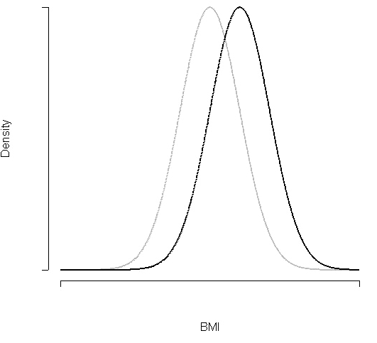
Key: population at time t1 population at time t2

Another graphical method often used to compare two distributions is the cumulative distribution. The cumulative distribution shows, for each of the populations, the cumulative percent of the population at each BMI value (Figure 6).

Figure 6: Cumulative BMI distribution
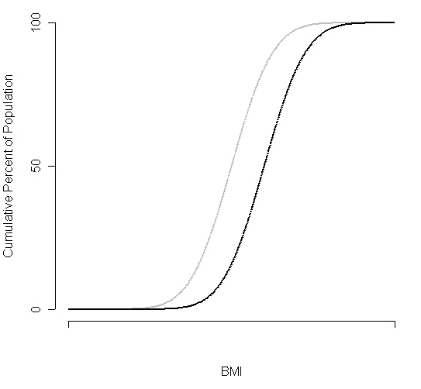
Key: population at time t1 population at time t2

It is easier to visualise the difference between the two distributions using the cumulative distribution than the simple relative frequency histogram (kernel densities), but it is still difficult to see changes at the extremes of the distributions, and to quantify the distributional shift. A method that overcomes both of these limitations is the Tukey mean–difference (m–d) plot (Cleveland 1993).

The m–d plots show the difference between the two distributions at each percentile against the mean of the two percentiles. For example, if the BMI value of the 50th percentile was 26.0 for one distribution and 25.0 for the other, then the m–d plot would show an x-axis value of 25.5 and a y-axis value of 1.0 (and so on for all other percentiles) (Figure 7).

Figure 7: Tukey mean–difference plot (single percentile only shown)
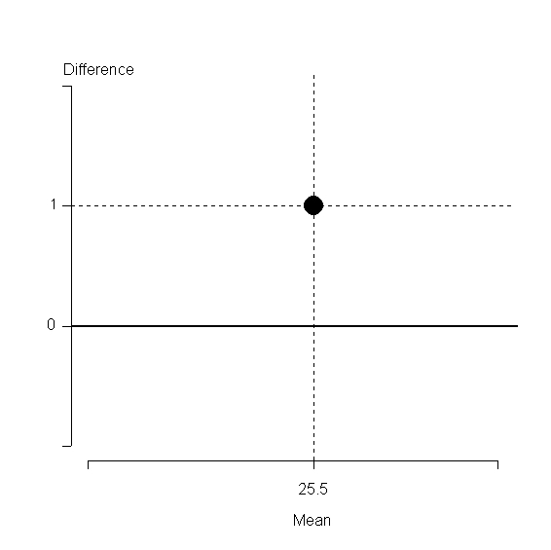

Note that if no shift had occurred at this percentile, the y-axis value would have been zero (and the x-axis value would have remained 25.5). So no shift at any percentile (identical distributions) is represented in an m–d plot as a horizontal line at zero.

Interpreting m–d plots
While not containing any new information beyond the (cumulative) distributions, the m–d plot allows us to more readily quantify the shift and to specify the location of the shift in relation to the distributions being compared. Figures 8–10 show three possible patterns:
- universal, single population or Rose model
- high-risk subgroup, two-population or stepped person–environment interaction model
- mixed or continuous person–environment interaction model.

Universal model
The ‘universal’ or ‘single-population’ model implies that increases in the prevalence of obesity are related to changes in the distribution of BMI in the population as a whole. Because the whole population is both exposed to an increasingly obesogenic environment and responds to this exposure in a consistent way, the entire distribution undergoes a uniform shift to the right (Figure 8, top chart). Similarly, the cumulative distribution shows a uniform shift to the right across its entire length (Figure 8, middle chart). And the m–d plot shows data points falling on a horizontal line whose distance from zero indicates the size of the (uniform) shift (Figure 8, lower chart).

Figure 8: Uniform upward shift (the universal model)
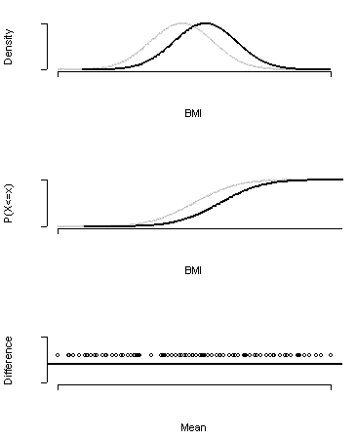
Key: population at time t1 population at time t2

High-risk subgroup model
The ‘high-risk subgroup’ or ‘two-population’ model implies that a subgroup of the population exists that is either more (or less) exposed or more (or less) susceptible to the obesogenic environment than the remainder of the population. Given universal exposure to the obesogenic environment, the most likely explanation is a gene–environment interaction, with ‘susceptibles’ undergoing weight gain while ‘resistants’ do not. Because only susceptibles undergo weight gain, the BMI distribution shows increasing skewness. At the lower (ie, lighter) end the two kernel density plots remain identical, but the peak of the second distribution falls relative to the first as its right-hand tail becomes thicker (Figure 9, top). Likewise, the cumulative distributions are superimposed at their lower ends, but the second skews increasingly to the right of the first at their upper ends (Figure 9, middle). And the m–d plot shows data points close to zero at lower percentiles, then rising progressively away from the horizontal at higher percentiles (Figure 9, bottom), clearly showing the increasing skewness.

Figure 9: Increased skewness (the high-risk subgroup model)
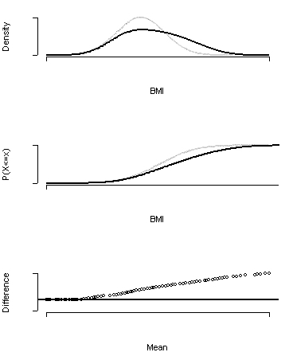
Key: population at time t1 population at time t2

Mixed model
Finally, the ‘mixed’ or ‘continuous person–environment interaction’ model shows both a shift of the whole distribution coupled with increasing skewness at the upper end of the distribution. This reflects a situation in which the whole population is exposed and responds to the obesogenic environment with an upward shift of the distribution, but genetically more susceptible or behaviourally more exposed individuals (who are likely to be already heavier on average) respond more, leading to increased skewness of the distribution at its upper end (Figure 10). Thus this model differs from the high-risk subgroup model in that it does not posit a distinct resistant or unexposed population (ie, a stepped person–environment interaction), but instead proposes a gradient in susceptibility and/or exposure across the population as a whole (ie, a continuous person–environment interaction).

Figure 10: Upward shift with increased skewness (the mixed population model)
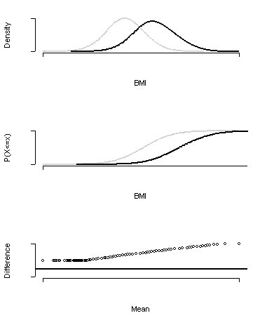
Key: population at time t1 population at time t2

Data Sources and Methods

The surveys
Four nationally representative nutrition or health surveys have been conducted in New Zealand, in which BMI was measured. These four surveys are summarised in Table 2 and described in more detail below. Although there was some variation in survey design and response rates, as well as in weight and height measurement methods (eg, number of measurements, adjustment for clothing and season), these surveys are considered to be reasonably comparable.

Table 2: Nationally representative surveys with measured BMI
Survey | Year | Age (years) | Sample size (for BMI) |  | Socioeconomic position | Smoking data
Survey | Year | Age (years) | Total | Mäori | Socioeconomic position | Smoking data
National Diet Survey | 1977 | 20–64 | 1,761 | 106 | Ellie–Irving Scale | No
Life in New Zealand | 1989 | 15–74* | 2,924 | 202 | Household income | Yes
National Nutrition Survey | 1997 | 15–74* | 4,100 | 638 | Household income, NZDep96 quartile | Yes
New Zealand Health Survey | 2003** | 15–74* | 10,813* | 3,648 | Household income, NZDep2001 quintile | Yes
* Subset of the data set, excluding the 75+ years age group.
** Actually 2002/03, but referred to as 2003 throughout this report.

Unfortunately, serial data on child and adolescent BMI distributions are not available from national surveys, so this study had to be restricted to the adult population. Results of the first national survey of children, the 2002 National Children’s Nutrition Survey, are reported elsewhere (Ministry of Health 2003b).

Despite oversampling of selected ethnic groups in the more recent surveys (ie, 1997 and 2003), once stratified by age and gender there were too few Mäori respondents to allow age-specific analysis of BMI distributions for this ethnic group. In analysing the changes in BMI distribution for Mäori we have pooled all age groups. There were too few Pacific or Asian respondents in any but the most recent survey (ie, 2003) to allow separate analysis of BMI distributional shifts for these ethnic groups.

Ethnicity was self-identified in all four surveys, although the precise wording of the ethnicity item did vary slightly between surveys. Social constructs of ethnicity, in particular the tendency to identify with more than one ethnic group, may also have varied over time. This additional source of bias should be borne in mind when interpreting the results reported here for Mäori for the 1989–2003 period.

1977 National Diet Survey
The target population for the 1977 National Diet Survey was non-institutionalised adults aged 20–64 years residing in permanent private dwellings. A stratified, multi-stage sampling design was used to select participants. Approximately 1900 adults responded to the survey. Further details about the survey design are reported in New Zealanders and Their Diet (Birkbeck 1979).

1989 Life in New Zealand Survey
The 1989 Life in New Zealand Survey used a stratified sampling process to select adult persons aged 15 years and over. The majority of respondents were selected from the 1988 general electoral rolls. As young people (under 18) are not on the electoral roll, a snowball technique was used to generate the sample for this group. Approximately 8000 adults responded to phase one of the survey, which involved completing two of the following four postal questionnaires, which were randomly selected and mailed to the respondent: ‘Your Health’, ‘Changes in Your Life’, ‘Your Eating Habits’, and ‘Leisure’. Over 3100 adults responded to phase two of the survey, a health check. Further details about the survey design are reported in Life in New Zealand Survey: Executive overview (Russell and Wilson 1991).

1997 National Nutrition Survey
The 1997 National Nutrition Survey was undertaken in a subset of the 1996/97 New Zealand Health Survey respondents. The target population for the 1996/97 New Zealand Health Survey was the total usually resident, non-institutionalised civilian population of all ages, residing in permanent private dwellings. A stratified multi-stage cluster sampling process was undertaken to select a sample from this population. Mäori and Pacific peoples were over-sampled. Approximately 7900 adults (aged 15 years and over) responded to the 1996/97 New Zealand Health Survey, and approximately 4600 adults responded to the 1997 National Nutrition Survey. Further details about the survey design are reported in Taking the Pulse: The 1996/97 New Zealand Health Survey (Ministry of Health 1999) and NZ Food NZ People: Key results of the 1997 National Nutrition Survey (Russell et al 1999).

2002/03 New Zealand Health Survey
The target population for the 2002/03 New Zealand Health Survey was the total usually resident civilian adult population (aged 15 years and over) residing in permanent private dwellings. A stratified multi-stage cluster sampling process was undertaken to select a sample from this population. Mäori and Pacific peoples were over-sampled. Approximately 12,900 adults responded to the survey. The survey also included a survey of institutions, but these results are not included in this analysis. Further details about the survey design are reported in A Portrait of Health: Key results of the 2002/03 New Zealand Health Survey (Ministry of Health 2004).

Methods
BMI data from the four surveys were extracted by 10-year age groups and by gender, then smoothed using a sample-weighted Gaussian kernel density estimator (Buskirk 1998). All estimates reported here, including BMI percentiles and means and overweight and obesity prevalences, are based on the weighted survey data.

Distributional changes from 1977 to 1989 (‘first period’), from 1989 to 1997 (‘second period’), and from 1997 to 2003 (‘third period’) were then analysed by age group and gender using kernel density plots, cumulative distribution plots and Tukey mean–difference plots as described in the ‘Introduction’. Confidence intervals could not be calculated for Tukey mean–difference plots.

As well as BMI distributions, mean and median BMI and the prevalence of overweight, obesity and extreme obesity were also calculated for each age group/gender–period combination. Confidence intervals for mean BMI and prevalence of overweight and obesity for each age–gender group for 1989, 1997 and 2003 were estimated using replicated weights. Insufficient information about the 1977 survey design meant that we were unable to create replicated weights for this survey. Consequently, variances for the 1977 estimates were derived under a simple random sampling framework, and then multiplied by an assumed design effect of 2.

Socioeconomic inequalities in mean BMI and obesity prevalence, and trends in these inequalities, were examined using two markers of socioeconomic position:
- equivalised household income expressed in constant 2001 dollars and categorised into tertiles (a household level measure) was used for 1989, 1997 and 2003
- an index of small area (neighbourhood) deprivation (NZDep), based on principal components analysis of nine socioeconomic variables from the 1996 and 2001 censuses (the NZDep96 and NZDep2001 indexes), was used for 1997 and 2003.

The data were also stratified by smoking status (current, ex-smoker and never smoker) to investigate the impact of trends in smoking on the changes in the BMI distribution (see later for more detail of method).

As well as BMI, data on stature were analysed separately to assess whether a secular trend in stature persists in New Zealand (see later for more detail of the methods).

Presentation of results

BMI distributions
We first present the overall shift in the whole population BMI distribution over the 26-year study period (1977–2003), with all age groups pooled.

We then examine each period (1977–1989, 1989–1997 and 1997–2003) separately. Within each period, we examine the shift in BMI distribution for each age (and gender) group in turn. Note that by comparing age group x in period t with age group x+1 in period t+1, an approximation can also be gained of cohort as well as age and period effects.

Prevalence of overweight and obesity
Along with the BMI distributions, we also present summary charts of the prevalence of overweight and obesity using a similar approach to that above. Confidence intervals for these statistics, as well as tabulations of changes at key percentiles (10th, 25th, 50th, 75th and 90th), are provided in the Statistical Annexe to this report.

Epidemic growth rate
The growth rate of the epidemic is presented next. This statistic is measured by calculating the average annual percentage change (AAPC) separately for mean and median BMI, and for overweight and obesity prevalence.

The AAPC is estimated for the whole observation period, or each period of interest, assuming a constant rate of change over the period concerned (log linearity). A compound interest model is used whereby, given statistic y₁ at time t₁ and statistic y₂ at time t₂, the rate of change is calculated via:
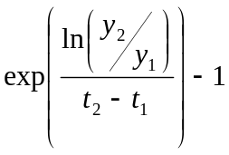.

Confidence intervals could not be estimated for the AAPCs because this statistic involves two sets of replicate weights from two different surveys, and it is not clear how such weights should be incorporated into variance estimates.

Ethnic analysis
A separate analysis of trends in the BMI distribution of the Mäori population is also presented. This could be done only for the three most recent surveys (ie, the second [1989–1997] and third [1997–2003] periods), and only for all adult age groups combined.

A similar analysis was done for non-Mäori, and for the total population with ethnic mix standardised (ie, the proportions of Mäori, Pacific and non-Mäori non-Pacific ethnic groups were held constant over all time points at their 2001 levels). Results for both analyses did not differ substantially from the total population analysis, implying that changes in ethnic mix do not contribute substantively to the observed shifts in the total population’s BMI distribution. Because of space limitations, only total population and Mäori ethnic group results are presented in this report.

Socioeconomic position analysis
Analysis of inequalities in mean BMI and in the prevalence of obesity by tertiles of household income are presented for 1989–2003, for all age and ethnic groups combined. Corresponding analysis by NZDep is then presented for 1997–2003.

Smoking and stature
Data on BMI distributions stratified by smoking status, and on trends in stature, are then briefly summarised.

Age standardisation
The crude ages-pooled analysis (total population and Mäori population) was repeated with the data age-standardised by the direct method to the WHO world population. This was done to separate the influence of changes in population age structure from other factors affecting BMI distribution. Age-standardised results were similar to the crude results, and are briefly presented in relevant sections of the report.

Life cycle stages
Life cycle stages are defined as follows:
- youth (15–24 years)
- young adults (25–44 years)
- middle-aged adults (45–64 years)
- older people (65+ years).

Results – Total Population

BMI distributions

Changes in BMI distribution, 1977–2003
We first describe the changes in the BMI distribution and the prevalence of overweight and obesity over the whole 1977–2003 period (Figures 11 and 12, Table 3). Gender-specific results are presented, but all age groups have been pooled to provide a population-level overview (ages 20–64 years for 1977 and 15–74 years for 2003).

Figure 11: Changes in BMI distribution, ages pooled, 1977–2003
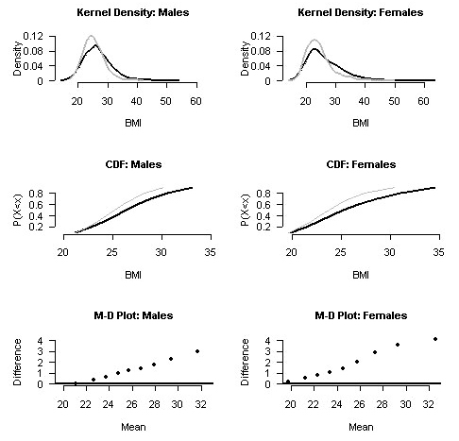

Key: 1977 distribution 2003 distribution

Figure 12: Prevalence of overweight and obesity, ages pooled, 1977–2003
Males | Females
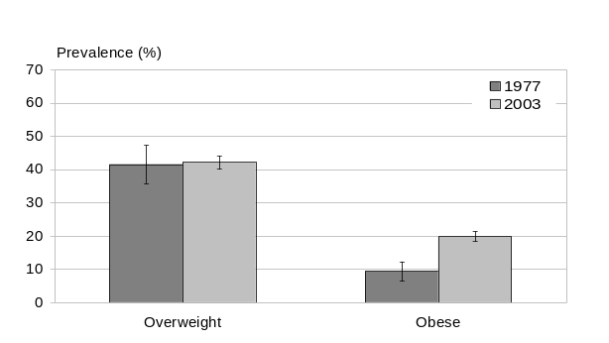 | 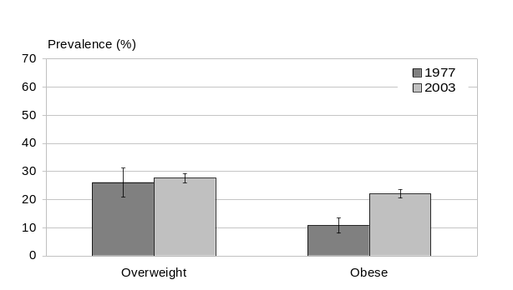

Table 3: Selected sample statistics, ages pooled, 1977–2003
 | Males |  |  | Females
 | 1977 | 2003 | AAPC (%)* | 1977 | 2003 | AAPC (%)*
Mean BMI | 25.5 | 26.9 | 0.20 | 24.5 | 26.4 | 0.28
Median BMI | 25.1 | 26.3 | 0.18 | 23.8 | 25.2 | 0.23
Overweight (%) | 41.5 | 42.1 | 0.05 | 26.1 | 27.7 | 0.23
Obese (%) | 9.4 | 19.9 | 2.93 | 10.8 | 22.1 | 2.79
* Average annual percentage change; assumes linearity.

These results confirm that an epidemic of obesity has occurred in New Zealand over the past quarter century. In fact, it is clear that the epidemic began even earlier than the 1970s, since by 1977 42 percent of adult males and 26 percent of adult females were already overweight, and 9 percent and 11 percent, respectively, were already obese (ie, 51 percent of males and 37 percent of females were already either overweight or obese).

The obesity epidemic has affected both genders equally. From 1977 to 2003 the prevalence of obesity increased from 11 to 22 percent among females, and from 9 to 20 percent among males (relative increases of 100 percent and 116 percent, respectively). This corresponds to an AAPC of around 3 percent for both genders, assuming log linearity (a constant rate of change over the 26-year period).

Changes in the prevalence of overweight over the study period have, by contrast, been minimal, with males showing only a 1.4 percent and females a somewhat larger 6.1 percent relative increase (corresponding to absolute increases of 0.6 and 1.6 percentage points, respectively). The prevalence of overweight among males has thus remained almost stable over the entire 26 years, at approximately 42 percent, while among females only a very slight increase has been seen – from approximately 26 to 28 percent.

This differential trend in the prevalence of obesity versus that of overweight indicates increasing skewness in the BMI distribution over time. A major proportion of the change has involved people who were already obese becoming even more obese, together with a proportion of people who were already overweight moving up into the obese category, and a similar proportion of people who were previously of normal weight becoming overweight. Overall, the prevalence of obesity has slightly more than doubled, and that of normal weight has declined by about one-fifth, while that of overweight has remained virtually unchanged. Furthermore the average BMI of the obese subpopulation increased from 33.5 units in 1977 to 34.1 units in 2003 for males, and from 34.5 to 35.2 units, respectively, for females. At the same time, the prevalence of extreme obesity increased from 0.3 to 2.2 percent among males and from 1.2 to 3.0 percent among females (see ‘Trends in Extreme Obesity’ section for more detail).

The increasing skewness of the BMI distribution can be seen also by examining the change in mean and median BMI over the study period. Mean BMI increased by 1.4 units among males (from 25.5 at the beginning to 26.9 at the end of the observation period) and by a somewhat larger 1.9 units (from 24.5 to 26.4) among females. This is an AAPC in mean BMI of 0.2 percent for males and 0.3 percent for females, assuming log linearity. The change in median BMI was slightly smaller (1.2 units among males and 1.4 units among females, an AAPC in mean BMI of 0.2 percent in both genders). This lesser change in median than mean BMI reflects increasing skewness in the BMI distribution.

So the typical adult male of average stature weighed 77.5 kg in 1977 but 86.2 kg in 2003, equivalent to an average daily weight gain of approximately 0.9 g/day over the 26 years. Similarly, the typical adult female of average stature weighed 65.0 kg in 1977 and 72.2 kg in 2003, which is equivalent to an average daily weight gain of 0.8 g/day over the same period. (More detail about trends in average stature over the study period is provided later – see ‘Trends in Stature’ section).

Examining the whole BMI distribution (Figure 11), the overall pattern (ie, across all ages and calendar years) is consistent with the mixed model, although the male pattern is close to a high-risk subgroup model. The kernel density plots show a fall in the peak density accompanied by thickening of the right-hand tail, indicating increasing skewness of the distribution with very little change in the lighter percentiles. This is borne out by the cumulative distributions for 1977 and 2003, which are superimposed at the lower end but diverge increasingly toward the upper end. Likewise, the m–d plots show data points near zero at lighter percentiles, but rising progressively away from zero at higher percentiles. These plots also show that the increase in skewness was greater for females, with BMI differences reaching over three units at the heaviest percentiles for females versus less than three units for males.

In summary, the overall pattern has been one of increasing skewness in the population BMI distribution (ie, a mixed or possibly a high-risk subgroup model), with the prevalence of obesity more than doubling (from 9 to 20 percent among males and from 11 to 22 percent among females); while the prevalence of overweight has remained essentially stable (42 percent for males and 26 percent for females), and mean (median) BMI has increased by 1.4 (1.2) units in males and 1.9 (1.4) units in females. That is, the prevalence of obesity has increased at an average rate of approximately 3 percent per year (both genders) while the prevalence of overweight has remained stable and mean (median) BMI has shifted at a rate of approximately 0.2 (0.3) percent per year.

It is also worth noting the different pattern of the epidemic in males compared to females: across the entire study period, males are more likely to be overweight while females are more likely to be obese. With the prevalence of overweight remaining stable in both genders yet that of obesity doubling, the ratio of overweight to obese individuals has declined sharply over the study period, from 4.4 to 2.1 among males and from 2.4 to 1.2 among females. That is, there are now only two overweight males for every obese male, while the number of obese females already almost equals the number of overweight females. Again, this falling ratio is an inevitable consequence of the increasing skewness in the BMI distribution.

The overall pattern from 1977 to 2003 disguises significant variation between age groups and periods, variations which are explored in detail in the next three sections of this report.

Changes in BMI distribution, 1977–1989
We now look at changes in the distribution of BMI from 1977 to 1989 (first period), by age group and gender (Figures 13–16, Tables 4 and 5). Because of age restrictions in the 1977 National Diet Survey, our analysis is limited to ages 25–64 years.

Figure 13: Kernel densities of BMI, 1977–1989
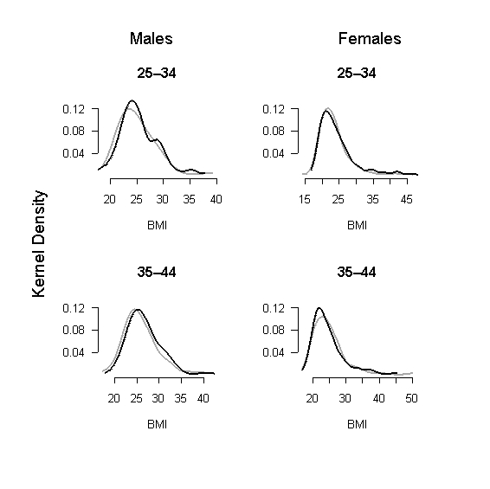
Key: 1977 distribution 1989 distribution

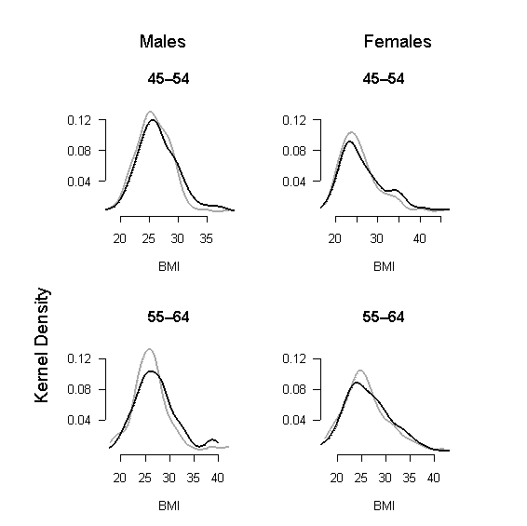
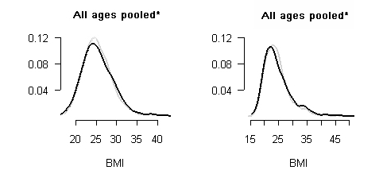

Key: 1977 distribution 1989 distribution

* 20–64 years for 1977 and 15–74 years for 1989.

Figure 14: Cumulative distribution functions, 1977–1989
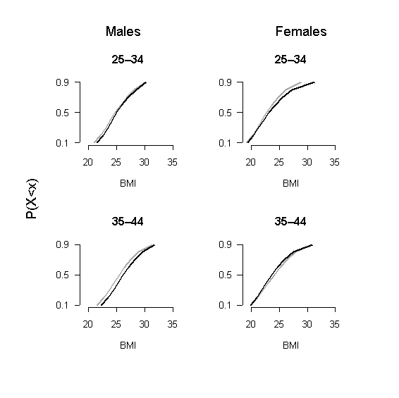
Key: 1977 distribution 1989 distribution

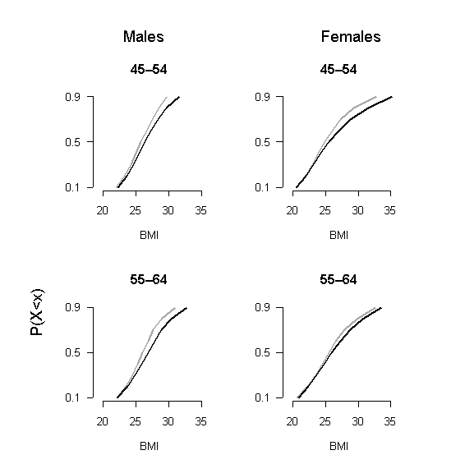

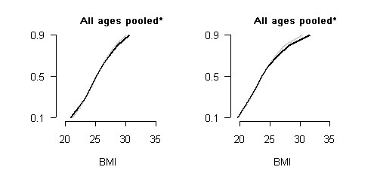
Key: 1977 distribution 1989 distribution

* 20–64 years for 1977 and 15–74 years for 1989.

Figure 15: Tukey mean–difference plots, 1977–1989
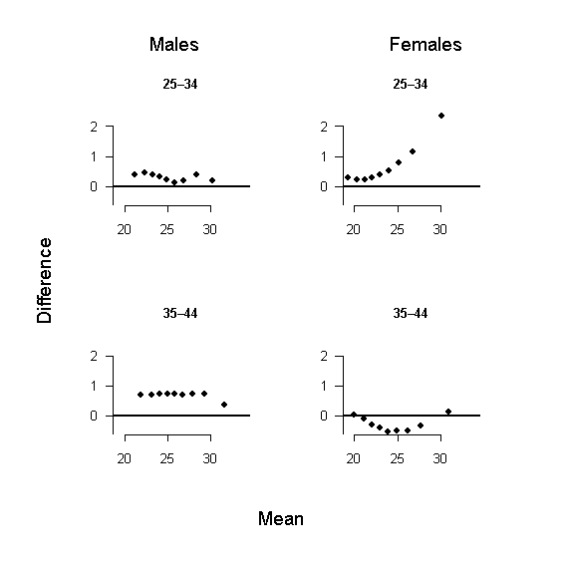

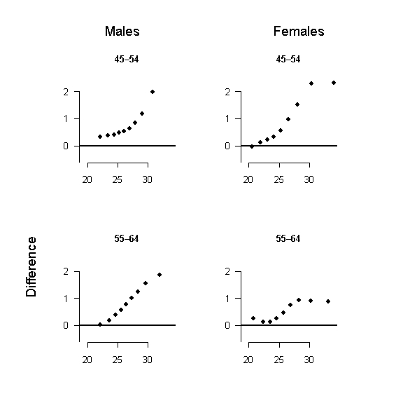
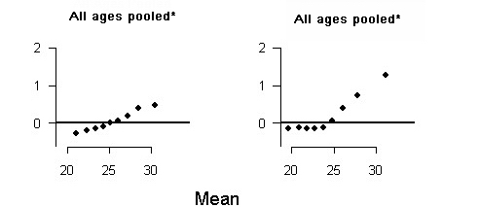

* 20–64 years for 1977 and 15–74 years for 1989.

Figure 16: Prevalence of overweight and obesity, 1977–1989
Males | Females
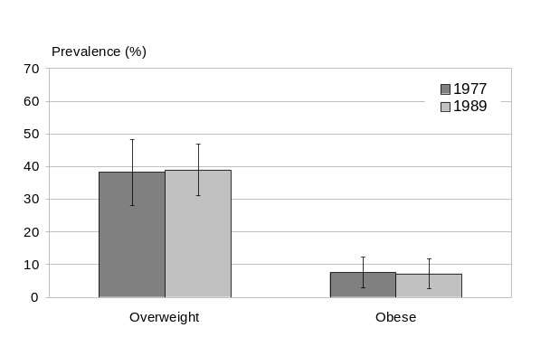 | 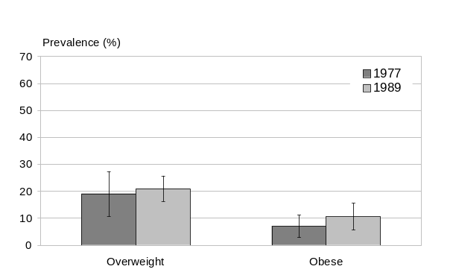
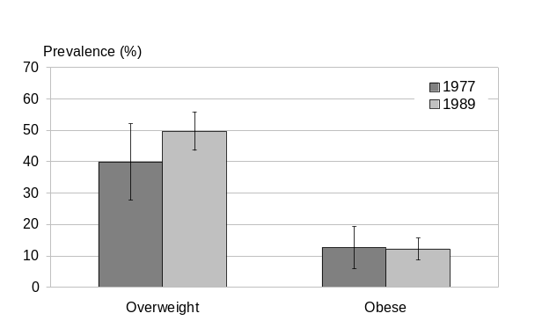 | 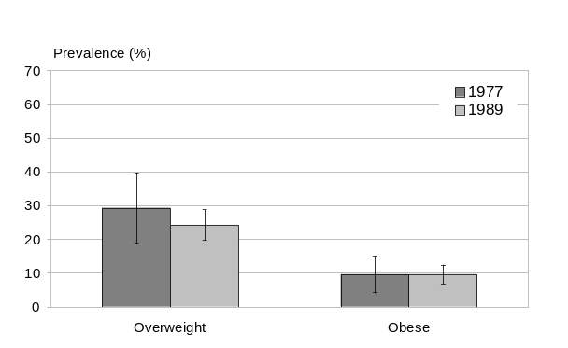
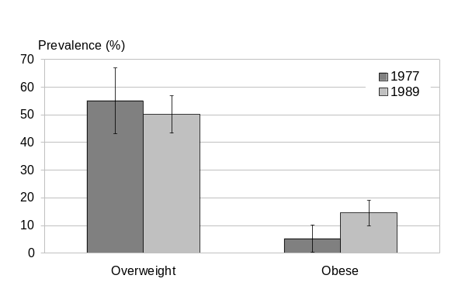 | 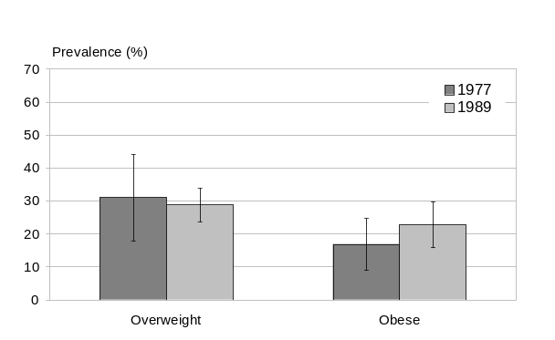
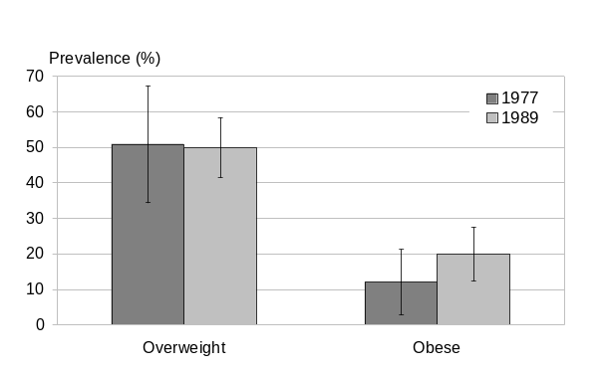 | 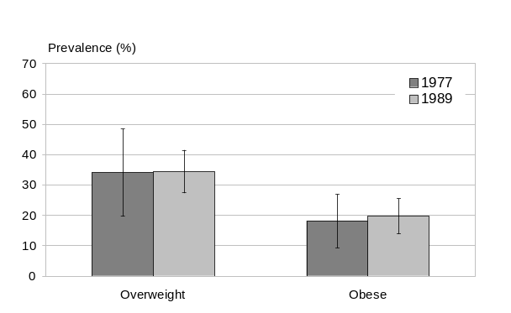
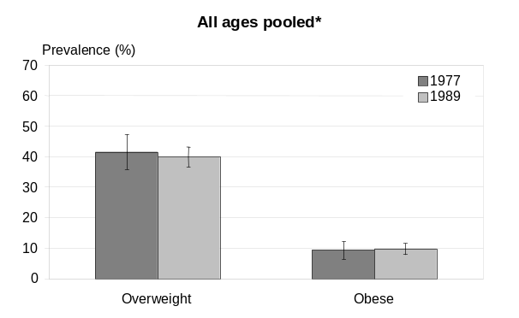 | 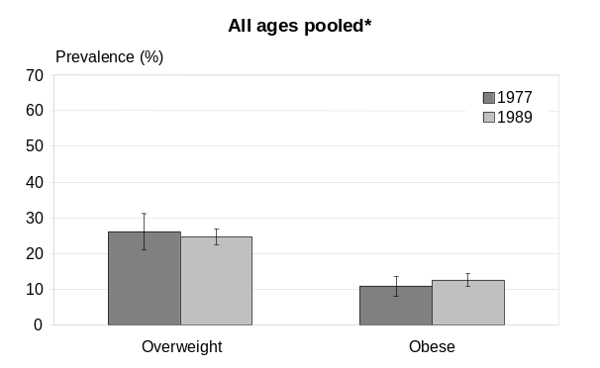
* 20–64 years for 1977 and 15–74 years for 1989.

Table 4: Selected sample statistics, by 10-year age group (males), 1977–1989
Statistic | Year | 25–34 | 35–44 | 45–54 | 55–64 | All ages**
Mean BMI | 1977 | 25.1 | 26.0 | 25.8 | 26.3 | 25.5
Mean BMI | 1989 | 25.4 | 26.6 | 26.8 | 27.2 | 25.6
Mean BMI | AAPC* | 0.12 | 0.20 | 0.31 | 0.30 | 0.02
Median BMI | 1977 | 24.6 | 25.3 | 25.6 | 25.9 | 25.1
Median BMI | 1989 | 24.8 | 26.1 | 26.2 | 27.0 | 25.1
Median BMI | AAPC* | 0.05 | 0.28 | 0.20 | 0.34 | 0.00
Overweight (%) | 1977 | 38.2 | 39.9 | 55.1 | 50.9 | 41.5
Overweight (%) | 1989 | 39.0 | 49.7 | 50.1 | 49.9 | 40.0
Overweight (%) | AAPC* | 0.16 | 1.85 | -0.78 | -0.15 | -0.32
Obese (%) | 1977 | 7.6 | 12.6 | 5.2 | 12.0 | 9.4
Obese (%) | 1989 | 7.2 | 12.2 | 14.5 | 20.0 | 9.8
Obese (%) | AAPC* | -0.41 | -0.28 | 8.85 | 4.30 | 0.33
* Average annual percentage change; assumes linearity.
** For the all ages pooled analysis, 1977 statistics include ages 20–64 years and 1989 statistics include ages 15–74 years.

Table 5: Selected sample statistics, by 10-year age group (females), 1977–1989
Statistic | Year | 25–34 | 35–44 | 45–54 | 55–64 | All ages**
Mean BMI | 1977 | 23.6 | 24.8 | 25.7 | 25.8 | 24.5
Mean BMI | 1989 | 24.3 | 24.6 | 26.8 | 26.6 | 24.8
Mean BMI | AAPC* | 0.27 | -0.06 | 0.33 | 0.24 | 0.08
Median BMI | 1977 | 22.7 | 24.0 | 24.7 | 25.2 | 23.8
Median BMI | 1989 | 22.9 | 23.5 | 25.3 | 25.7 | 23.6
Median BMI | AAPC* | 0.09 | -0.19 | 0.23 | 0.17 | -0.08
Overweight (%) | 1977 | 19.1 | 29.3 | 31.1 | 34.1 | 26.1
Overweight (%) | 1989 | 21.0 | 24.3 | 28.8 | 34.5 | 24.6
Overweight (%) | AAPC* | 0.81 | -1.57 | -0.62 | 0.09 | -0.49
Obese (%) | 1977 | 7.1 | 9.6 | 16.9 | 18.2 | 10.8
Obese (%) | 1989 | 10.7 | 9.7 | 22.8 | 19.7 | 12.5
Obese (%) | AAPC* | 3.47 | 0.03 | 2.57 | 0.69 | 1.24
* Average annual percentage change; assumes linearity.
** For the all ages pooled analysis, 1977 statistics include ages 20–64 years and 1989 statistics include ages 15–74 years.

Overall, the epidemic grew relatively slowly from 1977 to 1989. The pattern was different for males and females, and also varied across age groups.

Across all adult ages (25–64 years), the prevalence of obesity among males remained almost static, increasing from 9.4 percent in 1977 to 9.8 percent in 1989, an AAPC of 0.3 percent, assuming log linearity. However, this was because increases in obesity prevalence among middle-aged males were largely offset by slight decreases among young adult males. Females showed an increase in obesity prevalence across all age groups except the 35–44 years age group (which remained stable), with the pooled increase across all ages being from 10.8 to 12.5 percent, an AAPC of 1.2 percent, assuming log linearity.

Both males and females showed very little change in overweight prevalence at any age (except for males age 35–44 years who showed an increase, and females aged 45–54 years who showed a decrease).

Mean BMI for males increased by approximately 0.5 BMI units among young adults and by approximately 1 BMI unit among middle-aged adults. The pattern was similar (though smaller in absolute differences) for median BMI. Females showed a more consistent pattern of increasing mean and (to a lesser extent) median BMI across all age groups, except for the 35–44 years age group, which showed little change.

Examining the full BMI distributions (eg, using the m–d plots), young adult males showed very little change at all (except for the 35–44 years age group who showed a uniform increase). Middle-aged males showed a typical mixed pattern, with increasing skewness at the higher percentiles (reaching up to 1.5 BMI units) but little change at the lower percentiles. Except for the 35–44 years age group, females also showed increasing skewness at higher percentiles (ie, a mixed pattern) at all ages, reaching up to 2 BMI units (approximately) in the 45–54 years age group. The ‘anomalous’ behaviour of 35–44-year-old females, and to a lesser extent males, has no obvious explanation but may reflect chance, selection bias or possibly a cohort effect.

In summary, from 1977 to 1989 females of all ages within the 25–64 years age range, except for the 35–44 years age group, demonstrated rightward BMI shifts with increasing skewness, leading to small but significant increases in mean and median BMI, with no change in the prevalence of overweight and modest increases in the prevalence of obesity. By contrast, the epidemic had not yet spread to include young adult males, although middle-aged males were already affected – indeed, almost as severely as middle-aged females.

The epidemic, while it probably commenced well before the 1970s, was still slow growing even in the 1980s, and was still predominantly an epidemic of the middle-aged. Females showed a greater skewness in their BMI distribution – affecting a broader age range – than males, suggesting that the epidemic was already more advanced among females, and may have begun first in middle-aged females before spreading to older and younger (female) age groups and to middle-aged males.

Changes in BMI distribution, 1989–1997
Changes in the distribution of BMI from 1989 to 1997 (second period) are examined in the following section (Figures 17–20, Tables 6 and 7). Ages 15–74 years are included (75+ were not included because there were insufficient numbers of survey participants in this age group).

Figure 17: Kernel densities of BMI, 1989–1997
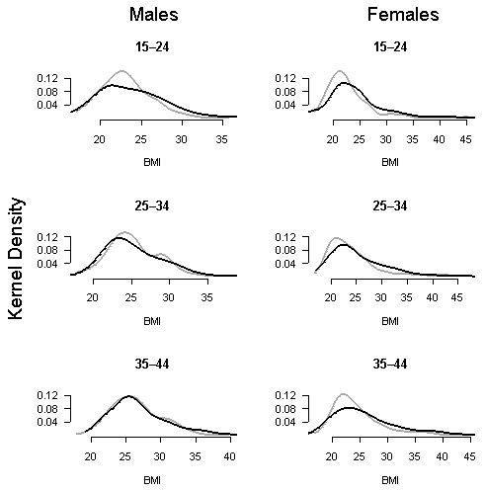

Key: 1989 distribution 1977 distribution

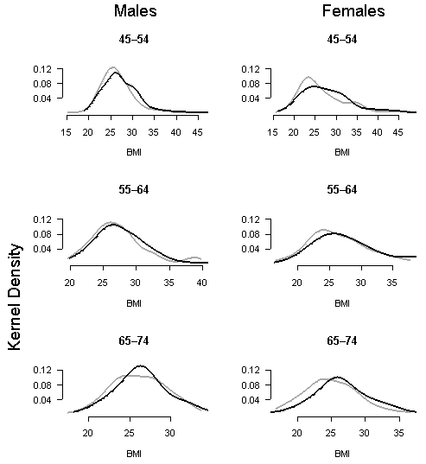

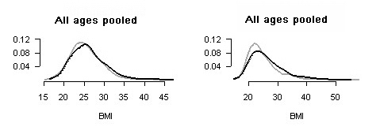

Key: 1989 distribution 1997 distribution

Figure 18: Cumulative distribution functions, 1989–1997
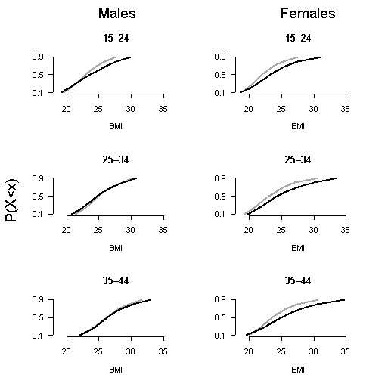
Key: 1989 distribution 1997 distribution

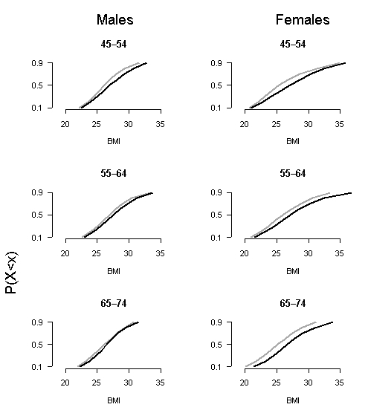

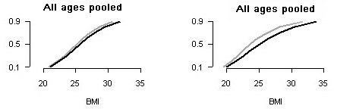

Key: 1989 distribution 1997 distribution

Figure 19: Tukey mean difference plots, 1989–1997
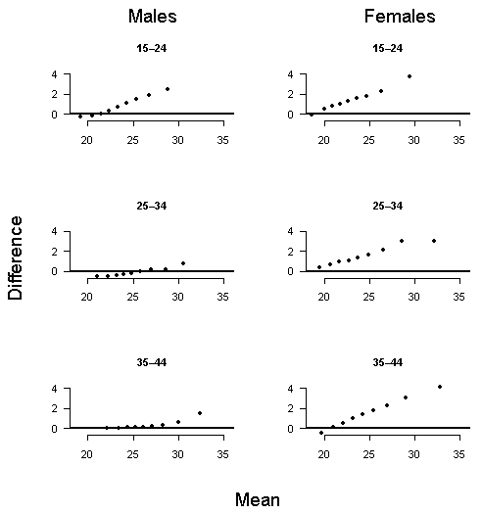

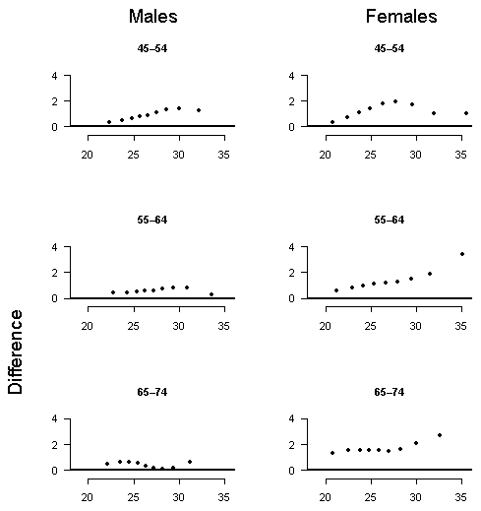
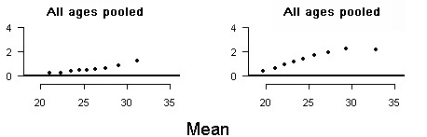

Figure 20: Prevalence of overweight and obesity, 1989–1997
Males | Females
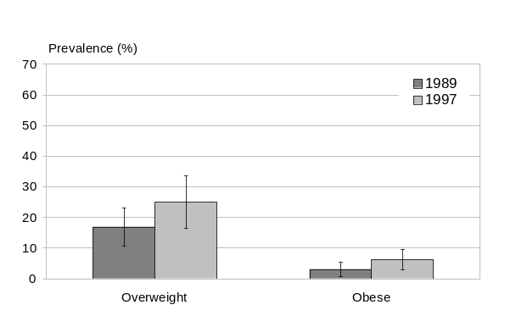 | 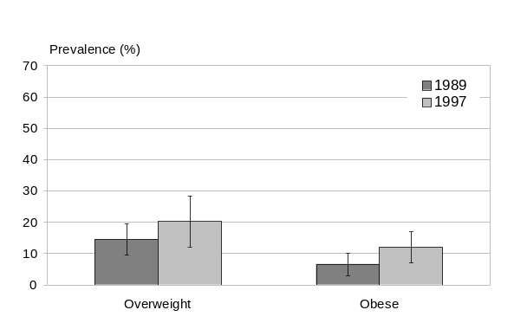
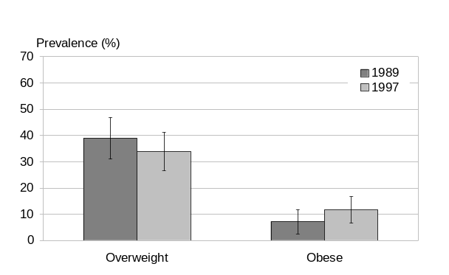 | 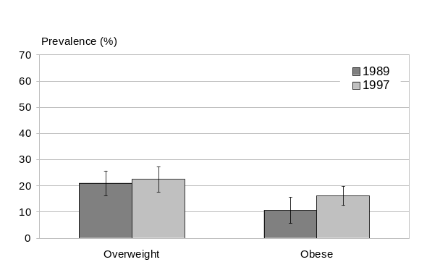
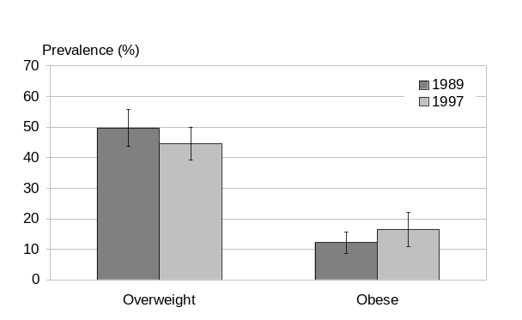 | 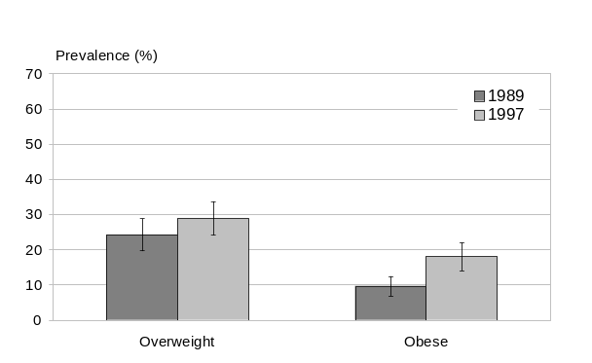
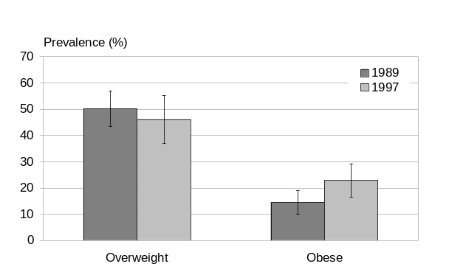 | 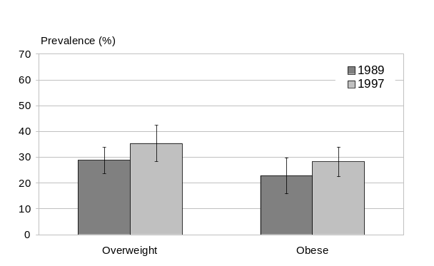
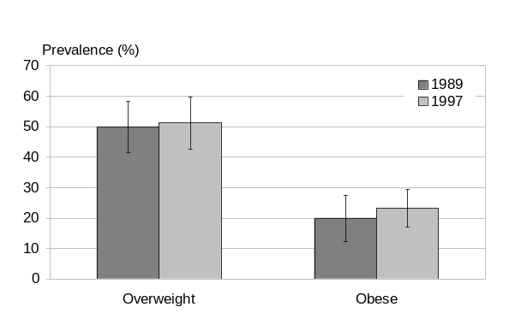 | 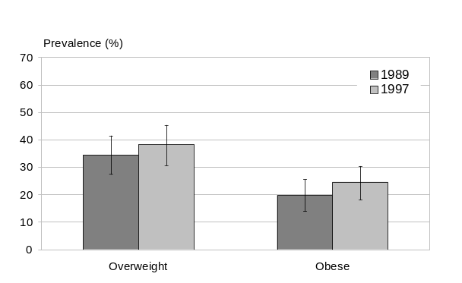
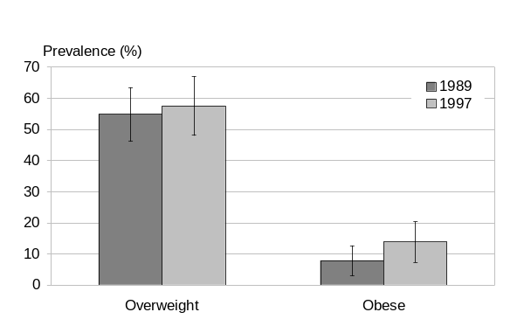 | 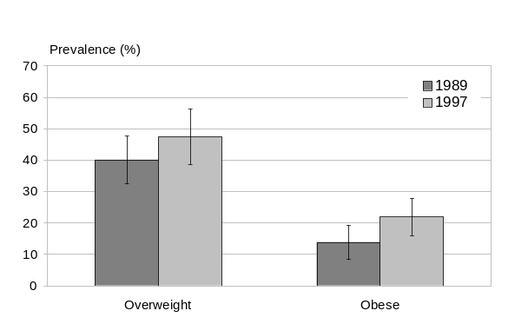
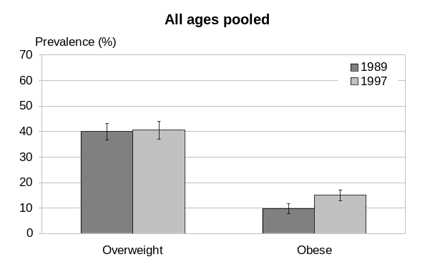 | 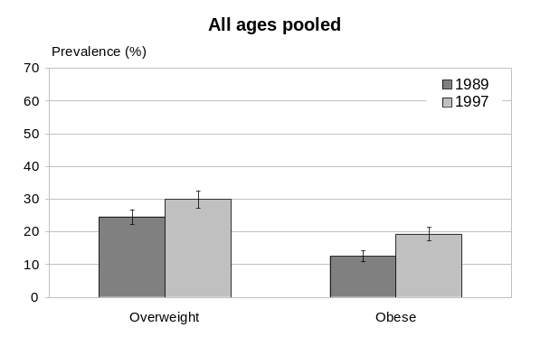

Table 6: Selected sample statistics, by 10-year age group (males), 1989–1997
Statistic | Year | 15–24 | 25–34 | 35–44 | 45–54 | 55–64 | 65–74 | All ages*
Mean BMI | 1989 | 23.0 | 25.4 | 26.6 | 26.8 | 27.2 | 26.4 | 25.6
Mean BMI | 1997 | 24.2 | 25.5 | 26.9 | 27.5 | 27.8 | 26.6 | 26.2
Mean BMI | AAPC* | 0.63 | 0.02 | 0.12 | 0.31 | 0.27 | 0.09 | 0.31
Median BMI | 1989 | 22.6 | 24.8 | 26.1 | 26.2 | 27.0 | 26.2 | 25.1
Median BMI | 1997 | 23.4 | 24.9 | 26.0 | 26.5 | 27.0 | 26.3 | 25.7
Median BMI | AAPC* | 0.44 | 0.04 | -0.04 | 0.14 | 0.03 | 0.08 | 0.28
Overweight (%) | 1989 | 16.9 | 39.0 | 49.7 | 50.1 | 49.9 | 54.9 | 40.0
Overweight (%) | 1997 | 25.0 | 33.9 | 44.6 | 46.1 | 51.3 | 57.6 | 40.5
Overweight (%) | AAPC* | 5.05 | -1.72 | -1.35 | -1.04 | 0.32 | 0.61 | 0.17
Obese (%) | 1989 | 3.0 | 7.2 | 12.2 | 14.5 | 20.0 | 7.9 | 9.8
Obese (%) | 1997 | 6.3 | 11.7 | 16.5 | 22.9 | 23.3 | 13.9 | 15.0
Obese (%) | AAPC* | 9.56 | 6.27 | 3.85 | 5.86 | 1.96 | 7.34 | 5.52
* Average annual percentage change; assumes linearity.

Table 7: Selected sample statistics, by 10-year age group (females), 1989–1997
Statistic | Year | 15–24 | 25–34 | 35–44 | 45–54 | 55–64 | 65–74 | All ages*
Mean BMI | 1989 | 23.0 | 24.3 | 24.6 | 26.8 | 26.6 | 25.6 | 24.8
Mean BMI | 1997 | 24.1 | 25.3 | 26.1 | 27.9 | 27.8 | 27.2 | 26.2
Mean BMI | AAPC* | 0.62 | 0.48 | 0.72 | 0.55 | 0.59 | 0.76 | 0.68
Median BMI | 1989 | 21.9 | 22.9 | 23.5 | 25.3 | 25.7 | 25.5 | 23.6
Median BMI | 1997 | 22.8 | 23.8 | 24.9 | 27.1 | 26.7 | 26.3 | 25.0
Median BMI | AAPC* | 0.46 | 0.47 | 0.71 | 0.86 | 0.49 | 0.4 | 0.75
Overweight (%) | 1989 | 14.5 | 21.0 | 24.3 | 28.8 | 34.5 | 40.0 | 24.6
Overweight (%) | 1997 | 20.2 | 22.4 | 29.0 | 35.4 | 38.3 | 47.5 | 29.9
Overweight (%) | AAPC* | 4.22 | 0.83 | 2.24 | 2.61 | 1.33 | 2.16 | 2.47
Obese (%) | 1989 | 6.6 | 10.7 | 9.7 | 22.8 | 19.7 | 13.8 | 12.5
Obese (%) | 1997 | 12.0 | 16.2 | 18.1 | 28.2 | 24.6 | 22.0 | 19.4
Obese (%) | AAPC* | 7.82 | 5.32 | 8.13 | 2.68 | 2.78 | 5.95 | 5.58
* Average annual percentage change; assumes linearity.

The epidemic accelerated sharply during the second period (1989–1997). For both genders, the prevalence of obesity increased sharply and fairly consistently across all ages. Pooling ages, the prevalence of obesity increased from 9.8 percent in 1989 to 15.0 percent in 1997 among males (an AAPC of 5.5 percent), and from 12.5 to 19.4 percent among females (an AAPC of 5.6 percent). However, unlike males (who showed stable overweight prevalence at 40 percent), females also showed significant increases in the prevalence of overweight (from 24.6 to 29.9 percent, an AAPC of 2.5 percent).

Among males, significant increases in mean BMI were only seen among youth and the middle-aged (half a BMI unit or more), but among females such increases occurred at all ages (typically 1 BMI unit or more). The same pattern was seen in median BMI for females, but changes in median BMI were similar for males at all ages, except youth.

Examination of the full BMI distributions extends these findings. Shifts in the distributions were minor for young adult males (although male youth showed a marked increase in skewness at heavier percentiles). Shifts were greater for middle-aged males, especially the 45–54 age group, although interestingly the pattern in this age–gender group is more one of a uniform upward shift (averaging about 1 BMI unit) of the whole subpopulation (a universal model) than one of increasing skewness. Older males showed little evidence of shift in their BMI distribution at all.

By contrast, females show the typical pattern of increasing skewness at heavier percentiles with little change at lighter percentiles, in all young adult and middle-aged groups. The pattern in
45–54-year-olds is anomalous, suggesting that the similar pattern seen in 35–44-year-olds in the first period (1977–1989) may indeed reflect a cohort effect. Older females, unlike older males, do show some distributional shifting, but this is uniform across all percentiles (ie, more a universal than a high-risk subgroup or mixed pattern in this older age group).

In summary, the shift in population BMI distribution from 1989 to 1997 was considerable. Almost all age groups of both genders were affected, older males being the major exception. The pattern of shifting was predominantly one of increasing skewness (ie, a mixed if not a high-risk subgroup model). The result was a steep increase in the prevalence of obesity (at an average growth rate of over 5 percent per year), with little change in the prevalence of overweight, especially among males. Mean and (to a lesser extent) median BMI increased significantly, but relatively slowly compared with the 90th percentile of the BMI distribution, which increased dramatically as obese people became even heavier on average, leading to a rapid increase in the prevalence of extreme obesity (see later for a detailed account of the evolution of extreme obesity).

Changes in BMI distribution, 1997–2003
Changes in the distribution of BMI from 1997 to 2003 (third period) are examined in the following section for ages 15–74 years (Figures 21–24, Tables 8 and 9).

Figure 21: Kernel densities of BMI, 1997–2003
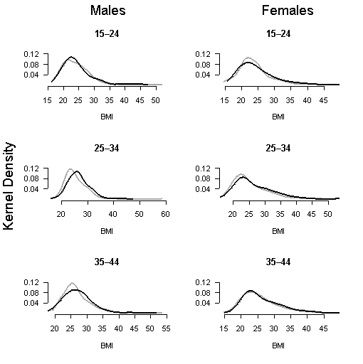
Key: 1997 distribution 2003 distribution

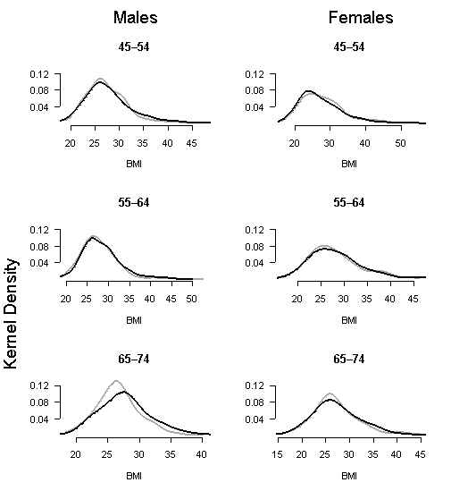
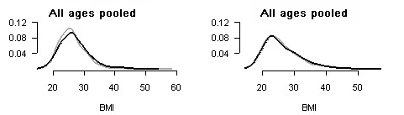

Key: 1997 distribution 2003 distribution

Figure 22: Cumulative distribution functions, 1997–2003
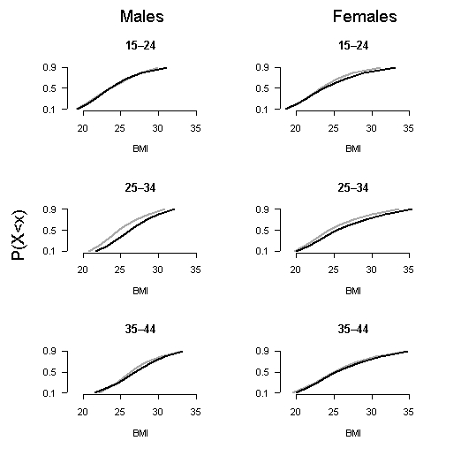

Key: 1997 distribution 2003 distribution

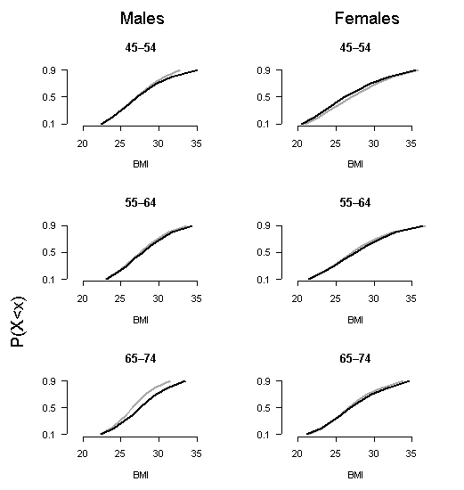

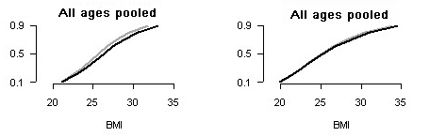

Key: 1997 distribution 2003 distribution

Figure 23: Tukey mean difference plots 1997–2003
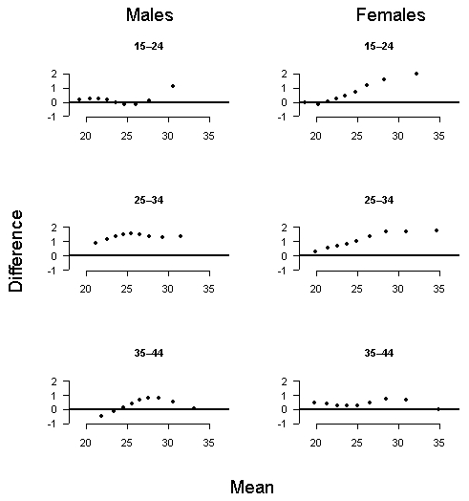

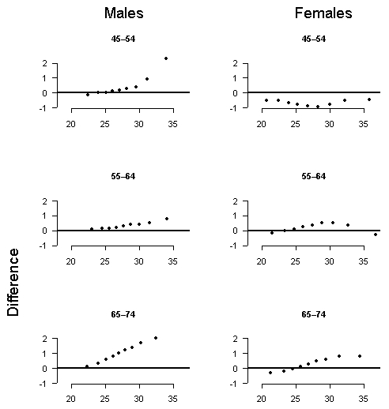

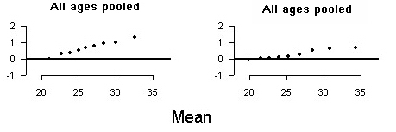

Figure 24: Prevalence of overweight and obesity, 1997–2003
Males | Females
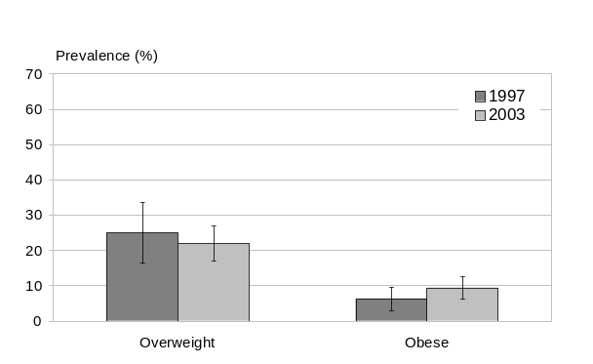 | 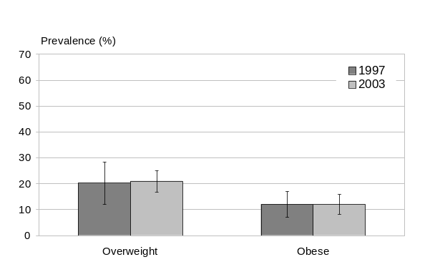
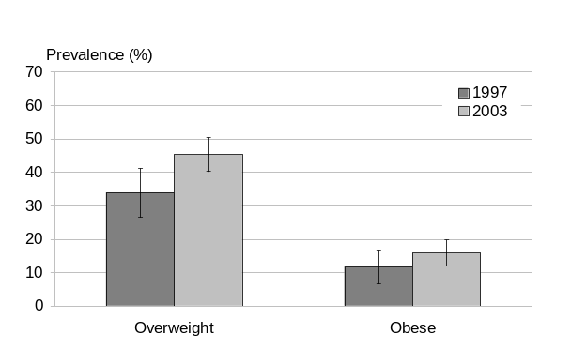 | 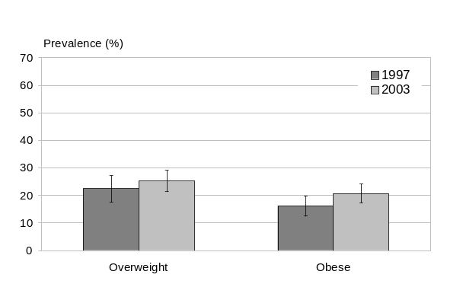
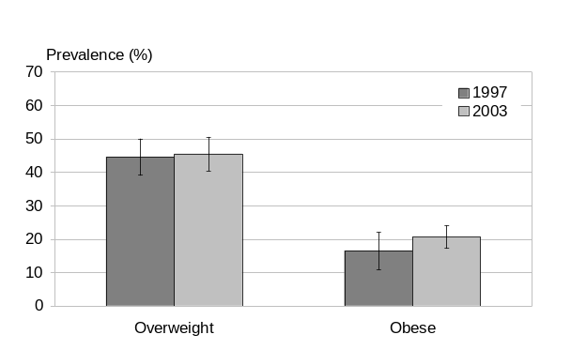 | 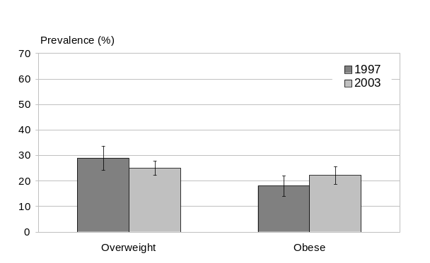
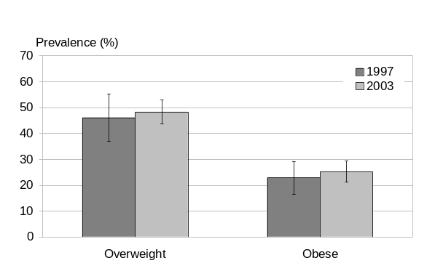 | 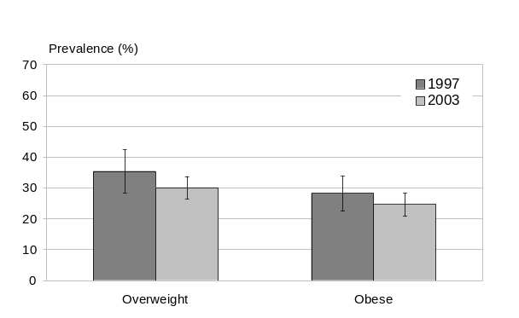
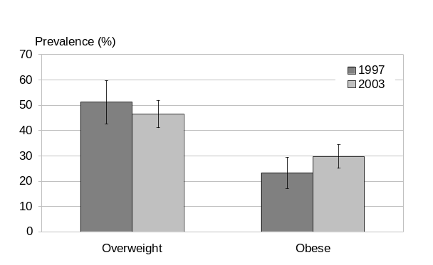 | 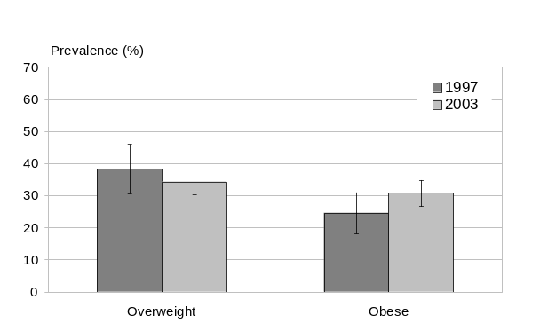
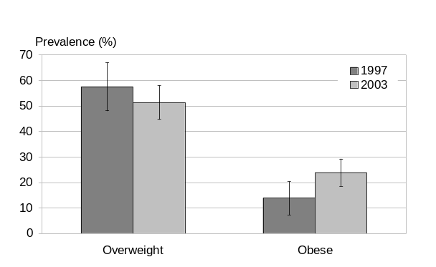 | 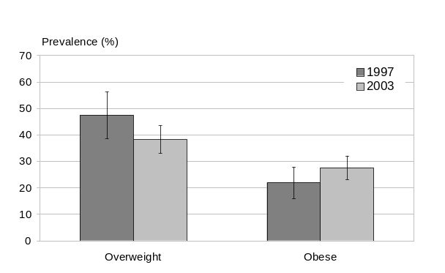
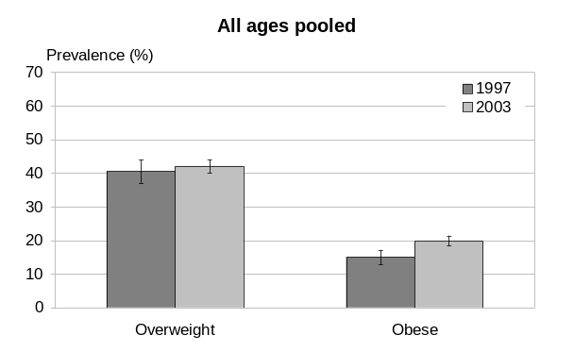 | 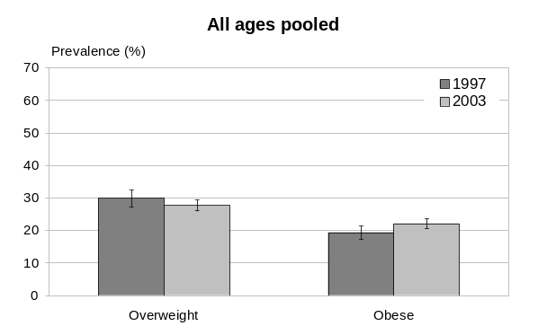

Table 8: Selected sample statistics, by 10-year age group (males), 1997–2003
Statistic | Year | 15–24 | 25–34 | 35–44 | 45–54 | 55–64 | 65–74 | All ages*
Mean BMI | 1997 | 24.2 | 25.5 | 26.9 | 27.5 | 27.8 | 26.6 | 26.2
Mean BMI | 2003 | 24.4 | 26.6 | 27.2 | 28.1 | 28.3 | 27.7 | 26.9
Mean BMI | AAPC* | 0.19 | 0.74 | 0.22 | 0.37 | 0.31 | 0.66 | 0.41
Median BMI | 1997 | 23.4 | 24.9 | 26.0 | 26.5 | 27.0 | 26.3 | 25.7
Median BMI | 2003 | 23.2 | 26.3 | 26.6 | 27.1 | 27.8 | 27.5 | 26.3
Median BMI | AAPC* | -0.15 | 0.92 | 0.35 | 0.38 | 0.47 | 0.72 | 0.42
Overweight (%) | 1997 | 25.0 | 33.9 | 44.6 | 46.1 | 51.3 | 57.6 | 40.5
Overweight (%) | 2003 | 21.6 | 45.3 | 45.2 | 48.3 | 46.5 | 51.6 | 42.1
Overweight (%) | AAPC* | -2.46 | 4.94 | 0.24 | 0.78 | -1.60 | -1.80 | 0.65
Obese (%) | 1997 | 6.3 | 11.7 | 16.5 | 22.9 | 23.3 | 13.9 | 15.0
Obese (%) | 2003 | 10.6 | 16.1 | 20.7 | 25.4 | 29.7 | 23.9 | 19.9
Obese (%) | AAPC* | 9.06 | 5.50 | 3.82 | 1.75 | 4.13 | 9.54 | 4.80
* Average annual percentage change; assumes linearity.

Table 9: Selected sample statistics, by 10-year age group (females), 1997–2003
Statistic | Year | 15–24 | 25–34 | 35–44 | 45–54 | 55–64 | 65–74 | All ages*
Mean BMI | 1997 | 24.1 | 25.3 | 26.1 | 27.9 | 27.8 | 27.2 | 26.2
Mean BMI | 2003 | 24.3 | 26.2 | 26.6 | 27.3 | 28.1 | 27.6 | 26.4
Mean BMI | AAPC* | 0.14 | 0.60 | 0.36 | -0.41 | 0.18 | 0.26 | 0.16
Median BMI | 1997 | 22.8 | 23.8 | 24.9 | 27.1 | 26.7 | 26.3 | 25.0
Median BMI | 2003 | 23.0 | 24.5 | 24.9 | 25.9 | 27.1 | 26.9 | 25.2
Median BMI | AAPC* | 0.17 | 0.48 | 0.03 | -0.77 | 0.23 | 0.40 | 0.16
Overweight (%) | 1997 | 20.2 | 22.4 | 29.0 | 35.4 | 38.3 | 47.5 | 29.9
Overweight (%) | 2003 | 20.9 | 25.3 | 25.4 | 29.4 | 33.7 | 38.3 | 27.7
Overweight (%) | AAPC* | 0.56 | 2.02 | -2.19 | -3.05 | -2.10 | -3.50 | -1.27
Obese (%) | 1997 | 12.0 | 16.2 | 18.1 | 28.2 | 24.6 | 22.0 | 19.4
Obese (%) | 2003 | 12.4 | 21.6 | 23.2 | 26.5 | 30.9 | 28.0 | 22.1
Obese (%) | AAPC* | 0.42 | 4.99 | 4.21 | -1.05 | 3.88 | 4.14 | 2.25
* Average annual percentage change; assumes linearity.

While both mean (and median) BMI and the prevalence of obesity continued to increase, the rapid rate of acceleration of the epidemic seen in the second period (1989–1997) appeared to slow in the third period (1997–2003), at least among females. Among males, the average annual percentage increase in obesity prevalence decreased marginally (if at all) from 5.5 to 4.8 percent, while among females the epidemic growth rate decreased more substantially, from 5.6 to 2.3 percent. Thus the prevalence of obesity continued to increase – from 15 to 20 percent among males and from 19 to 22 percent among females – but this was less than expected based on previous trends (ie, 1989–1997). Had the AAPC remained stable at its second-period level, the prevalence of obesity in 2003 would have been 21 percent among males (rather than the 20 percent observed) and 27 percent among females (rather than the 22 percent observed).

Still, the absolute increase in obesity prevalence over the period remains substantial. Among males, increases were most marked at both ends of the age spectrum (ie, the 15–24 and – for the first time – the 65–74 years age group), while among females all age groups showed a fairly uniform increase except for the 45–54 years age group.

For both genders, little change was seen in the prevalence of overweight. Overall, this increased slightly among males (from 40.5 to 42.1 percent), and declined slightly among females (from 29.9 to 27.7 percent). The prevalence of overweight decreased in all age groups except the two youngest age groups among females, and in the 15–24, 55–64 and 65–74 years age groups among males.

Examining the full BMI distributions (eg, using m–d plots), the most noticeable finding is how little change has occurred in all percentiles for most age groups. Among males, most age groups show small but typical patterns of increased skewness at heavier percentiles, but generally less than 2 BMI units even at the 90th percentile, (except for the 45–54 and 65–74 years age groups). Very little change is seen in the 55–64 years age group, and the 35–44 years age group shows an anomalous pattern with a small change in the middle percentiles and little change at either end of the distribution.

Among females the pattern is generally similar, with little change in the 15–24 years age group, a uniform shift in the 25–34 years age group, a somewhat anomalous pattern in the 35–44 years age group (similar to the males), and little change at any percentile in the 55–64 and 65–74 years age groups. The (female) 45–54 years age group is the first and only to show an actual decrease in the prevalence of obesity (from 28 percent in 1997 to 26.5 percent in 2003). No such decline is seen in any other age group, or among males.

In summary, the epidemic continued to grow in this most recent period (1997–2003), with mean BMI increasing 0.7 units among males and 0.25 units among females, although more slowly than it did from 1989 to 1997, at least among females (in most if not all age groups).

This pattern of change in the epidemic growth rate, affecting many age groups simultaneously (as opposed to a single birth cohort), is highly suggestive of a ‘period effect’. Possible explanations for this welcome if unexpected period effect will be discussed later.

Overview of BMI distributional shifting, 1977–2003
We now briefly review the evolution of the epidemic over the whole study period again, this time emphasising variations in its time course between periods (1977–1989, 1989–1997, 1997–2003), age groups and genders. Age-specific analyses were restricted to adults (25–64 years) as data are missing for youth (15–19 years) in the first period, and relatively little shift has occurred in the BMI distribution among older people (65+ years).

Trends in overweight and obesity
The changes in overweight prevalence have been small in both genders overall, although more variable across individual age groups (Figure 25). For females, the increase in overweight prevalence has been slightly higher than for their male counterparts. Yet more recently
(1997–2003), overweight prevalence has fallen slightly again in all female age groups except the youngest.

However, the prevalence of obesity has increased steadily, particularly among the middle-aged and during the 1989–1997 period. The increase in obesity prevalence has been similar in both genders in relative terms (slightly more than doubling over the study period). The rate of increase in obesity prevalence appears to have declined in the most recent period (1997–2003) among females, but has decreased only slightly (if at all) among males.

This pattern of increasing obesity but stable overweight prevalence overall suggests that it is individuals at the heavier end of the BMI distribution who are experiencing the greatest change in weight. In other words, the most substantive increases in BMI are occurring among the heaviest individuals in the population: more people are becoming obese, and those already obese are becoming even more obese (on average). As a result, the proportion of normal weight adults has declined by about one-fifth, while that of overweight adults has remained stable, and that of obese adults has more than doubled.

Figure 25: Prevalence of overweight and obesity, 1977–2003
Males | Females
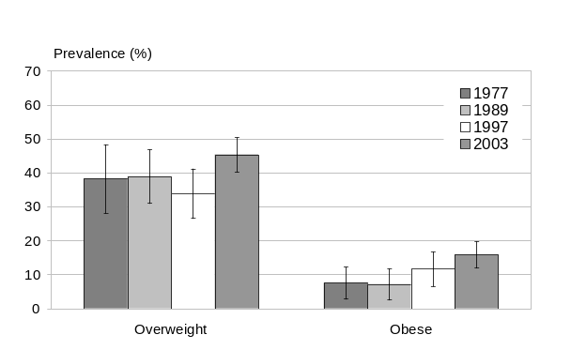 | 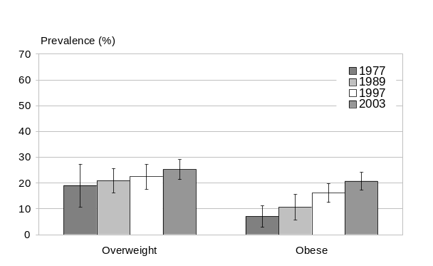
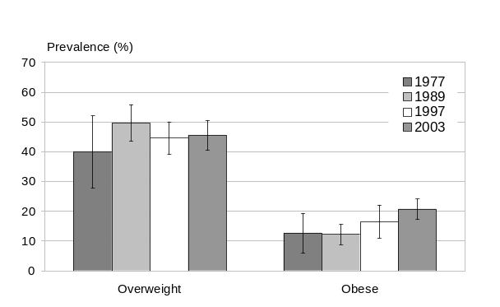 | 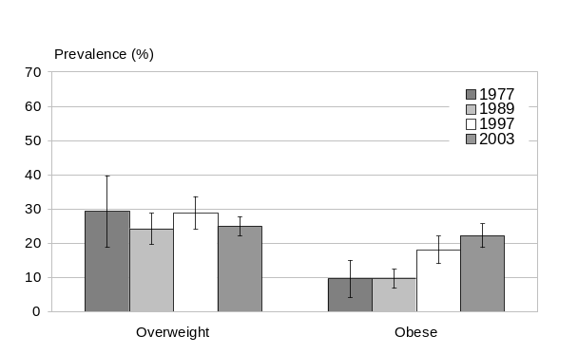
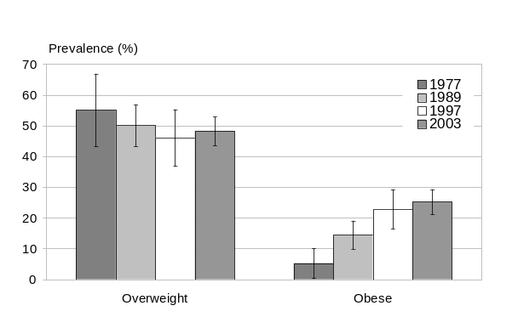 | 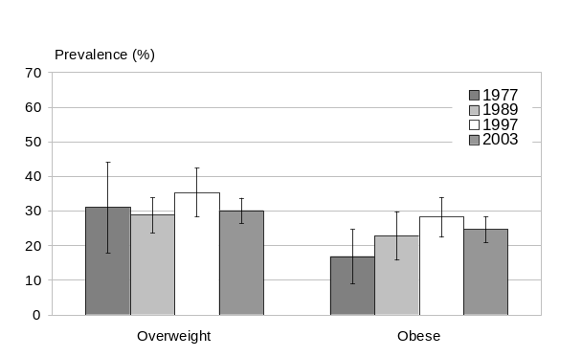
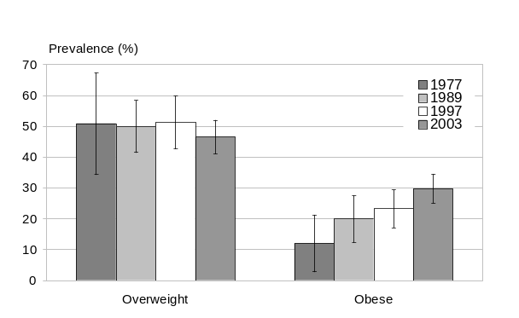 | 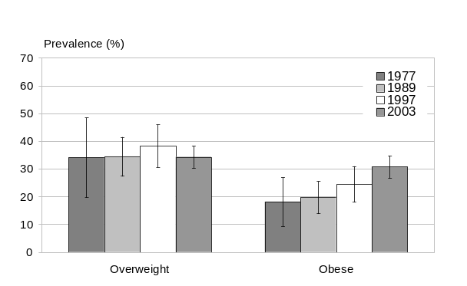
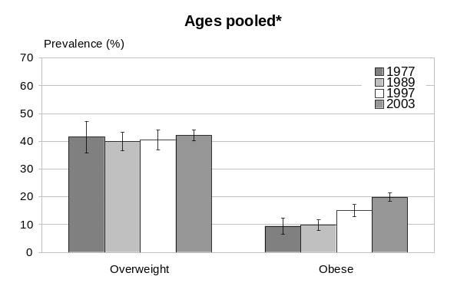 | 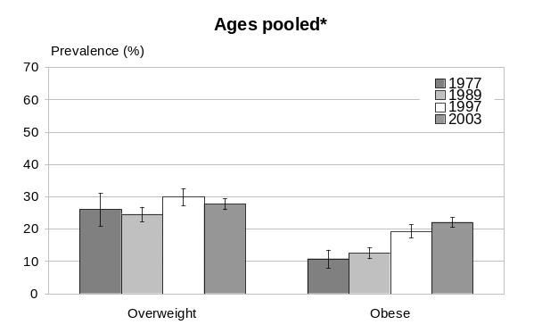
* 20–64 years for 1977, 15–74 years for 1989–2003.

Trends in BMI distributions
The increases in mean and median BMI have been much less dramatic than the increases in the 90th percentile across all age groups and both genders. The increases in mean and median BMI have been higher in middle-aged individuals than in other age groups, yet even this increase is relatively small compared to the trends in the 90th percentile in this age group (Figure 26). This is further evidence in support of the ‘mixed’ model (increasing skewness of the BMI distribution, implying a person–environment interaction), where the most significant changes involve the heaviest percentiles.

From the m–d plots it can be seen that the greatest increases in the 90th percentile occurred from 1989 to 1997, with smaller increases (most age groups) thereafter – again indicating the acceleration of the epidemic in the second period, followed by a relative deceleration more recently. That is, the epidemic has not yet peaked, but is no longer growing as fast as it did from 1989 to 1997, at least among females.

Figure 26: Trends in BMI (mean, median and 90th percentile), 1977–2003
Males | Females
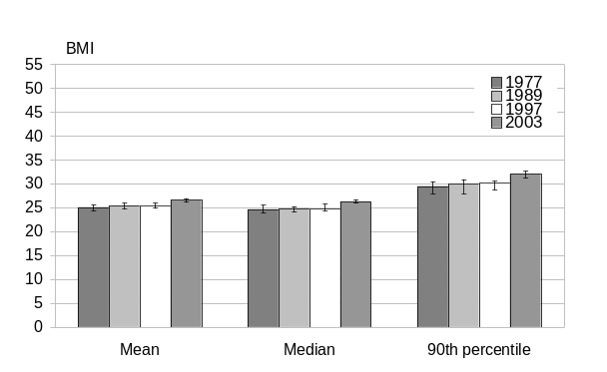 | 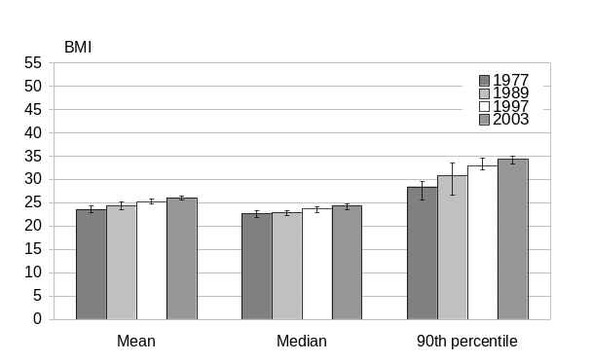
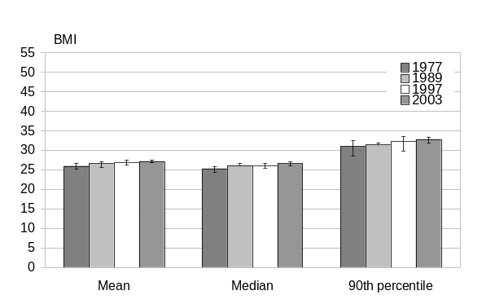 | 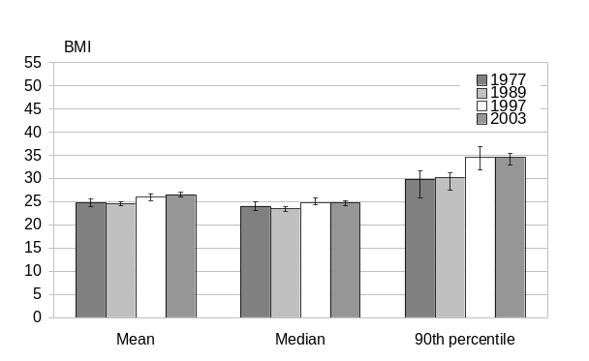
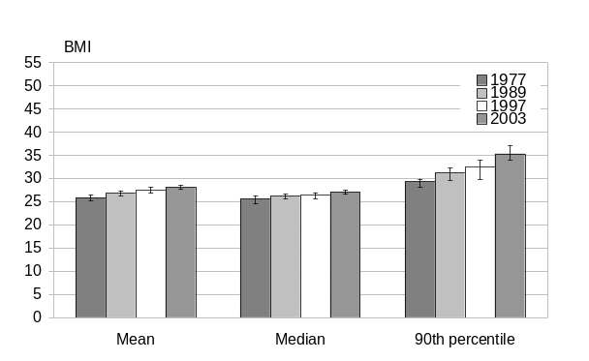 | 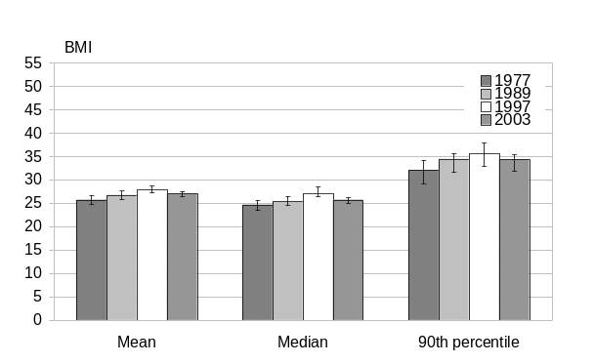
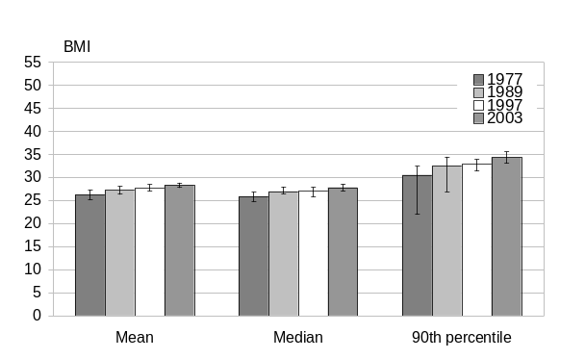 | 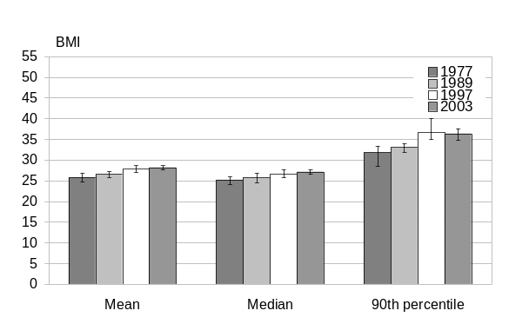
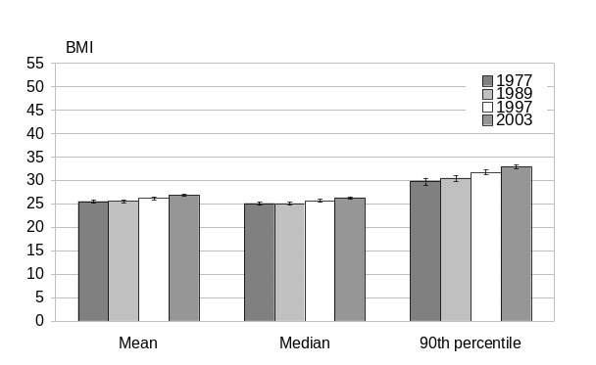 | 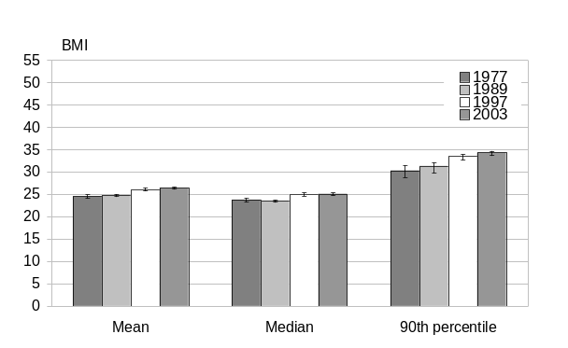
* 20–64 years for 1977, 15–74 years for 1989–2003.

Trends in the epidemic growth rate
While the AAPCs (epidemic growth rates) for mean or median BMI, and for overweight prevalence, are relatively small, this is not the case for obesity prevalence. The latter is also of most policy relevance, and so is briefly highlighted here (Figure 27). Note that confidence intervals are difficult to calculate for AAPCs; however, large changes are likely to be significant.

Figure 27: AAPC in obesity prevalence, total population, by period and gender
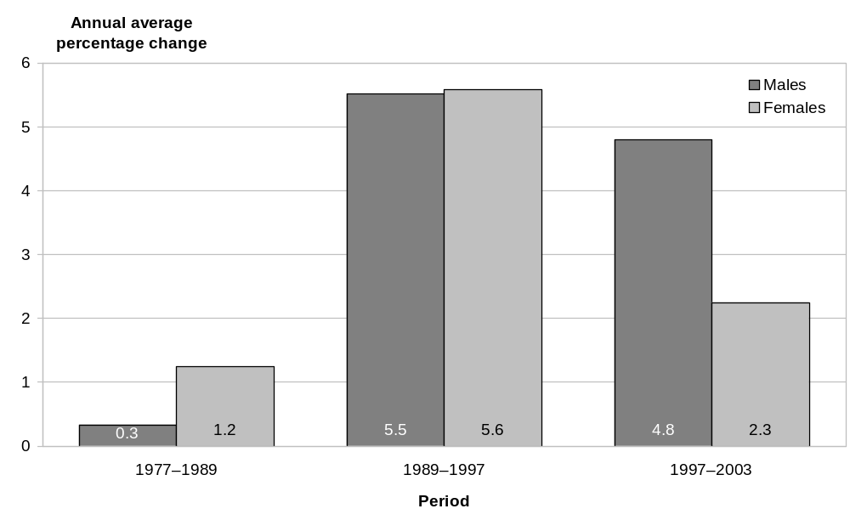

Figure 27 clearly demonstrates that the rate of growth of the epidemic has not been stable over the study period, so the average growth rate calculated for the entire period (3 percent per year for both genders, ages pooled) disguises substantive differences between periods.

Instead, the epidemic grew at a relatively slow rate during the first period (1977–1989), although more rapidly among females than males. The growth rate then accelerated sharply during the second period (1989–1997), when it grew at over 5.5 percent per year in both genders.

Since then a slight deceleration may have occurred during the third period (1997–2003) for males, among whom the epidemic has continued to grow at a rate of 4.8 percent per year (at least to 2003). However, among females, the growth rate of the epidemic appears to have clearly decelerated during the third period to a rate of 2.3 percent per year, compared to 5.6 percent in the preceding period. Again, however, it needs to be emphasised that artefact resulting from differences in survey design and fielding cannot be excluded as a possible explanation for the apparent trend.

Age- and ethnicity-standardised analysis
A full understanding of the BMI trends requires examination of the data by age, cohort and period, as presented in earlier sections of this report. Crude age-pooled results have, however, also been presented as a summary measure. Yet these overall (age-pooled) estimates do not take the changing age structure of the New Zealand population into account.

To estimate the contribution of the ageing population to the observed trends in the BMI distribution over the past quarter century, we have repeated the analyses after standardising the distributions for age (using the direct method of standardisation, with the WHO world population as the reference) within the 25–64 years age range.

In brief, there is little difference between the crude and age-standardised results, indicating that the evolution of the epidemic in the total population over the past quarter century has been little affected by the population’s changing age structure (data not shown).

Similarly, the total population analysis was repeated after standardising the BMI distributions for both age and ethnicity (using the 2001 Census population as the standard for the latter). Again, the results were little different from the crude analysis, indicating that changes in ethnic mix have not contributed noticeably to the observed shifts in the total population’s BMI distribution (data not shown).

Results – Mäori Population
Changes in the distribution of BMI in the Mäori population from 1989 to 2003 are presented in this section (the 1977 survey included too few Mäori respondents to permit analysis by ethnicity). Even in the 1989 and 1997 surveys, the sample sizes for Mäori were too small to allow age-specific analysis, so only overall estimates (crude and age standardised) are presented here. Due to small Mäori samples sizes in the 1989 and 1997 surveys, and changes in the definition of ethnicity over time, care should be taken when interpreting these results.

BMI distributions

Changes in BMI distribution, 1989–2003
We first present an overview of the changes in the BMI distribution over the entire 1989–2003 period (Figures 28 and 29, Table 12).

Figure 28: Changes in BMI distribution of Mäori population, ages pooled, 1989–2003
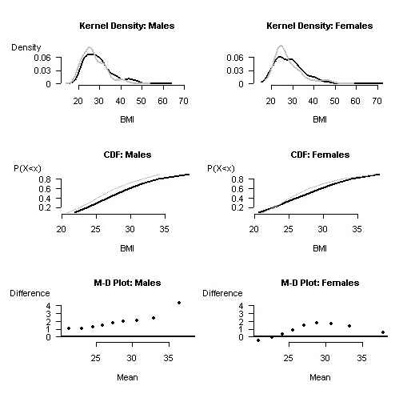
Key: 1989 distribution 2003 distribution

Figure 29: Prevalence of overweight and obesity (Mäori population), ages pooled, 1989–2003
Males | Females
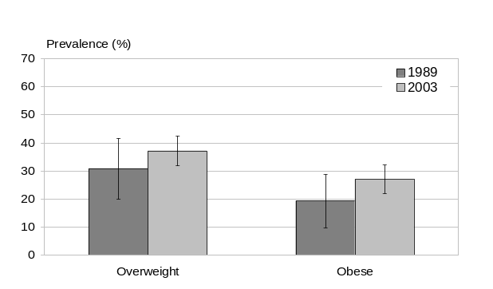 | 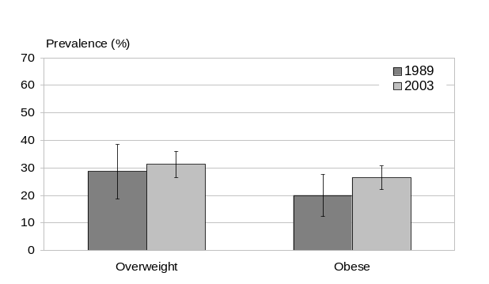

Table 10: Selected Mäori sample statistics, ages pooled, 1989–2003
 | Males |  |  | Females
 | 1989 | 2003 | AAPC* | 1989 | 2003 | AAPC*
Mean BMI | 27.2 | 29.3 | 0.52 | 27.8 | 28.5 | 0.19
Median BMI | 27.8 | 29.1 | 0.32 | 25.9 | 29.1 | 0.85
Overweight (%) | 30.8 | 37.2 | 1.35 | 28.7 | 31.3 | 0.63
Obese (%) | 19.3 | 27.0 | 2.45 | 20.0 | 26.5 | 2.01
* Average annual percentage change; assumes linearity.

The epidemic was well advanced among Mäori by 1989, with higher rates of obesity than seen among non-Mäori at that time. Unlike the non-Mäori pattern, among Mäori the prevalence of both overweight and obesity in 1989 were similar across genders: 31 percent of Mäori males and 29 percent of Mäori females were overweight, while 19 percent of Mäori males and 20 percent of Mäori females were obese.

From 1989 to 2003, Mäori males showed a moderately steep increase in obesity prevalence, reaching 27 percent by 2003 – an AAPC of 2.5 percent (assuming log linearity). Over the same period, overweight prevalence increased to 37 percent, a smaller but still substantial AAPC of over 1 percent.

Obesity prevalence among Mäori females increased slightly less steeply than it did among males, reaching 27 percent by 2003 – an AAPC of 2 percent. Unlike the male pattern, overweight prevalence increased only to 31 percent, an AAPC of only 0.6 percent.

As with non-Mäori, shifts in mean and median BMI have been relatively smaller than those at higher percentiles of the BMI distribution. Among Mäori males, mean (median) BMI increased by 2.1 (1.3) units over the study period, corresponding to an AAPC of 0.5 percent (0.3 percent) (assuming log linearity). Females showed a larger shift in median BMI than males (3.3 units of BMI corresponding to an AAPC of 0.9 percent), but a smaller change in mean BMI (0.7 units, corresponding to an AAPC of 0.2 percent).

Examining the whole BMI distribution (ie, using the m–d plots), Mäori males show a consistent increase in skewness of the BMI distribution until the 90th percentile (approximately), which shows a very large shift (approximately 5 units), suggesting even greater increase in skewness at the heaviest end of the distribution. This is compatible with a mixed model; ie, a continuously distributed person–environment interaction.

By contrast, Mäori females show an unusual pattern of distributional shifting, with modest increases in BMI at the middle percentiles but no change at both light and heavy ends of the distribution. In fact, the 90th percentile shows no change, comparing the beginning and the end of the observation period.

These contrasting gender patterns are reflected in the trend in extreme obesity, which increased over the observation period from 3.2 to 7.8 percent among Mäori males, while remaining stable at approximately 7 percent (or possibly declining slightly) among Mäori females (see ‘Trends in Extreme Obesity’ section for more detail).

So the epidemic among Mäori over the past 14 years has been different to that among non-Mäori, in that in the former only males have shown the classic pattern of increasing skewness in their BMI distribution (when the whole 1989–2003 period is considered), and the relative magnitude of the increase in obesity prevalence has also been smaller. Note, however, that confidence intervals are wide because of small numbers of Mäori respondents, especially in the earlier surveys.

We now turn to an analysis of trends in the Mäori BMI distribution, including the prevalence of overweight and obesity, for each period (1989–1997 and 1997–2003) separately.

Changes in BMI distribution 1989–1997
Changes in the distribution of BMI in the Mäori population from 1989–1997 are presented below (Figures 30 and 31, Table 13). Sample sizes were too small to allow age-specific analysis so all ages (15–74 years) have been pooled.

Figure 30: Changes in BMI distribution (Mäori), ages pooled, 1989–1997
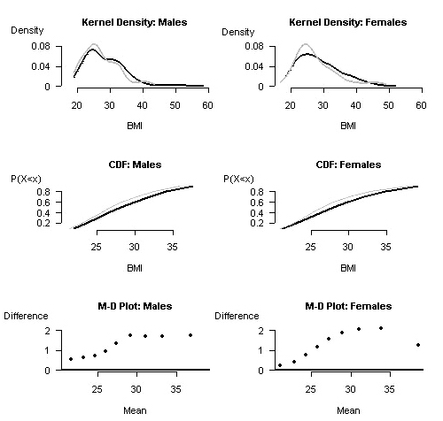

Key: 1989 distribution 1997 distribution

Figure 31: Prevalence of overweight and obesity (Mäori), ages pooled, 1989–1997
Males | Females
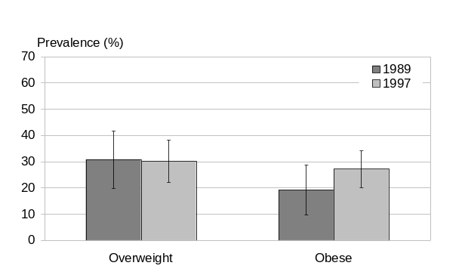 | 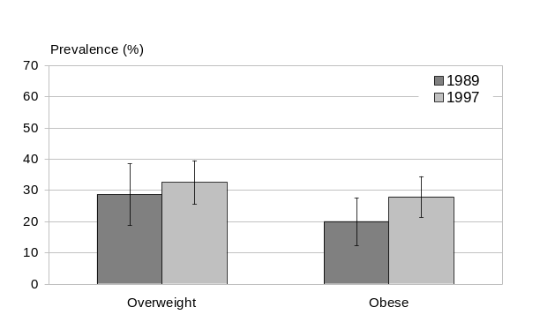

Table 11: Selected Mäori sample statistics, ages pooled, 1989–1997
 | Males |  |  | Females
 | 1989 | 1997 | AAPC* | 1989 | 1997 | AAPC*
Mean BMI | 27.2 | 28.7 | 0.67 | 27.8 | 28.7 | 0.40
Median BMI | 25.9 | 27.7 | 0.81 | 25.6 | 27.5 | 0.89
Overweight (%) | 30.8 | 30.3 | -0.22 | 28.7 | 32.6 | 1.60
Obese (%) | 19.3 | 27.2 | 4.40 | 20.0 | 27.9 | 4.25
* Average annual percentage change; assumes linearity.

From 1989 to 1997 the epidemic grew rapidly among Mäori (both genders) as it did among non-Mäori. The prevalence of obesity increased from 19 percent in 1989 to 27 percent in 1997 among Mäori males (an AAPC of 4.4 percent), and from 20 to 28 percent among Mäori females (an AAPC of 4.3 percent). At the same time, overweight prevalence remained stable among Mäori males (at approximately 31 percent) while increasing slightly among females (from approximately 29 to 33 percent, an AAPC of 1.6 percent).

Examining the whole BMI distribution, both Mäori males and females show progressive increases in BMI at light percentiles. This is replaced by a constant upward shift (of about 1.5 BMI units) from the 60th percentile onwards. Among females the extent of change declines again (to about 1 unit) at the heaviest (90th) percentile.

In summary, the overall pattern over the 1989–1997 period is one of increasing skewness, leading to a rapid growth in obesity prevalence (albeit relatively less than for non-Mäori – an AAPC of approximately 4 percent versus over 5 percent), with little change in overweight prevalence. Increases in mean and median BMI are substantial, if less dramatic. Beyond the middle percentiles, the progressive increase in skewness ceases, and among females the shift at the heavier percentiles is actually (and unusually) less than that at the middle percentiles.

Changes in BMI distribution, 1997–2003
Changes in the distribution of BMI in the Mäori population from 1997 to 2003 are presented below (Figures 32 and 33, Table 14). Sample sizes were too small to allow age-specific analysis so all ages (15–74 years) have been pooled.

Figure 32: Changes in BMI distribution of Mäori population, ages pooled, 1997–2003
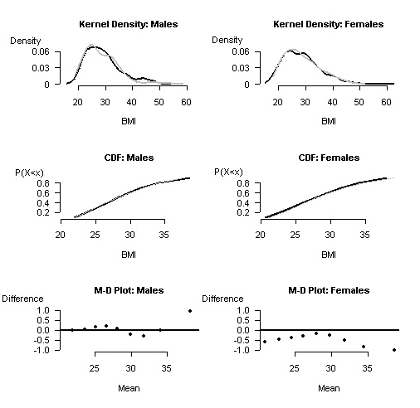
Key: 1997 distribution 2003 distribution

Figure 33: Prevalence of overweight and obesity (Mäori), ages pooled, 1997–2003
Males | Females
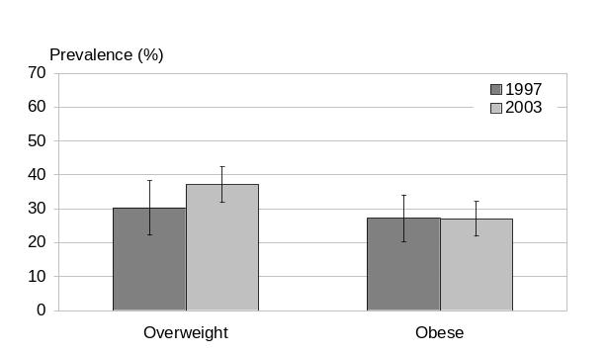 | 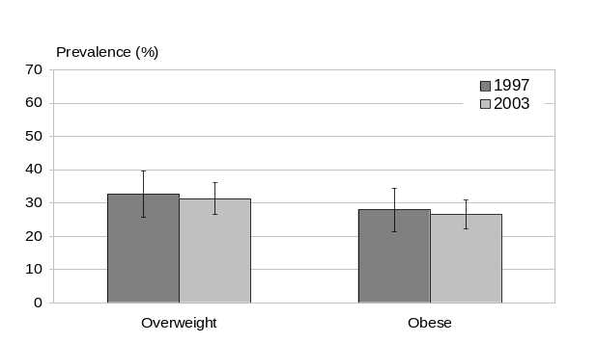

Table 12: Selected Mäori sample statistics, ages pooled, 1997–2003
 | Males |  |  | Females
 | 1997 | 2003 | AAPC* | 1997 | 2003 | AAPC*
Mean BMI | 28.7 | 29.3 | 0.33 | 28.7 | 28.5 | -0.10
Median BMI | 28.7 | 29.1 | 0.24 | 29.0 | 29.1 | 0.08
Overweight (%) | 30.3 | 37.2 | 3.48 | 32.6 | 31.3 | -0.65
Obese (%) | 27.2 | 27.0 | -0.10 | 27.9 | 26.5 | -0.90
* Average annual percentage change; assumes linearity.

From 1997 to 2003, a substantial slowing in the rate of growth of the epidemic occurred among Mäori, more marked than that seen among non-Mäori over the same period. The prevalence of obesity remained stable at approximately 27 percent among males. More dramatically, the prevalence of obesity appears to have declined slightly among Mäori females, from 27.9 to 26.5 percent (corresponding to an AAPC of -0.9 percent).

In contrast, overweight prevalence increased significantly among Mäori males (from 30.3 to 37.2 percent) while remaining stable or possibly declining slightly among Mäori females (from 32.6 to 31.3 percent).

Mean and median BMI both increased among Mäori males, but only slightly (AAPCs of < 0.5 percent), while showing little change among females (AAPCs of 0.2 percent or less). Note that wide confidence intervals – the result of small numbers of survey respondents – make it difficult to identify trends in the Mäori BMI distribution with any precision.

Examining the whole BMI distribution (eg, using the m–d plot), Mäori males showed only very small increases at all percentiles, except for a substantial increase in BMI at the high end of the distribution (90th percentile). By contrast, Mäori females showed a small but uniform decrease (of about -0.5 BMI units) at low and middle percentiles and even greater decreases at high percentiles (reaching -1.5 units at the 90th percentile).

This pattern is consistent with a slowing in the rate of growth of the epidemic among Mäori males, although the growth rate remains positive. However, among Mäori females, the growth rate appears to have become negative (whereas among non-Mäori females it has declined sharply but still remains positive; that is, the epidemic is still growing in the latter ethnic group). This raises the possibility that among Mäori females (but not non-Mäori), the epidemic may have already peaked and the prevalence of obesity among this group may now actually be (slowly) declining once again. However, the wide confidence intervals mean that we cannot exclude the possibility of chance fluctuation (ie, the trend of obesity prevalence among Mäori females does not reach conventional levels of statistical significance). Also, changes in the concept and definition of ethnicity create additional sources of potential bias for the ethnic analysis, not relevant to the total population analysis. Caution is therefore necessary in interpreting the ethnic-specific trend estimates in particular.

Overview of BMI distributional shifting among Mäori, 1989–2003
Inadequate statistical power in earlier surveys precludes the sort of analysis by period and age group presented above for the total New Zealand population. However, trends in the epidemic growth rate, and assessment of the influence of change in the population age structure on the BMI distribution, are summarised for Mäori below.

Trends in the prevalence of obesity
As with non-Mäori, the AAPCs for mean and median BMI, and for overweight prevalence, have been relatively small. AAPCs for obesity prevalence have been much larger and are of most policy relevance, so these are highlighted here to illustrate the changes that have occurred from the earlier to the later half of the observation period (Figure 34).

Figure 34: AAPC in obesity prevalence, Mäori population, by period and gender
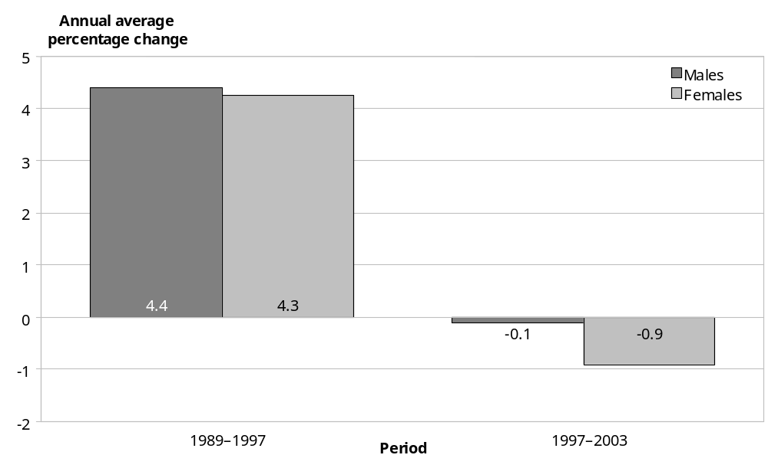

Figure 34 demonstrates that the growth rate of the epidemic has varied markedly over time, so the average rate calculated over the whole 14-year observation period disguises substantial differences between periods. Instead, the epidemic grew rapidly from 1989 to 1997, at an annual average of over 4 percent per year (both genders) – although this is still slower than the 5.5 percent average annual rate of growth for non-Mäori over the same period.

As with non-Mäori, the rate of growth then slowed from 1997 to the present (2003) – but this slowing was far more dramatic than for non-Mäori. Among Mäori males, the epidemic appears to have stabilised (virtually no change in obesity prevalence from 1997 to 2003). Among Mäori females, the epidemic may have actually peaked and begun to decline, with the prevalence of obesity possibly shrinking at an average rate of almost 1 percent per year. However, the latter trend does not reach conventional levels of statistical significance, possibly due to small numbers, and so should not be over-interpreted.

Age-standardised analysis
As for the total population, we have repeated the analyses with the Mäori BMI distributions at each point in time age standardised to the WHO world population. Standardising for age does make a larger difference to the Mäori than to the total population BMI distributions, perhaps because of the particular reference population selected. Briefly, once adjusted for variation in the age structure of the Mäori population over the past quarter century, the underlying growth rate of the epidemic in this ethnic group appears even smaller than when not so adjusted, especially for Mäori males (data not shown). Nevertheless, as for the total population, changes in the age structure of the Mäori population over time account for relatively little of the trend in the BMI distribution.

Socioeconomic Position and BMI
Detailed analysis of the association between socioeconomic position (SEP) and BMI will be presented in a separate paper. Here we briefly describe levels and trends in this association over the study period, for all age and ethnic groups combined, using stratification methods. We present inequality (and trend in inequality) results for mean BMI (as a measure of central tendency) and for the prevalence of obesity (as a measure of the right-hand tail), rather than for the BMI distribution as a whole.

Socioeconomic position is examined at both the level of the individual or family (using household income as the marker) and the neighbourhood level (using small area deprivation as the marker).

Household income was available for all except the 1977 survey. Income was equivalised for household size and composition using a modified Jensen scale, converted to constant 2001 dollars, and categorised into tertiles. Less than 10 percent of respondents could not be attributed an equivalised household income in any of the surveys.

Deprivation level of small area of residence (‘neighbourhood’) was assigned to each respondent in the 1997 and 2003 surveys using the corresponding NZDep index (ie, NZDep96 and NZDep2001, respectively). NZDep is a census-based index of social and material deprivation derived by principal component analysis of nine socioeconomic variables from the respective censuses (Salmond and Crampton 2002). While there are slight differences in index structure and meshblock boundaries between these censuses, comparison is still possible because the index produces relative rankings rather than absolute values. However, this could not be extended to earlier surveys, restricting the neighbourhood deprivation analysis to the late 1990s–early 2000s only. For technical reasons, the NZDep scores were categorised into quartiles for the 1997 survey but quintiles for the 2003 survey. While this imposes further restrictions on the trend analysis, it allows us to maximise the cross-sectional information available from the most recent survey, which is perhaps of greatest interest.

We first present the results for the association of BMI with household level socioeconomic position, followed by the results for the association between neighbourhood deprivation and BMI.

Household income and BMI

Mean BMI and income
Estimates of mean BMI by income tertile for the three surveys with household income data (1989, 1997 and 2003) are summarised in Figure 35.

Figure 35: Mean BMI, by income, 1989, 1997 and 2003
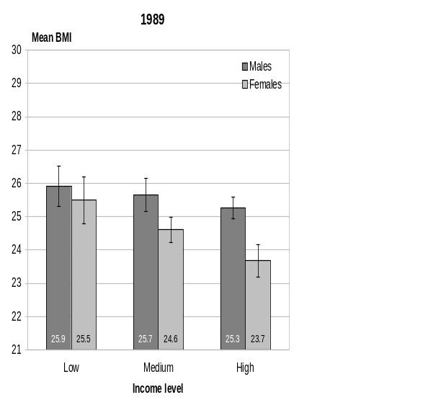 | 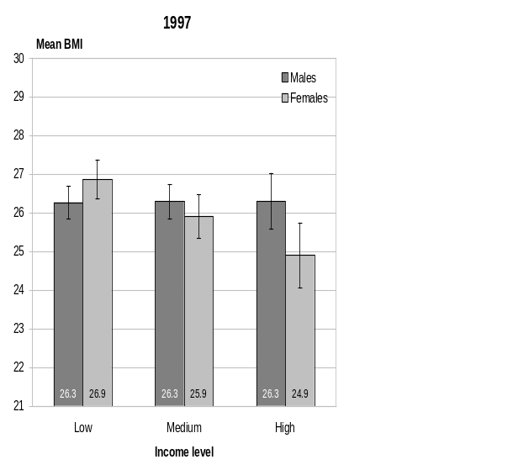
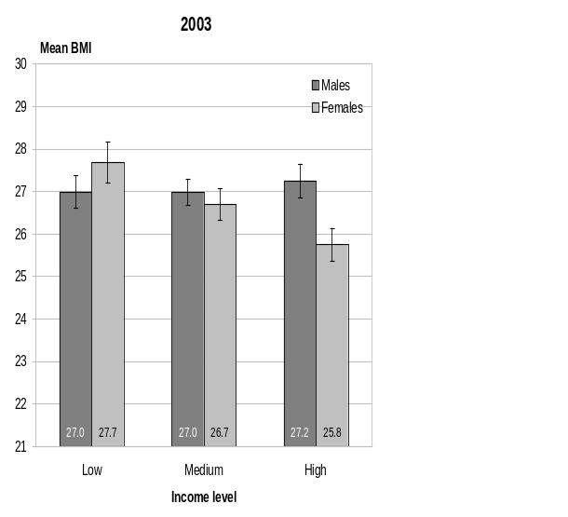

Among males, there is a slight inverse gradient in mean BMI across the income tertiles in 1989, but this pattern is not apparent in the latter two surveys (ie, 1997 and 2003). Mean BMI is approximately 25.5 in 1989, 26.3 in 1997 and 27.0 in 2003 for all income groups. Comparing the beginning with the end of the observation period, the increase in mean BMI was 1.1 units for the low-income tertile, 1.3 units for the medium-income tertile, and 1.9 units for the high-income tertile. Although not statistically significant, this pattern is certainly not suggestive of an emerging inverse gradient, at least when examining the centre of the BMI distribution.

Among females, the pattern is different. An inverse income gradient in mean BMI is already evident at the beginning of the observation period and persists throughout. However, the gradient does not become steeper over time in either absolute or relative terms. For example, the rate difference comparing low- with high-income tertiles was 1.8 units in 1989, 2.0 units in 1997, and 1.9 units in 2003. The corresponding rate ratios were 1.08, 1.08 and 1.07, respectively.

Obesity and income
Estimates of the prevalence of obesity (as previously defined) by income for the three surveys with household income data are summarised in Figure 36.

Among males, there is a suggestion of an inverse relationship between income tertile and obesity prevalence in 1989, but this is clearly absent in 1997 and, if anything, a possible (but not statistically significant) positive relationship emerges in 2003.

In summary, there is no statistically significant relationship between income and BMI – whether measured as mean BMI or as obesity prevalence – among males.

Figure 36: Obesity prevalence, by income, 1989, 1997 and 2003
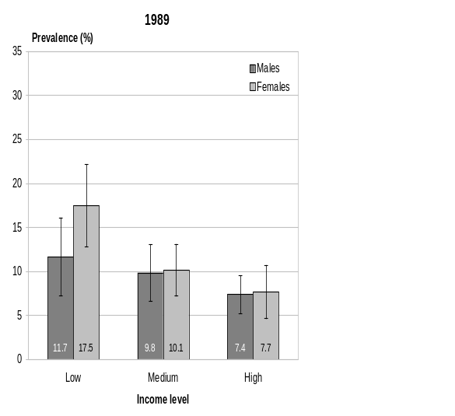 | 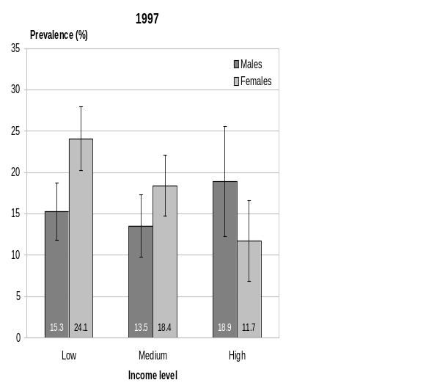
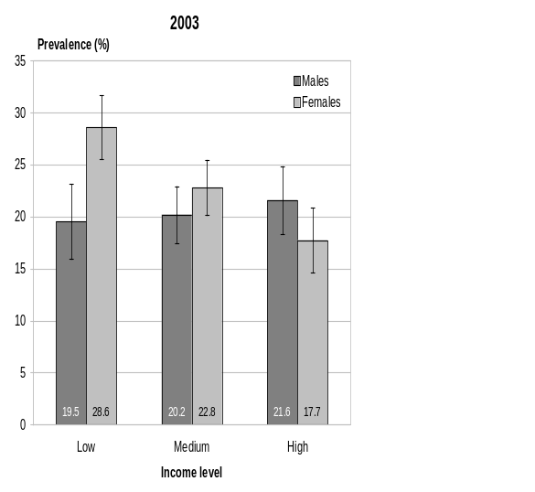
Among females, the pattern is again different. A statistically significant and continuous gradient in obesity prevalence exists across the income tertiles at all three time points. There is no evidence that the gradient has become steeper over time. In absolute terms, the rate difference (comparing low- to high-income groups) was 9.8 per 100 in 1989, 12.4 per 100 in 1997, and 10.9 per 100 in 2003. The corresponding rate ratios were 2.3, 2.1 and 1.6, respectively. While the latter trend does not meet conventional levels for statistical significance, if anything it suggests a reducing rather than an increasing relative inequality.

In summary, a clear inverse income gradient exists for BMI (both mean and obesity prevalence) among females but not males. The female gradient has remained stable over the 1989–2003 period in absolute terms, but may be declining in relative terms.

Neighbourhood deprivation and BMI

Mean BMI and NZDep
Estimates of mean BMI by NZDep category are summarised in Figure 37, for the two surveys for which such estimates can be calculated.

Figure 37: Mean BMI, by NZDep category, 1997 and 2003
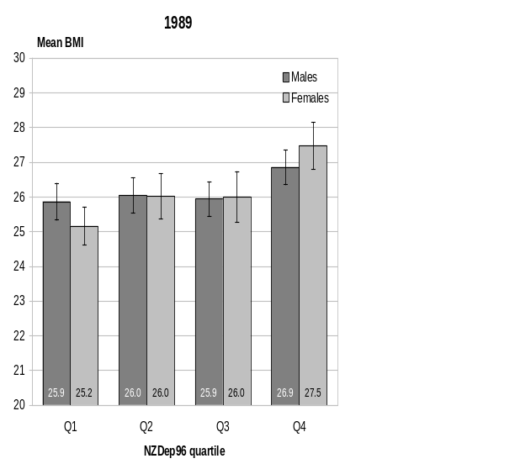 | 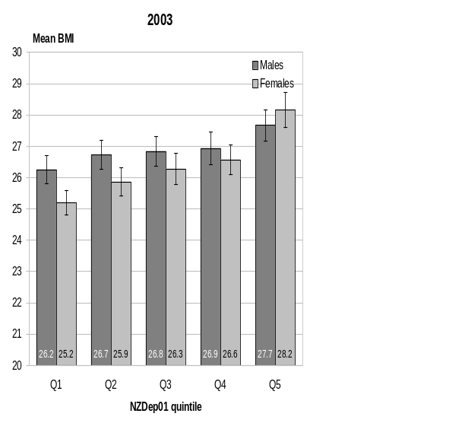

Unlike the pattern for income, there is a suggestion of an inverse gradient between mean BMI and deprivation of small area of residence among males in 1997. While there is no significant difference among the first three quartiles, their mean BMI (approximately 26.0 units) is significantly less than that of the fourth (most disadvantaged) quartile (26.9 units). This pattern is more pronounced in 2003, where there is more of a gradient, with the first (least disadvantaged) quintile having a mean BMI of 26.2 units, the middle three quintiles having similar mean BMIs of around 26.8 units, and the fifth (most disadvantaged) quintile having a mean BMI of 27.7 units.

The pattern is similar but with a steeper and smoother gradient among females. Furthermore, the gradient in 2003 appears to be smoother and steeper than it was in 1997, although comparison of the two time points is difficult because of the differences in the deprivation measure.

Obesity and NZDep
Among males, there is little suggestion of a deprivation gradient in obesity prevalence in 1997, but by 2003 such a gradient has emerged (Figure 38). In 2003, only 14 percent of adult males living in quintile 1 small areas (the least disadvantaged fifth of small areas) were obese versus 25 percent of those living in quintile 5 (the most disadvantaged fifth of small areas). The middle quintiles were intermediate (at an obesity prevalence of around 20.5 percent), with no difference among these quintiles.

Among females, the pattern is similar to that for mean BMI. There is a clear gradient at both time points, but the gradient appears smoother and steeper in 2003. As with males, the ratio of obesity prevalence in the most to the least disadvantaged quintile in that year was just under twofold (1.8 for both genders).

Figure 38: Prevalence of obesity, by NZDep category, 1997 and 2003
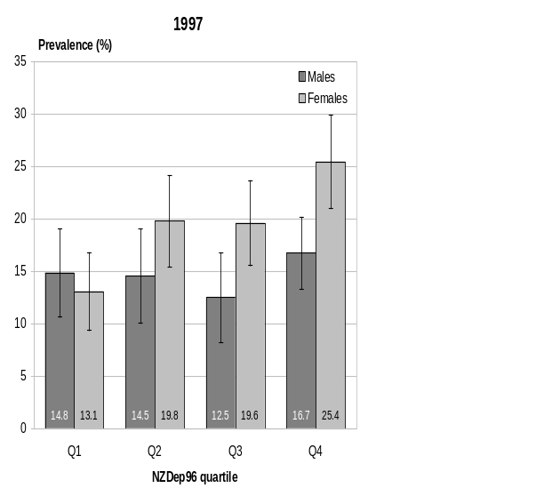 | 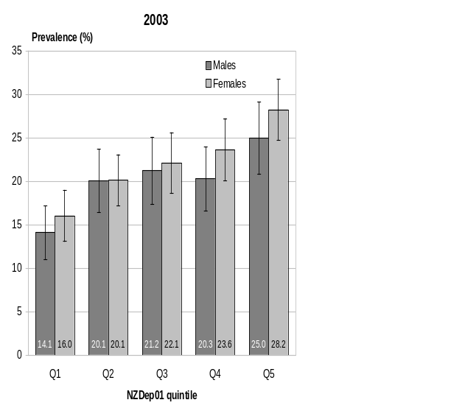

In summary, an inverse socioeconomic gradient in BMI distribution (as measured both by mean BMI and by obesity prevalence) has existed among females at least since 1989. There is little evidence to suggest any substantial trend in this inequality over the observation period. As an indication of the steepness of the gradient, females living in the most deprived fifth of small areas in 2003 had almost twice the prevalence of obesity as those living in the least deprived fifth.

By contrast, any socioeconomic inequality in the male BMI distribution is less marked and has emerged only recently (ie, is not evident prior to the 2003 survey). Even today, the male gradient is visible only using small area deprivation as the socioeconomic measure, and is less smoothly graded than the female gradient. This gender difference in socioeconomic BMI gradients again supports the hypotheses that the obesity epidemic emerged earlier and so is more advanced among females. It seems reasonable to postulate that the gradient will become more pronounced in future among males, while possibly becoming less pronounced among females.

Smoking and BMI
There have been significant changes in the prevalence of smoking over the last 30 years (Ministry of Health 2003c). Smoking is associated with slightly lower BMI (Rasky et al 1996) and smoking cessation is associated with a small weight gain in some people (Williamson et al 1991; Flegal et al 1995, Froom et al 1998), so it is of interest to estimate the effect that the changing prevalence of smoking has had on the observed BMI distributional shifts over the past several decades.

Unfortunately, the necessary longitudinal data to assess this effect are not available for New Zealand. Instead, we analysed the strength of the association between smoking and mean BMI in the New Zealand survey data sets (especially the New Zealand Health Survey (NZHS) 2003). If the effect size is small, then changes in the prevalence of smoking over time could not have had a substantive effect on the population’s BMI distribution.

To this end, we present here the average difference in mean BMI, and in the prevalence of overweight and obesity, between current smokers and never smokers in the 2003 NZHS data set.

Mean BMI and smoking
Figure 39 summarises mean BMI for current smokers versus never smokers by ethnicity and gender (we do not show the data for ex-smokers). The estimates are adjusted for age, ethnicity and deprivation quintile. The 95 percent confidence interval for mean difference is superimposed above the bars. If zero is contained within this interval then the mean difference is not significant. Significance is denoted with an asterisk.

There is a significant difference of half a BMI unit between current smokers (mean BMI 26.4) and never smokers (mean BMI 27.0) for males. However, for females there is only a very small (albeit statistically significant) difference of 0.1 units and in the opposite direction to that expected (mean BMI of current smokers 26.5 and of never smokers 26.4).
Figure 39: Mean BMI, by smoking status, 2003
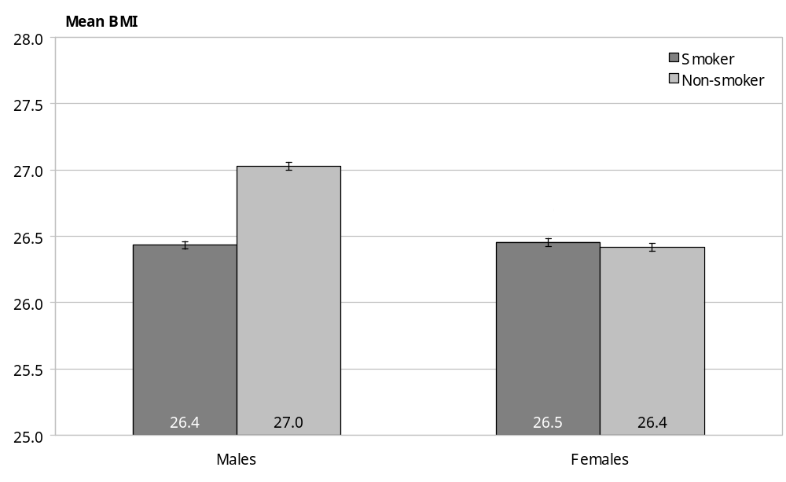
** p < 0.05

Obesity and smoking
Figure 40 summarises the prevalence of overweight and obesity, stratified by gender and adjusted for age, ethnicity and deprivation. Again, the 95 percent confidence interval for the difference is provided above the bars. Significance is denoted with an asterisk.

Only the difference in the prevalence of overweight between male smokers and non-smokers is statistically significant. However, the overall pattern is suggestive of a (slightly) lower prevalence of overweight and obesity among current smokers compared to never smokers for both genders.

Our findings are in accord with a previous New Zealand study which found that the change in smoking status in the Auckland population accounted for only 7–10 percent of the observed increase in BMI over the period from 1986–88 to 1993–94 in men and women, respectively (Simmons et al 1996). In fact, our results would suggest an even smaller contribution from smoking trend for males, and little if any contribution at all for females. Accordingly, we conclude that it is not necessary to adjust for trends in smoking status when describing the shifts in the population’s BMI distribution over the past 26 years.

Figure 40: Prevalence of overweight and obesity, by smoking status, 2003
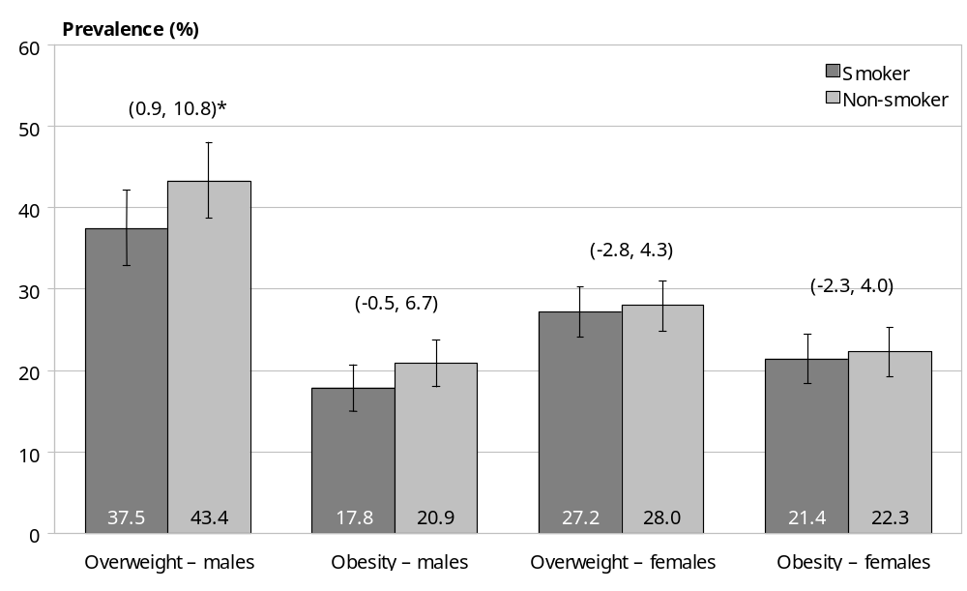

Trends in Extreme Obesity
Here we present a brief summary of trends in the prevalence of extreme obesity, defined as a BMI of 40 kg/m²or more, for both the total New Zealand and the Mäori populations. BMI in this range imposes a high risk of premature death and disability.

First, however, we briefly summarise data on trends in the average BMI of the obese subpopulation (total and Mäori), which provides another indicator of the impact of the increasing skewness of the BMI distribution on people at the higher end of the BMI distribution.

Another perspective on trends at the heavy end of the distribution can be obtained by examining changes in BMI of the 90th percentile of the distribution for each subgroup of the population at each period. This has already been presented in Figure 26 and will not be repeated here.

Trends in mean BMI of the obese
Figures 41 and 42 show the trend in mean BMI of the obese subpopulation, for both total and Mäori populations. As described earlier, the higher percentiles of the obese subpopulation’s BMI distribution have become heavier as the skewness of the whole population BMI distribution has increased. However, the obese subpopulation is itself very left skewed (ie, most obese people have BMI values close to 30 (or 32 for Mäori)), partly because this subpopulation represents the rapidly narrowing tail of a larger distribution, and partly because of a mortality selection effect. Thus the shift in the average BMI of this subpopulation has in fact been quite small, with increases of less than one BMI unit for all age–gender–ethnic cells (comparing the start with the end of the observation period). Very similar results are obtained if we examine the median rather than the mean of the BMI distribution of the obese subpopulation. It is only at the 90th percentile of this distribution that larger shifts are seen, a similar pattern of shifting to that seen in the BMI distribution of the population as a whole.

Figure 41: Mean BMI of the obese subpopulation, by gender, total population, 1977–2003
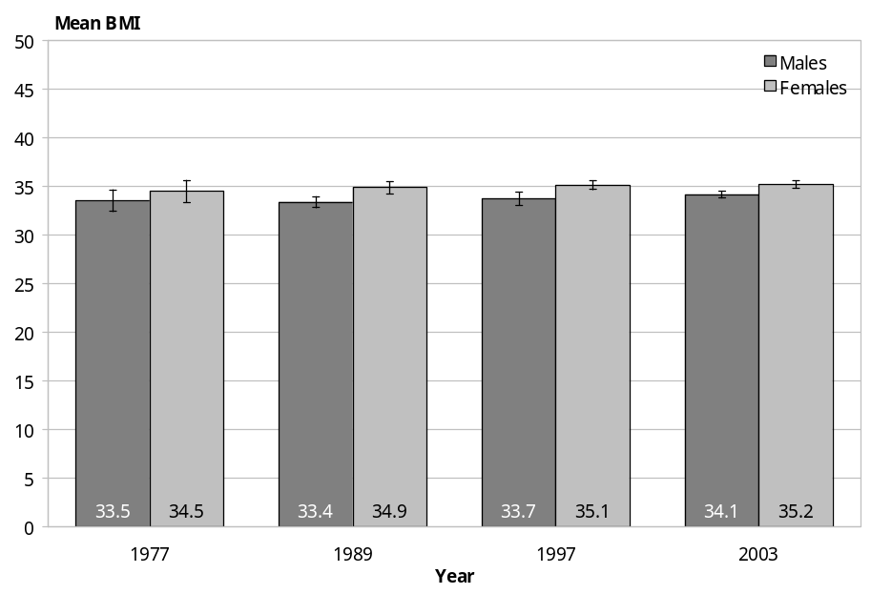
Figure 42: Mean BMI of the obese subpopulation, by gender, Mäori population, 1989–2003
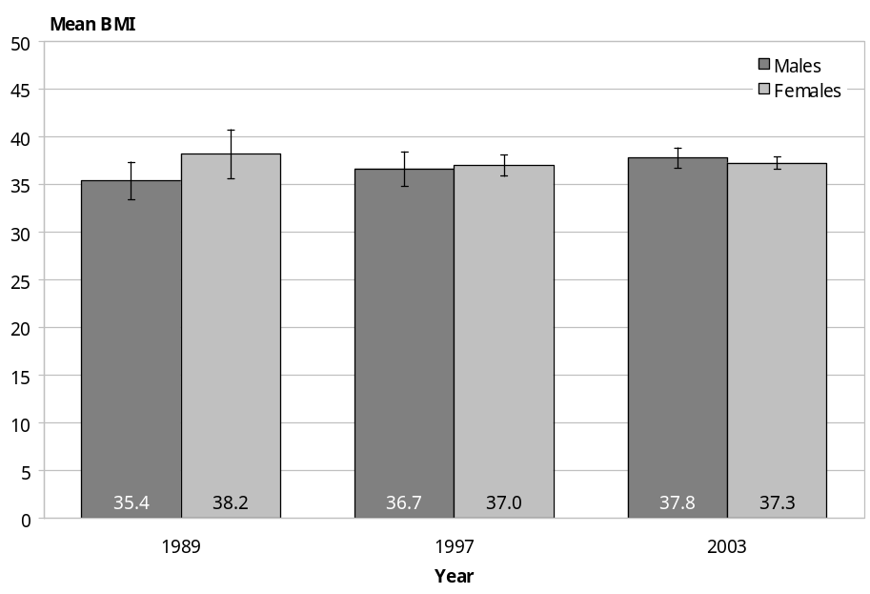

Trends in the prevalence of extreme obesity
Unlike the mean BMI of the obese subpopulation, which has increased relatively little (because of its left skewness), the prevalence of extreme obesity (BMI ≥ 40) has increased sharply over the observation period, at least for the New Zealand population as a whole (Figures 43 and 44). Age-standardised prevalence rates, which adjust for the changing age structure of the population over time, are also shown (Tables 15 and 16). Results are presented below for the total and the Mäori populations; non-Mäori results are not shown but are very similar to those for the total population.

Figure 43: Prevalence of extreme obesity, by gender, total population, 1977–2003
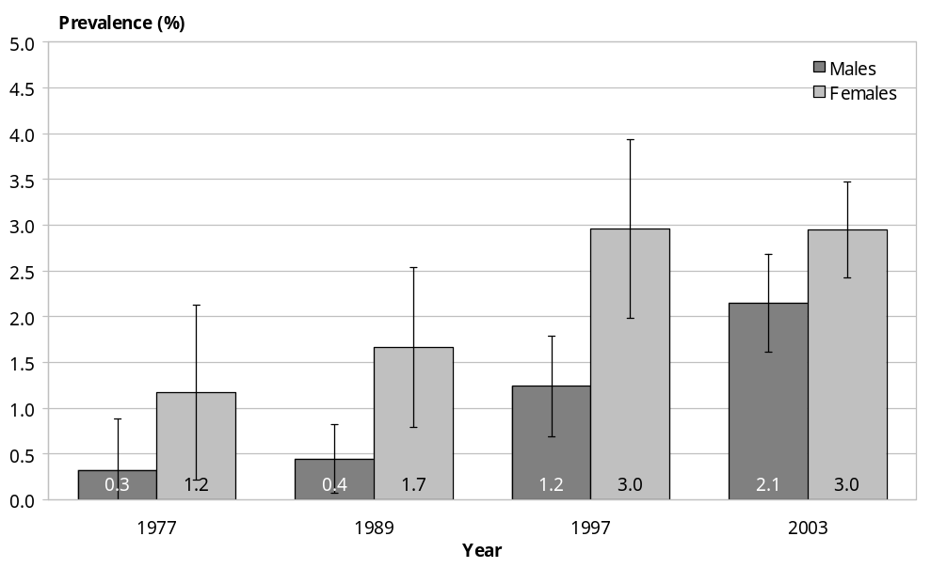

Figure 44: Prevalence of extreme obesity, by gender, Mäori population, 1989–2003
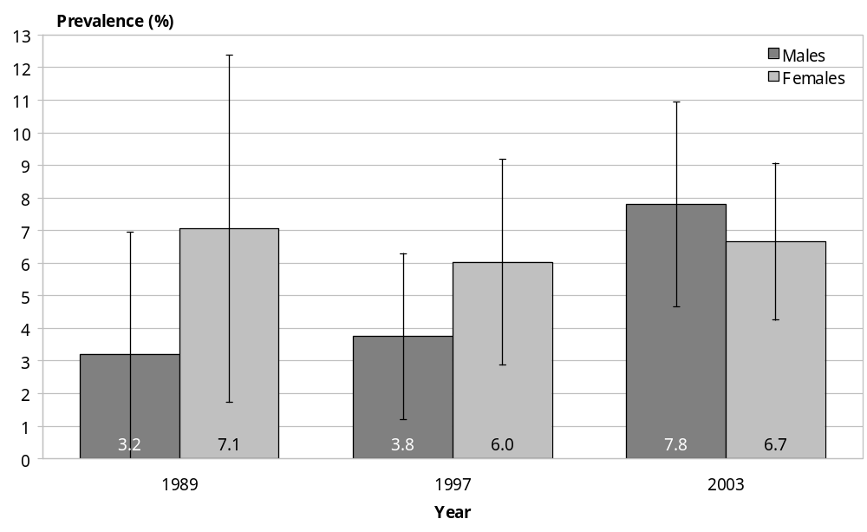

Table 13: Prevalence of extreme obesity, crude and age standardised,* total population
 | 1977 | 1989 | 1997 | 2003
Males | 0.32 (0.50) | 0.45 (0.58) | 1.24 (1.33) | 2.15 (2.68)
Females | 1.17 (1.42) | 1.66 (2.10) | 2.96 (3.26) | 2.95 (3.54)
* Age-standardised rates in parentheses.

Table 14: Prevalence of extreme obesity, crude and age standardised,* Mäori population
 | 1989 | 1997 | 2003
Males | 3.20 (3.70) | 3.75 (4.78) | 7.80 (7.95)
Females | 7.05 (7.18) | 6.03 (8.31) | 6.66 (8.07)
* Age-standardised rates in parentheses.

Total population
In 1977, pooling all adult ages, the (crude) prevalence of extreme obesity was only 0.32 percent among males but almost fourfold higher among females (although note that the confidence intervals are quite wide). This finding is consistent with the hypothesis that the epidemic began earlier among females. The prevalence of extreme obesity grew slowly among both genders from 1977 to 1989. Rapid growth then occurred (both genders) from 1989 to 1997, when the crude prevalence had reached 1.2 percent and 3.0 percent, respectively. From 1997 to 2003, relatively rapid growth continued among males but virtually ceased among females, so that current prevalence is 2.2 percent among males and still 3.0 percent among females. This corresponds to an estimated 58,000 (± 8000) extremely obese people in the population today, of whom almost 60 percent are female.

Mäori population
The pattern for Mäori is slightly different. The crude prevalences of extreme obesity in 1989 (3.2 percent for males and 7.1 percent for females) was much higher than those for non-Mäori, although arguably a higher cut-off than 40 BMI units should be used to define ‘extreme obesity’ in iso-risk terms for this ethnic group. Unlike non-Mäori, the prevalence did not increase particularly rapidly from 1989 to 1997 among males, reaching 3.8 percent, while among females the point estimate actually declined to 6.0 percent. Finally, from 1997 to 2003, prevalence increased sharply once more for males (reaching 7.8 percent), while increasing again but only slightly for females (to 6.7 percent). This is consistent with the increase observed in the BMI of the 90th percentile from 1997 to 2003 for Mäori males, in contrast to the decrease in this parameter seen for females. However, note that the confidence intervals for the prevalence of extreme obesity in Mäori are so wide that the trends do not meet conventional criteria for statistical significance.

Even if a higher cut-off (than BMI > 40) might have been more appropriate for Mäori and Pacific peoples (and a lower cut-off for Asian ethnic groups), the startling fact remains that today almost 3 percent of the total adult population (and approximately 8 percent of the Mäori population) have a BMI ≥ 40 units, placing these approximately 58,000 individuals at very high risk of serious health outcomes in the near future. Of course, at the individual level, absolute cardiovascular (and cancer) risk also depends on other factors, such as the level of physical fitness, whether the person is a smoker, presence of co-morbidities such as type 2 diabetes, high blood pressure, dyslipidaemia, and personal and family medical history.

Trends in Stature
The secular trend in stature can be estimated from a single cross-sectional survey, in this case using the 2003 NZHS. This is because full adult height is attained by age 25 years, and generally remains stable until late middle age. So each 10 years age group in the 2003 survey corresponds to a distinct birth cohort – ranging from the birth cohort of the 1940s (survey respondents currently 55–64 years of age) to that of the 1970s (survey respondents currently
25–34 years of age).

Below we summarise the age-specific mean statures from the NZHS 2003 data set (Table 15). As indicated, each 10-year age group represents a different cohort, so if there has been an increase in stature over the last 30 years, then the younger age groups should, on average, be taller than their older counterparts.

Table 15: Mean height (cm), by age group and sex, 2003
Age group (years) | Male | Female
25–34 | 177.3 (176.6, 178.0) | 163.7 (163.2, 164.2)
35–44 | 176.2 (175.6, 176.8) | 163.2 (162.8, 163.6)
45–54 | 175.3 (174.7, 175.9) | 162.0 (161.4, 162.6)
55–64 | 173.4 (172.7, 174.1) | 161.2 (160.6, 161.8)

Inspection of Table 15 confirms that there has indeed been an increase in average stature over the last three decades: 25–34-year-old males are 3.9 cm (and females 2.5 cm) taller than their 55–64-year-old counterparts, with the intermediate 35–44 and 45–54 years age groups intermediate in mean stature. Comparing these age groups in 2003 is equivalent to establishing a cohort effect over (approximately) 30 years. Hence, we can say that over the last 30 years, males have grown in stature by (on average) 1.3 cm per decade, and females have grown 0.8 cm per decade.

Figures 45 and 46 show this same information graphically, clearly revealing that there has been an increase in average stature over the last three decades. That is, males born in the 1970s (or current 25–34-year-olds) are 3.9 cm taller than the 1940s cohort (or current 55–64-year-olds). Similarly, females born in the 1970s are 2.5 cm taller than females belonging to the 1940s cohort. Furthermore, there is little evidence of any slowing in the secular trend in recent versus earlier decades.

This secular trend in stature may account for a small proportion of the BMI distributional shift seen over the past 26 years, as BMI does not fully adjust for changes in height.
Furthermore, should high rates of childhood obesity persist (or worsen), this may well contribute to further increases in mean stature (high insulin levels associated with childhood obesity also promote increases in linear growth, as insulin has growth hormone-like effects in children). So the magnitude of excess body fat in children may be progressively underestimated if reliance continues to be placed on BMI as the measure of body adipose tissue mass in this age group.

Figure 45: Trends in mean stature of males
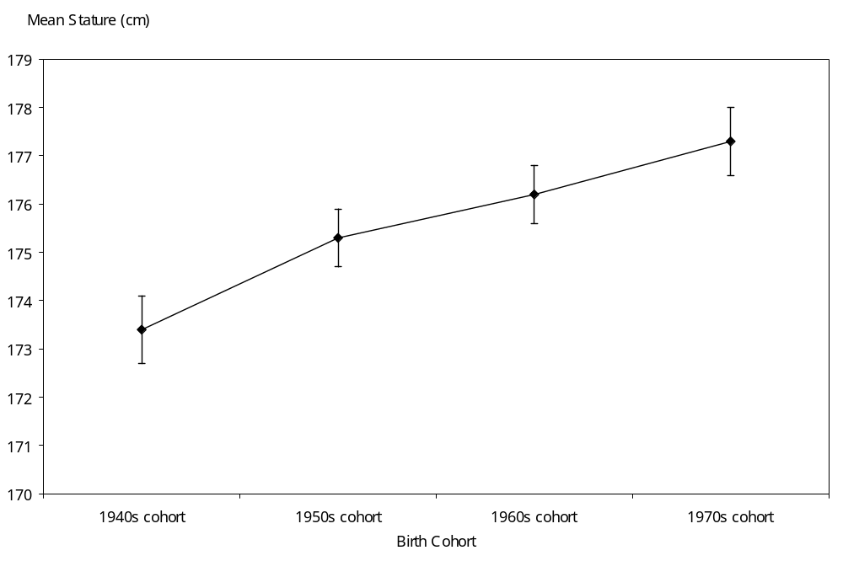

Figure 46: Trends in mean stature of females
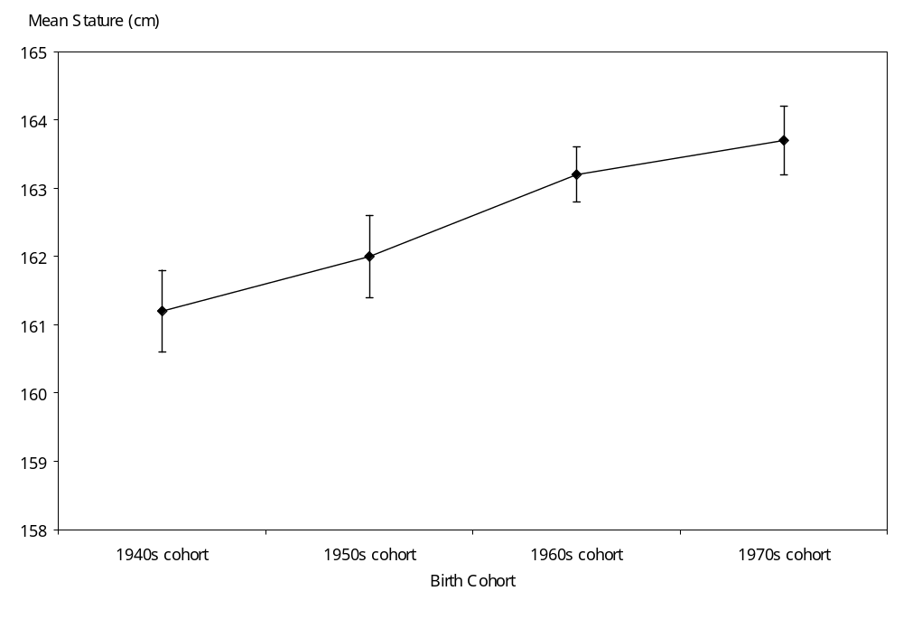

Discussion

Shifts in the BMI distribution, 1977–2003
This study has provided a clearer and richer picture of the evolution of the obesity epidemic in New Zealand than has previously been available (Wilson et al 2001). It appears that the origins of the epidemic precede 1977, yet the epidemic did not really begin to accelerate until the late 1980s or early 1990s. Most likely it began first among middle-aged females. Even today, it remains largely confined to middle-aged groups (especially among males), although some spread into both older and younger age groups has already occurred (especially among females).

Possible explanations for the observed shift in BMI distribution over this 26-year period (14 years for Mäori) include demographic trends, declining tobacco consumption, and changes in dietary and physical activity patterns.

Changes in the age structure of the population (especially the middle-aged group) have been relatively small over the study period, however, and can explain only a small proportion of the shift in the population’s BMI distribution (although a slightly greater proportion for Mäori). Changes in ethnic mix and socioeconomic conditions likewise account for little of the observed BMI distributional shifting for the New Zealand population as a whole.

Reduction in the prevalence and intensity of smoking over the 1980s and 1990s has also been shown to explain very little of the shift in population BMI distribution, both in this study and another (Simmons et al 1996).

Interestingly, this study shows that the secular trend in stature has continued in New Zealand even into the 1990s (in terms of decade of adult height attainment; ie, the 1970s birth cohort), similar to the experience in most European countries (Cole 2000) and the United States (Ogden et al 2004). Pooling over all ethnic groups and both genders, the mean adult stature of New Zealanders increased by just over 1 cm per decade over the 1970s, 1980s and 1990s. However, this trend again explains very little of the BMI distributional shift.

We are left with the conclusion that the major drivers of the epidemic have in fact been changing dietary and physical activity patterns, themselves largely reflections of an increasingly obesogenic environment.

Examination of the shifts in the BMI distribution, most readily achieved using the Tukey mean–difference plots, shows a fairly consistent pattern across decades, age groups and genders. The pattern that emerges is largely compatible with the mixed model, with little change occurring at the lower percentiles and most of the increase in BMI being concentrated at the higher percentiles (ie, a pattern of increasing skewness). This is mirrored in the rising prevalence of obesity (from 9 to 20 percent among males and 11 to 22 percent among females) accompanied by near stable prevalence of overweight (at approximately 42 percent among males and 27 percent among females). Although differing in detail, the overall pattern is similar for Mäori (for the 1989–2003 period), among whom the prevalence of obesity rose from 19 to 28 percent (males) and from 20 to 28 percent (females), while the prevalence of overweight remained stable at 30 percent (males) or increased slightly (from 29 to 32 percent) (females).

In essence, much of the weight gain appears to have involved people who were already obese becoming even more obese (leading to a sharp rise in the number of people with extreme obesity – from less than 1 percent to almost 3 percent of the total adult population), together with a proportion of people who were already overweight moving up into the obese category, only to be replaced by a similar number of people moving up from the normal weight into the overweight category. So the proportion of the population in the obese category has increased sharply (more than doubled) while that in the normal weight category has decreased moderately (about one-fifth), and that in the overweight category has remained stable.

However, this general pattern disguises some differences between subgroups. In particular, the pattern, rate or extent of change has varied between genders, ethnic groups and socioeconomic categories at different times within the overall observation period.

Shifts in the BMI distribution, 1997–2003
This study provides the first indication that, while the epidemic has continued its relentless progress, the period of rapid acceleration from 1989 to 1997 may be coming to an end. Instead, the growth rate of the epidemic appears to have fallen from 1997 to 2003, especially among Mäori and among females. Among non-Mäori males the BMI distribution has continued to become increasingly skewed, but at a slightly slower rate than in the preceding decade (though the average growth rate in obesity prevalence for this subpopulation currently remains at approximately 5 percent per year, which still represents a very rapid growth rate). Among Mäori males, however, the growth rate in obesity prevalence has declined to less than 1 percent per year, although the confidence interval around this point estimate is very wide. Even more dramatically, obesity prevalence is now increasing at a rate of ‘only’ 3 percent per year among non-Mäori females and may already be declining (albeit very slowly) among Mäori females. That is, the epidemic may already have peaked among the latter subpopulation, although again the wide confidence intervals prevent definitive conclusions being drawn as to trends in this ethnic group.

Possible explanations for the apparent slowing in the growth rate of the New Zealand obesity epidemic over the late 1990s and early 2000s include artefact, chance, saturation, and genuine public health response (or some combination of these).

Artefactual explanations warrant serious consideration because changes in survey design, sample frames and sampling strategies, response rates, calculation of sample weights and confidence intervals, choice and calibration of instruments for measuring height and weight, standardisation of measurement method (including removal of clothing), and adjustment for seasonality have occurred between all four surveys. Of most relevance is the comparison of the 1997 National Nutrition Survey (NNS) with the 2003 NZHS (although comparison of the 1989 with the 1997 survey is also potentially problematic).

However, a range of statistical tests and substantive analyses suggest that artefact is at most only a partial explanation for the observed differences in BMI distributions between the 1997 and 2003 surveys. For example, comparison of the results obtained using the unweighted instead of the weighted sample are very similar, reducing the possibility of bias being introduced through the weighting process. Differences between the two surveys vary for different genders and age groups, suggesting again the lack of a systematic bias between them. Differences in self-reported diabetes prevalence between the 1996/97 NZHS (which was linked to the 1997 NNS) and the 2003 NZHS are consistent with the observed BMI distributional shift. Nevertheless, the possibility of selection or information biases between the 1997 NNS and the 2003 NZHS cannot be completely excluded as a possible explanation for the apparent slowing of the epidemic in the most recent period. Or it may be that differences between the 1989 and 1997 surveys created an artefactual impression of rapid acceleration during the early to mid-1990s, and the apparent slowing in the late 1990s to early 2000s simply reflects this.

Chance may have also exaggerated the apparent variations in AAPC across the observation period, despite the differences in BMI distributions being statistically significant at the conventional 95 percent level. For example, the point estimate for obesity prevalence (pooling age groups) may have been biased upwards in 1997 and downwards in 2003 as a result of random variation in the respective samples, thus inflating the AAPC estimate for 1989–1997 while underestimating it for 1997–2003.

Saturation (exhaustion of susceptibles, ie all people susceptible to becoming obese have already done so) must inevitably occur if the high-risk model is true – as our results suggest may be the case (although our results are more compatible with a mixed model). If so, saturation should be seen first among that subgroup of the population among whom the epidemic is found to have begun the earliest and to have already advanced the furthest – Mäori females. This is precisely what we observe. Nevertheless, it is surprising that this (sub)population should begin to display exhaustion of susceptibles at a time when ‘only’ one-quarter of the group is obese and a further one-third are overweight – although this leaves only approximately one-quarter of this subpopulation categorised as being of ‘normal’ weight; for all other subpopulations, exhaustion of susceptibles would be even less likely. While the prevalence at which saturation becomes manifest is not understood, surveys in several Pacific islands suggest that it is possible for as much as 90 percent of a population to exceed ‘normal’ BMI limits (with as much as 70 percent or more meeting the conventional criterion of BMI > 30 for ‘obese’) (Davis et al 2004), although the saturation threshold may well be lower in other ethnic groups.

Is it possible that a proportion of the apparent slowing in the growth rate of the obesity epidemic is in fact due to community response to the public health message about healthy weight? While physical activity and nutrition promotion has been actively pursued for some years, there has as yet been relatively little modification to the obesogenic environment (eg, the food environment or opportunities to be more physically active).

However, public health success without intervention (ie, without a formal or structured campaign or other deliberately organised and managed intervention) is not unknown. For example, in New Zealand, a time series (ARIMA) analysis of SIDS incidence found that mothers changed their infants’ sleep position in response to an article in a women’s magazine (reporting on a case control study that identified sleep position as a critical modifiable risk factor for this condition), six months before a major public health campaign was mounted for this purpose (Tobias, unpublished). A similar phenomenon has been described in relation to HIV/AIDS, where high-risk groups changed their behaviour once the risk became known to them, and in advance of any extensive public health interventions to promote and support such behaviour change (De Angelis et al 1998).

Given the extensive media coverage of the obesity epidemic and its risks to health in recent years (especially the past decade), it is conceivable that at least some individuals have indeed been able to change their dietary and physical activity patterns despite the absence of any major reduction in the obesogenicity of the environment.

A reasonable working hypothesis is that some degree of slowing in the growth rate of the obesity epidemic has occurred over the past five or so years (albeit probably not among non-Mäori males), and that this is most likely due to a mix of genuine public health response to the barrage of media publicity on this topic in recent years, together with early saturation among some groups. Yet the extent of the slow-down may have been exaggerated through a combination of chance variation and technical differences between the surveys (especially between the 1997 and 2003 surveys, or possibly the 1989 and 1997 surveys). Clearly, the BMI data from the next wave of health and nutrition surveys (scheduled for 2005–07) will be critical in confirming or refuting this apparent trend.

Policy implications
What policy implications fall out of this detailed description of the shifts in population BMI distribution over the past quarter century? Firstly, we now have clear evidence that the epidemic – while its origins may go back several decades – only really gathered steam in the late 1980s or early 1990s. Middle-aged adults remain the group most heavily affected. Worryingly, however, some spread into younger age groups has already occurred. In the 1990s (but not the 1980s), young people (15–24 years) already had an obesity prevalence of 9 percent (as estimated in this report from 1997 NNS data), similar to the 10 percent prevalence among children (5–14 years) found in the 2002 National Children’s Nutrition Survey (Ministry of Health 2003b). Also, spread into older age groups has occurred, particularly among females.

The greater involvement of females, in terms of obesity prevalence, can be expected to dissipate in future as males ‘catch up’ to their female counterparts. Similarly, ethnic differences should also narrow over the next decade. However, it is possible that the socioeconomic inequality in BMI distribution demonstrated in this report will strengthen and become more graded among males, while persisting or possibly weakening among females.

Our study provides suggestive evidence that the phase of rapid epidemic advance may already be over among females and the epidemic may now be growing more slowly than it did during the early to mid-1990s in this gender; indeed, among Mäori women it may already have peaked. However, artefact cannot be excluded as an explanation for this welcome if unexpected trend – at least in part. If not simply an artefact of technical differences between the surveys, this finding of slowing down in the rate of growth of the epidemic (at least among some population groups) may reflect in part the exhaustion of susceptibles (saturation) and in part individual, family and community responses to public health messages about healthy weight.

Even if the latter explanation (ie, a genuine slowing in the epidemic growth rate among non-Mäori females and possibly among Mäori of both genders) is true, this provides no justification for complacency. Firstly, slowing has not yet been clearly shown for non-Mäori males, and even for non-Mäori females the epidemic continues to grow, albeit more slowly than formerly. Secondly, the possibility that the progress of the epidemic may in fact be less relentless than previously thought should re-invigorate public health efforts and lead us to set more ambitious targets – and then redouble our efforts to achieve them. Instead of aiming merely to slow down the rate of growth of the epidemic, which is all that was previously considered by many public health workers and researchers to be possible, we may instead be able to realistically contemplate restoring the population BMI distribution of the 1970s or early 1980s. While communication of the healthy weight and other healthy eating and active lifestyle messages should of course continue to be a part of this, it remains likely that any sustainable change will require policy intervention to reduce the obesogenicity of the environment, both with regard to childhood and adulthood obesity.

This is so despite our finding that the pattern of BMI distributional shifting over the past quarter century in New Zealand more closely resembles that of a mixed than a universal model. Even if a substantial minority of the population is in some way resistant to the obesogenic environment, this resistance is unlikely to be absolute. Furthermore, a majority of each birth cohort is likely to remain susceptible to exposures in the social environment that encourage overconsumption of food and avoidance of physical activity. Environmental modification would address the problem for these susceptibles, and for all succeeding cohorts.

A full discussion of policy and other interventions to control, or possibly reverse, the obesity epidemic is beyond the scope of this report. Here, it is sufficient to note that reducing obesity, improving nutrition and increasing physical activity are all included among the priority objectives of the New Zealand Health Strategy (Minister of Health 2000). These three objectives have been combined into the Healthy Eating – Healthy Action Strategy (Ministry of Health 2003a), a high-level framework involving action not only by the health sector but by other sectors as well – including education, physical activity, transport, food and agriculture, and local government. An implementation plan for this strategy has recently been developed by the Ministry in partnership with other central government agencies (eg, SPARC), health-related non-government organisations, academia and industry (Ministry of Health 2004). This plan should be consulted for details of the wide range of interventions potentially available to reduce the obesogenicity of the social and built environments.

The present report, together with its companion report on the health impact of higher-than-optimal population BMI distributions (Ministry of Health and University of Auckland 2003), should provide a useful input to the further development and evaluation of the strategy and its associated implementation plan.

Monitoring implications
The results reported here also have implications for ongoing monitoring of the obesity epidemic. The unanticipated possibility that the growth rate of the epidemic may already be slowing, at least among women, and possibly even reversing among Mäori women, necessitates repetition of the NZHS within the next two years (as planned), to confirm that this is in fact the case and not merely an artefact of one particular survey. The next (and all subsequent) surveys should make every effort to maintain high response rates for anthropometric measures and standardise methodology to minimise method drift, and so ensure the integrity of the BMI time series. Repetition of the next National Nutrition Survey, scheduled for 2006–07, will also be critical, by allowing trends in BMI to be related to trends in dietary intakes and participation in physical activity.

Future surveys should also have sufficient power to permit analysis of ethnic-specific BMI distributions beyond only a Mäori/non-Mäori split, and be repeated at frequent and regular intervals (preferably two- to three-yearly). Anthropometric measures need not be restricted to BMI but should include waist circumference as well (as has been collected in recent surveys).

In addition to monitoring trends in the population BMI distribution, the causes and consequences of such trends should also be monitored. The former information domain would involve improving current survey assessments of energy and macronutrient intake, together with physical activity levels and participation rates. The latter information domain would involve ongoing monitoring of attributable burdens of fatal outcomes related to BMI, and extension of impact assessment to non-fatal conditions such as musculoskeletal, mental and reproductive health outcomes.

Features of the obesogenic environment, ranging from the role of advertising in shaping food preferences to the affordability and availability of public transport, should also be brought under surveillance, along with evaluation of specific nutrition and physical activity policies and programmes funded or co-ordinated under the Healthy Eating – Healthy Action strategy. Monitoring of the recently launched Food Industry Accord should also be included.

This study of the evolution of the obesity epidemic in New Zealand, together with its planned regular updates, will also provide a means for projecting future BMI distributions, and modelling impacts of actual or potential interventions on both the BMI distribution itself and on its health consequences. Such simulations could provide a valuable input to evidence-informed policy and so contribute to minimising the extent and duration of this ‘21st century’ epidemic.

Summary of key policy and monitoring implications
- Mean BMI and obesity prevalence are continuing to increase, although possibly less rapidly now than in the 1990s, at least among non-Mäori females and Mäori of both genders.
- The apparent slowing of the ‘epidemic’ in some population groups could be artefactual and still needs to be confirmed in future surveys (especially for Mäori, for whom the results are based on relatively small numbers of survey participants).
- Even if the slowing in the epidemic growth rate is confirmed, this gives no reason for complacency. Rather, this finding should invigorate intersectoral control efforts and encourage the setting of more ambitious targets.
- The pattern of shifting of the BMI distribution is compatible with a mixed rather than a universal model – suggesting that strategies aimed at reducing the obesogenicity of the environment could usefully be complemented with targeted strategies aimed at high-risk groups.
- BMI distributional shifting began earliest and has advanced furthest among middle-aged women, but now involves both sexes, Māori and non-Māori, and has spread to younger and older age groups.
- Increased efforts to monitor and control childhood obesity are critical for the health of future generations of adults (the 2002 National Children’s Nutrition Survey indicates that 10 percent of school age children are now obese). Thus any slowing in the growth rate of the epidemic among adults could be temporary and may reverse as the current generation of children reach adulthood.
- Socioeconomic inequality in the distribution of BMI is marked among females and beginning to emerge among males. Strategies tailored to the needs of lower socioeconomic groups are needed to reverse this trend.
- Monitoring of BMI distributional shifting provides a basis for the projection of future BMI-related burden. This information can also be used to assess the effectiveness of intervention strategies and to model the potential impact of different policy options.
- Such information may not only be of use at the national policy level, but may assist District Health Boards and primary health organisations in designing and evaluating their own obesity prevention and control strategies, programmes and services.

References
Asia Pacific Cohort Studies Collaboration. 2004. Body mass index and cardiovascular disease in the Asia–Pacific Region: an overview of 33 cohorts involving 310,000 participants. International Journal of Epidemiology 33: 751–8.
Birkbeck JA. 1979. New Zealanders and Their Diet: A report to the National Heart Foundation of New Zealand on the National Diet Survey 1977. Auckland: National Heart Foundation.
Buskirk TD. 1998. Non-parametric density estimation using complex survey data. Proceedings of the American Statistical Association Conference, Dallas, Texas, 14–17 May 1998.
Cleveland WS. 1993. Visualizing Data. Summit, NJ: Hobart Press.
Cole TJ. 2000. Secular trends in growth. Proceedings of the Nutrition Society 59: 317–24.
Davis J, Busch J, Harmmatt Z, et al. 2004. The relationship between ethnicity and obesity in Asian and Pacific Islander populations: a literature review. Ethnicity and Disease 14: 111–18.
De Angelis D, Gilks WR, Day NE. 1998. Bayesian projection of the acquired immune deficiency syndrome epidemic. Applied Statistics 47: 449–98.
Flegal KM, Troiano RP, Pamuk ER, et al. 1995. The influence of smoking cessation on the prevalence of overweight in the United States. New England Journal of Medicine 333: 1165–70.
Froom P, Melamed S, Benbassat J. 1998. Smoking cessation and weight gain. Journal of Family Practice 46: 460–4.
Kott PS. 1998. Using the Delete-a-Group Jackknife Variance Estimator in NASS Surveys. Washington, DC: USDA.
Minister of Health. 2000. New Zealand Health Strategy. Wellington: Ministry of Health.
Ministry of Health. 1999. Taking the Pulse: The 1996/97 New Zealand Health Survey. Wellington: Ministry of Health.
Ministry of Health. 2003a. Healthy Eating – Healthy Action: Oranga Kai – Oranga Pumau: A strategic framework. Wellington: Ministry of Health.
Ministry of Health. 2003b. NZ Food NZ Children: Key results of the 2002 National Children’s Nutrition Survey. Wellington: Ministry of Health.
Ministry of Health. 2003c. Tobacco Facts 2003. Wellington: Ministry of Health.
Ministry of Health. 2004. A Portrait of Health: Key results of the 2002/03 New Zealand Health Survey. Wellington: Ministry of Health.
Ministry of Health and University of Auckland. 2003. Nutrition and the Burden of Disease: New Zealand 1997–2011. Wellington: Ministry of Health.
Ogden CL, Fryar CD, Carroll MD, Flegal KM. 2004. Mean body weight, height, and body mass index, United States 1960–2002. Advance Data 347: 1–20.
Rasky E, Stronegger WJ, Freidl W. 1996. The relationship between body weight and patterns of smoking in women and men. International Journal of Epidemiology 25: 1208–12.
Russell DG, Parnell WR, Wilson NC, et al. 1999. NZ Food: NZ People: Key results of the 1997 National Nutrition Survey. Dunedin: University of Otago.
Russell DG, Wilson NC. 1991. Life in New Zealand Survey. Volume I: Executive overview. Dunedin: University of Otago.
Salmond C, Crampton P. 2002. NZDep2001 Index of Deprivation: Users’ manual. Wellington: Wellington School of Medicine and Health Sciences.
Simmons D, Jackson R, Swinburn BA, et al. 1996. The increasing prevalence of obesity in New Zealand: is it related to recent trends in smoking and physical activity? New Zealand Medical Journal 109: 90–2.
Swinburn B. 1998. Using the body mass index: weigh then weigh up. New Zealand Medical Journal 111: 377–9.
Swinburn B, Egger G, Raza F. 1999. Dissecting obesogenic environments: the development and application of a framework for identifying and prioritizing environmental interventions for obesity. Preventive Medicine 29: 563–70.
WHO. 2000. Obesity: Preventing and managing the global epidemic. Geneva: World Health Organization.
WHO Expert Consultation. 2004. Appropriate body-mass index for Asian populations and its implications for policy and intervention strategies. Lancet 363: 157–63.
WHO, IASO (International Association for the Study of Obesity), IOT (International Obesity TaskForce). 2000. The Asia-Pacific Perspective: Redefining obesity and its treatment. Sydney: Health Communications.
Willett WC, Dietz WH, Colditz GA. 1999. Guidelines for healthy weight. New England Journal of Medicine 341: 427–34.
Williamson DF, Madans J, Anda RF, et al. 1991. Smoking cessation and severity of weight gain in a national cohort. New England Journal of Medicine 324: 739–45.
Wilson BD, Wilson NC, Russell DG. 2001. Obesity and body fat distribution in the New Zealand population. New Zealand Medical Journal 114: 127–30.
Woodruff RS. 1952. Confidence intervals for medians and other position measures. American Statistical Association Journal 47: 635–46.

Statistical Annexe
Point estimates and confidence intervals for mean BMI, prevalence of overweight and obesity, and selected percentiles are presented in this annexe.

Confidence intervals for percentiles were derived using Woodruff’s method (Woodruff 1952), which, in a nutshell, uses the empirical cumulative distribution function and its inverse to compute the percentile estimates and their confidence intervals.

Replicate weights using a jack-knife method (Kott 1998) were used to obtain standard errors for 1997 and 1989 estimates. Insufficient information about the design of the 1977 study meant that we were unable to create replicate weights for this data set. As a consequence, a rather crude process was used to derive the variances of the sample statistics of interest. A design effect of 2 was assumed for the 1977 survey. The variance of each sample statistic was calculated under a simple random sampling framework, and then multiplied by the assumed design effect.

Also note that in calculating prevalence estimates, we have assumed different BMI cut-offs for Mäori and Pacific groups. The BMI cut-offs used are summarised in Table 16.

Table 16: BMI cut-offs for overweight and obesity
 | Overweight | Obese | Extreme obesity
European and Other | BMI 25.0–29.9 | BMI ≥ 30.0 | BMI ≥ 40.0
Mäori and Pacific | BMI 26.0–31.9 | BMI ≥ 32.0 | BMI ≥ 40.0

Results are presented first for the total population, by age group and for all ages pooled. Then results are presented for Mäori, with all ages pooled (age-specific rates are not shown due to small numbers). The ‘all ages pooled’ rates are crude, not age standardised.

Total population
Table 17: Mean BMI (kg/m²) and 95% confidence intervals, total population
Age group | Year | Males |  |  | Females
Age group | Year | Estimate | Lower CI | Upper CI | Estimate | Lower CI | Upper CI
All ages | 1977 | 25.50 | 25.14 | 25.86 | 24.54 | 24.14 | 24.94
All ages | 1989 | 25.55 | 25.32 | 25.79 | 24.77 | 24.52 | 25.03
All ages | 1997 | 26.20 | 25.94 | 26.46 | 26.16 | 25.82 | 26.49
All ages | 2003 | 26.86 | 26.68 | 27.04 | 26.41 | 26.19 | 26.64
15–24 | 1977 | 24.55 | 23.46 | 25.64 | 23.19 | 22.31 | 24.08
15–24 | 1989 | 22.97 | 22.52 | 23.42 | 22.96 | 22.47 | 23.46
15–24 | 1997 | 24.15 | 23.47 | 24.83 | 24.13 | 23.25 | 25.02
15–24 | 2003 | 24.20 | 23.71 | 24.69 | 24.25 | 23.70 | 24.80
25–34 | 1977 | 25.06 | 24.45 | 25.68 | 23.57 | 22.84 | 24.29
25–34 | 1989 | 25.42 | 24.83 | 26.01 | 24.34 | 23.57 | 25.10
25–34 | 1997 | 25.46 | 24.93 | 25.99 | 25.28 | 24.75 | 25.81
25–34 | 2003 | 26.58 | 26.18 | 26.97 | 26.08 | 25.62 | 26.53
35–44 | 1977 | 25.95 | 25.15 | 26.75 | 24.77 | 23.95 | 25.58
35–44 | 1989 | 26.60 | 26.11 | 27.08 | 24.59 | 24.15 | 25.04
35–44 | 1997 | 26.85 | 26.24 | 27.46 | 26.05 | 25.33 | 26.76
35–44 | 2003 | 27.17 | 26.81 | 27.54 | 26.51 | 26.02 | 27.00
45–54 | 1977 | 25.83 | 25.18 | 26.49 | 25.71 | 24.75 | 26.68
45–54 | 1989 | 26.82 | 26.28 | 27.35 | 26.75 | 25.88 | 27.63
45–54 | 1997 | 27.50 | 26.89 | 28.11 | 27.94 | 27.23 | 28.66
45–54 | 2003 | 28.11 | 27.64 | 28.58 | 27.02 | 26.45 | 27.58
55–64 | 1977 | 26.26 | 25.21 | 27.32 | 25.80 | 24.79 | 26.80
55–64 | 1989 | 27.22 | 26.37 | 28.07 | 26.55 | 25.89 | 27.20
55–64 | 1997 | 27.81 | 27.15 | 28.47 | 27.83 | 27.05 | 28.61
55–64 | 2003 | 28.34 | 27.84 | 28.84 | 28.16 | 27.66 | 28.66
65–74 | 1989 | 26.40 | 25.62 | 27.18 | 25.60 | 24.86 | 26.35
65–74 | 1997 | 26.59 | 25.95 | 27.23 | 27.21 | 26.45 | 27.97
65–74 | 2003 | 27.68 | 27.19 | 28.17 | 27.53 | 27.03 | 28.03

Table 18: Prevalence (%) of overweight and 95% confidence intervals, total population
Age group | Year | Males |  |  | Females
Age group | Year | Estimate | Lower CI | Upper CI | Estimate | Lower CI | Upper CI
All ages | 1977 | 41.52 | 35.79 | 47.25 | 26.09 | 21.00 | 31.18
All ages | 1989 | 39.96 | 36.70 | 43.22 | 24.61 | 22.40 | 26.81
All ages | 1997 | 40.51 | 37.02 | 44.00 | 29.91 | 27.26 | 32.55
All ages | 2003 | 42.11 | 40.13 | 44.10 | 27.70 | 26.02 | 29.37
15–24 | 1977 | 23.83 | 8.08 | 39.58 | 19.65 | 8.48 | 30.81
15–24 | 1989 | 16.87 | 10.60 | 23.15 | 14.53 | 9.54 | 19.53
15–24 | 1997 | 25.02 | 16.35 | 33.69 | 20.23 | 12.02 | 28.44
15–24 | 2003 | 22.03 | 17.10 | 26.96 | 21.00 | 16.87 | 25.13
25–34 | 1977 | 38.24 | 28.15 | 48.33 | 19.08 | 10.81 | 27.35
25–34 | 1989 | 38.96 | 31.02 | 46.90 | 21.01 | 16.33 | 25.70
25–34 | 1997 | 33.91 | 26.62 | 41.20 | 22.45 | 17.63 | 27.26
25–34 | 2003 | 45.36 | 40.29 | 50.42 | 25.24 | 21.37 | 29.10
35–44 | 1977 | 39.92 | 27.80 | 52.05 | 29.32 | 18.88 | 39.77
35–44 | 1989 | 49.73 | 43.59 | 55.87 | 24.26 | 19.73 | 28.78
35–44 | 1997 | 44.60 | 39.12 | 50.07 | 28.96 | 24.21 | 33.70
35–44 | 2003 | 45.52 | 40.49 | 50.56 | 25.02 | 22.18 | 27.86
45–54 | 1977 | 55.07 | 43.26 | 66.89 | 31.05 | 18.01 | 44.10
45–54 | 1989 | 50.13 | 43.36 | 56.91 | 28.81 | 23.73 | 33.88
45–54 | 1997 | 46.11 | 36.91 | 55.31 | 35.41 | 28.38 | 42.44
45–54 | 2003 | 48.32 | 43.70 | 52.94 | 30.14 | 26.52 | 33.76
55–64 | 1977 | 50.86 | 34.38 | 67.34 | 34.11 | 19.78 | 48.44
55–64 | 1989 | 49.94 | 41.50 | 58.38 | 34.47 | 27.43 | 41.50
55–64 | 1997 | 51.25 | 42.71 | 59.79 | 38.31 | 30.68 | 45.95
55–64 | 2003 | 46.55 | 41.13 | 51.98 | 34.32 | 30.29 | 38.36
65–74 | 1989 | 54.85 | 46.20 | 63.50 | 40.02 | 32.44 | 47.61
65–74 | 1997 | 57.57 | 48.11 | 67.03 | 47.47 | 38.65 | 56.29
65–74 | 2003 | 51.42 | 44.78 | 58.07 | 38.27 | 33.03 | 43.50

Table 19: Prevalence (%) of obesity and 95% confidence intervals, total population
Age group | Year | Males |  |  | Females
Age group | Year | Estimate | Lower CI | Upper CI | Estimate | Lower CI | Upper CI
All ages | 1977 | 9.39 | 6.50 | 12.28 | 10.81 | 8.06 | 13.56
All ages | 1989 | 9.77 | 7.88 | 11.66 | 12.54 | 10.82 | 14.25
All ages | 1997 | 15.02 | 12.86 | 17.18 | 19.36 | 17.37 | 21.35
All ages | 2003 | 19.90 | 18.41 | 21.39 | 22.13 | 20.59 | 23.67
15–24 | 1977 | 10.81 | 2.20 | 19.41 | 3.79 | -0.80 | 8.38
15–24 | 1989 | 3.04 | 0.64 | 5.45 | 6.60 | 3.06 | 10.14
15–24 | 1997 | 6.32 | 2.99 | 9.66 | 12.05 | 7.09 | 17.01
15–24 | 2003 | 9.43 | 6.16 | 12.69 | 12.07 | 8.31 | 15.82
25–34 | 1977 | 7.56 | 2.83 | 12.28 | 7.09 | 2.92 | 11.25
25–34 | 1989 | 7.19 | 2.58 | 11.80 | 10.67 | 5.73 | 15.60
25–34 | 1997 | 11.70 | 6.66 | 16.74 | 16.15 | 12.47 | 19.83
25–34 | 2003 | 15.89 | 12.00 | 19.78 | 20.73 | 17.34 | 24.13
35–44 | 1977 | 12.64 | 5.92 | 19.36 | 9.65 | 4.24 | 15.06
35–44 | 1989 | 12.22 | 8.75 | 15.69 | 9.68 | 6.92 | 12.44
35–44 | 1997 | 16.52 | 10.94 | 22.11 | 18.09 | 14.09 | 22.08
35–44 | 2003 | 20.70 | 17.29 | 24.10 | 22.24 | 18.80 | 25.69
45–54 | 1977 | 5.24 | 0.34 | 10.14 | 16.85 | 9.03 | 24.67
45–54 | 1989 | 14.50 | 9.92 | 19.08 | 22.85 | 15.83 | 29.86
45–54 | 1997 | 22.87 | 16.46 | 29.27 | 28.22 | 22.46 | 33.98
45–54 | 2003 | 25.26 | 21.17 | 29.35 | 24.65 | 20.89 | 28.41
55–64 | 1977 | 12.04 | 2.83 | 21.25 | 18.17 | 9.42 | 26.93
55–64 | 1989 | 19.95 | 12.37 | 27.54 | 19.74 | 13.93 | 25.55
55–64 | 1997 | 23.30 | 17.16 | 29.45 | 24.57 | 18.18 | 30.97
55–64 | 2003 | 29.80 | 25.09 | 34.51 | 30.73 | 26.66 | 34.79
65–74 | 1989 | 7.86 | 3.06 | 12.67 | 13.83 | 8.33 | 19.34
65–74 | 1997 | 13.85 | 7.37 | 20.34 | 21.96 | 16.03 | 27.90
65–74 | 2003 | 23.93 | 18.59 | 29.27 | 27.60 | 23.14 | 32.05

Table 20: Prevalence (%) of extreme obesity and 95% confidence intervals, total population
Age group | Year | Males |  |  | Females
Age group | Year | Estimate | Lower CI | Upper CI | Estimate | Lower CI | Upper CI
All ages | 1977 | 0.32 | -0.24 | 0.88 | 1.17 | 0.22 | 2.12
All ages | 1989 | 0.45 | 0.07 | 0.82 | 1.66 | 0.79 | 2.53
All ages | 1997 | 1.24 | 0.69 | 1.79 | 2.96 | 1.99 | 3.93
All ages | 2003 | 2.15 | 1.62 | 2.68 | 2.95 | 2.43 | 3.47
15–24 | 1977 | 0.00 | 0.00 | 0.00 | 0.00 | 0.00 | 0.00
15–24 | 1989 | 0.00 | 0.00 | 0.00 | 0.64 | -0.64 | 1.92
15–24 | 1997 | 1.44 | 0.05 | 2.84 | 2.09 | -0.28 | 4.45
15–24 | 2003 | 1.81 | 0.49 | 3.13 | 1.49 | 0.42 | 2.55
25–34 | 1977 | 0.00 | 0.00 | 0.00 | 1.70 | -0.40 | 3.80
25–34 | 1989 | 0.00 | 0.00 | 0.00 | 2.71 | -0.56 | 5.98
25–34 | 1997 | 0.50 | -0.14 | 1.14 | 1.78 | 0.82 | 2.75
25–34 | 2003 | 1.21 | -0.01 | 2.42 | 2.53 | 1.69 | 3.36
35–44 | 1977 | 0.51 | -0.93 | 1.96 | 1.09 | -0.81 | 2.99
35–44 | 1989 | 0.68 | -0.30 | 1.65 | 0.99 | 0.04 | 1.93
35–44 | 1997 | 0.88 | 0.25 | 1.52 | 2.95 | 1.16 | 4.75
35–44 | 2003 | 1.95 | 0.85 | 3.04 | 3.86 | 2.54 | 5.19
45–54 | 1977 | 0.00 | 0.00 | 0.00 | 1.88 | -0.96 | 4.72
45–54 | 1989 | 1.51 | 0.04 | 2.99 | 3.49 | 1.18 | 5.80
45–54 | 1997 | 2.19 | 0.19 | 4.20 | 4.87 | 2.27 | 7.47
45–54 | 2003 | 4.12 | 2.38 | 5.85 | 3.49 | 2.07 | 4.91
55–64 | 1977 | 1.38 | -1.92 | 4.69 | 0.68 | -1.19 | 2.55
55–64 | 1989 | 0.00 | 0.00 | 0.00 | 1.05 | -0.39 | 2.50
55–64 | 1997 | 2.27 | 0.04 | 4.51 | 3.20 | 0.98 | 5.42
55–64 | 2003 | 2.48 | 0.70 | 4.27 | 4.16 | 2.62 | 5.70
65–74 | 1989 | 1.20 | -1.80 | 4.21 | 1.23 | -0.68 | 3.14
65–74 | 1997 | 0.26 | -0.21 | 0.73 | 3.60 | 0.74 | 6.46
65–74 | 2003 | 0.55 | -0.05 | 1.14 | 1.82 | 0.58 | 3.05

Table 21: 10th percentile of BMI and 95% confidence intervals, total population
Age group | Year | Males |  |  | Females
Age group | Year | Estimate | Lower CI | Upper CI | Estimate | Lower CI | Upper CI
All ages | 1977 | 21.28 | 20.79 | 21.65 | 19.88 | 19.51 | 20.13
All ages | 1989 | 20.97 | 20.66 | 21.27 | 19.71 | 19.51 | 19.87
All ages | 1997 | 21.28 | 20.83 | 21.57 | 20.19 | 19.79 | 20.46
All ages | 2003 | 21.26 | 20.94 | 21.47 | 19.94 | 19.77 | 20.15
15–24 | 1977 | 20.15 | 18.64 | 20.94 | 19.38 | 18.29 | 20.09
15–24 | 1989 | 19.58 | 18.83 | 19.95 | 18.98 | 18.35 | 19.37
15–24 | 1997 | 19.59 | 17.95 | 20.26 | 18.93 | 17.05 | 19.99
15–24 | 2003 | 19.22 | 18.64 | 19.74 | 18.69 | 18.33 | 19.06
25–34 | 1977 | 21.17 | 20.37 | 21.58 | 19.44 | 18.74 | 19.94
25–34 | 1989 | 21.48 | 20.72 | 22.01 | 19.63 | 19.29 | 19.80
25–34 | 1997 | 21.34 | 20.43 | 21.70 | 20.00 | 19.39 | 20.45
25–34 | 2003 | 21.76 | 21.09 | 22.36 | 19.67 | 19.38 | 20.20
35–44 | 1977 | 21.85 | 20.49 | 22.49 | 20.14 | 19.45 | 20.65
35–44 | 1989 | 22.42 | 21.82 | 22.84 | 20.16 | 19.68 | 20.42
35–44 | 1997 | 21.95 | 21.35 | 22.55 | 19.70 | 19.29 | 20.59
35–44 | 2003 | 21.94 | 21.21 | 22.32 | 20.29 | 19.83 | 20.57
45–54 | 1977 | 21.81 | 20.79 | 22.73 | 20.69 | 19.78 | 21.56
45–54 | 1989 | 22.46 | 21.58 | 23.05 | 20.88 | 20.26 | 21.42
45–54 | 1997 | 22.78 | 22.04 | 23.28 | 21.27 | 20.72 | 21.98
45–54 | 2003 | 22.31 | 21.62 | 22.87 | 20.77 | 20.12 | 21.39
55–64 | 1977 | 22.54 | 18.45 | 23.34 | 20.36 | 18.69 | 21.75
55–64 | 1989 | 22.32 | 21.54 | 22.88 | 21.18 | 20.35 | 21.85
55–64 | 1997 | 23.24 | 21.88 | 23.44 | 22.01 | 21.43 | 22.53
55–64 | 2003 | 23.41 | 22.84 | 23.60 | 21.62 | 21.04 | 22.56
65–74 | 1989 | 22.40 | 20.99 | 22.98 | 20.20 | 19.37 | 20.70
65–74 | 1997 | 22.16 | 21.08 | 23.31 | 21.52 | 20.12 | 22.75
65–74 | 2003 | 22.48 | 21.71 | 23.23 | 21.72 | 20.60 | 22.19

Table 22: 25th percentile of BMI and 95% confidence intervals, total population
Age group | Year | Males |  |  | Females
Age group | Year | Estimate | Lower CI | Upper CI | Estimate | Lower CI | Upper CI
All ages | 1977 | 23.06 | 22.57 | 23.38 | 21.47 | 21.02 | 21.86
All ages | 1989 | 22.83 | 22.63 | 23.09 | 21.28 | 21.07 | 21.44
All ages | 1997 | 23.21 | 22.90 | 23.44 | 22.07 | 21.82 | 22.37
All ages | 2003 | 23.43 | 23.25 | 23.61 | 22.16 | 22.00 | 22.39
15–24 | 1977 | 21.78 | 20.27 | 22.71 | 20.82 | 19.89 | 21.63
15–24 | 1989 | 20.82 | 20.54 | 21.29 | 20.33 | 19.70 | 20.76
15–24 | 1997 | 21.03 | 20.43 | 21.56 | 20.64 | 20.04 | 21.30
15–24 | 2003 | 20.94 | 20.45 | 21.45 | 20.61 | 19.95 | 21.00
25–34 | 1977 | 22.50 | 21.84 | 23.30 | 20.54 | 20.13 | 21.33
25–34 | 1989 | 23.02 | 22.56 | 23.63 | 20.86 | 20.32 | 21.21
25–34 | 1997 | 22.64 | 22.18 | 23.20 | 21.46 | 21.03 | 22.04
25–34 | 2003 | 23.61 | 23.09 | 24.09 | 21.99 | 21.55 | 22.28
35–44 | 1977 | 23.29 | 22.51 | 24.05 | 21.47 | 20.83 | 22.44
35–44 | 1989 | 24.02 | 23.63 | 24.38 | 21.49 | 21.19 | 21.87
35–44 | 1997 | 24.03 | 23.27 | 24.57 | 21.79 | 21.06 | 22.54
35–44 | 2003 | 24.01 | 23.50 | 24.56 | 22.07 | 21.73 | 22.42
45–54 | 1977 | 23.99 | 22.65 | 24.65 | 22.42 | 21.48 | 23.30
45–54 | 1989 | 24.23 | 23.66 | 24.72 | 22.69 | 22.28 | 23.16
45–54 | 1997 | 24.67 | 23.60 | 25.48 | 23.67 | 22.84 | 24.29
45–54 | 2003 | 24.83 | 24.15 | 25.23 | 22.87 | 22.45 | 23.25
55–64 | 1977 | 24.10 | 22.83 | 24.99 | 22.98 | 21.50 | 23.91
55–64 | 1989 | 24.38 | 23.73 | 25.10 | 23.18 | 22.52 | 23.76
55–64 | 1997 | 24.88 | 23.97 | 25.77 | 23.67 | 23.05 | 24.65
55–64 | 2003 | 25.29 | 24.67 | 25.69 | 23.92 | 23.35 | 24.31
65–74 | 1989 | 23.84 | 23.33 | 24.50 | 22.65 | 21.50 | 23.16
65–74 | 1997 | 24.36 | 23.49 | 25.47 | 24.32 | 23.29 | 25.04
65–74 | 2003 | 25.03 | 24.21 | 25.72 | 23.88 | 23.50 | 24.59

Table 23: 50th percentile of BMI and 95% confidence intervals, total population
Age group | Year | Males |  |  | Females
Age group | Year | Estimate | Lower CI | Upper CI | Estimate | Lower CI | Upper CI
All ages | 1977 | 25.09 | 24.74 | 25.44 | 23.77 | 23.37 | 24.21
All ages | 1989 | 25.09 | 24.82 | 25.35 | 23.56 | 23.37 | 23.85
All ages | 1997 | 25.67 | 25.35 | 25.97 | 25.00 | 24.65 | 25.33
All ages | 2003 | 26.30 | 26.06 | 26.45 | 25.10 | 24.84 | 25.43
15–24 | 1977 | 23.82 | 22.66 | 24.94 | 22.53 | 21.96 | 23.56
15–24 | 1989 | 22.60 | 22.21 | 23.07 | 21.94 | 21.55 | 22.34
15–24 | 1997 | 23.42 | 22.27 | 24.15 | 22.75 | 22.23 | 24.13
15–24 | 2003 | 23.17 | 22.77 | 23.53 | 22.91 | 22.36 | 23.44
25–34 | 1977 | 24.64 | 23.72 | 25.33 | 22.66 | 21.96 | 23.37
25–34 | 1989 | 24.79 | 24.29 | 25.44 | 22.91 | 22.44 | 23.52
25–34 | 1997 | 24.88 | 23.98 | 25.36 | 23.79 | 23.36 | 24.56
25–34 | 2003 | 26.29 | 25.85 | 26.53 | 24.34 | 23.88 | 25.20
35–44 | 1977 | 25.28 | 24.64 | 26.10 | 24.01 | 23.05 | 24.82
35–44 | 1989 | 26.13 | 25.56 | 26.50 | 23.48 | 23.04 | 23.94
35–44 | 1997 | 26.04 | 25.46 | 26.55 | 24.85 | 23.86 | 25.40
35–44 | 2003 | 26.59 | 26.14 | 27.12 | 24.73 | 24.19 | 25.38
45–54 | 1977 | 25.60 | 24.90 | 26.67 | 24.66 | 23.74 | 25.81
45–54 | 1989 | 26.22 | 25.79 | 26.72 | 25.33 | 24.27 | 26.04
45–54 | 1997 | 26.51 | 26.04 | 27.35 | 27.13 | 25.76 | 27.84
45–54 | 2003 | 27.09 | 26.71 | 27.59 | 25.73 | 25.19 | 26.42
55–64 | 1977 | 25.87 | 24.91 | 26.90 | 25.18 | 24.40 | 26.21
55–64 | 1989 | 26.96 | 25.96 | 27.36 | 25.70 | 24.56 | 26.85
55–64 | 1997 | 27.02 | 26.20 | 28.18 | 26.72 | 25.71 | 27.65
55–64 | 2003 | 27.80 | 27.04 | 28.48 | 27.11 | 26.51 | 27.68
65–74 | 1989 | 26.18 | 25.32 | 27.07 | 25.45 | 24.13 | 26.12
65–74 | 1997 | 26.33 | 25.91 | 27.13 | 26.28 | 25.67 | 27.25
65–74 | 2003 | 27.59 | 27.02 | 27.94 | 26.82 | 26.23 | 27.49

Table 24: 75th percentile of BMI and 95% confidence intervals, total population
Age group | Year | Males |  |  | Females
Age group | Year | Estimate | Lower CI | Upper CI | Estimate | Lower CI | Upper CI
All ages | 1977 | 27.48 | 27.03 | 27.92 | 26.32 | 25.83 | 27.21
All ages | 1989 | 27.84 | 27.40 | 28.28 | 26.95 | 26.66 | 27.40
All ages | 1997 | 28.42 | 27.98 | 29.06 | 29.13 | 28.65 | 29.48
All ages | 2003 | 29.46 | 29.23 | 29.72 | 29.76 | 29.34 | 30.04
15–24 | 1977 | 26.72 | 24.91 | 28.45 | 24.56 | 23.86 | 25.78
15–24 | 1989 | 24.58 | 23.69 | 25.68 | 24.46 | 23.77 | 25.52
15–24 | 1997 | 26.00 | 25.14 | 27.57 | 26.35 | 25.16 | 28.21
15–24 | 2003 | 25.94 | 25.40 | 27.01 | 26.52 | 25.90 | 27.85
25–34 | 1977 | 27.13 | 26.02 | 28.21 | 25.19 | 24.34 | 26.31
25–34 | 1989 | 27.55 | 26.37 | 28.81 | 26.09 | 25.25 | 27.02
25–34 | 1997 | 27.81 | 26.68 | 28.39 | 27.96 | 27.01 | 29.25
25–34 | 2003 | 28.91 | 28.28 | 29.71 | 29.28 | 28.50 | 30.31
35–44 | 1977 | 27.79 | 26.88 | 29.38 | 26.83 | 25.61 | 27.79
35–44 | 1989 | 28.57 | 27.79 | 29.92 | 26.25 | 25.83 | 26.94
35–44 | 1997 | 29.01 | 28.01 | 30.10 | 28.56 | 27.76 | 29.92
35–44 | 2003 | 29.65 | 29.09 | 30.15 | 29.80 | 28.95 | 30.85
45–54 | 1977 | 27.72 | 26.99 | 28.72 | 27.63 | 26.13 | 30.21
45–54 | 1989 | 28.77 | 27.92 | 29.90 | 29.61 | 28.02 | 31.93
45–54 | 1997 | 29.97 | 28.78 | 30.85 | 31.23 | 29.98 | 32.05
45–54 | 2003 | 30.35 | 29.64 | 31.11 | 30.11 | 29.35 | 31.17
55–64 | 1977 | 27.73 | 26.87 | 29.78 | 27.93 | 26.49 | 30.51
55–64 | 1989 | 29.21 | 28.49 | 30.55 | 29.32 | 28.28 | 30.12
55–64 | 1997 | 29.95 | 29.25 | 31.01 | 30.05 | 29.29 | 32.31
55–64 | 2003 | 30.79 | 30.33 | 31.48 | 31.12 | 30.48 | 31.93
65–74 | 1989 | 28.67 | 27.80 | 29.53 | 27.76 | 27.28 | 29.10
65–74 | 1997 | 28.18 | 27.54 | 29.53 | 29.40 | 28.74 | 31.30
65–74 | 2003 | 29.89 | 29.42 | 30.81 | 30.51 | 29.77 | 31.49

Table 25: 90th percentile of BMI and 95% confidence intervals, total population
Age group | Year | Males |  |  | Females
Age group | Year | Estimate | Lower CI | Upper CI | Estimate | Lower CI | Upper CI
All ages | 1977 | 29.91 | 29.29 | 30.88 | 30.30 | 29.06 | 31.74
All ages | 1989 | 30.50 | 29.97 | 31.23 | 31.34 | 30.56 | 32.85
All ages | 1997 | 31.70 | 31.16 | 32.09 | 33.50 | 33.01 | 34.31
All ages | 2003 | 32.93 | 32.57 | 33.37 | 34.30 | 33.92 | 34.91
15–24 | 1977 | 30.20 | 27.20 | 34.16 | 26.64 | 25.30 | 35.20
15–24 | 1989 | 26.99 | 25.95 | 28.63 | 28.54 | 26.56 | 30.55
15–24 | 1997 | 29.64 | 27.84 | 31.90 | 31.02 | 28.46 | 34.31
15–24 | 2003 | 30.53 | 29.23 | 32.01 | 31.56 | 30.03 | 33.33
25–34 | 1977 | 29.46 | 28.43 | 30.98 | 28.43 | 27.24 | 31.31
25–34 | 1989 | 29.97 | 29.01 | 31.94 | 30.77 | 28.04 | 34.90
25–34 | 1997 | 30.30 | 30.07 | 31.78 | 32.90 | 31.17 | 33.73
25–34 | 2003 | 32.07 | 31.43 | 32.91 | 34.30 | 33.57 | 35.32
35–44 | 1977 | 31.00 | 29.41 | 33.41 | 29.87 | 28.05 | 33.88
35–44 | 1989 | 31.37 | 30.77 | 32.34 | 30.21 | 29.21 | 32.94
35–44 | 1997 | 32.36 | 31.12 | 34.88 | 34.71 | 32.50 | 37.56
35–44 | 2003 | 32.81 | 32.17 | 33.80 | 34.54 | 33.68 | 36.10
45–54 | 1977 | 29.31 | 28.70 | 30.44 | 32.12 | 30.02 | 35.02
45–54 | 1989 | 31.26 | 30.18 | 32.84 | 34.45 | 33.24 | 37.30
45–54 | 1997 | 32.49 | 31.06 | 35.06 | 35.56 | 33.22 | 38.21
45–54 | 2003 | 35.30 | 33.41 | 36.53 | 34.36 | 33.38 | 36.73
55–64 | 1977 | 30.48 | 28.55 | 38.92 | 31.77 | 30.14 | 35.05
55–64 | 1989 | 32.53 | 30.60 | 38.09 | 33.03 | 32.03 | 34.15
55–64 | 1997 | 32.92 | 31.96 | 34.39 | 36.62 | 33.18 | 38.31
55–64 | 2003 | 34.35 | 33.15 | 35.57 | 36.34 | 35.05 | 37.86
65–74 | 1989 | 30.76 | 29.06 | 38.26 | 31.23 | 29.64 | 33.75
65–74 | 1997 | 31.27 | 29.64 | 32.92 | 33.47 | 32.26 | 35.21
65–74 | 2003 | 33.03 | 32.59 | 33.89 | 34.53 | 33.59 | 35.61

Mäori population
Table 26: Mean BMI and 95% confidence intervals, Mäori population
Year | Males |  |  | Females
Year | Estimate | Lower CI | Upper CI | Estimate | Lower CI | Upper CI
1989 | 27.21 | 26.06 | 28.35 | 27.75 | 26.55 | 28.95
1997 | 28.69 | 27.79 | 29.59 | 28.66 | 27.82 | 29.50
2003 | 29.26 | 28.46 | 30.06 | 28.48 | 27.86 | 29.09

Table 27: Prevalence (%) of overweight and 95% confidence intervals, Mäori population
Year | Males |  |  | Females
Year | Estimate | Lower CI | Upper CI | Estimate | Lower CI | Upper CI
1989 | 30.80 | 19.97 | 41.63 | 28.68 | 18.86 | 38.50
1997 | 30.25 | 22.22 | 38.28 | 32.57 | 25.61 | 39.53
2003 | 37.15 | 31.88 | 42.43 | 31.31 | 26.55 | 36.07

Table 28: Prevalence (%) of obese and 95% confidence intervals, Mäori population
Year | Males |  |  | Females
Year | Estimate | Lower CI | Upper CI | Estimate | Lower CI | Upper CI
1989 | 19.26 | 9.77 | 28.75 | 20.02 | 12.43 | 27.62
1997 | 27.18 | 20.25 | 34.11 | 27.94 | 21.44 | 34.44
2003 | 27.01 | 21.91 | 32.12 | 26.47 | 22.16 | 30.78

Table 29: Prevalence (%) of extreme obesity and 95% confidence intervals, Mäori population
Year | Males |  |  | Females
Year | Estimate | Lower CI | Upper CI | Estimate | Lower CI | Upper CI
1989 | 3.20 | -0.54 | 6.94 | 7.05 | 1.73 | 12.37
1997 | 3.75 | 1.21 | 6.30 | 6.03 | 2.88 | 9.18
2003 | 7.80 | 4.67 | 10.93 | 6.66 | 4.25 | 9.07

Table 30: 10th percentile of BMI and 95% confidence intervals, Mäori population
Year | Males |  |  | Females
Year | Estimate | Lower CI | Upper CI | Estimate | Lower CI | Upper CI
1989 | 23.86 | 16.37 | 24.71 | 21.77 | 19.65 | 22.63
1997 | 23.86 | 21.51 | 24.17 | 22.23 | 21.04 | 23.01
2003 | 23.27 | 22.07 | 23.96 | 21.62 | 21.09 | 22.32

Table 31: 25th percentile of BMI and 95% confidence intervals, Mäori population
Year | Males |  |  | Females
Year | Estimate | Lower CI | Upper CI | Estimate | Lower CI | Upper CI
1989 | 25.28 | 24.00 | 26.06 | 23.65 | 22.63 | 24.48
1997 | 25.12 | 24.18 | 26.06 | 24.89 | 24.02 | 25.48
2003 | 25.73 | 24.91 | 26.52 | 24.37 | 23.78 | 25.27

Table 32: 50th percentile of BMI and 95% confidence intervals, Mäori population
Year | Males |  |  | Females
Year | Estimate | Lower CI | Upper CI | Estimate | Lower CI | Upper CI
1989 | 27.83 | 25.95 | 30.40 | 25.89 | 24.81 | 27.64
1997 | 28.69 | 27.62 | 30.43 | 29.00 | 27.75 | 30.36
2003 | 29.10 | 27.91 | 30.12 | 29.14 | 28.26 | 29.80

Table 33: 75th percentile of BMI and 95% confidence intervals, Mäori population
Year | Males |  |  | Females
Year | Estimate | Lower CI | Upper CI | Estimate | Lower CI | Upper CI
1989 | 31.83 | 29.95 | 33.75 | 31.55 | 29.19 | 33.68
1997 | 32.88 | 31.42 | 35.28 | 33.43 | 31.89 | 36.60
2003 | 33.00 | 31.66 | 34.65 | 33.26 | 32.46 | 34.71

Table 34: 90th percentile of BMI and 95% confidence intervals, Mäori population
Year | Males |  |  | Females
Year | Estimate | Lower CI | Upper CI | Estimate | Lower CI | Upper CI
1989 | 33.81 | 32.84 | 43.77 | 36.95 | 33.46 | 44.04
1997 | 36.38 | 35.28 | 41.37 | 38.37 | 37.60 | 41.24
2003 | 38.59 | 36.97 | 41.52 | 38.96 | 37.37 | 40.74

The term ‘obesity epidemic’ is used loosely in this report to refer to the observed shifts in BMI distribution rather than specifically to the increase in obesity prevalence per se.
The comparability of the four surveys is considered in more detail in the ‘Discussion’ section.
Figure 11 shows the epidemic at a glance – a visualisation not previously available, yet useful for setting and (with appropriate updates) evaluating the policy response to the epidemic.
Since this conclusion is based on serial cross-sectional data, it relies on the assumption that adults generally do not shift back and forth across BMI categories.
This estimate is approximate, as it is based on serial cross-sectional surveys rather than a cohort study. The increase in weight gain (in g/day) is based on an assumed linear increase.
This refers to a relative increase of 3 percent, not three percentage points.
The non-Mäori data are not shown here because of space limitations. However, the non-Mäori results are very similar to the results for the total population. Full results for non-Mäori are available on request.
Apparent loss of height in middle age is mainly postural, rather than reflecting development of thoracic kyphosis or change to the trabecular structure of vertebrae (V Kippers, personal communication, September 2004).
Dated in terms of decade in which full adult height is attained, not decade of birth.
That is, the (small) residual effect of increasing stature that remains after dividing weight by the square of height could explain some of the shift in the population’s BMI distribution over time. However, this effect could only be a very minor contributor to the observed trends.
A joint Ministry of Health and SPARC project has developed an improved physical activity instrument, the NZPAQ, for use in future surveys of population physical activity levels.
In theory, a higher cut-point should be used to determine ‘extreme obesity’ in Mäori and Pacific peoples. However, due to the lack of research on such cut-points we will use the same cut-off for the entire population.
Note that for the 1977 data set the sample statistics for the 15–24-year-old age group only include 20–24-year-olds.

