Tobacco Use 2012/13
New Zealand Health Survey

Citation: Ministry of Health. 2014. Tobacco Use 2012/13: New Zealand Health Survey. Wellington: Ministry of Health.
Published in December 2014
by the Ministry of Health
PO Box 5013, Wellington 6145, New Zealand
ISBN: 978-0-478-44442-1 (online)
HP 6063
This document is available at www.health.govt.nz

This work is licensed under the Creative Commons Attribution 4.0 International licence. In essence, you are free to: share ie, copy and redistribute the material in any medium or format; adapt ie, remix, transform and build upon the material. You must give appropriate credit, provide a link to the licence and indicate if changes were made.

Foreword
I am pleased to present this report about tobacco use and exposure in New Zealand in 2012/13, from the New Zealand Health Survey.

The survey provides us with a valuable data source about a range of health topics, using data collected from about 13,000 adults and 4000 children each year. Since the New Zealand Health Survey became a continuous survey in 2011, it has included a rotating programme of subject-specific modules that changes every 12 months in addition to a core questionnaire. Year two (July 2012 to June 2013) of the survey, included a module focusing on tobacco use. This report presents information sourced from both the survey’s core and module questions about tobacco use.

You will find information in the report on how New Zealand is progressing towards the Smokefree 2025 goal, “a longer term goal of reducing smoking prevalence and availability to minimal levels, thereby making New Zealand essentially a smoke-free nation in 2025” (Ministry of Health 2011). The report provides a snapshot on tobacco use by adults over the age of 15 years, across different population groups. It presents information on when smokers smoke their first cigarette and how this has changed over the years. It also presents detailed data on who is quitting smoking and how they are quitting. The report also addresses the issue of second-hand smoke exposure for adults and children.

I look forward to future releases from the survey which provide further insights about the health of New Zealanders. These include the annual update of key findings from the 2013/14 New Zealand Health Survey and the Alcohol use, Drug use and Obesity reports.

I would also like to extend a special thank you to the many thousands of New Zealanders who gave their time to take part in the survey. The information they have provided is critical in informing and monitoring tobacco control and developing tobacco policy to assist in achieving a Smokefree New Zealand by 2025.

I hope you find this report useful and informative.

Don Gray
Deputy Director-General, Policy
Ministry of Health

Authors
This report was written by Sainimere Boladuadua and Marie Ditchburn. Statistical analyses were carried out by Deepa Weerasekera and Robert Templeton. The authors are employed by the Health and Disability Intelligence Group, Ministry of Health.

Acknowledgements
Thank you to the many thousands of New Zealanders who gave their time to participate in the New Zealand Health Survey. This report would not have been possible without your generosity.

Project manager of the New Zealand Health Survey
Anne McNicholas

Interview and data-processing team
CBG Health Research Ltd, especially Barry Gribben, Carol Boustead, Neil Tee, Heni Tupe and the survey interviewers and data management staff

Design and methodology team
Robert Clark (University of Wollongong, Australia), Robert Templeton (Ministry of Health)

Questionnaire developers
Anne McNicholas, Anthea Hewitt, Marianne Linton

Peer reviewers of the report
Richard Edwards (University of Otago, Wellington), Hayden McRobbie (Queen Mary, University of London), Marewa Glover (The University of Auckland), Jackie Fawcett, Sue Dahl, Robert Templeton, Marianne Linton, Hilary Sharpe, John Stribling, Paula King, Deepa Weerasekera, Bridget Murphy, Chloe Lynch, Sharon Cox (Ministry of Health)

Contents
Foreword iii
Authors iv
Acknowledgements iv
Executive summary x
Key findings x
Glossary xiv
Introduction 1
Smokefree 2025: how are we progressing towards this goal? 1
Technical details of the 2012/13 survey 2
Interpretation notes 2
Section 1: Are we on track to a smokefree 2025? 5
Smoking rates are continuing to decline 5
Are smoking rates declining for everyone? 7
Summary 9
Section 2: Smoking profile in New Zealand 10
Who is smoking, what are they smoking and where are they purchasing their tobacco products? 10
Profile of smokers 13
Smoking in youth 14
Mental health and hazardous alcohol consumption 15
What are smokers smoking? 21
Where are smokers purchasing their tobacco/cigarettes? 23
Tobacco access in young people 24
Section 3: Initiation and uptake 26
What is the mean age of smoking initiation and smoking uptake, and how is this changing over time? 26
How is smoking initiation and uptake changing over time? 27
Section 4: Smoking cessation 29
Quitting: who, why and how? 29
Successful quitting 29
Which smokers are quitting? 30
Why are smokers quitting? 30
How are smokers quitting? 31
Health targets and use of the ABC pathway 36
Section 5: Exposure to second-hand smoke (SHS) 44
Non-smoking adult exposure to SHS 44
Children’s exposure to SHS 48
Section 6: Looking ahead 50
Appendix 1: Statistical methods 52
References 53

List of Tables
Table 1: Changes in current smoking prevalence by ethnicity between 2006 and 2012 7
Table 2: Changes in current smoking prevalence by age group between 2006 and 2012 8
Table 3: Changes in current smoking prevalence by neighbourhood deprivation between 2006 and 2012 8
Table 4: Changes in current smoking prevalence by sex between 2006 and 2012 9
Table 5: Current smoking among the total population aged 15 and above, by ethnic group and sex 11
Table 6: Adjusted rate ratios for current smoking 12
Table 7: Profile of smoking population compared with non-smoking population in New Zealand 13
Table 8: Current smoking in youth aged 15–19 years, by ethnic group, 2012 14
Table 9: Adjusted rate ratios for current smoking for young people aged 15–19 years 15
Table 10: Prevalence of diagnosed mental health conditions among smokers and non-smokers, by ethnicity 17
Table 11: Comparisons of prevalence of mental health conditions among smokers and non-smokers, by sex, ethnicity and neighbourhood deprivation 17
Table 12: Prevalence of hazardous drinking among smokers and non-smokers who had had a drink in the past year, by ethnicity 19
Table 13: Comparisons of prevalence of hazardous drinking among smokers and non-smokers, by sex, ethnicity and neighbourhood deprivation 20
Table 14: Adjusted rate ratios for ‘mostly RYO’ and ‘mostly manufactured cigarette’ consumption 23
Table 15: Mean age of smoking initiation and mean age of smoking uptake of current smokers over the age of 20, by ethnic group (age standardised) 27
Table 16: Mean age of smoking initiation of Year 10 students from 2006 to 2012 27
Table 17: Used quitting products or advice in most recent quit attempt, among recent quit attempters, by ethnic group 33
Table 18: Adjusted rate ratios for using quitting products or advice in the most recent quit attempt 33
Table 19: Use of NRT during most recent quit attempt, among recent quit attempters, by ethnic group 35
Table 20: Adjusted rate ratios for the use of NRT in most recent quit attempt among most recent quit attempters 35
Table 21: Asked smoking status by a GP in the past 12 months, among the total population, by ethnic group 38
Table 22: Adjusted rate ratios for the total population being asked about their smoking status by a GP in the past 12 months 38
Table 23: Proportion provided with brief advice to stop smoking by a GP in the past 12 months, among current smokers and those who quit smoking in the past 12 months, by ethnic group 40
Table 24: Adjusted rate ratios for current smokers seen by a GP in the past 12 months who were provided with brief advice 40
Table 25: Received the ABC pathway from a GP in the past 12 months, among current smokers and those who quit smoking in the past 12 months, by ethnic group 41
Table 26: Adjusted rate ratios for current smokers and those who quit smoking in the past year, who received the ABC pathway from a GP 42
Table 27: Asked smoking status by staff in public hospitals in the past 12 months, total population, by ethnic group 42
Table 28: Prevalence of exposure to SHS at home and in the car, among non-smokers, by ethnic group 46
Table 29: Adjusted rate ratios for non-smoking adults’ SHS exposure at home and in the car 46
Table 30: Changes in SHS exposure prevalence in the home by ethnicity between 2006 and 2012 47
Table 31: Changes in SHS exposure prevalence in the car by ethnicity between 2006 and 2012 48
Table 32: Exposure to SHS at home and in the car for children aged 14 years and under, by ethnic group 48
Table 33: Adjusted rate ratios for children’s SHS exposure at home and in the car 49

List of Figures
Figure 1: Daily smoking, 1996/97–2012/13 (age-standardised prevalence) 5
Figure 2: Time trends of current smoking prevalence for 15- to 19-year-olds and prevalence of successful quitting between 2006 and 2012 6
Figure 3: Current smoking among the total population, by age group and sex 11
Figure 4: Current smoking among the total population, by neighbourhood deprivation (age-standardised) 12
Figure 5: Current smoking among young people aged 15–19 years, by sex, between 2006 and 2012 14
Figure 6: Current smokers reporting diagnosed mental health conditions versus non-smokers reporting diagnosed mental health conditions, by age group 16
Figure 7: Prevalence of diagnosed mental health conditions by neighbourhood deprivation, smokers compared to non-smokers (age-standardised) 18
Figure 8: Hazardous drinking among current smokers and non-smokers who had had an alcoholic drink in the past year, by age group 19
Figure 9: Hazardous drinking among current smokers and non-smokers who had had an alcoholic drink in the past year, by neighbourhood deprivation (age-standardised) 20
Figure 10: Roll-your-own, manufactured and both roll-your-own and manufactured cigarette consumption, among current smokers, by age group 21
Figure 11: Consumption of ‘mostly RYO’, ‘mostly manufactured’ and ‘mostly both RYO and manufactured cigarettes’ among current smokers, by ethnic group 22
Figure 12: Places of purchase of the current packet of cigarettes or pouch of tobacco by current smokers aged 20 and above, by sex (age-standardised prevalence) 24
Figure 13: Source of cigarettes/tobacco products currently smoked, current smokers aged under 20 years 25
Figure 14: Place of purchase of the current packet of cigarettes/tobacco products, current smokers aged 20 years and under 25
Figure 15: Distribution of age of smoking initiation for Year 10 students, 2012 28
Figure 16: Successful quitting by age group, 2012/13 30
Figure 17: Reasons for most recent quit attempt, among recent quit attempters 31
Figure 18: Proportion of recent quit attempters using quitting products or advice in their most recent quit attempt, by age group 32
Figure 19: Proportion of recent quit attempters using cessation help in their most recent quit attempt, by services used 34
Figure 20: Proportion of recent quit attempters who used NRT during their most recent quit attempt, by age group 34
Figure 21: Source of NRT, among recent quit attempters who used NRT in their most recent quit attempt 36
Figure 22: Proportion of the total population who had been asked their smoking status by a GP in the past 12 months, by age group 37
Figure 23: Proportion of the total population who had been asked their smoking status by a GP in the past 12 months, by neighbourhood deprivation (age-standardised) 39
Figure 24: Proportion provided with brief advice to stop smoking by a GP in the past 12 months, among current smokers and those who quit smoking in the past year, by age 39
Figure 25: Current smokers and those who quit smoking in the past year who received the ABC pathway from a GP in the past 12 months, by age group 41
Figure 26: Exposure to SHS at home and in the car, among total population, by age group 45
Figure 27: Exposure to SHS at home and in the car among non-smokers, by neighbourhood deprivation (age-standardised) 47
Figure 28: Exposure to SHS at home and in the car for children aged 14 years and under, by neighbourhood deprivation (age-standardised) 49

Executive summary
The New Zealand Health Survey (NZHS) is a valuable source of information about the health behaviours of the people of New Zealand, their health status and their access to health care. The NZHS is in continuous operation and comprises a set of core questions (which includes tobacco use questions) combined with a flexible programme of rotating thematic/topic modules. From July 2012 to June 2013, the NZHS ran the Tobacco Use module, which had questions solely focused on tobacco use.

This report presents key findings about tobacco use and exposure derived from the survey’s questions on tobacco use.

Key findings

Who is smoking?
The significant decrease in current and daily smoking in New Zealand seen since 1996/97 has continued. In 1996/97, a quarter (25%) of the adult population reported being current smokers, and by 2012/13, this rate had dropped to one in six adults (18%), representing 626,000 adult smokers. Around 16% smoked daily in 2012/13, equating to 554,000 adults.

The steady reduction is being influenced by two factors: a decrease or delay in smoking initiation (flow in) and an increase in smoking cessation (flow out).

The decline in smoking prevalence is occurring, at different rates among different population groups, with some slower than others. For example, among age groups the 15–19 year olds showed the largest relative decline in current smoking prevalence (36%) between 2006 and 2012. In comparison, those aged 65–74 years and 25–34 years showed 27% and 13% relative declines respectively between 2006 and 2012.

Almost one in eight young people aged 15–19 years (13%) was a current smoker in 2012/13. This represents a significant decline from the 2006/07 prevalence of one in five young people (20%). The age of this group of smokers is close to the common age of smoking initiation, with the significant decline in smoking prevalence contributing to a significant decrease in the overall in-flow of smokers. However, the minimal decline in smoking prevalence among the 20–24 year olds between 2006 and 2012 (27%–25%) dictates caution in presuming that the in-flow of smokers has decreased solely based on the decline in smoking by young people.

Around four in ten Māori adults (39%) were current smokers in 2012/13. This is a non-significant change from the 2006/07 prevalence of 40%. Almost one in four Pacific adults (24%) was a current smoker. Similar to the Māori smoking prevalence, this was a non-significant decline from the 2006/07 prevalence of 26%.

Manufactured cigarettes preferred by smokers
Most smokers (45%) smoked mainly manufactured cigarettes; 42% primarily smoked roll-your-own (RYOs); and the balance (13%) smoked a combination of RYOs and manufactured cigarettes. Younger adults were more likely to smoke RYOs, while older adults were more likely to smoke manufactured cigarettes. Time trend analyses between the years 2006 and 2012 showed no significant differences in the proportion of smokers smoking each type or a combination of the two types of cigarettes.

Smokers mainly purchase their tobacco/cigarettes from dairies
There is a clear preference for where adult smokers (aged over 20 years) choose to purchase their cigarettes, with almost half (48%) having purchased their current pack of cigarettes or tobacco from a dairy (or ‘other shop’). Almost a quarter (23%) purchased from a supermarket, followed by 19% of adult smokers buying from a petrol station.

Of the smokers aged less than 20 years who purchased their own cigarettes/tobacco products, the majority (58%) purchased them from a dairy or shop, one-third (28%) from a petrol station and one-tenth (11%) purchased from a supermarket.

Although it is illegal to sell cigarettes or other tobacco products to people under 18 years of age in New Zealand, just over 15% of smokers aged 15–17 years reported buying their current cigarettes from a shop.

Mental health conditions and hazardous alcohol consumption more common among smokers
One in four smokers (24%) reported diagnosed mental health condition(s) compared with 15% of non-smokers. Four out of ten smokers (40%) who had drunk an alcoholic drink in the previous 12 months had a potentially hazardous drinking pattern, compared to 14% of non-smokers.

Smoking initiation and uptake
The mean age of smoking initiation (that is, when smokers tried their first cigarette) for current smokers aged 20 years and above was 14.8 years. The mean age of smoking initiation varied across all four main ethnic groups with Māori smokers being the youngest to start, at 14.1 years, and Asian smokers the oldest, at 18.4 years.

The mean age of smoking uptake (that is, when smokers started smoking daily) was around three years after smoking initiation.

Smoking cessation behaviour
Most smokers surveyed had tried to quit smoking. In the past 12 months, almost two-thirds (64%) of smokers had quit smoking for at least 24 hours and almost six out of ten smokers (58%) had quit smoking for at least a week.

Smokers cited concern for their own health as the most common reason for making a quit attempt, followed by cost. Half of recent quit attempters (49%) used some type of quitting product or advice to assist them in their most recent quit attempt. Over half of all Māori smokers (52%) who had made a quit attempt used a cessation product or advice to assist them.

Successful quitting
Eleven percent of recent quit attempters successfully quit in the previous 12 months.

How are smokers quitting?
The most common quitting product or service used by recent quit attempters was medicinal therapy, of which nicotine replacement therapy (NRT) was the most used (25%). Most smokers (59%) received subsidised NRT via a Quitcard, while just over one-fifth (20%) bought it at full price over the counter.

Use of the ABC pathway by health care workers
Ask, Brief Advice, Cessation support (the ABC pathway) is a brief intervention model for delivering support to people who smoke. The Ministry of Health (the Ministry) monitors its use in primary and secondary health care to measure performance on the ‘Better help for smokers to quit’ health target.

The primary health care target data, collected by the Tobacco Control team at the Ministry, showed that 57% of enrolled patients in general practice who smoke had been given brief quitting advice and/or cessation support by a GP in the 12 months ending 30 June 2013.

The secondary health care target data for hospitalised patients who smoke and had been given brief advice to stop smoking by a health practitioner in public hospitals at the end of the 2012/13 reporting period, showed an annual rate of 95%.

Comparisons with 2012/13 NZHS data
Half (50%) of all adults and approximately three-quarters (74%) of current smokers who had seen a GP in the previous 12 months reported that a GP had asked if they had ever been or currently were a smoker. Māori and Pacific smokers were more likely than non-Māori and non-Pacific smokers to have been provided with brief quitting advice by a GP in the past 12 months.

The 2012/13 NZHS showed that 56% of current smokers who had seen a GP in the past 12 months were offered brief quitting advice (by the GP). It also showed that almost seven out of ten current smokers (68%) who had been admitted at least overnight at a public hospital in the past 12 months were provided with brief quitting advice and information, with no differences detected by sex, age, ethnicity or neighbourhood deprivation.

Exposure to second-hand smoke
In 2012/13, almost 4% of non-smoking adults were exposed to second-hand smoke (SHS) in the home and 3% in the car they usually travelled in. Exposure to SHS both in the home and car was shown to be significantly higher in non-smokers who were younger, Māori or living in more deprived neighbourhoods.

This prevalence had reduced by half (4%) when compared with the 2006/07 non-smoking adults’ exposure to SHS in the home (8%).

Similarly, the prevalence of non-smoking adults’ exposure to SHS in the car they usually travelled in had almost halved (3.8%) compared to the 2006/07 prevalence (7%).

Children’s exposure to SHS in the home and car were similar at 6% and 5% respectively. Children’s exposure to SHS in the home and car was shown to be significantly higher if they were Māori or lived in more deprived neighbourhoods. Māori children were 2.6 times more likely to be exposed to SHS in the home and car compared to non-Māori children.

Looking ahead
New Zealand has made significant progress in the past three decades in terms of reducing smoking prevalence and tobacco availability. This has been due to a wide range of health sector interventions that includes legislation (the Smoke-free Environments Act 1990, its subsequent amendments and the incremental tobacco tax increases since 1987), mass-media campaigns and smoking cessation interventions.

To achieve New Zealand’s aspirational smoke-free status by 2025, more work will need to be done particularly in population groups with high smoking prevalence rates, such as, Māori and Pacific peoples, in order to drive down their rates and decrease their burden of disease. This will require continued combined efforts across government, schools, communities and families.

Did you find what you were looking for?
Please help us improve our reports – tell us whether we are giving you the information you want at: www.health.govt.nz/nzhs-feedback
It will only take a minute or two, and we really value your feedback!

Glossary
AUDIT | The Alcohol Use Disorders Identification Test developed by the World Health Organization (WHO). AUDIT comprises 10 questions, including questions about alcohol use, the volume and frequency of alcohol consumed, alcohol-related problems and abnormal drinking behaviour. NZHS participants who had had a drink in the past 12 months were asked the AUDIT questions.
Casual smoker | Someone who smokes less often than once per month.
Current smoker | Someone who has smoked more than 100 cigarettes in their lifetime and at the time of the survey was smoking at least once a month.
Daily smoker | Someone who has smoked more than 100 cigarettes in their lifetime and at the time of the survey was smoking at least once a day. In the NZHS and in this report, smoking refers to the use of cigarettes, roll-your-own tobacco, pipes and cigars.
Electronic cigarettes (e-cigarettes) | An electronic vaporisation system used to produce an aerosol vapour rather than burning tobacco to produce smoke. The battery-operated device typically contains nicotine and propylene glycol and may include other substances, such as flavourings (for example, tobacco flavour, menthol, etc). E-cigarettes in New Zealand may or may not contain nicotine.
Ex-smoker | Someone who has smoked more than 100 cigarettes in their lifetime and at the time of the survey had not smoked for at least a month.
Manufactured cigarette | Also known as a tailor-made, ready-made or factory-made cigarette.
Non-smoker | Someone who at the time of the NZHS did not smoke at all. Non-smokers include:  - ex-smokers (people who were formerly current smokers but at the time of the survey did not smoke at all)  - people who have not smoked more than 100 cigarettes in their lifetime  - people who have never smoked.
Recent quit attempter | Someone who has made a quit attempt in the past 12 months.
Roll-your-own (RYO) cigarette | Also known as a rollie.
Smoking initiation | The time when an individual smoked their first cigarette (may have been just a few puffs).
Smoking uptake | When an individual starts smoking daily.
Successful quitting | Having quit smoking within the last 1 to 12 months and has remained abstinent since then.
The New Zealand Guidelines for Helping People to Stop Smoking | A set of guidelines that provide advice for health care workers who are dealing with people who smoke. The guidelines are structured around the ABC pathway for stopping smoking, which requires health care workers to Ask about smoking status, give Brief advice to stop smoking to all smokers and provide evidence-based Cessation support for those who wish to stop smoking.

Introduction

Smokefree 2025: how are we progressing towards this goal?
In March 2011, the New Zealand Government agreed to “a longer term goal of reducing smoking prevalence and tobacco availability to minimal levels, thereby making New Zealand essentially a smoke-free nation by 2025” (Ministry of Health 2011). This aspirational goal has been widely interpreted to mean reducing daily smoking prevalence to less than 5% by 2025.

To achieve the 2025 smokefree goal, the Government has set mid-term targets for reductions in smoking prevalence. These are to have the total adult daily smoking prevalence fall to 10% by 2018 and to have Māori and Pacific daily smoking prevalence in 2018 halved from their 2011/12 levels.

In 2011/12, one in six (17%) adults was a daily smoker. Smoking rates for Māori however remained high, with 39% of Māori adults continuing to smoke daily.

This report shows how well New Zealand is progressing towards being smokefree in 2025 by providing a snapshot of tobacco use in New Zealand, using data from the 2012/13 New Zealand Health Survey (NZHS).

The report answers four key questions.
1. Who is smoking and what are they smoking?
Key findings are presented on daily and current smoking, behaviours associated with smoking, types of tobacco products consumed, and access and source of cigarettes and other tobacco products.
2. What is the mean age of initiation and uptake and how is this changing over time?
Trends in the age of first experience of smoking and progression to daily smoking are presented.
3. Who is quitting and how are they quitting?
Detailed data is provided on quitting behaviour, including the history of quit attempts and the use of quitting programmes/services, attitudes to quitting and the use of services and health professionals to aid smoking cessation.
4. Who is exposed to second-hand smoke?
Key trend data is provided on adults and children exposed to second-hand smoke in their house and car.

Results are presented by sex, age group, ethnic group and neighbourhood deprivation, and where possible, the data are compared to results from the 2006/07 NZHS. A limitation of this report is that time-trend analysis was not always possible because of changes in how the NZHS data has been collected.

This report aims to inform those involved in tobacco control, tobacco research or policy, as well as health professionals involved in providing quitting products or services.

Technical details of the 2012/13 survey
Full details of the latest New Zealand Health Survey (NZHS) methodology can be found in:
- the New Zealand Health Survey Methodology Report (Ministry of Health 2012)
- the Ministry of Health website (www.health.govt.nz)
- Appendix 1: Statistical methods.

The Ministry of Health (the Ministry) previously repeated national population health surveys at regular intervals. Since July 2011, the NZHS and the other surveys in the Ministry’s wider survey programme have been integrated into a single survey, which is operated continuously. The survey includes a core questionnaire, as well as a flexible programme of subject-specific modules that change every 12 months.

Year two (July 2012 to June 2013) of the NZHS, included a module focusing on tobacco use. This report presents information sourced from both the survey’s core and module questions about tobacco use.

In 2006, 2008 and 2009, the Ministry ran three comprehensive tobacco-use surveys called the New Zealand Tobacco Use Survey, NZTUS. All New Zealanders aged 15 to 64 years who were usually resident in permanent, private dwellings at the time of the survey were eligible to take part in the NZTUS surveys.

The current survey covers the usually resident population of all ages, living in permanent dwellings, aged-care facilities and student accommodation. The following people were not included in the survey: people living in long-term hospital care, hospital and dementia-level care in aged-care facilities, and prisons; the homeless; short-term visitors and tourists. Participants were randomly selected from throughout New Zealand, with trained surveyors from CBG Health Research Ltd carrying out the survey interviews. Of those invited to participate in the survey, 80% of adults (about 13,000 adults) and 85% of parents/care givers (representing about 4000 children) agreed to be interviewed.

Interpretation notes
This section gives some key points for interpreting survey results. For more details about the survey methodology, see Appendix 1 or the New Zealand Health Survey Methodology Report (Ministry of Health 2012).

Representative of the total population
All results presented in this report are weighted so that they are representative of the total adult population (those aged 15 years and over) and the total child population (those aged 0–14 years).

Calculation of proportions
The proportion of the population who belong to a particular group (eg, the proportion of the population who are daily smokers) is estimated by calculating the sum of the weights for the respondents in the group divided by the sum of the weights of all respondents.

Calculation of totals (counts)
Estimates of totals are given by calculating the sum, over all the respondents, of the weight multiplied by the variable of interest. For example, the estimate of total daily smokers in the whole population would be given by the sum, over all respondents, of (the number of respondents who are daily smokers) multiplied by the weight.

Statistical significance
All differences reported in the text are statistically significant unless noted otherwise.

Statistical significance is measured at the 5% significance level (that is, p-value less than 0.05). Where required for comparison of means, a statistical test (a t-test) was undertaken to confirm that a particular finding was statistically significant.

Ninety-five percent confidence intervals (CIs) can be found for all estimates in the data tables published online at www.health.govt.nz/publication/tobacco-use-new-zealand-2012-13-key-findings-new-zealand-health-survey

Rounding
Data tables give prevalence estimates rounded to one decimal place if less than 5% and to whole numbers if more than 5%. Estimated numbers of people are rounded to the nearest 1000 people. Unrounded values were used during calculations.

Reliability of survey results
The survey collects self-reported information. As such, the results may underestimate or overestimate some indicators due to the nature of self-reported information. For example, many of the survey results assume that respondents can accurately recall previous events (such as a diagnosis by a doctor).

People may also over-report good behaviours or under-report risk behaviours based on what they consider to be socially desirable. The amount of error will vary depending on a number of factors (including the age of the respondent).

Small numbers
In order to ensure the reliability of the survey data presented, and to protect the confidentiality of the participants, data have only been presented when at least 30 respondents were in the population group being analysed. In some cases, to obtain an adequate sample size, data have been presented in an aggregated form.

Sampling error
Sampling error is random error that results from selecting a number of people (a sample) in the population to represent the entire population. It is influenced by the complex design of the survey (resulting in some people having a higher chance of selection than others). That is, the estimates in this survey may by chance differ from the ‘true’ value that would have been produced if the information had been obtained for all the people in the population. The degree of uncertainty in estimates resulting from this sampling error is described by providing the 95% CI in each instance.

Age standardisation in time trends
In this report, all time trend results have been age standardised in the graphs so that populations can be compared over time. This means that changes in age-standardised rates over time are not due to changes in the population age structure (such as population ageing).

For this report, age standardisation was performed by the direct method, using the World Health Organization (WHO) world population age distribution.

Adjusted rate ratios for comparisons between population groups
This report uses adjusted rate ratios to compare prevalences between different population groups. A rate ratio tells us how many times larger or smaller the rate is for the group of interest (eg, Māori) compared with the reference group (eg, non-Māori). A rate ratio above 1 means that the indicator is more likely in the group of interest than in the reference group; a rate ratio below 1 means that the indicator is less likely. An asterisk (*) indicates statistically significant rate ratios in the tables.

To analyse ethnic differences, each ethnic group was compared with all other people. This analysis helps to answer the question, ‘Does each ethnic group differ from other New Zealanders for this outcome?’.

This report presents adjusted rate ratios for the following comparisons:
- men and women
- Māori and non-Māori (for total, men, women)
- Pacific and non-Pacific (for total, men, women)
- Asian and non-Asian (for total, men, women)
- people living in the most and least deprived areas.

The adjusted rate ratios have been adjusted for other demographic factors that may be influencing (ie, confounding) the comparison, such as age, sex and ethnic group. This means that the comparisons take into account differences in the age, sex and/or ethnicity structure between the population groups.
- When comparing men and women (within the total, Māori, Pacific or Asian populations), rate ratios have been adjusted for age.
- For ethnic comparisons where data on men and women are combined, rate ratios have been adjusted for age and sex.
- Ethnic rate ratios have not been adjusted for neighbourhood deprivation in this report because deprivation is one of the key mechanisms contributing to differences in health status between ethnic groups (ie, deprivation is on the causal pathway between ethnicity and health status).
- Deprivation comparisons have been adjusted for age, sex and ethnic group.

Section 1: Are we on track to a smokefree 2025?
Key findings
- Smoking rates are continuing to decline.
- The European/Others group showed the only decline in smoking prevalence among ethnic groups between 2006 and 2012.
- The greatest decline in smoking prevalence occurred among 15- to 19-year-olds.
- There were similar declines in smoking prevalence for males and females.

Smoking rates are continuing to decline
The significant decrease in current and daily smoking rates in New Zealand seen since 1996/97 has continued (Figure 1). In 1996/97, a quarter (just over 25%) of the adult population reported being current smokers, and by 2012/13 this rate had dropped to around one in six adults (18%). About 16% of the adult population smoked daily, equating to 554,000 adult daily smokers.

Figure 1: Daily smoking, 1996/97–2012/13 (age-standardised prevalence)
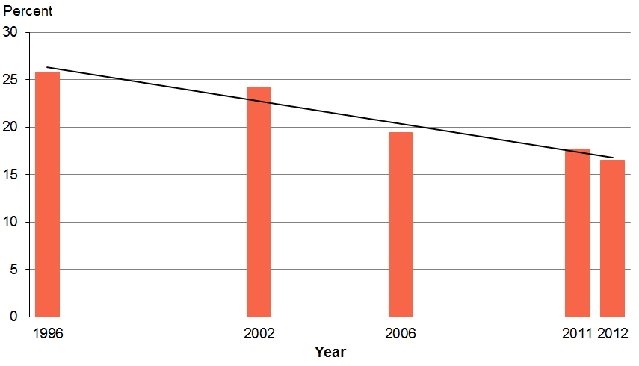
Sources: 1996 = 1996/97 New Zealand Health Survey (NZHS); 2002 = 2002/03 NZHS; 2006 = 2006/07 NZHS; 2011 = 2011/12 NZHS; 2012 = 2012/13 NZHS

Smoking rates are driven by both flow in and flow out
The decline in smoking prevalence reflects both decreasing smoking initiation, or ‘flow in’, and increasing successful quitting, or ‘flow out’. There has been a significant decrease in the rate of current smoking in 15- to 19-year-olds, from 20% in 2006 to 13% in 2012 (Figure 2). At the same time, there has been a significant increase in the prevalence of people who have successfully quit smoking, from 8% in 2006 to 11% in 2012.

Figure 2: Time trends of current smoking prevalence for 15- to 19-year-olds and prevalence of successful quitting between 2006 and 2012
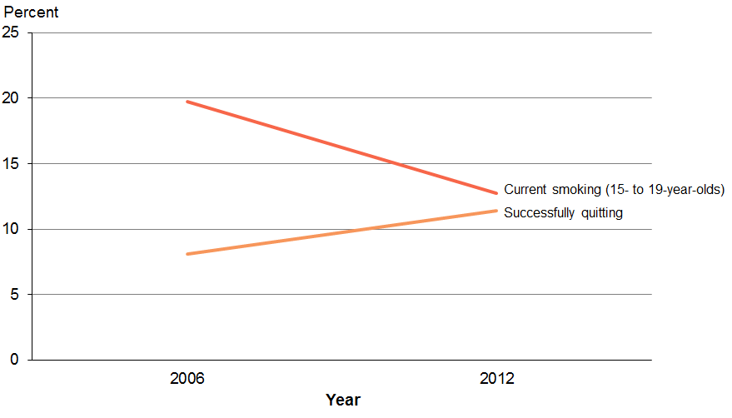
Sources: 2006 = 2006/07 NZHS; 2012 = 2012/13 NZHS

Flow in
The decline in current smoking prevalence among 15- to 19-year-olds has occurred at the same time as an increase in the average age of first use. The average age that current smokers over the age of 20 tried or smoked their first cigarette was 14.8 years. Only current smokers over the age of 20 have been considered in this analysis in order to capture smokers who started smoking later in their teens (eg, 16–19 years) compared with those who may have started earlier.

Comparison to the 2006/07 NZHS figures was not possible because of differences in questions asked. For this reason, comparison was made with figures from the bi-annual Youth Insights Survey (YIS) (2006, 2008, 2010 and 2012). The former Health Sponsorship Council’s (HSC’s) Youth Insights Survey is a national youth survey and includes topics relevant to New Zealand’s tobacco control sector. Respondents were Year 10 students mainly aged around 14 and 15 years.

The YIS findings show a slight delay in smoking initiation over the four years recorded, with an increase in the mean age of initiation from 11.3 to 11.6 years (J White, Health Promotion Agency, personal communication 20 March 2014).

The figure for age of initiation will be lower in the YIS than would be found for all young smokers (<20 years) as the average age of YIS respondents in 2012 was 14.1 years, and a number will first try a cigarette at an older age.

Flow out
Approximately 81,500 smokers (11%) successfully quit smoking in 2012/13. This number is calculated from the pool of recent quit attempters and current smokers from the beginning of the survey year.

Successful quitting has been defined in this report as those respondents who had quit smoking between a month and a year from when they participated in the survey, and had remained abstinent.

Are smoking rates declining for everyone?
Although there has been a general decline in the overall prevalence of smoking in recent years, the observed decline in smoking rates is not occurring at the same rate across all population groups, with some groups showing greater declines than others.

The only decline in smoking prevalence among ethnic groups occurred among European/Others
As shown in Table 1, the European/Other group showed a decline (18%) in smoking between 2006 and 2012, but other ethnic groups did not.

Table 1: Changes in current smoking prevalence by ethnicity between 2006 and 2012
Ethnic group | 2006  (%) | 2012  (%) | Relative percentage change (%)
Māori | 42 | 39 | -7
Pacific | 27 | 25 | -9
Asian | 11 | 10 | -10
European/Other | 19 | 15 | -18*
Sources: 2006 = 2006/07 NZHS; 2012 = 2012/13 NZHS
This table presents unadjusted prevalence results in 2006 and 2012.
* There is a statistically significant difference (p<0.05) between 2006 and 2012. The p-values have been adjusted for differences in the age structures of the underlying populations over time.

The greatest decline in smoking prevalence occurred among
15–to 19-year-olds
Between 2006 and 2012, the largest relative declines in current smoking prevalence occurred among 15- to 19-year-olds (36%) followed by those aged 65–74 years (27%) (Table 2). The third largest decline was recorded with smokers in the 25–34 years age group (13%).

Table 2: Changes in current smoking prevalence by age group between 2006 and 2012
Age group | 2006  (%) | 2012  (%) | Relative percentage change (%)
15–19 | 20 | 13 | -36*
20–24 | 27 | 25 | -7
25–34 | 28 | 24 | -13*
35–44 | 22 | 21 | -8
45–54 | 21 | 20 | -7
55–64 | 15 | 15 | -2
65–74 | 11 | 8 | -27*
75+ | 4 | 4 | 9
Sources: 2006 = 2006/07 NZHS; 2012 = 2012/13 NZHS
* There is a statistically significant difference (p<0.05) between 2006 and 2012.

Smoking declined in the middle neighbourhood deprivation groups
Adults living in the middle neighbourhood deprivation quintiles (2, 3 and 4) showed the biggest declines (22%, 17% and 17% respectively) in current smoking prevalence between 2006 and 2012 (Table 3).

Table 3: Changes in current smoking prevalence by neighbourhood deprivation between 2006 and 2012
Neighbourhood deprivation | 2006  (%) | 2012  (%) | Relative percentage change (%)
Quintile 1  (most deprived) | 11 | 11 | -2
Quintile 2 | 16 | 12 | -23*
Quintile 3 | 19 | 16 | -18*
Quintile 4 | 24 | 20 | -16*
Quintile 5  (least deprived) | 32 | 30 | -6
Sources: 2006 = 2006/07 NZHS; 2012 = 2012/13 NZHS
This table presents unadjusted prevalence results in 2006 and 2012.
* There is a statistically significant difference (p<0.05) between 2006 and 2012. The p-values have been adjusted for differences in the age structures of the underlying populations over time.

There were similar declines in smoking prevalence for males and females
Current smoking prevalence fell significantly by a similar amount for males and females (relative declines of 12% and 13% respectively) between 2006 and 2012 (Table 4). The proportion of females smoking in 2012 (16%) was significantly lower than the proportion of males smoking (19%).

Table 4: Changes in current smoking prevalence by sex between 2006 and 2012
Sex | 2006  (%) | 2012  (%) | Relative percentage change (%)
Male | 21 | 19 | -12*
Female | 19 | 16 | -13*
Sources: 2006 = 2006/07 NZHS; 2012 = 2012/13 NZHS
This table presents unadjusted prevalence results in 2006 and 2012.
*There is a statistically significant difference (p<0.05) between 2006 and 2012. The p-values have been adjusted for differences in the age structures of the underlying populations over time.

Summary
Since 1996, smoking prevalence rates declined steadily, and that decline continued between 2006 and 2012. The decline is likely to be driven by two things; a decline or delay in smoking initiation and an increase in smoking cessation.

Although smoking prevalence is declining across all deprivation groups, among both sexes and most age groups, these declines are not occurring at a fast enough speed to reach the aspirational goal of being a smokefree nation by the year 2025.

Section 2: Smoking profile in New Zealand

Who is smoking, what are they smoking and where are they purchasing their tobacco products?
Key findings
- One in six people smoked.
- Māori continued to have the highest rates of smoking among adults and youth.
- One in four smokers reported a diagnosed mental health condition(s).
- Four out of ten smokers had a drinking pattern that was considered potentially hazardous.
- Hazardous drinking patterns were higher in smokers than non-smokers.
- Younger adults were more likely to smoke roll-your-own cigarettes (RYOs), and older adults were more likely to smoke manufactured cigarettes.
- Almost half of all smokers purchased their tobacco products from dairies.

One in six people smoked, with more male smokers than females
Around one in six adults (18%) was a current smoker in 2012/13, including 16% who smoked daily. This is an estimated 554,000 daily smokers.

Smoking was most common among adults aged 20–34 years
The highest rates of smoking occurred in the 20–24 years age group for females and 25–34 years group for males, while the lowest rates were observed in those aged 75 and over (Figure 3). In most age groups, more males than females were current smokers. Current smoking prevalence increased with age for males until aged 25–34. From the age of 35, a steady decline was observed. From the age of 55, both male and female smoking prevalence declined at a similar rate.

Figure 3: Current smoking among the total population, by age group and sex
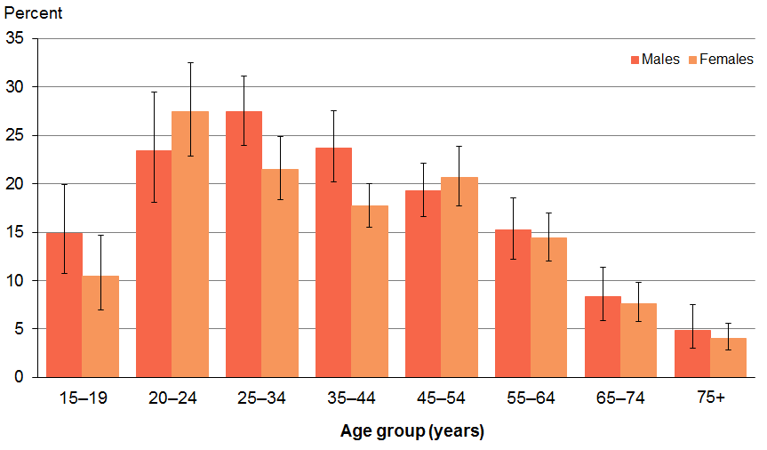
Source: 2012/13 NZHS

Smoking prevalence is declining for both males and females
Overall, the current age-standardised adult smoking prevalence rate fell from 21% in 2006 to 19% in 2012, with a significant decrease observed for both males and females during this period.

The highest smoking rates persist among Māori adults
As has been the case for many years, in 2012/13, Māori continued to have the highest rates of daily and current smoking (Table 5).

Around four in ten (39%) Māori adults were current smokers, and there were significantly more Māori female smokers (42%) than Māori male smokers (37%). Māori were 2.5 times more likely to be smokers than non-Māori after adjusting for age and sex differences (Table 6).

One in four Pacific adults (25%) was a current smoker. Pacific adults were 1.3 times more likely than non-Pacific adults to be smokers, after adjusting for age and sex.

One in ten Asians (10%) was a smoker, with significantly more Asian males than Asian females being smokers. Asians were half as likely as non-Asians to be smokers, after adjusting for age and sex differences.

Table 5: Current smoking among the total population aged 15 and above, by ethnic group and sex
Ethnic group | Males |  | Females |  | Total
 | Prevalence | Estimated number | Prevalence | Estimated number | Prevalence | Estimated number
Māori | 36 | 79,000 | 42 | 98,000 | 39 | 177,000
Pacific | 27 | 26,000 | 23 | 25,000 | 25 | 50,000
Asian | 16 | 33,000 | 4.3 | 8000 | 10 | 41,000
European/Other | 16 | 217,000 | 14 | 201,000 | 15 | 418,000
Source: 2012/13 NZHS

Table 6: Adjusted rate ratios for current smoking
Men versus women | 1.1*
Māori versus non-Māori | 2.5*
Pacific versus non-Pacific | 1.3*
Asian versus non-Asian | 0.5*
Most versus least deprived | 2.8*
Source: 2012/13 NZHS
* There is a statistically significant difference between the two groups.
Notes: The sex comparison is adjusted for age. Ethnic comparisons are adjusted for age and sex. Deprivation comparisons are adjusted for age, sex and ethnicity. Total response ethnicity has been used.

Smoking is more common in the most deprived neighbourhoods
There was a clear gradient seen in smoking prevalence by neighbourhood deprivation (Figure 4). Three in ten people living in the most deprived areas were smokers compared to one in ten people living in the least deprived areas. After adjusting for age, sex and ethnic group, people who lived in the most deprived areas were almost three times more likely to be smokers than people who lived in the least deprived areas (Table 6).

Figure 4: Current smoking among the total population, by neighbourhood deprivation (age-standardised)
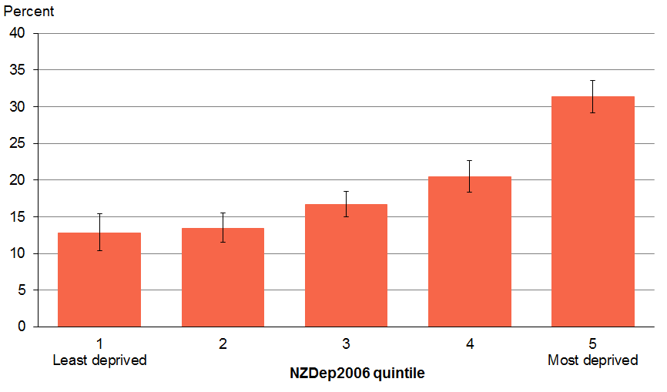
Source: 2012/13 NZHS

Profile of smokers
Table 7 shows a snapshot of what the smoking population looked like in 2012/13 compared with the non-smoking population. In general, smokers are more likely to be younger males of Māori descent living in the most deprived neighbourhood areas.

Table 7: Profile of smoking population compared with non-smoking population in New Zealand
 | Smokers | Non-smokers
Total estimated number | 626,000 | 2,897,000
Males (%) | 52 | 48
Females (%) | 48 | 52
Age distribution (%)  15–19 years  20–24 years  25–34 years  35–44 years  45–54 years  55–64 years  65–74 years  75+ years | 6  13  23  19  20  12  5  2 | 9  8  15  16  17  15  11  9
Mean age | 40 | 46
Ethnicity (%)  Māori  Pacific  Asian  European/Other | 28  8  7  67 | 9  5  12  78
Deprivation (%)  Quintile 1 (least deprived)  Quintile 2  Quintile 3  Quintile 4  Quintile 5 (most deprived) | 13  15  18  22  32 | 22  22  21  20  16
Source: 2012/13 NZHS
Note: Total response ethnicity has been used, so the total for all ethnic groups combined is 100%.

Smoking in youth

The youth smoking rate has fallen
Since 2006, there has been a significant decline in current smoking among young people aged 15–19 years, from 20% in 2006 to 13% in 2012/13. Although there was a significant decrease in young female smoking rates during this period (21% and 10% respectively), there was no significant change for their male counterparts (Figure 5).

One in ten (10%) young people aged 15–19 years was a daily smoker in 2012/13. There were no significant differences by sex for current or daily smoking.

Figure 5: Current smoking among young people aged 15–19 years, by sex, between 2006 and 2012
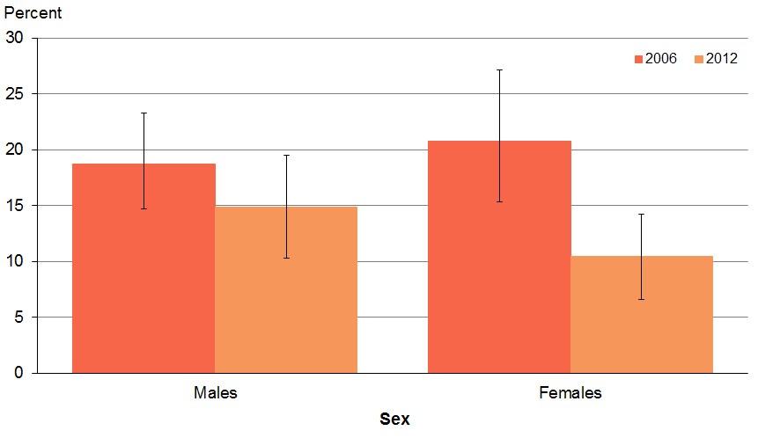
Source: 2006/07 NZHS, 2012/13 NZHS

Smoking is most common among Māori youth
Like their adult counterparts, Māori young people had the highest prevalence of current smoking (Table 8). One in four Māori (25%) aged 15–19 years was a smoker. After adjusting for age and sex differences, Māori young people were 2.5 times more likely than non-Māori to be smokers (Table 9).

Table 8: Current smoking in youth aged 15–19 years, by ethnic group, 2012
Ethnic group | Prevalence (%) | Estimated number
Māori | 25 | 15,000
Pacific | 11 | 3000
Asian | 6 | 3000
European/Other | 12 | 26,000
Source: 2012/13 NZHS
Note: Total response ethnicity has been used.

Smoking rates were highest in young people who lived in the most deprived neighbourhoods
Young people aged 15–19 years living in the most deprived areas were 6.1 times more likely than young people living in the least deprived areas to be smokers, after adjusting for age, sex and ethnicity differences (Table 9).

Table 9: Adjusted rate ratios for current smoking for young people aged 15–19 years
Men versus women | 1.4
Māori versus non-Māori | 2.5*
Pacific versus non-Pacific | 0.8
Asian versus non-Asian | 0.5
Most versus least deprived | 6.1*
Source: 2012/13 NZHS
* There is a statistically significant difference between the two groups.
Notes: The sex comparison is adjusted for age. Ethnic comparisons are adjusted for age and sex. Deprivation comparisons are adjusted for age, sex and ethnic group.

Mental health and hazardous alcohol consumption
There are well-established associations between smoking and poor mental health and smoking and excessive alcohol use. This section reports on these associations.

Smoking and mental health
Strong evidence exists that smoking increases stress, anxiety, the chances of developing depression, anxiety disorders and other mental illnesses, as well as increasing the risk of suicidal ideation and suicide related acts (Fergusson et al 2003; Breslau et al 2005; Zvolensky et al 2005; Morissette et al 2007; Ziedonis et al 2008; Cosci et al 2009).

In this report, diagnosed mental health conditions relates to those people who reported they have been told at some time in their life by a doctor that they had depression, bipolar disorder, anxiety disorder, an alcohol-related disorder or a drug-related disorder, which had lasted or was expected to last for more than six months. It must be noted that this is self-reported and not everyone with a particular condition will have had it diagnosed by a doctor.

Around one in four smokers reported one or more diagnosed mental health conditions
Almost one-quarter (24%) of current smokers reported one or more diagnosed mental health conditions compared with 15% of non-smokers. This higher rate of mental health conditions among smokers was evident at all ages except over 75 years (Figure 6).

The prevalence of smokers reporting diagnosed mental health conditions increased with age, peaking in the 35–44 and 45–54 year age groups (31% and 29% respectively) (Figure 6). These rates then declined, with the lowest rates of mental health conditions reported in those aged 75 years and over (8%).

Figure 6: Current smokers reporting diagnosed mental health conditions versus non-smokers reporting diagnosed mental health conditions, by age group
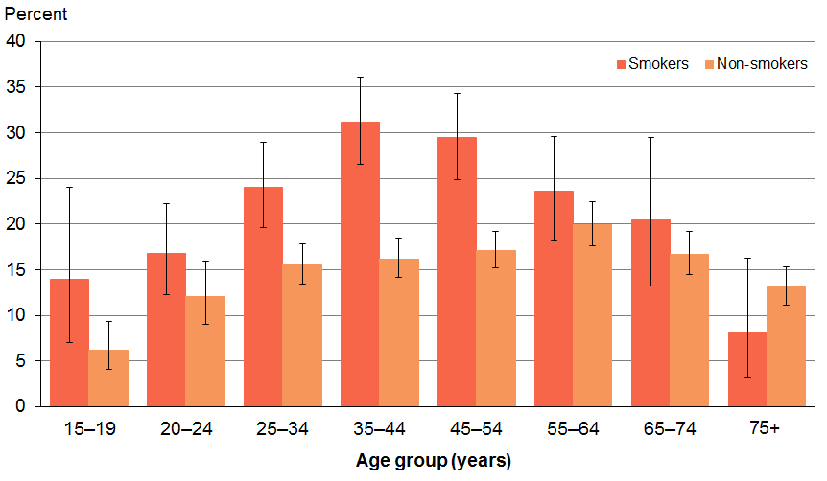
Source: 2012/13 NZHS

European/Other smokers showed a greater excess prevalence of mental health conditions
Almost one-third (30%) of smokers of European/Others ethnicity reported a diagnosed mental health condition(s) (Table 10). One in five Māori smokers (21%) had diagnosed mental health conditions. After adjusting for age, sex and deprivation differences, Māori smokers were shown to be 1.3 times more likely to have a mental health condition compared with Māori non-smokers (Table 11).

Although fewer Pacific smokers (11%) reported having been diagnosed with a mental health condition, they were almost 3 times more likely than Pacific non-smokers to have reported having a diagnosed mental health condition(s) (Table 11). The prevalence of diagnosed mental health conditions however, might not be an accurate measure of mental illness among the Pacific populations. Te Rau Hinengaro, the New Zealand Mental Health Survey, showed that Pacific people had high prevalence rates of mental disorders compared to the general population (Oakley Browne et al 2006). It also showed that Pacific people who had serious mental disorders were less likely to access treatment.

The NZHS 2012/13 results showed the Kessler 10-item Psychological Distress Scale (K10), which is a self-reporting instrument, as a better measure of mental illness among the Pacific group. The K10 measures non-specific psychological (mental) distress in the population and is strongly correlated with having an anxiety or depressive disorder.

The NZHS 2012/13 results reported the Pacific populations as showing a 4% prevalence of diagnosed common mental disorders. However, the K10 measure of psychological distress among Pacific peoples showed a prevalence of 9%.

Table 10: Prevalence of diagnosed mental health conditions among smokers and non-smokers, by ethnicity
Ethnic group | Smokers (%) | Non-smokers (%)
Māori | 21 | 15
Pacific | 11 | 3
Asian | 8 | 6
European/Other | 30 | 18
Source: 2012/13 NZHS
Note: Total response ethnicity has been used.

Table 11: Comparisons of prevalence of mental health conditions among smokers and non-smokers, by sex, ethnicity and neighbourhood deprivation
 | Adjusted rate ratio | Adjusted variables
Sex  Male smokers vs male non-smokers  Female smokers vs female non-smokers | 1.6*  1.5* | Age, ethnicity, deprivation
Ethnicity (%)  Māori smokers vs Māori non-smokers  Pacific smokers vs Pacific non-smokers  Asian smokers vs Asian non-smokers | 1.3*  2.8*  1.7 | Age, sex, deprivation
Deprivation (%)  Q1 smokers vs Q1 non-smokers  Q2 smokers vs Q2 non-smokers  Q3 smokers vs Q3 non-smokers  Q4 smokers vs Q4 non-smokers  Q5 smokers vs Q5 non-smokers | 1.6*  1.7*  1.2  1.6*  1.5* | Age, sex, ethnicity
Source: 2012/13 NZHS
* Statistically significant rate ratio
Note: Total response ethnicity has been used.

Smokers were more likely to have reported diagnosed mental health conditions regardless of levels of deprivation
In all neighbourhood deprivation groups, smokers were more likely to have reported diagnosed mental health conditions compared to non-smokers (Figure 7). After adjusting for age, sex and ethnic group differences, smokers living in the least deprived areas (quintiles 1 and 2) were 1.6 and 1.7 times respectively, more likely than non-smokers living in the same areas to report having diagnosed mental health conditions (Table 11). Similarly, smokers in the most deprived areas (quintiles 4 and 5) were 1.6 and 1.5 times respectively more likely to have reported diagnosed mental health conditions than non-smokers living in the same areas.

Figure 7: Prevalence of diagnosed mental health conditions by neighbourhood deprivation, smokers compared to non-smokers (age-standardised)
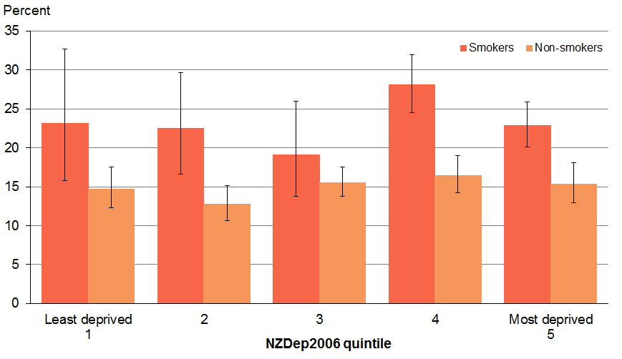
Source: 2012/13 NZHS

Smoking and hazardous alcohol consumption
Not only is there a well-established relationship between smoking and alcohol consumption, but higher levels of alcohol use are associated with higher levels of smoking (Sorlie and Kannel 1990; Anthony and Echeagaray-Wagner 2000; Dawson 2000; Chiolero et al 2006; Falk et al 2006; Kahler et al 2008; Kypri et al 2002; Bramley et al 2006; Wilson et al 2012) and lower rates of quitting (Augustson et al 2008; Hymowitz et al 1997; Osler et al 1999; Dollar et al 2009).

In this report, potentially hazardous drinking is measured using the international definition being an AUDIT score of eight or more. It is important to note that since men and women have been assigned the same minimum starting point on the score, this may underestimate hazardous drinking in women, who generally have lower alcohol tolerance than men (Alcohol Advisory Council of New Zealand 2008).

Four out of ten smokers had a drinking pattern that was considered potentially hazardous
All smokers had drunk an alcoholic drink in the past 12 months. Of these, four out of ten smokers (40%) had a potentially hazardous drinking pattern compared with 14% of non-smokers.

Hazardous drinking rates were higher in smokers than non-smokers across all age groups
The proportion of current smokers who had drunk alcohol in the last year with a potentially hazardous drinking pattern was markedly more than non-smokers across all age groups (Figure 8).

Hazardous drinking rates were highest in the younger age groups (15–34 years) with over half in each of these age groups having a hazardous drinking pattern. The proportion of smokers with potentially hazardous drinking patterns declined markedly with age.

Figure 8: Hazardous drinking among current smokers and non-smokers who had had an alcoholic drink in the past year, by age group
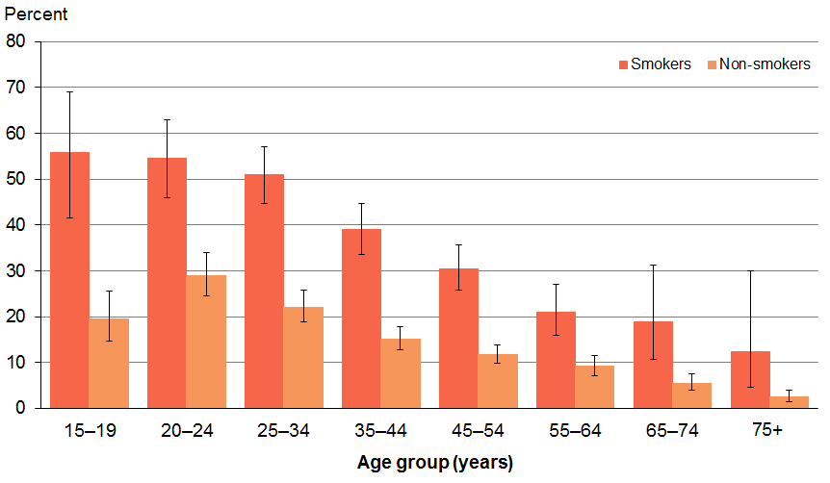
Source: 2012/13 NZHS

Hazardous drinking patterns were higher in smokers than non-smokers in all ethnic groups
Table 12 shows that the proportion of current smokers who had drunk alcohol in the last year with a potentially hazardous drinking pattern was markedly more than non-smokers in all ethnic groups.

Just over half of Māori (53%) and Pacific (54%) smokers who had drunk in the past 12 months had a potentially hazardous drinking pattern (Table 12). After adjusting for age and sex differences, Māori smokers were 1.7 times more likely to have a potentially hazardous drinking pattern than Māori non-smokers (Table 13).

Table 12: Prevalence of hazardous drinking among smokers and non-smokers who had had a drink in the past year, by ethnicity
Ethnic group | Smokers (%) | Non-smokers (%)
Māori | 53 | 27
Pacific | 54 | 21
Asian | 19 | 7
European/Other | 38 | 14
Source: 2012/13 NZHS
Note: Total response ethnicity has been used.

Hazardous drinking patterns were higher in smokers than non-smokers regardless of deprivation levels
The proportion of current smokers who had drunk alcohol in the last year with a potentially hazardous drinking pattern was markedly more than the proportion of non-smokers across all neighbourhood deprivation quintiles (Figure 9). After adjusting for age, sex and ethnicity differences, smokers who had drunk alcohol in the last year and lived in quintiles 2–5, were between 1.9 and 2.2 times more likely to have a potentially hazardous drinking pattern than non-smokers who lived in the same areas (Table 13).

Figure 9: Hazardous drinking among current smokers and non-smokers who had had an alcoholic drink in the past year, by neighbourhood deprivation (age-standardised)
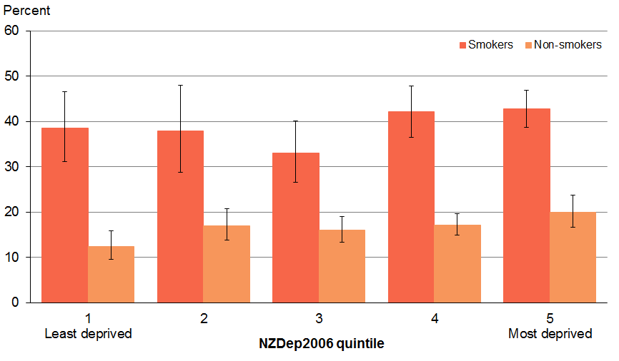
Source: 2012/13 NZHS

Table 13: Comparisons of prevalence of hazardous drinking among smokers and non-smokers, by sex, ethnicity and neighbourhood deprivation
 | Unadjusted rate ratio | Adjusted rate ratio | Adjusted variables
Sex  Male smokers vs male non-smokers  Female smokers vs female non-smokers | 2.4*  4.0* | 1.9*  2.6* | Age, ethnicity, deprivation
Ethnicity (%)  Māori smokers vs Māori non-smokers  Pacific smokers vs Pacific non-smokers  Asian smokers vs Asian non-smokers | 1.9*  2.5*  2.8* | 1.7*  2.5  2.6 | Age, sex, deprivation
Deprivation (%)  Q1 smokers vs Q1 non-smokers  Q2 smokers vs Q2 non-smokers  Q3 smokers vs Q3 non-smokers  Q4 smokers vs Q4 non-smokers  Q5 smokers vs Q5 non-smokers | 3.1*  3.1*  2.5*  2.6*  2.4* | 2.3  2.2*  2.0  2.2*  1.9* | Age, sex, ethnicity
Source: 2012/13 NZHS
* Statistically significant rate ratio
Note: Total response ethnicity has been used.

What are smokers smoking?
This section looks at the most commonly smoked types of cigarettes or tobacco products in New Zealand. In the survey, smokers were asked which tobacco products they smoked the most.

Most smokers (45%) smoke mainly manufactured cigarettes; 42% primarily smoked roll-your-own (RYOs); and the balance (13%) smoked a combination of RYOs and manufactured cigarettes.

Few smokers reported using e-cigarettes
Very few smokers reported using e-cigarettes, with only nine participants aged 15 years and over stating they had ever used e-cigarettes. Due to these small numbers, this report cannot make any meaningful analysis of e-cigarette use.

Younger adults were more likely to smoke RYOs and older adults were more likely to smoke manufactured cigarettes
The prevalence of smoking roll-your-own cigarettes (RYOs) was higher in younger than older age groups, with the rate peaking at 47% in the 35–44 years age group (Figure 10). From age 45 onwards, RYO consumption declined so that by the age of 75 years and above, only 24% preferred RYO cigarettes.

Conversely, from age 15 years and throughout the lifespan, the rate of consumption of manufactured cigarettes steadily increased with age, so that by 75 years, 70% of smokers were most likely to smoke manufactured cigarettes.

Young people aged 15–19 years were the most likely to smoke a combination of both RYOs and manufactured cigarettes (41%). This preference of smoking both RYOs and manufactured cigarettes declined from age 20–24 years, with people aged 75 years and over being the least likely to smoke both (5%).

Figure 10: Roll-your-own, manufactured and both roll-your-own and manufactured cigarette consumption, among current smokers, by age group
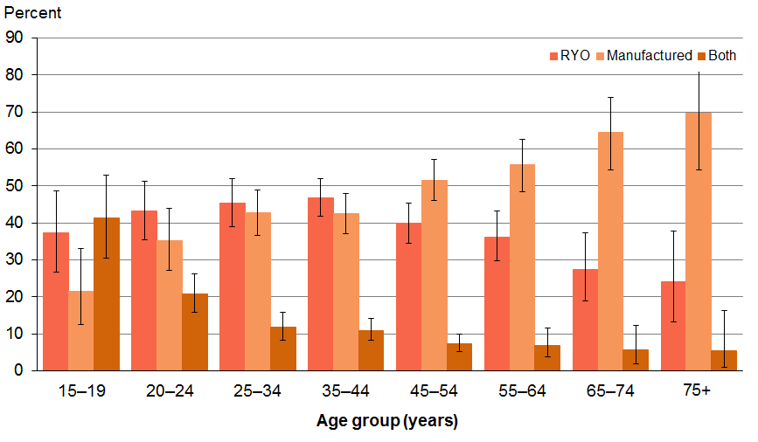
Source: 2012/13 NZHS

Māori smokers were more likely to smoke RYOs
One in two (53%) Māori and four in ten (42%) Europeans/Others smokers mostly smoked RYO cigarettes (Figure 11). After adjusting for age and sex differences, Māori smokers were 1.4 times more likely to smoke RYO cigarettes than non-Māori smokers (Table 14).

One in five (21%) Pacific smokers and one in six (15%) Asian smokers mostly smoked RYO cigarettes. Pacific and Asian smokers were less likely than non-Pacific and non-Asian smokers respectively to smoke RYO cigarettes, after adjusting for age and sex differences (Table 14).

Asian and Pacific smokers were more likely to smoke manufactured cigarettes
Three-quarters (73%) of Asian smokers smoked manufactured cigarettes (Figure 11). After adjusting for age and sex differences, Asian adults were almost twice as likely than non-Asian adults to mostly smoke manufactured cigarettes (Table 14).

Two-thirds (65%) of Pacific smokers smoked manufactured cigarettes (Figure 11). Pacific smokers were 1.6 times more likely than non-Pacific smokers to smoke manufactured cigarettes, after adjusting for age and sex differences (Table 14).

Less than half (45%) of European/Other and less than a third (28%) of Māori smokers smoked manufactured cigarettes. After adjusting for age and sex, Māori smokers were less likely to smoke manufactured cigarettes than non-Māori smokers.

Figure 11: Consumption of ‘mostly RYO’, ‘mostly manufactured’ and ‘mostly both RYO and manufactured cigarettes’ among current smokers, by ethnic group
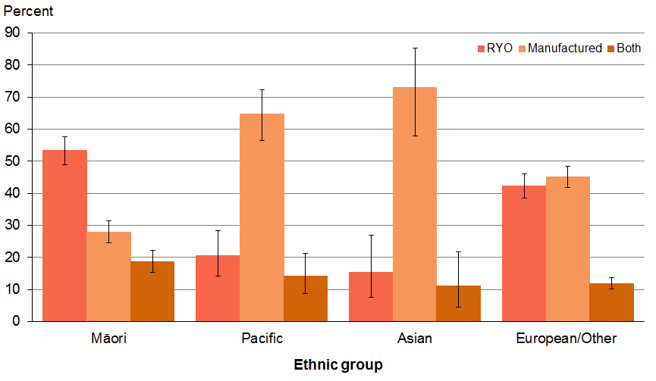
Source: 2012/13 NZHS
Note: Total response ethnicity has been used.

Table 14: Adjusted rate ratios for ‘mostly RYO’ and ‘mostly manufactured cigarette’ consumption
 | Mostly RYO | Mostly manufactured
Sex  Men vs women | 1.0 | 1.0
Ethnicity (%)  Māori vs non-Māori  Pacific vs non-Pacific  Asian vs non-Asian | 1.4*  0.4*  0.3* | 0.6*  1.6*  1.7*
Deprivation (%)  Most versus least deprived | 1.4* | 0.7*
Source: 2012/13 NZHS
* Statistically significant rate ratio
Notes: The sex comparison is adjusted for age. Ethnic comparisons are adjusted for age and sex. Deprivation comparisons are adjusted for age, sex and ethnic group.

There was no significant change in the type of cigarettes smoked between 2006 and 2012/13, for all age groups.

Smokers living in the most deprived areas were more likely to smoke RYO cigarettes
Smokers living in the most deprived areas were 1.4 times more likely than those living in the least deprived areas to smoke RYO cigarettes, after adjusting for age, sex and ethnic group differences (Table 14).

Where are smokers purchasing their tobacco/cigarettes?
In New Zealand smokers are able to purchase tobacco products from a range of outlets 24 hours a day, seven days a week. The NZHS asked smokers where they bought their current pack of cigarettes.

Most tobacco products are purchased from dairies (and other shops)
There is a clear preference for where adult smokers (aged over 20 years) choose to purchase their cigarettes, with almost half of smokers (48%) purchasing their cigarettes or tobacco from dairies (and other shops) (Figure 12). Almost a quarter (23%) of smokers purchased their cigarettes from a supermarket followed by 19% purchasing from a petrol station. A very low proportion (2.3%) of smokers purchased tobacco products from duty-free shops. There was no reported purchase of a smoker’s current pack of cigarettes by mail order or internet.

Men purchase tobacco products from petrol stations and women from supermarkets
After adjusting for age, male smokers were significantly more likely than female smokers to purchase cigarettes or tobacco from a petrol station, whereas females were significantly more likely than males to purchase tobacco products from a supermarket. Regardless of sex, smokers were most likely to purchase their tobacco products from a dairy (or other shop).

Figure 12: Places of purchase of the current packet of cigarettes or pouch of tobacco by current smokers aged 20 and above, by sex (age-standardised prevalence)
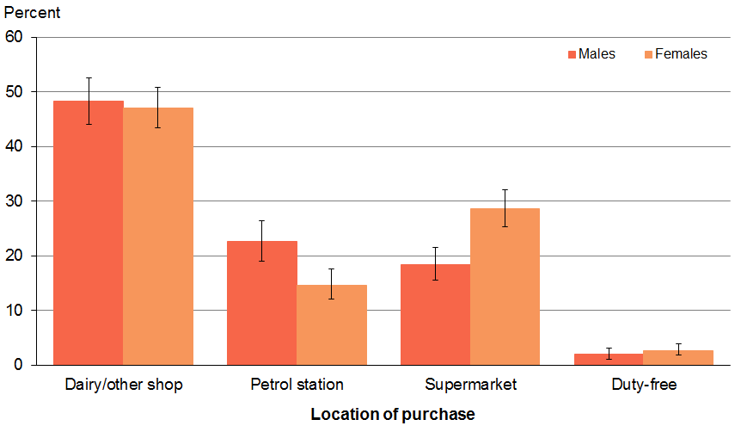
Source: 2012/13 New Zealand Health Survey

Tobacco access in young people
The 1997 amendment to the Smoke-free Environments Act 1990 prohibits the sale of cigarettes or other tobacco products to people under the age of 18 years in New Zealand. While it is not illegal for people under 18 to smoke, it is illegal for retailers to sell tobacco products to people younger than 18 years.

One in six smokers aged 15–17 years purchased their own tobacco products
Just over half (53%) of smokers aged younger than 20 years purchased the cigarettes they were smoking, over one-quarter (27%) obtained them from their family, and one-tenth (11%) obtained them from their friends. Despite it being illegal to sell cigarettes or other tobacco products to people under 18 years old, just over 15% of smokers aged 15–17 years reported buying their current smoking products (Figure 13). This equates to around 2000 young people.

Figure 13: Source of cigarettes/tobacco products currently smoked, current smokers aged under 20 years
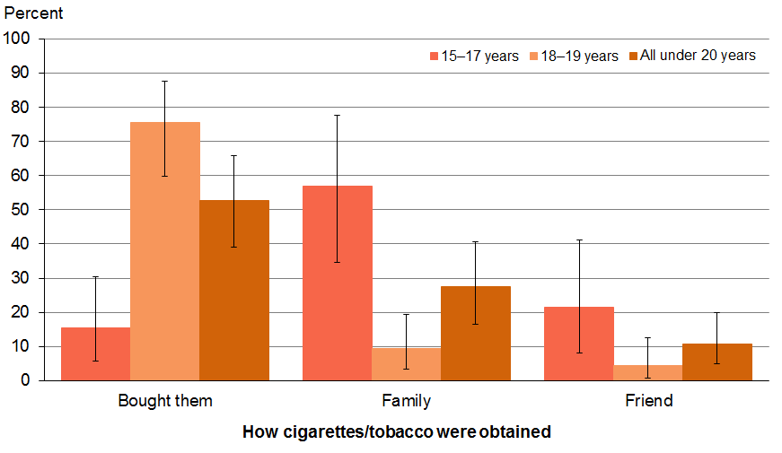
Source: 2012/13 NZHS

Most 15–17 year olds get their tobacco from family
Almost eight out of ten 18–19 year olds (76%) purchased their own packet of cigarettes or pouch of tobacco (Figure 13). 15–17 year olds (57%) were more likely than 18–19 year olds (9%) to get their cigarettes or tobacco from their family.

Most young smokers purchased their tobacco products in dairies or other shops
The most common place where smokers younger than 20 years purchased their own cigarettes/tobacco products was from a dairy or shop (58%) (Figure 14). Almost one-third (28%) purchased them from a petrol station and one-tenth (11%) from a supermarket. This equates to an estimated 12,000, 6,000 and 2,000 young people respectively.

Figure 14: Place of purchase of the current packet of cigarettes/tobacco products, current smokers aged 20 years and under
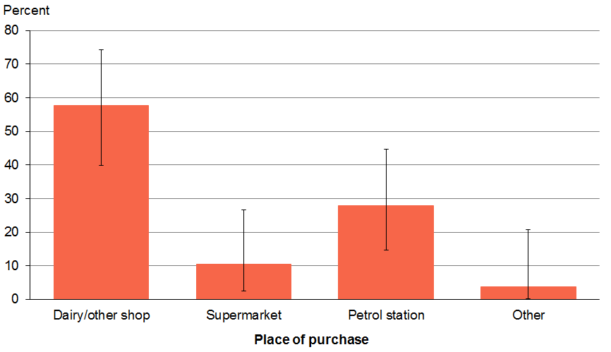
Source: 2012/13 NZHS

Section 3: Initiation and uptake

What is the mean age of smoking initiation and smoking uptake, and how is this changing over time?
Key findings
- The mean age of smoking initiation was 14.8 years.
- Māori had the earliest mean age of initiation at 14.1 years.
- The mean age of smoking uptake was 17.7 years.
- Pacific smokers had the shortest time lag between initiation and uptake, of 2.7 years.

This section looks at the average age that current smokers over the age of 20 tried their first cigarette (smoking initiation) and the average age at which they started smoking daily (smoking uptake). Only current smokers over the age of 20 have been considered in this analysis in order to capture smokers who started smoking later in their teens (eg, 16–19 years) compared with those who may have started earlier.

Māori had the earliest average age of smoking initiation
The average age that current smokers aged over 20 smoked their first puff or their first entire cigarette (smoking initiation) was 14.8 years.

There were significant differences in smoking initiation across ethnic groups, with Māori having the earliest average age of initiation, at 14.1 years, and Asian smokers having the latest onset of initiation at 18.4 years (Table 15).

Asian smokers were the slowest to take up daily smoking
The average age when smokers started smoking daily was 17.7 years, but this varied by ethnic group (Table 15). Pacific smokers had a later onset of initiation but had the shortest time period between initiation and uptake compared with smokers of other ethnicities (2.7 years). Not only did Asian smokers delay initiation longer than any other ethnic group, they also had the longest delay in progressing to daily smoking (3.7 years).

Table 15: Mean age of smoking initiation and mean age of smoking uptake of current smokers over the age of 20, by ethnic group (age standardised)
Ethnic group | Mean age of initiation  (years) | Mean age of uptake  (years) | Difference  (years)
Māori | 14.1 | 17.1 | 3.0
Pacific | 16.6 | 19.3 | 2.7
Asian | 18.4 | 22.1 | 3.7
European/Other | 14.5 | 17.5 | 3.0
Source: 2012/13 NZHS

How is smoking initiation and uptake changing over time?

Later initiation rates are confirmed by the Youth Insights Survey
Table 16 and Figure 15 report the results from the Year 10 YIS for 2006–2012. A statistically significant increase in the mean age of smoking initiation was reported over this period from 11.3 to 11.6 years (Table 16). While the mean age of initiation was 11.6 years in 2012, the most common age of first trying a cigarette was 13 years with the next most frequent ages of initiation being 12 and 14 years (Figure 15). No change in this pattern was observed over the 2006–2012 period.

Table 16: Mean age of smoking initiation of Year 10 students from 2006 to 2012
Year | Mean age (years)
2006 | 11.3
2008 | 11.4
2010 | 11.6
2012 | 11.6
Source: Youth Insights Survey 2006, 2008, 2010, 2012.

Figure 15: Distribution of age of smoking initiation for Year 10 students, 2012
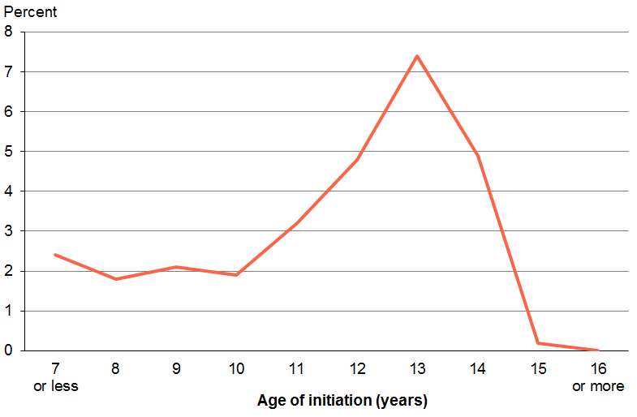
Source: Youth Insights Survey 2012

Section 4: Smoking cessation

Quitting: who, why and how?
Key findings
- The majority of smokers quit smoking for some period in the past year.
- Health concern was the most common reason given for quit attempts.
- Half of smokers who made a quit attempt had used some type of advice or product.
- Nicotine replacement therapy (NRT) was the most used cessation aid.
- Māori smokers were the highest users of NRT among ethnic groups during a recent quit attempt.
- Over half (56%) of smokers who saw a GP in the last year received Brief cessation advice.
- Two-thirds of smokers admitted to a public hospital received Brief cessation advice from a health care professional.

Quitting smoking has immediate health benefits: it reduces the risk of smoking related disease and improves general health and wellbeing (US Department of Health and Human Services 2006).

This section presents results about the smoking cessation behaviour of smokers, including quit attempts as well as reasons for quitting.

Successful quitting
Successful quitting has been defined in this report as respondents who had quit smoking between a month and a year from when they participated in the survey and had remained abstinent.

Approximately 81,500 smokers (11%) successfully quit smoking, according to this definition, in 2012/13.

Successful quitting was more likely to occur among 20–24 year olds and 65–74 year olds (Figure 16). Conversely, people at either end of the age spectrum (15–19 and 75+ year olds) were the least likely to successfully quit smoking.

Figure 16: Successful quitting by age group, 2012/13
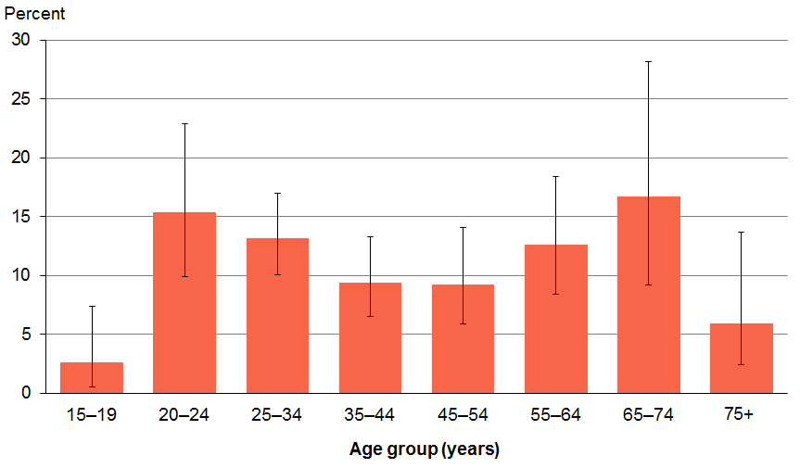
Source: 2012/13 NZHS

Time-trend analysis showed an increase in the prevalence of people who had successfully quit smoking, from 8% in 2006 to 11% in 2012/13.

Which smokers are quitting?
Current smokers and ex-smokers who had quit smoking within the previous 12 months were asked a series of questions, including: whether they had considered quitting smoking, tried to quit and/or made a quit attempt and how long they had been smokefree.

The majority of smokers quit for some period in the past 12 months. Almost 64% of current smokers had quit smoking between 24 hours and one week in the past 12 months. There were no significant differences between age groups in the smokers who had quit smoking for at least 24 hours across all age groups.

Almost six out of ten smokers (58%) had quit smoking for at least a week in the past 12 months. Males (62%) were significantly more likely than females (54%) to have quit for at least a week, after adjusting for age differences.

Why are smokers quitting?

Concern for their own health was the most common reason for smokers making a quit attempt
When asked to state the most common reason for making a quit attempt, over two-thirds (69%) of both male and female recent quit attempters responded ‘for their own health’ (Figure 17). This was a prompted question, and multiple responses were possible. After the age of 65, the cost of smoking (‘too expensive’) was a more common reason given for attempting to quit. Although the cost of smoking was the second most common reason given, regardless of sex, fewer than 40% of respondents identified this as a main reason. The least common reason given for quitting was ‘pregnancy’, with less than 10% of females and 1% of males identifying this as a significant reason for quitting smoking.

After adjusting for age and regardless of neighbourhood deprivation, the three most common reasons identified for making a quit attempt were: ‘for own health’, ‘too expensive’ and ‘sick of smoking’. Regardless of ethnicity the reasons for attempting to quit were the same.

Figure 17: Reasons for most recent quit attempt, among recent quit attempters
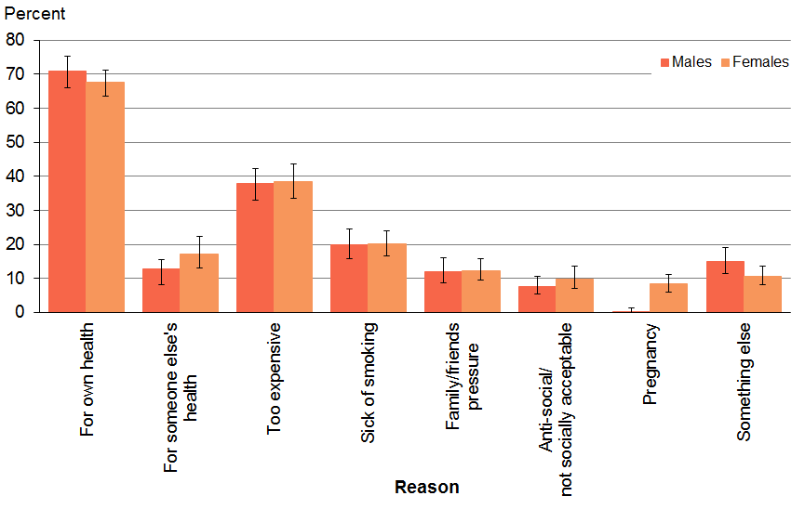
Source: 2012/13 NZHS
Note: Recent quit attempters were able to give multiple reasons for their most recent quit attempt, and so may be included in more than one category.

How are smokers quitting?
In 2012/13, over half of recent quit attempters (55%) reduced the number of cigarettes they smoked per day as a strategy to quit smoking. While many smokers make a quit attempt by ‘going cold turkey’ (unaided cessation) and smoking reduction, there are a number of products and services available in New Zealand to help people quit smoking.

What are smokers using to help them quit?
In the 2012/13 NZHS, recent quit attempters were asked to identify any help, advice, programmes or products they used to help them quit during their most recent quit attempt. They were able to select multiple responses, which were grouped into the following categories:
- Quitline or Aukati KaiPaipa
- general practitioner (GP)
- Māori community health worker
- other health care worker
- friend or family member
- school counsellor
- nicotine replacement therapy (NRT, nicotine patches, nicotine gum, nicotine Micro tab, nicotine lozenges, nicotine inhalers)
- other medicinal therapy (other lozenges, Zyban and Champix)
- e-cigarettes containing nicotine
- e-cigarettes without nicotine
- something else (another stop-smoking programme, the internet, a self-help book, some other product not mentioned elsewhere).

Half of the smokers who had tried to quit smoking had used some type of advice or product to aid their attempt
One in two (49%) recent quit attempters used some type of quitting product or advice to assist them in their most recent quit attempt. A ‘Recent quit attempter’ refers to a smoker who has made a quit attempt in the past 12 months. Females (54%) were more likely than males (46%) to have used quitting products or advice in their most recent quit attempt.

The use of quitting aids or advice steadily increased with age, from 27% for 15–19 year olds up to 72% for those aged 65–74 years (Figure 18).

Figure 18: Proportion of recent quit attempters using quitting products or advice in their most recent quit attempt, by age group
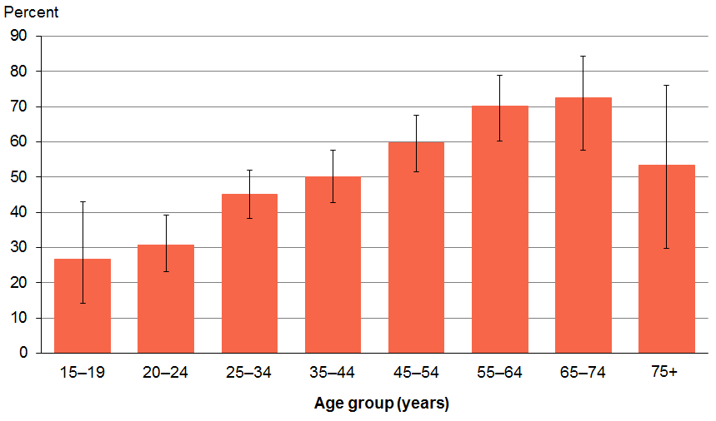
Source: 2012/13 NZHS

Over half of all Māori smokers who had made a quit attempt used some type of quitting product or advice
Table 17 shows the proportion of recent quit attempters who used quitting products or advice in their most recent quit attempt, by ethnic group. At least half of Māori and European/Other recent quit attempters (52% and 51% respectively) used quitting products or advice in their most recent quit attempt. In comparison, only one in three Pacific (35%) and Asian (35%) recent quit attempters used quitting products or advice when they last attempted to quit smoking.

After adjusting for age and sex differences, Māori recent quit attempters were 1.2 times more likely than non-Māori to have used a quitting product or advice in their most recent quit attempt (Table 18). Conversely Pacific recent quit attempters were less likely to have used a quitting product or advice when they last attempted to quit than non-Pacific after adjusting for age and sex differences.

Table 17: Used quitting products or advice in most recent quit attempt, among recent quit attempters, by ethnic group
Ethnic group | Prevalence (%) | Estimated number
Māori | 52 | 48,000
Pacific | 35 | 11,000
Asian | 35 | 10,000
European/Other | 51 | 133,000
Source: 2012/13 New Zealand Health Survey
Note: Total response ethnicity has been used.

Table 18: Adjusted rate ratios for using quitting products or advice in the most recent quit attempt
Men versus women | 0.9*
Māori versus non-Māori | 1.2*
Pacific versus non-Pacific | 0.8*
Asian versus non-Asian | 0.7
Most versus least deprived | 1.1
Source: 2012/13 NZHS
* There is a statistically significant difference between the two groups.
Notes: The sex comparison is adjusted for age. Ethnic comparisons are adjusted for age and sex. Deprivation comparisons are adjusted for age, sex and ethnic group.

Medicinal therapy was the most commonly used quitting aid in a recent quit attempt
Medicinal therapy was the most common quitting product or service used by recent quit attempters, with NRT being the most used cessation aid (25%) (Figure 19). The next most common was some other medicinal therapy, such as Champix or Zyban (18%). Of the non-pharmaceutical aids, 15% received help from their GP and almost 12% from a service such as the Quitline or Aukati KaiPaipa.

Figure 19: Proportion of recent quit attempters using cessation help in their most recent quit attempt, by services used
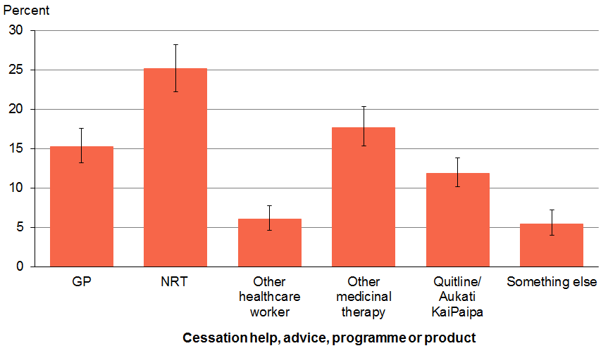
Source: 2012/13 NZHS
Note: Recent quit attempters were able to select multiple advice, programmes and products used in their most recent quit attempt. Therefore, they may be included in more than one category. For example, many Quitline users will also use NRT sourced from the Quitline in a quit attempt.

One in five young smokers used nicotine replacement therapy to aid their quit attempt
Nicotine replacement therapy (NRT) has been used in New Zealand for over two decades. NRT comes in a number of forms and controls nicotine addiction and severity of nicotine withdrawal symptoms by replacing some of the nicotine a smoker usually gets from cigarettes. It is a safe and effective treatment that doubles the chances of long-term quitting success (The Quit Group 2009).

The use of NRT to aid cessation was not restricted to the older smokers who were more than likely to have been smoking for some time. Almost one in five (19%) more novice smokers
(15–19 years) reported using NRT during their most recent quit attempt (Figure 20).

Figure 20: Proportion of recent quit attempters who used NRT during their most recent quit attempt, by age group
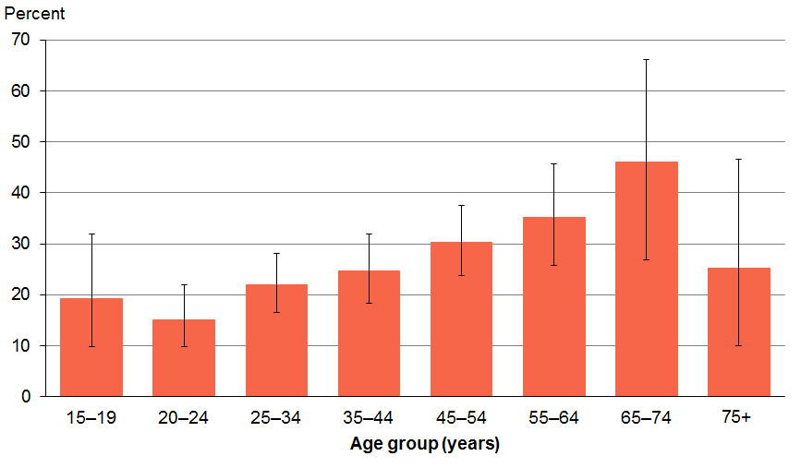
Source: 2012/13 NZHS

Māori smokers were the highest users of nicotine replacement therapy
Table 19 shows that among all ethnic groups, Māori made up the largest proportion (29%) of recent quit attempters who reported using NRT during their most recent quit attempt. Close behind were European/Other (25%) and Pacific (23%) recent quit attempters, while Asian smokers had the lowest rate of use of NRT (15%).

Māori were 1.3 times more likely than non-Māori recent quit attempters to have used NRT, after adjusting for age and sex differences (Table 20).

Table 19: Use of NRT during most recent quit attempt, among recent quit attempters, by ethnic group
Ethnic group | Prevalence (%) | Estimated number
Māori | 29 | 27,000
Pacific | 23 | 7000
Asian | 15 | 4000
European/Other | 25 | 65,000
Source: 2012/13 New Zealand Health Survey
Note: Total response ethnicity has been used.

Table 20: Adjusted rate ratios for the use of NRT in most recent quit attempt among most recent quit attempters
Men versus women | 1.0
Māori versus non-Māori | 1.3*
Pacific versus non-Pacific | 1.0
Asian versus non-Asian | 0.6
Most versus least deprived | 1.2
Source: 2012/13 NZHS
* There is a statistically significant difference between the two groups.
Notes: The sex comparison is adjusted for age. Ethnic comparisons are adjusted for age and sex. Deprivation comparisons are adjusted for age, sex and ethnic group.

Sources of nicotine replacement therapy
A nationally subsidised NRT scheme was introduced in New Zealand in 2000, aiming to support smokers to stop smoking by providing access to low-cost nicotine patches or gum. Over the following 10 years, access has improved so that, by 2009, subsidised NRT was distributed via Quitcards provided by health care professionals who have prescribing rights, including GPs, midwives, dentists, optometrists and nurse practitioners. Smokers are also able to purchase selected NRT products without a Quitcard at full price from retail outlets, including supermarkets and pharmacies.

In the survey, respondents were asked where they got their NRT from and whether it was subsidised or not.

Most smokers received subsidised nicotine replacement therapy via a Quitcard
Of those smokers who had used NRT in their most recent quit attempt, the majority (59%) received subsidised NRT via a Quitcard, while just over 20% purchased it over the counter at full price.

Less than half (44%) of smokers who had used NRT received their prescription or Quitcard from their GP, one-third (34%) received it from the Quitline and nearly 17% from somewhere else other than a hospital doctor or pharmacy (Figure 21). Of the 20% of recent quit attempters who purchased non-subsidised NRT, 16% bought it from a pharmacy, and 3.4% from a supermarket. Very few smokers (less than 5%) who had used NRT received it from a Māori community health worker, supermarket or a midwife.

Figure 21: Source of NRT, among recent quit attempters who used NRT in their most recent quit attempt
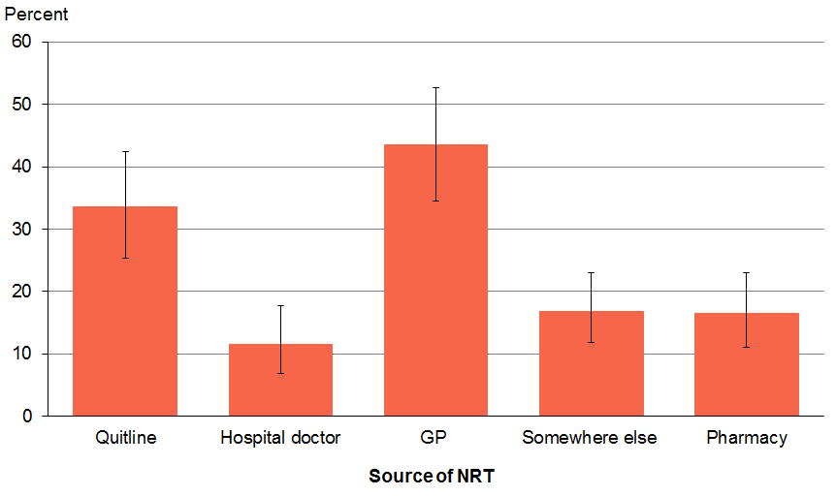
Source: 2012/13 NZHS
Notes: Recent quit attempters were able to select more than one subsidised source of NRT.

Health targets and use of the ABC pathway
In 2009, the Ministry of Health implemented the ‘Better help for smokers to quit’ health target aiming for 80% of hospitalised smokers would be provided with advice and help to quit (Ministry of Health 2009). The current 2012/13 health target has increased as it aims for 95% of hospitalised patients who smoke and are seen by a health care practitioner in public hospitals and 90% of enrolled patients who smoke and are seen by a health practitioner in general practice to be offered brief advice and support to quit smoking (Ministry of Health 2013). The target also includes progress towards 90% of pregnant women (who identify as smokers at the time of confirmation of pregnancy in general practice or booking with a Lead Maternity Carer, LMC) being offered advice and support to quit.

The New Zealand Guidelines for Helping People to Stop Smoking provide guidance for health care workers to use during their contact with smokers (Ministry of Health 2014). The guidelines are structured around the ABC pathway for stopping smoking, which requires health care workers to ‘Ask about and document every person’s smoking status, give Brief advice to stop to every person who smokes, and to strongly encourage every person who smokes to use Cessation support (a combination of behavioural support and stop-smoking medicine) and offer to help them access it’ (Ministry of Health 2014).

This section presents 2012/13 NZHS data relating to the use of the ABC (combined and single component use) by health care workers, particularly GPs and staff in public hospitals. Due to small numbers, we do not report information for midwives. It also presents ‘Better help for smokers to quit’ health target data that is collected by general practices and public hospitals.

Although NZHS data is compared with health target data, caution should be applied in the interpretation of these comparisons as there were methodological differences in data collection between the two sets of data. There were also reporting differences, in that the NZHS data was reported from the consumer’s perspective (smokers) whereas the ABC health target data was reported by health care providers.

Use of the ABC pathway by general practitioners

Three-quarters of current smokers reported being Asked their smoking status by a GP
Half (50%) of the total surveyed population regardless of smoking status and almost three-quarters (74%) of current smokers who had seen a GP in the previous 12 months reported that a GP had asked if they had ever been or currently were a smoker.

Of those who had seen a GP in the past 12 months, significantly fewer 15–19 year olds were asked if they had ever been or currently were a smoker compared with some of the older age groups (20–24, 25–34, 35–44 years) (Figure 22). From the 20–34 years age groups, being asked about smoking status steadily reduced with age.

Figure 22: Proportion of the total population who had been asked their smoking status by a GP in the past 12 months, by age group
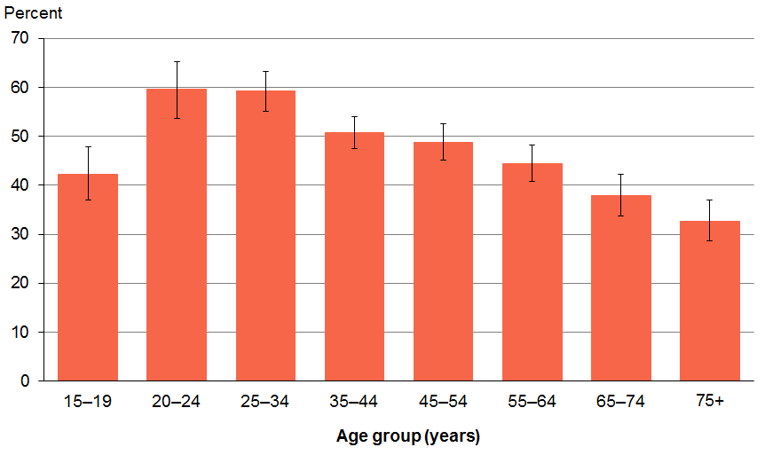
Source: 2012/13 NZHS

Māori and Pacific adults were more likely to report being Asked by a GP about their smoking status
Three out of five Māori (59%) adults and the same number of Pacific (59%) adults were asked by a GP in the past 12 months about their smoking status (Table 21). Māori and Pacific were both 1.2 times more likely (than non-Māori and non-Pacific respectively) to be asked about their smoking status by a GP (Table 22).

Table 21: Asked smoking status by a GP in the past 12 months, among the total population, by ethnic group
Ethnic group | Prevalence (%) | Estimated number
Māori | 59 | 192,000
Pacific | 59 | 87,000
Asian | 45 | 116,000
European/Other | 46 | 1,000,000
Source: 2012/13 New Zealand Health Survey
Note: Total response ethnicity has been used.

Table 22: Adjusted rate ratios for the total population being asked about their smoking status by a GP in the past 12 months
Men versus women | 1.0
Māori versus non-Māori | 1.2*
Pacific versus non-Pacific | 1.2*
Asian versus non-Asian | 0.8*
Most versus least deprived | 1.3*
Source: 2012/13 NZHS
* There is a statistically significant difference between the two groups.
Notes: The sex comparison is adjusted for age. Ethnic comparisons are adjusted for age and sex. Deprivation comparisons are adjusted for age, sex and ethnic group.

More people living in the most deprived neighbourhoods were Asked about their smoking status by a GP
Regardless of smoking status, respondents living in the most deprived areas (quintiles 4 and 5) were significantly more likely to have been asked about their smoking status by a GP they had seen in the past 12 months than those living in the least deprived areas (quintile 1) (Figure 23).

Adjusting for differences in age, sex and ethnic group showed that people living in the most deprived areas were 1.3 times more likely than those living in the least deprived areas to have been asked about their smoking status by a GP in the past 12 months (Table 22).

Figure 23: Proportion of the total population who had been asked their smoking status by a GP in the past 12 months, by neighbourhood deprivation (age-standardised)
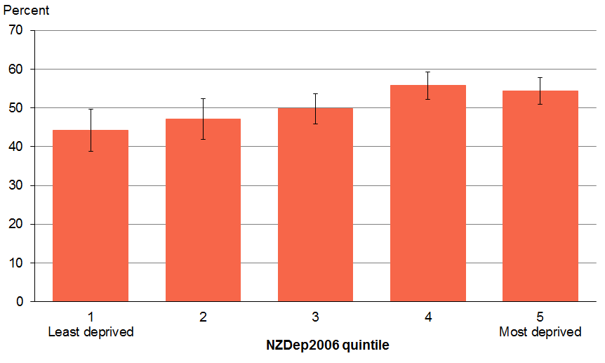
Source: 2012/13 NZHS

Over half of current smokers reported being provided Brief advice by a GP
Adjusting for age showed that more than half (56%) of current smokers (and those who had quit smoking in the past year) were offered brief advice by a GP to stop smoking. Significantly more female than male smokers were offered brief advice to stop smoking by a GP.

Young smokers aged 15–19 years were the least likely to have received brief advice from a GP during the past 12 months (Figure 24). Being given brief quitting advice increased with age except for two declines seen in the 25–34 years and after the 55–64 years age groups.

Figure 24: Proportion provided with brief advice to stop smoking by a GP in the past 12 months, among current smokers and those who quit smoking in the past year, by age
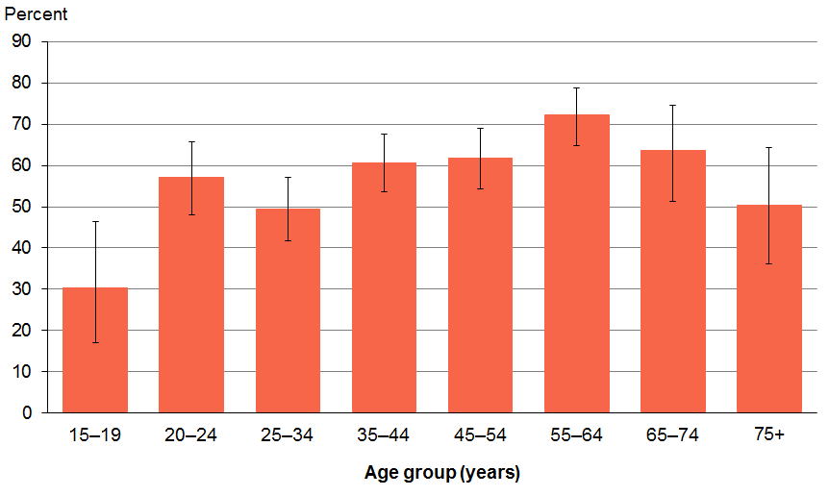
Source: 2012/13 NZHS

Māori and Pacific smokers were more likely to be provided Brief advice by a GP
Just over seven in ten Pacific current smokers (72%) were offered brief advice to stop smoking by a GP in the past 12 months (Table 23). After adjusting for differences in age and sex, Pacific smokers were 1.3 times more likely to be given brief advice by a GP they had seen than non-Pacific smokers (Table 24).

Around three in five (63%) Māori smokers received brief advice from a GP in the past 12 months (Table 23). Similar to Pacific smokers, after adjusting for differences in age and sex, Māori were 1.2 times more likely than non-Māori smokers to have received advice from a GP in the past 12 months (Table 24).

Table 23: Proportion provided with brief advice to stop smoking by a GP in the past 12 months, among current smokers and those who quit smoking in the past 12 months, by ethnic group
Ethnic group | Prevalence (%) | Estimated number
Māori | 63 | 75,000
Pacific | 72 | 23,000
Asian | 45 | 12,000
European/Other | 56 | 174,000
Source: 2012/13 New Zealand Health Survey
Note: Total response ethnicity has been used.

Table 24: Adjusted rate ratios for current smokers seen by a GP in the past 12 months who were provided with brief advice
Men versus women | 0.9*
Māori versus non-Māori | 1.2*
Pacific versus non-Pacific | 1.3*
Asian versus non-Asian | 0.8
Most versus least deprived | 1.0
Source: 2012/13 NZHS
* There is a statistically significant difference between the two groups.
Notes: The sex comparison is adjusted for age. Ethnic comparisons are adjusted for age and sex. Deprivation comparisons are adjusted for age, sex and ethnic group.

One in two current smokers received the ABC pathway from a GP
Nearly half (48%) of smokers who had seen a GP in the past 12 months received all three components of the ABC pathway (ie, were asked about their smoking status, offered brief advice to stop smoking and encouraged to use cessation support). Female smokers were significantly more likely to have received all three components from a GP than male smokers.

Younger smokers (15–19 years) were the least likely group to receive A, B and C (Figure 25). The likelihood of being provided with all three components of the ABC pathway increased with age, except for two declines seen in the 25–34 years and after the 55–64 years age groups.

Figure 25: Current smokers and those who quit smoking in the past year who received the ABC pathway from a GP in the past 12 months, by age group
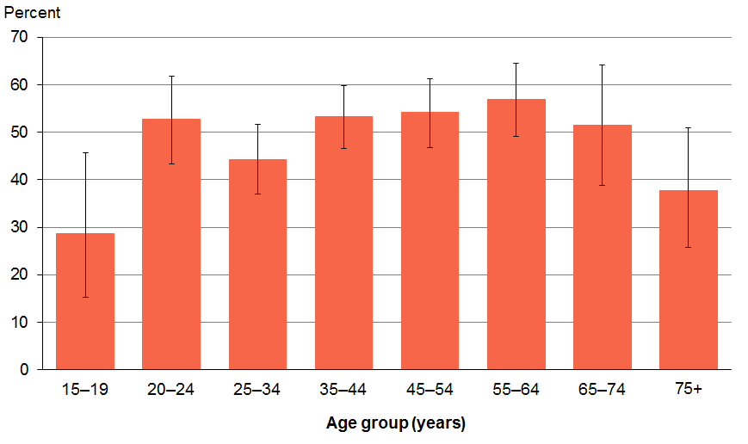
Source: 2012/13 NZHS

Over half of Māori and Pacific smokers received ABC from a GP
Pacific smokers were more likely (62%) than any other ethnic group to receive the combined ABC pathway from a GP in the past 12 months, with Asian smokers being the least likely (43%) (Table 25). After adjusting for age and sex differences, Pacific smokers were 1.3 times as likely as non-Pacific smokers to receive this intervention (Table 26).

Over half (56%) of Māori smokers received the combined ABC pathway, with Māori smokers more than 1.2 times more likely than non-Māori smokers to receive the ABC pathway from a GP, after adjusting for age and sex differences.

Table 25: Received the ABC pathway from a GP in the past 12 months, among current smokers and those who quit smoking in the past 12 months, by ethnic group
Ethnic group | Prevalence (%) | Estimated number
Māori | 56 | 65,000
Pacific | 62 | 20,000
Asian | 43 | 11,000
European/Other | 48 | 145,000
Source: 2012/13 New Zealand Health Survey
Note: Total response ethnicity has been used.

Table 26: Adjusted rate ratios for current smokers and those who quit smoking in the past year, who received the ABC pathway from a GP
Men versus women | 0.9*
Māori versus non-Māori | 1.2*
Pacific versus non-Pacific | 1.3*
Asian versus non-Asian | 0.9
Most versus least deprived | 0.9
Source: 2012/13 NZHS
* There is a statistically significant difference between the two groups.
Notes: The sex comparison is adjusted for age. Ethnic comparisons are adjusted for age and sex. Deprivation comparisons are adjusted for age, sex and ethnic group.

Comparison with health target ABC primary health care data
As outlined above, the current ‘Better help for smokers to quit’ health target aims for 90% of enrolled patients who smoke and are seen by a health care practitioner in general practice to be offered brief advice and support to quit smoking (Ministry of Health 2013).

The primary care health target data for the 12 months ending 30 June 2013 showed a national rate of 57%.

In comparison, the 2012/13 NZHS showed a 56% age-standardised prevalence of current smokers and those who quit smoking in the previous year being offered brief advice to stop smoking by a GP.

Use of the ABC pathway by staff in public hospitals

Almost nine out of ten hospitalised people were Asked their smoking status by a health professional
Regardless of ethnicity, sex, age or neighbourhood deprivation, patients admitted to a public hospital were highly likely to be asked about their smoking status. A total of 87% of people who had spent at least one night in hospital over the past 12 months, reported being asked about their smoking status by doctors or staff at the hospital.

Table 27 shows that high numbers of patients from all four ethnic groups admitted to public hospitals were asked by a health professional about their smoking status.

Table 27: Asked smoking status by staff in public hospitals in the past 12 months, total population, by ethnic group
Ethnic group | Prevalence (%) | Estimated number
Māori | 91 | 43,000
Pacific | 88 | 13,000
Asian | 86 | 20,000
European/Other | 86 | 198,000
Source: 2012/13 New Zealand Health Survey
Note: Total response ethnicity has been used.

Two-thirds of smokers and those who had quit in the past year were offered Brief advice to stop smoking at public hospitals
Almost seven out of ten (68%) smokers and those who quit smoking in the past year, who had been admitted to a public hospital in the past 12 months, were provided with brief advice to stop smoking, regardless of sex, age, ethnicity or neighbourhood deprivation.

Comparison with health target ABC data for secondary health care
As outlined above, the ‘Better help for smokers to quit’ health target aims for 95% of hospitalised patients who smoke and are seen by a health care practitioner in a public hospital to be offered brief advice and support to quit smoking (Ministry of Health 2013).

The secondary care health target data for hospitalised patients who smoke and had been given brief advice to stop smoking by a health care practitioner in a public hospital at the end of the 2012/13 reporting period showed an annual national rate of 95%.

In comparison, after adjusting for age, the 2012/13 NZHS showed that 68% of current smokers who had been hospitalised for at least a night in a public hospital had been offered brief quitting advice by a health care practitioner.

It is important to note the methodological differences in data collection. These include a difference in the definition of ‘hospitalisation’ by the two data sets, that is, the 2012/13 NZHS asked respondents whether they had stayed overnight in a public hospital in the last 12 months whereas the health target data captured hospitalised patients as those who had had a hospital admission, which did not necessarily have to be overnight.

Furthermore, there were also reporting differences, that is, the NZHS data was reported from the consumer’s perspective (smokers) whereas the ABC health target data was reported by health care providers.

Section 5: Exposure to second-hand smoke (SHS)
Key findings
- Around 4% of non-smoking adults were exposed to second-hand smoke (SHS).
- Younger non-smokers were more likely to be exposed to SHS than older non-smokers.
- Māori non-smoking adults were almost three times more likely to be exposed to SHS than non-Māori.
- Non-smokers in the most deprived areas had the highest exposure to SHS.
- SHS exposure in the home for non-smoking adults has halved since 2006.
- Around 6% of children were exposed to SHS at home and 5% in the car.
- Māori children were three times more likely to be exposed to SHS than non-Māori children.

Non-smokers exposure to second-hand smoke (SHS) comes from two places – smoke emitted by a person smoking and smoke from the end of a burning cigarette.

There is strong scientific evidence that there is no risk-free level of exposure to second-hand smoke (US Department of Health and Human Services 2006). Since the 1970s, research has linked the inhalation of second-hand smoke by non-smokers to specific diseases and other adverse effects (US Department of Health and Human Services 2006). Children who are exposed to second-hand smoke are at increased risk for sudden unexpected death in infancy (SUDI), chest infections, ear problems and more severe asthma (US Department of Health and Human Services 2006). In non-smoking adults, second-hand smoke causes lung cancer, coronary heart disease and an increased risk of stroke (Woodward and Laugesen 2001; US Department of Health and Human Services 2014).

Both smokers and non-smokers can inhale SHS, but this section focuses on exposure to SHS of non-smoking adults (15 years and over) and children (0–14 years).

Non-smoking adult exposure to SHS
All respondents in this survey, regardless of their smoking status were asked the questions ‘Does anyone smoke inside your house?’ and ‘Thinking about the car that you usually travel in, does anyone smoke in that car?’

Around 4% of non-smoking adults were exposed to SHS
Almost 4% of non-smoking adults were exposed to SHS in their homes. After adjusting for age, non-smoking males were 1.4 times more likely than non-smoking females to be exposed to SHS at home (Table 29). Just over 3% of non-smoking adults were exposed to SHS in the car they usually travelled in; males were no more likely than females to be exposed, after adjusting for age differences.

Younger non-smokers were more likely to be exposed to SHS
SHS exposure in the home was higher for non-smokers in the younger age groups (15–19 and 20–24 year olds) (9.9% and 6.8% respectively) compared with older non-smokers (25–75+ year olds) (2.2–3.2%) (Figure 26).

Non-smoking adults’ exposure to SHS in the car was also higher in the younger age groups (15- to 24-year-olds) than the older age groups (25–75+ years).

Figure 26: Exposure to SHS at home and in the car, among total population, by age group
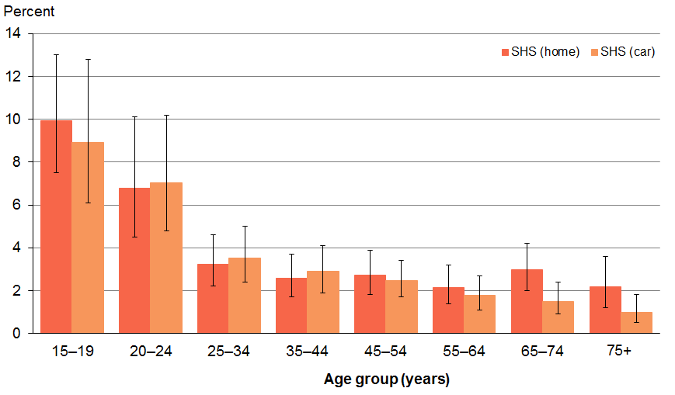
Source: 2012/13 NZHS

Māori non-smokers were more likely to be exposed to SHS
Around one in ten (9%) Māori non-smoking adults was exposed to SHS at home (Table 28). After adjusting for age and sex differences, Māori non-smoking adults were 2.6 times more likely to be exposed to SHS at home than non-Māori non-smokers (Table 29).

Conversely Asian non-smokers were the least likely to be exposed to SHS at home (2.4%), with Asian non-smokers half as likely as non-Asian non-smokers to be exposed to SHS at home, after adjusting for age and sex differences.

In terms of SHS exposure in the car, Māori and Pacific non-smokers recorded the most exposure (both 8%) (Table 28). After adjusting for age and sex differences, Māori non-smokers were over twice as likely to be exposed to SHS in their cars than non-Māori non-smokers (Table 29). Similarly, Pacific non-smokers were twice as likely as non-Pacific non-smokers to experience SHS exposure in their cars.

Table 28: Prevalence of exposure to SHS at home and in the car, among non-smokers, by ethnic group
Ethnic group | Exposure at home  (%) | Estimated  number | Exposure in car  (%) | Estimated  number
Māori | 9 | 25,000 | 8 | 21,000
Pacific | 6 | 8000 | 8 | 11,000
Asian | 2.4 | 9000 | 2.4 | 8000
European/Other | 3.4 | 76,000 | 2.9 | 65,000
Source: 2012/13 NZHS
Note: Total response ethnicity has been used.

Table 29: Adjusted rate ratios for non-smoking adults’ SHS exposure at home and in the car
Population group | Home | Car
Men versus women | 1.4* | 1.2
Māori versus non-Māori | 2.6* | 2.2*
Pacific versus non-Pacific | 1.3 | 2.0*
Asian versus non-Asian | 0.5* | 0.5*
Most versus least deprived | 3.2* | 2.4*
Source: 2012/13 NZHS
* There is a statistically significant difference (p<0.05) between the two groups.

Non-smokers in the most deprived areas had the highest exposure to SHS
Exposure to SHS among non-smokers in the home showed a clear linear gradient with neighbourhood deprivation, increasing by quintile from the least deprived area to the most deprived (Figure 27). SHS exposure at home in the most deprived areas was 3.2 times that of exposure at home in the least deprived areas (Table 29).

Exposure in the car was similar for non-smokers that lived in the least deprived areas (quintiles 1 and 2, 2.2% and 2.4% respectively) but more than doubled for those that lived in the most deprived areas (quintile 5, 6%) (Figure 27).

Figure 27: Exposure to SHS at home and in the car among non-smokers, by neighbourhood deprivation (age-standardised)
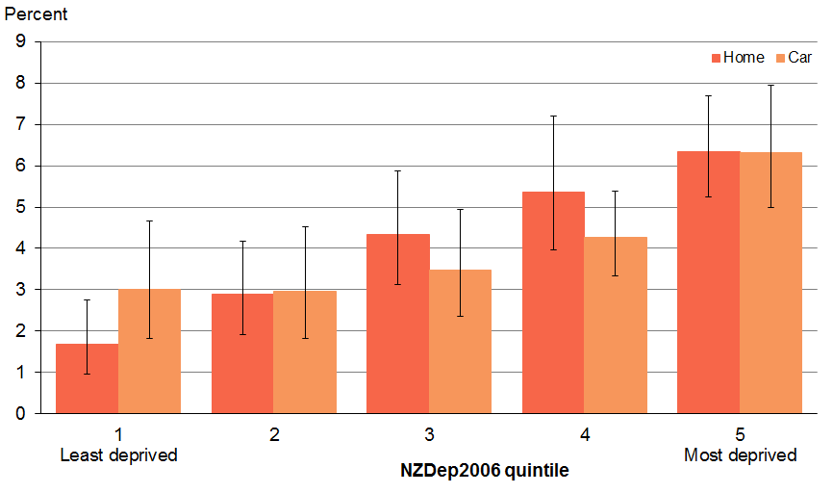
Source: 2012/13 NZHS

SHS exposure for non-smoking adults has halved since 2006
The prevalence of SHS exposure in the home for non-smoking adults in 2012/13 (3.7%) has gone down by half compared with 2006/07 (8%) (Table 30).

As also shown in Table 30, all ethnic groups showed significant declines between 2006 and 2012.

Table 30: Changes in SHS exposure prevalence in the home by ethnicity between 2006 and 2012
Ethnic group | Exposure prevalence,  2006 (%) | Exposure prevalence,  2012 (%) | Relative percentage  change (%)
Māori | 16 | 9 | -42*
Pacific | 17 | 6 | -67*
Asian | 9 | 2.4 | -72*
European/Other | 7 | 3.4 | -49*
All | 8 | 3.7 | -52*
Sources: 2006 = 2006/07 NZHS; 2012 = 2012/13 NZHS
* There is a statistically significant difference (p<0.05) between the two prevalences in 2006 and 2012.

For non-smoking adults, the prevalence of their SHS exposure in the car they usually travelled in was almost halved (3.3%) compared with the 2006 level (6%) (Table 31).

Between 2006 and 2012, the largest relative decline in the prevalence of SHS exposure in the car occurred in the Asian group (64%), with the European/Other and Māori groups following at 47% and 44% respectively (Table 31).

Table 31: Changes in SHS exposure prevalence in the car by ethnicity between 2006 and 2012
Ethnic group | Exposure prevalence,  2006 (%) | Exposure prevalence,  2012 (%) | Relative percentage  change (%)
Māori | 14 | 8 | -44*
Pacific | 11 | 8 | -30
Asian | 7 | 2.4 | -64*
European/Other | 5 | 2.9 | -47*
All | 6 | 3.3 | -46*
Sources: 2006 = 2006/07 NZHS; 2012 = 2012/13 NZHS
* There is a statistically significant difference (p<0.05) between the two prevalences in 2006 and 2012.

Children’s exposure to SHS
Child interviews were conducted with a guardian or primary caregiver of the child; that is, a person who had day-to-day responsibility for the care of the child. The following two questions were asked: ‘Does anyone smoke in your house?’ and ‘Thinking about the car that the concerned child usually travels in, does anyone smoke in that car?’

Around 6% of children were exposed to SHS at home and 5% in the car
Around 6% of children aged 14 years and under were exposed to SHS in their home and 5% were exposed to SHS in the car they usually travelled in.

Māori children were almost three times more likely to be exposed to SHS
Similar to Māori adults, one in ten Māori children was exposed to SHS both in the home (9%) and in the car (11%) respectively (Table 32). Adjustments for age and sex differences showed that Māori children were 2.6 times more likely to be exposed to SHS than non-Māori children in the home and in the car they travelled in (Table 33).

In comparison, Asian children were the least likely of any ethnic group to be exposed to SHS at home (2.3%) and in the car (1.4%).

Table 32: Exposure to SHS at home and in the car for children aged 14 years and under, by ethnic group
Ethnic group | Prevalence at home  (%) | Estimated  number | Prevalence in car  (%) | Estimated  number
Māori | 9 | 21,000 | 11 | 26,000
Pacific | 6 | 8000 | 5 | 6000
Asian | 2.3 | 2000 | 1.4 | 1000
European/Other | 4.1 | 26,000 | 6 | 35,000
Source: 2012/13 NZHS
Note: Total response ethnicity has been used.

Table 33: Adjusted rate ratios for children’s SHS exposure at home and in the car
Population group | Home | Car
Māori versus non-Māori | 2.6* | 2.6*
Pacific versus non-Pacific | 1.4 | 0.9
Asian versus non-Asian | 0.4* | 0.2*
Most versus least deprived | 7.8* | 3.9*
Source: 2012/13 NZHS
* There is a statistically significant difference (p<0.05) between the two groups.

Children in the most deprived areas had the highest exposure to SHS
Similar to the pattern observed with adults, a linear gradient was observed with more children being exposed to SHS in the home and in the car with increasing neighbourhood deprivation (Figure 28).

Adjustments for age, sex and ethnic group differences revealed that children who lived in the most deprived areas were almost eight times more likely to be exposed to SHS at home and four times more likely to be exposed to SHS in the car than children who lived in the least deprived areas (Table 33).

Figure 28: Exposure to SHS at home and in the car for children aged 14 years and under, by neighbourhood deprivation (age-standardised)
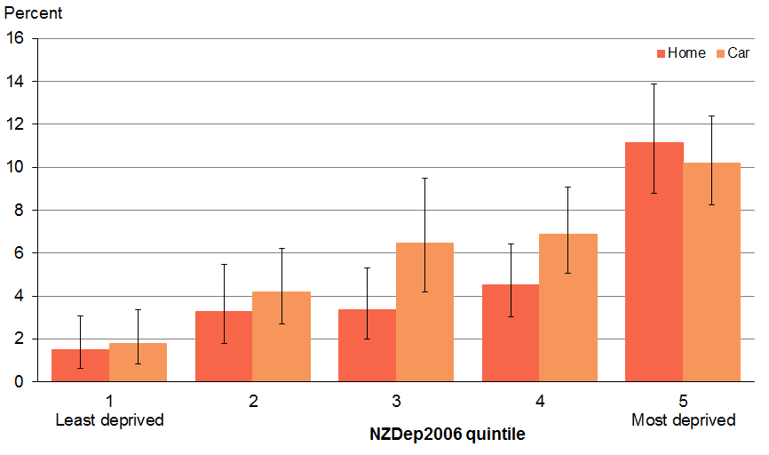
Source: 2012/13 NZHS

Section 6: Looking ahead
The purpose of this report is to provide a snapshot of tobacco use in New Zealand using data from the 2012/13 NZHS. It also provides information on the progress towards the aspirational goal of achieving a smokefree New Zealand by 2025.

Significant inroads have been made in reducing smoking over the past three decades, with prevalence rates reaching an all-time low of 18% (current smokers) and 16% (daily smokers). However, to achieve the 2025 smokefree goal, smoking rates must decline to 10% by 2018, and Māori and Pacific smoking rates need to halve.

Particularly encouraging is the significant decline in youth smoking observed between 2006 (20%) and 2012 (13%).

The decline in smoking is being driven by two factors – a decrease or delay in smoking initiation (flow in) and an increase in smoking cessation (flow out). A wide range of health sector interventions are likely to be impacting on these two drivers, including the Smoke-free Environments Act 1990 and its subsequent amendments, high tobacco prices (due to the incremental tobacco tax increases that have occurred since 2010), mass-media campaigns and smoking cessation interventions. Significant emphasis has been placed on providing better access to cessation treatment and services, including the provision of an 0800 telephone Quitline, subsidised NRT and other cessation aids, the implementation of the ABC approach by health care workers and offering culturally appropriate services specific to Māori, such as Aukati KaiPaipa.

Although the majority of smokers often find it difficult to quit smoking, data from this report shows that most smokers are trying to quit, with half (49%) of recent quit attempters having used some type of quitting product or advice to assist them in their most recent quit attempt.

Māori carry a greater burden of disease and poor health outcomes related to tobacco exposure compared with the non-Māori population. Māori have the highest prevalence of current smoking among adults and youth and a high prevalence of exposure to second-hand smoke. Given the higher prevalence of smoking by Māori, it is encouraging to find that Māori smokers were more likely to have received the ABC pathway from a health care worker in the past 12 months than the non-Māori smoker population. Māori smokers were also shown to be making more use of quitting services and products (eg, NRT) compared with the non-Māori population. This demonstrates that targeted smoking cessation programmes are reaching their target audience.

Pacific peoples have the second highest smoking prevalence rates after Māori and also carry a significant burden of disease and poor tobacco-related health outcomes compared with the non-Pacific population. Pacific people who had seen a GP in the past 12 months were significantly more likely to have been asked their smoking status and given brief quitting advice in the past 12 months than the non-Pacific population. Pacific recent quit attempters however, were significantly less likely to have used a quitting product in their most recent quit attempt than non-Pacific recent quit attempters. This highlights the need to target Pacific people for smoking cessation efforts.

The survey results have emphasised the strong associations between smoking and mental health and smoking and alcohol use. This highlights the consideration for combining efforts to address mental health and heavy alcohol drinking with smoking cessation efforts.

In conclusion, New Zealand is progressing well as it strives to become a smokefree nation by 2025. However, if the 2025 smokefree goal is to be achieved, considerable and sustained efforts towards tobacco control must continue across government, schools, communities and families.

Appendix 1:
Statistical methods
This section gives some key information to aid interpretation of the survey results.

Percentage refers to prevalence
Any percentages given in the text refer to ‘prevalence’; that is, the percentage of people affected in the population group of interest.

Reliability of survey results
The survey results are likely to underestimate or overestimate some indicators due to the nature of self-reported information. For example, many of the survey results assume that respondents can accurately recall events (such as a diagnosis by a doctor).

People may also over-report good behaviours or under-report risk behaviours based on what they consider to be socially desirable. The amount of error will vary depending on a number of factors (including the age of the respondent).

Survey results show associations rather than cause-and-effect relationships
This survey presents a picture of the health of New Zealand adults and children at one point in time. The survey can be used to look at associations between different factors, such as health status and neighbourhood deprivation. However, we cannot conclude that the survey results show cause-and-effect relationships between these factors, in part because we do not know which factor occurred first.

For example, if the survey finds that a particular condition is more common in people living in deprived areas, an association has been identified. This association does not necessarily mean that the condition is caused by living in deprived areas.

Total response ethnicity
This report uses total response ethnicity to define ethnic groups. Total response ethnicity classifies a person in all the ethnic groups they identify with. This means that people can appear in more than one ethnic group.

References
Alcohol Advisory Council of New Zealand. 2008. Is your drinking okay? URL: www.alac.org.nz/LowRiskDrinking.aspx (accessed June 2014).
Anthony JC, Echeagaray-Wagner F. 2000. Epidemiologic analysis of alcohol and tobacco use. Alcohol Research and Health 24: 201–8.
Augustson EM, Wanke KL, Rogers S, et al. 2008. Predictors of sustained smoking cessation: a prospective analysis of chronic smokers from the Alpha-Tocopherol Beta-Carotene Cancer Prevention Study. American Journal of Public Health 98: 549–55.
Bramley D, Broad J, Jackson R, et al. 2006. Cardiovascular risk factors and their associations with alcohol consumption: are there differences between Maori and non-Maori in Aotearoa (New Zealand)? The New Zealand Medical Journal. 119: U1929.
Breslau N, Schultz LR, Johnson EO, et al. 2005. Smoking and the risk of suicidal behaviour: a prospective study of a community sample. Archives of General Psychiatry 62(3): 328–34.
Chiolero A, Wietlisbach V, Ruffieux C, et al. 2006. Clustering of risk behaviours with cigarette consumption: a population-based survey. Preventative Medicine 42: 348–53.
Cosci F, Knuts IJE, Abrams K, et al. 2009. Cigarette smoking & panic: a critical review of the literature. Journal of Clinical Psychiatry 71(5): 606–15.
Dawson DA. 2000. Drinking as a risk factor for sustained smoking. Drug and Alcohol Dependency 59: 235–49.
Dollar KM, Homish GG, Kozlowski LT, et al. 2009. Spousal and alcohol-related predictors of smoking cessation: a longitudinal study in a community sample of married couples. American Journal of Public Health 99: 231–33.
Falk DE, Yi HY, Hiller-Sturmhofel S. 2006. An epidemiologic analysis of co-occuring alcohol and tobacco use and disorders: findings from the National Epidemiologic Survey on Alcohol and Related Conditions. Alcohol Research and Health 29: 162–71.
Fergusson DM, Goodwin RD, Horwood LJ. 2003. Major depression and cigarette smoking: results of a 21-year longitudinal study. Psychological Medicine 33(8): 1357–67. DOI 10.1017/S0033291703008596 (accessed May 2014).
Hymowitz N, Cummings KM, Hyland A, et al. 1997. Predictors of smoking cessation in a cohort of adult smokers followed for five years. Tobacco Control 6: S57–S62.
Kahler CW, Strong DR, Papandonatos GD, et al. 2008. Cigarette smoking and the lifetime alcohol involvement continuum. Drug and Alcohol Dependence 93: 111–20.
Kypri K, Langley JD, McGee R, et al. 2002. High prevalence, persistent hazardous drinking among New Zealand tertiary students. Alcohol and Alcoholism 37: 457–64.
Ministry of Health. 2009. Health Targets 2009/10. Wellington: Ministry of Health.
Ministry of Health. 2011. Government Response to the Report of the Maori Affairs Committee on Its Inquiry into the Tobacco Industry in Aotearoa and the Consequences of Tobacco Use for Māori. Wellington: Ministry of Health.
Ministry of Health. 2012. New Zealand Health Survey Methodology Report. Wellington: Ministry of Health.
Ministry of Health. 2013. Health Targets 2013/14. Wellington: Ministry of Health.
Ministry of Health. 2014. The New Zealand Guidelines for Helping People to Stop Smoking. Wellington: Ministry of Health.
Morissette SB, Tull MT, Gulliver SB, et al. 2007. Anxiety, anxiety disorder, tobacco use, and nicotine: a critical review of interrelationships. Psychological Bulletin 123(2): 245–72.
Oakley Browne MA, Wells JE, Scott KM (eds). 2006. Te Rau Hinengaro: The New Zealand Mental Health Survey. Wellington: Ministry of Health.
Osler M, Prescott E, Godtfredsen N, et al. 1999. Gender and determinants of smoking cessation: a longitudinal study. Preventive Medicine 29: 57–62.
Sorlie PD, Kannel WB. 1990. A description of cigarette smoking cessation and resumption in the Framingham Study. Preventive Medicine 19: 335–45.
The Quit Group. 2009. Quit Service Client Analysis Report: July 2008–June 2009. Wellington: The Quit Group. URL: www.quit.org.nz/file/research/Yearly%20Callers%20Report%20200807-200906.pdf (accessed 19 September 2014).
US Department of Health and Human Services. 2006. The Health Consequences of Involuntary Exposure to Tobacco Smoke: A report of the surgeon general –executive summary. Rockville, MD: United States Department of Health and Human Services, Centers for Disease Control and Prevention, Coordinating Center for Health Promotion, National Center for Chronic Disease Prevention and Health Promotion, Office on Smoking and Health.
US Department of Health and Human Services. 2014. The Health Consequences of Smoking – 50 Years of Progress: A report of the surgeon general. Atlanta, GA: United States Department of Health and Human Services, Centers for Disease Control and Prevention, National Center for Chronic Disease Prevention and Health Promotion, Office on Smoking and Health.
Wilson N, Weerasekera D, Kahler C, et al. 2012. Hazardous patterns of alcohol use are relatively common in smokers: ITC Project (New Zealand). The New Zealand Medical Journal
125(1348): 34–41.
Woodward A, Laugesen M. 2001. How many deaths are caused by second hand cigarette smoke? Tobacco Control 10: 383–8.
Ziedonis D, Hitsman B, Beckham JC, et al. 2008. Tobacco use and cessation in psychiatric disorders: National Institute of Mental Health report. Nicotine & Tobacco Research 10(12): 1691–715. DOI: 10.1093/ntr/ntp178 (accessed May 2014).
Zvolensky MJ, Feldner MT, Leen-Feldner EW, et al. 2005. Smoking and panic attacks, panic disorder and agoraphobia: a review of the empirical literature. Clinical Psychology Review
25: 761–89.

There is a difference in definitions of a ‘current smoker’ between the two surveys of 1996/97 and 2012/13. The definition of ‘current smokers’ used in the 1996/97 NZHS is ‘those who reported that they smoked one or more cigarettes per day’ whereas the 2012/13 NZHS defines ‘current smokers’ as ‘those who have smoked more than 100 cigarettes in their lifetime and at the time of the survey were smoking at least once a month’.
Successful quitters were defined in this report as those respondents who had quit smoking between a month and a year from when they participated in the survey and had remained abstinent.
Earlier NZHS data, namely 1996/97 and 2002/03, are not strictly comparable with data from 2006/07 onwards. The definition of ‘current smokers’ used in the 1996/97 and 2002/03 NZHS is those who reported that they ‘smoked one or more cigarettes per day’. This definition changed in 2006/07 to ‘someone who has smoked more than 100 cigarettes in their lifetime and at the time of the survey was smoking at least once a month’.
In 2012, the HSC became a part of the newly formed Health Promotion Agency (HPA).
Used in this report as a proxy for individual socioeconomic position.
Because of their young age, the age of initiation reported would not capture those who had yet to initiate smoking. This explains why the YIS mean age of initiation was lower than that calculated by the NZHS.
Micro tab is a sublingual (under the tongue) nicotine replacement tablet. Nicotine is released and absorbed through the lining of the mouth.
Zyban is an antidepressant and smoking cessation aid. It reduces the severity of nicotine cravings and withdrawal symptoms.
Champix is a medicine developed specifically as an aid to smoking cessation. It is a nicotinic receptor partial agonist, and as such, reduces cravings for and decreases the pleasurable effects of cigarettes and other tobacco products.
The data were supplied by the Tobacco Control team at the Ministry of Health who in turn sourced the data from the Primary Health Organisation (PHO) Performance Programme provided by DHB Shared Services as well as PHO enrolment datasets.
The data have been supplied by the Tobacco Control team at the Ministry of Health.

