Symptom management guidelines

Contents

Management of pain
- Definition
- Assessment tools
- Holistic considerations
- Flow chart
- Flow chart (severe renal impairment)

Management of agitation, delirium and restlessness
- Definition
- Holistic considerations
- Flow chart

Management of nausea/vomiting
- Definition
- Assessment
- Holistic considerations
- Flow chart

Management of excessive respiratory tract secretions
- Definition
- Assessment
- Holistic considerations
- Flow chart

Management of dyspnoea/breathlessness
- Definition
- Assessment
- Holistic considerations
- Flow chart

Management of pain

Definition
Pain is; “an unpleasant sensory or emotional experience associated with actual or potential tissue damage, or described in terms of such damage” (International Association for the Study of Pain, 2008).

Assessment tools

Person able to communicate
1. | Use preferred tool for your organisation  eg, Wong-Baker FACES™ Pain Rating Scale. |  |  |  | 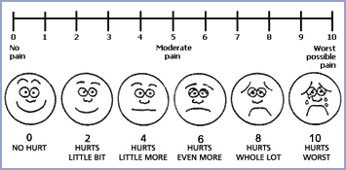
2. | Describe type of pain |  | Type of pain |  |  | Descriptor
 |  |  | Somatic |  |  | Aching, throbbing, gnawing, localised
 |  |  | Visceral |  |  | Deep aching, cramping, dull pressure
 |  |  | Neuropathic |  |  | Burning, shooting, pins and needs, tingling
 |  |  | Bone |  |  | Constant, deep
3. | Document clearly: Consider the following, assessing their pain using the PQRST format:
 | P | Palliating factors  Provoking factors |  | “What makes it better?”  “What makes it worse?”
 | Q | Quality |  | “What is your pain like? Give some words that tell me about it.”
 | R | Radiation |  | “Does that pain go anywhere else?”
 | S | Severity |  | “How severe is it?” Measured on numbered scale
 | T | Time |  | “Do you feel it all the time?”  “Does it come and go?”
 | U | Understanding |  | “What does this symptom mean to/for you?”  “How does this symptom affect your daily life?”  “What do you believe is causing this pain?”

Person unable to communicate
Use the preferred tool for your organisation if available. If no tool is available, the Abbey Pain Scale can be used to assess pain in those unable to communicate. This can be found at www.apsoc.org.au/PDF/Publications/4_Abbey_Pain_Scale.pdf

Holistic considerations

Reflect on: Te Whare Tapa Wha principles (Durie 1994)
Emotional considerations: | Fear and anxiety can be both cause and consequence.
Spiritual considerations: | What impact does pain have on the person’s sense of self and their mana/wellbeing?  Are there any cultural considerations, eg, Māori/Asian/Pacific peoples?
Social considerations: | How does the pain affect the person’s family/whānau life?  And how is this, in turn, affecting the family/whānau’s relationship with their partner/friends?
Physical considerations: | Are there activities or positions that are particularly painful for the person?

1 Involve the person’s family/whānau if the person is happy for them to be involved.
2 Being with the person and believing that their pain exists can help reduce their pain.
3 Helping to position the person to make them as comfortable as possible and helping to reposition them regularly can help reduce stiffness and muscular aches and provide pressure relief. Provide pressure relieving aids.
4 Guided imagery and distraction is a technique that teaches the person to mentally remove themselves from the present and imagine that they are in another place, eg, a favourite vacation spot. It can help reduce some types of pain by helping the person to relax or distract them from unpleasant thoughts. Distraction therapy comes in many forms, eg, guided audio, TV, music, reminiscing, etc.
5 Heat and/or coolness can often help ease pain, eg, by applying heated or chilled wheat packs. Care should be taken to ensure the temperature is suitable and the person will not be burned.
6 Massage or touch can be beneficial. Those giving massage should have an understanding of what is beneficial and what may cause harm. It is important to be aware that some people may not be comfortable with massage or touch.
7 Prayer and mindfulness meditation can be beneficial in reducing pain or existential suffering, depending on the person’s spiritual or cultural perspectives.

Pain management flow chart
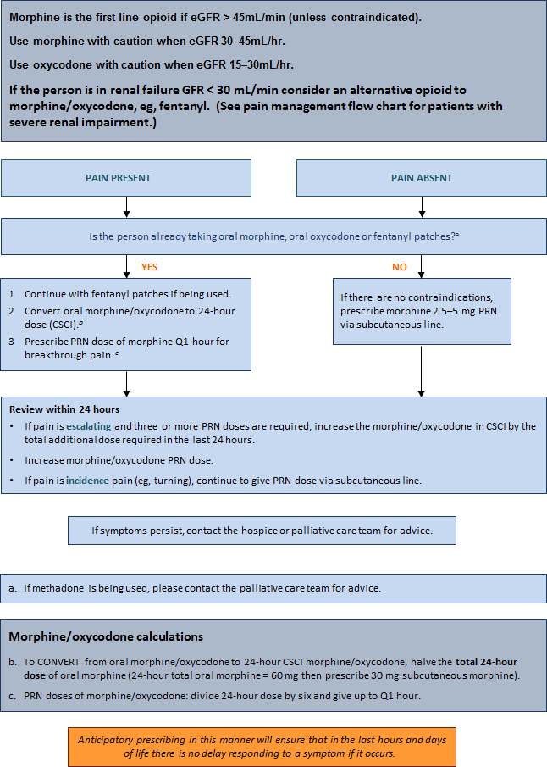

Pain management flow chart for patients with severe renal impairment (eGFR < 30mL/min)
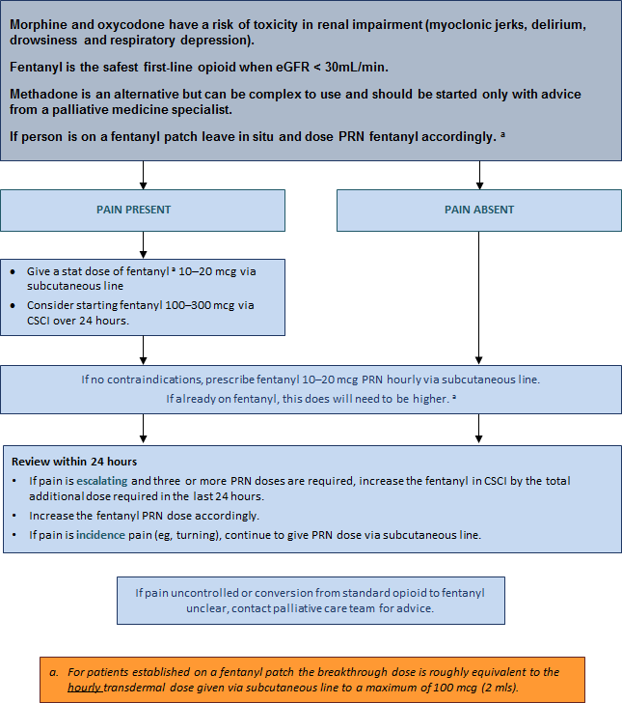

Management of agitation, delirium, restlessness
Agitation, delirium or restlessness is extremely common in dying people. The cause is often multifactorial and not reversible. It can be a distressing problem and difficult to manage. The burden of investigations in a dying person is often best avoided, but some causes can be treated (eg, pain, urinary retention, dehydration). Terminal restlessness is often a ‘pre-death event’.

Also known as: terminal agitation, terminal delirium, terminal anguish, terminal distress.

Definition
Delirium occurring in the last days of life is often referred to as terminal restlessness or agitation. In the last 24–48 hours of life, it is most likely caused by the irreversible processes of multiple organ failure.

Holistic considerations

Reflect on: Te Whare Tapa Wha principles (Durie 1994)
Emotional considerations: | How can emotional issues be identified and addressed at this time? Is there time to address these before the person dies?
Spiritual considerations: | How can feelings of hopelessness and helplessness (by the person and/or their family/whānau) be addressed?  Would the person like to see / benefit from a chaplain visiting? How would such a visit affect the person, their perception of self and their lifestyle?
Social considerations: | Is the person safe where they are at the moment? Can they remain there until they die? What other support does the family/whānau need at this time?
Physical considerations: | How can we make this person safe? How is this symptom affecting the person’s physical needs?

Management
Treat and/or remove possible causes of pain, for example, by:
1 regularly changing the person’s position
2 checking their bladder/bowels to eliminate retention/impaction
3 ensuring their safety
4 involving the person and their family/whānau and providing them with explanations as required
5 using sitters
6 providing a low-stimulus environment, ie, low-level noise and lighting
7 surrounding the person with familiar voices, pictures, belongings
8 providing gentle massage, aromatherapy, familiar music (volume low)
9 offering spiritual/religious guidance or support (if the person and/or their family/whānau have requested it)
10 lowering the person’s bed
11 providing sensor mats
12 helping keep the person’sbody or room at a comfortable, soothing temperature
13 helping apply smoking or nicotine patch.

Agitation, delirium, restlessness management flow chart
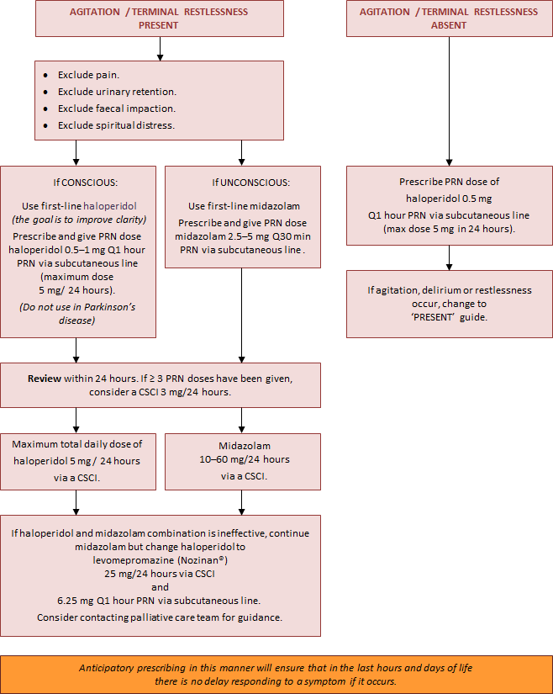

Management of nausea/vomiting
People at the end of their lives can experience nausea and vomiting, which has an adverse effect on the person’s physical, psychological and social wellbeing and significantly impairs their quality of life.

Definition
Nausea: A feeling of sickness in the stomach characterised by an urge to, but not always leading to, vomit.
Vomiting: The forcible voluntary or involuntary emptying of the stomach contents through the mouth.

Assessment
1 Knowledge of the physiology of nausea and vomiting will promote a rational choice of treatment.
2 History of symptoms and previous management (pharmacological and other) should be continued.
3 Treat reversible causes if possible and appropriate (such as constipation).

Holistic considerations

Reflect on: Te Whare Tapa Wha principles (Durie 1994)
Emotional considerations: | Fear and anxiety can be both cause and consequence.
Spiritual considerations: | What impact does the nausea have on the person’s mana and sense of self?  Are there any cultural considerations, eg, Māori/Asian/Pacific peoples?
Social considerations: | How is not eating affecting the person’s family/whānau life? And how is this, in turn, affecting the family/whānau’s relationship with their partner/friends?
Physical considerations: | Is there pressure from other people to eat? Does the smell of cooking/food cause the person to feel sick?

Management
Consider exploring the following options for managing nausea and vomiting.
1 Eliminate sights and smells that cause nausea and vomiting, eg, foods, deodorants, air fresheners, body odour and bowel motions.
2 Provide a well-ventilated room, circulating fresh air from a fan or open window.
3 Help the person dress in comfortable, loose-fitting, cool clothing.
4 Optimise the person’s oral hygiene. Consider using ½ tsp baking soda, ½ tsp salt in 250 mL water as a mouthwash. Alternatively, there are many different types of mouthwash available.
5 Offer sour candy ice chips made from a lemon/pineapple based juice, ginger ale or fruit as per the person’s individual preference and if they are still able to tolerate the taste.
6 Some people may prefer peppermints or peppermint tea.
7 If the person is still eating, offer small amounts of bland foods, fluids and snacks at room temperature.
8 Help elevate the person’s upper body when they are eating or drinking.
9 The person may already have a nasogastric (NG) tube on free drainage.
10 Use guided imagery/visualisation, teaching the person to mentally remove themselves from the present and imagine that they are in another place, eg, a favourite vacation spot. This can mentally block the nausea and vomiting.
11 Use music therapy to relieve stress and give a sense of wellbeing.
12 Use distraction techniques, such as, discussing family routines or providing suitable music or DVDs (eg, documentaries).
13 Apply acupressure. This can be done by the person or a family member/friend. Acupressure wrist bands are also available.

Some therapies that were used to provide more comfort for the person in the past may no longer be appropriate at the person’s end-of-life stage.

Nausea/vomiting management flow chart
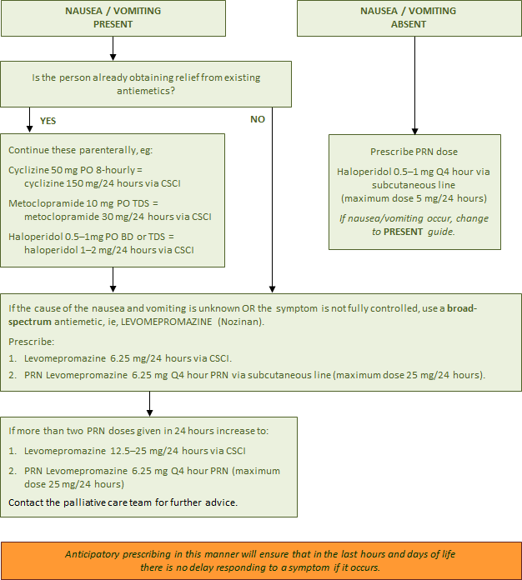

Management of excessive respiratory tract secretions
Respiratory tract secretions are generally seen only in dying people who are too weak to expectorate and are no longer able to clear their oral and upper airway secretions. The pooled secretions in the oropharynx and bronchi vibrate as air moves over them. It is audible and is described as noisy, rattling, gurgling and unpleasant. It is often called the ‘death rattle’. Excessive respiratory tract secretions have been observed in 23–92 percent of cases and are an indicator of impending death.

Definition

Classifications
- Type I due to salivary secretions.
- Type II due to accumulated bronchial secretions in the presence of pulmonary disease and infections, tumour, fluid retention or aspiration.

Studies suggest that people who develop noisy respirations have the following risk factors:
- Lung cancer
- Chest infections, ie, pneumonia
- Brain tumours
- Head and neck cancers
- Pulmonary diseases, ie, asthma, bronchitis, bronchiectasis
- Neuromuscular disorders, ie, myasthenia gravis, Guillain-Barre syndrome
- Cystic fibrosis
- Cardiac arrest
- Heart failure
- Cessation of steroids in cerebral involvement.

These situations are associated with an increase in oral, bronchial mucous and exudative secretions.

Assessment
1 Consider the person’s diagnosis – does the person have the risk factors? Is the breathing noisy and rattily. There are no standardised assessment tools to classify or measure the intensity of secretions, but some research has used subjective noise scores.
2 Consider the distress of the person – are they restless or frowning?
3 Consider the distress of the person’s family/whānau and carers – they may be anxious and fear the person is choking to death or drowning. Approximately half of those relatives and friends who witness it, as well as hospital staff, find the noise of respiratory tract secretions distressing.

Holistic considerations

Reflect on: Te Whare Tapa Wha principles (Durie 1994)
Emotional considerations: | What does this symptom mean for the family/whānau?
Spiritual considerations: | Are there any considerations that need to be taken into account around this time?
Social considerations: | How does this symptom affect family/whānau?
Physical considerations:

1 Anticipate problems if the person has the risk factors that increase airway secretions.
2 Reposition the person, often on their side in a semi-recumbent position, to facilitate postural drainage. Or raise the head of the bed and prop up the person with pillows.
3 Carefully assess hydration and reduce or cease parenteral fluids if required.
4 Explain the changes being observed in the dying person to the family and whānau. Communicate with compassion and sensitivity. Reassure the family the reason their loved one is not able to cough or clear their throat is due to their unconscious state – the person is not usually distressed.
5 Use distraction therapy, eg, music, TV, family talking and reminiscing.
6 Use aromatherapy therapy, eg, any of the following essential oils in an aroma burner or vaporiser: eucalyptus, cypress, ylang ylang, lavender, lemon, lime, cypress, marjoram, cedarwood.
7 Regularly provide mouth and lip care. Wipe away any dribbling with tissues. Use appropriate mouth swabs, eg, Den Tips® Disposable Oral Swabs, to gently wipe any loose secretions out of the person’s mouth if they allow it.
8 If the person has been receiving supplementary oxygen, it may no longer be necessary and can be discontinued. If the person remains on oxygen and thick secretions are a problem, add humidity if the device allows it.
9 Suctioning is not normally used in palliative care. In some hospitals, tracheal aspiration may be performed by skilled personnel, clearing secretions before anticholinergic drugs are started – this remains a complex and difficult procedure.
10 Many studies indicate a need for further research in order to develop ‘best practice’ standards.

Excessive respiratory tract secretions management flow chart
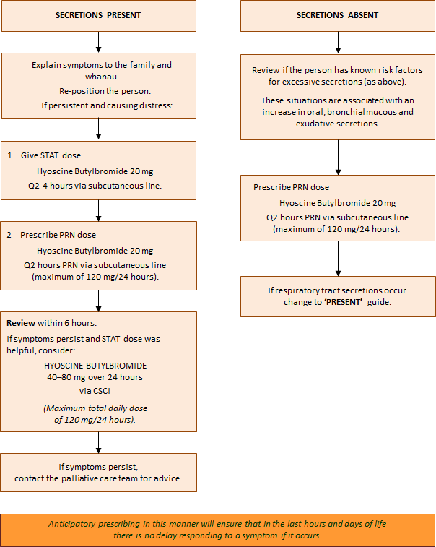

Management for dyspnoea/breathlessness
Dyspnoea is a very subjective symptom and does not always fit with the physical signs. Studies show that what onlookers see as distressing may not be distressing for the person. When the sensation of breathlessness is frightening, it may be described as suffocating, smothering, laboured breathing or air hunger.

Definition

The mechanism of dyspnoea/breathlessness
There are reported to be three paradigms of dyspnoea.
1 A perceived increase in respiratory effort or work of breathing (in people with airflow obstruction, eg, COPD or bronchiectasis or a large pleural effusion).
2 An increase in the proportion of chest wall strength and respiratory muscles required to maintain homeostasis (in people with neuromuscular disease (MND) and cancer cachexia).
3 An increase in ventilatory requirements, due to sepsis, anaemia, acidosis or hypoxemia.

Assessment
1 Because this is a very subjective experience, the assessment is best based on the person’s own report.
2 In severe breathlessness, clinical signs will be visible, such as; increased respiratory rate, excessive use of accessory muscles, gasping/air hunger, pursed lip breathing or arms held fixed down onto mattresses.
3 For unconscious people at the end of life, the health care professional will have to rely on relevant physical clues and support from the family/whānau. For example, tachypnoea (fast breathing), tachycardia (fast heart rate/pulse) and Cheyne-Stokes respiration may not necessarily be an indication of distress, unless accompanied by sweating, grimacing, agitation or use of accessory muscles.

Holistic considerations

Reflect on: Te Whare Tapa Wha principles (Durie 1994)
Emotional considerations: | How might it feel for the person to be out of breath all the time? How might the person’s distress be perceived by those around them?
Spiritual considerations: | What does being breathless mean to the person? How does this affect the person and their perception of self?
Social considerations: | How does being breathless affect the person’s lifestyle and the lifestyle of those around them?
Physical considerations: | Are there activities that particularly cause breathlessness but that are meaningful to the person?

Management
1 Positioning: Straight and upright – however, it may not be possible for a person to be positioned straight and upright at the end of their life due to weakness. Provide some support with pillows, avoiding horse shoe pillows as people who are small and frail may slip into the hollow space and compress their lungs. Support the person’s arms on pillows to help keep their shoulders relaxed and decrease their tension. It is equally important to support the person’s head in a good position.
2 Environment: A light, airy side room or single room with opening windows. Avoid showering or bathing in very hot water and a humid environment. Offer a gentle flow of air across the person’s face from an intermittent fan – the person could hold a fan if they still have the capacity. Dress them in non-restrictive cotton clothing when they are in bed.
3 Relaxation, anxiety reduction: Touch may or may not be appropriate. Massage the person’s feet and hands if they can tolerate it. Offer the person’s choice of relaxing music. Encourage visits from family and friends. Read out loud to the person. Health care professionals should have a calm approach. Avoid using phrases such as ‘just keep calm’.
4 Planning and practice: Plan what needs to be done and look for efficient ways of doing this. Practice abdominal breathing techniques.

Dyspnoea/breathlessness management flow chart
