Stocktake and Needs Analysis of Low Vision Services in New Zealand

Prepared for  
Ministry of Health Manatū Hauora

30 January 2015

# 

Preface 3

1. Executive Summary 4

2. Introduction 8

3. Methodology 10

4. Prevalence of people with low vision in New Zealand 12

5. Stocktake of Low Vision Services 17

6. Good Practice in Low Vision Service Provision 24

7. Low Vision Service Gaps and Unmet Needs 32

8. Conclusion 37

9. The Way Forward 38

Appendix 1 46

# Preface

This report was prepared for the Ministry of Health by Sally Duckworth, Partner, Litmus. Professor Steve La Grow, Deputy Pro Vice-Chancellor, College of Health, Massey University provided expert peer review of this report.

Litmus acknowledges the contribution of stakeholders who contributed to the study findings and conclusions by either participating in a key informant interview and/or the online survey. Litmus would also like to thank stakeholders who contributed articles and supporting evidence to the study.

Litmus also acknowledges the guidance and support received from Karen Hunter and Sue Primrose from the Ministry of Health.

If you have any questions about this report, please contact Sally Duckworth, Litmus, [Sally@litmus.co.nz](mailto:Sally@litmus.co.nz).

This report does not necessarily reflect the views of the Ministry of Health. The findings presented in the report are not Government policy.

# 1. Executive Summary

1.1 Introduction

The Ministry of Health commissioned Litmus Ltd to undertake a stocktake and needs analysis of low vision services in New Zealand. The study had the following four objectives:

1. Determine the prevalence of people with low vision in New Zealand (from existing data)
2. Identify the current situation and low vision service provision
3. Identify international good practice in low vision service provision
4. Determine the extent of service gaps and unmet needs for adults with low vision.

1.2 Methodology

The stocktake and needs analysis of low vision services in New Zealand was conducted between May and July 2014. Ten key informant interviews were conducted with stakeholders involved in and/or able to give expert commentary on low vision, and low vision services. This was followed by an online survey of stakeholders to measure stakeholders’ perceptions of low vision services in New Zealand. A total of 106 responses were received. A literature review was also undertaken to determine available information on the prevalence of people with low vision in New Zealand and to identify good practice in low vision service provision.

1.3 Prevalence of people with low vision in New Zealand

In the absence of an agreed definition of low vision in New Zealand, this Study defines low vision for the purpose of calculating the prevalence of low vision as the percentage of the New Zealand population who identify as being vision impaired and do not meet the membership criteria of the Blind Foundation.

The most recent estimate of the prevalence of people who are vision impaired in New Zealand is from the Statistics New Zealand 2013 Disability Survey. This survey revealed (based on a smaller sample of self-report) that 4% of the population (168,000) in 2013 is estimated to be vision impaired. People who are vision impaired are highest in the 65+ age group. Five percent of Māori and 3% of Pacific report a vision impairment that cannot be corrected by glasses or contact lenses.

The Blind Foundation provides services to approximately 12,000 vision impaired New Zealanders. The Blind Foundation’s membership criteria for adults is New Zealand residents who, in the opinion of a registered ophthalmologist or optometrist, have a visual acuity not exceeding 6/24 in the better eye with corrective lenses, or serious limitations in the field of vision, generally not greater than 20 degrees in the widest diameter in the better eye.

**When the Blind Foundation members are removed from this sample, this leaves about 156,000 New Zealanders who could be classified as having low vision, i.e. 3.9% of the New Zealand population.**

1.4 Stocktake of low vision service provision

The stocktake confirms there is a shortage of low vision services in New Zealand to improve visual function. There are six specialised low vision clinics offering free consultations, reportedly funded by some district health boards and the University of Auckland. These six are Greenlane Low Vision Clinic in Auckland, Burwood Low Vision Clinic in Canterbury, University of Auckland Optometry Clinic, the Wanganui Low Vision Trust, Wellington Low Vision Clinic and the Dunedin Low Vision. The resources and sustainability of the smaller low vision clinics are rumoured by a few stakeholders participating in the study to be marginal.

There are also approximately 30 private optometrists offering a fee paying service, mostly as an add-on to their main practices. None of the low vision clinics and private optometrists are providing a full time service. Most stakeholders agree that private optometrists are providing an adequate service. However, people with low vision who are accessing their services are not benefiting from an interdisciplinary approach.

There is adequate coverage in Canterbury and some coverage in Auckland, Wellington, Whanganui, and Dunedin. There is noticeable lack of coverage in Waikato, Bay of Plenty, Lakes, Taranaki, Tairawhiti and Nelson Marlborough regions.

While the majority of aids are relatively affordable, some are expensive, which is likely to be a barrier for people with low vision on low incomes to access these aids. There is no central depository for aids and therefore there is limited ability for people with low vision to trial aids, or be trained in their proper use.

1.5 Good practice in low vision service provision

There is limited national and international evidence documenting good practice low vision service provision. In spite of a lack of documentation, what is known is that good practice low vision service provision focuses on increasing visual performance. Good practice in low vision service provision includes expert assessment, prescription of optical and non-optical aids, provision of aids, training in the use of aids, and follow up. In addition, stakeholders consider the following design features are important in good practice low vision service provision.

1. **People-centred design:** A flexible service to respond to people with low vision’s individual and changing needs, including home visits for people who face mobility/transport barriers. A good practice low vision service would accept referrals from anywhere, including self-referrals.
2. **Low cost access**: Low vision services are free or heavily subsidised to minimise barriers to access, particularly for people on low incomes.
3. **Equitable access**: Low vision services are available and acceptable to all people with low vision, irrespective of culture, gender and ability.
4. **National coverage**: Low vision services are available in urban and provincial centres with outreach to less populated areas with high need.
5. **Interdisciplinary team**: A team including an optometrist and occupational therapist/low vision therapist would provide low vision services. This team would link with ophthalmologists, general practitioners and other health and social services to support other health and social issues.
6. **Skilled workforce**: Staff providing low vision services are suitably qualified and trained in low vision, and certified or accredited to practice.
7. **Timely intervention**: Low vision services would be undertaken in a timely manner (minimal wait times), as this leads to better outcomes for people.
8. **Appropriate consultation length**: Consultations are thorough and of an appropriate length (at least two-three hours), to assess, prescribe, advise and support.
9. **Quality improvement**: National standards for low vision services are established, and the services would be continuously monitored. A dedicated national focal point would be established to oversee the services.

There is evidence of good low vision service provision in Australia, New Zealand, and the United Kingdom. In New Zealand, Burwood Low Vision Clinic is considered a good model of integration and interdisciplinary service provision.

1.6 Gaps and unmet needs

Based on the number of and location of low vision clinics and private optometrists providing low vision consultations identified in the stocktake, when compared to the prevalence of people who currently and in the future will experience low vision, there is a significant unmet need and services are inadequate, and over 3.9% of the population (those who identify as being vision impaired and do not meet Blind Foundation membership) are underserved.

While pockets of good practice service are identified, most available services are inconsistently delivered and in some locations services are non-existent. People in need of low vision services who identify as Māori and Pacific and/or who live in provincial and rural areas are not receiving adequate services currently. Low vision services in New Zealand are therefore inequitable and inadequate to meet the needs of people with low vision.

While there is support for adults with hearing loss to manage their loss, there is not the equivalent level of support for people with low vision.

1.7 Conclusions

The stocktake and needs analysis of low vision services in New Zealand has confirmed that there is a significant need for low vision services in New Zealand and this need will grow significantly in the next 20 years as New Zealand’s population ages. While this report identified pockets of good practice service in New Zealand, most available services are inconsistently delivered and in some locations services are non-existent. This report has highlighted that people in need of low vision services who identify as Māori and Pacific or who live in provincial and rural areas are not receiving adequate services currently.

1.8 The way forward

It is recommended that a national reference group be established, facilitated by the Ministry of Health, to determine a strategic direction, agree a model of support (aligning with international best practice), and propose an appropriate and equitable service delivery pathway for low vision services in New Zealand. Proposed service delivery options would, however, be dependent upon the priorities determined by Ministers, the Ministry of Health and individual DHBs.

# 2. Introduction

2.1 Background

Vision impairment is a serious disability with wide-ranging personal, social and economic implications including:

* Loss of wellbeing: Those with vision impairment are likely to be in worse physical health, be financially disadvantaged, experience depression and have less social support, than those with no vision problems.[1] Having low vision impacts on peoples’ ability to read, do hobbies, drive, study, shop, undertake daily tasks and participate in their communities. Having low vision can therefore lead to loss of confidence and independence, cause social isolation and contribute to depression, underemployment, unemployment, falls and entry into residential care facilities with associated high costs.
* Economic costs: In 2009, the total economic cost to New Zealand resulting from vision impairment amongst members of the population was estimated at $2.8 billion. Health expenditure was estimated at $198 million, and was projected to reach $523 million by 2020.[2]

The Disability Support Services Group (DSS) within the Ministry of Health has received feedback from the sector indicating concern about the lack of a comprehensive, accessible, low vision service for adults in New Zealand. The concerns raised include:

* People are falling between existing services and availability of services differs across the country
* Lack of support services for older people with low vision may result in falls or other accidents resulting in hospital admissions
* There are a number of barriers to the provision of low vision services such as a lack of awareness, limited services in rural communities, and cost of services
* Emotional impact of vision loss such as unemployment, depression, anxiety, illiteracy and risk of suicide
* A number of ‘myths’ appear to exist, such as vision loss is “just part of growing old”
* That people with diabetes are at risk of vision loss because of their disease, with higher incidence in Māori and Pacific peoples’ communities
* People with age-related vision loss are over represented in residential facilities.

In response to the above concerns the Ministry of Health commissioned Litmus Ltd to investigate and review the current state, quality and provision of low vision services in New Zealand, to establish both the current standard of low vision care in New Zealand, and the needs of low vision New Zealanders.

Since then, Dr Lynley Hood and Associate Professor Gordon Sanderson on behalf of the Visual Impairment Charitable Trust Aotearoa NZ (VICTA) made a petition to the House of Representatives and Health Committee. The petition requested an inquiry into the need for accessible, comprehensive low vision services for the growing number of New Zealanders disabled by irreversible vision loss who do not qualify for membership of the Blind Foundation (previously known as the Royal New Zealand Foundation of the Blind).

2.2 Stocktake and needs analysis terms of reference

The Ministry of Health required the stocktake and needs analysis of low vision services in New Zealand to:

**1. Determine the prevalence of people with low vision in New Zealand**

Identify what data exists on the prevalence of people with low vision in New Zealand, broken into the following age bands: 0-16 years, 16-64 years and 64+ years.

**2. Identify the current situation and low vision service provision**

Undertake a stocktake of low vision services that:

* Summarises services available for people of all ages and the current process for accessing these services
* Provides a detailed summary of low vision services for adults (market analysis) such as where they are available, what type of services are offered and by whom.

**3. Identify international good practice in low vision service provision**

Explore the evidence base of good practice internationally of low vision services using a search of recent international studies which have been completed in the last 10 years. This will include:

* The identification of relevant models and principles (design) of the delivery of low vision services of adults that could be applicable to the New Zealand situation
* The identification of specialist skills and experience, if any, that are required by optometrists, occupational therapists or other allied health professionals, to assess the needs of and make recommendations to support the needs of adults with low vision
* The identification of key types of equipment and sustainable housing design that could be recommended to support adults with low vision. This will include the estimated cost range of equipment items, available in New Zealand, and the value and potential impact of their use
* Comparison of the current provision of low vision services for adults with other sensory services in New Zealand (such as hearing).

**4. Determine the extent of service gaps and unmet needs for adults with low vision**

Consultation with relevant stakeholders to determine:

* What is working well
* Any barriers for people preventing their access to low vision services
* Current service gaps and challenges
* Any inconsistencies/inequalities and where and why they exist
* Drivers for likely increased demand and cost (such as an aging population).

# 3. Methodology

The stocktake and needs analysis of low vision services in New Zealand was conducted between May and July 2014. The approach was planned and agreed with the Ministry of Health during project inception, along with the development of data sources and collection tools. The data collection tools including consent form, key stakeholder discussion guide and survey questionnaire can be found in Appendix 1.

3.1 Data sources

The stocktake and needs analysis adopted a mixed-method approach, using qualitative and quantitative data to explore the current situation and provision of low vision services in New Zealand and to determine the extent of gaps and unmet needs for adults with low vision in New Zealand.

* **Ten key informant interviews** were conducted with people involved in and/or able to give expert commentary on low vision, and the services provided to people with low vision

**Table 1. Key informant interviews**

|  |  |
| --- | --- |
| **Key informants** | **Number of interviews** |
| Low vision service providers | 3 |
| Low vision advocates | 3 |
| Optometrists | 2 |
| Professional body | 1 |
| Low vision researcher | 1 |
| **Total** | **10** |

* **An online survey** of stakeholders was conducted to measure and collate stakeholder’s perceptions of the current state of low vision service provision in New Zealand. An online survey was sent by Litmus to 108 valid email addresses identified by the Ministry of Health and other stakeholders. The survey link was also forwarded by the New Zealand Association of Optometrists and Vision Hearing Technicians to their respective professional member lists. From this, 106 responses were received. The survey remained open for three weeks, with one reminder sent by email.
* **A literature review** was also undertaken to determine available information on the prevalence of people with low vision in New Zealand and to identify international good practice of low vision services. Literature was sourced and provided by the Ministry of Health library services, Blind Foundation and online searches. Key search words included ‘low vision’, ‘low vision services’, ‘clinical low vision services’, ‘vision impairment’, ‘sight loss’, ‘vision’, ‘partially sighted’, and these were cross referenced with ‘prevalence’, ‘definition’, ‘model or principles’, ‘visual support services’ and ‘visual rehabilitation’.

3.2 Caveats

The Study Team is confident that this report accurately represents the views and perceptions of stakeholders who contributed in the study, and is supported by the documentation and literature. The consistency of themes across stakeholders strengthens the findings presented. In considering the findings of this study, some caveats are acknowledged.

* There is no data on the prevalence of people with low vision in New Zealand that defines low vision on both clinical and functional criteria. Data available is on reported vision impairment.
* The study was largely desk based. The scope and budget for the study did not extend to face-to-face field visits to low vision clinics.
* The scope and budget for the study did not extend to engagement with people with low vision. Insights from a consumer perspective of service gaps and unmet needs were provided by stakeholders only.
* Stakeholders interviewed and surveyed were provided by the Ministry of Health, Blind Foundation, and the New Zealand Association of Optometrists. It is possible there may be sample selection bias.

# 4. Prevalence of people with low vision in New Zealand

This section answers **Question 1: Determine the prevalence of people with low vision in New Zealand**. It outlines a definition of low vision and summarises available data on the prevalence of low vision in New Zealand, by age and ethnicity.

4.1 Defining low vision

**Visual impairment** is a defect or anomaly existing anywhere in the visual system which includes the lids, the eye and its parts, including the musculature which controls it, the optical nerve and the occipital lobe of the brain.

**A visual disability** is a functional limitation resulting from having a visual impairment. Functional limitation can be overcome by optical correction.

Most definitions for **people who are vision impaired** include people with a visual impairment whose functional limitations cannot be overcome by optical correction. People may be identified as being visually impaired using clinical measures of acuity and field of view. These definitions usually state that a person’s acuity is worse than 6/12 or 6/18 or the field of view is less than 20 degrees or 10 degrees at its greatest angle after best possible correction. This means that a person with a visual acuity of 6/12 or 6/18 can see an object at six metres that a person with normal vision can see from 12 or 18 metres away. The United Nations and World Health Organisation generally use 6/18 while most developed countries (Australia, United Kingdom and Canada) use 6/12.

People who are visually impaired can be classified as either **being blind or having low vision**. The cut off point for low vision is generally accepted as 3/60. Thus people who have acuity measures that are better than 3/60 are considered to have **low vision** and people who have acuity measures of 3/60 or worse are considered to be **blind**.

The World Health Organisation (WHO) uses five categories to define those who are visually impaired:

1. Moderate visual impairment 6/18 to 6/60
2. Severe visual impairment 6/60 to 3/60
3. Blindness with presenting visual acuity of 3/60 to 1/60
4. Blindness with presenting visual acuity of 1/60 to light perception
5. Blindness with no light perception.

The WHO states that all those who are not blind are said to have low vision.

Other definitions of low vision from the literature are as follows:

* The Clear Focus publication defines vision loss as being less than the vision threshold for driving, which is measured as 6/12. The number means that an individual can see at six metres what a person with unimpaired vision can see at twelve metres.[3]
* Vision Australia defines a person with low vision as someone with permanent vision loss that cannot be corrected with glasses and affects their daily functioning. Low vision may cause problems with recognising faces, reading the newspaper, dialling the telephone or seeing road signs. Visual acuity limits vary between less than 6/12 and less than 6/18.[4]
* The Canadian National Institute for the Blind define people who are partially sighted and have low vision as being between 20/60 and 20/190.[5]
* United Kingdom Vision Strategy states a person with low vision is one who has an impairment of visual function for whom full remediation is not possible by conventional spectacles, contact lenses, medical or surgical intervention and which causes restriction in that person’s everyday life.[6]
* The National Eye Institute (United States of America) defines low vision as the best-corrected visual acuity less than 6/12 in the better-seeing eye[7], and even with regular glasses, contact lenses, medicine, or surgery, people find everyday tasks difficult to do e.g. reading the mail, shopping, cooking, seeing television, and writing.

Currently, New Zealand does not have an agreed definition for people who have low vision. However, like other countries, definitions that are being used have both a clinical and a functional component.

* The petition submitted to the House of Representatives and Health Committee says “low vision is the reduced ability to carry out important life activities – such as obtaining an education, living independently, being employed and enjoying visual images – due to a visual impairment that cannot be corrected by medical or surgical treatments, ordinary glasses or contact lenses.” Vision loss occurs on a continuum similar to hearing loss, so people with low vision are not blind, and given appropriate aids and education they can successfully accomplish most tasks.[8]
* Sight Loss Services defines low vision functionally, as “a person is said to have low vision when they cannot perform the visual tasks they wish to because of loss of visual function that cannot be improved with conventional refractive corrections.[9]

In the absence of a New Zealand definition for people who are vision impaired, it is recommended that New Zealand uses the same definition as that which is used by Australia, Canada and the United Kingdoms, i.e. that the person’s acuity is worse than 6/12 after best possible correction.

4.2 Prevalence of people who have low vision

In the absence of an agreed definition of low vision in New Zealand, this Study defines low vision for the purpose of calculating the prevalence of low vision as the percentage of the New Zealand population who identify as being vision impaired and do not meet the membership criteria of the Blind Foundation.

### Statistics New Zealand 2013 Disability Survey

The most recent estimate of the prevalence of people who are vision impaired in New Zealand is from the Statistics New Zealand 2013 Disability Survey. This survey revealed (based on a smaller sample of self-report) that 4% of the population (168,000) in 2013 is estimated to be vision impaired.

People who are vision impaired are highest in the 65+ age group and are double the reported rate of 45-64 year age group, which in itself is over double the reported rate of the younger age groups. The incidence of vision impaired people is likely to significantly increase over time, due to the ageing population (see Section 7 for further information). Table 2 shows the breakdown in the prevalence of vision impaired people by gender and age.

**Table 2. Percentage and number estimate of vision impaired people in New Zealand**

|  |  |  |  |  |  |
| --- | --- | --- | --- | --- | --- |
|  | **0-14** | **15-44** | **45-64** | **65+** | **Total Population** |
| *% of population* | | | |  |  |
| **Males** | 1% | 1% | 5% | 10% | **3%** |
| **Females** | 1% | 2% | 6% | 12% | **4%** |
| **Total** | 1% | 2% | 5% | 11% | **4%** |
| *Population estimate* | | | |  |  |
| **Males** | 3,000 | 12,000 | 28,000 | 30,000 | **72,000** |
| **Females** | 3,000 | 20,000 | 33,000 | 40,000 | **96,000** |
| **Total** | 6,000 | 32,000 | 61,000 | 70,000 | **168,000** |
| *Note*: Population estimates are rounded, so do not accurately add up | | | | | |

The youngest age groups (0-14 and early 15-44) are likely to be vision impaired from a birth or congenital anomaly/defect, lesions of the central nervous system or retinal disorders. Vision issues are likely to be detected at birth, or by Plunket or other well child provider, or through the education system.

People aged 45-64 years are likely to be vision impaired from diseases such as diabetes, or accidents damaging their eyes as they move through life, diabetic retinopathy, retinopathy pigmentosa, or optic atrophy.[10]

While vision deterioration is a normal part of aging, the 65+ age groups are likely to develop low vision because of eye diseases such as age related macular degeneration, glaucoma, diabetic retinopathy, and uncorrected/uncorrectable refractive errors[11]. Recent advances in in the treatment of wet macular degeneration has meant that people who would have normally progressed rapidly to full blindness can now be stabilised with a level of low vision.

In the 2013 Disability Survey, 5% of Māori and 3% of Pacific report a vision impairment that cannot be corrected by glasses or contact lenses. Vision impairment is highest for Māori aged 45-64 years (12%) and Māori aged 65 years and over (14%). Vision impairment data for Pacific people is not robust enough to be broken down by age and gender. Table 3 shows a breakdown of sight loss by age for Māori. Note: statistics for Māori and Pacific contain a high sampling error, and therefore should be treated with caution.

**Table 3. Percentage and number of New Zealand Māori with reported vision impairment**

|  |  |  |  |  |  |
| --- | --- | --- | --- | --- | --- |
|  | **0-14** | **15-44** | **45-64** | **65+** | **Total** |
| **Proportion** | 1% | 3% | 12% | 14% | **5%** |
| **Number** | 2,000 | 10,000 | 14,000 | 5,000 | **32,000** |
| *Note*: Population estimates are rounded, so do not accurately add up | | | | | | |

The Blind Foundation provides services to approximately 12,000 vision impaired New Zealanders. The Blind Foundation’s membership criteria for adults is New Zealand residents who, in the opinion of a registered ophthalmologist or optometrist, have a visual acuity not exceeding 6/24 in the better eye with corrective lenses, or serious limitations in the field of vision, generally not greater than 20 degrees in the widest diameter in the better eye.

**When the Blind Foundation members are removed from this sample, this leaves about 156,000 New Zealanders who could be classified as having low vision, i.e. 3.9% of the New Zealand population.**

### Clear Focus Report (2010) and other research

Prior to the 2013 Disability Survey release, most organisations concerned with vision impairment quoted the numbers from the Clear Focus report (2010), which states that in 2009, 125,000 people over the age of 40 were vision impaired, representing 6.1% of that age group. They projected that by 2020, 174,000 New Zealanders over the age of 40 will be vision impaired. This incidence rate is very close to the actual self-reported figure in 2013 (168,000). Some stakeholders believe the Clear Focus figures is limited in that it only focused on the 40+ age group, and was extrapolated from Australian research, perhaps limiting its accuracy in a New Zealand context, which has a different ethnic makeup.

Other organisations quoted between 80,000 and 95,000 New Zealanders are vision impaired:

* VICTA’s website says that approximately 95,000 New Zealanders are vision impaired, that cannot be corrected by glasses or contact lenses. The prevalence rate was based on the 2001 New Zealand Disability Survey, combining the totals for children, adults in household and adults living in residential facilities with vision impairments.
* Sight Loss Services which provides information, equipment and support to New Zealanders who are vision impaired estimates **80,000** New Zealanders are vision impaired, and this data is also based on 2001 Census data.

The Blind Foundation is in the midst of carrying out an investigation into the prevalence of blindness and low vision within New Zealand. Their data was not available to be included in this study. Their prevalence survey was driven by concern that the Clear Focus report might not accurately represent the New Zealand context and our ethnic profile. Additionally there was concern that it possibly overestimated the prevalence of low vision, as it was based on old Australian data.

The Terms of Reference for the Blind Foundation’s low vision prevalence study states that it will use “international standard definitions and measures” of blindness and low vision in the investigation. Blindness will be defined using the constitution of the Blind Foundation (“a person who, in the opinion of a registered Optometrist or Ophthalmologist, has visual acuity not exceeding 6/24 in the better eye with correcting lenses, or serious limitations in the field of vision to less than 20 degrees in the widest diameter”). Low vision will be defined as “visual acuity of between Snellen 6/12 to 6/21, or limitations in the field of vision generally not less than 20 degrees in the widest diameter in the best seeing eye, or both” (a solely clinical definition). The survey will use capture-recapture methods, using three lists of people with vision disorders (Blind Foundation membership list, attendance at ophthalmology clinics in public hospitals, and attendance at private ophthalmology or optometry clinics in New Zealand) to estimate the total prevalence.

4.3 Summary

Currently, New Zealand does not have a definition for people who are vision impaired. In the absence of a New Zealand definition for people who are vision impaired, it is recommended that New Zealand uses the same definition as that which is used by Australia, Canada and the United Kingdoms, i.e. that the person’s acuity is worse than 6/12 after best possible correction.

People who are vision impaired can be classified as either being blind or having low vision. The cut off point for low vision is generally accepted as 3/60.

At this point in time, the best estimate of the prevalence of vision impairment in New Zealand is from the 2013 Disability Survey, which estimated that 4% of the population (approximately 168,000) has a vision impairment that assistive devices such as glasses did not eliminate. Therefore when those who do qualify for the Blind Foundation (approximately 12,000) are removed, there are 156,000 people with low vision in New Zealand. Prevalence is self-reported to be higher in people aged 65+ (11%). This survey supports the Clear Focus study that estimates that by 2020, 174,000 New Zealanders over the age of 40 will have vision loss.

The Study Team considers the 2013 Disability Survey low vision prevalence figure significant, and along with the Clear Focus data provides strong evidence to begin work to develop an accessible and comprehensive low vision service. While the Blind Foundation’s soon to be conducted prevalence study will add to this body of knowledge, the Study Team does not recommend delaying decisions on further work until this prevalence study is completed.

# 5. Stocktake of Low Vision Services

This section responds to **Question 2** in the study’s Terms of Reference. It describes the low vision services that are available to people with low vision in New Zealand, including the location and type of services. It also summarises other services that are available for people with low vision, including vision rehabilitation services for adults and special education services for children.

5.1 Low Vision Services

Low vision services are designed to improve visual function. They tend to rely on assessment for and prescription of optical and non-optical aids, as well as, training people to use aids effectively. Low vision services are a component of both vision rehabilitation and development and special education services for vision impaired children and adolescents.

There are a handful of specialised low vision clinics offering free consultations, reportedly funded by some district health boards and the University of Auckland. The number of district health board low vision clinics has reduced in recent years from ten to four, due to a reprioritisation of services. There are also a number of private optometrists offering fee paying low vision consultations, mostly as part of their practice.

### Low vision clinics

Four specialised low vision clinics operate in the North Island and two specialised low vision clinics operate in the South Island. These clinics are available to both adults and children. None of the clinics operate full time.

**Figure 2. Map of low vision clinics**



The Greenlane Low Vision Clinic in Auckland and the Burwood Low Vision Clinic in Canterbury have interdisciplinary teams which consist of optometrists to assess and prescribe optical and non-optical aids and occupational therapists/vision therapists to train people to use aids effectively.

The Greenlane Low Vision Clinic is open for one day a week and saw 235 clients in the 2013 calendar year. The Burwood Low Vision Clinic operates for two and a half days per week and saw 439 people in the 2013 calendar year.

The Wanganui Low Vision Trust, Wellington Low Vision Clinic and the Dunedin Low Vision Clinic are staffed by one or two optometrists and are open one half day a week or less frequently. The Wellington clinic saw approximately 250 people in a year and the Whanganui and Dunedin clinics each see less than 50 people in a year. The resources and sustainability of these smaller low vision clinics are rumoured by a few stakeholders participating in the study to be marginal.

Appointments at the above clinics are generally two to three hours in length and wait times for an appointment can be one month or longer. Some stakeholders comment that the Greenlane Low Vision Clinic is particularly overloaded.

The Study Team was unable to access information on the services provided by the University of Auckland Optometry Clinic in the time available.

**Table 5. Low vision clinics in New Zealand**

|  |  |  |
| --- | --- | --- |
| **Clinic name** | **Location** | **Staffing/services** |
| Greenlane Low Vision Clinic | Greenlane Hospital | Open one day per week. Undertakes follow up appointments. In 2013, 235 people were seen. Staffed by two optometrists and one low vision therapist. |
| University of Auckland Optometry Clinic | Grafton Campus | No data available at time of reporting. |
| Wanganui Low Vision Trust | Operates from Blind Foundation rooms, Whanganui | Open for half a day every two months. See approximately four people at each clinic. Blind Foundation arranges appointments and follow up for people. Staffed by two optometrists. |
| Wellington Low Vision Clinic | Wellington Hospital | One outpatient clinic per week seeing approximately four-five people per week. No data available on staffing. |
| Burwood Low Vision Clinic | Beacon House, Burwood Hospital | Operates two half days per week. Saw 495, 497, 439 people in 2011, 2012 and 2013. |
| Dunedin Low Vision Clinic | Ophthalmology Department, Dunedin Hospital | No data available for 2013/14. Saw 47 people in 2012/13. |

“[Greenlane is] organised and **interdisciplinary** which is key.” – Optometrist

“Greenlane clinic is **effective**, but it is **overloaded** and extremely **slow.**” – Person with low vision

“Wellington Hospital is also okay in its services, but **under resourced.**” – Optometrist

“Dunedin is rumoured to be under threat of **closure.**” – Optometrist

### Private optometrists

Sight Loss Services, based in Auckland, provides a fee paying low vision service. Appointments are Monday to Friday and the organisation also provides outreach services in Pukekohe, Manurewa and North Shore. Aids can be purchased from Sight Loss Services’ website, or from Age Plus who work with them to provide services for people living on Auckland’s North Shore.

Approximately, 30 private optometrists are known to provide low vision consultations as part of their practice. These optometrists are clustered around Auckland, Hawkes Bay, mid-central North Island, Wellington and Canterbury. There is a noticeable lack of private optometrists offering low vision consultations in the Waikato, Bay of Plenty, Lakes, Taranaki, Tairawhiti and Nelson Marlborough regions.

Private optometrists tend to charge their standard consultation fee when they provide a low vision consultation. The time and resources required to undertake low vision services is significant, as these appointments tend to take longer than a standard consultation, making it not sustainable for many private optometrists to offer this service. Private optometrists providing low vision consultations are doing so, mainly because they have an interest in low vision or they want to be able to serve their communities.

Private optometrists often see people with low vision on the same day or within one week of making an appointment. Most consultation times with private optometrists are up to one hour, significantly less than low vision appointments provided by specialised low vision clinics.

Most private optometrists providing low vision as part of their practice saw less than ten people with low vision in the last four weeks. Very few private optometrists provide outreach or follow up services

Most stakeholders agree that private optometrists do an adequate job on limited low vision training, resources and support. However, the majority of private optometrists do not work with occupational therapists/vision therapists to train people to use aids effectively or other health and social services in order to provide a holistic service. For some people low vision is accompanied by depression, and a period of acceptance and readjustment. People with low vision often have other physical and sensory impairments, and these wider needs are not being adequately addressed through the current private optometrist delivery model.

“We have a private practitioner in Hamilton but **only one.**” – Optometrist

“There needs to be a **business model** to make delivery profitable to self-employed practitioners or **incentives** to incorporate low vision into their daily schedule.” - Optometrist

### Blind Foundation Vison Solutions

The Blind Foundation’s Vision Solutions offered a low vision fee paying service to people who did not meet Blind Foundation membership for a trial period in Auckland. The pilot was over a 14 week period from April to July 2013. Of the 23 people referred for services, a large proportion of those referred declined services, due mainly to affordability. Furthermore, the market appeal of the service may have been too narrow, as optical medication and technical communications were excluded in the service offered.[12]

### Optical and non-optical aids

Optical and non-optical aids are also prescribed and provided as part of a low vision service. Optical aids include a range of magnification aids, but also microscopic aids, telescopes and electromechanical aids like Closed Circuit Television (CCTV). Non-optical aids include individualised lighting, high contrast markers, pens, tape, cutting boards, as well as marking aids (high visibility markings on appliances to allow people to see set dials from a safe distance) and large print books, directories, key pads, etc.

Based on survey responses, the most commonly prescribed aids are magnifiers (hand held or stand), lamps, CCTV and e-readers. Other aids, such as talking watches, large print books, audio books, larger TVs, different colour chopping boards are also prescribed occasionally to improve peoples’ participation in and quality of life.

The majority of aids are relatively affordable, and involve regaining the ability to read by increasing the lighting or size of the material so people can use their normal glasses. Magnifiers and lamps range from $20-$150 for a person to buy. However, other aids, e.g. CCTV range from $1,000-$5,000 for a person to buy (or $50-$70 per month for a person to rent).

The majority of commonly prescribed aids are manufactured in Germany. Stakeholders report that these aids are of higher quality and more durable, but often at least two to three times the price of similar products manufactured in China. Stakeholders mention that other commonly prescribed aids are manufactured in the United States of America.

While a few stakeholders who provide aids provide them at cost, or with a small mark-up, some private optometrists are adding substantial mark-ups, which is likely to be causing a barrier for people on low incomes to access aids.

As well as the cost of aids being a barrier and often prohibitive for people with low vision on low incomes, there is often insufficient guidance and support offered to people when selecting aids. Currently, people with low vision are reportedly unsupported to find, fund and purchase aids. Most information is online and some people do not have access or are not proficient with using the internet. While people can attend Blind Foundation open days to view and purchase aids, many people receive little or no advice about aids and their correct use.

There is no central depository for aids and therefore there is limited ability for people with low vision to trial aids, or be trained in their proper use. Some items are expensive and private optometrists cannot afford to purchase demonstration models for people to try.

In most cases, people with low vision need to be trained in the proper use of aids to maximise their effectiveness. While training happens in low vision clinics and to some extent in private optometry practices, stakeholders do not know whether people who are provided with aids are successfully using them, as there is minimal in home training and follow up.

“Training in use of low vision aids for the elderly is **not well co-ordinated** and many have **poor motivation**, or do not wish to spend money. Those with computer skills can access good online services, but those without a computer may need more help.” – Optometrist

In 2008, the Ministry of Health provided one-off funding to the New Zealand Association of Optometrists for low vision kits to be sent to optometry clinics around the country. These kits were well received, and three quarters of stakeholders surveyed who received this equipment said they still use it, at least sometimes, for loans, demonstrations and as an introduction to low vision aids. Private optometrists commented positively on this initiative. Many said these kits contained a good basic range of styles and magnifications.

“Great to be able to show patients a range of options…and to **loan** items to patients before purchase.” – Optometrist

Some stakeholders mention providing advice and assistance with environmental modifications for people with low vision, including path lighting and strips on stairs.

5.2 Other services for people with low vision

A range of organisations are providing other services to people with low vision, including vision rehabilitation services for adults and special education services for children. These services are as follows.

**Table 6. Summary of other services for people with low vision**

|  |  |
| --- | --- |
| **Organisation** | **Services provided** |
| *Blind Foundation* | The Blind Foundation provides practical and emotional support for 11,700 New Zealanders who are blind or have low vision. The organisation targets adult membership to people who have “visual acuity not exceeding 6/24 in the better eye with corrective lenses or serious limitations in the field of vision, generally not greater than 20 degrees in the widest diameter in the better eye.”  Some stakeholders mention that access to Blind Foundation resources is dependent on the location where people live, and their knowledge of Blind Foundation services. The Blind Foundation offers good vision rehabilitation services but do not provide clinical low vision services themselves and have to refer if necessary. |
| *The Blind and Low Vision Network New Zealand (BLENNZ)* | BLENNZ is funded through the Ministry of Education and is a school made up of a national network of educational services for children and young people (aged 0-21 years) who are blind, deafblind or have low vision in New Zealand. BLENNZ provides a national assessment service, has an onsite early childhood education centre and residential programme with on-campus schooling for some students, although the majority of students go off campus to specific schools. BLENNZ also provides visual resources including a special formats library, immersion courses, developmental orientation and mobility. BLENNZ would refer clients to low vision clinics and low vision optometrists for specialist low vision services. |
| *Macular Degeneration New Zealand* | A not-for-profit charitable trust that aims to reduce incidence and impact of macular degeneration in New Zealand. Macular Degeneration New Zealand has a 0800 phone help line for information, education and support for people with macular degeneration and their families. It has a comprehensive website, provides printed material, DVDs, and refers people to low vision services, where required. |
| *Retina New Zealand* | A not-for-profit organisation that aims to increase awareness of retinal disorders, provide information on retinal disorders and eye conditions, research into causes, effects, treatments and care for retinal disorders, and provide mental support for people and their families. The organisation also produces quarterly newsletters with a mix of practical coping tips, member’s stories, meeting reports and articles on latest research and treatments. |
| *Visual Impairment Charitable Trust Aoteroa (VICTA)* | A charity established in 2013, to address the unmet needs of people with low vision. VICTA aims to facilitate the independence, integration and well-being of people with low vision who don’t qualify for Blind Foundation assistance, provide support and assistance, increase awareness, eliminate barriers and facilitate research into visual impairment in New Zealand. VICTA provides a voice for people with low vision. They launched the petition into the provision of low vision rehabilitation services, campaigned to restore low vision clinics in public hospitals, and initiated a low vison road safety campaign, amongst other things. VICTA also runs an active support group for people with low vision in Dunedin. |
| *Enable NZ and Accessable* | The Ministry of Health contracts two providers, Enable NZ and Accessable to administer equipment and modification services. Vision assistive technology (e.g. magnifiers,CCTV), is part of these services. |
| *Workbridge* | Workbridge provides professional employment services for people with low vision. They also administer support funds on behalf of the Ministry of Social Development. |
| *Other groups providing information, advocacy and support* | Other groups/charities/organisations/trusts that provide information or support for people with low vision include (but are not limited to): Dunedin VIPs, Albinism Trust, Age Concern New Zealand, Parents of Visually Impaired (PVI), Association of Blind Citizens, Glaucoma New Zealand, Grey Power Federation, McKenzie Trust, New Zealand Vision Impaired Empowering Women (VIEW), Ngati Kapo Aotearoa and Pacific Vision. |

5.3 Summary

There is a shortage of low vision services in New Zealand to improve visual function. There are a handful of specialised low vision clinics offering free consultations, mostly in the main centres, and a number of private optometrists offering a fee paying service, mostly as an add-on to their main practices. None of the low vision clinics and private optometrists are providing a full time service.

Most stakeholders agree that private optometrists are providing an adequate service. However, people with low vision who are accessing their services are not benefiting from an interdisciplinary approach.

While Auckland and Christchurch are comparatively well serviced for low vision services, the rest of the country does not have adequate services. Waikato, Bay of Plenty, Lakes, Taranaki, Tairawhiti and Nelson Marlborough have a very low number of low vision providers.

While the majority of aids are relatively affordable, some are expensive, which is likely to be a barrier for people with low vision on low incomes to access these aids. There is no central depository for aids and therefore there is limited ability for people with low vision to trial aids, or be trained in their proper use.

# 6. Good Practice in Low Vision Service Provision

This section explores the national and international evidence for good practice in low vision service provision and responds to **Question 3 of the study’s Terms of Reference**. Good practice design principles and service models identified in the literature and in stakeholder interviews are summarised, along with examples of good practice low vision service provision in Australia, New Zealand and the United Kingdom. The Ministry of Health contracted Hearing Therapy Services was appraised to see whether learnings from this service could be applied to low vision services.

There is limited national and international evidence documenting good practice low vision service provision. In spite of a lack of documentation, what is known is that good practice low vision service provision focuses on increasing visual performance.

6.1 Design features

Core services of low vision service provision includes expert assessment, prescription of optical and non-optical aids, provision of aids, training in the use of aids, and follow up. In addition, stakeholders consider the following design features are important in good practice low vision service provision.

1. **People-centred design:** A flexible service to respond to people with low vision’s individual and changing needs, including home visits for people who face mobility/transport barriers. A good practice low vision service would accept referrals from anywhere, including self-referrals
2. **Low cost access**: Low vision services are free or heavily subsidised to minimise barriers to access, particularly for people on low incomes
3. **Equitable access**: Low vision services are available and acceptable to all people with low vision, irrespective of culture, gender and ability
4. **National coverage**: Low vision services are available in urban and provincial centres with outreach to less populated areas with high need
5. **Interdisciplinary team:** A team including an optometrist and occupational therapist/vision therapist would provide low vision services. This team would link with ophthalmologists, rehabilitation specialists, general practitioners and other services to support rehabilitation, health and other needs. (Refer 6.3 below)
6. **Skilled workforce**: Staff providing low vision services are suitably qualified and trained in low vision, and certified or accredited to practice
7. **Timely intervention**: Low vision services would be undertaken in a timely manner (minimal wait times), as this leads to better outcomes for people
8. **Appropriate consultation length**: Consultations are thorough and of an appropriate length (at least two-three hours), to assess, prescribe, advise and support
9. **Quality improvement**: National standards for low vision services are established, and the services would be continuously monitored. A dedicated national focal point would be established to oversee the services.

“The most effective service delivery model provides according to **need.**” – Optometrist and researcher

“**Time and energy** of the professional who is leading or driving the service provision is the main factor in success.” – Optometrist

6.2 Models of low vision service provision

The SmartSight™ Model and the Recognise and Respond Model of low vision were identified by stakeholders as supporting the core functions and good practice design features of low vision service provision.

***SmartSight Model***

The SmartSight™ Model of vision rehabilitation developed by the American Academy of Ophthalmology in 2003 is a model of graduated low vision interventions. It provides useful information about vision rehabilitation for patients as well as an outline for the care process for the ophthalmologist who is providing rehabilitative care. SmartSight™ includes two levels:

**Level 1** calls on all ophthalmologists to recognise that vision loss due to acuity less than 20/40, scotoma, visual field loss and loss of contrast sensitivity impacts their patients' ability to function. Level 1 also calls on all ophthalmologists to respond by offering patients a copy of the SmartSight™ Patient Hand-out and to encourage them to read it and act on it. The hand out directs patients to services in their community.

**Level 2** includes the multidisciplinary vision rehabilitation services that are important to follow when vision loss impacts more than reading fine print. Comprehensive vision rehabilitation may be a limited clinical encounter when patient goals are limited or it may be a more extensive intervention involving many professionals.

The SmartSight™ Model appears to have been adopted by Canada, and possibly in parts of North America. According to the Blind Foundation, Australia is also developing a programme based on this model.[13]

***Recognise and Respond Model***

The Recognise and Respond Model[14] was adopted from the SmartSight™ Model to suit the New Zealand context by Naomi Meltzer of Sight Loss Services. Naomi Meltzer is currently working with the New Zealand Association of Optometrists to implement Recognise and Respond in New Zealand. This model uses existing resources to make low vision services more accessible in the community. It involves collective responsibility and education of health care and rehabilitation health workers. This model aims to increase health workers’ knowledge about who has the ability to provide help, who to refer to, how to access services, and the provision of continuing education for optometrists in the area of low vision.

The model has four levels of service provision:

1. Recognise and respond:

Involves all health and rehabilitation professionals including general practitioners, ophthalmologists, optometrists, gerontologists, occupational therapists, needs assessors, etc. to recognise when a person is starting to struggle with their daily activities due to vision loss and respond and give appropriate information about low vision services available and/or make referrals.

1. Basic services:

Involves all optometrists to provide accurate refraction and spectacle prescriptions, advice on lighting and glare control and prescribe a magnifier from a limited range of stock.

1. Advanced optometric low vision and basic rehabilitation services:

Optometrists combining their skills with occupational therapists and Blind Foundation adaptive living skills trainers or other similarly trained assistant to provide follow up care, including functional assessment, history taking, providing wide range of magnifiers, facilitating access to rehabilitation/support groups, and providing a limited home visit service.

1. Comprehensive multidisciplinary low vision services:

Combines level 3 services with advanced rehabilitation services provided mainly by the Blind Foundation, such as techniques for daily living, orientation and mobility, vocational counselling, assistive technology, and counsellors experienced in the social and psychological adjustment to vision loss.

6.3 Interdisciplinary team

As discussed above, stakeholders believe a good low vision service must be provided by a core team consisting of an optometrist(s) and an occupational therapist/low vision therapist. A credentialed, trained (Bachelor of Optometry) optometrist should be involved for the assessment of vision, and ideally they should have particular interest and training in low vision rehabilitation. An occupational therapist/vision therapist would be available to train and support people with low vision on the use of optical and non-optical aids. The core team might also include or link with an ophthalmologist for specialist training in the diagnosis and management of disorders of the eye and visual system and an orthoptist who would detect, diagnose and manage eye diseases.

The core team would work closely with general practitioners for first line low vision assessment, and other health and social services e.g. counsellors, psychologists, social workers, or support groups to meet the person’s wider needs.

Stakeholders believe it is important for people working in low vision to have good communications, empathy and problem solving skills.

Currently, there is limited formal low vision training in New Zealand. It is understood that low vision forms part of a paper during the Bachelor of Optometry degree, but this general and brief tuition is not considered to be sufficient for providing good practice low vision service provision. Stakeholders recommend that a postgraduate diploma in low vision and/or sector-based short refresher courses be available for people working or wanting to start a career in low vision. This training would include low vision aids and rehabilitation to keep workers’ knowledge and skills current.

“Ideally a year-long **post graduate course**. Most optometrists have inadequate knowledge; mine was gained by hands on clinical experience.” – Optometrist

6.4 Examples of good practice in low vision service provision

The following low vision services in Australia, New Zealand, and the United Kingdom, are considered to represent good practice in low vision service provision. These services appear to have adopted many of the design features of good practice service provision and have staff with specialist skills and experience required to work in low vision services identified above. While stakeholders commented favourably on these services (particularly Vision Australia’s Low Vision Clinic Service in Melbourne and the Burwood Low Vision Service Clinic in Canterbury), information on their service models was limited and there are few documented appraisals of these models. More in-depth analysis, including site visits to Australia’s Low Vision Clinic Service and the Burwood Low Vision Service Clinic would be beneficial to research these services in more detail.

***Vision Australia Low Vision Clinic Service***

Vision Australia is the leading national provider of blindness and low vision services in Australia. The head office of Vision Australia is in Kooyong, Melbourne (Victoria).

Vision Australia’s Low Vision Clinic Service assists adults and school-aged children to maximise the use of their remaining vision through the recommendation and provision of optical aids, supply of specialty equipment, and demonstration of practical techniques to use in the home and community. The Low Vision Clinic Service is focused on addressing the needs that clients and their family identify. The service is mainly based at a Vision Australia office or at one of their outreach locations. Services are also provided in community settings, such as schools and workplaces, and home based services are provided in special circumstances.

Vision Australia has a comprehensive website with information on eye diseases and how to look after your eyes; information and tips on how to live with low vision; links to support groups; low vision aids for sale; and information on low vision clinics across the country.[15]

Many stakeholders commented positively on Vision Australia’s Low Vision Clinic Service and the Greenlane Low Vision Clinic bases its service on the Australian model. The Study Team did not have access to any documentation evaluating the effectiveness of the Vision Australia Low Vision Clinic Service.

“Good low vision services exist in Victoria (Australia).” – Optometrist

***Burwood Low Vision Clinic***

The Low Vision Clinic at Burwood Hospital provides low vision services for people in Canterbury and West Coast. It is funded by Canterbury District Health Board and governed and administered by a charitable trust (The Lighthouse Trust). The clinic provides expert assessment, prescription of optical and non-optical aids and training in the use of aids. In addition to providing low vision assessments, the clinic rents low vision aids to people, which generates a modest return to the trust.

A large number of stakeholders identified Burwood Low Vision Clinic as an effective model of integration and interdisciplinary service provision in New Zealand. The Study Team did not have access to any documentation evaluating the effectiveness of the Burwood Low Vision Clinic.

“Burwood Low Vision Clinic **works well** for those who know about it, live in the Canterbury Region and are referred to the service.” – Occupational Therapist

***Low Vision Services Wales***

Low Vision Service Wales was set up in 2004 and is based in local optometry practices throughout Wales. The intervention includes: assessment of peoples’ ocular condition and prognosis, discussion of needs and initial goal setting; assessment of vision; provision of low vision aids, on loan and free of charge; advice about lighting and other methods of enhancing vision; provision of information about ocular condition and other rehabilitation services; referral to additional services; reappraisal of goals; and arrangement for follow up. Not all people attend a follow up appointment, but these are arranged if a clinical need is identified. The Welsh Government provides funding for people with low vision to have one full free assessment each year.

An evaluation of this scheme found the service has significantly reduced waiting times, increased the number of assessments, and improved access to low vision services for people seeking the service.[16]

***Surrey Integrated Eye Care Pathway***

Surrey in the United Kingdom is working to integrate low vision services in to a visual impairment pathway alongside health and social care. In this model, patients who have problems with their vision can choose to visit an optometrist or a general practitioner for an initial assessment who can then refer directly to ophthalmology for further diagnosis and, if necessary, treatment for the underlying eye condition. People with low vision are then offered a range of interventions from low vision aids to more comprehensive support from the Surrey Association for Visual Impairment, a charity, including specialist rehabilitation, emotional support and help with certification. Where appropriate, people are offered a social care assessment then support. The aim is that people with low vision will then be actively monitored in the community, perhaps by an Eye Care Liaison Officer or by using a virtual ward system.

The Study Team is not aware of any evaluation of the Surrey Integrated Eye Care Pathway.

***Visibility Patient Support Service at Gartnavel Hospital, Glasgow***

The Greater Glasgow and Clyde National Health Service Board works in partnership with local charity Visibility, formerly the Glasgow and West of Scotland Society for the Blind, providing funding for a Patient Support Service for people with low vision. Visibility established a Patient Support Service in Gartnavel Hospital Eye Department in December 2002. The service was prompted by a 2001 review of services available for visually impaired people, commissioned by the Greater Glasgow and Clyde National Health Services Board. The Patient Support Service aims to connect people with the practical experiences of living with low vision, and to complement the medical services offered at the hospital. The service provides feedback to patient concerns, offering information, advice and support, and refers on to wider support services. Low vision aids and equipment are available for trial. Central to the service is the Eye Clinic Liaison Officer.

The patient-centred service has been heralded as a success for the area, and similar posts to the Eye Clinic Liaison Officer have been established throughout England by the Royal National Institute for the Blind.[17]

6.5 Comparison of low vision service provision to other sensory services in New Zealand

There is a view amongst some stakeholders participating in this study that services for people with hearing impairments are substantially more resourced and effective than low vision services, and therefore people with hearing loss receive better services than people with low vision in New Zealand.

“There is a lack of government funding to support a national low vision service on par with **hearing services.**” – Nurse

According to the 2013 Disability Survey, the prevalence of hearing impairment amongst New Zealanders is double that of vision impairment (see Table 7).

**Table 7. Comparison of the prevalence of vision and hearing impairments, showing proportion and population estimate**

|  |  |  |  |  |
| --- | --- | --- | --- | --- |
|  | **Vision** | | **Hearing** | |
|  | *Proportion* | *Estimate* | *Proportion* | *Estimate* |
| **Males** | 3% (72,000) | | 10% (219,000) | |
| **Females** | 4% (96,000) | | 7% (161,000) | |
| **Total** | **4%** (168,000) | | **9%** (380,000) | |

The Study Team appraised Life Unlimited Hearing Therapy Services, which is a national service funded by the Ministry of Health to understand what learnings could be applied to low vision services in New Zealand. Hearing and vision loss have a lot in common, as both are sensory impairments and disproportionately impact on older people’s independence and quality of life. Many of the low vision design features outlined above have been adopted by Life Unlimited Hearing Therapy Services in the implementation of services for people with hearing impairments.

Life Unlimited Hearing Therapy Services was established in 2002 and provides a free, independent service to New Zealand citizens and permanent residents aged 16 years and over.

Life Unlimited Hearing Therapy Services accepts referrals from general practitioners, audiologists, and other health professionals, as well as self-referrals. People can see a hearing therapist before or after receiving a diagnostic assessment to discuss their needs, goals, and the impact of hearing loss on various aspects of their lives, what options are available – and which best suit the individual. Hearing therapists can do screening tests along with needs assessment, and are able to refer people to audiologists to get hearing aids fitted, if appropriate. Hearing therapists aim to provide the best possible advice, and to help people achieve their personal goals. The organisation promotes itself as independent from audiologists and other service providers.

The organisation has 15 clinics across the country, with approximately 30 therapists allocated to those clinics (the number of therapists depends on the need and size of the region the clinic is servicing). They also provide outreach services to smaller centres, including health centres, community centres and marae. Clinics occur as regularly as once a week or month, or longer depending on demand, and wait times vary. The organisation sees approximately 5,000 people per year.

Life Unlimited Hearing Therapy Services is a community-based service. The organisation believes being based in the community (as opposed to a hospital) makes it more accessible, user friendly and approachable. Providing services within the community also helps to increase awareness of the service, particularly if it is being provided where the population group accesses other community services (such as community centres, marae, medical centres).

Life Unlimited Hearing Therapy Services also runs its own registered diploma, the National Diploma in Hearing Therapy. The diploma is two years part-time, made up of six months pre-employment training, with a six week practicum in Auckland (scholarships are provided to cover the costs of training), and 18 months on the job training. There is a preference to bring on new recruits who have a tertiary qualification in health or social service (e.g. occupational therapists, counsellors, and teachers).Turnover of hearing therapists is low (7-9%) so there is rarely more than one person a year undertaking training.

6.6 Summary

The evidence suggests that good practice in low vision service provision includes expert assessment, prescription of optical and non-optical aids, provision of aids, training in the use of aids, and follow up. Furthermore a number of good practice design features are identified by stakeholders and supported in the literature, including people-centred design, low cost access, equitable access, national coverage, having an interdisciplinary team and skilled workforce, timely intervention, appropriate consultation length, and a culture of quality improvement. The Recognise and Respond Model, while still in its infancy, embraces many of these design features.

There is evidence of good low vision service provision in Australia, New Zealand and the United Kingdom. In New Zealand, Burwood Low Vision Clinic is a good model of integration and interdisciplinary service provision. Further investigation is warranted to determine whether the model used by the Burwood Clinic and other clinics could be replicated or scaled up to other parts of New Zealand. However, given the limited number of low vision providers, a mixed model of hospital based and community based clinics and practices is likely to be the most pragmatic solution to fill gaps in service delivery.

The model to support people to manage their hearing loss (including referral mechanisms, community based and outreach services and qualifications and training) could be adapted for low vision services.

# 7. Low Vision Service Gaps and Unmet Needs

This section responds to Question 4 of the Terms of Reference. It summarises low vision service gaps in New Zealand, and compares the service with the good practice design features identified earlier. It also identifies the unmet need within the New Zealand population and the likely future demand for low vision services.

7.1 Low vision service gaps

On the whole, there are gaps in low vision service provision. As shown in Figure 4 below, 76% of stakeholders rate the location of services poor/very poor, and over one half of stakeholders rate the affordability and timeliness of services as poor/very poor. Forty nine percent of stakeholders rate the appropriateness and 47% of stakeholders rate the quality of low vision services as poor/very poor.

**Figure 4. Performance of low vision services**

As discussed earlier, there is a shortage of low vision services in New Zealand. There are a handful of low vision clinics offering assessment, prescription, provision of aids and some follow up mainly in the main centres. There are also some private optometrists offering an adequate fee paying service, mostly as an add-on to their main practices. People with low vision outside of these main centres or do not have access to a private optometrist who offers low vision consultations are not accessing services.

There is adequate coverage in Canterbury and some coverage in Auckland, Wellington, Whanganui, and Dunedin. There is noticeable lack of coverage in Waikato, Bay of Plenty, Lakes, Taranaki, Tairawhiti and Nelson Marlborough regions.

7.2 Unmet need

Due to the low vision service gaps, over 3.9% of the population (those who identify as being vision impaired and do not meet Blind Foundation membership) are underserved. Note: This study did not review the needs of Blind Foundation members so cannot make any judgement on whether Blind Foundation members’ needs are being met.

When considering low vision service provision by age, older people are particularly underserved. As shown in Figure 5 below 51% of stakeholders believe the overall performance of low vision services to older people is poor/very poor. People aged 65 years and over are particularly disadvantaged as they often are on a low income and are less able to afford private optometry services, have reduced mobility thus cannot drive and are dependent on others (public transport if it is available and family members for transport) to access services.

“All age bands need focus/help for differing reasons; the young to **learn**, the middle band to **earn**, and the older band to be able to be **independent**.” – Person with low vision

**Figure 5. Overall performance of low vision services by age**

Māori, Pacific, low income, and people living in provincial and rural areas are also underserved. Stakeholders providing low vision services mention they have few clients who identify as Māori and Pacific, and who live in provincial and rural areas. Low awareness, high cost and the appropriateness of services is likely to be driving these inequities. Low access to low vision services for Māori and Pacific is a concern, due to the high rates of diabetes within these population groups, which is a contributing factor to low vision.

Stakeholders believe there is a general lack of knowledge of low vision and low vision services amongst people with low vision, optometrists, and general practitioners, and there are low levels of referrals from general practitioners and self-referrals.

There is also believed to be a general acceptance in New Zealand that low vision comes with getting older and there is nothing that can be done when vision cannot be corrected by glasses, contact lenses or surgery. In spite of this low awareness, some stakeholders acknowledge that community groups are doing a good job in helping to raise awareness of low vision in New Zealand by providing handy tips and coping techniques for day-to-day living.

7.3 Comparison of services against good practice design principles

Currently, the provision of low vision services in New Zealand is not meeting many of the good practice design features and only partially meeting others, as summarised in Table 8 below.

**Table 8. Comparison of low vision services against good practice low vision design features**

|  |  |  |
| --- | --- | --- |
| Design feature | Description | Comparison of services against good practice design feature |
| 1. People-centred design | A flexible service to respond to people with low vision’s individual and changing needs, including home visits for people who face mobility/transport barriers. A good practice low vision service would accept referrals from anywhere, including self-referrals. | While referrals are accepted from anywhere (ophthalmologist, optometrist, general practitioner, Blind Foundation and self-referral), there is limited home visits, outreach or follow up. |
| 2. Low cost access | Low vision services are free or heavily subsidised to minimise barriers to access, particularly for people on low incomes. | Access to the handful of specialised low vision clinics is free. Private optometrists are a fee paying service, restricting low income people from access. There is a charge or rental fee for aids. |
| 3. Equitable access | Low vision services are available and acceptable to all people with low vision, irrespective of culture, gender and ability. | There is low access to low vision services amongst Māori and Pacific. |
| 4. National coverage | Low vision services are available in urban and provincial centres with outreach to less populated areas with high need. | There is adequate coverage in Canterbury and some coverage in Auckland, Wellington, Whanganui, and Dunedin. There is noticeable lack of coverage in Waikato, Bay of Plenty, Lakes, Taranaki, Tairawhiti and Nelson Marlborough regions. |
| 5. Interdisciplinary team | A team including an optometrist and occupational therapist/low vision therapist would provide low vision services. This team would link with ophthalmologists, general practitioners, rehabilitation and social services | Low vision clinics operate as part of an interdisciplinary team. However, private optometrists offering low vision services are largely working on their own. |
| 6. Skilled workforce | Staff providing low vision services are suitably qualified and trained in low vision, and certified or accredited to practice. | Staff are mostly knowledgeable and experienced. However, there is no recognised formal low vision training and qualifications, and no certification or accreditation system. |
| 7. Timely intervention | Timely low vision interventions lead to better outcomes. | Due to lack of awareness and provision of low vision services nationally, most people with low vision are not accessing services. |
| 8. Appropriate consultation length | Consultations are thorough and of an appropriate length (at least two-three hours), to assessment, prescription, advice and support. | Low vision clinics meet this design criteria. However, private optometrists undertake significantly shorter appointments. |
| 9. Quality improvement | National standards for low vision services are established, and the services would be continuously monitored. A dedicated national focal point would be established to oversee the services. | There are no national standards for low vision services, no monitoring and no national focal point. |

7.4 Future demand for low vision services

The future demand for low vision services is likely to significantly increase, as the incidence of people with low vision increases. Stakeholders believe the incidence of people with low vision is likely to increase due to:

* The aging of the population. By 2036, it is expected that between 21 and 24 percent of New Zealanders will be aged 65+, compared with 14 percent in 2012. Based on 11% prevalence identified in the 2013 Disability Survey, it is estimated that the number of older people with low vision will increase from 70,000 in 2013 to 132,000 in 2036.
* Better technology and treatment becoming available (e.g. for age-related macular degeneration), resulting in more people remaining in the vision loss range that does not qualify for Blind Foundation assistance for longer.
* Increased awareness and acceptance of vision loss within the population.
* Obesity and diabetic epidemics, which disproportionately impacts on Māori and Pacific contributing to low vision. The Diabetes New Zealand website published that in December 2013 it was estimated that there were 243,125 people with diabetes, of whom 34,489 are Māori and 28,199 are Pacific.
* Increased survival of premature babies who have low vision.
* Increased exposure to UV light (LED screens etc.)

Only a few stakeholders offered a contrary view, believing that there may be a decrease in the incidence of low vision, due to improvements in early intervention, treatment and technology.

#### *An important note on energy efficient light bulbs*

Finally, the following issue not related to the Terms of Reference has been included in this report for completeness. A few stakeholders raised the promotion of energy efficient lightbulbs and its consequence for older people who need more light to undertake daily tasks and live safely and independently. These bulbs reportedly take 27 minutes to properly warm up, which makes them particularly ineffective if they are installed in a hallway. Putting certain light bulbs into lamp shades can reduce the light emitted down to one ninth of its original strength, as up to 75% of the light is emitted out the side of the bulb.

7.5 Summary

There are gaps in the provision of low vision services in New Zealand, and services are not meeting many of the good practice design features and only partially meeting others. There is also a noticeable unmet need, with a significant number of people with low vision being underserved. There is likely to be a significant increase in demand for low vision services in future, due to New Zealand’s aging population.

# 8. Conclusion

This stocktake and needs anaylsis of low vision services in New Zealand has confirmed that there is a significant gap in low vision service provision and the need for low vision services will grow in the next 20 years as the population ages. The results of the 2013 Disability Survey state there are 168,000 adults who self-reported having low vision that assistive devices such as glasses did not eliminate.

While pockets of good practice service are identified, most available services are inconsistently delivered and in some locations services are non-existent. People in need of low vision services who identify as Māori and Pacific and/or who live in provincial and rural areas are not receiving adequate services currently. Low vision services in New Zealand are therefore inequitable and inadequate to meet the needs of people with low vision.

Due to an absence of evaluations of international and national low vision service models, there is insufficient evidence at present to recommend one evidence-informed model of low vision services for New Zealand. Furthermore, these international models have not been tested and evaluated in the New Zealand context. However, the evidence suggests that the core functions of a low vision service should include expert assessment, prescription of optical and non-optical aids, provision of aids, training in the use of aids, and follow up.

While there is support for adults with hearing loss to manage their loss, there is not the equivalent level of support for people with low vision.

# 9. The Way Forward

The New Zealand health sector should embark on a national plan of action for low vision services. The way forward for the next three years would involve:

* confirming the strategic direction for low vision services with input from the sector
* determining the core functions and design features for a low vision service in New Zealand
* determining service delivery options
* undertaking monitoring and evaluation at both strategic and activity levels.

The key organisations with responsibility for low vision services are the Ministry of Health DSS and individual DHBs. Additional budget would be required to undertake the above strategy and activities and would therefore be dependent upon the priorities determined by Ministers, the Ministry of Health and individual DHBs.

**National Strategic Plan for Low Vision Services**

Firstly, the country needs to confirm the strategic direction for low vision services by developing a National Strategic Plan for Low Vision Services. This would include determining the overarching vision and goals for low vision services, agreeing the definition for low vision, priority audiences, key priority areas (e.g. addressing equity and workforce shortages), and determining roles and responsibilities.

It is recommended that a working group of representatives from the low vision sector is appointed to guide the development of the National Strategic Plan. To meet the good practice design feature of ‘people-centred design’ people with low vision and/or organisations supporting people with low vision should be represented on this working group.

The National Strategic Plan should be aligned with wider health and disability strategies (e.g. the Primary Health Care Strategy and the New Zealand Disability Strategy).

**Service delivery**

Future service delivery will be guided by the National Strategic Plan for low vision services. Initial service delivery is likely to involve supporting DHBs, private optometrists, and/or other providers in the blind and low vision sector to provide small scale low vision service pilots or demonstrations initially in areas of high need.

Careful consideration should be given to providers’ capacity and capability, and the ability of their services to demonstrate value for money and be centred on the core features (expert assessment, prescription of optical and non-optical aids, provision of aids, training in the use of aids, and follow up) and the design features of a good practice low vision service:

1. People-centred design
2. Low cost access
3. Equitable access
4. National coverage
5. Interdisciplinary team
6. Skilled workforce
7. Timely intervention
8. Appropriate consultation length
9. Quality improvement.

Given the known inequities in low vision services, it is critical that service delivery options are delivered in a manner that eliminates (or at a minimum does not increase) current inequalities.

**Monitoring and evaluation**

A Monitoring and Evaluation Plan should support National Strategic Plan for low vision services to allow for informed strategic decision making. The Monitoring and Evaluation Plan would inlude a set of national indicators, a plan for the systematic collection of data and how the data will be managed and reported.

It is also recommended that the health and disability sector invests in monitoring the performance of selected low vision services pilots and/or demonstrations and to evaluate them after 12-18 months implementation to establish effectiveness and inform decisions on future service delivery design and scalability.

References

### Websites

|  |  |
| --- | --- |
| Accessable | <http://www.accessable.co.nz/> |
| Age Concern New Zealand | <http://www.ageconcern.org.nz/> |
| Age plus | <http://www.ageplus.org.nz/> |
| Albinism Trust | <http://www.albinism.org.nz/home.html> |
| Association of Blind Citizens | <http://www.abcnz.org.nz/> |
| BLENNZ | <http://blennzonline.edublogs.org/> |
| Blind Foundation | <http://blindfoundation.org.nz/> |
| Clear focus report | http://blindfoundation.org.nz/learn/blindness/clear-focus/frequency-and-causes-of-vision-loss-and-blindness |
| CNIB (Canadian National Institute for the Blind) | <http://www.cnib.ca/en/your-eyes/eye-conditions/low-vision/Pages/default.aspx> |
| Diabetes NZ | <http://www.diabetes.org.nz/> |
| Enable | <http://www.enable.co.nz/> |
| Glaucoma New Zealand | <http://www.glaucoma.org.nz/> |
| Hearing Therapy Services | <http://www.hearingtherapists.org.nz/> |
|  | <http://lifeunlimited.net.nz/hearing/> |
| Lighthouse Trust | <http://www.lowvisionclinic.org.nz/> |
| Macular Degeneration NZ | <http://www.mdnz.org.nz/> |
| National Eye Institute | <http://www.nei.nih.gov/lowvision/> |
|  | <https://www.nei.nih.gov/eyedata/lowvision.asp> |
| New Zealand Association of Optometrists | <http://www.nzao.co.nz/home> |
| Parents of Visually Impaired (PVI) | <http://www.pvi.org.nz/> |
| Retina NZ | <http://www.retina.org.nz/> |
| Sight Loss Services | <http://www.sightloss-services.com/> |
| Statistics New Zealand | <http://www.stats.govt.nz/> |
| UK Vision strategy | <http://www.commissioningforeyecare.org.uk/commhome.asp?section=182&sectionTitle=Low+vision+services> |
| VICTA | <http://www.visualimpairment.org.nz/> |
| Visibility | http://www.nhsggc.org.uk/content/default.asp?page=s1694 |
| Vision 2020 NZ | <http://www.vision2020.net.nz/avoidable_blindness> |
| Vision Australia | <http://www.visionaustralia.org/living-with-low-vision/newly-diagnosed/blindness-and-vision-loss> |
| WHO | <http://www.who.int/blindness/causes/priority/en/index4.html> |
| Wikipedia | <http://en.wikipedia.org/wiki/Low_vision> |
| Workbridge | <http://www.workbridge.co.nz/?page=1> |

### Articles and Petitions

Access Economics Pty Limited (2011). Clear Focus: The Economic Impact of Vision Loss in New Zealand in 2009. Auckland, New Zealand.

Agency for Healthcare Research and Quality Technology Assessment Program (2004). Vision Rehabilitation for Elderly Individuals with Low Vision or Blindness. Maryland, United States of America.

American Academy of Ophthalmology (2012). SmartSightTM Overview.

American Academy of Opthalmology Vision Rehabilitation Committee (2013). Preferred Practice Pattern Guideleines: Vision Rehabilition. California, United States of America.

Auckland Uniservices Limited (2007). The Health of Pacific Children and Young people in New Zealand.

Blind Foundation (2014). Blindness and low vision prevalence study design (v5). New Zealand.

Blind Foundation (2014). Low Vision Stocktake May 2014, Volumes 1 & 2. New Zealand.

Binns, A. et al. (2009). Low vision service outcomes: a systematic review. Cardiff, United Kingdom.

Bradfield, T. (2013). Low Vision Services – RNZFB Pilot Programme.

Budd, S. (2013). RNZFB’s Feedback to the Ministry of Health Assessing VICTA’s Petition 2011/71. New Zealand.

The College of Optometrists and The Royal College of Ophthalmologists (2013). Commissioning Better Eye Care: Adults with Low Vision.

Crewe, J. et al. (2012). “Prevalence of Blindness in Western Australia: A Population Study using Capture and Recapture Techniques.” British Journal of Opthalmology 96: 478-481.

Daye, P. FAQ – Low Vision Centre. Auckland, New Zealand.

Eyecare Services Programme (2007). Recommended Standards for Low Vision Services.

Heather, D from Parents of Vision Impaired NZ Incorporated (2013). Submission to the Education and Science Select Committee Inquiry into Engaging Parents in the Education of their Children. Waikanae, New Zealand.

Health Committee report (2014). Petition 2011/71 of Dr Lynley Hood and Associate Professor Gordon Sanderson on behalf of the Visual Impairment Charitable Trust.

Hood, L. (2013). An Absence of Vision (by VICTA). Dunedin, New Zealand.

Hood, L. (2014). Supplementary Submission of Vision Loss in New Zealand – A note on the statistics. New Zealand.

Hood, L. (2014). Supplementary Submission – VICTAs response to the Blind Foundation Submission & Information on the Glasgow Model.

Hunter, K. (2012). Response to Sight Loss Services Inquiry About How to Increase Low Vision Awareness in the Primary Community. New Zealand.

JR McKenzie Trust (2008). Improving Services to Children with Mild and Moderate Vision Impairment in New Zealand: Ata Titiro. Wellington, New Zealand.

Kocur, I. & Resnikoff, S. (2002). “Visual impairment and blindness in Europe and their prevention”, BR J Ophthalmol, 86(7): 716-722. (<http://www.ncbi.nlm.nih.gov/pmc/articles/PMC1771203/>)

La Grow, S. (2004). The Effects of Comprehensive Low Vision Services on Older Persons with Vision Impairments in New Zealand: Report for the Royal New Zealand Foundation of the Blind. Palmerston North, New Zealand.

La Grow, S., Alpass, F. & Stephen C. (2009) ‘Economic Standing, Health Status and Social Isolation among Visually Impaired Persons Aged 55 to 70 in New Zealand’, J optom, 2: 155-158.

Lim, H., O’Connor, P. & Keeffe, J. (2008). Low vision services provided by optometrists in Victoria, Australia. *Clinical and Experimental Optometry*, 91(2), 177-182.

Little, A., of Health Select Committee (2012). Albinism Trust in Support of Petition 2011/71 of Dr Lynley Hood and Associate Professor Gordon Sanderson on Behalf of VICTA and 1,321 Others. Levin, New Zealand.

Local Optical Committee Support Unit (2012). Adult Community Optical Low Vision Enhanced Service Pathway. United Kingdom.

Macular Degeneration New Zealand (2012). Treatment and Research Update April 2012. New Zealand.

Macular Degeneration New Zealand (2012). Vision Resource Guide. New Zealand.

Meltzer, N. (2013). The ‘Recognise and Respond’ plan for low vision services. New Zealand Optics.

Millikan, L. for Home Modification Information Clearinghouse (2009). Consumer Factsheet – Issue 2.

Ministry of Health, Health Committee, House of Representatives (2013). Information regarding: Petition 2011/71 of Dr Lynley Hood and Associate Professor Gordon Sanderson on behalf of the visual impairment charitable trust Aotearoa New Zealand and 1,321 others. Wellington.

Ministry of Health, DSS (2014) Models: Low Vision.

Ministry of Health (2013). Disability Support Services: Client Demographic Report. New Zealand.

Ministry of Health (2014). Survey of DHB Provided Low Vision Clinics. New Zealand.

Ngāti Kāpo O Aotearoa Inc. (2009). Appendix 7: Growing Up Kāpo Māori: Summary of the Research and its Findings; Appendix 8: Summary of the Findings. New Zealand.

Optometrists Association Australia (2014). Advancing Low Vision Services: A plan for Australian Optometry

Petition 2011/71 of Dr Lynley Hood and Associate Professor Gordon Sanderson on behalf of VICTA New Zealand and 1321 others.

Palmer, S., & Traynor, C. of Visibility. (2004). The Patient Support Service at Gartnavel Hospital Eye Department: An Evaluation of the First Year. Glasgow, United Kingdom.

Palmer, S., of Visibility. (2002). Services for People with a Visual Impairment: Preliminary Findings. Glasgow, United Kingdom.

Scottish Executive. (2006). Review of Community Eye Care Services in Scotland Annex J: Shared and Delegated care schemes. Edinburgh, United Kingdom.

Rogers, D. of RNZFB (2014). RNZFB’s Submission in Support of Petition 2011/71 of Dr Lynley Hood and Associate Professor Gordon Sanderson on Behalf of VICTA and 1,321 Others. Auckland, New Zealand.

Royal National Institute of Bling People UK (2008). Good Practice in Sight. London, United Kingdom.

Royal National Institute of Blind People (2012). Scottish Vision Strategy Interim Review.

Ryan, B., Khadka, J., Bunce, C. & Court, H. (2003). Effectiveness of the community-based Low Vision Service Wales: a long-term outcome study. Br J Ophthalmol, 97, 487-491.

Ryan, B., Margrain, T. & White, S. for Welsh Assembly Government (2007) Does extending the provision of low vision services into primary care improve access? Cardiff, United Kingdom.

Scottish Executive (2006). Review of Community Eyecare Services in Scotland. Edinburgh, United Kingdom.

Shelton, C. (2012). Email request for Low Vision Information. New Zealand.

Sight Loss Services (2012). Annual Report 31 March 2012. New Zealand.

Sight Loss Services (2012). Annual Report 2012-2013. New Zealand.

Sight Loss Services (2012). Losing Your Sight, Finding your Way. Auckland, New Zealand.

Sight Loss Services (2012). Low Vision NZ Conference Report. Auckland, New Zealand.

Sight Loss Services (2012). Proposed Awareness Plan. New Zealand.

Sight Loss Services (2013). Response to VICTA’s Submission. New Zealand.

Sight Loss Services Charitable Trust (2012). Contract report to Ministry of Health 2011-2012. New Zealand.

Sight Loss Services Charitable Trust (2012). Proposal: the Future of Low Vision Services in New Zealand. New Zealand.

Sight Loss Services Charitable Trust (2013). Contract report to Ministry of Health 2012-2013. New Zealand.

Sight Loss Services website (2012). Low Vision Clinics in Auckland.

Sight Loss Services website (2014). National List of Low Vision Clinics.

Statistics New Zealand (2002). Disability Survey: 2001. New Zealand.

Statistics New Zealand (2007). Disability Survey: 2006. New Zealand.

Statistics New Zealand (2014). Disability Survey: 2013. New Zealand.

Taylor, H. R., et al. for Indigenous Eye Health Unit, Melbourne School of Population Health (2012) The Roadmap to Close the Gap for Vision. Melbourne, Australia.

Thomas Pocklington Trust (2010). All Wales Visual Impairment Database (AWVID). London, United Kingdom.

Thomas, D., et al. for IBES (2011). Comparative Analysis of Delivery of Primary Eye Care in Three European Countries. Germany.

Thompson, L. & Burton, P. for RNIB Scotland (2010). Glasgow Eye Health Community Engagement Project: Eye Health Equity Profile. Glasgow, United Kingdom.

Turner, A., et al. for Indigenous Eye Health Unit, Melbourne School of Population Health (2012). Outreach Eye Services in Australia. Melbourne, Australia.

Turner, P. (2012). Proposal for Wellington & Kapiti Low Vision Services.

Turner, P.J. (2014). Petition Support.

UK Vision Strategy (2001). Commissioning guide for eye care and sight loss services: building on the QIPP agenda. London, United Kingdom.

UK Vision Strategy (2013). Appendix C: Adult UK sight loss pathway. London, United Kindom.

U.S Department of Veteran’s Affairs (2014). Blind Rehabilition Service – AFB Directory Profile: General Information. Washington DC, United States of America.

VA Medical Centre (n/a). Visual Impairment Services Outpatient Rehabilitation (VISOR) Manual for Veterans. New Jersey, United States of America.

VeteransEyeCare.com (2014). Veteran’s Affairs Increases Services for Veterans with Vision Loss. United States of America.

VICTA (2014). Trust dislocates itself from low vision services review.

Vision 2020 (UK) Ltd initiative (2013). Scottish Vision Strategy (2013-18).

Wojcik, K. (2014). Bridging the Gap: Improving the Transition of Visually impaired Youth from School into Further Education, Training and Employment. Wellington, New Zealand.

# Appendix 1

Detailed review methodology

### A1: Online provider survey

**Overview:** An online survey of stakeholders was conducted to measure and collate people’s perceptions of the current state of Low Vision within New Zealand.

**Scope:** The review team was provided with the sample list of stakeholders, including optometrists, tertiary lecturers involved in optometry schools, and various interested charities and Trust organisations. Some additional names were added to the list following stakeholder interviews. All of those providers with a valid email address were sent an email introducing the survey, and the invitation to participate.

**Methodology:** The questionnaire was developed in collaboration with the Ministry team, using key review questions and stakeholder interview data to guide topic areas.

All stakeholders in the sample list were sent an email that included information about the review, a web link to the online survey, and information that it was a confidential and voluntary survey, and how they could opt out. The survey remained open for two weeks, with one reminder sent by email.

The survey was reopened for a further week when it was realised the DHB locality of participants hadn’t been recorded. Emails were sent to the sample list with the request to complete the newly added question 3. During this time an additional 25 stakeholders completed the survey

**Response rate:** Litmus was provided with a list of email addresses for optometrist and ophthalmologist providers. The survey was sent to 108 valid email addresses, and 2 stakeholders (Lesley Frederickson of NZ Association of Optometrists, and Gail Tihore of Vision Hearing Technicians) forwarded the link to their respective professional distribution lists.

Of this, 106 individuals responded to the survey (approximately 50% response rate – based on 20 optometrists from stakeholder list and 50 from NZAO). The demographics of the sample are shown in the following tables:

Table A1. Stakeholder demographics

|  |  |  |  |
| --- | --- | --- | --- |
| **Occupation/Background** | **(%)** | **Organisation** | **(%)** |
| Optometrist | 64% | Private practice | 52% |
| Info/support provider | 5% | DHB | 16% |
| Vision hearing therapist | 5% | Consumer support group (e.g. BLENNZ, Blind Foundation, Retina NZ, Albinism Trust, VICTA) | 10% |
| Low vision therapist/practitioner | 4% | Tertiary institution | 9% |
| Person with/parent of low vision | 4% | Trust/Charity | 3% |
| Nurse | 4% | Rehabilitation service | 2% |
| Ophthalmologist | 3% | Private residential care | 1% |
| Researcher | 3% | Other | 8% |
| Occupational therapist | 2% |  |  |
| Policy advisor | 2% |  |  |
| Other | 4% |  |  |

Table A2. District Health Board location of stakeholders

|  |  |
| --- | --- |
| **District Health Board** | **(%)** |
| Not answered | 60% |
| Nationwide | 2% |
| Auckland (includes all 3 DHBs) | 9% |
| Bay of Plenty | 5% |
| Canterbury | 5% |
| Capital & Coast | 2% |
| Hutt Valley | 1% |
| MidCentral | 2% |
| Nelson Marlborough | 1% |
| Northland | 1% |
| South Canterbury | 1% |
| Taranaki | 2% |
| Waikato | 5% |
| Wairarapa | 1% |
| West Coast | 2% |
| Whanganui | 1% |

*Note*: DHBs not represented: Hawkes Bay, Lakes, Southern, Tairawhiti.

### A 1.2 Email to survey participants

Dear XX,

**Review and Stocktake of Low Vision Services  
Online Stakeholder Survey**

The Ministry of Health commissioned Litmus Limited, an independent research and evaluation company ([www.litmus.co.nz](http://www.litmus.co.nz)), to undertake an independent stocktake and review of low vision services in New Zealand.  The objectives of the review are to:

1.       Determine the prevalence of People with low vision in New Zealand

2.       Provide the Ministry of Health with information and analysis of what services are available for adults with vision impairment

3.       Evaluate the provision of current low vision services for adults against international good practice and other sensory support services

4.       Identify where any unmet needs and service gaps exist for adults with low vision.

You have been identified by the Ministry of Health as an important stakeholder in this issue, and we would like to get your input into this important review.

Please note the focus of this evaluation is on low vision services generally across the country, and not the performance of specific individuals or practices.

The survey will close on **Sunday 15th June, 2014**. It should take approximately 30 minutes to complete.

Your participation is voluntary and you can withdraw at any time.

Your name will not be attached to any of the information you provide, although your role may be identified in the review report.

Following the link in this email implies your consent to participate.

Thanks in advance for your time**.**

**Click here to start the survey: [link]**

If you have any questions about the review or this survey, please contact:

Antoinette Murray  
Litmus Research Assistant   
Phone: 04 473 3883  
Email: [Antoinette@litmus.co.nz](mailto:Antoinette@litmus.co.nz)

If you would like to speak to someone at the Ministry of Health regarding this survey or the Evaluation, please contact:

Karen Hunter  
Contract Relationship Manager

Service Access  
Disability Support Services  
National Services Purchasing  
National Health Board  
Ministry of Health  
Phone: 04 470 034  
[email: Karen_Hunter@moh.govt.nz](mailto:email:%20Karen_Hunter@moh.govt.nz)

### A 1.3 Survey Questionnaire

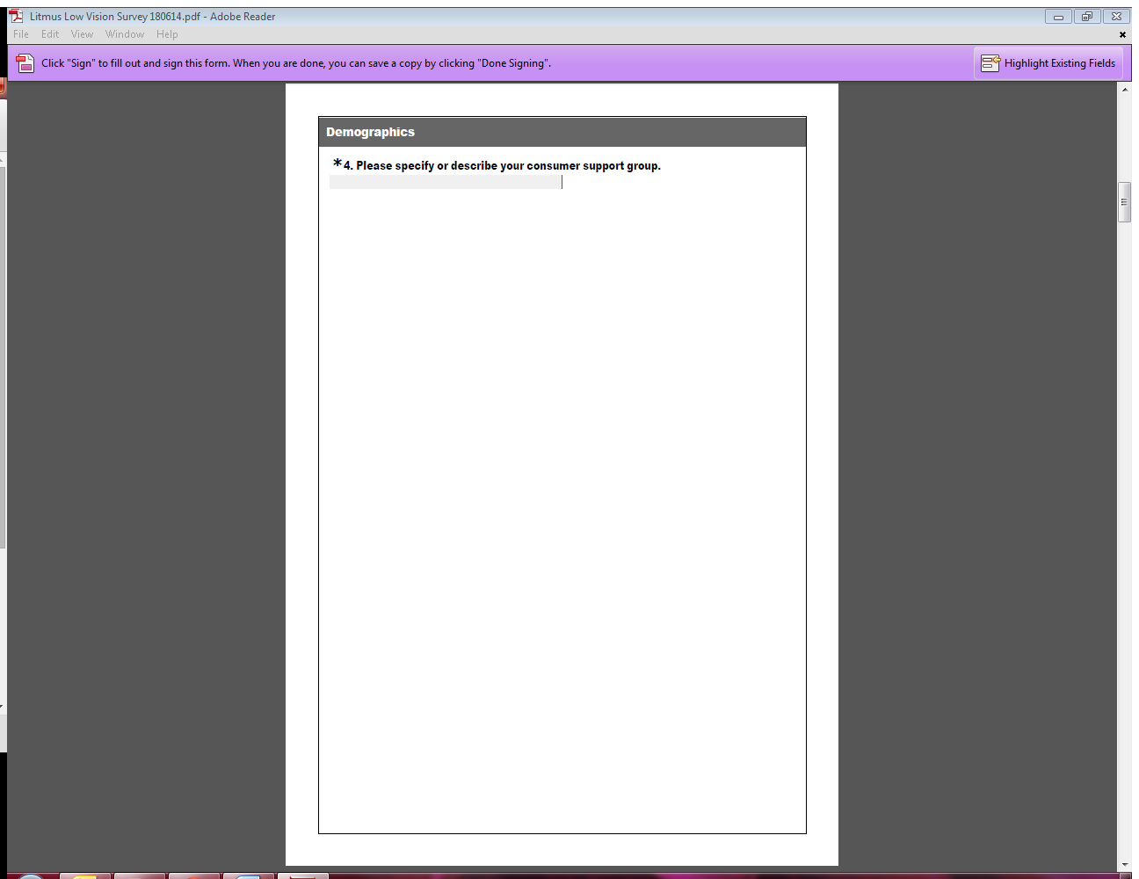 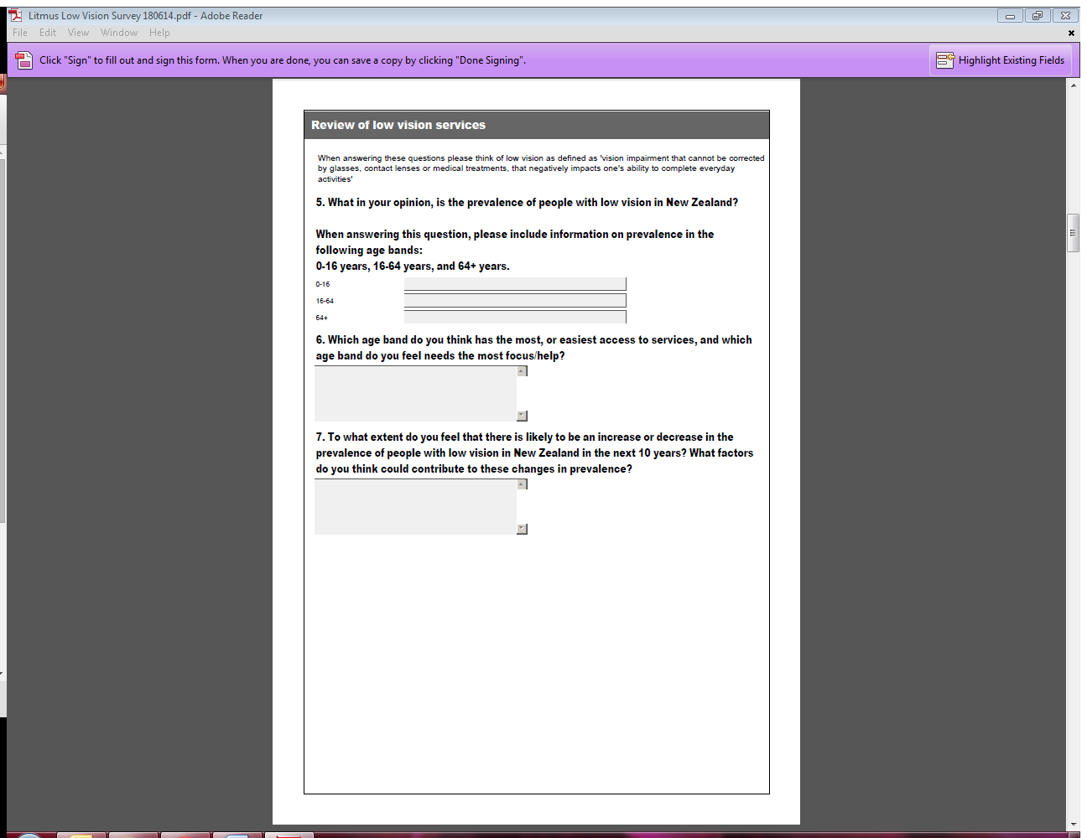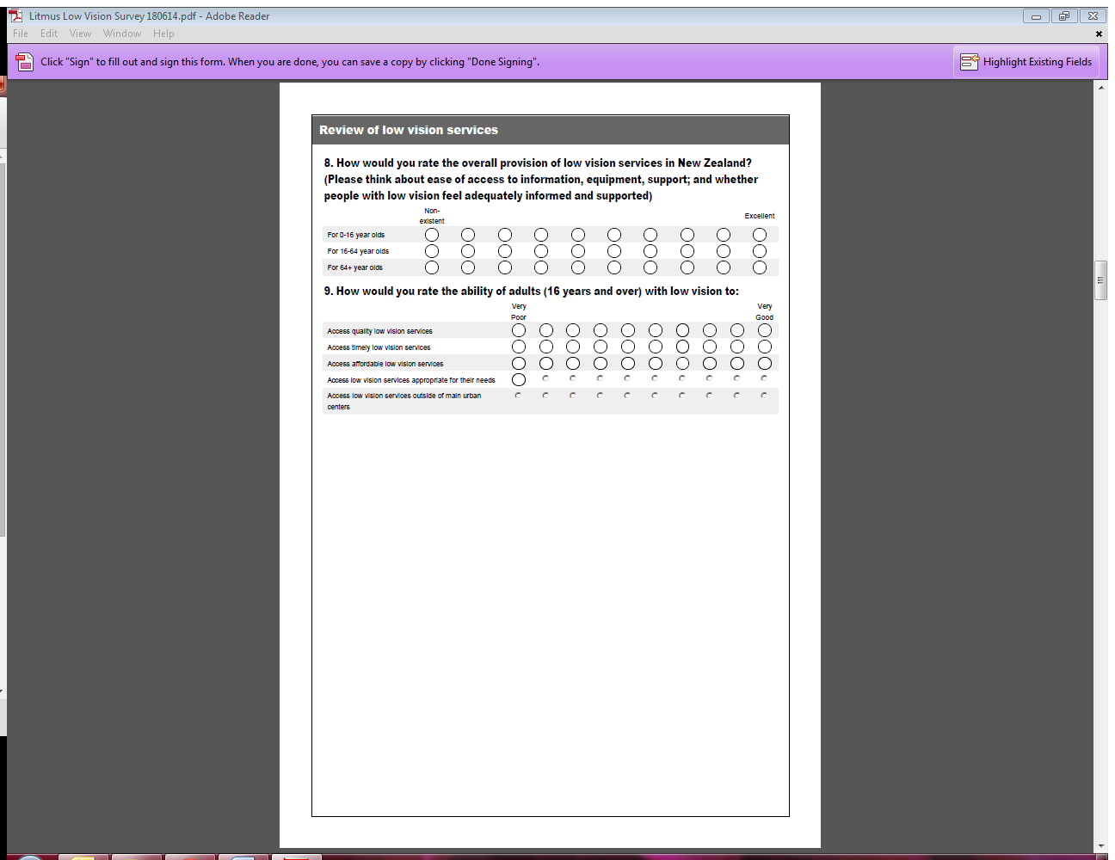 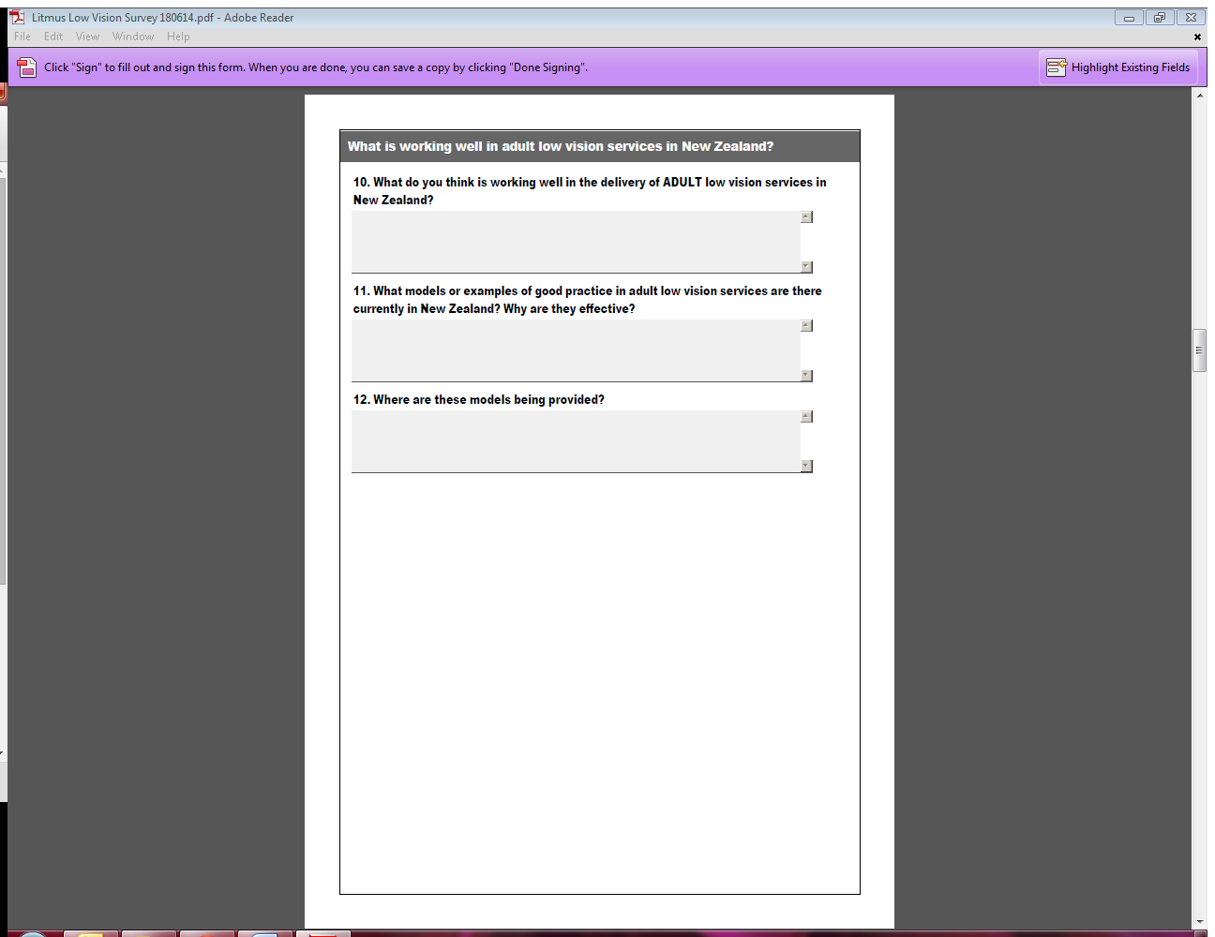

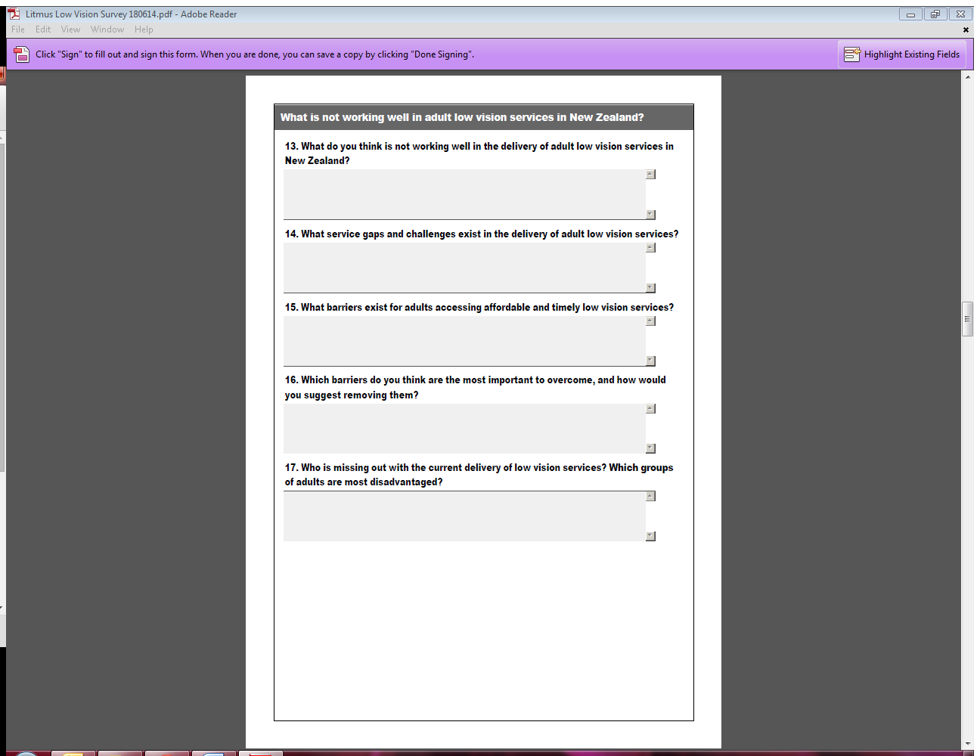 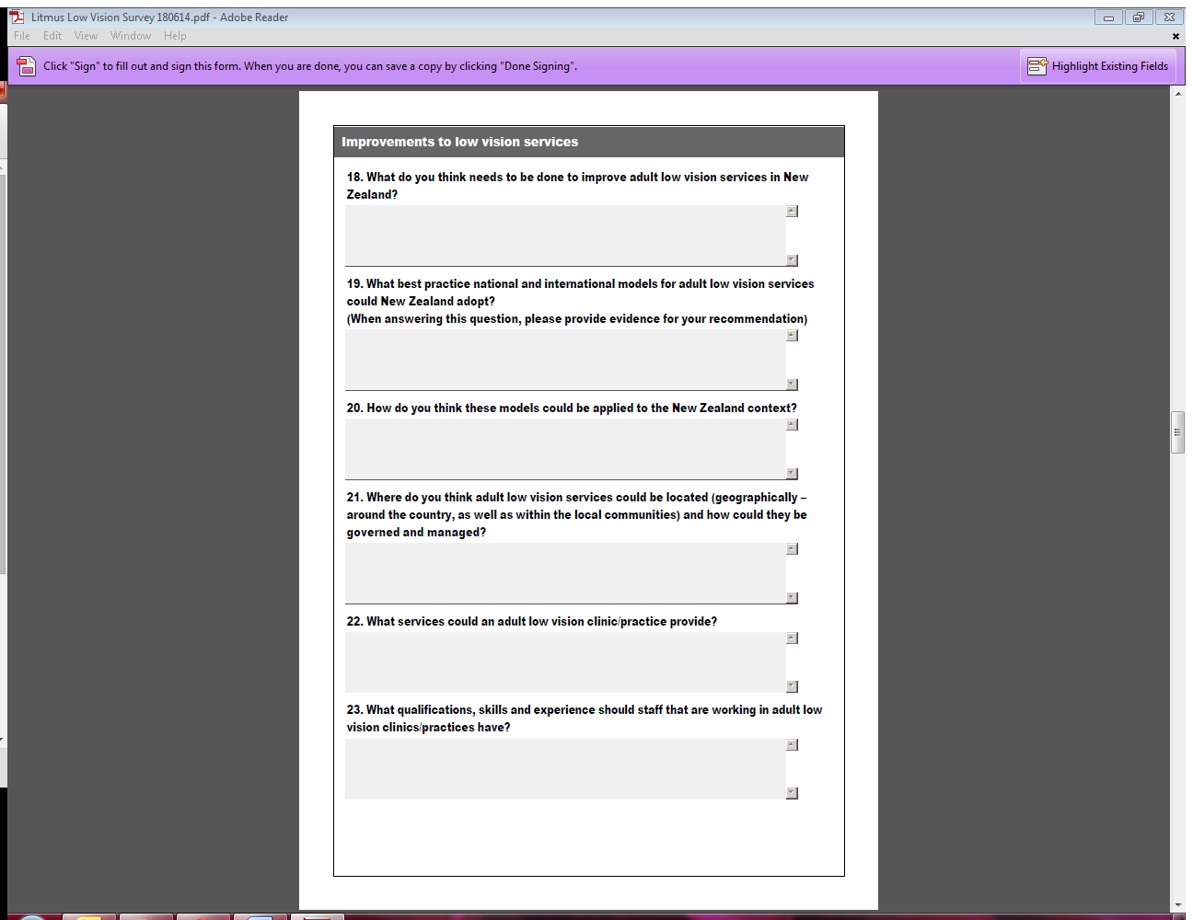

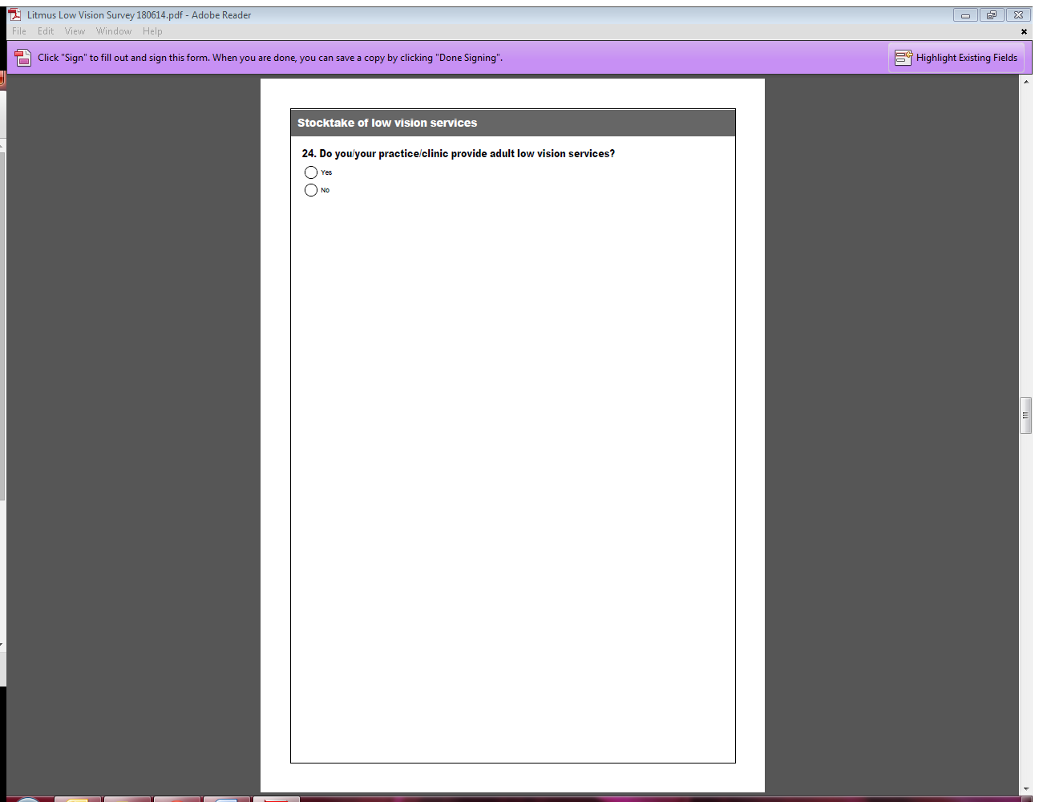 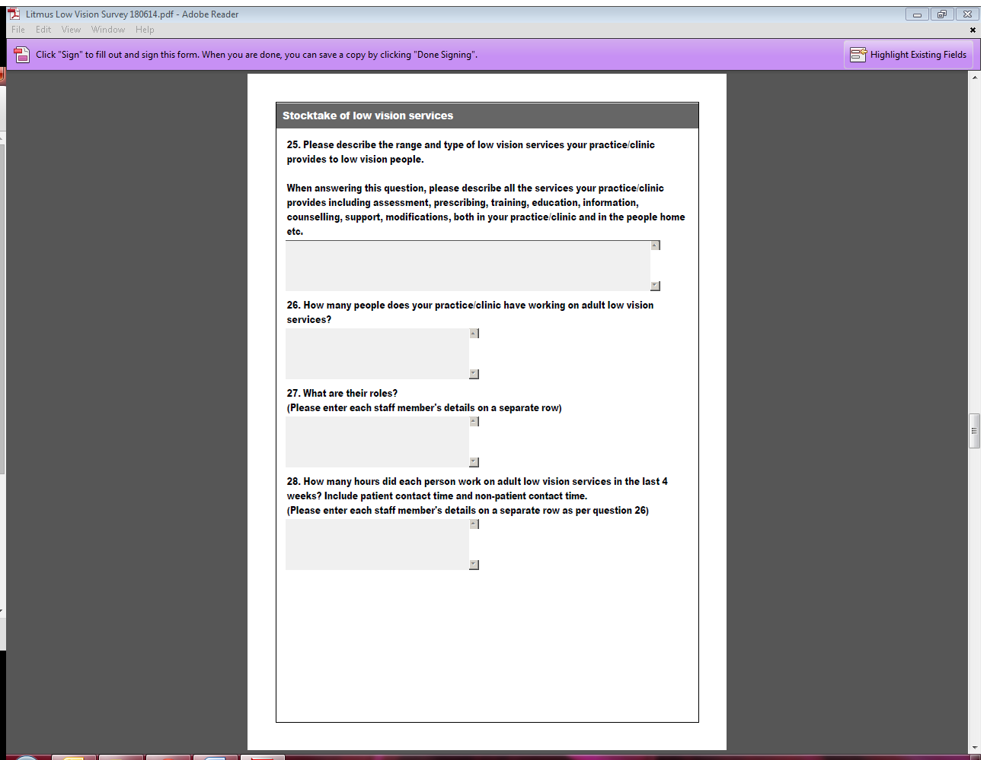

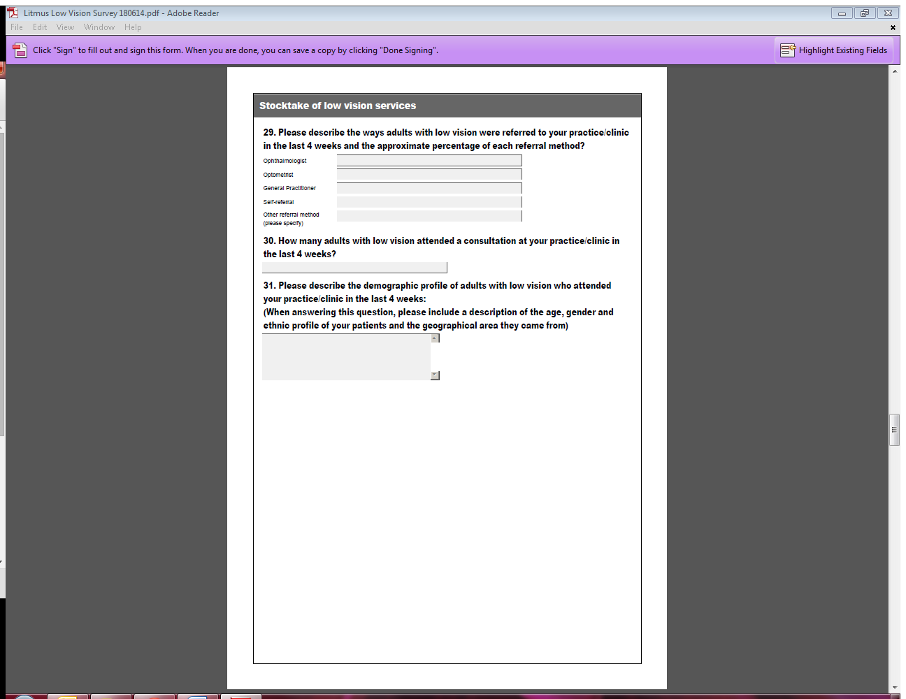 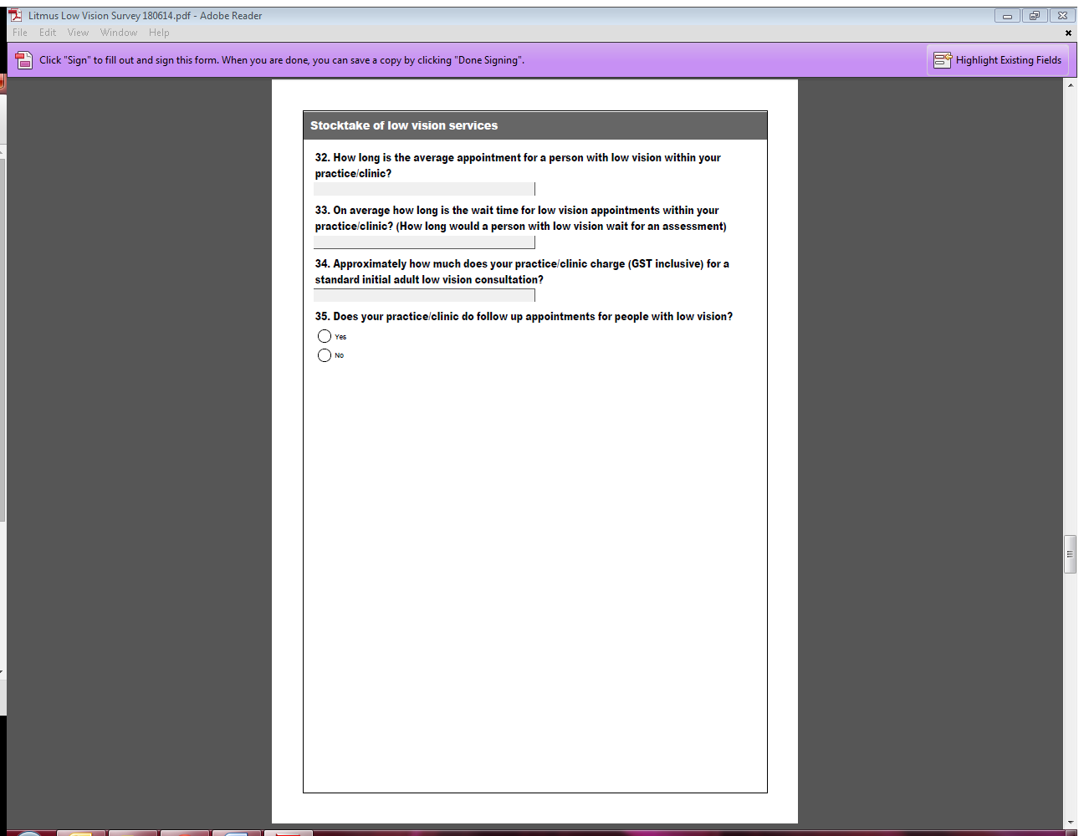

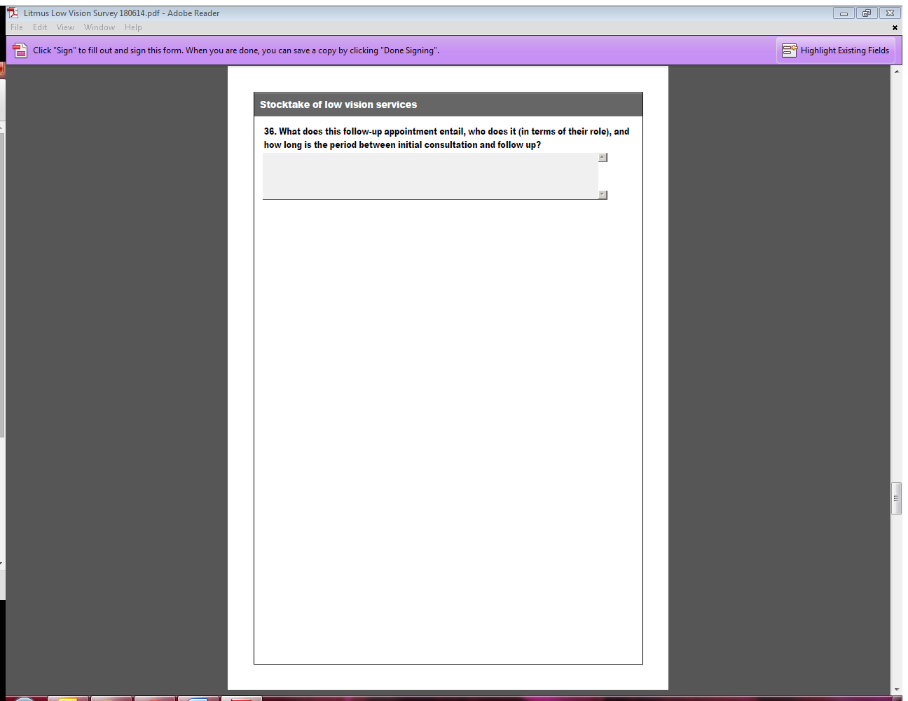 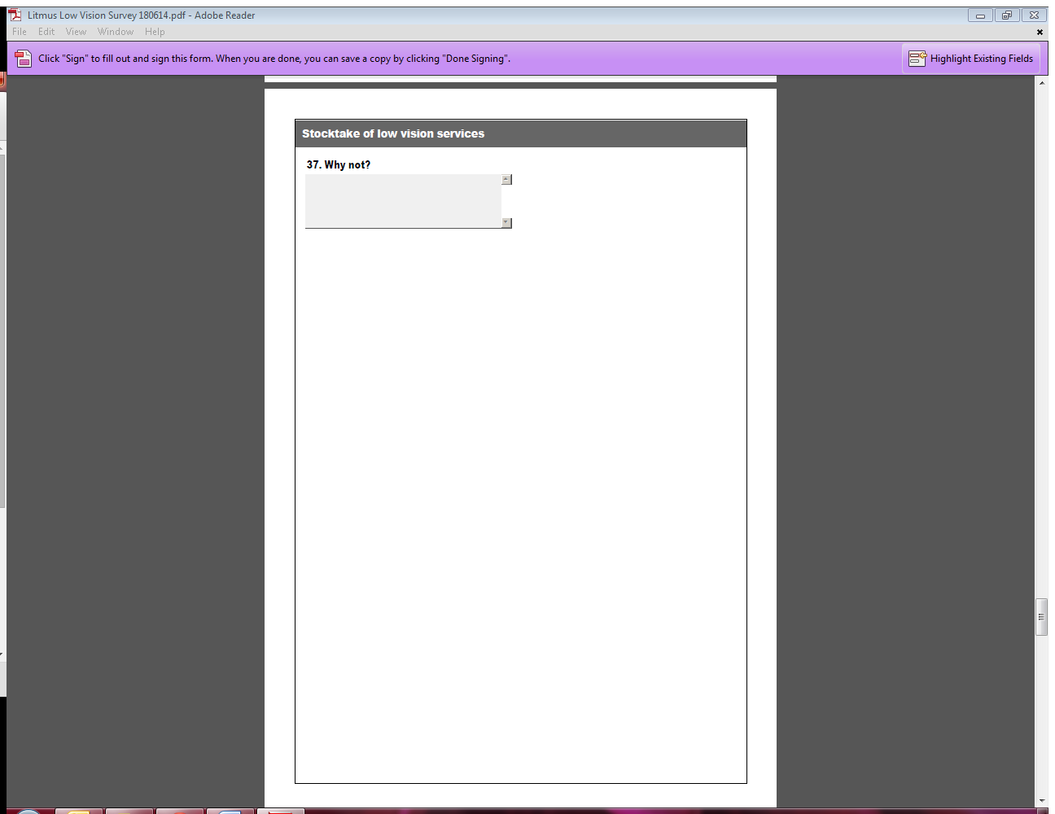

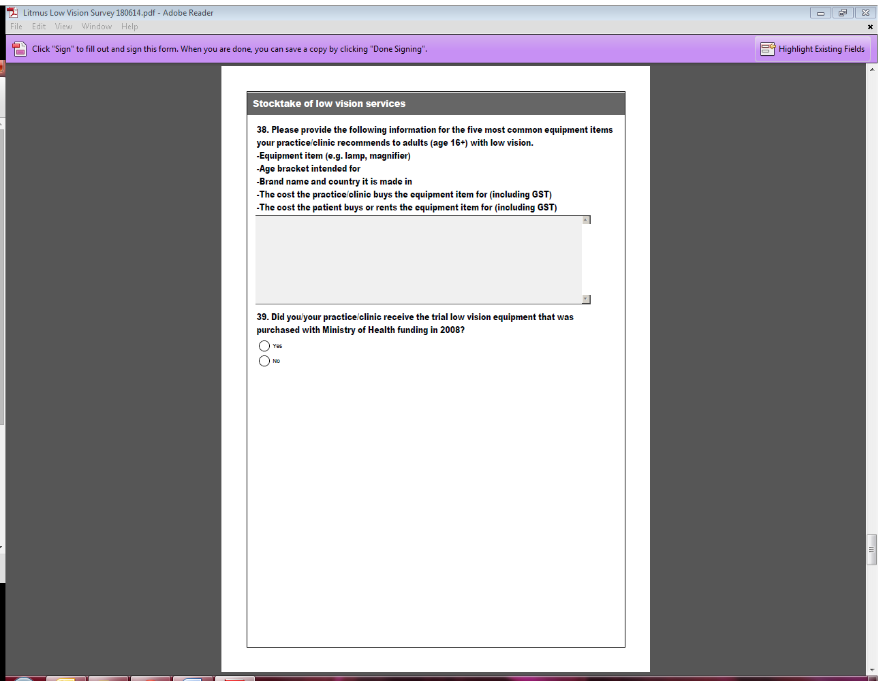 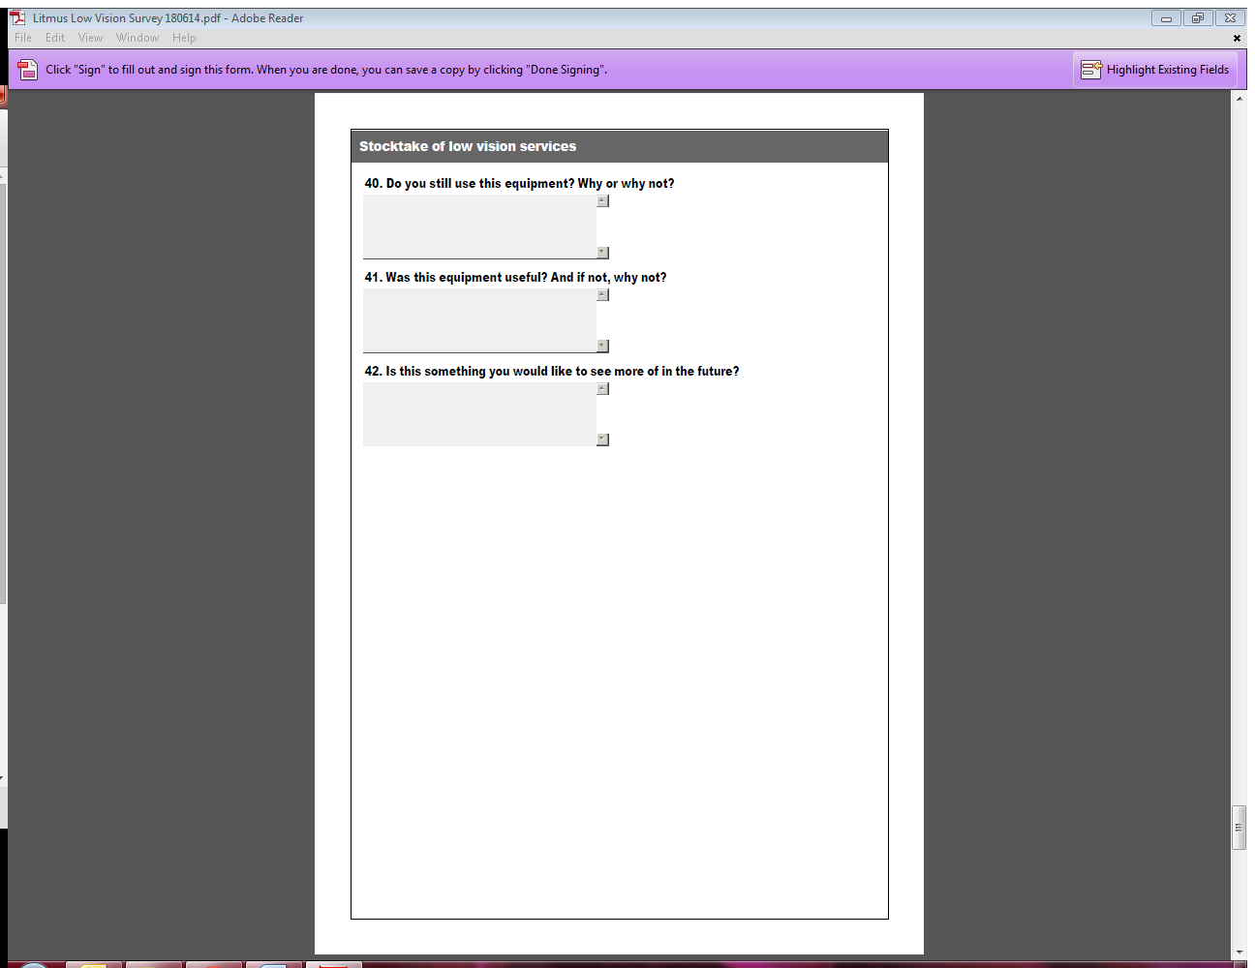

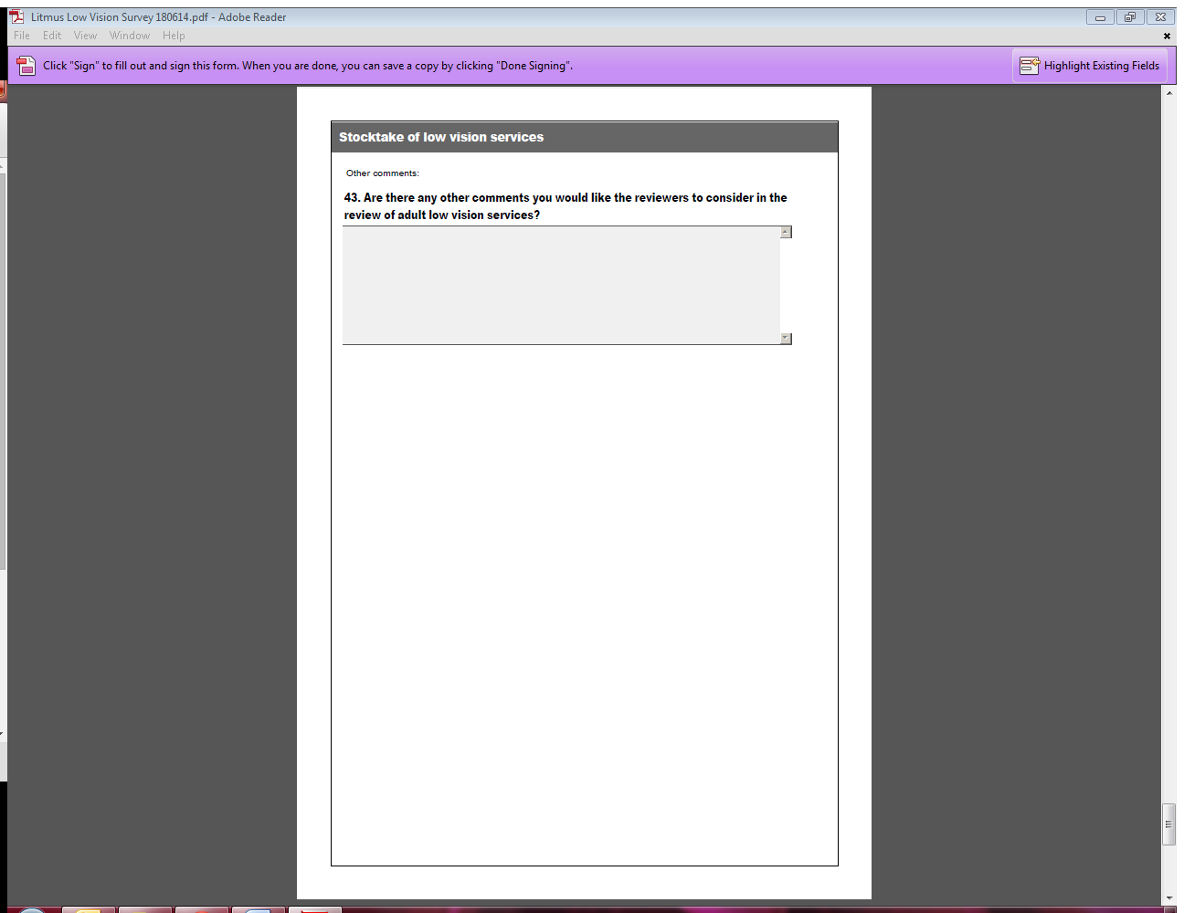 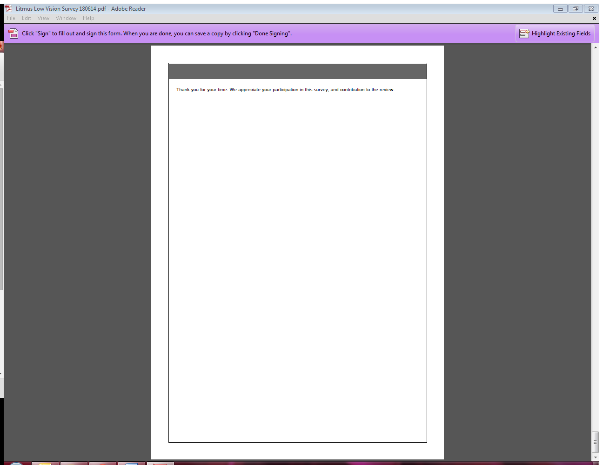

### A2: In-depth stakeholder interviews

#### A 2.1 Stakeholder interview consent form

I (write name) …………………………………………………………………………………….

of (write address) ……………..………………………………………………………………….

agree to participate in this project for the stocktake and review of low vision services in New Zealand, as outlined in the information provided to me by Litmus Ltd. I understand that:

* My participation in the project is voluntary and I can withdraw at any time.
* No information in the review report will be attributed to me by name, although my role may be identified.
* The interview will be audio recorded with my permission, and may be transcribed. I have the right to request a copy of the audio or transcript of my discussion.
* I can request any information collected from me to be withdrawn at any time up until the analysis stage.
* If I withdraw, I can request that any information collected from me to be returned or destroyed.
* Recordings, notes, and summaries will be stored securely at Litmus and will not identify me by name. They will be kept for two years and then securely destroyed.

I have this consent form, and have been given the opportunity to ask questions and have them answered. I give my consent to participate in this review.

Participant’s signature: __________________________

Date: _________________

#### A 2.2 Stakeholder interview guiding questions

*Objective 1: Determine the prevalence of People with low vision in New Zealand.*

* How would you define low vision?
* What information is available on the prevalence of People with low vision, in the following age bands: 0-16 years; 16-64 years; 64+ years in New Zealand?
* What is your opinion of the prevalence of People with low vision in New Zealand?

*Objective 2: Undertake a stocktake of low vision services in New Zealand.*

* What services are available for People with low vision, across all age groups?
* What types of services are offered?
* Where are they available in New Zealand?
* Who provides these services? (including allied health and specialist medical practitioners)
* What are the current processes for accessing these services?

*Objective 3: Evaluate the provision of low vision services (for adults) against international good practice and other sensory support services.*

* What is the evidence-based best practice internationally in the provision of low vision services?
* What relevant models and principles of the delivery of low vision services of adults could be applicable to the New Zealand situation?
* What specialist skills and experience, if any, are required by optometrists, ophthalmologists, occupational therapists or other allied health professionals, to assess the needs of, and make recommendations to support the needs of adults with low vision?
* If any specialist skills are identified, should these be linked to the EMS Assessor Accreditation Framework as an identified credentialed area of accreditation?
* What key types of equipment and sustainable housing design could be recommended to support adults with low vision? (including estimated cost range for equipment items; availability in New Zealand; and value and potential impact of their use.)
* How does the current provision of low vision services for adults compare with the provision of other sensory services in New Zealand (such as hearing)?

*Objective 4: Identify where any unmet needs and service gaps exist for adults with low vision.*

* What is working well in the current delivery of low vision services for adults?
* What are the barriers for people preventing their access to low vision rehabilitation?
* What are the key unmet needs of adults with low vision?
* What are the current service gaps and challenges?
* What inconsistencies / inequalities are evident for different population sub-groups and/or geographical locations across New Zealand? Why do these inequalities/ inconsistencies exist?
* What are the drivers for likely increased demand and cost (such as an aging population?)

1. Clear Focus Report (2010)
2. Clear Focus Report (2010)
3. Clear Focus Report (2010)
4. See References section for Vision Australia website link
5. See References section for CNIB website link
6. See References section for UK Visions Strategy website link
7. See References section for the National Eye Institute website link
8. Petition 2011/71 of Dr Lynley Hood and Associate Professor Gordon Sanderson on behalf of VICTA New Zealand and 1321 others.
9. See References section for Sight Loss Services website link
10. I Kocur & S Resnikoff, ‘Visual impairment and blindness in Europe and their prevention’, BR J Ophthalmol, 2002, 86(7): 716-722.
11. Kocur, I., & Resnikoff, S. (2002) ‘Visual Impairment and Blindness in Europe and their Prevention’. BR J Ophthalmol, 86(7): 716-722.
12. Briefing note from the Blind Foundation to the Ministry of Health on the low vision services trial, September 2013.
13. BF Compendium Vol 2.
14. New Zealand Optics article April 2013
15. http://www.visionaustralia.org/about-us/contact-us/locations/vic-locations/kooyong---victorian-head-office
16. Ryan, B., Khadka, J., Bunce, C., & Court, H. (2003). Effectiveness of the community-based Low Vision Service Wales: a long-term outcome study. Br J Ophthalmol, 97, 487-491.
17. Palmer, S., & Traynor, C. (2004). The Patient Support Service at Gartnavel Hospital Eye Department: An Evaluation of the First Year.