Standardised Tobacco Products and Packaging Draft Regulations
Consultation document

Citation: Ministry of Health. 2016. Standardised Tobacco Products and Packaging Draft Regulations: Consultation document. Wellington: Ministry of Health.
Published in May 2016
by the Ministry of Health
PO Box 5013, Wellington 6140, New Zealand
ISBN 978-0-947515-16-4 (print)
ISBN 978-0-947515-17-1 (online)
HP 6422
This document is available at health.govt.nz

This work is licensed under the Creative Commons Attribution 4.0 International licence. In essence, you are free to: share ie, copy and redistribute the material in any medium or format; adapt ie, remix, transform and build upon the material. You must give appropriate credit, provide a link to the licence and indicate if changes were made.

Contents
Scope of this consultation iv
How to have your say v
Introduction 1
Overview 1
Background 2
Terms used – ‘plain’ versus ‘standardised’ 2
Alignment with Australia 3
International developments 3
General principles used in developing the draft regulations 4
Protection from commercial and other vested interests of the tobacco industry 5
Outline of draft regulations 6
Part 1 – General requirements 6
Part 2 – Cigarettes 6
Part 3 – Loose tobacco 7
Part 4 – Cigars 7
Relationship to existing Smoke-free Environments Regulations 2007 7
Summary of key consultation issues and questions 9
Size and quantities of tobacco products 9
Permitted markings on tobacco packages 11
Additional features to increase the effectiveness of standardised packaging 13
Other comment on content of the draft regulations 13
Indicative 3-D image of a standardised cigarette pack 13
Indicative layout for printing a standardised cigarette pack 14
Consultation submission 15
Consultation questions 16

Scope of this consultation
In 2013 the Government decided to introduce a new regulatory scheme to standardise tobacco products and packaging.

The Ministry of Health is now seeking feedback on an ‘exposure draft’ of a proposed set of regulations. The regulations will be needed to bring the new regulatory scheme into force, and set out the detailed specifications for the standardised tobacco products and packages.

The legislation that creates the regulatory powers to bring in standardised tobacco products and packaging – the Smoke-free Environments (Tobacco Plain Packaging) Amendment Bill – is currently progressing through Parliament. The date when the regulations would come into force depends on when the Bill is passed, and has yet to be determined.

The scope of this consultation is confined to the proposed requirements for standardised tobacco products and packages as set out in the exposure draft of the regulations. The Government has not yet made any final decisions on these detailed regulatory requirements.

Both the contents of the Bill and the earlier policy decision to standardise tobacco products and packaging have been the subject of previous public consultation, and are outside the scope of this consultation.

How to have your say
Your feedback is important to help inform the drafting of the final regulations.

The Ministry of Health welcomes submissions on the content and coverage of the draft regulations, backed up wherever possible with detailed reasons and factual evidence. The Ministry is particularly interested in information about the impact and practical implications of the proposed regulations, including for compliance and enforcement.

This consultation document gives an overview of the exposure draft regulations, raises a number of consultation issues and poses some specific questions that may help you to prepare your submission. (Please note that commentary not directly related to the content and coverage of the draft regulations will be treated as out of scope.)

At the back of this document is an optional submission form with a list of the questions presented in this document. You may decide to fill it all in, to use it but answer only some of the questions, or to follow your own format instead of using the submission form.

You can make your submission by sending an email to:
standardisedtobacco@moh.govt.nz

The closing date for submissions is Friday 29 July 2016.

Your submission may be subject to a request under the Official Information Act 1982.

If you consider there could be good reasons to withhold your submission in whole or in part, please indicate this clearly in your submission.

Submitters are also requested to disclose any links to the tobacco industry.

Introduction

Overview
Tobacco products are harmful and highly addictive. Smoking is a major risk factor for serious disease and the leading avoidable cause of premature death in New Zealand – between 4500 and 5000 lives are lost each year.

Tobacco products are already required to carry large, graphic health warnings and may not be displayed at point of sale or advertised in any media. However, the design and appearance of tobacco products and tobacco product packaging continue to be powerful marketing tools that work to promote the use of tobacco products.

These marketing tools undermine the effectiveness of health warnings that aim to persuade people not to start smoking and encourage smokers to stop. They also create false perceptions among consumers, leading smokers to underestimate the harms caused by tobacco products.

Allowing tobacco products to be advertised or promoted in any way is inconsistent with the Government’s wider goal of making New Zealand ‘smokefree’ by 2025.

To counter the current and future marketing power of tobacco products and packaging, the Government has decided to tightly regulate how tobacco products may be packaged and presented. The new regulatory scheme to standardise tobacco products and packaging is a two-stage legislative package comprising:
- primary legislation (an Act of Parliament to amend the Smoke-free Environments Act 1990)
- regulations to be made under the amended Act to set out the detailed requirements for implementing and complying with the new regime.

The primary legislation creates the powers to regulate how tobacco products are packaged and presented, and introduces new offences and penalties for breaches of the new requirements.

The detailed requirements for tobacco product design, appearance, packaging and labelling, improved graphic warnings, and standardised pack quantities are all to be set out in the subsequent regulations.

This consultation relates to the draft content of the regulations that will be finalised into law after the primary legislation has passed.

The main features of the overall scheme of the new law and regulations are:
- standardising the size and appearance of tobacco products and packages to make them less appealing, and to make the graphic warnings on the packs larger and more effective
- allowing a brand name and certain other manufacturer information to be printed on the pack, but with tight controls (eg, over the typeface, font size, colour and position)
- prohibiting the use of tobacco company branding imagery and all other marketing devices on tobacco product packaging and on tobacco products themselves.

Background
In February 2013 Cabinet agreed to introduce a plain packaging regime for tobacco products.

In February 2014 the Smoke-free Environments (Tobacco Plain Packaging) Amendment Bill was introduced to Parliament and had its first reading. In August 2014 the Bill was reported back to Parliament from its select committee stage. The Health Committee recommended the Bill be passed, with some minor amendments.

The Bill is currently on Parliament’s Order Paper, awaiting its second reading. It is expected the Bill will be passed later this year.

The Bill includes the powers needed to make the detailed regulations for bringing in the new regime to standardise tobacco products and packaging.

The commencement clause in the Bill would bring the new regulatory regime into force 18 months after the Bill is passed, unless the Government decides to bring it into force earlier. The regulations need to be in place before the Bill comes into force.

Cabinet has therefore decided that the Ministry of Health should run this consultation on an ‘exposure draft’ of the regulations before the Bill is finally passed. Even though the Bill has not yet been passed, the consultation is important to give affected parties ample warning of the detailed proposed requirements. The consultation gives all stakeholders an opportunity to comment on and influence the detail that will be included in the final regulations.

The consultation is not intended to re-open the wider policy debate on whether to introduce standardised tobacco products and packaging in New Zealand. There has already been extensive public consultation on this topic in July 2012 and also during the select committee phase when the Health Committee of Parliament examined the Bill in 2014.

For further information on the 2012 and 2014 consultation processes, please visit the websites listed in footnotes 1 and 2 below.

Terms used – ‘plain’ versus ‘standardised’
As noted above, Parliament’s Health Committee recommended passing the Bill with minor amendments. Among those amendments were changes to the language in the Bill, including in the Bill’s title, to use the term ‘standardised’ rather than ‘plain’.

Both terms (‘plain’ and ‘standardised’) are in use internationally and are often interchangeable. In New Zealand, official government terminology is settling towards ‘standardised’ as a more accurate and meaningful description (as endorsed by the Health Committee), but the term ‘plain packaging’ continues to be sometimes used.

Alignment with Australia
Australia was the first country in the world to introduce standardised tobacco packaging.

Australia’s Tobacco Plain Packaging Act and Tobacco Plain Packaging Regulations came into force in October 2012. They were fully implemented from December 2012.

Before Australia introduced standardised packaging, tobacco packaging and labelling regulatory regimes were very similar in New Zealand and Australia. There were some country-specific differences (eg, the New Zealand health messages in te reo Māori, different free-phone Quitline numbers on the back of the pack and some different warning colours). However, the regulated appearance of tobacco products on both sides of the Tasman was essentially the same. The size and positioning of the health images followed the same specifications in both countries.

After New Zealand’s standardised packaging legislation and regulations are passed and come into force, the tobacco product packaging and labelling regimes in Australia and New Zealand will again be broadly aligned.

For illustrated guides to Australia’s tobacco plain packaging requirements, go to:
www.health.gov.au/internet/main/publishing.nsf/Content/tppbook
http://health.gov.au/internet/main/publishing.nsf/Content/tpp-resources

The Australian Government has reported on evaluation research and evidence that demonstrates the effectiveness of its plain packaging regime:
www.health.gov.au/internet/main/publishing.nsf/Content/tobacco-plain-packaging-evaluation

Australia has also undertaken a formal Post Implementation Review, published by its Office of Best Practice Regulation:
https://ris.govspace.gov.au/2016/02/26/tobacco-plain-packaging

International developments
Three other countries (Ireland, the United Kingdom and France) have also passed standardised packaging legislation following Australia’s lead.

These three countries have timed their standardised packaging regimes to be consistent with the requirements for European Union (EU) members to comply with a new Tobacco Products Directive, agreed in 2014 with effect from 20 May 2016.

The EU Tobacco Products Directive brings in large mandatory pictorial health warnings on tobacco products across the EU. The Directive also expressly allows for EU member countries to go further and introduce standardised packaging provisions if they wish.

Standardised packaging has now come into force in the United Kingdom and France and the main legislation is in place in Ireland. Initially the standardised packaging requirements apply only at the manufacturing and distribution end of the supply chain.

In France full implementation (ie, no retail sales of non-compliant tobacco products permitted) comes into force from January 2017. In Ireland and the United Kingdom the ‘wash-through’ period for retail sales of non-standardised tobacco products extends to May 2017.

Several other countries both within and outside the European Union (including Norway, Singapore, Canada, Sweden, Finland, Hungary, Turkey and South Africa) are at various stages of considering or developing standardised tobacco packaging legislation.

The World Health Organization (WHO) has declared the theme for World No Tobacco Day on 31 May 2016 to be ‘Get ready for plain packaging’ (Figure 1).

Figure 1: ‘Get ready for plain packaging’ as theme for World No Tobacco Day 2016
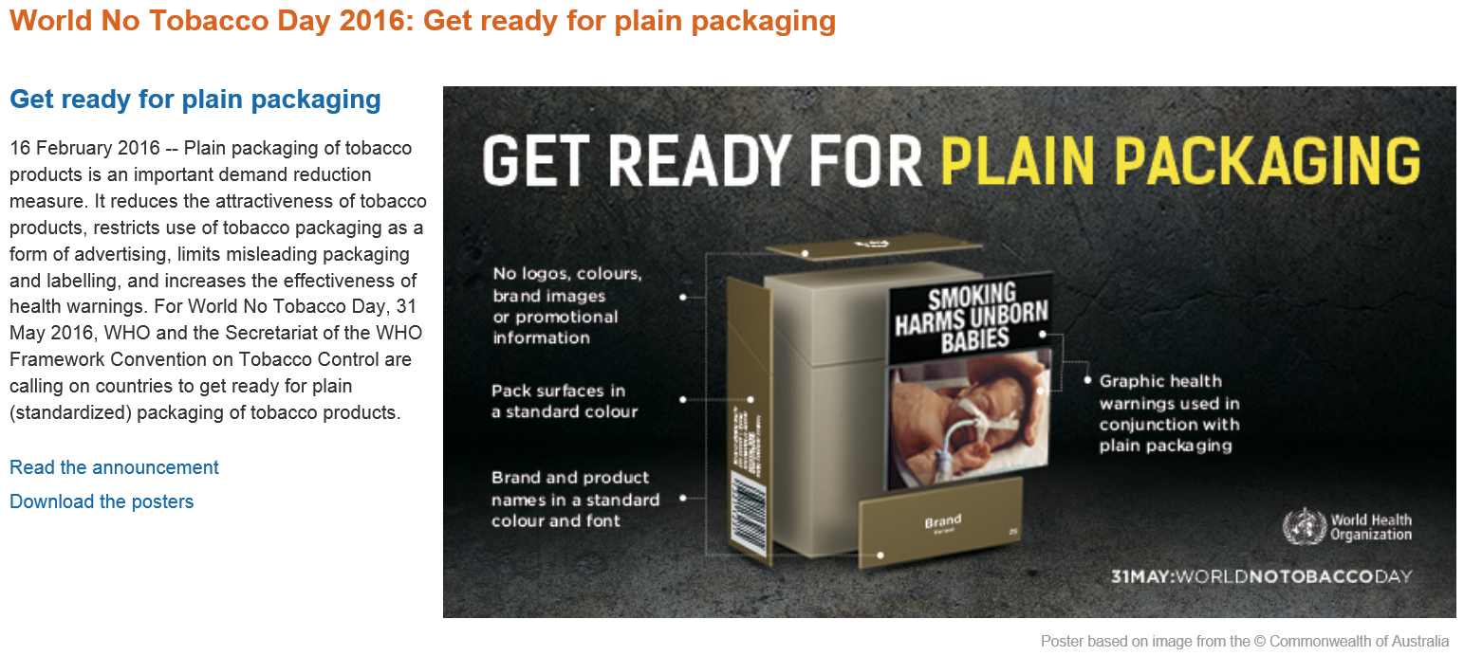
Source: WHO web page, www.who.int/campaigns/no-tobacco-day/2016/en

General principles used in developing the draft regulations
The aim of the standardised packaging amendment to the Smoke-free Environments Act is to standardise the appearance of tobacco products and tobacco product packaging to reduce their appeal and acceptability, make warning messages more effective and minimise false impressions about harmful effects.

In developing the proposals in these draft regulations, the following principles have been applied:
- alignment of New Zealand requirements with those applying in Australia as the starting point for standardised packaging, taking into consideration the requirements being introduced or proposed in other jurisdictions (see ‘Alignment with Australia’ and ‘International developments’ sections above)
- effectiveness – a preference for the strongest form of standardisation unless there is good reason to relax this or to vary it for New Zealand circumstances (including potentially strengthening the requirements)
- practicality – a preference for simplicity without compromising effectiveness
- consistency with New Zealand’s international obligations and commitments.

Protection from commercial and other vested interests of the tobacco industry
New Zealand is a party to the global tobacco control treaty, the World Health Organization Framework Convention on Tobacco Control (FCTC).

New Zealand has an obligation under Article 5.3 of the FCTC when “setting and implementing public health policies with respect to tobacco control ... to protect these policies from the commercial and other vested interests of the tobacco industry”.

The internationally agreed Guidelines for Implementation of Article 5.3 recommend that parties to the treaty “should interact with the tobacco industry only when and to the extent strictly necessary to enable them to effectively regulate the tobacco industry and tobacco products”.

The views, evidence and information that only the tobacco industry can provide are important input to this consultation on the contents and coverage of the draft regulations proposed to implement standardised tobacco products and packaging.

The Guidelines for Implementation of Article 5.3 also include an overarching principle of transparency when governments are dealing with the tobacco industry or those working to further its interests.

To help meet this obligation, all respondents are asked to disclose whether they have any direct or indirect links to, or receive funding from, the tobacco industry.

Outline of draft regulations
The draft regulations for consultation are set out in four parts.

Part 1 sets out general requirements that will apply to all tobacco products (subpart 1) and all tobacco packages (subpart 2) respectively. Part 2 contains provisions that apply only to cigarettes, cigarette packs and cigarette cartons. Part 3 relates to loose tobacco packaging. Part 4 covers packaging for cigars.

Part 1 – General requirements
Part 1 deals with general issues such as the colour and smell of products and packaging and the format for text that can be printed on tobacco products and packages. The general intent of these provisions is to standardise these design features, so that they cannot be used in an attempt to create consumer appeal. This includes ‘future-proofing’ to avoid new marketing devices such as the use of noises or features that might change the appearance of tobacco products or packaging after sale.

Part 1 specifies the typefaces, font sizes and colours that may be used on tobacco packages. The unattractive dark green/brown colour (known as Pantone 448C) is set as the basic standardised background colour for all standardised tobacco packaging. Part 1 also ensures that any wrappers put around tobacco products do not interfere with the off-putting impact of packages in this colour or disguise any of the required features on tobacco packages.

Part 1 also sets out the general requirement for enlarged health warnings to cover at least 75 percent of each of the front and back surfaces of tobacco product packages. (For cigarette packs the current requirement for health warnings to cover 90 percent of the back surface continues.)

Part 2 – Cigarettes
Cigarettes are the most commonly smoked tobacco products and the main focus of tobacco industry efforts to appeal to consumers through product and packaging design and appearance. As a result, the draft regulations proposed in Part 2 take a detailed and comprehensive approach to standardising cigarettes, cigarette packs and cigarette cartons.

This approach includes restricting the shape, size and appearance of cigarette sticks to their traditional cylindrical shape with specified minimum and maximum length and diameter.

The draft regulations also restrict the design of cigarette packs to a standard rigid cardboard flip-top box with size limits in terms of minimum and maximum dimensions. Another proposal is to restrict the number of cigarettes in a pack to either 20 or 25. These are the most common pack sizes currently sold.

The draft regulations for cigarette packs also propose controlling the linings inside the cigarette packs to prevent the use of any attractive designs, colours or materials.

Under the draft regulations the only branding that will be permitted on tobacco packaging will be the brand name and the brand variant name. Part 2 contains the detail of how these brand and variant names will be standardised in terms of their size and position on cigarette packaging and the specific typeface, font sizes and colours in which they may be printed.

Part 3 – Loose tobacco
The draft regulations in Part 3 propose that loose tobacco will only be able to be sold in plastic pouches containing either 30 grams or 50 grams of manufactured tobacco. These are the most common form of packaging and standard sizes currently available on the market. Other types of loose tobacco packaging and quantities would no longer be permitted for sale.

Part 3 also covers the requirements for printing standardised brand names and variant names on loose tobacco pouches. Another provision allows manufacturers to meet the new, more extensive health warning requirements under standardised packaging by sticking permanent adhesive labels onto the plastic tobacco pouches. This continues the current permitted practice that assists manufacturers and importers to comply with labelling regulations.

Part 4 – Cigars
The draft regulations in Part 4 propose that cigars may be sold singly in a cigar tube, or in packs containing 5 or 10 cigars. Part 4 also sets out the requirements for printing the number of cigars, a bar code, and brand and variant names.

As noted above, the draft regulations in Part 1 covering all tobacco products will increase the size of required warnings to cover 75 percent of each of the main front and back surfaces of cigar packages. To accommodate the cylindrical shape of cigar tubes, Part 4 sets out an equivalent requirement for health warnings to cover 95 percent of the length of the tube and 60 percent of the circumference.

Relationship to existing Smoke-free Environments Regulations 2007
The draft regulations for consultation contain only the new measures being proposed to standardise tobacco products and tobacco product packaging. After the consultation has concluded, the Government will make final decisions on the content of the new regulations.

It is intended that the final regulations will be issued as an amended version of the existing Smoke-free Environments Regulations 2007. Some of the provisions in the existing regulations will be replaced by the new standardised packaging regulations, while some other provisions do not need changing and will continue to apply. A number of consequential and necessary amendments are likely to be made as well.

Before the new regulations are finalised, the Government will also make decisions on new health warnings and graphic images to refresh and enhance the existing set of messages.

The Smoke-free Environments Regulations 2007 include detailed schedules that set out the content of the required health warnings and the graphic images that accompany each warning (including the exact wording of the different warning messages and explanatory messages) and also give clear instructions on how the different components of the warnings should be laid out on tobacco packages. The schedules will be updated with the new warnings and messages and all the new standardised packaging requirements.

Summary of key consultation issues and questions

Size and quantities of tobacco products

Cigarettes
The draft regulations contain several inter-related provisions to standardise the contents and size of cigarette packages. These include proposals to:
- limit the number of cigarettes in a pack to 20 or 25
- restrict the dimensions of cigarette sticks by setting minimum and maximum length and diameter
- set minimum and maximum height, width and depth of cigarette packs, consistent with the limits on the number and size of the cigarette sticks they contain.

At present cigarette packs must contain at least 20 cigarettes, but may contain any number greater than 20. These minimum quantities prevent the sale of single cigarettes or small packages of cigarettes and tobacco that would be more affordable and attractive to young people at risk of taking up smoking. They also reduce the likelihood of impulse purchases of small amounts by smokers who are trying to stop smoking.

At the other end of the scale, if smokers were able to continue to buy larger quantities of cigarettes in single packages of say 40 or 50, this would encourage higher consumption. The ability to package cigarettes in any quantity above the legal minimum opens the door for marketing approaches such as ‘bonus’ packs containing say 21 or 26 cigarettes to give the impression of better value for money, particularly when cigarette prices are rising due to increases in tobacco excise tax.

The suggestion that cigarette packs should be limited to 20 or 25 cigarettes was raised in submissions to Parliament’s Health Committee on the Smoke-free Environments (Tobacco Plain Packaging) Amendment Bill. These are the most common quantities currently sold, making up 75 percent of reported cigarette sales, with packs of 20 alone accounting for 55 percent.

The draft regulations also limit the size of cigarettes to between 7 mm and 9 mm in diameter, and no more than 95 mm in length. Standardisation of cigarettes to these current common dimensions would prevent the sale of different cigarette sizes (eg, extra long and slim sticks) in an attempt to appeal to particular market segments.

The draft regulations for cigarette packs follow the Australian requirement for rigid, flat-surfaced, cuboid, cardboard cigarette packs with flip-top lids. The dimensions of the packs would be restricted to match the number of cigarettes and the size limits on the individual sticks. This would prevent any manipulation of pack dimensions in an attempt to create a marketing effect.

Loose tobacco, cigars and other tobacco products
Current legislation also sets a minimum quantity for loose tobacco, which must be sold in quantities weighing 30 grams or more.

Most loose tobacco for hand-rolling cigarettes is sold in plastic pouches of similar size and shape. However, current labelling regulations need to accommodate a wider range of packages in cylindrical, hexagonal and other shapes made from metal, wood or other material.

In order to simplify and standardise the appearance of loose tobacco packages, the regulations propose permitting rectangular pouches made of soft plastic only. Restricting the ability for tobacco to be packaged in containers of different shapes, sizes and materials prevents these design features from being used to increase the market appeal of any such distinctive tobacco product line.

Over 90 percent of the current market for loose tobacco is sold in packets of either 30 or 50 grams. The regulations propose that loose tobacco may only be sold in these two quantities.

The draft regulations also propose that cigars may continue to be sold singly or in packs containing 5 or 10 cigars. This is intended to provide a similar degree of standardisation as would apply to cigarettes and loose tobacco, while also reflecting the common quantities in which cigars are currently sold.

Note 1 (see consultation question 5): The proposals for cigars in the draft regulations are based on Australia’s plain packaging regime, which applies comprehensively to all tobacco products including cigars. However, like the proposals for cigarettes and loose tobacco, the draft regulations also propose prescribing the quantities in which cigars can be sold. (Ireland’s legislation also extends standardised packaging requirements to include cigars. Standardised packaging regimes in the United Kingdom and France apply only to cigarettes and loose tobacco, and do not apply to cigars.)
Note 2 (see consultation question 6): Australia’s legislation also includes a general requirement for loose tobacco pouches, cigar packs and all other tobacco packages to be at least 85 mm long and 55 mm wide. This provision ensures the packages are of sufficient size to clearly display mandatory health warnings and images. The draft regulations do not currently propose a similar provision for New Zealand because it would appear this may be unnecessary alongside the other restrictions on tobacco packages and contents.

Consultation questions
1. Do you agree with the proposals to limit the number of cigarettes in a pack to either 20 or 25, and the amount of loose tobacco to 30 grams or 50 grams?
2. Do you agree with the proposals to restrict the dimensions of cigarette sticks by setting minimum and maximum length and diameter?
3. Do you agree with the proposals setting minimum and maximum height, width and depth of cigarette packs, consistent with the limits on the number and size of the cigarette sticks they contain?
4. Do you agree with the proposal that loose tobacco should be sold only in rectangular pouches made of soft-plastic?
5. Do you agree with the proposals to standardise cigar packaging, including the proposal to limit the number of cigars that may be sold in a pack?
6. Should the regulations include a general provision to set a minimum size for all tobacco packages, including cigar packages?
7. Do you have any other suggestions for regulatory requirements to standardise the shape and size of tobacco products and tobacco product packages?

Permitted markings on tobacco packages

Anti-counterfeiting marks
Concerns have been raised that moving tobacco products into standardised packaging will make it harder to detect illegal tobacco products (ie, products on which tobacco excise tax has not been paid) and increases the opportunity for counterfeiting and ‘black market’ trade.

The Government considered this issue at the time it decided to proceed with standardised packaging, and found that New Zealand does not currently have a major problem with illegal tobacco trade. Furthermore, the shift to standardised packaging is unlikely to make any material difference to the ease with which tobacco packages could be copied by counterfeiters. These conclusions are now backed by Australia’s experience with standardised packaging over more than three years since it was introduced in late 2012. There is no evidence that illicit trade in counterfeit tobacco products has increased in Australia as a result of standardised packaging.

While illicit trade in tobacco products is not a major concern in New Zealand, it is a problem in many other parts of the world. As a result, the international community has negotiated a new treaty, the Protocol to Eliminate Illicit Trade in Tobacco Products. Global efforts to distinguish legitimate, tax-paid tobacco products from illicit tobacco trade depend on the ability to effectively track and trace tobacco products through the supply chain.

To assist with the tracking and tracing of legal, tax-paid tobacco products and the detection of counterfeit products, the draft regulations allow for identification marks in the form of alphanumeric codes to be printed on cigarettes and tobacco product packages, in the same way as allowed in Australia.

Like all elements that will be allowed to appear on standardised tobacco products and packages, these identification marks will not be permitted to be designed or presented in any way that communicates to consumers or might have the effect of promoting the product. For example, the alphanumeric identification marks may not be linked to product names or physical properties of the products.

Australia’s plain packaging regulations also explicitly allow for covert marks that are not visible to the naked eye. This provision has not been included in the draft regulations as currently proposed, but the Government is open to the possibility of allowing alternative or additional anti-counterfeiting marks where a good case can be made for their use in a way that is consistent with the aims of standardised packaging.

Marks or other features to allow for manufacturing processes
The Australian regulations allow for a small number of features on tobacco product packages on the basis that these are required for automated manufacturing and packaging processes. These features include inconspicuous calibration marks, bevelling on some corners of cigarette packs, and internal linings with a regular pattern of small embossed dots.

Although these features have not been included in the draft regulations as currently proposed, the Government is open to the possibility of allowing additional marks and features that are needed for automated manufacturing and packaging processes. A good case would need to be made that these are unavoidably necessary and would not undermine the aims of standardised packaging.

Country of manufacture
The draft regulations include a provision similar to Australia’s plain packaging scheme in allowing for the country of manufacture to be printed on a band around a single cigar.

Australia’s scheme also allows for the country of manufacture to be stated along with the manufacturer’s name, contact details and identification codes on cigarette packs and other tobacco product packages. This wider provision has not been explicitly included in the draft regulations as currently proposed, but the Government is open to the possibility of allowing country of manufacture markings on cigarette packs and other tobacco packages.

Consultation questions
8. Do the regulations need to allow for any other anti-counterfeiting marks?
9. If additional anti-counterfeiting marks are to be allowed, how could these be regulated to ensure they do not communicate to consumers or have any effect that might undermine the intention of standardised packaging?
10. Do the regulations need to permit any other marks or features on tobacco product packages to allow for automated manufacturing and packaging processes?
11. Should the regulations allow for the country of manufacture to be printed on tobacco products or packages?

Additional features to increase the effectiveness of standardised packaging
Consultation question
12. Are there any additional features within the scope of the regulation-making powers in the Smoke-free Environments (Tobacco Plain Packaging) Amendment Bill that might increase the effectiveness of standardising tobacco products and packaging? If so, what is the rationale and can you provide supporting evidence?

Other comment on content of the draft regulations
There is space at the end of the consultation submission form to give feedback on any other proposals in the draft regulations not otherwise covered by the consultation questions above.

Indicative 3-D image of a standardised cigarette pack
The image below is a simple three dimensional mock-up to give a visual impression of what a cigarette pack would look like under the proposals for standardised packages contained in the draft regulations. This illustration is only intended as a general guide, and is not intended to accurately represent all the detailed proposals in the draft regulations. The example of a health warning image and associated message are included in the image to give a complete impression, but are not within the scope of this consultation.
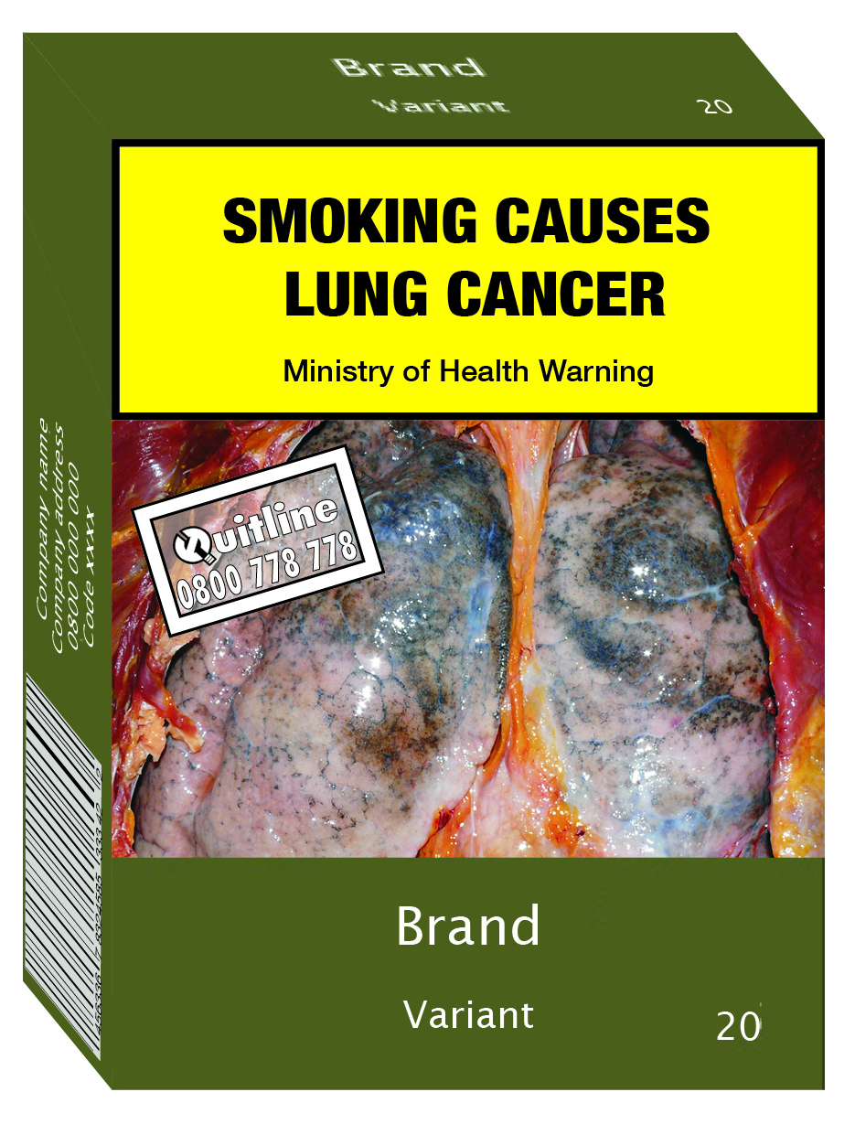

Indicative layout for printing a standardised cigarette pack
The image below is a simple mock-up of how a standardised cigarette pack might be laid out for printing. This is intended to give a visual impression of the key elements of a standardised cigarette pack under the proposals for standardised packages contained in the draft regulations. The illustration is only intended as a general guide, and is not intended to accurately represent all the detailed proposals in the draft regulations. The example of a health warning image and associated messages are included in the image to give a complete impression, but are not within the scope of this consultation.
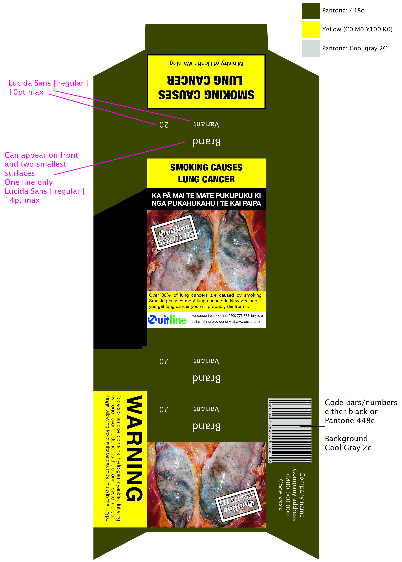

Consultation submission

Details
Name and designation:
Company organisation name and address:
Contact phone number and email address:

Confidentiality
Please keep my comments confidential:  (reasons including identity of specific comments if applicable) | Yes
This request can only be actioned if your reasons satisfy Official Information Act criteria.

Declaration of any tobacco industry links or vested interests
As a party to the global tobacco control treaty, the World Health Organization Framework Convention on Tobacco Control, New Zealand has an obligation to protect the development of public health policy from the vested interests of the tobacco industry. To help meet this obligation, we ask all respondents to disclose whether they have any direct or indirect links to, or receive funding from, the tobacco industry. The Ministry will still carefully consider responses from the tobacco industry and from respondents with links to the tobacco industry, alongside all other submissions. Please provide details of any tobacco company links or vested interests below.

Additional information
I am, or I represent, an organisation that is based in:
New Zealand Australia Other (please specify):

I am, or I represent, the following category or categories: (tick all that apply)
Overseas manufacturer New Zealand-based manufacturer
Importer Exporter
Retailer Government
Wholesaler or distributor Institution (eg, university, hospital)
Member of the public Non-governmental organisation
Other (please specify):

Please return this form to:
Email: standardisedtobacco@moh.govt.nz

Consultation questions
Although the submission form includes blank spaces for answering the questions, these do not set a limit for the length of your responses and you should take as much space as you need to answer or comment. Feel free to enlarge the boxes or attach additional pages.

Size and quantities of tobacco products
1 Do you agree with the proposals to limit the number of cigarettes in a pack to either 20 or 25, and the amount of loose tobacco to 30 grams or 50 grams?
Yes
No
Please outline your reasons.

2 Do you agree with the proposals to restrict the dimensions of cigarette sticks by setting minimum and maximum length and diameter?
Yes
No
Please outline your reasons.

3 Do you agree with the proposals setting minimum and maximum height, width and depth of cigarette packs, consistent with the limits on the number and size of the cigarette sticks they contain?
Yes
No
Please outline your reasons.

4 Do you agree with the proposal that loose tobacco should be sold only in rectangular pouches made of soft plastic?
Yes
No
Please outline your reasons. If you do not agree, what alternatives do you suggest?

5 Do you agree with the proposals to standardise cigar packaging, including the proposal to limit the number of cigars that may be sold in a pack?
Yes
No
Please outline your reasons. If you do not agree, what alternatives do you suggest?

6 Should the regulations include a general provision to set a minimum size for all tobacco packages, including cigar packages?
Yes
No
Please outline your reasons below.

7 Do you have any other suggestions for regulatory requirements to standardise the shape and size of tobacco products and tobacco product packages?
Yes
No
If yes, please provide detail below.

Permitted markings on tobacco packages
8 Do the regulations need to allow for any other anti-counterfeiting marks?
Yes
No
Please provide detail and reasons below.

9 If additional anti-counterfeiting marks are to be allowed, how could these be regulated to ensure they do not communicate to consumers or have any effect that might undermine the intention of standardised packaging?
Please provide detail below.

10 Do the regulations need to permit any other marks or features on tobacco product packages to allow for automated manufacturing and packaging processes?
Yes
No
Please provide detail and reasons below.

11 Should the regulations allow for the country of manufacture to be printed on tobacco products or packages?
Yes
No
Please provide detail and reasons below.

Additional features to increase the effectiveness of standardised packaging
12 Are there any additional features within the scope of the regulation-making powers in the Smoke-free Environments (Tobacco Plain Packaging) Amendment Bill that might increase the effectiveness of standardising tobacco products and packaging? If so, what is the rationale and can you provide supporting evidence?
Yes
No
If yes, please provide detail below.

Other comment on content of draft regulations
If you wish to make any other comments on the content or coverage of the draft regulations, please provide detail below.

For further information on the Government’s decision to introduce plain packaging, including the public consultation on the proposal in 2012, visit the Ministry of Health website at: www.health.govt.nz/our-work/preventative-health-wellness/tobacco-control/plain-packaging
For further information on the Smoke-free Environments (Tobacco Plain Packaging) Amendment Bill, including the select committee submissions, visit Parliament’s website at: www.parliament.nz/en-nz/pb/legislation/bills/00DBHOH_BILL12969_1/smoke-free-environments-tobacco-plain-packaging-amendment
www.legislation.gov.au/Details/C2013C00190
www.legislation.gov.au/Details/F2013C00801
Public Health (Standardised Packaging of Tobacco) Act 2015 (Ireland) www.irishstatutebook.ie/eli/2015/act/4/enacted/en/html?q=public+health+standardised+packaging+of+tobacco+ Draft Public Health (Standardised Packaging of Tobacco) Regulations 2016 (Ireland) http://ec.europa.eu/growth/tools-databases/tris/en/search/?trisaction=search.detail&year=2015&num=650
Children and Families Act 2014 (UK) www.legislation.gov.uk/ukpga/2014/6/contents/enacted/data.htm Standardised Packaging of Tobacco Products Regulations 2015 (UK) www.legislation.gov.uk/uksi/2015/829/introduction/made
Website references to France’s standardised packaging legislation and regulations (in French) available on request.
Also known in New Zealand as World Smokefree Day.
For brand and variant names and manufacturer information, the typography and colour (Pantone Cool Gray 2c) are the same as required in Australia. There are some differences for health warnings.
Smoke-free Environments Act 1990, s 30A(3)(a).
The Ministry of Health Departmental Report advised that this proposal would be considered for inclusion in the regulations: www.parliament.nz/en-nz/pb/sc/documents/advice?custom=00dbhoh_bill12969_1
Ministry of Health analysis based on statutory Tobacco Returns.
Smoke-free Environments Act 1990, s 30A(3)(b).
Under the proposed regulations, cigarillos would be treated like cigarettes, only able to be sold in packs of 20 or 25.
See Draft regulation 41(4)(b).
See Draft regulation 18.

