Rural Health Strategy 2023

Citation: Minister of Health. 2023. Rural Health Strategy. Wellington: Ministry of Health.
Published in July 2023 by the Ministry of Health
PO Box 5013, Wellington 6140, New Zealand
ISBN 978-1-991075-46-8 (online)
HP 8811
This document is available at health.govt.nz
This work is licensed under the Creative Commons Attribution 4.0 International licence. In essence, you are free to: share ie, copy and redistribute the material in any medium or format; adapt ie, remix, transform and build upon the material. You must give appropriate credit, provide a link to the licence and indicate if changes were made.

Ministers’ foreword
We are proud to present the Rural Health Strategy, the first health strategy for rural communities. It will set the direction over the next 10 years for improving the health of rural communities.

Improving rural health outcomes are key part of building towards pae ora and achieving equity for health outcomes in Aotearoa New Zealand, with one in five people living in rural communities, and for Māori, one in four live in rural communities.

Rural communities’ strengths, challenges, and outcomes have been overlooked in how health services are provided. From this strategy, there are clear expectations on health agencies and entities to deliver better options that work for rural communities, by taking into account the different characteristics and approaches needed. For rural Māori communities, recognising the unique relationship with solutions that are led by the Māori community are a vital part of tino rangatiratanga and changing the experiences and outcomes of Māori.

As we work to improve the health system, we know health cannot solve these issues alone. There are opportunities for the health sector to strengthen outcomes by working across government and with crucial players in rural communities.

The five priorities in the Rural Health Strategy set the high-level direction for change, with the forthcoming Government Policy Statement on Health in 2024 having specific action towards change over 2024–2027.

While agencies have started to improve data and monitoring of rural communities’ health outcomes, there is a way to go. Monitoring rural communities’ equity to urban communities, as well as equity within rural communities will be crucial in monitoring progress towards the direction set by the strategy for all groups within rural communities.

For the rural health workforce, and those supporting them, we want to thank you on behalf of our communities for your dedication, perseverance and the important work you do. This is a pivotal time for the health of rural Aotearoa New Zealand, and we look forward to working with you to improve health outcomes in rural communities.

Hon Dr Ayesha Verrall Hon Willow-Jean Prime
Minister of Health Associate Minister of Health

Contents
Ministers’ foreword iii
Executive summary 1
Introduction 4
Purpose of the Rural Health Strategy 4
Structure of this document 5
Part 1: Our vision for rural health 6
Our vision 6
Commitment to Te Tiriti o Waitangi | The Treaty of Waitangi 7
Reflecting rural voices 8
Part 2: Rural communities 10
Definition of rural communities 10
Groups within rural communities 12
Living and working in rural communities 16
Health and wellbeing in rural communities 22
Part 3: Priorities for rural health 25
Priorities to improve health outcomes for rural communities 25
Rural Health Strategy 28
Priority 1: Considering rural communities as a priority group 30
Priority 2 Prevention: Paving the path to a healthier future 33
Priority 3: Services are available closer to home for rural communities 37
Priority 4: Rural communities are supported to access services at a distance 42
Priority 5: A valued and flexible rural health workforce 45
Part 4: Delivering our commitment to change 52
Turning strategies into action 52
Programme needed for change 53
Monitoring outcomes 54
Ongoing research and evaluation 54
Appendix 1: Geographic Classification for Health 55
Appendix 2: Rural Health outcomes 59

List of Figures
Figure 1: New Zealand population share by Geographic Classification for Health (GCH), rural and urban categories, 2022 11
Figure 2: Age distribution for rural and urban populations, total and Māori, 2018 12
Figure 3: System architecture of the health system post-reforms 53
Figure 4: Population percentage in urban-rural areas, by ethnic group and deprivation quintile, 2022 57
Figure 5: The differences in the GCH at SA1 (top) and SA2 (bottom) for the Wairarapa 58
Figure 6: Age-standardised amenable mortality rates, by urban and rural, per 100,000 68

List of Tables
Table 1: Overview of Rural Health Strategy priorities 27

Executive summary
The purpose of the Rural Health Strategy is to set the direction for improving the health of rural communities over the next ten years.

Rural life is varied and changing. The health of rural populations is strongly linked to rural economies, the environment, infrastructure and community connectedness. Rural communities are resourceful – community organisations, iwi and hapū play an important role in promoting health in their communities and supporting rural people through challenging times.

However, rural communities have too often been overlooked in health system planning, delivery and monitoring. Rural people can face significant challenges in accessing health care, and experience worse overall health outcomes compared to urban populations. One in five New Zealanders and one in four Māori live in rural areas – it is critical that we address these challenges if we are going to achieve pae ora – healthy futures for all New Zealanders.

Our vision is for people living in rural communities to live long and healthy lives, supported by a health system that meets the varied needs of these communities and draws on the strengths and knowledge of rural communities to achieve pae ora.

Achieving this vision will require us to work collaboratively with the communities our system serves. This includes iwi, hapū and Māori communities exercising tino rangatiratanga in the design and delivery of rural health services.

This strategy identifies five priorities that will give effect to this vision over the next ten years.
- Considering rural communities as a priority group: Health policies and planning are designed to meet the specific needs of rural communities – rather than expecting rural communities to fit into funding approaches and ways of offering care in urban settings.
- Prevention: paving the path to a healthier future: Rural communities have building blocks in place to support healthier futures – stable jobs, good pay, quality housing, digital connectivity and resilience to climate change. Preventive health interventions (such as screening) and promoting and protecting people’s health and wellbeing are key areas of focus.
- Services are available closer to home for rural communities: A wider range of service options are available in the home or in the community, including from outreach options (such as mobile outpatients’ clinics and digital solutions).
- Rural communities are supported to access services at a distance: Where it is not possible to access health services locally, coordinated support is available to help rural people travel or use digital technology to receive care.
- A valued and flexible workforce: The rural health workforce is developed and supported to deliver the care that rural communities need – including through kaupapa Māori approaches and extended health care roles and rural specialisations.

This strategy does not commit to specific actions, but sets the long-term direction for improving rural health in these priority areas. The Government will set out more specific actions within the Government Policy Statement on Health and the New Zealand Health Plan | Te Pae Tata – which will set out measurable actions to advance the priorities over the next three years. Change will also require significant improvements in the monitoring of rural health data over time, so that we can understand where we are having an impact and where we may need to alter the course.

This strategy has been developed by Manatū Hauora (the Ministry of Health) and draws on conversations that we have had with rural communities and the health sector, as we consulted on the development of six new health strategies required of us under the Pae Ora (Healthy Futures) Act 2022. It represents the start of
a much longer conversation about ways to improve the health of rural communities that will need to take place over the coming years to ensure that we meet the health needs and aspirations of rural communities.

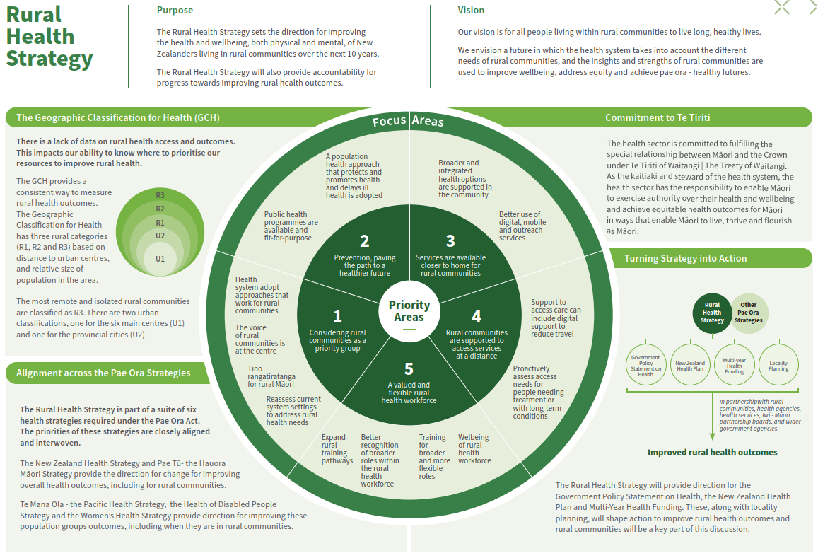

Introduction

Purpose of the Rural Health Strategy
The Rural Health Strategy sets the direction for improving the health and wellbeing, both physical and mental, of New Zealanders living in rural communities over the next ten years.

This is the first New Zealand Rural Health Strategy. Rural communities have often been overlooked in policy advice, priority setting, health service planning and monitoring health outcomes. As a result, settings have not met rural communities’ needs, and inequities in rural health outcomes have not been a focus in monitoring or addressed through policy.

The health system reforms focus on achieving equity, including removing geographic differences in health outcomes, and the system to better serve the needs of all communities, including rural. The Rural Health Strategy will provide the next step for the system to recognise rural communities’ needs and aspirations, set the direction and provide accountability for progress towards improving rural health outcomes.

The Pae Ora (Healthy Futures) Act 2022 (the Pae Ora Act) requires the Government to produce a Rural Health Strategy, including, for the rural context, an assessment of the current state of health outcomes and health sector performance; an assessment of
the medium and long-term trends that will affect health outcomes and health sector performance; and an identification of priorities for improving the health sector, including for the health workforce.

The role of this strategy is to set the long-term direction for improving rural health. The strategy does not commit to precise actions for health entities. More specific decisions will be made in the Government Policy Statement on Health and the New Zealand Health Plan | Te Pae Tata, which will set out specific actions and priorities for the next three years (beginning in mid-2024, and for subsequent three-year periods). Planning and design of local services will also be guided by locality plans, which rural communities and iwi-Māori partnership boards will partner in developing.

This strategy is part of a suite of six health strategies required under the Pae Ora Act that are being published in 2023. The New Zealand Health Strategy takes a whole-population focus, and considers systemic issues, opportunities and priorities. These priorities are relevant to improving health in rural communities as well as nationally.

We also recognise the special relationship between New Zealand and countries of the Realm in the Pacific – the territory of Tokelau, and the self-governing states of the Cook Islands and Niue. In recognition of New Zealand’s obligations to Realm countries and as citizens of New Zealand, the Strategy includes these Pacific peoples when in New Zealand.

Structure of this document
The structure of this document is as follows.

Part 1: describes a long-term vision for rural health and key guiding approaches.

Part 2: provides an overview of rural communities and the current state of rural health.

Part 3: identifies the priority areas and the changes we need to make within these areas to achieve our ten-year vision for improving the health outcomes of rural communities.

Part 4: describes the process for next steps for taking up these changes and incorporating them into the health system people experience in future.

Part 1: Our vision for rural health

Our vision
Our vision is for all people living within rural communities to live long, healthy lives. We envision a future in which the health system takes into account the different needs of rural communities, and the insights and strengths of rural communities are used to improve wellbeing, address equity and achieve pae ora – healthy futures.

Achieving pae ora for all New Zealanders is a long-term challenge, and will require a sustained effort across generations. This strategy sets out the next steps towards achieving this vision and focuses on what we can achieve, and what changes we need to make, over the next ten years.

The concept of pae ora encourages everyone in the health system to work collaboratively, to think beyond narrow definitions of health and to provide high-quality and effective health services. This includes a focus on:
- improving people’s own health and wellbeing
- supporting strong and empowered whānau or family networks and recognising their impact on health and wellbeing
- considering the impact of our communities and the places where we live, work and rest on our health and wellbeing.

In this vision, rural communities are valued, and the needs of people in rural areas are considered across the health system.

Rural communities are well-supported, health-promoting and well-connected environments to live, learn, work and age. Health and wellbeing services are accessible, culturally safe and more options are available closer to whānau, reducing the need for long and costly journeys, and time away from home. There is flexibility for recognising regional or local differences between rural communities and their needs be addressed as fits the community.

The health system is committed to working in partnership with Māori and taking an approach to health that is inclusive, respectful and honours te āo Māori. Māori communities are empowered to design and deliver the services and supports they value, including kaupapa Māori services, rongoā and whānau- centred and Māori-led health care.

Achieving this vision will require government and health entities to work collectively and in collaboration with the communities our system serves, including iwi, hapū and Māori communities, and with the wider organisations that contribute to the health and wellbeing of whānau.

This will enable rural people to live longer in good health; experience improved wellbeing and quality of life; be part of healthy, inclusive and resilient communities; and live in environments that sustain their health and wellbeing.

Commitment to Te Tiriti o Waitangi | The Treaty of Waitangi
The health sector is committed to fulfilling the special relationship between Māori and the Crown under Te Tiriti o Waitangi | The Treaty of Waitangi (Te Tiriti). Regarding the text of Te Tiriti and declarations made during its signing, the Crown, as the kaitiaki and steward of the health system (under article 1 of Te Tiriti), has the responsibility to enable Māori to exercise authority over their health and wellbeing (under article 2) and achieve equitable health outcomes for Māori (under article 3) in ways that enable Māori to live, thrive and flourish as Māori (Ritenga Māori declaration).

The Crown’s approach to meeting its obligations under Te Tiriti is outlined in section 6 of the Pae Ora Act. The legislation contains specific provisions intended to give effect to the Crown’s obligations.

In particular, the health sector principles in section 7 of the Pae Ora Act guide the Minister of Health, Manatū Hauora and all health entities in how they carry out their functions. The health sector principles incorporate key outcomes and behaviours derived from the principles of Te Tiriti, as articulated by the courts and the Waitangi Tribunal, including:
- Tino rangatiratanga: Providing for Māori self-determination and mana motuhake in the design, delivery and monitoring of health services.
- Equity: Being committed to achieving equitable health outcomes for Māori.
- Active protection: Acting to the fullest extent practicable to achieve equitable health outcomes for Māori. This includes ensuring that the Crown, its agents and its Treaty partner under Te Tiriti are well informed on the extent, and nature, of both Māori health outcomes and efforts to achieve Māori health equity.
- Options: Providing for and properly resourcing kaupapa Māori health services. Furthermore, the Crown is obliged to ensure that all health services are provided in a culturally appropriate way that recognises and supports the expression of hauora Māori models of care.
- Partnership: Working in partnership with Māori in the governance, design, delivery and monitoring of health services – Māori must be co-designers, with the Crown, of the primary health system for Māori.
These principles are central to achieving our vision of pae ora | healthy futures for Māori. Pae ora has a special meaning for Māori, and includes three inter-connected elements:
- Mauri ora (healthy individuals) seeks to shift the mauri (or life force) of a person from one that is languishing to one that is flourishing.
- Whānau ora (healthy families) is a fundamental philosophy for creating strong, healthy and empowered whānau. A strong healthy and empowered whānau can make the most significant difference to Māori health and wellbeing.
- Wai ora (healthy environments) acknowledges the importance of Māori connections to whenua as part of the environments in which we live and belong – and the significant impact this has on the health and wellbeing of individuals, whānau, hapū, iwi and Māori communities.

Our commitment to Te Tiriti and priorities for hauora Māori are described in greater detail in Pae Tū: the Hauora Māori Strategy published in parallel with this document.

Becoming a good Te Tiriti partner is necessary if we are to realise the overall aims of the Pae Ora Act and the Rural Health Strategy and see Māori living longer, healthier, and more independent lives. We aim to embed a dynamic health system which places Te Tiriti at the forefront of thinking and provides opportunities to improve health outcomes for Māori.

Reflecting rural voices
The development of the Rural Health Strategy has been informed by engagement with the public, stakeholders and partners that we undertook across the suite of pae ora strategies. Between November 2022 and May 2023, Manatū Hauora received feedback and submissions across multiple different channels, including through in-person and online engagements, regional wānanga, and social media.

Further information on the process of, and key themes from the engagement, is included in a summary report on the engagement that is published alongside the suite of strategies.

Key themes for rural health from engagement included the following.
- People expressed concerns about access to care; in particular, options restricted by workforce gaps and the limited availability of services in rural areas (maternity care, urgent care and emergency and mental health services were highlighted as particular concerns).
- There needs to be more local input into services available in the community, including more services available closer to home.
- While people were generally positive about their experiences in receiving care, they also related experiencing challenges to get into the system to gain the care they needed, citing difficult referral processes and long wait times. Lack of access to acute mental health support was noted as a particular risk.
- Those making decisions do not consider the impact of these decisions on rural communities; for example, in suggesting appointment times which do not work when people have to travel two or more hours to attend.
- Rural communities want to see expanded prevention support, such as access to screening, health improvement practitioners and mental health promotion activities.

Some key themes for rural Māori communities from the Ngā Wānanga Pae Ora 2023 engagement included the following.
- There needs to be more recognition of, and resources to enable, rural Māori communities’ right to tino rangatiratanga. This can be supported through partnerships with Māori, hapū, iwi; the work of iwi-Māori partnership boards; and entities’ commissioning decisions.
- There needs to be more whānau-centred services, delivered through trusted community groups, with solutions that bring together primary care, prevention and other services and enable more proactive and effective support.
- System settings create burdens for whānau making barriers when they seek help, including past interactions where they felt disrespected.

This strategy is based on what we heard from rural communities, stakeholders and the rural health sector.
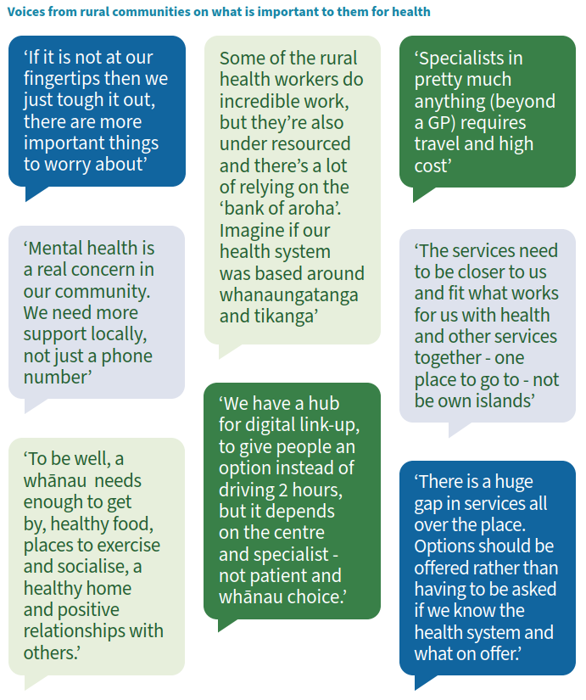

Part 2: Rural communities

Definition of rural communities
The Rural Health Strategy focuses on people who live in rural communities. This means it is based on the geographic areas people live in rather than an individual’s identity. Rural areas are generally categorised by the small and sparse population compared to cities, as well as the degree of isolation, in terms of distance from main centres.

Rural communities, or populations, for the purpose of measuring outcomes within the strategy, are defined using the Geographic Classification for Health, which has been developed for categorising rural and urban areas to monitor health outcomes. This purpose aligns with the two focuses of the Rural Health Strategy, to set the direction for improving rural health outcomes, and to monitor. Stats NZ’s rural definitions also classify rural and urban areas based on population size and the drive times to urban centres. However, the population and drive time thresholds used in the Geographic Classification for Health framework were developed specifically with health services in mind.

The Geographic Classification for Health takes into account distances, in terms of travel times, from urban centres, where key health services are more likely to be located, in addition to the population within surrounding communities (see Appendix 1). The resulting classification of rural and urban areas was also informed by feedback from the health sector to ensure the classification ‘makes sense on the ground’. Geographically based boundaries always have some contention as they are not definitive; the determination of the right place for boundaries is subjective.
Geographic classifications result in some people living quite close to each other in different categories.

The Geographic Classification for Health has five categories. It has three rural categories (R1, R2 and R3) based on distance to urban centres, and relative sizes of populations in the area (see Appendix 1, which provides the full map of New Zealand by rural and urban areas). The most remote and isolated rural communities are classified as R3. There are two urban classifications, one for the six main centres (U1) and one for provincial cities (U2). Figure 1 shows the New Zealand population distribution by this classification.

Using this more distance-based approach, instead of a purely population-based approach, sees, for example:
- Taihape, classified as R2 within rural, due to its distance from main urban centres, rather than as a small urban area
- areas around Rangiora are classified as part of a main urban centre, Christchurch, which is U1, rather than a mix of rural or smaller urban areas, given it is a short distance from Christchurch city.

Figure 1: New Zealand population share by Geographic Classification for Health (GCH), rural and urban categories, 2022
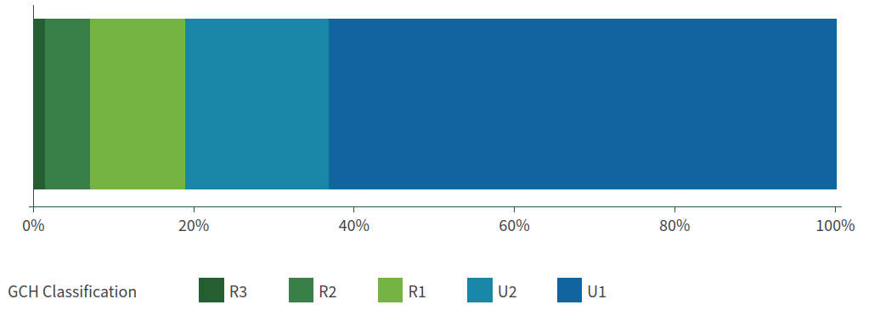

For monitoring outcomes, health entities will use this geographic- based definition for rural communities. The interim New Zealand Health Plan | Te Pae Tata has already made this commitment for Te Whatu Ora and Te Aka Whai Ora. However, when engaging rural communities or implementing initiatives for rural communities there are reasons to have flexibility outside these specific geographic boundaries. For example, mental health promotion focussed on rural communities may also have a wider scope for engagement and delivering services, such as on primary industry workers who may also live or work in urban areas.

In 2022, around one in five (19%) of the New Zealand population lived in rural areas. Most of the people in rural communities are in areas that border urban areas, or relatively large rural centres (R1). The R1 category comprised 12% of the New Zealand population, and the R2 category, 6% (this group are either further away than R1 or have smaller populations than R1). The R3 group, the most remote rural areas including offshore islands, such as Chatham Islands and Stewart Island/Rakiura, had only around 1% of total New Zealand population.

The proportion of people living in rural communities was stable within census data between 2006–2018, at 19%. The rural population in 1996 was slightly higher at 21%. Further data on population breakdowns within rural communities uses population estimates from the 2018 Census instead of 2022 population estimates.

In countries with a similar total population to New Zealand, Finland (30%) and Sweden (25%) have higher rural populations, while Norway (18%), Denmark (18%) and Scotland (17%) have similar rates to New Zealand, and Ireland a bit less (14%). In Australia, a much larger country with a higher population, 28% live outside main centres, but this mostly represents smaller regional communities, with 2% in remote areas.

Groups within rural communities
In the 2018 Census, Europeans are the largest ethnic group in rural areas (82%), followed by Māori, (22%). Asian (4%) and Pacific peoples (3%) make up a small share of people within rural communities. Rural communities have a higher proportion of Māori than urban populations, around 22% identifying as Māori, compared to 15% in urban areas. The proportion of the Māori population that live in rural communities has fallen slightly since 1996, from 28% to 25% in 2018. However, the proportion of people in rural communities that identify as Māori has been increasing, as it has for the total New Zealand population.

The rural population is split evenly between male and female, at 50%, with urban areas having slightly more females, at 51%. However, 54% of Pacific peoples in rural communities are male – likely reflecting the rural migrant Pacific peoples workforce, which is predominantly male.

People aged between 20–39 years are less likely to live in rural areas than other age groups. Young people tend to leave rural areas for education and employment opportunities (see Figure 2). Women are more likely to exit rural communities for study and work when young adults. Among the rural population aged 15–29 years, the share of women is 47% of the age group. The proportion of the rural population that are children, is similar to urban areas.

Figure 2: Age distribution for rural and urban populations, total and Māori, 2018
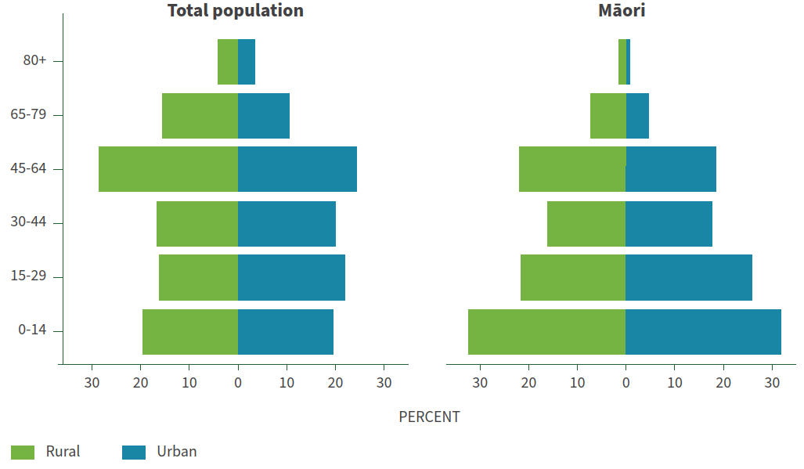
Older people are more likely to live in rural communities than people in other age groups. Around one-quarter of people aged over 65 years live in rural communities (making up 20% of the total rural population in 2018). Māori kaumātua are even more likely to live rurally; 34% of the Māori population over 65 years live in rural areas.

The share of older people in the rural population has increased with the ageing population, and will continue to grow. Between 1996–2018, those over 65 years grew from 13% to 20% of the rural population. This increase was higher than the equivalent change in urban areas.

The older-age dependency ratio (the number of people over 65 years to the number of working age) is 50% higher in rural communities than it is in urban communities, at 35 people per 100 compared to 23 people per 100 in urban areas. The higher dependency ratio for rural communities reflects higher proportions of older age groups, and the lower share of younger adults in rural communities.

Among those over 65 years, there are more women than men in rural communities, reflecting women’s longer life expectancy. However, the higher share of women in older age groups is not as large as it is in urban areas. For example, in urban areas around 60% of people 80 years and older are women. In rural areas this figure is 55%. This could reflect more older rural women moving to urban areas with extended family, or for better access to care or support.

Two-thirds of the total rural population, and 86% of the rural Māori population, live in the North Island. Waikato (21%), has around one-fifth of the total rural population, followed by Northland (12%), Otago (12%) Canterbury (11%) and Manawatu- Wanganui (9%). Regions with a higher composition of rural communities are the West Coast (where all communities are considered rural), followed by Northland (where around 60% of population live in rural communities), followed by Tasman, Otago, Southland and Waikato (where around 40%–50% of the population live in rural communities). Māori are the largest ethnic group within rural areas in the Gisborne region (74%) and rural Bay of Plenty region (54%). Within the Northland and Hawkes Bay regions, Māori comprise around 40% of the rural communities.

Ethnic diversity is growing in rural communities
Ethnic diversity is not as high in rural communities as it is in urban centres. In 2018 within rural communities, 4% of people identified as Asian and 3% as Pacific peoples, well below the population share for these groups nationally (15% and 8% respectively).
However, the ethnic diversity of rural communities is starting to grow, particularly for Pacific peoples, Indians and Filipinos.

Over 1996–2006, the population of Pacific peoples living rurally was stable and low, at around 1% of rural communities. From 2006–2018, that population living rurally doubled. The proportion of the Pacific peoples population living rurally grew from 4%
to 6% over that time. Rural areas in Waikato, Northland and Manawatu-Wanganui comprise around 60% of the rural Pacific peoples population.

Rural towns with significant populations of Pacific peoples include: Tokoroa, Taupo, Levin, Ashburton and Oamaru.

Asian and other European groups that had grown in the 2018 Census for rural communities include Indian, Filipino, Chinese, Dutch and German ethnic groups. Indian and Chinese rural populations represent only around 3% of the total population share for these groups. There has been a significant increase in the Filipino rural population in recent years, with links to primary industry employment. In Ashburton, Selwyn, Waimate, Southland district and Hurunui, Filipino students comprise 5%–7% of
school enrolments. The total Filipino population however is predominantly urban – with around 85% living in urban areas. Dutch, German and Latin American populations, while small, have a share of their population living in rural communities more comparable to those of the European and Māori populations, at around 20% of their total populations.

Refugee resettlement will also increase ethnic diversity in rural areas over the next ten years. Ashburton (with recent groups from Afghanistan being resettled) and Levin (with some groups from Colombia being resettled) are rural areas that have some refugee resettlement.

Increasing diversity from migration can revitalise local economies and provide additional labour, but can also bring challenges for the new migrant communities, including experiences of racism.

Temporary population groups: seasonal or itinerant workers and tourism
Rural communities also have people living temporarily, such as short-term migrant workers in the primary industries, and people who move around rural areas for work, such as shearers. It is important that these groups can have their health needs met while in rural communities. This can be challenging due to lack of eligibility for services (for those on work visas less than two years duration), not being able to enrol with general practices in the area, and long workdays limiting their time to access health supports.

Tourism (including holiday homes) plays a growing role in some rural areas and creates population influxes that impact health services. Tourism can help maintain the viability of rural communities, boost local economies and employment. However, tourism can also reduce local housing supply and affordability for local people. Health services are also affected by seasonal influxes or visitors. For example, Central Otago, Coromandel
and Taupō have significantly higher populations during holiday periods. This can put pressure on rural health services and the rural health workforce, especially in smaller communities, and mean that the longer-term care needs of residents are delayed.

Disabled people in rural communities
There is limited data on disabled people within rural communities. The New Zealand Health Survey data over 2019– 2022 indicates that a similar share of disabled people live in rural communities as the total New Zealand population – around 19%. However the focus of the disability questions in the New Zealand Health Survey are more limited than Stats NZ’s post-census Disability Survey approach, as they do not cover all disabilities or impairments.

Living rurally can be challenging for disabled people due to the potential for isolation and distance from key supports. While some disabled people may move to rural areas for cheaper housing, building up social networks can take time.

Access to disability supports can be more limited in rural areas, and in this situation people are often more reliant on family. Specialist support (such as speech therapists) may not be available.

While many health and wellbeing services are able to support greater access to services by using remote and digital technologies, these are sometimes not offered or have limitations due to poorer connectivity in rural communities.

Digital options can also not be appropriate or accessible for disabled people with a range of impairments, and who in some cases, are then further distanced from services through the expected use of technology.

Rainbow communities
There is no comprehensive research that documents the experience of rainbow people in rural communities. In 2021, an estimated 4.4% of New Zealanders identified as being part of the rainbow community, and this was estimated to be lower in rural areas, at 3.5%. In time, we will have better data to tell a richer story about the lives of rural rainbow communities, including from Census 2023.

As is the case more generally, the rainbow community in rural areas can face unacceptable levels of discrimination and inequities in everyday life. While anecdotally, rural communities can offer warm and supportive environments, it may be different for younger members of the rainbow community, especially those who are exploring gender and sexuality and who do not have easy access to a diverse range of role models. Previous research identified that rural towns can be isolating and unsafe for young people exploring identity, and more recent research showed that one in eight rainbow people had moved towns or cities to feel safer expressing their identity, in part due to both push (away from stigma, harassment, and structural barriers) and pull factors (moving towards visible communities and spaces, healthcare, and increased opportunities to find belonging and partners).

While rainbow communities are diverse, there are some commonly reported health issues, including anxiety, distress and depression. There is also a need for health specific services for rainbow communities, such as gender-affirming care and
support for people with variations of sex characteristics. Rainbow communities can face barriers to accessing healthcare and they may avoid seeking health care because they are worried about disrespect or adequate knowledge to support them.

“We both went together to our doctor while we were still living up in Kerikeri, and asked the doctor about taking hormones. And he pretty much had no idea what we were talking about, had to search it up. And then he said that he would send a referral to the nearest endocrinology place, which was in Whangārei. I think it was either 2016 or 2017 and (we) still haven’t heard back.”

– Rainbow engagement participant

It is important that we remove barriers to accessing health services and improve inclusiveness for rural rainbow communities. With greater training, upskilling and support, the rural workforce can create welcoming and inclusive services, where the needs of rainbow people are understood and respected.

Living and working in rural communities
The health and wellbeing of rural communities needs to be considered within the broader context of living and working rurally. Social connections, housing, transport, employment, culture and the environment have long-standing impacts on the health and wellbeing of rural communities. While rural communities have diverse characteristics and needs, sustainable and prosperous rural communities are dependent on all these factors, as well as access to health care.

Community connectedness and trust
Community, social support, and cohesion are important contributors to health in rural areas. Conversely, loneliness and isolation adversely affect people’s physical and mental health. Grass-roots community organisations, iwi and social groups play a big role in connecting rural communities, offering manaaki or ‘rural hospitality’, and fill the gaps where government support is not offered or under-resourced. Such groups also offer vital social connections at marae, sports clubs, community hubs and through activities, such as the regional Rural Support Trust’s community meals, or ‘surfing for farmers’. Schools also play an integral role in the social cohesion of rural communities.

The strong social networks and sense of responsibility for collective wellbeing that characterise rural communities has been evident in extreme weather events in early 2023 and the COVID-19 response. Many great examples of health innovation
that utilise community strengths and promote knowledge-sharing have emerged within rural communities. Rural women are often seen as the ‘glue’ in supporting community needs and caring for children, older people or disabled people that need support.

Being more isolated in rural communities and a focus on caring roles for children can mean that the wellbeing of women in rural communities is more reliant on the quality of relationships with family and neighbours. If they are negative relationships, it can have significant impact on women’s wellbeing. Isolation can compound this, with fewer support options to re-balance or exit relationships.

“Rural women are often isolated and over- burdened as a result of limited support and remoteness of location. This can lead to neglect and further deterioration in their health and wellbeing.”

– Rural Women NZ submission

Overall, nationally, around one in three women experience intimate partner violence at some stage in their life. While the prevalence of family and sexual violence patterns between urban and rural areas are not known, experiences of isolation and lack of support services may put rural women at risk of more harm when experiencing family and sexual violence. Rural women may find it more difficult to leave relationships and homes, as this often means leaving the community as well. The impacts of family and sexual violence on women are further outlined in the Women’s Health Strategy.

Support for older people or kaumātua
For kaumatua, the option to age in place in the communities they are connected to is important. When supports for ageing in place at home cannot adequately support older people, and residential care options are not available, older people may have to leave the area – this can separate couples and families. In addition, the lack of specific palliative or dementia care facilities or support, can put pressure on families, or health professionals in general roles to provide care.

Many Māori and Pacific whānau prefer to care for their elders at home rather than in aged residential care. Papakāinga housing options that support kaumatua, with whānau or communal support, have been developed by some iwi.

When older people lose the ability to drive, it also has a significant impact on their independence, and makes them more reliant on family or community.

Mātauranga Māori
Rural Māori face significant unmet health needs and face inequities in access to, and quality of, care. Māori health in rural communities is poor for a range of complex reasons, including racism and discrimination and the impact of wider socio- economic factors including poverty and poor housing. Further discussion on changes to the health system to support pae ora for Māori communities are set out in Pae Tū: Hauora Māori Strategy.

Despite these challenges, rural Māori communities are resilient and have networks and systems to support whānau and wider communities. Early in the COVID-19 pandemic, iwi, hapū and marae responses were based on mātauranga Māori and mana motuhake, offering support to ensure people stay safe, connected and have their essential needs met. In some rural areas, Māori health providers, linked to the community or iwi, play a key role in supporting pae ora for rural Māori.

Rural Māori have amplified efforts to revitalise te reo and mātauranga in recent years. Continuing these efforts to build the culture and mātauranga of rural Māori communities is essential to enable Māori who live in rural communities to live well for longer, to be part of strong and thriving communities and continue to be well connected to whenua in a way that builds and sustains wellbeing.

Housing
A range of factors contribute to housing challenges for rural communities. Quality, safe and affordable housing is a challenge for rural communities. The housing stock is generally older in rural communities, and is not built to modern healthy homes standards. Old, cold, damp and mouldy housing leads to ill health and preventable hospitalisations. People in rural areas are more likely to live somewhere that lacks a toilet, kitchen sink, or bath or shower, than people in urban areas. Māori in rural areas were considerably more likely than the total rural population to live in a dwelling that lacked these basic amenities. Improvements in rural housing will greatly benefit health outcomes. Homelessness in rural communities has been growing and 2018 Census data shows that the Far North district had one of the highest numbers of homeless people in the country.

For those working in rural communities, including the rural health workforce, finding suitable and available housing is a challenge – and many people are reliant on employer-led solutions, including renting arrangements. This is particularly challenging for people on short-term work or training placements, including health students. It is common for employers in rural communities to include housing as part of an employment package, or to secure housing to support recruitment – this can be an important part of filling workforce gaps.

Increasing housing supply in rural areas is often not seen as a priority beyond some popular holiday and retirement areas. There is often land options available in rural areas, but asset value is generally lower, infrastructure costs higher, and construction options can be more limited than in urban areas, making it challenging to attract investors and developers. There is some work underway to address this – including MAIHI Ka Ora – the National Māori Housing Strategy, which is creating space in our housing system to ensure Māori can remain connected to their people, their whenua and their whānau.

Declining rates of home ownership particularly affects older people as they exit the workforce, in terms of their housing security and affordability. Depending on housing options in specific rural areas, this can either result in older people leaving the rural communities they consider to be their home, or some people moving into rural areas where housing costs are lower with available housing.

Food security
While rural communities play a key role in producing some key food products, rural communities can face issues with food security within their community due to limited local commercial options, distances to larger more affordable shops, or financial pressures. For those that do face financial pressures, there can also be more limited local charitable support, such as from food banks. Out of necessity, more food purchase planning takes place for those in more remote communities. However, if you have financial pressures, the transport costs and higher costs from a larger shop at more economical option overall, are not viable on a week-to-week budget.

Food security can be a particular concern for families with children and some older people, as they are more likely to be on modest incomes and may have reduced transport options. Some rural families with children benefit greatly from food in schools, Ka Ora, Ka Ako, providing school lunches, (discussed further below), as well as initiatives that support the re-establishment of indigenous gardening practices. There can also be a more limited range of foods within rural communities, which can affect new migrant groups looking to maintain their cultural food options.

Transport
Rural communities are reliant on transport networks to get to work and school, access health services, or pick up supplies from town. Public transport is often inadequate or non-existent – leaving people reliant on their own transport or help from others. Transport links can be precarious. A single bridge or road being closed can have significant impacts on people’s daily lives. This can also ultimately impact their ability to continue living in certain areas (as seen in the aftermath of cyclone Gabrielle). Alternative transport options using back roads tend to be maintained to a lower standard, which can limit their usability when main roads are out. Waka Kotahi is looking to prioritise resilience within its framework, as set out in the Government Policy Statement on Land Transport. However, some areas have limited alternative options and inherent risk to impacts of extreme weather and climate change, due to the geography of the area.

Resilient infrastructure includes options for air-based transport, such as helipads, that are a key need for emergency care, or provide access for health and other essential needs, when other transport links are damaged.

Digital connectivity
The COVID-19 pandemic has accelerated the availability and effectiveness of digital technology in the provision of social and health services. However, there is a digital divide between urban and rural households, which is more pronounced in remote areas and for people with lower incomes. Some people in rural areas are still unable to access the internet, or have limited or intermittent connectivity, especially in sparsely populated geographic areas such as Northland and the West Coast. Addressing the technical and financial challenges of getting reliable internet to rural areas could lessen the digital divide in future (such as affordable satellite-based solutions).

A lack of digital connectivity limits rural communities’ access to online health and social services, but also isolates rural communities from a range of online activities, such as connecting with family and video streaming services. The lack of reliable internet in some areas can put people off living there, including the health workforce.

When there is internet connectivity, people often lack digital devices or capability to use digital technology. During the COVID-19 pandemic, there was increased government support to provide digital access to groups without access for education (for families with children) and for social services. This also supported digital access to health information for COVID-19 and for online appointments during this period. This support for digital inclusion is now more limited.

The necessary infrastructure and supports need to be put in place to improve digital equity in rural areas for digital health services to be available and usable across the motu. Areas of focus for improving digital equity include:
- improving digital connectivity. The Ministry for Business, Innovation and Employment (MBIE) has launched several rural-focussed initiatives to this end, as well as the Marae Digital Connectivity programme, in partnership with Te Puni Kōkiri. In addition, some iwi groups are also active in supporting connectivity for their communities, but more work to support connectivity is needed
- supporting people with the financial costs associated with accessing digital health care, including access to digital devices and any data costs
- supporting people and communities to develop digital literacy, so that they have the confidence to utilise digital health services.

Environmental factors and climate change
The conditions in and around our homes, schools, places for recreation, workplaces, or rivers and beaches all have an impact on healthy communities. The environment affects our wellbeing, including the quality of our drinking water, the quality of the air we breathe, and our exposure to hazardous substances. Sustaining a healthy environment is central to keeping the rural population well and to reducing avoidable deaths due to preventable environmental health issues.

Wai ora, people’s connection to the environment that supports their wellbeing, is an important aspect of wellbeing for rural communities, especially rural Māori living in their tūrangawaewae. Many people within rural communities live off the land and water within their communities and often have strong intergenerational connections to the place they live in. Environmental change, including to the built environment, in the place they live, can impact wai ora.

Rural communities are disproportionately affected by climate change, with direct and indirect impacts on rural health, in the following ways.
- Rural areas are more exposed to climate-related events, such as droughts, flooding and sea-level rise, than urban areas. The toll on wellbeing from these events on people and their livelihoods, or concern for future events, is immense and expected to worsen as they become more frequent.
- Climate related events affect people and exacerbate already poor health outcomes. Around half of those impacted by the loss of safe drinking water in Cyclone Gabrielle were Māori and over half were living in the most deprived areas. A lack of access to safe drinking water and sewage can be another stress on flood-wearied communities.
- Rural communities are more prone to being cut off from vital support networks and economic activity in the aftermath of severe weather, such Cyclone Gabrielle.

The cumulative financial and personal effects of severe events and uncertainty about the future puts strain on mental health.

Adaptations in response to climate change can help rural communities to become more sustainable and resilient. Greater resiliency in infrastructure, including water and digital infrastructure, is needed to serve basic health needs in the face of climate change. For example, more rural homes with solar panels offer a more resilient and affordable energy option to rural communities, especially those on low incomes, including kaumatua, who won’t face large bills for heating. Solar panels were beneficial in the aftermath of Cyclone Gabrielle, where solar- connected homes were able to continue using basic appliances as they were not affected by the breakdown of infrastructure.

There will need to be transformational change to balance investment in coastal or river protection versus supporting managed retreat to ensure the safety and viability of rural settlements on the coast or near rivers.
Proactive planning and adaptation to impact of climate are essential steps towards safeguarding our communities against the impacts of climate change. While adaptions and mitigations can help lessen the impacts, preparation for managing the impact of more frequent events affecting rural communities will be needed. This could include support for community-based organisations and emergency responders to have more capability on the ground. Also, options for delivering and getting to health care when transport and infrastructure links are increasingly unreliable for long periods.

Sustainable communities
The sustainability of rural communities and the availability of health services within these communities are intrinsically linked. As health and social services lessen, people are dissuaded from living in certain areas and may choose to move – particularly those looking to start a family, older people, or those with specific health needs. Struggling health services and communities can also find it hard to recruit health workers, compounding the problem – as schooling, digital connectivity and wider employment options (for family members) all contribute to the decision to live rurally.

Rural communities are based strongly around rural economies, particularly the primary industries (including farming, forestry and fishing). However, primary industries are vulnerable to weather and international markets. New opportunities for growth have the potential to revitalise rural communities. For example, a new medicinal cannabis operation being established near Ruatoria has the potential to boost employment, and increase the population and business activity, and then also community facilities.

More limited education and employment opportunities also dissuade young people from staying in rural areas. More work is needed on attracting young people to employment options in rural communities that support their life aspirations, which could include health careers. This should include opportunities to support those in community, including young disabled people, and to grow local employment pathways.

As well as economic growth, maintaining and enhancing health and social infrastructure is important to attract people and businesses to communities. The Resource Management Reforms, led by the Ministry for the Environment, have increased opportunities to embed health and wellbeing in future spatial planning, and, over time, this will lead to health-promoting environments.

Health and wellbeing in rural communities
Information and knowledge are necessary for evidence-based decision-making in health. However, high-quality information for rural communities has been limited in recent times. The data to create a picture of rural health outcomes is now building. This section and Appendix 2 set out the current state of rural communities’ health and wellbeing, based on available data. Improving rural health monitoring and reporting will be a key priority for health agencies in the reformed system.

Rural communities have higher levels of deprivation
Higher levels of socioeconomic deprivation are associated with poorer health. Deprivation, as measured through the New Zealand Deprivation Index with geographic areas through the census, is a combination of communication, income, employment, qualifications, home ownership, support, living space and transport. Rural communities have a higher share of their population living within areas considered to have the highest deprivation (top quintile), than the main urban areas. Deprivation is felt hardest in remote rural areas, R3, with around 40% living in these areas categorised as being in group with highest deprivation. In comparison, people in larger rural centres or who live closer to urban areas have similar deprivation levels to those in provincial urban areas.

The Ministry of Education’s Equity Index, which is also used to determine the schools that will receive the Ka Ora, Ka Ako food in schools programme, suggests that families with children in rural areas are more likely to have more socio-economic challenges. Of rural-based students, 41% were in schools that received the Ka Ora, Ka Ako programme at the start of 2023. For Māori rural-based students, this figure is around two-thirds, and for Māori students in the most remote rural schools, it is over 70%. This is higher than students in urban-based schools, where 24% of total urban- based students and 48% of Māori urban-based students benefited from the programme.

Overview of rural health outcomes
Rural communities have poorer overall health outcomes than those living in urban centres. Rural communities have a larger share of populations with high health needs including Māori and older people.

Data on the uptake of some prevention initiatives and diagnostic access indicates that some rural communities do not access care that prevents or identifies issues early. Barriers include the distance to services, the availability of services, or the approaches offered for meeting rural communities’ needs.

Where distance affects access to health care, or where it is hard to access care within the community, for example, long delays for appointments or inability to enrol, lead to it being more likely that health issues will not be being picked up or treated as early as they could. Distances to services can also impact treatment options and lessen people’s ability to have their whānau near when they are receiving treatment and recovering.

Amenable mortality rates for rural communities are generally higher than they are for their counterparts living in urban centres, including for rural Māori communities. Further work is needed to understand the interactions between deprivation, ethnicity and living in rural communities towards shaping health outcomes for rural communities.

Appendix 2 provides further details on rural health outcomes.

Improving reporting on rural health outcomes
Health agencies are currently working towards adapting data sets to enable the monitoring and publication of health data for rural communities using the Geographic Classification for Health. Over time, this will build the evidence base for rural health outcomes and health care experiences. It will also be part of an evidence base and feedback loops to inform future actions – including through monitoring this Rural Health Strategy and evaluating rural health approaches.

When building this data and evidence base, we will need to include a focus on different population groups within rural communities, including Māori, Pacific peoples, other growing ethnic groups, disabled people, the rainbow community and other groups with higher health needs. The evidence base will also include the wider determinants of health, including housing and socio-economic impacts.

Part 3: Priorities for rural health

Priorities to improve health outcomes for rural communities
The New Zealand Health Strategy, Women’s Health Strategy, and Pae Tū: the Hauora Māori Strategy provide direction for change for improving overall health outcomes, including for rural communities. Te Mana Ola – the Pacific Health Strategy, and the Health of Disabled People Strategy provide direction for improving outcomes within these population groups, including in rural contexts. Many of the priorities set out in the other health strategies also support rural communities as they are about improving the system and experience for everyone, or they support populations in rural communities that have multiple identities, such as rural Māori or rural disabled people.

Key areas of focus in other strategies that apply to the rural health context, includes the health system adopting a learning culture (priority 4 in the New Zealand Health Strategy). Ending racism and discrimination in the health system will require collective action at every level. In future, health services will be able to monitor and acknowledge where system inequities lie and take a proactive approach to dismantling systemic racism. This is further outlined in Outcome 3 of the Pae Tū: the Hauora Māori Strategy.

The priority areas for the Rural Health Strategy set a ten-year direction for health in pursuit of our long-term vision of pae ora. Each of the priorities has been chosen based on an assessment of the evidence base and feedback from communities and the health sector. Collectively, the priorities highlight the key opportunities for change in our health system for rural communities. They indicate the types of change needed to re-balance the system towards people, whānau and communities, to develop new approaches, and to change how agencies and people delivering care work together. The priorities reinforce each other and are inter-linked. An action in one area is likely to have a broader impact in others.

The priorities in the Rural Health Strategy relate specifically to how rural communities are served by the health system.

Many of these envisage practical and operational changes within the system, as well as the policy decisions to make the changes happen.

The priorities for this first Rural Health Strategy are:
- Considering rural communities as a priority group – making sure the diverse needs of rural communities are considered in policy, planning and service decisions.
- Prevention: Paving the path to a healthier future – Shifting focus to prevention and addressing wider influences on health.
- Services are available closer to home for rural communities – shifting the balance towards more services being closer to home, through local provision, or services coming to the community through mobile or digital options.
- Rural communities are supported to access services at a distance – better support for when whānau need to access care outside their community.
- A valued and flexible rural health workforce – growing and supporting the rural health workforce and expanding their capabilities to deliver the care needed by the community closer to home.

The table on the following page provides an overview of the priorities and key focus areas within each priority.

In addition, there is an outline of a ‘persona’ for each priority, to illustrate what change might look like for people in rural communities in different scenarios with changes in the direction of the priorities.

Table 1: Overview of Rural Health Strategy priorities
Priority 1: Considering Rural Communities as a priority group | Priority 2: Prevention: paving the path to a healthier future | Priority 3: Services are available closer to home for rural communities | Priority 4: Rural communities are supported to access services at a distance | Priority 5:  A valued and flexible rural health workforce
Decisions and planning to consider and factor in the needs of, and impact on, rural communities | Shifting focus to prevention and addressing wider influences on health | Improve access to services within rural communities from local entities, or from those outside the community through outreach and digital options | When health care at a distance, financial support for travel or digital options, that can reduce travel, are supported | Build a workforce with broad capabilities to meet health needs within rural communities to provide a wider range of care closer to home
Adapt ‘rural proofing’ framework for health decisions | Addressing the building blocks that make and keep people well | Broader health services available locally | Proactively identify and assess access needs | Increased support for rural health training pathways, and the new workforce better reflects population served
Reassessment of existing settings that contribute to approach that does not work for rural Communities with service gaps or poorer health outcomes | A population approach and prevention to keep rural people healthy | Outreach services including outpatient clinics, diagnostics or mobile screening | Access support offered includes travel costs, digital support to enable remote care options, and could link to other supports, such as mobility aids or interpreting | Recognition of broader rural roles, clinical frameworks and task sharing. Support for training to broaden and maintain capability
Voice of rural communities input their needs through locality plans and iwi Māori partnership boards | Cross-agency work on factors that impact health and sustain prevention | Digital options are expanded and supported for patients, whānau and the workforce | Approach would support ease of use for patient and whānau in receiving support | Wellbeing of workforce is supported through recognition and reducing burdens

Rural Health Strategy

Purpose
The Rural Health Strategy sets the direction for improving the health, both physical and mental, of New Zealanders living in rural communities over the next ten years. The Rural Health Strategy will provide the next step for the system to recognise rural communities’ needs, set the direction and provide accountability for progress towards improving rural health outcomes.

Priorities for improving health outcomes for rural communities
The priority areas for the Rural Health Strategy set a ten-year direction for health in pursuit of our long-term vision of pae ora I healthy futures. The priorities set the direction for the types of change needed to re-balance the system towards people, whānau and communities, to develop new services and approaches, and to change how agencies, and people delivering care work together.

The change we envisage from each priority is illustrated below through personas. They demonstrate the aspiration of how changes within these priorities could be experienced by people in rural communities.

Priority 1: Considering Rural Communities as a priority group | Priority 2: Prevention: paving the path to a healthier future | Priority 3: Services are available closer to home for rural communities | Priority 4: Rural communities are supported to access services at a distance | Priority 5:  A valued and flexible rural health workforce
Sandra (age 85) has lived in Oamaru all her life. As she’s aged, she’s developed more complex conditions. Her eyesight is poor, and she relies on public transport to get around. Appointments at Dunedin are coordinated so that she goes in once and gets everything sorted. | Wiremu (age 5) and his whānau live near Kaitaia. They live in a home that is warm, dry and newly insulated following an iwi- led housing improvement scheme. Wiremu and his sister are safely able to walk to school. His mum and nana can access breast and cervical screening which is available at a visiting marae- based clinic | Tereapii (age 35) is a mother of two, working full-time in Tokoroa. Her and her sisters no longer need to take days off work to take Mum up to Hamilton for dialysis. There is a dialysis machine in the South Waikato Pacific Islands Community Trust and she is cared for by staff she has known most of her life. | Daniel (age 15) lives with his whānau in Westport and has muscular dystrophy and needs a range of specialist support to manage his condition. Daniel had an access assessment to see how he and his whanau can be best supported to access appointments either in person or through digital options. This ensures there’s a plan to support Daniel  and his family with financial costs to travel or digital options at home. | Kiri (age 40) started out working as kaiāwhina in Te Kaha and has two children. Kiri was supported to become a nurse while also being financially supported and able to take her of her children, by increasing her skills on the job and attending training at a Kaupapa provider. As a nurse, Kiri is able keep kaumatua safe and respected in their rohe. Kiri’s training pathway from kaiāwhina to nurse has encouraged others in her community to also have a career in health that supports their community and provides good financial support to their family.

Priority 1: Considering rural communities as a priority group

Why is this a priority?
Around one in five New Zealanders live in rural communities, and for Māori that is one in four. To achieve equity and improve overall health outcomes, we need to ensure that the policy approach works for this significant part of our population. Many existing systems and policies are designed for urban settings; there has been a lack of consideration for the different needs and circumstances of rural communities. Rural areas are not smaller urban areas – they have different strengths, needs and community characteristics – and different options and approaches are needed.

Given the specific challenges in rural communities, including sustaining services and the economics of provision to smaller, sparser groups, we must consider different approaches to improve health outcomes.

Many resilient rural communities work towards sorting out what their communities need, despite resource or support gaps. They are already innovative by necessity. However, the health sector should not rely on the ’bank of aroha’ or the strength and resilience of rural communities to make up for a lack of consideration of rural needs in health planning and resourcing.

Under the Pae Ora Act, rural communities are a priority group for the health sector. This priority within the strategy outlines how the process for considering them a priority group will be supported. Health planning and decisions on health services will need to explicitly consider and factor in the impact on, and needs of, rural communities.

What will the future look like
Rural communities will be recognised across the health system as a priority in planning and decision-making in the following ways:
- new health initiatives or approaches, consider how these will reach rural communities, such as cervical cancer screening through human papillomavirus (HPV) testing
- assessing priorities for technology roll-outs, such as use of monitoring devices or sensors or new diagnostic approaches will consider the potential higher benefits these technologies could bring to rural communities
- decisions on commissioning health services for rural communities will be informed by locality plans and iwi-Māori partnership boards
- continuous improvement processes, with monitoring and feedback loops, will be in place to identify and assess gaps in rural health outcomes, to enable better targeted support or to inform changes to policies or approaches.
Better meeting Māori rural communities’ needs also requires strong leadership from Māori communities and a system more open to doing things differently. This will be supported through iwi-Māori partnership boards, locality planning and more generally through Māori voice in decision-making. We expect to see mātauranga Māori approaches in rural models of care, and a focus on the broad and diverse needs to enhance whānau wellbeing, including kaupapa Māori approaches, and rongoā as a system for healing.

Better meeting rural communities’ needs will also require a coordinated and aligned approach across wider government services to reflect what is needed by rural communities. Inequity in meeting rural needs not only relates to health but to other sectors, such as disability, housing, education and training or social services. Common issues and barriers around approaches for rural communities can also be overcome by developing solutions together.

By focusing on and supporting what works better for rural communities, it will mean health outcomes for wider New Zealand will also benefit. For example, wider use of effective digital options, could improve health access and outcomes for other groups across New Zealand.

What needs to change
Improve approaches in decision-making to consider and meet rural communities’ needs across the health system – from policy and operational decisions, including the design of services, monitoring outcomes, and cross-agency work tackling wider determinants. Rural communities and the sector will be a key part in determining their needs, and informing design or monitoring on what approaches work for them.

The Ministry for Primary Industries ‘Rural proofing’ framework means:
- understanding the different needs of rural communities
- identifying the impacts of policies on them
- ensuring the policy outcomes are fair and equitable.

This approach can be adapted by health agencies and entities for a health context, to support sector decision-makers to apply it in considering the impact on rural communities within their decisions and planning. This needs to be systemic and supported through existing processes to ensure decision-makers at all levels have tools and systems to make the change in their thinking and approaches.

Approaches that work for rural communities should be part of designing key system settings, not as an ad-hoc rural addition later, when there are clear gaps. This would span a range of areas including funding models, but also include more operational choices such as appointment scheduling and co-ordination for those with multiple chronic conditions, or the screening options or collection of self-tests for an area with postal limitations.

The voice of rural communities should be central to developing approaches that work for them. Empowering local leadership also helps ensure rural needs and aspirations are well represented and effort is directed to the right places to improve outcomes.

This can build on the opportunity from locality planning to reflect and respond to the diversity of rural voices, and at the same time learn how approaches are currently working for them.

“Our marae are really important to us. We were valued during COVID, but that is changing back to the old ways. It’s silly because it works.”

– Ngā Wānanga Pae Ora 2023 participant

For rural Māori, community driven approaches are critical for supporting thriving rangatiratanga and mana motuhake. Māori-led, design, delivery and monitoring of health services will improve Māori health outcomes and equity. This requires the health system to recognise and strengthen rural Māori leadership, including through strengthening the work of iwi-Māori partnership boards.

During the COVID-19 pandemic kaupapa Māori approaches that focused on supporting all whānau needs were highly valued when reaching people and getting vaccine uptake was crucial. Many of these approaches can also support wider health and wellbeing challenges, but have not had the same respect from the system.

Current system settings should be reassessed when they contribute to gaps in health needs for rural communities. Considering rural needs will mean reassessing the role of existing system settings in contributing to persistent service gaps in multiple rural areas, and determining what needs to change for these to lessen in the long-term.

The reassessment should consider not just the immediate impact of the settings for rural and how to fix gaps, but the underlying reasons. For instance, when people in rural communities cannot enrol in a general practice, or where key care roles cannot be recruited, such as midwives or aged care support – what are the underlying commercial, funding and workforce factors that contributed to the resulting issues for rural communities. This provides an opportunity to approach the health system challenges for rural communities more innovatively and to look at different approaches to prevention, models of care and supporting the workforce.

Urgent care and emergency care currently have settings that create gaps or risks for rural communities. Health agencies, the Accident Compensation Corporation (ACC) and the sector need to re-assess options and approaches in rural areas that can be sustainable and still meet community needs.

Balancing the community needs and the system capability to respond is complex, with various resource and workforce needs. The levels of integration across community care and emergency response, and the different strengths or capabilities within local areas, may support different options being effective for different communities.

Priority 2 Prevention: Paving the path to a healthier future

Why is this a priority?
When rural communities lack necessities like warm, safe homes and healthy food, it affects their health. When people in rural areas worry about making ends meet, and their income is unpredictable, this puts a strain on their health and wellbeing. The health system needs to change the way things are done, to keep people well, prevent illness and support rural communities so everyone can thrive. Schools, marae, volunteer organisations and sports clubs are the social glue in rural communities, and they play a role in supporting communities achieve pae ora.

The ability to achieve pae ora in rural areas is dependent on social, cultural, structural, economic and environmental factors. To create healthy rural communities, we need the right building blocks, including stable jobs, good pay, quality housing and education, and resilience to climate change. We also need good leadership to build connections and offer additional support for people facing challenges or hardship.

A population health approach that protects and promotes health and prevents or delays ill health and injury, is crucial. By addressing the underlying factors that affect people’s ability to live and work well in rural areas, we are shifting the focus to prevention and taking an approach that promotes pae ora in its deepest sense.

“Having basic needs met is fundamental to health. Being able to afford to go to the doctor, to feed the family, to have access to and afford housing, and to have paid work.”

– Whānau voice findings

Change is possible, but we will need a different way of working. Current initiatives across government target housing, education, digital connectivity, employment and environment issues, but there are opportunities for better coordination and strengthened impacts. Rural communities need a joined-up approach to address issues of wellbeing across the life course.

The COVID-19 pandemic highlighted the importance of preventing disease, promoting healthy behaviour and working across sectors to address the drivers of ill health. Action to address COVID-19 demonstrated how the sustainability of the health care system
is best supported by keeping people well. When organisations and communities work together to improve living conditions and wellbeing, we are all collectively safer and healthier.

What will the future look like
Creating thriving communities and keeping whānau well requires preventive action at every level. Effective prevention will require action across a continuum to:
- reduce the impact of environmental and social factors that negatively affect health
- reduce risk factors and increase protective factors to prevent a disease in those who are well
- detect health issues early and manage diseases to prevent or reduce long-term effects, including by screening people to identify disease early
- minimise the day-to-day impact of disease or ill health.

Tertiary prevention
Ngāti Hine Health Trust remotely monitors patients who have had a cardiovascular disease event. They provide patients with a monitoring plan and devices that allow people to log daily vital signs and symptoms of deteriorating health from their home. Patients receive feedback, access coordinated treatment and educational material and can communicate virtually with their assigned Whānau Ora navigator.

With a focus on keeping people well, rural communities will be an attractive place to live, learn, work, play and age. Over the longer term, health outcomes will improve, life expectancy gaps for rural Māori will reduce and people will have easy and local access to the prevention solutions that the community sees as necessary.

The health system will support communities to deliver on their aspirations and build on their strengths under the leadership of communities, iwi, hapū, and whānau. The health sector will be supported to lead by example and use the levers it has, including procurement, to support rural communities. The experiences and voices of rural communities, iwi, hapū and whānau will be heard and their priorities respected.

What needs to change
Shifting the focus towards the prevention of ill health in rural communities will require many of the same cross-government and cross-sector actions identified in the New Zealand Health Strategy, Pae Tū: the Hauora Māori Strategy and other strategies.
In particular, locality planning will provide an opportunity for a specific rural focus that drives priorities and commissioning decisions for health and wider public services, and can support a greater focus on prevention.

We will adopt a population health approach that protects and promotes health and delays ill health. Prevention efforts for rural communities will be locally coordinated, culturally safe and sustainable over the long term. The health sector will report on the outcomes of the investment in prevention for rural communities.

Public health programmes will be available and fit-for-purpose. For the health sector, a greater focus on preventing, reducing and delaying health needs in rural communities might include:
- improving access to a wide range of public health programmes in rural communities, including health protection, health promotion and preventive interventions such as screening
- ensuring the availability of screening and immunisation in all rural communities, with a focus on children and women with caring commitments. Approaches may target seasonal workers, and those with limited mobility or transport options
- prioritising locally led mātauranga Māori solutions and access to rongoā, tikanga based solutions, and culturally and clinically safe health services
- making sure prevention solutions for rural Māori are driven by community wishes and are effective, such as Whānau Ora
- improving experiences for disabled people in rural communities through deliberate design that responds to environmental, sensory and care needs for these people and for their family and whānau
- engaging in monitoring, analysis and reporting of the impact of the determinants of health on the rural population that drives research and action
- ensuring data is easily available to strengthen community action in setting priorities, making decisions, planning and implementation
- reviewing funding approaches to support sustainable investment in prevention in rural communities, across a range of settings and at every stage of life.

Across wider sectors, it will be necessary to strengthen collaboration between services, agencies and communities to address shared issues. Such work needs to ensure that rural communities, and in particular Māori, can drive priorities and inform service design and delivery. It is likely that we will need to adapt community co-design approaches so that they are as effective as they can be in rural communities.

Buller flood recovery
The Buller Flood Recovery Team led work in 2022 to check in on those affected by floods living in the Buller district. The team included a range of local government and health staff, iwi and social service agencies. The results of the survey indicated a reduced quality of life among those affected by flooding that was linked to decreased levels of physical activity, weight gain, increased use of alcohol and tobacco and other drugs and a small increase in gambling. The survey also highlighted that women, Māori, those in one-adult households, those renting and those living with extended whānau or friends were among the most likely to be struggling. This work has informed Council planning, and is an excellent example of whole communities working together to navigate long-term social and economic recovery and adapt to the effects of climate change.

‘Health in all policies’ is a structured approach to working across sectors and with communities on a range of public policy in a way that promotes trusting relationships and engages stakeholders to systematically to consider the implications of decision making on population health and equity. We can use a health in all policies approach to address health inequities, the wider determinants of health and climate change. The approach aligns with the United Nations Sustainable Development Goals. A health in all policies approach leads to increased collaboration and efficiency and the consideration of health and equity across sectors. In New Zealand such an approach has been adopted, for example, in Christchurch and the wider Canterbury region.

As the New Zealand Health Strategy notes, we will provide support for health in all policies approaches nationally, to drive engagement with central government agencies. A commitment to this across the country will ensure that local initiatives are well supported by best practice. We will expand existing tools and case studies to build capacity across the health sector to work collaboratively. The health sector will partner with local government to support councils to better meet their legislative requirements for supporting wellbeing. Finally, we will resource support for the use of health impact assessments and other tools to enable health in all policies.

Priority 3: Services are available closer to home for rural communities

Why is this a priority?
Access to services is the key problem for rural communities: the further someone lives from a health service, the less likely they are to access that service. For example, people in urban centres were around one and a half times more likely to have a computed tomography (CT) scan than those living in rural areas, that did not have a CT scanner within their community.

We need to design and deliver health services in ways that work better for rural communities. Often the focus for services is on building capability in central locations instead of having services closer to where people live, or designing models that help people access services from their home.

“Keep me well, and keep me close to home.”

– Hauraki locality whānau voice

The opportunity for rural communities is not just about access to health services, but about the design of new integrated services that address health and wellbeing in the rural context, including for rural Māori. Innovation and collaboration are often part of the necessity of living and working within rural communities. While there are many innovative and positive approaches within rural communities, the system often supports these in an ad-hoc way and the opportunities for wider benefits are missed.

Challenges from remoteness and distance will always be the reality of living in rural areas, but ensuring more local options can reduce the impact.

What will the future look like
Rural communities will have broader options for services that support their health, delivered by locally-based entities. Primary and community care services, other community-based services, including kaupapa Māori services, and rural hospitals will provide patient and whānau-centred models of care that support continuity of care for rural communities. Currently, some rural communities have more integrated care options, such as in Gore, Hokianga and Golden Bay. These integrated options would be expanded and be options in more rural communities.

Integrated health care
Golden Bay Community Health, based in Tākaka, combined the resources from previous ‘isolated islands of services’ including the old hospital, aged care services, the district nurse service and a general practice, to provide integrated services for their community. A community trust owns the facilities, but they are operated by Nelson Primary Health. There is strong value to the community in its services, and the realisation of the integrated model was community led 10 years ago. It was not developed through standard funding within the health system.
The community benefits from having access to broader health care options locally – lessening the need to choose between travel to Motueka or Nelson and not finding out what is wrong or getting treatment. The integrated service provides general practice services with extended roles, an aged care facility with residential and hospital level care, a small ‘short stay’ bed wing, a primary birthing unit, community nursing, well child, allied health, palliative care and offer urgent care 24/7 for the community. Outreach services and outpatient clinics also visit to provide additional services to the community. Opportunities are looked at for more links to specialists, including via medical telehealth and expanding local services, to support more care options closer to home. For example, the Golden Bay community have access to specialist-led community-based rheumatology and oncology infusions, which reduce the need for these patients to travel, four hours return to Nelson, to receive this treatment. The community knows where to get support, has more continuity of care and links to specialist support through the community’s own integrated health service. They have broadened their workforce roles, such as rural nurse roles, and engaged a clinical nurse educator to grow workforce skills and provide career growth to support staff retention. They are generally able to maintain a workforce across different parts of their service, and have sufficient scale to make sure the cover rosters are manageable. This integrated approach provides more equitable health care close to home, managed locally with specialist oversight when needed.

People will have increased local access to community health services, medicines, more diagnostic options and services such as follow-up injections for arthritis, or less complicated repeated cancer treatment options. Health services will be delivered in ways and places that best support access for rural communities, for example nursing visits at a playgroup or screening at a community event. Options including mobile outpatient clinics, and other mobile or community outreach services will be expanded to provide key services such as diagnostics and specialist care services.

These broadened and integrated service options will depend on health needs of the community, relate to priorities raised in locality planning, and need resources and capabilities to deliver them, especially from the workforce. For rural Māori communities, local options could include marae-based clinics and mātauranga Māori services.
Digital options are not the panacea for access issues, but they are part of the solution. Digital access, such as telehealth, will be part of a standard offer for patient and whānau choice, when this is appropriate, with the right support provided to facilitate digital options. Urban-centres will have the processes and tools to support this digital offer, and patients will also be supported, including with health workers locally, if needed, for the consultation.

The focus on services closer to home aligns with the Oranga Hinengaro System and Service Framework, which provides direction for the mental health and addiction system and service and focuses on locally networked mental health and addiction services. Smaller areas, including rural and remote areas, will tailor their services, balancing local circumstances, workforce availability and the appropriateness of mixing people of different ages and needs. Smaller local services may have multi-purpose teams and multi-skilled staff and will be able to access advice and support from regional services.

What needs to change
Rural communities need to be supported to have more service options available in their community. The balance can be shifted for better access to services through increasing both:
- the range of services available in the community through integrated models that support health and wellbeing
- mobile outreach or digital options from entities in the main centres, into rural communities, to deliver services to meet a range of the community’s needs, including being accessible to disabled people.

We need to develop integrated health options as a desired model. To support more integrated models and expanded services within rural communities, we will need to make changes to the current funding approach for services, and an integrated commissioning approach at the community level. More flexible funding and planning arrangements that focus on broader service needs will need to be developed.

The Government Policy Statement on Health and New Zealand Health Plan | Te Pae Tata, informed by locality plans, will provide an opportunity to progress these options. These options would also need to look at providing support to expand facilities and the high-end equipment needed to cover a broader range of services locally. The expansion of services and development of models for rural communities will take place within the context of constraints that apply, including resourcing and workforce availability. Decision-makers will have to set priorities for initial actions and consider how to address the most substantial inequities or that provide the greatest health benefit to rural populations.

Expanded options in communities should build upon people and capabilities within rural areas by recognising and resourcing locally-led options. In areas where there is high community need, such as for mental health services, we should support health professionals to develop extended roles or capabilities to enable them to continue and expand their role within the community. Priority 5 also supports the rural health workforce to build broader capabilities.

Enabling broader options and choices for rural communities will provide Māori communities more options to deliver on tino rangatiratanga. Māori providers and iwi would need to be supported to expand services with te ao Māori approaches, including rongoā.

We need to make better use of digital, mobile and outreach health services to bring care to rural communities. There will need to be stronger commitments to improving and increasing outreach or mobile services including through:
- more outpatient or specialist clinics in rural communities, led by a range of health professionals
- additional mobile services, such as those providing minor surgery, Te Waka Wahine Hauora – the Women’s Health Bus, or diagnostic tools
- offering a telehealth option to rural patients when this is appropriate for the treatment or support needed
- providing digital support at locations where this works for the community, based on connectivity and services available, such as at a community hub, or health care provider
- ensuring approaches are responsive to the different needs of rural communities, including being accessible for disabled people.

Digital health options for rural communities should allow for care-in-place in an accessible location (either at home, in residential care, or in the community), and be enabled across the health system.

Pokapū o te Taiwhenua Network
The Pokapū o te Taiwhenua Network is a pilot network of health and wellbeing community providers, community members, primary care services and specialist care services supporting digital inclusion and digital health equity in the Te Manawa Taki region, in rural areas around Rotorua and Taupo.
The network offers video appointments through which clinical or non-clinical facilitators from the local workforce can support patients based on their needs. The kaupapa is aimed at providing whānau with the ’right care, in the right place at the right time with the right technology and the right facilitation’. The network offers:
- access to video appointments in people’s home or at local community hubs
- in-person clinical support, with blood pressure, oxygen and other health vitals reported back via technology to specialists on a video link
- digital literacy support
The network describes video consultations as ‘a one-on- one kōrero (between you and your health provider), with a screen in the middle of you’. Such consultations allow health professionals to form a relationship with their patients.
By eliminating the need for hours of travel and waiting rooms, especially for those with mobility issues, digitally- facilitated appointments are slotted into patient’s schedules with very minimal impact on the rest of their day. People can still go to work, care for their mokopuna, and participate in sports and recreation.
Enabling care to be received at home or in the community, ensures that patients receive care in a space that is safe and comfortable, and allows practitioners to understand patients’ health in the context of where they live. Remotely-based interpreters are also able to join video-consultations where necessary, to facilitate conversations between patients and providers. Patients are also invited to include their whānau in the consultations, either in-person in their home or remotely through the conference call.
Although the provision of local health services has the potential to greatly improve access and continuity of care in rural areas, we need to consider:
- the potential for negative interactions with one local option to make people hesitant about other local services
- the notion that ‘everyone knows everyone’ in rural communities, and that this can dissuade people from seeking care. Interconnected relationships or perceived risk that others within the community will find out personal information, can be a barrier to accessing support, in particular in the context of sexual or mental health issues; family violence; or sexual or gender identity.

Although the provision of local health services has the potential to greatly improve access and continuity of care in rural areas, we need to consider:
- the potential for negative interactions with one local option to make people hesitant about other local services
- the notion that ‘everyone knows everyone’ in rural communities, and that this can dissuade people from seeking care. Interconnected relationships or perceived risk that others within the community will find out personal information, can be a barrier to accessing support, in particular in the context of sexual or mental health issues; family violence; or sexual or gender identity.

“You can’t access sexual or mental healthcare if your local GP is your family friend.”

– Representative of the Rainbow sector

While these aspects will be considered as we work to broaden services locally, the option to access urban-based services or digital solutions (such as telehealth options for abortion services) provide an option outside their local community, that people can access, when they would prefer to do so.

Priority 4: Rural communities are supported to access services at a distance

Why is this a priority?
Needing to travel for health services, as well as compounding other barriers, can be a factor in people not seeking the health care they need. People who do not access care when needed may build up issues that leads to more ill-health and poorer outcomes.

There will always be a need for people living in rural communities to receive health services from parts of the health system outside their community, some of these services will take a long time to travel to. We know that distances create a higher impact on the time away from home and costs for people living in rural communities. We also know there are many people in rural communities, like urban areas, that also struggle with finances, and some rural areas have high levels of deprivation.

When travelling large distances to specialist services or treatment, rurally based patients do not only have to factor in direct travel costs for them and their whānau, but the wider impact on work and family roles of being away from home for periods of time. Sometimes, the costs, or lack of options to cover work or home life, will seem insurmountable and people will opt to not access health as a result.

When essential health services cannot be provided within reasonable travel distance the system needs to support people and families that have barriers to care. Those more affected by the impact of distances include disabled people needing health support, people with long-term health conditions, and people facing more financial pressures.

The necessity of travel for care can have more impact on Māori as they are more likely to live in rural communities, especially in more remote areas. The data for specialist appointments show that Māori, in both rural and urban areas, are more likely to not make their first appointment with a specialist (10 percentage points higher than European). It is not clear the degree to which gaining or agreeing to a referral for the first specialist appointment is impacted by living in rural communities.

Around 10% of routine hospital admissions for Māori are for hospitals out of their region; the majority of these are for tamariki and rangatahi. The financial costs of travel can impact the ability of whānau to support these patients, and place additional stress on people in terms of their work and care responsibilities. Longer travel distances from the centralised provision of liver cancer treatment for Māori (over 40% live two and a half hours away), and lack of travel support, are linked to lower survival rates, as this could delay access to care, and reduce the whānau support available.

There is likely to be significant unmet need for support for travel, including among some people who are eligible through the National Travel Assistance (NTA) scheme, but either did not know about it or did not fill out the necessary forms. In 2018, around 2% of people accessing specialist services received support from the NTA programme. The rate of people able to use NTA support is likely to be significantly below the level of need, given the proportion of rural families with distances to travel and the number of whānau with financial challenges.

What will the future look like
When people need to access services at a distance from their local community, their needs will be assessed, and they will proactively receive the appropriate support to help them access care. For people with some long-term conditions, those about to undertake an intense period of treatment, or as part of pregnancy, they can have an initial assessment of their access needs.

The assessment of support to access services at a distance will look at both transport options and opportunities to reduce the need for travel to health professionals. This will include the use of digital devices, wearable technology and other options that would support telehealth and remote monitoring. The more comprehensive the information is from remote monitoring, the less need to travel for general check-ups and it can improve the management of their conditions.

Assessments for access needs could also include actions to address other barriers people face, including the need for interpretation for ethnic communities, and other types of communication support. The assessment of needs for support will also be aligned with other assessments, if needed, such as assessments for home care, disability support or mobility equipment.

Support to access care outside the community will be easier for people to benefit from. Some payments can be made upfront, not retrospectively. Eligible people will more easily be able to claim some types of lower-level support, such as a small amount of funding in petrol vouchers, to offset travel to appointments. There will be simpler approaches and clearer rules and process to gain support.

What needs to change
Achieving this change requires a full re-assessment of existing options to support people to access services, when they are not within a reasonable distance, or where the higher needs and situation of the person and whānau would risk poorer health outcomes.

The health system needs to shift from expecting people to overcome difficulties to reach the services needed outside their community, and begin to offer proactive support that better responds to people’s circumstances. When people need to travel distances for health care, this should be managed and supported so that people follow through with the care they need, and face less stress through the process.

This change would look to proactively identify the access needs of people with longterm health conditions or those about to undertake a significant period of treatment. The consideration of access supports will include support for travel, for them and their whānau, and consider options for digital support.

A new approach would also need to be developed in partnership with the Ministry of Social Development and ACC, given they also provide some support to access health services. It would also involve Whaikaha, given that disabled people may have additional support needs to factor in with regard to travel and digital options. Other agencies would also have an interest in reducing the digital divide for rural families, related to support for broader access issues.

A new approach to assessing access supports should also include assessing the need for interpreting services for speakers of other languages. For rural communities, where there is a growing diversity of ethnic communities, this will be an increasing issue.

Broadening access support to include digital options will also improve access to care and reduce the necessity for travel and the burdens associated with it. The successful provision of digital supports for access, and digital options in priority 3, will require effective infrastructure for digital connectivity, as well as appropriate devices and the skills and confidence to use them – whether in a person’s home, or at a provider or community hub, depending on local options.

While there are rural connectivity initiatives to improve coverage, significant parts of rural communities have limited, intermittent or no coverage. Increasingly, satellite based services may fill some of these coverage gaps, but the cost of these services can be barrier for lower-income households.

The design of a new approach will consider how any support is administered and funded. Access criteria for a new approach should recognise the high and growing costs of transportation and should be less restrictive on qualifying distances. For instance, of people living on the West Coast, currently only those in Karamea or south of Franz Josef can access support to travel to Christchurch as standard under the NTA scheme.

Priority 5: A valued and flexible rural health workforce

Why is this a priority?
The health workforce is the system’s most valuable asset; it is a critical part of delivering all our priorities for rural communities.

Within rural communities, there are significant issues recruiting and retaining people to the health workforce. Current high rates of people who trained overseas, or those on short contracts, make it more reliant on international inflows and contractors. Acute shortages and an ageing workforce, especially among general practitioners (GPs), create a significant risk in terms of our ability to meet the health needs of rural communities, now and in the future.

Although rural health roles and lifestyles in rural communities can be attractive, retaining people in rural health roles can be challenging. Some characteristics of rural communities, such as lack of adequate housing, isolation, poor digital connectivity or more limited employment and school options for families can be issues. In addition, the rural health workforce often has added burdens and additional work hours. The 2022 Royal New Zealand College of General Practitioners workforce survey found that rural GPs were three times as likely as urban GPs to have after-hours commitments on a weekly basis.

Tackling attraction and retention challenges will be essential to building a rural health workforce that is robust and flexible enough to provide broader care options closer to home for rural people, and to meet range of needs and the high variation from a smaller population base. We need the wider health workforce to be more supportive of the rural health workforce – by being responsive, collegial, and understanding the impact of distance and service options for rural communities.

We need more people training or already working in New Zealand, to choose to work in rural health settings. To achieve this, part of the solution is having more people training that may be more likely to choose rural settings. This can be because they are from rural areas or undertook long-term placements in rural settings to learn about the roles available. Another part of the response is attracting the workforce into rural settings and retaining them through valuing rural health roles and improving workforce experience and wellbeing. Having a work life balance is increasingly important for attracting and retaining younger age groups in the workforce.

Having a more culturally safe and representative workforce can support diverse communities better, and a reduction in health inequities experienced by population groups currently under- represented. To better support the health needs of rural Māori communities, this would include recognition of the role that tohunga and other practitioners play in keeping whānau well, and supporting the rongoā workforce to grow and develop. A range of health options that include te ao Māori responses are especially important where there is deep and intergenerational distrust of the health system.

“My mother goes to Māori health centre in Whanganui. (She) won’t go closer to home – because (there are) no Māori doctors there. (She) drives 35 minutes to get service... Plus …Māori model of care. Addressed as ‘auntie’ – because from same iwi.”

– Engagement participant at Central Field Days

What will the future look like
The New Zealand Health Strategy has set out that to protect, promote and improve the health of New Zealanders, achieve equity in health outcomes and build towards pae ora (healthy futures), we need:
- a workforce that is available to meet service and population needs
- a workforce that is equitably accessible to provide choice and timely care
- a responsive workforce that is culturally safe, representative of the population and flexible to population health needs
- a productive workforce that is motivated and empowered
- a quality workforce that delivers safe, effective and efficient care and are partners with Māori.

What this envisions will also strengthen the rural health workforce.

There will be more health workers in rural areas and they will be better valued and supported to stay in rural health roles. More people trained in New Zealand will choose to work in rural health settings, reducing the reliance on migration or short-term contracts. This will be supported by broader training pathways for rural-based people, and more exposure to long-term rural placements, particularly for the professions with a long overall training period. There will be better co-ordination of support for rural-based entities receiving students to manage and align placements, especially with more places across health professions and from a range of providers.

Broader more flexible training pathways will also provide opportunities for existing workers based in rural areas, such as kaiāwhina, to develop, extend or grow into other roles. The health system will support the local health workforce by providing opportunities for training and career progression.

Flexible roles to support the needs of whānau
When a kuia goes home from the hospital after a hip replacement, she will need a lot of care, including wound checks, mobility assessments, and help getting to the bathroom. In the city, she may see different health professionals for different tasks.
In rural communities like Arahura on the West Coast, her needs will be met differently. Using skill sharing, a district nurse, physiotherapist, occupational therapist or rural nurse specialist might go and see the kuia, each is able to give all the care that she needs in one visit. The framework ensures that she receives safe and coordinated care without disruption to her recovery.
This interdisciplinary approach to healthcare has major benefits for rural communities. Health professionals task sharing across a range of skills focuses on putting patients and whānau first and improving health outcomes. This approach enables rural health professionals to deliver comprehensive care to more rural people closer to home. Through this approach, rural communities can receive the same quality of care as urban areas, making it easier for your kuia and others like her to get back to their daily lives.

There will be increased flexibility around tasks to better use health workforce that is available within different rural communities. This will provide a better range of supports within rural communities to meet people’s needs.

The rural health workforce will support broader coverage of health needs, including kaupapa Māori approaches. The support for workforce teams to build their skills will include those that are delivering mātauranga Māori services.

What needs to change
To move towards having a valued and flexible rural workforce, a range of changes need to progress. We need to improve the wellbeing of the workforce, including by valuing rural roles through better recognition in professional frameworks, and better support for rural pathways and ongoing training to support broader health coverage.

We need to provide more recognition and visibility of the broader range of skills and capabilities needed in rural health settings. This should be through professional rural scopes or career paths, clinical frameworks and in the training options available. This would include expanding rural scopes to wider groups of health workers including the allied health professions. Broader rural scopes could also include the teaching and mentoring needed for supporting student placements or upskilling teams.

The development of robust clinical frameworks will support flexible rural roles while ensuring clinical safety and accountability. The supportive framework allows the provision of the best models of care for the community, safely and sustainably in rural contexts. This requires the health system working culture to be positive and trusting, including relationships between the rural health workforce and those based in main centres, where collaboration between the two is critical.

As an example, the rural obstetric model in Te Nikau Hospital, Greymouth supports rural generalists to train and maintain safe obstetric practice including through local delivery of caesarean sections, while also working in their generalist medical roles. This means the care team looks different to the way it looks in urban centres but still provides high-quality care.

Recognition of rural roles can also support retention as it demonstrates value and career progression. Recognition through either, progression in rural roles or skills needs, or time in rural health roles, could also link to remuneration support directly through pay or Kiwisaver contributions. Often there are ad-hoc financial arrangements or exemptions to maintain a workforce in rural areas. More standard approaches as part of a career pathway model could demonstrate more effectively how rural-based roles are valued and supported.

Rural training pathways need to be expanded for all health professions. More people need to choose to work in rural health roles. Part of this is having more people training that may be likely to choose rural settings. We need to increase the number of people from rural communities transitioning into health careers, including those already working in the wider rural health workforce, and expand the availability of long-term rural immersion placements, involving both rural hospital and community settings, and to include broader range of health professions.

Key areas to improve for rural placements include:
- integrated rural training pathways for all health professions
- better co-ordination enabling hosts and students to plan and have alignment across the system to make the best use of training spaces available
- more support for those hosting rural placements, for example by supporting the role of managing the placement or the costs of hosting
- support students to take up rural placements, for example, travel and accommodation support that could be targeted to some students
- removal of inequitable support in the context of rural placements for students studying in different programmes or disciplines – all are studying towards valued roles in the health system that should have parity in support for placements (for example, medical trainee interns receive financial support for their final year studying with significant work placements, but there is no direct support for midwives undertaking significant work placements).

Health entities are already looking at improving co-ordination of student placements across the whole system in partnership with education agencies.

It will also be important to expand admission into health pathways for rural students, including those from diverse rural backgrounds, across limited entry programmes and by more generally supporting the attraction of rural students into health pathways. It should also be a priority to support those already rural-based and settled, including those that are part of the sector, such as kaiāwhina roles or those who volunteer as first responders, to pathway into other health roles. The first focus could be for health pathways with shorter training time or existing regionally available training. This could include allied health roles, such as paramedics, mental health roles, as well as midwife and nursing roles.

People already living in rural areas and interested in these health pathways will likely be women, and many will have families and financial commitments. For this group, training options ‘for rural, in rural’ can have a significant impact on take up of health training. These options would enable them to train in rural areas, while in employment, with work-based or digital options, and financial support for any block training or placements outside their community in urban areas. These pathways could also provide employment and training opportunities for young people in rural communities, especially rangatahi, reducing the likelihood of them leaving for employment in urban areas.

We need to develop broader and more flexible roles across the rural workforce. Building-up integrated and expanded service options in rural communities requires a workforce to be supported to train for broader, extended roles, and upskill or maintain capabilities, including for increasingly recognised rural-specific roles. The broader training should include kaupapa Māori training options for supporting a hauora Māori workforce.

It will be important to ensure there is support from urban centres for rural training or upskilling. While some training options could be online and utilise daily practical experiences, others may involve time spent in urban centres to build or maintain specific skills or extended roles. Collaborative relationships between rural and urban-based workforces need to be there for the provision of broader services as well.

Building digital capability is also important so that the health workforce can be confident to offer digital or telehealth options.

Training support for the rural workforce should apply across the public-funded system. This could include the costs of training and potentially associated costs, such as travel or support to backfill if training is required in main centres or facilities, depending on the training needs. We would also want to be inclusive of the realm countries utilising approaches or training support. Training for rural health care within New Zealand will also have relevance for their workforce training needs.

With the shift to a more preventative and proactive public health approach, more interpersonal skills will be needed, such as supporting people to manage their conditions or change behaviour. Broadening rural workforce teams, such as through health improvement practitioners and health coaches, is an example of how the workforce has been broadening and undertaking different tasks.

Health improvement practitioners
In Oamaru, Sione was determined to conquer his diabetes despite the barriers in his path. His GP referred him to a dedicated Health Improvement Practitioner (HIP). Sione’s HIP understood that to truly make a difference, she needed to build a bridge of trust with Sione. She learned about his unique cultural background, comprehending the challenges he faced in accessing healthcare services. The HIP and Sione crafted a care plan that aligned with Sione’s values, focusing on vital aspects such as diet, exercise, and consistent medication. She encouraged him to actively participate in diabetes education programs and community events, reminding him of the strength that lies in shared experiences. With newfound confidence and armed with knowledge, Sione took charge of his health. He diligently monitored his blood sugar levels, adhered to his prescribed medication, and embraced healthier lifestyle choices. Sione’s transformation was remarkable, both physically and emotionally. This approach has continuity of care as HIP are part of a team, and also enables a broader use of different workforce skills from an expanded team to support better outcomes.

We also need to support a culturally safe and representative workforce in rural areas. We want a workforce that reflects the people it serves. We need to increase the cultural safety of the workforce across the health sector, especially for delivering culturally safe options to rural Māori communities. Having specific recruitment pathways for rural Māori will be key to growing the rural health workforce and reducing health inequity for rural Māori. A workforce that can also support te ao Māori options will be an important part of growing the rural Māori health workforce.

While ethnic diversity is generally lower in rural areas than in urban centres, it is growing with Pacific peoples, Indian and Filipino communities. The rural health workforce needs to take cultural needs into account, including the use of interpreters. The workforce also needs to be better equipped to respond to the needs of rainbow communities in rural areas.
We need to improve wellbeing for the rural health workforce. Growing the workforce and valuing them better through recognition of rural roles will take some pressure and burdens off the rural health workforce and lessen burnout and fatigue.

In addition to the overall volume of work, other tasks can be time consuming and be a burden. Some of these involve administration, follow-up, or monitoring results. These responsibilities have grown with patient expectations, including for more customised support and communication, and with clinical expectations and more monitoring options. These trends are likely to continue.

We should seek changes that are focused on lessening the burdens of these tasks. Monitoring can be made more effective for the workforce and those receiving care. For example, there could be regional task-based support, such as for monitoring, following up with patient, or undertaking the process for a referral. Also, having digital, or artificial intelligence-informed, tools and systems could make tasks easier for those having to monitor or assess results, or action referrals. These would make a difference to workloads tied up with these growing tasks.

Part 4: Delivering our commitment to change

Turning strategies into action
One of the objectives of the health system reforms is to better align and integrate the accountability arrangements that set direction and priorities for health agencies. The reforms put in place a new approach that aims to ensure clarity and coherence, from long-term strategic objectives to shorter-term priorities and expectations.

This new approach provides clear roles for key documents, underpinned by statutory requirements in the Pae Ora Act.
- Health strategies are intended to set a long-term, ten-year, direction for improving health and identify priorities and opportunities for the health system. The strategies provide a vision and indicate the types of change necessary over the medium and long term. Strategies do not make commitments to particular actions or require health entities to undertake specific activities – instead they describe potential choices and issues to be considered, to inform the decisions that the Government will make on what actions are taken forward, and when. Health entities must take the strategies into account in carrying out their responsibilities, including in commissioning for service outcomes and allocating resources to better reflect community need.
- The Government Policy Statement on Health (GPS) sets out the specific priorities and expectations for the health system over a three-year period. It is the key document for Government to set its priorities, confirm actions for entities and funding for the health system, and detail how progress and success will be measured. The GPS will reflect the long- term direction of the strategies, and include more detailed actions for health entities in the short-term that work towards the strategic goals. The GPS is agreed by ministers, closely linked to Budget funding decisions, and health entities must give effect to it.
- The New Zealand Health Plan | Te Pae Tata is a three-year national service plan, that specifies the service priorities and areas for improvement that will achieve Government’s expectations in the GPS. New Zealand Health Plan | Te Pae Tata includes more detailed plans for health services, programmes and enablers that show how the health entities will meet priorities within the funding available. New Zealand Health Plan | Te Pae Tata is developed by health entities and approved by ministers.

These documents work together to set a consistent direction for the health system, which is then developed into more specific actions and costed service plans that span a multi-year period, as illustrated in Figure 3 below.
Figure 3: System architecture of the health system post-reforms
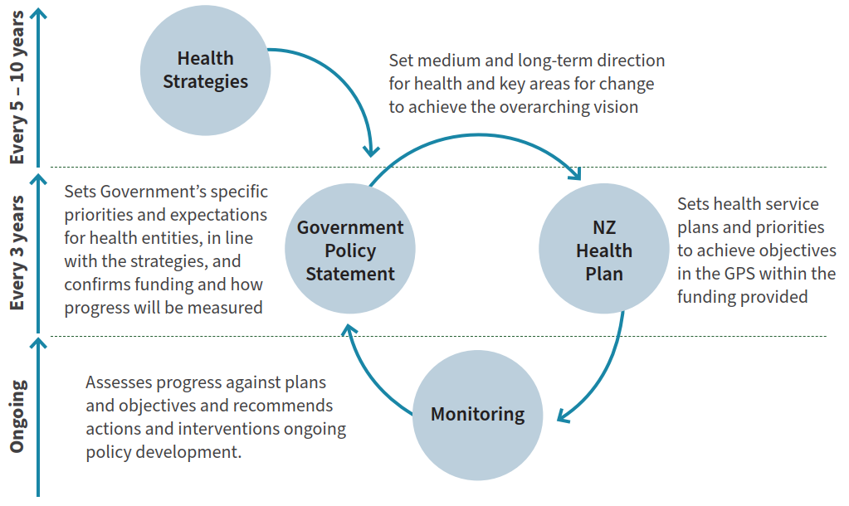

This new approach provides a clear pathway for translating strategies into action, and monitoring and evaluating the impact of strategies and the performance of agencies. The role of health strategies is critical to providing the long-term vision and priority areas that inform decisions on the other documents.

As the Government determines the first three-year GPS for 2024– 2027, and in subsequent cycles, the strategies will be turned into clear expectations and actions that will provide the opportunity to achieve the changes set out.

Programme needed for change
For this strategy to make a difference, we need to take a different approach and consider the forces that drive change, and the underlying barriers that have held back progress in some places.

Critical to our approach is recognising that change in a complex system cannot be driven by changing structures, rules and policies alone. Each of these contribute to setting a direction and framing the environment, but do not always tackle the inherent factors that influence how people work and how decisions are made: the culture and values of our workforce and system.

The key areas for change are outlined in each Rural Health Strategy priority. Manatū Hauora will need to assess progress towards the direction set by the priorities.

Monitoring outcomes
The health strategies set a direction towards achieving pae ora | healthy futures for all New Zealanders, and include goals to eliminate health inequities and improve health outcomes. Monitoring progress towards this vision requires a long-term approach to measuring key health outcomes.

The GPS will set requirements for measures and indicators that will be used to monitor and assess the progress of the health system as a whole, and of individual entities, in achieving these goals. These measures will combine more enduring and long-term system-level outcomes that are closely linked to the strategies, as well as more specific measures that reflect three-year priorities and help drive action in areas prioritised in the GPS. They will support Manatū Hauora, in its stewardship role, to track delivery of the strategies and report on the impact on outcomes over time. There will also be a significant monitoring role for Te Aka Whai Ora and iwi-Māori partnership boards and to ensure that local services are accountable and responsive to Māori needs
and aspirations.

High-quality data will be essential to monitoring outcomes. This is particularly the case for monitoring inequities between population groups, which require a breakdown of data to make comparisons and develop insights.

Ongoing research and evaluation
In addition to monitoring the intended outcomes of the strategies to account for the success of their delivery, it is also important to ensure ongoing evaluation of the strategy direction itself to ensure that this remains appropriate.

Over the coming years as the strategies are developed into firm actions in the GPS and New Zealand Health Plan | Te Pae Tata and then implemented, it will be necessary to invest in ongoing research and evaluation to continue to build our understanding of the direction and evolve it where needed. This may include:
- evaluating the impact of the Pae Ora Act, the effectiveness of its implementation and lessons for the system structure
- evaluating the new accountability approach, the roles of strategies, the GPS and New Zealand Health Plan | Te Pae Tata, and the effectiveness of their delivery and alignment in achieving system goals
- evaluating actions taken in the spirit of continuous quality improvement.

These areas for evaluation will be developed further with targeted resources to support a refreshed approach to evaluation and the use of evidence across the health system.

Appendix 1: Geographic Classification for Health

Geographic Classification for Health by two factors, distance and population size
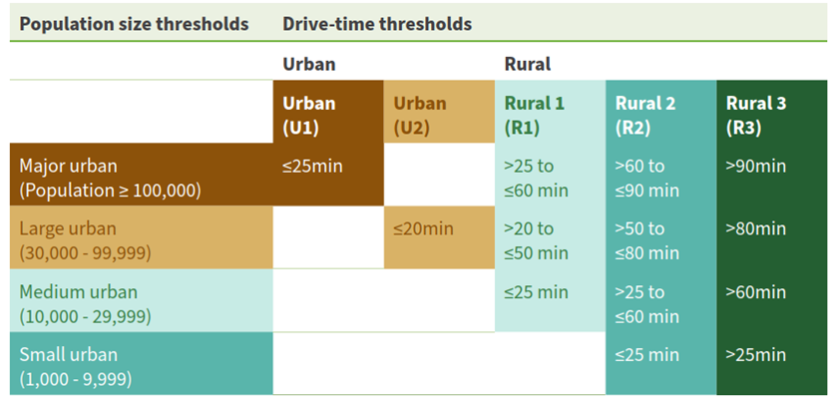

Maps of New Zealand by Geographic Classification for Health
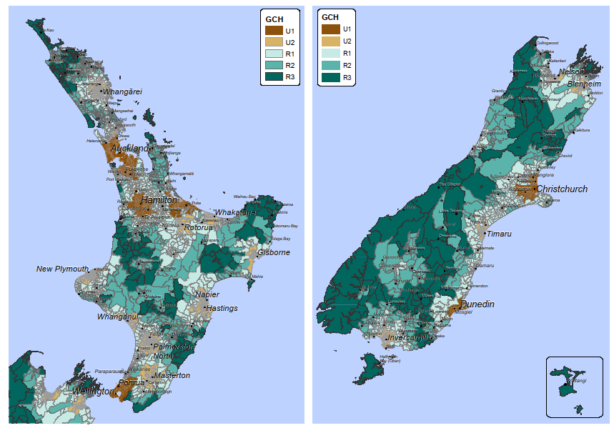
Further information about the development of the Geographic Classification for Health is available on the University of Otago’s website: https://blogs.otago.ac.nz/ruralurbannz/ or in Whitehead J, Davie G, de Graaf B, Crengle S, Fearnley D, Smith M, Lawrenson R, Nixon G. Defining rural in Aotearoa New Zealand: a novel geographic classification for health purposes (2022) New Zealand Medical Journal, August 5, 2022, volume 135.

Caveats to use of the Geographic Classification for Health for health outcomes
The health data analysis for rural communities from the Geographic Classification for Health (GCH) is considered preliminary, as Manatū Hauora has not fully investigated the implications from the analysis to date. For example, rural areas, particularly rural category R3, have a much smaller population than urban areas. That means any subgroup analyses within the rural categories has a higher margin of error than sub-group analyses within the urban categories, which can introduce potential bias to results.

Also, there are correlations between rural populations and ethnicity as well as deprivation. For example, more people in rural areas also live in higher deprivation areas and identify as Māori. Urban and rural, as broad geographic areas, like regions, have differences related to population composition, the distribution of health services and wider determinants. Some urban communities may share more in common, in terms of their population or health outcomes, with some rural areas than other urban areas.

Significant overlap exists between demographic characteristics in rural areas, such as ethnicity and deprivation (see Figure 4). Therefore, further analysis is required to understand the driving factors behind health outcomes in rural areas. For example, high-level analysis of urban-rural outcomes by ethnic group can suggest that there are poorer health outcomes for Māori in rural areas. The factors that influence this, such as deprivation and wider determinants, health access or treatment experiences and outcomes, need further investigation.

Figure 4: Population percentage in urban-rural areas, by ethnic group and deprivation quintile, 2022
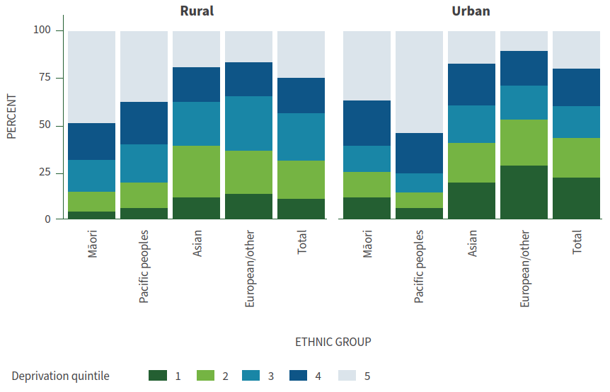

Occasionally geographic information is missing from health records for people, which affects the coverage of urban-rural analysis. Also, sometimes rounded population numbers are all that is available for smaller geographic areas, which introduces potential error into analysis, especially at the sub-group level.

Finally, the GCH is designed to be used at the Statistical Area 1 (SA1) geographic level but is often aggregated up to Statistical Area 2 (SA2) using GCH-specific concordance. This can mean that some SA2s combine several SA1s with different GCH categories, resulting in less refined categories and more aggregation (Figure 5). This creates problems when analysing health data with multiple variables, as the population size in each SA1 is often too small to breakdown by other variables, so the SA2 level data is used instead. The consequence of this is that results may vary depending on the geographic representation used in an analysis. There are also issues linking to population data from Stats NZ, when health data is defined by different geographic building blocks.

Figure 5: The differences in the GCH at SA1 (top) and SA2 (bottom) for the Wairarapa
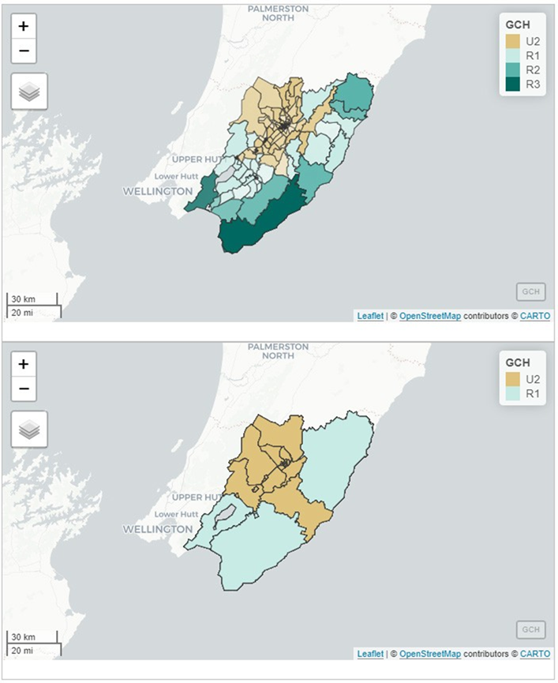

Appendix 2: Rural Health outcomes

Further work on rural health outcomes
This appendix provides a high-level overview of rural health from available information. However, there are many gaps. Health data for rural communities needs to be a systemic part of the health information produced and reported by the health sector.

Health outcomes data that is available, as well as in other health research, highlights the additional challenges and poorer outcomes rural communities experience in general, especially for rural Māori. However, the experiences and outcomes for rural communities differ by population group and region.

Access to healthcare is more challenging in rural areas
If health care options are not available close to where people live and work, people are less likely to use them as distance is a barrier.

“If it is not at our fingertips then we just tough it out, there are more important things to worry about”

– Hokonui locality, engagement participant

Rural communities, especially more remote areas, have challenges accessing health care due to where and how care is made available, and with many health options limited to main centres.

During engagement, significant concerns were raised about access to maternity care, mental health supports and urgent or emergency care. While primary care practices are generally accessible in rural areas, getting appointments can take time. Oral care, pharmacy services and other allied health options, like physiotherapy and occupational therapy, can also be limited. Options that support the availability of mental health supports within rural communities are part of priority 3.

Access to urgent care has declined in some areas due to issues with funding settings and the burden current models place on the rural health workforce. While trained local volunteers, local clinicians on call and air ambulances are some options currently supporting rural communities, there are concerns for access to urgent care options that are sufficiently staffed and resourced to provide safe and timely responses. In many communities there are gaps in support, or a reliance on small groups within the workforce to cover too much in addition to existing roles.

Workforce pressures also play a role for clinical staff where staffing levels mean they cannot support urgent transportation while maintaining services. There are also challenges transporting patients’ long distances, as this impacts the rural- based ambulance and clinicians’ availability to support others, or to return to their home. Non-urgent patient transport alongside emergency needs also creates complexity to manage resources and staff, while maintaining services.

“If my daughter has an asthma attack it will depend at that time, if there are enough nurses so we can be transported to Waikato hospital with a nurse. Otherwise, I will have to drive her myself, alone, unless there is enough risk to call the air ambulance that brings its own clinicians”

– Participant in Waikato engagement

Some rural emergency services rely on fundraising by local rural communities to keep them going. This can be a sense of pride for rural communities to fund services themselves. However, it also means services are partly dependent on resources within local communities rather than their health needs. Communities with fewer financial resources may be less likely to raise funding. Such communities, are also likely to have higher Māori populations that have higher health needs, increasing inequity in care. Urgent care and emergency care are outlined as an area where change is needed within priority 1.

For maternity care, there are significant shortages and gaps in many rural communities. Of midwives registering a location of work, 11% worked in rural areas, but 18% of 0–4 year-olds live in rural communities. Digital options for some maternity services, such as lactation consultants, are not utilised as much as they could be, sometimes due to funding barriers. Some expectant mothers have to make hard choices about where to be in the lead-up to birth, and choose between what is best for pepe and what is best for any existing children.

“Would be nice to have our babies here. I’m choosing to go to Nelson because that’s where my support is. It’s three hours away.”
– Participant in rural mothers’ group

Access to general practice
Wait times to access a doctor or nurse from a general practice can often be weeks or a month, or in some communities there is no local access for new people as the provider has closed enrolments. As at July 2022, around 25% of rural practices were not taking new enrolments, including in the rural towns of Kaitaia, Stratford, Dannevirke and Motueka. People in rural communities have far fewer alternative options (such as urgent care clinics) than people in urban centres. Rural people could look to access telehealth from other providers or allied health providers in their community, if this could meet the purpose of the visit. Otherwise, they will need to travel to providers outside their community.

These barriers to accessing care may result in them seeking emergency care or a delayed diagnosis. To support health and wellbeing in rural communities, it is crucial that there is health care coverage in rural areas, especially remote areas, where urban services are far away.

Of rural people enrolled in a general practice, 12% travelled more than 30 minutes to their enrolled practice. Regions with rural populations more likely to have higher travel times to general practice included Bay of Plenty, Gisborne, the West Coast and Otago regions. Of those traveling over 30 minutes, two-thirds were driving to urban-based practices, which could partly reflect work commuting patterns. In three regions, Southland, Otago and Northland, rural people traveling over 30 minutes were more likely to be traveling to a rural-based practice than an urban practice.

The 2021/22 New Zealand Health Survey found similar rates of unmet need for a GP, and of transport being a barrier to accessing a GP, between rural and urban populations. It also found similar rates of people in rural and urban areas who identified cost as the reason for not attending a GP or picking up a prescription.

In 2022, 58% of rural people enrolled in a general practice benefited from zero or low-cost access. This was through zero fees for children under 14, the very low-cost access scheme that the practice was part of, or through a person being a community service card holder. This is slightly higher than the equivalent figure for urban communities, 53%.

Urban Pacific peoples and rural Māori have the highest rates of benefit from zero or low-cost access, both around 85%, followed by rural Pacific peoples with 77%, and urban Māori with 76%. European and Māori within rural communities benefit at higher rates from zero and low-cost access than their urban counterparts, (54% to 43% for European and 84% to 76% for Māori). This pattern of benefits was the reverse for Pacific and Asian people, with higher rates of people benefiting in urban areas. These higher rates of access to zero fees or low-cost access may have helped reduce unmet need for GPs due to cost within rural communities, despite the fact that rural communities are more likely to be in high deprivation areas.

Rural communities are more likely to be enrolled in health services
In 2022, of rural people who had recently interacted with health services, 96% are enrolled in a general practice, slightly higher than those in urban centres. The enrolment percentage does not include people who have not recently accessed any health services. Rural health system users are under-represented in
the unenrolled population, at 14% of total unenrolled. This partly reflects the older age distribution within rural communities, as younger adults who are less likely to be enrolled are underrepresented in rural communities.

Rural ethnic groups most likely to be unenrolled are Pacific peoples and Asian groups within rural communities, both at 13%, which is three times the unenrolment rate for all rural people, and higher than the equivalent rate for their urban counterparts. This may reflect the fact that some recent migrants are ineligible to enrol for publicly funded primary care. Rural communities within the Bay of Plenty, Otago and Tasman regions had higher rates of unenrolled people.

Rural Māori in the most remote areas were more likely than Māori in urban or other rural areas to be unenrolled (7% compared to 4%–5%). Māori were under-represented in health service users (both those enrolled and unenrolled), compared to their share
of the total population. This indicates Māori were also slightly more likely to not have recently accessed the public-funded health system at all. The under-representation of Māori within recent health service users is across both urban and rural areas. Māori in the most remote rural communities, were more likely to not access publicly funded health care, and not be part of recent health service users.

Hospital Services are further away
Over one-quarter of rural communities from Northland, Gisborne, and the West Coast travel over 90 minutes to a secondary-tertiary hospital, while over half of rural communities in Otago travel 2 hours or more.

By comparison, Tasman and Waikato are the only urban areas where more than one-quarter of people travel over 20 minutes to a main hospital (in driving distance, excluding traffic).

The availability of mobile outpatient clinics and other outreach options, even where there is significant need for service from rural areas, is often dependent on specific clinicians or administrators promoting them. Similarly, digital options, such as telehealth, are not standard options offered across the system to people and whānau when feasible. When digital options are offered, this is often driven by specialists or administrators keen to adapt, or rural-based groups pushing for telehealth. Some current digital options are part of pilots or special targeted initiatives, rather than standard practice.

Support to access services outside the community
Current supports within the health system for patients to access health care outside their community are outdated. They focus on travel only, and do not include support for digital options. They also have restricted eligibility criteria, which is not flexible to respond to people with high needs.

Introduced in 2005, the National Travel Assistance (NTA) Scheme provides financial assistance to those who need to travel long distances, or travel frequently to access government-funded health services. In some circumstances, the Ministry of Social Development (MSD) can also support travel to health services through special needs grants or a disability allowance, when this is not covered by the NTA.

The NTA is a national programme but is a key support for those more likely to have to travel distances for treatment, such as rural communities and those from provincial areas. While additional data analysis will be needed on NTA to inform options to advance actions that support priority 4, indicative data from the 2018 review showed that a person from a rural area was more likely than an urban counterpart to benefit from the NTA. However, it was still a very small share of rural people accessing treatment. People living in areas with higher rural populations, the West Coast, Northland, Otago/Southland and Tairawhiti, claimed just over 30% of the total NTA payments.

The NTA currently has many shortcomings, as outlined in a 2018 review that made recommendations to improve the scheme. Identified issues included restrictive eligibility, with regional differences on how exceptions are used, payments are made to reimburse the costs which require people to pay the costs upfront, insufficient financial support to cover costs of accessing services, as rates have not been reviewed since 2009, and to claim financial support there is an outdated and time-intensive administrative processes involving posting paper-based forms.

Many volunteer groups, often formed around specific health conditions such as cancer, support people with transport. Accommodation is also supported by charities, including those linked to hospitals. However, this charitable support depends on their presence and capacity within an area.

There is a lack of consideration of the impact on rural people of hospital-based appointments that can also exacerbate travel, especially when there is no co-ordination for people with multiple appointments. This poor coordination results in additional
travel, unnecessary overnight or multi-night stays and, at times, missing appointments altogether. Bureaucratic process within departments and lack of co-ordination are a barrier to asking for better appointment times.

Further data related to the uptake of NTA for rural communities and looking at the frequency and duration of travel for some treatment or management plans will be a priority. This information will provide further insight to inform the policy work needed for a new support system, related to priority 4.

Wait times for elective treatment
Average wait times for elective treatment have increased across the health system since the beginning of the COVID-19 pandemic. By the end of 2022, two out of every five patients who had been given a commitment for treatment were not being treated within four months.

These figures are similar between rural and urban populations. There is a slightly higher proportion of people waiting more than four months for treatment in the most remote rural areas; although this may have more to do with wait times in the regions with the majority of the most remote populations, rather than their remote location.

We would need further data related to treatment pathways offered and outcomes of care, and the equity of these between rural and urban, and within rural communities, to inform further analysis on outcomes for rural communities.

Rural health outcomes by areas

Immunisation and screening
Barriers to access services can mean rural people do not have the same uptake of prevention or public health initiatives, or options that mitigate health conditions, including early diagnosis. Rural and urban comparisons for childhood immunisation at the 2-year-old milestone are outlined below.
- Rural Māori (56%) and rural European (75%) children have lower rates of being fully immunised at the 2 year-old milestone than urban counterparts. Both of these rural figures are around 5 percentage points lower than their urban counterparts. For Pacific and Asian children, the rural and urban immunisation rates were similar.
- Immunisation rates for Māori children in the most remote rural areas, just under 50% fully immunised, were lower than other rural and urban Māori children.
- Māori children in rural areas within Northland, Gisborne and Bay of Plenty had the lowest immunisation rates. Northland accounted for around one-quarter of rural Māori children not fully immunised.
- For fully immunised rates for Measles, Mumps and Rubella (MMR) at 2-years-old, rural Māori and rural European children had lower rates of being fully immunised than their urban counterparts, with a difference similar to the overall immunisation rates.
• Fully-immunised rates for whooping cough (pertussis), at 2-years-old, have smaller differences for rural and urban, with around 90% of both groups being fully vaccinated (88% for rural; 91% for urban).

A priority for additional data on prevention and public health initiatives will be cancer screening data by rural areas and ethnicity, to assess reach and uptake of these initiatives. Monitoring these rates will inform work around priority 3 to have services closer to home.

“There is variable access to screening services. In many areas, the Breast Screening Bus only visits a rural town every two years, in others, it is unreliably available. Women who are not able to get to an appointment during its scheduled times in their town are expected to travel to an urban centre for a mammogram that takes no more than 15 minutes. This is not an easy option for women with young children, or those who cannot arrange or afford transport.”

– Hauora Taiwhenua Rural Health Network submission

Access and use of diagnostic tools for rural communities is another area to improve ongoing data reporting by health entities. This could look at travel times, and uptake of use by rural communities. Part of this would also be monitoring progress on options to support diagnostic access closer to home under priority 3, including through mobile options, outreach or through other approaches with new technology.

Lifestyle and risk factors
The New Zealand Health Survey 2021/22 found that:
- rural men had higher rates of physical activity than urban men or women – the proportions or rural people with active jobs in primary industries are likely to contribute to this
- rural men had higher rates of hazardous drinking than men in urban areas or rural women
- people living in rural communities were more likely to be regular smokers, than their urban counterparts, but smoking rates for rural communities have been falling, as they have for the total population
- the use of e-cigarettes, or vaping, has risen over recent years, but is similar for people living in rural communities and urban areas.

Rural men experience a higher risk of workplace injury because of the higher rates of employment in key industries with more workplace accidents. In 2021, the agriculture, forestry and fishing industry held the highest incident rate of work-related injury claims, at 172 claims per 1,000 full-time equivalent employees. Males accounted for 78% of these claims.

Oral health
Rural communities need oral health services that promote, improve, maintain and restore oral health throughout the life course. Access to oral health services, and overall oral health outcomes are generally poorer in rural areas than urban areas.
Children in Northland and the rural regions around Rotorua in particular, are less likely to be caries-free at age five when compared to the national average.

“I have been supporting a young person to get access to dental care. There is nothing available in the Gore district and we could not find anything in Invercargill either. The options available were Queenstown, Central Otago, Milton or Dunedin. That is a huge barrier if you are a single parent on a low income. Dental care is expensive, but it becomes more unattainable if you have to travel 1–2 hours one-way to access it. You need access to transport, there are additional fuel costs and potentially having to take time off work to attend”

– Hokonui locality engagement participant

Rates of community water fluoridation are much lower in rural areas. Work is underway to improve community water fluoridation where this is feasible. As the older rural population increases, so will oral health needs (particularly as more older people now have their own teeth). The health system will need to find ways to support local and in-home oral health care for older people.

Innovative approaches are needed to tackle oral health inequities for rural communities that are focussed on prevention, and are accessible and appropriate for rural people.

Mental health and substance-related harm
Rural communities persistently experience poorer mental health outcomes than the general population. This is likely to be due to both challenges in accessing specialist mental health support in rural communities, as well as the social, economic, environmental and cultural factors affecting rural communities.

Rural communities have endured a number of events in recent years that have affected livelihoods and people’s mental wellbeing (the COVID-19 pandemic, the M. Bovis outbreak, repeated flooding, Cyclone Gabrielle and droughts). These types of events cause significant disruption to peoples’ normal lives and contribute to stress and uncertainty. In January 2023, around 70% of respondents to the Federated Farmers Farm Confidence Survey indicated that economic conditions were affecting
mental wellbeing. The main three concerns for farmers related to climate change action policies, debt and interest payments and regulation and compliance costs.

Over 2016–2018, the rate of suicide for men in rural communities was on average 40% higher than men in urban areas and the rate for women in rural communities was on average 20% higher than women in urban areas. For young people aged 15–24 years, the rate of suicides in rural communities was on average 20% higher than that of their urban counterparts. A higher proportion of suicides in rural areas involve firearms than urban areas – possibly reflecting easier access to firearms in rural areas. Suicide is complex. There is no specific factor that accounts for the differences between rural and urban suicide rates. There are a wide range of factors that interact to influence a person’s risk of suicide, and these factors influence and change people in varying ways throughout their lives.

Rural communities may be less likely to access health services for alcohol-related conditions, and experience higher rates of alcohol-related health loss and premature death. Relationships with alcohol also influence mental health outcomes and riskier behaviour. There is also a perception that drink-driving laws are less likely to be enforced in rural areas. There is growing evidence that additional alcohol outlets in rural areas have a greater impact on violence in comparison to those in urban environments. These impacts on rural communities must be considered when implementing alcohol control strategies.

The actions in Kia Manawanui Aotearoa – Long-term pathway to mental wellbeing, the Government’s long-term plan for transforming New Zealand’s approach to mental wellbeing, have the potential to benefit rural communities. They have a focus on increasing the availability of local community-led supports and addressing barriers to support including access to, and use of, digital technology. Integrated Primary Mental Health and Addiction Services have been rolled out to general practices across the country, with rural areas a priority. As at March 2023, part way through these being rolled out, they are available in practices with around 70% of the rural population enrolled in primary care. While there is growing accessibility to mental health and addiction services within primary care settings in rural areas, acute and specialist services are mainly limited to urban areas, with additional barriers to the distance involving long wait times and workforce gaps.

Inequity in mortality data for rural people
Over 2018–2020, age-standardised all-cause mortality rates and amenable mortality rates were higher for rural populations than for urban populations. Amenable mortality is a subset of all-cause mortality, and is defined as deaths under age 75 years that
could potentially be avoided, given effective and timely healthcare. However, these higher mortality rates, for both male and female, in rural areas partly reflect population differences.

Age-standardised Māori mortality is significantly higher than non-Māori rates in both urban and rural communities. The share of the population identifying as Māori is 40% higher in rural communities than the share of the population in urban (22%
in rural communities, compared to 15% in urban areas). When comparing mortality rates by ethnic groups, there were more differences between rural and urban populations for amenable mortality rates.

Figure 6: Age-standardised amenable mortality rates, by urban and rural, per 100,000
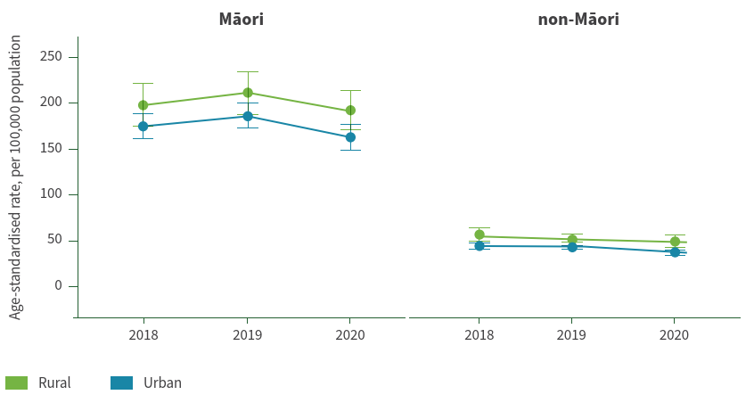
Source: Ministry of Health, analysis of New Zealand Mortality Collection

Over 2018–2020, rural amenable mortality rates were 20% higher than for urban populations, and for rural Māori and non-Māori they also had higher rates than their urban counterparts. For rural Māori, the amenable mortality rate is around 12% higher over 2018–2020 than urban Māori, with rural non-Māori also having a similarly higher amenable rate compared to their urban counterparts.

Māori mortality, both urban and rural, have around one-third categorised as amenable mortality, compared to around 15% for non-Māori mortality. In 2018, the main causes of amenable mortality in rural communities were ischaemic heart diseases, external causes (including accidents and suicide) and cancer. While these are generally similar main causes for the urban population, external causes for males and non-Māori were a higher proportion of deaths in rural communities than for their urban counterparts.

Recent research into rural and urban mortality over 2014–2018, has also looked at age-specific rates and the groups within rural and urban categories. Being in more remote rural areas compounds the already higher Māori mortality rates, such that the largest gaps between Māori and non-Māori mortality are observed in the most remote rural communities, R3. For younger age groups, all-cause mortality rates for Māori and non-Māori are comparatively higher in rural areas, as well as for provincial areas, than in the main urban centres. The mortality disparities for rural age-groups when compared to urban counterparts, are much more apparent in the younger age groups, and lessen, or even reverse, for older age groups. The pattern for older people may reflect migration from rural to urban areas later in life for people needing better access to services.

The higher amenable mortality rates for rural Māori and rural non- Māori, when compared to their urban counterparts, suggests that there are additional challenges faced by rural communities. The inequities experienced by rural Māori and rural non- Māori will need further research to understand which factors impact this, especially for rural Māori. Rural Māori have the highest amenable mortal rates and are overrepresented in rural communities with higher differences to urban counterparts – those in the most remote rural communities and younger age groups.

Inequities in amenable mortality could be related to wider determinants, such as deprivation, access to care, early detection, the quality of treatment, or other characteristics in rural communities, such as higher workplace accident fatalities, related to the type of work undertaken.

Another factor that influences rural and urban outcomes, as outlined above for age-specific differences, are people moving between rural and urban areas. Rural classifications are about where people live, but this can change over their lives. If they are in poor health or need aged care support, this may contribute towards moving to urban areas, especially for non-Māori. The migration pattern would lessen groups with poor health outcomes in rural communities. Living in rural areas, ethnic differences and deprivation can all feed into mortality differences, but understanding the relationships will need further research.

Waitangi Tribunal (2019) Hauora: Report on Stage One of the Health Services and Outcomes Kaupapa Inquiry
Whitehead J, Davie G, de Graaf B, et al. 2022. Defining rural in Aotearoa New Zealand: a novel geographic classification for health purposes. New Zealand Medical Journal, August 5, 2022, volume 135.
While different approaches to define rural communities are used internationally, they generally use comparable population size and travel distance approaches.
This is for ‘total response’ ethnic group. Under the ‘total response’ ethnicity approach, people can be counted in more than one ethnic group, as they identify with more than one ethnicity. The sum of ethnic groups will then add to more than 100%.
The growing pacific population can be seen in school enrolments within rural communities. In Horowhenua, Waitaki, Ashburton and Rangitikei the Pacific students are around 10%. In south Waikato district (including Tokoroa), Pacific school enrolments are around 20% with a high Cook Islands Māori community.
These regions were established as resettlement locations when the Refugee Quota was increased to 1,500 people per year.
The Washington Group Short Set (WGSS) within the New Zealand Health Survey should not be used to produce estimates of total disability prevalence or to investigate levels of need for services or environmental change. To meet these and other data needs, a disability-specific survey, with a more extensive question set, would be required. The population identified as disabled using the WGSS is considerably smaller than the population identified by disability- specific surveys. One of the limitations is that no WGSS question fully captures mental health impairments. The share of the disabled population between rural and urban may differ with a fuller measure of disability.
Rainbow is an umbrella term that covers a diversity of sexual orientations, gender identities and expressions, and sex characteristics and is used in place of LGBTQIA+. It is a diverse population group and includes people who identify as gay or lesbian, bisexual, queer, asexual, intersex, transgender, non-binary, takatāpui and MVPFAFF+ (Pacific peoples identities).
Stats NZ, Household Economic Survey data for the year ended June 2021. Rural and urban definitions were based on Stats NZ definitions and estimates for rurality were based on survey data. There are challenges having robust estimates of rainbow communities, and there may be extra challenges within rural areas.
Ministry of Youth Development. 2015. Supporting LGBTI Young People in New Zealand.
Fenaughty J, Ker A. Alansari M, et al. 2022. Identify survey: Community and advocacy report. Identify Survey Team.
Stats NZ, Household Economic Survey data for the year ended June 2021.
Fanslow J, Robinson E. 2011. Sticks, Stones, or Words? Counting the Prevalence of Different Types of Intimate Partner Violence Reported by New Zealand Women, Journal of Aggression, Maltreatment and Trauma, Vol 20, Issue 7, https://doi.org/10.1080/10926771.2011.608221; Fanslow, J., Hashemi, L., Gulliver, et al. 2021. A century of sexual abuse victimisation: A birth cohort analysis, Social Science & Medicine, Volume 270,113574, https://doi.org/10.1016/j.socscimed.2020.113574
There is limited data on social inequity such as child poverty and housing affordability measures for rural communities. The relevant survey data does not produce rural and urban breakdowns.
The Equity Index (EQI) is a statistical model that estimates the extent to which students face socio-economic barriers to achievement at school using 37 variables linked to school achievement. The information that this model provides allows the Ministry of Education to better target equity funding. The higher EQI number indicates that a school has students facing more or greater socio-economic barriers. For further information see: https://www.education.govt.nz/our-work/changes-in-education/equity-index/faq-equity-index/
This analysis of rural and urban schools classifies them into the Geographic Classification for Health using the school’s address and applying that to all enrolled students.
Amenable mortality is defined as premature deaths that could potentially be avoided given effective and timely care. See footnote 48 for more information.
For example, monitoring of real-time glucose levels for diabetic patients that enables both patient and health workers receiving this data would have greater benefits for rurally-based patients
The rural proofing framework is currently part of the impact of Cabinet policy decisions.
See Whānau Ora | Home (whanauora.nz) URL: https://whanauora.nz/ (accessed June 2023).
United Nations Regional Information Centre for Western Europe. Sustainable Development Goals. URL: https://unric.org/en/united-nations-sustainable-development-goals/ (accessed 27 June 2023).
Community and Public Health. Health in All Policies: Ways of working. URL: https://www.cph.co.nz/your-health/health-in-all-policies/ways-of-working (accessed June 2023).
Nixon G, Samaranayaka A, de Graaf B, McKechnie R, Blattner K, Dovey S. (2014) Geographic disparities in the utilisation of computed tomography scanning services in southern New Zealand. Health Policy; 118(2):222-8.
Te Tara o te Whai, Hauraki Locality whānau voice, https://www.tetaraotewhai.nz/ (accessed June 2023).
Ministry of Health. 2023. Oranga Hinengaro System and Service Framework. Wellington: Ministry of Health.
Another benefit of mobile services is that they can provide back-up for diagnostics, workforce gaps or seasonal population surges.
For instance, for reasons of quality, safety and efficiency, including in ability to sustain the workforce.
Cormack D, Masters-Awatere B, Lee A, et al. 2022. Understanding the context of hospital transfers and away-from-home hospitalisations for Māori. New Zealand Medical Journal. 2022 Nov 11;135(1565):41-50. PMID: 36356268.
Gurney J, Whitehead J, Kerrison C, et al. 2022. Equity of travel required to access first definitive surgery for liver or stomach cancer in New Zealand. PLoS ONE 17(8): e0269593. https://doi.org/10.1371/journal.pone.0269593
Within medicine, there is the rural generalist model, and rural hospital medicine as training path, and for nursing rural nurse specialists as career option, however, more is needed in these and other professions to recognise and value the skills and capabilities.
A clinical framework outlines training and certification requirements and maintenance of standards. This can demonstrate that services, while differently configured in rural areas, are operating according to a framework that considered safety, quality and managed risk within a rural context.
While rural placements can increase graduates that go on to work in rural areas, many of these students will still take up career pathways in urban centres. The groups going into urban-based roles can still benefit rural health, as having a broader workforce that have experienced work in rural areas means that more urban-based clinicians will have better understanding of the context of rural health workforce.
While some training support responsibilities are set out through employment contracts with health entities, the support also needs to be part of system settings to cover the publicly-funded health workforce.
These are the Cook Islands, Niue and Tokelau
Hokonui locality, Community feedback, https://www.hokonuilocality.nz/community-feedback (accessed June 2023).
This included around one in ten midwives working in rural communities also working in urban areas.
General Practice NZ, (2022) PHO Closed Books Stocktake Report 2022, https://gpnz.org.nz/publications/pho-closed-books-stocktake-report-2022/ (accessed June 2023)
Distances are based on driving times in good road conditions with no impact from traffic.
The practice being part of the very low-cost access initiative, or the individual being a community services card holder, limits the fees a GP can charge them. The current maximum in 2023 is a $19.50 fee payment for adults.
Health service users are the number of people who use a health service within 12 months. People not included in enrolment data are those who have not accessed health care within the last 12 months.
Distances are based on driving times in good road conditions with no impact from traffic.
Ministry of Health. 2019. The National Travel Assistance Scheme: Policy Recommendations Report, Wellington: Ministry of Health.
Some areas, such as Northland, support transport to first specialist appointments (currently outside the National Travel Assistance coverage). They also provide some payments in advance of other appointments, as they know this can be insurmountable for their population, who include remote rural communities and those with financial challenges.
For example, around two-thirds of the most remote rural group, R3, are in Northland, Waikato and Otago regions.
Stats NZ. 2022. Injury statistics – work-related claims: 2021
Hokonui locality, Community feedback, https://www.hokonuilocality.nz/community-feedback (accessed June 2023).
Rural and urban suicide data is based on the Stats NZ definition from the Rural/Urban (experimental) profile, developed in 2004. This differs from Geographic Classification of Health used for other measures. Suicide rates were age-standardised to WHO world standard population.
Amenable mortality is defined as premature deaths that could potentially be avoided given effective and timely care. That is, deaths from diseases for which effective health interventions exist that might prevent death before an arbitrary upper age limit (usually 75). The definition used is from Ministry of Health (2018) Amenable Mortality SLM Data.
Sometimes within a single year of data, the difference is not statistically significant, due to small numbers.
Crengle S, Davie G, Whitehead J, et al. 2022. Mortality outcomes and inequities experienced by rural Māori in Aotearoa New Zealand, The Lancet – Regional Health Western Pacific, 2022;28 100570; Nixon G, Davie G, Whitehead J, et al. 2023. Comparison of urban and rural mortality rates across the lifespan in Aotearoa/New Zealand: a population-level study, J Epidemiol Community Health Published Online First. Doi: 10.1136/jech-2023-220337

