The Role of the Health Workforce New Zealand

Citation: Ministry of Health. 2014. The Role of the Health Workforce New Zealand. Wellington: Ministry of Health.
Published in November 2014
by the Ministry of Health
PO Box 5013, Wellington 6145, New Zealand
ISBN 978-0-478-42887-2 (print)
ISBN 978-0-478-42888-9 (online)
HP 6005
This document is available at www.health.govt.nz

This work is licensed under the Creative Commons Attribution 4.0 International licence. In essence, you are free to: share ie, copy and redistribute the material in any medium or format; adapt ie, remix, transform and build upon the material. You must give appropriate credit, provide a link to the licence and indicate if changes were made.

Foreword from
the Board Executive Chair
Health Workforce New Zealand
The Health Workforce New Zealand (HWNZ) Board is pleased to release this report on The Role of Health Workforce New Zealand. It is a companion document to our first yearly update on The Health of the Health Workforce 2013–2014, and provides background and contextual information to sit alongside that report.

The past five years have seen HWNZ lead a comprehensive response to the workforce challenges faced in New Zealand in 2009, some of which we will continue to face in years to come. However, these challenges are well understood and corrective strategies have been, or are being, put in place.

In the past five years, we have applied workforce intelligence based on the innovative and world- leading HWNZ health service forecasting methodology. We have tested innovative roles that move away from traditional approaches to workforce planning that will become increasingly unaffordable in years to come. We have substituted an outcomes perspective for a siloed profession-by-profession approach to forecasting because we are confident that this will deliver greater benefits to New Zealanders.

HWNZ was established to provide guidance and leadership in the health sector. It is heartening to see at the end of five years that many of our health workforces in New Zealand are no longer in crisis. Together with the sector, we are working on sound responses to the issues we face today and those we expect to face in the future.

The HWNZ Board looks forward to carrying on the work we have started over the past five years.

Professor Des Gorman BSc MBChB MD (Auckland) PhD (Sydney)
Board Executive Chair, Health Workforce New Zealand

Foreword from the Director
Health Workforce New Zealand
The dedicated people who work in New Zealand’s health and disability sector are crucial to the delivery of high quality services to all. Arguably they are the most critical component of our health system.

HWNZ’s goal is to ensure that the workforce is appropriately trained and configured to meet current and future health needs, so New Zealanders can be confident that they will receive the best health care possible.

Our role is that of facilitator, working with and through stakeholders to build a sustainable workforce. We support and, where appropriate, lead health sector responses to workforce planning and development. This can only occur through the coordinated efforts of training organisations, employers, unions, staff, regulatory bodies, professional associations and government bodies.

To identify and develop joined-up, mutually owned solutions to the challenges our sector faces, HWNZ has developed a taskforce and work programme for each of the key workforces – doctors, nurses, midwives, allied health workers, non-regulated workers, and those in leadership and managerial roles. Each taskforce comprises a steering group, made up of representatives drawn from across the health sector and a smaller working group. The working groups will implement defined programmes of work to improve professional development, recruitment and retention.

For now, the six taskforces will focus on their designated professions, mirroring the traditional approach taken to workforce planning. Additional projects are also under way, on mental health and the Māori and Pacific health workforces. The focus will then shift to new models of aged, primary and cancer care and other health priorities. In particular, we will examine how individual workforces can combine and align their efforts. For example, aged care will rely increasingly – but not exclusively – on kaiāwhina care workers working closely with general practitioners (GPs), practice nurses and allied health professionals.

This programme of work will enable us to develop more sophisticated responses to meeting the future health needs of New Zealanders.

Dr Graeme Benny
Director, Health Workforce New Zealand

Contents
Foreword from the Board Executive Chair Health Workforce New Zealand iii
Foreword from the Director Health Workforce New Zealand iv
Introduction 1
Background 2
Responses to health care challenges 3
The purpose of Health Workforce New Zealand 4
Workforce challenges for Health Workforce New Zealand 5
Responses to workforce challenges 6
Developing the workforce to meet government health targets 7
Working with the sector 9
Building a sustainable workforce 10
Developing workforce intelligence 11
Workforce service forecasts 12
The need for workforce data 14
Demonstrating innovative roles 15
Recruitment, retention and distribution initiatives 17
Voluntary Bonding Scheme 17
Advanced Trainee Fellowship Scheme 18
Rural Health Interprofessional Immersion Programme 19
Managing the medical and nursing pipelines 20
Medical workforce taskforce 20
Setting up the nursing workforce programme 21
Developing the non-regulated (kaiāwhina) workforce 22
Increasing the number of targeted training opportunities 24
General Practice Education Programme 24
Midwifery First Year of Practice programme 24
Allied health, science and technical workforce review 24
Regional workforce development hubs 25
Career planning 26
Removing barriers to innovation 27
Clinical pharmacist prescriber 27
Extending legal functions to a range of health practitioners 27
Funding 28
Allocation of the HWNZ funding pool 30
Appendices 31
Appendix 1: Summarised recommendations of Workforce Service Forecasts 31
Appendix 2: Voluntary Bonding Scheme maps 35

List of Tables
Table 1: Examples of demonstrations supported by HWNZ 15
Table 2: VBS registrants 2009–2014 17
Table 3: Hard-to-staff specialties for 2015 18
Table 4: VBS registrants 2014 18

List of Figures
Figure 1: Developing sustainable workforces and new models of care 8
Figure 2: Distribution of HWNZ funding, totalling more than $165 million14 28
Figure 3: Medical hard-to-staff communities 2015 35
Figure 4 Nursing hard-to-staff communities 2015 36
Figure 5: Midwifery hard-to-staff communities 2015 37

Introduction
The Role of Health Workforce New Zealand is one of two reports that Health Workforce New Zealand (HWNZ) is publishing in 2014. The other report, The Health of the Health Workforce 2013–2014, describes the state of the health and disability workforce (the workforce) in New Zealand at the present time. It is the first of what will be a yearly report.

The data and workforce intelligence cited in these reports are drawn from multiple sources; for example, regulatory bodies such as the Medical Council of New Zealand (MCNZ) and Nursing Council of New Zealand (NCNZ), the wider Ministry of Health, district health boards (DHBs) and other employers, OECD reports, the New Zealand Census and Workforce Service Forecasts commissioned by HWNZ.

Because of this, there is some variation in the date ranges of the workforce data used.

Background
New Zealand has, by international standards, a high-performing and efficient health system. But, in common with other OECD countries, we face a number of challenges. The proportion of New Zealanders aged 65 and over is predicted to increase from 14 percent of the general population in 2012 (600,000 people) to 23 percent in 2036 (1.2 million people). The growing cost of health care for this ageing population is expected to fall on a relatively smaller number of taxpayers.

Chronic conditions and non-communicable diseases such as diabetes, heart disease and mental health conditions are likely to be more prevalent in future, and may have a disproportionate effect on Māori and Pacific people, whose life expectancy is lower than that of the general population. On the positive side, new technologies are expected to result in earlier diagnoses and return more people to good health, but their benefits cannot be fully exploited without a skilled and well-trained workforce.

New technology also contributes to the uncertainty and ambiguity associated with the future of public health services. Solutions are not always clear, and may not lie entirely with the health sector. For this reason, increased cooperation across the health and wider social sector will, of necessity, become more and more the norm.

Health spending accounted for 10.3 percent of gross domestic product in New Zealand in 2011, which is higher than the OECD average of 9.3 percent. In the same year in New Zealand, 82.7 percent of health spending was funded by public sources; this was well above the average of 72.2 percent for other OECD countries. About two-thirds of Vote Health operational funding is spent on workforce, which amounted to approximately $9 billion in the 2013/14 financial year.

Responses to health care challenges
There have been a series of consistent responses around the world to the challenge of delivering high standards of health care within manageable budgets. In New Zealand, a Ministerial Review Group (MRG) set up in 2009 to make recommendations to the Minister of Health on the future direction of the health and disability system said New Zealand could only meet forecast growth within a sustainable cost track by investing in more efficient solutions. The MRG’s recommendations were based around one central theme – ensuring that New Zealand continued to have a world-class health and disability system.

The MRG concluded that New Zealand needed to move away from hospital-based models of care and rigid job definitions and work practices.4 New models of care were needed that placed the patient at the centre of service delivery, and placed health care services as close to home as possible. The MRG suggested that New Zealanders should be encouraged to play a greater part in their own health and wellbeing, noting that prevention and self-care would become increasingly important in future.

These strategic responses had implications for the workforce. The MRG pointed out that workforce planning at the time was fragmented and hampered by the variable quality of data collection systems. National oversight and leadership was needed to develop a strategic response to New Zealand’s workforce challenges.

Government, the Ministry of Health, the DHBs and HWNZ have implemented a number of policy responses to address wider service delivery challenges and those specific to the health and disability workforce. The Ministry’s two primary outcomes reflect government priorities for health: that New Zealanders live longer, healthier and more independent lives, and the health system operates effectively within a constrained funding environment.

The health and disability sector is working towards a system in which:
- individuals, families/whānau and communities take greater ownership of their health and wellbeing
- health responses are geared towards keeping people well through early intervention and prevention – at both individual and population levels
- more health and disability care is delivered in primary and community settings
- work across the public social sector is incorporated into achieving better health, social and economic outcomes.

The purpose of Health Workforce New Zealand
Health Workforce New Zealand was set up in 2009 to provide strategic leadership for a sector-wide response to New Zealand’s workforce challenges. HWNZ consists of a multi-disciplinary board and a business unit that employs 17 full-time staff. The business unit is part of the National Health Board within the Ministry of Health, and is funded from Vote Health.

Professor Des Gorman has been the Executive Chair of the HWNZ Board since 2009. The Director of the business unit is Dr Graeme Benny, who took up the post in February 2014.

In 2009, HWNZ also became the primary provider of funding for post-entry clinical training in New Zealand, with an allocation of approximately $174 million from Vote Health for postgraduate clinical training, workforce development and innovation in the 2013/14 financial year. More information about the education and training programmes HWNZ supports can be found in the Funding section (page 28).

Workforce challenges for Health Workforce New Zealand
When HWNZ was established, New Zealand’s workforce was highly skilled and professional but characterised by staffing shortages. Locally trained doctors and nurses were leaving to work overseas, and there was a heavy reliance on highly mobile locums and overseas-trained health professionals to fill vacancies. The World Health Organization analysed the health workforces of OECD member countries in 2008 and concluded that New Zealand was overly reliant on migrant doctors and nurses.

Workforce distribution was another issue; some rural and provincial areas experienced consistent and significant gaps between supply and demand across all the major workforces. New Zealand’s small and widely dispersed population made regional delivery of certain specialised services a particular challenge. For example, some cancer treatments depend on services provided by small allied health, science and technical workforces. It takes time to train these specialist workforces, and New Zealand- trained graduates were sometimes lured off-shore by the higher salaries and career development opportunities available in other countries.

New Zealand had, and continues to have, an ageing workforce. Young people enter the health professions at a lower rate than they do in other professions. General practice in rural areas has an older workforce in general than in urban areas.

Although Māori make up 15 percent of the general population, 2.9 percent of doctors and 6.6 percent of nurses are Māori. Pacific peoples represent 11.8 percent of the population, yet 1.8 percent of doctors and 2.5 percent of nurses are Pacific.

Responses to workforce challenges
Responding to current challenges requires leaders who understand the health system’s direction of travel, who work across the health and wider social sector, and who have the ability to innovate and steer a system in transition. But a shift in culture is also required, so the health system increasingly encourages individuals and communities to take greater personal care of their health and wellbeing. The health care system of the future will transcend traditional professional, provider and organisational boundaries.

As the population ages, community and home-based care will become increasingly important. HWNZ recognises that coordination of care for older people by inter-professional teams outside hospital settings will be necessary, and will become ‘business as usual’ for the relevant health practitioners.

The pace of change will need to increase to keep up with medical advances such as personalised medicine and genetic mapping. Work will also continue to reduce disparities in health outcomes for Māori and Pacific peoples (for example, through coordinated responses that target the early diagnosis of rheumatic fever).

HWNZ proposes the training and recruitment of more health professionals with generic skills. This will increase the workforce’s flexibility and support the increasing shift towards primary and community-based models of care and integration between institutional and community settings.

Another response to future challenges is to encourage health professionals to take on new tasks and responsibilities, freeing up limited and expensive clinician time. This can be achieved through the enhancement of existing roles and the development of new and innovative roles. Such an approach is expected to lead to improved satisfaction for trainees and earlier treatment for patients.

HWNZ has supported the demonstration and evaluations of a range of innovative roles in New Zealand settings. More information about these can be found in the Demonstrating innovative roles section (page 15).

Developing the workforce to meet government health targets
Government’s health targets are a set of national performance measures that provide a clear and specific focus for improving health care at local and national levels. They provide a way of measuring whether the health and disability system is improving New Zealanders’ access to services, and also their overall health outcomes.

Six priority health targets have been in place over the past six years.
- Shorter stays in emergency departments.
- Improved access to elective surgery.
- Shorter waits for cancer treatment.
- Increased immunisation.
- Better help for smokers to quit.
- More heart and diabetes checks.

Between 2007/08 and 2013/14, the number of elective surgeries increased by an average of more than 8000 a year, from 118,000 to 158,500. Collectively, DHBs achieved 105 percent against a target of 100 percent access to elective surgeries in the third quarter of 2013/14.

For the 2009/10 year, a target of radiotherapy treatment for all cancer patients within six weeks of their first specialist appointment was established. From December 2010, this was changed to ‘within four weeks’. In light of DHBs’ existing achievements, the target was changed to include chemotherapy as well as radiotherapy. All DHBs achieved the target in the third quarter of 2013/14.

The DHBs’ collective performance against the shorter stays in emergency departments target stayed at 94.3 percent in the third quarter of the 2013/14 year. All DHBs achieved 90 percent or greater in the same quarter (for the first time since the target was established in July 2009). Eleven DHBs met 95 percent of the target.

Almost 849,000 New Zealanders have had heart and diabetes checks over the past five years, and almost a quarter of a million have been offered advice and support to give up smoking. As a result of this and other initiatives (such as annual increases in tobacco excise and the withdrawal of retail displays), the prevalence of daily smoking in New Zealand has now reduced to 15 percent.

Six years ago, the Māori immunisation rate for eight-month-olds was 59 percent. Today, in over half of the DHBs, the rate is equal to or higher than the rate for Europeans. The current target is that by December 2014, 95 percent of all eight-month-old children will have had their primary course of immunisation.

Achieving health targets depends on a capable and well-distributed supply of health professionals. Since its establishment, HWNZ has worked on initiatives aimed at developing a workforce capable of supporting the delivery of health targets and other government and wider Ministry priorities for health.

Figure 1 describes key workforces we are working with to achieve government and Ministry of Health priorities. It also shows the aggregate areas, or interdisciplinary priorities, to which the individual workforces contribute. HWNZ will increasingly move towards an aggregate approach to workforce planning that works across the different workforces to achieve outcomes in a particular area, for example, in aged care.

Figure 1: Developing sustainable workforces and new models of care
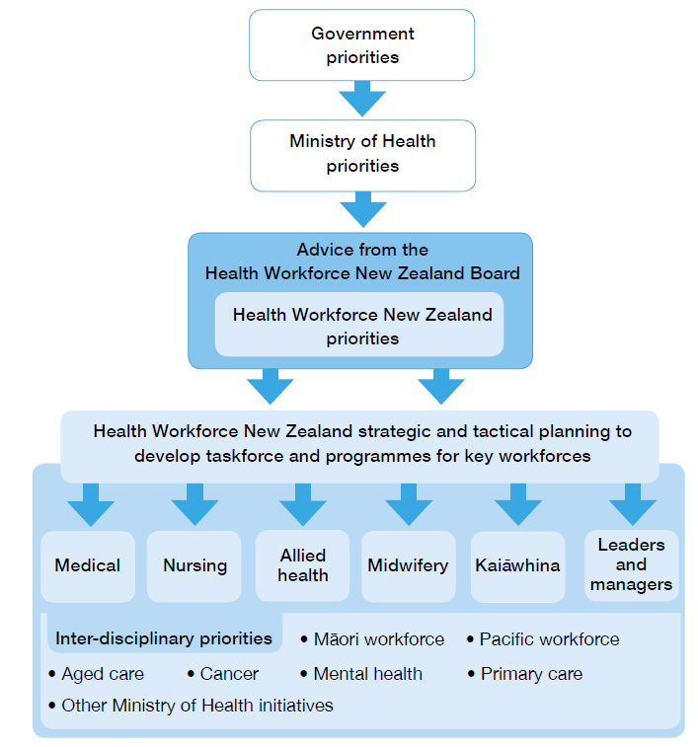

Working with the sector
DHBs, private sector bodies, professional organisations, education and training providers, professional colleges, and health clinicians and practitioners are all powerful contributors to the shape of the health and disability workforce. HWNZ’s strategic and tactical planning function is carried out in the context of partnerships with, and data and workforce intelligence from, these agencies.

As a small organisation, HWNZ provides leadership, support and coordination in the sector, but the implementation of strategic responses is often led by a stakeholder group. For example, we are working in partnership with Careerforce on the Health and Disability Kaiāwhina Worker Workforce Action Plan 2014 for the development of the non-regulated workforce, see the Developing the Non-regulated (kaiāwhina) workforce section (page 22).

HWNZ also works with other organisations that lead projects in areas of common interest. For example, we are seeking to have a high degree of influence in the scope of training offered and funded at undergraduate level through a proactive relationship with the Tertiary Education Commission (TEC). HWNZ and the TEC have a common interest in ensuring that the supply of graduates is geared to match the career opportunities for each workforce group.

In our work with the sector, we are guided by an engagement philosophy that reflects our leadership role and the need for a ‘whole of health workforce’ perspective across plans for the future. These guiding principles are set out in full at www.health.govt.nz.

Building a sustainable workforce
During the past five years, HWNZ has focused on a number of key areas that together contribute to building a sustainable workforce. They include:
- developing workforce intelligence (through Workforce Service Forecasts and data collections)
- demonstrating innovative roles
- recruitment, retention and distribution initiatives
- managing the medical and nursing pipelines
- developing the non-regulated (kaiāwhina) workforce
- increasing the number of targeted training opportunities
- removing barriers to innovation
- career planning.

Developing workforce intelligence
New Zealand is a small player in a global market that is highly susceptible to economic and workforce ebbs and flows. We face a number of unknowns when we try to forecast workforce demand. For example, we cannot predict with any certainty the impact that technological change will have on the shape and size of future workforces.

It is certain that an ageing and growing population, together with medical advances, will result in an unprecedented demand for health and disability services in years to come. The emerging prevalence of chronic conditions will put pressure on primary health care systems as patients seek treatment closer to home.

Traditional workforce forecasting will not serve us well when we plan for a workforce to meet this demand. Experience shows that it is unhelpful to try to estimate the number of health practitioners the system will need because precise calculations are invariably wrong. When projections base demand on existing workforce models, they predict a health care system that is increasingly unaffordable and difficult to sustain.

In light of this, HWNZ has taken an alternative approach to forecasting that moves away from traditional numerical forecasting and instead emphasises pressure points and trends. We take into account the impact of a number of events in modelling trends, including: retirement patterns, recruitment rates, international labour market trends, service demands and the popularity of some training programmes compared with others. Reliable data is important, but so is intelligence about the events that are likely to impact on workforce supply and demand.

Workforce service forecasts
The Workforce Service Forecasts represent an outcome-focused approach to workforce planning. This approach involves scenario-building for the effective delivery of service aggregates (such as mental health, aged care and eye health) rather than profession-by-profession methodology of traditional forecasting. The former is a methodology that accommodates uncertainty and encourages innovation.

Over the past five years, HWNZ has commissioned groups of clinicians and other experts to undertake Workforce Service Forecasts across particular service areas.

Summaries of the individual Forecasts can be found in Appendix 1, and the full reports are available at www.health.govt.nz.

A number of common themes emerge from the 13 Forecasts published to date. These findings, together with information collected from a variety of sources (including workforce data sets) provide a rich source of intelligence upon which we predict future workforce trends.

The Forecasts consider the workforce that New Zealand will require in 2020. They use a ‘whole of system’ approach that takes into account the needs of people, the service configurations that can best meet these needs, and the workforce we require to deliver the services. The Forecasts generated a number of key themes including:
- developing new roles and extending existing roles to make the best use of the workforce
- focusing on prevention, rehabilitation and self-care to shift resources from hospitals to communities
- developing regional clinical networks to make the best use of existing skills and resources.

Several Forecasts noted that traditional approaches to service delivery can be costly and inefficient. They frequently require highly trained clinicians to complete tasks that can safely be left to other health professionals. As an example, the Musculoskeletal Workforce Service Forecast reviews a traditional referral pathway that sends a patient from a GP to a neurologist, a rheumatologist, an orthopaedic surgeon and/or a specialised pain clinic.

The Forecast suggests an alternative pathway involving a range of health practitioners who screen out patients suitable for conservative treatments. This frees up specialists to manage the relatively small proportion of cases requiring surgery or other specialised services. This type of approach can be supported by long-distance, virtual diagnostic techniques, a useful means for specialist engagement.

Another theme is the contribution that information technology systems can make to medicine in terms of efficiency. As one example, if patients can digitally monitor their own vital signs and stream this data on their mobile phones to their health professionals, they will not need to see health professionals face to face so often.

The Forecasts support the idea of bringing services to people rather than people to services. This home and community-based approach is particularly important for older people. With the support of informal carers and the kaiāwhina workforce, it is possible to avoid unnecessary disruptions to a person’s ordinary routines.

Another theme for workforce planning for the future is that demographically appropriate services are desirable not only for older people but also for young people, and for Māori, Pacific and Asian/Indian populations.

The Forecasts suggest New Zealand needs an integrated workforce that can prevent and delay loss of function, and rehabilitate and support individual patients and people with disabilities in their homes.

The Mental Health and Addictions Workforce Service Forecast points to the importance of agencies working together to influence patient pathways, including by monitoring the passage of at-risk individuals through the education, health and justice systems. A recent report published by the Ministry of Health, Rising to the Challenge, supports the findings of the Forecast.

Workforce maldistribution favouring larger centres is considered, for example, in the Anaesthesia Forecast, which suggests more cross-boundary movement of staff and patients and a less siloed approach to health care delivery by DHBs.

The Forecasts’ conclusions in terms of education and training are as follows.
- General practice is a key to the delivery of health care in the community – New Zealand will need more GPs in future, and they will need to provide more specialised care.
- An adequate and well-trained practice nurse workforce is also vital.
- New Zealand needs a workforce that is responsive to the needs of key populations, including Māori, Pacific people, older people, youth and people with disabilities. Accordingly, the workforce requires more Māori and Pacific health practitioners, more geriatricians, more gerontology nurses, and more support workers and carers working in primary care and across aged and disability care and residential facilities.
- General scopes of practice help to future-proof the workforce; for example, a generic role such as rehabilitation practitioner is more effective than specific roles such as physiotherapist, occupational therapist and speech therapist.
- We know enough about the growing prevalence of some diseases to plan for particular specialist health practitioners; for example, New Zealand will need more diabetes nurses in the future.
- There needs to be a greater emphasis on keeping people well – an integrated workforce can help to prevent or delay the onset of disease.
- Innovative approaches are required to streamline training of the specialist allied health workforce.
- The non-regulated support worker and carer workforce is key to the delivery of health care in primary settings. This workforce needs appropriate training and career development opportunities.

The need for workforce data
Data from a variety of sources contributes to HWNZ’s ability to amalgamate information about the workforce and the environment it operates in, and from there to identify trends. Such data underpins our ability to carry out workforce modelling and to gauge the impact of demonstrations such as new roles or models of care.

Inaccurate and unreliable data collections have been an issue across the sector for some time now. HWNZ has access to better data than ever before – data that compares favourably to that available in other countries. However, still more is needed. Data about each individual in the workforce is important for forecasting, and to identify where there are shortcomings in workforce distribution.

Patient data collected by the Ministry is detailed and accurate, but information about the main occupational groups in the workforce is of variable quality. Issues include data that is summarised, inconsistent, out-of-date or collected ad hoc. Data quality and quantity also varies by profession. Information about aged care workers and others in the non-regulated workforce is particularly scarce.

Lack of detail in current workforce data sets provided by DHBs and regulatory authorities, and difficulties pertaining to the alignment of this data, impede our ability to carry out workforce modelling and to gauge the success of interventions.

HWNZ aims to set up a master workforce database to be used across the sector, comparable in its level of detail to that currently available for patient data. Such a database could be used to generate detailed reports for workforce forecasting purposes. It would not involve the disclosure of information that might impact on the privacy of individuals.

Workforce planning cannot rely on data crunching alone. Economic and social trend analysis is also vital, as is preparing for changes resulting from technological advances. Together with HWNZ’s forecasting, these activities form a broad and comprehensive source of workforce intelligence for analytical purposes.

Demonstrating innovative roles
A flexible workforce is better able to meet the needs of the public. So over the past five years, HWNZ has funded demonstration sites to investigate whether new roles and extended scopes of practice can improve service delivery. The term ‘demonstration site’ refers to a DHB or GP practice where an innovative change in practice is explored on a small scale. These arise from sector initiatives, open tenders, HWNZ’s Workforce Service Forecasts and Ministry programmes.

Some of the roles trialled have already been developed and implemented in other countries. What we are testing is their potential to add value to integrated teams of health practitioners working in New Zealand settings.

Priorities for demonstration projects are services that cater for long-term conditions, mental health and older people. For example, HWNZ supported a demonstration of nurse practitioners who worked with aged care residential facilities. This was a locally proposed response to GP shortages in the MidCentral region.

The roll-out of innovative roles has had mixed results. Embedding innovations more widely is one of HWNZ’s next challenges. So too is tapping into the sector’s enthusiasm for change and providing support for initiatives that do things differently. More can be done to create new models of community- based care and to enhance the potential of the non-regulated workforce.

A number of innovations have been expanded or extended after successful demonstrations. For example, the Lower North Island Palliative Care Managed Clinical Network now has a three-year contract to continue its work to improve access to palliative care closer to home. The network is made up of three DHBs – Capital & Coast, Hutt Valley and Wairarapa – and Te Omanga and Mary Potter Hospices.

Table 1: Examples of demonstrations supported by HWNZ
Extended scopes of practice | New roles* | New training model options | Integrated care arrangements
Diabetes nurse prescriber | Clinical exercise physiologist | Surgical simulations for theatre teams | Gerontology nurse specialist
Registered nurse first surgical assistant | Primary care practice assistant | Mental health credentialing for primary care nurses | Nurse practitioner in aged care
Pharmacist prescriber | Physician associate (or assistant) | Intensive sonography training | Agility TRx+
Nurse performing endoscopies |  | Rural health interprofessional immersion programme | Palliative care managed clinical network
* Some of these are new roles; others are new to New Zealand.
+ Agility TRx is an electronic tool that gives district nurses remote access to patient information and allows them to make changes to home visit schedules.

Demonstrations involving nurses have been shown to improve patient care and to open new career pathways within the profession. For example, diabetes nurse prescribers improve continuity of care for patients, reduce the need for separate appointments for routine prescriptions and reduce the time doctors spend on routine diabetes appointments. Most diabetes nurse prescribers currently work in secondary services; there will be an effort to increase the number working in primary care, consistent with the principle of delivering services closer to home.

Rehabilitation services are the focus of several demonstrations in Palmerston North. The Universal College of Learning (UCOL) offers a new postgraduate diploma for clinical exercise physiologists, who work with referred hospital patients with chronic conditions compounded by lifestyle factors. The tailored exercise programmes they create result in improved respiratory function, weight loss and lifestyle changes for patients. Although clinical exercise physiologist is an established role overseas, it is new to New Zealand.

In another demonstration, UCOL also runs an in-home programme to help older people regain mobility, in partnership with Lavender Blue Nursing and Home Care Agency. Sports science and exercise students from the college gain work experience through this programme.

More information about current and established innovations is available at www.health.govt.nz.

Recruitment, retention and distribution initiatives
New Zealand’s relatively small and widely dispersed population creates challenges for the delivery of health services outside metropolitan areas.

In addition, changes in clinical practice can lead to workforce shortages. For example, interventional radiology is experiencing a growth in activity. As a result, there are global workforce shortages.

HWNZ administers the Voluntary Bonding Scheme and the Advanced Training Fellowship Scheme to address recruitment, retention and distribution issues. A demonstration of a rural immersion programme is also underway, with HWNZ support.

Voluntary Bonding Scheme
Table 2: VBS registrants 2009–2014
Doctors* | Nurses | Midwives | Radiation therapists | Medical physicists | Total
370 | 2413 | 312 | 38 | 5 | 3138
* Including 136 GP trainees.

The Voluntary Bonding Scheme (VBS) was set up in 2009 to encourage doctors, nurses and midwives to work in places and specialties that are recognised as hard to staff.

The VBS calls for medical, nursing and midwifery students to register on the Scheme when they graduate, and then work for three to five years in a hard-to-staff community or specialty. At the end of three years, they are eligible for their first payment under the Scheme.

Payments are made at a rate of $2,833 a year for nurses; $3,500 a year for midwives; and $10,000 a year for doctors. This means that a doctor who takes part in the Scheme for five years can earn $50,000 towards paying off a student loan.

Medical physicists and radiation therapists were added in 2012 to address a trend of graduates leaving for higher salaries overseas. In 2013, the terms and conditions were changed to encourage postgraduate doctors to take up GP training with rural or provincial general practice trainers. Sonographers will be included in 2015.

In total, $15 million has been paid out as of 30 June 2014 to those who meet the requirements. Since 2009, 1230 payments have been made to 700 eligible participants.

The Minister of Health takes into account advice from the sector when considering which communities and specialties will be included each year.

Appendix 2 provides maps of the 2015 hard-to-staff communities for doctors, nurses and midwives.

Table 3: Hard-to-staff specialties for 2015
For doctors | For nurses
General practice | Aged care
General surgery | Mental health
Internal medicine (adult) | Primary care – including practice nurses, public health nurses, Well Child / Tamariki Ora nurses and district nurses
Psychiatry
Pathology
Rural hospital medicine

Table 4: VBS registrants 2014
Doctors* | Nurses | Midwives | Radiation therapists | Medical physicists | Total
63 | 324 | 45 | 15 | 3 | 450
* Including 29 GP trainees.

Of the graduates who registered in 2014, 88 percent are women and 12 percent are men; 7.8 percent are Māori and 2.2 percent are Pacific peoples.

The occupations with the highest percentages of Māori graduates are doctors (12.9%) and radiation therapists (13%).

Women account for almost two-thirds of the 63 doctors registered on the Scheme. Midwifery registrants are wholly female, and 91 percent of the 324 nurses are women. Men predominate only among medical physicists, with two men and one woman signing up in 2014.

Not all graduates who register decide to continue to work in hard-to-staff specialties or communities. They are free to withdraw at any point without penalty. Although this means they will no longer be eligible for payments, they will have made a contribution, and could in the future, return to areas experiencing workforce shortages.

It is too early yet to determine whether working in hard-to-staff specialties and communities affects participants’ long-term career choices. However, the level of interest so far gives rise to cautious optimism about the VBS’s potential to improve workforce distribution. More information can be found at www.health.govt.nz.

Advanced Trainee Fellowship Scheme
The Advanced Trainee Fellowship Scheme enables health professionals with demonstrated leadership potential to undertake advanced training or further study in New Zealand or overseas in a shortage specialty area. This is intended over time to help to address New Zealand’s reliance on overseas-trained health professionals.

Since its launch in 2010, 34 applicants have received financial assistance to expand their expertise in fields such as forensic pathology, colorectal surgery and health leadership.

To date, only one nurse has taken part. HWNZ aims to attract more nurses on to the Scheme, and also encourages allied health professionals to apply.

Rural Health Interprofessional Immersion Programme
The Rural Health Interprofessional Immersion Programme, supported by HWNZ, involves rural training placements for undergraduate nursing, medical, physiotherapy, pharmacy, dental and other students from The University of Auckland and the University of Otago.

Through the Programme, the students gain clinical experience and the chance to work in rural communities and with Māori health providers in Māori communities. The Programme will test whether some experience of rural settings at an undergraduate level influences postgraduate career decisions.

Managing the medical and nursing pipelines
New Zealand’s health workforce supply has changed in the past five years. To increase workforce self- sufficiency, more government funding has been provided for additional nursing and medical school student places.

Medical workforce taskforce
The number of medical school places is being increased incrementally by 200 places over a five-year period. It is expected to rise from 285 in 2004 to 505 in 2014, and is on track to reach a total of 565 places in 2016.

A proportion of the new medical school places have been set aside for students from rural backgrounds. Preferential rural entry schemes are based on research findings that medical students raised in the country are more likely to return to work in rural areas once they have graduated. Preferential entry places are also provided to encourage Māori and Pacific participation in the workforce.

The introduction of additional medical places is reflected in increased numbers of New Zealand-trained graduates. Alongside other factors (such as the fact that fewer graduates are choosing to travel overseas), this has meant that for the first time in 2013, the number of applicants for postgraduate year one (PGY1) positions exceeded the number of places available across the DHBs. HWNZ and the DHBs continue to ensure that sufficient entry-level placements are found for all New Zealand Government- funded medical graduates who apply for PGY1 positions.

As the supply of medical students increases, specialties previously considered vulnerable, or critical to achieving health targets, may find they are able to attract more graduates into their training programmes. An increasing supply of graduates is likely to impact on the geographic maldistribution of the medical workforce.

A Medical Workforce Taskforce and a Working Group have been set up to identify key issues affecting medical students’ career choices and factors that constrain their ability to achieve career objectives. The Taskforce is chaired by the Chair of the HWNZ Board, and includes the four regional DHB Chief Executives, the two Medical School Deans, the Chair of the MCNZ, the Chair of the Council of Medical Colleges, the General Secretary of the New Zealand Resident Doctors Association, the Executive Director of the Association of Salaried Medical Specialists, the Director of the National Health Board and the Director of HWNZ.

In support of the work being undertaken by the Taskforce, HWNZ is undertaking modelling work on the medical training pipeline. In addition, HWNZ conducted meetings with groups of resident medical officers (RMOs) to identify the challenges they face in following their chosen career pathways. Meetings with DHB chief executives and senior executives at regional level and in provincial areas have also contributed to the development of strategies to address issues faced by RMOs as they move from internship through to vocational registration.

While the Taskforce initially focused on the immediate postgraduate period, it has now adopted a whole-of-career perspective. The most important issue currently is the impact of a prolonged period of medical labour market shortages on the workloads, wellbeing and productivity of DHB-employed senior doctors. Other areas under consideration, some of which are directly related, include the distribution and long-term retention, including retirement intentions, of doctors trained in New Zealand and overseas. Leadership opportunities in systems improvement and innovation, consistent with the In Good Hands report on clinical leadership, are another focus for the Taskforce.

Setting up the nursing workforce programme
The number of graduate nurses passing the Nursing Council of New Zealand’s state registration examination increased from 1321 in 2010 to 1817 in 2013. Although not all nursing graduates gain employment immediately on completing their studies, the number who find work increases over time. The medium- and long-term employment prospects for nurses are good. There is enough information about our growing and ageing population, the nature of disease and the ageing nursing workforce to show that New Zealand is not educating too many nurses.

To increase the employment opportunities of graduate nurses and enhance the sustainability of the nursing workforce, the government announced funding for up to 200 additional places for the Nurse Entry to Practice (NETP) programme in July 2014, bringing the total number of places up to 1300 from 2015. The NETP programme provides professional and educational support for newly registered nurses in their first year of practice.

Of the new places, 160 will be located in DHBs (in public hospitals and DHB-funded community health services) and 40 in aged residential care facilities.

Additional funding has been allocated for an extra 25 graduate nursing scholarships in 2015 (in addition to 48 scholarship places in the past year) in GP practices in high-needs communities through the Very Low Cost Access Scheme (VLCA). Many nursing graduates want to work in the regions they trained in. The VLCA places assist them to live and work in regions with high health need populations.

HWNZ is establishing a nursing workforce programme to plan and implement the nursing workforce of the future, through:
- improving the integrity of nursing data
- improving graduate nursing recruitment
- improving nurse retention
- workforce planning
- workforce development.

The programme will be delivered by a governance group and a working group made up of Ministry and nursing sector representatives.

Developing the non-regulated (kaiāwhina) workforce
The non-regulated workforce consists of a wide range of occupations that are not regulated under the Health Practitioners Competence Assurance Act 2003. This does not imply a lack of professional standards. Professional bodies, and a range of other legislative controls, provide a suitable framework for this workforce.

In 2013, the non-regulated workforce – excluding corporate and administrative staff – was estimated at 62,910 people (or 3.3% of the New Zealand workforce). HWNZ classifies this workforce under four groups: professionals, technicians, support workers and carers.

The ‘professionals’ group includes health promotion officers, traditional Māori health practitioners, drug and alcohol counsellors, rehabilitation counsellors, other counsellors and welfare workers. This group makes up 15 percent of the non-regulated workforce.

‘Technicians’ represent 4 percent of the non-regulated workforce and include, for example, cardiac technicians and medical laboratory technicians.

‘Support workers’ are dental technicians, diversional therapists, kaiawhina hauora (Māori health assistants), community workers, disabilities services officers, family support workers and residential care officers. This group amounts to 15 percent of the non-regulated workforce.

Work areas for non-regulated roles include:
- addiction | - aged care | - allied health
- core health | - dental support | - intellectual, physical and sensory disability
- health support | - mental health | - primary and secondary health care
- public health | - Whānau Ora

‘Carers’ are the largest group within the total non-regulated workforce (66% – about 41,000 people). They include:
- aged or residential carers
- dental assistants
- hospital orderlies
- nursing support workers
- personal care assistants
- therapy aides
- child or youth residential care assistants.

The residential care sector was the largest employer of the carer workforce in 2013.

Carers are a critical workforce for the care of people with disabilities. The 2006 Disability Survey found that about 90,000 children and 570,000 adults in New Zealand reported having a disability. Most of these people lived in the community, including the 5 percent who lived in residential facilities. In 2012/13, approximately one in four people aged 85 years and over lived in aged residential care; the remainder were living in their own homes.

The non-regulated workforce is a priority area for HWNZ, and we are working with Careerforce on a Health and Disability Kaiāwhina Worker Workforce Action Plan. This Plan will consider the shape and size of the non-regulated workforce that will be needed to meet demand five years from now. It incorporates new models of care and sets out the knowledge and skills that will be required to respond to these models. The Plan will also set out a career pathway for this workforce.

Careerforce, the New Zealand Qualifications Authority and the Ministry of Health are also reviewing the Matauranga Māori qualification pathway, and establishing a Whānau Ora qualification pathway to realise the potential of the Whānau Ora workforce within the non-regulated workforce.

Increasing the number of targeted training opportunities
A key objective for HWNZ is to align education and training funding with professional areas that are in weak supply yet are critical to achieving government targets for health. Another important strategy is to strengthen the workforce that is essential to the delivery of future models of care. This involves a shift in focus towards the workforces that deliver care in primary settings.

General Practice Education Programme
An example of the focus on primary care is the General Practice Education Programme (GPEP). This Programme represents a change in the way GPs are trained, following a review undertaken by the Royal New Zealand College of General Practitioners (RNZCGP) with the support of HWNZ and the MCNZ. During years two and three of their training, general practice registrars can now complete six months of training alongside a specialist registered in a scope of practice other than general practice. This is intended to strengthen the contribution that GPs can make to preventative health care and to reduce the number of acute admissions to hospitals. It is also expected to enhance the integration of primary and secondary health care.

Midwifery First Year of Practice programme
The Midwifery First Year of Practice (MFYP) programme is a national programme that provides a supportive and professional environment for graduate midwives. HWNZ contracts the New Zealand College of Midwives to deliver the programme.

From 2015, a strengthened MFYP will be delivered to ensure that New Zealand midwifery graduates continue to be well supported, safe, skilled and confident in their practice as they commence their careers.

Allied health, science and technical workforce review
In conjunction with members from the allied health, science and technical workforce and the health education sector, HWNZ has developed a multi-disciplinary education framework for the allied health, science and technical workforce. Professional groups whose qualifications include similar basic elements of education and training will be invited to participate in a joint initiative with tertiary education institutions to implement the framework during 2014/15.

The framework is expected to provide clear pathways for allied health, science and technical professionals who want to transition from one profession to another. Under the framework, students will study core subjects that are common to several qualifications and then undertake specialist subjects for their particular qualification. This means that, if they want to retrain in a related profession, they will not have to complete an entire alternative degree.

Regional workforce development hubs
HWNZ set up regional workforce development hubs (formerly known as ‘training hubs’) in 2012. The hubs coordinate workforce development and training, optimising available resources from the four DHB regions (Northern, Midland, Central and South Island). The aim is to make the educational journeys of health professionals within and across these regions easier by reducing duplication and providing a consistent curriculum. Each hub is led by a regional director of workforce development.

The directors of workforce development work closely with various organisations involved in the hubs – including HWNZ, DHBs, education providers and professional associations. The directors work with the DHBs in regional service planning, and ensure that all HWNZ-funded trainees have a career plan and access to career guidance. More information can be found in the Career planning section of this report (page 26).

The initial focus of the hubs has been on standardising pre-vocational medical training. Other objectives include retention and recruitment to meet particular regional needs and the roll-out of training initiatives, such as the MCNZ’s PGY1 and PGY2 pre-vocational curriculum.

HWNZ acts as a resource for the hubs and guides the alignment of their activities with government, Ministry and HWNZ strategies for health. Examples of the hubs’ activities include:
- coordinating clinical simulation training and sharing simulation resources across DHBs
- developing a regional e-learning strategy to enable learning modules to be shared
- introducing a Lippincott online evidence-based nursing procedure manual
- advanced care planning training for end-of-life care.

Career planning
HWNZ expects career plans to be in place for all the trainees it funds. Career plans provide guidance to help trainees plan and follow their career aspirations, and to identify the support they will need along the way.

Employers are expected to provide all HWNZ-funded trainees with career advice, pastoral care and a career plan that aligns individual aspirations with regional and national future workforce requirements.

A career plan identifies the skills and knowledge an individual needs to reach current and future goals, and sets out how these can be developed, including through:
- formal and informal learning
- coaching
- mentoring
- experience-based programmes.

Advice and career plan templates can be found at www.health.govt.nz. Labour market data aimed at helping medical undergraduates and resident medical officers choose a specialty are available at www.kiwihealthjobs.com, part of a joint project between HWNZ and DHB shared services organisations.

Removing barriers to innovation
The implementation of new and extended roles is sometimes hampered by regulatory or other constraints. The examples that follow describe ways in which barriers to innovation have been removed.

Clinical pharmacist prescriber
The new role of clinical pharmacist prescriber was developed by the Pharmacy Council with support from HWNZ. It provides experienced clinical pharmacists with an opportunity to register in a new advanced scope of practice, once they have completed specialised training and competency assessments.

Since July 2013, qualified clinical pharmacists have been able to work in a collaborative health care environment and prescribe medication to patients under the care of an integrated team. Based on the diagnosis of a medical practitioner, a pharmacist prescriber can, for example: assess the effectiveness of a patient’s current medicines; review and interpret test results; and make prescribing decisions to modify the dosage of an existing medicine.

Extending legal functions to a range of health practitioners
Historically, certain functions have been reserved in law for ‘medical practitioners’. For example, the Holidays Act 2003 specifies that only medical practitioners may provide a certificate as proof of illness. The Land Transport Act 1998 permits only medical practitioners and optometrists to provide reports on people who are unfit to drive.

These restrictions can create unnecessary delays and have cost implications. HWNZ has been working on legislative changes that widen the range of health practitioners who can undertake particular functions. These changes are expected to achieve:
- more timely and effective treatment
- better access to services
- more flexible service delivery
- better use of the skills of the wider workforce.

Funding
HWNZ provides funding for postgraduate training and education programmes to develop the health and disability workforce. This funding contributes towards the costs incurred by DHBs in providing training for medical and nursing graduates. HWNZ also funds DHBs to support Māori and Pacific trainees completing vocational training programmes.

Other organisations receive funding from HWNZ for the delivery of postgraduate education and training programmes. For example, the RNZCGP is funded to deliver the first year of the GPEP, as well as the employment of GPEP registrars.

HWNZ funding does not cover the total costs of training. The DHBs and other organisations that employ post-graduate health professionals must cover the additional costs.

New Zealand has traditionally made a higher investment in medical education than other health workforce development programmes. If we are to deliver affordable care according to new models of service delivery in future, a greater focus on other professions, may be required.

Notes follow on the various sectors of the health workforce (shown in Figure 2) for which HWNZ funds training.

Figure 2: Distribution of HWNZ funding, totalling more than $165 million14
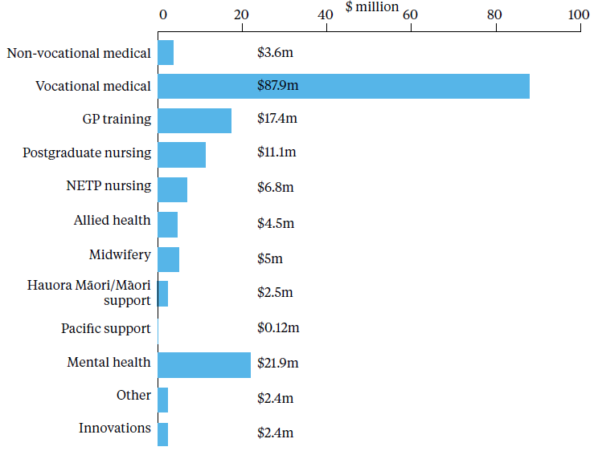

Non-vocational medical: this funding contributes towards DHBs’ delivery of PGY1 and PGY2 training programmes. This training is undertaken by graduates who have completed a six-year degree in medicine and are employed by a DHB.

HWNZ funding also covers the delivery of training programmes for doctors to obtain a Diploma in Paediatrics and a Diploma in Obstetrics and Gynaecology.

Vocational medical: the largest proportion of HWNZ funding is provided to the DHBs for vocational medical training programmes. The training is undertaken by registrars who have completed the PGY1 and PGY2 requirements and have enrolled in training programmes run by a medical college. Most vocational training programmes are funded by HWNZ and are typically delivered within the DHBs. HWNZ funding ranges from $42,518 to approximately $60,000 per FTE trainee a year.

GP training: HWNZ funds the GPEP programme, which is administered by the RNZCGP. Successful applicants to general practice vocational education programmes train under clinical supervision in accredited practices. These practices are located in urban and rural settings, to allow trainees to experience a variety of general practice environments before they qualify.

Postgraduate nursing: HWNZ funding for nursing programmes covers the postgraduate certificates and diplomas that qualify nurses for work in specialist areas, such as mental health. It is also available to applicants for a Master’s degree as a prerequisite for registration as a nurse practitioner.

Nurse Entry to Practice: the NCNZ approves and monitors NETP programmes under an agreement with HWNZ. NETP programmes are also delivered outside hospital settings in aged residential care facilities, primary health organisations and by Māori health providers.

Allied health: HWNZ funds training and education programmes for anaesthetic technicians, pharmacy internships, sonographers, radiation therapists, medical physicists, medical laboratory scientists, cervical cytologists and psychology internships.

Midwifery: HWNZ funding contributes towards the delivery of MFYP programmes, which provide a supportive, professional environment for midwifery graduates in their first year of practice. HWNZ also provides funding for postgraduate complex care training programmes, for midwives working in secondary and tertiary settings with women who have complex care needs.

HWNZ funding is provided to the Midwifery Rural Recruitment and Retention Service to support the recruitment of midwives to join or set up practices in rural areas experiencing a shortage of midwives (through grants for the establishment of lead maternity carer (LMC) practices).

Hauora Māori/Māori support: the Ministry of Health has put in place a number of initiatives to attract Māori into the workforce and to support ongoing Māori workforce development. The Māori Provider Development Scheme supports the development of the Māori health and disability provider sector to develop more effective health service provision.

HWNZ allocates funding for DHBs to provide mentoring, cultural supervision and cultural development activities to support Māori and Pacific trainees to complete vocational training programmes. The Hauora Māori training fund helps DHBs develop Māori staff in the non-regulated workforce. It provides access to training programmes to develop formal competencies for current roles and for career development opportunities.

Pacific support: HWNZ funds similar programmes to the Hauora Māori programmes to develop and extend the Pacific workforce. This includes, for example, the provision of scholarships for qualifications in psychology, psychotherapy, mental health nursing and counselling, which are covered by the Pacific Mental Health and Addictions Awards Scheme run by Le Va, a national provider for Pacific mental health and addiction workforce development.

Mental health: HWNZ allocates funding to support the development of the mental health and addictions workforce, including through post-entry clinical training for mental health nurses, as well as psychiatry and health psychology training. Workforce roles across the mental health continuum are represented in the programmes delivered, and postgraduate, undergraduate and support worker qualifications are included.

For example, HWNZ provides funding for Te Rau Matatini to deliver programmes for the Māori mental health and addictions workforce. This includes scholarships and bursaries, fostering Māori health leadership and professional development programmes, and supporting Māori nursing programmes.

Another example is Te Pou’s Skills Matter programmes for nurses and allied health professionals in the mental health and addiction sector, including social workers, occupational therapists, psychologists and addiction practitioners. Each year Te Pou funds more than 260 places across two broad themes identified in conjunction with HWNZ as having the highest need for workforce development.

Skills Matter supports new entrants into mental health and addiction to develop the specific skills required in this specialist field. The programmes are known as New Entry to Specialist Practice programmes. In addition, Te Pou supports existing practitioners to develop their advanced or specialist skills in cognitive behavioural therapy and clinical leadership in nursing practice programmes.

Allocation of the HWNZ funding pool
For transparency, accountability and contestability, HWNZ proposes to introduce a phased approach to the funding of educational and training providers, starting with the clinical vocational programmes provided by DHBs. Under this model, 70 percent of the total HWNZ funding pool for medical vocational training would be allocated to DHBs from the beginning of an academic year, for the delivery of programmes to specified types and numbers of medical vocational trainees.

A further 20 percent of the total funding pool would be allocated part way through the year, once it was clear that agreed targets had been satisfactorily met. The final 10 percent in the pool would be available for distribution to DHBs towards the end of the year for programmes and initiatives that were demonstrably aligned with HWNZ’s funding priorities.

The new funding model will be expanded to cover the other programmes for which HWNZ provides funding once it is embedded in clinical vocational training.

Appendices

Appendix 1: Summarised recommendations of Workforce Service Forecasts
To produce its Forecasts, HWNZ commissioned independent reports from small groups of clinicians. The Forecasts build pictures of the future health workforce in key areas such as aged care, diabetes and mental health.

This appendix summarises the 13 Forecasts published to date. The reports in full can be found at www.health.govt.nz. Reviews of the dermatology and plastic surgery workforces are due to be released later this year.

Aged care | February 2011
This report looked at factors that impact on the health of older people, the relationships between these factors and how to reduce an unsustainable increase in demand for aged residential care and hospital admissions among older people.

Recommendations included:
- strengthening preventive and rehabilitative care
- greater focus on clinicians working in community and primary care settings.

Anaesthesia | March 2011
This report looked at how to sustain the anaesthesia workforce in coming decades. It identified workforce shortages in some regions.

Recommendations included:
- anesthetists working across multiple worksites within a region
- improvements to theatre productivity
- making more training positions available in smaller hospitals.

Diabetes | May 2011
This report looked at how to respond to the rise in diabetes across all age groups. Appropriate expertise will be increasingly required to meet the complex demands of those with all types of diabetes.

Recommendations included:
- more mobile health care services
- care being provided remotely via electronic communications
- primary health services identifying and managing high-risk individuals
- specialist interdisciplinary teams focusing on patients with more complex needs.

Eye health | December 2010
This report looked at how eye health services could be integrated at the primary, secondary and tertiary level, with the consumer at the centre of the pathway.

Recommendations included:
- a community model of care
- more efficient use of the various eye health workforces.

Since this Forecast was completed, changes to the Medicines Act 1981 allow optometrists to be authorised prescribers. Optometrists are now able to diagnose and manage glaucoma in the community, and prescribe medication.

Gastroenterology | March 2011
This report looked at how people affected by gastroenterology health issues can be cared for by a well- prepared and responsive gastroenterology workforce.

Recommendations included:
- mobile clinics and teams for rural areas and smaller centres
- health professionals working across primary, secondary and tertiary settings
- expansion of the nurse specialist role, a role already in place in some DHBs.

Māori health | August 2013
This report, by Reanga Consultancy New Zealand Ltd, looked at how to deliver health equality for Māori and a workforce that demonstrates cultural competence, and ensure that clinical and cultural competencies are well integrated.

Recommendations included:
- fostering recognition that clinical and cultural competence are inseparable
- greater integration of Māori cultural competence, to enhance Māori engagement and access to health care
- the establishment of a Māori workforce development centre of excellence.

The recommendations in the report represent the views of the steering group and the wider Māori workforce sector. The report should be considered as part of a number of sector views and publications that propose delivering better health care and preparing a workforce that demonstrates cultural competence.

HWNZ and the Ministry of Health are working to enhance coordination of Māori workforce activities with a view to increasing the proportion of Māori and Pacific peoples in the health workforce.

Maternity | December 2012
This report looked at how the maternity sector should look in the future. The working group found that developments were needed in four key areas of maternity care:
- improving readiness for children
- proactive planning and action from confirmation of pregnancy
- safe, effective and seamless care through pregnancy, birth and infancy
- developing capable parents and safe environments for infant and child development.

This report has been received by HWNZ to generate discussion and debate around key issues in the future of reproductive health, women’s health, family planning and early childhood.

Mental health and addiction | June 2011
This report proposed a shift in focus towards primary and integrated care and preventive interventions, building on the ‘Better, Sooner, More Convenient’ primary health care policy.

Recommendations included:
- improving mental health and addiction support services so that they provide better access for those with unmet mental health needs, including the elderly and at-risk young people
- developing mental health care skills in primary care teams.

This report sits alongside a number of other initiatives across the Ministry and the mental health and addictions sector, as part of Rising to the Challenge.

HWNZ and the Ministry have established an action plan to implement recommendations from the Workforce Service Forecast and Rising to the Challenge.

Musculoskeletal | March 2011
This report looked at how to improve efficiency and effectiveness in musculoskeletal care.

Recommendations included:
- making managing musculoskeletal disorders a core competency for GPs and physiotherapists
- developing a workforce skilled in caring for older people
- placing more emphasis on rehabilitation and self-care.

See notes on the Rehabilitation Forecast for related recommendations.

Pacific health | January 2013
This report looked at ways to increase the number of Pacific peoples in the health workforce and improve outcomes for Pacific patients.

Recommendations included:
- implementing an improved model of care
- developing leadership and coordination to affect this new model
- addressing issues in the training and development of the Pacific workforce
- focusing on the Auckland region, home to seven in 10 of the Pacific population.

Some recommendations are being addressed through the Ministry of Health’s Pacific work programme. HWNZ and the Ministry have established a working group with key stakeholders to address several of the remaining recommendations.

Palliative care | February 2011
This report looked at the provision of palliative care in the community, hospitals, residential care and hospices.

Recommendations included:
- developing regional clinical networks that link locally, regionally and nationally to meet future palliative care needs
- aiming to give people requiring palliative care better health and disability services closer to home.

Rehabilitation | December 2011
This report looked at support systems for ill or injured patients on treatment pathways from acute care through to their return to their communities and homes after illness or injury.

Recommendations included:
- increasing provision of rehabilitation training
- improving care coordination once patients have been discharged from hospital. See notes on the Musculoskeletal Forecast for related recommendations.

Youth health | April 2011
This report looked at how to deliver health services that are youth-centred and mainly delivered in primary care settings.

Recommendations included:
- more workforce training in youth health
- better monitoring of young people’s needs
- more youth-centred services to increase access for vulnerable and at-risk young people.

Appendix 2: Voluntary Bonding Scheme maps
Figure 3: Medical hard-to-staff communities 2015
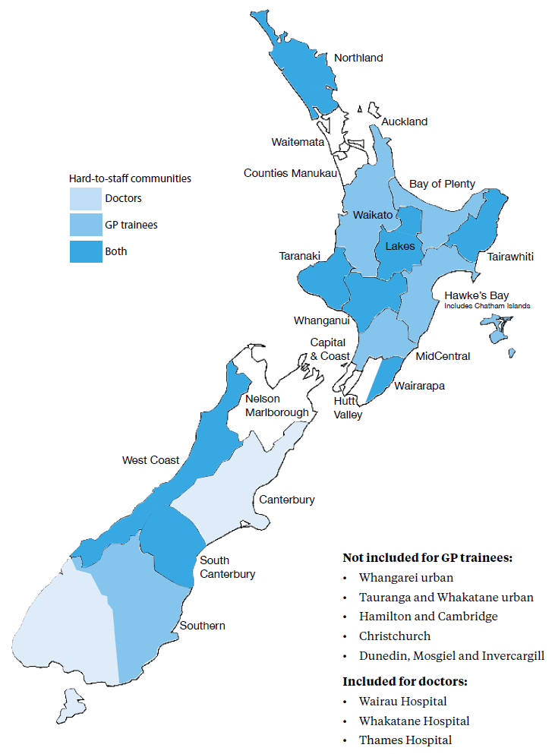

Figure 4 Nursing hard-to-staff communities 2015
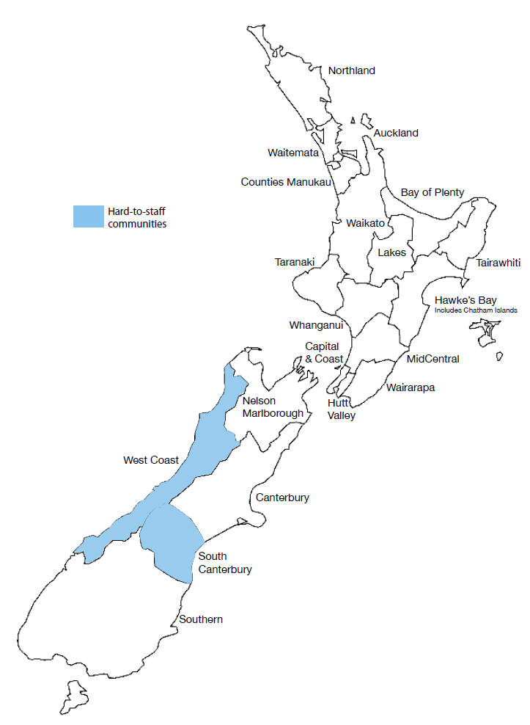

Figure 5: Midwifery hard-to-staff communities 2015
Included, but not marked on the map, are Ashburton, Darfield and the Hurunui region in the South Island and Taumarunui, Tokoroa, Huntly, Thames, Coromandel and the Taupō region in the North Island.

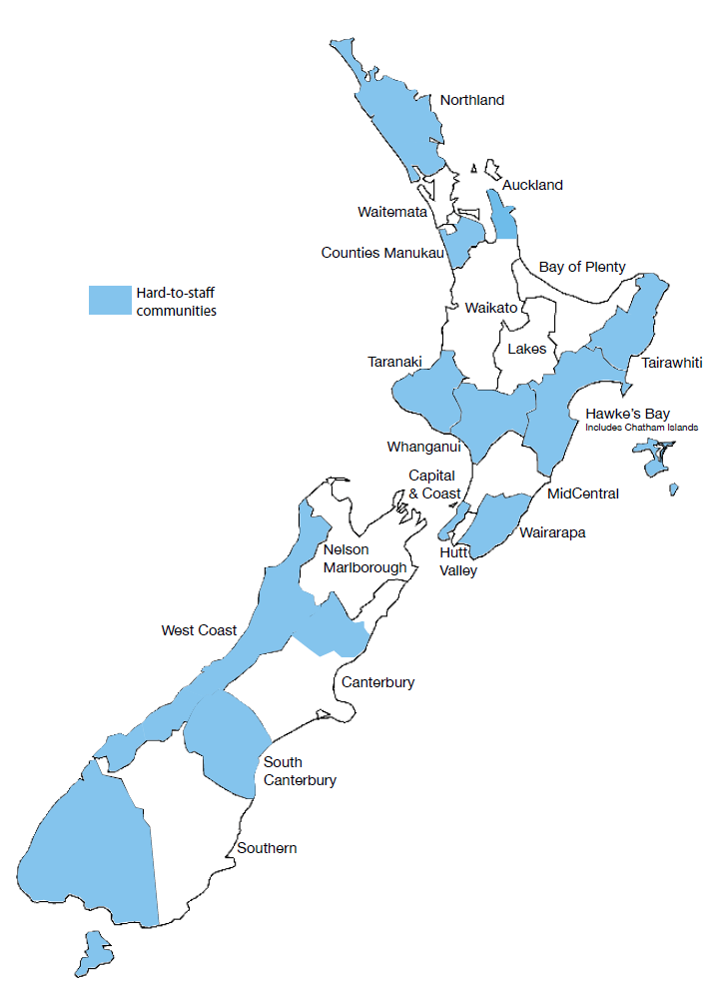

Statistics New Zealand. 2012. National Population Projections: 2011(base)–2061. Wellington: Statistics New Zealand.
OECD Health Data 2013.
Ministerial Review Group. 2009. Meeting the Challenge. Wellington: Ministerial Review Group.
Ibid, page 38.
More information on workforce demographics can be found in The Health of the Health Workforce 2013/14.
Ibid.
Ministry of Health. 2012. Rising to the Challenge: The Mental Health and Addiction Service Development Plan 2012–2017. Wellington: Ministry of Health.
Ministerial Task Group on Clinical Leadership. 2009. In Good Hands: Transforming clinical governance in New Zealand. Wellington: Ministry of Health.
BERL Economics. 2014. Health and Disability Kaiāwhina Worker Workforce 2013 Profile, for Careerforce. Wellington: Business and Economic Research Ltd.
Using the Australian and New Zealand Standard Classification of Occupations 2006.
BERL Economics. 2014. Health and Disability Kaiāwhina Worker Workforce 2013 Profile, for Careerforce. Wellington: Business and Economic Research Ltd.
Statistics New Zealand. 2007. Disability Survey 2006. Wellington: Statistics New Zealand.
‘Lippincott’ is a detailed procedural manual for nurses.
This does not include funding for the Voluntary Bonding Scheme ($6.1 million in the 2013–2014 financial year).
A government initiative to deliver a more personalised health care system that provides services closer to home.
Ministry of Health. 2012. Rising to the Challenge: The mental health and addiction service development plan 2012–2017. Wellington: Ministry of Health.

