Report on Maternity

2014

**Acknowledgements**

Many people have assisted in the production of this publication. In particular, the Ministry of Health thanks the peer reviewers from the New Zealand College of Midwives and the Royal Australian and New Zealand College of Obstetricians and Gynaecologists for their valuable contribution.

Citation: Ministry of Health. 2015. *Report on Maternity 2014*.  
Wellington: Ministry of Health.

Published in December 2015  
by the Ministry of Health  
PO Box 5013, Wellington 6145, New Zealand

ISBN 978-0-947491-40-6 (online)  
HP 6302

This document is available at health.govt.nz



 This work is licensed under the Creative Commons Attribution 4.0 International licence. In essence, you are free to: share ie, copy and redistribute the material in any medium or format; adapt ie, remix, transform and build upon the material. You must give appropriate credit, provide a link to the licence and indicate if changes were made.

Contents

Executive summary vii

Introduction 1

Purpose 1

Background 1

Data sources 1

Analytical methods 2

Data presentation 4

Additional information 5

Women giving birth 6

Age 6

Ethnicity 8

Deprivation 10

Geographic distribution 14

Parity 17

Body mass index 19

Smoking status 21

Primary maternity care 24

Labour and birth 31

Type of birth 31

Interventions 39

Plurality 46

Place of birth 47

Babies 53

Sex, maternal age, ethnicity and deprivation 53

Birthweight 54

Gestation 57

Breastfeeding 61

Handover of care 64

References 65

Glossary 66

Appendices 70

Appendix 1: Maternity model of care 70

Appendix 2: National Maternity Collection 72

Appendix 3: Technical notes 74

Appendix 4: Guide to reading maps 76

Appendix 5: Catchment areas 77

List of tables

Table 1: Comparing proportions and birth rates between Māori and the European or Other ethnic group 5

Table 2: Comparison of Lead Maternity Carer types between 2003 and 2014 29

Table 3: Number and percentage of women giving birth, by type of birth, 2014 32

Table 4: Number and percentage of women giving birth, by plurality and type of birth, 2014 46

Table 5: Number and percentage of women giving birth, by place of birth, 2014 47

Table 6: Number and percentage of women giving birth, by DHB of residence and place of birth, 2014 48

Table 7: Priority for reporting birth procedures 75

List of figures

Figure 1: Percentage of women giving birth, by age group (years), 2014 6

Figure 2: Birth rate, by age group, 2005–2014 7

Figure 3: Percentage of women giving birth, by ethnic group, 2014 8

Figure 4: Percentage of women giving birth, by age (in years), for each ethnic group, 2014 8

Figure 5: Birth rate, by ethnic group, 2005–2014 9

Figure 6: Percentage of women giving birth, by neighbourhood deprivation quintile, 2014 10

Figure 7: Distribution of women giving birth, by neighbourhood deprivation quintile for each age group, 2014 11

Figure 8: Distribution of women giving birth, by neighbourhood deprivation quintile for each ethnic group, 2014 12

Figure 9: Birth rate, by neighbourhood deprivation quintile, 2005–2014 13

Figure 10: Birth rates by DHB of residence, 2010 and 2014 14

Figure 11: Birth rates for the under 20 years and the 40 years and over age groups, by DHB of residence, 2014 15

Figure 12: Birth rates for Māori and non-Māori, by DHB of residence, 2014 16

Figure 13: Birth rates of women in the least deprived neighbourhoods (quintile 1) and in the most deprived neighbourhoods (quintile 5), by DHB of residence, 2014 16

Figure 14: Percentage of women giving birth, by number of previous births (parity), 2008–2014 17

Figure 15: Percentage of women giving birth for the first time, by age group, ethnic group and neighbourhood deprivation quintile, 2014 18

Figure 16: Percentage of women giving birth, by body mass index (BMI) category at first registration with their primary maternity care provider, 2008–2014 19

Figure 17: Percentage of women giving birth identified as obese at first registration with their primary maternity care provider, by age group, ethnic group and neighbourhood deprivation quintile, 2014 20

Figure 18: Percentage of women giving birth identified as smokers at first registration with their primary maternity care provider and at two weeks after birth, 2008–2014 21

Figure 19: Percentage of women giving birth identified as smokers at first registration with their primary maternity care provider, by age group, ethnic group and neighbourhood deprivation quintile, 2014 22

Figure 20: Percentage of women giving birth identified as smokers at two weeks after birth, by age group, ethnic group and neighbourhood deprivation quintile, 2014 22

Figure 21: Percentage of women smoking at first registration with their primary maternity care provider who were also smoking at two weeks after birth, by age group, ethnic group and neighbourhood deprivation quintile, 2014 23

Figure 22: Percentage of women giving birth, by primary maternity care provider, 2008–2014 24

Figure 23: Percentage of women giving birth who registered with a Lead Maternity Carer by age group, ethnic group and neighbourhood deprivation quintile, 2014 26

Figure 24: Percentage of women registered with a Lead Maternity Carer, by DHB of residence, 2010 and 2014 26

Figure 25: Percentage of women registered with a Lead Maternity Carer by trimester of first registration, 2008–2014 27

Figure 26: Percentage of women giving birth who registered with a Lead Maternity Carer prior to birth, by trimester of registration, age group, ethnic group and neighbourhood deprivation quintile, 2014 28

Figure 27: Percentage of women giving birth who registered with a Lead Maternity Carer within the first trimester of pregnancy, by DHB of residence, 2010 and 2014 28

Figure 28: Percentage of women registered with a Lead Maternity Carer (LMC), by type of LMC, 2008–2014 29

Figure 29: Percentage of women giving birth who were registered with a DHB primary maternity service, 2014 30

Figure 30: Percentage of women giving birth, by type of birth (aggregated), 2005–2014 32

Figure 31: Comparison of caesarean section rates (per 100 live births) in 2000, 2005 and 2011 (or nearest year) for OECD countries 33

Figure 32: Percentage of vaginal breech births, 2005–2014 34

Figure 33: Distribution of breech birth types, 2005–2014 35

Figure 34: Percentage of emergency and elective caesarean sections, 2005–2014 35

Figure 35: Percentage of caesarean sections, by type, age group, ethnic group and neighbourhood deprivation quintile, 2014 36

Figure 36: Percentage of emergency caesarean sections, by DHB of residence, 2010 and 2014 37

Figure 37: Percentage of elective caesarean sections, by DHB of residence, 2010 and 2014 38

Figure 38: Percentage of women having a normal birth and having an induction, augmentation, epidural or episiotomy during labour and birth, 2005–2014 40

Figure 39: Percentage of women having a normal birth, by age group, ethnic group and neighbourhood deprivation quintile, 2014 41

Figure 40: Percentage of women having an induction of labour, by age group, ethnic group and neighbourhood deprivation quintile, 2014 42

Figure 41: Percentage of women undergoing augmentation of labour, by age group, ethnic group and neighbourhood deprivation quintile, 2014 43

Figure 42: Percentage of women having an epidural, by age group, ethnic group and neighbourhood deprivation quintile, 2014 44

Figure 43: Percentage of women having an episiotomy, by age group, ethnic group and neighbourhood deprivation quintile, 2014 45

Figure 44: Percentage of women giving birth, by place of birth, 2005–2014 47

Figure 45: Distribution of women giving birth at a maternity facility, by type of facility, age group, ethnic group and neighbourhood deprivation quintile, 2014 50

Figure 46: Distribution of women giving birth at a maternity facility, by type of facility and DHB of residence, 2014 51

Figure 47: Percentage of women giving birth at home, by age group, ethnic group and neighbourhood deprivation quintile, 2014 52

Figure 48: Percentage of women giving birth at home, by DHB of residence, 2010 and 2014 52

Figure 49: Percentage of babies, by sex, maternal age group, baby ethnic group and baby neighbourhood deprivation quintile, 2014 53

Figure 50: Average birthweight, by maternal age group, baby ethnic group and baby neighbourhood deprivation quintile, 2014 55

Figure 51: Percentage of babies born with a low birthweight, by maternal age group, baby ethnic group and baby neighbourhood deprivation quintile, 2014 56

Figure 52: Percentage of babies born with a low birthweight, by DHB of residence, 2010 and 2014 56

Figure 53: Percentage of babies, by gestation in weeks, 2005–2014 57

Figure 54: Percentage of babies born preterm, by maternal age group, baby ethnic group and baby neighbourhood deprivation quintile, 2014 58

Figure 55: Percentage of babies born preterm, by DHB of residence, 2010 and 2014 59

Figure 56: Percentage of babies born at term with a low birthweight, by maternal age group, baby ethnic group and baby neighbourhood deprivation quintile, 2014 60

Figure 57: Percentage of babies born at term with a low birthweight, by DHB of residence, 2010 and 2014 60

Figure 58: Percentage of babies, by breastfeeding status at two weeks after birth, 2008–2014 61

Figure 59: Percentage of breastfed babies at two weeks after birth, by maternal age group, baby ethnic group and baby neighbourhood deprivation quintile, 2014 62

Figure 60: Percentage of babies exclusively or fully breastfed at two weeks after birth, by DHB of residence, 2010 and 2014 63

Figure 61: Percentage of women referred to their general practitioner and babies to a Well Child/Tamariki Ora provider, 2008–2014 64

Figure 62: Number of women giving birth in 2014 recorded in the National Maternity Collection by data source and place of birth 72

Figure 63: Maternity facilities in New Zealand, by DHB region and facility type 79

# Executive summary

The *Report on Maternity* series provides annual health statistics about women giving birth, their pregnancy and childbirth experience, and the characteristics of live-born babies in New Zealand. This publication is focused on women who gave birth, and the babies who were born, in 2014. A summary of the key findings is provided below.

### Lowest birth rate in a decade

In 2014, 59,193 women were recorded as giving birth. This equates to a birth rate (number of births as a proportion of females aged 15–44 years in the population) of 65.0 per 1000 females of reproductive age: the lowest since 2005.

### Decrease in birth rates for young women and increase in birth rates for older women

Between 2005 and 2014, the birth rate for women aged under 20 years fell by almost one-third – a statistically significant decrease. Conversely, birth rates for women in their 30s and 40s showed a significant increase from 2005 to 2014, particularly for women aged 40 years and over whose birth rate increased by 17%.

### Women giving birth were predominantly European, aged 25–34 years, residing in more deprived neighbourhoods, and had had at least one previous birth

Of the women giving birth in 2014:

* more than half were between the ages of 25 and 34 years
* almost half were European and almost one-quarter were Māori
* the median age at birth for Māori and Pacific women was 26 years and 28 years, respectively, while the median age for Asian (excluding Indian) and European women was 31 years
* almost 30% resided in the most deprived neighbourhoods
* 60% had previously given birth.

### Most women received primary maternity care from a midwife Lead Maternity Carer

The vast majority of women giving birth were registered with and received care from a Lead Maternity Carer (LMC) during their pregnancy and postnatal period. A midwife was the most common LMC type.

Two-thirds of women who registered with an LMC did so within their first trimester of pregnancy in 2014: a statistically significant increase from 2008, when only half of women registered within the first trimester.

### Most women gave birth at a secondary or tertiary maternity facility

The vast majority of women gave birth at a maternity facility. Approximately 87% gave birth at a secondary or tertiary facility, and 9% at a primary maternity facility.

### Home births were more common among women in their 40s, Māori women, and European women

Approximately 3% of women giving birth in 2014 had a planned home birth. The proportion of home births has remained stable over the last decade. Home births were more common among:

* women aged 40 years and over
* Māori and European women
* women residing in the Northland DHB region.

### Elective caesarean section rates have increased

In 2014, almost two-thirds of women had a spontaneous vaginal birth, one-quarter had a caesarean section and the remaining women had an assisted vaginal birth.

Between 2005 and 2014 there was a significant increase in the proportion of elective caesarean sections and a significant decrease in spontaneous vaginal births. The proportion of women having an emergency caesarean section or assisted birth showed less variation over the same time period.

Caesarean sections were more common among:

* women aged 35 years or more
* Indian and other Asian women, and European women
* women in the least deprived neighbourhoods.

### One in every three women had a normal birth

One is every three women giving birth in 2014 had a normal birth; that is, a spontaneous vaginal birth without an induction, augmentation, epidural or episiotomy.

One in every two women giving birth in 2014 had at least one form of obstetric intervention during labour and birth: 24% had an induction, 26% had their labour augmented, 27% had an epidural and 15% had an episiotomy.

### More babies were male than female

There were 59,494 live-born babies recorded in 2014, 52% of whom were male.

### Little change in average birthweight

The average birthweight of babies born in 2014 was similar to that of babies born in previous years, at 3.42 kg. Asian babies (particularly Indian) and female babies had a lower average birthweight. Almost 6% of babies were born with a low birthweight.

### Median gestation at birth was 39 weeks

The vast majority of babies were born at term in 2014, while 7% were born preterm.

The median gestation at birth each year between 2008 and 2014 was 39 weeks, a decrease from the median gestation of 40 weeks between 2005 and 2007.

Of the babies born at term, 1.9% had a low birthweight. The Indian ethnic group with the highest percentage of babies with a low birthweight Indian.

### Most babies were exclusively or fully breastfed

Almost 80% of babies born in 2014 were exclusively or fully breastfed at two weeks after birth. Exclusive or full breastfeeding was most common among babies:

* born to women aged 30–39 years
* in the European or Other ethnic group
* residing in the least deprived neighbourhoods
* in the West Coast DHB region.

# Introduction

This chapter provides the purpose and background of the report, as well as information on the source of the data provided, how the data is presented and the analytical methods used. It provides contact details if you require additional information.

## Purpose

This publication presents data from the National Maternity Collection, and is the latest release in the *Report on Maternity* series. It provides annual health statistics about women giving birth, their pregnancy and childbirth experience and the characteristics of live-born babies in New Zealand.[1]

## Background

In New Zealand, maternity services are classified according to the level of complexity of clinical care a woman and her baby requires – either primary, secondary or tertiary. A range of practitioners contribute to the provision of antenatal care (midwives, general practitioners (GPs), obstetricians, radiologists and childbirth educators), in a range of settings (the woman’s home, consulting rooms, primary birthing units and hospitals). A summary of these services is described in ‘’.

Maternity services are a crucial part of public health services. The World Health Organization (WHO) states that ‘care for pregnant women is often the entry point for health services for the family and community’ (WHO 2005). Monitoring maternal and newborn health is therefore an integral part of monitoring the health of the overall population.

## Data sources

Data for this publication was extracted from maternity events recorded in the Ministry of Health’s National Maternity Collection on 11 August 2015. The National Maternity Collection collates data from three different sources to provide statistical, demographic and clinical information about women giving birth and live-born babies in New Zealand.

Some variables presented in this publication primarily depend on Lead Maternity Carer (LMC) claim forms as a data source. These variables are parity, body mass index (BMI), smoking status, breastfeeding status and referrals to a GP and Well Child/Tamariki Ora provider. Following recent upgrades to the National Maternity Collection, some DHBs are now reporting data from their primary maternity services for these variables. In 2014, Waitemata, Auckland, Counties Manukau, Hawke’s Bay and Hutt Valley DHBs reported data from their primary maternity services to the National Maternity Collection.

‘’ presents further information about the collection and sources of data for women giving birth in 2014.

Maternal and newborn records are coded and extracted separately, so the information collected in these two sources (eg, maternal age) may differ. Some disparities may be due to incomplete maternal or newborn information submitted to the Ministry of Health by district health boards (DHBs) and other maternity providers.

Population data used to calculate birth rates in this publication was derived from multiple data sets provided by Statistics New Zealand. The list of data sets is available in ‘’.

## Analytical methods

The data presented in this publication primarily pertains to all women recorded as giving birth and to live-born babies in 2014, as sourced from the National Maternity Collection. Data prior to 2014 has also been analysed using the same methods and criteria to provide a consistent view over time.

### Ethnicity

Each individual represented in the data is allocated to a single ethnic group (if multiple ethnicities were recorded) using a priority system of Māori > Pacific > Indian > Asian (excluding Indian) > Other ethnicities> European (Ministry of Health 2004).

In this publication, individuals are commonly presented as the following ethnic groups: Māori, Pacific, Indian, Asian (excl. Indian) and European or Other. See the ‘Ethnicity’ section in ‘’.

### Counting births and babies

In the ‘Women giving birth’ and ‘Labour and birth’ chapters, births are counted using the number of women giving birth during the calendar year (ie, between 1 January and 31 December). These births include women who had either live-born babies (born at any gestation) or stillborn babies (born at ≥ 20 weeks’ gestation or with a birthweight of ≥ 400 g). A woman who had twins or a multiple birth is counted as having had one birth. A woman who gave birth twice within the same calendar year is counted as having had two births.

In the ‘Babies’ chapter, the numbers presented only include live-born babies (at any gestation). Babies resulting from a twin or a multiple pregnancy are counted as individual babies.

### Proportions

Proportions are expressed as a percentage. The denominator for proportion calculations is the total for each variable for which the information was recorded, and excludes ‘Unknown’ categories. For example:

Proportion of male babies = (number of male babies * 100) / (total number of babies - babies of unknown sex)

All proportions were calculated using raw data. Summarised information presented may be slightly different from the sum of proportions presented in the tables due to rounding.

### Birth rates

A birth rate shows the proportion of women giving birth out of the female population who are of reproductive age (15–44 years). It is expressed as births per 1000 females of reproductive age.

Rates for a specific group (eg, Māori, those residing in quintile 3 or the 30–34 years age group) are calculated using the best available population for that group. For example:

Maori birth rate = number of Maori women giving birth * 1000 / female Maori population aged 15-44 years

Teens aged under 15 years and women aged 45 years and over giving birth account for a very small proportion of the total number of women giving birth each year (<0.5%). They are included in the numerator to calculate birth rates (as part of the <20 years and 40+ years age groups, respectively). The denominator used is limited to the female population aged 15–44 years.

More than one population data set may have been used within a set of birth rate calculations. Further information about the different population data sets used in this publication is provided in the ‘Denominators used for calculating birth rates’ section of ‘’.

Regional rates (DHB regions) were calculated based on the residence of women giving birth. Rates have not been standardised for differences in population structures (ie, birth rates are crude and not age-standardised).

### Statistical significance testing

Statistical significance was calculated using Pearson’s chi-squared test at 95% confidence level. Fisher’s exact test at 95% confidence level was also used when expected frequencies were below five.

Significance testing has only been applied to selected analyses in this publication. Therefore, differences observed are not necessarily statistically significant, except where stated as so.

## Data presentation

This publication first presents information about women giving birth, their demographic profile and selected antenatal factors. This is followed by information relating to labour and birth, covering the type of birth, interventions and place of birth. Finally, the publication provides a description of the characteristics of live-born babies, along with data on handover of care after birth for the woman and her baby.

### Figures

Graphs and maps are included to help you to visualise the quantitative information more easily. They are intended to highlight trends and relationships rather than provide a means to look up individual values. The underlying numbers used to create graphs and maps in this publication are provided in the [accompanying online tables](http://www.health.govt.nz/publication/report-maternity-2014).

Geographical information is usually presented in maps with DHB boundaries showing. On these maps, the darkest colour represents the highest percentage or rate, and the lightest colour the lowest percentage or rate. See ‘’ for the location of DHBs in New Zealand and help with reading maps in this publication.

### Time series

Although the focus of this publication is on births in the 2014 calendar year, comparisons are often made over the 10‑year period of 2005–2014 and five-year period of 2010–2014, to provide context and to help with interpreting the information provided. Variables using data sourced from LMC claims and DHB primary maternity services are only available from 2008 onwards. Over time, a 10-year series will become available for these variables.

### Proportions vs birth rates

In this publication, proportions (expressed as a percentage) are used to describe and compare the characteristics of women giving birth or of live-born babies. Proportions have been calculated using the number of women giving birth or of live-born babies as the denominator.

In addition, birth rates are also presented for women giving birth in each main demographic group (ie, age group, ethnic group and neighbourhood deprivation quintile). They have been calculated using the female population of reproductive age as the denominator.

Birth rates can provide helpful context, as they account for the size of the population in relation to the number of women giving birth for that demographic group. Table 1 shows how the proportion and birth rate for Māori women compare with that for the European or Other ethnic group, where:

* 24% of women who gave birth were Māori while 50% were of European or Other ethnicities
* the birth rate for Māori women was 1.7 times the rate for women in the European or Other ethnic group.

Table : Comparing proportions and birth rates between Māori and the European or Other ethnic group

|  | **Māori** | **European or Other** |
| --- | --- | --- |
| **Proportion (%)** | | |
| Formula | Women giving birth in the Māori ethnic group / All women giving birth with known ethnicity * 100 | Women giving birth in the European or Other ethnic group / All women giving birth with known ethnicity * 100 |
| Calculation | (14,318 / 59,154) * 100 | (29,412 / 59,194) * 100 |
| Value | 24.2% | 49.7% |
| Interpretation | For every 100 women giving birth, 24 were Māori | For every 100 women giving birth, 50 were of European or Other ethnicities |
| **Birth rate (births per 1000 females of reproductive age)** | | |
| Formula | Women giving birth in the Māori ethnic group / Female population aged 15–44 years in the Māori ethnic group * 1000 | Women giving birth in the European or Other ethnic group / Female population aged 15–44 years in the European or Other ethnic group * 1000 |
| Calculation | (14,318 / 155,450) * 1000 | (29,412 / 541,840) * 1000 |
| Value | 92.1 per 1000 females of reproductive age | 54.3 per 1000 females of reproductive age |
| Interpretation | For every 1000 females aged 15–44 years of Māori ethnicity, 92 gave birth | For every 1000 females aged 15–44 years of European or Other ethnicities, 54 gave birth |

### Commonly used terms

Definitions for key terms are usually provided at the start of the relevant section. The Glossary provides a list of common terms and their descriptions or definitions.

## Additional information

A set of online tables was produced to accompany this publication, and is available from the [Ministry of Health’s website](http://www.health.govt.nz/publication/report-maternity-2014) www.[health.govt.nz](http://www.health.govt.nz) These tables include the underlying data for all graphs and maps presented in this publication.

If you require information not included in this publication or in the accompanying online tables, the Ministry of Health is able to produce customised data extracts tailored to your needs. These may incur a charge (at Official Information Act rates). The contact details are as follows:

Postal address: Analytical Services

Ministry of Health

PO Box 5013

Wellington 6145

New Zealand

Email: [data-enquiries@moh.govt.nz](mailto:data-enquiries@moh.govt.nz?subject=Report%20on%20Maternity,%202014)

Phone: (04) 496 2000

# Women giving birth

This chapter aims to describe the demographic profile of the women giving birth and selected antenatal factors. It contains these sections: Age; Ethnicity; Deprivation; Geographic distribution; Parity; Body mass index; Smoking status; and Primary maternity care.

There were 59,193 women recorded as giving birth in New Zealand during 2014 (including 46 women who gave birth twice during this time). Approximately 1 in every 15 females in the population aged 15–44 years gave birth in 2014. This is represented as a birth rate of 65.0 births per 1000 females of reproductive age. The 2014 rate was similar to the 2013 rate (65.6 per 1000 females of reproductive age). Birth rates fluctuated between 64.8 and 71.1 births per 1000 females of reproductive age from 2005 to 2014.

## Age

The median age of women giving birth in 2014 was 30 years;[2] more than half of the women giving birth in 2014 were either in the 25–29 years or the 30–34 years age groups (26.7% and 29.9%, respectively). There were 3020 women aged 20 years and under and 2516 women aged 40 years and over who gave birth. Approximately 10% of all women giving birth were in these two age groups (Figure 1).

Figure : Percentage of women giving birth, by age group (years), 2014

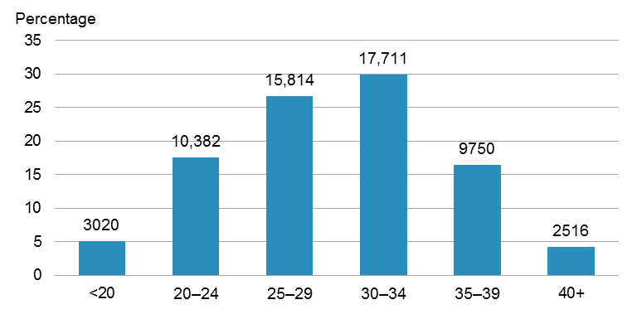

Note: The number on each bar is the number of women giving birth in that age group.

The highest birth rate in 2014 was for the 30–34 years age group, in which there were 122.8 births per 1000 females of reproductive age, followed by the 25–29 years age group (106.9 per 1000 females of reproductive age). Rates were lowest for the 40 years and over and under 20 years age groups (15.3 and 19.9 per 1000 females of reproductive age, respectively).

The birth rate for younger women (<20 years and 20–24 years age groups) in 2014 was statistically significantly lower than it was in 2005. In particular, the birth rate for women aged under 20 years fell by almost one-third between 2005 and 2014 (from 28.7 to 19.9 per 1000 females of reproductive age). Birth rates for women in their 30s and 40s showed a significant increase from 2005 to 2014. Notably, the birth rate for women aged 40 years and over increased by 17% over this period, from 13.0 to 15.3 per 1000 females of reproductive age (Figure 2).

Figure : Birth rate, by age group, 2005–2014

Figure 2: Birth rate, by age group, 2005–2014

Note: Birth rate is expressed as births per 1000 females of reproductive age (15–44 years).

## Ethnicity

European women formed the largest proportion of women giving birth in 2014 (47.6%), followed by Māori (24.2%), Asian (excl. Indian) (11.0%), Pacific (10.4%), Indian (4.6%) and other ethnicities, such as Middle Eastern, Latin American or African (2.1%) (Figure 3).

Figure : Percentage of women giving birth, by ethnic group, 2014

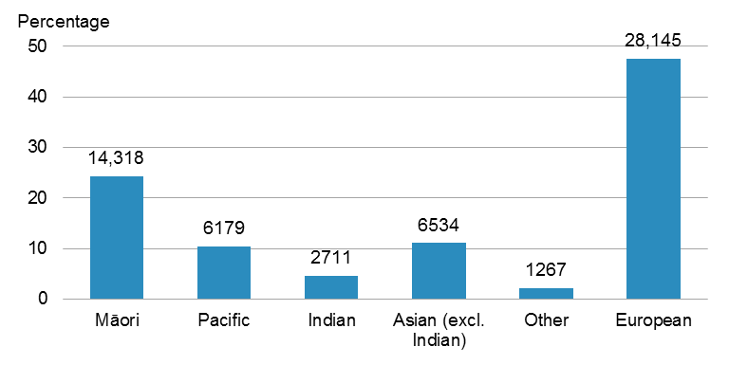

Notes:

The number on the bar is the number of women giving birth in that ethnic group.

The denominator used to calculate percentages excludes those with unknown ethnicity (39 women).

Women in the Asian (excl. Indian) and European or Other ethnic groups had a median age of 31 years at birth in 2014. Māori, Pacific and Indian women generally gave birth at a younger age, with median ages at birth of 26 years, 28 years and 29 years, respectively (Figure 4).

Figure : Percentage of women giving birth, by age (in years), for each ethnic group, 2014

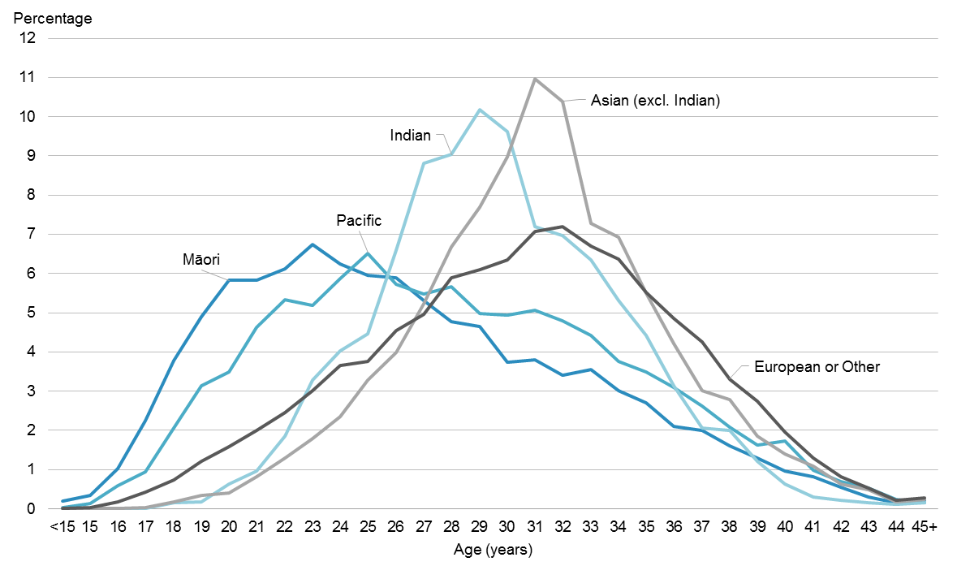

Note: The denominator used to calculate percentages is the total number of women giving birth for each ethnic group.

In 2014, birth rates[3] were highest for the Māori and Pacific ethnic groups (92.1 and 92.0 births per 1000 females of reproductive age, respectively), followed by Asian women (61.9 per 1000 females of reproductive age) and women in the European or Other ethnic group (54.3 per 1000 females of reproductive age).

Birth rates for Māori and Pacific women showed a statistically significant decrease from 2005 to 2014, falling by 8% and 19%, respectively. In contrast, the Asian birth rate increased significantly over this time, from 45.0 to 61.9 per 1000 females of reproductive age. The European or Other ethnic group had birth rates that fluctuated between 54.3 and 59.4 per 1000 females of reproductive age over the same time period. Since 2012, birth rates for Asian women have been higher than for women of European or other ethnicities (Figure 5).

Figure : Birth rate, by ethnic group, 2005–2014

Figure 5: Birth rate, by ethnic group, 2005–2014

Note: Birth rate is expressed as births per 1000 females of reproductive age (15–44 years).

## Deprivation

Deprivation quintiles are based on the characteristics of the neighbourhood in which a woman or baby resides. They range from 1 (least deprived) to 5 (most deprived), and are derived from:

* the 2006 NZDep for women giving birth before 2010
* the 2013 NZDep for women giving birth from 2010 onwards.

Approximately equal numbers of the total New Zealand population reside in areas associated with each of the five deprivation quintile areas.

See the ‘Deprivation’ section in ‘’ for more information.

Half of women giving birth in 2014 were in the more deprived neighbourhoods: 29.3% resided in quintile 5 and 22.7% resided in quintile 4. Less than 15% of women giving birth in 2014 resided in the least deprived neighbourhoods (quintile 1).[4] Figure 6 shows the distribution of women giving birth, by neighbourhood deprivation.

Figure : Percentage of women giving birth, by neighbourhood deprivation quintile, 2014

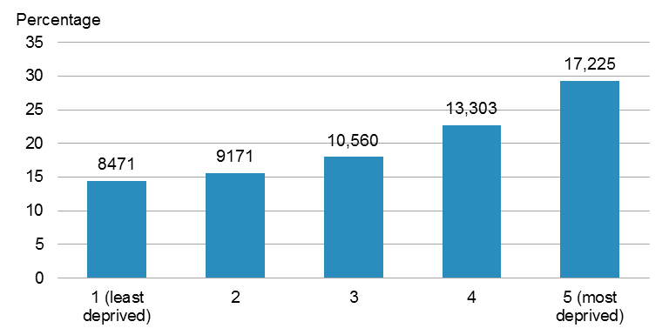

Notes:

The number on the bar is the number of women giving birth residing in that deprivation quintile.

The denominator used to calculate the percentage is the total number of women giving birth, excluding those with unknown deprivation quintile (463 women).

Women in the least deprived neighbourhoods were generally older at the time they gave birth than women in the most deprived neighbourhoods (a median age of 32 years for women in quintile 1 compared with 27 years for women in quintile 5).

Women giving birth in their 30s or 40s were equally distributed across all neighbourhood deprivation quintiles (which reflects the overall New Zealand population). In contrast, younger women (those aged under 30 years) giving birth were more likely to reside in more deprived neighbourhoods than in less deprived neighbourhoods (Figure 7). This trend was particularly evident in women aged under 20 years (52.0% of women in quintile 5 compared with 4.6% of women in quintile 1) and women aged 20–24 years (44.5% of women in quintile 5 compared with 6.3% of women in quintile 1).

Figure : Distribution of women giving birth, by neighbourhood deprivation quintile for each age group, 2014

Figure 7: Distribution of women giving birth, by neighbourhood deprivation quintile for each age group, 2014

Note: The denominator used to calculate the percentage is the number of women giving birth for that age group, excluding those with unknown deprivation quintile.

Women in the Asian (excl. Indian) and European or Other ethnic groups were equally distributed across all neighbourhood deprivation quintiles (which reflects the overall New Zealand population).

Māori, Pacific and Indian women giving birth were more likely to reside in more deprived neighbourhoods than in less deprived neighbourhoods (Figure 8). This trend was more evident for Māori and Pacific women (51.1% of Māori and 61.1% of Pacific women resided in quintile 5, whereas 5.0% and 3.5%, respectively, resided in quintile 1). The distribution of Indian women giving birth showed similar trends as that for Māori and Pacific women, but to a lesser extent (29.6% of Indian women resided in quintile 5, and 9.2% in quintile 1).

Figure : Distribution of women giving birth, by neighbourhood deprivation quintile for each ethnic group, 2014

Figure 8: Distribution of women giving birth, by neighbourhood deprivation quintile for each ethnic group, 2014

Note: The denominator used to calculate the percentage is the number of women giving birth for that ethnic group, excluding those with unknown deprivation quintile.

Birth rates were more variable for women residing in more deprived neighbourhoods then for women in less deprived neighbourhoods from 2005 to 2014. Birth rates for women in quintiles 4 and 5 increased slightly from 2005 to 2008, and then decreased from 2010 to 2014. Birth rates for each of the five neighbourhood deprivation quintiles showed a statistically significant decrease between 2010 and 2014 (Figure 9).

Over the 10-year period, birth rates were consistently higher for women in more deprived neighbourhoods than for women in less deprived neighbourhoods. The birth rate for those in quintile 5 was 1.8–2.0 times the rate for those in quintile 1 (Figure 9).

Figure : Birth rate, by neighbourhood deprivation quintile, 2005–2014

Figure 9: Birth rate, by neighbourhood deprivation quintile, 2005–2014

Note: Birth rate is expressed as births per 1000 females of reproductive age (15–44 years).

## Geographic distribution

The geographic distribution of women giving birth is based on DHB region of the woman’s residence. Rates and numbers in this section are intended to reflect the usually resident population of the DHB and not necessarily the facilities run by that DHB. See ‘Appendix 4: Guide to reading maps’ for the location of DHBs in New Zealand and further information on each component of the maps presented in this section.

Birth rates in 2014 varied across the different DHB regions of residence. The highest birth rates were for women residing in Tairāwhiti, Whanganui and Northland DHB regions (78.5, 77.9 and 77.0 per 1000 females of reproductive age, respectively). The lowest rates were for women residing in Capital & Coast, Southern and Auckland DHB regions (51.3, 52.7 and 54.5 per 1000 females of reproductive age, respectively) (Figure 10).

All DHB regions had lower birth rates in 2014 than in 2010 (Figure 10). The largest decrease was in Nelson Marlborough DHB region (from 69.3 to 59.9 per 1000 females of reproductive age). The decrease in birth rates was statistically significant in all DHB regions except Tairāwhiti, Taranaki, Whanganui, West Coast and South Canterbury.

Figure : Birth rates by DHB of residence, 2010 and 2014

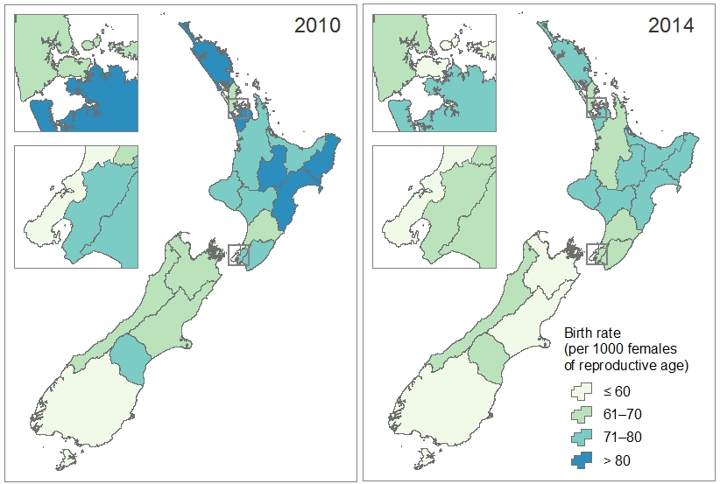

Note: Reproductive age is defined as 15–44 years.

Most DHB regions had a higher birth rate for teens (<20 years) than for women in their 40s (Figure 11). Birth rates for teens were higher for those residing in the North Island, particularly in the Tairāwhiti DHB region (45.5 per 1000 females of reproductive age). Birth rates for women aged 40 years and over were generally lower, ranging from 6.5 per 1000 females of reproductive age (South Canterbury DHB) to 19.4 per 1000 females of reproductive age (Auckland DHB).

Figure : Birth rates for the under 20 years and the 40 years and over age groups, by DHB of residence, 2014

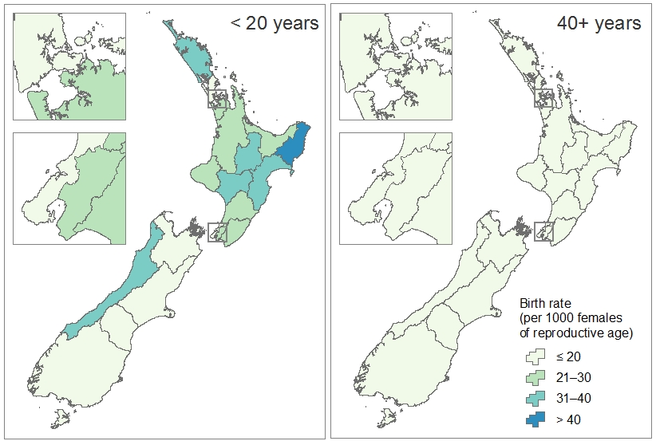

Note: Reproductive age is defined as 15–44 years.

Māori birth rates were statistically significantly higher than non-Māori birth rates for all DHB regions in 2014 (Figure 12). The Māori birth rate for each DHB region was 1.2–2.0 times the rate for non-Māori. Whanganui DHB region had the highest birth rate for Māori (109.3 per 1000 females of reproductive age). The Capital & Coast DHB region had the lowest birth rate for Māori (61.7 per 1000 females of reproductive age). Birth rates for non-Māori women ranged from 49.4 to 69.4 per 1000 females of reproductive age.

In 2014, birth rates by neighbourhood deprivation varied throughout the country (Figure 13). Birth rates for women residing in the most deprived neighbourhoods (quintile 5) were statistically significantly higher than those for women in the least deprived neighbourhoods (quintile 1) in all DHB regions in the North Island, except Capital & Coast, Hutt Valley and Wairarapa. In the Northland and Whanganui DHB regions, the birth rate for women in quintile 5 was 10.9 and 8.0 times, respectively, the birth rate for women in quintile 1. The difference in birth rates for women in the most and least deprived neighbourhoods was not statistically significant in the South Island.

Figure : Birth rates for Māori and non-Māori, by DHB of residence, 2014

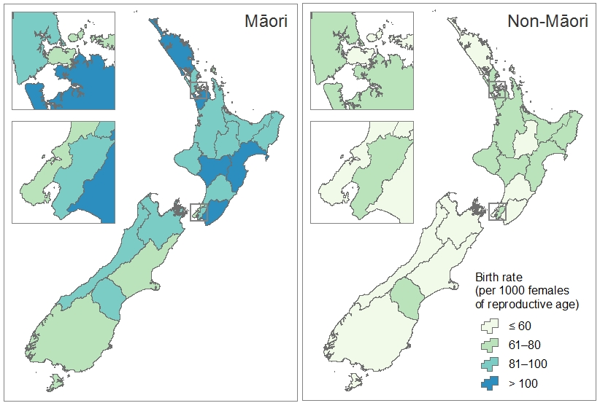

Note: Reproductive age is defined as 15–44 years.

Figure : Birth rates of women in the least deprived neighbourhoods (quintile 1) and in the most deprived neighbourhoods (quintile 5), by DHB of residence, 2014

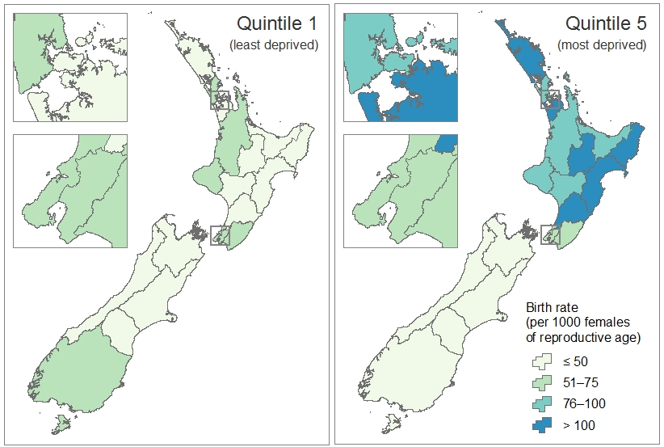

Note: Reproductive age is defined as 15–44 years.

## Parity

Parity refers to the number of times a woman has previously given birth, including stillbirths. Parity data is primarily sourced from LMC claim forms, with additional data from some DHB primary maternity services. It is therefore only available for women registered with an LMC or DHB primary maternity services (approximately 95% of women giving birth).

Almost 40% (22,050) of women who gave birth in 2014 did so for the first time. A further 34.3% had given birth once, 14.9% had given birth twice, and 10.9% had given birth at least three times previously.[5] This distribution remained fairly consistent between 2008 and 2014 (Figure 14).

Figure : Percentage of women giving birth, by number of previous births (parity),  
2008–2014

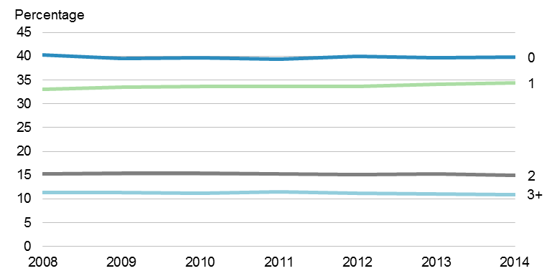

Notes:

The denominator used to calculate percentages is the number of women giving birth, excluding those with unknown parity.

Parity data is only available for women registered with an LMC or a DHB primary maternity service.

Figure 15 presents the proportion of women giving birth for the first time in 2014 for each age group, ethnic group and deprivation quintile.

The vast majority of young women giving birth did so for the first time (81.8% of women aged under 20 years).

A larger proportion of women giving birth in the Indian, Asian (excl. Indian) and European or Other ethnic groups did so for the first time (55.9% of Indian women, 48.5% of Asian (excl. Indian) women and 41.7% of European or Other women) compared with Pacific (29.3%) and Māori (33.0%) women.

The proportion of women giving birth for the first time was slightly higher among women living in less deprived neighbourhoods compared to those living in more deprived neighbourhoods (43.2% of women in quintile 1 compared to 34.7% of women in quintile 5).

Figure : Percentage of women giving birth for the first time, by age group, ethnic group and neighbourhood deprivation quintile, 2014

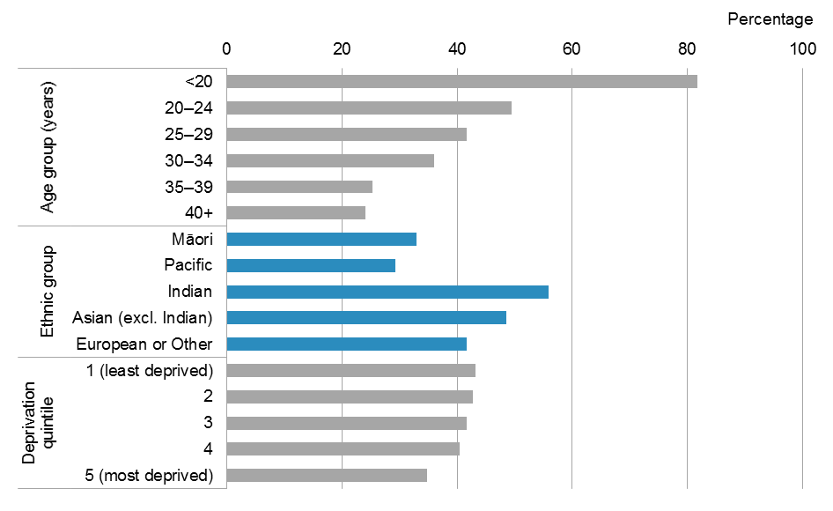

Notes:

The denominator used to calculate percentages is the number of women giving birth for that demographic, excluding those with unknown parity.

Parity data is only available for women registered with an LMC or a DHB primary maternity service.

Capital & Coast and Auckland DHB regions had a larger proportion of women giving birth for the first time, at 45.9% and 44.3% percent of women giving birth, respectively. The lowest proportion was among women in West Coast DHB, where 27.3% of women giving birth in 2014 were giving birth for the first time.

## Body mass index

Body mass index (BMI) is a ratio used to determine healthy weight ranges, and it has been used to define the medical standard for overweight and obesity. It is defined as weight in kilograms divided by the square of height in metres. The BMI range for each weight category is as follows:

**Underweight:** <19  
**Healthy weight:** 19–24  
**Overweight:** 25–29  
**Obese**: 30+

Height and weight measurements for calculating BMI are taken during first registration with a woman’s primary maternity care provider. This usually happens during the first trimester of pregnancy.

BMI data is primarily sourced from LMC claim forms, with additional data from some DHB primary maternity services. It is therefore only available for women registered with an LMC or with a DHB primary maternity service (approximately 95% of women giving birth).

Over half of women giving birth in 2014 were identified as overweight (28.3%: 15,915 women) or obese (24.8%: 13,914 women) at first registration with their primary care provider. A further 44.0% of women had a healthy weight and 2.9% were underweight.[6]

From 2008 to 2014, the proportion of women who had a healthy weight at first registration decreased significantly, while the proportion of women who were obese increased significantly (Figure 16).

Figure : Percentage of women giving birth, by body mass index (BMI) category at first registration with their primary maternity care provider, 2008–2014

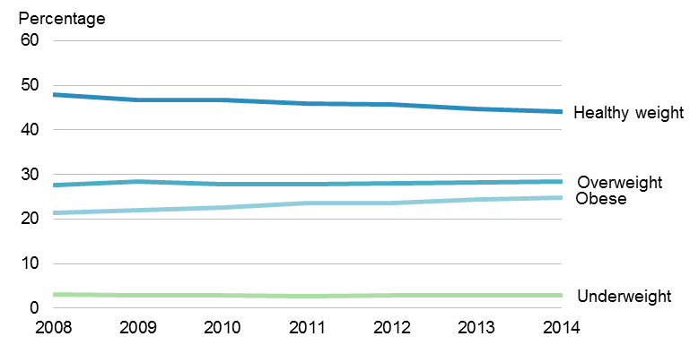

Notes:

Underweight: BMI<19; Healthy weight: BMI 19–24; Overweight: BMI 25–29; Obese: BMI 30+.

BMI is calculated based on measurements taken at first registration with an LMC or a DHB primary maternity service.

The denominator used to calculate percentages excludes women giving birth with unknown BMI.

The proportion of women identified as obese was highest among Pacific women giving birth (57.6%), followed by Māori women (35.4%). Women in the most deprived neighbourhoods had a higher proportion of obesity than women in the least deprived neighbourhoods (36.6% of women in quintile 5 compared with 13.7% of women in quintile 1). There was little variation in the proportion of obese women giving birth across age groups (Figure 17).

Figure : Percentage of women giving birth identified as obese at first registration with their primary maternity care provider, by age group, ethnic group and neighbourhood deprivation quintile, 2014

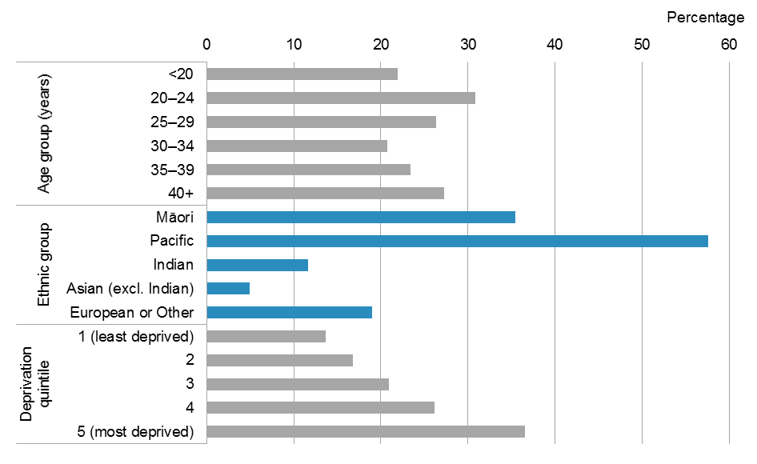

Notes:

A woman is identified as obese if her body mass index (BMI) is 30 or more at first registration with an LMC or a DHB primary maternity service.

The denominator used to calculate percentages is the number of women giving birth for that demographic group, excluding those with unknown BMI.

At least one-quarter of women were identified as obese at first registration in 11 of the 20 DHB regions. The highest proportion of obese women as a percentage of women giving birth was in Counties Manukau DHB region (35.0%), followed by Tairāwhiti (31.0%). The lowest proportion was in Waitemata and Auckland DHB regions (18.9% and 19.3%, respectively).

## Smoking status

Maternal smoking status is recorded at the time of a woman’s first registration with her primary maternity care provider and at two weeks after birth. Smoking data is primarily sourced from LMC claim forms, with additional data from some DHB primary maternity services. It is therefore only available for women registered with an LMC or with a DHB primary maternity service (approximately 95% of women giving birth).

In 2014, 14.8% (8352) of women giving birth were identified as smokers at first registration with their primary maternity care provider, and 12.8% (6892) at two weeks after birth.[7] Between 2008 and 2014, there was a statistically significant decrease in the proportion of women identified as smokers, both at first registration and at two weeks after birth (Figure 18).

Figure : Percentage of women giving birth identified as smokers at first registration with their primary maternity care provider and at two weeks after birth, 2008–2014

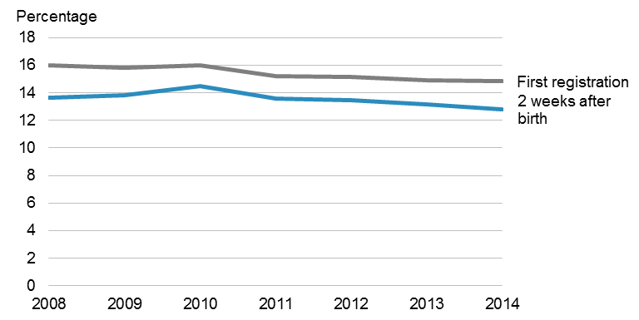

Notes:

The denominator used to calculate percentages is the number of women giving birth, excluding those with unknown smoking status.

Smoking status is only available for women registered with an LMC or a DHB primary maternity service.

Figure 19 and Figure 20 show the proportion of smokers among women giving birth in 2014 at first registration and at two weeks after birth, respectively. The proportion of smokers during pregnancy and the postnatal period showed similar trends, with generally higher proportions among:

* younger women
* Māori women
* women residing in the most deprived neighbourhoods.

The proportion of smokers among women giving birth varied throughout the country. The lowest proportion was among women residing in Auckland DHB region (5.4% at first registration and 2.8% at two weeks after birth) and the highest was among women in Northland (29.3% at first registration and 27.3% at two weeks after birth) and Tairawhiti (29.2% at first registration and 28.5% at two weeks after birth) DHB regions.

Figure : Percentage of women giving birth identified as smokers at first registration with their primary maternity care provider, by age group, ethnic group and neighbourhood deprivation quintile, 2014

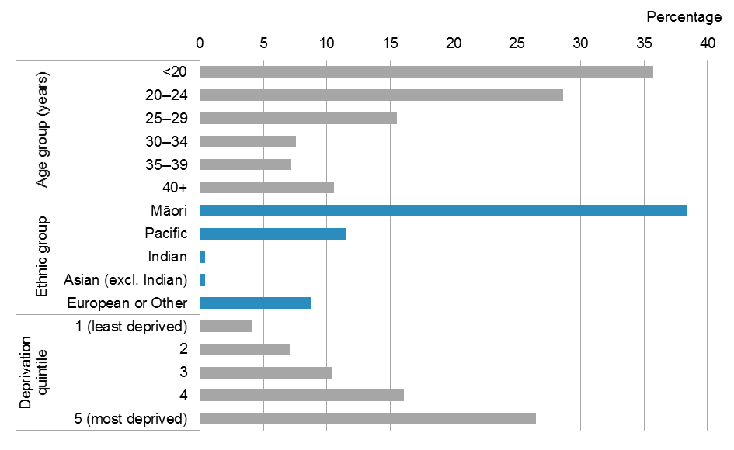

Notes:

The denominator used to calculate percentages is the number of women giving birth for that demographic group, excluding those with unknown smoking status.

Smoking status is only available for women registered with an LMC or a DHB primary maternity service.

Figure : Percentage of women giving birth identified as smokers at two weeks after birth, by age group, ethnic group and neighbourhood deprivation quintile, 2014

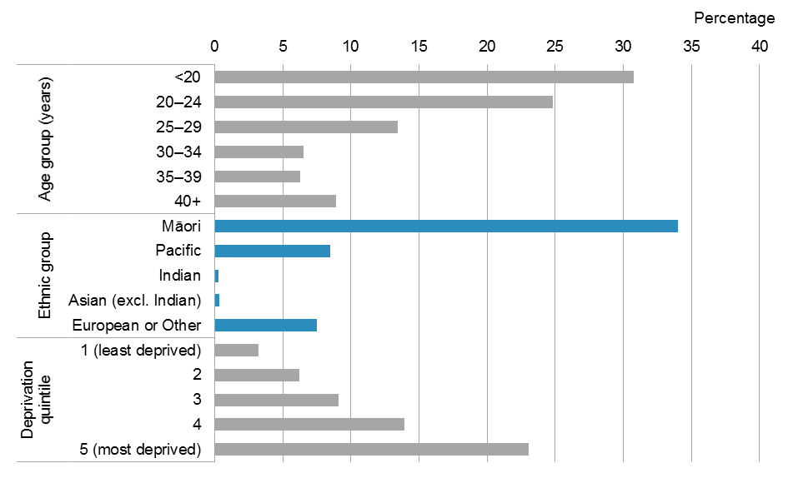

Notes:

The denominator used to calculate percentages is the number of women giving birth for that demographic group, excluding those with unknown smoking status.

Smoking status is only available for women registered with an LMC or a DHB primary maternity service.

Of the 8352 women who were smoking at first registration with their primary maternity care provider, 74.9% (6256) were also smoking at two weeks after birth. Figure 21 shows the number of women who were also smoking at two weeks after birth as a proportion of the women who were smoking at first registration.

Smoking during both pregnancy and postnatal periods was more common among older women, and Māori women (77.5% of women aged 40 years and over and 77.0% of Māori women who were smoking at first registration were also smoking at two weeks after birth).

Conversely, there was a higher proportion of Indian and Pacific women who were smoking during pregnancy but were not smoking during the postnatal period (40.0% of Indian women and 59.6% of Pacific women who were smoking at first registration were also smoking at two weeks after birth). Note that there were only 10 Indian women identified as smokers at first registration in 2014.

Figure : Percentage of women smoking at first registration with their primary maternity care provider who were also smoking at two weeks after birth, by age group, ethnic group and neighbourhood deprivation quintile, 2014

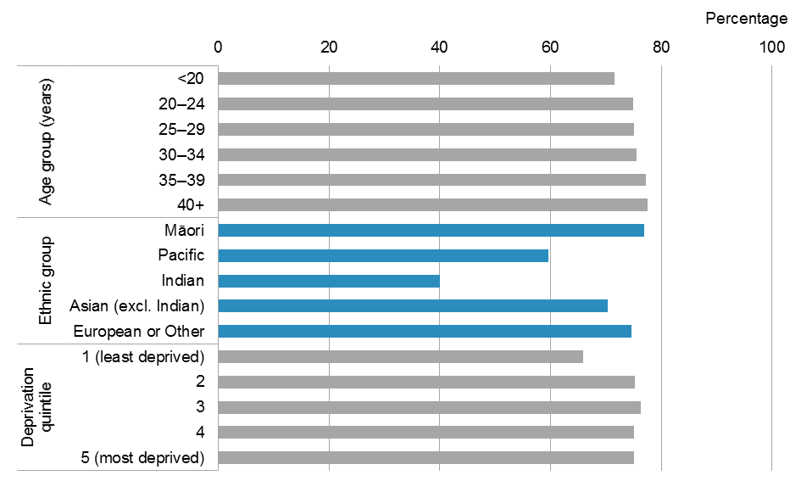

Note: The denominator used to calculate percentages is the number of women giving birth who were identified as smokers at first registration with an LMC or a DHB primary maternity service.

## Primary maternity care

Primary maternity care is usually provided by a community-based LMC. An LMC provides a ‘woman and her baby with continuity of care throughout pregnancy, labour and birth and the postnatal period’.[8]

Women who do not access an LMC, either through choice or lack of availability, are entitled to receive primary maternity services from their DHB. Collection of data from DHB primary maternity services is under way; currently, only some DHBs have provided their data.

The vast majority of women giving birth in 2014 received primary maternity care from an LMC (91.3%: 54,020 women). A further 3.9% (2296) received care from a DHB primary maternity service. Provision of care was unknown for 2877 women (4.9%). These women most likely received care from their respective DHB primary maternity services (not yet reporting),[9] but some may not have received any primary maternity care.

There was a statistically significant increase in the proportion of women registered with an LMC, from 81.6% in 2008 to 91.3% in 2014. Approximately 5% of women giving birth between 2008 and 2014 were registered with a DHB primary maternity service (Figure 22).

Figure : Percentage of women giving birth, by primary maternity care provider,  
2008–2014

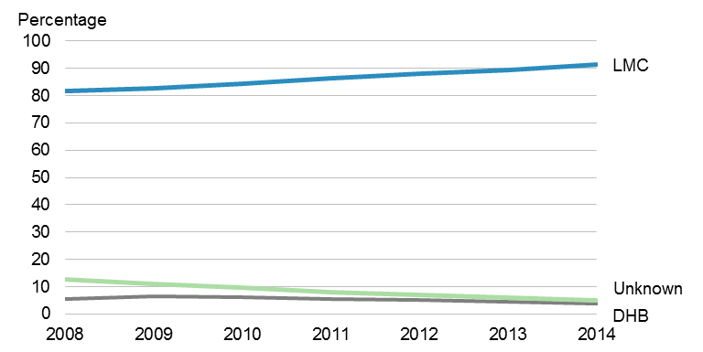

Notes:

LMC: women registered with a Lead Maternity Carer.

DHB: women registered with a DHB primary maternity service.

The denominator used to calculate percentages is the number of women giving birth.

### Registration with a Lead Maternity Carer

Most LMCs are midwives, but a GP meeting the required criteria or an obstetrician may also provide LMC services. A description of LMC services from registration to discharge is available from the [New Zealand College of Midwives](http://www.midwife.org.nz/women-in-new-zealand/about-lead-maternity-carer-lmc-services) website www.midwife.org.nz.

**Registration** refers to the selection of an LMC and the documentation of this selection.

**Discharge** refers to the end of an LMC care episode, which occurs four to six weeks after the baby’s birth.

This section focuses on women registered with an LMC, when they registered and the type of practitioner they chose. Information presented in this chapter may not fully reflect the collaborative and complex nature of primary maternity care. LMCs may work in a group or as solo practitioners with a back-up LMC for when they are not available. This publication does not present analysis of non-LMC maternity services such as maternity-related GP visits and ultrasounds, and of DHB-funded primary maternity services (although data can be obtained on request).

The data presented here is sourced from LMC claim forms submitted to the Ministry of Health for payment of services.

The proportion of LMC registration in 2014 varied across age groups, ethnic groups and neighbourhood deprivation; within most groups, at least 80% of women giving birth were registered with an LMC (Figure 23).

The proportion of women giving birth who were registered with an LMC ranged between 88.3% and 92.3% across all age groups. Women in the European or Other ethnic group were most likely to register with an LMC (95.7%), followed by Māori women (91.6%). Registration with an LMC was less common among Pacific women (75.3%) and Indian women (82.3%).

Registration with an LMC was less common among women in the most deprived neighbourhoods (85.5% of women in quintile 5 compared to 93.8% of women in quintiles 1–4).

Variations in the proportion of women registered with an LMC likely reflect the LMC workforce availability. DHB primary maternity services are expected to be available for women who do not access an LMC (through choice or availability).

The proportion of women who registered with an LMC was generally very high in most DHB regions. In six DHB regions, at least 99% of women giving birth were registered with an LMC: Bay of Plenty, Taranaki, Wairarapa, Canterbury, South Canterbury and Southern. West Coast, Counties Manukau and Auckland DHB regions had the lowest proportion of women registered with an LMC (49.1%, 76.4% and 77.0%, respectively).

The proportion of women giving birth who were registered with an LMC remained close to 100%, or showed a statistically significant increase from 2010 to 2014, in all DHB regions. The largest increase was among women residing in Whanganui DHB (from 65.7% to 95.0%) (Figure 24).

Figure : Percentage of women giving birth who registered with a Lead Maternity Carer by age group, ethnic group and neighbourhood deprivation quintile, 2014

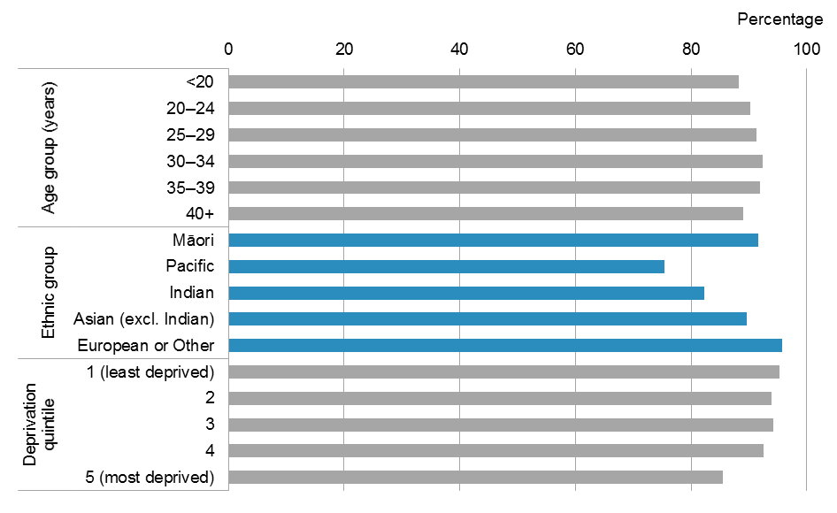

Note: The denominator used to calculate percentages is the number of women giving birth for that demographic group.

Figure : Percentage of women registered with a Lead Maternity Carer, by DHB of residence, 2010 and 2014

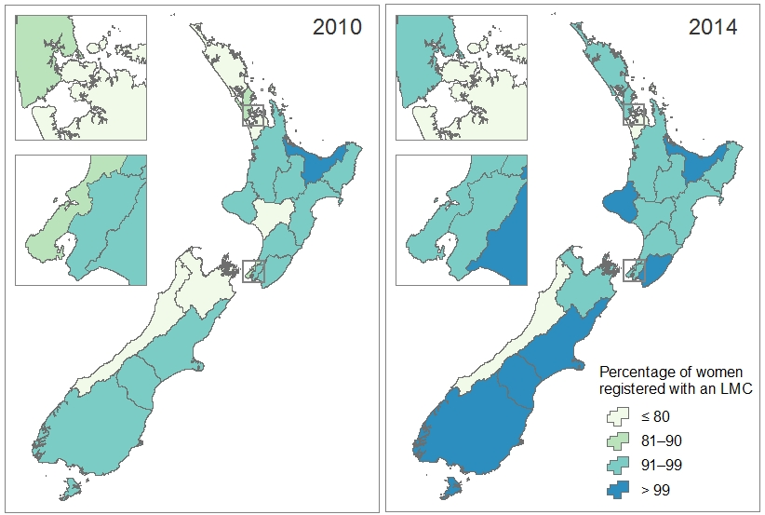

Note: The denominator used to calculate percentages is the number of women giving birth residing in the DHB region.

#### Trimester of registration with Lead Maternity Carer

Of the women giving birth in 2014 who registered with an LMC, 67.7% registered within the first trimester of pregnancy (under 13 weeks’ gestation), a statistically significant increase from 50.2% in 2008. Accordingly, the percentage of women who registered during the second trimester of pregnancy (13–28 weeks’ gestation) decreased significantly from 43.3% in 2008 to 27.6% in 2014 (Figure 25).

Figure : Percentage of women registered with a Lead Maternity Carer by trimester of first registration, 2008–2014

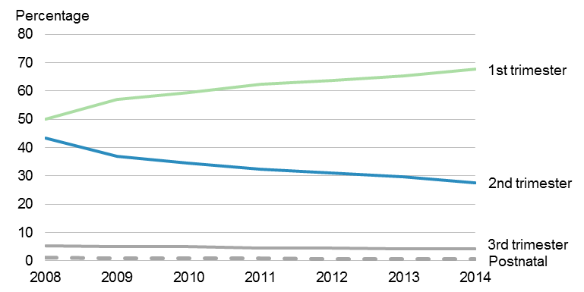

Note: The denominator used to calculate percentages is the number of women registered with an LMC.

Figure 26 shows the number of women registered with an LMC during the first, second and third trimester of pregnancy, as a proportion of the total number of women giving birth.

Registration with an LMC during the first trimester of pregnancy was less common among:

* young women (43.3% of women aged under 20 years)
* Māori and Pacific women (48.9% of Māori women and 30.7% of Pacific women)
* women in the most deprived neighbourhoods (46.7% in quintile 5).

Within most groups presented in Figure 26, at least 80% of women had registered with an LMC by the end of their second trimester, except among Pacific women (66.8%) and women residing in the most deprived neighbourhoods (78.9% in quintile 5).

The proportion of women giving birth who registered with an LMC within the first trimester of pregnancy ranged from 27.7% to 76.6% across DHBs. The lowest percentage was for women residing in West Coast and Counties Manukau DHB regions, where less than 40% of women registered with an LMC during their first trimester. At least 50% of women in all other DHB regions registered with an LMC within their first trimester, the highest proportion being evident among women in the Canterbury region (76.6%) (Figure 27).

Between 2010 and 2014, the proportion of women registered with an LMC within the first trimester of pregnancy increased significantly among women giving birth in all DHB regions except Wairarapa. The largest increases were among women residing in South Canterbury DHB (from 33.0% to 62.9%) and Whanganui DHB (from 36.1% to 64.1%) regions (Figure 27).

Figure : Percentage of women giving birth who registered with a Lead Maternity Carer prior to birth, by trimester of registration, age group, ethnic group and neighbourhood deprivation quintile, 2014

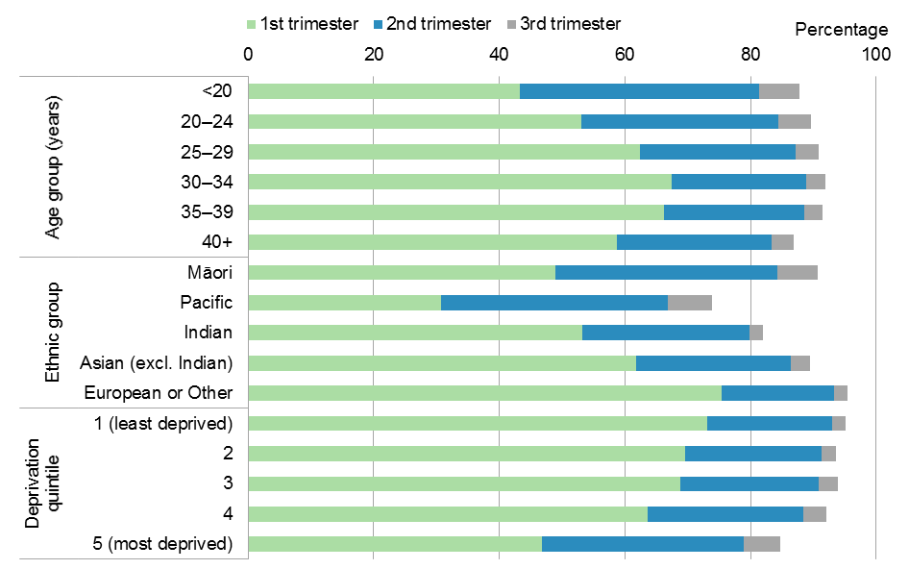

Note: The denominator used to calculate percentages is the number of women giving birth for that demographic group.

Figure : Percentage of women giving birth who registered with a Lead Maternity Carer within the first trimester of pregnancy, by DHB of residence, 2010 and 2014

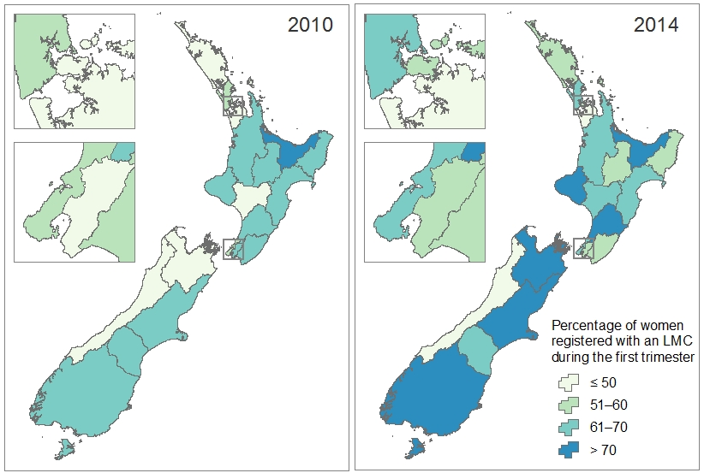

Note: The denominator used to calculate percentages is the number of women giving birth residing in the DHB region.

#### Type of Lead Maternity Carer

In 2014 the majority of women giving birth who were registered with an LMC had a midwife as their LMC (93.4%). A small proportion of women were registered with an obstetrician or a GP as their LMC (6.0% and 0.5%, respectively). The number of women registered with a GP LMC as a proportion of all women registered with an LMC decreased steadily between 2008 and 2014, from 2.8% to 0.5%. Conversely, the proportion of women registered with a midwife LMC increased significantly, from 89.8% in 2008 to 93.4% in 2014 (Figure 28).

Figure : Percentage of women registered with a Lead Maternity Carer (LMC), by type of LMC, 2008–2014

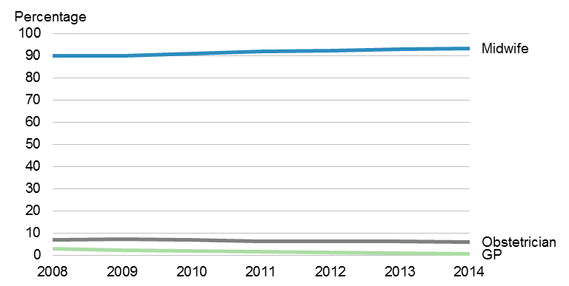

Note: The denominator used to calculate the percentage is the number of women registered with an LMC.

Between 2003 (prior to implementation of the Primary Maternity Services Notice 2007) and 2014, there was an increase in the percentage of women registered with a midwife LMC (from 60.7% in 2003 to 85.2% in 2014) and a decrease in the percentage of women registered with a GP LMC (from 6.1% to 0.1%). Table 2 presents the number and percentage of each LMC type in 2003 and 2014.

Table : Comparison of Lead Maternity Carer types between 2003 and 2014

| **Lead Maternity Carer (LMC) type** | **2003** | | **2014** | |
| --- | --- | --- | --- | --- |
| **Number** | **Percentage** | **Number** | **Percentage** |
| Registered with LMC | 42,906 | 77.7 | 54,020 | 91.3 |
| Midwife | 33,531 | 60.7 | 50,460 | 85.2 |
| Obstetrician | 3,342 | 6.1 | 3,254 | 5.5 |
| General practitioner | 3,376 | 6.1 | 261 | 0.4 |
| Other/unknown | 2,657 | 4.8 | 45 | 0.1 |
| Not registered with LMC | 12,306 | 22.3 | 5,173 | 8.7 |
| **Total** | **55,212** | **100.0** | **59,193** | **100.0** |

Note: 2003 data was sourced from the Report on Maternity: Maternal and Newborn Information 2003  
(Ministry of Health 2006).

### Registration with DHB primary maternity services

In 2014, five DHBs reported having a total of 2296 women registered with their primary maternity services. These DHBs were Waitemata, Auckland, Counties Manukau, Hawke’s Bay and Hutt Valley.

Registration with a DHB primary maternity service was more common among:

* women in the under 2o years and 40 years and over age groups (6.2% and 5.1%, respectively)
* Pacific and Indian women (12.7% and 9.8%, respectively)
* women in the most deprived neighbourhoods (6.3% of women in quintile 5).

Figure 29 shows the percentage of women giving birth who were registered with a DHB primary maternity service in 2014.

The vast majority of women who registered to receive care from a DHB primary maternity service instead of an LMC had already given birth at least once before doing so in 2014. Only 15 women giving birth for the first time in 2014 were registered with a DHB primary maternity service.

Figure : Percentage of women giving birth who were registered with a DHB primary maternity service, 2014

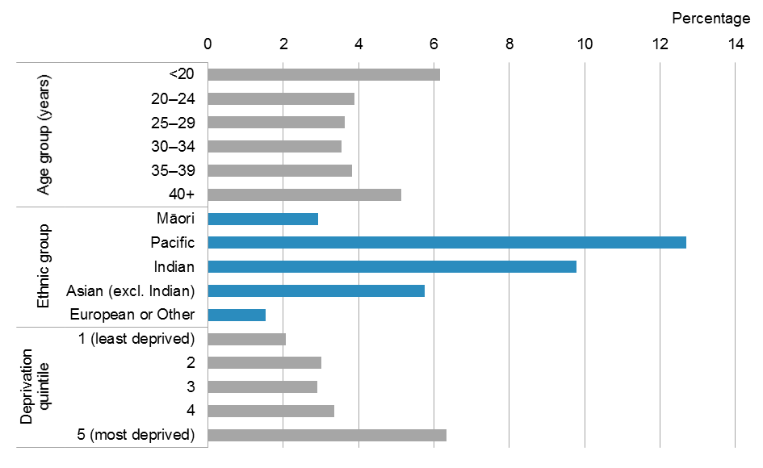

Note: The denominator used to calculate percentages is the number of women giving birth for that demographic group.

# Labour and birth

This chapter describes events relating to labour and birth, covering the type of birth, interventions and place of birth. It contains these sections are: Type of birth; Interventions; Plurality; and Place of birth.

## Type of birth

The numbers presented in this section refer to the number of women giving birth, not the number of delivery procedures. A priority system is used to report a procedure type for women having more than one of the delivery procedures described (see the ‘Type of birth’ section in ‘Appendix 3: Technical notes’ for more information). Types of birth have been grouped into the following aggregated categories.

**Spontaneous vaginal birth**: birth of a baby without any obstetric delivery assistance to facilitate delivery; includes spontaneous breech birth (vaginal birth in which the baby’s buttocks or lower limbs precede its head). These births may also include interventions such as induction or augmentation prior to delivery.

Spontaneous vaginal birth is known to provide multiple benefits for the woman and her baby. These benefits are evident at time of birth and have long-term effects for society as a whole. It specifically contributes to the physical and emotional wellbeing of women and babies by:

* preparing the baby for birth as a result of mother’s hormonal response in spontaneous labour
* initiating the bonding process through sight, touch and smell, from immediate skin-to-skin contact between mother and baby after birth
* reassuring the baby with ongoing attachment to a familiar environment (ie, the mother)
* reducing risk of respiratory difficulties for the baby after birth
* exposing the baby to normal flora from the mother, so that it colonises the baby’s intestine
* promoting early initiation of breastfeeding, thereby supporting exclusive breastfeeding for a longer duration
* contributing to an easier transition to motherhood with easier physical recovery following birth (Levine 2001; Jordan 2005; Penders 2006; Chalmers 2010; Gregory 2012; PMMRC 2014).

**Assisted birth**: vaginal birth (including assisted breech birth) requiring obstetric delivery assistance (forceps, vacuum).

**Caesarean section**: delivery involving an operation through an abdominal incision.

Of the 58,328 women with a known type of birth in 2014, 37,821 (64.8%) had a spontaneous vaginal birth, 15,088 (25.9%) had a caesarean section and 5419 (9.3%) had an assisted birth (Table 3).

Table : Number and percentage of women giving birth, by type of birth, 2014

| **Type of birth** | **Number** | **Percentage** |
| --- | --- | --- |
| **Spontaneous vaginal birth** | **37,821** | **64.8** |
| Spontaneous vertex | 37,656 | 64.6 |
| Spontaneous breech | 165 | 0.3 |
| **Assisted birth** | **5,419** | **9.3** |
| Forceps only | 2,068 | 3.5 |
| Vacuum only | 3,231 | 5.5 |
| Forceps and vacuum | 17 | 0.0 |
| Assisted breech | 57 | 0.1 |
| Breech extraction | 46 | 0.1 |
| **Caesarean section** | **15,088** | **25.9** |
| Emergency caesarean | 8,038 | 13.8 |
| Elective caesarean | 7,050 | 12.1 |
| **Unknown** | **865** | **–** |
| **Total** | **59,193** | **100.0** |

The distribution of birth types has changed over the last decade. There was a statistically significant decrease in the proportion of women having a spontaneous vaginal birth (from 67.7% in 2005 to 64.8% in 2014) and a statistically significant increase in the proportion of caesarean sections (from 23.3% in 2005 to 25.9% in 2014). The proportion of assisted births remained stable, ranging from 8.4% to 9.3% (Figure 30).

Figure : Percentage of women giving birth, by type of birth (aggregated), 2005–2014

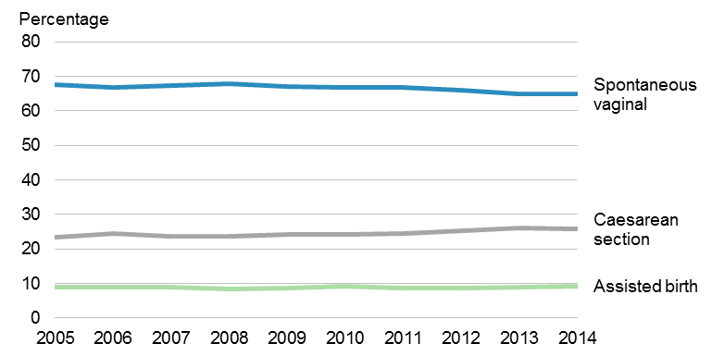

Notes:

Spontaneous vaginal birth includes spontaneous vertex and breech births. Assisted birth includes breech extraction and assisted breech.

The denominator used to calculate percentages is the number of women giving birth, excluding those with unknown birth type.

The Organisation for Economic Co-operation and Development (OECD) presented a comparison of caesarean section rates (number of caesarean section deliveries performed per 100 live births) across OECD countries between 2000 and 2011 in the most recent edition of the *Health at a Glance* publication (OECD 2013).[10]

The rate of caesarean sections for New Zealand in 2011 was 24.3 per 100 live births, similar to the United Kingdom (24.1 per 100 live births, 2011). The New Zealand rate was lower than the rates for the United States and Australia (31.4 and 32.2 per 100 live births, respectively, 2010), as well as the overall OECD rate (26.9 per 100 live births, 2011) (Figure 31).

Almost all OECD countries, including New Zealand, showed an increase in the caesarean section rate between 2000 and 2011. The increases were particularly rapid in the Czech Republic, Mexico, Slovenia, the Slovak Republic and Turkey. However, the growth rate has slowed or reversed since 2005 for Finland, Italy, Korea and Sweden (Figure 31).

The caesarean section rate for New Zealand in 2014 was 25.4 per 100 live births,[11] an increase from 24.3 per 100 live births in 2011.

Figure : Comparison of caesarean section rates (per 100 live births) in 2000, 2005 and 2011 (or nearest year) for OECD countries

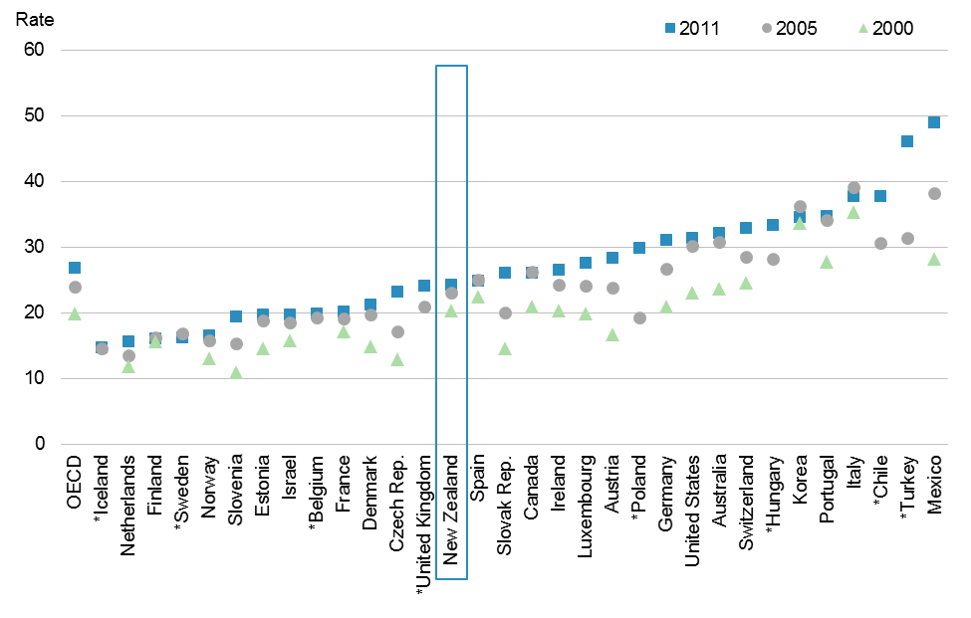

Notes:

Data was sourced from *Health at a Glance 2013: OECD indicators* (OECD 2013). Refer to publication for more details on limitations in data comparability.

Countries for which the caesarean section rate was unavailable for the year 2000 are marked with an asterisk (*).

The rate presented is the number of caesarean deliveries performed per 100 live births.

### Breech births

Breech birth in this publication refers to a vaginal birth of a baby by the buttocks or lower limbs first rather than the head.

**Spontaneous breech** refers to the birth of a baby from a breech presentation without obstetric intervention to facilitate delivery, but which may include other obstetric procedures such as induction.

**Assisted breech** refers toan assisted vaginal birth in which a baby being born feet or buttocks first is delivered spontaneously as far as its umbilicus and is then extracted. It may include the use of forceps.

**Breech extraction** refers toan assisted vaginal birth, performed by grasping the baby’s feet or buttocks before any part of the trunk is born and delivering by traction. It may include the use of forceps.

A total of 268 women had a vaginal breech birth in 2014; 165 had a spontaneous breech birth, 57 an assisted breech birth and 46 a birth by breech extraction (Table 3). These births represented 0.5% of all births with a known birth type.

Vaginal breech births ranged from 0.4% to 0.5% of all births between 2005 and 2014 (Figure 32).

Figure : Percentage of vaginal breech births, 2005–2014

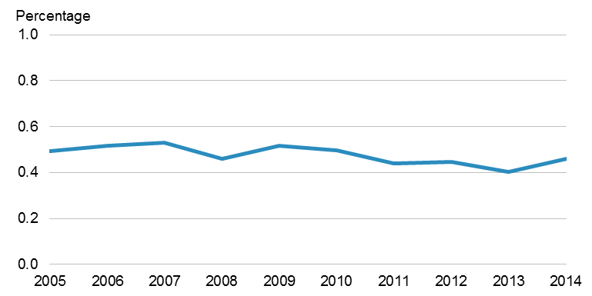

Note: The denominator used to calculate percentages is the number of women giving birth, excluding those with unknown birth type.

The majority of spontaneous and assisted breech births in 2014 were for singleton pregnancies (72.7% and 61.4%, respectively); 87% of breech extractions were for twin pregnancies.

Over half (52.9%) of babies born by vaginal breech birth were preterm (<37 weeks’ gestation).

The distribution of vaginal breech birth types changed from 2005 to 2014.There was an increase in the proportion of spontaneous breech births (from 46.8% to 61.6% of breech births) and a decrease in the proportion of assisted breech births (from 36.6% to 21.3% of breech births). The proportion of breech extraction fluctuated between 14.4% and 20.1% of breech births over the same time period (Figure 33).

Figure : Distribution of breech birth types, 2005–2014

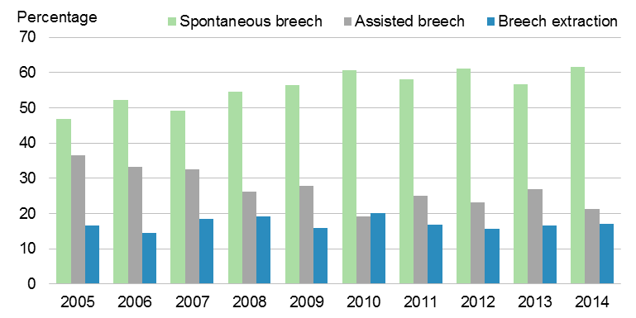

Note: The denominator used to calculate percentages is the number of vaginal breech births.

### Caesarean sections

**Emergency caesarean section** refers to a caesarean section performed urgently for clinical reasons, such as the health of the woman or baby, once labour has started.

**Elective caesarean section** refers to a caesarean section performed as a planned procedure before or following the onset of labour, where the decision to have a caesarean section was made before labour.

One in four women giving birth in 2014 had a caesarean section; just over half of these were emergency caesarean sections (Table 3).

Between 2005 and 2014 the percentage of elective caesarean sections showed a statistically significant increase, from 9.2% to 12.1% of all births, while the percentage of emergency caesarean sections remained fairly stable, ranging from 13.2% to 14.4% of all births (Figure 34).

Figure : Percentage of emergency and elective caesarean sections, 2005–2014

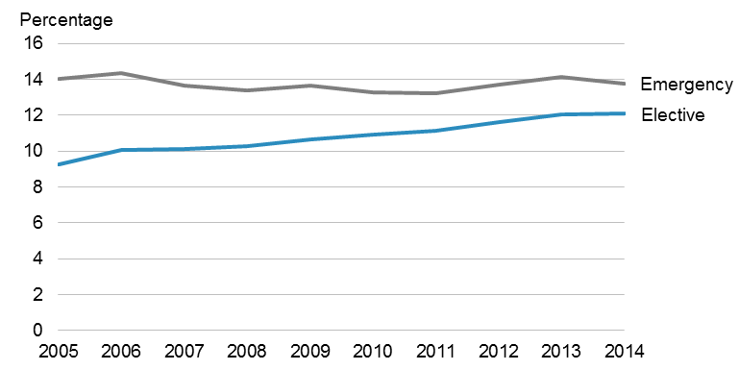

Note: The denominator used to calculate percentages is the total number of women giving birth, excluding those with unknown birth type.

The percentage of women having a caesarean section varied by age group, ethnic group and neighbourhood deprivation quintile (Figure 35). This variation was primarily driven by the difference in proportion of women having an elective caesarean section by demographic group. The percentage of women having an emergency caesarean section ranged from 11.4% to 22.0% across age groups, ethnic groups and deprivation quintiles.

Caesarean sections were more common among women:

* aged 35 years or more (34.2% of women aged 35–39 years and 42.1% of women aged 40 years and over)
* of Indian, Asian (excl. Indian), European or other ethnicities (34.9% of Indian women, 30.0% of Asian (excl. Indian) women and 28.1% of women in the European or Other ethnic group)
* in the least deprived neighbourhoods (31.7% of women in quintile 1).

Emergency caesarean sections were more common for women having their first baby (21.9%) than for women who had given birth before (7.9%). The opposite was true for elective caesarean sections (6.0% of women giving birth for the first time compared with 16.0% of women who had given birth at least once).

Figure : Percentage of caesarean sections, by type, age group, ethnic group and neighbourhood deprivation quintile, 2014

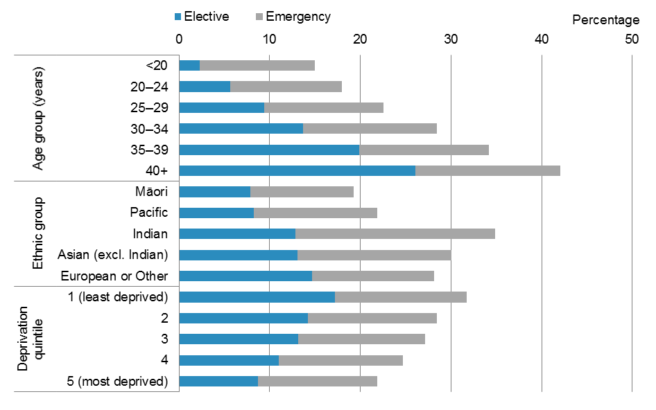

Note: The denominator used to calculate percentages is the total number of women giving birth, excluding those with unknown birth type.

The proportion of emergency caesarean sections varied throughout the country. Generally, proportions were lower in the middle of the North Island. Whanganui DHB region had the lowest proportion of emergency sections (9.6% of women giving birth); Wairarapa DHB region had the highest (17.4%) (Figure 36).

A statistically significant increase in the proportion of emergency caesarean sections from 2010 to 2014 was seen in Waitemata (from 14.8% to 16.0%), Auckland (from 14.3% to 15.7%) and Counties Manukau (from 11.9% to 14.7%) DHB regions. Conversely, the proportion of emergency caesarean sections decreased significantly for women in Canterbury DHB region (from 12.7% in 2010 to 11.6% in 2014). Ten other DHB regions showed a decrease (not statistically significant) in proportions of emergency caesarean sections from 2010 to 2014 (Figure 36).

Figure : Percentage of emergency caesarean sections, by DHB of residence, 2010 and 2014

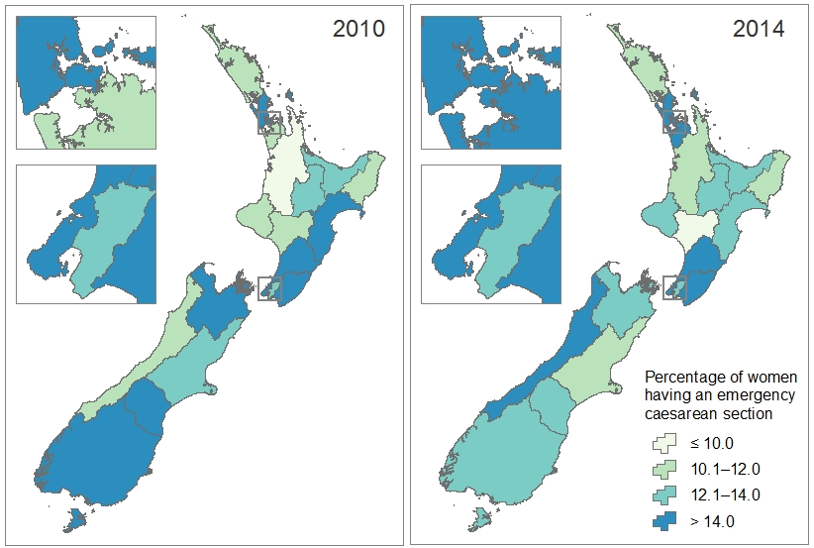

Note: The denominator used for calculating percentages is the number of women giving birth residing in the DHB region, excluding those with unknown type of birth.

The proportion of elective caesarean sections was generally higher among women residing in the South Island (15.0%) than among women residing in the North Island (11.4%). The highest proportion was among women residing in Southern DHB region (15.6%), followed by Canterbury DHB region (15.1%). Northland DHB had the lowest percentage (4.2%) (Figure 37).

The proportion of women having an elective caesarean section increased from 2010 to 2014 for 17 of the 20 DHB regions (Figure 37). The following DHB regions showed a statistically significant increase: Waitemata (from 12.1% to 14.2%), Counties Manukau (from 8.2% to 10.0%), Tairāwhiti (from 8.9% to 13.0%), Nelson Marlborough (from 12.0% to 14.9%) and Southern (from 13.1% to 15.6%). The proportion of elective caesarean sections decreased significantly in Whanganui DHB region (from 9.8% to 7.0%).

Figure : Percentage of elective caesarean sections, by DHB of residence, 2010 and 2014

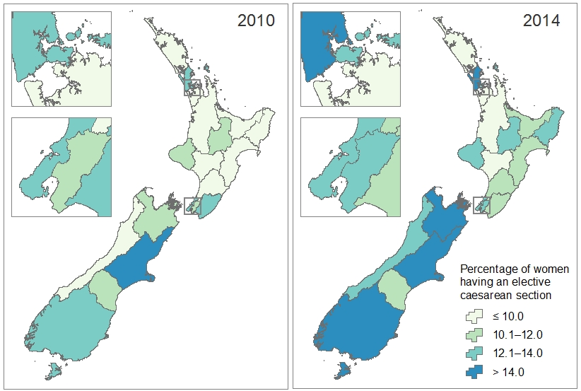

Note: The denominator used for calculating percentages is the number of women giving birth residing in the DHB region, excluding those with unknown type of birth.

## Interventions

This section describes women experiencing a normal birth and those having an obstetric intervention (induction, augmentation, epidural or episiotomy) during labour and birth.

**Normal** **birth** refers to spontaneous vaginal birth (including spontaneous vertex and spontaneous breech) without an induced or augmented labour, an epidural or an episiotomy.

**Induction** refers to the processof artificially stimulating the uterus to start labour by artificial rupture of membranes or pharmacological means.

**Augmentation** refers to the process of stimulating the uterus to increase the frequency, duration and intensity of contractions after the onset of spontaneous labour by artificial rupture of membranes or pharmacological means.

**Epidural** refers to a regional analgesic agent being injected into the epidural space of the spinal cord.

**Episiotomy** refers to an incision of the perineal tissue surrounding the vagina at the time of birth to facilitate delivery.

Women who had their labour both induced and augmented are recorded as having had an induction only. Therefore, the number of augmentations presented may be lower than the true number.

The number and percentage of inductions, augmentations and epidurals presented does not include women giving birth by elective caesarean section. The number and percentage of episiotomies is limited to vaginal births (all births excluding caesarean sections). It should be noted that women giving birth may have had more than one of these interventions.

From 2005 to 2014, one in every three women giving birth each year had a normal birth (Figure 38).

Half of all women giving birth had at least one form of intervention during labour and birth (ie, induction, augmentation, epidural or episiotomy).

The proportion of inductions and episiotomies among women giving birth showed a statistically significant increase from 2005 to 2014 (from 19.0% to 24.4% for inductions and from 11.7% to 14.6% for episiotomies). Conversely, women having their labour augmented as a proportion of women giving birth showed a statistically significant decrease (from 31.5% to 25.6%) over the same time period. About one-quarter of women giving birth had an epidural; this figure fluctuated between 25.3% and 28.2% each year (Figure 38).

Figure : Percentage of women having a normal birth and having an induction, augmentation, epidural or episiotomy during labour and birth, 2005–2014

Figure 38: Percentage of women having a normal birth and having an induction, augmentation, epidural or episiotomy during labour and birth, 2005–2014

Notes:

Normal births are women having a spontaneous vaginal birth without having an induced or augmented labour, an epidural or an episiotomy at time of birth. The denominator used to calculate normal births is the total number of women giving birth.

The denominator used to calculate percentage of induction, augmentation and epidural is the total number of women giving birth, excluding those who had an elective caesarean section and those with unknown birth type.

The denominator used to calculate percentage of episiotomy is the number of women who had vaginal births.

### Normal births

One-third (33.2%: 19,646) of women giving birth in 2014 had a normal birth (ie, a spontaneous vaginal birth without an induction, augmentation, epidural or episiotomy). Figure 39 shows the distribution of women having a normal birth.

Normal births were more common among younger women giving birth: 36.6% of women aged under 30 years had a normal birth, compared to 21.1% of women aged 40 years and over.

Compared to other ethnic groups, Māori women had the highest proportion of normal births (42.9%), while Indian women had the lowest proportion (19.0%).

The proportion of women having normal births was lowest for those in the least deprived neighbourhoods and highest for those in the most deprived neighbourhoods (26.8% of women in quintile 1 compared with 37.7% of women in quintile 5).

Almost one-quarter (23.3%) of women giving birth for the first time in 2014 had a normal birth, compared with 40.7% of women who had given birth at least once before doing so in 2014.

Women in Northland and Tairāwhiti DHB regions had the highest proportion of normal births (51.2% and 50.0%, respectively). The lowest proportion of normal births was in Auckland and Hutt Valley DHB regions (23.4% and 24.5%, respectively).

Figure : Percentage of women having a normal birth, by age group, ethnic group and neighbourhood deprivation quintile, 2014

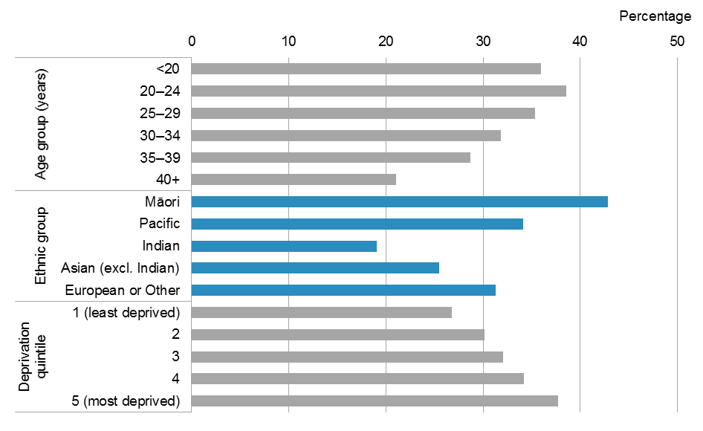

Notes:

Normal births are women having a spontaneous vaginal birth without having an induced or augmented labour, an epidural or an episiotomy at time of birth.

The denominator used to calculate percentages is the number of women giving birth for that demographic group.

### Induction

In 2014, almost one-quarter (24.4%: 12,506 women) of women giving birth (excluding those who had elective caesarean sections) had their labour induced. Figure 40 shows the distribution of women undergoing induction.

The proportion of inductions among women giving birth increased with maternal age, and was highest for women aged 40 years and over (21.0% of women aged under 20 years compared with 42.3% of women aged 40 years and over).

Inductions were more common among Indian women giving birth (32.5%) compared to women of other ethnicities. Inductions were least common among Māori women (19.8%).

The proportion of women giving birth who had their labour induced was less varied by neighbourhood deprivation: there was a slightly higher proportion among women in the least deprived neighbourhoods (26.9% of women in quintile 1) than among those in the most deprived neighbourhoods (23.2% of women in quintile 5).

Women giving birth for the first time in 2014 had a higher proportion of inductions (28.7%) compared with women who had given birth previously (20.4%).

Figure : Percentage of women having an induction of labour, by age group, ethnic group and neighbourhood deprivation quintile, 2014

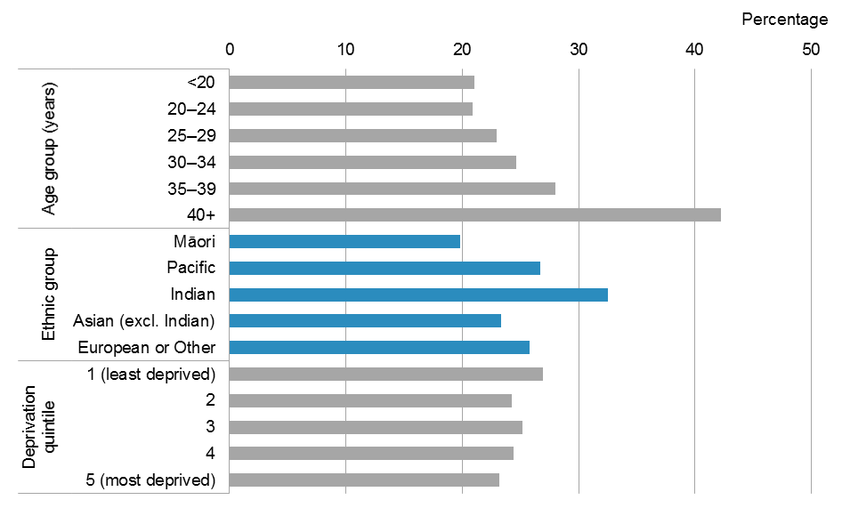

Note: The denominator used to calculate percentages is the number of women giving birth for that demographic group, excluding those who had an elective caesarean section or those with unknown birth type.

### Augmentation

One in every four (25.6%: 13,103) women giving birth in 2014 (excluding those who had elective caesarean sections) had their labour augmented.[12] Figure 41 shows the distribution of women undergoing augmentation of labour.

The proportion of augmentation among women giving birth decreased with maternal age (31.8% of women aged under 20 years compared with 16.2% of women aged 40 years and over).

Augmentation was more common for Asian and Pacific women: 31.8% of Asian (excl. Indian), 28.8% of Indian and 27.4% of Pacific women had an augmentation, compared with about 24% of women in the Māori and European or Other ethnic groups.

The proportion of women who had their labour augmented was similar across neighbourhood deprivation quintiles, ranging from 24.8% to 26.6%.

Almost one-third (31.5%) of women giving birth for the first time in 2014 had their labour augmented. In comparison, only one-fifth (21.0%) of women who had given birth at least once before had their labour augmented.

Figure : Percentage of women undergoing augmentation of labour, by age group, ethnic group and neighbourhood deprivation quintile, 2014

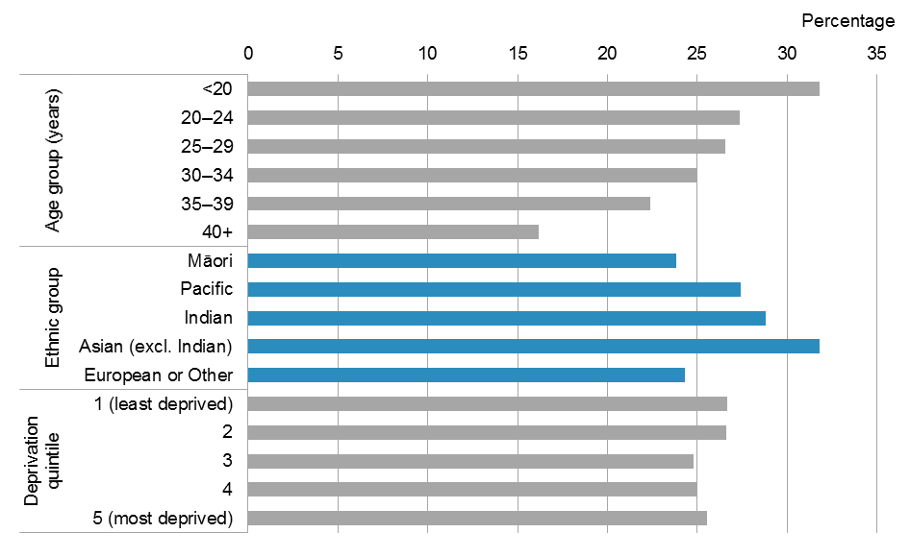

Note: The denominator used to calculate percentages is the number of women giving birth for that demographic group, excluding those who had an elective caesarean section or those with unknown birth type.

### Epidural

A total of 13,889 (27.1%) women giving birth in 2014 (excluding those who had elective caesarean sections) had an epidural. Figure 42 shows the distribution of women having an epidural.

The proportion of epidurals was fairly consistent across age groups, ranging from 24.3% (in the 20–24 years age group) to 29.2% (in the 30–34 years age group).

Use of epidural varied notably by ethnic group. Epidurals were most common among Indian women (39.7%), followed by women in the Asian (excl. Indian) (34.5%) and European or Other (30.5%) ethnic groups. In contrast, 17.9% of Māori women and 20.6% of Pacific women giving birth had an epidural.

Epidurals were more common among women in the least deprived neighbourhoods (35.7% of women in quintile 1) than among those in the most deprived neighbourhoods (20.7% of women in quintile 5).

The proportion of epidurals among women giving birth for the first time in 2014 was 2.8 times the proportion for women who had given birth previously (42.4% compared with 15.3%).

Figure : Percentage of women having an epidural, by age group, ethnic group and neighbourhood deprivation quintile, 2014

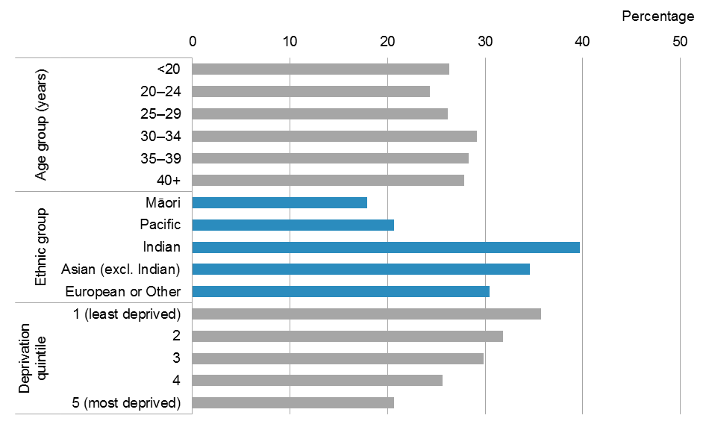

Note: The denominator used to calculate percentages is the number of women giving birth for that demographic group, excluding those who had an elective caesarean section or those with unknown birth type.

### Episiotomy

In 2014, 14.6% (6322) of women giving birth vaginally had an episiotomy. Figure 43 shows the distribution of women having an episiotomy.

The proportion of women having an episiotomy varied slightly across age groups, ranging from 11.9% (in the 40+ years age group) to 17.3% (in the 30–34 years age group).

Asian women had a notably higher proportion of having an episiotomy compared to women in other ethnic groups. The proportion of having an episiotomy for Indian and other Asian women was at least four times the proportion for Māori women (31.9% of Indian women and 27.6% of Asian (excl. Indian) women compared with 6.5% of Māori women).

Women in the least deprived neighbourhoods had almost twice the proportion of having an episiotomy compared with women in the most deprived neighbourhoods (19.8% of women in quintile 1 compared with 10.4% of women in quintile 5).

Women giving birth for the first time in 2014 had five times the proportion of having an episiotomy compared to women who had given birth at least once before (28.6% compared with 5.6%).

Figure : Percentage of women having an episiotomy, by age group, ethnic group and neighbourhood deprivation quintile, 2014

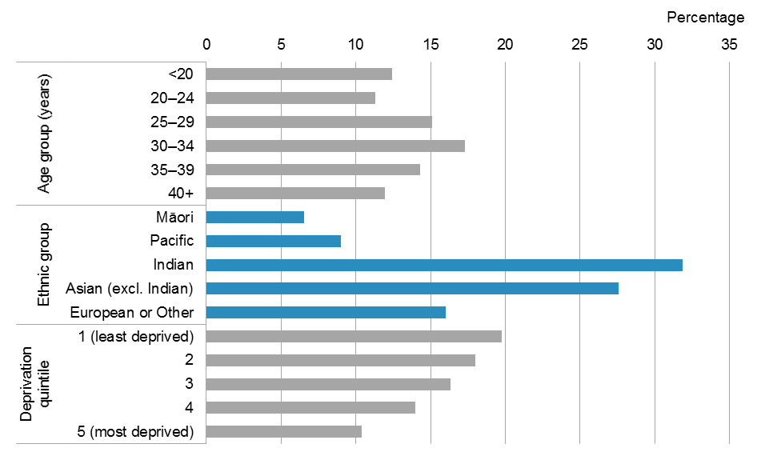

Note: The denominator used to calculate percentages is the number of women who had a vaginal birth for that demographic group, excluding those with unknown birth type.

## Plurality

Plurality is the number of babies resulting from a pregnancy.

**Singleton pregnancy** refers to being pregnant with one baby.

**Twin** **pregnancy** refers to beingpregnant with two babies.

**Multiple** **pregnancy** refers to being pregnant with three or more babies.

The vast majority of women giving birth in 2014 (98.5%) gave birth to one baby, and 855 women (1.5%) gave birth to two or more babies.[13] The proportion of twin or multiple births has not changed much over the last decade, ranging from 1.4% to 1.6% of all women giving birth.

The type of birth varied with plurality, as shown in Table 4. Approximately 75% of women with singleton pregnancies had a vaginal birth (including assisted birth) compared with 39.7% of women pregnant with twins and 10.0% of women with multiple pregnancy. The proportion of emergency and elective caesarean sections increased with the number of babies: 25.4% of women with a singleton pregnancy had a caesarean section compared with 60.3% of women with a twin pregnancy and 90.0% of women with a multiple pregnancy.

Table : Number and percentage of women giving birth, by plurality and type of birth, 2014

|  |  |  |  |  |  |  |
| --- | --- | --- | --- | --- | --- | --- |
| **Type of birth** | **Singleton** | | **Twin** | | **Multiple** | |
| **Number** | **Percentage** | **Number** | **Percentage** | **Number** | **Percentage** |
| Spontaneous vaginal | 37,458 | 65.3 | 203 | 24.2 | 1 | 10.0 |
| Assisted birth | 5,289 | 9.2 | 130 | 15.5 | 0 | 0.0 |
| Emergency caesarean | 7,824 | 13.6 | 212 | 25.3 | 2 | 20.0 |
| Elective caesarean | 6,749 | 11.8 | 294 | 35.0 | 7 | 70.0 |
| Unknown | 637 | – | 6 | – | 0 | – |
| **Total** | **57,957** | **100.0** | **845** | **100.0** | **10** | **100.0** |

## Place of birth

Women are entitled to choose where they give birth. This may include a secondary or tertiary hospital, a primary birthing unit or at home. Women are entitled to give birth at a facility with greater clinical capacity than their expected clinical need. Primary birthing units and home births are recommended for well, healthy women likely to experience normal birth (Birthplace in England Collaborative Group 2011; NICE 2014). Place of birth usually reflects the local configuration of facilities and LMC access agreements, in addition to clinical need and the woman’s preference.

The vast majority (96.6%) of women gave birth at a maternity facility in 2014: 9.1% of women gave birth at a primary facility, 41.0% at a secondary facility and 46.6% at a tertiary facility. A total of 1966 women (3.4%) had a planned home birth (Table 5).

Table : Number and percentage of women giving birth, by place of birth, 2014

| **Place of birth** | **Number** | **Percentage** |
| --- | --- | --- |
| Home | 1,966 | 3.4 |
| Maternity facility | 56,562 | 96.6 |
| Primary | 5,301 | 9.1 |
| Secondary | 24,003 | 41.0 |
| Tertiary | 27,258 | 46.6 |
| Unknown | 665 | – |
| **Total** | **59,193** | **100.0** |

The proportion of women giving birth at a tertiary facility increased steadily between 2007 and 2014, from 40.9% to 46.6% percent. There was a corresponding decrease over this time in the proportion of women giving birth at a primary facility, which fell from 15.6% to 9.1%. The proportion of births at home and at secondary facilities remained stable during this time (Figure 44).

Figure : Percentage of women giving birth, by place of birth, 2005–2014

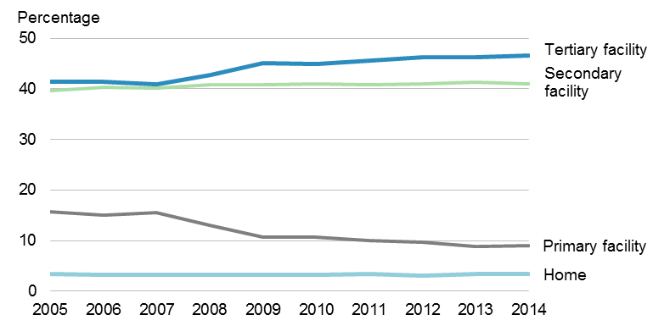

Note: The denominator used to calculate percentages is the number of women giving birth, excluding women without a place of birth recorded.

The breakdown of women giving birth by place of birth differed across DHB regions (Table 6). Women residing in Northland DHB had the highest proportion of home births (7.6% compared with 3.4% nationally). At least 90% of women residing in 13 of the 20 DHBs gave birth at a maternity facility within their DHB of residence.

Table : Number and percentage of women giving birth, by DHB of residence and place of birth, 2014

| **DHB of residence** | **Home birth** | | **Maternity facility** | | | | **Unknown** | **Total** |
| --- | --- | --- | --- | --- | --- | --- | --- | --- |
| **In DHB1** | | **Outside DHB2** | |
| **No.** | **%3** | **No.** | **%3** | **No.** | **%3** | **No.** | **No.** |
| Northland | 158 | 7.6 | 1,822 | 87.9 | 93 | 4.5 | 30 | 2,103 |
| Waitemata | 197 | 2.5 | 6,436 | 82.6 | 1,160 | 14.9 | 61 | 7,854 |
| Auckland | 92 | 1.5 | 5,195 | 83.1 | 961 | 15.4 | 50 | 6,298 |
| Counties Manukau | 107 | 1.3 | 6,778 | 82.6 | 1,323 | 16.1 | 79 | 8,287 |
| Waikato | 209 | 4.0 | 4,817 | 92.8 | 167 | 3.2 | 70 | 5,263 |
| Lakes | 36 | 2.6 | 1,278 | 92.7 | 64 | 4.6 | 8 | 1,386 |
| Bay of Plenty | 131 | 4.7 | 2,529 | 91.4 | 107 | 3.9 | 24 | 2,791 |
| Tairāwhiti | 33 | 4.8 | 645 | 93.2 | 14 | 2.0 | 2 | 694 |
| Hawke’s Bay | 72 | 3.5 | 1,950 | 94.5 | 41 | 2.0 | 13 | 2,076 |
| Taranaki | 54 | 3.6 | 1,400 | 93.0 | 51 | 3.4 | 14 | 1,519 |
| MidCentral | 106 | 5.1 | 1,887 | 90.6 | 90 | 4.3 | 9 | 2,092 |
| Whanganui | 20 | 2.5 | 671 | 82.8 | 119 | 14.7 | 6 | 816 |
| Capital & Coast | 89 | 2.5 | 3,294 | 93.9 | 124 | 3.5 | 18 | 3,525 |
| Hutt Valley | 51 | 2.8 | 1,661 | 90.1 | 131 | 7.1 | 12 | 1,855 |
| Wairarapa | 23 | 4.9 | 405 | 87.1 | 37 | 8.0 | 8 | 473 |
| Nelson Marlborough | 81 | 5.7 | 1,301 | 91.9 | 33 | 2.3 | 5 | 1,420 |
| West Coast | 21 | 6.1 | 279 | 80.4 | 47 | 13.5 | 3 | 350 |
| Canterbury | 236 | 3.9 | 5,707 | 95.5 | 33 | 0.6 | 26 | 6,002 |
| South Canterbury | 17 | 2.6 | 610 | 94.1 | 21 | 3.2 | 5 | 653 |
| Southern | 95 | 2.9 | 3,158 | 96.5 | 21 | 0.6 | 19 | 3,293 |
| Unknown | 138 | – | 0 | – | 102 | – | 203 | 443 |
| **Total** | **1,966** | **3.4** | **51,823** | **88.5** | **4,739** | **8.1** | **665** | **59,193** |

1 Women giving birth at a facility located within the DHB of residence.

2 Women giving birth at a facility located outside the DHB of residence.

3 The denominator used for calculating the percentage excludes women with unknown place of birth (665 women).

### Maternity facilities

A maternity facility is a place that women attend, or are resident in, for the primary purpose of receiving maternity care, usually during labour and birth. It may be classed as primary, secondary or tertiary depending on the availability of specialist services (Ministry of Health 2012). This section describes women giving birth at a maternity facility.

**Primary facility** refers to a maternity unit that provides care for women expected to experience normal birth with care provision from midwives. It is usually community-based and specifically for women assessed as being at low risk of complications for labour and birth care. Access to specialist secondary maternity services and care will require transfer to a secondary/tertiary facility. Primary facilities do not provide epidural analgesia or operative birth services. Birthing units are considered to be primary facilities.

**Secondary facility** refers to a hospital that can provide care for normal births, complicated pregnancies and births including operative births and caesarean sections plus specialist adjunct services including anaesthetics and paediatrics. As a minimum, secondary facilities include an obstetrician rostered on site during working hours and on call after hours, with access to support from an anaesthetist, paediatrician, radiological, laboratory and neonatal services.

**Tertiary facility** refers to a hospital that can provide care for women with high-risk, complex pregnancies by specialised multidisciplinary teams. Tertiary maternity care includes an obstetric specialist or registrar immediately available on site 24 hours a day. Tertiary maternity care includes an on-site, level 3, neonatal service.

See ‘Appendix 5: Catchment areas’ for a list of available facilities by DHB region.

Overall, women were more likely to give birth at a secondary or tertiary facility than at a primary facility in New Zealand in 2014. Figure 45 presents the distribution of women giving birth at a maternity facility, by type of facility and demographic group.

Births in a primary facility were more common among younger women: 12.5% of women aged under 20 years gave birth at a primary facility compared with 4.9% of women aged 40 years and over. The proportion of Māori women giving birth at a primary facility was double the proportion of non-Māori women (15.3% of Māori women compared with 7.5% of non-Māori women). Use of primary facilities was less common among women in the least deprived neighbourhoods (6.9% of women in quintile 1 compared with 11.0% of women in quintile 5).

There was less variation in the percentage of women giving birth at a secondary facility across the standard demographic groups, ranging from 24.1% (among Pacific women) to 50.5% (among Māori women).

Tertiary maternity facilities were commonly used by:

* older women (57.5% of women aged 40 years and over compared with 39.5% of women aged under 20 years)
* Pacific and Indian women (69.7% of Pacific women and 66.0% of Indian women compared with 34.2% of Māori women)
* women in the least deprived neighbourhoods (58.0% of women in quintile 1 compared with 47.7% of women in quintile 5).

Figure : Distribution of women giving birth at a maternity facility, by type of facility, age group, ethnic group and neighbourhood deprivation quintile, 2014

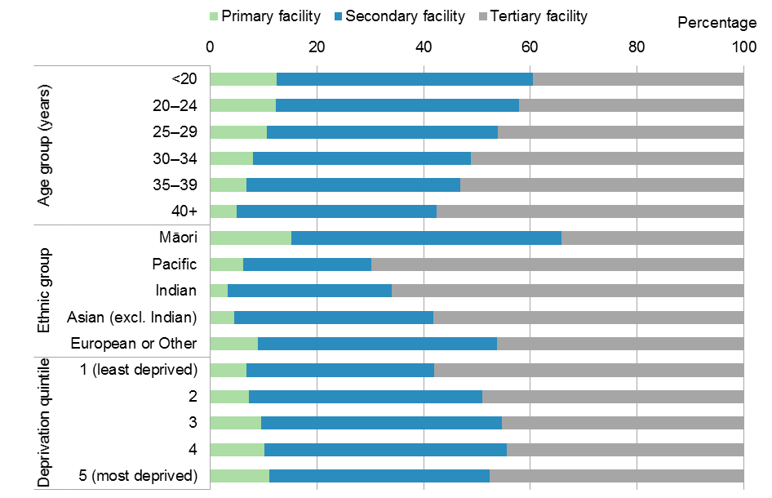

Note: The denominator used for calculating percentages is the number of women giving birth at a maternity facility for each demographic group.

The distribution of women giving birth at a maternity facility by type of facility used varied throughout the country (Figure 46). This variation primarily reflects the availability of maternity facilities in a DHB region: three DHB regions do not have any primary facilities (Hutt Valley, Wairarapa and South Canterbury DHBs) and six have a tertiary facility within the region: Auckland, Counties Manukau, Waikato, Capital & Coast, Canterbury and Southern.

Among women giving birth at a maternity facility:

* In 2 of the 17 DHB regions with at least one primary facility, at least 20% of women gave birth at a primary facility: Waikato (29.0%) and Northland (20.2%).
* In 8 of the 14 DHB regions with at least one secondary facility, at least 90% of women gave birth at a secondary facility, the highest proportions being in Hawke’s Bay (97.3%) and South Canterbury (96.7%).
* In 4 of the 6 DHB regions with a tertiary facility, over 80% of women gave birth at a tertiary facility: Canterbury (88.5%), Counties Manukau (88.0%), Auckland (87.8%) and Capital & Coast (87.6%). Waikato and Southern DHB regions had a smaller proportion of women giving birth at a tertiary facility (69.0% and 51.5%, respectively).

Figure : Distribution of women giving birth at a maternity facility, by type of facility and DHB of residence, 2014

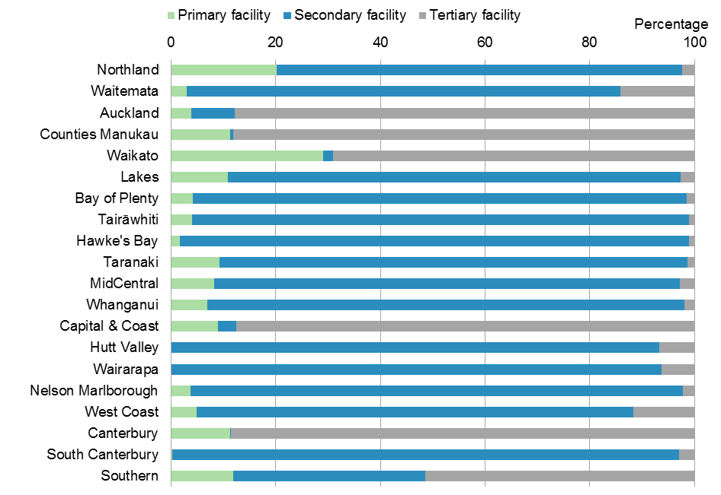

Note: The denominator used for calculating percentages is the number of women residing in each DHB region who gave birth at a maternity facility.

### Home births

**Intended home birth** refers to a birth for which there is a documented plan to give birth at home and the management of the labour commences at home.

**Home birth** refers toa birth that took place in a person’s home and not in a maternity facility or birthing unit.

In 2014, 2194 women (3.7%) intended to give birth at home. Of these, 1966 women (3.4%) actually gave birth at home.

The proportion of home births varied across age groups, ethnic groups and neighbourhood deprivation quintile (Figure 47).

Home births were more common among:

* older women (4.0% of women aged 40 years and over)
* women in the Māori and European or Other ethnic groups (4.4% of Māori women and 4.0% of women in the European or Other ethnic group).

The proportion of women having a home birth across neighbourhood deprivation quintiles was less varied, ranging from 2.7% to 3.6%.

Figure : Percentage of women giving birth at home, by age group, ethnic group and neighbourhood deprivation quintile, 2014

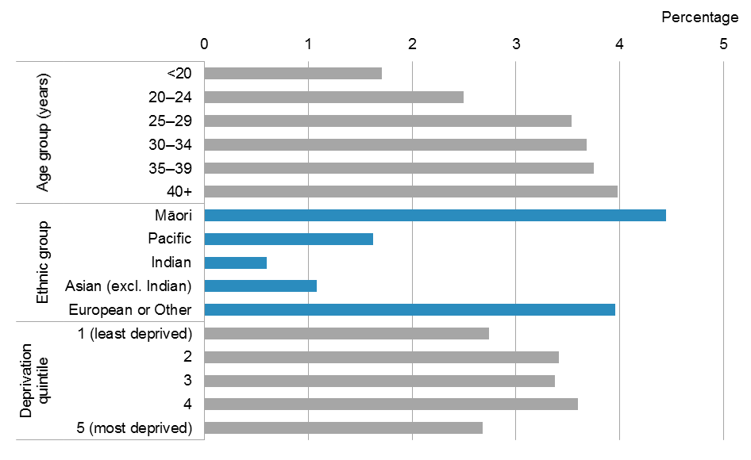

Note: The denominator used to calculate percentages is the number of women giving birth for that demographic group, excluding those without a place of birth recorded.

The percentage of home births did not vary between 2010 and 2014 for most DHB regions (Figure 48). The most notable changes over this time period was an increase among women giving birth at home in Hawke’s Bay DHB region (from 1.7% to 3.5%) and a decrease in West Coast DHB region (from 13.2% to 6.1%).

Figure : Percentage of women giving birth at home, by DHB of residence, 2010 and 2014

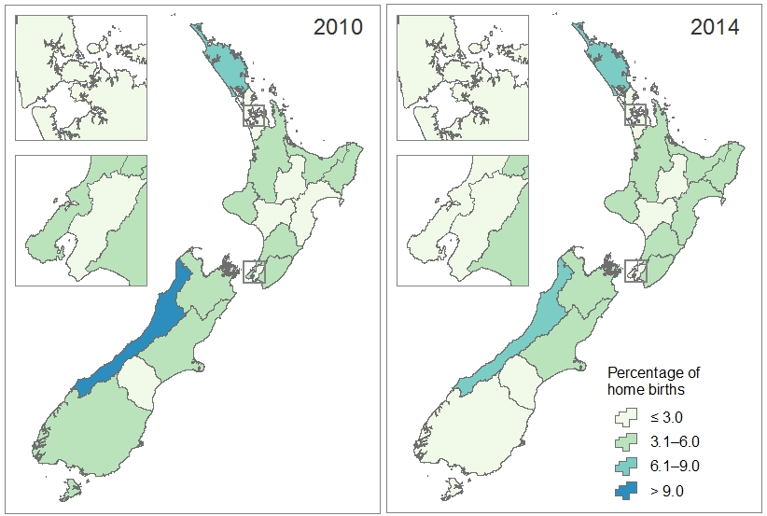

Note: The denominator used to calculate percentages is the number of women giving birth residing in each DHB region, excluding those without a place of birth recorded.

# Babies

This chapter describes the demographic profile of live-born babies in New Zealand, their birthweight and gestation, and the care provided in the postnatal period. It contains these sections: Sex, maternal age, ethnicity and deprivation; Birthweight; Gestation; Breastfeeding; and Care after birth.

There were 59,494 live-born babies recorded in the National Maternity Collection during 2014, a slight decrease from the 59,620 babies recorded in 2013.

## Sex, maternal age, ethnicity and deprivation

There were more male babies (51.8%) than female babies (48.2%) born in 2014. Figure 49 presents the distribution of live-born babies in 2014.

A higher proportion of babies were born to women aged between 20 years and 39 years than any other age group. One-quarter of babies in 2014 were Māori (25.8%). Non-Māori babies were predominantly in the European or Other ethnic group (47.9%). Half of live-born babies were from the more deprived neighbourhoods (22.7% in quintile 4 and 29.3% in quintile 5).

Figure : Percentage of babies, by sex, maternal age group, baby ethnic group and baby neighbourhood deprivation quintile, 2014

Figure 49: Percentage of babies, by sex, maternal age group, baby ethnic group and baby neighbourhood deprivation quintile, 2014

Note: The denominator used for calculating percentages is the total number of babies where the information for that variable was available.

## Birthweight

Birthweight is the first weight of the fetus or baby obtained after birth, preferably measured within the first hour of life before significant postnatal weight loss has occurred (WHO 1975).

**Low birthweight** refers to a birthweight of less than 2.5kg (at any gestation).

Prematurity, multiple pregnancy and restricted fetal (intra-uterine) growth are possible contributors to a baby’s low weight at birth. Low birthweight is associated with increased risk of fetal and neonatal mortality and morbidity, as well as inhibited growth and cognitive development (WHO and UNICEF 2004).

**Normal birthweight** refers to a birthweight between 2.5kg and 4.4kg.

**High birthweight** refers to a birthweight of 4.5kg or more.

In 2014 the majority of live-born babies (91.7%) were within the normal weight range at birth (2.5–4.4 kg). A further 5.9% of babies were born with a low birthweight (<2.5 kg) and 2.4% were born with a high birthweight (≥4.5 kg).[14] The average birthweight of babies born in 2014 was similar to previous years, at 3.42 kg. Male babies, on average, were heavier than female babies (3.47 kg and 3.36 kg, respectively).

Average birthweight varied slightly by maternal age, the baby’s ethnicity and neighbourhood deprivation (Figure 50).

Babies of women aged under 20 years and aged 40 years and over had a slightly lower average birthweight (3.34 kg for babies of both age groups) compared with babies of women aged 20–39 years (average birthweight ranged from 3.41 kg to 3.43 kg).

In regard to ethnic groups, Indian babies had the lowest average birthweight (3.13 kg), and Pacific babies the highest (3.51 kg). The average birthweight of babies for each ethnic group remained fairly constant between 2005 and 2014.

Babies in less deprived neighbourhoods had a higher birthweight on average compared to those in more deprived neighbourhoods (3.43 kg for babies in quintile 1 compared with 3.40 kg for babies in quintile 5).

Figure : Average birthweight, by maternal age group, baby ethnic group and baby neighbourhood deprivation quintile, 2014

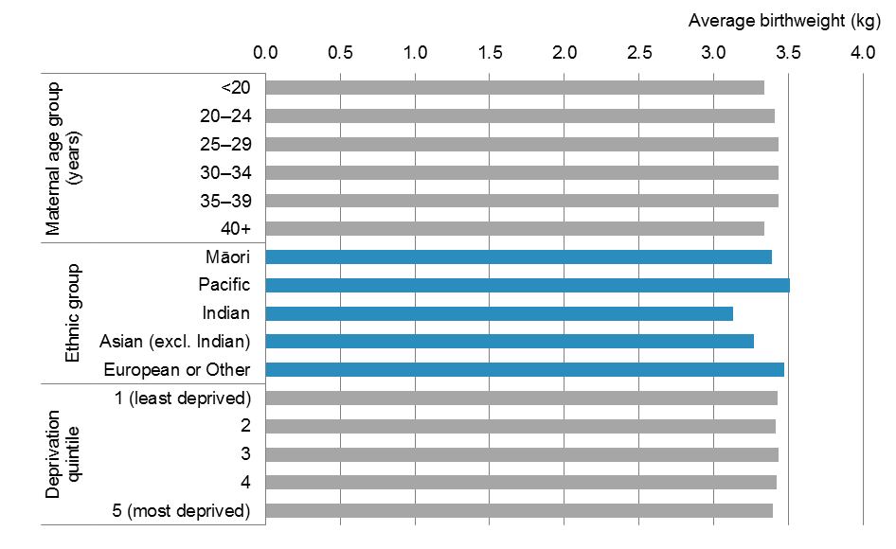

Note: The average birthweight is calculated based on the number of live-born babies, excluding those with unknown birthweight.

### Babies with low birthweight

There were 3345 babies (5.9%) born in 2014 with a low birthweight.[15] Babies of low birthweight accounted for 5.9%–6.2% of all babies born each year from 2005 to 2014. The lowest proportion was recorded in 2014.

A higher proportion of female babies were born with a low birthweight (6.3%) compared with male babies (5.5%) in 2014. Figure 51 shows the percentage of low-birthweight babies for each ethnic group, maternal age group and deprivation quintile.

Low birthweight was more common among:

* babies born to women in the 40 years and over and under 20 years age groups (8.4% and 7.2%, respectively)
* Indian and Māori babies (9.6% and 6.9%, respectively)
* babies in the more deprived neighbourhoods (6.4% of babies residing in quintile 5).

The proportion of low-birthweight babies varied across the country in 2014, from a low of 2.4% in South Canterbury DHB to a high of 7.7% in Lakes DHB (Figure 52). There was a significant decrease in the proportion of babies born with low birthweight in South Canterbury DHB region, from 5.7% in 2010 to 2.4% in 2014. Other DHB regions showed fluctuations in the proportion of low-birthweight babies over the same time period. These percentages have been calculated based on small numbers, and should be interpreted with caution.

Figure : Percentage of babies born with a low birthweight, by maternal age group, baby ethnic group and baby neighbourhood deprivation quintile, 2014

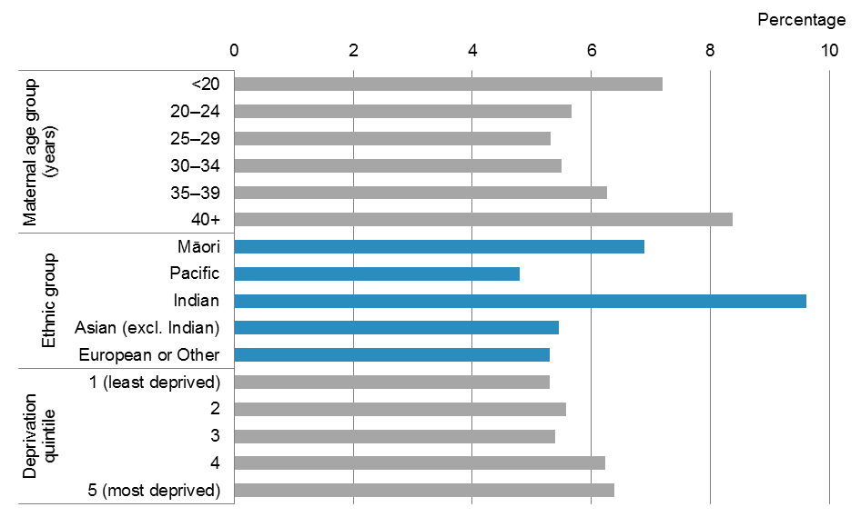

Note: The denominator used for calculating percentages is number of live-born babies, excluding those with unknown birthweight.

Figure : Percentage of babies born with a low birthweight, by DHB of residence, 2010 and 2014

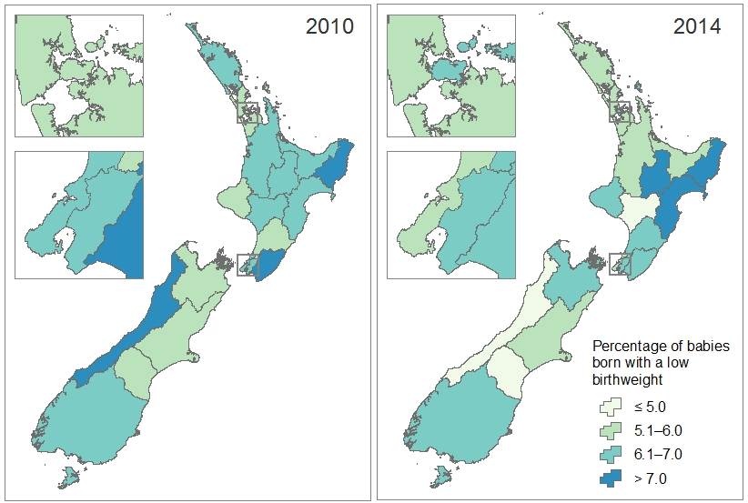

Note: The denominator used to calculate percentages is the number of live-born babies for each DHB region, excluding those with unknown birthweight.

## Gestation

Gestation is the duration of pregnancy measured from the first day of the last normal menstrual period to the delivery date, expressed in completed weeks (WHO 1975).

Gestational age may also be derived from clinical assessment during pregnancy, or from an examination of the baby after birth.

**Preterm** refers to babies born under 37 completed weeks’ gestation.

**Term** refers to babies born between 37 and 41 completed weeks’ gestation. However, the section on term babies with low birthweight includes babies born at over 41 week’s gestation with a low birthweight.

Of the 59,402 babies born in 2014 with known gestation, 90.7% were born at between 37 and 41 completed weeks’ of gestation, an increase from 89.4% in 2005.

Between 2005 and 2014 the proportion of babies born at 37, 38 and 39 weeks showed a statistically significant increase, while the proportion of babies born at 40 and 41 weeks showed a statistically significant decrease (Figure 53). This corresponds with the change in annual median gestation from 40 weeks during 2005—2007 to 39 weeks from 2008 onwards.

Figure : Percentage of babies, by gestation in weeks, 2005–2014

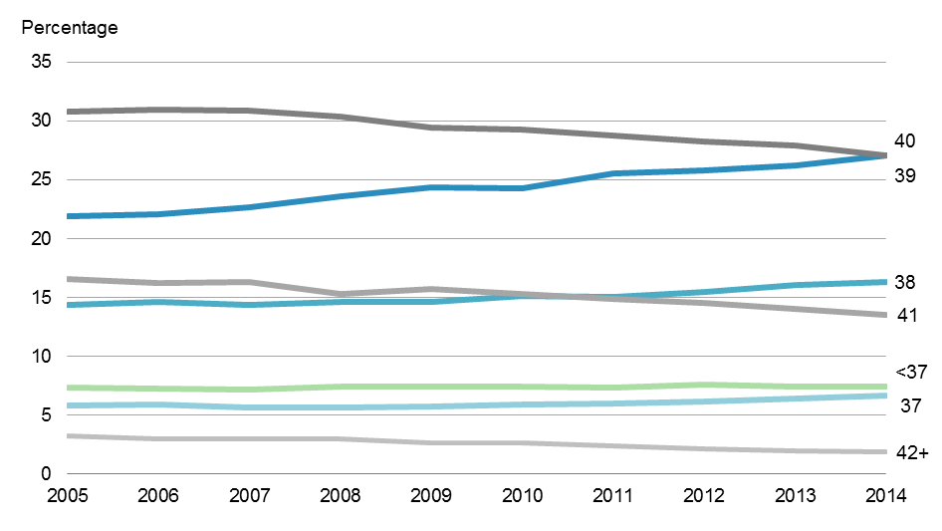

Note: The denominator used to calculate percentages is the total number of live-born babies, excluding those with unknown gestation.

### Preterm babies

In 2014, 4421 (7.4%) of babies were born preterm: 748 (1.3%) were born at under 32 weeks’ gestation and 3673 (6.2%) were born at 32–36 weeks’ gestation.[16] The proportion of preterm babies showed slight variations between 2005 and 2014: babies born at under 32 weeks’ gestation ranged from 1.2% to 1.4% of all births, and babies born at 32–36 weeks’ gestation ranged from 5.9% to 6.3% of all births.

The proportion of babies born preterm varied across the demographic groups with no obvious trends (Figure 54) except a higher proportion among babies born to older women (9.7% of babies born to women in the 40+ years age group).

Figure : Percentage of babies born preterm, by maternal age group, baby ethnic group and baby neighbourhood deprivation quintile, 2014

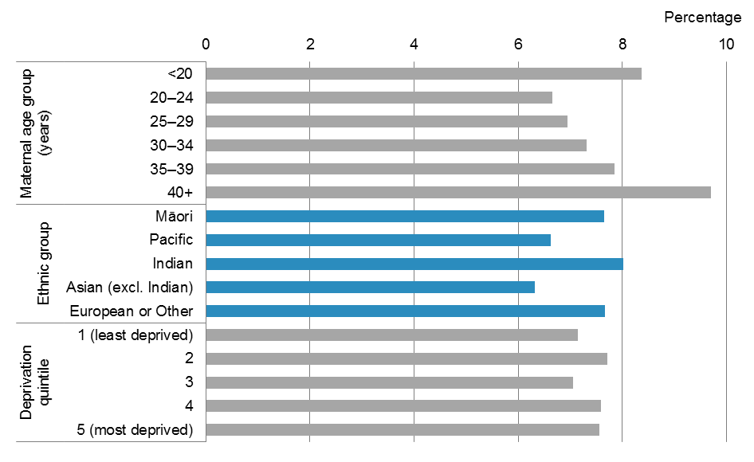

Note: The denominator used to calculate percentages is the total number of live-born babies, excluding those with unknown gestation.

The proportion of babies born preterm ranged from 6.6% to 9.2% across the 20 DHB regions, the highest proportion being evident in West Coast and Southern DHB regions and the lowest in Northland DHB region. Between 2010 and 2014 there were fluctuations in the proportion of preterm babies in all DHB regions (Figure 55).

Of preterm babies in 2014, almost 46% (1949) were born by caesarean section, the majority of which were born by emergency caesarean section (1219 were born by emergency caesarean section and 730 by elective caesarean section). This compares with 25% of babies born at term by caesarean section.

Over half of babies born preterm had a low birthweight. Almost 95% of babies born at under 32 weeks’ gestation and almost half of babies born at 32—36 weeks’ gestation had a low birthweight.

Figure : Percentage of babies born preterm, by DHB of residence, 2010 and 2014

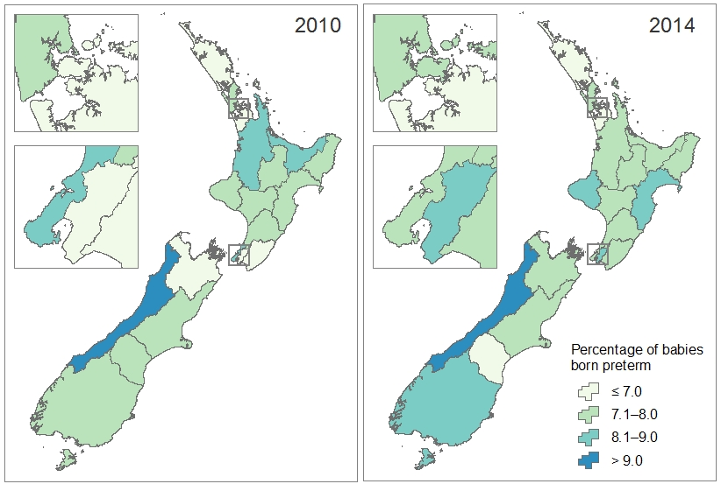

Note: The denominator used to calculate percentages is the total number of live-born babies for each DHB region, excluding those with unknown gestation.

### Term babies with low birthweight

In 2014, there were 988 (1.9%) term babies born with a low birthweight.[17] Between 2005 and 2014, 1.8%–2.1% of babies born at term each year had a low birthweight.

A larger proportion of female babies than male babies were born at term with a low birthweight (2.2% of female babies compared with 1.5% of male babies).

In regard to demographic groups, the highest proportion of babies born at term with a low birthweight was among Indian babies (4.6%), followed by babies born to young mothers aged under 20 years (2.7%). Term babies from the most deprived neighbourhoods had a higher proportion of having a low birthweight than those from the least deprived neighbourhoods (2.3% of those in quintile 5 compared to 1.5% of those in quintile 1) (Figure 56).

The DHB regions with the highest proportion of term babies born with a low birthweight were Lakes, Tairāwhiti and Hawke’s Bay (2.7% of babies in all three DHB regions). In comparison, only 0.5% of term babies in South Canterbury DHB had a low birthweight. Between 2010 and 2014 the proportion of term babies born with a low birthweight fluctuated slightly for each DHB. Some small decreases were seen in the DHB regions in the upper North Island over this time period. DHB regions in the South Island showed little change or a slight increase from 2010 to 2014 (Figure 57). Note that in three DHB regions the proportions presented are based on small numbers (fewer than five term babies with low birthweight).

Figure : Percentage of babies born at term with a low birthweight, by maternal age group, baby ethnic group and baby neighbourhood deprivation quintile, 2014

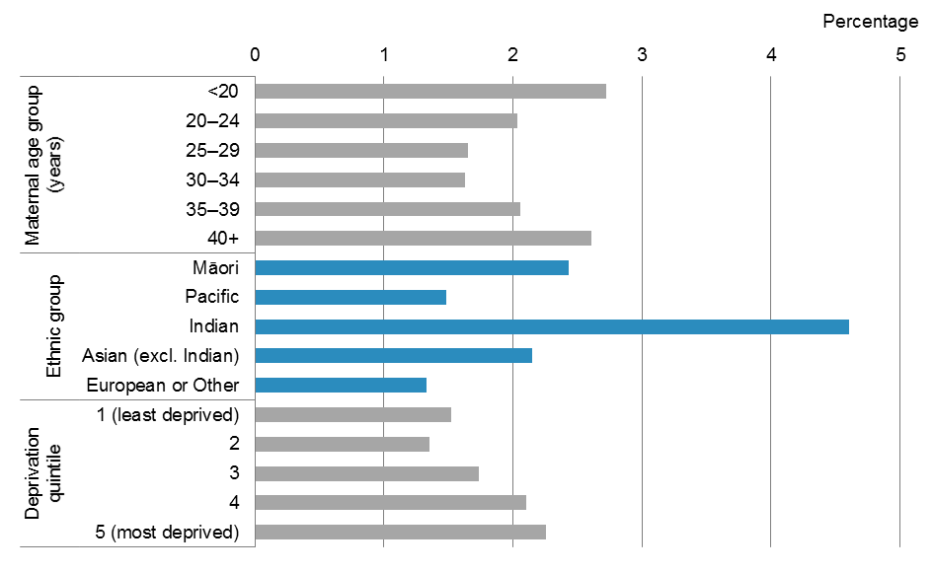

Note: The denominator used to calculate percentages is the number of live-born babies born at gestation of 37 weeks or more for each demographic group, excluding those with unknown birthweight.

Figure : Percentage of babies born at term with a low birthweight, by DHB of residence, 2010 and 2014

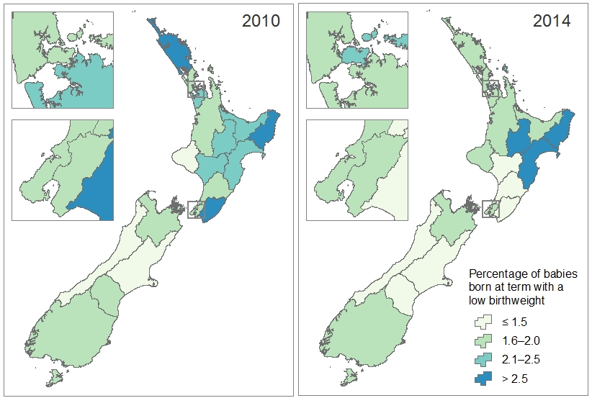

Note: The denominator used to calculate percentages is the number of live-born babies born at gestation of 37 weeks or more for each DHB region, excluding those with unknown birthweight.

## Breastfeeding

Breast milk is seen as the perfect food for an infant as it contributes positively to infant and also maternal health. The Ministry of Health uses the following standard breastfeeding definitions for New Zealand (Ministry of Health 2002).

**Exclusive:** the infant who has never, to the mother’s knowledge, had any water, formula or other liquid or solid food. Only breast milk (from the breast or expressed) and prescribed medicines (defined in the Medicines Act 1981) have been given to the baby from birth.

**Fully:** the infant has taken breast milk only, and no other liquids or solids except a minimal amount of water or prescribed medicines, in the past 48 hours.

**Partial:** the infant has taken some breast milk and some infant formula or other solid food in the past 48 hours.

**Artificial:** the infant has had no breast milk but has had alternative liquid such as infant formula, with or without solid food in the past 48 hours.

The data presented regarding breastfeeding is primarily sourced from LMC claim forms, with additional data from some DHB primary maternity services. It is therefore only available for babies of women registered with an LMC or with a DHB primary maternity service (approximately 95% of women giving birth).

The majority of babies of known breastfeeding status were breastfed, either exclusively (68.6%), fully (9.7%) or partially (14.5%) at two weeks after birth in 2014. The proportion of partially breastfed babies increased from 11.6% in 2008 to 14.5% in 2014, while the proportion of babies exclusively or fully breastfed at two weeks after birth decreased from 79.3% to 78.2%. There was an increase in total breastfed babies from 90.9% to 92.7% between 2008 and 2014 (Figure 58).

Figure : Percentage of babies, by breastfeeding status at two weeks after birth,  
2008–2014

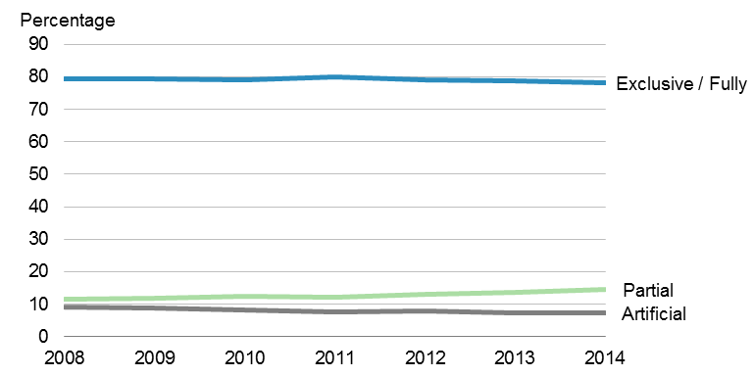

Notes:

The denominator used to calculate the percentage is the number of babies, excluding those with unknown breastfeeding status, at two weeks after birth.

Breastfeeding status is only available for babies of women registered with an LMC or a DHB primary maternity service.

Approximately 80% of babies born to women aged 25–39 years were exclusively or fully breastfed at two weeks after birth. Babies born to women aged under 20 years were less likely to be breastfed at two weeks after birth: 70.1% were exclusively or fully breastfed, 15.7%were partially breastfed and 14.2%were fed artificially.

The proportion of babies receiving breast milk was lowest for Māori: 76.2%of babies were being exclusively or fully breasted at two weeks after birth, and a further 12.9% were being partially breastfed. Babies in the European or Other ethnic group had the highest proportion of being exclusively or fully breastfed (81.5%).

Breastfeeding was more common for babies from less deprived neighbourhoods than for babies from more deprived neighbourhoods (95.2% of babies in quintile 1 compared with 89.7% of babies in quintile 5).

Figure 59 presents the distribution of breastfed babies by maternal age, ethnic group and deprivation quintile.

Figure : Percentage of breastfed babies at two weeks after birth, by maternal age group, baby ethnic group and baby neighbourhood deprivation quintile, 2014

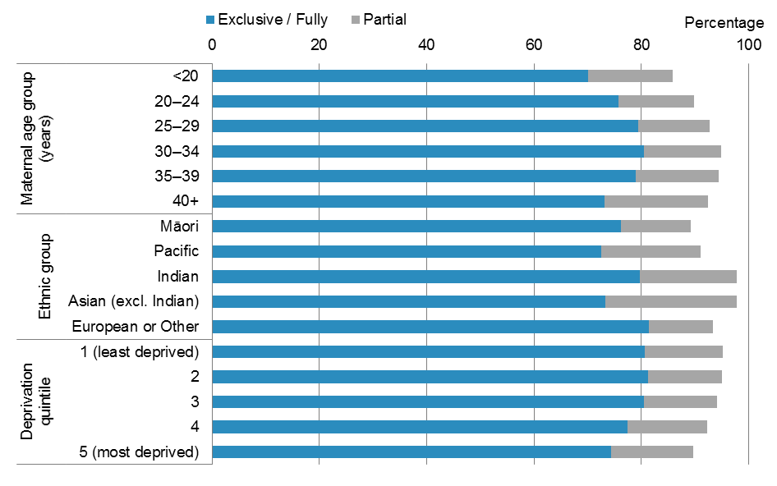

Notes:

The denominator used to calculate the percentage is the number of babies, excluding those with unknown breastfeeding status, at two weeks after birth.

Breastfeeding status is only available for babies of women registered with an LMC or a DHB primary maternity service.

In 2014, babies in West Coast DHB region had the highest proportion of being breastfed exclusively or fully (87.3%), while the lowest was in MidCentral DHB region (71.3%).

Between 2010 and 2014, the proportion of babies exclusively or fully breastfed at two weeks after birth decreased in most DHB regions. This decrease was significant for babies in Auckland (from 83.2% to 80.0%), Taranaki (from 80.8% to 75.5%), MidCentral (from 78.5% to 71.3%) and Nelson Marlborough (from 82.7% to 79.0%) DHB regions. There was a slight increase (not significant) in the proportion of babies exclusively or fully breastfed in Hawke’s Bay DHB region (from 78.4% to 80.0%) (Figure 60).

Figure : Percentage of babies exclusively or fully breastfed at two weeks after birth, by DHB of residence, 2010 and 2014

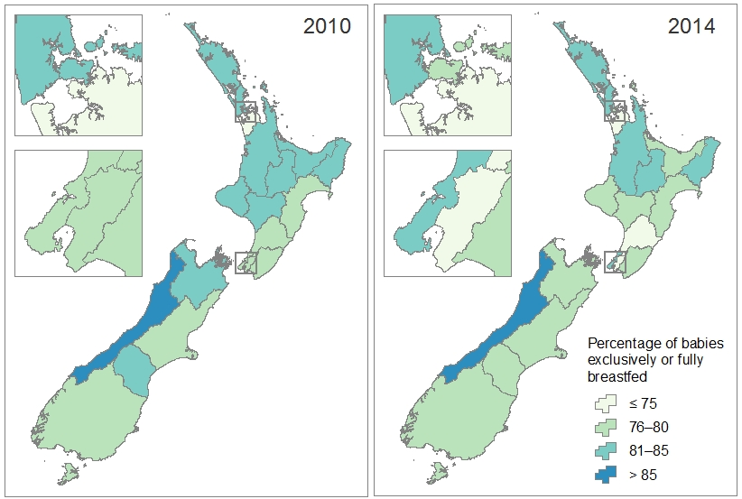

Notes:

The denominator used to calculate the percentage is the number of babies, excluding those with unknown breastfeeding status, at two weeks after birth.

Breastfeeding status is only available for babies of women registered with an LMC or a DHB primary maternity service.

## Handover of care

Under the Primary Maternity Services Notice 2007, the LMC is responsible for ensuring that handover to primary care and Well Child / Tamariki Ora services takes place. At four to six weeks after birth the LMC must:

* discharge the woman from LMC services and notify their GP
* transfer the baby’s care to a Well Child / Tamariki Ora provider.

Women may decline the referral to a GP and to a Well Child / Tamariki Ora provider.

The data presented regarding referrals is sourced from LMC claim forms and is therefore only available for women who were registered with an LMC and their babies.

Of the women giving birth in 2014 and registered with an LMC, the vast majority accepted referral to their GPs at LMC discharge (95.4%). Care for the majority of the babies was transferred to a Well Child/Tamariki Ora provider (97.6%).

The proportion of referral for women and their babies has been consistently high at over 95% from 2008 to 2014 (Figure 61).

Figure : Percentage of women referred to their general practitioner and babies to a Well Child/Tamariki Ora provider, 2008–2014

Figure 61: Percentage of women referred to their general practitioner and babies to a Well Child/Tamariki Ora provider, 2008–2014

Notes:

The denominator used to calculate percentages is the number of women giving birth or of live-born babies, excluding those with unknown status regarding referral (4–6% each year).

Referral data is sourced from LMC claim forms and is therefore only available for women registered with an LMC and their babies.

# References

APHO. 2008. *Technical Briefing 3: Commonly used public health statistics and their confidence intervals*.London: Association of Public Health Observatories.

Birthplace in England Collaborative Group. 2011. Perinatal and maternal outcomes by planned place of birth for healthy women with low risk pregnancies: the Birthplace in England national prospective cohort study. *BMJ* 343: d7400.

Chalmers B, Kaczorowski J, Darling R, et al. 2010. Cesarean and vaginal birth in Canadian women: a comparison of experiences. *Birth* 37(1): 44–9. DOI: 10.1111/j.1523-536X.2009.00377.x (accessed 22 October 2015).

Gregory K, Jackson S, Korst L, et al. 2012. Cesarean versus vaginal delivery: Whose risks? Whose benefits? *American Journal of Perinatology* 29(1): 7–18. DOI: 10.1055/s-0031-1285829 (accessed 22 October 2015).

Jordan S, Emery S, Bradshaw C, et al. 2005. The impact of intrapartum analgesia on infant feeding. *British Journal of Obstetrics & Gynaecology* 112: 927–34. DOI: 10.1111/j.1471-0528.2005.00548.x (accessed 22 October 2015).

Levine E, Ghai V, Barton J, et al. 2001. Mode of delivery and risk of respiratory diseases in newborns. *Obstetrics & Gynaecology* 97(3): 439–42.

Ministry of Health. 2002. *Breastfeeding: A guide to action*. Wellington: Ministry of Health.

Ministry of Health. 2004. *Ethnicity Data Protocols for the Health and Disability Sector*. Wellington: Ministry of Health.

Ministry of Health. 2006. *Report on Maternity: Maternal and newborn information 2003*.Wellington: Ministry of Health.

Ministry of Health. 2012. *Guidelines for Consultation with Obstetric and Related Medical Services (Referral Guidelines)*. Wellington: Ministry of Health.

NICE. 2014. *Intrapartum Care: Care of healthy women and their babies during childbirth (NICE clinical guideline 190)*. London: National Institute of Health and Care Excellence.

OECD. 2013. Caesarean sections. In: *Health at a Glance 2013: OECD Indicators*. OECD Publishing.

Penders J, Thijs C, Vinc C, et al. 2006. Factors influencing the composition of the intestinal microbiota in early infancy. *Paediatrics* 118(2): 511–21. DOI: 10.1542/peds.2005-2824 (accessed 22 October 2015).

PMMRC. 2014. *Eighth Annual Report of the Perinatal and Maternal Mortality Review Committee: Reporting mortality 2012.* Wellington: Health Quality & Safety Commission.

WHO. 1975. *International Classification of Diseases (Volume 1): 1975 revision*.Geneva: World Health Organization.

WHO. 2005. *Maternal and Newborn Health in the WHO European Region: The challenges and the way forward: Fact sheet EURO/03/05*. Copenhagen: World Health Organization.

WHO, UNICEF. 2004. *Low Birthweight: Country, regional and global estimates*. New York: United Nations Children’s Fund.

# Glossary

| **Term** | **Definition** |
| --- | --- |
| Artificially fed | The newborn has had no breast milk but has had alternative liquid such as infant formula with or without solid food in the past 48 hours. |
| Assisted birth | A vaginal birth (including breech birth) receiving obstetric assistance (eg, forceps, vacuum). |
| Assisted birth, forceps | An assisted vaginal birth using a metallic obstetric instrument. See also *Assisted birth*. |
| Assisted birth, vacuum | An assisted vaginal birth using a suction cap applied to the baby’s head. See also *Assisted birth*. |
| Assisted breech birth | An assisted vaginal birth in which a baby being born feet or buttocks first is delivered spontaneously as far as its umbilicus and is then extracted. It may include the use of forceps. See also *Assisted birth*; *Breech birth*. |
| Augmentation (of labour) | The process of stimulating the uterus to increase the frequency, duration and intensity of contractions after the onset of spontaneous labour by artificial rupture of membranes or pharmacological means. |
| Birth | The birth of a live-born or stillborn baby (or babies, in the case of a twin/multiple birth). See also *Live-born baby*; *Stillbirth*. |
| Birth rate | Number of women giving birth / female population of reproductive age * 100  See also *Reproductive age*. |
| Birthing unit | A primary maternity facility, usually staffed by midwives. Birthing units provide care for women assessed as being at low risk of complications for labour and birth care. They do not provide epidural analgesia or operative birth services (Ministry of Health 2012). See also *Primary maternity facility*. |
| Birthweight | The first weight of the fetus or newborn obtained after birth, preferably measured within the first hour of life before significant postnatal weight loss has occurred (WHO 1975). |
| Breastfed, exclusive | An infant who has never, to the mother’s knowledge, had any water, formula or other liquid or solid food. Only breast milk (from the breast or expressed) and prescribed medicines (defined in the Medicines Act 1981) have been given to the baby from birth. |
| Breastfed, fully | An infant has taken breast milk only, and no other liquids or solids except a minimal amount of water or prescribed medicines, in the past 48 hours. |
| Breastfed, partial | An infant has taken some breast milk and some infant formula or other solid food in the past 48 hours. |
| Breech birth | A vaginal birth of a baby by the buttocks or lower limbs first rather than the head. May be spontaneous or assisted. |
| Breech extraction | An assisted vaginal birth performed by grasping the baby’s feet or buttocks before any part of the trunk is born and delivering by traction. It may include the use of forceps. See also *Assisted birth*; *Breech birth*. |
| Caesarean section | An operative delivery through an abdominal incision. |
| Confidence interval | A range of values used to describe the uncertainty around a single value, used to estimate the true value in a population. Confidence intervals describe how different an estimate could have been if chance had led to a different set of data. |
| Denominator | The number that appears at the bottom of a fraction, used to calculate proportions.See also *Proportion*. |
| Deprivation quintile | A measure of socioeconomic status derived from the 2006 or 2013 New Zealand Social Deprivation Index. The measure is calculated for small geographical units, which are then built up to the relevant geographic scale using weighted average ‘usually resident population’ counts from the Census. Deprivation quintiles of residence range from 1 (least deprived) to 5 (most deprived). Approximately equal numbers of the total population reside in areas associated with each of the quintiles. |
| District health board (DHB) | An organisation established under Section 19 of the New Zealand Public Health and Disability Act 2000, acting within a defined geographic region. |
| Domicile code | A code representing the usual residential address of the woman giving birth or the live-born baby. |
| Elective caesarean section | A caesarean section performed as a planned procedure before or following the onset of labour, where the decision to have a caesarean section was made before labour. See also *Caesarean section*. |
| Emergency caesarean section | A caesarean section performed urgently once labour has started. See also *Caesarean section*. |
| Epidural | A regional analgesic agent injected into the epidural space of the spinal cord. |
| Episiotomy | An incision of the perineal tissue surrounding the vagina at the time of birth to facilitate delivery. |
| Ethnicity, ethnic group | Ethnicity is the ethnic group or groups that people may identify with or feel they belong to. Ethnicity is self-perceived; a person may identify with more than one ethnic group (Ministry of Health 2004). See also *Prioritised ethnicity*. |
| Facility (maternity) | See *Maternity facility*. |
| Forceps | See *Assisted birth, forceps*. |
| Gestation, gestational age | The duration of pregnancy measured from the first day of the last normal menstrual period to the delivery date, expressed in completed weeks (WHO 1975). Gestational age may also be derived from clinical assessment during pregnancy or from an examination of the baby after birth. |
| Home birth | A birth that takes place in a person’s home and not in a maternity facility or birthing unit. See also *Intended home birth*. |
| Induction (of labour) | The process of artificially stimulating the uterus to start labour by artificial rupture of membranes or pharmacological means. |
| Intended home birth | A birth for which there is a documented plan to give birth at home and the management of the labour commences at home. The birth may or may not occur at home. |
| Intervention | An induction or augmentation of labour, an epidural during labour or an episiotomy. See also *Augmentation*; *Epidural*; *Episiotomy*; *Induction*. |
| Lead Maternity Carer (LMC) | A person who:   * is: * a general practitioner with a Diploma in Obstetrics (or equivalent, as determined by the New Zealand College of General Practitioners); or * a midwife; or * an obstetrician; and * is either: * a maternity provider in his or her own right; or * an employee or contractor of a maternity provider; and * has been selected by the woman to provide her lead maternity care. |
| Live-born baby, live birth | The complete expulsion or extraction from its mother of a product of conception, irrespective of duration of pregnancy, which, after such separation, breathes or shows any other evidence of life, such as beating of the heart, pulsation of the umbilical cord, or definite movement of voluntary muscles, whether or not the umbilical cord has been cut or the placenta is attached; each product of such a birth is considered live-born (WHO 1975). |
| Low birthweight | A birthweight of less than 2.5 kg (WHO 1975). See also *Birthweight*. |
| Maternity facility | A facility that provides maternity services in accordance with the Tier Two Service Specification available from the Ministry of Health. See also *Birthing unit*; *Primary facility*; *Secondary facility*; *Tertiary facility*. |
| Median | The middle data point if data is ranked from the lowest to the highest. It is used instead of the mean when data does not have a normal distribution. |
| Ministry of Health | The New Zealand Government’s principal advisor on health and disability, with overall responsibility for the management and development of the system. |
| National Health Index (NHI) number | A unique identifier number allocated to individual service users by the National Health Index, managed by the Ministry of Health. |
| National Minimum Dataset (NMDS) | A collection of health data that is collected routinely from all people discharged from a hospital in New Zealand. |
| Normal birth | Spontaneous vaginal birth (includes spontaneous vertex and spontaneous breech), without an induced or augmented labour, an epidural or an episiotomy. |
| Numerator | The number that appears at the top of a fraction, used to calculate proportions.See also *Proportion*. |
| Parity | The number of times a woman has previously given birth, including stillbirths. |
| Plurality | The number of babies resulting from a pregnancy. |
| Postnatal | All pregnancy-related events up to six weeks following birth. |
| Preterm birth, preterm labour | Birth or labour before 37 completed weeks’ of gestation (WHO 1975). See also *Gestation*. |
| Primary maternity facility, primary facility | A maternity unit that provides care for normal births with care provision from midwives. It is specifically for women assessed as being at low risk of complications for labour and birth care. Access to specialist secondary maternity services and care will require transfer to a secondary or tertiary facility. Primary facilities do not provide epidural analgesia or operative birth services. Birthing units are considered to be primary facilities. See also *Birthing unit*; *Maternity facility*. |
| Primary Maternity Services Notice 2007 | Notice pursuant to Section 88 of the New Zealand Public Health and Disability Act 2000 that came into force on 1 July 2007. |
| Prioritised ethnicity | A system by which each individual is allocated to a single ethnic group using the priority system Māori > Pacific peoples > Indian > Asian (excluding Indian) > European > Other. See also *Ethnicity.* |
| Proportion | A part, share or number considered in comparative relation to a whole. Proportions are calculated by dividing the numerator by the denominator, and are expressed as a percentage in this publication.See also *Denominator*; *Numerator*. |
| Reproductive age | Aged between 15 and 44 years. |
| Secondary maternity facility, secondary facility | A hospital that can provide care for normal births, complicated pregnancies and births, including operative births and caesarean sections, plus specialist adjunct services including anaesthetics and paediatrics. As a minimum, secondary facilities include an obstetrician rostered on site during working hours and on call after hours, with access to support from an anaesthetist, paediatrician, radiological, laboratory and neonatal services (Ministry of Health 2012). See also *Maternity facility*. |
| Spontaneous breech | The birth of a baby in a breech presentation without obstetric intervention to facilitate delivery. See also *Breech birth*; *Spontaneous vaginal birth*. |
| Spontaneous vaginal birth | A vaginal birth without obstetric intervention to facilitate delivery. Includes spontaneous vertex and spontaneous breech births. |
| Spontaneous vertex birth | The birth of a baby in a vertex presentation without any obstetric intervention to facilitate delivery. See also *Spontaneous vaginal birth*. |
| Stillbirth, stillborn baby | A dead fetus that (a) weighed 400 g or more when issued from its mother, or (b) issued from its mother after the 20th week of pregnancy (Births, Deaths, Marriages, and Relationships Registration Act 1995). See also *Birth*. |
| Term birth, term labour | Birth or labour at 37–41 completed weeks’ gestation (WHO 1975). See also *Gestation*. |
| Tertiary maternity facility, tertiary facility | A hospital that can provide care for women with high-risk, complex pregnancies, by specialised multidisciplinary teams. Tertiary maternity care includes an obstetric specialist or registrar immediately available on site 24 hours a day and an on-site, level 3 neonatal service (Ministry of Health 2012). See also *Maternity facility*. |
| Trimester | One of three periods into which a woman’s pregnancy is divided: first trimester: <13 weeks’ gestation; second trimester: 13–28 weeks’ gestation; third trimester: 29+ weeks’ gestation. |
| Vacuum extraction | See *Assisted birth*, *vacuum*. |
| Well Child/Tamariki Ora | The Well Child/Tamariki Ora programme is a package of universal health services offered free to all New Zealand families/whānau for children from birth to five years. |

# Appendices

The appendices are as follows:

* Appendix 1: Maternity model of care
* Appendix 2: National Maternity Collection
* Appendix 3: Technical notes
* Appendix 4: Guide to reading maps
* Appendix 5: Catchment areas.

## Appendix 1: Maternity model of care

Maternity services in New Zealand are classified according to the level of complexity of clinical care a woman and her baby require – either primary, secondary or tertiary. Maternity services are provided by a range of practitioners (midwives, GPs, medical specialists, radiologists and childbirth educators) and in a range of settings (a woman’s home, consulting rooms, primary birthing units and hospitals).

There are a range of employment and contracting models in place for maternity services, including direct Ministry funding, DHB funding, private funding or a mix of these. Most maternity services are free to eligible women, although some services have co-payments.

### Primary maternity care

The Primary Maternity Services Notice 2007, pursuant to Section 88 of the New Zealand Public Health and Disability Act 2000, sets out the objectives of primary maternity services, which are to:

* give each woman, her partner and her family/whānau every opportunity to have a fulfilling outcome to the woman’s pregnancy and childbirth by facilitating the provision of primary maternity services that are safe, informed by evidence and based on partnership, information and choice
* recognise that pregnancy and childbirth are a normal life stage for most women
* provide the woman with continuity of care through her LMC, who is responsible for assessing her needs, and planning her care with her and the care of her baby
* facilitate the provision of appropriate additional care for those women and babies who need it.

All eligible women in New Zealand are entitled to continuity of primary maternity care through an LMC. Women who choose a midwife or GP as their LMC receive this care for free. Women may also choose to receive primary maternity care from an obstetrician operating as an LMC, but they usually have to pay a co-payment for this care.

Women who do not access an LMC, either through choice or lack of availability, are entitled to receive primary maternity services from their DHB. Women are less likely to receive continuity of care within a DHB primary maternity services service than they are with an LMC. The Primary Maternity Services Tier Two Service Specification sets the requirement for the delivery of DHB primary maternity services and is largely analogous to the Primary Maternity Services Notices 2007.

### Place of birth

Women are entitled to choose where they give birth. This may include a tertiary hospital, secondary hospital, primary birthing unit or at home. Women are entitled to give birth at a facility with greater clinical capacity than their expected clinical need. Primary birthing units and home birth are recommended for women likely to experience normal birth. Place of birth usually reflects the local configuration of facilities and LMC access agreements, in addition to clinical need and then woman’s preference.

### Current funding model

The majority of pregnant women receive services funded through the Notice. The Notice is a modular, fee-for-service model that specifies service expectations and funds LMC services, non‑LMC first trimester and urgent care, primary maternity ultrasounds and some specialist services.

The Ministry of Health also purchases primary maternity services from DHBs. The DHB is defined in the DHB Service Coverage Schedule as the ‘[primary maternity service] provider of last resort’ and is expected to meet the primary maternity service needs of women who do not receive care from a midwife LMC funded via the Notice, including women with no LMC and women who are under the care of an obstetric or GP LMC.

The extent of primary maternity services being provided by DHBs varies significantly by DHB, ranging from DHBs that do not currently provide any primary maternity services[18] to DHBs that provide primary maternity services to at least one-quarter of their women giving birth.[19] This has changed notably over time.

The Ministry of Health purchases all secondary and tertiary services and all maternity facilities from DHBs. These services and facilities are free for all eligible women.

## Appendix 2: National Maternity Collection

The Ministry of Health’s National Maternity Collection provides statistical, demographic and clinical information about selected publicly funded maternity services up to nine months before and three months after a birth. It collates data about each pregnancy that results in birth and each live-born baby separately from:

* inpatient and day-patient health event data during pregnancy, birth and the postnatal period for women giving birth and their babies, sourced from the National Minimum Dataset (NMDS)
* Lead Maternity Carer (LMC) claim forms for primary maternity services provided under the Primary Maternity Services Notice 2007
* primary maternity services provided by DHBs to women who do not have a midwife LMC.[20]

These sources are collected for administrative purposes, including the funding of maternity services. See below for further notes about each of the three sources of data for the National Maternity Collection, as well as a breakdown of data sources for women giving birth in 2014 (Figure 62).

Figure : Number of women giving birth in 2014 recorded in the National Maternity Collection by data source and place of birth

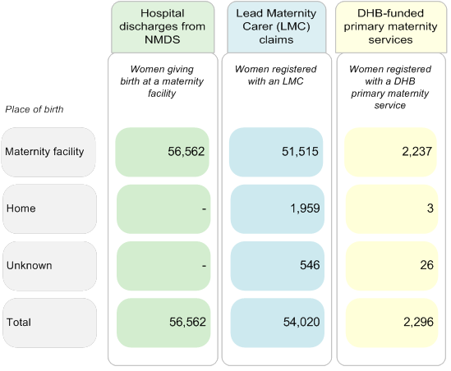

### National Minimum Dataset

NMDS stores administrative information routinely collected for all publicly funded inpatients of a New Zealand maternity facility (publicly and privately funded hospitals and birthing units). This information contains a large amount of demographic and clinical data, including data on diagnoses and the procedures used. The information is assigned standardised codes that are internationally comparable. The classification system used is the International Statistical Classification of Diseases and Related Health Problems, 10th Revision, Australian Modification (ICD-10-AM). This system is designed for the classification of morbidity and mortality information for statistical, epidemiological and clinical purposes. Refer to the NMDS Data Dictionary for more information on the data held in the NMDS.

### Lead Maternity Carer claims data

This data set contains information on women and babies who access primary maternity services funded under the Primary Maternity Services Notice 2007. This information is received through the claim forms and includes all women registered with an LMC. Data sourced from LMC claim forms includes details on registration with an LMC, as well as other antenatal and postnatal factors (eg, parity, smoking status and breastfeeding status).

### DHB-funded primary maternity services data

Collection of the data set from DHB-funded primary maternity services is under way. This data set contains information (similar to LMC claims data) on women who access DHB primary maternity services, including DHB caseload midwives, DHB primary midwifery teams and shared care arrangements. Once complete, this data set will increase the scope of information the Ministry of Health holds on women who access primary maternity services, and their babies.

## Appendix 3: Technical notes

### Ethnicity

This publication uses *prioritised ethnicity*, whereby each person represented in the data is allocated to a single ethnic group using the priority system Māori > Pacific > Indian > Asian (excluding Indian) > Other ethnicities> European. The aim of prioritisation is to ensure that where it is necessary to assign people to a single ethnic group, ethnic groups that are small or important in terms of policy are not swamped by the European ethnic group. This is also a more robust method of dealing with the low rate of multiple ethnicities in health sector data. Further information on ethnicity data protocols for the health and disability sector is available from the Ministry of Health ethnicity protocols (Ministry of Health 2004).

Individuals recorded as being of Other ethnicities are primarily Middle Eastern, Latin American or African. The number of individuals in the Other ethnic group is small, and therefore the ‘Other’ group is often included with the European group for analysis.

In this publication, individuals are commonly presented as the following ethnic groups: Māori, Pacific, Indian, Asian (excl. Indian) and European or Other. Information on individual ethnic groups that are aggregated in this publication can be made available on request.

### Deprivation

The New Zealand Deprivation Index (NZDep) is a measure of socioeconomic status calculated for small geographic areas. The calculation uses nine variables from each Census of Population and Dwellings and provides a summary deprivation score between 1 and 10 for each meshblock (small geographical unit containing a median of 90 people).

The Ministry of Health maps the meshblocks to domicile codes, which are built up to the relevant geographic scale using weighted average census usually resident population counts. Further information about socioeconomic deprivation in New Zealand is available on the [University of Otago](http://www.otago.ac.nz/wellington/departments/publichealth/research/hirp/otago020194.html#atlas) website www.otago.ac.nz.

In this publication, individuals are categorised into deprivation quintiles, ranging from 1 (least deprived) to 5 (most deprived). As this publication includes births over a time period  
(2005–2014) that included the occurrence of the 2006 and 2013 Censuses, the deprivation quintiles are derived from:

* the 2006 NZDep for women giving birth or babies born before 2010 (mid-point between Censuses)
* the 2013 NZDep for women giving birth or babies born from 2010 onwards.

Approximately equal numbers of the population reside in areas associated with each of the five deprivation quintile areas.

### Type of birth

Information on types of birth procedure is only available for women giving birth at a maternity facility. Women giving birth at home are assumed to have had a spontaneous vertex birth.

Some women have more than one birth procedure reported for the birth of their baby. This publication uses a priority system by which a maximum of one procedure type is reported per woman giving birth. Table 7 shows the priority system, and how this publication has aggregated each birth procedure into a type of birth for reporting purposes.

Table : Priority for reporting birth procedures

|  |  |  |
| --- | --- | --- |
| **Priority** | **Birth procedure** | **Type of birth (aggregated)** |
| 1 | Emergency caesarean | Caesarean section |
| 2 | Elective caesarean | Caesarean section |
| 3 | Breech extraction | Assisted birth |
| 4 | Assisted breech | Assisted birth |
| 5 | Spontaneous breech | Spontaneous vaginal birth |
| 6 | Forceps and vacuum | Assisted birth |
| 7 | Forceps | Assisted birth |
| 8 | Vacuum | Assisted birth |
| 9 | Spontaneous vertex | Spontaneous vaginal birth |
| 10 | Not stated | Unknown |

### Denominators used for calculating birth rates

The following data sets were used as denominators to calculate birth rates in this publication:

* estimated resident population by prioritised ethnicity, age, sex and DHB as at 30 June, 2005–2013
* estimated resident population by age, sex and DHB as at 30 June, 2014
* population projections derived from the estimated resident population as at 30 June, by prioritised ethnicity, age, sex and DHB, 2014
* Census 2006 usually resident population by deprivation quintile, age, sex and DHB
* estimated resident population by deprivation quintile, age, sex and DHB as at 30 June 2013.

All data sets were supplied as customised extracts from Statistics New Zealand. Further information about the methods used to prepare estimates and projections, as well as their limitations, is available on the [Statistics New Zealand website](http://www.stats.govt.nz/) www.stats.govt.nz

Estimated resident population counts are regarded as the best available population, and are used whenever possible as the denominator to calculate birth rates in this publication.

Annual population counts used to calculate birth rates by neighbourhood deprivation quintile were derived by applying the best available population count to the proportion of people in each deprivation quintile (only available on census years). The proportion of people in each deprivation quintile was based on:

* the 2006 Census usually resident population, to calculate rates before 2010
* the estimated resident population as at 30 June 2013, to calculate rates from 2010 onwards.

## Appendix 4: Guide to reading maps

Darkest colour on map represents the highest rate/percentage and the lighest colour represents the lowest rate/percentage. 
Inset shows an enlarged version of the DHBs in the greater Auckland and Wellington regions. 
Extent indicators show the location of the geographic area of the insets.
Legend shows the measure and rage of values for each colour/category presented. 


## Appendix 5: Catchment areas

The list of available primary, secondary and tertiary maternity facilities by DHB is provided below. Figure 63 presents their geographical locations.

| **District health board** | **Tertiary facility1** | **Secondary facility2** | **Primary facility3** |
| --- | --- | --- | --- |
| Northland | Auckland City | Whangarei | Bay of Islands  Dargaville  Hokianga Health  Kaitaia |
| Waitemata | North Shore  Waitakere | Helensville  Warkworth  Wellsford |
| Auckland |  | Birthcare Auckland |
| Counties Manukau | Middlemore |  | Botany Downs  Papakura  Pukekohe |
| Waikato | Waikato |  | Bethlehem  Birthcare Huntly  Matariki  Pohlen Trust  Rhoda Read  River Ridge  Taumarunui  Te Kuiti  Thames  Tokoroa  Waihi  Waterford |
| Lakes | Rotorua | Taupo |
| Bay of Plenty | Tauranga  Whakatane | Murupara  Opotiki |
| Tairāwhiti | Gisborne | Ngati Porou Hauora |
| Taranaki | Taranaki Base | Elizabeth R  Hawera |
| Hawke’s Bay | Wellington | Hawke’s Bay Regional | Wairoa |
| MidCentral | Palmerston North | Dannevirke  Horowhenua |
| Whanganui | Whanganui | Otaihape  Waimarino |
| Capital & Coast |  | Kapiti  Kenepuru |
| Hutt Valley | Hutt |  |
| Wairarapa | Wairarapa |  |
| Nelson Marlborough | Wairau  Nelson | Golden Bay  Motueka |
| West Coast | Christchurch | Grey Base | Buller |
| Canterbury |  | Akaroa*  Ashburton  Burwood  Darfield  Kaikoura  Lincoln  Rangiora  St George’s  Waikari* |
| South Canterbury | Timaru |  |
| Southern | Dunedin | Southland | Charlotte Jean  Clutha  Dunstan  Gore  Lakes District  Lumsden  Maniototo  Oamaru  Tuatapere  Winton |

1 A hospital that provides care for women with high-risk, complex pregnancies by specialised multidisciplinary teams. Tertiary maternity care includes an obstetric specialist or registrar immediately available on site 24 hours a day, and an on-site, level 3 neonatal service.

2 A hospital that provides care for normal births, complicated pregnancies and births, including operative births and caesarean sections, plus specialist adjunct services including anaesthetics and paediatrics. As a minimum, secondary facilities include an obstetrician rostered on site during working hours and on call after hours, with access to support from an anaesthetist, paediatrician, radiological, laboratory and neonatal services.

3 A maternity unit that provides care for normal births with care provision from midwives. It is specifically for women assessed as being at low risk of complications for labour and birth care. Access to specialist secondary maternity services and care will require transfer to a secondary or tertiary facility. Primary facilities do not provide epidural analgesia or operative birth services. Birthing units are considered to be primary facilities.

* These facilities did not provide birth care in 2014.

Figure : Maternity facilities in New Zealand, by DHB region and facility type

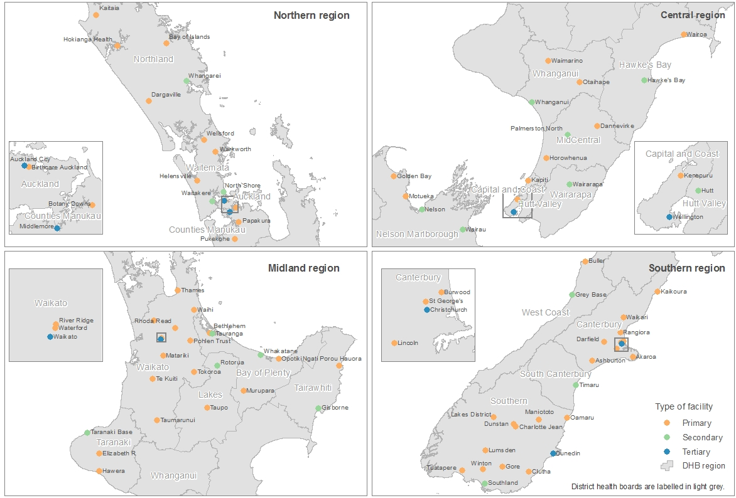

Note: Not all facilities presented in this map provided birth care in 2014.

1. Data on maternal deaths and stillborn babies is recorded in the Mortality Collection and is not included in the National Maternity Collection. Statistics about maternal deaths are presented in the [Mortality and Demographic Data series](http://www.health.govt.nz/nz-health-statistics/health-statistics-and-data-sets/mortality-and-demographic-data-series). Statistics about stillborn babies are presented in the [Fetal and Infant Deaths series](http://www.health.govt.nz/nz-health-statistics/health-statistics-and-data-sets/fetal-and-infant-deaths-series) and in the [annual report](http://www.hqsc.govt.nz/our-programmes/mrc/pmmrc/publications-and-resources/publication/2123/) of the Perinatal and Maternal Mortality Review Committee.
2. Age was recorded for all women giving birth.
3. Population denominator data is not available for the Indian ethnic group. Birth rates for the Asian ethnic group include women of Indian and of Asian (excl. Indian) ethnicities.
4. Neighbourhood deprivation quintile was unknown for 463 women (0.8%).
5. Parity was unknown for 896 women (1.6%).
6. BMI was unknown for 151 women (0.3%).
7. Smoking status was unknown for 15 women (0.03%) at first registration and for 2396 women (4.3%) at two weeks after birth.
8. Primary Maternity Services Notice 2007, pursuant to Section 88 of the New Zealand Public Health and Disability Act 2000.
9. Not all DHBs provide primary maternity services and not all DHBs who provide maternity primary services have reported to the National Maternity Collection. Collection of this data (from 2014 onwards) is under way.
10. The caesarean section rate presented here is not comparable to the percentage of caesarean sections given elsewhere in this publication. The OECD report uses live births, while this publication uses the number of women giving birth as the denominator for rate or percentage calculations.
11. Calculated by dividing the number of caesarean sections (15,088) by the number of live-born babies (59,494) and multiplying by 100.
12. Women who had their labour both induced and augmented are recorded as having had an induction only. Therefore, the number of augmentations presented may be lower than the true number.
13. Plurality was unknown for 381 women (0.6%).
14. Birthweight was unknown for 2699 babies (4.5%).
15. These numbers include babies born preterm. A full description of term babies with a low birthweight is provided in the ‘Gestation‘ section.
16. The number of preterm babies presented here includes both spontaneous preterm births and iatrogenic preterm births.
17. In this section, term babies includes babies born at over 41 weeks’ gestation.
18. Bay of Plenty, Tairāwhiti, Taranaki, Whanganui, Wairarapa and Southern DHBs.
19. Auckland, Counties Manukau and West Coast DHBs (in 2014).
20. Collection of this data set (from 2014 onwards) is under way, and is incomplete at this time. Data currently available in the National Maternity Collection has been included in this publication.