Pharmacy Action Plan 2016–2020
Analysis of submissions

Citation: Ministry of Health. 2016. Pharmacy Action Plan 2016–2020:
Analysis of submissions. Wellington: Ministry of Health.
Published in August 2016
by the Ministry of Health
PO Box 5013, Wellington 6140, New Zealand
ISBN 978-0-947515-44-7 (online)
HP 6459
This document is available at www.health.govt.nz
This work is licensed under the Creative Commons Attribution 4.0 International licence. In essence, you are free to: share ie, copy and redistribute the material in any medium or format; adapt ie, remix, transform and build upon the material. You must give appropriate credit, provide a link to the licence and indicate if changes were made.

Contents
Executive summary v
Vision 1
Focus areas 4
Focus area 1: Population and personal health 4
Focus area 2: Pharmacist clinical services 7
Focus area 3: Acute demand management 10
Focus area 4: Dispensing and supply services 12
Focus area 5: Prescribing pharmacists 14
Key enablers 16
Enabler 1: Leadership 16
Enabler 2: Information and other technologies 17
Enabler 3: Workforce 19
Enabler 4: Regulation 21
Priority of actions 23
Appendix 1: List of submitters 25
Appendix 2: Consultation meetings 27

List of figures
Figure 1: Number of ‘yes’ or ‘no’ responses for each question vi
Figure 2: Number of responses providing more detail for each question, with detail ranging from ‘No response’ to ‘Essential’ vi
Figure 3: Summary of responses to Question 1 1
Figure 4: Summary of responses to Question 2 4
Figure 5: Summary of responses to Question 3 6
Figure 6: Summary of responses to Question 4 7
Figure 7: Summary of responses to Question 5 8
Figure 8: Summary of responses to Question 6 9
Figure 9: Summary of responses to Question 7 10
Figure 10: Summary of responses to Question 8 11
Figure 11: Summary of responses to Question 9 12
Figure 12: Summary of responses to Question 10 13
Figure 13: Summary of responses to Question 11 14
Figure 14: Summary of responses to Question 12 16
Figure 15: Summary of responses to Question 13 17
Figure 16: Summary of responses to Question 14 18
Figure 17: Summary of responses to Question 15 19
Figure 18: Summary of responses to Question 16 21
Figure 19: Summary of responses to Question 17 22

Executive summary
The draft Pharmacy Action Plan was released for public consultation on 12 October 2015. Consultation closed on 23 November 2015. There was strong engagement in the consultation, with 101 written submissions received. Submissions were comprehensive, of a high standard and reflected the views of a broad range of stakeholders across primary and secondary care, professional organisations, health system leaders, providers, clinicians, non-governmental organisations (NGOs), private-sector partners and consumers (see Appendix 1).

In addition, 24 face-to-face meetings were held, including three consumer meetings (see Appendix 2).

All submission feedback was collated and analysed by the Ministry’s project team. All suggestions for new actions or amendments to the existing draft Plan were evaluated by the project team and the final decision logged in an actions register.

Many submissions were complex and detailed. Given the volume of information received and the breadth of views expressed in the responses, and in the interests of clarity, this document does not include every response received for each question but instead summarises the key themes that emerged from the consultation.

Overall there was strong support for the Pharmacy Action Plan. The most common themes to emerge were:
- a call for the Plan to articulate a greater people focus and more emphasis on actions to promote health literacy, equity and improved access to health care for Māori, Pacific, rural, vulnerable and hard-to-reach populations
- strong support for the integration of pharmacists into the multidisciplinary health care team, consistent with the New Zealand Health Strategy’s concept of a ‘one team’ approach
- consumer support for pharmacists taking on extended roles
- the need for funding models that enable and support an integrated one-team approach to the provision of people-focused health care services that are sustainable
- the belief that the priority of actions must be based on the provision of quality health care rather than commercial factors
- a perceived conflict of interest between the ‘retail model’ and the provision of ethical health care services
- the belief that a clear separation between dispensing and prescribing should be retained
- clear agreement that the implementation of information technology (IT) systems that enable appropriate members of the health care team to access, contribute to and share relevant clinical information is an immediate priority
- consumer support for pharmacist access to their personal clinical information, provided the information is relevant to the care being provided, is only being accessed by the appropriate people and is stored securely.

The information and views provided have been used to inform revisions to the final Pharmacy Action Plan. The detailed submissions will also inform the future implementation of the Plan.

The following figures provide a summary of the responses to each question. The summary of responses is displayed in two figures because some questions received simple ‘yes/no’ responses, while others received more comprehensive details.

Figure 1: Questions that received ‘yes’ or ‘no’ responses
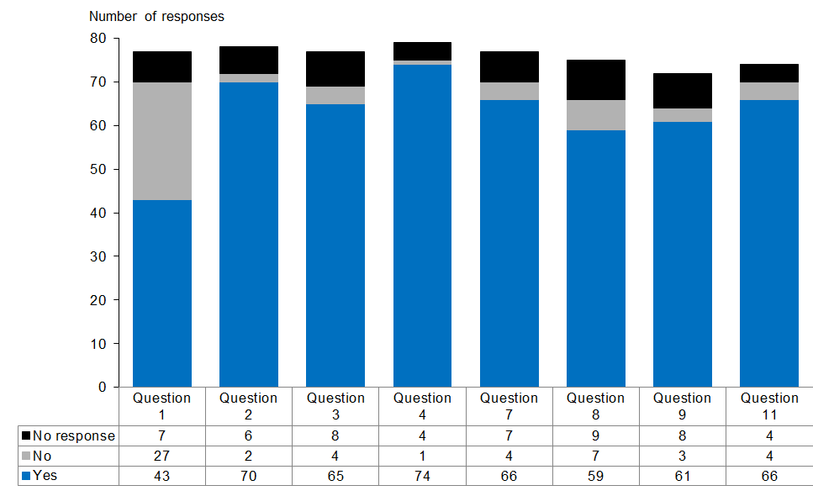

Figure 2: Questions that received more detailed responses, with detail ranging from ‘Not important’ to ‘Essential’
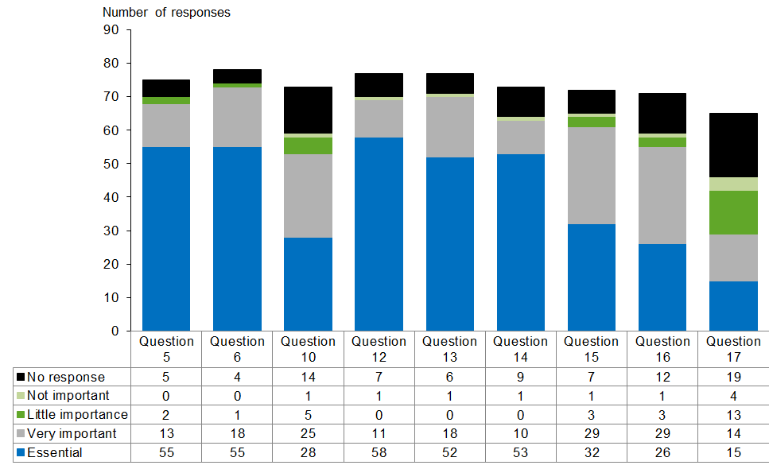

Vision

Question 1: Does the vision adequately address the strategic context for the future of pharmacy services as part of an integrated health and disability system in the next three to five years? If not, what is missing or what needs to be added?
Figure 3: Summary of responses to Question 1
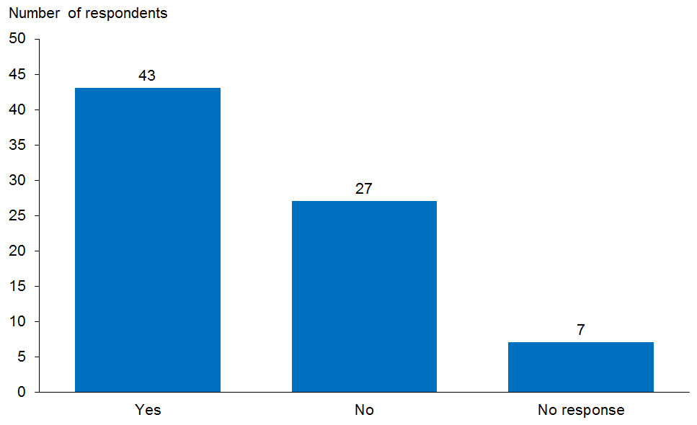

Seventy responses were received. There was general agreement on the direction signalled by the vision, but just over one-third of respondents felt the vision did not go far enough to address the strategic context for the future of pharmacy services over the next three to five years. The feedback suggested that the vision could be strengthened by broadening its focus, or better positioning it within strategies and frameworks that are already in place to guide the health and disability system as a whole.

Key themes

People focus
Some submissions commented that the draft Plan did not place sufficient emphasis and priority on people, people-focused service models and a partnership approach.

How we responded
The vision was expanded to reflect people and a partnership focus.

Equity
Several submitters wanted to see a stronger focus on improving health equity. It was noted that the draft Plan tended to frame equity in terms of actions to address ethnic disparities rather than the full range of socioeconomic factors that give rise to structural discrimination and health disparities. Several submitters noted that the ‘rural’ voice was missing and more needed to be done to ensure equity of access and sustainability of pharmacist services in rural areas, including the development and support of workforce.

How we responded
- The definition of equity was expanded.
- A new workforce action was developed: ‘Work with DHBs to develop a rural workforce programme to maintain access to pharmacist services in rural communities (Ministry of Health lead, 2017−19)’.

Integration
The majority of submitters agreed that health care services should be delivered in an integrated way, utilising the complementary skills of all professionals across the health and social sectors. Several commented on the need for a greater focus on collaboration and integration across the whole health workforce, alongside exploring expanded practice for pharmacists. Inter-professional learning at both undergraduate and postgraduate level was suggested as one way of fostering this. There were divergent views on whether co-location was necessary to provide integrated services.

Other key themes relating to integration were:
- the need for the pharmacist’s role within an integrated health system to be more clearly defined − this was considered important to allow pharmacists time to reconfigure business models, acquire new skills or adapt their practice to provide new services, which will not necessarily be delivered from a community pharmacy setting
- a perceived conflict of interest between the ‘retail model’ and the provision of ethical health care services
- the fact that some pharmacists and other health professionals may need support and encouragement to manage the change signalled by the Plan, which is a potential barrier to achieving the vision.

How we responded
A new workforce action was: ‘Develop programmes that support inter-professional education for pharmacists (undergraduate and post-graduate) (education providers lead, 2018−20)’.

Consumers
Several submissions commented on the need for consumers to be involved in the planning and development of new service models. There was also feedback on the importance of actions to strengthen health literacy and how to help consumers navigate the health system, as well as the need to educate consumers about the changing professional roles of pharmacists.

How we responded
- New wording was developed: ‘Health care professionals, funders and consumers work together to develop and implement models of care that take into account people’s preferences, lifestyles and desired health outcomes.’
- A New Population and Personal Health action was developed: ‘promote the dissemination of information on resources available to support safe and effective use of medicines (eg, medicines labelling for the blind) (Ministry of Health lead, 2017−18)’.
- The Minor Ailments action was reworded to: ‘Co-design a service model, in consultation with key stakeholders including consumers, to support the development and implementation of a minor ailments and referral service that delivers material net benefit to the whole system (Ministry of Health lead, 2016−17)’.
- A consumer representative will be appointed to the Pharmacy Steering Group.
- District health boards’ Community Pharmacy Services Agreement CPSA 2016 discussion forums will include consumer representatives.

Funding
Many submissions commented on funding and, in particular, noted that the draft Plan failed to provide specific detail on how new services will be funded. Following are some of the key funding themes identified.
- Sustainable and appropriate funding models need to be developed that support a ‘one team’ approach rather than those that drive competition for funding resources.
- Funding models should address financial barriers to access.
- Funding models should be materially cost-effective across the sector and match supply to local need.
- The CPSA should not be the only contractual agreement for funding pharmacist services.
- The vision is not achievable without funding to build capacity.
- It needs to be made clear how funding models will support practice setting changes.
- Funding models should address gaps in service delivery rather than potentially duplicating funding of services.

How we responded
- New wording was developed: ‘Funders will need to work closely with primary, secondary and community health care service providers to develop new, flexible ways of purchasing and contracting to enable these new people-centred, collaborative models of care to be implemented. New funding will be dependent on the development of a robust business case detailing proposed service changes, net benefits to the wider health system and the availability of funding from reprioritisation across the health sector.’
- The vision has been aligned with the Triple Aim, which balances quality of care and improved health and equity against best value for public health system resources.

Focus areas

Focus area 1: Population and personal health

Question 2: Do you agree that pharmacists should have a greater role in providing public-health-level interventions?
Figure 4: Summary of responses to Question 2
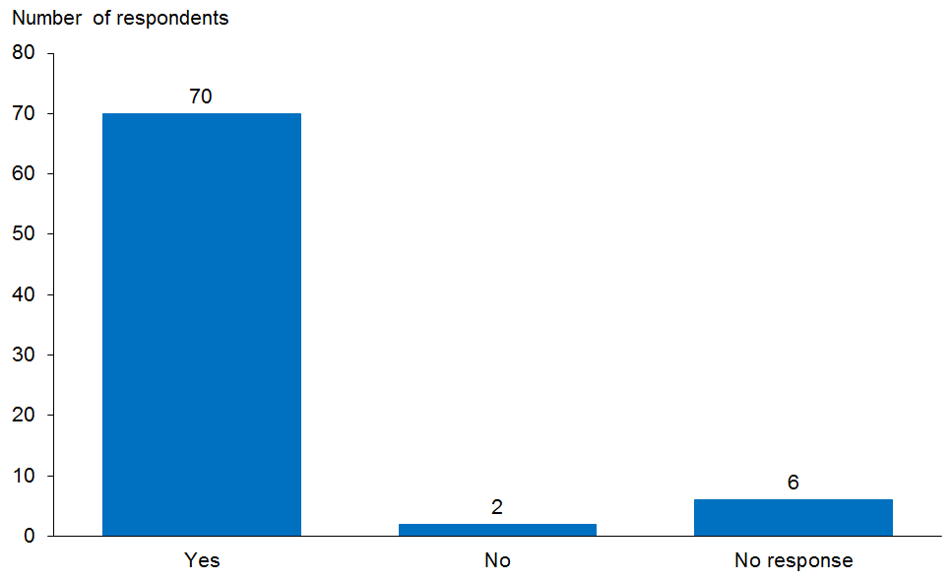

Seventy-two responses were received. The majority of submissions supported pharmacists playing a greater role in health promotion and preventive services, provided there are quality measures in place, the services do not take place in isolation and information can be shared with other health care providers.

A number of submissions noted that many pharmacies are actively involved in public health initiatives already, such as immunisation, needle exchange, blood pressure monitoring, weight management and smoking cessation support. Pharmacists are viewed as being ideally placed to work with public health initiatives in both primary and secondary settings to provide and/or reinforce lifestyle advice, assess health needs and refer to other health providers where needed.

Specific issues identified included the following.
- Pharmacist services must be complementary to, not in competition with, those offered by other health professionals.
- Consumers’ needs and preferences for how they access advice need to be understood and prioritised.
- For pharmacists to have a greater role in supporting public health interventions, contractual models must incentivise a change in the funding approach from product supply to patient-centred care.
- Patient−pharmacist activities need to be able to be recorded on a shared patient database in order to link the information with general practice and other health providers.

How we responded
- The Ministry is currently participating in a series of cross-sector forums organised by district health boards (DHBs) to discuss how ‘pharmacist services in the community’ might look. Participants at each forum include consumers.
- The person-centred and integration focus was strengthened.

Key themes

Screening
The majority of submissions supported pharmacist provision of screening services, with the caveat that risks be addressed and services limited to brief interventions (eg, screening for smoking status). Some submissions noted specific screenings services they considered inappropriate to be provided by pharmacists, including blood tests, blood pressure measurement or invasive procedures.

Specific issues noted included the following.
- Screening interventions may have the potential to place consumers at risk of unforeseen harms and add further pressure to limited health resources when not linked to the wider health system.
- Opportunistic screening may not address access and equity issues currently experienced by some members of the vulnerable population. There is the potential to further exacerbate unequal access to care.

Brief interventions
The majority of submissions supported the involvement of pharmacists in brief interventions, particularly smoking cessation and advice on weight management. There is support for pharmacists having an increased role in assessment, referral and providing brief interventions, provided this is supported by training and ongoing competency requirements.

Following are some of the specific issues raised.
- There is an ethical issue related to being both a prescriber and a dispenser (ie, the conflict of interest between providing an intervention and then ‘making a profit’ from the product supplied).
- Pharmacists need to be able to record their activities in national information systems to ensure continuity of care and integrated care (eg, if a patient receives an influenza vaccination, this information should be immediately available to a GP or hospital in case of an adverse reaction).
- Inappropriate referrals could incur unnecessary costs to the patient and the health sector as a whole.
- There is a need to provide a private consultation space to ensure patient privacy is maintained during the consultation.

How we responded
- The action was reworded as follows: ‘Support a review of regulatory requirements relating to licensed premises to clearly define the requirements that must be met to align with new service delivery models, with a focus on patient safety and privacy.’
- The focus on integration was strengthened.

Question 3: Do you think the population and personal health actions could encourage pharmacist-led population and personal health initiatives as part of integrated health services?
Figure 5: Summary of responses to Question 3
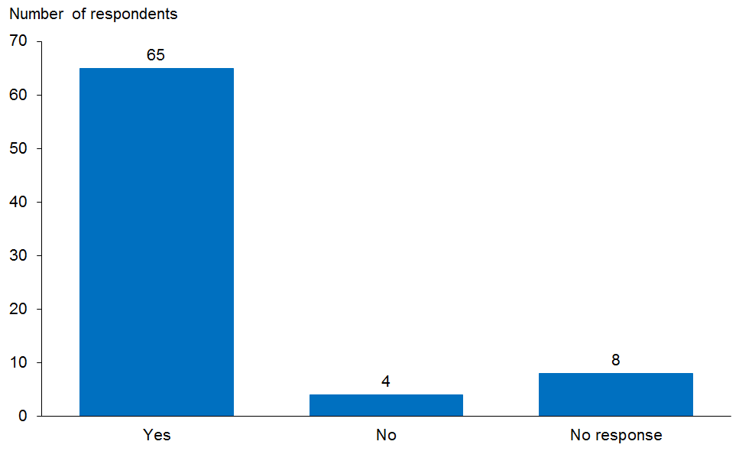

Sixty-nine responses were received, with the majority supporting the concept of pharmacist-led population and personal health initiatives, as long as these are carried out as part of an integrated service model, where brief interventions and other health initiatives provided in the community can be communicated to the other members of the health care team.

Several submissions commented on the importance of shared IT systems to facilitate this integrated approach, enable effective professional collaboration and assure patient safety. Having a shared care record with read/write access by all members of the health care team is considered essential to ensure brief interventions and other health initiatives provided in the community can be communicated to the other members of the health care team.

Specific issues noted included:
- the need for greater clarification on how pharmacists might lead such initiatives, which services could be specifically pharmacist led, and which services might coordinate the actions of other practitioners
- a perceived conflict of interest between the ‘retail model’ and the provision of ethical health care services.

Focus area 2: Pharmacist clinical services

Question 4: Do you agree with the focus in this section on optimising pharmacists’ medicines management expertise to be used across the health and social sectors in a broader range of settings as part of an interdisciplinary team?
Figure 6: Summary of responses to Question 4
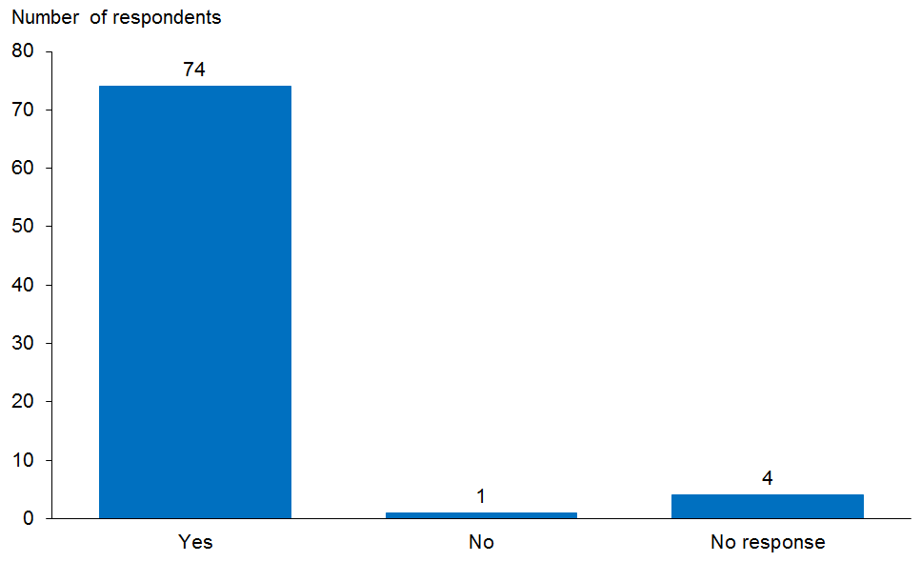

Seventy-five responses were received. There was strong support for pharmacists working collaboratively with other health professionals to improve medicines management and a clear message that pharmacists’ expertise in medicines management is valued.

Some submissions considered that long-term conditions and medicines use review (MUR) services are not clinical services and therefore should not be included in this focus area. Others noted that ‘clinical pharmacy’ doesn’t just happen in a hospital or GP surgery. There was support for a national roll-out of the MUR service, as this was seen as valuable in identifying non-adherence and health literacy issues before they lead to adverse outcomes.

There were divergent views on the terms ‘clinical’ and ‘clinical services’ and whether the Plan should refer to ‘clinical pharmacists’. Several submissions suggested that postgraduate qualifications are necessary in order to provide clinical services and that there should be similar support for pharmacists to gain these qualifications as there are for other health professionals (ie, equity for study days, Health Workforce New Zealand funding, etc).

There was significant feedback on the importance of providing clinical services in age-related residential care to support older people to live and remain well in their own home – especially roles for de-prescribing and avoiding medication-related adverse outcomes. Pharmacists were seen as having a key role in medicines optimisation.

Pharmacist clinical involvement in transitions of care to decrease medical and medication errors and improve care coordination also has strong support. There was a call for action to develop a national medicines information service.

How we responded
- Where possible, the terms ‘clinical’, ‘clinical services’ and ‘clinical pharmacist’ have been avoided. The focus area has been renamed ‘Medicines Management Services’ and now describes services on a continuum that includes prescribing. The National Pharmacist Services Framework diagram has been amended to illustrate this. The Plan remains non-specific about the level of qualifications required to deliver these services or the settings in which they will occur.
- A new action is: ‘Facilitate discussion with DHBs to explore development of a national medicines information service’.

Question 5: How important is it to change funding and contractual agreements (CPSA, PHO, Aged Care) for successful integration across primary health care services (including pharmacist services)?
Figure 7: Summary of responses to Question 5
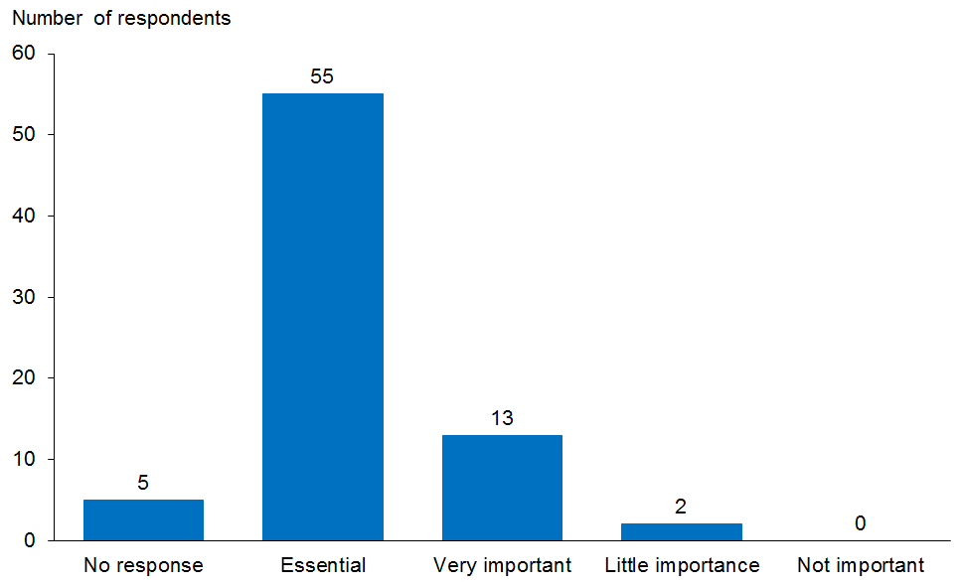

Seventy responses were received. Sixty-eight submissions agreed it is either essential or very important to change funding and contractual agreements for successful integration across primary health care services.

Concerns commented on by respondents included the following.
- Interdisciplinary teams can be costly and difficult to establish in primary care settings, so new ways of working will be essential to ensure success (eg, virtual teams).
- There was concern that ‘pharmacist clinical services’ only refers to those services outlined by the Pharmacy Council of New Zealand’s Medicine Management Competence Framework and does not include the important role pharmacists play in other areas (eg, education of other clinicians and quality improvement).
- There is a need to clearly define clinical services to ensure appropriate qualifications, training and monitoring.
- There is also a need to ensure services are well understood by the wider health team and embedded effectively within the health team, not alongside it.

How we responded
New wording was developed to illustrate that an integrated approach to contracting services will be taken, as follows.
- ‘Funders will need to work closely with primary, secondary and community health care service providers to develop new, flexible ways of purchasing and contracting to enable these new people-centred, collaborative models of care to be implemented. New funding will be dependent on the development of a robust business case detailing proposed service changes, net benefits to the wider health system and the availability of funding from reprioritisation across the health sector.’
- ‘While an improved inter-professional approach can provide enhanced people-centred care, there also needs to be system and organisational change to enable this. Under the Health and Disability Act, DHBs are required to work collaboratively with key stakeholders to plan, prioritise and coordinate at local, regional and national levels for the most effective and efficient delivery of health services. Our service delivery models need to match supply to local need while ensuring people can access the services they need, particularly in hard-to-reach areas.’

Question 6: How important is it that pharmacists are part of interdisciplinary teams?
Figure 8: Summary of responses to Question 6
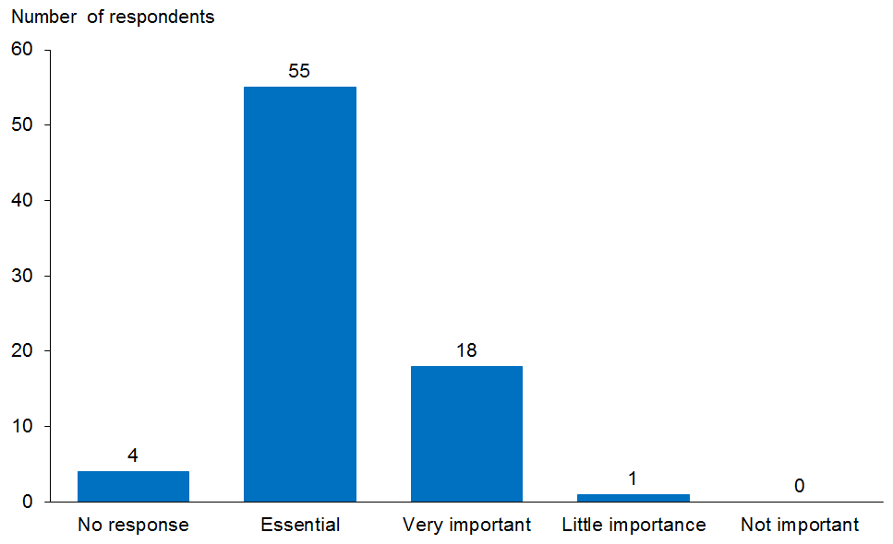

Seventy-four responses were received, with almost unanimous agreement that it is important that pharmacists be part of interdisciplinary teams. The perceived benefits of pharmacists working as part of interdisciplinary teams are that it:
- improves communication
- utilises the complementary skills of each team member and enables each to work to their skill set
- supports peer learning and better patient care.

Some respondents wanted to make a clear distinction between the terms ‘multidisciplinary team’ and ‘interdisciplinary team’, while others used these interchangeably. The Plan now uses the term ‘team’ where possible.

Following are some of the specific issues raised.
- The collaborative approach to care depends on a common patient management system accessible to all those in the health care team, including the pharmacists, to prevent fragmentation of care.
- Delivery of effective integrated teams will require investment and capacity building, acknowledging that the current infrastructure (particularly in rural New Zealand) may be a barrier to delivery.
- Teams may not necessarily be co-located: coordinated care of the patient is the key to the team environment.

Focus area 3: Acute demand management

Question 7: Do you agree with the focus in this section on pharmacists having a greater role in contributing to the treatment of minor ailments, acute demand triage and appropriate referral?
Figure 9: Summary of responses to Question 7
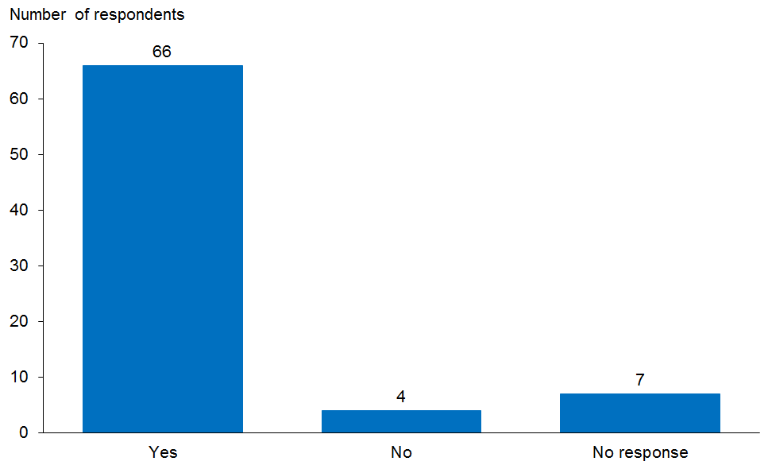

Seventy responses were received. Sixty-six submissions agreed with the focus on pharmacists having a greater role in contributing to the treatment of minor ailments, acute demand triage and appropriate referral. Some respondents sought clarification of what a ‘minor ailment’ is and questioned the role of the pharmacist in triage and referral, while many others felt that this is already a core function of pharmacy practice. Some respondents were unclear how such a service could reduce acute demand.

How we responded
The focus area has been renamed ‘Minor Ailments and Referral’ rather than ‘Acute Demand Management’ and extensively rewritten to reflect that the goal of the service is to reduce unnecessary presentations to general practice or the emergency department:
‘Pharmacists are part of an integrated team providing people with improved access to a minor ailments and referral service. The service is cost-effective to the whole system, materially reduces daily pressure on general practice teams and other acute care settings, enabling clinicians to prioritise people with more complex needs.’

Question 8: Do you agree with the focus in this section on developing a minor ailment service?
Figure 10: Summary of responses to Question 8
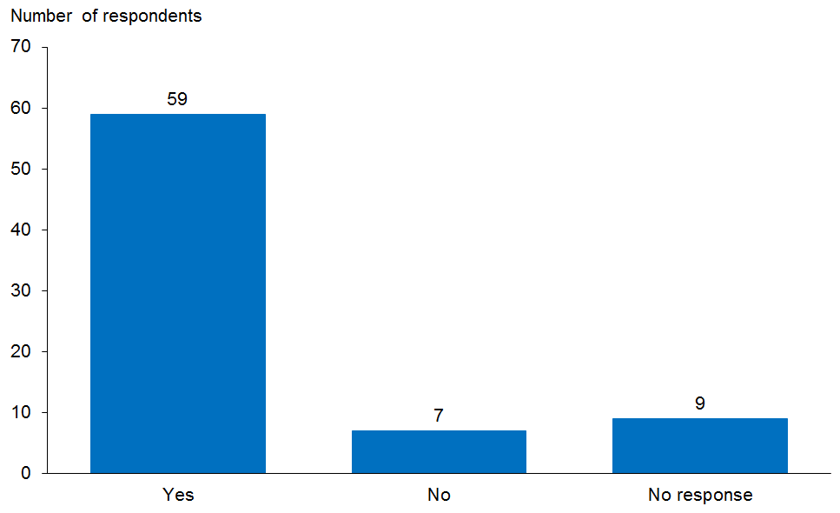

Sixty-six submissions commented on this question. Fifty-nine agreed with the focus on developing a minor ailment service. Submissions indicated strong support for the development of a business case for a minor ailment service, subject to some clear caveats.
- Community pharmacists need to have access to all relevant patient clinical information so that their ability to triage effectively is not compromised. There must be effective information flows, and pharmacist interventions must be able to be shared with general practice and other relevant health care professionals to avoid fragmentation of care. There is a strong belief that without this information, health care in the community could become more fragmented.
- ‘Triage’ pathways by pharmacists need to be clearly defined (eg, how do they integrate with other triage services such as Telehealth?).
- There was a clear message from many respondents that the service must be funded for vulnerable population groups so as to remove cost as a barrier, otherwise this will not decrease presentations to emergency departments by these groups. However, the service also has to be cost-effective.
- Many suggested that a multidisciplinary approach to providing a minor ailments service (including nursing) would be preferable.
- It was felt that a model should be developed collaboratively with general practice and other health professions and consumers.

How we responded
The reworded action was:
‘Co-design a service model, in consultation with key stakeholders including consumers, to support the development and implementation of a minor ailments and referral service that delivers material net benefit to the whole system.’

Focus area 4: Dispensing and supply services

Question 9: Do you agree with the focus in this section on driving efficiencies in the medicines supply chain through the broader use of technologies, for example, robotic dispensing and more flexible regulation?
Figure 11: Summary of responses to Question 9
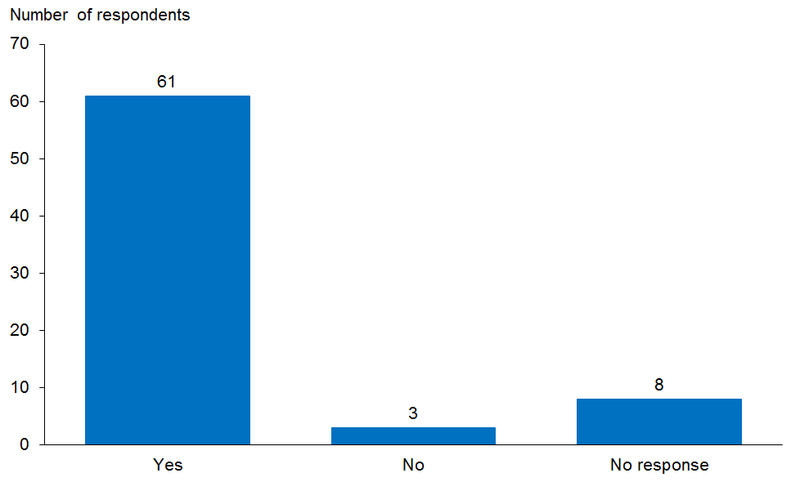

Sixty-four responses were received, with 61 agreeing with the focus on driving efficiencies in the medicines supply chain through the broader use of technologies. The majority of submissions supported changes such as a move towards robotic dispensing and the development of a regionalised or centralised approach to a sustainable medicines supply chain. Some submissions noted the importance of ensuring consumers understand that quality and safety will be maintained.

Following are some of the points and concerns raised.
- Increasing use of technology and robotics may be feasible for some pharmacies, but for small community pharmacies in rural areas, this may not be sustainable.
- Robotic dispensing may only be efficient for high-volume prescription pharmacies.
- Technology may not be the most effective way to drive further efficiencies. The introduction of measures such as original pack dispensing could provide the greatest efficiency gains.
- The supply chain needs to be sustainable, efficient and affordable.
- The issue of pharmaceutical waste should be addressed.
- A number of respondents questioned the inclusion of ‘pharmaceutical margins’ in the Plan, noting that this tended to anchor thinking in the present rather than the future.

How we responded
- Reference to ‘pharmaceutical margins’ has been removed as work is currently on track to deliver an interim solution to the margins issue by 1 July 2016.
- The reworded action is: ‘Manage the removal of non-regulatory barriers to supply chain efficiency to ensure reward is balanced with risk across the sector (eg, original pack dispensing or part-pack exchange between pharmacies; Pharmac/DHBs lead).’
- There are two new actions.
- ‘Review district need and develop and implement plans to deliver an accessible, sustainable and efficient medicines supply chain, and commission services to meet identified demand (DHB lead).’
- ‘Support systems to reduce prescribing/prescription errors and minimise pharmaceutical waste in Aged Care and other residential facilities (DHB lead).’

Question 10: How important is the role of the pharmacy accuracy checking technician (PACT) in driving dispensing efficiencies?
Figure 12: Summary of responses to Question 10
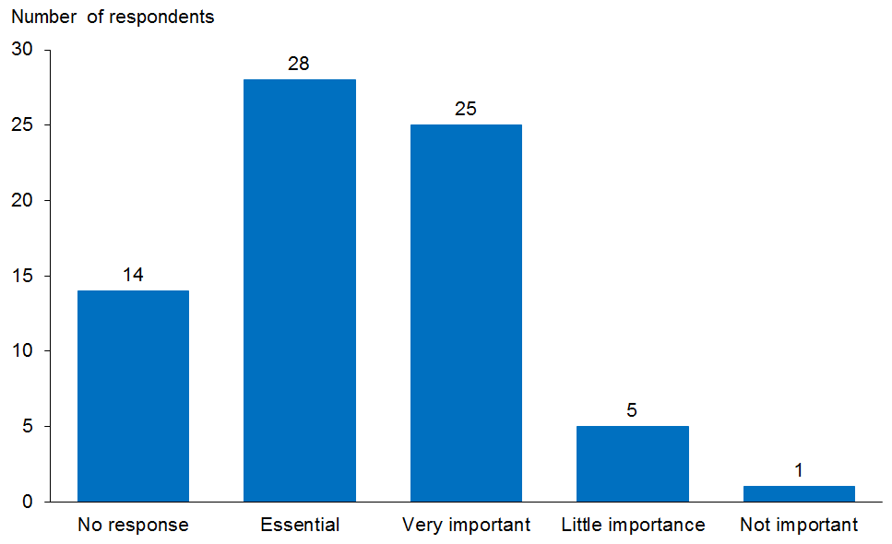

Fifty-nine submissions commented on this question. Fifty-three agreed that the role of the pharmacy accuracy technician (PACT) is essential or very important in driving dispensing efficiencies. Submissions supported the move to implementing PACT roles in both community and hospital pharmacies. There was agreement that greater use of PACTs will free up pharmacist time spent on technical tasks, which will allows pharmacists to focus on patient-centred services and lead to improved patient care.

Following are some of the specific issues mentioned.
- There are concerns that the number in the PACT workforce available within the next five years is limited and will not have a significant impact on practice in this timeframe.
- Some submissions called for PACTs to be registered to ensure public safety.
- There must be a sustainable approach to the development of a PACT workforce, with career pathway development and professional mentoring and support.
- Increasing use of PACT technicians will require clinical leadership within practices to ensure the pharmacist’s clinical input occurs at appropriate stages of the process to ensure patient safety.
- The lead-in time for action to support PACT is too long. This should not take up to three years to develop, but should occur in 2016.
- There is a need to educate consumers on the PACT role.

How we responded
Registration of health professionals is the responsibility of the regulatory authorities. The Pharmacy Council of New Zealand (PCNZ) has indicated they are not considering technician registration at this stage. The Ministry will pass this consultation feedback on to the PCNZ.

Focus area 5: Prescribing pharmacists

Question 11: Do you agree there should be greater integration of prescribing pharmacists into a wide range of primary and secondary health care teams, including residential care facilities?
Figure 13: Summary of responses to Question 11
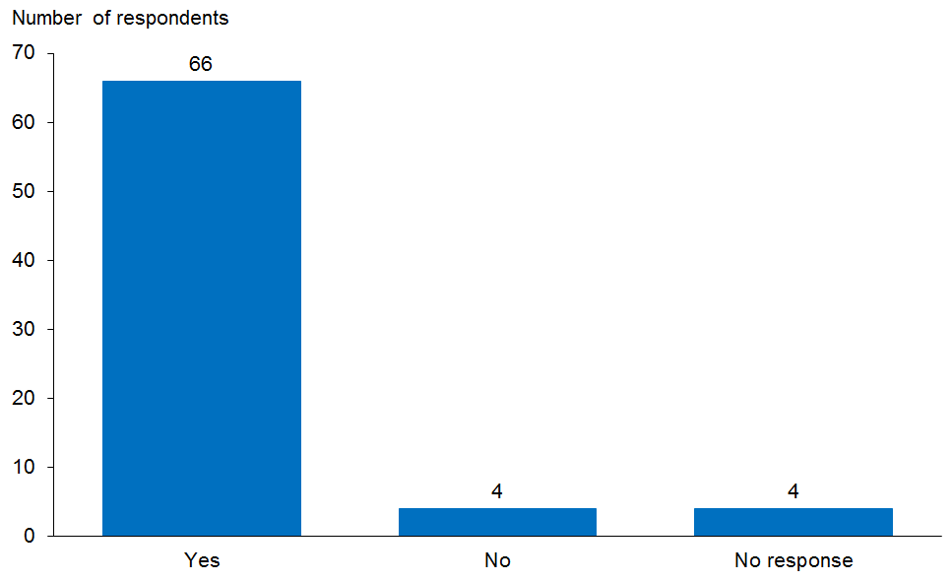

Seventy responses were received. Of these, 66 agreed there should be greater integration of prescribing pharmacists into a wide range of primary and secondary health care teams, including residential care facilities.

The majority of submissions supported prescribing pharmacists having an expanded role in integrated models of care and using their expertise in medicines management to contribute to better health outcomes. However, it was apparent from a number of the submissions that there is a lack of clarity around the role of the prescribing pharmacist, their training, scope of practice and practice model. In particular there seemed to be little recognition that prescribing is just one part of the role performed by these pharmacists and that their expertise lies primarily in medicines management. Concerns were also expressed that ‘more prescribers equals more prescriptions’ but not necessarily more rational use of medicines.
Following are some of the specific issues noted.
- Nationally led implementation of the roles, role descriptions, responsibilities and adequate remuneration was seen as the key enabler for integration.
- It is important to maintain the current separation of prescribing from dispensing to enhance patient safety.
- The Ministry must recognise the need for, and value of, a consistent and standard approach to prescribing for all health professionals with prescribing roles.

How we responded
- Focus area 2 (previously Pharmacist Clinical Services) now incorporates Focus area 5 (Prescribing) and has been renamed ‘Medicines Management Services’. This better reflects the fact that prescribing is part of the medicines management continuum.
- Additional wording has been added to emphasise the role of prescribing pharmacists in the collaborative health care team, in particular, the identification of and support for patients with complex needs and the need for contracts to align across the sector to enable this.
- There are two new actions.
- ‘Promote the role of pharmacist prescribers to other health professionals and the public (pharmacy sector lead).’
- ‘Develop a peer network to support pharmacists taking on new clinical roles (eg, pharmacist prescribers (pharmacy sector lead).’

Key enablers

Enabler 1: Leadership

Question 12: How important is leadership as an enabler to the actions in this plan?
Figure 14: Summary of responses to Question 12
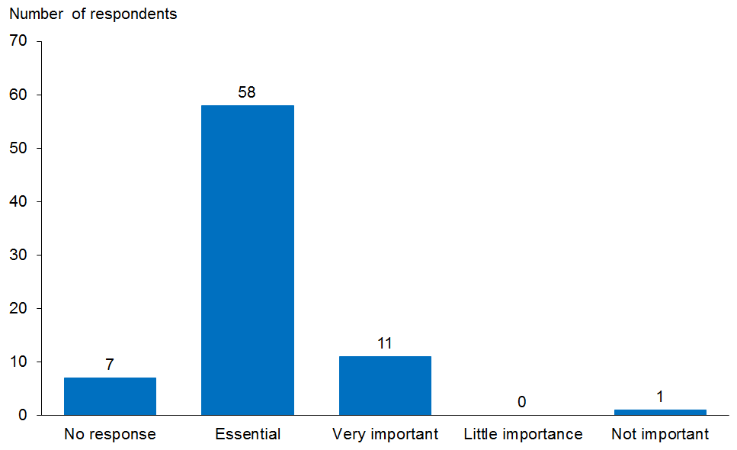

Seventy responses were received, with the majority agreeing that leadership is an essential enabler to the actions in the Plan. Strong leadership, both within the pharmacy profession and across the wider health sector, was seen as critical to the success of the transformational change signalled by the Plan and to ensure the profession remains strong and credible with professional colleagues, funders and the public.

There was feedback that pharmacists should be appointed to health governance structures across the health sector at national, regional and local levels.

Specific issues noted included:
- the need for a professional development pathway to develop leadership skills in early and mid-career pharmacists
- the need for mentoring and training opportunities, both within and external to the profession to develop future leaders.

How we responded
- The leadership section has been extensively reworked.
- There are reworded actions.
- ‘Support the appointment of suitably experienced pharmacists to leadership roles on health governance structures (eg, DHB committees, PHO alliances; Ministry, DHB lead).’
- ‘Provide leadership development for emerging pharmacy leaders.’

Enabler 2: Information and other technologies

Question 13: How important is information technology (IT) in terms of the potential to transform pharmacy practices?
Figure 15: Summary of responses to Question 13
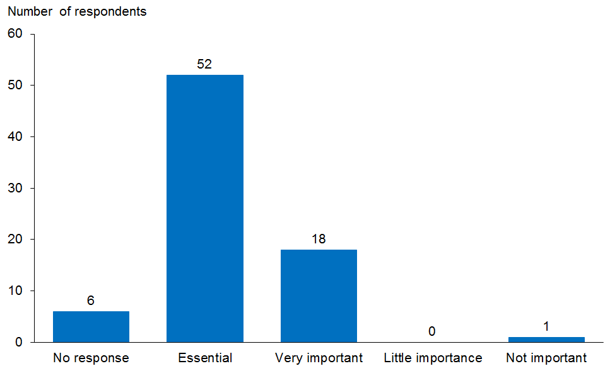

Seventy-one responses were received. There was almost unanimous support for IT as an enabler to provide integrated models of health care. IT change is recognised as a central enabler for the Plan, and this recognition extends to the underlying infrastructure and standards needed for national systems. There was strong concern that there could be a high risk of fragmentation and duplication of care if actions are not supported by IT.

Following are some of the specific issues identified.
- IT systems need to support patient-centred practice.
- All health practitioners have access to shared information systems is necessary to allow all practitioners to draw information from and contribute information to the shared patient care record.
- There are ongoing concerns around privacy of health information: it is essential there are safe processes / alternative access points to ensure all people have access to their health information, the confidentiality of that information is protected and health practitioners only have access to relevant information.

Question 14: How important is it for pharmacists to be able to have full readable/ writeable access to patient health records?
Figure 16: Summary of responses to Question 14
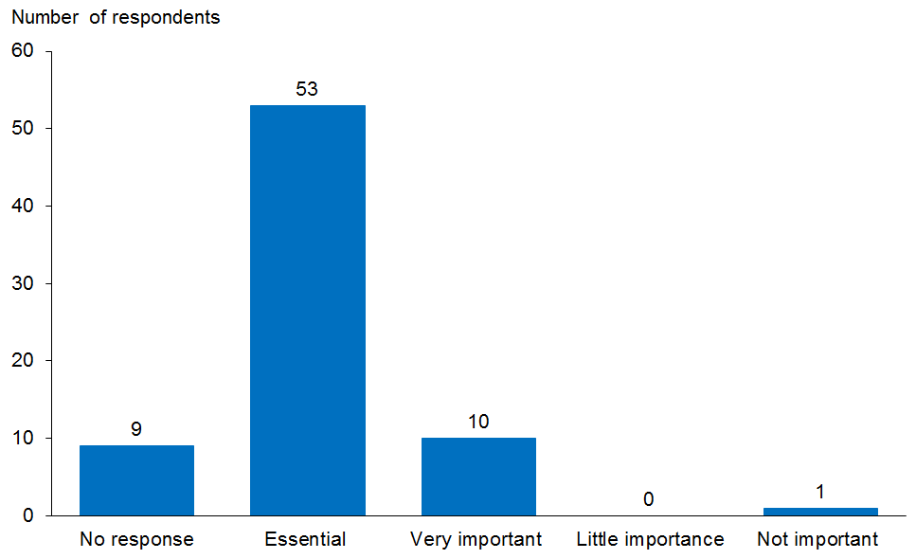

Sixty-four submissions were received, and 63 of these agreed that it was essential or very important for pharmacists to have full readable/writeable access to patient health records.

Several submissions emphasised a shared care record as a priority to avoid fragmentation and duplication of activity within the health system. There was agreement that access to a shared care record is a priority to allow pharmacists to be more involved in the provision of health advice and treatment in a collaborative and integrated context. However, some submissions noted there should be clear governance for access and that agreed principles should apply.

Following are some of the specific issues identified.
- Privacy and informed consent processes need to be clearly defined: the patient needs to know and consent to who will be accessing their record and the level of access permitted.
- Access should be directly related to patient care, and actions in response to evaluation of the information need to be within the scope of the health care provider.
- The provider must be able to influence the care of the person through access to relevant information, such as laboratory results.
- Feedback loops are needed so that all providers are aware of issues, up-to-date prescribed medications, allergies and adverse drug reactions history.

Enabler 3: Workforce

Question 15: How important is it to have pharmacists less involved in the technical aspects of medicines supply and better utilised to provide patient-centred care across a range of practice settings?
Figure 17: Summary of responses to Question 15
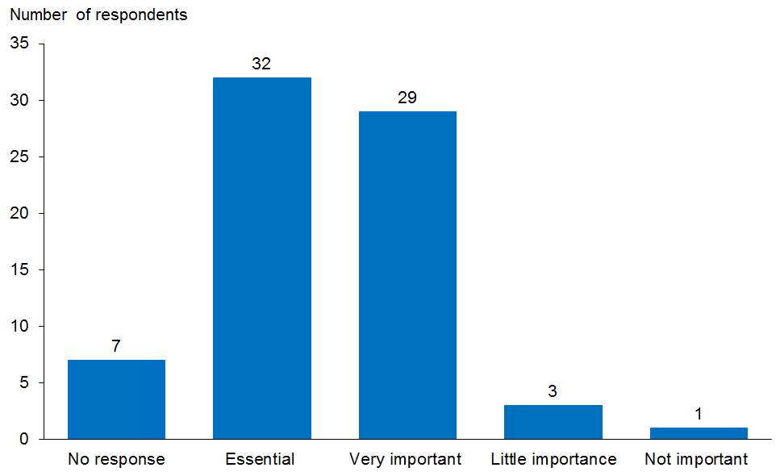

Sixty-five responses were submitted: 94 percent of submissions agreed it is essential or very important for pharmacists to be less involved in the technical aspects of medicines supply and better utilised to provide patient-centred care across a range of practice settings.

Some submissions noted the need for the pharmacist to retain a clinical oversight role and be involved in ‘patient engagement’ as part of the dispensing process. Several submissions called for more emphasis on the broader use of the pharmacy technician workforce, not just PACT.

Consumers, in particular, were unsure about the level of training and professional obligations of pharmacists (eg, privacy obligations, Code of Ethics).

Following are some of the specific issues identified.
- There is a need for consistent training and recognised career pathways.
- It is important to identify innovative roles for pharmacists.
- It is important to utilise health workforce skills and expertise, rather than water them down through duplication and/or overlapping scopes of practice.
- The Plan does not specifically address how pharmacists’ reskilling and upskilling will occur, or the associated potential reconfiguration of practices that will allow the delivery of supply and clinical services to patients.
- Devolving some of the medicines supply functions will be essential to ensuring pharmacists can deliver the full range of roles signalled in the Plan. Some pharmacists will need to change their practice and processes so that they have a reduced role in the technical aspects of medicines supply while retaining professional contact with patients as they collect medicines and maintaining the pharmacist’s central role in managing service delivery and quality.
- There is concern about the affordability and value of some of the present training options. Any changes will necessitate new training approaches.
- There is a need to review how pharmacist workforce development is funded in DHB regional service plans and annual plans.

How we responded
- The following new wording was added.
- ‘Pharmacists are registered health practitioners, under the Health Practitioners Competence Assurance Act 2003. They are also bound by a number of codes, including the Pharmacy Council of New Zealand Code of Ethics 2011, the Health Information Privacy Code 1994 and the Code of Health and Disability Services Consumers’ Rights 1996. Any service provided by a pharmacist must meet all obligations under these Codes.’
- ‘Pharmacy is viewed as a viable long-term option that offers a range of practice opportunities for those interested in a career in health. Pharmacists have a structured professional development pathway that attracts and retains people with the right skill mix to support new models of care. Development of the pharmacy workforce is aligned with development strategies for the broader health workforce.’
- The following new actions were added.
- ‘Work with key stakeholders to develop a career development framework for pharmacists working in primary and secondary care (pharmacy sector lead).’
- ‘Collaborate with other key stakeholders to develop a joint clinical/academic approach to workforce development to support the actions in the Plan (schools of pharmacy/DHB lead).’
- ‘Ensure that all pharmacists new to MTA-level service provision are appropriately supported to reach competence in this role.’
- ‘Develop programmes that support inter-professional education for pharmacists (undergraduate and post-graduate).’

Enabler 4: Regulation

Question 16: How important will a more permissive prescribing and dispensing framework be for changing the future direction of pharmacy services?
Figure 18: Summary of responses to Question 16
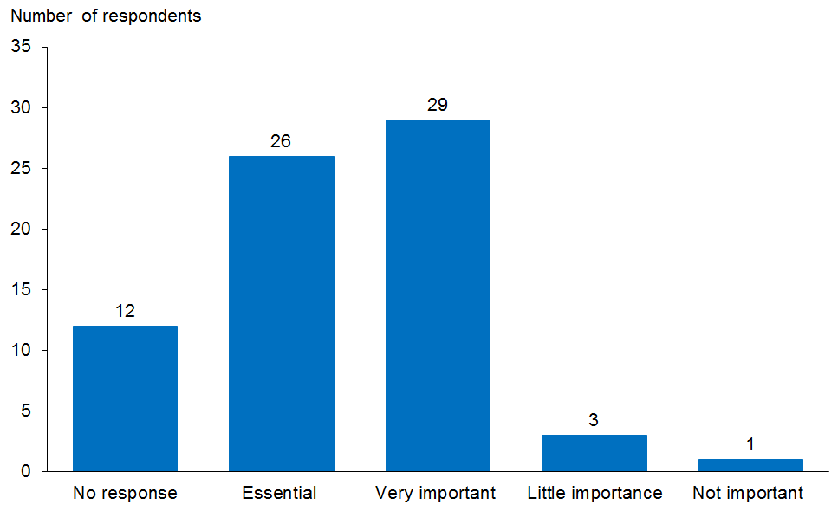

Fifty-nine responses were received. Twenty-six agreed it is essential to have a more permissive prescribing and dispensing framework for changing the future direction of pharmacy services.

Specific issues identified included:
- the need to define ‘permissive’ in the context of ownership and licensing
- the suggestion that legislative changes to services must reflect patient need, while retaining patient safety as a key priority.

How we responded
- Regulation is now referred to as ‘flexible’ rather than ‘permissive’.
- Detailed feedback on submission responses has been forwarded to the team responsible for the review of the Medicines Act and Regulations and drafting of new legislation.

Question 17: How important will potential changes in ownership and/or licensing arrangement be for changing the future direction of pharmacy services?
Figure 19: Summary of responses to Question 17
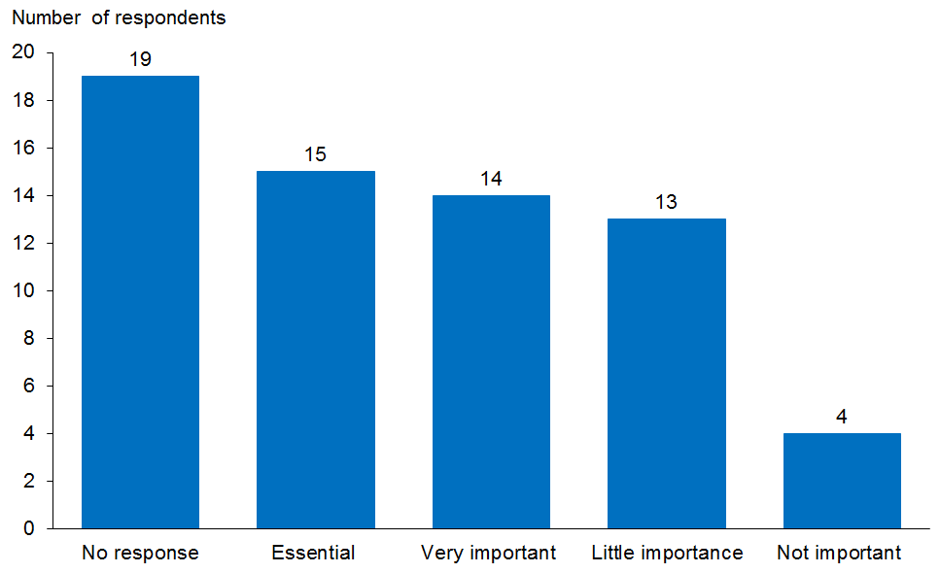

Forty-six responses were received. This question received the most divergent responses. Views were divided on the question of changes to pharmacy ownership or licensing regulation. Some submissions commented on the advantages of retaining the present regime if it were enforced.

Of the submissions that supported the actions associated with regulation in the context of the regulatory review, some felt that links with the regulatory review could be made more explicit. A more permissive environment is viewed as providing possibilities to support wider change.

The key themes were as follows.
- A clear framework for professional accountabilities needs to be maintained.
- Consideration needs to be given to audit and accountability requirements.
- It is important that pharmacists and prescribers be able to focus on the broader issue of how to promote health, maintain safety and optimise medicine usage.
- A permissive ownership model needs to extend to pharmacy services beyond traditional community pharmacy premises – ‘pharmacy without walls’.
- Rural pharmacy services will have specific needs in terms of the separation of pharmacy services from supply functions in the rural sector to improve access to clinical services beyond medicines supply.

The following specific issue was identified.
- Change in the ownership regulations has the potential to drive pharmacies by profit business model, rather than focusing on ethical and professional standards of practice.

How we responded
Consultation feedback has been shared with the team responsible for the Therapeutics Review.

Priority of actions

Question 18: If you had to prioritise the actions in this plan what would be your top three actions for implementing in the next five years?
Submissions prioritised the actions in the Plan as follows.
- Clinical services, including improved access to funding of clinical services
- Shared electronic health record and IT access
- Acute demand management / minor ailments
- Planning and implementation of new models of care / funding models to drive integration
- Workforce planning development (undergraduate and postgraduate), including incentivised/funded learning and education
- Population and personal health
- Leadership
- Prescribing pharmacists
- Reduced inequities / more timely access to medicines and health care
- Implementation of PACT.

Question 19: Are there any actions in this plan that you particularly agree with or disagree with, and if so why?
The majority of submissions agreed with the actions relating to:
- partnership approach, collaboration and integration
- pharmacists in a recognised role as experts in the provision of medicines management services
- the need for integrated supportive IT systems for better patient outcomes.

Some submissions disagreed with the actions relating to:
- re-regulated ownership of community pharmacies, the view being that this has the potential to drive a focus on profit rather than ethics-driven business.

Question 20: Are there any actions that you think have been omitted that should be included, and if so what are they and why should they be included?
Submitters felt the following require more specific actions.
- Electronic bedside verification and barcoding to patient level
- Antibiotic stewardship in primary care
- ‘Joined-up’ IT systems enabled by single log-on
- Reduction in pharmaceutical waste
- Development of long-term-condition health care plans rather than prescriptions
- Clinical pharmacists in large community pharmacy teams
- Measurement of outcomes
- Sustainable funding for pharmacist prescribers
- Funding for clinical pharmacists in Aged Residential Care (ARC)
- Support for rural pharmacists
- Prescribers being unable to hold shares in pharmacies
- Funding for transition to new models of care
- More community pharmacy examples
- Establish joint clinical/academic positions
- Improved access to clinical training at undergraduate level
- Development of inter-professional education
- Development and implementation of clinical quality standards and quality indicators to monitor performance
- More focus on cultural competence.

Appendix 1: List of submitters
Accident Compensation Corporation
Angela Harwood
Ann Bain
Aotearoa College of Diabetes Nurses
Arthritis New Zealand
Auckland & Waitemata District Health Boards
Australian and New Zealand College of Anaesthetists
Blind Foundation
Canterbury Clinical Network – Pharmacy Service Level Alliance
Canterbury Clinical Network – rural workstream
Canterbury Community Pharmacy Group
Carla Arkless
Caroline Woolerton
Christchurch Primary Health Organisation
Clare Hynd
Clinical Advisory Pharmacists Association (CAPA)
Community Pharmacy Service Programme Service Development Group
Council of Medical Colleges of New Zealand
Countdown Pharmacy
Don McKenzie
Euan Galloway
Family Planning Association
Fiona Corbin
Gary Sutcliffe
Green Cross Health
Grey Base Hospital Pharmacy
Grey Power Hastings & Districts Assn
Health Quality and Safety Commission
Jo Batcup
John Dunlop
Julie Kilkelly
Kerry Miedema
Linda Bryant
Manly Pharmacy Ltd
Māori Pharmacists Association
Marty Kennedy
Midcentral District Health Board
National Council of Woman of New Zealand
National Health IT Board Consumer Panel
Nelson Marlborough District Health Board
Neville Puckey
Neville Winsley
New Zealand Hospital Pharmacists Association
New Zealand Medical Association (NZMA)
New Zealand Nurses Association
New Zealand Nurses Organisation
New Zealand Psychological Society
New Zealand Self Medication Industry Assn
Nora Jayne Parore
Northland District Health Board
Office of the Health and Disability Commissioner
Opotiki Pharmacy and Kerry Nott Pharmacy
Pathways Health Ltd
Pauline McQuoid
Pegasus Health
Penny Clark
Peter Barron
PHARMAC
Pharmaceutical Society of New Zealand
Pharmacy Council of New Zealand
Pharmacy Guild of New Zealand
Pharmacy Partners Ltd
Presbyterian Support Southland
Procare Health Limited
Public Health Unit, Population Health, Waikato DHB
Regional Public Health
Ross Carrick
Royal New Zealand College of General Practitioners
School of Pharmacy, University of Auckland
School of Pharmacy, University of Otago
SimplHealth Solutions Limited
Southern District Health Board Mental Health, Addictions & Intellectual Disability
Southland Pharmacists Association
Te Awakairangi Health Network
The Asthma Foundation
The Royal Australian & New Zealand College of Psychiatrists
The Royal Australian College of Physicians
Veterans Affairs New Zealand
Waikato DHB
WellSouth Primary Care Network
Wendy King
Whytes Pharmacy 2007 Limited

Appendix 2: Consultation meetings
Pharmacy Council and Chief Executive
Pharmaceutical Society of New Zealand – National Executive and Chief Executive Officer
Pharmacy Guild of New Zealand – Board and Chief Executive Officer
Community Pharmacy Services Agreement (CPSA) Service Development Group
Community Pharmacy Services Agreement – General Managers Planning and Funding Strategy Meeting
PHARMAC Board
Māori Pharmacists Association Executive
New Zealand Hospital Pharmacists Association Executive
General Practice New Zealand – National Chief Executive Officers Group meeting
General Practice New Zealand
General Practice Leaders Forum
Community Pharmacy Leaders Forum
District Health Board Pharmacy Portfolio Managers
Ministry of Health Pharmacists peer group
Directors of Allied Health
New Zealand Nursing Organisation nursing representatives
Pahiatua Medical Centre – rural multidisciplinary meeting (general practice, pharmacy, director of nursing, nurse practitioner)
School of Pharmacy, Otago University
School of Pharmacy, Auckland University
Consumer meeting − Auckland
Consumer meeting − Wellington/Hutt Valley
National Association of Mental Health Consumers Board
Health IT Board
Health Workforce NZ Board

