**Report:**

**Feedback from people living in Ministry of Health funded residential services for people with disabilities**

**September 2016**

**Acknowledgements**

This study was commissioned by Ministry of Health. It was a collaborative undertaking involving the Ministry of Health, Malatest International, the interviewer team, residential service users and residential service providers. Input and advice from various organisations and individuals was invaluable in developing the interview questions.

We would like to thank everyone who worked with us on this study for the time they committed to the study.

We are particularly grateful to the service users who shared their experiences and thoughts.

We acknowledge that the language and terminology used to describe different groups of people and services can have an empowering or disempowering effect. Different people prefer different language to be used and have different views on the accuracy and effect of different terms.

We express our sincere apologies to people who prefer to use different language to the terms we have used in this report. Some important examples include:

* Service users: People who live in Ministry of Health funded residential services.
* Proxies: People answering on behalf of people living in Ministry of Health funded residential services who cannot answer themselves.
* Residences: The residences are the homes of the people who live in them.

Malatest International

September 2016.

**Table of contents**

Executive summary 5

Using a quality of life framework for feedback 5

How feedback was collected from service users 5

Overall quality of life of residential service users 6

Overview 7

1. The purpose of the study 8

1.1. Ministry of Health funded residential services 8

1.2. This study 8

2. Using a quality of life framework for feedback 9

2.1. We used the Schalock quality of life framework 9

2.2. Measuring quality of life within the Schalock framework domains 13

2.3. How we designed the questionnaire used in this study 13

2.4. The questions used in the study 14

3. How feedback was collected from service users 17

3.1. Peer interviewers completed face-to-face interviews 18

3.2. Recruiting service users 22

3.3. Privacy and consent 22

3.4. An online survey complemented the interviews 24

3.5. Data analysis 25

3.6. Strengths and challenges of our approach 26

4. Who we talked with 28

5. Overall quality of life of residential service users 31

5.1. Most service users liked where they lived 31

5.2. Staff were an important factor in whether service users liked their home 32

5.3. Food quality was frequently mentioned 33

5.4. Most service users had high overall quality of life scores 34

5.5. There was some variation in scores between domains 34

6. Self-determination 36

7. Personal development 40

8. Interpersonal relationships 43

9. Social inclusion 47

10. Rights 50

11. Emotional wellbeing 53

12. Physical wellbeing 56

13. Material wellbeing 59

14. Responses from proxies 62

15. Service users’ characteristics and service type can influence quality of life 65

15.1. Service users with different quality of life scores had similar patterns of results 66

15.2. Effect of age on interpersonal relationships and social inclusion 69

15.3. Effect of type of disability on the domain scores 69

15.4. Effect of type of providers 70

15.5. Differences between localities 72

15.6. Summary of domain scores and factors contributing to differences 73

16. Overview 75

16.1. Overall quality of life was high 75

16.2. Service users were positive about being interviewed 76

16.3. The interviewers benefitted from taking part in the study 76

16.4. The quality of life indicators 78

Appendix 1: Interviewer profiles 81

Wellington Interviewer profiles 81

Palmerston North interviewer profiles 83

Auckland interviewers 85

Appendix 2: Statistical validation of the questionnaire 89

# Executive summary

In 2015, the Ministry invited proposals for practical and innovative approaches to getting direct feedback from disabled people using the community residential services it funds. The Ministry requested statistically valid data focusing on outcomes for people living in residential services to inform both the Ministry and residential service providers.

Using a quality of life framework for feedback

The Schalock quality of life framework has been used in this study to provide a theoretical foundation for feedback. The quality of life framework was used because it has been validated internationally in studies of the quality of life of people with disabilities.

The domains in the framework link to the United Nations Convention on the Rights of People with Disabilities (UNCRPD) and the Disability Support Services[1] (DSS) service specifications.

Using a framework enables interpretation of feedback from service users by identifying the aspects of service users’ lives that contribute to positive and negative feedback. A framework also helps government and service providers to identify ways they can strengthen the services they provide.

How feedback was collected from service users

We collected data through face-to-face interviews conducted by a pair of peer interviewers (interviewers with disabilities). The interviewers benefitted from taking part in the study. For some interviewers, employment for this study was the first time they were challenged to see the strengths they gained from their disabilities rather than just the challenges. Their participation was essential to the study’s success.

The interviewers used a structured questionnaire primarily made up of multiple-response questions, and yes/sometimes/no rating scales. Participants had the opportunity to add extra comments so interviewers also captured some qualitative data about service users’ reasons for their responses.

Interviews were completed with service users from residences funded by DSS and owned/managed by 20 service providers across four locations (Wellington, Palmerston North and two Auckland locations).

We received a total of 356 valid survey responses from service users (332 face to face and 24 online/mail in) and 35 from proxies (16 face to face, 19 online).

Overall quality of life of residential service users

Most service users liked the residence or home where they lived. Staff were an important factor in whether service users liked their homes. Staff who engaged with residents, talked with and got to know residents and could communicate with them were very important to residents.

The majority of services users who provided feedback were positive about their quality of life based on the questions used on the study. The overall mean quality of life score was 84 of a possible 100, with 37% of service users with scores between 90 and 100.

Thirty-five proxies completed the survey on behalf of service users who could not complete the survey themselves. Proxy responses were more negative (lower mean scores) across all domains and overall than responses from service users. The biggest differences were in questions related to independence and choice, suggesting the proxy responses were for people with more severe disabilities. There was some variation between the scores for the individual quality of life domains

The overall domain scores highlight physical wellbeing, rights, and emotional wellbeing as areas of strength with scores of 93, 89, and 88 respectively. A substantially lower score (70) was recorded for personal development.

|  |  |  |
| --- | --- | --- |
| Quality of life domain | Mean score (of 100) | % scoring 91 to 100 |
| Self-determination | 82 | 46% |
| Personal development | 70 | 23% |
| Interpersonal relationships | 80 | 36% |
| Social inclusion | 83 | 51% |
| Rights | 89 | 54% |
| Emotional wellbeing | 88 | 63% |
| Physical wellbeing | 93 | 71% |
| Material wellbeing | 85 | 46% |

Service users who had consistently higher quality of life scores were more likely to be younger (less than 40 years) and to have an intellectual/learning disability rather than a physical disability. People with physical disabilities only were more negative about social inclusion, which had questions on access to transport and the community. Overall and domain quality of life scores did not vary between people from different gender and ethnic groups. Differences between people living in different types of providers (national or regional and provider size) were related to differences in the disability profiles of the service users who responded to the survey.

Generally, based on the interview data, feedback from service users and observations by the research team it seemed that being part of a minority group in a residence resulted in a lower quality of life score. Difficulty for service providers in meeting the specific needs of a few service users may contribute to this. For example:

* People with specific cultural, religious or other beliefs
* People who were lesbian, gay, bisexual, transgender
* People with physical disabilities or hearing disabilities who may feel isolated in homes or flats where they do not have a peer group.

Overview

This research provided services users with an opportunity to give their perspectives about their lives. Information from the research has the potential to be used by the Ministry of Health, residential service providers and service users to strengthen policies and improve service delivery.

# The purpose of the study

|  |
| --- |
| The purpose of this study is to allow the Ministry of Health to receive feedback directly from people using residential services it funds. |

* 1. Ministry of Health funded residential services

Ministry of Health funded community residential support services are one of a range of services funded by Disability Support Services (DSS). Community residential support services provide 24-hour residential support to disabled people to live in homes in the community. Residential services are provided to meet the needs and goals of individuals.

Community residential disability support services are provided by organisations contracted by the Ministry. The provider organisations vary in size from a single residence with fewer than five people to organisations with many residences across the country.

* 1. This study

In 2015, the Ministry invited proposals for practical and innovative approaches to getting direct feedback from disabled people using its community residential services. The Ministry requested statistically valid data focusing on outcomes for people living in residential services to inform both the Ministry and residential service providers.

The emphasis of the current study is therefore on the collection of quantitative data directly from people living in residential services.

# Using a quality of life framework for feedback

|  |
| --- |
| The Schalock quality of life framework has been used in this study to provide a theoretical foundation for feedback.  The domains in the framework link to the United Nations Convention on the Rights of People with Disabilities (UNCRPD) and the DSS service standards.  Using a framework enables interpretation of feedback from service users by identifying the aspects of service users’ lives that contribute to positive and negative feedback. A framework also helps government and service providers to identify ways they can strengthen the services they provide. |

Quality of life is a multidimensional construct that is used extensively in different sectors to assess the quality of life of individuals and changes in quality of life that may arise from different types of interventions. Quality of life can be compared between population groups and between points of time.

We recommended a quality of life framework approach over the use of a set of service satisfaction questions because it takes an outcomes focus. It examines the resulting outcomes of services, rather than outputs. Using a framework to measure quality of life provides a consistent approach to person-centred planning, guides service delivery policies and practices, and can provide information about the impact of various factors on quality of life related personal outcomes.[2]

* 1. We used the Schalock quality of life framework

Over time, many different quality of life frameworks have been developed. Most include a similar set of core concepts.

For the feedback from residential service users we chose to use a quality of life framework developed by Robert Schalock and others.[3] [4] The framework has been used extensively internationally and has been used in New Zealand in the evaluation of the Enabling Good Lives pilot. The framework includes eight domains grouped into three broad areas (Table 1). The domains were developed and validated through an extensive review of the international quality of life literature across the areas of intellectual/learning disabilities, special education, behavioural and mental health, and aging.[5] The domains in the Schalock framework align with other important documents on support for people with disabilities (Figure 1).

Table 1. Quality of life domains included in the Schalock framework

|  |  |
| --- | --- |
| Factors | Quality of life domains |
| Independence | Self-Determination: Autonomy/personal control; Goals and personal values (desires, expectations; Choices (opportunities, options, preferences) |
| Personal Development: Education (achievements, education status); Performance (success, achievement, productivity); Personal competence (cognitive, social, practical skills) |
| Social participation | Interpersonal Relations: Interactions (social networks, social contacts); Relationships (family, friends, peers); Supports (emotional, physical, financial); Social activities |
| Social Inclusion: Community integration and participation; Community roles (contributor, volunteer); Social supports (support networks, services |
| Rights:Human (respect, dignity, equality; Legal (citizenship, access, fair treatment) |
| Wellbeing | Emotional Wellbeing: Contentment; Self-concept; Lack of stress (predictability and control); Safety and security; Spirituality/ culture |
| Physical Wellbeing: Health and wellness; Activities of daily living; Physical activities including recreation |
| Material Wellbeing: Financial status; Employment status; Housing status; Having possessions |

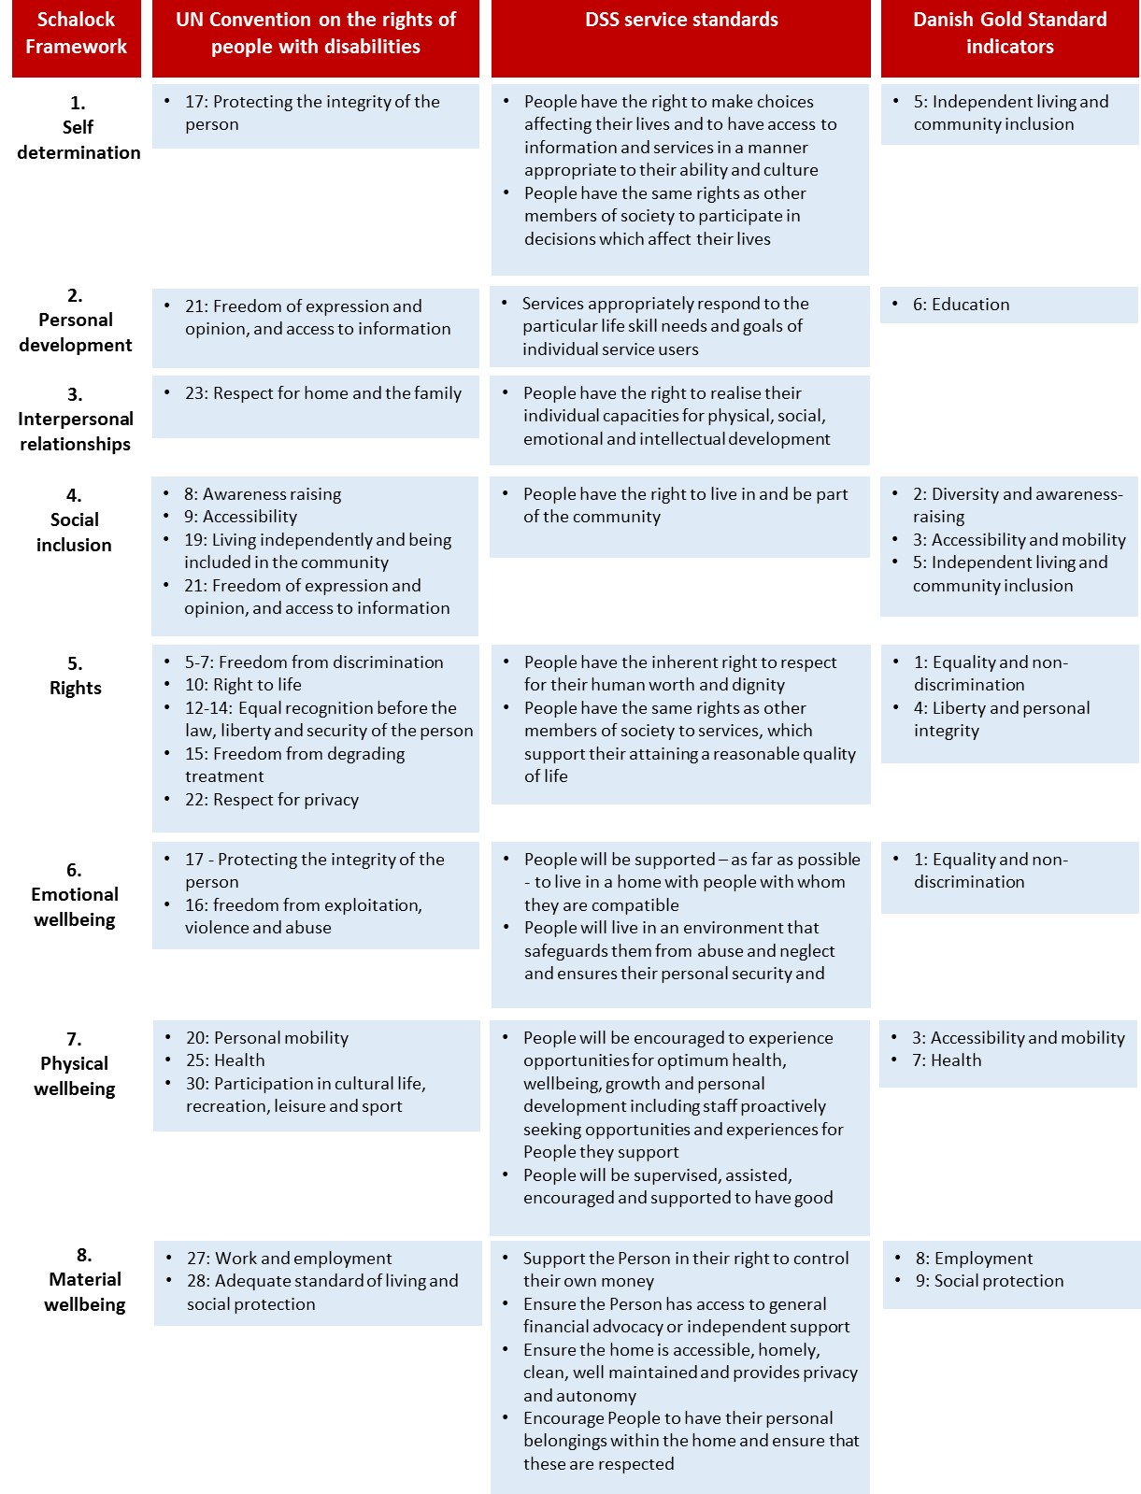Figure 1: Alignment of the Schalock framework quality of life domains with the components of quality of life included in other key documents and standards[6]

Schalock’s quality of life framework has been widely used internationally for research and disability service development. For example, it has been used successfully for over four years by Community Living British Columbia in Canada to collect data from people with intellectual/learning and/or physical disabilities.[7] Information has been provided back to service users and is resulting in positive changes.

|  |
| --- |
| **Include Me! – Feedback from service users in Canada**  The Initiative has been designed to gather the opinions of people with intellectual/learning disabilities about their quality of life, with the aim of eventually seeing these opinions serve as inputs for decision-making for everyone involved in community living.  The My Life survey instrument and data collection addresses each of the eight quality of life domains in the Schalock framework directly through an engaging format designed to maximize self-report. The survey consists of six questions for each domain.  The following process, which maximizes the engagement of Community Living stakeholders, was developed to administer the My Life survey:   * Service providers were involved and supported to provide information on the people they support, to obtain participation agreement from self-advocates, and book the self-report interviews * Peer-interviewers were hired and trained to conduct in-person, peer-to-peer interviews * Respondents were encouraged to self-report (i.e., answer for themselves) instead of letting proxies speak on their behalf * Two proxies were engaged to complete the interview on behalf of any individual who was unable or unwilling to self-report.[8]   Each participating service provider receives a report that summarises the feedback from the people they support and compares that feedback to grouped results for all service providers. |

* 1. Measuring quality of life within the Schalock framework domains

The eight quality of life domains are measured via the assessment of relevant indicators. The indicators are quality of life-related perceptions, behaviours and conditions that define operationally each quality of life domain. Questions are developed for each indicator. The questions can be used to quantitatively measure people’s quality of life and track changes over time where quality of life data is collected at multiple points in time.

* 1. How we designed the questionnaire used in this study

The research team developed a draft questionnaire structured using the Schalock quality of life framework and questions that had been used previously. The question language and content were adapted for this study to the New Zealand residential services context. Indicators (or the topics included in each domain) were developed in consultation with key stakeholders (the Ministry, service providers and people with disability including people using residential services). The aim of consultation was to develop indicators that are meaningful to residential service users. The indicators developed reflect expectations of people living in residential services and the extent these expectations are met.

The research team developed a first draft questionnaire by selecting a sub-set of the questions used previously with a focus on:

* Alignment with the Ministry of Health DSS service specifications
* Relevance to people living in residential services
* Reducing the number of questions by excluding some which were very similar in theme and had responses that were closely correlated.

Researchers then discussed the draft questionnaire in depth with disabled people living in residential services and family/whānau members of very high needs people who were not able to respond themselves. Feedback focused on both question content and wording. While individuals had different points of view on some questions, feedback was generally consistent.

The research team presented a draft version of the questionnaire to the national leadership group of People First New Zealand.[9] The group included people with experience advocating for people living in residential services and people who had lived in residential services. The group provided extensive and detailed feedback.

The most significant changes in response to feedback on the draft questionnaire were:

* **Simplifying wording:** There were often opportunities to use more accessible language by reducing the number and/or complexity of words used.
* **Including questions specifically about abuse:** There was strong feedback to include a question asking specifically about abuse.
* **Fine-tuning language:** Using familiar language consistent with the language used in the New Zealand disability sector, for example ‘home’ rather than ‘residence’ or ‘the right support’ rather than ‘the support you need’.

The final draft also incorporated some direct service focused questions.

* 1. The questions used in the study

The final list of questions aligned with each quality of life domain is provided in Table 2. An open-ended question was included after each domain asking for further comments in addition to the final wrap-up question.

Table 2. Final questionnaire used for this study.

|  |  |
| --- | --- |
| Domain | Questions |
| Self-determination | 1. Can you choose what you do each day? 2. Can you choose when you do things each day? 3. Do you make the choices in your life? 4. Do you have the right support to do what you want? 5. Do you feel you can complain? 6. If you complain, does anything change? |
| Personal development | 1. Do you get to share the things you are proud of? 2. Are you doing any education, courses or training? 3. Do you have the right support to try new things? |
| Interpersonal relations | 1. Do you have friends who do not live with you? 2. Can you spend as much time as you want with them? 3. Do you have family that you spend time with? 4. Can you spend as much time with your family as you want to? 5. Do you have someone to talk to if you have a problem? 6. Can you have a boyfriend, girlfriend or partner if you want to? |
| Social Inclusion | 1. Can you do things in your community when you want to? 2. Do you do things to help your community? 3. Can you get transport when you want to go somewhere? |

|  |  |
| --- | --- |
| Rights | 1. Can you have your door shut when you want to? 2. Is your privacy respected in your home? 3. Do people give you information in the best way for you? 4. Do the people in your home encourage your culture? 5. Do the people in your home encourage your beliefs? |
| Emotional Wellbeing | 1. Are you happy in your everyday life? 2. Do you have things that you are looking forward to? 3. Do you like your home? 4. Do you feel safe at home? 5. Does anyone hurt, tease or bully you? 6. Does anyone abuse you? |
| Physical Wellbeing | 1. Do you feel healthy? 2. Do you have the things you need? For example, wheelchairs, glasses, hearing aids, braces? 3. Can you use your energy on what you want to do? 4. Can you see the people who help you with your health when you want to? For example, doctors and dentists. |
| Material Wellbeing | 1. Can you choose how to spend your money? 2. Do you have enough money to pay for the things you need? 3. Can you save money? 4. Are your personal things respected? |
| Service Quality | 1. Did you choose to live here? 2. If you could change anything about your home, what would you change? 3. Are there enough staff in your home? 4. Does your home have the right staff to work with you? |
| Wrap-up | Do you have any other comments you would like to make? |

An example of the response options to survey questions is shown below.

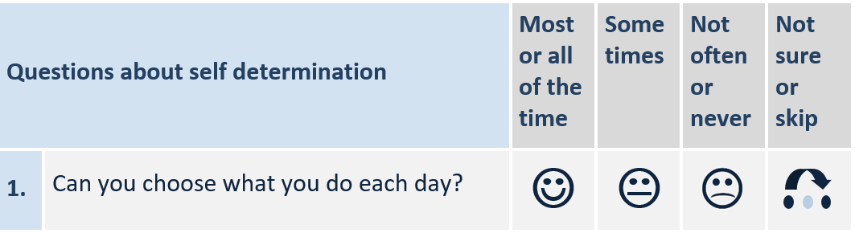

Three questions had ‘yes’ or ‘no’ responses:

1. Do you have friends who do not live with you?
2. Do you have family that you spend time with?
3. Did you choose to live here?

The final questions had a Flesch-Kincaid Reading Ease score of 110, confirming the survey was very easy to read.[10]

International results provide useful context for interpreting findings from this project. While often similar, the questions are not identical to those used in overseas implementations of the quality of life approach where indicators have been developed for different groups of disabled people.

# How feedback was collected from service users

|  |
| --- |
| A key component of our approach was recruiting, training and supporting people with disabilities to be peer interviewers. Peer interviewers worked in pairs to obtain feedback from service users. Our experiences confirmed the advantages of working with peer interviewers reported in other studies. |

The diagram below (Figure 2) provides an overview of the methods for this study.

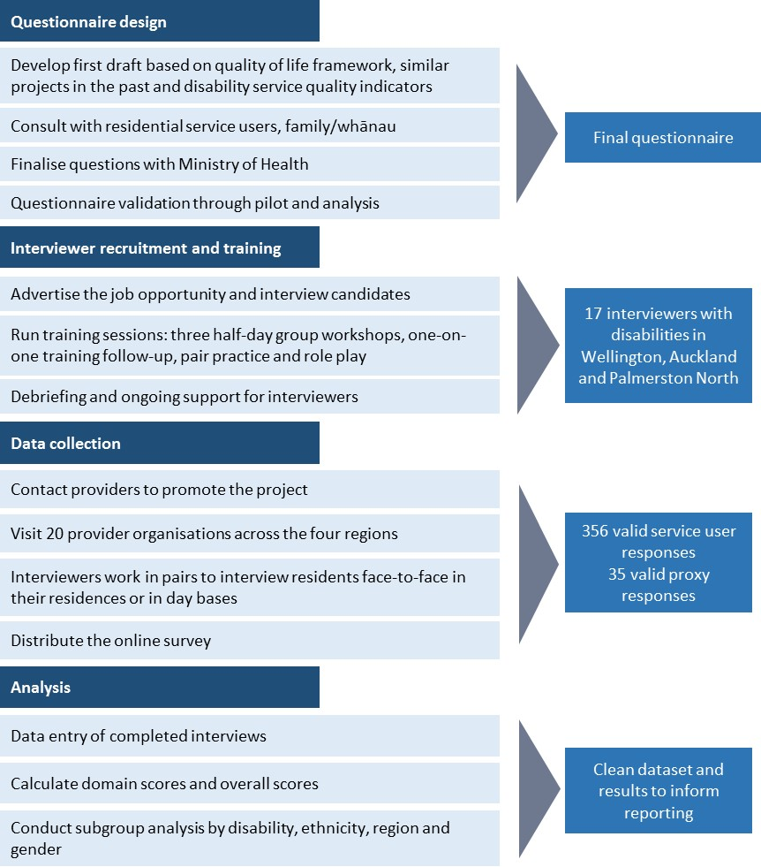

Figure 2: Overview of data collection methods

* 1. Peer interviewers completed face-to-face interviews

Peer interviewers are people with disabilities who are trained to interview people with intellectual/learning and other disabilities.

Using peer interviewers benefited both the interviewers and the interview participants. Studies reported in the literature provide evidence that peer interviewers can be more able to put respondents at ease, demonstrate understanding of their situations and collect accurate information. For example, Bonham (2004) reported, based on experience completing a similar study in the United States[11], that peer interviewers in consultation with project staff are in the best position to judge whether people understand the questions well enough to answer for themselves. In New Zealand, peer interviews were part of the Great Life project[12] and the evaluation of the Enabling Good Lives pilot. In the Include Me! project in Canada, participants with developmental disabilities said they felt more comfortable being asked questions by an interviewer who also had a disability.[13]

The experience of the peer interviewers for this study aligned with the evidence of their value in the literature. The interviewers showed a level of commitment to their work far exceeding that of interviewers we have recruited for other studies. They were successful in building rapport and empathising with interview participants.

Although we did not ask participants how they felt about being interviewed by our interviewers, they often commented they enjoyed answering the interviewers’ questions about their lives. The lead researchers observed many instances where the interviewers were able to closely relate to the experiences described by the people they interviewed.

|  |
| --- |
| During one of the last interviews, one resident said his aim was to live in Supported Living instead of residential services. The interviewer, who was currently living in Supported Living, discussed with him how good it was, what she was allowed to do, how she could choose her staff and how she could go out when she wanted without telling staff. He was so happy to have met someone who had achieved what he wanted. It precipitated a long and animated conversation. |

* + 1. Recruiting interviewers

Interviewer recruitment was an important part of the study. We developed a position description, application form and information sheet. All documents adhered to Easy Read guidelines[14] to make them as accessible as possible. These documents were circulated to:

* Workbridge and other recruitment and employment support companies focusing on people with disabilities
* University disability support service departments
* Disabled People’s Organisations (for example People First)
* Disability service provider organisations contacted in the process of recruiting participants.

We aimed to recruit between six and ten interviewers per region. While we promoted the position as widely as was practical, we are sure there were many other qualified candidates who were not aware of the opportunity.

The final team of 17 interviewers included people with mental health, intellectual/learning and/or physical disabilities. They are pictured below (Figure 3) and full profiles are included in Appendix One.



Figure 3: The peer interviewer team

* + 1. Training interviewers

Interviewer training included group, pair-based and individual components, generally totalling three half-day workshops with shorter follow-up sessions. Interviewers were paid for attending the training. The sessions were led by the interviewer trainer who had extensive experience both in conducting interviews with people with disabilities and training other people to interview people with communication challenges or other disabilities.

The first training session introduced interviewers to their interviewer packs which included:

* Training manual – Easy Read formatted training manual with advice on interviewer best practice, how to use the questionnaire, examples of difficult situations and how to manage them.
* Questionnaire – paper copies of the questionnaire in four different formats:
  + Interviewer-friendly – optimised for asking questions and recording answers
  + Prompts – questionnaires with prompts and options for re-phrasing questions to help with explaining questions to participants who had difficulty
  + Participant-friendly – questionnaire booklet with one question per A4 page, pictures and large font for participants who prefer to read the questions for themselves
  + Coloured paper – questionnaires on coloured paper to meet the needs of the interviewers who cannot read from white paper.
* Door sign – a laminated door sign to be hung on interview room doors saying ‘interview in progress – please do not interrupt’.
* Response symbol sheet – a laminated A4 sheet with all question response options and symbols (smiley, neutral and negative faces)
  + This symbol sheet had to be replaced often as some residents saw it as a certificate they were receiving for answering the interview questions.
* Consent forms – forms with scripting for gaining and recording consent.
* Information sheets – Easy Read formatted information sheets for participants.
* Interview step-by-step guides – step-by-step instructions for interviews for quick reference, covering arriving at residential services, greeting staff and participants and completing interviews.
* Employment material including timesheets and schedules.

The training team observed the interviewers and identified interviewer pairings of people with complementary strengths who interacted well with each other.

The subsequent group sessions focused on practising with the questionnaire and role-play. Interviewer pairs took turns interviewing each other and members of the research team. The interviewer trainer then followed up with each interviewer, offering individualised support. Often this involved strength-based discussion of an interviewer’s disability.

* 1. Recruiting service users

Residential service providers played an important role in supporting the residents in their services to take part. The Ministry of Health advised provider contract managers of the project then we approached them directly, initially at the national manager level for national provider organisations. The research team approached all residential service provider organisations in the participating regions.

For smaller providers, all residences and the people living there were invited to take part. In the case of larger providers, not all residences were included to ensure their representation in the final sample did not outweigh their representation in the residential service user population as a whole. This was particularly relevant in Auckland, where the population for some providers was higher than the targeted number of completions. People living in residences operated by larger providers were included through interviews at day bases and by sampling residences. Inclusion of a residence in the sample was pragmatic and influenced by location (accessibility for the interviewers). Residences were excluded if they primarily included people who were able to engage with the questions. Although we were not able to visit all residences, we aimed to interview everyone who was willing to take part at the residences we did visit.

Once a residence was selected, we identified key staff members to discuss the best way to reach the people living within their services. Providers were asked to:

* Present information about participating in the study to all their residents in the form of a one-page information sheet in Easy Read format.
* Display a poster in a shared area promoting the study. The posters and information sheets included instructions about contacting the research team directly by email, fax or 0800 number to arrange an interview time. However, very few of the residents chose to do so and instead arranged to take part through the staff in their residence.
* In some cases, providers distributed letters about the projects to residents’ family/whānau.
  1. Privacy and consent

The research team received confirmation from the National Health and Disability Ethics Committee that the study did not fall under the criteria for review. However, the data collection approach was developed to be consistent with ethical guidelines.

Many of the people consulted in developing the questionnaire discussed the importance of ensuring residents felt confident their information was being recorded confidentially. The interviewers adopted several approaches to inform and show residents their information would be kept private and not revealed to anyone. They included:

**Consent process:** Before interviews began, interviewers read residents a consent sheet. This included informing residents their information would be used to produce a report for the Ministry of Health. They were reassured their answers would not be identified to anyone except where there was a safety concern. Consent was taken verbally or by physical indication, with the interviewers signing consent forms confirming they gained consent before beginning the interview.

Where a safety concern was identified (for example, where a resident reported they were abused), we followed a process agreed with the Ministry of Health:

* Interviewers took notes and recorded any details volunteered by the participant
* Interviewers reported the information they recorded immediately after the interview to a Malatest team member onsite or over the phone
* The Malatest team member wrote a disclosure summary (anonymised) for the Ministry’s Quality Assurance team
* Where the Ministry identified safety concerns, we sought the service user’s consent to disclose identifying information, which was then passed on to the Ministry
* The Ministry followed up about concerns with the service user directly.

**Private space:** Most interviews took place in a private space where the questions and answers could not be overheard. Interviews took place in offices or in spaces that were usually shared but were set aside for the interviews. Some interviews took place in day bases away from residences. A few residents did not want to be interviewed away from the people they felt safe around (especially when they were interviewed in their homes) and chose to be interviewed around the dining room table. Interviewers recorded on each interview response whether the interview space was private or not. The number not interviewed in private was too small to determine whether lack of privacy influenced their responses.

**Door signs:** In early interviews, interviewers reported that staff and other residents sometimes interrupted interviews by entering the interview space without knocking. We developed a door sign requesting privacy which was usually successful in preventing interruptions.

**Support people:** Support people (staff, other residents, family members) were only present when requested by residents. Interviewers expressed a preference for speaking with people alone, but before starting the interviews offered participants the chance to have someone present.

* 1. An online survey complemented the interviews

To complement the interviews, an online survey was developed and made available nationwide. The survey used the same questionnaire as the interviews and included options for completion by service users, staff and proxies.

The survey was promoted to service providers in the study localities, and to organisations outside these localities.

**Providers**

The survey was promoted through the organisations which had already taken part in the study and which had residents who had not yet been interviewed. This was a pragmatic decision to reach service users who had not had the chance to take part or did not want to take part in a face-to-face interview.

The large providers were approached and requested to display posters and send out invitations to the online survey to their service users and their families. Although providers understood the need for surveys of this nature and were generally keen to be a part of the face-to-face interviews there was little uptake of the online option. Reasons included service providers wanting to run their own satisfaction surveys and did not want to overburden staff, service users or their families. Some providers did not have the facilities to complete the survey online. These residences were provided with hard copy questionnaires that could be mailed back.

Without the active engagement with staff at the residences there were virtually no survey completions.

**Other organisations**

The survey was also promoted to various disabled people’s organisations (DPOs) through phone calls, email and newsletters. The uptake was low as most DPOs had a very small number of members/clients in residential facilities. The low response may also reflect lack of reach of the ways the survey was promoted.

The Ministry also informed the sector of this project through regular updates in the DSS newsletters.

* 1. Data analysis
     1. Overall and domain scores

Domain scores are used to condense the results for each of the domains into one number. The scores are calculated by assigning scores for answers to each question:[15]

* Positive: Yes/most of the time = 2
* Neutral: Sometimes = 1
* Negative: No/rarely or never = 0

Domain scores are calculated by adding the points for each individual’s answers to the questions in the domain together and dividing the resulting total by the maximum possible score and multiplying by 100. A score of 100 represents all positive answers to that domain. A score of 0 represents all negative responses.

If a question is not answered, its potential points are excluded from the calculation.

* + 1. Percent positive

Individual questions are reported within each domain using percent positive. The results presented in this way show the percentage of respondents who gave the positive response option. A positive response for Q28 and Q29 (the teasing, bullying and abuse questions) indicated that the service user did not experience being hurt teased bullied or abused.

* + 1. Margin of error

Margin of error is a measure of the maximum expected difference between a measure from a sample (the service users who completed this survey) compared to the population as a whole (all people living in Ministry of Health funded residential services for people with disabilities).

The margin of error varies depending on the frequency of each response, but it is primarily determined by the sample size compared to the size of the population. Based on the total sample size of 356 within a population of 5,780 service users in the localities included, the margins of error for the percentage of positive responses to each quality of life question will vary between +/-3-5%. When sub-groups are compared, the sample size is smaller.

* + 1. Identifying significant differences

There are a variety of statistical tests available to test for relationships between variables or differences in the scores recorded between different groups of respondents.

We have primarily reported:

* Correlations between variables to evidence relationships. They were calculated using a two tailed analysis with Pearson’s R correlation coefficient.
* One-way ANOVA where scores were compared using an independent variable with three or more levels (for example, age divided into three bands).
* Independent samples t-test where scores were compared using an independent variable with two levels (for example, presence or absence of a physical disability).

For all tests, the level of significance used to reject the null hypothesis was P < 0.05.

* + 1. Qualitative data

Comments from service users were recorded in the surveys. Observations from research team members who supported interviewers in Auckland and Wellington were also recorded.

All comments were treated as qualitative data and analysed thematically. Qualitative data were used to provide context for survey responses.

* 1. Strengths and challenges of our approach

The study collected information from service users using a questionnaire underpinned by a validated quality of life framework. Interviews were completed by a sample of service users that broadly represented the service users in the localities included in the study. Every effort was made to ensure as wide a range of residents as possible were able to participate in the study.

The online survey aimed to provide an opportunity for feedback from a broader group and was used by a few people.

As with any study there are a number of limitations that need to be taken into account when interpreting the findings:

* The study aimed to give a ‘voice’ to service users and to collect information directly from service users rather than proxies. While every effort was made to provide service users with different ways to provide their feedback, some were not able to provide their own feedback. The indicators used in the survey were less appropriate for service users whose disabilities limited the extent they could provide any feedback and participate in the activities that were the topics of the questions. Proxy responses were an option for some service users who could not communicate with the interviewers. Proxy responses are reported separately in this report.
* Recruitment generally relied on service providers passing on project details to residents. Service providers were generally positive and helpful in promoting the interviews to their residents. We consider that all residents in the localities had the opportunity to contact us either by being interviewed directly, by completing the online survey or by emailing or phoning us. However, very few responded to us directly preferring to schedule interviews through the staff they worked with every day.
* We were also dependent on service providers to let us know which residents could be included in interviews. Service provider staff opinions on residents’ capability and capacity to participate may have influenced the sample.
* Difficulty determining whether people were not capable or not interested. After meeting a resident some interviews did not proceed when it became clear the resident was not able to engage with the survey questions. Some interviews proceeded in an attempt to allow the service user to share their views. This was challenging in some cases as some service users seemed to understand and engage with parts of the survey but not others and it was not always clear which answers could be considered as representing the interviewee’s actual views. Ten of these interviews had a very high proportion (greater than two-thirds) of ‘skip’ responses or responses and were removed from the sample due to concern about the accuracy of the recorded responses.

# Who we talked with

|  |
| --- |
| We received a total of 356 valid survey responses from service users (332 face to face and 24 online/mail in) and 35 from proxies (16 face to face, 19 online).  The profile of interviewed residents was broadly representative of the demographic profile of service users in the localities included in the study. |

People living in residential disability services include some of the most vulnerable people of those who receive DSS funding. Some of this vulnerability stems directly from communication challenges, including intellectual/learning disabilities, vision impairment, hearing impairment or difficulty communicating.

Interviews were conducted in Auckland, Palmerston North and Wellington. The proportions of all interviews from each region was:

* Auckland (52%)
* Palmerston North (21%)
* Wellington (28%)

These three locations include 2,745 (42%) of the national population of people living in community and residential services[16].

Valid surveys were completed by 356 service users and 35 by proxies. Completed service user interviews represent a sample of 13% of the total population from the localities. During data cleaning, 14 completions (ten service users, four proxies) were not considered valid responses due to not answering enough questions or the interviewers not being confident that the participant understood the questions.

Table 3. Valid completions

|  |  |  |
| --- | --- | --- |
|  | Service user | Proxy |
| Face to face | 332 | 16 |
| Online | 24 | 19 |
| Total | 356 | 35 |

The study aimed to include a representative sample of residents. The interviewed residents were broadly representative of the national population living in DSS residential services population. Table 4 provides a comparison to the Ministry’s demographic data on community residential services as at October 2015.

Table 4. Profile of the people who completed our survey compared to that of the population of people living in community residential services (based on Ministry of Health data as at October 2015 unless otherwise noted).

|  |  |  |  |
| --- | --- | --- | --- |
|  | Characteristic | Residents included in the study | All people living in community residential services |
| **Gender**[17] | * Male * Female | 53%  47% | 58%  42% |
| **Age[18]** | * 0-40 * 41-60 * 60+ | 30%  55%  15% | 30%  50%  20% |
| **Ethnicity[19]** | * New Zealand European * Māori * Pacific * Other/not stated | 79%  13%  4%  7% | 78%  14%  3%  5% |
| **Disability types[20]** | * Intellectual/learning * Intellectual/learning only * Physical * Physical only * Physical and intellectual * Hearing * Sight | 84%  59%  35%  10%  25%  8%  18% | 77%  Not stated  Not stated  12%  Not stated  Not stated  Not stated |
| **Commun-ication[21]** | * Verbal * Limited-verbal * Non-verbal | 82%  11%  6% | Not stated |
| **Years in residential services** | * 0-3 * 4-10 * 11-20 * 20+ | 15%  31%  19%  35% | Not stated |

# Overall quality of life of residential service users

|  |
| --- |
| Most people liked the residence where they lived. Staff were an important factor in whether service users liked their homes.  The majority of people who provided feedback were positive about their quality of life based on the questions used in the study. There was some variation in scores for the domains. The domain scores highlight physical wellbeing, rights, and emotional wellbeing as areas of strength with scores of 93, 89, and 88 respectively. A substantially lower score (70) was recorded for personal development, primarily driven by low engagement in education and/or training. |

* 1. Most service users liked where they lived

Most service users described the residence where they lived as their home. Most (88%) said they liked their home, although approximately one-third said they had not chosen to live at that residence (Figure 4). Some of those who said they had not chosen to live at the residence said they had chosen the home with the help of their families.

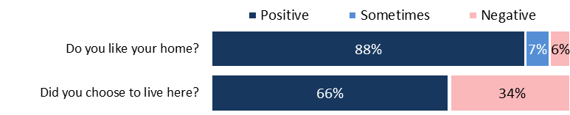

Figure 4. Service users’ attitudes to the residence where they live (n = 343-352)

|  |
| --- |
| **Home**  Some providers seemed to see the residences as their houses that residents lived in. Others saw the residences as people’s homes where they provided a service. Examples that contributed to a feeling that the residence was a ‘home’ included:   * Letting people choose the colour of their rooms * Showing respect for the residents’ privacy and asking before entering rooms * One provider thanked the residents for letting them use their home to have the interviews * Staff offices in the middle of residents’ lounges were common and contributed to an ‘institutional’ atmosphere. Some providers clearly separated staff, with small offices that could be closed off to enhance the home atmosphere.   Example: One provider provided support within an old facility with multiple bedrooms, a central lounge and kitchen. The home had a relatively large number of people living in a single building. The bedrooms were small but spotless with staff dusting each ornament. The residents felt loved, respected and supported. There was an activities centre – where residents did amazing things, for example Indian scarf dancing and Zumba. The residence had a computer lab and a beautiful art room with a trained art teacher. We felt it was a happy caring place, which was evident in comments from the people who lived there. All the staff (including the cleaning staff) knew who we were, what we were doing, why we were doing it. Each greeted us and was genuinely interested in the study. |

* 1. Staff were an important factor in whether service users liked their home

Staff were an important factor in whether service users liked their home (r = 0.27, p < 0.05) and most considered their home had the ‘right’ staff (85%) to work with them and that there were enough staff (79%).

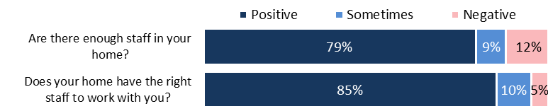

Figure 5. Service users’ attitudes to the staff in their residence (n = 342-343)

|  |
| --- |
| The service users who were happy with their staff thought:  They really think about the staff they hire. When they look at new staff they ask us what we need. So like let’s write a piece of paper about what we want and need with the other residents. They have to be able to listen to what we say and be able to guide us. It’s really important. Some staff haven’t been nice to us. The staff are really supportive, they even let staff come to the hospital (with me). They sometimes sleep over and sleep in the chairs.  We went on a cruise, they do fun things like that, they help us achieve our wants and beliefs. If we want to do something they try their best to help us.  Staff need to be paid more, it’s a tough job and they work really hard for basically nothing. It’s really tough conditions.  The staff are very caring and kind and helpful they cook us dinner when we need help. |
| Negative comments included:  Staff from agencies don’t know people too well.  There are so many agency workers. It would be better to have more permanent staff. People need to understand the disability. Agency workers need to read medical notes - sometimes the expectation is on people with the disability to train staff. It’s more an issue with agency staff. [There should be] longer orientation for staff, and to make sure staff don't talk down to people.  [There is] value in having permanent staff, with permanent staff they will know you and your cares.  Often short staffed. This results in staff being a bit rushed. I never feel unsafe.  Sometimes the staff go to sleep on the couch which isn’t very good, they're not really there to help me. |

* 1. Food quality was frequently mentioned

Food was not a topic included in the interview questions. However, it was one of the more common themes in comments on how services could be improved. Residents’ comments focused on either food quality or variety. Residents felt that food was very important to the quality of life, especially when services provided all of their food and where there was little or no choice.

|  |
| --- |
| **Food**  Twenty residents made comments about food. One resident said that he wants better food ‘not all the healthy stuff’. Some residences have monthly meetings to talk about things like food but ‘it’s really boring food.’ Others said:  I am really happy with the meals and activities.  I would like different food.  I would like to change to another house, and change the food.  More coffee and tea.  More food in cupboards.  I like the food menu to be changed more, more cheese crackers. |

* 1. Most service users had high overall quality of life scores

Responses to quality of life questions were scored across all domains providing a potential score range between 0 (all responses negative) and 100 (all responses positive).

The majority of services users who provided feedback were positive about their quality of life based on the questions used on the study. The average total score for all service users was 84 out of 100 and 73% of service users scored between 81 and 100 (Figure 6).

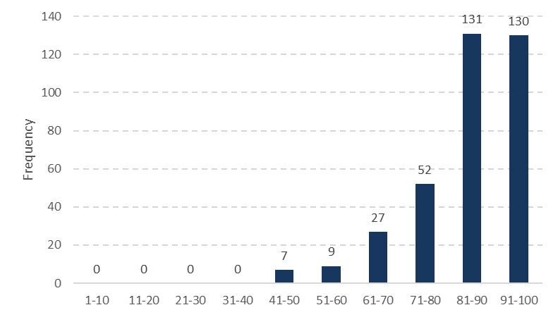

Figure 6. Distribution of total scores across all domains, 0 = lowest, 100 = highest (n = 356)

* 1. There was some variation in scores between domains

The total quality of life score is based on the results to all questions across all domains. We also calculated scores for each of the individual domains (Figure 7).

The domain scores highlight physical wellbeing, rights, and emotional wellbeing as areas of strength with scores of 93, 89, and 88 respectively. A substantially lower score (70) was recorded for personal development.

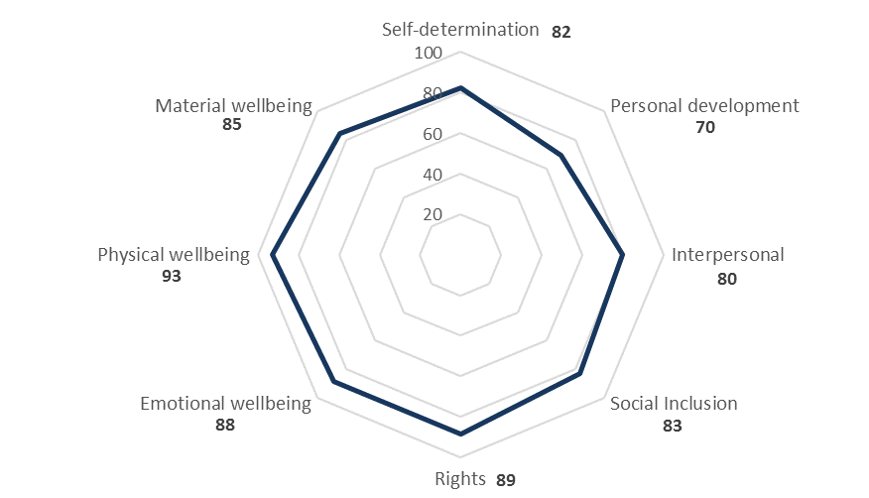

Figure 7. Overall scores for each question domain (n = 351-356).

Responses to individual questions and the reasons for different scores are described in the following sections.

# Self-determination

|  |
| --- |
| DSS service standards specify that:   * Service users have the right to make choices affecting their lives and to have access to information and services in a manner appropriate to their ability and culture * Have the same rights as other members of society to participate in decisions which affect their lives   Self-determination was assessed using four questions about whether residents felt they had choices in what they did, the support to do what they wanted to do and whether they could complain.  The overall domain score was 82/100. Areas of strength included being able to choose what to do each day and having the right support to do what they wanted to do. However, fewer residents considered they were involved in making choices about their lives.  The majority of residents (80%) felt able to complain but fewer (63%) felt anything changed when they did complain. There is a potential area of improvement in residents’ perceptions of whether anything changed when they complained. |

Self-determination had an average mean score of 82 based on six questions. The self-determination score was in the middle of domain scores which ranged from 70 to 93.

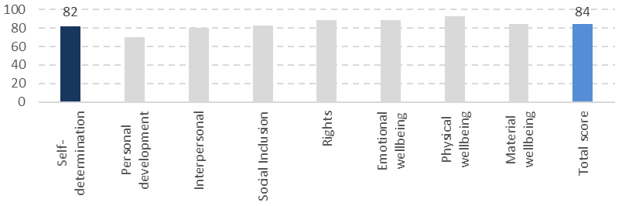

Figure 8. Overall domain scores out of 100 (n = 351-356)

The majority (67%) of service users scored between 81 and 100 in response to five questions developed as indicators of self-determination (Figure 9).

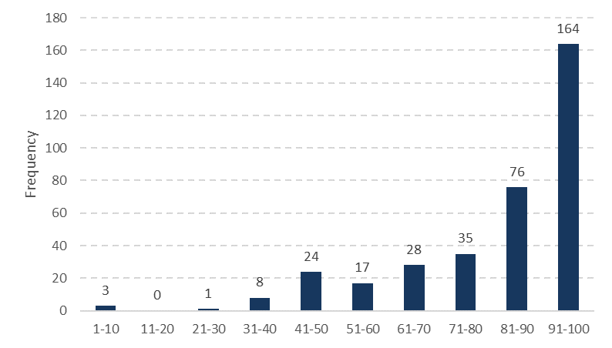

Figure 9. Distribution of self-determination scores (n = 356)

Most service users considered they could choose what to do each day and that they had the support they needed (Figure 10). More people reported making choices about what they do each day than about the larger choices in their lives.

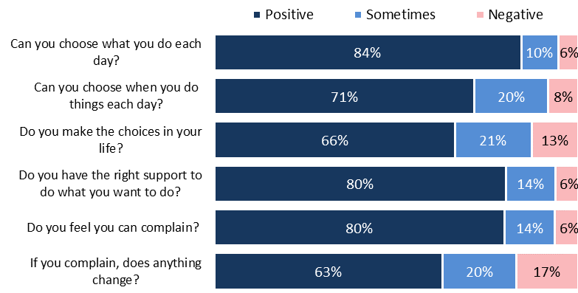

Figure 10. Distribution of answers for self-determination questions (n = 335-348)

|  |
| --- |
| **Making choices included:**  I do all sorts of things each day. Swimming in pool, sometimes go to spa and the beach and picnics.  I get the right support in the week. If I don’t need help I just let them know.  Staff support me well.  Availability of staff to provide assistance or support was a limiting factor in some people’s choice about what they did each day.  It depends how busy we are, we got routine, depends how busy the staff are.  Some constraints on choice were not always negative. Living in a group environment meant having rules and abiding by common expectations to create a more positive environment for all residents.  Staff tell people off if they are being noisy and banging on the walls, if they annoy other people.  I do things during the day I can choose what project I do. There is a routine in my life.  Advocacy meetings can play a role in service users’ self-determination. For example, they may not get to decide things day-to-day but they can decide and agree with a plan which is reached through service user and staff meetings. One provider had meetings with residents to discuss if things weren’t working and another had flat meetings:  At flatmates’ meetings I share with flatmates and staff.  Not all service users were so positive. For example, one service user thought that people dominate and control her, although she tries to make her own choices. Others felt that:  Sometimes I never get what I want and it upsets me.  I would like more of a say about what happens in my life  Another resident wanted to smoke medical marijuana for pain and to be able to smoke at night but was put to bed early so she could not smoke. She felt if it was her home then she should be able to go to bed when she wanted.  To change bed time, I want to smoke at night. |

Most people (80%) felt they could complain, however a smaller proportion thought nothing changed when they did complain.

|  |
| --- |
| One service user knew they had the option to complain but felt that things:  *D*on't change unless dad gets involved*.*  I feel I can complain but I don’t need to do it  I feel I can complain but I don’t do it.  Sometimes have to complain to the right person.  Others felt that they were not listened to when they did complain:  If I do complain nothing does change.  Really depends what it is, it depends if they have the money or not they don’t have much resources.  Another said that not much happens when he complains. He said he had to move house when he did not want to and wanted to live in a home with fewer people (three or four ideally, fewer than the five he lived with when interviewed).  One resident felt ‘imprisoned’ within her home. There are enough staff who ‘are wonderful’ but the other people in her home need a lot of support so there is little left over for her. She has voiced her concerns but does not feel she has been listened to and nothing has changed.  I’m happy to be in a service where I can do things. I have been there seven or eight years but it is not a place for life. Not a home, (but) a place you live. At the end of the day I just don’t want to live here. [Provider] say they will do things to improve but they don’t really. |

# Personal development

|  |
| --- |
| DSS service standards specify that service providers will:   * Appropriately respond to the particular life skill needs and goals of individual service users   Personal development was assessed using three questions about sharing, learning and trying new things.  The overall domain score was 70/100, the lowest of all domains. The low result was driven by the low proportion of people doing any education courses or training (only one-quarter - 24%). Some service users were developing through other activities they did not consider to be education, courses or training. |

Personal development had an average mean score of 70 based on three questions. The personal development score was the lowest domain score.

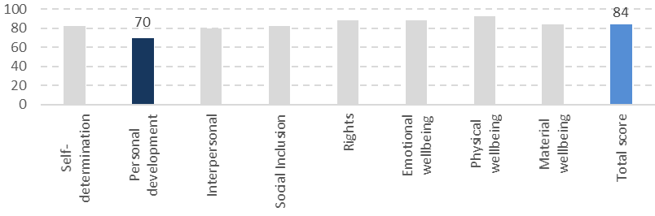

Figure 11. Overall domain scores out of 100 (n = 351-356)

Personal development had the most variation in scores with the largest portion (49%) of service users scoring 61 to 70 (Figure 12).

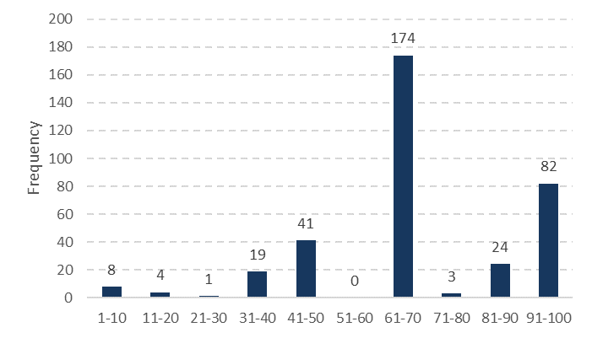

Figure 12. Distribution of personal development scores (n = 356) Based on three questions, limiting the range of potential scores.

Scores in the 61-70 range represented two positive answers and one negative answer, most often for participation in education or training. Most service users felt they could share what they are proud of (87%) and that they have the right support to try new things (82%) but the majority said they were not participating in any education or training (67%). Some residents did not recognise their personal development activities as education or training.

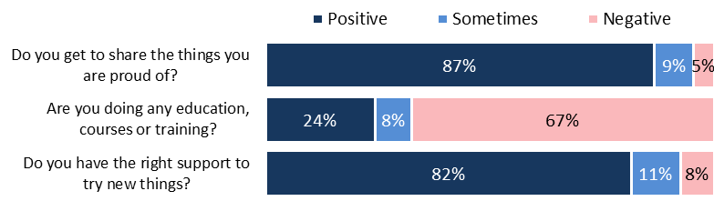

Figure 13. Distribution of answers for personal development questions (n = 332-350)

|  |
| --- |
| Other forms of personal development  All the interviewed participants at one provider said they were not involved in education. However, they all participated in monthly house meetings involving education, first aid, healthy living, OSH workshops, fire safety, social skills, managing relationships and healthy eating.  Service users also learnt everyday skills while living in residential services:  I have learnt how to catch the bus. |

While few of those interviewed did any education, courses or training, many described having jobs and being proud of them. Their jobs provided opportunities for personal development.

|  |
| --- |
| **Work**  Employment, sometimes voluntary work, was very important for many of the service users. The quantity or type of work did not appear to make a difference. Often the jobs were one day per week for a few hours. Jobs were a source of pride and gave purpose and direction. Service users who were employed often spoke about their jobs throughout their interviews. Providers often had a role in facilitating their employment.  For example, residents spoke with pride about washing the town ambulance once per week, volunteering at the library wiping DVDs and ‘conducting’ the town brass band. Another spoke of the 15 years she worked as a lobby assistant a few hours per week. She confidently discussed her role and the people she worked with.  I have a job at McDonalds (three times a week).  Depends on weather, I have two jobs (he worked at a golf club).  A job delivering junk mail, takes about two hours a day, and I mow lawns as well.  One provider gave residents lots of activities they could do. They all spoke proudly of the part they played in the community as a whole. Many went out to work and some did voluntary work around the facilities like gardening and/or cleaning.  **Travel**  Travel within New Zealand and internationally provided personal development, excitement and something to look forward to. One provider kept an array of photo albums and displayed photos of the residents enjoying themselves on trips.  Some of the providers recognised the importance of personal development through travel. Examples included:   * Two of the Auckland providers had holiday homes where the residents went for breaks. These were discussed by residents as a family member would discuss a family holiday home. * Two providers took residents on overseas holidays. Residents saved their money and fundraised for the trips. When interviewed, one had just returned from a cruise and was saving for an international trip. * One resident told us that she has had more opportunities than she ever had when she was living with her parents. She noted they were about to have an art exhibition to raise funds to ensure everyone in the residence could travel together which made her very happy. |

# Interpersonal relationships

|  |
| --- |
| DSS service standards specify that:   * Service users have the right to realise their individual capacities for physical, social, emotional and intellectual development.   Interpersonal relationships were assessed using six questions about having and seeing friends and family, and having partners.  The overall domain score was 80/100, one of the lowest domain scores. While many of the residents had family and/or friends, approximately one-third felt they could not spend as much time with them as they would like. Time with family and friends was often limited by their availability (distance, time) rather than restrictions from providers. |

The mean interpersonal relationship score was 80 based on the six questions shown in Figure 16. This score was one of the lowest domain scores.

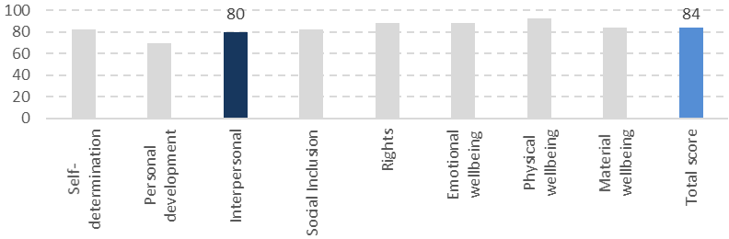

Figure 14. Overall domain scores out of 100 (n = 351-356)

Scores for interpersonal relationships varied more than for most other domains (Figure 15). Only 51% of respondents were in the top two score bands (81 to 100), fewer than other domains.

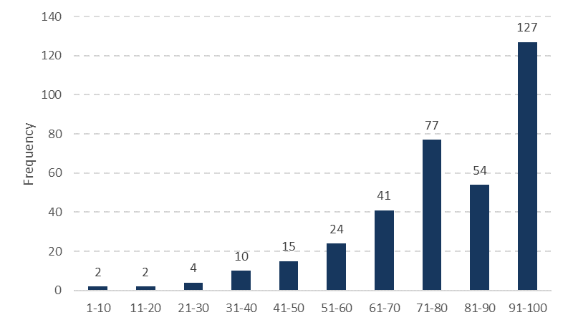

Figure 15. Distribution of interpersonal relationship scores (n = 356)

Three-quarters (76%) of service users had friends who did not live with them, but only 60% felt they could spend as much time with their friends as they wanted. Similarly, 63% of service users felt they could spend as much time with family as they wanted. Most (90%) service users said they have someone to talk to if they have a problem. While 75% of residents said they could have a partner, 20% felt they could not.

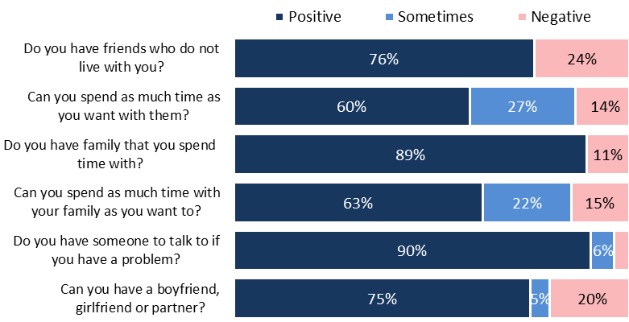

Figure 16. Distribution of answers for interpersonal relationships questions (n = 258-355). Questions about whether residents had friends and family were yes/no options. People who answered ‘no’ were not asked the follow-up question about spending time with them.

|  |
| --- |
| **Family**  Regular family contact was very important to service users. People had a wide range of different arrangements for seeing their family. For example, one went home most weekends and spent six to eight weeks with his family over summer. Others commented:  [I see] my sister every second Saturday, I stay at my sister’s.  I hang out with mum every Thursday.  I spent a lot of time with dad before he died  Residents who could not spend as much time with their families as they liked understood that their families were busy and often lived in other parts of the country or overseas making contact difficult.  Would like to spend more time with family but staff can’t take me and my family is busy.  Yes, I see them but they are busy lots of the time with work and things.  My brothers live in Christchurch and I don't see them much.  **Friends**  Service users did not talk about the importance of having friends outside their home as often as they talked about their families. All providers appeared to support opportunities for residents to mix and mingle with other residents who did not live with them as well as with residents living with other providers.  We do lots as a whole trust, they are really flexible and we do what we want to do.  I have a good life, lots of friends and I choose to do what I want to do and I have a great family.  **Partners**  The question ‘Can you have a boyfriend, girlfriend or partner if you wish?’ was a difficult question for many. If they did not want a partner, they often answered ‘No’. If asked ‘Are you allowed a partner?’ The answer was often ‘yes, but I don’t want one’.  Can have one but don't want to have a boyfriend.  I can have a girlfriend but I have to find one.  Six of those interviewed in Auckland were married or engaged couples. All had met their partners while in residential services though not always with the same provider. Two others interviewed had had recent partner bereavements. One residence displayed a wedding photo in the hallway proudly. One provider had a flat where one couple lived happily with full support.  The main reason for not having a partner may be that residents had not met someone or they were not interested in having a partner. A small number of people described family member resistance to them having a partner or felt they were not able to have a partner due to their disability.  **Sexuality**  The survey did not include a question about sexuality. One service user said they are transgender but that in official documents they have to be recorded as their original gender and not their new gender. They feel this is discrimination – the staff all referred to them using their new gender and their new name. |

# Social inclusion

|  |
| --- |
| DSS service standards specify that:   * Service users have the right to live in and be part of the community   Social inclusion was assessed using three questions about sharing, learning and trying new things.  The overall domain score was 83/100. Transport availability was an important influence on the extent people with physical disabilities could be active in their communities. |

The mean social inclusion score was 83 (Figure 17) based on the three questions shown in Figure 19.

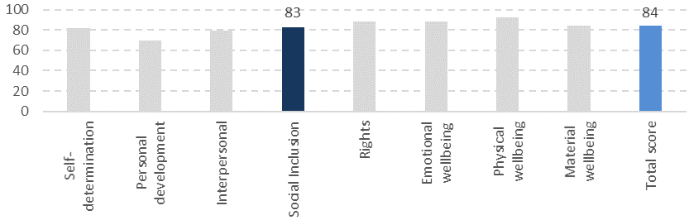

Figure 17. Overall domain scores out of 100 (n = 351-356)

The distribution of social inclusion scores was similar to most other domains (Figure 18) with 69% of the population in the top two score bands (81 to 100).[22]

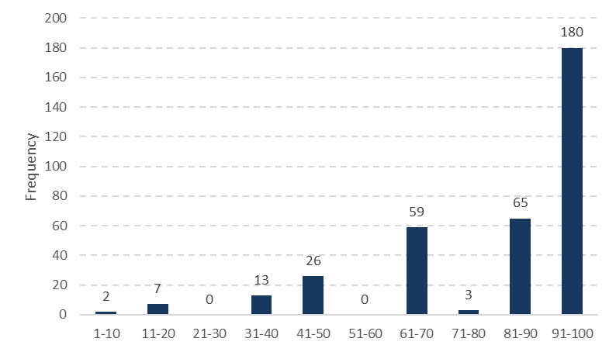

Figure 18. Distribution of social inclusion scores (n = 355)

There was little variation in the proportion of positive responses to the indicators within the social inclusion domain (Figure 19). Helping in the community had the fewest positive responses (69%). A slightly higher proportion of service users gave positive responses to being able to do things in their community when they want (76%) and getting transport when they needed it (80%).

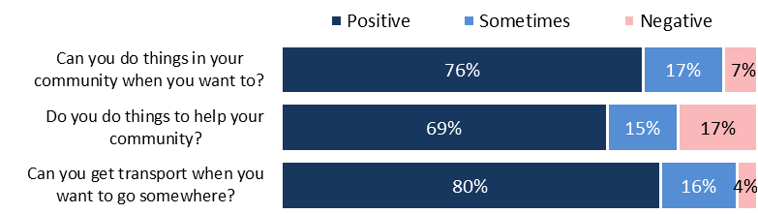

Figure 19. Distribution of answers for social inclusion questions (n = 337-352)

|  |
| --- |
| **Community involvement**  Service users were very positive about being involved in activities in their communities. For some this meant having set routines visiting different locations in their community throughout their weeks. Variation was an important factor.  For many of the service users helping in their community was usually helping with jobs around the home:  Pick rubbish up, help clean and look after the place.  Chores around the house and washes dishes.  Help friends in wheelchairs.  Outside the home one service user made cards for children at Lower Hutt hospital and delivered them. Others:  Help out at preschool with craftwork.  Helping other people at day base.  Help with meals on wheels.  Help at Pippins/Brownies.  **Transport**  Service users valued their independence when they were able to move around unaided:  I can catch the bus, train and the ferry.  I mainly just walk; small town so I usually walk or arrange a car ride with staff.  I have a motorised scooter, I go to shops and malls, always going out and about.  For example, on the day of his interview one service user was going to a local mall, an eight kilometre round-trip. He often came back after dark.  Some residents relied on transport from providers:  I can’t really walk places these days because of my epilepsy. They transport me whenever I want to go.  I have the van when it is available but not always available.  I am reliant on having support when out in the community.  Other residents used public transport:  Life revolves around wheelchair taxis. Taxis are not always available and have to revolve life around when wheelchair taxis are available. Taxis are not available often around when school starts and ends.  Wheelchair taxis are limited especially in the weekend.  I have a disability card, makes taxis half price but still too expensive. Have to pay for my own transport so don’t go out much. |

# Rights

|  |
| --- |
| DSS service standards specify that people:   * Have the inherent right to respect for their human worth and dignity * Have the same rights as other members of society to services, which support their attaining a reasonable quality of life   The rights domain was assessed using five questions about privacy, respect, culture and beliefs. The overall domain score was 89/100. Positive responses to individual questions were all over 77% and the lowest proportion was in response to the whether people gave residents information in the best way for them. |

The mean score for the rights domain was 89 (Figure 20) based on the five questions shown in Figure 22. This score was in the middle of other domain scores.

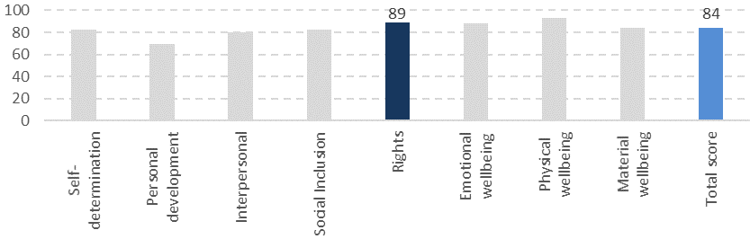

Figure 20. Overall domain scores out of 100 (n = 351-356)

The distribution of scores for rights was similar to most other domains (Figure 21) and 71% of the population had scores between 81 and 100).

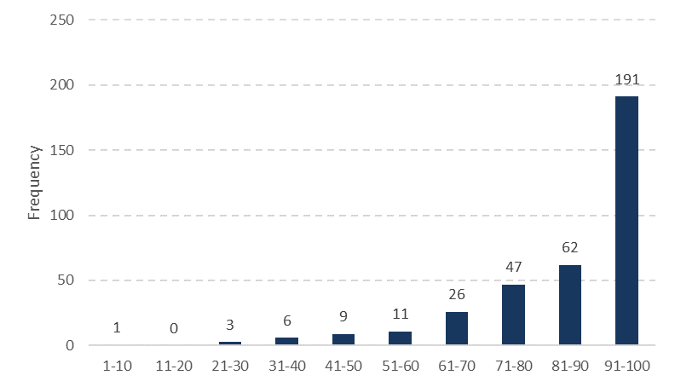

Figure 21. Distribution of the rights domain scores (n = 356)

With an overall high domain score of 89 there was only minor variation between the indicators. Service users recorded the highest proportion of positive responses for being able to have their door shut if they wanted to (90%) and the lowest for receiving information in the best way for them (77%).

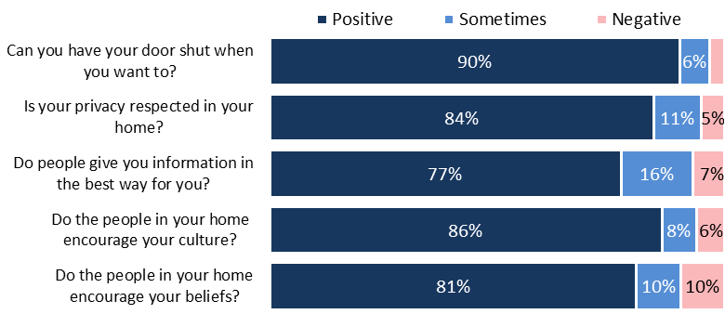

Figure 22. Distribution of answers for questions on rights (n = 319-354)

|  |
| --- |
| **Culture**  The questions on encouraging culture or beliefs caused difficulty for some residents. Those who did not identify with a religion or culture often found it hard to decide if their culture was encouraged as they did not see they had one. Interviewers provided examples such as being able to take part in traditions and celebrations or have special food on some occasions such as Christmas or birthdays.  I’m not sure if I have a culture.  Not sure I know what culture is.  People living with Māori providers had more understanding of what culture meant to them.  I'd like more trips to the marae and a hangi.  One resident said he ate far too many curries (which he did not like) and felt his culture as a New Zealander was not respected as there were too many ‘new’ New Zealanders supporting him.  **Beliefs**  Simplifying the term beliefs was difficult. Often residents focused on religion or church attendance. Many who went to church on Sundays were collected by another member of the congregation.  I go to church but since I moved I can’t walk there.  Don’t have a religion, but could if I wanted.  I used to go to church on Sundays but now people come to me on a Wednesday for holy communion so church comes to me.  Beliefs were important to some service users. In response to the online survey one parent said:  Some of the things that are most important to me in my life – relevant to my special cultural, spiritual, food, health and staff support needs are not met to the needed level. These cause me anxiety, stress, fear, worry, agitation and anger and may result in conflict with others and a poor quality of life for me (Proxy – parent).  **Privacy**  Most service users felt their privacy was respected however some questioned interviewers about whether privacy also includes what is written down about them. There were sometimes differing views on respect for physical boundaries (for example, knocking before entering a resident’s room) and respecting the privacy of information recorded about them. One resident asked:  Why does everything have to be recorded? The number of phone calls we make or who we made them to, when we go to bed, when we get up? Who gets this information and what does it have to do with our care? If we lived in our own home – as this is meant to be then this detailed information wouldn’t be recorded.  Others said:  Staff go into my room when I’ve locked it and I’m at work, which I don’t like.  Yes, but would like to lock my door.  Staff poke their heads in when you are trying to get dressed.  Staff make sure that if I want to be on my own I can be.  **Receiving information**  Many of the people living in residential services have communication challenges, which may relate to written or verbal information. Nearly one in five of the interview participants had limited or no verbal skills. It was important for staff to communicate with residents in a way that worked for the residents. For example, one resident who had communication difficulties, voiced similar concerns as she struggled to be understood by support workers who did not have English as their first language, she felt lonely and frustrated.  *If staff don’t understand who can I turn to?*  I find it hard when staff don’t speak English. |

# Emotional wellbeing

|  |
| --- |
| DSS service standards specify that:   * People will be supported – as far as possible - to live in a home with people with whom they are compatible. * People will live in an environment that safeguards them from abuse and neglect and ensures their personal security and safety needs are met.   Emotional wellbeing was assessed using six questions about happiness, having things to look forward to, safety and abuse.  The overall domain score was 88/100. However, 29% of service users said they had sometimes been hurt, teased or bullied and 16% that they had been abused. When asked about the details, in approximately two-thirds of instances the abuse or bullying was by another resident. |

The mean score for the rights domain was 88, this was based on the six questions shown in Figure 25. This score was slightly higher than the total score.

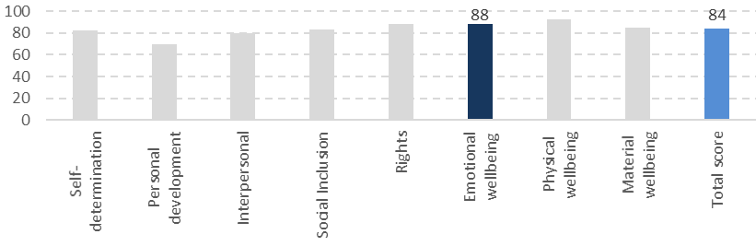

Figure 23. Overall domain scores out of 100 (n = 351-356)

A large proportion of service providers responded positively to emotional wellbeing indicators, 78% of service providers were in the top two score bands (81 to 100) (Figure 24).

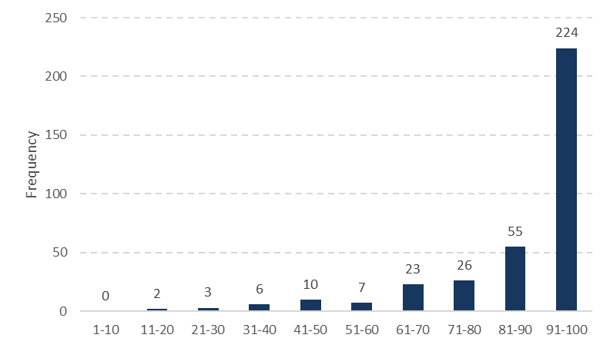

Figure 24. Distribution of emotional wellbeing scores (n = 356)

There was little variation in most of the emotional wellbeing indicators. However, 29% of interviewed service users said they had sometimes been hurt, teased or bullied and 16% that they had been abused.

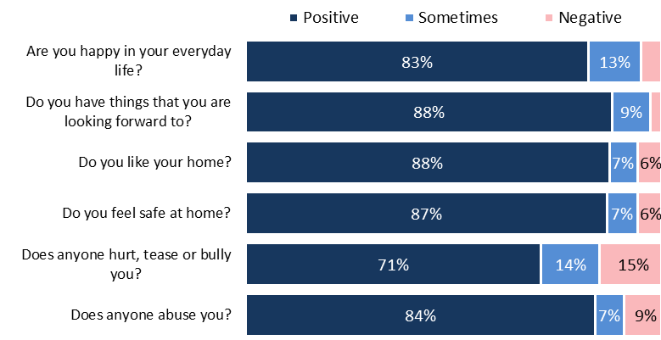

Figure 25. Distribution of answers for emotional wellbeing questions (n = 327-355)[23]

|  |
| --- |
| **Service users looked forward to** birthdays, flying kites, travelling, horse riding, bowling, starting Ramadan, letters from a sister, Christmas, singing, the IHC Ball, rugby, walking, biking, wings over Wairarapa. Positive comments included:  Of course I like my home, the train comes past and makes noises.  The staff let me have a pet, I have a cat I got from the SPCA seven years ago.  **Hurt, teased, bullied, abused or not safe**  Sixty-two service users answered yes to either question about being hurt, teased or bullied and/or abused. They said they often did not feel safe because of their housemates who were at times loud or who invaded personal spaces. Where details could be collected:   * 69% (43) said other residents in their own home caused their issues   Used to get bullied but the staff here are great.  I don’t like when people have argument, they quite often start fights even.  People in my home torment me and I get upset.  I am happy with life but not my flatmate.  Sometimes residents pick on me, but I feel safe, it’s just sometimes.  Yes, other clients hit me from time to time, I want it to stop, I have told staff and they do their best to help.   * Four service users (7%) said other residents at a day service abused them.   It is mostly the words that upset me.  One person says mean things.   * Two service users (3%) said it was someone else such as other special school pupils or a neighbour * One resident said that - Staff should have self-defence classes. * Six service users (10%) said it was staff   Sometimes the staff yell and screamed at me.  K (staff) she wouldn’t give me my coffee – she took my coffee and other stuff as well. This is not the first time. She hit [name] as well and tried to get the other staff on me as well. She said I took her house keys and it’s not true, they were in her bag. She tells me off a lot.  Grumpy staff scares me, staff hits me, mean words, shouts.  People tell me what to do when they are not the boss of me.   * One resident (who had a physical disability) said it was the service itself through their lack of support for her as a whole person * Six service users (10%) could not say who caused the issue. |

# Physical wellbeing

|  |
| --- |
| DSS service standards specify that:   * People will be encouraged to experience opportunities for optimum health, wellbeing, growth and personal development including staff proactively seeking opportunities and experiences for People they support. * People will be supervised, assisted, encouraged and supported to have good emotional and physical health   Physical wellbeing was assessed using six questions about whether people felt well, had the things they needed and could see people about their health when they needed to, and the extent people were able to choose how to use their energy. The overall domain score was 93/100. |

The mean score for the rights domain was 93, this was based on the four questions shown in Figure 28. Physical wellbeing was the highest scoring domain. 

Figure 26. Overall domain scores out of 100 (n = 351-356)

The distribution of scores for physical wellbeing was positively skewed compared to all other domains (Figure 24) with 82% of the population in the top two score bands (81 to 100) and 71% in the top score band (91 to 100).

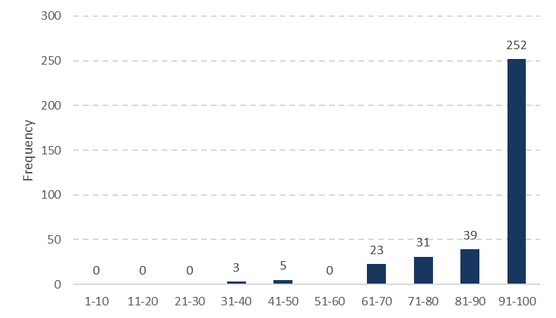

Figure 27. Distribution of physical wellbeing scores (n = 353)

There was little variation in responses to the different questions (Figure 28). Service users were prompted with examples on two questions in this domain:

* Do you have the things you need (for example, wheelchairs, glasses, hearing aids, braces?)
* Can you see the people who help you with your health when you want to (for example, doctors and dentists)?

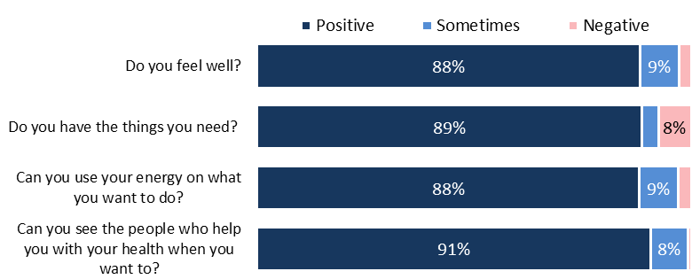

Figure 28. Distribution of answers for physical wellbeing questions (n = 316-348)

|  |
| --- |
| **Health**  Health was well understood by those interviewed. They responded positively to how well they felt and most felt they could see medical professionals when they needed to:  I go for checks yes, I go to the gym twice a week, I always try to do more things.  Half and half, I got to get healthy again like I was when I was slim.  I eat healthy so I feel healthy.  Our coordinator takes us to the Dr straight away.  If we ask to the health professionals we can see them, that’s why I said sometimes.  **Having what you need**  Two questions in this area caused difficulties when asked. Do you have the things you need (for example, wheelchairs, glasses, hearing aids, braces)? The question referred to extra physical support that might be needed but was too complex for some service users as many did not know what they needed. Most of those who responded had the things they needed but some said:  I asked for a walking frame but I haven’t got it yet, I think they are going to get one.  I think I need wheelchair now rather than a walker.  We all have phones so if the staff aren’t there we can call them. They take turns having the phone.  Yes, I am getting new glasses soon.  The question about using energy on what they wanted to do was suggested during consultation to identify whether people were able to use their sometimes limited energy on doing the things they wanted to do, rather than things other people required them to do.  For example, some people may prefer to be supported to dress and eat to conserve their energy for other activities. Interviewers reported this question was hard for some to understand, though those who answered it were mostly positive. |

# Material wellbeing

|  |
| --- |
| DSS service standards specify that the provider must:   * Support the person in their right to control their own money * Ensure the person has access to general financial advocacy or independent support * Ensure the home is accessible, homely, clean, well maintained and provides privacy and autonomy * Encourage people to have their personal belongings within the home and ensure that these are respected.   Material wellbeing was assessed using four questions about spending and saving money and respect for personal things.  The overall domain score was 85/100. Respect for their personal things had the largest proportion of positive responses (90%). Being able to choose how to spend their money had the largest proportion of negative responses. |

The mean score for the rights domain was 85 (Figure 29) based on the five questions shown in Figure 31. This score was in the middle of other domain scores.

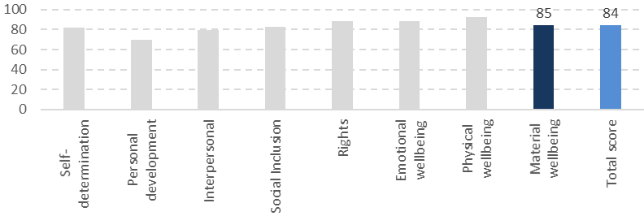

Figure 29. Overall domain scores out of 100 (n = 351-356)

The distribution of scores for rights was slightly different to other domains with more service users in the 71 to 80 score range compared to the 81 to 90 score range (Figure 30): 61% of the population were in the top two score bands (81 to 100).

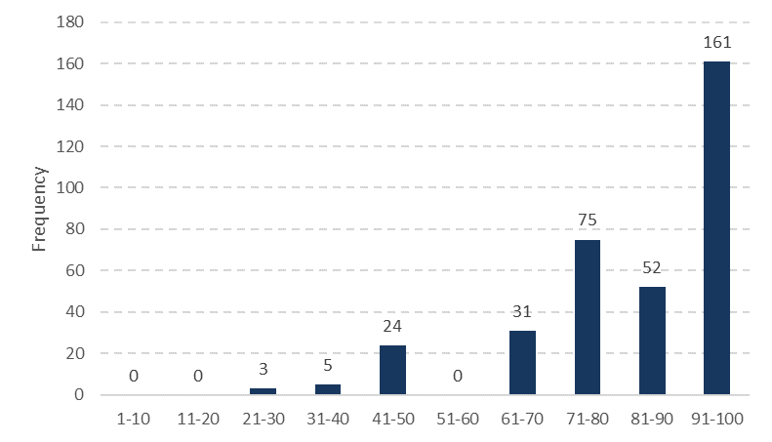

Figure 30. Distribution of material wellbeing scores (n = 351)

There was some variation in responses within the material wellbeing domain. Being able to choose how to spend their money had the largest proportion of negative responses (Figure 31).

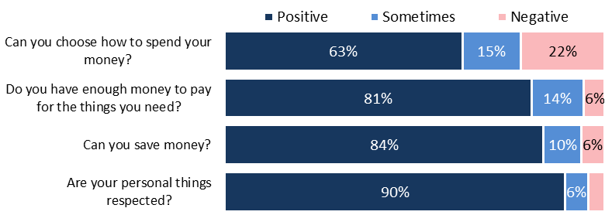

Figure 31. Distribution of answers for material wellbeing questions (n = 329-344)

Having a job was important to some residents but was not specifically explored in interviews because not all residents had the potential to work. Employment is discussed in sections 7 and 9.

|  |
| --- |
| **Money**  There were some differences in how service users interpreted the question about choosing how they spent their money. Some thought that as they could choose to buy a coke once a week or subway for lunch that they had enough choice in how they spent their money. Others were actively saving for long-term goals (for example, house trips) and choosing not to spend money on other things.  Staff help many residents manage their money.  Staff members assist  I'm not allowed to deal with money, they give me money for lunches and things.  A staff member helps me because I need to be careful with my money.  Staff manage money but I can choose to buy thing if I want.  Family members assist others  I usually do it but my brother helps transfer it from one account to another  I don’t manage my own money, my family help.  **Saving**  I try to be careful with money but $50 is not much a week. I need $80, [to buy] like a mobile phone. It was stolen on the bus by two girls.  I try to save $5.00 a week but sometimes have to draw it out to pay my bills.  I save most of my money.  Yes, I have saving account, rich as not smoking anymore.  Saving money to go to the Gold Coast.  I would like to know more about my money.  **Respect for personal belongings**  When service users said their personal things were not respected, this was usually because other flatmates came into rooms but in some cases residents said staff came into their room when they were not home or when they did not want them to.  Things are respected all the time, used to be worse years ago, but now the staff are great.  My things aren’t respected. One staff threatened to take my TV off me. |

# Responses from proxies

|  |
| --- |
| Thirty-five responses were collected from proxies (people answering on behalf of people living in residential services who were not able to provide answers themselves). Sixteen were provided on paper or in face-to-face interviews and 19 were provided as responses to the online survey.  Proxy responses were more negative (lower mean scores) across all domains and overall than responses from service users. The biggest differences were in questions related to independence and choice, suggesting the proxy responses were for people with more severe disabilities. |

Most proxy responses were provided either by immediate family members or by support workers who had long relationships with the service users they answered for:

* Immediate family – 18
* Support worker – 16
* Friend – 1

Responses from proxies were less positive across all domains and overall than those provided by service users themselves (Figure 32).



Figure 32. Results for proxy responses compared to those who provided answers for themselves.

The biggest differences were in self-determination and social inclusion. Proxies were much less positive about service users’ quality of life in a number of areas (Table 5). The differences were most significant in responses to questions related to independence and choice. The differences may therefore be a reflection of the differences in capability between service users who answered the survey for themselves and those the proxies were providing responses on behalf of. Proxies were likely to be answering for people with more severe disabilities that limited their independence. Some of the differences may also reflect differences between the expectations of proxies and service users about what is a good quality of life.

Table 5. Differences between percentage of positive responses by proxies and service users (Only differences of more than 20% are shown).

|  |  |  |  |
| --- | --- | --- | --- |
| Domain | Indicator | Proxy response | Service user response |
| Self-determination | Can you choose what you do each day? | 35% | 84% |
| Can you choose when you do things each day? | 23% | 71% |
| Do you make the choices in your life? | 18% | 66% |
| Do you feel you can complain? | 57% | 80% |
| Personal development | Do you get to share the things you are proud of? | 65% | 87% |
| Are you doing any education, courses or training? | 3% | 24% |
| Social inclusion | Can you do things in your community when you want to? | 47% | 76% |
| Do you do things to help your community? | 28% | 69% |
| Emotional wellbeing | Do you have things that you are looking forward to? | 59% | 88% |
| Physical wellbeing | Can you use your energy on the things you want to do? | 64% | 88% |
| Material wellbeing | Can you choose how to spend your money? | 30% | 63% |
| Can you save money? | 60% | 84% |
| Service questions | Did you choose to live here? | 36% | 66% |
| Are there enough staff in your home? | 56% | 79% |

Proxies were more positive (greater than a 5% difference) than service users in response to the following questions.

* Do the people in your home encourage your beliefs? (+5%)
* Do you have enough money to pay for the things you need? (+11%)

Fewer proxies considered service users were abused, hurt teased or bullied.

* Does anyone abuse you? (16% fewer)
* Does anyone hurt, tease or bully you? (11% fewer).

# Service users’ characteristics and service type can influence quality of life

|  |
| --- |
| Quality of life includes a number of inter-related components that were assessed in interviews with service users.  Quality of life as assessed in this study was high for the majority of service users. However, 26% consistently reported lower overall quality of life scores across the different domains.  Differences between respondents were most evident in the social inclusion and interpersonal relationship domains. Younger respondents and those with intellectual/learning disabilities tended to be more positive while those with physical disabilities were more negative, particularly about social inclusion and whether there were enough staff available.  Differences by provider type and area appeared to be related to the different proportions of service users from each who had different types of disabilities. |

As shown in Figure 33 the theory of quality of life comprises a number of interrelated aspects that influence each other, and the overall quality of life of an individual. In the current study we explored the extent different personal and service characteristics influenced overall quality of life.



Figure 33. Schalock quality of life theory[24]

* 1. Service users with different quality of life scores had similar patterns of results

Service users were divided into three groups based on their overall quality of life score:

* 37% of service users had total scores between 91 and 100
* 37% had total scores between 81 and 90
* 26% had total scores of 80 or less

Scores were consistent across the different quality of life domains. For example, service users who had lower overall quality of life scores tended to respond less positively in all domains (Figure 34). The magnitude of the difference between lower and higher scoring residents varied in size across the different domains.

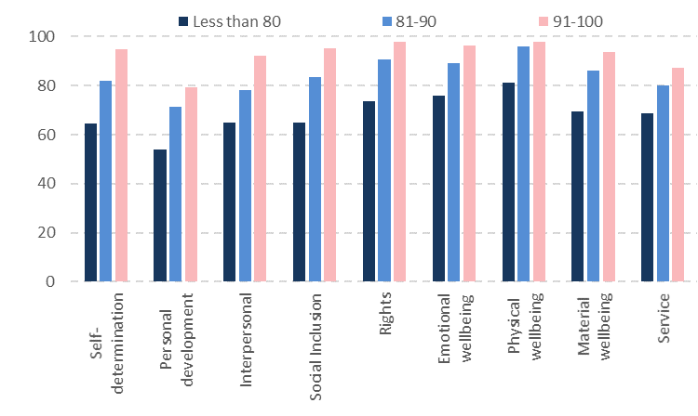

Figure 34. Mean scores across domains for low, medium and high scoring service users (n = 351-356)

The overall distribution of responses by people’s different characteristics is provided in Table 6 below. Service users who had consistently higher quality of life scores were more likely to be younger (less than 40 years), to have an intellectual/learning disability and to live in a residence owned/managed by a regional provider. There were not significant differences in the total scores or scores for individual domains between people from different gender and ethnic groups. A higher proportion of Pacific respondents recorded positive scores compared to people from other ethnic groups, however due to the small number of respondents, the difference was not significant.

Table 6. Service user characteristics and overall quality of life scores

|  |  |  |  |  |  |
| --- | --- | --- | --- | --- | --- |
| Characteristics | | # of service users | 80 or less | 81-90 | 91-100 |
| Age  (24 missing) | 0-40 | 101 | 19% | 38% | 44% |
| 41-60 | 181 | 29% | 38% | 33% |
| 60+ | 50 | 26% | 36% | 38% |
| Ethnicity (total count)  (11 with no ethnicity included) | NZ European | 283 | 27% | 37% | 36% |
| Māori | 46 | 26% | 41% | 33% |
| Pacific | 13 | 23% | 23% | 54% |
| Other | 24 | 17% | 46% | 38% |
| Communication type  (60 missing) | Verbal | 244 | 25% | 36% | 39% |
| Limited or non-verbal | 52 | 19% | 37% | 44% |
| Time in residential services (79 missing) | 0-20 years | 180 | 24% | 34% | 41% |
| 20+ years | 97 | 24% | 39% | 37% |
| Type of disability (missing for 16) | | | | | |
| Intellectual/learning disability | | 300 | 24% | 39% | 37% |
| Intellectual/learning disability only | | 211 | 22% | 39% | 39% |
| Physical disability | | 123 | 30% | 36% | 34% |
| Physical disability only | | 34 | 35% | 29% | 35% |
| Intellectual/learning and physical disability | | 89 | 28% | 38% | 34% |
| Hearing disability | | 30 | 33% | 37% | 30% |
| Sight disability | | 64 | 27% | 42% | 31% |
| Type of provider  (7 missing) | Regional | 85 | 13% | 39% | 48% |
| National | 264 | 31% | 37% | 32% |
| Size of provider  (none missing) | 0-100 | 96 | 21% | 37% | 43% |
| 101-200 | 38 | 13% | 32% | 55% |
| 201+ | 198 | 31% | 38% | 30% |
| Total | | 356 | 26% | 37% | 37% |

* 1. Effect of age on interpersonal relationships and social inclusion

Younger respondents had higher interpersonal and social inclusion domain scores than those in the 41-60 age band, though neither group differed significantly from those in the 60+ age band (Table 14).

Table 7. Mean scores for interpersonal relationships and social inclusion for different age bands. Means significantly different to another age band (p < 0.05) are marked with an asterisk (Significant differences only found between 0-40 and 41-60).

|  |  |  |
| --- | --- | --- |
| Age bands | Interpersonal score | Social inclusion score |
| 0-40 (n = 101) | 85* | 90* |
| 41-60 (n = 181) | 77* | 81* |
| 60+ (n = 50) | 79 | 85 |

* 1. Effect of type of disability on the domain scores

People with intellectual/learning disabilities tended to score more highly in the social inclusion and interpersonal relationship domains than those with physical disabilities. People with hearing disabilities had lower scores in the emotional wellbeing domain. Mean scores highlighting those differences are shown below (Table 8).

Table 8. Mean scores for interpersonal relationships and social inclusion for people with different disability types. Means significantly different from those not in group (p < 0.05) are marked with an asterisk. Score reported as: domain mean score for group (difference compared to other respondents).

|  |  |  |  |
| --- | --- | --- | --- |
| Type of disability | Interpersonal score | Social inclusion score | Emotional wellbeing |
| Intellectual/learning disability (n = 300) | 80 (+1) | 86 (+18)* | 88 (+1) |
| Intellectual/learning only (n = 211) | 81 (+4)* | 88 (+12)* | 89 (+2) |
| Physical disability (n = 123) | 77 (-4)* | 76 (-11)* | 87 (-2) |
| Physical only (n = 34) | 79 (-1) | 62 (-23)* | 89 (+1) |
| Hearing (n = 30) | 78 (-2) | 83 (0) | 78 (-11)* |

People with a physical disability had lower mean scores in the social inclusion domain than other people, with the difference particularly marked for those with a physical disability only (no intellectual or learning disability). People with physical disabilities were less likely to be positive about all three indicators in the social inclusion domain: ability to get transport, do things in their community when they want to and do things to help their community.

The extent service users liked their home, and whether they thought there were enough or the right staff were also affected by their type of disability. People with physical disabilities were less likely than those with intellectual/learning disabilities to think their homes had enough or the right staff (Table 9). The difference for those with physical disabilities was most clear when looking at the question about having enough staff, which may reflect their higher need for support with transport.

Table 9. Percent of positive responses from people with different disability types to questions about staff. Results which were significantly different with the rest of the service users are marked with an asterisk.

|  |  |  |
| --- | --- | --- |
| Type of disability | There are enough staff in my home (percent positive) | My home has the right staff (percent positive) |
| Intellectual/learning (n = 300) | 81% | 87%* |
| Intellectual/learning only (n = 211) | 84%* | 88%* |
| Physical all (n = 123) | 68%* | 81%* |
| Physical only (n = 34) | 58%* | 77%* |
| Hearing (n = 30) | 71% | 75% |

* 1. Effect of type of providers

Service users were linked with a service provider organisation that could be identified as:

* National providers: providers who had residences in multiple regions of New Zealand. This did not necessarily mean that individual residences were large.
* Regional providers: Providers who had residences in only one region.

Providers were also allocated to three size categories based on the total number of people they supported in New Zealand. The distribution of responses across the provider types and sizes is shown in Table 10 below.

Table 10. Proportion of overall responses by provider type and size (percentages represent proportion of all survey responses).

|  |  |  |
| --- | --- | --- |
| Size | Regional  (one region only) | National  (more than one region) |
| Small (0-100) | 22% | 11% |
| Medium (100-400) | 2% | 9% |
| Large (400+) | 1% | 56% |

Comparing the results of people living with different types of providers showed some significant differences. However, they were closely related to differences in the types of disabilities of the people those providers supported:

* People included in the survey who had physical disabilities only, who scored lower for social inclusion, were concentrated in smaller national providers.
* People included in the survey who had hearing disabilities, who had lower scores for emotional wellbeing, were concentrated in smaller, national providers.

Differences in the types of disabilities people had appeared to lead to differences in overall scores recorded by people living in the different provider types and sizes. The differences in scores are shown in the table below.

Table 11. Domain scores with differences for different provider types, looking at all respondents (n = 356).

|  |  |  |  |  |
| --- | --- | --- | --- | --- |
| Provider type | Interpersonal relationships | Social inclusion | Emotional wellbeing | Significant differences |
| National | 78* | 81* | 92* | National and regional providers significantly different for all (p < 0.05) |
| Regional | 85* | 90* | 87* |
|  |  |  |  |  |
| Small | 81 | 81* | 91 | Emotional wellbeing significantly lower for large providers (p < 0.05).  Social inclusion significantly lower for small (p < 0.05) |
| Medium | 84 | 92* | 93 |
| Large | 78 | 82 | 86* |

* 1. Differences between localities

Different localities had slightly different mean scores for each domain with Auckland having the highest scores for nearly all domains and Palmerston North having the lower score for nearly all domains (Figure 34).

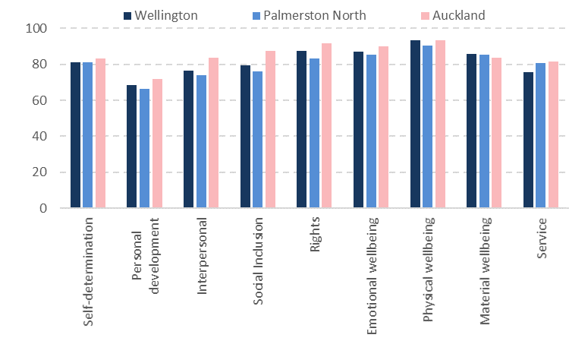

Figure 35. Mean scores across domains for different localities (n = 351-356)

When the proportion of service users with consistently low, medium and high scores was compared between localities (Table 12):

* Palmerston North had a higher proportion of service users with consistently lower scores
* Auckland had a higher proportion of service users with consistently higher scores.

Table 12. Comparison between study localities

|  |  |  |  |  |  |
| --- | --- | --- | --- | --- | --- |
| Region | # in study | 80 or less | 81-90 | 91-100 | p-value |
| Wellington | 98 | 31% | 42% | 28% | **P < 0.05** |
| P. North | 74 | 39% | 34% | 27% |
| Auckland | 184 | 20% | 35% | 45% |

The reasons for differences between localities appears to be driven by differences in the types of disability of people supported. Auckland had more responses from people with intellectual/learning disabilities and fewer from people with physical disabilities only.

Table 13. Proportion of service users with different types of disabilities responding from the different areas surveyed

|  |  |  |  |
| --- | --- | --- | --- |
|  | Wellington | Palmerston North | Auckland |
| Intellectual/learning disability | 76% | 80% | 91% |
| Intellectual/learning disability only | 59% | 55% | 61% |
| Physical disability | 33% | 34% | 36% |
| Physical disability only | 16% | 10% | 6% |
| Intellectual/learning and physical disability | 16% | 24% | 30% |
| Hearing disability | 9% | 10% | 8% |

* 1. Summary of domain scores and factors contributing to differences

Looking at the scores for each domain, only some characteristics had statistically significant effects on people’s scores. Provider type and size, type of disability and to a lesser extent being younger all had effects on some domains. Results in physical and material wellbeing were consistent across all groups of people who answered the survey.

Domain scores for the *Include Me!* Study in Canada are provided as a comparison. *Include Me!* Uses a similar approach to the current study but is not solely focussed on residential service users. Notable were the higher domain scores for interpersonal relations, social inclusion and rights in the current study. Personal development had a similar score in the current study and *Include Me!*

Table 14. Overview of domain scores (ranked by most to least positive). Note the connection between disability type and provider type/size.

|  |  |  |  |  |  |
| --- | --- | --- | --- | --- | --- |
| Quality of life domain | Mean score | Proportion 90 to 100 | Significantly lower mean scores for: | Significantly higher mean scores for: | Include Me! domain scores |
| **Independence** | | | | | |
| Self-determination | 82 | 46% | No effects | No effects | 71 |
| Personal development | 70 | 23% | National provider | Regional provider | 71 |
| **Social participation** | | | | | |
| Interpersonal relationships | 80 | 36% | National provider  Physical disabilities | Regional provider  Intellectual/learning disabilities  Younger people | 66 |
| Social inclusion | 83 | 51% | Physical disabilities  National provider  Small provider | Intellectual/learning disabilities  Regional provider  Younger people  Mid and large provider | 59 |
| Rights | 89 | 54% | 41-60 year olds | No effects | 76 |
| **Wellbeing** | | | | | |
| Emotional wellbeing | 88 | 63% | Large provider  National provider  Hearing disability | Small provider Regional provider | 91 |
| Physical wellbeing | 93 | 71% | No effects | No effects | 81 |
| Material wellbeing | 85 | 46% | No effects | No effects | 82 |

# Overview

* 1. Overall quality of life was high

Most residential service users liked the home they lived in and had a high quality of life, as measured by indicators linked to a quality of life framework validated and used extensively to assess the quality of life of people with a disability.

The overall domain scores highlight physical wellbeing, rights, and emotional wellbeing as areas of strength with scores of 93, 89, and 88 respectively. A substantially lower score (70) was recorded for personal development.

Service users with lower scores were more likely to be older and have a physical disability. Ethnicity and gender did not significantly affect overall scores or for individual domains. There were differences observed by provider type and size, however they appeared to be a result of the different disability profiles of the service users who completed the survey from those providers.

Differences in domain scores between groups of service users were focused in the social inclusion, interpersonal relationships and to a lesser extent emotional wellbeing domains. In our study, as in other studies, access to transport was an important factor for people with physical disabilities. Presence of a physical disability only (i.e. not in addition to an intellectual/learning disability) was associated with the lowest scores in social inclusion, with people less likely to be positive about their ability to get transport, do things in their community when they want to and do things to help their community.

Generally, based on the interview data, feedback from service users and observations by the research team it seemed that being part of a minority group in a residence resulted in a lower quality of life. Difficulty for service providers in meeting the specific needs of a few service users may contribute. For example:

* People with specific cultural, religious or other beliefs
* People who were lesbian, gay, bisexual, transgender
* People with physical disabilities or hearing disabilities who may feel isolated in homes or flats where they do not have a peer group.

Staff who engaged with residents, talked with and got to know residents and who could communicate with residents were very important to residents. Our team observed many very committed staff who created a positive home environment, respected service users and provided them with a range of opportunities and experiences. However, there were a few exceptions described by service users. Concerns about staff focused on temporary staff who residents did not know and staff who were less able to communicate with residents because they did not speak English.

The other residents in a home also influenced a service users’ quality of life. A compatible ‘mix’ of service users in a residence was important socially and from a safety perspective. Most of the ‘sometimes’ or ‘negative’ responses to questions about being hurt, abused or bullied related to interpersonal issues with flatmates or with a resident who was very disruptive (especially being noisy and banging).

There were some differences associated with type and size of provider but these appeared to be driven by the disability profiles of the people who responded from those providers.

The experiences of users of residential services sits within the context of their personal situations, service specifications and funding, and the ways service providers support people with disabilities living in their residences. The information from this study provides information about quality of life indicators that people with disabilities thought were important and areas of people’s lives that could be improved to improve their overall quality of life.

* 1. Service users were positive about being interviewed

A good number of the service users were really excited to be taking part in an official interview and talking about their lives. Some participants were passionate about advocacy, were part of advocacy groups and went to meetings. Being part of the study contributed to giving residents a sense of power and individuality.

* 1. The interviewers benefitted from taking part in the study

For some interviewers, employment for this study was the first time they were challenged to see the strengths they gained from their disabilities rather than just the challenges. Their participation was essential to the study’s success.

The research team working with the interviewers observed:

* Personal growth, for example changes in interviewers’ perceptions of their own disabilities and talents
* Increases in employability and understanding of the responsibilities of employment, for example the importance of being on time and presenting themselves professionally
* Empathy and understanding for participants’ situations and experiences
* Commitment to supporting people with disabilities to give their opinions
* Pride in making a contribution to the New Zealand community.

Feedback from the interviewers showed the experience they gained from training and interviewing was valuable for them personally.

Examples are provided below.

|  |
| --- |
| The interviewer has had one previous work experience placement. Since joining the interview team she made big gains in her personal skills. Initially she arrived late to interviews but towards the end of her work she arrived early, having organised herself the night before, prepared her lunch, had a shower at night and woke early. ‘I’ve learned about being there early for work. Don’t be late.’  Our team provided her with a detailed travel plan for each day of interviews. As her confidence grew she travelled farther and changed trains to get where she needed to go. She said she had improved by doing things: ‘Like catching the train when I haven’t been anywhere.’ During these interviews she travelled over the harbour bridge for the first time and went to a restaurant– something she had never done before. ‘I have learnt about going different places I hadn’t been.’  She feels as if she gained confidence doing this job. She said  *‘I have written everything in my notebook to make sure I did not forget anything’*…‘When I leave I will take everything with me, like how I met yous and other people...I just want to say I had a good time…nothing was boring…’  Over the six weeks she worked we noticed the interviewer began replying quickly to requests, turned up early, was really well groomed, tried hard and recorded everything about the interviews in her notebook. Her confidence grew. |

|  |
| --- |
| The interviewer has NCEA level 3. This role was her first official job. Since finishing at Malatest she has gone on to another job working in membership engagement and support for a regional organisation. The interviewer spoke a lot about the skills she learnt as a researcher. Not only did she learn practical working skills such as how to engage people in an interview situation but also more about herself.  It taught me not only to not take things so personally but also to have a really thick skin and to not assume things. Like I went in thinking it would all be the same but it wasn’t so it taught me a lot about not assuming things or the way it is.  I thought I had good listening skills, but after actually doing it I realised that they were actually pretty average and I needed to work on them. Those are the main ones.  I realised through this job I actually like listening to people and hearing what they say, especially with this unique job, it was interesting hearing how they came to the services or whether it was their choice or not. Just the fact that in some areas they did feel they had choices and other areas they didn’t. It was really interesting and eye opening, especially for me because I’m quite independent.  She thought that having the interviewer job allowed her to develop the skills and ability to move onto her current job.  I think if I didn’t do this job with you then I wouldn’t be at the job I’m at now. |

For future studies we recommend continuing to use peer interviewers. The study invested a greater amount of time in training and supporting peer interviewers than anticipated. Although not always necessary, we did find that having a research team member also available on-site helped to:

* Support the interviewers and assist in responding to any difficult questions posed by service users participating in the study
* Facilitate the interviews by managing scheduling changes on the day and relationships with staff
* Respond to questions from the service providers and in particular to address any concerns raised by service providers about the study.
  1. The quality of life indicators

The indicators within the framework domains were developed for this study but based on those used elsewhere. The challenge for the study was developing a set of indicators that could be used to provide a meaningful measure of quality of life for people living in residential services. In New Zealand, the majority of people living in residential services have intellectual/learning disabilities.[25] Developing indicators that could be readily understood by people with intellectual/learning disabilities meant sacrificing some complexity such as more extensive response scales that would have captured more detail from service users without intellectual/learning disabilities.

Use of the Schalock quality of life framework provides a way of analysing the components of quality of life that can provide a consistent approach over time. In Canada, *Include Me!* has demonstrated changes in repeat measures of quality of life over time in response to providing findings to service providers and facilitating discussion about what changes at policy, funding and service delivery might make a difference.

As part of our analysis we reviewed the indicators we used with a view to recommendations for changes and additions for future use.

Table 15. Review of the indicators used in this study

|  |  |
| --- | --- |
| Indicator | Comment |
| Self-determination | The indicators providing feedback about choices demonstrated that service users felt more able to make day to day choices than more complex choices about their lives. Questions about the opportunity to make complaints discriminated between the ability to make complaints and whether anything changed as a result.  No changes recommended. |
| Personal development | The low domain score for personal development was driven by the smaller proportion of positive responses to questions about whether service users were doing any education, courses or training. Service users were learning from activities that they did not consider to be education, courses or training.  We suggest:   * retaining this question in future studies as a baseline * the addition of a question about learning new things |
| Interpersonal relationships | Approximately one-third of residents felt they could not spend as much time as they liked with family and friends. Frequently while the service user would like to see their family more often, their family is busy or lives far away from them. Influencing change is therefore difficult for the service provider.  We recommend ongoing inclusion of the indicators. |
| Social inclusion | A large number of service users interpreted Q17 ‘doing things to help in their community’ as helping anybody from anywhere, examples given were helping with chores around the house, helping other residents by pushing them around, cooking cleaning etc. although some did do things out in the wider community.  No changes recommended. |
| Rights | Q22 and Q23 were about culture and beliefs. These questions were very important to service users who had a strong sense of culture and/or beliefs but service users who did not found it difficult to know how to respond. A number of people said they did not have a religion or did not have a culture.  Despite the challenges for people who did not identify with a culture or religion, we recommend retaining these questions. |
| Emotional wellbeing | Approximately a quarter of service users said they had been hurt, teased, bullied or abused.  Although more detail about the nature of the situation is required it is not reasonable to place peer interviewers in the position of collecting this additional information. In this study any instances where people said they had been hurt, teased, bullied or abused were referred to senior members of the study team for follow-up with the individual and the Ministry of Health where approved by the individual.  No changes recommended. |
| Physical wellbeing | No changes recommended. |
| Material wellbeing | The questions about money were interpreted differently. Some service users’ needs for money related to being able to buy a treat whereas others were earning and saving money. For service users with more independence, material wellbeing was a more important concept as they were more aware of what they could do with money. The different interpretations were appropriate for the diverse situations of the service users.  No changes recommended. |
| Service quality feedback | Food was important and often discussed. Inclusion of a question specifically about food is a consideration for future surveys. |

# Appendix 1: Interviewer profiles

Wellington Interviewer profiles

**Katrina Sneath** – Johnsonville, Wellington

Katrina has (high functioning) Down Syndrome. She was recently nominated as a Youth MP representing Mojo Mathers (Green Party). Katrina is Vice President for People First (Central). Her ambition is to be an advocate for people with disabilities. She has presented at the Australasian Society for Intellectual Disability Conference.

Katrina is also interested in a career in childcare. She has completed a PORSE Early Childhood Training Certificate and had work experience through a Gateway programme at school. She had assistance from a mentor to ensure understanding during work experience. She volunteers one day a week at her local Salvation Army shop. She has extensive public exposure through conference presentations and broadcast interviews. She has good use of language. Katrina describes herself as diligent and empathetic. In her free time she enjoys writing poetry and ballroom dancing.

*How we supported Katrina* – Katrina prefers a structured environment and needs more time/practice to master tasks. It helps to have instructions written down and not given too quickly. She will be carefully paired with an interviewer with complementary strengths.

**Rachel Alivale –**Te Aro, Wellington

Rachel has a visual impairment. She is keen to advocate for people with disabilities and give them a voice. She is a confident and softly spoken individual with a lovely temperament.

Rachel is currently working towards an English Degree at Victoria University. She is from Samoa and currently volunteers as a Youth Support Worker at her church. She done some work with the RNZBF, including helping to organise camps and events. She also counselled and mentored children with visual impairments with such success that she was invited to do the same for their parents.

In her free time, she is a passionate creative writer and has done some freelance writing work. She is highly organised and able to commit large pieces of information to memory.

*How we supported Rachel*- Rachel needs to utilise large fonts on computers. We will forward her training materials in advance so she can review them with her electronic magnifier. We will also talk through each resource clearly in the training. She will need to travel to interviews with another interviewer to locations she does not know. She will be carefully paired with an interviewer with differing strengths.

N**icholas O’Kane-**Upper Hutt

Nicholas has Aspergers. He had work experience as a labourer for the Hill Street Markets from 2010 – 2015. While there he proved to be reliable and carried out a variety of roles. He has helped with catering and cleaning duties in a residential service facility for the elderly.

Nicholas describes himself as good with computers and has done some data entry work. He has also had some experience conducting surveys of train passengers for the traffic design group. He is a confident independent traveller around the Hutt and Wellington and enjoys helping others.

*How we supported Nicholas* **–**Nicholas sometimes finds social situations difficult and mentioned he finds unstructured conversations challenging. We will conduct roleplays with Nicholas so he can practice some safe ‘small talk’ topics for the beginning and the end of interviews. He will be paired with someone that will value his computer and independent travel skills.

**Alice Leslie –**Mt Victoria, Wellington

Alice is a wheelchair user and has a learning disability. She completed a BA in Education over five years. She was Co-president of ‘Can Do’ at Victoria University, which is a student organisation focused on creating a positive outlook on disability and raising awareness. While she studied for her degree she worked as a volunteer Teacher Aide at Clyde Quay School (Mount Victoria) and Rewa Rewa School (Newlands). She is passionate about giving disabled people a voice. In working with students, she has been able to adapt activities and tasks to best meet the students’ needs, abilities and interests. She can speak some Te Reo Maori and some New Zealand sign language. In her free time, she helps out as a Cub Scout leader and enjoys sailing.

*How we supported**Alice*: Alice uses a wheel chair for mobility. She has limited reach, for example, she could not operate a photocopier. She needs an accessible bathroom. We will make sure these accommodations are available in each environment or she is paired with another interviewer that can assist.

**Emily Skogstad** – Aro Valley, Wellington

Emily has a learning disability and mild epilepsy. She recently completed an administration internship in the Ministry of Health (7 months). She has a National Certificate in Travel, Tourism and Airline (2014) and a Certificate in Business Administration (2012). She partially completed a Certificate in Secretarial Computer Applications. Emily is well presented and well mannered, and enjoys meeting people. She had a Tukana role at school – this means ‘big sister’ - responsible for providing mentoring support for a class of year 9 students. For the last four years, she has been involved in fundraising for a community organisation.

*How we supported Emily* – Emily has a learning disability which affects her ability to process information. She has asked that instructions be repeated clearly to help her solidify information. She may need extra time to re-read and process new information. Written information will be produced in a format informed by Easy Read guidelines. Emily has mild epilepsy which is well managed by medication. She is aware of her triggers and will inform us if she begins to feel unwell. Emily will be paired with someone that will value her skills and experience.

Palmerston North interviewer profiles

**Hamish Taverner** – Palmerston North

Hamish has a learning disability. He is an experienced advocate for people with disabilities and is currently the National President of People First (since 2012). Hamish is also a member of IDEA services Rangitikei branch.

He is involved with their internal standards and monitoring team and has conducted many surveys with residential service users, so brings really valuable experience to the Malatest team. Hamish is a NZ strategy committee member representing People First and people with learning disabilities generally. He is also a committee member for ASSID (Australasian Society for the Study of People with Intellectual Disability). He is a Global Messenger for the Special Olympics (since 2010) and he is helping to organise the national games next year in Wellington.

Hamish enjoys swimming and also competes for Manawatu at the Special Olympics.

*How we supported Hamish* – Hamish prefers written information in an ‘Easy Read’ style format (size 16 font with pictures) so we provide all his documents in this format. Hamish appreciates being able to practice tasks multiple times before carrying them out, so we have made opportunities for this throughout his training. We also make sure to have multiple reminders for when events are taking place. Hamish can struggle to select key information appropriately for open questions if asked to take notes if a participant is speaking quickly, so we have paired him with other interviewers with complementary strengths.

**Sarah McDonald** – Palmerston North

Sarah has Spina Bifida and is a wheelchair user. Sarah is currently studying part time towards a Diploma in Rehabilitation Studies. This is Sarah’s first paying job and she is extremely excited to be able to help people with disabilities have their voice heard. She is a very capable, empathic and approachable individual whose skills lend themselves well to interviewing others. She also has a lovely temperament for peer support and has been great at supporting other interviewers with their challenges.

Sarah has previously volunteered at the Summerset rest home where she helped with diversion therapy for elderly residents. Sarah has also volunteered at CCS Disability Action to help with administration needs as well as raising money for muscular dystrophy.

*How we supported Sarah* – We ensure in advance that all locations Sarah accesses are wheelchair accessible. Sarah prefers clear instructions on email that can be reviewed easily. Sarah has been paired with our interviewers with learning disabilities and regularly de-brief’s with staff about best ways to support others, so we can help with strategies to assist if needed.

**Chrissy Lee –**Palmerston North

Chrissy has a learning and mental health disability. Chrissy has been an advocate for IDEA services and is passionate about helping others traveling through the mental health system and does peer support work with ‘Journeys to Wellbeing’. Chrissy has also been the co-facilitator of mental health workshops in Palmerston North. She has experience interviewing people with disabilities and mental health needs in residential services so brings some great experience to the team. Chrissy is a great communicator who cares deeply about helping others. She is currently in supported living and in her free time is busy planning her Wedding!

*How we supported Chrissy* – Due to Chrissy’s disability she requires regular hospital appointments which can limit her availability. We always ensure that there is an appropriate stand by interviewer available on the day. Chrissy is very self-aware, great at communicating her needs and has many positive coping strategies in place. She has regular de-briefs with staff. If we become concerned about Chrissy’s wellbeing we will ensure that Chrissy is reminded of her pre-established support networks and action plan. Chrissy is carefully paired with interviewers with complementary strengths.

**Allan Wright** – Palmerston North

Allan has a learning disability. Allan recently completed a computer systems and business short course and has had several part-time jobs in trades and administration. He has a lot of experience advocating for people with disabilities. He was formerly the President and Secretary of Gisborne’s People First association (6 years) where he led the Gisborne association, attended conferences and helped with the administration of the group. Whilst working with People First, Allan had several achievements such as establishing a pedestrian crossing outside one of the large disability providers in Gisborne after campaigning to the Mayor. Allan has also been a self-advocate adviser in Tauranga/Taupo and Hamilton for IDEA services where he travelled to day bases and residential facilities and interviewed residents about where they lived for their ‘systems and monitoring’ services. Allan is a great communicator, clear to understand and has a wide range of transferrable skills that will be really helpful in this role.

*How we supported Allan* – Allan has requested that he be regularly reminded about upcoming schedules as well as receiving information in an ‘Easy read’ style format (size 16 font and pictures) so he can refer to it easily. All his documents have been produced in this format. Clear instructions are important for him. Allan can be paired quite flexibly with each of our interviewers due to his skill set which is really valuable.

Auckland interviewers

**Hazel Penton** - Auckland

Hazel has a learning disability. She is a People First Member. She is a member of a choir. Swimming and basketball. She moved from home to attend a residential school in Nelson that provided special education for women, and she currently lives in supported living in Auckland, so she can relate well to those living in residential services. Her future goals include living independently and travelling, she would love to visit Canada.

*How we supported Hazel* – Hazel has explained she can get her speech and letters mixed up at times. So she will be paired with an interviewer who can support her with this if it occurs. She can become distracted at times but having clear instructions and steps can help her find her place again if needed.

**Aaron Heather** - Auckland

Aaron has spina bifida and hydrocephalus which presents similarly to dyslexia for him. He has good mobility and has his provisional drivers licence, which is really helpful when working across Auckland. He has had several customer service part time roles through Workbridge.

Aaron enjoys working with people and his long term goal is to study social work and become a social worker for people with disabilities. He has been a fundraiser for IHC and currently is a coach for the girls hockey team at Pakuranga College. He still goes back to his old school to present about the strengths and challenges of having a disability. Aaron is a very conscientious team player with excellent communication skills.

He will be paired with interviewer partners with higher support needs.

*How we supported Aaron* – Aaron can find writing and spelling challenging. He will do his best during the interview and ask our Auckland staff for clarification afterwards if needed. Due to his disability Aaron will need access to a toilet close by when interviewing and the ability to leave the room if needed.

**Gabrielle Hogg** – Auckland

Gabrielle has Autism. She recently participated in the first supported decision making hui this year. She was one of the opening panel presenters and gave a speech with a focus on non-speaking autistic rights to have access to Augmentative Alternative Communication (ACC). She was recently and ACC user mentor at the Talklink Trust Kiwchat camp this year. Gabby is passionate about helping non-speaking individuals with ways to express themselves.

*How we supported Gabby* - Gabby likes to learn new things with visual aids, and appreciates documents in an easy read format (size 16 font with pictures). She also requires a blue background due to Irlen syndrome, so all her training pack has been printed onto blue paper. Gabby may need to use her speaking aid at some points during interviews. Gabby should only be booked in for a morning or afternoon session of interviews at a time to help manage her social anxiety and sensory hypersensitivity.

**Kay Gunning** – Auckland

Kay has Down Syndrome. She has worked at Kelston McDonalds part time for 16 years. She lives in a supported living environment. When asked how she would feel working in a residential support service environment she replied ‘caring’ which is a tribute to her character.

Kay is diligent and conscientious and it is important to her to work to the best of her ability. Kay would like to be a role model to other people with disabilities and has great skills for this. She is empathic, personable and inclusive of other members of the team. Kay took part in the Special Olympics and received a gold medal in dressage horse riding. In her free time she is writing a fantasy novel about Kings and Queens and enjoys cooking.

*How we supported Kay*– Kay requires time to process new information. She also values written information in an easy read format with pictures and size 16 font. She is doing regular practice to get familiar with our survey questions in her own time. Kay will also need a bit of help with travel planning to go to places she has not been before. Kay will be paired with some of our more independent interviewers that can be a peer support for these needs.

**Roland Askew** – Auckland

Roland has high functioning Aspergers. He is currently working towards a Degree in Business Intelligence (Computer Science) at Unitec, where he is getting over 90% for his assessments. Due to his systematic thinking, attention to detail and understanding of professional language he has been asked to be a mentor to international students which he really enjoys. Roland drives and has a restricted licence, which is a real asset when working in different parts of Auckland. He is also very good at navigating public transport and will be a good support to other members of the team. Roland is keen to give back to other people with disabilities and learn more from them. He has been into residential support services for the elderly previously, but not for people with disabilities.

*How we supported Roland*– Roland has had limited experience working with people with disabilities and may need some staff support with this. He will learn from some of our established disability advocates in the team. It will be important for Roland to de-brief with staff at the end of interviewing sessions to discuss and be reassured about any anxieties he may have. Roland pays close attention to detail so accurate communications are important. Roland will be a great support to some of our other interviewers.

**Tegan Johnston** – Auckland

Tegan has cerebral palsy and presents with learning support needs. She has volunteered in a residential home for elderly people supporting activities and providing morning tea.

This is Tegan’s first paid job and she is really excited to gain experience and learn from other people with disabilities. She has a cheery, personable temperament and has been increasing with confidence throughout the training process. Tegan may need a bit more support than some of our other interviewers, but her peers enjoy working with her and she is keen to give everything her best shot.

*How we supported Tegan*– Tegan values information in an easy read format with pictures and size 16 font. Tegan will need support with travel planning from staff and her peer interviewer. Her writing speed means she can have difficulty keeping up with notes. She will be paired with another interviewer that can support with this.

**Hussein Fayek** – Auckland

Hussein has an undiagnosed physical disability that affects his gross motor skills, balance and movement. He was referred to us by Geneva Elevator in Auckland. He currently volunteers at Middlemore hospital part time assisting them with research and data entry. He has a degree in Engineering from Cairo University.

Hussein worked for Vodafone in several roles over the years including technology and budget planning specialist. In Egypt he worked as a volunteer to deliver sessions to children about UN child rights. Hussein is very compassionate and enjoys connecting with new people. He has limited experience of working with people with a wide range of disabilities, but is keen to give back to his community.

*How we supported Hussein*– Hussein is from Egypt. English is his second language but he is a very articulate speaker. He can need some support with certain words and concepts. Hussein is also a little anxious about having limited disability knowledge, but has been proactive in asking staff and disability advocates in the group through training for the information he needs to equip himself well before interviews. De-briefing with staff at the end of the day around any anxieties he has will be important for Hussein. Hussein will be a great asset to pair with some of our less independent interviewers in future when his initial confidence has increased.

**Sheila George** – Auckland

Sheila has a learning disability. Sheila’s last paid employment with DHL as an administrator on a six-month contract. She did some basic data entry and photocopying. Prior to this she volunteered at an elderly retirement home for two years. Her responsibilities included bathing and showering residents, providing morning and afternoon tea and supporting them with activities. Sheila has a very friendly and caring temperament. Sheila lives in a supported living environment, but has regular contact with her family which she really values. Her goal is to save money from this job to be able to fly to Melbourne to visit her brother.

*How we supported Sheila*– Sheila can find taking notes challenging due to her writing speed and spelling. She will be paired with an interviewer that can support her with this. Sheila may need regular positive feedback from staff to help build her confidence. Regular de-briefs with staff to build a trusting relationship will be important for Sheila so she can feel comfortable to discuss her support needs, as she is very eager to please. Sheila is an independent traveller, but has been upfront about her time keeping difficulties so staff reminders and help from her peer interviewer may be needed to make sure she arrives at interviews on time.

# Appendix 2: Statistical validation of the questionnaire

The face validity of the questions was supported by:

* Questionnaire design using an already established quality of life framework which has been robustly tested
* Pre-testing the questionnaire with current and past service users to confirm the concepts and language aligned with what was intended.

The internal consistency of the questionnaire was shown to be acceptable with a Cronbach’s alpha = 0.81 above the conventional cut off of 0.70. Further details are appended.

As would be expected, the Cronbach alpha values for the domains are lower than the overall questionnaire. Due to the small number of items within each domain along with the limited differentiation in scores between domains the alpha values for the individual domains are less than 0.70. The correlation between individual questions and the overall domain score was tested for each domain.

Table 16. Internal reliability for domains (Cronbach’s alpha)

|  |  |  |
| --- | --- | --- |
| Domain | Cronbach’s alpha score | Number of items |
| Self-determination | 0.56 | 6 |
| Personal development | 0.23 | 3 |
| Interpersonal relationships | 0.22 | 6 |
| Social inclusion | 0.47 | 3 |
| Rights | 0.56 | 5 |
| Emotional wellbeing | 0.63 | 6 |
| Physical wellbeing | 0.42 | 4 |
| Material wellbeing | 0.29 | 4 |
| Full questionnaire | **0.81** | 37 |

The indicators included in each domain were intended to encompass the diverse experiences within that domain. Most domains have significant moderate correlations with each other and there is little variation between them (Table 17).

Table 17. Inter-domain correlations (significant correlations P < 0.05 are shown in bold)

|  |  |  |  |  |  |  |  |
| --- | --- | --- | --- | --- | --- | --- | --- |
| Domain | Personal dev | Inter-personal | Social | Rights | Emot-ional | Physical | Material |
| Self-determination | .371 | .312 | .340 | .352 | .313 | .393 | .341 |
| Personal dev |  | .232 | .322 | .260 | .142 | .302 | .261 |
| Interpersonal |  |  | .330 | .304 | .164 | .274 | .238 |
| Social inclusion |  |  |  | .276 | .289 | .311 | .283 |
| rights |  |  |  |  | .230 | .400 | .362 |
| Emotional |  |  |  |  |  | .255 | .202 |
| Physical |  |  |  |  |  |  | .304 |

1. DSS is the group within the Ministry of Health which funds service provision to people with disabilities who meet the eligibility requirements.
2. Schalock R, Verdugo M, Gomez L, Reinders H. (2016). Moving us toward a theory of individual quality of life. AJIDD 121 (1)., 1-12.
3. Schalock R, Brown I et al. Conceptualisation, measurement and application of quality of life for persons with intellectual disabilities: Report of an international panel of experts. Mental Retardation (2002):6:457-470.
4. Schalock R, Bonham G, Verdugo M (2008) The conceptualization and measurement of quality of life: Implications for program planning and evaluation in the field of intellectual disabilities*. Evaluation and Program Planning* 31: 181–190.
5. Townsend-White, C., A. Pham & M. Vassos. (2012) A systematic review of quality of life measures for people with intellectual disabilities and challenging behaviours. *Journal of Intellectual Disability Research*, 56(3): 270–284. <http://onlinelibrary.wiley.com/doi/10.1111/j.1365-2788.2011.01427.x/pdf>

   Schalock R, Verdugo M, Jenaro C, Wang M, Wehmeyer M, Xu J, et al. (2005) A cross-cultural study of quality of life indicators. *American Journal on Mental Retardation*, 110, 298–311.

   Claes et al. (2010) Quality of Life Measurement in the Field of Intellectual Disabilities: Eight Principles for Assessing Quality of Life-Related Personal Outcomes. *Social Indicators Research*, 98:61–72.
6. The numbers in the text boxes under the UNCRPD refer to relate to articles in the UNCRPD
7. http://www.communitylivingsociety.ca/docs/publications/clbc-cls-summary-report-final-apr-25.pdf?sfvrsn=0
8. Two proxies are used and the average score taken because the study team found the opinions of proxies could differ markedly from each other.
9. People First New Zealand is a self-advocacy organisation that is led and directed by people with learning (intellectual) disability (<http://www.peoplefirst.org.nz/>)
10. [www.readability-score.com/text/](http://www.readability-score.com/text/). The higher the score, the easier it is to read what is written. The highest score possible is around 120. For example, ‘the cat sat on the mat’ scores 116.
11. Bonham G, Basehart S, Schalock R, Marchand C, Kirchner N, Rumenap J (2004). Consumer-based quality of life assessment: The Maryland Ask Me! Project. Mental Retardation 42 (45): 338-355.
12. http://www.donaldbeasley.org.nz/assets/Uploads/publications/Plain-Lang-Rept-GLP.pdf
13. Personal communication with project lead, Joanne Barry, Include Me!
14. Easy Read is an approach to document formatting that increases accessibility to as many people as possible. There are many different sets of guidelines, see for example: <http://www.odi.govt.nz/resources/guides-and-toolkits/disability-perspective/resources/plain-language.html>.
15. Note the scaling is reversed for the two questions about whether someone hurts, teases or bullies you or whether you are abused. For these questions, answering yes/all or most of the time is a negative answer and therefore is assigned a score of 0.
16. Based on community residential services data from ‘Demographic Information on Clients Using the Ministry of Health’s Disability Support Services’ as at September 2013.
17. Ministry of Health figures based on the DSS demographic report (2014).
18. Age bands are one year different for MOH data (MOH age bands are 30-39, 40-49 etc).
19. Ethnicity based on total count. Residents allocated to one ethnicity only in MOH data.
20. Ministry of Health figures based on principal disability but survey respondents could select multiple.
21. Based on level of verbal communication as recorded by the interviewers (does not indicate level of comprehension).
22. As there are only three questions, the potential range of scores is limited
23. Note: response to the questions about being hurt, teased or bullied and/or abused have been reversed to align with other indicators
24. Schalock, R. L., Verdugo, M. A., Gomez, L. E., & Reinders, H. S. (2016). Moving us toward a theory of individual quality of life. *American Journal on Intellectual and Developmental Disabilities,* 121(1), 1-12.
25. Ministry of Health DSS demographic report (2014) <https://www.health.govt.nz/system/files/documents/publications/demographic-report-clients-allocated-ministry-of-health-dss-september-2014-jun16.pdf>