Office of the Director of Mental Health Annual Report

2013

### Disclaimer

The purpose of this publication is to inform discussion about mental health services and outcomes in New Zealand, and to assist in policy development.

This publication reports information provided to the Programme for the Integration of Mental Health Data (PRIMHD)(see Appendix 2) by district health boards and non-governmental organisations. It is important to note that, because PRIMHD is a dynamic collection, it was necessary to wait a certain period before publishing a record of the information in it, so that it is less likely that the information will need to be amended after publication.

Although every care has been taken in the preparation of the information in this document, the Ministry of Health cannot accept any legal liability for any errors or omissions or damages resulting from reliance on the information it contains.

### A note on the cover

‘Strange natural life’ by Fraidoon Aziz

Fraidoon Aziz was born in Baghdad, Iraq. He moved to New Zealand in January 2001 and has been a regular visitor to Vincents Art Workshop. His paintings have developed and often have a focus on previous memories of his home country or have themes of peace and harmony. He says, ‘I like it in New Zealand, it makes me happy. New Zealand is very nice; all green, everywhere!’

The artwork is titled, ‘Strange Natural Life’. It depicts a New Zealand landscape with a river running through it, seagulls and a sunset.

Vincents Art Workshop is a community art space in Wellington established in 1985. Although a number of people who attend have had experience of mental health services or have a disability, all people are welcome. Vincents models the philosophy of inclusion and celebrates the development of creative potential and growth. Website: [www.vincents.co.nz](http://www.vincents.co.nz/)

Citation: Ministry of Health. 2014. *Office of the Director of Mental Health  
Annual Report 2013*. Wellington: Ministry of Health.

Published in December 2014  
by the Ministry of Health  
PO Box 5013, Wellington 6145, New Zealand

ISBN 978-0-478-44448-3 (print)  
ISBN 978-0-478-44449-0 (online)  
HP 6074

This document is available at www.health.govt.nz



### CCBY This work is licensed under the Creative Commons Attribution 4.0 International licence. In essence, you are free to: share ie, copy and redistribute the material in any medium or format; adapt ie, remix, transform and build upon the material. You must give appropriate credit, provide a link to the licence and indicate if changes were made.

# Photo of Director of Mental Health John CrawshawForeword

Tēnā koutou.

Nau mai ki tēnei te tuaiwa o ngā Rīpoata ā Tau a te Āpiha Kaitohu Tari Hauora Hinengaro mō te Manatū Hauora. Kei tēnei tūnga te mana whakaruruhau kia tika ai te tiaki i te hunga e whai nei i te oranga hinengaro. Ia tau ka pānuitia tēnei ripoata kia mārama ai te kaitiakitanga me te takohanga o te apiha nei ki te katoa.

Welcome to the ninth Annual Report of the Office of the Director of Mental Health. The main purpose of the report is to present a range of information and statistics that serve as barometers of quality for our mental health services. Active monitoring of services is vital to ensuring New Zealanders are receiving quality mental health care.

In this year’s report there is a focus on people; those who seek mental health assistance, and the dedicated individuals who provide it. Ultimately, it is ‘the people’ who make the sector, and who the sector is there to serve. This focus is emphasised by the new addition of ‘voices’ through the report, profiling individuals from different vantage points in mental health.

Consistent with the focus on people, the word ‘patients’ in this report has been replaced with the more inclusive term ‘people’. Promotion of mental health is about changing attitudes, and part of this process is about changing the language that is used to speak about people who experience mental health issues.

Another new feature of the report is the inclusion of statistics on Māori and the use of section 29 of the Mental Health Act (Compulsory Assessment and Treatment) Act 1992 (the Mental Health Act). It is my hope that the publication of this information will further emphasise the need for the sector to engage in meaningful action to address the disparity of mental health outcomes for Māori in New Zealand.

While the sector currently faces some significant challenges (for example, addressing the high rates of Māori under the Mental Health Act), this report also presents some important success stories. For example, in 2013 waiting times decreased, approximately 80 percent of people surveyed were satisfied with the treatment they received, and 91 percent of long-term service users had a relapse prevention plan. In addition, in 2013 the use of seclusion in inpatient units continued to decline – providing evidence that district health boards are changing their cultures and practices in regard to assisting individuals in acute distress.

Since taking up the position of Director of Mental Health in November 2011, I have been consistently impressed by the dedication and spirit that people in the mental health sector bring to their work. I see my role as an opportunity to provide leadership that supports this commitment and builds on the good work that has already been done.

Looking to the future, our Office will continue to review and improve the processes and guidance related to the administration of the Mental Health Act, always with the aim of making a meaningful contribution to the mental health conversation in New Zealand.

Noho ora mai,

Dr John Crawshaw Director of Mental Health Chief Advisor, Mental Health

E hara taku toa i te toa taki tahi, engari he toa taki tini.

Our greatest hope for the health of whānau lies in our collective strength.

‘There is no health without mental health.’

World Health Organization

Contents

Foreword iii

Executive summary ix

Introduction 1

Objectives 1

Structure 1

Context 2

The Ministry of Health 2

Rising to the challenge 3

From ‘patients’ to people 3

Specialist mental health services 5

The Mental Health (Compulsory Assessment and Treatment) Act 1992 7

Activities for 2013 10

Mental health sector relationships 10

Cross-government relationships 10

District inspectors 11

Special patients and restricted patients 13

The Mental Health Review Tribunal 15

Ensuring service quality 17

Consumer satisfaction surveys 17

Waiting times 18

Relapse prevention plans 19

Use of the Mental Health Act 21

Māori and section 29 of the Mental Health Act 28

Seclusion 31

Electroconvulsive therapy 40

Serious adverse events 46

Death by suicide or suspected suicide 50

The Alcoholism and Drug Addiction Act 55

Opioid substitution treatment 57

References 64

Appendices

Appendix 1: Additional statistics 66

Appendix 2: Caveats relating to PRIMHD 70

List of Tables

Table 1: Number of completed section 95 inquiry reports received by the Director of Mental Health, 2003 to 2013 12

Table 2: Number of Ministerial long-leave, revocation and reclassification applications for special and restricted patients, 1 January to 31 December 2013 14

Table 3: Number of people transferred to hospital from prison under sections 45 and 46 of the Mental Health Act, 2001 to 2013 14

Table 4: Average number of people per 100,000, per month required to undergo assessment under sections 11, 13 and 14(4) of the Mental Health Act, by DHB, 1 January to 31 December 2013 23

Table 5: Average number of people per 100,000, on a given day subject to sections 29, 30 and 31 of the Mental Health Act, by DHB, 1 January to 31 December 2013 24

Table 6: Seclusion indicators for forensic services, by DHB, 1 January to 31 December 2013 39

Table 7: Number of people treated with ECT, by DHB of domicile, 1 January to 31 December 2013 42

Table 8: ECT not consented to, by DHB of service, 1 January to 31 December 2013 44

Table 9: Number of people treated with ECT, by age group and gender, 1 January to 31 December 2013 45

Table 10: Number of people treated with ECT, by ethnicity, 1 January to 31 December 2013 46

Table 11: Number of serious adverse events reported to the HQSC, 1 January to 31 December 2013 47

Table 12: Number of serious adverse events reported to the HQSC by DHB, 1 January to 31 December 2013 48

Table 13: Outcomes of reportable death notifications under section 132 of the Mental Health Act, 1 January to 31 December 2013 49

Table 14: Number and age-standardised rate of suicides, by service use, ages 10 to 64 years, 1 January to 31 December 2011 51

Table 15: Number and age-standardised rate of suicide, by service use and sex, ages 10 to 64 years, 1 January to 31 December 2011 52

Table 16: Number and age-standardised rate of suicides, by sex and service use, ages 10 to 64 years, 1 January to 31 December 2011 53

Table 17: Number and age-standardised rate of suicides and deaths of undetermined intent, by ethnicity and service use, ages 10 to 64 years, 1 January to 31 December 2011 54

Table 18: Number and outcomes of applications for detention and committal, 2004 to 2013 55

Table 19: Outcomes of applications for granted orders for detention and committal, 2004 to 2013 56

Table A1: Outcome of Mental Health Act applications received by the Mental Health Review Tribunal, 1 July 2012 to 30 June 2013 66

Table A2: Results of inquiries under section 79 of the Mental Health Act held by the Mental Health Review Tribunal, 1 July 2012 to 30 June 2013 66

Table A3: Ethnicity of people who identified their ethnicity in Mental Health Review Tribunal applications, 1 July 2012 to 30 June 2013 67

Table A4: Gender of people making Mental Health Review Tribunal applications, 1 July 2012 to 30 June 2013 67

Table A5: Applications for compulsory treatment orders (or extensions), 2004 to 2013 68

Table A6: Types of compulsory treatment orders made on granted applications, 2004 to 2013 68

List of Figures

Figure 1: Number of people engaging with specialist services each year, 2002 to 2013 5

Figure 2: Percentage of service users accessing only community services, 1 January to 31 December 2013 6

Figure 3: Responses to the statement ‘overall I am satisfied with the services I received’ 18

Figure 4: Percentage of people seen by mental health and addiction services within three and eight weeks, 2012/13 fiscal year 19

Figure 5: Percentage of long-term service users with a relapse prevention plan, 2007 to 2013 20

Figure 6: Percentage of service users with a relapse prevention plan, by DHB, 1 January to 31 December 2013 20

Figure 7: Average number of people per 100,000 on a given day subject to a community treatment order (section 29 of the Mental Health Act), by DHB, 1 January to 31 December 2013 24

Figure 8: Average number of people per 100,000 on a given day subject to an inpatient treatment order (section 30 of the Mental Health Act), by DHB, 1 January to 31 December 2013 25

Figure 9: Number of people per 100,000 subject to compulsory treatment order applications (including extensions), by age group, 2004 to 2013 26

Figure 10: Number of people per 100,000 subject to compulsory treatment order applications (including extensions), by gender, 2004 to 2013 26

Figure 11: The rate ratio of Māori to non-Māori under section 29 of the Mental Health Act, by DHB, 1 January to 31 December 2013 30

Figure 12: Number of people secluded in adult services nationally, 2007 to 2013 33

Figure 13: Total number of seclusion hours in adult services nationally, 2007 to 2013 33

Figure 14: Number of people secluded in all mental health units, by age group, 1 January to 31 December 2013 34

Figure 15: Distribution of seclusion events in all mental health units, by duration of the event, 1 January to 31 December 2013 35

Figure 16: Number of people secluded in adult services (aged 20 to 64 years), per 100,000 by DHB, 1 January to 31 December 2013 36

Figure 17: Number of seclusion events in adult services (aged 20 to 64 years), per 100,000 by DHB, 1 January to 31 December 2013 36

Figure 18: Seclusion indicators for adults (aged 20 to 64 years) in adult mental health services, Māori and non-Māori, 1 January to 31 December 2013 37

Figure 19: Proportion of adult inpatients (aged 20 to 64 years) secluded in adult mental health services, for Māori and non-Māori males and females, 1 January to 31 December 2013 38

Figure 20: Proportion of Māori and non-Māori aged 20 to 64 years secluded in general adult mental health services nationally, 2007 to 2013 38

Figure 21: Number of people treated with ECT in New Zealand, 2005 to 2013 41

Figure 22: Rate of people treated with ECT, by DHB of domicile, 1 January to 31 December 2013 43

Figure 23: Number of people treated with ECT, by age group and gender, 1 January to 31 December 2013 45

Figure 24: Age-standardised rate of suicides, by service users and non-service users, ages 10 to 64 years, 2001 to 2011 52

Figure 25: Age-standardised rate of suicide, by age group, sex and service use, ages 10 to 64 years, 1 January to 31 December 2011 53

Figure 26: Number of people prescribed suboxone, 2008 to 2013 58

Figure 27: Number of OST clients, by age group, 2008 to 2013 59

Figure 28: Number of people receiving treatment from a specialist service, GP or prison service, 2008 to 2013 60

Figure 29: Percentage of people receiving OST treatment with specialist services and GPs, by DHB, 2013 60

Figure 30: Client withdrawal from OST programmes, voluntary, involuntary or death, 2008 to 2013 62

# Executive summary

* In 2013, a record number of people accessed specialist mental health and addiction services (154,378 people, or 3.5 percent of the New Zealand population). Most (91 percent) of these people accessed services in the community. A small proportion of service users (approximately 6 percent1) had contact with compulsory assessment and/or treatment under the Mental Health (Compulsory Assessment and Treatment) Act 1992 (the Mental Health Act).
* Māori are over-represented under the Mental Health Act. In 2013, Māori were 2.9 times more likely to be under a community treatment order (section 29 of the Mental Health Act) than non-Māori. Reducing the disparity in mental health outcomes for Māori is a priority action for the Ministry of Health and district health boards.
* In 2013, waiting times for mental health services decreased, consumer satisfaction was rated around 80 percent and approximately 91 percent of long-term service users had a relapse prevention plan.
* In 2013, the use of seclusion in adult inpatient units continued to decline, providing evidence that district health boards are changing their cultures and practices in regard to assisting individuals in acute distress. However, Māori are still over-represented in the seclusion figures. In 2013, Māori were 3.7 times more likely to be secluded than non-Māori in an adult inpatient setting (per 100,000 population).
* In 2013, 253 people received electroconvulsive therapy (ECT) in New Zealand mental health services. Those treated received an average of nine administrations over the year. Women were more likely to receive ECT than men, and older people were more likely to receive ECT than younger people.
* For the first time, information on serious adverse events reported to the Health Quality and Safety Commission (HQSC) by district health boards has been included in the Annual Report. In 2013, mental health and addiction services reported 161 serious adverse events to the HQSC.
* Approximately 500 New Zealanders die by suicide every year. A total of 493 suicides is recorded in the mortality database for 2011. Approximately 40 percent of those who died by suicide or undetermined intent (aged 10 to 64 years) were mental health service users. Mental disorders are a significant risk factor for suicidal behaviour.

# Introduction

## Objectives

The objectives of this report are to:

* provide information about specific clinical activities that must be reported to the Director of Mental Health under the Mental Health (Compulsory Assessment and Treatment) Act 1992 (the Mental Health Act)
* report on the activities of statutory officers under the Mental Health Act (such as district inspectors and the Mental Health Review Tribunal)
* contribute to the improvement of standards of care and treatment for people with a mental illness through active monitoring of services against targets and performance indicators led by the Ministry of Health (the Ministry)
* inform mental health service users, their families and whānau, service providers and members of the public about the role, function and activities of the Office of the Director of Mental Health (the Office) and the Chief Advisor, Mental Health.

## Structure

This report is divided into three main sections. The first section (‘Context’) provides an overview of the legislative and service delivery contexts in which the Office operates. The second section (‘Activities for 2013’) describes the work carried out by the Office in 2013. The final section (‘Ensuring service quality’) provides statistical information, which covers the use of compulsion, seclusion, reportable deaths and electroconvulsive therapy during the reporting period.

# Context

## The Ministry of Health

The Ministry of Health improves, promotes and protects the mental health of New Zealanders by:

* providing whole-of-sector leadership of the New Zealand health and disability system
* advising the Minister of Health and the Government on mental health issues
* directly purchasing a range of important national mental health services
* providing health sector information and payment services.

Ministry groups play a number of roles in leading and supporting mental health services. The Clinical Leadership, Protection and Regulation business unit monitors the quality of mental health and addiction services and the safety of compulsory mental health treatment, through the Office of the Director of Mental Health and provider regulation groups.

The Sector, Capability and Implementation business unit supports the implementation of mental health policy through the Mental Health Service Improvement and Māori Health Service Improvement groups.

Over the last 50 years, New Zealand mental health services have moved from an institutional model to a recovery model that emphasises community treatment.

Clinical and policy leaders from these groups collaborate with the Policy business unit to advise the Government on mental health policy and to implement policy.

The National Health Board is responsible for the funding, monitoring and planning of district health boards (DHBs), including the annual funding and planning rounds. The Office of the Chief Nurse works to optimise the contribution of nursing to Government objectives and to the health and wellbeing of New Zealanders.

All of these Ministry teams have representation in the Mental Health Governance Group. The Governance Group was established in 2012 by the Director of Mental Health. The Governance Group allows the Director to collaborate closely with colleagues from across the Ministry, enabling different business units to work effectively together to reach mental health objectives.

## Rising to the challenge

Over the last 50 years, New Zealand mental health services have moved from an institutional model to a recovery model that emphasises community treatment. Compulsory inpatient treatment has largely given way to voluntary engagement with mental health services in a community setting.

In 2012 the Cabinet approved *Rising to the Challenge: The Mental Health and Addiction Service Development Plan 2012–2017* (Ministry of Health 2012e). This document builds on improvements to this model of mental health care by providing a strategic direction for mental health service improvement over the next five years.

*Rising to the Challenge* outlines key actions to build on and enhance mental health service delivery, with the aim of improving wellbeing and resilience, expanding access and decreasing waiting times.

*Rising to the Challenge* also targets disparities in mental health outcomes for certain groups, including Māori, Pacific peoples, refugees, and people with disabilities. Implementation of *Rising to the Challenge* is the responsibility of the Ministry, DHBs, other government agencies, and non- governmental organisations (NGOs) contracted to provide mental health and addiction services.

## From ‘patients’ to people

Promotion of mental health is about changing attitudes, and supporting a positive culture shift around mental health issues. Part of this process involves changing the language used to speak about people who experience mental health issues, particularly language that positions people with mental health issues as different or ‘other’.

In line with this approach, the word ‘patients’ in this report has been replaced with the word ‘people’ (where practicable). This change is a gesture towards normalising mental health issues and de-emphasising the difference between those who seek mental health services and other New Zealanders.

A well-informed New Zealand public will create an inclusive culture of participation, equality and fairness, allowing each person the space to prosper, thrive and realise their potential.

Mental health promotion is an invaluable intervention for people who experience mental illness. A well-informed New Zealand public will create an inclusive culture of participation, equality and fairness, allowing each person the space to prosper, thrive and realise their potential (Ministry of Health 1996).

### Sector voices

#### Photo of Kieran Moorhead – Consumer leader at Changing MindsKieran Moorhead – Consumer leader at Changing Minds

Hello, my name is Kieran Moorhead and I am a consumer leader at Changing Minds, working with the three metro district health boards in Auckland.

Consumer leadership was born out of the consumer movement. It represents the shift from paternalistic ‘do what I say’ approaches towards a more collaborative, recovery-focused model.

As a consumer leader my role is to advocate for groups and communities on a systemic and policy-making level and drive towards positive change in mental health services.

The purpose of consumer leadership is to work towards the equal distribution of collective power and to champion the voices of consumers.

Examples of the influence of consumer leadership are:

* increasing the use of peer support services
* communicating with DHBs about successes and service gaps
* ensuring there is collaboration and shared decision-making in mental health services
* promoting personalisation and self-directed care.

The most important qualities I need as a consumer leader are the ability to recognise the diverse range of human experiences and the fundamental belief that people can live fulfilling and meaningful lives.

Consumer leadership is a growing role in the mental health sector. I am excited to be involved in the future of our health services and how wider society views mental health.

## Specialist mental health services

Many people experiencing mental illness are supported by their general practitioner (GP) or another primary health care provider. Specialist mental health services provide support to people whose needs cannot be met by a primary care provider. In 2013, 154,378[1] people (3.5 percent of the New Zealand population) engaged with a specialist mental health or addiction service.

Figure 1: Number of people engaging with specialist services each year, 2002 to 2013

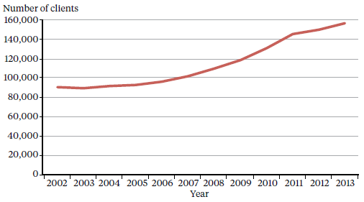

Source: PRIMHD data, extracted on 3 October 2014

Figure 1 shows that the number of people engaging with specialist services steadily increased from 2002 to 2013. The rise in specialist service users could be due to a range of factors, including better data capture, increased NGO reporting, a growing New Zealand population,[2] improved visibility of and access to services, and stronger referral relationships between providers.

DHBs are responsible for funding, planning and providing specialist mental health services for their respective populations. Mental health services are provided directly by DHBs, or indirectly by contracting between DHBs and NGOs. In most DHB areas, directly provided specialist mental health services include hospital mental health care and community mental health services. NGOs provide a range of significant mental health services in each area, which can include alcohol and other drug treatment, kaupapa Māori services, family support, supported accommodation and home-based support.

In 2013, 154,378 people engaged with a specialist mental health or addiction service.

Most people access mental health services in the community. In 2013, 91 percent of specialist service users accessed only community mental health services (Figure 2). The remaining 9 percent accessed a mixture of inpatient and community services. The proportion of people who receive treatment in the community has increased by 5 percent from 86 percent in 2002.

Most people access mental health services in the community.

In 2013, 91 percent of specialist service users accessed only community mental health services.

Figure 2: Percentage of service users accessing only community services, 1 January to 31 December 2013

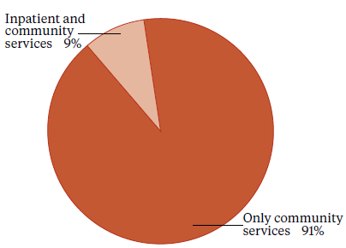

Note: Includes NGOs.

Source: PRIMHD data, extracted on 2 September 2014

### Sector voices

#### Photo Leah Cooper – social workerLeah Cooper – social worker

Tēnā koutou katoa, ngā mihi mahana ki a koutou. Nō England, Wales, Ireland ōku tīpuna. Kei te mahi au i Te Whare o Matairangi. He kaimahi a iwi ahau. Ko Leah Cooper tōku ingoa. Kia ora koutou.

I am a social worker at Te Whare o Matairangi, the adult acute mental health ward based at Wellington Hospital. We have a team of three social workers within a wider multidisciplinary team, which I feel privileged to be part of.

The social work role is hard to define; however, the International Federation of Social Workers describes social work as focusing on social change, problem solving and empowerment of people who are working towards wellbeing. Social work intervenes at the points where people interact with their environments, using the underlying principles of human rights and social justice.

A large part of my role is liaising with the support networks of patients: family, friends, community mental health teams and non-governmental organisations. Family members often find the experience of a loved one being hospitalised extremely stressful. It is important to support families by acknowledging their distress, as well as providing education around mental illness in order to normalise what has happened. It is crucial to always maintain hope in recovery and this is something that I hold on to, often when tāngata whaiora and their families cannot.

I was drawn to this role as I have a strong sense of social justice. A large number of the people I see are impacted by poverty, racism, sexism and experiences of significant trauma, often in childhood.

I really enjoy the diversity of my role. Each day is different; as is every family and individual I work with. Mental health issues affect many people from all walks of life. The people are the reason I am drawn to this work. It is amazing to see people’s recovery in the often short period of time they are with us in the unit. The people I work for are remarkable in their resilience and strength. People always have the potential for change and I am able to see this in my work and to be a small part of the journey.

## The Mental Health (Compulsory Assessment and Treatment) Act 1992

The Mental Health (Compulsory Assessment and Treatment) Act 1992 defines the circumstances under which people may be subject to compulsory mental health assessment and treatment.

The Mental Health Act provides a framework for balancing personal rights and the public interest when a person poses a serious danger to themselves or others due to mental illness.

The purpose of the Mental Health Act is to:

redefine the circumstances in which and the conditions under which persons may be subjected to compulsory psychiatric assessment and treatment, to define the rights of such persons and to provide better protection for those rights, and generally to reform and consolidate the law relating to the assessment and treatment of persons suffering from mental disorder.[3]

The ‘Ensuring service quality’ section provides data on the use of the Mental Health Act.

### Administration of the Mental Health Act

The chief statutory officer under the Mental Health Act is the Director of Mental Health, appointed under section 91 (the Director). The Director is responsible for the general administration of the Mental Health Act under the direction of the Minister of Health and Director-General of Health. The Director is also the Chief Advisor, Mental Health, and is responsible for advising the Minister of Health on mental health issues.

The Mental Health Act also allows for the appointment of a Deputy Director of Mental Health. The Director’s functions and powers under the Mental Health Act allow the Ministry to provide guidance to mental health services, supporting the strategic direction of Rising to the Challenge and a recovery-based approach to mental health.

In each DHB, the Director-General of Health appoints a director of area mental health services (DAMHS) under section 92 of the Mental Health Act. The DAMHS is a senior mental health clinician, responsible for administering the compulsory treatment regime within their DHB area. They must report to the Director of Mental Health every three months regarding the exercise of their powers, duties and functions under the Mental Health Act (Ministry of Health 2012b).

The Mental Health Act provides a framework for balancing personal rights and the public interest when a person poses a serious danger to themselves or others due to mental illness.

In each area, the DAMHS will appoint responsible clinicians and assign them to lead the treatment of every person subject to compulsory assessment or treatment (Ministry of Health 2012a). The DAMHS will also appoint competent health practitioners as duly authorised officers to respond to people experiencing mental illness in the community who are in need of intervention. Duly authorised officers are required to provide general advice and assistance in response to requests from members of the public and the New Zealand Police. If a duly authorised officer believes that a person may be mentally disordered and may benefit from a compulsory assessment, the Mental Health Act grants them powers to arrange for a medical examination (Ministry of Health 2012c).

### Protecting the rights of people subject to compulsory treatment

Although each DAMHS is expected to protect the rights of people under the Mental Health Act in their area, the Mental Health Act also provides for independent monitoring mechanisms. The Minister of Health appoints qualified lawyers as district inspectors under section 94 of the Mental Health Act to protect the rights of people under the Mental Health Act, investigate alleged breaches of those rights and monitor service compliance with the Mental Health Act process. District inspectors are required to inspect services regularly and report on their activities monthly to the Director of Mental Health.

From time to time the Director can initiate an investigation under section 95 of the Mental Health Act, in which case a district inspector is granted powers to conduct an inquiry into a suspected failing in a person’s treatment under the Mental Health Act or in the management of services (Ministry of Health 2012b).

The Mental Health Act also provides for the appointment of the Mental Health Review Tribunal, a specialist independent tribunal comprising a lawyer, a psychiatrist and a community member. If a person disagrees with their treatment under the Mental Health Act, they can apply to the Tribunal for an examination of their condition and of whether it is necessary to continue compulsory treatment. Where the tribunal considers it appropriate, the person may be released from compulsory status.

### Sector voices

#### Photo of Sue Mackersey – Director of area mental health servicesSue Mackersey – Director of area mental health services

Kia ora. I am Sue Mackersey, director of area mental health services for the Bay of Plenty District Health Board. I have been a specialist psychiatrist for over 20 years. All DAMHS are senior mental health clinicians. Most, but not all, are psychiatrists.

My role provides a point of contact between the Office of the Director of Mental Health and the local DHB mental health and addiction services. I keep the Director informed about the use of the Mental Health Act in the Bay of Plenty and any significant issues we are experiencing in the delivery of services. DAMHS make sure that each patient has a responsible clinician and that there are duly authorised officers available at all times.

DAMHS are involved in a range of governance roles so that they can influence decision-making about resourcing of local services. In delivering safe and high-quality services, the challenge is often getting adequate resourcing.

There are many relationships that a DAMHS needs to have, such as with the district inspectors, police and courts. The most important relationships I have are with people who are in our service and their family or whānau. I need to ensure that every person subject to compulsory assessment and treatment has care provided by our service in accordance with the legislation. People under the Mental Health Act, family, whānau and district inspectors let me know about issues that need rectifying.

To help me perform my role I am fortunate to have a team of experienced clinicians in the Bay of Plenty who are committed to providing high-quality care.

# Activities for 2013

## Mental health sector relationships

The Director of Mental Health visited each DHB mental health service at least once during the reporting year. These visits give the Director an opportunity to engage with the services and get an understanding of the particular constellation of challenges that the local mental health service is facing, while offering Ministry support and oversight.

The Office of the Director of Mental Health also maintains collaborative relationships with many parts of the mental health sector, attending and presenting at a large number of mental health sector meetings each year.

## Cross-government relationships

The Office of the Director of Mental Health maintains strong relationships with other government agencies to support good clinical practice and client-centred services for people with mental health and addiction problems.

In 2013 the Office of the Director of Mental Health worked with a number of agencies on a wide range of projects, including:

* the Youth Crime Action Plan
* implementation of new youth forensic mental health and alcohol and drug services
* the Vulnerable Children’s Action Plan
* the Gateway Assessments programme
* implementation of the Autism Spectrum Guidelines
* the Prime Minister’s Youth Mental Health Project
* the interface between the youth justice system and mental health and addiction services.

### Relationship with the Department of Corrections

The Ministry works closely with the Department of Corrections to improve the health services provided to people detained in prisons. People detained in prison often have complex mental health needs, which may require more intensive support than Corrections health services can give as a provider of primary health care. Regional forensic psychiatry services support Corrections to access and treat prisoners with complex mental health needs. Prisoners may be transferred to a hospital for treatment in a therapeutic environment where necessary.

### Relationship with New Zealand Police

People detained in police custody often have complex mental health needs. In addition, although DHB mental health services operate emergency intervention teams, police are often required to be the initial response to people whose mental illness appears to contribute to the person being a danger to themselves or to others. It is therefore important for police and DHB mental health services to maintain collaborative relationships.

## District inspectors

The Minister of Health appoints lawyers as district inspectors under section 94 of the Mental Health Act to ensure people’s rights are upheld during the compulsory assessment and treatment process.

District inspectors work to protect specific rights provided to people under the Mental Health Act, address concerns of family and whānau, and investigate alleged breaches of rights, as set out in the Act.

The Office of the Director of Mental Health’s responsibilities in relation to district inspectors include:

* coordinating the appointment and reappointment of district inspectors by the Minister of Health
* managing district inspector remuneration
* receiving and responding to monthly reports from the district inspectors
* organising twice-yearly national meetings of district inspectors
* facilitating inquiries under section 95 of the Mental Health Act
* implementing the findings of section 95 inquiries by district inspectors.

District inspectors work to protect people’s rights under the Mental Health Act.

### The role of district inspectors

District inspectors are required to report to the DAMHS within 14 days of inspecting mental health services. They are also required to report monthly to the Director of Mental Health on the exercise of their powers, duties and functions. These reports provide the Director with an overview of mental health services and any problems arising from them.

### Section 95 reports completed by 31 December 2013

The Director will occasionally require a district inspector to undertake an inquiry under section 95 of the Mental Health Act. Such inquiries are generally focused on systemic issues across one or more mental health services. A typical result of these inquiries is that the district inspector makes recommendations. The Director will consider the recommendations and audit the DHB’s implementation of relevant recommendations.

The Director will also act on any recommendations that have implications for the Ministry of Health and/or the mental health sector generally. The inquiry process is not completed until the Director considers that the recommendations have been satisfactorily implemented by the DHB and, if appropriate, by the Ministry and all DHBs.

No section 95 inquiries were completed during 2013. A section 95 inquiry remained ongoing from 2012, and another inquiry was initiated during late 2013. Table 1 shows the number of completed section 95 inquiry reports received by the Director of Mental Health between 2003 and 2013.

Table 1: Number of completed section 95 inquiry reports received by the Director of Mental Health, 2003 to 2013

|  |  |  |  |  |  |  |  |  |  |  |
| --- | --- | --- | --- | --- | --- | --- | --- | --- | --- | --- |
| **2003** | **2004** | **2005** | **2006** | **2007** | **2008** | **2009** | **2010** | **2011** | **2012** | **2013** |
| 1 | 2 | 1 | 4 | 1 | 1 | 3 | 2 | 1 | 1 | 0 |

### Number of district inspectors

As at 31 December 2013 there were 34 district inspectors appointed throughout New Zealand. One senior advisory district inspector is appointed to provide leadership and advice to the other district inspectors. A list of current district inspectors is available on the Ministry of Health website ([www.health.govt.nz](http://www.health.govt.nz/)).

### Photo of Barry Wilson – District inspectorSector voices

#### Barry Wilson – District inspector

Hello, I’m Barry Wilson and I’m a district inspector for mental health covering Auckland and Northland regions.

The role of the district inspector is unique to New Zealand. District inspectors are statutory officers acting in a watchdog role for people’s rights under the Mental Health Act. We are there to ensure that every person subject to compulsory assessment and treatment under the Mental Health Act is cared for in accordance with the Mental Health Act’s requirements.

For me, the challenge of the job is about building successful relationships, both with people receiving treatment (in hospital and in the community) and with the dedicated staff who serve their needs.

Most of the time I am dealing with very vulnerable people. If a person feels that I can assist his or her situation I must, above all, maintain lines of communication and remain alert to the person’s concerns. ‘Active listening’ is a key requirement of the job.

Features of a month’s work might include:

* ensuring a person’s objection to staying in hospital is heard by a judge
* ensuring a mother’s voice is heard by a person’s responsible clinician
* conducting an inquiry into whether a person who died had received appropriate medical treatment.

In visiting mental health facilities, I’m acting as the ‘eyes and ears’ of the Director of Mental Health. It is my role to inform the Director of any irregular patterns that may be emerging; for instance, the excessive use of restraint or seclusion in a mental health unit.

I have been a district inspector for nine years. My longstanding interest in civil liberties has helped to sustain me in this interesting and important role.

## Special patients and restricted patients

Special patients and restricted patients are covered by Part 4 of the Mental Health Act. Their treatment is provided in accordance with either the Mental Health Act or the Criminal Procedure (Mentally Impaired Persons) Act 2003.

Special patients include:

* people charged with, or convicted of, a criminal offence and remanded to a secure hospital for a psychiatric report
* remanded or sentenced prisoners transferred from prison to a secure hospital
* defendants found not guilty by reason of insanity
* defendants unfit to stand trial
* people who have been convicted of a criminal offence and both sentenced to a term of imprisonment and placed under a compulsory treatment order.

**Restricted patients** include people detained by a court order because of the special difficulties they present from the danger they pose to others.

Special and restricted patients are detained in the care of one of the five regional forensic psychiatry services throughout New Zealand. These services develop management plans to progressively reintegrate these people into community settings as treatment improves their mental health.

The Director of Mental Health has a central role in the management of special patients and restricted patients. The Director may direct their transfer under section 49 of the Mental Health Act, or grant leave for any period not exceeding seven days for certain special and restricted patients (section 52).

Longer periods of leave are granted by the Minister of Health (section 50) and are available to certain categories of special patients. The Director briefs the Minister of Health when requests for leave are made.

Special patients found not guilty by reason of insanity may be considered for a change of legal status if it is determined that their detention is no longer necessary to safeguard the interests of the person or the public.

The Director must also be notified of the admission, discharge or transfer of special and restricted patients, and certain incidents involving these people (section 43). The process for reclassifying special and restricted patients differs according to the person’s particular status, but always requires ministerial involvement.

Special patients found not guilty by reason of insanity may be considered for a change of legal status if it is determined that their detention is no longer necessary to safeguard the interests of the person or the public. Applications for changes of legal status are sent to the Director of Mental Health. After careful consideration, the Director will make a recommendation to the Minister about a person’s legal status.

Table 2 shows the section 50 long-leave applications, revocations and change of status applications processed by the Office of the Director of Mental Health during 2013.

Table 2: Number of Ministerial long-leave, revocation and reclassification applications for special and restricted patients, 1 January to 31 December 2013

|  |  |
| --- | --- |
| **Type of request** | **Number of applications** |
| Initial ministerial section 50 leave applications | 7 |
| Initial ministerial section 50 leave applications not approved | 1 |
| Ministerial section 50 leave revocations | 2 |
| Further ministerial section 50 leave applications | 27 |
| Change of legal status applications approved | 3 |
| Change of legal status applications not approved | 1 |
| Total | 41 |

Note: No applications were received in 2013 for restricted patients or defendants unfit to stand trial.

Source: Office of the Director of Mental Health records.

### Prisoner transfers to hospital

Once a person has been sentenced to a term of imprisonment, any compulsory treatment order relating to the prisoner ceases to have effect. Remand prisoners may remain on a pre-existing compulsory treatment order, but it is unlawful to enforce compulsory treatment in the prison environment. If compulsory assessment and/or treatment is required, section 45 of the Mental Health Act provides for the transfer to hospital of mentally disordered prisoners. Section 46 allows for voluntary admission to hospital with the approval of the prison superintendent. Services are required to notify the Director of Mental Health of all such admissions.

Table 3 shows the number of people who have been transferred from prison to hospital under either section 45 or section 46 from 2001 to 2013.

Table 3: Number of people transferred to hospital from prison under sections 45 and 46 of the Mental Health Act, 2001 to 2013

|  |  |  |
| --- | --- | --- |
| **Year** | **Number of prisoners transferred to hospital for compulsory treatment (s 45)** | **Number of prisoners transferred to hospital voluntarily (s 46)** |
| 2001 | 134 | 4 |
| 2002 | 96 | 0 |
| 2003 | 113 | 2 |
| 2004 | 121 | 1 |
| 2005 | 117 | 8 |
| 2006 | 128 | 16 |
| 2007 | 98 | 2 |
| 2008 | 80 | 2 |
| 2009 | 120 | 12 |
| 2010 | 105 | 11 |
| 2011 | 85 | 4 |
| 2012 | 84 | 3 |
| 2013 | 132 | 5 |

Source: Manual data provided by DHBs.

## The Mental Health Review Tribunal

The Mental Health Review Tribunal (the Tribunal) is an independent tribunal empowered by law to review compulsory treatment orders, special patient orders and restricted patient orders. If a person disagrees with their legal status or treatment under the Mental Health Act, they can apply to the Tribunal for an independent review of their condition.

The Tribunal comprises three members, one of whom must be a lawyer, one a psychiatrist and the third a community member.

A selection of the Tribunal’s published cases is available to the public on the New Zealand Legal Information Institute website ([www.nzlii.org/nz/ cases/NZMHRT](http://www.nzlii.org/nz/cases/NZMHRT/)). These cases have been carefully anonymised to respect the privacy of the individuals, family and whānau involved. The intention of publishing important and helpful cases is to help the public to have a better understanding of the work of the Tribunal and of mental health law and practice.

If a person disagrees with their legal status or treatment under the Mental Health Act, they can apply to the Tribunal for an independent review of their condition.

The main function of the Tribunal is to review the condition of people in accordance with sections 79 and 80 of the Mental Health Act. Section 79 relates to people who are subject to ordinary compulsory treatment orders, and section 80 relates to the status of special patients. During the year ending 30 June 2013, the Tribunal heard 102 cases of contested treatment orders. In five cases (5 percent), a person was deemed fit to be released from compulsory status.

The Tribunal has a number of other functions under the Mental Health Act, including reviewing the condition of restricted patients (section 81), considering complaints (section 75) and appointing psychiatrists authorised to carry out second opinions under the Mental Health Act (sections 59–61).

Under section 80 of the Mental Health Act, the Tribunal makes recommendations relating to special patients to the Minister of Health or the Attorney-General. It is for the Minister or Attorney-General to determine whether there should be a change to a special patient’s legal status.

The Tribunal may also investigate a complaint if the complainant is dissatisfied with a district inspector’s investigation. If the Tribunal decides a complaint has substance, it must report the matter to the relevant director of area mental health services (DAMHS), with appropriate recommendations. The DAMHS must then take all necessary steps to remedy the matter.

During the year ending 30 June 2013, the Tribunal heard 102 cases of contested treatment orders. In five cases (5 percent), a person was deemed fit to be released from compulsory status.

For more information about the Tribunal’s activities for the year ending 30 June 2013, see Appendix 1.

### Sector voices

#### Photo of Phyllis Tangitu – Mental Health Review Tribunal memberPhyllis Tangitu – Mental Health Review Tribunal member

Te Arawa te waka Matawhaura te maunga Rotoiti te roto

Tamateatutahi me Ngāti Kawiti ōku hapū

Ko Pikiao ahau. Tēnā koutou katoa.

Kia ora. My name is Phyllis Tangitu and I am the community member of the Mental Health Review Tribunal.

I was a deputy member of the Tribunal for 12 years and in 2012 I was appointed as the key community member. I am a mum to three sons, nanny to three beautiful mokopuna and partner to Wi. My experience in mental health comes from having whānau experience mental health issues and 20 years of work in the mental health and addiction sector.

The principal function of the Tribunal is to consider the condition of a person who has applied for a review of their treatment order. The Tribunal comprises three members: a lawyer (by convention the conveyor), a psychiatrist and a community member. At a hearing, members of the Tribunal will review a person’s file, listen to the evidence presented of a medical, legal, personal and family nature, clarify the key issues for that person’s present and future mental health and wellbeing and come to a decision regarding whether the person’s condition justifies the order to which he or she is subject.

We are a quasi-judicial board; however, it has been important that individuals, families and whānau understand the process and are welcomed to a hearing. It is also important that the hearings are located in a comfortable environment and there is respect and acknowledgement paid to any cultural needs the person and their family or whānau may have (eg, opening with a mihi/greeting or karakia). The Tribunal has used cultural practice during hearings, and has encouraged families and whānau to participate in the hearing process.

# Ensuring service quality

As a sector we are all working together to get better mental health care to more people sooner. Central government, district health boards, non-governmental organisations, international bodies (such as the United Nations and World Health Organization) and independent watchdogs (such the Office of the Ombudsman and district inspectors) all work in collaboration to achieve this goal.

Actively monitoring the performance of DHBs and NGOs is vital to ensuring service quality and safety. The Ministry and wider government set goals and targets for the sector aimed at improving outcomes for the people who use mental health services. Reporting from the sector is integral to this process, as it allows the Ministry to measure progress against these goals.

As a sector, we are all working together to get better mental health care to more people sooner.

This section presents statistics on a number of mental health indicators concerned with general mental health service use, as well as compulsory care under the Mental Health Act.

Statistics include consumer satisfaction surveys, waiting times, relapse prevention plans, the Mental Health Act, Māori and section 29 of the Mental Health Act, seclusion in inpatient units, electroconvulsive therapy, serious adverse events and opioid substitution treatment.

## Consumer satisfaction surveys

Since 2006, National Mental Health Consumer Satisfaction Surveys have been conducted as part of measuring DHB service quality and consumer outcomes. Survey participants are people who received treatment from specialist mental health community services in DHBs around New Zealand.

In summary, in the 2012/13 fiscal year:

* 80 percent of people surveyed agreed with the statement ‘overall I am satisfied with the services I received’.

In 2006 half of the DHBs in New Zealand participated in the survey, gathering a total of 596 respondents. Since then, participation has grown to the point that in 2013 all 20 DHBs participated, attracting a total of 3282 respondents.

### Survey results

In the 2012/13 fiscal year, 80 percent of respondents either agreed or strongly agreed with the statement ‘overall I am satisfied with the services I received’ (Figure 3). Another 10 percent gave an in-between rating, 4 percent disagreed and 6 percent strongly disagreed.

Figure 3: Responses to the statement ‘overall I am satisfied with the services I received’

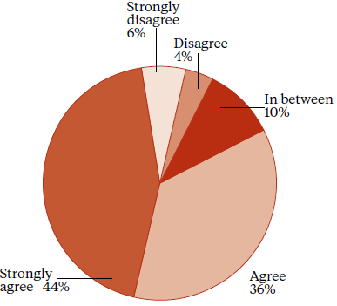

Source: National Mental Health Consumer Satisfaction Survey 2012/13

In addition to overall satisfaction, other results were that:

* 61 percent of respondents agreed with the statement ‘as a result of the services I have received, I feel that I do better in my personal relationships’
* 82 percent agreed that ‘I feel comfortable asking questions about my medication and treatment’
* 80 percent agreed that ‘staff have helped me to remain living in the community’
* 85 percent agreed that ‘there is at least one member of staff who believes in me’.

## Waiting times

Waiting times are a measure of how long ‘new’ clients wait to been seen by mental health and addiction services. ‘New’ clients are defined as people who have not accessed mental health or addiction services in the past year.

Waiting times reflect the length of time between the day when a person is referred to a mental health or addiction service and the day when the person is first seen by the service.

By 30 June 2015, DHBs are required to meet a sector-wide target where 80 percent of people referred for non-urgent mental health or addiction services are seen within three weeks, and 95 percent of people are seen within eight weeks.

The sector continues to approach this goal. In the 2012/13 fiscal year, 78 percent of all clients of mental health and addiction services were seen within three weeks and 93 percent were seen within eight weeks (Figure 4).

Figure 4: Percentage of people seen by mental health and addiction services within three and eight weeks, 2012/13 fiscal year

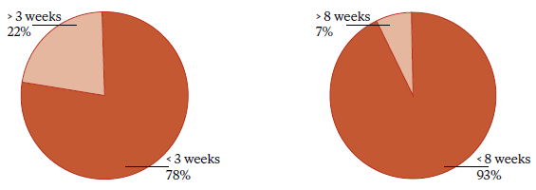

Source: PRIMHD data, extracted on 25 September 2013

## Relapse prevention plans

In 2007, the Director-General of Health introduced a health target requiring that at least 95 percent of people who have used mental health and addiction services for over two years must have a relapse prevention plan.

In summary, in 2013:

* 91 percent of long-term service users across the country had a relapse prevention plan, up from 59 percent in 2007 (Figure 5)
* 6 of the 20 DHBs achieved the 95 percent target.

A relapse prevention plan identifies the early warning signs for a person. It identifies what the person can do for themselves and what the service will do to support them.

In 2013, 91 percent of long-term service users across the country had a relapse prevention plan, up from 59 percent in 2007.

Ideally, the person will develop their own plan with support from their clinician and their family and whānau. The plan represents an agreement between parties. Each plan will vary according to the individual involved. Each person will know of (and ideally have a copy of ) their plan.

DHBs reported twice during 2013. The first reporting period covered 1 January to 30 June and the second 1 July to 31 December. Figure 6 shows the results of DHBs’ reporting for the 2013 calendar year. During 2013, 6 of the 20 DHBs achieved the 95 percent target for both reporting periods.

Figure 5: Percentage of long-term service users with a relapse prevention plan, 2007 to 2013

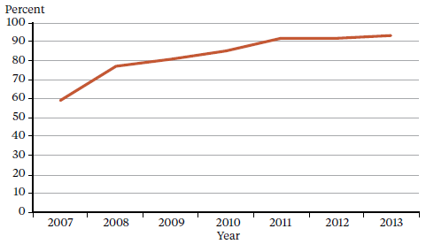

Source: DHB quarterly reporting data

Figure 6: Percentage of service users with a relapse prevention plan, by DHB, 1 January to 31 December 2013

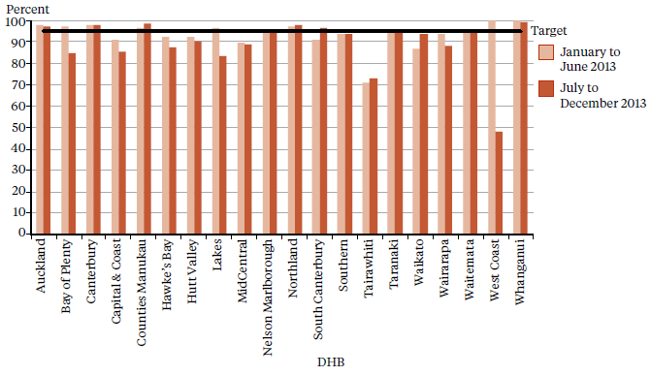

Source: DHB quarterly reporting data

## Use of the Mental Health Act

The Mental Health Act defines the circumstances under which people may be subject to compulsory mental health assessment and treatment. It provides a framework for balancing personal rights and the public interest when a person has a diminished capacity to care for themselves or poses a serious danger to themselves or others due to mental illness.

In summary, in 2013:

* 10,270 people (approximately 8 percent of specialist mental health service users) came into contact with the Mental Health Act
* on a given day in the year, approximately 6340 people were subject to either compulsory assessment or compulsory treatment under the Mental Health Act
* use of the Mental Health Act varied across district health boards
* males were more likely to be subject to the Mental Health Act than females
* people aged 25 to 34 years were the most likely to be subject to compulsory treatment, and people over 65 years of age were the least likely
* Māori were more likely to be under the Mental Health Act than non-Māori.

### The Mental Health Act process

The compulsory assessment and treatment process begins with a referral and an initial assessment by a psychiatrist. If the psychiatrist believes a person fits the criteria for the Mental Health Act and needs to be further assessed, the person will become subject to compulsory assessment under the Mental Health Act.

#### Compulsory assessment

Compulsory assessment can take place in either a community or a hospital setting. There are two periods of compulsory assessment, during which a person’s clinician may release them from assessment at any time.

During the assessment period, people are obliged to receive treatment as prescribed by their responsible clinician.

The first period (section 11 of the Mental Health Act) is for up to five days. The second period (section 13) can last up to 14 days.

Following the first two assessment periods, an application can be made to the Family or District Court (section 14(4)) to place the person on a compulsory treatment order.

A judicial review consists of a hearing in the District Court. Based on information provided by clinicians, a judge will decide whether the person should continue to be compulsorily assessed.

During 2013, there were approximately 1157 applications considered under section 16 of the Mental Health Act. Of this total, an order for release of the person from compulsory status was issued in 35 cases (5.3 percent of the applications that proceeded to hearings).[4]

The Mental Health Act provides a framework for balancing personal rights and the public interest when a person has a diminished capacity to care for themselves or poses a serious danger to themselves or others due to mental illness.

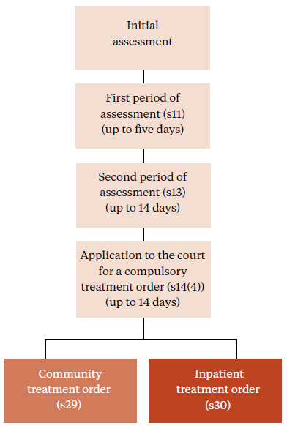

#### Compulsory treatment

There are two types of compulsory treatment orders. One is for treatment in the community (a section 29 order) and the other is for treatment in an inpatient unit (a section 30 order). An inpatient treatment order can be converted into a community treatment order at any time by the person’s responsible clinician.

A responsible clinician may also grant a person leave from the inpatient unit for treatment in the community for up to three months (section 31).

Most people subject to compulsory treatment access it in the community (approximately 88 percent in 2013) (sections 29 and 31).

### Statistics

During 2013, approximately 10,270 people came into contact with the Mental Health Act (approximately 8 percent of all specialist mental health service users in 2013). On average, 6340 people were subject to either compulsory assessment or compulsory treatment on a given day.[5]

In New Zealand in each month of 2013, on average:[6]

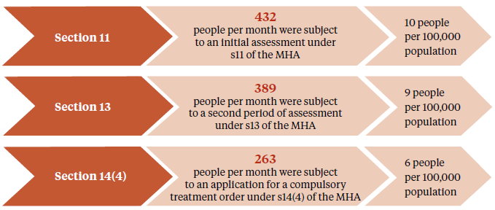

In New Zealand on a given day in 2013, on average:[7]

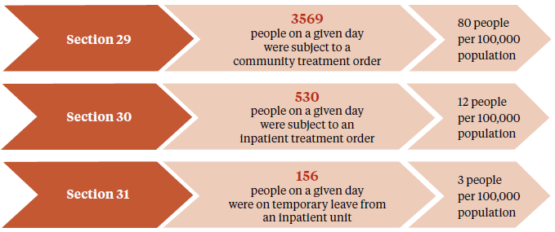

### Compulsory assessment and treatment by DHB

Table 4 shows the average number of people per month required to undergo assessment and treatment for each DHB in 2013. Table 5 shows the average number of people subject to a compulsory treatment order on a given day in 2013, with data again broken down by DHB. The figures that follow also present the average number of people on a compulsory treatment order on a given day, but focus specifically on community treatment orders (Figure 7) or inpatient treatment orders (Figure 8).

Table 4: Average number of people per 100,000, per month required to undergo assessment under sections 11, 13 and 14(4) of the Mental Health Act, by DHB, 1 January to 31 December 2013

|  |  |  |  |  |  |  |  |  |
| --- | --- | --- | --- | --- | --- | --- | --- | --- |
| **DHB** | **s 11** | **s 13** | **s 14(4)** |  | **DHB** | **s 11** | **s 13** | **s 14(4)** |
| Auckland | 11 | 10 | 7 |  | Northland | 14 | 14 | 13 |
| Bay of Plenty | 10 | 7 | 5 |  | South Canterbury | 9 | 7 | 4 |
| Canterbury | 11 | 11 | 7 |  | Southern | 8 | 6 | 4 |
| Capital & Coast | 12 | 11 | 8 |  | Tairawhiti | 12 | 11 | 8 |
| Counties Manukau | 9 | 8 | 5 |  | Taranaki | 8 | 5 | 3 |
| Hawke’s Bay | 10 | 8 | 4 |  | Waikato | 12 | 8 | 7 |
| Hutt Valley | 12 | 12 | 5 |  | Wairarapa | 5 | 1 | 0 |
| Lakes | 8 | 6 | 6 |  | Waitemata | 8 | 8 | 6 |
| MidCentral | 10 | 7 | 4 |  | West Coast | 9 | 5 | 4 |
| Nelson Marlborough | 9 | 7 | 4 |  | Whanganui | 12 | 8 | 5 |
|  |  |  |  |  | National average | 10 | 9 | 6 |

Note: Manual data supplied by DHBs has been used for most DHBs. This decision was made after issues with 2013 PRIMHD data were identified. These issues will be addressed, with the intention of returning to PRIMHD for future Annual Reports.

Source: Manual data provided by DHBs, except for Auckland, Counties Manukau, Southern, Taranaki and West Coast which is PRIMHD data, extracted on 14 August 2014.

Table 5: Average number of people per 100,000, on a given day subject to sections 29, 30 and 31 of the Mental Health Act, by DHB, 1 January to 31 December 2013

|  |  |  |  |  |  |  |  |  |
| --- | --- | --- | --- | --- | --- | --- | --- | --- |
| **DHB** | **s 29** | **s 30** | **s 31** |  | **DHB** | **s 29** | **s 30** | **s 31** |
| Auckland | 93 | 7 | – |  | Northland | 177 | 8 | 6 |
| Bay of Plenty | 46 | 9 | 5 |  | South Canterbury | 79 | 23 | 14 |
| Canterbury | 58 | 20 | 6 |  | Southern | 71 | 15 | 3 |
| Capital & Coast | 100 | 25 | 3 |  | Tairawhiti | 114 | 3 | 9 |
| Counties Manukau | 69 | 16 | 4 |  | Taranaki | 60 | 4 | 1 |
| Hawke’s Bay | 47 | 4 | 2 |  | Waikato | 100 | 8 | 4 |
| Hutt Valley | 66 | 9 | 1 |  | Wairarapa | 80 | 8 | 0 |
| Lakes | 117 | 2 | 6 |  | Waitemata | 80 | 5 | 0 |
| MidCentral | 59 | 9 | 7 |  | West Coast | 66 | 11 | 5 |
| Nelson Marlborough | 76 | 12 | 2 |  | Whanganui | 86 | 37 | 1 |
|  |  |  |  |  | National average | 80 | 12 | 3 |

Note: Manual data supplied by DHBs has been used for most DHBs. This decision was made after issues with 2013 PRIMHD data were identified. These issues will be addressed, with the intention of returning to PRIMHD for future Annual Reports.

Source: Manual data provided by DHBs, except for Auckland, Counties Manukau, Southern, Taranaki and West Coast which is PRIMHD data, extracted on 14 August 2014.

Figure 7: Average number of people per 100,000 on a given day subject to a community treatment order (section 29 of the Mental Health Act), by DHB, 1 January to 31 December 2013

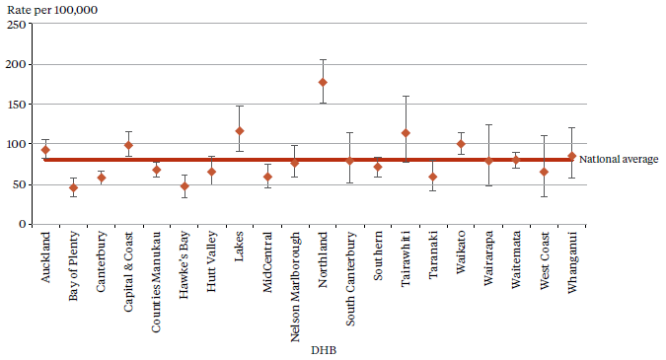

Notes: Confidence intervals (for 99 percent confidence) have been used to aid interpretation. Where a DHB region’s confidence interval crosses the national average, this means the DHB’s rate was not statistically significantly different to the national average.

Manual data supplied by DHBs has been used for most DHBs. This decision was made after issues with 2013

PRIMHD data were identified. These issues will be addressed, with the intention of returning to PRIMHD for future Annual Reports.

Source: Manual data provided by DHBs, except for Auckland, Counties Manukau, Southern, Taranaki and West Coast which is PRIMHD data, extracted on 14 August 2014.

Figure 8: Average number of people per 100,000 on a given day subject to an inpatient treatment order (section 30 of the Mental Health Act), by DHB, 1 January to 31 December 2013

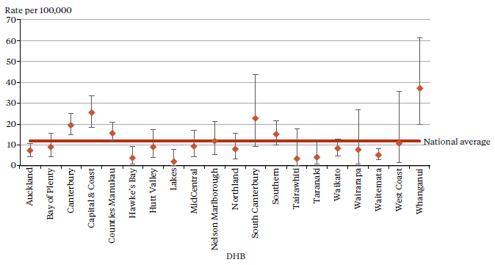

Notes: Confidence intervals (for 99 percent confidence) have been used to aid interpretation. Where a DHB region’s confidence interval crosses the national average, this means the DHB’s rate was not statistically significantly different to the national average.

Manual data supplied by DHBs has been used for most DHBs. This decision was made after issues with 2013

PRIMHD data were identified. These issues will be addressed, with the intention of returning to PRIMHD for future Annual Reports.

Source: Manual data provided by DHBs, except for Auckland, Counties Manukau, Southern, Taranaki and West Coast which is PRIMHD data, extracted on 14 August 2014

### Compulsory treatment by age and gender

During 2013:

* people aged 25 to 34 years were the most likely to be subject to a compulsory treatment order (177 per 100,000) and people over 65 years of age were the least likely (51 per 100,000) (Figure 9)
* males were 1.5 times more likely to be subject to a compulsory treatment order (105 people per 100,000) than females (69 people per 100,000) (Figure 10).

Figure 9: Number of people per 100,000 subject to compulsory treatment order applications (including extensions), by age group, 2004 to 2013

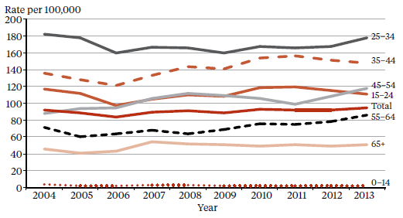

Source: Ministry of Justice’s Integrated Sector Intelligence System, which uses data entered into the Case Management System (CMS). The CMS is a live operational database, and figures are subject to minor changes at any time.

Figure 10: Number of people per 100,000 subject to compulsory treatment order applications (including extensions), by gender, 2004 to 2013

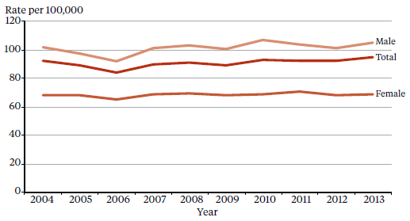

Source: Ministry of Justice’s Integrated Sector Intelligence System, which uses data entered into the Case Management System (CMS). The CMS is a live operational database, and figures are subject to minor changes at any time.

### Sector voices

#### Photo of Patrick PoraPatrick Pora

Questions by Kieran Moorhead (consumer leader)

What was the experience like when you were first undergoing the Mental Health Act process?

I was first under the Mental Health Act about nine years ago. At the time I was regularly using methamphetamine which is when I first started becoming unwell and experiencing symptoms of psychosis. During that time one of my family members began the process of me going under the Mental Health Act. I decided that I didn’t want to be a part of the group of my old school friends who were using meth; I wanted to get out of that life and stop doing the same old things. I broke away from the people that influenced me to become unwell. Now I’m trying to help people and represent them.

What has it been like being under the Mental Health Act?

It does really help, there are good times and bad times being under it – like the medication side effects – and I’d like to eventually lower my medication but I know it’s all about balance. I hope to be able to leave the Mental Health Act in the future, and get out and do things and help people. I have awesome people around me that really care about me and always try and help me out. Family supporting you is really important.

How did you find the mental health services when you were first using them?

It was the mental health people that were helping me. I didn’t have my family at the time, so I treated them like my family.

I do feel safer and securer being under the Mental Health Act. With the support that I have had it’s easier for me to get up, go for a walk, have a run and socialise with other people.

I’m here to support people that are under the Mental Health Act. I’d like to be a role model for people, give them support and help them out.

## Māori and section 29 of the Mental Health Act

This section presents data on Māori under community treatment orders (section 29 of the Mental Health Act) in 2013. This is the first time information of this kind has been published in the Annual Report. It is intended that this information will further underline the need for the mental health sector to engage in meaningful action to address the disparity of mental health outcomes for Māori in New Zealand.

In summary:

* during 2013 Māori were 2.9 times more likely to be under a community treatment order than non-Māori (section 29 of the Mental Health Act)
* the ratio of Māori to non-Māori subject to section 29 varies by DHB
* reducing the disparity in mental health outcomes for Māori is a priority action for the Ministry of Health and DHBs.[8]

The high rate of Māori on compulsory treatment in New Zealand is a complex issue. Māori make up approximately 15 percent of New Zealand’s population, yet they account for 25 percent of all mental health service users.[9]

The national mental health prevalence study, Te Rau Hinengaro (Oakley Browne et al 2006), showed that Māori experience the highest levels of mental health disorder overall. They are also more likely to experience serious disorders and co-morbidities than other population groups.

During 2013, Māori were 2.9 times more likely to be under a community treatment order than non-Māori.

Other demographic features relevant to the high rate of Māori service users include the youthfulness of the Māori population (approximately half of the population is under 25 years of age) and the disproportionate representation of Māori in low socioeconomic groups (two-thirds live in deprivation deciles 7 to 10).

Analysis has shown that these demographic factors do not completely account for the high rate of Māori with serious mental illness (ie, if Māori had the same age structure and level of socioeconomic privilege as people in other groups, their rates of mental disorder would still be higher) (Oakley Browne et al 2006). In addition, Māori experiencing mental health issues tend to present to health services at a later stage of illness, when the need for treatment is more acute.

### What other factors are involved in this disparity?

Elder and Tapsell (2013) emphasise that more research is needed to better understand the Māori experience of the Mental Health Act and why Māori are over-represented in compulsory treatment.

They suggest that the following are important questions for the sector to consider.

* Are Māori receiving differential treatment in the mental health system?
* How can we build a more culturally competent workforce and reduce cultural bias from formulations of mental illness?
* Are whānau of tāngata whaiora being sufficiently engaged by mental health services?

It is clear that the sector needs to be actively engaged with these questions in order to bring about better outcomes for Māori. However, when asking these questions it is important to keep in mind the significant improvements in the service provision to Māori that have been achieved over the last few decades.

One of these improvements is the establishment of dedicated kaupapa Māori services in certain areas around New Zealand. In 2013 Māori access rates to services exceeded the access rates of other groups (5.65 percent of Māori accessed mental health services in 2013, compared with 3.43 percent of non- Māori).[10] These higher access rates are likely to be a contributing factor to higher rates of Māori under section 29.

### Māori and section 29 of the Mental Health Act by DHB

Figure 11 shows variation around the country in regard to the disparity between Māori and non-Māori subject to community treatment orders, with the Māori to non-Māori rate ratio ranging from 0.7:1 (West Coast) to 5:1 (Bay of Plenty). DHBs whose Māori rate is significantly higher[11] than the New Zealand rate include Auckland, Bay of Plenty, Counties Manukau and Waikato (all of which have a large population of young Māori, the group most at risk for serious mental health problems).

These numbers are difficult to interpret as it is hard to indicate what an ideal rate ratio would be for a given population or DHB. What these numbers do make clear is that in-depth, area-specific knowledge would be useful for understanding the particular disparities around the country and what could be done at a local level to address them.

Figure 11: The rate ratio of Māori to non-Māori under section 29 of the Mental Health Act, by DHB, 1 January to 31 December 2013

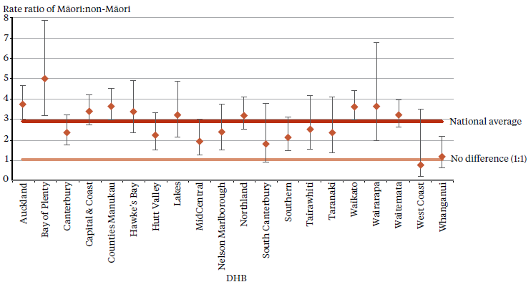

Notes: New Zealand total is a unique client count – it is not a sum of the DHB figures. Some clients were under section 29 at more than one DHB.

While some data quality concerns have been identified for 2013 PRIMHD data on section 29, the ethnicity rate ratio of the data set remains stable.

Confidence intervals (for 99 percent confidence) have been used to aid interpretation. Where a DHB region’s confidence interval crosses the national average, this means the DHB’s rate was not statistically significantly different to the national average.

Source: PRIMHD data, extracted on 22 August 2014.

### Future focus

Reducing the disparity of Māori mental health outcomes is a priority for the Ministry (Ministry of Health 2012e). Publishing data on Māori who are under section 29 is a good first step towards gaining a better understanding and awareness of Māori over-representation under the Mental Health Act. To add to this, the Director of Mental Health intends to publish more comprehensive data on Māori who are under the Mental Health Act in future Annual Reports.

The Director of Mental Health will continue to work alongside DHBs and other Ministry and government groups to ensure the best possible mental health outcomes are being sought for Māori in New Zealand.

### Sector voices

#### Photo of Hinemoa Elder – PsychiatristHinemoa Elder – Psychiatrist

Kia ora koutou katoa, ko Parengarenga te moana, ko Tawhitirahi te maunga, ko Awapoka te awa, ko Te Aupouri, Ngāti Kuri, Te Rarawa me Ngāpuhi nui tonu ōku iwi. Ko Hinemoa Elder tōku ingoa.

My name is Hinemoa Elder and I am a psychiatrist. From time to time in my clinical work I am involved with assessing and treating people under the Mental Health Act.

The Mental Health Act process can be set in motion at a time when someone is perceived to be thinking and behaving in unusual and distressing ways. These concerns can be self-identified, but more often they come from others such as friends and whānau. My job in these situations is to ensure that the supports outlined in the law are put in place to reduce stress and suffering for the person, their whānau and community, in addition to ensuring that appropriate decisions are being made for the person regarding their health and the law.

I am also a deputy psychiatrist member of the Mental Health Review Tribunal. Together with legal and community members we hold reviews for people treated under the Mental Health Act who wish to be removed from compulsory status.

Whether working as part of a multidisciplinary team using the Mental Health Act or as a Tribunal member, I continue to question how the Mental Health Act could be used to better serve Māori. Māori are treated at higher rates under the Mental Health Act. Does this fact denote the appropriate use of the law given that there are higher rates of serious mental illness in the Māori community, or is there some other reason? Accurate reporting of Mental Health Act ethnicity data from around Aotearoa will give us a better picture of the variability of the use of this law and provide a platform for quality research to address these important questions.

While the Mental Health Act does not have specific mandated sections regarding working with Māori, respect for cultural identity and the importance of recognition of ‘whānau, hapū and iwi’ links are emphasised. The Mental Health Act also notes that ‘proper respect’ be paid to language. The extent to which te reo Māori is offered as part of this legal process is not known and is another area ripe for investigation.

## Seclusion

Seclusion is ‘where a consumer is placed alone in a room or area, at any time and for any duration, from which they cannot freely exit’.[12]

In summary, in adult mental health services in 2013:

* the number of people secluded decreased by 29 percent since 2009
* the total number of hours spent in seclusion decreased by 50 percent since 2009
* men were almost two times more likely to be secluded than women
* people aged 20 to 30 years were more likely to be secluded than other age groups
* Māori were more likely to be secluded than non-Māori.

The *Health and Disability Services (Restraint Minimisation and Safe Practices) Standards* came into effect on 1 June 2009 (Standards New Zealand 2008b). The intent of the standards is to ‘reduce the use of restraint in all its forms and to encourage the use of least restrictive practices’.

In addition, reducing (and eventually eliminating) seclusion is one of the goals of the Ministry’s service development plan, *Rising to the Challenge* (Ministry of Health 2012e).

Seclusion is provided for in section 71 of the Mental Health Act. Seclusion can only occur where, and for as long as, it is necessary for the care or treatment of the person, or for the protection of other people.

Seclusion should be an uncommon event and should be used only when there is an imminent risk of danger to the individual or others and no other safe and effective alternative is possible.

Seclusion rooms must be designated by the DAMHS and can be used only with the authority of a person’s responsible clinician. The duration and circumstances of each episode of seclusion must be recorded in a register, which must be available for review by district inspectors.

Seclusion should be an uncommon event and should be used only when there is an imminent risk of danger to the individual or others and no other safe and effective alternative is possible. Seclusion should never be used for the purposes of discipline, coercion or staff convenience, or as a substitute for adequate levels of staff or active treatment.

The Ministry of Health guidelines on seclusion (Ministry of Health 2010) identify best practice methods for using seclusion in mental health acute inpatient units. The intent of the revised guidelines is to progressively decrease and limit the use of seclusion and restraint for mental health service users.

Te Pou o Te Whakaaro Nui (National Workforce Centre for Mental Health, Addiction and Disability) supports the national direction set by the Ministry of Health for seclusion and restraint reduction by using evidence-based information, such as the ‘Six Core Strategies’ of the National Technical Assistance Centre (Huckshorn 2005). Te Pou works with DHBs to support their local initiatives. Further information and stories of emerging good practice can be found on its website ([www.tepou.co.nz](http://www.tepou.co.nz/)).

### Changes in the use of seclusion over time

Since 2009, when the seclusion reduction policy was introduced, the total number of people secluded in adult services nationally has decreased by 29 percent. The number fell by 13 percent between 2012 and 2013.

Since 2009, the total number of seclusion hours for people in adult services nationally has decreased by 50 percent. Between 2012 and 2013, the decrease was 21 percent.

Figures 12 and 13 show a decrease in the number of people secluded in adult services (for ages 20 to 64 years) and in the total number of seclusion hours since 2007.

Since 2009, the total number of seclusion hours for people in adult services has decreased by 50 percent. Between 2012 and 2013, the decrease was 21 percent.

The declining trend for both the number of people and the total number of hours spent in seclusion aligns with one of the goals of *Rising to the Challenge* (Ministry of Health 2012e), to reduce and eventually eliminate the use of seclusion and restraint in New Zealand.

Figure 12: Number of people secluded in adult services nationally, 2007 to 2013

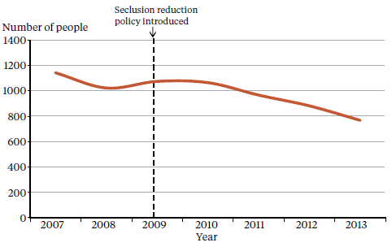

Source: Office of the Director of Mental Health Annual Reports, 2007 to 2012. For 2013 PRIMHD data was used, extracted on 8 July 2014.

Figure 13: Total number of seclusion hours in adult services nationally, 2007 to 2013

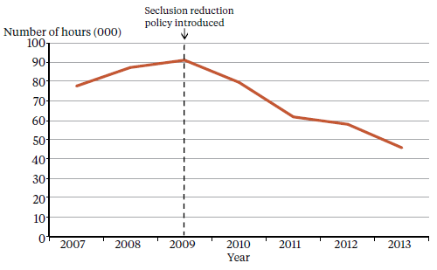

Source: Office of the Director of Mental Health Annual Reports, 2007 to 2012. For 2013 PRIMHD data was used, extracted on 8 July 2014.

### Seclusion in New Zealand mental health services

Between 1 January and 31 December 2013, 7146 people spent time in New Zealand adult mental health units (excluding forensic and other regional rehabilitation services). This represents 199,142 bed nights. Of this total of 7146 people, 768 (10.7 percent) were secluded at some time during the reporting period.

As the same people were often secluded more than once (on average 2.4 times), the number of seclusion events in adult services was higher than the number of people secluded (1851 events for adult clients).

Across all services, including forensic and youth services, 968 people across all age groups experienced at least one seclusion event. Of those secluded, 70 percent were male and 30 percent were female. The most common age group for those secluded was 20 to 24 years (see Figure 14), and a total of 106 young people (under 19 years) were secluded during the 2013 year, representing a total of 311 seclusion events.[13]

During 2013, 768 people were subject to seclusion in adult mental health units in New Zealand, representing a total of 1851 seclusion events.

Figure 14: Number of people secluded in all mental health units, by age group, 1 January to 31 December 2013

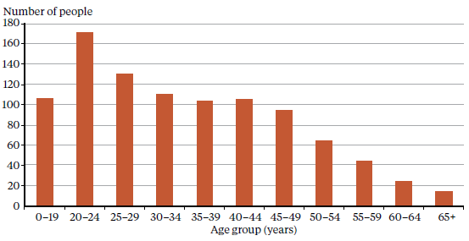

Source: PRIMHD data, extracted on 8 July 2014.

The length of time spent in seclusion varied considerably. Most seclusion events (74 percent) lasted for less than 24 hours. Figure 15 shows the number of seclusion events by duration of the event.

Figure 15: Distribution of seclusion events in all mental health units, by duration of the event, 1 January to 31 December 2013

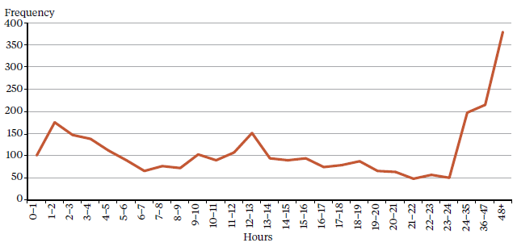

Source: PRIMHD data, extracted on 8 July 2014.

### Seclusion by DHB

All DHBs except for Wairarapa (which has no mental health inpatient service) use seclusion.[14] In 2013 the national average number of people secluded per 100,000 population was 29, and the average number of events per 100,000 population was 70.

As Figures 16 and 17 show, seclusion data varied widely across DHBs. Such variation is likely to be due to a number of factors, including:

* differences in seclusion practice
* geographical variations in the prevalence and acuity of mental illness
* ward design factors, such as the availability of intensive care and low-stimulus facilities
* staff numbers, experience and training
* use of sedating psychotropic medication
* the frequent or prolonged seclusion of one person, distorting seclusion figures over the 12‑month period.

Because it is difficult to measure and adjust for these factors, it can be useful to compare an individual DHB’s performance over time in addition to considering the adjusted comparisons between DHBs made in this Annual Report.

Figure 16: Number of people secluded in adult services (aged 20 to 64 years), per 100,000 by DHB, 1 January to 31 December 2013

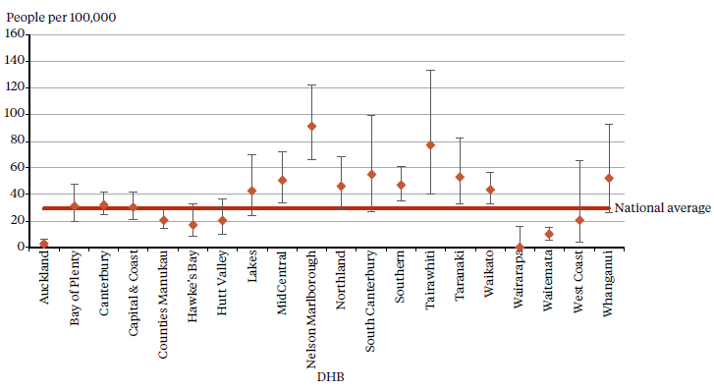

Note: Confidence intervals (for 99 percent confidence) have been used to aid interpretation. Where a DHB region’s confidence interval crosses the national average, this means the DHB’s rate was not statistically significantly different to the national average.

Source: PRIMHD data, extracted on 8 July 2014.

Figure 17: Number of seclusion events in adult services (aged 20 to 64 years), per 100,000 by DHB, 1 January to 31 December 2013

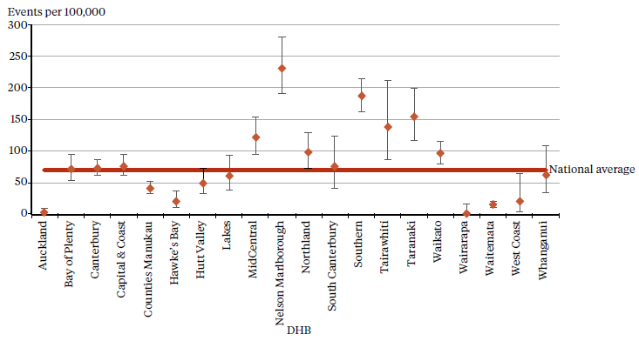

Note: Confidence intervals (for 99 percent confidence) have been used to aid interpretation. Where a DHB region’s confidence interval crosses the national average, this means the DHB’s rate was not statistically significantly different to the national average.

Source: PRIMHD data, extracted on 8 July 2014.

### Seclusion and ethnicity

As a population group, Māori experience the greatest burden due to mental health issues in New Zealand.

In 2013, Māori were 3.7 times more likely to be secluded in adult services than people from other ethnic groups (per 100,000 population). Of the 768 people (aged 20 to 64 years) secluded in adult services during 2013, 36 percent were Māori.

Figure 18 shows seclusion indicators for Māori and non-Māori during 2013. Māori were secluded at a rate of 78 people per 100,000, and non-Māori at a rate of 21 people per 100,000 population.

In 2013, Māori were 3.7 times more likely to be secluded than people from other ethnic groups.

Reducing and eventually eliminating the use of seclusion for Māori is a priority action in *Rising to the Challenge* (Ministry of Health 2012e).

Te Pou supports the Ministry initiative outlined in *Rising to the Challenge.* Information on initiatives and strategies for reducing the use of seclusion with Māori can be accessed on Te Pou’s website ([www.tepou.co.nz](http://www.tepou.co.nz/)).

Figure 18: Seclusion indicators for adults (aged 20 to 64 years) in adult mental health services, Māori and non-Māori, 1 January to 31 December 2013

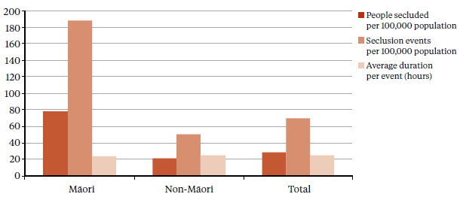

Source: PRIMHD data, extracted on 8 July 2014.

Figure 19 shows the percentage of inpatients secluded in acute adult services, for Māori and non-Māori males and females in 2013. This figure indicates that a greater proportion of Māori were secluded than non-Māori, and that across all ethnicities men were more likely to be secluded (13.7 percent) than women (7.5 percent).

Figure 19: Proportion of adult inpatients (aged 20 to 64 years) secluded in adult mental health services, for Māori and non-Māori males and females, 1 January to 31 December 2013

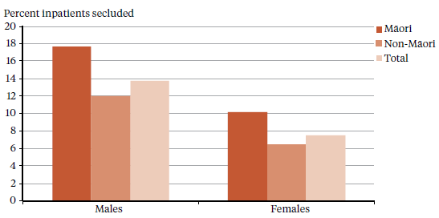

Source: PRIMHD data, extracted on 8 July 2014.

Figure 20 shows the proportion of Māori secluded in general adult mental health services (for ages 20 to 64 years) from 2007 to 2013. Nationally since 2007 the number of people secluded has decreased by 33 percent. Consistent with the declining national rate, the number of people secluded who identify as Māori has decreased by 28 percent between 2007 and 2013.

Figure 20: Proportion of Māori and non-Māori aged 20 to 64 years secluded in general adult mental health services nationally, 2007 to 2013

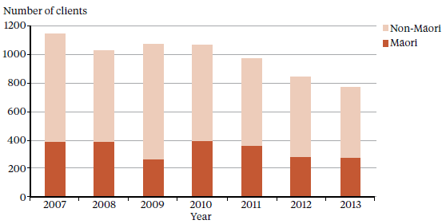

Source: PRIMHD data, extracted on 8 July 2014

### Seclusion in forensic units

Specialist inpatient forensic services are provided in five regions: Northern, Midland, Central, Canterbury and Otago, with a smaller inpatient forensic service in Whanganui.[15]16 Forensic services provide mental health treatment in a secure environment for prisoners with a mental disorder, and for people defined as special or restricted patients under the Mental Health Act.

In 2013, 98 people were secluded in forensic units (down from 118 in 2012), contributing to a total of 786 seclusion events. The average duration of a seclusion event in a forensic service increased from 28.3 hours in 2012 to 34.4 hours in 2013.

Table 6 presents the seclusion indicators for the 2013 calendar year. These indicators cannot be compared with adult service indicators because they do not reflect the same client base. The rates of seclusion of the relatively small group of people in the care of forensic services can be affected by individuals who were secluded significantly more often than others. In particular, one person accounted for 344 (44 percent) of the 786 seclusion events over the reporting period.

Table 6: Seclusion indicators for forensic services, by DHB, 1 January to 31 December 2013

|  |  |  |  |
| --- | --- | --- | --- |
| **DHB** | **Number of clients secluded** | **Number of events** | **Average duration per event (hours)** |
| Canterbury | 21 | 524 | 26 |
| Capital & Coast | 6 | 8 | 30.2 |
| Southern | 9 | 38 | 105.5 |
| Waikato | 26 | 81 | 37.9 |
| Waitemata | 35 | 131 | 45.4 |
| Whanganui | 2 | 4 | 30.8 |
| **Total** | **99** | **786** | **34.4** |

Source: PRIMHD data, extracted on 8 July 2014.

### Sector voices

#### Photo of Anne Brebner – Te PouAnne Brebner – Te Pou Supporting district health boards to reduce seclusion

Here at Te Pou we continue to support DHBs using the Six Core Strategies (Huckshorn 2005) as an evidence-based methodology that supports a whole-of-system change.

More than half of the DHBs are using this methodology to promote less restrictive practices. In practice visits, I can see real shifts in staff perceptions of tolerance for people using a more personalised aspect to self-management; some examples are using sensory modulation as a method to calm and soothe, some are incorporating cultural practices such as kapa haka to help manage the need for loud, expressive emotion.

I am hearing about more practices that incorporate family and whānau in ways that are innovative and really do support personalised care. How much these practices truly reduce the trajectory that may have ended in seclusion, we may never really be able to measure; however, clinical stories definitely reinforce the view that some people who previously have had multiple seclusion events are managing in innovative ways to have an acute admission that no longer includes the use of seclusion. The DHBs are to be congratulated for supporting such practice change.

There are many resources on the Te Pou website that can be used to support reduced restraint and seclusion ([www.tepou.co.nz](http://www.tepou.co.nz/)).

## Electroconvulsive therapy

Electroconvulsive therapy (ECT) is a therapeutic procedure in which a brief pulse of electricity is delivered to a person’s brain in order to produce a seizure. ECT can be an effective treatment for various types of mental illness, including depressive illness, mania, catatonia and other serious neuropsychiatric conditions. It is often effective as a last resort in cases where medication is contraindicated or is not relieving symptoms sufficiently. ECT can only be given with the consent of the person receiving it, other than in certain carefully defined circumstances.

In summary, in 2013:

* 253 people received ECT (5.7 people per 100,000)
* a total of 2341 treatments of ECT were administered
* those treated received an average of 9 administrations of ECT over the year
* women were more likely to receive ECT than men
* older people were more likely to receive ECT than younger people.

ECT is administered under anaesthesia and with muscle relaxants by medical staff in an operating theatre. The person goes to sleep under anaesthesia and wakes unable to recall the details of the procedure. The most common side effects of ECT are confusion, disorientation and memory loss. Confusion and disorientation typically clear within an hour, but memory loss can be persistent and in some cases even permanent (American Psychiatric Association 2001; Ministry of Health 2004).

While ECT remains controversial, a 2004 independent review concluded that it continues to have a place as a treatment option in New Zealand.

Significant advances have been made in improving ECT techniques and reducing side effects over the last 20 years. Despite these improvements it remains a controversial treatment. In 2003, the Health Select Committee recommended that a review be undertaken, independently of the Ministry of Health, on the safety and efficacy of ECT and the adequacy of regulatory controls on its use in New Zealand. The review concluded that ECT continues to have a place as a treatment option for consumers of mental health services in New Zealand, and that banning its use would deprive some seriously ill people of a potentially effective and sometimes life-saving means of treatment. The report of the independent review is available on the Ministry of Health website ([www.health.govt.nz/publications](http://www.health.govt.nz/publications)).

In 2009 a consumer resource was created as part of the 2003 Government response to the Health Committee’s report on petition 1999/30 of Anna de Jonge and others regarding ECT (Ministry of Health 2009). The ECT consumer resource is available on the Ministry of Health website ([www.health.govt.nz/](http://www.health.govt.nz/)publications).

### Number of patients treated with ECT

The number of people treated with ECT in New Zealand has remained relatively stable since 2006, with around 200 to 300 people receiving the treatment each year (Figure 21).

Figure 21: Number of people treated with ECT in New Zealand, 2005 to 2013

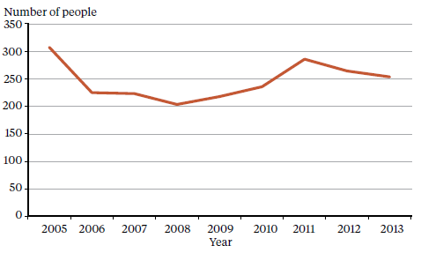

Source: Office of the Director of Mental Health Annual Reports, 2005 to 2012. 2013 data is from PRIMHD, extracted on 8 July 2014 except for Hawke’s Bay which provided manual data.

A total of 253 people received ECT during the year ending 31 December 2013. Table 7 shows the total number of people who received ECT from 1 January to 31 December 2013, by DHB of domicile.[16] The total number of treatments administered over this period was 2341, with a mean of nine treatments per person.

Table 7: Number of people treated with ECT, by DHB of domicile, 1 January to 31 December 2013

|  |  |  |  |
| --- | --- | --- | --- |
| **DHB of domicile** | **Number of people treated with ECT** | **Total number of treatments** | **Mean number of treatments per person (range)** |
| Auckland | 15 | 118 | 7.9 (1–24) |
| Bay of Plenty | 14 | 141 | 10.1 (1–30) |
| Canterbury | 33 | 292 | 8.9 (1–23) |
| Capital & Coast | 29 | 129 | 3.9 (1–35) |
| Counties Manukau | 23 | 226 | 9.8 (2–31) |
| Hawke’s Bay | 8 | 73 | 9.1 (5–19) |
| Hutt Valley | 5 | 78 | 15.6 (11–19) |
| Lakes | 24 | 120 | 5 (1–25) |
| MidCentral | 13 | 191 | 14.7 (2–46) |
| Nelson Marlborough | 2 | 13 | 6.5 (5–8) |
| Northland | 4 | 40 | 10 (1–22) |
| South Canterbury | 2 | 11 | 5.5 (3–8) |
| Southern | 18 | 172 | 9.6 (1–41) |
| Tairawhiti | 1 | 4 | 4 (4–4) |
| Taranaki | 1 | 5 | 5 (5–5) |
| Waikato | 32 | 388 | 12.1 (2–52) |
| Wairarapa | 1 | 9 | 9 (9–9) |
| Waitemata | 27 | 303 | 11.2 (1–24) |
| West Coast | 3 | 26 | 8.7 (8–10) |
| Whanganui | 2 | 3 | 1.5 (1–2) |
| Unknown | 1 | 1 | 1 (1–1) |
| New Zealand | 253 | 2341 | 9 (1–52) |

Notes: This table does not include ECT figures for individuals receiving treatment with health services for older people in the Central and Southern regions. Health services for older people in these regions do not report to PRIMHD.

In 2013, 16 people were seen out of area:

* Auckland DHB saw one person from Waitemata
* Canterbury DHB saw two people from South Canterbury, one from Waitemata and three from West Coast
* Counties Manukau DHB saw three people from Auckland
* Hutt Valley DHB saw one person from Capital & Coast and one from Wairarapa
* MidCentral DHB saw one person from Whanganui
* Northland DHB saw one person from an unknown area
* Southern DHB saw one person from Nelson Marlborough
* Waikato DHB saw one person from Lakes.

If a person was seen while living in two DHB areas, they were counted twice. The New Zealand total of 253 is a unique count and not a sum of this column in the table as the New Zealand total excludes individuals who were counted by more than one DHB.

Source: PRIMHD data, extracted on 8 July 2014 except for Hawke’s Bay which provided manual data.

The rate of people treated with ECT by DHB of domicile is presented in Figure 22. The national rate of people receiving ECT treatment was 5.7 per 100,000 in 2013.

As Figure 22 shows, the rate of ECT treatments given varies regionally. Several factors contribute to such variation. First, regions with smaller populations will be more vulnerable to annual variations (according to the needs of the population at any given time). In addition, people receiving continuous or maintenance treatment will typically receive more treatments in a year than those treated with an acute course. ECT is indicated in older people more often than in younger adults because older people are more likely to have associated medical problems contraindicating medication. Finally, populations in some DHBs have better access to ECT services than others, which is likely to influence the rates of use.

Figure 22: Rate of people treated with ECT, by DHB of domicile, 1 January to 31 December 2013

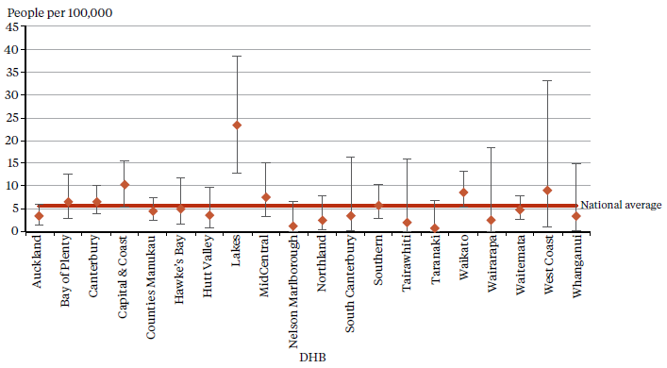

Note: Confidence intervals (for 99 percent confidence) have been used to aid interpretation. Where a DHB region’s confidence interval crosses the national average, this means the DHB’s rate was not statistically significantly different to the national average.

As the numbers of people receiving ECT by DHB are so small, it is difficult to make meaningful comparisons between DHBs as rates per 100,000 population.

Source: PRIMHD data, extracted on 8 July 2014 except for Hawke’s Bay which provided manual data.

### Consent to treatment

Section 60 of the Mental Health Act describes the process required for obtaining consent for ECT. Either the person’s consent or a second opinion from a psychiatrist appointed by the Mental Health Review Tribunal is required.[17] In the latter case, the treatment must be considered to be in the interests of the person.

This process allows for the treatment of people too unwell to consent to treatment. Clinicians are advised to make the decision about whether ECT is in the interests of the person after discussing the options with family and whānau and considering any relevant advance directives the person has made.[18]

During 2013 six people were treated with ECT who retained decision-making capacity and refused consent. Table 8 shows the number of treatments administered without consent during 2013.

Table 8: ECT not consented to, by DHB of service, 1 January to 31 December 2013

|  |  |  |  |
| --- | --- | --- | --- |
| **DHB of service** | **Number of people given ECT who did have the capacity to consent** | **Number of administrations not able to be consented to** | **Number of people given ECT who had capacity and refused consent** |
| Auckland | 4 | 48 | 0 |
| Bay of Plenty | 4 | 50 | 0 |
| Canterbury | 1 | 17 | 3 |
| Capital & Coast | 2 | 17 | 0 |
| Counties Manukau | ^ | ^ | ^ |
| Hawke’s Bay | 2 | 13 | 0 |
| Hutt Valley | 2 | 82 | 3 |
| Lakes | 4 | 21 | ^ |
| MidCentral | 9 | 63 | 0 |
| Nelson Marlborough | 0 | 0 | 0 |
| Northland | ^ | ^ | ^ |
| South Canterbury | 0 | 0 | 0 |
| Southern | 5 | 79 | 0 |
| Tairawhiti | 0 | 0 | 0 |
| Taranaki | 1 | 5 | 0 |
| Waikato | 14 | 141 | 0 |
| Wairarapa | − | − | − |
| Waitemata | 12 | 95 | 0 |
| West Coast | − | − | − |
| Whanganui | − | − | − |
| New Zealand total | 60 | 631 | 6 |

Notes: The data in this table cannot be reliably compared with the data in Table 7 above, as this data is for DHB of service, and Table 7 presents data for DHB of domicile.

The total number of ECT treatments not able to be consented to decreased from 690 treatments in 2012 to 631 treatments in 2013. One factor explaining this decrease is the exclusion of data from Northland and Counties Manukau who did not supply this data for the 2013 Annual Report.

A dash (–) indicates the DHB does not perform ECT: people are sent to other DHBs for treatment.

^ indicates the DHB did not report its data to the Ministry for the 2013 reporting period.

Source: The Ministry of Health is currently unable to provide this data from PRIMHD. DHBs supplied manual data.

### Age and gender of patients treated with ECT

Information on the age and gender of people who were treated with ECT in 2013 is presented in Table 9 and Figure 23. For this data, age group was determined by the individual’s age at the beginning of their treatment. The majority of people (61 percent) treated with ECT were aged over 50 years in 2013.

Of the 253 people who received ECT treatment in 2013, 165 (65 percent) were women and 88 (35 percent) were men. The main reason for the gender difference is that more women present to mental health services with depressive disorders. This ratio is similar to that reported in other countries.

Table 9: Number of people treated with ECT, by age group and gender, 1 January to 31 December 2013

|  |  |  |  |
| --- | --- | --- | --- |
| **Age group (years)** | **Female** | **Male** | **Total** |
| 15–19 | 3 | 2 | 5 |
| 20–24 | 3 | 3 | 6 |
| 25–29 | 6 | 2 | 8 |
| 30–34 | 4 | 3 | 7 |
| 35–39 | 11 | 9 | 20 |
| 40–44 | 12 | 11 | 23 |
| 45–49 | 16 | 10 | 26 |
| 50–54 | 19 | 9 | 28 |
| 55–59 | 14 | 8 | 22 |
| 60–64 | 15 | 16 | 31 |
| 65–69 | 18 | 0 | 18 |
| 70–74 | 11 | 8 | 19 |
| 75–79 | 12 | 3 | 15 |
| 80–84 | 10 | 4 | 14 |
| 85–89 | 8 | 0 | 8 |
| 90–95 | 3 | 0 | 3 |
| Total | 165 | 88 | 253 |

Note: This table does not include ECT figures for people receiving treatment with health services for older people in the Central and Southern regions. Health services for older people in these regions do not report to PRIMHD.

Source: PRIMHD data, extracted on 8 July 2014, except for Hawke’s Bay DHB, which provided manual data.

Figure 23: Number of people treated with ECT, by age group and gender, 1 January to 31 December 2013

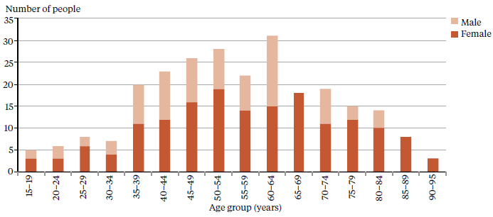

Note: This table does not include ECT figures for people receiving treatment with health services for older people in the Central and Southern regions. Health services for older people in these regions do not report to PRIMHD.

Source: PRIMHD data, extracted on 8 August 2014, except for Hawke’s Bay DHB, which provided manual data.

### Ethnicity of people treated with ECT

The numbers presented in Table 10 suggest that Asian, Māori and Pacific peoples are less likely to receive ECT than those of European ethnicity. However, the numbers involved are so small that it is not statistically appropriate to compare the percentages of people receiving ECT in each ethnic group with the proportion of each ethnic group in the total population of New Zealand.

Table 10: Number of people treated with ECT, by ethnicity, 1 January to 31 December 2013

|  |  |
| --- | --- |
| **Ethnicity** | **Number of people treated with ECT** |
| Asian | 9 |
| European | 213 |
| Māori | 20 |
| Pacific | 6 |
| Other | 5 |
| Total | 253 |

Note: This table does not include ECT figures for people receiving treatment with health services for older people in the Central and Southern regions. Health services for older people in these regions do not report to PRIMHD.

Source: PRIMHD data, extracted on 8 July 2014, except for Hawke’s Bay DHB, which provided manual data.

## Serious adverse events

Serious adverse events (SAEs) relating to clients of DHB mental health services are reported to the Health Quality and Safety Commission (HQSC) in accordance with the requirements of the national reportable events policy.[19] The Office of the Director of Mental Health collects information on serious adverse events involving people under the Mental Health Act, including deaths.

In summary, in 2013:

* 161 serious adverse events were reported to the HQSC by mental health and addiction services
* 126 events involved suspected suicide, 18 events involved serious self-harm and 17 events involved serious adverse behaviour
* 47 deaths of people under the Mental Health Act were reported to the Director of Mental Health.

Of these deaths, 9 people were reported to have died by suicide or suspected suicide and 38 were reported to have died by other means, including natural causes.

The purpose behind the reporting of SAEs is to encourage DHBs to identify and review incidents with the aim of preventing similar events in the future. Ultimately the reporting requirements exist to promote a reflexive process around serious events, helping to ensure safer and better mental health care for New Zealanders into the future.

The purpose of reporting serious events is for DHBs to review the incidents with the aim of preventing similar incidents in the future.

In the time since the HQSC took over the public reporting of SAEs, the number reported to the HQSC has grown considerably: from the first report in 2007, when 182 such events were reported, to 2013, when almost 650 were reported. This growth is not because the frequency of SAEs has increased, but rather because DHBs have improved their reporting systems and cultures, with the result that a greater number of incidents are being reviewed.

In 2013, the HQSC released its first report specifically related to serious incidents that involved clients of mental health and addiction services.[20] However, both the HQSC and the Director of Mental Health recognised that it would be more appropriate for these SAEs to be included in this Annual Report, to put them in association with the wider mental health and addictions sector.

In 2013, a total of 161 serious adverse events were reported to the HQSC by mental health and addiction services. Of those events, 126 (78 percent) were cases of suspected suicide, 18 (11 percent) were cases of serious self-harm and 17 (11 percent) were cases of serious adverse behaviour.

Table 11 shows a breakdown of the events reported to the HQSC during 2013 and Table 12 shows the number of events reported by each DHB. It is important to note that comparisons between individual DHBs are problematic as high numbers may only indicate that a DHB has a good reporting culture (rather than a significantly high number of serious events). In addition, DHBs that manage larger and more complex mental health services are likely to report a higher number of adverse events.

Table 11: Number of serious adverse events reported to the HQSC, 1 January to 31 December 2013

|  |  |  |  |  |  |
| --- | --- | --- | --- | --- | --- |
| **Type of event** | **Community** | **Inpatient unit** | **On approved leave** | **Absent without leave** | **Total** |
| Suspected suicide | 117 | 3 | 3 | 3 | 126 |
| Serious self-harm | 6 | 9 | 0 | 3 | 18 |
| Serious adverse behaviour | 4 | 9 | 0 | 4 | 17 |
| Total | 127 | 21 | 3 | 10 | 161 |

Source: Data reported to the HQSC by DHBs.

Table 12: Number of serious adverse events reported to the HQSC by DHB, 1 January to 31 December 2013

|  |  |  |  |  |
| --- | --- | --- | --- | --- |
| **DHB** | **Number of events** |  | **DHB** | **Number of events** |
| Auckland | 17 |  | Northland | 2 |
| Bay of Plenty | 1 |  | South Canterbury | 0 |
| Canterbury | 22 |  | Southern | 12 |
| Capital & Coast | 12 |  | Tairawhiti | 2 |
| Counties Manukau | 14 |  | Taranaki | 4 |
| Hawke’s Bay | 9 |  | Waikato | 4 |
| Hutt Valley | 6 |  | Wairarapa | 0 |
| Lakes | 3 |  | Waitemata | 29 |
| MidCentral | 8 |  | West Coast | 6 |
| Nelson Marlborough | 8 |  | Whanganui | 2 |
|  |  |  | New Zealand total | 161 |

Source: Data reported to the HQSC by DHBs.

### Reportable deaths under the Mental Health Act

Section 132 of the Mental Health Act requires that the Director of Mental Health be notified within 14 days of the death of any person or special patient under the Mental Health Act, and that such notification identifies the apparent cause of death.[21]

If the circumstances surrounding a death cause concern, the DHB may initiate an inquiry. The Director of Mental Health can also initiate an investigation under section 95 of the Mental Health Act, and in rare cases the Minister or Director-General of Health can initiate an inquiry under section 72 of the New Zealand Public Health and Disability Act 2000. The Director of Mental Health has a role in ensuring that recommendations are followed up by district health boards.

In 2013 the Director of Mental Health received notification of 47 deaths of people who were under the care of the Mental Health Act at the time of death (Table 13). Nine people are reported to have died by suicide or suspected suicide, and two of these deaths have been confirmed as a suicide by the coroner at the time of writing this report. The Ministry is yet to receive coroners’ reports for the other seven people who are suspected to have died by suicide.

In 2013, 38 people are reported to have died by other means while receiving treatment under the Mental Health Act, including by natural causes and illness unrelated to the individual’s mental health status.

Table 13: Outcomes of reportable death notifications under section 132 of the Mental Health Act, 1 January to 31 December 2013

|  |  |
| --- | --- |
| **Reportable death outcome** | **Number of notifications** |
| Suicide | 2 |
| Suspected suicide | 7 |
| Other deaths | 38 |
| Total events | 47 |

Note: A person is recorded as having died by suicide when the coroner has made a finding of suicide.

Source: Office of the Director of Mental Health records.

### Sector voices

#### Photo of Janice Wilson – Chief Executive, Health Quality and Safety CommissionJanice Wilson – Chief Executive, Health Quality and Safety Commission

Over the last year the Health Quality and Safety Commission has been increasingly working with the Director of Mental Health in order to improve the quality of services in the mental health and addictions sector. Two examples of this work are the establishment of the Suicide Mortality Review Committee, and the process of learning from adverse events.

The Suicide Mortality Review Committee has been established as an 18-month trial, with a main aim of collecting a set of information on every suicide death in New Zealand, to improve our knowledge about people who die by suicide. The Committee will also review three sub-groups with particularly high rates of suicide: Māori youth, users of specialist mental health and addiction services, and men aged between 25 and 64 years.

The Director of Mental Health and the Commission are also working together on how we can learn from serious adverse events that have involved users of mental health and addiction services. We are developing tools and resources to support providers in the review of these events, so that lessons can be learnt and – where possible – steps taken to prevent similar events from occurring in future.

As a psychiatrist myself, I acknowledge the difficulties associated with tackling these two challenging areas, but I see these as vital steps that are part of our responsibilities.

## Death by suicide or suspected suicide

This section provides a brief overview of suicide and deaths of undetermined intent among people who use specialist mental health services for 2011. Data from 2011 is used because it can take over two years for a coroner’s investigation into a suicide to be completed.

In summary, in 2011:

* 493 suicides were recorded in the mortality database
* approximately 40 percent of those who died by suicide or undetermined intent (aged 10 to 64) were mental health service users
* mental disorders were a significant risk factor for suicidal behaviour
* males were more likely to commit suicide than females
* younger people were more likely to commit suicide than older people.

Suicide is a serious concern for New Zealand. Around 500 New Zealanders die by suicide every year; which also affects the lives of many others – families, whānau, friends, colleagues and communities.

New Zealand is one of 28 countries with a national strategy to address suicide, the New Zealand Suicide Prevention Strategy 2006–2016 (Associate Minister of Health 2006). It also has the New Zealand [Suicide Prevention Action Plan 2013–2016](http://www.health.govt.nz/publication/new-zealand-suicide-prevention-action-plan-2013-2016) (Ministry of Health 2013a) which represents the next step in the Government’s commitment to addressing New Zealand’s unacceptably high suicide rates.

Around 500 New Zealanders die by suicide every year.

With funding of $25 million over four years to implement 30 actions, the Suicide Prevention Action Plan aims to expand existing services, to make these more accessible and to support communities to prevent suicide.

The focus of this subsection is on people who died by suicide with a history of contact with specialist mental health (including alcohol and other drug) services in the year prior to their death. People with no history of mental health service use in the year prior to death are referred to as ‘non-service users’, although it is acknowledged that some non-service users may have used mental health or alcohol and other drug services at some earlier time in their lives.

Mental disorders are a significant risk factor for suicidal behaviour.

### Prevalence of suicide in the population[22]

At the time the data was extracted, there were 493 suicides recorded in the mortality database for 2011.[23] A further 18 deaths of undetermined intent were recorded and are included in this report. Of this initial total of 511 deaths, 45 involved people aged 65 years and over. These deaths are excluded from the following discussion.

Table 14 shows the remaining 466 deaths by suicide or deaths of undetermined intent. Within this total, 185 (40 percent) of the people had contact with specialist mental health services in the year prior to death. Mental disorders (in particular, mood disorders, substance use disorders and antisocial behaviours) are a significant risk factor for suicidal behaviour (Beautrais et al 2005).

Table 14: Number and age-standardised rate of suicides, by service use, ages 10 to 64 years, 1 January to 31 December 2011a

|  |  |  |
| --- | --- | --- |
|  | **Number** | **Age-standardised rateb** |
| **Deaths due to intentional self-harm** | | |
| Service users | 177 | 124 |
| Non-service users | 271 | 7 |
| Total | 448 | 12 |
| **Deaths of undetermined intent** | | |
| Service users | 8 | 6 |
| Non-service users | 10 | 0 |
| Total | 18 | 0 |
| **Total deaths** | | |
| Service users | 185 | 129 |
| Non-service users | 281 | 7 |
| Total | 466 | 12 |

Notes:

a Service user denominator excludes service users with unknown age

b Age-standardised rate is per 100,000, standardised to the WHO standard population aged 0–64 years.

Source: Ministry of Health mortality database, extracted on 22 July 2014.

### Changes in number of suicides over time

Figure 24 shows the changes in the rates of suicide by service users and non-service users between 2001 and 2011.

Figure 24: Age-standardised rate of suicides, by service users and non-service users, ages 10 to 64 years, 2001 to 2011

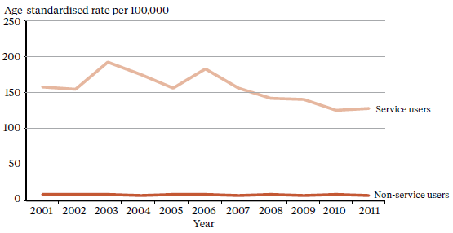

Notes: Age-standardised rate is per 100,000, standardised to the WHO standard population aged under 65 years.

The service-user population is much smaller than the total population of non-service users and will therefore produce rates more prone to fluctuation from year to year.

Source: Ministry of Health mortality database.

### Sex and age in relation to suicide[24]

As shown in Table 15 and Figure 25, approximately 3.3 times as many males as females died by suicide in 2011. Forty percent of both females and males who died by suicide in 2011 were service users. Of those service users who died by suicide in 2011, 24 percent were female and 76 percent were male.

Table 15: Number and age-standardised rate of suicide, by service use and sex, ages 10 to 64 years, 1 January to 31 December 2011a

|  |  |  |  |  |  |  |
| --- | --- | --- | --- | --- | --- | --- |
| **Sex** | **Service usersb** | | **Non-service users** | | **Total** | |
| **Number** | **ASR** | **Number** | **ASR** | **Number** | **ASR** |
| Male | 141 | 178.1 | 216 | 11.2 | 357 | 17.9 |
| Female | 44 | 70.1 | 65 | 3.4 | 109 | 5.5 |
| Total | 185 | 129.1 | 281 | 7.3 | 466 | 11.7 |

Notes: ASR = age-standardised rate.

a Suicide includes deaths of undetermined intent. The age-standardised rate is per 100,000, standardised to the WHO standard population 0–64 years.

b Service-user denominator excludes service users of unknown age.

Source: Ministry of Health mortality database, extracted on 22 July 2014.

Figure 25: Age-standardised rate of suicide, by age group, sex and service use, ages 10 to 64 years, 1 January to 31 December 2011

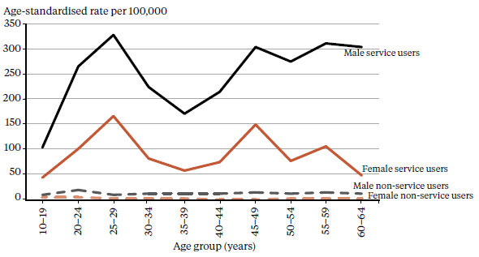

Note: The age-standardised rate is the rate per 100,000 standardised to the WHO standard population under 65 years. Source: Ministry of Health mortality database.

As shown in Table 16 and Figure 25, the age-standardised rate of suicide among female and male service users in 2011 was highest for the age group of 25 to 29 years, at 167 per 100,000 ASR and 329 per 100,000 ASR respectively.

When considering these numbers it is important to note that because these age-standardised rates are derived from a small service-user population, they are highly variable over time.

For female and male non-service users, the rate of suicide was highest in the 20 to 24 years age group, at 6.6 per 100,000 ASR and 20 per 100,000 ASR respectively.

Table 16: Number and age-standardised rate of suicides, by sex and service use, ages 10 to 64 years, 1 January to 31 December 2011

|  |  |  |  |  |  |  |  |  |
| --- | --- | --- | --- | --- | --- | --- | --- | --- |
| **Age band (years)** | **Service users** | | | | **Non-service users** | | | |
| **Female** | | **Male** | | **Female** | | **Male** | |
| **Number** | **ASR** | **Number** | **ASR** | **Number** | **ASR** | **Number** | **ASR** |
| 10–19 | 5 | 45.7 | 14 | 104.1 | 17 | 5.9 | 33 | 11.0 |
| 20–24 | 6 | 102.2 | 22 | 267.3 | 10 | 6.6 | 32 | 20.0 |
| 25–29 | 8 | 166.7 | 22 | 328.5 | 5 | 3.5 | 16 | 11.4 |
| 30–34 | 4 | 83.4 | 14 | 226.5 | 5 | 3.7 | 19 | 15.2 |
| 35–39 | 3 | 58.5 | 11 | 172.0 | 6 | 4.1 | 18 | 13.7 |
| 40–44 | 4 | 75.4 | 14 | 216.8 | 2 | 1.3 | 19 | 13.3 |
| 45–49 | 7 | 150.9 | 17 | 305.4 | 3 | 1.9 | 24 | 16.1 |
| 50–54 | 3 | 79.6 | 12 | 276.2 | 7 | 4.7 | 20 | 14.2 |
| 55–59 | 3 | 108.7 | 9 | 311.0 | 6 | 4.7 | 19 | 15.4 |
| 60–64 | 1 | 50.9 | 6 | 304.4 | 4 | 3.4 | 16 | 14.0 |

Notes: Includes deaths of undetermined intent. ASR = age-standardised rate.

Source: Ministry of Health mortality database, extracted on 22 July 2014.

### Ethnicity and suicide

As Table 17 indicates, among people using mental health services in 2011, the age-standardised rate of suicide was higher for Māori (116 per 100,000 service users) compared with Pacific peoples (74 per 100,000 service users). The age-standardised rate of suicide for those in the category of other ethnicities was 133 per 100,000 service users.

Table 17: Number and age-standardised rate of suicides and deaths of undetermined intent, by ethnicity and service use, ages 10 to 64 years, 1 January to 31 December 2011

|  |  |  |  |  |  |  |
| --- | --- | --- | --- | --- | --- | --- |
| **Ethnicity** | **Service users** | | **Non-service users** | | **Total** | |
| **Number of deaths** | **ASR** | **Number of deaths** | **ASR** | **Number of deaths** | **ASR** |
| Māori | 48 | 115.6 | 71 | 12.3 | 119 | 22.9 |
| Pacific | 7 | 74.0 | 20 | 7.8 | 27 | 11.7 |
| Other | 130 | 133.2 | 190 | 5.9 | 320 | 10.0 |
| Total | 185 | 129.1 | 281 | 7.3 | 466 | 11.7 |

Note: ASR = age-standardised rate.

Source: Ministry of Health mortality database.

### Service users who died by suicide during 2011

During 2011, 185 service users died by suicide. Of this total, four service users died while an inpatient,[25] seven died within a week of being discharged[26] and 39 died within 12 months of discharge.[27]

### An overview of service users dying by suicide, 2001 to 2011

Over the 10-year period from 2001 to 2011, 1793 service users died by suicide.[28] Of this total, 23 service users (1 percent) died while an inpatient, 111(6 percent) died within a week of being discharged and 462 (26 percent) died within 12 months of discharge.

Of the 1793 service user suicides from 2001 to 2011, 1525 service users were receiving treatment from a specialist service community team in the 12 months before death, and 387 patients were receiving treatment from a specialist alcohol and drug team in the 12 months before death.

## The Alcoholism and Drug Addiction Act

The Alcoholism and Drug Addiction Act 1966 (ADA Act) provides for the compulsory detention and treatment of people with severe substance dependence for up to two years at certified institutions.

In summary, in 2013:

* 75 orders were granted by the Family Court for either detention or committal under the ADA Act
* 59 of the granted orders were for voluntary detention (section 8) and 16 were for involuntary committal (section 9).

In October 2009 the Prime Minister announced a review of the ADA Act as part of a range of initiatives to reduce harm from methamphetamine. The Law Commission released its report *Compulsory Treatment for Substance Dependence: A review of the Alcoholism and Drug Addiction Act 1966* in October 2012 (New Zealand Law Commission 2012). In 2012 a bill to repeal and replace the ADA Act was developed.

Section 8 of the ADA Act allows a person who is dependent on alcohol or another drug to voluntarily apply to the Family Court for detention in a specified institution that is certified under the ADA Act (detention). Section 9 of the ADA Act applies when another person (such as a relative or the police) makes an application to the Family Court for the person to be committed to a specified institution that is certified under the ADA Act (committal). Section 9 applications must be accompanied by two medical certificates.

Ministry of Justice statistics on the use of the ADA Act are available from the beginning of 2004. Table 18 details the outcomes of applications under the ADA Act to the Family Court. Table 19 shows the number of orders granted for detention under section 8 and for committal under section 9 of the ADA Act.

Table 18: Number and outcomes of applications for detention and committal, 2004 to 2013

|  |  |  |  |  |  |  |  |  |  |  |
| --- | --- | --- | --- | --- | --- | --- | --- | --- | --- | --- |
| **Application outcome** | **2004** | **2005** | **2006** | **2007** | **2008** | **2009** | **2010** | **2011** | **2012** | **2013** |
| Application granted or granted with consent | 72 | 79 | 77 | 71 | 75 | 71 | 69 | 74 | 72 | 75 |
| Application dismissed or struck out | 5 | 3 | 4 | 1 | 2 | 3 | 3 | 1 | 2 | 3 |
| Application withdrawn, lapsed or discontinued | 3 | 9 | 2 | 6 | 1 | 4 | 9 | 5 | 9 | 8 |
| Total applications for s 8 and s 9 orders | 80 | 91 | 83 | 78 | 78 | 78 | 81 | 80 | 83 | 86 |

Note: The table presents applications that were disposed at the time of data extraction at 26 June 2014.

Source: Ministry of Justice’s Case Management System (CMS). The CMS is a live operational database. Figures are subject to minor changes at any time.

Table 19: Outcomes of applications for granted orders for detention and committal, 2004 to 2013

|  |  |  |  |
| --- | --- | --- | --- |
| **Year** | **Number (and percentage) of section 8 applications granted for detention** | **Number (and percentage) of section 9 applications granted for committal** | **Total number of applications granted** |
| 2004 | 44 (92%) | 28 (85%) | 72 |
| 2005 | 49 (96%) | 30 (79%) | 79 |
| 2006 | 60 (98%) | 17 (77%) | 77 |
| 2007 | 52 (100%) | 19 (76%) | 71 |
| 2008 | 63 (98%) | 12 (86%) | 75 |
| 2009 | 49(98%) | 22 (81%) | 71 |
| 2010 | 55 (96%) | 14 (58%) | 69 |
| 2011 | 59 (97%) | 15 (75%) | 74 |
| 2012 | 61 (97%) | 11 (58%) | 72 |
| 2013 | 59 (95%) | 16 (64%) | 75 |

Note: The table presents applications that were disposed at the time of data extraction on 26 June 2014.

Source: Ministry of Justice’s Case Management System (CMS). The CMS is a live operational database. Figures are subject to minor changes at any time hereafter.

### Sector voices

#### Photo of Erin Watts and Brighid Galvin – Mental health nursesErin Watts and Brighid Galvin – Mental health nurses

Hello, my name is Erin Watts (left) and my colleague’s name is Brighid Galvin (right). We are both registered nurses practising within the scope of mental health.

Together we provide a home-based detox service in Dunedin. The aim of the service is to provide safe, managed withdrawal for people who are substance dependent. As mental health nurses we are holistic in our approach and offer a brief intervention service that is recovery and strengths based.

To receive support from the detox service, people can self-refer or be referred by GPs, community mental health teams or other alcohol and other drug services. We work in partnership with people’s GPs who provide us with medical support.

With detox it is not always appropriate to treat people in their home environment (ie, when there’s no support person at home, when the environment is not suitable or when the person has a past history of withdrawal seizures). In these cases it is possible for people to be treated in a respite setting and we purchase these beds from the Ashburn Clinic.

Things we love about being mental health nurses are the wide variety of people we work with, the privilege of going into people’s homes and the autonomy of the role. Mental health nurses work across a variety of settings, from inpatient to community. Over the years there has been a big shift in where services are provided, with most mental health nurses now caring for people in the community.

Some of the challenges include the frustrations of clients not being able to be attended to now (managed withdrawal is a planned intervention which requires careful steps in order to be safely implemented) and the difficulty of providing a service for the homeless. It is a great job which allows us to work alongside clients towards their experience of wellbeing.

## Opioid substitution treatment

Opioid substitution treatment (OST) is a well-established treatment that involves prescribing opioids such as methadone and buprenorphine with naloxone (suboxone) as a substitute for illicit opioids.

In summary:

* during 2013 over 5000 people were being treated in New Zealand for opioid dependence
* most people (73 percent) received treatment from specialist addiction services in 2013
* the Ministry would like more people to be receiving treatment from their GP
* in 2013, approximately 26 percent of OST patients were in GP care
* suboxone is increasingly being used in New Zealand to treat opioid dependence
* people aged 30 to 60 years are the most likely to be receiving OST.

The Director of Mental Health is responsible for approving qualified practitioners to prescribe controlled drugs for the treatment of drug dependence under section 24 of the Misuse of Drugs Act 1975.

At the end of 2013, 5158 people were being treated in New Zealand for opioid dependence.

In 2012 the Director of Mental Health began a review of the process and criteria for prescribing controlled drugs under section 24. This work aims to:

* establish greater governance and oversight around prescribing
* ensure all prescribers are appropriately qualified
* mitigate drug diversion.

This work continued through 2013 and is expected to be completed in early 2014.

The Director of Mental Health undertakes regular site visits to opioid substitution services. The Director’s role in OST service quality and safety is supported by regular meetings with the National Association of Opioid Treatment Providers and other Ministry of Health teams with an involvement in OST.

In 2013, 16 DHBs, one NGO, one primary health organisation and one general practice provided specialist OST services for national coverage. In addition, a number of individual GPs were authorised to provide OST to clients stabilised in treatment.

At the end of 2013, 5158 people were being treated in New Zealand for opioid dependence. Of this total, 3745 (73 percent) were at specialist services 1362 (26 percent) were in GP care and 51 (1 percent) were in prison. There has been a 17.4 percent increase in the number of clients reported to be receiving OST since 2007.[29]

Opioid dependence is a complex health condition that often requires long-term treatment and care.

### The use of buprenorphine with naloxone (suboxone) for OST

Since 1 July 2012 PHARMAC has funded buprenorphine with naloxone (suboxone) for both detoxification and maintenance for people who are dependent on opioids. This funding has given a welcome choice in opioid substitution treatment. With suboxone the risk of diversion and misuse is lower than for methadone. In addition, suboxone is safer in overdose and can be given in cumulative doses lasting several days, rather than the daily dosing regimen required for methadone.

The number of people being prescribed suboxone has more than tripled over the last two years, increasing from 71 people in December 2011 to 360 at the end of 2013 (Figure 26).

The number of people being prescribed suboxone has more than tripled since 2011.

Figure 26: Number of people prescribed suboxone, 2008 to 2013

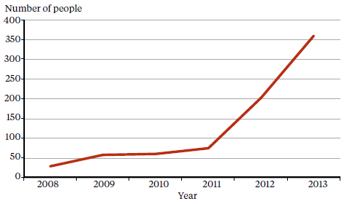

Source: Data provided by OST services in six-monthly reports.

### The ageing population of OST clients

Opioid dependence is a complex health condition that often requires long-term treatment and care. People aged 30 to 60 years are the biggest client group for OST services.

OST clients are an ageing population. The number of people aged between 45 and 59 years who are receiving OST has increased by 52 percent since 2007 and is now larger than the age group of 30 to 44 years (previously the largest group of OST clients)(Figure 27).

In addition, there is now more emphasis on managing co-existing medical and mental health problems for OST clients. This more holistic approach will help improve outcomes for people who are opioid dependent.

A more holistic approach to recovery will help to improve outcomes for people who are opioid dependent.

Figure 27: Number of OST clients, by age group, 2008 to 2013

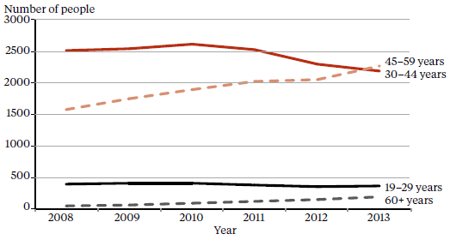

Source: Data provided by OST services in six-monthly reports.

### Shared care with GPs

OST services in New Zealand are provided by specialist addiction services and primary health care teams. Opioid substitution treatment aims to support clients to lead a life that is as normal as possible within the constraints of treatment. For this reason, the primary health care setting is regarded as the best environment for the long-term management of stable clients receiving OST.

Primary health care is preferred for the long-term management of stable clients receiving OST.

Figure 28: Number of people receiving treatment from a specialist service, GP or prison service, 2008 to 2013

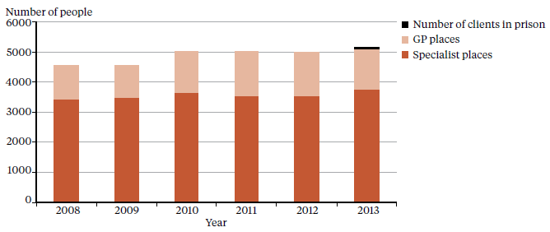

Source: Data provided by OST services in six-monthly reports.

Ideally, the Ministry would like to see a service provision of 50:50 between specialist care and primary care, with more people being seen in general practice (as for any other long-term chronic condition such as diabetes or asthma). This would enable specialist services to concentrate on initiating people onto OST and on treating those with complex co-morbid health issues and those in high-risk situations.

Metro Auckland and Canterbury DHBs continue to get closer to this goal (Figure 29). In 2013 Bay of Plenty and Northland joined Capital & Coast, Nelson Marlborough, South Canterbury and Waikato DHBs in attaining 25 percent or more people receiving OST in primary care.

Figure 29: Percentage of people receiving OST treatment with specialist services and GPs, by DHB, 2013

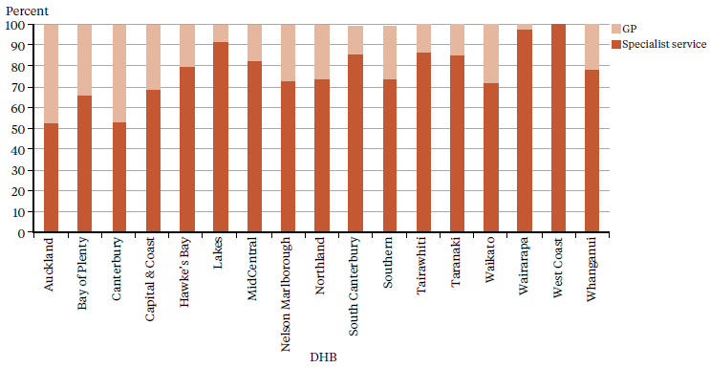

Source: Data provided by OST services in six-monthly reports.

Nationally the number of general practitioners authorised to prescribe OST dropped by 10 percent from 666 in 2012 to 596 in 2013. Although the number of clients being transferred to GP care remains consistent,[30] from time to time clients de-stabilise and return to the specialist service. In addition, a number of clients remain at specialist services, even though they are ready for GP care, for one of three possible reasons: a general lack of GPs means that a position is unavailable; GPs are not keen to take on OST clients; or clients want to stay with the specialist service due to the financial benefit.

### OST in prison

In 2006 the Department of Corrections revised its Methadone Maintenance Treatment Policy to allow all people who were on an opioid substitution programme before they were imprisoned to be maintained on treatment while in prison.[31]

The number of people receiving treatment for opioid dependency in prison has reduced from 83 in 2010 to 64 in 2013.[32]

### Entry to and exit from OST

Entering, staying in and exiting opioid substitution treatment are important indicators of an individual’s recovery journey, but reaching each of these points does not in itself constitute recovery.

Recovery is a process rather than a single event, which takes time to achieve and effort to maintain. Recovery involves accruing positive benefits as well as reducing harms, and moving away from uncontrolled substance use and its associated problems around health, wellbeing and participation in society.

At the end of 2013 there were 40 people waiting for OST compared with 60 in 2012 and 80 in 2011. However, the number of people on a waiting list is not a good measure of unmet demand, as people tend not to seek treatment if they perceive there is little chance of accessing it in the foreseeable future. The Ministry continues to work closely with specialist services and DHB planners and funders to resolve the issue of waiting times for people who require specialist service interventions.

Recovery is a process rather than a single event, which takes time to achieve and effort to maintain.

The year 2013 saw a record number of people choosing to withdraw from OST programmes (see Figure 30 below). It was also the year in which the lowest number of people were involuntarily withdrawn from OST due to behaviour that jeopardised the safety of the individual concerned or others (including staff).

In 2013, 36 people receiving OST treatment from specialist services died from a range of causes, including natural causes and accidents. Two clients died as a consequence of an overdose related to the use of other substances. The use of other substances, particularly sedatives (such as alcohol and benzodiazepines), in combination with opioids significantly increases the risk of death by respiratory depression and overdose. However, this risk is usually less than the risk arising from increasing substance use if a client is withdrawn from OST medication against their wishes.

2013 saw a record number of people choosing to withdraw from OST programmes.

Figure 30 shows the reasons why clients withdrew from OST specialist services from 2008 to 2013.

Figure 30: Client withdrawal from OST programmes, voluntary, involuntary or death, 2008 to 2013

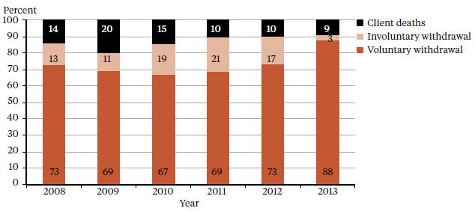

Source: Data provided by OST services in six-monthly reports.

### Sector voices

#### Photo of Jeremy McMinn – Consultant psychiatrist and addiction specialistJeremy McMinn – Consultant psychiatrist and addiction specialist

I’m Jeremy McMinn, the current clinical lead for opioid substitution in Lakes DHB, Rotorua. I also work as a psychiatric advisor for the Accident Compensation Corporation.

Addiction is a fascinating field. Treatment involves both mental and physical health care challenges. There are often complex ethical dimensions around risk/benefit and autonomy/paternalism.

This is particularly the case in the treatment of opioid dependence – where for most people, giving up the drug habit is rarely successful without a period of substitution using methadone or buprenorphine.

Care that is provided well dramatically changes lives in ways that go far beyond just the individual person’s health. Families can be reconstituted; children thrive with their parents’ stability; employment rises and crime falls. Treatment is a great combination of being effective and cheap – it even pays itself back with an estimated $6 gain for every $1 spent.

I have worked in addiction for over 10 years, most of this in Wellington. I am a certified consultant psychiatrist through the College of Psychiatrists and addiction specialist through the College of Physicians.

For the last two years I have co-chaired the National Association of Opioid Treatment Providers. The Association works hard to advocate for our patients while making sure treatment is provided wisely (within the right dose ranges and sensible dispensing restrictions).

The immediate future for opioid addiction is to achieve better prescribing of opioids by all doctors – prescribing that includes safeguards to prevent new cases of addiction. Our collective medical professionalism and the ability of New Zealand’s health systems to rise to challenges stand us in good stead to respond to this opportunity.

# References

American Psychiatric Association. 2001. *The Practice of ECT: A task force report* (2nd ed.). Washington, DC: American Psychiatric Association.

Associate Minister of Health. 2006. *New Zealand Suicide Prevention Strategy 2006–2016*. Wellington: Ministry of Health.

Beautrais AL, Collings SCD, Ehrhardt P, et al. 2005. *Suicide Prevention: A review of evidence of risk and protective factors, and points of effective intervention*. Wellington: Ministry of Health.

Department of Corrections. 2007. *Over-representation of Māori in the Criminal Justice System: An exploratory report.* Wellington: Department of Corrections.

Elder H, Tapsell R. 2013. *Māori and the Mental Health Act.* In J Dawson and K Gledhill (eds), *New Zealand’s Mental Health Act in Practice.* Wellington: Victoria University Press.

Huckshorn KA. 2005. *Six Core Strategies to Reduce the Use of Seclusion and Restraint Planning Tool*. National Association of State Mental Health Program Directors. URL: www.wafca. org (accessed 23 September 2013).

Ministry of Health. 1996. *Inquiry under Section 47 of the Health and Disability Services Act 1993 in Respect of Certain Mental Health Services*. Wellington: Ministry of Health.

Ministry of Health. 2004. *Use of Electroconvulsive Therapy (ECT) in New Zealand: A review of efficacy, safety, and regulatory controls.* Wellington: Ministry of Health.

Ministry of Health. 2009. *Electroconvulsive Therapy (ECT) in New Zealand: What you and your family and whānau need to know.* Wellington: Ministry of Health.

Ministry of Health. 2010 *Seclusion under the Mental Health (Compulsory Assessment and Treatment) Act 1992*. Wellington: Ministry of Health.

Ministry of Health. 2012a. *Guidelines for the Role and Function of Directors of Area Mental Health Services.* Wellington: Ministry of Health.

Ministry of Health. 2012b. *Guidelines for the Role and Function of District Inspectors Appointed under the Mental Health (Compulsory Assessment and Treatment) Act 1992*. Wellington: Ministry of Health.

Ministry of Health. 2012c. *Guidelines for the Role and Function of Duly Authorised Officers under the Mental Health Act 1992.* Wellington: Ministry of Health.

Ministry of Health. 2012d. *Guidelines to the Mental Health (Compulsory Assessment and Treatment) Act 1992.* Wellington: Ministry of Health.

Ministry of Health. 2012e. *Rising to the Challenge: The Mental Health and Addiction Service Development Plan 2012–2017*. Wellington: Ministry of Health.

Ministry of Health. 2013a. *New Zealand Suicide Prevention Action Plan 2013–2016.* Wellington: Ministry of Health. Ministry of Health. 2013b. *PRIMHD: Mental health data*. URL: [www.health.govt.nz/nz-health-statistics/national-collections-and-surveys/collections/primhd-mental-health-data](http://www.health.govt.nz/nz-health-statistics/national-collections-and-surveys/collections/primhd-mental-health-data) (accessed 16 September 2013).

New Zealand Law Commission. 2012. *Compulsory Treatment for Substance Dependence: A review of the Alcoholism and Drug Addiction Act 1966.* Wellington: New Zealand Law Commission.

Oakley Browne MA, Wells JE, Scott KM (eds). 2006. *Te Rau Hinengaro: The New Zealand Mental Health Survey*. Wellington: Ministry of Health.

Platform Charitable Trust. 2013. *NGO Stories & Statistics*. Wellington: Platform Charitable Trust.

Standards New Zealand. 2008a. *Health and Disability Services (General) Standard*. Wellington: Standards Council. Standards New Zealand. 2008b. *Health and Disability Services (Restraint Minimisation and Safe Practices) Standards*. Wellington: Standards Council.

# Appendix 1: Additional statistics

## The Mental Health Review Tribunal

During the year ended 30 June 2013, the Tribunal received 207 applications under the Mental Health Act. Table A1 presents both the types of applications received and the outcomes of these applications.

Table A1: Outcome of Mental Health Act applications received by the Mental Health Review Tribunal, 1 July 2012 to 30 June 2013

|  |  |  |  |  |  |
| --- | --- | --- | --- | --- | --- |
| **Case outcome** | **Section 79** | **Section 80** | **Section 81** | **Section 75** | **Total** |
| Deemed ineligible | 8 | 0 | 0 | 0 | 8 |
| Withdrawn | 78 | 4 | 0 | 0 | 82 |
| Held over to the next report year | 15 | 2 | 1 | 0 | 18 |
| Heard in the report year | 93 | 6 | 0 | 0 | 99 |
| Total number of cases | 194 | 12 | 1 | 0 | 207 |

Source: Annual Report of Mental Health Review Tribunal, 1 July 2012 to 30 June 2013.

During the year ended 30 June 2013, the Tribunal heard 99 applications that had been received during the reporting year, and 9 applications held over from the previous reporting year, under section 79 of the Mental Health Act. The results of those cases are reported in Table A2.

Table A2: Results of inquiries under section 79 of the Mental Health Act held by the Mental Health Review Tribunal, 1 July 2012 to 30 June 2013

|  |  |
| --- | --- |
| **Result of Mental Health Act section 79 inquiry** | **Number of cases** |
| Not fit to be released from compulsory status | 97 |
| Fit to be released from compulsory status | 5 |
| Total | 102 |

Source: Annual Report of Mental Health Review Tribunal, 1 July 2012 to 30 June 2013.

Table A3 shows the ethnicity of the 176 people for whom ethnicity was identified in an application to the Tribunal in the year ended 30 June 2013.

Table A3: Ethnicity of people who identified their ethnicity in Mental Health Review Tribunal applications, 1 July 2012 to 30 June 2013

|  |  |  |
| --- | --- | --- |
| **Ethnicity** | **Number** | **Percentage** |
| NZ European | 119 | 68 |
| Māori | 40 | 23 |
| Pacific | 6 | 3 |
| Asian | 4 | 2 |
| Other | 7 | 4 |
| Total | 176 | 100 |

Source: Annual Report of Mental Health Review Tribunal, 1 July 2012 to 30 June 2013.

Of the 207 Mental Health Act applications received by the Tribunal during the year ended 30 June 2013, 126 (61%) were from males and 81(39%) from females. These gender figures are broken down in Table A4.

Table A4: Gender of people making Mental Health Review Tribunal applications, 1 July 2012 to 30 June 2013

|  |  |  |  |
| --- | --- | --- | --- |
| **Type of application submitted to the Tribunal** | **Total number (and percentage)** | **Gender** | **Number** |
| Applications by people subject to community treatment orders | 140 (68%) | Female  Male | 63  77 |
| Applications by people subject to inpatient treatment orders | 54 (26%) | Female  Male | 16  38 |
| Applications by people subject to special patient orders | 12 (6%) | Female  Male | 2  10 |
| Applications by people subject to restricted person orders | 1 (0%) | Female  Male | 0  1 |

Source: Annual Report of Mental Health Review Tribunal, 1 July 2012 to 30 June 2013.

## Ministry of Justice statistics

Table A5 presents data on applications for a compulsory treatment order from 2004 through to 2013. Table A6 shows the types of orders granted over the same period.

Table A5: Applications for compulsory treatment orders (or extensions), 2004 to 2013

|  |  |  |  |  |  |
| --- | --- | --- | --- | --- | --- |
| **Year** | **Number of applications for a CTO, or extension to a CTO** | **Number of applications granted, or granted with consent** | **Number of applications dismissed or struck out** | **Number of applications withdrawn, lapsed or discontinued** | **Number of applications transferred to the High Court** |
| 2004 | 4423 | 3863 | 100 | 460 | 0 |
| 2005 | 4302 | 3682 | 100 | 520 | 0 |
| 2006 | 4268 | 3643 | 109 | 515 | 1 |
| 2007 | 4557 | 3916 | 99 | 542 | 0 |
| 2008 | 4557 | 3969 | 103 | 485 | 0 |
| 2009 | 4586 | 4038 | 54 | 494 | 0 |
| 2010 | 4751 | 4156 | 74 | 520 | 1 |
| 2011 | 4801 | 4215 | 70 | 516 | 0 |
| 2012 | 4843 | 4331 | 71 | 441 | 0 |
| 2013 | 5038 | 4578 | 66 | 394 | 0 |

Note: The table presents applications that had been processed at the time of data extraction on 26 June 2014. The year is determined by the final outcome date.

CTO = compulsory treatment order.

Source: Ministry of Justice’s Integrated Sector Intelligence System, which uses data entered into the Case Management System (CMS). The CMS is a live operational database, and figures are subject to minor changes at any time.

Table A6: Types of compulsory treatment orders made on granted applications, 2004 to 2013

|  |  |  |  |  |  |
| --- | --- | --- | --- | --- | --- |
| **Year** | **Number of granted applications for orders** | **Number of compulsory community treatment orders (or extensions)** | **Number of compulsory inpatient treatment orders (or extensions)** | **Number of orders recorded as both compulsory community and inpatient treatment orders (or extensions)** | **Number of applications where type of order not recorded** |
| 2004 | 3863 | 1832 | 1534 | 117 | 380 |
| 2005 | 3682 | 1575 | 1439 | 92 | 576 |
| 2006 | 3643 | 1614 | 1384 | 91 | 554 |
| 2007 | 3916 | 1713 | 1335 | 116 | 752 |
| 2008 | 3969 | 1841 | 1429 | 119 | 580 |
| 2009 | 4038 | 2086 | 1565 | 104 | 283 |
| 2010 | 4156 | 2239 | 1614 | 105 | 198 |
| 2011 | 4215 | 2255 | 1677 | 89 | 194 |
| 2012 | 4331 | 2427 | 1680 | 75 | 149 |
| 2013 | 4578 | 2630 | 1752 | 62 | 134 |

Notes: The table presents applications that had been processed at the time of data extraction on 26 June 2014. The year is determined by the final outcome date. Where more than one order type is shown, it is likely to be because new orders are being linked to a previous application in the Case Management System.

Source: Ministry of Justice’s Integrated Sector Intelligence System, which uses data entered into the Case Management System (CMS). The CMS is a live operational database, and figures are subject to minor changes at any time.

In 2013, 5038 applications for a compulsory treatment order or extension to a compulsory treatment order were dealt with in the Family Court. Of these applications, 4578 (91 percent) were granted, 66 (1 percent) were dismissed and 394 (8 percent) were withdrawn.

Of the 4578 applications granted, 2630 (57 percent) resulted in compulsory community treatment orders and 1752 (38 percent) in compulsory inpatient treatment orders. A combination of compulsory community and compulsory inpatient treatment orders was made for an additional 62 (1 percent) applications. For the remaining 134 (3 percent) applications, the type of compulsory treatment order is not recorded in the Case Management System.

# Appendix 2: Caveats relating to PRIMHD

The Programme for the Integration of Mental Health Data, or PRIMHD (pronounced ‘primed’), is the Ministry of Health’s national collection for mental health and addiction service activity and outcome data for mental health consumers. PRIMHD data is used to report on what services are being provided, who is providing the services, and what outcomes are being achieved for health consumers across New Zealand’s mental health sector. These reports enable mental health and addiction service providers to undertake better-quality service planning and decision-making, at the local, regional and national levels (Ministry of Health 2013b). PRIMHD reports are invaluable for facilitating important conversations and debates about mental health issues in New Zealand.

In 2008, reporting to PRIMHD became mandatory for DHBs. In addition, from this date an increasing number of NGOs began reporting to the PRIMHD database. As of December 2012, 228 NGOs were reporting to PRIMHD, representing 90 percent of all NGO funding (Platform Charitable Trust 2013).

Because of both its recent introduction and the enormous complexities of creating and maintaining a national data collection, the following caveats need to be kept in mind when reviewing the statistics generated using PRIMHD data.

* Shifts or patterns in the data after 2008 may reflect the gradual adaptation of service providers to the PRIMHD system, in addition to, or instead of, any trend in mental health service use or consumer outcomes.
* PRIMHD is a living data collection, which continues to be revised and updated as data reporting processes are improved. For this reason, previously published data may be liable to amendments.
* Statistical variance between services may reflect different models of practice and different consumer populations. However, inter-service variance may also result from differences in data entry processes and information management.
* To function as a national collection, PRIMHD requires integration with a wide range of person management systems across hundreds of unique service providers. As the services adjust to PRIMHD, it is expected that the quality of the data will improve.
* For the 2013 Annual Report, manual data supplied by DHBs has been used for 15 of the 20 DHBs for reporting compulsory assessment and treatment under the Mental Health Act. This decision was made after issues with 2013 PRIMHD data were identified. These issues will be addressed, with the intention of returning to PRIMHD for future Annual Reports.
* Mental health and addiction services for older people are funded as mental health and addiction services in the Northern and Midland regions but as health services for older people in the Southern and Central regions. PRIMHD mainly captures mental health and addiction services and occasionally captures data on health services for older people, which means that data on clients aged over 65 years (including services for older people) is incomplete.
* The quality and accuracy of statistical reporting relies on consistent, correct and timely data entry by the services that report to PRIMHD.
* The Ministry of Health is actively engaged in a continuing project to review and improve the data quality of PRIMHD. This project is considered a priority given the importance of mental health data in providing information about mental health service use and outcomes, and in generating conversations and public debate about how to improve mental health care for New Zealanders.

1. If people seen by addiction services only are excluded, the total number of people who engaged with a specialist mental health service was 122,438. Source: PRIMHD, extracted 23 October 2014.

   In addition, data on clients aged over 65 years is incomplete as health services for older people in the Central and Southern regions do not report to PRIMHD.
2. Between 2002 and 2013, the total New Zealand population increased by approximately 13.4 percent.
3. Mental Health (Compulsory Assessment and Treatment) Act 1992, long title.
4. Data extracted from the Ministry of Justice’s Case Management System as at 26 June 2014.
5. PRIMHD data, extracted on 21 July 2014.
6. Manual data provided by DHBs, except for Auckland, Counties Manukau, Southern, Taranaki and West Coast, which is PRIMHD data, extracted on 8 August 2014.
7. Manual data provided by DHBs, except for Auckland, Counties Manukau, Southern, Taranaki and West Coast, which is PRIMHD data, extracted on 14 August 2014.
8. This action is outlined in Rising to the Challenge (Ministry of Health 2012f ). In addition, reducing the number of Māori subject to section 29 of the Mental Health Act will be an indicator in forthcoming 2014/15 Māori Health Plans for every DHB.
9. PRIMHD data, extracted on 19 March 2014. This priority applies to both voluntary service users and those under the Mental Health Act.
10. PRIMHD data, extracted on 19 March 2014.
11. Statistical difference was calculated with a 99 percent confidence interval.
12. The Health and Disability Services (General) Standard (Standards New Zealand 2008a).
13. A total of 37 young people were secluded in the country’s specialist facilities for children and young people (in Christchurch, Auckland and Wellington). There were 143 seclusion events reported for this group of young people.
14. If a person in Wairarapa requires admission, they are transported to Hutt Valley or MidCentral DHB, and any seclusion statistics in relation to these patients appear on the corresponding DHB’s database.
15. The Whanganui inpatient unit comes under the Central region’s forensic services.
16. The number of people treated with ECT in 2013 is presented in Table 7 by DHB for the area where the person lives (DHB of domicile). These statistics are presented in this way because some DHBs do not perform ECT; instead, people in that area are referred to other DHBs for ECT treatment. Presenting the figures by DHB of domicile therefore gives a better picture of the rates of ECT treatment prescribed by DHB. Other ECT statistics are by DHB of service.
17. The psychiatrist must be independent of the person’s clinical team.
18. Refer to the *Guidelines to the Mental Health (Compulsory Assessment and Treatment) Act 1992* (Ministry of Health 2012d), available on the Ministry’s website (www.health.govt.nz).
19. For more information on reporting, please see the Health Quality and Safety Commission website (www.hqsc.govt.nz).
20. For the 2012/13 fiscal year, 177 incidents were reported, including 134 cases of death by suspected suicide of mental health and addiction service users within 28 days of contact with that service.
21. Any suicides or suspected suicides of people under the Mental Health Act also come under the serious adverse event reporting requirements of the HQSC.
22. The statistics discussed here cover only people under 65 years of age because in the Central and Southern regions, older people’s mental health treatment was provided by health services for older people rather than mental health services and is not necessarily recorded in PRIMHD. Deaths of children under 10 years have also been excluded because they are unlikely to be caused by suicide. The data was drawn from information provided to the Ministry’s national mortality database and PRIMHD.
23. These numbers are subject to change. The mortality database is a dynamic collection, and changes can be made even after the data is considered nominally final.
24. The term ‘gender’ has been used for all other reporting measures in this report. However, the mortality database uses ‘sex’ in relation to suicide statistics, and this section follows that convention.
25. This figure is determined from the number of people who died on the same day as they had an inpatient activity. This approach to classification has been taken to mean here that they were still in the context of an inpatient unit on the day of death.
26. Excluding those who received treatment on the day of death.
27. Excluding those who received treatment on the day of death and those who died within a week of being discharged from an inpatient service.
28. Includes deaths of undetermined intent.
29. Data from OST six-monthly reporting to the Director of Mental Health, which began in 2007. The increase in the number of clients may also be due to services adjusting to the new reporting measure and improving their reporting.
30. Number transferred was 278 in 2008, 228 in 2009, 225 in 2010, 219 in 2011, 227 in 2012 and 231 in 2013.
31. Prison Opioid Substitution and Managed Withdrawal Protocol 2007.
32. Data from six-monthly reports, collected on December of the mentioned year.