Office of the Director of Mental Health Annual Report
2015

Disclaimer
The purpose of this publication is to inform discussion about mental health services and outcomes in New Zealand, and to assist in policy development.
This publication reports information provided to the Programme for the Integration of Mental Health Data (PRIMHD) (see Appendix 2) by district health boards and non-governmental organisations. It is important to note that, because PRIMHD is a dynamic collection, it was necessary to wait a certain period before publishing a record of the information in it, so that it is less likely that the information will need to be amended after publication.
Although every care has been taken in the preparation of the information in this document, the Ministry of Health cannot accept any legal liability for any errors or omissions or damages resulting from reliance on the information it contains.

A note on the cover
‘Mid Transformation’ by Teresa Stuart
Teresa Stuart has been working with pastels and paint for the last 10 years. She lives with cerebral palsy and mild depression. Attending Vincents Art Workshop gave Teresa a new focus, and has brought much to her life. This pastel work shows Teresa’s current outlook of hope and optimism.
Vincents Art Workshop is a community art space in Wellington established in 1985. A number of people who attend have had experience of mental health services or have a disability, and all people are welcome. Vincents Art Workshop models the philosophy of inclusion and celebrates the development of creative potential and growth.
Website: www.vincents.co.nz

Citation: Ministry of Health. 2016. Office of the Director of Mental Health Annual Report 2015. Wellington: Ministry of Health.
Published in November 2016
by the Ministry of Health
PO Box 5013, Wellington 6140, New Zealand
ISBN 978-0-947515-71-3 (print)
ISBN 978-0-947515-72-0 (online)
HP 6501
This document is available at www.health.govt.nz
This work is licensed under the Creative Commons Attribution 4.0 International licence. In essence, you are free to: share ie, copy and redistribute the material in any medium or format; adapt ie, remix, transform and build upon the material. You must give appropriate credit, provide a link to the licence and indicate if changes were made.

Foreword
Tēnā koutou.

Nau mai ki tēnei tekau mā tahi o ngā Rīpoata ā Tau a te Āpiha Kaitohu Tari Hauora Hinengaro mō te Manatū Hauora. Kei tēnei tūnga te mana whakaruruhau kia tika ai te tiaki i te hunga e whai nei i te oranga hinengaro. Ia tau ka pānuitia tēnei ripoata kia mārama ai te kaitiakitanga me te takohanga o te apiha nei ki te katoa.

Welcome to the 11th Annual Report of the Office of the Director of Mental Health. The main purpose of the report is to present information and statistics that serve as indicators of quality for our mental health services. Active monitoring of services is vital to ensuring New Zealanders are receiving quality mental health care.

The cover art of this year’s report echoes its focus: the transformational journey that mental health care in New Zealand is undergoing. In 2015 a record number of people accessed specialist mental health and addiction services, an increase consistent with international trends. While this reflects that more New Zealanders are seeking and receiving mental health care, which is positive, services are experiencing increasing pressure.

We must build on the gains made by Rising to the Challenge: The Mental Health and Addiction Service Development Plan 2012–2017 (Ministry of Health 2012e) by continuing to ensure services are best placed to respond to the changing needs of the populations they serve. The Ministry has recently initiated a project to investigate how to better support people with mental health and addiction needs in primary and community settings.

In 2015, the use of seclusion steadied. Most services in New Zealand, having successfully employed best-practice strategies to reduce their use of seclusion, and are now entering a re-planning phase in which they are refining and refocusing their seclusion reduction initiatives. The continued reduction (and eventual elimination) of seclusion will require strong local leadership, evidence-based initiatives, ongoing workforce development and significant organisational commitment.

My office will continue to provide national leadership in this area through the publication of new guidance on the use of restrictive practices and the introduction of a monitoring regime for the use of night safety procedures. Both will be informed by my office’s leadership of action 9(d) of the Disability Action Plan 2014–2018, which will explore how the Mental Health Act relates to the New Zealand Bill of Rights Act and the Convention on the Rights of People with Disabilities.

Consistent with the strategic direction outlined in Rising to the Challenge, this year we have expanded the report’s section on ‘Māori and the Mental Health Act’ to include statistics on Māori subject to inpatient treatment orders. The section also includes new, valuable research on Māori experiences of the Mental Health Act and acute mental health care.

Looking to the future, the Office of the Director of Mental Health will continue to improve processes related to the administration of the Mental Health Act, always with the aim of making a meaningful contribution to the changing landscape that is the mental health sector in New Zealand.

Noho ora mai

Dr John Crawshaw
Director of Mental Health, Chief Advisor, Mental Health

Yesterday is gone from my control, so I don’t worry about it. I can make decisions that will feed my soul and give me the life that I can feel good about.
Sir John Kirwan, All Blacks Don’t Cry
He waka eke noa.
A waka that we are all in, with no exception.

Contents
Foreword iii
Executive summary iii
Introduction 3
Objectives 3
Structure of this report 3
Context 3
The Ministry of Health 3
Mental health care in New Zealand: A transformational journey 3
Specialist mental health services 3
The Mental Health Act 3
Activities for 2015 3
Mental health sector relationships 3
Cross-government relationships 3
New Zealanders returning from Australia 3
Substance Addiction (Compulsory Assessment and Treatment) Bill 3
Action 9(d) of the Disability Action Plan 2014–2018 3
District inspectors 3
Special patients and restricted patients 3
The Mental Health Review Tribunal 3
Ensuring service quality 3
Consumer satisfaction 3
Waiting times 3
Transition (discharge) plans 3
Use of the Mental Health Act 3
Māori and the Mental Health Act 3
Family/whānau consultation and the Mental Health Act 3
Seclusion 3
Electroconvulsive therapy 3
Serious adverse events 3
Death by suicide 3
The Alcoholism and Drug Addiction Act 3
Opioid substitution treatment 3
References 3
Appendices
Appendix 1: Additional statistics 3
Appendix 2: Caveats relating to the Programme for the Integration of Mental Health Data 3

List of Tables
Table 1: Average number of people per 100,000 per month required to undergo assessment under sections 11, 13 and 14(4) of the Mental Health Act, by district health board, 1 January to 31 December 2015 3
Table 2: Average number of people per 100,000 on a given day subject to sections 29, 30 and 31 of the Mental Health Act, by district health board, 1 January to 31 December 2015 3
Table 3: Age-standardised rates of Māori and non-Māori subject to community and inpatient treatment orders (sections 29 and 30) under the Mental Health Act, by gender, 1 January to 31 December 2015 3
Table 4: Seclusion indicators for forensic and intellectual disability services, by district health board, 1 January to 31 December 2015 3
Table 5: Electroconvulsive therapy indicators, by district health board of domicile, 1 January to 31 December 2015 3
Table 6: Indicators for situations in which electroconvulsive therapy was not consented to, by district health board of service, 1 January to 31 December 2015 3
Table 7: Number of people treated with electroconvulsive therapy, by age group and gender, 1 January to 31 December 2015 3
Table 8: Number of people treated with electroconvulsive therapy, by ethnicity, 1 January to 31 December 2015 3
Table 9: Number of serious adverse events reported to the Health Quality & Safety Commission, 1 January to 31 December 2015 3
Table 10: Number of serious adverse events reported to the Health Quality & Safety Commission, by district health board, 1 January to 31 December 2015 3
Table 11: Outcomes of reportable death notifications under section 132 of the Mental Health Act, 1 January to 31 December 2015 3
Table 12: Number and age-standardised rate of suicide, by service use, people aged
10–64 years, 2013 3
Table 13: Number and age-standardised rate of suicide, by service use and sex, people aged 10–64 years, 2013 3
Table 14: Number and age-specific rate of suicide, by age group, sex and service use, people aged 10–64 years, 2013 3
Table 15: Number and age-standardised rate of suicide and deaths of undetermined intent, by ethnicity and service use, people aged 10–64 years, 2013 3
Table 16: Number of applications for detention and committal, by application outcome, 2004–2015 3
Table 17: Number of granted orders for detention and committal, 2004–2015 3
Table A1: Number of completed section 95 inquiry reports received by the Director of Mental Health, 2003–2015 3
Table A2: Number of long-leave, revocation and reclassification applications for special patients and restricted patients, 1 January to 31 December 2015 3
Table A3: Number of people transferred to hospital from prison under sections 45 and 46 of the Mental Health Act, 2001–2015 3
Table A4: Outcome of Mental Health Act applications received by the Mental Health Review Tribunal, 1 July 2014 to 30 June 2015 3
Table A5: Results of inquiries under section 79 of the Mental Health Act held by the Mental Health Review Tribunal, 1 July 2014 to 30 June 2015 3
Table A6: Ethnicity of people who identified their ethnicity in Mental Health Review Tribunal applications, 1 July 2014 to 30 June 2015 3
Table A7: Gender of people making Mental Health Review Tribunal applications, 1 July 2014 to 30 June 2015 3
Table A8: Applications for compulsory treatment orders (or extensions), 2004–2015 3
Table A9: Types of compulsory treatment orders made on granted applications,
2004–2015 3

List of Figures
Figure 1: Number of people engaging with specialist services each year, 2011–2015 3
Figure 2: Percentage of service users accessing only community services, 1 January to 31 December 2015 3
Figure 3: Responses to the statement ‘overall I am satisfied with the services I received’, 2014/15 3
Figure 4: Percentage of people seen by mental health services within three weeks (left) and within eight weeks (right), 2014/15 3
Figure 5: Percentage of people seen by addiction services within three weeks (left) and within eight weeks (right), 2014/15 3
Figure 6: Percentage of child and adolescent service users with a transition plan, by district health board, 1 January to 31 December 2015 3
Figure 7: Average number of people per 100,000 on a given day subject to a community treatment order (section 29 of the Mental Health Act), by district health board, 1 January to 31 December 2015 3
Figure 8: Average number of people per 100,000 on a given day subject to an inpatient treatment order (section 30 of the Mental Health Act), by district health board, 1 January to 31 December 2015 3
Figure 9: Rate of people per 100,000 subject to compulsory treatment order applications (including extensions), by age group, 2004–2015 3
Figure 10: Rate of people per 100,000 subject to compulsory treatment order applications (including extensions), by gender, 2004–2015 3
Figure 11: Rate ratio of Māori to non-Māori subject to a community treatment order (section 29) under the Mental Health Act, by district health board, 1 January to 31 December 2015 3
Figure 12: Rate ratio of Māori to non-Māori subject to an inpatient treatment order (section 30) under the Mental Health Act, by district health board, 1 January to 31 December 2015 3
Figure 13: Age-standardised rates of Māori and non-Māori subject to community and inpatient treatment orders (sections 29 and 30) under the Mental Health Act, by gender, 1 January to 31 December 2015 3
Figure 14: Length of time spent subject to community and inpatient treatment orders (sections 29 and 30) under the Mental Health Act for Māori and non-Māori, 2009–2013 3
Figure 15: Average national percentage of family/whānau consultation for particular assessment/treatment events, 1 January to 31 December 2015 3
Figure 16: Average percentage of family/whānau consultation across all assessment/ treatment events, by district health board, 1 January to 31 December 2015 3
Figure 17: Reasons for not consulting family/whānau, 1 January to 31 December 2015 3
Figure 18: Number of people secluded in adult inpatient services nationally, 2007–2015 3
Figure 19: Total number of seclusion hours in adult inpatient services nationally,
2007–2015 3
Figure 20: Number of people secluded across all inpatient services (adult, forensic, intellectual disability and youth), by age group, 1 January to 31 December 2015 3
Figure 21: Number of seclusion events across all inpatient services (adult, forensic, intellectual disability and youth), by duration of event, 1 January to 31 December 2015 3
Figure 22: Number of people secluded in adult inpatient services per 100,000, by district health board, 1 January to 31 December 2015 3
Figure 23: Number of seclusion events in adult inpatient services per 100,000, by district health board, 1 January to 31 December 2015 3
Figure 24: Seclusion indicators for adult inpatient services, Māori and non-Māori, 1 January to 31 December 2015 3
Figure 25: Percentage of people secluded in adult inpatient services, Māori and non-Māori males and females, 1 January to 31 December 2015 3
Figure 26: Number of Māori and non-Māori secluded in adult inpatient services,
2007–2015 3
Figure 27: Number of people treated with electroconvulsive therapy, per 100,000 service user population, 2005–2015 3
Figure 28: Rates of people treated with electroconvulsive therapy, by district health board of domicile, 1 January to 31 December 2015 3
Figure 29: Number of people treated with electroconvulsive therapy, by age group and gender, 1 January to 31 December 2015 3
Figure 30: Age-standardised rate of suicide, by service use, people aged 10–64 years, 2001–2013 3
Figure 31: Age-specific rate of suicide, by age group, sex and service use, people aged
10–64 years, 2013 3
Figure 32: Number of opioid substitution treatment clients, by age group, 2008–2015 3
Figure 33: Number of people receiving opioid substitution treatment from a specialist service, general practice or prison service, 2008–2015 3
Figure 34: Percentage of people receiving opioid substitution treatment from specialist services and general practice, by district health board, 1 January to 31 December 2015 3
Figure 35: Percentage of withdrawals from opioid substitution treatment programmes, by reason (voluntary, involuntary or death), 2008–2015 3
Figure 36: Number of people prescribed Suboxone, 2008–2015 3

Executive summary
- In 2015, a record number of people accessed specialist mental health and addiction services. Most accessed services in the community.
- In 2015, consumer satisfaction with mental health and addiction services was rated around 82 percent.
- In 2015, a small proportion of all service users received compulsory assessment and/or treatment under the Mental Health (Compulsory Assessment and Treatment) Act 1992 (the Mental Health Act).
- Māori are over-represented under the Mental Health Act. Reducing the disparity in mental health outcomes for Māori is a priority action for the Ministry of Health and district health boards (DHBs).
- In 2015, the use of seclusion in adult inpatient units steadied. Most services in New Zealand that use seclusion are now entering a re-planning phase, in which they are refining and refocusing seclusion reduction initiatives. Māori continue to be over-represented in the seclusion figures.
- In 2015, 225 people received electroconvulsive therapy (ECT) in mental health services. Females were more likely to receive ECT than males, and older people were more likely to receive ECT than younger people.
- In 2013, a total of 513 people died by suicide. Mental disorders are a significant risk factor for suicidal behaviour.

Further reading
The New Zealand Mental Health and Addictions KPI Programme
The New Zealand Mental Health and Addictions KPI Programme is a provider-led initiative designed to bring about quality and performance improvement across the mental health and addictions sector. Further information on the KPI Programme can be found at www.mhakpi.health.nz
Other PRIMHD publications
The Ministry of Health publishes additional information provided to PRIMHD on mental health and addiction service use. Further information on these publications can be found at www.health.govt.nz/publications

Introduction

Objectives
The objectives of this report are to:
- provide information about specific clinical activities that must be reported to the Director of Mental Health under the Mental Health (Compulsory Assessment and Treatment) Act 1992 (the Mental Health Act)
- report on the activities of statutory officers under the Mental Health Act (such as district inspectors and the Mental Health Review Tribunal)
- contribute to the improvement of standards of care and treatment for people with a mental illness through active monitoring of services against targets and performance indicators led by the Ministry of Health
- inform mental health service users, their families/whānau, service providers and members of the public about the role, function and activities of the Office of the Director of Mental Health and the Chief Advisor, Mental Health.

Structure of this report
This report is divided into three main sections. The first section (‘Context’) provides an overview of the legislative and service delivery contexts in which the Office operates. The second section (‘Activities for 2015’) describes the work carried out by the Office in 2015. The final section (‘Ensuring service quality’) provides statistical information, which covers the use of compulsion, seclusion, reportable deaths and electroconvulsive therapy (ECT) during the reporting period.

Context

The Ministry of Health
The Ministry of Health improves, promotes and protects the mental health and independence of New Zealanders by:
- providing whole-of-sector leadership of the New Zealand health and disability system
- advising the Minister of Health and the Government on mental health issues
- directly purchasing a range of important national mental health services
- providing health sector information and payment services.
The Ministry of Health improves, promotes and protects the mental health and independence of New Zealanders
Ministry groups play a number of roles in leading and supporting mental health services. The Protection, Regulation and Assurance business unit monitors the quality of mental health and addiction services and the safety of compulsory mental health treatment, through the Office of the Director of Mental Health, Medicines Control and HealthCERT groups.

The Ministry of Health improves, promotes and protects the mental health and independence of New Zealanders

The Service Commissioning business unit supports the implementation of mental health policy. Clinical and policy leaders collaborate with the Strategy and Policy business unit to advise the Government on mental health policy, and to implement policy. The Service Commissioning business unit is also responsible for the funding, monitoring and planning of district health boards (DHBs), including the annual funding and planning rounds.

Mental health care in New Zealand: A transformational journey
Over the last 50 years, mental health and addiction services have moved from an institutional model of care to a recovery model of care. Compulsory inpatient treatment has largely given way to voluntary engagement with services in community settings. New Zealand has been on a transformational journey in mental health care.

There has been significant investment in mental health, resulting in the establishment of a wide range of community, kaupapa Māori, specialist and acute services. Ring-fenced funding for mental health services has increased from $1.1 billion in 2008/09 to more than $1.4 billion in 2015/16. The Ministry has lead and contributed to many cross-agency initiatives that seek to improve population-level mental health outcomes.

Despite these achievements, the sector faces new and shifting challenges. In 2015 a record number of people accessed specialist mental health and addiction services. This increase is consistent with international trends, and has occurred in the context of population growth, improved non-Governmental organisation (NGO) reporting, growing social awareness and increasingly open discussion of mental health issues, as promoted by initiatives such as the Prime Minister’s Youth Mental Health Project and Like Minds, Like Mine. More New Zealanders are seeking and receiving specialist mental health care, which is positive. But services are experiencing increasing pressure.
The mental health sector faces new and shifting challenges
We know that mental health outcomes continue to be inequitable in New Zealand. Māori, Pacific peoples, people with disabilities and refugees are (among others) population groups that disproportionately experience mental health issues.

In addition, we know that there is a group of New Zealanders with moderate mental health needs who are not easily managed in primary care, but whose needs do not meet the threshold for specialist care. This can result in their needs not fully being met.

Rising to the Challenge
Rising to the Challenge: The Mental Health and Addiction Service Development Plan
2012–2017 (Ministry of Health 2012e) provides a strategic direction for mental health services. It sets out 100 actions to enhance mental health service delivery, with the aim of improving wellbeing and resilience, expanding access and decreasing waiting times.

While Rising to the Challenge has made significant gains in service delivery, we must build on these gains by continuing to ensure services are best placed to respond to the changing needs of the populations they serve.

Primary and community mental health
In 2016, the Ministry initiated a new project to explore how to better support people with mental health and addiction needs in primary and community settings. As part of this work the Ministry is seeking to identify innovative, sustainable solutions to the increased demand on specialist services.

Consistent with the people-powered theme of the New Zealand Health Strategy 2016–2026 (Ministry of Health 2016), people are at the heart of this work. Through a co-development process the Ministry is engaging with people throughout the sector to understand the issues for those whose mental health needs are not well supported at present, the outcomes we would hope to see and how we could work differently to achieve those outcomes.
The Ministry is seeking to identify innovative, sustainable solutions to the increased demand on specialist services

Specialist mental health services
In 2015, specialist mental health or addiction services engaged with 162,222 people (3.5 percent of the New Zealand population).

Figure 1 shows that the number of people engaging with specialist services gradually increased from 143,060 people in 2011 to 162,222 people in 2015. The rise could be due to a range of factors, including better data capture, the growing New Zealand population, improved visibility of and access to services, and stronger referral relationships between providers.

Figure 1: Number of people engaging with specialist services each year, 2011–2015
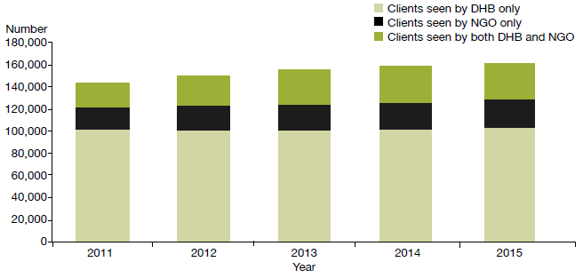
Source: Programme for the Integration of Mental Health Data (PRIMHD) data

Most people access mental health services in the community. In 2015, 91 percent of specialist service users accessed only community mental health services, less than 1 percent accessed only inpatient services and the remaining 9 percent accessed a mixture of inpatient and community services (see Figure 2). The proportion of people who received treatment in the community increased by 5 percent between 2002 (when it was 86%) and 2015.
Most people (91 percent of all specialist service users in 2015) access mental health services in the community

Figure 2: Percentage of service users accessing only community services, 1 January to 31 December 2015
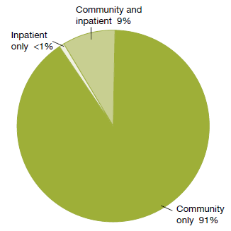
Note: Includes NGOs.
Source: PRIMHD data

The Mental Health Act
The Mental Health Act defines the circumstances in which people may be subject to compulsory mental health assessment and treatment. It provides a framework for balancing personal rights and the public interest when a person poses a serious danger to themselves or others due to mental illness.

The long title of the Act states that its purpose is to:
redefine the circumstances in which and the conditions under which persons may be subjected to compulsory psychiatric assessment and treatment, to define the rights of such persons and to provide better protection for those rights, and generally to reform and consolidate the law relating to the assessment and treatment of persons suffering from mental disorder.

The ‘Ensuring service quality’ section provides data on the use of the Mental Health Act.

Administration of the Mental Health Act
The chief statutory officer under the Mental Health Act is the Director of Mental Health, appointed under section 91. The Director is responsible for the general administration of the Mental Health Act under the direction of the Minister of Health and Director-General of Health. The Director is also the Chief Advisor, Mental Health, and is responsible for advising the Minister of Health on mental health issues.
The Mental Health Act defines the circumstances in which people may be subject to compulsory mental health assessment and treatment

The Mental Health Act also allows for the appointment of a Deputy Director of Mental Health.

The Director’s functions and powers under the Mental Health Act allow the Ministry to provide guidance to mental health services, supporting the strategic direction of Rising to the Challenge and a recovery-based approach to mental health.

In each DHB, the Director-General of Health appoints a director of area mental health services (DAMHS) under section 92 of the Act. The DAMHS is a senior mental health clinician, responsible for administering the Mental Health Act within their DHB area. They must report to the Director of Mental Health every three months regarding the exercise of their powers, duties and functions under the Mental Health Act (Ministry of Health 2012b).

In each area, the DAMHS appoints responsible clinicians and assigns them to lead the treatment of every person subject to compulsory assessment or treatment (Ministry of Health 2012a). The DAMHS also appoints competent health practitioners as duly authorised officers to respond to people experiencing mental illness in the community who are in need of intervention. Duly authorised officers are required to provide general advice and assistance in response to requests from members of the public and the New Zealand Police. If a duly authorised officer believes that a person may be mentally disordered and may benefit from a compulsory assessment, the Mental Health Act grants the officer powers to arrange for a medical examination (Ministry of Health 2012c).

Protecting the rights of people subject to compulsory treatment
Although the Ministry of Health expects each DAMHS to protect the rights of people under the Mental Health Act in their area, the Mental Health Act also provides for independent monitoring mechanisms. The Minister of Health appoints qualified lawyers as district inspectors under section 94 of the Mental Health Act to protect the rights of people under the Mental Health Act, investigate alleged breaches of those rights and monitor service compliance with the Mental Health Act process.

The Mental Health Act requires district inspectors to inspect services regularly and report on their activities monthly to the Director of Mental Health. From time to time the Director can initiate an investigation under section 95 of the Mental Health Act, in which case the Act grants a district inspector powers to conduct an inquiry into a suspected failing in a person’s treatment under the Mental Health Act or in the management of services (Ministry of Health 2012b).
If a person disagrees with their treatment under the Mental Health Act, they can make an application to the Mental Health Review Tribunal

The Mental Health Act also provides for the appointment of the Mental Health Review Tribunal, a specialist independent tribunal comprising a lawyer, a psychiatrist and a community member. If a person disagrees with their treatment under the Mental Health Act, they can apply to the Tribunal for an examination of their condition and of whether it is necessary to continue compulsory treatment. Where the Tribunal considers it appropriate, it may release the person from compulsory status.

Activities for 2015

Mental health sector relationships
The Director of Mental Health visited most DHB mental health services at least once during the reporting year. Such visits give the Director an opportunity to engage with the services and understand the particular constellation of challenges that the local mental health service is facing, while offering Ministry support and oversight.

The Office of the Director of Mental Health also maintains collaborative relationships with many parts of the mental health sector, attending and presenting at a large number of mental health sector meetings each year.

Cross-government relationships
The Office of the Director of Mental Health maintains strong relationships with other government agencies, to support good clinical practice and person-centred services for people with mental health and addiction problems.
The Office of the Director of Mental Health maintains strong relationships with other government agencies
In 2015, the Office of the Director of Mental Health worked with a number of agencies on a wide range of projects, including:
- the Youth Crime Action Plan
- the Vulnerable Children’s Action Plan
- the Expert Panel Review on Child, Youth and Family
- the Interagency High and Complex Needs Unit
- implementation of the Autism Spectrum Guidelines and resolution of mental health/disability support service interface issues
- the Prime Minister’s Youth Mental Health Project
- the Suicide Prevention Action Plan 2013–2016
- the cross-agency response for children and young people with conduct problems
- the transfer of responsibilities for psychosocial welfare in emergencies from the Ministry of Social Development to the Ministry of Health and DHBs
- the transfer of accountabilities for psychosocial recovery in Canterbury from Canterbury Earthquake Recovery Authority to the Ministry of Health and Canterbury DHB
- implementation of new youth forensic mental health and AOD services
- improvement of the interface between the youth justice system and mental health and addiction services.

Relationship with the Department of Corrections
The Ministry works closely with the Department of Corrections to improve health services for people detained in prisons. Prisoners often have complex mental health needs, which may require more intensive support than Corrections health services can give as a provider of primary health care.

Regional forensic psychiatry services support Corrections to access and treat prisoners with complex mental health needs. Prisoners may be transferred to a secure forensic mental health facility for treatment in a therapeutic environment.

Relationship with the New Zealand Police
Mental health services need to promptly see people who come to the attention of police as a result of possible mental health problems. Police often provide the initial response to events involving people whose mental illness may render them a danger to themselves or to others. It is therefore important for Police and mental health services to maintain collaborative relationships. An updated schedule to the Memorandum of Understanding clarifying the roles of Police and mental health services was signed in November 2015.

Victims of Crime interagency working group
Forensic mental health services have a dual role, facilitating special patients’ rehabilitative journeys and protecting members of the public, including registered victims of the special patients’ offending. The Ministry of Health works with the Ministry of Justice, New Zealand Police, Department of Corrections, Ministry of Business, Innovation and Employment, Accident Compensation Corporation and WorkSafe on the Victims of Crime interagency working group. As part of this collaboration the Ministry of Justice launched the Victims Code in 2015. The Code is a statement of victims’ rights, and includes a complaints procedure that people who feel their rights have not been upheld can follow.

New Zealanders returning from Australia
In December 2014, the Australian Government passed legislative changes that set a lower threshold for mandatory cancellation of visas for non-citizens. The new threshold includes non-citizens who have a substantial criminal record, who have been found unfit to stand trial and/or who have been acquitted of a crime on grounds of insanity.

During 2015, the New Zealand Government negotiated an information-sharing arrangement with the Australian Government for removals and deportations between Australia and New Zealand. The Ministry of Health is an ‘approved agency’ under this arrangement: it may receive advance notice of New Zealanders being deported, including health information on these New Zealanders for the purposes of identifying significant mental or physical health needs that will require a health response on their return.

Substance Addiction (Compulsory Assessment and Treatment) Bill
The Substance Addiction (Compulsory Assessment and Treatment) Bill was introduced to Parliament in December 2015, and subsequently referred to the Health Select Committee. It provides a mechanism for the compulsory treatment of people with a severe substance addiction and with severely impaired capacity to make decisions about treatment for that addiction. Such people are often already known to health services including addiction treatment services, mental health services and emergency departments.

Action 9(d) of the Disability Action Plan 2014–2018
In partnership with Balance Aotearoa, the Office of the Director of Mental Health is leading action 9(d) of the Disability Action Plan 2014–2018, to ‘explore how the Mental Health Act relates to the New Zealand Bill of Rights Act and the Convention on the Rights of People with Disabilities’. A review of the Mental Health Act is out of scope, but the findings will inform any future reviews of the Act.

The Ministry has undertaken a legal analysis and established a stakeholder reference group. Some of the key areas of interest thus far relate to perceived overuse of the Mental Health Act, conservative interpretation for discharge from compulsory treatment orders and over-representation of Māori among compulsory service users. The Ministry will provide advice and recommendations to the Ministerial Committee on Disability Issues in the first half of 2017.

District inspectors
The Minister of Health appoints lawyers as district inspectors under section 94 of the Mental Health Act to ensure people’s rights are upheld during the compulsory assessment and treatment process.
District inspectors work to protect specific rights provided to people under the Mental Health Act
District inspectors work to protect specific rights provided to people under the Mental Health Act, address concerns of family/whānau, and investigate alleged breaches of rights, as set out in the Act.

The Office of the Director of Mental Health’s responsibilities in relation to district inspectors include:
- coordinating the appointment and reappointment of district inspectors
- managing district inspector remuneration
- receiving and responding to monthly reports from district inspectors
- organising twice-yearly national meetings of district inspectors
- facilitating inquiries under section 95 of the Mental Health Act
- implementing the findings of section 95 inquiries by district inspectors.

The role of district inspectors
The Act requires district inspectors to report to the DAMHS in their area within 14 days of inspecting mental health services. It also requires them to report monthly to the Director of Mental Health on the exercise of their powers, duties and functions. These reports provide the Director with an overview of mental health services and any problems arising from them.

Section 95 inquiries
The Director will occasionally require a district inspector to undertake an inquiry under section 95 of the Mental Health Act. Such inquiries are generally focused on systemic issues across one or more mental health services. These inquiries typically result in the district inspector making specific recommendations. The Director considers the recommendations, and later audits the DHB’s implementation of them.

The Director also acts on any recommendations that have implications for the Ministry of Health or the mental health sector generally. The inquiry process is not completed until the Director considers that the DHB concerned and, if appropriate, the Ministry and all other DHBs have satisfactorily implemented the recommendations.

For more information on section 95 inquiry reports completed between 2002 and 2015, see Appendix 1.

Number of district inspectors
As at 31 December 2015, there were 35 district inspectors throughout New Zealand. This number included one senior advisory district inspector, who provides leadership and advice to the other inspectors. A list of current district inspectors is available on the Ministry of Health website (www.health.govt.nz).

Special patients and restricted patients
Part 4 of the Mental Health Act covers special patients and restricted patients. Health providers treat these patients in accordance with either the Mental Health Act or the Criminal Procedure (Mentally Impaired Persons) Act 2003.

Special patients include:
- people charged with, or convicted of, a criminal offence and remanded to a hospital for a psychiatric report
- remanded or sentenced prisoners transferred from prison to a hospital
- defendants found not guilty by reason of insanity
- defendants unfit to stand trial
- people who have been convicted of a criminal offence and both sentenced to a term of imprisonment and placed under a compulsory treatment order.

Restricted patients are people detained by a court order because they pose a danger to others.

Special and restricted patients are detained in the care of one of five regional forensic psychiatry services throughout New Zealand. These services develop management plans to progressively reintegrate people into the community as treatment improves their mental health.

The Director of Mental Health has a central role in the management of special patients and restricted patients. The Director may direct the transfer of such patients under section 49 of the Mental Health Act, or grant leave for any period not exceeding seven days for certain special and restricted patients (section 52).
The Director of Mental Health has a central role in the management of special patients and restricted patients
The Minister of Health grants longer periods of leave (section 50), which are available to certain categories of special patients. The Director briefs the Minister of Health when requests for leave are made.

The Director must also be notified of the admission, discharge or transfer of special and restricted patients, and certain incidents involving these people (section 43). The process for reclassifying special and restricted patients differs according to the person’s particular status, but always requires ministerial involvement.

Special patients found not guilty by reason of insanity may be considered for a change of legal status if it is determined that their detention is no longer necessary to safeguard the interests of the person or the public. Services send applications for changes of legal status to the Director of Mental Health. After careful consideration, the Director makes a recommendation to the Minister about a person’s legal status.

For more information on section 50 applications processed by the Office of the Director of Mental Health, see Appendix 1.

Prisoner transfers to hospital
Once a person has been sentenced to a term of imprisonment, any compulsory treatment order relating to the prisoner ceases to have effect. Remand prisoners may remain on a pre-existing compulsory treatment order, but it is unlawful to enforce compulsory treatment in the prison environment.

If a mentally disordered prisoner requires compulsory assessment and/or treatment, section 45 of the Mental Health Act provides for their transfer to hospital. Section 46 allows for voluntary admission to hospital with the approval of the prison superintendent. Services must notify the Director of Mental Health of all such admissions.

For more information on people transferred from prison to hospital under either section 45 or section 46 from 2001 to 2015, see Appendix 1.

Strengthening special patient security
During 2015, the Ministry of Health developed guidance on special patient management, safety (including public safety) and security. This work included the development of a national incident process to be followed by health services and New Zealand Police, as well as updated guidance on actions forensic services and the Ministry should take when a special patient becomes absent without leave. The Ministry also updated its guidance on preventing special patients travelling overseas without permission.

The Mental Health Review Tribunal
The Mental Health Review Tribunal is an independent tribunal empowered by law to review compulsory treatment orders, special patient orders and restricted patient orders. If a person disagrees with their legal status or treatment under the Mental Health Act, they can apply to the Tribunal for an independent review of their condition.

The Tribunal comprises three members, one of whom must be a lawyer, one a psychiatrist and the third a community member.

A selection of the Tribunal’s published cases is available to the public online (see www.nzlii.org/nz/ cases/NZMHRT). The Tribunal has carefully anonymised these cases for publication, to respect the privacy of the individuals and family/whānau involved. The intention of publication is to improve public understanding of the Tribunal’s work and of mental health law and practice.

The main function of the Tribunal is to review the condition of people in accordance with sections 79 and 80 of the Mental Health Act. Section 79 relates to people who are subject to ordinary compulsory treatment orders, and section 80 relates to the status of special patients. During the year ending 30 June 2015, the Tribunal heard 62 cases of contested treatment orders. In five cases (8 percent), a person was deemed fit to be released from compulsory status.

The Tribunal has a number of other functions under the Mental Health Act, including reviewing the condition of restricted patients (section 81), considering complaints (section 75) and appointing psychiatrists authorised to carry out second opinions under the Mental Health Act (sections 59–61).
A selection of the Tribunal’s published cases is available online to improve public understanding of mental health law and practice
Under section 80 of the Mental Health Act, the Tribunal makes recommendations relating to special patients to the Minister of Health or the Attorney-General, who determine whether there should be a change to the patient’s legal status.

The Tribunal may also investigate a complaint if the complainant is dissatisfied with a district inspector’s investigation. If the Tribunal decides a complaint has substance, it must report the matter to the relevant DAMHS, with appropriate recommendations. The DAMHS must then take all necessary steps to remedy the matter.

For more information about the Tribunal’s activities for the year ending 30 June 2015, see Appendix 1.

Ensuring service quality
As a sector we are working together to get better mental health care to more people sooner. Central government, DHBs, NGOs, international bodies (such as the United Nations and the World Health Organization (WHO)) and independent watchdogs (such the Office of the Ombudsman and district inspectors) all work in collaboration to achieve this goal.
As a sector we are working together to get better mental health care to more people sooner
Actively monitoring the performance of DHBs and NGOs is vital to ensuring service quality and safety. The Ministry of Health and wider government set goals and targets for the sector aimed at improving outcomes for the people who use mental health services. Reporting from the sector is integral to this process, as it allows the Ministry to measure progress against these goals.

This section presents statistics on a number of mental health indicators concerned with general mental health service use, as well as compulsory care under the Mental Health Act.

Statistics cover consumer satisfaction, waiting times, transition plans, the Mental Health Act, Māori and the Mental Health Act, family/whānau consultation and the Mental Health Act, seclusion in inpatient units, ECT, serious adverse events and opioid substitution treatment (OST).

Consumer satisfaction
Since 2006, the Ministry has conducted national mental health consumer satisfaction surveys as one measurement of DHB service quality and consumer outcomes. Survey participants have received treatment from specialist mental health community services in DHBs around New Zealand.

In 2006, half of the DHBs in New Zealand participated in the survey, which gathered a total of 596 respondents. Since then, participation has grown. In 2015, there was a shift in method, from paper-based to real-time surveys. In the 2014/15 financial year, six DHBs participated in real-time surveys and eight DHBS participated in paper surveys; a total of 3990 participants responded.

Paper-based survey results
In the 2014/15 fiscal year, 82 percent of respondents either agreed or strongly agreed with the statement ‘overall I am satisfied with the services I received’ (see Figure 3). Ten percent gave an in-between rating, 4 percent disagreed and 4 percent strongly disagreed.

Figure 3: Responses to the statement ‘overall I am satisfied with the services I received’, 2014/15
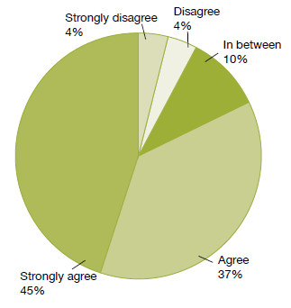
Source: National Mental Health Consumer Satisfaction Survey 2014/15

Other results from the survey included the following.
- Sixty-three percent of respondents agreed or strongly agreed with the statement ‘as a result of the services I have received, I feel that I do better in my personal relationships’.
- Eighty-four percent agreed or strongly agreed that ‘I feel comfortable asking questions about my medication and treatment’.
- Eighty-three percent agreed or strongly agreed that ‘staff have helped me to remain living in the community’.
- Eighty-six percent agreed or strongly agreed that ‘there is at least one member of staff who believes in me’.
- Eighty-two percent agreed that they ‘would recommend the service to friends and family if they needed similar care or treatment’.

Waiting times
The Ministry collects data on how long new clients wait to be seen by mental health and addiction services. New clients are defined as people who have not accessed mental health or addiction services in the past year. The Ministry defines ‘waiting time’ as the length of time between the day when a person is referred to a mental health or addiction service and the day when the person is first seen by the service.

A sector-wide target for DHBs to achieve by 30 June 2015 specified that mental health or addiction services should see 80 percent of people referred for non-urgent services within three weeks, and 95 percent within eight weeks. Urgent referrals should be seen within 48 hours.

In the 2014/15 fiscal year, services saw 78 percent of all clients of mental health services within three weeks, and 93 percent within eight weeks (see Figure 4). In addiction services (both DHB services and NGOs), services saw 84 percent of clients within three weeks, and 95 percent within eight weeks (see Figure 5).

Figure 4: Percentage of people seen by mental health services within three weeks (left) and within eight weeks (right), 2014/15
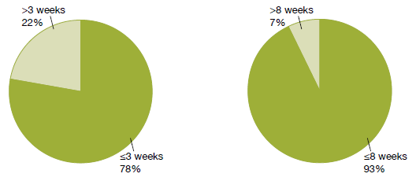
Source: PRIMHD data

Figure 5: Percentage of people seen by addiction services within three weeks (left) and within eight weeks (right), 2014/15
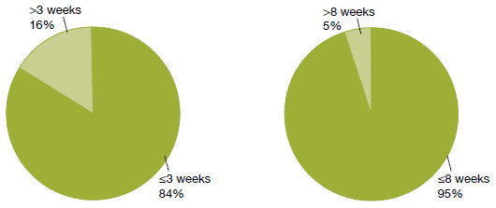
Source: PRIMHD data

Transition (discharge) plans
In 2014, the Ministry introduced a target that at least 95 percent of young people who have used mental health and addiction services have a transition (discharge) plan.

Transition planning aims to ensure that:
- service provision is matched as closely as possible to the needs of young people and delivered by the most appropriate services to meet those needs
- young people and their families/whānau are the key decision-makers regarding the services they receive
- care is delivered across a dynamic continuum of specialist- and primary-level services, and decisions are based on the needs and wishes of young people and their families/whānau and not service boundaries
- processes are in place to identify and respond early should young people experience a re-emergence of a mental health or AOD concern.

Figure 6 shows the percentage of child and adolescent service users with a transition plan as at 31 December 2015.

Figure 6: Percentage of child and adolescent service users with a transition plan, by district health board, 1 January to 31 December 2015
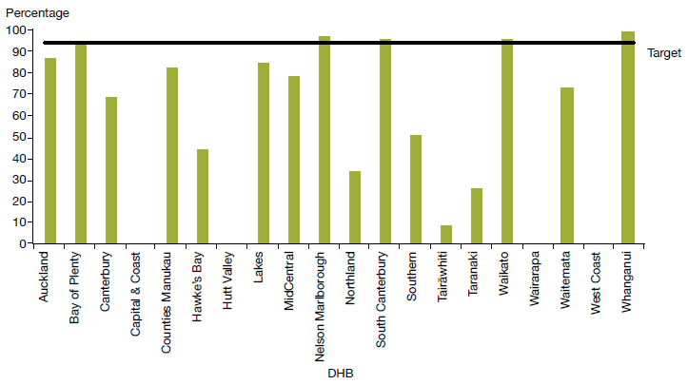
Notes:
Capital & Coast, Hutt Valley, Wairarapa and West Coast DHBs are not yet reporting on transition plans.
Previous annual reports published DHB quarterly reporting data on relapse prevention plans. This data is now being collected via PRIMHD; it will be published in the Office of the Director of Mental Health Annual Report 2016.
Source: DHB quarterly reporting data

Use of the Mental Health Act
The Mental Health Act defines the circumstances under which people may be subject to compulsory mental health assessment and treatment. In summary, in 2015:
- 9904 people (approximately 6.1 percent of specialist mental health and addiction service users) were subject to the Mental Health Act
In 2015, 9904 people in New Zealand were subject to the Mental Health Act
- on the last day of 2015, approximately 5612 people were subject to either compulsory assessment or compulsory treatment under the Mental Health Act
- use of the Mental Health Act varied across DHBs
- males were more likely to be subject to the Mental Health Act than females
- people aged 25–34 years were the most likely to be subject to compulsory treatment, and people over 65 years of age were the least likely
- Māori were more likely to be assessed or treated under the Mental Health Act than non-Māori.

The Mental Health Act process
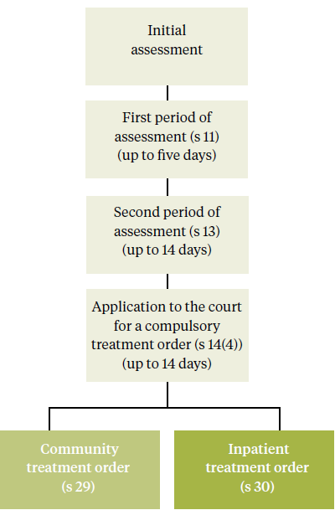
The compulsory assessment and treatment process begins with a referral and an initial assessment by a psychiatrist. If the psychiatrist believes a person fits the statutory criteria, the person will become subject to the Act, and will receive further assessment accordingly.

Compulsory assessment
Compulsory assessment can take place in either a community or a hospital setting. There are two periods of compulsory assessment, during which a person’s clinician may release them from assessment at any time.

During the assessment period, a person is obliged to receive treatment as prescribed by their responsible clinician.

The first period (section 11 of the Mental Health Act) is for up to five days. The second period (section 13) can last up to 14 days.

Following the first two assessment periods, a person’s responsible clinician can make an application to the Family or District Court
(section 14(4)) to place the person on a compulsory treatment order.

At any time during the compulsory assessment process, the person (or someone acting on their behalf) can request a judicial review to review their condition and determine whether it is appropriate that they continue to receive assessment under the Mental Health Act. A judicial review consists of a hearing in the District Court. Based on information provided by clinicians, a judge will decide whether the person should continue to be compulsorily assessed.

During 2015, approximately 1153 applications for compulsory treatment orders were considered under section 16 of the Mental Health Act. Of this total, an order for release of the person from compulsory status was issued in 33 cases (5 percent of the applications that proceeded to hearings).

Compulsory treatment
There are two types of compulsory treatment orders. One is for treatment in the community (a section 29 order) and the other is for treatment in an inpatient unit (a section 30 order). A person’s responsible clinician can convert an inpatient treatment order into a community treatment order at any time. A responsible clinician may also grant a person leave from the inpatient unit for treatment in the community for up to three months (section 31).

There are two types of compulsory treatment orders: one for treatment in the community, and the other for treatment in an inpatient unit

Most people subject to compulsory treatment access it in the community (approximately 86 percent in 2015).

Statistics
On the last day of 2015, 5612 people were subject to either compulsory assessment or compulsory treatment.

In New Zealand in each month of 2015, on average, the assessment provisions of the Mental Health Act were applied as follows.

Section 11 | 537  people were subject to an initial assessment | 12 people  per 100,000 population
Section 13 | 550  people were subject to a second  period of assessment | 12 people  per 100,000 population
Section 14(4) | 396  people were subject to an application  for a compulsory treatment order | 9 people  per 100,000 population

In New Zealand on a given day in 2015, on average, the treatment provisions of the Mental Health Act were applied as follows.

Section 29 | 3970  people were subject to a community treatment order | 86 people  per 100,000 population
Section 30 | 654  people were subject to an  inpatient treatment order | 14 people  per 100,000 population
Section 31 | 147  people were on temporary leave  from an inpatient unit | 3 people  per 100,000 population

Compulsory assessment and treatment by district health board
Table 1 shows the average number of people per month in 2015 required to undergo assessment under the Mental Health Act, by DHB. Table 2 shows the average number of people subject to a compulsory treatment order on a given day in 2015, again by DHB. The figures that follow also present the average number of people subject to a compulsory treatment order on a given day, but focus specifically on community treatment orders (Figure 7) and inpatient treatment orders (Figure 8) respectively.

Table 1: Average number of people per 100,000 per month required to undergo assessment under sections 11, 13 and 14(4) of the Mental Health Act, by district health board, 1 January to 31 December 2015
DHB | s 11 | s 13 | s 14(4) |  | DHB | s 11 | s 13 | s 14(4)
Auckland | 13 | 16 | 12 |  | Northland | 13 | 17 | 12
Bay of Plenty | 13 | 8 | 4 |  | South Canterbury | 6 | 6 | 2
Canterbury | 11 | 11 | 8 |  | Southern | 10 | 10 | 6
Capital & Coast | 10 | 15 | 12 |  | Tairāwhiti | 16 | 17 | 12
Counties Manukau | 10 | 12 | 9 |  | Taranaki | 12 | 9 | 5
Hawke’s Bay | 14 | 11 | 7 |  | Waikato | 18 | 14 | 8
Hutt Valley | 14 | 14 | 7 |  | Wairarapa | 6 | 4 | 4
Lakes | 12 | 9 | 9 |  | Waitemata | 11 | 12 | 10
MidCentral | 13 | 11 | 13 |  | West Coast | 16 | 11 | 7
Nelson Marlborough | 9 | 9 | 10 |  | Whanganui | 11 | 10 | 6
 |  |  |  |  | National average | 12 | 12 | 9
Note: The national average rates per 100,000 are slightly higher than the 2014 rates, which were 12, 11 and 8 for sections 11, 13 and 14(4) respectively. The rise in the national rates may have been influenced by better data capture: more DHBs reported via PRIMHD for 2015.
Source: PRIMHD data, extracted on 10 June 2016, except for data from Capital & Coast DHB, which was supplied manually.

Table 2: Average number of people per 100,000 on a given day subject to sections 29, 30 and 31 of the Mental Health Act, by district health board, 1 January to 31 December 2015
DHB | s 29 | s 30 | s 31 |  | DHB | s 29 | s 30 | s 31
Auckland | 107 | 8 | – |  | Northland | 164 | 11 | 6
Bay of Plenty | 47 | 12 | 3 |  | South Canterbury | 67 | 4 | 3
Canterbury | 64 | 18 | 6 |  | Southern | 74 | 15 | 4
Capital & Coast | 109 | 29 | 4 |  | Tairāwhiti | 133 | 11 | 6
Counties Manukau | 81 | 12 | 2 |  | Taranaki | 68 | 3 | 3
Hawke’s Bay | 98 | 9 | 7 |  | Waikato | 107 | 11 | 2
Hutt Valley | 63 | 8 | 2 |  | Wairarapa | 89 | 5 | –
Lakes | 153 | 25 | 15 |  | Waitemata | 98 | 18 | 3
MidCentral | 56 | 22 | 2 |  | West Coast | 69 | 10 | –
Nelson Marlborough | 103 | 29 | – |  | Whanganui | 77 | 19 | 2
 |  |  |  |  | National average | 86 | 14 | 3
Source: PRIMHD data, extracted on 10 June 2016, except for data from Capital & Coast and Counties Manukau DHBs, which was supplied manually.

Figure 7: Average number of people per 100,000 on a given day subject to a community treatment order (section 29 of the Mental Health Act), by district health board, 1 January to 31 December 2015
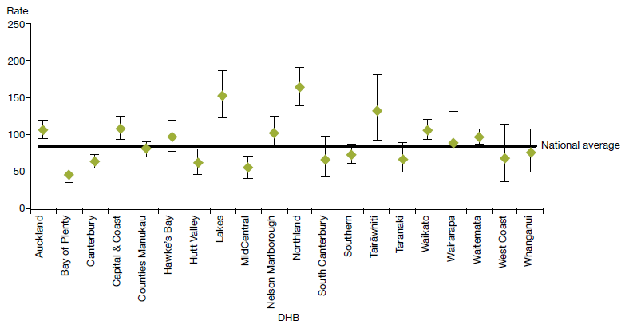
Note: Confidence intervals (for 99 percent confidence) have been used to aid interpretation. Where a DHB region’s confidence interval crosses the national average, this means the DHB’s rate was not statistically significantly different to the national average.
Source: PRIMHD data, extracted on 10 June 2016, except for data from Capital & Coast and Counties Manukau DHBs, which was supplied manually.

Figure 8: Average number of people per 100,000 on a given day subject to an inpatient treatment order (section 30 of the Mental Health Act), by district health board, 1 January to 31 December 2015
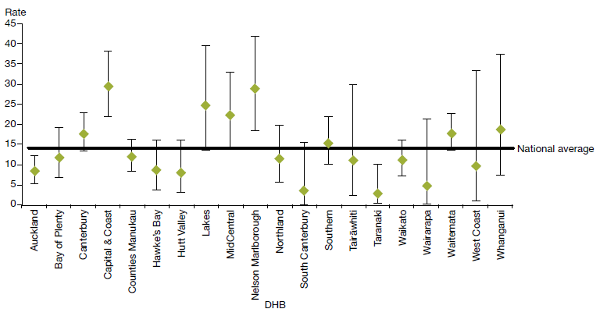
Note: Confidence intervals (for 99 percent confidence) have been used to aid interpretation. Where a DHB region’s confidence interval crosses the national average, this means the DHB’s rate was not statistically significantly different to the national average.
Source: PRIMHD data, extracted on 10 June 2016, except for data from Capital & Coast and Counties Manukau DHBs, which was supplied manually.

Compulsory treatment by age and gender
During 2015:
- people aged 25–34 years were the most likely to be subject to a compulsory treatment order application (181 per 100,000) and people over 65 years of age were the least likely (55 per 100,000) (see Figure 9)
- males were 1.5 times more likely to be subject to a compulsory treatment order application (114 per 100,000) than females (74 per 100,000) (see Figure 10).

Figure 9: Rate of people per 100,000 subject to compulsory treatment order applications (including extensions), by age group, 2004–2015
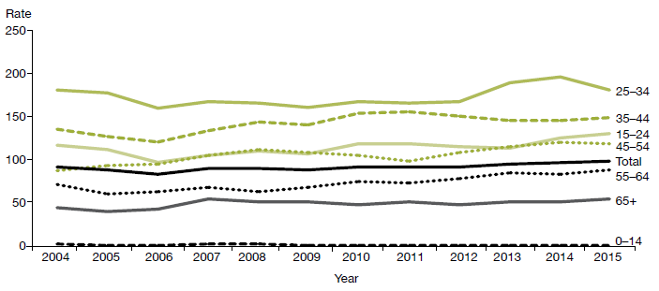
Source: Ministry of Justice’s Integrated Sector Intelligence System as at 16 May 2016; this system uses data entered into the Case Management System (CMS). The CMS is a live operational database. Figures are subject to minor changes at any time.

Figure 10: Rate of people per 100,000 subject to compulsory treatment order applications (including extensions), by gender, 2004–2015
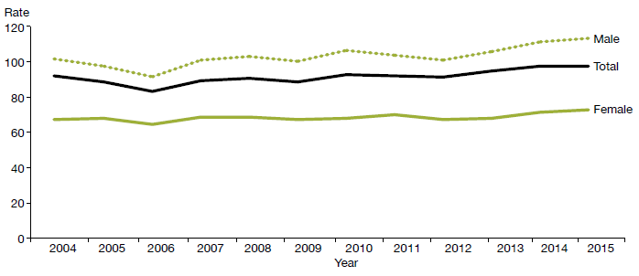
Source: Ministry of Justice’s Integrated Sector Intelligence System as at 16 May 2016.

Māori and the Mental Health Act
This section presents statistics on Māori subject to community treatment orders (section 29 of the Mental Health Act) and inpatient treatment orders (section 30) in 2015. These statistics further underline the need for the mental health sector to engage in meaningful action to address the disparity of mental health outcomes for Māori in New Zealand.

In summary, in 2015:
- Māori were 3.6 times more likely than non-Māori to be subject to a community treatment order, and 3.3 times more likely to be subject to an inpatient treatment order
- Māori males were the population group most likely to be subject to community and inpatient treatment orders (compared to non-Māori males, and Māori and non-Māori females)
- the ratio of Māori to non-Māori subject to community and inpatient treatment orders varied by DHB
- on average, Māori and non-Māori remained on community and inpatient treatment orders for similar periods of time.

The high rate of Māori subject to compulsory treatment orders
The high rate of Māori subject to compulsory treatment orders is a complex issue. Māori make up approximately 16 percent of New Zealand’s population, yet they account for 26 percent of all mental health service users.
The high rate of Māori subject to compulsory treatment orders is a complex issue
The national mental health prevalence study, Te Rau Hinengaro (Oakley Browne et al 2006), showed that Māori experience the highest levels of mental health disorder overall. They are also more likely to experience serious disorders and co-morbidities than non-Māori.

In 2015, Māori access rates to services exceeded those of other groups (5.8 percent of Māori accessed mental health services in 2015, compared with 3.1 percent of non-Māori). These higher access rates are likely to be a contributing factor to higher rates of Māori under compulsory treatment orders.

Other demographic features relevant to the high rate of Māori service users include the youthfulness of the Māori population (approximately half of the population is under 25 years of age) and the disproportionate representation of Māori in low socioeconomic groups (two-thirds live in deprivation deciles 7–10).

Analysis has shown that these demographic factors do not completely account for the high rate of Māori with serious mental illness (ie, if Māori had the same age structure and level of socioeconomic privilege as people in other groups, their rates of mental disorder would still be higher) (Oakley Browne et al 2006).

What other factors are involved in the disparity?
Elder and Tapsell (2013) emphasise that we need more research to better understand the Māori experience of the Mental Health Act, and why Māori are over-represented in compulsory treatment. They suggest that the following are important questions for the sector to consider.
- Are Māori receiving differential treatment in the mental health system?
Are Māori receiving differential treatment in the mental health system?
- How can we build a more culturally competent workforce and reduce cultural bias from formulations of mental illness?
- Are whānau of tāngata whaiora (people seeking wellness) being sufficiently engaged by mental health services?

Māori experiences of the Mental Health Act and acute mental health care
In June 2015, Te Rau Matatini facilitated a one-day hui with ten tāngata whaiora to better understand Māori experiences of the Mental Health Act and acute mental health care (Baker 2015).

Some tāngata whaiora described using the Act as a ‘bargaining tool’ to appease clinicians and more quickly gain release from the inpatient service in which they were receiving treatment. Others described the Act as providing a ‘false sense of security’ in terms of access to medication. Participants also talked of:
- not understanding the compulsory assessment and treatment process
- experiencing the opposite of what clinicians advised was going to happen under the Act
- experiencing overt discrimination in the community, such as disproportionately harsh treatment by police and refusal of accommodation and employment, due to the stigma that continues to surround compulsory treatment orders
- struggling to be released from the Act.

With regard to acute mental health care, tāngata whaiora described its restrictive and disempowering nature, and their sense that the treatment they received was more closely aligned with the clinicians’ needs than their own. It is clear that the sector needs to actively address these issues in order to make mental health care for Māori as empowering an experience as possible.

At the hui, tāngata whaiora identified a number of solutions to improve Māori experiences of mental health care, including:
- a holistic approach to service provision, incorporating tīkanga Māori (Māori customs), te reo Māori (Māori language), mātauranga Māori (Māori knowledge), and increased whānau involvement
Tāngata whaiora called for the formation of a national body of Māori with lived experience of mental health care
- the provision of acute mental health care in alternative, less restrictive environments
- the formation of a national body of Māori with lived experience of mental health care, in order to improve advocacy for tāngata whaiora, increase representation of Māori consumer advisors in mental health services and influence policy and decision-making.

Māori and compulsory treatment orders by district health board
Figures 11 and 12 show variation across New Zealand in terms of the disparities between Māori and non-Māori subject to compulsory treatment orders in 2015. With regard to community treatment orders, the Māori to non-Māori rate ratio ranged from 0.9:1 (in West Coast DHB) to 5.3:1 (in Bay of Plenty DHB). With regard to inpatient treatment orders, the rate ratio ranged from 0:1 (in West Coast DHB) to 4.9:1 (in Lakes DHB).

These numbers are difficult to interpret, because it is hard to define an ideal rate ratio for a given population or DHB. However, for comparative purposes, a line of no difference has been included in the figures. The figures emphasise that we need in-depth, area-specific knowledge to understand the particular disparities around the country and what could be done at a local level to address them.

Figure 11: Rate ratio of Māori to non-Māori subject to a community treatment order (section 29) under the Mental Health Act, by district health board, 1 January to 31 December 2015
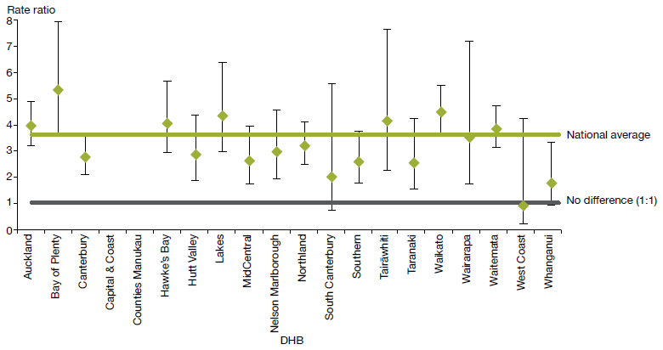
Notes:
Rates per 100,000 are age-standardised to account for differences in the population structures of the DHBs.
Confidence intervals (for 99 percent confidence) have been used to aid interpretation. Where a DHB region’s confidence interval crosses the national average, this means the DHB’s rate was not statistically significantly different to the national average.
Because Capital & Coast and Counties Manukau DHBs submitted data manually, the rate ratios for these DHBs were not able to be represented in the above graph. The (non-age standardised) rate ratios for Capital & Coast and Counties Manukau DHBs were 2.4 and 3.7 respectively.
Source: PRIMHD data, extracted on 10 June 2016, except Capital & Coast and Counties Manukau DHBs, which submitted data manually.

Figure 12: Rate ratio of Māori to non-Māori subject to an inpatient treatment order (section 30) under the Mental Health Act, by district health board, 1 January to 31 December 2015
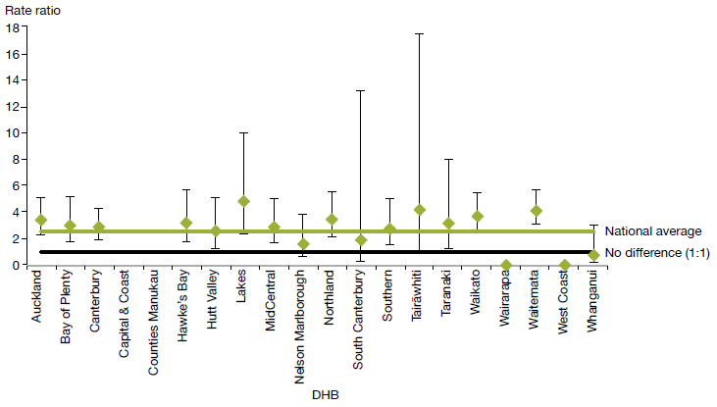
Notes:
Rates per 100,000 are age-standardised to account for differences in the population structures of the DHBs.
Confidence intervals (for 99 percent confidence) have been used to aid interpretation. Where a DHB region’s confidence interval crosses the national average, this means the DHB’s rate was not statistically significantly different to the national average.
Because Capital & Coast and Counties Manukau DHBs submitted data manually, the rate ratios for these DHBs were not able to be represented in the above graph. The (non-age standardised) rate ratios for Capital & Coast and Counties Manukau DHBs were 3.5 and 3.2 respectively.
Source: PRIMHD data, extracted on 10 June 2016, except for data from Capital & Coast and Counties Manukau DHBs, which submitted data manually.

Gender, ethnicity and compulsory treatment
In 2015, Māori males were the population group most likely to be subject to community and inpatient treatment orders. In particular, in 2015 Māori males were almost four times more likely to be subject to a community treatment order (section 29) than non-Māori males.

Table 3 and Figure 13 present information on age-standardised rates of community and inpatient treatment orders by gender and ethnicity.

Table 3: Age-standardised rates of Māori and non-Māori subject to community and inpatient treatment orders (sections 29 and 30) under the Mental Health Act, by gender, 1 January to 31 December 2015

 | Community treatment orders |  | Inpatient treatment orders
 | Male | Female | Male | Female
Māori | 466 | 210 | 151 | 80
Non-Māori | 119 | 65 | 42 | 28
Rate ratio Māori: non-Māori | 3.9:1 | 3.2:1 | 3.6:1 | 2.9:1
Note: Rates per 100,000 are age-standardised.
Source: PRIMHD data, extracted on 10 June 2016.
Figure 13: Age-standardised rates of Māori and non-Māori subject to community and inpatient treatment orders (sections 29 and 30) under the Mental Health Act, by gender, 1 January to 31 December 2015
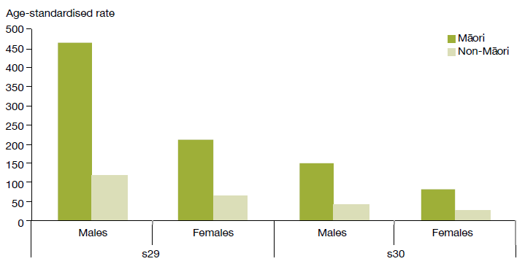
Note: Rates per 100,000 are age-standardised.
Source: PRIMHD data, extracted on 10 June 2016.

Length of time spent subject to compulsory treatment orders
On average, Māori and non-Māori remain on compulsory treatment orders for a similar amount of time (see Figure 14). For community treatment orders commenced between 2009 and 2013, 72 percent of Māori and 73 percent of non-Māori were subject to the order for less than a year. For inpatient treatment orders commenced between 2009 and 2013, 92 percent of Māori and 94 percent of non-Māori were subject to the order for less than a year.

Figure 14: Length of time spent subject to community and inpatient treatment orders (sections 29 and 30) under the Mental Health Act for Māori and non-Māori, 2009–2013
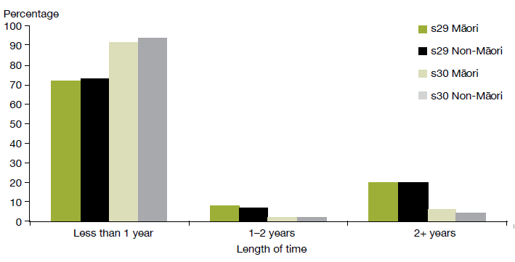
Note: The data refers to treatment orders started between 2009 and 2013. 2013 is the most recent year referred to in this figure, as this analysis requires at least two years to have elapsed to determine the number of people who have remained on a treatment order for two or more years.
Source: PRIMHD data, extracted on 10 June 2016.

Future focus
Reducing the disparity of Māori mental health outcomes continues to be a priority for the Ministry of Health (Ministry of Health 2012e). Publishing data on the rate of Māori subject to compulsory treatment is just one aspect of what needs to be a wider conversation around Māori over-representation in compulsory assessment and treatment under the Mental Health Act.
Reducing the disparity of Māori mental health outcomes continues to be a priority for the Ministry of Health
The Office of the Director of Mental Health will continue to work alongside DHBs and other Ministry and government groups to ensure that the best possible mental health outcomes are being sought for Māori in New Zealand.

Family/whānau consultation and the Mental Health Act
In 1999, Parliament made an amendment to the Mental Health Act that required clinicians to consult family/whānau at particular junctures of a person’s compulsory assessment and treatment under the Mental Health Act (section 7A). The new section requires a mental health service to consult unless it is deemed not reasonably practicable, or not in the interests of the person.

In summary, in 2015:
- the average percentage of family/whānau consultation in Mental Health Act assessment/ treatment events was 59 percent nationally
- of all the steps in the Mental Health Act treatment process, families/whānau were most likely to be consulted during a person’s initial assessment (section 10)
- family/whānau consultation varied by DHB
- the most common reason families/whānau were not consulted was that service providers deemed consultation not reasonably practicable in the given circumstance.

Purpose of family/whānau consultation
Family/whānau involvement can be a vital component in a person’s journey of recovery
The purpose of consultation with family/whānau is to:
- strengthen family/whānau involvement in the compulsory assessment and treatment process
- enhance family/whānau contribution to the person’s care
- address family/whānau concerns about information sharing and treatment options
- facilitate ongoing family/whānau involvement in Mental Health Act processes, such as clinical reviews of treatment or court hearings (Ministry of Health 2012d).

In 2006, the Ministry of Health published a review of the application of section 7A of the Mental Health Act, following concerns that mental health services were not adequately carrying out the required consultation (Ministry of Health 2006). The review made a number of recommendations, including revision of the relevant section in the Mental Health Act Guidelines (Ministry of Health 2012d), better training and resources for clinicians, development of more information and opportunities for involvement in the compulsory assessment and treatment process for family/whānau, and the establishment of nationwide reporting on section 7A consultation.

This is the second year that national data on the application of section 7A has been included in this report. It has been included in the hope that its publication will further emphasise the importance of family/whānau consultation, bring greater transparency and accountability to DHB efforts to involve family/whānau, and further encourage a culture of family/whānau involvement in mental health treatment.

Definition of family/whānau
Family/whānau is not limited to blood ties but may include partners, friends and others in a person’s wider support network
Definitions and understandings of family/whānau vary, and are informed by different cultural backgrounds and practices. Almost always, the most important perspective for defining family/whānau is that of the person. Therefore, family/whānau is not limited to blood ties, but may include partners, friends and others in a person’s wider support network (Ministry of Health 2012d).

District health board reporting of family/whānau consultation
The Ministry requires DHBs to report on family/whānau consultation across five different assessment/treatment events in the Mental Health Act process, as follows.

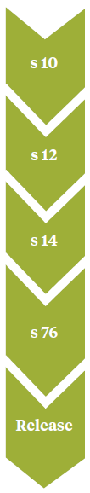 | Preliminary assessment  The clinician makes a preliminary assessment, including as to whether the person should undergo the initial five-day period of assessment under s 11.
Further assessment
After an initial assessment period of five days, the clinician decides whether the person should undergo a further two-week period of assessment under s 13.
Final assessment
After the second period of assessment, the clinician decides whether the person should be placed on either an inpatient treatment order or a community treatment order.
Review
If a person has been placed on a compulsory treatment order, the clinician conducts a review no later than three months after it was put in place to see whether it should remain. Thereafter, the clinician reviews the order at intervals no longer than six months.
Release
If at any time while the compulsory treatment order is in place the clinician considers that the person no longer requires compulsory treatment, they can direct release with immediate effect.

Across all DHBs in 2015, the point in this process at which the highest rate of family/whānau consultation occurred was the clinician’s initial assessment (68 percent). Figure 15 shows the percentage of cases in which family/whānau consultation occurred at this and other points in the process in 2015.

Figure 15: Average national percentage of family/whānau consultation for particular assessment/ treatment events, 1 January to 31 December 2015
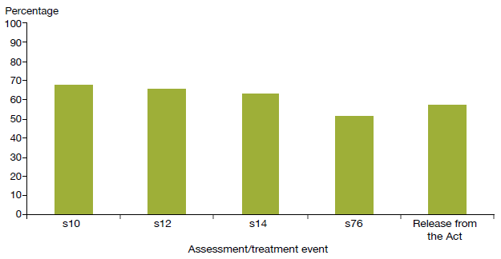
Notes:
Waitemata DHB does not record section 7A family/whānau consultation data.
Hutt Valley and South Canterbury DHBs did not submit section 7A data for July–September 2015 and January– March 2015 respectively.
Source: Office of the Director of Mental Health records

Nationally during 2015, the average percentage of cases in which family/whānau consultation occurred across all assessment/treatment events was 59 percent. West Coast DHB had the highest rate of consultation, at 100 percent, and Capital & Coast had the lowest, at 29 percent.

Figure 16: Average percentage of family/whānau consultation across all assessment/ treatment events, by district health board, 1 January to 31 December 2015
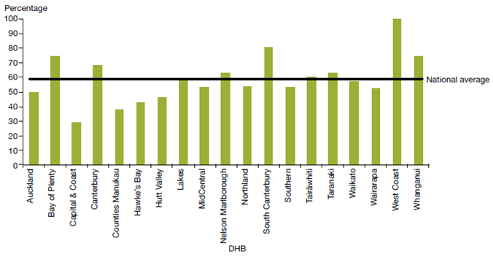
Notes:
Waitemata DHB does not record section 7A family/whānau consultation data.
Hutt Valley and South Canterbury DHBs did not submit section 7A data for July–September 2015 and January– March 2015 respectively.
Source: Office of the Director of Mental Health records

Reasons for not consulting family/whānau
During 2015, the most common reason DHBs gave for not arranging family/whānau consultation was that it was not reasonably practicable (55 percent). This was followed by ‘don’t know’ (31 percent), ‘not in the best interests of the person’ (5 percent) and ‘no for another reason’ (9 percent) (see Figure 17).

Figure 17: Reasons for not consulting family/whānau, 1 January to 31 December 2015
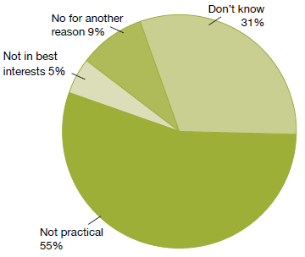
Notes:
Waitemata DHB does not record section 7A family/whānau consultation data.
Hutt Valley and South Canterbury DHBs did not submit section 7A data for July–September 2015 and January– March 2015 respectively.
Source: Office of the Director of Mental Health records

Seclusion
Standards New Zealand (2008a) defines seclusion as a situation ‘where a consumer is placed alone in a room or area, at any time and for any duration, from which they cannot freely exit’. Seclusion should be an uncommon event, and services should use it only when there is an imminent risk of danger to the individual or others and no other safe and effective alternative is possible.

In summary, in adult inpatient services in 2015:
- the total number of people who experienced seclusion while receiving mental health treatment in an adult inpatient service had decreased by 30 percent since 2009
- the total number of hours spent in seclusion had decreased by 58 percent since 2009
Seclusion should be an uncommon event, used only when there is an imminent risk of danger to the individual or others
- the use of seclusion steadied. Most services in New Zealand that use seclusion are now entering a re-planning phase in which they are refining and refocusing seclusion reduction initiatives
- males were more than twice as likely to have been secluded as females
- people aged 20–24 years were more likely to have been secluded than those in any other age group
- Māori were more likely to have been secluded than non-Māori.

The Health and Disability Services (Restraint Minimisation and Safe Practices) Standards came into effect on 1 June 2009 (Standards New Zealand 2008b). Their intent is to ‘reduce the use of restraint in all its forms and to encourage the use of least restrictive practices’. In addition, reducing (and eventually eliminating) seclusion is one of the goals of the Ministry’s service development plan Rising to the Challenge (Ministry of Health 2012e).

Section 71 of the Mental Health Act covers seclusion. It states that seclusion can only occur where, and for as long as, it is necessary for the care or treatment of the person, or for the protection of other people.
Reducing (and eventually eliminating) seclusion is one of the goals of the Ministry’s service development plan Rising to the Challenge
Seclusion rooms must be designated by the relevant DAMHS, and can be used only with the authority of a person’s responsible clinician. Clinicians must record the duration and circumstances of each episode of seclusion in a register that must be available for review by district inspectors. Seclusion should never be used for the purposes of discipline, coercion or staff convenience, or as a substitute for adequate levels of staff or active treatment.

The Ministry of Health’s revised guidelines on seclusion (Ministry of Health 2010) identify best practice methods for using seclusion in mental health inpatient units. Their intent is to progressively decrease and limit the use of seclusion.

Te Pou o Te Whakaaro Nui (National Workforce Centre for Mental Health, Addiction and Disability) supports the national direction set by the Ministry of Health for seclusion reduction by using evidence- based information, such as the ‘Six Core Strategies’ of the National Technical Assistance Centre (Huckshorn 2005). Te Pou works with DHBs to support their local initiatives. Further information and stories of emerging good practice can be found on Te Pou’s website (www.tepou.co.nz).

Changes in the use of seclusion over time
Figures 18 and 19 show a decrease in the number of people secluded in adult inpatient services, and in the total number of seclusion hours since 2007.

Between 2009, when the seclusion reduction policy was introduced, and 2015, the total number of people secluded in adult inpatient services nationally decreased by 30 percent. The total number of seclusion hours for people in adult inpatient services nationally decreased by 58 percent.

Between 2014 and 2015, the use of seclusion steadied. While the total number of seclusion hours decreased by 6 percent, the total number of people secluded increased by 2 percent.
Between 2009 and 2015, the total number of people secluded decreased by 30 percent
The Ministry of Health anticipated this steadying. Most services in New Zealand, having successfully employed best-practice strategies to reduce their use of seclusion, are now entering a re-planning phase in which they are refining and refocusing seclusion reduction initiatives. Since 2009 there have been focused efforts to improve reporting on seclusion; this may partially explain the steadying of seclusion rates.

The continued reduction (and eventual elimination) of seclusion will require strong local leadership, evidence-based seclusion reduction initiatives, ongoing workforce development and significant organisational commitment. The Office of the Director of Mental Health will continue to provide national leadership in this area through the publication of new guidance on the use of restrictive practices and the introduction of a monitoring regime for the use of night safety procedures.

Figure 18: Number of people secluded in adult inpatient services nationally, 2007–2015
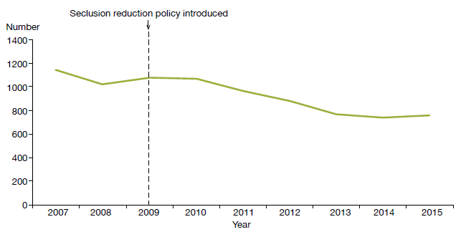
Source: Office of the Director of Mental Health Annual Reports 2007–2014 and PRIMHD data for 2015, extracted on 10 June 2016. Capital & Coast, Hutt Valley and Lakes DHBs supplied data manually.

Figure 19: Total number of seclusion hours in adult inpatient services nationally,
2007–2015
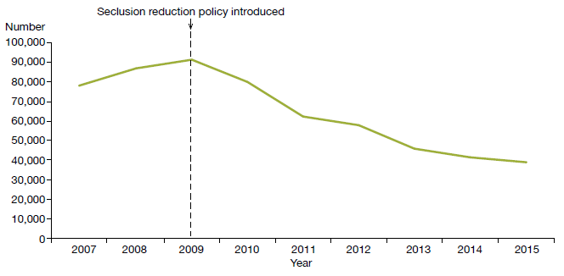
Source: Office of the Director of Mental Health Annual Reports 2007–2014 and PRIMHD data for 2015, extracted on 10 June 2016. Capital & Coast, Hutt Valley and Lakes DHBs supplied data manually.

Seclusion in New Zealand mental health services
Between 1 January and 31 December 2015, New Zealand adult mental health services (excluding forensic and other regional rehabilitation services) accommodated 7545 people for a total of 198,525 bed nights. Of these people, 754 (10 percent) were secluded at some time during the reporting period.

People who were secluded were often secluded more than once (on average 2.2 times). Therefore, the number of seclusion events in adult inpatient services (1668) was higher than the number of people secluded.

Across all inpatient services, including forensic, intellectual disability and youth services, 1001 people experienced at least one seclusion event. Of those secluded, 69 percent were male and 31 percent were female. The most common age group for those secluded was 20–24 years (see Figure 20). A total of 121 young people (aged 19 years and under) were secluded during the 2015 year, in 289 seclusion events.

Figure 20: Number of people secluded across all inpatient services (adult, forensic, intellectual disability and youth), by age group, 1 January to 31 December 2015
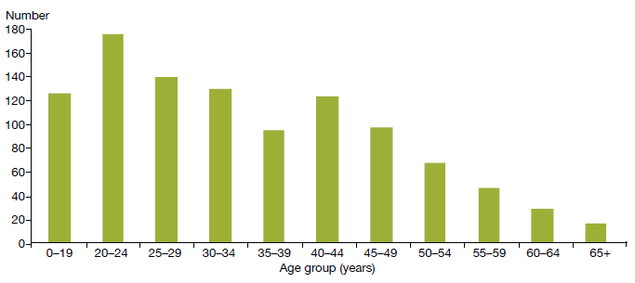
Source: PRIMHD data, extracted on 10 June 2016. Capital & Coast, Hutt Valley and Lakes DHBs supplied data manually.

The length of time spent in seclusion varied considerably. Most seclusion events (72 percent) lasted for less than 24 hours. Some (16 percent) lasted for longer than 48 hours. Figure 21 shows numbers of seclusion events by duration of the event.

Figure 21: Number of seclusion events across all inpatient services (adult, forensic, intellectual disability and youth), by duration of event, 1 January to 31 December 2015
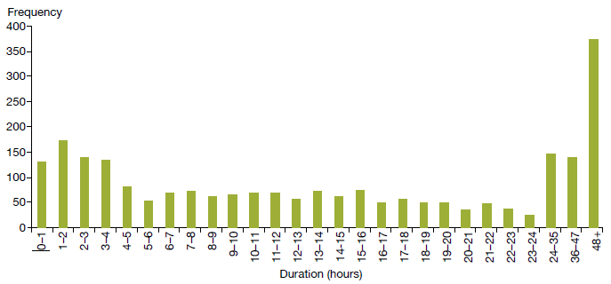
Source: PRIMHD data, extracted on 10 June 2016. Capital & Coast, Hutt Valley and Lakes DHBs supplied data manually.

Seclusion by district health board
All DHBs except for Wairarapa (which has no mental health inpatient service) use seclusion. In 2015, the national average number of people secluded in adult inpatient services per 100,000 population was 28.1, and the average number of seclusion events per 100,000 population was 62.1.

As Figures 22 and 23 show, seclusion data varied widely across DHBs in 2015. Such variation is likely to be due to a number of factors, including:
- differences in seclusion practice
- geographical variations in the prevalence and acuity of mental illness
- ward design factors, such as the availability of intensive care and low-stimulus facilities
- staff numbers, experience and training
- use of sedating psychotropic medication
- the frequent or prolonged seclusion of a small number of people, distorting seclusion figures over the 12-month period.

Because it is difficult to measure and adjust for these factors, the Ministry recommends comparing an individual DHB’s performance over time in addition to considering the adjusted comparisons between DHBs in this report.

Figure 22: Number of people secluded in adult inpatient services per 100,000, by district health board, 1 January to 31 December 2015
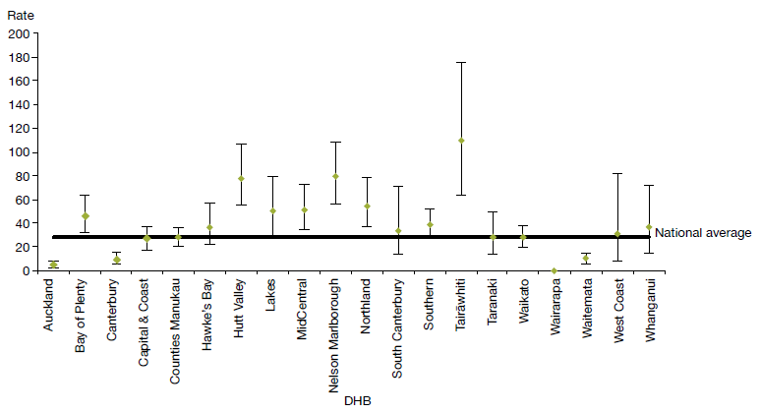
Note: Confidence intervals (for 99 percent confidence) have been used to aid interpretation. Where a DHB region’s confidence interval crosses the national average, this means the DHB’s rate was not statistically significantly different to the national average.
Source: PRIMHD data, extracted on 10 June 2016. Capital & Coast, Hutt Valley and Lakes DHBs supplied data manually.

Figure 23: Number of seclusion events in adult inpatient services per 100,000, by district health board, 1 January to 31 December 2015
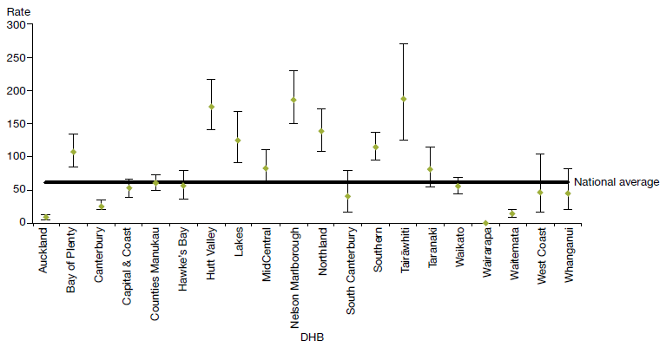
Note: Confidence intervals (for 99 percent confidence) have been used to aid interpretation. Where a DHB region’s confidence interval crosses the national average, this means the DHB’s rate was not statistically significantly different to the national average.
Source: PRIMHD data, extracted on 10 June 2016. Capital & Coast, Hutt Valley and Lakes DHBs supplied data manually.

Seclusion and ethnicity
In 2015, Māori were almost five times more likely to be secluded in adult inpatient services than people from other ethnic groups. Of those secluded in adult inpatient services during 2015, 44 percent were Māori.

Figure 24 shows seclusion indicators for Māori and non-Māori during 2015. Māori were secluded at a rate of 89 people per 100,000, and non-Māori at a rate of 18 people per 100,000 population.
In 2015, Māori were almost five times more likely to be secluded than people from other ethnic groups
Reducing and eventually eliminating the use of seclusion for Māori is a priority action in Rising to the Challenge (Ministry of Health 2012e) supported by Te Pou. Information on initiatives and strategies for reducing the use of seclusion with Māori can be accessed on Te Pou’s website (www.tepou.co.nz).

Figure 24: Seclusion indicators for adult inpatient services, Māori and non-Māori, 1 January to 31 December 2015
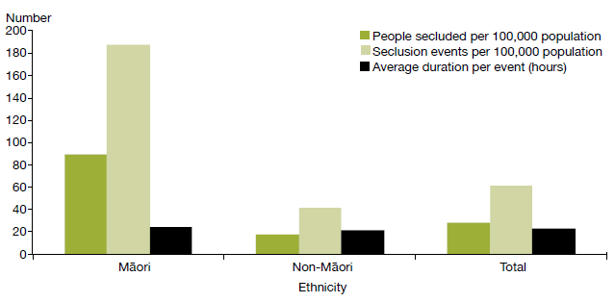
Source: PRIMHD data, extracted on 10 June 2016. Capital & Coast, Hutt Valley and Lakes DHBs supplied data manually.

Figure 25 shows the percentage of Māori and non-Māori male and female service users secluded in adult services in 2015. This figure indicates that a greater proportion of Māori were secluded than non-Māori, and that across ethnicities males were more likely to be secluded (12 percent) than females (7 percent).

Figure 25: Percentage of people secluded in adult inpatient services, Māori and non-Māori males and females, 1 January to 31 December 2015
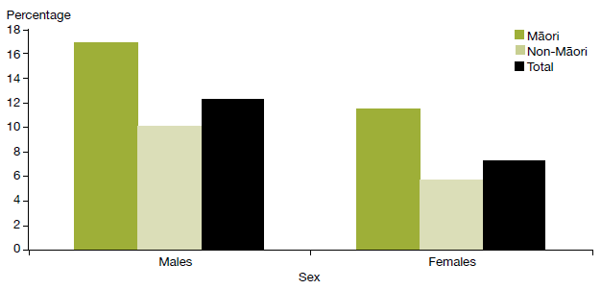
Source: PRIMHD data, extracted on 10 June 2016. Capital & Coast, Hutt Valley and Lakes DHBs supplied data manually.

Figure 26 shows the proportion of Māori aged 20–64 years secluded in adult inpatient services from 2007 to 2015. Nationally over this time the number of people secluded decreased by 34 percent. Consistent with the declining national rate, the number of people secluded who identified as Māori decreased by 15 percent over the same time.

Figure 26: Number of Māori and non-Māori secluded in adult inpatient services,
2007–2015
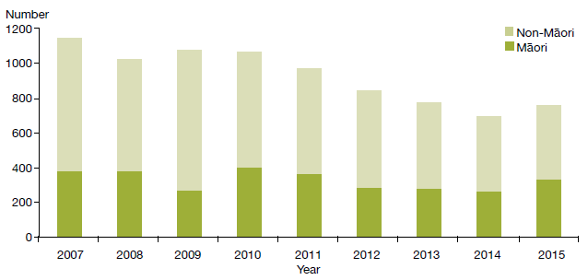
Source: PRIMHD data, extracted on 10 June 2016. Capital & Coast, Hutt Valley and Lakes DHBs supplied data manually.

Seclusion in forensic units and intellectual disability units
Five DHBs provide specialist inpatient forensic services: Canterbury, Capital & Coast, Southern, Waikato and Waitemata. There is a smaller inpatient forensic service in Whanganui. These services provide mental health treatment in a secure environment for prisoners with a mental disorder, and for people defined as special or restricted patients under the Mental Health Act.

Forensic services also provide care for people defined as care recipients or special care recipients under the Intellectual Disability (Compulsory Care and Rehabilitation) Act 2003 (IDCC&R Act). These services are delivered in specialised intellectual disability units for people with an intellectual disability and who are subject to a compulsory care order under the IDCC&R Act.

In 2015, forensic services (including specialised intellectual disability units) placed 116 people (down from 125 in 2014) in seclusion, in a total of 456 seclusion events. The average duration of a seclusion event in a forensic service increased from 31.7 hours in 2014 to 37.8 hours in 2015.

Table 4 presents seclusion indicators for the 2015 calendar year. These indicators cannot be compared with adult service indicators, because they do not reflect the same client base. The rates of seclusion for the relatively small group of people in the care of forensic and intellectual disability services can be affected by individuals who were secluded significantly more often or for longer than others.

Table 4: Seclusion indicators for forensic and intellectual disability services, by district health board, 1 January to 31 December 2015
DHB | Number of clients secluded | Number of  events | Average duration per event (hours)
Canterbury | 19 | 86 | 22.1
Capital & Coast | 12 | 56 | 38.5
Southern | 9 | 51 | 37.3
Waikato | 25 | 85 | 24.9
Waitemata | 53 | 178 | 51.4
Total | 116 | 456 | 37.8
Note: The total of 116 in this table is a unique count and not a sum of the column, as two clients were seen by two DHBs.
Source: PRIMHD data, extracted on 10 June 2016.

Electroconvulsive therapy
ECT can be an effective treatment as a last resort, where medication is contraindicated or is not relieving symptoms sufficiently
Electroconvulsive therapy is a therapeutic procedure in which a brief pulse of electricity is delivered to a person’s brain in order to produce a seizure. It can be an effective treatment for various types of mental illness, including depressive illness, mania, catatonia and other serious neuropsychiatric conditions. It is often effective as a last resort in cases where medication is contraindicated or is not relieving symptoms sufficiently. It can only be given with the consent of the person receiving it, other than in certain carefully defined circumstances.
In summary, in 2015:
- 225 people received ECT (4.9 people per 100,000)
- services administered a total of 2295 treatments of ECT
- those treated received an average of 10 administrations of ECT over the year
- females were more likely to receive ECT than males
- older people were more likely to receive ECT than younger people.

Medical staff administer ECT under anaesthesia in an operating theatre, making use of muscle relaxants. The person who has received ECT wakes unable to recall the details of the procedure. The most common side effects of ECT are confusion, disorientation and memory loss. Confusion and disorientation typically clear within an hour, but memory loss can be persistent and in some cases even permanent (American Psychiatric Association 2001; Ministry of Health 2004).

Significant advances have been made in improving ECT techniques and reducing side effects over the last 20 years. Despite these improvements, ECT remains a controversial treatment. In 2003, in response to petition 1999/30 of Anna de Jonge and others regarding ECT, the Health Select Committee recommended that a review be undertaken, independently of the Ministry of Health, on the safety and efficacy of ECT and the adequacy of regulatory controls on its use in New Zealand. The review concluded that ECT continues to have a place as a treatment option for consumers of mental health services in New Zealand, and that banning its use would deprive some seriously ill people of a potentially effective and sometimes life-saving means of treatment (Ministry of Health 2004).

In 2009, the Ministry of Health created a consumer resource on ECT as part of the 2003 Government response to the review (Ministry of Health 2009).

Changes in the use of ECT over time
The number of people treated with ECT in New Zealand has remained relatively stable since 2006. Around 200 to 300 people receive the treatment each year. When the increase in mental health service use during that time is taken into account the rate of people treated with ECT can be seen to have declined (see Figure 27).

Figure 27: Number of people treated with electroconvulsive therapy, per 100,000 service user population, 2005–2015
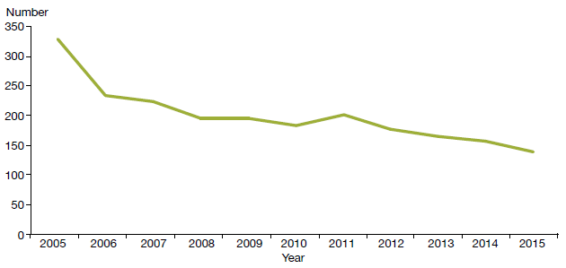
Source: PRIMHD data, extracted on 10 June 2016.
A total of 225 people received ECT during the year ending 31 December 2015. Table 5 shows the total number of people who received ECT in 2015 by DHB of domicile. The total number of treatments administered over this period was 2296, representing a mean of 10 treatments per person.

Table 5: Electroconvulsive therapy indicators, by district health board of domicile, 1 January to 31 December 2015
DHB of domicile | Number of people treated with ECT | Number of treatments | Mean number of treatments per person (range)
Auckland | 17 | 180 | 10.6 (1–20)
Bay of Plenty | 12 | 141 | 11.8 (2–28)
Canterbury | 40 | 342 | 8.6 (1–32)
Capital & Coast | 12 | 130 | 10.8 (1–24)
Counties Manukau | 14 | 170 | 12.1 (4–31)
Hawke’s Bay | 17 | 126 | 7.4 (1–21)
Hutt Valley | 4 | 18 | 4.5 (1–8)
Lakes | 10 | 151 | 15.1 (1–39)
MidCentral | 9 | 79 | 8.8 (1–19)
Nelson Marlborough | 4 | 37 | 9.3 (3–15)
Northland | 4 | 31 | 7.8 (5–15)
South Canterbury | 0 | 0 | 0
Southern | 28 | 312 | 11.1 (1–56)
Tairāwhiti | 0 | 0 | 0
Taranaki | 0 | 0 | 0
Waikato | 29 | 306 | 10.6 (1–30)
Wairarapa | 1 | 5 | 5.0 (5–5)
Waitemata | 21 | 232 | 11.1 (1–35)
West Coast | 4 | 35 | 8.8 (1–14)
Whanganui | 0 | 0 | 0
Unknown | 0 | 0 | 0
New Zealand | 225 | 2295 | 10.2 (1–56)
Notes:
In 2015, 15 people were treated out of area, as follows.
- Auckland DHB saw one person from Lakes DHB.
- Canterbury DHB saw one person from Southern DHB and four people from West Coast DHB.
- Capital & Coast DHB saw two people from Hawke’s Bay DHB and one person from Wairarapa DHB.
- Hawke’s Bay DHB saw one person from Waikato DHB.
- Hutt Valley DHB saw one person from Capital & Coast DHB and two people from Wairarapa DHB.
- Waitemata DHB saw two people from Auckland DHB.
The New Zealand total of 225 in this table is a unique count and not a sum of the column, as the New Zealand total excludes one individual who was treated by more than one DHB.
Source: PRIMHD data, extracted on 10 June 2016.

The national rate of people receiving ECT treatment in 2015 was 4.9 per 100,000. Figure 28 presents the rate of people treated with ECT by DHB of domicile.

As the figure shows, the rate of ECT treatments given varies regionally. Several factors contribute to this. First, regions with smaller populations are more vulnerable to annual variations (according to the needs of the population at any given time). In addition, people receiving continuous or maintenance treatment will typically receive more treatments in a year than those treated with an acute course. Electroconvulsive therapy is indicated in older people more often than in younger adults because older people are more likely to have associated medical problems contraindicating medication. Finally, populations in some DHBs have better access to ECT services than others.

Figure 28: Rates of people treated with electroconvulsive therapy, by district health board of domicile, 1 January to 31 December 2015
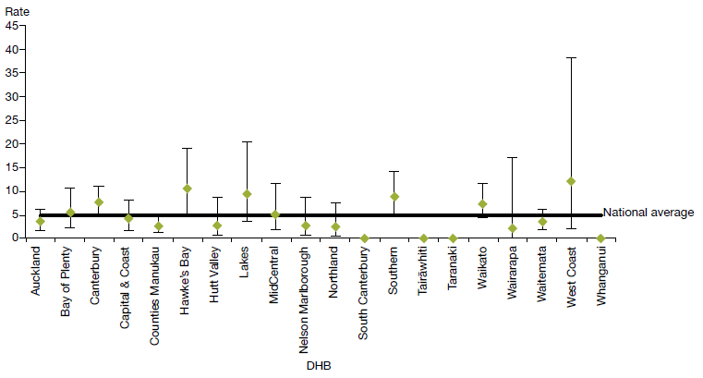
Notes:
As the numbers of people receiving ECT by DHB are so small, it is difficult to make meaningful comparisons between DHBs as rates per 100,000 population.
Confidence intervals (for 99 percent confidence) have been used to aid interpretation. Where a DHB region’s confidence interval crosses the national average, this means the DHB’s rate was not statistically significantly different to the national average.
Source: PRIMHD data, extracted on 10 June 2016.

Consent to treatment
Section 60 of the Mental Health Act describes the process required for obtaining consent for ECT. Either the consent of the person themselves or a second opinion from a psychiatrist appointed by the Mental Health Review Tribunal is required. In the latter case, the psychiatrist must consider the treatment to be in the interests of the person.

This process allows for the treatment of people too unwell to consent to treatment. Clinicians should make the decision about whether ECT is in the interests of the person after discussing the options with family/whānau and considering any relevant advance directives the person has made.
During 2015, five people were treated with ECT who retained decision-making capacity and refused consent. The total number of ECT treatments not able to be consented to increased from 259 treatments in 2014 to 576 treatments in 2015, which may be attributable to focused efforts by the Office of the Director of Mental Health during 2015 to improve reporting on non-consensual ECT. Table 6 shows the number of treatments administered without consent during 2015.

Table 6: Indicators for situations in which electroconvulsive therapy was not consented to, by district health board of service, 1 January to 31 December 2015
DHB of service | Number of people  given ECT who did not have the capacity to consent | Number of administrations  not able to be  consented to | Number of people given ECT who had capacity and refused consent
Auckland | 4 | 37 | 0
Bay of Plenty | 3 | 31 | 1
Canterbury | 8 | 83 | 0
Capital & Coast | 4 | 38 | 0
Counties Manukau | 8 | 74 | 0
Hawke’s Bay | 1 | 1 | 0
Hutt Valley | 3 | 3 | 0
Lakes | 0 | 0 | 0
MidCentral | 1 | 1 | 0
Nelson Marlborough | 0 | 0 | 0
Northland | 5 | 20 | 0
South Canterbury | 0 | 0 | 0
Southern | 8 | 74 | 0
Tairāwhiti | 0 | 0 | 0
Taranaki | 0 | 0 | 0
Waikato | 10 | 105 | 3
Wairarapa | – | – | –
Waitemata | 11 | 109 | 1
West Coast | – | – | –
Whanganui | – | – | –
New Zealand | 66 | 576 | 5
Notes:
The data in this table cannot be reliably compared with the data in Table 5 above, as it relates to DHB of service rather than DHB of domicile.
A dash (–) indicates the DHB does not perform ECT. In this case, the DHB sends people to other DHBs for treatment.
Data is missing from Nelson Marlborough DHB for July–September 2015, and from South Canterbury DHB for January–June 2015.
Source: Manual data from DHBs (the Ministry of Health is currently unable to provide this data from PRIMHD).

Age and gender of patients treated with electroconvulsive therapy
Table 7 and Figure 29 present information on the age and gender of people treated with ECT in 2015. For this data, age group was determined by the individual’s age at the beginning of the reporting period. The majority of people (61 percent) treated with ECT were aged over 50 years in 2015.

In 2015, of the 225 people who received ECT treatment, 141 (63 percent) were female and 84 (37 percent) were male. The main reason for the gender difference is that more females present to mental health services with depressive disorders. This ratio is similar to that reported in other countries.

Table 7: Number of people treated with electroconvulsive therapy, by age group and gender, 1 January to 31 December 2015
Age group (years) | Female | Male | Total |  | Age group (years) | Female | Male | Total
15–19 | 4 | 2 | 6 |  | 55–59 | 15 | 12 | 27
20–24 | 8 | 5 | 13 |  | 60–64 | 16 | 8 | 24
25–29 | 7 | 3 | 10 |  | 65–69 | 13 | 4 | 17
30–34 | 7 | 4 | 11 |  | 70–74 | 10 | 10 | 20
35–39 | 11 | 3 | 14 |  | 75–79 | 5 | 6 | 11
40–44 | 9 | 8 | 17 |  | 80–84 | 2 | 7 | 9
45–49 | 11 | 6 | 17 |  | 85–89 | 4 | 1 | 5
50–54 | 19 | 5 | 24 |  | 90–95 | 0 | 0 | 0
 |  |  |  |  | Total | 141 | 84 | 225
Note: Two people included in the 15–19-year age group were 19 years old at the start of the reporting period but 20 when they received treatment.
Source: PRIMHD data, extracted on 10 June 2016.

Figure 29: Number of people treated with electroconvulsive therapy, by age group and gender, 1 January to 31 December 2015
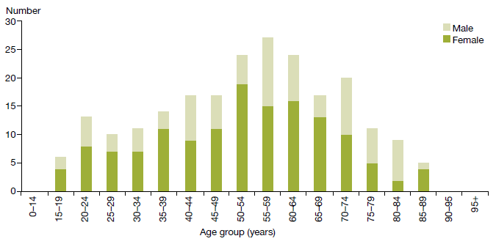
Source: PRIMHD data, extracted on 10 June 2016.

Ethnicity of people treated with electroconvulsive therapy
Table 8 suggests that Asian, Māori and Pacific peoples are less likely to receive ECT than those of other ethnicities. However, the numbers involved are so small that it is not statistically appropriate to compare the percentages of people receiving ECT in each ethnic group with the proportion of each ethnic group in the total population of New Zealand.

Table 8: Number of people treated with electroconvulsive therapy, by ethnicity, 1 January to 31 December 2015
Ethnicity | Number
Asian | 15
Māori | 15
Pacific | 6
Other | 189
Total | 225
Source: PRIMHD data, extracted on 10 June 2016.

Serious adverse events
District health boards report serious adverse events (SAEs) relating to clients of their mental health services to the Health Quality & Safety Commission (the Commission) in accordance with the requirements of the national reportable events policy. The Office of the Director of Mental Health collects information on SAEs involving people under the Mental Health Act, including deaths. Some DHBs dually report to both the Office and the Commission.

In summary, in 2015:
- mental health and addiction services reported 185 SAEs to the Commission
- 144 SAEs involved suspected suicide, 18 involved serious self-harm and 23 involved serious adverse behaviour
- mental health and addiction services reported 48 deaths of people under the Mental Health Act to the Director of Mental Health. Of these, nine people were reported to have died by suicide or suspected suicide, and 39 were reported to have died by other means, including natural causes.

The purpose of reporting of SAEs is to encourage DHBs to identify and review incidents with the aim of preventing similar events in the future. Ultimately, the reporting requirements exist to promote a reflective process for dealing with SAEs, helping to ensure better and safer health care for New Zealanders.
Serious adverse event reporting requirements help ensure better and safer mental health care for New Zealanders
In the time since the Commission took over the public reporting of all SAEs, the total number reported to the Commission has grown considerably. This growth is not necessarily because the frequency of SAEs has increased; it may reflect that DHBs have improved their reporting systems and cultures.

Table 9 shows a breakdown of mental health SAEs reported to the Commission during 2015, and Table 10 shows the number of SAEs reported by each DHB. It is important to note that comparisons between individual DHBs are problematic. High numbers may indicate that a DHB has a good reporting culture, rather than a significantly high number of SAEs. In addition, DHBs that manage larger and more complex or regional mental health services may report a higher number of SAEs.

There is some cross-over between events reported to the Commission and those reported to the Office of the Director of Mental Health. However, not all events reported through the Office are also reported to the Commission, due to differing reporting requirements.

Table 9: Number of serious adverse events reported to the Health Quality & Safety Commission, 1 January to 31 December 2015
Type of event | Community | Inpatient unit | On approved leave | Total
Suspected suicide | 140 | 3 | 1 | 144
Serious self-harm | 8 | 10 | 0 | 18
Serious adverse behaviour | 13 | 10 | 0 | 23
Total | 161 | 23 | 1 | 185
Source: Data reported to the Commission by DHBs.

Table 10: Number of serious adverse events reported to the Health Quality & Safety Commission, by district health board, 1 January to 31 December 2015
DHB | Number |  | DHB | Number
Auckland | 35 |  | Northland | 8
Bay of Plenty | 5 |  | South Canterbury | 3
Canterbury | 16 |  | Southern | 23
Capital & Coast | 13 |  | Tairāwhiti | 2
Counties Manukau | 6 |  | Taranaki | 0
Hawke’s Bay | 5 |  | Waikato | 14
Hutt Valley | 5 |  | Wairarapa | 1
Lakes | 4 |  | Waitemata | 19
MidCentral | 11 |  | West Coast | 10
Nelson Marlborough | 2 |  | Whanganui | 3
 |  |  | Total | 185
Source: Data reported to the Commission by DHBs.

The Commission’s Adverse Event Learning Programme is focusing on learning from review of adverse events including those in the mental health context. The Commission is updating its National Reportable Events Policy of 2012, and will share the updated version widely with the sector for discussion later this year.

Suicide Mortality Review Committee
Suicide is a major cause of death in New Zealand and the most common cause of death for young people. In September 2013, the Ministry of Health contracted the Commission to trial suicide mortality review, an action set out in the New Zealand Suicide Prevention Action Plan 2013–16 (Ministry of Health 2013a). This resulted in the establishment of the Suicide Mortality Review Committee within the Commission, and the Suicide Mortality Review Feasibility Study.

The Commission published the resulting reports, including recommendations, in May 2016 (see its website: www.hqsc.govt.nz/our-programmes/mrc/sumrc/publications-and-resources/publication/2471/). The Ministry of Health will use findings from the trial to develop its new Suicide Prevention Strategy and Action Plan.

Reportable deaths under the Mental Health Act
Section 132 of the Mental Health Act requires that the Director of Mental Health be notified within 14 days of the death of any person or special patient under the Mental Health Act, and that such notification identifies the apparent cause of death.

If the circumstances surrounding a death cause concern, the relevant DHB may initiate an inquiry. The Director of Mental Health can also initiate an investigation under section 95 of the Mental Health Act, and in rare cases the Minister or Director-General of Health can initiate an inquiry under section 72 of the New Zealand Public Health and Disability Act 2000. The Director of Mental Health has a role in ensuring that DHBs follow up on recommendations.

In 2015, the Director of Mental Health received notification of 48 deaths of people who were under the Mental Health Act at the time of death (see Table 11). Nine people were reported to have died by suicide or suspected suicide. The remaining 39 were reported to have died by other means, including by natural causes and illness unrelated to their mental health status.

Table 11: Outcomes of reportable death notifications under section 132 of the Mental Health Act, 1 January to 31 December 2015
Reportable death outcome | Number
Suicide | 0
Suspected suicide | 9
Other deaths | 39
Total | 48
Note: A person is recorded as having died by suicide when the coroner has made a finding of suicide.
Source: Office of the Director of Mental Health records

Death by suicide
Suicide is a serious concern for New Zealand. Around 500 New Zealanders die by suicide every year. Suicide affects the lives of many – families/whānau, friends, colleagues and communities.
Suicide affects the lives of many – families/whānau, friends, colleagues and communities
This section provides a brief overview of suicide deaths and deaths of undetermined intent among people who used specialist mental health services for 2013. This overview uses data from 2013 because it can take over two years for a coroner’s investigation into a suicide to be completed.

In summary, in 2013:
- 513 people died by suicide. A further 31 deaths of undetermined intent were recorded in the mortality database
- approximately 37 percent of those who died by suicide or undetermined intent (among those aged 10–64) were mental health service users
- mental disorders were a significant risk factor for suicidal behaviour
- males were more likely to complete suicide than females.

New Zealand’s national strategy to address suicide is the New Zealand Suicide Prevention Strategy 2006–2016 (Associate Minister of Health 2006). The New Zealand Suicide Prevention Action Plan 2013– 2016 (Ministry of Health 2013a) implements this strategy, and reflects the Government’s commitment to addressing New Zealand’s unacceptably high suicide rates.

The Government has allocated $25 million over four years to implement the Action Plan, which sets out 30 actions, including expanding existing services to make them more accessible and to support communities to prevent suicide.
New Zealand’s national strategy to address suicide is the New Zealand Suicide Prevention Strategy 2006–2016
The focus of this section is on people who died by suicide with a history of contact with specialist mental health (including AOD) services in the year prior to their death. People with no history of mental health service use in the year prior to death are referred to as ‘non-service users’ here, although it is acknowledged that some non-service users may have used mental health or AOD services at some earlier time in their lives.

Prevalence of suicide in the population
At the time the data was extracted, there were 513 suicides recorded in the mortality database for 2013. A further 31 deaths of undetermined intent were recorded, and are included in this report. Of this initial total of 544 deaths, 58 involved people aged 65 years and over. The following discussion excludes these deaths.

Table 12 sets out statistics on the remaining 486 deaths. Of these 486 people, 178 (37 percent) had had contact with specialist mental health services in the year prior to death. Mental disorders (in particular, mood disorders, substance use disorders and antisocial behaviours) are a significant risk factor for suicidal behaviour (Beautrais et al 2005).

Table 12: Number and age-standardised rate of suicide, by service use, people aged
10–64 years, 2013ª
 | Number | Age-standardised rate^{b}
Deaths due to intentional self-harm
Service users | 162 | 106.4
Non-service users | 296 | 7.5
Total | 458 | 11.6
Deaths of undetermined intent
Service users | 16 | 11.3
Non-service users | 12 | 0.3
Total | 28 | 0.7
Total deaths
Service users | 178 | 117.7
Non-service users | 308 | 7.8
Total | 486 | 11.8
Notes:
a Service user denominator excludes service users of unknown age.
b Age-standardised rate is per 100,000, standardised to the WHO standard population aged 0–64 years.
Source: Ministry of Health mortality database data, extracted on 14 June 2016.

Changes in number of suicides over time
Figure 30 shows the changes in the rates of suicide by service users and non-service users between 2001 and 2013.

Figure 30: Age-standardised rate of suicide, by service use, people aged 10–64 years,
2001–2013
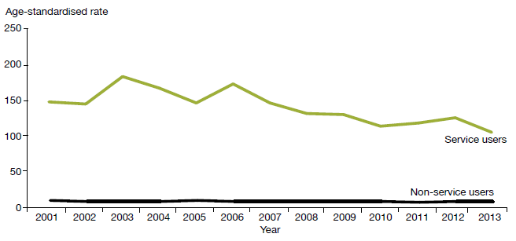
Notes:
Age-standardised rate is per 100,000, standardised to the WHO standard population aged 0–64 years.
The service user population is much smaller than the non-service user population, and will therefore produce rates more prone to fluctuation from year to year.
Source: Ministry of Health mortality database data, extracted on 14 June 2016.

Sex and age in relation to suicide
As Table 13 and Figure 31 show, 2.3 times as many males as females died by suicide in 2013. Thirty- seven percent of people who died by suicide in 2013 were service users. Of those service users who died by suicide in 2013, 36 percent were female and 64 percent were male.

Table 13: Number and age-standardised rate of suicide, by service use and sex, people aged 10–64 years, 2013ª
Sex | Service users^{b} |  | Non-service users |  | Total
 | Number | ASR | Number | ASR | Number | ASR
Male | 114 | 137.3 | 224 | 11.4 | 338 | 16.6
Female | 64 | 92.4 | 84 | 4.4 | 148 | 7.2
Total | 178 | 117.7 | 308 | 7.8 | 486 | 11.8
Notes:
ASR = age-standardised rate.
a Suicide includes deaths of undetermined intent. Age-standardised rate is per 100,000, standardised to the WHO standard population aged 0–64 years.
b Service user denominator excludes service users of unknown age.
Source: Ministry of Health mortality database data, extracted on 14 June 2016.

Figure 31: Age-specific rate of suicide, by age group, sex and service use, people aged
10–64 years, 2013
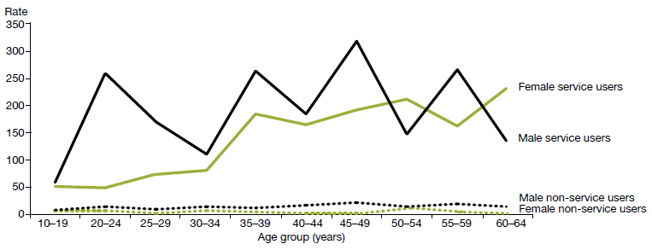
Source: Ministry of Health mortality database data, extracted on 14 June 2016.

As Table 14 shows, the rate of suicide among female service users was highest for those aged 60–64 years, at 230.5 per 100,000. The rate of suicide among male service users was highest for those aged 45–49 years, at 316.4 per 100,000.

When considering these numbers it is important to note that because these age-specific rates are derived from a small service-user population, they are highly variable over time.

For female non-service users, the rate of suicide was highest in those aged 50–54 years, at 11.1 per 100,000 ASR. For male non-service users, the rate of suicide was highest in those aged 45–49 years, at 23.3 per 100,000 ASR.

Table 14: Number and age-specific rate of suicide, by age group, sex and service use, people aged 10–64 years, 2013
Age group (years) | Service users |  |  |  | Non-service users
 | Female |  | Male |  | Female |  | Male
 | Number | ASR | Number | ASR | Number | ASR | Number | ASR
10–19 | 7 | 51.9 | 8 | 58.8 | 19 | 6.8 | 25 | 8.5
20–24 | 3 | 48.1 | 22 | 257.5 | 10 | 6.5 | 25 | 15.4
25–29 | 4 | 74.3 | 12 | 169.3 | 5 | 3.5 | 15 | 10.5
30–34 | 4 | 79.7 | 7 | 110.5 | 10 | 7.2 | 20 | 15.6
35–39 | 9 | 183.1 | 16 | 262.3 | 6 | 4.2 | 17 | 13.3
40–44 | 9 | 164.8 | 12 | 184.6 | 5 | 3.2 | 23 | 16.2
45–49 | 9 | 190.8 | 18 | 316.4 | 3 | 1.9 | 34 | 23.3
50–54 | 9 | 210.9 | 7 | 146.5 | 17 | 11.1 | 21 | 14.6
55–59 | 5 | 161.9 | 9 | 265.0 | 6 | 4.6 | 26 | 20.7
60–64 | 5 | 230.5 | 3 | 136.0 | 3 | 2.5 | 18 | 15.8
Note: Includes deaths of undetermined intent.
Source: Ministry of Health mortality database data, extracted on 14 June 2016.

Ethnicity and suicide
As Table 15 indicates, among people using mental health services in 2013, the age-standardised rate of suicide was higher for Māori (96.7 per 100,000 service users) than for Pacific peoples (55.7 per 100,000 service users). The age-standardised rate of suicide for those in the category of other ethnicities was 126.9 per 100,000 service users.

It should be noted that the suicide rate for Pacific peoples is highly variable over time.

Table 15: Number and age-standardised rate of suicide and deaths of undetermined intent, by ethnicity and service use, people aged 10–64 years, 2013
Ethnicity | Service users |  | Non-service users |  | Total
 | Number of deaths | ASR | Number of deaths | ASR | Number of deaths | ASR
Māori | 42 | 96.7 | 69 | 12.3 | 111 | 21.2
Pacific | 6 | 55.7 | 16 | 6.0 | 22 | 9.0
Other | 130 | 126.9 | 223 | 6.6 | 353 | 10.4
Total | 178 | 117.7 | 308 | 7.8 | 486 | 11.8
Note: ASR = age-standardised rate.
Source: Ministry of Health mortality database data, extracted on 14 June 2016.

Service users who died by suicide during 2013
During 2013, 178 service users died by suicide. Of this total, four died while an inpatient, eight died within a week of being discharged and 48 died within 12 months of discharge.

An overview of service users dying by suicide, 2001–2013
Over the 12-year period from 2001 to 2013, 2172 service users died by suicide. Of this total, 43 service users (2 percent) died while an inpatient, 157 (7 percent) died within a week of being discharged and 789 (36 percent) died within 12 months of discharge.

Of the 2172 service user suicides, 2138 people had received treatment from a specialist service community team in the 12 months before their death, and 492 had received treatment from a specialist AOD team in the 12 months before their death.

The Alcoholism and Drug Addiction Act
The Alcoholism and Drug Addiction Act 1966 (the ADA Act) provides for the compulsory detention and treatment of people with severe substance dependence for up to two years at certified institutions.

In summary, in 2015:
- the Family Court granted 59 orders for either detention or committal under the ADA Act
- 36 of the granted orders were for voluntary detention (under section 8) and 23 were for involuntary committal (under section 9).

In October 2009, the Prime Minister announced a review of the ADA Act as part of a range of initiatives to reduce harm from methamphetamine. The Law Commission released its report Compulsory Treatment for Substance Dependence: A review of the Alcoholism and Drug Addiction Act 1966 in October 2012 (New Zealand Law Commission 2012). In 2012, Parliament introduced a bill to repeal and replace the ADA Act.

Section 8 of the ADA Act allows a person who is dependent on alcohol or another drug to voluntarily apply to the Family Court for detention in a specified institution certified under the ADA Act (detention). Section 9 of the ADA Act applies when another person (such as a relative or the police) makes an application to the Family Court for the person to be committed to a specified institution certified under the ADA Act (committal). Section 9 applications must be accompanied by two medical certificates.

Table 16 details the outcomes of applications under the ADA Act to the Family Court since 2004, when the Ministry of Justice began to publish statistics on the use of the ADA Act. Table 17 shows the number of orders granted for detention under section 8 and for committal under section 9 of the ADA Act.

Table 16: Number of applications for detention and committal, by application outcome, 2004–2015
Application outcome | 2004 | 2005 | 2006 | 2007 | 2008 | 2009 | 2010 | 2011 | 2012 | 2013 | 2014 | 2015
Granted or granted with consent | 72 | 79 | 77 | 71 | 75 | 71 | 69 | 74 | 72 | 74 | 64 | 59
Dismissed or struck out | 5 | 3 | 4 | 1 | 2 | 3 | 3 | 1 | 2 | 3 | 4 | 2
Withdrawn, lapsed or discontinued | 3 | 9 | 2 | 6 | 1 | 4 | 9 | 5 | 9 | 9 | 7 | 2
Total | 80 | 91 | 83 | 78 | 78 | 78 | 81 | 80 | 83 | 86 | 75 | 63
Note: The table presents applications that were disposed at the time of data extraction at 16 May 2016.
Source: Ministry of Justice’s CMS. The CMS is a live operational database. Figures are subject to minor changes at any time.

Table 17: Number of granted orders for detention and committal, 2004–2015
Year | Number (percentage) of orders  granted for detention | Number (percentage) of orders  granted for committal | Total
2004 | 44 (92%) | 28 (85%) | 72
2005 | 49 (96%) | 30 (79%) | 79
2006 | 60 (98%) | 17 (77%) | 77
2007 | 52 (100%) | 19 (76%) | 71
2008 | 63 (98%) | 12 (86%) | 75
2009 | 49 (98%) | 22 (81%) | 71
2010 | 55 (96%) | 14 (58%) | 69
2011 | 59 (97%) | 15 (75%) | 74
2012 | 61 (97%) | 11 (58%) | 72
2013 | 58 (94%) | 16 (64%) | 74
2014 | 50 (94%) | 14 (64%) | 64
2015 | 36 (100%) | 23 (85%) | 59
Note: The table presents applications that were disposed at the time of data extraction on 16 May 2016.
Source: Ministry of Justice’s CMS. The CMS is a live operational database. Figures are subject to minor changes at any time.

Opioid substitution treatment
Opioid substitution treatment involves prescribing opioids such as methadone and buprenorphine with naloxone (Suboxone) as a substitute for illicit opioids. It is a well-established treatment that ensures that people with opioid dependence have access to comprehensive services that support them in their recovery. One of the key objectives of OST is to improve the physical and psychological health and wellbeing of the people who use opioids.

In summary, in 2015:
- the total number of people receiving OST at the end of 2015 was 5386
- of people receiving OST, 79 percent were New Zealand European, 14 percent were Māori, 1 percent were Pacific peoples and 6 percent were of another ethnicity
- approximately 28 percent of people receiving OST were being treated by a GP in a shared care arrangement.
OST is a well-established treatment that supports people with opioid dependence in their recovery
The Director of Mental Health is responsible for approving qualified practitioners to prescribe controlled drugs for the treatment of drug dependence under section 24 of the Misuse of Drugs Act 1975. For this purpose, the Director undertakes regular site visits, with an emphasis on building relationships and service quality improvement.

Achievements/service improvements

The Specialist Opioid Substitution Treatment Service Audit and Review Tool
The Specialist Opioid Substitution Treatment Service Audit and Review Tool sets out clinical audit requirements to ensure best treatment and services for clients and their family/whānau. The indicators against which the Ministry of Health audits services are drawn from two key documents:
- New Zealand Practice Guidelines for Opioid Substitution Treatment (Ministry of Health 2014)
- National Guidelines: Interim methadone prescribing (Ministry of Health 2007).

The Ministry of Health has initiated a rolling programme of audits of all OST services, to support the services in an ongoing programme of quality improvement.

A greater emphasis on managing co-existing medical and mental health problems and a continued focus on integration between primary and specialist services will be required (Ministry of Health 2012e) to ensure the best possible health outcomes for those receiving the service.

The aging population of OST clients
Opioid substitution treatment clients are an aging population; those over 45 years are the most likely to be receiving treatment.

Figure 32: Number of opioid substitution treatment clients, by age group, 2008–2015
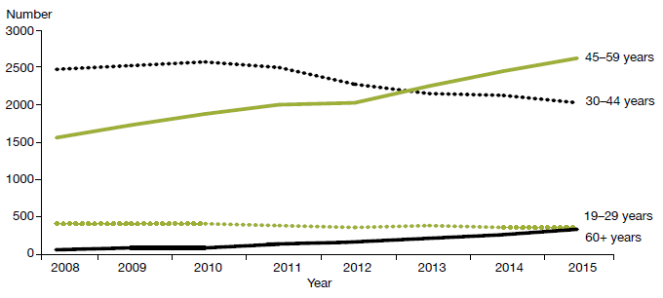
Source: Data provided by OST services in six-monthly reports.

Shared care with general practice
Opioid substitution treatment in New Zealand is provided by specialist addiction services and primary health care teams. Transferring care to a shared care arrangement with primary care offers a lot of benefits, including allowing specialist services to focus on those with the highest need and normalising the treatment process. Ensuring services are delivered seamlessly across providers will be an important focus going forward.

Corrections opioid substitution treatment shared care model
When a person receiving OST goes to prison, the system ensures that they continue to receive OST services there, including psychosocial support and treatment from specialist services.

Figure 33: Number of people receiving opioid substitution treatment from a specialist service, general practice or prison service, 2008–2015
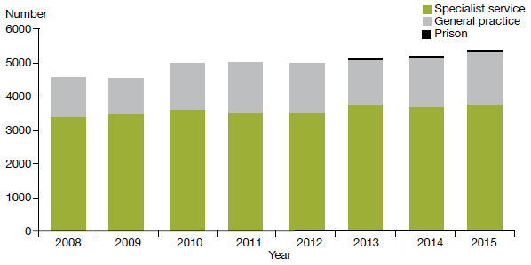
Source: Data provided by OST services in six-monthly reports.

Between 2014 and 2015, the number of clients accessing OST services increased by approximately 150. This growth is consistent with the previous year, when the increase was approximately the same level.

In 2015, 17 DHBs and one primary health organisation delivered OST services, thereby providing national coverage. The Ministry of Health’s target for service provision is 50:50 between primary and specialist care. Currently, across the country, general practice delivers approximately 28 percent of OST and specialist services approximately 70 percent.

Figure 34: Percentage of people receiving opioid substitution treatment from specialist services and general practice, by district health board, 1 January to 31 December 2015
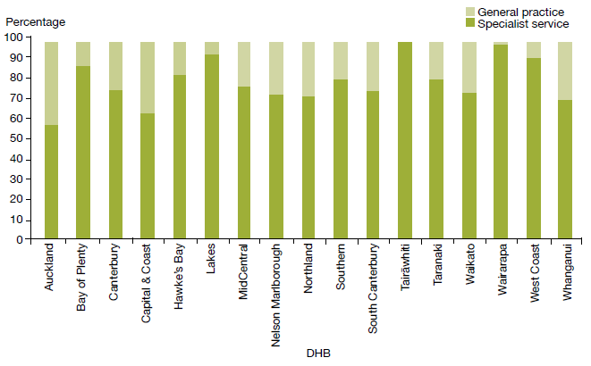
Source: Data provided by OST services in six-monthly reports.

Entry to and exit from opioid substitution treatment
Opioid substitution treatment is built on a model of recovery; it aims to assist people to stay well through building support structures that help them to define and achieve their goals. We can track a person’s entry to, involvement in and exit from OST to monitor their individual recovery.

At the end of 2015, there were 306 planned voluntary withdrawals from OST (86 percent of all withdrawals during 2015). This is consistent with the previous year’s figure. During 2015, there were 10 involuntary withdrawals (3 percent of all withdrawals). Involuntary withdrawals are generally a result of behaviour that may have jeopardised the safety of the individual or others. The number of involuntary withdrawals continues to decrease from year to year.
We can track a person’s entry to, involvement in and exit of OST to monitor their individual recovery

The remaining withdrawals during 2015 were due to deaths of service users. During that year, 41 people receiving OST from specialist treatment services died, from a range of causes. This figure is lower than the previous year’s. Of the 41, five deaths were likely a result of overdose related to the use of other substances. When a client dies of a suspected overdose, the Ministry of Health requires services to conduct an incident review and report on it to the Director of Mental Health.

Figure 35: Percentage of withdrawals from opioid substitution treatment programmes, by reason (voluntary, involuntary or death), 2008–2015
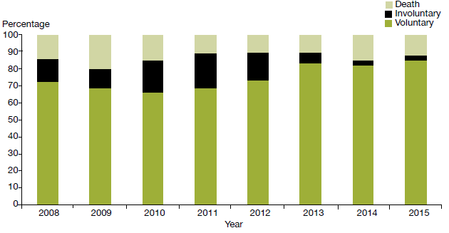
Source: Data provided by OST services in six-monthly reports.

Methadone and Suboxone prescribing
Since July 2012 PHARMAC has funded Suboxone for OST. Since then, there has been a steady increase in the number of people prescribed it. Suboxone lowers the risk of diversion, and its misuse is lower than that associated with methadone. In addition, Suboxone can be given in cumulative doses lasting several days, rather than the daily dosing regimen that is required with methadone.

Figure 36: Number of people prescribed Suboxone, 2008–2015
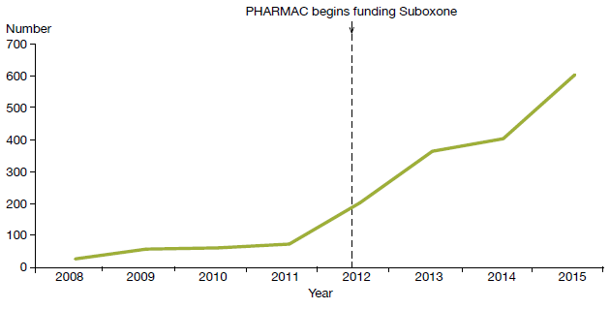
Source: Data provided by OST services in six-monthly reports.

References
American Psychiatric Association. 2001. The Practice of ECT: A task force report (2nd ed). Washington, DC: American Psychiatric Association.
Associate Minister of Health. 2006. New Zealand Suicide Prevention Strategy 2006–2016. Wellington: Ministry of Health.
Baker M. 2015. He kai I nga Rangatira: He korero o nga whānau whaiora. Wellington: Te Rau Matatini Ltd.
Beautrais AL, Collings SCD, Ehrhardt P, et al. 2005. Suicide Prevention: A review of evidence of risk and protective factors, and points of effective intervention. Wellington: Ministry of Health.
Department of Corrections. 2007. Over-representation of Māori in the Criminal Justice System: An exploratory report. Wellington: Department of Corrections.
Elder H, Tapsell R. 2013. Māori and the Mental Health Act. In J Dawson and K Gledhill (eds). New Zealand’s Mental Health Act in Practice. Wellington: Victoria University Press.
Huckshorn KA. 2005. Six Core Strategies to Reduce the Use of Seclusion and Restraint Planning Tool. Alexandria, VA: National Association of State Mental Health Program Directors.
Ministry of Health. 1996. Inquiry under Section 47 of the Health and Disability Services Act 1993 in Respect of Certain Mental Health Services. Wellington: Ministry of Health.
Ministry of Health. 2004. Use of Electroconvulsive Therapy (ECT) in New Zealand: A review of efficacy, safety, and regulatory controls. Wellington: Ministry of Health.
Ministry of Health. 2006. Review of the Application of Section 7A of the Mental Health (Compulsory Assessment and Treatment) Act 1992. Wellington: Ministry of Health.
Ministry of Health. 2007. National Guidelines: Interim methadone prescribing. Wellington: Ministry of Health.
Ministry of Health. 2009. Electroconvulsive Therapy (ECT) in New Zealand: What you and your family and whānau need to know. Wellington: Ministry of Health.
Ministry of Health. 2010. Seclusion under the Mental Health (Compulsory Assessment and Treatment) Act 1992. Wellington: Ministry of Health.
Ministry of Health. 2012a. Guidelines for the Role and Function of Directors of Area Mental Health Services. Wellington: Ministry of Health.
Ministry of Health. 2012b. Guidelines for the Role and Function of District Inspectors Appointed under the Mental Health (Compulsory Assessment and Treatment) Act 1992. Wellington: Ministry of Health.
Ministry of Health. 2012c. Guidelines for the Role and Function of Duly Authorised Officers under the Mental Health Act 1992. Wellington: Ministry of Health.
Ministry of Health. 2012d. Guidelines to the Mental Health (Compulsory Assessment and Treatment) Act 1992. Wellington: Ministry of Health.
Ministry of Health. 2012e. Rising to the Challenge: The Mental Health and Addiction Service Development Plan 2012–2017. Wellington: Ministry of Health.
Ministry of Health. 2013a. New Zealand Suicide Prevention Action Plan 2013–2016. Wellington: Ministry of Health.
Ministry of Health. 2013b. PRIMHD: Mental health data. URL: www.health.govt.nz/nz-health-statistics/national- collections-and-surveys/collections/primhd-mental-health-data (accessed 8 September 2016).
Ministry of Health. 2014. New Zealand Practice Guidelines for Opioid Substitution Treatment. Wellington: Ministry of Health.
Ministry of Health. 2015. Suicide Facts: Deaths and intentional self-harm hospitalisations 2012. Wellington: Ministry of Health.
Ministry of Health. 2016. New Zealand Health Strategy 2016–2026. Wellington: Ministry of Health.
New Zealand Law Commission. 2012. Compulsory Treatment for Substance Dependence: A review of the Alcoholism and Drug Addiction Act 1966. Wellington: New Zealand Law Commission.
Oakley Browne MA, Wells JE, Scott KM (eds). 2006. Te Rau Hinengaro: The New Zealand Mental Health Survey. Wellington: Ministry of Health.
Standards New Zealand. 2008a. Health and Disability Services (General) Standard. Wellington: Standards Council.
Standards New Zealand. 2008b. Health and Disability Services (Restraint Minimisation and Safe Practices) Standards. Wellington: Standards Council.

Appendix 1: Additional statistics

Section 95 inquiries
One section 95 inquiry was completed during 2015. Table A1 shows the number of completed section 95 inquiry reports received by the Director of Mental Health between 2003 and 2015.

Table A1: Number of completed section 95 inquiry reports received by the Director of Mental Health, 2003–2015
2003 | 2004 | 2005 | 2006 | 2007 | 2008 | 2009 | 2010 | 2011 | 2012 | 2013 | 2014 | 2015
1 | 2 | 1 | 4 | 1 | 1 | 3 | 2 | 1 | 1 | 0 | 0 | 1
Source: Office of the Director of Mental Health records

Section 50 long-leave, revocation and reclassification applications for special patients and restricted patients
Table A2 shows the numbers of section 50 long-leave, revocation and reclassification applications processed by the Office of the Director of Mental Health during 2015.

Table A2: Number of long-leave, revocation and reclassification applications for special patients and restricted patients, 1 January to 31 December 2015
Type of request | Number
Initial ministerial section 50 leave applications | 5
Initial ministerial section 50 leave applications not approved | 0
Ministerial section 50 leave revocations | 0
Further ministerial section 50 leave applications | 12
Further ministerial section 50 applications not approved | 0
Change of legal status applications approved | 8
Change of legal status applications not approved | 2
Total | 27
Source: Office of the Director of Mental Health records

Prisoner transfers to hospital
Table A3 shows the number of people transferred from prison to hospital under either section 45 or section 46 from 2001 to 2015.

Table A3: Number of people transferred to hospital from prison under sections 45 and 46 of the Mental Health Act, 2001–2015
Year | Number transferred compulsorily (s 45) | Number transferred voluntarily (s 46) | Total
2001 | 134 | 4 | 138
2002 | 96 | 0 | 96
2003 | 113 | 2 | 115
2004 | 121 | 1 | 122
2005 | 117 | 8 | 125
2006 | 128 | 16 | 144
2007 | 98 | 2 | 100
2008 | 80 | 2 | 82
2009 | 120 | 12 | 132
2010 | 105 | 11 | 116
2011 | 85 | 4 | 89
2012 | 84 | 3 | 87
2013 | 132 | 5 | 137
2014 | 80 | 6 | 86
2015 | 61 | 5 | 66
Source: Manual data provided by DHBs

The Mental Health Review Tribunal
During the year ended 30 June 2015, the Mental Health Review Tribunal received 156 applications under the Mental Health Act. Table A4 presents the types of applications received (by governing section) and the outcomes of these applications.

Table A4: Outcome of Mental Health Act applications received by the Mental Health Review Tribunal, 1 July 2014 to 30 June 2015
Outcome | Section 79 | Section 80 | Section 81 | Section 75 | Total
Deemed ineligible | 20 | 0 | 0 | 0 | 20
Withdrawn | 54 | 2 | 1 | 0 | 57
Held over to the next report year | 13 | 1 | 0 | 1 | 15
Heard in the report year | 58 | 6 | 0 | 0 | 64
Total | 145 | 9 | 1 | 1 | 156
Source: Annual Report of Mental Health Review Tribunal, 1 July 2014 to 30 June 2015

During the year ended 30 June 2015, the Tribunal heard 80 applications under section 79 of the Mental Health Act. Table A5 presents the results of those cases.

Table A5: Results of inquiries under section 79 of the Mental Health Act held by the Mental Health Review Tribunal, 1 July 2014 to 30 June 2015
Result | Number
Not fit to be released from compulsory status | 57
Fit to be released from compulsory status | 5
Total | 62
Source: Annual Report of Mental Health Review Tribunal, 1 July 2014 to 30 June 2015

Table A6 shows the ethnicity of the 137 people for whom ethnicity was identified in an application to the Tribunal in the year ended 30 June 2015.

Table A6: Ethnicity of people who identified their ethnicity in Mental Health Review Tribunal applications, 1 July 2014 to 30 June 2015
Ethnicity | Number | Percentage
New Zealand European | 93 | 68
Māori | 31 | 23
Pacific | 5 | 4
Asian | 6 | 4
Other | 2 | 1
Total | 137 | 100
Source: Annual Report of Mental Health Review Tribunal, 1 July 2014 to 30 June 2015

Of the 156 Mental Health Act applications received by the Tribunal during the year ended 30 June 2015, 93 (60%) were from males and 63 (40%) from females. Table A7 presents these figures.

Table A7: Gender of people making Mental Health Review Tribunal applications, 1 July 2014 to 30 June 2015
Subject of application | Total number (percentage) | Gender | Number
Community treatment order | 111 (71%) | Female | 42
 |  | Male | 69
Inpatient treatment order | 35 (22%) | Female | 20
 |  | Male | 15
Special patient order | 9 (6%) | Female | 1
 |  | Male | 8
Restricted person order | 1 (1%) | Female | 0
 |  | Male | 1
Source: Annual Report of Mental Health Review Tribunal, 1 July 2014 to 30 June 2015

Ministry of Justice statistics
Table A8 presents data on applications for a compulsory treatment order from 2004 to 2015. Table A9 shows the types of orders granted over the same period.

Table A8: Applications for compulsory treatment orders (or extensions), 2004–2015
Year | CTO or extension to a CTO | Granted, or granted with consent | Dismissed or struck out | Withdrawn, lapsed or discontinued | Transferred to the High Court
2004 | 4423 | 3863 | 100 | 460 | 0
2005 | 4302 | 3682 | 100 | 520 | 0
2006 | 4268 | 3643 | 109 | 515 | 1
2007 | 4557 | 3916 | 99 | 542 | 0
2008 | 4557 | 3969 | 103 | 485 | 0
2009 | 4586 | 4038 | 54 | 494 | 0
2010 | 4754 | 4156 | 74 | 523 | 1
2011 | 4801 | 4215 | 70 | 516 | 0
2012 | 4857 | 4343 | 71 | 443 | 0
2013 | 5058 | 4580 | 68 | 410 | 0
2014 | 5237 | 4617 | 47 | 573 | 0
2015 | 5344 | 4745 | 52 | 547 | 0
Notes:
The table presents applications that had been processed at the time of data extraction on 16 May 2016. The year is determined by the final outcome date.
CTO = compulsory treatment order.
Source: Ministry of Justice’s Integrated Sector Intelligence System, which uses data entered into the CMS. The CMS is a live operational database. Figures are subject to minor changes at any time.

Table A9: Types of compulsory treatment orders made on granted applications, 2004–2015
Year | Number of granted applications for orders | Compulsory community treatment orders (or extension) | Compulsory inpatient treatment orders (or extension) | Both compulsory community and inpatient treatment orders (or extension) | Type of order not recorded
2004 | 3863 | 1832 | 1534 | 117 | 380
2005 | 3682 | 1576 | 1439 | 92 | 575
2006 | 3643 | 1614 | 1384 | 91 | 554
2007 | 3916 | 1716 | 1336 | 116 | 748
2008 | 3969 | 1841 | 1429 | 120 | 579
2009 | 4038 | 2085 | 1564 | 106 | 283
2010 | 4156 | 2238 | 1614 | 107 | 197
2011 | 4215 | 2255 | 1677 | 90 | 193
2012 | 4343 | 2428 | 1680 | 76 | 159
2013 | 4580 | 2630 | 1749 | 69 | 132
2014 | 4617 | 2651 | 1781 | 79 | 106
2015 | 4745 | 2805 | 1793 | 62 | 85
Notes:
The table presents applications that had been processed at the time of data extraction on 16 May 2016. The year is determined by the final outcome date.
Where more than one order type is shown, it is likely to be because new orders are being linked to a previous application in the CMS.
Source: Ministry of Justice’s Integrated Sector Intelligence System, which uses data entered into the CMS. The CMS is a live operational database. Figures are subject to minor changes at any time.

Appendix 2: Caveats relating to the Programme for the Integration of Mental Health Data
The Programme for the Integration of Mental Health Data, or PRIMHD (pronounced ‘primed’), is the Ministry of Health’s national collection for mental health and addiction service activity and outcome data for mental health consumers. PRIMHD data is used to report on what services are being provided, who is providing the services, and what outcomes are being achieved for health consumers across New Zealand’s mental health sector. These reports enable mental health and addiction service providers to undertake better quality service planning and decision-making, at the local, regional and national levels (Ministry of Health 2013b). PRIMHD reports are invaluable for facilitating important conversations and debates about mental health issues in New Zealand.

In 2008, DHB reporting to PRIMHD became mandatory. In addition, from this date an increasing number of non-governmental organisations (NGOs) began reporting to the PRIMHD database. As of December 2015, 223 NGOs were reporting to PRIMHD.

Because of both its recent introduction and the enormous complexities of creating and maintaining a national data collection, the following caveats need to be kept in mind when reviewing statistics generated using PRIMHD data.
- Shifts or patterns in the data after 2008 may reflect the gradual adaptation of service providers to the PRIMHD system, in addition to, or instead of, any trend in mental health service use or consumer outcomes.
- PRIMHD is a living data collection, which continues to be revised and updated as data reporting processes are improved. For this reason, previously published data may be liable to amendments.
- Statistical variance between services may reflect different models of practice and different consumer populations. However, inter-service variance may also result from differences in data entry processes and information management.
- To function as a national collection, PRIMHD requires integration with a wide range of person management systems across hundreds of unique service providers. As the services adjust to PRIMHD, it is expected that the quality of the data will improve.
- The quality and accuracy of statistical reporting relies on consistent, correct and timely data entry by the services that report to PRIMHD.
- The Ministry of Health is actively engaged in a continuing project to review and improve the data quality of PRIMHD. This project is considered a priority given the importance of mental health data in providing information about mental health consumption and outcomes, and in generating conversations and public debate about how to improve mental health care for New Zealanders.

Data from 2013 is used because it can take over two years for a coroner’s investigation into a suicide to be completed.
More information on the Ministry’s work in the areas of mental health, depression and suicide prevention can be found at www.health.govt.nz/our-work/mental-health-and-addictions
Excluding people seen by addiction services only, the total number of people who engaged with a specialist mental health service was 161,934. Source: PRIMHD data.
Between 2011 and 2015, the total New Zealand population increased by approximately 5.5 percent.
The figure in each case excludes those who accessed a mixture of inpatient and community services.
The Ministry is able to share this information with other health services under specific health information privacy laws and regulations.
The average rating for this statement in the real-time survey was 4.08 out of 5, where 4 is ‘agree’ and 5 is ‘strongly agree’.
Note that the equivalent figure in the 2014 report would be 5.9% if it was calculated to exclude clients seen by an addiction service only (not by a mental health service) as is the case for the 6.1% in this year’s report. The 7.4% figure included in the 2014 report was based on a denominator that excluded clients seen by both mental health and addiction services.
Mental Health Act sections 11, 13, 14(4), 15(1), 15(2), 29, 30 and 31. It should be noted that some legal status statistics for 2015 are over-counted due to a known data issue when reporting transfers between DHBs. This over count is estimated to affect less than 1% of the legal status records used to collate the statistics published in this report.
Data extracted from the Ministry of Justice’s Case Management System as at 16 May 2016.
Source: PRIMHD data, extracted on 10 June 2016.
Source: PRIMHD data, extracted on 10 June 2016, except for data from Capital & Coast DHB, which was supplied manually.
Source: PRIMHD data, extracted on 10 June 2016, except for data from Capital & Coast and Counties Manukau DHBs, which was supplied manually. ‘On a given day’ is the average of the last day of each month.
This is a specific action outlined in Rising to the Challenge (Ministry of Health 2012e). In addition, the number of Māori subject to section 29 of the Mental Health Act is now an indicator for reporting in the Māori Health Plans the Ministry of Health requires every DHB to produce.
These ratios are based on the age-standardised rates of the Māori and non-Māori populations.
Source: PRIMHD data, extracted on 10 June 2016. This applies to both voluntary service users and those treated under the Mental Health Act.
Source: PRIMHD data, extracted on 10 June 2016.
The Ministry’s leadership of action 9(d) of the Disability Action Plan 2014–18, to ‘explore how the Mental Health Act relates to the New Zealand Bill of Rights Act and the Convention on the Rights of People with Disabilities’ is expected to meaningfully contribute to this conversation.
Adult mental health services generally care for people aged 20–64 years. Adult inpatient services are distinct from forensic services, youth services, intellectual disability services and services for older people.
Source: PRIMHD data, extracted on 10 June 2016. Capital & Coast, Hutt Valley and Lakes DHBs supplied data manually.
Source: PRIMHD data, extracted on 10 June 2016. Capital & Coast, Hutt Valley and Lakes DHBs supplied data manually.
Source: PRIMHD data, extracted on 10 June 2016. Capital & Coast, Hutt Valley and Lakes DHBs supplied data manually.
Of the 121 young people secluded, 40 were secluded in the country’s specialist facilities for children and young people (in Christchurch, Auckland and Wellington). Of the 289 seclusion events, 115 occurred in those specialist facilities.
If a person in Wairarapa requires admission to mental health inpatient services, they are transported to Hutt Valley or MidCentral DHB; seclusion statistics in relation to these service users appear on the corresponding DHB’s database.
The Whanganui inpatient unit comes under the Central region’s forensic services.
The Ministry intends to publish data on the use of seclusion in forensic units and intellectual disability units separately in future annual reports.
The table presents data by DHB of domicile; that is, the area where a person lives. This takes account of the fact that some DHBs do not perform ECT; people who live in such areas are referred to other DHBs for ECT treatment. Other ECT statistics are presented by DHB of service.
This psychiatrist must be independent of the person’s clinical team.
Refer to the Guidelines to the Mental Health (Compulsory Assessment and Treatment) Act 1992 (Ministry of Health 2012d).
For more information on reporting, see the Commission’s website (www.hqsc.govt.nz).
Any suicides or suspected suicides of people under the Mental Health Act also come under the SAE reporting requirements of the HQSC.
These numbers are subject to change. The mortality database is a dynamic collection, and changes can be made even after the data is considered nominally final.
This is because in the Central and Southern regions, older people’s mental health treatment was provided by health services for older people rather than mental health services and was not necessarily recorded in PRIMHD. Each year, deaths of children under 10 years are also excluded because undetermined-intent deaths in this age group are unlikely to be caused by suicide, though in 2013 there were no such deaths. The data was drawn from information provided to the Ministry’s national mortality database and PRIMHD.
The term ‘gender’ has been used for all other reporting measures in this report. However, the mortality database uses ‘sex’ in relation to suicide statistics, and this section follows that convention.
This figure is determined from the number of people who had an inpatient activity on the day they died; the approach considers that these people were still in the context of an inpatient unit on the day of their death. Note that these figures should not be compared to those of previous Annual Reports, as the definitions of inpatient and community service users have been updated.
Excluding those who received treatment on the day of their death.
Excluding those who received treatment on the day of their death and those who died within a week of being discharged from an inpatient service.
Includes deaths of undetermined intent.

