|  |  |
| --- | --- |
| New Zealand Spinal Cord Impairment Action Plan | The best possible health and wellbeing outcomes for people with spinal cord impairment are achieved, which enhances their quality of life and ability to participate in society |

Citation: New Zealand Spinal Cord Impairment Action Plan 2014–2019.  
Wellington, ACC and the Ministry of Health.

Published in June 2014 by ACC and the Ministry of Health  
Wellington 6145, New Zealand

ISBN 978-0-478-42812-4 (print)  
ISBN 978-0-478-42813-1 (online)

This document is available at [www.health.govt.nz](http://www.health.govt.nz) and www.acc.co.nz

Contents

Why New Zealand needs an Action Plan 3

Introduction 3

Definitions and scope 4

Development approach 4

What we aim to do 5

Vision 5

Purpose 5

Principles 5

Implementation and governance 7

OBJECTIVE 1:  
Improve acute clinical outcomes for adults requiring acute SCI care 9

OBJECTIVE 2:  
Improve outcomes for children and adolescents 12

OBJECTIVE 3:  
Improve information sharing 15

OBJECTIVE 4:  
Provide nationally consistent SCI rehabilitation services and extend community-based rehabilitation 18

OBJECTIVE 5:  
Review and align the Ministry and ACC processes for access to equipment, housing modifications and transport 23

OBJECTIVE 6:  
Develop peer support services 26

OBJECTIVE 7:  
Build health and disability workforce capability 28

OBJECTIVE 8:  
Support improvements for carers taking a cross-agency approach 31

APPENDIX 1:  
Draft national acute destination guidelines and draft national acute referral guidelines 32

APPENDIX 2:  
Draft acute SCI pathway with DHBs and ambulance services 34

APPENDIX 3:  
Draft SCI pathway developed for children and adolescents 35

Acknowledgement

ACC and the Ministry of Health would like to thank the many people who have contributed to the development of this Action Plan and willingly shared their time, personal experience and vast wealth of knowledge. The input of many individuals and organisations with personal and professional experience of spinal cord impairment has been vital in shaping this Action Plan.

# Why New Zealand needs an Action Plan

## Introduction

### Complexity

Spinal cord impairment (SCI) is rare but complex. Every year in New Zealand approximately 80 to 130 people are diagnosed with SCI through injury or medical/congenital causes. This affects their lives and those of many others, especially their families and whānau. SCI can occur at any age from birth, during childhood or as an adult. Due to medical advancements most people living with SCI now have a near normal life expectancy, but this brings with it progressive complexity for people and their lifelong self-management.

### Coordination

The management of SCI is both complex and challenging. It requires a specialised multidisciplinary and coordinated approach across the continuum from initial presentation, assessment and diagnosis, through to life in the community.

In New Zealand, the current model of care for medical interventions and lifelong supports is fragmented and needs better coordination. Variable and inconsistent approaches to accessing services do not deliver the best health, wellbeing or life expectancy outcomes for people with SCI. This also increases the cost of providing care and services over a person’s lifetime.

### Opportunities for improvement

Delivery of services and supports plays an important role in determining the quality of day-to-day life. The best outcomes are achieved when a person is treated as an individual. Services and supports are then tailored to meet their physical and emotional needs, taking the personal situation and context into full account.

A recent review of health and disability services identified opportunities for improvements that will result in better outcomes, not only for the person with SCI but also for their family and whānau.[1] Many of these improvements can be achieved with better coordination and refinement of existing services and supports.

### Life outcomes

Changing the way we use the system will deliver improved outcomes for people with SCI and their families. A national plan and an approach that optimises and coordinates resources will reduce lifetime costs by focusing on early and timely interventions. Improving the coordination of services that support people with SCI will enhance health outcomes and maximise quality of life.

## Definitions and scope

There are varying definitions of SCI and medical coding which make its incidence difficult to determine accurately. For this New Zealand SCI Action Plan 2014–2019 (Action Plan), SCI has been defined as a compromise of the spinal cord as a result of traumatic insult, vascular disruption or a disease process that may be immediate or insidious in onset. The consequence is a significant loss or reduction in voluntary motor function, sensory deprivation and disruption of autonomic function related to the level and severity of the cord damage.[2]

This Action Plan should be used to benefit people of all ages with acquired (i.e. traumatic or medically acquired) or congenital SCI where there are neurological deficits.

## Development approach

This Action Plan was developed by the Accident Compensation Corporation (ACC) and the Ministry of Health (the Ministry) in collaboration with a wide range of stakeholders across the health system including consumer groups, professional bodies, expert clinicians, district health boards (DHBs) and researchers. It should be used as the basis for more detailed plans that will be developed and implemented by the lead agencies identified.

The approach outlined in this Action Plan aims to improve the health and wellbeing of people with SCI, promote independence and community participation, and support their family/whānau or significant others who may be assisting with supports and care.

Initiatives in the plan do not stand alone. They link with several other work programmes and initiatives across government that share a focus on strengthening services, supports and workforce capability.

These programmes include:

* Whānau Ora – building whānau resilience and developing whānau solutions to whānau needs
* workforce development – development of enhanced qualifications for people in the home and community workforce and rehabilitation sector
* Disability Action Plan – various initiatives align with those in the Disability Action Plan[3]
* Disability Workforce Action Plan  
  2013–2016
* National Trauma Network developments
* peer support developments
* New Zealand Carer’s Strategy Action Plan.

The development of this Action Plan recognises that a focus on SCI is a national health priority.

# What we aim to do

## Vision

The best possible health and wellbeing outcomes for people with SCI are achieved, which enhances their quality of life and ability to participate in society.

## Purpose

The overarching purpose of this Action Plan is to support people with SCI by:

* maximising opportunities for optimal improvements and maintenance of function
* reducing risks of complications and physical and mental wellbeing deterioration in the short and long term
* enabling independence and community participation
* supporting family, whānau, carers and employers who help people with SCI.

## Principles

All activities undertaken as part of this plan have been guided by the following eight principles:

1. Services and supports will have a person-centred focus and include family and whānau needs where related (Whānau Ora – wellbeing model).

2. Services and supports will improve the consistency and quality of services to maximise outcomes for people with SCI and their family and whānau.

3. Services and supports will be evidence based and use agreed approaches to service development and delivery.

4. Future service monitoring, evaluation and improvement will include benchmarking.

5. The Action Plan will foster strong clinical leadership.

6. The Action Plan will guide the purchase of high-quality services that represent value for money.

7. The Action Plan will improve access to services for people with SCI to the maximum extent possible.

8. The Action Plan will help in planning for future needs for people with SCI of all ages across a five-year period (or longer if it is needed to inform capital and other planning processes).

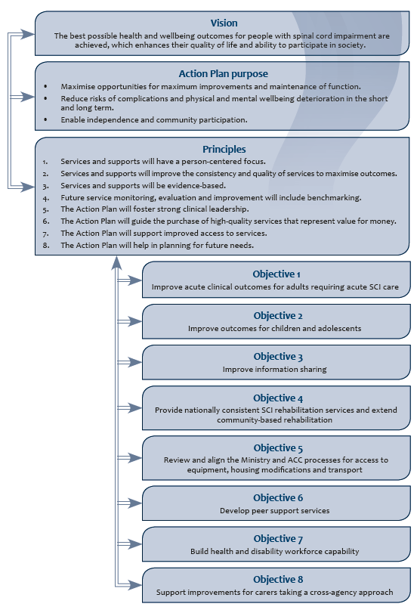

# Implementation and governance

ACC and the Ministry will continue to progress the work on the Action Plan. This will include keeping up to date with national and international research developments, both clinical and non-clinical.

Many agencies need to be involved and provide leadership to achieve a coordinated approach. These include DHBs, a range of service providers, peer support agencies and the Ministry of Social Development (MSD).

The process for overseeing and evaluating implementation shall include reviewing whether specific outcome measures in addition to those already collected will be required.[4] This will form part of a monitoring framework that will assess and report on the implementation of the actions in this Action Plan. Emphasis will also be placed on a range of process and quality measures.[5]

A national governance group for SCI services will be established by ACC and the Ministry. This group comprising service managers, senior clinical lead and community representatives across SCI services will initially be derived from the current National Quality Forum Group that

meets twice a year.[6] The group will provide national direction for SCI services, monitor quality and continue to promote innovation. It will meet a minimum of twice a year.

Immediate priorities for the first year of implementation are to:

* establish a national governance group for SCI services
* implement an acute pathway for adult SCI services including a single point of coordination
* establish clinical leadership by Starship Hospital for children’s acute services
* start planning to establish a national paediatric rehabilitation service
* pilot two SCI registries via Canterbury DHB
* pilot shared care plans via Counties Manukau DHB
* progress work to introduce an equipment and asset transfer process between the Ministry and ACC
* progress workforce development actions consistent with this Action Plan and the Disability Workforce Action Plan.

Objectives are described in the following section, together with examples of how the work will translate into improving outcomes for people with SCI. Actions for future years are signalled, but may be subject to revision following the introduction of changes identified as immediate priorities.



OBJECTIVE

Improve acute clinical  
outcomes for adults  
requiring acute SCI care

**OBJECTIVE 1:**Improve acute clinical outcomes for adults requiring acute SCI care

I was rescued from a beach after breaking my neck surfing. The paramedic spoke with the spinal doctor from the specialist unit while I was still on the beach because I couldn’t move or feel my legs. They decided to helicopter me up to the unit. I was there within about an hour of the injury where I received specialist care from doctors, nurses and physiotherapists. A social worker was on hand to talk with me and my family. We were kept informed and I was transferred to the spinal rehabilitation unit a few days after having had surgery, able to fully participate in the rehabilitation programme.

### Action areas

Develop a national model under which two supra-regional acute adult services operate.[7]

Where there is clinical evidence of isolated SCI, specify a single point for coordination of care in the acute SCI pathway.

Where there is confirmed SCI, either in isolation or in association with major trauma elsewhere in the body, early contact is made with the relevant acute adult service and a transfer arranged at a clinically appropriate time.

### Outcomes

Decision-making will be improved to ensure a person with an acute SCI receives the best possible care in the timeliest fashion.

A coordinated, integrated national service is provided at two sites, thus improving patient outcomes with fewer medical secondary complications, faster transfers to rehabilitation, reduced overall length of stay and lower mortality rates.

There will be improved use and capability of the workforce through concentrating low-volume, high-complexity patients within each supra-regional acute SCI service.

|  |  |  |
| --- | --- | --- |
| Actions | | Lead agencies |
| Establish formal protocols, systems and processes to ensure acute management of people with isolated SCI occurs in one of the two regional supra-regional acute SCI services.  Establish formal protocols, systems and processes to ensure that patients with SCI in association with major trauma to other body regions are transferred at the earliest practicable time to one of the two supra-regional acute SCI services.  Establish a process that allows for the on-call SCI clinician at the acute supra-regional service to provide advice to paramedics and/or regional clinicians about immediate transport of isolated SCI patients.[8]  The disposition of multi-trauma patients with SCI will be discussed with regional spinal specialists prior to transfer.  For multi-trauma patients, National Ambulance Services triage and transfer guidelines will be guided by best clinical practice as defined by clinical specialists.  SCI experts based in the two supra-regional spinal units provide expert care and management advice on SCI to other health professionals and service providers.  Ratify the draft national acute destination guidelines and draft national acute referral guidelines.[9] These will be consistent with regional transfer guidelines.  Ratify the draft acute SCI pathway with DHBs and ambulance services.[10]  Implement guidelines and pathways through policy and education. | | CMDHB,[11] CDHB,[12] MTNCN,[13] National Ambulance Service Sector Office |
| Ensure the two acute supra-regional SCI services are equivalent and consistent in the delivery of services under a national model.  Ensure equitable treatment and early rehab pathways are developed in conjunction with regional centres for patients with multi-trauma who cannot be safely transferred to a supra-regional SCI service.  Ensure that acute clinical services are equitably and readily accessible for optimal ongoing management of multi-trauma patients with SCI once they are transferred to the supra- regional SCI service.  Agree standards (e.g. Consortium for Spinal Cord Medicine Clinical Practice Guidelines) and performance measures to govern the way care is delivered within the acute supra- regional SCI services and regions to ensure a national approach.  Audit the delivery of care to ensure it is of a consistently high standard across the supra- regional SCI services and regional trauma centres where multi-trauma patients with SCI are initially treated. | | CMDHB, CDHB |
| Timing | Implementation starts in July 2014.  Implementation completed by October 2014. | |



OBJECTIVE

Improve  
outcomes for  
children and  
adolescents

**OBJECTIVE 2:**  
Improve outcomes for children and adolescents

My child developed an infection of the spinal cord. The paediatrician at our local hospital talked with Starship and we were transferred there straight away. Rehabilitation started at Starship before we were transferred to the Wilson Centre where a full rehabilitation programme was put in place.14 The plan included our local hospital so we could get back home as soon as possible.  
The local hospital has been working with our school as well as keeping in contact with the Wilson Centre. We will be returning to the  
Wilson Centre for a reassessment in a few weeks.

### Action areas[14]

Improve acute clinical outcomes for children and adolescents requiring acute SCI care by ensuring Starship Children’s Hospital leads the clinical management.

Improve outcomes for children and adolescents with SCI through the provision of a national paediatric rehabilitation service (hub and spoke model) that has a focus on early discharge home.

Use existing local services better to achieve rehabilitation goals for a child or adolescent following discharge from the Starship (National) Rehabilitation Service.

Establish processes to ensure children and adolescents with SCI receive appropriate follow-up and onward services to maximise their rehabilitation and habilitation potential.

Establish a transition process for adolescents when the management of their on-going rehabilitation and habilitation needs are transferred to a specialist spinal rehabilitation service for adults.

### Outcomes

Care is delivered at the right time by the right personnel in the correct care setting with fewer medical secondary complications, faster transfers to rehabilitation, reduced overall length of stay and lower mortality rates.

The complex rehabilitation needs of children and adolescents and their families are met through a coordinated, competent interdisciplinary team with a holistic approach to maximise function and participation.

Children and adolescents are discharged to their own community and local paediatrician as soon as possible. They receive community-based rehabilitation as part of the paediatric service, providing a developmentally appropriate and integrated approach.

There is sharing of knowledge and mutual development of policies, procedures, guidelines and protocols, thus strengthening services and linking paediatric health professionals (including school and private therapists).

Children and adolescents continue to maximise their rehabilitation potential as they develop and avoid preventable secondary complications through a regular reassessment programme.

Adolescents with SCI (irrespective of cause) transitioning to adulthood have their specific on‑going health and independence needs met through the appropriate service.

Optimal use and capability of the workforce.

|  |  |  |
| --- | --- | --- |
| Actions | | Lead agencies |
| Develop and implement a plan for nationally consistent pathways across the continuum (acute care through to living in the community, participating in school and transitioning to adult services) within a hub and spoke model. | | ADHB,[15] WDHB,[16] NZ Paediatric Society |
| **Acute management**  Establish and implement formal protocols,[17] systems and processes to ensure the acute management of all children and adolescents with SCI are managed in conjunction with Starship Children’s Hospital.  Ratify the acute component of the draft SCI pathway developed for children and adolescents with DHBs and retrieval (air and land) services.[18] | | ADHB |
| Ensure equitable treatment and early rehabilitation pathways are developed in conjunction with regional centres for children with multi-trauma until they can be safely transferred to Starship Children’s Hospital. | | ADHB, WDHB, NZ Paediatric Society |
| **Rehabilitation**  Ratify the rehabilitation component of the draft SCI pathway developed for children and adolescents with DHBs.[19] | | The Ministry |
| Describe requirements of the paediatric rehabilitation service in a specification linked to the services for children and young peoples service specification on the national service framework.  Develop a Starship (national) rehabilitation service which will become the national centre of excellence for children and adolescents rehabilitation,[20] including developing an outreach service and processes for reassessment. | | ADHB, WDHB, NZ Paediatric Society |
| Formalise and implement a process for transitioning adolescents from paediatric services to adult SCI rehabilitation services. | | ADHB, WDHB, CMDHB, CDHB |
| **Knowledge and information sharing**  Establish a paediatric rehabilitation clinical network or similar mechanism through the New Zealand Paediatric Society to:   * improve linkages between school therapy services, child development services, the local paediatrician and other providers including ACC providers (e.g. specialised wheelchair and seating services) in supporting the rehabilitation programme * develop processes and guidelines that assist local clinicians to confidently contribute to and implement a rehabilitation plan * influence allocation of rehabilitation resources within DHBs. | | NZ Paediatric Society, the Ministry, ACC |
| Timing | Acute actions areas implementation by July 2014.  Rehabilitation action areas approved by June 2014.  Rehabilitation action areas staged implementation starts by December 2014. | |



OBJECTIVE

Improve information sharing

**OBJECTIVE 3:**Improve information sharing

Having a registry  
Collecting and using information will contribute to improved outcomes for people with SCI. If we know the incidence and prevalence of SCI we can plan to ensure services are sustainable. We can also identify areas for improvement in services and contribute to a national and international research effort to improve outcomes for people with SCI.

Benefits of an e-shared care plan  
When I was nearing discharge from the spinal rehabilitation service I was involved in developing an e-shared care plan with the team. This electronic plan describes my support needs and other information which might be vital  
if I was admitted into hospital or became unwell. It saves me having to repeat information or worrying that people do not have the right information about  
my support needs and goals I am working towards. The e-shared care plan lets my GP share information with the spinal rehabilitation unit and also helps keep track of when I need to be recalled for a reassessment at the unit. I can also look at the e-shared care plan and assist with updating it. The shared care plan helped link aspects of my discharge plan such as vocational rehab and housing modifications so we knew what was going to happen and when.

### Action areas

#### Registry:

Implement a pilot to test whether the capture and reporting of SCI data in New Zealand will optimise the quality and consistency of care delivered, both acutely and within spinal rehabilitation services.

Establish a registry for SCI that will provide nationally relevant and internationally comparable data to inform quality improvement and research objectives.

#### e-shared care plans:

Pilot and then introduce shared care plans for people with SCI.

### Outcomes

The requirements of an SCI registry are met. The feasibility and costs for establishing and maintaining this registry will be determined through a pilot.

National data collected will provide a baseline and enable measurement of the incidence and prevalence of SCI.

e-shared care plans provide a mechanism for patient- centred goal setting, improved information sharing, and supporting the delivery of multidisciplinary services (enabling alerts to non-related services and supporting reassessment recalls).

|  |  |  |
| --- | --- | --- |
| Actions | | Lead agencies |
| **Registry**  Feasibility pilot of the Rick Hansen and Victorian ICF[21] registries at Burwood Spinal Unit to:   * test workflow processes, the interface and data transfer between other programmes including the NZ Trauma Registry and the usefulness of the data collections for research, quality improvement and/or clinical management * identify processes and costs associated with manual and automated data collection, including potential extracts and the use of Concerto[22] * identify capacity for routine monitoring that contributes to data collection * consider implications for AROC data collections * recommend a national approach for the implementation of a registry.   Use recommendations from the registry pilot to develop and implement a national registry. Build interfaces for data transfer between registries that collect duplicate information. | | CDHB, BAIL,[23] ACC |
| **e-shared care plans**  Pilot shared care plans at the Auckland Regional Spinal Unit to:   * test e-shared care planning systems and processes, including how they can support the client, and services provided in primary care, the community and other DHBs * explore the use of shared care plans to allow for more proactive health engagement over a person’s lifetime regardless of the setting, including access to their clinical records * identify the systems and processes from the pilot that are required for national implementation of e-shared care for all SCI clients.   Use recommendations from the e-shared care plan pilot to implement e-shared care plans nationally. | | CMDHB, CDHB |
| Timing | Registry pilot – completion by June 2015 – followed by national roll-out  e-shared care plan pilot – completion by September 2015 with intended national roll-out | |
| Lead agencies | Registry pilot – Burwood Academy and CDHB  e-shared care plan pilot – CMDHB | |



OBJECTIVE

Provide nationally  
consistent SCI  
rehabilitation  
services and extend  
community-based  
rehabilitation

**OBJECTIVE 4:**Provide nationally consistent SCI rehabilitation services and extend community-based rehabilitation

Benefits of case management, discharge planning and referral  
I’m diabetic and recently had a small stroke. I was doing really well, having been discharged home, and was aiming to get back to my job  
as a data analyst. On one of my walks I tripped and fell forward which resulted in an SCI. During my stay in the spinal rehabilitation unit they worked with me and got others involved to work through my discharge plan so I could return to my home town as soon as possible. This meant I had the right supports to get home and try to return to work. I was referred to an occupational therapist, physiotherapist and the local  
pain clinic as pain is an on-going issue for me and I need to continue  
my rehabilitation programme. The staff at the spinal rehabilitation unit made sure the pain clinic, my GP and providers had all the information they need as I don’t think they are that familiar with SCI. My homecare support worker also came to the unit for some training and to go over my routine. I’ll be seeing staff from the unit for a reassessment when they visit in a few weeks. I know there has been some work behind the scenes to make this all happen because some things have been paid for by ACC and some by the health system but this hasn’t affected me.

### Action areas

Ensure nationally consistent pathways, protocols and processes for SCI specialised rehabilitation to improve life and wellbeing outcomes.

Introduce a framework for spinal rehabilitation services to provide advice and information to people with SCI, other health professionals[24] and family carers.

Ensure all patients have timely access to optimal follow-up, treatment and rehabilitation of other injuries that are not SCI.

Review and strengthen the continuum of the service delivery (inpatient, outpatient, outreach and reassessment services) framework (roles and interfaces).

Improve timely access to:

* pain management services
* improved psychological and vocational supports.

### Outcomes

Consistent centralised referral management of all specialised spinal referrals across New Zealand.

A standardised early support model of service delivery, transfer of care and discharge.

Strengthened national and regional coordination and management supporting appropriate early transfer back to a person’s own region.

Standardised coordinated case management processes and systems for Long-Term Supports and Chronic Health Conditions (LTS-CHC), Disability Support Services (DSS) and ACC clients.

National pathways, protocols and processes for SCI rehabilitation that consistently deliver quality rehabilitation services from skilled providers.

All people with SCI and health professionals will have timely access to appropriate clinical management information supporting best practice decision support, including when people living with SCI represent or require readmission to an acute service.

A national quality framework which includes self- assessment, audit and outcome reporting is used by spinal rehabilitation services to continuously improve services.

Regular reassessments assist in the reduction of secondary complications, attention to pain management and psychological supports when needed.

Community-based rehabilitation services are coordinated with the spinal rehabilitation services, strengthened and extended.

People with SCI are supported to prepare for and participate in meaningful activities of their choice (e.g. paid or voluntary employment).

|  |  |
| --- | --- |
| Actions | Lead agencies |
| **Service delivery model**  Clearly define the requirements of a SCI-specific rehabilitation service. Identify best practice service delivery models (and an associated quality framework) that prevent secondary issues and complications.  Agree on a consistently coordinated, risk-stratified and planned service for routine reviews for SCI clients regardless of funding source.[25]  Explore the use of tele-health and virtual clinics, implementing them for reassessment as appropriate. | CMDHB, CDHB |
| Review and align relevant service specifications, to meet best practice guidelines and the agreed quality framework.[26]  Explore opportunities to use ACC suppliers in the on-going delivery of rehabilitation and habilitation services for both the Ministry and ACC-funded clients. | ACC, the Ministry, CMDHB, CDHB |
| **Referral**  Improve referral management to specialist supra-regional spinal rehabilitation services. Develop a centralised referral process at each site.  Explore the use of generic e-referrals for GPs. | CMDHB, CDHB |
| **Presentation and re-admission**  Identify and implement key service information and pathways to support clients presenting acutely or requiring re-admission.  Explore and develop interventions required in emergency departments (EDs) for nursing staff including triage and acute management, chronic management (post-initial injury). | CMDHB, CDHB |
| **Community reintegration and discharge planning**  Standardise and improve transfer of care discharge information, processes and systems for GPs and DHBs of domicile from specialised spinal units.  Ensure clients have a ‘crisis plan’ and information on predicting what to do if issues emerge.[27]  Identify options for clients to access transport to health appointments.  Develop an early supported discharge and rehabilitation clinical guideline and pathway. Identify common barriers to discharge and address these by introducing standard procedures where possible.  Develop a pain pathway referral process. Improve access to psychological supports.  Develop an advisory service within SCI rehabilitation services, identifying the responsibilities and scope to align with existing roles. Identify the education or training requirements required. Develop a business case for any additional full-time equivalent (FTE) requirement, including identifying costs associated if required. Identify information and advice about SCI that needs to be available to primary care, community services, EDs, other acute DHB services and NGOs, and produce it. | CMDHB, CDHB |

|  |  |  |
| --- | --- | --- |
| Actions | | Lead agencies |
| **Community reintegration and discharge planning** *(continued)*  Use a coordination model[28] to integrate community-based rehabilitation/habilitation programmes within the wider rehabilitation/wellness programme.  Develop and implement access to e-referral and e-messaging by primary care GPs to allow proactive communication and early prevention and management of secondary complications.  Use the Health Passport concept of empowering clients and carers taking responsibility for their health if a shared care portal is not available or opted out of. | |  |
| Identify temporary accommodation processes to streamline the provision, timeliness and quality of discharges.[29]  Explore funding mechanisms and processes to adequately support health-funded clients to receive multidisciplinary team involvement in the community. | | ACC, MSD, CMDHB, CDHB  CMDHB, CDHB, the Ministry |
| **Quality framework**  Identify a preferred quality framework, standards and tools to be used nationally for monitoring and strengthening services.  Conduct a self-assessment against the requirements of the quality standards, review findings and identify areas for improvement.  Develop a regular quality audit framework timetable and reporting process.[30] | | CMDHB, CDHB |
| **Vocational supports**  Develop a plan to address gaps in vocational supports using a cost-effective model.  Spinal rehabilitation services develop a process to include vocational support in discharge planning.  ACC and Ministry of Social Development (MSD) work together to develop a coordinated national vocational plan that prevents duplication and addresses gaps in vocational supports for people with SCI.  Explore the ACC weekly compensation model and MSD benefit model to ensure the right incentives are in place, so people can try work options without fear of loss of compensation or benefit that may prevent them attempting employment options.  Provide specific SCI training for ACC case managers and Needs Assessment Service Coordination (NASC) coordinators who work with people with SCI to ensure realistic back- to-work planning.  Specify minimum skill-set requirements of vocational support services to ensure SCI expertise. | | ACC, MSD |
| Timing | Referral improvements driven by DHBs by December 2014.  Other action areas phased implementation starting in July 2014. | |



OBJECTIVE

Review and align the Ministry and ACC processes for access to equipment, housing modifications and transport

**OBJECTIVE 5:**  
Review and align the Ministry and ACC processes for access to equipment, housing modifications and transport

I had a goal to get back home as soon as possible, start driving my car again and go back to university study. I set this goal soon after my injury which meant staff at the spinal rehabilitation unit got others involved to work out how my parents’ house could be modified and what equipment I would need. My rehabilitation at the unit also included a driving assessment and lessons using a modified car. While I was still in the unit, an assessor and social worker worked out what modifications were needed at Mum and Dad’s. My car is getting hand controllers and a hoist so I can start driving. Although the house needs quite a bit of change they are putting in a temporary ramp and widening doorways first before doing the other modifications so I can get home. They are putting a port-a-com on the section which means I can shower there until the wet area shower goes in. Because staff knew I wanted to go back to university and drive a car, this has meant the type of wheelchair I need is very specific. I have had a chance to use this chair at the unit and I will be keeping this one. My case manager has also got someone looking into what I might need to get around the university campus and arrange a disability park for me.  
Although I won’t be going back to university full time, because it would be too exhausting, I feel like my life is getting back on track.

### Action areas

Develop national protocols for equipment and modifications that will improve access and timeliness.

Reduce delays across the system including those associated with ACC clients who also have disability-related needs – joint funding is required between the Ministry and ACC.

Review the Ministry income and asset testing process for eligibility for housing and vehicle modifications.

Ensure assessors have the right skills and level of experience to competently complete assessments.

Progress the development of joint procurement processes and approaches by the Ministry and ACC.

### Outcomes

People with SCI have timely access to quality equipment and the necessary housing modifications to improve their independence and wellbeing.

Earliest possible discharge to the most appropriate setting.

The income and asset testing threshold used by the Ministry is updated to reflect the current economic environment.

Assessors develop and maintain skill-sets which means equipment and modification solutions for people with SCI are fit for purpose.

There are cost-efficiency gains across the equipment and modification system.

Accessible housing stock is improved, reducing the need for costly modifications.

|  |  |  |
| --- | --- | --- |
| Actions | | Lead agencies |
| **Concomitant injury and non-injury related needs**  ACC to lead the development of a joint ACC and Ministry of Health protocol for managing equipment and modification requests, where a person has dual injury and non-injury related needs.  Introduce regular two-monthly meetings between ACC and the Ministry to discuss joint clients and/or emerging issues. | | ACC, the Ministry |
| **Assessors**  Develop an information sheet for assessors and providers.  ACC to consider adopting the Ministry assessor credentialling process with the intent of a consistent cross-agency approach.  Provide training opportunities for assessors irrespective of how the assessors, equipment or modifications are funded. | | ACC, the Ministry |
| **Procurement synergies**  The Ministry and ACC to more closely align equipment services when reviewing and tendering services. Future opportunities to jointly tender for vehicle and housing modification services are explored. | | ACC, the Ministry |
| **Accessible housing**  Promote accessible housing which then limits the need for equipment or modifications should a person develop an impairment:   * ACC to explore linking into the memorandum of understanding between the Ministry and Housing NZ * work with Housing NZ to explore the possibility that all new builds of state housing or government subsidised housing comply with principles of universal design * contribute to the development of a position statement related to social housing that is not subject to a government subsidy. | | ACC, the Ministry |
| **Retaining equipment**  Allow people to retain equipment that is meeting their needs when initially supplied on a temporary basis or by a different funder:   * develop an asset transfer process between ACC/the Ministry/DHBs/suppliers where they hire equipment * develop alternative options for low-cost equipment (e.g. purchase of equipment through a voucher system at a local pharmacy for crutches or a shower stool) * develop a protocol for writing off equipment based on the life of the equipment, condition, age, demand, value and ability to refurbish. | | ACC, the Ministry |
| **Vehicle modifications**  Improve the vehicle modifications process for Ministry-funded clients including those with SCI:   * continue discussions around what future contracting options may look like, working with ACC to improve processes. | | ACC, the Ministry |
| **Funding**  Ministry review and update of income and asset testing thresholds. | | The Ministry |
| Timing | Completion by June 2015 with the exception of those tasks that are dependent on current tender processes. | |



OBJECTIVE

Develop peer support services

**OBJECTIVE 6:**Develop peer support services

Although there was excellent support from all the experts, I needed to talk to someone who knew how I was feeling and what life with SCI is really like. I was put in touch with the peer support service. They have been great visiting me when I was in the spinal rehabilitation unit and then linking me with another peer support worker in my community. They also have a support group for family members which my wife is now attending. Through the peer support service I realised there is life after SCI and a wealth of practical advice and camaraderie which makes life so much easier. It is great that this service is widely available as it has really helped us.

### Action areas

Develop a nationally consistent framework for providing sustainable peer support services.

### Outcomes

People with SCI, their family and whānau receive consistent and practical peer support services through a national peer support programme.

Sustainable funding is available for SCI peer support agencies.

Benefits of peer support for people with SCI, their families and whānau are maximised through a targeted approach.

|  |  |  |
| --- | --- | --- |
| Actions | | Lead agencies |
| Develop a memorandum of understanding between the New Zealand Spinal Trust (NZST) and The Association of Spinal Concerns (TASC). | | NZST, TASC |
| Develop a specification for a nationally consistent peer support programme. Embed the peer support framework within existing health and disability services. Build capacity of peer support to provide national coverage.  Provide training for the peer support programme.  Identify sustainable multi-year funding sources that support continuity of services:   * consider the role of DHB service coverage documents and the operational policy framework (for DHBs) in requiring peer support services to be available/offered * develop minimum requirements guidelines for peer support services by ACC, the Ministry and DHBs * determine costs to implement the programme * match existing funding with the programme components to identify gaps * develop a business case for funding to meet the gaps * enter into contracts for peer support. | | ACC, the Ministry, CMDHB, CDHB |
| Timing | Progressive implementation by June 2016. | |



OBJECTIVE

Build health and disability workforce capability

**OBJECTIVE 7:**Build health and disability workforce capability

I have three support workers who come by each day to assist me. They have all had training in rehabilitation and received additional training from the spinal rehabilitation unit. I have a complicated routine that needs to be carefully followed to make sure I stay well. Having well-trained support workers means they know what they are doing and are quick to identify anything that isn’t quite right. I have confidence in them and don’t have to worry about giving them instructions.

### Action areas

Build a well-trained, skilled and competent health and disability workforce that supports positive outcomes for people with SCI.

Identify the change management and technical support required for the workforce to use electronic shared care tools that improve the communication and coordination of services to people with SCI.

### Outcomes

The health and disability workforce has the right skills and knowledge at the right level to respond effectively to people with SCI.

Quality, timely, coordinated and appropriate services that support positive health outcomes are delivered.

Workforce resources and skills match the needs of people with SCI needing advanced personal care or acute assessment of hospital care.

Hospital readmission rates are reduced as people with SCI receive quality and timely care.

|  |  |  |
| --- | --- | --- |
| Actions | | Lead agencies |
| **Skill development**  Link actions to the implementation of the DSS Disability Workforce Action Plan 2013–2016 and Careerforce training developments to:   * develop a career pathway for the SCI workforce * address gaps in the knowledge and skills of the SCI workforce (regulated and non- regulated) through training and education * develop training packages for informal carers * ensure that SCI is included in the suite of qualifications developed for the health and disability workforce * ensure appropriate cultural training and competencies are available for SCI health workers through wider workforce development work such as the DSS Disability Workforce Action Plan and Whāia Te Ao Mārama: The Māori Disability Action Plan for DSS. | | HWNZ,[31] the Ministry, ACC |
| Ensure supra-regional spinal services identify, recommend and deliver (as appropriate) standardised training in SCI for Home and Community Support Service (HCSS) providers and informal carers.[32] | | CMDHB, CDHB |
| **Change management**  Identify the workforce and roles, skills and knowledge of the multidisciplinary  team needed to support a shared care pathway including patient engagement and communication processes. | | CMDHB, CDHB |
| Develop a training programme to support staff and/or link to existing training for patient engagement and using electronic shared care tools.  Identify the contractual options required to build relationships between agencies and providers and develop processes to enable shared care. | | ACC, the Ministry, CMDHB, CDHB |
| Develop funding processes to manage access and delivery of services, without delays and consequent stress for people who may require dual funding.  Explore initiatives to improve recruitment and retention (align with DSS Disability Workforce Action Plan). | | HWNZ, the Ministry |
| Timing | Completion by June 2016.  Dependency on the DSS Disability Workforce Action Plan.  Dependency on the New Zealand Qualifications Authority (NZQA) Level 4 Rehabilitation Certificate. | |



OBJECTIVE

Support improvements for carers taking a cross-agency approach

**OBJECTIVE 8:**Support improvements for carers  
taking a cross-agency approach

Although my wife has support workers coming in each day, I am with her almost all the time. I got taught how to assist her with managing toileting and transferring to get into the car and was given a lot of information about SCI. I also needed some emotional support myself as this has been such a life‑changing experience. I’ve been seeing a social worker and have joined an SCI peer support group for family members. To stop me getting too run down I have been able to go away on holiday and have a support worker live in at home with my wife whilst I take a short break. I am also planning a trip away with my wife where a support worker will come with us.

### Action areas

Ensure the model for delivery of services and supports for people with SCI includes the needs of family, whānau and unpaid carers.

Develop a process where a person’s existing support worker is able to provide supports to them if they are admitted to a public hospital outside of a specialist SCI service.

### Outcomes

Family, whānau and carers receive the information and support they need.

Carers are able to remain in their caring role safely and for longer.

Carer mental and physical wellbeing is improved.

The person with SCI has less risk of physical health compromise.

|  |  |  |
| --- | --- | --- |
| Actions | | Lead agencies |
| Funders of health and rehabilitation services strengthen links with the MSD to ensure appropriate cross-government actions in the National Carers Strategy Action Plan.  Improve assessments, planning and access to services that reflects consideration of family, whānau and unpaid carers and their needs.  Develop and implement a national quality education plan for family, whānau and unpaid carers delivered through a variety of mechanisms.  Improve options for planned and unplanned respite care.  Enable funders and providers to fund and/or provide a support worker via another provider and/or provide joint supports in acute care settings outside of specialist SCI services. | | ACC, the Ministry, MSD |
| Timing | Completion by April 2015. | |
| Lead agencies | The Ministry, MSD, ACC | |

**APPENDIX 1:**Draft national acute destination guidelines and draft national acute referral guidelines

## Destination Guidelines – Spinal Cord Impairment

In accordance with the Guidelines for a Structured Approach to the Provision of Optimal Trauma Care,[33] the major trauma destination policy ensures major trauma (which includes all patients with spinal cord injury and the majority of those with spinal column injury) go to their nearest receiving hospital that has the capacity to stabilise or definitively manage severe trauma.

As part of the initial assessment and treatment of the patient, the acute supra-regional SCI service consultant on call shall be contacted where an initial treatment and transfer plan can be agreed. Contact with the acute supra-regional SCI service shall occur as soon as possible and ideally by the attending paramedics.

The patient may be taken directly to the acute central SCI service by either road or air where:

* a patient is awake and alert, has no evident injury other than spinal cord injury with neurological impairment; or
* where the injury incident location is closer to the acute supra-regional SCI service by road or air than the nearest alternative receiving hospital.

Where the patient has major trauma, including SCI, the patient will follow the major trauma route as per the National and Regional Trauma Guidelines. Note that where the patient with SCI is taken to a regional or district hospital and does not have major trauma, they should be referred without delay and transported appropriately to an acute supra-regional SCI service.

Patients transported to a regional or district hospital with major trauma that are found to have SCI as part of their injuries, should be transferred to the acute supra-regional SCI service as soon as their other injuries are treated and they are safe for transfer. If a patient cannot be safely moved from a regional trauma centre, regional spinal surgeons in consultation with the acute supra-regional SCI service will provide initial spinal surgical services in a timely manner.

## Guidelines for referral to acute supra-regional SCI services from receiving hospitals

Note: Patients with multiple injuries should be managed as per the Guidelines for a Structured Approach to the Provision of Optimal Trauma Care, which includes onward referral from a receiving hospital until such time as they are safe and appropriate for transfer.

Acute central SCI services have a no-refusal policy.

The following patients shall be referred to the acute supra-regional SCI service as soon as possible:

1. Any patient with an acute spinal cord injury and associated neurologic deficits. This will include the group who have neurological deficits (e.g. central cord syndrome), but do not have radiological evidence of a spinal column injury, or where advanced imaging is not available at their hospital of domicile within an appropriate timeframe. Note patients may or may not require surgical intervention but need specialised nursing care.

2. Any patient with medical or non-traumatic spinal cord pathology that will likely benefit from surgical intervention in order to determine suitability for certain procedures (e.g. patients with spinal cord compression from tumours, cauda equina syndrome) and whether there is any benefit in transferring the patient to the acute supra-regional SCI service.

3. Any patient with suspected spinal cord injury or pathology in need of urgent advanced imaging, which is not available at their hospital of domicile within an appropriate timeframe.

Note: Any patient with acute spinal column injury with real or apparent instability may be referred to the acute supra-regional SCI service where other appropriate facilities are not available.

**APPENDIX 2:**Draft acute SCI pathway[34] with DHBs and ambulance services

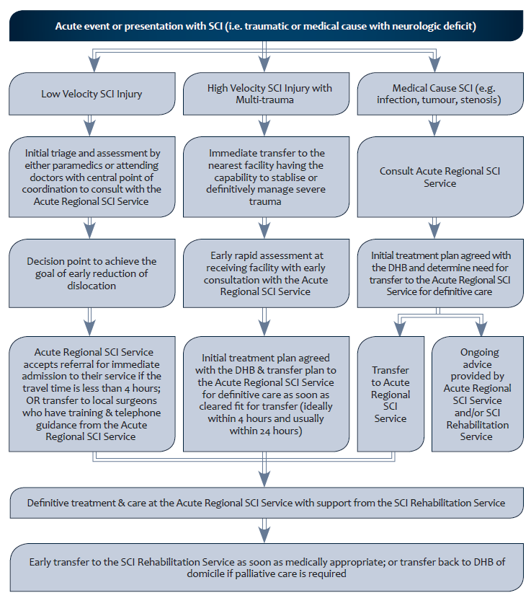

**APPENDIX 3:**Draft SCI pathway developed for children and adolescents

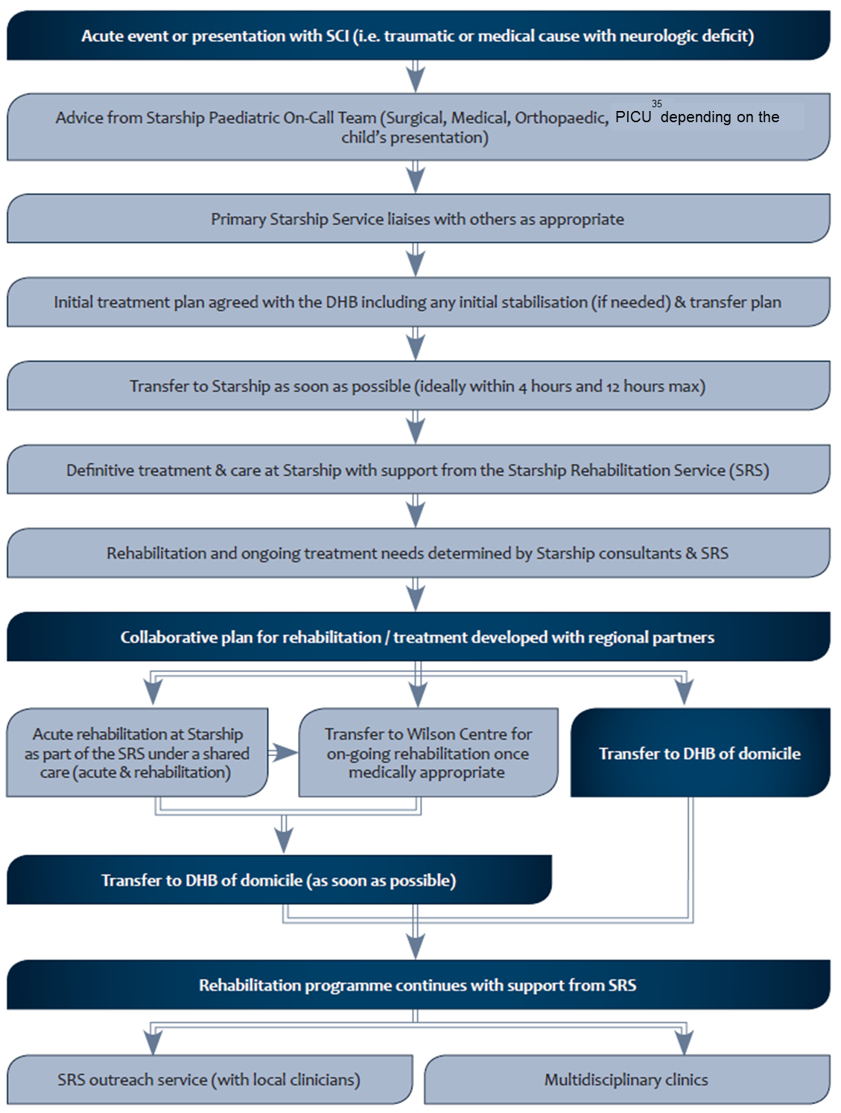[35]

1. Joint ACC and Health Spinal Cord Impairment Initiative & Implementation Plan – Situation Analysis Paper, 24 February 2013.
2. Derived from Krischblum, S. 2009. Spinal Cord Medicine. Philadelphia: Lippincott.
3. [www.odi.govt.nz/what-we-do/ministerial-committee-on-disability-issues/#DisabilityActionPlan20122014 focusonresults4](http://www.odi.govt.nz/what-we-do/ministerial-committee-on-disability-issues/#DisabilityActionPlan20122014 focusonresults4)
4. Australasian Rehabilitation Outcomes Centre (AROC) SCI measures (e.g. Length of Stay and Functional Independence Measure (FIM) change) and DHB-specific measures (e.g. time and cost to discharge).
5. For example, the time from injury to consultation with an SCI specialist and time to spinal column definitive stabilisation.
6. Selected members (AROC).
7. Recommended by the New Zealand Orthopaedic Association Spine Society.
8. Note that a single point of coordination may differ between the two sites (i.e. Canterbury will be SCI rehabilitation consultants and Auckland will be spinal surgeons).
9. See Appendix 1.
10. See Appendix 2.
11. Counties Manukau DHB.
12. Canterbury DHB.
13. Major Trauma National Clinical Network.
14. The Wilson Centre for Children (Waitemata DHB).
15. Including any age definitions or developmental descriptions for triaging to either adult or paediatric/youth services.
16. See Appendix 3.
17. See Appendix 3.
18. Note that the service would also cater for other children and adolescents requiring specialist rehabilitation.
19. Auckland District Health Board.
20. Waitemata District Health Board.
21. International Classification of Functioning, Disability and Health.
22. Electronic patient management system.
23. Burwood Academy of Independent Living.
24. Including primary care (GPs, emergency care departments, DHBs, district nursing, allied health and non-governmental organisations (NGOs).
25. May link to registry work.
26. Will also include Ministry of Business Innovation and Employment (MBIE).
27. May be linked to e-shared care plans/collaborative plans.
28. Note this may be through the shared care plans/collaborative plans coordinators or a case coordinator (e.g. within a needs assessment service or a spinal service) or case manager dependent on individual needs.
29. See the ‘Equipment and housing modification’ section of this report (under Objective No. 5).
30. Extends current quality monitoring to include the development of quality actions.
31. Note this is a key action under the DSS Disability Workforce Action Plan. ACC is also undertaking work in this area.
32. Health Workforce New Zealand.
33. [www.hqsc.govt.nz/assets/Other-Topics/QS-challenge-reports/Revised-Guidelines-for-Optimal-Trauma-Care.pdf](http://www.hqsc.govt.nz/assets/Other-Topics/QS-challenge-reports/Revised-Guidelines-for-Optimal-Trauma-Care.pdf)
34. Note clinical criteria that includes risk analysis and prognostication will be set in accordance with evidence-based guidelines to further describe low and high-velocity injury. Note this is not a triage guideline, but will be used to assist in the next stage of development of referral guidelines.
35. Paediatric Intensive Care Unit (PICU).