New Zealand Health Strategy 2023

Citation: Minister of Health. 2023. New Zealand Health Strategy. Wellington: Ministry of Health.
Published in July 2023 by the Ministry of Health
PO Box 5013, Wellington 6140, New Zealand
ISBN 978-1-991075-42-1 (online)
HP 8806
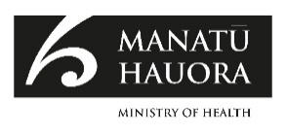
This document is available at health.govt.nz
This work is licensed under the Creative Commons Attribution 4.0 International licence. In essence, you are free to: share ie, copy and redistribute the material in any medium or format; adapt ie, remix, transform and build upon the material. You must give appropriate credit, provide a link to the licence and indicate if changes were made.

Minister’s foreword
The New Zealand Health Strategy marks the next important step in our journey to achieve long, healthy lives for all New Zealanders, and sets the direction for the health system over the next 10 years.

Protecting and improving the health of our population is one of the primary responsibilities of all governments. For many people, our health system works well and delivers health outcomes that compare with the best internationally. But it still fails too many others, and leaves many communities living in poorer health and with less access to essential services.

The Government’s health reforms provide a platform for a health system that works better for all the people it serves. This will be a system that is more collaborative at all levels, that is nationally managed and locally delivered. It will help to bring decisions closer to communities and use resources more equitably to improve the health of all New Zealanders. These reforms provide the foundation for meaningful change as described in this strategy.

The New Zealand Health Strategy – and the suite of other strategies published in parallel – set an ambitious long-term vision. Our vision is for a system that honours Te Tiriti o Waitangi | The Treaty of Waitangi, is inclusive of all people, protects and promotes health, and prevents illness, injury, and harm throughout their lives. This is a system that ensures access to timely, high-quality care when people need it.

The health system cannot achieve this vision on its own. Success will require collective action and partnerships with other government agencies, other sectors, and with people, whānau and communities. This strategy sets priorities and opportunities for change both within the health system, and in how the system works with others to address the many wider factors that contribute to our health.

Taken together, the priorities and ambitions in this strategy chart a course to a healthier future for all. They are a next step and not the end point. The strategy will inform the choices that Government and health entities make over coming years and set a common direction for change that will need to be supported by detailed actions, measurement and investment.

I am grateful for all those people and organisations who have contributed to the development of this strategy – both through recent engagements and making the case for change over time. We have heard your voices and experiences, and your aspirations for the future, and these are at the heart of the approach.

Hon Dr Ayesha Verrall
Minister of Health

Contents
Minister’s foreword iii
Executive summary 1
He whakarāpopoto 1
Introduction 5
The purpose of this document 5
The structure of this document 6
Part 1: Our vision of better health for all New Zealanders 7
Our two goals 7
Our commitment to Te Tiriti o Waitangi | The Treaty of Waitangi 8
What does this look like for people? 11
Part 2: Where are we now? 13
We are living longer, but with more years in poor health 13
Our population is changing 16
Inequitable access and longer wait times for health services 19
Support during the early years sets us up for the best possible health and wellbeing outcomes later in life 21
The cost of delivering publicly funded healthcare will continue to increase, presenting a financial sustainability challenge 23
These issues have been reflected in feedback from people, whānau and communities on their experiences and aspirations 23
Part 3: Opportunities and priorities 25
Change is already underway 25
We need to continue to evolve our approach to change 25
Our strategic priorities over the next 10 years 28
Ten-year ambitions will encourage collective action on shared goals 29
Priority 1: Voice at the heart of the system 30
Priority 2: Flexible, appropriate care 38
Priority 3: Valuing our workforce 48
Priority 4: A learning culture 55
Priority 5: A resilient and sustainable system 63
Priority 6: Partnerships for health 71

Part 4: Delivering our commitment to change 78
Turning strategies into action 78
Monitoring outcomes 79
Ongoing research and evaluation 80

List of Figures
Figure 1: New Zealand Health Strategy 4
Figure 2: Our vision for people, whānau and communities 12
Figure 3: Projections of life expectancy at birth by ethnicity and sex 14
Figure 4: Healthy life expectancy and years in poor health by sex at birth, from 1990 to 2019 14
Figure 5: NZ population pyramids for 1996, 2022 and 2053 16
Figure 6: New Zealand population projections by ethnicity 17
Figure 7: Unmet need for GP due to cost in the past 12 months 20
Figure 8: Proportion of women registering with a lead maternity carer in the first trimester, by prioritised ethnicity, 2011-2020 22
Figure 9: What we heard from whānau and communities 24
Figure 10: Whiria te Muka Tangata, anti-racism systems change model 27
Figure 11: Relationships between health system direction-setting documents 79

Executive summary
The New Zealand Health Strategy sets the direction for improving the health of all New Zealanders over the next ten years. It is part of a suite of strategies published under the Pae Ora (Healthy Futures) Act 2022 (the Pae Ora Act) and is the main strategy addressing the health of our population as a whole.

The strategy sets a long-term vision that is focused on achieving pae ora | healthy futures for all. This vision comprises the many factors that influence people’s health and wellbeing, including the role of health services, and describes a future state where people and whānau can live well and achieve good health, and where our communities and environments support us to be healthy.

The strategy is founded on a commitment to Te Tiriti o Waitangi | The Treaty of Waitangi (Te Tiriti) and enacting the health system’s obligations to Māori. The health sector principles in the Pae Ora Act, which incorporate the key outcomes of Te Tiriti principles that were identified by the Waitangi Tribunal, guide health entities in their functions and shape the priorities of all health strategies. The New Zealand Health Strategy sits alongside Pae Tū: the Hauora Māori Strategy, which sets the direction for the health system in respect of Te Tiriti.

The New Zealand Health Strategy’s vision of pae ora is underpinned by two long-term goals. These are:
- to achieve health equity for our diverse communities, and especially for Māori, Pacific, disabled and other groups who currently have poorer outcomes
- to improve health outcomes for all New Zealanders.

Succeeding in these goals will require long-term actions across multiple generations and partners. The goals recognise the need for collective and coordinated actions to address health inequities, poor health outcomes and the underlying causes of both.

In determining priority areas for action to work towards these goals over the next ten years, the New Zealand Health Strategy focuses on the factors driving and sustaining change, recognising the underlying barriers to progress in some areas. It builds on learning from past strategies and national programmes, as well as more recent experiences from COVID-19.

A central element of this strategy’s approach is recognising that change in a complex system like health requires shifts in many areas – it cannot be driven by simply changing structures, regulations and policies or by increasing investment. While these all contribute to creating an environment that supports change, they do not always tackle the inherent factors influencing how people work and how decisions are made: the culture and values of our workforce and system.

This strategy seeks to catalyse a cultural shift: to align the motivations and values of a diverse workforce, to balance decision-making and influence, and to focus on how relationships and connections influence people’s behaviour. This recognises that lasting transformation requires a shift in how we think about health and what we value.

Applying this approach to the direction for the next ten years, the strategy sets out six priority areas for change to work towards the two long-term goals. These priority areas are:
- Voice at the heart of the system: Giving people, whānau and communities greater control and influence over decisions about their health and the design of their health services and embedding their voices in system planning, delivery and reporting on health care
- Flexible, appropriate care: Developing services that adapt to people’s health needs and expectations, are focused on preventing ill health, are delivered closer to our homes and communities and support access for all
- Valuing our workforce: Recognising our health workforce as our most valuable asset and supporting the development of sustainable, diverse, skilled and confident workers for the future
- A learning culture: Creating a culture of continuous learning and quality improvement, supported by research, evaluation and innovation
- A resilient and sustainable system: Ensuring our health system is prepared for future shocks and we make the best use of resources to manage demand and affordability over the long term
- Partnerships for health and wellbeing: Building cross-sector and cross-government relationships to drive collaborative actions on health and wellbeing and the factors that determine health outcomes.

These six priority areas have been identified from an assessment of current health outcomes, trends and opportunities, as well as feedback received through engagement on developing the health strategies. They aim to reflect and respect the voices and shared experiences and aspirations of our communities, as well as evidence, research and practice.

The areas are not a hierarchy – they overlap and reinforce each other. Although we might expect to see short-term actions and first steps occurring in specific areas, change will need to take place across all six over time if this strategy is to be successful.

Health strategies are not intended to commit health entities to specific actions – decisions on the precise actions and plans to deliver the strategy’s vision will be made through the next Government Policy Statement (GPS) on Health (for 2024–2027) and Te Pae Tata | the New Zealand Health Plan. The GPS on Health is a public statement that sets the Government’s focused expectations for the health system, for a three-year period. Te Pae Tata | the New Zealand Health Plan sets detailed service plans for the same period.

To help inform decisions on actions and plans to achieve the strategy’s vision of pae ora, each of the six priority areas includes a summary of key areas that need change and a set of ten-year ambitions to shape a shared direction for the health system. The description of these changes and ambitions will set the foundation for steps we can take to turn the New Zealand Health Strategy into successful actions and to monitor and evaluate progress over time.

He whakarāpopoto
E whakatakoto ana te Rautaki Hauora o Aotearoa i te ara ki te whakapikinga ake o te hauora o ngā tāngata katoa o Aotearoa i te ngahuru tau e heke mai ana. He wāhi tēnei o tētahi huinga rautaki e whakaputaina ana ki raro i te ture o Pae Ora 2022, otirā, koia te rautaki matua e whakaū ana i te hauora o te pāpori whānui.

E arotahi ana te wawata roa o tēnei rautaki ki te whakatutukinga o pae ora mō te katoa. E mau ana tēnei wawata ki ngā tini āhuatanga e whakapā atu ana ki te hauora me te oranga o te tangata, pērā i ngā mahi a ngā ratonga hauora. Waihoki, e whakaahua ana tēnei rautaki i te tū o te kaupapa hei ngā rā ki tua, arā, e noho ora ana ngā tāngata me ngā whānau, e pai ana ō rātou hauora, ā, kei te hāpaitia te hauora e ō tātou hapori me ngā momo wāhi e nōhia ana e te tangata.

Kua whakatūria te rautaki i runga i te ngākau pūmau ki Te Tiriti me te whakatutukinga o ngā kawenga o te pūnaha hauora hei painga mō te iwi Māori. E arahina ana ngā mahi a ngā hinonga hauora e ngā mātāpono o te rāngai hauora i raro i te ture o Pae Ora. E mau ana ēnā mātāpono ki ngā putanga matua o ngā mātāpono o Te Tiriti i whakaahuatia e Te Rōpū Whakamana i Te Tiriti o Waitangi e āhua mai ai ngā whāinga tōmua o ngā rautaki hauora katoa. E noho ana te Rautaki Hauora o Aotearoa ki te taha o Pae Tū: te Rautaki mō te Hauora Māori koia te rautaki e whakatakoto ana i te ahunga o te pūnaha hauora i raro i Te Tiriti.

Ko te tūāpapa o te wawata o te Rautaki Hauora o Aotearoa, arā, o pae ora, ko ēnei whāinga roa e rua:
- ko te whakapūmautanga o te mana taurite i te ao hauora mō ō mātou hapori rerekē, arā, mō te Māori, mō ngā iwi o Te Moananui-a-Kiwa, mō te hunga whaikaha me ērā atu rōpū e rongo ana ki ngā putanga ngoikore o te ao hauora
- ko te whakapikinga ake o ngā putanga hauora mō ngā tāngata katoa o Aotearoa.

Ka tutuki ēnei whāinga mā ngā mahinga roa a ngā reanga me ngā hoamahi maha. E tohu ana ēnei whāinga i te hiahia ki te whakatikatika i ngā āhuatanga taurite-kore i te ao hauora, i ngā putanga ngoikore me ngā take e ara mai ana aua āhuatanga e rua e te mahi ngātahi me ngā whakaritenga tōtika.

I roto i ā mātou whiriwhiringa e pā ana ki ngā kaupapa tōmua hei whakatutuki i ēnei whāinga hei ngā tekau tau e heke mai ana, kei te arotahi te Rautaki Hauora o Aotearoa ki ngā āhuatanga e kōkiri ana, e whakapūmau ana hoki i ngā whakahoutanga, me ērā e aukati ana i te ahunga whakamua o ētahi kaupapa. Kei te whāngaia te kaupapa e ngā akoranga nō ngā rautaki me ngā hōtaka ā-motu o mua, me ērā nō te wā tata nei, pērā i te wā o te KOWHEORI-19.

Kei te manawa o tēnei rautaki ko te mōhio inā kē te nui o ngā āhuatanga me huri kia huri anō hoki te pūnaha matatini o te ao hauora – ehara i te mea ka kōkirihia ēnei huringa mā te whakahoutanga o ngā hanganga, o ngā ture me ngā kaupapa here, mā te whakapikinga ake o te pūtea rānei. Ahakoa ka whāngai tonu ērā āhuatanga i tētahi taiao e hāpai ana i te ara hou, ka ū tonu pea ngā āhuatanga e whakaawe ana i ngā mahi a te tangata, i te putanga mai o ngā whakatau hoki, arā, ko ngā tikanga me ngā uara tonu a ō mātou kaimahi me te pūnaha whakahaere.

Kei te kōkiri tēnei rautaki i tētahi huringa ā-ahurea, arā, me whakakotahi ngā hiahia me ngā tikanga rerekē a ngā kaimahi, me whakataurite te mahi whakatau me te mahi whakaweawe, me āta kite te pānga o ngā hononga tāngata me ngā momo tuituinga ki te whanonga o te tangata. E whakaahua ana ēnā whakaaro i te mōhio, ka ū ngā huringa nui mēnā ka huri hoki ō tātou whakaaro mō te hauora me ā tātou uara tonu.

Koinei te ahunga o te whakaaro mō ā mātou mahi ā ngā tau 10 e heke mai ana, ā, e whakatakoto ana te rautaki i ngā kaupapa tōmua e ono, hei whakatutuki i ngā whāinga roa e rua. Koinei ngā kaupapa tōmua:
- Ko te reo te pūtake: Kia nui ake te mana whakahaere me te pānga o te tangata, o te whānau me te hapori ki runga i ngā whakataunga e pā ana ki tō rātou hauora me te whakahoahoatanga a ō rātou ratonga hauora. Me noho pūmau ō rātou reo ki ngā mahi māherehere, ki te whakaratonga me te arotakenga o ngā mahi hauora.
- Me ngāwari, me hāngai ngā mahi tiaki: Kia whakawhanakehia ngā momo ratonga hauora e hāngai ana ki ngā hiahia me ngā tūmanako o te tangata. Me arotahi ki te kauparenga atu o ngā momo mate, me tuku atu ngā ratonga mai i ngā wāhi e pā tata ana ki ō tātou kāinga me ō tātou hapori, kia āta manaakihia ngā tāngata katoa.
- Me whakanui ō mātou kaimahi: Me whakanui ō mātou kaimahi i runga i te whakaaro he taonga nui te tangata, arā, me tautoko te whakawhanaketanga o ngā kaimahi tūroa, o ngā kaimahi rerekē, o ngā kaimahi whai pūkenga, o ngā kaimahi māia hoki hei ngā rā ki tua.
- Me hāpai te mahi ako: Me waihanga tētahi tikanga ako kia piki tonu te kounga o ngā mahi. Me tautoko mā te mahi rangahau, mā te mahi arotake me ngā mahinga auaha.
- He pūnaha māia, he pūnaha tūroa: Me takatū tō mātou pūnaha hauora mō ngā tū āhuatanga ohorere, me whakapau kaha mātou ki te āta whakamahi i ngā rauemi, ki te āta whakatutuki i ngā tono, ki te āta whakapau i te pūtea hei ngā tau e heke mai ana.
- Me whai hoamahi mō te hauora me te oranga: Me whakatū ngā hononga huri noa i te rāngai kāwanatanga ki te kōkiri i ngā mahinga ngātahi e pā ana ki te hauora me te oranga o te tangata, i raro anō i ngā tūtohu e whakaahua ana i ngā putanga hauora o te tangata.

Kua puta mai ēnei kaupapa tōmua e ono i tētahi aromatawai o ngā putanga hauora, o ngā ia o te wā me ngā ara hou, waihoki ko ngā kōrero i tukuna mai i ngā huihuinga e pā ana ki te whanaketanga mai o ngā rautaki hauora. Kei te whakaata mai, kei te whakamana hoki ēnei kaupapa tōmua i ngā reo, i ngā wheako kotahi me ngā wawata o ō mātou hapori, otirā, ko te hua tēnei o te taunaki, o te rangahau me te mahi.

Ehara i te mea kua āta whakaraupapahia ēnei kaupapa, heoi, kua whakatakotohia ngā whenu hei whiri i te kaupapa. Ahakoa ka tutuki noa ētahi o ngā tūmahi i te wā poto, ka kitea hoki pea ngā whakahoutanga tōmua ki ētahi wāhi motuhake, ka mātua ea tēnei rautaki mēnā ka kitea ngā huringa tūturu i te whānuitanga o ngā kaupapa e ono i te takanga o te wā.

Ehara i te mea me ū ngā whare hauora ki ngā tūmahi motuhake kei ngā rautaki hauora – ka puta ngā whakatau e pā ana ki ngā tūmahi me ngā mahere mō te whakatutukinga o te wawata nui ki te Government Policy Statement (GPS) on Health (mō te tau 2024– 2027) me Te Pae Tata | the New Zealand Health Plan. He tauāki tūmatanui te GPS mō te Hauora, e whakatakoto ana i te aronga o ngā hiahia o te Kāwanantanga mō te pūnaha hauora i te roanga o ngā tau e toru. Ka whakatakotoria ngā taipitopito o ngā mahere whakarato e Te Pae Tata | the New Zealand Health Plan.

Hei whāngai i ngā whakatau e pā ana ki ngā tūmahi me ngā mahere mō te whakatutukinga o te wawata o te rautaki, arā, o pae ora, kua whakarāpopotohia ngā wāhi matua o ngā kaupapa tōmua e ono kia kitea ngā mea hei whakarerekē me ngā whāinga nui mō te 10 tau hei whakaahua i te ahunga kotahi o te pūnaha hauora. Ka noho te whakamārama mō ēnei whakahoutanga me ngā whāinga nui hei tūāpapa mō ngā takahanga whakamua, kia huri te Rautaki Hauora o Aotearoa ki te tūmahi whaihua, waihoki kia aroturukihia, kia arotakehia ngā ahunga whakamua i roto i ngā tau.

Figure 1: New Zealand Health Strategy
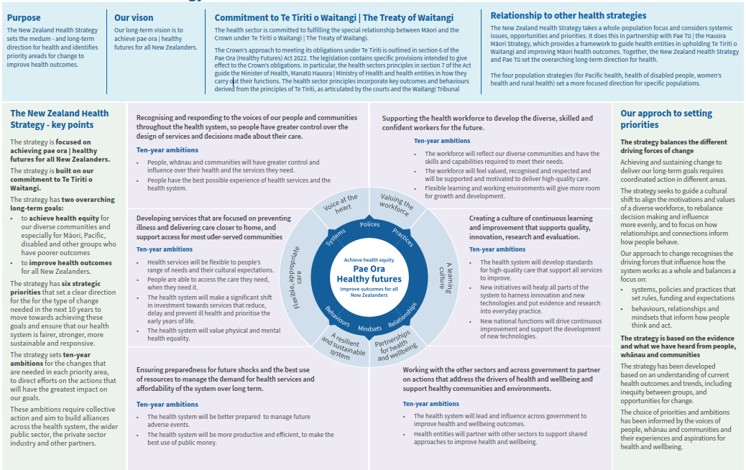

Introduction

The purpose of this document
This strategy, the New Zealand Health Strategy, sets the direction for improving the health and wellbeing of New Zealanders over the next 10 years. It is a key element of the Government’s health system reforms and is part of a suite of strategies required under the Pae Ora (Healthy Futures) Act 2022 that are being published together.

The purpose of the New Zealand Health Strategy is to provide a framework to guide health entities in protecting, promoting, and improving people’s health and wellbeing. Other entities must also take the strategy into account.

The New Zealand Health Strategy takes a whole population focus and considers systemic issues, opportunities and priorities. It does this in partnership with Pae Tū: Hauora Māori Strategy, which provides a framework to guide health entities in upholding Te Tiriti o Waitangi | The Treaty of Waitangi and improving Māori health outcomes. Together, the New Zealand Health Strategy and Pae Tū set the overarching long-term direction for health.

The four population strategies (for Pacific health, health of disabled people, women’s health and rural health) set a more focused direction for specific populations. Each strategy builds on and reflects the higher-level priorities set in the New Zealand Health Strategy and Pae Tū, but from their unique perspectives. Throughout this document ‘health’ includes physical and mental health.

Together, the suite of health strategies guide collective efforts to achieve pae ora | healthy futures. This direction will inform future decisions on Government objectives and health and wellbeing approaches, and in turn guide service priorities and the performance of health entities.

The New Zealand Health Strategy is focused on creating the right conditions for change and maximising the opportunities of the reformed health system. While it sets direction and objectives, and indicates where change will be necessary, it does not commit to precise actions for entities. More specific actions and decisions on investment will be made as part of confirming the three-year Government Policy Statement on Health and the New Zealand Health Plan | Te Pae Tata that will be set from July 2024.

Throughout this strategy, examples are provided about the health system. These examples are intended to illustrate the types of change that are possible, rather than prescribing detailed solutions. Design solutions for local services should sit with whānau and communities as far as possible.

The strategy recognises the special relationship between New Zealand and countries of the Realm in the Pacific –the territory of Tokelau, and the self-governing states of the Cook Islands and Niue. In recognition of New Zealand’s obligations to Realm countries and as citizens of New Zealand, the strategy includes these Pacific peoples when in New Zealand.

The New Zealand Health Strategy complements a number of other sector and government strategies and strategic frameworks focused on health and wellbeing, including:
- Kia Manawanui Aotearoa, the long-term strategy for transforming New Zealand’s approach to mental wellbeing
- Oranga Hinengaro System and Service Framework, which identifies the core components of a contemporary mental health and addiction system with a 10-year view
- Healthy Ageing Strategy, the long-term strategy for the delivery of services to people into and throughout their later years
- Child and Youth Wellbeing Strategy for improving the wellbeing of children and young people
- Te Aorerekura: National Strategy to Eliminate Family Violence and Sexual Violence
- All-of-Government Pacific Wellbeing Strategy to improve wellbeing outcomes for Pacific peoples
- New Zealand Disability Strategy, the long-term strategy to guide the work of government agencies on disability issues
- Te Arataki mō te Hauora Ngākau mō ngā Mōrehu a Tū me ō rātou Whānau | The Veteran, Family and Whānau Mental Health and Wellbeing Policy Framework, which identifies and provides guidance on what needs to be done to advance the mental health and wellbeing of veterans, their families and whānau.

The structure of this document
Part 1 describes a long-term vision for health and identifies the key challenges and opportunities.

Part 2 provides an assessment of the current state of the health of our population and the health system itself, drawing on engagement carried out to develop this strategy.

Part 3 identifies the priority areas in which changes are needed to achieve our vision, and indicates the types of change required over the next 10 years.

Part 4 describes the next steps for how these changes can be delivered, including how the strategic direction will be translated into actions for health entities.

Part 1: Our vision of better health for all New Zealanders

Our long-term vision is to achieve pae ora | healthy futures for all New Zealanders.
This is a future in which all people from all communities are able to live long, healthy lives.
Achieving pae ora | healthy futures means looking at the many factors that influence people’s health, including the role of publicly funded health services. This includes a focus on:
- improving people’s own health and wellbeing
- supporting strong and empowered family networks and recognising the impact of family on health and wellbeing
- the impact of our communities and the places where we live, work and rest on our health and wellbeing.

Achieving pae ora | healthy futures for all New Zealanders is a long-term challenge and requires a sustained long-term effort that lasts across generations. This strategy sets out the next steps towards this vision and focuses on what can be achieved, and what change is needed, over the next five to ten years.

Our two goals
Achieving our vision will require us to address two major long-term goals:
- to achieve health equity, in particular for Māori, Pacific, disabled and other communities who experience the poorest health outcomes, so that we eliminate avoidable and unfair differences in health outcomes
- to improve health outcomes for all New Zealanders, so that everyone is able to live longer, healthier and more independent lives.

These goals are related and mutually reinforcing. Achieving health equity will mean a health and wider system that better recognises the needs of different communities, and that is able to adapt services and approaches to best fit to those needs.

A more adaptable and flexible system will be better for everyone and improve health outcomes for all New Zealanders.

Each of these goals recognises the need for collective action – between different services, across government, between the public and private sector, and with iwi, Māori and communities. Health services will play a major leadership role, but the goals cannot be achieved by the health system alone.

These goals also recognise the need for long-term action to achieve long-lasting change. Strategies are an important instrument to set a long-term direction, identify effective solutions and galvanise change. But success will require a dynamic, safe and inclusive culture within the health system, as well as a commitment to collective and collaborative working within and beyond the health sector that is sustained over time and upheld by successive governments.

Our commitment to Te Tiriti o Waitangi | The Treaty of Waitangi
The health sector is committed to fulfilling the special relationship between Māori and the Crown under Te Tiriti o Waitangi | The Treaty of Waitangi (Te Tiriti). Regarding the text of Te Tiriti and declarations made during its signing, the Crown, as the kaitiaki and steward of the health system (under article 1 of Te Tiriti), has the responsibility to enable Māori to exercise authority over their health and wellbeing (under article 2) and achieve equitable health outcomes for Māori (under article 3) in ways that enable Māori to live, thrive and flourish as Māori (Ritenga Māori declaration).

The Crown’s approach to meeting its obligations under Te Tiriti is outlined in section 6 of the Pae Ora (Healthy Futures) Act 2022. The legislation contains specific provisions intended to give effect to the Crown’s obligations.

In particular, the health sector principles in section 7 of the Act guide the Minister of Health, Manatū Hauora | Ministry of Health and health entities in how they carry out their functions. The health sector principles incorporate key outcomes and behaviours derived from the principles of Te Tiriti, as articulated by the courts and the Waitangi Tribunal;
- Tino rangatiratanga: Providing for Māori self-determination and mana motuhake in the design, delivery and monitoring of health services.
- Equity: Being committed to achieving equitable health outcomes for Māori.
- Active protection: Acting to the fullest extent practicable to achieve equitable health outcomes for Māori. This includes ensuring that the Crown, its agents and its Treaty partner under Te Tiriti are well informed on the extent, and nature, of both Māori health outcomes and efforts to achieve Māori health equity.
- Options: Providing for and properly resourcing kaupapa Māori health services. Furthermore, the Crown is obliged to ensure that all health services are provided in a culturally appropriate way that recognises and supports the expression of hauora Māori models of care.
- Partnership: Working in partnership with Māori in the governance, design, delivery and monitoring of health services – Māori must be co-designers, with the Crown, of the primary health system for Māori.

These principles are central to achieving our vision of pae ora | healthy futures for Māori. Pae ora has a special meaning for Māori, and includes three inter-connected elements:
- Mauri ora (healthy individuals) seeks to shift the mauri (or life force) of a person from one that is languishing to one that is flourishing.
- Whānau ora (healthy families) is a fundamental philosophy for creating strong, healthy and empowered whānau. A strong healthy and empowered whānau can make the most significant difference to Māori health and wellbeing.
- Wai ora (healthy environments) acknowledges the importance of Māori connections to whenua as part of the environments in which we live and belong – and the significant impact this has on the health and wellbeing of individuals, whānau, hapū, iwi and Māori communities.

Our commitment to Te Tiriti and priorities for hauora Māori are described in greater detail in Pae Tū: Hauora Māori Strategy published in parallel with this document.

Health and wellbeing
Health and wellbeing are intertwined. Good health improves our ability to work, study, care for others and make the best use of our time.

Good health outcomes are influenced by many factors including wealth, education, quality of housing, access to services, and trust in public services. Similarly, these same factors are associated with poorer health, especially for some communities. We can see how these factors have different impacts on different populations and at different stages of life, as explored in Part 2 of this document.

Most of these wider factors sit outside the scope of the publicly funded health system, with critical roles for other sectors and agencies, as well as non-governmental partners, the private sector, and people and communities themselves. Achieving our vision for health requires collective long-term action across these groups.

This strategy is focused on the role of the health system itself. This means a dual focus on:
- health-led actions to protect, promote and improve health and wellbeing (including the provision of health services and public health initiatives)
- health-partnering actions that contribute to the wider determinants of health and wellbeing, but which are led by other services or sectors.

Working together with other agencies and partners to improve health and wellbeing for all New Zealanders, we can achieve:
- the best possible health throughout life, starting before birth and continuing to the end of life: including a focus on the early years of life, support to recognise, express and manage emotional and physical health, support during life transitions and to age well, and equitable access to high quality support in times of need
- good mental health and wellbeing, where people feel safe, connected, valued and accepted, and have a sense of belonging, identity and hope for the future
- freedom from racism and all forms of discrimination, including sexism, homophobia, transphobia and ableism
- autonomy, agency, and the ability to exercise control over health, including the power to influence and change the health system, to commission our own care when appropriate, and to manage our own health
- the opportunity to live in healthy, sustainable and inclusive environments, including a focus on healthy homes and communities, green spaces, and locally-led initiatives that support physical activity and tackle loneliness
- solutions that reduce deprivation and wider causes of poor health, including tackling child poverty, poor housing, family violence and sexual violence, and supporting access to education and good employment.

The health system reforms
The health system reforms have laid the foundations for structural change to improve outcomes and achieve equity. As these structures develop and mature, they provide the opportunity to embed and sustain a new direction to achieve long-term, generational change. This strategy sets out the next steps in that direction over the coming 10 years.

New system structures allow us to move away from unnecessary complexity and fragmentation towards more cohesive planning, design and use of resources. There will be greater national leadership and coordination where it matters most, greater local decision-making on service priorities, and a stronger focus on Māori leadership at all levels, including through Te Aka Whai Ora and the iwi-Māori partnership boards.

While the health reforms pave the way to embed collaboration, it is our shared vision, understanding, relationships and values that will drive real change. This strategy considers the role of the health system not just in relation to the services and processes that can be put in place, but in how the system can evolve a culture and leadership that embraces change, diversity and flexibility, listens and responds to the people it services, and that is open to doing things differently.

What does this look like for people?
The graphic below describes what this vision will mean for people, whānau and communities. It identifies some of the characteristics of the future state and outcomes that should be expected within the next 10 years.

These statements build on the feedback received from communities through engagement on the health strategies, and earlier consultations, as well as on evidence and research on outcomes and best practice in health care. Further detail on engagement feedback is included in Part 2 of this strategy, and set out in an accompanying report.
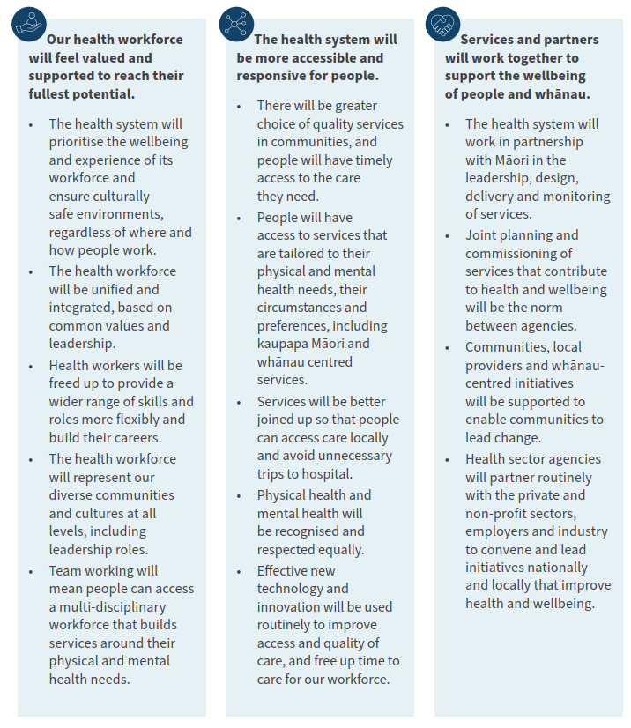
Figure 2: Our vision for people, whānau and communities
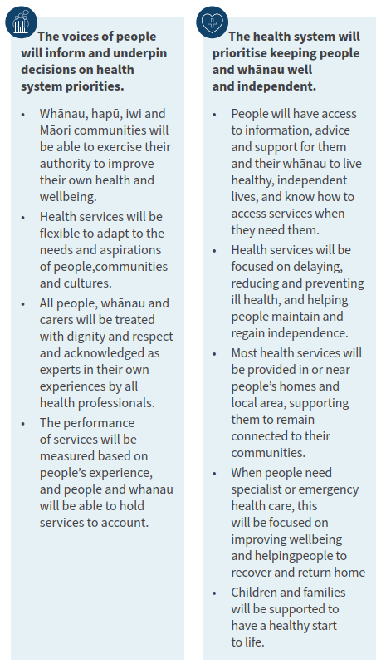

Part 2: Where are we now?
Our health system works well for many people. Most New Zealanders are in good health and life satisfaction is high overall, with 84% of adults rating their life satisfaction highly. Overall, we are living longer, and life expectancy is projected to continue rising for all groups of people. For many people, our sector delivers health outcomes that compare well with other countries around the world. There are many examples of excellence across our health system.

However, our system does not work well for all. For a large number of population groups and communities, health outcomes continue to lag behind and progress has been limited. There are unacceptable disparities in how the impacts of health conditions are distributed.

Moreover, our population is growing and changing, with significant implications for health in the future. Increases in life expectancy are leading to more unhealthy years of life, with long-term conditions a major and growing contributor to poor health and premature death. Many of these impacts are avoidable, and in some circumstances, they are reversible. An ageing population creates a risk of these conditions becoming more prevalent, increasing demand on the health system.

The following sections provide more detail on important trends and a current state assessment. Additional information is available in the Health and Independence Report (2022) that is published alongside this strategy.

We are living longer, but with more years in poor health
Overall, in New Zealand we are living longer, and life expectancy is projected to continue rising for all groups.

However, on average we are spending over a decade in poor health and this period of poor health is slowly increasing. Long term conditions are a major and growing contributor to poor health and premature death.
Figure 3: Projections of life expectancy at birth by ethnicity and sex
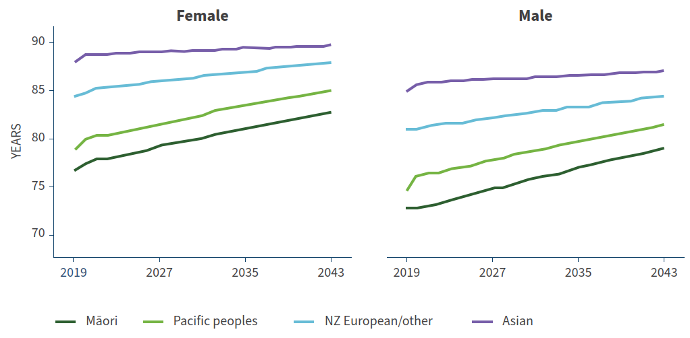

Figure 4: Healthy life expectancy and years in poor health by sex at birth, from 1990 to 2019
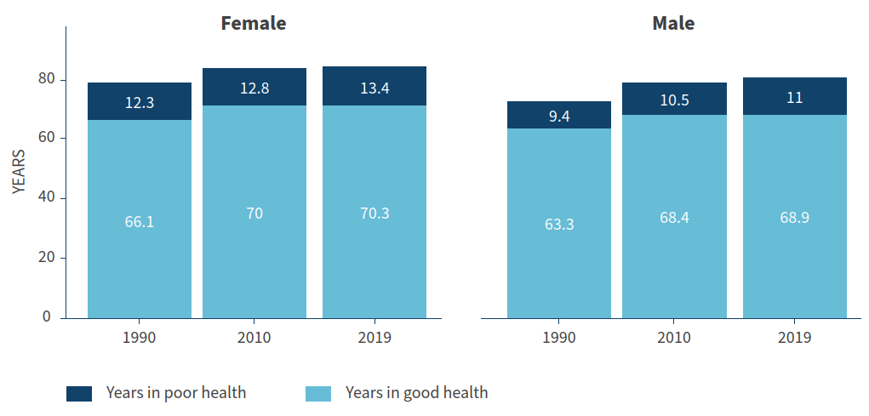

Risk factors for health conditions start early and are linked to deprivation, including factors such as child poverty, household food insecurity, poor quality housing, lack of access to safe water, and breathing second-hand smoke.

Diabetes is the fastest growing major cause of death and disability. The prevalence of unhealthy weight and diabetes has risen in the past 10 years, particularly for people aged 45-64 years. Rates of unhealthy weight are greatest among Māori and Pacific populations, and are strongly associated with deprivation. The impact of persistent and inter-generational disadvantage, in terms of material deprivation and social exclusion, is profound.

The major causes of death and disability are dominated by non-communicable diseases such as diabetes, heart disease, stroke, cancer, back pain, mental health and Alzheimer’s. Estimates from the Global Burden of Disease Study (2019) indicate that the fastest growing major causes of death (excluding disability) in New Zealand over the past 10 years included respiratory infections (acute bronchitis, pneumonia), Alzheimer’s, chronic kidney disease, prostate cancer and chronic obstructive pulmonary disease (COPD). The top two causes of death (excluding disability) continued to be ischemic heart disease and stroke, although they have not grown as quickly as the above causes. Smoking is still the top risk factor (as measured) in New Zealand for health loss and premature death, but rates are declining. Unhealthy weight and high blood sugar are in the top five risk factors and have grown significantly, and alcohol use and dietary risks are in the top six factors and have grown.

‘The standard of health care differs around the country. We need consistent quality of health care services from the North through to the South.’

- Pacific health fono participant

Focus on mental health and addiction
Levels of mental distress are increasing. Mental health issues and substance-related harm start early in the life course and have lasting impacts. There are disproportionate impacts for Māori, Pacific peoples, young people, disabled people, rainbow communities and Asian communities, amongst other groups. Unmet need for professional help with mental health has increased significantly in the past five years. This increase is mostly related to younger people (aged 15-44) where rates of unmet need have nearly doubled.
In addition to some groups experiencing inequitable mental health and addiction outcomes, people with mental health and substance use disorders have higher rates of many physical illnesses than others in the population, and an average reduced life expectancy of 25 years. In New Zealand, people using specialist mental health services have more than twice the mortality rate of the total population, and for people with a diagnosis of a psychotic disorder, this rises to three times the overall mortality rate of the population.

While there are changes that can be made to increase the likelihood of good health (and to reduce the likelihood of developing long-term conditions), health choices are largely driven by much wider social and economic factors, and the lived environment is a key determinant of health and wellbeing. For example, at a community level, evidence increasingly suggests an association between the local food environment and diabetes. Currently, neighbourhoods with the highest socio-economic needs often have a high density of fast-food and alcohol outlets. Exposure to ready-to-eat food environments can increase the frequency of eating highly processed foods.

Our population is changing
By 2053 the population aged 85+ is projected to more than triple for both males and females. The population aged 65-84 is projected to increase by nearly 60%. This will add nearly 640,000 people to the population aged 65+.

The 65+ dependency ratio (which refers to the number of people aged 65+ compared with the number of people aged 15-64) is projected to rise from 25 people per 100 in 2022 up to 39 people per 100 in 2053. An ageing population tends to put more demand on a health system, as older people commonly require more health services than younger people.

Figure 5: NZ population pyramids for 1996, 2022 and 2053
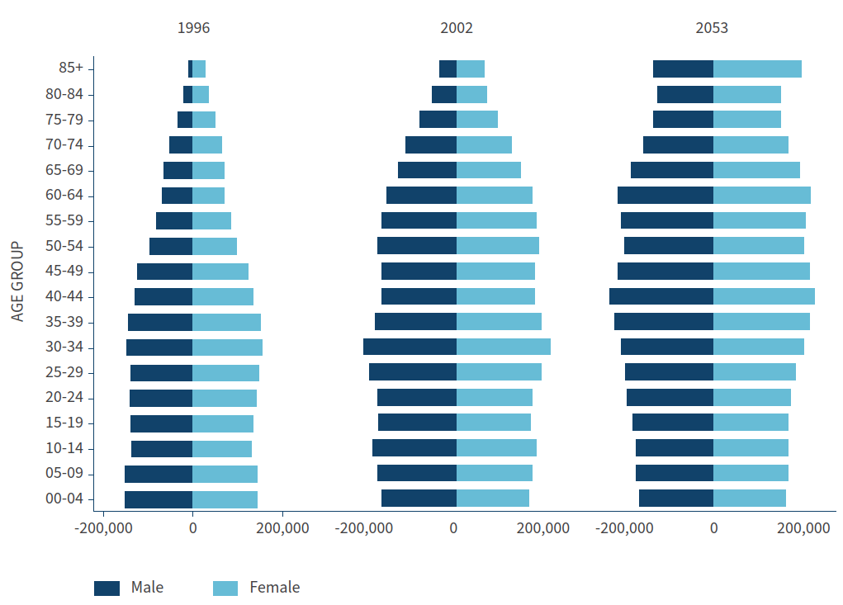

There is also a risk of higher overall rates of disability in the future as the population ages. This is because for all groups, disability rates rise steadily with age for both males and females. Māori have the highest disability rates in the 45-64 age group and Pacific peoples have the highest disability rates in the 65+ age group.

Focus on older people’s experience of the health system
Results from the New Zealand Health Survey in 2021/22 found that older groups report fewer issues getting GP appointments. Older people rate their family wellbeing slightly higher than younger groups, and the 75+ age group is particularly high. They also have high levels of life satisfaction, particularly the 65-74 age group. Older age groups have relatively lower levels of depression, and low levels of psychological distress.
However, older groups have slightly more visits to emergency departments, likely reflecting higher incidence of falls, cardiovascular disease, diabetes, dementia and other long-term conditions. Despite this, older people rate their health as very good or excellent – very close levels to the rest of the population. This is even as rates of living with chronic pain are higher.

Life expectancy at birth is significantly lower for Māori and Pacific peoples and for people living in deprived areas. Mortality rates have been falling for Māori, but levelled off around 2014 and remain significantly higher than for non-Māori. Birth rates are dropping for every age group of women except for those aged over 40 years.

While the population is ageing, Māori and Pacific populations have a much younger age structure than the European population. Birth rates remain higher for Māori and Pacific peoples than for Asian and European/other ethnic groups. The Māori population is young and growing fast, and is projected to reach 1 million by 2033. By 2038, one third of all pēpi | babies are projected to be Māori. About 6% of the Pacific population is aged 65+, with 50% of the population aged under 25.

Figure 6: New Zealand population projections by ethnicity
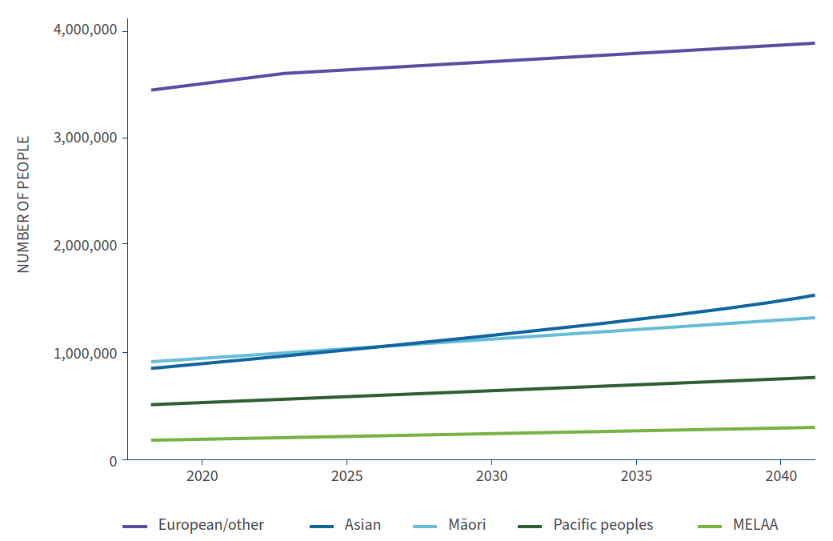

Our population is also projected to become more ethnically diverse. Compared to the latest estimates in the 2018 Census, by 2033 it is projected that Middle Eastern, Latin American and African populations will rise by 68%, Asian by 48%, Pacific by 38% and Māori by 31%. The European/other population has a relatively small projected rise of 9%.

Our future health system must respond to these changing needs and celebrate our growing diversity. As Māori and Pacific populations grow, and we become more ethnically diverse, we services must be culturally appropriate and responsive to people’s needs.

Focus on ethnic communities
Ethnic communities represent almost 20% of New Zealand’s total population. The largest ethnic communities in New Zealand are Chinese (4.9%), Indian (4.7%), Filipino (1.5%) and Korean (0.7%). Seventy-six percent of people from ethnic communities were born overseas, while 24% were born in New Zealand. The largest numbers of people from ethnic communities live in Auckland, Christchurch, Wellington, Hamilton and Lower Hutt.
Some ethnic communities make up a significant element of the health workforce. At December 2022, Asian people represent almost a quarter, or 24.8%, of the total workforce (including 33.8% of nursing staff, 18.2% of senior medical officers, and 27% of resident medical officers). However, representation in leadership positions remains much lower.

‘Patients don’t feel their voices and concerns are being listened to. When they try to ask for preventive tests, like blood, diagnostics, etc they feel they need to prepare a good case to present to their GP to get a referral. Preventive tests and diagnostics at younger ages could help save lives.’

- Ethnic communities engagement event participant

Focus on rainbow communities
Of the New Zealand population aged 18 years and over, 4.4% (169,500 people) identified as being part of the rainbow population for the year ended June 2021.
- People who reported being part of the rainbow population are younger on average than the non-rainbow population (28.9% of the rainbow population were aged 18-24 versus 10.8% of the non-rainbow population).
- Five percent of the Māori adult population (27,300 people) identified as being part of the rainbow population, or takatāpui.
- The rainbow population had a higher proportion of disabled people than the non-rainbow population (15.9% compared with 11.7%).
People in the rainbow population were over two times more likely to experience daily feelings of depression and anxiety compared to the non-rainbow population.

Inequitable access and longer wait times for health services
Currently, many people experience inequities and struggle to access timely, effective primary and specialist health support. Many of these inequities have been created over time by a system that has failed to respond to the diverse needs of our population.

Figure 7: Unmet need for GP due to cost in the past 12 months
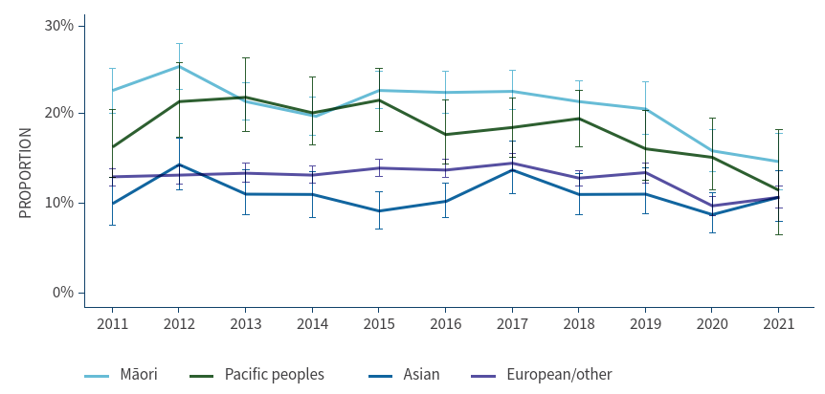

Some families and whānau experience inequitable access to health support because of barriers like cost, where they live, availability of health services (particularly out of working hours), being unable to take time off work, and needing to care for family members, as well as issues with transport.

Transport and care for dependants particularly affects women. Some people report that they do not trust the system enough to access or ask for the help that is available, or that services simply do not meet their needs. For people and whānau with higher and more complex needs, these barriers can be compounded and can further exacerbate health and wellbeing issues.

Inequitable access to health services also drives inequitable outcomes, and there are significant intergenerational impacts. Reduced access to screening, delayed identification of health conditions and unequal access to treatment are compounding factors that lead to avoidable (and sometimes reversible) health conditions and inequitable outcomes.

Focus on discrimination and barriers to access
The Counting Ourselves survey found a high level of participants wanting but not being able to access gender- affirming healthcare. This unmet need ranged from 19% for hormone treatment through to 67% of trans men wanting chest reconstruction surgery. Around half of trans women had an unmet need for voice therapy (50%) and feminising genital surgery (49%). Over a third of participants in the survey had avoided seeing a doctor because they were worried about disrespect or mistreatment as a trans or
non-binary person. Sixty-seven percent of participants had experienced discrimination (in any context) at some point.

‘Because I moved to a rural area, I am continuing to see my old GP over an hour’s drive away as I have no faith in the local GP’s knowledge and professionalism regarding trans and non-binary people.’

- Rainbow communities engagement participant

Focus on the impact of COVID-19
COVID-19 highlighted the importance of preventing disease, promoting healthy behaviour, and working across sectors to address the drivers of ill health.
There are many examples of health innovation during the pandemic, where strong social networks and a collective sense of responsibility brought community strengths and knowledge-sharing to the fore. Early in the pandemic, iwi, hapū and marae demonstrated responses based on mātauranga Māori and mana motuhake, offering support to help people stay safe and socially connected. There was also increased support to provide digital access to health information and for online appointments during this period.
COVID-19 exacerbated patterns of inequity that were present before the pandemic, such as inequitable access to health services, compounded by factors including precarious housing, overcrowding and poverty.
It is vital we continue to learn from our experiences and to understand the full impact of COVID-19, particularly where it has exposed vulnerabilities within our health system. This requires continuous learning, rapid dissemination of what works, and learning from others. The Royal Commission
of Inquiry will help to support this learning and support preparedness for any future pandemic.

Support during the early years sets us up for the best possible health and wellbeing outcomes later in life
The early years of a child’s life lay the foundations for their future. During this time, a range of protective and risk factors shape our mental and physical health outcomes throughout our lives. In New Zealand most children, young people and families are doing well. However, there are still children for whom this is not the case – particularly Māori and Pacific children, children supported by Oranga Tamariki, and disabled children.

While there is a rising trend for the percentage of women registering with a lead maternity carer (LMC) in the first trimester of pregnancy, there is significant disparity for LMC care, maternal and perinatal outcomes by ethnicity. For example, the Perinatal and Maternal Mortality Review Committee has published data showing that more than 25% of perinatal deaths for Pacific women could potentially have been prevented through better access to high-quality maternal care. Registration rates with an LMC in the first trimester of pregnancy are significantly lower for Māori, Pacific peoples and people in the most deprived areas.

Young people are generally resilient and experience good mental wellbeing. Maintaining mental wellbeing supports young people to achieve their goals and to live a full and meaningful life. There are, however, a number of health inequities that affect young people in New Zealand, and these can lead to a range of mental health and substance-related harm issues throughout their lives. The Youth19 survey found that 69.3% of young people reported good mental wellbeing, but 22.7% had significant depressive symptoms, which continues to trend upwards. Mental wellbeing outcomes were worse for Māori, Pacific peoples, rainbow people, and young people who have interactions with Oranga Tamariki.

Figure 8: Proportion of women registering with a lead maternity carer in the first trimester, by prioritised ethnicity, 2011-2020
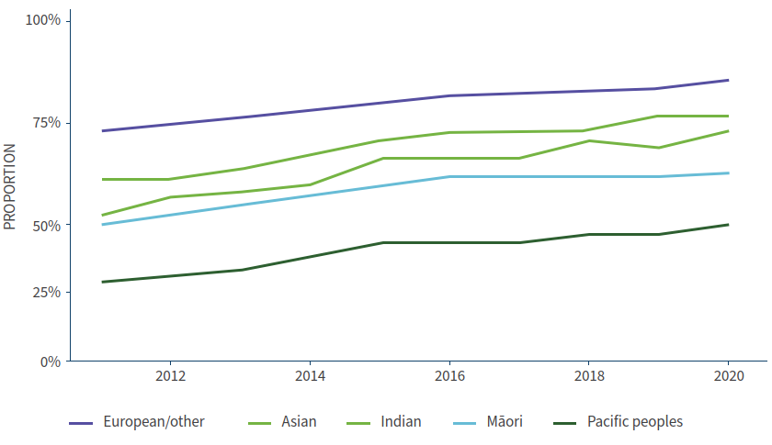

The cost of delivering publicly funded healthcare will continue to increase, presenting a financial sustainability challenge
Health expenditure has seen significant growth since 2017/18, including in response to the COVID-19 pandemic. These trends are expected to continue to meet the increasing demand for health services and complexity of health need. The Treasury’s long-term fiscal model projects New Zealand’s health spending based on historical trends to reach 10.5% of GDP by 2060, consistent with international experience.

This level of projected spending, and its implication for wider public finances, poses questions on the long-term affordability of the current health service model – focused on treatment, secondary care and legacy services – and the need to evolve sustainably meet growing demand.

These issues have been reflected in feedback from people, whānau and communities on their experiences and aspirations
The content on this page summarises key messages from public engagement carried out to support development of the health strategies. These messages form consistent themes that strengthen the evidence base on the current state and support the trends and insights outlined above. A fuller report on engagement is published alongside the strategies.

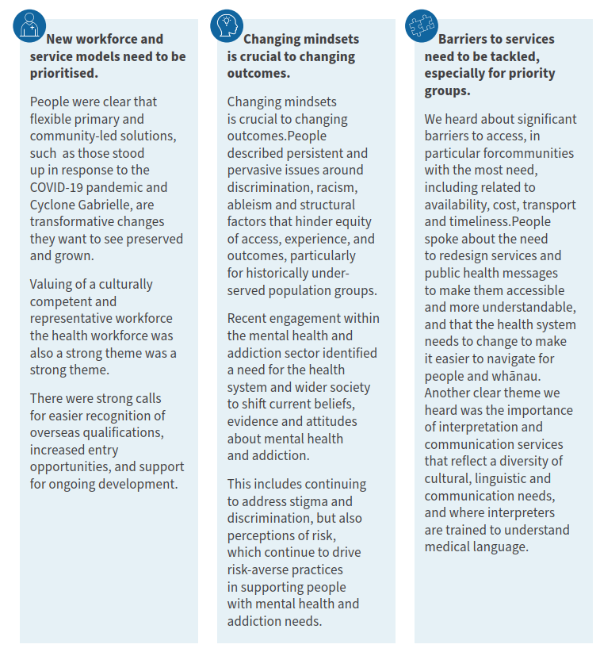
Figure 9: What we heard from whānau and communities
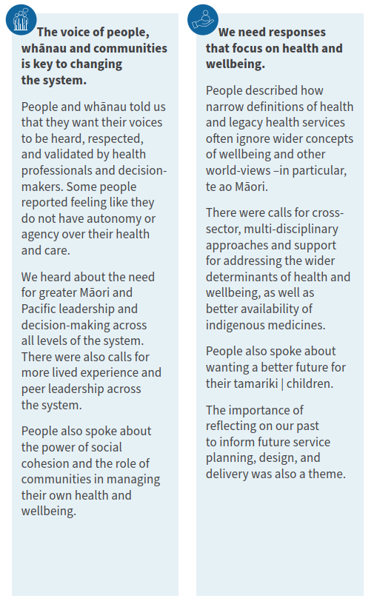

Part 3: Opportunities and priorities

Change is already underway
Our health system is constantly evolving in response to changing health needs and our understanding of what works. Reform and transformation programmes over the decades have been designed to improve health outcomes, increase accountability and efficiency and to reduce escalating health expenditure.

The 2022 health system reforms introduced by the Pae Ora (Healthy Futures) Act made significant changes to the system’s structures, functions and operating model. These shifts aimed to strengthen the health system, making it more equitable, accessible and whānau centred, while embedding the principles of Te Tiriti and working in partnership to improve Māori health inequities. They allow us to move away from unnecessary complexity and fragmentation towards more cohesive planning and consistency, and provide the foundation for meaningful change.

We need to continue to evolve our approach to change
The six new health strategies are the catalyst for the next wave of change across the system.

The New Zealand Health Strategy has two overarching long-term goals:
- to achieve health equity in particular for Māori, Pacific, disabled and other communities who experience the poorest health outcomes, so that we eliminate avoidable and unfair differences in health outcomes
- to improve health outcomes for all New Zealanders, so that everyone is able to live longer, healthier and more independent lives.

We need to be bold and courageous if we are to successfully effect long-term change. We also need to learn the lessons from past strategies and consider what has worked, and the reasons why reality has fallen short of aspirations.

These goals, and many of our aims in this strategy, are similar to those that governments have set in the past. The case for change, and the need for improvement in these areas, has not been diminished by time – in many respects, the urgency has increased.

For this strategy to make a difference, it is necessary to take a different approach and consider the forces that drive change, and the underlying barriers that have held back progress in some places.

Critical to this approach is recognising that change in a complex system requires shifts in many places – it cannot be driven by changing structures, regulations and policies alone. Each of these contribute to setting a direction and framing the environment, but do not always tackle the inherent factors that influence how people work and how decisions are made: the culture and values of our workforce and system.

The New Zealand Health Strategy has two overarching long-term goals:
- to achieve health equity in particular for Māori, Pacific, disabled and other communities who experience the poorest health outcomes, so that we eliminate avoidable and unfair differences in health outcomes
- to improve health outcomes for all New Zealanders, so that everyone is able to live longer, healthier and more independent lives.

This strategy seeks to catalyse a cultural shift: to align the motivations and values of a diverse workforce, to rebalance decision-making and influence more evenly, and to focus on how relationships and connections inform how people behave. This recognises that transformation requires a shift in how we think about health and what we value, and that changes to regulations and organisations will not be enough.

Focus on supporting system change
An example of a model that supports systems change by addressing the conditions that are holding the problem in place is the anti-racism systems change model Whiria te Muka Tangata. It has four dimensions that consider the mental models and societal values that shape our thinking and include the levers for change that are essential for shifting the conditions that hold inequities in place. The following graphic shows the four dimensions of the model:
Figure 10: Whiria te Muka Tangata, anti-racism systems change model
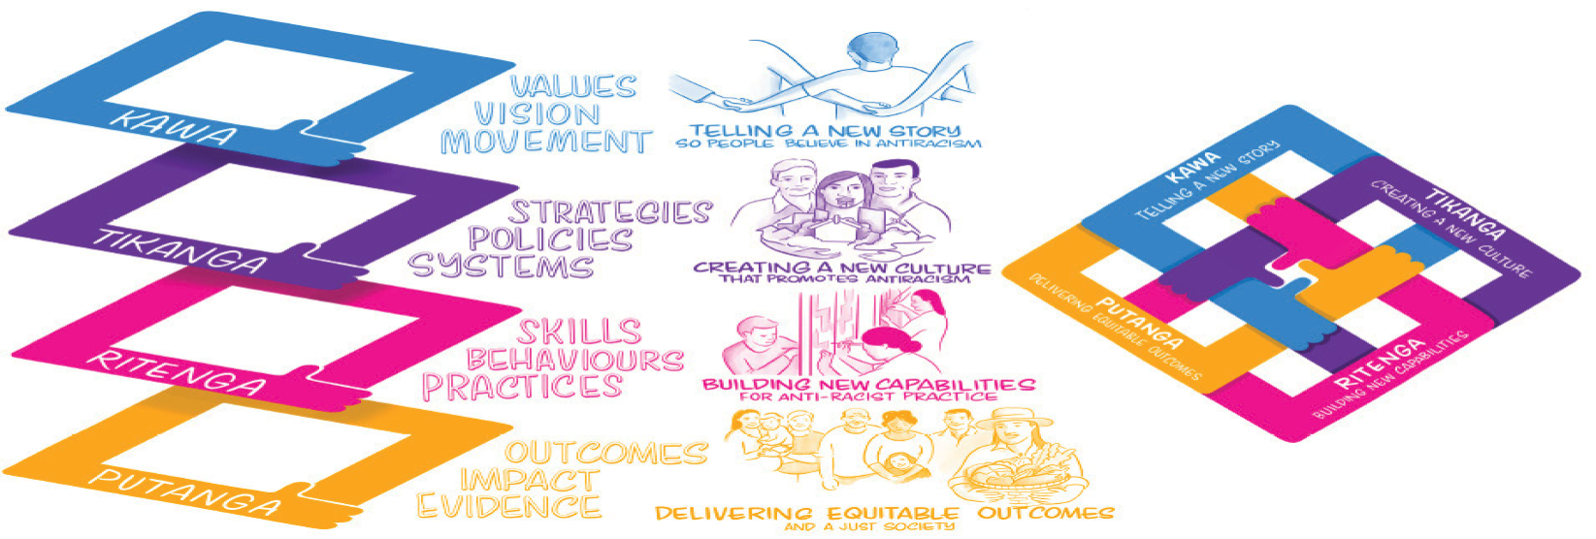

We need to continue to evolve our approach to change
A balanced approach must consider how to address both the more tangible types of change (such as structures, regulations and policies) and the more intangible types (such as relationships and power imbalances), and it must acknowledge that cultural change takes time, perhaps several generations, to embed
and sustain.

Our approach to the New Zealand Health Strategy combines:
- six priorities to set a clear direction for the type of change needed in the next ten years to move towards achieving these goals and ensure that our health system is fairer, stronger, more sustainable and responsive
- a focus within each priority on how change can be delivered, recognising the driving forces for change, and the need for more immediate and longer-term actions
- a balance between changes that can be delivered by the health system, for current and future populations, and those that require wider action and partnerships outside the health system
- ten-year ambitions for change that will act as markers to lead collective action across the health system and with other partners.

Our strategic priorities over the next 10 years
The priority areas in the next section set a 10-year direction for health in pursuit of our long-term vision of pae ora | healthy futures.

Each of the six priorities has been chosen based on an assessment of the evidence base and feedback from people and communities. Collectively, the priorities span a range of areas that highlight the key opportunities for change in our health system. They indicate the types of change needed to rebalance the system towards people, whānau and communities, to develop new services, treatments and approaches, and to change how agencies, teams and professionals work together.

Our priorities reinforce each other and overlap in a number of ways. Action in one area is likely to have a broader impact in others. The six priorities are:
- Voice at the heart of the system: Recognising and responding to the voices of our people and communities throughout the health system, so people have greater control over the design of services and decisions made about their care.
- Flexible, appropriate care: Developing services that are focused on preventing illness and delivering care closer to home, and support access for the most under- served communities.
- Valuing our health workforce: Recognising our health workforce as our most valuable asset and key to achieving transformative change. Supporting the health workforce to develop the diverse, skilled and confident workers of the future.
- A learning culture: Creating a culture of continuous learning and improvement that supports high quality, innovation, research and evaluation.
- A resilient and sustainable system: Ensuring preparedness for future shocks and the best use of resources to manage demand for health services and affordability of the system over the long-term.
- Partnerships for health and wellbeing: Working with other sectors and across government to partner on actions that address the drivers of health and wellbeing and support healthy communities and environments.

Ten-year ambitions will encourage collective action on shared goals
The priorities include a number of 10-year ambitions that encourage cross-sector and cross-government action to achieve the type of change required. These aim to build strategic alliances and partnerships across the public and private sectors, non-government organisations, academia and industry, amongst others.

Our 10-year ambitions call for collective action on shared goals, but they do not specify how to achieve success. Instead, agencies will work with partners, communities and Māori to define success in their own context and develop and design solutions.
This includes the opportunity to develop locally-led solutions that are created with a wide range of groups, particularly those who experience the greatest inequities, including Māori, Pacific peoples, rainbow communities and those living with disabilities and mental health and addiction.

Priority 1: Voice at the heart of the system

What we’ve heard
‘Patients don’t feel their voices and concerns are being listened to. When they try to ask for preventive tests, like blood, diagnostics, etc they feel they need to prepare a good case to present to their GP to get a referral. Preventive tests and diagnostics at younger ages could help save lives.’
- Ethnic communities engagement event participant
‘Don’t question my authority to make the best decisions for me.’
- Ngā Wānanga Pae Ora 2023 participant
‘I want to feel heard, not rushed. Take the time to read the notes about me and my history, come to an appointment with understanding and empathy, I am not a robot, and neither are you.’
- Women’s Health Strategy engagement participant

Why is this a priority?
Our health system exists to serve the population of New Zealand. We can only serve our communities well if we truly understand how people live and how it affects their health, and if we act on that understanding to change how services are designed and provided.

Having a voice in the health system is not just about having a say. It means that all people, whānau and communities have greater autonomy over their own health and greater control over their care and the decisions made about them.

We have heard that services that are designed with people and communities, and that take account of their needs and aspirations, are likely to be more effective and better value. Services that can adapt to reflect how people live their lives and recognise both a person’s wider needs and the role of their whānau are better placed to improve their health and wellbeing. The ‘one size fits all’ approach to services rarely accounts for the needs and context of people and can lead to poorer experience and outcomes. Moreover, for the most disadvantaged groups, it has been an unintended contributor to inequity.

In the past, the health system has not always placed the voices of health users at the heart of the system, or made decisions that reflect the needs of the diverse communities it serves. It has often been too removed from people and communities.

The health system has not honoured Te Tiriti, contributing to ongoing inequity in health outcomes. At times, decisions have been made about people without seeking their views, or without meaningful action to reflect their wishes. As a result, the health system has inadequately responded to the diverse needs of New Zealanders, further exacerbating health inequities.

People have told us that they feel that they do not have a voice, and do not have the ability to influence decisions and priorities that affect them. As a result, legacy service models remain the majority, and development of more new approaches has been more marginal.

The reformed health system has been designed to address this. New elements of the system have been put in place to re-balance decision-making at different levels.
- The establishment of localities and locality planning is an important step. Locality plans are a place-based approach that will support a more joined-up response to improve community health outcomes with whānau, hapū, iwi and Māori communities. Locality plans will enable a focus on wellbeing beyond just health services. They provide a platform to consider the wider issues that determine health, including the environment people live in, how they live, and the opportunities they have to thrive, provide for their whānau and contribute to their communities.
- The new legislation underpinning the reforms aims to address the health inequities experienced by Māori by transforming the way the health system makes decisions and ensures accountability. This includes engaging with Māori to develop, deliver, and monitor services and programmes designed to improve hauora Māori outcomes.
- The recognition of iwi-Māori partnership boards as a key partner to the health system and the powers provided under the legislation for them to engage with Māori in their communities and agree local priorities is an important step towards providing for mana motuhake and ensuring Māori voices inform decision-making.
- A new code of expectations for engagement with consumers and whānau sets the expectations for how health entities must work with consumers, whānau and communities in the planning, design, delivery and evaluation of health services.

These structures provide a foundation for change – but they will not work on their own. Shifting the health system to actively seek, respect and act on the voices of our communities requires more fundamental long-term change.

What does success look like?
A health system with voice at its heart will look and feel different.

The health system will further honour Te Tiriti and reflect te ao Māori world-views and social structures. This includes opportunities for Māori to make decisions on the design of services that are tailored to people’s needs and preferences, including kaupapa Māori services. Māori health leadership at all levels of the health sector will increase in capacity and capability.

The voices of whānau and communities will underpin the priorities that health services are focused on achieving. Health services will be flexible to adapt to the needs and aspirations of our diverse communities and cultures, while delivering consistent high-quality care.

The system will be more inclusive of communities who have been under-served and excluded from decision-making about their care and local health services, with processes to ensure all groups have a voice in issues that affect them.

More locally led and centrally enabled approaches that strengthen co-design and partnering with people will help us move towards preventive approaches to improve health outcomes for people today, as well as for future generations.

Health entities will continue to be responsible for leading the provision of high-quality, culturally responsive health services and there will continue to be clear expectations about the services that all people can expect to access throughout their lives – our standard universal offer.

Service models that work for most people, based on the latest evidence and ongoing research and best practice, will continue to be delivered at scale to reduce unjustifiable variation in outcomes and to ensure that the system is efficient and effective. But these services will be more flexible in how and when they are delivered, allowing for communities to inform their design and for the methods of delivery to vary based on needs. And a much wider array of more bespoke services will be developed that enable greater diversification for different cultures, communities and particular needs. This includes, for example, supporting and resourcing rainbow-specific health services and organisations.

Focus on locally led, centrally enabled approaches
For Māori, whānau centred approaches put whānau at the centre of decision-making. They empower whānau to identify and work towards their goals and aspirations, building on existing strengths. This gives commissioning agencies the flexibility to invest in different initiatives and services designed to best meet the needs and aspirations of the whānau they serve.
Whānau Ora was introduced in 2010 and is an innovative approach to improving whānau wellbeing that puts whānau at the centre of decision-making. It comprises a group of whānau centred initiatives. The Whānau Ora commissioning approach involves Te Puni Kōkiri contracting three commissioning agencies to invest in whānau-centred services throughout the country. Providers of these services work with whānau and support them to achieve their goals and aspirations.
Several reports note that Whānau Ora has been a success for many whānau. A report by the Controller and Auditor- General in Feb 2023 found that public sector processes and practices need to change to create a more enabling environment to implement these types of approaches where they are appropriate.

All people will be treated with dignity and respect, and whānau and carers will be acknowledged as experts in care by all health professionals. People will have access to information, advice and support for them and their whānau to live healthy, independent lives.

Communities will be better supported to help their people maintain social connections and strengthen their quality of life. Health services will be easy to navigate, with multiple ways to engage with diverse workforces and networks of people with lived experience.

Bringing diverse voices to the heart of the health system enables greater opportunities to listen and learn and to design a system that is responsive and empathetic. This is an important shift to rebalance power and control between different stakeholders in the system and to better distribute responsibility of central and local government decision-making.

What needs to change?
How the health system is designed and operates, and how decisions are made at all levels of the system, will always require a balance of different perspectives and objectives. Often these objectives will be well-aligned, but there will always be the potential for tension: for example, weighing the benefits to the whole population with those to particular groups or individuals; and dividing up resources given the financial constraints of a publicly-funded system. Maintaining a balance is important to deliver a health system that works for all.

At present, the system is not in balance. The ability to influence and make decisions rests in small groups, and there can be little opportunity or support for people to exercise authority or influence decisions that affect them. Changes are needed to ensure a balance of voices from every level of the system to strengthen how the health system performs and provides accountability.

For people and whānau
Giving people a more direct voice in their own care is essential to them having control and agency over their own health, and that of their family. The principle of ‘nothing about me, without me’ should be the default for all health services and programmes, with an expectation that people will be able to inform decisions about their care and that health professionals will respect their aspirations as far as practicable.

There are already a number of expectations on health agencies for engaging with people and upholding their rights as consumers of health services. However, while the expectations are clear there are few systems in place to ensure that these are met or to address concerns. To ensure that these baseline requirements are followed, it will be necessary to consider strengthening how they are enforced, for example:
- undertaking regular reviews at service-level of compliance with the Code of expectations for health entities’ engagement with consumers and whānau and Code of Health and Disability Services Consumers’ Rights, and reporting publicly on findings to share lessons and improve standards
- providing new accessible and culturally appropriate channels for people, whānau and health professionals to raise concerns and make complaints, and proportionate interventions for services or agencies that are found to be failing to meet their responsibilities.

Beyond strengthening these existing features, ensuring people have more control will require developing approaches for people and whānau with different needs and expectations.

This should include person centred and whānau centred care planning that supports people to make appropriate choices about the types of care they receive, and how and when they receive these. This sort of approach can lead to more responsive services that fit with the person’s life and goals – in particular, for those with long-term conditions or more complex packages of care.

It can be supported by greater control over how funding is spent to buy services, as demonstrated by the Enabling Good Lives programme and other international examples.

We will also need to provide mechanisms that support a meaningful choice of services – for instance, when accessing mental health support in the community. This might include greater information on the quality of services to inform decisions, and the ability for people to make an active choice from a range of suitable options.

At the local level
Locality planning as part of the health reforms provides a crucial platform to strengthen the voices of whānau and communities.

As locality planning matures in the coming years, there will be new opportunities to further expand the principles and processes. Locality planning allows health entities to start with people and whānau, understand their needs and aspirations, and to create a system that enables these diverse needs to be met.

One key opportunity is evolving locality planning to encompass a wider approach to health and wellbeing that engages other public services and partners to support local priorities. This could use locality structures to involve other agencies and organisations that contribute to health, including housing services and local government, and create a space for collaborative local action, leading to joint commissioning across public services and pooling of resources. This opportunity is also considered under Priority 6.

Other actions might include:
- maximising the benefits of iwi-Māori partnership boards as a key driver for change in representing the wellbeing aspirations of Māori, with responses needed within and beyond the health system
- considering other mechanisms and support to ensure that all communities and people who use health services – in particular, those who have the greatest inequity in health outcomes such as disabled people and rainbow communities have a voice in locality planning, including strengthening local consumer networks and considering a more formal role for community groups in developing locality plans
- ensuring that whānau, hapū, iwi, Māori and communities have a voice in decisions made at the regional level by health agencies, including for example by strengthening the role of iwi-Māori partnership boards and other local leadership groups to inform and challenge commissioning decisions that span multiple localities.

Ten-year ambition
People, whānau and communities will have greater control and influence over their health and the services they need.

At the regional and national level
Some health services are best planned across wider populations, because our resources need to be managed for the benefit of the whole population, especially in a relatively small country like New Zealand. However, even where decisions are made nationally, it remains critical that the voice of people and communities – particularly, whānau, hapū, iwi and Māori communities – inform the design choices that are made.

All health entities should consider how they engage and involve people, whānau and communities in delivering their roles. As the reformed health system matures, there is ongoing opportunity to ensure that the voices of people inform decision-making at the national and regional levels as the default. This is likely to need further deliberate change to how entities work, including:
- ensuring appropriate representation of different communities in how the system is planned and operated, so that there is a clear channel for expressing people’s voices – in particular, those who have been least well represented in the past
- strengthening the role of the national health consumer forum and other ‘peak bodies’ that represent the views of different communities, so that there is a clearer expectation of their involvement in key discussions that affect different groups
- opening up system governance to ensure transparency on decision-making to the people, whānau, hapū, iwi and communities that the system serves, which might include open board meetings and approaches to share and communicate the information that supports decisions.

Supporting diverse voices at all levels
Ensuring that all people are able to have a voice is essential – we cannot tackle health inequity if the system only recognises the loudest voices. Many of our communities face barriers to having their voice heard, including older people, children, tāngata whaiora, rainbow communities, and ethnic communities, as well as neurodiverse groups.

Supporting all voices to be heard will necessitate both improved general resources for the whole population, and more targeted support for those with the greatest need. We need:
- people to be able to access their personal health records and the information that agencies hold about them, including through use of electronic records
- universal information and advice services that help people to take active steps to manage their own health and that of their whānau, and to know how and when to access health services locally
- advocacy services that support people who need help to exercise control and authority, and that can work with health professionals to broker choices about their care
- translation and interpretation services — in particular, for ethnic communities and people with lived experience who face communication challenges

Improving experience of care
A key outcome of a focus on voice is ensuring that people’s experience of the health system is a priority for all health providers and for the health system as a whole. More culturally safe and responsive, fair and accessible health services will tackle many of the issues that affect experiences for some communities. This should also include a focus on the other things that matter to people, like being treated with dignity and respect, smooth transitions between services, easy access to information, advice and support, and ensuring informed consent.

Action will be needed to ensure that people’s feedback and information on the experience of health services are key indicators of success and underpin system monitoring and performance at all levels. This includes recognising the value of complaints and direct feedback mechanisms, and supporting people to use these. It should be reinforced through public reporting that demonstrates how the system is listening and responding to voices, and how services are judged based on the experience of the people they serve.

Ten-year ambition
People have the best possible experience of health services and the health system.

Links to other strategies
The themes in this priority area are developed further in the other health strategies, including in the sections of each as follows:
- Pae Tū: Hauora Māori Strategy: Priority 1: Enabling whānau, hapū, iwi and Māori community leadership, decision-making and governance at all levels
- Te Mana Ola: The Pacific Health Strategy: Priority 3: Soalaupule | Autonomy and determination. The health system better understands the needs and aspirations of Pacific peoples and communities and enables them to exercise authority over their health and wellbeing
- Health of Disabled People Strategy: Priority 1: Embed self-determination of disabled people and their whānau as the foundation of a person and whānau centred system
- Women’s Health Strategy: Priority 1: A health system that works for women
- Rural Health Strategy: Priority 1: Considering rural communities as a priority group.

Priority 2: Flexible, appropriate care

What we’ve heard
‘I consistently hear complaints about treatment and a lack of culturally appropriate care. These are the things that stop people stepping in the door, and this can have profound, long lasting effects … in 20 years, this should be a shocking experience, not a common occurrence’
- Ethnic communities engagement event participant
‘A lot of the poor outcomes experienced by disabled people are through lack of access … to treatment, … to information…’.
- Health of Disabled People Strategy engagement event participant
‘‘Because I moved to a rural area, I am continuing to see my old GP over an hour’s drive away as I have no faith in the local GP’s knowledge and professionalism regarding trans and non-binary people.’
- Rainbow communities engagement participant

Why is this a priority?
People’s expectations for health services are changing. Communities rightly expect services to be designed around them, and to be flexible and responsive to their needs. They expect services to be available and accessible when they need them. They use technology in all other aspects of their lives and expect the same for their health. Communities also want a stronger shift towards preventing illness and promoting health and wellbeing – not just responses to health issues after they occur.

While there have been significant advancements across our system, our health services have been slow to adapt to the expectations of New Zealanders. Many of the services, models and professional identities that have existed throughout the last 30 years continue to dominate people’s everyday experience. Definitions of ‘primary’ and ‘secondary’ care continue to reinforce barriers and amplify gaps; and the system does not support mental and physical health needs equitably. There remains a clear distinction between ‘mainstream’ services and others, which are too often deprioritised and under-funded. The division between services and professions employed within the health system and those on the outside is unclear and often lacks a strong rationale.

Innovation occurs throughout our system. But this innovation exists in patches and has not been scaled and disseminated across the system as a whole, and too often people face a lack of options. Technology that is common in other sectors, such as the use of personal digital devices, has not been embraced, and newer technologies such as precision medicine, nanotechnology and ‘the internet of things’ are in their infancy.

Access to services also remains unequal, and many people continue to face a range of barriers to getting the care they need. These include financial barriers (caused by individual co-payments for some services), practical barriers (especially for those who require help with transport or interpretation), cultural barriers and emotional barriers.

Improving health outcomes for all and achieving health equity requires a major redesign of health care. It necessitates a shift in how the system thinks about health and wellbeing, what it values and prioritises, and its willingness to test and adopt new ways of working.

What does success look like?
Successfully redesigning care will require collective actions and creative solutions that prioritise and resource services that are co-designed with communities, and that create the conditions for healthy individuals, healthy families and whānau, and healthy environments.

More preventive support, closer to home
Our future health system will be ‘community-based by default’ – that is, services will be available locally unless there is a clear clinical need to deliver them in a hospital or specialist setting, such as to ensure best quality and safety.

When people have a health need, they will engage with a health system that provides promotive, protective, preventive, curative, rehabilitative, and palliative services throughout the life course. This is a system that prioritises health for those with the greatest inequities, and focuses on quality of life, as well as length of life, including:
- promoting good health and wellbeing at the earliest opportunity – starting before birth and focusing on the early years of life
- preventing illness before it develops
- supporting early detection and intervention
- responsive and active management to delay progression of symptoms, avoidance of complications, and restoration of health when illness is present.

Focus on prevention
A strong focus on prevention is essential if we are to create the best possible chance of healthy ageing and a sustainable health system in the future. This means the broadest interpretation of prevention – including health promotion while also moving towards societal action to create the conditions for healthy, inclusive environments and lifestyles.
The preventive actions in this strategy – including those to create the best start in life, as well as focused policies that support people to have healthy, active lifestyles, with easily accessible pathways for help seeking behaviours, and equitable access to high-quality support – will improve outcomes later in life.
We must also tackle risk factors that tend to cluster around inequities - for example, through actions to create environments where physical activity is supported, people do not smoke, and they have better access to healthy food and nutrition.

Flexible, adaptive and responsive services become the ‘new mainstream’
The health system will embrace more flexible service models across a range of settings that bring together multi-disciplinary support to reflect people’s lives and how they want to engage with services. The boundaries between different types of care will be dissolved to allow for services that are more integrated and able to adapt and respond to people’s needs – considering their mental and physical health and wellbeing together and putting in place the right support for them.

A more flexible approach means recognising how culture, both historically and presently, affects how people navigate the health and wider social system. This is particularly the case for Māori and Pacific cultures, but also applies to cultures of gender, sexual and ethnic communities (among others). It also recognises that communities are often best placed to know what they need and want, and designing services from the ground up strengthens solutions that respond to local needs.

Service models that work for most people, based on the latest evidence and best practice, will continue to be delivered at scale across the country to reduce unjustifiable variation in outcomes and to ensure that the system is efficient and effective. But these services will be more flexible in how and when they are delivered, allowing for communities to inform their design and for the methods of delivery to vary based on needs. And a much wider array of more bespoke services will be developed that enable greater responsiveness to different cultures, communities and particular needs.

Focus on new service models for transgender and non-binary people
Work is underway to improve access to primary care for transgender and non-binary people. We are establishing tailored models of care, developing national gender- affirming health care guidelines, and developing training and workforce resources for primary health care professionals. We are also investing in services to increase access to mental health supports for rainbow communities and to provide rainbow competency training for health services. We heard strong calls during our engagement for gender-affirming health, provided at a reasonable and affordable cost and with much better availability.

What needs to change?
Achieving this priority requires a commitment to change over time. A more flexible approach to designing and delivering health services means changes in how services are planned and designed. Tackling structural and practical barriers – both real and perceived – will be important, and strong leadership will be a key factor in achieving change.

Shifting the system towards prevention
Sustaining a shift towards prevention requires a shared commitment to change within the health system and across the wider sectors that contribute to health. Within the health system, major change is needed to deliver a clear long-term plan for developing and investing in new services that focus on preventing, reducing and delaying needs. Prevention in this context is broad, and it includes a focus on slowing or stopping the progress of long-term conditions and frailty.

This will need to include proposals for targeted funding to support the growth of new models, while continuing to prioritise equity of access and outcomes. These may include:
- building on lessons from COVID-19 to use community-led approaches where these support the greatest involvement with groups, including for routine vaccinations and catch-up campaigns
- widening access to proactive screening for certain conditions to support early detection and intervention
- implementing service models that support independence for older people and others at risk of hospital admission, such as intermediate care and reablement
- equipping people, whānau and communities to look after their own health and wellbeing – for instance, through mental wellbeing promotional campaigns and digital tools and resources.

Focus on prevention
The HIV Action Plan aims to eliminate local HIV transmission and ensure people living with HIV have healthy lives free from stigma and discrimination. Priority groups include people living with HIV, gay, bisexual and other men who have sex with men, Māori at risk of and living with HIV, and transgender and non-binary people.

Plans for new preventive services will need to be combined with plans to disinvest in old services as benefits are realised, requiring trade-offs to ensure that service coverage is maintained during the transition. This requires a balanced, long-term plan that is transparent about when and how changes will occur and what people should expect.

Shifting these types of services will need to be combined with wider actions that reinforce prevention and encourage other sectors and communities to play their part.
- Outside the health system, this requires strategic partnering across sectors and government to promote healthy whānau, healthy behaviours and choices in our schools, work, and community spaces. This looks to public policies that address the determinants of health, for instance by tackling family violence and sexual violence, and that create healthy environments to lift wellbeing, for example through the Healthy Homes Initiative.
- Other government levers, including regulation, will also need to be considered in pursuit of health improvement and equity – in particular, where voluntary actions are not suitable or cannot deliver change quickly enough. For example, there is significant international evidence of different approaches in relation to tobacco, food environments, alcohol and other drugs, nutrition and gambling. This includes opportunities to explore policies and infrastructure that support healthy environments at a national and local level. This topic is also discussed in Priority 6.

Case example: Healthy Families NZ
Healthy Families NZ teams have been working with local leaders, champions and changemakers to identify and enable change that supports ‘kai secure’ communities.
Healthy Families Far North collaborated with Whangaroa Health Services, Mahitahi Hauora, local whānau, kaumātua and growers to better understand what food security and resiliency looks like in Whangaroa. Through a series of community workshops, the team learnt how disconnected tamariki and rangatahi are from where kai comes from. These community insights led to a prototype initiative creating an ‘Edible Playground’ and ‘Sowing Machine’ – a fun and engaging space where our tamariki can interact, learn and play with kai.

This requires “health in all policies”, including to strengthen the health narrative across existing policies that contribute to wider determinants, including family and whānau-friendly policies. Our 10-year ambitions support collective action on shared goals and encourage cross-sector and cross-government action to achieve the type of change required.

Case example: Kahu Taurima
Kahu Taurima is a joint approach to maternity and early years for all whānau in New Zealand. Kahu Taurima focuses on pēpi, tamariki, and support for strong, healthy, empowered whānau, ensuring whānau are well informed about their options and the standard of care they can expect to receive.
Kahu Taurima seeks to create whānau-centred service delivery through the redesign and integration of maternity and early years services, for a child’s first 2,000 days from conception to five years old. It will remove barriers and silos, integrate primary care, community and specialist services to improve quality, safety and equity of outcomes, deliver excellent, well connected, easy to navigate, culturally affirming health services for all wāhine and whānau, no matter who they are, and wherever they are, and make it easier for people to access services and extra support when needed.
To support the transformation, health entities will commission new, integrated, interprofessional, culturally tailored maternity and early years service delivery models. These models will contribute to achieving consistency in national service delivery while enabling local tailoring to support whānau aspirations and goals, which will be achieved by working with whānau, communities, hauora Māori partners, and service providers across the motu.

A strong focus on the early years
Prevention starts before birth. This means we need to invest in maternal health, pēpi, tamariki and the entire whānau to ensure that every child has the strongest start to life and the best possible chance of healthy outcomes later in life.

We will build on the current Kahu Taurima programme (see below) and expand other initiatives to develop integrated, whānau centred services that reinforce Māori and Pacific perspectives. As these models are developed and refined, they will become a default approach to delivering care to families and tamariki in their early years. It is also important that wider government and community efforts are also reinforcing this change by reducing the stressors on families and whānau and supporting their wellbeing during this critical period.

Flexible, more responsive primary and community health services
The health reforms provide us with the opportunity to integrate our system, embed new ways of working and remove silos across primary, community and specialist services.

Integrated, multi-disciplinary teams will become the norm in our communities, supporting people based on best use of skills, rather than by profession. Primary care will expand to include a much wider range of health professionals who can adapt to their communities, and better link to other professionals that support people’s wider needs.

This means taking a broader view of the role that could be played by all services and professions in delivering care closer to communities, including:
- a stronger role for pharmacists and nurses in providing health advice and prescribing medication
- integrating the allied health workforce into primary and community teams
- linking services that support people’s wider wellbeing and contribute to housing and good employment, such as Individual Placement and Support
- the potential role of schools, sports facilities and other local community infrastructure to improve health outcomes.

This will require a review of how we fund and regulate services, to consider how to encourage flexibility in professional skills and remove boundaries to support multi-disciplinary working as standard – and to ensure investment follows the best approaches.

It should consider the variation in employment status between different professional groups (for example, those who are directly employed by health entities and those who have other employers or are self-employed, such as many midwives and paramedics), and the potential impact on creating a unified and integrated workforce.

For the workforce, there will be greater ability to develop a more diverse skill set and work more flexibly to meet people’s needs and cultural expectations. This will support more effective approaches to caring for older people – for example, by integrating delivery of home care, community health services, and mental health and dementia services.

There will be strong leadership at all levels to recognise the contribution of different roles, skills and experiences in a health team. This includes recognising expertise in mātauranga Māori as a crucial skill set for supporting whānau Māori. It also includes the role of lived experience and peer support for people experiencing mental health and addiction challenges, as well as ensuring positive experiences for other communities (such as rainbow and ethnic communities). Leadership will be critical in tackling racism and discrimination and promoting culturally responsive, inclusive services and ways of working.

This shift will also require a significant expansion in the use of technology and a more open attitude to innovation as a force for change. This is considered further in Priority 4.
Ten-year ambition
Health services will be flexible to people’s range of needs and their cultural expectations.

Integration example: access and choice of mental health and addiction support
‘Access and Choice’ is a nationwide programme that increases access to and choice of primary mental health and addiction services across New Zealand.
The programme is being rolled out in general practice, kaupapa Māori, Pacific and youth-specific settings. The services are delivered in communities and offer mental health and addiction support for people who are experiencing significant levels of distress. There are no referral criteria and services and support are individually tailored to need.
The programme aims to ensure we can recognise and respond to distress early, increase choice in addressing people’s concerns, reduce wait times for mental health and addiction support and improve population health and equity outcomes. The programme also aims to build a general practice team who are confident and capable to support the wellbeing of people with mental health and addiction issues in their local population.
The core components of the service were designed nationally, but how these services are delivered is then determined locally – in order to ensure national consistency with local flexibility. In a number of areas, services are delivered by an integrated network of providers with one point of entry. For example, the Waypoint Youth Access and Choice service in Counties Manukau is delivered by a range of providers offering clinical services, cultural support, resilience building and group-based programmes. The service has one point of entry and rangatahi are able to access the range of services and support from the integrated network of providers that best meet their needs.

Tackling barriers to access
Over the next 10 years we must address barriers to accessing services – in particular, for primary and community care. This includes a focus on our system of user charges, which creates inequities for people who do not have the means to pay and who often have the highest need, and the availability of health services out of working hours.

Change requires considering the balance of funding in the health system between the state and individuals, and the impact of user charges on people and whānau. Part-charges exist for a range of health services and treatments. While many charges
are affordable to people and can promote responsible use of resources, for others they represent an unmanageable burden and can lead people to not access care when they need it.

Addressing the impact of user charges will not mean that all services become free at the point of use, and action is likely to have to be targeted over time to make best use of investment. There may be a case, for example, to prioritise addressing charges for preventive services that have a wider population health benefit.

Moreover, barriers are not just about finances. There is a range of other factors that can hinder access to care, especially for some communities. A comprehensive approach to improving access will also need to address a wide spectrum of barriers.
- Practical barriers, including transport to reach services, working hours and accessibility of buildings. In many cases, these exacerbate financial barriers where people are required to pay for critical support to attend appointments. We need to ensure that people have transport so they can access care, especially in rural communities, and we need to ensure availability of services outside of normal working hours.
- Communication barriers, in particular for ethnic communities who may not speak English and for others who have complex communication needs due to a health condition or disability. Access to effective interpretation, translation and advocacy support can be essential for these groups to engage with health services.
- Social and cultural barriers – for instance, based on a lack of trust in services among some communities, a reluctance to seek advice or treatment, or people experiencing family violence. The health system will need to sustain trust, reaching out to speak to people in ways (and through intermediaries) that work for them.
- Technology barriers, including the role of digital support as an enabler of accessing certain types of healthcare.

Even where these barriers are tackled, there may still be issues ensuring the availability of care services. In some places (such as remote rural communities) there are challenges to the viability of some primary and community services and this can lead to a lack of coverage. In other areas, unplanned increases in demand may outstrip supply, meaning that existing services cannot safely take on more patients.

In both of these cases, there is a role for government and health agencies to address gaps in service availability and ensure available of core services. This may include considering stronger requirements for health entities to be a ‘provider of last resort’ to ensure a safety net where communities risk not getting the care they need.

Parity between mental and physical health

Ten-year ambition
People are able to access the care they need, when they need it.

Physical health and mental health are inter-dependent, so they need an equitable focus within all services and teams. This includes supporting a sustainable, diverse, competent and confident mental health and addiction workforce, while also ensuring the wider workforce is equipped to support people’s mental health and wellbeing, across all interactions with the system.
To achieve equitable outcomes for people with mental health, substance use and addiction challenges, we must address the higher morbidity and mortality rates ofthose with more complex and enduring conditions. Prevention, early intervention, tailored approaches that address equity, and enhanced choice of services, are as important for mental health and addiction as for physical health. Multi-disciplinary health teams should include skills in mental health and addiction, and allocation of time and resources for mental health and addiction should be reflective of levels
of need.

Achieving parity will require the system to direct equitable efforts to workforce development, quality improvement, information and measurement, as well as ensuring that commissioners place equal value on improving mental health, addiction and mental wellbeing outcomes. Underpinning this will need to be a shift in attitudes towards mental health and addiction within the system and across the workforce, with equally high aspirations held for people with mental health and addiction needs to achieve pae ora.

Ten-year ambition
The health system will value physical and mental health equally.

Links to other strategies
The themes in this priority area are developed further in the other health strategies, including in the sections of each as follows:
- Pae Tū: Hauora Māori Strategy: Priority 4: Enabling culturally safe, whānau centred and preventive primary care
- Te Mana Ola: The Pacific Health Strategy: Priority 4: Haitiaaga moui malolo | Access. The health system ensures that timely, high-quality services are reaching Pacific peoples, wherever they live
- Health of Disabled People Strategy: Priority 2: Ensure the health system is designed by and accessible for disabled people and their whānau
- Women’s Health Strategy: Priority 2: Improving health care for issues specific to women
- Rural Health Strategy: Priority 3: Services are available closer to home for rural communities.

Priority 3: Valuing our workforce

What we’ve heard
‘[We need] a more joined up system where healthcare professionals have the time to support the needs of their individual patients and are not overworked and under resourced.’
- Women’s Health Strategy engagement submission
‘As people with lived experience of mental health and addictions, we want opportunities to train and work in the health care workforce to help our communities.’
- Pacific health fono participant
‘There is a skills shortage — opportunity for Māori to fill roles and increase mana wāhine leadership.’
- Ngā Wānanga Pae Ora 2023 participant

Why is this a priority?
Our health workforce is our greatest asset – a wide range of highly skilled, diverse and dedicated people and teams who are committed to improving health for New Zealanders. They are our frontline in protecting, promoting and improving the health of all New Zealanders and achieving health equity.

As our country changes, so too do our people’s health needs. Changing demographics and technological change mean we must think radically and differently about the types of skills we need to care for our future population. We need to challenge how we attract, develop, support and retain our workforce, and move away from traditional approaches that are focused on purely supply and demand of core professions. We must also re-think how we use our workforce, to be adaptive to emerging technologies and digital tools and incentivise ways of working that will deliver the most equitable health outcomes.

Communication and cultural skills must be recognised as core skills. They must be purposefully developed, utilised, and valued, with a commitment to fulfilling the special relationship between Māori and the Crown under Te Tiriti. Our system needs to recognise the importance of cultural skills and knowledge in developing a workforce that is truly representative of our diverse communities.

The workforce has told us that persistent shortages, a lack of diversity, maldistribution of services and inconsistent cultural responsiveness create barriers for the workforce to provide equitable, high-quality care and meet our strategic aspirations. Within the workforce, an imbalance in power and decision- making between roles means that many do not feel they have a voice in how services are designed and delivered.
These challenges are not new, nor are they unique to New Zealand – they reflect workforce pressures that are being experienced globally.

We recognise the importance and value of the workforce and the need for government and the wider system to support our current workforce while we transition to a new approach.

What does success look like?
To protect, promote and improve the health of New Zealanders and achieve equity in health outcomes, we need to shift the way we think about the workforce. We need to see our workforce as not just numbers but people who bring a unique balance of skills, competencies and personal attributes that, when properly valued, supported and utilised, can meet the varied health needs of New Zealanders.

Our health system is equipped with the people, skills and capabilities to meet New Zealand’s health needs
The health system attracts, retains and develops highly-skilled and diverse people to ensure we have an available workforce to deliver equitable outcomes, including for Māori, Pacific peoples, disabled people, ethnic communities and rainbow communities.

Training and employment models recognise and incentivise active learning and cultural competency to increase the depth, breadth and availability of care across New Zealand. On-the-job training, digital-driven learning, and other more accessible and affordable training pathways make it easy to enter the workforce or change careers.

Diverse models of care are funded and attract people into the health sector, where it is known that we produce positive and equitable health outcomes. Workplaces will be inclusive and multi-cultural, creating supportive and culturally safe working environments that retain our workforce.

Our workforce supports equitable access to care
A diverse and multi-disciplinary workforce will be equitably distributed across the country and in a range of settings that support people to easily access health services. People will be able to see a health professional that is competent and safe, whether they need health advice, treatment or support, wherever they live and work. There will be more choice for people to access health professionals that share their cultural background or have increased experience of capabilities in meeting the needs of disabled people, Māori, Pacific peoples, ethnic communities and rainbow communities.

The voice of communities, whānau and people will be reflected in the design of health service which is then translated into the development of education and training. New workforce roles, training and capabilities will enable better access to health services, particularly within rural communities. Wherever a health worker is based, they can trust that working in health will be flexible, rewarding, and empowering, with opportunities for personal development, and career progression.

Our workforce is responsive to the evolving needs of New Zealanders
The health system recognises, values and enables the development of diverse skills and capabilities to ensure we have an available workforce to deliver equitable outcomes. Mana Māori and mātauranga Māori are recognised as professional skill sets and Pacific worldviews, disability and cultural responsiveness will be considered core competencies for workforce safety.

Increased representation of Māori, Pacific peoples and disabled people, particularly in leadership and decision-making roles, will mean we have a representative health system. The people who design services, develop training, and determine cultural safety requirements and employment conditions will be reflective of the population to increase the cultural responsiveness of our health system.

Curricula and ongoing professional development will prepare our workforces to excel within new care models and increase availability of mātauranga Māori, Pacific approaches to hauora, and disability-specific skills. This will mean that the people in the workforce have the tools, skills and capabilities they need to work efficiently across services and organisations, delivering models of care that meet the communities’ needs.

Greater recognition of the full range of skills and capabilities will make it easier to access health careers and provide more opportunities to move between careers. It will mean working within a health system that creates a positive, active learning environment, with room for movement and progression, and that tackles racism and discrimination at all levels (including through Ao Mai te Rā).

Our health workforce is motivated and empowered to deliver efficient care
Employers, regulators, educators and service designers will be incentivised to collaborate and create adaptable and innovative workforce settings. This means a stronger interprofessional culture and leadership, fairer conditions, and embedding the norms of flexible working. Funding and performance monitoring will incentivise the workforce to work in efficient and effective ways. Interprofessional learning and working will break down professional boundaries and enable a more collaborative workforce with shared values and common ground. Right-touch regulation will support cross-profession collaboration, flexibility and capability.

Our health workforce delivers safe, high-quality and effective care
The health system will create a dynamic relationship with partners in education, regulation and employment settings to ensure we have safe and effective care. Modern regulation will mean increased flexibility and transparency of decision-making, and greater accountability for employers to provide safe working environments for the workforce.
Employers will provide the safety and support for health workers to develop and utilise the skills they need to work at the top of and across scopes of practice. Investment in workforce, infrastructure and services will be aligned to our priorities, and the workforce will have the tools they need to work and train flexibly and efficiently across services and organisations.

A more interconnected system with efficient, flexible and adaptive pathways to train will focus on what people need to know and do, to practise safely and well.

There will be opportunities to grow and develop technical skills balanced with a focus on kaiāwhina, peer and lived experience, and cultural skills. This means support for high-quality, inter- disciplinary care that is efficient and responsive to local needs.

What needs to change?
Solving our long-term challenges in a sustainable way requires a systematic and multi-layered approach. We need to re-think how we recognise, develop, value and enable the workforce. Cultural and behavioural factors, constraints like labour market supply and the role of artificial intelligence and technology must also inform workforce employment practices and health system legislation and investment.

Recognising and developing skills and capabilities to meet population health needs
Our workforce must be planned by looking as much to decades in the future as to today. Health entities will invest in workforce planning to support employers to recruit, value and develop the breadth of skills and capabilities required. This includes
a more sophisticated approach to modelling future demand and associated skills and competencies required to support pae ora, and intentionally building new workforce compositions, identifying potential shortfalls, and intervening early to
ensure sustainability.

As part of this, the health system will need to work with communities and iwi to understand what skills and capabilities are required. It will strengthen how community voices inform workforce requirements and training pathways through locality planning processes and other mechanisms including iwi-Māori partnership boards.

Delivering the future workforce will require novel, flexible and adaptive pathways to train, removing barriers to entry, and focusing on the skills people need to respond to improve health outcomes and achieve equity.

This includes a focus on the importance of ongoing professional development, and the opportunity to grow and stretch with new skills and responsibilities within supportive multi- disciplinary teams.

In practice, this looks like greater options for on-the-job training, digital-driven learning, recognition of prior learning, more accessible training programmes (both in terms of duration and cost), and programmes grounded in te ao Māori and Pacific worldviews becoming standard practice over time, in turn enhancing and accelerating kaupapa Māori and Pacific-led services. It includes developing resources to help identify and respond to wider issues that compound health needs, such as family violence and sexual violence. There are also opportunities for improved training and information for family carers to ensure they can safely and competently carry out their caring role and keep well themselves.

This also includes actions to grow and develop a workforce that reflects the population it serves and to ensure representation of Māori, Pacific peoples and disabled people, and other groups who are under-represented within the health workforce, particularly
in leadership and decision-making roles. This requires greater recognition and promotion of the Māori workforce to reflect the Māori population (in both mainstream and tikanga Māori based health services) and practitioners who work in a Māori way – for example, the growth and development of the rongoā workforce.

Ten-year ambition
The workforce will reflect our diverse communities and have the skills and capabilities required to meet their needs.

Valuing and respecting our workforce
The health system will place an explicit focus on workforce wellbeing and flexible employment models, including to recognise the critical role of workforce culture and leadership within health care settings. People will be able to combine work, care and social responsibilities without being disadvantaged.

Health entities will create the conditions for our health workforce to have more time to work directly with people in their care, with staff-led quality initiatives and automation to reduce variation and streamline administrative processes.

Action to value the health workforce will include efforts to provide fair and transparent remuneration, to provide more consistent terms and conditions, and to achieve pay parity. Employers will also provide consistent support for the health workforce in their workplace and throughout their career, where leaders create high-trust environments and relationships.

This will enable a much broader understanding of retention, with more flexibility to move between roles and organisations, including kaiāwhina and clinical roles, and more widely into planning, commissioning, policy, education, research and evaluation, and analytical roles.

This will require employers to work to lift cultural and leadership capability, and to set expectations, provide support and strengthen accountability to ensure employment conditions are supportive and promote wellbeing. This will create a flexible and active learning culture that supports development of skills. There will be greater visibility of career pathways and strengthened leadership development, particularly for Māori.

Ten-year ambition
The workforce will feel valued, recognised and respected and will be supported and motivated to deliver high-quality care.

Ensuring capacity to care
Our health system is facing shortages in a number of different professional groups. This is placing pressure on existing teams and individuals and their ability to provide high- quality care. Moreover, there are services and places that have been traditionally hard to recruit to, including more remote rural communities.

Addressing shortages alone will not solve the challenges facing the health workforce. We need to shift from looking at professions to looking at the skills and capabilities required to deliver high- quality care in New Zealand. Over the coming years, these elements need to be brought together into a coherent national plan to attract, train, utilise and retain people with the right values, skills and capabilities.

Expanding training pathways will deliver more New Zealand trained professionals over time, and can address shortages and improve workforce representation for our communities, in particular for Māori. However, these routes are essential but
are longer term, and are unlikely to deliver all the professionals that are needed in the future.

Ensuring we have an appropriate supply of international health workers will continue to be an important element. New Zealand is part of a global labour market for health, and we will need to think differently about how our system competes with others internationally. This should also consider our international responsibilities and the effects of our recruitment choices on other countries.

Enabling flexibility and upholding safety through regulation
Legislation and regulation need to be proportionate, enable flexibility and safety (including cultural safety), and uphold Te Tiriti in alignment with the Pae Ora Act. It must be fit-for-purpose not just for now, but in preparation for the future – for instance, in enabling the safe and effective use of new technology.

There must be clear roles and responsibilities across all parts of the health system. At a national level, relationships with responsible authorities (RAs) should be strengthened to ensure coordinated and aligned efforts towards achieving our ambitions. This includes a stronger guidance, advisory and monitoring role to support alignment across RAs and other organisations to guide how the health workforce is developed and managed.

Ten-year ambition
Flexible learning and working environments will give more room for growth and development.

Links to other strategies
The themes in this priority area are developed further in the other health strategies, including in the sections of each as follows:
- Pae Tū: Hauora Māori Strategy: Priority 3: Growing the Māori health workforce and sector to match community needs
- Te Mana Ola: The Pacific Health Strategy: Priority 5: Kau ngāue (Workforce). The health system grows and supports strong Pacific health leadership and a resilient health care workforce that reflects the population it serves
- Health of Disabled People Strategy: Priority 4: Build health sector workforce capacity and capability to meet the needs of disabled people and their whānau
- Women’s Health Strategy: Priority 1: A health system that works for women
- Rural Health Strategy: Priority 5: A valued and flexible rural health workforce.

Priority 4: A learning culture

What we’ve heard
‘Ka ma te ariki ka ma te tauira — be an active learner.’
- Ngā Wānanga Pae Ora 2023 participant
‘The standard of health care differs around the country. We need consistent quality of health care services from the North through to the South.’
- Pacific health fono participant
‘Good quality data and research on disability are essential to provide the basis for policy and programs, resource allocation, and to better understand issues and solutions in providing health care for disabled people.’
- Submission to the Health of Disabled People Strategy

Why is this a priority?
As technologies advance and the complexities of health and healthcare continue to increase, there is increasing global recognition of the value of a learning culture within health systems. Day-to-day, continuous cycles of generating and applying knowledge are the hallmark of modern health systems, and these can bring about dramatic improvements to health care, health system performance and health outcomes for the people they serve.

Our health system has many examples of innovation and new practice that are demonstrating how to deliver the type of care we want in the future. However, too often these developments rely on local factors and leadership that are not replicated elsewhere, meaning that best practice fails to spread and wider benefits are missed.

To achieve our twin goals of health equity and improved health outcomes, we need to harness the creativity and dynamism in our system and make these the norm for all. We need a system that encourages new thinking and supports good ideas to spread.

Establishing a culture of continuous learning and improvement will encourage and sustain change across our system, including by:
- upskilling health professionals and investing in their development, to ensure that everyone who works in the health system makes the most of their career
- ensuring clinical and workforce leadership promote the value of ongoing education, research and evaluation
- harnessing the benefits of innovation, technology and practice that improves how care is delivered, reduces variation and tackles inequity in outcomes
- enabling systems, processes and mindsets to be quicker to adapt to different ways of working and recognise the benefits of change for our communities.

At the heart of a learning culture and health system are research, innovation and the best use of data. Establishing a vibrant environment for research and innovation in the health system is a central objective of the New Zealand Health Research Strategy (2017-2027), emphasising the powerful impact that these functions have on achieving improved health outcomes and reducing inequities. We know that parts of our health system already have well-established approaches to research and innovation, whereas others will need support to develop through strong leadership and investment. At the same time, we know that our health system as a whole lacks a fully fledged learning culture, as well as the systems and settings (including data infrastructure) that would support such a culture to flourish.

For the system as a whole, this culture will support a clearer and contemporaneous understanding of what works for our diverse communities. It will build and share knowledge as a living resource that continues to evolve. As a result, it will help agencies to identify and tackle outdated practice that leads to unjustifiable variation in outcomes – in particular, for groups whose poor outcomes may be masked by whole-population averages.

Learning cultures flourish best when they centre on the needs of people and communities and are situated within systems and structures that proactively support and enable learning to occur. When we approach our work with people, communities, iwi, hapū and whānau from a place of curiosity and enquiry, we can identify their fundamental challenges and aspirations, co-design research that will help us to move forward, and co-design innovative solutions that will support those aspirations to be realised.

Case example: The Niho Taniwha
The Niho Taniwha is a values-led set of practices, developed by the Southern Initiative, that weaves learning and evaluation through the innovation process. It is developed from working with whānau, communities and systems. It is grounded in Aotearoa and draws respectfully from mātauranga Māori. Applying Niho Taniwha helps create a learning system for reflecting critically on where we are in our journey, and to set and reset the direction of travel.

What success looks like

A learning system that is focused on people
A culture of learning in health begins with people. Across the system, we will seek out excellence and build relationships to understand what is working and why. This means a dual focus on people who interact with the health system (and their families), and people who work within the health system – across health providers, health entities, and central and local government.

Establishing a culture of learning within the health system will mean gathering, sharing and synthesising information from many sources, with a focus on the diverse views and perspectives of people to create knowledge about what works and for whom. Our knowledge and understanding will include science, research and evaluative data, and mātauranga Māori and Pacific knowledge, as well as lived experience.

Building on what happens today
We will create ways to shine a light on the bright spots of change across the system and reflect on the conditions that enabled change. Where appropriate, this will reduce inconsistency and fragmentation and help us to move towards more cohesive planning, design and use of resources – for example, standardised care pathways for routine care.

Health agencies will more readily identify local innovation and have processes in place to generate insights and scale learning. The system will not seek to prescribe solutions for all places. Instead it will allow local areas to understand the different components of success.

This will not be limited only to best practice. We can learn as much from failed attempts at change and must be willing to seek out lessons in all places, ensuring that there is no blame culture to discourage new efforts.

We spread good practice through curiosity and leadership
Our health system will have the structures, processes and partnerships it needs to translate learning and research into new treatments and services and to implement them into practice.

We will create and sustain a learning, research and evaluation infrastructure that cultivates sharing between places and enables patterns to be recognised across systems. We will move away from approaches that hinder learning and constrain innovation, such as arbitrary reporting and compliance requirements. We will build a positive learning culture, with spaces to grow and learn.

This will take place at all levels – locally, regionally, and nationally – with regular feedback loops between and across all parts of the system, where people collaborate and continuously learn together.

A thriving environment for research and innovation in the health system
Research and innovation are accepted as core functions of the health system. Research will be embedded into every day clinical care and service delivery, enabling people to participate in research, including clinical trials, as part of their usual care.

All health professionals have the opportunity to be involved in research, whether to develop their own research questions ‘from the bedside’ or to collaborate with others to investigate areas of mutual interest.

Over time, sustained investment ensures that the health system has the necessary infrastructure, pathways and processes to generate and apply knowledge gained through research, analytics and evaluation as part of a continuous cycle of learning. This translates into significant improvements in care, health system performance and health outcomes.

Embracing innovation, data and new technologies
The health system will increase its focus on innovation and new technologies to accelerate better care, use of resources and health outcomes. Effective technologies will be more readily adopted, with easier routes to implementation, proportionate regulation and stronger feedback processes to share learning.

Integrated data systems with robust data standards allow knowledge to be inferred from clinical data using a continuous process of analytics and insights. Clinicians will have real-time access to this knowledge and use it to inform decision-making.

We will harness the power of data and digital platforms, such as electronic health records, disease registries and mobile devices, for the real-time capture, production and application of knowledge. We embrace the opportunities offered by precision health, including the use of genomics to help personalise health care in a targeted way.

What needs to change
Creating a learning culture will require a long-term programme of action to put in place the foundations for new ways of working, and progressively build the leadership, alliances and relationships that will build and sustain new approaches. We know some of the critical success factors through observing other successful health and innovation systems.

Translating these into the Aotearoa New Zealand context will require specific, purposeful investment in people and infrastructure over the next decade and be complementary to the unique opportunities to learn from indigenous knowledge.

Identifying what works
To spread best practice, we need to be able to identify it. This means both being clear about what works and being able to highlight where it is taking place.

Our health system has minimum standards for care quality and safety, and these work to protect all people from poor care and treatment. However, we have not routinely defined what ‘good’ or ‘excellent’ care looks like for our different communities and have not set out to capture evidence systematically to challenge and develop this understanding over time.

A foundation for a learning culture must be to encourage broader definitions of quality that reflect the voices of people, their outcomes and experience, alongside matters such as clinical effectiveness and efficiency. This requires a broad conversation on what services aspire to achieve and what good looks like, to develop principles that reflect our diversity.

This will support the system to develop a better understanding of good and excellent care for different conditions, pathways and communities, based on evidence and feedback from people. New standards for high quality can then be established as markers of best practice that inform commissioning and service design.

Ten-year ambition
The health system will develop standards for high-quality care that support all services to improve.

Spreading new ideas
Many good ideas fail to spread because they lack the support necessary to capture and translate their learning in ways that are accessible for others. This reinforces the idea that a successful approach in one place must be unique and cannot be replicated.

We need to reorient towards a ‘one system ethos’, where research and innovation across all parts of the system, regardless of scale, have their place within a national operating model.

The ecosystem and opportunities for learning, research and innovation need to be highly visible so they can be easily understood, both by those within the system and by those who it services – as people, communities and whānau also play a critical role.

To achieve a learning system, we will need new mechanisms for disseminating innovation and supporting all parts of our system to harness new opportunities.
- A strong national leadership function focused on the delivery of research and innovation will drive better health outcomes through providing and overseeing coordination, organisation and opportunities across the system.
- A systemic approach to research in practice will sit alongside promising new service models and technologies and help to build the evidence base. This will provide ready-made information for other parts of the system to adopt new approaches more easily. Collaboration and coordination across disciplines and locations will allow more people to benefit through participation and create more generalisable findings.
- We will harness improvement science to understand how services implement innovation consistently, with targeted support for new models and technologies. This will look to different approaches internationally to consider how to provide services and professionals with regular learning opportunities that build on new thinking.

Ensuring health workers have time to learn and be involved in research
The health workforce is the strongest asset and advocate for a learning health system. Our health professionals want to develop their skills and capabilities and test out their bright ideas, but they often lack the incentives, support and time required.

We need to address the barriers to learning and research for our health workforce and create more time to upskill and contribute to the learning of others. Currently, a large proportion of research conducted in our health services is conducted by clinicians in their own time, despite the direct relevance to their day-to-day responsibilities and the benefit it brings to care. We need to recognise that research and learning are a fundamental part of a health professional’s role, and provide the time and environment for these to be realised.

We also need to make sure that there is organisation-level support for continuous improvement through research, evaluation, innovation and implementation across all parts of the system and that all health workers have access to professional development in these areas. This includes skills in implementation; improvement and evaluation; data literacy and analytical expertise; front-line implementation capability; and organisational improvement capability. This will help to future- proof our health system by maintaining a core research-trained workforce, as well as contributing to staff retention and a vibrant workplace culture.

Ten-year ambition
New initiatives will help all parts of the system to harness innovation and new technologies and put evidence and research into everyday practice.

Robust, integrated data systems and standards
Realising a learning health system at a national level depends on the quality of our data and data systems, and having the expertise to interrogate and interpret data and translate it into meaningful knowledge. Robust data allows us to monitor trends and outcomes and to conduct formal evaluation of health services and programmes, helping us to identify gaps and issues that need further research or provide opportunities for innovation.

We must have unified and trusted data gathering systems that are accessible to all, where privacy and security are paramount. These data will need robust governance and alignment with respect to Māori data sovereignty. We also need to address data gaps, including those identified in the pae ora strategies, as well as more outcome-based measures of health.

Data-driven approaches to research using digital platforms will be increasingly powerful in our health system as we strengthen and integrate our data infrastructure. Data that draw from sources such as high-quality clinical registries, electronic health records and ‘the internet of things’ all provide opportunities to embed interventions within health care systems and provide evidence for their effectiveness within real-world settings. They can also be used to identify potential participants, leading to research that has greater impact.

Technological and scientific advances such as artificial intelligence and genomic-based medicine will be increasingly important enablers of learning and help underpin new models of diagnostic and therapeutic development.

New national roles for learning and improvement
To achieve a learning system, we need to be able to apply knowledge derived from analytics, research, and evaluation to improve practice and system performance – including knowledge from a range of sources such as mātauranga Māori and Pacific knowledge, the voices of people and whānau and lived experience. This requires formal mechanisms that involve robust, ongoing assessment of existing knowledge and new technologies, and processes to support implementation of best practice across the system in a consistent, equity-driven way.

We can learn from the roles and functions in other sectors and international health systems to inform the approach we take.
- Establishing a new system-wide innovation function to develop and disseminate knowledge on what works, to promote new practice and provide targeted support for improvement. Such a function could provide an organising structure around clinical networks and other analytical, research and innovation functions that are already producing, translating and implementing knowledge in the system, as well as identifying and filling existing gaps. This might best sit outside commissioning agencies so that it can broker support and present evidence impartially.
- Creating a more direct role for the health system in developing, assessing and incubating new models of care and technologies, alongside a process to accelerate their uptake. This would include working more closely with industry and linking with other agencies, including the Ministry of Business, Innovation and Employment.
- Strengthening the role of clinical and workforce networks to bring together different groups of health professionals. Nationally led networks can drive uptake of best practice and support and lead professional development. While some networks exist at present, these are largely driven by individuals, are not in place for all professions and their role in the leadership of the health system is not clearly defined.
- Evolving the way the system is monitored, the way performance is measured, and the way the results of monitoring are communicated and acted on. This would make the relative performance of services clearer, enable targeting of support, and improve accountability to the public and our communities.
- New mechanisms to capture and share information, as well as reflective spaces, are also needed so that people can collaborate in making sense of the data captured. This includes a stronger focus on mātauranga Māori and Pacific knowledge, and the voices of whānau, hapū, iwi and Māori communities.

Ten-year ambition
New national functions will drive continuous improvement and support the development and implementation of new technologies.

Links to other strategies
The themes in this priority area are developed further in the other health strategies, including in the sections of each as follows:
- Pae Tū: Hauora Māori Strategy: Priority 5: Ensuring accountability for system performance for Māori
- Te Mana Ola: The Pacific Health Strategy: Priority 3: Soalaupule | Autonomy and determination. The health system better understands the needs and aspirations of Pacific peoples and communities and enables them to exercise authority over their health and wellbeing
- Health of Disabled People Strategy: Priority 5: Increase the visibility of disabled people in health data, research and evidence as part of an active learning system
- Women’s Health Strategy: Priority 1: A health system that works for women
- Rural Health Strategy: Priority 1: Considering rural communities as a priority group.

Priority 5: A resilient and sustainable system

What we’ve heard
‘We need to come back to the grass root level — the places people meet, eat, and greet together. This has shown us the way … we need to take lots of learning from COVID 19 and of communities coming together, protecting themselves and each other [in the context of discussing a flu vaccine clinic being brought to a temple in 2019].’
- Ethnic communities engagement event participant
‘It would be much more beneficial to invest in interventions early before waiting to get to crisis level and having to spend a lot of money and impact a wide range of people.’
- Written submission on the Women’s Health Strategy

Why is this a priority?
Our health system, like all publicly funded services, continues to exist, grow and improve based on the support it maintains from our population. This requires a balancing act: at once striving to deliver the best outcomes for New Zealanders, with timely access to high-quality, culturally responsive services, while also ensuring that public money is invested wisely and for the greatest value.

Spending on health has increased in recent years, including in response to the COVID-19 pandemic. This trend is projected to continue as our population ages and complexity of health needs increase. Forecasts suggest that by 2060 spending on health will reach 10.5% of GDP, compared with about 7% today. This level of growth will place substantial additional pressure on public spending for other critical services.

A core challenge for our health system is to continue to improve quality of services and equity of outcomes in the context of increasing and changing health needs. Stats NZ projects that people aged 65+ will make up 26% of the population in 2060, compared to 16% in 2020. While increased life expectancy is a measure of success, it poses questions for how the health system responds to the additional needs without requiring an unacceptable proportion of government spending.

Managing this demand for health care better, and supporting people to live independently for longer, are critical to sustainability.
Many of the priorities in this strategy support sustainability in some way – for example, by improving how we train and use the workforce to meet future needs, and by ensuring that services continuously improve, harness new technologies and learn from the best. Over and above these important areas, there are three further issues to address:
- how the system manages increasing demand for health services in the short and medium term – in particular, related to older people
- how the health system makes best use of public money and remains affordable in the long term
- how the system ensures resilience over time – in particular,
- in relation to the effects of adverse events and climate change and the need for environmental sustainability.

Our ambitions must be achieved in a long-term, sustainable financial envelope. This includes a focus on improving productivity of health services, reducing waste and maximising the value of public money. But we must also ensure that a focus on shorter-term efficiency does not exclude sensible planning and investment that makes the system more adaptive and resilient in the longer term.

Fiscal sustainability helps maintain and improve inter- generational wellbeing. It ensures governments can continue to pay for the services into the future and can respond to unexpected shocks to protect living standards, and that future generations are not unfairly burdened through higher taxes or a lower level of services.

Case example: Prevention in ageing
Prevention is possible at many stages and for many conditions. Globally, the number of older people, including those living with dementia, is rising. A growing body of evidence has identified 12 modifiable risk factors that account for around 40% of worldwide dementia cases, which consequently could theoretically be prevented or delayed. Dementia is rising more in low-income and middle-income countries than in high-income countries, because of population ageing and higher frequency of potentially modifiable risk factors.
Research shows that it is never too early and or too late for dementia prevention. Risks for and mitigation of dementia begin early and continue throughout life. The actions we take now to create the best start in life, as well as targeted interventions for high-risk groups to increase social, cognitive, and physical activity and improve vascular health, will improve outcomes later in life. There is also a need to tackle risk factors that tend to cluster around inequalities, including actions to create healthy environments.
For people who are at risk or early signs of symptoms, a healthy ageing approach seeks to delay the onset or progression of symptoms by building and maintaining people’s physical and mental function, and independence.

What does success look like?
A resilient health system is one that is prepared for and able to manage the impact of additional pressures – including predictable pressures such as seasonal impacts (such as winter) and unpredictable shocks such as those caused by the COVID-19 pandemic. In the long-term, a resilient system is also a sustainable one because it is better able to manage changes in demand for services or availability of resources without affecting health outcomes.

In the future, our health system will be better able to respond and adapt to fluctuations in demand and changes in the wider environment. The health system reforms already put in place the structural foundations, by creating the conditions for a nationally planned, regionally managed and locally delivered network of health services. This will enable the health entities to plan effectively and use resources across the whole of New Zealand where necessary, and to have the relationships and processes in place to work directly with communities and providers of health services to manage the response to incidents.

Learning from the COVID-19 response, such as new working relationships with Māori communities and hauora Māori providers and the increased use of digital platforms in primary care, will be harnessed and made routine to build community resilience and sustainability of services from the ground up.

A resilient system will also be better prepared for the impacts of climate change. As recent events such as Cyclone Gabrielle have demonstrated, our health and welfare services are at risk of major disruption. In the future, our health system will have plans in place to secure core services, respond rapidly to events, and work collectively with government and communities to deal with both immediate risks and the longer-term response. An increase with more significant weather events could bring increased impacts on people’s mental health and wellbeing, meaning we also need to consider future demands on the health system.

While our system will be more adaptive and flexible to deal with known and unknown issues as they arise, it will also be more sustainable and grow public trust in how it operates and spends public money.

Financial sustainability will be based on a stronger approach to managing demand for healthcare, and actions to reduce, delay and prevent health needs at all stages of life. This will require a decisive shift from legacy services towards greater investment in preventive measures and early interventions, new service types that improve access and experience for different communities, and the wider use of new technology.

Focus on ‘ageing in place’
As we age, many of us will want to remain at home, closer to family, friends, and neighbours. Being at home will help us to maintain our independence and social connections – and it can also be more cost-effective than residential care. Successful ‘ageing in place’ means people can age in enabling environments that protect against frailty and that support healthy ageing.
Frailty is not based on the age of a person but on their physical and functional ability. As we age, we can lose the ability to bounce back quickly after a physical or mental illness or to adapt to decreased physical strength and/or cognitive decline. Frailty has multiple causes and contributors and can increase the risk of serious adverse outcomes after a stressful event or change. This includes the risk of falls, needing to be treated in the hospital (and with lengthened stays) and a shift to permanent residential care – all of which can affect a person’s ability to maintain independence.
There are many actions we can take to promote healthy ageing and protect against frailty, including:
- targeted interventions to create enabling environments and increase social, cognitive, and physical activity
- healthy ageing approaches to delay of the onset or progression of symptoms
- actions to slow or stop the progress of long-term conditions towards frailty
- timely access to health care that is responsive to the needs of older people and focused on building and maintaining people’s physical and mental function.
Taken together, these actions will increase the likelihood of people being able to maintain independence and have a better quality of life for longer.

Reducing and preventing health needs will improve sustainability in the long term, but the system must also ensure that it uses resources optimally in the present. A sustainable system will ensure the delivery of high-quality, effective and efficient services, supported by processes and technologies that empower the health workforce to focus on care, highlight and address unjustifiable variation, and reduce waste and duplication.

The health system will be underpinned by a sustainable long-term funding model, where the balance of revenue raised through taxation and individual payments is well understood, has the broadest possible support by the public, and is capable of meeting future costs.

What do we need to change?
There are actions across all priority areas that will contribute to a resilient and sustainable system.
- To deliver more preventive care, we expect to see changes to the distribution of funding, including towards community- based services and digitally enabled models. This will shift the balance of care to better manage health need, and enable people to remain closer to home for longer – avoiding hospital visits and reducing demand over the long term.
- To develop the health workforce, we want to encourage greater flexibility to work across professions and boundaries as part of multi-disciplinary teams.
- To develop a learning culture, we want to more clearly define what best practice looks like, and put in place the mechanisms to identify, incentivise and reward excellence wherever it occurs in the system, and provide long-term support for research and innovation. This will help to spread practice of what works and reduce variation.

All of these will make a significant difference – including to improve the productivity of the workforce by ensuring a focus on care that is targeted at the greatest need – but we will need to do more over the coming years to supplement and reinforce these gains.

Supporting an ageing population
While a focus on prevention and the early years of life will deliver health benefits for future generations, to remain sustainable in the shorter term we also need to address the effects of an ageing population on our health system. Strengthening the focus on older people will support greater independence, improve health outcomes, and better manage demand for health services, both during later life and at the end of life.

Health agencies will need to lead and contribute to actions that promote independence in older age and protect against frailty, including:
- targeted interventions such as those to increase social, cognitive, and physical activity for older people – including to increase social connection and address loneliness
- investment in services for people who are at risk or have early signs of physical or mental health needs, to delay of the onset or progression of symptoms – including therapy-led services such as intermediate care and respite care that support older people to regain independence and avoid hospital admissions
- creating culturally-appropriate enabling environments, ranging from modifications to homes so that they are safer, to multi-agency approaches so that urban and environmental policies support older communities to thrive – including investment in adopting technologies that help older people to live independently for longer and to monitor their health actively;
- actions to slow or stop the progression of long-term conditions, such as timely access to health care that is responsive to the needs of older people and focused on building and maintaining people’s physical and mental function – including exploration of a frailty identification tool to enable health professionals to identify frail older people earlier and improve access to necessary supports, treatment and rehabilitation services;
- actions to improve end of life care and integrate services for people and whānau – including those provided by health agencies and non-government providers (such as hospices), where greater integration of support can help to reduce the need for unnecessary hospital stays or medicalisation at the end of life, promoting dignity and better use of resources.

Health agencies will also continue to strengthen their contribution to cross-government work that supports the health and wellbeing of older people. This should include a renewed focus on improving support for socially isolated older people and targeted actions to address elder abuse, such as the Family Violence and Sexual Violence Work Programme by Te Manatū Whakahiato Ora | the Ministry of Social Development and the Ministry of Justice). It should also include support for communities to become age friendly, and to consider the needs of people with dementia, including through the Age-Friendly Aotearoa New Zealand programme and the broader work of the Office for Seniors.

Supporting resilience
The health system reforms are already putting into place roles and processes that will help to coordinate its response to events and ensure whole-system planning and levers. Learning from COVID-19 and lessons identified by the Royal Commission of Inquiry will provide crucial indications of where further steps should be taken. As new arrangements develop and are tested through real events, there will be opportunities to continue to learn and improve.

A core element of the health system being resilient to climate change is ensuring that it delivers its own actions to become more environmentally sustainable. The health system already has targets for reducing carbon emissions in the next 10 years, but will need to ensure delivery of these across all entities and make significant changes to how it provides services and uses its assets, buildings and resources.

Ten-year ambition
The health system will be better prepared to manage future adverse events.

Improving productivity and efficiency
The health reforms have been designed with the aim of strengthening how the system works to implement best practice at scale, to reduce unwarranted variation and to identify waste and inefficiency to release resources to be reprioritised for higher value activities.
The learning culture that we want to develop will support consistent adoption of best practice and evidence-based service models where appropriate. As part of this culture of continuous improvement and innovation, we will need to see targeted actions to support the system to realise productivity and efficiency gains, and achieve greater value.
- We will implement existing technology at scale to improve system operations – for example, the use of digital staffing rosters and planning tools. There is significant potential gain through technologies that already are in use in other health systems – the best models for our system need to be identified and rolled out consistently.
- We will incentivise productivity and efficiency – for instance recognising and rewarding health workforces and teams for improvements as part of a positive learning culture, and trialling financial incentives that allow services to retain and re-invest the savings that they achieve.
- We will develop the framework for harnessing innovation and new technology in the health system, including the potential benefits of artificial intelligence, machine learning and genomics. This will require reviewing the legislative and regulatory framework, considering infrastructure and investment implications, and tackling ethical issues to ensure that new technologies are delivered safely and equitably.
- We will drive reduction in waste and duplication – encouraging people who use health services and our workforce to raise the issues that they see in their day-to-day interactions, and supporting entities to address practical problems together. This might include actions to reduce carbon emissions and single-use items.

Ten-year ambition
The health system will be more productive and efficient, to make the best use of public money.

Ensuring long-term affordability
Long-term affordability of the health system will be heavily influenced by both how successfully the system transforms to better manage demand for health services, and the economic context within which all public services must be paid for.

In the face of projections for an ageing population, a change in the complexity of health need, and wider economic risks, it will be necessary to consider whether the balance of funding for the health system remains appropriate and commands public support. Over the coming years, this might include reviewing other international funding models and looking for lessons and opportunities.

Links to other strategies
The themes in this priority area are developed further in the other health strategies, including in the sections of each as follows:
- Pae Tū: Hauora Māori Strategy: Priority 5: Ensuring accountability for system performance for Māori
- Te Mana Ola: The Pacific Health Strategy: Priority 2: Te pāruru’anga, te apii’anga, e te akateretere’anga no te ora’anga meitaki (Disease prevention, health promotion and management for good health); and Priority 3: Soalaupule | Autonomy and determination
- Health of Disabled People Strategy: Priority 3: Ensure the health system is part of a coherent cross- government system that addresses the drivers of poor health and wellbeing
- Women’s Health Strategy: Priority 4: Living well and ageing well
- Rural Health Strategy: Priority 2: Prevention – paving the path to a healthier future.

Priority 6: Partnerships for health

What we’ve heard
‘How do you expect us to be healthy when there are fast food outlets, alcohol and vape shops on every street corner in neighbourhoods where we live?’
- Pacific health fono participant
‘Parks, gardens, services & facilities, exercise, health services, healthy homes [describing what keeping well in communities looks, sounds and feels like].’
- Ethnic communities engagement event participant
‘Wai ora is about connection and responsibility to the environment, it’s also about having access to healthy, stable and secure environments both inside and outside the home.’
- Ngā Wānanga Pae Ora 2023 participant

Why is this a priority?
Our health is influenced by a wide range of social, economic and environmental factors, such as income, education and housing. There are different estimates of how much each of these contributes to health, but research has shown that taken together, these wider factors have a greater impact on health outcomes than our behaviours (what we eat and how physically active we are, how much we smoke or drink alcohol); and the health care and services we receive.

These wider factors contribute to inequitable health outcomes for Māori, Pacific peoples, disabled people and women, and adversely affect the health of people in rural communities (this is explained in more detail in the Pae Ora strategies for each of these groups).

The wider determinants of health also adversely affect ethnic communities and rainbow communities, among other groups who face high levels of social exclusion and discrimination.

Simply stated: we cannot achieve our objectives to improve health and eliminate inequity without getting to the heart of the factors that drive outcomes. The health system alone cannot achieve and sustain the change we need, and its efforts will be undermined without wider action that supports all our people to live well.

Successive health strategies have called for collaboration across agencies and sectors, and embedding a population health approach. However, while we know that wider determinants have a major impact on health, this has not always been translated into how sectors work together, and the policy and regulatory settings that support this.

The health sector has had limited ability to influence the work of other sectors, even where there is a clear link to health and wellbeing outcomes. Similarly, the health system has not always been an effective partner to support other sectors and organisations to prioritise health. Narrow definitions of health have ignored wider concepts of wellbeing and other worldviews – in particular, te ao Māori and Pacific models of health and wellbeing – and with that the need for more holistic approaches to wellbeing. Together, this means that opportunities for collective effort and innovation have been missed.

Achieving pae ora will require more effective and inclusive approaches across the health system, between public sector agencies, with communities, and with other sectors, including private industry. Only by harnessing collective effort can wider determinants be addressed and barriers to health tackled.

What does success look like?
Health sector agencies will partner with a wide range of groups and organisations, including those from the private and non- profit sectors, to work on initiatives nationally and locally that improve health and wellbeing.

Cross-government partnerships
There will be a range of new opportunities to encourage participation in current cross-government initiatives that improve health. We will see greater use of existing mechanisms and flexibilities, such as joint investments and joint ventures,
and the development of new approaches such as joint commissioning, budget pooling and integrated governance.

The health system will be a stronger partner and will enhance its role in other sectors’ initiatives that influence the creation of a better living environment, especially for tamariki. This includes a renewed focus on the determinants of health – for example, healthy housing, urban design policy and interactions with the justice sector.

In areas such as climate change, where the work is led by other sectors, data and other evidence, information and insights will help influence agencies to ensure a health and wellbeing outcomes focus as standard. This would include realising opportunities to strengthen health input in policies that contribute to giving every child the best start in life.

At the national level, Manatū Hauora | the Ministry of Health will leverage its role as chief steward of the health system to convene and lead cross-government initiatives that improve health and tackle inequity, coordinate policy development across health entities, and support effective arrangements for cross-system working.

Focus on cross-government initiatives
Health agencies participate in a number of cross- government initiatives that address some of the wider determinants of health and are examples of the types of partnerships that we want to develop.
- The Oranga Tamariki Action Plan is a joint plan to promote wellbeing for the children, young people and families involved with Oranga Tamariki. Health sector agencies are responsible for a range of actions, including detailed needs assessments and responses, the development of new models of care, improving health capability for social workers and caregivers, and supporting a review of the Gateway assessment process, as well as actions to improve data and information sharing.
- The Child and Youth Wellbeing Strategy is a national strategy to improve the wellbeing of all children and young people under the age of 25. Health agencies are leading actions to design a maternity whole of system action plan; provide intensive parenting support; expand the pregnancy and parenting service; review the Well Child Tamariki Ora programme; provide healthy active learning; extend nurses in schools. The Ministry of Health is also leading the new priority of child and youth mental wellbeing, added to the strategy in response to the 2022 review.
- Te Aorerekura is a national strategy to eliminate family violence and sexual violence. The Ministry of Health is partner to delivery of the strategy, including leading action focused on support for safe early years.
- The Aotearoa New Zealand Homelessness Action Plan 2020-2023 is a national plan to prevent homelessness and increase support services. It is based on a commitment to partner with iwi, hapū, marae and Māori organisations, local authorities, providers, and people with lived experience of homelessness to prevent and reduce homelessness. The plan includes an action led by Te Whatu Ora to support people leaving acute mental health and addiction inpatient units who are at risk of homelessness.
- The Physical Activity and Play Plan is a framework to guide cross-government work on the promotion of physical activity and play.
- Healthy Active Learning is a joint government initiative between Sport NZ, Te Whatu Ora | Health New Zealand, and the Ministry of Education to improve the wellbeing of tamariki and rangatahi through healthy eating and drinking and physical activity.
- There are also a range of health/education initiatives with examples of introducing mental wellbeing support in education and learning settings, including Mana Ake in primary/intermediate schools and mental wellbeing support in all tertiary organisations.

Working with communities
The health system will work to build on the successes and learning from Māori, Pacific and rural community-led COVID-19 responses. These responses involved a wide range of sector groups – including providers, iwi and other Māori groups, Pacific community leaders and organisations, lived experience networks, schools, churches and other community groups – and demonstrated the value of partnership in reaching groups that health services cannot easily access alone. The approach demonstrated by those communities and providers, including the Māori and Pacific values and world-views underpinning the approach, should be applied more widely and proactively, not just when responding to national emergencies.

There are also opportunities to build on the Māori and Pacific community-led responses to cyclones, earthquakes and other natural disasters to resource and support these communities to have a more proactive role in relation to climate change.

Working with wider sectors
The health system will build new partnerships with wider sectors that influence population health and wellbeing, to convene and lead collaborative action and recognise the many influences in people’s lives that affect their health. This should include partnerships with employers that reflect the critical role of work in contributing to health outcomes, and the importance of safe workplaces to physical and mental health. It should also include working with the retail sector to influence consumer behaviours and choices that affect their health, and to promote products that help people to remain well and independent.

Creating the space for partnerships and corporate involvement in health will reinforce the principle of health as a shared endeavour and open up new ways of supporting and investing in our communities to promote good health.

What needs to change?

Working across government
Building partnerships across government to improve health and wellbeing will require a change in mindset and relationships, supported by strong leadership. While practical barriers to cross- agency working exist (which should be reviewed and addressed where necessary), many barriers are the result of perceived issues and institutional silos.

There are already examples of cross-government programmes. However, further cross-government action will require a deliberate application of existing mechanisms that have been used in only limited ways to date. For instance, the Public Service Act 2020 provides for new organisational and instrument types that create opportunities to improve effectiveness across government. These are intended to address accountability issues, including situations where agencies were not able to make legally enforceable agreements with each other, and the problem of their individual accountability being prioritised over shared priorities. The new flexibilities in this Act have not been widely used in the health sector, however.
We also need to develop and test new mechanisms and approaches, and learn from existing good practice and international examples and evidence. This might include:
- approaches that encourage or require joint needs assessments and joint strategic commissioning of services that contribute to health – at the national, regional and local levels
- reviewing the impact of the Public Finance Act to consider how to support ‘co-funding’ flexibilities to pool budgets and resources between agencies and appropriations, for instance to support joint investment in initiatives that benefit shared objectives
- new governance models that bring together public sector agencies to lead and account for delivery of shared health outcomes, with a focus on partnering with Māori and identifying opportunities to partner in decision-making.

Ten-year ambition
The health system will lead and influence across government to improve health and wellbeing outcomes.

Case example: Ngā Tini Whetū
This work will be informed by the learnings from Ngā Tini Whetū, a whānau-centred early support prototype involving Te Puni Kōkiri, Oranga Tamariki and the Accident Compensation Corporation (ACC) designed to strengthen families and improve the safety and wellbeing of children. An evaluation report at the end of the first year of the prototype’s operation found that:
“Ngā Tini Whetū is a landmark two-year prototype for government agencies that has the potential to achieve positive outcomes for whānau and tamariki by changing the way that government agencies and Crown entities collaborate and partner with kaupapa Māori organisations and commissioning models. It has created a space for Te Puni Kōkiri, Oranga Tamariki and ACC to collaborate and work in partnership with the Whānau Ora Commissioning Agency using a different policy, funding and commissioning model. The model is underpinned by kaupapa Māori principles.”

Working with communities
At the local level, locality planning (discussed in more detail in Priority 1) will create new relationships and partnerships between the health system and communities that could over time evolve to encompass a wider approach to health and wellbeing that engages other public services and partners to support local priorities. As locality planning embeds and relationships mature, the new arrangements will provide a basis for engaging other partners towards mutual priorities.

Māori-Crown partnerships will guide the system, and health entities will partner with whānau, hapū, iwi and Māori communities to shape and drive change. Iwi-Māori partnership boards will be a critical Te Tiriti partner to represent local Māori perspectives in relation to hauora Māori outcomes and ensure services are being designed to meet local context in each locality. Other mechanisms to engage with Māori will also be adopted as appropriate to ensure a range of voices are heard.

Working across sectors
Fostering new partnerships across sectors, and building on current relationships, will require concerted action for government and the health system to lead and convene coalitions that focus on health outcomes. The Government and the health sector can drive voluntary action that can avoid the need for new regulation in some cases.

There is significant opportunity in harnessing the shared interests of different sectors of our economy to improve health, for instance:
- working with major employers to strengthen workplace safety, occupational health and access to support for physical and mental health at work – including to recognise the important impact of good work and work environments on health, and the interests of employers in promoting this
- working with wider industries and businesses to build movements for change that focus on the benefits of health to the economy and the potential contributions of different sectors to shared goals – for instance, by creating a movement for change that encourages voluntary action on health (for example, by taking a specific focus with different sectors to target activity, such as working with food producers to encourage reformulation of salt and sugar and consistent food labelling, and working with media to address advertising of unhealthy products to children)
- working with the retail sector to consider influences on healthy behaviours and choices, and actions that can encourage healthier choices (such as point of sale advertising and promotions) and development of products and markets that keep people well
- working with non-governmental organisations and peak bodies to align messages and campaigns on healthy lifestyles, how to access health services, and other support for health and wellbeing.

Mechanisms such as joint venture-type arrangements may be required to facilitate cross-sector collaboration with non- governmental individuals and groups, and options for these will need to be explored in coming years.

Ten-year ambition
Health entities will partner with other sectors to support shared approaches to improving health and wellbeing.

Links to other strategies
The themes in this priority area are developed further in the other health strategies, including in the sections of each as follows:
- Pae Tū: Hauora Māori Strategy: Priority 2: Strengthening whole of government commitment to Māori health
- Te Mana Ola: The Pacific Health Strategy: Priority 1: Vaqaqacotaka na yavutu ni tiko bulabula (Population health). The health system works with communities and government and non-government agencies to build, maintain and enable strong foundations for Pacific health and wellbeing
- Health of Disabled People Strategy: Priority 3: Ensure the health system is part of a coherent cross- government system that addresses the drivers of poor health and wellbeing
- Women’s Health Strategy: Priority 3: Better outcomes for mothers, whānau and future generations
- Rural Health Strategy: Priority 2: Prevention – paving the path to a healthier future

Part 4: Delivering our commitment to change

Turning strategies into action
One of the objectives of the health system reforms is to better align and integrate the accountability arrangements that set direction and priorities for health agencies. The reforms put in place a new approach that aims to ensure clarity and coherence, from long-term strategic objectives to shorter-term priorities and expectations.

This new approach provides clear roles for key documents, underpinned by statutory requirements in the Pae Ora (Healthy Futures) Act.
- Health strategies are intended to set a long-term (5 to 10 years) direction for improving health and identify priorities and opportunities for the health system. The strategies provide a vision and indicate the types of change necessary over the medium and long term. Strategies do not make commitments to particular actions or require health entities to undertake specific activities – instead they describe potential choices and issues to be considered, to inform the decisions that the Government will make on what actions are taken forward, and when. Health entities must take the strategies into account in carrying out their responsibilities, including in commissioning services and allocating resources.
- The Government Policy Statement on Health (GPS) sets out the specific priorities and expectations for the health system over a three-year period. It is the key document for Government to set its priorities, confirm actions for entities and funding for the health system, and detail how progress and success will be measured. The GPS will reflect the long- term direction of the strategies, and include more detailed actions for health entities in the short term that work towards the strategic goals. The GPS is agreed by ministers, closely linked to Budget funding decisions, and health entities must give effect to it.
- The New Zealand Health Plan (NZHP) | Te Pae Tata is a three- year national service plan, that specifies the service priorities and areas for improvement that will achieve Government’s expectations in the GPS. The NZHP includes more detailed plans for health services, programmes and enablers that show how the health entities will meet priorities within the funding available. The NZHP is developed by health entities and approved by ministers.

These documents work together to set a consistent direction for the health system, which is then developed into more specific actions and costed service plans that span a multi-year period, as illustrated in the diagram below.
Figure 11: Relationships between health system direction-setting documents
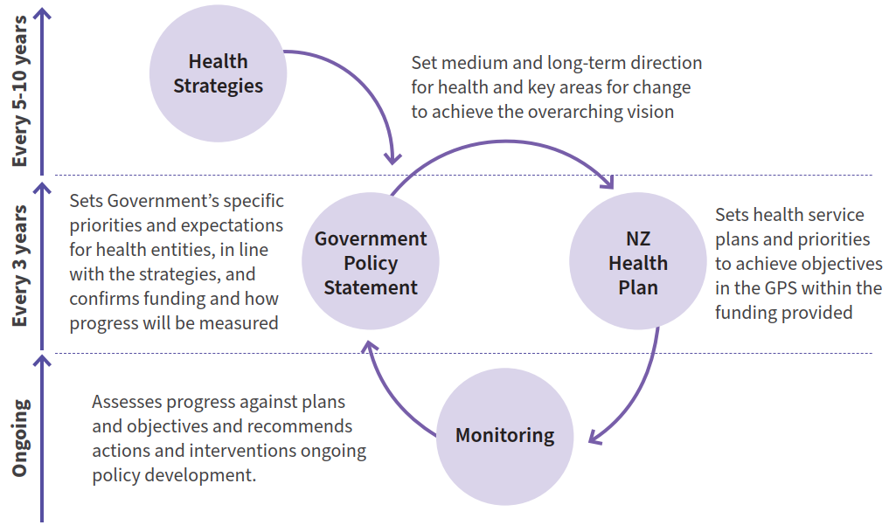

This new approach provides a clear pathway for translating strategies into action, and monitoring and evaluating the impact of strategies and the performance of agencies. The role of health strategies is critical to providing the long-term vision and priority areas that inform decisions on the other documents.

As the Government determines the first three-year GPS on Health for 2024-2027, and in subsequent cycles, the strategies will be turned into clear expectations and actions that will provide the opportunity to achieve the changes set out.

Monitoring outcomes
The health strategies set a direction towards achieving pae ora | healthy futures for all New Zealanders, and include goals to eliminate health inequities and improve health outcomes. Monitoring progress towards this vision requires a long-term approach to measuring key health outcomes.

The GPS on Health will set requirements for measures and indicators that will be used to monitor and assess the progress of the health system as a whole, and of individual entities, in achieving these goals. These measures will combine more enduring and long-term system-level outcomes that are closely linked to the strategies, as well as more specific measures that reflect three-year priorities and help drive action in areas prioritised in the GPS. They will support Manatū Hauora, in its stewardship role, to track delivery of the strategies and report on the impact on outcomes over time.

High-quality data will be essential to monitoring outcomes. This is particularly the case for monitoring inequities between population groups, which require a breakdown of data to make comparisons and develop insights. The current health data sets contain numerous gaps – both for certain groups (including Pacific peoples, rainbow communities, ethnic communities, disabled people and rural communities) and services (eg, primary and community care) – that will need to be addressed through purposeful, targeted data and analytics plans to ensure that the intended effect of the strategies can be appropriately monitored for all groups. Work is underway to improve the quality and timeliness of data acquisition from all parts of the sector, especially primary care and non-governmental organisations, but a successful integrated data system will require ongoing leadership and investment.

‘Good quality data and research on disability are essential to provide the basis for policy and programs, resource allocation, and to better understand issues and solutions in providing health care for disabled people.’

- Submission to the Health of Disabled People Strategy

Ongoing research and evaluation
In addition to monitoring the intended outcomes of the strategies to account for the success of their delivery, it is also important to ensure ongoing evaluation of the strategy direction itself to ensure that this remains appropriate.

An early step will be to undertake an evaluation into the process undertaken to develop the health strategies, to draw insights on the benefits of different engagement approaches, analysis and development.

Over the coming years as the strategies are developed into firm actions in the GPS on Health and NZ Health Plan and then implemented, it will be necessary to invest in ongoing research and evaluation to continue to build our understanding of the direction and evolve it where needed. This may include:
- evaluating the impact of the Pae Ora (Healthy Futures) Act, the effectiveness of its implementation, and lessons for the system structure
- evaluating the new accountability approach, the roles of strategies, the GPS and NZ Health Plan, and the effectiveness of their delivery and alignment in achieving system goals.

These areas for evaluation will be developed further with targeted resources to support a refreshed approach to evaluation and the use of evidence across the health system.

In parallel with this work there will be a refresh of the New Zealand Health Research Strategy, in partnership with health agencies, to ensure that evidence gaps are progressively filled and that research is embedded into wider health delivery systems to enable innovation in service provision.

‘Health entities’, as defined in section 4 of the Pae Ora (Healthy Futures) Act 2022, are Te Whatu Ora | Health New Zealand, Health Quality and Safety Commission, Te Aka Whai Ora | Māori Health Authority, Pharmac and the New Zealand Blood and Organ Service.
For instance, anyone making decisions under the Health and Disability Commissioner Act 1994 has to take the strategy into account, and Sport New Zealand has to work in a way that aligns with New Zealand Health Strategy objectives (section 7 of the Health and Disability Commissioner Act 1994 and section 8(k) of the Sport and Recreation New Zealand Act 2002).
Waitangi Tribunal. 2019. Hauora: Report on Stage One of the Health Services and Outcomes Kaupapa Inquiry
Manatū Hauora. 2022. Annual Update of Key Results 2021/22: New Zealand Health Survey. URL: http://www.health.govt.nz/publication/annual-update-key-results-2021-22-new-zealand-health-survey (accessed 4 July 2023).
It is anticipated that nine of the top 10 conditions contributing to health loss over the next 20 years will be long term conditions.
According to data from the New Zealand Health Survey.
Cunningham R, Peterson D, Sarfati D, et al (2014). Premature mortality in adults using New Zealand psychiatric services. New Zealand Medical Journal 2014; 127 (1394). *Note: This refers to people who use New Zealand adult public psychiatric services.
These are known as modifiable risk factors. A healthy weight and diet, and an active lifestyle are proven to effectively reduce or delay the onset of many long-term conditions. Actions that support people, their families and whānau to have the right knowledge and tools to make healthy lifestyle choices are important. Friends and social networks also have a key role to play.
The Ministry for Ethnic Communities defines ‘ethnic communities’ as people who identify their ethnicity as African, Asian, Continental European, Latin American or Middle Eastern. They also include former refugees, asylum seekers, new and temporary migrants, long-term settlers and multi- generational New Zealanders. This definition is adopted throughout the strategy when referring to ethnic communities.
Te Whatu Ora. District Employed Workforce Quarterly Report (December 2022).
‘Rainbow’ is a broad umbrella term that covers a diversity of sexual orientations, gender identities and expressions, and sex characteristics and is used in place of LGBTQIA+. It is a diverse population group with a range of experiences and includes people who identify with terms like gay, lesbian, bisexual, queer, ace or asexual, intersex, transgender, non-binary, takatāpui and MVPFAFF+.
Stats NZ. 2022. LGBT+ population of Aotearoa: Year ended June 2021. URL: http://www.stats.govt.nz/information-releases/lgbt-plus-population-of-aotearoa- year-ended-june-2021/ (accessed 22 June 2023). Note: This data is based on questions about sexual identity and gender and do not capture all of those who are part of rainbow communities. StatsNZ defined this population as people aged 18 years and over who reported a gender that was not male or female, reported a sexual identity that was not heterosexual (also known as straight), or who reported a gender that did not match what was recorded for their sex at birth (for example, transgender male or transgender female).
Counting Ourselves is the first comprehensive national survey of the health and wellbeing of trans and non-binary people living in Aotearoa New Zealand and was conducted from 21 June to 30 September 2018. For more information, visit countingourselves.nz/2018-survey-report.
Health Quality & Safety Commission. 2021. A window on quality 2021: COVID-19 and impacts on our broader health system | He tirohanga kounga 2021: COVID-19 me ngā pānga ki te pūnaha hauora whānui. URL: http://www.hqsc.govt.nz/resources/resource-library/a-window-on-quality-2021-covid-19-and-impacts-on-our-broader-health-system-part-1-he-tirohanga-kounga-2021-me-nga-panga-ki-te-punaha-hauora-whanui-wahanga-1 (accessed 22 June 2023).
Department of the Prime Minister and Cabinet. 2023. Child and Youth Wellbeing Strategy: Annual report for the year ending 30 June 2022. URL: http://www.childyouthwellbeing.govt.nz/resources/child-and-youth-wellbeing-strategy-annual-report-20212022 (accessed 22 June 2023).
Manatū Hauora | Ministry of Health. Health and Independence Report (2022).
For example, 67% of rangatahi Māori surveyed reported good mental wellbeing, while 27.8% reported significant depressive symptoms. These outcomes were worse still for young people currently in Oranga Tamariki care, with 55.7% reporting good mental wellbeing and 48.5% reporting significant depressive symptoms.
Quin, P. 2009. New Zealand Health System Reforms (Parliamentary Library Research Paper 09/03). URL: http://www.parliament.nz/resource/en-NZ/00PLSocRP 09031/9772cc5da74650da549200e3627fef0ef46c5fa7 (accessed 23 June 2023).
McMeeking S, Tarena E, Williams M et al. 2022. Whiria te Muka Tangata: Anti-Racism Systems Change. A Preliminary Model for the Aotearoa New Zealand Health System. URL: http://www.health.govt.nz/publication/whiria-te-muka-tangata-anti-racism-systems-change (accessed 21 June 2023). Note: Whiria te Muka Tangata is influenced by Professor Mānuka Henare’s model for the Royal Commission for Social Policy. It draws on the recommendations of the literature reviews produced as part of Ao Mai te Rā: the Anti-Racism Kaupapa.
Te Tāhū Hauora | Health Quality & Safety Commission. 2023. Te tikanga mō te mahi tahi a ngā hinonga hauora ki ngā kiritaki me ngā whānau | Code of expectations for health entities’ engagement with consumers and whānau. URL: http://www.hqsc.govt.nz/consumer-hub/engaging-consumers-and-whanau/ code-of-expectations-for-health-entities-engagement-with-consumers-and-whanau/ (accessed 23 June 2023)
This includes an audit of Whānau Ora by the Office of the Auditor-General in 2015 after its first four years, and a review in 2018, when the Minister for Whānau Ora commissioned a review that found Whānau Ora creates positive change for whānau and creates the conditions for that change to be sustainable.
The Code of Health and Disability Services Consumers’ Rights (Code of Health and Disability Services Consumers’ Rights - Health and Disability Commissioner (hdc.org.nz)) and the Code of expectations for health entities’ engagement with consumers and whānau (Code of expectations for health entities’ engagement with consumers and whānau | Health Quality & Safety Commission (hqsc.govt.nz).
In this document, tāngata whaiora refers to people from all backgrounds who experience mental distress or substance-related harm and who are seeking wellness or recovery.
Particularly for Māori, Pacific, disabled people and people who experience serious mental health and addiction needs and people from ethnic communities, and peoples experiencing high levels of deprivation.
Ao Mai te Rā: The Anti-Racism Kaupapa that supports the health system to better understand, react and respond to racism in health.
Lived/Living Experience roles involve people utilising their lived experience knowledge, insight and expertise, informed by Lived/Living or Peer Movements values, to bring about system or organisation change or to provide personal support. Examples of these include Lived Experience Advice, Peer Advocacy or Peer Support. Peer support workers are trained in and use peer support practices.
New Zealand health practitioners are regulated primarily under the Health Practitioners Competence Assurance Act 2003. Responsible authorities oversee registration of practitioners, set scopes of practice, accredit education and training providers, and define professional standards.
The Institute of Medicine described a learning health system as a health system where ‘science, informatics, incentives and culture are aligned for continuous improvement and innovation, with best practices seamlessly embedded in the care process, patients and families active participants in all elements, and new knowledge captured as an integral by-product of the care experience.’ Institute of Medicine. 2013. Best Care at Lower Cost: The Path to Continuously Learning Health Care in America. Washington, DC: The National Academies Press. URL: https://doi.org/10.17226/13444 (accessed 26 June 2023).
The New Zealand Health Research Strategy (2017-2027) will be refreshed over the first year of the New Zealand Health Strategy to take into account the new health system structures and any emerging priorities in the health research environment.
Further consideration of precision health is set out in the Ministry of Health’s Long-term Insights Briefing: Ministry of Health. 2023. Precision health: Exploring opportunities and challenges to predict, prevent, diagnose, and treat disease more precisely in Aotearoa New Zealand. URL: http://www.health.govt.nz/ publication/precision-health-exploring-opportunities-and-challenges-predict-prevent-diagnose-and-treat-disease-0 (accessed 26 June 2023).
Such as the New South Wales Agency for Clinical Innovation.
Treasury statement on the long-term fiscal position: New Zealand Treasury. 2021. He Tirohanga Mokopuna 2021. URL: http://www.treasury.govt.nz/publications/ltfp/he-tirohanga-mokopuna-2021 (accessed 26 June 2023).
The 12 factors are education, hypertension, hearing impairment, smoking, unhealthy weight, depression, physical inactivity, diabetes, and low social contact, excessive alcohol consumption, traumatic brain injury, and air pollution.
Livingston G, Huntley J, Sommerlad A, et al. 2020. Dementia prevention, intervention, and care: 2020 report of the Lancet Commission. The Lancet 396(10248): 413–46. URL: https://doi.org/10.1016/S0140-6736(20)30367-6 (accessed 26 June 2023).
The elder abuse response services (EARS) sector comprises 26 social service providers contracted by Te Manatū Whakahiato Ora to deliver EARS. The sector currently receives approximately $9.8 million per annum to deliver these services and respond to elder abuse and neglect experienced by older people across the country. Contractually, all territorial land authority areas are covered by existing EARS providers — this ensures older people have timely access to support regardless of where they live.
For example, rainbow people are less likely to own their home than non- rainbow people of the same age, with significant differences for some age groups. Rainbow youth, particularly Māori rainbow rangatahi and Pacific rainbow young people, experience higher rates of homelessness than other young people.
Aiko Consultants. 2021. Ngā Tini Whetū: Lessons Learnt. URL: http://www.orangatamariki.govt.nz/about-us/research/our-research/nga-tini-whetu-lessons-learnt (accessed 26 June 2023).

