The National Radiation Oncology Plan
2017–2021

Citation: Ministry of Health. 2017. The National Radiation Oncology Plan 2017–2021. Wellington: Ministry of Health.
Published in April 2017
by the Ministry of Health
PO Box 5013, Wellington 6140, New Zealand
ISBN 978-1-98-850223-6 (online)
HP 6569
This document is available at www.health.govt.nz
This work is licensed under the Creative Commons Attribution 4.0 International licence. In essence, you are free to: share, ie, copy and redistribute the material in any medium or format; adapt ie, remix, transform and build upon the material. You must give appropriate credit, provide a link to the licence and indicate if changes were made.

Contents
1 Introduction 1
1.1 Background 1
1.2 The National Radiation Oncology Plan 2017–2021 3
2 Context 4
2.1 Overview of radiation oncology in New Zealand 4
2.2 Overview of international trends in radiation oncology 5
3 Introducing the Service Planning Tool 7
3.1 Robust measurement to support quality improvement 7
3.2 Findings 8
4 Using the outputs of the Service Planning Tool 13
4.1 Addressing unwarranted variation 13
4.2 Supporting the foundations of the New Zealand health system 15
4.3 National clinical governance 17
4.4 The regional cancer networks 17
4.5 The role of the Ministry in the ongoing management of ROMDS 17
4.6 The role of private providers 18
5 A framework for action 19
5.1 Overview of the framework 19
5.2 Strategic priorities 20
6 Making it happen – tools, structures and processes 28
6.1 Cancer information 28
6.2 Clinical governance 31
6.3 Linear accelerator capacity 33
6.4 Workforce capacity 34
References 36
Appendix A: Progress with actions from the Radiation Oncology National Linear Accelerator and Workforce Plan (2013) 38
Appendix B: Radiation oncology metrics 40
Quarterly measures 40
Annual measures 41

List of tables
Table 1: New Zealand radiation oncology providers by ownership and location 4
Table 2: Provisional curative radiation therapy intervention rate for selected cancers, 2013–2015 10
Table 3: Factors affecting whether patients and referring clinicians choose radiation therapy 21
Table 4: Actions to give people fair access to the services they need 22
Table 5: Actions to make radiation oncology services safe and effective 24
Table 6: Actions to make radiation oncology services sustainable 26
Table 7: Actions to improve cancer information 30
Table 8: Actions to establish the clinical governance function 32
Table 9: Actions to support enhanced linac capacity planning 33
Table 10: Actions to support enhanced workforce capacity planning 35

List of figures
Figure 1: Provisional radiation oncology intervention and subsequent treatment rates by DHB of residence, 2013–2015 9
Figure 2: Provisional radiation oncology projected linear accelerator numbers based on different intervention rates, 2015–2023 11
Figure 3: Provisional attendance numbers for curative intervention rates for breast cancer by provider, 2014–2015 12
Figure 4: Framework for managing unwarranted variation 14
Figure 5: Functions and activities throughout the process of using the tool to address unwarranted variation 16
Figure 6: Vision and outcomes, and their supporting tools, structures and processes 19

Introduction

Background
The New Zealand radiation oncology sector (including both the public and private radiation oncology providers) and the Ministry of Health (the Ministry) have been working together to improve the way clinical information is collected and used. The purpose of this work is to support service and capacity planning, and improve quality in line with the Government’s priority of improving cancer outcomes for all New Zealanders.

The Radiation Oncology National Linear Accelerator and Workforce Plan
In 2014 the Ministry published the Radiation Oncology National Linear Accelerator and Workforce Plan (Health Partners Consulting Group 2014), New Zealand’s first dedicated national radiation oncology plan (‘the first national plan’). Its purpose was to guide a nationally coordinated approach to radiation oncology service and capacity planning. The first national plan was strongly linked to the development of the National Linear Accelerator and Workforce Capacity Model (‘the Model’), an Excel workbook that helped district health boards (DHBs) and regional cancer networks (RCNs) in building their understanding of current access and future demand for radiation therapy, and its implications for linear accelerator (‘linac’) and workforce capacity.

Through analysis using the Model, the first national plan identified that radiation oncology providers and DHBs of domicile vary in their radiation therapy intervention rates (that is, the rate at which people with cancer receive radiation therapy as part of their treatment plans). Other variations it noted were in the length of time taken to deliver treatments and in the number of treatments received per course of radiation therapy for the same types of cancer. In response to such findings, the first national plan recognised the potential to improve equity in access, quality of care and efficiency of service delivery by achieving greater standardisation of clinical practice across New Zealand, which would in turn address key priorities of the National Cancer Programme.

The first national plan made 15 recommendations to support the radiation oncology sector to deliver on National Cancer Programme priorities. In summary, they fell into the three key focus areas of:
1. further strengthening of planning, which would look beyond capacity to include patient services as well
2. reviewing data collection, reporting and analysis to inform planning and quality improvement
3. standardising care to improve equity of access, and quality and efficiency of service delivery.

Progress against the 15 recommendations (see Appendix A) has informed the development of this second National Radiation Oncology Plan.

The New Zealand Cancer Plan 2015–2018
Cancer is a leading cause of morbidity and mortality in New Zealand, accounting for almost one-third of all deaths. Given this level of significance, the Government has prioritised improving cancer outcomes as a key area of focus and investment. The New Zealand Cancer Plan 2015–2018 (Ministry of Health 2014) provides a strategic framework to guide all cancer-related activities across the health system. The aim is for all people to have timely access to excellent cancer services that will enable them to live better and longer.

For Māori and people living in socioeconomically deprived areas, the burden of cancer is much higher than it is for the general population. For this reason, the New Zealand Cancer Plan focuses strongly on equity and improving cancer outcomes for all New Zealanders. No matter what their ethnicity, gender, locality or socioeconomic status, people must be able to access the right type of services to meet their needs. To improve cancer outcomes for Māori, the New Zealand Cancer Plan is guided by the overarching framework and aspirations of the Māori Health Strategy, He Korowai Oranga (Ministry of Health 2015).

The New Zealand Cancer Plan refers specifically to the predicted growth in cancer-related activity and cost associated with the growth and ageing of the population. Spending on cancer treatment services in 2008 was approximately 6 percent of publicly funded health costs, with the overall spend projected to increase by 20 percent by 2021. Given such high projected increases in cost, the New Zealand Cancer Plan strongly emphasises the need to improve productivity and make cancer services sustainable by:
- focusing on innovative models of service delivery
- increasing the capability and capacity of the cancer workforce
- ensuring quality by developing standards and protocols to guide care.

The New Zealand Cancer Plan addresses the growing burden of cancer, inequity of access and outcomes, and accelerated growth in costs. It sets out the Government’s expectations for cancer services and outlines the cancer-related initiatives that are being implemented nationwide by 2018. The New Zealand Cancer Plan is consistent with the overarching principles of:
- equitably, effectively and sustainably meeting the future demand for cancer services
- maintaining high quality of care and improving the quality of life for people with cancer
- being fiscally responsible.

The New Zealand Cancer Health Information Strategy
A key way of putting the New Zealand Cancer Plan into action is to strengthen the consistency and quality of information required to support performance improvement. The New Zealand Cancer Plan states that by 2018 the Government expects the sector to have timely access to comprehensive and accurate patient-level data, and that the various types of cancer information will be structured to provide a consolidated view.

The Cancer Health Information Strategy (Ministry of Health 2015) details key strategies and activities to achieve the Government’s expectations.

The Cancer Health Information Strategy identifies four strategic interventions:
1. Establish a national framework for managing consistent change to cancer data, information and intelligence
2. Standardise, digitise and make accessible cancer data at the point of care
3. Combine relevant patient and cancer service data into cancer information
4. Analyse information, produce cancer intelligence and communicate it to stakeholders.

Given that the Ministry and the radiation oncology sector prioritise collecting and using data to provide the information needed to improve both service planning and performance, this second national plan is strongly aligned with the Cancer Health Information Strategy.

The New Zealand Health Strategy
In 2016 the Ministry published the New Zealand Health Strategy (Ministry of Health 2016). The strategy outlines the high-level direction for New Zealand’s health system from 2016–2026. Through five strategic themes –people-powered, closer to home, value and high performance, one team and smart system – it emphasises providing integrated social services to improve the health of people and their communities.

The National Radiation Oncology Plan 2017–2021
This National Radiation Oncology Plan (‘the Plan’) builds on the first national plan by taking a broader perspective of the radiation oncology sector, and looking beyond linac and workforce capacity to include patient services. The Plan is intended to strengthen the sector’s efforts to improve quality, and service and capacity planning. It is guided by the New Zealand Cancer Plan’s priorities and expectations, Cancer Health Information Strategy and the New Zealand Health Strategy.

As part of national radiation oncology service planning, a Radiation Oncology Minimum Data Set (ROMDS) has been introduced. This ongoing data collection will allow transparent assessment of care pathways, and will inform capacity planning through the Service Planning Tool (‘the Tool’).

The Plan is strongly informed by analysis of data from ROMDS and the Tool. It considers the outputs of each to:
- reveal variations in patient access and clinical practice by tumour type across the radiation oncology providers
- compare updated linac and workforce capacity projections with previous projections to inform radiation oncology service and capacity development.

The Plan provides a set of metrics developed in collaboration with the radiation oncology sector so that it is possible to benchmark the complexity, quality and consistency of service delivery across New Zealand’s public and private radiation oncology providers. For the set of metrics, see Appendix B.

The Plan presents:
- a snapshot of the insights developed through collecting and analysing data from ROMDS
- a framework for collecting and using radiation oncology data to understand variation in access and practice, in order to improve service performance
- guidance on priorities and actions for applying the framework over five years
- guidance on how to align radiation oncology activities with the New Zealand Cancer Plan, Cancer Health Information Strategy and the New Zealand Health Strategy.

Context

Overview of radiation oncology in New Zealand
Radiation oncology services provide radiation therapy as a method of treating cancer. Radiation therapy uses ionising radiation to destroy or damage cancer cells so they cannot multiply. It can be used to cure cancer, shrink a tumour before surgery, reduce the risk of a cancer returning after surgery, or control symptoms if a cancer is too advanced to cure. It is usually delivered over an extended period due to the number of doses or ‘fractions’ required.

Radiation therapy may be delivered externally using a linac, or internally as brachytherapy (where radioactive materials are placed inside the body in, or near, the cancer). Linacs are high-cost technology and must be replaced about every 10 years. They also require custom-built facilities (‘bunkers’) that protect staff from radiation.

To deliver radiation therapy, a highly specialised workforce works in a multidisciplinary team. Core team members are the radiation oncologist, radiation therapist and medical physicist.

Radiation therapy is commonly given as part of a combination treatment with surgery and/or chemotherapy. For this reason, radiation oncology functions within a wider cancer service in which professionals use multidisciplinary meetings to plan and monitor overall patient treatment. Professional disciplines within a wider cancer service can include medical oncology, paediatric oncology, surgical oncology, clinical haematology and palliative care.

Nine radiation oncology providers operate in New Zealand. Three of them are privately owned and the remaining six are owned by DHBs. Table 1 lists each radiation oncology provider by type of ownership and location.

Table 1: New Zealand radiation oncology providers by ownership and location
Radiation oncology provider | Ownership | Location
Auckland DHB | Public | Auckland
Auckland Radiation Oncology | Private | Auckland
Waikato DHB | Public | Hamilton
Kathleen Kilgour Centre | Private* | Tauranga
MidCentral DHB | Public | Palmerston North
Capital and Coast DHB | Public | Wellington
Canterbury DHB | Public | Christchurch
St George’s Cancer Care Centre | Private | Christchurch
Southern DHB | Public | Dunedin
Note: * The Kathleen Kilgour Centre also routinely provides public radiation therapy funded by Bay of Plenty DHB.

Because radiation oncology services are highly specialised and costly, they need to serve a large population catchment. For this reason, providers usually offer support for travel and accommodation to patients and their families and whānau. The radiation oncology service also usually provides outreach (visiting) clinics to improve access for patients living in rural and smaller urban areas. The service has close links with local specialists and primary health care services.

Overview of international trends in radiation oncology

Evolution of radiation therapy technologies
Radiation therapy techniques and delivery technologies continue to develop globally. Intensity modulated radiotherapy (IMRT) and image guided radiotherapy (IGRT) are two advanced radiation therapy options that are becoming routine in clinical practice in developed countries, including New Zealand. Internationally the use of stereotactic ablative body radiotherapy (SABR) is increasing along with proton beam therapy (PBT) (Cancer Research UK 2014). However, while SABR is available in New Zealand, PBT is not.

In addition to having increasingly sophisticated delivery technologies, radiation therapy is moving towards delivering more personalised care. Key innovations in this area include:
- adaptive treatments that respond to changes in tumour and patient characteristics throughout the course of treatment. While these are proven to improve patient outcomes, such as reducing side effects and normal tissue damage, they can involve significant investment of staff time
- molecular and biological imaging techniques to support more targeted treatments.

The role of radiation therapy software is growing as its sophistication increases and allows aspects of the treatment planning process to be automated. Such developments should help minimise unwarranted variation in therapy, make treatment delivery more efficient, improve clinical practice through sharing and peer review of plans, and enable staff to link plans with outcomes.

The use of target intervention rates
Several countries (including the United Kingdom, Australia, Canada, the Netherlands and Sweden) have set ‘optimal’ intervention rates (IRs) as a national standard for access to radiation therapy. England has progressed further to develop optimal access rates for specific radiation therapy techniques – for example, 24 percent of radical fractions should be delivered by inverse planned IMRT. The aim of such targets is to encourage National Health Service Trusts (ie, public hospitals) to invest in contemporary technologies.

Countries vary in what they consider to be the optimal access rate for radiation therapy, and these standards also change over time. Recent reviews of international evidence in several countries have recommended reducing IR targets for each type and stage of cancer. In England, for example, the recommendation was to reduce the IR target for cancer from 52 percent to 40.6 percent (Round et al 2013), and in Australia from 52 percent to 48 percent (Barton et al 2013).

To date, New Zealand has not specified a national IR goal. Instead it has focused on providing timely access for patients referred for radiation therapy, and reducing barriers to accessible and high-quality treatment to improve patient outcomes. The initial steps towards these goals have been to improve the approach to collecting and using clinical data. With the development of the Service Planning Tool (section 3.1), it is now possible to understand variation by tumour stream, including in IRs. The intention is to use the Tool to guide the delivery of high-quality care, which in future may include setting optimal IRs for specific tumour streams if this is considered likely to improve quality of and access to care.

Developing a world-class radiation oncology service
A report for Cancer Research UK describes seven prerequisites for a world-class radiation oncology service (The Tavistock Institute 2014). These components are based on a combination of broad consensus from the literature, examples of global best practice and the views of leading practitioners in the field. The seven prerequisites are for the radiation oncology service to:
1. have sufficient capacity and activity volume to create economies of scale
2. fully use up-to-date technology and equipment
3. have sufficient numbers of trained staff to meet demand and develop the service
4. invest adequately in capital, with an appropriate business model and commissioning structure to use it effectively
5. conduct high-quality research and transfer research knowledge into practice
6. create an evaluation culture by providing robust measurement tools to support evidence-based, high-quality practice
7. have a work environment and an organisational culture, supported by effective leadership and management, that promote coordinated planning, multidisciplinary working, and good radiotherapy practices, standards and research.

In the New Zealand context, these seven prerequisites have helped to form the framework within which this Plan has been developed.

Introducing the Service Planning Tool

Robust measurement to support quality improvement
In line with Government priorities for cancer treatment, the Ministry and the radiation oncology sector are focusing on the collection and use of data to inform quality improvement, and service and capacity planning.

The first national plan suggested the radiation oncology services of DHBs of domicile and radiation oncology providers vary significantly, including in IRs, subsequent treatment rates (STR) and complexity. However, it could not confirm such variations as the existing national data set was not robust enough in terms of the measures it used and the accuracy of the data.

Recognising the fundamental importance of accurate information for capacity and service planning, quality improvement, evaluation and research, this second national plan has reviewed how providers capture and use radiation oncology data, covering the entire process from submitting data to monitoring and escalating actions. The aim is to ensure that all radiation oncology providers are collecting and reporting data consistently, and that this is analysed and used for quality improvement within a consistent national framework.

The data fields and metrics have been agreed across the sector through the Radiation Oncology Working Group (ROWG), and a data collection system specified. The metrics focus on three main areas.
1. Equity of access – do all New Zealanders have access to the radiation therapy they need?
2. Capacity – do the radiation therapy providers have the linac and workforce capacity to provide that care?
3. Quality of care – how can the sector demonstrate the quality of the care it provides?

Timeliness of care falls into areas 2 and 3, and is covered in the national Faster Cancer Treatment programme (for more details, see Ministry of Health 2014).

The radiation oncology providers have each contributed data to compile a test data set, covering 2012–2015, to support the new metrics and prepare for the full radiation oncology information system that this Plan advances. The National Linear Accelerator and Workforce Capacity Model was updated and further developed, becoming known as the Service Planning Tool (the Tool). The Tool now includes the new data elements, and allows users to analyse data by the major cancer types. Users can also explore future projection scenarios for each cancer type, with parameters including the IR, the STR, the number of attendances per course, and time taken for each attendance. With future developments of the Tool, it will be possible to collect and analyse more ethnicity data, sourced from the Ministry’s national collections.

Findings
The test data set, with data from each of the radiation therapy providers, was loaded into the Tool and used in a preliminary analysis for 2012–2015. The preliminary analysis has combined these three years to reduce variability in data from year to year. As the new data collection system is implemented, these findings will be updated. For this reason, the findings are presented below only to illustrate some of the ways in which the Tool will be used and should be seen as provisional. These provisional findings will not inform decision-making around clinical practice and the data will be analysed in more detail once it becomes more robust.

Equity of access

Intervention rate
A key measure of access to radiation oncology is the population IR. This assesses the proportion of cases of cancer that are treated at least once with radiation therapy. The Cancer Registry provides the number of cancer cases, while the radiation oncology data system collates the number of people being treated. New Zealand’s overall IR of 37 percent is comparable with the IRs of New South Wales (NSW Health 2013) and the United Kingdom, but some research indicates that higher rates (up to 48 percent) might contribute to population health gain (Delaney and Barton 2015). For more on potential growth in the IR for New Zealand, see section 5.1, priority 3.

Evidence-based IRs vary widely by cancer type, so the same access rates by cancer might result in different overall IRs. Nevertheless it would be expected that within the mix of cancers being treated, all of the DHBs would lie within a 5–8 percent IR span. As Figure 1 shows, the range by DHB is from 28–44 percent, which is more than would be expected from variations in cancer type. There appears to be little difference between males and females, and the national Māori IR of 37 percent is the same as the overall rate.

Figure 1: Provisional radiation oncology intervention and subsequent treatment rates by DHB of residence, 2013–2015
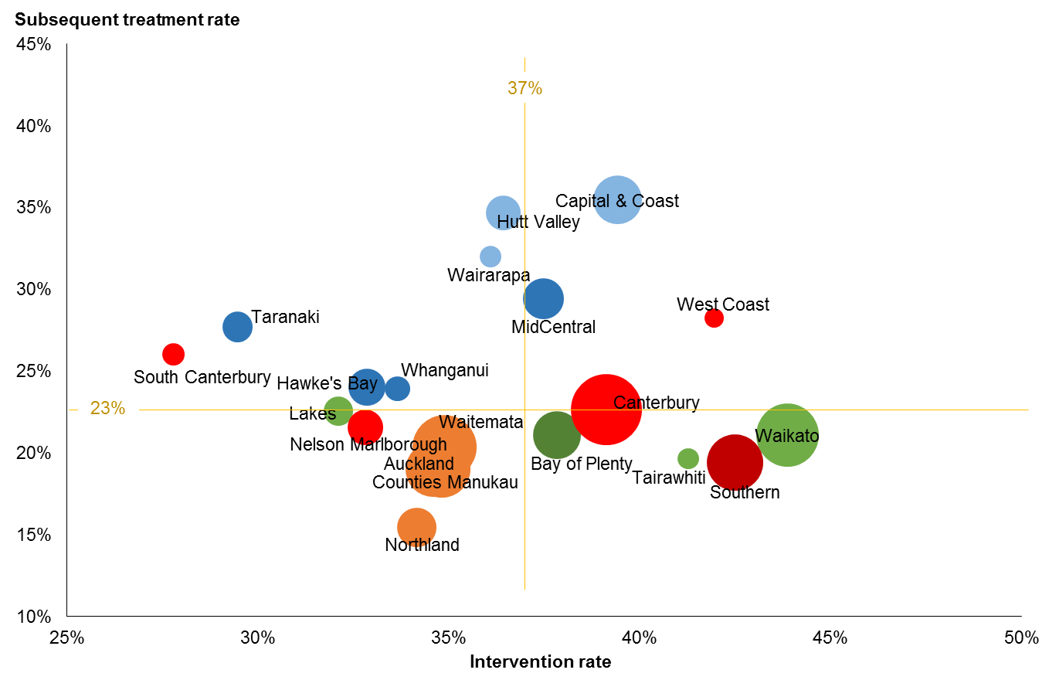
Source: Radiation oncology provisional data, EY analysis.
Note: Excludes treatments for non-melanoma skin cancer, benign cancer, in-situ, myelodysplasia, and conditions other than cancer (enables matching like for like with the international literature). Cancer registrations estimated for 2014–2015. Intervention rate = the proportion of all registered cancers that are treated with at least one course of radiation therapy. Subsequent treatment rate = the proportion of all radiation therapy treatment courses delivered to people who have already had at least one treatment course for the same cancer. Subsequent treatment courses at same time for same patient counted once only. Circles proportional to the average number of treatments 2013–2015. Colours represent cancer network areas.

Subsequent treatment rate
A second measure of access, the STR, considers the proportion of all treatments that were the second or later treatments for that person for that cancer. The STR mainly represents access to palliative (rather than curative) treatment. It is expected that subsequent treatment rates will vary more than intervention rates because palliative care arrangements vary across the DHBs (some issues around defining courses are also yet to be resolved.) The vertical axis data in Figure 1 indicates that the subsequent treatments comprise 23 percent of all treatments (21 percent for Māori) and range from 15–35 percent across DHBs.

The curative IR
The purpose of treatment can be seen as a subset of the IR. For those first treatments done for curative purposes, the spread by DHB is smaller: the provisional data ranges from 17–30 percent. On average, 24 percent of all registered cancers in New Zealand get a curative radiation oncology course. For Māori patients the rate is slightly lower at 21 percent. The rank order by DHB is similar to that for the overall IR.

The IR for individual cancers
The IR can also be examined for individual cancers. For example, Table 2 shows the curative intervention rate for the four most commonly treated cancers (excluding non-melanoma skin cancer). The proportion of cancers receiving a curative radiation treatment varies based on the evidence of effectiveness and the stage of the cancer at presentation. Overall, around two-thirds of breast cancers and half of rectum cancers received at least one curative course, while only 24 percent of prostate cancer patients and 13 percent of lung cancer patients were so treated.

Rates varied significantly by DHB, as evidenced by the minimum and maximum percentages in Table 2 – small numbers of cancers in smaller DHBs can create large swings from year to year. The pattern varies by cancer: in other words, it is not that one DHB has low radiation therapy access in every cancer; rather they might be relatively low in one and high in another. It is necessary explore cancer pathways further, at both the therapy providers and the referring hospitals. Metrics for these four key cancers for radiation oncology treatment will be covered by DHB in the first year of monitoring (see Appendix B).

Table 2: Provisional curative radiation therapy intervention rate for selected cancers, 2013–2015
Cancer | Number of registrations per year | Number treated with radiation | Average IR | Minimum DHB rate | Maximum DHB rate
Breast | 3,056 | 1,970 | 64% | 40% | 81%
Prostate | 3,627 | 863 | 24% | 7% | 34%
Lung | 2,038 | 273 | 13% | 8% | 17%
Rectum | 798 | 400 | 50% | 36% | 71%
Source: Radiation oncology provisional data, EY analysis. Cancer registrations estimated for 2014–2015.
Note: IR = intervention rate. Average IR refers to the proportion of all registered cancers that are treated with at least one curative course of radiation therapy for that specific tumour type. Minimum DHB rate = lowest proportion by DHB of domicile; Maximum DHB rate = highest proportion by DHB of domicile.

Capacity
As section 3.1 notes, the Service Planning Tool has been updated with the new provisional data. Based on current operational parameters (treatment visits per course and treatment times), linac numbers and operating hours, and given no increase in IRs, New Zealand might need five to six additional linacs by 2023. This additional demand will come from the growth in both the overall population and the older population, which together will increase the number of cancers expected and therefore the number of people undergoing radiation treatment. This increased demand is offset a little by the expected fall in incidence of some cancers – for example, in lung cancer through the reduction in tobacco smoking. Note that this prediction assumes the current mix of public and private provision continues, and that each radiation oncology provider maintains its current catchment.

To provide these additional courses, a larger workforce will be needed. Based on current workforce provisioning (and assuming current vacancies are filled), the estimated need is for an additional 28 radiation oncologists, 24 medical physicists and 70 radiation therapists by 2023 to maintain current IRs. Current workloads are assumed to continue; for example, if overtime is used extensively now, then that would continue into the future.

If the IR rises over future years, then the number of linacs required will increase. Each percentage point increase in IR equates to roughly an extra linac over time for the New Zealand population – rising to 42 needed from the 31 available in 2015, if an IR of 45 percent is reached (a scenario based on all DHBs reaching a rate equal to the highest reached by a DHB in 2013–2015) (see Figure 2). The subsequent treatment rate is held steady in these scenarios, as are the number of treatment visits per course and average time per treatment. The timing of any increase is illustrated in the Tool for each provider, with local circumstances and demand determining the actual development of additional capacity.

Figure 2: Provisional radiation oncology projected linear accelerator numbers based on different intervention rates, 2015–2023
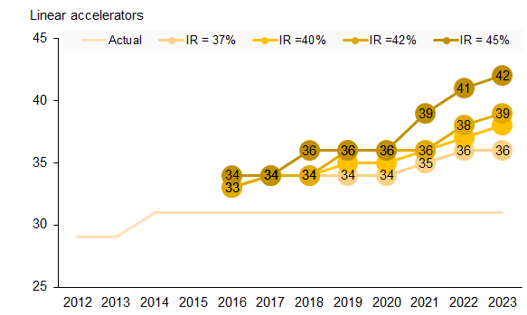
Source: Radiation Oncology Service Planning Tool, provisional data. Based on estimated cancer registration growth and current work parameters as discussed in text.
Note: IR = intervention rate; 37% maintains current rates. ‘Actual’ represents current linear accelerator stock. Figures subject to change once the Radiation Oncology Minimum Data Set is fully operational.

Variation in practice
In the future, it will be possible to use the detailed data collected for the Tool to compare treatment regimes across providers. While still provisional, the test data set highlights some variation in current treatment patterns. For example, breast cancer treatment has changed in recent years to prefer a shorter course of 15 treatments rather than the traditional 25 treatment course (where anatomy allows). This shorter course is termed ‘hypofractionation’ – literally fewer fractions, where a fraction is a proportion of a radiation oncology treatment. As expected, curative treatments follow this pattern at most centres (Figure 3): the main peak is at 15–16 visits and a secondary one at 25 visits. Two centres appear to show the reverse pattern.

Figure 3: Provisional attendance numbers for curative intervention rates for breast cancer by provider, 2014–2015
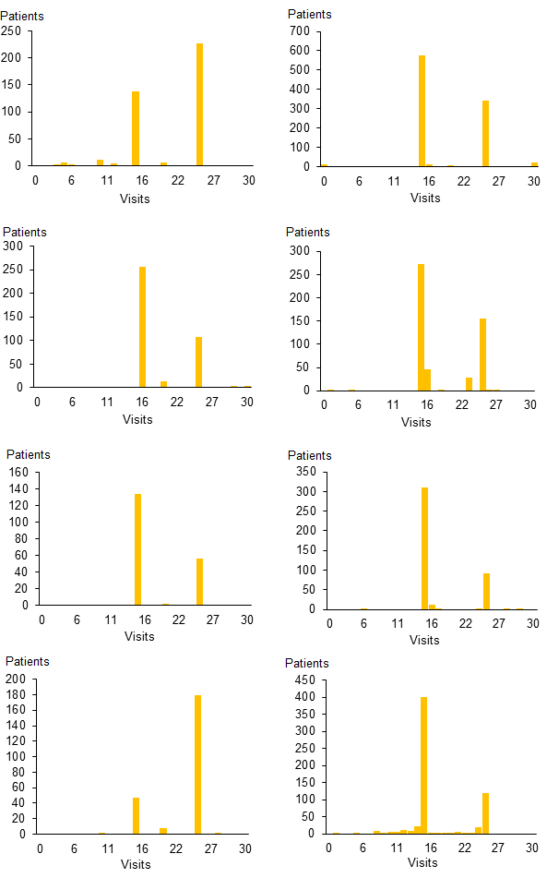
Source: Radiation oncology provisional data, EY analysis.
Note: Curative first treatments for external beam radiation treatment for breast cancer showing the number of visits (attendances) per course. Each graph represents a provider; one provider is not represented, as data was not supplied.

Using the outputs of the Service Planning Tool
New functions and accountabilities will be needed, first, to make the Tool a sustainable part of everyday practice at national, regional and local levels. They will also be needed to ensure people use its insights to address unwarranted variation in radiation oncology services and inform capacity planning. Radiation oncology services will provide a prototype for cancer services generally in their use of information within the Cancer Health Information Strategy framework. The approach to establishing the Tool must ensure it drives the actions outlined in section 6.1.

Addressing unwarranted variation
In 2014, the Health Quality & Safety Commission published a literature review on methods for addressing unwarranted variation (HQSC 2014). Unwarranted variation is defined as variation that cannot be explained on the basis of illness, medical evidence or patient preference. Clinical care can be grouped into three categories to help understand how services may vary.
1. Effective care – interventions have benefits that far outweigh the risks. In this case, almost every patient will receive the ‘right’ treatment defined by evidence-based guidelines. Unwarranted variation here generally involves underuse.
2. Preference-sensitive care – more than one generally accepted treatment option is available. The rate of ‘right’ treatment depends on informed patient choice but treatment rates can vary extensively because of differences in professional opinion.
3. Supply-sensitive care – these clinical activities include doctor visits, diagnostic tests and hospital admissions. Their frequency of use depends on the capacity of the local health care system. The key issue is that those living in districts with a high-intensity pattern of care have worse or no better outcomes than those living in low-intensity regions. That is, greater intensity of care does not necessarily equate to improved outcomes.

In its publication, the Health Quality & Safety Commission outlines a step-by-step process for understanding and managing variation. The first step is to identify variation and understand its causes to establish whether it is actually unwarranted. International experience shows that understanding clearly which variations are unwarranted and agreeing on responsibilities for action are critical to moving from initial information gathering towards decisions about allocating resources and changing behaviour.

Since 2008 the Ministry has supported the radiation oncology providers and private radiation therapy services to gather information on access to and provision of radiation oncology services. Using the Tool, the sector will now be able to understand variation with more detailed and accurate data. However, to effectively address variation, an appropriate structure must be established and given the resources to take action. The Health Quality & Safety Commission’s literature review highlights the need for a focused programme of work to:
- define unwarranted variation clearly and consistently
- prioritise those variations and causes that have the strongest impact on equity, effectiveness, efficiency and patient health outcomes
- agree on responsibilities for action and leadership to influence change (HQSC 2014).

Figure 4 presents a useful framework for moving from information gathering and decision-making to supporting performance improvement.

Figure 4: Framework for managing unwarranted variation
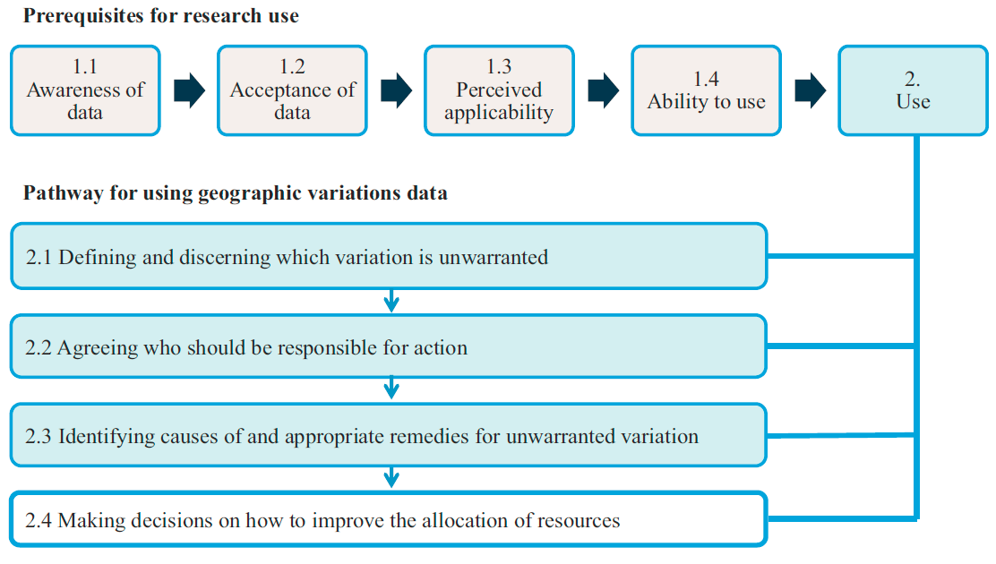
Source: Schang et al (2014).

The radiation oncology sector has reached box 1.4 ‘ability to use’ and is ready to move to box 2 ‘use’ (Figure 4). Section 6.1 sets out the actions needed to establish the appropriate structure that will support steps 2.1–2.4.

Importantly, the use of data to improve clinical practice is not without its challenges. The United Kingdom National Cancer Intelligence Network gives practical advice on publishing comparative data and managing outlier institutions (NCIN 2012). Acknowledging that such tasks can be challenging, it provides a principles-based approach to manage outliers most effectively while recognising the need for flexibility to account for different circumstances. The principles, as summarised below, give useful guidance for the radiation oncology sector on using and managing information from ROMDS.
- Involve clinical staff strongly from the start.
- Engage early with professional leaders.
- Build sufficient time into plans for publication.
- Inform those included in the analysis that it is happening.
- Inform potential outliers well in advance of publication and be prepared to address their concerns.
- Be prepared to conduct additional analyses.
- Respond sensitively to requests and challenges.
- Emphasise outcomes that are better than expected and the opportunities to learn from these.

Supporting the foundations of the New Zealand health system
The Tool has been developed to support two dimensions of radiation oncology planning:
1. clinical service planning, including quality improvement
2. linear accelerator (linac) and workforce capacity planning.

While these two dimensions address different components of service delivery, they overlap in some ways. For example, if intervention rates or workforce models change, it may influence use of current capacity and, in turn, future requirements.

The New Zealand public health system has strong foundations in devolving power through clinical governance and DHB accountability. Arrangements for applying the radiation oncology Tool support these foundations, as does the regional collaboration between constituent DHBs and between public and private radiation oncology providers. DHBs have the local accountability for service and capacity planning, access and outcomes; they are legislated to fund access to the necessary services for their resident populations. DHBs work closely with the RCNs to gain regional commitments by constituent DHBs to support capacity planning and decision-making among radiation oncology providers. Figure 5 shows the functions and activities involved in using the Tool nationwide to address unwarranted variation, covering the entire process from submitting data to monitoring and escalating actions.

Figure 5: Functions and activities throughout the process of using the tool to address unwarranted variation
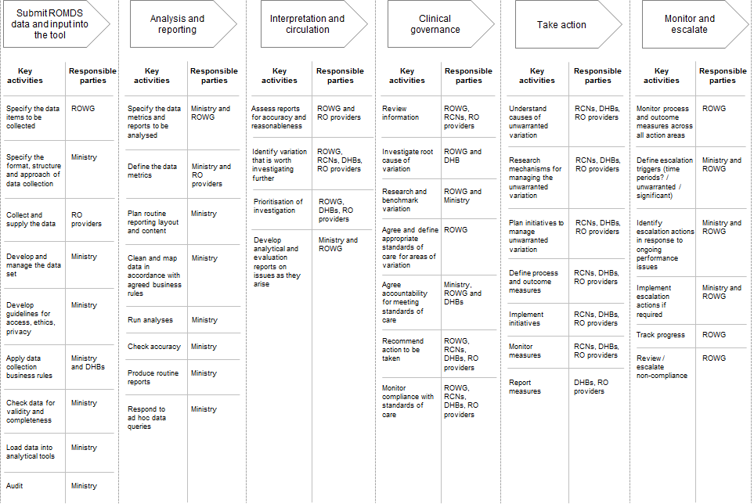
Note: Responsible parties: Ministry = Ministry of Health; ROWG = Radiation Oncology Working Group; RCNs = regional cancer networks; DHBs = district health boards; RO providers = radiation oncology providers.

National clinical governance
The governance structure of the National Cancer Programme was refreshed in May 2016. To reflect the changing priorities for cancer as set out in the New Zealand Cancer Plan and the New Zealand Health Strategy, the Cancer Programme Leadership Board (the Board) was established as the main governance body overseeing the National Cancer Programme. The Board will drive and support the long-term strategic direction for cancer.

Within the new National Cancer Programme structure, the Radiation Oncology Working Group (ROWG) will continue to have a key role in clinical leadership across the public and private radiation therapy providers. Through this Plan, its role will be expanded and more explicit as it takes on responsibility for national clinical governance of radiation oncology (section 6.2). ROWG’s terms of reference, membership and resourcing will be reviewed to ensure they are appropriate to support this function. The Ministry will continue to be responsible for providing secretariat support for ROWG.

The regional cancer networks
Within the National Cancer Programme, the role of the four regional cancer networks (RCNs) is to provide regional leadership through working with the DHBs in their regions to promote collaboration in service planning and delivery. RCNs are contracted by the Ministry and their primary accountability is to their constituent DHBs, who in turn are accountable to the Minister for delivering their regional priorities as outlined in regional planning documents. While the functions of each of the RCNs are similar, their local context informs their priorities and so their work programmes may be different.

The role of RCNs in supporting the implementation of the national plan and ROMDS will focus on radiation oncology service and capacity planning, and supporting quality improvement. ROWG will give the RCNs guidance on unwarranted variation and the RCNs will work with their constituent DHBs and radiation oncology provider(s) to define and action a regional plan for addressing that variation.

The role of the Ministry in the ongoing management of ROMDS
The Ministry will be primarily accountable and responsible for the ongoing management of the ROMDS. This includes the first three functions of the entire process for using ROMDS (see Figure 5):
- submitting data and inputting it into the Tool
- analysing and reporting
- interpreting and circulating results.

The long-term vision, as outlined in the New Zealand Cancer Plan and the Cancer Health Information Strategy, is for the radiation oncology sector to have timely access to comprehensive and accurate patient-level data across treatment modalities.

The strategies in the Cancer Health Information Strategy align closely with those activities needed to support the ongoing management and use of the Tool. In particular, they involve:
- providing a national framework for managing cancer data and ongoing changes
- combining relevant patient and cancer service data into cancer information for service and capacity planning
- analysing information to produce cancer intelligence and communicate it to stakeholders.

The final activities listed above – generating cancer intelligence, developing meaningful insights and effectively communicating them to stakeholders – are particularly important as they frame the clinical governance review (see Figure 5). The long-term vision for managing cancer data is to have the required information flowing into a central analysis hub operated by the Ministry. However, given the Cancer Health Information Strategy will not be fully implemented before the sector is using the Tool, an interim solution will be needed to support the radiation oncology sector with achieving its priorities.

As section 6.1 outlines, the first action for making ROMDS part of everyday practice is to establish an interim solution that enables the radiation oncology sector to continue to build on its use of data to inform clinical practice. The Ministry is currently working with the Cancer Health Information Strategy to develop a solution that will support the transition into the future central analysis hub.

The role of private providers
Private providers will be responsible for supplying ROMDS data. Although standards of care that ROWG develops will be primarily aimed at the public radiation oncology providers, private providers will be encouraged to improve services voluntarily based on analysis of the data.

A framework for action

Overview of the framework
The vision for radiation oncology services is:
Radiation oncology services will be equitable to all New Zealanders, providing them with high-quality care to achieve the best possible outcomes.

Underpinning the vision are three priority outcomes.
1. People have fair access to the treatment they need.
2. Radiation oncology services are safe and effective.
3. Radiation oncology services are sustainable.

Five key supporting tools, structures and processes that will help to make the vision and outcomes happen are:
1. cancer information
2. clinical governance
3. linear accelerator capacity
4. workforce capacity
5. information technology (IT) infrastructure.

Figure 6 summarises this framework for action.

Figure 6: Vision and outcomes, and their supporting tools, structures and processes
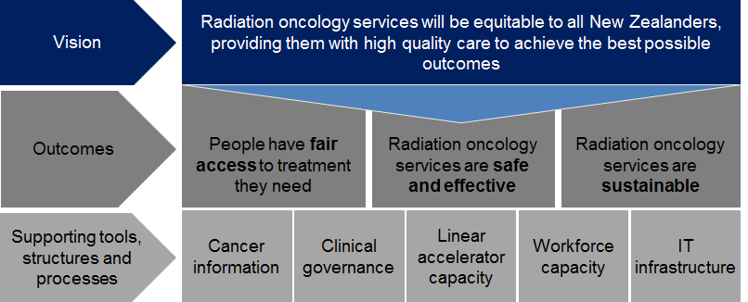

Strategic priorities

Priority 1: People have fair access to the treatment they need

Faster Cancer Treatment
The Government is committed to better, sooner, more convenient health care, and the Faster Cancer Treatment (FCT) programme is a key element in achieving this. The FCT programme is designed to reduce waiting times for appointments, tests and treatment, and standardise care pathways for all patients wherever they live.

The Faster Cancer Treatment health target is 85 percent of patients referred urgently with a high suspicion of cancer receive their first cancer treatment (or other management) within 62 days. This will increase to 90 percent by July 2017.

Data from 1 October 2015 to 31 March 2016 suggests patients receiving radiation therapy as their first treatment are less likely to meet the 62-day target than patients receiving other treatment modalities (such as chemotherapy and surgery). This difference highlights the need for continued effort to improve timely access to radiation therapy.

Fair access
In addition to the Faster Cancer Treatment health target, the two other key indicators of access to radiation therapy are:
- intervention rate (IR): the proportion of all registered cancers that are treated with at least one course of radiation therapy
- subsequent treatment rate (STR): the proportion of all radiation therapy courses delivered to people who have already had at least one course for their cancer.

As discussed in section 3.2.1, in New Zealand the average IR is 37 percent and average STR is 23 percent. Individual DHB radiation therapy rates range from 28–40 percent for IR and 15–35 percent for STR. These wide ranges highlight the considerable variation in access across the DHBs. The reasons for these differences and their implications are not immediately apparent. However, with the Tool and the supporting clinical governance structure in place, the radiation oncology sector can now investigate the issue further and take action to minimise unwarranted variation in access.

There is no evidence to suggest patients who need radiation therapy in New Zealand are being turned away because of workforce or linac capacity shortages. However, factors that can help or reduce a person’s access to services include:
- the clinical practice of the referrers
- the clinical practice of the treating radiation oncologist
- the radiation oncology provider’s model of care
- how far away the patient lives from the radiation oncology provider
- the patient’s own choice
- the tumour type
- the patient’s ethnic group
- the patient’s socioeconomic deprivation level.

It is likely that the current variation in access reflects a complex interplay of such factors. Through its research into the causes of variation in access, New South Wales Health (2011) provides an evidence-based list of factors identified through the international literature (see Table 3). The evidence underpinning these factors suggests that addressing these barriers will improve access, as measured by both referral and intervention rates.

The Government has prioritised improving the coverage and functionality of multidisciplinary meetings as a key initiative for the FCT programme. Cancer is often treated using multiple treatment modalities, including radiation therapy, chemotherapy and surgery. The specialty of the referrer, or the preferences of the individual specialist, may influence which of the multiple treatment modalities they use and the order in which they use them. For this reason, multidisciplinary meetings can be useful in supporting evidence-based treatment planning.

Those investigating variation in access in New Zealand will consider questions such as the following.
- Are varying STRs simply a reflection of differing approaches to palliative care around the country, or are providers not offering radiation therapy as an option for some patients?
- Where a DHB of domicile has a lower intervention or subsequent treatment rate, what is the impact of this? Is the DHB using other cancer treatment modalities instead?

It is expected that the RCNs will lead the detailed investigation of such questions, with national guidance from ROWG. RCNs are well placed to take a regional view of service variation, and work locally with DHBs and radiation oncology providers on achieving national standards of access.

Table 3: Factors affecting whether patients and referring clinicians choose radiation therapy
Perspective | Factor | Description
Patient | Distance | Where the distance to treatment is significant, patients may choose another treatment option. Factors related to ease of transport, such as availability of public transport and road quality, also affect their choice.
 | Accommodation | Whether affordable accommodation is available for the lengthy treatment period and whether financial compensation is available (and easy to access) may influence patient choice.
 | Patient perception | Perception of risk and benefit of radiotherapy compared with other treatment options (another treatment, or no treatment).
 | Disruption to patient | Degree of disruption that treatment causes to the patient and family/carers.
 | Family/carer support | Availability of family/carer support in the location of treatment.
 | Waiting times | Perception of waiting times, based on media, service data or other sources.
 | Cultural considerations | Rates of cancer mortality are higher among the Māori and Pacific populations, mainly because of disparities in treatment. Important ways of reducing these disparities are to have empathetic personal contact and to acknowledge and respect Māori and Pacific family structures, culture and life circumstances, and the importance of history, land and community. Treatment that is remote from the spiritual link with home and community is also a barrier.
 | Financial impacts | Out-of-pocket costs or upfront payment.
Referring clinician | Pathway | Understanding and knowledge of radiotherapy indications and treatment regimes. Involvement in a multidisciplinary meeting may help improve this understanding, as would access to online referral and treatment guidelines.
 | Specialty | Radiotherapy is often delivered in conjunction with surgery and chemotherapy. The specialty of the referrer, or the preferences of the individual specialist, may influence which of the multiple treatment modalities they use and the order in which they use them. Having multidisciplinary meetings and access to referral and treatment pathways and guidelines may improve access to treatment for patients.
 | Waiting times | If the clinician perceives the patient may have a lengthy wait, this may discourage them from making referrals, whether or not that perception matches reality.
 | Financial impacts | Financial impacts of referral on an individual practitioner or on a service.

Priority 1: Actions – Roadmap
Table 4 lists the actions planned to enhance enquiry into clinical variation and improve access to services in line with Government priorities.

Table 4: Actions to give people fair access to the services they need
 | Action | Who is involved | By when
1.1 | Prioritise at least one variation in access and/or care query of interest per year and investigate the root cause | ROWG will review current variation/s in access and prioritise at least one query per year  The Ministry will undertake the specific analysis required  RCNs will investigate the causes of variations beyond the data | 2017–2021
1.2 | Plan and implement initiatives to manage the prioritised variation/s in access per year | ROWG will determine the standard of care expected and monitor progress  RCNs will plan the initiative in collaboration with radiation oncology providers and referrers  Radiation oncology providers will implement the initiative in collaboration with RCNs and referrers | 2017–2021
1.3 | Understand variation | RCNs and radiation oncology providers will work with DHB cancer managers to understand variation and report to ROWG | Ongoing

Priority 2: Radiation oncology services are safe and effective

Evidence-based care and variation in clinical practice
In addition to variable intervention rates, the first national plan identified significant variation between radiation oncology providers in their subsequent treatment rates, treatment times and numbers of treatments per course for the same cancers. Challenges with the accuracy of data made it difficult to validate the variation for the first national plan. However, the plan considered that while some variation in clinical practice is to be expected, evidence-based care would drive convergence towards the same specific care pathways. It would therefore be worthwhile to further investigate the potential benefits of increasing standardisation and cross-provider learning.

Using ROMDS under the guidance of this second national plan will provide the sector with a more reliable means of evaluating variation in clinical practice. While the data reported in this Plan is provisional, initial findings suggest the providers are reasonably consistent in their treatment patterns for the major cancers. Some differences are noticeable though. For example, for curative treatment for breast cancer, current evidence suggests the majority of women can be treated with a 15- or 16-day course; however, some providers continue to provide mainly 25-day courses (see Figure 3 in section 3.2.3). Similar types of variation across providers are evident for prostate and lung cancer.

However, it is important to note that not all variation is undesirable or unwarranted. As Mulley (2010) writes, ‘The trick is in reducing the bad variation, which reflects the limits of professional knowledge and failures in its application, while preserving the good variation that makes care patient centred’. Through ROWG, national direction on the best evidence-based treatment pathways will help the sector to interpret variation and identify approaches to address it.

At a national level it is difficult to determine whether local variation is warranted. Local initiatives and analyses are required to understand the reasons for the variation and to identify any variation that is unwarranted. This is why ROMDS has the support of a governance and accountability structure that operates throughout the sector from national through to regional and local levels (see section 6.2). The aim is to achieve the related prerequisite of a world-class radiation therapy service: to create an evaluation culture by providing robust measurement tools to support evidence-based, high-quality practice.

The learnings of the Health Quality & Safety Commission and of existing national and regional clinical networks will inform the approach to reducing unwarranted clinical variation that the radiation oncology sector uses.

Research
High-quality research and the transfer of research knowledge into practice drive the evidence-based care noted above and form another prerequisite for delivering world-class radiation therapy. Directly contributing to and participating in research is considered a marker of good practice. Nations with a reputation for delivering effective radiation oncology services – such as the Netherlands, Canada and Sweden – all conduct extensive research. This work includes conducting many clinical trials and adopting any beneficial learnings. When findings are translated into routine clinical practice, this in turn promotes inquiry, innovation, the spread of knowledge and retention of staff.

Tripartite Radiation Oncology Practice Standards
This Plan recognises that implementing mandatory standards of care can be an effective way of increasing safety and quality of care. In 2013 the ROWG adapted the Tripartite Radiation Oncology Practice Standards, developed by the Royal Australian and New Zealand College of Radiologists (Tripartite Committee 2008), for use in New Zealand. At this stage it is too early to recommend that those standards should be implemented, either partially or in full. Further investigation is needed to assess whether it is feasible to implement them and what their costing implications would be. This Plan includes an action to review the standards by 2018 (see Table 8 in section 6.2).

Patient experience
This Plan recognises the importance of patient experience and patient-centred care. Patient experience is an indicator of quality of care. The Health Quality & Safety Commission (HQSC) currently publishes summary indicators for adult inpatient experience and is developing measures of the experience of primary care patients. Although this Plan does not include metrics based on patient experience, an option is to develop them in future. Any patient experience metrics developed for radiation oncology should be consistent with the HQSC’s work.

Priority 2: Actions – Roadmap
Table 5 lists the actions planned to enhance enquiry into variation in clinical practice and improve safety and effectiveness in line with Government priorities.

Table 5: Actions to make radiation oncology services safe and effective
 | Action | Who is involved | By when
2.1 | Support the continued development of a quality improvement culture within the radiation oncology sector by implementing a nationwide clinical governance system | The Ministry will review the terms of reference, membership and resourcing of ROWG to ensure appropriateness for the clinical governance function. | 2017
 |  | The Ministry will appoint a clinical governance group with the required capabilities (see section 6.2 for more detail). | 2017
2.2 | ROWG, with support and resources from the Ministry, will provide national leadership and promote system-wide improvements | The Ministry will review the terms of reference, membership and resourcing of ROWG to ensure they are appropriate for it to provide clinical governance. | 2017
2.3 | Develop and implement a process for managing unwarranted variation, informed by the learnings of the Health Quality & Safety Commission and national and regional clinical networks | This Plan includes actions to implement a process for managing unwarranted variation. This is expected to be in place by December 2017. For more information, see section 6.1. | 2017
2.4 | Develop and implement a system to support the whole radiation oncology sector to identify, spread and adopt performance improvement innovations and evidence-based best practice | ROWG will work with RCNs as the vehicle to identify, adopt and spread innovations that improve performance. This work will include:  - establishing a mechanism for sharing learnings and practice  - distributing guidance on how to adopt and spread specific innovations  - supporting individual radiation oncology providers to implement innovations. | 2019–2020
2.5 | Use the regional reviews of services against national tumour standards as a way of limiting unwarranted variation through standardising treatment | RCNs and radiation oncology providers will identify and address any service gaps against each tumour stream as it is prioritised for review. | 2017–2021
2.6 | Encourage all radiation oncology providers to engage in research and be ‘learning organisations’ | ROWG will review the New Zealand National Research Strategy currently being developed, and explore ways of enhancing radiation oncology research within the sector. | 2020–2021

Priority 3: Radiation oncology services are sustainable
The New Zealand health system is operating in an environment of increasing demand for services and constrained resources, and it is expected that these trends will continue for the foreseeable future. The sustainability of services has therefore become an important consideration in longer-term service and capacity planning. Sustainability, which has both clinical and financial dimensions, means that a health service can provide ongoing access to high-quality care efficiently and effectively in a changing environment.

Recognising the recommendation of the first national plan, the Ministry is anticipating a growth in IR as services become more standardised and access to radiation therapy improves. It has used the 45 percent IR as a likely maximum, allowing for a range of 40–45 percent by 2022 in planning for services and capacity. To respond to such growth, it would be necessary to expand service capacity to serve DHB populations at currently lower IRs, and to take a collective approach to planning. In this context the three crucial considerations are:
- innovation in radiation therapy techniques and technology
- workforce (see section 6.4)
- efficiency.

Innovation in radiation therapy techniques and technology
As section 2.2 outlines, future innovations in radiation therapy treatment have the potential to significantly change the treatment of specific cancers, which would in turn have material impacts on capacity requirements. The Service Planning Tool is particularly well suited to the task of strengthening capacity planning through innovations in service delivery, including variables such as average attendance time per cancer, average attendance per course per cancer, and workforce ratio adjustments. The Tool will support more accurate projections with reduced variation. Efficiency can be improved further (through standardisation and technological developments) and included in future implementation planning.

To date, new technologies and techniques have been introduced to the New Zealand health system in a relatively ad hoc manner. However, given that radiation oncology innovation is expected to accelerate, the sector needs a more systematic approach to evaluating and adopting new techniques and technologies that supports the related prerequisite for a world-class radiation therapy service: to fully use up-to-date technology and equipment.

As radiation therapy continues to become more sophisticated, it is important to consider the need to develop specialised radiation oncology providers for treatment of particular tumours. As the new technologies tend to be significantly more expensive than existing ones, it is unlikely that all radiation oncology providers will be able to buy and operate them. In addition, developing specialised providers would help to minimise variation in access and to use the new technologies more efficiently.

Another of the seven prerequisites for world-class radiation therapy services is to have sufficient capacity and activity volume to create economies of scale. Having specialised ‘hubs’ to treat particular tumours would support such economies of scale while creating further opportunities for training and research, but may also make access to care more difficult. Specialised working environments are typically rewarding for health professionals and are likely to help retain the highly specialised radiation oncology workforce while supporting quality improvement. However, such specialisation could make it more difficult for regional radiation oncology providers to attract the workforce they need if opportunities for training and research were consolidated in major metropolitan centres. Having new technologies in ‘hubs’ could also make treatment less accessible for patients living in areas outside those hubs.

Efficiency
Each DHB funds access to radiation therapy for its resident population. All DHBs are likely to need to allocate additional funds to radiation therapy to respond to the predicted increasing incidence of cancer. Some DHBs may also expect an increase in the proportion of cancers being treated with radiation therapy, for which they will need to allocate appropriate funds. As radiation providers’ capacity grows, DHBs will need to support them by allocating the required operating funds, and regional capital committees will need to approve capital investment by the DHB radiation therapy providers.

Through this process, radiation therapy will be competing for investment against other services, so it is critical to demonstrate value for money. In reviewing cost information from five DHB radiation oncology providers, the first national plan found indications of considerable variation. It also identified significant opportunities to improve operational performance. For example, it would be possible to reduce the additional linacs required for the growth scenario by up to six linacs by coupling a 1 percent operational gain per year with a longer day of linac use (for example, 10 instead of 8 hours in peak months). Staff numbers and ratios across the providers vary, suggesting providers differ in their models of care. Attention to this issue could also improve operational efficiencies.

Priority 3: Actions – Roadmap
Table 6 lists the actions planned to support capacity and service planning to make radiation oncology services sustainable.

Table 6: Actions to make radiation oncology services sustainable
 | Action | Who is involved | By when
3.1 | Review the radiation oncology service and capacity implementation plan every two years, which includes reviewing the Tool’s variables and assumptions | ROWG will review the variables applied for service and capacity planning and make recommendations to the Ministry on suggested changes. | 2017–2021
3.2 | Establish a nationwide process for evaluating and adopting new radiation oncology technologies | ROWG and the Ministry will define the criteria for technologies that require national evaluation before they are adopted. | 2018
 |  | The Ministry will work with ROWG, the RCNs and the radiation oncology providers to establish a nationwide process for evaluating and adopting new technologies.  Following the process for evaluating and adopting new technologies will include nationwide service and capacity planning to identify the appropriate configuration. | 2019 onwards
3.3 | Explore developing areas of specialisation for radiation oncology providers to support more efficient use of high-cost technologies | ROWG, DHBs and RCNs will work with radiation oncology providers to develop areas of specialisation that:  - align with population flow and need  - consider nationwide service and capacity planning to identify the appropriate configuration. | 2018–2019
 |  | Radiation oncology providers will begin to develop areas of specialisation. | 2019–2020
3.4 | Understand variation in productivity and efficiency across radiation oncology providers and take action to reduce this variation | The Ministry and ROWG will incorporate productivity and efficiency metrics. Some of these metrics will be:  - workforce ratios  - average attendance time  - linac hours. | 2017
 |  | When necessary, RCNs will support radiation oncology providers to understand variation in productivity and efficiency metrics.  RCNs will support shared learning across radiation oncology providers to standardise productivity and efficiency.  The radiation oncology providers, with support from RCNs, will take action to standardise and improve productivity and efficiency to support sustainable radiation oncology services. | 2017 onwards
3.5 | Explore innovative models of care to support delivery of care through lower-cost models such as ‘virtual’ follow-ups via telemedicine as an alternative to specialist or patient travel | The radiation oncology providers and RCNs will work regionally to assess opportunities, and link with each other and with Health Workforce New Zealand as appropriate.  This information will be provided to ROWG each year to contribute to national capacity planning (see section 6.3). | 2018–2021

Making it happen – tools, structures and processes
A set of tools, structures and processes will support radiation oncology providers, networks, DHBs and the Ministry of Health in achieving the priorities set out in section 5.2.

Cancer information
As section 4.1 outlines, the radiation oncology sector can use the data from the ROMDS to understand variation more accurately and in greater detail. However, to effectively address variation, it is necessary to establish an appropriate structure with the resources to fulfil the following six key functions associated with capturing and using ROMDS data.

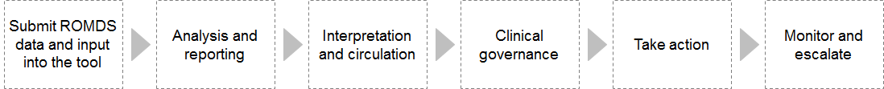

The Ministry will be primarily accountable and responsible for the ongoing management of ROMDS, which includes the first three functions. Table 7 identifies actions needed to make the new information collection part of everyday practice and to use the insights generated from that data to reduce unwarranted variation, improve service performance, and support service and capacity planning.

Submission of data and input into the Tool
Making ROMDS part of ongoing data collection is fundamental to this Plan. With this data, it will be possible to assess care pathways clearly, and to make better-informed decisions on capacity planning using the Service Planning Tool (section 6.2). A key step will be to integrate ROMDS into the wider Cancer Health Information Strategy architecture, so that researchers can analyse care pathways across all cancer treatment modalities.

As part of the process of testing and developing ROMDS, radiation therapy providers submitted a test data set covering the years 2012–2015 at the end of 2015. This data is provisional and will need to be updated because the definitions and data elements have been updated since it was collected. The first action is to establish an interim solution that the radiation oncology sector can use to continue to build on its use of data to inform clinical practice. This interim solution will be established in such a way as to allow a straightforward transition to the future Cancer Health Information Strategy.

Analysis and reporting
As section 4.5 outlines, the long-term vision for managing cancer data is for the required information to flow into a central analysis hub that the Ministry operates, and for the Ministry to then be responsible for analysing, reporting, interpreting and circulating the data. Given the Cancer Health Information Strategy will not be fully implemented before the sector is using the tool, an interim solution is needed to support the radiation oncology sector to use its data well. Preliminary work is under way to develop a solution that will support an easy transition to the future central analysis hub.

Interpretation and circulation
Interpretation and circulation are highly significant but often overlooked activities. They involve developing a clear narrative to explain what the data shows and why this is important. The literature identifies the narrative as the most crucial step on the pathway from data to change when managing unwarranted variation. It helps clinicians, managers and commissioners understand the size and nature of the issue, the impact on population access and outcomes, and the opportunity cost of not changing. Supported with the right accountability structures, the narrative helps the sector to take ownership of variation and drives change (HQSC 2014).

The party that typically carries out this function has a sound understanding of national data collections for radiation oncology and the limitations of the data. They also have clinical understanding to interpret the data correctly and undertake more detailed analyses.

Clinical governance
Clinical governance is focused on adding a formal layer of clinical responsibility for maintaining and improving the clinical quality of care for patients who receive radiation oncology services. This function is discussed in more detail in section 6.2.

Take action
Taking action is concerned with understanding the causes of unwarranted variation and applying quality improvement tools to address these causes. Many quality improvement tools and methodologies help to understand the problem rapidly and develop solutions.

This function is an area where RCNs will play a key leadership role in supporting radiation oncology providers with quality improvement. It is envisaged that ROWG will guide RCNs on unwarranted variation, and RCNs will work with their constituent DHBs and radiation oncology provider(s) to define and act on regional plans to address that variation. The Ministry and DHBs will need to prioritise this work so that RCNs have sufficient resources to deliver on objectives.

Monitor and escalate
Monitoring and escalating form the feedback loop when the sector is using ROMDS. These activities will ensure the process is working as intended and is achieving the intended outcomes. ROWG, as the clinical governance lead, and the Ministry Cancer Team will be responsible for these activities.

Table 7: Actions to improve cancer information
Function | Action | Who is involved | By when
Submitting data and inputting it to the Tool | Publish business rules to guide data collection for radiation oncology providers | The Ministry will publish a business rules document that sets out agreed data items to collect, data definitions and frequency of collection. | 2017
 | Implement ROMDS | Each radiation oncology provider will supply data at least quarterly to the Ministry. | 2017
 | Update 2012–2015 baseline data | The Ministry will update baseline metric reports with new data from the radiation oncology providers. | 2017
 | Develop metric reporting systems | The Ministry will develop metric reporting systems. | 2017
 | Develop metrics that accurately measure service performance, and continue to refine them | The Ministry will work with ROWG to refine and optimise the system. | 2017
 | Extract data and make it available to update the Service Planning Tool | The Ministry will work with ROWG and radiation oncology providers to update the Service Planning Tool. | 2017
 | Integrate ROMDS into the Ministry’s central analysis hub | The Ministry’s Cancer Health Information Strategy (CHIS) team will integrate ROMDS into the central analysis hub. | 2018
Analyse and report | Establish an interim solution to support the radiation oncology sector to use its data well, while the CHIS is being implemented | The Ministry’s CHIS team will document plans for the central analysis hub.  The Ministry will develop an interim solution that supports an easy transition to the future central analysis hub. | TBC
Interpret and circulate | Develop the capabilities needed to perform this function | The Ministry will ensure that the interim solution has the capabilities needed to carry out this function. | 2017
 |  | The Ministry will explore potential for developing the capabilities needed in the long term. | 2018
Clinical governance | Appoint a clinical governance group with the required capabilities | The Ministry will reach agreement with the radiation oncology sector on the best model to provide clinical governance through ROWG (see section 6.2). | 2017
Take action | Outline expectations of how to ‘take action’ in practice | ROWG will reach agreement with the Ministry, DHBs and radiation oncology providers on how to carry out this function. | 2017
Monitor and escalate | Establish a structured mechanism for providing feedback on reducing unwarranted variation in the new governance model, and the strengths and weaknesses of this model, to inform the future work programme of the CHIS | The Ministry will give clear guidance on escalation paths in its new terms of reference for ROWG. | 2017
 |  | ROWG will reach agreement with RCNs and DHBs on the reporting requirements for initiatives being implemented. | 2017
 |  | ROWG will define clear escalation triggers for failing to address variation that is considered unwarranted. | 2017

Clinical governance
As section 4.3 outlines, through this Plan ROWG will gain a more explicit role as it takes responsibility for national clinical governance of radiation oncology services. This means ROWG will be responsible for providing national guidance on improving and maintaining clinical quality of care for patients who receive radiation therapy within the limitations of the information available through ROMDS. Within this context, quality of care specifically considers issues of access, equity, variation in care and standards of treatment and delivery. Notably ROWG’s governance role for radiation oncology services will evolve over time.

The Ministry will give ROWG the mandate to identify and lead quality improvement nationally for radiation oncology services. In this capacity, ROWG will have the three key roles of:
1. monitoring effectiveness of care
2. minimising unwarranted variation
3. providing quality assurance.

Monitoring the effectiveness of care
In addition to measuring and monitoring the effectiveness of current treatment, this role includes keeping track of technological advances and developing treatment practices and innovative models of care that promise value for money in the New Zealand context.

Given the overlap between service and capacity planning, this monitoring role contributes strongly to ROWG’s work on planning for workforce and linac capacity. As sections 6.3 and 6.4 outline, ROWG will advance future capacity planning by offering advice on how innovations in radiation therapy treatment directly affect the capacity the sector needs.

Minimising unwarranted variation
ROWG’s key role in helping to make ROMDS part of everyday practice focuses on minimising unwarranted variation. As the national clinical governance group, ROWG will play a critical part in decisions that will shape future radiation oncology services. These decisions include but are not limited to:
- specifying the data items providers should collect
- specifying the metrics or report outputs they should analyse
- identifying variation for further investigation
- defining unwarranted variation and prioritising one area of focus per year
- defining standards of care for areas of variation
- recommending actions to minimise unwarranted variation.

Quality assurance
The final key role for ROWG is monitoring the sector to ensure that it is meeting minimum standards of care, and that mechanisms are in place to manage circumstances where performance does not meet these standards.

The three standards of care to consider within this context are:
1. national tumour standards – the level of service that a person with cancer should have access to
2. practice standards – radiation treatment pathways and aspects of facility management to achieve high-quality service delivery
3. clinical standards – evidence-based treatment with the aim of making available patient-centred, appropriate and clinically effective care.

The extent of ROWG’s role in monitoring performance of the radiation oncology sector against all standards will vary with the extent of the wider sector’s involvement. ROWG’s main focus will be on the clinical standards. Within this scope, its role includes but is not limited to:
- monitoring compliance with relevant standards of care
- monitoring process and outcome measures across all action areas
- defining escalation triggers (for example, time periods; unwarranted; significant)
- identifying escalation actions in response to ongoing performance issues
- providing guidance to the Ministry and the Cancer Programme Leadership Board on initial action or escalation options to address performance issues
- implementing escalation actions if required.

If a provider does not comply with the agreed standards of care, one response may be for the Chair of ROWG to help appropriate Ministry representatives in their interaction with representatives of that provider. The Ministry will not hold ROWG accountable for DHB funding decisions or for the performance of individual radiation oncology providers.

ROWG will be supported by the Ministry to fulfil its expanded role. The Ministry will work with ROWG to develop an approach that can be transferred to other areas of cancer treatment.

Table 8 identifies actions needed to establish the clinical governance function to support improving the quality of radiation oncology services. The Ministry will review ROWG’s terms of reference, membership and resourcing to ensure they are appropriate for clinical governance. It will continue to be responsible for providing secretariat support for ROWG.

Table 8: Actions to establish the clinical governance function
Action | Who is involved | By when
Review the terms of reference, membership and resourcing of ROWG to ensure they are appropriate for clinical governance | The Ministry will review ROWG to understand the changes needed for ROWG to undertake clinical governance. | 2017
Review the radiation oncology practice standards | ROWG will review and provide advice on the applicability of the practice standards. | 2018

Linear accelerator capacity
Effective planning for linac capacity is vital given the large fixed capital investment required and long lead times to become fully operational. Further, linac purchases around CT imaging and planning involve additional costs. Although the Plan does not include these costs, the Ministry acknowledges their importance in future planning. Demand for radiation therapy and so for linac capacity is forecast to grow to 2023 as the prevalence of cancers increases due to population growth and ageing.

Part of developing this Plan has been to expand the Tool’s features so that it is possible to analyse data by major cancer types and adjust additional variables that take into account the changing technological landscape, such as hypofractionation (see section 3.2.3). This information can be used to develop a more detailed understanding of capacity requirements and variation in practice, which will inform linac capacity planning.

As section 3.2.2 outlines, based on the current provisional data, New Zealand will need five to six additional linacs by 2023 to meet the growth in demand for radiation therapy services. However, in addition to population changes, other changes may increase the IR. These changes include:
- implementing and embedding multidisciplinary team meetings and tumour standards
- developing new technologies and techniques
- achieving greater standardisation of clinical practice across New Zealand.

Given these possible influences, for planning purposes a scenario based on all DHBs reaching an IR equal to the highest reached by a DHB in 2013–2015 (45 percent) has been used as a maximum estimate. If an IR of 45 percent is reached and current workloads and practices continue, an additional 11 linacs may be required by 2023 (rising to 42, from 31 in 2015).

It will be necessary to increase service capacity to meet not only the demand growth associated with increased cancer prevalence, but also growth driven by technology and policy decisions. While the model can forecast capacity requirements based on a number of variables, the assumptions used are preliminary and only used here to illustrate the kind of information the Tool can provide. Understanding the impact of changing technology, innovative models of care and the delivery of more consistent treatment across the country will be pivotal in informing these assumptions.

Table 9: Actions to support enhanced linac capacity planning
Action | Who is involved | By when
Develop analysis every two years, which outlines a series of informed assumptions to adjust the variables in the Tool and support consistent DHB and regional annual planning | ROWG will understand the impact of changing technology, models of care, and standardisation of treatment on linac capacity.  ROWG will develop a series of informed assumptions to adjust the variables in the National Linear Accelerator and Workforce Capacity Model.  The Ministry will publish this analysis to inform DHB planning. | 2018 and 2020
Update the assumptions underpinning the national radiation linac capacity plan every two years | ROWG will update the assumptions every two years.  The Ministry will publish these updates. | 2018 and 2020

Workforce capacity
The four core workforce groups for radiation oncology services are: radiation oncologists, medical physicists, radiation therapists and nurses. Meeting future workforce requirements is likely to be the most challenging component of planning for sustainable radiation therapy services. Based on the growth expected, an additional 28 radiation oncologists, 24 medical physicists and 70 radiation therapists will be needed by 2023 to maintain current IRs.

The following education providers are responsible for catering to the workforce needs of the radiation oncology sector.
- The Royal Australian and New Zealand College of Radiologists is responsible for a specialist training programme of radiation oncology trainees throughout Australasia.
- The University of Canterbury offers a postgraduate Masters in Science, through a medical physics programme, to students with a Bachelor of Science (physics) degree.
- The University of Otago offers a three-year Bachelor of Radiation Therapy degree.

To develop specialty cancer nursing competencies, nursing students usually need further education in cancer control at postgraduate level. They can get postgraduate certificates from a range of providers around the country. Additional work is also under way to support the ongoing professional development of nurses working in the sector. ROWG has identified training opportunities to enhance the knowledge and skills of radiation oncology nurses in line with the National Knowledge and Skills Framework for Cancer Nurses. An example is the eViQ training programme.

Each year New Zealand produces around four qualified radiation oncologists, three graduate medical physicists and 25 graduate radiation therapists. Data on the number of nurses specialising in radiation oncology was not available during the development of this Plan.

Currently, New Zealand appears to be training sufficient radiation oncologists and radiation therapists to cover changes in cancer incidence and population ageing, and even an increase in intervention rates. However, actual numbers of professionals available in New Zealand are lower than those suggested by the annual rates of those being trained because of training attrition rates, emigration patterns and retirement numbers. Therefore New Zealand needs an additional two medical physicists per year simply to keep up with the increasing cancer incidence and population ageing. It is important to note that the number of students entering the Masters programme for medical physics is limited: the previously agreed minimum of five trainees per year has been reached only once since 2003. This shortfall is currently made up through international recruitment. If intervention rates increased to 45 percent, an additional physicist per year would be required.

One of the prerequisites for a world class radiation therapy services is to have sufficient numbers of trained staff to meet demand and develop the service. To meet this prerequisite, workforce planning should aim to have enough personnel to cover 45 percent IR by 2023. Ultimately radiation oncology providers are responsible for arranging for appropriate clinical and professional skills to deliver services. However, the Ministry recognises its own role in supporting the supply of radiation oncology professionals and has been working closely with the sector to understand why these professionals, particularly medical physicists, leave the New Zealand workforce.

Currently, Health Workforce New Zealand supports 19.5 medical physicist trainees (registrars) in six DHBs through the first three years of the trainee programme. The Ministry, in consultation with the Chief Medical Physicist Group and DHB shared services, is working through options to best support registrars in the trainee programme, and make best use of medical physicist skills within DHBs.

Table 10: Actions to support enhanced workforce capacity planning
Action | Who is involved | By when
Understand why radiation oncology professionals are leaving the workforce and take actions to shift this trend | The Ministry will continue working with ROWG and Health Workforce New Zealand to understand why radiation oncology professionals are leaving the workforce.  Health Workforce New Zealand, working with the ROWG, will advise the relevant education providers of possible actions they could take to help meet the workforce needs of the radiation oncology sector.  The Ministry will take actions to support the development of a more sustainable workforce by 2021. | 2017–2021
Promote workforce retention by supporting staff to operate at the top of their scope of practice | ROWG will support radiation oncology providers to understand models of care across the country and support them to adopt workforce models that help to expand scopes of practice.  ROWG will work with the Cancer Nurses College to investigate and implement an appropriate training programme for radiation oncology nurses in New Zealand. | 2017–2021
In line with the Government’s priorities of improving workforce capacity and capability, the radiation oncology sector will continue to explore alternative workforce models to make best use of available capacity and support all professionals to work at the top of their scope of practice | The radiation oncology providers will work with one another to assess opportunities and link with each other and with Health Workforce New Zealand as appropriate.  Providers will give this information to ROWG each year to inform assumptions for national capacity planning (see section 6.3). | 2017–2021
 | ROWG will assess contemporary models of care every two years and consider their suitability in the New Zealand context. | 2018 and 2020
 | Workforce data collections will include radiation oncology nurses. | 2017–2021

References
Barton M, Jacob S, Shafiq J, et al. 2013. Review of Optimal Radiotherapy Utilisation Rates: Report for Department of Health and Ageing, Australia. Sydney: Ingham Institute.
Cancer Research UK. 2014. Vision for Radiotherapy 2014–2024. London: NHS England. URL: www.cancerresearchuk.org/sites/default/files/policy_feb2014_radiotherapy_vision2014-2024_final.pdf (accessed 21 December 2016).
Delaney GP, Barton MB. 2015. Evidence-based estimates of the demand for radiotherapy. Clinical Oncology (Royal College of Radiologists) 27(2): 70–6.
Health Partners Consulting Group. 2014. Radiation Oncology National Linear Accelerator and Workforce Plan. Wellington: Ministry of Health. URL: www.health.govt.nz/system/files/documents/publications/national-radiation-oncology-service-planning-jun14_0.pdf (accessed 21 December 2016).
HQSC. 2014. Addressing Unwarranted Variation: Literature review on methods for influencing practice. URL: Wellington: Health Quality & Safety Commission. URL: www.hqsc.govt.nz/assets/Health-Quality-Evaluation/PR/Variation-literature-review-on-methods-for-influencing-practice-May-2014.pdf (accessed 21 December 2016).
Minister of Health. 2016. New Zealand Health Strategy: Future direction. Wellington: Ministry of Health. URL: www.health.govt.nz/system/files/documents/publications/new-zealand-health-strategy-futuredirection-2016-apr16.pdf (accessed 21 December 2016).
Minister of Health and Associate Minister of Health. 2015. He Korowai Oranga: Māori Health Strategy. Wellington: Ministry of Health. URL: www.health.govt.nz/our-work/populations/maori-health/he-korowai-oranga (accessed 21 December 2016).
Ministry of Health. 2014. New Zealand Cancer Plan: Better, faster cancer care 2015–2018. Wellington: Ministry of Health. URL: www.health.govt.nz/system/files/documents/publications/new-zealand-cancer-plan-2015-2018-dec14-v3.pdf (accessed 21 December 2016).
Ministry of Health. 2015. New Zealand Cancer Health Information Strategy. Wellington: Ministry of Health. URL: www.health.govt.nz/system/files/documents/publications/cancer-health-information-strategy-jul15-v2.pdf (accessed 21 December 2016).
Mulley AJ. 2010. Improving productivity in the NHS. British Medical Journal 341(7766): c3965.
NCIN 2012. Identification and Handling of Outlier Institutions. London: National Cancer Intelligence Network.
NSW Health. 2013. Radiotherapy Volumes Report 2013. Analysis by Health Partners Consulting Group. Sydney: New South Wales Health.
Round CE, Williams MV, Mee T, et al. 2013. Radiotherapy demand and activity in England
2006–2020. Clinical Oncology (Royal College of Radiologists) 25(9):522–30.
Schang L, Morton A, DaSilva P, et al. 2011. Dare to compare, brace for change? Exploring the use and usefulness of the NHS Atlas of Variation in Healthcare. MSc thesis, London School of Economics, London. URL: https://pure.strath.ac.uk/portal/files/38015246/Schang_et_al_NHS_Atlas_Health_Policy.pdf (accessed 21 December 2016).
The Tavistock Institute. 2014. Recommendations for Achieving a World-class Radiotherapy Service in the UK. London: Cancer Research UK.
Tripartite Committee. 2008. Tripartite Radiation Oncology Practice Standards. Royal Australian and New Zealand College of Radiologists, Faculty of Radiation Oncology, Australian Society of Medical Imaging and Radiation Therapy and Australasian College of Physical Scientists and Engineers in Medicine. URL: www.ranzcr.edu.au/quality-a-safety/radiation-oncology/tripartite-radiation-oncology-practice-standards (accessed 21 December 2016).

Appendix A: Progress with actions from the Radiation Oncology National Linear Accelerator and Workforce Plan (2013)
1. The Ministry should maintain the currency of the Plan and Model through regular review and updates. | As part of the radiation oncology project, the Ministry has updated the Service Planning Tool and national plan.
2. The Ministry should ensure that future iterations editions of the Plan take a broader service perspective than the predominant capacity focus of this Plan. The Ministry should also investigate how best to include consumer representation in the radiation oncology planning process. | The updated plan to be completed will include a clinical service planning component. The terms of reference for the Radiation Oncology Working Group were amended in May 2015 to include a member from the National Cancer Consumer Representative Advisory Group.
3. The national radiation oncology service specification should be reviewed by the Ministry and DHBs to ensure it remains relevant. | The service specifications for radiation oncology have not yet been reviewed.
4. A national radiation therapy intervention rate (IR) goal and individual DHB IR targets for accountability purposes should not be set at this time because of uncertainty as to the reasons for and impact of current variation. However, a national IR should be confirmed by the Ministry and DHBs for service and capacity planning purposes. | See action 5 below.
5. The Growth scenario should be adopted by the Ministry and DHBs as the preferred scenario for planning purposes, meaning a national IR of 45 percent by 2022, and maintenance of current DHB subsequent treatment volumes (national average 31 percent of treatments being subsequent treatments). | For planning purposes the Ministry and DHBs will adopt a scenario based on all DHBs reaching an IR equal to the highest reached by a DHB in the  2013–2015 period (45%).
6. The Ministry’s Cancer Services Team should advise Health Workforce New Zealand of the Growth scenario’s implications for workforce capacity requirements, and in particular the need to improve retention rates and to urgently increase medical physicist training numbers and training places. | Health Workforce New Zealand has been advised of the Growth scenario’s future implications for workforce capacity requirements and has been providing updates to ROWG on actions taken to address this matter. The Ministry is reviewing the mechanisms for best supporting medical physicist registrars.
7. The Ministry’s Cancer Services Team should advise the Capital Investment Committee of the Growth scenario’s implications for capital expenditure – that is, an additional $64 million over and above the $152 million needed for existing equipment upgrades and replacement over the next 10 years. | The Capital Investment Committee has been advised of this scenario.
8. DHB IRs and subsequent treatment rates (STRs) should be monitored nationally by the Radiation Oncology Work Group (ROWG), and by the regional cancer networks working with the DHBs and radiation oncology providers. The regional cancer networks should be required to report to the Cancer Programme Steering Group on the acceptability of the regional or DHB variation in IR and STR where this is more than five percentage points above or below the national average prevailing at the time of measurement, and reasons for the variation. | IRs and STRs will be calculated based on reporting by radiation oncology providers, once regular reporting for the Radiation Oncology Project is under way. This Plan describes the role of ROWG and the regional cancer networks.
9. The Ministry and DHBs should consider a set of radiation oncology service standards for adoption in New Zealand, including by identifying the cost implications related to promulgation, compliance and accreditation. | ROWG specifically considered the implementation of the 2008 radiation oncology practice standards. It encouraged individual centres to adopt these standards, while noting that the cost of implementing and auditing against mandatory standards would be prohibitive. ROWG will support self-assessments against the standards by the radiation oncology providers.  ROWG continues to monitor the adoption of mandatory standards in other jurisdictions.  The voluntary basis of the standards will be reviewed in 2018.
10. An end-to-end review of the national radiation oncology metrics should be undertaken by the Ministry, including:  - purpose of the collection  - confirmation that the metrics are fit-for-purpose  - barriers to accurate reporting  - how use of the information for performance improvement and planning can be strengthened at local, regional and national levels. | This work is being undertaken in developing the second National Radiation Oncology Plan and is being overseen by ROWG. This Plan is advancing this work.
11. The Ministry and DHBs should encourage increased standardisation of clinical practice, with a focus on the treatment course for common tumour sites. | ROWG will advise the Ministry on variation in treatment including for average fractionation, IR and STR and for common tumour types. It will do so once regular data reporting by the radiation oncology providers is under way. This Plan is advancing this work.
12. The Ministry’s Cancer Services Team should discuss annually with the National Health Committee and National Health Board how a national approach to evaluation and implementation of new radiation therapy technologies and techniques could be maintained. The approach should be established for 2014/15. | ROWG has submitted on new technology proposals via the National Health Committee referral rounds. Given the Committee has now been disestablished, the Ministry is confirming what processes it will take in the future. This Plan is advancing this work.
13. The Ministry and DHBs should use the Model to inform local, regional and national planning and business case development. Consistent assumptions and metrics should be used in planning, based on the national metrics data set and Model standardisation. | The Ministry and DHBs have been using the Model to inform local, regional and national planning and business case development.
14. The Ministry and DHBs should place greater emphasis on benchmarking of radiation therapy services to inform help identification at regional and national levels of opportunities for improved access and productivity. | This Plan is advancing this work.
15. The Ministry should produce an annual national radiation oncology implementation plan, as part of the Cancer Programme. | The Ministry has not produced annual national radiation oncology implementation plans. However, it has included this work in its standard work planning process.

Appendix B: Radiation oncology metrics

Quarterly measures
Measure | Variables
Volumes
Number of courses | By provider, region
Number of courses by modality (brachytherapy or external beam) | By provider, region
Number of external beam courses by technique | By provider
Number of first courses palliative/curative | By provider
Total attendances | By provider
Workforce
Workforce full-time equivalent numbers by type | By provider
Workforce vacancies by type | By provider
Treatment
% of treatment plans that use intensity modulated radiotherapy (IMRT) | By provider, region, New Zealand
% of treatment plans that use volumetric modulated arc therapy (VMAT) | By provider, region, New Zealand
% of treatment plans that use stereotactic ablative body radiotherapy (SABR) | By provider, region, New Zealand
Waiting times for priority A, B, C, D categories | By provider, region, New Zealand
Faster cancer treatment
% treated within 31 days of decision to treat, curative/palliative | By provider

Annual measures
Measure | Variables
Equity
First courses per 100 estimated cancers (intervention rate) | By DHB, region, New Zealand
Curative first courses per 100 estimated cancers (curative intervention rate) | By DHB, region, New Zealand
Subsequent courses per 100 courses delivered (subsequent treatment rate) | By DHB, region, New Zealand
Breast cancer first curative per 100 cancers | By DHB, region, New Zealand
Prostate cancer first curative per 100 cancers | By DHB, region, New Zealand
Lung cancer first curative per 100 cancers | By DHB, region, New Zealand
Rectum cancer first curative per 100 cancers | By DHB, region, New Zealand
Intervention rate by ethnicity, curative/all | By region, New Zealand
Intervention rate by sex, curative/all | By region, New Zealand
Intervention rate by deprivation quintile, curative/all | New Zealand
Intervention rate by age group, curative/all | By DHB, region, New Zealand
Intervention rate by stage, curative/all | By DHB, region, New Zealand
Treatment
Doses per curative first course – breast, prostate, lung, rectum | By provider
Fractions per first course for curative treatment – breast, prostate, lung, rectum | By provider
Average dose per course – curative/palliative | By provider
Average attendances per course – curative/palliative | By provider
Capacity
Estimated linac capacity usage | By provider
Brachytherapy courses | By provider
Treatment modality proportions | By provider
Workforce vacancies by type | By provider
First patients per radiation oncologist | By provider
Medical physicists per linac-equivalent | By provider
Radiation therapists per linac-equivalent | By provider
First patients per radiation oncology nurse | By provider
Cancers
Estimated number of cancers (Cancer Registry, updated estimates) | By DHB, region, New Zealand

DHB of domicile refers to the DHB where the treated patient resides, which may differ from DHB of treatment.
DHB of domicile refers to the DHB where the patient primarily resides, which may differ from DHB of treatment.
This estimate is based on the assumptions that: linacs operate for up to nine hours per week day for peak months; intra-monthly fluctuations in demand can be managed through judicious use of overtime; and linacs can be operated 95 percent of the available time (nine hours per week day). Changes to these assumptions would change the overall estimate. For example, if the assumptions were that linacs operated only eight hours per week day and operated 90 percent of the time, between seven and eight linacs might be required by 2023.
This estimate is based on the assumptions that: linacs operate for up to nine hours per week day; intra-monthly fluctuations in demand can be managed through judicious use of overtime; and linacs can be operated 95 percent of the available time.

