Living with Disability in New Zealand
A descriptive analysis of results from the 2001 Household Disability Survey and the 2001 Disability Survey of Residential Facilities
Prepared for Ministry of Health/Intersectoral Advisory Group, April 2004.
Published in October 2004 by the
Ministry of Health
PO Box 5013, Wellington, New Zealand
ISBN 0-478-28305-9
HP 4002
This document is available on the Ministry of Health’s website:
http://www.moh.govt.nz
 |  | 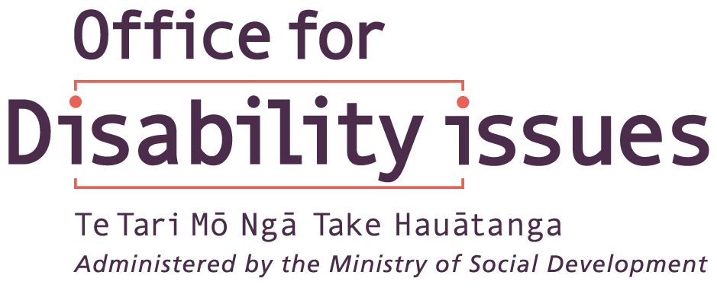

Foreword
Living with Disability in New Zealand is the most comprehensive report ever produced on the status of people with disability in New Zealand. It builds on the post-census disability surveys undertaken in 1996, providing extensive descriptive analysis from the 2001 post-census surveys.

Reliable information helps us to understand the needs of people with disability, and plan more effective and responsive policies and services. The report is intended to be a resource for a wide range of users including people with disability, policy analysts, funders, service providers and other interested parties, both inside and outside government.

Widely distributing this important information in a format that is accessible to as many people as possible is a key priority. To complement this report, a comprehensive set of data tables is being made available on-line on the Ministry of Health’s website, www.moh.govt.nz. A shortened summary of the report will be available by the end of the year in hard copy and alternative formats, including Braille, audio and plain English versions.

One of the objectives of the New Zealand Disability Strategy is to:
‘collect and use relevant information about disabled people and disability issues; and improve the quality of relevant disability information collected, analysed and used, including regular national surveys of activity limitation’.

It is my hope that Living with Disability in New Zealand promotes further investigation into the status of New Zealanders with disabilities so that we can work towards the Strategy’s vision of an inclusive and non-disabling society.

Hon Ruth Dyson
Minister for Disability Issues

Acknowledgements
This report was developed by an intersectoral group lead by the Ministry of Health. The original group comprised Marianne Linton (Project Leader, Ministry of Health), Hilary Boyd (Royal NZ Foundation of the Blind), Anne Hawker (Accident Compensation Corporation), Robin Peace (Ministry of Social Development), Kate Lynch (Department of Labour), Louise Hoather (Housing NZ Corporation), Mary-Anne Stewart (Observer, Statistics New Zealand), Valerie Smith (Ministry of Health), Pamela Fletcher (Ministry of Health), Durga Rauniyar (Ministry of Health), Wendi Wicks (Disabled Persons Assembly), Joanna Curzon (Ministry of Education) and Helen Baxter (Accident Compensation Corporation). Additional members included Owen Hughes (Office for Disability Issues), Denise Brown (Statistics NZ), Juliet Elworthy (Ministry of Social Development) and Kylie Clode, Lester Mundell, Dr Martin Tobias, Dr Pat Tuohy, Rebecca Purcell-Hewitt, Dr Rod Watts and Sue Merrilees (Ministry of Health).

All chapters were written by Caroline Maskill and Dr Ian Hodges except for Chapter 8, Pamela Burns and Chapter 9, Christopher Carroll. Further processing of data, all data analysis and preparation of the report’s Appendix Tables, which are located on the Ministry of Health website, was also carried out by Caroline Maskill and Dr Ian Hodges.

The complete report was externally peer reviewed by Dr Shanthi Ameratunga (University of Auckland), Dr Berni Kelly (Donald Beasley Institute) and Aron Spector (Social Development Canada). Acknowledgement is also made to the many other peer reviewers who commented on specific chapters. The external peer review process and publication of this report was co-ordinated by Marianne Linton and Kate Hirst (Ministry of Health).

Particular acknowledgement goes to the Office for Disability Issues and the Ministry of Social Development for their ongoing support, both financially and in the development of the report. Thanks also to the Royal NZ Foundation of the Blind and ACC for their financial contributions to this publication. Thanks to Andrew McLaren and Mary-Anne Stewart Statistics NZ for supplying data for the report.

Comments on this report should be sent to:
Disability Services Directorate
Ministry of Health
PO Box 5013
Wellington.

Contents
Foreword iii
Acknowledgements iv
1 Introduction 1
Design of the 2001 Household Disability Survey 1
Comparison with 1996 survey 1
2001 Census questions 2
Survey administration 3
Screening questionnaires 3
Content questionnaires 4
Survey participants 4
Linking survey data to census data 4
Design of the 2001 Disability Survey of Residential Facilities 5
Comparison with 1997 survey 5
Survey administration and participants 5
Questionnaire 5
Purpose of the report 6
Preparing the report 6
Structure of the report 7
Interpreting the survey results 8
Results are based on perceptions 8
Terms used 9
People with disability 9
Disability type 9
Main disability 9
Cause of disability 10
Severity of disability 10
Ethnicity 10
Equipment and technology 11
Unmet need 11
Minimal contextual interpretation 11
Disability and age 12
Age standardisation of disability prevalence rates 12
Age effects in other findings 13
Population estimates 14
Rounding 14
Calculating percentages 14
Relative sampling errors 14
Between-group differences 15
Response options 16
2 Patterns of Disability 17
Key points 17
Prevalence of disability 17
Types of disability 17
Introduction 19
Prevalence of disability 20
Age-specific and age-standardised rates of disability 21
Disability prevalence and ethnicity 22
Prevalence of disability in urban and rural areas 24
Prevalence of disability by region 24
Multiple disabilities 26
Types of disability 27
Disability type – adults 27
Mobility 28
Agility 31
Hearing 32
Seeing 33
Speaking 34
Psychiatric/psychological 35
Remembering 35
Learning 35
Intellectual 36
Main disability – adults 36
Disability type – children 38
Use of special education 39
Chronic condition/health problem 40
Psychiatric/psychological 41
Hearing 42
Speaking 43
Seeing 43
Intellectual 43
Use of technical aids 43
Cause of disability 44
Cause of disability in adults and children 45
Age-specific rates for adults 46
Age-specific rates for children 47
Cause of disability by sex 48
Causes of different types of disability 49
Disability caused by accident/injury 50
Adults 50
Children 52
Cause of main disability in adults 52
Cause of main disability at different ages 53
Main disabilities caused by accident/injury 54
Severity of disability 55
Defining severity levels 55
Prevalence of mild, moderate and severe disability 55
Severity of disability at different ages 56
Severity of disability in males and females 57
Severity of main disability 58
Severity of disability and cause of main disability 59
Age at onset of first disability 60
Duration of disability 61
Longest-lasting disability 61
Duration of main disability 62
Comparing 2001 and 1996 62
Number of people with disability 62
Disability in adults living in households 63
Disability in children living in households 65
Other survey findings 66
3 Support, Equipment and Services 67
Key points 67
Help with everyday activities 67
Adults 67
Children 67
Unmet need for help with everyday activities 68
Respite care 68
Adults 68
Children 69
Equipment and technology 69
Adults 69
Children 70
Disposable items 70
Adults 70
Children 71
Special dietary items 71
Adults 71
Children 71
Needs assessments 71
Adults 71
Children 71
Health services 72
Adults 72
Children 72
Reported unmet need for health services 72
Medication 72
Introduction 74
Help with everyday activities 75
Types of help 75
Adults 75
Children 84
Unmet need for help with everyday activities 85
Adults 85
Reasons for unmet need 86
Children 87
Payment and subsidies for help with everyday activities 89
Adults 89
Children 91
Respite care 92
Adults 92
Government help to pay for respite care 92
Self-funded respite care 92
Unmet need for respite care 93
Children 93
Government help to pay for respite care 94
Parents or caregivers who paid for respite care 95
Free respite care 95
Unmet need for respite care 95
Equipment and technology 96
Use of equipment and technology 96
Adults 96
Children 100
Unmet need for equipment and technology 103
Adults 103
Children 105
Payment and subsidies for equipment 106
Adults 106
Children 107
Disposable items 107
Use of disposable items 107
Adults 107
Children 107
Unmet need for disposable items 108
Adults 108
Children 108
Payment and subsidies for disposable items 108
Adults 108
Children 108
Special dietary items 109
Need for special diets 109
Adults 109
Children 109
Unmet need for dietary items 109
Adults 109
Children 109
Payment and subsidies for dietary items 110
Adults 110
Children 110
Needs assessments 110
Adults 111
When were needs assessments done? 112
Booked in for a needs assessment 113
Intention to have a needs assessment 113
Reasons for not having a needs assessment recently 113
Children 114
When were needs assessments done? 115
Booked in for a needs assessment 115
Intention to have a needs assessment 115
Reasons for not having a needs assessment recently 115
Health services 117
Use of different kinds of health care worker 117
Use of general practitioners or family doctors 118
Adults 118
Children 120
Use of chemists or pharmacists 122
Adults 122
Children 123
Use of medical specialists 124
Adults 124
Children 125
Use of nurses 127
Adults 127
Children 128
Unmet need for health services 129
Adults 129
Children 130
Payment and subsidies for health services 131
Medication 131
Use of medication 131
Adults 131
Children 132
Unmet need for medication 134
Adults 134
Children 134
Payment and subsidies for medication 135
Adults 135
Children 135
Comparing 2001 and 1996 136
Adults 136
Children 138
4 Education 139
Key points 139
Children with disability 139
Adults with disability 141
Introduction 142
Children with disability 143
Early childhood education services 143
Primary and secondary education 145
Special education services 146
Receiving special education services 146
Attendance at special schools 148
Attendance at mainstream classes and/or special units 150
Assessments of developmental and educational need 152
Participation in Individual Education Programmes or Individual Development Programmes 156
Age when first received an Individual Education Programme or Individual Development Programme 158
Learning disability 160
Choosing schools for children with disability 163
Impact of disability on school activities 164
How activities at school were limited 164
At least one effect on school activities 166
Effect of disability on children’s education 168
How children’s education was affected 168
At least one effect on education 169
Equipment and support services children needed to help their education 172
Types of equipment and support service needed 172
At least one type of equipment or support service needed 173
Adults with disability 175
Participation in formal education or training 175
Types of educational institution 176
Main disability 177
Cause of main disability 177
Severity of disability 177
Impact of disability on education and training 177
Special education 178
Other effects of disability on education 180
Educational qualifications 181
Post-school qualifications 181
School qualifications 182
No educational qualifications 184
Educational qualifications and ethnicity 185
Educational qualifications and income 186
Rural and urban residence 188
Geographic regions 188
Disability type 189
Main disability 190
Disability cause 191
Severity of disability 192
Comparing 2001 and 1996 193
Children 193
Adults 195
5 Employment and Income 196
Key points 196
Labour force status of working age (15–64) adults with disability 196
Labour force status of people with disability aged 65 and over 196
Employed people with disability 197
Unemployed people with disability 197
People with disability not in the labour force 198
Income sources 198
Government financial assistance 198
Health care cards 199
Household income 199
Personal income 199
Socioeconomic areas 199
Introduction 200
Employment and labour force status 201
Labour force status of adults aged 15–64 201
Employment 202
Unemployment 203
Not in the labour force 203
Labour force status and disability type 205
Labour force status and main disability 206
Labour force status and cause of main disability 207
Labour force status and single/multiple disability 208
Labour force status and severity of disability 209
Labour force status of adults aged 65 and over 210
Employed people with disability 211
Status in employment 211
More than one job 212
Sheltered employment 212
Types of occupation 212
Industry category 214
Disability type 215
Main disability 216
Cause of main disability 216
Special workplace requirements 216
Building alterations 218
Unemployed people with disability 218
Length of time seeking work 219
Special workplace requirements 219
People with disability not in the labour force 220
Capacity to work 220
Reasons for not seeking work 222
Special workplace requirements 222
Income sources and subsidies 222
Main sources of income 222
Adults aged 15–24 222
Adults aged 25–64 224
Adults aged 65 and over 225
Government financial assistance 226
Disability Allowance 227
Child Disability Allowance 229
Community Wage – Sickness Benefit 231
Invalids Benefit 232
War Disablement Pension 233
Special Needs Grant 234
Health care cards 234
Community Services Card 235
Pharmaceutical Subsidy Card 236
High Use Health Card 236
Income levels 237
Household income 237
Children 237
Personal income 241
Young adults (aged 15–24) 241
Adults aged 25–44 242
Adults aged 45–64 243
Older adults (aged 65 and over) 244
Ethnicity 245
Socioeconomic areas 246
NZDep2001 246
People with and without disability 246
Children 247
Adults aged 15–64 248
Adults aged 65 and over 249
Ethnicity 250
Severity of disability 251
Comparing 2001 and 1996 252
Labour force status 252
Labour force status and ethnicity 253
Labour force status and disability type 254
Labour force status and severity of disability 255
People with disability on low incomes 256
6 House and Home 257
Key points 257
Household composition 257
Adults 257
Children 257
Had a partner or spouse 257
Home ownership 258
Housing tenure 258
Financial help for accommodation costs 258
Phone, fax and internet 258
Modifications in and around the home 259
Modifications inside the home 259
Modifications for entering or leaving the home 259
Introduction 261
Household composition 261
Adults 262
One-family households 262
One-person households 264
Two-family households 265
Other multi-person households 265
Children 265
Social marital status 266
Home ownership 269
Housing tenure 271
Adults 271
Age and housing tenure 272
Housing tenure and other factors 273
Adults with and without disability 273
Children 275
Rental payments 277
Adults 277
Children 278
Financial help for accommodation costs 278
Accommodation Supplement 279
Other kinds of financial help 279
Awareness of the Accommodation Supplement 279
Access to telephone, fax and internet 280
Adults 280
Children 281
Modifications in and around the home 281
Modifications inside the home 282
Adults 282
Children 283
Modifications for entering or leaving the home 284
Adults 284
Children 285
Government loans or grants to help with alterations 285
Comparing 2001 and 1996 286
Adults 286
Children 287
7 Travel and Transport 288
Key points 288
Long-distance travel 288
Short-distance travel 288
Private motor vehicles 289
Taxis 290
Public transport 290
Transport subsidies and grants 291
Introduction 292
Long-distance travel 292
Recent long-distance travel 292
Adults 293
Children 294
Prevention of long-distance travel 294
Adults 295
Need for special transport 297
Need for assistance 297
Short-distance travel 299
Recent short-distance travel 299
Prevention of short-distance travel 299
Need for special transport 299
Adults 299
Children 299
Need for assistance 299
Adults 299
Children 300
Travel to school 301
Private motor vehicles 302
Access to motor vehicles 302
Adults 302
Children 304
Need to buy a vehicle 304
Adults 304
Children 304
Drivers 305
Changes to private motor vehicles to enable driving 307
Travelling as a passenger 309
Adults 309
Children 310
Changes needed to private motor vehicles to enable travel as a passenger 311
Parking private motor vehicles 312
Need to park close to destination 312
Problems finding car parking 315
Taxis 315
Use of taxis 315
Adults 315
Children 316
Reasons for not using taxis 316
Public transport 317
Access to a bus stop or railway station 317
Difficulty travelling long distances on public transport 319
Types of difficulty 319
Difficulty travelling short distances on public transport 320
Adults 321
Children 322
Types of difficulty 323
Buses 323
Use of buses 323
Would buses be used if they were easier to use? 327
Transport subsidies and grants 328
Subsidies or grants for modifying vehicles 328
Total Mobility Scheme 328
Awareness of the Total Mobility Scheme 328
Use of Total Mobility Scheme vouchers 329
Other financial assistance 329
Unmet need for financial assistance 330
Adults 330
Children 330
Reasons for not getting financial assistance 331
Comparing 2001 and 1996 331
8 Mäori and Disability 333
Key points 333
Mäori living in households 333
Mäori living in residential facilities 334
Introduction 335
Features of the Mäori population 336
Mäori living in households 337
Mäori disability rates 337
All Mäori 337
Children 337
Adults 337
Sex 338
Socioeconomic factors 338
Disability type 339
Adults 339
Children 344
Main disability 345
Most common types of main disability 345
Sex 345
Comparing Mäori and non-Mäori 346
Severity of disability 346
Dependent disability 349
Single and multiple disability 349
Cause of disability 351
Adults 351
Children 352
Duration of disability 353
Support services and equipment 353
Type of health service used 353
Use of equipment and technology 355
Received help for everyday activities 357
Family needing help with personal care of child or household work 357
Socioeconomic areas 357
Personal income 359
Labour force status 360
Education 361
Educational qualifications 361
Enrolment in formal education 364
Housing 365
Household composition 365
Social marital status 365
Tenure of dwelling 365
Rural/urban residence 365
Travel and transport 365
Awareness of Total Mobility Scheme 366
Unmet need for transport costs 366
Mäori with disability in residential facilities 366
9 Pacific Peoples and Disability 367
Key points 367
Pacific peoples with disability living in households 367
Pacific peoples in residential facilities 369
Introduction 370
Demography 371
2001 Census 371
Pacific peoples with disability in New Zealand 372
Pacific peoples with disability living in households 373
Prevalence of disability among Pacific people 373
Adults 373
Children 374
Single and multiple disability 374
Adults 374
Children 374
Disability type 375
Adults 375
Children 377
Specific disability 379
Adults 379
Children 380
Main disability 380
Adults 380
Severity of disability 381
Adults 383
Children 383
Cause of disability 384
Adults 384
Children 384
Duration of disability 384
Services and support for Pacific peoples 385
Type of assistance received 385
Needs assessments 387
Health service use in previous 12 months 388
Use of equipment and technology 390
Unmet needs for services and support 391
Education 393
Assessments of developmental and educational need 393
Educational qualifications 393
Enrolment in formal education or training 396
Work and income 397
Labour force status 397
Status in employment 401
Child Disability Allowance 401
Community Wage – Sickness Benefit 402
Community Services Card 402
Socioeconomic areas 402
Personal income 402
House and amenities 402
Household composition 402
Social marital status 403
Housing tenure 403
Accommodation Supplement 403
Access to telephone, fax and internet 403
Transport 404
Long distance travel 404
Difficulty travelling long distances 404
Need for vehicle 404
Motor vehicles in households 404
Driver of motor vehicle 404
Use of buses 404
Use of taxis 404
Total Mobility Scheme 405
Unmet need for financial help for transport costs 405
Pacific adults with disability living in residential facilities 405
10 Adults with Disability Living in Residential Facilities 406
Key points 406
Proportion of adults living in residential facilities 406
Features of adults with disability living in residential facilities 406
Types of residential facilities 406
Length of stay 406
Patterns of disability 407
Need for assistance 407
Use of equipment and technology 407
Introduction 409
Proportion of adult New Zealanders living in residential facilities 410
Proportion of adults with disability living in residential facilities 411
Features of adults with disability living in residential facilities 412
Age 412
Sex 412
Ethnicity 413
Types of residential facility 414
Length of stay 415
Patterns of disability 416
Disability type 416
Mobility 416
Agility 417
Other disabilities 417
Main disability 419
Main disability and age 420
Main disability and type of residential facility 420
Multiple disability 421
Cause of disability 421
Cause of disability and age 422
Cause of disability by sex 423
Cause of disability and disability type 423
Cause of main disability 425
Severity of disability 426
Prevalence of severe disability 426
Severity of disability by age 427
Severity of disability and type of residential facility 427
Severity of disability and main disability 428
Severity of disability and cause of main disability 429
Age at onset of first disability 430
Duration of disability 431
Longest-lasting disability 431
Duration of main disability 432
Need for help 432
Help with personal care 432
Help with shopping 433
Help with personal finances 434
Help with communication 435
Use of equipment and technology 436
Use of any kind of equipment or technology 436
Use of equipment for moving about 436
Use of equipment for helping hands or arms 437
Use of other equipment and technology 438
Use of equipment for hearing 438
Use of equipment for speaking and being understood 439
Use of equipment by people with seeing disability 439
Comparing 2001 and 1997 439
11 Future Focus 442
Introduction 442
Scope of the disability surveys and this report 442
Relevance to the New Zealand Disability Strategy 443
Future policy and services 443
Monitoring change 444
Future disability research 444
Future disability surveys 445
Addressing information gaps 446
Defining disability 447
Comparing sub-groups 448
Mäori and Pacific perspectives 449
Perspectives of people with disability 449
Glossary 450
Appendices
Appendix 1: Classification of Disability Type 467
Appendix 2: Relative Sampling Error (RSE) Cut-off Points Used for this Report and Appendix Tables 468
References 469

List of Tables
Table 2.1: Number and percentage of people (adults and children) with disability living in households, by age, sex and ethnic group, 2001 22
Table 2.2: Rates (per 100,000 population) of disability among people (adults and children) living in urban and rural households, by age and sex, 2001 24
Table 2.3: Categories of mobility limitation in adults living in households, 2001 30
Table 2.4: Categories of hearing limitation in adults living in households, 2001 32
Table 2.5: Categories of seeing limitation reported by adults living in households, 2001 34
Table 2.6: Causes of the different types of disability in adults and children, 2001 49
Table 2.7: Age of onset of first disability in people (adults and children) with disability living in households, by current age, 2001 60
Table 2.8: Duration of longest-lasting disability in people (adults and children) with disability living in households, by age, 2001 61
Table 2.9: Duration of main disability in adults with disability living in households, by current age, 2001 62
Table 2.10: Selected results from the 1996 and 2001 Household Disability Surveys 66
Table 3.1: Number and percentage of adults with disability living in households who, because of disability, were receiving help with everyday activities, by activity type, 2001 75
Table 3.2: Number and percentage of adults with disability living in households who, because of disability, were receiving help with everyday activities, by type of activity and type of person providing help, 2001 81
Table 3.3: Unmet needs for help with everyday activities in the previous 12 months reported by adults with disability living in households, 2001 86
Table 3.4: Reasons adults with disability living in households gave for not being able to get the help they needed with everyday activities, by activity type, 2001 86
Table 3.5: Unmet needs for help with everyday activities in the previous 12 months reported by parents or caregivers of children with disability living in households, 2001 87
Table 3.6: Reasons reported by parents or caregivers of children with disability for why they were unable to get the help they needed for everyday activities, 2001 88
Table 3.7: Payment and payment sources for family, whänau, friends, flatmates, neighbours or other informal carers providing help for adults with disability living in households, by type of help, 2001 89
Table 3.8: Current use of technical aids because of a long-term condition or health problem, children with disability living in households, 2001 101
Table 3.9: Reported unmet need for equipment, children with disability living in households, 2001 105
Table 3.10: Comparison of selected 1996 and 2001 Household Disability Survey results for adults 137
Table 3.11: Comparison of selected 1996 and 2001 Household Disability Survey results for children 138
Table 4.1: Percentage of children aged 0–14 with disability living in households, by age when first had Individual Education Programme or Individual Development Programme and current age, 2001 158
Table 4.2: Percentage of children aged 0–14 with disability living in households, by age when first had Individual Education Programme or Individual Development Programme and age of onset of first disability, 2001 159
Table 4.3: Summary comparison of 1996 and 2001 Household Disability Surveys – children 193
Table 4.4: Summary comparison of 1996 and 2001 Household Disability Surveys – adults 195
Table 5.1: Labour force status of adults aged 15–64 with disability living in households, by disability type, 2001 205
Table 5.2: Percentage of adults with disability living in households and participating in labour force, by disability type, 1996 compared with 2001 254
Table 6.1: Household composition for children (aged 0–14) with disability, by ethnic group, 2001 266
Table 6.2: Adults with disability who owned or partly owned the dwelling in which they usually lived, by disability type, 2001 270
Table 6.3: Ownership and rental status of the private dwellings occupied by adults with disability, 2001 271
Table 6.4: Ownership and rental status of the private dwellings occupied by children with disability, 2001 276
Table 6.5: Summary comparison of 1996 and 2001 Household Disability Surveys for adults 286
Table 6.6: Summary comparison of 1996 and 2001 Household Disability Surveys for children 287
Table 7.1: Frequency of taxi use to travel short distances in the previous 12 months by adults with disability living in households, 2001 315
Table 7.2: Frequency of taxi use to travel short distances in the previous 12 months by children with disability living in households, 2001 316
Table 7.3: Frequency of use of bus services to travel short distances, by adults with disability who lived in a place with a bus service in the previous 12 months, 2001 324
Table 7.4: Frequency of use of bus services for short trips in the previous 12 months by children living in households whose disability did not completely stop them from travelling, 2001 326
Table 7.5: Summary comparison of 1996 and 2001 Household Disability Surveys 332
Table 8.1: Rates of mobility, agility and hearing disability Mäori and non-Mäori aged 15–24, living in households, 2001 340
Table 8.2: Rates of mobility, agility and hearing disability Mäori and non-Mäori aged 25–44, living in households, 2001 341
Table 8.3: Rates of selected disability types, Mäori and non-Mäori aged 45–65, living in households, 2001 342
Table 8.4: Rates of selected disability types, Mäori and non-Mäori aged 65 and over, living in households, 2001 343
Table 8.5: Rates of selected disability types, Mäori children, living in households, 2001 344
Table 8.6: Rates per 100,000 by disability type for Mäori children living in households, by sex 2001 345
Table 8.7: Age-standardised rates, of severity of disability for Mäori and non-Mäori people (children plus adults) living in households, by sex, 2001 347
Table 8.8: Type of health service used in previous 12 months for Mäori and non-Mäori (children and adults) living in households, 2001 353
Table 8.9: Type of health service used in previous 12 months for Mäori and non-Mäori children aged 0–14 living in households, 2001 354
Table 8.10: Use of equipment and technology, Mäori and non-Mäori with disability living in households, by age, 2001 355
Table 8.11: Use of equipment and technology, Mäori and non-Mäori adults with disability living in households, by type of equipment, 2001 356
Table 8.12: Use of equipment and technology, Mäori and non-Mäori children with disability living in households, by type of equipment, 2001* 356
Table 8.13: Received help for everyday activities, Mäori and non-Mäori adults with disability living in households, by type of help, 2001 357
Table 8.14: Labour force status of Mäori and non-Mäori adults with disability living in households, 2001 360
Table 8.15: Labour force status of Mäori and non-Mäori adults without disability living in households, 2001 361
Table 8.16: Short taxi and bus trips made by Mäori and non-Mäori with disability living in households in 2001 366
Table 9.1: Rates of mobility disability, for Pacific and non-Pacific adults living in households, by age, 2001 375
Table 9.2: Rates of agility disability, for Pacific and non-Pacific peoples living in households, by age, 2001 376
Table 9.3: Rates of hearing disability, for Pacific and non-Pacific peoples living in households, by age, 2001 376
Table 9.4: Percentage of Pacific and non-Pacific adults with disability living in households who had a difficulty with, or were unable to carry out, specific activities, 2001 379
Table 9.5: Percentage of Pacific and non-Pacific children with disability living in households, with specific types of disability, 2001 380
Table 10.1: Number of adults with disability living in residential facilities, by facility type and age group, 2001 414
Table 10.2: Cause of the disability in adults living in residential facilities, by disability type, 2001 424
Table 10.3: Age of onset of disability in adults living in residential facilities, by age, 2001 430
Table 10.4: Duration of longest-lasting disability in adults living in residential facilities, by age, 2001 431
Table 10.5: Duration of main disability in adults living in residential facilities, by age, 2001 432
Table 10.6: Comparison of results from 1997 and 2001 Disability Surveys of Residential Facilities 440
Table 11.1: Relevance of the report to the objectives of the New Zealand Disability Strategy 443
Table 11.2: Objectives of the New Zealand Disability Strategy and related information gaps 446

List of Figures
Figure 2.1: Number of people with disability in the New Zealand population, 2001 19
Figure 2.2: Number of people (adults and children) with disability living in households, by age and sex, 2001 20
Figure 2.3: Rates of disability among people (adults and children) living in households, by age and sex, 2001 21
Figure 2.4: Age-standardised rates of disability in people (adults and children) living in households, by ethnic group, 2001 23
Figure 2.5: Age-standardised rates of disability among people (adults and children) living in households, by region, 2001 25
Figure 2.6: Rates of single and multiple disabilities among people (adults and children) living in households, by age, 2001 26
Figure 2.7: Percentage of adults living in households experiencing different types of disability, 2001 28
Figure 2.8: Rates of mobility disability among adults living in households, by age and sex, 2001 29
Figure 2.9: Rates of agility disability among adults living in households, by age and sex, 2001 31
Figure 2.10: Rates of hearing disability among adults living in households, by age and sex, 2001 33
Figure 2.11: Types of main disability experienced by adults living in households, 2001 37
Figure 2.12: Percentage of children living in households experiencing different types of disability, 2001 39
Figure 2.13: Number of children with disability living in households experiencing most common types of chronic condition/health problem, 2001 41
Figure 2.14: Rates of hearing disability among children living in households, by age, 2001 42
Figure 2.15: Number of people (adults and children) living in households experiencing different causes of disability, 2001 44
Figure 2.16: Percentage of people (adults and children) experiencing different causes of disability, 2001 45
Figure 2.17: Rates for the causes of disability in adults living in households, by age, 2001 46
Figure 2.18: Rates for the causes of disability in children living in households, by age, 2001 47
Figure 2.19: Age-standardised rates for the causes of disability in people (adults and children) living in households, by sex, 2001 48
Figure 2.20: Number of adults living in households experiencing accident/injury disability, by accident/injury location and sex, 2001 50
Figure 2.21: Rates of disability caused by accident/injury, in adults living in households, by accident/injury location and age, 2001 51
Figure 2.22: Number of adults living in households experiencing different causes of main disability, by sex, 2001 52
Figure 2.23: Rates of different causes of main disability in adults living in households, by age, 2001 53
Figure 2.24: Number of adults living in households with main disability caused by accident/injury, by accident/injury location and sex, 2001 54
Figure 2.25: Severity of disability in people (adults and children) living in households, 2001 55
Figure 2.26: Rates of disability severity in people (adults and children) living in households, by age, 2001 56
Figure 2.27: Age-standardised rates of disability severity in people (adults and children) living in households, by sex, 2001 57
Figure 2.28: Percentage of adults living in households, by disability severity and main disability, 2001 58
Figure 2.29: Percentage of adults living in households, by disability severity and cause of main disability, 2001 59
Figure 2.30: Rates of disability in adult males living in households, by age, 1996 and 2001 63
Figure 2.31: Rates of disability in adult females living in households, by age, 1996 and 2001 64
Figure 2.32: Rates of disability in children living in households, by sex, 1996 and 2001 65
Figure 3.1: Percentage of adults with disability living in households who, because of disability, were receiving help with everyday activities, by age and ethnicity, 2001 76
Figure 3.2: Percentage of children with disability living in households whose parents or caregivers needed help with their child’s personal care or household work in the previous 12 months, by disability type, 2001 84
Figure 3.3: Percentage of children with disability living in households whose parents or caregivers had needed respite care in the previous 12 months, by disability type, 2001 94
Figure 3.4: Percentage of adults with disability living in households who had ever received a needs assessment, by age, 2001 111
Figure 3.5: Percentage of adults with disability living in households who had ever received a needs assessment, by main disability, 2001 112
Figure 3.6: Percentage of children with disability living in households who had ever received a needs assessment, by disability type, 2001 114
Figure 3.7: Percentage of people (adults and children) with disability using different types of health services in the previous 12 months, 2001 118
Figure 3.8: Percentage of adults with disability who consulted a general practitioner or family doctor more than 10 times in the previous 12 months, by ethnic group, 2001 119
Figure 3.9: Percentage of children with disability who consulted a general practitioner or family doctor more than 10 times in the previous 12 months, by disability type, 2001 121
Figure 3.10: Percentage of children with disability who consulted a chemist or pharmacist at least once in the previous 12 months, by disability type, 2001 123
Figure 3.11: Percentage of children with disability who consulted a medical specialist at least once in the previous 12 months, by disability type, 2001 126
Figure 3.12: Percentage of children with disability who had seen a nurse at least once in the previous 12 months, by disability type, 2001 128
Figure 3.13: Percentage of adults with disability who reported having an unmet health services need in the previous 12 months, by age, 2001 129
Figure 3.14: Percentage of children with disability who took prescribed medication daily, by disability type, 2001 133
Figure 4.1: Number of children aged 0–4 with disability living in households attending or enrolled in different types of early childhood services, week ending 4 March 2001 143
Figure 4.2: Percentage of children aged 0–4 with disability living in households attending or enrolled in at least one type of early childhood service, by disability type, week ending 4 March 2001 144
Figure 4.3: Number of children aged 5–14 with disability living in households enrolled in different types of primary or secondary education services, week ending 4 March 2001 145
Figure 4.4: Percentage of children aged 5–14 with disability living in households receiving special education services, by disability type, week ending 4 March 2001 147
Figure 4.5: Percentage of children aged 5–14 with disability living in households receiving special education services, by age when first started to receive special education services, week ending 4 March 2001 148
Figure 4.6: Percentage of children aged 5–14 with disability living in households, who had ever attended a special school, by disability type, 2001 149
Figure 4.7: Percentage of children aged 5–14 with disability living in households attending only mainstream classes, by residence in NZDep2001 decile areas, week ending 4 March 2001 150
Figure 4.8: Percentage of children aged 5–14 with disability living in households attending only mainstream classes, by disability type, 2001 151
Figure 4.9: Percentage of children aged 5–14 with disability living in households attending mainstream classes and/or special units, by severity of disability, week ending 4 March 2001 152
Figure 4.10: Number of children aged 0–14 with disability living in households who were assessed by different types of professionals, by age, 2001 153
Figure 4.11: Percentage of children aged 0–14 with disability living in households who received a professional assessment, by disability type, 2001 154
Figure 4.12: Percentage of children aged 0–14 with disability living in households who had received a professional assessment, by age and severity of disability, 2001 155
Figure 4.13: Percentage of children aged 0–14 with disability living in households with an IEP or IDP, by disability type, 2001 157
Figure 4.14: Rates of learning disability among children aged 0–14 living in households, by age and sex, 2001 160
Figure 4.15: Rates of learning disability among children aged 0–14 living in households, by ethnic group, 2001 161
Figure 4.16: Rates of learning disability among children aged 0–14 living in households, by household income, 2001 162
Figure 4.17: Rates of learning disability among children aged 0–14 living in households, by NZDep2001 decile areas, 2001 163
Figure 4.18: Percentage of children aged 5–14 with disability living in households experiencing different types of limitations on school activities, 2001 165
Figure 4.19: Percentage of children aged 5–14 with disability living in households experiencing at least one effect on school activities, by disability type 166
Figure 4.20: Percentage of children aged 5–14 with disability living in households experiencing at least one effect on school activities, by single/multiple disability and severity of disability, 2001 167
Figure 4.21: Percentage of children aged 5–14 with disability living in households experiencing different types of effects on education, 2001 168
Figure 4.22: Percentage of children aged 5–14 with disability living in households experiencing at least one effect on their education, by type of disability, 2001 170
Figure 4.23: Percentage of children with disability aged 5–14 living in households experiencing at least one effect on their education, by single/multiple disability and severity of disability, 2001 171
Figure 4.24: Percentage of children aged 5–14 with disability living in households needing different types of equipment and support service for education, 2001 172
Figure 4.25: Percentage of children aged 5–14 with disability living in households requiring at least one type of equipment or support service to help with their education, by disability type, 2001 174
Figure 4.26: Percentage of children aged 5–14 with disability living in households requiring at least one type of equipment or support service to help with their education, by single/multiple disability and severity of disability, 2001 175
Figure 4.27: Number of adults with disability living in households enrolled in main types of educational institutions, by age, week ending 4 March 2001 176
Figure 4.28: Percentage of adults with disability living in households whose disability started before formal education was completed, by age, 2001 178
Figure 4.29: Percentage of adults aged 15–44 with disability living in households who had ever attended special education schools or classes, by disability type, 2001 179
Figure 4.30: Percentage of adults with disability living in households, whose disability began before they finished formal education, experiencing different effects on their education, 2001 180
Figure 4.31: Percentage with post-school qualifications, adults with and without disability living in households, by age, 2001 182
Figure 4.32: Percentage with school qualifications, adults with and without disability living in households, by age, 2001 183
Figure 4.33: Percentage with no educational qualifications, adults with and without disability living in households, by age, 2001 184
Figure 4.34: Percentage with school or post-school qualifications, adults with and without disability living in households, by ethnic group, 2001 185
Figure 4.35: Percentage with post-school qualifications, adults with and without disability living in households, by total annual personal income, 2001 186
Figure 4.36: Percentage with no educational qualifications, adults with and without disability living in households, by annual household income, 2001 187
Figure 4.37: Percentage of adults with disability living in households, by region, by highest educational qualification gained, 2001 188
Figure 4.38: Percentage of adults with disability living in households, by highest educational qualification gained and disability type, 2001 189
Figure 4.39: Percentage of adults with disability living in households, by highest educational qualification gained and main disability, 2001 190
Figure 4.40: Percentage of adults with disability living in households, by highest educational qualification gained and cause of main disability, 2001 191
Figure 4.41: Percentage of adults with disability living in households, by highest educational qualifications gained and severity of disability, 2001 192
Figure 5.1: Percentage of adults aged 15–64 with and without disability living in households, by labour force status, 2001 201
Figure 5.2: Employment rates of adults aged 15–64 with and without disability living in households, by age, 2001 202
Figure 5.3: Unemployment rates of adults aged 15–64 with and without disability living in households, by age, 2001 203
Figure 5.4: Percentage of adults aged 15–64 with and without disability living in households not in the labour force, by age, 2001 204
Figure 5.5: Percentage of adults aged 15–64 with disability living in households, by labour force status and main disability, 2001 206
Figure 5.6: Percentage of adults aged 15–64 with disability living in households, by labour force status and cause of main disability, 2001 207
Figure 5.7: Percentage of adults aged 15–64 with disability living in households, by labour force status and single/multiple disability, 2001 208
Figure 5.8: Percentage of adults aged 15–64 with disability living in households, by labour force status and severity of disability, 2001 209
Figure 5.9: Percentage of adults aged 65 and over with and without disability living in households, by labour force status, 2001 210
Figure 5.10: Percentage of employed adults with and without disability living in households, by status in employment, 2001 211
Figure 5.11: Percentage of all employed adults living in households who had disability, by sex and occupation, 2001 213
Figure 5.12: Percentage of all employed adults living in households who had disability, by industry category, 2001 214
Figure 5.13: Percentage of all employed adults living in households who had disability, by disability type and main disability, 2001 215
Figure 5.14: Percentage of employed adults with disability living in households needing different types of workplace assistance, equipment or modification, 2001 217
Figure 5.15: Percentage of unemployed adults aged 15–64 with disability living in households, by length of time they had been looking for work and age, 2001 219
Figure 5.16: Percentage of adults aged 15–64 with disability living in households not in the labour force whose condition or health problem did not stop them working, by disability type and main disability, 2001 221
Figure 5.17: Percentage of adults aged 15–24 with and without disability living in households, by income source, 2001 223
Figure 5.18: Percentage of adults aged 25–64 with and without disability living in households, by income source, 2001 224
Figure 5.19: Percentage of adults aged 65 and over with and without disability living in households, by income source, 2001 225
Figure 5.20: Percentage of adults with disability living in households receiving different types of government financial assistance in the previous 12 months, 2001 226
Figure 5.21: Percentage of adults with disability who received a Disability Allowance in the previous 12 months, by disability type and main disability, 2001 227
Figure 5.22: Percentage of adults with disability who received a Disability Allowance in the previous 12 months, by single/multiple disability and severity of disability, 2001 228
Figure 5.23: Percentage of children with disability who received a Child Disability Allowance in the previous 12 months, by disability type, 2001 230
Figure 5.24: Percentage of children with disability who received a Child Disability Allowance in the previous 12 months, by single/multiple disability and severity of disability, 2001 231
Figure 5.25: Percentage of adults with disability receiving a Community Wage – Sickness Benefit in the previous 12 months, by disability type and main disability, 2001 232
Figure 5.26: Percentage of adults with disability receiving an Invalids Benefit in the previous 12 months, by disability type and main disability, 2001 233
Figure 5.27: Number of people (adults and children) with disability holding health care cards in the previous 12 months, by card type, 2001 234
Figure 5.28: Percentage of adults with disability who had a Community Services Card in the previous 12 months, by disability type and main disability, 2001 235
Figure 5.29: Percentage of children aged 0–14 with and without disability living in households, by household income, 2001 237
Figure 5.30: Percentage of adults aged 25–44 with and without disability, living in households, by household income, 2001 238
Figure 5.31: Percentage of adults aged 65 and over with and without disability living in households, by household income, 2001 239
Figure 5.32: Percentage of people (adults and children) with and without disability living in households with household incomes of $70,001 and over per year, by region, 2001 240
Figure 5.33: Percentage of adults aged 15–24 with and without disability living in households, by personal income, 2001 241
Figure 5.34: Percentage of adults aged 25–44 with and without disability living in households, by personal income, 2001 242
Figure 5.35: Percentage of adults aged 45–64 with and without disability living in households, by personal income, 2001 243
Figure 5.36: Percentage of adults aged 65 and over with and without disability living in households, by personal income, 2001 244
Figure 5.37: Percentage of adults with and without disability living in households with personal incomes of $15,000 and under per year, by ethnic group, 2001 245
Figure 5.38: Percentage of people (adults and children) with and without disability living in households, by NZDep2001 area, 2001 246
Figure 5.39: Percentage of children with and without disability living in households, by NZDep2001 area, 2001 247
Figure 5.40: Percentage of adults aged 15–64 with and without disability living in households, by NZDep2001 area, 2001 248
Figure 5.41: Percentage of adults aged 65 and over with and without disability living in households, by NZDep2001 area, 2001 249
Figure 5.42: Percentage of European and Mäori people (adults and children) with disability living in households, by NZDep2001 area, 2001 250
Figure 5.43: Percentage of people (adults and children) with disability living in households, by NZDep2001 area and severity of disability, 2001 251
Figure 5.44: Percentage of adults aged 15–64 with disability living in households, by labour force status, 1996 compared with 2001 252
Figure 5.45: Percentage of adults aged 15 years and over with disability living in households and participating in the labour force, by ethnic group, 1996 compared with 2001 253
Figure 5.46: Percentage of adults with disability living in households and participating in the labour force, by severity of disability, 1996 compared with 2001 255
Figure 5.47: Percentage of adults with disability with personal incomes $15,000 and under, by age, 1996 compared with 2001 256
Figure 6.1: Percentage of people (adults and children) living in households, by household composition, 2001 262
Figure 6.2: Percentage of adults with and without disability living in one-family households, by age, 2001 263
Figure 6.3: Percentage of adults with and without disability living alone in households, by age, 2001 264
Figure 6.4: Percentage of adults with and without disability living in households who had a partner or spouse, by age, 2001 267
Figure 6.5: Percentage of adults with disability living in households who had a partner or spouse, by disability type, 2001 268
Figure 6.6: Percentage of adults with and without disability living in households who personally owned or partly owned the dwelling in which they usually lived, by age, 2001 269
Figure 6.7: Percentage of adults with disability living in households, by ownership of the dwellings they occupied, by age, 2001 272
Figure 6.8: Percentage of adults with and without disability living in a dwelling owned or partly owned by the usual residents and where the usual residents do not make mortgage payments, by age, 2001 274
Figure 6.9: Percentage of adults with and without disability living in a dwelling where the usual residents paid rent, by age, 2001 275
Figure 6.10: Total weekly rental payments for accommodation used by adults with and without disability living in households, 2001 277
Figure 6.11: Total weekly rental payments for accommodation used by children with and without disability living in households, 2001 278
Figure 6.12: Percentage of adults with and without disability living in households, with internet access at home, by age, 2001 281
Figure 7.1: Percentage of people (adults and children) with disability living in households who had not made a long trip in the previous 12 months, by age, 2001 293
Figure 7.2: Percentage of adults with disability living in households who were prevented by disability from travelling long distances, by age, 2001 295
Figure 7.3: Percentage of adults with disability living in households who were prevented by disability from travelling long distances, by disability type and main disability, 2001 296
Figure 7.4: Percentage of adults living in households with disability able to travel long distances who needed assistance on long trips, by age, 2001 297
Figure 7.5: Percentage of adults with disability living in households able to travel long distances who needed assistance on long trips, by disability type and main disability, 2001 298
Figure 7.6: Percentage of adults with disability living in households able to travel short distances who needed assistance on short trips, by disability type and main disability, 2001 300
Figure 7.7: Percentage of children with disability living in households able to travel short distances who needed assistance on short trips, by disability type, 2001 301
Figure 7.8: Number of motor vehicles available to adults with and without disability living in households, 2001 302
Figure 7.9: Percentage of adults with and without disability living in households with no access to a motor vehicle, by household income, 2001 303
Figure 7.10: Percentage of children with disability living in households whose parents or caregivers had needed to buy a vehicle in the previous 12 months because of the child’s condition or health problem, by disability type, 2001 305
Figure 7.11: Percentage of adults with disability living in households who drove private motor vehicles, by disability type and main disability, 2001 306
Figure 7.12: Percentage of adults with disability living in households who drove private motor vehicles, by disability cause and cause of main disability, 2001 307
Figure 7.13: Percentage of adults with disability living in households who experienced difficulty travelling as passengers in private motor vehicles, by disability type and main disability, 2001 309
Figure 7.14: Percentage of children with disability living in households who experienced difficulty travelling as passengers in private motor vehicles, by disability type, 2001 310
Figure 7.15: Percentage of people (adults and children) with disability living in households who drove or travelled as passengers in private motor vehicles needing to park close to their destination, by age, 2001 312
Figure 7.16: Percentage of adults with disability living in households who drove or travelled as passengers in private motor vehicles needing to park close to their destination, by disability type and main disability, 2001 313
Figure 7.17: Percentage of children with disability living in households who travelled as passengers in private motor vehicles needing to park close to their destination, by disability type, 2001 314
Figure 7.18: Percentage of adults with disability living in households who could not easily get to a bus stop or railway station from where they lived, by age, 2001 317
Figure 7.19: Percentage of adults with disability living in households who could not easily get to a bus stop or railway station from where they lived, by disability type and main disability, 2001 318
Figure 7.20: Percentage of people (adults and children) with disability living in households who would have difficulty using public transport for short distances, by age, 2001 320
Figure 7.21: Percentage of adults with disability living in households who would have difficulties using public transport for short distances, by disability type and main disability, 2001 321
Figure 7.22: Percentage of children with disability living in households who would have difficulties using public transport for short distances, by disability type, 2001 322
Figure 7.23: Percentage of adults with disability living in households in a place with a bus service who used a bus for short trips at least once in the previous 12 months, by age, 2001 324
Figure 7.24: Percentage of adults with disability living in households in a place with a bus service who had used a bus for short trips at least once in the previous 12 months, by disability type and main disability, 2001 325
Figure 7.25: Percentage of children living in households whose disability did not stop them from travelling who used a bus for short trips at least once in the previous 12 months, by disability type, 2001 327
Figure 8.1: Percentage of Mäori and non-Mäori people (adults and children) with disability living in households, by age and sex, 2001 338
Figure 8.2: Age-standardised rates of different disability types for Mäori and non-Mäori adults living in households, 2001 339
Figure 8.3: Rates of different disability types for Mäori and non-Mäori adults aged 15–24 living in households, 2001 340
Figure 8.4: Rates of different disability types for Mäori and non-Mäori adults aged 25–44 living in households, 2001 341
Figure 8.5: Rates of different disability types for Mäori and non-Mäori adults aged 45–64 living in households, 2001 342
Figure 8.6: Rates of different disability types for Mäori and non-Mäori adults aged 65 and over living in households, 2001 343
Figure 8.7: Rates of different disability types for Mäori and non-Mäori children living in households, 2001 344
Figure 8.8: Age-standardised rates of different types of main disability for Mäori and non-Mäori adults living in households, 2001 346
Figure 8.9: Rates of mild disability among Mäori and non-Mäori living in households, by age and sex, 2001 347
Figure 8.10: Rates of moderate disability among Mäori and non-Mäori living in households, by age and sex, 2001 348
Figure 8.11: Rates of severe disability among Mäori and non-Mäori living in households, by age and sex, 2001 348
Figure 8.12: Rates of single disability among Mäori and non-Mäori living in households, by age and sex, 2001 349
Figure 8.13: Rates of multiple disability among Mäori and non-Mäori living in households, by age and sex, 2001 350
Figure 8.14: Rates of disability caused by disease/illness among Mäori and non-Mäori living in households, by age and sex, 2001 351
Figure 8.15: Rates of disability caused by accident/injury among Mäori and non-Mäori living in households, by age and sex, 2001 352
Figure 8.16: Percentage of Mäori and non-Mäori with disability living in households who reported an unmet need for health services in the previous 12 months, by age, 2001 355
Figure 8.17: Percentage of Mäori and non-Mäori with and without disability living in households, by NZDep2001 area 358
Figure 8.18: Percentage of Mäori and non-Mäori adult males with and without disability living in households with a personal income of $15,000 and under per year, by age, 2001 359
Figure 8.19: Percentage of Mäori and non-Mäori adult females with and without disability living in households with a personal income of $15,000 and under per year, by age, 2001 360
Figure 8.20: Percentage of Mäori and non-Mäori adults with and without disability living in households with no educational qualifications, by age, 2001 362
Figure 8.21: Percentage of Mäori and non-Mäori adults with and without disability living in households with a school qualification, by age, 2001 363
Figure 8.22: Percentage of Mäori and non-Mäori adults with and without disability living in households with a post-school qualification, by age, 2001 363
Figure 8.23: Percentage of Mäori and non-Mäori adults with disability living in households enrolled in formal education, by age, 2001 364
Figure 9.1: Percentage of Pacific and non-Pacific peoples (adults and children) with disability living in households, by age and sex, 2001 373
Figure 9.2: Age-standardised rates of different disability types for Pacific and non-Pacific adults living in households, 2001 377
Figure 9.3: Rates of different disability types for Pacific and non-Pacific children aged 0–14 living in households, 2001 378
Figure 9.4: Rates of mild disability among Pacific and non-Pacific peoples (adults and children) living in households, by age and sex, 2001 382
Figure 9.5: Rates of moderate disability among Pacific and non-Pacific peoples living in households, by age and sex, 2001 382
Figure 9.6: Rates of severe disability among Pacific and non-Pacific peoples (adults and children) living in households, by age and sex, 2001 383
Figure 9.7: Percentage of Pacific and non-Pacific adults living in households who received help for everyday activities, by age, 2001 385
Figure 9.8: Percentage of Pacific and non-Pacific adults living in households who received help for different everyday activities, 2001 386
Figure 9.9: Percentage of Pacific and non-Pacific peoples (adults and children) with disability living in households who had used different types of health service in the previous 12 months, 2001 388
Figure 9.10: Percentage of Pacific and non-Pacific peoples with disability living in households who reported an unmet need for health services in the previous 12 months, by age, 2001 392
Figure 9.11: Percentage of Pacific and non-Pacific adults with and without disability living in households with no educational qualifications, by age, 2001 393
Figure 9.12: Percentage of Pacific and non-Pacific adults with and without disability living in households with a school qualification, by age, 2001 394
Figure 9.13: Percentage of Pacific and non-Pacific adults with and without disability living in households with a post-school qualification, by age, 2001 395
Figure 9.14: Percentage of Pacific and non-Pacific adults with disability living in households enrolled in formal education, by age, 2001 396
Figure 9.15: Percentage of Pacific and non-Pacific adult males with and without disability living in households who were not in the labour force, by age, 2001 397
Figure 9.16: Percentage of Pacific and non-Pacific adult females with and without disability living in households who were not in the labour force, by age, 2001 398
Figure 9.17: Percentage of Pacific and non-Pacific adults with and without disability living in households who were unemployed, by age, 2001 399
Figure 9.18: Percentage of Pacific and non-Pacific adult males with and without disability living in households who were employed, by age, 2001 400
Figure 9.19: Percentage of Pacific and non-Pacific adult females with and without disability living in households who were employed, by age, 2001 401
Figure 10.1: Percentage of adult population who were living in residential facilities and had a disability, by age and sex, 2001 410
Figure 10.2: Percentage of adults with disability who were living in residential facilities, by age and sex, 2001 411
Figure 10.3: Number of adults with disability living in residential facilities, by age and sex, 2001 413
Figure 10.4: Number of adults with disability living in residential facilities, by length of stay, 2001 415
Figure 10.5: Percentage of adults with disability living in residential facilities with different types of disability, by sex, 2001 416
Figure 10.6: Percentage of adults with disability living in residential facilities, by disability type and age, 2001 418
Figure 10.7: Percentage of adults with disability living in residential facilities, by main disability and sex, 2001 419
Figure 10.8: Number of adults with disability living in residential facilities, by cause of disability and sex, 2001 421
Figure 10.9: Percentage of adults with disability living in residential facilities, by cause of disability and age, 2001 422
Figure 10.10: Percentage of adults with disability living in residential facilities, by cause of disability and sex, 2001 423
Figure 10.11: Percentage of adults with disability living in residential facilities, by cause of main disability and age, 2001 425
Figure 10.12: Percentage of adults with disability living in residential facilities, by severity of disability, 2001 426
Figure 10.13: Percentage of adults with disability living in residential facilities, by severity of disability and age, 2001 427
Figure 10.14: Percentage of adults with disability living in residential facilities, by severity of disability and main disability, 2001 428
Figure 10.15: Percentage of adults with disability living in residential facilities, by severity of disability and cause of main disability, 2001 429

1 Introduction
In 2001, Statistics New Zealand conducted two national disability surveys.

The Household Disability Survey examined the day-to-day living arrangements and activity restrictions of 7256 adults and children with disability living in households.

The Disability Survey of Residential Facilities gathered a smaller set of information from 928 adults with disability living in institutions such as homes for older people and hospitals.

This report comprehensively describes the results from the two surveys, covering all the main themes and issues they examined. It is intended to be a resource for all people with an interest in disability and disability-related issues in New Zealand, while also providing information to support policy work, service development and monitoring, as specified in Objective 10.3 of the New Zealand Disability Strategy (Minister for Disability Issues 2001).

Design of the 2001 Household Disability Survey

Comparison with 1996 survey
The design of the 2001 Household Disability Survey was based on the 1996 Household Disability Survey, which was the first detailed, national survey of disability in the New Zealand population.

Like the 1996 survey, the 2001 survey collected information on the prevalence, nature, duration, severity and causes of the disabilities experienced by New Zealanders living in households, as well as on issues related to education, employment, transport, accommodation, and health and disability support services.

The 2001 survey differed from the 1996 survey in that it oversampled Mäori and Pacific peoples, to enable more detailed analysis of the circumstances and needs of Mäori and Pacific peoples with disability. This resulted in a larger overall survey sample.

The 2001 survey also collected data on the main type of disability adults experienced. This was not done in the 1996 survey.

An additional goal of the 2001 survey was to examine the degree to which patterns of disability identified in 1996 had changed.

As in the 1996 survey, the focus of the 2001 survey was people living in private dwellings such as houses, flats, apartments and holiday homes. The 1996 criterion of including people living in group homes, but excluding people living in boarding houses, was also adopted in the 2001 survey.

2001 Census questions
Participants in the 2001 survey were initially selected using information from the 2001 Census of Population and Dwellings, which contained two short questions designed to identify whether people thought they had a disability.
1. Does a health problem, or a condition you have (lasting six months or more) cause you difficulty with, or stop you doing:
- everyday activities that people your age can usually do
- communicating, mixing with others or socialising
- any other activity that people your age can usually do
- no difficulty with any of these.
2. Do you have any disability or handicap that is long-term (lasting six months or more)?
- Yes
- No.

Based on the results of these questions, a group of just over 38,500 people living in private households was selected as the 2001 Household Disability Survey sample. This included people who reported in the 2001 Census that they had difficulty with everyday activities or had a long-term disability or handicap, as well as people who reported they did not.

There were three separate sample selections: the main sample, the Mäori oversample and the Pacific oversample. Within each of these samples, a selection of individuals was made using a partly stratified, partly systematic sampling design, based on where people lived and their demographic characteristics (Statistics New Zealand nd c).

Seventy-three percent of the people selected for the survey agreed to participate. This resulted in just over 28,100 people going on to answer questions from the survey’s screening questionnaires (Statistics New Zealand 2002a; Statistics New Zealand nd c).

Survey administration
All interviews for the 2001 Household Disability Survey were completed from 16 June to 18 September 2001.

Most survey questionnaires were administered in English by computer-assisted telephone interview, although some were administered in person if, for example, participants did not have a telephone, required an interpreter or communicated in sign language.

In the case of children, a parent, guardian or other adult caregiver usually answered the survey questions on behalf of their child. Caregivers also answered on behalf of adults who were unable to answer the survey questions.

Screening questionnaires
The screening questionnaires included several questions designed to find out whether people had certain types of disability. If a person had one or more of these disability types, they were classified as a person with disability.

Different screening questionnaires were used for adults (people aged 15 and over) and for children (people aged 0–14). This was to cater for differences in the definitions of disability among adults and children.

For most types of disability, the screening questions asked if people found it difficult or impossible to carry out various kinds of everyday activity. Examples included difficulty seeing newsprint, hearing conversations, walking up and down stairs, carrying objects and mixing with others. A person was not counted as having a disability if they had a limitation that was eliminated or corrected by things such as hearing aids, glasses, contact lenses or medication.

For other types of disability, the screening questions asked if people used certain kinds of service or equipment. To identify people with intellectual disability, for example, adults were asked if they needed support or help from other people or organisations or had received special education because of an intellectual disability or intellectual handicap. Similarly, parents or caregivers were asked if their children used certain types of equipment, received special education services or had Individual Education Programmes (IEPs) or Individual Development Programmes (IDPs).

For children, another type of disability – chronic condition/health problem – was defined by a list of medical diagnoses.

A person was defined as having a disability if they reported having any type of disability resulting from a long-term condition or health problem where the limitation had lasted, or was expected to last, six months or more.

For each of the different types of disability they reported, survey participants were asked to indicate how old they were when they first experienced this disability. In the case of adults, they were also asked to specify the main condition or health problem they believed had caused the disability.

Content questionnaires
The screening questionnaires identified 7256 people with disability. These people were then asked to respond to a second, lengthier Content Questionnaire. This covered a variety of topics related to people’s personal circumstances and day-to-day activities, including employment, education and training, access to transport, accommodation, assistance and support, use of special equipment and use of health services. Again, there were different questionnaires for adults and children.

Survey participants
Of the 7256 people identified as having a disability who participated in the 2001 Household Disability Survey, 2055 were aged 0–14, 3483 were aged 15–64 and 1718 were aged 65 and over.

Linking survey data to census data
A key advantage of using the 2001 Census to recruit participants in the 2001 Household Disability Survey was that Statistics New Zealand could anonymously link census information with results from the survey. This reduced the number of questions survey participants had to answer about employment, education, income, household composition, home ownership, marital status and education, since most of this information had been collected in the census.

Linking results from the 2001 Census and 2001 Household Disability Survey also made it possible to compare the sociodemographic features of people with disability and people without disability, indicating the extent to which people with disability were less likely than other New Zealanders to be, for example, employed, living by themselves or on low incomes.

Design of the 2001 Disability Survey of Residential Facilities

Comparison with 1997 survey
The 2001 Disability Survey of Residential Facilities followed on from the 1997 Disability Survey of Residential Facilities, which was New Zealand’s first comprehensive disability survey of adults living in residential care. Like the 1997 survey, the 2001 survey focused on adults aged 15 and over living in residential facilities such as homes for older people (also known as rest homes), public and private hospitals, and long-stay units for people with intellectual, psychiatric or physical disability or multiple disabilities (Statistics New Zealand 2002a).

Unlike the 1997 survey, the 2001 survey also collected data on the main type of disability that these adults experienced.

Survey administration and participants
From a list of 1170 residential facilities throughout New Zealand, a sample of 132 facilities was selected as the focus for the survey. Ninety-one percent (118) of these facilities agreed to participate. A total of 1016 adult residents of these facilities were selected for interview using a systematic sampling technique within each facility. Of these residents, 928 (91 percent) agreed to participate in the survey and completed interviews (Statistics New Zealand 2002a; Statistics New Zealand nd b).

In contrast to the Household Disability Survey, the Disability Survey of Residential Facilities used face-to-face, paper-and-pen administered interviews. This included some interviews where family members or facility staff answered questions on behalf of residents.

Questionnaire
The first part of the Disability Survey of Residential Facilities consisted of the adult screening questions described above for the Household Disability Survey. These examined features of the different types of disability that people had. The second part of the survey included questions about people’s use of assistance and equipment, including whether they needed help with personal care or used equipment such as a walking stick or wheelchair.

Purpose of the report
Previous publications have described selected results from the 1996, 1997 and 2001 disability surveys and supplied a range of statistical tables.

The purpose of this document is to provide a more in-depth and complete description of the results from the 2001 surveys, addressing all the main themes and issues covered in the survey interviews. In particular, the report comprehensively describes the sociodemographic characteristics and day-to-day living circumstances of people with disability, including their use of services and self-identified unmet needs for various types of support and assistance.

Preparing the report
The report’s authors were guided and supported in their work by the project’s advisory group made up of representatives from a range of government and non-government organisations with an interest in disability issues, research and policy. Members of the advisory group were responsible for the initial design of the report’s structure and for commenting on chapter drafts.

Statistics New Zealand provided all survey and census data used in the report. The authors transferred these data into a tabular format suitable for further analysis and publication, wrote the text for the chapters and prepared the charts.

Chapters 8 and 9 were prepared by Mäori and Pacific staff members of the Ministry of Health. Mäori and Pacific reviewers provided feedback on chapter drafts.

Members of the project advisory group and three external peer reviewers reviewed the full draft report.

An extensive set of Appendix Tables containing the survey data used for preparing the report is available separately. These Appendix Tables can be downloaded free from the Ministry of Health website (http://www.moh.govt.nz).

Structure of the report
The report’s structure largely reflects the structure of the 2001 disability surveys’ questionnaires, particularly the Household Disability Survey. The structure also recognises, in broad terms, key themes and issues identified in the New Zealand Disability Strategy (Minister for Disability Issues 2001).

Chapter 2 (Patterns of Disability) examines the types of disability reported by adults and children living in households. It describes the causes attributed to these disabilities and their severity and duration. It also examines the extent to which the prevalence and severity of disability varied across age groups, ethnic groups and other population groups.

Chapter 3 (Support, Equipment and Services) describes the kinds of support or help with everyday activities that adults and children with disability living in households received or needed, whether from family members or other people. It also looks at how many people with disability used or needed equipment such as wheelchairs, walking frames, communication devices, or artificial limbs. Later sections indicate how many people with disability needed or used health and disability services such as respite care, needs assessments, general practitioners (GPs) and pharmacists.

Chapter 4 (Education) covers topics related to the participation of people with disability living in households in regular (mainstream) and special education. It summarises the levels of educational qualifications achieved by people with disability, and describes the barriers to participating more fully in school and tertiary education they reported facing.

Chapter 5 (Employment and Income) presents data on the labour force status of adults with disability living in households and indicates the occupations and industries in which adults with disability were most likely to work. It also examines the levels of personal and household income reported by people with disability, comparing these with the income levels reported by people without disability. The final section uses NZDep2001, an index of socioeconomic deprivation for small geographic areas, to examine where people with and without disability lived.

Chapter 6 (House and Home) focuses on the home life and home environments of people with disability living in households. It indicates how many people with disability lived alone and how many lived with others (household composition), how many were in a partnered relationship (‘social marital status’), and how many lived in rented accommodation rather than in their own homes (housing tenure). The chapter also describes the different kinds of disability-related building modification that people had or needed in and around their home.

Chapter 7 (Travel and Transport) examines the travel patterns of people with disability living in households and their access to, and use of, different forms of transport such as private motor vehicles, taxis, buses, trains and ferries. It also describes the kinds of disability-related modification to vehicles that people had or needed.

Chapter 8 (Mäori and Disability) draws together survey results of special relevance to Mäori. It looks first at the prevalence, severity and causes of the types of disability reported by Mäori adults and children. It then examines features of the day-to-day living circumstances of Mäori with disability, covering education, employment, income, accommodation, transport and access to health and disability support services. The chapter also presents a range of survey data comparing Mäori and non-Mäori, both with and without disability.

Chapter 9 (Pacific Peoples and Disability) presents survey results of special relevance to New Zealand’s Pacific peoples. As well as describing the types of disability most commonly reported by Pacific peoples, it describes the educational, economic and employment circumstances of Pacific peoples with disability. It also examines features of Pacific peoples’ home situation, such as housing tenure, household composition and access to telephones and transport. Comparisons are made between Pacific and non-Pacific peoples, both with and without disability.

Chapter 10 (People with Disability in Residential Care) presents the results for all the main questions contained in the 2001 Disability Survey of Residential Facilities. It describes the types of disability reported by adults living in residential care, as well as the causes, severity and duration of these disabilities. It also examines the kinds of everyday assistance or support that people used or needed, including help with personal care, shopping, personal finances and communication. Indications are given, too, of the number of people using or needing equipment such as wheelchairs, walking frames and shower stools.

The final chapter (Chapter 11, Future Focus) outlines how the information presented in this report could be used for future service planning, policy, monitoring and research. It also considers the applicability of the information for supporting work related to promoting the objectives of the New Zealand Disability Strategy (Minister for Disability Issues 2001). The last part of the chapter discusses recent international developments in the field of measuring disability and health, highlighting issues that may need to be considered when planning future disability surveys in New Zealand.

The Glossary, at the end of the report, provides definitions of the terms used in the text.

Interpreting the survey results
Readers are urged to bear in mind the following points when interpreting the survey results.

Results are based on perceptions
The data presented here are based on survey participants’ perceptions of their situation and memory of their experiences, rather than measurements or assessments conducted by other people, such as a trained needs assessor. This means survey results describing, for example, levels of unmet need for certain items of equipment or which type of organisation or person pays for certain kinds of service, should be interpreted cautiously.

Terms used
In most cases, the disability-related terms used in the report are the same as those used in the survey questions. While some readers may regard some of these terms as less than ideal, altering them may have obscured or distorted the original meaning and intent of the survey questions.

People with disability
In this report, people who have one or more types of disability are termed ‘people with disability’. This term was chosen in consultation with members of the project advisory group, recognising that there appears to be no consensus internationally or in New Zealand on the most appropriate and acceptable term to use. The term ‘people with disability’ has the advantage of being simple, not too negative and appropriate for use in a variety of contexts.

It is acknowledged that different terms for the same concept are used in other documents and contexts. For example, the term ‘disabled people’ is used in the New Zealand Disability Strategy (Minister for Disability Issues 2001). Other terms used by different organisations and interest groups include ‘people with impairments’, ‘people who are differently abled’, ‘people with handicaps’, ‘people who experience disability’, and ‘people with disabilities’.

It is also acknowledged that all people, including people with disability, achieve things or experience problems in their everyday lives not just because of their particular physical or psychological characteristics. These achievements and problems are also shaped by the characteristics of their physical and social environments (Minister for Disability Issues 2001).

Disability type
The categories of disability type used in this report, and their definitions, are derived directly from the questions used in the screening questionnaire, the glossary of Disability Counts 2001 (Statistics New Zealand 2002a) and the disability surveys’ manuals for survey interviewers. Detailed definitions are in the Glossary and chapter 2, while chapter 11 discusses some of the issues associated with using these categories and definitions.

Results given throughout the report for ‘disability type’ refer to all the different types of disability reported by individuals. Because many people reported having two or more different types of disability (for example, a seeing disability, a hearing disability and a mobility disability), there are considerably more disabilities reported in total than there are people with disability.

Main disability
The category ‘main disability’ refers to the one particular type of disability that people considered was most limiting their everyday activities. Therefore the number of main disabilities in the population is the same as the number of people with disability.

Cause of disability
The category ‘cause of disability’ (for example, accident/injury or disease/illness) refers to the causes of all the different disability types individuals had. By contrast, the ‘cause of main disability’ category refers only to the cause of the main disability individuals had.

Severity of disability
A three-level classification system was used to define how severely people were affected by disability, based on the level of assistance or equipment people indicated they received or needed. According to this system people with:
- severe disabilities received or needed daily help with activities such as preparing meals, shopping, everyday housework, bathing or dressing
- moderate disabilities used or needed ‘some type of assistive device, aid or equipment’ and/or help with certain heavier or more difficult household tasks
- mild disabilities had a disability, but did not require regular help from other people or technical aids.

Severity of disability was defined slightly differently in adults than in children, because adults and children were not asked identical questions about the assistance they received or the equipment they used.

Ethnicity
The report provides disability-related data for four ethnic groups: European, Mäori, Pacific peoples, and Asian/Other peoples. When people specified they belonged to only one ethnic group, they were classified as follows:
- European people identified themselves as New Zealand European (or New Zealanders, Päkehä or Kiwi), Australian, Dutch, Greek, English, Scottish, Irish, Eurasian, Caucasian or any other European group.
- Mäori identified themselves as (New Zealand) Mäori.
- Pacific peoples identified themselves as Samoan, Cook Island Mäori, Tongan or Niuean or from another Pacific Island cultural group.
- Asian/Other peoples identified themselves as belonging to either an Asian ethnic group such as Indian, Japanese or Chinese or belonged to ethnic groups not classified as Mäori, Pacific, European or Asian. These people were classified together because of relatively small numbers participating in the disability surveys.

Where people indicated they belonged to two or more ethnic groups, Statistics New Zealand allocated them to one of the four ethnic groups using its standard system of prioritisation. Under this system, the Mäori ethnic group was given first priority, followed by the Pacific, the Asian/Other and, finally, European.

This meant a person who indicated they belonged to both Mäori and Pacific ethnic groups was categorised as Mäori. A person who indicated they belonged to both Pacific and European ethnic groups was categorised as Pacific. A person who belonged to Asian/Other as well as one of the European ethnic groups was categorised as Asian/Other.

Equipment and technology
The term ‘special equipment’ was used in various questions in the disability survey. However, several members of the project advisory group indicated that it would not be appropriate to use the term in this report. Suggested alternatives included ‘assistive technology’, ‘assistive equipment’, ‘adaptive equipment’, ‘technical aids’ and ‘technical equipment’.

In the end it was decided to adopt the term ‘equipment and technology’, mainly because it is relatively easy for a wide audience to understand. The term covers such things as equipment to help with mobility and agility such as wheelchairs and artificial limbs, and equipment to help with sensory functions such as hearing aids. It also includes other equipment such as glucose meters and specialised chairs and other technology such as computer software and communications technology. It may be more appropriate to use different terms in other contexts.

Unmet need
In the 2001 Household Disability Survey, an unmet need was defined as an occasion when a person with disability was unable to get a particular service or item of equipment they considered they needed (for example, financial assistance, equipment or technology, modifications to a building or vehicle, health service or personal assistance). The identification of need was based on survey participants’ perceptions rather than formal needs assessments. Survey participants were asked to identify the reasons for their unmet need from a list of options such as: not knowing there was such a service; lack of local availability of the service; lack of eligibility for the service; not liking the service that was available; feeling uncomfortable with the service for cultural reasons; lack of transport; and lack of appointment availability.

Minimal contextual interpretation
Large-scale population surveys like the disability surveys are especially useful for identifying broad patterns or trends, such as how many older adults compared with younger adults have a seeing disability. However, these kinds of survey are often less useful when it comes to explaining why certain patterns or trends exist, because the causes are often quite complex and open to debate. For this reason, discussion of possible causal factors underlying the descriptive information presented here has been kept to a minimum.

For similar reasons, the implications of the survey results for policy and further research are not discussed in any great detail. It was felt the report’s prime objective should be to describe the survey results, rather than define policy options or new areas for study. Nonetheless, the document is likely to serve as a core resource for a variety of people and organisations active in the development of disability-related policy and research in New Zealand (see chapter 11).

Disability and age
When the number of respondents allows, survey results are reported for specific age groups, rather than just for everyone. Readers are, therefore, able to examine the effects of age on most of the survey results.

For example, in chapter 2, it was possible to report disability prevalence rates in the following age groups: 0–4, 5–9, 10–14, 15–24, 25–44, 45–64, 65–74, 75–84 and 85 and over. These relatively narrow age bands have been used to minimise age variation within the age groups. This means, for example, that results for individual age groups can be directly compared for males and females.

Age standardisation of disability prevalence rates
For some analyses where one or more variables were significantly related to age, it was useful to summarise data for all age groups. This particularly applied to analyses involving the prevalence of disability. An example is the comparison of disability rates between non-Mäori and Mäori people (data are available for disability status by ethnicity by age).

One way of summarising the data for non-Mäori is simply to divide the number of non-Mäori with disability by the total number of non-Mäori in the population and then multiply by a standard factor (for example, 100,000). This is known as the ‘crude’ rate. The same process is then carried out for Mäori, and the two results compared. The calculated crude rates are similar for non-Mäori and Mäori (19,400 and 20,500 per 100,000 respectively).

However, compared with Mäori, much higher proportions of people in the non-Mäori population are in the older age groups and disability rates among older people are generally much higher than among younger people. By summarising the prevalence rates for Mäori and non-Mäori using the crude rate method, just because of their age non-Mäori have higher rates of disability.

An alternative and (for some purposes) more meaningful way to summarise this type of data is to use age standardisation. This is a mathematical procedure that controls, or adjusts, for the effects of age differences between different groups of people.

Using the same example as above, age standardising the data means the relationship between ethnicity and disability rates can be summarised and examined by itself. Using this method, the age-standardised rate of disability is 16,700 per 100,000 for non-Mäori and 24,000 per 100,000 for Mäori. This is a much larger difference than that calculated by the crude rate, suggesting Mäori are more likely than non-Mäori to have disability independent of the effects of age.

Age effects in other findings
As already mentioned, when numbers allow and it is warranted, survey findings are reported for individual age groups in the Appendix Tables, the text and charts. In addition, for most survey questions, results were obtained by ethnicity and sex.

For some survey questions, especially those relevant to a high proportion of people with disability, results were analysed by an additional set of variables that included rural/urban residence, geographic region, household income, disability type, disability cause and severity of disability. This provided numerous two-way tables where data for two variables, other than age, were cross-tabulated.

Data from these tables have been included in the report because they are useful starting points for identifying demographic and disability-related factors that may have a bearing on the results of particular questions. Examples include labour force status by ethnicity, educational qualification by disability type and long-distance travel by severity of disability. However, readers should be aware that age may be an important factor influencing the results reported for these two-way tables, as both variables in the two-way tables are age-related.,

There are two main reasons why it was impractical to age standardise all the survey results presented in this report. First, many of the results were not amenable to being analysed in three or more dimensions, because of the small numbers that would result. Secondly, the time and resource costs of obtaining and processing all the data in this way were prohibitive.

Readers may wish to obtain more detailed data from Statistics New Zealand to examine the effect of age in these types of analyses, and for age-standardising additional survey results, when numbers allow.

Population estimates
A total of 8184 people with disability completed interviews for the 2001 Household Disability Survey and 2001 Disability Survey of Residential Facilities. To improve the usefulness of the survey findings, Statistics New Zealand used mathematical techniques to convert the survey results to population estimates.

All the data reported in this document and in the Appendix Tables relate to these population estimates. For example, this report refers to a total 346,300 adults with mobility disability living in New Zealand households. This number is a population estimate derived from the results for participants in the survey who had mobility disability. It does not mean the survey interviewed 346,300 adults with mobility disability.

Rounding
All population estimates and rates reported in the text and tables have been rounded to the nearest hundred. All percentages have been rounded to the nearest 1 percent.

Calculating percentages
For most survey questions, some results were classified under residual categories such as ‘other’, ‘not specified’, or ‘not included elsewhere’. When this occurred, data for these residual categories are reported in the Appendix Tables available from the Ministry of Health’s website (http://www.moh.govt.nz). In addition, when calculating percentages, the values of the residual categories have been included in the denominator.

Percentages reported throughout the document have been calculated using unrounded population estimates.

Relative sampling errors
Sample numbers for particular breakdowns of data were sometimes too small to provide reliable population estimates. When the relative sampling error (RSE) exceeded 70 percent, the population estimates were suppressed in the data tables and not reported.

Between-group differences
This report identifies noteworthy differences between certain groups, such as between younger and older people with disability, between Mäori, Pacific, European and Asian/Other peoples with disability, or between people with and people without disability. When no notable differences exist, the survey results are not usually reported in detail.

In general, a noteworthy difference was defined as being at least a 5–10 percentage point difference between two or more groups. Because of the complex nature of the survey design, it was not possible to carry out standard statistical significance testing of between-group differences for this report.

Readers interested in accessing unreported results for survey questions examined in this report may download the relevant Appendix Tables from the Ministry of Health’s website (http://www.moh.govt.nz). These Appendix Tables present the survey results for a selection of variables from a standard set comprising:
- age group
- sex
- ethnic group
- urban/rural residence
- geographic region
- household income
- personal income
- NZDep2001
- disability type
- main disability (adults only)
- disability cause
- cause of main disability (adults only)
- single/multiple disability
- severity of disability
- disability status (with or without disability).

Response options
Results for the most commonly selected response options are usually reported for each survey question. However, for some questions, response options were selected by only a few respondents (often smaller than the 70 percent RSE cut-off point). Results for these response options are not usually reported. For a full list of possible response options for each question, see the various survey questionnaires or the Appendix Tables.

2 Patterns of Disability

Key points
This chapter describes the nature and extent of disability experienced by people living in New Zealand households. It examines the prevalence of disability in different age groups, the specific types of disability people experience, the most common causes of disability and the degree to which people’s disability conditions are severe and long-lasting.

Prevalence of disability
- In 2001, 22 percent of adults (people aged 15 years and over) and 11 percent of children (people aged 0–14) living in households had a disability. This was an estimated 716,500 people: 626,500 adults and 90,000 children.
- Males had a slighter higher rate of disability than females, with an age-standardised rate of 18,000 per 100,000, compared with the female rate of 17,000 per 100,000. An important factor contributing to this was the higher prevalence of disability among boys (13 percent) compared with girls (9 percent).
- Older people were substantially more likely than younger people to experience disability, with just 9 percent of adults aged 15–24 having a disability, compared with 87 percent of people aged 85 and over.
- An estimated 106,500 Mäori had a disability, as did 27,700 Pacific peoples, 551,100 Europeans, and 21,100 Asian/Other peoples. These totals included substantial numbers of children, with an estimated 28,400 Mäori and 5700 Pacific children having a disability, along with an estimated 52,300 European and 2200 Asian/Other children.
- Of the four main ethnic groups, Mäori had the highest age-standardised rate of disability (24,100 per 100,000). The Asian/Other ethnic group had the lowest rate (13,400 per 100,000).

Types of disability
- Mobility disabilities were the most common type of disability in adults. An estimated 346,300 adults, 12 percent of adults living in households, had mobility disabilities. This included 213,400 adults whose main disability was a mobility disability.
- An estimated 35,500 children, 4 percent of children living in households, used special education because of long-term conditions or health problems.
- Over half (57 percent) of people with disability living in households had more than one type of disability (for example, a hearing disability and a seeing disability).
- The most common cause of disability was disease/illness. An estimated 281,000 adults and children, 8 percent of all people living in households, had at least one disability caused by disease/illness.
- Accident/injury was the second most common cause of disability, with disability caused by accident/injury affecting an estimated 214,200 people.
- An estimated 88,100 adults and children, 2 percent of all people in households, had severe disability. This meant they required daily help from someone else for tasks such as bathing or preparing meals.
- Eleven percent of all people aged 75 and over living in households had severe disability.

Introduction
In 2001, an estimated 743,800 people with disability were living in New Zealand. This is a disability prevalence rate of 20 percent or one in five (Figure 2.1).

Most (96 percent) New Zealanders with disability were living in private households such as houses, flats or apartments. The rest were living in residential facilities such as homes for older people or rest homes, public and private hospitals, or units for people with intellectual, psychiatric or physical disability.

Figure 2.1: Number of people with disability in the New Zealand population, 2001
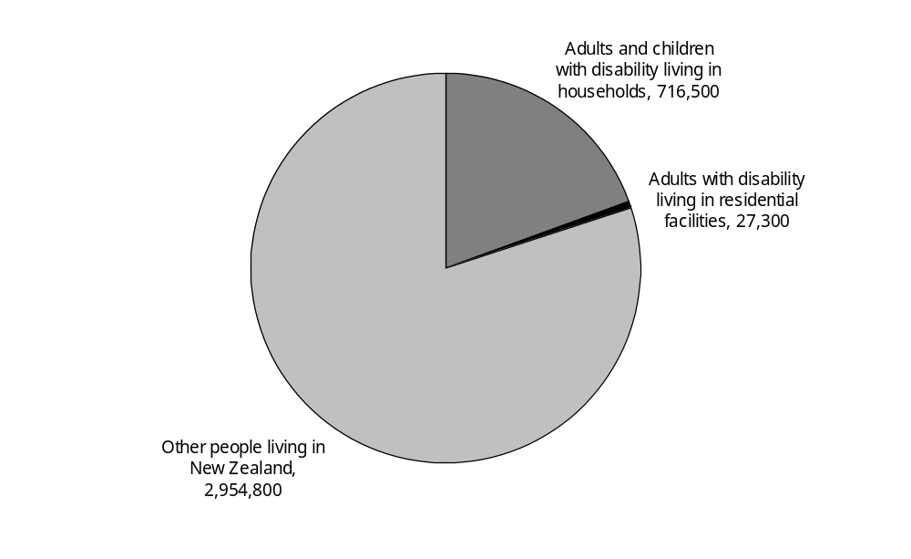
Source: Statistics New Zealand, 2001 Household Disability Survey, 2001 Disability Survey of Residential Facilities
Note: The 2001 Disability Survey of Residential Facilities did not include children living in residential facilities.

This chapter examines the nature and extent of disability experienced by people living in households. It describes the prevalence of disability in different age and ethnic groups, the specific types of disability people experienced (for example, mobility, hearing, intellectual or psychiatric disability), the most common causes of disability, and the degree to which people’s disability conditions were severe and long-lasting. Taken together, this information shows the diversity of the disability conditions and circumstances experienced by New Zealanders at different ages and life-stages.

Prevalence of disability
In 2001, an estimated 716,500 people with disability, 626,500 adults and 90,000 children, were living in private households.

Slightly more than half (51 percent) of these 716,500 people were aged 25–64, 26 percent were aged 65–84 and 4 percent were aged 85 and over. An estimated 366,100 (51 percent) were female and 350,400 (49 percent) were male (Figure 2.2).

Figure 2.2: Number of people (adults and children) with disability living in households, by age and sex, 2001
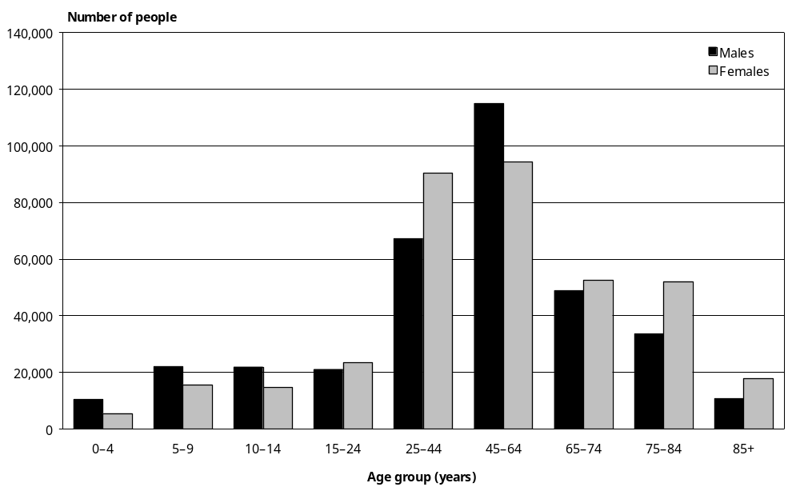
Source: Statistics New Zealand, 2001 Household Disability Survey
Note: Data in Appendix Table 2.1.

When these estimates of the number of people with disability are compared with the total number of people living in New Zealand households (that is, people with disability plus people without disability), they show that 22 percent of adults and 11 percent of children had at least one kind of disability in 2001.

Age-specific and age-standardised rates of disability
The prevalence of disability increases with age, and is substantially higher in the older age groups. People aged 85 and over had the highest age-specific rate of disability (87,300 per 100,000), with people aged 75–84 (58,200 per 100,000) and 65–74 (42,100 per 100,000) having the next highest rates. By contrast, the 0–4, 5–9, 10–14 and 15–24 age groups all had age-specific rates of disability below 13,000 per 100,000 (Figure 2.3).

Figure 2.3: Rates of disability among people (adults and children) living in households, by age and sex, 2001
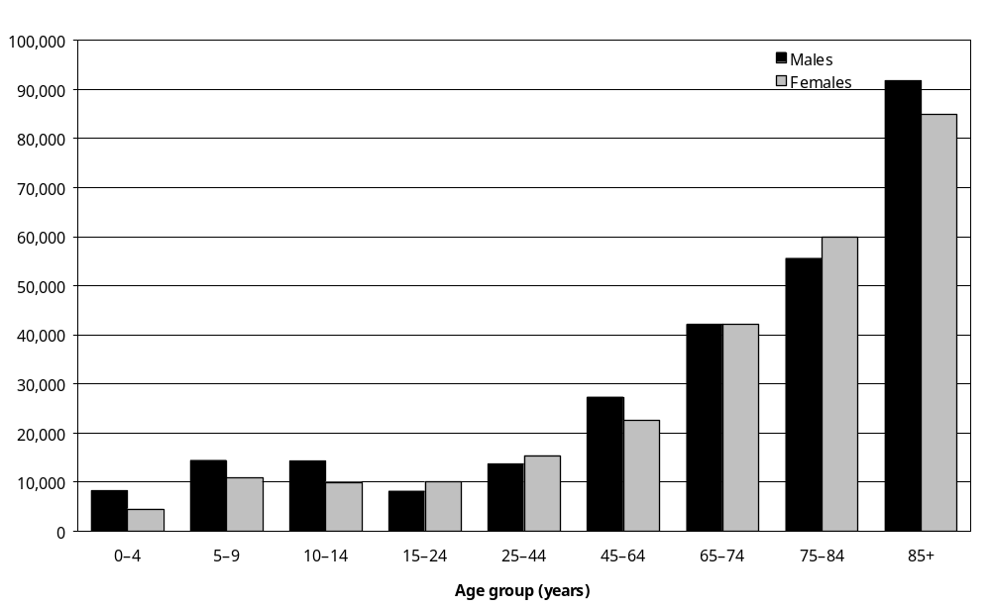
Source: Statistics New Zealand, 2001 Household Disability Survey
Note: Data in Appendix Table 2.2.

Overall, males had a slightly higher age-standardised rate of disability than females (18,000 per 100,000 compared with 17,000 per 100,000). An important factor contributing to this was the higher prevalence of disability among boys (13 percent) compared with girls (9 percent). Males also had higher age-specific rates of disability than females in the 45–64 and 85 and over age groups.

Disability prevalence and ethnicity
In 2001, just over three-quarters (77 percent) of people with disability living in households were European, 15 percent (an estimated 106,500 people) were Mäori, 4 percent (an estimated 27,700) were Pacific peoples, and 3 percent (an estimated 21,000 people) were Asian/Other peoples (Table 2.1).

Table 2.1: Number and percentage of people (adults and children) with disability living in households, by age, sex and ethnic group, 2001
Ethnic group | Sex | Age group (years)
Ethnic group | Sex | 0–14 | % | 15–64 | % | 65 or over | % | Total | %
European | Male | 33,500 | 12 | 154,100 | 57 | 84,500 | 31 | 272,100 | 100
 | Female | 18,800 | 7 | 152,600 | 55 | 107,700 | 39 | 279,000 | 100
 | Total | 52,300 | 9 | 306,700 | 56 | 192,200 | 35 | 551,100 | 100
Mäori | Male | 15,600 | 32 | 29,400 | 60 | 4,100 | 8 | 49,100 | 100
 | Female | 12,800 | 22 | 38,400 | 67 | 6,200 | 11 | 57,400 | 100
 | Total | 28,400 | 27 | 67,800 | 64 | 10,300 | 10 | 106,500 | 100
Pacific | Male | 3,500 | 27 | 8,200 | 63 | – | – | 13,000 | 100
 | Female | 2,100 | 15 | 10,200 | 70 | 2,300 | 16 | 14,700 | 100
 | Total | 5,700 | 21 | 18,300 | 66 | 3,700 | 13 | 27,700 | 100
Asian/Other | Male | 1,100 | 11 | 7,300 | 69 | 2,200 | 21 | 10,600 | 100
 | Female | 1,100 | 10 | 5,500 | 53 | 3,900 | 37 | 10,500 | 100
 | Total | 2,200 | 11 | 12,800 | 61 | 6,100 | 29 | 21,100 | 100
Not specified | Male | – | – | 4,200 | 74 | – | – | 5,600 | 100
 | Female | 900 | 20 | – | – | 2,400 | 54 | 4,500 | 100
 | Total | 1,400 | 14 | 5,300 | 53 | 3,400 | 34 | 10,100 | 100
Total | Male | 54,200 | 15 | 203,000 | 58 | 93,100 | 27 | 350,400 | 100
 | Female | 35,700 | 10 | 207,900 | 57 | 122,500 | 33 | 366,100 | 100
 | Total | 90,000 | 13 | 410,900 | 57 | 215,600 | 30 | 716,500 | 100
Source: Statistics New Zealand, 2001 Household Disability Survey
– Percentages too small to report (estimated frequencies outside the 70 percent relative sampling error cut-off point).
Note: The sum of the values for each category may differ from the total due to rounding.

Children with disability featured prominently in the Mäori and Pacific ethnic groups. More than a quarter of Mäori with disability (27 percent) and one in five Pacific peoples with disability (21 percent) were children. This contrasted with the European ethnic group where only 9 percent of those with disability were children. Likewise, in the Asian/Other ethnic group only 11 percent of people with disability were children.

Unadjusted for age (that is, before age standardisation to adjust for age-related factors such as the relatively high proportion of older people in the European group), 22 percent of Europeans and 21 percent of Mäori had one or more disabilities, compared with 14 percent of Pacific peoples and 10 percent of Asian/Other peoples.

After age standardisation, Mäori had the highest rate of disability (24,100 per 100,000). European people had the next highest rate (17,900 per 100,000), followed by Pacific peoples (17,000 per 100,000). The Asian/Other group had the lowest rate (13,400 per 100,000) (Figure 2.4).

Figure 2.4: Age-standardised rates of disability in people (adults and children) living in households, by ethnic group, 2001
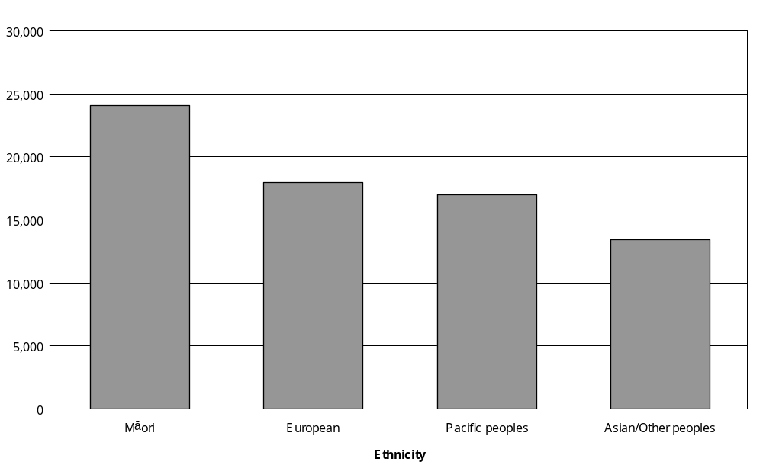
Source: Statistics New Zealand, 2001 Household Disability Survey
Notes:
- Calculated from data in Appendix Table 2.4.
- Age-standardised to World Health Organization (WHO) World Standard Population.

Prevalence of disability in urban and rural areas
Eighty-seven percent of New Zealanders with disability, an estimated 621,000 people, lived in households in urban areas. The remaining 13 percent, an estimated 95,500 people, lived in households in rural areas.

People living in urban households had only a slightly higher age-standardised rate of disability (17,900 per 100,000) than people living in rural households (16,600 per 100,000). However, in the 75 and over age group, urban women had a markedly higher rate of disability than rural women (Table 2.2). Rates of disability were also higher for urban males compared with rural males in the 75 and over age group, and for urban females compared with rural females in the
0–14, 15–44 and 65–74 age groups (Table 2.2).

Table 2.2: Rates (per 100,000 population) of disability among people (adults and children) living in urban and rural households, by age and sex, 2001
 |  | Age group (years)
 |  | 0–14 | 15–44 | 45–64 | 65–74 | 75 and over
Males | Urban | 12,500 | 11,500 | 27,700 | 42,000 | 62,000
 | Rural | 12,500 | 13,700 | 25,600 | 42,700 | 57,100
 | Total | 12,500 | 11,800 | 27,300 | 42,100 | 61,400
Females | Urban | 9,100 | 14,400 | 22,100 | 42,600 | 66,300
 | Rural | 6,300 | 10,400 | 24,600 | 38,100 | 49,200
 | Total | 8,700 | 13,900 | 22,600 | 42,100 | 64,800
Source: Statistics New Zealand, 2001 Household Disability Survey

Prevalence of disability by region
To assist with the funding and delivery of health and disability support services across the country, New Zealand is divided into administrative regions. In 2001 these were the Northern, Midland, Central and Southern regions. The Northern region included Northland and Auckland, the Midland region included Waikato, Rotorua, Taupo, Bay of Plenty and Taranaki, the Central region included Gisborne, Hawkes Bay, Wairarapa, Wanganui, Manawatu and Wellington, and the Southern region covered the whole of the South Island.

In 2001, the Northern region had the most people with disability living in households, an estimated 199,900 individuals or 28 percent of all people with disability in households. Not far behind was the Southern region with 192,600 people with disability (27 percent). The Central region had 153,300 people with disability (21 percent), while the Midland region had the lowest number, an estimated 134,900 people or 19 percent of the total population of people with disability in households.
Figure 2.5 shows the age-standardised rates of disability for the four regions. In 2001, the Northern region had the lowest disability rate (15,600 per 100,000 population). The Central region (18,300 per 100,000) and Midland region (18,700 per 100,000) had mid-range rates, and the Southern region had the highest rate (19,400 per 100,000).

Figure 2.5: Age-standardised rates of disability among people (adults and children) living in households, by region, 2001
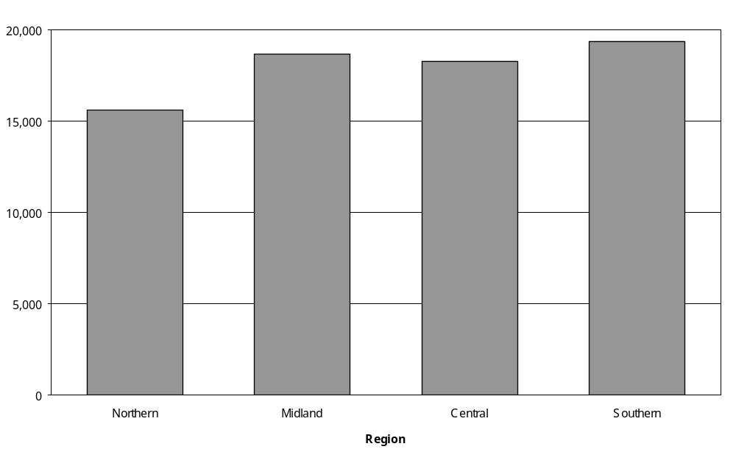
Source: Statistics New Zealand, 2001 Household Disability Survey
Notes:
- Calculated from data in Appendix Tables 2.8 and 2.9.
- Age-standardised to WHO World Standard Population.

Multiple disabilities
The 2001 Household Disability Survey examined how many people with disability had more than one type of disability, such as a hearing disability combined with a seeing disability, or a mobility disability combined with an intellectual disability.

Over half (57 percent) the 716,500 people with disability living in households had multiple disabilities. A similar proportion of females and males had multiple disabilities (58 percent and 56 percent respectively).

Older people were more likely than younger people to have multiple disabilities. Seventy-six percent of people aged 75 and over with disability had multiple disabilities, as did 58 percent of people aged 45–64 with disability.

Comparing these figures with the total number of New Zealanders living in households (that is, people with disability plus people without disability) shows that 48 percent of all people aged 75 and over had multiple disabilities, as did 27 percent of people aged 65–74. By contrast, only 3 percent of people aged 0–4 and 6 percent of people aged 5–14 and 15–44 had multiple disabilities (Figure 2.6).

Figure 2.6: Rates of single and multiple disabilities among people (adults and children) living in households, by age, 2001
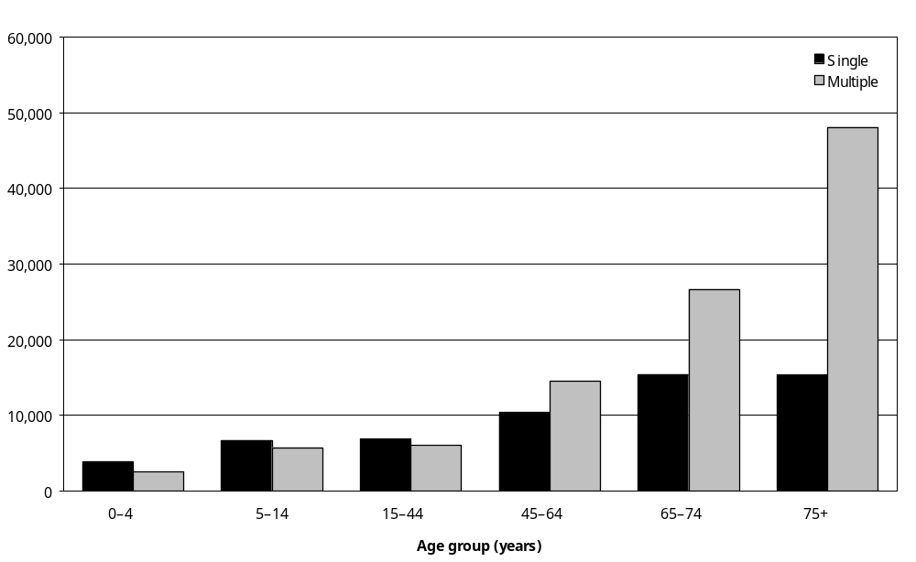
Source: Statistics New Zealand, 2001 Household Disability Survey
Note: Data in Appendix Table 2.11.

Types of disability
This section describes the types of disability experienced by adults and children living in households. Adults and children are considered separately, as the 2001 Household Disability Survey defined some types of disability differently for children than adults.

Disability type – adults
The types of disability reported by adults in the 2001 Household Disability Survey were categorised into 10 groups:
- mobility
- agility
- hearing
- seeing
- speaking
- psychiatric/psychological
- learning
- remembering
- intellectual
- other.

Figure 2.7 shows the percentage of all adult New Zealanders living in households (that is, people with disability plus people without disability) estimated to have these types of disability in 2001.

Readers should note that participants in the 2001 Household Disability Survey could report more than one type of disability. The data in Figure 2.7 include all the different disabilities reported, not just those identified as a person’s main disability.

Figure 2.7: Percentage of adults living in households experiencing different types of disability, 2001
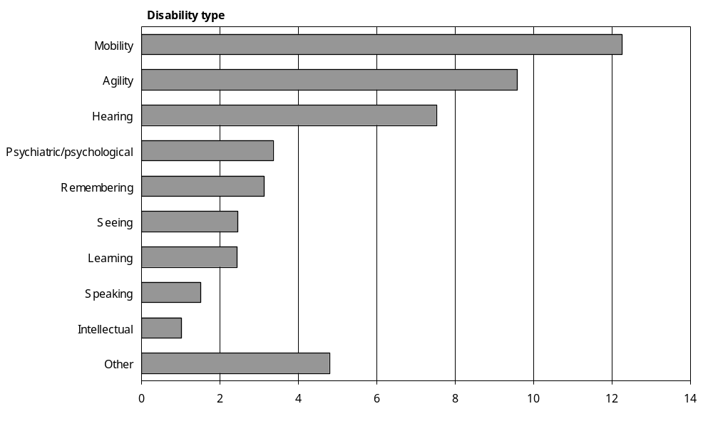
Source: Statistics New Zealand, 2001 Household Disability Survey
Notes:
- Calculated from data in Appendix Table 2.12.
- If individuals reported more than one disability type, they were counted in each applicable disability group.

Mobility
Mobility disability was the most common type of disability identified in adults. An estimated 346,300 adults living in households, 12 percent of the adult household population (that is, people with disability plus people without disability), had mobility disabilities. The specific kinds of mobility disability they experienced included having difficulty with or being unable to:
- walk about 350 metres without resting
- walk up or down a flight of stairs
- carry an object as heavy as 5 kilograms for 10 metres
- move from room to room
- stand for longer than 20 minutes.
Mobility disability was especially common in older New Zealanders, with an estimated 29 percent of people aged 65–74 and 51 percent of people aged 75 and over living in households having a mobility disability (Figure 2.8).

Figure 2.8: Rates of mobility disability among adults living in households, by age and sex, 2001
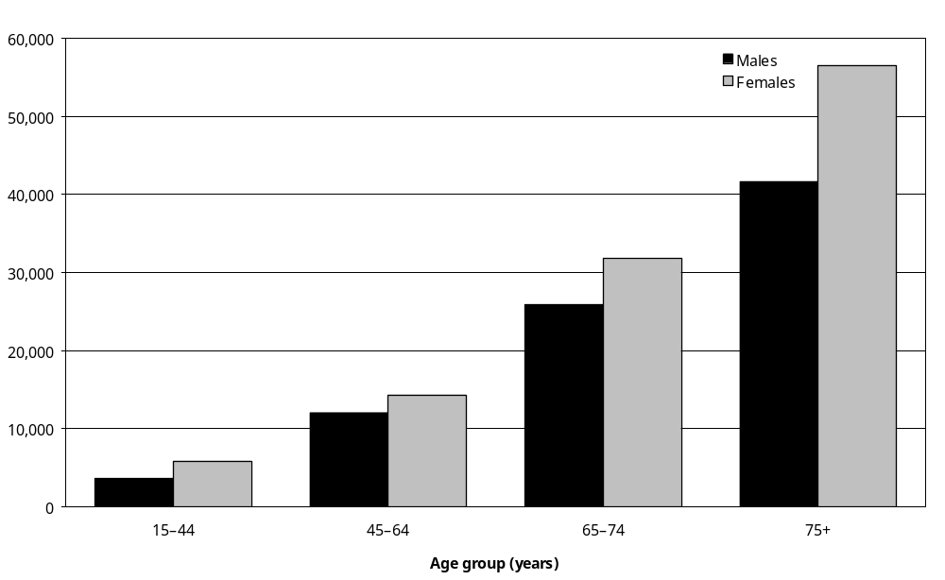
Source: Statistics New Zealand, 2001 Household Disability Survey
Note: Data in Appendix Table 2.13.

Across all the adult age groups, women were more likely than men to have mobility disability. Fourteen percent of women living in households had mobility disability, compared with 10 percent of men.

The most common kind of mobility disability was difficulty walking or not being able to walk 350 metres without resting. Nearly two out of three adults with a mobility disability had this kind of limitation (Table 2.3).

Table 2.3: Categories of mobility limitation in adults living in households, 2001
Category of mobility limitation | Percentage of adults with a mobility disability who had this kind of limitation (%) | Estimated number of adults in New Zealand households with this kind of mobility limitation
Can walk 350 m but with difficulty | 46 | 159,100
Cannot walk 350 m | 19 | 65,300
Total | 65 | 224,400
Can walk up and down a flight of stairs but with difficulty | 48 | 167,400
Cannot walk up and down a flight of stairs | 8 | 26,000
Total | 56 | 193,400
Can carry 5 kg for 10 m but with difficulty | 35 | 122,000
Cannot carry 5 kg for 10 m | 19 | 65,100
Total | 54 | 187,100
Can stand for 20 minutes but with difficulty | 40 | 139,500
Cannot stand for 20 minutes | 10 | 34,800
Total | 50 | 174,200
Can move from one room to another but with difficulty | 10 | 35,300
Cannot move from one room to another | 1 | 2,900
Total | 11 | 38,100
Source: Statistics New Zealand, 2001 Household Disability Survey
Notes:
- If individuals reported more than one category of mobility limitation they were counted in each applicable mobility limitation category.
- The sum of the values for each category may differ from the total due to rounding.

Difficulty walking or being unable to walk up and down a flight of stairs was the second most common kind of mobility limitation, experienced by over half (56 percent) the adults with any kind of mobility disability.

Almost as common was difficulty carrying or not being able to carry a 5 kilogram weight for 10 metres. This kind of mobility limitation was reported by 54 percent of adults with a mobility disability. Difficulty standing or not being able to stand for 20 minutes was reported by 50 percent of adults with a mobility disability.

The least common kind of mobility limitation was difficulty moving or not being able to move from one room to another. This significant limitation was reported by 11 percent of adults with mobility disability living in households, an estimated 38,100 adults.

Agility
Agility disability was the second most common disability type in adults. An estimated 270,900 adults, 10 percent of the total adult household population, had an agility disability.

People with agility disability had difficulty with or could not do one or more of the following: bending; dressing; grasping; cutting their toenails; reaching; cutting their food; or getting themselves in or out of bed.

Like mobility disability, agility disability was most common in the older age groups. An estimated 22 percent of people aged 65–74 and 40 percent of people aged 75 and over living in households had an agility disability (Figure 2.9).

Figure 2.9: Rates of agility disability among adults living in households, by age and sex, 2001
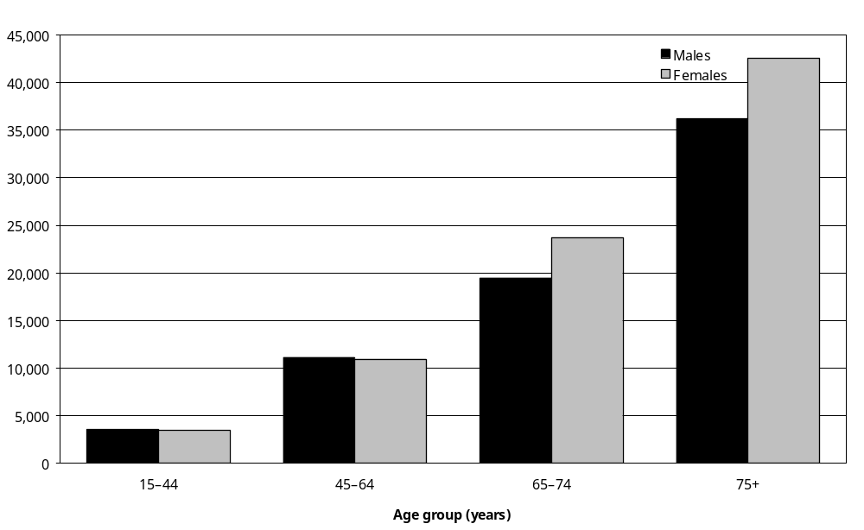
Source: Statistics New Zealand, 2001 Household Disability Survey
Note: Data in Appendix Table 2.13.

The two most common kinds of agility limitation were:
- difficulty bending down or not being able to bend down to pick up something off the floor
- difficulty cutting or not being able to cut one’s toenails.

Both these kinds of agility limitation were experienced by 57 percent of adults with agility disability, corresponding to an estimated 154,100 people in the case of bending down and 155,700 people in the case of cutting toenails.

An estimated 96,000 adults, 35 percent of all people with agility disability, had difficulty reaching out in certain directions with one or both arms, or were unable to reach out at all with one or both arms.

An estimated 74,600 adults, 28 percent of all people with agility disability, had difficulty using or were unable to use their fingers to grasp things like scissors or pliers. This included an estimated 7100 people who were completely unable to hold these kinds of object.

A smaller proportion of adults with agility disability (16 percent), an estimated 42,400 people, had difficulty getting, or were unable to get, into and out of bed, because of a long-term condition or health problem.

Twelve percent of adults with agility disability, an estimated 31,600 people, had difficulty cutting or could not cut their food.

Hearing
In the 2001 Household Disability Survey, adults were defined as having a hearing disability if they reported experiencing any long-term (six months or more) difficulty hearing what was being said in a conversation with another person or three other people. If the difficulty or inability to hear was completely corrected by, for example, a hearing aid, the person was not defined as having a hearing disability.

Hearing disability was the third most common disability type in adults. An estimated 212,500 adults, 8 percent of all adults living in households, had some kind of hearing disability.

Within this group, an estimated 202,400 people, or 95 percent of all people with hearing disability, had difficulty hearing or were unable to hear what was said in a conversation with three other people (Table 2.4).

Table 2.4: Categories of hearing limitation in adults living in households, 2001
Categories of hearing disability | Percentage of adults with a hearing disability who had this kind of limitation (%) | Estimated number of adults in New Zealand households with this kind of hearing limitation
Can hear conversation with three other people but with difficulty | 91 | 194,000
Cannot hear conversation with three other people | 4 | 8,400
Total | 95 | 202,400
Can hear conversation with one other person but with difficulty | 50 | 106,100
Cannot hear conversation with one other person | 1 | 2,100
Total | 51 | 108,300
Source: Statistics New Zealand, 2001 Household Disability Survey
Notes:
- If individuals reported more than one category of hearing disability, they were counted in each applicable hearing disability category.
- The sum of the values for each category may differ from the total due to rounding.

An estimated 108,300 people, or 51 percent of all adults with hearing disability, had difficulty hearing or were unable to hear what was said in a conversation with one other person.

Hearing disability was most common in the older age groups. A third of all men (35 percent) and a quarter of all women (24 percent) aged 75 and over living in households had hearing disability, compared with just 3 percent of men and women in the 15–44 age group (Figure 2.10).

Figure 2.10: Rates of hearing disability among adults living in households, by age and sex, 2001
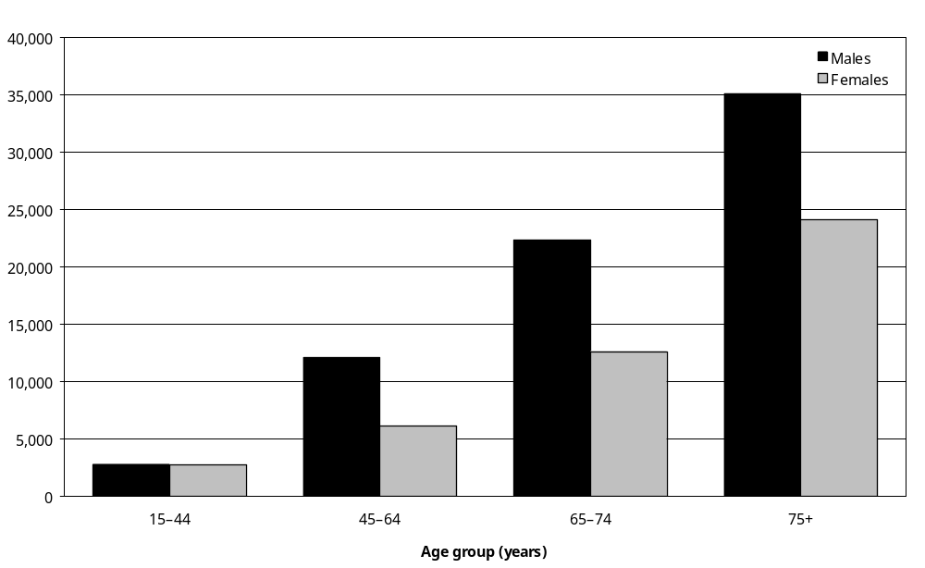
Source: Statistics New Zealand, 2001 Household Disability Survey
Note: Data in Appendix Table 2.13.

Seeing
In the 2001 Household Disability Survey, adults were defined as having a seeing or vision disability if they had difficulty seeing or were unable to see ordinary newspaper print or the face of someone across a room, even when using glasses or contact lenses (if these were usually worn).

Based on this definition, an estimated 69,300 adults (2 percent of all adults living in households) had a seeing disability. Men comprised 40 percent of adults with seeing disability (27,800 individuals) and women 60 percent (41,500 individuals).

Age-specific rates of seeing disability were higher in the older adult age groups and highest in the 75 and over age group, with more than 1 in every 10 people aged 75 and over (12,400 per 100,000 population) having at least one kind of seeing limitation.

It was more common for adults with seeing disability to have difficulty seeing newspaper print than to have difficulty seeing someone’s face across the room, that is from 4 metres (12 feet) away (Table 2.5).

Table 2.5: Categories of seeing limitation reported by adults living in households, 2001
Category of seeing limitation | Percentage of adults with a seeing disability who had this kind of limitation (%) | Estimated number of adults in New Zealand households with this kind of seeing limitation
Can see newspaper print, but with difficulty | 75 | 52,200
Cannot see newspaper print | 13 | 8,700
Total | 88 | 60,900
Can see someone’s face across the room, but with difficulty | 35 | 24,200
Cannot see someone’s face across the room | 10 | 6,700
Total | 45 | 30,900
Source: Statistics New Zealand, 2001 Household Disability Survey
Notes:
- If individuals reported more than one category of seeing disability, they were counted in each applicable seeing disability category.
- The sum of the values for each category may differ from the total due to rounding.

Seventy-five percent of adults with seeing disability (an estimated 52,200 adults) had difficulty seeing newspaper print, but just 35 percent (24,200 individuals) had difficulty seeing someone’s face across the room. Another 8700 adults were estimated to be unable to see newspaper print; while 6700 adults (1 in every 10 people with seeing disability) were unable to see someone’s face across the room.

Speaking
Adults participating in the 2001 Household Disability Survey were defined as having a speaking disability if they had a long-term condition, health problem or injury (such as a brain injury) that caused them to have difficulty speaking and being understood.

Based on this definition, an estimated 42,500 adults, 2 percent of all adults living in households, had a speaking disability.

Rates of speaking disability were similar for men (2 percent) and women (1 percent). Age-specific rates were also similar, ranging from 1 to 3 percent in all adult age groups.

Psychiatric/psychological
Adults were defined as having a psychiatric/psychological disability if they had difficulty with or were prevented from communicating, socialising or doing everyday activities that people their age could usually do because of a long-term emotional, psychological or psychiatric condition.

Based on this definition, 94,800 adults with psychiatric/psychological disabilities were estimated to be living in households in 2001. This was 3 percent of the total New Zealand adult household population. A similar percentage of men (3 percent) and women (4 percent) were estimated to have psychiatric/psychological disability.

Over half of the adults with psychiatric/psychological disability (58 percent), a total of 55,000 people, were in the 15–44 age group.

Seventy-seven percent of the estimated 94,800 adults with psychiatric/psychological disability indicated that the disability caused them difficulty with or stopped them from doing everyday activities. A similar proportion, 75 percent, indicated that the disability caused them difficulty with or stopped them from communicating, mixing with others or socialising.

Remembering
Participants in the 2001 Household Disability Survey were defined as having a disability of recall or memory if they had a long-lasting condition or health problem that caused them to have ongoing difficulty remembering things.

An estimated 88,400 adults (43,300 men and 45,100 women) had a disability of recall or memory. This was 3 percent of the total adult household population.

The prevalence of recall or memory disability increased with age, from an age-specific rate of 2200 per 100,000 in the 15–44 age group to 8700 per 100,000 in the 75 and over age group.

Learning
A person was considered to have a learning disability if they had a long-lasting condition or health problem that affected their mental capacity and made it hard for them to learn. This category of disability was considered to be distinct from intellectual disability (see definition below) and remembering disability (see definition above).

An estimated 68,900 adults (37,200 men and 31,700 women) had learning disability. This was 2 percent of all adult New Zealanders living in households.

Age-specific rates of learning disability were similar across the different adult age groups, ranging from 2000 per 100,000 for the 45–64 age group to 3100 per 100,000 in the 75 and over age group.

Intellectual
Adults participating in the 2001 Household Disability Survey were defined as having an intellectual disability if they:
- needed help or support from organisations like IHC or People First or other people because of an intellectual disability or handicap; or
- had ever gone to a special school or received special education because of an intellectual disability or handicap.

The survey estimated that 28,900 adults (14,200 men and 14,700 women) had intellectual disability. This was 1 percent of all adult New Zealanders living in households.

Seventy-one percent of these 28,900, an estimated 20,400 adults, needed help or support from other people or organisations because of intellectual disability or handicap. Fifty-two percent, an estimated 15,100 adults, had been to a special school or received special education for intellectual disability at some time in their life.

Adults with intellectual disability were predominantly in the younger age groups. Two-thirds (66 percent), an estimated 19,500 people, were in the 15–44 age group.

Main disability – adults
As well as identifying all the different types of disability that people had, the 2001 Household Disability Survey asked adults to identify their main disability (this question was not included in the questionnaires used for children). A main disability was defined as the disability that most limited a person’s everyday activities.

By far the most common main disability was mobility disability. Almost 8 percent of all adults living in households, an estimated 213,400 people, indicated that they had disability and that the main type of disability they had was a mobility disability (Figure 2.11).

Figure 2.11: Types of main disability experienced by adults living in households, 2001
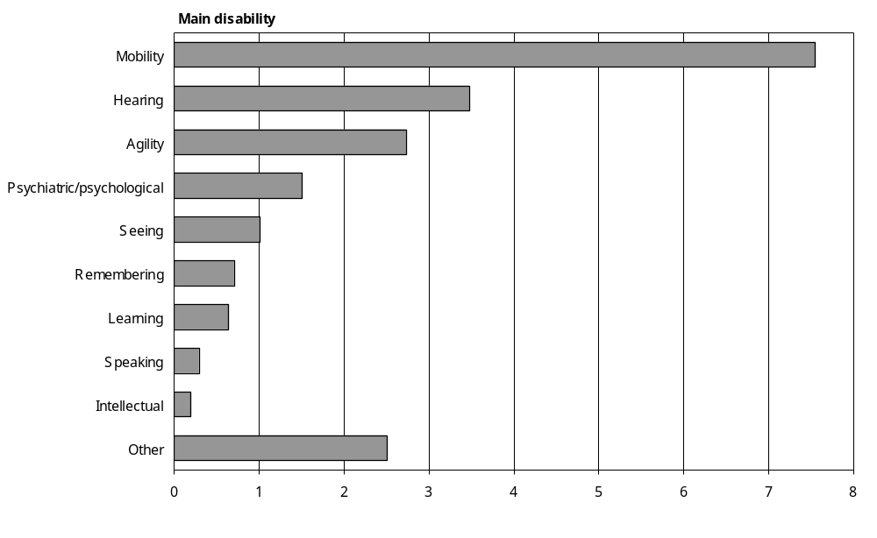
Source: Statistics New Zealand, 2001 Household Disability Survey
Notes:
- Calculated from data in Appendix Table 2.15.
- The ‘Other’ category includes other types of long-term condition or health problem that cause people ongoing difficulty with, or stops them from, doing everyday activities that people their age can usually do.

Older people were more likely to have a mobility disability as their main disability than younger people. For example, 35 percent of women and 24 percent of men aged 75 and over had a mobility disability as their main disability, compared with 3 percent of women and 2 percent of men aged 15–44.

Hearing disability was the second most common main disability, reported by an estimated 98,200 adults or almost 4 percent of all adults living in households. Older people were more likely to have a hearing disability as their main disability. In the 75 and over age group, 14 percent of men had a hearing disability as their main disability, as did 6 percent of women. This compared with 2 percent of men and 1 percent of women aged 15–44.

While agility disability was comparatively common in adults (see ‘Disability type – adults’ above), it was much less likely to be reported as people’s main disability. Only 3 percent of adults living in households, an estimated 77,200 people, had a main disability that was an agility disability, even though 10 percent of adults (an estimated 270,900 people) had an agility limitation of some kind. Agility disability as a main disability was more likely among older people. This was experienced by 8 percent of men and 7 percent of women aged 75 and over, compared with 1 percent of both men and women aged 15–44.

An estimated 42,700 adults, some 2 percent of all adult New Zealanders living in households, had a main disability that was a psychiatric/psychological disability.

Seeing disability was the main disability of 1 percent of adults living in households, an estimated 28,600 people.

Less than 1 percent of adults living in households, an estimated 20,000 people, had a main disability related to recall or memory (a remembering disability). A further 18,000 adults had a main disability that was a learning disability.

An estimated 8300 adults had a main disability that was a speaking disability; while an estimated 5500 had a main disability that was an intellectual disability.

Disability type – children
The types of disability experienced by children (aged 0–14) living in households were categorised into nine groups:
- use of special education (indicating the child was receiving some form of special education and/or had some form of learning disability)
- chronic condition/health problem
- psychiatric/psychological
- hearing
- speaking
- seeing
- intellectual
- use of technical aids (indicating the child used equipment or technology such as a wheelchair, an artificial limb or a hearing aid)
- other.

The disability types used for classifying children in the 2001 Household Disability Survey were different from those used for adults (see earlier in this chapter for the adult classification). Readers should be familiar with these differences before comparing survey results for adults and children. For example, the category ‘use of technical aids’ was not a category used for classifying disability in adults, but it was for children.

Figure 2.12 shows the percentage of all New Zealand children living in households estimated to have these different types of disability in 2001. When examining these data, remember that 45 percent of children with disability had more than one type of disability (see ‘Multiple disabilities’ above). Children with more than one type of disability will, therefore, appear more than once in the disability categories described below.

Figure 2.12: Percentage of children living in households experiencing different types of disability, 2001
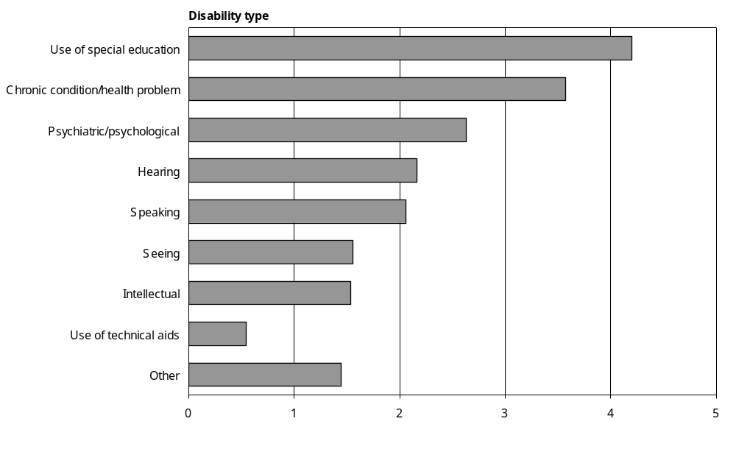
Source: Statistics New Zealand, 2001 Household Disability Survey
Notes:
- Calculated from data in Appendix Table 2.17.
- If individuals reported more than one disability type, they were counted in each applicable disability group.
- The ‘Other’ category includes other types of long-term conditions or health problems that limit a child’s participation at school, play, or any other activities considered usual for a child of their age.

Use of special education
‘Use of special education’ was the most common category of disability identified in children. It was defined as attending a special school, a special unit or class at a regular school or a regular class where special education services were provided, because of a long-term condition or health problem (received special education services). The category also included children who had an Individualised Education Programme (IEP) or Individual Development Programme (IDP) because of learning or developmental difficulties, as well as children who had learning difficulties such as dyslexia, attention deficit disorder or attention deficit hyperactivity disorder.

The 2001 Household Disability Survey estimated that 35,500 children used special education. This was 4 percent of all children living in households.

The group included an estimated:
- 25,000 children with learning disabilities such as dyslexia or attention deficit disorder
- 17,800 children with an individualised plan or programme at school because of learning or developmental difficulties
- 12,500 children who attended a special school or a special unit or class at a regular school (received special education services).

Boys were more than twice as likely as girls to use special education (6000 per 100,000 population compared with 2400 per 100,000).

Six percent of school-aged children (aged 5–14), an estimated 33,400 children, used special education.

For more details on the use of special education see chapter 4.

Chronic condition/health problem
Children with the following long-term conditions or health problems were defined as having the disability type ‘chronic condition/health problem’:
- severe asthma, lung condition or disease (excluding mild asthma or bronchitis)
- heart condition or disease (not including heart murmur)
- kidney condition or disease
- cancer
- diabetes
- epilepsy
- cerebral palsy
- muscular dystrophy
- spina bifida
- long-term gastro-intestinal condition
- growth failure or failure to thrive.

An estimated 30,200 children, 4 percent of children living in households, had chronic conditions/ health problems. A slightly higher proportion of boys (4000 per 100,000) than girls (3200 per 100,000) had this kind of disability.

Figure 2.13 indicates the most common types of chronic condition/health problem experienced by the children in this disability category.

Figure 2.13: Number of children with disability living in households experiencing most common types of chronic condition/health problem, 2001
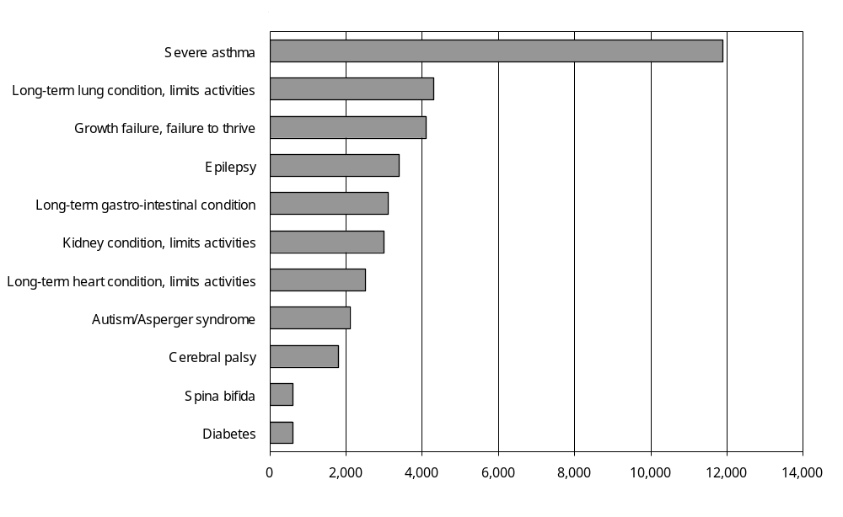
Source: Statistics New Zealand, 2001 Household Disability Survey
Notes:
- Data in Appendix Table 2.19.
- If individuals reported more than one type of condition/health problem, they were counted in each applicable group.

Severe asthma was by far the most common chronic condition/health problem, with an estimated 11,900 children experiencing this degree of asthma.

Psychiatric/psychological
Psychiatric/psychological disability was defined as any long-term emotional, behavioural, psychological, nervous or mental health condition that limited the kind or amount of activity that a child could do at home, school or play.

An estimated 22,200 children, 3 percent of all children living in households, had a psychiatric/ psychological disability. Boys (3300 per 100,000) had higher rates of psychiatric/psychological disability than girls (1900 per 100,000).

Hearing
Children with a hearing problem that was not fully corrected were defined by the survey as having a hearing disability. Children wearing hearing aids were assumed to have an uncorrected hearing problem (that is, they were automatically defined as having a hearing disability). Children with grommets whose hearing problem was not fully corrected were also classified as having a hearing disability. However, children with grommets whose hearing problem was corrected were not classified as having a hearing disability.

Using these definitions, an estimated 18,300 children, 2 percent of all children living in households, had a hearing disability.

The highest rate of hearing disability in children was in the 5–9 years age group (Figure 2.14).

Figure 2.14: Rates of hearing disability among children living in households, by age, 2001
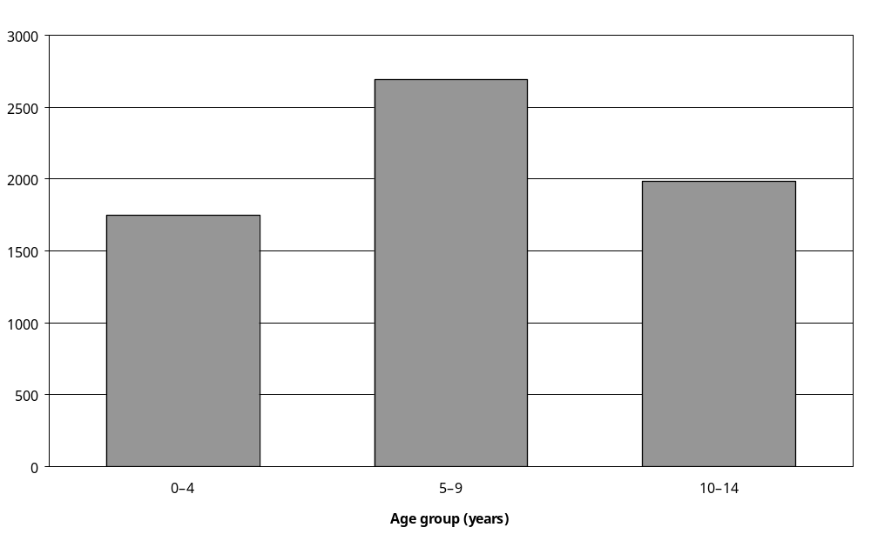
Source: Statistics New Zealand, 2001 Household Disability Survey
Note: Data in Appendix Table 2.18.

Speaking
This group included children who had difficulty speaking and being understood because of a long-term condition or health problem.

An estimated 17,400 children, 2 percent of all children living in households, had a speaking disability. A slightly higher proportion of boys than girls had a speaking disability. Children in the 5–9 age group had higher age-specific rates of speaking disability than children in the 0–4 and 10–14 age groups.

Seeing
Children were defined as having a vision or seeing disability if they were blind or had a seeing difficulty that was not corrected by glasses or contact lenses.

An estimated 13,200 children, 2 percent of all children in households, had seeing disability. Similar proportions of boys and girls had seeing disability. The highest age-specific rates of seeing disability were among children aged 10–14 (2100 per 100,000).

Intellectual
An intellectual disability in children was defined as any kind of intellectual disability, intellectual handicap or intellectual developmental delay.

An estimated 13,000 children, some 2 percent of all children living in households, had an intellectual disability. Boys (2100 per 100,000) had a higher rate of intellectual disability than girls (1000 per 100,000).

Use of technical aids
The category ‘use of technical aids’ included children who, because of a long-term condition or health problem, used equipment or technology such as a brace, a wheelchair, a special buggy or trolley, a standing frame, crutches, walking sticks, a walking frame or an artificial limb.

An estimated 4600 children, 0.5 percent of all children in households, used technical aids because of a long-term condition or health problem. Use of technical aids was almost as prevalent in boys as girls (500 per 100,000 and 600 per 100,000 respectively).

Cause of disability
Information about the causes of disability can be useful for planning strategies to prevent or reduce the incidence of disability in the population.

The 2001 Household Disability Survey categorised the causes of disability into five groups:
- disease/illness
- accident/injury
- conditions existing or occurring at birth
- natural ageing (this option was not initially read out by interviewers and was used only where respondents did not select one of the previous three categories)
- other (for example, childbirth, alcohol, illegal drugs, medical side-effects, working conditions and exposure to environmental factors such as noise and weather).

Only one cause was recorded for each disability type that an individual had.

In 2001, the most common cause of disability among people (adults and children) living in households was disease/illness. An estimated 281,000 people, 8 percent of all people living in households, had one or more disabilities caused by disease/illness (Figure 2.15).

Figure 2.15: Number of people (adults and children) living in households experiencing different causes of disability, 2001
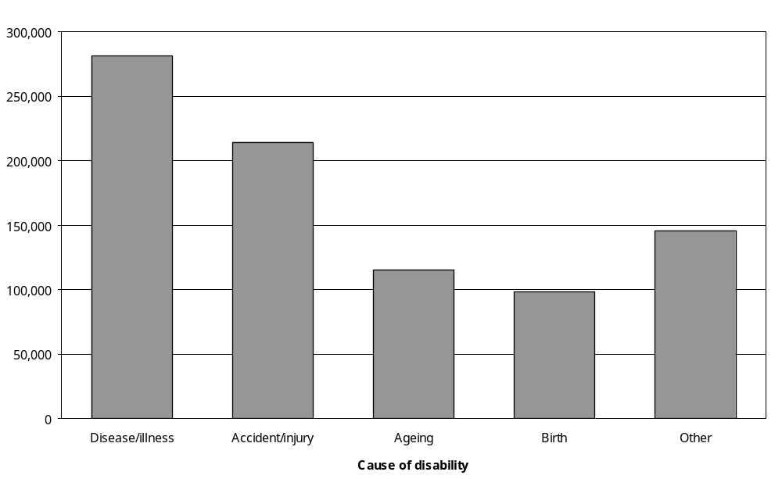
Source: Statistics New Zealand, 2001 Household Disability Survey
Notes:
- Data in Appendix Table 2.20.
- If individuals reported more than one disability type, they were counted in each applicable cause group.

Accident/injury was the second most common cause of disability, estimated to have caused the disabilities of 214,200 people or 6 percent of all people in households.
This was followed by ageing, which was estimated to have caused the disabilities of 115,100 people; 3 percent of all New Zealanders in households.
The least common cause of disability was conditions existing or occurring at birth. An estimated 98,000 people or about 3 percent of all New Zealanders in households had disabilities attributed to this cause.

Cause of disability in adults and children
The disability cause profile of adults was different from the disability cause profile of children.
In adults, the most common cause of disability was disease/illness, reported by 40 percent of adults with disability or an estimated 251,300 people. The second most common cause was accident/injury, reported by 34 percent of adults with disability or an estimated 212,000 people. Conditions present at birth were relatively uncommon (10 percent of adults or an estimated 60,700 people) (Figure 2.16).

Figure 2.16: Percentage of people (adults and children) experiencing different causes of disability, 2001
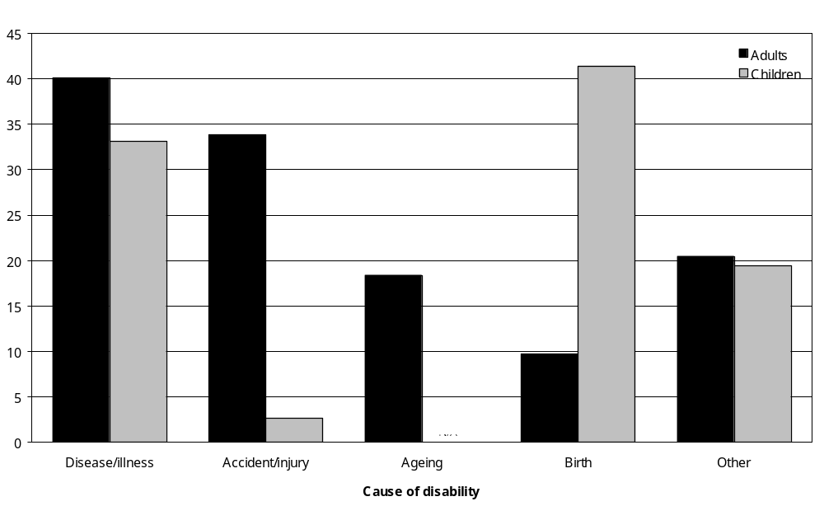
Source: Statistics New Zealand, 2001 Household Disability Survey
N/A: Not applicable as ageing was not a disability cause category used for children.
Notes:
- Data in Appendix Table 2.20.
- If individuals reported more than one disability type, they were counted in each applicable cause group.
In children, conditions present at birth were the most common cause of disability, affecting 41 percent of children with disability or an estimated 37,300 children.

The second most common cause was disease/illness, affecting 33 percent of children with disability, an estimated 29,800 children.

In contrast to adults, disability caused by accident/injury was uncommon in children. Just 3 percent of children in households, an estimated 2400 children, had disabilities caused this way.

Age-specific rates for adults
In adults, the rate of disability caused by disease/illness increased steadily with age, from 3900 per 100,000 in the 15–44 age group to 33,400 per 100,000 in the 75 and over age group (Figure 2.17).

Figure 2.17: Rates for the causes of disability in adults living in households, by age, 2001
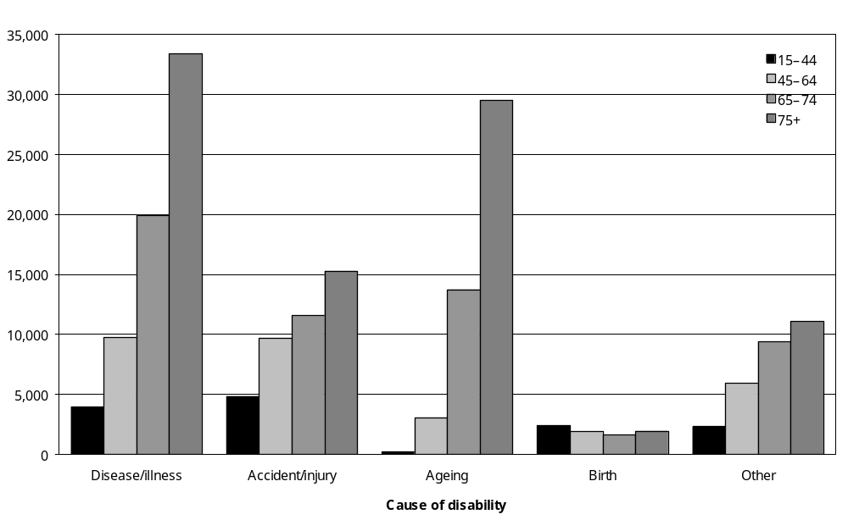
Source: Statistics New Zealand, 2001 Household Disability Survey
Notes:
- Data in Appendix Table 2.21.
- If individuals reported more than one disability type, they were counted in each applicable cause group.

The same was the case for disabilities caused by ageing, which rose from a rate of 3100 per 100,000 in the 45–64 age group to 29,500 per 100,000 in the 75 and over age group.

Rates for disabilities caused by accident/injury also increased with age, although not as dramatically as for disease/illness or ageing. In the 15–44 age group, 4800 per 100,000 had disability caused by accident/injury; while the rate in the 75 and over age group was about three times as high (15,300 per 100,000).

In contrast, rates of disability caused by conditions existing or occurring at birth did not vary much across the age groups, ranging from 1600 per 100,000 in adults aged 65–74 to 2400 per 100,000 in adults aged 15–44.

Age-specific rates for children
For all causes of disability, older children (aged 5–14) had slightly higher disability rates than younger children (aged 0–4). In older children, for example, the prevalence rate of disability caused by disease/illness was 3900 per 100,000; whereas for younger children the rate was 2600 per 100,000 (Figure 2.18).

Figure 2.18: Rates for the causes of disability in children living in households, by age, 2001
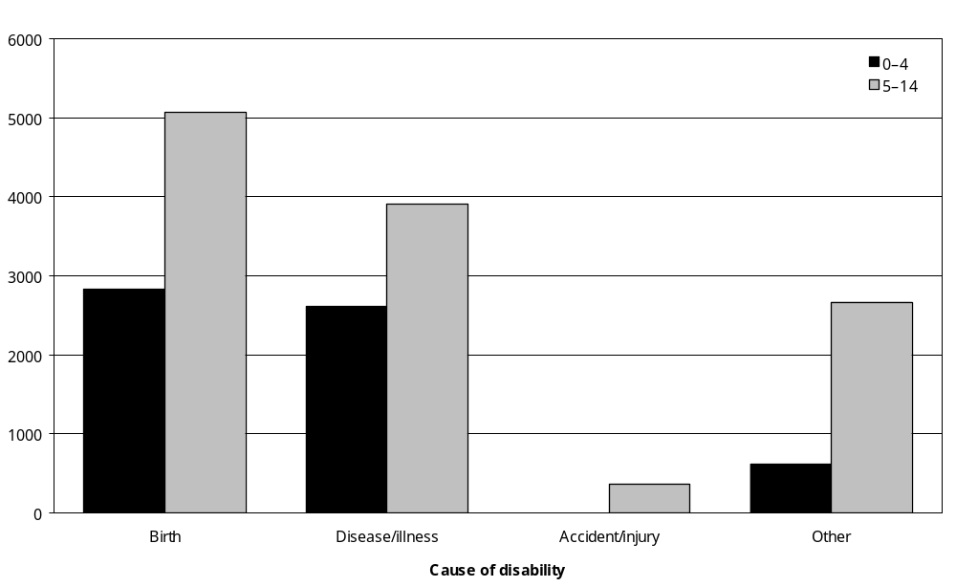
Source: Statistics New Zealand, 2001 Household Disability Survey
– Percentages too small to report (estimated frequencies outside the 70 percent relative sampling error cut-off point).
Notes:
- Data in Appendix Table 2.21.
- If individuals reported more than one disability type, they were counted in each applicable cause group.

Similarly, older children had a higher prevalence of disability resulting from birth conditions than younger children (5000 per 100,000 compared with 2800 per 100,000).

Cause of disability by sex
Disability cause data can also be compared using age-standardised rates. This indicates that females (7400 per 100,000) were more likely than males (5900 per 100,000) to have disabilities caused by disease/illness. They were also more likely than males to have disabilities caused by ageing (2500 per 100,000 compared with 2100 per 100,000) (Figure 2.19).

Figure 2.19: Age-standardised rates for the causes of disability in people (adults and children) living in households, by sex, 2001
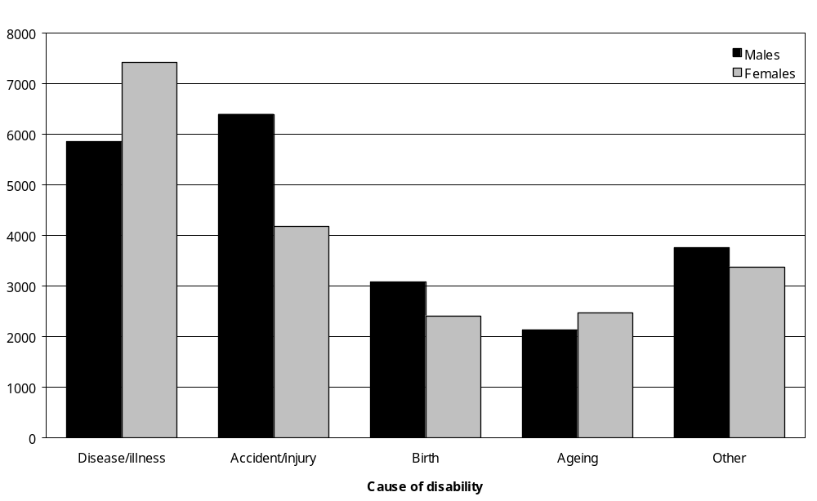
Source: Statistics New Zealand, 2001 Household Disability Survey
Notes:
- Calculated from data in Appendix Tables 2.20 and 2.21.
- If individuals person reported more than one disability type, they were counted in each applicable cause group.
- Age-standardised to WHO World Standard Population.

On the other hand, males were more likely than females to have disabilities caused by accident/ injury. Indeed, the male age-standardised rate for disabilities caused by accident/injury was almost 50 percent higher than the female rate (6400 per 100,000 compared with 4200 per 100,000).

Males were also more likely than females to have disabilities caused by conditions existing at birth (3100 per 100,000 compared with 2400 per 100,000).

Causes of different types of disability
Table 2.6 shows which disability causes were the most common for each type of disability experienced by adults and children. In adults, for example, disease/illness was the cause of 40 percent of mobility disabilities and 13 percent of hearing disabilities. In children, disease/illness was the cause of 30 percent of hearing disabilities and 13 percent of intellectual disabilities.

Table 2.6: Causes of the different types of disability in adults and children, 2001
Adults | Disability cause (%)
Adults | Disease/ illness | Birth | Accident/ injury | Ageing | Other | Not specified | Total
Disability type
Hearing | 13 | 7 | 25 | 19 | 21 | 15 | 100
Seeing | 23 | 8 | 10 | 27 | 11 | 22 | 100
Speaking | 30 | 19 | 16 | 5 | 12 | 18 | 100
Mobility | 40 | 4 | 29 | 14 | 10 | 10 | 100
Agility | 33 | 4 | 36 | 15 | 10 | 11 | 100
Intellectual | 27 | 32 | 14 | 2 | 4 | 21 | 100
Psychiatric/psychological | 34 | 9 | 13 | 1 | 26 | 19 | 100
Learning | 30 | 28 | 13 | 5 | 8 | 15 | 100
Remembering | 31 | 8 | 14 | 19 | 12 | 16 | 100
Other | 48 | 7 | 23 | 4 | 10 | 10 | 100

Children | Disability cause (%)
Children | Disease/ illness | Birth | Accident/ injury | Other | Not specified | Total
Disability type
Hearing | 30 | 32 | – | 14 | 25 | 100
Seeing | 9 | 49 | – | 12 | 27 | 100
Technical equipment | 17 | 56 | – | – | 17 | 100
Intellectual | 13 | 56 | – | 13 | 15 | 100
Psychiatric/psychological | 15 | 32 | 3 | 29 | 21 | 100
Chronic health problem | 50 | 37 | – | 7 | 11 | 100
Other | 16 | 44 | 3 | 18 | 22 | 100
Source: Statistics New Zealand, 2001 Household Disability Survey
– Percentages too small to report (estimated frequencies outside the 70 percent relative sampling error cut-off point).
Notes:
- The sum of the values for each category may differ from the total due to rounding.
- The adult ‘Other’ disability type includes other types of long-term conditions or health problems that cause people ongoing difficulty with, or stops them from doing, everyday activities that people their age can usually do.
- The child ‘Other’ disability type includes use of special education, speaking disability and other types of long-term conditions or health problems that limit a child’s participation at school, play, or other activities considered usual for a child of their age. Disability cause data are available separately for special education and learning disability in chapter 4.

Disability caused by accident/injury
This section examines disability caused by accident/injury.

Adults
In the 2001 Household Disability Survey, adults with disability caused by accident/injury were asked to identify where or in what situation the accident/injury occurred (accident/injury location). The options given were:
- accident/injury at home
- motor vehicle accident
- accident/injury at work
- sports accident/injury
- another type of accident/injury.

When people indicated the accident/injury occurred at home or that it was ‘another’ type of accident/injury they were also asked if the accident/injury was caused by psychological or physical abuse.

The results of these questions indicate that, of the estimated 214,200 adults with disability caused by accident/injury living in households, an estimated 87,700 (41 percent) were disabled as a result of work-related accidents/injuries (Figure 2.20).

Figure 2.20: Number of adults living in households experiencing accident/injury disability, by accident/injury location and sex, 2001
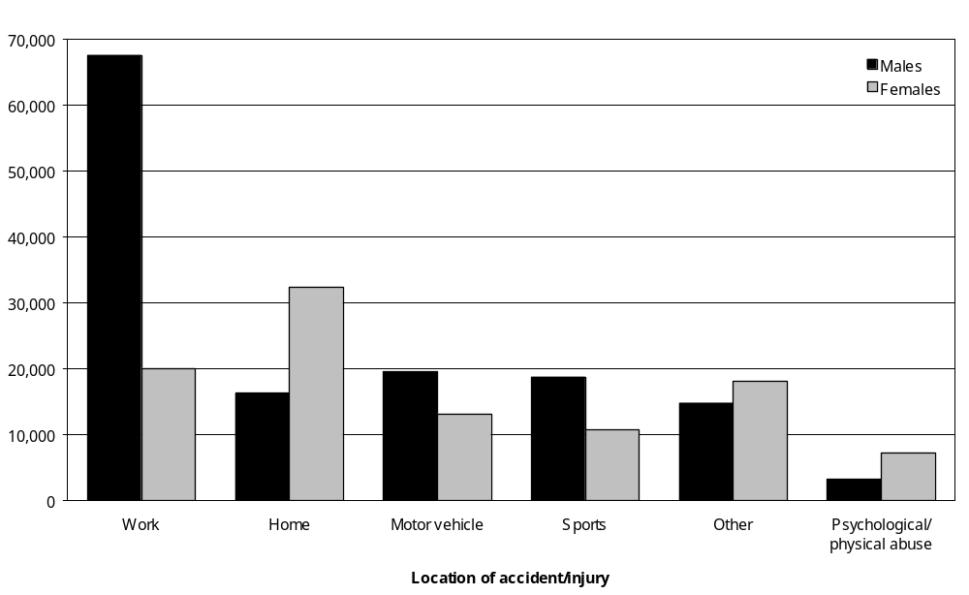
Source: Statistics New Zealand, 2001 Household Disability Survey
Notes:
- Data in Appendix Table 2.23.
- If individuals reported more than one disability type, they were counted in each applicable cause group.
A further 48,700 (23 percent) were disabled by accident/injury occurring at home, 32,800 (15 percent) were disabled by motor vehicle accident/injury and 29,500 (14 percent) were disabled by sports injury. An estimated 10,600 adults were disabled because of psychological or physical abuse.

More than three times as many men (67,600) as women (20,100) were estimated to have disabilities resulting from work-related accident/injury. More men were also disabled from motor vehicle accidents and sports injuries. However, twice as many women (32,400) as men (16,300) had disabilities from accident/injury occurring at home. The same was the case for disabilities resulting from psychological or physical abuse (7300 women compared with 3300 men).

The prevalence of disability caused by accident/injury occurring at home increased with age, from 1000 per 100,000 in the 15–44 age group to 5900 per 100,000 in the 75 and over age group (Figure 2.21).

Figure 2.21: Rates of disability caused by accident/injury, in adults living in households, by accident/injury location and age, 2001
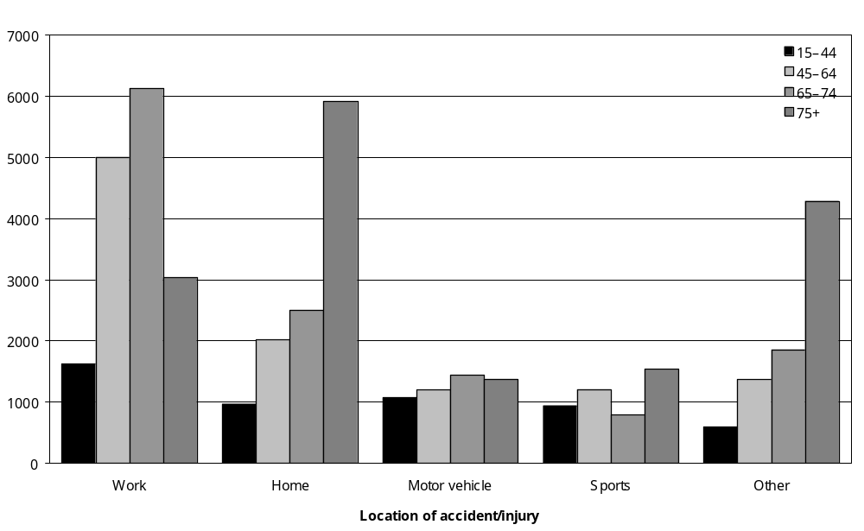
Source: Statistics New Zealand, 2001 Household Disability Survey
Notes:
- Data in Appendix Table 2.24.
- If individuals reported more than one disability type, they were counted in each applicable cause group.

The prevalence of disability caused by work-related accidents and injuries also rose with age, from 1600 per 100,000 in the 15–44 age group to 6100 per 100,000 in the 65–74 age group. However, in the 75 and over age group, the rate of disability caused by work-related accident/ injury (3000 per 100,000) was half the rate in the 65–74 age group.

Rates of disability from sports and motor vehicle injuries varied little with age, ranging from 800 per 100,000 in the 65–74 age group to 1500 per 100,000 in the 75 and over age group.

Children
Parents and caregivers of children living in households were asked if their child’s disability was caused by:
- an accident/injury at home or school
- a motor vehicle accident
- a sports accident/injury.
They were not asked about other types of accident/injury situations or locations.
Of the 2400 children with disabilities caused by accident/injury, an estimated 1500 were disabled from accidents or injuries received at home or school, while a further 700 had sports injury related disabilities.

Cause of main disability in adults
The 2001 Household Disability Survey asked adults to indicate the cause of their main disability. The person’s main disability was the disability they considered most limited their activities.
The most common cause of the main disabilities experienced by adults living in households was disease/illness, with 30 percent of all main disabilities caused in this way. An estimated 189,600 adults, 7 percent of all adults living in households, had a main disability caused by disease/illness (Figure 2.22).

Figure 2.22: Number of adults living in households experiencing different causes of main disability, by sex, 2001
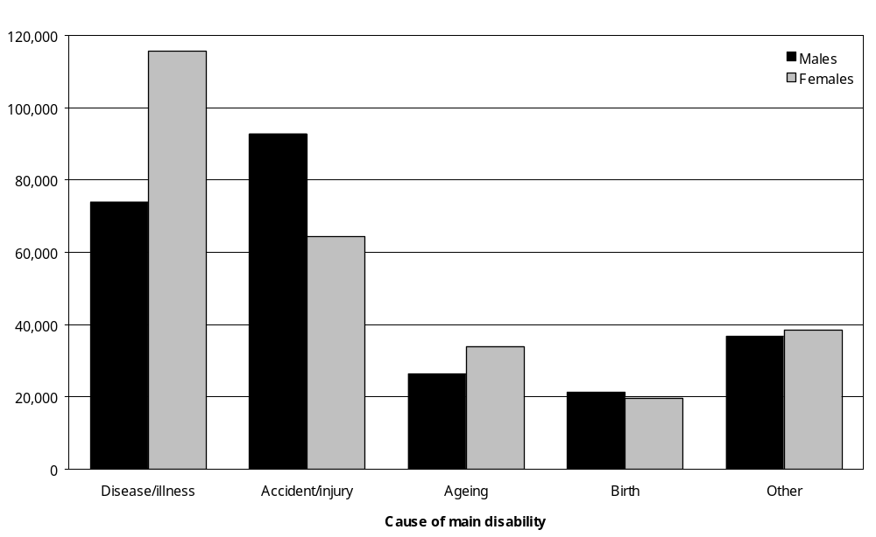
Source: Statistics New Zealand, 2001 Household Disability Survey
Note: Data in Appendix Table 2.26.
Accident/injury was the second most common cause, producing 25 percent of main disabilities. An estimated 157,100 adults had a main disability caused by accident/injury.

Ten percent of all main disabilities were caused by ageing, with an estimated 60,400 adults having their main disability caused in this way.

Conditions existing or occurring at birth caused 7 percent of main disabilities, affecting an estimated 41,000 adults.

Twelve percent of main disabilities were attributed to ‘other’ causes, with these causes affecting an estimated 75,200 adults.

More women (115,700 or 35 percent) than men (73,900 or 25 percent) had main disabilities caused by disease/illness. Women (34,000 or 10 percent) were also slightly more likely than men (26,400 or 9 percent) to have main disabilities caused by ageing.

Conversely, more men (92,800 or 31 percent) than women (64,300 or 19 percent) had main disabilities caused by accident/injury.

Cause of main disability at different ages
Age-specific rates for main disabilities caused by the ageing process ranged from 100 per 100,000 in the 15–44 age group to 15,000 per 100,000 in the 75 and over age group. In the
65–74 age group, the rate was 7900 per 100,000 (Figure 2.23).

Figure 2.23: Rates of different causes of main disability in adults living in households, by age, 2001
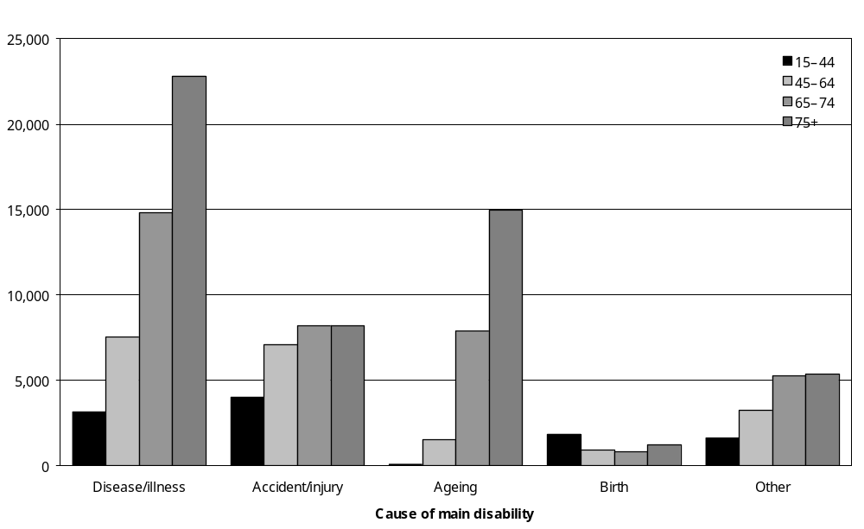
Source: Statistics New Zealand, 2001 Household Disability Survey
Note: Data in Appendix Table 2.27.
Rates for main disabilities caused by disease/illness also increased with age, from 3200 per 100,000 in the 15–44 age group, to highs of 14,800 per 100,000 in the 65–74 age group and 22,800 per 100,000 in the 75 and over age group.

The rate of main disabilities caused by accident/injury also increased with age, although not as sharply as for ageing or disease/illness. The rates ranged from 4000 per 100,000 in the 15–44 age group to 8200 per 100,000 in both the 65–74 and 75 and over age groups.

Main disabilities caused by accident/injury
In 2001, an estimated 157,100 adults living in households had main disabilities caused by accident/injury. For 56,900 (36 percent) of these adults, the cause of their main disability was an accident/injury at work. For a further 28,900 (18 percent) it was an accident or injury at home, while for 26,300 (17 percent) it was a motor vehicle crash (Figure 2.24).

Figure 2.24: Number of adults living in households with main disability caused by accident/injury, by accident/injury location and sex, 2001
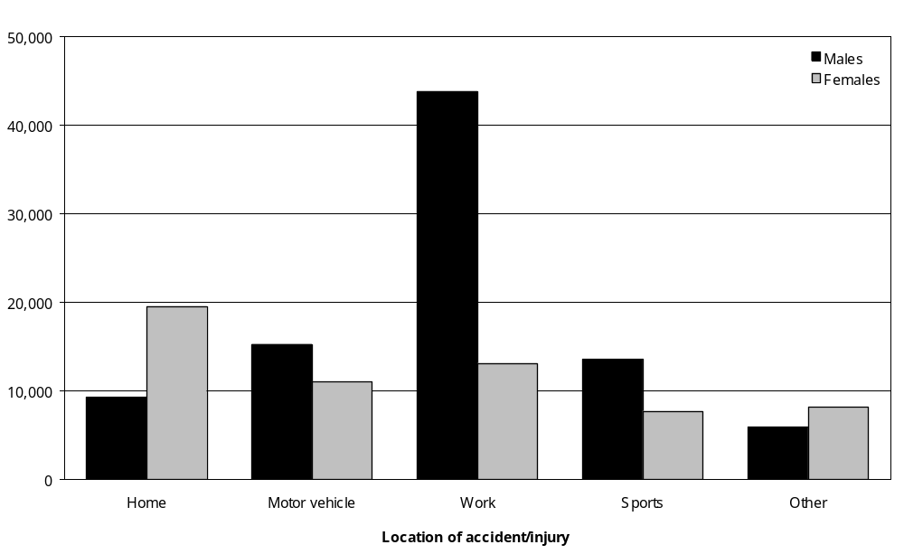
Source: Statistics New Zealand, 2001 Household Disability Survey
Note: Data in Appendix Table 2.28.

More than twice as many women (19,600) as men (9300) had main disabilities caused by accident/injury at home.

Conversely, more than three times as many men (43,800) as women (13,100) had main disabilities caused by work accident/injury, and almost twice as many men (13,600) as women (7700) had main disabilities caused by sports injuries. As well, more men (15,300) than women (11,100) had main disabilities caused by motor vehicle crashes.

Severity of disability
The severity of a person’s disability influences the kinds of everyday activity they can do and the levels of support and equipment they need.

Defining severity levels
The 2001 Household Disability Survey and the 2001 Disability Survey of Residential Facilities used a three-level definition to classify how severely people were affected by disability:
- People with severe disabilities received or needed daily help with activities such as preparing meals, shopping, everyday housework, bathing or dressing.
- People with moderate disabilities used or needed ‘some type of assistive device, aid or equipment’ and/or help with certain heavier or more difficult household tasks.
- People with mild disabilities had some kind of disability, but did not require regular help from other people or technical aids.

Prevalence of mild, moderate and severe disability
In 2001, an estimated 88,100 (12 percent) of the 716,500 adults and children with disability living in households had severe disability, necessitating daily assistance from someone else (Figure 2.25).

Figure 2.25: Severity of disability in people (adults and children) living in households, 2001
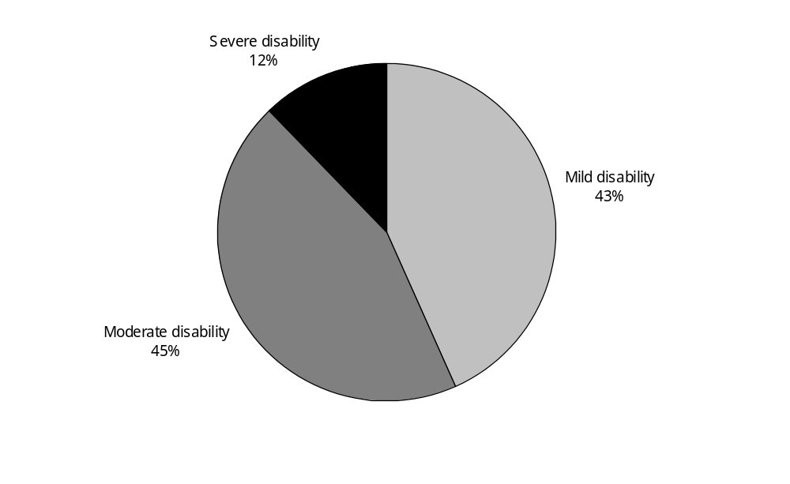
Source: Statistics New Zealand, 2001 Household Disability Survey
Note: Data in Appendix Table 2.29.

Given that a further 22,600 people with severe disability were living in residential facilities (see chapter 10), this means close to four out of five people with severe disability were living in households rather than in residential facilities.

An estimated 317,000 adults and children had moderate disability requiring a lower level of assistance. This was 44 percent of all people with disability in households.

A further 311,500 adults and children, 43 percent of all people with disability in households, had mild disability.

Severity of disability at different ages
As might be expected, age-specific rates for severe and moderate disability were highest in the older age groups and lowest in the younger age groups (Figure 2.26).

In the 75 and over age group, the rate of severe disability (10,600 per 100,000) was nearly double the rate in the next youngest age group (6000 per 100,000). As well, the rate of moderate disability in the 75 and over age group (at 39,100 per 100,000) was more than twice as high as in the next youngest age group (18,800 per 100,000).

Figure 2.26: Rates of disability severity in people (adults and children) living in households, by age, 2001
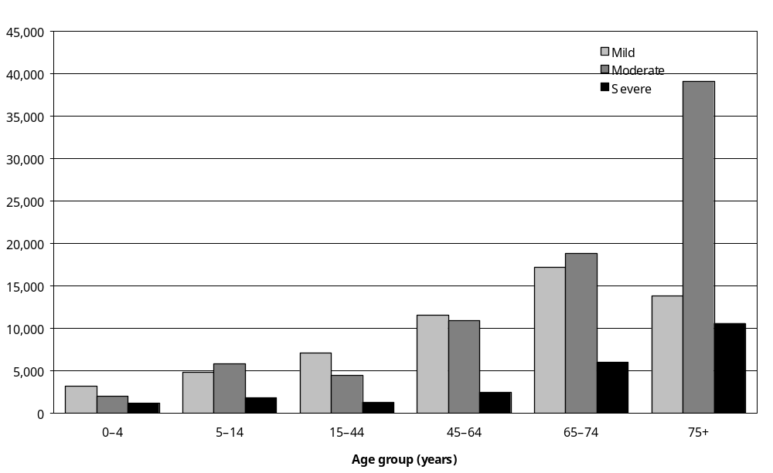
Source: Statistics New Zealand, 2001 Household Disability Survey
Note: Data in Appendix Table 2.30.

Severity of disability in males and females
In 2001, females outnumbered males in each of the mild, moderate and severe categories of disability. However, after adjusting for the different age profiles of the two sexes by calculating age-standardised rates, males had similar rates of mild disability to females (8100 per 100,000 compared with 7900 per 100,000). They also had similar rates of moderate disability (7800 per 100,000 compared with 7200 per 100,000) (Figure 2.27).

Figure 2.27: Age-standardised rates of disability severity in people (adults and children) living in households, by sex, 2001
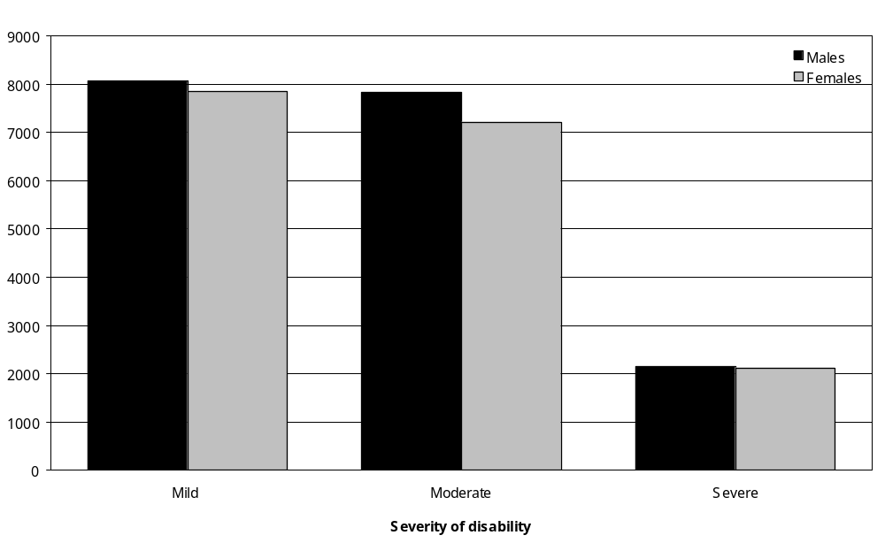
Source: Statistics New Zealand, 2001 Household Disability Survey
Notes:
- Calculated from data in Appendix Tables 2.29 and 2.30.
- Age-standardised to WHO World Standard Population.

Males and females had the same age-standardised rate of severe disability (at 2100 per 100,000).

Severity of main disability
Adults with a main disability that was a speaking, learning, remembering or psychiatric/ psychological disability were most likely to be defined as mildly disabled (Figure 2.28). Seventy-three percent of adults with a learning main disability were mildly disabled, as were 60 percent of people with a speaking main disability and 59 percent of people with a psychiatric/ psychological main disability.

Figure 2.28: Percentage of adults living in households, by disability severity and main disability, 2001
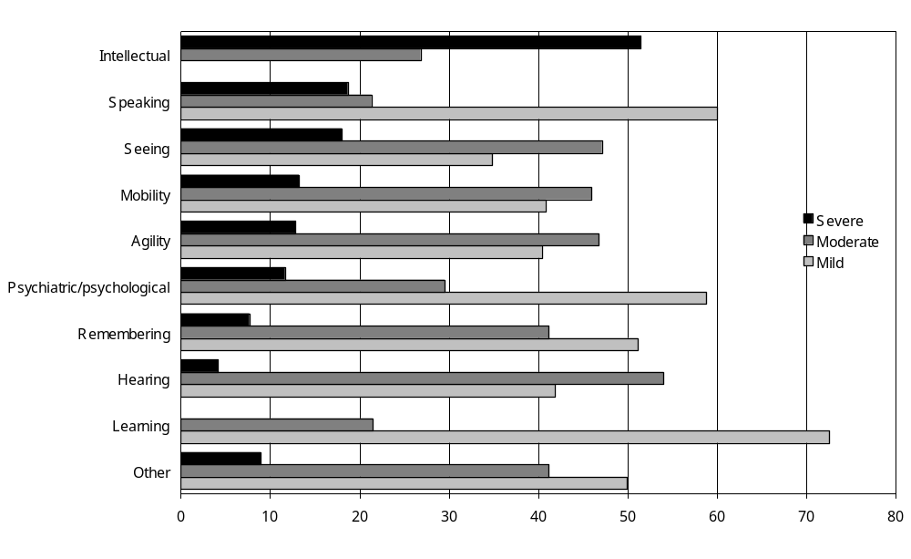
Source: Statistics New Zealand, 2001 Household Disability Survey
– Percentages too small to report (estimated frequencies outside the 70 percent relative sampling error cut-off point).
Notes:
- Data in Appendix Table 2.31.
- The ‘Other’ category includes other types of long-term conditions or health problems that cause people ongoing difficulty with, or stops them from doing, everyday activities which people their age can usually do.

Adults with a main disability that was a hearing, seeing, agility or mobility disability were most likely to be defined as being moderately disabled. Fifty-four percent of adults with a hearing main disability were moderately disabled, as were 47 percent of adults with a seeing main disability, 47 percent of adults with an agility main disability and 46 percent of adults with a mobility main disability.

Just over half (51 percent) the adults whose main disability was an intellectual disability were categorised as severely disabled.

By contrast, the prevalence of severe disability was comparatively low in adults with a hearing main disability (4 percent) or a remembering main disability (8 percent).

Severity of disability and cause of main disability
Figure 2.29 shows the different causes of the main disabilities experienced by adults, matched against disability severity levels.

Figure 2.29: Percentage of adults living in households, by disability severity and cause of main disability, 2001
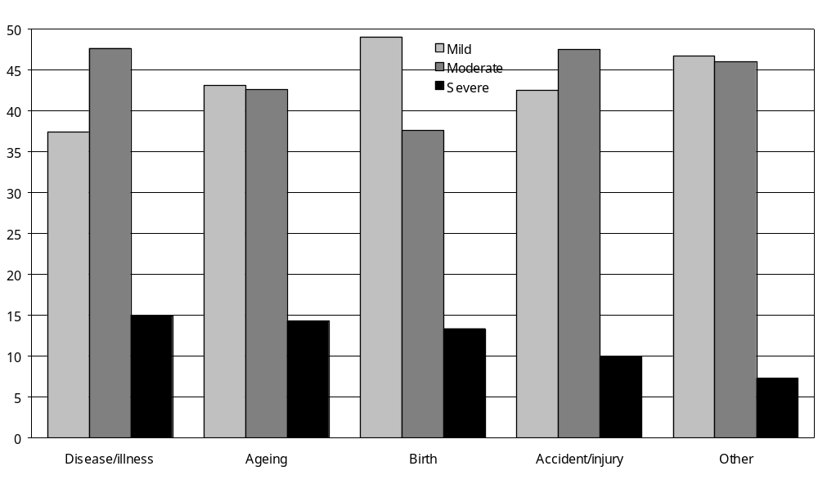
Source: Statistics New Zealand, 2001 Household Disability Survey.
Note: Data in Appendix Table 2.32.

Severe disability was almost as prevalent in adults with a main disability caused by disease/ illness (15 percent) as in adults with a main disability caused by ageing (14 percent), conditions present at birth (13 percent) or accident/injury (10 percent).

Moderate disability was not as common in adults with a main disability caused by conditions present at birth (38 percent) as it was in adults with a main disability caused by accident/injury (48 percent) or by disease/illness (48 percent).

Mild disability was most common in adults with a main disability caused by a condition present at birth (49 percent). It was least common in adults with a main disability caused by disease/ illness (37 percent).

Age at onset of first disability
Adults participating in the 2001 Household Disability Survey were asked how old they were when they started to experience disability. If they currently had more than one type of disability, they were asked how old they were when each disability started.

Caregivers of children with disability were asked what age their child was when they started to experience disability.

Table 2.7 indicates the age when people’s first disability started, matched against their age at the time of the 2001 Household Disability Survey.

Just over a third (36 percent) of people aged 75 and over at the time of the survey had developed their first disability after turning 75. Three-quarters of people with disability aged 75 and over had developed their first disability when they were in their middle years or older (that is, at age 45 and over). Only 7 percent had developed their first disability before age 25 and only 2 percent before they turned 5.

In contrast, more than half of people aged 25–44 with disability (57 percent) had developed their first disability before the age of 25, including 16 percent who developed their first disability before age 5.

Table 2.7: Age of onset of first disability in people (adults and children) with disability living in households, by current age, 2001
Age of onset of first disability | Current age (years)
Age of onset of first disability | 0–4  (%)  (n=15,900) | 5–14  (%)  (n=74,100) | 15–24  (%)  (n=44,400) | 25–44  (%)  (n=157,500) | 45–64  (%)  (n=209,100) | 65–74  (%)  (n=101,400) | 75+  (%)  (n=114,200) | Total  (%)  (n=716,500)
0–4 | 98 | 66 | 27 | 16 | 6 | 3 | 2 | 17
5–14 | N/A | 33 | 38 | 17 | 5 | – | 1 | 11
15–24 | N/A | N/A | 35 | 24 | 6 | 3 | 4 | 10
25–44 | N/A | N/A | N/A | 43 | 38 | 12 | 7 | 23
45–64 | N/A | N/A | N/A | N/A | 43 | 53 | 20 | 23
65–74 | N/A | N/A | N/A | N/A | N/A | 27 | 29 | 8
75+ | N/A | N/A | N/A | N/A | N/A | N/A | 36 | 6
Not reported | – | 1 | – | – | 1 | – | – | 1
Total | 100 | 100 | 100 | 100 | 100 | 100 | 100 | 100
Source: Statistics New Zealand, 2001 Household Disability Survey
N/A: Not applicable to this age group.
Note: The sum of the values for each category may differ from the total due to rounding.
– Percentages too small to report (estimated frequencies outside the 70 percent relative sampling error cut-off point).
n = Estimated number of people with disability in this age group in the household population.

Similarly, 66 percent of people aged 5–14 with disability developed their first disability before age 5.

These results suggest that younger people with disability are more likely to have experienced a disability condition for a substantial part of their lives (often from birth). They also suggest that older people with disability are more likely to have been disability-free for a good portion of their lives.

Duration of disability

Longest-lasting disability
Table 2.8 indicates how many years people had been living with a disability, based on the duration of their longest-lasting disability.

Table 2.8: Duration of longest-lasting disability in people (adults and children) with disability living in households, by age, 2001
Duration of longest lasting disability) | Current age (years)
Duration of longest lasting disability) | 0–4  (%) | 5–14  (%) | 15–44  (%) | 45–64  (%) | 65–74  (%) | 75 and over  (%) | Total  (%)
Less than 1 year | 12 | 4 | 5 | 4 | 3 | 3 | 4
1–14 years | 86 | 95 | 51 | 54 | 56 | 58 | 59
15+ years | N/A | N/A | 44 | 41 | 40 | 39 | 36
Unknown | 2 | 1 | 0 | 1 | 1 | 0 | 1
Total | 100 | 100 | 100 | 100 | 100 | 100 | 100
Source: Statistics New Zealand, 2001 Household Disability Survey
N/A: Not applicable to this age group.
Notes:
- The sum of the values for each category may differ from the total due to rounding.
- 0–4 and 5–14 could not have disabilities lasting for longer than 14 years.

It was uncommon for people of any age to have had a disability for less than a year. In all age groups from 5–14, less than 6 percent of people with disability had had a disability for less than a year. Even in the youngest age group (0–4), only 12 percent had had a disability for less than a year.

In each of the adult age groups, 39–44 percent of people had had a disability for 15 years or longer.

Duration of main disability
Duration patterns were similar for the main disabilities experienced by adults. In all the adult age groups, only 5–6 percent of people with disability had experienced their main disability for less than a year. In the 15–44, 45–64 and 65–74 age groups, between a quarter and a third of people had experienced their main disability for 15 years or more (Table 2.9).

Table 2.9: Duration of main disability in adults with disability living in households, by current age, 2001
Duration of main disability | Current age (years)
Duration of main disability | 15–44  (%) | 45–64  (%) | 65–74  (%) | 75+  (%) | Total  (%)
Less than 1 year | 6 | 5 | 6 | 6 | 6
1–14 years | 55 | 58 | 62 | 64 | 59
15+ years | 33 | 27 | 25 | 21 | 28
Unknown | 6 | 9 | 7 | 9 | 8
Total | 100 | 100 | 100 | 100 | 100
Source: Statistics New Zealand, 2001 Household Disability Survey
Note: The sum of the values for each category may differ from the total due to rounding.

Comparing 2001 and 1996

Number of people with disability
In 2001, an estimated 716,500 people with disability were living in New Zealand households. This was a 6 percent increase from the 1996 estimate of 674,400.

The increase in 2001 was entirely the result of an increase in the number of adults (rather than children) with disability. In 2001, an estimated 626,500 adults with disability were living in households, an 8 percent increase from the 1996 estimate of 580,000.

By contrast, the number of children with disability was lower in 2001 compared with 1996. In 1996, an estimated 93,900 children with disability were living in households. The corresponding estimate for 2001 was 90,000, a 4 percent reduction.

Disability in adults living in households
Figure 2.30 compares the age-specific rates of disability for adult males in 1996 and 2001. Rates were generally similar in the younger age groups. However, in the 75–84 age group, the 2001 rate was slightly lower than the 1996 rate. The situation was reversed in the 85 and over age group, with the 2001 rate being higher than the 1996 rate.

Figure 2.30: Rates of disability in adult males living in households, by age, 1996 and 2001
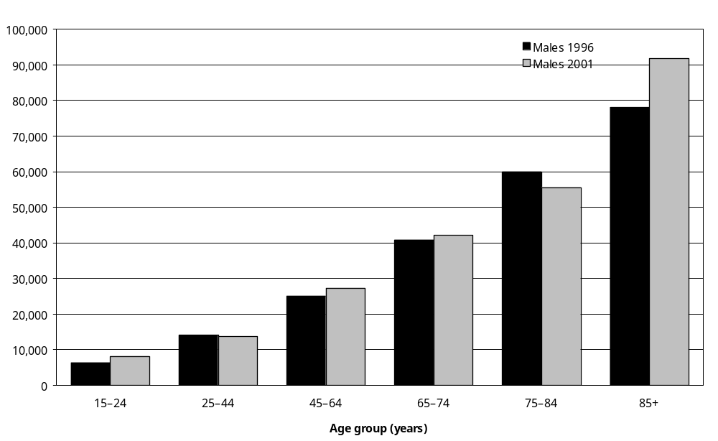
Source: Statistics New Zealand, 1996 Household Disability Survey & 2001 Household Disability Survey
Note: Data in Appendix Tables 2.2 and 2.37.

Figure 2.31 compares the 1996 and 2001 age-specific disability prevalence rates for adult females. Rates were slightly higher in 2001 compared with 1996 in all age groups except the
15–24 and 45–64 age groups.

Figure 2.31: Rates of disability in adult females living in households, by age, 1996 and 2001
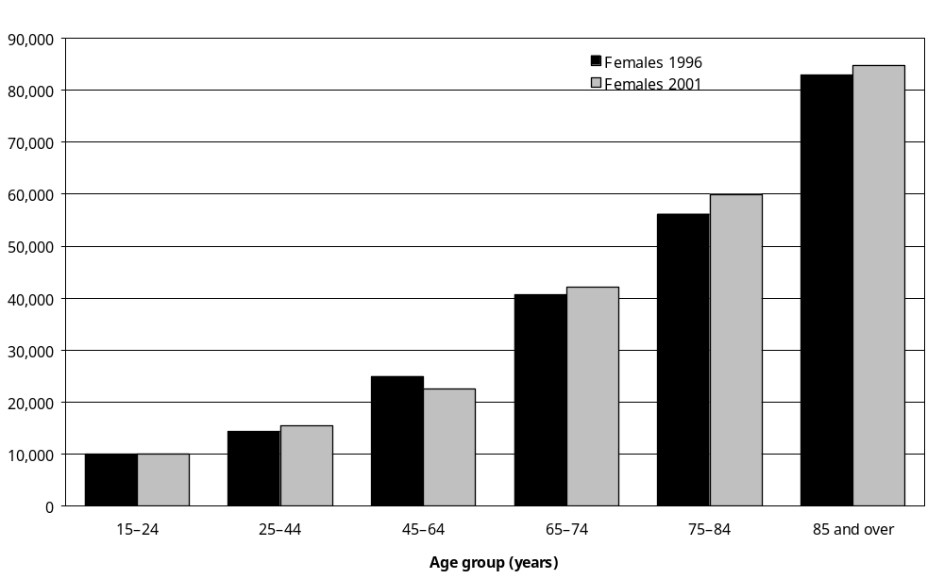
Source: Statistics New Zealand, 1996 Household Disability Survey and 2001 Household Disability Survey
Note: Data in Appendix Tables 2.2 and 2.37.

Disability in children living in households
The disability prevalence rate for boys was slightly lower in 2001 than in 1996 (12,500 per 100,000 compared with 13,400 per 100,000). The same was the case for girls, with a disability prevalence rate of 8700 per 100,000 in 2001 compared with 9200 per 100,000 in 1996 (Figure 2.32).

Figure 2.32: Rates of disability in children living in households, by sex, 1996 and 2001
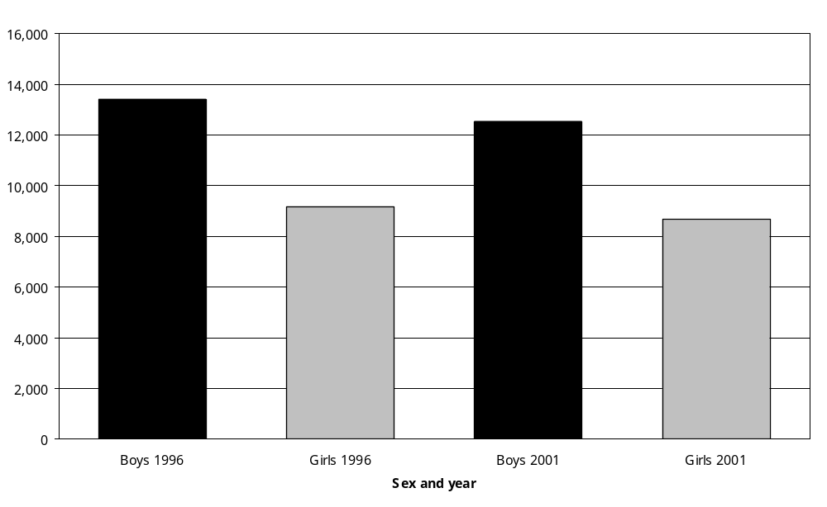
Source: Statistics New Zealand, 1996 Household Disability Survey and 2001 Household Disability Survey
Note: Data in Appendix Tables 2.2 and 2.39.

In both the 1996 and 2001 Household Disability Surveys, boys had a higher prevalence of disability than girls.

Other survey findings
Table 2.10 compares other selected results from the 1996 and 2001 Household Disability Surveys.

Table 2.10: Selected results from the 1996 and 2001 Household Disability Surveys
 | Estimated number of people |  | Percentage of New Zealand population living in households (%)
 | 1996 survey | 2001 survey | 1996 survey | 2001 survey
All people living in households (with or without disability)
Adults | 2,712,800 | 2,826,200 | 100 | 100
Children | 825,900 | 844,300 | 100 | 100
Total | 3,538,600 | 3,670,500 | 100 | 100
People with disability
Adults | 580,400 | 626,500 | 21 | 22
Children | 93,900 | 90,000 | 11 | 11
Total | 674,400 | 716,500 | 19 | 20
Single/multiple disability
Single | 283,600 | 308,500 | 8 | 8
Multiple | 390,800 | 408,000 | 11 | 11
Disability type – adults
Hearing | 204,700 | 212,500 | 8 | 8
Seeing | 70,500 | 69,300 | 3 | 2
Mobility | 328,600 | 346,300 | 12 | 12
Agility | 280,100 | 270,900 | 10 | 10
Intellectual | 18,500 | 28,900 | 1 | 1
Psychiatric/psychological | 77,600 | 94,800 | 3 | 3
Disability type – children
Hearing | 22,000 | 18,300 | 3 | 2
Seeing | 10,000 | 13,200 | 1 | 2
Use of technical equipment | 7,700 | 4,600 | 1 | 1
Intellectual | 11,300 | 13,000 | 1 | 2
Psychiatric/psychological | 20,600 | 22,200 | 2 | 3
Chronic health problem | 31,000 | 30,200 | 4 | 4
Disability cause*
Disease/illness | 266,700 | 281,000 | 8 | 8
Birth | 91,700 | 98,000 | 3 | 3
Ageing | 130,400 | 115,100 | 4 | 3
Severity of disability
Mild | 296,800 | 311,500 | 8 | 8
Moderate | 289,900 | 317,000 | 8 | 9
Severe | 87,700 | 88,100 | 2 | 2
Source: Statistics New Zealand, 1996 and 2001 Household Disability Surveys
* Accident/injury not included in this table because the category changed between surveys.

3 Support, Equipment and Services

Key points
This chapter describes the kinds of support, equipment and services used or needed by adults and children with disability living in New Zealand households.

Help with everyday activities

Adults
- Adults with disability living in households were asked if disability meant someone else carried out or helped them with various everyday activities like dressing, bathing, preparing meals, shopping and housework:
- 6 percent of adults with disability (an estimated 34,900 people) were getting help with personal care (for example, bathing, dressing or taking medication)
- 11 percent (67,400) were getting help with meal preparation
- 16 percent (99,700) were getting help with shopping (for example, for groceries)
- 21 percent (128,500) were getting help with everyday housework (for example, tidying up, cleaning or laundry)
- 30 percent (186,700) were getting help with heavy household work (for example, spring cleaning or gardening)
- 8 percent (51,300) were getting help with personal finances (for example, banking or paying bills)
- 6 percent (39,100) were getting help with communicating (for example, during doctor’s visits or job interviews).

Children
- Parents or caregivers of an estimated 11,700 children with disability (13 percent) indicated they had needed help in the previous 12 months with their child’s disability-related personal care or with household work connected to the child’s disability-related needs.

Unmet need for help with everyday activities

Adults
- Adults with disability were asked to indicate whether, in the previous 12 months, they had experienced any unmet need for help with everyday activities such as disability-related personal care, housework, shopping or meal preparation:
- 2 percent of adults with disability reported needing help with disability-related personal care (for example, dressing or bathing) from providers other than family or friends, but being unable to get this help
- 4 percent of adults with disability reported needing help with tasks such as housework or shopping from providers other than family or friends, but being unable to get this help
- 4 percent of adults with disability reported needing help with home repairs or property maintenance, but being unable to get this help.

Children
- Parents or caregivers of children with disability were asked to indicate whether, in the previous 12 months, they had experienced any unmet need for help with everyday activities related to caring for their child:
- parents or caregivers of 5 percent of children with disability reported an unmet need for help with their child’s disability-related personal care
- parents or caregivers of 4 percent of children with disability reported an unmet need for help with household tasks related to caring for their child with disability
- parents or caregivers of 5 percent of children with disability reported an unmet need for help with home repairs or home maintenance related to caring for their child with disability.

Respite care
- Respite care (carer support) is a period of alternative care that enables a usual caregiver to take a break from looking after a person with disability. It may include another caregiver staying with, or visiting, a person with disability in their home, or the person with disability staying temporarily in a hospital, a rest home or another service providing out-of-home care.

Adults
- An estimated 108,000 adults with disability living in households had someone who helped them or looked after them because of disability or health problem. Eight percent of this group (an estimated 9100 adults) received financial help from a government agency in the previous 12 months to pay for respite care. Five percent of this group (5100 adults) paid for respite care or carer support in the previous 12 months. Ten percent (10,300 adults) had needed respite care in the previous 12 months, but had been unable to get it.

Children
- Parents or caregivers of 18 percent of children with disability reported needing respite care or carer support in the previous 12 months. This was the parents or caregivers of an estimated 16,600 children.
- Parents or caregivers of children using technical aids were the most likely to need respite care (51 percent), while parents or caregivers of children with hearing disability were the least likely to need respite care (13 percent).
- Forty-eight percent of parents or caregivers of children with disability needing respite care in the previous 12 months had been unable to get this respite care. This was the parents or caregivers of an estimated 8000 children.

Equipment and technology

Adults
- In 2001 an estimated 207,200 adults with disability (33 percent) were using equipment or technology to assist themselves.
- The following types of equipment were being used by adults with disability:
- equipment or services for hearing – used by 36 percent of adults with hearing disability (an estimated 75,600 adults)
- equipment or services for seeing – used by 71 percent of adults with seeing disability (an estimated 49,200 adults)
- equipment and technology for speaking and being understood – used by 3 percent of adults with speaking disability (an estimated 1200 adults)
- equipment for moving about – used by 16 percent of all adults with disability (an estimated 99,300 adults)
- equipment for helping hands or arms – used by 2 percent of all adults with disability (an estimated 13,900 adults)
- other types of equipment such as shower stools, raised toilet seats, commode chairs, specialised cushions, respirators or ventilators – used by 4 percent of all adults with disability (an estimated 26,000 adults).
- Altogether, 27 percent of adults with disability, an estimated 171,000 people, used some kind of equipment because of disability in the previous 12 months.

Unmet need for equipment or technology
- In 2001, an estimated 77,100 (or 12 percent) of adults with disability reported an unmet need for at least one type of equipment or technology.
- Adults with disability indicated they did not have the following equipment or technology they considered they needed:
- equipment or services for hearing – needed by 21 percent of adults with hearing disability (an estimated 45,000 adults)
- equipment for speaking and being understood – needed by 3 percent of adults with speaking disability (an estimated 1400 adults)
- equipment or services for seeing – needed by 20 percent of adults with seeing disability (an estimated 14,000 adults)
- equipment for moving about – needed by 9 percent of adults already using this type of equipment (an estimated 8500 adults)
- equipment for helping hands or arms – needed by 16 percent of adults already using this type of equipment (an estimated 2700 adults)
- other types of equipment – needed by 2 percent of all adults with disability (an estimated 14,600 adults).

Children
- In 2001, an estimated 7700 children with disability (9 percent) were using equipment or technology to assist them.
- The following types of technical equipment were being used by children with disability:
- equipment for hearing – used by 9 percent of children with a hearing disability (an estimated 1600 children)
- equipment for seeing – used by 6 percent of children with a seeing disability (an estimated 700 children)
- equipment for communicating – used by 8 percent of children with a speaking disability (an estimated 1400 children).
- In addition, an estimated 4600 children, 5 percent of all children with disability, were classified as having the disability type ‘use of technical aids’. This category of disability included children who used equipment or technology for moving around, standing, using their arms or hands, or for other reasons.

Unmet need for equipment
- In 2001, parents or caregivers of an estimated 7100 (or 8 percent) of children with disability reported their child had an unmet need for at least one type of equipment or technology.

Disposable items

Adults
- Eleven percent of adults with disability reported needing disposable items such as batteries, needles, incontinence pads or dressings in the previous 12 months because of disability. This was an estimated 71,500 adults.
- Of these 71,500 adults, 7 percent indicated they needed certain disposable items they did not have.

Children
- Eleven percent of children with disability needed disposable items such as batteries, needles, incontinence pads or dressings in the previous 12 months because of disability. This was an estimated 9600 children.
- Parents or caregivers of 1200 of these 9600 children (13 percent) reported being unable to get some of the disposable items their child needed in the previous 12 months.

Special dietary items

Adults
- Nine percent of adults with disability (an estimated 58,100 people) needed something special in their diet in the previous 12 months because of disability.
- Of the 58,100 adults needing special dietary items over this time, an estimated 10,400 (18 percent) reported being unable to get some of the dietary items they needed.

Children
- An estimated 12,900 children with disability (14 percent) had needed something special in their diet in the previous 12 months because of disability.
- Parents or caregivers of an estimated 4600 of these 12,900 children (36 percent) reported being unable to get some of the dietary items their child needed over this time.

Needs assessments
- During a needs assessment, a person with disability has their care and support needs for everyday living identified and prioritised by a needs assessor.

Adults
- Fifteen percent of adults with disability (an estimated 95,400 people) indicated they had received a needs assessment at some time. This included an estimated 54,900 (9 percent) who had received a needs assessment in the previous 12 months.
- Thirty-four percent of adults with disability indicated they had not had a needs assessment in the previous 12 months, because they did not know about needs assessments.

Children
- Fifteen percent of children with disability (an estimated 13,200 children) had received a needs assessment at some time. This included an estimated 8400 (9 percent) who had received a needs assessment in the previous 12 months.
- When the parents or caregivers of children with disability who had not had a needs assessment in the previous 12 months were asked the reasons for this, the most common reason was that they did not consider their child’s disability to be serious enough to require a needs assessment. This reason was given by the parents or caregivers of an estimated 34,500 children; 38 percent of all children with disability.

Health services
- People with disability were asked how often they had consulted different types of health service in the previous 12 months. Consultations could have been for disability-related health care as well as for reasons unrelated to disability, such as immunisations, ante-natal care or treatment for short illnesses or minor accidents.

Adults
- In the previous 12 months, the most common health services that adults with disability used for any reason were:
- general practitioners (GPs) or family doctors – used at least once by 86 percent of adults with disability
- chemists or pharmacists – 76 percent
- medical specialists – 40 percent
- nurses (without also seeing a doctor) – 32 percent.

Children
- In the previous 12 months, the most common health services that children with disability used for any reason were:
- GPs or family doctors – used at least once by 88 percent of children with disability
- dentists or dental nurses – 71 percent
- chemists or pharmacists – 61 percent
- medical specialists – 42 percent
- nurses (without also seeing a doctor) – 30 percent.

Reported unmet need for health services
- Fifteen percent of adults with disability (an estimated 94,900 people) indicated there had been at least one time in the previous 12 months when they had needed to see a health professional, therapist or healer, but had been unable to.
- Parents or caregivers of 17 percent of children with disability indicated there had been at least one time in the previous 12 months when their child had needed to see a health professional, therapist or healer, but had been unable to. This was an estimated 15,500 children.

Medication
- The 2001 Household Disability Survey asked people with disability about their use of prescribed and non-prescribed medication. Survey questions were broad and covered use of medication for any reason, not just for disability-related conditions or health problems.
- Eighty percent of adults with disability and 76 percent of children with disability had taken some kind of prescribed or non-prescribed medication in the previous 12 months. This was an estimated 504,000 adults and 68,000 children.
- Sixty percent of adults with disability and 35 percent of children with disability took prescribed drugs daily.
- Fourteen percent of adults with disability and 4 percent of children with disability took non-prescribed drugs daily.
- Seven percent of adults with disability (an estimated 45,000 adults) reported needing medication at some time in the previous 12 months, but not being able to get it. Similarly, parents or caregivers of 10 percent of children with disability (an estimated 8800 children) reported needing medication for their child at some time in the previous year, but being unable to get it.

Introduction
This chapter describes the range of support, equipment and services used or needed by adults and children with disability living in New Zealand households.

As well as informal help from people such as family members and friends, people with disability can obtain assistance from a wide range of disability-related support and health services. Many of these services are government-funded or subsidised; others are run by voluntary or private organisations.

The first section of this chapter looks at how many adults and children with disability were getting informal and formal help with everyday activities such as personal care and housework.

Subsequent sections describe how many adults and children with disability used:
- respite care
- equipment and technology for moving about, seeing, hearing or communicating
- disposable items such as needles or dressings
- special dietary items
- needs assessments
- health services such as doctors or medical specialists
- medication.

The chapter also identifies how many people with disability reported unmet needs for certain kinds of support, equipment and services such as respite care or help with heavy household work. In addition, information is given on how many people with disability obtained financial assistance from government agencies to pay for services or items of equipment related to disability, and how many paid for these things themselves.

This information is relevant to several issues relating to the provision of services and support for people with disability highlighted in Objectives 7, 8 and 15 of the New Zealand Disability Strategy (Minister for Disability Issues 2001). The issues include:
- improving access to appropriate assessment services, support services and health services for people with disability
- identifying the unmet needs experienced by people with disability and developing affordable solutions to meet these needs
- improving the resources and choices for families, whänau and other people who provide ongoing support for people with disability.

Help with everyday activities

Types of help

Adults
Adults with disability living in households were asked if their condition or health problem meant someone else carried out or helped them with the following everyday activities:
- personal care (for example, bathing, dressing or taking medication)
- meal preparation
- shopping (for example, for groceries)
- everyday housework (for example, tidying up, cleaning or laundry)
- heavy household work (for example, spring cleaning or gardening)
- personal finances (for example, banking or paying bills)
- communicating with others (for example, during doctor’s visits or job interviews).

Table 3.1 shows the number and percentage of adults with disability estimated to be receiving help from someone with these activities.

Table 3.1: Number and percentage of adults with disability living in households who, because of disability, were receiving help with everyday activities, by activity type, 2001
 | Number of adults with disability who were receiving this kind of help (estimate) | Percentage of adults with disability (%)
Personal care (for example, bathing, dressing or taking medication) | 34,900 | 6
Meal preparation | 67,400 | 11
Shopping (for example, for groceries) | 99,700 | 16
Everyday housework (for example, tidying up, cleaning or laundry) | 128,500 | 21
Heavy housework (for example, spring cleaning, gardening) | 186,700 | 30
Personal finances (for example, banking or paying bills) | 51,300 | 8
Communicating with others (for example, during doctor’s visits or job interviews) | 39,100 | 6
Total getting at least one type of assistance | 244,700 | 39
Source: Statistics New Zealand, 2001 Household Disability Survey
Note: If individuals reported getting help with more than one everyday activity, they were counted in each applicable activity group.

At least one type of help
In 2001, an estimated 244,700 adults with disability (39 percent) were receiving at least one of the seven listed types of help with everyday activities, because of disability.

Older adults were more likely to be receiving help with everyday activities than younger adults. Over half (56 percent) of adults aged 65 and over with disability received help, compared with 30 percent of adults aged 45–64, 33 percent of adults aged 25–44 and 23 percent of adults aged 15–24.

Twenty-nine percent of men and 48 percent of women with disability were receiving help with everyday activities (calculated from Statistics New Zealand 2002a). Overall, the proportions of Pacific (48 percent) and Asian/Other (50 percent) adults with disability receiving help were higher than the proportions of Mäori (37 percent) and European (39 percent) adults with disability receiving help (Figure 3.1).

Figure 3.1: Percentage of adults with disability living in households who, because of disability, were receiving help with everyday activities, by age and ethnicity, 2001
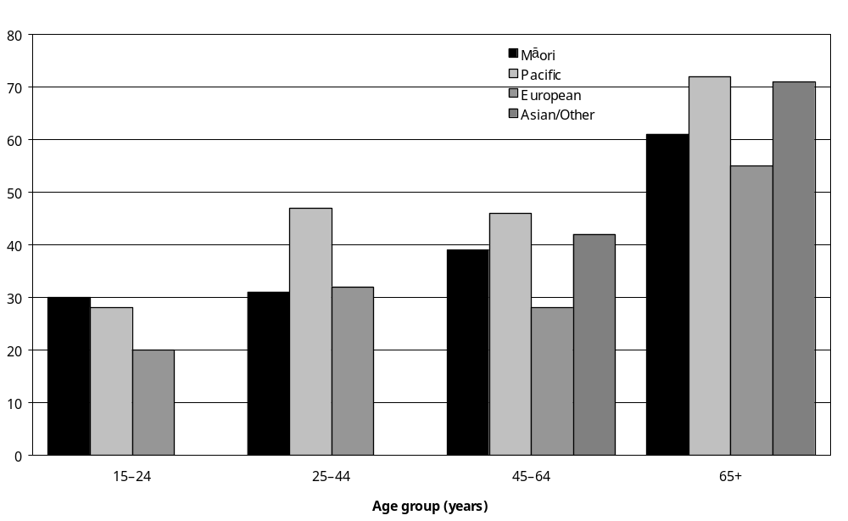
Source: Statistics New Zealand, 2001 Household Disability Survey.
– Percentages too small to report (estimated frequencies outside the 70 percent relative sampling error cut-off point)
Note: Data in Appendix Table 3.1.

This difference was particularly marked among older adults. In the 65 and over age group, 72 percent of Pacific and 71 percent of Asian/Other adults with disability received help, compared with 55 percent of European and 61 percent of Mäori adults with disability.

In addition, Pacific adults aged 25–44 with disability were more likely than their counterparts in other ethnic groups to be receiving help (47 percent of Pacific adults aged 25–44, compared with 32 percent of Europeans and 31 percent of Mäori).

Personal care
An estimated 34,900 adults with disability (6 percent) were getting help with disability-related personal care, such as bathing, dressing or taking medication.

In terms of age, adults with disability in the 85 and over age group were the most likely to be getting this kind of help (20 percent). The percentage of adults aged 75–84 getting this kind of help was markedly lower (8 percent).

Adults with intellectual disability were most likely to be receiving help with personal care. Thirty-two percent of adults whose main disability was an intellectual disability got help with personal care. This compares with:
- 7 percent of adults whose main disability was an agility disability
- 6 percent of adults whose main disability was a mobility disability
- 6 percent of adults whose main disability was a seeing disability
- 6 percent of adults whose main disability was a psychiatric/psychological disability.

Thirty-five percent of adults with severe disability were getting help with personal care, compared with just 3 percent of adults with moderate disability.

Meal preparation
Eleven percent of adults with disability, an estimated 67,400 people, were getting help to prepare their meals, because of disability.

People with disability in the 85 and over age group were the most likely to be getting help with meal preparation, with 29 percent getting this kind of help. In the 75–84 age group, 13 percent were getting help with meal preparation.

Pacific adults with disability (25 percent) were more likely to receive help with meal preparation than Asian/Other (15 percent), Mäori (13 percent) and European (10 percent) adults with disability.

Adults whose main disability was an intellectual disability were the most likely to receive help with meal preparation (50 percent). This compares with:
- 12 percent of adults whose main disability was a mobility disability
- 12 percent of adults whose main disability was a seeing disability
- 11 percent of adults whose main disability was an agility disability
- 11 percent of adults whose main disability was a psychiatric/psychological disability
- 4 percent of adults whose main disability was a hearing disability.

Seventy-one percent of adults with severe disability had someone helping them with meal preparation because of their condition or health problem, compared with 5 percent of adults with moderate disability.

Shopping
Sixteen percent of adults with disability, an estimated 99,700 people, were getting help with shopping for groceries or other things they needed because of disability.

Older adults with disability were most likely to receive this kind of help, with 47 percent of people aged 85 and over getting help with shopping, compared with 22 percent of people aged 75–84 and 17 percent aged 65–74.

Women with disability (21 percent) were more likely than men with disability (10 percent) to receive help with shopping because of disability.

Asian/Other (32 percent) and Pacific (29 percent) adults with disability were more likely than Mäori (19 percent) or European (14 percent) adults with disability to receive help with shopping.

Adults whose main disability was an intellectual disability (53 percent) were the most likely to receive help with shopping, followed by adults whose main disability was a seeing disability (25 percent) and adults whose main disability was a mobility disability (22 percent). Adults whose main disability was a hearing disability (5 percent) were the least likely to receive help with shopping.

Seventy-three percent of adults with severe disability were getting help with shopping, compared with 16 percent of adults with moderate disability.

Everyday housework
Twenty-one percent of adults with disability, an estimated 128,500 people, were getting help with everyday housework such as tidying up, cleaning and laundry because of disability. This included 52 percent of adults with disability in the 85 and over age group and 38 percent in the 75–84 age group. By contrast, only 15 percent of adults with disability in the 25–44 and 45–64 age groups were getting this kind of help.

Twenty-seven percent of women with disability and 13 percent of men with disability were receiving help with everyday housework.

Adults whose main disability was an intellectual disability were the most likely to receive help with everyday housework (49 percent), followed by adults whose main disability was a mobility disability (28 percent), adults whose main disability was an agility disability (25 percent) and adults whose main disability was a seeing disability (25 percent).

Eighty-five percent of adults with severe disability received help with everyday housework, as did 23 percent of adults with moderate disability.

Heavy household work
Thirty percent of adults with disability, an estimated 186,700 people, were getting help with heavy household work such as spring cleaning, gardening or mowing lawns, because of disability.

Once again, older adults were more likely to be getting this kind of help than younger adults. In the 85 and over age group, 68 percent of adults with disability were getting help with heavy household work, as were 49 percent in the 75–84 age group.

Women with disability (37 percent) were more likely than men with disability (22 percent) to be getting help with heavy household work.

Fifty-seven percent of adults whose main disability was an intellectual disability and 44 percent of adults whose main disability was a mobility disability were getting help with heavy household work. This compares with just 16 percent of adults whose main disability was a psychiatric/ psychological disability and 9 percent of adults whose main disability was a hearing disability.

Eighty percent of adults with severe disability were getting help with heavy household work, compared with 35 percent of adults with moderate disability and 11 percent of adults with mild disability.

Personal finances
Eight percent of adults with disability, an estimated 51,300 people, were getting help with their personal finances such as banking or paying bills, because of disability. This included 28 percent of people with disability aged 85 and over and 10 percent aged 75–84.

Twenty-five percent of Asian/Other adults with disability were getting help with their personal finances, compared with 18 percent of Pacific, 11 percent of Mäori and 7 percent of European adults with disability.

Fifty-two percent of adults whose main disability was an intellectual disability were getting help with their personal finances, as were 17 percent of adults whose main disability was a seeing disability. This compared with 2 percent of adults whose main disability was a hearing disability and 6 percent of adults whose main disability was an agility disability.

Adults with severe disability (46 percent) were more likely to be getting help with their personal finances than adults with moderate disability (6 percent).

Communicating
Six percent of adults with disability, an estimated 39,100 people, were getting help when communicating such as during doctor’s visits or at job interviews, because of disability. This included 13 percent of adults aged 85 and over with disability and 11 percent of people aged 15–24.

Asian/Other adults with disability were the most likely to be getting help with communicating. Twenty-one percent of Asian/Other adults with disability were getting this kind of help, compared with 15 percent of Pacific, 10 percent of Mäori and 5 percent of European adults with disability.

Adults with intellectual disability were the most likely to be getting help with communicating. Fifty-five percent of adults whose main disability was an intellectual disability were getting this kind of help compared with 3 percent of adults whose main disability was an agility disability, 4 percent of adults whose main disability was a mobility disability and 5 percent of adults whose main disability was a hearing disability.

In terms of disability cause, 17 percent of adults whose main disability was caused by a condition present at birth were getting help with communicating, compared with 8 percent or less of adults whose main disability was caused by disease/illness, accident/injury, or ageing.

Adults with severe disability (31 percent) were more likely than adults with moderate disability (6 percent) to be getting help with communicating.

Who provided help?
Adults with disability who were getting assistance with everyday activities were asked to indicate the kinds of people who were providing this help. The results are summarised below in Table 3.2.

Table 3.2: Number and percentage of adults with disability living in households who, because of disability, were receiving help with everyday activities, by type of activity and type of person providing help, 2001
 | Husband/ male partner | Wife/ female partner | Daughter | Son | Mother | Father | Sister | Brother | Other family/ whanau member | Flatmate | Friend or neighbour | Voluntary organisation | Private organisation | Organisation, type unknown | Other paid person | Other person | Total
Personal care (for example, bathing, dressing, taking medication) | 5,200  15% | 7,100  20% | 3,600  10% | 1,400  4% | 2,900  8% | –  – | –  – | –  – | –  – | –  – | –  – | –  – | 6,900  20% | 2,100  6% | 3,800  11% | 2,100  6% | 34,900  100%
Meal preparation | 16,500  24% | 12,500  19% | 12,600  19% | 4,600  7% | 5,200  8% | –  – | 1,900  3% | –  – | 4,500  7% | 2,600  4% | –  – | 3,400  5% | 6,400  10% | –  – | 3,300  5% | 2,200  3% | 67,400  100%
Shopping (for example, for groceries) | 23,100  23% | 12,500  13% | 23,800  24% | 12,100  12% | 5,900  6% | –  – | 3,000  3% | –  – | 8,500  9% | 1,600  2% | 6,200  6% | –  – | 5,200  5% | –  – | 3,500  3% | 4,200  4% | 99,700  100%
Everyday housework (for example, tidying up, cleaning or laundry) | 22,700  18% | 13,900  11% | 13,300  10% | 6,700  5% | 4,800  4% | –  – | 2,300  2% | –  – | 6,000  5% | 2,600  2% | 3,900  3% | 5,400  4% | 23,600  18% | 7,000  5% | 23,400  18% | 4,800  4% | 128,500  100%
Heavy housework (for example, spring cleaning or gardening) | 32,700  18% | 16,400  9% | 13,900  7% | 19,100  10% | 4,500  2% | 2,500  1% | 2,300  1% | 2,900  2% | 13,000  7% | 2,300  1% | 14,000  7% | 3,000  2% | 24,200  13% | 4,800  3% | 52,500  28% | 6,100  3% | 186,700  100%
Personal finances (for example, banking or paying bills) | 8,900  17% | 9,100  18% | 10,800  21% | 5,700  11% | 4,500  9% | 1,900  4% | 1,700  3% | –  – | 2,700  5% | –  – | 2,100  4% | –  – | 2,100  4% | –  – | –  – | 2,500  5% | 51,300  100%
Source: Statistics New Zealand, 2001 Household Disability Survey
– Numbers too small to report (estimated frequencies outside the 70 percent relative sampling error cut-off point).
Note: If individuals reported getting help with more than one everyday activity or from more than one type of person, they were counted in each applicable activity and/or person group.

The results indicate that family members, especially spouses/partners and daughters, were the people most commonly helping with everyday activities.

Assistance with meal preparation, shopping and personal finances were most likely to be provided by spouses/partners or daughters. Help with everyday and heavy household work was most likely to come from husbands/male partners, a private organisation or another paid person. Adults with disability who received assistance with their personal care most often got this from spouses/partners or private organisations.

Analysis of these figures by age indicates that, as might be expected, daughters and sons had a more prominent role in the care of older rather than younger adults with disability. For example, 27 percent of people aged 75–84 with disability who got help with meal preparation were helped by their daughters, compared with just 11 percent of people aged 25–44.

Mothers were generally most prominent in the care of younger adults with disability. For example, 55 percent of people aged 15–24 who got help with meal preparation were helped by their mother, as were 14 percent of people aged 25–44. By contrast, the numbers of adults with disability in the older age groups whose mother helped them with meal preparation were too small to report.

How often was help received?
Adults with disability receiving help with everyday activities were asked to indicate how often they were getting this help from different types of people such as partners, family members, private organisations or others.

Frequency of help with personal care
Of adults with disability who got help with disability-related personal care (for example, bathing, dressing or taking medication):
- 70 percent who got this help from their wife or female partner were getting this help every day from that person
- 57 percent who got this help from their husband or male partner were getting this help every day from that person
- 63 percent who got this help from their daughter were getting this help every day from that person
- 55 percent who got this help from their mother were getting this help every day from that person.

Frequency of help with meals
Of adults with disability who got help preparing meals:
- 95 percent who got this help from their wife or female partner were getting this help every day from that person, as were 81 percent who got this help from their mother
- 60 percent who got this help from their husband or male partner were getting this help every day from that person, as were 60 percent who got this help from their daughter, 60 percent who got this help from their son, and 60 percent who got this help from other family or whänau members
- 59 percent who got this help from private organisations were getting this help every day from that source.

Frequency of help with shopping
Of adults with disability who got help with shopping:
- 94 percent who got help from their husband or male partner got this help once a week or more from that person, as did 89 percent who got this help from their wife or female partner
- 84 percent who got this help from their daughter got this help once a week or more from that person, as did 83 percent who got this help from their son
- 64 percent who got this help from their mother got this help once a week or more from that person.

Frequency of help with everyday housework
Of adults with disability who got help with everyday housework (for example, tidying, cleaning or laundry):
- 84 percent who got this help from their wife or female partner got this help every day from that person, as did 60 percent who got this help from their husband or male partner
- 57 percent who got this help from their daughter got this help every day from that person, as did 68 percent who got this help from their son
- 63 percent who got this help from a private organisation got this help once a week from this source; 13 percent got this help from a private organisation every day
- 52 percent who got this help from other paid people got this help from these people once a week; 6 percent got this help from these people every day.

Frequency of help with heavy household work
Of adults with disability who got help with heavy household work from:
- their husband or male partner, 71 percent were getting this help once a week or more
- their wife or female partner, 66 percent were getting this help once a week or more
- a private organisation, 40 percent were getting this help once a week or more and 58 percent were getting this help less than once a week
- other paid people, 28 percent were getting this help once a week or more and 70 percent were getting this help less than once a week.

Frequency of help with personal finances
Of adults with disability who got help with personal finances from:
- their daughter, 12 percent were getting this help every day, 36 percent once a week and 48 percent less than once a week
- their wife or female partner, 23 percent were getting this help every day, 48 percent once a week and 20 percent less than once a week.
- their husband or male partner, 20 percent were getting this help every day, 44 percent once a week and 25 percent less than once a week.

Children

Personal care and household work
Parents or caregivers were asked whether they had needed help with their child’s personal care or household work in the previous 12 months because of their child’s disability.

Parents or caregivers of an estimated 11,700 children with disability (13 percent) indicated they had needed this kind of help.

The need for this kind of help was related to the child’s type of disability. Parents or caregivers of children using technical aids and children with intellectual disability were the most likely to need help with their child’s personal care or with household work (44 percent and 33 percent respectively). Parents or caregivers of children with hearing disability (8 percent) and seeing disability (12 percent) were the least likely to need help with these activities (Figure 3.2).

Figure 3.2: Percentage of children with disability living in households whose parents or caregivers needed help with their child’s personal care or household work in the previous 12 months, by disability type, 2001
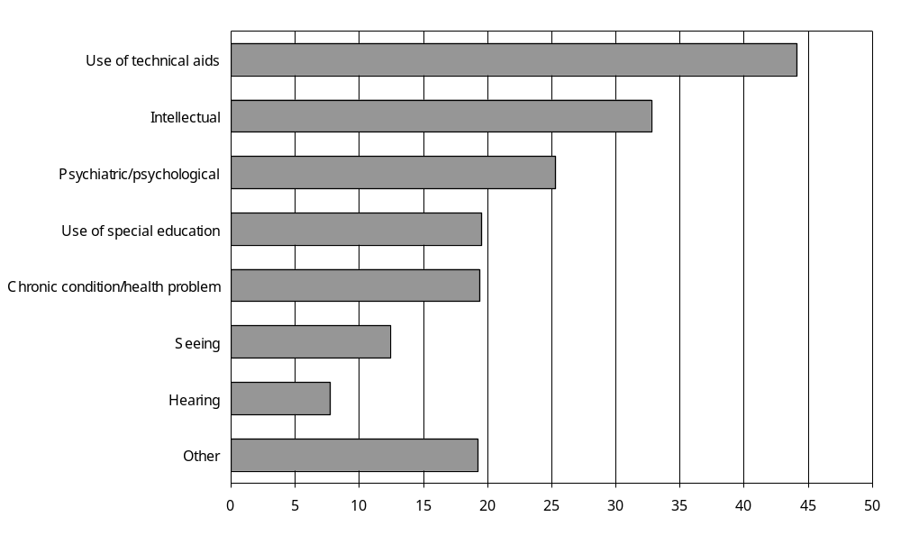
Source: Statistics New Zealand, 2001 Household Disability Survey
Notes:
- Data in Appendix Table 3.21.
- If individuals reported more than one disability type, they were counted in each applicable disability type group.

The likelihood that parents or caregivers would need help with personal care or household work was also strongly related to whether their child had one or more disabilities and the severity of their child’s disability.

Parents or caregivers of children with multiple disabilities were three times as likely to need help with their child’s personal care or household work as the parents or caregivers of children with a single disability (21 percent compared with 7 percent).

Parents or caregivers of nearly three-quarters of children with severe disability (72 percent) needed help with their child’s personal care or with household work, compared with 5 percent of children with moderate disability.

Unmet need for help with everyday activities

Adults

Unmet need for help with personal care
Two percent of adults with disability, an estimated 13,100 people, indicated they had needed help in the previous 12 months with personal care from providers other than family or friends, but had been unable to get this help.

Ninety-one percent of adults with disability indicated they had no unmet needs in the previous 12 months for personal care supplied by providers other than family or friends.

The most common reasons adults with disability gave for why they had unmet needs were:
- they did not know such a service was available (an estimated 3200 adults)
- they did not know they could apply for financial help for personal care or where to apply (an estimated 2800 adults)
- cost or affordability (an estimated 2200 adults).

Unmet need for help with housework and shopping
Four percent of adults with disability, an estimated 23,300 people, needed help in the previous 12 months with housework, shopping or other similar tasks from providers other than family or friends, but had been unable to get this help. This included 9 percent of adults with severe disability.

Unmet need for help with home repairs or property maintenance
Four percent of adults with disability, an estimated 26,400 people, reported they had needed help in the previous 12 months with repairs or maintenance to their home or property, but had been unable to get this help (Table 3.3).

Table 3.3: Unmet needs for help with everyday activities in the previous 12 months reported by adults with disability living in households, 2001
 | Unmet need for help with personal care from providers other than family or friends | Unmet need for help with tasks such as housework or shopping from providers other than family or friends | Unmet need for help with home repairs or maintenance
Population estimate | 13,100 | 23,300 | 26,400
Percentage of all adults with disability (%) | 2 | 4 | 4
Source: Statistics New Zealand, 2001 Household Disability Survey
Note: If individuals reported an unmet need for help with more than one of these activities, they were counted in each applicable category.

Reasons for unmet need
More than half (54 percent) the adults with disability with unmet needs for home repairs or maintenance indicated cost or affordability as a reason for these unmet needs. Thirty-eight percent indicated they did not know they could apply for financial help for home repairs or maintenance or where to apply. Twelve percent indicated they had applied for financial help, but were not eligible (Table 3.4).

Table 3.4: Reasons adults with disability living in households gave for not being able to get the help they needed with everyday activities, by activity type, 2001
 | Unmet need for help with personal care from providers other than family or friends | Unmet need for help with tasks such as housework or shopping from providers other than family or friends | Unmet need for help with home repairs or maintenance
Did not know there was such a service | 3,200 | 6,300 | N/A
Service not available in area | – | 2,400 | N/A
Too costly, could not afford | 2,200 | 3,700 | 14,100
Applied for financial help, but not eligible | – | 3,500 | 3,100
Did not know could apply for financial help or where to apply | 2,800 | 4,600 | 9,800
Other | 6,200 | 8,700 | 4,900
Total | 13,100 | 23,300 | 26,400
– Numbers too small to report (estimated frequencies outside the 70 percent relative sampling error cut-off point).
N/A Not applicable.
Note: If individuals reported more than one reason, they were counted in each applicable category.

Children
Parents or caregivers who had needed help with their child’s disability-related personal care or other household work were asked if there had been occasions in the previous 12 months when they had been unable to get this help. These results are summarised in Table 3.5.

Table 3.5: Unmet needs for help with everyday activities in the previous 12 months reported by parents or caregivers of children with disability living in households, 2001
 | Unmet need for help with personal care | Unmet need for help with tasks such as housework or shopping | Unmet need for help with home repairs or maintenance
Population estimate | 4100 | 3600 | 4300
Percentage of all children with disability whose parents or caregivers reported these unmet needs (%) | 5 | 4 | 5
Source: Statistics New Zealand, 2001 Household Disability Survey

Unmet need for help with personal care
Parents or caregivers of an estimated 4100 children with disability indicated they had needed help with their child’s personal care for disability in the previous 12 months, but had been unable to get this help. This was the parents or caregivers of 5 percent of all children with disability.

Parents or caregivers of 16 percent of children with severe disability reported having an unmet need for help with their child’s personal care for disability. This compared with the parents or caregivers of 5 percent of children with moderate disability.

Unmet need for help with household tasks
The parents or caregivers of an estimated 3600 children with disability reported being unable to get the help they needed in the previous 12 months with household tasks such as housework or shopping associated with their child having a disability. This was the parents or caregivers of 4 percent of all children with disability.

Parents or caregivers of children with severe disability (13 percent) were more likely to report having an unmet need for help with household tasks than parents or caregivers of children with moderate disability (4 percent).

Unmet need for help with home repairs or maintenance
Parents or caregivers of an estimated 4300 children with disability indicated that in the previous 12 months they had been unable to get the help they needed with home repairs or maintenance associated with their child having a disability. This was the parents or caregivers of 5 percent of children with disability.

Parents or caregivers of 14 percent of children with severe disability reported an unmet need for help with home repairs or maintenance associated with their child having a disability. This compared with parents or caregivers of 5 percent of children with moderate disability.

Reasons for unmet need
The most common reason parents or caregivers gave for being unable to get the help they needed with various types of everyday activity was cost, followed by a lack of knowledge that they could apply for help (Table 3.6).

Table 3.6: Reasons reported by parents or caregivers of children with disability for why they were unable to get the help they needed for everyday activities, 2001
 | Reasons for unmet need for help with personal care | Reasons for unmet need for help with household tasks (for example, housework and shopping) | Reasons for unmet need for help with home repairs or maintenance
Too costly, could not afford | 1600 | 1000 | 1900
Applied for financial help, but were not eligible | 1000 | 600 | –
Did not know could apply, or where to apply | 1000 | 1800 | 1400
Other | 1700 | 1100 | 1100
Total | 4100 | 3600 | 4300
Source: Statistics New Zealand, 2001 Household Disability Survey
– Numbers too small to report (estimated frequencies outside the 70 percent relative sampling error cut-off point).
Note: If individuals reported more than one reason, they were counted in each applicable category.

Payment and subsidies for help with everyday activities

Adults

Payment for family, friends and other informal helpers or carers
The 2001 Household Disability Survey examined whether the family, whänau, friends, flatmates and neighbours who helped adults with disability with different types of everyday activity got paid for providing this help and by whom. Results for these questions are summarised in Table 3.7.

Table 3.7: Payment and payment sources for family, whänau, friends, flatmates, neighbours or other informal carers providing help for adults with disability living in households, by type of help, 2001
Type of help | Total number of adults with disability whose family, friends or other informal helpers were being paid for their help (estimate) | Percentage where helper paid by a government agency (estimate)  (%) | Percentage where helper paid by the person with disability or their family (estimate) (%)
Personal care | 2,800 | 89 | –
Meals | 3,700 | – | 95
Shopping | 4,300 | 55 | 40
Everyday housework | 8,700 | 50 | 48
Heavy household work | 15,600 | 26 | 64
Source: Statistics New Zealand, 2001 Household Disability Survey
– Numbers too small to report (estimated frequencies outside the 70 percent relative sampling error cut-off point).
Note: If individuals reported receiving more than one type of help or more than one type of payment source, they were recorded in each applicable category.

Personal care
An estimated 20,500 adults with disability were getting help with disability-related personal care from family, whänau, friends, flatmates, neighbours or other informal helpers. In the case of 2800 or 13 percent of these adults, the person or people providing this help were paid – by a government agency in 89 percent of cases.

Meals
An estimated 53,400 adults with disability were getting help with preparing meals from family, whänau, friends, flatmates, neighbours or other informal carers. In the case of 3700 or 7 percent of these adults, the person or people providing this help were paid – nearly always by the adults with disability or their families (95 percent).

Shopping
An estimated 85,800 adults with disability were getting help with shopping from family, whänau, friends, flatmates, neighbours or other informal carers. In the case of 4300 or 5 percent of these adults, the person or people providing this help were paid – by a government agency (55 percent) or the adults with disability or their families (40 percent).

Everyday housework
An estimated 67,500 adults with disability were getting help with everyday housework from family, whänau, friends, flatmates, neighbours or other informal carers. In the case of 8700 or 13 percent of these adults, the person or people providing this help were paid – by a government agency (50 percent) or the adults with disability or their families (48 percent).

Heavy household work
An estimated 103,900 adults with disability were getting help with heavy household work from family, whänau, friends, flatmates, neighbours or other informal carers. In the case of 15,600 or 15 percent of these adults with disability, the person or people providing this help were paid – mostly by the adults with disability or their families (64 percent).

Personal finances
An estimated 30,200 adults with disability were getting help with personal finances from family, whänau, friends, flatmates, neighbours or other informal carers. In the case of 1800 or 6 percent of these adults, the person or people providing this help was paid.

Receipt of government-funded home support services
An additional survey question asked adults with disability whether, in the previous 12 months, government agencies had provided them with any home support services or the money to pay for these services.

Home support services provide help with everyday activities like personal care or housework. These services are often funded by government agencies such as the Ministry of Health or Accident Compensation Corporation (ACC).

In the previous 12 months, 8 percent of adults with disability, an estimated 50,600 people, received home support services or the money to pay for such services from a government agency.

Adults with disability aged 75–84 and 85 and over were more likely than younger adults with disability to receive government funded home support (18 percent and 26 percent respectively).

Twenty percent of adults with severe disability received government-funded home support, compared with 12 percent of adults with moderate disability and 1 percent of adults with mild disability.

Adults with disability who paid for help themselves
In the previous 12 months, 2 percent of adults with disability, an estimated 15,400 people, received help with their personal care related to disability that they paid for themselves.

In the previous 12 months, 5 percent of adults with disability, an estimated 31,400 people, received help with tasks such as housework or shopping that they paid for themselves. Adults with disability aged 75–84 and 85 and over were more likely than younger adults with disability to pay for help with housework or shopping because of disability (10 percent and 15 percent respectively).

Children

Receipt of home support services
In the previous 12 months, parents or caregivers of an estimated 3000 children with disability (3 percent of all children with disability) received home support for their child or money for home support services for their child from a government agency. Home support services included help with a child’s personal care such as bathing and dressing, or help with household work.

Parents or caregivers of children who used technical aids were most likely to have received home support (22 percent), followed by parents or caregivers of children with intellectual disability (14 percent). Parents or caregivers of children with seeing disability were the least likely to have received home support (5 percent).

Payments by parents and caregivers
In the previous 12 months, parents or caregivers of an estimated 3500 or 4 percent of children with disability paid for help with their child’s disability-related personal care.

Over the previous 12 months, the parents or caregivers of an estimated 2600 or 3 percent of children with disability paid for someone to help them with tasks such as housework or shopping associated with their child’s condition of health problem.

Respite care
Respite care services and carer support services enable a caregiver to take a break from looking after a person with disability. A substitute caregiver may be assigned to stay with or visit the person with disability in their home, or the person with disability may go to stay in a hospital, a rest home or another service providing out-of-home care.

Adults
The 2001 Household Disability Survey did not ask adults with disability if they had ever used respite care. Instead, it was first determined how many adults with disability had someone who helped them or looked after them because of disability. Those adults who had someone helping them or looking after them were then asked if they had paid for respite care or received financial help from a government agency to pay for respite care in the previous 12 months. They were also asked if they had experienced any unmet need for respite care over this period.

Government help to pay for respite care
Of the estimated 108,000 adults with disability who had someone helping or looking after them because of disability, 9100 or 8 percent had received financial help from a government agency in the previous 12 months to pay for respite care. This included an estimated 5900 adults with severe disability.

In terms of disability type, adults with intellectual disability (14 percent) were the most likely to have received financial help from a government agency for respite care.

Self-funded respite care
Of the 108,000 adults with disability who had someone helping them or looking after them because of disability, 5100 or 5 percent had paid for respite care in the previous 12 months. This included an estimated 2700 adults with severe disability.

Adults with intellectual disability (8 percent) were more likely to pay for respite care than adults with psychiatric/psychological disability (3 percent), mobility disability (1 percent) or agility disability (1 percent).

Unmet need for respite care
Of the 108,000 adults with disability who had someone who helped them or looked after them because of disability, an estimated 10,300 or 10 percent reported an unmet need for respite care in the previous 12 months. This is the equivalent of 2 percent of all adults with disability.

An estimated 8000 adults with severe disability, 11 percent of all adults with severe disability, reported an unmet need for respite care in the previous 12 months.

Reasons for unmet need for respite care
Of the 10,300 adults with disability who reported unmet needs for respite care, more than half (60 percent) indicated they did not get the respite care they needed because they did not know they could apply for free respite care or where to apply for it.

Thirty-one percent indicated they did not get the respite care they needed because respite care was unaffordable, while 14 percent indicated they had applied for free respite care but found they were not eligible for it.

Children
Parents or caregivers of 18 percent of children with disability living in households indicated that, in the previous 12 months, they had needed respite care or carer support, so they or other people usually caring for their child could take a break. This was the parents or caregivers of an estimated 16,600 children with disability.

Parents or caregivers of 26 percent of children with disability living in the Southern region reported they had needed respite care in the previous 12 months, compared with 14 percent of children in the Midland region, 15 percent of children in the Central region and 17 percent of children in the Northern region.

Parents or caregivers of 25 percent of children with disability from the lowest income households ($15,000 and under per year) indicated they had needed respite care in the previous 12 months, compared with 13 percent of children from the highest income households ($50,001 and over per year).

Parents or caregivers of children using technical aids were most likely to report a need for respite care (51 percent); while parents or caregivers of children with hearing disability were least likely to need respite care (13 percent) (Figure 3.3).

Figure 3.3: Percentage of children with disability living in households whose parents or caregivers had needed respite care in the previous 12 months, by disability type, 2001
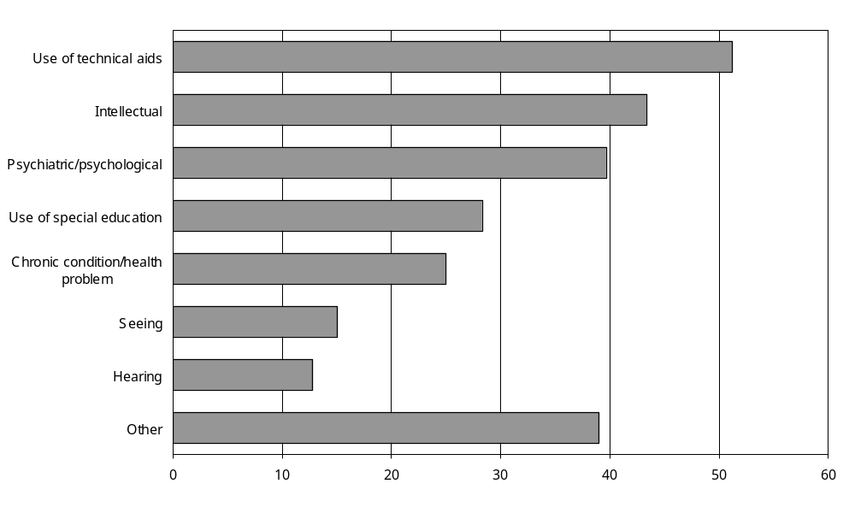
Source: Statistics New Zealand, 2001 Household Disability Survey.
Notes:
- Data in Appendix Table 3.52.
- If individuals reported more than one disability type, they were counted in each applicable disability type group.

Parents or caregivers of children with multiple disabilities were much more likely than the parents or caregivers of children with a single disability to need respite care (30 percent compared with 9 percent).

Parents or caregivers of the majority of children with severe disability (72 percent) said they needed respite care, as did the parents or caregivers of 17 percent of children with moderate disability.

Government help to pay for respite care
In the previous 12 months, parents or caregivers of an estimated 7300 children with disability reported that a government agency, hospital or Ministry of Health service helped to pay for respite care or carer support services. This was 44 percent of the estimated 16,600 children with disability whose parents or caregivers reported needing respite care over this period.

Parents or caregivers who paid for respite care
In the previous 12 months, parents or caregivers of an estimated 4200 children with disability paid for respite care. This was 5 percent of all children with disability or 25 percent of the estimated 16,600 children with disability whose parents or caregivers reported needing respite care over this period.

Free respite care
Parents or caregivers of 6100 children with disability reported receiving some respite care for free in the previous 12 months. This was 37 percent of the estimated 16,600 children with disability whose parents or caregivers reported needing respite care over this period.

Unmet need for respite care
Of the 16,600 children with disability whose parents or caregivers reported they had needed respite care in the previous 12 months, nearly half (48 percent, equivalent to the parents or caregivers of an estimated 8000 children with disability) had been unable to get this respite care.

Parents or caregivers of children with psychiatric/psychological disability were most likely to report an unmet need for respite care (22 percent), followed by parents or caregivers of children using technical aids (18 percent) and parents or caregivers of children with intellectual disability (17 percent). Parents or caregivers of children with hearing disability or seeing disability were the least likely to report an unmet need for respite care (7 percent each).

Parents or caregivers of 14 percent of children with multiple disabilities reported an unmet need for respite care, compared with parents or caregivers of 4 percent of children with a single disability.

Reasons for unmet need for respite care
The most common reason given by parents or caregivers of children with disability for why they did not get the respite care they considered they needed was that they did not know they could apply for free respite care or where to apply for it. This applied to the parents or caregivers of an estimated 3300 children with disability.

The next most common reason was the cost or affordability of respite care (2200), followed by the lack of availability of appropriate respite care in the local area (1200).

Other less common reasons given were that parents or caregivers had applied for financial help but were not eligible (800), and that parents or caregivers did not like the respite care services available (600).

Equipment and technology

Use of equipment and technology

Adults
In 2001 an estimated 207,200 adults with disability (33 percent) were using equipment or technology to assist themselves.

Thirteen percent of adults aged 15–24 with disability used equipment and technology, as did 18 percent of adults aged 25–44, 27 percent of adults aged 45–64 and 54 percent of adults aged 65 and over.

One-third (33 percent) of both males and females with disability were using equipment or technology to help them (calculated from Statistics New Zealand 2002a).

Use of equipment and services for hearing
Adults defined as having a hearing disability were asked to specify the equipment, technology and services they currently used for people who were deaf or hard of hearing.

In the 2001 Household Disability Survey, if an adult had a hearing disability but could hear easily because the hearing disability had been corrected with a hearing aid or some other device, they were not defined as having a hearing disability. Therefore, they were not asked about the types of equipment or services they used for people who were deaf or hard of hearing. This means the information in this section covers equipment and services used by adults with only uncorrected hearing disability.

Of the estimated 212,500 adults with uncorrected hearing disability, some 64 percent or 136,900 were not using any equipment or services for people who were deaf or hard of hearing.

Younger adults were more likely than older adults not to be using any hearing equipment or services, with 80 percent of adults aged 15–44 with hearing disability not using any hearing equipment or services, compared with 41 percent of adults aged 75 and over.

Ten percent of adults with uncorrected hearing disability, an estimated 22,100 adults, used a hearing aid with a T-switch. Eighteen percent, an estimated 39,200 adults, used another type of hearing aid.

Other commonly used types of hearing equipment were:
- volume control telephones, used by 10 percent of adults with hearing disability, an estimated 20,900 adults
- teletext, used by 3 percent of adults with hearing disability, an estimated 6700 adults
- fax machines, used by 2 percent of adults with hearing disability, an estimated 3500 adults
- flashing alarms or visual alarms, used by 1 percent of adults with hearing disability, an estimated 3000 adults
- hearing loop, FM or infrared systems, used by 1 percent of adults with hearing disability, an estimated 2500 adults
- computers to communicate, used by 1 percent of adults with hearing disability, an estimated 2000 adults.

Adults with hearing disability were also asked if they used interpreters or different sign languages and if they could lip read.

Interpreters
The number of adults with uncorrected hearing disability who used a sign language interpreter was too small to report.

Lip reading
Of the estimated 212,500 adults with uncorrected hearing disability, 51,000 or 24 percent could lip read.

Younger adults with hearing disability were more likely than older adults with hearing disability to be able to lip read. For example, 36 percent of adults aged 25–44 with hearing disability could lip read compared with 10 percent of people aged 85 and over.

New Zealand Sign Language and Signed English
Of the estimated 212,500 adults with hearing disability, 6900 or 3 percent used New Zealand Sign Language and an estimated 2400 or 1 percent used Signed English.

Use of equipment for speaking and being understood
Of the estimated 42,500 adults with speaking disability (that is, difficulty speaking and being understood), 1200 or 3 percent used equipment to assist them to speak and be understood.

Because of small numbers, it is not possible to report the kinds of equipment for speaking and being understood used most commonly by adults with speaking disability.

Use of equipment and services for adults with seeing disability
In the 2001 Household Disability Survey, if an adult had a seeing disability but could see easily because the seeing disability had been corrected with glasses, contact lenses or some other device, they were not defined as having a seeing disability. Therefore they were not asked about the types of equipment or services they used for people who were blind or visually impaired. This means the information in this section covers equipment and services used by adults with only uncorrected seeing disability.

Of the estimated 69,300 adults with uncorrected seeing disability, some 49,200 or 71 percent used equipment, technology or services for people who were blind or vision impaired. The remaining 20,100 or 29 percent did not use any of these kinds of equipment, technology or services.
The most commonly used types of equipment were glasses or contact lenses, used by an estimated 39,900 or 58 percent of adults with uncorrected seeing disability.

Other equipment, technology or services used were, in order of frequency:
- handheld or desk-mounted magnifiers, used by 26 percent of adults with seeing disability, an estimated 18,200 adults
- large print reading material, used by 18 percent of adults with seeing disability, an estimated 12,600 adults
- audio reading materials such as talking books, used by 8 percent of adults with seeing disability, an estimated 5500 adults
- white canes, used by 6 percent of adults with seeing disability, an estimated 4100 adults
- readers, used by 4 percent of adults with seeing disability, an estimated 2900 adults
- computers, including voice synthesis computers, used by 3 percent of adults with seeing disability, an estimated 1800 adults
- recording equipment, used by 2 percent of adults with seeing disability, an estimated 1600 adults.

Membership of Royal New Zealand Foundation for the Blind
Adults with uncorrected seeing disability were also asked if they were a member of the Royal New Zealand Foundation for the Blind.

Of the estimated 69,300 adults with uncorrected seeing disability, 8500 or 12 percent were registered members of the Foundation.

Use of equipment for moving about
Sixteen percent of adults with disability, an estimated 99,300 adults, used or needed some kind of equipment to help them move about, such as a walking stick or wheelchair.

Use, or need for, this kind of equipment was heavily age-related, with only 6 percent of people aged 25–44 with disability using or needing equipment for moving about, compared with 37 percent of people aged 75–84 and 56 percent of people aged 85 and over.

In terms of disability type, 27 percent of adults whose main disability was a mobility disability, 19 percent of adults whose main disability was a seeing disability and 17 percent of adults whose main disability was an agility disability used or needed equipment to help move about. By contrast, just 6 percent of adults whose main disability was a hearing disability used or needed equipment to help move about.
Adults whose main disability was caused by disease/illness (22 percent) or ageing (23 percent) were more likely to use or need equipment to help move about than adults whose main disability was caused by accident/injury (14 percent) or a condition present at birth (8 percent).

The rate of use of, or need for, equipment for moving about was greater among adults with multiple disability (24 percent) than among adults with a single disability (4 percent).

It was also greater among adults with severe disability (43 percent) than among adults with moderate disability (24 percent). The percentage of adults with mild disability using or needing equipment to move about was too small to report.

Walking sticks were the type of equipment used most commonly for moving about. Twelve percent of adults with disability, an estimated 74,200 adults, used walking sticks. Older adults with disability were more likely than younger adults with disability to use walking sticks, with 45 percent of the 85 and over age group using walking sticks, compared with 3 percent of the
25–44 age group and 7 percent of the 45–64 age group.

Three percent of adults with disability, an estimated 15,800 people, used walking frames (‘walkers’). This included 14 percent of the 85 and over age group and 7 percent of the 75–84 age group.

An estimated 10,300 adults with disability used crutches and 10,200 used a manual wheelchair.

Equipment used less commonly for moving about included:
- scooters, used by an estimated 4400 adults with disability
- back or leg braces, used by an estimated 3000 adults with disability
- motorised wheelchairs, used by an estimated 1700 adults with disability.

Use of equipment for helping hands or arms
Two percent of adults with disability, an estimated 13,900 adults, used special equipment to support, replace or help them to use their hands or arms.

Of this group, an estimated 2300 used arm braces and 11,200 used other kinds of equipment to help hands or arms.

Use of other equipment
Four percent of adults with disability, an estimated 26,000 adults, used other kinds of equipment because of disability. This is equipment apart from the equipment used for moving about, or to assist hands or arms, covered above.

Of this group, an estimated 3300 used shower stools and 2700 used raised-up toilet seats. The numbers of people using commode chairs, specialised cushions, respirators or ventilators were too small to report.

Overall use of equipment in the previous 12 months
Twenty-seven percent of adults with disability, an estimated 171,000 adults, used some kind of equipment because of disability in the previous 12 months. This included equipment for seeing, hearing, speaking and moving around or to assist hands or arms.

Equipment use was highly age-related, with 53 percent of adults aged 75–84 and 65 percent of adults aged 85 and over with disability using some kind of equipment in the previous 12 months, compared with just 11 percent of adults aged 15–24 and 16 percent of adults aged 25–44.

Rates of equipment use were highest among adults whose main disability was a seeing disability (57 percent), a mobility disability (31 percent), an agility disability (29 percent) or a hearing disability (28 percent). The rate was lowest among adults whose main disability was a psychiatric/psychological disability (8 percent).

Forty-seven percent of adults with severe disability and 45 percent of adults with moderate disability used disability-related equipment in the previous 12 months, compared with just 5 percent of adults with mild disability.

Children
In 2001, an estimated 7700 children with disability (9 percent) were using equipment or technology to assist them.

Use of equipment for seeing
In the 2001 Household Disability Survey, children who used equipment such as glasses that corrected a seeing limitation were not defined as having a seeing disability.

Of the estimated 13,200 children with uncorrected seeing disability, an estimated 700 or 6 percent currently used equipment for seeing, other than glasses or contact lenses.

Use of equipment for hearing
In the 2001 Household Disability Survey, children who wore a hearing aid were defined as having a hearing disability, irrespective of whether the hearing aid corrected their hearing limitation. However, children using other devices, such as grommets, that completely corrected their hearing problem, were not defined as having a hearing disability.

Of the estimated 18,300 children defined as having a hearing disability, an estimated 1600 or 9 percent currently used equipment for hearing, such as a hearing aid or an FM system.

Use of equipment for communicating
Of the estimated 17,400 children with a speaking disability, 1400 or 8 percent currently used equipment for communicating such as a Macaw, communication board or computer.

Use of technical aids
All children participating in the 2001 Household Disability Survey were asked if they currently used various types of special, technical or medical equipment, such as a wheelchair or an artificial arm, hand or foot. They were also asked if they used a special buggy or trolley, a standing frame, a brace, crutches, walking sticks, a walking frame, other kinds of walking aids or any other kind of equipment because of a long-term condition or health problem. These questions were used to identify the children with the disability type classified as ‘uses technical aids’. Results are summarised in Table 3.8.

Table 3.8: Current use of technical aids because of a long-term condition or health problem, children with disability living in households, 2001
 | Estimated number of children | Percentage of children using technical aids (%)
Special buggy or trolley | 1100 | 25
Standing frame | 900 | 20
Brace (not dental brace) | 1000 | 21
Wheelchair | 1100 | 24
Crutches, walking sticks, walking frame or other walking aid | 1100 | 24
Artificial arm, hand or foot | 900 | 20
Other kind or equipment | 2000 | 44
Total (at least one of these types of equipment) | 4600 | 100
Source: Statistics New Zealand, 2001 Household Disability Survey
Note: If individuals reported using more than one type of equipment, they were counted in each applicable group.

An estimated 4600 children used at least one of these kinds of special, technical or medical equipment. This was 5 percent of all children with disability. The three kinds most commonly used (by 1100 children each) were wheelchairs; special buggies and trolleys; and crutches, walking sticks and walking frames. Other commonly-used items were braces (1000), standing frames (900) and artificial limbs (900).
Children using technical aids were more likely than other children with disability to also have the disability type ‘chronic condition/health problem’ (71 percent of children using technical aids compared with 32 percent of other children with disability). They were also more likely than children not using technical aids to have an intellectual disability (36 percent compared with 13 percent) or a special education disability (52 percent compared with 39 percent).

Nearly half (49 percent) of children using technical aids had a disability caused by disease/ illness, compared with 32 percent of other children with disability. They were also more likely than other children to have had a disability since birth (71 percent compared with 40 percent).

Compared with other children with disability, children using technical aids were more likely to have multiple disabilities. Eighty-six percent of children using technical aids had multiple disabilities, compared with 43 percent of other children with disability.

Children using technical aids (55 percent) were also more likely than other children with disability (13 percent) to have a severe disability.

Need for equipment in the previous 12 months
The 2001 Household Disability Survey also asked if children with disability had needed equipment such as special chairs or blood glucose meters in the previous 12 months.

An estimated 8800 children, 10 percent of all children with disability, had needed these kinds of equipment in the previous 12 months.

Children using technical aids (48 percent) were the ones most likely to have needed this kind of equipment. Children with intellectual disability were the next most likely to have done so (19 percent). Children with hearing disability (6 percent) and seeing disability (7 percent) were the least likely to have needed this kind of equipment in the previous 12 months.

Children with severe disability (25 percent) were more likely than children with moderate (10 percent) or mild (4 percent) disability to have needed this kind of special equipment in the previous 12 months.

Unmet need for equipment and technology
In 2001, an estimated 84,200, or 12 percent of, people with disability reported an unmet need for at least one type of equipment or technology.

An estimated 77,100 (or 12 percent) of adults with disability reported an unmet need for at least one type of equipment or technology.

Parents or caregivers of an estimated 7100 (or 8 percent) of all children with disability reported such an unmet need.

Among adults, unmet need for equipment and technology tended to increase with age. Five percent of adults aged 15–24 and 14 percent of adults aged 65 and over reported an unmet need.

Adults

Unmet need for hearing equipment and services
Twenty-one percent of adults with hearing disability, an estimated 45,000 adults, indicated they had unmet needs for equipment or services for people who were deaf or hard of hearing. This included an estimated:
- 17,500 adults with hearing disability who said they needed, but did not have, hearing aids with a T-switch
- 17,000 adults with hearing disability who said they needed, but did not have, another type of hearing aid
- 5000 adults with hearing disability who said they needed, but did not have, a volume control telephone.

Men with hearing disability (24 percent) were more likely than women with hearing disability (18 percent) to report unmet needs for hearing equipment or services.

In terms of age, rates of reported unmet need among adults with hearing disability varied from a high of 26 percent in adults aged 45–64 to a low of 11 percent in adults aged 25–44.

Affordability was the most common reason adults with hearing disability gave for why they had unmet needs for hearing equipment and services, with an estimated 23,000 reporting unmet needs for this reason. As well, an estimated:
- 7000 had unmet needs, because they had never been assessed
- 5900 had unmet needs, because they did not know they could apply for financial help or where to apply
- 4100 had unmet needs, because they did not know where to get the equipment or services they needed.

Unmet need for equipment for speaking and being understood
Of the estimated 42,500 adults with speaking disability, 1400 or 3 percent reported they needed, but did not have, equipment for people who had difficulty speaking and being understood.

Unmet need for equipment or services for adults with seeing disability
Of the estimated 69,300 adults with seeing disability, 14,000 or 20 percent, indicated they had unmet needs for equipment or services for blind or vision impaired adults.

More than two-thirds of this group, an estimated 10,700 adults, had unmet needs for glasses or contact lenses.

The numbers of adults with unmet needs for other types of equipment or services for blind or vision impaired adults, such as large print reading materials or guide dogs, were too small to report.

Cost or affordability was the most common reason adults with seeing disability gave for why they did not have the seeing equipment or services they needed. More than half (58 percent) of adults with unmet needs gave this as a reason for their unmet need.

Twenty percent, an estimated 2800 adults with seeing disability, indicated they had unmet needs because they had never been assessed; while 19 percent, an estimated 2700 adults with seeing disability, indicated they had unmet needs because they did not know they could apply for financial help or where to apply.

Unmet need for equipment for moving about
Of the estimated 99,300 adults with disability who used equipment to move about, 8500 or 9 percent indicated they had unmet needs for additional mobility aids and equipment, including an estimated:
- 2200 who said they needed, but did not have, manual wheelchairs
- 1600 who said they needed, but did not have, scooters
- 1400 who said they needed, but did not have, motorised wheelchairs.

Unmet need for equipment for helping hands or arms
An estimated 2200 adults with disability reported they needed, but did not have, equipment to support, replace or help them to use their hands or arms. This was 16 percent of the adults already using this type of equipment. Of this group, 75 percent needed other kinds of equipment. Sixty-eight percent cited affordability as a reason why they did not have the equipment they needed.

Unmet need for other equipment
Two percent of adults with disability, an estimated 14,600 people, indicated they needed, but did not have, other kinds of equipment for disability that had not been identified in previous questions in the 2001 Household Disability Survey. This included equipment such as shower stools, raised-up toilet seats, commode chairs, specialised cushions, respirators or ventilators.

Of those who reported unmet needs for these other kinds of equipment, 56 percent cited affordability as a reason for this unmet need. Twenty-two percent indicated that they did not know they could apply for financial help or where to apply, and 17 percent indicated they did not know where to get the equipment they needed.

Children

Current unmet need for equipment
Parents or caregivers of children with disability taking part in the 2001 Household Disability Survey were asked if their child currently needed any disability-related equipment that they did not have. An estimated 5500 children with disability were reported to not have equipment they needed. This was 6 percent of all children with disability.

Children already using technical aids were most likely to have an unmet need for equipment (24 percent). Thirteen percent of children with hearing disability had an unmet need for equipment, as did 10 percent of children with seeing or intellectual disability, and 7 percent of children with a chronic condition/health problem. Six percent of children with a psychiatric/ psychological disability and 6 percent of children with a special education disability had an unmet need for equipment.

The most commonly reported unmet need was for equipment to help with hearing (Table 3.9).

Table 3.9: Reported unmet need for equipment, children with disability living in households, 2001
 | Estimated number of children with disability
Unmet need for equipment to help with seeing | 1000
Unmet need for equipment to help with hearing | 1600
Unmet need for equipment to help with speaking or communicating | 1000
Unmet need for equipment to help with standing or moving around | 1100
Unmet need for another type of equipment | 1200
Total with unmet need for equipment | 5500
Source: Statistics New Zealand, 2001 Household Disability Survey
Note: If individuals reported an unmet need for more than one type of equipment, they were counted in each applicable group.

The most common reason given for why children with disability did not have the equipment they needed was affordability. This applied to an estimated 2500 children with disability.

Other common reasons were that parents or caregivers:
- did not know where to get the equipment their child needed (applicable to an estimated 1000 children with disability)
- did not know they could apply for financial help or where to apply for financial help to buy the equipment their child needed (applicable to an estimated 900 children with disability).
- had not had their child assessed (applicable to an estimated 900 children with disability).

Unmet need for equipment in the previous 12 months
Parents or caregivers of the 8800 children with disability who had needed special equipment such as a special chair or blood glucose meter in the previous 12 months, were asked if their children had an unmet need for this kind of equipment during this time.

Parents or caregivers of 30 percent of these children reported they had an unmet need for equipment in the previous year. This was an estimated 2700 children, or 3 percent of all children with disability.

In the previous year, the most common reason for not being able to get special equipment was affordability, cited by the parents or caregivers of an estimated 1400 children with disability. The next most common reason was that parents or caregivers did not know they could apply for financial help or where they could apply (an estimated 700 children).

Payment and subsidies for equipment

Adults

Received government assistance for equipment
Of the 171,000 adults with disability who had used some kind of equipment because of disability in the previous 12 months, an estimated 47,500 or 28 percent had obtained at least some of this equipment on loan or free from a government agency.

An estimated 12,500 or 7 percent had received financial help from a government agency in the previous 12 months, so they could lease or buy disability-related equipment.

Self-funded equipment
Of the 171,000 adults with disability who had used some kind of disability-related equipment in the previous 12 months, an estimated 38,800 or 23 percent bought or leased at least some of this equipment themselves.

Children

Received government assistance for equipment
Parents or caregivers of children with disability who had needed any equipment in the previous 12 months were asked if their child had received a Special Needs Grant over this time to pay for any disability-related equipment. The number of children who received a Special Needs Grant for this reason was too small to report.

Parents or caregivers of children with disability who had needed any equipment in the previous 12 months were also asked if, over this time, they had received any other financial help from a government agency to lease or buy equipment related to their child’s condition or health problem.

The parents or caregivers of an estimated 1000 children (12 percent of all children with disability needing special equipment) had received this kind of financial help in the previous 12 months.

Equipment paid for by parents or caregivers
In the previous 12 months, parents or caregivers of an estimated 3100 children with disability paid for disability-related equipment for their child themselves. This was the parents or caregivers of 35 percent of the children with disability needing disability-related equipment.

Disposable items

Use of disposable items

Adults
Eleven percent of adults with disability, an estimated 71,500 adults, needed disposable items in the previous 12 months for their condition or health problem. Examples of disposable items include batteries, needles, incontinence pads, colostomy bags and catheters.

Older adults were more likely than younger adults to need disposable items, with 17 percent of adults aged 75–84 and 24 percent of adults aged 85 and over with disability needing disposable items, compared with 7 percent of adults aged 15–24 and 9 percent aged 25–44 and 45–64.

Children
Eleven percent of children with disability, an estimated 9600 children, had needed disposable items such as hearing aid batteries, needles or dressings in the previous 12 months because of their condition or health problem.

Children with disability aged 0–4 (18 percent) were more likely to have needed disposable items than children aged 5–9 (9 percent) and 10–14 (9 percent).

Children using technical aids (38 percent) were the most likely to have needed disposable items in the previous year, while children with seeing disability (9 percent) were the least likely.

Nineteen percent of children with severe disability had needed disposable items in the previous year, compared with 11 percent of children with moderate disability and 7 percent of children with mild disability.

Unmet need for disposable items

Adults
Of the 71,500 adults with disability who required disposable items for their condition or health problem in the previous 12 months, an estimated 4900 or 7 percent reported they currently needed certain disposable items but did not have them. This was 1 percent of all adults with disability.

Affordability was the most common reason for not having these disposable items, cited by 62 percent of adults with an unmet need for disposable items. The next most common reason was not knowing they could apply for financial help or where to apply, cited by 29 percent.

Children
An estimated 1200 children with disability had needed certain disposable items in the previous year, but had not been able to get them. This was 13 percent of all children requiring disposable items in the previous year and 1 percent of all children with disability.

The most common reason given by parents or caregivers for why these children were not able to get the disposable items they needed was affordability. This applied to an estimated 800 children.

Payment and subsidies for disposable items

Adults
Of the estimated 71,500 adults with disability needing disposable items in the previous 12 months, some 11,900 or 17 percent received financial help from a government agency to buy disposable items. Some 47,800 or 67 percent paid for disposable items themselves over this time.

Children
Of the 9600 children with disability needing disposable items in the previous year, 4100 or 43 percent received financial help from a government agency to pay for disposable items. The parents or caregivers of an estimated 4900 or 51 percent of the children paid for disposable items themselves.

Special dietary items

Need for special diets

Adults
Nine percent of adults with disability, an estimated 58,100 people, had needed something special in their diet in the previous 12 months because of disability.

The need for special dietary items varied by age, ranging from a high of 13 percent in the adults aged 15–24 to 7 percent in the adults aged 75–84.

Children
In the previous 12 months, 14 percent of all children with disability, an estimated 12,900 children, needed something special in their diet because of their condition or health problem.

Children using technical aids (34 percent) and children with chronic conditions/health problems (26 percent) were most likely to have needed special dietary items. Children with hearing disability (7 percent) were least likely to have needed special diets.

Children with severe disability (30 percent) were more likely than children with moderate (14 percent) or mild (10 percent) disability to have needed special diets.

Unmet need for dietary items

Adults
Of those adults needing special dietary items because of their condition or health problem in the previous 12 months, an estimated 10,400 or 18 percent were unable to get some of the dietary items they needed over this time.

The most common reason adults with disability had unmet dietary needs was affordability. This reason was cited by 91 percent of adults with disability with unmet dietary needs.

Children
In the previous year, the parents or caregivers of 36 percent of children with disability who had needed special dietary items had been unable to get these items. This was 4600 children or 5 percent of all children with disability.

By far the most common reason identified for why children were unable to get the special dietary items they needed was affordability. This reason was given by parents or caregivers of an estimated 3200 children with disability.

Payment and subsidies for dietary items

Adults

Government assistance for dietary items
Of the estimated 58,100 adults with disability who had needed something special in their diet in the previous 12 months as a result of disability, 5500 or 9 percent received financial help from a government agency to buy these special items.

Paid for dietary items
An estimated 40,500 or 70 percent of adults with disability who needed something special in their diet in the previous 12 months paid for these special items over this time.

Children

Government assistance for dietary items
Parents or caregivers of an estimated 2400 children with disability received financial help in the previous 12 months from a government agency to pay for their child’s disability-related dietary needs. This was the parents or caregivers of 18 percent of children with disability-related dietary needs.

Dietary items paid for by parents or caregivers
Over the same time, parents or caregivers of 2600 children with disability-related dietary needs paid for special dietary items for their child. This was the parents or caregivers of 20 percent of all children with disability-related dietary needs.

Needs assessments
A needs assessment is a process in which all of a person’s care and support needs for everyday living are identified and prioritised with a needs assessor. This includes needs for home help, personal care, respite care, equipment, technology and building modifications.

At the time of the 2001 Household Disability Survey, needs assessments could be carried out by needs assessors from agencies funded by the Ministry of Health (for example, community-based Needs Assessment and Service Co-ordination agencies), Special Education Services (SES) and Child, Youth and Family.,
After they have been assessed, people with disability are provided with the most appropriate services and support options, depending on the funding and services available in their area.

Adults
Fifteen percent of adults with disability, an estimated 95,400 adults, had received a needs assessment.

Adults with disability in the older age groups were more likely to have received a needs assessment – 24 percent of adults aged 75–84 and 37 percent of adults aged 85 and over (Figure 3.4).

Figure 3.4: Percentage of adults with disability living in households who had ever received a needs assessment, by age, 2001
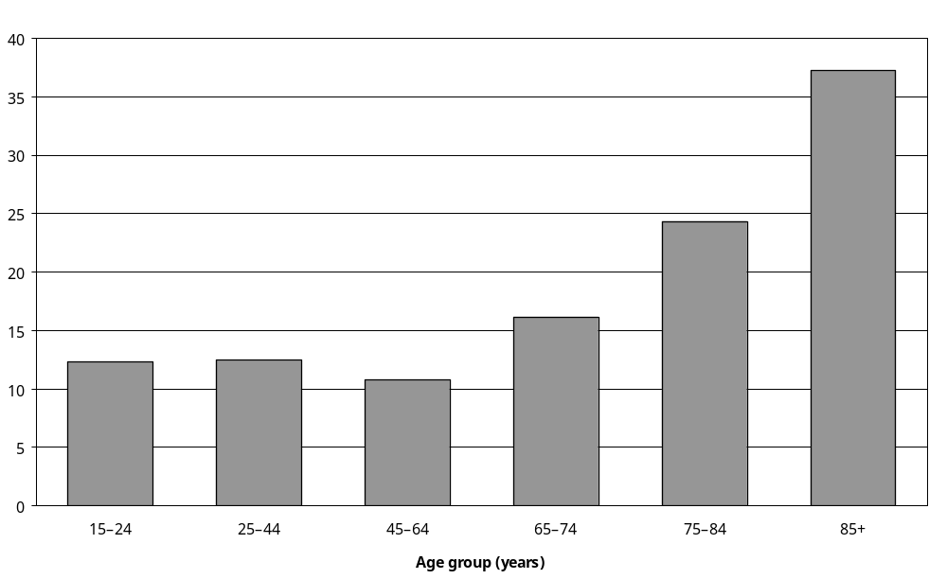
Source: Statistics New Zealand, 2001 Household Disability Survey.
Note: Data in Appendix Table 3.137.

Eighteen percent of women and 12 percent of men with disability had received needs assessments.

European (16 percent) and Mäori (15 percent) adults with disability were more likely to have received a needs assessment than Pacific (8 percent) or Asian/Other (8 percent) adults with disability.

Almost half (48 percent) of all adults whose main disability was an intellectual disability had received a needs assessment, compared with:
- 20 percent of adults whose main disability was a mobility disability
- 17 percent of adults whose main disability was a seeing disability
- 16 percent of adults whose main disability was a psychiatric/psychological disability
- 15 percent of adults whose main disability was an agility disability
- 6 percent of adults whose main disability was a hearing disability.
(See Figure 3.5.)

Figure 3.5: Percentage of adults with disability living in households who had ever received a needs assessment, by main disability, 2001
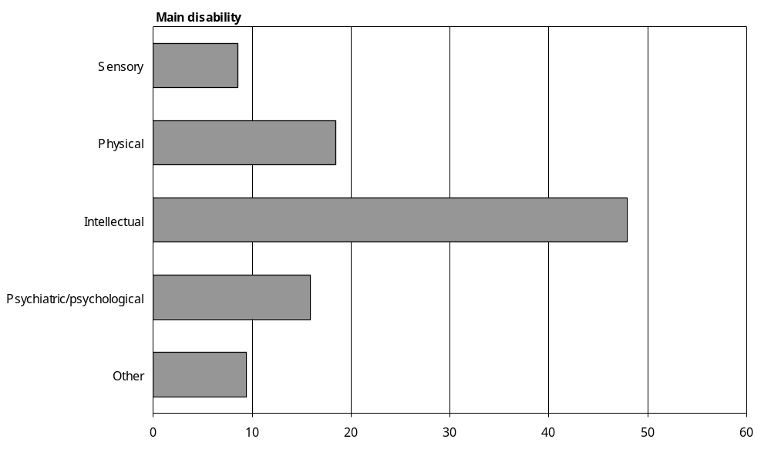
Source: Statistics New Zealand, 2001 Household Disability Survey.
Note: Data in Appendix Table 3.137.

More than a third (36 percent) of adults with severe disability had had a needs assessment, compared with 19 percent of adults with moderate disability and 6 percent of adults with mild disability.

When were needs assessments done?
Almost a third (31 percent) of the adults with disability who had received a needs assessment had received their most recent assessment in the previous six months. A further 26 percent had received their most recent assessment between 6 and 11 months ago.

The remaining 42 percent, an estimated 40,200 adults with disability, had received their most recent needs assessment 12 months ago or more.

Booked in for a needs assessment
The 2001 Household Disability Survey asked adults with disability who had never had a needs assessment or had had their most recent needs assessment 12 months ago or more, if they were booked in to have a needs assessment. An estimated 8700 of the adults in this group were booked in to have a needs assessment, the equivalent of 1 percent of all adults with disability living in households. An estimated 521,100 were not booked in.

Intention to have a needs assessment
Of the 521,100 not booked in to have a needs assessment, an estimated 27,400 (5 percent) indicated they intended to have a needs assessment.

Reasons for not having a needs assessment recently
Thirty-four percent of adults with disability indicated they had not had a needs assessment recently (that is, less than 12 months ago) because they did not know about needs assessments. This included 32 percent of adults aged 65–74, 29 percent of adults aged 75–84 and 33 percent of adults aged 85 and over.

Pacific adults with disability (50 percent) were most likely to indicate they had not had a needs assessment recently because they did not know about them, followed by Asian/Other (44 percent), Mäori (41 percent) and European (33 percent) adults with disability.

Adults with hearing disability (36 percent) were most likely to report they had not been assessed recently because they did not know about needs assessments, and adults with intellectual disability were least likely to say this was so (23 percent).

Lack of awareness or knowledge of needs assessments varied little by the severity of disability. Thirty-four percent of adults with severe disability indicated they had not had a needs assessment recently because they did not know about needs assessments, as did 35 percent of adults with moderate disability and 34 percent of adults with mild disability.

Thirty-three percent of adults with disability, an estimated 209,100 people, indicated they had not had a needs assessment recently because they did not consider their disability to be serious enough. Even 15 percent of adults with severe disability indicated they had not had a needs assessment recently for this reason.

Three percent had not had a needs assessment recently because they considered their needs had not changed since their last assessment. Approximately 1 percent, an estimated 6600 adults with disability, indicated they had declined to have a needs assessment when it had been offered to them.

Children
Fifteen percent of children with disability, an estimated 13,200 children, had received a needs assessment. This was the same as the proportion of adults with disability who had received a needs assessment.

Eighteen percent of European children with disability had received a needs assessment, compared with 10 percent of Mäori and 11 percent of Pacific children.

Children with disability in the Southern region were most likely to have had a needs assessment (24 percent), compared with 8 percent of children in the Midland region, 13 percent in the Northern region and 14 percent in the Central region.

The likelihood of ever having received a needs assessment also varied by the type of disabilities children had. For example, over half the children using technical aids (56 percent) had received a needs assessment, compared with just 9 percent of children with hearing disability (Figure 3.6).

Figure 3.6: Percentage of children with disability living in households who had ever received a needs assessment, by disability type, 2001
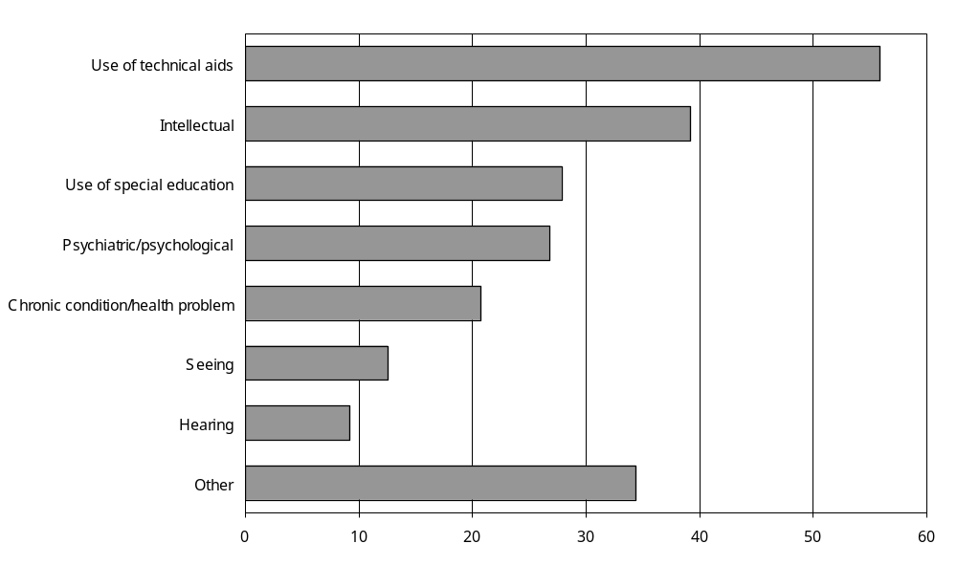
Source: Statistics New Zealand, 2001 Household Disability Survey.
Notes:
- Data in Appendix Table 3.142.
- If individuals reported more than one disability type, they were counted in each applicable disability type group.
Children with multiple disabilities were more than four times as likely as children with a single disability to have received a needs assessment (25 percent compared with 6 percent).

Nearly half (48 percent) of children with severe disability had received a needs assessment, compared with 14 percent of children with moderate disability and 3 percent of children with mild disability.

When were needs assessments done?
Just over a third (35 percent) of children with disability who had received a needs assessment had received their most recent assessment within the previous 6 months. A further 29 percent had received their most recent assessment 6 to 11 months ago, while the remaining 36 percent had received their most recent assessment 12 months ago or more.

Booked in for a needs assessment
At the time of the 2001 Household Disability Survey, an estimated 1100 children, or 1 percent of all children with disability, were booked in to have a needs assessment. This included children scheduled to have a needs assessment for the first time and children who had had a needs assessment before.

Intention to have a needs assessment
Parents or caregivers of an estimated 8300 children with disability who had not had a needs assessment in the previous year and were not already booked in for another assessment indicated they intended to have another assessment done for their child. This was equivalent to 9 percent of all children with disability.

Reasons for not having a needs assessment recently
When the parents or caregivers of children with disability who had not had a needs assessment recently were asked the reasons for this, the most common reason given was that they did not consider their children’s disability to be serious enough to require a needs assessment. This reason was given by the parents or caregivers of an estimated 34,500 children; 38 percent of all children with disability.

Parents or caregivers of children from higher-income households were more likely than those of children from lower-income households to consider their child’s condition to be not serious enough for a needs assessment (47 percent of children with households incomes of $50,001 and over per year, compared with 31 percent of children from households with incomes of $15,000 and under per year).

Similarly, parents or caregivers of children with disability living in the least socioeconomically deprived areas of New Zealand were more likely than those living in the most socioeconomically deprived areas to consider their child’s condition was not serious enough for a needs assessment. This applied to 46 percent of children living in NZDep2001 areas 1–2 (the least deprived), compared with 35 percent of children living in NZDep2001 areas 9–10 (the most deprived).

Parents and caregivers of children with seeing and hearing disabilities were most likely to say their child’s condition was not serious enough for a needs assessment (38 percent and 36 percent respectively). The parents and caregivers of children with intellectual disability and children who used technical aids were the least likely to say this was so (16 percent and 18 percent respectively).

Having a condition not serious enough for a needs assessment was more common among children with a single disability (50 percent) compared with children with multiple disabilities (24 percent). As might be expected, it was also more common among children with mild disability (52 percent) than among children with moderate or severe disability (34 percent and 14 percent respectively).

The second most common reason for not having needs assessments was that parents or caregivers did not know about needs assessments. This reason was given by the parents or caregivers of 35 percent of all children with disability; an estimated 31,900 children.

Not knowing about needs assessments was a reason given more commonly by parents or caregivers of Mäori (43 percent), Pacific (47 percent) and Asian/Other children with disability (50 percent) than by parents or caregivers of European children with disability (30 percent).

Parents or caregivers of children with disability from the Midland region were most likely to say they did not know about needs assessments (42 percent). Parents or caregivers of children with disability living in the Southern region were least likely to say they did not know about needs assessments (27 percent). Thirty-five percent of parents or caregivers of children with disability from both the Northern and Central regions were unaware of needs assessments.

A lack of knowledge of needs assessments was also more common among parents or caregivers of children with disability from low income households than among parents or caregivers of children with disability from high-income households. Parents or caregivers of 38 percent of children with disability who had household incomes of $15,000 and under per year did not know about needs assessments, compared with parents or caregivers of 25 percent of children with disability who had household incomes of $50,001 and over per year.

Similarly, parents or caregivers of children with disability living in the most socioeconomically deprived areas of New Zealand (NZDep2001 areas 9–10 – 43 percent) were more likely to be unaware of needs assessments than parents or caregivers of children with disability living in the least socioeconomically deprived areas (NZDep2001 areas 1–2 – 26 percent).

Other reasons were also given for why some children with disability had not had a recent needs assessment. In the case of an estimated 2600 children, their parents or caregivers considered the child’s needs had not changed since their last assessment. In the case of an estimated 1100 children, their parents or caregivers indicated that needs assessments were not available to them.

Health services
In the 2001 Household Disability Survey, people with disability were asked questions about the health services they had used or needed in the previous 12 months. This included asking how often they had consulted with different types of health worker such as GPs or family doctors, chemists or pharmacists, medical specialists, and nurses.

When considering the results for these and other questions in this section, it is important to remember that they refer to consultations with health services for any reason, not just consultations specifically relating to disability. Non-disability related consultations could be for routine screening, ante-natal care, immunisations, or for treatment for short-term illnesses or minor accidents.

Use of different kinds of health care worker
The four types of health worker most commonly consulted by adults with disability were:
- GPs or family doctors, consulted at least once in the previous 12 months by 86 percent of adults with disability
- chemists or pharmacists, consulted at least once in the previous 12 months by 76 percent of adults with disability
- medical specialists, consulted at least once in the previous 12 months by 40 percent of adults with disability
- nurses (without also seeing a doctor), consulted at least once in the previous 12 months by 32 percent of adults with disability.

Similarly, most children with disability (88 percent) had consulted a GP or family doctor at least once in the previous 12 months. Children were next most likely to have consulted a dentist or dental nurse (71 percent), followed by a chemist or pharmacist (61 percent), a medical specialist (42 percent) and a nurse without also seeing a doctor (30 percent) (Figure 3.7).

Figure 3.7: Percentage of people (adults and children) with disability using different types of health services in the previous 12 months, 2001
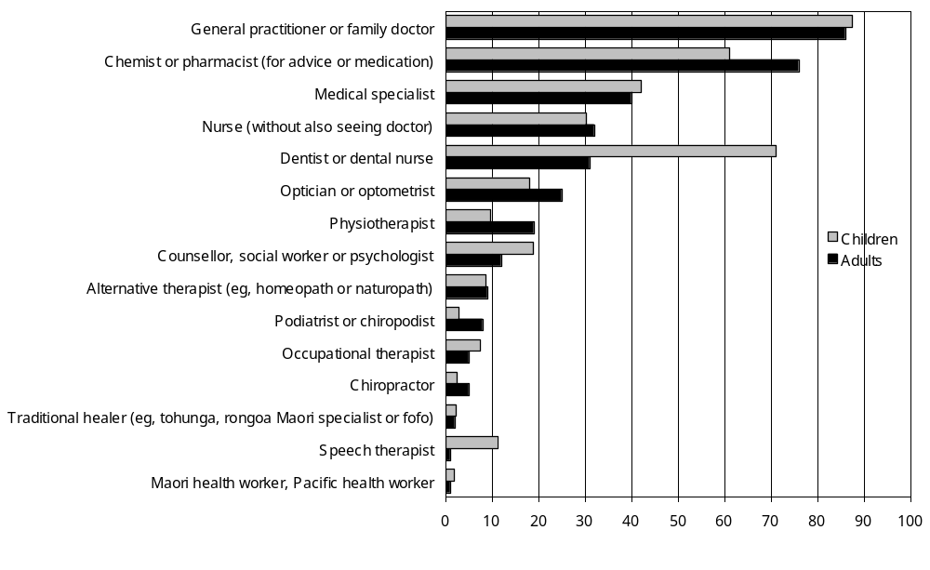
Source: Statistics New Zealand, 2001 Household Disability Survey
Notes:
- Data in Appendix Tables 3.150 and 3.151.
- If individuals reported using more than one type of health service, they were counted in each applicable service category.

Use of general practitioners or family doctors

Adults

At least one consultation
As already indicated, 86 percent of adults with disability had consulted a GP or family doctor at least once in the previous 12 months. This was an estimated 541,000 adults with disability.

Older adults were slightly more likely than younger adults to have consulted a GP or family doctor. Ninety-one percent of adults aged 65 and over consulted a GP or family doctor, compared with 84 percent of adults aged 15–64.

Eighty-eight percent of women and 85 percent of men had consulted a GP or family doctor at least once in the previous 12 months.

Ninety percent of adults whose main disability was a mobility disability consulted a GP or family doctor at least once in the previous 12 months, as did 90 percent of adults whose main disability was an agility disability. Adults whose main disability was a hearing disability had the lowest rate of GP contact, with 79 percent consulting a GP or family doctor at least once in the previous 12 months.

Virtually all adults with severe (97 percent) or moderate (92 percent) disability consulted a GP or family doctor at least once in the previous 12 months. By contrast, only 78 percent of adults with mild disability consulted a GP or family doctor over this period.

More than 10 consultations
Eighteen percent of adults with disability, an estimated 111,700 people, consulted a GP or family doctor more than 10 times in the previous 12 months.

Asian/Other adults with disability were more likely than European, Mäori and Pacific adults with disability to have consulted with a GP or family doctor more than 10 times (Figure 3.8).

Figure 3.8: Percentage of adults with disability who consulted a general practitioner or family doctor more than 10 times in the previous 12 months, by ethnic group, 2001
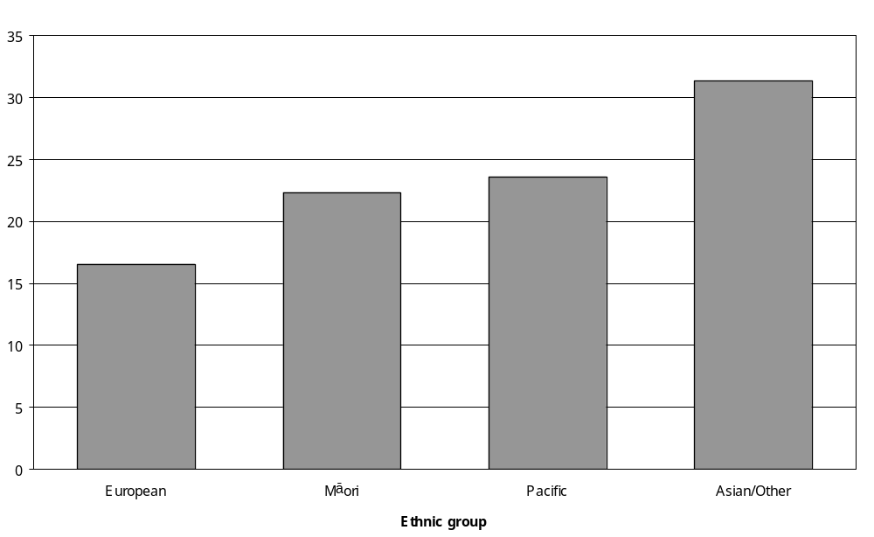
Source: Statistics New Zealand, 2001 Household Disability Survey.
Note: Data in Appendix Table 3.152.

Twenty-two percent of adults whose main disability was a psychiatric/psychological disability and 20 percent of adults whose main disability was a mobility disability consulted a GP or family doctor 10 times or more in the previous 12 months. By contrast, just 9 percent of adults whose main disability was a hearing disability consulted a GP or family doctor 10 times or more.

Children

At least one consultation
As already indicated, most children with disability (88 percent) consulted a GP or family doctor at least once in the previous 12 months. This was an estimated 78,800 children with disability.

Virtually all children aged 0–4 consulted a GP or family doctor (97 percent), but children aged 5–9 and 10–14 had lower rates of contact (88 percent and 83 percent respectively).

Children using technical aids were most likely to consult a GP or family doctor in the previous year (95 percent), followed by children with chronic conditions or health problems (92 percent). Children with hearing disability (84 percent) and children with a special education disability (84 percent) were the least likely to consult a GP or family doctor over this period.

Children with a disability caused by disease/illness were most likely to have consulted a GP or family doctor in the previous 12 months (94 percent), compared with 86 percent of children with a disability caused by accident/injury, 89 percent of children with a disability caused by a condition present since birth and 81 percent of children whose disability was caused by ‘other’ factors.

Compared with children with moderate (87 percent) or mild (86 percent) disability, a greater proportion of children with severe disability (96 percent) had consulted a GP or family doctor in the previous year.

More than 10 consultations
Fifteen percent of all children with disability had consulted a GP or family doctor more than 10 times in the previous 12 months. This was an estimated 13,600 children.

Children with disability aged 0–4 were nearly three times more likely than children with disability aged 5–9 to have consulted a GP or family doctor more than 10 times in the previous 12 months (37 percent compared with 13 percent). Children with disability aged 10–14 were the least likely to have consulted a GP or family doctor more than 10 times (8 percent).

One in four children using technical aids (25 percent) consulted a GP or family doctor more than 10 times in the previous 12 months, as did 24 percent of children with chronic conditions or health problems. By contrast, just 11 percent of children with special education disability and 12 percent of children with seeing disability consulted a GP or family doctor this often.

Twenty-four percent of children whose disability was caused by disease/illness consulted a GP or family doctor at least 10 times in the previous 12 months, compared with 17 percent of children whose disability had existed since birth (Figure 3.9).

One in four children with severe disability (25 percent) consulted a GP or family doctor more than 10 times in the previous 12 months. This was higher than the rates for children with moderate (13 percent) and mild (13 percent) disability.

Figure 3.9: Percentage of children with disability who consulted a general practitioner or family doctor more than 10 times in the previous 12 months, by disability type, 2001
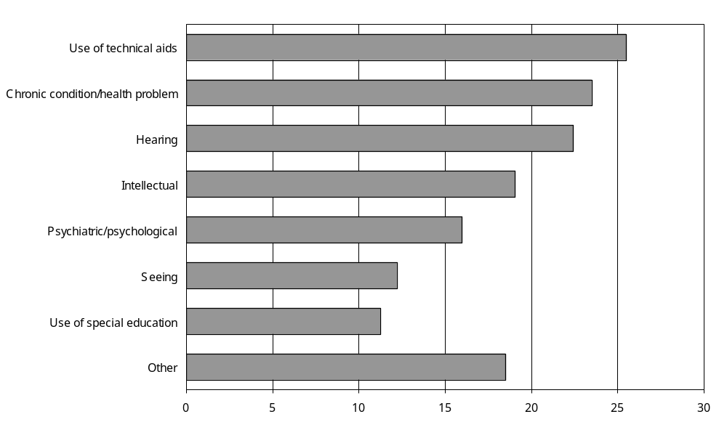
Source: Statistics New Zealand, 2001 Household Disability Survey.
Notes:
- Data in Appendix Table 3.153.
- If individuals reported more than one disability type, they were counted in each applicable disability type group.

Use of chemists or pharmacists

Adults

At least one consultation
Seventy-six percent of adults with disability, an estimated 473,700 adults, consulted a chemist or pharmacist for health advice or to get medication at least once in the previous 12 months.

Adults with disability aged 85 and over (80 percent) were slightly more likely to consult a chemist or pharmacist for health advice or medication than in younger adults.

Asian/Other adults with disability (65 percent) were less likely than European adults with disability (77 percent) to consult a chemist or pharmacist.

Eighty-four percent of adults with a main disability caused by disease/illness consulted a chemist or pharmacist in the previous 12 months, compared with 70 percent of adults with a main disability caused by ageing and 64 percent of adults with a main disability caused by a condition present at birth.

Adults with severe (82 percent) and moderate (81 percent) disability were more likely than adults with mild disability (68 percent) to consult a chemist or pharmacist.

More than 10 consultations
Twenty-four percent of adults with disability, an estimated 148,700 adults, consulted a chemist or pharmacist for health advice or to get medication more than 10 times in the previous 12 months.

In terms of age, adults aged 75–84 were the most likely to consult a chemist or pharmacist more than 10 times in the year (30 percent). Adults aged 15–24 were the least likely to do so (10 percent).

A third (33 percent) of adults whose main disability was caused by disease/illness consulted a chemist or pharmacist more than 10 times in the previous 12 months, compared with 19 percent of adults whose main disability was caused by ageing, and 16 percent of adults whose main disability was caused by a condition present at birth.

Thirty-seven percent of adults with severe disability consulted a chemist or pharmacist more than 10 times in the year, compared with 28 percent of adults with moderate disability and 16 percent of adults with mild disability.

Children

At least one consultation
The parents or caregivers of 61 percent of children with disability, an estimated 54,900 children, consulted a chemist or pharmacist for health advice or medication for their child in the previous 12 months.

Parents or caregivers of children aged 0–4 with disability (73 percent) were more likely to have consulted a chemist or pharmacist than parents or caregivers of children aged 5–9 (61 percent) or aged 10–14 with disability (56 percent).

In terms of disability type, parents or caregivers of children with chronic conditions or health problems were the most likely to have consulted a chemist or pharmacist about their child in the previous 12 months (77 percent). Parents or caregivers of children with seeing disability were the least likely to have done so (51 percent) (Figure 3.10).

Figure 3.10: Percentage of children with disability who consulted a chemist or pharmacist at least once in the previous 12 months, by disability type, 2001
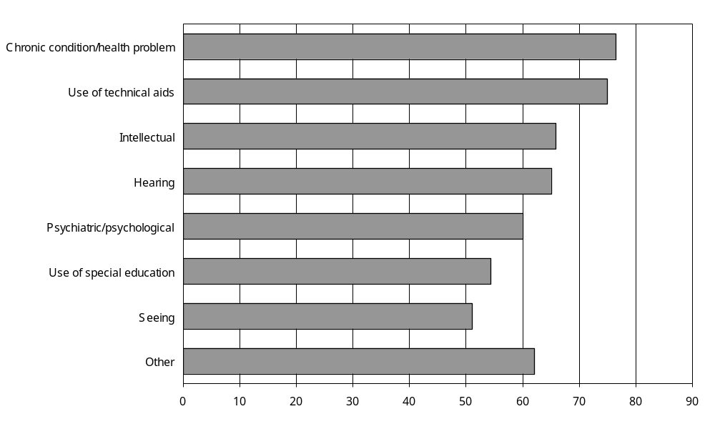
Source: Statistics New Zealand, 2001 Household Disability Survey
Notes:
- Data in Appendix Table 3.155.
- If individuals reported more than one disability type, they were counted in each applicable disability type group.

Parents or caregivers of nearly three-quarters (74 percent) of children with disability caused by disease/illness consulted a chemist or pharmacist about their child, compared with 61 percent of parents or caregivers of children with disability caused by a condition present since birth, 48 percent of parents or caregivers of children with disability caused by accident/injury, and 56 percent of parents or caregivers of children with disability caused by ‘other’ factors.

More than 10 consultations
The parents or caregivers of 14 percent of children with disability, an estimated 12,400 children, had consulted a chemist or pharmacist more than 10 times in the previous 12 months on their child’s behalf.

Parents or caregivers of children aged 0–4 (22 percent) were more likely than parents or caregivers of children aged 10–14 (11 percent) to consult a chemist or pharmacist this frequently.

Parents or caregivers of children using technical aids were most likely to have seen a chemist or pharmacist more than 10 times in the previous 12 months (25 percent). Parents or caregivers of children with seeing disability were least likely to have done so (10 percent).

Parents or caregivers of children with disability caused by disease/illness (22 percent) were most likely to have consulted a chemist or pharmacist more than 10 times, followed by parents or caregivers of children with disability caused by a condition present at birth (15 percent) and parents or caregivers of children who had a disability from ‘other’ causes (11 percent).

The parents or caregivers of more than a quarter of children with severe disability (27 percent) had seen a chemist or pharmacist about their child more than 10 times in the previous 12 months. By contrast, just 13 percent of parents or caregivers of children with moderate disability and 10 percent of parents or caregivers of children with mild disability had seen a chemist or pharmacist this often.

Use of medical specialists

Adults

At least one consultation
Forty percent of adults with disability, an estimated 252,600 adults, consulted a medical specialist in the previous 12 months. Medical specialists are doctors specialising in certain areas of medicine, for example, cardiology, general surgery, obstetrics or psychiatry.

Adults with disability aged between 45 and 74 were the most likely to consult a medical specialist, with 45 percent of adults aged 45–64 and 43 percent of adults aged 65–74 seeing a specialist in the previous 12 months. This compared with 29 percent of adults aged 15–24 and 38 percent of adults aged 75–84.

Forty-one percent of women and 40 percent of men had consulted a medical specialist in the previous 12 months.

Compared with European adults with disability (42 percent), smaller proportions of Pacific (29 percent) and Mäori (35 percent) adults with disability consulted a medical specialist at least once in the previous 12 months.

Adults from the lowest income households ($15,000 and under per year) were the least likely to consult a medical specialist (33 percent), compared with 42 percent of adults from the highest income households ($70,001 and over per year), 43 percent of adults with household incomes of $15,001–$30,000 and $30,001–$50,000 per year, and 38 percent of adults with household incomes of $50,001–$70,000 per year.

Just over half of adults with a main disability caused by disease/illness (51 percent) consulted a medical specialist at least once in the previous 12 months, compared with 27 percent of adults whose main disability was caused by a condition present since birth.

Thirty-nine percent of adults with a main disability caused by accident/injury consulted a medical specialist, as did 30 percent of adults with a main disability caused by ageing and 37 percent of adults with a main disability caused by ‘other’ factors.

Adults with multiple disability were more likely (45 percent) than adults with a single disability (33 percent) to consult a medical specialist.

Similarly, 56 percent of adults with severe disability consulted a medical specialist, compared with 44 percent of adults with moderate disability and 32 percent of adults with mild disability.

More than 10 consultations
Two percent of adults with disability, an estimated 14,900 adults, consulted a medical specialist more than 10 times in the previous 12 months.

Children

At least one consultation
Forty-two percent of children with disability, an estimated 32,800 children, consulted a medical specialist such as a paediatrician or surgeon at least once in the previous 12 months.

A much larger proportion of younger than older children with disability consulted a medical specialist. Sixty-three percent of children aged 0–4 consulted a specialist, compared with 38 percent of children aged 5–9 and 10–14.

Forty-seven percent of European children with disability consulted a medical specialist, compared with 36 percent of Mäori and 37 percent of Pacific children.

Children with disability from higher income households were slightly more likely than children from lower income households to have consulted a medical specialist. Forty percent of children with disability who had the lowest household incomes ($15,000 and under per year) had seen medical specialists, compared with 47 percent of children with the highest household incomes ($50,001 and over per year).

Children using technical aids were particularly likely to have seen a medical specialist in the previous year (79 percent). Children with seeing disability were the least likely to have done so (40 percent) (Figure 3.11).

Figure 3.11: Percentage of children with disability who consulted a medical specialist at least once in the previous 12 months, by disability type, 2001
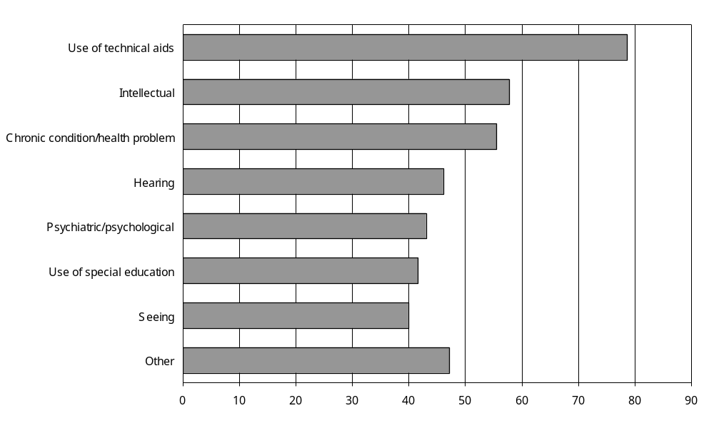
Source: Statistics New Zealand, 2001 Household Disability Survey
Notes:
- Data in Appendix Table 3.157.
- If individuals reported more than one disability type, they were counted in each applicable disability type group.

Children with multiple disabilities were more likely to consult a medical specialist than children with a single disability (49 percent compared with 36 percent).

Two-thirds of children with severe disability (67 percent) consulted a medical specialist, compared with 42 percent of children with moderate disability and 33 percent of children with mild disability.

More than 10 consultations
Four percent of children with disability, an estimated 3800 children, consulted a medical specialist more than 10 times in the previous 12 months.

Eleven percent of children aged 0–4 consulted a medical specialist this often, compared with 2 percent of children aged 5–9 and 3 percent aged 10–14.

Children using technical aids were most likely to consult a medical specialist more than 10 times in the previous 12 months (11 percent), compared with 4 to 7 percent of children with other types of disability such as seeing, hearing, intellectual or psychiatric/psychological disability.

Eleven percent of children with severe disability consulted a medical specialist more than 10 times in the previous 12 months, compared with 3 percent of children with moderate or mild disability.

Use of nurses
The results in this section relate to when people consulted or were treated by a nurse without seeing a doctor, that is, they do not include consultations with a doctor when a nurse was also present.

Adults

At least one consultation
Thirty-two percent of adults with disability, an estimated 198,400 adults, consulted with a nurse in the previous 12 months.

Women with disability (35 percent) were more likely than men with disability (28 percent) to consult a nurse in the previous 12 months.

Mäori (33 percent) and European (32 percent) adults with disability were more likely than Pacific (25 percent) and Asian/Other (22 percent) adults with disability to consult a nurse.

Adults with disability living in the Southern (37 percent), Midland (35 percent) and Central (31 percent) regions were more likely to consult a nurse than adults with disability living in the Northern region (26 percent).

More than 10 consultations
Five percent of adults with disability, an estimated 33,900 adults, consulted a nurse more than 10 times in the previous 12 months.

In terms of age, adults aged 85 and over were most likely to consult a nurse more than 10 times in the previous 12 months (15 percent).

Twelve percent of adults with severe disability consulted a nurse more than 10 times in the year, compared with just 2 percent of adults with mild disability.

Children

At least one consultation
Thirty percent of children with disability, an estimated 27,200 children, consulted a nurse in the previous 12 months.

The likelihood of children with disability consulting a nurse reduced with age. Forty-three percent of children aged 0–4 year olds had seen a nurse, compared with 32 percent of children aged 5–9 and 23 percent aged 10–14.

Nearly half (48 percent) of children using technical aids consulted a nurse, compared with 26 percent of children with a special education disability (Figure 3.12).

Figure 3.12: Percentage of children with disability who had seen a nurse at least once in the previous 12 months, by disability type, 2001
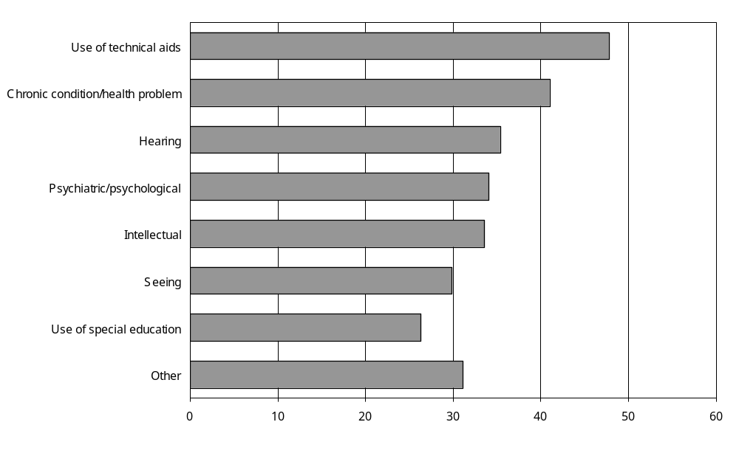
Source: Statistics New Zealand, 2001 Household Disability Survey
Notes:
- Data in Appendix Table 3.159.
- If individuals reported more than one disability type, they were counted in each applicable disability type group.

Children with disability caused by accident/injury (30 percent) and children with disability caused by a condition present at birth (28 percent) were less likely to consult a nurse than children with disability caused by disease/illness (36 percent) or ‘other’ causes (38 percent).

Thirty-six percent of children with severe disability consulted a nurse in the previous 12 months, compared with 32 percent of children with moderate disability and 27 percent of children with mild disability.

More than 10 consultations
Three percent of children with disability, an estimated 2900 children, had seen a nurse more than 10 times in the previous 12 months.

Unmet need for health services

Adults
Fifteen percent of adults with disability, an estimated 94,900 adults, indicated there had been a time in the previous 12 months when they had needed to see a health professional, therapist or healer but had not been able to.

Younger adults with disability were more likely than older adults with disability to report an unmet need for health services (Figure 3.13). In the 25–44 age group, 24 percent had an unmet need for health services, compared with just 6 percent of adults aged 85 and over.

Figure 3.13: Percentage of adults with disability who reported having an unmet health services need in the previous 12 months, by age, 2001
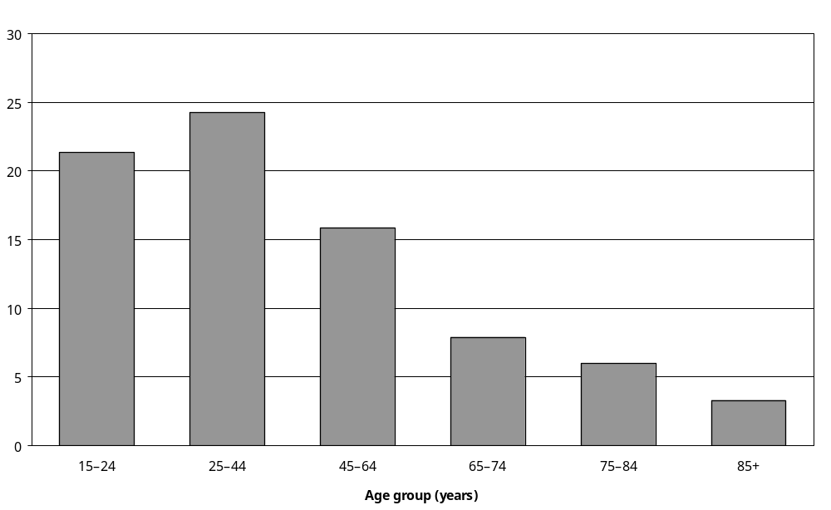
Source: Statistics New Zealand, 2001 Household Disability Survey
Note: Data in Appendix Table 3.160.

Mäori adults with disability (23 percent) were more likely than Pacific (17 percent), Asian/Other (15 percent) and European (14 percent) adults with disability to report an unmet need for health services.

Thirty-one percent of adults whose main disability was a psychiatric/psychological disability reported an unmet need for health services, compared with 17 percent of adults whose main disability was an agility disability and 13 percent of adults whose main disability was a mobility disability.

The lowest rates of unmet need for health services were reported by adults whose main disability was a hearing disability (8 percent) and adults whose main disability was a seeing disability (9 percent).

Adults with severe disability (22 percent) were more likely than adults with moderate (16 percent) or mild (12 percent) disability to report an unmet need for health services.

Children
Parents or caregivers of 17 percent of children with disability, an estimated 15,500 children, reported their child had needed to see a health professional, therapist or healer in the previous 12 months, but had been unable to.

Children with disability from the lowest income households ($15,000 and under per year) were most likely to have experienced an unmet need for these health services (29 percent), compared with 11 percent of children from the highest income households ($50,001 and over per year).

Children with disability living in the most socioeconomically deprived areas were most likely to have an unmet need for health services. Twenty-two percent of children living in NZDep2001 areas 9–10 (the most deprived areas) had an unmet need for health services, compared with 11 percent of children living in NZDep2001 areas 1–2 (the least deprived areas).

Children with psychiatric/psychological disability (27 percent), with intellectual disability (26 percent) and using technical aids (26 percent) were the most likely to have an unmet need for health services. Children with seeing disability were the least likely to have these unmet needs (12 percent).

The chances of having an unmet need for health services increased with the severity of disability. Thirty-one percent of children with severe disability had an unmet need, compared with 19 percent of children with moderate disability and 10 percent of children with mild disability.

Seven percent of children with disability, an estimated 6500 children, had an unmet need for a consultation with a medical specialist.

Five percent of children with disability, an estimated 4400 children, had an unmet need for a consultation with a GP or family doctor. Two percent, an estimated 2000 children, had an unmet need for a consultation with a counsellor, social worker or psychologist.

Fewer children with disability were estimated to have an unmet need for a consultation with an optician or optometrist (1100), dentist or dental nurse (1000), speech therapist (800) or Mäori or Pacific health worker (700).

Payment and subsidies for health services
Payment and subsidies for health services are discussed in chapter 5.

Medication

Use of medication
The 2001 Household Disability Survey asked people with disability about their use of prescribed and non-prescribed medication. Questions referred to all kinds of medication used, not just medication used for disability-related conditions or health problems. Therefore, caution is necessary when interpreting these results.

Adults
Eighty percent of adults with disability, an estimated 504,000 adults, had taken some kind of prescribed or non-prescribed medication in the previous 12 months.

Thirteen percent of adults with disability had not used any medication over this period. The medication use of the remaining 7 percent of adults with disability was not identified.

Use of medication was somewhat more common in older adults with disability, with 89 percent of adults aged 85 and over using some kind of prescription or non-prescription medication in the previous 12 months, compared with 73 percent of adults aged 15–24.

Adults whose main disability was a mobility disability (86 percent), an agility disability (83 percent) or a psychiatric/psychological disability (84 percent) were more likely to have taken medication than adults whose main disability was a hearing disability (68 percent), a seeing disability (71 percent) or an intellectual disability (77 percent).

Ninety-two percent of adults with severe disability had taken medication in the previous 12 months, compared with 85 percent of adults with moderate disability and 72 percent of adults with mild disability.

Prescribed medication
Looking just at prescribed medication, 60 percent of adults with disability indicated they used prescribed medication on a daily basis and 17 percent indicated they used it as needed.

Older adults with disability were more likely than younger adults with disability to use prescribed medication on a daily basis, with only 37 percent of adults aged 15–24 and 41 percent aged
25–44 using prescribed medication on a daily basis, compared with 79 percent of adults aged
65–74, 78 percent aged 75–84, and 79 percent aged 85 and over.

In general, younger adults with disability were more likely than older adults with disability to use prescribed medication as needed. Twenty-seven percent of adults aged 15–24 and 25–44 with disability using prescribed medication as needed, compared with just 8 percent of adults aged 65–74 and 75–84 with disability.
In terms of disability type, the highest rates of daily prescribed medication use were among adults with mobility (69 percent) and agility disability (69 percent). The lowest was among adults with intellectual disability (59 percent). Sixty-six percent of adults with psychiatric/psychological disability used prescribed medication on a daily basis.

Seventy-five percent of adults whose main disability was caused by disease/illness used prescribed medication daily, as did 67 percent of adults whose main disability was caused by ageing, 49 percent of adults whose main disability was caused by accident/injury and 43 percent of adults whose main disability was caused by a condition present at birth.

Seventy-five percent of adults with severe disability used prescribed medication daily, compared with 66 percent of adults with moderate disability and 49 percent with mild disability.

Non-prescribed medication
Fourteen percent of adults with disability indicated they were taking non-prescribed medication on a daily basis such as aspirin or herbal remedies (but excluding vitamins). Thirty-three percent were taking non-prescribed medication as needed.

In terms of age, rates of daily use of non-prescribed medication were comparatively high among adults aged 75–84 (23 percent), 65–74 (18 percent) and 85 and over (18 percent).

Twenty percent of adults with severe disability used non-prescribed medication on a daily basis, compared with 16 percent of adults with moderate disability and 11 percent of adults with mild disability.

Rates of ‘as needed’ use of non-prescribed medication were comparatively high in younger adults with disability, with 40 percent of adults aged 15–24 and 42 percent aged 25–44 with disability using non-prescribed medication in this way.

Children
Seventy-six percent of children with disability, an estimated 68,600 children, had taken prescribed or non-prescribed medication in the previous 12 months.

Prescribed medication
Thirty-five percent of all children with disability, an estimated 31,300 children, took prescribed medication on a daily basis. A further 3 percent took prescribed medication as needed; while 2 percent took it once a week or more. Seven percent did not take any prescribed medication.

Children with disability from higher-income households were more likely than children from lower-income households to take prescribed medication on a daily basis. Thirty-eight percent of children from the highest income households ($50,001 and over per year) took prescribed medication daily, compared with 28 percent of children from the lowest income households ($15,000 and under per year).

As might be expected, children with chronic conditions or health problems were the most likely to take prescribed medication daily (54 percent). Children with seeing disability were the least likely to do so (23 percent) (Figure 3.14).

Figure 3.14: Percentage of children with disability who took prescribed medication daily, by disability type, 2001
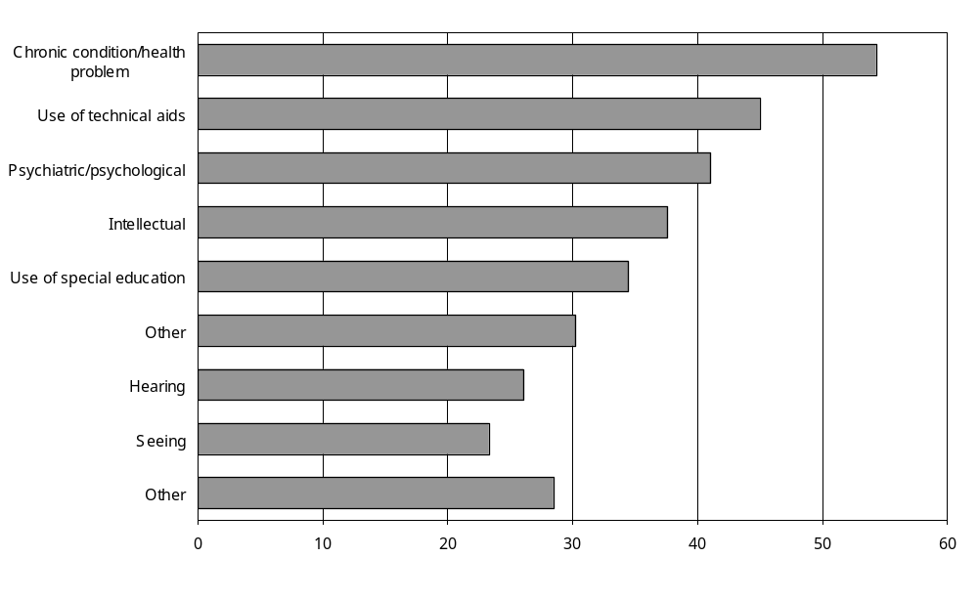
Source: Statistics New Zealand, 2001 Household Disability Survey
Notes:
- Data in Appendix Table 3.170.
- If individuals reported more than one disability type, they were counted in each applicable disability type group.

Half of all children with severe disability took prescribed medication daily, compared with 31 percent of children with moderate disability and 33 percent of children with mild disability.

Non-prescribed medication
A third of children with disability (34 percent), an estimated 31,000 children, took non-prescribed medication as needed. Four percent took non-prescribed medication daily – an estimated 3600 children. A further 36 percent did not take any non-prescribed medication.

Unmet need for medication

Adults
Seven percent of adults with disability, an estimated 45,000 adults, indicated that in the previous 12 months they had needed medication for disability, but were unable to get it.

In terms of age, adults aged 25–44 reported the highest rate of unmet need for medication (13 percent), followed by adults aged 15–24 and 45–64 (both 7 percent). In the older age groups, from 65 to 85 and over, rates of unmet need for medication were comparatively low, at 3 percent or less.

Fifteen percent of adults with severe disability reported an unmet need for medication, compared with 8 percent of adults with moderate disability and 5 percent with mild disability.

By far the most common reason for having an unmet need for medication was affordability, mentioned by 5 percent of all adults with disability (an estimated 32,900 adults). The next most common reason was that adults did not know they could apply for financial help or where to apply for it (an estimated 5100 adults, or 1 percent of all adults with disability). An estimated 3900 adults (1 percent) reported they had applied for financial help, but had found they were ineligible.

Children
Based on the reports of their parents or caregivers, 10 percent of children with disability had needed medication in the previous 12 months, but had been unable to get it. This was an estimated 8800 children.

Seventeen percent of Mäori children with disability had experienced an unmet need for medication, compared with 13 percent of Pacific and 6 percent of European children.

Children with disability from the lowest annual income households ($15,000 and under) were more likely than children with disability from the highest annual income households ($50,001 and over) to have an unmet need for medication. Twenty percent of children from the lowest annual income households had an unmet need for medication, compared with just 6 percent of children from the highest annual income households.

Similarly, children with disability from the most socioeconomically deprived areas were more likely than children with disability from the least socioeconomically deprived areas to have an unmet need for medication. Seventeen percent of children living in NZDep2001 areas 9–10 (the most deprived) had an unmet need for medication, compared with 5 percent of children living in NZDep2001 areas 1–2 (the least deprived).

A larger proportion of children with severe disability (17 percent) had an unmet need for medication than children with moderate (10 percent) or mild disability (7 percent).

Affordability was the reason most commonly given for why children with disability were not able to get the medication they needed. This reason applied to an estimated 7400 children or 84 percent of children who said they had an unmet need for medication.

Other, less common, reasons were: parents or caregivers did not know they could apply for financial help for medication for their child, or did not know where to apply for help (1100 children); or parents or caregivers had applied for financial help for getting medication, but were ineligible (900).

Payment and subsidies for medication

Adults

Government grants and allowances to pay for medication
Seventeen percent of adults with disability, an estimated 105,600 adults, indicated they had received the Disability Allowance or a Special Needs Grant to pay for medication in the previous 12 months.

Older adults were more likely than younger adults to receive these kinds of financial assistance to pay for medication. For example, 25 percent of adults with disability aged 85 and over got a Disability Allowance or Special Needs Grant to pay for medication, compared with just 12 percent of adults aged 15–24 and 25–44 with disability.

Paid for medication
In the previous 12 months, 54 percent of adults with disability, an estimated 336,500 adults, paid for medication they needed for disability without getting all the money they paid refunded by a government agency or medical insurer.

Older adults with disability were generally more likely than younger adults with disability to pay for medication themselves, with 64 percent of adults aged 85 and over paying for medication, compared with 49 percent of adults aged 15–24 and 53 percent of adults aged 25–44.

Children
In the previous 12 months, parents or caregivers of 15 percent of children, an estimated 13,900 children, with disability received a Special Needs Grant or Disability Allowance to help pay for their child’s medication.

Twenty-three percent of children with disability living in the Southern region received these subsidies for medication, compared with 10 percent of children in the Northern region, 14 percent of children in the Central region and 16 percent of children in the Midland region.

As might be expected given the eligibility criteria, children from the lowest income households were most likely to have received a Special Needs Grant or Disability Allowance for medication. Twenty-four percent of children with household incomes of $15,000 and under per year received this type of assistance, compared with 10 percent of children with household incomes of $50,001 and over per year.

Children using technical aids (42 percent) and children with intellectual disability (35 percent) were the most likely to receive these types of assistance. Children with hearing disability (10 percent) and children with seeing disability (12 percent) were the least likely to receive them.

Children with multiple disabilities were three times as likely as children with a single disability to receive a Disability Allowance or Special Needs Grant in the previous 12 months for medication (24 percent compared with 8 percent).

Children with severe disability (39 percent) were markedly more likely than children with moderate (16 percent) or mild disability (6 percent) to receive these types of assistance.

One percent of families had paid for medication their child needed without getting all the money refunded from a government agency or medical insurer. This was an estimated 1100 children with disability.

Comparing 2001 and 1996
The percentages of people receiving or needing most types of disability-related services and equipment did not change substantially between 1996 and 2001.

Adults
However, between 1996 and 2001 there was a slight decrease in the percentage of adults with disability receiving help with heavy household work (from 35 percent to 30 percent).

As well, the percentage of adults with disability consulting medical specialists in the previous 12 months decreased from 48 percent to 40 percent.

The percentage of adults with disability consulting a pharmacist or chemist for health advice or medication in the previous 12 months increased from 68 percent to 76 percent (Table 3.10).

Table 3.10: Comparison of selected 1996 and 2001 Household Disability Survey results for adults
 | Estimated number of adults with disability living in households |  | Percentage of adults with disability living in households (%)
 | 1996 survey | 2001 survey | 1996 survey | 2001 survey
Help received from others with everyday activities because of disability
Preparing meals | 75,100 | 67,400 | 13 | 11
Shopping for groceries and other necessities | 102,500 | 99,700 | 18 | 16
Everyday housework | 128,300 | 128,500 | 22 | 21
Heavy household work | 201,300 | 186,700 | 35 | 30
Personal finances | 45,900 | 51,300 | 8 | 8
Personal care | 29,300 | 34,900 | 5 | 6
Communicating with others | 23,600 | 39,100 | 4 | 6
Unmet need for help with everyday tasks in the previous 12 months
Unmet need for help with personal care from providers other than family or friends | 11,300 | 13,100 | 2 | 2
Unmet need for help with tasks such as housework or shopping from providers other than family or friends | 24,500 | 23,300 | 4 | 4
Unmet need for help with home repairs or maintenance | 24,900 | 26,400 | 4 | 4
Total with reported unmet needs for help with everyday tasks | 48,200 | 47,800 | 8 | 8
Respite care
Unmet need for respite care in previous 12 months | 9,800 | 10,300 | 2 | 2
Equipment and technology
Uses equipment or technology | 209,000 | 207,200 | 36 | 33
Unmet need for equipment or technology in previous 12 months | 72,200 | 77,100 | 12 | 12
Use of health professionals in previous 12 months
One or more consultations with GP or family doctor | 523,200 | 541,000 | 87 | 86
One or more consultations with a nurse (without seeing a doctor) | 160,000 | 198,400 | 28 | 32
One or more consultations with a pharmacist or chemist for health advice or medication | 421,100 | 473,700 | 68 | 76
One or more consultations with a medical specialist | 235,600 | 252,600 | 48 | 40
Unmet need for consultation with any health service in previous 12 months | 62,300 | 94,900 | 11 | 15
Needs assessment
Had one or more needs assessments | 81,100 | 95,400 | 14 | 15
Source: Statistics New Zealand, 2001 Household Disability Survey, 1996 Household Disability Survey
– Numbers too small to report (estimated frequencies outside the 70 percent relative sampling error cut-off point).

Children
There were some changes between 1996 and 2001 related to the use of health services by children with disability. The percentage of children consulting a nurse (without seeing a doctor at the same time) in the previous 12 months increased from 23 percent to 30 percent.

The percentage of parents or caregivers of children with disability reporting their child had an unmet need to consult a GP or family doctor (decreased from 16 percent to 5 percent) (Table 3.11).

Table 3.11: Comparison of selected 1996 and 2001 Household Disability Survey results for children
 | Estimated number of children with disability living in households |  | Percentage of children with disability living in households (%)
 | 1996 survey | 2001 survey | 1996 survey | 2001 survey
Unmet need for help in the previous 12 months
Unmet need for parents or caregivers to get help with personal care of child with disability | 4,900 | 4,100 | 5 | 5
Unmet need for parents or caregivers to get help with tasks such as housework or shopping related to care of child with disability | 3,600 | 3,600 | 4 | 4
Unmet need for parents or caregivers to get help with home repairs or maintenance related to care of child with disability | 3,500 | 4,300 | 4 | 5
Respite care
Parents or caregivers needed respite care in previous 12 months | 16,700 | 16,600 | 18 | 18
Unmet need for respite care in previous 12 months | 7,100 | 8,000 | 8 | 9
Equipment and technology
Uses equipment or technology | N/A | 7,700 | N/A | 9
Unmet need for equipment or technology in previous 12 months | 2,800 | 2,700 | 3 | 3
Use of health professionals in previous 12 months
One or more consultations with GP or family doctor | 82,000 | 78,800 | 87 | 88
One or more consultations with a nurse (without seeing a doctor) | 25,400 | 27,200 | 23 | 30
One or more consultations with a pharmacist or chemist for health advice or medication | 56,400 | 54,900 | 57 | 61
One or more consultations with a medical specialist | 42,100 | 37,800 | 39 | 42
Unmet need for consultation with a GP or family doctor in previous 12 months | 15,100 | 4,400 | 16 | 5
Unmet need for consultation with a medical specialist in previous 12 months | 8,400 | 6,500 | 9 | 7
Unmet need for consultation with any health service in previous 12 months | 16,200 | 15,500 | 17 | 17
Needs assessment
Had one or more needs assessments | 11,700 | 13,200 | 12 | 15
Source: Statistics New Zealand, 2001 Household Disability Survey, 1996 Household Disability Survey
– Numbers too small to report (estimated frequencies outside the 70 percent relative sampling error cut-off point).
N/A Not applicable.

4 Education

Key points
Most children with disability participate fully in New Zealand’s regular education system and many gain educational qualifications. Special education services, assistive technology and support services help some of these children to achieve their educational potential.

However, other children with disability face barriers when accessing education services and do not reach the educational levels of their non-disabled counterparts. This restricts their subsequent employment and other life opportunities.

The key points below illustrate these issues.

Children with disability
- In March 2001, an estimated 12,300 children aged 0–4 with disability (77 percent of all pre-school children with disability) attended, or were enrolled in, at least one type of early childhood education service. Kindergartens were the early childhood education service most commonly used by these pre-school age children with disability.
- Ninety-seven percent of children aged 5–14 with disability living in households, an estimated 71,600 students, were enrolled in some type of primary or secondary education.
- An estimated 12,400 children aged 5–14 with disability, 2 percent of all children aged 5–14 living in households, were attending a special school, special unit or special class at a regular school, or a regular class where special education was provided. This was 17 percent of all children with disability aged 5–14.
- An estimated 1400 children aged 5–14 with disability, 2 percent of children with disability, were enrolled at a special school at the beginning of 2001. Another 3100 children with disability (4 percent) in this age group had previously attended a special school.
- Most children aged 5–14 with disability attended only mainstream classes (53,300 children or 74 percent of children with disability). A further 11,400 children with disability (16 percent) attended ‘mainstream’ (regular) classes and a special unit. An estimated 2400 students (3 percent) attended only a special unit.
- Children with intellectual disability were more likely than children with other types of disability to attend only a special unit, or a mixture of mainstream and special unit classes. Children with chronic conditions/health problems and with seeing disability were most likely to attend only mainstream classes.
- Thirty-eight percent of children aged 0–14 with disability had been professionally assessed at some time in their life to determine their developmental or educational needs. Children using special education (66 percent) and with intellectual disability (64 percent) were twice as likely as children with hearing disability (31 percent) and chronic conditions/health problems (32 percent) to have been professionally assessed.
- An estimated 17,800 children with disability, or 20 percent of children with disability living in households, had an Individual Education Programme (IEP) or Individual Development Programme (IDP). Children most likely to have an IEP or IDP were children with intellectual disability (54 percent) and children using special education (50 percent).
- An estimated 25,000, or 3 percent of all children aged 0–14 living in households, had learning difficulties such as dyslexia, attention deficit disorder, attention deficit hyperactivity disorder and other conditions that interfere with typical learning processes.
- A high proportion (89 percent) of parents or caregivers of children with disability aged 5–14 said they had always been able to enrol their child in the school of their choice. However, parents or caregivers of 7 percent of children with disability (an estimated 5000) said they had not been able to do so. The most common reason parents or caregivers gave for why they were unable to enrol their child in a chosen school was that the school was unwelcoming. The second most common reason was the unavailability of special services or equipment.
- In 2001, just over half (51 percent) of all children with disability aged 5–14 were limited in school activities because of disability. The most common kind of limitation reported was a restriction on the ability to take part in school sports or games. This limitation was experienced by 30 percent of all children with disability living in households.
- Children aged 5–14 who used technical aids were most likely to have their school activities limited by disability. Those with a seeing disability were the least likely to have their school activities limited by disability.
- Disability was estimated to have affected the education of just under half (45 percent) of all children aged 5–14 with disability living in households. The most common effect on children’s education was that they had to change schools. The second most common effect was that their education was interrupted for long periods.
- Children aged 5–14 with intellectual disability and those who used technical aids were the most likely to have had their education affected by disability. Children with hearing disability and children with seeing disability were the least likely to have had their education affected.
- Parents or caregivers of an estimated 27,900 school-age children with disability reported their child needed at least one type of disability-related equipment and/or service to help them with their education. It was most common for children aged 5–14 with disability to need teacher aides (24 percent) and itinerant teachers (15 percent) because of disability.
- Children most likely to require equipment or services had intellectual disability (80 percent of children with intellectual disability), used technical aids (69 percent) or were receiving special education (65 percent).

Adults with disability
- In 2001, in every age-group from 15–24 to 65 and over, adults with disability were less likely than adults without disability to have a post-school qualification. This difference was particularly marked in the 15–24 age group, where 7 percent of people with disability had post-school qualifications compared with 16 percent of people without disability.
- Consistent with this, in all age groups adults with disability were more likely than adults without disability to have no educational qualifications. In the 15–24 age group, people with disability were almost twice as likely as people without disability to have no educational qualifications.
- In 2001, adults with disability generally had lower personal incomes than adults without disability, even when they had the same broad level of educational attainment.
- Adults whose main disability was a hearing, seeing or psychiatric/psychological disability were more likely than adults with other types of main disability to have school or post-school qualifications.
- A third (35 percent) of the adults whose main disability was caused by a sports accident/injury had post-secondary school qualifications. However, adults whose main disability was caused by disease/illness, conditions existing at birth, ageing or accidents/injuries at home were much less likely to have post-school qualifications.
- In the week ending 4 March 2001, an estimated 55,800 adults with disability living in households were enrolled in formal education such as secondary school, polytechnic or university. This was 9 percent of all adults with disability living in households.
- A quarter (25 percent) of adults with disability living in households and receiving formal education or training in March 2001 were enrolled in polytechnics, 22 percent were enrolled in universities and 20 percent were enrolled in secondary schools. Eight percent were enrolled in private training establishments, 4 percent in correspondence schools and 4 percent in colleges of education.
- A third (33 percent) of adults with disability living in households and enrolled in formal education in March 2001 had a main disability that was a physical disability (that is, mobility and/or agility disability). Seventeen percent had a main disability that was a psychiatric/ psychological disability, while 15 percent had a main disability that was a hearing disability. Three percent had a main disability that was an intellectual disability.
- An estimated 136,500 adults, 22 percent of all adults with disability living in households, had a disability that started before they finished their formal education and training. Almost half (47 percent) of adults aged 15–44 with disability had a disability that started before they finished their formal education.
- In 2001, an estimated 22,100 (16 percent) adults with disability living in households, whose disability started before they completed their formal education or training, had attended a special school or special classes in a mainstream school in the past.
- An estimated 51,700 (8 percent) adults with disability living in households indicated that disability had resulted in their education being interrupted for long periods.

Introduction
The New Zealand Disability Strategy states that educational services must be improved ‘so that all children, young people and adult learners [with disability] will have equal opportunities to learn and develop in their local, regular educational centres’ (Minister for Disability Issues 2001: 11). Specifically, the strategy promotes the following actions to provide the best education for people with disability:
3.1 Ensure that no child is denied access to their local, regular school because of their impairment.
3.2 Support the development of effective communication by providing access to education in New Zealand Sign Language, communication technologies and human aids.
3.3 Ensure that teachers and other educators understand the learning needs of disabled people.
3.4 Ensure that disabled students, families, teachers and other educators have equitable access to the resources available to meet their needs.
3.5 Facilitate opportunities for disabled students to make contact with their disabled peers in other schools.
3.6 Improve schools’ responsiveness to and accountability for the needs of disabled students.
3.7 Promote appropriate and effective inclusive educational settings that will meet individual educational needs.
3.8 Improve post-compulsory education options for disabled people, including: promoting best practice, providing career guidance, increasing lifelong opportunities for learning and better aligning financial support with educational opportunities.
(Minister for Disability Issues 2001: 16.)

This chapter examines the participation of New Zealanders with disability in regular (mainstream) education and special education. It also examines the educational achievements of people with disability and the educational barriers some of them face.

The chapter is divided into two sections. The first examines the educational experiences of children (aged 0–14) with disability. The second examines the educational experiences and qualifications of adults (aged 15 years and over) who had a disability at the time of the 2001 Household Disability Survey. This separation is necessary because the Disability Survey asked children and adults different questions about their educational experiences.

All the information presented in this chapter refers to adults and children living in households and does not include people with disability living in residential facilities.

Children with disability
As chapter 2 showed, in 2001 an estimated 90,000 children with disability were living in New Zealand households (11 percent of all children living in households). Of these, 15,900 (18 percent) were pre-school children (aged 0–4) and the remaining 74,100 (82 percent) were school-age children (aged 5–14).

Early childhood education services
In the week ended 4 March 2001, 77 percent of pre-school children with disability, an estimated 12,300 children, attended, or were enrolled in, some type of early childhood education service.
Kindergartens were the early childhood education service most commonly attended by pre-schoolers with disability. Thirty-three percent of pre-school children with disability, an estimated 5200 children, attended, or were enrolled in, kindergartens.
Childcare centres or crèches were the second most commonly used early childhood education services, with 13 percent of pre-school children with disability attending or enrolled. Playcentres were used by 11 percent of pre-school children with disability (Figure 4.1).

Figure 4.1: Number of children aged 0–4 with disability living in households attending or enrolled in different types of early childhood services, week ending 4 March 2001
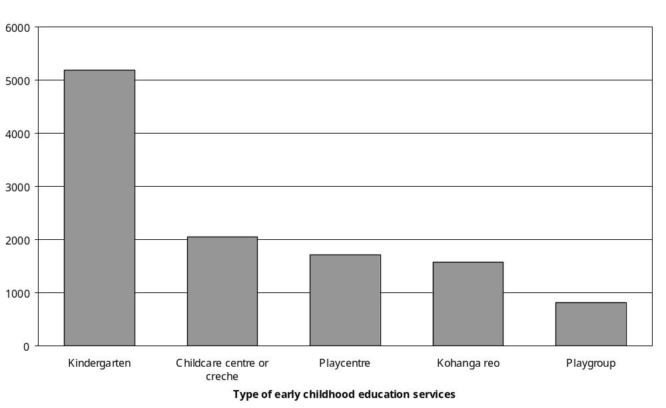
Source: Statistics New Zealand, 2001 Household Disability Survey
Notes:
- Data in Appendix Table 4.1.
- If individuals reported attendance or enrolment at more than one type of early childhood education service, they were counted in each applicable type of service.
Sixty percent of children aged 0–2 and 87 percent of children aged 3–4 with disability participated in early childhood education in 2001. European pre-school children were more likely to attend early childhood education than Mäori or Pacific pre-school children (83 percent compared with 72 percent and 67 percent respectively).

Pre-school children with hearing or psychiatric/psychological disability were most likely to participate in early childhood education and children with chronic conditions/health problems and intellectual disability were least likely to do so (Figure 4.2).

A smaller percentage (71 percent) of pre-school children who were severely disabled attended early childhood education than those with mild disability (80 percent).

Figure 4.2: Percentage of children aged 0–4 with disability living in households attending or enrolled in at least one type of early childhood service, by disability type, week ending 4 March 2001
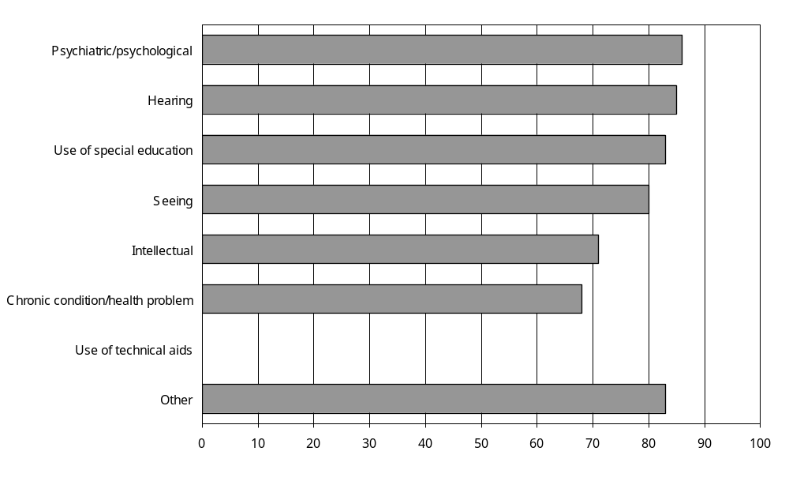
Source: Statistics New Zealand, 2001 Household Disability Survey
– Percentages too small to report (estimated frequencies outside the 70 percent relative sampling error cut-off point).
Notes:
- Data in Appendix Table 4.2.
- If individuals reported more than one disability type, they were counted in each applicable disability group.

Primary and secondary education
In March 2001, an estimated 71,600 children aged 5–14 with disability were enrolled in some type of primary or secondary education. This was 97 percent of all children aged 5–14 with disability living in households.

Most children aged 5–14 with disability were enrolled in primary or intermediate schools (an estimated 56,100 or 76 percent of children with disability in this age group). A much smaller number were enrolled in secondary schools (9900 children, 13 percent) or area/composite schools (2500 children, 3 percent). About 1400 (2 percent) were enrolled in special schools and another 1300 (2 percent) were being home-schooled (Figure 4.3).,

Figure 4.3: Number of children aged 5–14 with disability living in households enrolled in different types of primary or secondary education services, week ending 4 March 2001
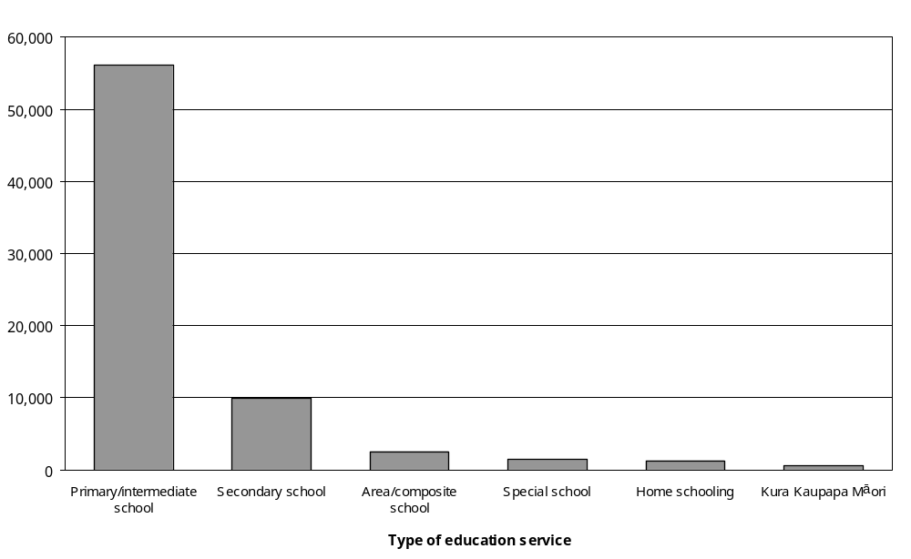
Source: Statistics New Zealand, 2001 Household Disability Survey
Notes:
- Data in Appendix Table 4.3.
- If individuals reported attendance or enrolment at more than one type of primary or secondary education service, they were counted in each applicable type of service.

While 76 percent of all children aged 5–14 with disability were enrolled in primary or intermediate schools, only 54 percent of children with accident/injury-related disability were enrolled in these types of school. Conversely, while only 13 percent of all children aged 5–14 with disability were enrolled in secondary schools, 38 percent of children in the same age group with accident/injury-related disability were enrolled in this type of school. These differences in enrolment are likely to be due to accident and injury-related disability being more common among older children than younger children.

Special education services
Special education is the provision of extra assistance, adapted programmes or learning environments, and specialised equipment or materials to support children and young people with special needs to access the education curriculum in a range of settings (Ministry of Education 2003). Some of these children are provided with specialised programmes to accelerate learning, for instance behavioural programmes or therapies.

Receiving special education services
In 2001, an estimated 12,400 children aged 5–14 were receiving special education services. That is, they were attending a special school, a special unit or special class at a regular school, or a regular class where special education services were provided. This was 2 percent of all children aged 5–14 living in households and 17 percent of all children aged 5–14 with disability.

Twenty-nine percent of Asian/Other children with disability were receiving special education services compared with 17 percent of European, 17 percent of Mäori, and 13 percent of Pacific children.

Children with disability living in the Northern region (20 percent) were more likely than children living in the Central region (11 percent) to be receiving special education services. Eighteen percent of children living in the Midland region were receiving special education services, as were 16 percent of children in the Southern region.

Fifteen percent of children living in the most socioeconomically deprived areas (NZDep2001
9–10) and the least deprived areas (NZDep2001 1–2) received special education services compared with 23 percent of children living in NZDep2001 areas 5–6.

Children with intellectual disability were most likely to be receiving special education services (46 percent); whereas children with hearing disability were least likely to be doing so (15 percent) (Figure 4.4).

Figure 4.4: Percentage of children aged 5–14 with disability living in households receiving special education services, by disability type, week ending 4 March 2001
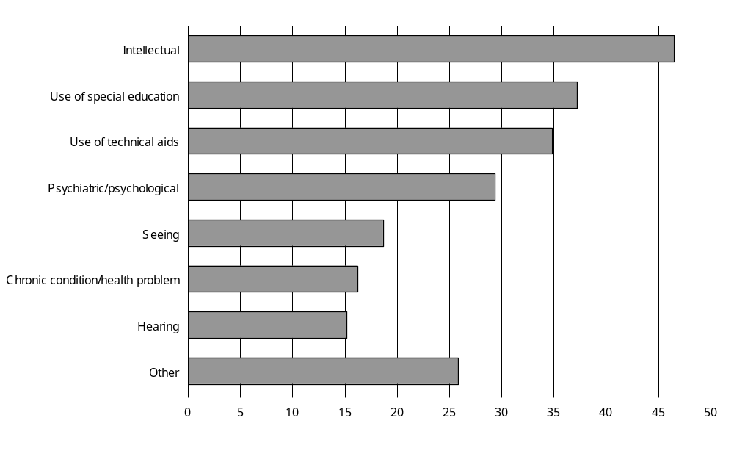
Source: Statistics New Zealand, 2001 Household Disability Survey
– Percentages too small to report (estimated frequencies outside the 70% relative sampling error cut-off point).
Notes:
- Data in Appendix Table 4.5
- If individuals reported more than one disability type, they were counted in each applicable disability group.
- The ‘use of special education’ category in this chart refers to the ‘use of special education’ disability type, which includes children currently attending special schools, special units or special classes (that is, receiving special education services) as well as children with learning difficulties such as dyslexia, attention deficit disorder or attention deficit hyperactivity disorder and children who have IEPs or IDPs.

Children with disability present when they were born were more likely than children with chronic conditions/health problems to be receiving special education services (24 percent compared with 12 percent). Also, children with multiple disabilities were much more likely than children with a single disability to receive special education services (32 percent compared with 4 percent).

None of the children with mild disability were receiving special education services. On the other hand, a quarter (26 percent) of children with moderate disability and nearly a third (32 percent) of children with severe disability received special education services.

Nearly half (42 percent) of the children aged 5–14 receiving special education services had first started using these services when they were five or six. Twenty percent had started using these services before they were five, and the remaining 38 percent started receiving special education services when they were seven or older (Figure 4.5).

Figure 4.5: Percentage of children aged 5–14 with disability living in households receiving special education services, by age when first started to receive special education services, week ending 4 March 2001
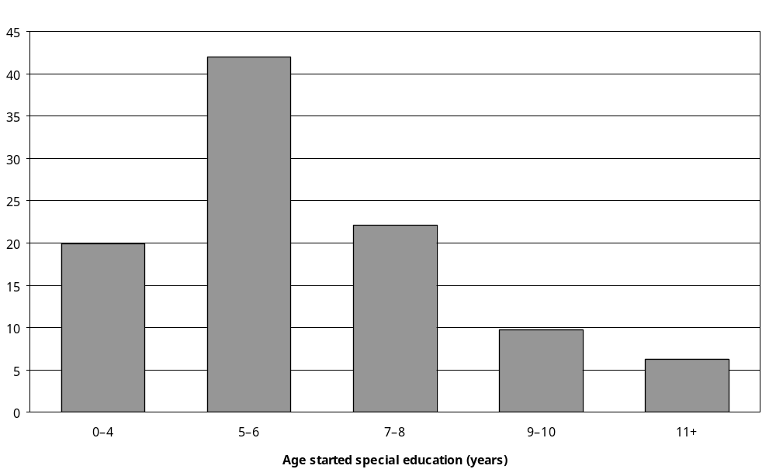
Source: Statistics New Zealand, 2001 Household Disability Survey
Note: Data in Appendix Table 4.6.

Attendance at special schools
As indicated above, 1400 children aged 5–14 with disability (2 percent) are estimated to have been enrolled at a special school at the beginning of 2001 (special schools cater only for children with special needs). To this figure can be added a further 3100 children who were not enrolled in a special school, but had attended a special school in the past. This means that altogether 4500, or 6 percent, of school-aged children with disability were estimated to have ever attended a special school.

Children using technical aids (25 percent) were most likely to have attended a special school at some time, and those with seeing disability were least likely to have attended one of these facilities (Figure 4.6).

Figure 4.6: Percentage of children aged 5–14 with disability living in households, who had ever attended a special school, by disability type, 2001
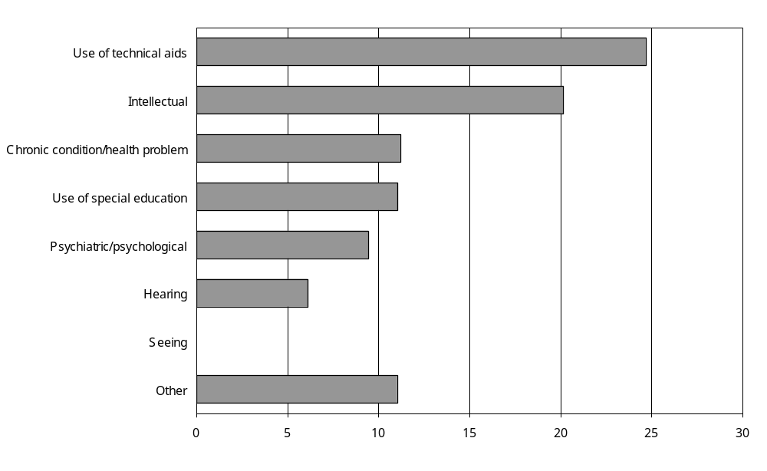
Source: Statistics New Zealand, 2001 Household Disability Survey
– Percentages too small to report (estimated frequencies outside the 70 percent relative sampling error cut-off point).
Notes:
- Data in Appendix Table 4.7.
- If individuals reported more than one disability type, they were counted in each applicable disability group.

Ten percent of children with multiple disabilities had ever gone to a special school, compared with three percent of children with a single disability.

Children with severe disability were more likely than children with moderate disability to have ever attended a special school (22 percent compared with 6 percent respectively). No children with mild disability had attended a special school.

Attendance at mainstream classes and/or special units
In the week ending 4 March 2001, an estimated 71,900 children aged 5–14 with disability attended ‘mainstream’ (regular) classes and/or special units.
Most children with disability (53,300 children; 74 percent) attended only mainstream classes, although 11,400 (16 percent) attended mainstream classes and a special unit. An estimated 2400 students (3 percent) attended only a special unit.
Twenty-four percent of children with disability whose annual household income was $15,000 and under received a mixture of mainstream and special unit education, compared with the average of 16 percent. Children with household incomes of $15,000 and under were also less likely to receive only mainstream education (69 percent compared with 79 percent of children with household incomes of $15,001–30,000 and $30,001–$50,000 per year).
Similarly, children with disability living in the most deprived areas of New Zealand were most likely to attend a mixture of mainstream and special unit classes, and were the least likely to receive only mainstream education (Figure 4.7).

Figure 4.7: Percentage of children aged 5–14 with disability living in households attending only mainstream classes, by residence in NZDep2001 decile areas, week ending 4 March 2001
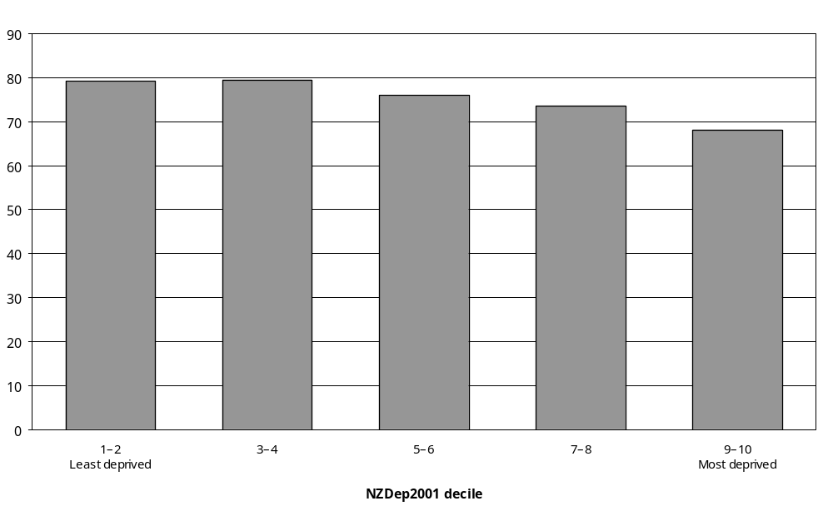
Source: Statistics New Zealand, 2001 Household Disability Survey
Notes:
- Data in Appendix Table 4.8.
- Excludes children attending special schools, attending only the Correspondence School, or having only home schooling.

Children with intellectual disability were more likely than children with other types of disability to attend only a special unit, or a mixture of mainstream and special unit classes. In 2001, 8 percent of children aged 5–14 with intellectual disability attended only a special unit, while 32 percent attended a mixture of mainstream and special unit classes. Fifty-five percent received mainstream education only.

Comparatively high proportions of school-aged children with seeing or hearing disability and chronic conditions/health problems attended only mainstream classes (Figure 4.8).

Figure 4.8: Percentage of children aged 5–14 with disability living in households attending only mainstream classes, by disability type, 2001
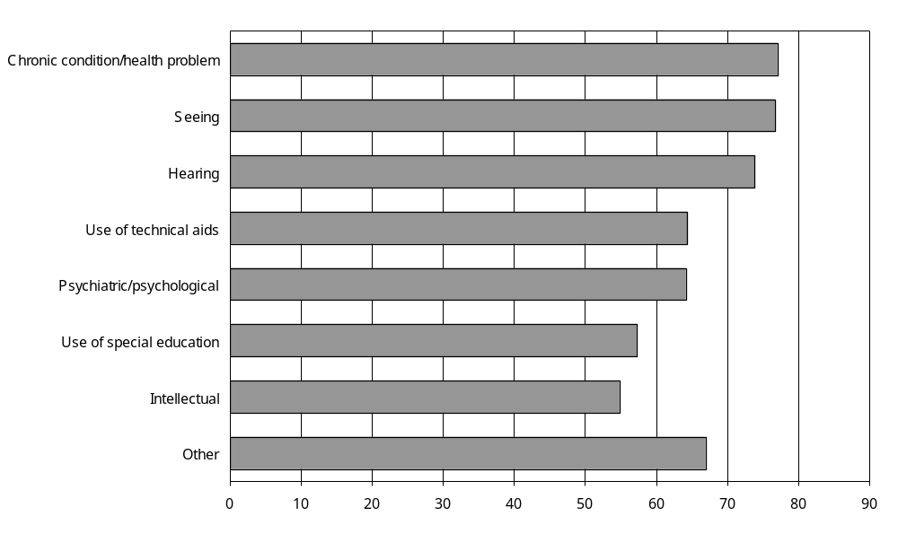
Source: Statistics New Zealand, 2001 Household Disability Survey
Notes:
- Data in Appendix Table 4.8.
- Excludes children attending special schools, the Correspondence school only, or having only home schooling.
- If individuals reported more than one disability type, they were counted in each applicable disability group.
- The ‘use of special education’ category in this chart refers to the ‘use of special education’ disability type, which includes children currently attending special schools, special units or special classes (receiving special education services) as well as children with learning difficulties such as dyslexia, attention deficit disorder or attention deficit hyperactivity disorder and children who have IEPs or IDPs.

Children with a single disability (82 percent) were more likely than children with multiple disabilities (64 percent) to attend mainstream classes only. They were also less likely than children with multiple disabilities to attend a mixture of mainstream and special classes (8 percent compared with 24 percent) (Figure 4.9).

Similarly, school-aged children with mild disability were more likely than school-age children with moderate or severe disability to attend mainstream classes only. Ninety-one percent of children aged 5–14 with mild disability attended mainstream classes only, compared with 64 percent of children with moderate disability and 61 percent of children with severe disability.

Figure 4.9: Percentage of children aged 5–14 with disability living in households attending mainstream classes and/or special units, by severity of disability, week ending 4 March 2001
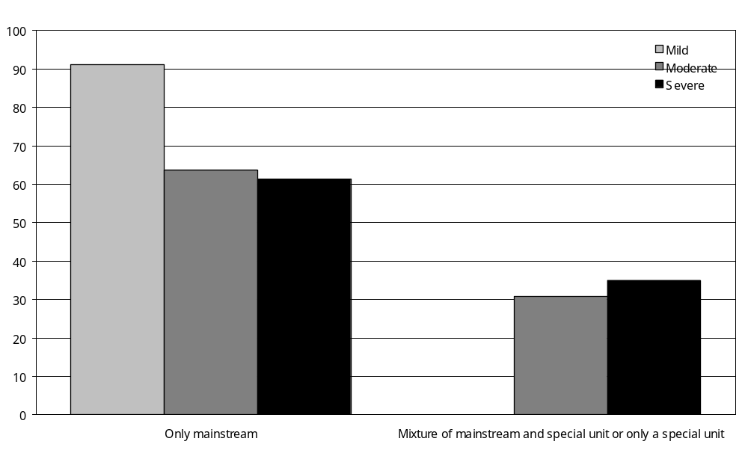
Source: Statistics New Zealand, 2001 Household Disability Survey
– Percentages too small to report (estimated frequencies outside the 70 percent relative sampling error cut-off point).
Notes:
- Data in Appendix Table 4.8.
- Excludes children attending special schools, attending only the Correspondence School, or having only home schooling.

Assessments of developmental and educational need
The 2001 Household Disability Survey asked the caregivers of children with disability if their child had ever had a ‘professional assessment’ (that is, an assessment carried out by a professional) to determine their developmental or educational needs.

In 2001, an estimated 3400 children aged 0–4 with disability, 22 percent of all children aged 0–4 with disability, had experienced an assessment by a professional to determine their developmental or educational needs.

Of pre-school children with disability who had been assessed, just over a third (35 percent) had been assessed by special education or early intervention teachers. A further 30 percent had been assessed by special education advisers or educational psychologists (Figure 4.10).

An estimated 30,500 school-aged children with disability (41 percent) had experienced assessments.

More than a third of these older children (40 percent) had been assessed by special education advisers or educational psychologists. Special education teachers or early intervention teachers had assessed another 28 percent.

Figure 4.10: Number of children aged 0–14 with disability living in households who were assessed by different types of professionals, by age, 2001
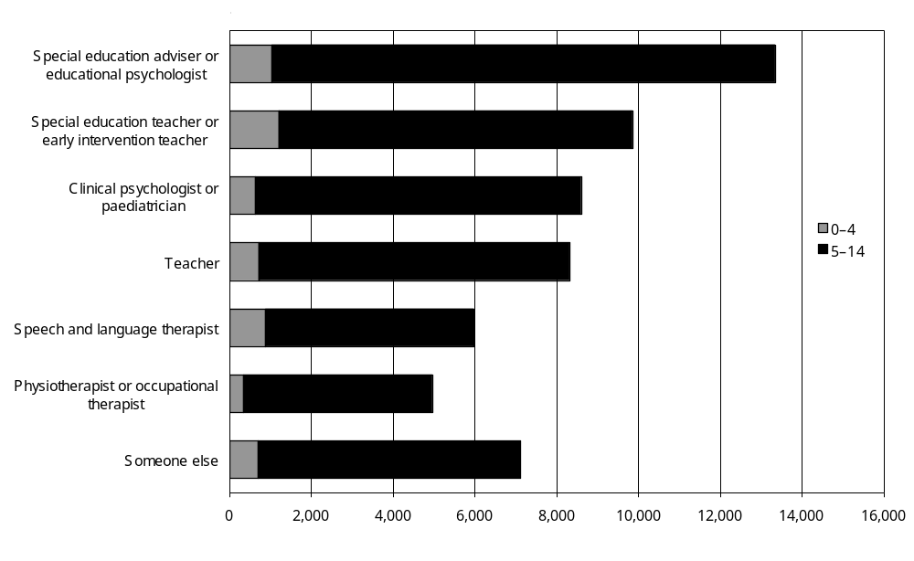
Source: Statistics New Zealand, 2001 Household Disability Survey
Notes:
- Data in Appendix Table 4.10.
- If individuals reported being assessed by more than one type of professional, they were counted for each applicable type of professional.

Children with psychiatric/psychological disability were more likely than children with other types of disability to have been assessed by clinical psychologists or paediatricians. Children who used technical equipment were most likely to have been assessed by special education advisers/educational psychologists or physiotherapists/occupational therapists. Children with hearing disability were most often assessed by special education teachers/early intervention teachers, school teachers or speech and language therapists.

Older children with disability were more likely than younger children to have had an assessment by a professional, an estimated 30,500 or 41 percent of all children aged 5–14 with disability.

Overall, 38 percent of all children with disability had received an assessment by a professional. Boys were more likely to have been assessed than girls (43 percent compared with 29 percent). European children (45 percent) and Asian/Other children (39 percent) were more likely to have been assessed than Mäori and Pacific children (28 percent and 18 percent respectively).
Children with disability living in urban areas were slightly more likely (39 percent) than children in rural areas (31 percent) to have had an assessment by a professional.
Children living in NZDep2001 decile areas 1–2 (the least socioeconomically deprived areas) were more likely to have been assessed (46 percent) than those living in NZDep2001 decile areas 9–10 (the most deprived areas) (34 percent).
Similarly, children with household incomes of $70,001 and over per year were more likely to have been assessed than children with medium or low household incomes.
Looking at different disability types, children using special education services (66 percent) and with intellectual disability (64 percent) were twice as likely as children with hearing disability (31 percent) and chronic conditions/health problems (32 percent) to have received a professional assessment (Figure 4.11).

Figure 4.11: Percentage of children aged 0–14 with disability living in households who received a professional assessment, by disability type, 2001
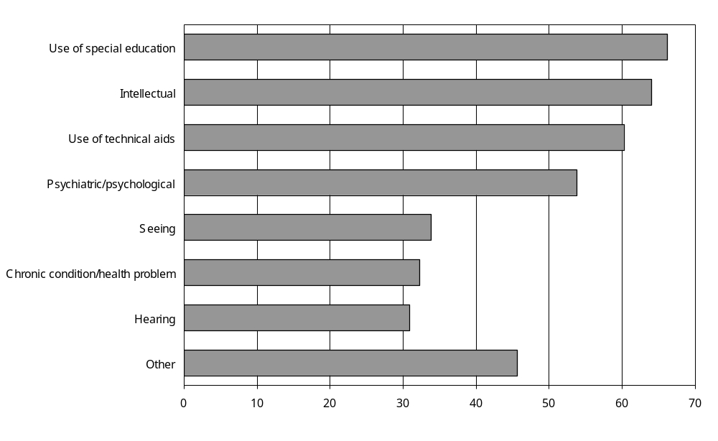
Source: Statistics New Zealand, 2001 Household Disability Survey
Notes:
- Data in Appendix Table 4.9.
- If individuals reported more than one disability type, they were counted in each applicable disability group.
Turning to disability causes, children with disability that was present at birth (44 percent) or caused by ‘other’ factors (45 percent) were more likely to have been assessed than children with disability caused by accident/injury (24 percent) or disease/illness (30 percent).

Children with multiple disabilities were more than twice as likely as children with a single disability to have had assessments (53 percent compared with 25 percent), while children with severe disability (55 percent) were three times more likely than children with mild disability to have had assessments (18 percent) (Figure 4.12).

Figure 4.12: Percentage of children aged 0–14 with disability living in households who had received a professional assessment, by age and severity of disability, 2001
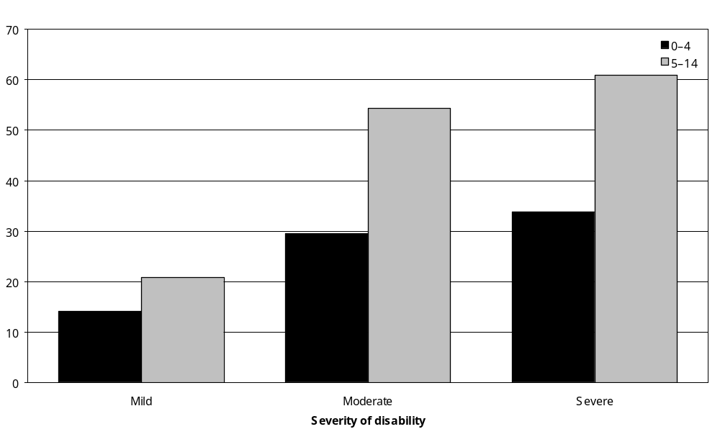
Source: Statistics New Zealand, 2001 Household Disability Survey
Note: Data in Appendix Table 4.9.

Participation in Individual Education Programmes or Individual Development Programmes
Individual Education Programmes (IEPs) are programmes for primary and secondary school students who have special educational needs due to disability, learning difficulties or behavioural difficulties. IEPs offer extra assistance and adapted programmes or learning environments, as well as special equipment or materials to support students in special or regular education settings (Ministry of Education 2003).

The term IEP is often used to refer to one or more of the following:
- the complete cycle of IEP assessment, planning, provision and evaluation
- the meeting at which the individual needs of a student are discussed
- a plan for an individual student
- a documented programme for an individual student.
Written plans for IEPs are prepared in consultation with teachers, parents, special educational professionals and students. These plans are regularly updated as students progress.

Individual Development Programmes (IDPs) are similar programmes for pre-school children with special needs.

In 2001, an estimated 17,800 children, or 20 percent of children with disability living in households, had an IEP or IDP. This was 2 percent of all children living in households (with or without a disability).

Children aged 10–14 with disability (24 percent) were more likely than children aged 5–9 (21 percent) or 0–4 (7 percent) to have an IEP or IDP.

Boys with disability were more likely than girls with disability to have an IEP or IDP (23 compared with 15 percent), while European (23 percent) and Asian/Other (29 percent) children were more likely than Mäori (15 percent) or Pacific (12 percent) children to have one.

Children from mid-range NZDep2001 areas were slightly more likely than children from other NZDep2001 areas to have an IEP or IDP, as were those living in households with incomes of $70,001 and over per year compared with those with lower annual incomes.

The likelihood of having an IEP or IDP varied with the type of disability children experienced. Just over half (54 percent) of children with intellectual disability and half (50 percent) of children using special education had an IEP or IDP. By contrast, just 16 percent of children with hearing disability had an IEP or IDP (Figure 4.13).

Figure 4.13: Percentage of children aged 0–14 with disability living in households with an IEP or IDP, by disability type, 2001
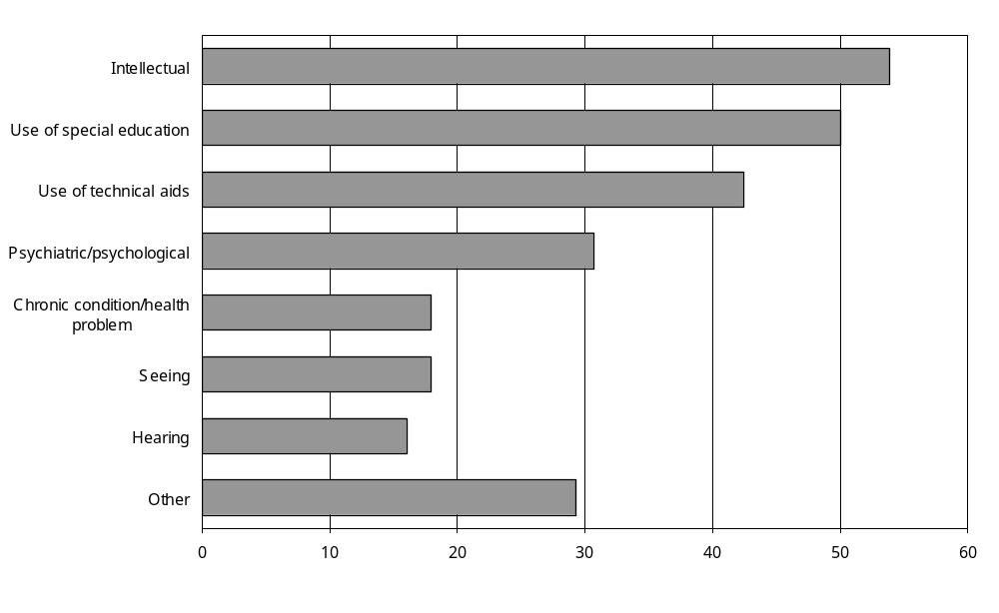
Source: Statistics New Zealand, 2001 Household Disability Survey
Notes:
- Data in Appendix Table 4.12.
- If individuals reported more than one disability type, they were counted in each applicable disability group.
- The ‘use of special education’ category in this chart refers to the ‘use of special education’ disability type, which includes children currently attending special schools, special units or special classes (receiving special education services) as well as children with learning difficulties such as dyslexia, attention deficit disorder or attention deficit hyperactivity disorder and children who have IEPs or IDPs.

Looking at disability cause, 20 percent of children with disability present at birth had an IEP or IDP, as did 22 percent of children with disability caused by accident/injury. A lower percentage of children with disability caused by disease/illness had an IEP or IDP (14 percent).

Five times as many children with multiple disabilities had an IEP or IDP as did children with a single disability (35 percent compared with 7 percent). No children with mild disability had an IEP or IDP; whereas 32 percent of children with moderate disability and 37 percent of children with severe disability had one.

Age when first received an Individual Education Programme or Individual Development Programme
Children with disability most commonly received their first IEP or IDP when they were 5 or 6, the usual age for starting primary school. A third (33 percent) of the estimated 17,800 children with an IEP or IDP received their first programmes at this age. A further 9 percent first had an IEP or IDP before they were 3, while 19 percent first had one when they were 3 or 4.

Table 4.1 shows that the age at which children had their first IEP or IDP was determined to some extent by their current age (that is, the age they were when they participated in the 2001 Household Disability Survey).

Table 4.1: Percentage of children aged 0–14 with disability living in households, by age when first had Individual Education Programme or Individual Development Programme and current age, 2001
Age first had IEP/IDP (years) | Current age (years)
Age first had IEP/IDP (years) | 0–4  (n=1100) | 5–9  (n=7900) | 10–14  (n=8700) | Total  (n=17,800)
Younger than 3 | 66 | – | 6 | 9
3–4 | – | 23 | 13 | 19
5–6 | N/A | 48 | 24 | 33
7–8 | N/A | 20 | 19 | 18
9+ | N/A | – | 37 | 20
Total | 100 | 100 | 100 | 100
Source: Statistics New Zealand, 2001 Household Disability Survey
– Percentages too small to report (estimated frequencies outside the 70 percent relative sampling error cut-off point).
N/A Not applicable.
Note: Numbers in table refer to the percentage of children currently in a specific age group (for example, aged 0–4) who first had an Individual Education Programme or Individual Development Programme at a specific age (for example, younger than 3 years).

The age when children with disability first had an IEP or IDP was also partly determined by the age they were when they first became disabled. Again, 5–6 years was a common age to first have an IEP or IDP. It was also quite common to have a delay of several years after the onset of disability before getting an IEP or IDP. For example, 25 percent of children whose disability started when they were younger than 3 first had an IEP or IDP when they were 7 or older (Table 4.2).

Table 4.2: Percentage of children aged 0–14 with disability living in households, by age when first had Individual Education Programme or Individual Development Programme and age of onset of first disability, 2001
Age first had IEP/IDP | Age of onset of first disability
Age first had IEP/IDP | Younger than 3  (n=10,500) | 3–4  (n=1800) | 5–8  (n=4500) | 9+  (n=900) | Total  (n=900)
Younger than 3 | 15 | N/A | N/A | N/A | 9
3–4 | 26 | 33 | N/A | N/A | 19
5–6 | 34 | 37 | 37 | N/A | 33
7–8 | 12 | -- | 37 | N/A | 18
9+ | 13 | -- | 24 | 100 | 20
Total | 100 | 100 | 100 | 100 | 100
Source: Statistics New Zealand, 2001 Household Disability Survey
– Percentages too small to report (estimated frequencies outside the 70 percent relative sampling error cut-off point).
N/A Not applicable.
Note: Numbers in table refer to the percentage of children whose first disability started at a specific age (for example, younger than 3 years) who first had an IEP or IEP at a specific age (for example, younger than 3 years).

Learning disability
In 2001, an estimated 25,000 children or 3 percent of all children aged 0–14 living in households, had ‘learning difficulties’ such as dyslexia, attention deficit disorder, attention deficit hyperactivity disorder and other conditions that interfere with typical learning processes.,

Learning disability was more common among older children than younger children, and boys aged 0–14 were nearly three times as likely as girls aged 0–14 to have a learning disability (4309 per 100,000 compared with 1538 per 100,000) (Figure 4.14).

Figure 4.14: Rates of learning disability among children aged 0–14 living in households, by age and sex, 2001
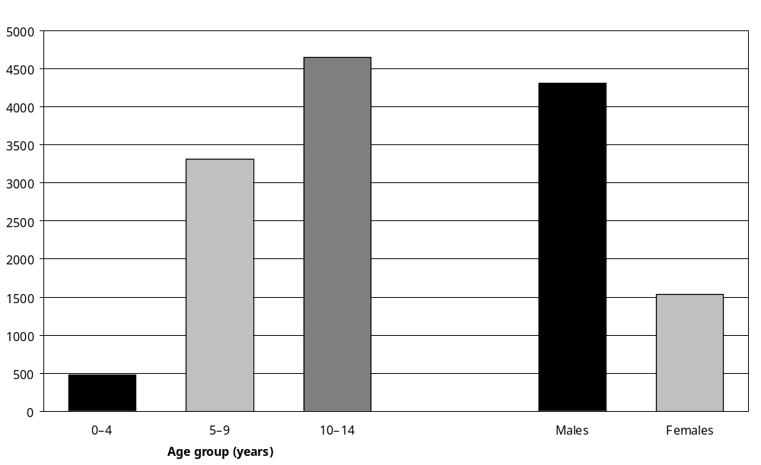
Source: Statistics New Zealand, 2001 Household Disability Survey
Note: Data in Appendix Table 4.13.

Rates of learning disability also varied across the different ethnic groups. European children had the highest rates, followed by Mäori, Asian/Other and Pacific children. European children were two-and-a-half times more likely than Pacific children to have a learning disability (Figure 4.15).

Figure 4.15: Rates of learning disability among children aged 0–14 living in households, by ethnic group, 2001
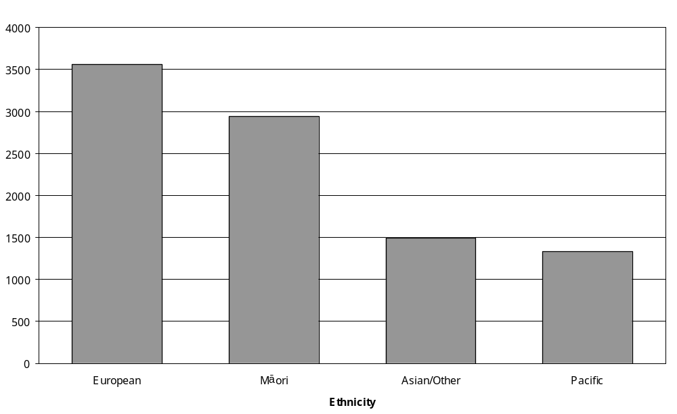
Source: Statistics New Zealand, 2001 Household Disability Survey
Note: Data in Appendix Table 4.13.

Learning disability was also more common in children from low income households than children from high income households (Figure 4.16).

Figure 4.16: Rates of learning disability among children aged 0–14 living in households, by household income, 2001
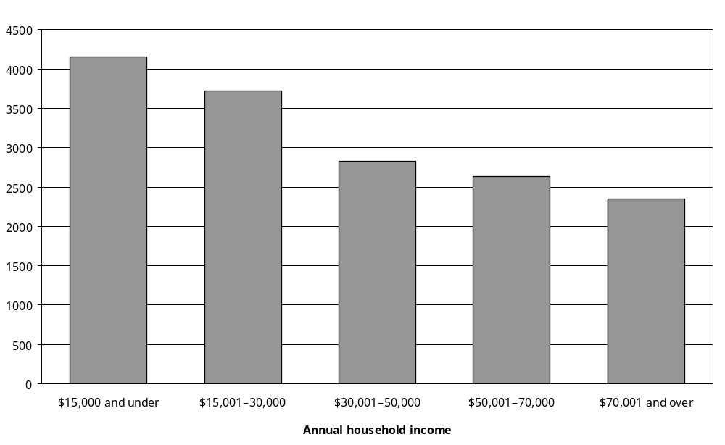
Source: Statistics New Zealand, 2001 Household Disability Survey
Notes:
- Data in Appendix Table 4.13.
- The household incomes of 25 percent of children were unknown.

Children living in the mid-range NZDep2001 areas had higher rates of learning disability than children living in the least and the most deprived areas of New Zealand (Figure 4.17).

Figure 4.17: Rates of learning disability among children aged 0–14 living in households, by NZDep2001 decile areas, 2001
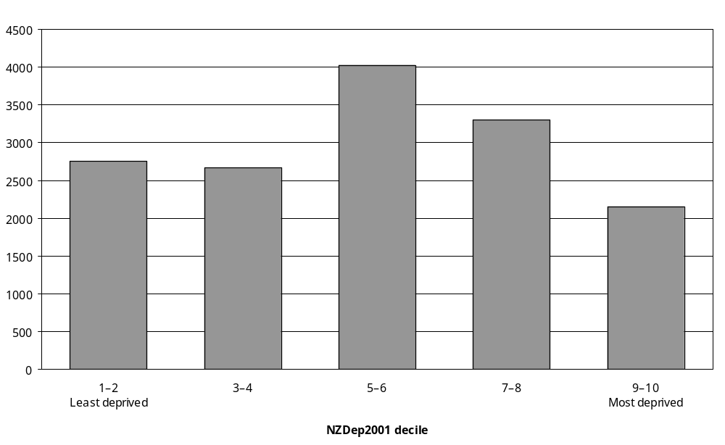
Source: Statistics New Zealand, 2001 Household Disability Survey
Note: Data in Appendix Table 4.13.

Choosing schools for children with disability
A high proportion of the parents or caregivers of children aged 5–14 with disability (89 percent) said they had always been able to enrol their child in the school of their choice. However, the parents or caregivers of 7 percent of children with disability (an estimated 5000) said they had not been able to do so.

Parents or caregivers of children with intellectual or psychiatric/psychological disability (11 percent) were slightly more likely than caregivers of children with hearing disability (6 percent) and chronic conditions/health problems (8 percent) to report being unable to enrol their child in a chosen school.

Parents or caregivers of children with multiple disabilities (10 percent) were also more likely than parents or caregivers of children with a single disability (4 percent) to report not being able to enrol their child in a chosen school. Similarly, the parents or caregivers of 12 percent of children with severe disability reported being unable to enrol their child in a preferred school, compared with 8 percent of children with moderate disability and 3 percent of children with mild disability.

The most common reason parents or caregivers gave for being unable to enrol their child in a chosen school was that the school was unwelcoming. This reason was mentioned by 17 percent of parents or caregivers who had been unable to enrol their child in a chosen school. The second most common reason given was the unavailability of special services or equipment.

Impact of disability on school activities
The parents or caregivers of an estimated 34,900 children aged 5–14 reported their children were ‘limited’ in some way at school because of disability in the week before their participation in the 2001 Household Disability Survey. This was just over half (51 percent) of children with disability living in households who were asked this question. Just under half (49 percent) of children with disability were reported by their caregivers to be not limited at school in any way.

How activities at school were limited
The most common kind of reported limitation related to taking part in school sports or games. This effect was experienced by 30 percent of all children with disability living in households.

A quarter (25 percent) of children were said to be limited in playing at school, and 22 percent found it difficult to make friends. The ability to go on school outings was affected for 15 percent of children with disability (Figure 4.18).

Figure 4.18: Percentage of children aged 5–14 with disability living in households experiencing different types of limitations on school activities, 2001
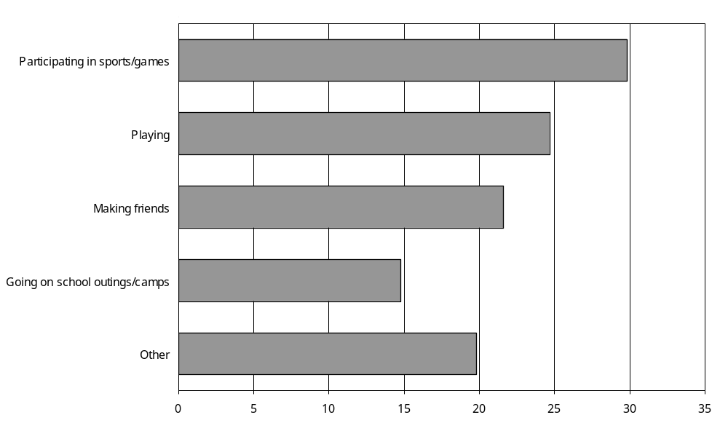
Source: Statistics New Zealand, 2001 Household Disability Survey
Notes:
- Data in Appendix Table 4.15.
- If individuals reported more than one type of limitation, they were counted in each applicable limitation category.

Children with disability who used technical aids were more likely (76 percent) than children with other types of disability to have a limited ability to participate in school sports or games. They were also the most likely to have their ability to play affected (61 percent), and the most likely to be restricted in going on school outings or camps (46 percent).

Parents or caregivers of children with psychiatric/psychological disability were most likely to indicate their child found it difficult to make friends (51 percent).

For every one of the different types of school activities listed in the survey question, children with multiple disabilities were more likely than children with a single disability to experience ‘limitations’. The same was the case for children with severe disability, compared with children with mild or moderate disability.

At least one effect on school activities
A relatively high proportion of parents or caregivers of children from the Asian/Other ethnic group (71 percent) reported their children’s school activities were affected because of disability. This compares with 53 percent of Mäori, 50 percent of European and 49 percent of Pacific children.

Children with low household incomes were also slightly more likely than children with high household incomes to be affected (for example, 56 percent of children with household incomes of $15,000 or under per year compared with 49 percent of children with household incomes of $70,001 and over per year).

Looking at different types of disability, children who used technical aids (81 percent) or had psychiatric/psychological disability (75 percent) were the most likely to be limited in some way at school. Children with seeing or hearing disability were the least likely to be affected (41 percent and 51 percent respectively) (Figure 4.19).

Figure 4.19: Percentage of children aged 5–14 with disability living in households experiencing at least one effect on school activities, by disability type
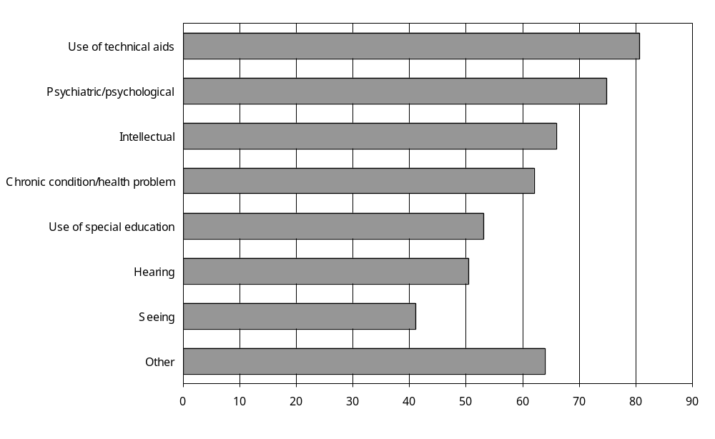
Source: Statistics New Zealand, 2001 Household Disability Survey
Notes:
- Data in Appendix Table 4.15.
- If individuals reported more than one disability type, they were counted in each applicable disability group.

Parents or caregivers of children with disability caused by accident/injury (79 percent) and disease/illness (61 percent) were more likely to say their children were limited at school than parents or caregivers of children with disability caused by conditions present at birth (53 percent).

The school activities of 63 percent of children with multiple disabilities were affected in some way, compared with 42 percent of children with a single disability (Figure 4.20).

Figure 4.20: Percentage of children aged 5–14 with disability living in households experiencing at least one effect on school activities, by single/multiple disability and severity of disability, 2001
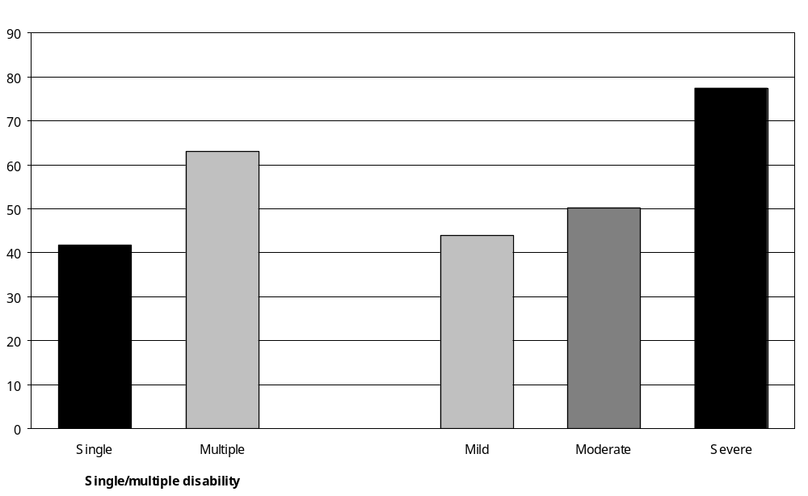
Source: Statistics New Zealand, 2001 Household Disability Survey
Note: Data in Appendix Table 4.15.

As might be expected, the greater the severity of disability the more likely it was that school activities were perceived to be limited. In 2001, 44 percent of children with mild disability experienced some limitation on their school activities, compared with 50 percent of children with moderate disability and 77 percent of children with severe disability.

Effect of disability on children’s education
In 2001, parents or caregivers of an estimated 33,400 or 45 percent of children aged 5–14 with disability reported their child’s education had been affected by disability. Parents or caregivers of the remaining 55 percent of children with disability reported no effects on their child’s education.

How children’s education was affected
The most common effect of disability on children’s education was that they had to change schools. An estimated 15,100 children, 20 percent of all children aged 5–14 with disability living in households, experienced this (Figure 4.21).

Figure 4.21: Percentage of children aged 5–14 with disability living in households experiencing different types of effects on education, 2001
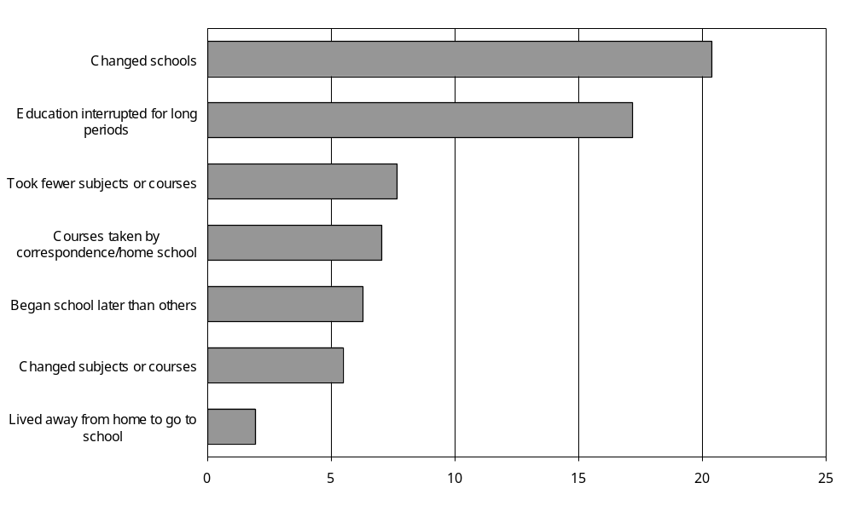
Source: Statistics New Zealand, 2001 Household Disability Survey
Notes:
- Data in Appendix Table 4.16.
- If individuals reported more than one type of effect, they were counted in each applicable effect category.

The second most common effect was that the child’s education was interrupted for long periods. Seventeen percent of children aged 5–14 with disability experienced this.

Because of disability, children aged 5–14 who used technical aids were more likely than children with other types of disability to have started their schooling late (20 percent). They were also more likely to have had their education interrupted for long periods (37 percent) or to have taken courses by correspondence or using home schooling (16 percent).

Children aged 5–14 with intellectual disability were the most likely to have changed schools (31 percent), changed subjects (12 percent) or taken fewer subjects (18 percent).

In addition, a comparatively high proportion (30 percent) of children aged 5–14 with psychiatric/ psychological disability had changed schools as result of disability.

At least one effect on education
Parents or caregivers of 54 percent of children aged 10–14 indicated their child’s education had been affected by disability, compared with 37 percent of children aged 5–9.

Children with lower household incomes were more likely than children with higher household incomes to have experienced an effect on their education as a result of disability. Fifty percent of children with disability who had household incomes of $15,000 and under per year experienced an effect on their education, compared with 40 percent of children with disability who had household incomes of more than $70,001 and over per year.

However, children living in NZDep2001 decile 1–2 areas, the least socioeconomically deprived areas of New Zealand, were more likely than children from the more disadvantaged decile areas to experience effects on their education because of disability.

Children living in the Southern region were slightly less likely (41 percent) than children living in the three other regions to experience an effect on their education.

Children aged 5–14 with intellectual disability and children who used technical aids were the most likely to have had their education affected by disability (65 percent and 62 percent respectively). Children with hearing disability (42 percent) and children with seeing disability (42 percent) were the least likely to have had their education affected (Figure 4.22).

Figure 4.22: Percentage of children aged 5–14 with disability living in households experiencing at least one effect on their education, by type of disability, 2001
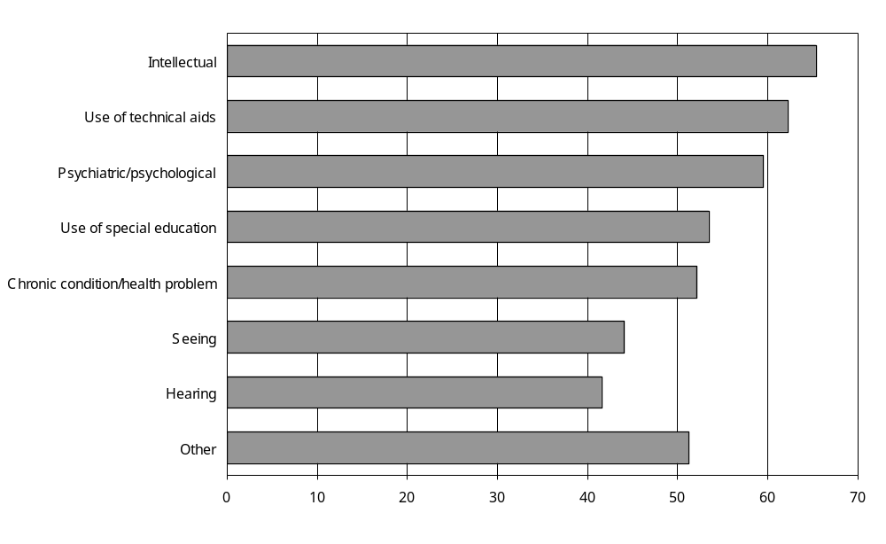
Source: Statistics New Zealand, 2001 Household Disability Survey
Notes:
- Data in Appendix Table 4.16.
- If individuals reported more than one disability type, they were counted in each applicable disability group.

A higher proportion of children with multiple disabilities (56 percent) than children with a single disability (36 percent) were reported to have had their education affected by disability (Figure 4.23).

Figure 4.23: Percentage of children with disability aged 5–14 living in households experiencing at least one effect on their education, by single/multiple disability and severity of disability, 2001
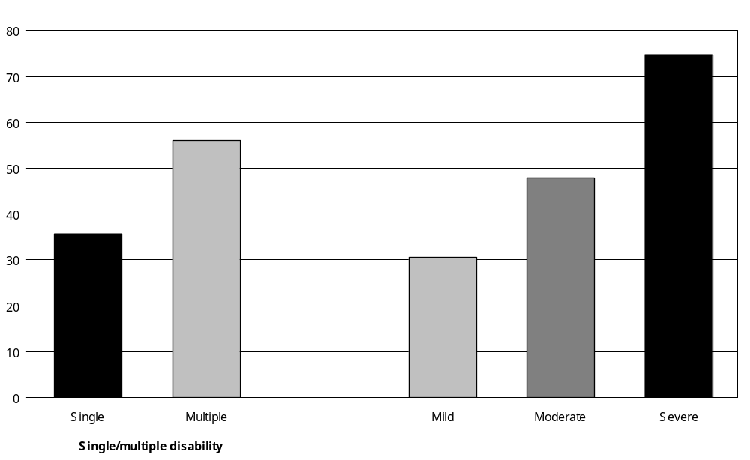
Source: Statistics New Zealand, 2001 Household Disability Survey
Note: Data in Appendix Table 4.16.

The likelihood of children’s education being affected also increased with the severity of disability. Whereas the education of 31 percent of children with mild disability had been affected by their condition, the education of 48 percent of children with moderate disability and 75 percent of children with severe disability had been affected.

Equipment and support services children needed to help their education
Parents or caregivers were asked if their children needed various equipment and support services because of their condition to help with their education. Parents or caregivers of an estimated 27,900 school-age children with disability (38 percent) reported their child needed at least one type of equipment or support service to help them with their education. However, the majority (59 percent) of school-age children with disability did not need any support services or equipment.

Types of equipment and support service needed
Parents or caregivers of children aged 5–14 were most likely to indicate their children needed teacher aides (24 percent) and itinerant teachers (15 percent) because of disability. Thirteen percent of children needed help with notetaking, writing or reading and 12 percent needed computer access (Figure 4.24).

Figure 4.24: Percentage of children aged 5–14 with disability living in households needing different types of equipment and support service for education, 2001
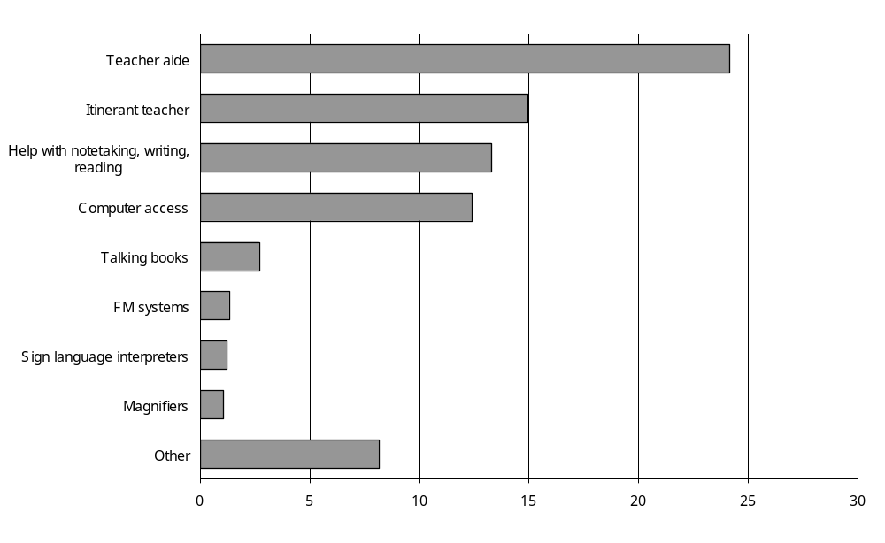
Source: Statistics New Zealand, 2001 Household Disability Survey
Notes:
- Data in Appendix Table 4.17.
- If individuals reported more than one type of equipment or service, they were counted in each applicable equipment or service category.
Of the different types of equipment and support service available, children with hearing or seeing disability were most likely to require a teacher aide (25 percent each). This was also the case for children with chronic conditions/health problems (24 percent), children with psychiatric/ psychological disability (43 percent) and children receiving special education (44 percent).

Children who used technical aids were also likely to require a teacher aide (51 percent), as well as access to a computer (43 percent) and help with notetaking, writing or reading (42 percent).

A relatively high proportion of children with an intellectual disability needed a teacher aide (61 percent), help with notetaking, writing or reading (41 percent), computer access (37 percent), or an itinerant teacher (35 percent).

At least one type of equipment or support service needed
Parents or caregivers of older children (aged 10–14) with disability were slightly more likely than parents or caregivers of younger children (aged 5–9) to indicate their child required at least one type of equipment or support service to help with their education (41 percent compared with 35 percent).

Children from the Asian/Other ethnic group were the most likely (58 percent) to need one type of equipment or support service (compared with 37 percent of European and Mäori children and 35 percent of Pacific children).

Children living in households with the lowest annual incomes were more likely than children living in households with higher incomes to report they needed equipment or support services to help with their education (for example, 42 percent of children with household incomes of $15,000 and under per year compared with 27 percent of children with household incomes of $70,001 and over per year).

Again, this was somewhat contradicted by the results for children living in different NZDep2001 areas. Children living in the least deprived areas (NZDep2001 1–2) were the most likely to report they required equipment or support services to help with their education (68 percent), compared with children from moderately deprived areas (NZDep2001 5–6 – 16 percent) and most deprived areas (NZDep2001 9–10 – 31 percent).

Children most likely to require equipment or support services had intellectual disability (80 percent), used technical aids (69 percent) or used special education (65 percent) (Figure 4.25).

Figure 4.25: Percentage of children aged 5–14 with disability living in households requiring at least one type of equipment or support service to help with their education, by disability type, 2001
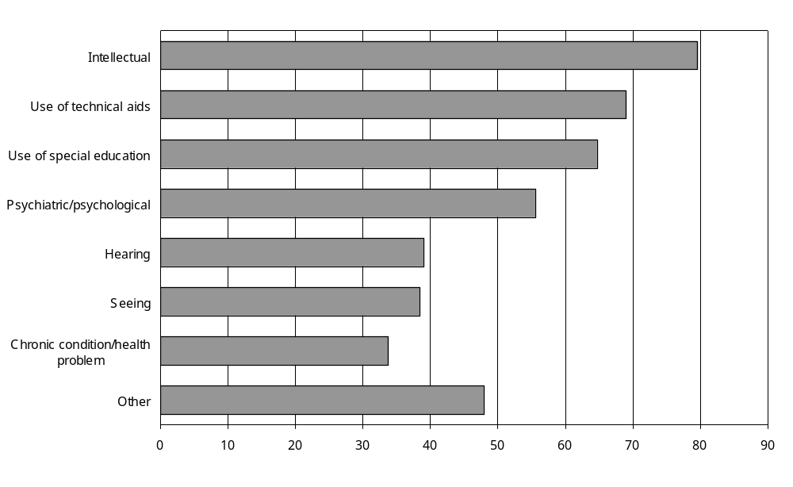
Source: Statistics New Zealand, 2001 Household Disability Survey
Notes:
- Data in Appendix Table 4.17.
- If individuals reported more than one disability type, they were counted in each applicable disability group.

As might be expected, children with multiple disabilities were more likely than children with a single disability to require help with their education in the form of equipment or support services (58 percent compared with 20 percent) (Figure 4.26).

Figure 4.26: Percentage of children aged 5–14 with disability living in households requiring at least one type of equipment or support service to help with their education, by single/multiple disability and severity of disability, 2001
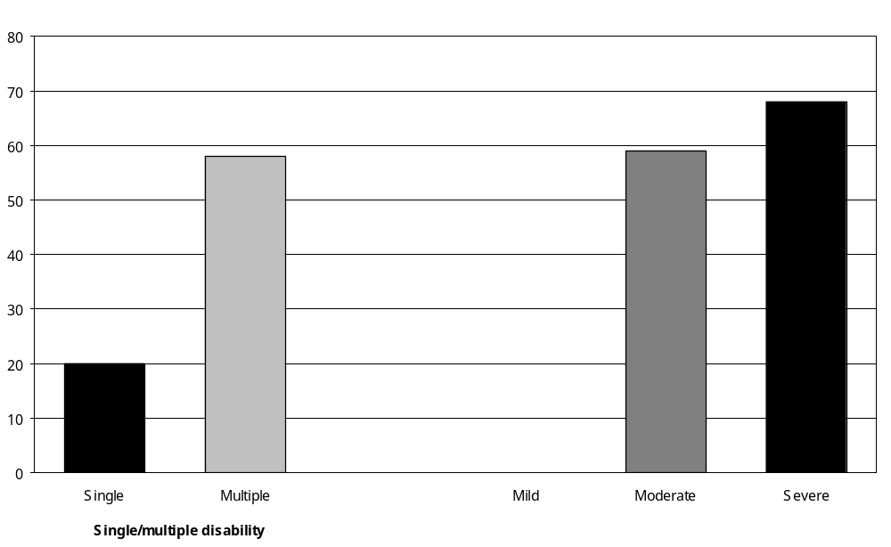
Source: Statistics New Zealand, 2001 Household Disability Survey
– Percentages too small to report (estimated frequencies outside the 70 percent relative sampling error cut-off point).
Note: Data in Appendix Table 4.17.

Just over two-thirds (68 percent) of children with severe disability needed equipment or support services, compared with 59 percent of children with moderate disability.

Adults with disability

Participation in formal education or training
In the week ending 4 March 2001, an estimated 55,800 adults with disability living in households were enrolled in formal education such as a secondary school, polytechnic or university. This was 9 percent of all adults with disability living in households. It included an estimated 38,800 European, 11,600 Mäori, 2300 Pacific and 2500 Asian/Other adults.

As might be expected, adults with disability aged 15–24 had the highest rates of participation in formal education. More than a third (37 percent) were enrolled in formal education, compared with 14 percent of adults aged 25–44 and 8 percent of adults aged 45–64 with disability.

Types of educational institution
A quarter (25 percent) of the estimated 55,800 adults with disability aged 15 and over receiving formal education or training were enrolled in polytechnics, 22 percent were enrolled in universities and 20 percent were enrolled in secondary schools. Eight percent were enrolled in private training establishments, 4 percent in correspondence schools and 4 percent in colleges of education. Eighteen percent were enrolled in other kinds of formal education or training (Figure 4.27).

Figure 4.27: Number of adults with disability living in households enrolled in main types of educational institutions, by age, week ending 4 March 2001
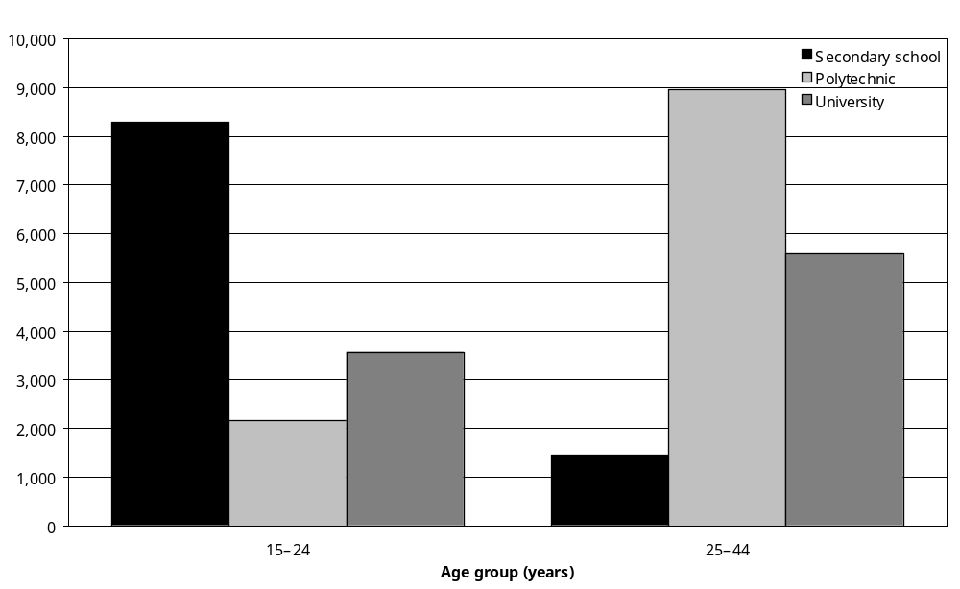
Source: Statistics New Zealand, 2001 Household Disability Survey
Notes:
- Data in Appendix Table 4.19.
- If individuals reported attending more than one educational institution, they were counted in each applicable category.

Of the 16,605 adults aged 15–24 with disability enrolled in formal education and training in March 2001, half (50 percent) were enrolled in secondary school, 21 percent were enrolled in universities and 13 percent were enrolled in polytechnics.

The estimated 21,800 adults aged 25–44 with disability enrolled in formal education and training were most likely to be at a polytechnic (41 percent). A quarter (24 percent) were at university and 12 percent were at private training establishments.

Main disability
Adults whose main disability was an intellectual disability had the highest rate of participation in formal education (27 percent), followed closely by adults whose main disability was a psychiatric/psychological disability (22 percent). Adults whose main disability was a hearing disability or a physical disability were much less likely to be enrolled in formal education (8 percent and 6 percent respectively).

That said, a third (33 percent) of the entire group of adults with disability enrolled in formal education in 2001 had a main disability that was a physical disability (that is, mobility and/or agility disability). Seventeen percent had a main disability that was a psychiatric/psychological disability, while 15 percent had a main disability that was a hearing disability. Three percent had a main disability that was an intellectual disability.

Cause of main disability
Nearly a third (31 percent) of the estimated 55,800 adults with disability enrolled in formal education or training in March 2001 had a main disability that had been caused by accident/ injury, especially work-related accidents or injuries. Disease/illness caused the main disability of a further 24 percent of adults enrolled in formal education; while for 16 percent their main disability was caused by a condition present at birth.

Severity of disability
A slightly higher percentage of adults with mild disability (10 percent) were enrolled in formal education or training than adults with moderate (8 percent) and severe (7 percent) disability.

Impact of disability on education and training
To help better identify the effects of disability on educational attainment it is possible to look specifically at features of the adults whose disability started before they completed their formal education.

In 2001, an estimated 136,500 adults, or 22 percent of all adults with disability living in households, had a disability that started before they finished their formal education and training. Most (70 percent) of these 136,500 adults were under the age of 45 (Figure 4.28).

Figure 4.28: Percentage of adults with disability living in households whose disability started before formal education was completed, by age, 2001
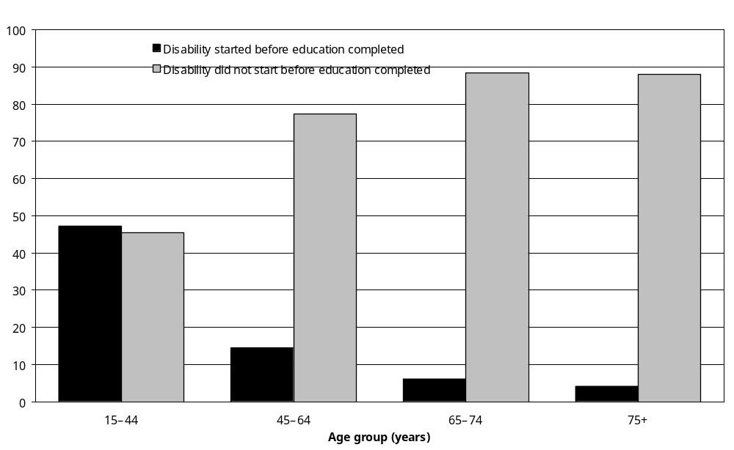
Source: Statistics New Zealand, 2001 Household Disability Survey
Note: Data in Appendix Table 4.21.

Just 14 percent of adults aged 45–64 with disability had a disability that started before they finished their education. This dropped to 6 percent of adults aged 65–74 and 4 percent of adults aged 75 and over with disability. By contrast, almost half (47 percent) of adults aged 15–44 with disability had a disability that started before they finished their formal education.

Special education
Sixteen percent of adults with disability living in households whose disability started before they completed their formal education or training had attended a special school or special classes in a mainstream school. This was an estimated 22,100 adults.

Of this group, an estimated 15,100 adults (8700 men and 6500 women) had been to a special school or received special education at some time in their lives specifically because of an intellectual disability. This included 11,300 European and 2900 Mäori adults.

Special education in the 15–44 age group
Most of the adults who had attended a special school or special classes were in the 15–44 age group. In fact, 9 percent of adults aged 15–44 with disability, a total of 18,400 people, had attended a special school or special classes in a mainstream school at some time.

The types of disability experienced by the adults aged 15–44 who attended special education schools or classes are summarised in Figure 4.29. Note that these are the types of disability people had at the time they participated in the 2001 Household Disability Survey and may not necessarily be the same condition they had when they attended special schools or classes.

Figure 4.29: Percentage of adults aged 15–44 with disability living in households who had ever attended special education schools or classes, by disability type, 2001
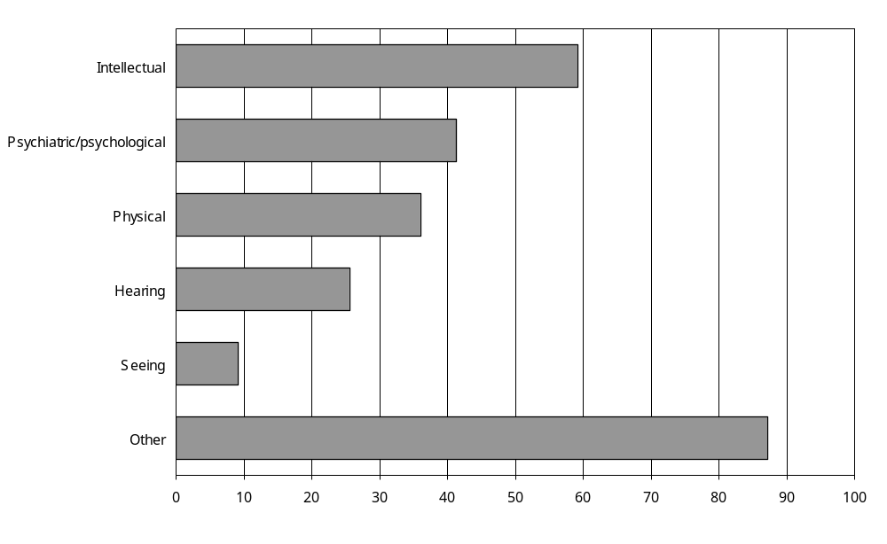
Source: Statistics New Zealand, 2001 Household Disability Survey
Notes:
- Data in Appendix Table 4.24.
- If individuals reported more than one disability type, they were counted in each applicable category.
- Physical disability comprises agility and mobility disabilities.

Almost 60 percent of the adults aged 15–44 who had attended special education schools or classes had intellectual disability at the time of the 2001 Household Disability Survey. Over 40 percent had psychiatric/psychological disability, while 87 percent had a range of ‘other’ kinds of disability (including learning, speaking and remembering disabilities).

Over half (59 percent) of the adults aged 15–44 who attended special education schools or classes had experienced their first disability by age 4. Twenty-seven percent had experienced their first disability from ages 5 to 9, while the remaining 15 percent had experienced their first disability from age 10.

Other effects of disability on education
In the 2001 Household Disability Survey, adults whose disability began before they finished their formal education or training were asked to state what effects, if any, they considered disability had on their formal education or training. Their answers are summarised in Figure 4.30.

Figure 4.30: Percentage of adults with disability living in households, whose disability began before they finished formal education, experiencing different effects on their education, 2001
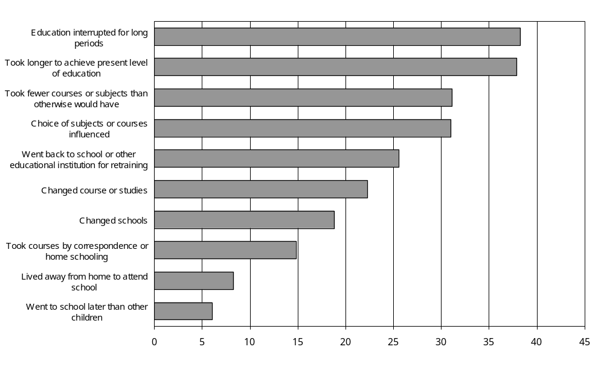
Source: Statistics New Zealand, 2001 Household Disability Survey
Notes:
- Data in Appendix Table 4.27.
- If individuals reported more than one disability type, they were counted in each applicable category.

Thirty-eight percent of adults whose disability began before they finished their formal education indicated that disability had resulted in their education being interrupted for long periods. This was an estimated 51,700 adults with disability, or 8 percent of all adults with disability living in households in 2001.

Thirty-eight percent of adults whose disability began before they finished their formal education also indicated that it had taken longer to achieve their present level of education because of disability. Of this group, 41 percent, or an estimated 20,800 adults, reported that it took up to two years longer to achieve their present level of education, while a further 34 percent, an estimated 16,200 adults, reported it took an extra three years or more to achieve their present level of education. Twenty-eight percent of the group did not know, or were unable to estimate, how much longer it had taken to achieve their present level of education because of disability.

Educational qualifications
This section examines the educational qualifications of adults aged 15 and over with and without disability living in households.

When interpreting these data, it is important to remember that most of the adults with disability who participated in the 2001 Household Disability Survey, especially those in the older age groups, had finished their formal education before experiencing disability (see the earlier section ‘Impact of disability on education and training’). The educational attainment of these people is, therefore, unlikely to have been affected by the presence of disability.

In 2001, 21 percent of adults aged 15 and over with disability living in households had post-school qualifications. Another 27 percent of these adults had school qualifications (but no post-school qualifications), and 31 percent had no educational qualifications.,

Post-school qualifications
Post-school qualifications include certificates, diplomas and degrees from tertiary-level education facilities like polytechnics, universities and private training institutes. In 2001, 21 percent of the estimated 626,500 adults with disability living in New Zealand households had these kinds of qualification.

Twenty-four percent of men with disability had post-school qualifications, as did 19 percent of women.

In all adult age groups, adults with disability were less likely to have a post-school qualification than adults without disability. The greatest difference between adults with and without disability was in the 15–24 age group, where the percentage of disabled people with post-school qualifications was under half that of non-disabled people (7 percent compared with 16 percent) (Figure 4.31).

Figure 4.31: Percentage with post-school qualifications, adults with and without disability living in households, by age, 2001
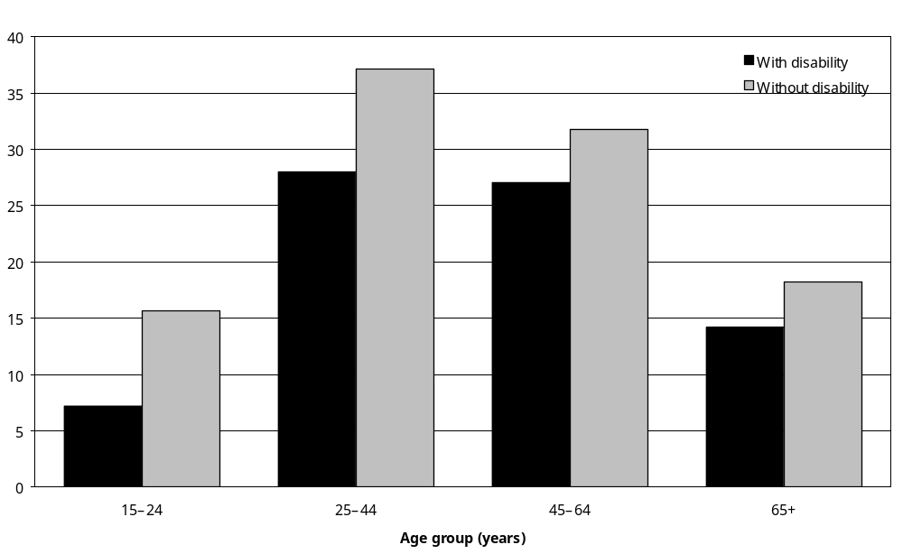
Source: Statistics New Zealand, 2001 Household Disability Survey
Notes:
- Data in Appendix Table 4.29.
- Information on the educational qualifications of 20 percent of adults with disability and 13 percent of adults without disability living in households was not available.

School qualifications
In 2001, 27 percent of adults with disability had school qualifications, but no post-school qualifications. School qualifications included School Certificate, Sixth Form Certificate, University Entrance and Bursary.

Twenty-six percent of men with disability and 28 percent of women with disability had school qualifications.

In most of the adult age groups, adults with disability were less likely than adults without disability to have school qualifications. However, in the 65 and over age group almost the same percentage of both groups had school qualifications (23 percent compared with 24 percent) (Figure 4.32).

Figure 4.32: Percentage with school qualifications, adults with and without disability living in households, by age, 2001
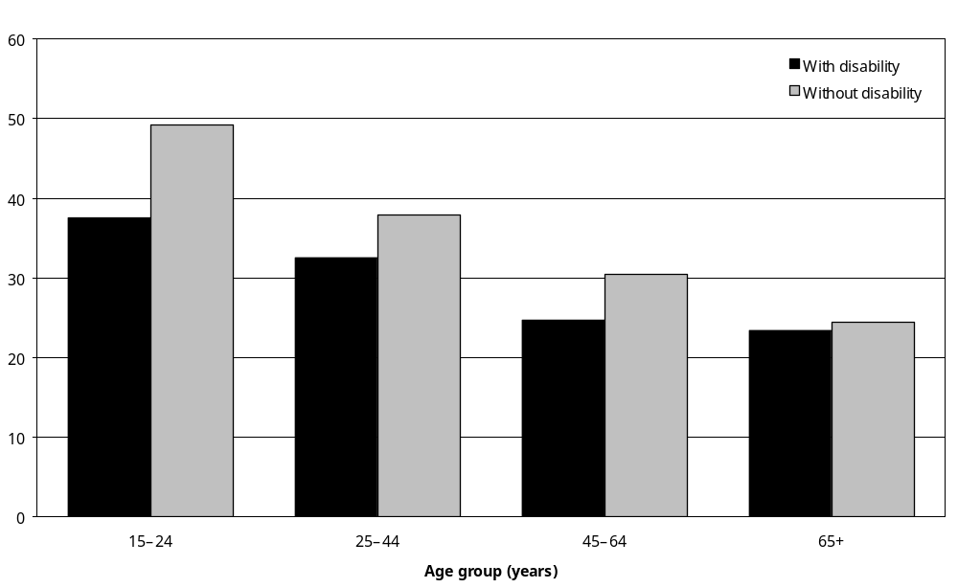
Source: Statistics New Zealand, 2001 Household Disability Survey
Notes:
- Data in Appendix Table 4.29.
- Information on the educational qualifications of 20 percent of adults with disability and 13 percent of adults without disability living in households was not available.

No educational qualifications
In 2001, 31 percent of adults with disability had no educational qualifications. This applied to 31 percent of both men and women.

In keeping with the results for school and post-school qualifications, in all age groups adults with disability were more likely than adults without disability to have no educational qualifications. The greatest differences were in the 15–24 and 25–44 age groups. In particular, adults with disability in the 15–24 age group were almost twice as likely as adults without disability in this age group to have no educational qualifications (35 percent compared with 19 percent) (Figure 4.33).

Figure 4.33: Percentage with no educational qualifications, adults with and without disability living in households, by age, 2001
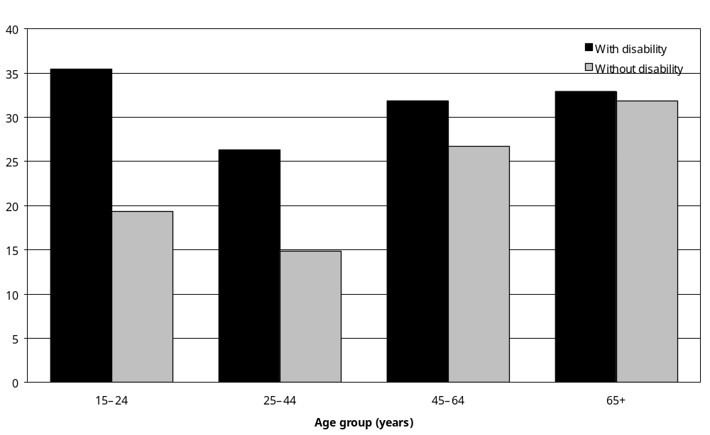
Source: Statistics New Zealand, 2001 Household Disability Survey
Notes:
- Data in Appendix Table 4.29.
- Information on the educational qualifications of 20 percent of adults with disability and 13 percent of adults without disability living in households was not available.

Educational qualifications and ethnicity
Adults with disability in the Asian/Other (52 percent) and European (52 percent) ethnic groups were more likely to have school or post-school educational qualifications than adults with disability in the Mäori (38 percent) and Pacific (36 percent) ethnic groups. The greatest difference in educational attainment between adults with disability and adults without disability was in the Asian/Other ethnic group (where 52 percent of adults with disability and 82 percent of adults without disability had school or post-school qualifications) (Figure 4.34).

Figure 4.34: Percentage with school or post-school qualifications, adults with and without disability living in households, by ethnic group, 2001
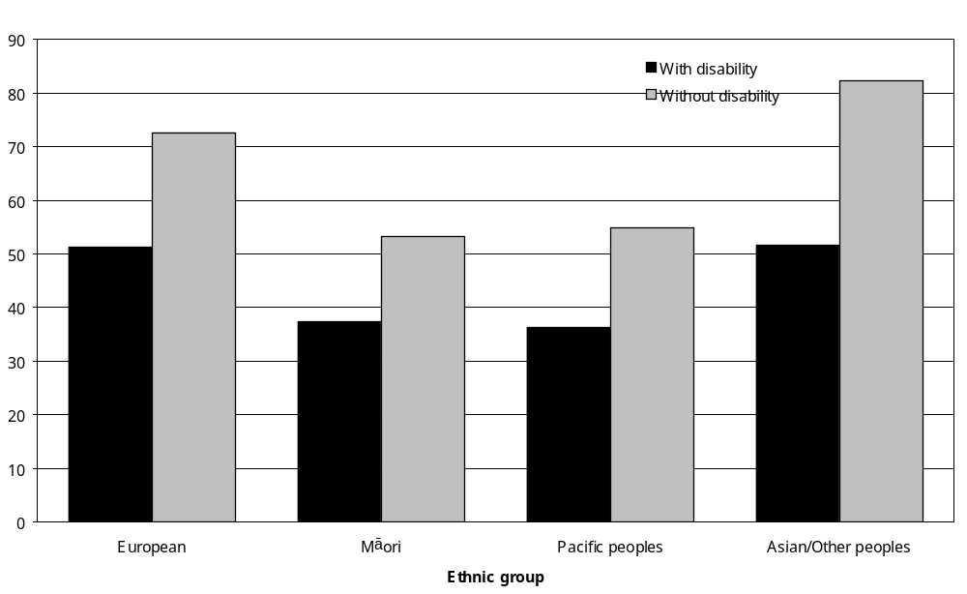
Source: Statistics New Zealand, 2001 Household Disability Survey
Note: Data in Appendix Table 4.29.

Educational qualifications and income

Personal income
Figure 4.35 compares the annual pre-tax personal incomes of adults with and without disability who had post-school qualifications. Generally, adults with disability had lower personal incomes than adults without disability, even when they had the same broad level of educational attainment.

Figure 4.35: Percentage with post-school qualifications, adults with and without disability living in households, by total annual personal income, 2001
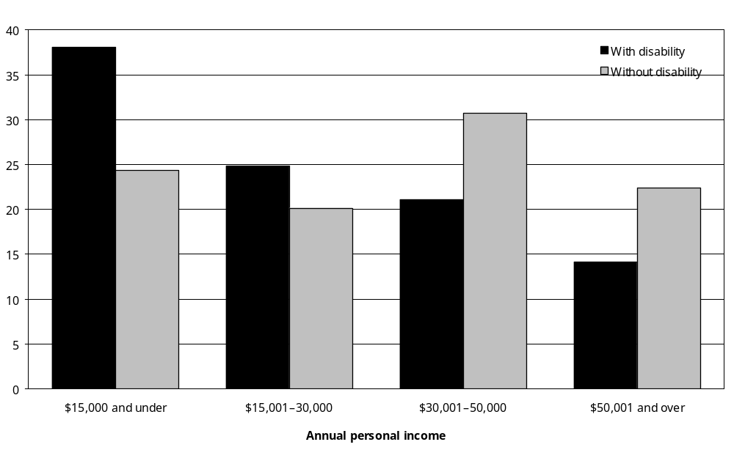
Source: Statistics New Zealand, 2001 Household Disability Survey
Note: Data in Appendix Table 4.29.

In 2001, adults with disability with post-school qualifications were more likely than adults without disability with post-school qualifications to be in the lower personal income groups. Sixty-three percent of adults with disability with post-school qualifications received $30,000 and under per year, compared with 44 percent of adults without disability with post-school qualifications.

Household income
Figure 4.36 compares the annual household incomes of adults with and without disability who had no educational qualifications. Adults with disability had lower household incomes than adults without disability, even when they were similarly qualified.

Figure 4.36: Percentage with no educational qualifications, adults with and without disability living in households, by annual household income, 2001
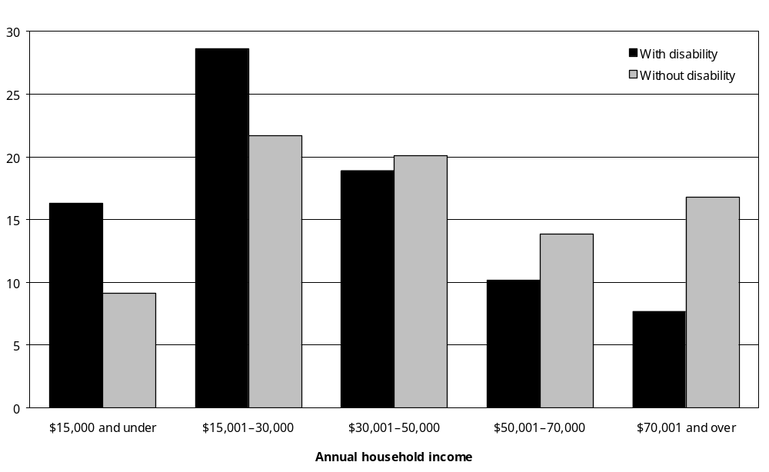
Source: Statistics New Zealand, 2001 Household Disability Survey
Note: Data in Appendix Table 4.29.

In 2001, adults with disability and no educational qualifications were more likely to have household incomes of $30,000 and under per year than adults without disability and with no educational qualifications. In fact, 45 percent of adults with disability and no educational qualifications had household incomes of $30,000 and under per year compared with just 31 percent of adults without disability and no educational qualifications.

Similarly, adults with disability and no educational qualifications were less likely to live in the higher income households than adults without disability and with no educational qualifications. Eight percent of adults with disability without school qualifications had household incomes of $70,001 and over per year, but 17 percent of adults without disability and without school qualifications lived in these high income households.

Rural and urban residence
In 2001, adults with disability living in rural households were more likely than adults with disability living in urban households to have no school qualifications (36 percent compared with 30 percent). This was similar to the pattern for adults without disability (27 percent of adults living in rural areas had no qualifications, compared with 20 percent of adults living in urban areas).

Geographic regions
Compared with the Midland and Southern regions, the Northern and Central regions contained a higher percentage of adults with disability who had school and post-school educational qualifications and a lower percentage of adults with disability who had no school qualifications (Figure 4.37).

Figure 4.37: Percentage of adults with disability living in households, by region, by highest educational qualification gained, 2001
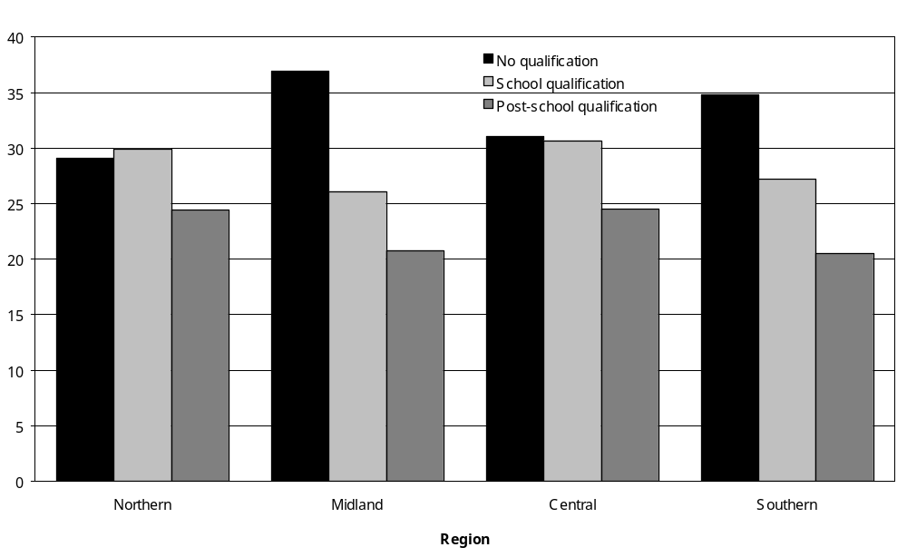
Source: Statistics New Zealand, 2001 Household Disability Survey
Note: Data in Appendix Table 4.29.

Disability type
In 2001, adults with psychiatric/psychological disability were the most likely to have school qualifications as their highest educational qualification, while adults with hearing disability were the most likely to have post-school qualifications (Figure 4.38).

Figure 4.38: Percentage of adults with disability living in households, by highest educational qualification gained and disability type, 2001
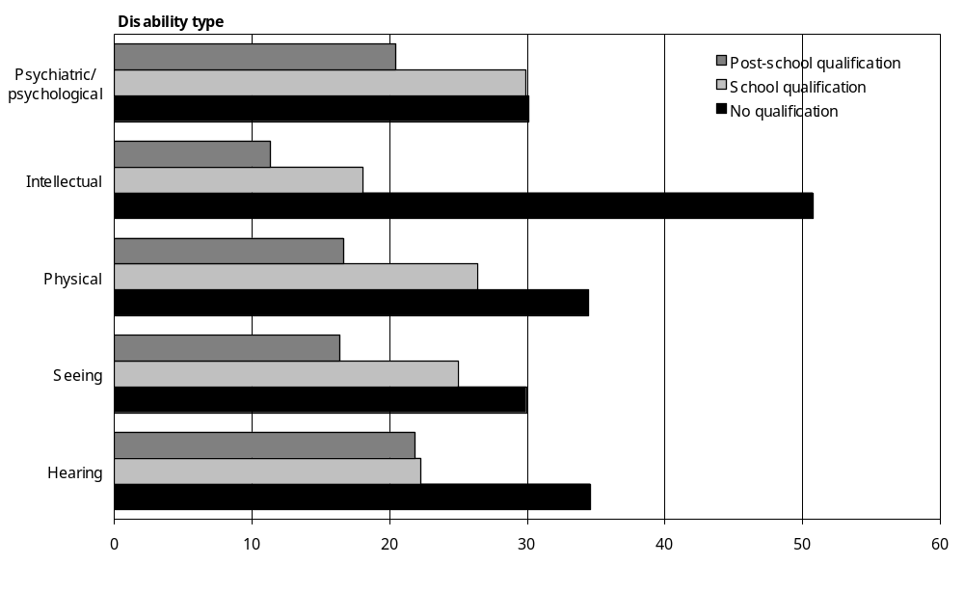
Source: Statistics New Zealand, 2001 Household Disability Survey
Notes:
- Data in Appendix Table 4.30.
- If individuals reported more than one disability type, they were counted in each applicable disability group.
- Physical disability comprises agility and mobility disabilities.

Adults with intellectual disability were the most likely to have no educational qualifications. Fifty-one percent of adults with intellectual disability had no educational qualifications, compared with 35 percent of adults with hearing disability and 30 percent of adults with seeing disability.

Main disability
Similar differences in educational attainment between disability categories were evident when the analysis was restricted to people’s main disability, that is, the disability that most limits a person’s everyday activities.

Adults whose main disability was a hearing disability, seeing disability or psychiatric/ psychological disability were generally more likely than adults with other types of main disability to have school or post-school qualifications. As well, the psychiatric/psychological main disability group contained a comparatively low proportion of people with no educational qualifications (21 percent) (Figure 4.39).

Figure 4.39: Percentage of adults with disability living in households, by highest educational qualification gained and main disability, 2001
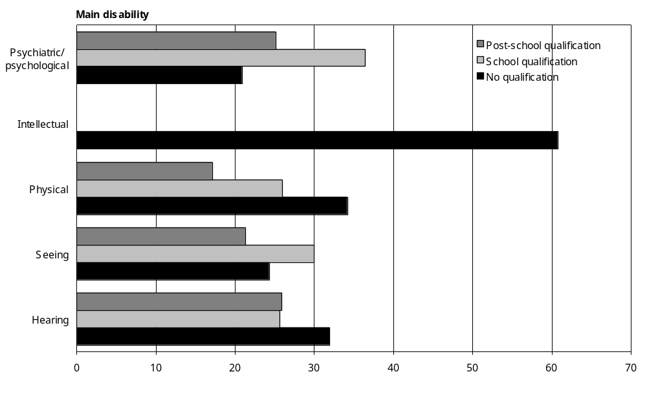
Source: Statistics New Zealand, 2001 Household Disability Survey
– Percentages too small to report (estimated frequencies outside the 70 percent relative sampling error cut-off point).
Notes:
- Data in Appendix Table 4.30.
- Physical disability comprises agility and mobility disabilities.

Adults whose main disability was an intellectual disability were most likely to have no educational qualifications (61 percent) and adults with psychiatric/psychological were least likely to have no qualifications (21 percent).

Disability cause
Adults with disability caused by motor vehicle crash injuries, work injuries and, in particular, sports injuries had comparatively high levels of educational attainment. A third (35 percent) of adults whose main disability was caused by a sports accident/injury had post-secondary school qualifications. By contrast, adults whose main disability was caused by disease/illness (19 percent), conditions existing at birth (18 percent), ageing (17 percent) or accidents or injuries at home (15 percent) were much less likely to have post-school qualifications (Figure 4.40).

Figure 4.40: Percentage of adults with disability living in households, by highest educational qualification gained and cause of main disability, 2001
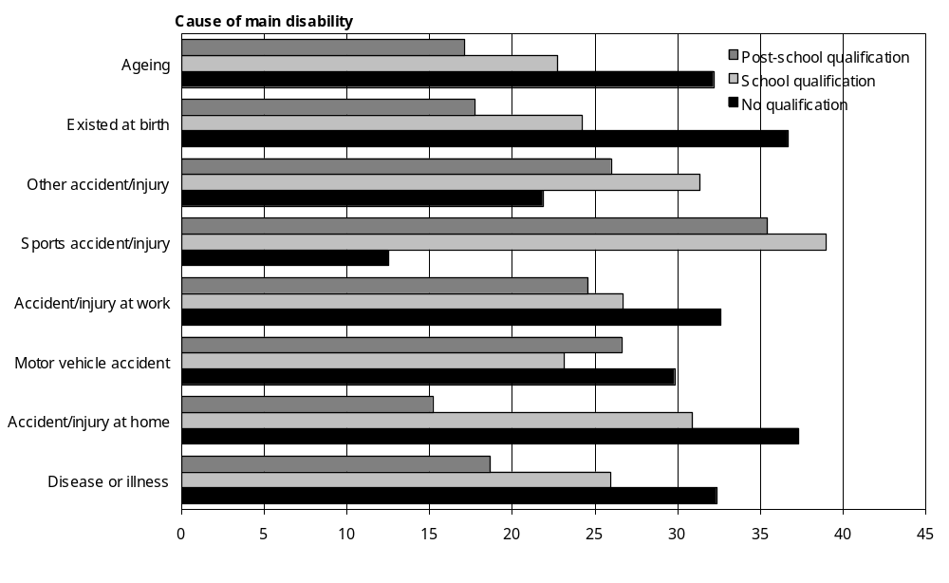
Source: Statistics New Zealand, 2001 Household Disability Survey
Note: Data in Appendix Table 4.30.

Severity of disability
In 2001, adults who experienced severe disability were more likely than adults with mild or moderate disability to have no educational qualifications and less likely to have post-school qualifications. Eleven percent of adults with severe disability had post-school qualifications, compared with 23 percent of adults with mild disability and 23 percent of adults with moderate disability (Figure 4.41).

Figure 4.41: Percentage of adults with disability living in households, by highest educational qualifications gained and severity of disability, 2001
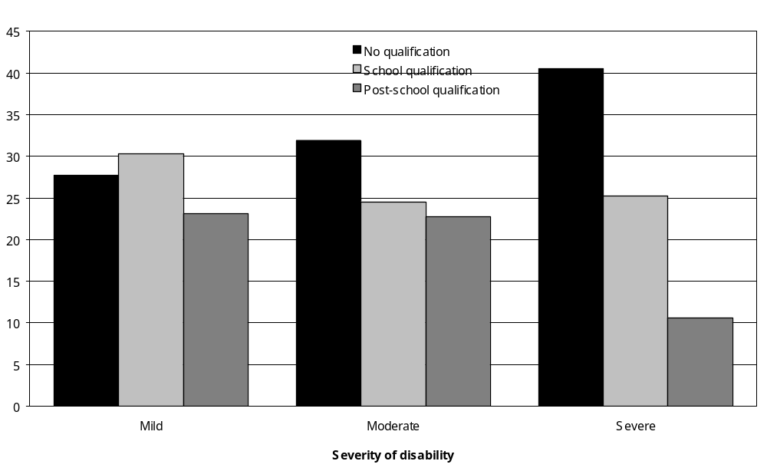
Source: Statistics New Zealand, 2001 Household Disability Survey
Note: Data in Appendix Table 4.30.

Comparing 2001 and 1996

Children
In general, when the 2001 Household Disability Survey results are compared with the 1996 Household Disability Survey results, the trends and patterns relating to education and children are similar (Table 4.3).

Table 4.3: Summary comparison of 1996 and 2001 Household Disability Surveys – children
 | Estimated number of children |  | Percentage of children with disability living in households (%)
 | 1996 survey | 2001 survey | 1996 survey | 2001 survey
Early childhood education (aged 0–4)
Kindergarten | 5,700 | 5,200 | 30 | 33
Childcare centre/crèche | 2,900 | 2,000 | 15 | 13
Playcentre | 2,600 | 1,700 | 14 | 11
Kohanga reo | – | 1,600 | – | 10
Playgroup | – | 800 | – | 5
At least one type of early education | 13,500 | 12,300 | 71 | 77
Primary and secondary education (aged 5–14)
Primary/intermediate | 54,500 | 56,100 | 75 | 76
Secondary | 11,900 | 9,900 | 16 | 13
Area/composite | 2,300 | 2,500 | 3 | 3
Special school | 2,300 | 1,400 | 3 | 2
Home schooling | – | 1,300 | – | 2
Kura Kaupapa Mäori | – | 600 | – | 1
Receiving special education
(aged 5–14)
Attends special school, special unit, special class | 9,100 | 12,400 | 10 | 17
Types of classes attending
(aged 5–14)
Only mainstream classes | 55,000 | 53,300 | 74 | 74
Mixture mainstream and special | 9,000 | 11,400 | 12 | 16
Only a special unit | 2,400 | 2,400 | 3 | 3
Educational assessments (aged 0–14)
Has had an assessment | 26,800 | 33,894 | 29 | 38
Learning disability (aged 0–14)
Had a learning disability (that is, dyslexia, ADD or ADHD) | 24,600 | 25,000 | 26 | 28
Ability to choose school (aged 5–14)
Not always been able to choose | 3,800 | 5,000 | 5 | 7
School activities affected (aged 5–14)
Participating in sports/games | 21,300 | 21,500 | 28 | 30
Playing | 15,000 | 17,800 | 20 | 25
Making friends | 14,500 | 15,600 | 19 | 22
Going on school outings/ camps | 11,100 | 10,600 | 15 | 15
At least one activity affected | 39,000 | 37,000 | 52 | 51
Education affected by disability
(aged 5–14)
Changed schools | 12,900 | 15,100 | 17 | 20
Education interrupted for long periods | 14,700 | 12,700 | 20 | 17
Took fewer subjects or courses | 5,200 | 5,700 | 7 | 8
Took courses by correspondence/home school | 4,200 | 5,200 | 6 | 7
Began school later than others | 3,500 | 4,700 | 5 | 6
Changed subjects or courses | 3,300 | 4,100 | 4 | 5
Lived away from home to go to school | 2,500 | 1,400 | 3 | 2
At least one aspect of education affected | 31,800 | 33,400 | 43 | 45
– Percentages too small to report (estimated frequencies outside the 70 percent relative sampling error cut-off point).

However, there was evidence of an increase in the delivery of special education services. This comprised:
- an increase in the percentage of children with disability receiving some form of special education (from 10 percent in 1996 to 17 percent in 2001)
- an increase in the percentage of children with disability experiencing educational assessments (from 29 percent in 1996 to 38 percent in 2001).

There was also an increase in the percentage of children aged 0–4 participating in early childhood education (from 71 percent in 1996 to 77 percent in 2001).

Adults
In 1996, an estimated 42,932 adults with disability, 7 percent of all adults with disability living in households, were enrolled in formal education. This was a slightly lower participation rate than in 2001 (9 percent) (Table 4.4).

Table 4.4: Summary comparison of 1996 and 2001 Household Disability Surveys – adults
 | Estimated number of adults |  | Percentage of adults living in households (%)
 | 1996 survey | 2001 survey | 1996 survey | 2001 survey
Enrolment in formal education
Adults with disability
15–24 | 16,500 | 16,600 | 43 | 37
25–44 | 21,100 | 21,800 | 14 | 14
45–64 | – | 15,400 | – | 7
65+ | – | 2,000 | – | 1
Total | 42,900 | 55,800 | 7 | 9
Types of formal education enrolled in
Adults with disability
Polytechnic | 12,200 | 13,900 | 29 | 25
University | 10,600 | 12,400 | 25 | 22
Secondary school | 9,000 | 11,200 | 21 | 20
Highest educational qualification
Adults with disability
No qualification | 248,000 | 194,700 | 43 | 31
School qualification | 146,600 | 170,000 | 25 | 27
Post-school qualification | 160,000 | 134,400 | 28 | 21
Adults without disability
No qualification | 555,500 | 456,600 | 26 | 21
School qualification | 719,100 | 809,200 | 34 | 37
Post-school qualification | 743,100 | 648,600 | 35 | 29
– Percentages too small to report (estimated frequencies outside the 70 percent relative sampling error cut-off point).
In 1996, 21 percent of adults with disability enrolled in formal education were at secondary schools, 29 percent were at polytechnics and 25 percent were at universities. The 1996 secondary school enrolment rates were similar to 2001, but the university and polytechnic enrolment rates were slightly higher in 1996. In 2001, 22 percent of adults with disability enrolled in formal education were at university compared with 25 percent in 1996.
In 1996, as in 2001, for adults who had a disability that developed before they finished their formal education, the most commonly reported detrimental effect of the disability on their education was that it interrupted their education for long periods. Next were effects on the choice of courses or subjects, taking fewer courses or subjects, and changing courses or subjects.
Compared with 1996, in 2001 adults with and without disability were less likely to have no qualifications or post-school qualifications. Most notably, 31 percent of adults with disability had no educational qualifications in 2001, compared with 43 percent in 1996.

5 Employment and Income

Key points
This chapter examines the employment and economic circumstances of New Zealanders with disability living in households. It looks at how many people with disability had a job, how many were unemployed and how many were not in the labour force. It also looks at people’s income sources and income levels, as well as their use of government financial assistance.

Labour force status of working age (15–64) adults with disability
- In 2001, 57 percent of people aged 15–64 with disability living in households were employed. Six percent were unemployed and actively seeking work, while 36 percent were not in the labour force.
- By comparison, in the same year 71 percent of people aged 15–64 without disability were employed, 4 percent were unemployed and 18 percent were not in the labour force.
- The highest rate of employment among people with disability was in the 25–44 age group (64 percent). People with disability aged 15–24 and 45–64 were less likely to be employed (55 percent and 45 percent respectively).
- Employment rates for people aged 15–64 with seeing, mobility, agility, intellectual or psychiatric/psychological disability were similar in 2001, ranging from 42 percent to 47 percent. However, people with hearing disability (62 percent) and people with ‘other’ types of disability (53 percent) had higher rates of employment.
- People with severe disability were less likely to be in the workforce than people with mild or moderate disability. Sixty-five percent of adults aged 15–64 with severe disability were not in the labour force, compared with 36 percent with moderate disability and 30 percent with mild disability.

Labour force status of people with disability aged 65 and over
- Most people aged 65 and over with disability were not in the labour force (93 percent). Six percent were employed. In comparison, 78 percent of people aged 65 and over without disability were not in the labour force and 16 percent were employed.

Employed people with disability
- Of the adults with disability who were employed in 2001, 17 percent were self-employed or had their own business, 54 percent worked as paid employees, and 2 percent worked without pay in a family business or farm. Information was not available for 27 percent.
- An estimated 5400 adults, 2 percent of employed adults with disability, worked in sheltered workshops or in jobs specifically set up to provide work for people with disability.
- Fifteen percent of New Zealand’s total population of employed adults had some kind of disability in 2001.
- Certain occupational groups, such as elementary occupations and trades, contained a relatively high percentage of workers with disability (23 percent and 17 percent respectively). Other occupational groups, such as clerks (12 percent) and professionals (11 percent), contained a relatively low percentage of workers with disability.
- Workers in elementary occupations had the highest rate of mobility disability (10 percent) and agility disability (10 percent). Ten percent of all trades workers, 7 percent of all plant and machine operators and assemblers, and 7 percent of all workers in elementary occupations were estimated to have a hearing disability.
- The most common cause of disability among employed adults in 2001 was accident/injury. An estimated 78,600 employed adults, 5 percent of all employed New Zealanders, had a main disability caused by accident/injury.
- Nineteen percent of employed adults with disability, an estimated 47,900 people, indicated they needed some form of personal assistance, technical equipment or other workplace modifications to enable them to work in their present job. The most common requirement was modified or different duties, indicated by 9 percent of adults with disability in employment.
- Two percent, or an estimated 5400 employed adults with disability, indicated they needed alterations to their work area or building. Three-quarters of these people had a mobility disability as their main disability or as one of their disabilities.

Unemployed people with disability
- In 2001, 22 percent of unemployed aged 15–64 with disability had been looking for work for more than a year.
- When unemployed people with disability were asked what they needed to be able to work, the most common requirement they identified was modified work hours (21 percent).

People with disability not in the labour force
- People under the age of 65 and not in the labour force were asked if their condition or health problem stopped them from working at a job or business. Just under half (42 percent) said it did not. Women (47 percent) were more likely than men (36 percent) to say they were not stopped from working. Older adults were more likely than younger adults to have a condition or health problem that stopped them from working at a job or business.
- Modified work hours was the special workplace requirement that adults with disability who were able and willing to work most commonly indicated they needed.

Income sources
- Compared with adults aged 15–24 without disability, adults aged 15–24 with disability were more likely to obtain income from the Community Wage – Job Seeker (otherwise known as the Unemployment Benefit), the Community Wage – Sickness Benefit and the Invalids Benefit. They were less likely than adults aged 15–24 without disability to obtain income from wages or salaries or from student allowances.
- Compared with people aged 25–64 years without disability, people aged 25–64 with disability were more likely to obtain income from the Accident Compensation Corporation (ACC) or a private work accident insurer, the Community Wage – Job Seeker, the Community Wage –Sickness Benefit and the Invalids Benefit. They were less likely than people aged 25–64 without disability to obtain income from wages or salaries, self-employment and interest, dividends, rent or other investments.
- In the 65 and over age group, most people with disability derived income from New Zealand Superannuation (including the Veterans Pension), as did most people without disability. However, people with disability were less likely than people without disability to derive income from wages, salary, commissions, bonuses and other payments made by employers, or from self-employment.

Government financial assistance
- In 2001 the Disability Allowance was provided to 13 percent of adults with disability, an estimated 84,000 adults. Seven percent of adults with disability received the Community Wage – Sickness Benefit, 7 percent received the Invalids Benefit, 2 percent received the War Disablement Pension and 2 percent received the Special Needs Grant.
- Eighteen percent of children with disability, an estimated 16,500 children, received the Child Disability Allowance, while 6 percent, an estimated 5400 children, received the Disability Allowance.

Health care cards
- The 2001 Disability Survey estimated that 54 percent of adults with disability and 63 percent of children with disability had a Community Services Card in the previous 12 months.
- Over this same time, 9 percent of adults with disability and 4 percent of children with disability had a Pharmaceutical Subsidy Card. Eight percent of adults with disability and 4 percent of children with disability had a High Use Health Card.

Household income
- Children with disability were more likely than children without disability to live in low income households (household incomes of $30,000 and under per year).
- Similarly, in all adult age groups, from 15–24 to 65 and over, adults with disability were more likely than adults without disability to live in low income households.

Personal income
- Adults with disability in the 25–44, 45–64 and 65 and over age groups were more likely than their non-disabled counterparts to have low personal incomes. For example, 42 percent of adults aged 25–44 with disability had personal incomes of $15,000 and under per year in 2001, compared with 25 percent of adults aged 25–44 without disability.

Socioeconomic areas
- In 2001, for all age groups, people with disability were more likely than people without disability to live in households in the more socioeconomically deprived areas of New Zealand (NZDep2001 areas 6–10).

Introduction
Objective 4 of the New Zealand Disability Strategy is to provide opportunities in employment and economic development for people with disability (Minister for Disability Issues 2001). Actions proposed to meet this objective include:
- encouraging the development of a range of employment options appropriate to the diverse needs of people with disability
- providing communication services, resources and flexible workplace options
- ensuring disabled people have access to economic development initiatives
- reviewing income support provisions to ensure people with disability have an adequate standard of living.

To contribute to the implementation and evaluation of these actions, this chapter presents results from the 2001 Household Disability Survey on the employment and economic circumstances of non-institutionalised people with disability.

It begins by looking at the labour force status of people with disability in 2001, indicating how many were employed, how many were unemployed and how many were not in the labour force. Results are compared with those for people without disability, revealing important differences.

Employed people with disability are then considered in more detail, looking at the kinds of occupation and industry they worked in, and their special workplace requirements related to disability.

Following this comes a closer look at the people with disability who were unemployed and actively seeking work. This examines how long they had been out of work and the special workplace requirements they needed to be able to work.

The next section examines the different income sources of adults with disability, covering paid employment and business ownership, as well as government financial assistance.

This is followed by a section summarising people’s levels of personal and household income in 2001. Data are also presented examining the extent to which people with disability were more likely than other people to live in the more socioeconomically disadvantaged areas of New Zealand.

The final section compares labour force status and income statistics from the 2001 and 1996 Household Disability Surveys.

Employment and labour force status

Labour force status of adults aged 15–64
The focus of this section is the 15–64 years age group, as this is the group usually regarded as the working age population. Of the estimated 626,500 adults with disability living in households in 2001, 411,000 (66 percent) were aged 15–64. The remaining 215,600 (34 percent) were aged 65 and over.
In 2001 just over half (57 percent) of people with disability aged 15–64 were employed. Six percent were unemployed and seeking work, while 36 percent were not in the labour force.
By comparison, in the same year 71 percent of people without disability aged 15–64 were employed, 4 percent were unemployed and 18 percent were not in the labour force (Figure 5.1).
Figure 5.1: Percentage of adults aged 15–64 with and without disability living in households, by labour force status, 2001
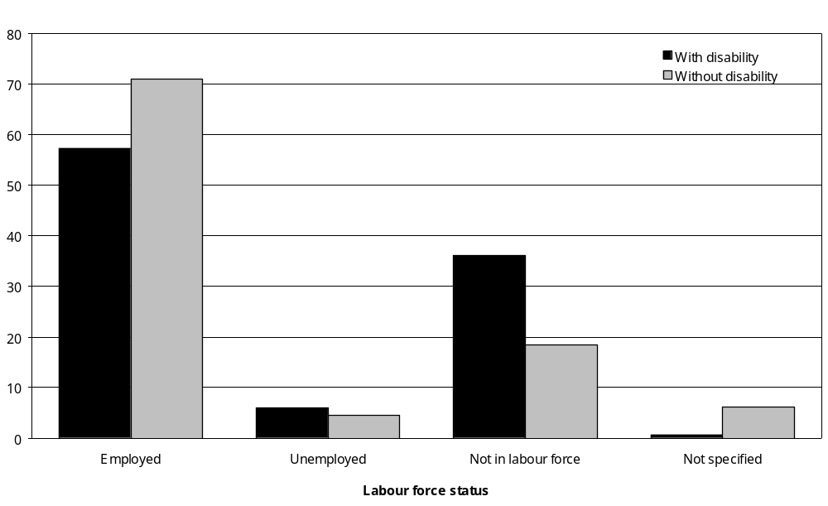
Source: Statistics New Zealand, 2001 Household Disability Survey, 2001 Census of Population and Dwellings
Notes:
- Data in Appendix Table 5.1.
- ‘Employed’ means working for pay or profit in a job, business or farm, or working without pay in a family business or farm. ‘Unemployed’ means not employed in a job, business or farm but actively looking for full-time or part-time work. ‘Not in the labour force’ means neither employed nor unemployed, including being retired, having personal or family responsibilities such as unpaid housework and childcare, attending educational institutions, being permanently unable to work due to disability, and not actively seeking work (Statistics New Zealand 2002a).
Working-age people with disability were, therefore, less likely to be in the labour force (that is, employed or actively seeking work) than working age people without disability.

Employment
The highest rate of employment among people with disability was in the 25–44 age group (64 percent). People with disability aged 15–24 and 45–64 were less likely to be employed (55 percent and 45 percent respectively).

In all three age groups from 15–24 to 45–64, people with disability had lower rates of employment than people without disability. This was particularly the case in the 45–64 age group (Figure 5.2).

Figure 5.2: Employment rates of adults aged 15–64 with and without disability living in households, by age, 2001
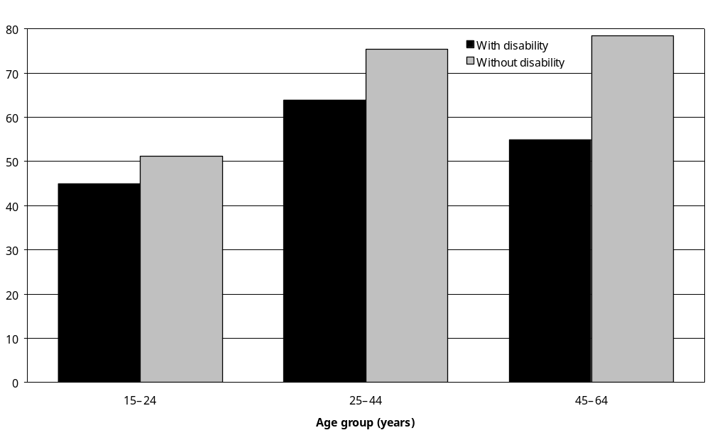
Source: Statistics New Zealand, 2001 Household Disability Survey, 2001 Census of Population and Dwellings
Notes:
- Data in Appendix Table 5.1.
- ‘Employed’ means working for pay or profit in a job, business or farm, or working without pay in a family business or farm (Statistics New Zealand 2002a).

In 2001, women with disability were less likely than men to be employed (51 percent and 63 percent respectively). A similar difference existed between women and men without disability (65 percent and 77 percent respectively).

Unemployment
Six percent of adults aged 15–64 with disability were unemployed and actively seeking work in 2001. However, adults aged 15–24 had a higher unemployment rate (9 percent), while adults aged 45–64 had a slightly lower unemployment rate (4 percent).

In all three age groups from 15–24 to 45–64, unemployment rates were higher for adults with disability than for adults without disability. In the 25–44 age group, the unemployment rate for people with disability was double that of people without disability (8 percent compared with 4 percent) (Figure 5.3).

Figure 5.3: Unemployment rates of adults aged 15–64 with and without disability living in households, by age, 2001
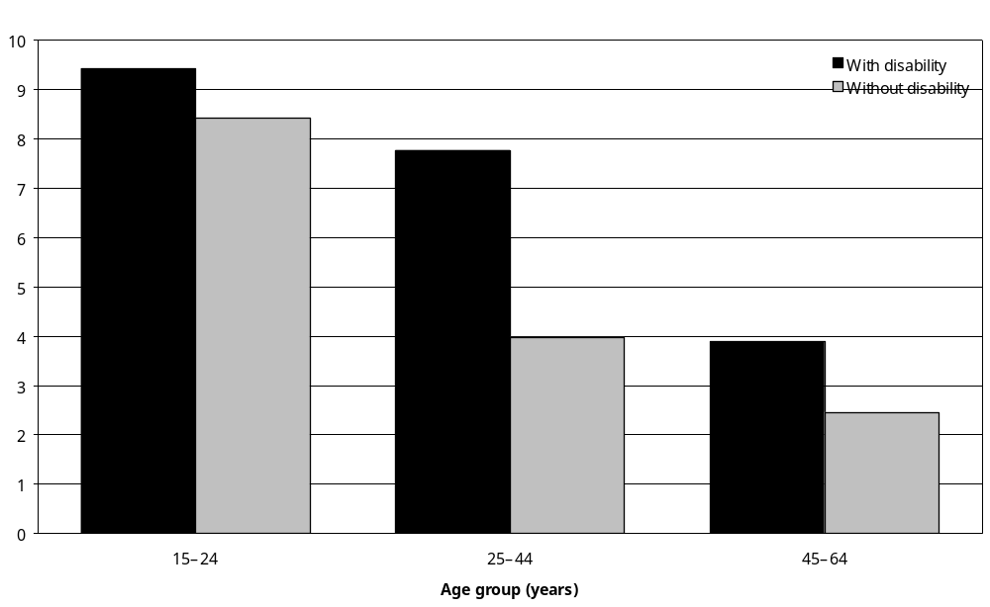
Source: Statistics New Zealand, 2001 Household Disability Survey, 2001 Census of Population and Dwellings
Notes:
- Data in Appendix Table 5.1.
- ‘Unemployed’ means not employed in a job, business or farm, but actively looking for full-time or part-time work (Statistics New Zealand 2002a).

In 2001, unemployment rates were similar for men and women, both with and without disability. Seven percent of men and 5 percent of women with disability were unemployed; 5 percent of men and 4 percent of women without disability were unemployed.

Not in the labour force
Thirty-six percent of adults aged 15–64 with disability were not in the labour force, including 45 percent of adults aged 15–24 and 41 percent of adults aged 45–64. The proportion of adults aged 25–44 not in the labour force was somewhat lower (28 percent).

In all three age groups from 15–24 to 45–64, people with disability were more likely than people without disability to be not in the labour force. For example, 28 percent of adults aged 25–44 with disability were not in the labour force, compared with 15 percent of adults aged 25–44 without disability (Figure 5.4).

Figure 5.4: Percentage of adults aged 15–64 with and without disability living in households not in the labour force, by age, 2001
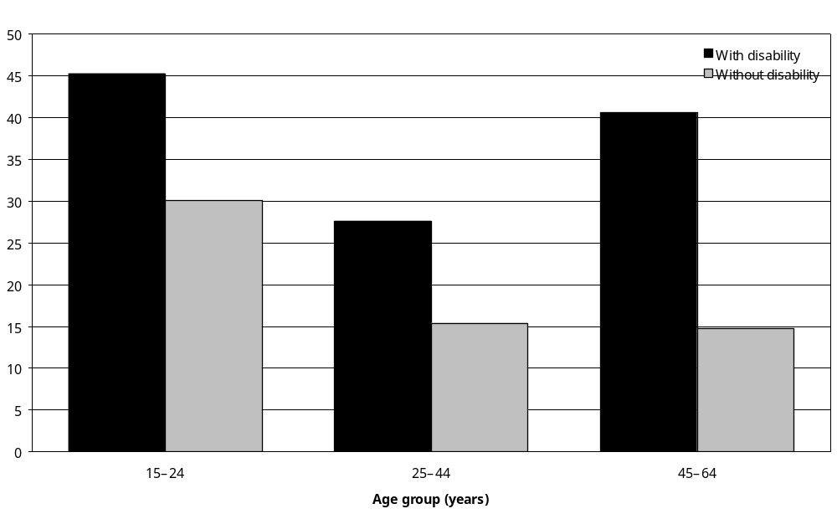
Source: Statistics New Zealand, 2001 Household Disability Survey, 2001 Census of Population and Dwellings
Notes:
- Data in Appendix Table 5.1.
- ‘Not in the labour force’ means being neither employed nor unemployed, including being retired, having personal or family responsibilities such as unpaid housework and childcare, attending educational institutions, being permanently unable to work due to disability, and not actively seeking work (Statistics New Zealand 2002a).

Women aged 15–64 were more likely than men to be classified as ‘not in the labour force’, whether or not they had disability. Forty-three percent of women and 29 percent of men with disability in this age group were not in the labour force, compared with 24 percent of women and 12 percent of men without disability.

Labour force status and disability type
Employment rates for adults aged 15–64 with seeing, mobility, agility, intellectual or psychiatric/ psychological disability were similar in 2001, ranging from 42 percent to 47 percent. However, people with hearing disability (62 percent) and people with ‘other’ types of disability (53 percent) had higher rates of employment (Table 5.1).

Table 5.1: Labour force status of adults aged 15–64 with disability living in households, by disability type, 2001
Disability type in adults aged 15–64 | In the labour force |  | Not in the labour force  % | Total  %
Disability type in adults aged 15–64 | Employed  % | Unemployed  % | Not in the labour force  % | Total  %
Hearing | 62 | 6 | 30 | 100
Seeing | 44 | 8 | 48 | 100
Mobility | 45 | 6 | 48 | 100
Agility | 47 | 6 | 46 | 100
Intellectual | 42 | 7 | 51 | 100
Psychiatric/psychological | 44 | 7 | 48 | 100
Other | 53 | 6 | 40 | 100
Total | 57 | 6 | 36 | 100
Source: Statistics New Zealand, 2001 Household Disability Survey
Notes:
- ‘Employed’ means working for pay or profit in a job, business or farm, or working without pay in a family business or farm. ‘Unemployed’ means not employed in a job, business or farm, but actively looking for full-time or part-time work. ‘Not in the labour force’ means being neither employed nor unemployed, including being retired, having personal or family responsibilities such as unpaid housework and childcare, attending educational institutions, being permanently unable to work due to disability, and not actively seeking work (Statistics New Zealand 2002a).
- If individuals reported more than one disability type, they were counted in each applicable disability group.
- The sum of the values for each category may differ from the total due to rounding.

Labour force status and main disability
A generally similar result is evident when the analysis is limited to people’s main disability. Adults aged 15–64 who had a seeing disability, a mobility disability, an intellectual disability or a psychiatric/psychological disability as their main disability were the least likely to be in the labour force, with 46 to 48 percent employed. By contrast, 79 percent of adults with a hearing disability as their main disability were employed, as were 62 percent of adults with an agility disability as their main disability, and 60 percent of adults with an ‘other’ disability as their main disability (Figure 5.5).

Figure 5.5: Percentage of adults aged 15–64 with disability living in households, by labour force status and main disability, 2001
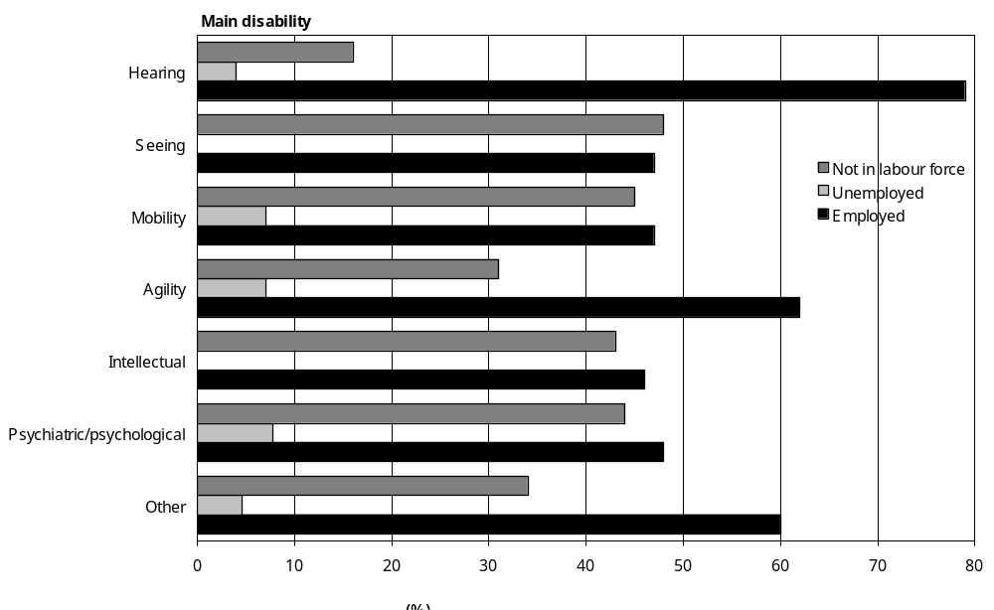
Source: Statistics New Zealand, 2001 Household Disability Survey
– Percentages too small to report (estimated frequencies outside the 70 percent relative sampling error cut-off point).
Notes:
- Data in Appendix Table 5.2.
- ‘Employed’ means working for pay or profit in a job, business or farm, or working without pay in a family business or farm. ‘Unemployed’ means not employed in a job, business or farm, but actively looking for full-time or part-time work. ‘Not in the labour force’ means being neither employed nor unemployed, including being retired, having personal or family responsibilities such as unpaid housework and childcare, attending educational institutions, being permanently unable to work due to disability, and not actively seeking work (Statistics New Zealand 2002a).

Labour force status and cause of main disability
Less than half of adults aged 15–64 with a main disability caused by disease/illness were employed in 2001 (47 percent). In contrast, 62 percent of adults aged 15–64 with a main disability caused by accident/injury were employed, as were 63 percent of adults aged 15–64 with a main disability from ‘other’ causes (Figure 5.6).

Figure 5.6: Percentage of adults aged 15–64 with disability living in households, by labour force status and cause of main disability, 2001
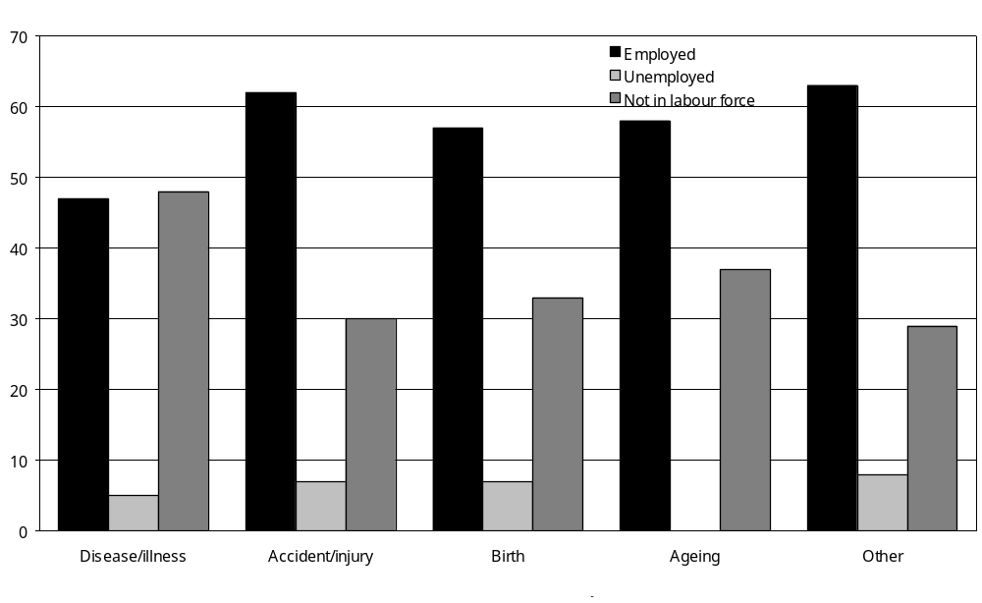
Source: Statistics New Zealand, 2001 Household Disability Survey
– Percentages too small to report (estimated frequencies outside the 70 percent relative sampling error cut-off point).
Notes:
- Data in Appendix Table 5.2.
- ‘Employed’ means working for pay or profit in a job, business or farm, or working without pay in a family business or farm. ‘Unemployed’ means not employed in a job, business or farm, but actively looking for full-time or part-time work. ‘Not in the labour force’ means being neither employed nor unemployed, including being retired, having personal or family responsibilities such as unpaid housework and childcare, attending educational institutions, being permanently unable to work due to disability, and not actively seeking work (Statistics New Zealand 2002a).

Labour force status and single/multiple disability
More than two-thirds (69 percent) of adults aged 15–64 with a single disability were employed, compared with 47 percent of adults aged 15–64 with multiple disabilities (Figure 5.7).

Figure 5.7: Percentage of adults aged 15–64 with disability living in households, by labour force status and single/multiple disability, 2001
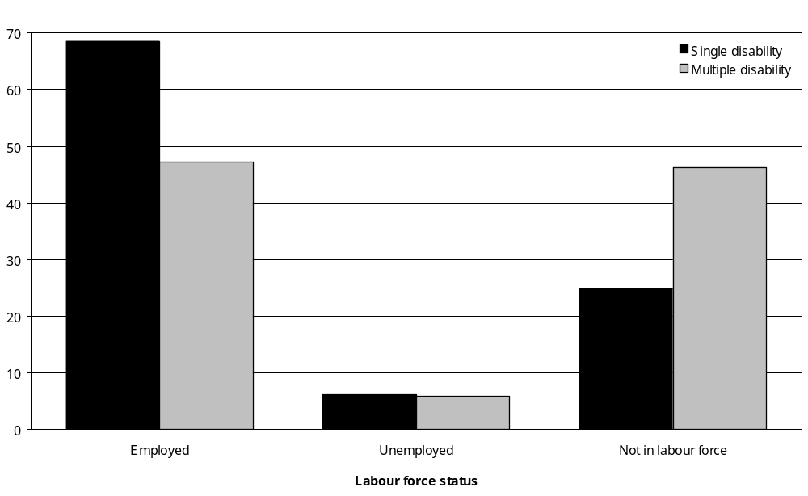
Source: Statistics New Zealand, 2001 Household Disability Survey
Notes:
- Data in Appendix Table 5.2.
- ‘Employed’ means working for pay or profit in a job, business or farm, or working without pay in a family business or farm. ‘Unemployed’ means not employed in a job, business or farm, but actively looking for full-time or part-time work. ‘Not in the labour force’ means being neither employed nor unemployed, including being retired, having personal or family responsibilities such as unpaid housework and childcare, attending educational institutions, being permanently unable to work due to disability, and not actively seeking work (Statistics New Zealand 2002a).

Labour force status and severity of disability
People with severe disability were less likely to be in the workforce than people with mild or moderate disability. Sixty-five percent of adults aged 15–64 with severe disability were not in the labour force, compared with 36 percent with moderate disability and 30 percent with mild disability (Figure 5.8).

Figure 5.8: Percentage of adults aged 15–64 with disability living in households, by labour force status and severity of disability, 2001
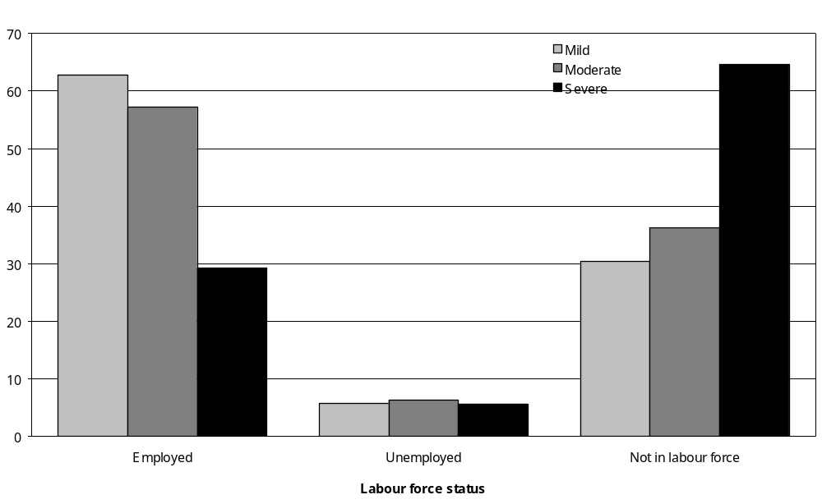
Source: Statistics New Zealand, 2001 Household Disability Survey
Notes:
- Data in Appendix Table 5.2.
- ‘Employed’ means working for pay or profit in a job, business or farm, or working without pay in a family business or farm. ‘Unemployed’ means not employed in a job, business or farm, but actively looking for full-time or part-time work. ‘Not in the labour force’ means being neither employed nor unemployed, including being retired, having personal or family responsibilities such as unpaid housework and childcare, attending educational institutions, being permanently unable to work due to disability, and not actively seeking work (Statistics New Zealand 2002a).

Labour force status of adults aged 65 and over
Most adults aged 65 and over with disability were not in the labour force (93 percent). Six percent were employed.

By comparison, 78 percent of adults aged 65 and over without disability were not in the labour force and 16 percent were employed (Figure 5.9).

Figure 5.9: Percentage of adults aged 65 and over with and without disability living in households, by labour force status, 2001
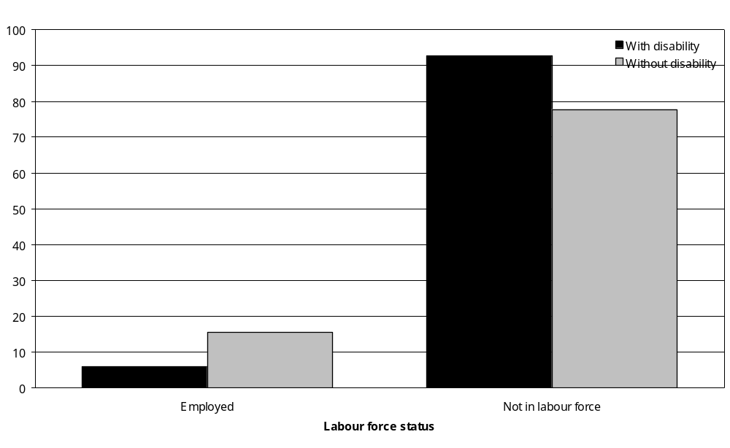
Source: Statistics New Zealand, 2001 Household Disability Survey, 2001 Census of Population and Dwellings
Notes:
- Data in Appendix Table 5.3.
- ‘Employed’ means working for pay or profit in a job, business or farm, or working without pay in a family business or farm. ‘Unemployed’ means not employed in a job, business or farm, but actively looking for full-time or part-time work. ‘Not in the labour force’ means being neither employed nor unemployed, including being retired, having personal or family responsibilities such as unpaid housework and childcare, attending educational institutions, being permanently unable to work due to disability, and not actively seeking work (Statistics New Zealand 2002a).
- The ‘unemployed’ category for people aged 65 and over is not shown as estimated frequencies were outside the 70 percent relative sampling error cut-off point.

Employed people with disability
In 2001, 40 percent of adults aged 15 and over with disability, an estimated 248,200 people, were employed. This section looks more closely at features of this group.

Status in employment
Just over half of employed adults with disability were paid employees (54 percent), which was less than the proportion of adults without disability (68 percent) (Figure 5.10).

Figure 5.10: Percentage of employed adults with and without disability living in households, by status in employment, 2001
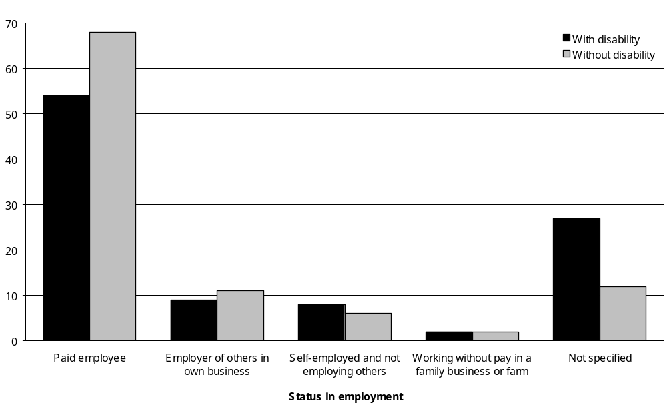
Source: Statistics New Zealand, 2001 Household Disability Survey, 2001 Census of Population and Dwellings
Notes:
- Data in Appendix Table 5.5.
- ‘Employed’ means working for pay or profit in a job, business or farm, or working without pay in a family business or farm (Statistics New Zealand 2002a).
- The data in this figure were obtained by matching Census data with data from the Household Disability Survey. The unmatched data from the Household Disability Survey indicate that 69 percent of employed people with disability were paid employees, 19 percent were self-employed or had their own business and 5 percent worked without pay in a family business or farm.

A sizeable percentage of employed adults with disability (17 percent) were self-employed or had their own business. This was the same as the proportion of adults without disability.

Two percent of employed adults, both with and without disability, were working without pay in a family business or farm.

Of the employed people with disability aged 65 and over, only 24 percent were paid employees, while 21 percent were employers of others in their own business.

In the 15–24 age group, 69 percent of people with disability in jobs were paid employees.

Employed females with disability were more likely than employed males with disability to be paid employees (61 percent compared with 50 percent). Males were more likely than females to be self-employed (11 percent compared with 4 percent) or to own a business employing others (11 percent compared with 6 percent).

More than one job
An estimated 34,000 adults, 14 percent of employed adults with disability, had more than one job, whether paid or unpaid. Adults aged 65 and over were more likely to have more than one job (20 percent), while adults in the 15–24 and 25–44 age groups were the least likely to have more than one job (11 percent in each case).

Sixteen percent of employed women with disability had more than one job, compared with 11 percent of employed men with disability.

Sheltered employment
An estimated 5400 people, 2 percent of employed adults with disability, worked in sheltered workshops or in jobs specifically set up to provide work for people with disability.

Two-thirds (68 percent) of adults working in sheltered employment were men. Most were aged 25 to 64.

Types of occupation
In 2001, 15 percent of all adults in employment (that is, adults with and without disability) had some kind of disability. This was lower than the rate of disability for the New Zealand adult population as a whole, which was 22 percent.

Certain occupational groups contained a relatively high percentage of people with disability; for example, 23 percent of workers in elementary occupations and 17 percent of trades workers had some kind of disability.

Other occupational groups, such as clerks (12 percent) and professionals (11 percent), contained a relatively low percentage of people with disability.

In some occupations, such as trades, male workers were more likely than female workers to have disability. In other occupations, such as professionals and clerks, female workers were more likely than male workers to have a disability (Figure 5.11).

Figure 5.11: Percentage of all employed adults living in households who had disability, by sex and occupation, 2001
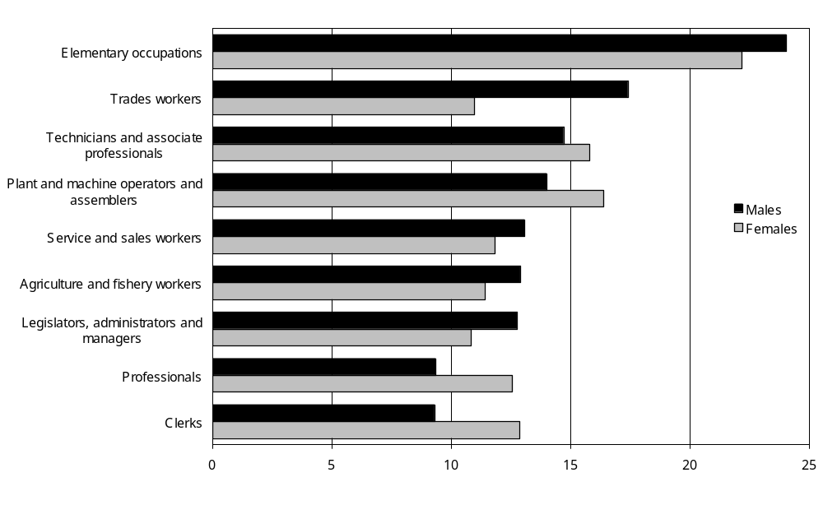
Source: Statistics New Zealand, 2001 Household Disability Survey
Notes:
- Data in Appendix Table 5.8.
- ‘Employed’ means working for pay or profit in a job, business or farm, or working without pay in a family business or farm (Statistics New Zealand 2002a).

Industry category
Rates of disability were highest among people employed in government administration and defence (17 percent), the transport and storage industry, the construction industry, manufacturing, and health and community services (all 16 percent) (Figure 5.12).

Figure 5.12: Percentage of all employed adults living in households who had disability, by industry category, 2001
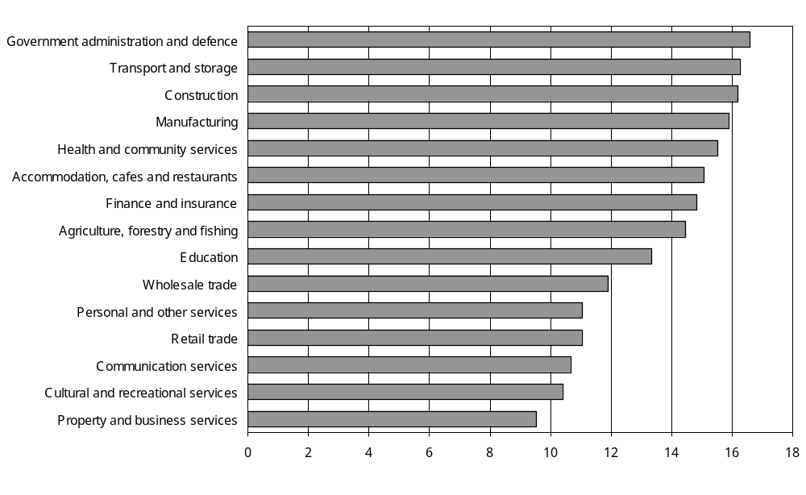
Source: Statistics New Zealand, 2001 Household Disability Survey
Notes:
- Data in Appendix Table 5.9.
- ‘Employed’ means working for pay or profit in a job, business or farm, or working without pay in a family business or farm (Statistics New Zealand 2002a).

Rates of disability were comparatively low among people employed in the property and business services sector (10 percent), cultural and recreational services (10 percent), communication services, the retail sector, and the personal and other services sector (all 11 percent).

Disability type
Results from the 2001 Household Disability Survey make it possible to estimate what percentage of the entire population of employed adults (that is, adults with and without disability) had various types of disability.

In 2001, 5 percent of all employed adults had a mobility disability. Five percent of all employed adults had a hearing disability and 4 percent of all employed adults had an agility disability. Slightly smaller percentages of employed adults had a psychiatric/psychological disability (2 percent), a seeing disability (1 percent) or an intellectual disability (less than 1 percent) (Figure 5.13).

Figure 5.13: Percentage of all employed adults living in households who had disability, by disability type and main disability, 2001
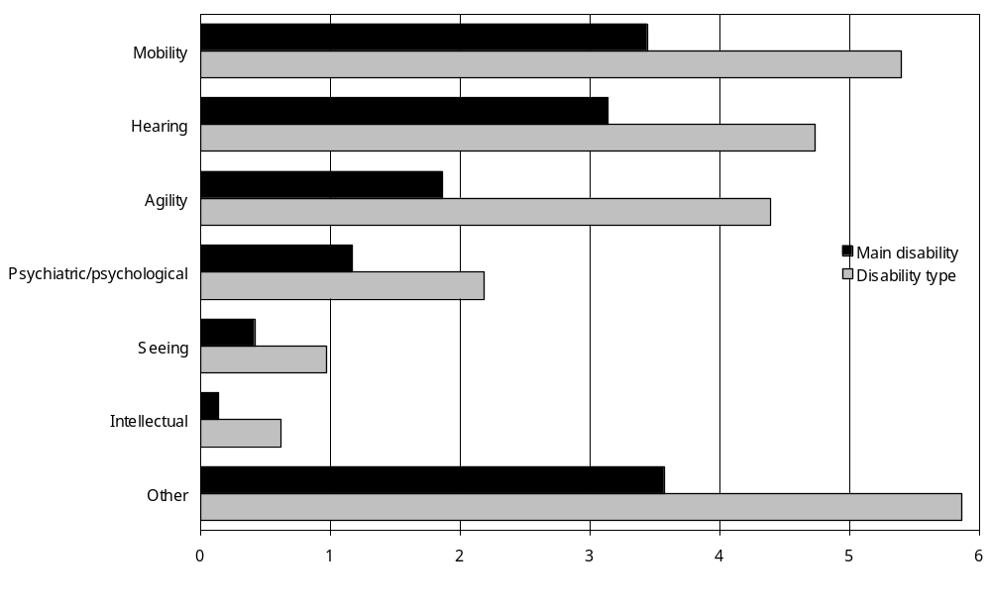
Source: Statistics New Zealand, 2001 Household Disability Survey
Notes:
- Calculated from data in Appendix Table 5.4.
- ‘Employed’ means working for pay or profit in a job, business or farm, or working without pay in a family business or farm (Statistics New Zealand 2002a).
- If individuals reported more than one disability type, they were counted in each applicable disability group.

Workers in elementary occupations had the highest rate of mobility disability (10 percent) and agility disability (10 percent).

Hearing disability was more common in certain occupations, with 10 percent of trades workers, 7 percent of plant and machine operators and assemblers, and 7 percent of workers in elementary occupations estimated to have a hearing disability.

Main disability
In 2001, 3 percent of all employed adults had a main disability that was a mobility disability; another 3 percent had a main disability that was a hearing disability. Two percent had an agility disability as their main disability and 1 percent had a psychiatric/psychological disability as their main disability (Figure 5.13).

Eight percent of trades workers, 5 percent of plant and machine operators and assemblers, and 4 percent of workers in elementary occupations had a main disability that was a hearing disability.

Six percent of workers in elementary occupations and 4 percent of plant and machine operators and assemblers, agricultural and fishery workers, and clerks had a main disability that was a mobility disability.

Three percent of workers in elementary occupations had a main disability that was an agility disability; another 3 percent of workers in elementary occupations had a main disability that was a psychiatric/psychological disability.

Cause of main disability
The disabilities experienced by employed adults were most likely to be caused by accident/injury or disease/illness. In 2001, an estimated 78,600 employed adults, 5 percent of all employed adults, had a main disability caused by accident/injury; another 54,500 employed adults, 3 percent of all employed adults, had a main disability caused by disease/illness.

Workers in certain occupations had above-average rates of disability caused by accident/injury. Eight percent of workers in elementary occupations, 7 percent of trades workers and 6 percent of plant and machine operators and assemblers had a main disability caused by accident/injury.

Special workplace requirements
Nineteen percent of employed adults with disability, an estimated 47,900 people, indicated they needed some form of personal assistance, technical equipment or other workplace modification to enable them to work in their present job. Seventy-four percent indicated they did not need any kind of assistance, equipment or workplace modification.

The kind of assistance, equipment or modification most commonly required was modified or different duties. This was required by 9 percent of employed adults with disability, or an estimated 21,100 people (Figure 5.14).

Figure 5.14: Percentage of employed adults with disability living in households needing different types of workplace assistance, equipment or modification, 2001
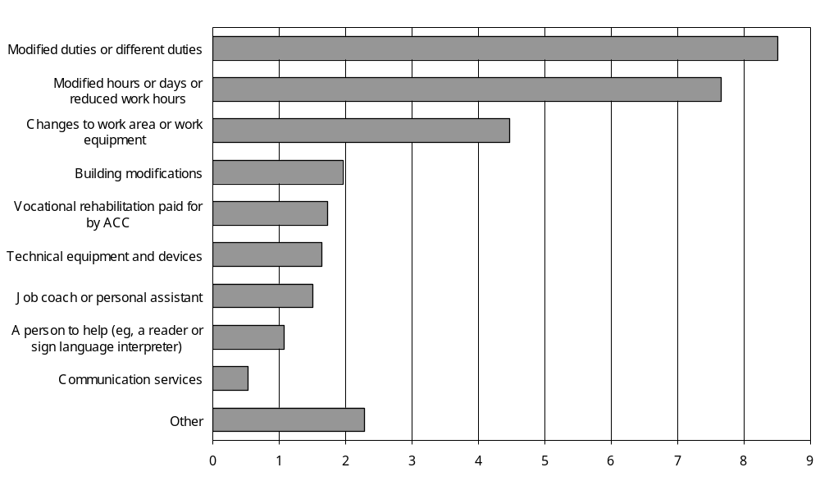
Source: Statistics New Zealand, 2001 Household Disability Survey
Notes:
- Data in Appendix Table 5.11.
- ‘Employed’ means working for pay or profit in a job, business or farm, or working without pay in a family business or farm (Statistics New Zealand 2002a).
- If individuals reported more than one requirement, they were counted in each applicable category.

People requiring modified or different duties were asked if their employer had met this requirement. The majority (79 percent) reported that they had.

The second most common requirement identified was modified hours or days or reduced work hours. This requirement was indicated by 8 percent of employed adults with disability, with 83 percent of them reporting that their employer had met this requirement.

Four percent of employed adults with disability, an estimated 11,100 people, indicated they required changes to their work area or equipment. Sixty-nine percent of this group said their employer had met this requirement.

Building alterations
All employed adults with disability were asked if they had needed any alterations to the building they worked in or their work area in the previous 12 months because of their condition or health problem. Two percent, an estimated 5400 employed adults with disability, indicated they needed alterations to their work area or building. Of these adults, the majority (79 percent) said they did not have an unmet need for these alterations.

Seventy-five percent of those needing alterations to their work area or building had multiple disabilities. Over half (59 percent) had moderate disability, while a quarter (27 percent) had mild disability.

Seventy-three percent of employed adults needing alteration to their work area or building had a mobility disability, while 61 percent had an agility disability.

For 42 percent, their main disability was a physical (mobility or agility) disability.

Accident/injury caused the main disabilities of 57 percent of employed adults needing alterations to their work building or area.

Unemployed people with disability
In 2001, an estimated 25,100 adults with disability living in households were unemployed and actively seeking work. This was an unemployment rate of 4 percent. This section looks more closely at features of this group, concentrating on adults aged 15–64.

Length of time seeking work
At the time of the 2001 Household Disability Survey, 22 percent of unemployed adults aged
15–64 with disability had been looking for work for over a year. A further 25 percent had been looking for work for 6–12 months. Eighteen percent had been looking for less than four weeks (Figure 5.15).

Figure 5.15: Percentage of unemployed adults aged 15–64 with disability living in households, by length of time they had been looking for work and age, 2001
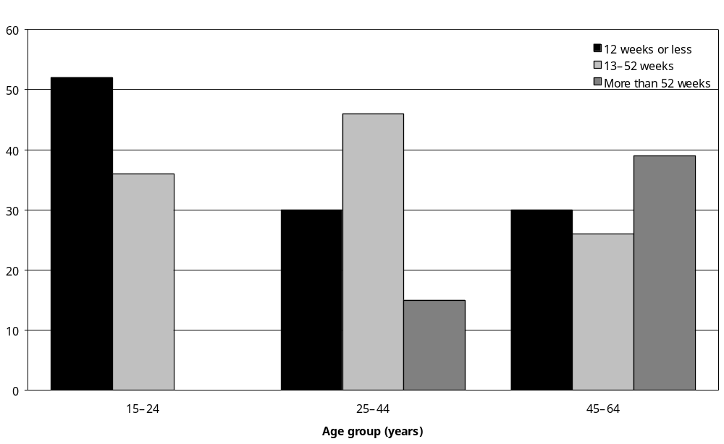
Source: Statistics New Zealand, 2001 Household Disability Survey
– Percentages too small to report (estimated frequencies outside the 70 percent relative sampling error cut-off point).
Notes:
- Data in Appendix Table 5.13.
- ‘Unemployed’ means not employed in a job, business or farm, but actively looking for full-time or part-time work (Statistics New Zealand 2002a).

Unemployed adults with disability in the 45–64 age group were more likely than their younger counterparts to have been out of work for more than 52 weeks.

Special workplace requirements
Unemployed adults with disability who were actively seeking work were asked what they needed to be able to work. The most common requirement was modified work hours, required by 21 percent.

Ten percent said they needed some kind of modification to work areas or equipment and 8 percent said they required vocational rehabilitation paid for by ACC. Five percent needed building modifications such as handrails, ramps, easy-to-access work areas, toilets or lifts.

Sixty percent indicated they had no special requirements.

People with disability not in the labour force
In 2001, 56 percent of adults with disability, an estimated 348,200 adults, were not in the labour force. This included an estimated 148,400 people aged 15–64. This section looks more closely at features of the 15–64 age group not in the labour force.

Capacity to work
In the 2001 Household Disability Survey, adults aged 15–64 with disability and not in the labour force were asked if their condition or health problem stopped them from working at a job or business. Just over half (56 percent) said it did, while 42 percent said it did not.

Capacity to work was highest in the younger age groups. Seventy-five percent of adults aged
15–24 not in the labour force said disability did not stop them from working, compared with 45 percent of adults aged 25–44 and 35 percent of adults aged 45–64.

A higher proportion of women (47 percent) than men (36 percent) with disability not in the labour force and aged under 65 reported disability did not stop them working.

Asian/Other people with disability not in the labour force and under the age of 65 were more likely to say disability did not stop them working (72 percent) than their European (41 percent), Mäori (39 percent) and Pacific (38 percent) counterparts.

Adults with hearing and seeing disabilities were most likely to say disability did not stop them working. Adults with intellectual and agility disabilities were least likely to be able to work for this reason (Figure 5.16).

Figure 5.16: Percentage of adults aged 15–64 with disability living in households not in the labour force whose condition or health problem did not stop them working, by disability type and main disability, 2001
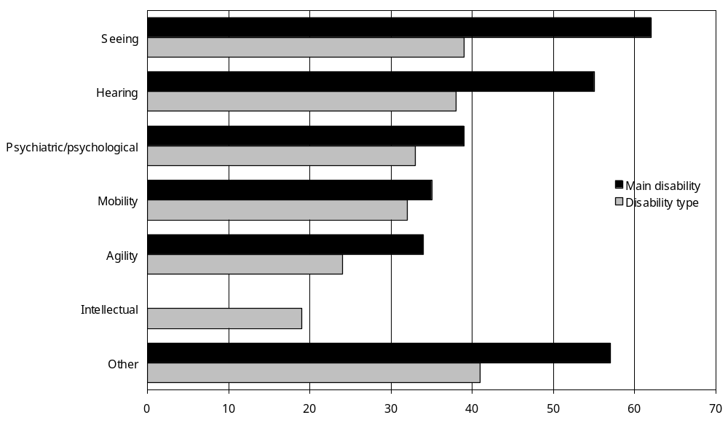
Source: Statistics New Zealand, 2001 Household Disability Survey
– Percentages too small to report (estimated frequencies outside the 70 percent relative sampling error cut-off point).
Notes:
- Data in Appendix Table 5.15.
- ‘Not in the labour force’ means being neither employed nor unemployed, including being retired, having personal or family responsibilities such as unpaid housework and childcare, attending educational institutions, being permanently unable to work due to disability, and not actively seeking work (Statistics New Zealand 2002a).
- If individuals reported more than one disability type, they were counted in each applicable disability group.

As might be expected, adults not in the labour force who had severe disability were least likely to say their condition or health problem did not stop them working (18 percent). Forty percent of adults not in the labour force with moderate disability, and 58 percent of adults not in the labour force with mild disability said this was the case.

Reasons for not seeking work
Adults aged under 65 and not in the labour force who indicated their condition or health problem did not stop them from working at a job or business were asked if they would like to do some paid work. An estimated 22,000 adults (45 percent) were able and willing to be employed to some degree.

Younger adults were more likely than older adults to say they would like some paid work. An estimated 4900 adults aged 15–24 (52 percent) and 7800 adults aged 25–44 (52 percent) were willing to work, compared with 9300 adults aged 45–64 (38 percent).

A higher proportion of males (54 percent) than females (40 percent) reported they would like paid work (an estimated 9200 males and 12,800 females).

Adults who were able and willing to do some paid work were asked to indicate the main reason they had not been looking for work in the previous four weeks. The most common reason given was temporary illness or injury (13 percent – 2900 adults), followed by lack of suitable childcare (10 percent – 2200 adults). Eight percent (1700 adults) indicated they had not been looking for work because they were attending an educational institution.

Special workplace requirements
Adults aged under 65 and not in the labour force who were able and willing to do some work were also asked if they had any special workplace requirements. An estimated 13,000 (59 percent) did not identify any special workplace requirements.

However, an estimated 9000 (41 percent) had at least one special workplace requirement. The most common was modified work hours, needed by an estimated 6000 adults (31 percent).

Income sources and subsidies

Main sources of income
This section describes the most common income sources of adults with disability living in households. Data come from the 2001 Household Disability Survey and the 2001 Census of Population and Dwellings.

Adults aged 15–24
Nearly half (48 percent) of all adults aged 15–24 with disability obtained income from wages or salaries.

As might be expected, adults aged 15–24 with disability were more likely than adults aged
15–24 without disability to obtain income from the Community Wage – Job Seeker, the Community Wage – Sickness Benefit, and the Invalids Benefit. They were less likely than adults aged 15–24 without disability to obtain income from wages or salaries or from student allowances (Figure 5.17).

Figure 5.17: Percentage of adults aged 15–24 with and without disability living in households, by income source, 2001
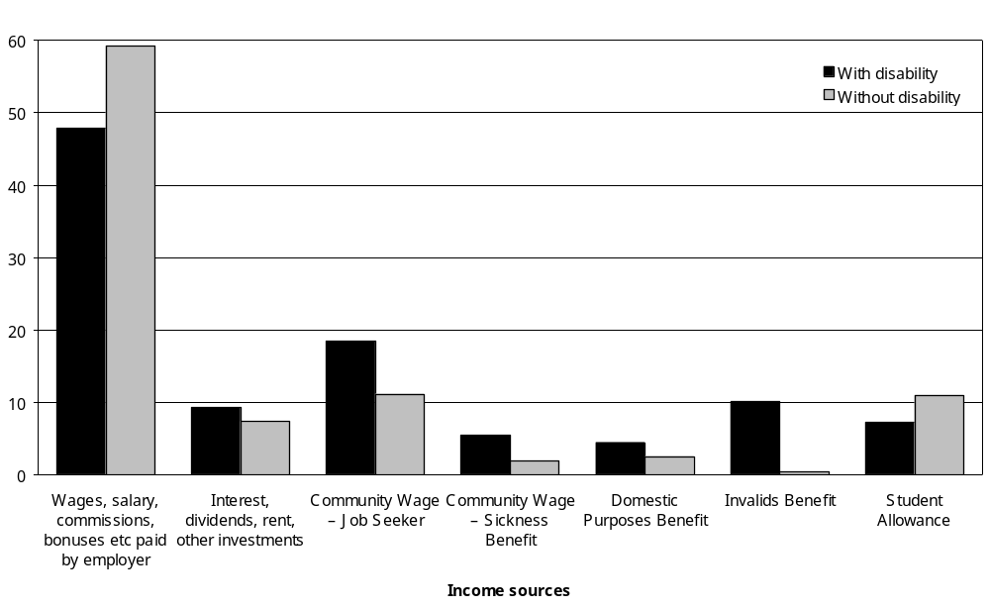
Source: Statistics New Zealand, 2001 Household Disability Survey and 2001 Census of Population and Dwellings
Notes:
- Data in Appendix Table 5.17.
- If individuals reported more than one income source, they were counted in each applicable income category.
- Income sources reported by less than 4 percent of people with disability are not shown.

Adults aged 25–64
Like adults aged 15–24, nearly half of adults aged 25–64 with disability (48 percent) obtained income from wages and salaries. Eighteen percent derived income from self-employment or their own business. Eleven percent obtained income from the Invalids Benefit.

Compared with adults aged 25–64 without disability, adults aged 25–64 with disability were less likely to obtain income from wages or salaries, self-employment and interest, dividends, rent or other investments. They were more likely to obtain income from the ACC or a private work accident insurer, the Community Wage – Job Seeker and the Community Wage – Sickness Benefit (Figure 5.18).

Figure 5.18: Percentage of adults aged 25–64 with and without disability living in households, by income source, 2001
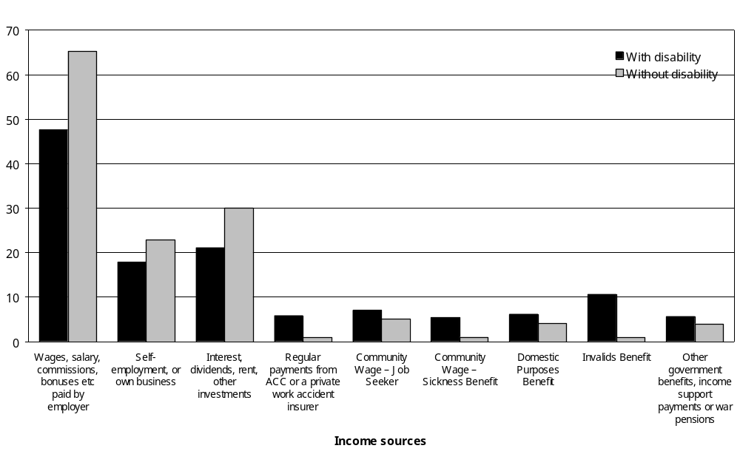
Source: Statistics New Zealand, 2001 Household Disability Survey and 2001 Census of Population and Dwellings
Notes:
- Data in Appendix Table 5.17.
- If individuals reported more than one income source, they were counted in each applicable income category.
- Income sources reported by less than 4 percent of people with disability are not shown.

Adults aged 65 and over
Eighty-seven percent of adults aged 65 and over with disability derived income from New Zealand Superannuation (including the Veterans Pension), while 13 percent obtained income from other superannuation pensions or annuities. Over a third (37 percent) obtained income from interest, dividends, rent or other investments.

In general, the income source profile for people aged 65 and over with disability was similar to the profile for people aged 65 and over without disability. However, a slightly smaller percentage of people with disability obtained income from wages and salaries, self-employment and interest, dividends, rent or other investments (Figure 5.19).

Figure 5.19: Percentage of adults aged 65 and over with and without disability living in households, by income source, 2001
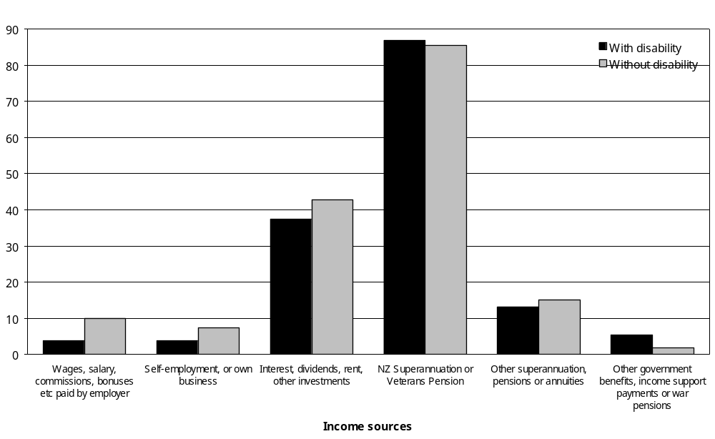
Source: Statistics New Zealand, 2001 Household Disability Survey and 2001 Census of Population and Dwellings
Notes:
- Data in Appendix Table 5.17.
- If individuals reported more than one income source, they were counted in each applicable income category.
- Income sources reported by less than 4 percent of people with disability are not shown.

Government financial assistance
The 2001 Household Disability Survey examined whether people with disability were receiving one or more of the following types of government financial assistance:
- Disability Allowance
- Child Disability Allowance
- Invalids Benefit
- War Disablement Pension
- Community Wage – Sickness Benefit
- Special Needs Grant.

Just over a third (34 percent) of adults with disability received at least one of these government allowances, benefits or grants at some time in the previous 12 months. The remaining two-thirds (66 percent) of adults with disability did not receive any of these types of financial assistance over this time (Figure 5.20).

Figure 5.20: Percentage of adults with disability living in households receiving different types of government financial assistance in the previous 12 months, 2001
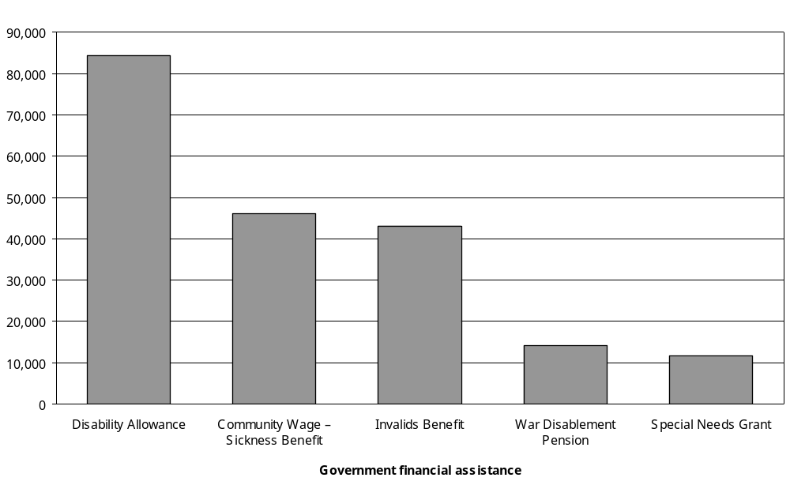
Source: Statistics New Zealand, 2001 Household Disability Survey
Notes:
- Data in Appendix Table 5.19.
- If individuals received more than one type of financial assistance, they were counted in each applicable category.
- The figure does not include other types of government financial assistance such as the Community Wage – Job Seeker or the Domestic Purposes Benefit as specific questions about these were not included in the Household Disability Survey. However, information is provided earlier in this Income Sources section about the use of other benefits, derived from the 2001 Census of Population and Dwellings.

Just over a quarter (26 percent) of all children with disability received the Disability Allowance or the Child Disability Allowance at some time in the previous 12 months.

The next sections look more closely at the people who received these different types of government financial assistance.

Disability Allowance
The Disability Allowance is an income-tested allowance that reimburses people for regular costs they have because of disability (Work and Income New Zealand 2003). In 2001, of the types of government financial assistance listed above, the Disability Allowance was most commonly received by people with disability. Thirteen percent of all adults and children with disability, an estimated 89,700 people, received the Disability Allowance.

Adults
Thirteen percent of adults with disability, an estimated 84,000 adults, received the Disability Allowance. Nearly half of these adults (48 percent) were aged 65 and over. Two-thirds (68 percent) were female and one-third (32 percent) were male.

Adults who had an intellectual disability as one of their disabilities (27 percent) or as their main disability (37 percent) were the most likely to receive the Disability Allowance. Adults with hearing disability were the least likely to receive it (Figure 5.21).

Figure 5.21: Percentage of adults with disability who received a Disability Allowance in the previous 12 months, by disability type and main disability, 2001
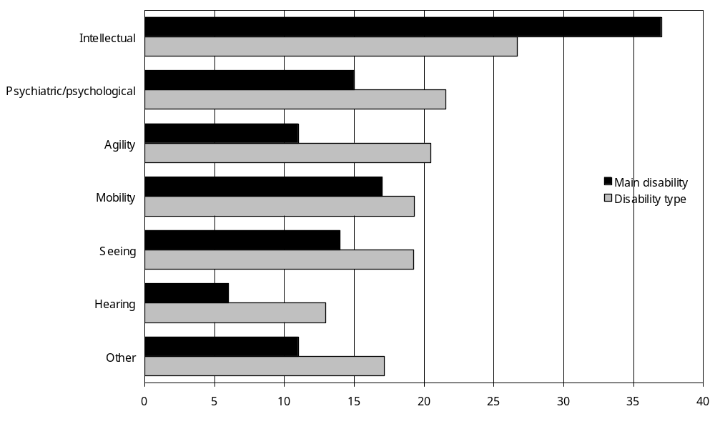
Source: Statistics New Zealand, 2001 Household Disability Survey
Notes:
- Data in Appendix Table 5.19.
- If individuals reported more than one disability type, they were counted in each applicable disability group.
Adults with a main disability caused by disease/illness (17 percent) or with disability present at birth (17 percent) were slightly more likely to receive the Disability Allowance than adults with a main disability caused by accident/injury (10 percent) or ageing (13 percent).

Having multiple disabilities rather than a single disability, and having severe rather than moderate or mild disability, also increased the likelihood that people would receive the Disability Allowance (Figure 5.22).

Figure 5.22: Percentage of adults with disability who received a Disability Allowance in the previous 12 months, by single/multiple disability and severity of disability, 2001
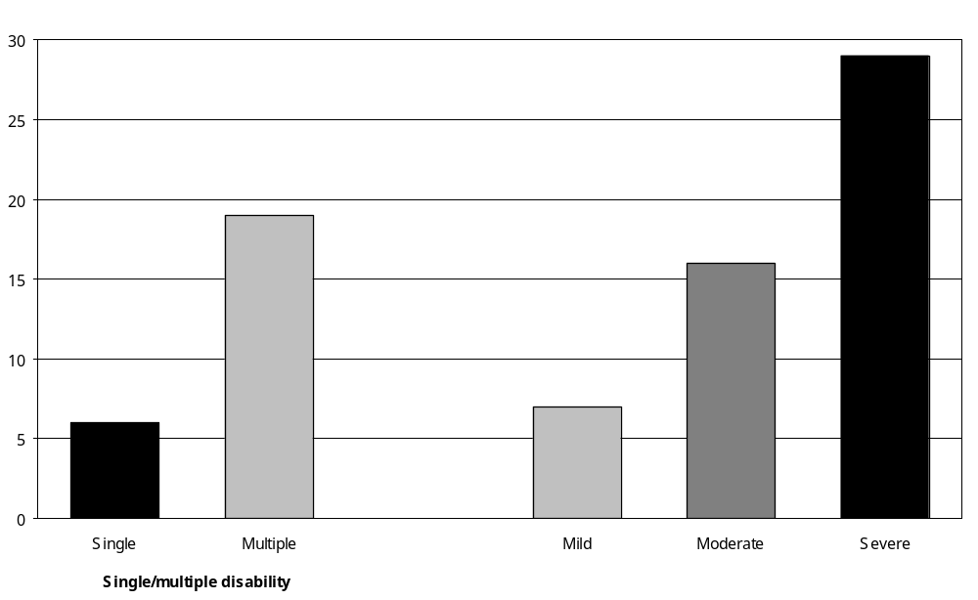
Source: Statistics New Zealand, 2001 Household Disability Survey
Note: Data in Appendix Table 5.19.

Children
Children may also be eligible to receive the Disability Allowance. In 2001, 6 percent of children with disability, an estimated 5400 children, received the Disability Allowance at some time in the previous 12 months. Nearly one quarter of these children were aged under 5 (23 percent), 37 percent were aged 5–9, and 41 percent were aged 10–14.

Children with intellectual disability (12 percent) were the most likely to receive the Disability Allowance. Children with hearing disability (7 percent) or chronic health problems (7 percent) were the least likely to receive it.

Nine percent of children with multiple disabilities received the Disability Allowance, compared with 4 percent of children with a single disability. A higher proportion of children with severe disability (15 percent) received the allowance than did children with moderate disability (5 percent) or mild disability (3 percent).

Child Disability Allowance
The Child Disability Allowance is paid to parents or guardians of children requiring ‘constant care and attention’ because of severe disability. The allowance is a regular fixed payment that is not means tested (Work and Income New Zealand 2003).

The 2001 Disability Survey found that 18 percent of children with disability, an estimated 16,500 children, received the Child Disability Allowance at some time in the previous 12 months. Twenty percent of these children were aged under 5, 38 percent were aged 5–9 and 42 percent were aged 10–14. Sixty-two percent were boys and 38 percent were girls.

Thirty-two percent of Asian/Other children received this allowance, compared with 21 percent of European, 14 percent of Mäori and 11 percent of Pacific children.

A higher proportion of children with disability living in the Southern region (24 percent) received the allowance than children living in the Central (20 percent), Midland (17 percent) or Northern (14 percent) regions.

Children using technical aids were most likely to receive the Child Disability Allowance (60 percent). Those with seeing (16 percent) and hearing (14 percent) disabilities were the least likely to receive it (Figure 5.23).

Figure 5.23: Percentage of children with disability who received a Child Disability Allowance in the previous 12 months, by disability type, 2001
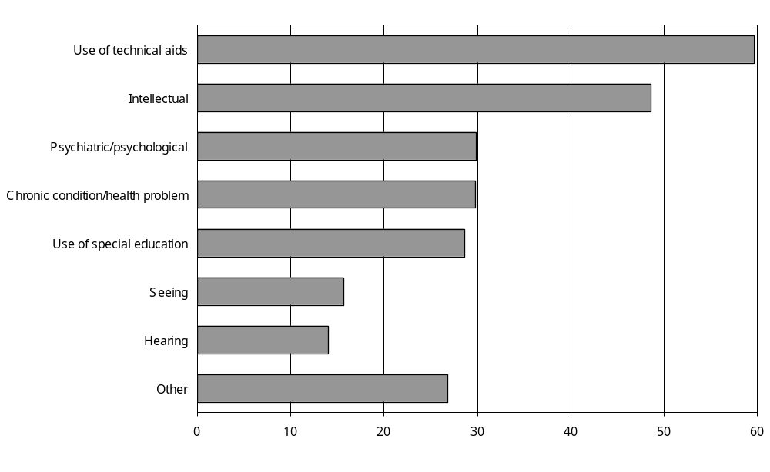
Source: Statistics New Zealand, 2001 Household Disability Survey
Notes:
- Data in Appendix Table 5.20.
- If individuals reported more than one disability type, they were counted in each applicable disability group.

Children with multiple disabilities were more likely than children with a single disability to receive the Child Disability Allowance. Children with severe disability were also more likely than children with mild and moderate disability to receive the allowance (Figure 5.24).

Figure 5.24: Percentage of children with disability who received a Child Disability Allowance in the previous 12 months, by single/multiple disability and severity of disability, 2001
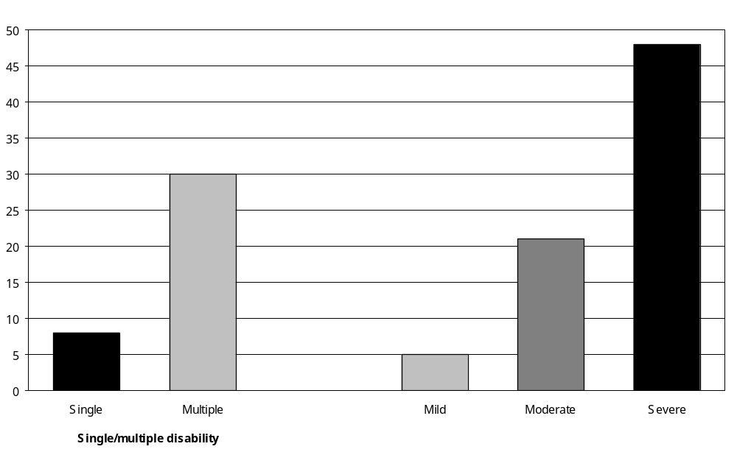
Source: Statistics New Zealand, 2001 Household Disability Survey
Note: Data in Appendix Table 5.20.

Community Wage – Sickness Benefit
The Community Wage – Sickness Benefit is an income-tested payment to adults who are temporarily unable to work because of disability, sickness, injury or pregnancy (Work and Income New Zealand 2003).

In 2001, 7 percent of adults with disability, an estimated 46,000 adults, received the Community Wage – Sickness Benefit at some time in the previous 12 months.

Ninety-five percent of the adults with disability receiving the Community Wage – Sickness Benefit were aged 15–64.

Compared with European adults with disability (6 percent), higher proportions of Pacific (17 percent) and Asian/Other (20 percent) adults with disability received the Community Wage – Sickness Benefit.

Adults who had a psychiatric/psychological disability as one of their disabilities or as their main disability were the most likely to receive the Community Wage – Sickness Benefit (Figure 5.25).

Figure 5.25: Percentage of adults with disability receiving a Community Wage – Sickness Benefit in the previous 12 months, by disability type and main disability, 2001
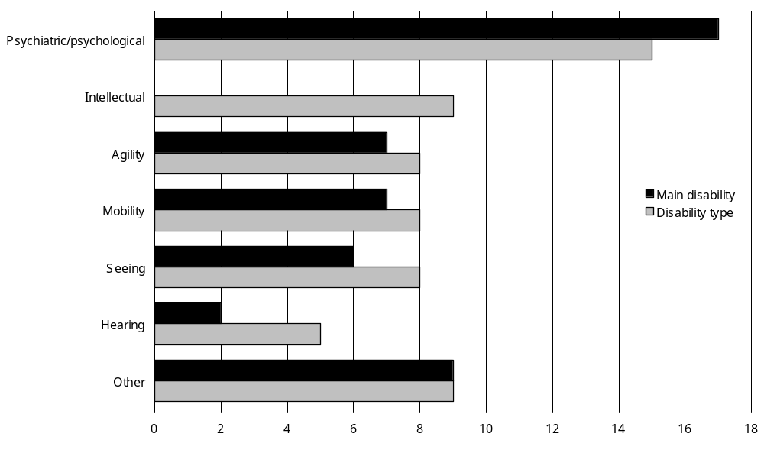
Source: Statistics New Zealand, 2001 Household Disability Survey
– Percentages too small to report (estimated frequencies outside the 70 percent relative sampling error cut-off point).
Notes:
- Data in Appendix Table 5.19.
- If individuals reported more than one disability type, they were counted in each applicable disability group.

Twelve percent of adults with severe disability received the Community Wage – Sickness Benefit, compared with 7 percent of adults with moderate disability and 6 percent with mild disability.

Invalids Benefit
The Invalids Benefit is paid to adults who are unable to work 15 hours or more per week because of permanent disability, sickness or injury (Work and Income New Zealand 2003).

The 2001 Household Disability Survey found that 7 percent of adults with disability, an estimated 43,100 people, received an Invalids Benefit at some time in the previous 12 months. Nearly all these people (95 percent) were aged under 65.

Adults with intellectual disability as one of their disabilities or their main disability were the most likely to receive the Invalids Benefit (Figure 5.26).

Figure 5.26: Percentage of adults with disability receiving an Invalids Benefit in the previous 12 months, by disability type and main disability, 2001
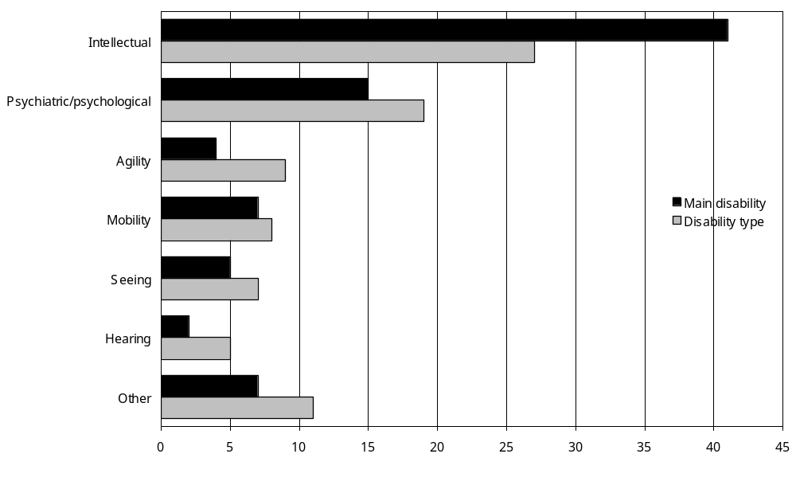
Source: Statistics New Zealand, 2001 Household Disability Survey
Notes:
- Data in Appendix Table 5.19.
- If individuals reported more than one disability type, they were counted in each applicable disability group.

Adults whose main disability was caused by a condition present at birth (19 percent) were more likely to receive this benefit than adults whose main disability was caused by disease/illness (8 percent), accident/injury (6 percent) or ageing (3 percent).

A greater proportion of adults with multiple disabilities (9 percent) received the Invalids Benefit than adults with a single disability (3 percent). Similarly, adults with severe disability (15 percent) were more likely to receive this benefit than adults with moderate (8 percent) or mild (4 percent) disability.

War Disablement Pension
The War Disablement Pension is available to people who have disability as a result of military service. The pension is non-taxable and non-income-tested, and is assessed according to the degree of disability (Work and Income New Zealand 2003).

The 2001 Household Disability Survey found that 2 percent of adults with disability, an estimated 14,100 people, received the War Disablement Pension in the previous 12 months. Most of the recipients were aged 65 and over (96 percent) and most were male (89 percent).

Special Needs Grant
Special Needs Grants are one-off payments to people on low incomes who have limited cash assets. The payments are for urgent necessities such as food, bedding, dental or medical treatment (Work and Income New Zealand 2003).

The 2001 Disability Survey estimated that 2 percent of adults with disability, an estimated 11,600 adults, received Special Needs Grants at some time in the previous 12 months.

Health care cards
The Pharmaceutical Subsidy Card, High Use Health Card and Community Services Card are health care subsidy cards provided by the government. The 2001 Disability Survey estimated that 67 percent of adults with disability and 70 percent of children with disability held at least one of these health care cards in the previous 12 months (Figure 5.27). People aged 65 and over with disability were most likely to have a card (83 percent).

Figure 5.27: Number of people (adults and children) with disability holding health care cards in the previous 12 months, by card type, 2001
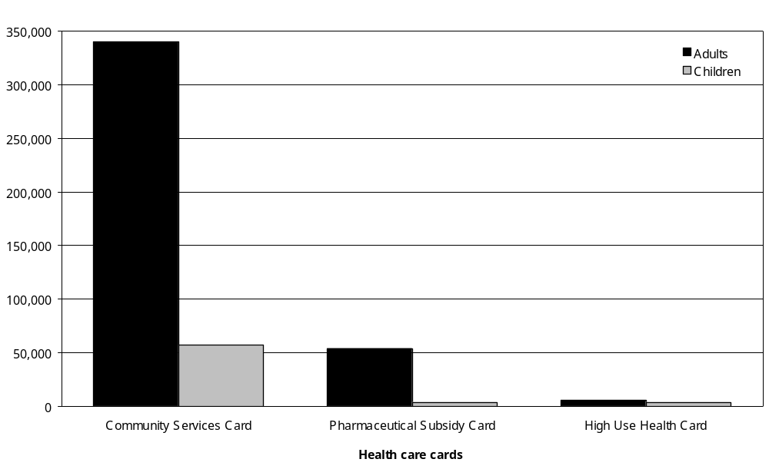
Source: Statistics New Zealand, 2001 Household Disability Survey
Notes:
- Data in Appendix Tables 5.21 and 5.22.
- If people received more than one type of financial assistance, they were counted in each applicable category.

Community Services Card
The Community Services Card was the health care card most commonly held by adults and children with disability. This card subsidises the costs of visits to family doctors. It is given automatically to people who receive certain types of government financial assistance (including the Community Wage – Job Seeker, Community Wage – Sickness Benefit, Invalids Benefit and Child Disability Allowance) and is also available to other people assessed as having low to middle incomes (Work and Income New Zealand 2003).

Adults
The 2001 Disability Survey estimated that 54 percent of adults with disability, 340,100 adults, had a Community Services Card at some time in the previous 12 months. People aged 65 and over (70 percent) were more likely than adults aged 15–24 (56 percent), adults aged 25–44 (49 percent) and adults aged 45–64 (42 percent) to have a Community Services Card.
Women with disability (60 percent) were more likely than men with disability (48 percent) to have a Community Services Card. Two-thirds (66 percent) of Pacific peoples with disability had this type of card, compared with 60 percent of Mäori, 55 percent of Asian/Other and 53 percent of European adults.
Adults with intellectual disability as one of their disabilities or their main disability were more likely than adults with other types of disability to have a Community Services Card (Figure 5.28).

Figure 5.28: Percentage of adults with disability who had a Community Services Card in the previous 12 months, by disability type and main disability, 2001
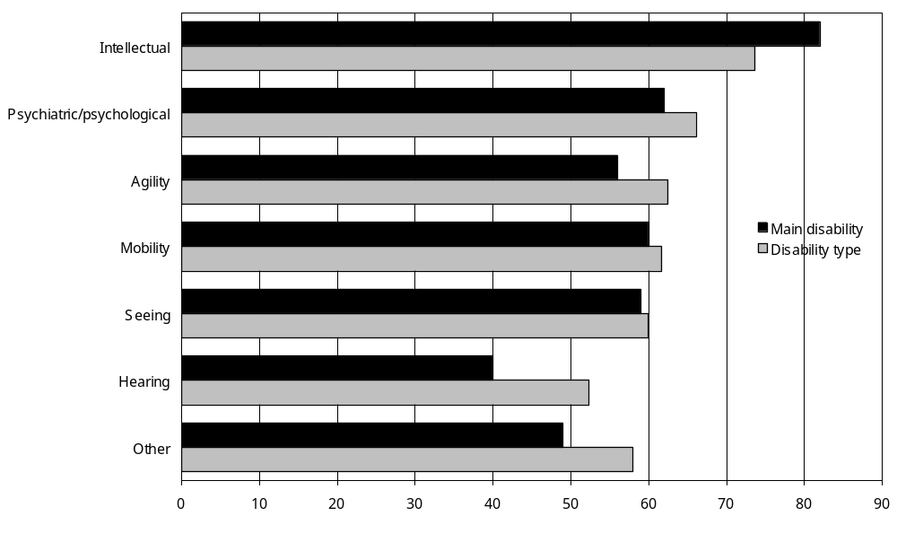
Source: Statistics New Zealand, 2001 Household Disability Survey
Notes:
- Data in Appendix Table 5.21.
- If individuals reported more than one disability type, they were counted in each applicable disability group.
Adults with multiple disabilities (61 percent) were more likely to have a Community Services Card than adults with a single disability (45 percent). Seventy-five percent of adults with severe disability had a Community Services Card, compared with 58 percent with moderate disability and 44 percent with mild disability.

Children
Sixty-three percent of children with disability, an estimated 57,100 children, had held a Community Services Card in the previous 12 months (whether individually or as a member of a family with a card).

Mäori (72 percent) and Pacific (72 percent) children were most likely to have a Community Services Card, followed by Asian/Other children (70 percent). European children (57 percent) were least likely to have this card.

Children living in the Northern region (54 percent) were least likely to have a Community Services Card. Children living in the Southern region were the most likely to have this card (74 percent).

Children using technical aids (79 percent) were most likely to have a Community Services Card. Children with seeing disability (65 percent) and chronic conditions/health problems (65 percent) were least likely to have this card.

Seventy-one percent of children with multiple disabilities and 57 percent of children with a single disability had a Community Services Card. Children with severe disability (85 percent) were more likely to have the card than children with moderate (68 percent) or mild (50 percent) disability.

Pharmaceutical Subsidy Card
Pharmaceutical Subsidy Cards are available to families who have paid for 20 or more government prescription charges in a year (excluding prescription charges for children aged under 6). After the 20th prescription item, families pay $2 per item for the rest of the year, along with any other non-government charges that apply (Work and Income New Zealand 2003).

The 2001 Disability Survey found that 9 percent of adults with disability (an estimated 53,900 people) and 4 percent of children with disability (an estimated 3700 children) had a Pharmaceutical Subsidy Card for some time in the previous 12 months. People in the 65 and over age group (15 percent) were more likely than people in younger age groups to have this card.

High Use Health Card
The High Use Health Card provides subsidised medical and prescription services for people who visit the doctor 12 times or more in a year (Work and Income New Zealand 2003).

Eight percent of adults with disability (an estimated 50,700 adults) and 4 percent of children with disability (an estimated 3700 children) had a High Use Health Card in the previous 12 months. Again, people aged 65 and over (12 percent) were more likely than younger people with disability to have this card.

Adults with severe disability (15 percent) were more likely than adults with mild disability (5 percent) to have a High Use Health Card.

Income levels

Household income

Children
In 2001 children (0–14) with disability were more likely than children without disability to live in households with relatively low annual incomes. Illustrating this, 10 percent of children with disability had household incomes of $15,000 and under per year, compared with 7 percent of children without disability. At the other end of the scale, 15 percent of children with disability had household incomes of $70,001 and over per year, compared with 21 percent of children without disability (Figure 5.29).

Figure 5.29: Percentage of children aged 0–14 with and without disability living in households, by household income, 2001
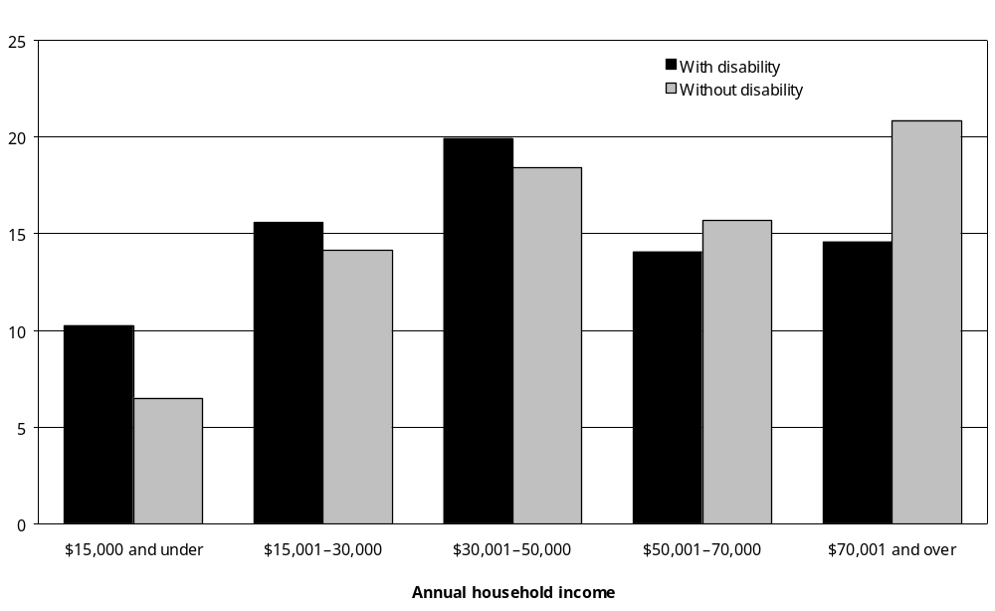
Source: Statistics New Zealand, 2001 Household Disability Survey and 2001 Census of Population and Dwellings
Note: Data in Appendix Table 5.23.

Adults
Across all the adult age groups, people with disability were less likely than people without disability to be in the higher household income categories. This was especially so in the 25–44 age group, where 15 percent of people with disability had household incomes of $70,001 and over per year, compared with 27 percent of people without disability (Figure 5.30).

Figure 5.30: Percentage of adults aged 25–44 with and without disability, living in households, by household income, 2001
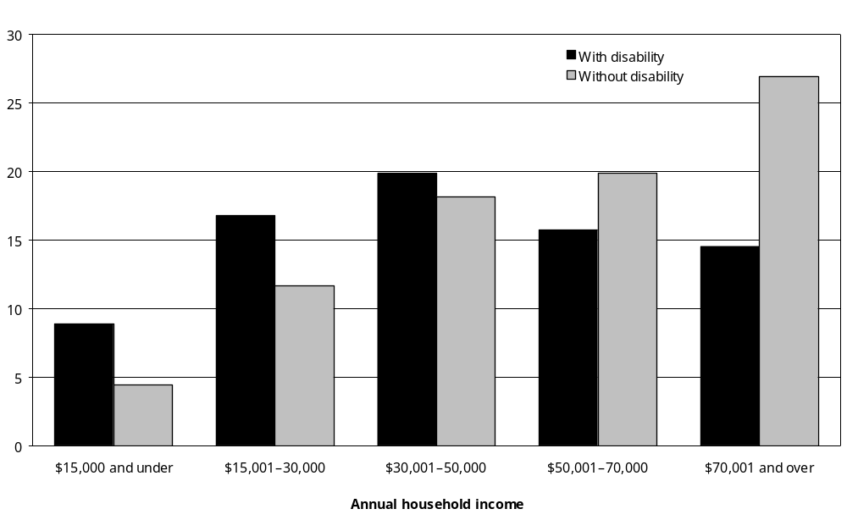
Source: Statistics New Zealand, 2001 Household Disability Survey and 2001 Census of Population and Dwellings
Note: Data in Appendix Table 5.23.

Older adults (aged 65 and over)
Clear differences were also apparent between the household incomes of people with and without disability in the 65 and over age group. Adults with disability were less likely than adults without disability to be in the three higher household income categories, and more likely to be in the two lower household income categories (Figure 5.31).

Figure 5.31: Percentage of adults aged 65 and over with and without disability living in households, by household income, 2001
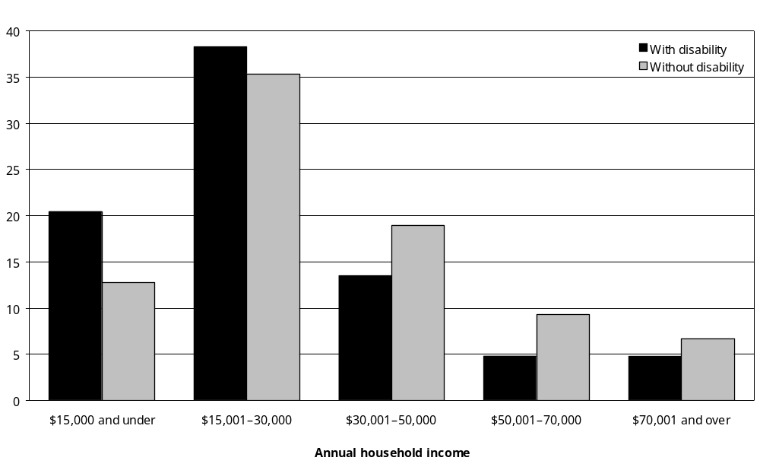
Source: Statistics New Zealand, 2001 Household Disability Survey and 2001 Census of Population and Dwellings
Note: Data in Appendix Table 5.23.

Regions
People with disability living in the Northern region were most likely to have annual household incomes of $70,001 and over. People with disability living in the Midland and Southern regions were the least likely to be in this comparatively high household income group.

In all four regions, people with disability were less likely than people without disability to have household incomes of $70,001 and over per year. This difference was greater in the Midland, Central and Southern regions than in the Northern region (Figure 5.32).

Figure 5.32: Percentage of people (adults and children) with and without disability living in households with household incomes of $70,001 and over per year, by region, 2001
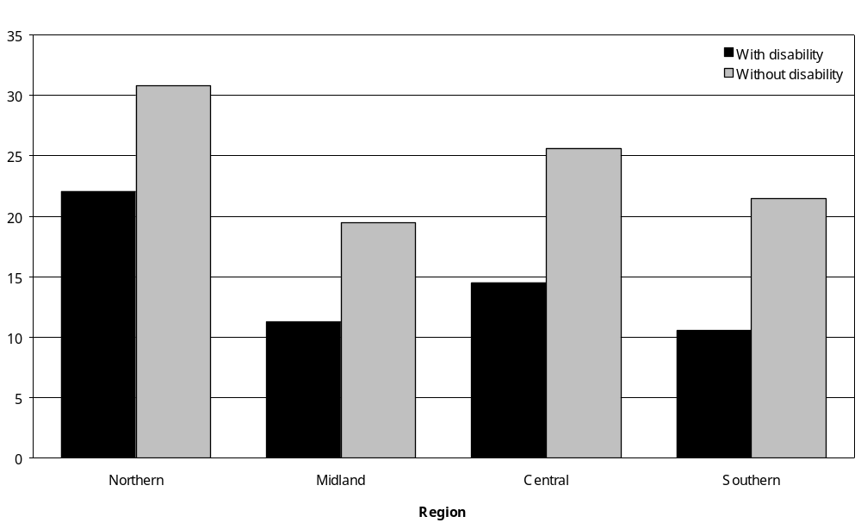
Source: Statistics New Zealand, 2001 Household Disability Survey, 2001 Census of Population and Dwellings
Note: Data in Appendix Table 5.23.

Personal income

Young adults (aged 15–24)
In 2001, 56 percent of adults aged 15–24 with disability had personal incomes of $15,000 and under per year, compared with 61 percent of adults aged 15–24 without disability.

Adults aged 15–24 with disability were more likely than adults without disability to have personal incomes from $15,001 to $30,000 per year (21 percent compared with 12 percent) (Figure 5.33).

Figure 5.33: Percentage of adults aged 15–24 with and without disability living in households, by personal income, 2001
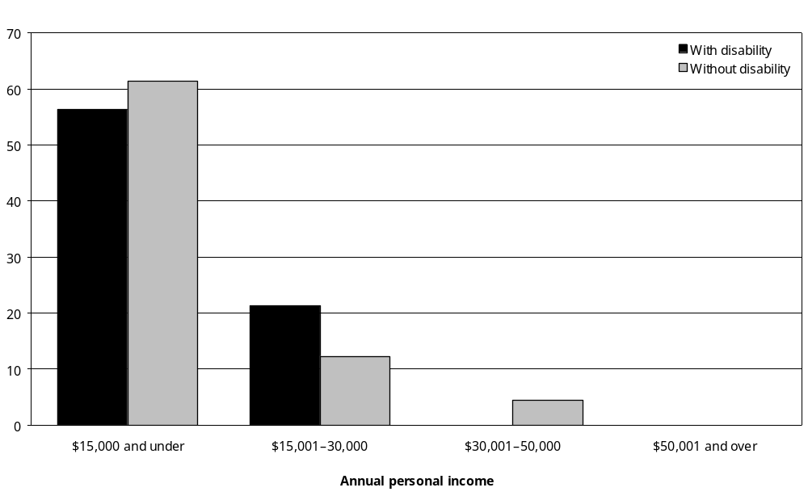
Source: Statistics New Zealand, 2001 Household Disability Survey, 2001 Census of Population and Dwellings
– Percentages too small to report (estimated frequencies outside the 70 percent relative sampling error cut-off point).
Notes: Data in Appendix Table 5.25.

Young women with disability in this age group were more likely than young men with disability to have personal incomes of $15,000 and under per year (64 percent compared with 48 percent).

Adults aged 25–44
In 2001, 42 percent of adults aged 25–44 with disability had personal incomes of $15,000 and under per year, compared with 25 percent of adults aged 25–44 without disability. Adults with disability were less likely than adults without disability to be in the two highest personal income groups. Four percent of people with disability had personal incomes of $50,001 and over per year in 2001, compared with 14 percent of people without disability (Figure 5.34).

Figure 5.34: Percentage of adults aged 25–44 with and without disability living in households, by personal income, 2001
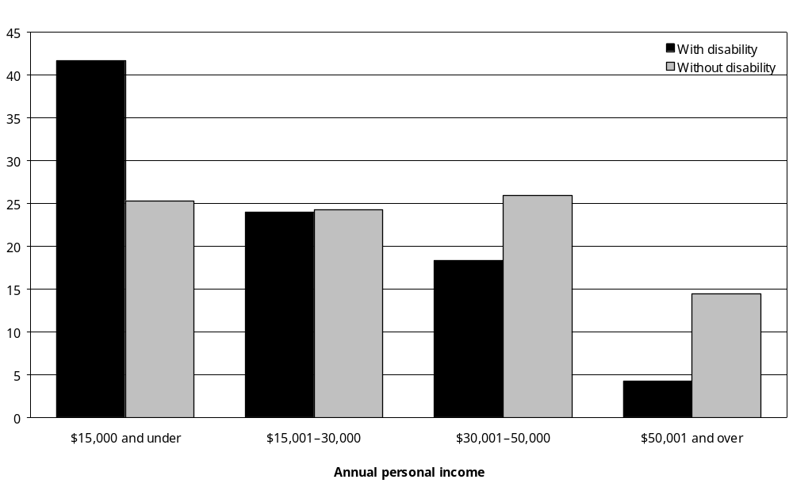
Source: Statistics New Zealand, 2001 Household Disability Survey, 2001 Census of Population and Dwellings
Note: Data in Appendix Table 5.25.

Again, women with disability in this age group were more likely than men with disability to have personal incomes of $15,000 and under per year (50 percent compared with 31 percent). They were also less likely to earn higher incomes (for example, 27 percent of men and 12 percent of women with disability in this age group earned $30,001–$50,000 per year).

Adults aged 45–64
The situation was similar for adults in the 45–64 age group. Once again, more than 40 percent of adults with disability had personal incomes of $15,000 and under per year, compared with 25 percent of those without disability.

Eleven percent of adults aged 45–64 with disability had personal incomes of $50,001 and over per year, compared with 17 percent of adults aged 45–64 without disability (Figure 5.35).

Figure 5.35: Percentage of adults aged 45–64 with and without disability living in households, by personal income, 2001
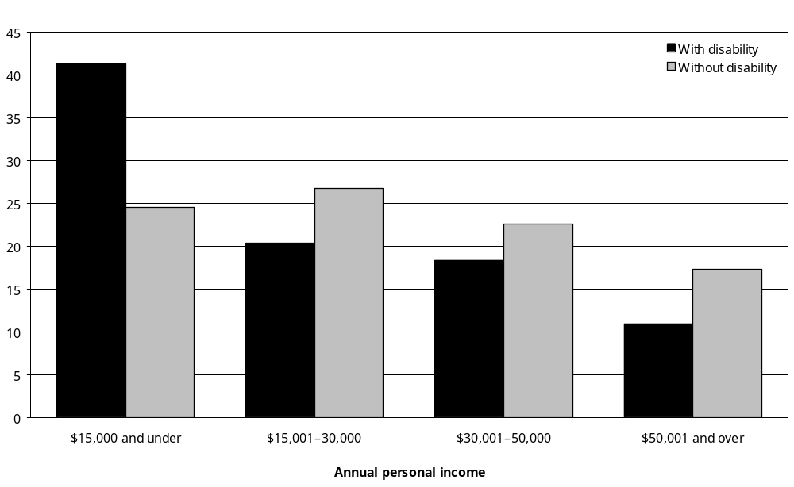
Source: Statistics New Zealand, 2001 Household Disability Survey, 2001 Census of Population and Dwellings
Note: Data in Appendix Table 5.25.

As was the case in the younger age groups, women with disability aged 45–64 were more likely than men with disability to earn $15,000 and under per year. Fifty-four percent of women and 31 percent of men with disability were in this lowest-income group in 2001. At the same time, 12 percent of women and 24 percent of men with disability earned from $30,001 to $50,000 per year.

Older adults (aged 65 and over)
In the 65 and over age group, 60 percent had personal incomes of $15,000 and under per year, compared with 51 percent of adults aged 65 and over without disability.

Five percent of adults aged 65 and over with disability had personal incomes of $30,001 and over per year. The corresponding figure for adults without disability was 11 percent (Figure 5.36).

Figure 5.36: Percentage of adults aged 65 and over with and without disability living in households, by personal income, 2001
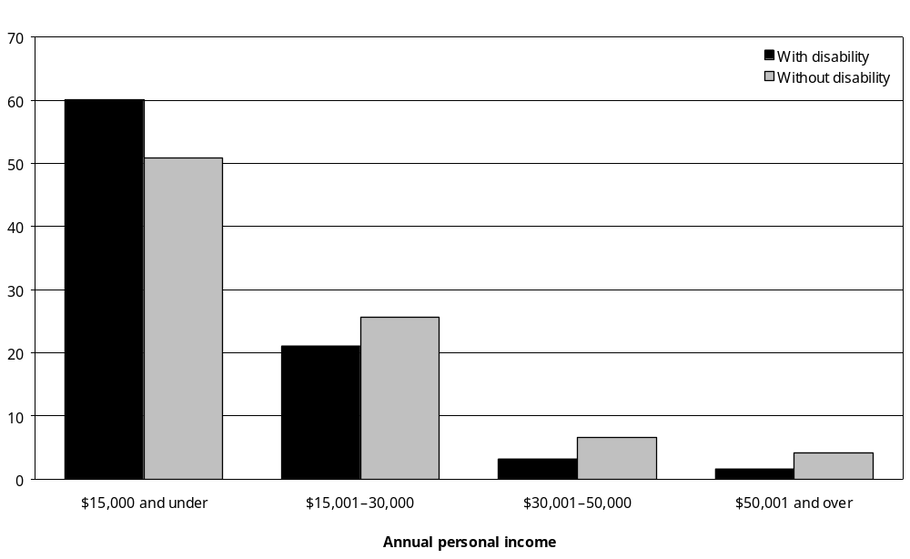
Source: Statistics New Zealand, 2001 Household Disability Survey, 2001 Census of Population and Dwellings
Note: Data in Appendix Table 5.25.

Similar proportions of men and women with disability aged 65 and over had personal incomes of $15,000 and under per year (61 percent and 59 percent respectively).

Ethnicity
Half the European adults with disability had personal incomes of $15,000 and under per year, as did 49 percent of Mäori, 46 percent of Pacific and 48 percent of Asian/Other adults with disability.

European adults with disability were more likely than European adults without disability to be in the $15,000 and under personal income group (50 percent compared with 35 percent). Similar differences between adults with and without disability were evident for Mäori and Pacific peoples, but not for Asian/Other adults (Figure 5.37).

Figure 5.37: Percentage of adults with and without disability living in households with personal incomes of $15,000 and under per year, by ethnic group, 2001
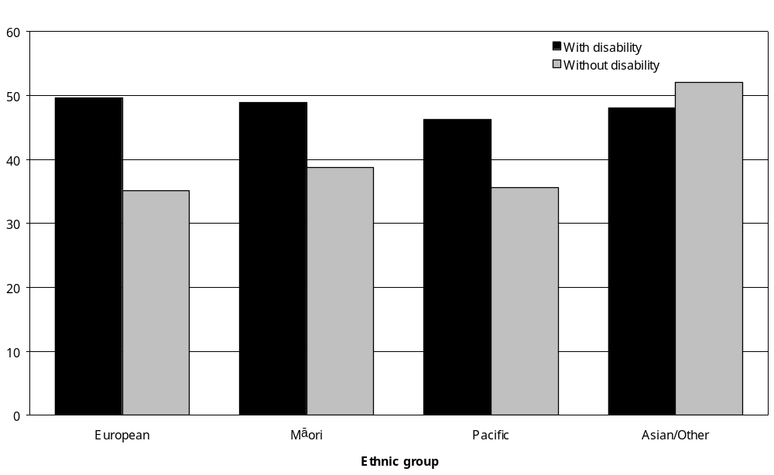
Source: Statistics New Zealand, 2001 Household Disability Survey, 2001 Census of Population and Dwellings
Note: Data in Appendix Table 5.25.

Socioeconomic areas

NZDep2001
NZDep2001 is an index or measure of the level of socioeconomic deprivation in the different geographic areas of New Zealand. It is calculated using census data on car and telephone access, receipt of means-tested benefits, unemployment, household income, sole parenting, educational qualifications, home ownership and home living space (Salmond and Crampton 2002). The index ranges from 1 to 10. A score of 1 indicates that people are living in the least deprived 10 percent of New Zealand’s geographic areas, while a score of 10 indicates that people are living in the most deprived 10 percent of New Zealand’s geographic areas.

People with and without disability
Figure 5.38 shows the range of NZDep2001 scores for people of all ages with disability living in households in 2001, compared with people of all ages without disability.

Figure 5.38: Percentage of people (adults and children) with and without disability living in households, by NZDep2001 area, 2001
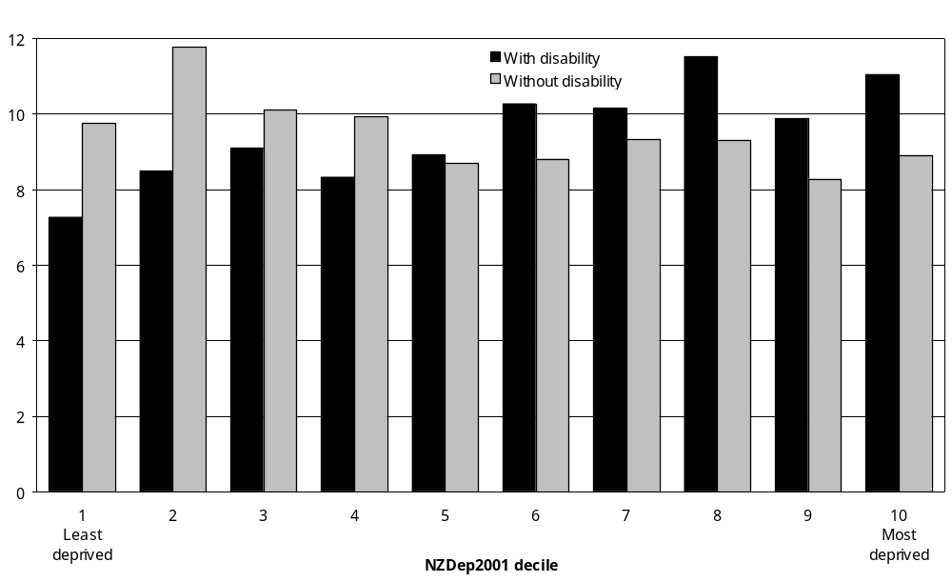
Source: Statistics New Zealand, 2001 Household Disability Survey, 2001 Census of Population and Dwellings
Note: Data in Appendix Table 5.27.

People with disability were more likely than people without disability to live in the five most deprived NZDep2001 areas (areas 6–10).

Children
In 2001, children with disability were more likely than children without disability to live in households in the most deprived NZDep2001 areas. Altogether, 57 percent of children with disability lived in NZDep2001 areas 6–10, compared with 49 percent of children without disability (Figure 5.39).

Figure 5.39: Percentage of children with and without disability living in households, by NZDep2001 area, 2001
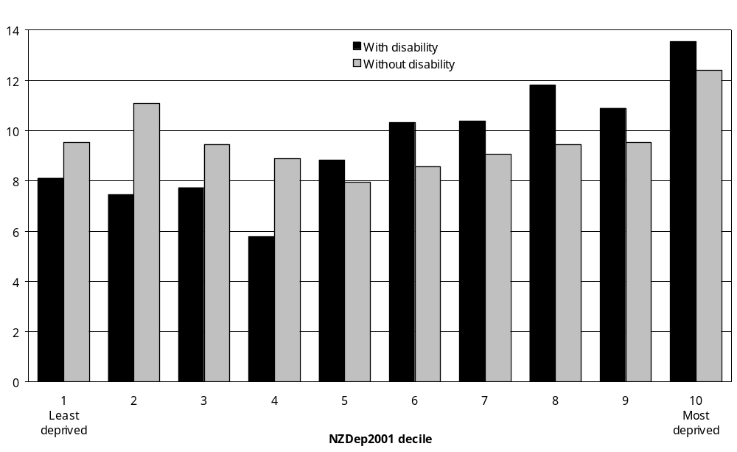
Source: Statistics New Zealand, 2001 Household Disability Survey, 2001 Census of Population and Dwellings
Note: Data in Appendix Table 5.27.

Adults aged 15–64
The situation was similar for adults in the 15–64 age group. In 2001, 53 percent of adults aged 15–64 with disability lived in NZDep2001 areas 6–10, compared with 43 percent of adults aged 15–64 without disability (Figure 5.40).

Figure 5.40: Percentage of adults aged 15–64 with and without disability living in households, by NZDep2001 area, 2001
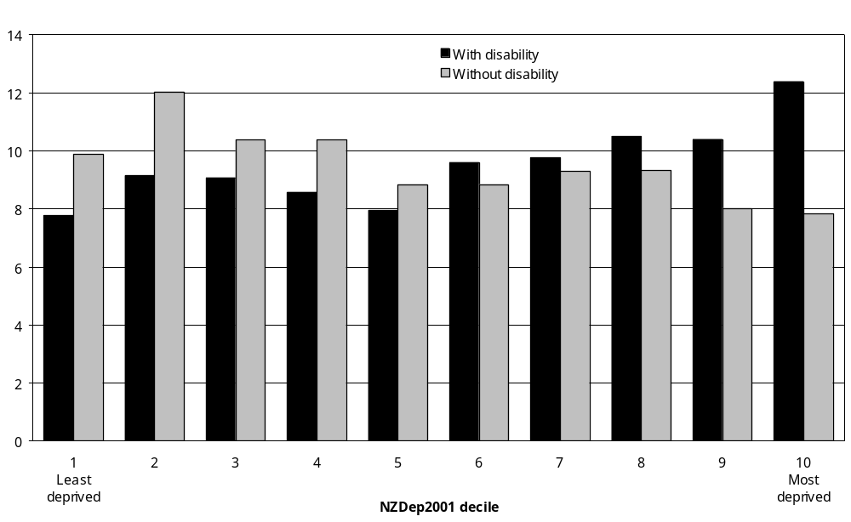
Source: Statistics New Zealand, 2001 Household Disability Survey, 2001 Census of Population and Dwellings
Note: Data in Appendix Table 5.27.

Adults aged 65 and over
Older adults with disability were also more likely than older adults without disability to live in households in the most deprived areas. Fifty-two percent of people aged 65 and over with disability lived in NZDep2001 areas 6–10, compared with 42 percent of people aged 65 and over without disability (Figure 5.41).

Figure 5.41: Percentage of adults aged 65 and over with and without disability living in households, by NZDep2001 area, 2001
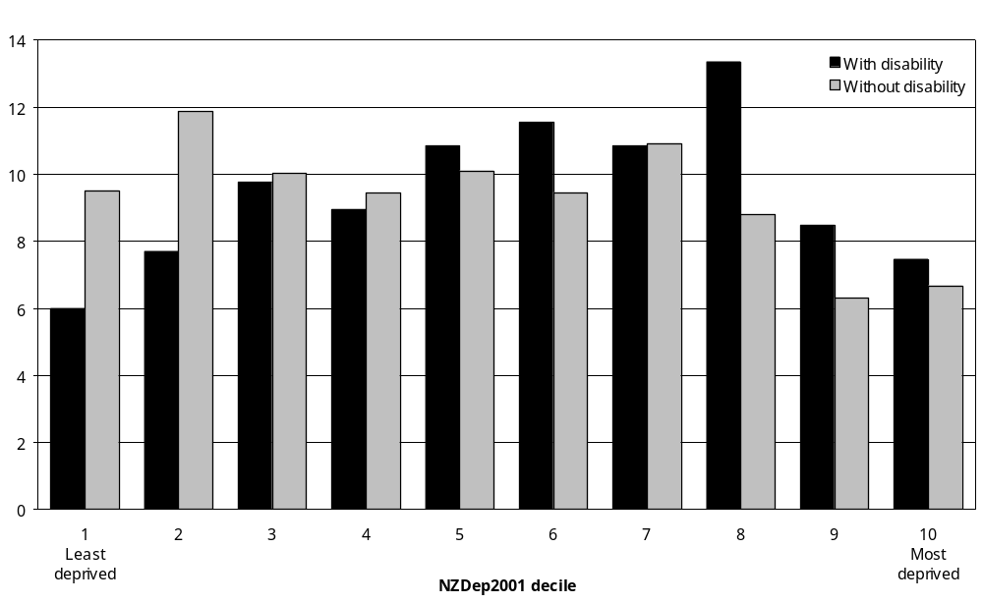
Source: Statistics New Zealand, 2001 Household Disability Survey, 2001 Census of Population and Dwellings
Note: Data in Appendix Table 5.27.

Ethnicity
Mäori and Pacific peoples with disability were more likely than Europeans with disability to live in the most deprived areas. Just under half (48 percent) of Europeans with disability lived in households in NZDep2001 areas 6–10, compared with 75 percent of Mäori and 76 percent of Pacific peoples with disability (Figure 5.42).

Figure 5.42: Percentage of European and Mäori people (adults and children) with disability living in households, by NZDep2001 area, 2001
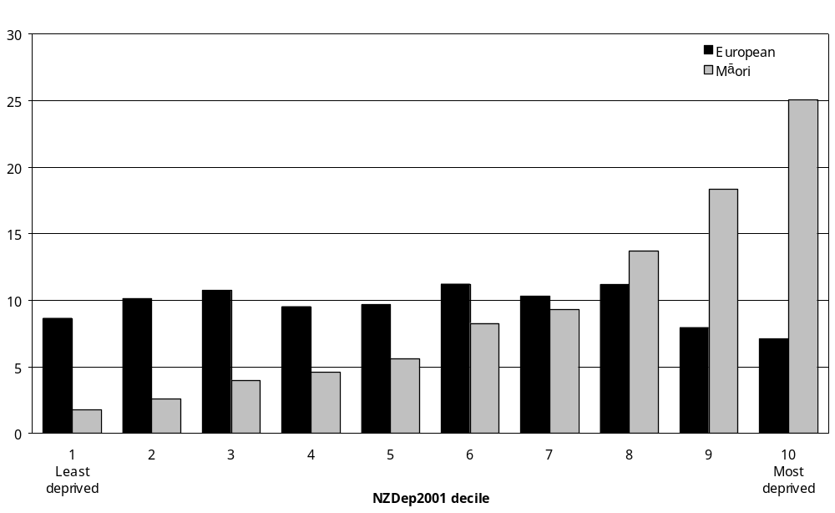
Source: Statistics New Zealand, 2001 Household Disability Survey, 2001 Census of Population and Dwellings
Notes:
- Data in Appendix Table 5.27.
- Survey numbers were too small to enable data to be included here for Pacific and Asian/Other peoples.

Severity of disability
People with severe disability were slightly more likely than people with mild or moderate disability to live in the more deprived areas. Fifty-seven percent of people with severe disability lived in NZDep2001 areas 6–10, compared with 53 percent of people with moderate and 51 percent of people with mild disability (Figure 5.43).

Figure 5.43: Percentage of people (adults and children) with disability living in households, by NZDep2001 area and severity of disability, 2001
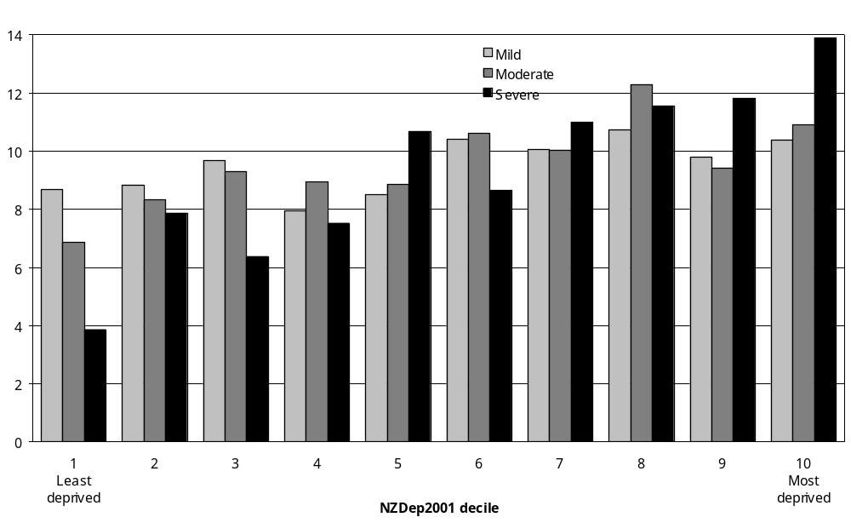
Source: Statistics New Zealand, 2001 Household Disability Survey, 2001 Census of Population and Dwellings
Note: Data in Appendix Table 5.28.

Comparing 2001 and 1996

Labour force status
The proportion of working age people with disability in the labour force (that is, adults aged
15–64 who were employed or unemployed and looking for work) increased from 58 percent in 1996 to 63 percent in 2001. There was also a corresponding reduction in the proportion of working age people with disability not in the labour force (from 42 percent to 36 percent) (Figure 5.44).

Figure 5.44: Percentage of adults aged 15–64 with disability living in households, by labour force status, 1996 compared with 2001
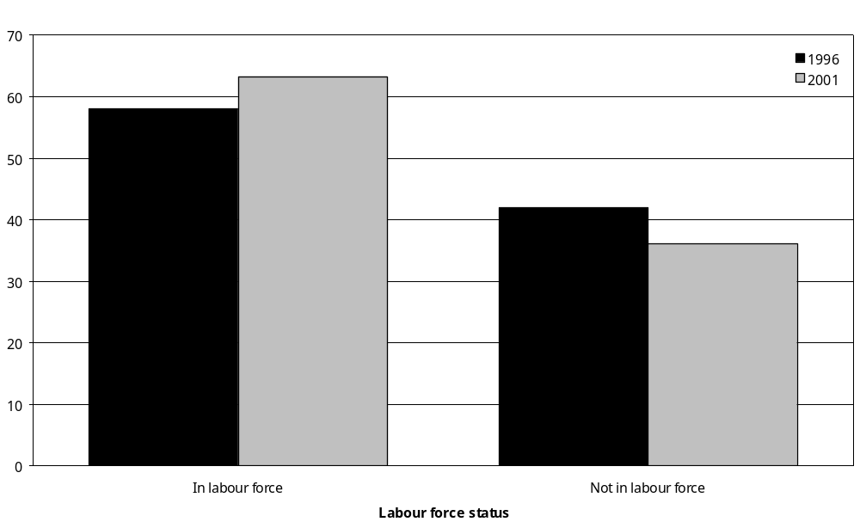
Source: Statistics New Zealand, 1996 and 2001 Household Disability Surveys
Note: ‘In labour force’ means employed plus unemployed people seeking work. ‘Not in the labour force’ means being neither employed nor unemployed, including being retired, having personal or family responsibilities such as unpaid housework and childcare, attending educational institutions, being permanently unable to work due to disability, and people not actively seeking work (Statistics New Zealand 2002a).

However, adults aged 15–24 with disability were the exception to this. In 2001, this group had a lower rate of labour force participation than in 1996 (54 percent compared with 63 percent), and a higher rate of inclusion in the not in the labour force category.

Labour force status and ethnicity
A higher proportion of European, Mäori and Pacific adults (aged 15 and over) with disability were participating in the labour force in 2001 than in 1996. However, the situation was the opposite among Asian/Other adults with disability (Figure 5.45).

Figure 5.45: Percentage of adults aged 15 years and over with disability living in households and participating in the labour force, by ethnic group, 1996 compared with 2001
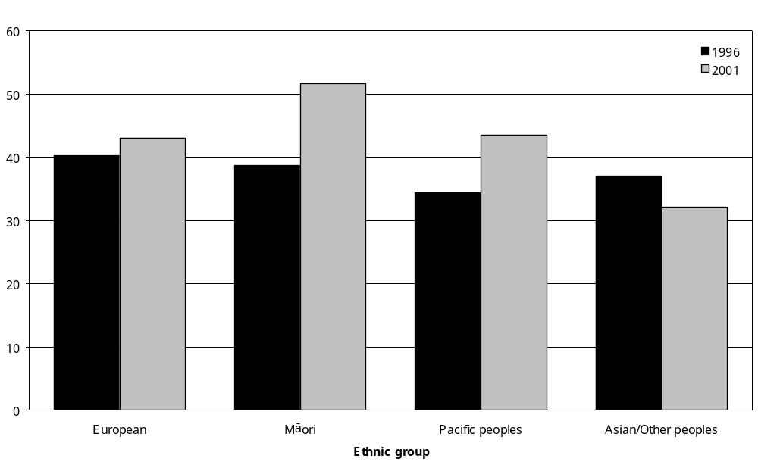
Source: Statistics New Zealand, 1996 and 2001 Household Disability Surveys
Note: ‘In labour force’ means employed people plus unemployed people seeking work (Statistics New Zealand 2002a).

Labour force status and disability type
For every disability type except hearing disability, the percentage of adults participating in the labour force was higher in 2001 than 1996, although the increase was relatively small (Table 5.2).

Table 5.2: Percentage of adults with disability living in households and participating in labour force, by disability type, 1996 compared with 2001
Disability type | Percentage in labour force  (%)
Disability type | 1996 | 2001
Hearing | 41 | 41
Seeing | 24 | 28
Mobility | 28 | 30
Agility | 29 | 31
Intellectual | 40 | 42
Psychiatric/psychological | 42 | 46
Source: Statistics New Zealand, 1996 and 2001 Household Disability Surveys
Notes:
- ‘In labour force’ means employed people plus unemployed people seeking work (Statistics New Zealand 2002a).
- If individuals reported more than one disability type, they were counted in each applicable disability group.

Labour force status and severity of disability
Rates of participation in the labour force increased between 1996 and 2001 for adults with severe disability, as well as for adults with mild and moderate disability. In 2001, 20 percent of adults with severe disability were employed or unemployed and seeking work, compared with 16 percent in 1996 (Figure 5.46).

Figure 5.46: Percentage of adults with disability living in households and participating in the labour force, by severity of disability, 1996 compared with 2001
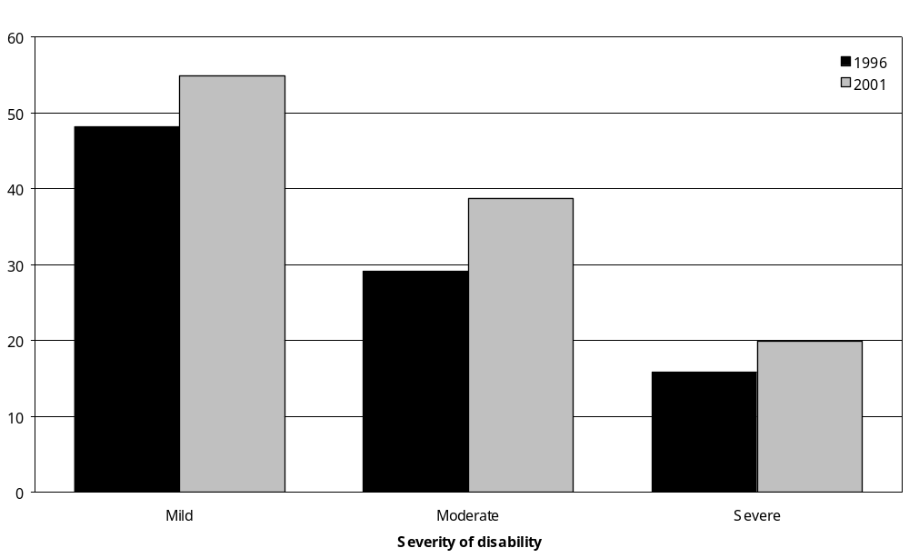
Source: Statistics New Zealand, 1996 and 2001 Household Disability Surveys
Note: ‘In labour force’ means employed people plus unemployed people seeking work (Statistics New Zealand 2002a).

People with disability on low incomes
From 1996 to 2001, the percentage of adults with disability who had incomes under $15,000 reduced for all age groups. The drop was greatest for adults aged 45–64. Factors influencing these changes could include rising wages and salaries, as well as increasing levels of government financial assistance. Note, however, that these figures have not been adjusted to take into account increases in the cost of living between 1996 and 2001 (that is, they are not inflation adjusted). While nominally the incomes of people with disability may have increased, the purchasing power of these incomes may not have increased in real terms (Figure 5.47).

Figure 5.47: Percentage of adults with disability with personal incomes $15,000 and under, by age, 1996 compared with 2001
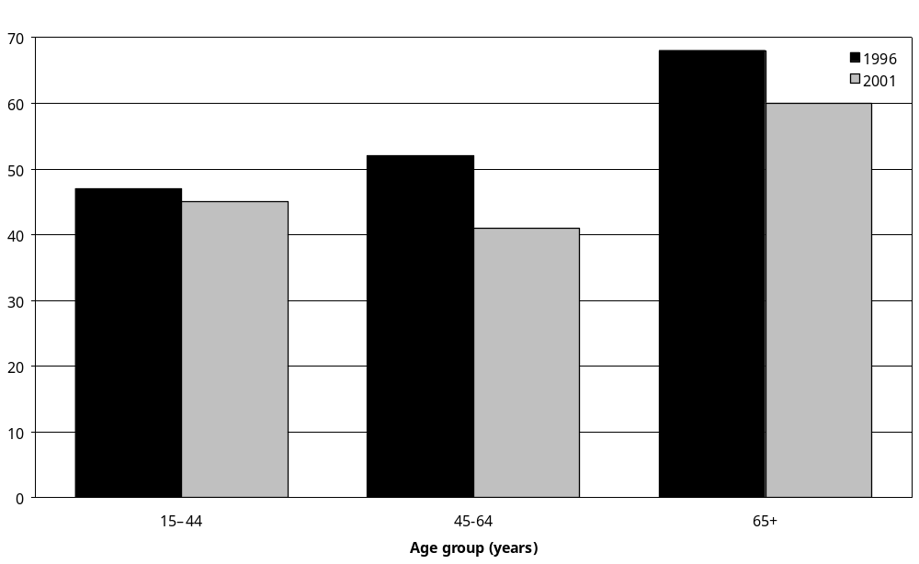
Source: Statistics New Zealand, 2001 Household Disability Survey, 2001 Census of Population and Dwellings.

6 House and Home

Key points
This chapter examines features of the home life and home environment of the estimated 626,500 adults and 90,000 children with disability living in private households. Topics covered include household composition (with whom people live), whether people have a partner or spouse, and home ownership and rental. The chapter also looks at the different kinds of building modification that people with disability said they needed in and around their home to assist them.

Household composition

Adults
- In 2001, 66 percent of adults with disability, an estimated 413,000 adults, lived in one-family households. A further 19 percent, an estimated 120,700 adults, lived by themselves.
- In every adult age group, except 15–24, adults with disability were more likely than adults without disability to live alone. For example, in the 45–64 age group, 16 percent of people with disability lived alone, compared with 11 percent of people without disability.
- Older adults with disability were more likely than younger adults with disability to live alone, with 24 percent of adults aged 65–74 and 42 percent of adults aged 75 and over living alone.
- Most adults with disability who lived by themselves were on low incomes. Seventy-six percent of adults with disability who lived alone had household incomes of $15,000 and under per year.
- Four percent of adults with disability, an estimated 24,200 adults, lived in two-family households. This was similar to adults without disability (3 percent).

Children
- Ninety percent of children (aged 0–14) with disability lived in one-family households. This was similar to the percentage of children without disability living in one-family households (89 percent).
- A further 4 percent of children with disability, an estimated 3300 children, lived in two-family households. This was similar to children without disability (5 percent).

Had a partner or spouse
- Just over half (54 percent) the adults with disability had a partner or spouse, while 37 percent did not. For the remaining 8 percent, no information was available on whether they had a partner or spouse.
- Men with disability (62 percent) were more likely than women with disability (48 percent) to have a partner or spouse.
- Nearly two-thirds of adults with hearing disability (61 percent) had a partner or spouse, compared with 39 percent of adults with psychiatric/psychological disability and 29 percent of adults with intellectual disability.
- In every adult age group except 15–24, adults with disability were less likely than adults without disability to have a partner or spouse.

Home ownership
- Half (52 percent) the adults with disability, an estimated 327,600 adults, owned or partly owned the house, apartment or other kind of dwelling in which they usually lived.
- In every adult age group from 25–44 to 75 and over, adults with disability were less likely than adults without disability to own or partly own their home.

Housing tenure
- Fifty-eight percent of adults with disability and 49 percent of children with disability were living in a home owned or partly owned by the usual residents.
- A further 23 percent of adults and 34 percent of children with disability were living in a home not owned by the usual residents and where the usual residents paid rent or did not pay rent.
- The ownership and rental status of the homes of the remaining 19 percent of adults and 17 percent of children with disability could not be identified.
- Children with disability (34 percent) were more likely than children without disability (28 percent) to be living in a house not owned by the usual residents.

Financial help for accommodation costs
- Thirteen percent of adults with disability, an estimated 84,400 adults, were receiving an Accommodation Supplement. Thirty-seven percent of adults with disability had not heard of the Accommodation Supplement.
- Other kinds of financial help for accommodation costs, such as special benefits or Special Needs Grants to assist with the costs of moving house or paying bonds to landlords, were each being used by only small proportions of adults with disability (1–2 percent each).

Phone, fax and internet
- Eighty percent of adults with disability had a working telephone or cellphone available in their home. Pacific (71 percent) and Mäori (74 percent) adults with disability had lower rates of home telephone access than European adults with disability (83 percent).
- Twenty-six percent of adults with disability, an estimated 162,200 adults, had access to the internet at home. This was a lower rate of home internet access than for adults without disability (39 percent).
- Children with disability (77 percent) were slightly less likely than children without disability (81 percent) to have a telephone or cellphone in their home.
- Children with disability were also less likely than children without disability to have access to the internet (34 percent compared with 40 percent).

Modifications in and around the home
- Sixteen percent of adults and 3 percent of children with disability, an estimated 97,500 adults and 2600 children, had certain kinds of built-in modifications in or around their home because of disability.
- Adults with severe disability (34 percent) were the most likely to have modifications in and around their home, compared with 22 percent of adults with moderate disability and just 4 percent of adults with mild disability.

Modifications inside the home
- Twelve percent of adults with disability, an estimated 74,200 adults, had some kind of built-in modifications inside their home because of disability.
- The most common modifications inside the home were grab or hand rails, used by 10 percent of adults with disability (an estimated 61,900). The two next most common modifications were wet-area showers and easy-to-get-at toilets, both used by 2 percent of adults with disability.
- Four percent of adults with disability indicated there were certain modifications they did not have inside their home that they needed. The most common modifications required, needed by an estimated 15,600 adults with disability, were grab or hand rails.
- Of the 90,000 children with disability, 2 percent or an estimated 2000, had one or more built-in modifications inside their home because of disability. Grab or hand rails were the most common modifications used by children.
- Parents or caregivers of 2 percent of children with disability indicated their children had unmet needs for disability-related modifications inside their home.

Modifications for entering or leaving the home
- Nine percent of adults with disability, an estimated 55,700 adults, were using certain kinds of built-in modifications to assist with entering or leaving their house, such as ramps or widened doorways.
- Modifications most commonly used for this purpose were hand rails at steps or doorways, used by 7 percent of adults with disability. The next most commonly used modifications were easy-to-get-at driveways, ramps and street level entrances, used by 3 percent of adults with disability or an estimated 19,200 adults.
- An estimated 3900 adults with disability used easy-to-get-at driveways or passenger drop-off or pick-up areas outside their house. An estimated 3800 used automatic or easy-to-open doors, while 1800 used elevators or lift devices.
- Three percent of adults with disability, an estimated 19,000 adults, indicated that their home did not have certain built-in modifications for entering or leaving the house that they needed. Of this group, an estimated 12,000 said they needed hand rails at steps or doorways, 5900 needed easy-to-get at driveways, ramps and street level entrances, and 1600 needed widened doorways.
- Approximately 1 percent of children with disability, an estimated 1200 children, used built-in modifications in and around their home to assist them with entering or leaving. The most common was easy-to-get at driveways, ramps or entrances.
- Parents or caregivers of 1 percent of children with disability indicated their house did not have certain modifications they needed for getting their children into and out of the house. The modifications most commonly needed were hand rails at steps or doorways.

Introduction
This chapter examines features of the home life and home environment of the estimated 626,500 adults and 90,000 children with disability who were living in private households in 2001. It begins by looking at how many people with disability were living in a family situation, how many were living alone and how many had a partner. It also examines how many people with disability owned their home and how many lived in rental accommodation. This is followed by a look at the different kinds of building modification people with disability had in and around their home because of disability, and people’s unmet needs for building modifications.

The material in this chapter has particular relevance to Objective 8 of the New Zealand Disability Strategy, which is to ‘support quality living in the community for disabled people’ (Minister for Disability Issues 2001: 22). This includes increasing the opportunities for people with disability to live in the community in affordable, quality housing and to support the development of independent communication for people with disability.

Household composition
By anonymously linking data from the 2001 Census of Population and Dwellings with data from the 2001 Household Disability Survey, it is possible to estimate how many adults and children with disability were living in:
- a one-family household
- a two-family household
- other multi-person households
- a one-person household.

Figure 6.1 summarises these findings for adults and children.

Figure 6.1: Percentage of people (adults and children) living in households, by household composition, 2001
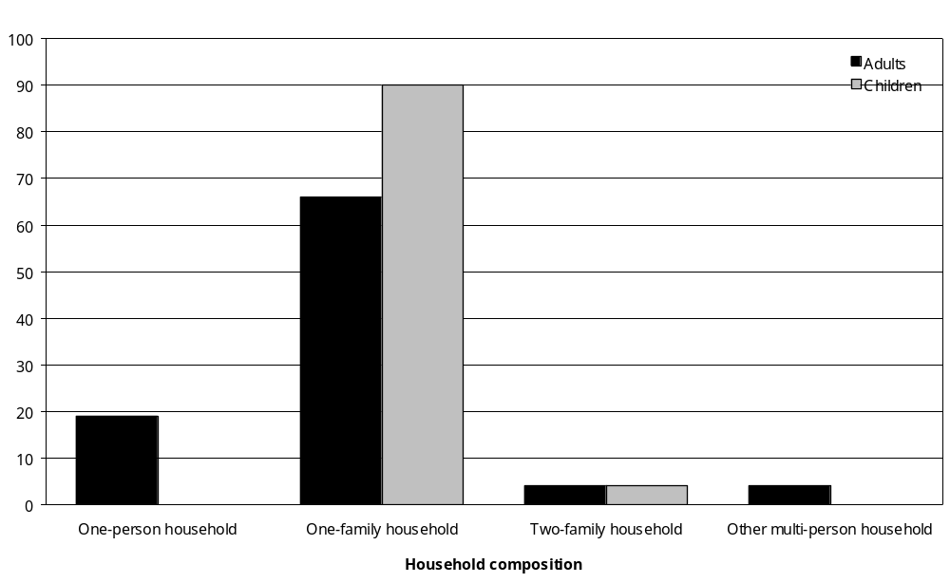
Source: Statistics New Zealand, 2001 Household Disability Survey, 2001 Census of Population and Dwellings
N/A Not applicable
– Percentages too small to report (estimated frequencies outside the 70 percent relative sampling error cut-off point).
Note: Data in Appendix Tables 6.1 and 6.3.

Adults

One-family households
In 2001, 66 percent of adults with disability, an estimated 413,000 adults, lived in one-family households. A one-family household is defined as a household containing a single family, with a family defined as a single parent or caregiver plus one or more children, a couple plus one or more children, or a couple without children.

In every adult age group from 15–24 to 65 and over, adults with disability were less likely than adults without disability to live in one-family households (Figure 6.2). For example, in the
45–64 age group, 80 percent of people without disability lived in one-family households, compared with 69 percent of people without disability.

Figure 6.2: Percentage of adults with and without disability living in one-family households, by age, 2001
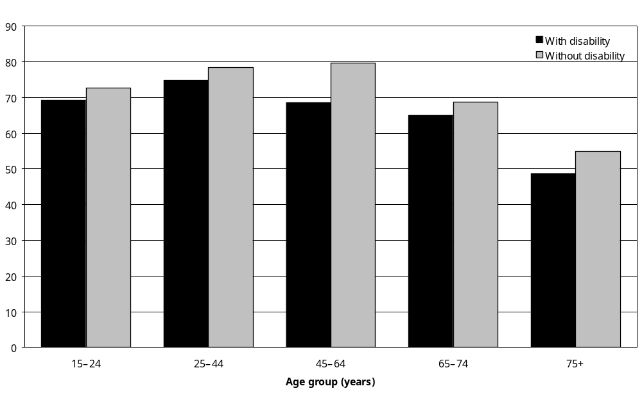
Source: Statistics New Zealand, 2001 Household Disability Survey, 2001 Census of Population and Dwellings
Notes:
- Data in Appendix Table 6.1.
- A one-family household is defined as a household containing a single family, with a family defined as a single parent or caregiver plus one or more children, a couple plus one or more children, or a couple without children.

Rural-dwelling adults with disability (76 percent) were more likely than urban-dwelling adults with disability (64 percent) to live in one-family households.

Adults with disability with household incomes of $15,000 and under per year were markedly less likely than adults with disability in the higher household income groups to live in one-family households. Only 21 percent of adults in the $15,000 and under annual household income group lived in one-family households, compared with 73 to 87 percent of adults with disability in each of the other, higher household income groups.

One-person households
Nineteen percent of adults with disability, an estimated 120,700 adults, lived in one-person households, meaning they usually lived alone.

In every adult age group, except 15–24, adults with disability were more likely than adults without disability to live alone (Figure 6.3). For example, in the 45–64 age group, 16 percent of people with disability lived alone, compared with 11 percent of people without disability.

Figure 6.3: Percentage of adults with and without disability living alone in households, by age, 2001
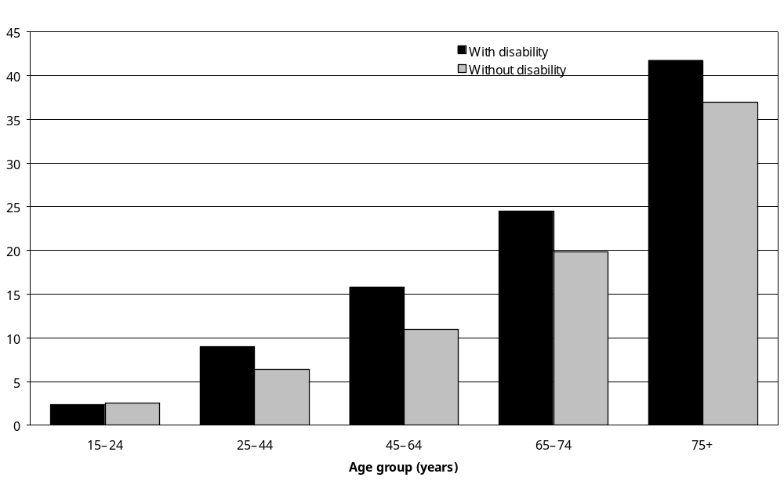
Source: Statistics New Zealand, 2001 Household Disability Survey, 2001 Census of Population and Dwellings
Note: Data in Appendix Table 6.1.

Older adults with disability (24 percent of adults aged 65–74 and 42 percent of adults 75 and over) were more likely than younger adults with disability to live alone. Reasons for this would include older adults being generally less likely to have children living with them and less likely to have a partner living with them, perhaps because the partner has died or lives elsewhere.

Most of the adults with disability who lived alone were on low incomes. Three-quarters (76 percent) of adults with disability who lived alone had household incomes of $15,000 and under per year.

Twenty-six percent of adults whose main disability was a seeing disability were living alone, as were 25 percent of adults whose main disability was a mobility disability. By contrast, only 15 percent of adults whose main disability was a psychiatric/psychological disability were living alone, as were 15 percent of adults whose main disability was a hearing disability, and 17 percent of adults whose main disability was an agility disability.

Two-family households
It was relatively rare for adults with disability to live in a household containing two families. Only 4 percent of adults with disability, an estimated 24,200 adults, lived in two-family households. This was similar to the situation for adults without disability, 3 percent of whom lived in two-family households.

Other multi-person households
The category ‘other multi-person household’ refers to non-family households containing two or more people.

Four percent of adults with disability lived in other multi-person households such as multi-person flats, compared with 6 percent of adults without disability.

Adults with intellectual disability (16 percent) and psychiatric/psychological disability (11 percent) were more likely than adults with other types of disability to live in multi-person households.

Children
Ninety percent of the estimated 90,000 children (aged 0–14) with disability lived in one-family households. This was similar to the percentage of children without disability (89 percent).

Four percent of children with disability, an estimated 3300 children, lived in two-family households. This was similar to the percentage of children without disability (5 percent).

Eleven percent of Pacific and 6 percent of Mäori children with disability lived in two-family households, compared with just 1 percent of European children with disability (Table 6.1).

Table 6.1: Household composition for children (aged 0–14) with disability, by ethnic group, 2001
 | One-family household | % | Two-family household | % | Household composition unidentifiable | % | Total | %
European | 49,100 | 94 | 800 | 1 | 2,400 | 5 | 52,300 | 100
Mäori | 24,000 | 85 | 1,800 | 6 | 2,500 | 9 | 28,400 | 100
Pacific peoples | 4,600 | 81 | 600 | 11 | – | – | 5,700 | 100
Asian/Other peoples | 1,800 | 82 | – | – | – | – | 2,200 | 100
Not specified | 1,200 | 90 | – | – | – | – | 1,400 | 100
Total | 80,800 | 90 | 3,300 | 4 | 5,800 | 6 | 90,000 | 100
Source: Statistics New Zealand, 2001 Household Disability Survey, 2001 Census of Population and Dwellings
– Population estimates or percentages too small to report (estimated frequencies outside the 70 percent relative sampling error cut-off point).
Note: A one-family household is defined as a household containing a single family, with a family defined as a single parent or caregiver plus one or more children, a couple plus one or more children, or a couple without children.

Social marital status
The term ‘social marital status’ refers to whether a person has a partner or spouse. Just over half (54 percent) of all adults with disability, an estimated 340,000 adults, had a partner or spouse. Adults with disability in the 45–64 age group (67 percent) were more likely to have a partner or spouse than adults with disability in the 65–74 (63 percent) and the 75 and over (41 percent) age groups.

Thirty-seven percent of adults with disability, an estimated 234,900 adults, did not have a partner or spouse.

Information on social marital status was not available for the remaining 8 percent of adults with disability.

Adults with disability were generally less likely than adults without disability to have a partner or spouse (Figure 6.4). In every adult age group, apart from 15–24, a smaller percentage of adults with disability had a partner or spouse than adults without disability. This difference was most marked in the 25–44 age group where 54 percent of people with disability had a partner or spouse, compared with 67 percent of people without disability.

Figure 6.4: Percentage of adults with and without disability living in households who had a partner or spouse, by age, 2001
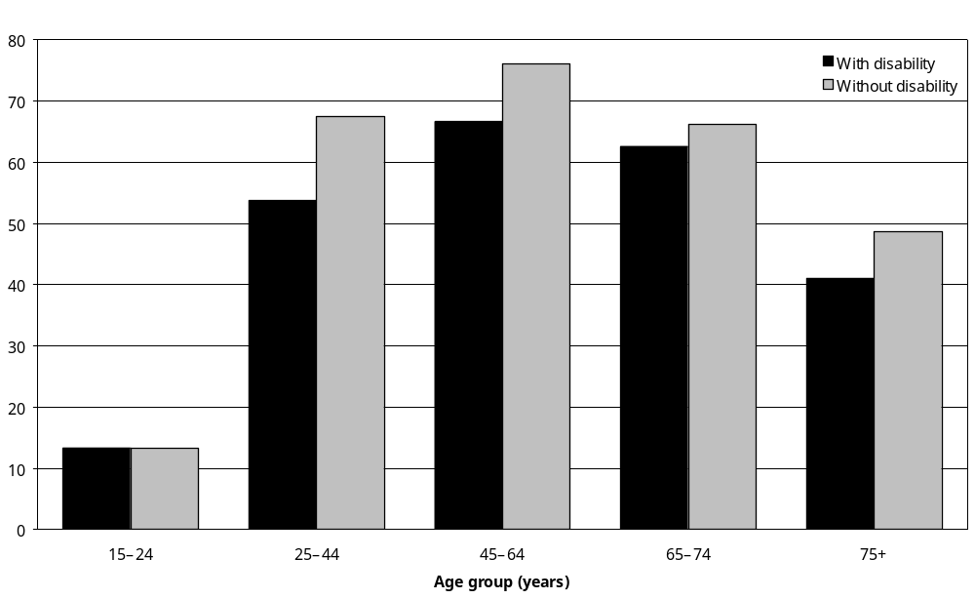
Source: Statistics New Zealand, 2001 Household Disability Survey, 2001 Census of Population and Dwellings
Note: Data in Appendix Table 6.5.

Men with disability (62 percent) were more likely than women with disability (48 percent) to have a partner or spouse. This difference probably relates at least in part to women with disability being generally older than men with disability, so more likely to have lost a partner or spouse through death.

Europeans with disability (57 percent) were more likely to have a partner or spouse than Mäori or Pacific adults with disability (44 percent and 48 percent respectively). Adults with disability living in rural areas (66 percent) were also more likely to have a partner or spouse than adults with disability living in urban areas (52 percent).

The proportion with a partner or spouse was relatively high among adults with hearing disability (61 percent), but relatively low among adults with psychiatric/psychological disability (39 percent) and intellectual disability (29 percent) (Figure 6.5).

Figure 6.5: Percentage of adults with disability living in households who had a partner or spouse, by disability type, 2001
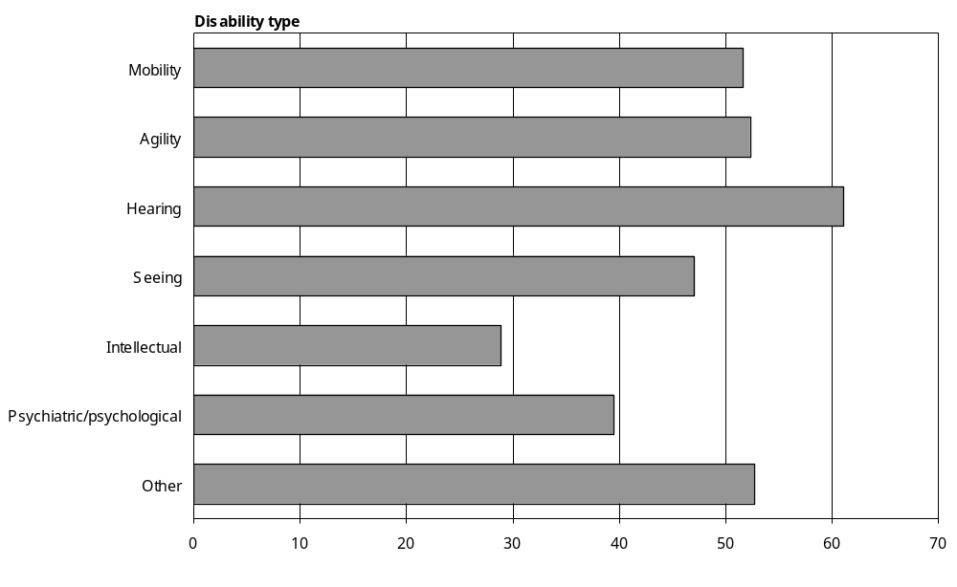
Source: Statistics New Zealand, 2001 Household Disability Survey, 2001 Census of Population and Dwellings.
Notes:
- Data in Appendix Table 6.6.
- If individuals reported more than one disability type, they were counted in each applicable disability group.

Similar percentages of adults with mild (54 percent), moderate (55 percent) and severe disability (52 percent) had a partner or spouse.

Home ownership
The 2001 Census of Population and Dwellings asked adult New Zealanders if they personally owned or partly owned the dwelling in which they usually lived. By anonymously matching the results for this question with results from the 2001 Household Disability Survey, it was possible to estimate how many adults with disability owned or partly-owned the dwelling in which they lived.

Half (52 percent) of adults with disability, an estimated 327,600 adults, owned or partly owned the house, apartment or other kind of dwelling in which they usually lived. Thirty percent did not own or partly own their home, while the home ownership status of the remaining 18 percent was unknown.

In every age group from 25–44 to 75 and over, adults with disability were less likely than adults without disability to own or partly own their home (Figure 6.6). In the 75 and over age group, for example, 63 percent of people with disability owned or partly owned their home, compared with 73 percent of people without disability.

Figure 6.6: Percentage of adults with and without disability living in households who personally owned or partly owned the dwelling in which they usually lived, by age, 2001
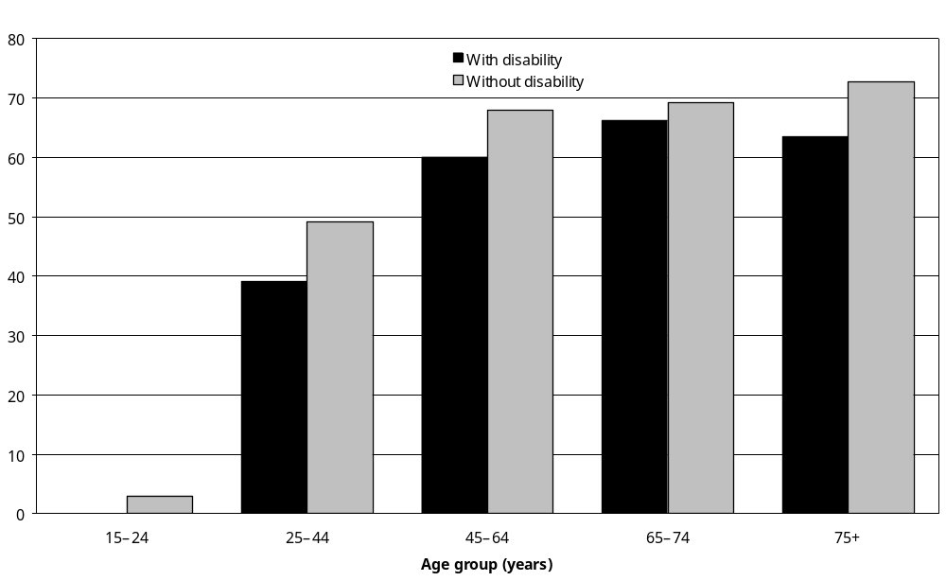
Source: Statistics New Zealand, 2001 Household Disability Survey, 2001 Census of Population and Dwellings
Note: Data in Appendix Table 6.7.

Europeans with disability (58 percent), were more likely than Mäori (31 percent) and Pacific (24 percent) adults with disability to own or partly own their home.

Almost two-thirds (62 percent) of adults with hearing disability owned their home, but rates of home ownership were lower for adults with mobility (54 percent), agility (52 percent) and seeing (49 percent) disability, and even lower for adults with psychiatric/psychological (35 percent) and intellectual (23 percent) disability (Table 6.2).

Table 6.2: Adults with disability who owned or partly owned the dwelling in which they usually lived, by disability type, 2001
Disability type | Population estimate | %
Mobility | 186,600 | 54
Agility | 140,900 | 52
Hearing | 132,200 | 62
Seeing | 32,500 | 47
Intellectual | 6,600 | 23
Psychiatric/psychological | 32,900 | 35
Other | 113,900 | 46
Total | 327,600 | 52
Source: Statistics New Zealand, 2001 Household Disability Survey, 2001 Census of Population and Dwellings
Note: If individuals reported more than one disability type, they were counted in each applicable disability group.

Rates of home ownership were higher for adults with mild and moderate disability (57 percent and 51 percent respectively) than for adults with severe disability (40 percent).

A relatively high percentage of adults with a main disability caused by ageing (66 percent) owned or partly owned their home. This contrasts with adults who had a main disability caused by a condition present at birth, only 27 percent of whom owned or partly owned their home.

Housing tenure
The 2001 Census of Population and Dwellings included questions aimed at identifying whether members of a household rented or owned the dwelling in which they lived. By anonymously matching results for these questions with data from the 2001 Household Disability Survey, it was possible to determine the mortgage and rental status of the dwellings occupied by adults and children with disability.

Adults
Fifty-eight percent of adults with disability, an estimated 361,400 adults, were living in a home owned or partly owned by the usual residents. This included an estimated 148,200 (24 percent of adults with disability) who lived in homes where the usual residents made mortgage payments, and an estimated 208,000 (33 percent of adults with disability) who lived in homes where the usual residents made no mortgage payments (Table 6.3).

Table 6.3: Ownership and rental status of the private dwellings occupied by adults with disability, 2001
 | Estimated number of adults with disability | Percentage  (%)
Dwelling owned or partly owned by the usual resident(s)
Usual residents make mortgage payments | 148,200 | 24
Usual residents do not make mortgage payments | 208,000 | 33
Mortgage arrangements of the usual residents not further defined | 5,300 | 1
Dwelling not owned by the usual resident(s)
Usual residents make rent payments | 121,500 | 19
Usual residents make no rent payments | 18,600 | 3
Rental arrangements of the usual residents not further defined | 4,400 | 1
Ownership and rental status of dwelling not specified | 120,600 | 19
Total adults with disability living in households | 626,500 | 100
Source: Statistics New Zealand, 2001 Household Disability Survey, 2001 Census of Population and Dwellings
Note: The sum of the values for each category may differ from the total due to rounding.

A further 23 percent of adults with disability, an estimated 144,500 adults, were living in a home not owned by the usual residents. Of this group an estimated 121,500 (19 percent of adults with disability) lived in homes where the usual residents paid rent. An estimated 18,600 (3 percent of adults with disability) lived in homes where the usual residents made no rent payments.

The home ownership and rental status of 19 percent of adults with disability, an estimated 120,600 adults, was not able to be identified.

Age and housing tenure
In all age groups except 15–24, most adults with disability lived in a house owned or partly owned by the usual residents, rather than in other kinds of dwellings such as rental accommodation not owned by the residents (Figure 6.7).

Figure 6.7: Percentage of adults with disability living in households, by ownership of the dwellings they occupied, by age, 2001
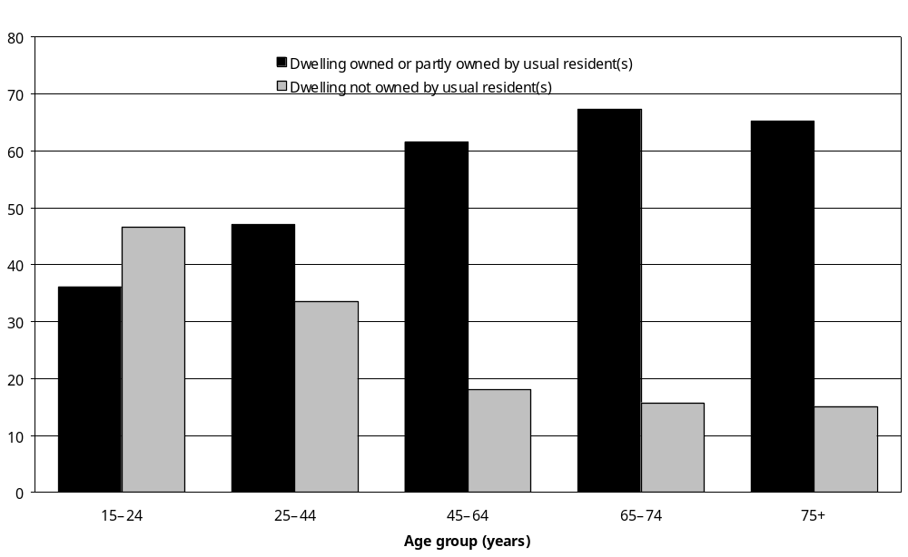
Source: Statistics New Zealand, 2001 Household Disability Survey, 2001 Census of Population and Dwellings
Note: Data in Appendix Table 6.9.

Younger adults with disability made greater use of rental accommodation, with 47 percent of adults aged 15–24 and 34 percent of adults aged 25–44 living in houses, flats or other kinds of dwelling not owned by the usual residents.

Housing tenure and other factors
Compared with European (16 percent) and Mäori (36 percent) adults with disability, a relatively high percentage of Pacific adults with disability (43 percent) were living in a house or other kinds of dwelling where the usual residents paid rent.

Urban adults with disability (21 percent) were more likely than rural adults with disability (11 percent) to be living in dwellings where the usual residents paid rent.

Adults with disability living in the Northern region (26 percent) were more likely than adults with disability living in the Southern region (16 percent) to reside in a dwelling where the usual residents paid rent.

In contrast to adults with psychiatric/psychological disability (46 percent) or intellectual disability (36 percent), a relatively high percentage of adults with hearing (66 percent), mobility (57 percent) or agility (56 percent) disability lived in a home owned or partly owned by the usual residents. However, it is important to note that information was not available on the home ownership and rental status of 19 percent of adults with disability, including 25 percent of adults with intellectual disability and 20 percent of adults with psychiatric/psychological disability.

Fifty percent of adults with severe disability lived in a house owned or partly owned by the usual residents and 29 percent lived in a house not owned by the usual residents. For adults with moderate disability the corresponding rates were 60 percent and 20 percent; and for adults with mild disability they were 58 percent and 24 percent.

Adults with and without disability
Compared with adults with disability living in households, adults without disability had a generally similar pattern of home ownership and rental status. In 2001, 60 percent of adults without disability lived in homes owned or partly owned by the usual residents compared with 58 percent of adults with disability. Twenty-three percent of adults with and without disability lived in houses not owned by the usual residents.

Examining these figures in more detail, older adults both with and without disability were more likely to live in a mortgage-free home than younger adults. Also, in every age adult group from 15–24 to 75 and over, a slightly smaller proportion of people with disability lived in a mortgage-free home than people without disability (Figure 6.8).

Figure 6.8: Percentage of adults with and without disability living in a dwelling owned or partly owned by the usual residents and where the usual residents do not make mortgage payments, by age, 2001
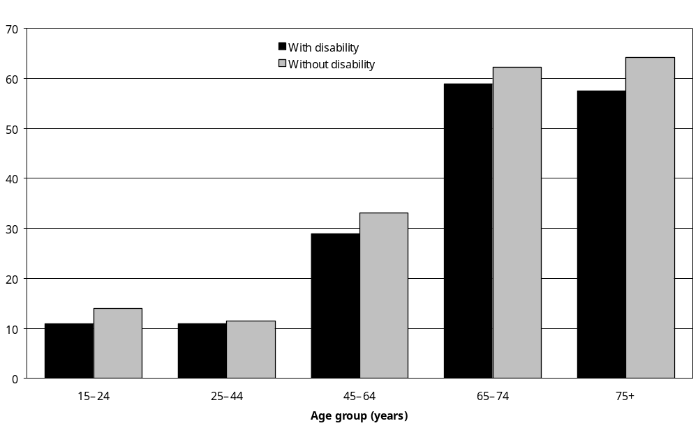
Source: Statistics New Zealand, 2001 Household Disability Survey, 2001 Census of Population and Dwellings
Note: Data in Appendix Table 6.9.

In each age group, adults with disability were more likely than adults without disability to be living in a house or other kind of dwelling where the usual residents paid rent (Figure 6.9). This was especially so in the 15–24 age group, where 44 percent lived in a dwelling where the residents paid rent, compared with 30 percent of people without disability.

Figure 6.9: Percentage of adults with and without disability living in a dwelling where the usual residents paid rent, by age, 2001
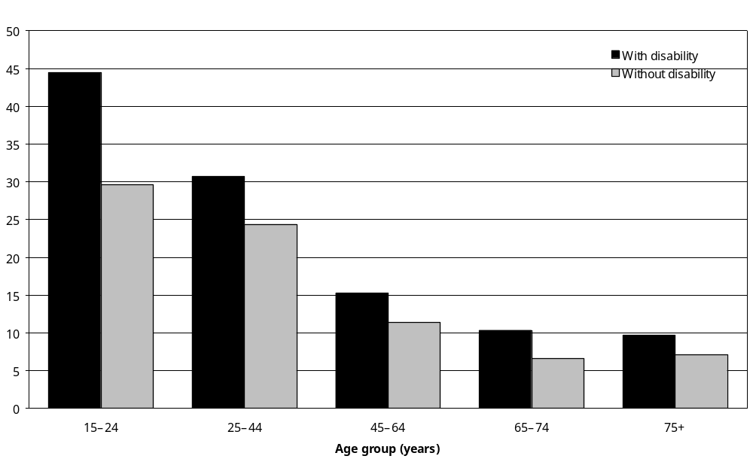
Source: Statistics New Zealand, 2001 Household Disability Survey, 2001 Census of Population and Dwellings
Note: Data in Appendix Table 6.9.

Children
Of the estimated 90,000 children with disability living in New Zealand households in 2001, 49 percent were living in a home owned or partly owned by the usual residents. This included 36,600 or 41 percent of children with disability who lived in homes where the usual residents made mortgage payments and 7400 or 8 percent of children with disability who lived in homes where the usual residents made no mortgage payments (Table 6.4).

A further 34 percent of children with disability were living in a home not owned by the usual residents. Of this group, 28,300 or 31 percent of children with disability lived in homes where the usual residents paid rent. Another 1800 or 2 percent of children with disability lived in homes where the usual residents paid no rent.

The ownership and rental status of the homes of 17 percent of children with disability were not able to be identified.

Table 6.4: Ownership and rental status of the private dwellings occupied by children with disability, 2001
 | Estimated number of children with disability | Percentage  (%)
Dwelling owned or partly owned by the usual resident(s)
Usual residents make mortgage payments | 36,600 | 41
Usual residents do not make mortgage payments | 7,400 | 8
Mortgage arrangements of the usual residents not further defined | – | –
Dwelling not owned by the usual resident(s)
Usual residents make rent payments | 28,300 | 31
Usual residents make no rent payments | 1,800 | 2
Rental arrangements of the usual residents not further defined | – | –
Ownership and rental status of dwelling not specified | 15,000 | 17
Total children with disability living in households | 90,000 | 100
Source: Statistics New Zealand, 2001 Household Disability Survey, 2001 Census of Population and Dwellings.
– Population estimates or percentages too small to report (estimated frequencies outside the 70 percent relative sampling error cut-off point).
Note: The sum of the values for each category may differ from the total due to rounding.

Children with disability were more likely than children without disability to live in homes not owned by the residents (34 percent compared with 28 percent). They were correspondingly less likely to live in homes owned by the usual residents (49 percent compared with 56 percent).

Rental payments

Adults
In 2001, of the estimated 121,500 adults with disability living in homes where the usual residents made rental payments, 29 percent lived in homes where the rental payments totalled less than $100 per week. Only 5 percent lived in dwellings where the rental payments were $300 or more per week.

The weekly rental payments made by adults without disability were generally higher than those made by adults with disability (Figure 6.10). Only 16 percent of adults without disability lived in dwellings where the weekly rental payments were under $100 per week; whereas 14 percent lived in dwellings where the occupants paid a total of $300 or more in rent per week.

Figure 6.10: Total weekly rental payments for accommodation used by adults with and without disability living in households, 2001
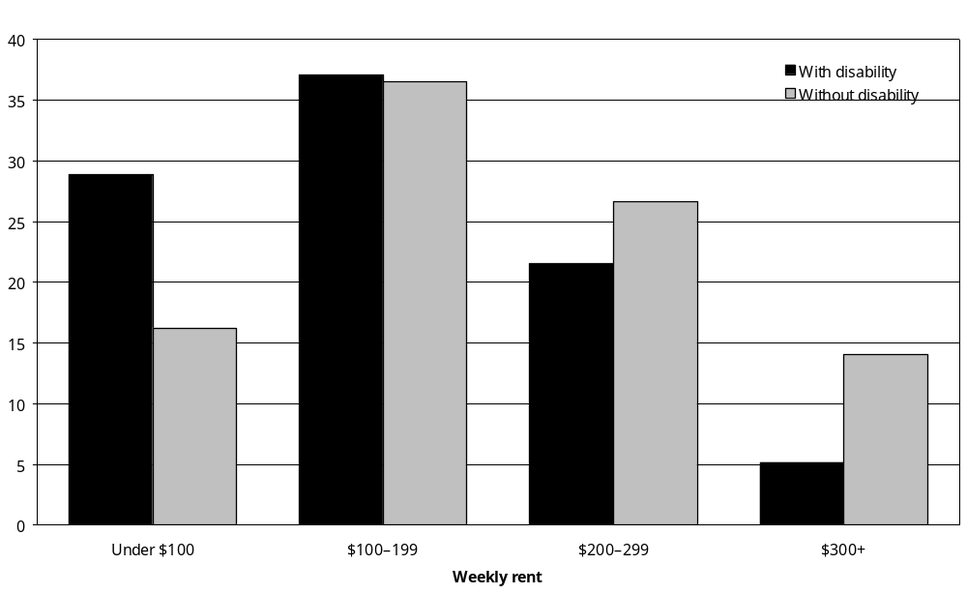
Source: Statistics New Zealand, 2001 Household Disability Survey, 2001 Census of Population and Dwellings.
Note: Data in Appendix Table 6.13.

In the 25–44 and 45–64 age groups, people with disability were more likely than people without disability to live in rental accommodation where the total weekly rent paid was under $100. However, the opposite was the case for people with disability aged 75 and over.

Children
The levels of weekly rental payments made for dwellings occupied by children with disability were generally similar to those made for dwellings occupied by children without disability. However, children with disability were slightly more likely than children without disability to live in the cheapest rental accommodation (with rental payments of under $100 per week) (Figure 6.11).

Figure 6.11: Total weekly rental payments for accommodation used by children with and without disability living in households, 2001
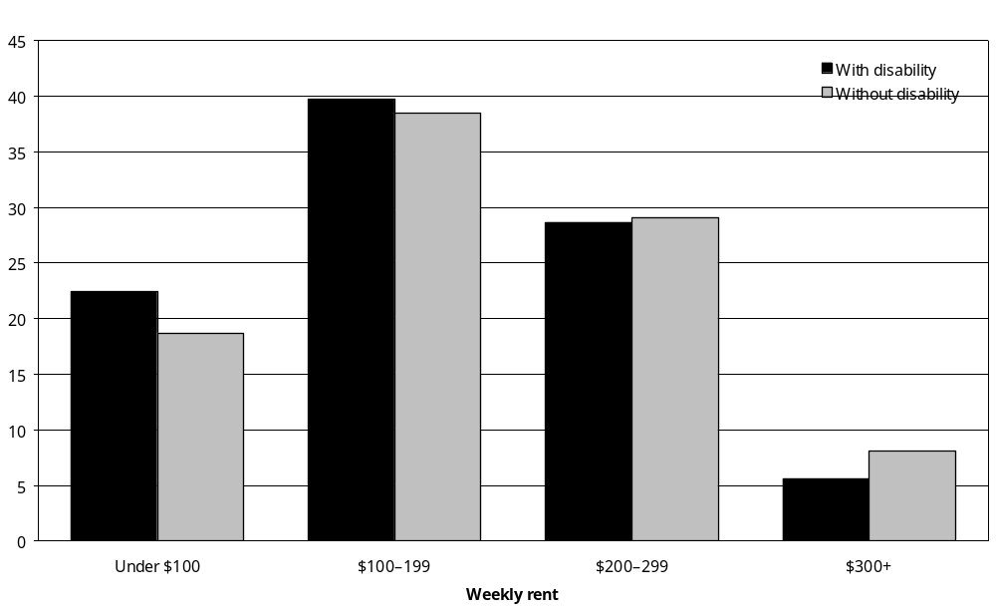
Source: Statistics New Zealand, 2001 Household Disability Survey, 2001 Census of Population and Dwellings.
Note: Data in Appendix Table 6.14.

Financial help for accommodation costs
The 2001 Household Disability Survey asked adults to specify, from a list of options, the kinds of financial help, if any, they were getting for their accommodation costs.

Seventy-three percent of adults with disability were not receiving any of the listed kinds of financial help for accommodation costs.

Accommodation Supplement
The Accommodation Supplement is a non-taxable government subsidy to help with accommodation costs. Eligibility depends on where in New Zealand people are living, their income and the costs of their accommodation (rent or mortgage) (Work and Income New Zealand 2004).

Thirteen percent of adults with disability, an estimated 84,400 adults, were receiving the Accommodation Supplement.

The proportions receiving the Accommodation Supplement were highest among adults aged
15–24 (18 percent) and 25–44 (24 percent) and lowest among adults aged 65–74 (6 percent) and 75 and over (5 percent).

Women with disability (16 percent) were more likely than men with disability (10 percent) to be receiving the Accommodation Supplement.

Mäori (24 percent) and Pacific (22 percent) adults with disability were more likely than European (11 percent) and Asian/Other (13 percent) adults with disability to be receiving the Accommodation Supplement.

Other kinds of financial help
Other kinds of financial help for accommodation costs such as Special Benefits or Special Needs Grants to assist with the costs of moving house or paying bonds to landlords, were each being used by a small proportion of adults with disability – no more than 1–2 percent in each case.

Awareness of the Accommodation Supplement
All adults with disability who were not getting the Accommodation Supplement were asked whether they had heard of it. Half (49 percent) said they had heard of it, while 43 percent said they had not. This indicated that 37 percent of the entire population of adults with disability, an estimated 232,100 adults, had not heard of the Accommodation Supplement.

Awareness of the Accommodation Supplement was relatively low in the 15–24 and 75 and over age groups (32 percent and 35 percent respectively), but higher in the other age groups (from 52 to 55 percent).

A slightly higher percentage of Mäori adults with disability (53 percent) knew about the Accommodation Supplement than European (49 percent), Pacific (44 percent) and Asian/Other (34 percent) adults with disability.

Access to telephone, fax and internet
The 2001 Census of Population and Dwellings included questions designed to identify the kinds of telecommunications devices people had in their homes. Matching the results of these questions with information from the 2001 Household Disability Survey makes it possible to estimate how many people with disability had access to a telephone, a fax or the internet in their home.

Adults
Eighty percent of adults with disability, an estimated 502,400 adults, had a working telephone or cellphone available in their home. This was almost the same as the rate of home telephone access for adults without disability (82 percent).

Pacific peoples (71 percent) and Mäori (74 percent) with disability had lower rates of access to a telephone or cellphone at home than Europeans (83 percent).

Nineteen percent of adults with disability, an estimated 119,400, had access to a fax at home, compared with 25 percent of adults without disability.

Twenty-six percent of adults with disability, an estimated 162,200, had access to the internet at home. This was a substantially lower rate of home internet access than the 39 percent identified for adults without disability.

Rates of internet access at home were highest among adults with disability in the age groups from 15 to 64 (from 30 to 32 percent), and lowest in the 65–74 (19 percent) and 75 and over (9 percent) age groups.

Rates of internet access were lower in all age groups for adults with disability, compared with adults without disability (Figure 6.12).

Figure 6.12: Percentage of adults with and without disability living in households, with internet access at home, by age, 2001
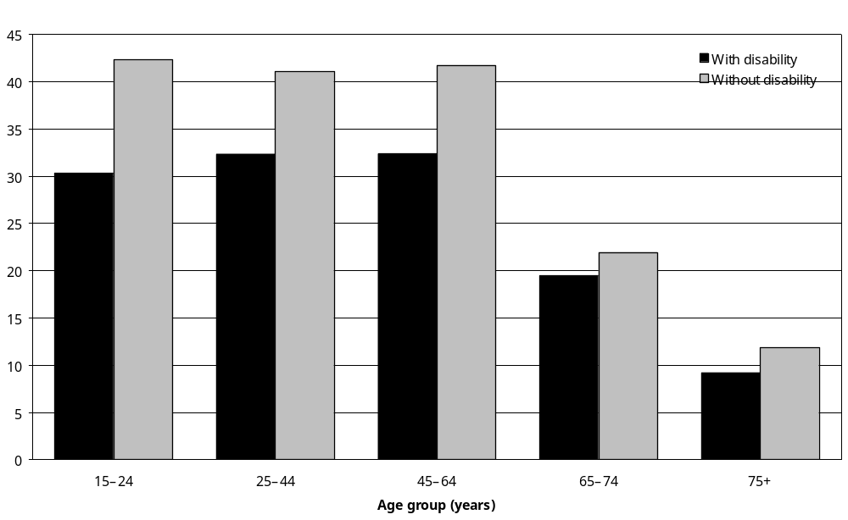
Source: Statistics New Zealand, 2001 Household Disability Survey, 2001 Census of Population and Dwellings.
Note: Data in Appendix Table 6.17.

Children
Children with disability (77 percent) were slightly less likely than children without disability (81 percent) to have a telephone or cellphone in their home. They were also less likely to have access to the internet at home (34 percent compared with 40 percent).

Modifications in and around the home
Sixteen percent of adults and 3 percent of children with disability, an estimated 97,500 adults and 2600 children, had certain kinds of built-in modification in or around their home because of disability.

Adults with severe disability (34 percent) were the most likely to have modifications in and around their home, compared with 22 percent of adults with moderate disability and just 4 percent of adults with mild disability.

Children with disability requiring the use of technical aids (29 percent) were more likely than children with other types of disability (for example, intellectual – 11 percent; psychiatric/ psychological – 7 percent; chronic condition/health problem – 5 percent) to have modifications in and around their home.

Modifications inside the home
The 2001 Household Disability Survey included questions examining how many adults and children with disability had modifications inside their home because of disability. The focus of the questions was items or features attached to the inside of the house, such as grab or hand rails or easy-to-get-at toilets, rather than portable equipment or appliances such as special chairs or stools.

Adults
Twelve percent of adults with disability, an estimated 74,200 adults, had some kinds of built-in modification inside their home because of disability.

By far the most common modifications were grab or hand rails, used by 10 percent of adults with disability (an estimated 61,900 adults).

The next two most common modifications were wet-area showers (2 percent of adults with disability or an estimated 14,600 adults) and easy-to-get-at toilets (2 percent of adults with disability or an estimated 14,800 adults). In addition the homes of an estimated:
- 6100 adults had lever door handles
- 6000 adults had emergency call systems
- 5500 adults had widened doorways or hallways
- 3300 adults had automatic or easy-to-open doors or windows
- 2800 adults had audio warning devices
- 2700 adults had lowered benches or sinks
- 2400 adults had bed or bath lifts
- 1800 adults had lowered switches or power points.

Older adults were most likely to use these kinds of modification inside their home, with 30 percent of people with disability aged 75 and over using one or more of these features, compared with just 4 percent of adults aged 25–44 with disability.

Women (15 percent) were more likely than men (9 percent) to use one or more of these features.

Seventeen percent of adults whose main disability was a mobility disability used one or more of these features, as did 15 percent of adults whose main disability was an agility disability, 12 percent of adults whose main disability was a seeing disability and 7 percent of adults whose main disability was a hearing disability.

Twenty-eight percent of adults with severe disability used one or more of these kinds of feature, compared with just 3 percent of adults with mild disability.

Unmet need for modifications inside the home
Four percent of adults with disability, an estimated 26,600 adults, indicated there were certain kinds of modification they did not have inside their home that they needed. More than half (59 percent) of this group, an estimated 15,600 adults, said they needed grab or hand rails. As well, an estimated:
- 6700 adults indicated they needed wet-area showers
- 2600 adults indicated they needed an easy-to-get-at toilet
- 1800 adults indicated they needed an emergency call system.
- 1800 adults indicated they needed bed or bath lifts.

When these adults were asked why they did not have these modifications, the most common reason was that the modifications were unaffordable (39 percent).

Seventeen percent indicated they did not know where to go to get the modifications they needed.

As well, 17 percent indicated they did not have the modifications they needed because they did not know where to go to apply for financial help to pay for them or were unaware financial help was available.

Other reasons adults gave for not having the modifications they needed included: they did not know the modification existed; their condition was not serious enough; or the modification was needed only occasionally.

Children
Of the 90,000 children with disability, 2 percent or an estimated 2000 children, had one or more kinds of built-in modifications inside their home because of disability.

Grab or hand rails were the most common types of modification used by this group (used by 30 percent of all children with modifications inside their home).

The caregivers of 2 percent of children with disability (an estimated 2200 children) indicated there were special features inside the home that their child did not have, but needed.

The most common reason for not having these features was affordability (reported by the parents or caregivers of an estimated 1300 children with disability).

Modifications for entering or leaving the home
The 2001 Household Disability Survey included questions to identify how many adults and children with disability were using any kinds of built-in modification in or around their home, such as ramps or widened doorways, to enable them to enter or leave their home more easily or safely.

Adults
Nine percent of adults with disability, an estimated 55,700 adults, used one or more built-in modifications to assist them to enter or leave their home.

The most common modifications for this purpose were hand rails at steps or doorways, used by 7 percent of adults with disability or an estimated 43,400 adults.

The next most commonly used modifications were easy-to-get-at driveways, ramps and street level entrances, used by 3 percent of adults with disability or an estimated 19,200 adults.
- An estimated 3900 adults with disability used easy-to-get-at driveways or passenger drop-off or pick-up areas outside their house.
- An estimated 3800 adults with disability used automatic or easy-to-open doors.
- An estimated 1800 adults with disability used elevators or lift devices.

Unmet need for special features for entering and leaving
Three percent of adults with disability, an estimated 19,000 adults, indicated their home did not have certain built-in modifications they needed for entering or exiting.

Almost two-thirds (63 percent) of this group, an estimated 12,000 adults, indicated they needed hand rails at steps or doorways. One-third, an estimated 5900 adults, indicated they needed easy-to-get-at driveways, ramps and street level entrances. An estimated 1600 adults needed widened doorways.

When these adults were asked why they did not have these modifications, the most common reason they gave was that the modifications were unaffordable. Forty-four percent, an estimated 8300 adults with disability, gave this as a reason.

Nineteen percent, or an estimated 3600 adults with disability, indicated they did not have the modifications they needed because they did not know where to go to apply for financial help to pay for them or were unaware financial help was available. Seventeen percent, an estimated 3000 adults with disability, indicated they did not know where to go to obtain the modifications they needed.

Children
Of the 90,000 children with disability, about 1 percent or an estimated 1200 children, used built-in modifications in or around their home to assist them with entering or leaving the house. Ninety-two percent of children did not use any of these types of modification.

The most frequently reported modifications used by children were easy-to-get-at driveways, ramps and street level entrances. Over half (56 percent) the estimated 1200 children who used some kind of modifications to assist them with getting into or out of the house used easy-to-get-at driveways, ramps or entrances.

About 1 percent of children with disability (an estimated 1300 children) did not have the built-in modifications they needed for getting into and out of the house. The modifications most commonly needed were hand rails at steps or doorways, required by over half this group of children (57 percent).

Government loans or grants to help with alterations
Three percent of adults with disability, an estimated 20,200 adults, had modifications made to the inside or outside of their home in the previous 12 months because of disability. Of this group, a third (32 percent), an estimated 6400 adults, received a loan or grant from a government agency such as the Ministry of Health, Ministry of Social Development or Accident Compensation Corporation (ACC), to pay or partly pay for these alterations.

Parents or caregivers of 2600 children (3 percent) reported their homes had been modified inside or outside because of their child’s disability. The majority (73 percent) of these parents or caregivers had not received loans or grants from government agencies to pay for these alterations.

Comparing 2001 and 1996

Adults
The proportion of adults with disability living alone was the same in 2001 as in 1996 (19 percent). However, in 2001 a slightly smaller proportion of adults with disability lived in one-family households (Table 6.5).

Table 6.5: Summary comparison of 1996 and 2001 Household Disability Surveys for adults
 | Estimated number of adults with disability living in households |  | Percentage of total number of adults with disability living in households (%)
 | 1996 survey | 2001 survey | 1996 survey | 2001 survey
Household composition
Living in one-family household | 404,800 | 413,300 | 70 | 66
Living in two or more family household | 19,800 | 25,200 | 3 | 4
Living in other multi-person household | 26,600 | 27,900 | 5 | 4
Living alone | 110,200 | 120,700 | 19 | 19
Not identified | 18,500 | 39,400 | 3 | 6
Social marital status
Partnered | 335,900 | 340,000 | 58 | 54
Non-partnered | 203,900 | 234,900 | 35 | 37
Not identified | 40,600 | 51,600 | 7 | 8
Need to have new or changed features to enter or leave home
Yes | 13,900 | 19,000 | 2 | 3
No | 550,200 | 561,100 | 95 | 90
Not specified | 16,300 | 46,300 | 3 | 7
Need to have new or changed features inside home
Yes | 30,100 | 26,600 | 5 | 4
No | 534,300 | 553,400 | 92 | 88
Not specified | 16,000 | 46,300 | 3 | 7
Types of financial help used for costs of accommodation
Accommodation Supplement | 76,700 | 84,400 | 14 | 13
Special benefits | 13,800 | 11,900 | 2 | 2
Tenure protection allowance | – | 2,300 | – | 0
Special Needs Grant for moving costs or bond | – | 5,700 | – | 1
ACC assistance | N/A | 7,700 | N/A | 1
Ministry of Health services | N/A | 3,200 | N/A | 1
Other | N/A | 14,700 | N/A | 2
None of these | 469,300 | 460,500 | 84 | 73
Did not know if got help | 9,600 | 5,000 | 2 | 1
Source: Statistics New Zealand, 2001 Household Disability Survey and 1996 Household Disability Survey.
– Numbers too small to report (estimated frequencies outside the 70 percent relative sampling error cut-off point).
N/A Not applicable.
Note: As indicated on the table by N/A, categories for financial help for accommodation costs were different in 1996 and 2001, which may explain at least part of the difference for the results for the ‘none of these’ category.
Compared with 1996, in 2001 a slightly smaller percentage of adults with disability had partners.

In both years a comparatively small proportion of adults with disability (2–3 percent) identified a need for new or upgraded features in their home to assist them with entering or leaving the house.

The proportion of adults with disability receiving the Accommodation Supplement was similar in both years (14 percent in 1996 and 13 percent in 2001).

Children
In 1996 and 2001 the same proportion of children with disability lived in one-family households (90 percent) (Table 6.6).

Table 6.6: Summary comparison of 1996 and 2001 Household Disability Surveys for children
 | Estimated number of children with disability living in households |  | Percentage of total number of children with disability living in households (%)
 | 1996 survey | 2001 survey | 1996 survey | 2001 survey
Household composition
Living in one-family household | 84,100 | 80,800 | 90 | 90
Living in two or more family household | 5,900 | 3,400 | 6 | 4
Not identified | 3,900 | 5,800 | 4 | 6
Need to have new or changed features for entering or exiting home
Yes | – | 1,300 | – | 1
No | 91,800 | 82,400 | 98 | 92
Not specified | 1,300 | 6,200 | 1 | 7
Need to have new or changed features inside home
Yes | 2,600 | 2,200 | 3 | 2
No | 90,100 | 81,500 | 96 | 91
Not specified | 1,300 | 6,200 | 1 | 7
Source: Statistics New Zealand, 2001 Household Disability Survey, 1996 Household Disability Survey
– Numbers too small to report (estimated frequencies outside the 70 percent relative sampling error cut-off point).

In both years, only a small proportion of children (3 percent or less) had unmet needs for new features in their home to assist with disability.

7 Travel and Transport

Key points
This chapter looks at the travel patterns of people with disability. It examines their access to private motor vehicles, taxis and public transport, as well as their use of transport subsidies and grants.

Long-distance travel
- In 2001, most adults and children with disability had made long trips, that is, trips of more than 80 kilometres, or the equivalent of one hour’s travelling on the open road. Twenty-three percent of adults and 14 percent of children with disability had not made any long trips in the previous 12 months.
- Seven percent of adults and 1 percent of children with disability indicated disability stopped them from making long trips.
- Of the adults with disability able to travel long distances, an estimated 12,300 (2 percent) could make long trips only if they travelled in special transport, such as taxis or modified cars. An estimated 66,800 (12 percent) needed someone to help them on long trips.

Short-distance travel
- It was common for adults and children with disability to make short trips that is, trips of less than 80 kilometres. Only 3 percent of adults with disability and 2 percent of children with disability had not made any short trips in the previous 12 months.
- Of the small group who had not made any short trips, most (adults – 91 percent, children – 75 percent) indicated their condition or health problem was not a factor preventing them from making short trips.
- One percent of adults with disability and 1 percent of children with disability could make short trips only if they travelled in special transport such as taxis or modified cars. This was an estimated 4800 adults and 1100 children.
- Of the adults with disability able to make short trips, an estimated 49,500 (9 percent) needed someone to help them on these trips. Similarly, of the children with disability able to make short trips, an estimated 9500 (11 percent) needed someone to help them on these trips.

Private motor vehicles
- Eleven percent of adults (an estimated 63,400 adults) and 7 percent of children with disability (an estimated 5500 children) lived in households with no private motor vehicle available for use, compared with 4 percent of adults and 5 percent of children without disability.
- Five percent of adults with disability, an estimated 27,400 adults, indicated they had needed to buy a vehicle in the previous 12 months specifically because of their condition or health problem. Most of these adults (78 percent) had gone on to purchase the vehicle they needed, although 22 percent (an estimated 6000 adults) had not been able to (usually because of the cost).
- Similarly, parents or caregivers of 5 percent of children with disability (an estimated 4000 children) reported needing to buy a vehicle in the previous 12 months specifically because of their child’s condition or health problem. The parents or caregivers of 69 percent of these children had gone on to purchase the vehicle they needed, but the parents or caregivers of 31 percent (an estimated 1200 children) had not (usually because of the cost).
- Seventy percent of adults with disability (an estimated 404,200 adults) were drivers.
- Of those adults who were drivers, 2 percent (an estimated 7000) had modified their motor vehicle so they could drive it. Three percent (an estimated 11,800 adults) needed to have modifications made to their motor vehicle to make it possible or easier to drive.
- In 2001, 86 percent of adults with disability travelled as passengers in private motor vehicles. Of this group, 12 percent (an estimated 60,100 adults) said they had difficulty travelling as a passenger in a motor vehicle. Adults whose main disability was a mobility disability (16 percent) or an agility disability (15 percent) were the most likely to have difficulty travelling as passengers in motor vehicles.
- Nearly all children with disability (94 percent) travelled as passengers at least some of the time in private motor vehicles. Seven percent of these children (an estimated 5700) had difficulty doing this. Children who used technical aids were the group most likely to have difficulty travelling in private motor vehicles (26 percent).
- One percent of adults with disability who travelled as passengers in private motor vehicles had made changes to these vehicles so they could travel in them (an estimated 2900 adults).
- Of the adults with disability able to travel as passengers in a private motor vehicle, 5 percent (an estimated 6700 adults) indicated they needed to make alterations to their household motor vehicle so they could travel in it.
- Modifications had been made to the household vehicles of 1 percent of children who travelled as passengers (an estimated 1000 children).
- One percent of all children with disability (an estimated 800 children) had unmet needs for changes to their household motor vehicle.
- An estimated 155,800 adults and 10,500 children who drove or travelled as passengers in private motor vehicles needed to park close to their destination because of disability. Adults with mobility or agility disability and children who used technical aids were the most likely to need to park close to their destination.
- Forty-nine percent of the adults and the parents or caregivers of 63 percent of the children with disability who needed to park close to their destination indicated they had difficulty finding parking.

Taxis
- Thirty-eight percent of adults and 20 percent of children with disability had travelled by taxi at least once in the previous 12 months.

Public transport
- Seventy-six percent of adults with disability indicated they could easily get to a bus stop or railway station from where they lived. The remaining 24 percent (an estimated 139,300 adults) indicated they could not.
- Thirty-five percent of adults with disability, an estimated 203,000 adults, had travelled long distances on aeroplanes, trains or buses in the previous 12 months. Of this group, 13 percent, an estimated 26,800 adults, had experienced at least one type of difficulty during this travel.
- Ten percent of children with disability (an estimated 8100 children) were considered by their parents or caregivers to have a disability that made it difficult for them to travel long distances on aeroplanes. Ten percent (8000) were considered to have difficulty travelling long distances on buses, 7 percent (5500) on trains and 7 percent (5500) on ferries.
- Twelve percent of adults and 7 percent of children with disability who were able to make short trips indicated they would have difficulty travelling short distances on public transport such as buses, trains, trams and ferries because of disability. The most common difficulty for both adults and children was getting on and off public transport.
- In the previous 12 months, 68 percent of adults with disability had lived in a place with a bus service. Thirty-four percent of these adults had used a bus at least once for a short trip in the previous 12 months. This was an estimated 133,400 adults (23 percent of adults with disability).
- Eighty percent of children able to make short trips without special transport had used buses for short trips. This was an estimated 34,700 children (42 percent of all children with disability).
- Of those adults who had access to a bus service but had not made any short trips by bus in the previous 12 months, 18 percent (an estimated 46,200) said they would travel on buses if they were easier to use.
- Parents or caregivers of 22 percent of children who had access to a bus service but had not made any short trips by bus in the previous 12 months (an estimated 1500 children) indicated their child would travel on buses if they were easier to use.
- Of the employed adults who had not used a bus to travel to work the previous day, 9 percent (an estimated 19,100) said they would travel to work more often in buses if they were made easier to use.

Transport subsidies and grants
- Of the estimated 3600 people (adults and children) who had modifications made to a vehicle in the previous 12 months because of disability, 77 percent did so without obtaining a loan or grant from a government agency.
- Seventy percent of adults with disability and the parents or caregivers of 78 percent of children with disability had not heard of the Total Mobility Scheme, which provides subsidised taxi fares to people with disability.
- Four percent of adults and 1 percent of children with disability had used Total Mobility Scheme vouchers in the previous 12 months (an estimated 26,100 adults and 600 children).
- Five percent of adults (an estimated 30,800 adults) and 7 percent of children with disability (an estimated 5800 children) obtained some form of government financial help for transport costs in the previous 12 months, excluding subsidised taxi fares from the Total Mobility Scheme.
- Seven percent of adults with disability (an estimated 38,900 adults) and parents or caregivers of 11 percent of children with disability (an estimated 9300 children) indicated they had needed financial assistance with disability-related transport costs in the previous 12 months, but had not been able to get this assistance.

Introduction
Objective 8 of the New Zealand Disability Strategy is to ‘support quality living in the community for disabled people’ (Minister for Disability Issues 2001: 22). As well as enabling people with disability to live in suitable accommodation (see chapter 6), proposed actions linked to this objective include:
- requiring all new scheduled public transport to be accessible in order to phase out inaccessible public transport
- encouraging the development of accessible routes to connect buildings, public spaces and transport systems
- developing nationally consistent access to passenger services where there is no accessible public transport.

The 2001 Household Disability Survey questioned adults and children with disability about their travel patterns and their access to, and use of, different forms of transport.

This chapter reports the results for these questions, looking first at how easy it was for people with disability to travel long and short distances. This is followed by a look at people’s use of private motor vehicles, either as drivers or passengers. The final sections cover people’s use of taxis and public transport such as buses, trains and ferries, as well as their use of financial subsidies to cover transport costs.

All the information presented in this chapter refers to adults and children living in households. Adults living in residential facilities are not included because they were not asked any questions about travel or transport.

Long-distance travel

Recent long-distance travel
In 2001, most adults and children with disability had made long trips, that is, trips of more than 80 kilometres or the equivalent of one hour’s travelling on the open road. Twenty-three percent of adults and 14 percent of children with disability had not made any long trips in the previous 12 months.

Adults with disability in the oldest age groups were least likely to have travelled long distances – 45 percent of adults aged 75 and over had not made any long trips in the previous 12 months (Figure 7.1).

Figure 7.1: Percentage of people (adults and children) with disability living in households who had not made a long trip in the previous 12 months, by age, 2001
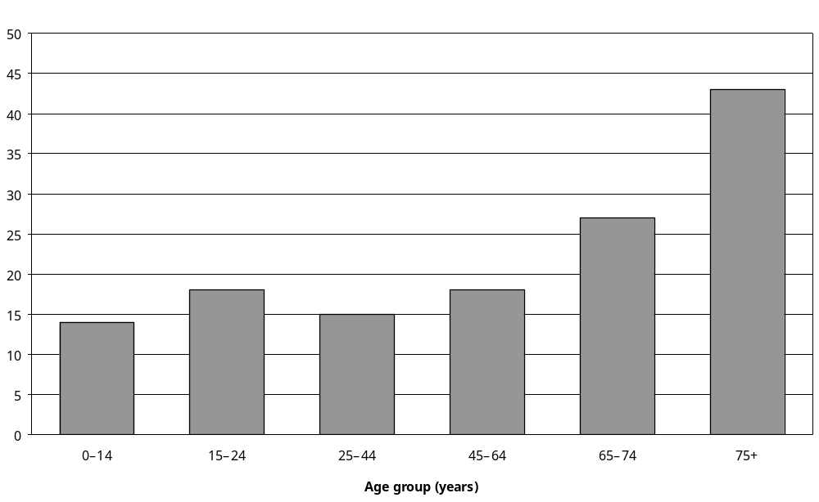
Source: Statistics New Zealand, 2001 Household Disability Survey
Note: Data in Appendix Tables 7.1 and 7.2.

Adults
Nearly half of Pacific (49 percent) and Asian/Other (47 percent) adults with disability had not made a long trip in the previous 12 months, compared with just 22 percent of European and 14 percent of Mäori adults with disability.

A quarter of urban adults with disability had not made long trips, compared with 14 percent of rural adults with disability.

Thirty percent of adults with disability living in the Northern region had not travelled long distances in the previous 12 months, compared with 24 percent of adults from the Central region, 19 percent from the Southern region and 16 percent from the Midland region.

Low annual household income was associated with not travelling long distances, with 32 percent of adults in the lowest income group ($15,000 and under per year) not having made a long trip, compared with 15 percent of adults in the highest income group ($70,001 and over per year).

Adults who had a seeing disability as their main disability (29 percent) were most likely not to have travelled long distances. Adults with hearing disability as their main disability (17 percent) were least likely not to have travelled long distances.

Adults with a main disability caused by ageing (62 percent) were more likely than adults with a main disability caused by other factors such as disease/illness (26 percent), accident/injury (18 percent), or existing at birth (17 percent) to have made a long trip.

More than a third (37 percent) of adults with severe disability had not travelled long distances in the previous 12 months, compared with 24 percent of adults with moderate disability and 18 percent of adults with mild disability.

Children
Pacific and Asian/Other children with disability (32 percent and 29 percent respectively) were more likely than European and Mäori children with disability (12 percent and 13 percent respectively) not to have made a long trip in the previous 12 months.

A slightly higher proportion of urban children than rural children had not travelled long distances (15 percent compared with 7 percent).

Like adults, children in the lowest annual household income group ($15,000 and under per year) were more likely not to have made a long-distance trip in the previous 12 months than children in the highest annual household income group ($70,001 and over per year) (20 percent compared with 6 percent).

Prevention of long-distance travel
Adults and children who had not been on a long trip in the previous 12 months were asked whether their ‘condition or health problem completely stopped them from travelling long distances’. An estimated 38,700 adults and 800 children said they had experienced this type of barrier when making long trips. This was 7 percent of all adults with disability and 1 percent of all children with disability.,

Adults
Older adults with disability were more likely than younger adults with disability to state their ‘condition or health problem’ completely stopped any long-distance travel. For example, 17 percent of people aged 75 and over indicated their condition completely ruled out long-distance travel, compared with 3 percent of adults aged 15–44 (Figure 7.2).

Figure 7.2: Percentage of adults with disability living in households who were prevented by disability from travelling long distances, by age, 2001
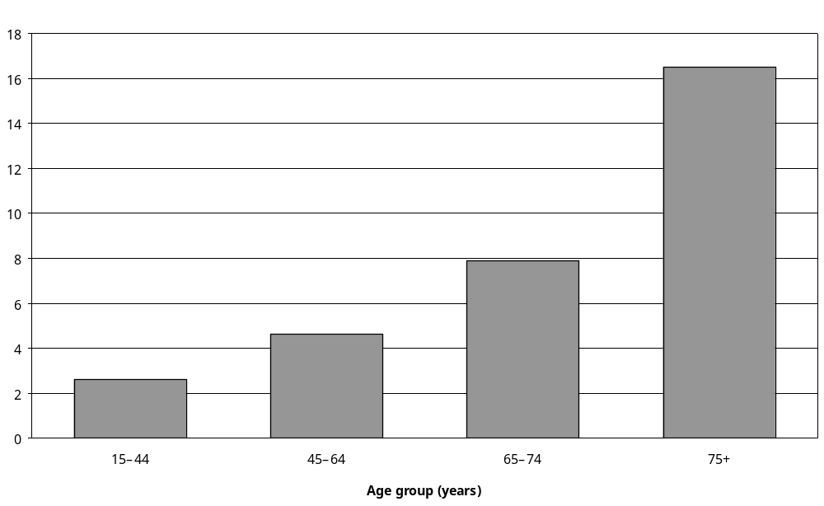
Source: Statistics New Zealand, 2001 Household Disability Survey
Note: Data in Appendix Table 7.3.

Pacific (11 percent) and Asian/Other (10 percent) adults were slightly more likely than Mäori (3 percent) or European adults (7 percent) to have been prevented by disability from travelling long distances.

Adults with disability from low income households were more likely to be prevented by disability from travelling long distances than adults with disability from high-income households. For example, 2 percent of adults with household incomes of $70,001 and over per year were unable to travel long distances, compared with 10 percent of adults with household incomes of $15,000 and under per year.

Adults with hearing disability were least likely to experience disability-related barriers to travelling long distances. Two percent of adults whose main disability was hearing loss were unable to travel long distances, compared with 9 percent of adults whose main disability was mobility disability and 8 percent whose main disability was seeing disability (35 percent) (Figure 7.3).
Figure 7.3: Percentage of adults with disability living in households who were prevented by disability from travelling long distances, by disability type and main disability, 2001
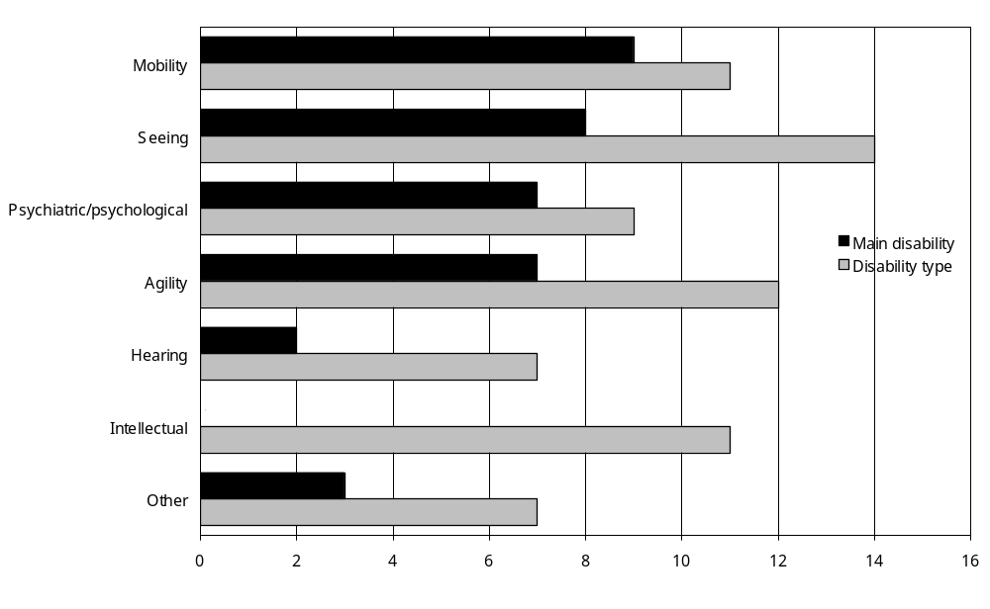
Source: Statistics New Zealand, 2001 Household Disability Survey
– Percentages too small to report (estimated frequencies outside the 70 percent relative sampling error cut-off point).
Notes:
- Data in Appendix Table 7.3.
- If individuals reported more than one disability type, they were counted in each applicable disability type group.
Looking at all disability types, adults with hearing loss were again least likely to be prevented by disability from travelling long distances (7 percent). Adults with intellectual disability (11 percent), agility disability (12 percent) and seeing disability (14 percent) were most likely to be prevented from making long trips.
Ten percent of adults with a main disability caused by disease/illness were prevented by disability from travelling long distances, compared with 14 percent of adults whose main disability was caused by ageing and 5 percent of adults whose main disability was caused by accident/injury.
Adults with multiple disabilities were more likely (10 percent) than those with a single disability (2 percent) to be unable to travel long distances because of disability.
The likelihood of adults being unable to travel long distances because of disability also increased with the severity of disability. Nineteen percent of adults with severe disability were unable to travel long distances in the previous 12 months, compared with 7 percent of adults with moderate disability and 2 percent of adults with mild disability.

Need for special transport
Of the estimated 542,300 adults whose disability did not stop them travelling long distances, 2 percent, an estimated 12,300 adults, indicated they could make these trips only using special kinds of transport such as taxis or modified cars.

Eight percent of adults with severe disability able to travel long distances reported they could use only special transport for these trips, compared with just 1 percent of adults with mild disability able to travel long distances.

Need for assistance
Of the adults whose disability did not stop them from travelling long distances, 12 percent, an estimated 66,800 adults, needed someone to help them on these long trips.

The need for assistance increased with age. Nineteen percent of adults aged 75 and over able to travel long distances needed someone to help them on these trips, compared with 7 percent of adults aged 15–24 able to travel long distances (Figure 7.4).

Figure 7.4: Percentage of adults living in households with disability able to travel long distances who needed assistance on long trips, by age, 2001
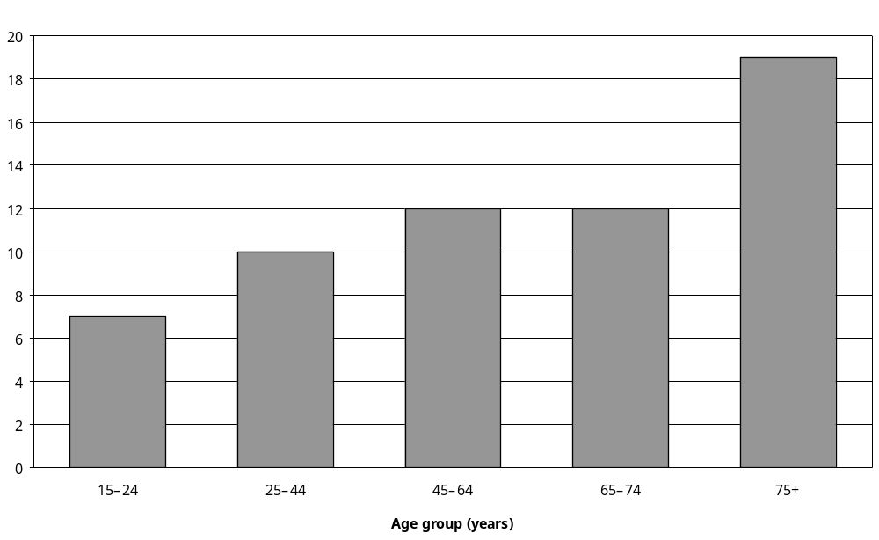
Source: Statistics New Zealand, 2001 Household Disability Survey
Note: Data in Appendix Table 7.6.

Of the adults with disability able to travel long distances, 20 percent of those living in the Northern region needed help with long trips, compared with 13 percent in the Midland region and 11 percent in both the Central and Southern regions.

Of the adults with intellectual disability as their main disability who were able to travel long distances, 42 percent needed help with long trips. This compared with just 3 percent of adults with hearing disability as their main disability who were able to travel long distances (Figure 7.5).

Figure 7.5: Percentage of adults with disability living in households able to travel long distances who needed assistance on long trips, by disability type and main disability, 2001
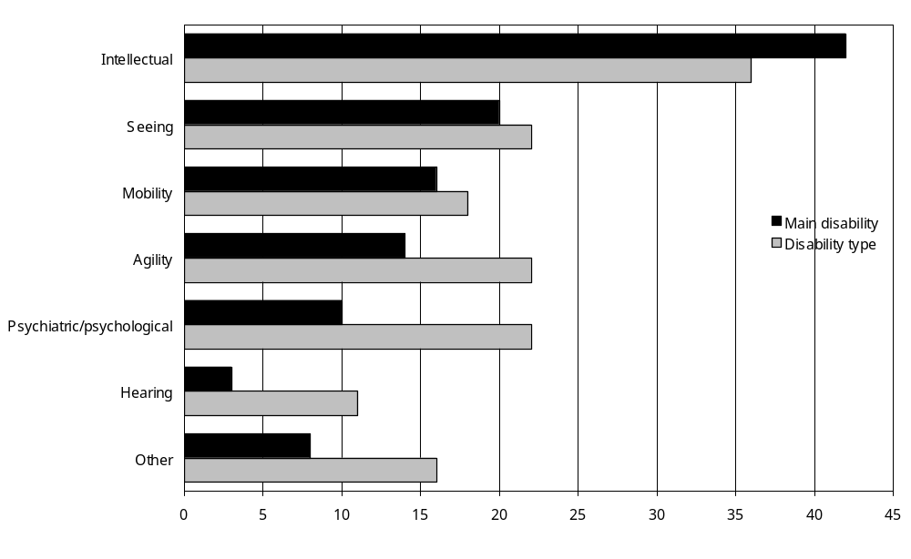
Source: Statistics New Zealand, 2001 Household Disability Survey
Notes:
- Data in Appendix Table 7.6.
- If individuals reported more than one disability type, they were counted in each applicable disability type group.

Eighteen percent of adults with multiple disabilities able to travel long distances required help on long trips, compared with just 4 percent of adults with a single disability able to travel long distances.

Nearly half (45 percent) of adults with severe disability able to travel long distances required help on long trips, compared with 12 percent of adults with moderate disability and 4 percent of adults with mild disability.

Short-distance travel

Recent short-distance travel
It was common for adults and children with disability to make short trips, that is, trips of less than 80 kilometres. In 2001, only 3 percent of adults with disability (an estimated 15,000 adults) and 2 percent of children with disability (an estimated 2000 children) had not made any short trips in the previous 12 months.

Prevention of short-distance travel
People with disability did not usually experience barriers to short trips because of disability. Of the small group who had not made short trips, most (adults – 91 percent; children – 75 percent) indicated that their condition or health problem had not been a factor stopping them from making short trips.

Need for special transport

Adults
The estimated 12,200 adults with disability who had travelled short distances in the previous 12 months and who had to use special transport on long trips, or had not travelled short distances but whose disability did not prevent them from travelling short distances, were asked if they could use only special transport such as taxis or modified cars to travel short distances. An estimated 4800 of these adults reported they could use only special transport for short trips. This was 1 percent of all adults with disability.

Children
One percent of children with disability, an estimated 1100 children, indicated they could use only special transport such as taxis or modified cars for short trips.

Need for assistance

Adults
Nine percent of adults able to travel short distances indicated they needed someone to help them on short trips (this was an estimated 49,500 adults). The need for assistance on short trips increased with age, with 16 percent of adults aged 75 and over able to travel short distances needing assistance on these trips, compared with 8 percent of adults aged 15–24 able to travel short distances.

Of the adults able to travel short distances who had an intellectual disability as their main disability, 36 percent needed assistance on these short trips. This compares with just 2 percent of the adults able to travel short distances who had a hearing disability as their main disability (Figure 7.6).

Figure 7.6: Percentage of adults with disability living in households able to travel short distances who needed assistance on short trips, by disability type and main disability, 2001
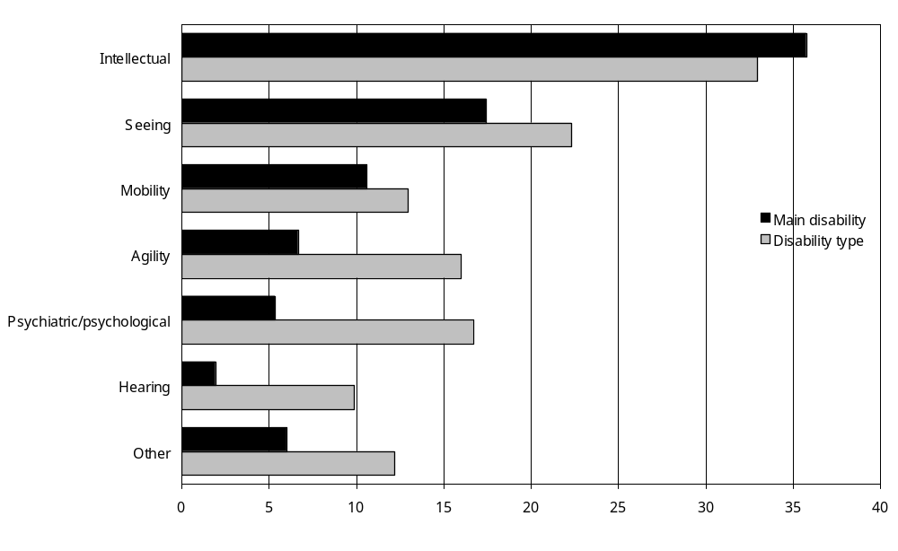
Source: Statistics New Zealand, 2001 Household Disability Survey
Notes:
- Data in Appendix Table 7.11.
- If individuals reported more than one disability type, they were counted in each applicable disability type group.

Of the adults with multiple disabilities able to make short trips, 13 percent required assistance from others on these trips, compared with just 2 percent of adults with a single disability able to make short trips.

Similarly, of the adults with severe disability able to make short trips, 37 percent required assistance from other people during these trips, compared with 7 percent of adults with moderate disability and 2 percent of adults with mild disability.

Children
Parents or caregivers of 11 percent of the children with disability able to travel short distances said their children needed someone to help them during these short trips (this was an estimated 9500 children).

Children’s need for assistance related to the type of disability they had. Of the children using technical aids able to make short trips, 49 percent needed someone to help them on these trips, as did 27 percent of children with intellectual disability able to make short trips. By contrast, of the children with hearing disability able to make short trips, just 8 percent needed someone to help them on these trips (Figure 7.7).

Figure 7.7: Percentage of children with disability living in households able to travel short distances who needed assistance on short trips, by disability type, 2001
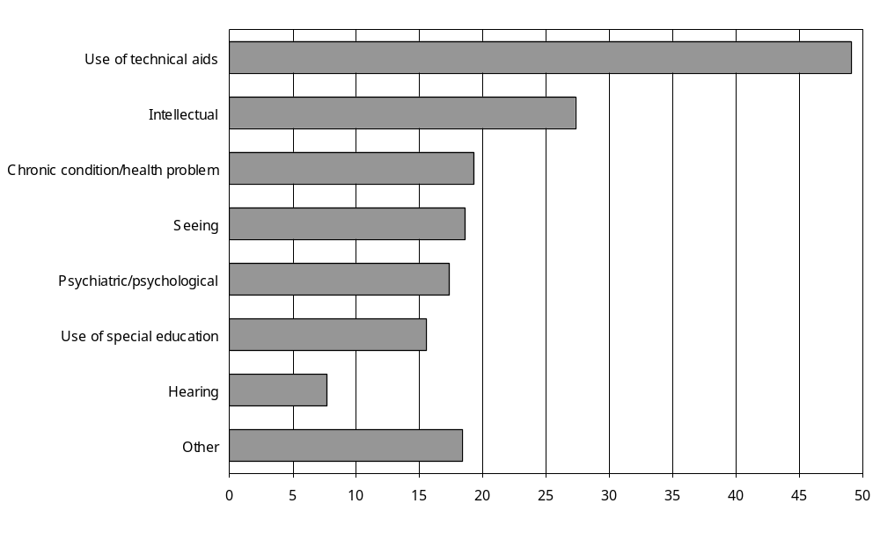
Source: Statistics New Zealand, 2001 Household Disability Survey
Notes:
- Data in Appendix Table 7.12.
- If individuals reported more than one disability type, they were counted in each applicable disability type group.

Similar to adults, children with multiple disabilities able to make short trips (18 percent) were more likely than children with a single disability (6 percent) to need help on these trips. Also, children with severe disability (31 percent) were more likely to require assistance than children with moderate disability (14 percent).

Travel to school
Of the 74,100 children aged 5–14 with disability, an estimated 6000 (8 percent) needed special transport or help to get to school because of disability. This included an estimated 3100 children who used specially-modified private motor vehicles to get to school and 2100 children who used subsidised special transport services or taxis.
Of the remaining 64,400 children aged 5–14 with disability who did not need special transport or help getting to school, an estimated 30,100 (47 percent) travelled to and from school in private motor vehicles. An estimated 18,400 (29 percent) walked to school and 9500 (15 percent) used regular school buses. Public buses or trains (2700 children – 4 percent) and bicycles (2600 – 4 percent) were the least common modes of transport children with disability used to get to school.

Private motor vehicles

Access to motor vehicles

Adults
Eleven percent of adults with disability (an estimated 63,400 adults) lived in households that had no private motor vehicles available for use. This compares with 4 percent of adults without disability, indicating that adults with disability were less likely than adults without disability to have access to private motor vehicles (Figure 7.8).

Figure 7.8: Number of motor vehicles available to adults with and without disability living in households, 2001
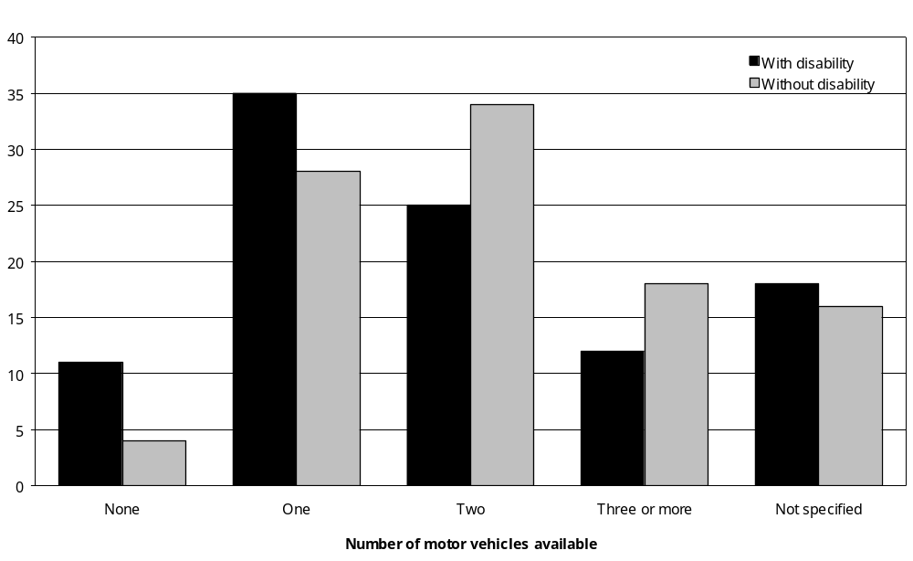
Source: Statistics New Zealand, 2001 Household Disability Survey, 2001 Census of Population and Dwellings
Note: Data in Appendix Tables 7.13 and 7.14.

Older adults with disability were more likely than younger adults with disability to live in households without a motor vehicle. For example, 25 percent of adults aged 75 and over with disability had no access to a motor vehicle, compared with 9 percent of adults aged 15–24 with disability.

As might be expected, adults with disability living in low-income households were less likely to have access to a motor vehicle than adults with disability living in high-income households. Thirty-four percent of adults with disability who had household incomes of $15,000 and under had no access to a motor vehicle, compared with 3 percent of adults with disability who had household incomes of $30,001 and over.

Adults with disability from low-income households were also less likely to have access to a motor vehicle than adults without disability from low-income households. While 34 percent of adults with disability who had household incomes of $15,000 and under did not have access to a motor vehicle, only 19 percent of adults without disability who had household incomes of $15,000 and under did not have access to a motor vehicle (Figure 7.9).

Figure 7.9: Percentage of adults with and without disability living in households with no access to a motor vehicle, by household income, 2001
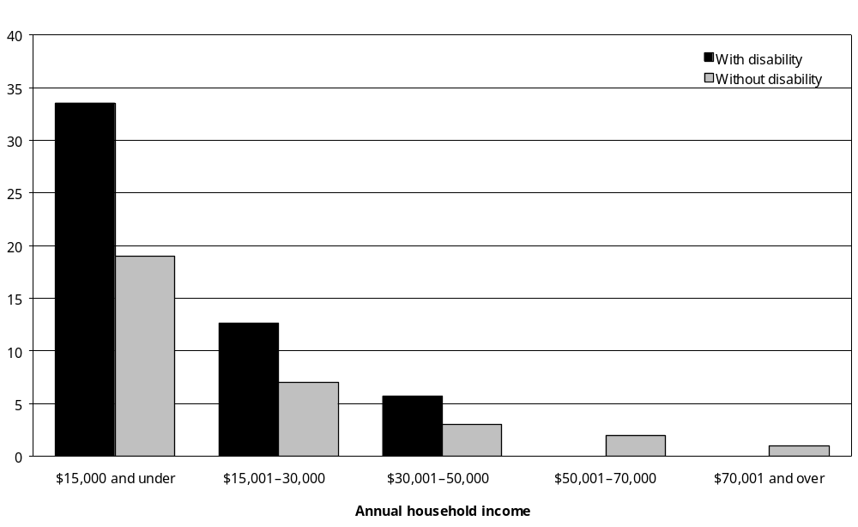
Source: Statistics New Zealand, 2001 Household Disability Survey, 2001 Census of Population and Dwellings
– Percentages too small to report (estimated frequencies outside the 70 percent relative sampling error cut-off point).
Note: Data in Appendix Tables 7.13 and 7.14.

Adults with seeing disability as one of their disabilities (19 percent) or their main disability (20 percent) were most likely to live in households with no motor vehicle. By comparison, 9 percent of adults with intellectual disability lived in households with no motor vehicle.

Children
Seven percent of children with disability (an estimated 5500 children) lived in households with no motor vehicle available, compared with 5 percent of children without disability.

Pacific children with disability (19 percent) were more likely than Mäori (12 percent) or European (2 percent) children with disability to live in households with no access to a motor vehicle.

Twenty-one percent of children with disability who had household incomes of $15,000 and under per year had no access to a motor vehicle, compared with 17 percent of children without disability who had household incomes of $15,000 and under per year.

Need to buy a vehicle
The 2001 Household Disability Survey asked people with disability whether, in the previous 12 months, they or their family had needed to buy a vehicle because of their condition or health problem. They were then asked whether they had been able to buy the vehicle they considered they needed.

Adults
Five percent of adults with disability, an estimated 27,400 adults, indicated they had needed to buy a vehicle because of their condition or health problem in the previous 12 months. More than three-quarters (78 percent) of this group, an estimated 21,500 adults, had bought the vehicle they needed, while the rest, an estimated 6000 adults, had not.

Adults with disability who had not bought the vehicle they needed were asked why not. The most common reason given, cited by 89 percent, was that the vehicle could not be afforded.

Pacific adults with disability (13 percent) were more likely than Mäori (9 percent), Asian/Other (8 percent) and European (4 percent) adults with disability to indicate they had needed to buy a vehicle in the previous 12 months.

Children
The parents or caregivers of 5 percent of children with disability (an estimated 4000 children) indicated they had needed to buy a vehicle because of their child’s condition or health problem in the previous 12 months. Just over two-thirds (69 percent) of these parents and caregivers had bought the vehicle they needed, while the rest, parents and caregivers of an estimated 1200 children, had not.

Again, affordability was the main reason parents and caregivers had not obtained the vehicle they needed for their child.

The parents or caregivers of nearly a quarter (24 percent) of children with disability who used technical aids said they had needed to buy a vehicle, compared with the parents or caregivers of 5 percent of children with hearing, seeing or special education disabilities (Figure 7.10).

Figure 7.10: Percentage of children with disability living in households whose parents or caregivers had needed to buy a vehicle in the previous 12 months because of the child’s condition or health problem, by disability type, 2001
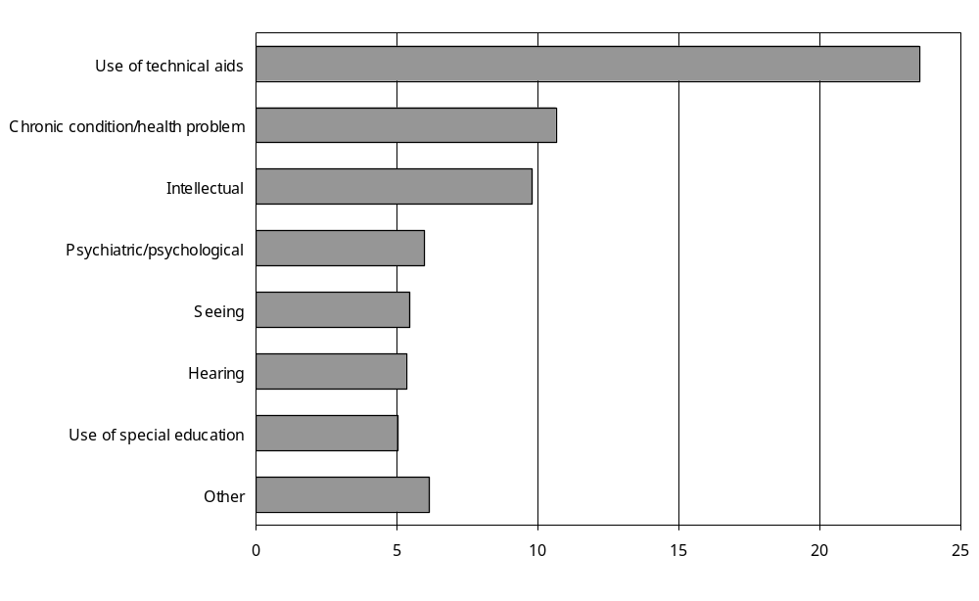
Source: Statistics New Zealand, 2001 Household Disability Survey
Notes:
- Data in Appendix Table 7.18.
- If individuals reported more than one disability type, they were counted in each applicable disability group.

Drivers
In 2001, 70 percent of adults with disability, an estimated 404,200 adults, drove a private motor vehicle.

The percentage driving a private motor vehicle was highest in the group aged 45–64 (80 percent) and lowest in the groups aged 15–24 and 75 and over (both 47 percent).

Men with disability were more likely than women with disability to drive a private motor vehicle (77 percent compared with 63 percent).

Asian/Other (36 percent) and Pacific (45 percent) adults with disability were less likely to be drivers than Mäori (65 percent) or European (73 percent) adults with disability.

Rural adults with disability were more likely to be drivers (82 percent) than their urban counterparts (68 percent).

Adults with disability from high-income households were more likely to be drivers than adults with disability from low-income households. Eighty-one percent of adults with disability who had household incomes of $70,001 and over per year were drivers, compared with 58 percent of adults with disability who had household incomes of $15,000 and under per year.

Adults with intellectual disability or seeing disability as one of their disabilities or their main disability were least likely to be drivers (Figure 7.11). Adults with hearing disability were the most likely to be drivers.

Figure 7.11: Percentage of adults with disability living in households who drove private motor vehicles, by disability type and main disability, 2001
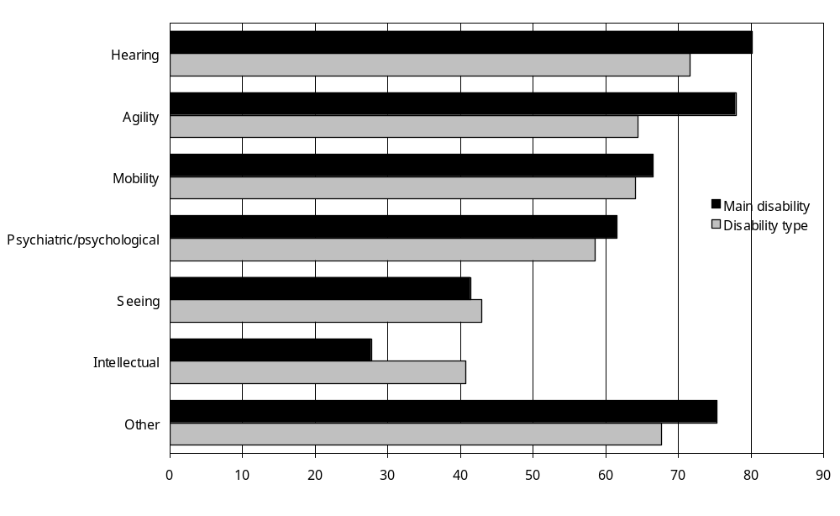
Source: Statistics New Zealand, 2001 Household Disability Survey
Notes:
- Data in Appendix Table 7.19.
- If individuals reported more than one disability type, they were counted in each applicable disability type group.

Adults with a main disability caused by accident/injury were more likely to be drivers (79 percent) than adults with a main disability caused by conditions existing at birth (55 percent), ageing (61 percent) or disease/illness (64 percent). This is likely to be at least partly because adults with disability caused by accident/injury tend to be younger (Figure 7.12).

Figure 7.12: Percentage of adults with disability living in households who drove private motor vehicles, by disability cause and cause of main disability, 2001
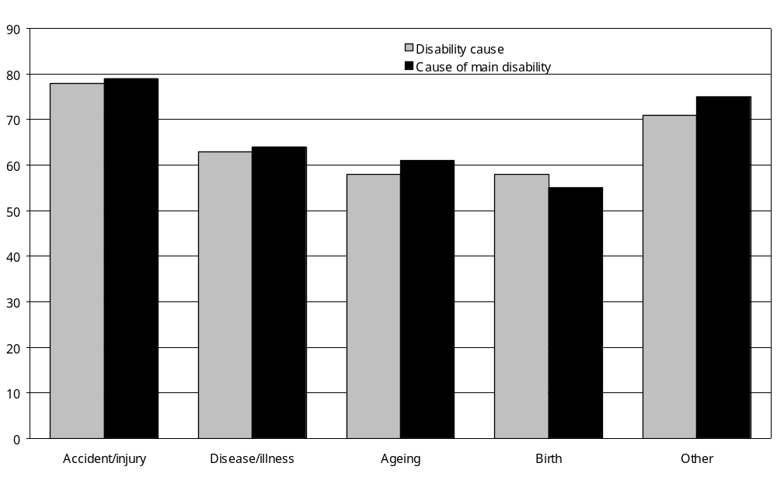
Source: Statistics New Zealand, 2001 Household Disability Survey
Notes:
- Data in Appendix Table 7.19.
- If individuals reported more than one disability type, they were counted in each applicable disability cause group.

Adults who had multiple disabilities (63 percent) were less likely than adults who had a single disability (79 percent) to drive a private motor vehicle.

Similarly, adults with severe disability (38 percent) were less likely to be drivers than adults with moderate (70 percent) or mild (78 percent) disability.

Changes to private motor vehicles to enable driving
The 2001 Household Disability Survey asked adults with disability questions about modifications to private motor vehicles. These modifications adapt vehicles to the individual needs of drivers and enable adults capable of driving to exercise that capability.

Changes made
Two percent of the estimated 404,200 adults with disability who drove a private motor vehicle had already modified their vehicle so they could drive it. This was an estimated 7000 adults.

The most common alterations made were the addition of hand controls (added by 1500 drivers) and customised seating (added by another 1500 drivers).

Changes needed
The 2001 Household Disability Survey included questions designed to assess what types of changes to motor vehicles were required, but had not been made at the time of the survey. These questions were put to two groups of survey respondents.
1. Adults with disability who drove a private motor vehicle, including adults who had already adapted their vehicle, were asked, ‘Have there been any changes that you needed in the past 12 months to that motor vehicle, but which you haven’t had done yet?’ Adults who said they had needed changes were then asked what kinds of modification the vehicle required.
2. Adults with disability who did not drive a private motor vehicle were asked, ‘Is there a private motor vehicle in your household that you would drive if it was adapted to your needs?’ Adults who said there was such a vehicle were then asked what kinds of modification the vehicle required.

Altogether, 3 percent of the adults who were asked these questions, an estimated 11,800 adults, said they needed at least one change to the motor vehicle they drove or a motor vehicle in their household they would drive if it were suitable.

The types of changes most commonly needed were the addition of power steering or power windows (required by an estimated 3300 adults) and customised seating (required by an estimated 1700 adults).

The most common reason adults gave for not making the needed changes to their vehicle was affordability (cited by an estimated 6800 adults). The second most common reason was that they did not know they could apply for financial help (cited by an estimated 1500 adults).

Travelling as a passenger

Adults
Eighty-six percent of adults with disability travelled at some time as passengers in private motor vehicles. Of this group, 12 percent (an estimated 60,100 adults) said they had difficulty travelling as a passenger in a motor vehicle.

Adults with agility and mobility disability as one of their disabilities or their main disability were most likely to say they had difficulty travelling as a passenger in a motor vehicle (Figure 7.13). Adults with hearing disability were the least likely to indicate they had any difficulty travelling as a passenger.

Figure 7.13: Percentage of adults with disability living in households who experienced difficulty travelling as passengers in private motor vehicles, by disability type and main disability, 2001
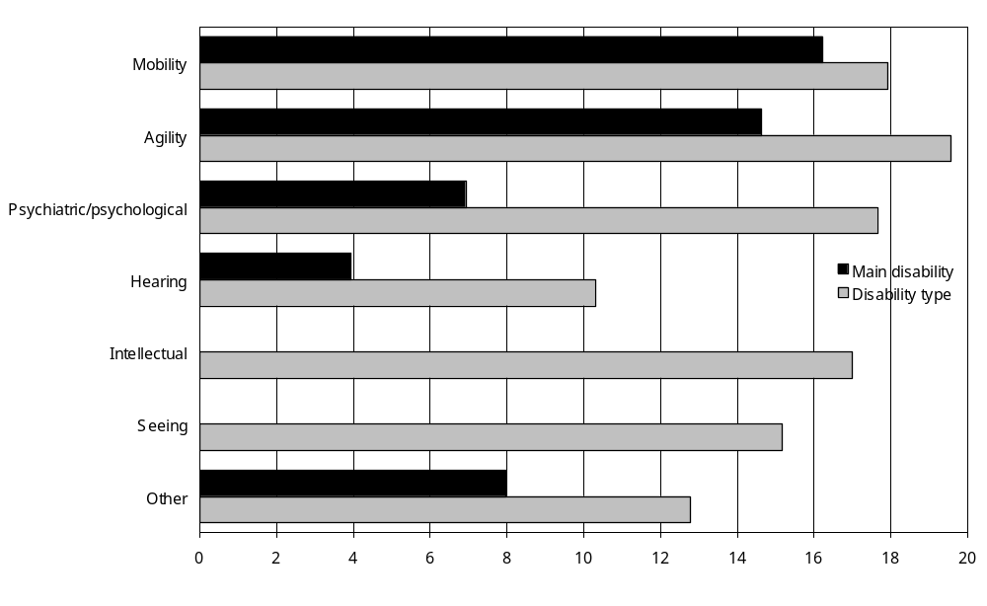
Source: Statistics New Zealand, 2001 Household Disability Survey
– Percentages too small to report (estimated frequencies outside the 70 percent relative sampling error cut-off point).
Notes:
- Data in Appendix Table 7.22.
- If individual adults reported more than one disability type, they were counted in each applicable disability type group.
- Excludes adults who did not travel as passengers.

Adults who had multiple disabilities were more likely (16 percent) than adults with a single disability (6 percent) to find it difficult to travel as a passenger in a private motor vehicle. Similarly, a quarter of adults with severe disability found it difficult, compared with 13 percent of adults with moderate disability and 6 percent of adults with mild disability.

Children
Nearly all children with disability (94 percent) travelled as passengers at some time in private motor vehicles. Seven percent of these children, an estimated 5700 children, found it difficult to do so.

Children with household incomes of $15,000 and under per year (16 percent) were more likely to have difficulty travelling as passengers than children with household incomes of $50,001 and over per year (5 percent).

Just over a quarter (26 percent) of children with disability who used technical aids found it difficult travelling as passengers in private motor vehicles, compared with only 5 percent of those with hearing disability (Figure 7.14).

Figure 7.14: Percentage of children with disability living in households who experienced difficulty travelling as passengers in private motor vehicles, by disability type, 2001
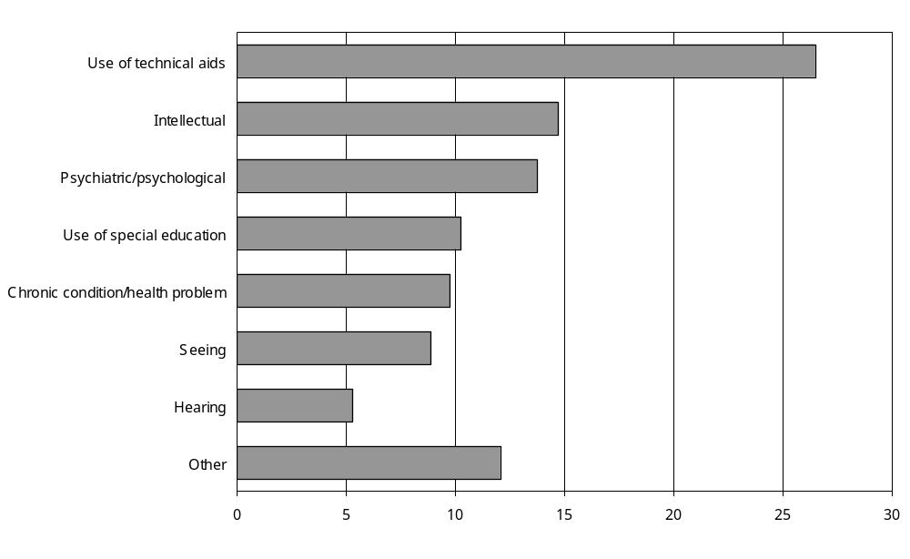
Source: Statistics New Zealand, 2001 Household Disability Survey
Notes:
- Data in Appendix Table 7.23.
- If individuals reported more than one disability type, they were counted in each applicable disability group.
- Excludes children who did not travel as passengers.

Children with severe disability (21 percent) were more likely to find it difficult to travel in private motor vehicles than children with either moderate (6 percent) or mild (2 percent) disability.

Changes needed to private motor vehicles to enable travel as a passenger

Changes made
At the time of the 2001 Household Disability Survey, 1 percent of adults with disability who usually travelled as passengers in private motor vehicles had made modifications to these vehicles to enable them to travel in them. This group comprised an estimated 2900 adults.

The most common type of modification was the addition of customised seating, done by an estimated 1400 adults.

Modifications had also been made to the household vehicles of 1 percent of children who travelled as passengers (an estimated 1000 children).

Changes needed
Of the adults with disability who travelled as passengers in a private vehicle, 5 percent (an estimated 6700 adults) indicated they needed changes to their household vehicle, but these changes had not been made. Customised seating was the most common addition still needed, identified by an estimated 2300 adults with disability.

One percent of children with disability who travelled as passengers had unmet needs for changes to their household motor vehicle so they could travel in it. This was an estimated 800 children.

Parking private motor vehicles

Need to park close to destination
Of the estimated 562,500 adults with disability who drove or travelled as passengers in private motor vehicles, 28 percent, an estimated 155,800 adults, indicated they needed to park close to their destination because of disability. The same applied to an estimated 10,500 or 13 percent of the children with disability who travelled as passengers.

The need to park close to their destination was comparatively high (21 percent) for children aged 0–4 with disability, but lower for children aged 10–14 (10 percent). In the adult age groups the need to park close increased with age, with 50 percent of adults with disability aged 75 and over indicating they needed to park close to their destination (Figure 7.15).

Figure 7.15: Percentage of people (adults and children) with disability living in households who drove or travelled as passengers in private motor vehicles needing to park close to their destination, by age, 2001
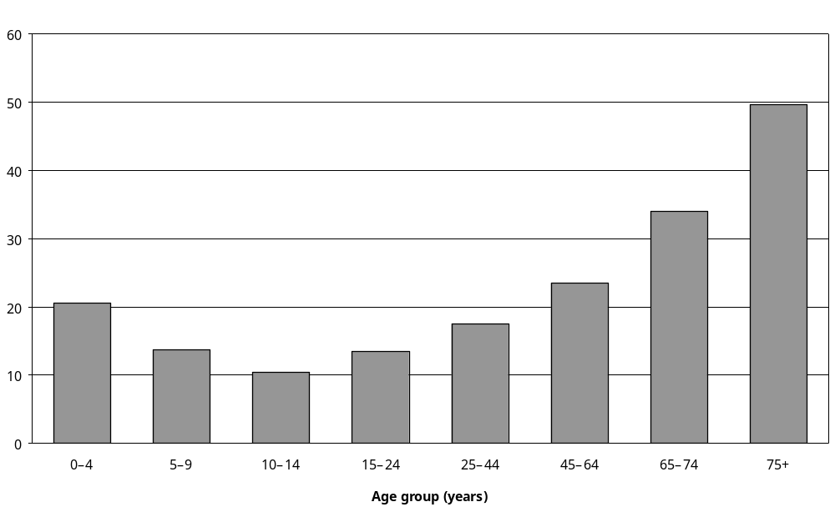
Source: Statistics New Zealand, 2001 Household Disability Survey
Note: Data in Appendix Tables 7.28 and 7.29.

Adults
Adults with disability living in households with household incomes of $15,000 and under per year were more likely to need to park close than adults with disability with household incomes of $70,001 and over per year (34 percent compared with 17 percent).

Adults with mobility disability as their main disability were most likely to say they needed to park close to their destination (43 percent) (Figure 7.16). Adults with hearing disability as their main disability were the least likely to say they needed to park close (11 percent).

Figure 7.16: Percentage of adults with disability living in households who drove or travelled as passengers in private motor vehicles needing to park close to their destination, by disability type and main disability, 2001
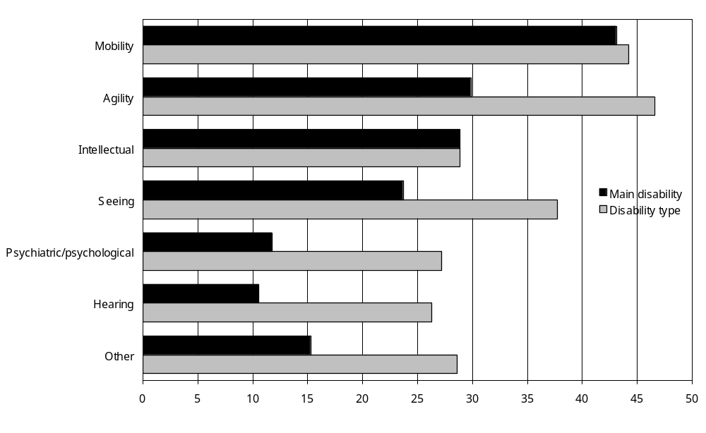
Source: Statistics New Zealand, 2001 Household Disability Survey
Notes:
- Data in Appendix Table 7.28.
- If individuals reported more than one disability type, they were counted in each applicable disability group.

Adults with a main disability caused by disease/illness (37 percent) or ageing (33 percent) were more likely to need to park close to their destination than adults with a main disability caused by accident/injury (25 percent) or a condition present at birth (16 percent).

Adults with multiple disabilities (39 percent) were more than three times as likely as adults with a single disability (11 percent) to need to park close to their destination. As well, adults with severe disability (63 percent) were far more likely than adults with moderate (32 percent) or mild (12 percent) disability to need to park close to their destination.

Children
Similar to adults, children with disability who had household incomes of $15,000 and under per year were more likely to need to park close to their destination than children with disability who had household incomes of $70,001 and over per year (17 percent compared with 8 percent).

Children with disability who used technical aids (60 percent) were the most likely to need to park close to their destination. Children with hearing disability were the least likely to need to park close (12 percent) (Figure 7.17).

Figure 7.17: Percentage of children with disability living in households who travelled as passengers in private motor vehicles needing to park close to their destination, by disability type, 2001
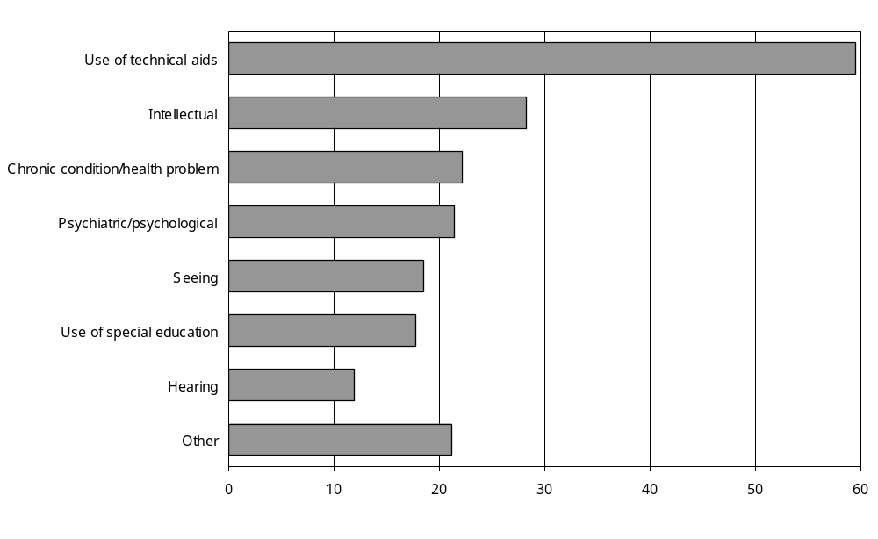
Source: Statistics New Zealand, 2001 Household Disability Survey
Notes:
- Data in Appendix Table 7.29.
- If individuals reported more than one disability type, they were counted in each applicable disability group.

Like adults, children with multiple disabilities (22 percent) were more likely than children with a single disability (6 percent) to need to park close to their destination. As well, 37 percent of children with severe disability needed to park close to their destination, compared with 13 percent of children with moderate disability and 3 percent of children with mild disability.

Problems finding car parking
Of the estimated 155,800 adults with disability who needed to park close to their destination because of their condition or health problem, 49 percent indicated they had experienced problems finding parking in the previous six months. The same applied to 63 percent of the estimated 10,500 children with disability who required parking close to their destination because of their condition or health problem.

The most common problem was being unable to find parking close enough to their destination, identified by an estimated 62,100 adults and the parents and caregivers of 5700 children with disability. Other common problems were the parking close to a destination being too awkward to use (an estimated 18,700 adults and 1700 children) and people without disability using parking spaces set aside for people with disability (an estimated 33,000 adults and 1500 children).

Taxis

Use of taxis

Adults
Table 7.1 shows how frequently adults with disability used taxis.

Thirty-eight percent of adults with disability, an estimated 220,800 adults, had used a taxi at least once in the previous 12 months to travel short distances. The remaining 62 percent had not used a taxi at all for short trips over this time.

Table 7.1: Frequency of taxi use to travel short distances in the previous 12 months by adults with disability living in households, 2001
 | Population estimate | Percentage of adults with disability (%)
Used taxis less than once a month | 130,600 | 22
Used taxis once a month or more but less than once a week | 42,700 | 7
Used taxis once a week or more but less than every day | 37,200 | 6
Used taxis every day, or almost every day | 10,400 | 2
Total adults with disability using taxis | 220,800 | 38
Total adults with disability not using taxis | 358,500 | 62
Total adults with disability | 581,000 | 100
Source: Statistics New Zealand, 2001 Household Disability Survey

Of adults who used taxis in the previous 12 months, most used them less than once a month. An estimated 10,400 adults with disability, 2 percent of the total adult population with disability, used taxis every day or nearly every day.

Adults with disability aged 15–24 were more likely to have used taxis at least once in the previous 12 months than adults with disability aged 65–74 (61 percent compared with 26 percent).

Children
Table 7.2 shows how frequently children with disability used taxis.

Table 7.2: Frequency of taxi use to travel short distances in the previous 12 months by children with disability living in households, 2001
 | Population estimate | Percentage of children with disability (%)
Used taxis less than once a month | 8200 | 10
Used taxis once a month or more but less than once a week | 2600 | 3
Used taxis once a week or more but less than every day | 2100 | 3
Used taxis every day, or almost every day | 3300 | 4
Total children with disability using taxis | 16,300 | 20
Total children with disability not using taxis | 66,800 | 80
Total children with disability | 83,100 | 100
Source: Statistics New Zealand, 2001 Household Disability Survey.

Twenty percent of children with disability had used a taxi at least once in the previous 12 months to travel short distances. The remaining 80 percent of children had not used a taxi over this period for short trips.

Three percent of children with disability used taxis once a week or more, and a further 4 percent used taxis every day or almost every day.

Pacific (41 percent) and Asian/Other (37 percent) children with disability were more likely than Mäori (22 percent) or European (14 percent) children with disability to have used a taxi at least once in the previous 12 months for short trips.

Children using technical aids (43 percent) were more likely than children with other types of disability to have used a taxi in the previous 12 months. Indeed, a quarter of children using technical aids used taxis every day or nearly every day.

Reasons for not using taxis
Adults and children with disability who had used taxis less than once a month in the previous 12 months or not at all were asked to indicate the main reason they used taxis infrequently.

The most common reason given by these people was that they did not need to use taxis (adults – 77 percent; children – 82 percent). The next most common reason was that taxis were too expensive (adults – 15 percent; children – 10 percent).

Parents and caregivers of 1 percent of the children who used taxis infrequently said the main reason they did not use taxis more often was because a taxi van with a hoist was often not available.

Public transport

Access to a bus stop or railway station
Just over three-quarters (76 percent) of adults with disability stated they could get to a bus stop or railway station easily from where they lived.,

Almost a quarter of adults with disability (24 percent) did not have easy access to a bus stop or railway station. Ease of access decreased with age, with 36 percent of adults aged 75 and over saying they did not have easy access, compared with 9 percent of adults aged 15–24 (Figure 7.18).

Figure 7.18: Percentage of adults with disability living in households who could not easily get to a bus stop or railway station from where they lived, by age, 2001
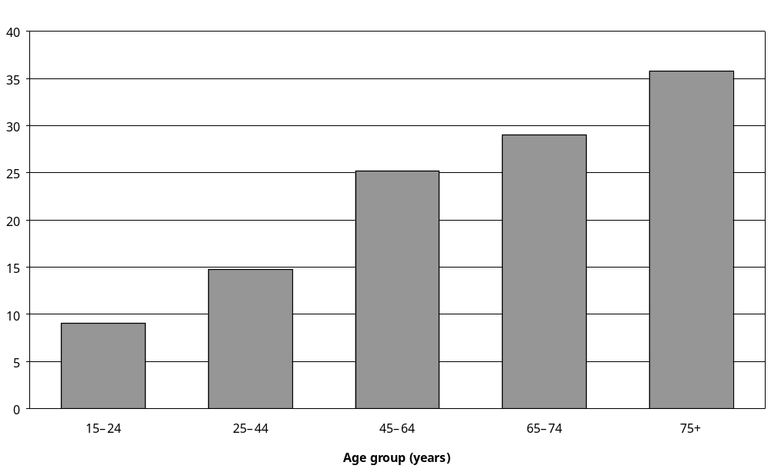
Source: Statistics New Zealand, 2001 Household Disability Survey
Note: Data in Appendix Table 7.36.

As might be expected, people in rural areas found it harder than people in urban areas to get to a bus stop or railway station. More than half (54 percent) the adults with disability living in rural areas could not get to a bus stop or railway station easily, compared with 19 percent of adults with disability living in urban areas.

Adults with disability with household incomes of $15,000 and under per year were more likely to have difficulty getting to a bus stop or railway station than adults with disability with household incomes of $70,001 and over per year (30 percent compared with 17 percent).

Adults with seeing disability as one of their disabilities or their main disability were most likely to state that they could not easily get to a bus stop or railway station from where they lived (Figure 7.19). Adults with psychiatric/psychological disability as one of their disabilities or their main disability were least likely to have difficulty getting to a bus stop or railway station.

Figure 7.19: Percentage of adults with disability living in households who could not easily get to a bus stop or railway station from where they lived, by disability type and main disability, 2001
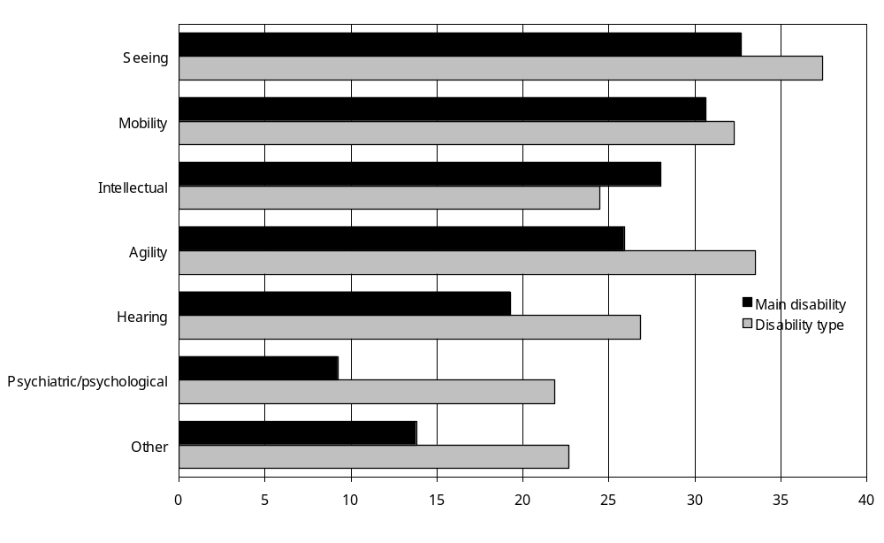
Source: Statistics New Zealand, 2001 Household Disability Survey
Notes:
- Data in Appendix Table 7.36.
- If individuals reported more than one disability type, they were counted in each applicable disability group.

Adults with a main disability caused by a condition existing at birth (16 percent) were less likely than adults with a main disability caused by other factors such as ageing (29 percent), disease/ illness (26 percent) or accident/injury (24 percent) to indicate they did not have easy access to a bus stop or railway station.

Adults with multiple disabilities (29 percent) were more likely than adults with a single disability (16 percent) to be unable to get to a bus stop or railway station easily from where they lived.

Ease of access to bus stops and railway stations also decreased with severity of disability. Forty-two percent of adults with severe disability could not get to a bus stop or railway station easily from where they lived, compared with 26 percent of adults with moderate disability and 16 percent of adults with mild disability.

Difficulty travelling long distances on public transport
Thirty-five percent of adults with disability, an estimated 203,300 adults, had travelled long distances on aeroplanes, trains or buses in the previous 12 months.

Of this group, 13 percent, an estimated 26,800 adults, had experienced at least one type of difficulty during their long trip using these types of public transport.

A further 10 percent of all adults with disability, an estimated 56,300 adults, had not travelled long distances on aeroplanes, trains or buses in the previous 12 months because of their condition or health problem.

Types of difficulty
Adults who had travelled long distances by aeroplanes, trains or buses in the previous 12 months, and adults who had not travelled in this way but whose disability had not stopped them from travelling, were asked to indicate what actual or potential difficulties they associated with using these forms of public transport for long journeys.

The difficulty most frequently identified was getting on and off aeroplanes, trains or buses, cited by an estimated 22,500 adults. The next most frequently mentioned problem was the seating on board these types of transportation, cited by an estimated 20,200 adults.

Other difficulties included moving around the station or terminal (an estimated 8600 adults), hearing announcements (6500), lack of accessible toilets on board (5800), transporting wheelchairs or other equipment (5000), lack of accessible transport to and from the station or terminal (4300), lack of accessible toilets in the station or terminal (3900), hard-to-see signs and notices (3800) and unsupportive staff (2900).

Ten percent of children with disability (an estimated 8100 children) were considered by their parents or caregivers to have a disability that made it difficult (although not impossible) for them to travel long distances on aeroplanes. Ten percent of children (an estimated 8000 children) were considered to have a disability that made it difficult to travel long distances on buses, while 7 percent (5500) were considered to have difficulty travelling on trains and 7 percent (5500) on ferries.

Difficulty travelling short distances on public transport
All adults and children with disability, except people whose disability stopped them from making short trips, were asked what specific difficulties, if any, they would have using public transport to travel short distances.

Twelve percent of the adults and 7 percent of the children in this group indicated they would have difficulties travelling short distances on public transport (that is, buses, trains, trams and ferries).

Older people were more likely than younger people to indicate they would have these difficulties (Figure 7.20).

Figure 7.20: Percentage of people (adults and children) with disability living in households who would have difficulty using public transport for short distances, by age, 2001
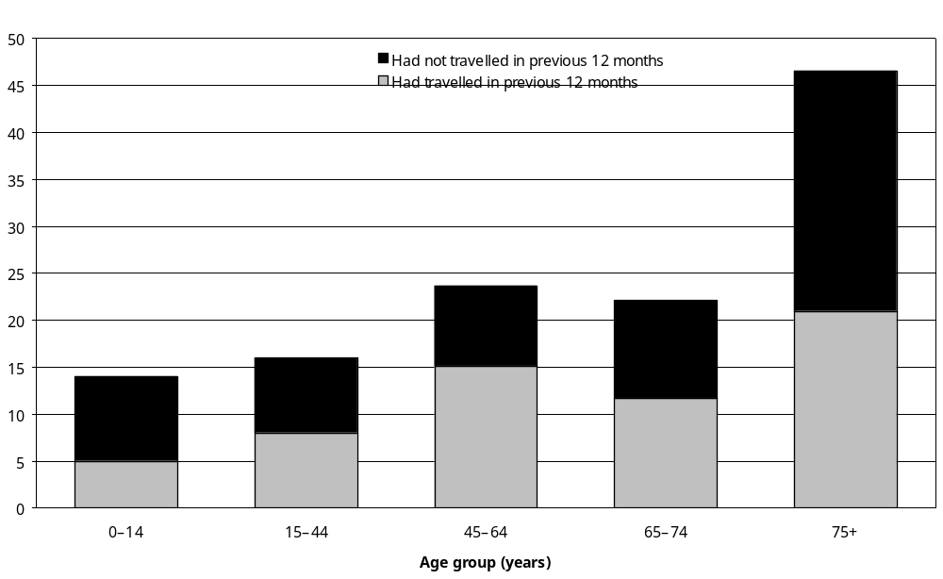
Source: Statistics New Zealand, 2001 Household Disability Survey
Notes:
- Data in Appendix Tables 7.39 and 7.40.
- Excludes people whose disability stopped them making short trips.

Adults
Women with disability were more likely (16 percent) than men with disability (8 percent) to indicate they would have difficulties using public transport for short journeys. Rural adults with disability (13 percent) were also slightly more likely than urban adults with disability (5 percent) to report difficulties using public transport.

Adults with disability with household incomes of $15,000 and under per year were more likely to report difficulties using public transport than adults with disability with household incomes of $70,001 and over per year (18 percent compared with 6 percent).

Compared with adults with other types of disability, a higher percentage of adults with intellectual disability as one of their disabilities or their main disability reported actual or potential difficulties using public transport for short trips (Figure 7.21).

Figure 7.21: Percentage of adults with disability living in households who would have difficulties using public transport for short distances, by disability type and main disability, 2001
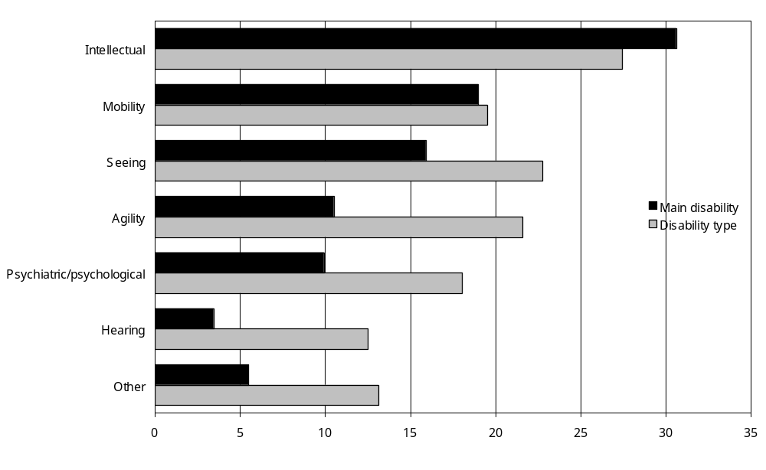
Source: Statistics New Zealand, 2001 Household Disability Survey
Notes:
- Data in Appendix Table 7.39.
- If individuals reported more than one disability type, they were counted in each applicable disability group.
- Excludes adults whose disability stopped them making short trips.

Adults with multiple disabilities (18 percent) were more likely than adults with a single disability (4 percent) to identify potential difficulties with using public transport for short trips.

Adults with severe disability were also much more likely (34 percent) than adults with moderate (14 percent) or mild (3 percent) disability to say they would have difficulties using public transport for short trips.

Children
Children using technical aids were more likely to identify difficulties with using public transport for short trips (27 percent) than children with other types of disability, such as seeing disability (6 percent) (Figure 7.22).

Figure 7.22: Percentage of children with disability living in households who would have difficulties using public transport for short distances, by disability type, 2001
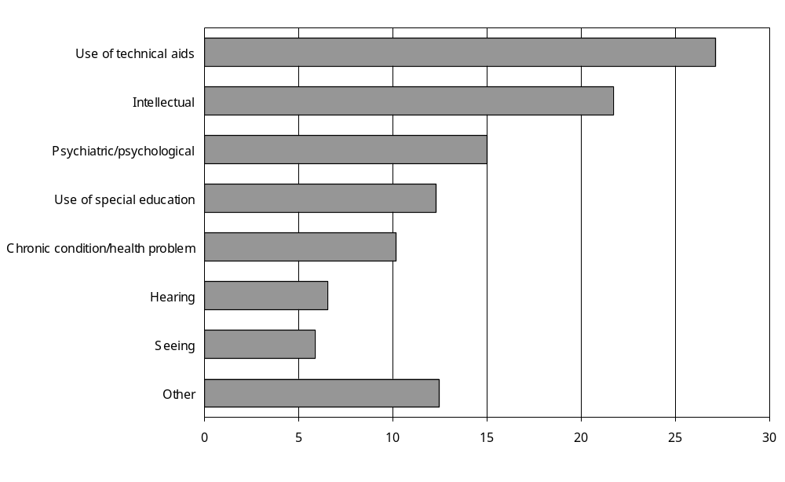
Source: Statistics New Zealand, 2001 Household Disability Survey
Notes:
- Data in Appendix Table 7.40.
- If individuals reported more than one disability type, they were counted in each applicable disability group.
- Excludes children whose disability stopped them making short trips.

As with adults, children with multiple disabilities (13 percent) were more likely than children with a single disability (2 percent) to have difficulties using public transport for short trips. Likewise, children with severe disability (24 percent) were more likely to have difficulties than those with moderate disability (7 percent).

Types of difficulty
Adults and children who indicated disability would make it difficult to travel short distances on buses, trains, trams or ferries were asked to identify the nature of these difficulties.

The difficulty most frequently mentioned by adults with disability was getting on or off public transport vehicles (specified by an estimated 47,100 adults). This was followed by difficulty getting to or finding the stop (26,600), having to stand in the vehicle while it was moving (24,600) or having to wait at the stop (20,800). Less common problems were lack of space to sit or stand (12,600), identifying the right bus, train, tram or ferry (11,700), identifying the right stop to get off at (10,500), getting information about timetables or routes (9300), transporting wheelchairs or other equipment (6300), and unsupportive or unhelpful staff (5800).

The difficulties identified by parents or caregivers of children with disability were, in order of frequency, getting on or off the vehicle (an estimated 2800 children), identifying the right stop to get off (2200), difficulty getting to or finding the stop (2100), standing in the vehicle while it was moving (2000), waiting at the stop (1800), identifying the right bus, train, tram or ferry (1800), hearing announcements (1300), unsupportive or unhelpful staff (1200) and not enough space to sit or stand (900).

Buses

Use of buses

Adults
Just over two-thirds of adults with disability (68 percent) had lived for at least some of the previous 12 months in a place with a bus service.

Table 7.3 shows how frequently these adults used buses.

Thirty-four percent of adults who had lived in a place with a bus service had used a bus at least once for a short trip in the previous 12 months. This was an estimated 133,400 adults.

Fourteen percent of adults with disability who lived in a place with a bus service had used a bus less than once a month in the previous 12 months. Six percent had used a bus once a month or more, 7 percent had used a bus once a week or more, and 6 percent had used a bus every day or almost every day.

Table 7.3: Frequency of use of bus services to travel short distances, by adults with disability who lived in a place with a bus service in the previous 12 months, 2001
 | Population estimate | Percentage of adults with disability (%)
Used bus less than once a month | 56,600 | 14
Used bus once a month or more, but less than once a week | 23,600 | 6
Used bus once a week or more, but less than every day | 28,600 | 7
Used bus every day or almost every day | 24,600 | 6
Total adults with disability living in a place with a bus service and who used a bus at least once | 133,400 | 34
Total adults with disability living in a place with a bus service who had not used buses at all | 259,900 | 65
Total adults with disability living in a place with a bus service | 397,000 | 100
Source: Statistics New Zealand, 2001 Household Disability Survey.
Note: The use of bus services by 3400 adults was unspecified.

Adults with disability aged 15–24 (68 percent) were more likely to have used buses in the previous 12 months than adults aged 65–74 (26 percent) or 75 and over (28 percent) (Figure 7.23).

Figure 7.23: Percentage of adults with disability living in households in a place with a bus service who used a bus for short trips at least once in the previous 12 months, by age, 2001
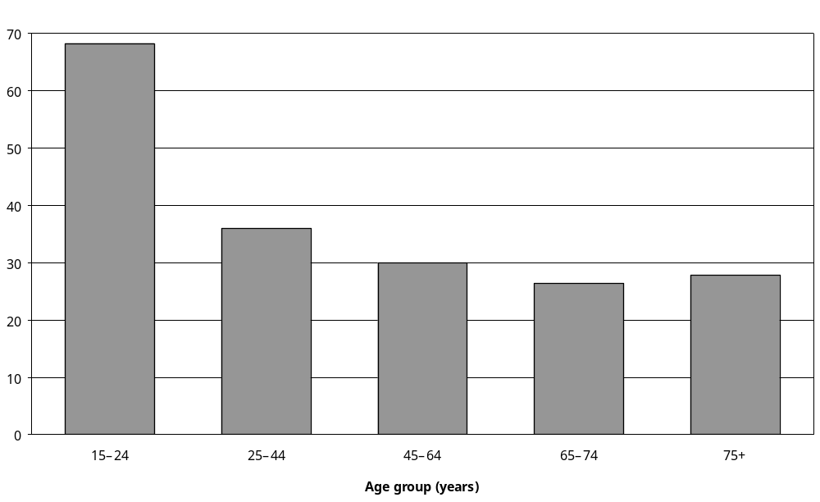
Source: Statistics New Zealand, 2001 Household Disability Survey
Note: Data in Appendix Table 7.43.

Fifty percent of Pacific and 46 percent of Asian/Other adults with disability who lived in a place with a bus service had used a bus at least once in the previous 12 months. This compares with 39 percent of Mäori and 32 percent of European adults with disability who lived in a place with a bus service.

Of the urban adults with disability living in a place with a bus service, 35 percent had used a bus for short trips in the previous 12 months, compared with 12 percent of rural adults with disability living in a place with a bus service.

Adults with disability living in places with a bus service in the Midland region were least likely to have used a bus for short trips in the previous 12 months (26 percent). Adults living in the Central region were most likely to have done so (38 percent). Thirty-one percent of adults living in places with a bus service in the Northern region and 35 percent of adults in the Southern region had used a bus for short trips in the previous 12 months.

Of the adults with psychiatric/psychological disability living in a place with a bus service, 49 percent had used buses for short trips, as had 47 percent of adults with intellectual disability living in a place with a bus service. Adults with agility disability living in a place with a bus service were the least likely to have used buses for short trips (27 percent) (Figure 7.24).

Figure 7.24: Percentage of adults with disability living in households in a place with a bus service who had used a bus for short trips at least once in the previous 12 months, by disability type and main disability, 2001
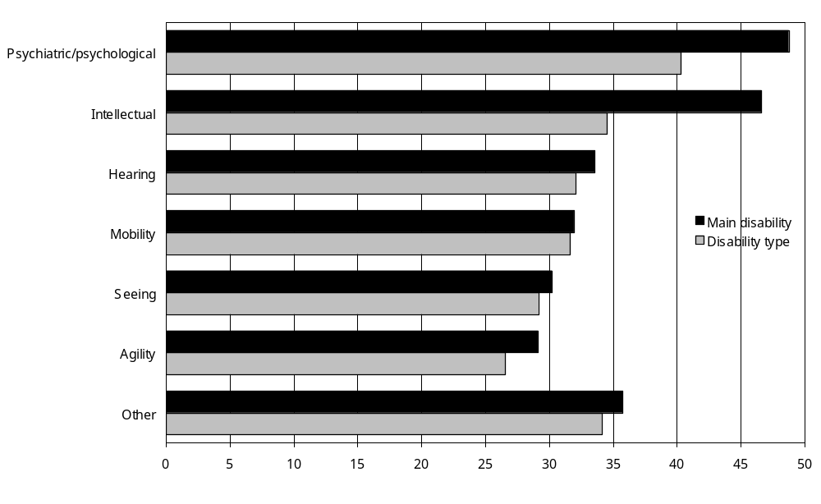
Source: Statistics New Zealand, 2001 Household Disability Survey
Notes:
- Data in Appendix Table 7.43.
- If individuals reported more than one disability type, they were counted in each applicable disability group.

Of the adults living in a place with a bus service and whose main disability was caused by a condition existing at birth, 52 percent had used a bus for short trips. This compares with 32 percent of adults whose main disability was caused by accident/injury, 36 percent of adults whose main disability was caused by disease/illness and 27 percent of adults whose main disability was caused by ageing.

Of the adults with severe disability living in a place with a bus service, 20 percent had used a bus for short trips, compared with 20 percent of adults with moderate disability and 37 percent of adults with mild disability.

Children
Parents or caregivers of all children with a disability that did not stop them from travelling (excluding children who needed to use special transport for short-distance travel) were asked how often their child had used a bus to travel short distances in the previous 12 months.

Eighty percent of these children had used buses for short trips at least once in the previous 12 months. This was an estimated 34,700 children; corresponding to 42 percent of all children with disability (Table 7.4).

Table 7.4: Frequency of use of bus services for short trips in the previous 12 months by children living in households whose disability did not completely stop them from travelling, 2001
 | Population estimate | Percentage of children with disability (%)
Used bus less than once a month | 19,900 | 46
Used bus once a month or more, but less than once a week | 4,700 | 11
Used bus once a week or more, but less than every day | 3,300 | 8
Used bus every day or almost every day | 6,800 | 16
Total children with disability living in a place with a bus service and who used a bus at least once | 34,700 | 80
Total children with disability living in a place with a bus service who had not used buses at all | 8,600 | 20
Total children with disability living in a place with a bus service | 43,400 | 100
Source: Statistics New Zealand, 2001 Household Disability Survey.
Note: Excludes children who needed to use special transport for short distance travel.

In the previous 12 months, 16 percent of children who were able to travel short distances without special transport had used buses every day or almost every day. Eight percent had used buses once a week or more, while 11 percent had used buses once a month or more. Nearly half (46 percent) had used buses less than once a month.

Children living in the Midland region were less likely (71 percent) to use buses than children living in other regions of New Zealand (Central – 80 percent; Northern – 81 percent; and Southern – 85 percent).

Children with hearing disability were most likely (85 percent) to have used buses at least once for short trips in the previous 12 months; while children using technical aids were least likely to have done so (68 percent) (Figure 7.25).

Figure 7.25: Percentage of children living in households whose disability did not stop them from travelling who used a bus for short trips at least once in the previous 12 months, by disability type, 2001
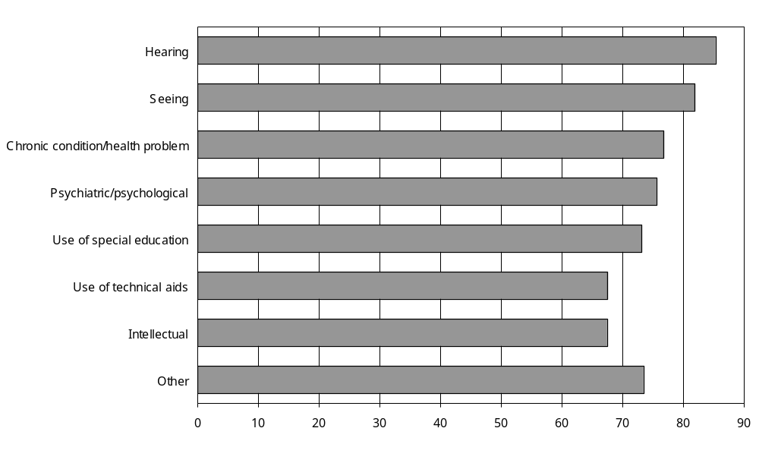
Source: Statistics New Zealand, 2001 Household Disability Survey
Notes:
- Data in Appendix Table 7.44.
- If individuals reported more than one disability type, they were counted in each applicable disability group.
- Excludes children who needed to use special transport for short distance travel.

Eighty-seven percent of children with mild disability had used buses at least once for short trips in the previous 12 months, compared with 79 percent of children with moderate disability and 68 percent of children with severe disability.

Would buses be used if they were easier to use?
Adults with disability who had not used a bus for short trips in the previous 12 months, even though they had lived in a place with a bus service, were asked if they would use buses if they were made easier for people with disability to use. Eighteen percent, an estimated 46,200 adults, said they would. Seventy-eight percent said they would not.

This same question was put to parents or caregivers of children who had not used a bus for short trips in the previous 12 months, even though they had lived in a place with a bus service. Parents or caregivers of 22 percent of these children (an estimated 1500 children) indicated their child would use buses. Parents or caregivers of 73 percent of the children (an estimated 4900 children) indicated their child would not.

Adults with disability who were employed and who had not travelled on a public bus on the most recent day they went to work, were asked if they would use buses more often to travel to or from work if they were made easier for people with disability to use. Nine percent of these adults said they would use buses more often if they were easier to use. This was an estimated 19,100 adults with disability.

Transport subsidies and grants

Subsidies or grants for modifying vehicles
In the previous 12 months, an estimated 3600 adults and children with disability had had modifications made to a vehicle they drove or travelled in as a passenger, because of their condition or health problem. Of these people, 77 percent did not receive a loan or grant from a government agency or medical insurer to pay for these modifications.

Total Mobility Scheme
The Total Mobility Scheme is funded by local government agencies and Transfund (a stand-alone government agency). It provides subsidised taxi fares to people with all types of disability who find it difficult to use public transport (Transfund 2003).

Awareness of the Total Mobility Scheme
Seventy percent of adults with disability had not heard of the Total Mobility Scheme. Similarly, 78 percent of parents or caregivers of children with disability had not heard of the scheme.

Older adults with disability were more likely to have heard of the scheme than younger adults with disability and parents or caregivers of children with disability. Forty-three percent of adults aged 75 and over had heard of it, compared with just 15 percent of adults aged 15–24 and 21 percent of the parents or caregivers of children with disability.

Relatively low percentages of Pacific (18 percent), Asian/Other (17 percent) and Mäori (22 percent) adults with disability had heard of the Total Mobility Scheme. This compared with 31 percent of European adults.

Adults with seeing disability (43 percent) were most likely to have heard of the Total Mobility Scheme. Adults with psychiatric/psychological disability (27 percent) were least likely to have heard of it.

In the case of children, parents or caregivers of 23 percent of European, 20 percent of Mäori and 12 percent of Pacific children with disability had heard of the scheme. Parents or caregivers of children with a disability using technical aids (28 percent) were most likely to have heard of the scheme. Parents or caregivers of children with a hearing disability were least likely to have heard of it (16 percent).

Use of Total Mobility Scheme vouchers

Adults
Four percent of adults with disability had used Total Mobility Scheme vouchers in the previous 12 months. This was an estimated 26,100 adults.

Older adults with disability were more likely than younger adults with disability to have used the vouchers, with 13 percent of adults aged 75 and over using the vouchers, compared with just 2 percent of adults aged 15–44.

Adults with seeing disability (15 percent) were most likely to have used Total Mobility Scheme vouchers. Adults with psychiatric/psychological disability were least likely to have used them (3 percent).

Children
The parents or caregivers of just 1 percent of children with disability said their children had used Total Mobility Scheme taxi vouchers in the previous 12 months. This was an estimated 600 children.

Other financial assistance
Aside from the Total Mobility Scheme, 5 percent of adults and 7 percent of children with disability indicated they had used other types of government financial assistance for transport costs in the previous 12 months. This was an estimated 30,800 adults and 5800 children.

Unmet need for financial assistance

Adults
Seven percent of adults with disability indicated they had needed financial assistance with transport costs at some time in the previous 12 months, but had been unable to get this assistance. This was an estimated 38,900 adults.

Adults with disability aged 25–44 (11 percent) were most likely to indicate they had an unmet need for financial help for transport costs. Adults with disability aged 75 and over (3 percent) were least likely to indicate they needed this kind of financial help.

Sixteen percent of Pacific and 14 percent of Mäori adults with disability indicated they had unmet needs for financial help with transport costs. This compared with 5 percent of European and 7 percent of Asian/Other adults with disability.

Adults with psychiatric/psychological disability (14 percent) were most likely to report unmet needs for financial help with transport costs, compared with 6 percent of adults with hearing disability.

A larger percentage of adults with multiple disabilities (10 percent) than adults with a single disability (2 percent) indicated they had unmet needs for financial assistance for transport costs. Similarly, a larger percentage of adults with severe disability (18 percent) had unmet needs for transport costs compared with adults with moderate (7 percent) or mild (3 percent) disability.

Children
Parents or caregivers of 11 percent of children with disability indicated they had needed financial help with their child’s transport costs at some time in the previous 12 months, but had not been able to get assistance. These unmet needs related to an estimated 9300 children.

Mäori (18 percent) and Pacific (16 percent) children with disability were more likely than European children with disability (7 percent) to have unmet needs for financial help with transport costs.

Children with disability who had household incomes of $15,000 and under per year were more likely to have unmet needs for financial assistance with transport costs than children with disability with household incomes of $70,001 and over per year (21 percent compared with 6 percent).

Likewise, 20 percent of children with disability living in the most deprived areas of New Zealand (NZDep2001 9–10) had been unable to get the financial assistance they needed for transport costs, compared with just 6 percent of children with disability living in the least deprived areas (NZDep2001 1–2).

A relatively high proportion of children using technical aids (25 percent) and children with psychiatric/psychological disability (21 percent) had unmet needs for help with transport costs. Rates of unmet need for this kind of help were lower among children with seeing disability (11 percent) and receiving special education (12 percent).

Sixteen percent of children with multiple disabilities had unmet needs for financial help with transport costs, compared with 7 percent of children with a single disability.

Nearly a quarter (24 percent) of children with severe disability had unmet needs for financial help with transport costs, compared with 12 percent of children with moderate disability and 5 percent of children with mild disability.

Reasons for not getting financial assistance
The most common reason people gave for not being unable to get financial assistance for transport costs was that they did not know they could apply for such help. This reason was mentioned by 57 percent of adults and the parents or caregivers of 62 percent of children with unmet needs for financial assistance, an estimated 22,300 adults and 5700 children.

The second most common reason people gave was that they had applied for financial help, but were not eligible. Twenty-four percent of adults who were not able to get financial assistance for transport costs cited this reason, as did the parents or caregivers of 22 percent of children with these unmet needs.

Comparing 2001 and 1996
Travel and transport survey results were generally similar for 2001 and 1996, both for adults and for children with disability (Table 7.5).

The main changes from 1996 to 2001 were:
- an increase in the percentage of adults with disability reporting they could not get to a bus stop or railway station easily from home (17 percent in 1996 compared with 24 percent in 2001)
- an increase in the percentage of children with disability who had used a bus for a short trip in the previous 12 months (37 percent in 1996 compared with 42 percent in 2001)
- a decrease in the proportion of children who were prevented by disability from travelling long distances (5 percent in 1996 compared with 1 percent in 2001) (although, as noted under Table 7.5, there was a slight change in the wording of the question between the two surveys).

Table 7.5: Summary comparison of 1996 and 2001 Household Disability Surveys
 | Estimated number of people with disability living in households |  | Percentage of New Zealand people with disability living in households (%)
 | 1996 survey | 2001 survey | 1996 survey | 2001 survey
Answered transport section
Adults (15+) | 561,500 | 581,000 | 100 | 100
Children (0–14) | 92,700 | 81,900 | 100 | 100
Disability prevented long-distance travel
Adults (15+) | 37,800 | 38,700 | 7 | 7
Children (0–14) | 4,800* | 800 | 5* | 1
Disability prevented short-distance travel
Adults (15+) | – | – | – | –
Children (0–14) | – | – | – | –
Drove a private motor vehicle
Adults (15+) | 398,500 | 404,200 | 71 | 70
Had difficulty travelling as a passenger in private motor vehicle?
Adults (15+) | 64,000 | 60,100 | 11 | 12
Children (0–14) | 4,500 | 5,700 | 5 | 7
Could not get to a bus stop or railway station easily from home
Adults (15+) | 98,100 | 139,300 | 17 | 24
Had used a bus for a short trip in previous 12 months
Adults (15+) | 119,400 | 133,400 | 21 | 23
Children (0–14) | 34,100 | 34,700 | 37 | 42
Total Mobility Scheme
Had heard of Total Mobility Scheme – adults (15+) | 150,700 | 169,700 | 27 | 29
Had heard of Total Mobility Scheme – children (0–14) | 19,000 | 17,600 | 21 | 21
Had used Total Mobility vouchers – adults (15+) | 22,100 | 26,100 | 4 | 4
Had used Total Mobility vouchers – children (0–14) | 1,000 | 600 | 1 | 1
Unmet need for transport costs
Adults (15+) | 39,000 | 38,900 | 7 | 7
Children (0–14) | 9,800 | 9,300 | 11 | 11
– Percentages too small to report (estimated frequencies outside the 70 percent relative sampling error cut-off point).
* The wording of this question was slightly different in the two surveys. In 1996, parents or caregivers were asked if their child’s condition or health problem made it ‘impossible’ for the child to travel long distances. In 2001, they were asked if it ‘completely stopped’ the child from travelling long distances.

8 Mäori and Disability

Key points
This chapter looks at the nature and extent of long-term disability experienced by Mäori and how the lives of Mäori are affected by disability.

Mäori living in households
- In 2001, there were an estimated 106,500 Mäori adults and children with disability living in households. This was 21 percent of all Mäori. By comparison, 19 percent of non-Mäori adults and children living in households had disability.
- Adjusting for age differences, Mäori had higher age-standardised rates of disability (24,000 per 100,000 or 24 percent) than non-Mäori (16,700 per 100,000 or 17 percent).
- Mäori were more likely than non-Mäori to have a functional disability requiring assistance (14 percent of all Mäori living in households compared with 9 percent of all non-Mäori living in households).
- Fifteen percent of Mäori children aged 0–14 living in households had a disability. The disability rate for the non-Mäori population aged 0–14 was 10 percent. Mäori boys were more likely to have a disability than Mäori girls (16 percent compared with 13 percent).
- The most common types of disability experienced by Mäori children were chronic conditions/ health problems. The next most common were use of special education and hearing disability.
- The prevalence of disability among Mäori increased with age. Sixty-one percent of Mäori aged 65 and over had a disability, compared with 34 percent of Mäori aged 45–64, 22 percent of Mäori aged 25–44 and 13 percent of Mäori aged 15–24.
- Mobility disability and agility disability were the most common types of disability experienced by Mäori adults (reported by 11 percent and 9 percent of all Mäori adults living in households respectively).
- Disease/illness was the most common cause of disability reported by Mäori (with an age-standardised rate of 8400 per 100,000 people living in households). The most common cause of disability for non-Mäori was also disease/illness with an age-standardised rate of 5500 per 100,000.
- Mäori with disability were more likely than non-Mäori with disability to live in the more deprived areas of New Zealand. In 2001, 43 percent of Mäori with disability living in households lived in NZDep2001 deciles 9–10 (the areas of greatest deprivation in New Zealand) compared with 17 percent of non-Mäori with disability.
- Forty-nine percent of Mäori adults with disability living in households had a personal income of $15,000 and under per year.
- Mäori adults with disability were less likely to be in the labour force than Mäori adults without disability (48 percent compared with 26 percent were not in the labour force).
- The proportion of Mäori adults with disability living in households with no educational qualification was 39 percent. This was considerably higher than non-Mäori adults with disability (30 percent).
- Mäori children with disability were more likely than non-Mäori children with disability to live in two-family households (6 percent compared with 2 percent).
- Mäori with and without disability were more likely than non-Mäori with and without disability to live in rented accommodation.
- In 2001, Mäori with disability were more likely than non-Mäori with disability to report an unmet need for transport costs (17 percent compared with 7 percent).

Mäori living in residential facilities
- In 2001, only a few Mäori adults with disability (an estimated 700) lived in residential facilities such as rest homes, private hospitals and long-stay residential units.
- Mäori with disability were less likely than non-Mäori with disability to live in residential care facilities.

Introduction
Using results from the 2001 New Zealand Disability Survey, this chapter focuses on Mäori to provide an overview of trends and patterns of disability experienced by Mäori living in New Zealand. The first part of the chapter presents survey results for Mäori with disability living in households and the second part presents results for Mäori with disability living in residential facilities.

There is no distinction between health and disability in Mäoridom and the definition of disability in this report has been determined using the parameters applied to non-Mäori with disability. Indicators of ‘wellness’ for Mäori are broader than health and disability status as they include factors that encompass ethnic dimensions such as language, tikanga and involvement in Mäori institutions. Wellness for Mäori is defined by an individual’s ability to contribute to the iwi and whänau, so is based on personal performance within an iwi and whänau setting.

The data presented in this chapter highlight inequalities within the disability sector and provide the opportunity on which Objective 11 of the New Zealand Disability Strategy can be used to help promote participation of disabled Mäori and their family and whänau within the community (Minister for Disability Issues 2001). Proposed actions linked to this objective include:
- building the capacity of disabled Mäori through the equitable allocation of resources within the context of Mäori development frameworks
- establishing more disability support services designed and provided by Mäori for Mäori
- ensuring mainstream providers of disability services are accessible to and culturally appropriate for disabled Mäori and their whänau
- training more Mäori disability service provider professionals and increasing the advisory capacity of Mäori
- ensuring government funded or sponsored marae-based initiatives meet the access requirements of people with disability
- supporting training and development of trilingual interpreters for Deaf people
- ensuring Te Puni Kökiri undertakes a leadership role in promoting the participation of Mäori with disability.

The New Zealand Health Strategy clearly recognises the importance of ‘reducing inequalities for all New Zealanders including Mäori’ (Minister of Health 2000). Specific actions to address the participation of Mäori with disability in te ao Mäori and wider New Zealand society are outlined in the Ministry of Health’s internal planning document, Mäori Disability Action Plan for Disability Services (Ministry of Health 2003b).

The quality of ethnicity data poses a considerable challenge for official statistics. Issues of validity, continuity through time, consistency across data sets and completeness are ongoing. The method of data collection is important and the changes in the Census of Population and Dwellings ethnic question has demonstrated this with the varying results in 1996 and 2001. Caution is advised when analysing disability trends over time for Mäori and comparing results for Mäori and non-Mäori (Te Röpü Rangahau Hauora a Eru Pömare 2000). Therefore, in this chapter we have chosen not to compare the 1996 and 2001 surveys.

Features of the Mäori population
Just 4 percent of New Zealand’s older population (aged 65 years and over) are Mäori, compared with 15 percent of the total population. Several factors contribute to this difference, a higher mortality in earlier age groups resulting in lower life expectancy, (Cunningham et al 2002), the gap between Mäori and non-Mäori life expectancy due to the earlier onset of age related illness and disease (Ajwani et al 2003) and a higher birth rate. These factors combined with a higher concentration of the Mäori population in the childbearing age groups, results in a younger Mäori population.

The Ministry of Health’s report, Decades of Disparity: Ethnic mortality trends in New Zealand 1980–1999, shows that non-Mäori, non-Pacific peoples now live, on average, 10 years longer than Mäori (Ministry of Health 2003a).

A Mäori girl born in 1996 can expect to live to age 72. This is 16 years longer than her 1951 counterpart (56 years) and five years longer than a Mäori boy born in 1996 who can expect to live to age 67, which is 13 years more than his 1951 counterpart (54 years) (Ajwani et al 2003).

At the 2001 Census, the median age of Mäori was 22 years, while the median age for the total New Zealand population was considerably higher at 35 years (Statistics New Zealand 2002a).

Mäori mortality rates at all ages, except 15–24 and 75 and over, were greater than for non-Mäori. The most marked differences occurred in the under 1 age group and for females aged 45–64. These rates were nearly twice those for the non-Mäori population (Ajwani et al 2003).

To control for these differences in the age structures of the Mäori and non-Mäori populations, age-standardised rates are used as much as possible when summarising Mäori disability statistics in this chapter.

When appropriate, age-specific rates have been presented to provide a more accurate and meaningful comparison between Mäori and non-Mäori.

This chapter concentrates on disability issues where there were notably different survey results for Mäori and non-Mäori.

Mäori living in households

Mäori disability rates

All Mäori
In 2001, an estimated 106,500 Mäori living in households had a disability. This was 21 percent of all Mäori living in households. By comparison, 19 percent of non-Mäori living in household had a disability.

Adjusting for the different age profiles of the two populations, age-standardised rates of disability were higher for Mäori (24,000 per 100,000 or 24 percent) than for non-Mäori (16,700 per 100,000 or 17 percent).

Children
The disability rate for Mäori children aged 0–14 was 15 percent. This was higher than the rate for non-Mäori children (10 percent). Sixteen percent of Mäori boys aged 0–14 reported a disability, compared with 13 percent of Mäori girls in the same age group.

Adults
In 2001, among Mäori adults living in households, the prevalence of disability was closely associated with age. Sixty-one percent of Mäori aged 65 and over reported having at least one kind of disability, compared with 34 percent of Mäori aged 45–64, 22 percent of Mäori aged
25–44 and 13 percent of Mäori aged 15–24.

In contrast, 51 percent of non-Mäori adults aged 65 and over had a disability, as did 24 percent of non-Mäori aged 45–64, 13 percent of non-Mäori aged 25–44 and 8 percent of non-Mäori aged 15–24.

Sex
In 2001, just over half (54 percent) of Mäori with disability living in households were female. While Mäori males with disability outnumbered Mäori females with disability in the 0–14 age group, Mäori females outnumbered Mäori males in all other age groups. This gender pattern of disability over the different age groups was similar to non-Mäori (Figure 8.1).

Figure 8.1: Percentage of Mäori and non-Mäori people (adults and children) with disability living in households, by age and sex, 2001
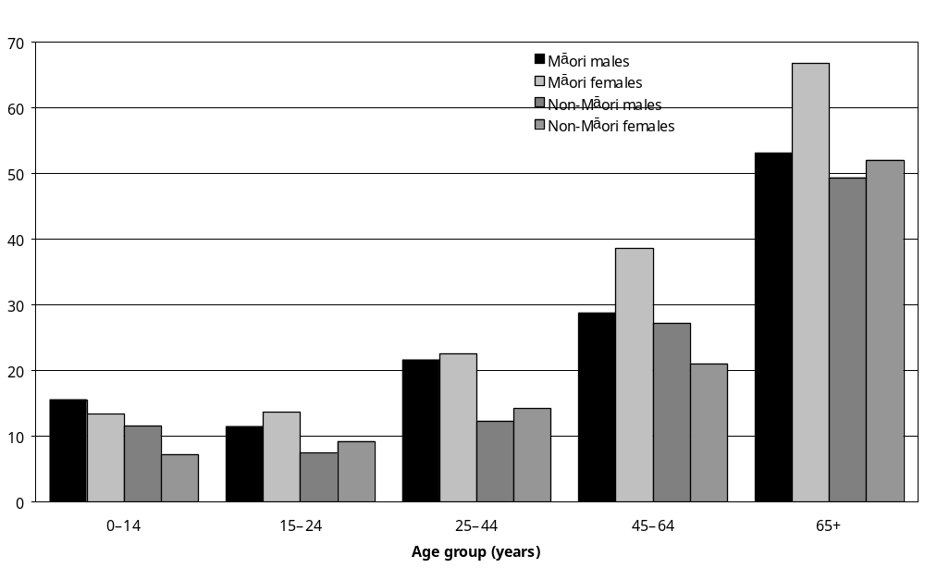
Source: Statistics New Zealand, 2001 Household Disability Survey
Note: Calculated from data in Appendix Table 8.1B.

Rates of disability were also higher for Mäori women than Mäori men in all the adult age groups. For instance, 39 percent of Mäori women aged 45–64 reported at least one disability, compared with 29 percent of Mäori men in the same age group.

Among children the situation was reversed with more Mäori boys (16 percent) than Mäori girls (13 percent) having disability.

Socioeconomic factors
There may be several explanations for the discrepancy between Mäori and non-Mäori rates of disability but the over-representation of Mäori in the lower socioeconomic groups and the higher levels of social and material deprivation experienced by Mäori can be seen as a major factor (Crampton et al 2000).

Disease/illness was reported as the most common cause of disability for Mäori. The effects of disadvantage accumulate over time. Health in middle and old age depends on past and present circumstances such as poor housing, lack of educational achievement, unemployment, low wages, living in disadvantaged neighbourhoods and disease. Therefore, the influence of socioeconomic factors on health and the risk of premature death cannot be ignored when looking at Mäori and disability (Ministry of Health 2002b).

Disability type

Adults
The types of disability most commonly reported by Mäori adults living in households were:
- mobility disability (with an age-standardised prevalence rate of 11,400 per 100,000 Mäori adults living in households)
- agility disability (9000 per 100,000)
- hearing disability (6700 per 100,000)
- remembering disability (4100 per 100,000)
- psychiatric/psychological (3800 per 100,000)
(see Figure 8.2).

Figure 8.2: Age-standardised rates of different disability types for Mäori and non-Mäori adults living in households, 2001
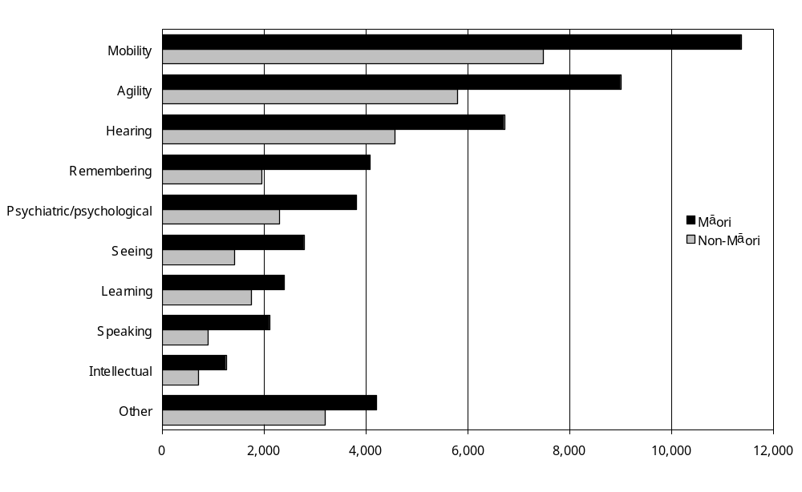
Source: Statistics New Zealand, 2001 Household Disability Survey
Notes:
- Data in Appendix Table 8.3B.
- If individuals reported more than one disability type, they were counted in each applicable disability type group.
Rates of disability were generally higher for Mäori women than Mäori men and this was particularly so in the case of mobility disability. Mäori women also had notably higher rates of agility disability and seeing disability than Mäori men.
The most common type of disability in the 15–24 age group for Mäori with disability was hearing disability, followed by mobility disability and psychiatric/psychological disability. However, the biggest disparities in disability type between Mäori and non-Mäori in this age group were in hearing and speaking disability. The disparity reflects the equally striking difference in the rates of hearing and speaking disability for children (reported later in this chapter). It is important to note that hearing and speaking disabilities will be closely associated with a learning disability (Table 8.1 and Figure 8.3).

Table 8.1: Rates of mobility, agility and hearing disability Mäori and non-Mäori aged 15–24, living in households, 2001
Disability | Rate per 100,000
Disability | Mäori | Non-Mäori
Hearing | 3600 | 1000
Mobility | 3300 | 1900
Psychiatric/psychological | 3300 | 2900
Learning | 3100 | 3000
Speaking | 2700 | 700
Note: Data in Appendix Table 8.3B.

Figure 8.3: Rates of different disability types for Mäori and non-Mäori adults aged 15–24 living in households, 2001
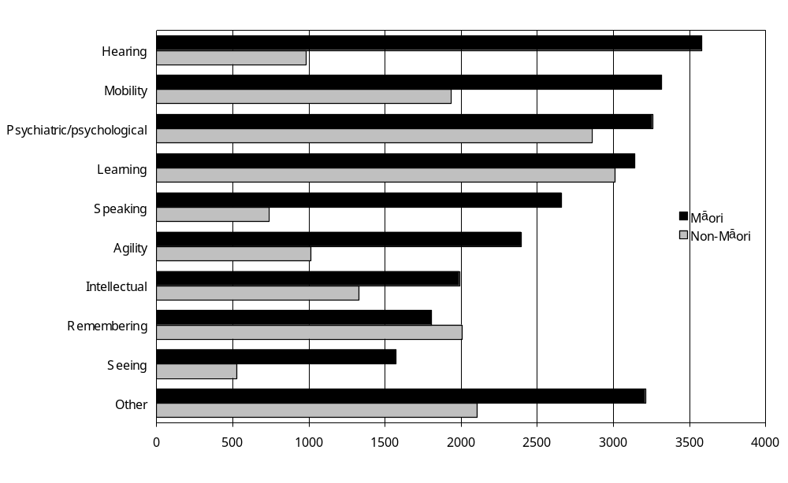
Source: Statistics New Zealand, 2001 Household Disability Survey
Notes:
- Data in Appendix Table 8.3B.
- If individuals reported more than one disability type, they were counted in each applicable disability type group.
The pattern of disability type for Mäori with disability in the 25–44 age group begins to change with mobility disability replacing hearing disability as the most common disability, followed by agility disability then psychiatric/psychological disability. Hearing in this age group is the fourth most common disability (Table 8.2 and Figure 8.4).

Table 8.2: Rates of mobility, agility and hearing disability Mäori and non-Mäori aged 25–44, living in households, 2001
Disability | Rates per 100,000
Disability | Mäori | Non-Mäori
Mobility | 8300 | 5600
Agility | 7100 | 4000
Psychiatric/psychological | 7000 | 3200
Hearing | 5800 | 2900
Note: Data in Appendix Table 8.3B.

Figure 8.4: Rates of different disability types for Mäori and non-Mäori adults aged 25–44 living in households, 2001
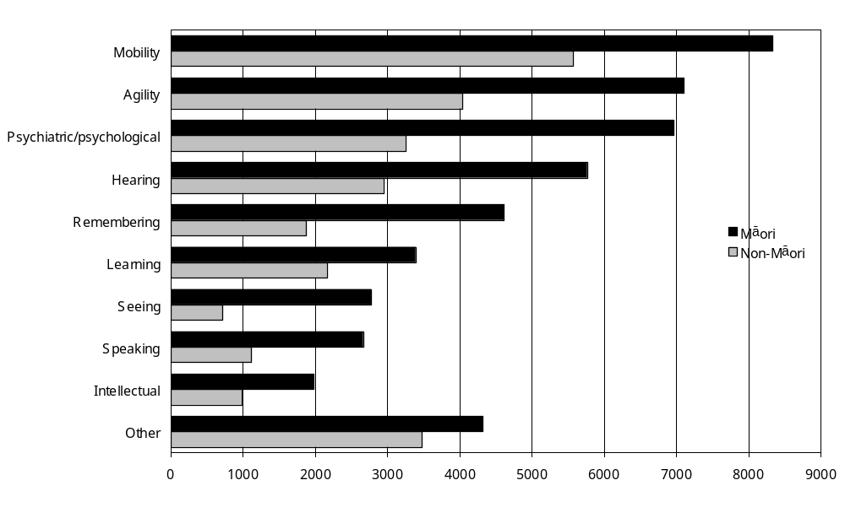
Source: Statistics New Zealand, 2001 Household Disability Survey
Notes:
- Data in Appendix Table 8.3B.
- If individuals reported more than one disability type, they were counted in each applicable disability type group.

In 2001, the Mäori rate for mobility disability in the 45–64 age group was nearly double that for non-Mäori. Rates of agility disability and hearing disability were also much higher for Mäori than non-Mäori (Table 8.3 and Figure 8.5).

Table 8.3: Rates of selected disability types, Mäori and non-Mäori aged 45–65, living in households, 2001
Disability | Rate per 100,000
Disability | Mäori | Non-Mäori
Mobility | 23,500 | 12,300
Agility | 18,400 | 10,400
Hearing | 12,300 | 8,800
Note: Data in Appendix Table 8.3B.

Figure 8.5: Rates of different disability types for Mäori and non-Mäori adults aged 45–64 living in households, 2001
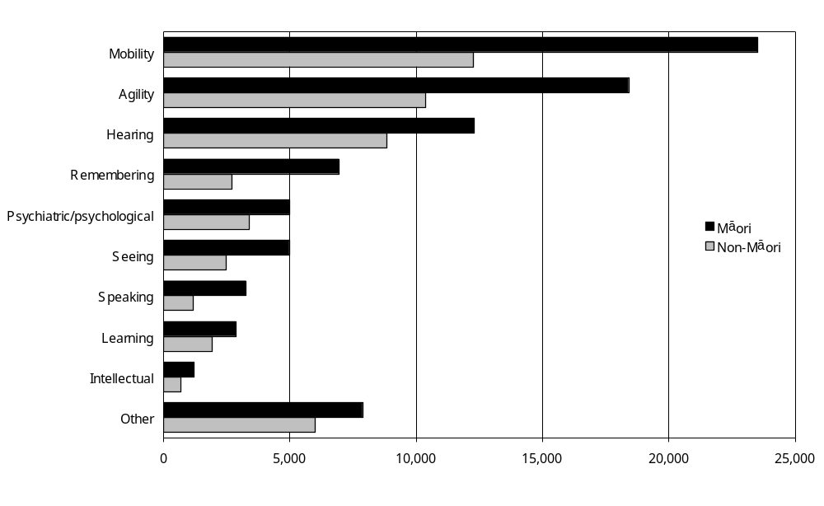
Source: Statistics New Zealand, 2001 Household Disability Survey
Notes:
- Data in Appendix Table 8.3B.
- If individuals reported more than one disability type, they were counted in each applicable disability type group.

The pattern of disability for Mäori in the oldest age group is similar to that for the 45–64 age group. These higher disability rates for older Mäori reflect the greater incidence of disease and illness, which affect Mäori from a younger age than the non-Mäori population (Table 8.4 and Figure 8.6).

Table 8.4: Rates of selected disability types, Mäori and non-Mäori aged 65 and over, living in households, 2001
Disability | Rates per 100,000
Disability | Mäori | Non-Mäori
Mobility | 45,500 | 37,900
Agility | 35,200 | 29,300
Hearing | 24,400 | 22,000
Note: Data in Appendix Table 8.3B.

Figure 8.6: Rates of different disability types for Mäori and non-Mäori adults aged 65 and over living in households, 2001
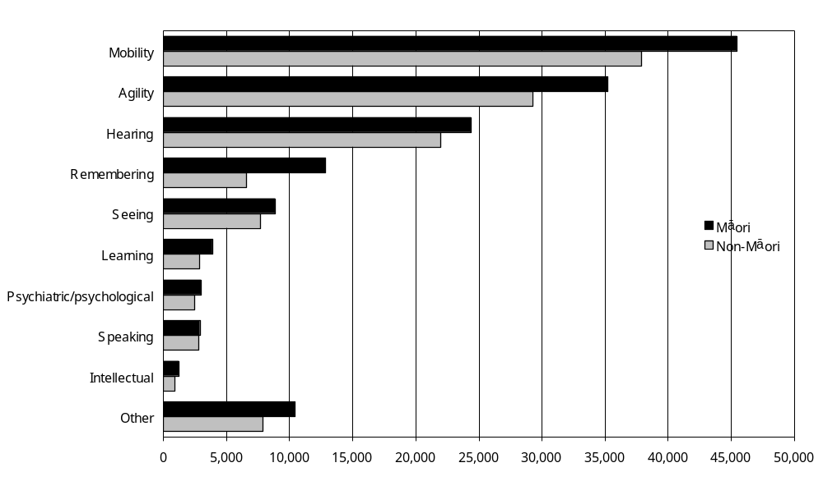
Source: Statistics New Zealand, 2001 Household Disability Survey
Notes:
- Data in Appendix Table 8.3B.
- If individuals reported more than one disability type, they were counted in each applicable disability type group.

Children
Mäori children living in households had similar types of disability as non-Mäori children, but had a higher rate of prevalence of each type of disability. The difference in the rates of hearing and speaking disabilities between Mäori and non-Mäori was large. This is important because these types of disability are related and affect learning and education.

Mäori boys with disability had higher rates for all types of disability except chronic conditions/ health problems (Tables 8.5 and 8.6 and Figure 8.7).

Table 8.5: Rates of selected disability types, Mäori children, living in households, 2001
Disability | Rates per 100,000
Disability | Mäori | Non-Mäori
Chronic condition/health problem | 4900 | 3200
Use of special education | 4500 | 4100
Hearing | 4100 | 1600
Psychiatric/psychological | 3200 | 2500
Speaking | 3100 | 1700

Figure 8.7: Rates of different disability types for Mäori and non-Mäori children living in households, 2001
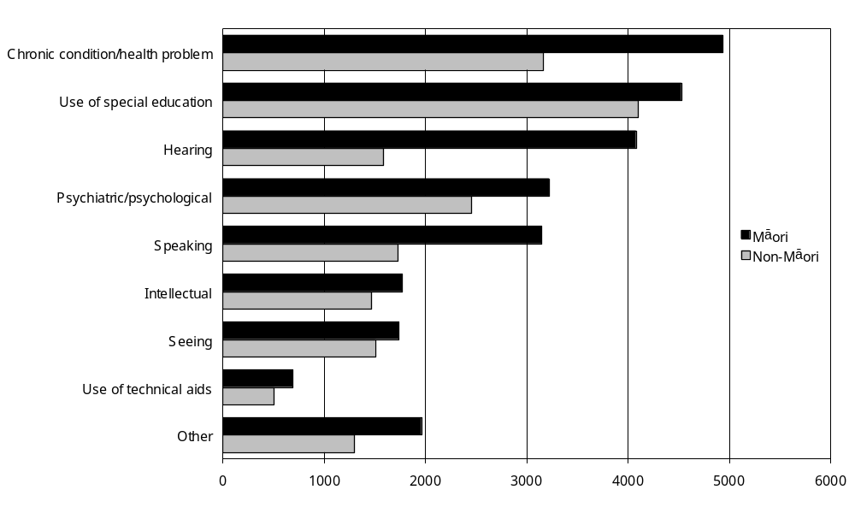
Source: Statistics New Zealand, 2001 Household Disability Survey
Notes:
- Data in Appendix Table 8.4B.
- If individuals reported more than one disability type, they were counted in each applicable disability type group.

Table 8.6: Rates per 100,000 by disability type for Mäori children living in households, by sex 2001
Disability | Rates per 100,000
Disability | Boys | Girls
Chronic condition/health problem | 4600 | 5300
Use of special education | 6300 | 2600
Hearing | 4500 | 3700
Psychiatric/psychological | 4100 | 2300
Speaking | 3400 | 2900
Note: Data in Appendix Table 8.4.

Main disability

Most common types of main disability
Age-standardised rates for the most commonly reported types of main disability among Mäori adults were:
- mobility disability (7 percent of all Mäori adults living in households)
- hearing disability (3 percent)
- agility disability (3 percent).

Sex
Mäori women (8500 per 100,000) were more likely than Mäori men (4700 per 100,000) to have a main disability that was a mobility disability.

Comparing Mäori and non-Mäori
For all types of main disability, except learning disability, age-standardised rates were higher for Mäori adults living in households than non-Mäori (Figure 8.8).

Figure 8.8: Age-standardised rates of different types of main disability for Mäori and non-Mäori adults living in households, 2001
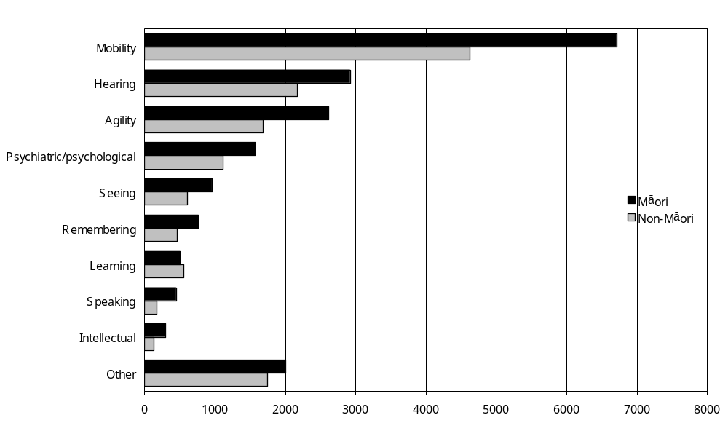
Source: Statistics New Zealand, 2001 Household Disability Survey
Notes:
- Data in Appendix Table 8.5B.
- If individuals reported more than one disability type, they were counted in each applicable disability type group.

Mobility disability was the type of main disability with the largest Mäori/non-Mäori difference. The age-standardised rate for Mäori adults was 6700 per 100,000, compared with 4600 per 100,000 for non-Mäori adults.

Severity of disability
In 2001, 44 percent of Mäori with disability living in households had mild disability, 40 percent had moderate disability and 16 percent had severe disability.

These figures were similar to those for non-Mäori people with disability (mild – 43 percent; moderate – 45 percent and severe – 12 percent).

However, for all three severity levels the age-standardised disability rates for Mäori were higher than for non-Mäori. In particular, the age-standardised rate of severe disability for Mäori was more than twice the rate for non-Mäori (4100 per 100,000 population compared with 1900 per 100,000) (Table 8.7 and Figures 8.9–8.11).

Table 8.7: Age-standardised rates, of severity of disability for Mäori and non-Mäori people (children plus adults) living in households, by sex, 2001
 | Age-standardised rate per 100,000
 | Mild | Moderate | Severe | Total
Mäori males | 9,000 | 9,600 | 3,700 | 22,400
Mäori females | 11,100 | 9,900 | 4,500 | 25,500
Total Mäori | 10,100 | 9,800 | 4,100 | 24,000
Non-Mäori males | 7,800 | 7,500 | 2,000 | 17,300
Non-Mäori females | 7,300 | 6,900 | 1,800 | 16,000
Total non-Mäori | 7,600 | 7,200 | 1,900 | 16,700
Notes:
- Mild = Not requiring regular help from other people or technical aids.
- Moderate = requiring intermittent (that is, non-daily) assistance from other people or technical equipment.
- Severe = Requiring continuous or daily assistance, generally in the self-care domain.
- Data in Appendix Table 8.1B.

Figure 8.9: Rates of mild disability among Mäori and non-Mäori living in households, by age and sex, 2001
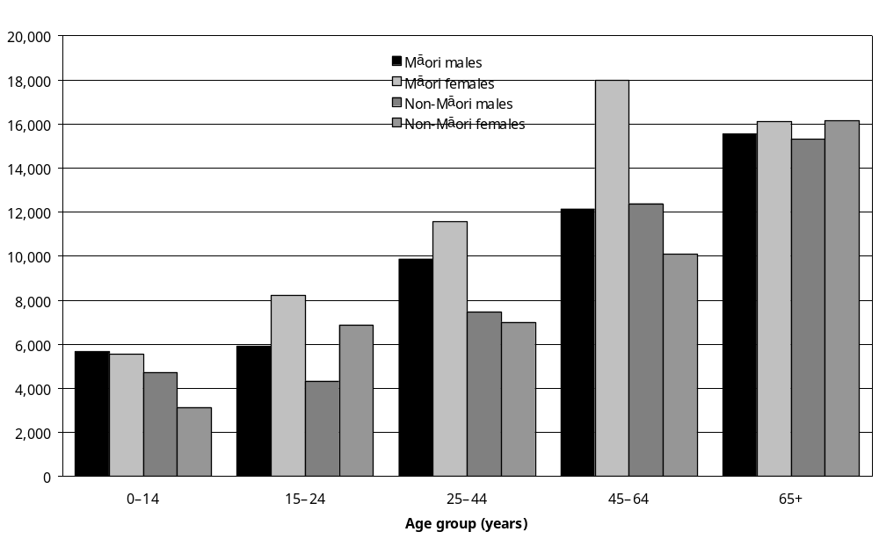
Source: Statistics New Zealand, 2001 Household Disability Survey
Note: Data in Appendix Table 8.1B.
Figure 8.10: Rates of moderate disability among Mäori and non-Mäori living in households, by age and sex, 2001
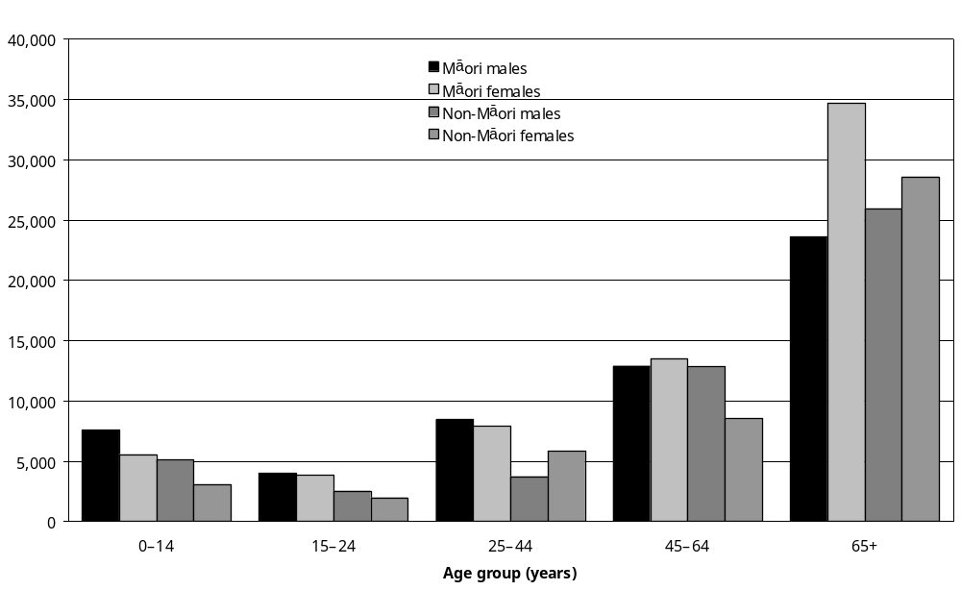
Source: Statistics New Zealand, 2001 Household Disability Survey
Note: Data in Appendix Table 8.1B.

Figure 8.11: Rates of severe disability among Mäori and non-Mäori living in households, by age and sex, 2001
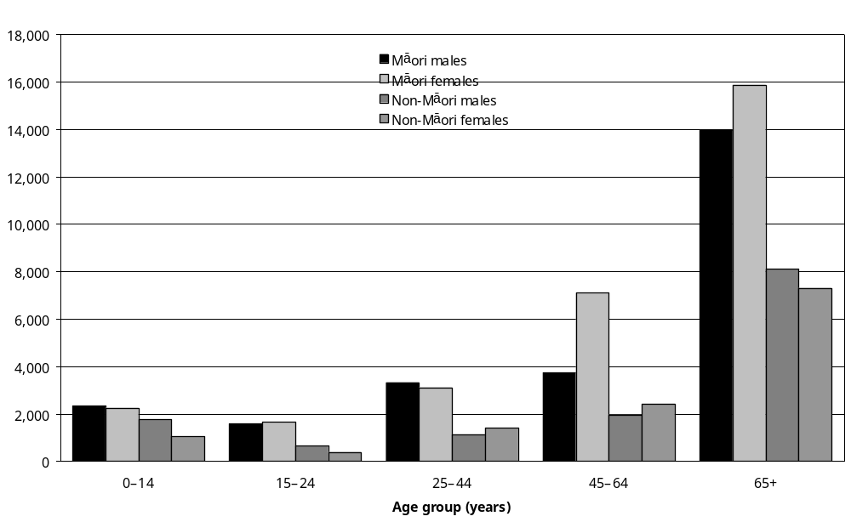
Source: Statistics New Zealand, 2001 Household Disability Survey
Note: Data in Appendix Table 8.1B.

Dependent disability
People with ‘dependent disability’ were those assessed by the Household Disability Survey as having severe or moderate disability. It meant they needed help from other people or needed to use equipment such as wheelchairs or computers.

In 2001, the prevalence of dependent disability was similar for Mäori males and Mäori females. The survey estimated that 13 percent of Mäori males and 14 percent of Mäori females living in households had dependent disability. This compared with a dependent disability rate of 9 percent for both non-Mäori males and non-Mäori females.

Single and multiple disability
An estimated 58,300 or 55 percent of Mäori with disability living in households reported having more than one disability. This was similar to the percentage of non-Mäori who reported having more than one disability (57 percent).

However, the age-standardised rates for Mäori were higher than for non-Mäori for both single and multiple disability.

For single disability, the age-standardised rate for Mäori was 9900 per 100,000 and the rate for non-Mäori was 7500 per 100,000. For multiple disability, the age-standardised rate for Mäori was 14,100 per 100,000 and the rate for non-Mäori was 9200 per 100,000 (Figures 8.12–8.13).

Figure 8.12: Rates of single disability among Mäori and non-Mäori living in households, by age and sex, 2001
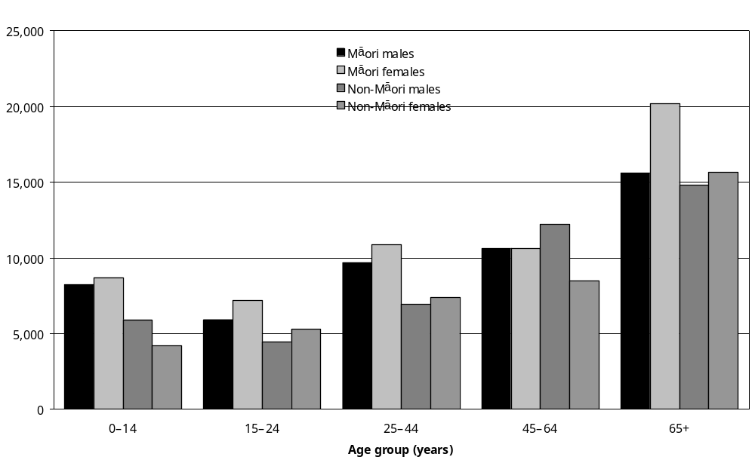
Source: Statistics New Zealand, 2001 Household Disability Survey
Note: Data in Appendix Table 8.2B.
Figure 8.13: Rates of multiple disability among Mäori and non-Mäori living in households, by age and sex, 2001
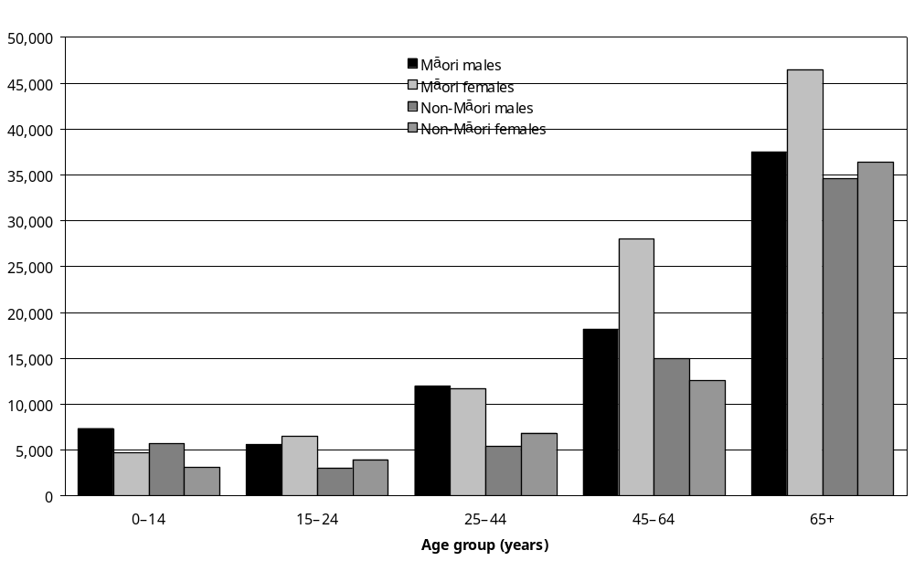
Source: Statistics New Zealand, 2001 Household Disability Survey
Note: Data in Appendix Table 8.2B.

Cause of disability

Adults
In 2001, the most common cause of disability for Mäori adults was disease/illness (the age-standardised rate was 8400 per 100,000). This was notably higher than for non-Mäori adults (5500 per 100,000) (Figure 8.14).

Figure 8.14: Rates of disability caused by disease/illness among Mäori and non-Mäori living in households, by age and sex, 2001
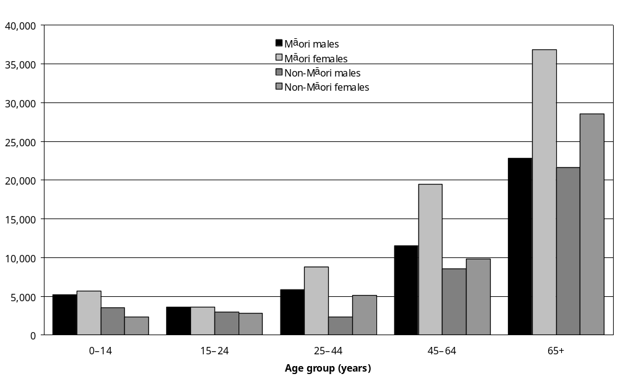
Source: Statistics New Zealand, 2001 Household Disability Survey
Notes:
- Data in Appendix Table 8.6B.
- If individuals reported more than one disability type, they were counted in each applicable disability cause group.

The next most common cause of disability among Mäori adults was accident/injury (6900 per 100,000), which was also higher than non-Mäori (4800 per 100,000). This difference was most marked for Mäori men aged 25–44 (10,800 per 100,000) and non-Mäori men (6600 per 100,000). However, in the age group 45–64 the difference between Mäori and non-Mäori men was less obvious. This may be explained by the risk both groups experience in the work environment. What is of interest in the 45–64 age group is the high rate of Mäori women who experience disability caused by accident/injury (13,600 per 100,000) (Figure 8.15).

Figure 8.15: Rates of disability caused by accident/injury among Mäori and non-Mäori living in households, by age and sex, 2001
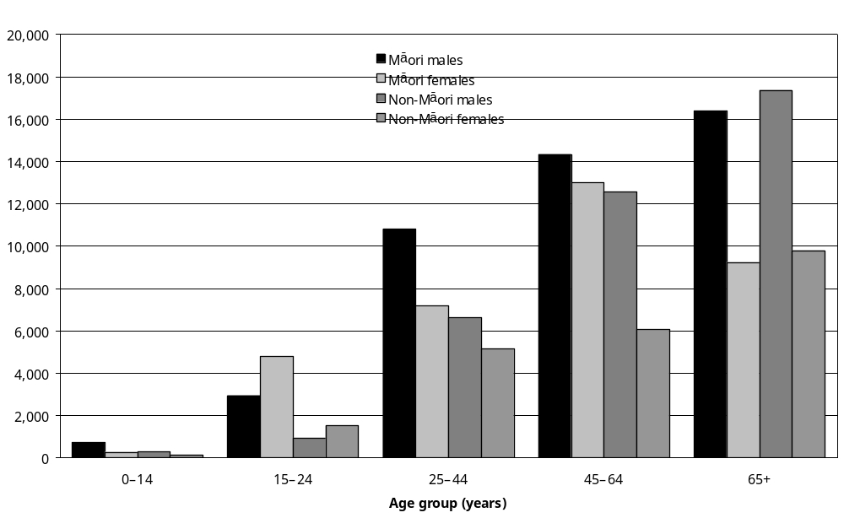
Source: Statistics New Zealand, 2001 Household Disability Survey
Notes:
- Data in Appendix Table 8.6B.
- If individuals reported more than one disability type, they were counted in each applicable disability cause group.

The rate of disability caused by disease/illness is significantly higher for Mäori women aged 45 and over. A possible explanation for this difference is connected with the earlier ageing process and age-related disabilities experienced by younger Mäori women and men. Disease/ illness-related disabilities are generally associated with the age group 65 and over in non-Mäori.

Children
Disease/illness was also the most common cause of disability among Mäori children (5400 per 100,000). This was almost double the rate of non-Mäori children (2900 per 100,000) (Figure 8.14).

Mäori children also had a slightly higher rate of disability caused by conditions present at birth than non-Mäori children (5000 per 100,000 compared with 4300 per 100,000).

The higher rates of disability for Mäori due to disease/illness may be at least partially attributable to their over-representation in the lower socioeconomic groupings.

Duration of disability
Just 4 percent of Mäori with disability living in households had experienced their longest-lasting disability for less than one year. Thirty-one percent of Mäori with disability had experienced a disability lasting 15 years or longer, while most Mäori with disability, 64 percent, had experienced disability for 1–14 years.

Non-Mäori had a similar duration of disability profile to Mäori. Like Mäori, 4 percent of non-Mäori had experienced their longest-lasting disability for less than one year. Thirty-seven percent had experienced disability for 15 or more years, while 58 percent had experienced disability for 1–14 years.

Support services and equipment

Type of health service used
The types of health service used by Mäori with disability living in households are listed in Table 8.8, which also gives the percentage of Mäori and non-Mäori with disability who used each service one or more times in the previous 12 months. Table 8.9 shows similar information for children.

Table 8.8: Type of health service used in previous 12 months for Mäori and non-Mäori (children and adults) living in households, 2001
Type of health service | Percent of Mäori  (%) | Percent of non-Mäori  (%)
Family doctor/general practitioner | 84 | 87
Chemist/pharmacist (for health advice or getting medication) | 68 | 75
Dentist/dental nurse | 37 | 36
Medical specialist | 35 | 41
Nurse only | 33 | 31
Physiotherapist | 16 | 18
Optician/optometrist | 16 | 26
Counsellor/social worker/psychologist | 14 | 12
Traditional healer | 7 | 1
Mäori or Pacific health worker | 4 | –
Podiatrist/chiropodist | 4 | 8
– Percentages too small to report (estimated frequencies outside the 70 percent relative sampling error cut-off point).
Note: Data in Appendix Table 8.28.
Table 8.9: Type of health service used in previous 12 months for Mäori and non-Mäori children aged 0–14 living in households, 2001
Type of health service | Percent of Mäori  (%) | Percent of non-Mäori  (%)
Family doctor/general practitioner | 86 | 88
Chemist/pharmacist (for health advice or getting medication) | 63 | 60
Dentist/dental nurse | 65 | 74
Medical specialist | 36 | 45
Nurse only | 31 | 30
Physiotherapist | 8 | 11
Optician/optometrist | 12 | 21
Counsellor/social worker/psychologist | 17 | 20
Traditional healer | 4 | 1
Mäori or Pacific health worker | 4 | –
Podiatrist/chiropodist | 3 | 3
– Percentages too small to report (estimated frequencies outside the 70 percent relative sampling error cut-off point).
Note: Data in Appendix Table 8.28.

Unmet need for at least one type of health service
An estimated 24,200 Mäori with disability living in households, 23 percent of all Mäori with disability, reported an unmet need for some type of health service in the previous 12 months. This compares with 14 percent of non-Mäori with disability living in households.

In particular, younger Mäori with disability were more likely than their non-Mäori counterparts to report an unmet need for health services. Thirty-two percent of Mäori aged 15–24 with disability reported an unmet need, compared with 18 percent of non-Mäori with disability in this age group.

Similarly, 22 percent of Mäori children aged 0–14 with disability reported an unmet need, compared with 15 percent of non-Mäori children (Figure 8.16).

Figure 8.16: Percentage of Mäori and non-Mäori with disability living in households who reported an unmet need for health services in the previous 12 months, by age, 2001
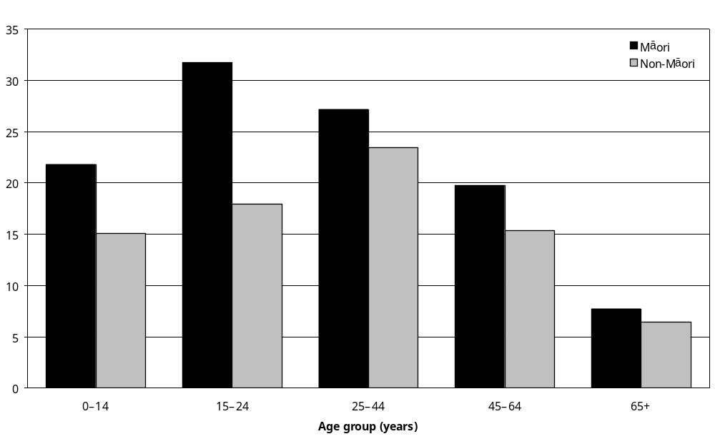
Source: Statistics New Zealand, 2001 Household Disability Survey
Note: Data in Appendix Table 8.29.

Use of equipment and technology
Overall the use of disability-related equipment was less common among Mäori with disability than non-Mäori with disability. Twenty-three percent of Mäori with disability reported using some kind of equipment, compared with 31 percent of non-Mäori with disability, although there was some variation within the different age groups (Table 8.10).

Table 8.10: Use of equipment and technology, Mäori and non-Mäori with disability living in households, by age, 2001
Age | Mäori |  | Non-Mäori
Age | Number | % | Number | %
0–14 | 2,200 | 8 | 5,500 | 9
15–24 | 1,700 | 16 | 4,100 | 12
25–44 | 8,200 | 24 | 20,000 | 16
45–64 | 7,300 | 31 | 49,800 | 27
65+ | 5,200 | 51 | 111,000 | 54
Total | 24,600 | 23 | 190,400 | 31
Note: Data in Appendix Table 8.30.

The type of equipment used by Mäori and non-Mäori adults was similar, with the highest use being for mobility equipment (Table 8.11). The pattern for use of the type of equipment for Mäori and non-Mäori children was also similar. However, as the numbers are small caution is advised in interpreting these results (Table 8.12).

Table 8.11: Use of equipment and technology, Mäori and non-Mäori adults with disability living in households, by type of equipment, 2001
Type of equipment | Mäori |  | Non-Mäori
Type of equipment | Number | % | Number | %
Hearing | 4,400 | 6 | 71,200 | 13
Seeing | 5,600 | 7 | 42,500 | 8
Mobility | 11,300 | 14 | 88,100 | 16
Agility | 1,900 | 2 | 12,000 | 2
Other | 3,600 | 5 | 22,300 | 4
Note: Data in Appendix Table 8.31A.

Table 8.12: Use of equipment and technology, Mäori and non-Mäori children with disability living in households, by type of equipment, 2001*
Type of equipment | Mäori |  | Non-Mäori
Type of equipment | Number | % | Number | %
Hearing | 600 | 2 | 1000 | 2
Seeing | – | – | – | –
Mobility/agility | 900 | 3 | 2100 | 3
Speaking/communication | – | – | 1100 | 2
Other | 500 | 2 | 1500 | 2
– Numbers too small to report (estimated frequencies outside the 70% relative sampling error cut-off point).
* The numbers using equipment and technology are low and should be treated with caution.
Note: Data in Appendix Table 8.31B.

Unmet need in use of special equipment
Fifteen percent of Mäori with disability had an unmet need for special equipment, compared with 11 percent of non-Mäori with disability.

Received help for everyday activities
Thirty-seven percent of Mäori adults with disability received at least one kind of help for everyday activities in 2001, compared with 39 percent of non-Mäori adults.

The activities in which most help was received for Mäori with disability were heavy household work (28 percent), shopping and everyday housework (both 19 percent) (Table 8.13).

Table 8.13: Received help for everyday activities, Mäori and non-Mäori adults with disability living in households, by type of help, 2001
Type of help | Mäori |  | Non-Mäori
Type of help | Number | % | Number | %
Preparing meals | 10,200 | 13 | 57,200 | 10
Shopping | 14,500 | 19 | 85,200 | 16
Everyday housework | 14,700 | 19 | 113,800 | 21
Heavy housework | 21,700 | 28 | 164,900 | 30
Private finances | 8,300 | 11 | 43,000 | 8
Personal care | 5,600 | 7 | 29,300 | 5
Communicating with others | 7,600 | 10 | 31,500 | 6
Source: Statistics New Zealand, 2001 Household Disability Survey
Note: Data in Appendix Table 8.34.

Unmet need for help with everyday activities
Eleven percent of Mäori adults with disability had an unmet need for at least one type of help for everyday activities in 2001. The rate of unmet need in this area for non-Mäori was 7 percent.

Family needing help with personal care of child or household work
Fourteen percent of Mäori families of children with disability living in households needed help in the previous 12 months with the personal care of a child or housework because of the child’s disability. The non-Mäori rate was 13 percent.

Socioeconomic areas
There are several explanations for the relatively high rates of disability among Mäori, but a major factor is the high proportion of the Mäori population with and without disability who are represented in the lower socioeconomic groups and the higher levels of social and material deprivation.

The difference in the proportion of Mäori and non-Mäori people with disability living in the most deprived areas is significant. For instance, 43 percent of Mäori with disability lived in NZDep2001 areas 9–10; while only 17 percent of non-Mäori with disability lived in these areas (Figure 8.17).

Figure 8.17: Percentage of Mäori and non-Mäori with and without disability living in households, by NZDep2001 area
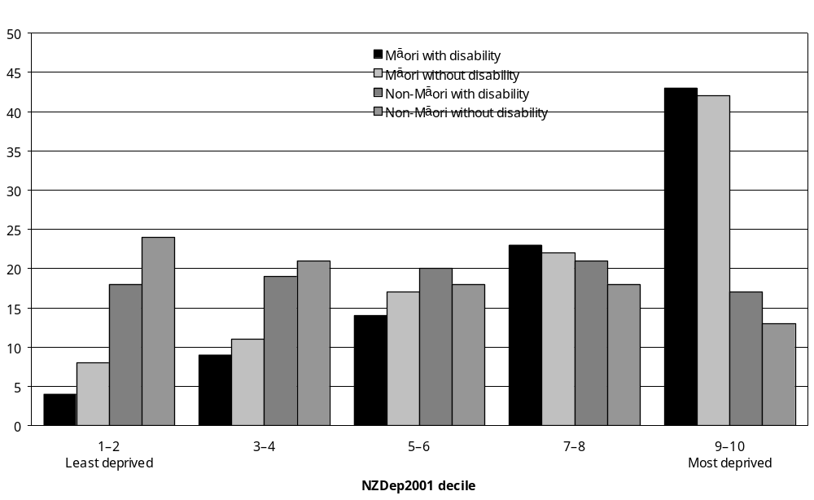
Source: Statistics New Zealand, 2001 Household Disability Survey
Note: Data in Appendix Tables 8.18 and 8.19.

Looking at the two most deprived decile areas (NZDep2001 9–10), the same percentage of Mäori children aged 0–14 with disability and without disability lived in these areas (43 percent). For the adult age groups 15–24, 25–44 and 45–64 only slightly higher percentages of Mäori with disability lived in NZDep2001 areas 9–10 compared with Mäori without disability. However, a notably higher percentage of Mäori with disability aged 65 and over lived in NZDep2001 9–10 areas, compared with Mäori without disability in the same age group (49 percent compared with 40 percent).

Poverty, poor housing and unemployment adversely affect health and wellbeing. Lack of educational achievement and disease/illness are reported as the most common causes of disability for Mäori. Research has shown that Mäori are also significantly over-represented in psychiatric disability figures (Ratima 1995).

The growing inequality in survival chances between Mäori and non-Mäori, and the differing chronic disease mortality rate in middle and old age must be considered as these mortality trends coincide with the major social and economic differences between Mäori and non-Mäori (Ajwani et al 2003).

Personal income
In 2001, an estimated 38,200 or 49 percent of Mäori adults with disability living in households had a personal income of $15,000 and under per year. An estimated 268,400 or 49 percent of non-Mäori adults with disability had a personal income of $15,000 and under per year. This compared with 39 percent of Mäori adults without disability, an estimated 95,100 adults, and 34 percent of non-Mäori without disability, an estimated 669,400 adults.

Half the Mäori adult females with disability living in households had a total personal income of $15,000 and under per year. This compared with 56 percent of non-Mäori adult females with disability (Figure 8.19). The corresponding rates for men with disability were 47 percent for Mäori and 41 percent for non-Mäori (Figure 8.18). This reflects the difference in the labour force situation of Mäori adults with and without disability (see section below on labour force status).

Figure 8.18: Percentage of Mäori and non-Mäori adult males with and without disability living in households with a personal income of $15,000 and under per year, by age, 2001
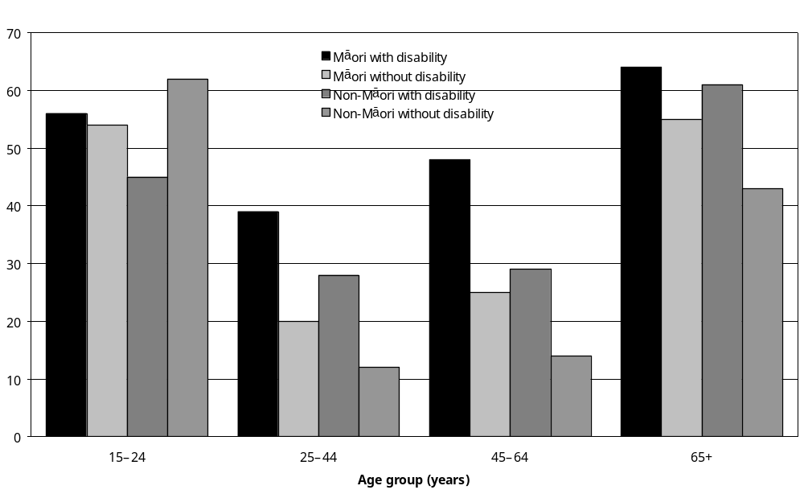
Source: Statistics New Zealand, 2001 Household Disability Survey
Note: Data in Appendix Tables 8.16 and 8.17.

Figure 8.19: Percentage of Mäori and non-Mäori adult females with and without disability living in households with a personal income of $15,000 and under per year, by age, 2001
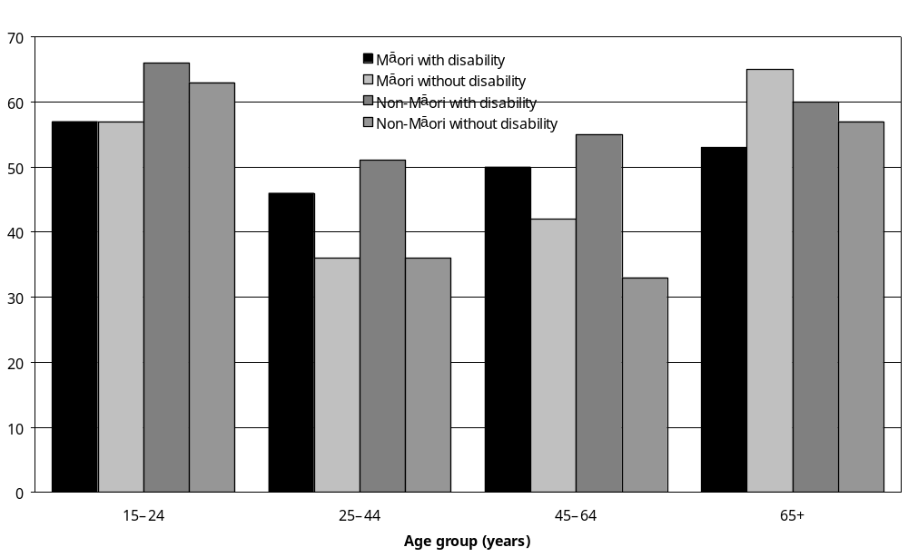
Source: Statistics New Zealand, 2001 Household Disability Survey
Note: Data in Appendix Tables 8.16 and 8.17.

Labour force status
Employment rates for Mäori with and without disability are much lower than the non-Mäori rates and unemployment rates are higher for both Mäori with and without disability.

The most striking difference is in the employment rates for Mäori and non-Mäori with and without disability. For Mäori, the employment rate was 44 percent for people with disability and 63 percent for people without disability – a difference of 19 percentage points. The non-Mäori rates were 39 percent for people with disability and 66 percent for people without – a difference of 27 percentage points (Tables 8.14 and 8.15). These differences show that Mäori with disability are more likely to be in paid employment than non-Mäori with disability.

Table 8.14: Labour force status of Mäori and non-Mäori adults with disability living in households, 2001
Labour force status | Mäori |  | Non-Mäori
Labour force status | Number | % | Number | %
Employed | 34,600 | 44 | 213,600 | 39
Unemployed | 5,700 | 7 | 19,400 | 4
Not in labour force | 37,600 | 48 | 310,700 | 57
Source: Statistics New Zealand, 2001 Household Disability Survey.
Note: Data in Appendix Table 8.11.
Table 8.15: Labour force status of Mäori and non-Mäori adults without disability living in households, 2001
Labour force status | Mäori |  | Non-Mäori
Labour force status | Number | % | Number | %
Employed | 155,600 | 63 | 1,290,500 | 66
Unemployed | 22,200 | 9 | 67,700 | 3
Not in labour force | 64,600 | 26 | 463,300 | 24
Source: Statistics New Zealand, 2001 Household Disability Survey.
Note: Data in Appendix Table 8.14.

Following on from this, 48 percent of Mäori with disability identified as not in the labour force, compared with 57 percent of non-Mäori with disability, while similar percentages of Mäori and non-Mäori without disability were not in the labour force (26 percent of Mäori and 24 percent of non-Mäori).

Education

Educational qualifications
In 2001, an estimated 30,200 or 39 percent of Mäori adults with disability living in households had no educational qualifications. This compared with 30 percent of non-Mäori adults with disability.

An estimated 17,900 or 23 percent of Mäori adults with disability had a school qualification, compared with 28 percent of non-Mäori adults with disability. An estimated 11,400 or 15 percent of, Mäori adults with disability had a post-school qualification, compared with 22 percent of non-Mäori adults with disability.

Similarly, Mäori adults without disability had lower levels of educational qualifications than non-Mäori adults without disability (Figures 8.20–8.22).

Figure 8.20: Percentage of Mäori and non-Mäori adults with and without disability living in households with no educational qualifications, by age, 2001
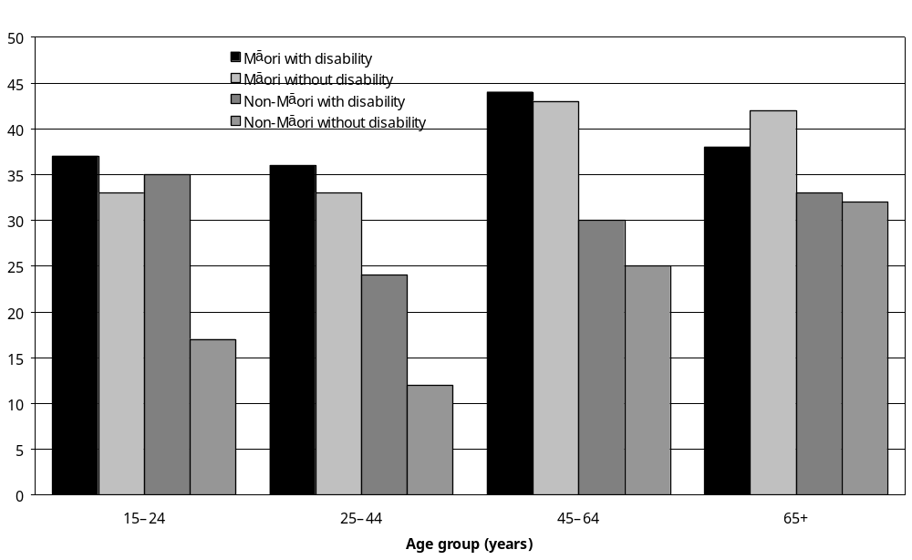
Source: Statistics New Zealand, 2001 Household Disability Survey
Note: Data in Appendix Tables 8.20 and 8.21.

Figure 8.21: Percentage of Mäori and non-Mäori adults with and without disability living in households with a school qualification, by age, 2001
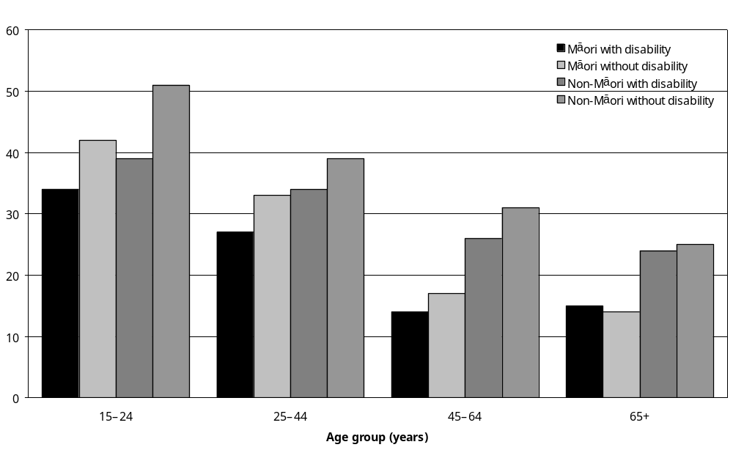
Source: Statistics New Zealand, 2001 Household Disability Survey
Note: Data in Appendix Tables 8.20 and 8.21.

Figure 8.22: Percentage of Mäori and non-Mäori adults with and without disability living in households with a post-school qualification, by age, 2001
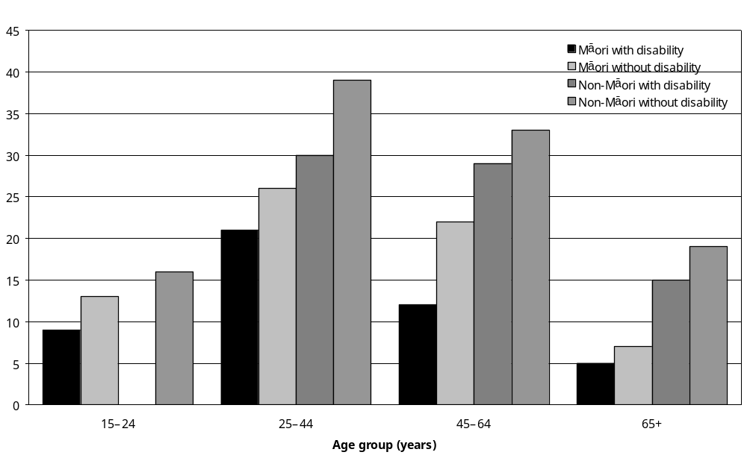
Source: Statistics New Zealand, 2001 Household Disability Survey
– Percentages too small to report (estimated frequencies outside the 70 percent relative sampling error cut-off point).
Note: Data in Appendix Tables 8.20 and 8.21.

Enrolment in formal education
The enrolment of Mäori adults with disability in formal education or training was highest in the younger age groups. In 2001, 35 percent of Mäori aged 15–24 were enrolled in formal education or training, compared with only 19 percent aged 25–44 (Figure 8.23).

Figure 8.23: Percentage of Mäori and non-Mäori adults with disability living in households enrolled in formal education, by age, 2001
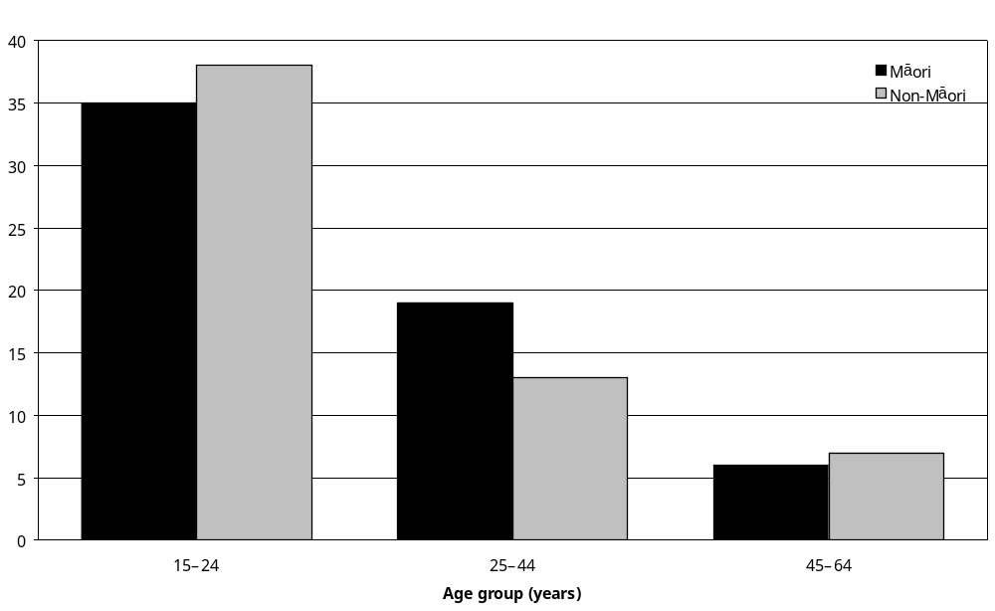
Source: Statistics New Zealand, 2001 Household Disability Survey
Note: Data in Appendix Table 8.22.

More Mäori with disability aged 25–44 were enrolled in formal education than non-Mäori with disability in the same age group. However, even non-Mäori with disability were more likely than Mäori without disability to have a school qualification for the 25 and over age group.

Housing

Household composition
Six percent of Mäori children with disability lived in two-family households, compared with only 2 percent of non-Mäori children.

Social marital status
In 2001, 44 percent of Mäori adults with disability were in a partnered relationship, compared with 56 percent of non-Mäori with disability.

Tenure of dwelling
Mäori both with and without disability were less likely to own their homes than non-Mäori, and are more likely to pay rent.

In 2001, only 43,600 or 41 percent of Mäori with disability lived in dwellings owned or partly owned by the usual residents, compared with 59 percent of non-Mäori with disability.

Similar differences existed in the rates of home ownership between Mäori and non-Mäori without disability. Forty-six percent of Mäori without disability lived in dwellings owned or partly owned by the usual residents compared with 61 percent of non-Mäori without disability.

In 2001, 38 percent of Mäori with disability lived in dwellings that were rented compared with 18 percent of non-Mäori with disability. There were similar differences among people without disability, where 39 percent of Mäori lived in rented dwellings, compared with 19 percent of non-Mäori.

Rural/urban residence
In 2001, the majority of Mäori and non-Mäori with disability lived in urban areas (84 percent and 87 percent respectively). This pattern of urban residence is similar to people without disability, with 85 percent of both Mäori and non-Mäori living in urban areas.

Travel and transport
In 2001:
- 79 percent of Mäori with disability made a long trip, that is, a trip of more than 80 km or one hour’s travelling on the open road. In contrast, 71 percent of non-Mäori with disability made a long trip
- 68 percent of Mäori with disability had access to a private vehicle, compared with 77 percent of Mäori without disability
- Mäori with disability were more likely than non-Mäori with disability to use buses for short trips; while Mäori and non-Mäori with disability had similar rates of taxi use for short trips (Table 8.16).

Table 8.16: Short taxi and bus trips made by Mäori and non-Mäori with disability living in households in 2001
Frequency of use | Taxi |  | Bus
Frequency of use | Mäori  (%) | Non-Mäori  (%) | Mäori  (%) | Non-Mäori  (%)
Not at all | 61 | 59 | 29 | 39
Once a week or more | 9 | 7 | 12 | 8
Once a month or more, but less than once a week | 6 | 6 | 5 | 4
Less than once a month | 16 | 20 | 11 | 11
Source: Statistics New Zealand, 2001 Household Disability Survey
Note: Data in Appendix Tables 8.42 and 8.43.

Awareness of Total Mobility Scheme
Only 20 percent of Mäori with disability had heard of the Total Mobility Scheme, compared with 27 percent of non-Mäori with disability.

Unmet need for transport costs
In 2001, 17 percent of Mäori with disability reported they had an unmet need for transport costs in the previous 12 months, compared with 7 percent of non-Mäori with disability.

Mäori with disability in residential facilities
In 2001, an estimated 700 Mäori with disability were living in residential facilities such as rest homes, private hospitals and long-stay residential units. This was only 1 percent of all Mäori with disability (living in households and residential facilities).

By contrast, 4 percent of non-Mäori with disability were living in residential facilities, indicating that Mäori with disability were less likely than non-Mäori with disability to live in residential facilities.

The appropriateness, accessibility and acceptability of residential facilities for Mäori with disability and their whänau may be important in accounting for this difference, but need further study to determine if this is the case.

9 Pacific Peoples and Disability

Key points
This chapter reports on the nature and extent of disability experienced by Pacific peoples in New Zealand and the socioeconomic circumstances of Pacific peoples with disability. It builds on the initial profile of Pacific peoples and disability achieved through the Household Disability Survey (Statistics New Zealand 2001).

The survey findings indicated that Pacific peoples with disability had:
- experienced severe disability , especially in people aged over 65
- significant health (poor health) and social inequalities (socioeconomic disadvantage)
- high needs for health and disability support services, some of which were not being met
- not been, or had difficulties, accessing the full range of health and disability support and services they needed, including needs and other specialist assessments.

Pacific peoples with disability living in households
- In 2001, an estimated 27,700 Pacific peoples living in households reported having a disability. This was about 14 percent of Pacific peoples living in households in New Zealand.
- Among Pacific peoples with disability living in households, an estimated 22,000 or 79 percent were adults (that is, aged 15 and over) and 5700 (21 percent) were children (that is, aged
0–14).
- Pacific peoples had an age-standardised rate of disability of 17,000 per 100,000. The age-standardised rate for non-Pacific peoples was 17,800 per 100,000.
- Pacific boys were more likely to have a disability and three times more likely to have multiple disabilities than Pacific girls.
- Older Pacific peoples (65 years and over) were more likely than younger Pacific peoples to have severe disability and more than one disability.
- Over half of all Pacific peoples with disability (52 percent) had more than one disability.
- Mobility disability and agility disability were the most common types of disability reported by Pacific adults. Ten percent of all Pacific adults living in households had a mobility disability, while 7 percent had an agility disability.
- Mobility disability was also the most common main disability reported by Pacific adults that most limited their everyday activities. Forty-three percent of Pacific adults with disability living in households had mobility disability as their main disability, while 10 percent had agility disability and 11 percent had hearing disability.
- Chronic conditions/health problems, use of special education and hearing disability were the most commonly reported types of disability reported by Pacific children.
- Disease/illness was the most common cause of disability for Pacific adults, followed by accident/injury. In Pacific children, the most common cause of disability was disease/illness, followed by disability present at birth.
- Compared with non-Pacific adults with disability, Pacific adults with disability were more likely to receive help with everyday activities such as meal preparation, shopping, housework, managing private finances, personal care and communication.
- Pacific adults with disability were less likely to use all types of equipment than non-Pacific adults with disability (21 percent compared with 30 percent). In particular, Pacific adults with disability were less likely to use hearing-related equipment than non-Pacific adults with disability.
- Pacific peoples with disability were less likely to have received a needs assessment than non-Pacific peoples with disability. Eight percent of Pacific adults with disability had received a needs assessment, compared with 15 percent of non-Pacific adults. Eleven percent of Pacific children and 15 percent of non-Pacific children with disability had received needs assessments.
- Pacific adults with disability were as likely as non-Pacific adults with disability to have consulted a family doctor in the previous 12 months. However, they were less likely to have seen health professionals such as nurses, dentists, opticians and medical specialists. They were more likely than non-Pacific adults to have consulted a traditional healer or Pacific (or Mäori) health worker.
- Almost three-quarters (72 percent) of Pacific peoples with disability reported living in the most socioeconomically deprived areas (NZDep2001 7–10), compared with 42 percent of non-Pacific peoples with disability. Pacific peoples with disability were less likely than Pacific peoples without disability (81 percent) to live in the most socioeconomically deprived areas.
- More than half (55 percent) of Pacific adults with disability were not in the labour force, compared with 31 percent of Pacific adults without disability and 56 percent of non-Pacific adults with disability.
- As is the case for the Pacific and non-Pacific populations as a whole, Pacific adults with disability were less likely to have post-school educational qualifications than non-Pacific adults with disability.
- Compared with non-Pacific adults with disability, Pacific adults with disability were:
- less likely to own or partly own a home and more likely to pay rent for accommodation
- less likely to drive their own motor vehicle and more likely to use taxis and buses for short trips everyday
- more likely to receive a Community Wage – Sickness Benefit or Accommodation Supplement or hold a Community Services Card.
- Parents or caregivers of Pacific children with disability were less likely than parents or caregivers of non-Pacific children to receive the Child Disability Allowance.
- Pacific peoples with disability were less likely than non-Pacific peoples with disability to know about services such as the Total Mobility Scheme, but were more likely to know about allowances such as the Accommodation Supplement.

Pacific peoples in residential facilities
- An estimated 500 Pacific adults with disability were living in residential facilities such as rest homes, private hospitals and long-stay residential units. This was just 2 percent of Pacific peoples with disability.
- An estimated 400 or 80 percent of Pacific adults with disability living in residential facilities were aged 65 and over.

Introduction
This chapter draws on information from the 2001 Household Disability Survey and Disability Survey of Residential Facilities to provide an overview of disability experienced by Pacific peoples in New Zealand. It reports on the nature and extent of disability experienced by Pacific peoples living in New Zealand and examines the socioeconomic circumstances of Pacific peoples with disability.

In its broadest sense, ‘Pacific peoples’ is an umbrella term that encompasses peoples from nations of the South Pacific region who are ‘linguistically, culturally, and geographically distinctive from each other’ (Health Research Council 2003: 7). In this document, the term ‘Pacific peoples’ is exclusive of Mäori and covers people in New Zealand who self-identify as belonging to one or more of the major Pacific ethnic groups (from Samoa, the Cook Islands, Tonga or Niue) or from another Pacific ethnic group (such as from Tokelau and Fiji (excluding the Fijian Indian ethnic group)). As a statistical category, Pacific peoples include many different groups, including groups with relatively small numbers in New Zealand (Gray 2001).

There is also a growing proportion of Pacific peoples with multiple ethnicities who identify as belonging to more than one ethnic group. This adds to the complexity of defining ethnicity from a Pacific peoples perspective (Gray 2001). That the ethnicity classification for the survey sample was subjected to ‘prioritisation’ has implications for the number of Pacific peoples who may belong to dual or multiple ethnic groups that include Mäori. For the purposes of the survey, a person who indicated they belonged to Mäori and Pacific ethnic groups was categorised as Mäori and included in the Mäori count (Lang 2002).

Pacific peoples are not a homogeneous group. There are differences in the social structures, worldviews, cultures and languages of peoples from the different Pacific nations. Within these ethnic and cultural variations there are also differences in how Pacific models of wellbeing and concepts of disability are viewed and understood (Anae et al 2001).

According to Huakau and Bray (2000), Pacific peoples explain disability from two main perspectives – biomedical and social. In the biomedical perspective, Pacific peoples understand disability to mean a person has a physical, a sensory or an intellectual disability. There is a reason for the cause of disability that justifies why certain people are disabled and others are not. Most explanations used to explain disabilities were associated with religious (for example, disability as punishment from God) or cultural (for example, disability as a curse due to a family wrong) explanations. From a social perspective, Pacific peoples see disability as the effect of living within a culture that is different from their own. Key issues are communication (for example, not being able to communicate adequately with English as a second language), racial (for example, discrimination on the basis of race) or socioeconomic (for example, lack of income and money).

In this chapter it is not possible to provide a comprehensive analysis of disability in each of the main Pacific ethnic groups. Therefore, the findings presented here are limited to a homogeneous view of the Pacific group. This is primarily because the 2001 Household Disability Survey did not include enough people from each Pacific ethnic group to provide reliable data for each group.

This chapter has particular relevance to the New Zealand Disability Strategy (Objective 12) and the Pacific Health and Disability Action Plan (Priority 5) to promote opportunities for Pacific peoples with disability to participate in their communities and access disability services (Minister for Disability Issues 2001; Minister of Health 2002). The Pacific objectives are to ensure policy and service development for Pacific health care and disability support services are informed by accurate and useful data.

The Pacific survey findings may have particular applications for Pacific health and disability research, evaluation, policy formulation across government agencies and service delivery.

The chapter looks at how Pacific peoples with disability in New Zealand fare in relation to non-Pacific peoples with disability. Specifically, the chapter takes account of:
- the structure of the Pacific population (demography)
- disability patterns within the Pacific population
- services and support for Pacific peoples with disability
- work and income
- education
- housing and amenities.

Demography
In this report, the term ‘Pacific peoples’ refers to people living in New Zealand who define themselves as being of Pacific Islands ethnicity (for example, Samoan, Tongan, Cook Island Mäori, Fijian, Niuean or Tokelauan). It includes Pacific peoples born in New Zealand as well as overseas, and people from the smaller Pacific ethnic groups.

2001 Census
At the time of the 2001 Census of Population and Dwellings, one in 16 or about 231,800 people in New Zealand were of Pacific ethnicity, making up 6.5 percent of the total population. The Samoan ethnic group was by far the largest Pacific group, numbering over 115,000 and making up almost half the Pacific population. Cook Island Mäori were the next largest group (52,570), followed by Tongan (40,700), Niuean (20,150), Fijian (7000), Tokelauan (6200) and Tuvalu Islander (2000) (Statistics New Zealand nd a).

The majority (60 percent) of the Pacific population living in New Zealand was born in New Zealand. The Cook Island Mäori, Niuean and Tokelauan ethnic groups had the highest proportions of New Zealand-born people. The Ministry of Pacific Island Affairs and Statistics New Zealand (2002) have commented that most migration from the Pacific to New Zealand came from the Cook Islands, Niue, Tokelau, Samoa, Tonga and Fiji. People from the Cook Islands, Niue and Tokelau hold New Zealand citizenship, so have unrestricted rights of resettlement in New Zealand. People from other Pacific nations, particularly Samoa, Tonga and Fiji, entered through a range of provisions, including temporary permits, quota schemes and family reunification provisions.

The age structure of Pacific peoples is noticeably younger than the general population. In 2001, the median age of Pacific peoples was 21, a rise from 20 years at the time of the 1991 Census.

In 2001, 35 percent of Pacific peoples living in households were aged under 15, and only 4 percent were aged 65 and over. In comparison, 22 percent of non-Pacific peoples living in households were aged under 15 and 12 percent were aged 65 and over.

Ninety-nine percent of Pacific peoples lived in urban rather than rural areas, compared with 85 percent of non-Pacific peoples. About two-thirds of the Pacific population was located in the Auckland region, with most of the remainder living in the Hamilton, Porirua, Hutt Valley, Wellington and Christchurch regions.

Pacific peoples with disability in New Zealand
In the 2001 disability surveys, the Pacific population was estimated at 198,500, with 198,000 for the Pacific household population (adults and children) and 500 for the Pacific residential adult population. Among the Pacific household population, an estimated 128,500 (65 percent) were Pacific adults (aged 15 and over) and an estimated 69,500 (35 percent) were Pacific children (aged 0–14).

An estimated 28,100 Pacific peoples reported having a disability. This was 14 percent of Pacific peoples living in New Zealand. By comparison, an estimated 743,800 or 20 percent of all New Zealanders reported some level of disability in 2001.

Almost all Pacific peoples with disability (an estimated 27,700 or 98 percent) were living in private households in the community. In this group, 22,000 (79 percent) were adults and 5700 (21 percent) were children. This compared with an estimated 604,500 (88 percent) non-Pacific adults and an estimated 84,300 (12 percent) non-Pacific children with disability living in households. Further, Pacific adults with disability made up 17 percent of the Pacific adult population living in households. Pacific children with disability made up 7 percent of the Pacific children living in households.

An estimated 500 (2 percent) Pacific adults were living in residential facilities such as rest homes, private hospitals and long-stay residential units. An estimated 400 or 80 percent of Pacific adults with disability living in residential facilities were aged 65 and over.

In the next section, information is presented on Pacific peoples with disability living in households including separate data for adults and children where possible. A separate section follows that looks briefly at Pacific adults with disability living in residential facilities. Percentages are mainly used to describe disability rates but age-standardised rates per 100,000 are also used where appropriate for more meaningful comparisons between Pacific and non-Pacific peoples with and without disability.

Pacific peoples with disability living in households

Prevalence of disability among Pacific people

Adults
Key features of the estimated 22,000 Pacific adults (aged 15 and over) with disability living in households were:
- Pacific adults made up 79 percent of Pacific peoples with a disability living in households, compared with 88 percent for non-Pacific adults (Figure 9.1).
- Forty-three percent of Pacific adults with disability were male, compared with 47 percent of non-Pacific adults with disability. Fifty-seven percent of Pacific adults with disability were female, compared with 53 percent of non-Pacific adults with disability.
- Most Pacific adults with disability were aged 25–44 (35 percent) or 45–64 (32 percent).
- The percentage of Pacific adults with disability who were in the 65 and over age group (17 percent) was noticeably lower than the percentage of non-Pacific adults with disability who were in the same age group (35 percent).
- Conversely, the percentage of Pacific adults with disability who were aged 15–24 was noticeably higher than non-Pacific adults in the same age group (16 percent compared with 7 percent).

Figure 9.1: Percentage of Pacific and non-Pacific peoples (adults and children) with disability living in households, by age and sex, 2001
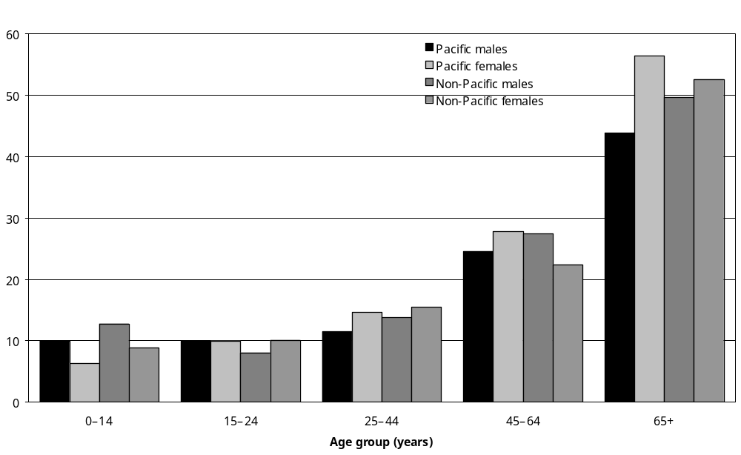
Source: Statistics New Zealand, 2001 Household Disability Survey
Note: Calculated from data in Appendix Table 9.1B.

Children
Key features of the estimated 5700 Pacific children with disability were:
- Twenty-one percent Pacific peoples with a disability were children, compared with 12 percent for non-Pacific children with a disability.
- Sixty-one percent of Pacific children with disability were male and 39 percent were female, which was similar to non-Pacific children (60 percent and 40 percent respectively).
- Pacific boys living in households had a lower disability rate (10,000 per 100,000 or 10 percent) than non-Pacific boys (12,800 per 100,000 or 13 percent). Pacific girls also had a lower disability rate (6300 per 100,000 or 6 percent) than non-Pacific girls (8900 per 100,000 or 9 percent).

Single and multiple disability
Forty-eight percent of Pacific peoples with disability living in households had a single disability; 52 percent had more than one disability.

By comparison, 43 percent of non-Pacific peoples with disability living in households had a single disability; 57 percent had more than one disability.

Adults
Pacific women with disability aged 25–44 living in households had almost twice the rate for single disability than Pacific men (7700 and 3900 per 100,000 respectively).

Pacific women with disability aged 65 and over living in households had noticeably higher rates for multiple disabilities than Pacific men with disability aged 45–64 (16,100 and 13,200 per 100,000 respectively) and the 65 and over age group (46,000 and 33,300 per 100,000 respectively).

Children
Pacific children with disability living in households had a similar rate of single disability to non-Pacific children (5300 and 5900 per 100,000 respectively).

However, non-Pacific children with disability had a higher rate of multiple disabilities than Pacific children with disability (5000 and 2900 per 100,000 respectively).

Pacific boys with disability had a higher rate of single disability and were almost three times more likely to have multiple disabilities than Pacific girls with disability (4100 and 1600 per 100,000 respectively).

Disability type

Adults
The most common types of disability reported by Pacific adults living in households were:
- mobility disability (an age-standardised prevalence rate of 9800 per 100,000 Pacific adults living in households (see Figure 9.2))
- agility disability (7200 per 100,000)
- hearing disability (3600 per 100,000).

Mobility disability
Mobility disability was the most common disability reported by Pacific adults living in households. Pacific adults living in households had a higher age-standardised rate of mobility disability (9800 per 100,000) than non-Pacific adults living in households (7800 per 100,000).

Table 9.1 shows that Pacific adults living in households had higher rates of mobility disability than non-Pacific adults living in households across all age groups.

Table 9.1: Rates of mobility disability, for Pacific and non-Pacific adults living in households, by age, 2001
Age group | Rate per 100,000
Age group | Pacific | Non-Pacific
15–24 years | 3,000 | 2,100
25–44 years | 6,800 | 5,900
45–64 years | 17,700 | 13,000
65 years and over | 45,800 | 38,100
Source: Statistics New Zealand, 2001 Household Disability Survey

Older Pacific adults (aged 65 and over) living in households had the highest rate (45,800 per 100,000) of mobility disability of all Pacific adults living in households.

Pacific women reported more mobility disability than Pacific men. Pacific women aged 65 years and over living in households had noticeably higher rates of mobility agility (50,500 per 100,000) than Pacific men aged 65 and over living in households (39,400 per 100,000).

Agility disability
Agility disability was the second most common type of disability reported by Pacific adults living in households.

Pacific adults living in households had a higher age-standardised rate of agility disability (7200 per 100,000) than non-Pacific adults living in households (6100 per 100,000).

Table 9.2 shows that Pacific adults living in households had higher rates of agility disability than non-Pacific adults living in households across all age groups.

Table 9.2: Rates of agility disability, for Pacific and non-Pacific peoples living in households, by age, 2001
Age group | Rate per 100,000
Age group | Pacific | Non-Pacific
15–24 years | 1,900 | 1,200
25–44 years | 5,000 | 4,400
45–64 years | 12,900 | 11,000
65 years and over | 34,700 | 29,400
Source: Statistics New Zealand, 2001 Household Disability Survey

Older Pacific adults (aged 65 and over) living in households had the highest rate (34,700 per 100,000) of agility disability of all Pacific adults living in households.

Pacific women had higher rates of agility disability than Pacific men. Pacific women aged 65 and over living in households had noticeably higher rates of agility disability (42,100 per 100,000) than Pacific men aged 65 and over living in households (24,600 per 100,000).

Hearing disability
Hearing disability was the third most common type of disability reported by Pacific adults living in households. However, Pacific adults living in households were less likely (with an age-standardised rate of 3600 per 100,000) to have a hearing disability than non-Pacific adults living in households (4800 per 100,000).

Table 9.3 shows that Pacific adults had higher rates of hearing disability at a younger age than non-Pacific adults, but older non-Pacific adults had higher rates of hearing disability than Pacific adults.

Pacific adults aged 65 and over living in households had the highest rate (13,400 per 100,000) of hearing disability of all Pacific adults living in households.

Table 9.3: Rates of hearing disability, for Pacific and non-Pacific peoples living in households, by age, 2001
Age group | Rate per 100,000
Age group | Pacific | Non-Pacific
15–24 years | 2,600 | 1,400
25–44 years | 3,500 | 3,300
45–64 years | 5,600 | 9,200
65 years and over | 13,400 | 22,200
Source: Statistics New Zealand, 2001 Household Disability Survey
Pacific women 65 years and over living in households had slightly higher rates (13,900 per 100,000) of hearing disability than Pacific men aged 65 and over living in households (12,700 per 100,000). In contrast, Pacific men aged 45–64 living in households were more likely to have a hearing disability (6100 per 100,000) than Pacific women in the same age group (5100 per 100,000).

Figure 9.2: Age-standardised rates of different disability types for Pacific and non-Pacific adults living in households, 2001
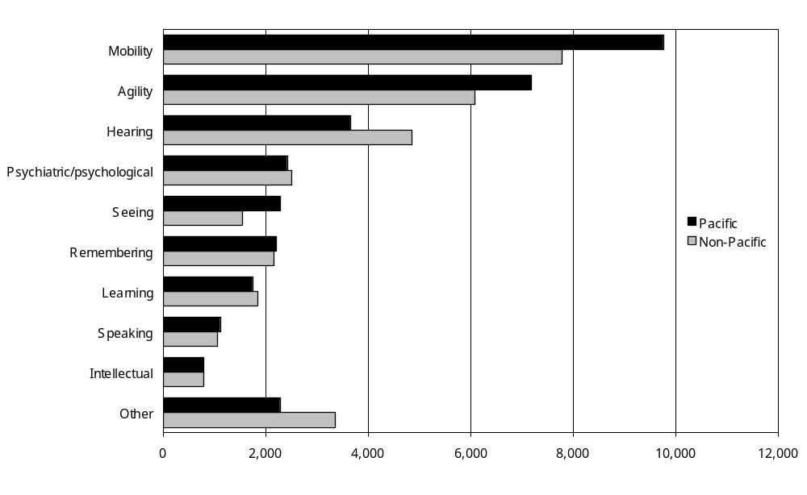
Source: Statistics New Zealand, 2001 Household Disability Survey
Notes:
- Data in Appendix Table 9.3B.
- If individuals reported more than one disability type, they were counted in each applicable disability type category.

Children
In 2001, Pacific children living in households reported the following types of disability:
- chronic conditions/health problems (3100 per 100,000)
- use of special education (2200 per 100,000)
- hearing disability (2000 per 100,000)
- psychological/psychiatric disability (1700 per 100,000)
- speaking disability (1500 per 100,000)
- intellectual disability (900 per 100,000)
- seeing disability (800 per 100,000)
- use of technical aids (300 per 100,000)
- other type of disability (1000 per 100,000).

Non-Pacific children living in households reported higher rates in each of these types of disability, compared with Pacific children living in households.

Pacific boys had higher rates of disability for most types of disability than Pacific girls.

Figure 9.3: Rates of different disability types for Pacific and non-Pacific children aged 0–14 living in households, 2001
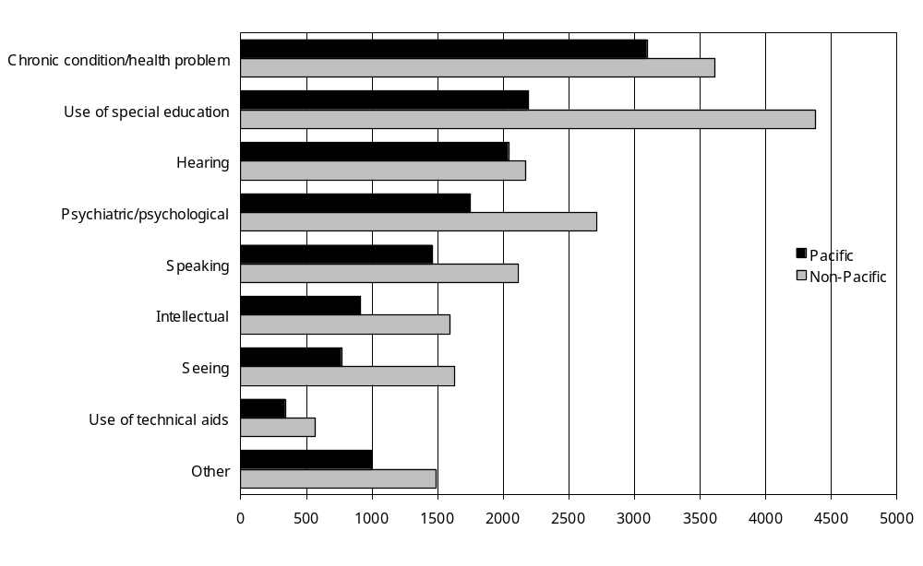
Source: Statistics New Zealand, 2001 Household Disability Survey
Notes:
- Data in Appendix Table 9.4B.
- If individuals reported more than one disability type, they were counted in each applicable disability type category.

Specific disability

Adults
Table 9.4 lists the 10 most common types of disability reported by Pacific adults living in households (people may have had more than one difficulty). Pacific adults were mostly affected by mobility difficulties. Overall, Pacific adults were more likely to have mobility difficulties than non-Pacific adults.

Table 9.4: Percentage of Pacific and non-Pacific adults with disability living in households who had a difficulty with, or were unable to carry out, specific activities, 2001
Disability type | Pacific adults with disability  (%) | Non-Pacific adults with disability  (%)
Walking up to 350 m | 39 | 36
Walking up and down stairs | 38 | 31
Carrying 5 kg for 10 m | 37 | 30
Standing for 20 minutes | 28 | 28
Bending to pick something up off floor | 26 | 25
Cutting own toenails | 22 | 25
Hearing conversation when talking with three others | 22 | 33
Reaching in any direction | 16 | 15
Remembering (because of condition or health problem) | 14 | 14
Hearing conversation when talking with one other | 14 | 17
Source: Statistics New Zealand, 2001 Household Disability Survey

Children
Table 9.5 lists the 10 most common types of disability reported by Pacific children living in households. Pacific children were most likely to have uncorrected deafness or trouble hearing, long-term emotional difficulties and severe asthma. Pacific children reported higher rates of deafness and asthma than non-Pacific children. Non-Pacific children reported higher rates for all other disability types.

Table 9.5: Percentage of Pacific and non-Pacific children with disability living in households, with specific types of disability, 2001
Disability type | Pacific children with disability  (%) | Non-Pacific children with disability  (%)
Deafness, trouble with hearing – not corrected | 25 | 20
Long-term emotional/nervous problems | 21 | 25
Severe asthma | 20 | 13
Trouble speaking and being understood aged 2 years and older | 18 | 19
Learning difficulty | 16 | 29
Has Individual Education Programme or Individual Development Programme | 12 | 20
Activity limitation due to condition/health problem | 12 | 14
Intellectual disability/developmental delay | 11 | 15
Attends special school due to condition/health problem | 10 | 14
Blindness, trouble with eyesight – not corrected | 9 | 15
Source: Statistics New Zealand, 2001 Household Disability Survey

Main disability

Adults
Over half (53 percent) of Pacific adults with disability reported a physical disability (mobility or agility disability) as the main type of disability that most limited their everyday activities. By comparison, 46 percent of non-Pacific adults reported physical main disabilities.

Mobility disability
Mobility disability was the most common main disability reported by Pacific adults with disability. Forty-three percent of Pacific adults with disability had mobility disability as their main disability, compared with 34 percent of non-Pacific adults.

Mobility main disabilities were most common in Pacific adults aged 65 and over with disability (65 percent) and 45–64 (49 percent), compared with 47 percent and 32 percent respectively in non-Pacific adults with disability.

Pacific men with disability aged 65 and over (68 percent) reported the highest rate of mobility main disability, compared with 38 percent of non-Pacific men with disability. In the same age group, a greater percent of Pacific women (64 percent) had mobility disability as their main disability than non-Pacific women with disability (53 percent).

Mobility main disability was noticeably higher among Pacific women with disability (49 percent) than non-Pacific women with disability (39 percent) and Pacific men with disability (34 percent).

Hearing disability
The second most common type of main disability was hearing disability. Eleven percent of Pacific adults with disability had a hearing disability, compared with 16 percent of non-Pacific adults with disability.

Hearing main disability was most common among Pacific women aged 15–24 with disability (25 percent).

Agility disability
The third most common type of main disability was agility disability. Ten percent of Pacific adults with disability had agility disability as their main disability, compared with 12 percent of non-Pacific adults with disability.

Agility main disability was most common among Pacific men aged 45–64 with disability (16 percent).

Severity of disability
Forty-four percent of Pacific peoples with disability living in households reported having mild disability, which was similar to the proportion of non-Pacific peoples (43 percent) (Figure 9.4).

A smaller proportion of Pacific peoples with disability living in households had moderate disability than non-Pacific peoples (32 percent and 45 percent respectively) (Figure 9.5).

However, a greater proportion of Pacific peoples with disability living in households had severe disability than non-Pacific peoples (24 percent and 12 percent respectively) (Figure 9.6).

Figure 9.4: Rates of mild disability among Pacific and non-Pacific peoples (adults and children) living in households, by age and sex, 2001
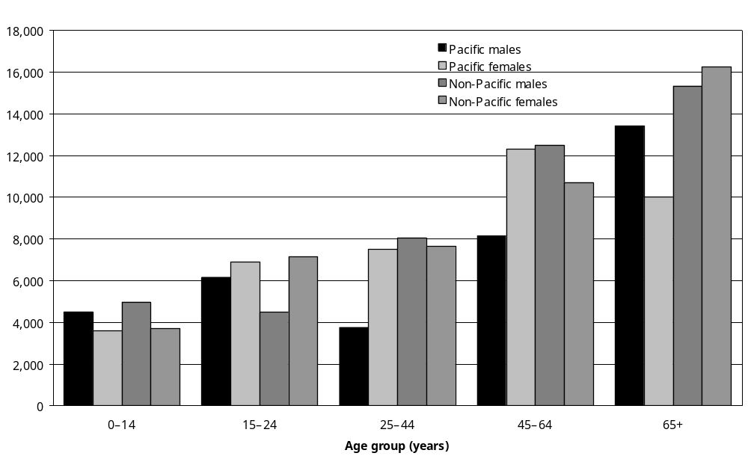
Source: Statistics New Zealand, 2001 Household Disability Survey
Note: Data in Appendix Table 9.1B.

Figure 9.5: Rates of moderate disability among Pacific and non-Pacific peoples living in households, by age and sex, 2001
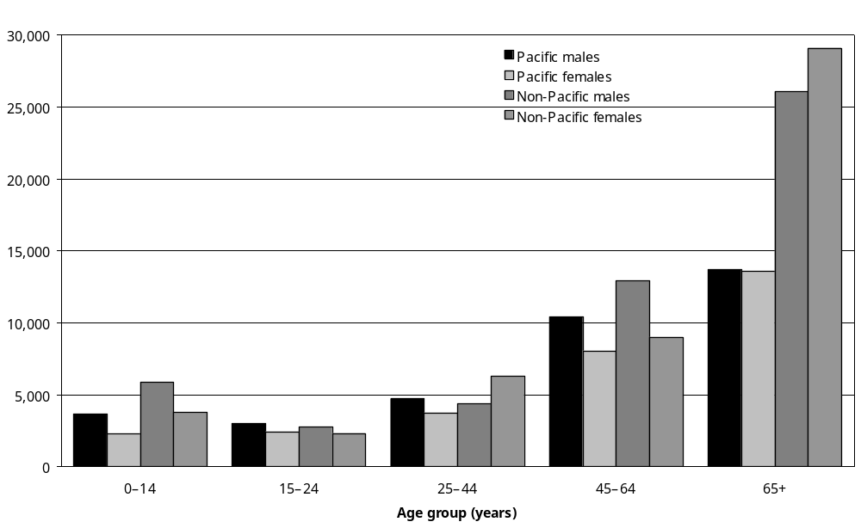
Source: Statistics New Zealand, 2001 Household Disability Survey
Note: Data in Appendix Table 9.1B.
Figure 9.6: Rates of severe disability among Pacific and non-Pacific peoples (adults and children) living in households, by age and sex, 2001
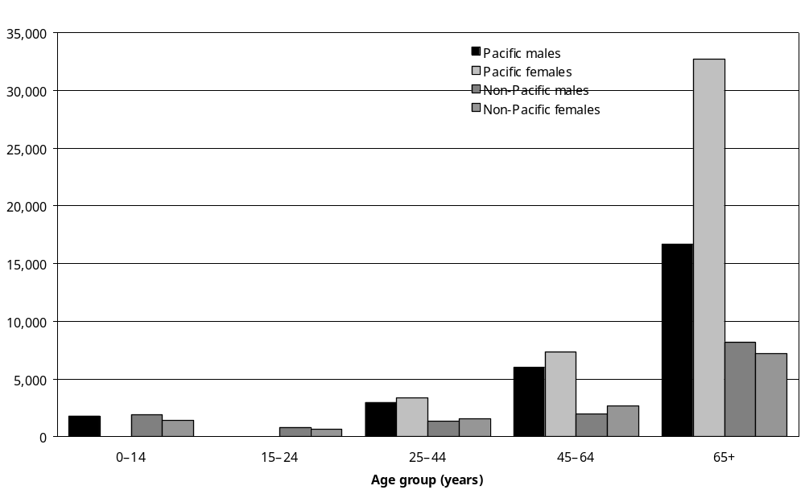
Source: Statistics New Zealand, 2001 Household Disability Survey
– Percentages too small to report (estimated frequencies outside the 70 percent relative sampling error cut-off point).
Note: Data in Appendix Table 9.1B.

Adults
Pacific adults aged 65 and over living in households were almost three times more likely to have severe disability than non-Pacific adults in the same age group (25,900 and 7700 per 100,000 respectively).

Pacific women aged 65 and over living in households were twice as likely to have severe disability than Pacific men aged 65 and over (32,700 and 16,700 per 100,000 respectively). Pacific women in this age group were also over four times more likely to have severe disability than non-Pacific women (32,700 and 7200 per 100,000).

Children
Pacific children living in households had slightly lower disability rates for all three severity levels (mild, moderate and severe) than non-Pacific children.

Cause of disability
Pacific peoples had their disability caused by disease/illness (41 percent) or accident/injury (23 percent), being present at birth (13 percent), ageing (11 percent) or other causes (18 percent).

Adults
Among Pacific adults living in households, the most common cause of disability was disease/ illness (with an age-standardised rate of 6400 per 100,000), followed by accident/injury (3800 per 100,000) and ageing (3000 per 100,000). The least common cause of disability among Pacific adults living in households was disability present at birth (1100 per 100,000).

Overall, the causes of disability were similar for Pacific and non-Pacific adults living in households.

Pacific women living in households were more likely than Pacific men to have a disability caused by disease/illness or ageing. In contrast, Pacific men were more likely to have disability caused by accident/injury than Pacific women.

Children
Among Pacific children living in households, disease/illness (3500 per 100,000) was the most common cause of disability, followed by conditions present at birth (2300 per 100,000).

The rate for disease/illness was the same for Pacific and non-Pacific children living in households (3500 per 100,000). However, non-Pacific children were twice as likely as Pacific children to have a disability present at birth (4600 per 100,000 compared with 2300 per 100,000).

Duration of disability
The majority (68 percent) of Pacific peoples with disability living in households reported having a disability lasting from 1 to 14 years. One-quarter had experienced a disability lasting 15 years or more.

Pacific peoples with disability living in households were less likely than non-Pacific peoples living in households to have a disability lasting 15 years or more (25 percent compared with 37 percent).

Services and support for Pacific peoples
This section indicates the range of support services, equipment and technology used or needed by Pacific peoples with disability living in households.

Type of assistance received

Adults

Help with everyday activities
In 2001, nearly half (48 percent) of Pacific adults with disability received some kind of help from other people with everyday activities, compared with 39 percent of non-Pacific adults with disability (Figure 9.7).

Figure 9.7: Percentage of Pacific and non-Pacific adults living in households who received help for everyday activities, by age, 2001
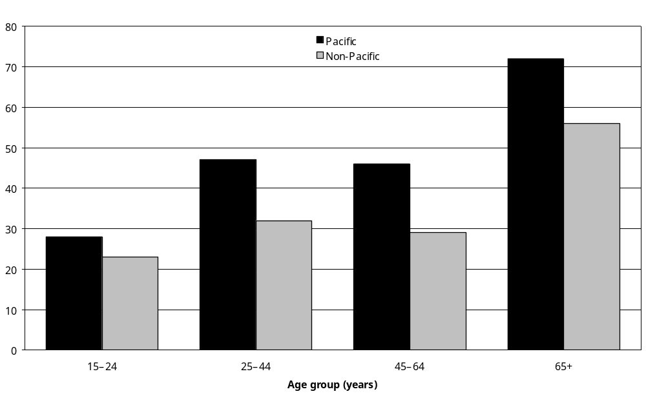
Source: Statistics New Zealand, 2001 Household Disability Survey
Note: Data in Appendix Table 9.33.

In all age groups, the proportion of Pacific adults with disability receiving help was greater than non-Pacific adults with disability. For example, 72 percent of Pacific adults with disability aged 65 and over reported receiving help from other people with everyday activities, compared with 56 percent of non-Pacific peoples in the same age group.

Meal preparation
A quarter of Pacific adults with disability reported receiving help with meal preparation because of disability, compared with 10 percent of non-Pacific adults with disability (Figure 9.8).

Figure 9.8: Percentage of Pacific and non-Pacific adults living in households who received help for different everyday activities, 2001
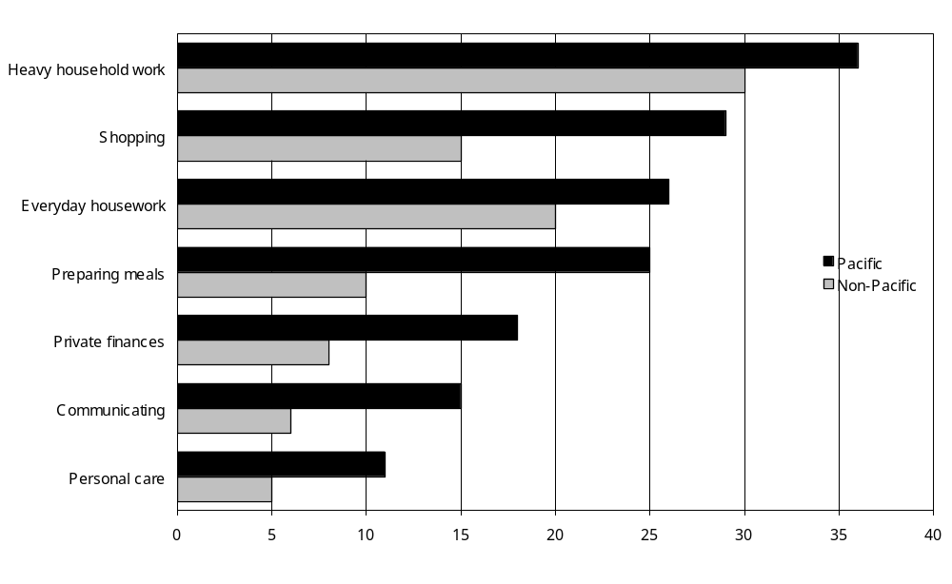
Source: Statistics New Zealand, 2001 Household Disability Survey
Note: Data in Appendix Table 9.34.

Shopping
Almost a third (29 percent) of Pacific adults with disability reported receiving help from others with shopping because of disability, compared with 15 percent of non-Pacific adults with disability.

Everyday housework
Just over a quarter (26 percent) of Pacific adults with disability reported getting help with everyday housework because of disability, compared with 20 percent of non-Pacific adults with disability.

Heavy household work
Just over a third (36 percent) of Pacific adults with disability reported getting help with heavy household work because of disability, compared with 30 percent of non-Pacific adults with disability.

Private finances
Eighteen percent of Pacific adults with disability reported getting help with their personal finances such as banking or paying bills because of disability, compared with 8 percent of non-Pacific peoples with disability.

Personal care
Eleven percent of Pacific adults with disability reported getting help with their personal care such as dressing or bathing because of disability, compared with 5 percent of non-Pacific-people with disability.

Communicating with others
Fifteen percent of Pacific adults with disability reported receiving help with communicating with others because of disability, such as when they went to a doctor, compared with 6 percent of non-Pacific adults with disability.

Children

Family help with personal care or household work for children
In the previous 12 months, the parents or caregivers of 14 percent of Pacific children with disability had needed help with their child’s personal care or with household work related to their child having a disability. This compared with the parents or caregivers of 13 percent of non-Pacific children with disability.

Needs assessments

Adults
Pacific adults with disability were less likely (8 percent) than non-Pacific adults with disability (15 percent) to have had a needs assessment of their personal care and support needs for everyday living.

Half (50 percent) of Pacific adults with disability indicated they had not had a needs assessment recently (that is, within 12 months) because they did not know about needs assessments. In comparison, 34 percent of non-Pacific adults with disability had not had a needs assessment recently because they did not know about needs assessments.

Children
Pacific children with disability (11 percent) were slightly less likely to have received a needs assessment than non-Pacific children with disability (15 percent).

Not knowing about needs assessments was more common among the parents or caregivers of Pacific children with disability (47 percent), than among the parents or caregivers of non-Pacific children with disability (35 percent).

Health service use in previous 12 months

Adults and children

Family doctor or general practitioner
Pacific peoples with disability (87 percent) were just as likely as non-Pacific peoples with disability (86 percent) to have seen a family doctor or a general practitioner (GP) in the previous 12 months. However, Pacific children with disability (91 percent) were slightly more likely than non-Pacific children with disability (87 percent) to have consulted with their family doctor or GP (Figure 9.9).

Figure 9.9: Percentage of Pacific and non-Pacific peoples (adults and children) with disability living in households who had used different types of health service in the previous 12 months, 2001
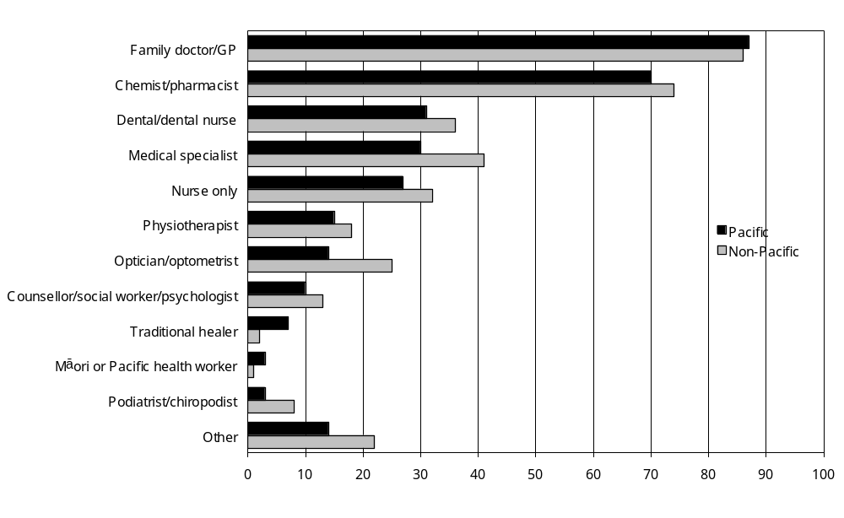
Source: Statistics New Zealand, 2001 Household Disability Survey
Note: Data in Appendix Table 9.28.

Nurse
In the previous 12 months, Pacific peoples with disability (27 percent) were slightly less likely than non-Pacific peoples with disability (32 percent) to have seen a nurse without seeing a doctor at the same time.

In particular, Pacific adults aged 25–64 (25 percent) and 65 and over (22 percent) with disability were less likely to have consulted a nurse, than non-Pacific adults aged 25–64 (32 percent) and 65 years and over (32 percent).

Chemist/pharmacist
Pacific peoples with disability (70 percent) were slightly less likely than non-Pacific peoples (74 percent) to have consulted a chemist or pharmacist in the previous 12 months. While more Pacific children with disability (68 percent) saw a chemist than non-Pacific children with disability (61 percent), fewer Pacific youth and young adults (15–24 years) with disability (56 percent) saw a chemist than non-Pacific youth and young adults with disability (64 percent).

Dentist/dental nurse
Pacific peoples with disability (31 percent) were less likely than non-Pacific peoples (36 percent) to see a dentist or dental nurse in the previous 12 months. In particular, Pacific adults aged
45–64 with disability (19 percent) were less likely to have consulted a dentist or dental nurse than non-Pacific adults aged 45–64 with disability (33 percent).

Physiotherapist
Fifteen percent of Pacific peoples with disability had seen a physiotherapist in the previous 12 months, compared with 18 percent of non-Pacific peoples.

Medical specialist
Thirty percent of Pacific peoples with disability had consulted a medical specialist in the previous 12 months, compared with 41 percent of non-Pacific peoples with disability. This smaller proportion of consultation occurred in each age group.

In particular, Pacific young people aged 15–24 (17 percent) were less likely to have consulted a medical specialist than non-Pacific young people (30 percent). Also, adults aged 45–64 with disability (32 percent) were also less likely to have consulted a medical specialist than non-Pacific adults with disability (45 percent).

Counsellor/social worker/psychologist
Ten percent of Pacific peoples with disability had consulted a counsellor, social worker or psychologist in the previous 12 months, compared with 13 percent of non-Pacific peoples with disability. Pacific peoples had a smaller proportion of consultation in each age group.

In particular, Pacific young people (aged 15–24) with disability (12 percent) were less likely to have consulted a counsellor than non-Pacific young people with disability (23 percent). Also, Pacific adults aged 25–44 with disability (12 percent) were less likely to have consulted a counsellor than non-Pacific adults with disability (21 percent).

Optician
Fourteen percent of Pacific peoples with disability had consulted an optician or optometrist in the previous 12 months, compared with 25 percent of non-Pacific peoples with disability.

The lower proportion of consultation occurred mainly in younger and older age groups. In particular, Pacific children with disability (9 percent) were less likely to have consulted an eye specialist than non-Pacific children with disability (19 percent). Pacific adults aged 45–64 with disability (18 percent) were less likely to have consulted an eye specialist than non-Pacific adults with disability (26 percent). Finally, Pacific adults aged 65 and over with disability (16 percent) were less likely to have consulted an eye specialist than non-Pacific older adults with disability (34 percent).

Traditional healer
According to Sui Ne’emia (2003), alternative health options, including traditional Pacific healing, are seen by Pacific peoples as the most wanted services for physical wellbeing, particularly for stroke and musculo-skeletal conditions and for older people and family members with a disability.

Seven percent of Pacific peoples with disability had consulted a traditional healer in the previous 12 months, compared with 2 percent of non-Pacific peoples with disability.

Ten percent of Pacific adults aged 45–64 and 10 percent of Pacific adults aged 65 and over-reported using a traditional healer.

Pacific health worker
Eight hundred (3 percent) of Pacific peoples with disability had used a Pacific (or Mäori) health worker in the previous 12 months. This was similar to 4500 Mäori (4 percent) with disability who used a Mäori (or Pacific) health worker in the previous 12 months.

Use of equipment and technology
Twenty-one percent of Pacific peoples with disability reported using equipment and technology, compared with 30 percent of non-Pacific peoples with disability.

Adults
Pacific men and women aged 65 and over with disability used special equipment the most (49 percent and 46 percent respectively). However, this was slightly less than non-Pacific men and women aged 65 and over with disability (56 percent and 52 percent respectively).

Pacific adults with disability most commonly used equipment for mobility purposes (an estimated 3000 or 14 percent), followed by equipment for seeing (an estimated 1400 or 6 percent) and equipment for hearing (an estimated 900 or 4 percent).

Children
Only a few Pacific children with disability (an estimated 200 or 3 percent) reported using special hearing equipment. This was similar to the level of special hearing equipment use in non-Pacific children.

Unmet needs for services and support

Unmet need for help with everyday activities
Most (92 percent) Pacific adults with disability did not have an unmet need for help with everyday activities (that is, personal care, housework, shopping or home repairs and maintenance). This was the same proportion as non-Pacific adults with disability.

Among the 8 percent of Pacific adults with disability who had an unmet need for help, Pacific adults in the 45–64 age group had the highest level (12 percent) of unmet need.

Unmet need for help with personal care of child or household work
Most (89 percent) Pacific children with a disability had not had an unmet need for family help with personal care or household work because of the child’s disability. This was a similar proportion as for non-Pacific children with disability (91 percent).

Unmet need for equipment and technology
Twelve percent of Pacific peoples with disability reported an unmet need for equipment and technology. This was the same proportion as for non-Pacific peoples with disability.

Among Pacific peoples with disability, Pacific men with disability aged 65 and over (31 percent) reported the highest level of unmet equipment need. By comparison, 16 percent of non-Pacific men with disability aged 65 and over had unmet equipment needs. Pacific women with disability aged 45–64 (18 percent) reported the next highest level of unmet equipment need. This was higher than the proportion of non-Pacific women with disability in the same age group (13 percent).

Unmet need for health services
Seventeen percent of Pacific peoples with disability reported an unmet need for at least one type of health service in the previous 12 months, compared with 15 percent of non-Pacific peoples with disability.

Among Pacific peoples with disability, adults aged 45–64 reported the highest proportion of unmet need (21 percent) for some type of health service. This compared with 16 percent of non-Pacific adults aged 45–64 with disability (Figure 9.10).

Figure 9.10: Percentage of Pacific and non-Pacific peoples with disability living in households who reported an unmet need for health services in the previous 12 months, by age, 2001
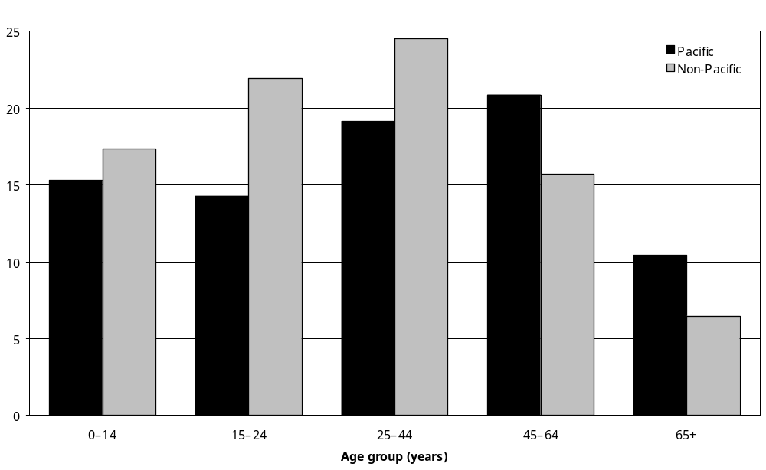
Source: Statistics New Zealand, 2001 Household Disability Survey
Note: Data in Appendix Table 9.29.

Fifteen percent of Pacific children with disability reported some type of unmet need, which was similar to the rate for non-Pacific children (17 percent).

Fourteen percent of Pacific peoples with disability aged 15–24 reported some type of unmet need for health services, compared with 22 percent of non-Pacific peoples in the same age group.

Ten percent of Pacific peoples with disability aged 65 and over reported an unmet need for health services, compared with 6 percent of non-Pacific peoples with disability in the same age group.

Education

Assessments of developmental and educational need
Pacific children (18 percent) with disability were less likely than non-Pacific children (39 percent) to have been professionally assessed to determine their developmental and educational needs.

Educational qualifications

With disability
In 2001, 34 percent of Pacific adults with disability (an estimated 7500 people) had no school or post-school qualifications (Figure 9.11). This was similar to the proportion of non-Pacific adults with disability who had no school or post-school qualifications (31 percent).

Among Pacific and non-Pacific adults with disability who had no qualifications, Pacific women with disability were the most likely (37 percent) to have no qualifications, followed by non-Pacific women with disability (31 percent), then Pacific men with disability (30 percent).

Figure 9.11 shows the age groups the most likely not to have school or post-school qualifications.

Figure 9.11: Percentage of Pacific and non-Pacific adults with and without disability living in households with no educational qualifications, by age, 2001
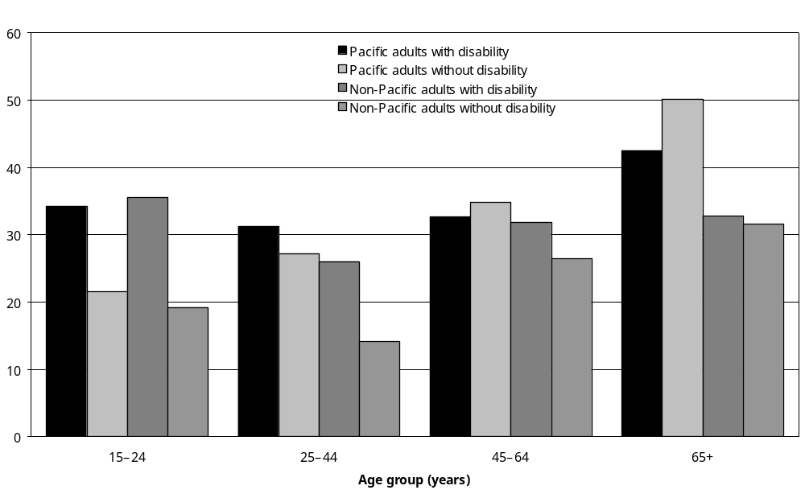
Source: Statistics New Zealand, 2001 Household Disability Survey
Note: Data in Appendix Tables 9.20 and 9.21.
Twenty-nine percent of Pacific adults with disability (an estimated 6300 adults) had a school qualification. Again, this was similar to the proportion of non-Pacific adults with disability who had a school qualification (27 percent).

Figure 9.12 shows the age groups the most likely to have a school qualification.

Figure 9.12: Percentage of Pacific and non-Pacific adults with and without disability living in households with a school qualification, by age, 2001
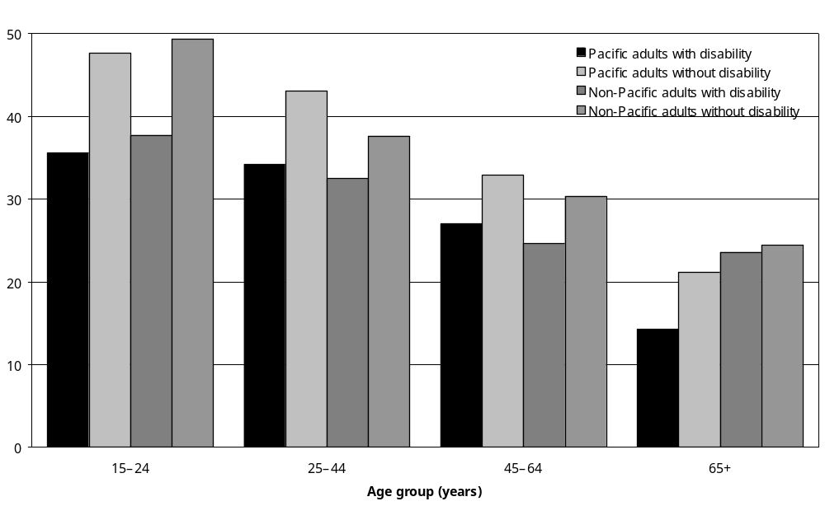
Source: Statistics New Zealand, 2001 Household Disability Survey
Note: Data in Appendix Tables 9.20 and 9.21.

Seven percent of Pacific adults with disability (an estimated 1600 people) had a post-school qualification. This was much lower than the proportion of non-Pacific adults with disability who had a post-school qualification (22 percent), reflecting Pacific peoples being generally less likely than non-Pacific peoples to have post-school qualifications. The proportion of Pacific adults without disability who had post-school qualifications was 13 percent, somewhat higher than the 7 percent of Pacific adults with disability who had these qualifications.

Figure 9.13 shows the age groups the most likely to have a school qualification.

Figure 9.13: Percentage of Pacific and non-Pacific adults with and without disability living in households with a post-school qualification, by age, 2001
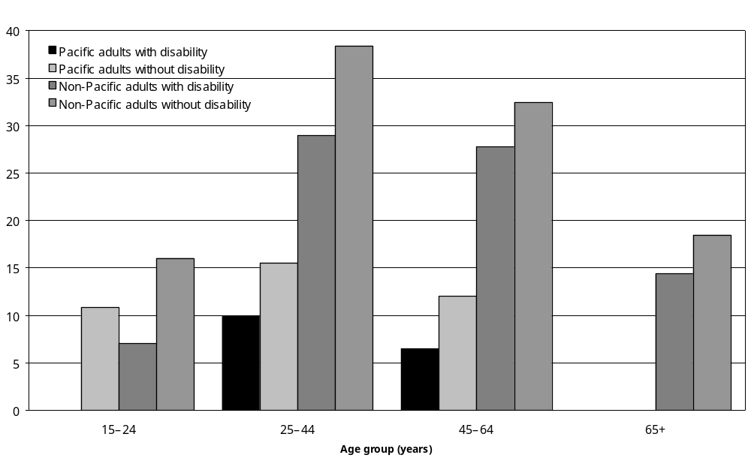
Source: Statistics New Zealand, 2001 Household Disability Survey
– Percentages too small to report (estimated frequencies outside the 70 percent relative sampling error cut-off point).
Note: Data in Appendix Tables 9.20 and 9.21

Enrolment in formal education or training
In 2001, levels of enrolment in formal education and training (for example, secondary school, polytechnic or university) were similar for Pacific and non-Pacific adults with disability. Ten percent of Pacific adults with disability were enrolled in education and training, compared with 9 percent of non-Pacific adults with disability. However, a lower percentage of Pacific adults aged 25–44 with disability (8 percent) were enrolled in formal education or training than non-Pacific adults with disability in the same age group (14 percent) (Figure 9.14).

Figure 9.14: Percentage of Pacific and non-Pacific adults with disability living in households enrolled in formal education, by age, 2001
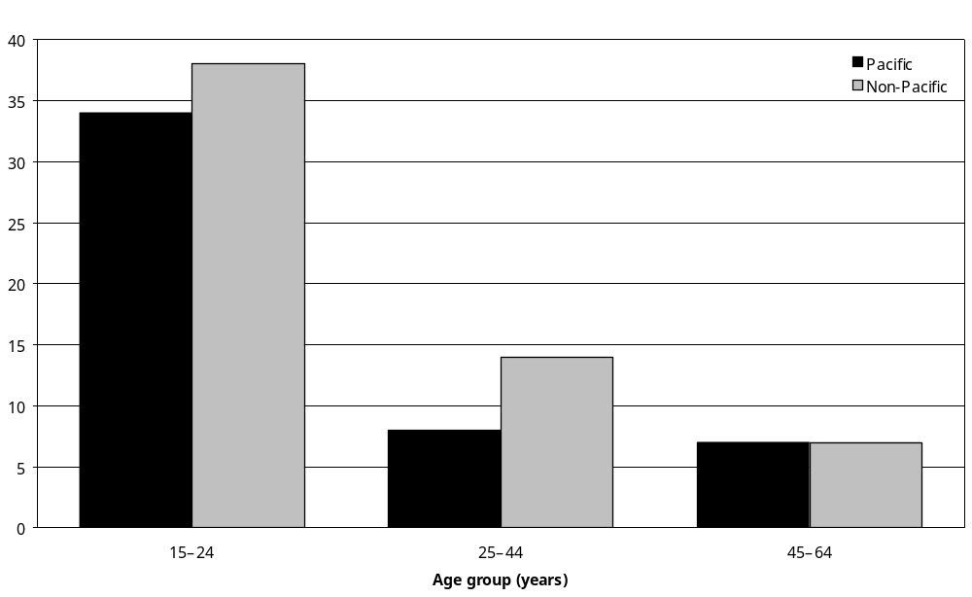
Source: Statistics New Zealand, 2001 Household Disability Survey
Note: Data in Appendix Table 9.22.

Work and income

Labour force status

Not in the labour force
In 2001, more than half (55 percent) the Pacific adults with disability living in households reported not being in the labour force. This was similar to the proportion of non-Pacific adults with disability not in the labour force (56 percent).

However, Pacific men aged 25–44 with disability had a higher rate of non-participation in the labour force than non-Pacific men with disability in the same age group (37 percent compared with 18 percent) (Figure 9.15). The same was the case for Pacific men aged 45–64 with disability compared with non-Pacific men with disability in the same age group (52 percent compared with 33 percent). This reflects Pacific men being generally less likely to be in the labour force than non-Pacific men.

Figure 9.15: Percentage of Pacific and non-Pacific adult males with and without disability living in households who were not in the labour force, by age, 2001
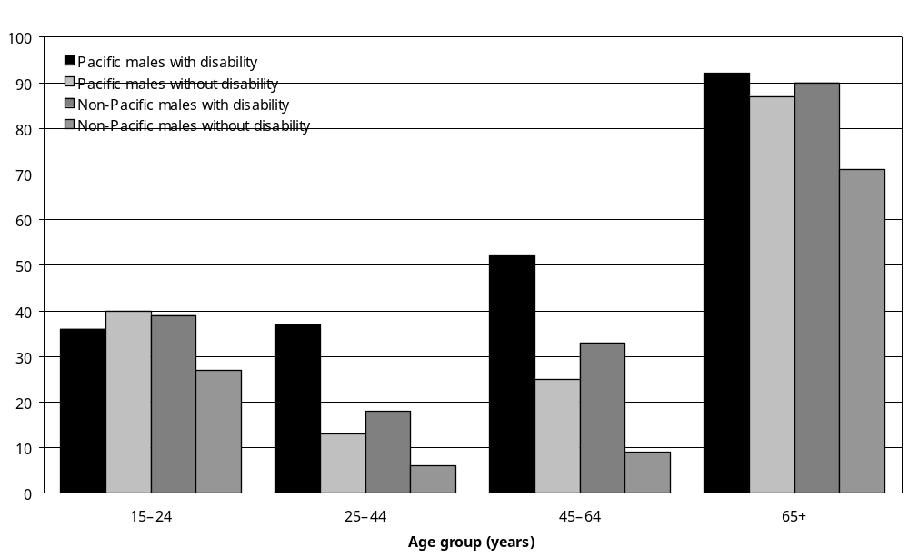
Source: Statistics New Zealand, 2001 Household Disability Survey
Note: Data in Appendix Tables 9.11 and 9.12.

Pacific women with disability had a higher rate of non-participation in the labour force (59 percent) than Pacific men with disability (50 percent). This was especially the case in the 45–64 age group, where 65 percent of Pacific women with disability were not in the labour force, compared with 52 percent of Pacific men with disability (Figures 9.15 and 9.16).

Figure 9.16: Percentage of Pacific and non-Pacific adult females with and without disability living in households who were not in the labour force, by age, 2001
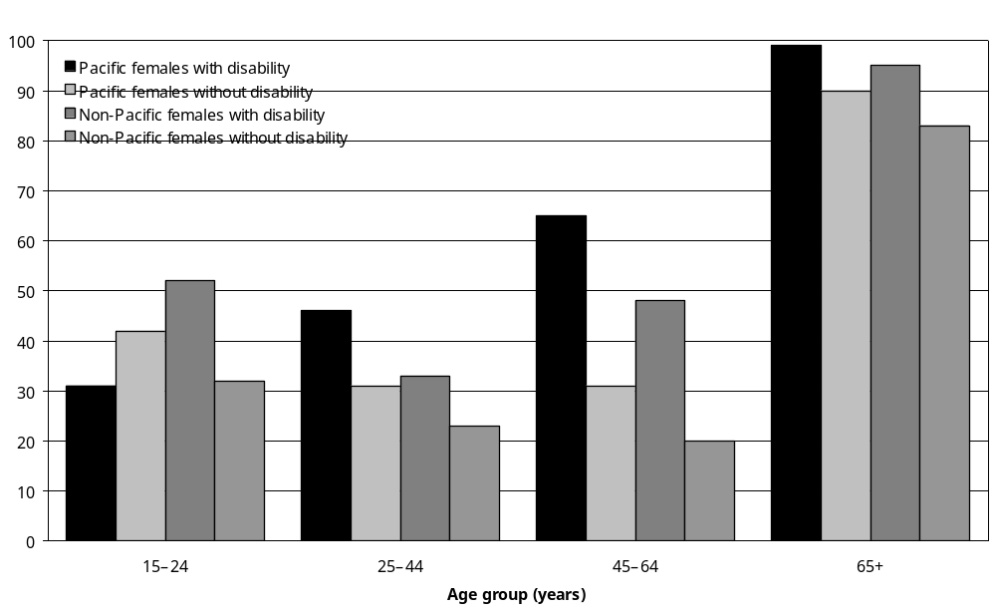
Source: Statistics New Zealand, 2001 Household Disability Survey
Note: Data in Appendix Tables 9.11 and 9.12.

Pacific peoples with disability had a higher rate of non-participation in the labour force than Pacific peoples without disability (55 percent and 31 percent respectively).

Unemployed
In 2001, Pacific adults with disability reported the same unemployment rate as Pacific adults without disability (10 percent). By comparison, the unemployment rate was lower in non-Pacific adults with disability and non-Pacific adults without disability (both 4 percent).

However, unemployment rates were comparatively high among Pacific peoples with disability in certain age (see Figure 9.17) and gender groups. In particular, 37 percent of Pacific women aged 15–24 with disability were unemployed.

Figure 9.17: Percentage of Pacific and non-Pacific adults with and without disability living in households who were unemployed, by age, 2001
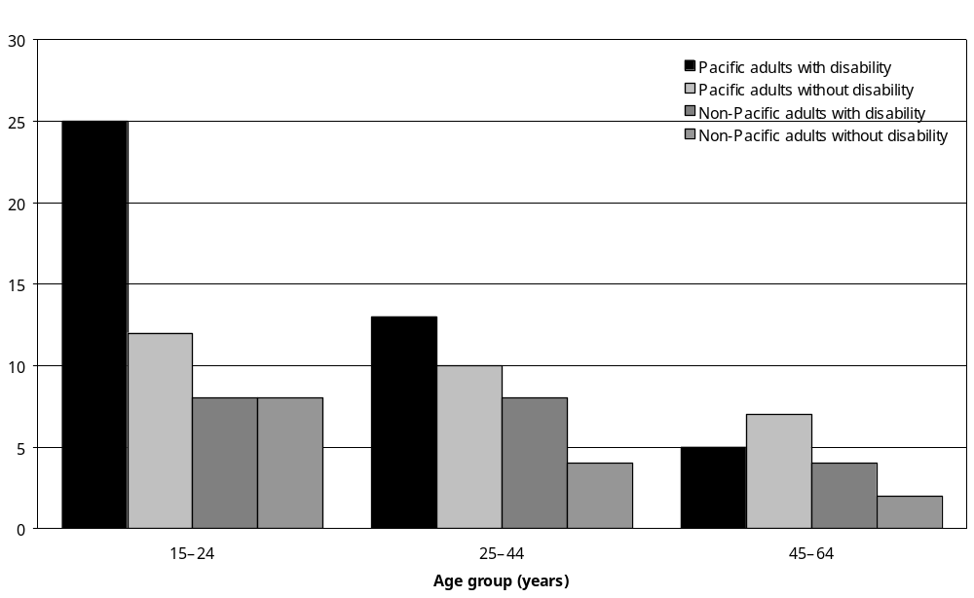
Source: Statistics New Zealand, 2001 Household Disability Survey
Note: Data in Appendix Tables 9.11 and 9.12.

Employed
Pacific adults with disability were slightly less likely to be employed than non-Pacific adults with disability (34 percent compared with 40 percent).

Pacific adults with disability were less likely to be employed than Pacific adults without disability. About a third (34 percent) of Pacific adults with disability reported they were employed, compared with 57 percent of Pacific adults without disability. Pacific male adults with disability were less likely to be employed (43 percent) than Pacific male adults without disability (64 percent). Pacific female adults with disability were less likely to be employed (27 percent) than Pacific female adults without disability (51 percent).

Figures 9.18 and 9.19 show the employment rates by age group for Pacific and non-Pacific adult males and females.

Figure 9.18: Percentage of Pacific and non-Pacific adult males with and without disability living in households who were employed, by age, 2001
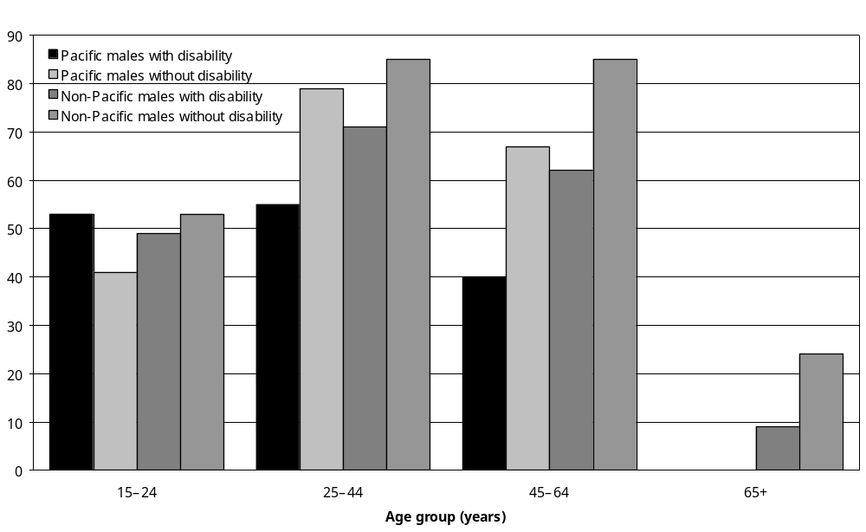
Source: Statistics New Zealand, 2001 Household Disability Survey
– Percentages too small to report (estimated frequencies outside the 70 percent relative sampling error cut-off point).
Note: Data in Appendix Tables 9.11 and 9.12.

Figure 9.19: Percentage of Pacific and non-Pacific adult females with and without disability living in households who were employed, by age, 2001
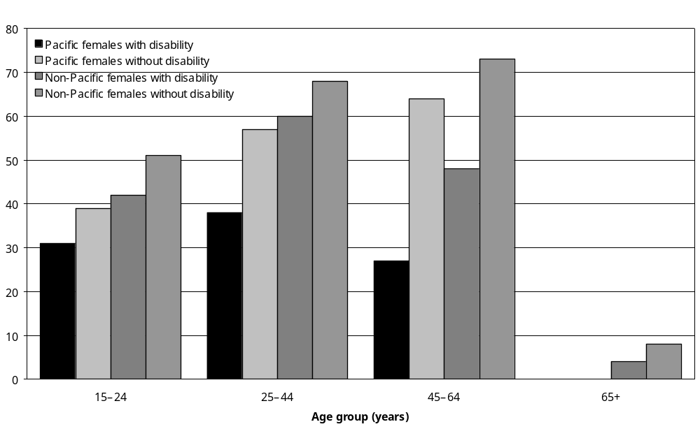
Source: Statistics New Zealand, 2001 Household Disability Survey
– Percentages too small to report (estimated frequencies outside the 70 percent relative sampling error cut-off point).
Note: Data in Appendix Tables 9.11 and 9.12.

Status in employment
Pacific adults with disability were as likely to be employees (57 percent) as non-Pacific adults with disability (54 percent). However, non-Pacific adults with disability were much more likely to be self-employed or an employer than Pacific adults with disability.

Pacific adults with disability were less likely to be employees (57 percent) than Pacific adults without disability (81 percent).

Child Disability Allowance
The Child Disability Allowance is paid to the parents or guardians of children requiring constant care and attention because of severe disability. Parents or caregivers of Pacific children with disability (11 percent) were less likely to receive the allowance than parents or caregivers of non-Pacific children with disability (19 percent).

Community Wage – Sickness Benefit
The Community Wage – Sickness Benefit is an income-tested payment to adults who are temporarily unable to work because of disability, sickness, injury or pregnancy. Pacific adults with disability (17 percent) were more likely to receive this benefit than non-Pacific adults with disability (7 percent).

Community Services Card
The Community Services Card subsidises the cost of visits to family doctors. Two-thirds (66 percent) of Pacific adults with disability held this card, compared with 54 percent of non-Pacific adults with disability.

Pacific children with disability (72 percent) were more likely than non-Pacific children with disability (43 percent) to hold a Community Services Card.

Socioeconomic areas
Nearly three-quarters (72 percent) of Pacific peoples with disability were living in the most socioeconomically deprived areas (NZDep2001 7–10). This compares with just 42 percent of non-Pacific peoples with disability, reflecting Pacific peoples being generally more likely than non-Pacific peoples to live in the most socioeconomically deprived areas.

However, Pacific peoples with disability (72 percent) were slightly less likely than Pacific peoples without disability (81 percent) to live in the most socioeconomically deprived areas (NZDep2001 7–10).

Personal income
In 2001, almost half (46 percent) of the Pacific adults with disability had personal incomes of $15,000 and under per year. This was similar to the proportion of non-Pacific adults with disability with personal incomes of $15,000 and under per year (49 percent).

Pacific adults with disability were more likely than Pacific adults without disability to be in the $15,000 and under personal income group (46 percent compared with 36 percent). Further, Pacific men with disability aged 15–24 were most likely be in the lowest income group.

House and amenities

Household composition
Fifteen percent of Pacific adults with disability lived in two-family households, compared with 3 percent of non-Pacific adults with disability.

Eleven percent of Pacific children with disability lived in two-family households, compared with just 3 percent of non-Pacific children with disability.

Social marital status
Pacific adults with disability (48 percent) were less likely to be partnered than non-Pacific adults with disability (54 percent).

Housing tenure

Owned or partly owned
Pacific peoples with disability (32 percent) were just as likely to live in dwellings they owned or partly owned as Pacific adults without disability (34 percent), but much less likely than non-Pacific adults with disability (58 percent).

Rented or not owned
Pacific peoples with disability (48 percent) were more likely to live in dwellings that they rented or did not own than non-Pacific peoples with disability (23 percent). However, Pacific peoples with disability were slightly less likely to live in dwellings they did not own than Pacific peoples without disability (52 percent).

Accommodation Supplement
Pacific adults with disability (22 percent) were more likely to be receiving the Accommodation Supplement than non-Pacific adults with disability (13 percent).

Forty-four percent of Pacific adults with disability knew about the Accommodation Supplement. This was higher than the rate for non-Pacific adults with disability (40 percent).

Access to telephone, fax and internet
Seventy-one percent of Pacific adults with disability had access to a telephone at home. This was less than the proportion of non-Pacific adults with disability (81 percent).

Pacific children with disability (68 percent) had less access to a telephone at home than non-Pacific children with disability (77 percent).

Pacific adults with disability (13 percent) had less access to home internet facilities than non-Pacific adults with disability (26 percent).

Pacific children with disability (16 percent) also had less access to the internet at home than non-Pacific children with disability (36 percent).

Transport

Long distance travel
Nearly half the Pacific peoples with disability (48 percent) had made a long-distance trip, that is, a trip of more than 80 km or the equivalent of one hour’s travelling on the open road, in the previous year. This was much smaller than the proportion of non-Pacific peoples with disability (73 percent) who had made a long trip during this time.

Difficulty travelling long distances
Pacific adults with disability (11 percent) were more likely to have a disability that stopped them from travelling long distances than non-Pacific adults with disability (6 percent).

Need for vehicle
Pacific adults with disability (13 percent) were more likely to indicate a need to buy a vehicle because of disability than non-Pacific adults with disability (4 percent).

Motor vehicles in households
Sixty-four percent of Pacific peoples with disability lived in households with access to at least one motor vehicle, compared with 72 percent of non-Pacific peoples with disability and 76 percent of Pacific peoples without disability.

Driver of motor vehicle
Pacific adults with disability (41 percent) were less likely to be drivers of private motor vehicles than non-Pacific adults with disability (65 percent).

Use of buses
Pacific adults with disability (50 percent) living in a place with a bus service were more likely to have used a bus service to travel short distances at least once in the previous 12 months than non-Pacific adults with disability (22 percent).

Use of taxis
Pacific peoples with disability (40 percent) were more likely to have used a taxi for short trips at least once in the previous 12 months compared with non-Pacific peoples with disability (32 percent).

Pacific peoples with disability (11 percent) were slightly more likely than non-Pacific peoples with disability (7 percent) to use a taxi for short trips every day. They were also more likely to use a taxi once a month or more (10 percent compared with 6 percent).

Total Mobility Scheme
Three-quarters of Pacific peoples with disability (75 percent), including 81 percent of people aged 65 and over, had not heard of the Total Mobility Scheme. This compares with 66 percent of non-Pacific peoples with disability.

Unmet need for financial help for transport costs
Seventeen percent of Pacific peoples with disability said they needed financial help for transport costs in the previous 12 months, but were unable to get this help. This compared with just 8 percent of non-Pacific peoples with disability.

Pacific children with disability reported the highest rates of unmet need for financial help for transport costs (24 percent), followed by Pacific adults aged 45–64 (22 percent).

Pacific adults with disability living in residential facilities
In 2001, an estimated 500 Pacific adults with disability lived in residential facilities such as rest homes, private hospitals and long-stay residential units. This was just 2 percent of Pacific peoples with disability, compared with 4 percent of non-Pacific peoples with disability.

Of the estimated 500 Pacific adults with disability in residential facilities, over 400 (80 percent) were aged 65 and over, and an estimated 200 (40 percent) were living in rest homes or homes for older people.

Several factors may account for the low number of Pacific peoples with disability living in residential facilities. Many of these facilities cater for older clients; whereas Pacific peoples with disability tend to be younger than non-Pacific peoples with disability. Pacific peoples are also more likely to live in an extended family situation, which may include more than one set of related parents, their children and grandchildren. This means older Pacific peoples with disability may be more likely than older non-Pacific peoples to have family members available in their households to care for them.

10 Adults with Disability Living in Residential Facilities

Key points
The 2001 Disability Survey of Residential Facilities looked at adults with disability:
- living in rest homes and homes for older people
- occupying long-stay beds in public and private hospitals
- living in long-stay residential units (with 10 or more residents) for people with an intellectual, a psychiatric or a physical disability or multiple disabilities.

Proportion of adults living in residential facilities
- In 2001, an estimated 27,300 adults, 1 percent of the adult population of New Zealand, had disabilities and were living in residential facilities.
- Thirty-two percent of New Zealand women aged 85 and over and 17 percent of New Zealand men aged 85 and over had disabilities and were living in residential facilities.

Features of adults with disability living in residential facilities
- In 2001, 4 percent of New Zealand’s estimated 653,800 adults with disability were living in residential facilities.
- Most adults with disability living in residential facilities (92 percent) were aged 65 and over, including 45 percent aged 85 and over. Eight percent were aged 16–64. Over two-thirds (69 percent) were women.
- Most adults with disability living in residential facilities were European (86 percent – an estimated 23,500 adults). Ten percent were Asian/Other (an estimated 2700 adults), 2 percent were Mäori (an estimated 700 adults) and 2 percent were Pacific (an estimated 500 adults).

Types of residential facilities
- More than two-thirds of adults with disability living in residential facilities lived in rest homes or homes for older people (69 percent or an estimated 18,900 people). A further 25 percent, an estimated 6900 people, lived in private hospitals.
- Twenty-two percent of adults aged 15–64 with disability living in residential facilities were living in mental health units. Another 21 percent were living in intellectual disability units, physical disability units or multiple disability units.

Length of stay
- More than three-quarters of adults with disability living in residential facilities (79 percent) had lived in these facilities for five years or less. Only a small proportion, 8 percent, had lived in residential facilities for 11 years or more.

Patterns of disability
- Eighty-three percent of adults with disability living in residential facilities had severe disability, meaning they required daily assistance from someone.
- Ninety-six percent of adults with disability living in residential facilities had multiple disabilities. The other 4 percent had a single disability.
- Mobility disability was the most common type of disability. Ninety-five percent of women and 86 percent of men with disability living in residential facilities had mobility disability.
- Eighty-nine percent of adults with disability living in residential facilities had agility disability.
- Over half the adults with disability living in residential facilities (55 percent) had recall or memory disability (remembering disability).
- Disease/illness was the most common cause of disability. Sixty-eight percent of adults with disability living in residential facilities had disabilities caused by disease/illness. The next most common cause was ageing (affecting 37 percent) followed by accident/injury (affecting 23 percent).

Need for assistance
- Of the estimated 27,300 adults with disability living in residential facilities an estimated:
- 22,600 (83 percent) were getting help from someone with personal care such as bathing, dressing or taking medication
- 24,300 (89 percent) were getting help with shopping for things they needed
- 24,800 (91 percent) were getting help with looking after their personal finances such as doing tax returns or banking
- 16,300 (60 percent) were getting help when communicating with others such as when they saw a doctor.

Use of equipment and technology
- An estimated 24,700 or 91 percent of adults with disability living in residential facilities used some kind of equipment or technology for disability. In particular an estimated:
- 21,600 or 79 percent used some kind of equipment to help them move about such as a walking stick or wheelchair
- 1200 or 4 percent used some kind of equipment to support, replace or help them use their hands or arms
- 21,600 or 79 percent used other kinds of equipment including shower stools, raised toilet seats, commode chairs, specialised cushions, a respirator, a ventilator, a helping hand or grabbing stick, incontinence products or lifting equipment such as belts or a hoist.
- Of the estimated 11,000 adults living in residential facilities with an uncorrected hearing disability 36 percent, an estimated 4000 adults, were using some kind of equipment, technology or services for people who were deaf or hard of hearing. This included 4 percent who used hearing aids with a T switch and 30 percent (an estimated 3300 people) who used other types of hearing aid.
- Fifty-six percent of adults with an uncorrected seeing disability (an estimated 7000 adults) living in residential facilities used some kind of equipment or services for people who were blind or vision impaired (mainly glasses or contact lenses).

Introduction
The 2001 Disability Survey of Residential Facilities looked at the disability status and disability-related needs of people aged 15 years and over:
- living in rest homes and homes for older people
- occupying long-stay beds in public and private hospitals
- living in long-stay residential units (with 10 or more residents) for people with an intellectual, a psychiatric or a physical disability or with multiple disabilities.

These kinds of facility provide disability support services to individuals who, for a variety of reasons, are unable to be supported in their own homes.

This chapter presents the main results of the survey. Key topics include:
- the age, sex and ethnicity of adults with disability in residential facilities
- facility type and length of stay
- patterns of disability, including the most common types and causes of disability, as well as duration of disability and severity
- types of support, equipment and technology used or needed.

Proportion of adult New Zealanders living in residential facilities
In 2001 an estimated 27,300 adults, 1 percent of the adult population of New Zealand, were living in residential facilities and had a disability.,

The likelihood of having a disability and living in residential care increased with age (Figure 10.1). Almost one in three New Zealand women aged 85 and over (32 percent) and one in six New Zealand men aged 85 and over (17 percent) were living in residential facilities and had a disability.

Figure 10.1: Percentage of adult population who were living in residential facilities and had a disability, by age and sex, 2001
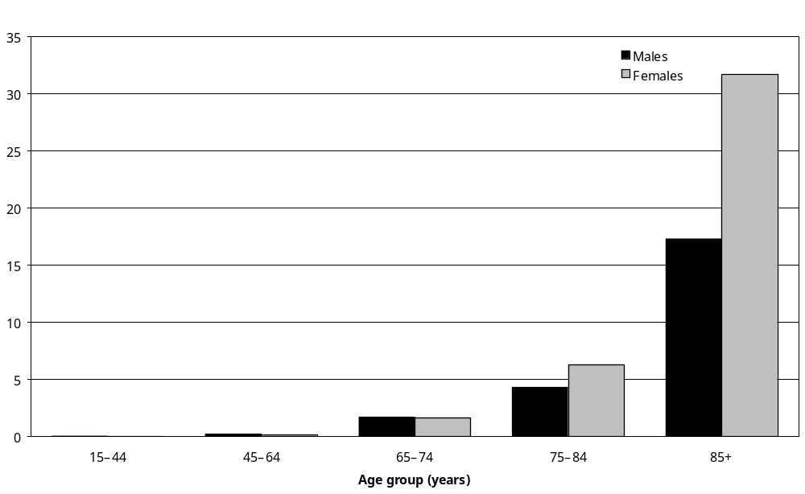
Source: Statistics New Zealand, 2001 Disability Survey of Residential Facilities
Note: Data in Appendix Table 10.1.

Proportion of adults with disability living in residential facilities
In 2001, an estimated 27,300 adults with disability were living in residential facilities. This was 4 percent of New Zealand’s estimated 653,800 adults with disability.

The likelihood of adults with disability living in residential facilities increased with age. A third of women with disability aged 85 and over (35 percent) were in residential facilities, as were 19 percent of men with disability aged 85 and over (Figure 10.2).

Figure 10.2: Percentage of adults with disability who were living in residential facilities, by age and sex, 2001
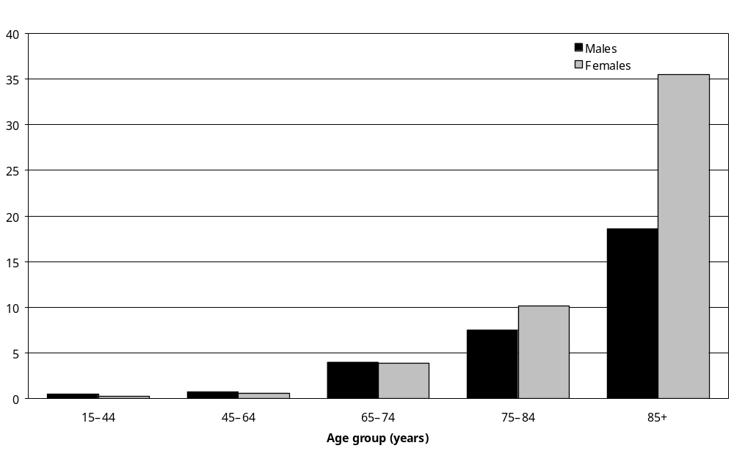
Source: Statistics New Zealand, 2001 Disability Survey of Residential Facilities
Note: Data in Appendix Table 10.2.

Features of adults with disability living in residential facilities

Age
Most (92 percent) of the 27,300 adults with disability living in residential facilities were aged 65 and over, which included:
- 45 percent aged 85 and over (an estimated 12,300 people)
- 32 percent aged 75–84 (an estimated 8600 people)
- 15 percent aged 65–74 (an estimated 4200 people).

Just 8 percent were aged 15–64 (an estimated 2200 people), which included 700 adults aged
25–44 and 1500 aged 45–64 (Figure 10.3).

Sex
Just over two-thirds of adults with disability living in residential facilities were women (an estimated 18,700 or 69 percent), which included an estimated:
- 5900 women aged 75–84
- 9800 women aged 85 and over.

Men made up a nearly a third of the adults with disability living in residential facilities (an estimated 8500 or 31 percent), which included an estimated:
- 2700 men aged 75–84
- 2400 men aged 85 and over.

Figure 10.3 shows the much higher numbers of women than men living in residential facilities in the older age groups.

Figure 10.3: Number of adults with disability living in residential facilities, by age and sex, 2001
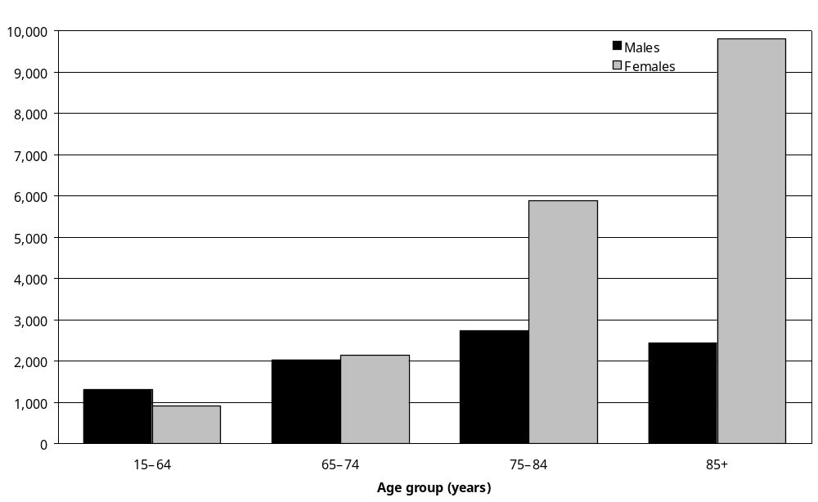
Source: Statistics New Zealand, 2001 Disability Survey of Residential Facilities
Note: Data in Appendix Table 10.3.

Ethnicity
The majority of adults with disability living in residential facilities were European (86 percent or an estimated 23,500 adults). Ten percent (an estimated 2700 adults) were Asian/Other adults. Only a small proportion were Mäori adults (2 percent or an estimated 700 adults) or Pacific adults (less than 2 percent or an estimated 500 adults).

Types of residential facility
Adults with disability living in residential facilities were most likely to live in rest homes or homes for older people. Of the 27,300 adults with disability living in residential facilities, 69 percent, an estimated 18,900 adults, lived in rest homes or homes for older people (Table 10.1).

The next largest group resided in private hospitals (25 percent or an estimated 6900 adults with disability).

Two percent of adults with disability living in residential facilities lived in mental health units, one percent in public hospitals and a further one percent in physical disability units.

As might be expected, older people were more likely than younger people to live in rest homes or homes for older people. Seventy-two percent of people aged 65 and over with disability living in residential facilities were in rest homes or homes for older people, compared with 44 percent of adults aged 15–64 with disability living in residential facilities.

Twenty-two percent of adults aged 15–64 with disability living in residential facilities were living in mental health units; another 21 percent were living in other types of residential facility including intellectual disability units, physical disability units and multiple disability units.

Table 10.1: Number of adults with disability living in residential facilities, by facility type and age group, 2001
Type of facility | Age group
Type of facility | 65 and over |  | 15–64 |  | Total
Type of facility | Number (estimate) | Percent  (%) | Number (estimate) | Percent  (%) | Number (estimate) | Percent  (%)
Rest homes or home for older people | 17,900 | 72 | 1,000 | 44 | 18,900 | 69
Private hospitals | 6700 | 27 | 300 | 11 | 6,900 | 25
Public hospitals | 300 | 1 | – | – | 400 | 1
Mental health units | – | – | 500 | 22 | 500 | 2
Other | – | – | 500 | 21 | 500 | 2
Total | 25,000 | 100 | 2,200 | 100 | 27,300 | 100
Source: Statistics New Zealand, 2001 Disability Survey of Residential Facilities
– Number or percentage too small to report (estimated frequencies outside the 70 percent relative sampling error cut-off point).
Notes:
- The ‘Other’ category comprises intellectual disability units, physical disability units and multiple disability units.
- The sum of the values for each category may differ from the total due to rounding.

Sixty-nine percent of European and 75 percent of both Mäori and Asian/Other adults living in residential facilities were living in rest homes or homes for older people, compared with just 51 percent of Pacific adults living in residential facilities.

Length of stay
Of the estimated 27,300 adults with disability living in residential facilities, an estimated 21,500 or 79 percent had been living in these kinds of facility for five years or less (Figure 10.4).
Only a relatively small proportion, 8 percent or an estimated 2100 people, had been living in residential facilities for 11 years or more.

Figure 10.4: Number of adults with disability living in residential facilities, by length of stay, 2001
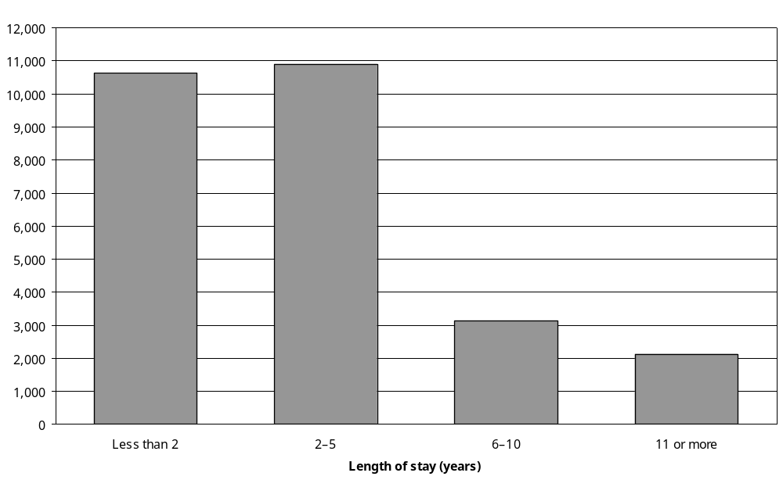
Source: Statistics New Zealand, 2001 Disability Survey of Residential Facilities.
Note: Data in Appendix Table 10.5.
Adults in the 25–44 and 45–64 age groups were more likely than those in the 65 and over age group to have lived in residential facilities for 11 years or more. Thirty-eight percent of adults aged 45–64 had lived in residential facilities for 11 years or more, compared with just 17 percent of adults aged 65–74 and 3 percent of adults aged 75 and over.
People with intellectual disability were most likely to have lived for a long period in residential facilities. Sixty percent of the estimated 800 adults whose main disability was an intellectual disability had lived in residential facilities for 11 years or more. By contrast, only 4 percent of the estimated 10,200 adults whose main disability was a mobility disability had lived in residential facilities for this length of time.
Half (51 percent) of all people with a main disability caused by conditions present at birth had been living in residential facilities for 11 years or more. However, it was uncommon for people whose main disability was caused by disease/illness (4 percent), accident/injury (10 percent) or ageing (6 percent) to have lived in residential facilities for 11 years or more.

Patterns of disability

Disability type

Mobility
Mobility disability was the most common type of disability experienced by adults living in residential facilities. Ninety-five percent of women and 86 percent of men with disability living in residential facilities had mobility disabilities (Figure 10.5).

Sixty-four percent of adults with disability living in residential facilities (about two in every three people) could not walk a distance of 350 metres. Another 18 percent could do this only with difficulty. Sixty-eight percent could not carry a 5 kilogram weight for 10 metres. A further 13 percent could do this only with difficulty.

Figure 10.5: Percentage of adults with disability living in residential facilities with different types of disability, by sex, 2001
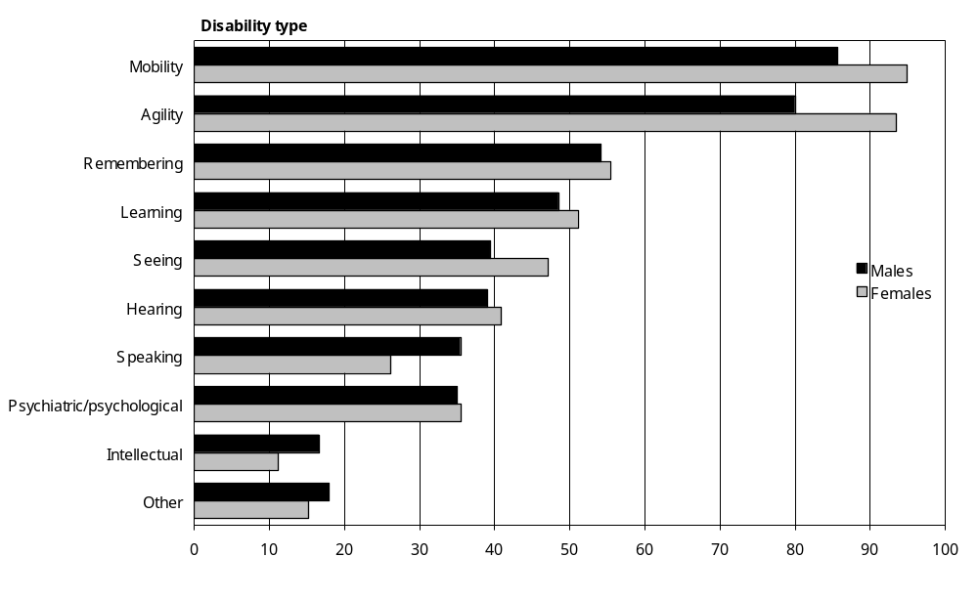
Source: Statistics New Zealand, 2001 Disability Survey of Residential Facilities
Notes:
- Data in Appendix Table 10.6.
- If individuals reported more than one disability type, they were counted in each applicable disability group.
- The ‘Other’ category includes other types of long-term condition or health problem that cause people ongoing difficulty with, or stops them from doing, everyday activities that people their age can usually do.

Agility
Eighty-nine percent of adults with disability living in residential facilities, an estimated 24,300 people, had agility disabilities. This included 45 percent (an estimated 12,300 people) who were not able to bend down to pick up objects off the floor and 37 percent (an estimated 10,000 people) who were not able to dress and undress themselves (Figure 10.5).

Other disabilities
While physical types of disability (that is, mobility and agility disability) were the most common among adults in residential facilities, other types were also prevalent (Figure 10.5).

An estimated 13,700 adults with disability living in residential facilities (50 percent) had learning disability.

Fifty-five percent (an estimated 10,400 women and 4600 men) had disabilities related to recall or memory, defined as an ongoing difficulty with remembering because of a long-term condition or health problem.

Almost half (45 percent or an estimated 12,200 adults) had a seeing disability, including 24 percent who could not see newspaper print and 13 percent who could not see someone’s face across a room.

Forty percent (or an estimated 11,000 adults) had a hearing disability. This included 13 percent who could not hear a conversation with three others and 4 percent who could not hear a conversation with one other person.

Just over a third of adults with disability living in residential facilities (35 percent or an estimated 9600 adults) had a psychiatric/psychological disability. This included an estimated 9100 people with long-term emotional, psychological or psychiatric conditions limiting their everyday activity, and an estimated 6600 people with long-term emotional, psychological or psychiatric conditions limiting their communicating, mixing and socialising.

Thirteen percent of adults with disability living in residential facilities, an estimated 3500 people, had an intellectual disability.

As shown in Figure 10.6, adults aged 15–64 had a somewhat different disability profile compared with adults aged 65 and over. In the 15–64 age group there was a greater prevalence of intellectual and psychiatric/psychological disabilities and a lower prevalence of seeing, hearing and physical disabilities.

Figure 10.6: Percentage of adults with disability living in residential facilities, by disability type and age, 2001
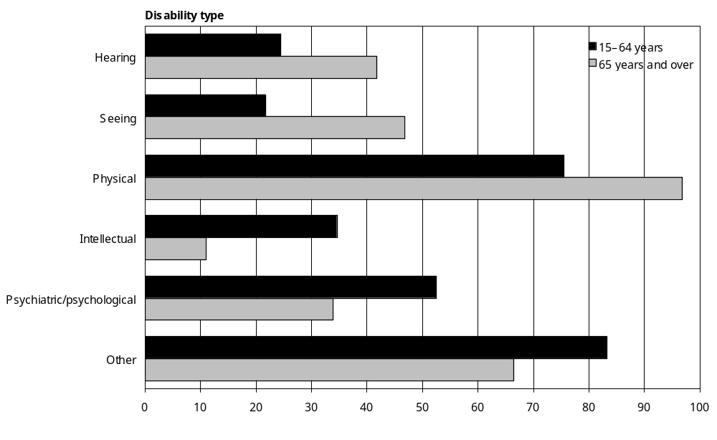
Source: Statistics New Zealand, 2001 Disability Survey of Residential Facilities
Notes:
- Calculated from data in Appendix Table 10.7.
- If individuals reported more than one disability type, they were counted in each applicable disability group.
- The ‘Physical’ category includes mobility disability and agility disability.
- The ‘Other’ category includes speaking, learning and remembering disabilities, and other types of long-term condition or health problem that cause people ongoing difficulty with, or stops them from doing, everyday activities that people their age can usually do.

Main disability
After identifying the different types of disability experienced by adults living in residential facilities, the 2001 Disability Survey of Residential Facilities sought to determine each person’s main disability. Main disability was defined as the disability that most limited a person’s everyday activities.

Mobility disability was the most common type of main disability among adults living in residential facilities. Thirty-eight percent of residents with disability, an estimated 10,200 people, had mobility disability as their main disability (Figure 10.7).

Figure 10.7: Percentage of adults with disability living in residential facilities, by main disability and sex, 2001
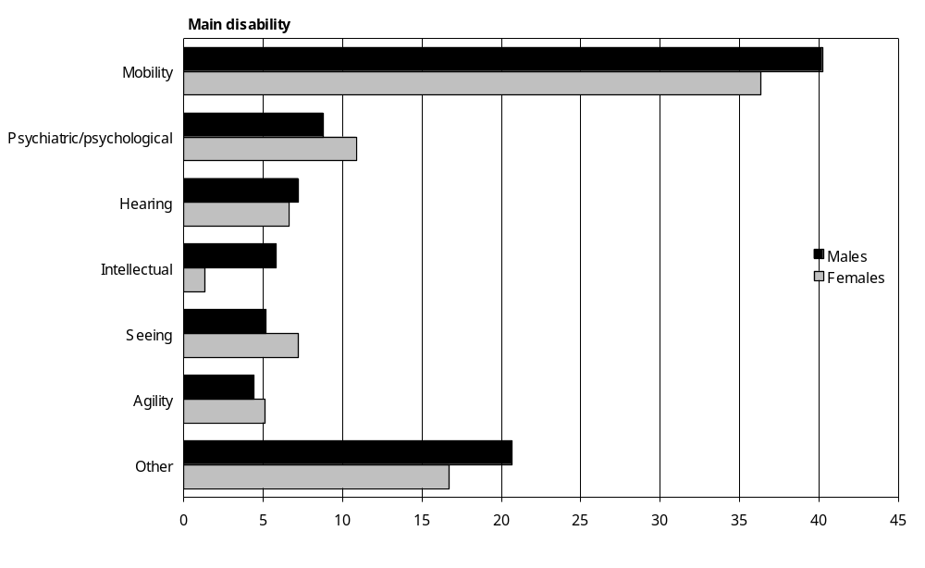
Source: Statistics New Zealand, 2001 Disability Survey of Residential Facilities
Notes:
- Data in Appendix Table 10.8.
- The ‘Other’ category includes speaking, learning and remembering disabilities, and other types of long-term condition or health problem that cause people ongoing difficulty with, or stops them from doing, everyday activities that people their age can usually do.

The second most common type of main disability was psychiatric/psychological disability. Ten percent of adults with disability living in residential facilities, an estimated 2800 people, had a psychiatric/psychological disability as their main disability.

Seven percent of adults with disability living in residential facilities, an estimated 1900 people, had a hearing disability as their main disability. A similar number, 1800, had a seeing disability as their main disability.

Five percent had agility disability as their main disability, despite a considerably higher proportion, 89 percent, having some kind of agility disability (see previous section). Thus, for the majority of adults in residential facilities with agility disability, it was not the agility disability that most limited their everyday activities but another type of disability.

For three percent of adults with disability living in residential facilities, an estimated 800 people, their main disability was an intellectual disability.

Main disability and age
A mobility main disability was substantially more common in the 65 and over age group than in the 15–64 age group (40 percent compared with 16 percent).

Other types of main disability were more prevalent in the 15–64 age group. Twelve percent of adults aged 15–64 had a main disability that was an intellectual disability, compared with only 2 percent of adults aged 65 and over. Sixteen percent of adults aged 15–64 had a main disability that was a psychiatric/psychological disability, compared with 10 percent of adults aged 65 and over.

Main disability and type of residential facility
Almost 9 in every 10 adults living in residential facilities whose main disability was a hearing disability (89 percent) were living in rest homes or homes for older people, rather than in private or public hospitals or other kinds of residential facility. By contrast, only 65 percent of adults whose main disability was an intellectual disability and 58 percent of adults whose main disability was a psychiatric/psychological disability were living in rest homes or homes for older people, rather than other kinds of residential facility.

Twenty-four percent of adults living in residential facilities whose main disability was a psychiatric/psychological disability were living in private hospitals, as were 24 percent of adults whose main disability was a mobility disability. Twenty-two percent of adults whose main disability was a seeing disability and 18 percent of adults whose main disability was an agility disability were living in private hospitals.

Ten percent of adults living in residential facilities whose main disability was a psychiatric/ psychological disability were living in mental health units.

Multiple disability
Almost all adults living in residential facilities (96 percent) had multiple disabilities (that is, more than one type of disability). Even in the two youngest age groups, 15–44 and 45–64, most had multiple disabilities (82 percent and 94 percent respectively).

Women were slightly more likely to have multiple disabilities than men (97 percent compared with 93 percent).

Cause of disability
Disease/illness was the most common cause of disability. Sixty-eight percent of adults with disability living in residential facilities, an estimated 18,600 people, had disabilities caused by disease/illness (Figure 10.8).

Thirty-seven percent, an estimated 10,100 adults, had disabilities caused by ageing, while 23 percent (6300 adults) had disabilities caused by accident/injury. Five percent (1500 adults) had disabilities already existing or occurring at birth.

Figure 10.8: Number of adults with disability living in residential facilities, by cause of disability and sex, 2001
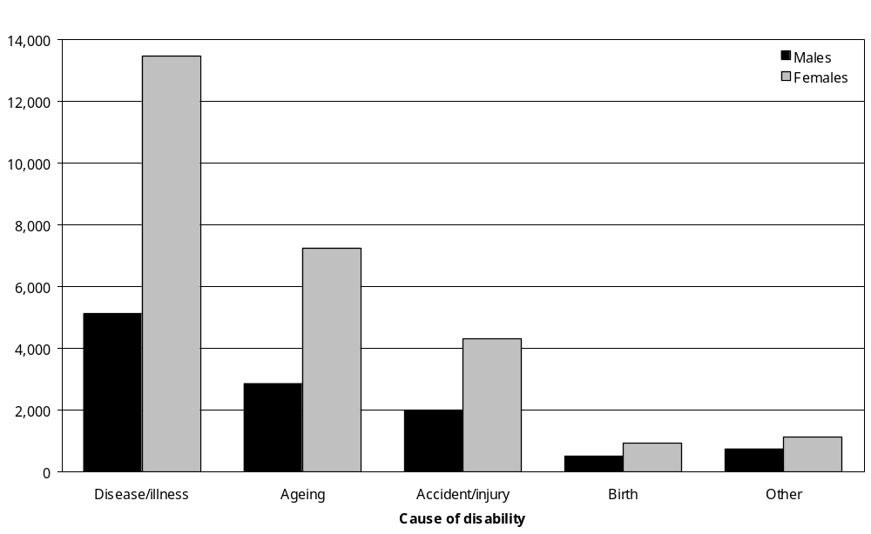
Source: Statistics New Zealand, 2001 Disability Survey of Residential Facilities
Notes:
- Data in Appendix Table 10.10.
- If individuals reported more than one disability type, they were counted in each applicable cause group.

Women outnumbered men for each of the five kinds of disability cause. In particular, far more women than men had disabilities caused by disease/illness and ageing.

Cause of disability and age
Disabilities caused by disease/illness and ageing were increasingly prevalent in the older age groups. Fifty percent of adults aged 15–64 had disabilities due to disease/illness, but this increased to 71 percent in the 75 and over age group (Figure 10.9).

By contrast, the prevalence of disabilities caused by conditions existing or occurring at birth decreased with age.

The prevalence of accident/injury related disabilities was similar in all age groups.

Figure 10.9: Percentage of adults with disability living in residential facilities, by cause of disability and age, 2001
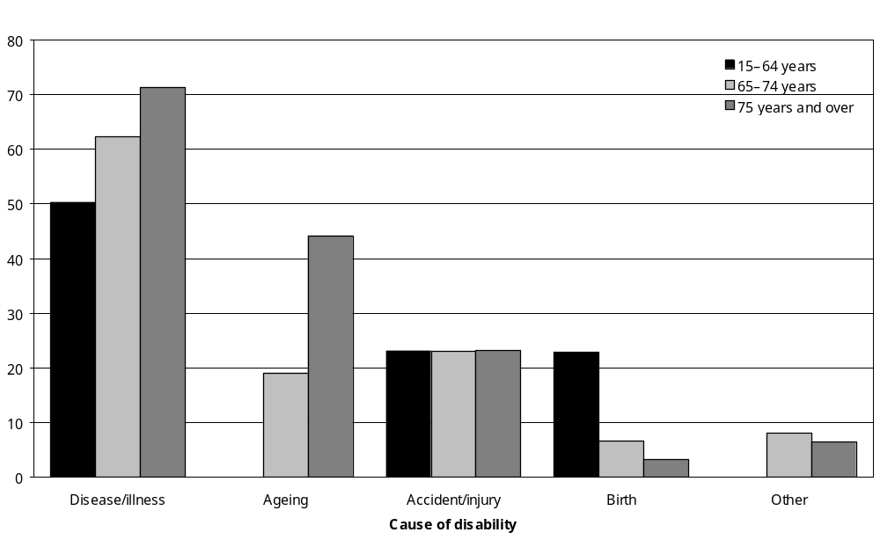
Source: Statistics New Zealand, 2001 Disability Survey of Residential Facilities
– Percentages too small to report (estimated frequencies outside the 70 percent relative sampling error cut-off point).
Notes:
- Data in Appendix Table 10.10.
- If individuals reported more than one disability type, they were counted in each applicable cause group.

Cause of disability by sex
Compared with men living in residential facilities, women living in residential facilities had a higher prevalence of disabilities caused by disease/illness and ageing. However, men and women had a similar prevalence of disabilities caused by accident/injury and conditions present at birth (Figure 10.10).

Figure 10.10: Percentage of adults with disability living in residential facilities, by cause of disability and sex, 2001
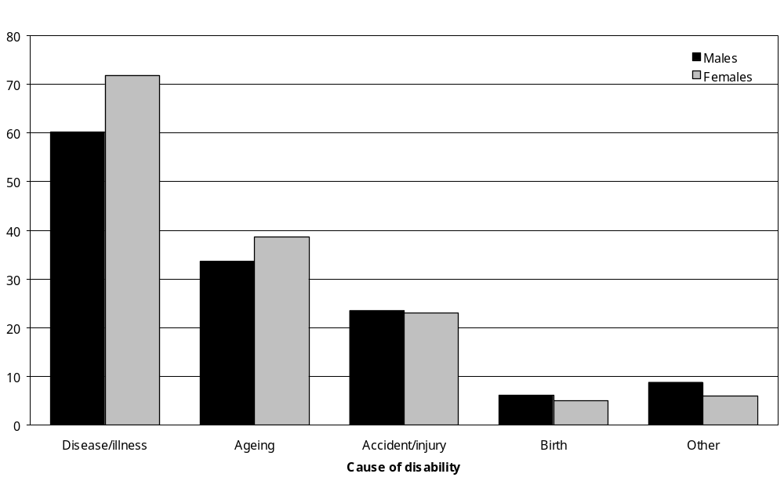
Source: Statistics New Zealand, 2001 Disability Survey of Residential Facilities
Notes:
- Data in Appendix Table 10.10.
- If individuals reported more than one disability type, they were counted in each applicable cause group.

Cause of disability and disability type
Table 10.2 shows the causes of the different types of disability experienced by adults living in residential facilities.

Nearly half (48 percent) of all hearing disabilities were attributed to ageing.

Over half of seeing (53 percent), physical (60 percent) and psychiatric/psychological (61 percent) disabilities were attributed to disease/illness.

Over a third (37 percent) of intellectual disabilities were attributed to disease/illness, while 21 percent were attributed to conditions existing at birth.

The causes of a quarter or more of intellectual (29 percent) and psychiatric/psychological (25 percent) disabilities were not specified.
Table 10.2: Cause of the disability in adults living in residential facilities, by disability type, 2001
Disability type | Disability cause (%)
Disability type | Disease/ illness | Birth | Accident/injury | Ageing | Other | Not specified | Total
Hearing | 31 | 3 | 7 | 48 | 6 | 5 | 100
Seeing | 52 | 2 | 3 | 21 | – | 22 | 100
Physical | 60 | 2 | 21 | 24 | 3 | 13 | 100
Intellectual | 37 | 21 | – | 7 | – | 29 | 100
Psychiatric/psychological | 61 | 3 | – | 6 | 3 | 25 | 100
Other | 42 | 4 | 2 | 12 | 2 | 39 | 100
Source: Statistics New Zealand, 2001 Disability Survey of Residential Facilities
– Percentages too small to report (estimated frequencies outside the 70 percent relative sampling error cut-off point).
Notes:
- The sum of the values for each category may differ from the total due to rounding.
- The ‘Other’ category includes speaking, learning and remembering disabilities, and other types of long-term condition or health problem that cause people ongoing difficulty with, or stops them from doing, everyday activities that people their age can usually do.

Cause of main disability
Disease/illness was the most common cause of the main disabilities experienced by adults living in residential facilities. Half (52 percent) had a main disability that was caused this way.

Fourteen percent had a main disability caused by ageing and 10 percent had a main disability caused by accident/injury.

People in the 65–74 and 75 and over age groups were more likely than people in the 15–64 age group to have a main disability caused by disease/illness. However, they were less likely to have a main disability caused by accident/injury or a condition present at birth (Figure 10.11).

Figure 10.11: Percentage of adults with disability living in residential facilities, by cause of main disability and age, 2001
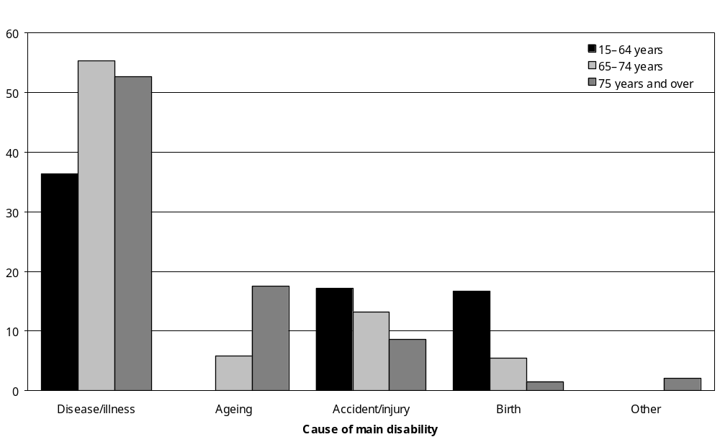
Source: Statistics New Zealand, 2001 Disability Survey of Residential Facilities
– Percentages too small to report (estimated frequencies outside the 70 percent relative sampling error cut-off point).
Note: Data in Appendix Table 10.12.

Severity of disability

Prevalence of severe disability
More than four out of five adults with disability living in residential facilities (83 percent or an estimated 22,600 adults) had severe disability. This meant they received or needed daily help with activities such as bathing, dressing and preparing meals (Figure 10.12).

Another 16 percent of adults with disability living in residential facilities, an estimated 4400 adults, had moderate disability. These people used or needed some type of disability-related equipment or required help with certain heavier or more difficult tasks.

The remaining 1 percent of adults with disability in residential facilities, some 300 people, had mild disability. These people did not require regular help from people or technical aids.

Figure 10.12: Percentage of adults with disability living in residential facilities, by severity of disability, 2001
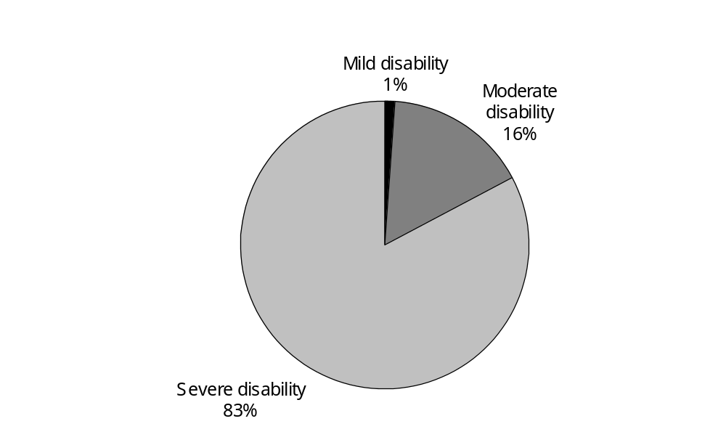
Source: Statistics New Zealand, 2001 Disability Survey of Residential Facilities
Note: Data in Appendix Table 10.13.

Severity of disability by age
Rates of severe disability varied from a high of 86 percent among adults in the 75 and over age group, to a low of 61 percent amongst people in the 15–44 age group (Figure 10.13).

The highest prevalence of moderate disability was in the 15–44 age group (33 percent).

Mild disability was uncommon in all age groups, but was highest in the 45–64 age group (14 percent).

Figure 10.13: Percentage of adults with disability living in residential facilities, by severity of disability and age, 2001
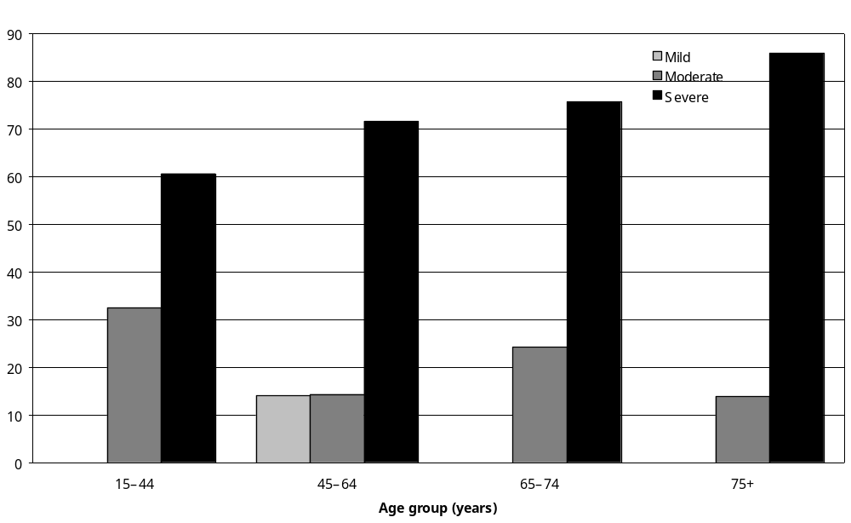
Source: Statistics New Zealand, 2001 Disability Survey of Residential Facilities
– Percentages too small to report (estimated frequencies outside the 70 percent relative sampling error cut-off point).
Note: Data in Appendix Table 10.13.

Severity of disability and type of residential facility
Sixty-five percent of adults living in residential facilities with severe disability were living in rest homes or homes for older people, while 30 percent were living in private hospitals.

Ninety-one percent of adults with moderate disability were living in rest homes or homes for older people.

Severity of disability and main disability
Figure 10.14 shows the disability severity profile of each type of main disability.

A high proportion of adults who had intellectual disability as their main disability were severely disabled (98 percent). This contrasts with adults who had hearing disability as their main disability, only 55 percent of whom were severely disabled.

Figure 10.14: Percentage of adults with disability living in residential facilities, by severity of disability and main disability, 2001
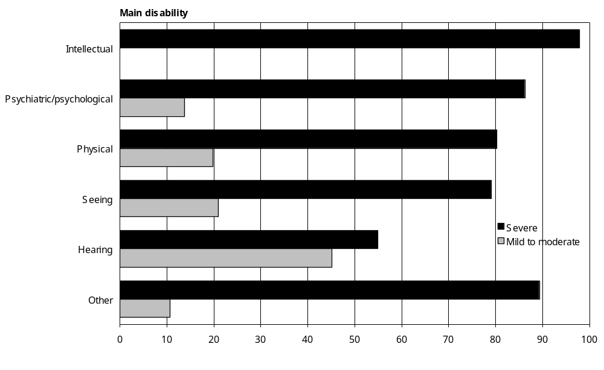
Source: Statistics New Zealand, 2001 Disability Survey of Residential Facilities
– Percentages too small to report (estimated frequencies outside the 70 percent relative sampling error cut-off point).
Notes:
- Data in Appendix Table 10.14.
- The ‘Other’ category includes speaking, learning and remembering disabilities, and other types of long-term condition or health problem that cause people ongoing difficulty with, or stops them from doing, everyday activities that people their age can usually do.

Severity of disability and cause of main disability
Adults living in residential facilities who had a main disability caused by accident/injury had a higher prevalence of severe disability (89 percent) than adults with a main disability caused by a condition present at birth (71 percent) or ‘other’ causes (52 percent) (Figure 10.15).

Figure 10.15: Percentage of adults with disability living in residential facilities, by severity of disability and cause of main disability, 2001
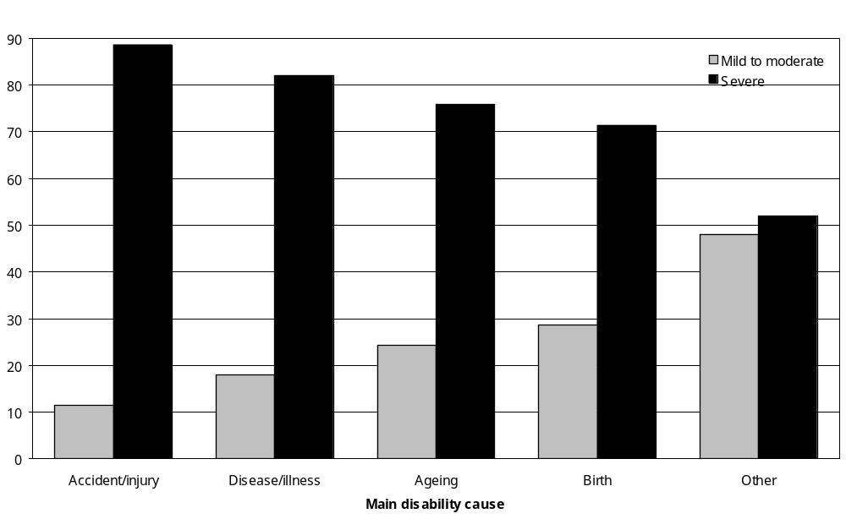
Source: Statistics New Zealand, 2001 Disability Survey of Residential Facilities
Note: Data in Appendix Table 10.15.

Age at onset of first disability
Adults with disability living in residential facilities were asked how old they were when their first (or only) disability began or became apparent. Table 10.3 indicates the results for this question, matched against people’s age at the time of the 2001 Disability Survey of Residential Facilities. This shows that adults aged 15–64 living in residential facilities had a higher prevalence of life-long disability than people aged 65 and over living in residential facilities.

Over half (58 percent) of adults aged 75 and over got their first disability after turning 75, while less than 10 percent got their first disability before age 25.

By contrast, 34 percent of adults aged 15–44 and 38 percent of adults aged 45–64 got their first disability before turning five.

Table 10.3: Age of onset of disability in adults living in residential facilities, by age, 2001
Age of onset of first disability (years) | Current age (years)
Age of onset of first disability (years) | 15–44  (%)  (n=800) | 45–64  (%)  (n=1500) | 65–74  (%)  (n=4200) | 75+  (%)  (n=20,900) | Total  (%)  (n=27,300)
0–4 | 34 | 38 | 15 | 6 | 10
5–14 | – | – | – | – | 1
15–24 | – | – | – | – | 1
25–44 | – | 14 | 12 | 3 | 5
45–64 | N/A | 39 | 36 | 8 | 14
65–74 | N/A | N/A | 31 | 18 | 18
75+ | N/A | N/A | N/A | 58 | 45
Not reported | – | – | – | 5 | 5
Total | 100 | 100 | 100 | 100 | 100
Source: Statistics New Zealand, 2001 Disability Survey of Residential Facilities
– Percentages too small to report (estimated frequencies outside the 70 percent relative sampling error cut-off point).
N/A Not applicable.
Note: The sum of the values for each category may differ from the total due to rounding.

Duration of disability

Longest-lasting disability
Table 10.4 shows the length of time (in years) that adults living in residential facilities had been living with disability, based on the duration of their longest-lasting disability.

The majority of adults aged 15–44 and 45–64 had had disability for 15 years or more (58 percent and 60 percent respectively). This reflects the sizeable percentage of people in these age groups whose first disability began before age 5 (see the previous section).

By contrast, most people in the 65–74 and 75 and over age groups had had disability for less than 15 years (59 percent and 69 percent respectively).

Table 10.4: Duration of longest-lasting disability in adults living in residential facilities, by age, 2001
Duration of longest-lasting disability | Current age (years)
Duration of longest-lasting disability | 15–44  (%)  (n=800) | 45–64  (%)  (n=1,500) | 65–74  (%)  (n=4,200) | 75+  (%)  (n=20,900) | Total  (%)  (n=27,300)
Less than 15 years | 30 | 39 | 59 | 69 | 64
15 years or more | 58 | 60 | 36 | 26 | 30
Unknown | – | – | – | 5 | 5
Total | 100 | 100 | 100 | 100 | 100
Source: Statistics New Zealand, 2001 Disability Survey of Residential Facilities
– Percentages too small to report (estimated frequencies outside the 70 percent relative sampling error cut-off point).
Note: The sum of the values for each category may differ from the total due to rounding.

Duration of main disability
Similar patterns emerge when looking at the duration (in years) of people’s main disability.

Almost half the adults aged 15–44 with disability in residential facilities (46 percent) had their main disability for 15 years or more. This compares with just 9 percent in the 75 and over age group (Table 10.5).

Similarly, two-thirds of people in the 65–74 and 75 and over age groups had their main disability for less than 15 years. This compares with about a third of the 15–44 and 45–64 age groups.

Table 10.5: Duration of main disability in adults living in residential facilities, by age, 2001
Duration of main disability | Current age (years)
Duration of main disability | 15–44  (%)  (n=800) | 45–64  (%)  (n=1,500) | 65–74  (%)  (n=4,200) | 75+  (%)  (n=20,900) | Total  (%)  (n=27,300)
Less than 15 years | 30 | 34 | 64 | 67 | 64
15 years or more | 46 | 40 | 24 | 9 | 14
Unknown | 24 | 27 | 12 | 23 | 22
Total | 100 | 100 | 100 | 100 | 100
Source: Statistics New Zealand, 2001 Disability Survey of Residential Facilities
Note: The sum of the values for each category may differ from the total due to rounding.

Need for help

Help with personal care
Eighty-three percent of adults with disability living in residential facilities, an estimated 22,600 adults, were getting help with personal care such as bathing, dressing or taking medication, because of disability.

People in the 75–84 and 85 and over age groups were the most likely to be getting help with personal care (87 percent and 85 percent respectively), while people in the 25–44 age group were the least likely (62 percent).

Residents of public hospitals (100 percent) and private hospitals (98 percent) were more likely than residents of rest homes (78 percent) and mental health units (61 percent) to be getting help with personal care.

Ninety-eight percent of adults whose main disability was an intellectual disability were getting help with personal care. Adults whose main disability was a psychiatric/psychological disability were also relatively likely to be getting help with personal care (86 percent). By contrast, just 55 percent of adults whose main disability was a hearing disability were getting help with personal care.

A higher percentage of adults with a main disability caused by accident/injury (89 percent) were getting help with personal care than adults with a main disability caused by disease and illness (82 percent), ageing (76 percent) or conditions present at birth (71 percent).

All the adults with severe disability living in residential facilities were getting assistance with their personal care.

Help with shopping
Because of disability, 89 percent of adults with disability living in residential facilities, an estimated 24,300 people, got help with shopping for things they needed.

The need for help with shopping was greatest in the older age groups. Ninety-three percent of adults aged 85 and over and 92 percent of adults aged 75–84 got this kind of help, compared with 83 percent of adults aged 65–74, 73 percent of adults aged 45–64 and 61 percent of adults aged 25–44.

Women (93 percent) were more likely than men (81 percent) to get help with shopping.

Asian/Other (93 percent) and European (90 percent) adults were more likely than Pacific (76 percent) or Mäori (72 percent) adults to get help with shopping.

Residents of public hospitals (100 percent) and private hospitals (97 percent) were more likely than residents of rest homes (87 percent) and mental health units (57 percent) to get help with shopping.

Ninety-eight percent of adults whose main disability was an intellectual disability got help with shopping. This compares with 91 percent of adults whose main disability was a psychiatric/ psychological disability and 92 percent of adults whose main disability was a mobility disability. Just 63 percent of adults whose main disability was an agility disability got help with shopping, as did 74 percent of adults whose main disability was a hearing disability.

Adults with a main disability caused by a condition present at birth (77 percent) were less likely to get help with shopping than adults with a main disability caused by accident/injury (93 percent), disease/illness (89 percent) or ageing (83 percent).

Ninety-five percent of adults in residential facilities with severe disability got help with shopping, compared with 67 percent of adults with moderate disability.

Help with personal finances
Because of disability, 91 percent of adults with disability living in residential facilities, an estimated 24,800 people, got help with their personal finances such as doing tax returns or banking.

Adults in the older age groups were most likely to get help with their personal finances. Ninety-two percent of adults aged 85 and over, 94 percent of adults aged 75–84 and 90 percent of adults aged 65–74 got this kind of help, compared with 80 percent of adults aged 45–64 and 71 percent of adults aged 25–44.

Pacific adults (99 percent) were most likely to get help with their personal finances, followed by European (91 percent), Asian/Other (88 percent) and Mäori (84 percent) adults.

Residents of public hospitals (100 percent), private hospitals (94 percent) and rest homes (90 percent) were more likely to get help with personal finances than residents of mental health units (69 percent).

All adults whose main disability was an intellectual disability (100 percent) got help with personal finances, as did 93 percent of adults whose main disability was a psychiatric/ psychological disability and 93 percent of adults whose main disability was a seeing disability. Ninety percent of adults whose main disability was a mobility disability received help with their personal finances, as did 79 percent of adults whose main disability was an agility disability and 70 percent whose main disability was a hearing disability.

Ninety-five percent of adults living in residential facilities with severe disability got help with personal finances, compared with 73 percent of adults with moderate disability.

Help with communication
Because of disability, 60 percent of adults with disability living in residential facilities, an estimated 16,300 people, got help when communicating with others such as when they visited a doctor.

Younger adults were more likely than older adults to require help with communication. Seventy-two percent of adults aged 25–44 and 66 percent of adults aged 45–64 got help when communicating with others, compared with 57 percent of adults aged 65–74 and 58 percent of adults aged 75–84.

Mäori adults with disability (85 percent) were more likely than European (60 percent), Pacific (57 percent) and Asian/Other (57 percent) adults with disability to get help with communicating.

Residents of public hospitals (98 percent) were more likely than residents of private hospitals (75 percent), rest homes (54 percent) and mental health units (50 percent) to get help with communicating.

Ninety-three percent of adults whose main disability was an intellectual disability got help with communicating. This was a much higher rate of help than among adults whose main disability was an agility disability (18 percent), a seeing disability (39 percent), a hearing disability (46 percent), a mobility disability (50 percent) or a psychiatric/psychological disability (68 percent).

Sixty-nine percent of adults living in residential facilities with severe disability got help with communicating, compared with 19 percent of adults with moderate disability.

Use of equipment and technology

Use of any kind of equipment or technology
An estimated 24,700 or 91 percent of adults with disability living in residential facilities used some kind of equipment or technology for disability. This included equipment to move about, equipment to assist hands or arms, and other equipment such as commode chairs, shower stools, lifting equipment and incontinence products.

The rate of equipment use was higher among women (94 percent) than men (84 percent). People in the 65–74 (86 percent), 75–84 (91 percent) and 85 and over (97 percent) age groups were more likely to use equipment than people in the 25–44 (59 percent) or 45–64 (64 percent) age groups.

All adults with disability occupying long-stay beds in public hospitals (100 percent) and virtually all those occupying long-stay beds in private hospitals (99 percent) used some kind of disability-related equipment or technology. This compared with 89 percent of adults with disability living in rest homes or homes for older people.

Adults whose main disability was a mobility disability (98 percent), a seeing disability (97 percent), an agility disability (92 percent), a hearing disability (92 percent) or a psychiatric/psychological disability (87 percent) were more likely to use some kind of technical equipment than adults whose main disability was an intellectual disability (46 percent).

Adults whose main disability was caused by accident/injury (96 percent) had the highest rate of equipment use, followed by adults whose main disability was caused by disease/illness (92 percent) and ageing (91 percent). Adults whose main disability was a condition present at birth had the lowest rate of equipment use (73 percent).

Use of equipment for moving about
Seventy-nine percent of adults with disability living in residential facilities, an estimated 21,600 adults, used some kind of equipment to help them move about such as a walking stick or wheelchair.

People in the 85 and over age group (92 percent) were most likely to use equipment for moving about, followed by adults aged 75–84 (73 percent) and adults aged 65–74 (69 percent).

Men (83 percent) were more likely than women (71 percent) to use equipment for moving about.

All adults occupying long-stay beds in public hospitals (100 percent) and 93 percent of adults occupying long-stay beds in private hospitals used equipment for moving about. This compared with 76 percent of adults living in rest homes or homes for older people.

Ninety-three percent of adults whose main disability was a mobility disability, 89 percent of adults whose main disability was an agility disability and 82 percent of adults whose main disability was a seeing disability used equipment to help them move about. By contrast, just 34 percent of adults whose main disability was an intellectual disability used equipment to move about.

Adults living in residential facilities with multiple disabilities (81 percent) were more likely than adults with a single disability (45 percent) to use equipment for moving about.

Similarly, adults with severe disability (84 percent) were more likely than adults with moderate disability (60 percent) to use equipment for moving about.

Walking frames were the type of mobility equipment used most commonly by adults with disability living in residential facilities. Forty-three percent, an estimated 11,600 adults, used walking frames. This included 41 percent of adults aged 75–84 and 53 percent of adults aged 85 and over.

Thirty-nine percent of adults with disability living in residential facilities, an estimated 10,600 adults, used manual wheelchairs, and 2 percent, an estimated 400 adults, used motorised wheelchairs.

Twenty percent, an estimated 5300 people, used walking sticks.

Two percent used back or leg braces and two percent used orthopaedic footwear to move about. One percent, an estimated 300 adults, used scooters.

Use of equipment for helping hands or arms
Four percent of adults with disability living in residential facilities, an estimated 1200 people, used equipment or technology to support, replace or help them to use their hands or arms.

Of this group, an estimated 500 used arm braces, while 700 used other kinds of equipment for this purpose.

Use of other equipment and technology
Seventy-nine percent of adults with disability living in residential facilities, an estimated 21,600 adults, used other kinds of disability-related equipment or technology apart from those already discussed:
- 70 percent, an estimated 19,100 adults, used shower stools
- 43 percent (an estimated 11,600 adults) used incontinence products (47 percent of women and 32 percent of men)
- 36 percent (an estimated 9900 adults) used commode chairs
- 22 percent (an estimated 5900 adults) used raised toilet seats
- 16 percent (an estimated 4200 adults) used specialised cushions
- 15 percent (an estimated 4200 adults) used lifting equipment such as belts or hoists, and 9 percent or 2500 used a helping hand or grabbing stick
- 3 percent (an estimated 700 adults) used a ventilator
- 2 percent (an estimated 400 adults) used a respirator.

Use of equipment for hearing
In the 2001 Disability Survey of Residential Facilities, if a person had a hearing disability but could hear easily because the hearing disability had been corrected with a hearing aid or some other device, they were not defined as having a hearing disability. Therefore they were not asked about the types of equipment or services they used for people who were deaf or hard of hearing. This means the information in this section covers equipment and services used only by adults with uncorrected hearing disability.

An estimated 11,000 adults living in residential facilities had an uncorrected hearing disability. Of this group, 36 percent, an estimated 4000 adults, were using some kind of equipment, technology or services for people who were deaf or hard of hearing. This included 4 percent who used hearing aids with a T switch and 30 percent, an estimated 3300 people, who used other types of hearing aid.

Sixty-four percent, an estimated 7000 adults with hearing disability, were not using any equipment, technology or services for people who were deaf or hard of hearing.

Men with hearing disability (71 percent) were more likely than women with hearing disability (61 percent) not to be using any equipment, technology or services for people who were deaf or hard of hearing.

Use of equipment for speaking and being understood
Of the estimated 7900 adults living in residential facilities with speaking disability, an estimated 7500 adults or 94 percent did not use any equipment or services to assist them to speak and be understood.

Use of equipment by people with seeing disability
In the 2001 Disability Survey of Residential Facilities, if a person had a seeing disability but could see easily because the seeing disability had been corrected with glasses, contact lenses or some other device, they were not defined as having a seeing disability. Therefore, they were not asked about the types of equipment, technology or services they used for people who were blind or visually-impaired. This means the information in this section covers equipment and services used only by people with uncorrected seeing disability.

Of the estimated 12,200 adults living in residential facilities with uncorrected seeing disability, an estimated 7000 adults (56 percent) used some kind of equipment, technology or services for blind or vision impaired people. This included:
- 45 percent (an estimated 5500 adults) who used glasses or contact lenses
- 16 percent (an estimated 1900 adults) who used large-print reading material
- 13 percent (an estimated 1600 adults) who used hand-held or desk mounted magnifiers
- 8 percent (an estimated 1000 adults) who used audio reading materials such as talking books
- 8 percent (an estimated 1000 adults) who used readers.

An estimated 5400 or 44 percent of adults in residential facilities with seeing disability did not use any kind of equipment, technology or services for blind or vision impaired people.

Comparing 2001 and 1997
Table 10.6 compares key disability statistics for 2001 and 1997 for adults in residential facilities.

In 1997, 27,600 adults with disability were estimated to be living in residential facilities. This was 300 more adults with disability than were estimated to be living in residential facilities four years later in 2001.

Compared with 1997, in 2001 seeing, mobility, agility, intellectual and psychiatric/psychological disabilities were all slightly more prevalent among adults living in residential facilities. However, the prevalence of hearing disability was lower.

Disability caused by disease/illness or ageing was slightly less prevalent in 2001 than in 1997.

There was a higher rate of severe disability among adults living in residential facilities in 2001 (83 percent) than in 1997 (77 percent).

From 1997 to 2001 there was a 5 percentage point increase in the proportion of adults living in residential facilities who used equipment or technology for disability (86 percent in 1997 up to 91 percent in 2001). This reflected increases of between 4 and 14 percentage points in the use of nearly every type of equipment listed in Table 10.6. The exception was a decrease in the use of walking sticks, from 28 percent in 1997 to 20 percent in 2001.

From 1997 to 2001, there were also increases of from 5 to 9 percentage points in the proportions of adults getting help with the four types of everyday activity relevant to people living in residential facilities (that is, personal care, shopping, personal finances and communicating).

Table 10.6: Comparison of results from 1997 and 2001 Disability Surveys of Residential Facilities
 | Estimated number of adults with disability in residential facilities |  | Percentage of adults with disability in residential facilities (%)
 | 1997 survey | 2001 survey | 1997 survey | 2001 survey
Adults with disability | 27,600 | 27,300 | 100 | 100
Length of stay in residential facilities
Under 2 years | 10,400 | 10,600 | 37 | 39
2–5 years | 9100 | 10,900 | 33 | 40
6–10 years | 3700 | 3100 | 14 | 12
11 years and over | 4000 | 2100 | 15 | 8
Not specified | 400 | 500 | 2 | 2
Single/multiple disability
Single | 1600 | 1100 | 6 | 4
Multiple | 26,000 | 26,200 | 94 | 96
Disability type
Hearing | 11,900 | 11,000 | 43 | 40
Seeing | 11,200 | 12,200 | 41 | 45
Mobility | 23,600 | 25,100 | 86 | 92
Agility | 22,800 | 24,300 | 83 | 89
Intellectual | 2500 | 3500 | 9 | 13
Psychiatric/psychological | 8800 | 9600 | 32 | 35
Disability cause*
Disease/illness | 20,700 | 18,600 | 75 | 68
Birth | 2500 | 1500 | 9 | 5
Ageing | 12,700 | 10,100 | 46 | 37
Severity of disability
Mild | 700 | 300 | 3 | 1
Moderate | 5500 | 4400 | 20 | 16
Severe | 21,300 | 22,600 | 77 | 83
Equipment use
Uses wheelchair (manual or motorised) | 8900 | 11,000 | 32 | 40
Uses walking frame | 8100 | 11,600 | 29 | 43
Uses walking stick | 7800 | 5300 | 28 | 20
Uses shower stools | 17,000 | 19,100 | 62 | 70
Uses incontinence products | 10,300 | 11,600 | 37 | 43
Uses commode chair | 8800 | 9900 | 32 | 36
Uses raised toilet seats | 3500 | 5900 | 13 | 22
Uses specialised cushions | 2900 | 4200 | 11 | 16
Uses lifting equipment | 2800 | 4200 | 10 | 15
Total using equipment to move about | 19,300 | 21,600 | 70 | 79
Total using any type of equipment for disability | 23,700 | 24,700 | 86 | 91
Help with everyday activities
Getting help with personal care (bathing, dressing, taking medication etc) | 21,400 | 22,600 | 78 | 83
Getting help with shopping for necessities | 23,000 | 24,300 | 83 | 89
Getting help with personal finances (for example, tax returns and banking) | 22,800 | 24,800 | 82 | 91
Getting help with communicating (eg, when visiting a doctor) | 15,000 | 16,300 | 54 | 60
Total getting help with at least one type of everyday activity | 25,500 | 26,400 | 92** | 97**
Source: Statistics New Zealand, 1997 and 2001 Disability Surveys of Residential Facilities, Statistics New Zealand 2002a.
* Accident/injury not included in this table because the category changed between surveys.
** Percentages calculated on rounded numbers, rather than raw numbers, so may not be as reliable as the other percentages reported in this table.

11 Future Focus

Introduction
This final chapter reflects on how the information presented in this report can be used. This includes assessing the relevance of the information for disability research and policy development, as well as to the objectives of the New Zealand Disability Strategy (Minister for Disability Issues 2001). The chapter also considers recent international developments in the field of measuring disability and their implications for the design of future New Zealand disability surveys.

Scope of the disability surveys and this report
Key strengths of the 2001 Household Disability Survey and the 2001 Disability Survey of Residential Facilities were their size and breadth of coverage of disability-related topics, including important issues such as unmet need and barriers to accessing services. A particular strength of the Household Disability Survey was that its results could be linked to Census data, so adding considerably to the information about New Zealanders with disability. The ability to compare results with the 1996 and 1997 surveys and the improved reliability of Mäori and Pacific data (because of the larger Mäori and Pacific samples) were other important features of the 2001 surveys.

This report has described the findings from the 2001 surveys. In so doing, it has addressed all the main themes and issues covered in the survey questions, thus expanding on the results presented in Disability Counts 2001 (Statistics New Zealand 2002a). It has also compared a selection of key results for 2001 with those of the 1996 Household Disability Survey and the 1997 Disability Survey of Residential Facilities.

Relevance to the New Zealand Disability Strategy
The report contributes to the fulfilment of Objective 10 of the New Zealand Disability Strategy (Minister for Disability Issues 2001), which is to collect and use relevant information about the situation of people with disability and disability issues. As well, the information provided in the report has relevance to many of the other objectives of the New Zealand Disability Strategy (Table 11.1).

Table 11.1: Relevance of the report to the objectives of the New Zealand Disability Strategy
Objective of the New Zealand Disability Strategy | Chapters in the report providing relevant information
Objective 3: Provide the best education for disabled people | Chapter 4: Education
Objective 4: Provide opportunities in employment and economic development for disabled people | Chapter 5: Employment and Income; chapter 4: Education
Objective 7: Create long-term support systems centred on the individual | Chapter 3: Support, Equipment and Services; chapter 10: Adults with Disability in Residential Facilities
Objective 8: Support quality living in the community for disabled people | Chapter 6: House and Home; chapter 7: Travel and Transport
Objective 10: Collect and use relevant information about disabled people and disability issues | All chapters
Objective 11: Promote participation of disabled Mäori | All chapters, especially chapter 8: Mäori and Disability
Objective 12: Promote participation of disabled Pacific peoples | All chapters, especially chapter 9: Pacific Peoples and Disability
Objective 13: Enable disabled children and youth to lead full and active lives | Chapters 2–9
Objective 14: Promote participation of disabled women to improve their quality of life | All chapters
Objective 15: Value families, whänau and people providing ongoing support | Chapter 3: Support, Equipment and Services

Future policy and services
Much of the information in this report will be useful for policy development and planning services for, and with, people with disability. Topics covered in the report likely to be of particular relevance include the:
- prevalence of disability in New Zealand in the whole population and different groups
- different types and causes of disability
- proportion of people with disability using certain kinds of support services, equipment and technology
- levels of, and barriers to, participation by people with disability in areas of society such as the workforce or post-secondary school education
- extent of the socioeconomic disadvantage and inequity experienced by people with disability, including indicators of the extent to which people with disability are more disadvantaged than people without disability (for example, levels of educational achievement and income)
- proportion of people with disability who report they have unmet needs relating to support services, equipment, technology, transport, work opportunities or housing.

Monitoring change
Information presented in the report, the report’s Appendix Tables, or available directly from the survey databases, is also likely to be useful for monitoring changes in the areas mentioned above. These changes may occur for many different reasons, including:
- demographic changes in the population, such as increases in the proportion of older people in the population
- changes in social attitudes towards people with disability
- policy changes in various sectors, such as changes in the accessibility of support services, the provision of income support, or the removal of social or physical environmental barriers
- new developments in the prevention or treatment of specific health conditions associated with disability or in the rehabilitation of people with certain kinds of disability.

Future disability research
This report contains a large amount of descriptive information, but there is still potential to examine the data in more depth. Readers are encouraged to identify areas of interest from the data published in the report and its accompanying Appendix Tables. More detailed survey data on specific topics also can be obtained directly from Statistics New Zealand, and further analysis can be undertaken using appropriate research questions and analytical expertise.

The report’s structure largely reflects the main themes and organisation of the disability survey questionnaires and the New Zealand Disability Strategy. Clearly, though, there are other ways the survey results could be organised and presented. For example, separate reports or chapters could be prepared focusing on people with disability in different age groups (for example, children, working-age adults or older adults) or people with certain types or causes of disability.

Further work includes developing estimates or projections of future levels of disability in New Zealand by applying reported prevalence rates to population projections.

The data could also be used for modelling the prevalence of disability at a smaller regional level, for example, for District Health Board service planning.

Interested readers may also wish to obtain additional cross-tabulations of data from Statistics New Zealand, where survey numbers allow. These could be used, for example, to age-standardise results that have not already been age-standardised in this report.

Multivariate analyses may also be appropriate to explore aspects of the survey findings in more depth.

Using age-standardisation and multivariate analyses, the survey results could be examined without the confounding effects of age or other demographic variables that may be affecting the mainly bivariate analyses presented in this report.

Information in the report could also be compared with the results of other national or regional disability surveys from New Zealand and overseas. This would help put the New Zealand survey findings into a broader context.

The data presented here also provide a basis for identifying important disability-related topics that could be further examined using qualitative research. This type of research provides the potential to investigate specific issues related to the experience of living with disability in considerable depth. In combination with quantitative survey research, qualitative research would help fill in key information gaps and contribute to answering the many ‘why?’ questions likely to emerge from the results presented in the current report.

Future disability surveys
Statistics New Zealand is planning a further Household Disability Survey and Disability Survey of Residential Facilities for 2006. These surveys will provide the third national, five-yearly picture of disability in New Zealand. It is timely, therefore, to consider ways that aspects of these future surveys might be enhanced. This would include considering:
- different or additional survey questions
- more appropriate and clearer terminology and definitions
- more efforts to seek the views of people with disability about the survey design (including children and young people).

Addressing information gaps
While the 1996, 1997 and 2001 surveys clearly provide a large amount of information relevant to the objectives of the New Zealand Disability Strategy, significant information gaps remain. Some of these gaps, particularly those related to the objectives not covered by the disability surveys, are highlighted in Table 11.2.

Table 11.2: Objectives of the New Zealand Disability Strategy and related information gaps
Objectives of the New Zealand Disability Strategy | Actions of the objectives not covered by the disability surveys
Objective 1: Encourage and educate for a non-disabling society | Anti-discrimination programmes; achievements of people with disability; participation of people with disability in ethical debates; recognition that people with disability are experts on their own experience; wider public debate about disability issues.
Objective 2: Ensure rights for disabled people | Provision of information about the rights of people with disability (to general public, people with disability and support agencies); education of agencies about the rights and abilities of disabled parents; review of Human Rights legislation; United Nations convention on the rights of people with disability; access to independent advocacy; New Zealand’s performance regarding rights of people with disability.
Objective 5: Foster leadership by disabled people | Participation of people with disability in governance, management, planning and evaluation of support services; self-help initiatives, service provision and advocacy by people with disability; modelling and mentoring of leadership roles for people with disability; register of people with disability for government appointments; provision of information to people with disability and advocacy groups.
Objective 6: Foster an aware and responsive public service | Consistency of government policy, legislation and services with New Zealand Disability Strategy; provision of information in appropriate formats; access to buildings of government agencies and public services; territorial authorities’ support of New Zealand Disability Strategy.
Objective 9: Support lifestyle choices, recreation and culture for disabled people | Choices of people with disability about their relationships, sexuality and reproductive potential; opportunities in arts, recreation and sports; education of arts, recreation and sports administrators about disability issues and inclusion; development of arts, recreational and sports projects run by and for people with disability.

At least some of these information gaps could be addressed in future disability surveys. The levels of participation of people with disability in arts, recreation and sport, for example, or their access to, or needs for, information, are all readily amenable to measurement in these surveys.

Other information gaps may need to be filled using different methods, for example, audits of the practices of government agencies and other organisations, analyses of administrative data, social surveys of the general public (which may include questions to identify people with disability), surveys of the physical environment, evaluations of services, and qualitative research with people with disability (for example, investigating their perceptions of the accessibility and appropriateness of various services).

Defining disability
When designing surveys, it will be important to think carefully about the criteria used to define whether people have certain types of disability.

Two years ago the World Health Organization published the International Classification of Functioning, Disability and Health (ICF) (World Health Organization 2002). This is a new, internationally recognised system for defining and measuring health and disability. In contrast to many previous approaches, it focuses on health, rather than disease or dysfunction. It also takes into account interactions between the following sets of factors or ‘domains’:
- body functions (for example, sensory functions, mental functions and voice and speech functions)
- body structures (for example, structure of the nervous system and cardiovascular system)
- activities and participation (for example, learning and applying knowledge, communication, mobility, self-care, relationships, community and social and civic life)
- environmental factors (for example, products and technology, natural and human-made physical environment, social attitudes, services, systems and policies).

The 1996, 1997 and 2001 New Zealand disability surveys used definitions of disability type that incorporated a mixture of ICF domains, including:
- body functions – seeing disability and hearing disability for both adults and children
- body structures – chronic condition/health problems for children
- activities and participation – mobility disability for adults and learning disability for adults and children
- environmental factors – use of technical aids and use of special education services for children.

Having a mixture of concepts to define disability type has led to overlapping categories (for example, most children who used technical aids were also defined as having a chronic condition/health problem).

This, together with the fact that adults and children had different classifications of disability type, has led to some difficulties interpreting and reporting survey results.

Consideration should be given to using alternative ways to define disability in future surveys. One possible approach would be to develop definitions based on the ICF, with the definitions formulated and refined in consultation with the disability sector.

In 2001, the United Nations established the Washington Group on Disability Measurement to investigate and develop standard sets of population measures of disability that could be used in censuses and disability surveys throughout the world (National Center for Health Statistics 2004). These general measures, once finalised, will be based on the ICF and will enable disability data to be collected for several purposes, including international comparison.

At its last meeting in February 2004, the Washington Group decided the main purpose of the general disability measures it is developing should be to assess equalisation of opportunity, with the secondary purpose being to monitor the level of functioning in the population (National Center for Health Statistics 2004).

Background papers prepared for the Washington Group have raised issues that are also relevant to the design of New Zealand Census questions and disability surveys (Hillerman 2002; Langlois 2002; Madans et al 2002; Madans et al 2004), for example:
- What questions about disability are suitable to use in general population censuses, as well as in more extended disability surveys?
- What measures of disability are appropriate for adults as well as children, and for people from different cultures?
- What measures of severity of disability are appropriate?
- Should people be defined as having a disability if they use equipment or technology that corrects or partially corrects any activity limitations they might have?

Comparing sub-groups
Results from the disability surveys have been analysed in this report in relation to several demographic and disability-related variables (for example, age, sex, ethnicity, disability type, disability cause, severity of disability and levels of socioeconomic deprivation). This enables readers to compare how different groups in the population experience disability or use various kinds of disability-related services or equipment.

However, as explained in chapter 1, when analysing these results it was not possible to test the statistical significance of the differences between the groups (for example, to calculate p values). This was primarily because of the complex design of the survey sample. Should it be concluded that the ability to test for statistical significance is important for interpreting the results of future surveys, the design of the survey samples may need to be reconsidered.

That said, the advantages of simplifying the sample design, for instance by not oversampling certain population groups such as Mäori and Pacific peoples, would have to be balanced against the considerable disadvantages of reducing the reliability of the data for these groups (see next section ‘Mäori and Pacific perspective’).

The size of different sub-groups within the sample may also need to be reviewed to take account of changes in the New Zealand population. For instance, the increasing proportions of people in the oldest age groups (75 and over or 85 and over), and Asian peoples, may warrant special consideration when designing surveys.

It also could be useful to identify and describe the experiences of population groups such as migrants and refugees with disability.

Mäori and Pacific perspectives
This report indicates that Mäori and Pacific peoples with disability are more disadvantaged in several areas than their non-Mäori and non-Pacific counterparts. This is particularly in the areas of socioeconomic status, service use, access to amenities (such as private transport and non-rental homes) and knowledge of the resources available to them. Mäori and Pacific peoples are also more likely to have relatively severe levels of disability, to need or receive more disability-related assistance, and to have more severe disability at younger ages.

Future disability surveys may expand on these survey findings, particularly if questions are designed to take into account the cultural attitudes, beliefs and values that Mäori and Pacific peoples have towards health and disability, and their views of appropriate support services.

Future disability surveys should also allow comparisons of Mäori and Pacific data to be made over time, for example, by continuing to oversample these populations and by considering the most appropriate way to define ethnicity.

Perspectives of people with disability
The New Zealand Disability Strategy states that people with disability should be included in the development of the disability research agenda and enabled to put forward their own experiences in the context of the research. Consistent with this, people with disability should be involved in deciding what should be included in future disability surveys and how ‘disability’ is defined and measured. Survey participants should also be given, whenever possible, the opportunity to answer survey questions for themselves. This applies to adults with disability, as well as children and young people.

Glossary
Note: Terms printed in bold are defined separately.

2001 Disability Survey of Residential Facilities | Survey of the disability status of New Zealand adults living in residential facilities carried out in 2001. A similar survey was carried out in 1997.
2001 Household Disability Survey | Survey of the disability status of adults and children in the New Zealand household population carried out between June and September 2001. A similar survey was carried out in 1996.
ACC | Accident Compensation Corporation. The ACC is a Crown entity administering New Zealand’s accident compensation scheme. This scheme provides insurance cover to New Zealand citizens, residents and temporary visitors for work- and non-work-related personal injuries. The scheme includes weekly earnings compensation, case management, health and disability support services, and injury prevention programmes.
Accident/injury | Injury as a cause of disability. Examples include burns, near drowning, poisoning, motor vehicle crashes, and falls. Note that the preferred term for ‘accidents’ is now ‘unintentional injury’.
Accident/injury location | The location where an accident/injury occurred.  In the case of adults: At home; in a motor vehicle; at work; playing sports or at another location.  In the case of children: At home or school; in a motor vehicle; playing sports or at another location.
Accommodation Supplement | A means-tested, non-taxable, government-funded allowance that provides assistance with accommodation costs to people who rent or own their own home. Eligibility does not depend on receipt of other benefits (Work and Income New Zealand 2003).
Adult | A person aged 15 years or older (at the time of the 1996 or 2001 Household Disability Survey or at the time of the 1997 or 2001 Disability Survey of Residential Facilities). Different survey screening questionnaires and content questionnaires were used for adults and children.
Age of onset | The age (in years) at which a person experienced a particular disability type for the first time.
Age-specific rate | The proportion of people in a specific age group with a particular characteristic. In this report, age-specific rates have been expressed as percentages (that is, rates per 100 people) or as rates per 100,000 people.
Age standardisation, age-standardised rates | ‘Age standardisation’ involves calculating ‘age-standardised rates’ that enable populations with different age profiles to be compared in a summarised way. Age standardisation adjusts for age by applying age-specific rates to a standard population to produce a single, age-adjusted rate for each population. This report uses the World Health Organization’s world standard population to calculate age-standardised rates (Ahmad et al, no date).
Ageing | Natural ageing as a cause of disability for adults. This option was recorded as a cause of disability only if other disability causes were not specified. It was not read out by interviewers.
Agility disability | A disability type applying only to adults that consists of difficulty with, or complete inability to do, one of more of the following activities: bending down; dressing; cutting own toenails; grasping or handling objects; reaching in any direction; cutting own food; getting into and out of bed.  Along with mobility disability, agility disability is a sub-category of physical disability.
Appendix Tables | These present all the data reported in this document, as well as additional data and are available free from the Ministry of Health’s website www.moh.govt.nz.
Asian/Other | People who identify as belonging to Asian ethnic groups such as Indian, Japanese and Chinese or other ethnic groups not classified as Mäori, Pacific, European or Asian. See Ethnic group, ethnicity for how people were allocated to an ethnic group where more than one was specified.
Birth, existed at birth, present at birth | A cause of disability referring to a disability that was already present at the time of birth or occurred during the birth process (includes congenital and pre-natal conditions).
Carer support | See respite care.
Cause of disability, disability cause | The main underlying reason for, or process leading to, a disability, based on the respondent’s perception of the cause of disability. Only one cause was recorded for each disability type reported by a respondent.  In the case of adults: A disability could be classified as being caused by disease/illness; accident/injury; birth; ageing or other cause.  In the case of children: A disability could be classified as being caused by disease/illness; accident/injury; birth or other cause.
Cause of main disability | The main underlying reason for, or process leading to, an adult’s main disability.
Census | New Zealand Census of Population and Dwellings. Statistics New Zealand was able to link data from the 1996 and 2001 Household Disability Surveys to data from the individual and dwelling questionnaires of the 1996 Census and 2001 Census. This type of linking was not possible for the Disability Survey of Residential Facilities.
Child | A person aged 0–14 (at the time of the 1996 or 2001 Household Disability Survey or at the time of the 1997 or 2001 Disability Survey of Residential Facilities). Different survey screening questionnaires and content questionnaires were used for children and adults. Parents or caregivers usually answered survey questions on their children’s behalf.
Child Disability Allowance | A government-funded allowance paid to the parents or guardians of children requiring ‘constant care and attention’ because of severe disability. The allowance is a regular fixed-amount payment that is not means tested (Work and Income New Zealand 2003).
Chronic condition/ health problem | A disability type applying only to children that consists of long-term physical conditions or health problems limiting activities. These conditions or health problems include: severe asthma; a lung condition or disease; diabetes; a heart condition or disease; a kidney condition or disease; cancer; epilepsy; cerebral palsy; muscular dystrophy, spina bifida; a gastro-intestinal condition; growth failure or failure to thrive.  This category of disability type relates to particular diagnoses children have, rather than functional limitations.
Community Services Card | Subsidises (through government funding) the costs of visits to family doctors. The card is given automatically to people who receive certain types of government financial assistance (including the Community Wage – Job Seeker, Community Wage – Sickness Benefit, Invalids Benefit and Child Disability Allowance). It is also available to other people assessed as having low to middle incomes (Work and Income New Zealand 2003).
Community Wage – Job Seeker | Also referred to as the Unemployment Benefit. Government-funded, income support for people who: are not working full time and are actively seeking a full-time job and able to start work immediately; or are a full time trainee on an approved work-related course. People who are aged 18 years and over, or are aged 16–17 and living with a partner and dependent children, are eligible for this benefit (Work and Income New Zealand 2003).
Community Wage – Sickness Benefit | Also known as the Sickness Benefit. An income-tested, government-funded payment to adults who are temporarily unable to work because of disability, sickness, injury or pregnancy (Work and Income New Zealand 2003).
Content questionnaire | One of the two survey questionnaires used in the 1996 and 2001 Household Disability Surveys. The main purpose of the content questionnaire was to gain further information about various aspects of the lives of people with disabilities, covering areas such as: use of support services and special technical equipment; education; employment; income; accommodation; living situation and travel.  Different content questionnaires were used for adults and children. Content questionnaires were administered only to people identified as having a disability by the screening questionnaire.  A few of the questions used in the adult content questionnaire of the Household Disability Surveys were also used in Section B of the questionnaire for the 1997 and 2001 Disability Surveys of Residential Facilities.
Disability | In the case of adults: For most disability types, a self-reported, long-term limitation in the ability to carry out one or more activities specified by the Household Disability Survey screening questions. For intellectual disability, the need for support from other people or organisations, or previous use of special education services.  In the case of children: A long-term limitation in the ability to carry out one or more activities specified by the Disability Survey screening questions; use of special education services; use of specific types of equipment; or having certain types of chronic condition/health problem.  ‘Long-term’ was defined as lasting, or being expected to last, for six months or more. (See also disability type.)
Disability Allowance | An income-tested, government-funded allowance that reimburses people for regular costs they have because of disability (Work and Income New Zealand 2003).
Disability cause | See cause of disability.
Disability support services | See DSS.
Disability type | In the case of adults: A particular type of functional limitation (for example, hearing, seeing, mobility, agility, psychiatric/psychological) or use of services (intellectual).  In the case of children: A particular type of functional limitation (for example, hearing, seeing, intellectual, psychiatric/psychological); use of equipment (use of technical aids); use of services (use of special education); or a long-term condition or health problem (chronic condition/ health problem).  See Appendix 1 to the Glossary for further details on classifying disability type.
Disease/illness | A cause of disability where the disability is due to a disease or an illness process such as heart disease, cancer or asthma.
Disposable items | Special disposable items required because of a long-term condition or health problem including: batteries for special equipment; needles; dressings; incontinence pads; colostomy bags and catheters.
DSS, disability support services | Mainly community-based support services for people with disability of all ages to increase their independence and participation. Families of people with disability may also receive these services. Examples of these services include needs assessment, service co-ordination, personal care, housework, respite care, day and vocational services, residential care, equipment and technology, housing and transport modifications, vehicle purchase, and habilitation and rehabilitation (Ministry of Health 2002a).  In New Zealand, disability support services are funded by several government agencies including the Ministry of Health, the Ministry of Education and Work and Income New Zealand. A wide range of other government agencies, as well as private and not-for-profit organisations, provide disability support services.  DSS refers to those services funded by the Ministry of Health and District Health Boards.
Duration of disability | Length of time (in years) that a person has had a particular disability type (since the age of onset).
Dwelling | Any building or structure, or part thereof, used, or intended to be used, for the purpose of human habitation. The building or structure can be permanent, temporary or mobile.
Early childhood education services | Education services for children aged 0–4 including kindergartens, playcentres, childcare centres or crèches, the Early Childhood Correspondence School, playgroups, te Kohanga Reo, and Pacific Island language groups.
Employed | Working for at least one hour per week for financial gain or carrying out unpaid work in a family business.
Employment rate | The proportion of people in a particular population who are employed.
Equipment and technology | Equipment and other technology designed to assist people with disability to carry out certain activities. Examples are: wheelchairs; hearing aids; communication devices; artificial limbs; computers; ventilators; shower stools; lifting equipment; commode chairs; and blood glucose meters.  The Disability Survey questionnaires referred to this equipment and technology as ‘special equipment’. In other contexts it is also referred to as technical equipment, technical aids, assistive technology or assistive equipment.
Ethnic group, ethnicity | The ethnic group (or groups) that people identify with, as recorded in the Census. Ethnicity is a self-defined concept that encompasses the sense of belonging to a particular cultural group. In this report, data are provided for four main ethnic groups: Mäori, Pacific, European and Asian/Other.  When an individual identified with more than one ethnic group, Statistics New Zealand used its standard system of prioritisation to allocate the individual to one ethnic group in the order of Mäori, Pacific, Asian/Other, European.
European | People who identify as being New Zealand European (New Zealander, Päkehä, Kiwi), Australian, Dutch, Greek, English, Scottish, Irish, Eurasian, Caucasian, or any other European group. See Ethnic group, ethnicity for how people were allocated to an ethnic group when more than one was specified.
Everyday housework | Examples include tidying up, cleaning and laundry. The other category of housework used by the survey was heavy household work.
Health care cards | Cards that provide government-funded subsidies for health services. They include the Pharmaceutical Subsidy Card, High Use Health Card and Community Services Card.
Health services | Services provided by health professionals, other health workers, therapists or healers including general practitioners or family doctors, nurses, chemists or pharmacists, dentists or dental nurses, physiotherapists, occupational therapists, speech therapists, medical specialists, counsellors, social workers or psychologists, opticians or optometrists, chiropractors, podiatrists or chiropodists, alternative therapists (for example, naturopaths, homeopaths and iridologists), traditional healers (for example, tohunga, rongoa Mäori specialists or fofo) and Mäori and Pacific health workers.
Hearing disability | In the case of adults: A disability type consisting of a difficulty, or an inability, to hear what is said in conversation with one other person and/or with three other people in an environment with no background noise. If the difficulty or inability to hear was corrected, for example, with a hearing aid, an adult was not defined as having a hearing disability.  In the case of children: A disability type consisting of being deaf or having trouble hearing that was not corrected. Children wearing hearing aids were assumed to have an uncorrected hearing problem (that is, they were defined as having a hearing disability). Children with grommets could have a corrected or an uncorrected hearing problem.  The hearing disability category includes people who might, in other contexts, be referred to as ‘deaf’ or ‘hearing impaired’.  Hearing disability, along with seeing disability, is a sub-category of sensory disability.
Heavy household work | Examples include spring cleaning, gardening and mowing lawns.
High Use Health Card | Subsidises (through government funding) medical and prescription services for people who visit the doctor 12 times or more in a year (Work and Income New Zealand 2003).
Highest qualification | The most advanced, formally recognised educational attainment by adults. In this report the categories used are: no school qualification; school qualification and post-school qualification (where ‘school’ means secondary school).
Home ownership | Whether an individual personally owned, or partly owned, the dwelling in which they usually lived. Ownership includes owning a home with a mortgage.
Home support | Help with the personal care of a person with disability and/or help with housework.
Household | One person who usually resides alone or two or more people who usually reside together and share facilities such as eating, cooking, or bathroom facilities or a living area.
Household composition | The nature of a household based on who lives there and their relationship to one another. In this report, the categories used are: one-family household; two-family household; another kind of multi-person household; and a one-person household.
Household income | The sum of the annual personal incomes, from all sources, of all adults aged 15 or over living in one household for the year ending 31 March (1996 or 2001).
Household population | The usually-resident population of New Zealand staying in private dwellings and group homes (for example, IHC houses) on Census night. This was the population included in the 1996 and 2001 Household Disability Surveys.  The 1996 and 2001 Household Disability Surveys excluded: non-New Zealand diplomats and non-New Zealand members of their staff and households; members of non-New Zealand armed forces and their dependants; overseas visitors who had been resident in New Zealand for less than 12 months and who did not intend to stay in New Zealand for more than 12 months; long-term residents of non-private dwellings such as homes for older people, retirement homes, hospitals, psychiatric and psychopaedic institutions, and penal institutions; and people living in boarding houses with six or more boarders or lodgers.  (See residential facility for the types of non-private dwelling that were included in the Disability Survey of Residential Facilities.)
Housing tenure | Whether the dwelling in which an individual lived was owned with or without a mortgage or was rented by the usual residents.
IDP, Individual Development Programme | Similar to an IEP (Individual Education Programme) but for pre-school children with special needs.
IEP, Individual Education Programme | Programmes for primary and secondary school students who have special educational needs due to disabilities, learning difficulties or behavioural difficulties.  The term ‘IEP’ is used to describe several concepts, including: the complete cycle of IEP assessment, planning, provision and evaluation; the meeting at which a student’s individual needs are discussed; a plan for an individual student; a documented programme for an individual student.  Written plans for IEPs are prepared in consultation with teachers, parents, special educational professionals and students. Plans are regularly updated as students progress.  IEPs outline a programme for special education services including extra assistance and adapted programmes or learning environments, as well as special equipment or materials to support students in special or regular education settings.
Income source | The source or sources of personal income obtained by adults in the year ending March 2001. Categories include: wages, salary, commissions and bonuses paid by employers; self-employment; interest, dividends, rent and other investments; regular payments from ACC or a private work accident insurer; New Zealand Superannuation or Veteran’s Pension; other superannuation, pensions and annuities; Community Wage – Job Seeker; Community Wage – Sickness Benefit; Domestic Purposes Benefit; Invalids Benefit; Student Allowance; other government benefits, government income support payments and war pensions; other sources of income including support payments from people not living in the household; or no source of income. Excluded are: income in kind and imputed, unrealised and contingent income; money received by borrowing, making withdrawals for savings and receiving payments of loan principal; tax credits; and reimbursements of expenses.
Individual Development Programme | See IDP.
Individual Education Programme | See IEP.
Industry | The type of activity undertaken by the organisation, enterprise, business or unit of economic activity within which people are employed. Categories include: government administration and defence; transport and storage; construction; manufacturing, health and community services; accommodation, cafés and restaurants; finance and insurance; agriculture, forestry and fishing; education; wholesale trade; personal and other services; retail trade; communication services; cultural and recreational services; property and business services.
Intellectual disability | A disability type.  In the case of adults: Needing help or support from organisations like IHC or People First, or other people, because of an intellectual disability or a ‘handicap’; or previous attendance at a special school or receipt of special education because of an intellectual disability or a ‘handicap’.  In the case of children: Any kind of intellectual disability, intellectual handicap or intellectual developmental delay.  The term ‘handicap’ was used in the relevant survey questions, but usually this term is no longer used.
Invalids Benefit | A government-funded benefit paid to adults who are unable to work 15 hours or more per week because of permanent disability, sickness or injury (Work and Income New Zealand 2003).
Labour force, in the labour force | All people aged 15 years and older who: worked in the reference period for one hour or more per week for financial gain; were unpaid workers in a family business; or were unemployed but were actively seeking full-time or part-time work.
Labour force status | Defines an adult as employed, unemployed or not in the labour force. Employed and unemployed people are categorised as being in the labour force.
Learning disability | A disability type.  In the case of adults: Disability type sub-category (of ‘other’ disability) a long-lasting condition or health problem that affects a person’s mental capacity, making it hard in general for them to learn.  In the case of children: Disability type sub-category (of ‘use of special education’ disability), consisting of learning disabilities such as dyslexia, attention deficit disorder, attention deficit hyperactivity disorder and other conditions that interfere with typical learning processes.
Long-distance travel | Trips of 80 kilometres (50 miles) or more, or that take one hour or more travelling on the open road.
Long-term | Six months or more (in the context of having a disability).
Main disability | The disability type people rated as the one that most limited their everyday activities. For people with only one disability type, this was counted as their main disability.  Only adults in the 2001 Household Disability Survey and the 2001 Disability Survey of Residential Facilities were asked to specify their main disability.  Children in the 2001 Household Disability Survey were not asked this question. No information on main disability was collected in the 1996 Household Disability Survey or the 1997 Disability Survey of Residential Facilities.  The categories of main disability are the same as for disability type (for example, seeing or hearing).
Mäori | People who identified as being New Zealand Mäori as their sole ethnic group or as one of their ethnic groups. See Ethnic group, ethnicity for how people were allocated to an ethnic group when more than one was specified.
Medical specialists | Doctors who specialise in a particular area of medicine. Their patients are usually referred to them by other doctors such as general practitioners or family doctors. Examples of medical specialists are cardiologists, general surgeons, obstetricians, psychiatrists and paediatricians.
Mobility disability | A disability type applying only to adults that consists of difficulty with, or complete inability to do, one of more of the following activities: walking 350 m; walking up and down a flight of stairs; carrying a 5 kg weight for 10 m; moving from one room to another; standing for 20 minutes.  Along with agility disability, mobility disability is a sub-category of physical disability.
Multiple disabilities | Adults with multiple disabilities had two or more of the following disability types: hearing, seeing, mobility, agility, speaking, intellectual, psychiatric/psychological or other.  Children with multiple disabilities had two or more of the following disability types: hearing, seeing, speaking, use of technical aids, chronic condition/health problem, intellectual, psychiatric/psychological, use of special education or other.
Needs assessment | A needs assessment is a process in which all of a person’s care and support needs for everyday living are identified and prioritised with a needs assessor. Care and support needs include home help, personal care and respite care.  At the time of the 2001 Household Disability Survey, needs assessments could be carried out by needs assessors from agencies funded by the Ministry of Health (for example, community-based needs assessment and service co-ordination agencies, Special Education Services (SES) and Child, Youth and Family).  Note that needs assessments provided by the ACC were excluded from questions in the 2001 Household Disability Survey.  Based on the needs assessment, a subsequent process – service co-ordination – identifies the most appropriate services and support options for a person, subject to the availability of services and funding.
Non-partnered | Adults who are not partnered. See also social marital status.
Non-private dwellings | Dwellings that are available to the public including hotels; motels; hospitals; prisons; educational, welfare, religious and charitable institutions; homes for the elderly; and boarding houses with six or more boarders or lodgers. Non-private dwellings usually have shared cooking and dining facilities.
Not in the labour force | Not currently employed for financial gain for one or more hours per week, not working in an unpaid position in a family business, or unemployed but not actively seeking work. The category includes people who are retired, students, parents or carers of young children, people doing unpaid housework, and people with disability who are unable to work.
NZDep2001 | An index or measure of the level of socioeconomic deprivation in different geographic areas of New Zealand. It is calculated using 2001 Census data on car and telephone access, receipt of means-tested benefits, unemployment, household income, sole parenting, educational qualifications, home ownership and home living space (Salmond and Crampton 2002).  The index ranges from 1 to 10. A score of 1 indicates that people are living in the least deprived 10 percent of New Zealand, while a score of 10 indicates that people are living in the most deprived 10 percent of New Zealand.  Because the index is derived from data referring to the whole population of an area (and not individuals) the socioeconomic circumstances of individuals with disability can vary from the average situation in an area. For example, while someone with disability may live in an area assigned to NZDep2001 decile 1 (least deprived), he or she may still have a lower socioeconomic status compared with most other people living in that area. Therefore, caution is needed when interpreting NZDep2001 data.
Occupation | The job, trade, profession or type of work in which a person is employed for financial reward or as an unpaid worker in a family business. In this report the major group level of the New Zealand Standard Classification of Occupations 1999 (NZSCO99) is used to classify people’s occupations. The groups are: elementary occupations; trades workers; technicians and associated professionals; plant and machine operators and assemblers; service and sales workers; agriculture and fishery workers; legislators, administrators and managers; professionals; and clerks.
One-family household | A household containing a single family, with a family defined as a single parent or caregiver plus one or more children, a couple plus one or more children, or a couple without children. Couples may be same-sex or opposite-sex.
Other cause of disability | The category used when the main, underlying reasons for, or processes leading to, a disability, were unable to be classified as one of the following:  In the case of adults: disease/illness; accident/injury; birth; or ageing.  In the case of children: disease/illness; accident/injury; or birth.  Examples of other causes of disability included effects of childbirth, alcohol or illegal drugs, medical side-effects, working conditions and environmental factors such as noise and weather.
Other disability type | See Appendix 1 to the Glossary.
Pacific | People identifying as being Samoan, Cook Island Mäori, Tongan, Niuean or from another Pacific Island ethnic group. See Ethnic group, ethnicity for information on how people were allocated to an ethnic group where more than one was specified.
Partnered | A category of social marital status applying only to adults.  Adults who are partnered live with their:  - legal husband or wife; or  - de facto partner, girlfriend or boyfriend (this includes same-sex or opposite-sex partners).  All other people are classified as ‘non-partnered’.
Personal care | Assistance with activities such as bathing, dressing and taking medication.
Personal income | An individual’s annual income from all income sources for the year ending 31 March (1996 or 2001). To overcome collection difficulties, Census information about personal income is collected as an income range, rather than an actual dollar income.
Pharmaceutical Subsidy Card | Available to families who have paid for 20 or more government prescription charges in a year, excluding prescription charges for children aged under six. After the 20th prescription item, families pay $2 per item for the rest of the year, along with any other non-government charges that apply. This is a government-funded subsidy (Work and Income New Zealand 2003).
Physical disability | A broad disability type category that comprises agility disability and mobility disability.
Population estimate | An estimate of the number of people in the New Zealand population who have a particular characteristic (for example, a mobility disability) derived from data obtained from the 1996 or 2001 Household Disability Survey and the 1997 or 2001 Disability Survey of Residential Facilities.
Prevalence | The proportion of people with a particular characteristic measured at one point in time. In this report, prevalence is expressed as a percentage (rate per 100) or as a rate per 100,000 population.
Primary and secondary education services | Schools for children aged 5 years and older including: primary schools; intermediate schools; area or composite schools; kura kaupapa Mäori; secondary schools; special schools; home schooling; and the Correspondence School.
Private dwelling | Any permanent or temporary dwelling occupied by one or more people that is not available to the general public including: houses; flats; apartments; residences attached to a business or an institution; baches, cribs and holiday homes; and individual flats or units in a retirement village. Excludes dwellings with six or more boarders or lodgers (that is, boarding houses).
Psychiatric/ psychological disability | A disability type.  In the case of adults: Any long-term emotional, psychological or psychiatric condition resulting in difficulty with, or prevention of, communicating, socialising or doing everyday activities that people the same age can usually do.  In the case of children: Any long-term emotional, behavioural, psychological, nervous or mental health condition limiting the kind, or amount, of children’s activities at home, school or play.
Public transport | Aeroplanes, trains, ferries, buses and trams.
Receive(d) special education services, receiving special education services | A sub-category of the disability type ‘use of special education’. Children currently attending special schools, special units or special classes were defined by the 2001 Household Disability Survey as receiving special education services.
Region | Geographical regions of New Zealand. Four are used in this report – Northern, Midland, Central and Southern – equivalent to the 2001 administrative boundaries used by the Ministry of Health and ACC. The Northern region includes Northland and Auckland; the Midland region includes Waikato, Rotorua, Taupo, Bay of Plenty and Taranaki; the Central region includes Gisborne, Hawkes Bay, Wairarapa, Wanganui, Manawatu and Wellington; and the Southern region covers all of the South Island.
Relative sampling error, RSE | A measure of the statistical reliability of the Disability Survey results. Because results come from a sample of people, rather than the entire population, variability from the true situation occurs because of chance. This is called the sampling error.  All results presented in the current report are within the 70 percent relative sampling error cut-off points. This means there is a 95 percent chance that the true value lies between plus or minus 70 percent of the calculated population estimate.  See Appendix 2 to the Glossary for a table of sampling errors used in this report and the Appendix Tables.  For further details about relative sampling error calculations for the 2001 Household Disability Survey and the 2001 Disability Survey of Residential Facilities, see Disability Counts 2001 (Statistics New Zealand 2002a: 19–23).
Remembering disability | A disability type, applying only to adults, that is defined as an ongoing difficulty with remembering things (that is, a problem with long-term memory and/or short-term memory). The difficulty may be due to a long-lasting condition or health problem such as Alzheimer’s disease, a head injury or epilepsy.
Residential facility | A non-private dwelling included in the sample for the Disability Survey of Residential Facilities. Residential facilities included: rest homes/homes for older people; long-stay beds in public hospitals; long-stay beds in private hospitals; long-stay residential units (with 10 or more people) including intellectual disability units, psychiatric disability units, physical disability units, and multiple disability units. Excluded were several types of dwellings, for example, acute wards of hospitals, prisons, schools, boarding houses, group homes, hotels, motels, guest houses, motor camps, communes and marae (for a full list of exclusions, see Statistics New Zealand 2002a: 132).
Respite care | Also known as carer support. A period of alternative care that enables a usual caregiver to have a break from looking after a person with disability. It may involve a replacement caregiver staying at, or visiting, a person’s home. Alternatively, the person with disability may stay in a hospital, a rest home or another service providing out-of-home care.
RSE | See relative sampling error.
Rural | Areas not specifically designated as urban. Rural areas include towns of fewer than 1000 population, plus an administrative district territory where this is not included in an urban area. Offshore islands, normally classified as rural by Statistics New Zealand, were excluded from the 1996 and 2001 Household Disability Surveys, apart from Waiheke Island.
Screening questionnaire | A questionnaire used in the 1996 and 2001 Household Disability Surveys to determine if people met the criteria for having a disability. Questions covered the types and causes of disability. Different screening questionnaires were used for adults and children.
Seeing disability | In the case of adults: A disability type consisting of a difficulty, or an inability, to read ordinary newspaper print and/or to see the face of someone across a room.  In the case of children: A disability type consisting of being blind or having trouble with eyesight.  For adults and children, if the difficulty or inability to see was corrected, for example, by glasses or contact lenses, people were not defined as having a seeing disability.  The seeing disability category includes people who might in other contexts be referred to as ‘blind’ or ‘vision impaired’.  Along with hearing disability, seeing disability is a sub-category of sensory disability.
Sensory disability | A broad category of disability type comprising hearing disability and seeing disability.
Severity of disability | A three-level classification of how severely people were affected by disability. According to this definition people with:  - severe disabilities receive, or need, daily help with activities such as preparing meals, shopping, everyday housework, bathing or dressing  - moderate disabilities use, or need, ‘some type of assistive device, aid or equipment’ and/or help with certain heavier or more difficult household tasks  - mild disabilities have a disability, but do not require regular help from other people or technical aids.  The classification of severity was derived from a slightly different set of questions for adults and children, because adults and children were not asked identical questions about the assistance they received or the equipment they used.
Sex | Male or female.
Sheltered employment | Employment in sheltered workshops or in jobs specifically set up to provide work for people with disability.
Sheltered workshops | Places that provide a variety of services to people with disability, one of which is employment.
Short-distance travel | Trips of less than 80 kilometres (50 miles), or that take less than one hour travelling on the open road.
Single disability | Adults were classified as having a single disability if they had one of the following disability types: hearing, seeing, mobility, agility, speaking, intellectual, psychiatric/psychological, or other.  Children were classified as having a single disability if they had one of the following disability types: hearing, seeing, speaking, use of technical aids, chronic condition/health problem, intellectual, psychiatric/psychological, special education or other.
Social marital status | Whether an adult has a legal or de facto partner or spouse (husband or wife). The categories of social marital status used in this report are partnered and non-partnered.
Speaking disability | A disability type consisting of difficulty speaking and being understood because of a long-term condition or health problem.  Speaking disability is usually included within the category ‘other disability’ in this report.
Special education services | Services that provide extra assistance, adapted programmes or learning environments, and specialised equipment or materials, to support children and young people with special needs to access the education curriculum in a range of settings. Also see received special education services.
Special Needs Grants | One-off, government-funded payments to people on low incomes who have limited cash assets. The payments are for urgent necessities such as food, bedding or dental or medical treatment (Work and Income New Zealand 2003).
Special school | A school catering only for children with special needs.
Special workplace requirements | Personal assistance, technical equipment or other workplace modifications that enable or assist people with disability to work.
Spouse | Husband or wife.
Status in employment | The classification of employed people as: paid employees; self-employed and not employing others; an employer of others in their own business; or working without pay in a family business or family farm.
Te ao Mäori | The Mäori point of view, perspective or world.
Technical aids | See uses technical aids.
Total Mobility Scheme | A scheme funded by local government agencies and Transfund (a stand-alone government agency – a crown entity) offering subsidised taxi fares to people with all types of disability who find it difficult to use public transport.
Type of disability | See disability type.
Unemployed | People aged 15 years or over were categorised as unemployed if they: were not working for one hour or more per week for financial gain; or were not working in an unpaid position in a family business; and had been actively seeking full-time or part-time employment in the previous four weeks. Note that this category excludes adults who are students enrolled in secondary and tertiary education, as they are not in the labour force.
Unemployment rate | The proportion of people in the labour force who are unemployed.
Unmet need | A particular support service that people with disability reported they needed but had been unable to get (for example, financial assistance, special equipment, modifications to a building or vehicle, health service or personal assistance). The identification of need was based on survey participants’ perceptions of their situation and memory of experiences, rather than measurements or assessments conducted by other people, such as needs assessors. Survey participants were asked to identify the reasons for their unmet need from a list of options such as: not knowing there was such a service; lack of local availability of the service; lack of eligibility for the service; not liking the service that was available; feeling uncomfortable with the service for cultural reasons; lack of transport; and lack of appointment availability.
Urban | Area(s) of a city (or cities) and/or area(s) of a district (or districts), having populations of 1000 people or more. Urban areas include: ‘main urban areas’ (population 30,000 and over); ‘secondary urban areas’ (population 10,000–29,999); and ‘minor urban areas’ (population 1000–9999).
Use of special education | A disability type applying only to children and defined as current attendance at a special school, or a special unit or class at a regular school, or a regular class where special education services are provided, because of a long-term condition or health problem (receiving special education services). The category also includes children who have an individualised plan or programme at school or pre-school because of learning or developmental difficulties (IEP or IDP), as well as children who have a learning disability caused by conditions such as dyslexia, attention deficit disorder or attention deficit hyperactivity disorder.  This disability type category is based on the use of certain types of service or clinical diagnoses rather than the limitation of a specific type of function.
Use of technical aids | A disability type applying only to children where a long-term condition or health problem necessitates the use of equipment or technology. Includes use of: wheelchairs; special buggies or trolleys; crutches; walking sticks; walking or standing frames; braces (but not dental braces); artificial limbs; or other equipment like modified beds or eating utensils (but excluding asthma inhalers, grommets, spectacles and other types of equipment that eliminate functional limitation). Note that only a minority of children with disability using equipment for seeing, hearing or communication were included in this category.  This disability type this category is based on the use of certain types of equipment rather than being a limitation in a specific type of function.
Veterans Pension | Income support for ex-service people aged 65 and over who are receiving a War Disablement Pension for a disability that has been assessed as at least 70 percent, or ex-service people aged under 65 who cannot work because of a disability from any cause (including a non-service related cause) (Work and Income New Zealand 2003).
War Disablement Pension | Available to people who have a disability as a result of military service. The pension is non-taxable and non-income-tested, and is assessed according to the degree of disability (Work and Income New Zealand 2003).
Whänau | Mäori term for ‘family’ commonly used in New Zealand. The term has many meanings, depending on context, but often refers to an extended family group comprising several generations and parent-child families related by descent from a recent ancestor (Metge 1995).
With disability | Met the criteria for having a disability, as determined by the screening questionnaires of the 1996 and 2001 Household Disability Surveys and the screening section of the 1997 and 2001 Disability Surveys of Residential Facilities.
Without disability | Did not meet the criteria for having a disability, as determined by the screening questionnaires of the 1996 and 2001 Household Disability Surveys and the screening section of the 1997 and 2001 Disability Surveys of Residential Facilities.

Appendix 1: Classification of Disability Type
Higher level classification used in Disability Counts | Standard classification used in the current report | More detailed classification used in current report
Adults
(aged 15 years and older)
Sensory | Hearing  Seeing | Hearing  Seeing
Physical | Agility  Mobility | Agility  Mobility
Intellectual | Intellectual | Intellectual
Psychiatric/psychological | Psychiatric/psychological | Psychiatric/psychological
Other | Other | Learning  Remembering  Speaking  Other
Children (aged 0–14 years)
Sensory | Hearing  Seeing | Hearing  Seeing
Use of technical equipment | Use of technical equipment | Use of technical equipment
Chronic condition/health problem | Chronic condition/health problem | Chronic condition/health problem
Intellectual | Intellectual | Intellectual
Psychiatric/psychological | Psychiatric/psychological | Psychiatric/psychological
Other | Use of special education | Learning  Had an IEP or IDP  Attended special school, special unit or class at a regular school (received special education services)
Other | Other | Speaking  Other
Source: Statistics New Zealand 2002a: 128–9.

Appendix 2: Relative Sampling Error (RSE) Cut-off Points Used for this Report and Appendix Tables
 | 70% RSE cut-off point | 50% RSE cut-off point
2001 Household Disability Survey data
Chapters 2–7, 10
Adults | 1,380 | 2,860
Children | 540 | 1,140
Total (adults and children) | 1,380 | 2,860
Chapter 8
Mäori adults | 350 | 750
Mäori children | 350 | 730
Total Mäori (adults and children) | 350 | 750
Non-Mäori adults | 2,330 | 4,700
Non-Mäori children | 840 | 1,710
Total Non-Mäori (adults and children) | 2,330 | 4,700
Chapter 9
Pacific adults | 310 | 640
Pacific children | 180 | 430
Total Pacific (adults and children) | 310 | 640
Non-Pacific adults | 2,330 | 4,700
Non-Pacific children | 840 | 1,710
Total Non-Pacific (adults and children) | 2,330 | 4,700
2001 Disability Survey of Residential Facilities
Adults (= total) | 200 | 520
1996 Household Disability Survey data
Adults | 5,600 | 12,000
Children | 1,600 | 3,200
Total (adults and children) | 5,600 | 12,000
1996 Disability Survey of Residential Facilities
Adults (=Total) | 190 | 420
Source: Statistics New Zealand (2002a: 128–9); Statistics New Zealand (personal communication).

References
Ahmad OB, Boschi-Pinto C, Lopez AD, et al. nd. Age Standardization of Rates: A new WHO standard. Global Programme on Evidence for Health Policy Discussion Paper Series no. 31 EIP/GPE/EPD. World Health Organization. URL: http://www3.who.int/whosis/discussion_papers/pdf/paper31.pdf (accessed April 2003).
Ajwani S, Blakely T, Robson B, et al. 2003. Decades of Disparity: Ethnic mortality trends in New Zealand 1980–1999. Wellington: Ministry of Health and University of Otago. URL: http://www.moh.govt.nz/moh.nsf/0/febdcf2d4baae173cc256d5c00137cae?OpenDocument.
Anae M, Coxon E, Mara D, et al. 2001. Pasifika Education Research Guidelines. Wellington: Ministry of Education.
Brown D. 2003. Disability Strategy: Statistics New Zealand’s assessment of the information needs arising from the strategy. Paper presented at the Workshop on Statistical Needs of the Disability Sector, convened by Statistics New Zealand, Wellington, 31 July 2003.
Crampton P, Salmond C, Kirkpatrick R, et al. 2000. Degrees of Deprivation in New Zealand: An atlas of socioeconomic difference. Auckland: David Bateman.
Cunningham C, Durie M, Fergusson D, et al. 2002. Ngā Āhuatanga Noho o te Hunga Pakeke Māori: Living Standards of Older Māori. Wellington: Ministry of Social Development.
Environment Bay of Plenty. 2003. Total Mobility. URL: http://www.ebop.govt.nz/Land/Transport/Mobility/Total-Mobility.asp (accessed 24 October 2003).
Gray A. 2001. Review of the Measurement of Ethnicity: The definition and measurement of ethnicity: A Pacific perspective. Wellington: Statistics New Zealand.
Health Funding Authority, Ministry of Health. 1998. Disability in New Zealand: Overview of the 1996/97 surveys. Wellington: Health Funding Authority and Ministry of Health. URL: http://www.moh.govt.nz/moh.nsf/0/749faa67e948a0dd4c256695007374a0?OpenDocument.
Health Research Council. 2003. Guidelines on Pacific Health Research. Draft 5 for external review. Auckland: Health Research Council. URL: http://www.adhb.govt.nz/rdo/Documents/draft%205%20for%20ethics%20com%20Pacific.doc.
Hillerman J (Australian Bureau of Statistics). 2002. Australian Experience in Developing Disability Questions for the Census. Presentation for the First Meeting of the Washington Group on Disability Statistics, 18–20 February 2002. URL: http://www.cdc.gov/nchs/ppt/citygroup/hillerman1.ppt (accessed 12 March 2004).
Huakau G, Bray A. 2000. ‘Talking Disabilities’ from a Pacific Perspective. Dunedin: Donald Beasley Institute.
Hughes O. 2003. Content of the New Zealand Disability Survey in Relation to the Information Needs Arising from the New Zealand Disability Strategy. Paper presented at the Workshop on Statistical Needs of the Disability Sector, convened by Statistics New Zealand, Wellington, 31 July 2003.
Lang K (Statistics New Zealand). 2002. Measuring Ethnicity in the New Zealand Population Census. Wellington: Statistics New Zealand.
Langlois R (Housing, Family and Social Statistics Division, Statistics Canada). 2002. Global Measures of Disability: Statistics Canada’s experience so far ... Paper for the First Meeting of the Washington Group on Disability Statistics, 18–20 February 2002. URL: http://www.cdc.gov/nchs/about/otheract/citygroup/products/langlois.htm (accessed 2 April 2004).
Madans JH, Altman BM, Rasch EK, et al. 2004. Washington Group Position Paper: Proposed purpose of an internationally comparable general disability measure. Paper for the Third Meeting of the Washington Group on Disability Statistics, 19–20 February 2004. URL: http://www.cdc.gov/nchs/about/otheract/citygroup/WG_purpose_paper.doc (accessed 12 March 2004).
Madans JH, Rasch B, Altman BM (National Center for Health Statistics, CDC). 2002. Exploring the Impact of Assistive Device Use on Disability Measurement. Presentation for the First Meeting of the Washington Group on Disability Statistics, 18–20 February 2002. URL: http://www.cdc.gov/nchs/ppt/citygroup/madans_rasch_altman.ppt (accessed 12 March 2004).
Metge J. 1995. New Growth from Old: The whānau in the modern world. Wellington: Victoria University Press.
Minister for Disability Issues. 2001. The New Zealand Disability Strategy: Making a world of difference: Whakanui Oranga. Ministry of Health: Wellington. URL: http://www.odi.govt.nz/publications/nzds/index.html.
Minister of Health. 2000. The New Zealand Health Strategy. Wellington: Ministry of Health. URL: http://www.moh.govt.nz/moh.nsf/ea6005dc347e7bd44c2566a40079ae6f/fb62475d5d911e88cc256d42007bd67e?OpenDocument.
Minister of Health. 2002. The Pacific Health and Disability Action Plan. Wellington: Ministry of Health.
Ministry of Education. 2003. What is Special Education? URL: http://www.minedu.govt.nz (accessed 7 January 2003).
Ministry of Health. 1999. Taking the Pulse: The 1996/97 New Zealand Health Survey. Wellington: Ministry of Health. URL: http://www.moh.govt.nz/moh.nsf/0/d7b3cf1eee94fefb4c25677c007ddf96?OpenDocument.
Ministry of Health. 2002a. Disability Support Services: Increasing participation and independence. Wellington: Ministry of Health. URL: http://www.moh.govt.nz/moh.nsf/0/75f5a04fb626a985cc256c240079150d/$FILE/Disability%20Support%20Services.doc.
Ministry of Health. 2002b. Reducing Inequalities in Health. Wellington: Ministry of Health. URL: http://www.moh.govt.nz/moh.nsf/0/523077dddeed012dcc256c550003938b/$FILE/ReducIneqal.pdf.
Ministry of Health. 2003a. Māori Disability Action Plan for Disability Services Directorate: He Ratonga Tautoko I te Hunga Haua o Aotearoa. Internal planning document.
Ministry of Health. 2003b. A Snapshot of Health: Provisional results of the 2002/03 New Zealand Health Survey. Wellington: Ministry of Health. URL: http://www.moh.govt.nz/moh.nsf/238fd5fb4fd051844c256669006aed57/9ad4668e36fecf37cc256deb007c38b8?OpenDocument.
Ministry of Health. 2004. About GP Visits: Frequently asked questions. URL: http://www.moh.govt.nz/moh.nsf/wpg_Index/About-GP+visits (accessed 3 March 2004).
Ministry of Pacific Island Affairs, Statistics New Zealand. 2002. Pacific Progress: A report on the economic status of Pacific peoples in New Zealand. Wellington: Statistics New Zealand.
National Center for Health Statistics. 2004. Background Information. Washington Group on Disability Statistics. URL: http://www.cdc.gov/nchs/about/otheract/citygroup/background.htm (accessed 12 March 2004).
Ne’emia S. 2003. Capital Support in the Lives of Pacific Peoples with Disabilities. Wellington: Capital Support ‘Links for Living’.
Office for Disability Issues. 2003. Defining Disability: A complex issue. Canada: Government of Canada. URL: http://www.sdc.gc.ca/asp/gateway.asp?hr=/en/hip/odi/documents/Definitions/ Definitions000.shtml&hs=pyp.
Ratima MM, Durie MH, Allan GR, et al. 1995. He Anga Whakamana: A framework for the delivery of disability support services for Māori. Wellington: National Advisory Committee on Core Health and Disability Support Services.
Salmond C, Crampton P. 2002. NZDep2001 Index of Deprivation Users Manual. Wellington: Department of Public Health, Wellington School of Medicine and Health Sciences.
Statistics New Zealand. 1998. Disability Counts. Wellington: Statistics New Zealand.
Statistics New Zealand. 2001. Household Disability Survey. Wellington: Statistics New Zealand.
Statistics New Zealand. 2002a. Disability Counts 2001. Wellington: Statistics New Zealand.
Statistics New Zealand. nd a. 2001 Census Snapshot 6: Pacific peoples. Wellington: Statistics New Zealand.
Statistics New Zealand. nd b. 2001 Disability Survey of Residential Facilities: Users’ guide. Wellington: Statistics New Zealand.
Statistics New Zealand. nd c. 2001 Household Disability Survey: Users’ guide. Wellington: Statistics New Zealand.
Te Rōpū Rangahau Hauora a Eru Pōmare. 2000. Counting for nothing: Understanding the issues in monitoring disparities in health. Social Policy Journal of New Zealand 14: 1–16.
Transfund. 2003. 2003 Total Mobility: The findings of a survey of: Users, support agencies, regional councils, transport operators. URL: http://www.transfund.govt.nz (accessed 10 March 2004).
Work and Income New Zealand. 2003. URL: http://www.workandincome.govt.nz (accessed 15 April 2003).
Work and Income New Zealand. 2004. URL:: http://www.workandincome.govt.nz (accessed 5 April 2004).
World Health Organization. 2002. Towards a Common Language for Functioning, Disability and Health: ICF. Geneva: World Health Organization. URL: http://www3.who.int/icf/beginners/bg.pdf (accessed 12 March 2004).

The New Zealand Disability Strategy is a long-term plan for changing New Zealand from a disabling to an inclusive society. It was developed in consultation with a wide range of individuals, groups and organisations. The strategy includes 15 government objectives covering a diverse range of issues such as education, employment, families and support services. Information relevant to many of these objectives was collected in the two disability surveys. For more details on the relevance of the surveys for the strategy’s objectives, see chapter 11.
The 1996 Household Disability Survey was based on the 1986 and 1991 Canadian Health and Activity Limitation Surveys. A new survey design was adopted in Canada in the 2001 Participation and Activity Limitation Survey (see Statistics Canada’s website http://www.statcan.ca).
See further discussion of main disability in the section entitled ‘Main disability’.
Boarding houses are defined as private dwellings with six or more boarders or lodgers. People with disability living in boarding houses were also not covered by the Disability Survey of Residential Facilities.
The term ‘handicap’ is no longer usually used.
The reason for including this latter group was that 12 percent of the group were later classified as having a disability by the screening questionnaires used in the Household Disability Survey. This was most likely to apply to people aged 65 and over and people with mild disability. (In addition, about 38 percent of people who reported in the 2001 Census that they had difficulty with everyday activities or had a disability were subsequently classified as not having a disability by the Household Disability Survey. This particularly applied to children and younger adults.)
Copies of all questionnaires used for the 1996, 1997 and 2001 disability surveys and the 2001 Census can be downloaded free from the Statistics New Zealand website (http://www.stats.govt.nz).
An exception was that children using hearing aids were classified as having a disability, regardless of whether their hearing difficulty was corrected.
For further discussion about the way in which the disability surveys identified disability, see chapters 2 and 11 and the Glossary.
See further discussion of main disability in the section entitled ‘Main disability’.
When residents were unable to give consent to participate in the survey, family members or facility staff were asked to give consent on their behalf (Statistics New Zealand nd b).
Publications describing the findings of the 1996 and 1997 surveys include Statistics New Zealand (2002a; 1998) and Health Funding Authority and Ministry of Health (1998). On its website, Statistics New Zealand has also published snapshots of selected 2001 survey results covering particular groups, such as Mäori and Pacific peoples with disability (http://www.stats.govt.nz).
See the Acknowledgements.
Interactions between personal and environmental factors are included in the World Health Organization’s International Classification of Functioning, Disability and Health (ICF) (World Health Organization 2002). For further discussion of the ICF, see chapter 11.
For a full description of the different disability causes, see chapter 2 and the Glossary.
Lists of options were different for different questions concerning unmet need.
In other chapters, different age groups have been used, depending on the numbers involved in the analysis and the topic under consideration. For example, due to the younger age structure of the Mäori and Pacific populations and the small numbers of older people in these ethnic groups, 65 and over was the oldest age group for which results could be presented (see chapters 8 and 9).
The full standard set of variables is listed in the later section of this chapter entitled ‘Between-group differences’.
Because these data were not obtained by the third dimension of age, results for individual age groups cannot be compared and age-standardised rates cannot be calculated.
One example of the type of analysis where caution is needed when interpreting the results relates to educational qualifications by disability type. The survey found that 34 percent of adults who have a physical disability as their main disability had no school qualifications; whereas only 21 percent of adults who have a psychiatric/psychological disability as their main disability had no school qualifications. These figures cannot necessarily be interpreted to mean that people with physical disability are inherently less likely than people with psychiatric/psychological disability to do well at school. The differences may instead be due in large part to adults with physical disability tending to be older than adults with psychiatric/psychological disability, and therefore having gone to school in an era when the emphasis on obtaining post-school qualifications was not as high as in recent decades.
This would mean age-specific results could not be calculated, and these are necessary for the process of direct age standardisation.
For the Household Disability Survey population estimates were calculated by weighting the results using three components: selection weight; non-response adjustment and linear weighting (Statistics New Zealand nd c). For the Disability Survey of Residential Facilities population estimates were calculated by weighting the results using four components: a facility selection weight; a facility imputation factor; a resident selection weight and a resident imputation factor (Statistics New Zealand nd b).
For further explanation of RSEs relevant to the 2001 disability surveys, see Disability Counts 2001 (Statistics New Zealand 2002a). Tables of RSEs are available in Disability Counts and are downloadable free from the Statistics New Zealand website (http://www.stats.govt.nz).
For example, it was not possible to calculate p-values for the survey data. Readers interested in the statistical reliability of reported between-group differences can refer to data presented in the Appendix Tables and the RSE tables in Appendix 2 to the Glossary and Disability Counts 2001 (Statistics New Zealand 2002a). From these latter two sources, sampling errors for the results for two survey groups can be calculated and the corresponding intervals can be checked for overlap. However, published RSEs are also subject to variability, are only summary estimates and are based on an assumption about the size of the survey design effect.
For more detail on how private households and residential facilities were defined in the 2001 Household Disability Survey and the 2001 Disability Survey of Residential Facilities, see chapter 1 and the Glossary.
Chapter 10 describes the nature and extent of disability among adults living in residential facilities.
See Chapter 1 for a description of how households were defined in the 2001 Household Disability Survey.
Age standardisation adjusts for the different age structures of groups within a population, allowing for better comparison of disability rates between groups. For more detail on the use of age-standardisation, see chapter 1.
Therefore, the ethnic composition of the population of people with disability was similar, but not identical, to the ethnic composition of the New Zealand population as a whole. In 2001, the total New Zealand household population (that is, people with disability plus people without disability) was estimated to include 70 percent Europeans, 14 percent Mäori, 5 percent Pacific peoples and 6 percent Asian/Other people.
An urban area is defined as a part of a city or parts of cities and/or part of a district or parts of districts with a population of 1000 people or more (Statistics New Zealand 2001). A rural area is any other part of New Zealand.
In 2001, these regional boundaries were used by the Ministry of Health and Accident Compensation Corporation (ACC).
See chapters 8 and 9 for age-specific rates for Mäori/non-Mäori and Pacific/non-Pacific populations.
A person with a single disability may not necessarily be less severely disabled than a person with multiple disabilities. Sometimes a person with a single disability may be severely impaired, while a person with two or three types of disability may be only mildly or moderately impaired.
The ‘other’ category includes other types of long-term condition or health problem that cause people ongoing difficulty with, or stops them from doing, everyday activities that people their age can usually do.
Survey results relating to people’s main disability are presented later in this chapter.
All children using hearing aids were defined as having a hearing disability.
This definition of intellectual disability has limitations as it is based on use of services, rather than on an ability to carry out certain types of activity. Thus, adults’ access to services could influence whether they were classified as having this type of disability.
Some individuals could be included in more than one category, such as a child who had dyslexia and attended a special school or class.
Adults using hearing aids were classified as having a hearing disability only if their hearing loss was not corrected by their hearing aid.
Further information on the use of equipment and technical aids by children with disability is in chapter 3.
The phrase ‘accident/injury’ was used in the survey questions. However, the preferred term for ‘accident’ is now ‘unintentional injury’.
It is not possible to report further details on the causes of accident/injury related disabilities in children because of the small numbers that make the data unreliable.
The classification of severity was derived from a slightly different set of questions for adults and children, because adults and children were not asked identical questions about the assistance they received or the equipment they used.
The estimate of 88,100 is equivalent to 2 percent of the total household population.
This estimate does not include children with disability living in residential facilities, as the 2001 Disability Survey of Residential Facilities included only people aged 15 years and over.
Note, however, that the 2001 Household Disability Survey was a snapshot of the general population at a particular point, rather than a longitudinal study where individuals (and the course of their disabilities) are followed over several years. The survey collected information only on existing disabilities that had already lasted, or were expected to last, six months. Information was not collected about other disabilities people may have had in the past but which had resolved before the survey.
Parents or caregivers of children were not asked to identify their child’s main disability.
All the information in this chapter refers to adults and children with disability living in households. Information on the support, equipment and services used or required by adults living in residential facilities is in chapter 10.
Disability Support Services: Increasing participation and independence (Ministry of Health 2002a) outlines current policy for the delivery of Disability Support Services (DSS) in New Zealand. It is available on the Ministry of Health’s website: http://www.moh.govt.nz.
This is likely to be at least partially due to the older age profile of women with disability.
The number of Asian/Other adults with disability in this age group receiving assistance was too small to report.
The number of adults with mild disability receiving help with personal care was too small to report.
The number of adults with mild disability receiving help with meal preparation was too small to report.
These results may have been influenced by respondents’ ability to communicate in English.
This question was intended to include help that was needed and received as well as help that was needed but not received.
By definition, children with severe disability needed daily assistance with some kind of everyday activities and children with mild disability needed no regular assistance.
Information on unmet needs for personal care was not obtained from the remaining 7 percent of adults with disability.
By definition, children with mild disability did not require regular personal care.
By definition, the families of children with mild disability did not require regular help with household tasks.
The results described in the previous section refer to payment for current help with different types of everyday activity.
These figures exclude people who paid for personal care, but reclaimed the money they paid from a government agency or medical insurer.
These figures exclude people who paid for help with housework or shopping, but reclaimed the money they paid from a government agency or medical insurer.
The number of children with hearing disability who received home support was too small to report.
This excludes parents or caregivers who paid for this help, but reclaimed the money they paid from a government agency or medical insurer.
This excludes parents or caregivers who paid for this help, but reclaimed the money they paid from a government agency or medical insurer.
This excludes adults who paid for respite care, but reclaimed the money they paid from a government agency or medical insurer.
Adults with a main disability that was an intellectual disability were the most likely to have someone helping them or looking after them (53 percent) compared with 22 percent for psychiatric/ psychological disability, 20 percent mobility disability, 19 percent seeing disability, 16 percent agility disability and 12 percent hearing disability.
Whether or not they had received this. ‘Need’ was self-reported.
The number of children with mild disability requiring respite care was too small to report.
This excludes parents or caregivers who paid for respite care, but reclaimed the money they paid from a government agency or medical insurer.
New Zealand Sign Language and Signed English are two kinds of sign language used in New Zealand.
The disability surveys’ manuals for survey interviewers defined ‘readers’ as people who read out loud for people with seeing disability. There are also ‘screen readers’ which assist people witih seeing disability to use computers through a speech synthesiser or through an image magnification and enhancement process.
The name of the foundation was changed to the Royal New Zealand Foundation of the Blind in December 2002. However, the previous name is used here, as it was used in the 2001 Household Disability Survey.
The number of adults using an artificial foot or leg or orthopaedic footwear was too small to report.
Readers are reminded that different definitions of hearing disability were used for adults and children in the 2001 Household Disability Survey. See the Glossary.
‘Other’ types of equipment included modified beds, specialised seating, medical aids, special eating utensils, lifts and hoists, modified shoes, nebulisers, blood glucose meters, gym equipment and hand rails. The category excluded equipment that completely corrected a limitation or was for a minor condition such as asthma inhalers, dental braces or grommets. Note that only a minority of children with disability who indicated in previous questions that they used equipment for seeing, hearing or communication (such as hearing aids or computers) said they used ‘other equipment’ in this part of the survey. This means a sizeable proportion of children with hearing, seeing or speaking disabilities who used special equipment to help them with these disabilities were not classified as ‘using technical aids’. The disability type category ‘uses technical aids’ thus includes children who used only a specific sub-set of disability-related equipment.
This question was asked in the Content questionnaire for children. It included equipment already mentioned by some respondents in the screening questionnaire (in the ‘other equipment’ sub-category of the disability type category ‘uses technical aids’). Unlike the questions in the Screening questionnaire, it included equipment that had been used at any time in the previous 12 months, not just equipment that was being used currently. Further explanation of what equipment was intended to be included in this question was not given in the survey questionnaire or field manual.
Just over half of the children currently using technical aids said they had not needed this kind of equipment in the previous 12 months. Therefore, it appears survey participants interpreted this question in different ways.
These figures referring to unmet need for at least one type of equipment or technology are based on a summary variable derived by Statistics New Zealand.
It is not possible to report the number of people requiring the individual items of equipment in this list, as in all cases the numbers were too small to be reliable.
This excludes people who paid for equipment, but reclaimed the money they paid from a government agency or medical insurer.
This excludes parents or caregivers who paid for equipment, but reclaimed the money they paid from a government agency or medical insurer.
The estimate of 47,800 excludes people who paid for disposable items, but reclaimed the money from a government agency or medical insurer.
The estimate of 4900 excludes children or their families who paid for disposable items, but reclaimed the money they paid from a government agency or medical insurer.
No examples of special dietary items were given in the survey questionnaires or the survey field manual. However, the items are likely to include food for people with food allergies (for example, dairy-free food), or food for people who needed special diets because of a gastro-intestinal condition or medication they were taking.
This excludes people who paid for special dietary items, but reclaimed the money they paid from a government agency or medical insurer.
This excludes parents or caregivers who paid for special dietary items, but reclaimed the money they paid from a government agency or medical insurer.
The 2001 Household Disability Survey field manual, used by interviewers, stated that Health Funding Authority (HFA) providers carried out needs assessments. However, by the time the survey was conducted, the Ministry of Health had taken over these HFA functions.
Needs assessments provided by the ACC were excluded from questions in the 2001 Household Disability Survey.
Because adults who had had a needs assessment less than 12 months ago were not asked if they were booked to have another needs assessment, the figure of 8700 may be an underestimate of the true number of adults with disability booked in to have a needs assessment.
This question was asked only of adults who were not already booked in for a needs assessment and who had never had a needs assessment or had had their last needs assessment 12 months ago or more. It was not asked of adults who had had a needs assessment less than 12 months ago.
All adults with disability who had not had a needs assessment within the previous 12 months were asked why they had not had an assessment recently. The question was not put to those who had had an assessment less than 12 months ago or who were booked in to have a needs assessment.
The number of Asian/Other children was too small to report.
Statistics presented here on reasons for not having a needs assessment recently exclude children who had not had a needs assessment recently, but who were booked in to have one.
The 2001 Household Disability Survey did not ask people without disability these questions. However, the questions were similar to those used in the 1996/97 New Zealand Health Survey, results of which are published in Taking the Pulse (Ministry of Health 1999). A further national health survey was conducted in 2003, with results to be published in 2004.
Provisional results for the 2002/2003 New Zealand Health Survey show that 80 percent of all New Zealand adults had visited their GP in the previous year (Ministry of Health 2003b).
The number of children with disability caused by accident/injury who consulted a GP or family doctor more than 10 times was too small to report.
The number of children with disability caused by accident/injury was too small to report.
The type of nurse was not specified by the survey questionnaire.
The number of Asian/Other children with an unmet need for medication was too small to report.
Note that the Disability Allowance and Special Needs Grants are means tested, so receipt of these depends on financial eligibility as well as the degree of health-related need. In general, older adults are more likely than younger adults to receive a Disability Allowance, but less likely to receive a Special Needs Grant (also see chapter 5).
In 1997, subsidies were introduced for GP visits by children under six (Ministry of Health 2004).
As was the case for the rest of the issues covered by the 2001 Household Disability Survey, questions about the educational experiences of children with disability were usually answered by parents or caregivers, not the children.
Note that adults may have first experienced disability after their formal education had finished.
The 2001 Disability Survey of Residential Facilities did not ask adults about their education and excluded children. Also it was not possible to link the results of this survey with those of the Census.
Education is compulsory in New Zealand from 6 to 16 years, although most children start school soon after their fifth birthday.
Comparable information on the use of early childhood education services by children without disability was not available.
Comparable information on the use of primary and secondary education services by children without disability was not available.
Combining survey results for children aged 5–14 and adults aged 15 years and over indicates that in the week ending 4 March 2001 21,000 people with disability were enrolled in secondary schools (see the section on adults with disability later in this chapter). Another 2200 were enrolled in special schools and 2300 were enrolled in the Correspondence School.
Students who are home-schooled have a Ministry of Education exemption from participating in the state school system. This is different to students who study at home and are enrolled in the Correspondence School, which is a state school.
The number of children aged 5–14 with disability enrolled in the other types of education were too small for a more detailed analysis using these variables.
The 2001 Household Disability Survey classified all these children receiving special education services, as well as all children who had IEPs, IDPs or a learning disability, as having the disability type ‘use of special education’.
These children who had attended a special school in the past, but were not doing so at the time of the 2001 Household Disability Survey, were not defined as ‘receiving special education services’.
The 2001 Household Disability Survey used the term ‘mainstream classes’ so this term has been used in this part of this report. It is now more usual to use the term ‘regular classes’. Some children with disability attending regular classes receive special education services, while others do not.
Forty-nine percent of children with household incomes of $70,001 and over per year compared with, for example, 40 percent of children with annual household incomes of $15,000 and under and 35 percent of children with annual household incomes of $30,001–50,000.
The 2001 Household Disability Survey categorised all children with IEPS or IDPs, as well as all children with a learning disability and all children attending special schools, special units or special classes (receiving special education services) as children with the disability type ‘use of special education’.
See previous footnote.
This was how the 2001 Household Disability Survey questionnaire defined ‘learning’ disability. Note too that the reported prevalence of these types of conditions among different population groups depends to some extent on their access to services that carry out assessments and diagnose these conditions (such as special education services and paediatricians).
The 2001 Household Disability Survey classified these children, along with all children attending special schools, special units or special classes (receiving special education services), and all children with an IEP or IDP, as children having the disability type ‘use of special education’.
It is unknown how many children aged 5–14 without disability are able to enrol in their school of choice.
Because only a relatively small number of parents or caregivers of children answered this question, further analysis has not been possible.
The word ‘limited’ was used in the survey questionnaire, so this term has been used in this section.
The questions addressed in this section applied to an estimated 71,900 children. Excluded were children with disability who were enrolled in only the Correspondence School, or were being only home schooled.
Other equipment and services that children with disability needed to help with other aspects of their lives are discussed in chapter 3.
Survey questions often used the term ‘special equipment’, rather than the term ‘equipment’ that has been used in this section. The ‘need’ for equipment was based on the perception of parents or caregivers.
No survey or census data were available on the enrolment of adults without disability in formal education or training.
Because this was a cross-sectional survey (a ‘snapshot’ taken at one time), rather than a longitudinal survey, the results in this section could be influenced by period and cohort effects. For example, education policies and services are likely to have been quite different for adults who were older at the time of the survey, compared with adults who were younger. People’s ability to remember their experiences may also be affected by how long ago they participated in the education system.
See also the discussion in chapter 1 on age effects in other findings.
Information for another 20 percent of adults with disability was not available for this question.
Fifteen is usually the earliest age at which young people start gaining school qualifications.
Chapter 4 focuses on the economic and employment status of people with disability.
Educational qualifications may have been gained before people became disabled. Also disability type is related to current age and earlier age cohorts generally have lower-level qualifications than later cohorts.
Educational qualifications may have been gained before people became disabled. Also main disability is related to current age and earlier age cohorts generally have lower-level qualifications than later cohorts.
Educational qualifications may have been gained before people became disabled. Also disability cause is related to age and earlier age cohorts generally have lower-level qualifications than later cohorts.
Note that educational qualifications may have been gained before people became disabled. Also severity of disability is related to age and earlier age cohorts generally have lower-level qualifications than later cohorts.
This includes 5 percent of people with disability who were working without pay in a family business or farm. For further details see ‘Employed people with disability’.
The category ‘not in the labour force’ refers to people who were neither employed nor unemployed and actively seeking work.
The labour force status of 6 percent of people aged 15–64 without disability was not specified.
The 2001 Disability Survey of Residential Facilities did not examine the economic circumstances of people with disability living in residential facilities.
Data on the labour force status of people with disability aged 65 and over is in a separate section of this chapter.
This includes the 5 percent of people with disability who were working without pay in a family business or farm. See ‘Employed people with disability’.
The labour force status of 1 percent of people aged 15–64 with disability was not specified.
The labour force status of 6 percent of people aged 15–64 without disability was not specified.
Note that age and sex could be having an effect on these results (see the discussion on the effects of age in chapter 1).
Note that age and sex could be having an effect on these results (see the discussion on the effects of age in chapter 1).
The labour force status of 1 percent of adults with disability aged 65 and over was not specified.
The labour force status of 7 percent of adults without disability aged 65 and over was not specified.
Almost half (46 percent) of the 248,200 employed people with disability were aged 45–64, while a further 41 percent were aged 25–44, 8 percent were aged 15–24 and 5 percent were aged 65 and over.
Note, however, the relatively large proportion of adults with disability (27 percent) for whom this information was not available (compared with 12 percent of adults without disability).
Sheltered workshops provide a variety of services to people with disability, one of which is employment.
Workers in elementary occupations perform tasks such as cleaning commercial and private buildings and vehicles, delivering messages and packages, collecting refuse, packing and moving goods, and other general labouring work.
This excludes adults who were enrolled as students in secondary or tertiary education (they are classified as being ‘not in the labour force’, see next section of this chapter).
Other factors stopped some of these people with disability from working – see later section of this chapter ‘Reasons for not seeking work’.
Also commonly known as the unemployment benefit.
Also see the next section on the Child Disability Allowance.
In practice, it is the parents or caregivers of children who receive the allowance, as it is not paid directly to children.
The direction of the relationship (that is, the cause and effect) between household income and disability cannot be determined from these results. It is possible adults in lower income households may be more likely to become disabled for certain reasons (for example, they may work in more risky occupations). On the other hand, households may have lower incomes because they include an adult with disability whose earning capacity is restricted.
The direction of the relationship (that is, the cause and effect) between personal income and disability cannot be determined from these results. It is possible adults with lower personal incomes may be more likely to become disabled for certain reasons (for example, they may work in more risky occupations). On the other hand, adults may have lower personal incomes because their earning capacity is impaired once they have a disability.
However, note the relatively high proportions of Asian/Other adults not stating their personal income. For adults with disability, the proportions not stating their personal incomes were: European 10 percent; Mäori 18 percent; Pacific 22 percent and Asian/Other 31 percent. For adults without disability the proportions were: European 5 percent; Mäori 12 percent; Pacific 19 percent and Asian/Other 9 percent.
The NZDep2001 index is derived from data referring to the whole population of an area. The socioeconomic circumstances of individuals with disability can vary from the average situation in an area. For example, while someone with disability may live in an area assigned to decile 1 (least deprived), he or she may still have a lower socioeconomic status compared with most other people living in that area. Caution is, therefore, needed when interpreting NZDep2001 data.
Note that the direction (that is, cause and effect) of the relationship between NZDep2001 and disability cannot be determined from these results. It is possible that people living in the more deprived areas of New Zealand may be at higher risk of becoming disabled for certain reasons (for example, aspects of the physical environment may be less safe). On the other hand, people with disability may be more likely to move to the more deprived areas of New Zealand (for example, because they have lower incomes and it is cheaper to live in these areas).
For more details about NZDep2001 for Mäori and non-Mäori and Pacific and non-Pacific peoples, see chapters 8 and 9.
Chapter 10 indicates the types of accommodation used by adults with disability living in residential facilities.
Other issues under Objective 8 are covered in other chapters. In particular, transport issues are covered in chapter 7 and access to health services is covered in chapter 3.
A couple may be same-sex or opposite-sex.
The number of adults with a main disability that was an intellectual disability who were living alone was too small to report.
Data for adults living in three or more family households could not be reported due to small numbers. The household composition of 6 percent of adults with disability could not be identified.
‘Social marital status’ is the term used by Statistics New Zealand with reference to this type of census data. ‘Partners’ include same-sex or opposite-sex partners.
This section refers to personal home ownership, rather than housing tenure, which is whether a dwelling in which an individual lives is owned by any of the usual residents or is rented (see next section).
The category ‘living in a dwelling owned or partly owned by usual residents’ has a different meaning from the category ‘owned or partly owned the dwelling in which usually lived’ used in the previous section. The latter refers to situations where adults personally own or part own the house or other kind of dwelling in which they live. The former is a more general category describing the tenure or ownership status of the dwelling. A person with disability living in the dwelling may not necessarily be the owner or part owner of the dwelling.
The listed kinds of financial help were: the Accommodation Supplement; Special Benefits for accommodation purposes; Tenure Protection Allowance; Special Needs Grant for moving costs or bond; ACC assistance; Ministry of Health services; Other.
These figures include adults living in dwellings owned by the usual residents as well as adults living in rental accommodation.
Information on access to telephone, fax and internet communications was not available for 16 percent of adults with and without disability.
Only a small percentage of adults whose main disability was an intellectual disability used any of these kinds of modification, and the actual percentage is statistically too unreliable to report. The same is the case for adults whose main disability was a psychiatric/psychological disability.
Because of small numbers, it is not possible to report any further specific modifications made to children’s homes.
The results for the question asking about which particular features children needed, but did not have, were not available from Statistics New Zealand at the time of writing.
The number of parents or caregivers giving other reasons were too small to report.
Information on the use of special features for getting into or out of the house was not available for 7 percent of children.
The number of parents or caregivers reporting particular reasons for not having these modifications was too small to report except for the category ‘other reason’, which applied to 800 children.
Note that 7 percent of adults and 7 percent of children taking part in the 2001 Household Disability Survey did not answer any of the travel and transport questions. These non-responders have been excluded from the analysis in this chapter. This left an estimated 581,000 adults and 83,500 children with disability in the analysis.
Note that difficulties with travelling (and other everyday activities) experienced by people with disability may be due to the lack of appropriate services as much as the nature of the disability or impairment (see Minister for Disability Issues 2001: 1).
This equates to 29 percent of all adults with disability and 7 percent of all children with disability who had not travelled long distances in the previous 12 months.
Because of the relatively small number of children stating disability stopped them from travelling long distances, it has not been possible to further analyse the children’s data.
Children were not asked this question.
Children were not asked this question.
All children with mild disability could make short trips without someone to help them.
All children aged 5–14 with disability are included in this analysis because the relevant questions were covered in the education section (not the transport section) of the 2001 Household Disability Survey.
‘Motor vehicles’ excluded motorbikes and scooters, visitors’ vehicles and vehicles that could be used only for work.
Together these two groups added up to an estimated 409,200 adults with disability (70 percent of all adults with disability).
Note that eligibility for financial help depends on several factors, including the purposes for which a vehicle is used (for example, the Ministry of Health car grant is available to people who need their vehicle for work, training or tertiary education).
It is not possible to report the types of modification made because the estimated frequencies were too small to be reliable.
At the time of the 2001 Household Disability Survey.
Numbers were insufficient to analyse the types of change needed.
The question did not ask about the reasons for it being easy (or not) for people to get to a bus stop or railway station.
Parents or caregivers of children with disability were not asked this question.
Parents or caregivers of children with disability were not asked about the types of difficulty their children would have.
The group consisted of 579,000 adults and 81,300 children.
Ninety-nine percent of children with mild disability had or would have no difficulty.
This is equivalent to 23 percent of all adults with disability living in households.
Four percent gave no answer.
The parents or caregivers of the rest of the children with disability gave no answer.
For example, Environment Bay of Plenty (2003) provides a scheme comprising a 50 percent taxi fare subsidy to people with disability who cannot unaided proceed to the nearest bus stop or train station, board, ride securely and alight, and proceed from the destination stop to the trip end. This includes people with physical, sensory, intellectual or psychological disability. Examples of the types of condition covered are pain, respiratory problems, loss or severe impairment of vision, neurological fatigue, reliance on complex walking aids, cognitive disability or need for assistance from another person because of any other type of disability.
The number of Asian/Other children who had heard of the scheme was too small to report.
This included financial assistance from agencies such as the Ministry of Health, Work and Income New Zealand, the Accident Compensation Corporation and AccessAble/Enable New Zealand. Special transport provided by the Ministry of Education was not included.
The number of Asian/Other children who had unmet needs for financial assistance was too small to report.
These are age-standardised percentages. Functional disability relates to the limitations around activity that has lasted more than six months.
These are age-standardised percentages.
Calculating ‘age-standardised’ rates enables populations with different age profiles to be compared. Age standardisation adjusts for age by applying age-specific rates to a standard population to produce a single, age-adjusted rate for each population. This report uses the World Health Organization’s (WHO’s) world standard population to calculate age-standardised rates of the number per 100,000 population.
Deprivation is determined by the lack of material, social, cultural and spiritual needs that are linked to the norms of a person’s society and culture. It is possible to be deprived in one or more respects.
Adults with more than one type of disability were asked which one limited their everyday activities the most. This was their ‘main’ disability. Caregivers and parents of children with disability were not asked to identify their child’s main disability.
These are age-standardised percentages.
For each functional difficulty people had, they were asked at what age they first had difficulty doing that type of activity. ‘Duration of longest-lasting disability’ was calculated from the age at which people had their first disability and their age at the time of the survey.
‘Not in the labour force’ refers to people who are neither employed nor unemployed and actively looking for work.
Comparative information about enrolment in education and training was not available for people without disability.
The differences in tenure between Mäori and non-Mäori, at least in part, may be related to the different age structures of the two populations, as owning a home is associated with age and stage in the life cycle.
These are age-standardised percentages.
For example, Australian Aboriginals, Austral Islanders, Belau/Palau Islanders, Bouganvilleans, Caroline Islanders, Easter Islanders, Gambier Islanders, Guam Islanders, Hawaiians, I-Kiribati, Kanaka, Marquesas Islanders, Marshall Islanders, Nauru Islanders, Papua New Guineans including all island groups, Phoenix Islanders, Pitcairn Islanders, Society Islanders, Solomon Islanders including each island group, Tuamotu Islanders, Tuvaluans, Vanuatuans, Wallis Islanders and Yap Islanders.
Because of the small numbers of older Pacific peoples in the population, the 65 and over age group is the oldest age group used in the analysis for this chapter.
This reflects the older age structure of the non-Pacific population.
This reflects the younger age structure of the Pacific population. In 2001, 35 percent of Pacific peoples living in households were aged under 15.
Ibid.
This was from a list of 24 specific disability types – see Appendix Table 9.9A for the full list.
This was from a list of 23 specific disability types – see Appendix Table 9.10A for the full list.
This section reports the main type of disability for Pacific adults only. Caregivers and parents of children with disability were not asked to identify their child’s main disability.
This reflects the younger age structure of the Pacific population. In 2001, 35 percent of Pacific peoples living in households were aged under 15.
Consultations with health professionals were not necessarily for disability-related reasons.
Educational qualifications data excludes 6500 or 30 percent of Pacific adults because no answer was provided in the census return, or 2001 Household Disability Survey data could not be linked to census data.
The questionnaire did not ask whether people had ever been in the labour force.
Treat these data with caution as 37 percent of Pacific adults with disability did not specify their employment status.
Differences reflect to some extent the different age structures of the Pacific and non-Pacific populations and different income levels. According to the Ministry of Pacific Island Affairs and Statistics New Zealand (2002: 90), ‘Pacific peoples are proportionately more likely to be in the lower income bands and less likely to be in the higher income bands than the national population even after differences in age structure are controlled for’.
In 2001, an estimated 29 percent of the Pacific population was living in an extended family, compared with 8 percent of the national population (Statistics New Zealand 2001).
Children (aged 0–14) were not included in the 2001 Disability Survey of Residential Facilities.
The 2001 Disability Survey of Residential Facilities did not include people with disability living in hospices and acute psychiatric wards, forensic psychiatric wards or hospitals, nurses homes, night shelters, residential units run by (the former) Department of Social Welfare, orphanages, welfare facilities, penal and correction facilities, educational facilities, religious facilities, drug and alcohol recovery centres, boarding houses, supported housing or group homes, work camps, construction camps, training camps, seasonal group quarters, defence areas, vessels, police lock-ups, hotels, motels, guest houses, motor camps, communes or marae (Statistics New Zealand 2002a). People living in group homes were covered by the Household Disability Survey. For more information on the sample frame used for the 2001 Disability Survey of Residential Facilities and the 2001 Household Disability Survey, see chapter 1.
The ‘adult population’ means adults with and without disability.
A further 800 adults without disability were estimated to be living in residential facilities, making a total of 28,100 adults with and without disability living in residential facilities in 2001. Ninety-seven percent of adults living in residential facilities had a disability.
‘Adults with disability’ means adults with disability living in households as well as residential facilities.
The higher female rate in the 85 and over age group is likely to reflect the relatively high numbers of very old women (for example, 90 years and over) in the New Zealand population.
The number of adults aged 15–24 is too small to report. Also note that, throughout this chapter, it has often been necessary to combine the results for younger age groups because of the small numbers of younger people covered by the 2001 Disability Survey of Residential Facilities.
The number of adults with disability living in intellectual disability units and multiple disability units was too small to report.
The number of adults aged 15–64 living in each of these types of residential facility was too small to report separately.
The number of adults aged 15–24 living in residential facilities for 11 years or more was too small to report.
By comparison, 63 percent of women and 46 percent of men with disability living in households had mobility disabilities (see chapter 2).
This compared with 12 percent of adults with disability living in households.
Compared with 11 percent of adults with a seeing disability living in households.
Compared with 14 percent of adults with disability living in households.
Compared with 11 percent of adults with disability living in households.
Compared with 34 percent of adults with disability living in households.
Compared with 15 percent of adults with disability living in households.
Compared with 5 percent of adults with disability living in households.
A similar proportion of adults with disability living in households (34 percent) had a mobility disability as their main disability (see chapter 2).
Because of the relatively small number of adults aged 64 and under living in residential facilities, age groups within the 15–64 age group have had to be combined to provide sufficiently reliable population estimates and percentages.
By comparison, only 12 percent of adults with disability living in households had severe disability (see chapter 2).
Compared with 45 percent of adults with disability living in households.
Compared with 43 percent of adults with disability living in households.
By comparison, only 6 percent of adults with disability living in households got help with personal care (see chapter 3).
The number of adults in other types of facility needing help with personal care was too small to report.
The number of adults with mild and moderate disability needing help with personal care was too small to report.
By comparison, 16 percent of adults with disability living in households got help with shopping for things they needed (see chapter 3).
The number of adults aged 15–24 needing help with shopping was too small to report.
The number of adults in other types of facility needing help with shopping was too small to report.
The number of adults with mild disability needing help with shopping was too small to report.
By comparison, 8 percent of adults with disability living in households got help with personal finances (see chapter 3).
The number of adults aged 15–24 needing help with personal finances was too small to report.
The number of adults with mild disability needing help with personal finances was too small to report.
By comparison, 6 percent of adults with disability living in households got help with communication (see chapter 3).
The number of adults aged 15–24 needing help with communication was too small to report.
The number of adults in other types of facility needing help with communication was too small to report.
The number of adults with mild disability needing help with communication was too small to report.
The number of adults aged 15–24 using equipment or technology was too small to report.
The number of adults in other types of facility using equipment or technology was too small to report.
By comparison, 16 percent of adults with disability living in households used or needed equipment to help them move about (see chapter 3).
The number of adults in other types of facility using equipment to move about was too small to report.
By definition, people with mild disability do not use equipment to help them.
The number of people using equipment such as voice output communication aids or other equipment or services specifically for people with speaking disability were too small to report.
This chapter does not summarise the survey findings or suggest how policy or services could be developed in response to the results. Topic-specific summary information is provided at the start of chapters 2–10 for readers wishing to access the main survey findings quickly. Identifying the policy implications of all the survey data presented here is a separate task and outside the scope of this report.
In addition to the text and charts presented in this report, more detailed survey data are available in a comprehensive set of Appendix Tables. These can be downloaded from the Ministry of Health’s website (http://www.moh.govt.nz).
The survey sample allowed data to be analysed only at the level of four regions – Northern, Midland, Central and Southern.
Multivariate analyses examine several interrelated variables together. The aim is to determine which variables are most important in influencing a particular outcome, such as whether people have a disability or not.
Bivariate analyses examine the relationship between two variables. See also the discussion on disability and age in chapter 1.
Where definitions, concepts and data collection methods are similar.
Examples of these questions are: why is the prevalence of disability relatively high in the most socioeconomically deprived areas of New Zealand?; why is the severity of disability relatively high among younger Pacific adults? and why do so few Mäori adults with disability live in residential care?
The New Zealand Disability Strategy was developed after these disability surveys were designed.
See also Brown (2003) and Hughes (2003). Not all the actions associated with the other 10 objectives are covered by the disability surveys. For instance, while Objective 15 is partly covered because the surveys ask questions about the level of support for everyday activities that families and whänau give to people with disability, other actions under this objective are not covered. These include actions related to the involvement of families, whänau and support people in assessment processes and decision-making; the improvement of support and choices for people who support people with disability; and the provision of accurate, accessible and easily found information to people who support people with disability. Likewise, while Objective 4 is partly covered by the surveys in questions that cover current patterns of employment and workplace needs, actions relating to planning and training for entering employment (work-related training) are not particularly well covered. Other strategy actions not well covered by the survey include ensuring service providers are well-trained and understand the needs of people with disability, and ensuring certain services, for example, residential facilities, are accessible, acceptable and responsive to people with disability.
A third purpose – collecting data to assist with service provision – is not a priority for the group, because it was considered infeasible to develop a small set of questions that would be applicable to the different policy and service environments in different countries.
The survey questionnaire did not specify what type of housework this was (everyday housework or heavy household work).
Note that the 2001 Household Disability Survey field manual, used by interviewers, stated that Health Funding Authority (HFA) providers carried out needs assessments. However, by the time the survey was conducted, these HFA functions had been taken over by the Ministry of Health.

