|  |
| --- |
| ***Like Minds, Like Mine*** |
| *National Plan 2014–2019*  Programme to increase social inclusion and reduce stigma and discrimination for people with experience of mental illness |

***Like Minds, Like Mine***

The slogan *Like Minds, Like Mine* is a play on the phrase “we are all of one mind”.  
It indicates that mental illness can happen to you, me or anyone.  
The Māori slogan *“Whakaitia te whakawhui I te tangata”* can be translated as  
“reduce your potential to discriminate”.

The mathematical symbols in the logo represent “greater than” and “equal to”,  
and are used to indicate “greater than discrimination, equal to others”.



Citation: *Ministry of Health and Health Promotion Agency. 2014. Like Minds, Like Mine National Plan  
2014–2019: Programme to Increase Social Inclusion and Reduce Stigma and Discrimination for People with Experience of Mental Illness*. Wellington: Ministry of Health.

Published in May 2014 by Ministry of Health (PO Box 5013, Wellington 6145, New Zealand) and Health Promotion Agency (PO Box 2142, Wellington 6140, New Zealand).

ISBN 978-1-927224-69-4 (Print)  
ISBN 978-1-927224-70-0 (Online)  
HP 5889

This document is available on the Ministry of Health’s website at: [www.health.govt.nz](http://www.health.govt.nz)

 

Contents

Preface 2

Introduction 3

Context 4

Achievements to date 4

Stigma and discrimination today 4

The policy context 5

Lead organisations 5

Links with other programmes and agencies 6

Like Minds, Like Mine programme infrastructure 2014 to 2019 7

PROGRAMME INFRASTRUCTURE 8

Strategic leadership 8

Operational leadership 8

Guiding Principles 9

Leadership and coordination 9

Strong, shared purpose 9

Multi-level approaches 9

Social model of disability and human rights perspective 9

Power of contact 10

Social inclusion 10

PRIORITY AUDIENCES 11

OUTCOMES FRAMEWORK 12

Like Minds, Like Mine outcomes framework 2014 to 2019 12

Outcomes 13

Impacts 13

Outputs 15

Promoting 15

Enabling 15

Research and evaluation 15

REFERENCES 16

# Preface

This *Like Minds, Like Mine National Plan 2014–2019* will take the programme into and past its 20th year. It is timely then to look back on its considerable success in reducing stigma and discrimination and to consider how the programme needs to evolve in order to build on that success in the future.

Like Minds, Like Mine (Like Minds) media campaigns have been remarkable achievements, not least in terms of the awards they have won, but also in their successful transitions to new areas that reflect changes in attitude and society. While stigma and discrimination continue to affect many New Zealanders’ quality of life, research shows that public attitudes to mental health have improved for the better as information has become more widely spread. Like Minds has been at the forefront of those changes since 1997, through the passion and energy of the service providers and of the inspirational people featured in its campaigns.

New Zealand’s mental health services are in a period of growth and renewal. Guided by *Rising to the Challenge: The Mental Health and Addiction Service Development Plan 2012–2017*, the sector is working to increase consistency and integration of services nationwide. *Rising to the Challenge* acknowledges the importance of increasing social inclusion in improving mental health services and the unique place of Like Minds among New Zealand’s mental health and addiction services. However, it is vital that Like Minds continues to evolve alongside other mental health services in order to maintain and build on its success.

I am confident that the changes outlined in the refreshed Like Minds National Plan will achieve those goals. Reinvigorated leadership, new priority audiences, and more flexible service options, together with a strong shared purpose, will lead the programme in an exciting new direction. A backbone of research and evaluation will help guide future development and ensure that Like Minds remains robust and evidence-based as it moves with the times and changing shape of New Zealand communities.

Changing society for the better is a challenging, long term goal. It requires innovation and creativity, as well as passion and patience – qualities that the Like Minds programme and the people involved in it have demonstrated for nearly 20 years. The bar has been set and it is up to us all to maintain or exceed those efforts and help create an inclusive New Zealand for everyone.

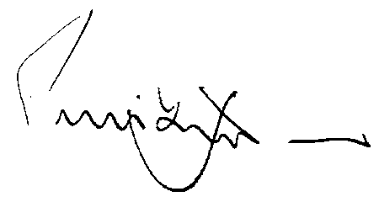

Hon Peter Dunne

Associate Minister of Health

# Introduction

**We support a public awareness campaign – it is a must.**

**It is fundamentally wrong that a vulnerable group in our society should be continually subjected to the comments and actions of those who possess an outcast mentality...We are optimistic enough to believe that a well informed New Zealand public will realise that [people with mental illness] are people whom we should nurture and value.1**

The Like Minds, Like Mine (Like Minds) programme was established in 1997 by the Ministry of Health in response to the 1996 Mason Report. It was one of the first comprehensive national campaigns in the world to counter stigma and discrimination associated with mental illness. The programme has combined national television and other media and communication activities with community action to bring about social change.

The previous Like Minds plan, Like Minds, *Like Mine National Plan  
2007–2013* expired on 30 June 2013. *Rising to the Challenge: The Mental Health and Addiction Service Development Plan 2012–2017* states that the Ministry of Health will continue national efforts to reduce stigma, including continuing and refreshing the Like Minds programme.2

This document sets the guiding principles for service delivery of the Like Minds programme over the next five years, providing direction for the continuation of the journey towards social inclusion for people with mental illness in New Zealand.

There is a consensus that after 16 years Like Minds needs to continue evolving – to learn from the past and to respond to the changing environment. This plan signals some of these changes. It is more specific than past plans in prioritising the people with mental illness who most need to benefit from the programme and in targeting the issues and audiences that are most likely to have a major impact on their social inclusion.

1 Ministry of Health. (1996). *Inquiry under Section 47 of the Health and Disability Services Act 1993 in Respect of Certain Mental Health Services (The Mason Report)*. Wellington: Ministry of Health.

2 Ministry of Health. (2012). *Rising to the Challenge: The Mental Health and Addiction Service Development Plan 2012–2017*. Wellington: Ministry of Health.

# Context

## Achievements to date

The award winning national media campaigns have been through five phases since 2000. The campaigns have shifted in emphasis over this time from focusing on famous to everyday people with mental illness, from experiences of mild and moderate mental illness to more severe ones, and from awareness raising to modelling inclusive relationships.

Like Minds has tracked public attitudes since 1997 and commissioned a cost-benefit analysis of the programme in 2010.3 The public attitudes surveys demonstrate that attitudes towards people with mental illness in the target group of 15 to 44-year-olds have improved significantly, especially among Māori, Pacific and young people.4 The cost benefit analysis calculated that Like Minds had cost a total of $52m since its inception. The estimated economic benefits (increased access to employment, hours worked, and increased use of primary care) totalled $720m, or $13.80 for every dollar spent.5

## Stigma and discrimination today

Stigma and discrimination are among the biggest barriers to social inclusion for people with mental illness. Stigma associated with mental illness refers to a devalued social identity and is usually expressed through disrespectful attitudes. Discrimination refers to unfair treatment and is usually expressed through excluding behaviour and unfair structures.

Stigma and discrimination continue to interfere with the quality of life of people with mental illness in New Zealand, despite the achievements of Like Minds over the last 16 years. Stigma and discrimination have deep cultural roots that are present in every area of life and eliminating them requires a long term commitment. Like Minds has created some positive outcomes but there is a long way to go to ensure that individuals and organisations demonstrate socially inclusive attitudes and behaviours towards people with mental illness.

Data taken from the 2008 New Zealand General Social Survey showed that people with ‘severe’ symptoms of mental illness fared significantly worse in many social inclusion indicators, especially in social relationships, employment and income.

3 Vaithianathan, R. (2010). *Cost Benefit Analysis of the New Zealand National Mental Health Destigmatisation Programme*. Auckland: UniServices.

4 Phoenix Research. (2011). *Impacts of National Media Campaign to Counter Stigma and Discrimination Associated with Mental Illness. Survey 11: Response to fifth phase of campaign*. Auckland: Phoenix Research.

5 Vaithianathan, R. (2010). *Cost Benefit Analysis of the New Zealand National Mental Health Destigmatisation Programme*. Auckland: UniServices.

For instance, 77% of people with severe symptoms experienced social isolation compared to 25% of people with no symptoms, and only 27% of people with severe symptoms were employed compared to 68% of people with no symptoms. Additionally, younger people are more likely to have experienced a mental illness than older people, with people aged 25 to 34 years having the highest prevalence (33%) and people aged 65 to 74 years having the lowest prevalence (18%). Māori are more likely than Pacific People or people in the ‘European/ Other Group’ to experience a mental illness in general and specifically have higher prevalence rates in the ‘severe category’.6 However, Pacific People are more likely than any other group to experience a mild or moderate mental illness.

A 2010 survey of the experiences of 1,135 people with a diagnosis of mental illness showed that 54% thought there had been some improvement in discrimination in the last five years and 16% thought it had worsened. Over half reported hiding their mental illness from others ‘moderately’ or ‘a lot’ and around one third stopped themselves from applying for work or having close relationships because of anticipated discrimination.7

## The policy context

Both the mental health and disability policy contexts support the need for a programme such as Like Minds.

*Rising to the Challenge* sets the national direction for mental health and addiction services as well as mental health promotion, prevention and social inclusion work from 2012 to 2017. The plan expects measurable improvements in social inclusion among people with severe mental illness over the five year period. It states that the Ministry of Health will enhance social inclusion opportunities – this includes responsibility for continuing and refreshing Like Minds. *Rising to the Challenge* also expects there will be a reduction in the disparities in outcomes for both Māori and Pacific peoples.

The New Zealand Disability Strategy8 includes people with ‘psychiatric impairments’. Its vision is for ‘a society that highly values our lives and continually enhances our full participation’. Its first two objectives are to encourage and educate for a non-disabling society and to ensure the rights of disabled people.

## Lead organisations

In July 2012, some funding for Like Minds was transferred to the Health Promotion Agency (HPA) to contract services for national advertising, evaluation and coordination, while the Ministry of Health maintained funding for local delivery and support.

As of January 2015, HPA will be the single lead operational agency for Like Minds. The Ministry of Health will retain ‘Strategic Responsibility’ and strategic development will be supported through the Joint Project Group.

6 Mental Health Commission. (2011). *Measuring Social Inclusion: People with experience of mental illness and addiction*. Wellington. Mental Health Commission.

7 Phoenix Research. (2011). *Discrimination Reported by Users of Mental Health Services: 2010 Survey*. Auckland: Phoenix Research.

8 Minister for Disability Issues. (2001). *The New Zealand Disability Strategy: Making a World of Difference Whakanui Oranga*. Wellington: Ministry of Health.

## Links with other programmes and agencies

Like Minds has a unique place in the landscape of programmes and agencies that promote the wellbeing, human rights and social inclusion of people with mental illness. These programmes and agencies have different responsibilities to Like Minds but they share the same environment and we need to work together to increase social inclusion for people with mental illness.

Like Minds sits alongside three major mental health promotion programmes – the New Zealand Suicide Prevention Action Plan 2013–2016, the Prime Minister’s Youth Mental Health Project and the National Depression Initiative. While all three programmes work with communities to achieve better outcomes for people with mental illness, Like Minds differs from the other three as its main purpose is social inclusion, not prevention and treatment, and its main audience is people who exclude, not people with mental illness. The primary outcome of Like Minds is to create a socially inclusive New Zealand that is free of stigma and discrimination towards people with mental illness. The programme seeks to promote more inclusive attitudes, behaviour and structures in New Zealand’s social environment rather than to directly assist people with mental illness.

It is important to note, however, that by changing environments, discriminatory attitudes and behaviours towards people with experience of mental illness, Like Minds works to reduce people’s self-belief in negative stereotypes. This internalised stigma is yet another barrier to full participation in society. Like Minds will continue to strengthen its approaches to address the internalisation of stigma and discrimination associated with mental illness.

Like Minds also aligns with ‘Think Differently’ – a social change campaign to support a fundamental shift in attitudes and behaviour towards disabled people, led by the Ministry of Social Development. ‘Think Differently’ has a similar purpose to Like Minds but it focuses on shifting attitudes and behaviour towards people with physical, sensory and intellectual disabilities.

The offices of the Health and Disability Commissioner and Human Rights Commission are closely linked with Like Minds. The Health and Disability Commissioner promotes and protects the rights of health and disability services’ consumers and facilitates the resolution of individual complaints. The Mental Health Commissioner, within the office of the Health and Disability Commissioner, provides advocacy and monitoring. The Human Rights Commission enforces the Human Rights Act 1993, which addresses discrimination against specified groups, including people with mental illness. While the main focus of these two agencies is on resolving individual complaints, they both have a role in monitoring at a government level. Like Minds complements the work of the Health and Disability Commissioner and the Human Rights Commission by working to reduce stigma and discrimination through national and community activity.

## Like Minds, Like Mine programme infrastructure 2014 to 2019

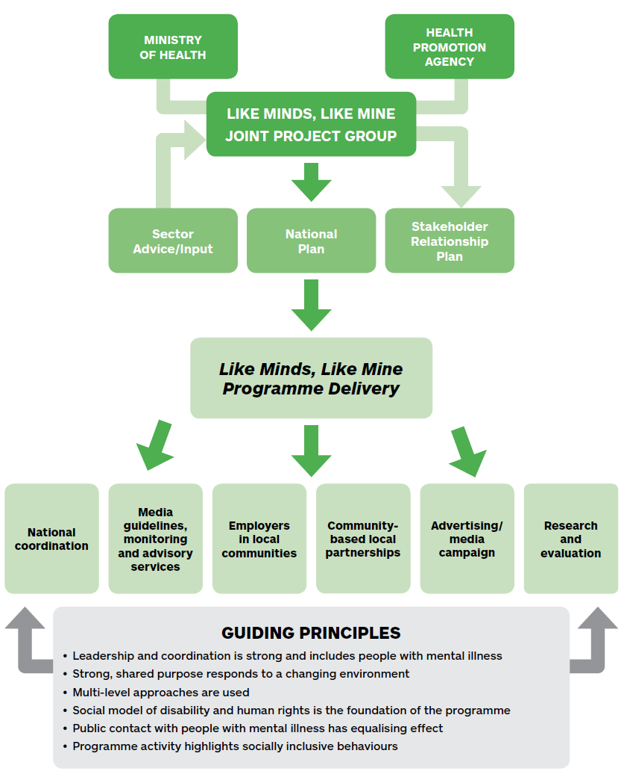

# PROGRAMME INFRASTRUCTURE

A multi-faceted programme such as Like Minds needs leadership that communicates the vision, inspires people and works with communities to support the programme. The infrastructure must provide the ‘glue’ that gives the programme momentum and co‑ordination.

## Strategic leadership

The Ministry of Health and HPA have established a Joint Project Group that has oversight of the development of Like Minds. The Joint Project Group will:

* support strategic direction
* establish a structure for sector advice and input
* establish a stakeholder relationship plan to support key communications
* guide the implementation
* monitor delivery
* agree an action plan.

## Operational leadership

HPA will be the single lead operational agency for Like Minds. With the current mandate of HPA in the health promotion field, this is well within its scope of work. HPA will be responsible for providing funding and leadership to support programme delivery through:

* national coordination
* media guidelines, monitoring and advisory services
* employers in local communities
* community-based local partnerships
* advertising/media campaigns
* research and evaluation.

# Guiding Principles

## Leadership and coordination

Social change programmes need to maximise their impact by developing clear strategic priorities and best practice based on international evidence, expert opinion and stakeholder views. When tackling complex problems with multiple activities and organisations, Like Minds must provide strong, inspirational leadership and expert coordination and support. This includes modelling the kind of inclusion the programme is working towards and ensuring people with mental illness have a major stake in its oversight.

## Strong, shared purpose

Like Minds seeks to promote the conditions where social inclusion can occur most easily by changing the attitudes and behaviours of those in the general public who have the potential to exclude. The role of Like Minds is not to provide direct services to people with mental illness. Rather, it seeks to ensure that individuals and organisations demonstrate socially inclusive attitudes and behaviours towards people with mental illness, thereby increasing the opportunity for people with mental illness to fully participate in public life.

Like Minds will develop a strong shared purpose for the programme but keep the implementation flexible enough to learn from successes and failures, respond to a changing environment, and change direction if needed.

## Multi-level approaches

Like Minds will ensure that change efforts occur in multiple settings at multiple levels with a combination of top-down and bottom-up approaches.

## Social model of disability and human rights perspective

Like Minds is founded on a social model of disability and an associated human rights perspective. The social model of disability describes disability as a process that happens when one group of people creates barriers to equal participation by designing a world only for their way of being. Discrimination against people with disability is created by society, not by the individuals with disabilities who encounter barriers to participation.

A human rights approach asserts the dignity and value of all people and the right to be free of discrimination. The UN Convention on the Rights of Persons with Disabilities9 has been ratified by New Zealand and underpins the work of Like Minds.

9 United Nations. (2006). Convention on the Rights of Persons with Disabilities. New York: UN General Assembly.

The Convention protects the civil, political, social, cultural and economic rights of people with disabilities, including mental illness. Its guiding principles include autonomy, non-discrimination, full participation in society and equality of opportunity.

## Power of contact

Like Minds needs to take advantage of powerful evidence from social change initiatives by promoting equalising contact between members of the excluded groups and people who exclude. These educational and contact-based strategies are promising and effective for sustained knowledge gain and positive attitude change.10

## Social inclusion

Social inclusion can be defined as “the extent to which people are able to exercise their rights and participate, by choice, in the ordinary activities of citizens”.11 Social inclusion means that people with mental illness are able to participate in the community as employees, students, volunteers, carers, parents, etc. They have a personal identity, aside from ill health, and have valuable contributions to make within the many communities to which they belong.

This meaning of social inclusion is underlined by a social model of disability as described earlier, which is the basis of Like Minds placing focus on shifting attitudes and behaviours of those who exclude rather than on the excluded.

10 Dalky, H. (2012). *Mental Illness: Stigma Reduction Interventions – Review of Intervention Trials*. Western Journal of Nursing Research 34(4).

11 Mental Health Commission. (2009). Mental health and social inclusion concepts and measurements. Wellington: Mental Health Commission.

# PRIORITY AUDIENCES

The role of Like Minds is not to provide direct services to people with mental illness who are socially excluded. Rather, it is to promote the conditions where social inclusion efforts and outcomes can occur more easily within the general public who have the potential to exclude. The Like Minds work needs to be directed at people, environments and infrastructures that exclude. This must include the active involvement of the ‘excluders’ in identifying barriers and determining solutions.

Like Minds needs to put emphasis on removing the barriers to social inclusion for the most excluded groups:

* People with severe mental illness tend to experience more stigma and discrimination than people with mild to moderate mental illness and, as a consequence, are at high risk of long-term social exclusion.
* Māori and Pacific people are more likely than their New Zealand European counterparts to begin their journey through mental illness in a position of social disadvantage, increasing their vulnerability to social exclusion.
* Many people develop mental illness before the age of 25, prior to the establishment of secure employment, housing and relationships, increasing their vulnerability to drifting into social exclusion.

Like Minds needs to understand the experience of people with mental illness and develop partnerships within their communities of interest to find local solutions to social exclusion, stigma and discrimination.

# OUTCOMES FRAMEWORK

## Like Minds, Like Mine outcomes framework 2014 to 2019

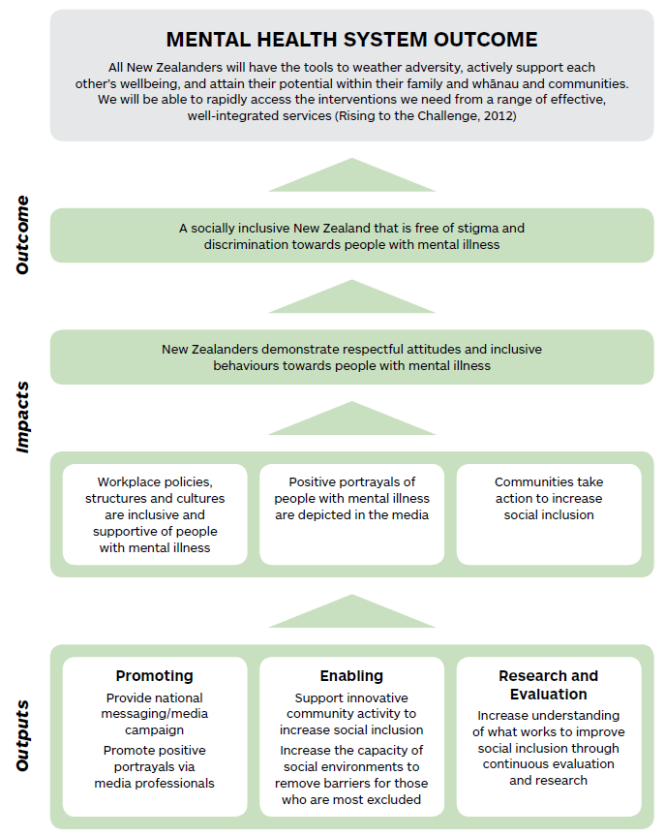

# Outcomes

Like Minds seeks to create:

*A socially inclusive New Zealand that is free of stigma and discrimination towards people with mental illness.*

People function in society at both an individual and organisational level and, therefore, people with mental illness experience exclusion at both these levels as well.

We will know Like Minds has been successful when various institutions, agencies, businesses and organised environments in New Zealand function in a socially inclusive manner towards people with mental illness.

We will know Like Minds has been successful at an individual level when New Zealanders are socially included in all areas of life.

## Impacts

In order to create a socially inclusive New Zealand that is free of stigma and discrimination towards people with mental illness, Like Minds needs to clear the barriers that interfere with inclusion across all areas of life. For the next five years, Like Minds will focus its efforts in:

* workplaces
* media
* community.

### Workplace

Workplaces are an important route to social inclusion and have multiple benefits to individuals and to society. However, people with mental illness have higher unemployment than any other disability group.12 There is significant opportunity to improve the inclusive behaviours of the general public who come into contact with people with mental illness along their journey to seeking, getting and maintaining employment. This includes enabling the structures and cultures within workplaces to be more inclusive and supportive in order to reduce stigma and discrimination towards people with mental illness.

12 Mental Health Commission. (2011). *Measuring Social Inclusion: People with experience of mental illness and addiction*. Wellington. Mental Health Commission.

### Media

The news media, social media, and stories in the form of television, film and books both shape and reflect social norms surrounding mental illness and have huge reach and influence on public attitudes and resulting behaviours. Like Minds will develop and provide guidelines and advice that professionals can refer to in order to improve public and fictional portrayals of people with mental illness. It will also monitor and respond to the media to improve the quality, accuracy and sensitivity of reporting on mental illness.

### Community

Like Minds seeks to harness resources from within communities to further the programme’s strategic objectives by supporting those who are committed to increasing social inclusion, specifically in the workplace, and increasing their capacity to make an impact. This includes working alongside people who have experience of mental illness to contribute to local solutions. While the primary purpose of these activities is not to provide personal support for people with mental illness, a reduction in self-stigma may be a secondary benefit. People with mental illness often internalise stigma and limit their opportunities through anticipated discrimination.

# Outputs

## Promoting

Advertising and promotion is a central component to behaviour change. Clear alignment between national, regional and local activities will ensure appropriate messages are delivered and appropriate channels for delivery are used, including traditional paid and unpaid media, as well as social media.

There is good evidence that work to improve public portrayals of people with experience of mental health problems increases social inclusion.13 This work can reach beyond traditional media into social media. This includes efforts to:

* encourage and promote positive public and fictional portrayals of people with mental illness in the media
* monitor all relevant media activities and report on changes over time.

## Enabling

We seek to enable innovative community activity to increase social inclusion for people with mental illness through advice, resources and tools. Community activity will remove barriers for those who are most excluded in environments where social exclusion occurs eg, the workplace.

## Research and evaluation

A social change programme such as Like Minds is dealing with a deep and complex problem that requires informed and tested solutions. The international evidence on what works in programmes to increase social inclusion for people with mental illness is not well developed and there is no guarantee that what works in one setting or audience will work in another. For these reasons Like Minds needs to continually build its own evidence base. In order to do so, we will:

* gain a deep understanding of the barriers and facilitators of social inclusion from the perspective of people who are excluded as well as people who exclude
* use this understanding to develop activities for maximum impact
* evaluate the activities for their impact
* make incremental improvements.

A mix of evaluation and monitoring methods needs to be used to ensure that programme delivery meets outcomes and engages in a continuous cycle of improvement.

13 Health Promotion Agency. (2013). *Review of Selected Material on Stigma and Discrimination and Programmes to Reduce Them*. Wellington: HPA.

# REFERENCES

Dalky, H. (2012). *Mental Illness: Stigma Reduction Interventions – Review of Intervention Trials*. Western Journal of Nursing Research 34(4).

Estroff, S., Penn, D., and Toprek, J. (2004). *From Stigma to Discrimination: An Analysis of Community Efforts To Reduce the Negative Consequences of Having A Psychiatric Disorder and Label*. Schizophrenia Bulletin 30(3).

Health Promotion Agency. (2013). *Review of Selected Material on Stigma and Discrimination and Programmes to Reduce Them*. Wellington: HPA.

Hinshaw, S., and Stier, A. (2008). *Stigma as related to mental disorders*. Annual Review of Clinical Psychology 4, 367-393.

Mental Health Commission. (2009). *Mental health and social inclusion concepts and measurements*. Wellington: Mental Health Commission.

Mental Health Commission. (2011). *Measuring Social Inclusion: People with experience of mental illness and addiction*. Wellington. Mental Health Commission.

Minister for Disability Issues. (2001). *The New Zealand Disability Strategy: Making a World of Difference Whakanui Oranga*. Wellington: Ministry of Health.

Ministry of Health. (1996). *Inquiry under Section 47 of the Health and Disability Services Act 1993 in Respect of Certain Mental Health Services (The Mason Report)*. Wellington: Ministry of Health.

Ministry of Health. (2012). *Rising to the Challenge: The Mental Health and Addiction Service Development Plan 2012–2017*. Wellington: Ministry of Health.

Phoenix Research. (2011). *Discrimination Reported by Users of Mental Health Services: 2010 Survey*. Auckland: Phoenix Research.

Phoenix Research. (2011). *Impacts of National Media Campaign to Counter Stigma and Discrimination Associated with Mental Illness. Survey 11: Response to fifth phase of campaign*. Auckland: Phoenix Research.

United Nations. (2006). *Convention on the Rights of Persons with Disabilities*. New York: UN General Assembly.

Vaithianathan, R. (2010). *Cost Benefit Analysis of the New Zealand National Mental Health Destigmatisation Programme*. Auckland: UniServices.