Indicators for the Well Child / Tamariki Ora Quality Improvement Framework
September 2014

Citation: Ministry of Health. 2015. Indicators for the Well Child / Tamariki Ora Quality Improvement Framework September 2104. Wellington: Ministry of Health.
Published in January 2015
by the
Ministry of Health
PO Box 5013, Wellington 6145, New Zealand
ISBN: 978-0-478-44479-7 (online)
HP 6113
This document is available at www.health.govt.nz

This work is licensed under the Creative Commons Attribution 4.0 International licence. In essence, you are free to: share ie, copy and redistribute the material in any medium or format; adapt ie, remix, transform and build upon the material. You must give appropriate credit, provide a link to the licence and indicate if changes were made.

Foreword from the EAG
The Well Child / Tamariki Ora Quality Improvement Framework Expert Advisory Group (EAG) welcomes the third report on the indicators for the Quality Improvement Framework. We acknowledge the Well Child / Tamariki Ora (WCTO) sector’s commitment to improving services for children and their families and whānau. We see the WCTO Quality Improvement Framework as a tool to support each level of the sector to achieve family-centred, high-quality, equitable and effective child health services that deliver the best possible health outcomes for all New Zealand children and their families and whānau.

This third report continues to demonstrate the commitment of every person in the child health sector, at every level of service provision, to achieving better and fairer outcomes for children and their families and whānau. Since the last report, notable gains have been made in rate of newborn enrolment with general practice: enrolments rose by 8 percent overall and by 9 and 11 percent among Māori and Pacific families respectively. Newborn enrolment rates for Māori and Pacific peoples are both higher and gaining faster than rates for other ethnic groups, demonstrating that a sustained focus on equity is effective. The EAG looks forward to seeing further reduced inequalities in child health outcomes as a result of more equitable access to primary care and urges the child health sector to maintain its focus on increasing newborn enrolment rates.

Among the other gains since the last report are the achievement of the 90 percent B4 School Check target, including 90 percent of children living in areas of high socioeconomic deprivation, and a significant increase in the number of appropriate referrals for children with dental decay identified at the B4 School Check. A number of indicators continue to meet or exceed their targets, and we have chosen to continue to report these to demonstrate the commitment and achievements the WCTO sector makes every day.

This is not time to become complacent. A number of areas require intensive focus and urgent action. With 29 percent of infants still not enrolled with general practice by three months of age, as a child health community this needs to be one of our highest priorities. Improvements are also needed in access to WCTO core contacts, community oral health enrolment rates, oral health outcomes and childhood obesity including referral pathways for four-year-olds with a very high body mass index. Equity must continue to be a high priority within any quality improvement activity.

Over the next six months, the EAG looks forward to the appointment of regional WCTO Quality Improvement Project Managers to coordinate and drive further improvement, and to coordinate activity across regions and across the country. There are outstanding pockets of innovation and improvement around the country that we can all learn from. Quality improvement cannot thrive in a vacuum.

Once again the EAG issues a challenge as you read this report and consider what the results mean for you: think about what you can do to help build a system that treats our children as taonga and ensures we work in partnership with families and whānau to help them grow strong, healthy and resilient. Together we can build towards world-leading health outcomes for all New Zealand children and their families and whānau.

Summary of national results
Quality indicator | March 2014 |  |  |  | September 2014
 | Total | High dep | Māori | Pacific | Total | High dep | Māori | Pacific
1. Newborns are enrolled with a general practice by three months* | 63% | N/A | 65% | 62% | 71% | N/A | 74% | 73%
2. Families and whānau are referred from their lead maternity carer to a WCTO provider | 97% | 97% | 97% | 97% | 98% | 97% | 97% | 98%
3. Infants receive all WCTO core contacts due in their first year | 74% | 66% | 65% | 65% | 76% | 67% | 67% | 61%
4. Four-year-olds receive a B4 School Check | 89% | 85% | 81% | 74% | 91% | 90% | 83% | 80%
5. Children are enrolled with child oral health services | 70% | N/A | 55% | 66% | 73% | N/A | 59% | 68%
6. Immunisations are up to date by eight months | 91% | 90% | 88% | 93% | 92% | 89% | 88% | 95%
7. Children participate in early childhood education | 96% | 89% | 93% | 89% | 96% | 90% | 93% | 90%
8. Children under six years have access to free primary care | 98% | 99% | 99% | 100% | 98% | 99% | 100% | 100%
9. Children under six years have access to free after-hours primary care | 98% | N/A | N/A | N/A | 98% | N/A | N/A | N/A
10. Children are seen promptly by specialist services | 99% | N/A | N/A | N/A | 100% | N/A | N/A | N/A
11. Infants are exclusively or fully breastfed at two weeks | 80% | 77% | 78% | 76% | 79% | 77% | 77% | 74%
12. Infants are exclusively or fully breastfed at six weeks | 76% | 73% | 71% | 75% | 75% | 73% | 71% | 73%
13. Infants are exclusively or fully breastfed at three months | 55% | 43% | 44% | 45% | 55% | 43% | 44% | 45%
14. Infants are receiving breast milk at six months | 65% | 55% | 52% | 59% | 66% | 55% | 54% | 59%
15. Children are a healthy weight at four years | 75% | 68% | 70% | 58% | 75% | 69% | 71% | 59%
16. Children are caries free at five years | 59% | N/A | 39% | 37% | 57% | N/A | 37% | 36%
17. The burden of dental decay is minimised (average dmft) | 4.5  dmft | N/A | 5.1 dmft | 5  dmft | 4.4  dmft | N/A | 5.0  dmft | 5.1  dmft
18. Child mental health is supported  (normal SDQ-P score) | 96% | 93% | 93% | 94% | 96% | 93% | 93% | 95%
19. Mothers are smokefree at two weeks postnatal | 86% | 75% | 64% | 90% | 87% | 77% | 65% | 91%
20. Children live in smokefree homes  (age four years) | 98% | 97% | 96% | 98% | 98% | 97% | 97% | 96%
21. B4 School Checks are started before children are 4½ years | 82% | 80% | 77% | 81% | 83% | 82% | 80% | 81%
22. Children with an abnormal SDQ-P score are referred* | 100% | 100% | 100% | 100% | 100% | 100% | 100% | 100%
23. Children with a PEDS Pathway A are referred* | 97% | 97% | 98% | 94% | 98% | 99% | 99% | 98%
24. Children with a Lift the Lip (oral health) score of 2–6 are referred | 59% | 66% | 64% | 64% | 70% | 66% | 71% | 81%
25. Children with an untreated vision problem are referred | 100% | 100% | 100% | 100% | 100% | 100% | 100% | 100%
26. Children with an untreated hearing problem are referred | 100% | 100% | 100% | 100% | 100% | 100% | 99% | 100%
27. Children with a body mass index > 99.4th percentile are referred | 69% | 74% | 59% | 74% | 69% | 73% | 66% | 78%
Note: dmft = count of decayed, missing or filled deciduous teeth; High dep = High socioeconomic deprivation; N/A = not available; PEDS = Parental Evaluation of Developmental Status; SDQ-P = Strengths and Difficulties Questionnaire (Parent); WCTO = Well Child / Tamariki Ora.
* Data to monitor this indicator is not yet available. PHO enrolment at three months will be used as a de facto indicator in the interim.
** Includes ‘advice given’; all other referrals exclude ‘advice given’. See full analysis for more information.
Contents
Foreword from the EAG iii
Summary of national results iv
Introduction 1
Background 1
Development of the quality indicators 1
Quality indicator targets 2
How to use this document 2
Indicators 1–10: Access 3
Summary of results for this period 3
WCTO Quality Improvement Framework Indicator 1 6
WCTO Quality Improvement Framework Indicator 2 8
WCTO Quality Improvement Framework Indicator 3 10
WCTO Quality Improvement Framework Indicator 4 12
WCTO Quality Improvement Framework Indicator 5 14
WCTO Quality Improvement Framework Indicator 6 16
WCTO Quality Improvement Framework Indicator 7 18
WCTO Quality Improvement Framework Indicator 8 20
WCTO Quality Improvement Framework Indicator 9 22
WCTO Quality Improvement Framework Indicator 10 23
Indicators 11–20: Outcomes 24
Summary of results for this period 24
WCTO Quality Improvement Framework Indicator 11 26
WCTO Quality Improvement Framework Indicator 12 28
WCTO Quality Improvement Framework Indicator 13 30
WCTO Quality Improvement Framework Indicator 14 32
WCTO Quality Improvement Framework Indicator 15 34
WCTO Quality Improvement Framework Indicator 16 36
WCTO Quality Improvement Framework Indicator 17 38
WCTO Quality Improvement Framework Indicator 18 40
WCTO Quality Improvement Framework Indicator 19 43
WCTO Quality Improvement Framework Indicator 20 45
Indicators 21–27: Quality 47
Summary of results for this period 47
WCTO Quality Improvement Framework Indicator 21 49
WCTO Quality Improvement Framework Indicator 22 51
WCTO Quality Improvement Framework Indicator 23 53
WCTO Quality Improvement Framework Indicator 24 56
WCTO Quality Improvement Framework Indicator 25 59
WCTO Quality Improvement Framework Indicator 26 62
WCTO Quality Improvement Framework Indicator 27 65
Appendix 1: Summary of the WCTO quality indicators 68
Appendix 2: Membership of the WCTO Quality Improvement Framework Expert Advisory Group 69

List of Figures
Figure 1: Newborns enrolled with a PHO by three months, total New Zealand 6
Figure 2: Newborns enrolled with a PHO by three months, Māori 7
Figure 3: Newborns enrolled with a PHO by three months, Pacific peoples 7
Figure 4: Referral from LMC to WCTO, total New Zealand 8
Figure 5: Referral from LMC to WCTO, high deprivation 8
Figure 6: Referral from LMC to WCTO, Māori 9
Figure 7: Referral from LMC to WCTO, Pacific peoples 9
Figure 8: Core WCTO contacts 1–5 received, total New Zealand 10
Figure 9: Core WCTO contacts 1–5 received, high deprivation 10
Figure 10: Core WCTO contacts 1–5 received, Māori 11
Figure 11: Core WCTO contacts 1–5 received, Pacific peoples 11
Figure 12: Children receive a B4 School Check, total New Zealand 12
Figure 13: Children receive a B4 School Check, high deprivation 12
Figure 14: Children receive a B4 School Check, Māori 13
Figure 15: Children receive a B4 School Check, Pacific peoples 13
Figure 16: Preschool children enrolled with oral health services, total New Zealand 14
Figure 17: Preschool children enrolled with oral health services, Māori 14
Figure 18: Preschool children enrolled with oral health services, Pacific peoples 15
Figure 19: Fully immunised by eight months, total New Zealand 16
Figure 20: Fully immunised by eight months, high deprivation 16
Figure 21: Fully immunised by eight months, Māori 17
Figure 22: Fully immunised by eight months, Pacific peoples 17
Figure 23: Prior participation in ECE, total New Zealand 18
Figure 24: Prior participation in ECE, high deprivation 18
Figure 25: Prior participation in ECE, Māori 19
Figure 26: Prior participation in ECE, Pacific peoples 19
Figure 27: Under-six access to free primary care, total New Zealand 20
Figure 28: Under-six access to free primary care, high deprivation 20
Figure 29: Under-six access to free primary care, Māori 21
Figure 30: Under-six access to free primary care, Pacific peoples 21
Figure 31: Under-six access to free after-hours primary care, total New Zealand 22
Figure 32: First specialist appointment for paediatric medicine received within five months, total New Zealand 23
Figure 33: Exclusively or fully breastfed at two weeks, total New Zealand 26
Figure 34: Exclusively or fully breastfed at two weeks, high deprivation 26
Figure 35: Exclusively or fully breastfed at two weeks, Māori 27
Figure 36: Exclusively or fully breastfed at two weeks, Pacific peoples 27
Figure 37: Exclusively or fully breastfed at LMC discharge, total New Zealand 28
Figure 38: Exclusively or fully breastfed at LMC discharge, high deprivation 28
Figure 39: Exclusively or fully breastfed at LMC discharge, Māori 29
Figure 40: Exclusively or fully breastfed at LMC discharge, Pacific peoples 29
Figure 41: Exclusively or fully breastfed at three months, total New Zealand 30
Figure 42: Exclusively or fully breastfed at three months, high deprivation 30
Figure 43: Exclusively or fully breastfed at three months, Māori 31
Figure 44: Exclusively or fully breastfed at three months, Pacific peoples 31
Figure 45: Infants receive breast milk at six months, total New Zealand 32
Figure 46: Infants receive breast milk at six months, high deprivation 32
Figure 47: Infants receive breast milk at six months, Māori 33
Figure 48: Infants receive breastmilk at six months, Pacific peoples 33
Figure 49: Children are a healthy weight at age four years, total New Zealand 34
Figure 50: Children are a healthy weight at age four years, high deprivation 34
Figure 51: Children are a healthy weight at age four years, Māori 35
Figure 52: Children are a healthy weight at age four years, Pacific peoples 35
Figure 53: Caries free at five years, total New Zealand 36
Figure 54: Caries free at five years, Māori 36
Figure 55: Caries free at five years, Pacific peoples 37
Figure 56: Burden of dental decay, total New Zealand 38
Figure 57: Burden of dental decay, Māori 38
Figure 58: Burden of dental decay, Pacific peoples 39
Figure 59: Children have a normal SDQ-P score at four years, total New Zealand 40
Figure 60: Children have a normal SDQ-P score at four years, high deprivation 41
Figure 61: Children have a normal SDQ-P score at four years, Māori 41
Figure 62: Children have a normal SDQ-P score at four years, Pacific peoples 41
Figure 63: Mother smokefree at two weeks postnatal, total New Zealand 43
Figure 64: Mother smokefree at two weeks postnatal, high deprivation 43
Figure 65: Mother smokefree at two weeks postnatal, Māori 44
Figure 66: Mother smokefree at two weeks postnatal, Pacific peoples 44
Figure 67: Children live in a smokefree home (age four years), total New Zealand 45
Figure 68: Children live in a smokefree home (age four years), high deprivation 45
Figure 69: Children live in a smokefree home (age four years), Māori 46
Figure 70: Children live in a smokefree home (age four years), Pacific peoples 46
Figure 71: B4 School Checks started before age 4½ years, total New Zealand 49
Figure 72: B4 School Checks started before age 4½ years, high deprivation 49
Figure 73: B4 School Checks started before age 4½ years, Māori 50
Figure 74: B4 School Checks started before age 4½ years, Pacific peoples 50
Figure 75: Abnormal SDQ-P referred, total New Zealand 51
Figure 76: Abnormal SDQ-P referred, high deprivation 51
Figure 77: Abnormal SDQ-P referred, Māori 52
Figure 78: Abnormal SDQ-P referred, Pacific peoples 52
Figure 79: PEDS Pathway A referred, total New Zealand 53
Figure 80: PEDS Pathway A referred, high deprivation 54
Figure 81: PEDS Pathway A referred, Māori 54
Figure 82: PEDS Pathway A referred, Pacific peoples 54
Figure 83: Children with LTL score > 1 referred, total New Zealand 56
Figure 84: Children with LTL score > 1 referred, high deprivation 57
Figure 85: Children with LTL score > 1 referred, Māori 57
Figure 86: Children with LTL score > 1 referred, Pacific peoples 57
Figure 87: Vision problem referred, total New Zealand 59
Figure 88: Vision problem referred, high deprivation 60
Figure 89: Vision problem referred, Māori 60
Figure 90: Vision problem referred, Pacific peoples 60
Figure 91: Hearing problem referred, total New Zealand 62
Figure 92: Hearing problem referred, high deprivation 63
Figure 93: Hearing problem referred, Māori 63
Figure 94: Hearing problem referred, Pacific peoples 63
Figure 95: Children with BMI > 99.4th percentile referred, total New Zealand 65
Figure 96: Children with BMI > 99.4th percentile referred, high deprivation 66
Figure 97: Children with BMI > 99.4th percentile referred, Māori 66
Figure 94: Children with BMI > 99.4th percentile referred, Pacific peoples 66

Introduction

Background
Well Child / Tamariki Ora (WCTO) is a free health service offered to all New Zealand children from birth to five years. Its aim is to support families and whānau to maximise their child’s developmental potential and health status, establishing a strong foundation for ongoing healthy development.

The 2007/08 review and the 2012 quality reviews of the WCTO programme identified variable clinical practice, service quality and health outcomes. They all recommended that an evidence-based quality framework be developed to ensure the programme consistently achieves its aims.

In response, the Ministry of Health, in partnership with sector expert advisors, developed the WCTO Quality Improvement Framework, drawing on New Zealand and international research. The Framework has three high-level aims, which focus on the WCTO experience of families and whānau, population health, and best value for the health system’s resources. The Framework also sets quality indicators to monitor health system performance.

The Framework and quality indicators provide a mechanism to drive improvement in the delivery of WCTO services. Ultimately, they aim to support the WCTO programme to ensure all children and their families and whānau achieve their health and wellbeing potential.

Development of the quality indicators
The aim of the quality indicators is to monitor and promote quality improvement across WCTO providers without creating an additional reporting burden. As such, the quality indicators are a subset of potential measures drawn from existing data collections and reporting mechanisms.

The quality indicators are broadly grouped under the categories of:
- universal access (access)
- equitable outcomes (outcomes)
- continuous quality improvement (quality).

All quality indicators will be reported on by region, ethnicity and deprivation quintile, where possible, and the results will be published six-monthly. This is the second report on the quality indicators.

As information collection improves and the WCTO programme evolves, indicators may be added or changed. The Ministry of Health will review the quality indicators at least every three years.

Quality indicator targets
Targets for the quality indicators reflect national targets set by other monitoring frameworks and processes, including health targets, district health board (DHB) non-financial performance monitoring and Better Public Service key result areas.

Where there is no existing target, the Expert Advisory Group has agreed on new three-year targets to best reflect the objectives of the Framework. New targets are staged in recognition that improvements will be realised over time. Interim targets to be achieved by December 2014 are set at 90 percent of the three-year targets.

To promote equity, the target for each quality indicator is the same across all ethnic groups, deprivation quintiles and DHB regions.

How to use this document
Regular monitoring is an essential part of quality improvement. The quality indicators presented here enable WCTO providers, DHBs and other stakeholders to review local performance, identify quality improvement priorities, and monitor progress in improving the uptake, timeliness and quality of WCTO and related child health services over time.

The quality indicators do not stand alone. They are part of a whole-system approach to quality improvement that includes:
- standards (the WCTO Quality Improvement Framework)
- monitoring (quality indicator reports)
- support for collaboration and planning quality improvement priorities (DHB-led local WCTO quality improvement programmes)
- support for learning and sharing best practice (via the Child and Youth Compass and other tools and resources).

Indicators 1–10: Access
Aim 1 of the WCTO Quality Improvement Framework is improved safety and quality of WCTO experience for the child and their family and whānau. This can be measured, to some degree, by the uptake of and continued engagement with services, as families and whānau will be more likely to access and remain involved with acceptable, high-quality services that address barriers to access for families and whānau. It is expected that, in addition to these indicators, DHBs and WCTO providers will consider other ways to monitor quality of experience, such as through the use of consumer surveys or parent focus groups.

Indicators 1–10 measure access rates, with or without consideration of timeliness, across a range of universal and specialist services that contribute to improved outcomes for children. The inclusion of this broad range of services as indicators reflects the role of WCTO in assessing and supporting the health and developmental needs of a growing family. The core roles of WCTO in supporting the access indicators are to:
- facilitate and support a family’s timely engagement with health services such as primary care, immunisation and oral health
- support referral to specialist services, where required
- support child development by discussing the importance of children participating in high-quality early childhood education.

Summary of results for this period

National
The data for this period reflects the outstanding work of the wider WCTO sector to exceed the B4 School Check programme target of 90 percent. Although the target of enrolling 88 percent of newborns with a primary health organisation (PHO) has not been met, there has been significant progress in increasing the number who are enrolled. Eight-month immunisation coverage continues to increase but further work is needed to meet the immunisation health target and WCTO quality indicators target of 95 percent of newborns fully immunised by eight months by December 2014.

The rate for Indicator 3: Infants receive all WCTO core contacts in their first year was 76 percent of all children but remains well below the 88 percent target for December 2014, having made only a small improvement since the last report. Similarly, Indicator 5: Children are enrolled with child oral health services showed a small increase but, at 73 percent, still fell well below its December 2014 target of 86 percent.

Nationally, four indicators met December 2014 targets; of these, two also met June 2016 targets. DHBs, PHOs and WCTO providers need to review their systems to ensure there is universal access to WCTO, oral health and primary care.

By region
All DHB regions met two or more of the 2014 targets; six DHBs met six of ten 2014 targets. Since the last report, there has been a decrease in the number of DHBs that met the 2014 and 2016 targets for Indicator 8: Children under six years have access to free primary care, which addresses a critical barrier to access for many families. Three more DHBs (Northland, Lakes and South Canterbury) joined Whanganui in meeting the December 2014 target for Indicator 5: Children are enrolled with child oral health services.

By deprivation
Of the access indicators currently available by New Zealand Deprivation Index (NZDep) quintile, two show improvement since the last report. Since the last report, providers have almost closed the gap between children in the high deprivation group and children in New Zealand overall for Indicator 4: Four-year-olds receive a B4 School Check (90 percent and 91 percent respectively), an increase of 5 percent in the last six months. The B4 School Check sector should be congratulated on its outstanding efforts to deliver equity in access across deprivation quintiles and should turn this focus to achieving equity across ethnic groups. Indicator 3: Infants receive all WCTO core contacts in their first year increased by 1 percent but, at 67 percent, still lags significantly behind the national rate of 76 percent.

Performance against Indicator 6: Immunisations are up to date by eight months has dropped since the last report, with the rate for children living in areas of high deprivation now 3 percent lower than the total population rate. It is an urgent priority to focus on ensuring access to universal services for all families and whānau to help mitigate the health inequalities experienced by children due to material deprivation.

By ethnicity
Results for Indicator 4: Four-year-olds receive a B4 School Check (at 83 percent for Māori and 80 percent for Pacific children) show gains since the last report but are still significantly lower than the rate for all other ethnicities (91 percent). This is partly due to lower overall B4 School Check coverage for a number of regions that have large Māori and Pacific populations, but providers should consider strategies to ensure equitable access to the B4 School Check.

For Māori, a number of indicators still show lower access and uptake compared with the total population. For example, Māori had lower rates for Indicator 3: Infants receive all WCTO core contacts in their first year (67 percent versus 76 percent overall), Indicator 5: Children are enrolled with child oral health services (59 percent versus 73 percent overall) and Indicator 6: Immunisations are up to date by eight months (88 percent versus 92 percent overall). Encouragingly, more Māori infants were enrolled with primary care by three months of age than any other group. However, with the rate at 74 percent this still means over one-quarter of Māori infants are not enrolled by three months. Early enrolment with primary care is an important driver of timely immunisation and referral to other services such as community oral health and WCTO. Timely access to primary care can also reduce demand on emergency departments and secondary care. WCTO (including maternity services) has an important role in this area, and improving engagement with primary care will have a positive impact on a number of other indicators across the Framework.

Pacific children have a 95 percent rate for Indicator 6: Immunisations are up to date by eight months, meaning that their rate continues to be higher than that of any other population group and that, nationally, they are the only population group meeting the 95 percent Better Public Service target. Nine regions (three more than in the last report) reached 100 percent immunisation coverage for Pacific children at eight months, which is a significant achievement. However, Pacific children have lower rates than other population groups for Indicators 3, 4 and 5. Regions with large Pacific populations should focus on reviewing access rates and prioritise improvements that support access for Pacific families.

WCTO Quality Improvement Framework Indicator 1
Standard: | All children and families have access to primary care, WCTO services (including the B4 School Check) and early childhood education
Indicator: | Newborns are enrolled with a primary health organisation (PHO) by three months of age
Target by December 2014: | 88 percent
Target by June 2016: | 98 percent

 | Total New Zealand | High deprivation | Māori | Pacific peoples
September 2014 mean (range) | 71% (58–85) | N/A | 74% (48–131) | 73% (14–100)

Figure 1: Newborns enrolled with a PHO by three months, total New Zealand
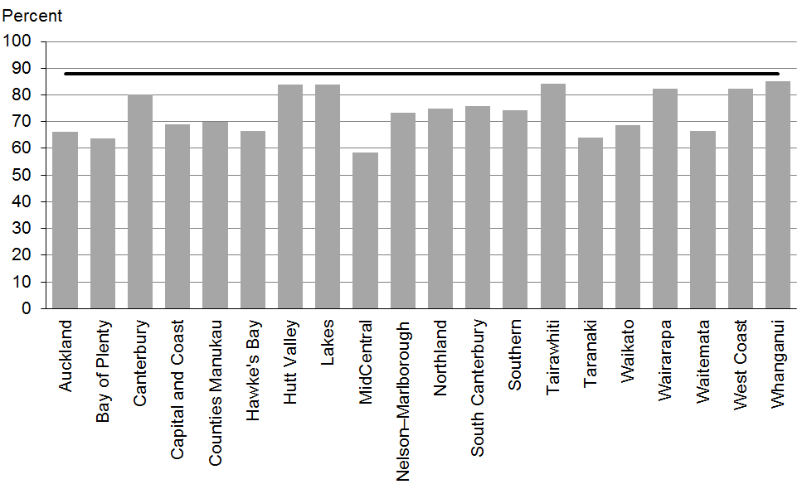

Figure 2: Newborns enrolled with a PHO by three months, Māori
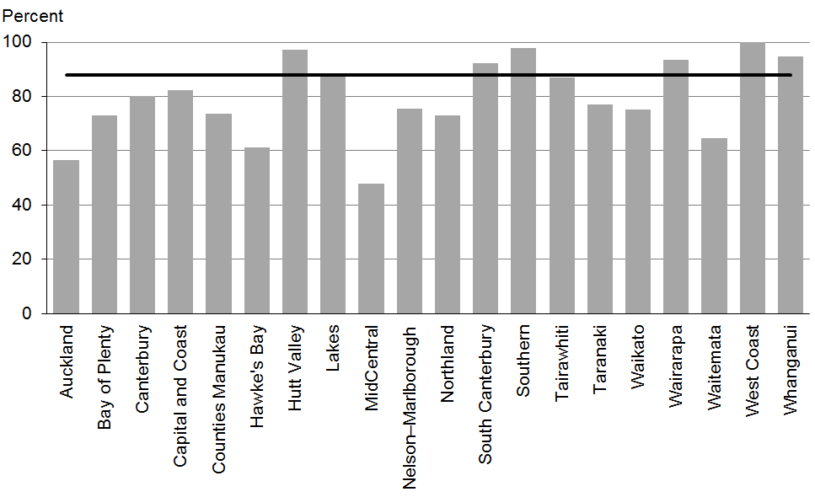

Figure 3: Newborns enrolled with a PHO by three months, Pacific peoples
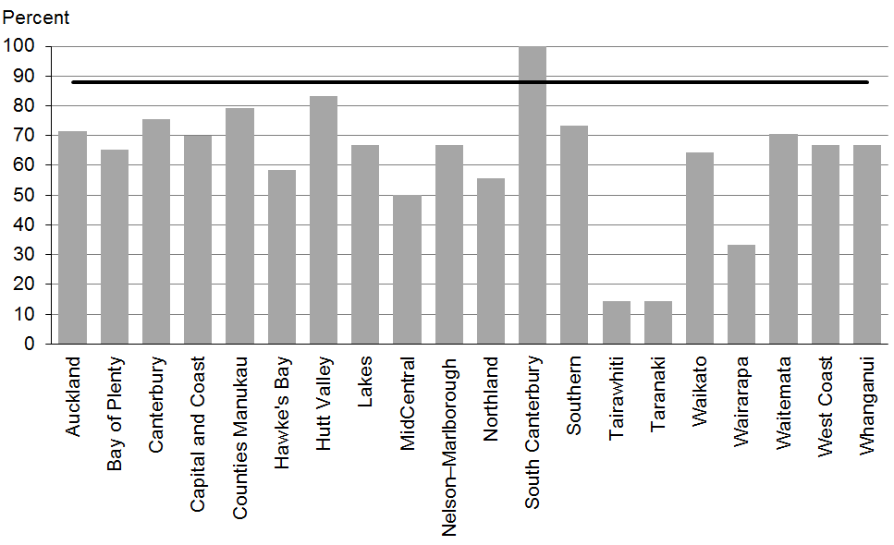

Data notes
- Data on enrolment with a general practice by two weeks of age was not available at the time of writing. Enrolment with a PHO by three months of age has been used as an interim measure.
- Data is not currently available by deprivation quintile.
- Time period: births between 20 February 2014 and 19 May 2014.
- Excludes overseas DHB and undefined DHB.
- Numerator: enrolments of infants under three months with a PHO.
- Denominator: births reported to the National Immunisation Register.

WCTO Quality Improvement Framework Indicator 2
Standard: | All children and families have access to primary care, WCTO services (including the B4 School Check) and early childhood education
Indicator: | Families and whānau are referred from their lead maternity carer (LMC) to a WCTO provider
Target by December 2014: | 88 percent
Target by June 2016: | 98 percent

 | Total New Zealand | High deprivation | Māori | Pacific peoples
September 2014 mean (range) | 98% (95–99) | 97% (94–100) | 97% (92–100) | 98% (94–100)

Figure 4: Referral from LMC to WCTO, total New Zealand
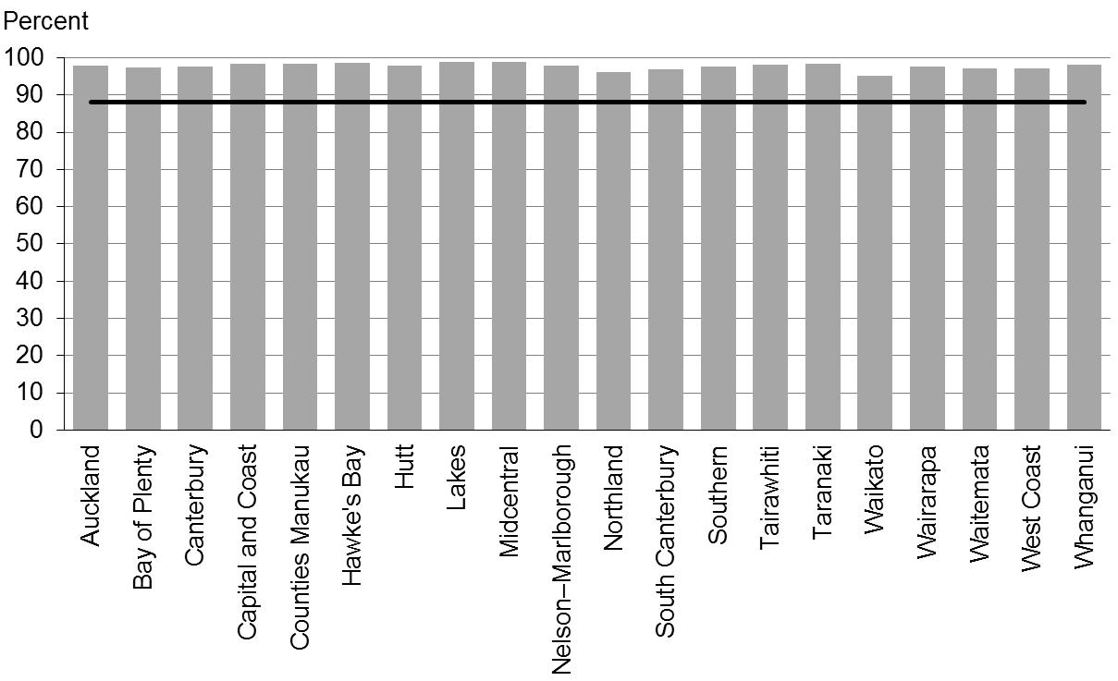

Figure 5: Referral from LMC to WCTO, high deprivation
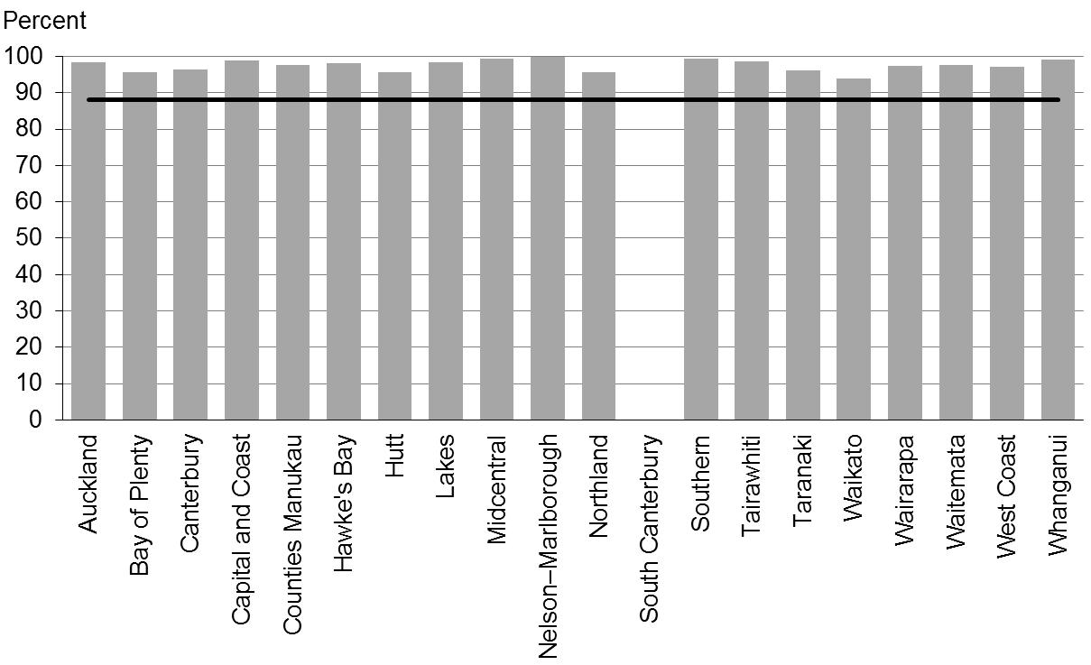

Figure 6: Referral from LMC to WCTO, Māori
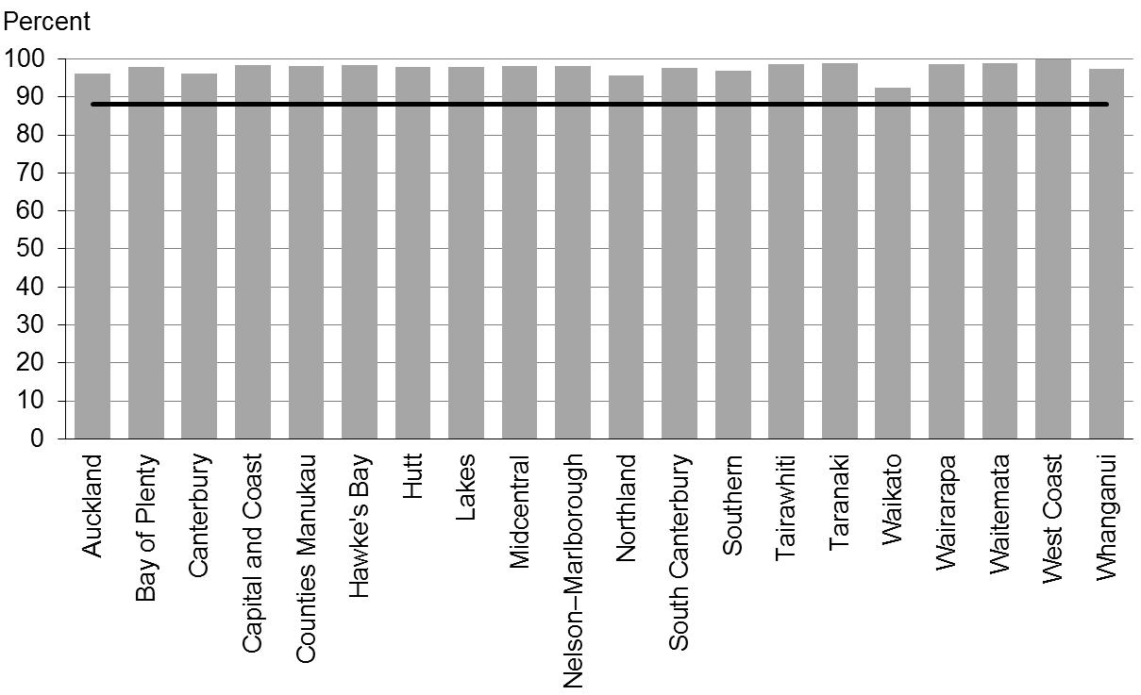

Figure 7: Referral from LMC to WCTO, Pacific peoples
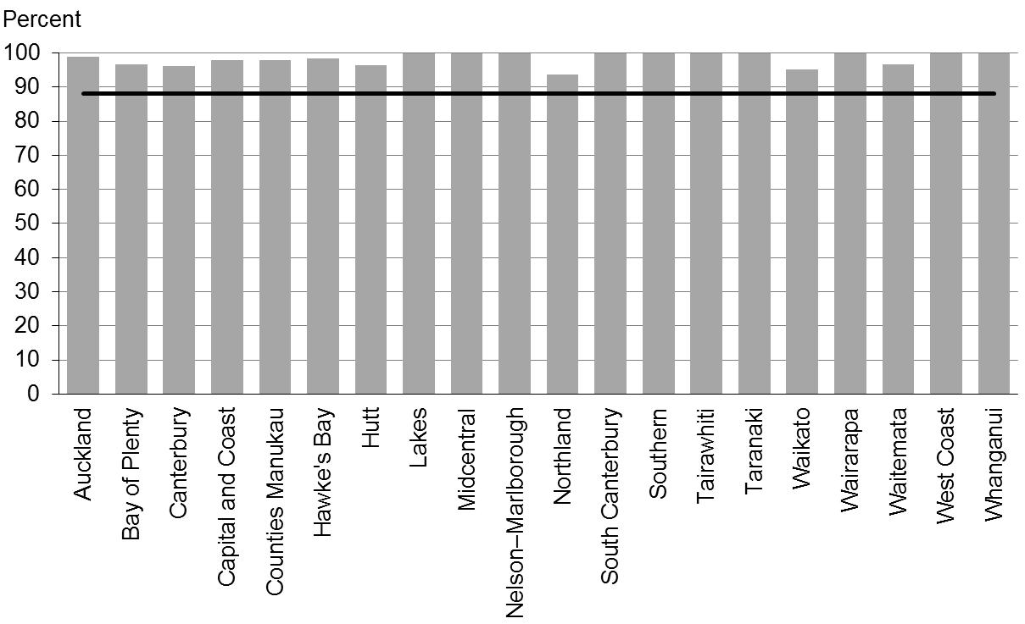

Data notes
- No bar on graph = no infants in this category.
- Time period: births between July 2013 and December 2013.
- The data excludes overseas DHB and undefined DHB.
- Numerator: LMC referral to WCTO = Yes (source: National Maternity Collection [MAT]).
- Denominator: LMC referral to WCTO = Yes or No (source: MAT).

WCTO Quality Improvement Framework Indicator 3
Standard: | All children and families have access to primary care, WCTO services (including the B4 School Check) and early childhood education
Indicator: | Infants receive all WCTO core contacts due in their first year
Target by December 2014: | 86 percent
Target by June 2016: | 95 percent

 | Total New Zealand | High deprivation | Māori | Pacific peoples
September 2014 mean (range) | 76% (66–86) | 67% (58–86) | 67% (55–82) | 61% (55–80)

Figure 8: Core WCTO contacts 1–5 received, total New Zealand
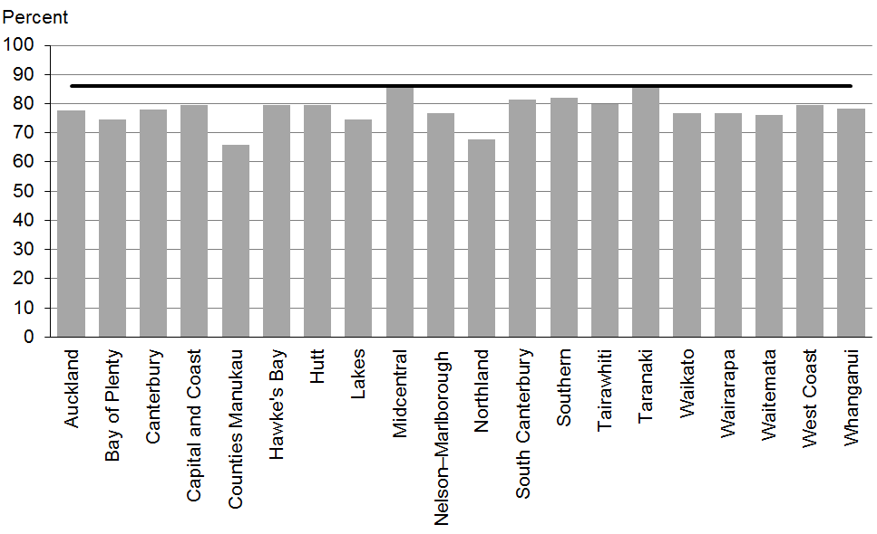

Figure 9: Core WCTO contacts 1–5 received, high deprivation
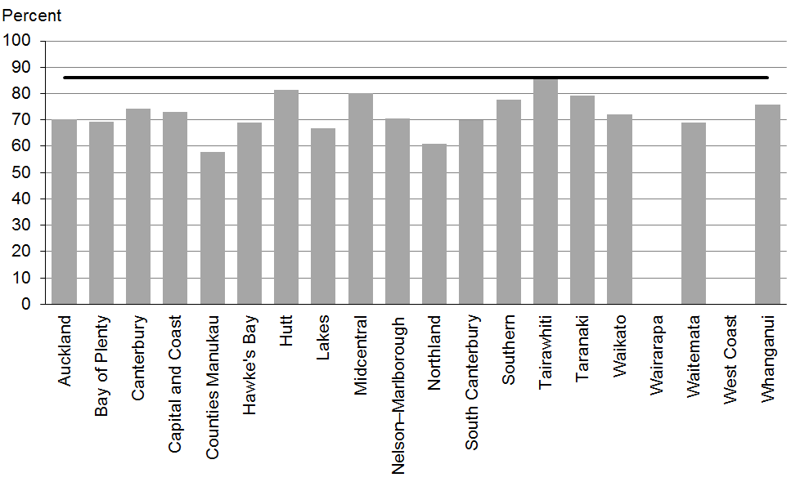

Figure 10: Core WCTO contacts 1–5 received, Māori
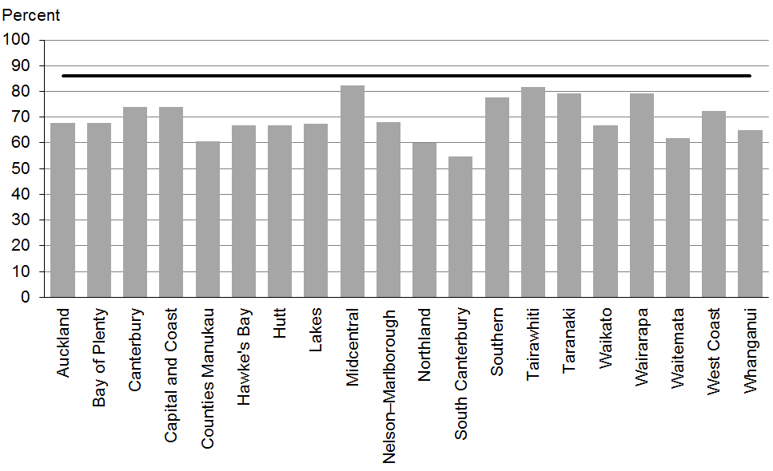

Figure 11: Core WCTO contacts 1–5 received, Pacific peoples
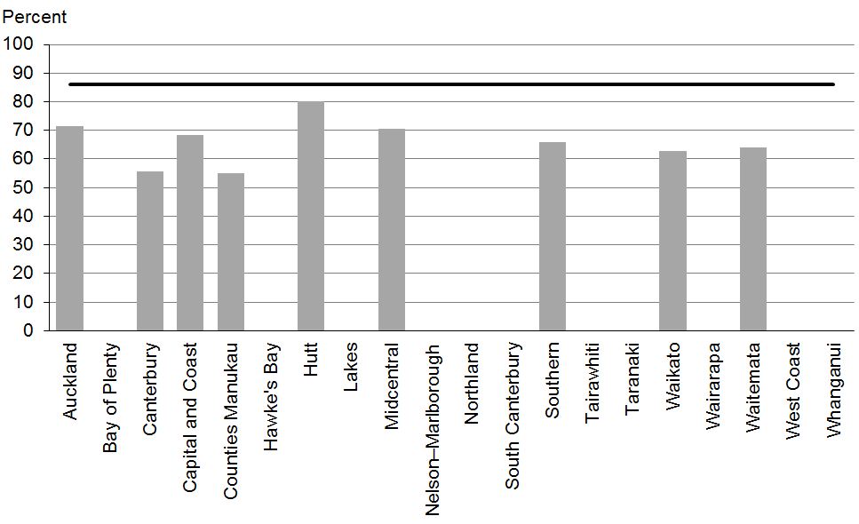

Data notes
- No bar on graph = fewer than 20 children in that population.
- Time period: children reaching age band for core contact 6 between January 2014 and June 2014.
- Excludes overseas DHB and undefined DHB.
- Numerator: number of infants where contact was able to be made by six weeks and who received all five contacts (source: Plunket).
- Denominator: number of infants where contact was able to be made by six weeks, who reached age band for core contact 6 (13 months, 4 weeks, 1 day) (source: Plunket).

WCTO Quality Improvement Framework Indicator 4
Standard: | All children and families have access to primary care, WCTO services (including the B4 School Check) and early childhood education
Indicator: | Four-year-olds receive a B4 School Check
Target by December 2014: | 90 percent
Target by June 2016: | 90 percent

 | Total New Zealand | High deprivation | Māori | Pacific peoples
September 2014 mean (range) | 91% (80–112) | 90% (76–119) | 83% (65–114) | 80% (60–133)

Figure 12: Children receive a B4 School Check, total New Zealand
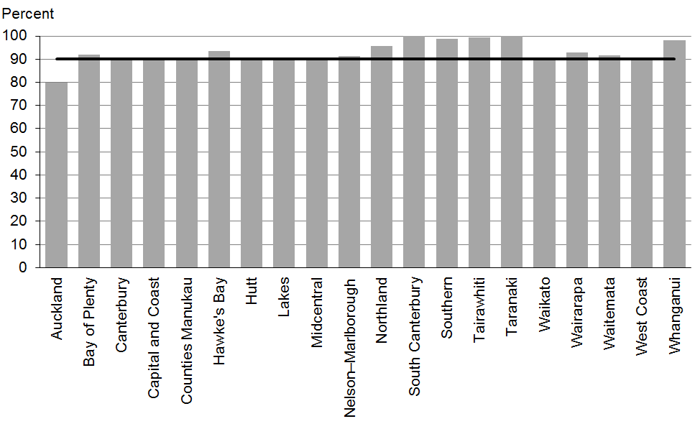

Figure 13: Children receive a B4 School Check, high deprivation
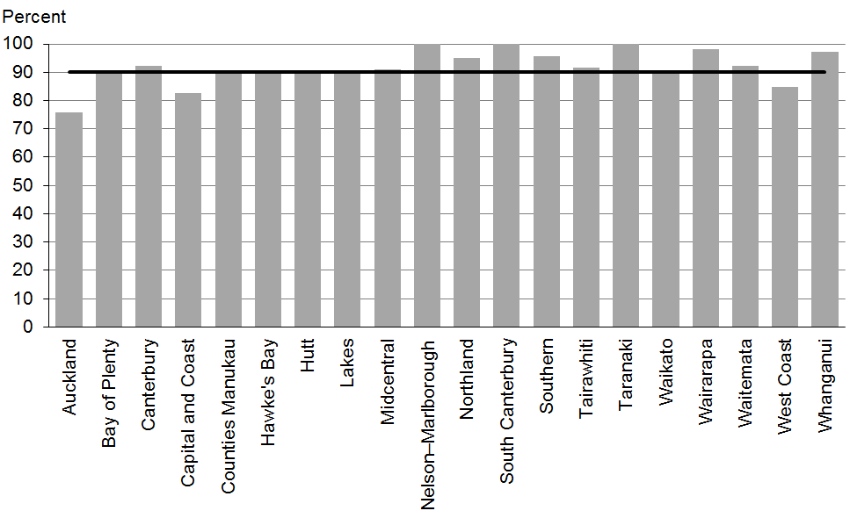

Figure 14: Children receive a B4 School Check, Māori
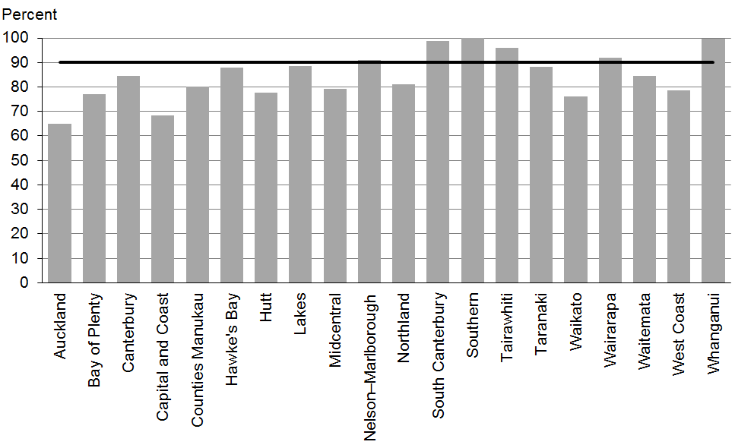

Figure 15: Children receive a B4 School Check, Pacific peoples
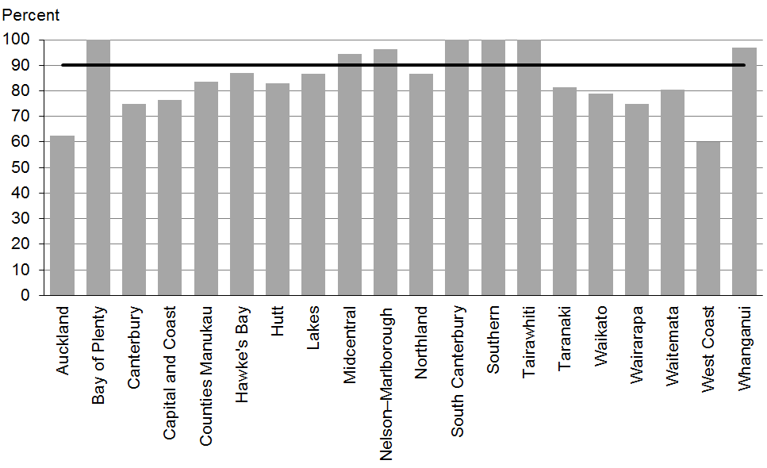

Data notes
- Time period: checks in the 2013/14 fiscal year.
- DHB is DHB of service.
- Numerator: number of completed B4 School Checks (source: B4 School Checks).
- Denominator: number of children eligible for a B4 School Check (source: PHO).

WCTO Quality Improvement Framework Indicator 5
Standard: | All children and families have access to primary care, WCTO services (including the B4 School Check) and early childhood education
Indicator: | Children are enrolled with child oral health services
Target by December 2014: | 86 percent
Target by June 2016: | 95 percent

 | Total New Zealand | High deprivation | Māori | Pacific peoples
September 2014 mean (range) | 73% (43–94) | N/A | 59% (27–86) | 68% (34–108)

Figure 16: Preschool children enrolled with oral health services, total New Zealand
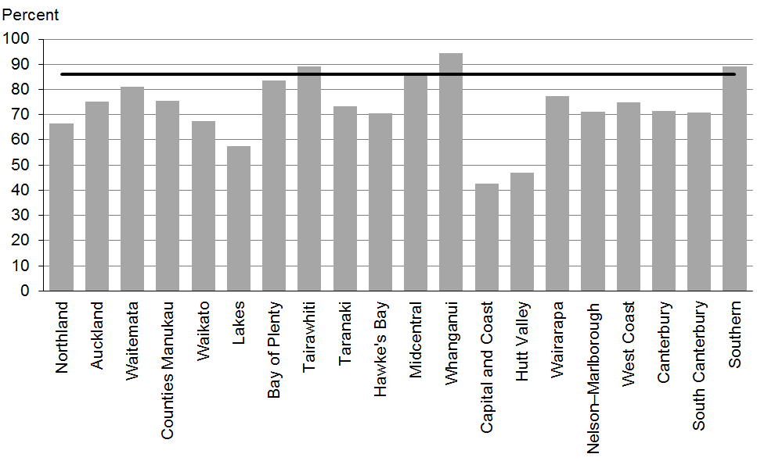

Figure 17: Preschool children enrolled with oral health services, Māori
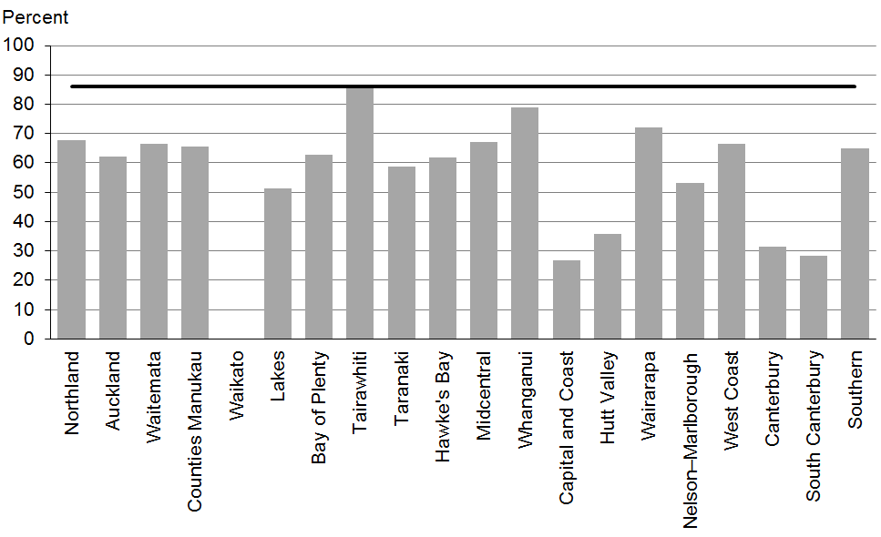

Figure 18: Preschool children enrolled with oral health services, Pacific peoples
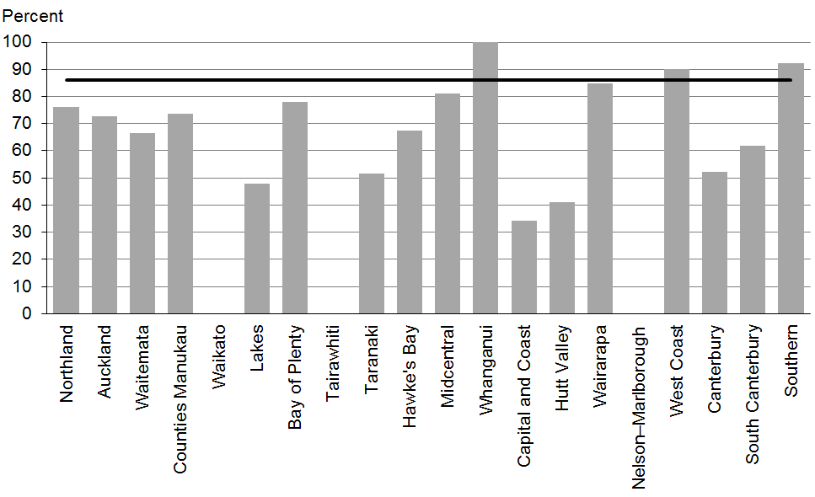

Data notes
- No bar on graph = no preschool children in this category.
- Data is not currently available by deprivation quintile.
- Time period: number of preschool children enrolled in 2013 calendar year.
- Numerator: number of children aged under five years enrolled with oral health services (source: community oral health services).
- Denominator: number of children aged under five years (source: PHO).

WCTO Quality Improvement Framework Indicator 6
Standard: | All children and families have access to primary care, WCTO services (including the B4 School Check) and early childhood education
Indicator: | Immunisations are up to date by eight months
Target by December 2014: | 95 percent
Target by June 2016: | 95 percent

 | Total New Zealand | High deprivation | Māori | Pacific peoples
September 2014 mean (range) | 92% (81–97) | 89% (52–100) | 88% (83–100) | 95% (86–100)

Figure 19: Fully immunised by eight months, total New Zealand
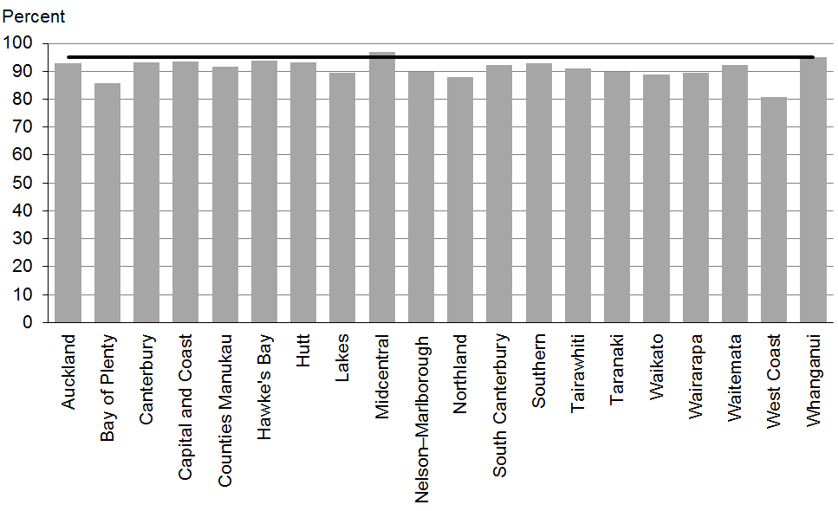

Figure 20: Fully immunised by eight months, high deprivation
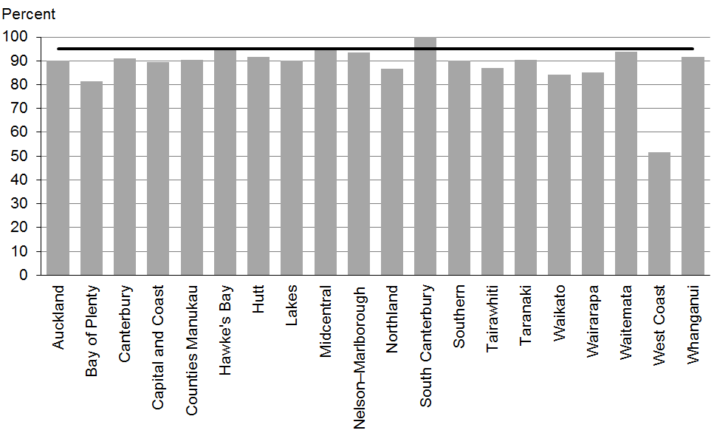

Figure 21: Fully immunised by eight months, Māori
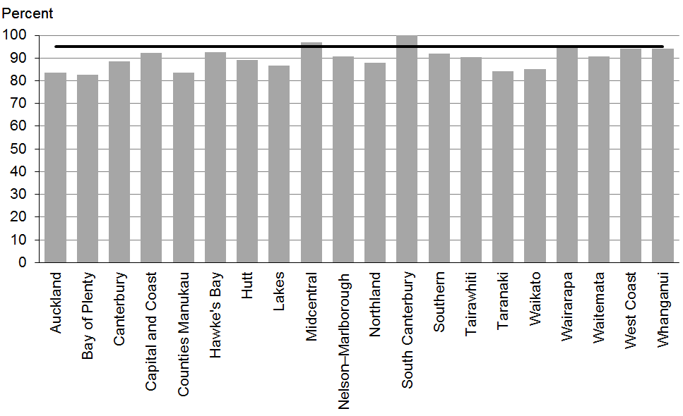

Figure 22: Fully immunised by eight months, Pacific peoples
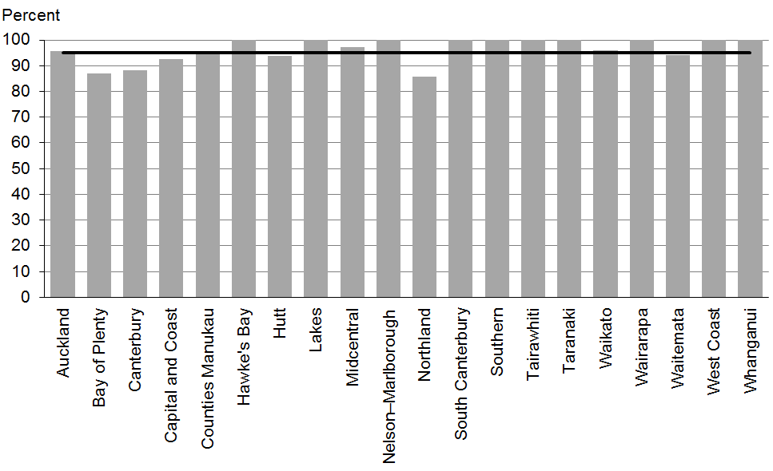

Data notes
- Time period: April 2014 to June 2014.
- Excludes overseas DHB and undefined DHB.
- Numerator: number of eight-month-old infants up to date with immunisations for age (source: National Immunisation Register).
- Denominator: number of eight-month-old infants (source: National Immunisation Register).

WCTO Quality Improvement Framework Indicator 7
Standard: | All children and families have access to primary care, WCTO services (including the B4 School Check) and early childhood education
Indicator: | Children participate in early childhood education (ECE)
Target by December 2014: | 98 percent
Target by June 2016: | 98 percent

 | Total New Zealand | High deprivation | Māori | Pacific peoples
September 2014 mean (range) | 96% (91–99) | 90% (86–99) | 93% (86–97) | 90% (87–100)

Figure 23: Prior participation in ECE, total New Zealand
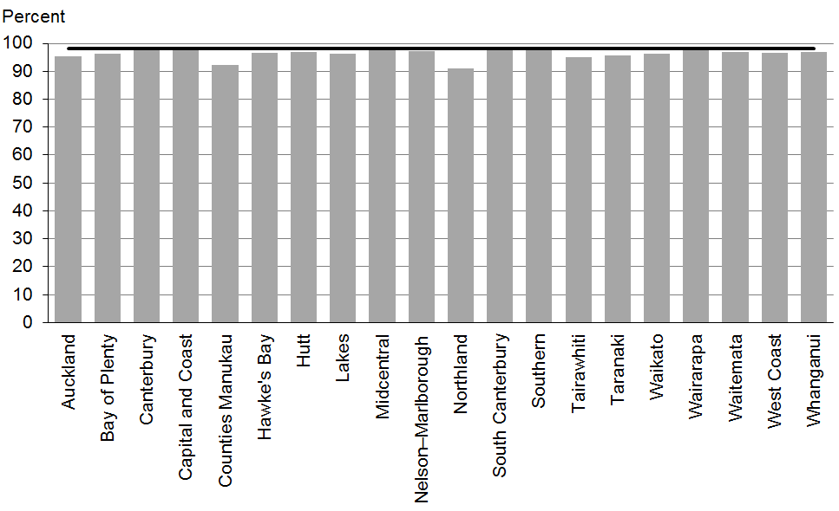

Figure 24: Prior participation in ECE, high deprivation
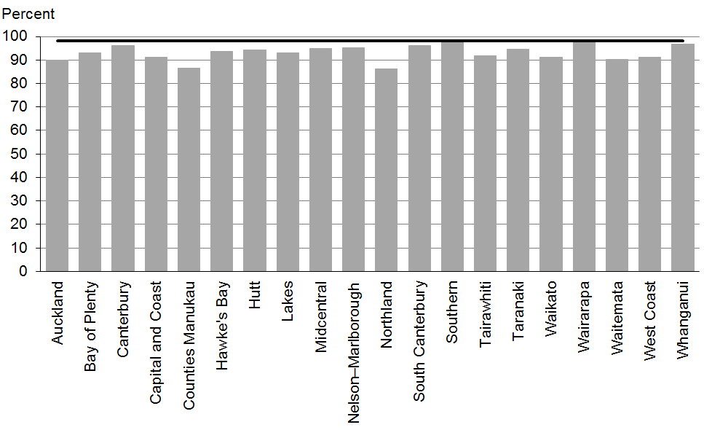

Figure 25: Prior participation in ECE, Māori
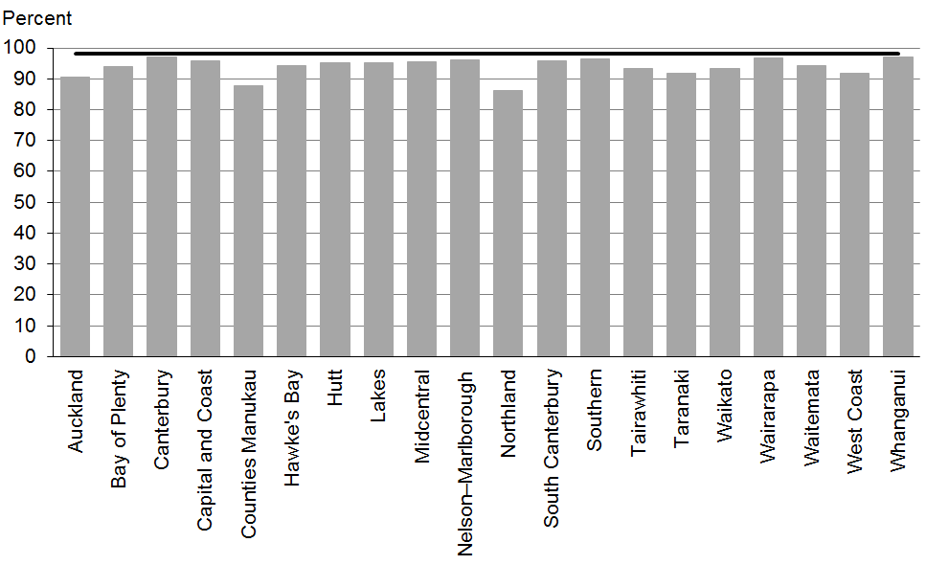

Figure 26: Prior participation in ECE, Pacific peoples
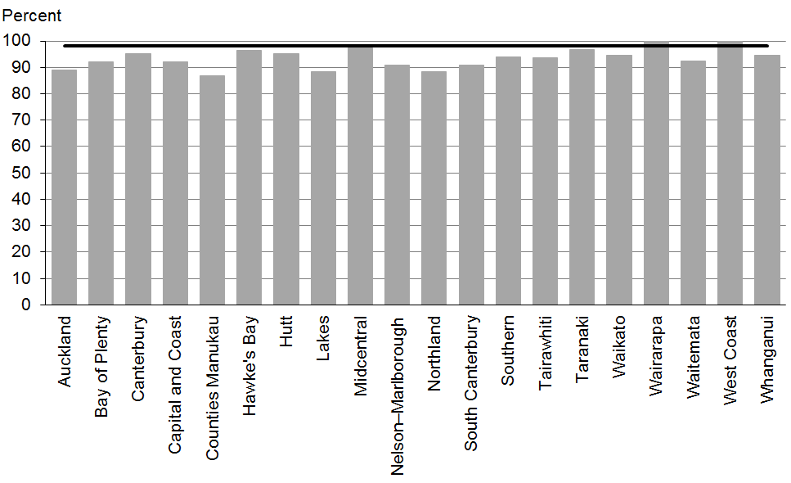

Data notes
- No bar on graph = no children in this category.
- Time period: children starting school during the 12 months to June 2014.
- High deprivation: children attending a Ministry of Education decile 1 or 2 school.
- Numerator: number of children starting school who have participated in ECE (source: ENROL).
- Denominator: number of children starting school (source: ENROL).

WCTO Quality Improvement Framework Indicator 8
Standard: | All children and families have access to primary care, WCTO services (including the B4 School Check) and early childhood education
Indicator: | Children under six years have access to free primary care
Target by December 2014: | 98 percent
Target by June 2016: | 100 percent

 | Total New Zealand | High deprivation | Māori | Pacific peoples
September 2014 mean (range) | 98% (94–100) | 99% (92–100) | 100% (95–100) | 100% (93–100)

Figure 27: Under-six access to free primary care, total New Zealand
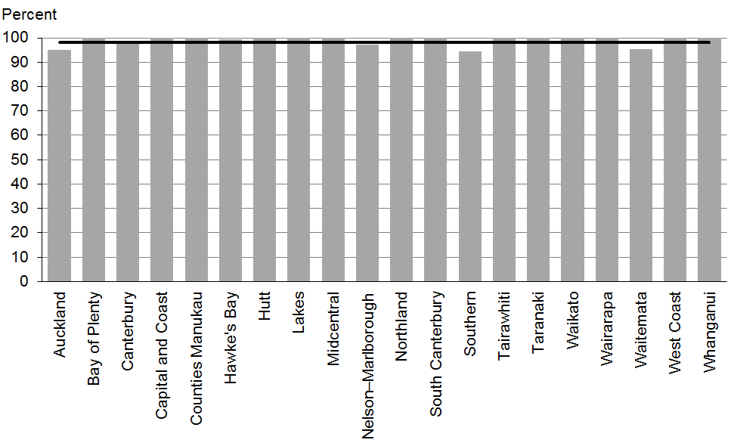

Figure 28: Under-six access to free primary care, high deprivation
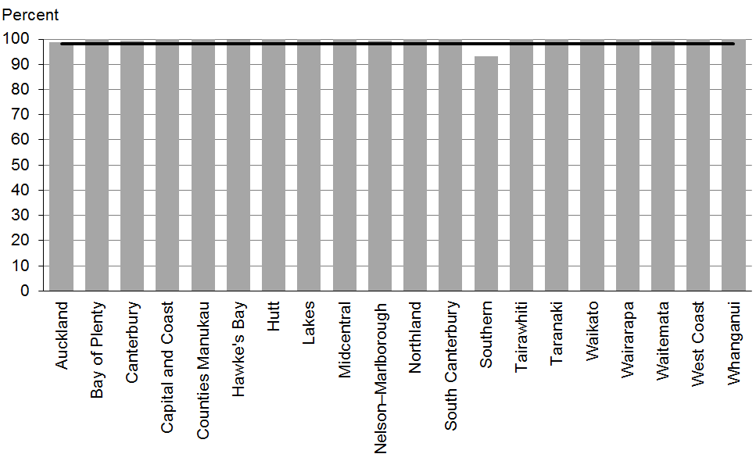

Figure 29: Under-six access to free primary care, Māori
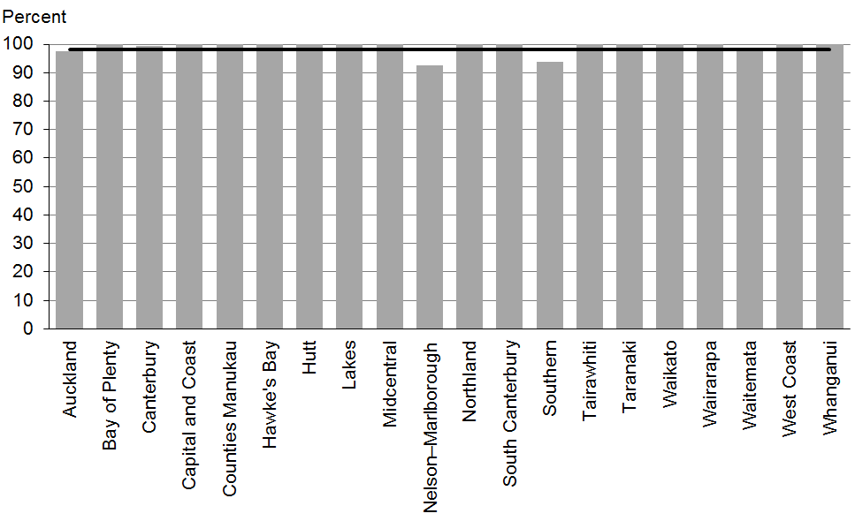

Figure 30: Under-six access to free primary care, Pacific peoples
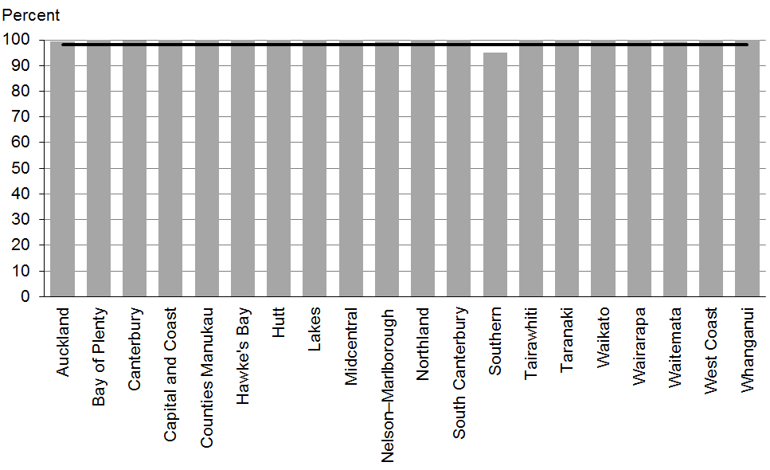

Data notes
- Time period: snapshot as at 1 July 2014.
- Numerator: number of children aged under six years enrolled with a PHO that delivers free primary care for under-sixes (source: PHO).
- Denominator: number of children aged under six years enrolled with a PHO (source: PHO).

WCTO Quality Improvement Framework Indicator 9
Standard: | All children and families have access to primary care, WCTO services (including the B4 School Check) and early childhood education
Indicator: | Children under six years have access to free after-hours primary care
Target by December 2014: | 98 percent
Target by June 2016: | 100 percent

 | Total New Zealand | High deprivation | Māori | Pacific peoples
September 2014 mean (range) | 98% (83–100) | N/A | N/A | N/A

Figure 31: Under-six access to free after-hours primary care, total New Zealand
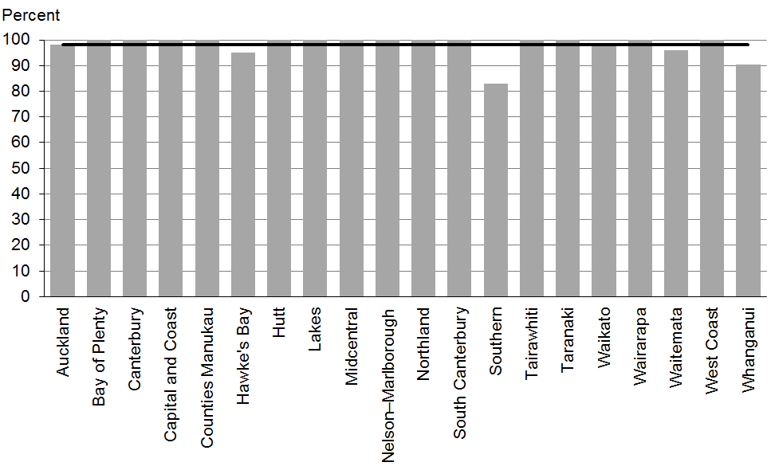

Data notes
- Time period: snapshot as at 1 July 2014.
- Data is not available by ethnicity or deprivation quintile.
- Numerator: number of children under aged six years who are enrolled with a PHO that delivers free after-hours primary care for under sixes (source: PHO).
- Denominator: number of children aged under six years who are enrolled with a PHO (source: PHO).

WCTO Quality Improvement Framework Indicator 10
Standard: | All children and families have access to specialist and other referred services, where required, in a timely manner
Indicator: | Children are seen promptly following referral to specialist services
Target by December 2014: | 100 percent within five months of referral
Target by June 2016: | 100 percent within four months of referral

 | Total New Zealand | High deprivation | Māori | Pacific peoples
September 2014 mean (range) | 100% (99–100) | N/A | N/A | N/A

Figure 32: First specialist appointment for paediatric medicine received within five months, total New Zealand
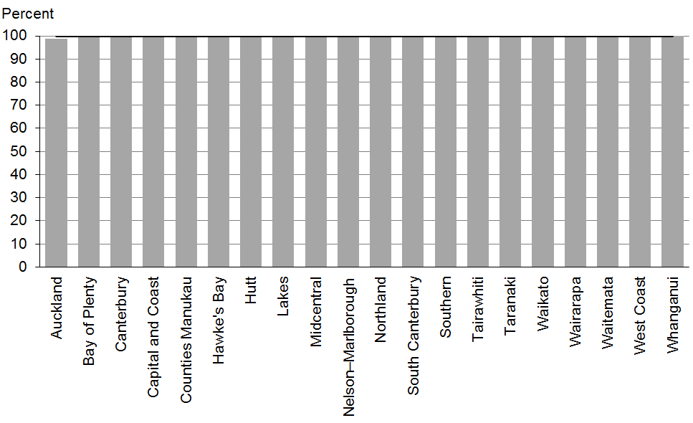

Data notes
- Time period: snapshot for July 2014 (data extracted 9 September 2014).
- DHB is DHB of service.
- Data is not available by ethnicity or deprivation quintile.
- The data presented is for any referral to DHB paediatric medicine (any age).
- Numerator: number waiting longer than five months (source: DHB Elective Services Patient Flow Indicators reporting).
- Denominator: total number waiting at end of month (source: DHB Elective Services Patient Flow Indicators reporting).

Indicators 11–20: Outcomes
Aim 2 of the WCTO Quality Improvement Framework is improved health and equity for all populations. This can be measured by improved health and wellbeing outcomes for children, families and whānau. It is expected that, in addition to these indicators, DHBs and WCTO providers will consider other measures of family and whānau health and wellbeing that can be monitored through national or local data sources.

Indicators 11–20 measure health outcomes across a range of domains. This set is not exhaustive, but instead aims to measure a range of outcomes related to infant and child physical health (nutrition and healthy weight, oral health), infant and child mental health (strengths and difficulties questionnaire) and family health (smoking status). It is expected that additional measures of health and wellbeing outcomes will be added as new data becomes available. A number of these indicators have been adopted into other performance and outcome monitoring documents including Māori Health Plans, the New Zealand Maternity Clinical Indicator and the draft Integrated Performance and Incentive Framework Healthy Birth Measure.

These indicators reflect the core roles of WCTO in promoting and supporting physical health, mental wellbeing, healthy families and whānau and healthy home environments. Achieving improvements in these indicators will require a cross-sector response and a multi-faceted approach, and improvements may not be seen in the short term. However, monitoring health and wellbeing outcomes is important because it shows where WCTO services are working well and where they are working together with the wider health sector to achieve the best outcomes for families and whānau.

Summary of results for this period

National
Data for this period shows good overall outcomes for a number of indicators in relation to the 2014 and 2016 targets, with eight indicators continuing to meet or exceed 2014 targets nationally. Three indicators show improvement since the last report, which notably include a slight increase in the number of mothers who are smokefree at two weeks postnatal and a slight decrease in the burden of dental decay at five years of age. Rates of breastfeeding prior to six weeks of age (Indicators 11 and 12) show a slight decrease since the last report, and the rate of children who are caries free at five years (Indicator 16) has dropped by 2 percent. At a whole-of-population level the focus should be on targeting indicators that have room for improvement, while striving to maintain the good outcomes that have already been achieved in other areas.

By region
Data for this period shows variable performance by region. No DHBs achieved the 2014 targets for all 10 outcome indicators, compared with two DHBs who achieved this in the last report. However, all DHBs met at least six targets, whereas in the last report this minimum was lower at four targets. High levels of variation by DHBs were seen in Indicator 16: Children are caries free at five years (range = 34–68 percent) and Indicator 19: Mothers are smokefree at two weeks postnatal (range = 70–97 percent). DHBs and WCTO providers, including primary maternity providers, should review the characteristics of higher-performing regions and identify success factors that could be applied locally.

By deprivation
Oral health data (Indicators 16 and 17) is not available by deprivation quintile at this time. Other indicators all show poorer rates for children living in areas of high deprivation, with lower national rates and fewer DHBs meeting 2014 or 2016 targets.

Since the last report, more children living in areas of high deprivation are a healthy weight at four years old (69 percent, compared with 68 percent in the last report) and more women living in areas of high deprivation are smokefree at two weeks postnatal (77 percent, compared with 75 percent in the last report). However, these indicators lag 6 and 10 percent respectively behind the national rates.

In all three age groups covered by these indicators (at two weeks, six weeks and three months), fewer infants living in areas of high deprivation are exclusively or fully breastfed and fewer infants receive some breast milk at six months relative to the total population. There has been no increase in rates for any of the four breastfeeding indicators for infants living in areas of high deprivation since the last report. Breastfeeding is free and helps lay the foundations of a healthy life for a baby. Supporting families living in areas of high deprivation to establish and maintain breastfeeding should be a focus for all district health boards.

By ethnicity
Outcomes for Māori and Pacific families are significantly poorer across a range of indicators. For Māori, maternal tobacco use is significantly higher than for the total population, with only 65 percent of women smokefree at two weeks postnatal relative to 87 percent of the total population. Nationally, Māori infants still have the lowest rates of exclusive or full breastfeeding at six weeks and of any breastfeeding at six months.

Indicator 16: Children are caries free at five years shows significant rates of decay for Māori children: only 37 percent of children are caries free at the age of five years, a further drop of 2 percent since the last report. There are also significant disparities in oral health for Pacific infants and children, with only 36 percent caries free at five years, which also represents a decrease since the last report. The WCTO programme has an important role in the assessment and support of oral health at core and additional contacts, and through referral to oral health services, to minimise the inequitable burden of poor oral health among Māori and Pacific children.

Nationally, Pacific infants are the least likely to be breastfed at six weeks of age, when less than three-quarters are exclusively or fully breastfed. However, breastfeeding rates at older ages decrease more gradually among Pacific families than for other population groups. Pacific children are least likely to be a healthy weight at four years of age (59 percent, versus 71 percent for Māori, 69 percent for children living in areas of high deprivation and 75 percent nationally).

WCTO Quality Improvement Framework Indicator 11
Standard: | WCTO providers use evidence-based interventions and education to promote child, family and whānau health and wellbeing
Indicator: | Infants are exclusively or fully breastfed at two weeks
Target by December 2014: | 72 percent
Target by June 2016: | 80 percent

 | Total New Zealand | High deprivation | Māori | Pacific peoples
September 2014 mean (range) | 79% (74–90) | 77% (70–92) | 77% (67–88) | 74% (54–100)

Figure 33: Exclusively or fully breastfed at two weeks, total New Zealand
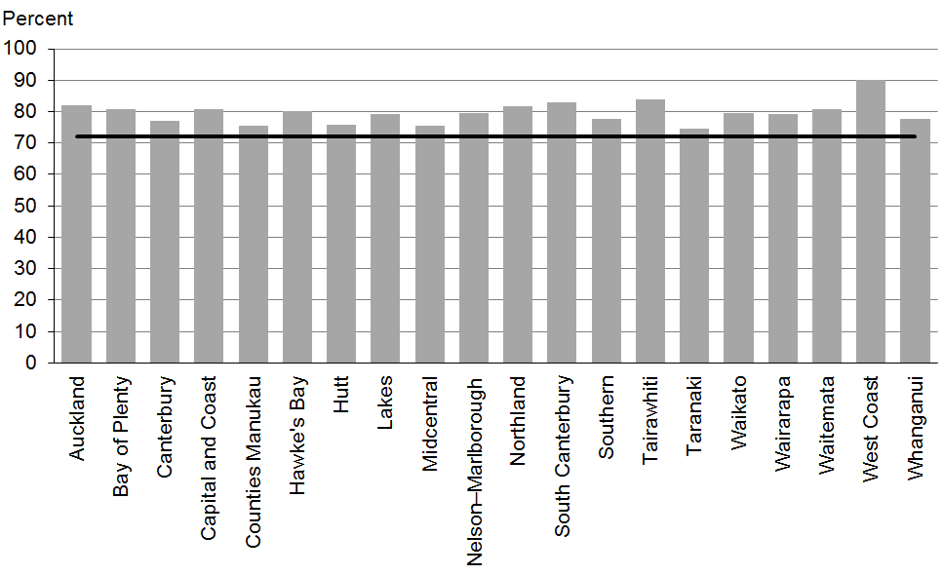

Figure 34: Exclusively or fully breastfed at two weeks, high deprivation
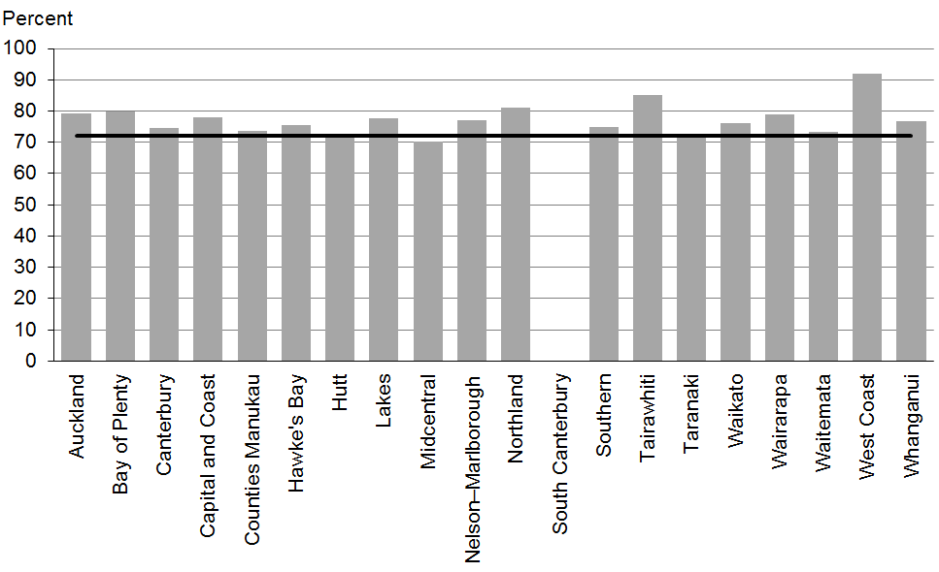

Figure 35: Exclusively or fully breastfed at two weeks, Māori
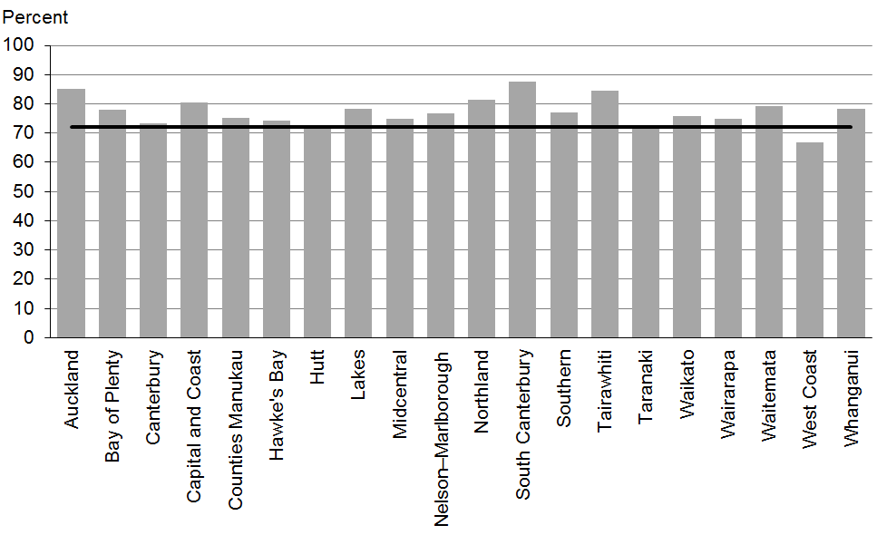

Figure 36: Exclusively or fully breastfed at two weeks, Pacific peoples
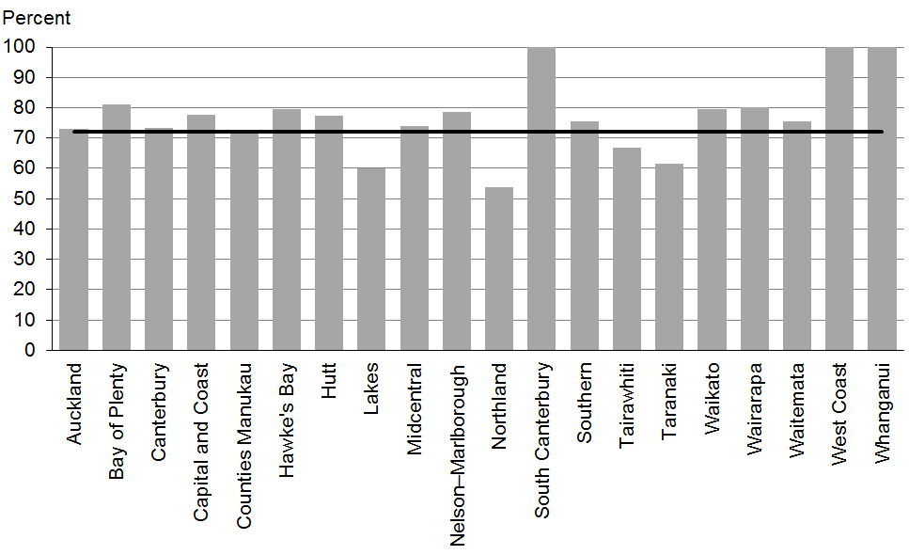

Data notes
- No bar on graph = no infants in this category.
- Time period: babies born between July 2013 and December 2013.
- Excludes overseas DHB and undefined DHB.
- Numerator: breastfeeding at two weeks = exclusive or fully (source: MAT).
- Denominator: breastfeeding at two weeks = not null (source: MAT).

WCTO Quality Improvement Framework Indicator 12
Standard: | WCTO providers use evidence-based interventions and education to promote child, family and whānau health and wellbeing
Indicator: | Infants are exclusively or fully breastfed on discharge from lead maternity carer (LMC) care
Target by December 2014: | 68 percent
Target by June 2016: | 75 percent

 | Total New Zealand | High deprivation | Māori | Pacific peoples
September 2014 mean (range) | 75% (67–82) | 73% (59–82) | 71% (42–82) | 73% (33–100)

Figure 37: Exclusively or fully breastfed at LMC discharge, total New Zealand
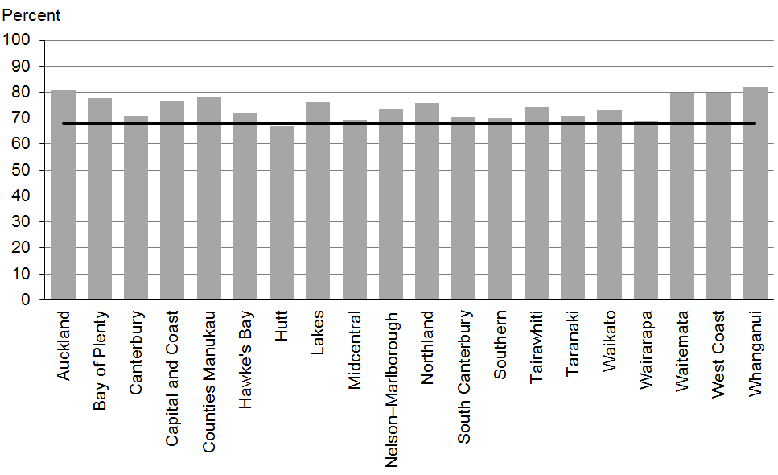

Figure 38: Exclusively or fully breastfed at LMC discharge, high deprivation
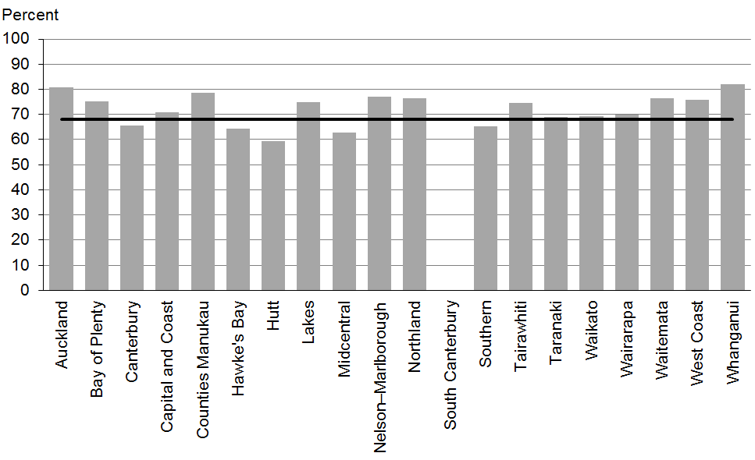

Figure 39: Exclusively or fully breastfed at LMC discharge, Māori
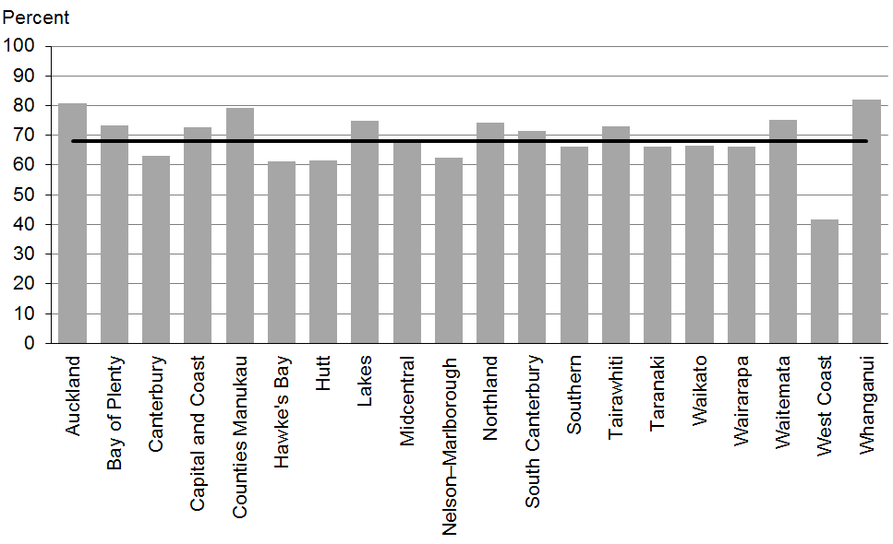

Figure 40: Exclusively or fully breastfed at LMC discharge, Pacific peoples
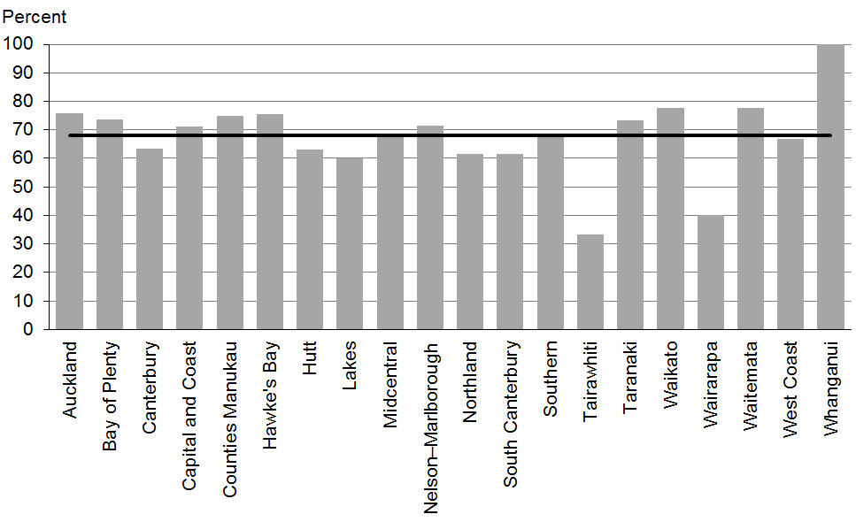

Data notes
- No bar on graph = no infants in this category.
- Time period: babies born between July 2013 and December 2013.
- Excludes overseas DHB and undefined DHB.
- Numerator: breastfeeding at discharge = exclusive or fully (source: MAT).
- Denominator: breastfeeding at discharge = not null (source: MAT).

WCTO Quality Improvement Framework Indicator 13
Standard: | WCTO providers use evidence-based interventions and education to promote child, family and whānau health and wellbeing
Indicator: | Infants are exclusively or fully breastfed at three months of age
Target by December 2014: | 54 percent
Target by June 2016: | 60 percent

 | Total New Zealand | High deprivation | Māori | Pacific peoples
September 2014 mean (range) | 55% (47–61) | 43% (36–56) | 44% (31–51) | 45% (39–67)

Figure 41: Exclusively or fully breastfed at three months, total New Zealand
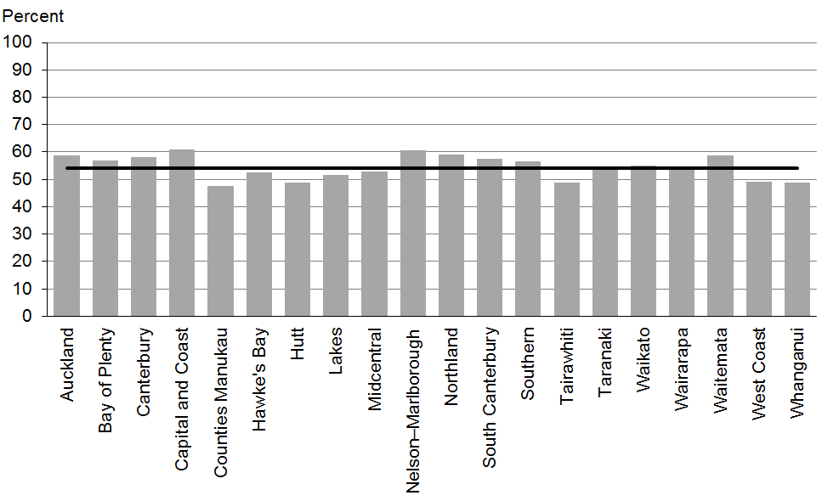

Figure 42: Exclusively or fully breastfed at three months, high deprivation
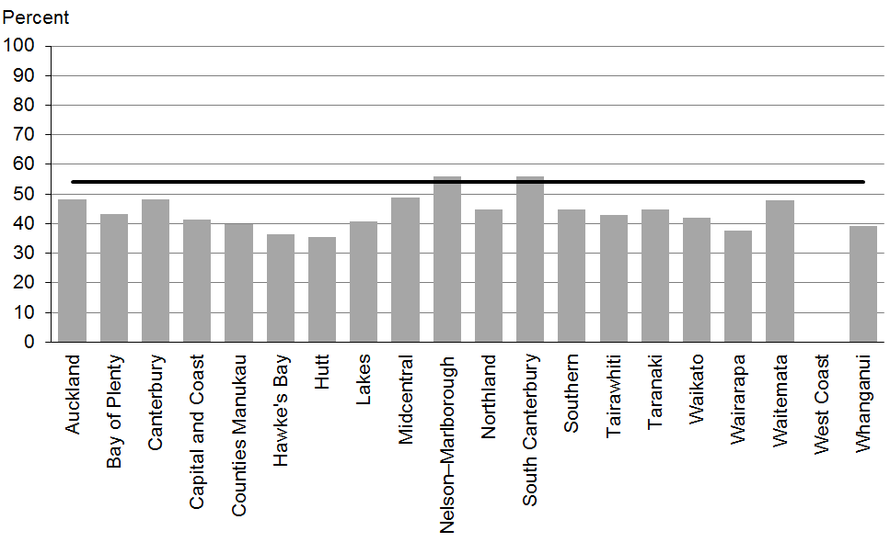

Figure 43: Exclusively or fully breastfed at three months, Māori
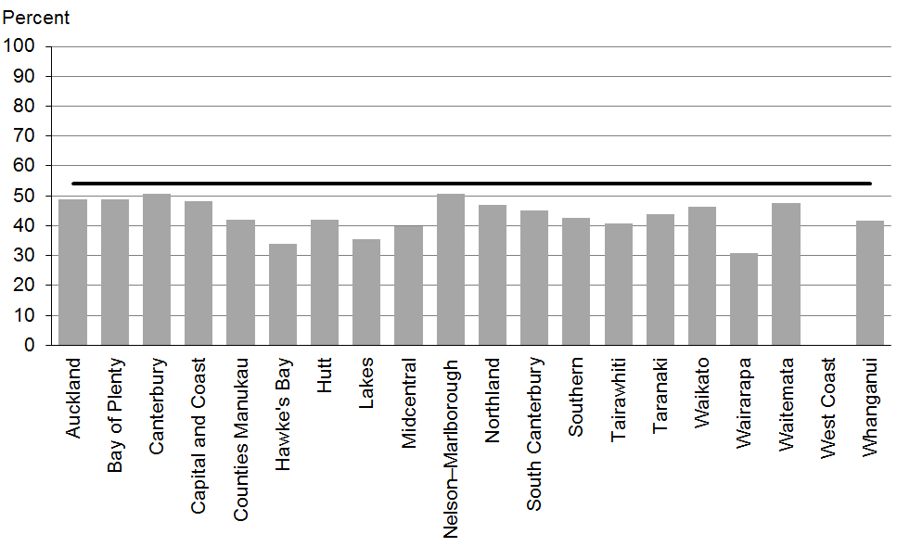

Figure 44: Exclusively or fully breastfed at three months, Pacific peoples
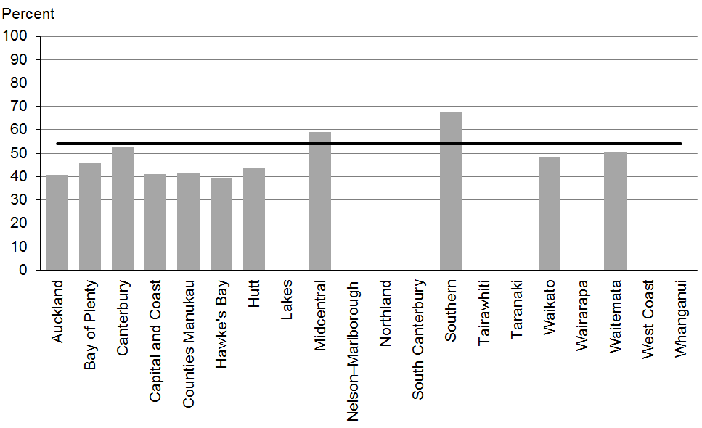

Data notes
- No bar on graph = fewer than 20 infants in this category.
- Time period: infants aged three months between January 2014 and June 2014.
- Excludes overseas DHB and undefined DHB.
- Numerator: breastfeeding at three months = exclusive or fully (source: Plunket).
- Denominator: breastfeeding at three months = not null (source: Plunket).

WCTO Quality Improvement Framework Indicator 14
Standard: | WCTO providers use evidence-based interventions and education to promote child, family and whānau health and wellbeing
Indicator: | Infants are receiving breast milk at six months of age (exclusively, fully or partially breastfed)
Target by December 2014: | 59 percent
Target by June 2016: | 65 percent

 | Total New Zealand | High deprivation | Māori | Pacific peoples
September 2014 mean (range) | 66% (56–73) | 55% (46–65) | 54% (33–70) | 59% (55–72)

Figure 45: Infants receive breast milk at six months, total New Zealand
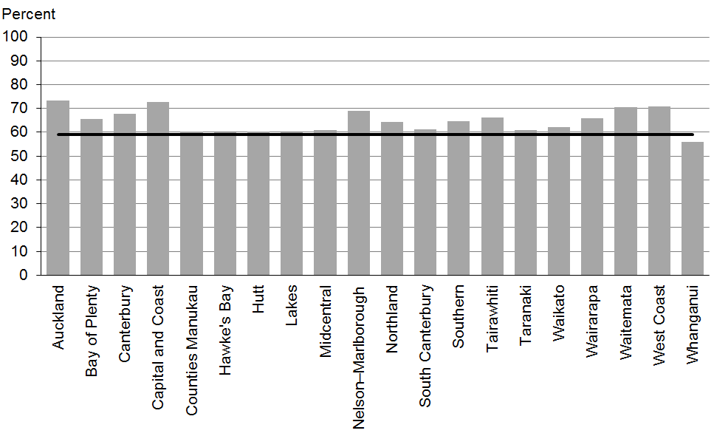

Figure 46: Infants receive breast milk at six months, high deprivation
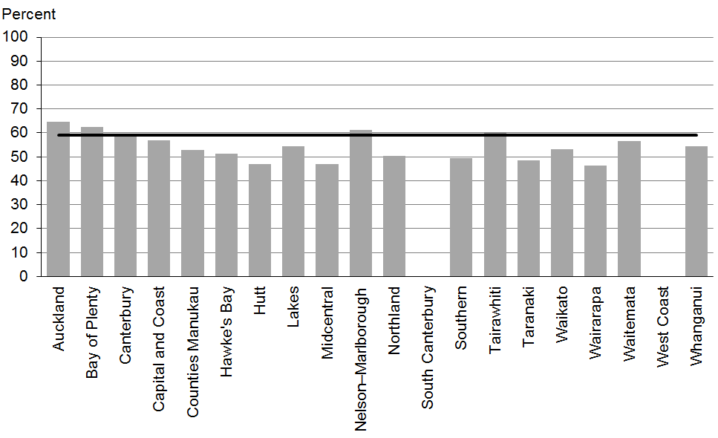

Figure 47: Infants receive breast milk at six months, Māori
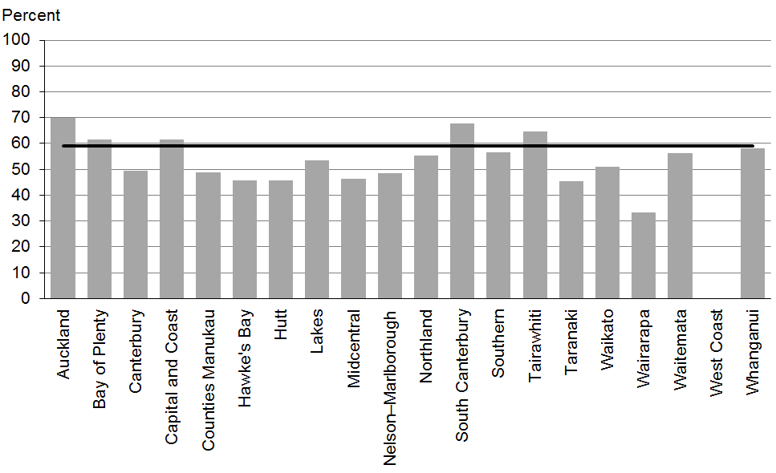

Figure 48: Infants receive breastmilk at six months, Pacific peoples
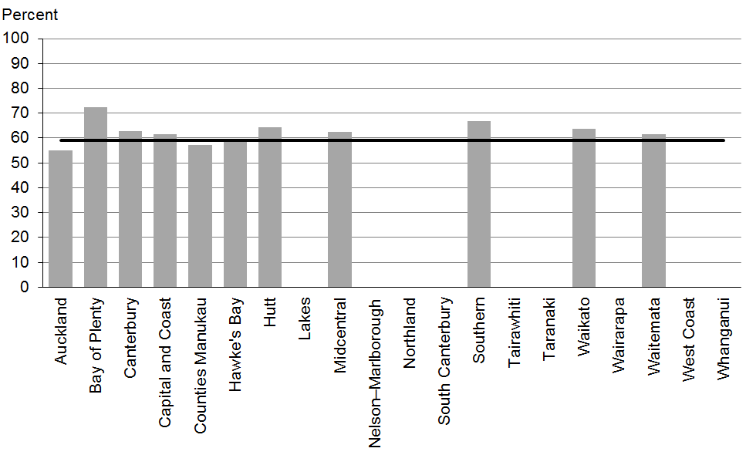

Data notes
- No bar on graph = fewer than 20 infants in this category.
- Time period: infants aged six months between January 2014 and June 2014.
- Excludes overseas DHB and undefined DHB.
- Numerator: breastfeeding at six months = exclusive, full or partial (source: Plunket).
- Denominator: breastfeeding at six months = not null (source: Plunket).

WCTO Quality Improvement Framework Indicator 15
Standard: | WCTO providers use evidence-based interventions and education to promote child, family and whānau health and wellbeing
Indicator: | Children are a healthy weight at four years
Target by December 2014: | 68 percent
Target by June 2016: | 75 percent

 | Total New Zealand | High deprivation | Māori | Pacific peoples
September 2014 mean (range) | 75% (69–80) | 69% (61–91) | 71% (57–88) | 59% (0–77)

Figure 49: Children are a healthy weight at age four years, total New Zealand
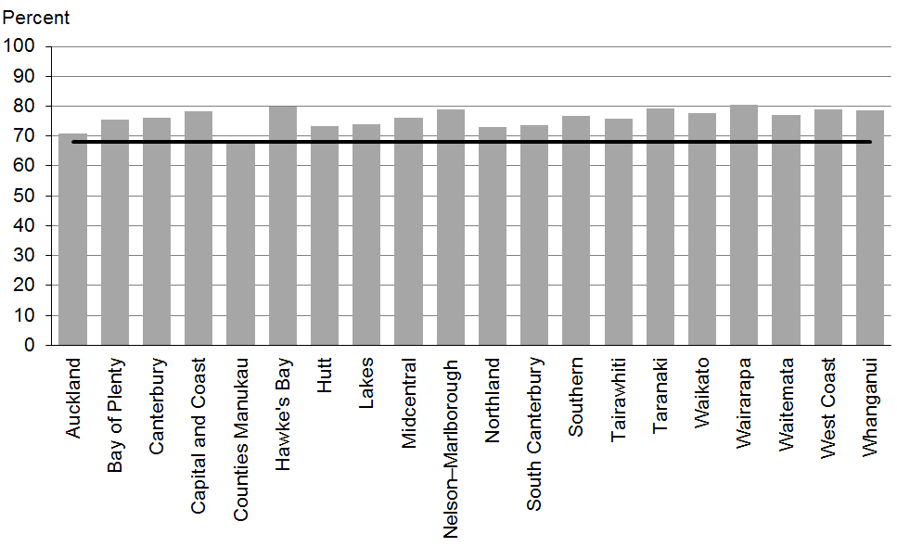

Figure 50: Children are a healthy weight at age four years, high deprivation
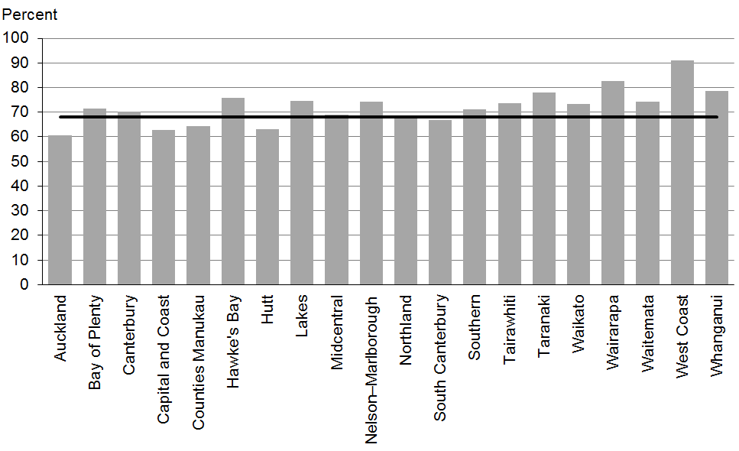

Figure 51: Children are a healthy weight at age four years, Māori
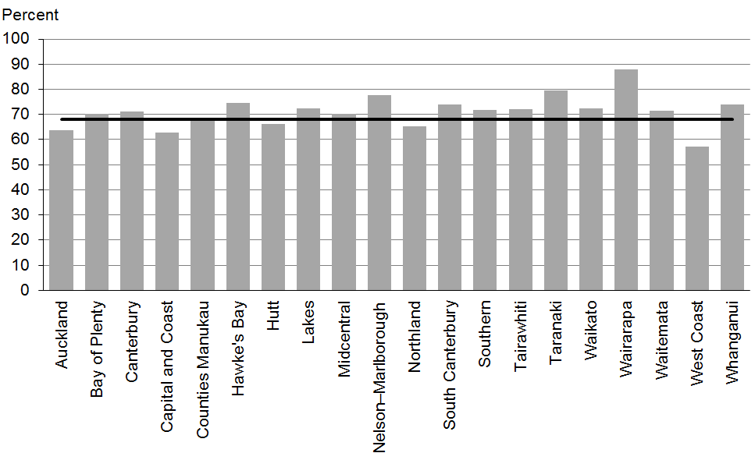

Figure 52: Children are a healthy weight at age four years, Pacific peoples
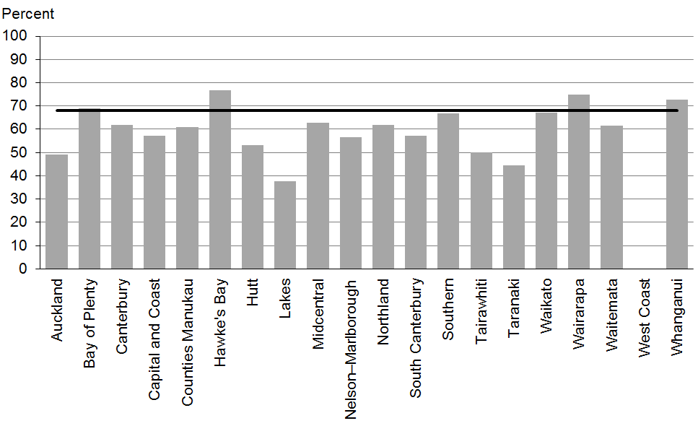

Data notes
- Time period: children receiving a B4 School Check between 1 January 2014 and 30 June 2014.
- DHB is DHB of service.
- Numerator: children with a BMI between the 5th and 84th percentile at B4 School Check (source: B4 School Check).
- Denominator: children with a BMI recorded at B4 School Check (source: B4 School Check).

WCTO Quality Improvement Framework Indicator 16
Standard: | WCTO providers use evidence-based interventions and education to promote child, family and whānau health and wellbeing
Indicator: | Children are caries free at five years
Target by December 2014: | 65 percent
Target by June 2016: | 65 percent

 | Total New Zealand | High deprivation | Māori | Pacific peoples
September 2014 mean (range) | 57% (34–68) | N/A | 37% (23–53) | 36% (10–86)

Figure 53: Caries free at five years, total New Zealand
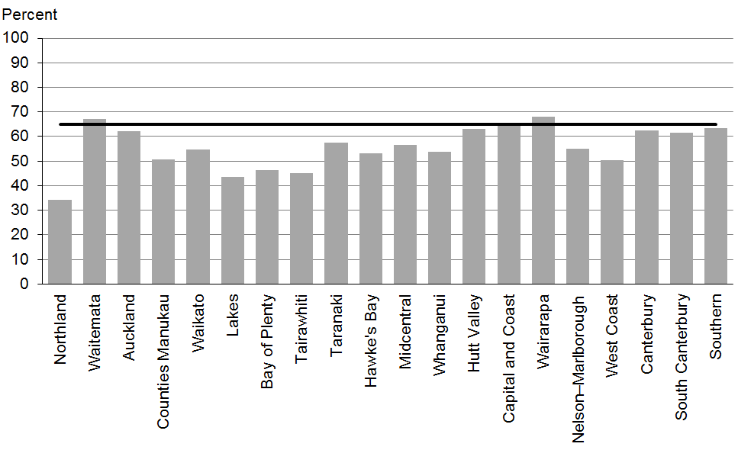

Figure 54: Caries free at five years, Māori
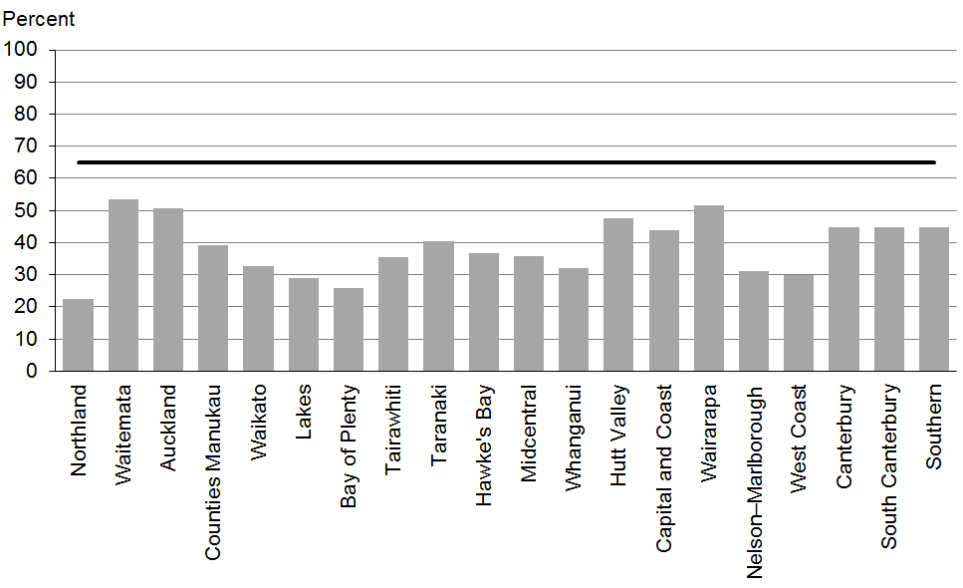

Figure 55: Caries free at five years, Pacific peoples
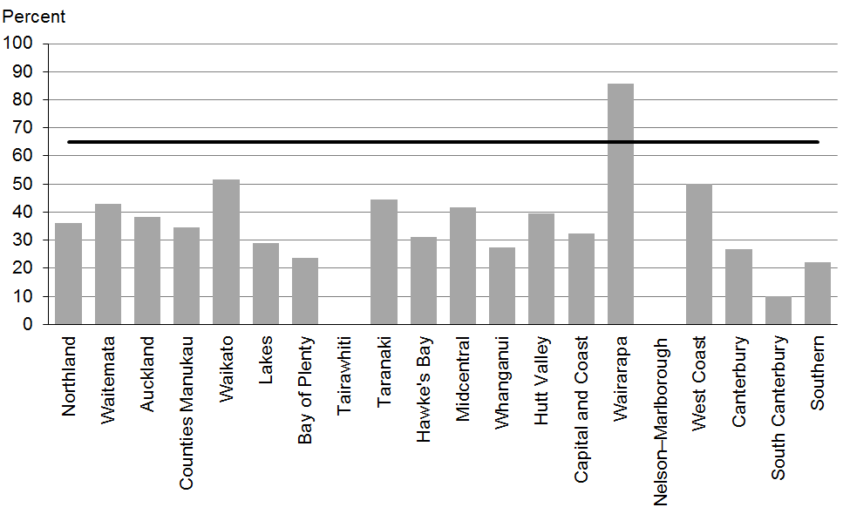

Data notes
- No bar on graph = no children in this category.
- Time period: children turning five years between 1 January 2013 and 31 December 2013.
- Excludes overseas DHB and undefined DHB.
- Data is not available by deprivation quintile.
- Numerator: number of five-year-old children caries free (source: community oral health services).
- Denominator: number of five-year-old children enrolled with oral health services (source: community oral health services).

WCTO Quality Improvement Framework Indicator 17
Standard: | WCTO providers use evidence-based interventions and education to promote child, family and whānau health and wellbeing
Indicator: | The burden of dental decay among children with one or more decayed, missing and filled teeth (dmft) is minimised
Target by December 2014: | 4.4 dmft
Target by June 2016: | 4 dmft

 | Total New Zealand | High deprivation | Māori | Pacific peoples
September 2014 mean (range) | 4.4 dmft (3.6–5.5) | N/A | 5.0 dmft (3.9–6.2) | 5.1 dmft (4.0–7.8)

Figure 56: Burden of dental decay, total New Zealand
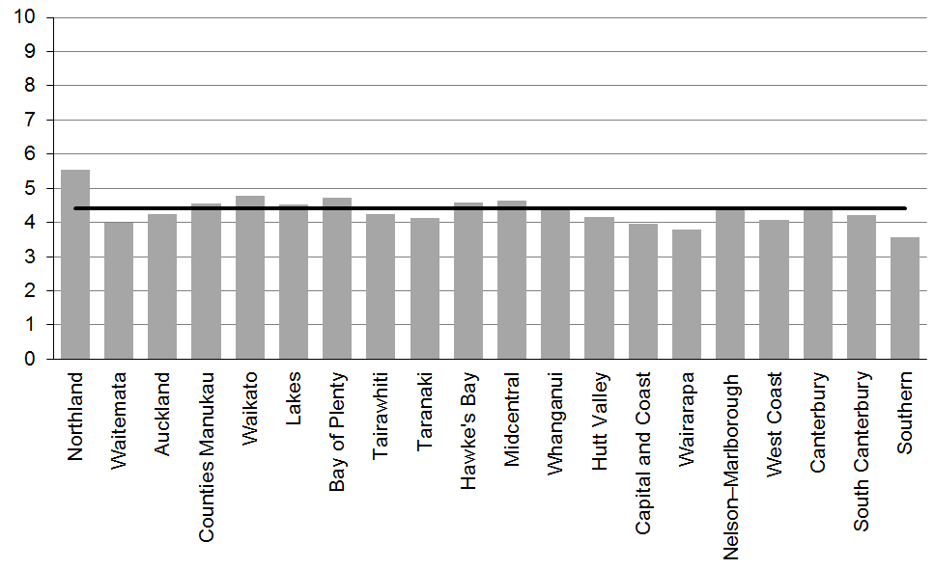

Figure 57: Burden of dental decay, Māori
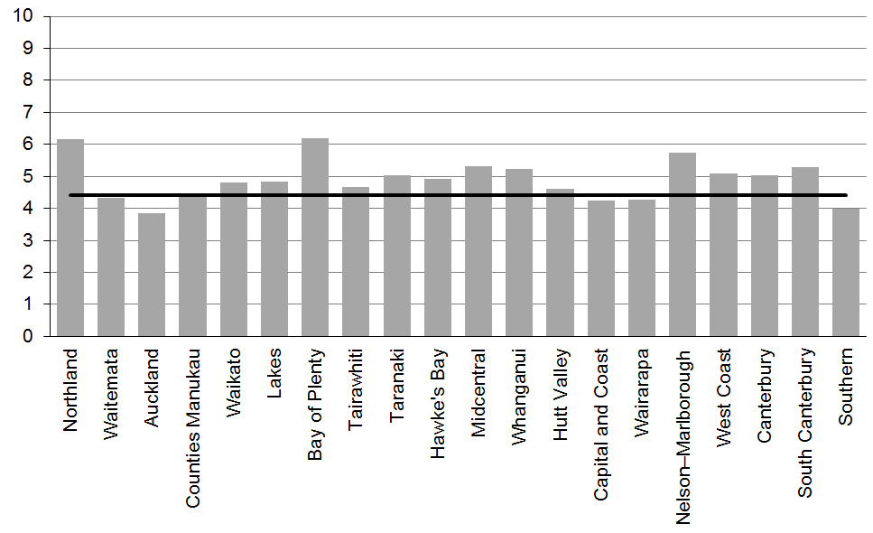

Figure 58: Burden of dental decay, Pacific peoples
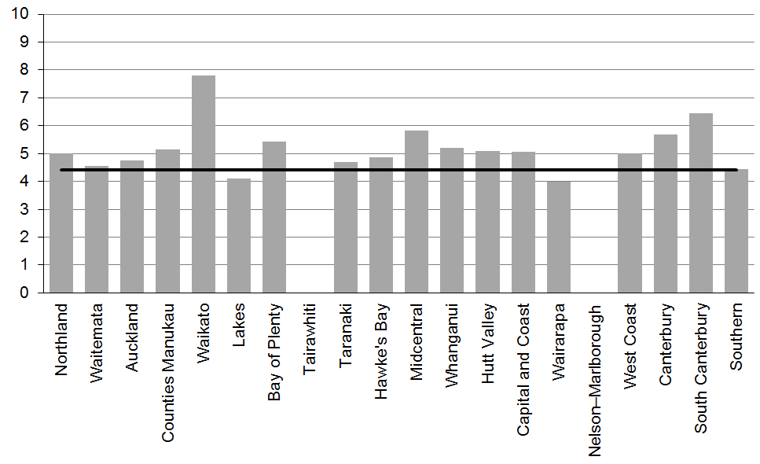

Data notes
- No bar on graph = no children in this category.
- The indicator measures the average score of decayed, missing or filled deciduous (baby) teeth (dmft).
- Time period: children turning five years old between 1 January 2013 and 31 December 2013.
- Excludes overseas DHB and undefined DHB.
- Data is not available by deprivation quintile.
- Numerator: sum of dmft scores at five years old (source: community oral health services).
- Denominator: number of five-year-olds with a dmft score greater than zero (source: community oral health services).

WCTO Quality Improvement Framework Indicator 18
Standard: | WCTO providers use evidence-based interventions and education to promote child, family and whānau health and wellbeing
Indicator: | Child mental health is supported (children’s SDQ-P scores are within the normal range at the B4 School Check)
Target by December 2014: | 86 percent
Target by June 2016: | 95 percent

 | Total New Zealand | High deprivation | Māori | Pacific peoples
September 2014 mean (range) | 96% (90–98) | 93% (85–97) | 93% (86–100) | 95% (86–100)

Figure 59: Children have a normal SDQ-P score at four years, total New Zealand
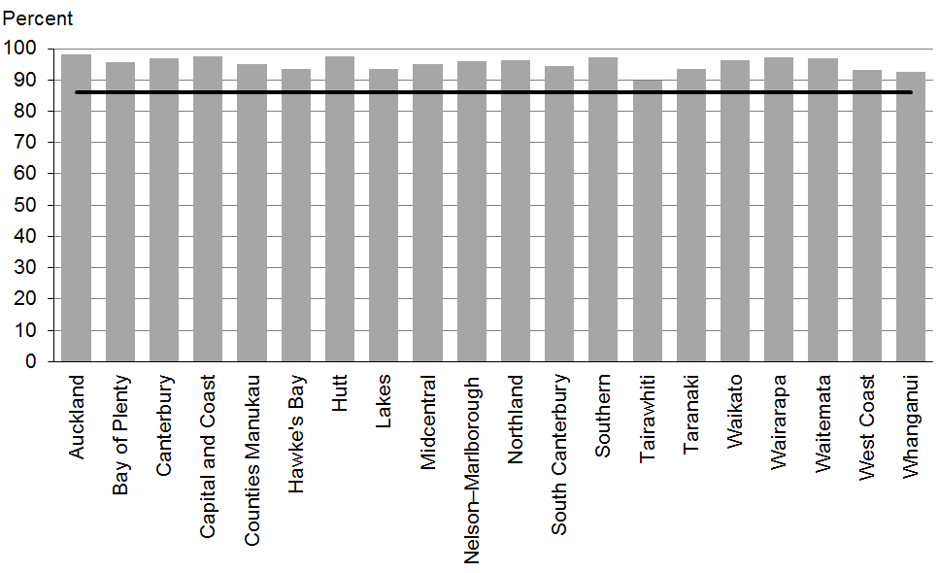

Figure 60: Children have a normal SDQ-P score at four years, high deprivation
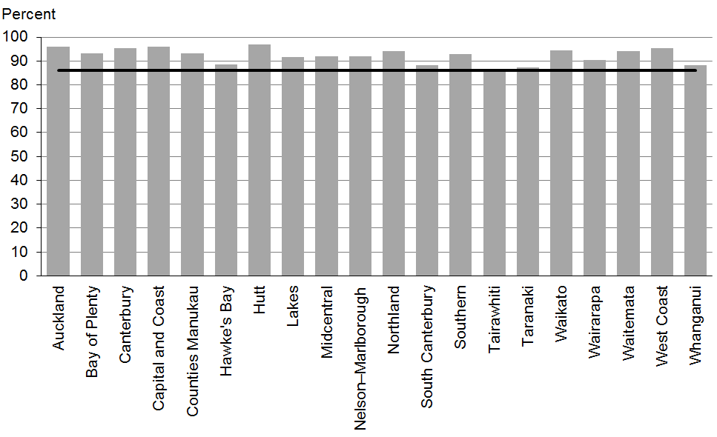

Figure 61: Children have a normal SDQ-P score at four years, Māori
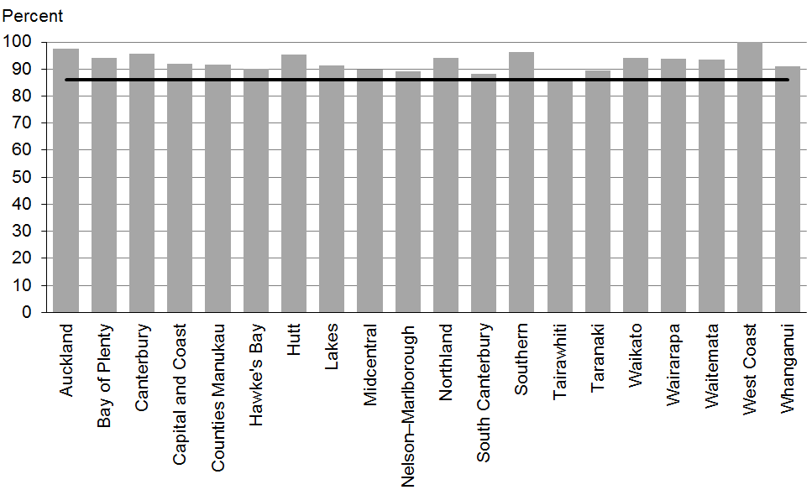

Figure 62: Children have a normal SDQ-P score at four years, Pacific peoples
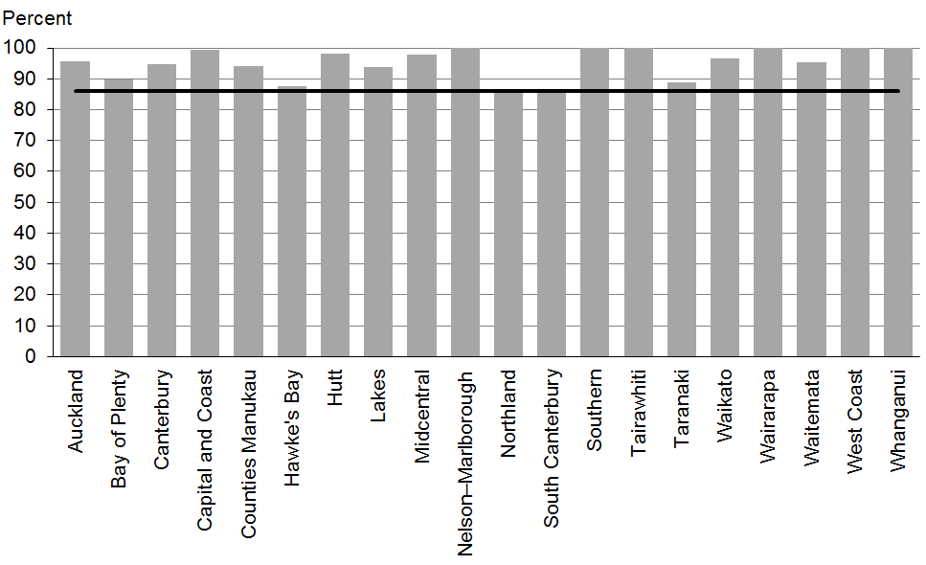

Data notes
- Time period: children receiving a B4 School Check between 1 January 2014 and 30 June 2014.
- DHB is DHB of service.
- Numerator: children with an SDQ-P score that is within normal range (source: B4 School Check).
- Denominator: children with an SDQ-P score recorded at the B4 School Check (source: B4 School Check).

WCTO Quality Improvement Framework Indicator 19
Standard: | WCTO providers use evidence-based interventions and education to promote child, family and whānau health and wellbeing
Indicator: | Mothers are smokefree at two weeks postnatal
Target by December 2014: | 86 percent
Target by June 2016: | 95 percent

 | Total New Zealand | High deprivation | Māori | Pacific peoples
September 2014 mean (range) | 87% (70–97) | 77% (59–94) | 65% (54–90) | 91% (75–100)

Figure 63: Mother smokefree at two weeks postnatal, total New Zealand
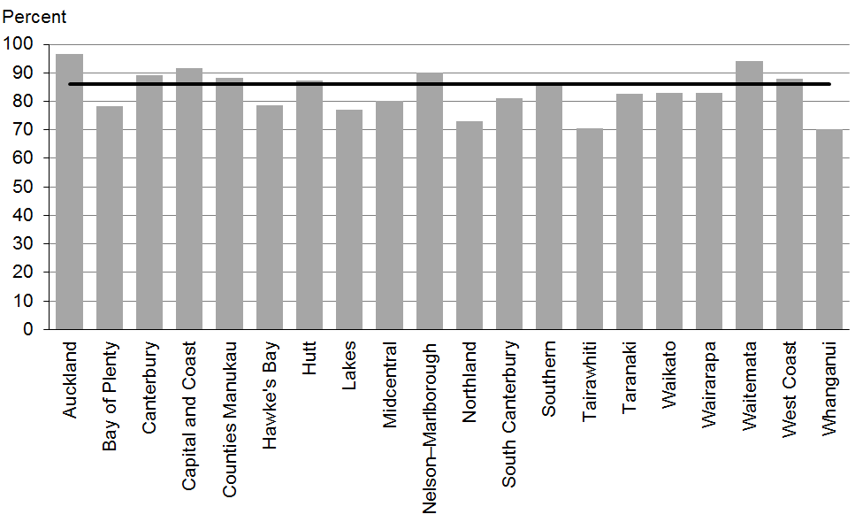

Figure 64: Mother smokefree at two weeks postnatal, high deprivation
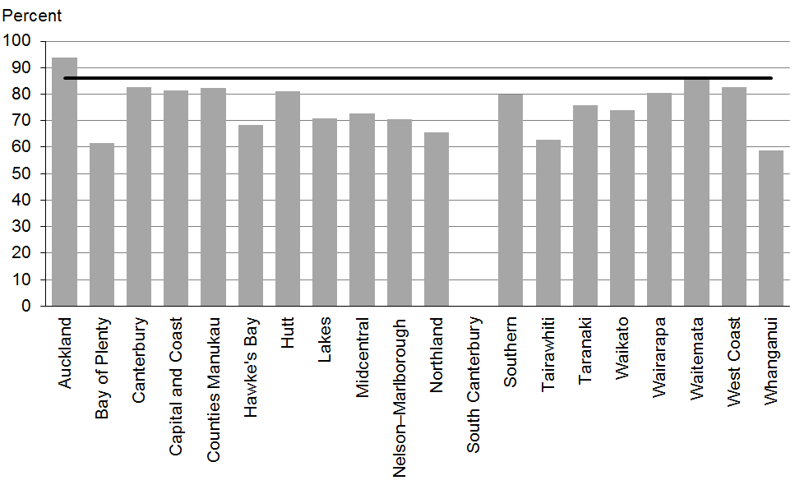

Figure 65: Mother smokefree at two weeks postnatal, Māori
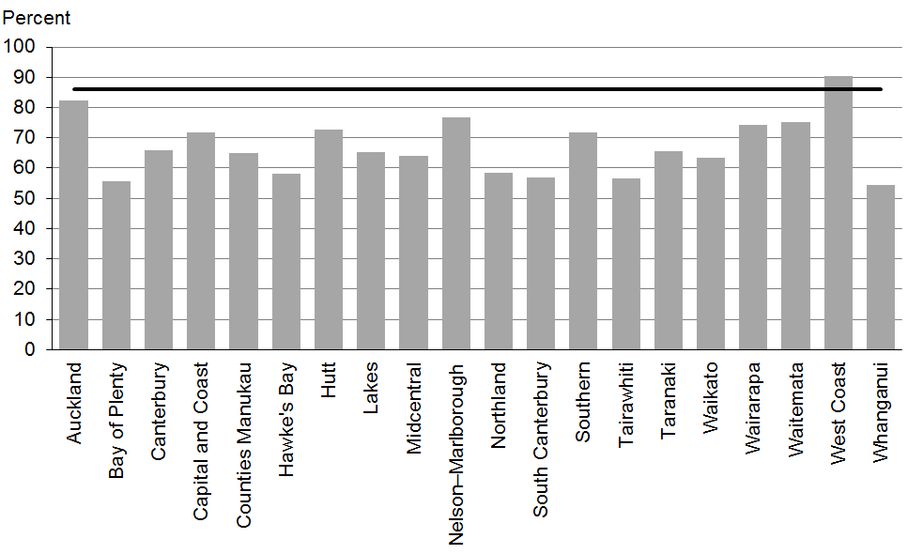

Figure 66: Mother smokefree at two weeks postnatal, Pacific peoples
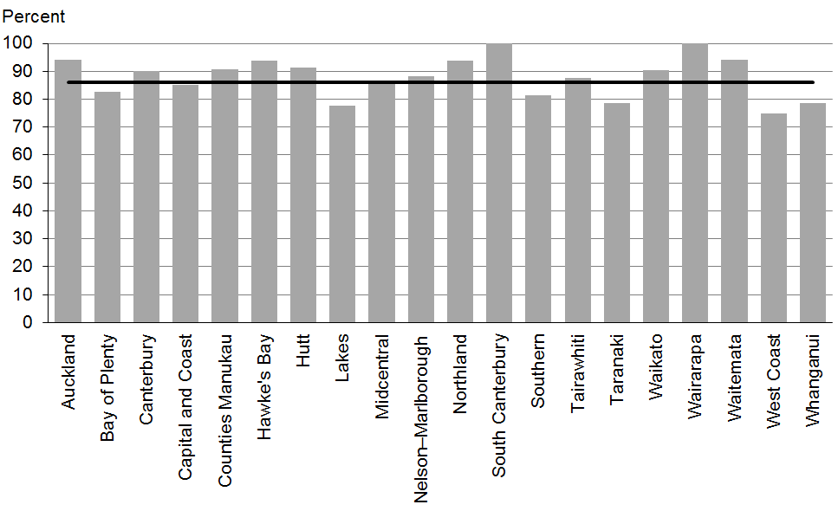

Data notes
- Time period: births between July 2013 and December 2013.
- Excludes overseas DHB and undefined DHB.
- Numerator: maternal tobacco use (two weeks) = Yes (source: MAT).
- Denominator: maternal tobacco use (two weeks) = Yes or No (source: MAT).

WCTO Quality Improvement Framework Indicator 20
Standard: | WCTO providers use evidence-based interventions and education to promote child, family and whānau health and wellbeing
Indicator: | Children live in a smokefree home (age four years)
Target by December 2014: | 90 percent
Target by June 2016: | 100 percent

 | Total New Zealand | High deprivation | Māori | Pacific peoples
September 2014 mean (range) | 98% (92–100) | 97% (90–100) | 97% (87–100) | 96% (88–100)

Figure 67: Children live in a smokefree home (age four years), total New Zealand
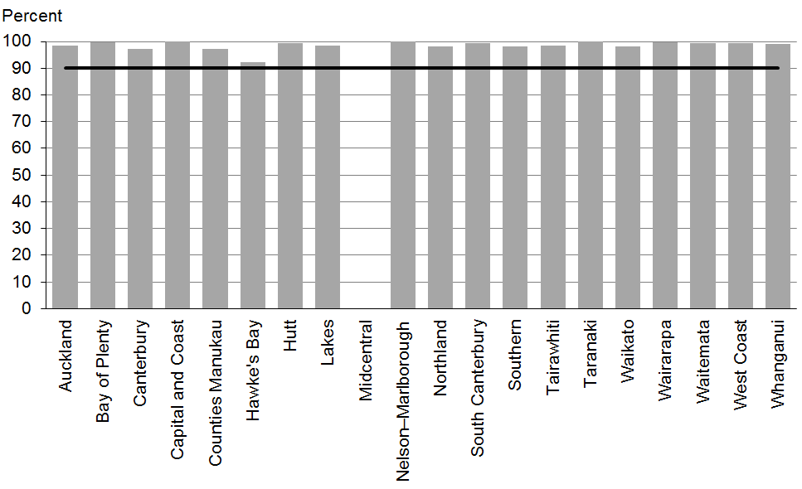

Figure 68: Children live in a smokefree home (age four years), high deprivation
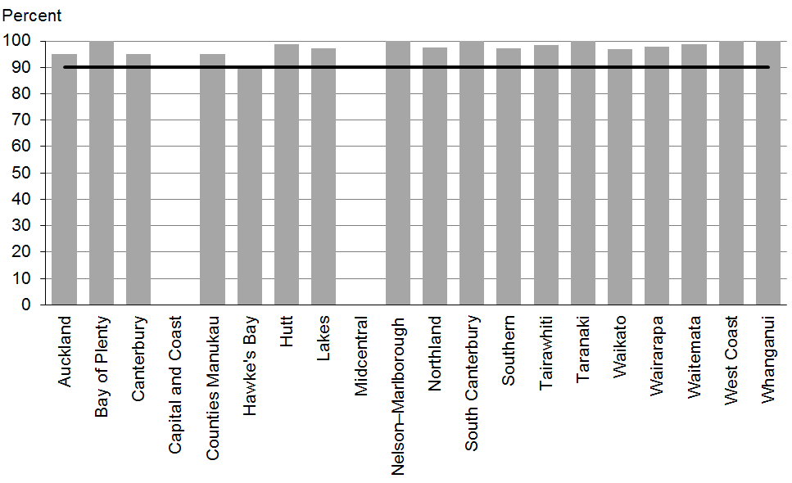

Figure 69: Children live in a smokefree home (age four years), Māori
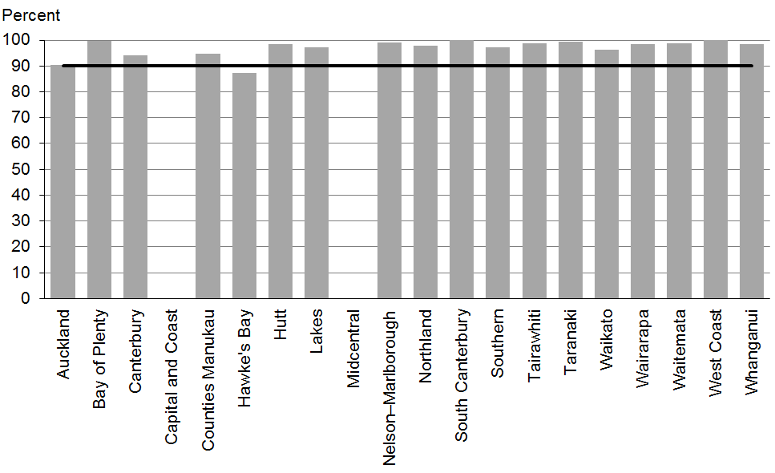

Figure 70: Children live in a smokefree home (age four years), Pacific peoples
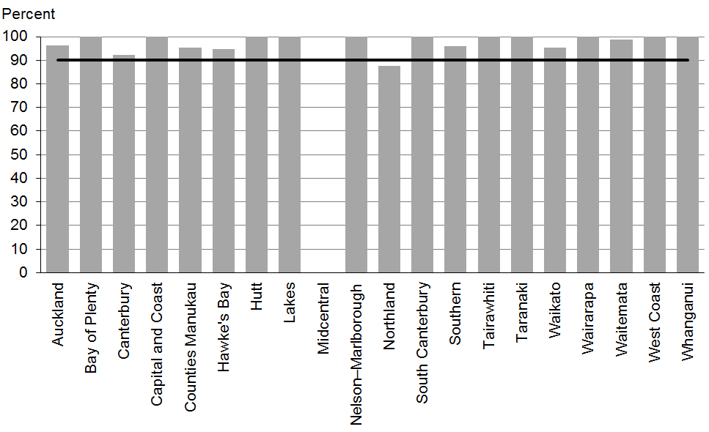

Data notes
- This indicator relates to parental smoking indoors at home.
- No bar on graph = smokefree at-home status not reported.
- Time period: children receiving a B4 School Check between 1 January 2014 and 30 June 2014.
- DHB is DHB of service.
- Numerator: children with smokefree home = Yes (source: B4 School Check)
- Denominator: children with smokefree home = Yes or No (source: B4 School Check).

Indicators 21–27: Quality
Aim 3 of the WCTO Quality Improvement Framework seeks best value for health system resource. To achieve this aim, advice, screening and interventions must be based on the best available evidence and delivered to a consistently high quality. This approach ensures best value for money, because health or development issues are:
- identified accurately (reducing downstream costs related to poor sensitivity, and wastage due to poor specificity)
- treated early (reducing the intensity of the intervention required) through interventions that have the best evidence of success (maximising health gain for investment).

Indicators 21–27 measure the quality of service delivery; in other words, the adherence to best practice (either in the timing of the intervention or adherence to screening protocol) in delivering components of the WCTO programme. The current indicators focus exclusively on the B4 School Check due to the limited availability of data for other parts of the WCTO programme. It is expected that other indicators to monitor the quality of WCTO service delivery will be added over time.

Summary of results for this period

National
Indicator 21: B4 School Checks are started before children are 4½ years seeks to ensure that children with additional health or development needs can receive appropriate support or intervention before starting school to minimise the impact of any issues on their readiness to learn at school. Nationally, 83 percent of B4 School Checks are started before the age of 4½ years, exceeding the 2014 target of 81 percent and picking up the gains that had been lost in the previous six-month period.

Nationally, referral for oral health concerns (Indicator 24) continues to show improvement at 70 percent, compared with 59 percent in the last report. However, it remains lower than expected and significantly lower than the December 2014 target of 86 percent. Child oral health services are free and have the capacity to see all children regularly. Providers should discuss with parents the importance of oral health care, including regular visits to community oral health services, and should ensure all children with obvious decay are referred. The overall rate of 69 percent for referrals for extreme obesity (a BMI greater than the 99.4th percentile) has not changed at all.

Indicators 25 and 26 measure referral to specialist services where a hearing or vision problem is identified. Following previous quality improvement efforts and commitment by B4 School Check providers, vision and hearing technicians and specialist audiology and optometry/ ophthalmology services, 100 percent of children with an identified issue are referred – across all regions, deprivation quintiles and ethnic groups. This is a significant achievement for the B4 School Check programme and ensures children receive the support needed to minimise the impact of hearing or vision problems on their ability to learn and develop. Since the last report, this achievement has been maintained.

Referral (including advice) rates for several indicators are high or have reached 100 percent across all regions, deprivation quintiles and ethnic groups, although rates of referral (excluding advice) vary significantly by DHB. In some instances, giving advice will be the most pragmatic approach to meeting a need identified through the B4 School Check. However, in most cases, referral, at least to the child’s general practitioner, is expected and represents best practice.

By region
Nationally, although 83 percent of B4 School Checks are started before the age of 4½ years, there is still significant variation by region (Indicator 21, range = 22–96 percent). There remains significant variation by region for rates of referral by DHB for oral health concerns (Indicator 24, range = 43–91 percent, excluding ‘advice given’) and extreme obesity (Indicator 26, range = 0–100 percent, excluding ‘advice given’). DHBs and B4 School Check providers should investigate referral protocol and referral options in regions with high rates of referral to establish appropriate local pathways, and then build local capacity of specialist services where required.

By deprivation
Unlike other indicators in this report, performance against these seven quality-related indicators does not seem to be lower for children living in areas of high deprivation. The referral rate for oral health concerns (Indicator 24) is 81 percent for children in areas of high deprivation, compared with 70 percent overall, and for extreme obesity (Indicator 27) their referral rate is 78 percent compared with 69 percent overall (rates for both indicators excluding ‘advice given’). It is encouraging to see that both these referral rates are increasing faster for children in areas of high deprivation, as this is often where baseline need is greater.

By ethnicity
Quality of service delivery (adherence to protocol) within the indicators presented here on the whole does not seem to differ significantly for different ethnic groups. Among Māori children, all seven indicators showed improvement or remained at 100 percent since the last report. Notable improvements were in referral rates for oral health concerns (Indicator 24), which increased from 59 to 64 percent, and for extreme obesity (Indicator 27), which increased from 66 to 71 percent. Among Pacific children, all but one indicator showed improvement or maintained its 100% rate since the last report. The gap between referral rates for Māori and non-Māori children with extreme obesity still exists but appears to be closing (66 percent for Māori versus 69 percent nationally). Providers should ensure that consistent, evidence-based protocols are applied across all services and service providers so that all families and whānau have access to high-quality services.

WCTO Quality Improvement Framework Indicator 21
Standard: | WCTO services are delivered at the right time
Indicator: | B4 School Checks are started before children are 4½ years
Target by December 2014: | 81 percent
Target by June 2016: | 90 percent

 | Total New Zealand | High deprivation | Māori | Pacific peoples
September 2014 mean (range) | 83% (22–96) | 82% (27–95) | 80% (33–94) | 81% (33–100)

Figure 71: B4 School Checks started before age 4½ years, total New Zealand
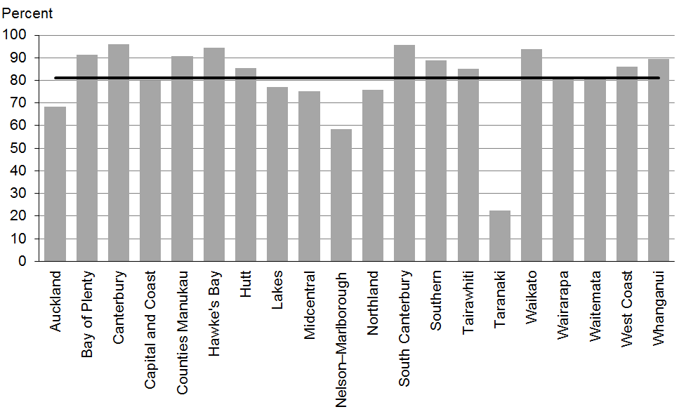

Figure 72: B4 School Checks started before age 4½ years, high deprivation
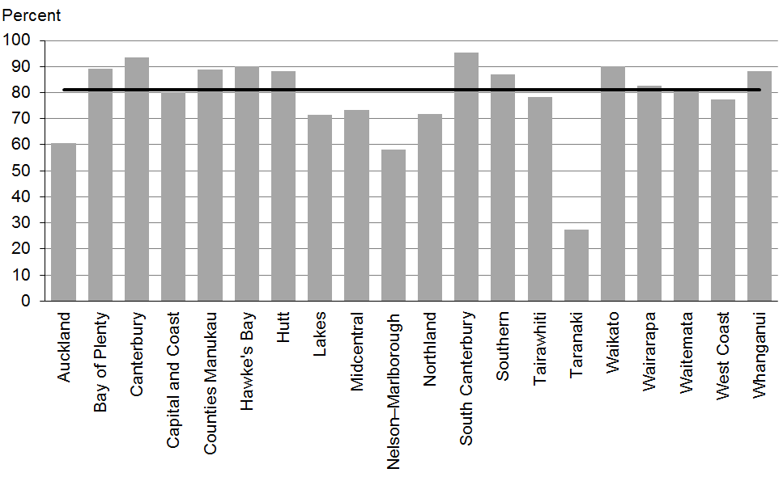

Figure 73: B4 School Checks started before age 4½ years, Māori
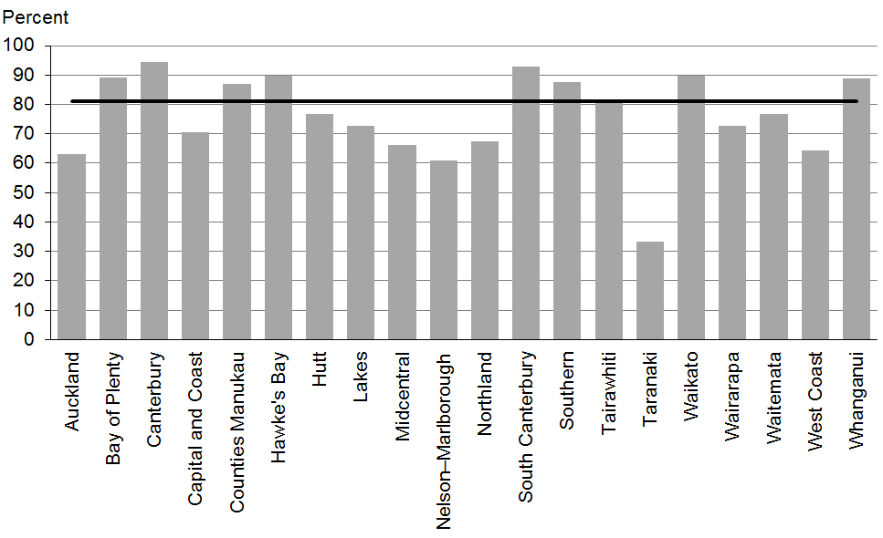

Figure 74: B4 School Checks started before age 4½ years, Pacific peoples
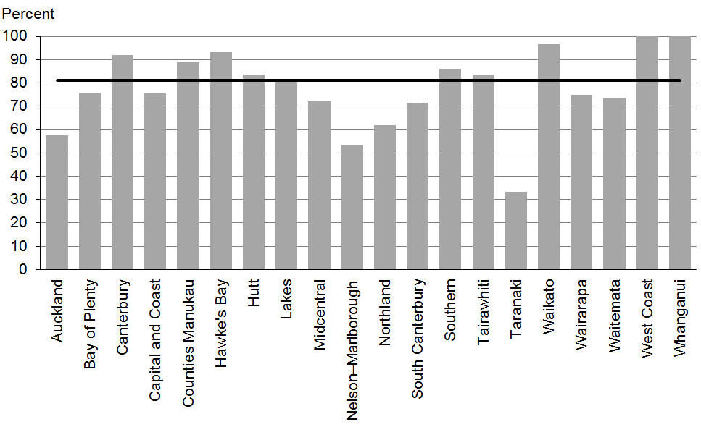

Data notes
- Time period: children receiving a B4 School Check between 1 January 2014 and 30 June 2014.
- DHB is DHB of service.
- Numerator: number of children receiving a B4 School Check who started the check at younger than 4½ years (source: B4 School Check).
- Denominator: number of children receiving a B4 School Check (source: B4 School Check).

WCTO Quality Improvement Framework Indicator 22
Standard: | WCTO providers deliver services in accordance with best practice (inappropriate variation is reduced)
Indicator: | Children with an abnormal SDQ-P at the B4 School Check are referred to specialist services
Target by December 2014: | 86 percent
Target by June 2016: | 95 percent

 | Total New Zealand | High deprivation | Māori | Pacific peoples
September 2014 mean – including advice given | 100% | 100% | 100% | 100%
September 2014 mean (range) – excluding advice given | 43% (10–93) | 44% (0–100) | 44% (0–92) | 40% (0–100)

Figure 75: Abnormal SDQ-P referred, total New Zealand
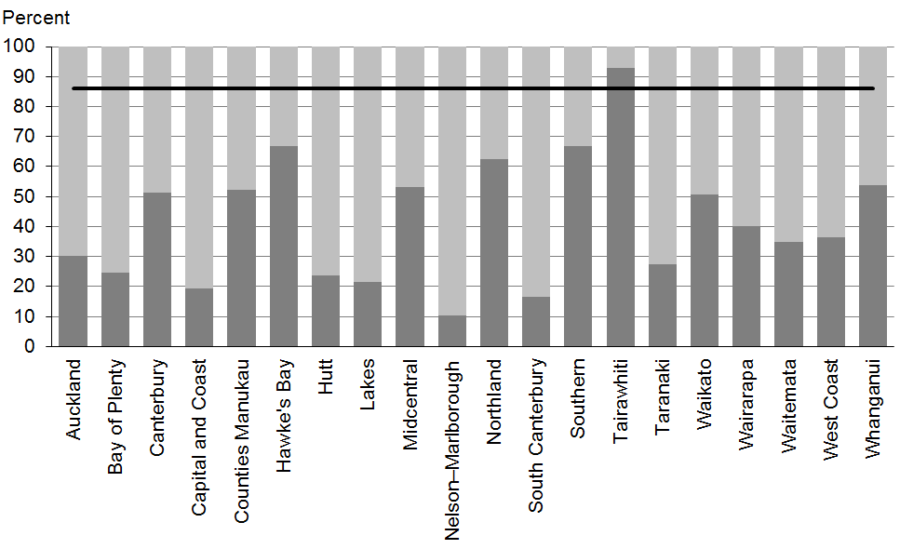

Figure 76: Abnormal SDQ-P referred, high deprivation
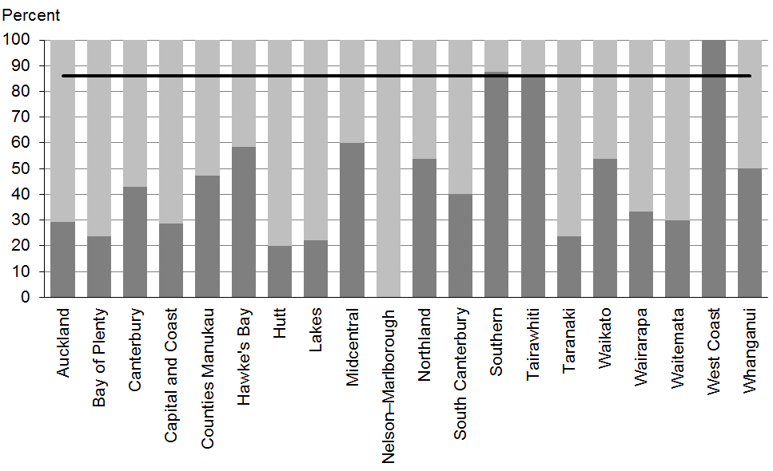
Figure 77: Abnormal SDQ-P referred, Māori
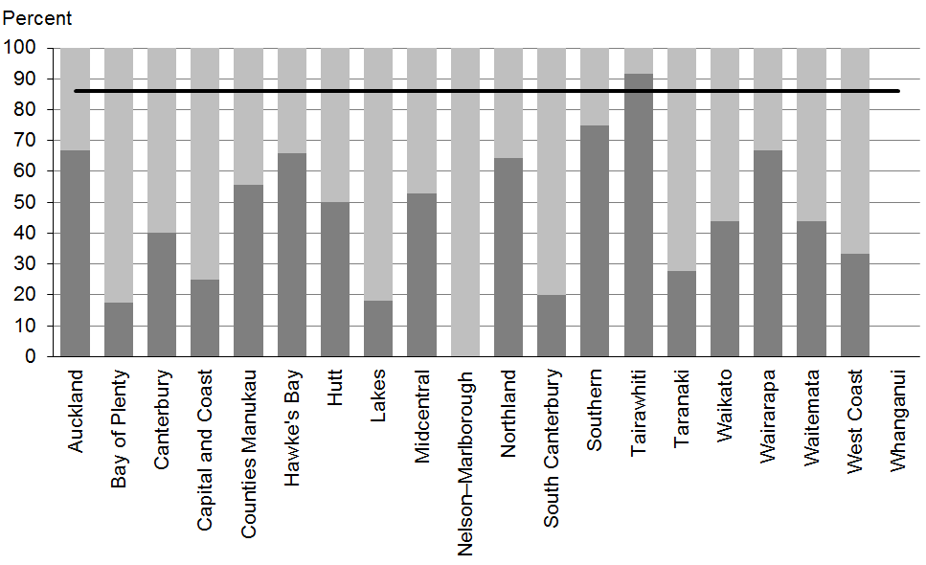

Figure 78: Abnormal SDQ-P referred, Pacific peoples
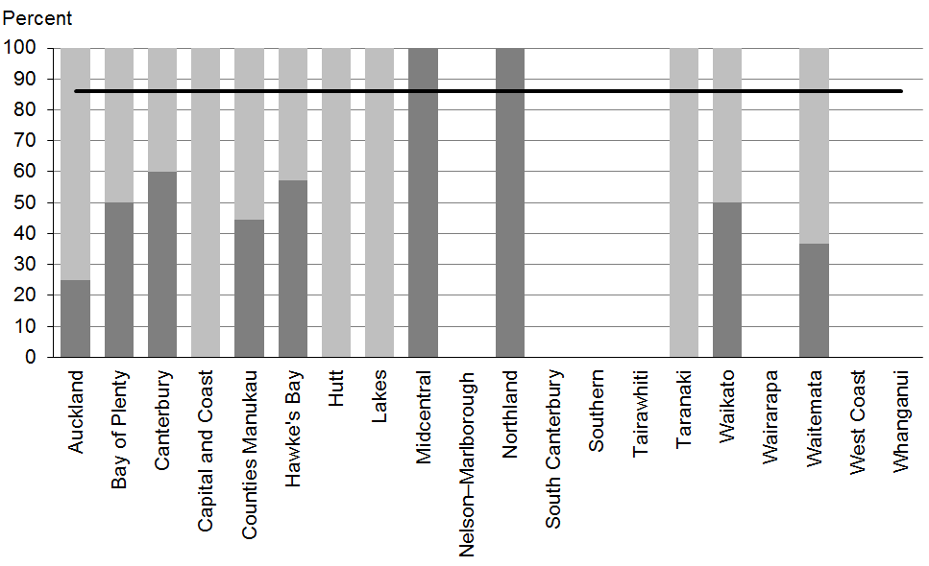

Data notes
- Stacked bar shows rate of referral excluding ‘advice given’ (dark grey section) and rate of referral including ‘advice given’ (dark grey plus light grey sections).
- No bar on graph = no children with abnormal SDQ-P for that population.
- Time period: children receiving a B4 School Check between 1 January 2014 and 30 June 2014.
- DHB is DHB of service.
- Numerator: number of children with an abnormal SDQ-P referred (source: B4 School Check).
- Denominator: number of children with an abnormal SDQ-P (excluding those already under care) (source: B4 School Check).

WCTO Quality Improvement Framework Indicator 23
Standard: | WCTO providers deliver services in accordance with best practice (inappropriate variation is reduced)
Indicator: | Children with a Parental Evaluation of Developmental Status (PEDS) Pathway A at the B4 School Check are referred to specialist services
Target by December 2014: | 86 percent
Target by June 2016: | 95 percent

 | Total New Zealand | High deprivation | Māori | Pacific peoples
September 2014 mean (range) – including advice given | 98% (57–100) | 99% (0–100) | 99% (96–100) | 98% (50–100)
September 2014 mean (range) – excluding advice given | 57% (17–85) | 63% (0–100) | 63% (0–89) | 67% (0–100)

Figure 79: PEDS Pathway A referred, total New Zealand
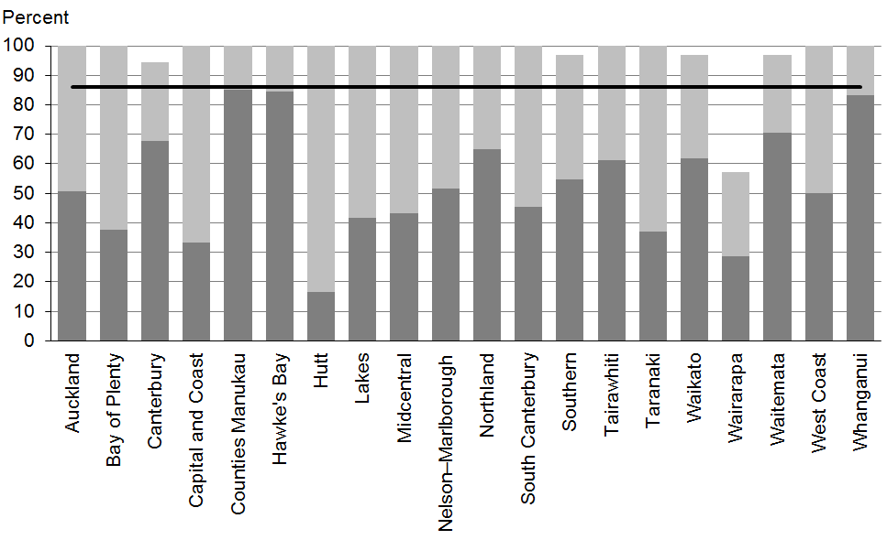

Figure 80: PEDS Pathway A referred, high deprivation
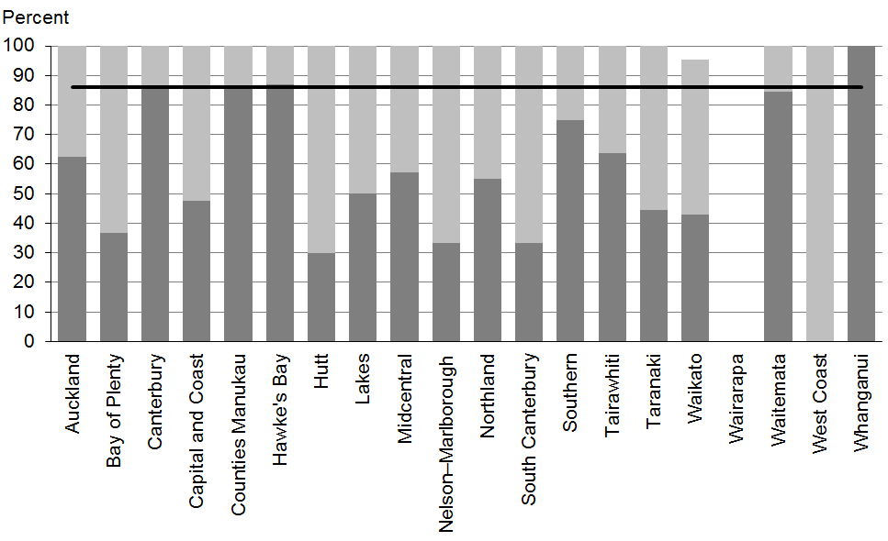

Figure 81: PEDS Pathway A referred, Māori
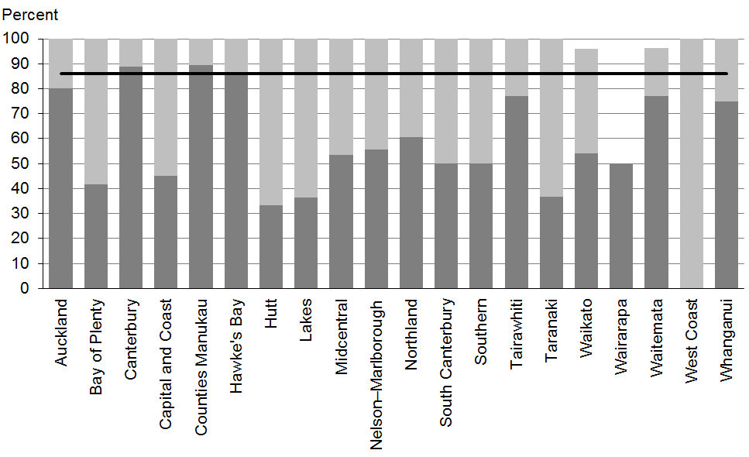

Figure 82: PEDS Pathway A referred, Pacific peoples
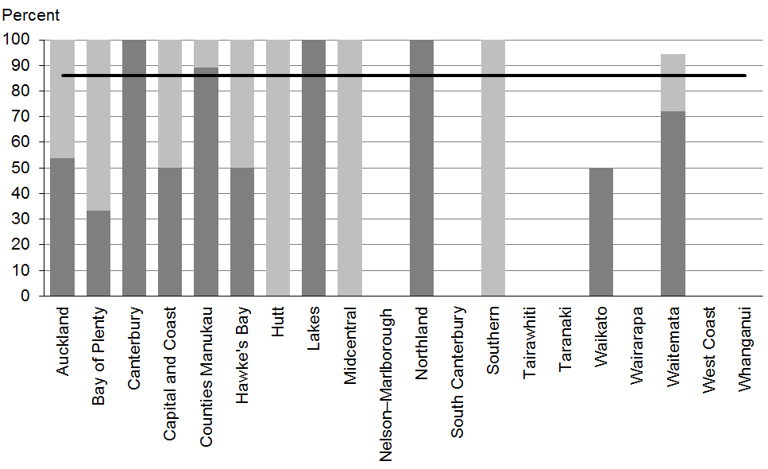

Data notes
- Stacked bar shows rate of referral excluding ‘advice given’ (dark grey section) and rate of referral including ‘advice given’ (dark grey plus light grey sections).
- No bar on graph = no children with PEDS Pathway A for that population.
- Time period: children receiving a B4 School Check between 1 January 2014 and 30 June 2014.
- DHB is DHB of service.
- Numerator: number of children assessed as PEDS Pathway A referred (source: B4 School Check).
- Denominator: number of children assessed as PEDS Pathway A (excluding those already under care) (source: B4 School Check).

WCTO Quality Improvement Framework Indicator 24
Standard: | WCTO providers deliver services in accordance with best practice (inappropriate variation is reduced)
Indicator: | Children with a Lift the Lip (LTL) score of 2–6 at the B4 School Check are referred to specialist services
Target by December 2014: | 86 percent
Target by June 2016: | 95 percent

 | Total New Zealand | High deprivation | Māori | Pacific peoples
September 2014 mean (range) – including advice given | 86% (62–100) | 85% (64–100) | 88% (50–100) | 91% (50–100)
September 2014 mean (range) – excluding advice given | 70% (43–91) | 66% (34–100) | 71% (45–100) | 81% (25–100)

Figure 83: Children with LTL score > 1 referred, total New Zealand
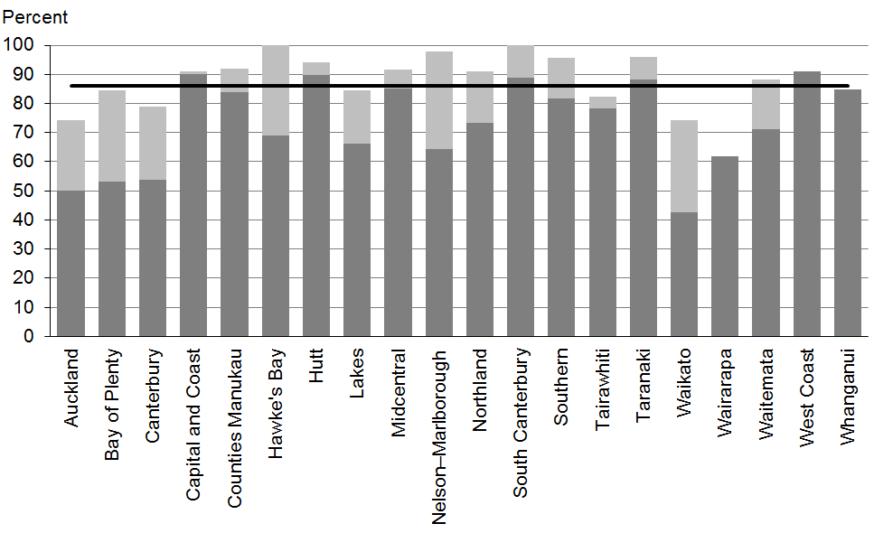

Figure 84: Children with LTL score > 1 referred, high deprivation
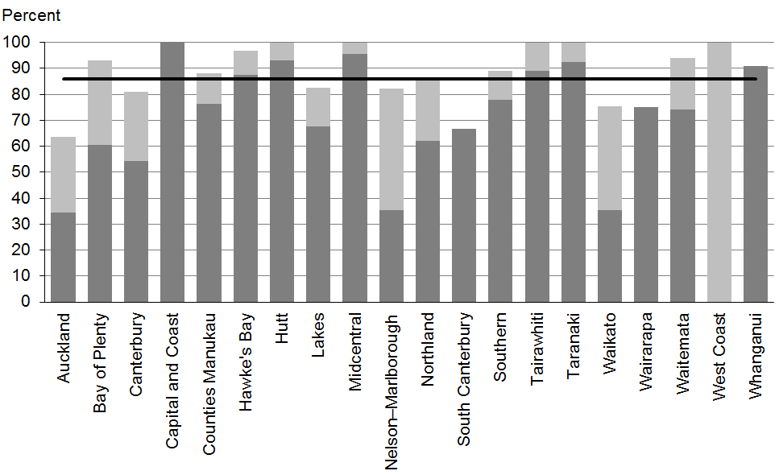

Figure 85: Children with LTL score > 1 referred, Māori
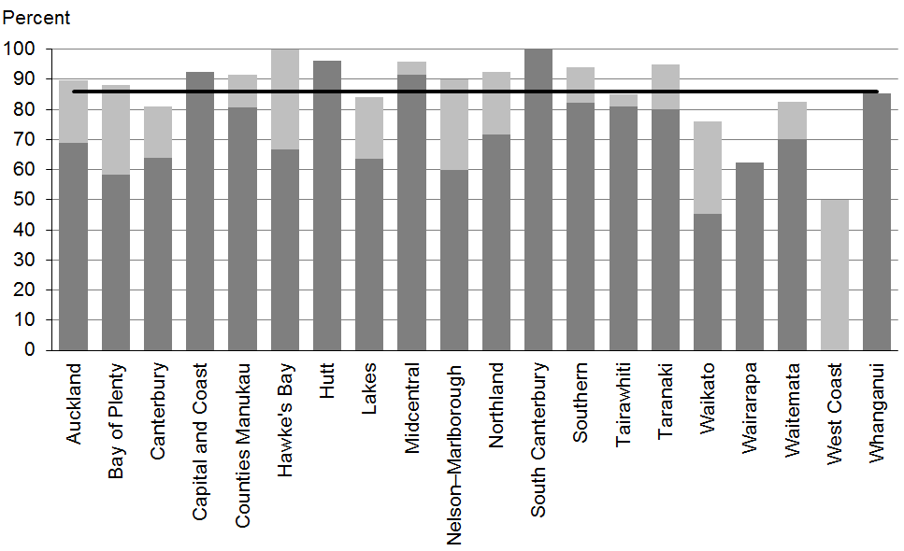

Figure 86: Children with LTL score > 1 referred, Pacific peoples
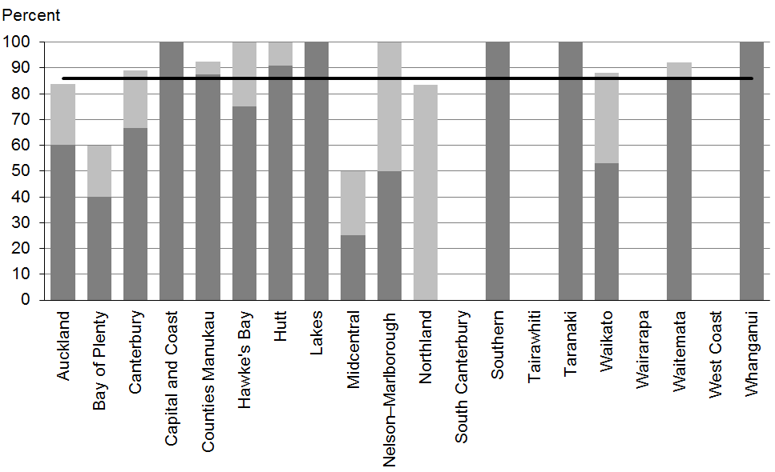

Data notes
- Stacked bar shows rate of referral excluding ‘advice given’ (dark grey section) and rate of referral including ‘advice given’ (dark grey plus light grey sections).
- No bar on graph = no children with LTL score 2–6 for that population.
- Time period: children receiving a B4 School Check between 1 January 2014 and 30 June 2014.
- DHB is DHB of service.
- Numerator: number of children with LTL score of 2–6 referred (B4 School Check).
- Denominator: number of children with LTL score of 2–6 (excluding those already under care) (B4 School Check).

WCTO Quality Improvement Framework Indicator 25
Standard: | WCTO providers deliver services in accordance with best practice (inappropriate variation is reduced)
Indicator: | Children with an untreated vision problem at the B4 School Check are referred to specialist services
Target by December 2014: | 86 percent
Target by June 2016: | 95 percent

 | Total New Zealand | High deprivation | Māori | Pacific peoples
September 2014 mean – including advice given | 100% | 100% | 100% | 100%
September 2014 mean – excluding advice given | 100% | 100% | 100% | 100%

Figure 87: Vision problem referred, total New Zealand
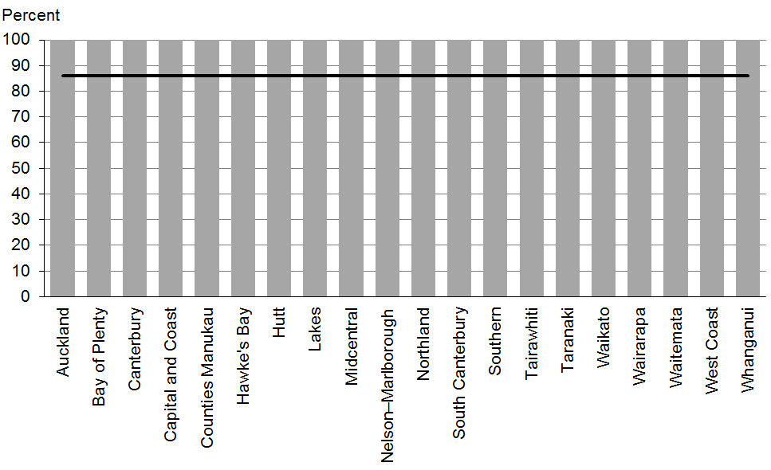

Figure 88: Vision problem referred, high deprivation

Figure 89: Vision problem referred, Māori
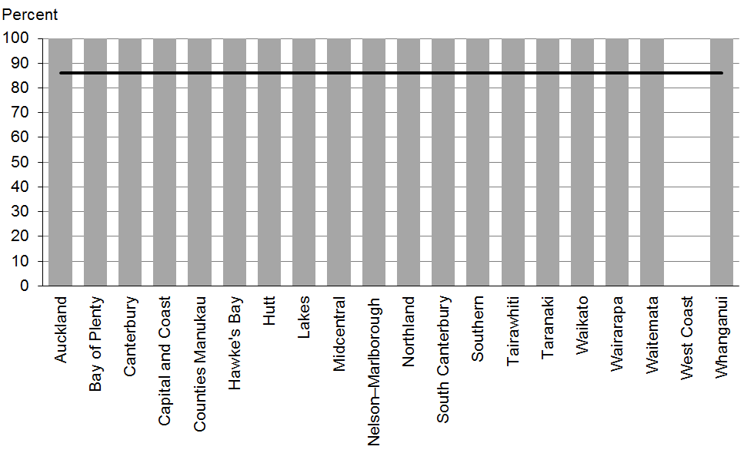

Figure 90: Vision problem referred, Pacific peoples
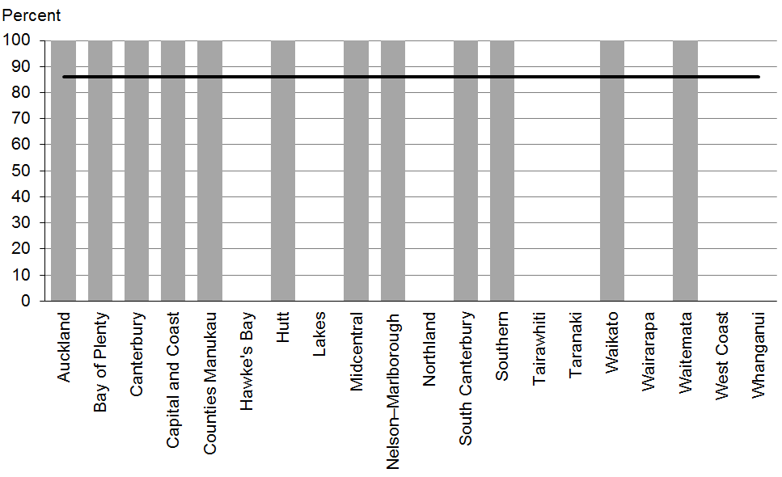

Data notes
- No bar on graph = no children with vision problem for that population.
- Time period: children receiving a B4 School Check between 1 January 2014 and 30 June 2014.
- DHB is DHB of service.
- Numerator: number of children with a vision problem referred (excluding advice given) (source: B4 School Check).
- Denominator: number of children with a vision problem (excluding those already under care) (source: B4 School Check).

WCTO Quality Improvement Framework Indicator 26
Standard: | WCTO providers deliver services in accordance with best practice (inappropriate variation is reduced)
Indicator: | Children with an untreated hearing problem at the B4 School Check are referred to specialist services
Target by December 2014: | 86 percent
Target by June 2016: | 95 percent

 | Total New Zealand | High deprivation | Māori | Pacific peoples
September 2014 mean – including advice given | 100% | 100% | 100% | 100%
September 2014 mean – excluding advice given | 100% | 100% | 99% | 100%

Figure 91: Hearing problem referred, total New Zealand

Figure 92: Hearing problem referred, high deprivation
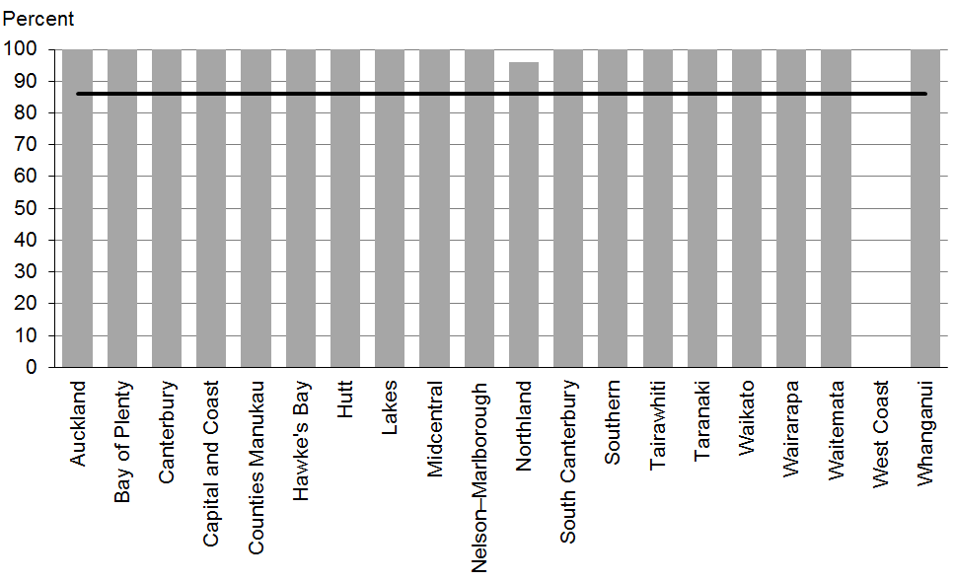

Figure 93: Hearing problem referred, Māori
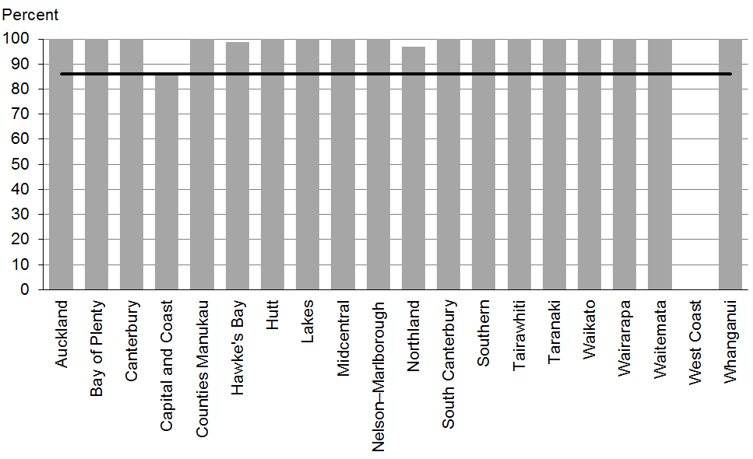

Figure 94: Hearing problem referred, Pacific peoples
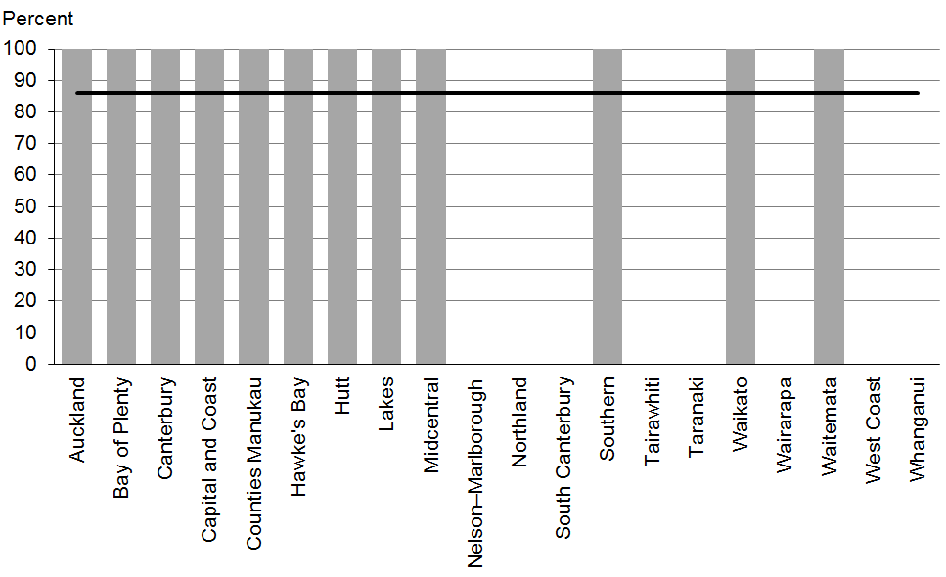

Data notes
- No bar on graph = no children with hearing problem for that population.
- Time period: children receiving a B4 School Check between 1 January 2014 and 30 June 2014.
- DHB is DHB of service.
- Numerator: number of children with a hearing problem referred (excluding advice given) (B4 School Check).
- Denominator: number of children with a hearing problem (excluding those already under care) (B4 School Check).

WCTO Quality Improvement Framework Indicator 27
Standard: | WCTO providers deliver services in accordance with best practice (inappropriate variation is reduced)
Indicator: | Children with a BMI greater than the 99.4th percentile at the B4 School Check are referred to a general practitioner or specialist services
Target by December 2014: | 86 percent
Target by June 2016: | 95 percent

 | Total New Zealand | High deprivation | Māori | Pacific peoples
September 2014 mean – including advice given | 100% | 100% | 100% | 100%
September 2014 mean (range) – excluding advice given | 69% (0–100) | 73% (0–100) | 66% (0–100) | 78% (31–100)

Figure 95: Children with BMI > 99.4th percentile referred, total New Zealand
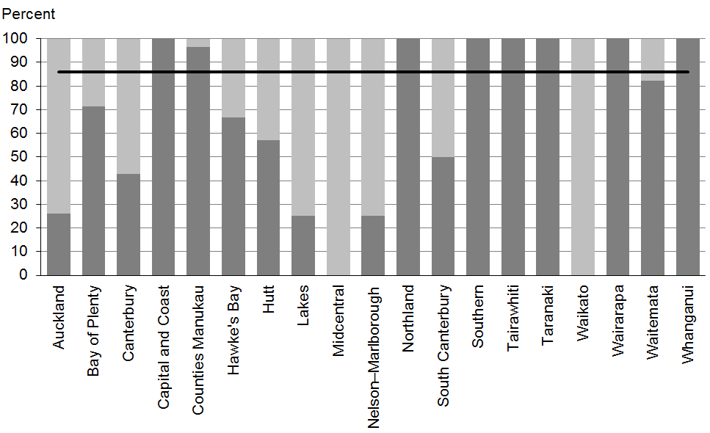

Figure 96: Children with BMI > 99.4th percentile referred, high deprivation
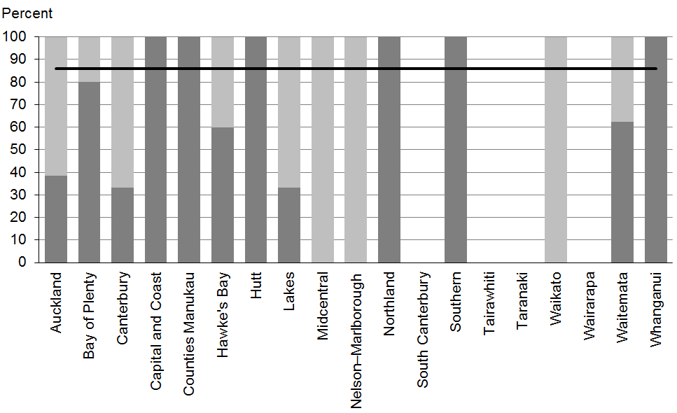

Figure 97: Children with BMI > 99.4th percentile referred, Māori
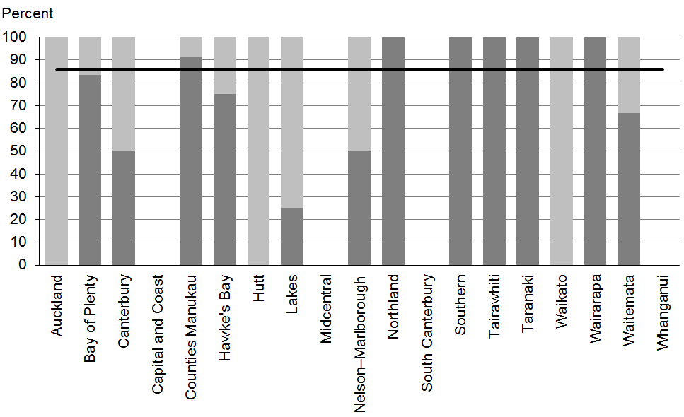

Figure 94: Children with BMI > 99.4th percentile referred, Pacific peoples
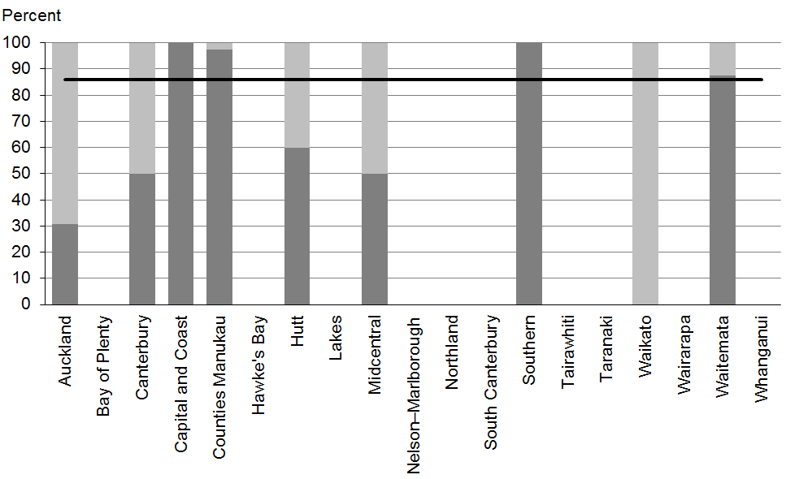

Data notes
- Stacked bar shows rate of referral excluding ‘advice given’ (dark grey section) and rate of referral including ‘advice given’ (dark grey plus light grey sections).
- No bar on graph = no children with BMI > 99.4th percentile for that population.
- Time period: children receiving a B4 School Check between 1 January 2014 and 30 June 2014.
- DHB is DHB of service.
- Numerator: number of children with a BMI greater than the 99.4th percentile referred (source: B4 School Check).
- Denominator: number of children with a BMI greater than the 99.4th percentile (excluding those already under care) (source: B4 School Check).

Appendix 1: Summary of the WCTO quality indicators
 |  | Indicator | December 2014 target | June 2016 target
Access | 1 | Newborns are enrolled with a general practice by two weeks of age* | 88% | 98%
 | 2 | Families and whānau are referred from their LMC to a WCTO provider | 88% | 98%
 | 3 | Infants receive all WCTO core contacts due in their first year** | 86% | 95%
 | 4 | Four-year-olds receive a B4 School Check | 90% | 90%
 | 5 | Children are enrolled with child oral health services | 86% | 95%
 | 6 | Immunisations are up to date by eight months | 95% | 95%
 | 7 | Children participate in early childhood education | 98% | 98%
 | 8 | Children under six years have access to free primary care | 98% | 100%
 | 9 | Children under six years have access to free after-hours primary care | 98% | 100%
 | 10 | Children are seen promptly following referral to specialist services | 100%  in 5 months | 100%  in 4 months
Outcomes | 11 | Infants are exclusively or fully breastfed at two weeks | 72% | 80%
 | 12 | Infants are exclusively or fully breastfed at six weeks (discharge from LMC) | 68% | 75%
 | 13 | Infants are exclusively or fully breastfed at three months of age | 54% | 60%
 | 14 | Infants are receiving breast milk at six months (exclusively, fully or partially breastfed) | 59% | 65%
 | 15 | Children are a healthy weight at four years | 68% | 75%
 | 16 | Children are caries free at five years | 65% | 65%
 | 17 | The burden of dental decay among children with one or more decayed, missing and filled teeth (dmft) is minimised | 4.4 dmft | 4 dmft
 | 18 | Child mental health is supported (children’s SDQ-P scores are within the normal range at the B4 School Check) | 86% | 95%
 | 19 | Mothers are smokefree at two weeks postnatal | 86% | 95%
 | 20 | Children live in smokefree homes (age four years) | 90% | 100%
Quality | 21 | B4 School Checks are started before children are 4½ years | 81% | 90%
 | 22 | Children with an abnormal SDQ-P score at the B4 School Check are referred to specialist services | 86% | 95%
 | 23 | Children with a PEDS Pathway A at the B4 School Check are referred to specialist services | 86% | 95%
 | 24 | Children with an LTL score of 2–6 at the B4 School Check are referred to specialist services | 86% | 95%
 | 25 | Children with an untreated vision problem at the B4 School Check are referred to specialist services | 86% | 95%
 | 26 | Children with an untreated hearing problem at the B4 School Check are referred to specialist services | 86% | 95%
 | 27 | Children with a BMI greater than the 99.4th percentile at the B4 School Check are referred to a general practitioner or specialist services | 86% | 95%
Note
* Data to monitor this indicator is not yet available. PHO enrolment at three months will be used as a de facto indicator in the interim.
** Data for all WCTO providers is not yet available, and so data from Plunket has been used in the interim for quality indicators 3, 11 and 12.

Appendix 2: Membership of the WCTO Quality Improvement Framework Expert Advisory Group
Name | Role(s) | Representing
Helen Connors | WCTO Nurse and Clinical Advisor – Plunket | Royal New Zealand Plunket Society
Dave Graham | Paediatrician – Waikato DHB, Chair of Midland Child Health Action Group and Member of the Paediatric Society of New Zealand | Paediatric Society of New Zealand
Christine Griffiths | Lead Maternity Carer, Lecturer Otago Polytechnic and Expert Advisor to the New Zealand College of Midwives | New Zealand College of Midwives
Laurie Mahoney | Senior Lecturer, Otago Polytechnic | College of Primary Care Nurses, New Zealand Nurses Organisation
Tui Makoare-Iefata | WCTO Nurse/Team Leader – Ngati Whatua o Orakei and Tamariki Ora provider national representative | Tamariki Ora providers
Gail Tihore | Vision and Hearing Technician – Hutt Valley DHB | VHT Society
Pat Tuohy | Paediatrician – Hutt Valley DHB and Chief Advisor Child and Youth Health | Ministry of Health
Nikki Turner | General Practitioner, Associate Professor Auckland University and Director of CONECTUS and the Immunisation Advisory Centre | New Zealand College of General Practitioners
Russell Wills | Paediatrician – Hawke’s Bay DHB and Children’s Commissioner | Office of the Children’s Commissioner
Mollie Wilson | WCTO Nurse and CEO of the Paediatric Society of New Zealand | Paediatric Society of New Zealand
Note: Membership as at March 2014. The Ministry would like to thank previous members of the EAG for their work.

Membership of the EAG is set out in Appendix 2.
Indicator 1 was designed to measure enrolment with a general practice by two weeks of age. This data was not available at the time of writing, and so enrolment with a PHO by three months of age has been used as an interim measure.
The SDQ is used to assess a child’s social and emotional development. There are two versions of the questionnaire: one for parents (SDQ-P) and the other for teachers (SDQ-T).

