Independent Life Expectancy in New Zealand
2013

Acknowledgements
This report was written by Vladimir Stevanovic with support from Michelle Liu.

The authors acknowledge valuable input from peer reviewers of this report:
- Jackie Fawcett, Denise Hutana, Martin Tobias and Li-Chia Yeh (Ministry of Health)
- Phillipa O’Brien, Kim Dunstan and Shari Mason (Statistics New Zealand)
- Natalie Jackson (Massey University)
- Peter Davis (University of Auckland).
Citation: Ministry of Health. 2015. Independent Life Expectancy in New Zealand 2013.Wellington: Ministry of Health.
Published in July 2015
by the Ministry of Health
PO Box 5013, Wellington 6145, New Zealand
ISBN 978-0-478-44843-6 (online)
HP 6219
This document is available at www.health.govt.nz

Contents
Executive summary v
Introduction 1
Health expectancy as a summary measure of population health 1
Two approaches to estimating health expectancy 1
How health expectancy and ILE are being applied in New Zealand 3
Overview of this report 3
How independent life expectancy has been estimated 4
Sources of data for this report 4
Methods of estimating ILE 4
Analysis by gender and ethnicity 5
Independent life expectancy at birth in 2013 6
ILE by gender 6
ILE by ethnicity 7
Analysis across gender and ethnic groups 9
Limits to data reliability 10
Independent life expectancy at age 65 in 2013 11
ILE by gender 11
ILE by ethnicity 12
Analysis across gender and ethnic groups 14
Limits to data reliability 17
Trends in independent life expectancy 1996–2013 18
Trends in ILE by gender 18
Trends in ILE by ethnicity 19
Analysis across gender and ethnic groups 23
Limits to data reliability and comparability 24
How well does ILE perform as an indicator? 25
Strengths 25
Limitations 25
Overall assessment 26
Conclusions 27
References 28
Appendix: Methods used to produce the findings in this report 30

List of Tables
Table 1: Independent life expectancy at birth, by gender and ethnicity, 2013 9
Table 2: Independent life expectancy at age 65, by gender and ethnicity, 2013 14
Table 3: Independent life expectancy at selected ages in 2013 15
Table 4: Independent life expectancy at birth, by gender, 1996–2013 19
Table 5: Change in independent life expectancy at birth, by gender, between 1996 and 2013 19
Table 6: Independent life expectancy at birth, by ethnicity, 1996–2013 19
Table 7: Change in independent life expectancy at birth, by ethnicity, between 1996 and 2013 20

List of Figures
Figure 1: A model of different levels of health state expectancy measures 2
Figure 2: Independent life expectancy at birth, New Zealand males and females, 2013 7
Figure 3: Independent life expectancy at birth, Māori males and females, 2013 8
Figure 4: Independent life expectancy at birth, non-Māori males and females, 2013 9
Figure 5: Independent life expectancy at age 65, New Zealand males and females, 2013 12
Figure 6: Independent life expectancy at age 65, New Zealand males and females, 2013 13
Figure 7: Independent life expectancy at age 65, non-Māori males and females, 2013 13
Figure 8: Life expectancy, independent life expectancy and life expectancy with dependency, New Zealand males, 2013 14
Figure 9: Life expectancy, independent life expectancy and life expectancy with dependency, New Zealand females, 2013 15
Figure 10: Independent life expectancy at birth, New Zealand males and females,
1996–2013 18
Figure 11: Independent life expectancy at birth, Māori males, 1996–2013 20
Figure 12: Independent life expectancy at birth, Māori females, 1996–2013 21
Figure 13: Independent life expectancy at birth, non-Māori males, 1996–2013 22
Figure 14: Independent life expectancy at birth, non-Māori females, 1996–2013 23

Executive summary
Independent life expectancy (ILE) is one measure of health expectancy that both the Ministry of Health and the Ministry of Social Development have used as a ‘headline’ or ‘peak’ health indicator.

ILE is defined as the average number of years that a person can be expected to live independently, either free of any disability (functional limitation) or with functional limitations that they can manage without assistance. It is estimated using the Sullivan prevalence method and the following Statistics New Zealand data:
- disability data from the disability surveys carried out after each Census of Population and Dwellings
- mortality data from the complete period life tables.

Independent life expectancy in 2013
The following findings have been concluded from the results of the 2013 Disability Survey and the 2012–2014 period life tables.
- Males have shorter lives than females but spend a higher proportion of their lives in good health. A New Zealand male born in 2013 can expect to live 3.7 years less than a New Zealand female born in the same year (79.5 years and 83.2 years respectively). He can expect to live 65.2 years independently (82.0% of his life), while a female can expect to live 66.5 years independently (79.9% of her life). Conversely, females are expected to live longer with disability for which they need support than males (16.7 years and 14.3 years respectively).
- Māori males have the lowest ILE and live longest with dependency. A Māori male born in 2013 can expect to live 54.3 years, or 74.4% of his life, independently, which is the lowest ILE estimate among all groups. He also can expect to live longest with functional limitations for which he needs support (18.7 years). A Māori female born in 2013 can expect to live 60.4 years independently, which is 78.4% of her life.
- At the age of 65 years, New Zealanders can expect to live half of their remaining lives independently (54.1% for males and 49.5% for females). Non-Māori females aged 65 in 2013, including Pacific and Asian peoples, can expect to live longest without disability requiring assistance (another 10.7 years). A 65-year-old Māori male has, on average, the shortest remaining time of living independently (5.5 years) and the highest proportion of remaining years lived with dependency (64.3%).

Trends in independent life expectancy 1996–2013
The following findings have been concluded from the results of disability surveys and period life tables from 1996 onwards to gauge trends in independent life expectancy over 17 years.
- Overall, people are living longer, but spending more time in dependent health states (morbidity). Between 1996 and 2013, independent life expectancy at birth increased for all groups apart from Māori males. In relative terms, however, all groups experienced a decrease: that is, the proportion of years they lived independently relative to their life expectancy was lower than it was for their counterparts in 1996.
- Independent life expectancy for Māori males decreased in both absolute and relative terms, which indicates an absolute expansion of morbidity.
- ILE for Māori females increased in absolute terms and decreased in relative terms. Among those with functional limitations, more required a medium level of support and fewer required a high level of support over time.

Conclusions
The findings on ILE are aligned with the results from the New Zealand Burden of Diseases, Injuries and Risk Factors Study (Ministry of Health 2013) and illustrate the value of ILE for health policy.

Today people in New Zealand live longer in good health, but spend proportionally more time living with dependency than before. Part of the reason for this trend is the ageing population structure because, with a higher proportion of older people in the population, the proportion of people with functional limitations is likely to be correspondingly higher.

As ILE is not keeping pace with life expectancy, these findings indicate an increasing need in the future for the treatment of long-term conditions with relatively low fatality. They also highlight substantial inequality between Māori and non-Māori groups. These issues are particularly important at a time when the health system is facing challenges associated with population ageing and increased expenditure on long-term care.

Introduction
Independent life expectancy (ILE) is one measure of health expectancy that both the Ministry of Health and the Ministry of Social Development have used as a ‘headline’ or ‘peak’ health indicator. Although it is the main focus of this report, ILE is part of a broader set of indicators of health expectancy. This section presents the general context in which ILE fits. After defining health expectancy, it describes the two main ways of estimating it and outlines how health expectancy generally and ILE specifically have been applied in New Zealand. Finally, this section gives a brief overview of the content of this report.

Health expectancy as a summary measure of population health
Health expectancy is a summary measure of population health in terms of both quality and quantity (Murray et al 2002). It is a single figure calculated from both non-fatal and fatal health outcomes. As life expectancy (LE) is increasing, health expectancy indicators offer a way of assessing how many of the years a population has gained in life expectancy are spent in good health and free from functional limitations.

The World Health Organization (WHO) has developed reliable survey instruments to measure non-fatal health states using the International Classification of Functioning, Disability and Health (ICF) (WHO 2001). The aim of the ICF, an international standard endorsed by WHO Member States, is to describe and measure health and disability. It defines different non-fatal health states based on people’s level of functioning across a range of health and health-related domains. Health expectancy is calculated by combining survey data on a population’s level of functioning with mortality data.

As an overall outcome measure, health expectancy is essential for assessing the performance of the health system. It also reflects the level of performance of other sectors whose actions contribute to population health outcomes. Therefore, policy makers and researchers across the social policy spectrum may find this indicator useful when reflecting on their own contribution to population health gain and the reduction of health inequalities (Ministry of Health and Statistics New Zealand 2009).

Two approaches to estimating health expectancy
The two main ways of estimating health expectancy involve:
- health state expectancy measures – which are based on functional limitation thresholds
- health-adjusted life expectancy – which is based on continuous weighting of non-fatal health states relative to full health.

Health state expectancy measures
Health state expectancy measures categorise individuals (in terms of person years) into different health states based on their level of dependency, or functional limitation thresholds. Dependency in this context means the need for assistance with everyday routines, which may come from another person or from a complex assistive device, and may be either intermittent or continuous. Statistics New Zealand (Statistics NZ) post-censal disability surveys classify respondents into three support need levels:
- level 1 (low support need) – a person has a functional limitation but does not need assistance with any every day routines
- level 2 (medium support need) – a person has a functional limitation and needs assistance but not on a daily basis
- level 3 (high support need) – a person has a functional limitation and needs some types of assistance daily.

Building on this framework, a model of health state expectancy measures can be constructed (Figure 1):
- life expectancy (LE) – the average full life span
- active life expectancy (ALE) – the average number of years it is expected people will live free of functional limitation needing daily assistance (ie, before reaching level 3)
- independent life expectancy (ILE) – the average number of years it is expected people will live independently, with no functional limitation that needs assistance (ie, before reaching level 2)
- life expectancy with dependency (LED) – the average number of years it is expected people will live with functional limitation that needs either daily or non-daily assistance (ie, at support levels 2 and 3)
- disability-free life expectancy (DFLE) – the average number of years it is expected people will live free of any functional limitation (ie, before reaching level 1).

Figure 1: A model of different levels of health state expectancy measures
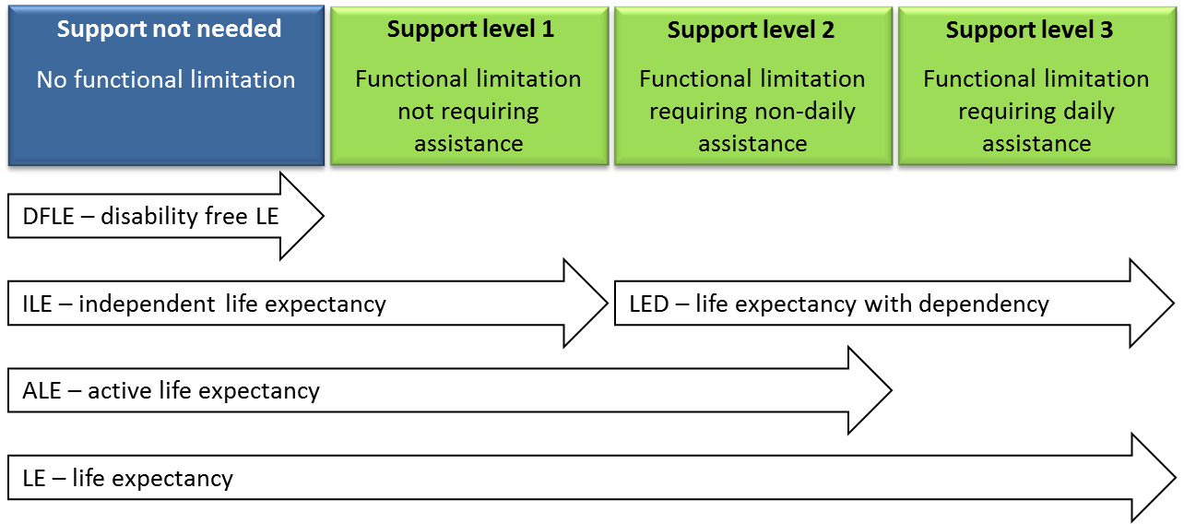

Health-adjusted life expectancy
Where health state expectancies take a categorical approach with reference to functional limitation thresholds, health-adjusted life expectancy or healthy life expectancy (HLE) is based on continuous weighting of non-fatal health states relative to full health. Therefore, HLE is the number of years of full health that an average person can expect to live.

This method was used in the New Zealand Burden of Diseases Study (NZBD). To estimate average levels of health among survivors of disease and injury, researchers summed the NZBD’s estimates of years lived with disability (YLD) over all causes. YLD is estimated by multiplying the prevalence of the different health states by their disability weight, which ranges from 0 (full health) to 1 (equivalent to being dead). These estimates were then incorporated into the life tables to give an estimate of health-adjusted life expectancy (Ministry of Health 2013).

How health expectancy and ILE are being applied in New Zealand
The Ministry of Health recognises health expectancy as a key outcome indicator. An increasing number of other countries are also taking this approach, such as the United States of America (Molla et al 2001), the United Kingdom (Office for National Statistics 2004), Canada (Public Health Agency of Canada 2012) and Australia (Australian Institute of Health and Welfare 2014).

The Ministry of Health has been regularly reporting on health expectancy since 2003. It reports independent life expectancy as a ‘headline’ health indicator in both its Statement of Intent (Ministry of Health 2003a and later editions) and its Health and Independence Report (Ministry of Health 2003b and later editions). Independent life expectancy also features as the ‘peak’ health indicator in the Health chapter of The Social Report (Ministry of Social Development 2003 and later editions). In addition:
- several research studies have been conducted on social variations and evolution of health expectancy in New Zealand (Davis et al 1999; Graham et al 2004)
- the Ministry of Health used the health expectancy construct in its long-term forecasting of public health expenditure (Tobias et al 2004)
- the Ministry of Health (2013) estimated health expectancy in the NZBD based on the health-adjusted life expectancy measures to estimate health loss.

Overview of this report
The next section summarises the sources and methods for the data presented in this report (with more detail available in the Appendix). The following sections then set out recent data on independent life expectancy in 2013 and longer-term trends in this indicator from 1996 to 2013. The final sections analyse the performance of ILE as an indicator and draw overall conclusions from the findings in this report.

How independent life expectancy has been estimated
The first health expectancy tables in New Zealand were constructed using disability prevalence rates from the 1996 Household Disability Survey and its companion Disability Survey of Residential Facilities (Tobias and Cheung 1999). These prevalence rates were based on a functional limitation concept of disability and corresponded closely with the ICF’s core health and health-related domains. The survey was repeated after the 2001, 2006 and 2013 Censuses of Population and Dwellings. In each case, the survey was designed (with specific attention to drift and fielding of household and institutional components) so that trends in health expectancy and differences between population subgroups and regions could be estimated (Ministry of Health and Statistics NZ 2008).

Sources of data for this report
All data for this report were supplied by Statistics NZ.

Post-censal disability surveys (1996, 2001, 2006 and 2013, as noted above) provided data on:
- disability rates – more precisely described in the context of this report as functional limitation rates by level of support needed
- the number of respondents, which were needed to calculate the standard error of ILE.

Abridged life tables for the total, Māori and non-Māori populations by sex came from the complete period life tables 1995–1997, 2000–2002, 2005–2007 and 2012–2014 (Statistics NZ 2015b).

Methods of estimating ILE
The ILE prevalence estimates by 10-year age group were smoothed using kernel smoothing (Wand and Jones 1994) to produce estimates by five-year age group. The smoothing was conducted using statistical software Stata version 12.1. ILE and the other health state expectancy measures were calculated by the Sullivan observed prevalence method (Sullivan 1971). The two main inputs were age-specific mortality obtained from Statistics NZ’s abridged life tables and smoothed disability prevalence rates by support need level and five-year age group. ILE and its standard error were calculated using the formulae embedded in the spreadsheet. (For a full explanation of these formulae, see Jagger et al 2006.)

See the Appendix for a more detailed description of the methods used to estimate ILE.

Analysis by gender and ethnicity
Separate estimates have been calculated for New Zealand males and females overall, Māori males and females and non-Māori males and females. In this report, ‘non-Māori’ refers to those respondents who identified with an ethnic group other than Māori. European/Pākehā are included in the non-Māori category. This category also includes Asian and Pacific peoples, for whom separate estimates could not be calculated accurately because the number of respondents was too small.

Independent life expectancy at birth in 2013
This section presents estimates of independent life expectancy for New Zealanders born in 2013. Estimates are presented separately by gender and ethnicity (Māori and non-Māori) before an overall analysis of the findings and limits to data reliability are discussed.

ILE by gender
The New Zealand life expectancy at birth for babies born between 2012 and 2014 was 79.5 years for males and 83.2 years for females, which is a difference of 3.7 years.

Applying the 2013 Disability Survey results to 2012–2014 period life tables, a male New Zealander born in 2013 can expect to live for:
- an average of 65.2 years independently, which is 82.0% of his life
- another 14.3 years with some level of disability requiring support (life expectancy with dependency or LED). For 10.2 years of this time, he will need some assistance but not every day and for the other 4.1 years he will need daily assistance due to his functional limitations.

Also based on the 2013 Disability Survey results and 2012–2014 period life tables, a female New Zealander born in 2013 can expect to live for:
- an average of 66.5 years independently, which is 79.9% of her life
- another 16.7 years with functional limitations that require support. During this time, she will need non-daily assistance for 10.7 years and daily assistance for 6.0 years.

At birth, therefore, females can expect to live independently for 1.3 years longer than males. They can also expect to live 2.4 years longer with disability requiring assistance than males (Figure 2).

Figure 2: Independent life expectancy at birth, New Zealand males and females, 2013
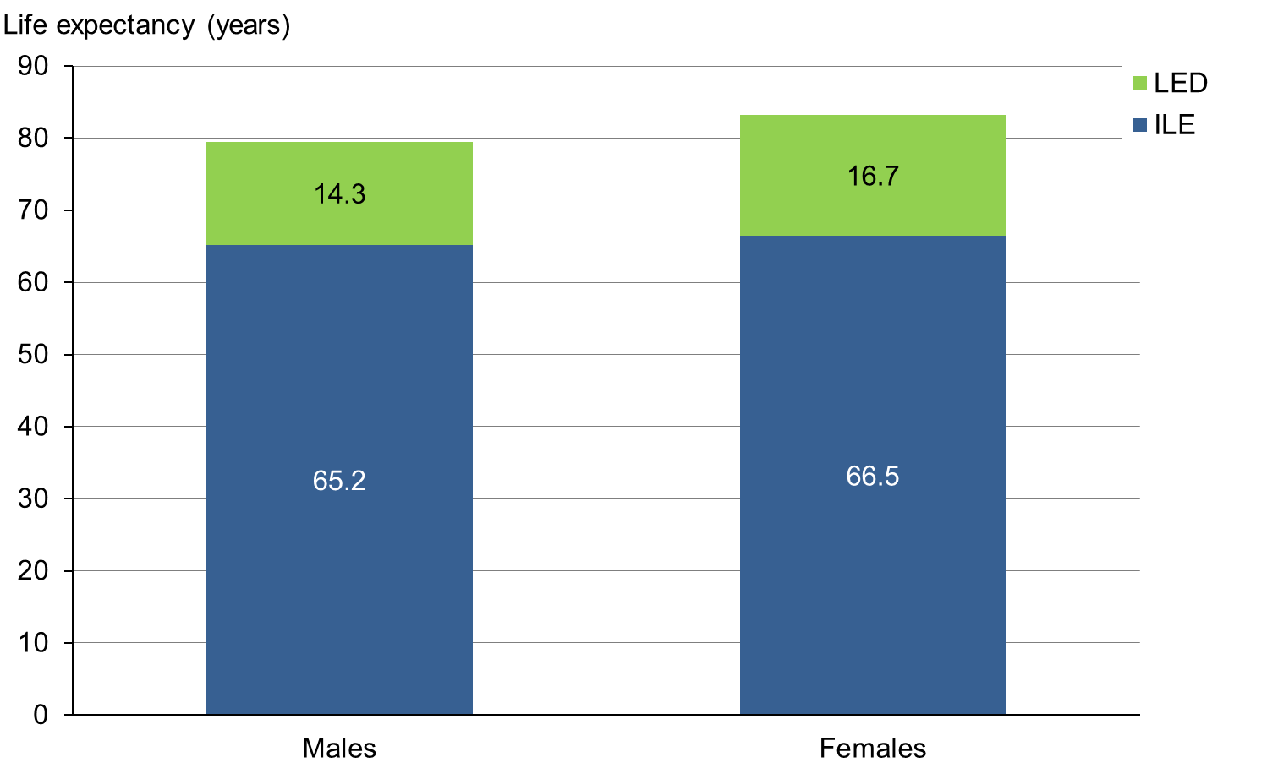
Note: ILE = independent life expectancy, LED = life expectancy with dependency.

The literature does not offer sufficient evidence to determine whether biological, social or behavioural factors explain why males have a higher proportion of years free of dependency than females (Oksuzyan et al 2010). It is possible that males are more active and are less likely to report functional limitations. Males are also more likely to engage in risky behaviours that shorten their life (Robine and Jagger 2005).

ILE by ethnicity
Māori born between 2012 and 2014 had a shorter life expectancy at birth than non-Māori. Life expectancy for Māori males was 73.0 years, compared with 79.5 years for New Zealand males overall. For Māori females it was 77.1 years, compared with 83.2 years for New Zealand females overall.

Based on the 2013 Disability Survey results and 2012–2014 period life tables, a Māori male born in 2013 can expect to live for:
- an average of 54.3 years independently, which is 74.4% of his life
- another 18.7 years with disability requiring assistance (non-daily 14.2 years and daily 4.5 years).

A Māori female born in 2013 can expect to live for:
- 60.4 years independently, which is 78.4% of her life
- another 16.7 years with some level of disability requiring assistance (non-daily 12.0 years and daily 4.7 years).

At birth, Māori females can expect to live independently for 6.1 years longer than Māori males (Figure 3). Māori can expect to live fewer years independently than non-Māori (males: Māori 54.3 and non-Māori 66.7 years; females: Māori 60.4 and non-Māori 67.4 years), a difference that is statistically significant at the 95% confidence level. Māori men are expected to live longer with disability requiring assistance (18.7 years) than non-Māori men (13.6 years).

Figure 3: Independent life expectancy at birth, Māori males and females, 2013
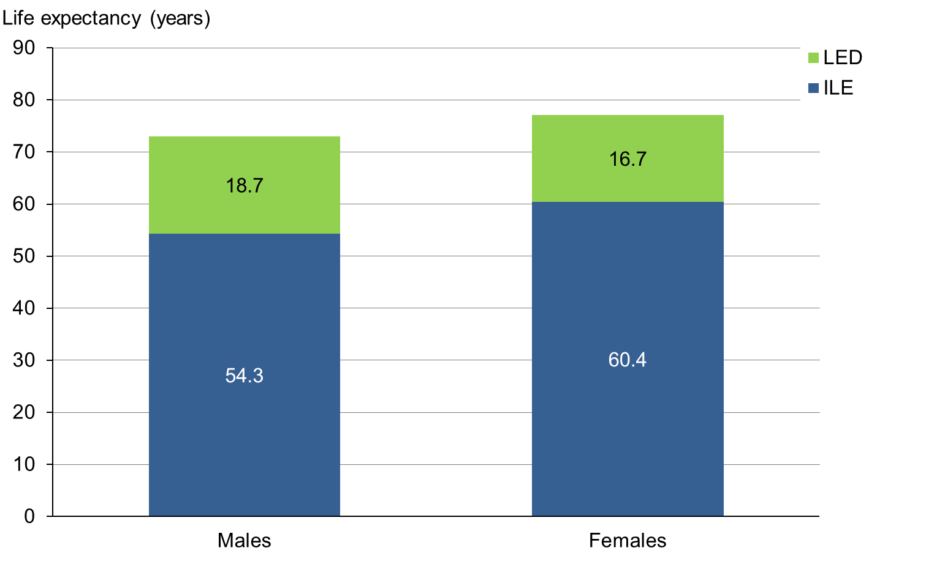
Note: ILE = independent life expectancy, LED = life expectancy with dependency.

Non-Māori (those who identified with an ethnic group other than Māori) born in 2013 had a longer life expectancy at birth than Māori: life expectancy at birth was 80.3 years for non-Māori males and 83.9 years for non-Māori females.

Based on death and disability rates in 2012–2014, a non-Māori male born in 2013 can expect to live for:
- an average of 66.7 years free of any functional limitation requiring assistance, which is 83.0% of his life
- another 13.6 years with disability requiring assistance (non-daily 9.6 years and daily 4.0 years).

A non-Māori female born in 2013 can expect to live for:
- an average of 67.4 years independently, which is 80.4% of her life
- another 16.5 years requiring assistance (non-daily 10.4 years and daily 6.1 years).

At birth, non-Māori females are expected to live independently for 0.7 years longer than non-Māori males (Figure 4). Non-Māori males and females live longer independently and have fewer years with a disability requiring assistance than Māori males and females.

Figure 4: Independent life expectancy at birth, non-Māori males and females, 2013
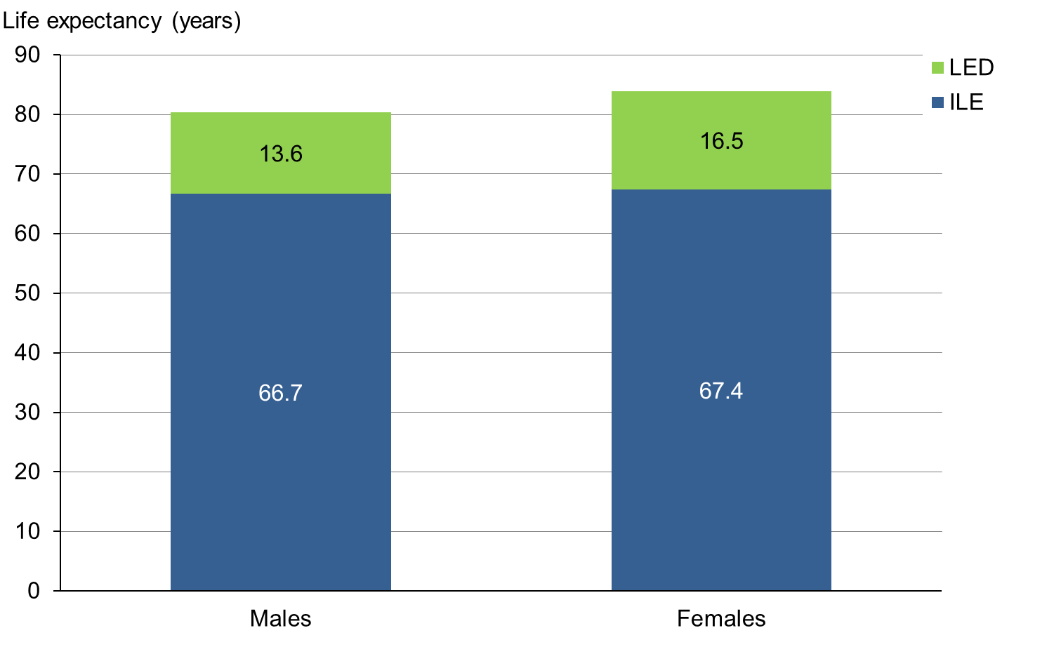
Note: ILE = independent life expectancy, LED = life expectancy with dependency.

Analysis across gender and ethnic groups
Table 1 compares the number of years people at birth are expected to live independently with the number of years they are expected to live with dependency and their life expectancy. It breaks down these data by gender and ethnic groups.

Table 1: Independent life expectancy at birth, by gender and ethnicity, 2013
Indicator | Independent life expectancy in years
 | Total  males | Total females | Māori  males | Māori females | Non-Māori males | Non-Māori females
LE | 79.5 | 83.2 | 73.0 | 77.1 | 80.3 | 83.9
LED daily assistance | 4.1 | 6.0 | 4.5 | 4.7 | 4.0 | 6.1
LED non-daily assistance | 10.2 | 10.7 | 14.2 | 12.0 | 9.6 | 10.4
ILE  (95% CI) | 65.2  (64.6–65.9) | 66.5  (65.8–67.1) | 54.3  (52.6–56.0) | 60.4  (58.6–62.3) | 66.7  (65.9–67.4) | 67.4  (66.7–68.2)
Note: LE = life expectancy, LED = life expectancy with dependency, ILE = independent life expectancy.

As the above data show, Māori have shorter lives than non-Māori. The inequality is even greater if only healthy years are considered: although their lives are shorter, on average both Māori males and females live longer with dependency than non-Māori. This trend is particularly marked with Māori males: in 2013, Māori males had the lowest ILE at birth (54.3 years) and the lowest proportion of years lived independently (74.4%) among all groups. They also lived for longest with dependency (18.7 years with functional limitations requiring assistance – less than daily for 14.2 of those years and daily for the other 4.5 years).

The underlying causes for such inequality should be investigated by assessing the degree to which fatal and non-fatal outcomes each contribute to that inequality. The New Zealand Burden of Diseases Study indicated that most of the health loss in Māori is likely to be due to fatal outcomes (Ministry of Health 2013).

Limits to data reliability
The design of the disability survey providing much of the data for these estimates has changed over time. Māori and Pacific peoples were considerably over-sampled in the 2006 Disability Survey to allow for more robust estimates for these populations. The 2013 Disability Survey, however, included a small over-sample for Māori only. Therefore, ILE estimates for Māori are less reliable given the wide confidence intervals.

Independent life expectancy at age 65 in 2013
Independent life expectancy at the age of 65 years (pensionable age) is used to monitor healthy ageing. It is a more appropriate indicator for this age group because mortality in early life does not influence health state expectancies.

Estimates are presented separately by gender and ethnicity (Māori and non-Māori) before an overall analysis of the findings and limits to data reliability are discussed.

ILE by gender
Between 2012 and 2014, New Zealand life expectancy at age 65 was another 18.9 years for males and another 21.3 years for females.

Based on death and disability rates in 2012–2014, a male New Zealander aged 65 years in 2013 can expect to live for:
- another 10.2 years independently, on average, which is 54.1% of his remaining life
- a further 8.7 years with functional limitations requiring assistance (non-daily 5.6 years and daily 3.1 years).

At 65 years of age in 2013, a female New Zealander can expect to live for:
- another 10.6 years independently, on average, which is 49.5% of her remaining life
- a further 10.7 years with disability requiring assistance (non-daily 5.9 years and daily 4.8 years).

At the age of 65 years, therefore, females can expect to live independently for only 0.4 years more than males. However, they can expect to live 2.0 years longer with disability requiring assistance than males (Figure 5).

Figure 5: Independent life expectancy at age 65, New Zealand males and females, 2013
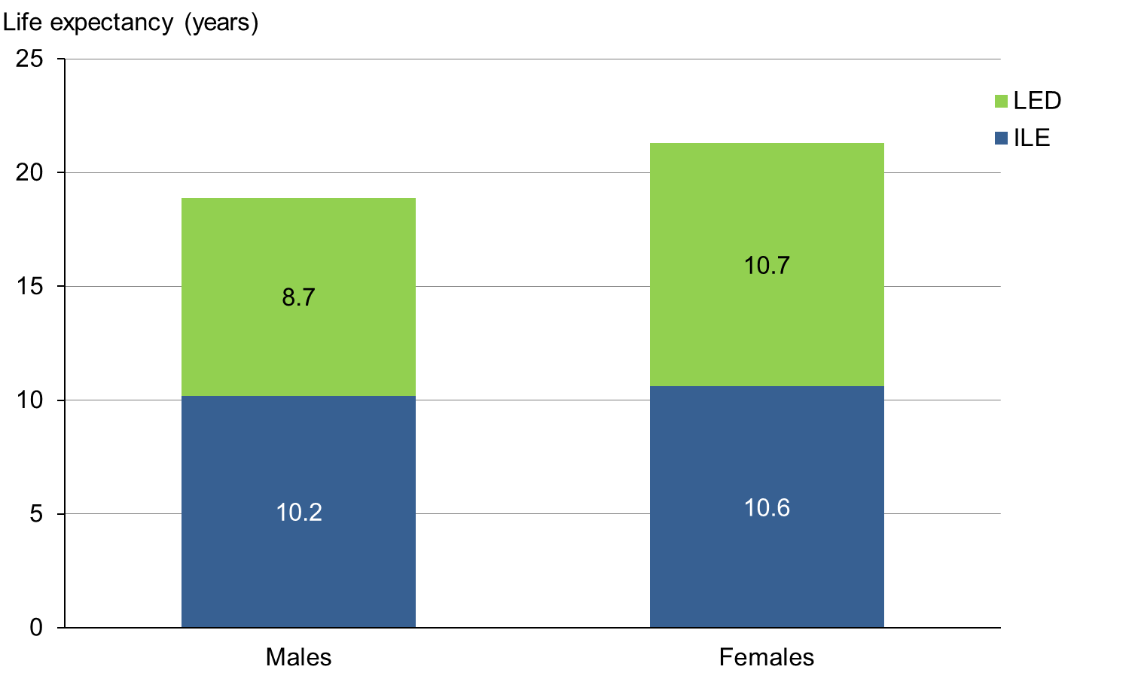
Note: ILE = independent life expectancy, LED = life expectancy with dependency.

ILE by ethnicity
Between 2012 and 2014, life expectancy for Māori at age 65 was another 15.4 years for males and another 17.5 years for females. These estimates compare with another 19.1 years for non-Māori males and another 21.6 years for non-Māori females.

Based on death and disability rates between 2012 and 2014, a Māori male aged 65 years in 2013 can expect to live for:
- another 5.5 years independently, on average, which is about a third of the remaining years of his life. It is also half the number of years non-Māori males are expected to live independently (10.6 years), a difference that is statistically significant at the 95% confidence level
- a further 9.9 years with disability requiring assistance, which is longer than for non-Māori males (8.5 years). Māori males can expect to live most (7.5 years) of these 9.9 years requiring non-daily assistance and another 2.4 years requiring daily assistance.

At the age of 65 years, a Māori female can expect to live for:
- another 9.4 years independently, on average, which is approximately half of her remaining years of life and 3.9 more years than a Māori male
- a further 8.1 years with disability requiring assistance, which is not different at a statistically significant level from non-Māori females (10.9 years). Māori females can expect to require non-daily assistance (4.8 years) for a longer time than they require daily support (3.3 years) (Figure 6).

Figure 6: Independent life expectancy at age 65, New Zealand Māori males and females, 2013
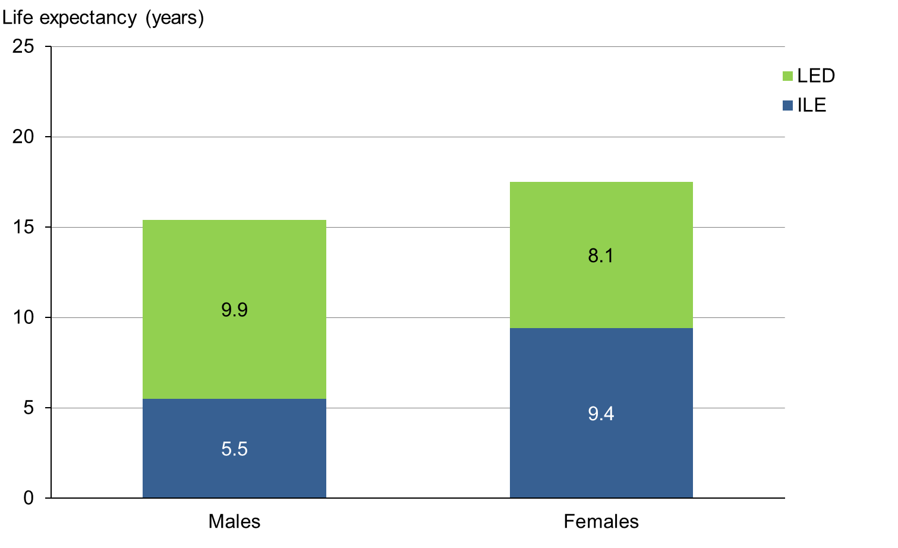
Note: ILE = independent life expectancy, LED = life expectancy with dependency.

ILE at the age of 65 years is nearly the same for non-Māori males and females (another 10.6 and 10.7 years respectively), and is approximately half of their remaining years of life. At 65 years of age, non-Māori females can expect to live longer with disability requiring assistance than non-Māori males (10.9 and 8.5 years respectively), but with a similar proportion of years requiring non-daily support (females 6.0 years and males 5.4 years) and daily support (females 4.9 years and males 3.1 years) (Figure 7).

Figure 7: Independent life expectancy at age 65, non-Māori males and females, 2013
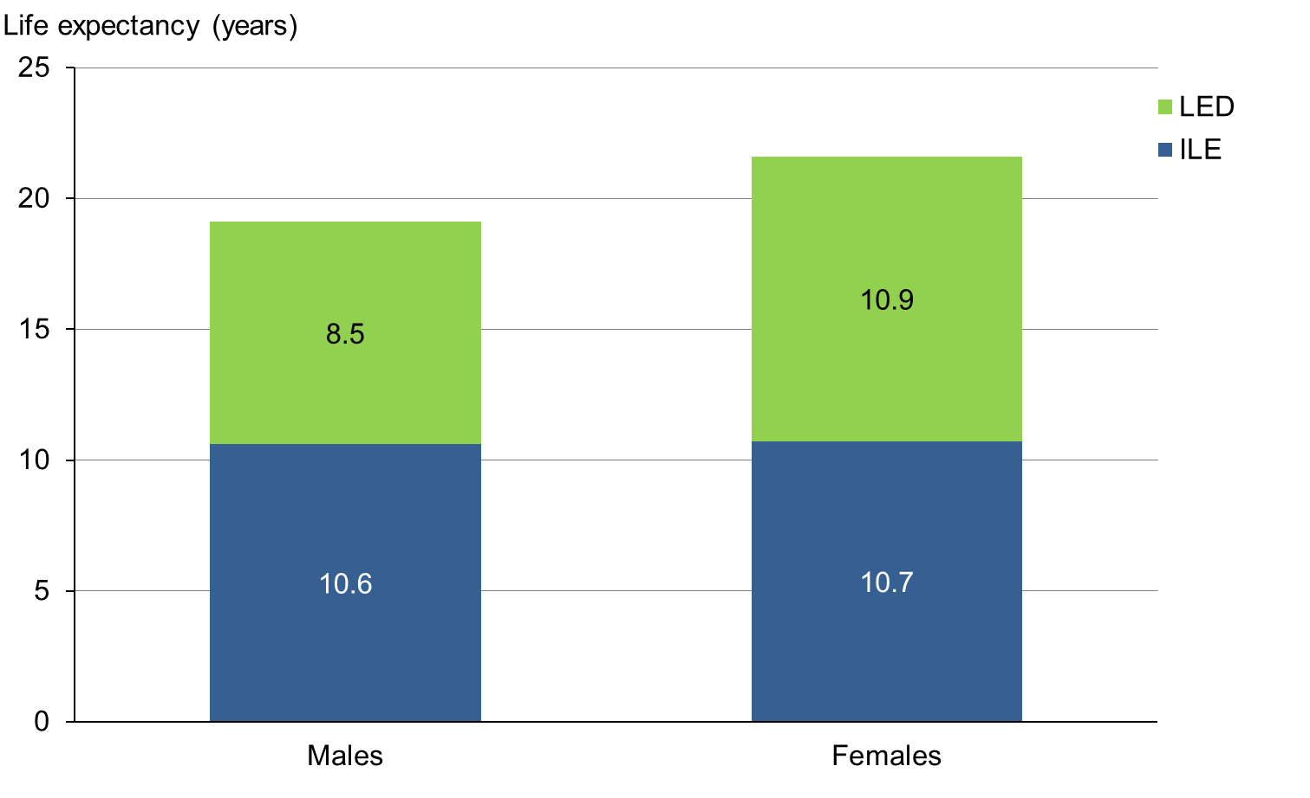
Note: ILE = independent life expectancy, LED = life expectancy with dependency.

Analysis across gender and ethnic groups
Table 2 compares the remaining number of years people aged 65 years in 2013 can expect to live independently with the remaining number of years they are expected to live with dependency and their remaining life expectancy. It breaks these data down by gender and ethnic groups.

Table 2: Independent life expectancy at age 65, by gender and ethnicity, 2013
Indicator | Independent life expectancy in years
 | Total  males | Total females | Māori  males | Māori females | Non-Māori males | Non-Māori females
LE | 18.9 | 21.3 | 15.4 | 17.5 | 19.1 | 21.6
LED daily assistance | 3.1 | 4.8 | 2.4 | 3.3 | 3.1 | 4.9
LED non-daily assistance | 5.6 | 5.9 | 7.5 | 4.8 | 5.4 | 6.0
ILE  (95% CI) | 10.2  (9.7–10.8) | 10.6  (10.0–11.1) | 5.5  (4.1–6.9) | 9.4  (7.7–11.0) | 10.6  (10.0–11.1) | 10.7  (10.1–11.2)
Notes: LE = life expectancy, LED = life expectancy with dependency, ILE = independent life expectancy.

Figures 8 and 9 illustrate life expectancy, independent life expectancy and life expectancy with dependency for New Zealand males and females in 2013. Table 3 gives an overview of ILE at selected ages.

Figure 8: Life expectancy, independent life expectancy and life expectancy with dependency, New Zealand males, 2013
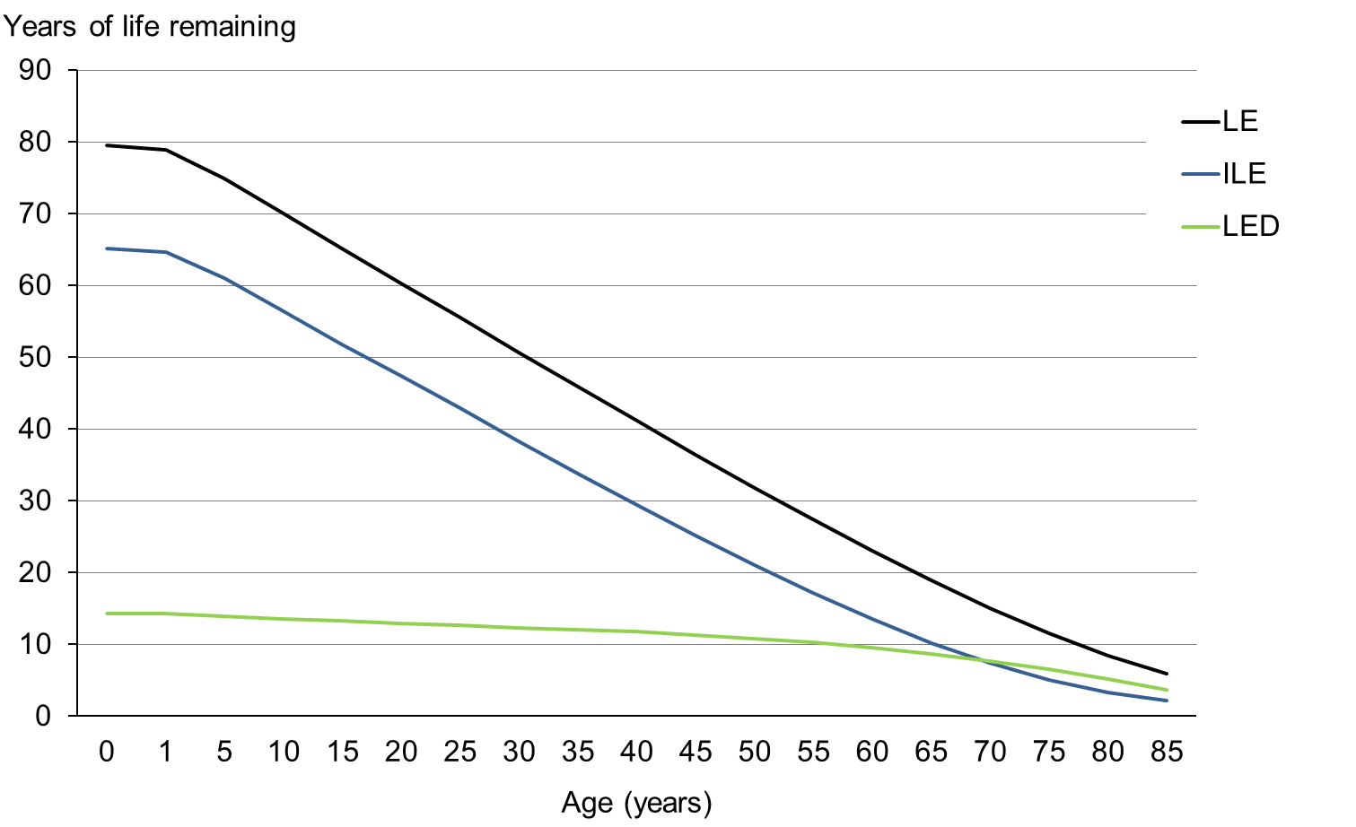
Note: LE = life expectancy, ILE = independent life expectancy, LED = life expectancy with dependency.

Figure 9: Life expectancy, independent life expectancy and life expectancy with dependency, New Zealand females, 2013
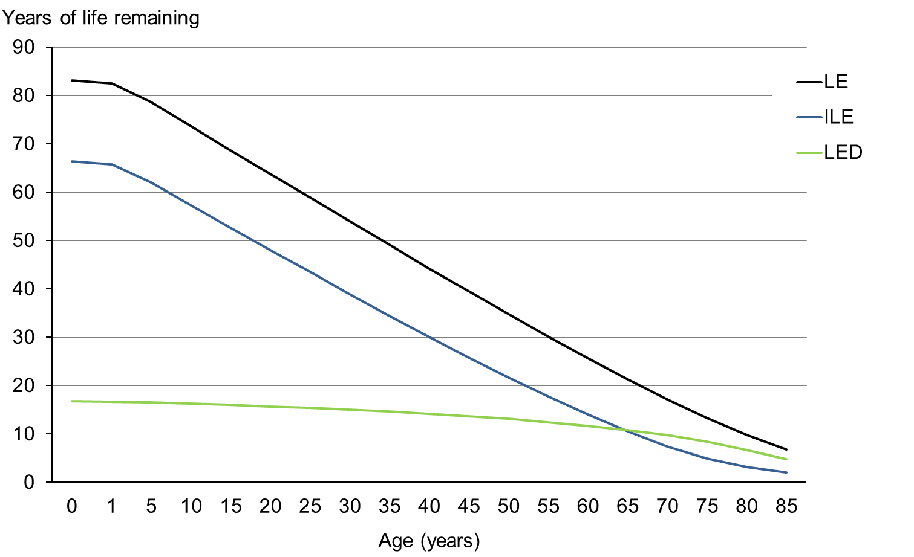
Note: LE = life expectancy, ILE = independent life expectancy, LED = life expectancy with dependency.

Table 3: Independent life expectancy at selected ages in 2013
Age (years) | LE  (years) | ILE  (years) | LE-ILE  (years) | ILE/LE  (%) | LE  (years) | ILE  (years) | LE-ILE  (years) | ILE/LE  (%)
 | New Zealand males |  |  |  | New Zealand females
0 | 79.5 | 65.2 | 14.3 | 82.0 | 83.2 | 66.5 | 16.7 | 79.9
1 | 78.9 | 64.6 | 14.3 | 81.9 | 82.5 | 65.8 | 16.7 | 79.7
5 | 74.9 | 61.0 | 13.9 | 81.4 | 78.6 | 62.0 | 16.6 | 78.9
10 | 70.0 | 56.4 | 13.6 | 80.6 | 73.6 | 57.3 | 16.3 | 77.9
15 | 65.1 | 51.8 | 13.3 | 79.6 | 68.7 | 52.7 | 16.0 | 76.7
20 | 60.3 | 47.4 | 12.9 | 78.5 | 63.8 | 48.1 | 15.7 | 75.3
25 | 55.5 | 42.9 | 12.6 | 77.2 | 58.9 | 43.5 | 15.4 | 73.8
30 | 50.7 | 38.3 | 12.4 | 75.6 | 54.0 | 38.9 | 15.1 | 72.1
35 | 45.9 | 33.8 | 12.1 | 73.7 | 49.1 | 34.4 | 14.7 | 70.1
40 | 41.2 | 29.4 | 11.8 | 71.5 | 44.2 | 30.0 | 14.2 | 67.9
45 | 36.4 | 25.2 | 11.2 | 69.1 | 39.5 | 25.8 | 13.7 | 65.3
50 | 31.8 | 21.0 | 10.8 | 66.1 | 34.8 | 21.7 | 13.1 | 62.3
55 | 27.4 | 17.1 | 10.3 | 62.4 | 30.2 | 17.8 | 12.4 | 58.8
60 | 23.0 | 13.5 | 9.5 | 58.7 | 25.7 | 14.0 | 11.7 | 54.5
65 | 18.9 | 10.2 | 8.7 | 54.1 | 21.3 | 10.6 | 10.7 | 49.5
70 | 15.0 | 7.4 | 7.6 | 49.1 | 17.2 | 7.5 | 9.7 | 43.4
75 | 11.5 | 5.0 | 6.5 | 43.5 | 13.3 | 4.9 | 8.4 | 37.0
80 | 8.4 | 3.3 | 5.1 | 38.9 | 9.8 | 3.1 | 6.7 | 31.9
85 | 5.9 | 2.2 | 3.7 | 36.8 | 6.8 | 2.0 | 4.8 | 29.8
 | Māori males |  |  |  | Māori females
0 | 73.0 | 54.3 | 18.7 | 74.4 | 77.1 | 60.4 | 16.7 | 78.4
1 | 72.4 | 53.8 | 18.6 | 74.3 | 76.6 | 59.8 | 16.8 | 78.1
5 | 68.5 | 50.3 | 18.2 | 73.4 | 72.7 | 56.1 | 16.6 | 77.2
10 | 63.6 | 45.9 | 17.7 | 72.1 | 67.7 | 51.5 | 16.2 | 76.1
15 | 58.7 | 41.5 | 17.2 | 70.8 | 62.8 | 47.1 | 15.7 | 74.9
20 | 54.0 | 37.3 | 16.7 | 69.2 | 57.9 | 42.7 | 15.2 | 73.7
25 | 49.3 | 33.2 | 16.1 | 67.3 | 53.1 | 38.3 | 14.8 | 72.2
30 | 44.6 | 29.0 | 15.6 | 65.0 | 48.2 | 34.0 | 14.2 | 70.6
35 | 40.0 | 24.8 | 15.2 | 61.9 | 43.4 | 29.8 | 13.6 | 68.8
40 | 35.4 | 20.7 | 14.7 | 58.4 | 38.7 | 25.8 | 12.9 | 66.8
45 | 31.0 | 16.8 | 14.2 | 54.3 | 34.0 | 22.1 | 11.9 | 64.9
50 | 26.7 | 13.3 | 13.4 | 49.7 | 29.5 | 18.5 | 11.0 | 62.7
55 | 22.6 | 10.2 | 12.4 | 44.9 | 25.2 | 15.2 | 10.0 | 60.4
60 | 18.8 | 7.5 | 11.3 | 40.1 | 21.1 | 12.1 | 9.0 | 57.5
65 | 15.4 | 5.5 | 9.9 | 35.5 | 17.5 | 9.4 | 8.1 | 53.6
70 | 12.3 | 3.6 | 8.7 | 28.9 | 14.2 | 6.8 | 7.4 | 47.7
75 | 9.6 | 1.9 | 7.7 | 20.0 | 11.2 | 4.5 | 6.7 | 40.2
80 | 7.4 | 0.9 | 6.5 | 12.4 | 8.5 | 2.9 | 5.6 | 33.8
85 | 5.7 | 0.5 | 5.2 | 9.0 | 6.4 | 2.0 | 4.4 | 31.1
 | Non-Māori males |  |  |  | Non-Māori females
0 | 80.3 | 66.7 | 13.6 | 83.0 | 83.9 | 67.4 | 16.5 | 80.4
1 | 79.7 | 66.0 | 13.7 | 82.8 | 83.2 | 66.7 | 16.5 | 80.2
5 | 75.7 | 62.3 | 13.4 | 82.3 | 79.3 | 62.9 | 16.4 | 79.3
10 | 70.8 | 57.7 | 13.1 | 81.5 | 74.3 | 58.2 | 16.1 | 78.3
15 | 65.8 | 53.1 | 12.7 | 80.6 | 69.4 | 53.5 | 15.9 | 77.1
20 | 61.0 | 48.5 | 12.5 | 79.5 | 64.4 | 48.8 | 15.6 | 75.8
25 | 56.2 | 43.9 | 12.3 | 78.2 | 59.5 | 44.2 | 15.3 | 74.3
30 | 51.4 | 39.3 | 12.1 | 76.5 | 54.6 | 39.6 | 15.0 | 72.5
35 | 46.5 | 34.8 | 11.7 | 74.8 | 49.7 | 35.0 | 14.7 | 70.4
40 | 41.8 | 30.3 | 11.5 | 72.5 | 44.8 | 30.5 | 14.3 | 68.2
45 | 37.0 | 26.0 | 11.0 | 70.2 | 40.0 | 26.2 | 13.8 | 65.5
50 | 32.3 | 21.7 | 10.6 | 67.3 | 35.3 | 22.0 | 13.3 | 62.4
55 | 27.8 | 17.7 | 10.1 | 63.7 | 30.6 | 18.0 | 12.6 | 58.9
60 | 23.4 | 14.0 | 9.4 | 59.7 | 26.1 | 14.2 | 11.9 | 54.4
65 | 19.1 | 10.6 | 8.5 | 55.3 | 21.6 | 10.7 | 10.9 | 49.4
70 | 15.2 | 7.6 | 7.6 | 49.9 | 17.4 | 7.5 | 9.9 | 43.2
75 | 11.6 | 5.1 | 6.5 | 44.3 | 13.4 | 4.9 | 8.5 | 36.9
80 | 8.5 | 3.3 | 5.2 | 39.4 | 9.9 | 3.1 | 6.8 | 31.8
85 | 5.9 | 2.2 | 3.7 | 37.5 | 6.9 | 2.0 | 4.9 | 29.4
Note: LE = life expectancy, ILE = independent life expectancy; LE-ILE = number of years estimated to be living with dependency; ILE/LE = proportion of years estimated to be living independently relative to overall life expectancy.

Limits to data reliability
ILE estimates at the age of 65 years must be interpreted cautiously. Health expectancies are average estimates for the population of that age group, which includes people who already have functional limitations. If expected years of life without and with dependency were calculated based on only those 65-year-olds who do not yet have functional limitations, the figures may be different (AIHW 2014).

Trends in independent life expectancy 1996–2013
This section presents estimates of independent life expectancy at birth in 1996, 2001, 2006 and 2013 to identify any trends over this 17-year period. Estimates are presented by gender and ethnicity (Māori and non-Māori) before an overall analysis of the findings is presented. A discussion of the limits to the reliability and comparability of these data concludes this section.

Trends in ILE by gender
Male New Zealanders born in 2013 can expect to live independently for 65.2 years, 1.4 more years than male New Zealanders born in 1996 (63.8 years). Over the same period, independent life expectancy for female New Zealanders has increased slightly, by 0.1 years, from 66.4 years in 1996 to 66.5 years in 2013 (Figure 10 and Table 4).

Figure 10: Independent life expectancy at birth, New Zealand males and females,
1996–2013
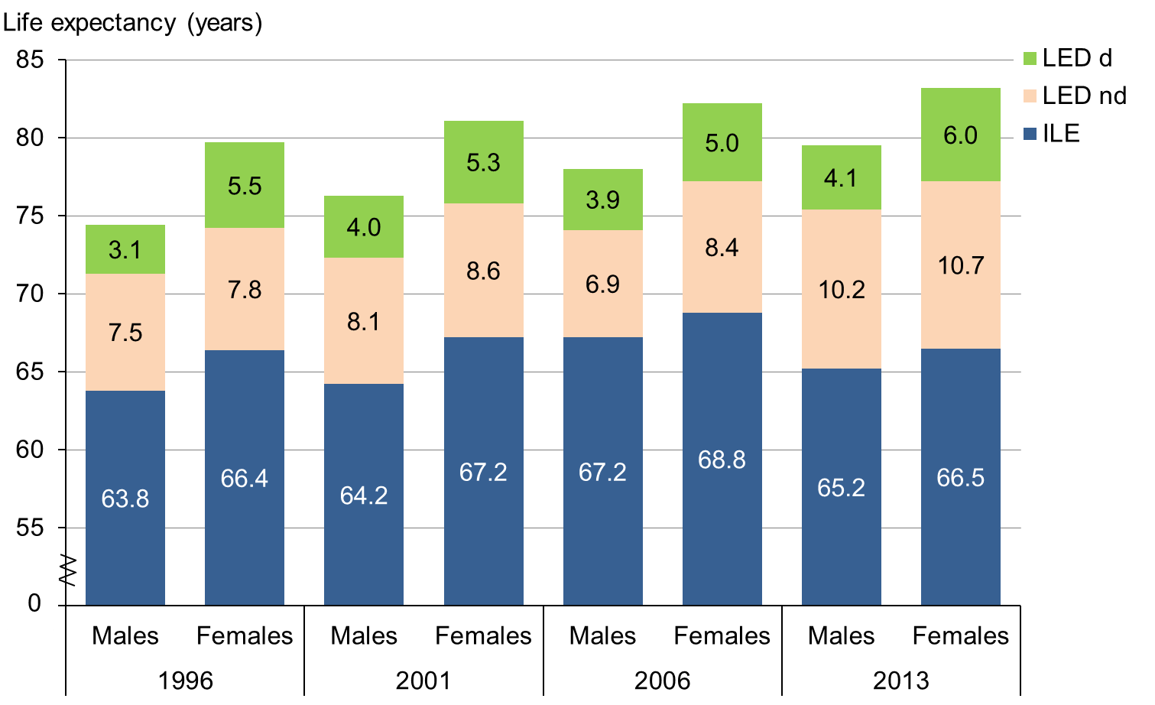
Note: ILE = independent life expectancy, LED nd = life expectancy with dependency requiring non-daily assistance, LED d = life expectancy with dependency requiring daily assistance.

Table 4: Independent life expectancy at birth, by gender, 1996–2013
 | Independent life expectancy in years (95% confidence interval)
 | 1996 | 2001 | 2006 | 2013
New Zealand males | 63.8  (63.2–64.4) | 64.2  (63.7–64.7) | 67.2  (66.7–67.7) | 65.2  (64.6–65.9)
New Zealand females | 66.4  (65.7–67.0) | 67.2  (66.7–67.7) | 68.8  (68.3–69.3) | 66.5  (65.8–67.1)

In relative terms, however, independent life expectancy has fallen for both male and female New Zealanders between 1996 and 2013. That is, the proportion of years a male New Zealander born in 2013 can expect to live independently relative to his overall life expectancy has fallen by 3.7% since 1996. Similarly, the proportion of years that a female New Zealander can expect to live independently relative to her overall life expectancy fell by 3.4% over the same period (Table 5).

Table 5: Change in independent life expectancy at birth, by gender, between 1996 and 2013
 | Independent life expectancy in years |  | Change
 | 1996 | 2013 | Absolute (years) | Relative* (%)
New Zealand males | 63.8 | 65.2 | 1.4 | –3.7
New Zealand females | 66.4 | 66.5 | 0.1 | –3.4
Note: * Difference in the proportion of years lived independently (ILE/LE*100).

Trends in ILE by ethnicity
Table 6 presents the trends in independent life expectancy at birth for Māori and non-Māori males and females. Table 7 provides a comparison of 1996 and 2013 figures in both relative and absolute terms for these same four groups.

Table 6: Independent life expectancy at birth, by ethnicity, 1996–2013
 | Independent life expectancy in years (95% confidence interval)
 | 1996 | 2001 | 2006 | 2013
Māori males | 56.0  (54.1–58.0) | 56.9  (56.0–57.9) | 60.1  (59.2–61.0) | 54.3  (52.6–56.0)
Māori females | 58.2  (56.0–60.4) | 58.0  (57.0–59.0) | 61.6  (60.6–62.5) | 60.4  (58.6–62.3)
Non-Māori males | 64.5  (63.8–65.1) | 64.9  (64.3–65.5) | 68.2  (67.7–68.8) | 66.7  (65.9–67.4)
Non-Māori females | 66.9  (66.2–67.7) | 67.9  (67.3–68.5) | 69.8  (69.2–70.3) | 67.4  (66.7–68.2)

Table 7: Change in independent life expectancy at birth, by ethnicity, between 1996 and 2013
 | Independent life expectancy in years |  | Change
 | 1996 | 2013 | Absolute (years) | Relative* (%)
Māori males | 56.0 | 54.3 | –1.7 | –9.7
Māori females | 58.2 | 60.4 | 2.2 | –3.3
Non-Māori males | 64.5 | 66.7 | 2.2 | –2.5
Non-Māori females | 66.9 | 67.4 | 0.5 | –2.7
Note: * Difference in the proportion of years lived independently (ILE/LE*100).

For Māori males:
- life expectancy at birth increased by 6.4 years from 66.6 years in 1996 to 73.0 years in 2013
- ILE at birth decreased by 1.7 years in absolute terms, from 56.0 to 54.3 years (Table 6 and Figure 11)
- ILE at birth also decreased in relative terms – Māori males born in 1996 could expect to live 84.1% of their lives independently, compared with 74.4% of Māori males born in 2013 (Table 7).

These findings indicate that Māori males are living longer but spending much more of their lives in poor health than they were in 1996.

Figure 11: Independent life expectancy at birth, Māori males, 1996–2013
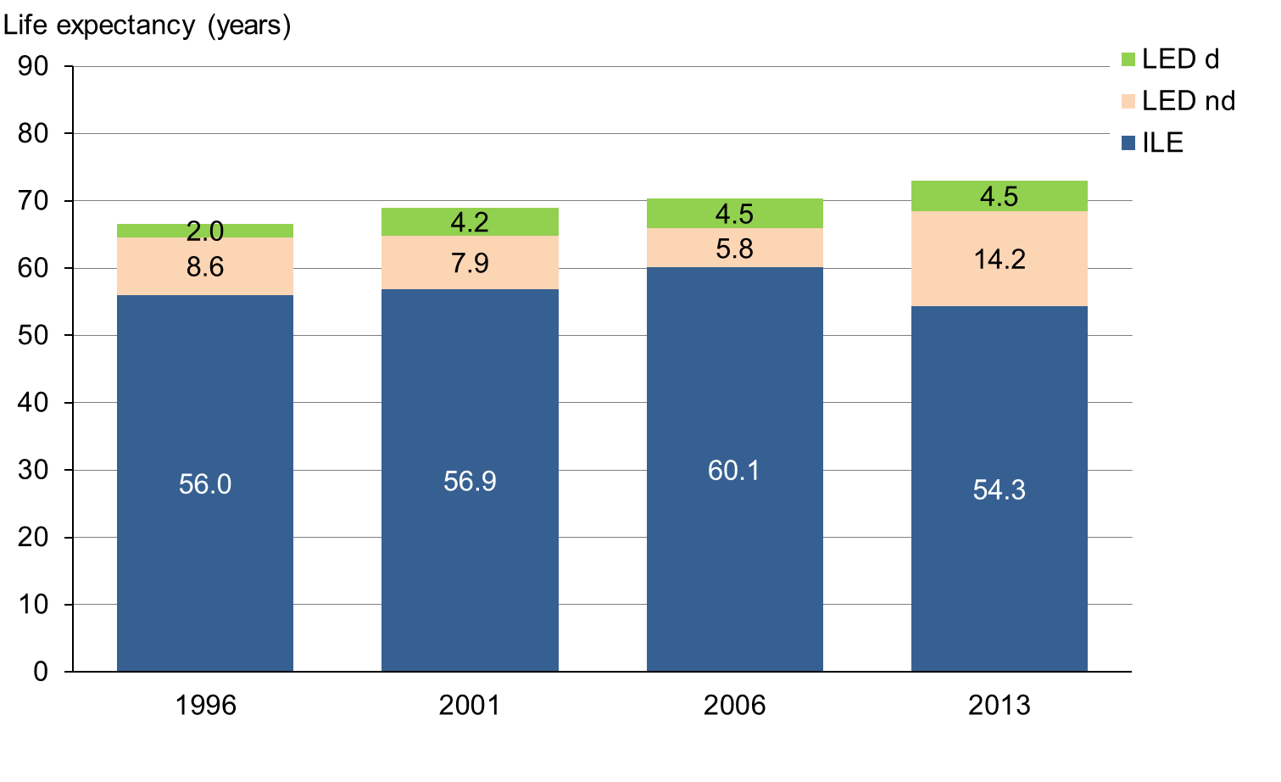
Note: ILE = independent life expectancy, LED nd = life expectancy with dependency requiring non-daily assistance, LED d = life expectancy with dependency requiring daily assistance.

For Māori females:
- life expectancy increased by 5.8 years, from 71.3 years in 1996 to 77.1 years in 2013
- ILE at birth increased by 2.2 years in absolute terms, from 58.2 to 60.4 years, in contrast to the trend for Māori males (Table 6 and Figure 12)
- ILE at birth decreased by 3.3% in relative terms (Table 7).

The relative decrease in the proportion of years spent living independently was associated with an increase in the number of years Māori females spent with functional limitations that needed a medium (non-daily) level of support, from 6.9 years in 1996 to 12.0 years in 2013. At the same time, the number of years they spent with functional limitations requiring a higher (daily) level of support decreased from 6.2 years in 1996 to 4.7 years in 2013 (Figure 12).

Figure 12: Independent life expectancy at birth, Māori females, 1996–2013
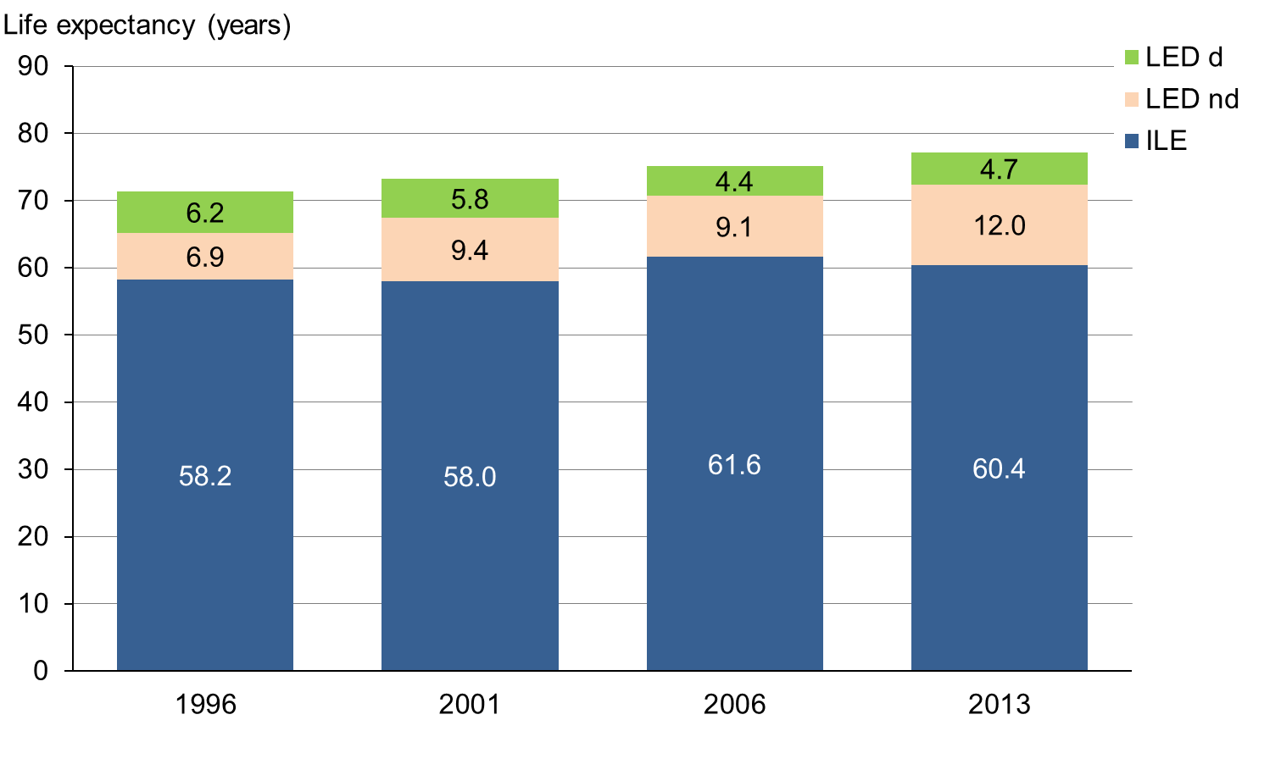
Note: ILE = independent life expectancy, LED nd = life expectancy with dependency requiring non-daily assistance, LED d = life expectancy with dependency requiring daily assistance.

For non-Māori males:
- life expectancy at birth increased by 4.9 years, from 75.4 years in 1996 to 80.3 years in 2013 ILE at birth increased by 2.2 years in absolute terms, from 64.5 to 66.7 years, while the number of years lived with dependency (functional limitations requiring non-daily and daily assistance) increased from 10.9 years to 13.6 years (Table 6 and Figure 13)
- ILE at birth decreased by 2.5% in relative terms, from 85.5% to 83.0% of their lives (Table 7).

Figure 13: Independent life expectancy at birth, non-Māori males, 1996–2013
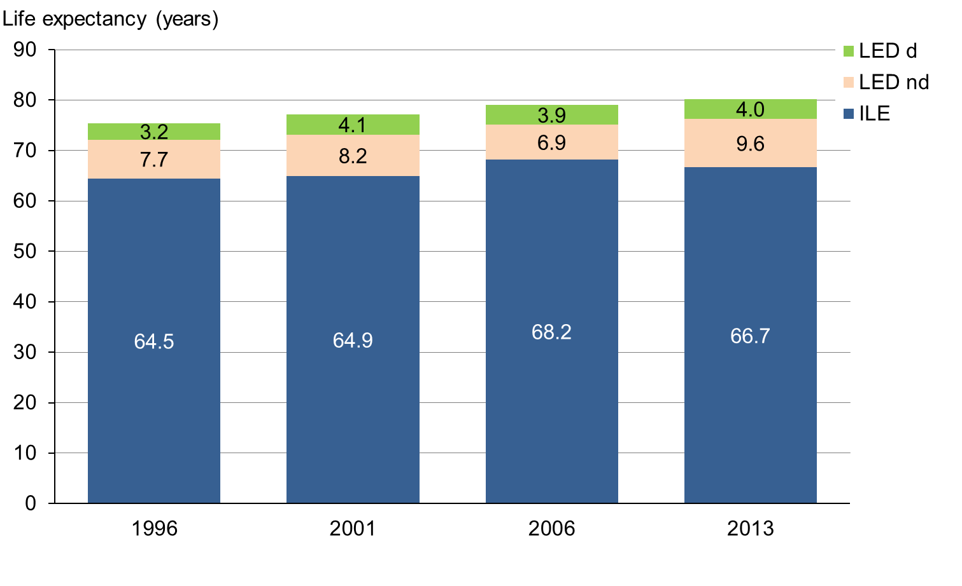
Note: ILE = independent life expectancy, LED nd = life expectancy with dependency requiring non-daily assistance, LED d = life expectancy with dependency requiring daily assistance.

For non-Māori females, trends in life expectancy and ILE at birth are similar to non-Māori males but non-Māori females are expected to live longer and have more independent years than non-Māori males. Specifically:
- life expectancy at birth increased by 3.3 years, from 80.6 to 83.9 years
- ILE at birth increased by only 0.5 years in absolute terms, from 66.9 to 67.4 years (Table 6 and Figure 14)
- ILE at birth decreased by 2.7% in relative terms, from 83.1% of their lives in 1996 to 80.4% in 2013 (Table 7).

The relative decrease in the number of years lived independently was mainly associated with an increase in the number of years lived with functional limitations requiring a medium (non-daily) level of assistance (Figure 14).

Figure 14: Independent life expectancy at birth, non-Māori females, 1996–2013
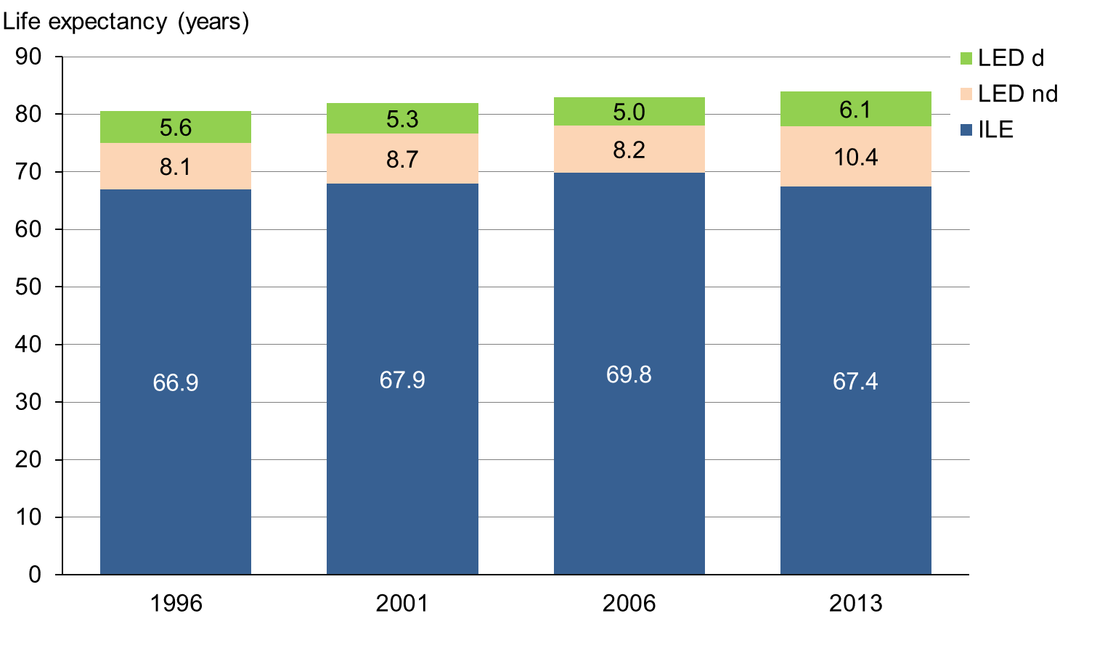
Note: ILE = independent life expectancy, LED nd = life expectancy with dependency requiring non-daily assistance, LED d = life expectancy with dependency requiring daily assistance.

Analysis across gender and ethnic groups
Between 1996 and 2013, independent life expectancy increased in an absolute sense for all groups apart from Māori males. In relative terms, however, all groups experienced a decrease: that is, the proportion of years they lived independently relative to their life expectancy was lower than it was for their counterparts in 1996. These findings indicate that people are living longer, but spend more time in dependent health states. The ageing population structure is likely to influence this finding: with a higher proportion of older people in the population, the proportion of people with functional limitations is likely to be correspondingly higher.

When dependency is used as the threshold to monitor trends, as in this report, ILE may relate to increasing life expectancy in any of the following ways.
- Compression of morbidity: ILE is increasing more quickly than life expectancy and the proportion of life spent in ‘good’ health is increasing.
- Expansion of morbidity: ILE is not keeping pace with life expectancy and the proportion of life spent in ‘good’ health is decreasing.
- Dynamic equilibrium: Both the proportion of life spent in ‘good’ health and the required support level are decreasing.

As life expectancy increased faster than ILE between 1996 and 2013, the proportion of years lived independently decreased for all groups, indicating that morbidity is expanding in relative terms.

Data by ethnicity generally follow this trend. From 1996 to 2013, ILE at birth for Māori females increased in absolute terms and decreased in relative terms; in addition, the number of Māori females with functional limitations requiring a medium level of support increased while the number requiring a high level of support decreased. Likewise, ILE for non-Māori males and females increased in absolute terms, but decreased in relative terms. These trends indicate morbidity is expanding in relative terms for Māori females and for non-Māori. Māori males, however, experienced a decrease in ILE in both absolute and relative terms, indicating an absolute expansion of dependent health states (morbidity).

In terms of gender, the differences in life expectancy and ILE for males and females generally narrowed from 1996 to 2013. The estimated gain in ILE during that period was 1.4 years for New Zealand males overall and only 0.1 years for New Zealand females. This suggests that most of the rise in life expectancy for women was due to increased number of years lived with dependency. The only exception is a widened gap in ILE between Māori females and males: Māori females born in 1996 could expect to live independently for 2.2 years more than males (ILE 58.2 and 56.0 years respectively), whereas those born in 2013 could expect to live independently for 6.1 years longer (ILE 60.4 and 54.3 years respectively).

Limits to data reliability and comparability
When comparing data over time and interpreting trends, caution is necessary as health measures may change over time even when health does not. The following are potential issues that should be considered when explaining the trends in ILE reported above.

The health expectancy estimates for 1996, 2001, 2006 and 2013 should be comparable because all the surveys on which they are based used the same methods. However, the survey design did vary over time. In particular, the findings of the 2006 Disability Survey may be less comparable and should be interpreted cautiously. Changes in life table methodology and statistical model used to estimate death rates may also have contributed to observed differences between groups between 2006 and 2013 (Statistics NZ 2015b).

Because the disability rate reported in the 2006 Disability Survey (17%) was lower than in the other surveys (20% in 1996 and 2001; 24% in 2013), ILE estimates for 2006 are correspondingly higher. A combination of statistical and non-statistical factors may explain the apparent difference. First, the lower disability rate in 2006 was observed primarily in adult households with low support needs, rather than in those with medium or high support needs, so could have been influenced by minor variations between questionnaires and changes in people’s perception of whether they are limited by a condition. Another contributing reason may be an increase in proxy interviews, where a person in the household provides information on behalf of the selected respondent, and this person may underestimate or overestimate the level of disability (Statistics NZ 2007). Moreover, between 2006 and 2013, the criteria had to be re-examined due to changes to the questionnaire and a ‘best-match’ was created so that the independent population could be identified consistently over time.

Another potential issue is that an individual’s perceptions of their health may change while their health remains the same. Improving the social and physical environment so that it is more inclusive and accessible can help disabled people to be more active and report less disability. Conversely, if the overall health of the population improves, people may be less likely to tolerate their health problems and report them more systematically. A change in the situation of disabled people may also influence how they feel rather than changing how they are (EHEMU 2007).

How well does ILE perform as an indicator?
This section turns from the findings on ILE in New Zealand to focus on how well ILE itself performs as an indicator of population health and, consequently, as an indicator of the effectiveness of the national health system.

Strengths
Measuring and monitoring population health is an essential part of assessing the performance of a national health system. Health expectancy is perhaps better suited to this task than any other available measure (WHO 2000). As a single indicator to inform policy (Ministry of Health and Statistics NZ 2009), ILE offers the following advantages.
- It is directly comparable with life expectancy.
- It is comparable across populations.
- It can be calculated without needing to allocate values to different types of non-fatal health states.
- The functional limitation threshold used to define ILE is meaningful in a policy sense in that the health system needs to plan for those people with functional limitations who need assistance.
- The approach produces figures that are readily interpreted, in the form of difference between life expectancy and ILE and the proportion of years of ILE relative to overall life expectancy.

Moreover, New Zealand already has the information infrastructure it needs to measure and monitor health expectancy. Statistics NZ provides high-quality vital statistics based on a five-yearly population census and full registration of deaths. In addition, it gathers data from a post-censal disability survey covering people of all ages living in both private dwellings and in residential institutions.

Limitations
The major limitation of ILE is that it places an arbitrary threshold on disability. It overlooks all disability that does not meet the threshold of a functional limitation requiring some level of assistance. Likewise, it treats all disability above the threshold as the same.

Furthermore, the information on functional limitation used in this report came from respondents’ self-reports, which can be influenced by norms and expectations that differ between cultural groups and over time. The greatest difficulty lies in getting accurate self-report data for people with lower support needs, as individuals may differ in their perception of whether they need or do not need assistance with their functional limitation.

Caution with estimates based on period life tables
Independent life expectancy reflects population health status during a specific period. It is calculated with reference to period life tables, which are based on the mortality experience for a three-year period. Because mortality rates tend to change over time, the ILE estimates that are based on them should be interpreted with caution.

In addition, the methodology on which period life tables are based has the limitations that:
- death rates at the youngest and oldest age groups, in which there are relatively few deaths and/or small populations, are less accurate
- collection and reporting of ethnicity data may lack consistency across all official statistics
- some death registrations and census forms do not contain information about the individual’s ethnicity.

The latest 2012–2014 period life tables include credible intervals for the first time to help users interpret this uncertainty.

Limited insights into causes
With a single measure such as ILE, there is not enough information to analyse specific causes or groups of causes in any depth. Causal data collected in the disability survey make a very limited contribution to the task of estimating the impact of different diseases and risk factors that may affect ILE.

Limited insights into the experiences of subgroups and regions
In calculating the health expectancy measure, some of the statistics used may have high sampling errors due to a limited number of respondents in particular categories (eg, older age groups and Māori). For this reason, data for Asian and Pacific peoples are included in the data for the ‘non-Māori’ population rather than being presented separately. The capacity for analysing ILE by region, socioeconomic group and other ethnic groups is likewise limited.

The need for a reliable data source
The disability prevalence rates used in this report came from the post-censal disability surveys. If the future of these surveys is not assured, substitute data sources should be found. One possibility is the New Zealand Health Survey, but it is unlikely to collect data from which disability prevalence can be calculated at the level of support need. Alternatively, the Institute of Health Metrics and Evaluation (IHME) conducts the Global Burden of Diseases Study to produce estimates for almost 300 diseases and injuries and 70 risk factors for 187 countries, including New Zealand (IHME 2015). These data could potentially be used to update health expectancy estimates in the future. Moreover, as the New Zealand Burden of Diseases Study is updated annually, health-adjusted life expectancy can also be updated every year rather than every five or more years.

Overall assessment
Taking account of both the strengths and limitations noted above, ILE has been selected as the ‘peak’ health indicator because it integrates both quality and quantity of life outcomes. In this respect, it offers a major advantage compared with life expectancy, which focuses on quantity alone. In addition, ILE meets all principles and protocols that apply to Tier 1 statistics.

Conclusions
The findings in this report are aligned with the results from the New Zealand Burden of Diseases, Injuries and Risk Factors Study and illustrate the value of ILE for health policy.

Today people in New Zealand live longer in good health, but spend proportionally more time living with dependency than before. Part of the reason for this trend is the ageing population structure because, with a higher proportion of older people in the population, the proportion of people with functional limitations is likely to be correspondingly higher.

As ILE is not keeping pace with life expectancy, key findings indicate an increasing need in the future for the treatment of long-term conditions with relatively low fatality. They also highlight substantial inequality between Māori and non-Māori groups. These issues are particularly important at a time when the health system is facing challenges associated with population ageing and increased expenditure on long-term care.

References
AIHW. 2014. Healthy Life Expectancy in Australia: Patterns and trends 1998 to 2012. Canberra: Australian Institute of Health and Welfare.
Davis P, Graham P, Pearce N. 1999. Health expectancy in New Zealand 1981–1991: social variations and trends in a period of rapid social and economic change. Journal of Epidemiology and Community Health 53: 519–27.
EHEMU. 2007. Interpreting Health Expectancies. Montpellier: European Health Expectancy Monitoring Unit Reports.
Graham P, Blakely T, Davis P et al. 2004. Compression, expansion or dynamic equilibrium? The evolution of health expectancy in New Zealand. Journal of Epidemiology and Community Health 58: 659–66.
IHME. 2015. GBD Compare. Institute of Health Metrics and Evaluation. URL: www.healthdata.org/data-visualization/gbd-compare (accessed 2 July 2015).
Jagger C, Cox B, Le Roy S. 2006. Health Expectancy Calculation by the Sullivan method. Third edition. Montpellier: European Health Expectancy Monitoring Unit. URL: www.eurohex.eu/pdf/Sullivan_guide_final_jun2007.pdf (accessed 3 July 2015).
Ministry of Health. 2003a. Statement of Intent 2003–2004. Wellington: Ministry of Health. URL: www.moh.govt.nz/notebook/nbbooks.nsf/0/7611cbbb226ee839cc256bc800100085/$FILE/MoHSOI03-04.pdf (accessed 3 July 2015).
Ministry of Health. 2003b. Health and Independence Report 2003. Wellington: Ministry of Health. http://www.moh.govt.nz/notebook/nbbooks.nsf/0/4160aae38cd6faa3cc256b440002395b/$FILE/HealthandIndependenceReport2003.pdf (accessed 3 July 2015).
Ministry of Health. 2013. Health Loss in New Zealand: A report from the New Zealand Burden of Diseases, Injuries and Risk Factors Study, 2006–2016. Wellington: Ministry of Health. URL: www.health.govt.nz/system/files/documents/publications/health-loss-in-new-zealand-final.pdf (accessed 3 July 2015).
Ministry of Health and Statistics NZ. 2008. Health Expectancy: Toward Tier 1 official statistic status. Wellington: Ministry of Health and Statistics NZ. URL: www.moh.govt.nz/notebook/nbbooks.nsf/0/c0c861cb917e1761cc257543006e0d09/$FILE/health-expectancy-toward-tier1-official-statistic-status%5B1%5D.pdf (accessed 3 July 2015).
Ministry of Health and Statistics NZ. 2009. Longer Life, Better Health? Trends in health expectancy in New Zealand 1996–2006. Wellington: Ministry of Health and Statistics NZ. URL: www.stats.govt.nz/browse_for_stats/health/life_expectancy/longer-life-better-health.aspx (accessed 3 July 2015).
Ministry of Social Development. 2003. The Social Report 2003. Wellington: Ministry of Social Development.
Molla M, Wagener DK, Madans JH. 2001. Summary measures of population health: Methods for calculating health expectancy. Healthy People Statistical Notes No 21. Hyattsville: National Center for Health Statistics.
Murray CJL, Salomon JA, Mathers CD et al. 2002. Summary Measures of Population Health. Geneva: World Health Organization. URL: www.webcitation.org/query.php?url=http://www.who.int/pub/smph/en/index.html&refdoi=10.1186/1478-7954-1-6 (accessed 3 July 2015).
Office for National Statistics. 2004. Health Expectancies at Birth and at Age 65 in the United Kingdom, 1981–2001. London: Office for National Statistics.
Oksuzyan A, Bronnum H, Jeune B. 2010. Gender gap in health expectancy. European Journal of Ageing 7: 213–8.
Public Health Agency of Canada Steering Committee on Health-Adjusted Life Expectancy. 2012. Health-adjusted Life Expectancy in Canada: 2012 Report by the Public Health Agency of Canada. Ottawa: Public Health Agency of Canada.
Robine J, Jagger C. 2005. The relationship between increasing life expectancy and healthy life expectancy. Ageing Horizons 3: 14–21.
Statistics NZ. 2007. 2006 Disability Survey. Wellington: Statistics New Zealand. URL: www.stats.govt.nz/browse_for_stats/health/disabilities/DisabilitySurvey2006_HOTP06/Technical%20Notes.aspx (accessed 3 July 2015).
Statistics NZ. 2013. Disability Survey. Wellington: Statistics New Zealand. URL: www.stats.govt.nz/survey-participants/a-z-of-our-surveys/disability-survey.aspx (accessed 3 July 2015).
Statistics NZ. 2014. Disabilities. Wellington: Statistics New Zealand. URL: www.stats.govt.nz/browse_for_stats/health/disabilities.aspx (accessed 3 July 2015).
Statistics NZ. 2015a. Life Expectancy. Wellington: Statistics New Zealand. URL: www.stats.govt.nz/browse_for_stats/health/life_expectancy.aspx (accessed 3 July 2015).
Statistics NZ. 2015b. New Zealand Period Life Tables: Information releases. Wellington: Statistics New Zealand. URL: www.stats.govt.nz/browse_for_stats/health/life_expectancy/nz-period-life-tables-info-releases.aspx (accessed 3 July 2015).
Sullivan DF. 1971. A single index of mortality and morbidity. HSMHA Health Reports 86(4):
347–54.
Tobias M, Cheung J. 1999. Independent life expectancy in New Zealand, 1996–97. Australian Health Review 22: 78–91.
Tobias M, Bryant J, Teasdale A et al. 2004. Population Ageing and Health Expenditure: New Zealand 2002–2051. Wellington: Ministry of Health.
Wand MP, Jones MC. 1994. Kernel Smoothing. London: Chapman and Hall.
WHO. 2000. The World Health Report 2000: Health systems: improving performance. Geneva: World Health Organization.
WHO. 2001. ICF: International Classification of Functioning, Disability and Health. Geneva: World Health Organization. URL: www.who.int/classifications/icf/en (accessed 5 July 2015).

Appendix: Methods used to produce the findings in this report

Method for estimating the independent population using the New Zealand Disability Survey
Data from the disability survey were used to identify the ‘independent’ population. People in the independent population fit into one of the following categories:
1. no long-term limiting impairments (ie, are not disabled)
2. long-term limiting impairments that are entirely eliminated by assistive devices (ie, not disabled)
3. long-term limiting impairments for which they do not use or need assistive devices or support services (ie, disabled with low support need).

A survey of disability in New Zealand has been carried out in the same year as the population census since 1996. Each time the survey is run, there are two data collections: one selecting adults (15 years or older) living in long-term residential care; and the other selecting people (adults and children) living in private dwellings. The latter collection uses the census to inform the sample design.

Disabled people are identified in the survey by a series of questions (called screening questions), most of which ask how well the respondent can carry out a range of common daily activities. To be defined as disabling, the limitation the respondent experiences must have existed for at least six months or be expected to last for at least six months (Statistics NZ 2014).

The disabled population is classified into three levels of ‘support need’ according to responses across a number of questions. The lowest level of support need includes people who, while disabled in some way, do not need or use support services or assistive devices to help them in their daily lives. All disabled people are assigned to level 1 unless they meet a set of specified criteria, which moves them into a higher level of support need.

The criteria for moving up to support level 2 (medium need) or support level 3 (high need) were specified by the Ministry of Health prior to the 2001 survey and were defined in terms of the 1996 questionnaire. Little change was made to the questions when the disability survey was run in 2001 and 2006. Between 2006 and 2013, changes to the questionnaire meant that the criteria had to be re-examined and a ‘best-match’ created that maintained consistency over time in the identification of the independent population.

To move up from support level 1 to support level 2, a disabled adult:
1. has need (met or unmet) for equipment to assist with hearing, speaking, vision, moving around, use of hands or arms, or for another purpose
2. has need (met or unmet) for special modification of their work area; or does not work and would need modifications, special equipment or special building features in order to work
3. gets help with cooking, shopping, cleaning, managing finances, communication or personal care at least once a month
4. is unable to get help with personal care, housework or shopping when needing it
5. has had respite care (carer support) in the last 12 months or needs respite care.

To move up from support level 2 to support level 3, a disabled adult:
1. gets help with cooking, shopping, cleaning, managing finances, or personal care every day.

To move up from support level 1 to support level 2, a disabled child:
1. has need (met or unmet) for equipment to assist with hearing, speaking, vision, moving around, use of hands or arms, or for another purpose
2. needs special help with education or at school: attends special school or special classes or needs extra help at school, needs special equipment at school, or needs adapted classroom materials
3. needs special features to enter or leave home, or move around home or in the bathroom, or needs other special features in the home
4. needs modifications made to a private car to travel as a passenger, or uses and has difficulty using public transport.

To move up from support level 2 to support level 3, a disabled child:
1. needs extra help with personal care (more than other children of the same age)
2. is in a household that needs help with general housework, shopping, cooking and other household chores due to the child’s condition
3. has had respite care (carer support) in last 12 months plus at least one other level 2 criterion.

Once a person meets the criteria for moving into level 2 support, they are no longer independent. Having determined the level of support need for each disabled person, estimated numbers of males and females for each population by 10-year age groups were generated for use in estimating health expectancy. For analytical purposes, ethnic information was aggregated to one of three mutually exclusive categories: Māori, non-Māori (identified with an ethnic group other than Māori) and unspecified (no identification with any ethnic group).

Method for smoothing disability prevalence rates
The following process was used to estimate smoothed disability prevalence rates.
1. The crude disability rates were calculated by age group, gender, ethnicity, and support need level. The numerator was the population-weighted number of people with disability in the 2013 Disability Survey and the denominator was the 2013 Census population (Statistics NZ 2013).
2. The 2013 Disability Survey data yielded rates by 10-year age group and up to 80+ years of age.
3. Kernel smoothing was performed by the statistical software STATA version 12.1 with function lpoly to estimate disability rates by five-year age group.

Method for calculating New Zealand life tables
The period life tables are based on death rates during a specific period. Such tables are derived every five years using average death rates for three successive years centred on a census year. A complete life table presents functions for each single year of age, while an abridged life table presents functions for five-year age groups. Information on methods used to produce life tables is available on Statistics NZ’s website (Statistics NZ 2015a).

Method for calculating ILE
ILE and the other health state expectancies were estimated using the Sullivan prevalence method. The formulae for calculating the standard error of ILE are embedded in the spreadsheet. Columns in the Sullivan spreadsheet are explained below.

Column | Explanation
1–9 | abridged life table supplied by Statistics NZ
10 | smoothed disability prevalence rates from the 2013 post-censal Disability Survey
13 | column 12 / column 2, ie, ILEx = Σ[(1-πx)×Lx] / lx
14 | total number of participants in the 2013 Disability Survey per the age interval
15 | [column 10×(1–column 10)] / column 14, ie, S²(πx) = [πx×(1– πx)] / Nx
18 | column 17 / (column 2)² , ie, S²(ILEx) = ΣL² S²(πx) / (lx)²
19 | square root of column 18, ie, S(ILEx) = √S²(ILEx)
20 and 21 | column 13 ± 1.96 × column 19

An example spreadsheet is shown below. Please note that the numbers in columns 10 and 14 are illustrative only.

1 | 2 | 3 |  | 4 | 5 | 6 | 7 | 8 | 9 | 10 | 11
Exact age (years) | Out of 100,000 people born: |  |  |  | Probability that a person who reaches this age: |  | Central annual death rate for the age interval | Proportion of age group x to x+5 surviving another five years | Expected number of years of life remaining at age x | Proportion of age group with disability | Person years lived without disability in interval
 | Number alive at exact age |  | Average number alive in the age interval | Number dying in the age interval | Is alive at end of the age interval | Dies in the age interval
X | l_{x} |  | L_{x} | d_{x} | p_{x} | q_{x} | m_{x} | s_{x} | e_{x} | π_{x} | (1-πx)*L_{x}
0 | 100,000 |  | 99,568 | 509 | 0.99491 | 0.00509 | 0.00511 | 0.99904 | 79.3 | 0.06500 | 93096.08
1 | 99,491 |  | 397,725 | 100 | 0.99899 | 0.00101 | 0.00025 | … | 78.7 | 0.06500 | 371872.88
5 | 99,391 |  | 496,817 | 48 | 0.99952 | 0.00048 | 0.00010 | 0.99949 | 74.8 | 0.07000 | 462039.81
10 | 99,343 |  | 496,563 | 82 | 0.99917 | 0.00083 | 0.00017 | 0.99805 | 69.9 | 0.07500 | 459320.78
15 | 99,261 |  | 495,593 | 338 | 0.99659 | 0.00341 | 0.00068 | 0.99567 | 64.9 | 0.07000 | 460901.49
20 | 98,923 |  | 493,446 | 452 | 0.99543 | 0.00457 | 0.00092 | 0.99600 | 60.1 | 0.06500 | 461372.01
25 | 98,471 |  | 491,473 | 345 | 0.99650 | 0.00350 | 0.00070 | 0.99640 | 55.4 | 0.06500 | 459526.79
30 | 98,126 |  | 489,702 | 392 | 0.99601 | 0.00399 | 0.00080 | 0.99519 | 50.6 | 0.07000 | 455422.86
35 | 97,734 |  | 487,346 | 560 | 0.99427 | 0.00573 | 0.00115 | 0.99317 | 45.8 | 0.08000 | 448358.32
40 | 97,174 |  | 484,017 | 785 | 0.99192 | 0.00808 | 0.00162 | 0.99019 | 41.0 | 0.10000 | 435614.85
45 | 96,389 |  | 479,269 | 1,142 | 0.98815 | 0.01185 | 0.00238 | 0.98530 | 36.3 | 0.12500 | 419360.38
50 | 95,247 |  | 472,226 | 1,713 | 0.98202 | 0.01798 | 0.00363 | 0.97777 | 31.7 | 0.15000 | 401391.68
55 | 93,534 |  | 461,730 | 2,534 | 0.97291 | 0.02709 | 0.00549 | 0.96621 | 27.3 | 0.20000 | 369384.00
60 | 91,000 |  | 446,130 | 3,804 | 0.95820 | 0.04180 | 0.00853 | 0.94673 | 23.0 | 0.25000 | 334597.50
65 | 87,196 |  | 422,363 | 5,849 | 0.93292 | 0.06708 | 0.01385 | 0.91372 | 18.8 | 0.30000 | 295653.75
70 | 81,347 |  | 385,921 | 8,897 | 0.89063 | 0.10937 | 0.02305 | 0.85921 | 15.0 | 0.40000 | 231552.30
75 | 72,450 |  | 331,588 | 13,002 | 0.82054 | 0.17946 | 0.03921 | 0.76834 | 11.5 | 0.50000 | 165794.00
80 | 59,448 |  | 254,773 | 17,715 | 0.70201 | 0.29799 | 0.06953 | 0.62117 | 8.5 | 0.60000 | 101909.00
85 | 41,733 |  | 248,143 | 41,733 | 0.00000 | 1.00000 | 0.16818 | … | 5.9 | 0.65000 | 86850.05
continued …

12 | 13 | 14 | 15 | 16 | 17 | 18 | 19 | 20 | 21
Total years lived without disability from age x | Disability not requiring assistance | Number in survey in age interval | SE of the proportion of age group with disability |  |  | Variance of ILE | Standard error of ILE | Lower 95% CI of ILE | Upper 95% CI of ILE
Σ[(1-πx)*Lx] | ILE_{x} | N_{x} | S²(π_{x}) | L²S²(π_{x}) | ΣL²S²(π_{x}) | S²(ILE_{x}) | S(ILE_{x}) | LCI(ILE_{x}) | UCI(ILE_{x})
6514018.51 | 65.1 | 100 | 0.000608 | 6025104 | 1117074904 | 0.111707 | 0.33 | 64.5 | 65.8
6420922.43 | 64.5 | 850 | 0.000072 | 11310240 | 1111049801 | 0.112245 | 0.34 | 63.9 | 65.2
6049049.55 | 60.9 | 1200 | 0.000054 | 13390372 | 1099739560 | 0.111326 | 0.33 | 60.2 | 61.5
5587009.74 | 56.2 | 1400 | 0.000050 | 12218663 | 1086349189 | 0.110077 | 0.33 | 55.6 | 56.9
5127688.97 | 51.7 | 600 | 0.000109 | 26648948 | 1074130526 | 0.109018 | 0.33 | 51.0 | 52.3
4666787.48 | 47.2 | 550 | 0.000111 | 26905530 | 1047481578 | 0.107041 | 0.33 | 46.5 | 47.8
4205415.47 | 42.7 | 450 | 0.000135 | 32622024 | 1020576049 | 0.105252 | 0.32 | 42.1 | 43.3
3745888.68 | 38.2 | 450 | 0.000145 | 34692231 | 987954025 | 0.102605 | 0.32 | 37.5 | 38.8
3290465.82 | 33.7 | 500 | 0.000147 | 34960901 | 953261794 | 0.099798 | 0.32 | 33.0 | 34.3
2842107.50 | 29.2 | 600 | 0.000150 | 35140796 | 918300893 | 0.097249 | 0.31 | 28.6 | 29.9
2406492.65 | 25.0 | 450 | 0.000243 | 55829563 | 883160097 | 0.095057 | 0.31 | 24.4 | 25.6
1987132.28 | 20.9 | 400 | 0.000319 | 71080269 | 827330534 | 0.091196 | 0.30 | 20.3 | 21.5
1585740.60 | 17.0 | 400 | 0.000400 | 85277837 | 756250264 | 0.086442 | 0.29 | 16.4 | 17.5
1216356.60 | 13.4 | 350 | 0.000536 | 106624273 | 670972427 | 0.081026 | 0.28 | 12.8 | 13.9
881759.10 | 10.1 | 300 | 0.000700 | 124873057 | 564348154 | 0.074226 | 0.27 | 9.6 | 10.6
586105.35 | 7.2 | 250 | 0.000960 | 142977247 | 439475097 | 0.066413 | 0.26 | 6.7 | 7.7
354553.05 | 4.9 | 200 | 0.001250 | 137438252 | 296497850 | 0.056487 | 0.24 | 4.4 | 5.4
188759.05 | 3.2 | 175 | 0.001371 | 89018094 | 159059598 | 0.045008 | 0.21 | 2.8 | 3.6
86850.05 | 2.1 | 200 | 0.001138 | 70041504 | 70041504 | 0.040216 | 0.20 | 1.7 | 2.5

These data differ slightly from previously published estimates (Ministry of Health and Statistics NZ 2009) because Statistics NZ is now using new population weights to make the data more comparable across years. The 1996 data also include residential cases that had been left out in previous estimates.

