Improving the Lives of People with Dementia | August 2014

Introduction
Good health is essential for the social and economic wellbeing of New Zealanders. As the population of older people grows, so too will the population of people with dementia. An ageing population means that maximising the health, independence and wellbeing of people with dementia is a key part of ensuring the good health of New Zealanders.

There are an estimated 50,000 people with dementia in New Zealand and this number is projected to rise to an estimated 78,000 people by 2026. Dementia currently costs our health system around $1 billion each year; this cost will rise as the number of older people with dementia increases.

Actions we need to take in the next three years
There is currently no cure for dementia so we need to focus on improving the quality of life for people with dementia and their carers, families and whānau.

As a country, we need to make sure that the dementia services and support people receive are appropriate, person- centred and of high quality. The right support needs to be available at the right time, especially when a person’s needs change. Proactive and coordinated services and support for people with dementia and their carers, family and whānau will improve their quality of life.

Good progress is being made in improving the lives of people with dementia and their carers, family and whānau. But we need to maintain the momentum if we are to meet our goal of ensuring that people with dementia can be as healthy and independent as possible. We need to take action to address the issues people with dementia are facing so they can be active and respected members of our communities.

Over the next three years, the Ministry of Health (the Ministry) will support action in nine key areas to improve the quality of life for people with dementia. These action areas are to:
- implement a nationally consistent approach to dementia care
- increase dementia awareness
- reduce the risk of dementia
- increase access to a timely diagnosis of dementia
- provide navigation of services and increase the quality of information and education
- increase the ability of people with dementia to remain living at home
- increase the quality of information and education for the workforce
- develop dementia-friendly health and social support services
- provide respectful and supportive end-of-life care.

The Ministry’s nine action areas are described in further detail in the table on the next page.

Maximising wellbeing and independence of people with dementia
Action area | Priority group | Why this is important
A nationally consistent approach to dementia care | Ministry of Health, DHBs, NGOs | - Placing the person with dementia, and their needs and wishes, at the centre of care and supporting them to make decisions will maximise their wellbeing and independence.  - Evidence identifies that proactive, coordinated services for people with dementia and their family will maximise their wellbeing and independence and reduce the risk of a crisis.
Increase dementia awareness | All New Zealanders | - Evidence shows that increasing awareness of dementia will lower the stigma associated with it.  - Increasing awareness of dementia can help people diagnosed with dementia and their families come to terms with their diagnosis and seek the support they need.
Reduce the risk of dementia | All New Zealanders | - There is growing evidence that healthy lifestyles can reduce the risk of some types of dementia occurring and can, for some people, slow its progression.
Increase access to timely diagnosis of dementia | People with concerns about their cognition | - Providing a timely diagnosis can give the person with dementia the ability to discuss their plans for their future while they are still able to, including appointing an enduring power of attorney and developing an advance care plan.  - Evidence shows that accessing support and care at an earlier stage can reduce stress on the person and their family and whānau.
Provide navigation of services and increase the quality of dementia information and education | People with dementia and their family and whānau | - Evidence shows that providing people with dementia and their families with a navigator to support them accessing the health and social supports available to them reduces stress and improves outcomes.  - People with dementia and their family and whānau want to have a good understanding of the support, information, education and choices available to them and would like to be able to gain this from a single point of contact.
Increase the ability of people with dementia to remain living at home | People with dementia and their family and whānau | - Services must be connected, coordinated and person-centred so that people with dementia and their families receive the right services at the right time and in the right place.  - Increasing the ability for people with dementia to socialise and be involved in their community will reduce loneliness and isolation while providing the people supporting them an opportunity for a break.
Increase the quality of information and education for the workforce | Health and social support services | - Improving the dementia knowledge and skills for a wide range of health and social support professionals is likely to lead to better outcomes for people with dementia. It could also encourage clinically led innovation in support for people with dementia and their families.
Develop dementia-friendly health and social support services | Ministry of Health, DHBs, aged residential care, families | - Evidence shows that dementia-friendly environments can reduce stress and confusion for people with dementia. Simple changes in emergency departments, hospital wards, residential care settings and the person’s own home can make a big difference for a person with dementia.
Provide respectful and supportive end-of-life care | Ministry of Health, DHBs, palliative care services | - End-of-life care that takes the person’s wishes and preferences into account and includes their family and whānau as active participants in the planning and provision of their care improves outcomes and reduces stress for everyone.  - There is a need for end-of-life care with a palliative approach for people with dementia to be developed to support consistent best practice in New Zealand.
Note: DHBs = district health boards; NGOs = non-governmental organisations.

The challenge
Dementia is a degenerative condition that affects a person’s memory and their ability to do everyday tasks. It is caused by a range of diseases, of which Alzheimer’s disease is the best known. While most people with dementia are older, the condition can also affect younger people, people with Down syndrome, and those with alcohol and/or drug addictions. But the impact of dementia is not limited to those with it. It also has an impact on the life of the carer as well as family, whānau, friends and communities.

There are large health and social costs for the person with dementia, including lost quality of life, a shortened lifespan, and the impact their condition has on their family and friends. In the Ministry of Health’s (2013a) report, Health Loss in New Zealand, dementia was one of the top four leading causes of health loss for people aged over 75 years.

Historically, people with advanced dementia have been cared for in rest homes. We understand that more and more people want to stay in their own homes alongside their families and community. Supporting people with dementia to remain at home safely and appropriately, with services coming to them and being readily available in the community, is crucial to ensuring their health, independence and happiness.

Our challenge is to take action to make sure we have the best dementia health and social support services available to improve people’s lives. We need these services not only to provide the best support today, but also to continue to do so in the future as demand increases.

What are we doing now?
A key part of meeting the challenge outlined above is making sure New Zealand has a working and integrated system for people with dementia. To achieve this goal, in November 2013 the Ministry set an overarching direction for dementia care and support in the New Zealand Framework for Dementia Care (the Framework) (Ministry of Health 2013b). The Framework was developed in collaboration with people with dementia, their families, district health boards and non-governmental organisations. The Ministry will use the Framework along with the investments we have made and the collective interest that has been built to drive further change and improvement in dementia care.

The Framework centres around using dementia care pathways to provide seamless, proactive and planned care and support services throughout a person’s journey with dementia. District health boards are now progressively developing dementia care pathways to ensure that people with dementia are receiving best-practice care and support.

In addition to dementia care pathways, the Ministry has made significant investments to improve dementia services. Investments have included funding to encourage growth in dementia residential care to meet future need, a public dementia awareness campaign, increasing primary care awareness and responsiveness to dementia, and increasing the number of support workers doing dementia training.

The Ministry has also invested in growing the skills, knowledge and ability of the aged-care workforce which will improve support for people with dementia. These investments include a Voluntary Bonding Scheme that encourages doctors and nurses to work in hard-to-staff areas and vocational fields, including aged care, and an Aged Residential Care Nurse Entry to Practice programme that aims to attract and retain graduate nurses in the aged-care sector.

The Ministry also acknowledges the important role that family members and unpaid carers have in supporting those with dementia. The recent New Zealand Carers’ Strategy Action Plan for 2014 to 2018 (Ministry of Social Development 2014) recognises the immense contribution of whānau, aiga and carers and addresses the issues that impact them.

The table on the next page provides further detail on the current actions targeted at dementia care. Together, all of these initiatives create a comprehensive care system for New Zealanders with dementia. But we need to build on this system to make it the best it can be, both now and in the future. By combining these initiatives with the nine action areas for the next three years, we can develop a care system that maximises the health, independence and wellbeing of people with dementia, as well as of their carers, families, whānau and communities.

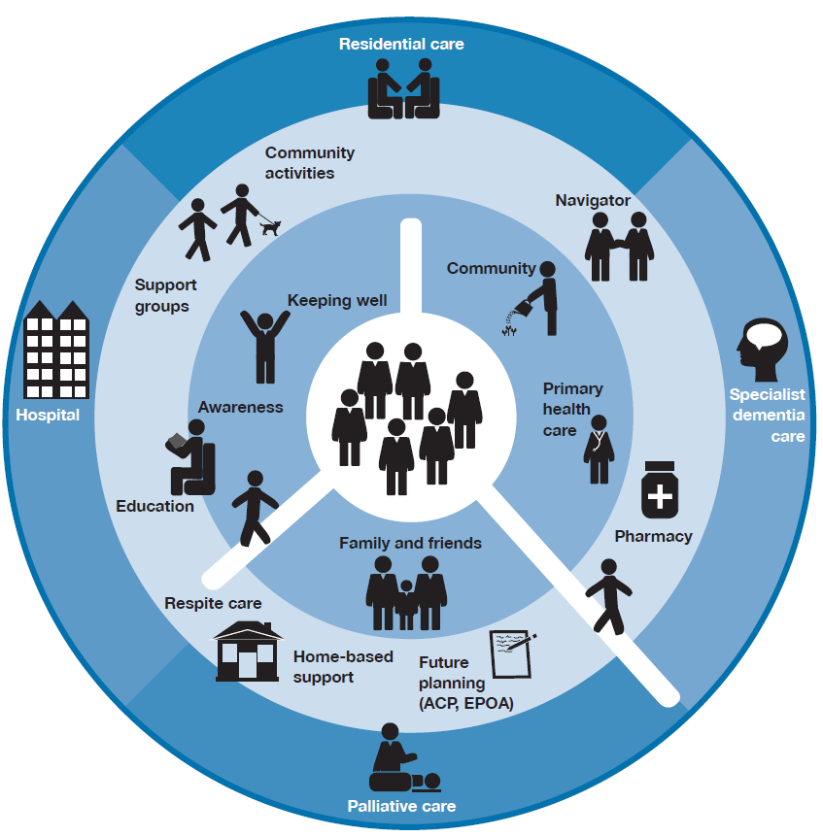

Dementia care and support: range of existing actions
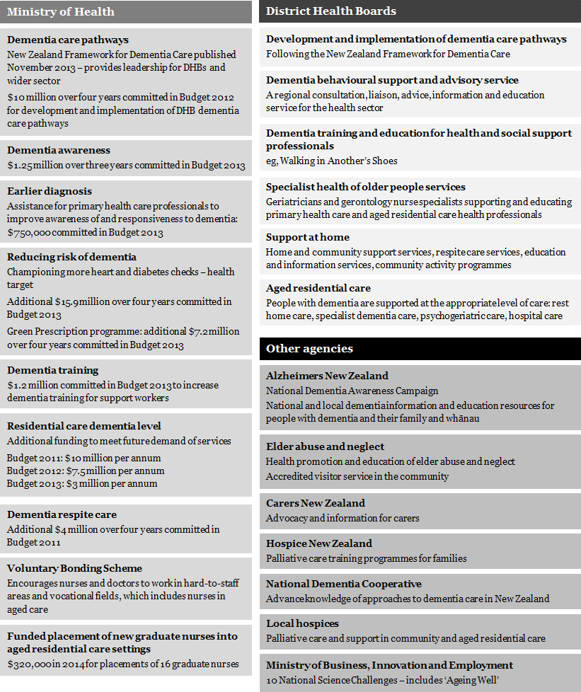
Note: DHB = district health board.

References
Ministry of Health. 2013a. Health Loss in New Zealand. Wellington: Ministry of Health.
Ministry of Health. 2013b. New Zealand Framework for Dementia Care. Wellington: Ministry of Health.
Ministry of Social Development. 2014. New Zealand Carers’ Strategy Action Plan for 2014 to 2018. Wellington: Ministry of Social Development.

Published in August 2014 by the Ministry of Health, PO Box 5013, Wellington 6145.
ISBN 978-0-478-42869-8 (print)
ISBN 978-0-478-42870 (online)
HP 5963
